

VistA Blood Establishment Computer Software (VBECS) Version 2.4.0

User Guide Version 3.0

July 2025

Department of Veterans Affairs
Enterprise Project Management Office

Table of Contents

Introduction 6
Freeware Disclaimer 7
Related Manuals and Materials 7
Orientation 8
How This User Guide Is Organized 8
Terms 8
Background and Basic Knowledge 8
Figures and Tables 8
Options 8
Supplemental Information 9
Appendices 9
Security 9
Application Architecture 11
Options That Require VistALink 11
Getting Help from Customer Support 12
Requesting New VBECS Features or Functionality 13
Using the Software 13
Software Basics 13
Commonly Used System Rules 16
Date and Time 16
Working with Data 16
Searching the Database 17
Testing 18
Creating and Viewing Reports 21
Scheduling Report Print Jobs 18
Report Toolbar 18
Navigation Arrows and Report Pages 18
Report Layout 19
Report Zoom-in/Zoom-out 19
Report Search 19
Report Export 20
Using VBECS 22
Searching Using the Table of Contents 22
VistA Records in VBECS 23
Accessing the System 24
Log into VBECS and VistA 24
Closing VBECS 28
Application Windows 31
Keyboard Shortcuts for Windows 32
Drop-Down Menus 33
Tool Tips 33
Icons and Buttons 33
Toolbars 34
Patient Information Toolbar 35
Patient Blood Availability 35
Medication Profile 36
View Special Instructions and Transfusion Requirements 37
View Recent Orders, Recent Transfusions/Issued Units, and Transfusion Reaction History 39
Patient Information Toolbar: Recent Orders 39
Patient Information Toolbar: Recent Transfusions/Issued Units 40
Patient Information Toolbar: Transfusion Reaction History 40
Main Status Bar 41
Throughout VBECS 41
VBECS Read-Only 42
Other VBECS Functions 42
Collecting Workload 42
Configuring Site Parameters 43
Update User Roles 43
Component Classes 46
Configure Daily QC 49
Configure Division 52
Configure Division 52
Configure Testing 54
Product Modifications 56
Order Alerts 58
Login Message 60
Local Facilities 62
Blood Products 65
Antibodies 68
Canned Comments 70
Setting Transfusion Parameters 72
Transfusion Complications 72
Transfusion Effectiveness 74
MSBOS 76
Workload Codes 78
Reagents and Supplies 81
Enter Daily QC Results 81
Reagents 89
Supplies 98
Equipment 103
Component Processing 108
Shipments 108
Incoming Shipment 108
Outgoing Shipment 120
Edit Invoice Text 127
Unit Search Screen 127
Test Units 130
ABO/Rh Confirmation 130
Unit Antigen Typing 134
Modify Components 145
Modify Units 145
Modify Units: Split a Unit 157
Modify Units: Pool Units 160
Add and/or Remove Units from a Pool 164
Maintain Unit Records 167
Edit Unit Information 167
Edit Financial Data 174
Free Directed Unit For Crossover 176
Discard or Quarantine 178
Select Units 184
Issue Blood Components 195
Return Issued Units To Blood Bank 209
Release Units From Patient Assignment 213
Print Unit Caution Tag & Transfusion Record Form 216
Invalidate Test Results 226
Remove Final Status 230
Processing Orders 233
Accept Orders: Accept an Order 233
Accept Orders: Pending Order List 239
Display Order Alerts 241
CPRS Order Status Alert 243
Display Patient Update Alerts 244
Display Patient Merge Alerts 245
Emergency Transfusion Order Processing 246
Maintain Specimen 249
Patient Testing: Cancel an Active Order 253
Patient Testing: Pending Task List 255
Accept Orders: Cancel a Pending Order 258
Order Reflex Tests 260
Patient Services 263
Patient Search Screen 263
Patient Merge 265
Updated Patients and Deceased Patients 270
Patient Testing: General Instructions 271
Patient Testing: Record a Patient ABO/Rh 277
Patient Testing: Record a Patient Antibody Screen 280
Patient Testing: Record a Direct Antiglobulin Test 282
Patient Testing: Record a Crossmatch 285
Patient Testing: Record a Patient Antigen Typing 290
Patient Testing: Enter Antibody Identification Results 296
Patient Testing: Record a Transfusion Reaction Workup 299
Finalize/Print TRW 310
Maintain Patient Records 315
Special Instructions & Transfusion Requirements: Enter a Transfusion Requirement 315
Special Instructions & Transfusion Requirements: Enter and Remove Special Instructions 320
Post-Transfusion Information 323
Document ABO Incompatible Transfusions 329
Justify ABO/Rh Change 331
Automated Testing 334
Automated Testing Interface 334
Automated Testing Review for Blood Units 338
Automated Testing Review for Patients 342
Reports 348
Administrative Data Report 348
Audit Trail 350
Blood Availability 352
Cost Accounting Report 354
C:T Ratio Report 356
CPRS Blood Bank Report (Used by JLV and VistA Read Only) 358
Division Transfusion Report 360
Division Workload Report 362
Exception Report 364
Finalize/Print TRW (See Patient Services, Finalize/Print TRW) 366
Inappropriate Transfusion Request Report 366
Issued/Returned Unit Report 367
Medication Profile (See Patient Information Toolbar) 368
Order History Report 368
Patient History Report 371
Patient Testing Worklist and Testing Worklist Reports 373
Prolonged Transfusion Time Report 376
Transfusion Complications Report 378
Transfusion Effectiveness Report 380
Transfusion Reaction Count Report 382
Transfusion Requirements Report 384
Unit History Report 386
References 389
Glossary 392
Appendices 402
Appendix A: Downtime Forms and Instructions 402
Patient Testing Form 403
Unit ABO/Rh Confirmation Form 406
Unit Issue and Inspection Log 407
Unit Modification Form 408
Appendix B: Database Table Information 410
Antibody and Antigen Tables 410
Antibody and Antigen Table: Irregular Antibodies 410
Antibody and Antigen Table: Database Conversion 413
Antibody Screen Test Interpretation 414
Canned Comment Category Types and Text 414
CPRS Orderable Blood Components (Component Classes) Mapped to ICCBBA Component Classes 420
Details in Audit Trail Report 420
Details in Exception Report 425
Product Modification Targets 427
Order Status Flowchart 428
Rules for Electronic and Serologic Crossmatch 429
Unit Status Flowchart 430
VBECS Maximum Surgical Blood Order Schedule 432
BCE COTS Message Updates 433
Workload Process to Use Case Mapping Table 436
Appendix C: VBECS Work Flow 446
Appendix D: Limitations and Restrictions 449
Appendix E: Known Defects and Anomalies 466
Appendix F: System Validation 467
Introduction 467
Validation Plan 467
Record System Settings 469
Configure Division 469
Configure Testing: Full Service 469
Product Modifications: Full Service 470
Order Alerts 471
Configure Daily QC: Full Service 472
Maintain Minimum Levels: Full Service 473
Log In Reagents: Full Service 474
Blood Products 475
Local Facilities 476
Component Classes 477
Transfusion Complications 478
Transfusion Effectiveness 479
Workload Codes 480
Canned Comments 480
MSBOS 480
Edit Invoice Text 480
Antibodies 481
Update User Roles 482
Testing 482
VBECS Forms and Reports 483
Appendix G: Work Process Flowcharts 484
Appendix H: Frequently Asked Questions 494
Appendix I: Common Error Corrections 495
Correct Patient Test Results 495
Invalidate Test Results 495
UN-Pooling a Pooled Unit (in the computer only) 496
UN-Modifying a Unit 496
Appendix J: Recommended Report Usage 497
Appendix K: Barcode Scanner Configuration and Troubleshooting 499
Appendix L: System Responses to Active Transfusion Requirements in Select Unit and Issue Blood Component 500
Appendix M: Workload Process Mapping to Application Option Table 509
Appendix N: Orderable Reflex Tests 517
Index 519
Revision History 525

Introduction
VistA Blood Establishment Computer Software (VBECS) is an improved Blood Bank application that facilitates ongoing compliance with Food and Drug Administration (FDA) standards for medical devices and enhances the Department of Veterans Affairs (VAs) ability to produce high-quality blood products and services to veterans. The system follows blood bank standards, standards of national accrediting agencies, FDA regulations and VA policies.
Intended Use
VBECS is a computer software application that manages transfusion service activities. The purpose of VBECS is to automate the documentation and record keeping of selected daily activities of the transfusion service.
Indications for Use
The main purpose of VBECS is to automate the daily processing of blood inventory and patient transfusions in a hospital transfusion service. The purpose of VBECS is to automate the documentation and record keeping of selected activities of a hospital transfusion service.
VBECS Accommodates:
- The processing of blood component shipments.
- The modification of blood units.
- Electronic receipt of orders from the Department of Veterans Affairs VistA computer system.
- The recording of patient compatibility testing, transfusions, transfusion processing requirements and special instructions.

Limitations and Restrictions

VBECS does not support:
- Blood donor collection activities (donor module)
- Direct data entry of antibody identification
- Direct data entry of transfusion reaction workups
- Patient testing, transfusions, and blood components recorded in Legacy VistA are not available in VBECS
- Pediatric blood product preparation
- Printing of blood product labels
- User defined customized queries or reports
- User editing blood product, antigen, antibody, or transfusion reaction tables
- Validation record storage

BCE information applies ONLY when a BCE COTS product is available for communication and is configured.

Limitations and Restrictions are listed in Appendix D: Limitations and Restrictions by option as well as throughout this document as part of the detailed information associated with the functionality.

Unauthorized access or misuse of this system and/or its data is a federal crime. Use of all data, printed or electronic, must be in accordance with VA policy on security and privacy.
The U.S. Food and Drug Administration classifies this software as a medical device. Unauthorized modifications will render this device an adulterated medical device under Section 501 of the Medical Device Amendments to the Federal Food, Drug, and Cosmetic Act. Acquiring and implementing this software through the Freedom of Information Act requires the implementer to assume total responsibility for the software and become a registered manufacturer of a medical device, subject to FDA regulations.

Freeware Disclaimer
Requests for VBECS source code may be submitted through the Freedom of Information Act (FOIA). Effective on September 19, 2011, the Department of Veterans Affairs will accept FOIA requests electronically. Most VA Central Office (VACO) Offices are in the process of establishing an electronic mailbox. In the meantime, the FOIA Service will accept electronic FOIA requests for any VACO FOIA Office that does not yet have a mailbox in place and will forward your request to the appropriate office for processing.
Submit requests to REDACTED

Related Manuals and Materials
- VBECS 2.4.0 Admin User Guide
- VBECS 2.4.0 Release Notes
- VBECS 2.4.0 Technical Manual-Security Guide
- VBECS Frequently Asked Questions (FAQs)

This VBECS 2.4.0 User Guide can be obtained from:
- VistA Documentation Library (VDL) Web site (content may have redactions)
- REDACTED

Orientation
This section covers:
- How This User Guide Is Organized
- Security: who can use VBECS
- Application Architecture: the architectural requirements for VBECS
- VistA and VBECS: how VBECS compares to VistA
- Customer Support: how to get help

How This User Guide Is Organized

Terms
For consistency and space considerations, the pronouns “he,” “him,” and “his” are used as pronouns of indeterminate gender equally applicable to males and females.
In many instances, a user may scan a barcode or enter data manually (by typing). The term “enter” is used throughout this guide to mean “enter manually.”
See the Glossary for definitions of other terms and acronyms used in this guide.

Background and Basic Knowledge
The Introduction, Orientation, and Using the Software sections provide the background and basic knowledge VBECS users need.

Figures and Tables
If you refer to figures and tables from the user guide in your local policy and procedure documents, you may wish to use their titles only, without figure or table numbers: as the user guide is updated, those numbers may change.

Options
The Configuring Site Parameters, Component Processing, Processing Orders, Patient Services, and Reports sections cover VBECS options.
Each option section starts with an introduction, a short paragraph that explains what a function allows a user to do, followed by:
- Assumptions: tasks that must be completed before performing a function.
- Outcome: results of performing a function.
- Limitations and Restrictions: features of the system that are restricted by and exist within this function.
- Additional Information: information that helps the user perform a function.
- User Roles with Access to This Option: which users may perform this option in whole or in part.
- A detailed description of what the function allows each user to do. Two or more arrows () indicate functions limited to a specific role.
- Table of steps for the basic path (user and VBECS actions).
- Tables of steps for alternate paths (user and VBECS actions).
- Figures (examples of reports, screen shots, etc.).
- Table of alerts that may occur during an option.
A  (bullhorn) indicates that VBECS emits an audible alert. Keep the sound on to hear the alerts (see Volume for instructions on adjusting the volume).
- Outlined, italicized text highlights tips, warnings, and cautions, for example:
A signals potential hazards throughout this guide as they occur.

Supplemental Information
The third group of sections (References, Glossary) provides knowledge that may be needed beyond the standard, daily use of VBECS.

Appendices
The appendices contain truth tables, diagrams, and other materials for reference.
Click a section name or page number in the table of contents to move to a section. The index does not incorporate this feature.

Security
User roles identify who can access which functions. Not every VBECS user has access to all VBECS options or functions within options. Two or more arrows () indicate functions limited to a specific role.
It is critical that each site evaluate its staff and determine appropriate security levels based on training and qualifications.
User roles also govern which options are available and which warnings can be overridden. VBECS displays options that are not available to a user in gray text.
Each of the six user roles is associated with a security level (see Table 1). Privileges accumulate as the security level increases. For example, a Lead Technologist’s privileges include those of a Blood Bank Technologist and Enhanced Technologist.
Table 1: User Roles and Functions
Security Levels and User Roles | Accessible Functions | Who Should Fill These Roles?
Level 1: Blood Bank Technologist (all users) | - Standard access:  - patient and donor testing  - accepting and canceling orders  - modifying units  - processing shipments  - selecting and issuing blood that does not require higher level overrides  - processing transfusion reaction workups  - add patient’s transfusion requirements  - accessing report functions  - enter daily QC results  - discard/quarantine blood units  - release units from patient assignment  - return issued units to blood bank  - Activate/edit some shipper information.  - Activate/edit some blood product information.  - Add new local facility, not already on the table issued with VBECS. | Rotating technologists, new employees, and students trained to perform associated tasks and overrides.
 Level 2: Enhanced Technologist | - Edit unit cost.  - Modify/issue expired blood products.  - Release blood products from quarantine.  - Edit unit information prior to defining patient associations.  - Edit verified unit confirmation testing.  - Edit patient record/verified data and test results (except the ABO/Rh for historic record and the antibody field, which results in an antigen negative requirement).  - Release directed units to the main blood supply. | Experienced technologists trained to process associated overrides and options.
 Level 3: Lead Technologist | - Select/issue ABO incompatible blood.  - Select/issue antigen positive or untyped red blood cells (for the clinically significant antibodies in the table).  - Maintain login message. | Experienced technologists trained to process associated overrides and options (e.g., evening- or night-shift supervisors).
 Level 4: Traditional Supervisor | - Maintain reagent minimum levels.  - Edit permanent record of the patient’s historic ABO/Rh.  - Edit Transfusion Requirements (TRs) and Special Instructions (SIs).  - Edit patient record red cell antibody permanent fields (match antigens in the antigen table).  - Edit a blood unit’s record (verified unit data when unit has any previous patient associations).  - Edit a Patient’s Transfusion Record.  - Remove a Blood Unit’s Final Status.  - Edit a blood product’s maximum storage time. | Experienced blood bank supervisors trained to process associated overrides and options
 Level 5: Enhanced Supervisor | - Edit antigen frequency table to reflect local population.  - Edit and create canned comments for the division.  - Edit and create consultative reports, templates, MSBOS, reagents, and equipment maintenance logs for the division. | Experienced blood bank supervisors or VBECS administrators trained to process associated overrides and options
 Level 6: Administrator/Supervisor | - Define VBECS users’ security settings.  - Define the division as full service or transfusion only.  - Enable electronic crossmatch at the division.  - Populate International Council for Commonality in Blood Banking Automation, Inc. (ICCBBA) number for the division.  - Define valid unit modifications for the division.  - Assign workload codes for the division.  - Configure testing.  - Configure division. | VBECS administrators trained to process all overrides and options not designed to change frequently. This role may be assigned temporarily to a blood bank supervisor at setup to configure the division.
The VA Wide Area Network (WAN) is protected from unauthorized access. The hardware running the VBECS application and its database are located in one of three Microsoft Azure for Government (MAG) regional data centers:
- EAST (Virginia)
- SOUTH (Texas)
- SOUTHWEST (Arizona)
All sites are secure data centers where they are protected against unauthorized modifications and accidental damage.

Application Architecture
VBECS operates as a discrete application and interfaces with other VA systems using Health Level 7 (HL7) and VistALink.
VBECS is a Windows-based application hosted on a server. Users access VBECS through a graphical user interface and other VA systems interface with VBECS through Health Level 7 (HL7) and VistALink.
The major goals of the application are:
- Improve the safety of blood/blood component transfusions by decreasing the risk of errors through effective use of current technology such as barcode scanning, retrieval of previous records to be used for comparison, and detection of inconsistencies in data input
- Improve the quality of patient care through evaluation of transfusion appropriateness and follow-up on the effectiveness of transfusions
- Provide comprehensive reporting capabilities for quality monitoring within the transfusion service and for clinicians
VBECS operates in accordance with FDA regulations regarding change to a medical device. Areas of operation that are part of the VistA Blood Bank v5.2 software medical device (except for the donor module) are contained in this encapsulated VBECS package. Patient orders originate and are received from the Computerized Patient Record System (CPRS) and Laboratory applications.

Options That Require VistALink
These options require a connection through VistALink. When VistALink is not active and VBECS requires access to VistA data, VBECS prompts the user to activate VistALink. When VistALink is not available, VBECS warns the user and asks him to try again later.
Contact your local support staff immediately when VistALink is not available. VBECS, VistA and CPRS all depend on VistALink to exchange information.
Main Menu: Orders
- Accept Orders: Accept Orders and Pending Order List
Main Menu: Blood Units
- Edit Unit Information (used when editing patient restrictions)
- Return Issued Units To Blood Bank
Main Menu: Patients
- Post-Transfusion Information
- Return Issued Units To Blood Bank
- Issue Blood Components (to include a hospital location)
Main Menu: Shipments
- Incoming Shipment (used when restricting units to patients)
Main Menu: Tools
- Blood Products
- Component Classes
- Transfusion Complications
- Transfusion Effectiveness
- Workload Codes
Main Menu: Supervisor
- Document ABO Incompatible Transfusion
Main Menu: Reports
- Audit Trail Report (only when an audit date range includes a change to the accession area, which is unlikely to occur)
- Transfusion Complications Report
- Transfusion Effectiveness Report
- Medication Profile (Reports or from the Patient Tool Bar icon)
Main menu window, icon in the bottom of the window:
- Display Order Alerts

Getting Help from Customer Support
Contact your Local/Regional Office of Information Technology (OIT) or Laboratory Information Manager (LIM) if you encounter VistA or CPRS connection problems and for training support before contacting the Service Desk (SD).
Please ensure local/regional VistA Support contact information is available at all times.
If you experience an FDA reportable adverse event (patient death or serious injury) that VBECS may have caused or contributed to, contact the Service Desk directly to enter a ticket for Blood Bank software support.

Service Desk Contact
Call the Service Desk REDACTED
Refer to the REDACTED on the VBECS SharePoint site for up-to-date information about contacting the Service Desk.

Requesting New VBECS Features or Functionality
Requesting new features or functionality for VBECS is done through a New Service Request. To get the process started, please contact VBECS Customer Support by referring to the VBECS Getting Help page. A VBECS customer support technician will work with you to gather the technical details and verify if a similar change has been previously requested.

Using the Software
Using the Software explains:
- How to access VBECS and VistA
- What users will see on the screen
- What the icons and other symbols mean
- Which conventions are used in this guide
- How to exit VBECS

Software Basics
- When a message window requires a user response and VBECS displays it behind the active window, the user must minimize the active window or click and drag dialog boxes to expose the message window.
- A user may click Cancel, Close, or  in the upper right corner at any time to exit without saving.
- All operations depend on the user being logged into the appropriate division.
- A user may click a column heading to resort the items in that column (Figure 1 and Figure 2).
- Reaction results entries are allowed for only those reagents defined as part of the reagent rack.
- Select a date from the calendar in the drop-down list to edit a date, or click each part of the date to edit the date and time (Figure 3 and Figure 4).
- Labels shown in figures are visual aids only and do not represent actual labels.
Although the copy-and-paste function is enabled, do not use it to enter patient identification information. It is highly recommended that the user scan this information when possible; otherwise, enter it.
Figure 1: Click to Sort by Patient Name
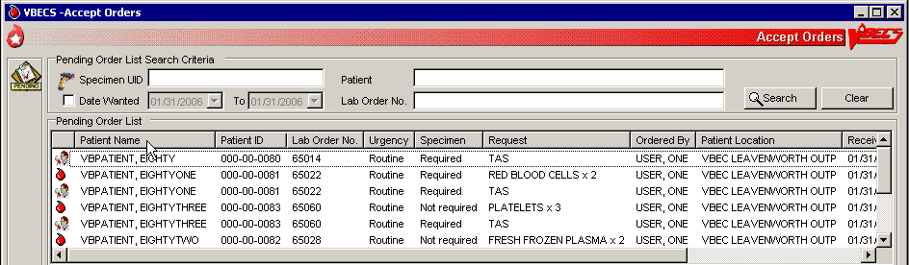
Figure 2: Click to Sort by Request
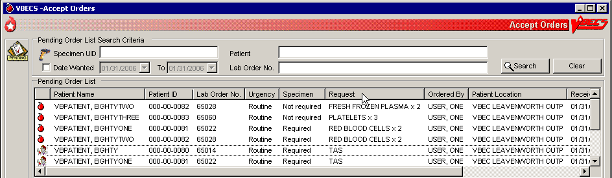

Figure 3: Select a Date from the Calendar
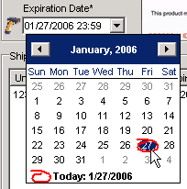

Figure 4: Edit the Date and Time
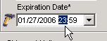

Commonly Used System Rules
This section includes system rules that apply to several or all options.

Date and Time
- Users must contact the Service Desk when the date or time is incorrect.
- The date, time, and time zone in VBECS is defined where the blood bank is located. Any requests for data from a particular blood bank database will reflect the time zone where the data was created and not the time zone where the report is generated.
- Refer to VBECS 2.4.0 Admin User Guide to change the time zone.

Working with Data
- VBECS will emit an audible alert when a user exceeds the maximum character limit for a field.
- The user may enter interpretations and reactions in full-service facilities. The user may enter only interpretations in transfusion-only facilities.
- Information displayed on an active window is updated with information from other options only when it is refreshed (i.e., closed and reopened) in the active window.
- When VBECS displays a scanner icon next to a data entry field, a user may enter or scan the data. The Caps Lock key must not be engaged.
- Entry of Codabar labeled blood units is disabled.
- VBECS captures all technologist IDs and the name of the technologist who displays and/or prints testing information on reports associated with entering test results on a worksheet.
- With each valid keystroke entry in the antibody screen and crossmatch test grids, VBECS moves the cursor from top to bottom in the far-left column within the cells in which results are being entered. The cursor returns to the top cell in the next column to the right and so on across the worksheet grid. The cursor stays in the reaction results cells by default (the technologist may navigate independently) until the last entry is made in the reaction result portion of the grid, then the cursor moves to the first (top) interpretation cell.
- To clear an entry in a test grid cell, press the Backspace key.
- VBECS allows selection of deceased patients without a warning message presented when VBECS has not received a patient death update message from VistA.
- VBECS displays the data that a user enters in a session. The user may edit the data and save them. VBECS warns the user that if he chooses to cancel using the cancel or “X” button or by leaving/refreshing the current page, VBECS will not save any data changes entered during the session. VBECS closes the form and returns the user to the main menu screen that may include unrelated open windows.
- VBECS displays and enforces active Transfusion Requirements (TRs) to all divisions in a multidivisional database.
- The user may not edit the title column of the data grid that specifies the reagent used in the test with a patient specimen.
- Unless otherwise indicated, data entry and retrieval are restricted to the division logged into.
- To enter data after VBECS has been unavailable, a user may enter a past date, time, and the technologist who performed the work.
- VBECS displays changes in reverse chronological order.
- VBECS calculates and displays the days (hours, if less than one day) remaining until a unit’s expiration based on the date and time of unit selection entered during modification.
- A scanned ISBT 128 expiration date barcode is identified by the presence of hidden identifiers. Once the hidden identifier is removed, there are two possible formats of the barcode, one involving the date only and another involving date and time. If no time in the barcode, then 23:59 is assumed.
- VBECS supports the scanning of ISBT 128 2-d barcodes by detecting the appropriate hidden identifier. Once the hidden identifier is removed, the 2-d barcode represents one or more scan codes, depending on the value scanned.
- VBECS supports the scanning of ISBT 128 special testing information barcodes by detecting the appropriate hidden identifiers. Once the hidden identifier is removed, the special testing code is a varying length of digits, depending on the type of special testing barcode scanned.
- Data are never deleted: they are saved indefinitely.
- Although a user may appear to select and delete data in gray fields, VBECS does not save such edits.
- A column’s width may be adjusted or hidden for a session. This view returns to the default presentation when the view is opened again.
- The ABO/Rh confirmation worklist may be sorted by Unit ID, ABO/Rh, Product Type, Component Type, or Date/Time Received. When displaying the Date/Time Received, seconds are not displayed, but are used to sort the worklist when selecting Date/Time Received for the worklist sort criteria.

Searching the Database
- A user may search for a patient by:
- Patient’s last name (symbols such as an apostrophe and/or dash are not allowed)
- Patient’s ID (omit hyphens) (“Full”)
- Patient’s last initial and last four digits of the ID (“Last 4”)
- Patient’s last four digits of the ID (“Last 4”)
- For example, for a patient whose last name is TEST with an ID of 000-11-2222:
- Patient's last name: user enters "TEST"
- Patient's ID: user enters "000112222" (no dashes or spaces)
- Patient's last initial and last four digits of the patient ID: user enters "T2222" (no dashes or spaces)
- Patient's last four digits of the patient ID: user enters "2222"
- The system displays all patients that fit the search criteria, allowing the user to select a patient from a pick list.
Note: Searching by last four digits on the patient ID in VBECS against the VistA database will return matches on the last four digits or the first four digits. The following search formats in VistA are not allowed in VBECS:
- Last name, first name
- Various patient ID lengths other than 4 or 9 digits
- VistA Patient ID
- A user must scan or enter a unit ID and a product code to select a unit from inventory.

- When VBECS does not find a unit record, it displays an error message stating that the unit was not found and instructing the user to reenter unit information. A user may close this message, click Clear, and enter another unit ID and product code.
- VBECS lists all or part of a division’s blood component inventory, based on system rules. A user may enter a varied combination of unit information to create a customized list of selectable units, including:
- Unit ID
- Product type
- ABO/Rh
- Special testing (CMV Neg, SC Neg, or equal to or greater than (= >) 2 mL RBC Contamination)
- RBC antigens (available only for the RED BLOOD CELLS component class)
- Received date range
- Expiration date range
- VBECS displays this unit information in the selection list whether full inventory, subset, or filtered subset:
- Unit ID
- Unit ABO/Rh
- Product short name
- Product code
- Unit status
- Unit expiration date
- Donation type
- Restricted for patient name, when available
- Date and time received (standard format)

Testing
-  Administrator/Supervisors may configure reagent racks to use a tube, solid phase, or gel method.
- VBECS allows a user to perform QC testing at AHG and later perform patient testing at all phases using a rack configured for AHG only.
- VBECS does not verify that the phase of testing matches the reagents used for testing.
- Users working with reagent racks containing different reagents must do so in accordance with local policy and procedures.
- Reaction result cells in the data grid contain only symbols. A legend of the symbols and their meanings, specific to the data grid and its truth tables, is located in the bottom left corner of the form and is available to the user throughout data entry.
- Entry of a symbol (not a number or letter) into a test grid reaction result cell or interpretation field will not elicit a system response. The entry of the symbol is not allowed and does not overwrite the previous entry, if any. See Table 2 for valid observed test result entries.
- After entering a canned or free-text comment in the testing comment field of the testing grid, the user must press Enter to store the comment.
- The user may enter canned comments in comment cells by selecting from a pick list or enter free-text comments by selecting “Other.”

Table 2: Valid Observed Test Result Entries
Entry | VBECS Translation
H | Hemolysis | Positive
W | Weak | Positive
F | Mixed Field | Positive
M | Microscopic | Positive
1 | 1+ | Positive
2 | 2+ | Positive
3 | 3+ | Positive
4 | 4+ | Positive
X | Not Tested | Not Tested
0 | No Agglutination | Negative
R | Rouleaux, No Agglutination | Negative
- When recording test results:
- In the Test Details window, click a check box to select a rack.
- In the Date Tested field, select the default date and time (current date and time) for testing performed, which the user may edit to a past date and time.
- In the Tested By field, select the default identification (current user) for the testing technologist or another user from the drop-down menu.
- Click the appropriate radio button to determine the grid configuration for antibody screen and crossmatch grids [All phases or Anti-Human Globulin (AHG) only (pre-checked default varies with local configuration)].
- When an automated instrument is used, click the Using Automated Instrument check box, enter the instrument name in the Instrument Name field, and click the Instrument QC’d? check box, as appropriate.
- VBECS requires Red Blood Cells, Whole Blood, Granulocytes and Leukocytes to have ABO confirmation testing (forward typing), and Rh confirmation testing for units labeled as Rh negative. Units labeled with an ABO group of “Pooled” cannot be confirmed.
- The user may not edit VBECS-populated grid worksheet fields that contain unit or patient data.
- The user may sort worksheet entries only before beginning data entry, preferably during unit selection. When the user wishes to sort a worksheet after entering the first reaction result, he must exit without saving the work and begin again.
-  When a user enters an invalid symbol in a cell, VBECS emits an audible alert and prevents the cursor from moving to the next cell.
- VBECS moves the cursor to the comment cell automatically, when applicable; the user may also use the mouse to move to another cell.
- VBECS displays E (error) at the beginning of invalid rows and V (valid reagent) or W (reagent will expire within 24 hours) at the beginning of valid rows. These warning icons change as the user updates information. When the user holds the mouse over an icon, VBECS displays the message associated with the truth table interpretation (as with a tool tip).
- VBECS compares user-entered interpretations with truth table data.
- The user performs tests and enters data simultaneously.
- Throughout this option, the user may view the patient’s VBECS demographics, including the information entered in the patient Special Instructions (SIs), Transfusion Requirements (TRs), and other clinical lab results related to the transfusion through CPRS.
- The historical ABO/Rh display includes the date and division of creation or indicates that the record is from the VistA database conversion.
- The test record captures the entering and testing technologists’ ID and the display/print technologists’ name, the division, date, and time of the save, the content (details of the verified testing), QC rack ID (if not by automated instrument), test method, automated test instrument information, if indicated, data entries, interpretations, and comments. (When the configuration changes in Configure Testing after the test data are entered, the record is retrievable as originally configured.)
-  When a site is defined as “full service” and daily QC was not performed on the selected rack or the Not in Use Today check box was checked for the 24-hour period (beginning with the time set for the alert defined in Configure Daily QC and including the date/time tested), VBECS emits an audible alert, warns the user and asks whether he wishes to continue. Yes requires a comment and captures details for inclusion in the Exception Report (exception type: QC not performed on rack used for testing). No allows the user to select a different rack or cancel and return to the main menu.
- When reagents or antisera are within 24 hours of expiration (23:59 on the expiration date), VBECS warns the user when the reagent will expire and asks whether the user wishes to continue. Yes allows the user to continue testing. No moves the cursor to a cleared lot number cell, which is ready for the user to enter a new lot number.
- The unit record will capture the entering tech ID, and display and/or print the entering tech name; the selecting tech ID, and display and/or print the selecting tech name; division, date, and time of the save; and the content (details of the unit selection), if indicated, data entries, interpretations, and comments.
- VBECS allows a user to save partially completed tests and allows the same or different user to complete the tests later. A first or second user may enter only new results and may not edit prior entries. VBECS allows the user to save partially completed testing. The user may return to complete the pending tasks but may not edit saved interpretations.

Creating and Viewing Reports
- Click ☑ in the Include Report Sections area to select all report sections (Figure 5).
- Click  in the Include Report Sections area to clear all report sections (Figure 6).
Figure 5: Click to Select All Report Sections
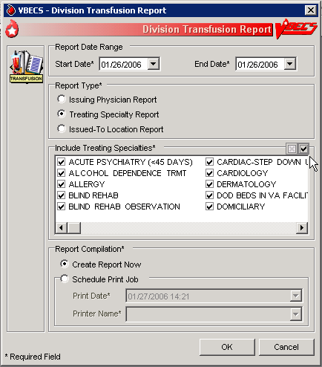
Figure 6: Click to Clear All Report Sections
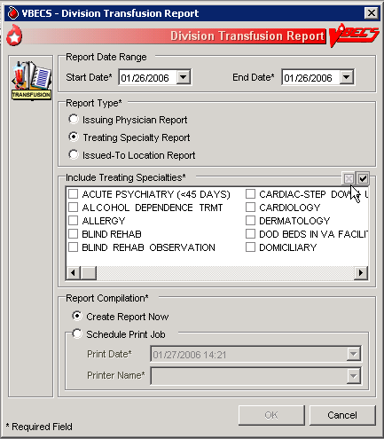
- In the Report Compilation area, click the Create Report Now radio button and OK to view the report, or click the Schedule Print Job radio button and OK, then enter or select a print date and printer name, then click OK to view and print the report.
- Reports are printed only in their entirety.
- A single-division report includes information from one division.
- When a site is a single division or a user does not have multidivisional access and a report has a multiple-division option, the user may not select a multidivisional report.
- VBECS maintains a cumulative history of all transactions, including testing and status changes, for every blood unit entered in the database (Unit History Report).
- VBECS captures changes to verified data for inclusion in an audit trail report (Audit Trail Report, Unit History Report, and Patient History Report).
- VBECS displays patient ABO/Rh results in reverse chronological order, regardless of division, then from the VistA database conversion. When no ABO/Rh records exist, VBECS displays “NR” (no records). When there are discrepant ABO/Rh results from the same universal ID (UID) or from two specimen UIDs, VBECS displays the results recorded just prior to the latest result that created the discrepancy and warns the user.
- When no information that fulfills search criteria is available, VBECS notifies the user that no information is available, per entered search criteria.
- The user may change the default start and end dates (the previous day). The end date must be later than or the same as the start date. Report activity begins at and includes midnight on the start date and ends 23:59 on the end date. When the date range includes the current date, VBECS displays “Preliminary” in the header on each page of the report.
- VBECS displays headers on every page of a report; it displays search and sort criteria and date ranges at the end of the report. VBECS identifies whether reports are generated from a test environment or from a production environment.
- The user may choose to schedule a report to run at a future date and time and print on a designated printer. When a date range is supplied for the report, the report's end date must occur before selected date of printing. The report scheduled to run at the future date/time will start processing the data at the time the report is scheduled to print (future date/time). If the date range spans more than 30 days, the system displays the warning message: "You are requesting more than 30 days of data to be printed. Continue?"
- Local record retention policy instructs users to print, review, document, and save the Audit Trail, Exception, and Testing Worklist Reports. The reports contain only data entries generated in the user’s login division. Each entry includes an area for supervisor acknowledgement (signature or initials and date of review) and comment.
- The search functionality (binoculars icon) may not work in a displayed report.
- VBECS displays the patient historical ABO/Rh, antibodies identified, antigen negative requirements, and transfusion reaction history (date, division of testing, whether from the VistA database conversion), and whether the historical ABO/Rh was changed.
- When a patient has a history of an ABO/Rh change justified through Justify ABO/Rh Change, VBECS displays “History of justified ABO/Rh change” next to the historical ABO/Rh information.
- Refer to the VBECS Technical Manual-Security Guide for details on which workstation settings may affect the appearance of a report preview.
- When VBECS has been set Read-Only, the header of every page of a report will contain “VBECS DATA IS READ ONLY”.

Reports in VBECS are created using a Microsoft technology called SQL Server Reporting Services (SSRS). Reports are rendered on screen using Microsoft Report Viewer control. Reports are not deployed on the reporting server but as a part of the main application. All reports rendered on screen can be exported. The user has the option to export reports in three different formats (PDF, Excel and/or Word).

Scheduling Report Print Jobs
To have a report printed automatically at a later date, the user selects the Schedule Print Job option on any VBECS report (Figure 5). Scheduled print jobs wait in a queue until the designated time (set in the Print Date field), at which point they are sent to the printer selected in the Printer Name field.

- The print job engine runs in UTC time. This means that if you set the Print Date field to 9:00AM it will print at 9:00AM UTC, (which equates to 6:00AM EDT, 5:00AM CDT, 4:00AM MDT and 3:00AM PDT). The Start Date and End Date fields are converted into user division time, which can create a scenario where the job prints before the End Date.
- The user may choose to schedule a report to run at a future date and time and print on a designated printer. When a date range is supplied for the report, the report's end date must occur before the selected date of printing. The report scheduled to run at the future date/time will start processing the data at the time the report is scheduled to print (future date/time). If the date range spans more than 30 days, the system displays the warning message: "You are requesting more than 30 days of data to be printed. Continue?"
- If a print job is scheduled for Printer Name “VBECS Backup Printer”, and the “VBECS Backup Printer” is renamed or removed before the job’s Print Date, that report will not print.

Report Toolbar
Each report in VBECS will have a toolbar on top that allows the user to interact with the report (Figure 7). The following sub-sections elaborate on the controls found on the Report Toolbar. It is suggested that users create a local directory for exporting their reports (see the VBECS 2.4.0 Technical Manual-Security Guide for additional information).
Figure 7: Report Toolbar

Navigation Arrows and Report Pages
Navigation arrows allow the user to move to the next or previous page of the report. If the user is on the first page of the report, the arrows pointing to the left will be disabled. If the user is on the last page of the report, the arrows pointing to the right will be disabled.
The first arrow button moves the report by one page forward (or backward for left facing arrow). The second moves the report to either the last or first page (in case of the left facing arrow). The number X of Y tells user which page is currently being viewed (X) and what is the total number of pages (Y).
Using arrow keys may cause erroneous “Invalid Key Pressed” messages or swap values while entering control results. Use the mouse to move between cells instead of using the arrow keys. Verify the control cell entries are correct before saving.

Report Layout
There are two ways (layouts) in which reports can be displayed. By default, reports are displayed in Print Layout. It allows reports to appear on the screen exactly how they will look when printed. However, when reports are displayed in Print Layout mode, the Report Search function (see Report Search) is disabled. In order to be able to use Report Search, the user has to turn off Print Layout mode by pressing this icon: . When Print Layout is disabled, the icon will look like this: . It can be pressed again to return to Print Layout mode.
Page size of reports not displayed in Print Layout mode differs from the regular letter size (8.5in. x 11in.) and that is why the total number of pages for the same report displayed in different layouts may differ.

Report Zoom-in/Zoom-out
Clicking the drop-down menu showing 100% will give the user a choice of the report display size (Figure 8).
Figure 8: Report Zoom-in/Zoom-out Control
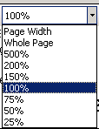
The default value is 100%. The option Page Width will resize the report to fit the screen horizontal size. The option Whole Page will display the entire page on the screen. Selecting an option less than 100% will zoom out the report making the font smaller and allowing more data to fit on the screen. Selecting an option higher than 100% will zoom in the report making the font bigger. If the report does not fit on the screen, the user will be able to use scroll bars to scroll up or down and left or right to view the entire report.

Report Search
This option allows the user to search for specific text in a report and is only enabled if Print Layout is disabled (see Report Layout). By default, the Find and Next buttons are disabled. Once the user enters text in the search box, the Find button becomes enabled (Figure 9).
Figure 9: Report Search Control
Clicking the Find button will search the entire report. If the searched text is found, the report will display the page where it was found. The Next button will then become enabled allowing the user to search for subsequent instances of the search string. If the searched text cannot be found, the user will be presented with the message shown in Figure 10.
Figure 10: Report Search Warning Message
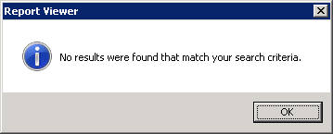

Report Export
For all sites, reports are saved in subfolders named after Division Code. VBECS will check to see if the subfolder exists. If the subfolder does not exist, it will attempt to create it. If the creation fails, it will attempt to save the report to the default report directory.
The user has an option to export the report in three different formats: PDF, Excel and Word. The export to PDF creates a report that is Read-Only (may not be modified) and will match the report that users can see directly in VBECS in terms of data and format. The export to Excel and Word creates a report that may be modified. VBECS reports exported to Excel or Word can be altered by a user. Only copies printed directly from VBECS should be shared with clinicians to ensure data integrity.
The data output from VBECS is not controlled by the medical device and must be strictly regulated by local facility personnel. Many of the reports contain patient sensitive information and must be treated as such. Use of the exported reports, including alteration of data, is the responsibility of the user.

Export of the reports to Excel and Word comes with known problems. Reports exported to Excel or Word contain the same data as reports that can be seen directly in VBECS; however, their formatting may differ from the original report. Not all reports can be exported to all the identified formats. Table 3 lists the reports and their exportable formats.
Table 3: Recommended Exportable Formats for Reports
Report Name | PDF | Word | Excel
Maintain Reagent Inventory | Yes | Yes | No
Testing Worklist Report | Yes | Yes | No
Blood Availability Report | Yes | Yes | No
Division Transfusion Report | Yes | Yes | No
Blood Bank Supplies Report | Yes | Yes | No
Unit History Report | Yes | Yes | No
Patient History Report | Yes | Yes | No
Other VBECS reports | Yes | Yes | Yes
By clicking on , the user has the option to select and export to an Excel, PDF or Word file (Figure 11). Choosing any of these options will open the dialog shown in Figure 12.
Figure 11: Report Export Toolbar
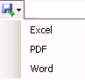
Figure 12: Example of Report Export Dialog for Blood Bank with Division Code 589
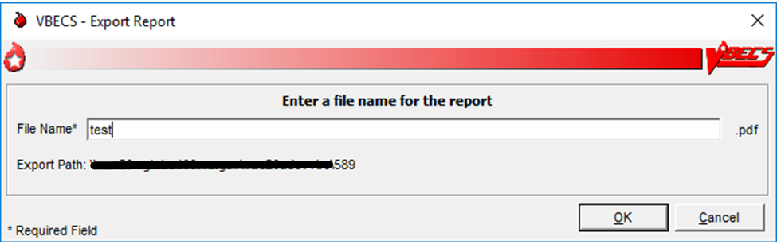
This dialog allows the user to specify the name of the file to which the report will be exported. The extension of the file is pre-filled for the user and depends on which export option was selected (.xls for Excel, .pdf for PDF or .doc for Word). The file name length is limited to 200 characters and will not accept special characters as part of the name (e.g., \ / ? % * | : ’ ” < >).
If the user attempts to use a special character in the file name, it will be ignored and not appear on the screen.
Once the user enters a proper file name, the OK button will become enabled. Clicking the OK button will present the user with the message shown in Figure 13.
Figure 13: Report Exporting in Progress
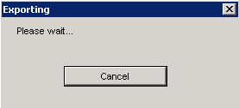
Clicking the Cancel button will stop the export and the user will be reverted back to viewing the report. If the export is successful, the user will be presented with the message shown in Figure 14.
Figure 14: Example of Report Exporting Success
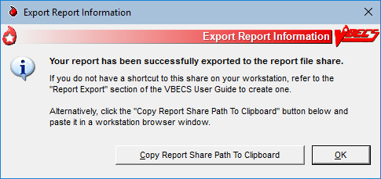
This dialog contains a Copy Share Path to Clipboard button, which when clicked will put the full path to the report network share in the user's clipboard. The user can then return to their workstation and open File Explorer or any web browser and paste the copied path into the Address bar to be taken to their report.
To create a workstation shortcut directly to the network share of exported reports, follow the instructions from the Exported Reports Network Share section of the VBECS Technical Manual-Security Guide.

Using VBECS
VBECS is a Windows-based application.
One VBECS system is implemented for each VistA database.
Subject matter experts (SMEs) at user sites will help implement VBECS and train blood bank staff and other authorized users.
The REDACTED contains training, Frequently Asked Questions (FAQs), Technical Bulletins, ListServ messages and sign up, etc. to support the implementation and use of VBECS. Users may access links to VBECS training modules and frequently asked questions and join a ListServ (an email distribution list to manage discussion groups) for VBECS announcements and updates. Contact information is provided for comments and questions.
Pressing the “F1” key brings up the VBECS Information window to inform the user that if you need help with VBECS or VBECS Admin, to refer to the VBECS User Guide or VBECS Admin User Guide that are found on the VBECS SharePoint or file a Service Desk ticket.

Searching Using the Table of Contents
Scroll through the Table of Contents and click any Table of Contents topic/link to go to the desired page.

VistA Records in VBECS
Historic VistA blood bank records were transferred to VBECS and validated during the database conversion. VBECS handles these records in accordance with system rules:
Patient names in VistA that exceed the database standard for File #2 (30 characters) or do not have a last name do not convert to VBECS.
- VBECS may display patient information differently from VistA. For example, VBECS displays patient names as “LAST NAME, FIRST NAME, MIDDLE NAME or INITIAL, SUFFIX.”
- A patient name may be truncated in the following screens when one of the name fields (Last, First, or Middle) exceeds 22 characters. The full name is displayed elsewhere on the screens identified or it is provided as read-only information and is not used to make decisions for the selected patient.
  - Blood Unit Details tab
  - Patient Specimen Selector control
  - Patient Order Selector control
  - Patient Order Selector for Report control
- VBECS may only display the first 25 characters of the name.
- VBECS displays historic ABO/Rh types from the database conversion but doesn’t use them for issuing blood or for comparing test results.
- VBECS truncates Special Instructions (SIs) text from the VistA database conversion.
- SIs from database conversion entries are labeled as such.
- VistA SIs from the database conversion may include component or antigen negative requirements. The VistA SIs remain SIs and are not enforced unless they are entered in the Components Requirements tab in Special Instructions & Transfusion Requirements.
- Patient antibody identifications from VistA were included in the database conversion.
- Antigen negative requirements properly set in VistA were transferred to antigen negative requirements in VBECS.
- VBECS informs the user when the displayed historical ABO/Rh, transfusion reaction history, and/or antigen typing result from the database conversion.
- Transfusion reaction types without their associated units were transferred to VBECS.

Accessing the System

Log into VBECS and VistA
A user may work in only one division at a time. After login, a user with access privileges in several divisions may change divisions. For users with access to a single division, an option to change divisions will not be available. VBECS allows access only to valid divisions associated with the user.

Assumptions
- There is not an active VistALink connection in VBECS Administrator.
- VistA is set up, operating normally and accessible via the network.
- The user is defined in VistA, has a DUZ, and connectivity to VistA can be established.
- The user must be defined in the VistA new person file and have valid Access and Verify Codes.
- The user’s division is configured in both VistA and VBECS. (See Update User Roles)

Outcome
- The user is logged into the selected division.
- A VistALink connection is established or restored and the user is logged onto VistA.
- VBECS is available for use whether or not VistALink is connected, depending on the option.

Limitations and Restrictions
- VBECS automatically logs a user with access to only one division into that division.
- Connectivity by IAM services access approval (PIV Card) is not possible when IAM services are not available.
- Connectivity by IAM services access approval (PIV Card) is not required when a user has a PIV exemption or when IAM services are not available.
- An Access and Verify code is required to connect to VistA when the IAM services are not available.
- Connectivity is not possible when VistA is not available.
- The user’s Active Directory account is a member of the proper VBECS security groups and configured with the AES256 bit encryption flag. Refer to the Active Directory section of the VBECS Technical Manual Security Guide.
- For Remote Desktop constraints, consult the VBECS Technical Manual Security Guide.

Additional Information
- The initial entry into VBECS will require a VistA Access and Verify Code in order to initiate the IAM PIV sign on process. This is only required for the first use of the system for each user.
- If VBECS does not automatically select the correct authentication certificate, users may see several certificates listed during the sign on process. The user should select the current authentication certificate with their name from the list of certificates.
- If VBECS presents the user with multiple in-date certificates to choose from (e.g., this may happen after early PIV renewal) open a service desk ticket to have the older certificate removed from the system.
- VBECS provides an interface (VistALink) with VistA to allow the user to log onto VistA (not required for most options; see Options That Require VistALink).
- The system attempts to reuse the security credentials initially entered in the user’s session to perform VistA logoff and logon without user interaction.
- If the user is required to enter a VistA Access and Verify Code, VBECS checks the characters in the Access and Verify Codes and warns when there are fewer than six characters or when a semicolon (;), colon (:), or caret (^) is entered. VBECS sends the entered Access and Verify Codes to VistA. VistA checks the codes and responds to VBECS with a message stating whether the entered Access and Verify Codes are invalid or valid for the user attempting to log on. VBECS warns when VistA does not accept the Access and Verify Codes entered.
- After a number of unsuccessful attempts to log onto VistA (defined in VistA server settings), the VistA server terminates the logon session and displays a message prompting the user to log onto VistA again.
- A user with multidivisional access privileges may change divisions during a VBECS session.
- VBECS will attempt to resend queued DSS information when VistALink is available after any user logs in.

User Roles with Access to This Option
All users

Starting VBECS
Before a user can start the VBECS software, they first need to connect to a VBECS server. Each blood bank will have two Remote Desktop shortcuts: one for accessing VBECS Test and one for accessing VBECS Production. Refer to the Remote Desktop section of the VBECS Technical Manual Security Guide to learn more about what Remote Desktop is and how it works.
User Action | VBECS
- Once connected to a VBECS server via Remote Desktop, click on the VBECS icon to start the VBECS software. | - Displays the Select Division screen when the user has access privileges to multiple divisions in a single VBECS installation.  NOTES  A user may exit without logging into a division.
- Multidivisional users will be prompted to select a division from the Select Division list and click OK, or double-click the division (Figure 15). | - Displays an error message to the user when logging into VBECS, or switching divisions, if the default printer for the division was removed.  - Displays a division login message.  NOTES  When VBECS is started, the user may have access to more than one division.  The division login message allows the display of data as each user logs into his division. When no login message text is entered, VBECS does not display a login message.
*If the user is using PIV credentials  and the IAM authentication broker service is running.  - The user enters their PIV PIN when prompted. | - VBECS will attempt to automatically select the user’s PIV certificate.  If successful, the user will be prompted with a PIN-entry window.  - If VBECS fails to automatically select the user’s PIV certificate, the user will be presented with a certificate list, where they should select their most current “Authentication” certificate to proceed.  NOTES  If the user cancels out of the PIN-entry window or the certificate selection window, VBECS continues with Step 4.  If the IAM authentication broker service is down, or the user’s PIV card is not inserted in the workstation, VBECS continues with Step 4.  When a user logs into VBECS, a connection to VistA is established.  Behind the scenes, VBECS refreshes its VistA data cache data if 24 hours have passed since they were last refreshed.
- Enter the VistA Access and Verify Codes (Figure 16). | - Allows a user to log on by entering VistA Access and Verify Codes, OR both separated by a semicolon (;), in the Access Code data entry field.  - Verifies that the user’s credentials for the VBECS and VistA Access and Verify Codes belong to the same user.  - Emits a tone to verify that the workstation’s sound works.  NOTES  The VBECS user must have his own VistA Access and Verify Codes when accessing VistA. The system will not allow the user to log onto VistA if his DUZ in the VBECS database does not match the user’s DUZ in VistA.  The user will log onto VistA by entering VistA Access and Verify Codes if the system is reconfigured during this session (e.g., VistALink dropout and recovery, division change) and subsequently requires a logoff or logon to VistA.  The system will prompt the user to enter a current Verify Code, the new Verify Code and a confirmation for a new Verify Code.  When a Verify Code is changed, the system must check that the new code is different from the currently used Verify Code.
- Continue working in VBECS in the selected division. | - Displays the main menu.
- Users with multidivisional access: to change division, select File.  Select Change Division.  Continue at Step 6. | - Ensures that there are no incomplete activities for the user’s session.  - Displays a division login message.  - Opens the selected division.  NOTES  A user may log into or change divisions without being logged onto VistA.  VBECS displays a message advising the user to close dialogs and transactions with pending data changes and closes open dialogs with no pending data changes before the user changes division.  VBECS automatically logs onto VistA for the selected division.

Figure 15: Example of Division Logon
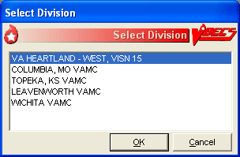
Figure 16: Example of VistA Access and Verify Code Logon
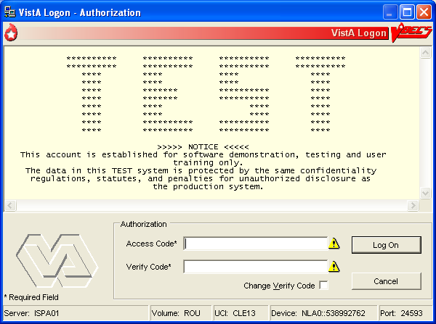

Restore VistALink Connection
Before any option requiring VistALink is started, the system validates VistALink availability. When the server does not respond or there is no active connection, the system brings up the dialog informing the user of the VistALink connection’s unavailability and offering the option to restore the connection.
User Action | VBECS
- The Restore option is presented. Choose to restore or cancel (Figure 17). | - Attempts to connect using the user’s previously entered PIV/PIN information when logon information is entered.  - When VBECS Administrator is up and running and the user attempts to access a VistALink dependent option when VistALink is not connected, the system will prompt a reconnection dialog where the user will have two options: to reconnect or to cancel. When the reconnect process fails or when the user cancels, the system shows an error dialog.  - Closes the pop-up when the user clicks Cancel.
- If the site is not PIV exempt, use PIV and PIN to connect to VistALink.  If the IAM PIV sign on process succeeds, continue at Step 4.  If the IAM PIV sign on process fails, continue to next step. | - Directs user to the IAM service interface to select PIV certificate and possibly to re-enter PIN  - If the IAM PIV sign on process fails, VBECS continues to the next step and prompts the user for VistA Access and Verify Code. The user may log onto VistA or continue and log on as needed.  NOTES  The system prompts the user for their access and verify code when there is no active IAM service certification.  When a user logs into VBECS, the connection to VistA is established and the data in the cache tables are out-of-date. VBECS retrieves the current data from VistA and saves them. This update process may delay user login.
- Enter the VistA Access and Verify Codes (Figure 16). | - The system will reuse the security credentials initially entered in this user’s session (VistA Access and Verify Codes) to perform VistA logoff and logon without user interaction.  - Allows a user to log on by entering VistA Access and Verify Codes, separated by a semicolon (;), in the Access Code data entry field.  - Verifies that the user credentials for the VBECS and VistA Access and Verify Codes belong to the same user.  - Emits a tone to verify that the workstation’s sound works.
- Continue working in the VistALink dependent option. | - Displays the VistALink dependent option.
Figure 17: Restore VistA Connection
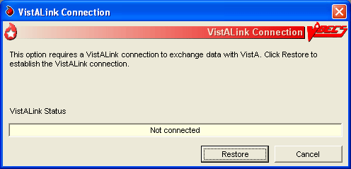

Closing VBECS
There are three terms used to describe leaving the application and/or the application server:
- Exit VBECS: This action is to close the VBECS application. The server connection is unaffected, and the server session continues.
- Sign Out: This action is to close the connection to the application server and end the server session. Any applications that were running in the server session are closed.
- Disconnect: This action is to close the connection to the application server but leave the server session (and any applications in the session) running.

Exit VBECS
User Action | VBECS
- To close the VBECS application, either:  Select File.  Select Exit VBECS.  OR  In the top right corner of the VBECS application, click the X to close the application window.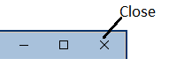  OR  Press Alt+F4.  VBECS will prompt you to confirm you would like to close the application. | - The user is closed out of VBECS.  - The user remains connected to the application server.  - The user’s application server session remains open/active.

Sign Out
User Action | VBECS
- On the application server’s desktop, in the top left corner, double-click Sign Out.    If VBECS was running with unsaved changes, the server will protect you against data loss by presenting Figure 18. Click Sign out anyway to proceed with signing out.  If you have not responded within 30 seconds, the message will disappear and the sign out process is automatically canceled. | - The user is closed out of VBECS.  - The user is disconnected from the application server.  - The user’s application server session is closed/ends.
Figure 18: Example of Sign Out Preventing VBECS Data Loss
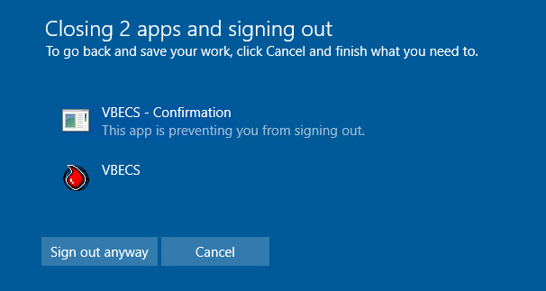

Disconnect
Refer to the Remote Desktop section of the VBECS Technical Manual Security Guide to learn more about remote desktop behavior.

User Action | VBECS
- On the application server’s desktop, in the bottom left corner,  click Start  (the Windows icon),  Power (the circle with a line icon), Disconnect.  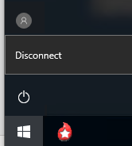  OR  In the remote desktop window title bar or connection bar, click the X. If prompted about closing the remote desktop session, click OK. | - The VBECS application is unaffected.  - The user is disconnected from the application server.  - The application server session remains active. The user may reconnect to this session from any workstation before it automatically ends after 60 minutes.

Local Machine Screen Resolution
Set the local machine’s desktop resolution to 1024 by 768 pixels or higher for optimal display. Failure to maintain these settings may result in partial display of safety-critical information.

Application Windows
A window is the section of the screen that displays the active application or file.
Click the control buttons in the upper-right corner (Figure 19) of an open file or application window to:
- Minimize: reduce the window to appear as a button (rectangle) at the bottom of the screen. Click the button to enlarge the window to its previous size.
- Maximize: enlarge a window to fill the entire screen or parent window
- Restore: return a window to a smaller size that can be adjusted (Figure 20)
- Close: shut down a window or application
Maximize option windows to display safety-critical information in full.
Figure 19: Example of Resize or Close a Window
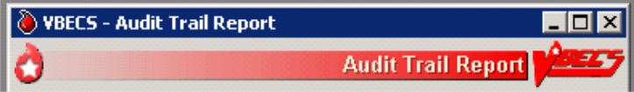
Close
Minimize
Maximize

Figure 20: Example of Restore a Window


When a window is partially displayed or freezes; or when you move from one window to another, enter information, return to the original window, and the entered information is not available, minimize then maximize the window to refresh it.
To resize an open window:
- Make sure the Maximize symbol is visible.
- Change the width: move the mouse cursor to the left or right window border until the pointer changes into a horizontal double-headed arrow, then drag the border to the right or left.
- Change the height: move the mouse cursor to the top or bottom window border until the pointer changes into a vertical double-headed arrow, then drag the border up or down.
- Change the height and width together: move the mouse cursor to any window corner until the pointer changes into a diagonal double-headed arrow, and then drag the border in any direction.
A maximized window cannot be resized or moved.
To move a window, click the dark blue bar at the top of the window. While depressing the mouse button, drag the window to the desired position.
The first time a user opens a form [such as the Blood Transfusion Record Form (BTRF)], VBECS displays it in cascade style. When a user opens the form again, VBECS displays it in the size and position last selected.
Forms can be resized and moved in the same way that windows are resized and moved.

Keyboard Shortcuts for Windows
Using a mouse to navigate VBECS requires fewer steps than using the keyboard. A user who prefers using the keyboard may refer to these keyboard shortcuts. Keys preceded and/or followed by “+” indicate that they must be pressed simultaneously:
Keyboard navigation of VBECS does not accommodate the presentation of error providers or tool tips. A mouse is required to reveal this information as needed.

CPRS and VBECS
- Toggle between VBECS and CPRS or another application: Alt + Tab

Menus
- Display the Start menu (use the arrow keys to select an item): Alt + Home
- Activate a menu bar option: F10 or Alt
- Open a menu: Alt + underscored letter
- Move to and select a menu item: Arrow key + Enter
- Open a submenu item: Shift + letter (case insensitive)
- Open a drop-down menu: Alt + down arrow key
- Close a drop-down menu: Alt + up arrow key or Escape
- Display a shortcut menu for the selected item: Application key ()

Buttons, Check Boxes, and Fields
- Move to and select fields and buttons: Tab or Alt + underscored letter
- Select or clear a check box: Tab, arrow key (or Alt + underscored letter), spacebar
- Select a different radio button: Tab, arrow key (or Alt + underscored letter)
- Many windows contain a default button which is activated by pressing Enter
- Many windows contain a Cancel/Close button which is activated by pressing Escape

Screen Prints
- Place a snapshot of the desktop on the local clipboard and paste it in another application: Ctrl + Alt + Plus (+ on the numeric keypad; Ctrl + V to paste)
- Place a snapshot of the active window on the local clipboard and paste it in another application: Ctrl + Alt + Minus (– on the numeric keypad; Ctrl + V to paste)
- See FAQ How to take faster screen shots from Remote Desktop Session for additional information.

Drop-Down Menus
A drop-down menu may appear when a button is clicked or text is selected. Click or hold the mouse pointer over an item in a drop-down menu to reveal other items and submenus. Press an underscored letter (mnemonic) to select a menu item. To view underscored letters, press the Alt key once.
A  (submenu arrow) next to a menu item indicates that a submenu is available. An option that is not available to a user is visible but grayed out.

Tool Tips
A tool tip is a description or explanation that appears when the mouse pointer is held over (not selected or highlighted) a tool, button, or other object (without clicking a mouse button).
When a tool tip does not appear, wait a few moments, then reposition the mouse pointer over the tool, button, or other object. If necessary, exit and reenter the window.
Tool tips appear with:
- Some control buttons
- Icons in the Patient Information Toolbar
Text enclosed in angle brackets (< >) in tool tips and messages will change to reflect the current activity.
The user may click column headings in some data displays, such as the Pending Task List, Pending Order List, and Select Units, to sort the information in those columns.

Icons and Buttons
VBECS uses several types of images to help you move through the system:
- Icons represent objects (information used in an application). The rectangular area in the lower-right corner of the screen (system tray) contains icons of programs that always run in the background (see Main Status Bar section).
- Buttons are icons that represent tools or commands.
- Radio buttons are small circles preceding text. Related radio buttons are grouped together. Only one radio button in a group may be selected: clicking a radio button turns the other radio buttons off.

Toolbars
A tool is a shortcut button, usually shown on a bar near the top of a window. Tools provide quick access to commonly used functions. A toolbar displays groups of tools. Toolbars may contain buttons, menus, or combinations of both. (See also Patient Information Toolbar.)
A toolbar with tools for several options (Main Toolbar) appears near the top of the screen.
Click a tool to open a function quickly.
A function may also be opened by pressing Alt and the key for the underscored letter in the tool name.

Main Toolbar
The Main Toolbar appears at the top of the screen. All icons will be greyed out (un-clickable) when VBECS has been set to Read-Only. If enabled, the icons can be clicked to access:
Log In Reagents
Enter Daily QC Results
Incoming Shipment
ABO/Rh Confirmation
Modify Units
Unit Antigen Typing
Outgoing Shipment
Accept Orders: Accept an Order
Maintain Specimen
Patient Testing
Automated Instrument Pending Blood Unit Tests
Automated Instrument Pending Patient Tests
Select Units
Issue Blood Components
Post-Transfusion Information

Clicking an icon in the Main Toolbar saves a step: it’s the same as clicking the main menu item, and then on the option.
VBECS uses tree views to display list items. Click a plus sign (+) to expand a list. Click a minus sign (–) to condense a list.

Patient Information Toolbar
The Patient Information Toolbar appears in the active window when a patient record is displayed. VBECS displays only the icons appropriate to the option. Click the icons in the Patient Information Toolbar to display:
a Blood Availability Report (Blood Availability)
a patient’s current medication profile (Medication Profile)
a patient’s recent orders (Recent Orders)
a patient’s Special Instructions and/or Transfusion Requirements (View Special Instructions and Transfusion Requirements)
a patient’s recent transfusion history (Recent Transfusions/Issued Units)
a patient’s transfusion reaction history (Transfusion Reaction History)

Patient Blood Availability
The user views blood products available to a patient. The Blood Availability Report does not include unassigned, restricted blood products. To view unassigned, restricted blood products and other custom reports, see Blood Availability.

Medication Profile
The user views a patient’s current medication profile.

Assumptions
- The connection to VistA is active.

Outcome
- VBECS displays a patient’s current medications.

Limitations and Restrictions
- None

Additional Information
- The user may access CPRS for additional information on a patient medication order.
- These data are accessible to the user through the Patient Information Toolbar on all patient-specific screens.

User Roles with Access to This Option
All users

Medication Profile
At the user’s request, VBECS queries VistA to search for active prescriptions within a user-specified time frame or a default time frame of six months, regardless of division, in a multidivisional database.
User Action | VBECS
- Select Reports from the main menu.  Select Medication Profile.  Select a patient, or  Select an option that displays the Patient Information Toolbar.  Click to view a patient’s current medication list. | - Lists report names.  - Displays the report date range, sections, and compilation criteria.  - Displays options for processing patient-related functions.  - Compiles the active patient identification data.  NOTES  The user may edit the default start date (six months before the current date) for the patient medication search.
- Accept or edit the default start and end dates. | - Displays each medication name status, order number, and issue/start date returned from the VistA query.  - When a query does not return any medications, notifies the user that he may repeat the query with a different date range.
- View the display. When desired, go to Step 1 to repeat the query, | - Allows the user to print the displayed patient medication profile.
- Print the profile or click Cancel to exit. | - Displays and prints the medication information profile.

View Special Instructions and Transfusion Requirements
The user views patient-specific Special Instructions (SIs) and Transfusion Requirements (TRs).

Assumptions
- SI entries were created through Special Instructions & Transfusion Requirements: Enter a Special Instruction or from database conversion.
- TR entries were entered through Special Instructions & Transfusion Requirements: Enter a Transfusion Requirement or Patient Testing: Enter Antibody Identification Results.

Outcome
- VBECS displays a patient’s SIs and TRs.

Limitations and Restrictions
- Changing a patient's antigen negative requirement or antibody identified after a unit is crossmatched does not provide an alert at Issue Unit regarding the type of crossmatch (electronic or serologic) performed on a unit available for issue.
- This icon will be disabled when the icon is displayed:
- within the patient search window because special instructions and transfusion requirements are already displayed automatically within this option.
- within this option to view SIs and TRs.
- When the selected patient does not have SIs or TRs to display.

Additional Information
- VBECS displays a patient’s known antibodies in all divisions in a multidivisional database. VBECS does not restrict viewing SI and TR entries by division; they are linked to the patient’s record and not to an order, a specimen, or a unit.
- VBECS does not enforce SIs; VBECS enforces TRs and persistent antigen negative requirements throughout the database.

User Roles with Access to This Option
All users

View Special Instructions and Transfusion Requirements
The user views a patient record. When SIs and TRs are available for the patient, VBECS activates the Patient Information Toolbar icons. VBECS alerts the user when a patient’s record includes SIs and TRs.
It is highly recommended that the user clicks every active icon when reviewing patient data.
User Action | VBECS
- Select Patients from the main menu.  Select Special Instructions & Transfusion Requirements, or  Click in the Patient Information Toolbar, when it is active. | - Displays options for processing patient-related functions.  - Displays the option to select a patient, when one is not already selected.  NOTES   When a patient’s VBECS record includes an active TR, SI, or antigen negative requirement, VBECS emits an audible alert and notifies the user by enabling the icon.
- Select a patient and click OK.  View the data.  Click OK to continue. | - Displays the data.  NOTES  VBECS displays active TRs to all divisions within a multidivisional database.  VBECS alerts the user when an active TR, SI, or antigen negative requirement is in a patient’s record.  VBECS displays component requirements to all divisions in a multidivisional database. No division allows issue until requirements are met.  When VBECS displays the Patient Information Toolbar, it calculates the overall compatibility percentage of units to be screened to find compatible units.  The compatibility percentage displayed is based on the following calculation:  Type Specific ABO % x Antigen compatibility % as defined in Antibodies equals % compatible.  For example, if a patient is A Positive and has both Anti-E (compatibility percentage = 75%) and Anti-K (compatibility percentage = 91%) antigen negative requirements, the percentage of the population considered compatible for this patient would be .45 x .75 x .91 = .30 (rounded).  Rh type of the patient is not used in the calculation when the patient does not have an Anti-D as Rh Pos or Rh Neg units may be screened.  The blood type percentages in VBECS are as follows and are general percentages for the American population: A is 45%, B is 15%, AB is 6% and O is 45%.
- Select another patient and return to Step 2, if desired.
- Click OK to exit.

View Recent Orders, Recent Transfusions/Issued Units, and Transfusion Reaction History
The user views portions of a patient’s data previously recorded in VBECS in three formats: recent orders, recent transfusions/issued units, and transfusion reaction history.

Assumptions
- A VBECS record must be established for a patient in this database in at least one division, if multidivisional.

Outcome
- The user views:
- A patient’s active order data (recent orders).
- A patient’s transfusions and currently issued units (recent transfusion history).
- A snapshot of the patient’s VBECS clinical record (transfusion reaction history).

Limitations and Restrictions
- Recent Orders is showing Order Status values like “Not Started” and “Filled”, which are actually Task Statuses.
- Completed TRWs do not display on the Recent Orders screen. Completed TRWs can be found by searching in the Reports, Finalize/Print TRW option.

Additional Information
- None

User Roles with Access to This Option
All users

Patient Information Toolbar: Recent Orders
The user views current (pending and active) order data (including reflex tests), which include clinical data from all divisions within a multidivisional database.
User Action | VBECS
- In the Patient Information Toolbar, click to view the patient’s recent orders. | - Allows the user to click an icon to view a patient’s recent orders.  NOTES  When the user selects , VBECS displays all orders associated with the selected patient, including open orders and orders placed and processed within the last 14 days.  Diagnostic Test orders sort and display by the date the order was placed in CPRS. Component orders sort and display by the date the order was accepted in VBECS.  Orders with a status of Cancelled, Completed, Expired or Filled are not displayed in this view. See Order History Report.
- View the data and click Close to exit.

Patient Information Toolbar: Recent Transfusions/Issued Units
The user views transfused and currently issued units for a patient.
User Action | VBECS
- In the Patient Information Toolbar, click to view the recent transfusion history. | - Allows the user to click an icon to view a patient’s recent transfusion history.  NOTES  When the user selects , VBECS displays blood units issued and transfused within the last seven days in reverse chronological order. The date and time issued or the location issued to does not display.
- View the data and exit.

Patient Information Toolbar: Transfusion Reaction History
The user views a snapshot of the patient’s transfusion reaction record.
User Action | VBECS
- In the Patient Information Toolbar, click to view the transfusion reaction history. | - Allows the user to click an icon to view a patient’s transfusion reaction history.  NOTES  When the user selects , VBECS displays all finalized transfusion reaction entries in the database.
- View the data and exit.

Main Status Bar
The following icons are displayed in the main status bar:
The Order Alert icon blinks three times and remains visible when orders are added to the system. Hold the mouse pointer over the icon to see order information. Click the associated button to open the Pending Order List.
The Patient Alert icon flashes three times and remains displayed when patient information is updated. Hold the mouse pointer over the icon to see what type of patient change occurred. Click the Patient Alert Icon to view the menu which allows navigation to Updated Patients, Deceased Patients, Patient Merge. These menu options enable when alerts exist in each category.
The VistALink icon indicates that the connection to VistA is active.
- The VistALink Failure icon indicates that the connection to VistA is severed.
CPRS Communications Error. Some orders in CPRS will not reflect the same status as VBECS. Contact Customer Support to have the issue investigated and resolved. Most problems can typically be resolved by restarting the VBECS-OERR HL7 link in VistA.
CPRS Communications Good. All VBECS order status messages have been sent to CPRS.

Throughout VBECS
The Delete/Invalidate icon appears on buttons that cause entries to be deleted or invalidated in the database.
☑ Click to select all items in a list.
 Click to clear all items in list.
Click the find button to display a list of items for selection.
Click the Print icon’s associated button to print a document.
Click the Save icon’s associated button to update the database.
The Scanner icon indicates which screen prompts permit scanned entries.
Click the Search icon’s associated button to search for entries meeting search criteria entered.
Click the Order Details icon’s associated button to display the full details of a selected order.
The Input Error icon indicates that a user made an invalid entry at a screen prompt. The icon appears and flashes next to the invalid entry. Hold the mouse pointer over the icon to see a message explaining the problem. Enter valid information to make the icon disappear.

VBECS Read-Only
When a VBECS site is set to Read-Only, the application restricts access for all user roles to menu options that would allow adding or modifying blood bank data (Figure 21). Top-level menus are disabled if all sub-level menus are disabled. For example, the top-level Reagents menu is disabled because every menu option beneath the Reagents menu can modify data. Any report printed in a VBECS Read-Only will contain a watermark in the upper-right corner of each printed page to indicate VBECS has been set to Read-Only. Refer to the FAQ What is VBECS Read-Only for more details.
Figure 21: Example of the Appearance of a VBECS Read-Only

Other VBECS Functions

Collecting Workload
In some options, VBECS collects workload (statistical data used to calculate productivity) when the user saves data:
- ABO/Rh Confirmation
- Accept Order
- Automated Testing
- Cancel Active Order
- Cancel Pending Order
- Discard or Quarantine
- Document ABO Incompatible Transfusion
- Edit Unit Information
- Enter Daily QC Results
- Finalize/Print TRW
- Free Directed Unit For Crossover
- Invalidate Test Results
- Issue Blood Components
- Justify Patient ABO/Rh Change
- Maintain Equipment
- Maintain Reagent Inventory
- Maintain Specimen
- Maintain Supplier
- Modify Units
- Outgoing Shipment
- Patient Testing
- Post-Transfusion Information
- Process Incoming Shipment
- Record Transfusion Reaction Workup
- Release Units From Patient Assignment
- Remove Final Status
- Return Issued Units To Blood Bank
- Select Units
- Unit Antigen Typing

Configuring Site Parameters
Configuration must be done as part of the VBECS installation.

Update User Roles
The user reviews and changes the user roles and associated security levels that determine which options and functions are available to a user in the division.

Assumptions
- The user is logged into VBECS in the division of the users to be edited.
- A VBECS Application Administrator defined the users to the VBECS database and assigned a division-specific role to each user.

Outcome
- A user’s role code changed.

Limitations and Restrictions
- One role at a time may be assigned to a user at a division. The role may be reset.
- VBECS does not allow users to edit or delete the sole Administrator/Supervisor.

Additional Information
- An undefined user remains in the VBECS database.
- There must be at least one Administrator/Supervisor in the division to maintain users.
- A VBECS user ID is the user’s Windows Logon ID.
- One or more users may be selected for batch update.
- A VBECS Application Administrator defines and undefines VBECS users. See VBECS 2.4.0 Admin User Guide.
- A user may be defined at multiple divisions within a multidivisional database. The settings for a user may differ from division to division and are independent.

User Roles with Access to This Option
 Administrator/Supervisor
 Lead Technologist

Update User Roles
 An Administrator/Supervisor maintains assigned user roles, including associated levels of system access and the ability to process system overrides. These roles determine the available options and the ability to override certain warnings.
It is recommended that more than one staff member be assigned the role of Administrator/Supervisor: when more than one Administrator/Supervisor updates roles simultaneously, changes made by one user are not visible to the other.
One of six user roles may be assigned to users, by division:
- Level 1: Technologist 
- Level 2: Enhanced Technologist 
- Level 3: Lead Technologist 
- Level 4: Traditional Supervisor 
- Level 5: Enhanced Supervisor 
- Level 6: Administrator/Supervisor 
The functions associated with each user role are described in Table 1: User Roles and Functions.
User Action | VBECS
- Select Tools from the main menu.  Select Update User Roles (Figure 21). | - Displays options for processing administrative functions.  - Lists active users and associated information, including user name, ID, role, initials and email address.  - Displays an option to print a VBECS User Report.  NOTES  Click Print at any time in this process to print a VBECS User Report.
- Click one or more check boxes to select users. | - Allows the assignment of a security level to one or more users at a time.  NOTES  The role that a user selects is assigned to all selected users.
Select a user role from the drop-down list in the User Role field.  - Click OK. | - Requests confirmation of the names of users to be changed and the role to be assigned.
- Click Yes to confirm the save or No to change the users selected. | - Creates an Audit Trail Report entry.
- Repeat Steps 2 through 4 to change the roles of additional users.
- Click Cancel to exit.
Figure 22: Update User Roles
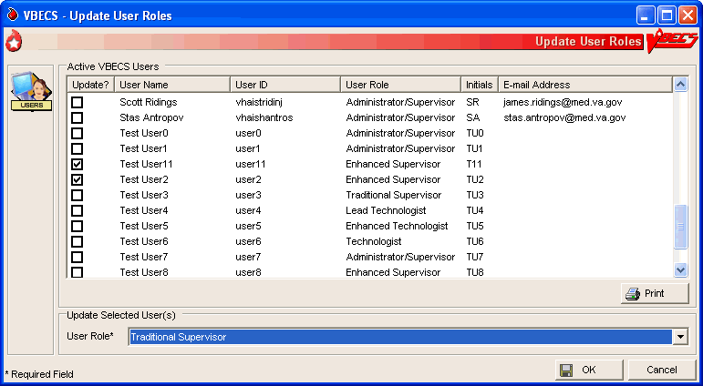

VBECS User Report
The user may generate a division report that includes the names, VBECS user IDs, and roles of active users.  A Lead Technologist may generate a report of current VBECS users, by division, that includes the users’ name, user ID, division, and role.

Component Classes
The user configures the component class parameters for the selected division. For more information, see Appendix G: Work Process Flowcharts.

Assumptions
- The connection to VistA is active.
- The WHOLE BLOOD and RED BLOOD CELLS component classes are deployed as requiring current specimen ABO/Rh results before issue and may not be edited.
- The FFP, PLT, CRYO and OTHER component classes do not have a specimen requirement defined at deployment.

Outcome
- Divisions have local settings for all component classes.

Limitations and Restrictions
- The user may not change the specimen requirement for a component class when there are incomplete orders for that component class.
- There is no retrospective data entry or user selection for this option.

Additional Information
- None

User Roles with Access to This Option
 Enhanced Supervisor

Component Classes
The user configures the parameters for the division’s component classes. These parameters are applied to all blood units that descend from this class. Component classes may be reset when business practices affecting the use of component classes change at a division.
User Action | VBECS
- Select Tools from the main menu.  Select Component Classes (Figure 22). | - Displays options for processing administrative functions.  - Lists component classes.  - Displays options for configuring division component classes:  - Require Current Specimen ABO/Rh Results?  - Maximum Transfusion Time.  - Displays options for defining inappropriate request indicators.  NOTES  See Appendix B: Table 19: CPRS Orderable Blood Components (Component Classes) Mapped to ICCBBA Component Classes.
- Select a class from the Select Component Class list.  Click OK to accept the list, or click the Require Current Specimen ABO/Rh Results? check box, when appropriate. | - Requires current specimen ABO/Rh results for issue.  - Defines the maximum transfusion times.  - Defines inappropriate request indicators.  - Allows the user to edit this parameter for component classes that do not contain only red blood cells.  - Saves the component to the division list.  NOTES  Component class configuration is required. Component classes: RED BLOOD CELLS, FFP, CRYO, PLT, WHOLE BLOOD, and OTHER.
- Edit the maximum transfusion time. | NOTES  VBECS records the maximum transfusion time from the transfusion start to the transfusion end time in minutes with a default of 270 minutes. The user may edit the maximum transfusion time to a minimum time of 5 minutes and a maximum time of 999 minutes.  VBECS uses the maximum transfusion times in minutes to determine whether the time used to transfuse a unit of blood is inappropriate for a class.
- Define the inappropriate request indicators.  Click the find button to search for a new laboratory test name.  Enter a partial laboratory test name and click Search.  Select a laboratory test name and click OK to add it.  Click the Show Inactive Inappropriate Request Indicators check box, if desired. | - Facilitates data entry of one or more inappropriate request indicators:  - Laboratory Test Name  - Specimen Type  - Threshold Result  - Uses VistALink to retrieve the laboratory test name and specimen type indicators. The user enters the threshold result indicator.  - Displays the entry and allows the user to edit it.  - Displays inactive tests and allows the user to reactivate them.  NOTES  VBECS uses the laboratory test name as the only input parameter to search for all possible matches and return the Laboratory Test Name, Specimen Type(s), and VistA Lab Test Internal Entry Number (IEN).  A numeric threshold result must include “<” or “>”and a numerical result, e.g., “>8.0.”  The settings here indicate predetermined levels used to determine the appropriateness of a component order. Settings are different for each component class. The example of a “>8.0” hemoglobin level is set according to local policy.  An example of an inappropriate request indicator:  - The test name is “HGB.”  - The specimen is entered as “Blood.”  - The threshold result is set to “>8.0.”
- Click Add to add the VBECS component class site parameters to the database. | - Displays the component class parameters and allows the user to edit them before saving.
- Repeat Steps 2 through 5 for each component class to be edited.
- Click OK to save.  Click Yes to confirm changes and exit. | - Updates the database and captures changes to previously defined parameters for inclusion in an Audit Trail Report.
Figure 23: Example of Component Classes
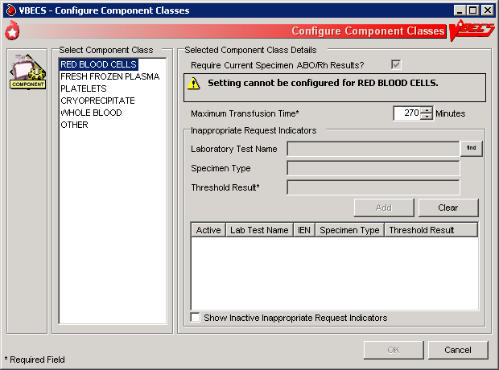

Configure Daily QC
The user sets up the routine reagent racks and QC template for the division before performing daily reagent QC.

Assumptions
- The division is “full service.”
- In the first use of this option, there are no defaults or data in place until the user selects the type of QC template (commercial or non-commercial).

Outcome
- A testing template is available for Enter Daily QC Results; reagent racks and identifiers were created.
- Minimum reaction strengths for each reagent type are defined and used by Enter Daily QC Results.
- A historical record for each rack will be maintained.
- Rack names created are available for use by other options.

Limitations and Restrictions
- This option pertains only to routine reagents.
- When there are partially or currently QC’d racks in the system, the user may not change the QC template.

Additional Information
- This option is disabled for transfusion-only facilities.
- The naming convention for the active template is not editable. When fewer racks are indicated, the system will inactivate existing rack names to keep the list in order without skipping a number or letter. Rack names are reusable. It is recommended for sites comprising a multidivision to assign different reagent rack names to prevent overlap (See FAQ Multidivisional QC Rack Workaround).
- The daily use field for QC Rack template entries exported as REQUIRED for Daily Use are not editable by the user. The daily use field for entries exported with the daily use as OPTIONAL may be changed to be REQUIRED and remain editable by the user at any time.
- If Screening Cell 3 (SC3) and/or (SC4) are set to “required” as part of the configuration of the antibody screening cell set, they are enabled on the antibody screen data grid.
- The user must identify an enhancement media reagent type as the primary. In addition, the user must identify the Anti-Human Globulin serum used during daily quality control testing of the screening cells and primary enhancement media.
- VBECS does not evaluate maximum strength of reaction for daily QC, as required by CAP. Local policy must define maximum strength of reaction.

User Roles with Access to This Option
 Enhanced Supervisor

Configure Daily QC
The user sets up the daily reagent QC template for reagent rack testing for the division. In the first use of this option, all fields default to blank with no template preferred. Additional tests are available and may be included in the daily QC testing template in accordance with local practice. When a user changes the active template, there is no carryover of field settings to the new template. All are set to the default and configuration must be completed.
User Action | VBECS
- Select Reagents from the main menu.  Select Configure Daily QC. | - Displays options for processing reagents.  - Displays an option to configure online Daily Reagent Rack Quality Control.
- Click the Commercial or Non-Commercial radio button (Figure 23). | - Lists the two system-supplied Daily QC templates.  - Commercial Daily QC  - Non-commercial Daily QC  - When there are partially or currently QC’d racks in the system, warns the user to wait until QC expires (passes the daily alert time) and then make the changes.
- Set the daily alert time. | - Asks the user to set the time the daily alert to all users at the site will begin.  NOTES  The user indicates the local time that defines the start of the 24-hour period (the QC day) during which a rack is considered QC’d. VBECS alerts users when a rack was not performed after this local time passed.  The user may test a rack no earlier than the alert time for the next 24 hours.
- Enter the number of racks at the site.  Select a naming convention. | - Asks the user to set the number of racks to be QC’d daily at the division.  - Asks the user to set the naming convention for racks.  NOTES  A user may indicate 1–26 racks per site and names them according to the convention selected (A–Z or 1–26).
- Accept or edit the default settings of the template.  Select primary and secondary enhancement medium options from the drop-down menus. | - Lists the default reagent types for inclusion in the daily reagent rack quality control and expected minimum reactions for each test type.  - Displays changes and edits for review before saving.  NOTES  One setting covers all racks at the site.  Reagent types selected display on the rack lot number template and the reaction result entry worksheet for each rack in Enter Daily QC Results with some exceptions: gel kit, selected AHG, and automated testing lot numbers.  When previously entered parameters for daily QC rack definitions are changed, VBECS requires a comment before the user saves the update.
- Click OK to save.
Figure 24: Commercial and Non-Commercial Radio Buttons
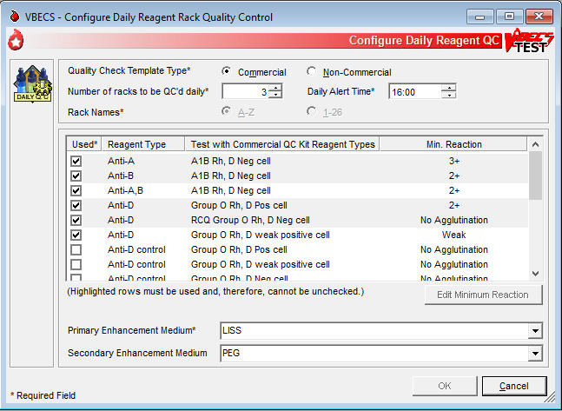

Configure Division

Configure Division
A user defines site parameters that affect how VBECS behaves at a specific division. VBECS may be configured to function differently at each division within a multidivisional database. Site parameters may be redefined. For additional information, see Appendix G: Work Process Flowcharts.

Assumptions
- The site administrator defines the VBECS configuration, adds users, and assigns privileges for each division so that they mirror the associated VistA database.

Outcome
- Functional parameters are set for divisions that use the VistA database.

Limitations and Restrictions
- Changes made to the division setting are not applied to a user until they re-connect to VBECS after the change is made. It is highly recommended that all users sign out of VBECS prior to any configuration setting change.
It is recommended that users configure a division before configuring testing (click the Configure Testing tab).

Additional Information
- To incorporate changes in division codes and names from VistA to VBECS, and to change time zones, see the VBECS 2.4.0 Admin User Guide.
- VBECS records configuration changes (such as time zone) on the Audit Trail Report.

User Roles with Access to This Option
 Administrator/Supervisor

Configure Division
Once VBECS is configured to identify all of the divisions, the user sets up critical fields required for routine use of VBECS.
User Action | VBECS
- Select Tools from the main menu.  Select Configure Division (Figure 24). | - Displays options for processing administrative functions.  - Displays the Configure Division tab with fields for entering division-specific blood product information.
- Enter the ICCBBA Registration Number, the medical director’s name (or select it from the drop-down list), and the maximum number of days until the specimen expires in their respective fields. | NOTES  An ICCBBA Registration Number contains an alphabetical character followed by four numeric characters.  A user may enter the name of the blood bank medical director or acting medical director to appear on reports. The user may edit the name and title but may select only one name at a time for use. VBECS saves these edits for retrieval.  The user may edit the default setting for the maximum number of specimen expiration days from “3” to any value from “3” to “93.”  This setting allows the user to extend the expiration date of any one specimen to the maximum date indicated. This does not change the normal specimen expiration date of all specimens received.
- Click OK to save and click OK again to confirm the save and exit, or click another tab. | - Displays the information entered.  - Requests confirmation to update the database.  - Updates the database.
Figure 25: Example of Configure Division Tabs
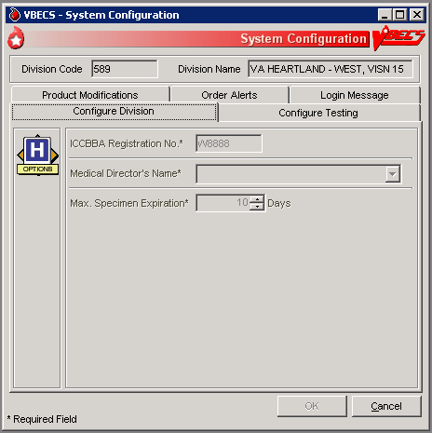

Configure Testing
The user sets testing preferences according to a division’s medical policies.

Assumptions
- A division’s worksheets affected by the option are not open or incomplete at the time of configuration.

Outcome
- Division testing preferences are configured.

Limitations and Restrictions
- None
It is recommended that users configure testing before modifying products (click the Product Modifications tab).

Additional Information
- None

User Roles with Access to This Option
 Administrator/Supervisor

Configure Testing
The user sets the system to display testing grids to the users in their division. The user determines whether an autocontrol is used and whether a Direct Antiglobulin Test (DAT) is added as part of the routine Antibody Screen Test (ABS) described in Patient Testing: Record a Patient Antibody Screen.
User Action | VBECS
- Select Tools from the main menu.  Select Configure Division. | - Displays options for processing administrative functions.  - Displays the Configure Division tab with fields for entering division-specific testing information.
- Click the Configure Testing tab (Figure 25). | - Displays the Configure Testing tab with fields for entering division-specific blood product information.  - Displays options to set standard operating procedures for a division’s laboratory testing.
- Click the appropriate radio buttons to:  Enable Electronic Crossmatch  Determine antibody screen (display antibody screen only, or with a DAT or Autocontrol)  Determine the default test grid displayed for ABS and XM Testing Phases | - Displays default configuration settings of:  - Electronic Crossmatch: Disabled  - Antibody Screen: Antibody Screen Only  - ABS and XM Testing Phases: All Phases  - Changes to the configuration settings are captured for the Audit Trail Report.
- Click OK to save and click OK again to confirm the save and exit, or click another tab. | - Displays the appropriate testing grids for subsequent patient orders.
Figure 26: Example of Configure Testing Tab
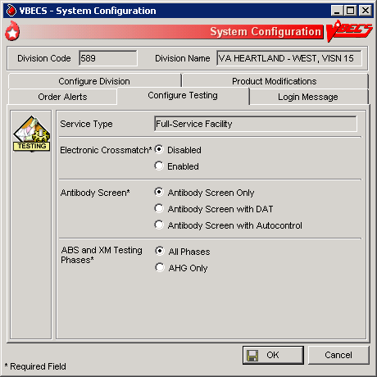

Product Modifications
The user enables the types of modifications made at a division. For additional information, see Appendix G: Work Process Flowcharts.

Assumptions
- An ICCBBA number was entered for the division.
- VBECS locks a user out when the user attempts to change the configuration and there are open or partially completed worksheets or processes in the division.

Outcome
- This option dictates the available modification types displayed in Modify Units: Pool Units, Modify Units: Split a Unit, and Modify Units.

Limitations and Restrictions
- None

Additional Information
- None

User Roles with Access to This Option
 Administrator/Supervisor

Product Modifications
The user enables specific modification type procedures performed in the blood bank in the hospital division. The user may enable one, all, or some of the modification processes. Once the types of modifications are enabled, individual blood unit modification is controlled by the rules of modification truth tables. VBECS is exported with all modification types disabled. VBECS allows for full customization upon deployment as well as changes to the enabled modifications when a division’s capabilities and procedures change.
User Action | VBECS
- Select Tools from the main menu.  Select Configure Division. | - Displays options for processing administrative functions.  - Displays the Configure Division tab with fields for entering division-specific testing information.
- Click the Product Modifications tab (Figure 26). | - Lists valid modification procedures.  NOTES  A user may enable one, more, or all modification types.
- Click one or more check boxes to enable modification types.  Enter the processing cost associated with each modification procedure. | - Lists modification procedures.  NOTES  Modification procedures:  - Thaw  - Pool  - Thaw/Pool Cryo  - Split/Divide  - Irradiate  - Leukoreduce  - Volume reduce  - Wash  - Rejuvenate  - Freeze  - Deglycerolize  The modification process fee is added to the base unit cost of the first target unit and special testing costs, creating a patient bill for a transfused blood product, not including on-site antigen typing performed. The modification process fee may be U.S. $0.00 to $9,999.99. VBECS will generate an audit trail report entry when this field is filled or changed.
- Click OK to save and click OK again to confirm the save and exit, or click another tab. | - Updates the database and captures changes to any previously defined parameters for inclusion in the Audit Trail Report.
Figure 27: Example of Product Modifications Tab
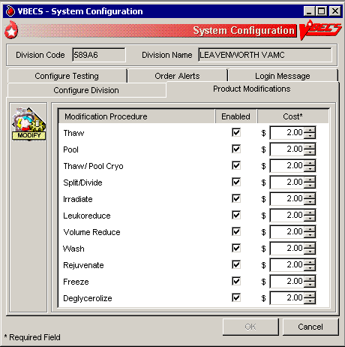

Order Alerts
The user configures VistA alerts that appear at login. For additional information, see Appendix G: Work Process Flowcharts.

Assumptions
- None

Outcome
- User alerts of physician orders for blood bank diagnostic tests and blood components are configured.

Limitations and Restrictions
- This is an alert only and contains limited information from the CPRS order.
- This option does not create a mechanism to accept or reject orders or specimens or define reports for viewing orders.
- The user may select the option to display printer alerts only when the designated printer is configured and available.
- The printer must be configured by the System Administrator.
- The Order alert functionality is disabled when VBECS is set to Read-Only.

Additional Information
- A user may review current user alert configurations.
- VBECS uses other alerts (patient update alerts, VistALink status alerts) that do not require configuration.
- The user may set VBECS to automatically print an order alert on the designated printer when VBECS acknowledges the order. The CPRS can be configured to print a copy of the order on a printer in the blood bank.
- Printed order alerts are not queued.

User Roles with Access to This Option
 Administrator/Supervisor

Order Alerts
The user configures diagnostic test or component order alerts and turns them on or off. The alerts notify users when new orders are entered, updated, or cancelled in VistA.
User Action | VBECS
- Select Tools from the main menu.  Select Configure Division. | - Displays options for processing administrative functions.  - Displays configuration tabs.
- Click the Order Alerts tab (Figure 27).  Click the Printer Alerts On and/or the Icon Alerts On check box.  Select the order alert type from the drop-down menus in the Order Alert Type fields. | - Displays the existing order alert configuration and allows the user to edit it.  - Requires the user to select a printer name and to define which orders to print.  - Displays the selected printer, the selected order alert type, and the number of hours (default: 48 hours) entered for review.  NOTES  VBECS lists application server printers.  The user must select an order alert type:  - All orders (orders received by VBECS)  - Hours limit to fill order (orders received by VBECS needed in the next n hours)  - Specimen OK or N/A (orders where no specimen is required)
- Enter or select a refresh rate (the interval between searches for new orders) for the order alert in the Refresh Rate field. | - Requires the user to enter a refresh rate (default: 60 seconds) (Icon Alerts On).  - Displays the updated refresh rate.  - Displays the selected order alert type.
- Click OK to save | - Saves the user alert configuration settings.
- Click Yes to confirm the changes and exit.
Figure 28: Example of Order Alerts Tab
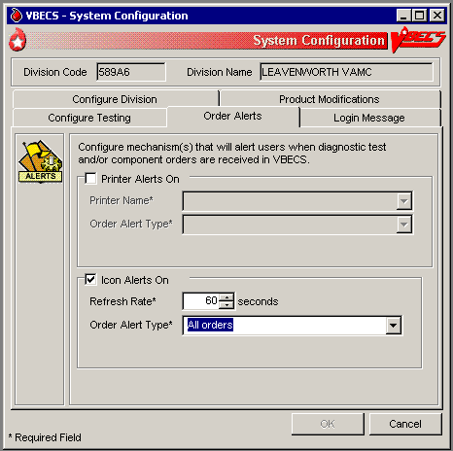

Login Message
The user creates a division-wide VBECS message that appears at login.

Assumptions
- None

Outcome
- A message was created for display when users log into a VBECS division.

Limitations and Restrictions
- None

Additional Information
- None

User Roles with Access to This Option
 Lead Technologist

Login Message
The user may add, update, or delete a message that VBECS displays to users logging into the division.
User Action | VBECS
- Select Tools from the main menu.  Select Configure Division. | - Displays options for processing administrative functions.  - Displays configuration tabs.
- Click the Login Message tab (Figure 28).  Enter a message in the message field to display at login. | - Displays the existing login message and allows the user to edit or delete it.  - Displays the updated login message.  NOTES  VBECS does not display a blank login message.  The user may click Clear to clear the message field and enter a new login message.
- Click OK to save. | - Saves the login message changes.
- Click Yes to confirm the changes and exit.
Figure 29: Example of Login Message Tab
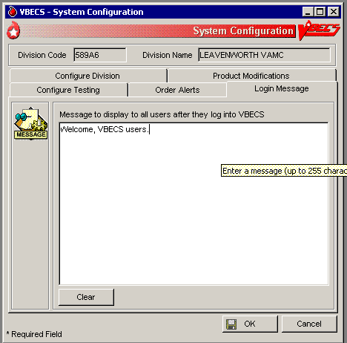

Local Facilities
The user customizes local facility information. (A “collection facility” is not a facility for blood collection: it is for blood distribution only. See FAQ Local Facilities)

Assumptions
- A table of known FDA-registered facilities accompanies VBECS.

Outcome
- The local facility is configured for a division.

Limitations and Restrictions
- A user may:
- Activate and edit local facility records distributed with VBECS.
- Add and edit active local facilities.
- Activate and/or deactivate local facilities.
- Edit a division name, which may result in a mismatch between VistA and VBECS division names.
- The Local Facility Address maximum length is 45 characters including spaces to allow the address to display on VBECS reports. The third line of the facility address is not displayed on VBECS reports.
- FDA registration number is limited to 7 or 10 characters. Copy and paste can be used for entry of 10 characters.

Additional Information
- A local facility must be activated and have at least one blood product defined to be a shipper.
- A user may identify his site as a collection facility through this option.
- An ICCBBA Registration Number has one letter, indicating the country of origin (“W” for the U.S.) and four alphanumeric characters. The field is five characters long.
- The user may change facility addresses that appear on reports.

User Roles with Access to This Option
All users

Local Facilities
This option allows a user to activate an entry from the national facility table, thereby adding it to a division’s local facility table, and add or update the facility’s information (except for the FDA Registration Number). A user may select an active local facility to associate blood products (which makes the facility a shipper).
This option also allows a user to create a local facility.
Verify that site information entered during installation is correct prior to adding local facilities.
User Action | VBECS
- Select Tools from the main menu.  Select Local Facilities. | - Displays options for processing administrative functions.  - Displays fields for entering facility information.  - Allows a user to access an existing facility record.
- To find a facility, scan or enter an FDA Registration Number in the FDA Reg. No. field and go to Step 4 (or click the find button to open the Facility Search window). FDA Reg. No. must be 7 or 10 characters long. | - Displays the facilities that match the search criteria.
- In the Facility Search window, enter a full or partial facility name in the Partial Facility Name field (or enter a full or partial FDA Registration Number in the FDA Reg. No. field), and click Search to view a list of facilities.  Select a facility name from the list and click OK. | - Displays properties of the selected facility.  NOTES  A local facility is tied to the user’s current login division.  A user may activate a national facility or can create a unique local facility. By default, VBECS marks facilities as local facilities.  When a user clears the Active Facility check box for a local facility in a division, warns the user, and asks whether he wishes to inactivate this facility and continue.  Yes allows the action to continue. No leaves the local facility marked as active for the division.  In order to inactivate a facility that has been previously configured as a shipper, you must first inactivate all product shipper entries for that facility. To deactivate shippers, refer to the Blood Products section. Contact the Service Desk if you would like a list of products linked to the facility you want to inactivate.
- Edit or enter information in the local facility information fields (for example, address, telephone number, whether the facility is a testing and/or collection facility) (Figure 29) and click OK to save the updated information. | - Displays entries for review and acceptance.  - Prompts to save.  NOTES  OK remains disabled until the user edits or enters information or simply clicks in a field or check box.  The eye-readable prefix (when used) is always a 2-character numeric field.
- Click Yes to confirm the save. | - Saves the active local facility record and prompts to add or edit another facility.  NOTES  VBECS saves an active collection facility only when it is identified as a collection facility.  A facility must be activated and have at least one blood product defined to be a shipper. Refer to Blood Products section for additional information.
- Repeat these steps to process another facility.
- Click Cancel in the Maintain Facility screen to exit.

Figure 30: Example of Maintain Facility
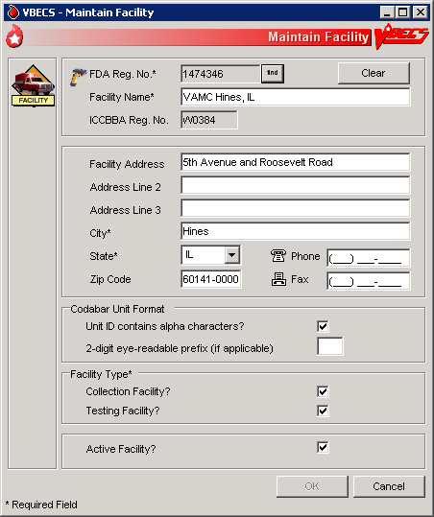

Blood Products
The user activates, deactivates, and edits a limited number of variables for an existing blood product site parameter. VBECS provides. an ISBT 128 Blood Product reference table to facilitate these and other actions. (See FAQ Blood Product Table Processes and FAQ Identifying a Comparable Blood Product Code)

Assumptions
- The connection to VistA is active.
- The user understands Healthcare Common Procedure Coding System (HCPCS) codes. (See Additional Information.)
- A shipper must be marked as an active local facility for a division before a user may select it as a valid shipper for a blood product for that division. This includes marking the division facility itself as an active local facility to accommodate the creation of new blood products through modification.

Outcome
- Blood product codes are activated in the user’s division.
- Each product’s HCPCS code and its activation and deactivation dates are maintained in a permanent historical record.

Limitations and Restrictions
- Blood product records distributed through VBECS are national standards.
- The division must have activated the valid target blood products for modification.

Additional Information
- HCPCS codes are required for medical and surgical services and supplies for the outpatient setting under the final code set standards for the Health Insurance Portability and Accountability Act of 1996 (HIPAA). See your local Current Procedural Terminology (CPT) coordinator for additional information.
- At least one valid shipper and product cost must be defined for each active product code in use in the division; multiple shippers may be associated with a blood product code.

User Roles with Access to This Option
All users

Blood Products
Before processing a blood unit in an incoming shipment, or activating or creating a blood unit in-house, the user identifies the shipper(s), cost, and return credit percentage for each shipper. The user also tags each product as active for use within the division and assigns an HCPCS code to each. These are the only fields the user may edit when maintaining an existing blood product code.
A “shipper” is the facility that delivers and bills for the blood product, regardless of the facility named on the unit’s label. The facility that delivers the product to the shipper is not considered a shipper nor does it have a product cost associated with it, but it needs to be activated in the division for VBECS to interpret the unit ID. When components are modified within the division, the shipper is defined as the division. The cost may be $0.00 or other U.S. dollar value assigned by the shipper.

User Action | VBECS
- Select Tools from the main menu.  Select Blood Products. | - Displays options for processing administrative functions.  - Displays fields for entering blood product information.
- To identify the product, scan or enter an ISBT product code.  Click the find button to search for a product.  Select a product type from the drop-down Product Type list or enter a partial product name in the Partial Product Name field.  Click Search. | - Displays current blood product information.  NOTES  When a user enters a product code that VBECS does not recognize, VBECS warns that the blood product was not found and that it does not support entry of new blood products.  OK returns the user to a blank screen to enter a different product. VBECS clears the screen. The user may enter a different product code.
- Select a product from the Search Results list and click OK (Figure 30).  Select an HCPCS code from the drop-down HCPCS Code list or enter an HCPCS code. | - Allows a user to enter the HCPCS code.  NOTES  A blood product may have only one HCPCS code at a time.  A user may also add an HCPCS code after the blood product code is activated.
- Select or enter product shipper information: shipper name, FDA Registration Number, cost, and return credit percentage. | NOTES  Site parameters determine which products are active for a division. Products marked as active can be received in an incoming shipment or created in-house through modification.  A user with no increased security can maintain an existing blood product for use only within the user’s current division.  The return credit default is “100%.”  In order to inactivate a product shipper, all units via that shipper must be in a final status (or inactivated). Contact the Service Desk if you would like a list of units linked to the product shipper you want to inactivate.  User role Traditional Supervisor or higher can override the default Maximum Storage Time of ISBT-128 blood products. This change is shown in the Audit Trail Report.
- Repeat Steps 3 and 4 for each selected product’s shipper and for other products. | - Displays the information entered.  - Requests confirmation to update the database.  - Updates the database or warns the user with no override for discrepancies.
- Click OK to exit.

Figure 31: Example of Maintain Blood Products
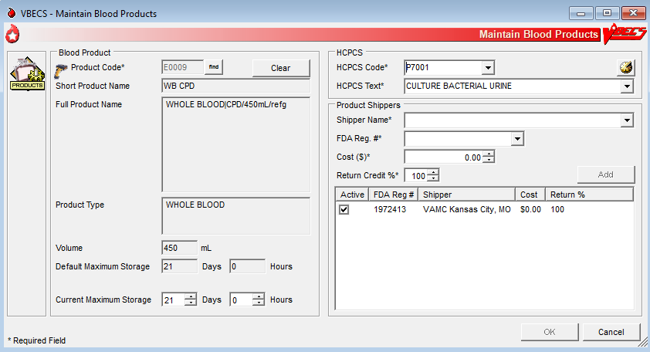

Antibodies
The user edits certain fields in the supplied antibody table.

Assumptions
- VBECS is configured to reflect antibody reference parameters. Only some of these parameters may be changed locally.
- The default settings are enforced without user interaction.

Outcome
- Each division has a populated antibody table whether or not the user makes any edits.

Limitations and Restrictions
- None

Additional Information
- The antibody table defines an antigen negative requirement for all instances of the antibody for all patients in the division. When an antibody specificity does not generally require antigen negative blood but a patient has a unique appearance of that antibody that requires antigen negative blood, the user may enter the antigen negative requirement for that patient in Special Instructions & Transfusion Requirements: Enter a Transfusion Requirement.

User Roles with Access to This Option
 Enhanced Supervisor

Antibodies
The user chooses to edit the system-supplied blood antibody table. The Compatibility Percentage field is fully editable (except for ABO antibodies and anti-D) to allow facilities to reflect local populations. The user may edit only the Clinically Significant entries initially exported as “No.”
User Action | VBECS
- Select Tools from the main menu.  Select Antibodies. | - Displays options for processing administrative functions.  - Lists available antibodies based on the system-supplied table.  NOTES  See Appendix B: Table 14: Antibody and Antigen Table: Irregular Antibodies.  The table’s presentation order is predefined at implementation and may not be sorted.
- Select the antibody, edit each field, and click Update (Figure 31). | - Displays data and allows the user to edit them.  - Accommodates data entry of whole numbers (0–100) and edit of the Antigen Negative Compatibility Percentage and Higher-Level Override fields. The user may not edit fields displayed on a gray background.  NOTES  When Table 14: Antibody and Antigen Table: Irregular Antibodies “antibody sets an antigen negative requirement” field is defined as REQ (required) at installation, it is not editable. When the default settings are OPT (optional), the user may change the name to REQ at any time and it will remain editable.
- Repeat for each antibody to be edited.
- Click OK and Yes to confirm changes and exit.
Figure 32: Maintain Antibodies
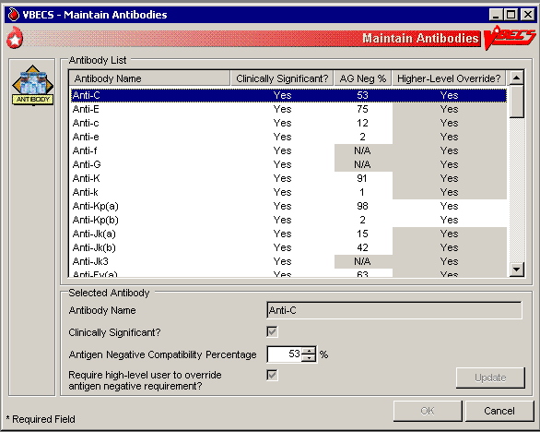

Canned Comments
The user defines canned comments for a division.

Assumptions
- None

Outcome
- Canned comments for a division are available for selection.

Limitations and Restrictions
- The user may not edit comments provided with VBECS but may create additional comments. Although comments can also be removed, there should remain at least one comment per category available for selection, (e.g., “Other”).
- Site personnel must enter comments in accordance with local policy and procedures.
- Canned comments cannot include an apostrophe (‘).

Additional Information
- Canned comments are specific to each division. See Appendix B: Table 17: Canned Comment Category Types and Message Text defines the category types and comments.
- Currently, VBECS does not identify the testing laboratory and include its address on results reports in CPRS. A workaround for the issue is to create Canned Comments for the missing information and apply them to blood bank results.

User Roles with Access to This Option
 Enhanced Supervisor

Canned Comments
It is recommended that the user review the canned comments provided with VBECS for each category type and inactivate those that will not be used.
The user creates canned comments to use in lieu of entering text. Canned comments are restricted for selection based on the category type of the comment field.
The user may select a comment and has the option to enter explanatory text in the details field.
User Action | VBECS
- Select Tools from the main menu.  Select Canned Comments. | - Displays options for processing administrative functions.
- Select a comment category type from the drop-down list (Figure 32). | - Lists the category types for canned comments.  - Allows the user to create a comment or inactivate an existing one.
- Enter text in the Comment field and click Add to add a comment.  Click one or more check boxes to inactivate existing comments. | - Displays entered data and allows the user to edit them before saving.  NOTES  A user may:  - Add canned comments.  - Inactivate canned comments.  - Reactivate inactive comments.  - View inactive comments and dates of inactivation.  - Control the order in which VBECS displays comments in a context.
- Click the Show Inactive Comments check box to view inactive comments.  Click one or more check boxes to reactivate inactive comments. | - Displays inactive comments and allows the user to reactivate them.
- Repeat Steps 2 through 4, as needed.  Click OK and Yes to save and exit, or Cancel to exit without saving. | - Updates the database.
Figure 33: Maintain Comments
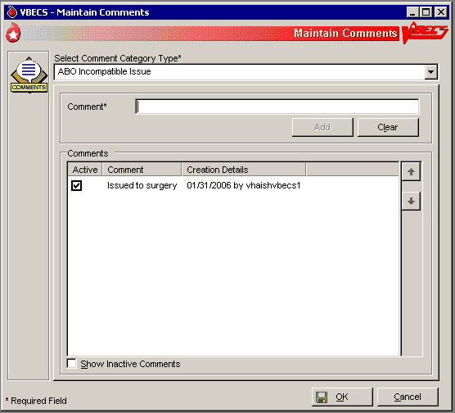

Setting Transfusion Parameters

Transfusion Complications
The user defines Laboratory tests and threshold values used to generate a report listing patients who were transfused within a specified period and who may have developed a transfusion-associated disease. For additional information, see Appendix G: Work Process Flowcharts.

Assumptions
- VistA tests are defined.
- The connection to VistA is active.

Outcome
- Parameters are defined for future Transfusion Complication Reports.

Limitations and Restrictions
- None

Additional Information
- None

User Roles with Access to This Option
 Enhanced Supervisor

Transfusion Complications
The user defines Laboratory tests for use in the transfusion complication table.
User Action | VBECS
- Select Tools from the main menu.  Select Transfusion Complications. | - Displays options for processing administrative functions.  - Displays fields for entering transfusion complication threshold data.
- Click the find button to search for a Laboratory test.  Select a test.  Click OK. | - Allows the user to edit or add previously defined tests for use in a Transfusion Complication Report.  NOTES  VBECS displays the entered laboratory test names in all uppercase letters. The retrieval of lab tests occurs in VistA and results for the Transfusion Complications Report are not case sensitive. There is a limit of 25 active entries. (If the user enters all of the available results for the test, he can get results that are not filtered by VBECS.)
- Click the Numeric Threshold radio button and enter or edit test threshold information (Figure 33).  Click Add to add the test to the list, or  Click Update to save changes to a previously saved test.  Click OK to save and Yes to confirm the save. | - Allows the user to enter one or more tests.  - Uses VistALink to retrieve test data.  NOTES  When defining a test reported as a text value, VBECS accommodates the input of specific text (1 through 255 characters) that are used to search for matching values.
- Click OK to save and Yes to confirm the save and exit. | - Updates the database.
- Repeat Steps 2 through 4 for each transfusion complication test to be defined or click Cancel to exit.
Figure 34: Transfusion Complication Thresholds
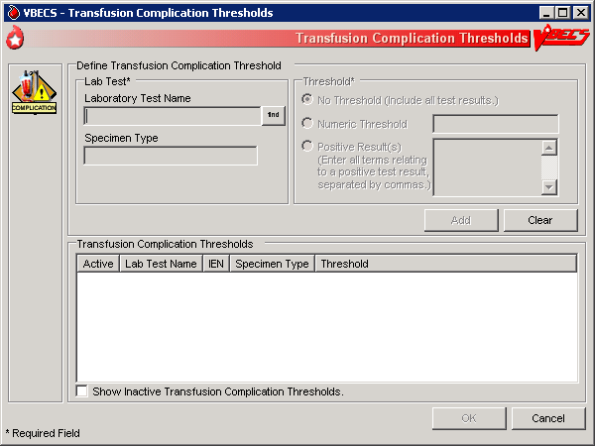

Transfusion Effectiveness
The user defines Laboratory tests to monitor the effectiveness of transfusions.

Assumptions
- VistA lab tests are defined.
- The connection to VistA is active.

Outcome
- Parameters are defined for future reports.

Limitations and Restrictions
- None

Additional Information
- None

User Roles with Access to This Option
 Enhanced Supervisor

Transfusion Effectiveness
The user enters the tests to be included in the Transfusion Effectiveness Report.
User Action | VBECS
- Select Tools from the main menu.  Select Transfusion Effectiveness. | - Displays options for processing administrative functions.  - Allows the user to edit a previously defined Transfusion Effectiveness Tests or add a test.
- Click the find button to search for a Transfusion Effectiveness Test.  Enter part or all of a laboratory test name.  Click Search.  Click one to four check boxes to select tests.  Click OK.  Click Add to add the tests (Figure 34), or  Click the Show Inactive Transfusion Effectiveness Report Tests check box, if desired.  Click Update to edit the tests. | - Allows the user to enter one or more Transfusion Effectiveness Tests.  - Uses VistALink to retrieve Laboratory test data for each of these indicators:  - Laboratory test name  - VistA Laboratory test Internal Entry Number (IEN)  - Specimen type
- Repeat Step 2 for each Transfusion Effectiveness Test to be defined, or click Cancel to exit.
- Click OK to save and Yes to confirm the save. | - Updates the database, including the date and time and the technologist ID. Saves changes to previously defined tests for inclusion in an Audit Trail Report.
Figure 35: Transfusion Effectiveness Report Tests
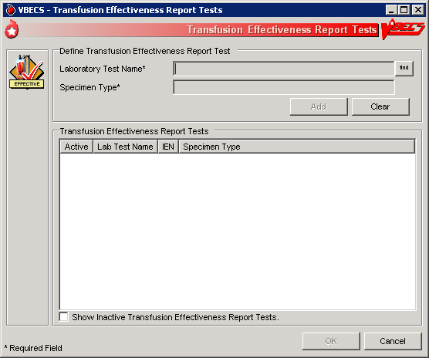

MSBOS
The user defines parameters for comparing blood component orders placed by a clinician with the Maximum Surgical Blood Ordering Schedule (MSBOS).

Assumptions
- A table of generic surgery names is available for MSBOS activation.

Outcome
- CPRS users will see only active surgery names when placing a blood bank order.
- MSBOS will be available to VBECS users to evaluate the appropriateness of pre-op orders.

Limitations and Restrictions
- None

Additional Information
- The maximum number of blood products serves as a guideline. Orders in excess of the MSBOS are not prohibited.
- The VBECS user may view active and inactive surgery names.

User Roles with Access to This Option
 Enhanced Supervisor

MSBOS
The user selects a surgery name from the generic surgery list or creates a new surgery name, then defines the associated MSBOS recommendation. MSBOS is used when VBECS acknowledges orders from VistA that are written for preoperative patients.
User Action | VBECS
- Select Tools from the main menu.  Select MSBOS. | - Displays options for processing administrative functions.  - Displays the schedule and component recommendation options.
- To activate an existing surgery name, click the Show Inactive MSBOS entries check box (Figure 35).  Select a surgery name.  Click the Active MSBOS Entry? check box, or  To add and activate a surgery name, click New Surgery and enter a surgery name in the Surgery Name field. Click Add, or  To edit and/or inactivate an existing surgery name, click the appropriate options in the MSBOS Component Recommendation area of the screen edit. Click Update. | - Lists active surgery names or allows the user to create an entry.  - Activate, add, or edit a MSBOS entry and its associated data.  - Displays surgery names available for activation.  - Displays entries for review and acceptance.  NOTES  MSBOS is specific to the division.  See Appendix B: Table 23: VBECS Maximum Surgical Blood Order Schedule (MSBOS).  Each surgery name has a Type & Screen (TAS) (no blood order recommended) or one or more component classes defined as recommended orders.  The user may select one or more component classes for MSBOS recommendation. Each defined component class must have an associated maximum number recommended. The user may inactivate previously activated component classes for an MSBOS recommendation. The OTHER component class is not available for selection.
- Repeat Step 2 until all new entries are created or existing entries are edited.  Click OK to save the updated data. | NOTES  VBECS does not save changes to the database when the user clicks Cancel without clicking OK.
- Click Cancel to exit.
Figure 36: Maintain MSBOS
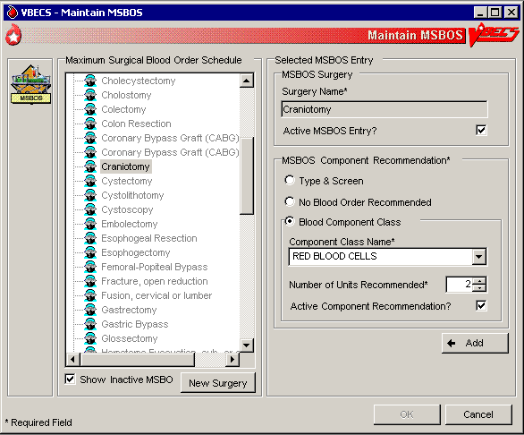

Workload Codes
The user assigns workload Laboratory Management Index Program/National Laboratory Test (LMIP/NLT) tests to processes performed through VBECS. VBECS test names are associated with VistA workload codes, which VBECS uses when compiling and storing data to provide workload-related reports to VistA. See FAQ Workload Assignments Single vs Batch Processing. For additional information, see Appendix G: Work Process Flowcharts.

Assumptions
- The VistA database was updated to include all required workload codes for the VBECS process.
- The VistA database was updated to associate CPT codes and costs with the workload codes to be used by VBECS.
- The connection to VistA is active.

Outcome
- Data are available to the VistA workload package.

Limitations and Restrictions
- Transfusion-only sites must not map workload codes to processes, such as ABO/Rh testing, not performed on site.
- Retrieved LMIP/NLT codes from VistA may have multiple CPT codes. Inactivating any of the associated CPT codes in VBECS will inactivate the LMIP/NLT code. Editing of the LMIP/NLT code associations must be done in VistA.
- Invalidating split units will result in extra workload equal to the number of splits created applied to the total number of units logged in. This occurs when split units are incorrectly processed in VBECS.

Additional Information
- VistALink is required to query VistA files 64 (NLT/LMIP) and 81 (CPT) for appropriate entries.
- The division provides CPT codes and costs associated with the workload codes when they need updating.
- Each site is responsible for notifying users when incorrect CPT codes are used.
- Workload events are placed in a queue for transmission via VistALink.

User Roles with Access to This Option
 Administrator/Supervisor

Workload Codes
As part of record-keeping activity, VBECS allows the user to account for workload units associated with each activity and to assign costs incurred by the blood bank due to these activities. Data gathered because of this workload collection are available to VistA, as needed, for various reports.
User Action | VBECS
- Select Tools from the main menu.  Select Workload Codes. | - Displays options for processing administrative functions.  - Displays fields for entering workload-related data.  - Lists and retrieves processes that may involve workload.
- Select a process for which to define workload codes. | - Allows the user to edit existing data or add data.  NOTES  The user may assign multiple LMIP and CPT workload codes to a process.  VBECS checks for active and inactivated workload associations and does not allow the user to enter a duplicate association. VBECS allows the user to reactivate previously inactivate entries and add workload associations.
- Select an LMIP/NLT code.  Click Add to add the code, or click Update to select a current association to edit. | - Lists previously assigned LMIP/NLT codes for the selected process.  - Allows the user to select an LMIP/NLT code.  NOTES  VBECS uses VistALink to query the VistA WKLD CODE File (#64) for valid LMIP/NLT codes.  VistA uses the LMIP/NLT code to create workload reports as well as reports to patient care encounter (PCE) and the decision support system (DSS) database.
- Enter the start or stop date (whichever is appropriate) of the workload code association with the VBECS process (Figure 36). | - Allows the user to enter a date.  NOTES  The user may enter an inactivation date only when an activation date was previously entered (default start date and time: current date and time).  The inactivation date must be later than or the same as the activation date. When the user attempts to enter an inactivation date that is earlier than the activation date, VBECS warns the user. There is no override.
- Repeat Steps 3 through 4 for each LMIP/NLT code to be associated with the selected process.
- Add the selected parameters to the selected process. | - Allows the user to add the selected parameters.
- Repeat Steps 1 through 6 for to define workload parameters for another process, or exit.
Figure 37: Assign Workload Codes
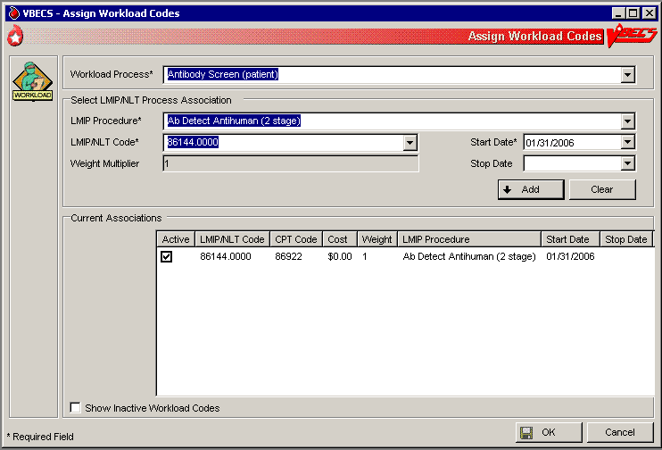

Remapping Workload Codes
When workload codes or a workload code multiplier is changed, VBECS must be updated. The active workload process to LMIP/NLT Code association must be inactivated and remapped for VBECS to track workload correctly.
User Action | VBECS
- Select Tools from the main menu.  Select Workload Codes. | - Displays options for processing administrative functions.  - Displays fields for entering workload-related data.  - Lists and retrieves processes that may involve workload.
- Select a process to edit workload codes. | - Allows the user to edit existing data or add data.
- Click one or more check boxes to inactivate LMIP/NLT Code.  Click OK and Yes to save and exit. | - Removes the code from the Current Associations window.  NOTES  Inactive codes can be viewed by clicking the Show Inactive Workload Codes checkbox.
- Click OK and Yes to save and exit. | - Saves the changes to the workload code mapping.
- Select Tools from the main menu.  Select Workload Codes | - Displays options for processing administrative functions.  - Displays fields for entering workload-related data.  - Lists and retrieves processes that may involve workload.
- Select a process to edit workload codes. | - Allows the user to edit existing data or add data.
- Select an LMIP/NLT code.  Click Add to add the code. | - Allows the user to select an LMIP/NLT code.  NOTES  LMIP/NLT weight multipliers values are set in VistA and that value is imported into VBECS.  Changes made to VistA files 64 (NLT/LMIP) and 81 (CPT) are updated in VBECS on a rolling 24-hour clock. The first user to log in 24 hours after the last update will trigger the next update.
- Repeat Steps 1 through 7 for to edit workload parameters for another process.

Reagents and Supplies

Enter Daily QC Results
The user enters observed serological reactions for all phases of testing and interpretations of the various routine reagents.

Assumptions
- The division is “full service.”
- Site parameters regarding reagent quality control are set up.
- Minimum inventory levels for reagent types are defined.
- Inventory control functionality is in use and reagents are in the inventory of the user’s division.
- Daily QC testing does not include reagents used in special antigen typing.

Outcome
- Routine reagents are available for use, shutting down the alert for the day associated with the rack.
- The user may enter and save reaction results below the minimum expected reaction; an Exception Report may be generated for supervisory review; the rack may or may not be used by the site for routine testing throughout that day.
- If workload codes are assigned for this process, workload-related data collected as the result of this process are stored for inclusion in Workload Reports.

Limitations and Restrictions
- Additional user-defined reagent types not available in Configure Daily QC or Enter Daily QC Results are not part of a reagent rack’s daily QC testing.

Additional Information
- VBECS allows the user to save a partially filled worksheet for a specific QC rack ID and allows the same or a different user to redisplay the form for the entry of remaining test results at a later time. The user, first or second, may enter new results but may not edit prior entries. VBECS records the ID of each user who enters test observations on a worksheet.
- VBECS issues warnings when they are defined in Maintain Minimum Levels.
- VistALink does not need to be active when a user enters daily quality control results.
- A testing template is generated for daily quality control testing of routine reagents for each rack in a division. (Multiple templates may be used on a given day.)
- System rules determine the validity of the test interpretations and determine if all phases of testing were recorded for both scenarios.
- A user must enter and may view one day’s QC data at a time. The supervisor or administrator must review these entries and the reagent information daily.
- VBECS compares the current rack QC results with the prior day’s QC results.
- Multiple technologists may use the same rack.
- Rack number and reagents used to test a specimen are linked to the lot number, manufacturer, and expiration date of the reagent type as well as the rack identifier.
- A user may use more than one testing method in accordance with local policies and procedures.
- If a rack has never been used with reagents prior to using the QC Documentation Offline option and the rack is not so checked when the user attempts to use this untested rack, the message appears that this rack has never been tested and cannot be used. The user may not proceed. To use this rack on this date, the QC Offline check needs to be indicated or testing performed.
- A rack can be set as partially tested and marked as "QC’d Offline" at the same time. The rack will be listed as "Tested = No", Selecting it will prompt for the "Rack QC not performed" override, as the partially tested rack setting is enforced.
- The antiglobulin testing grids for QC have a title of IAT. The same grid for patient testing is titled AHG.
- If two instances of Enter Daily QC are opened, the second instance will not recognize testing performed in the first instance and will accept retesting of the rack. (See FAQ QC Setup and FAQ Retesting QC for additional information.)

User Roles with Access to This Option
All users

Enter Daily QC Results
The American Association of Blood Banks’ Standards for Blood Banks and Transfusion Services requires that commercial reagents in the blood bank—antisera and routinely-used red cell reagents—must be tested for performance “on the day of use.” As routine reagents are always used, they are tested daily. Records of these reagents, their lot numbers, and their testing results must be stored for reference. VBECS verifies and indicates whether the reagent is satisfactory for use.
This option facilitates the direct entry of reaction results and interpretations, constituting daily reagent quality control testing for a rack of reagents.
VBECS allows the user to change individual reagents without repeating the QC for the full rack during the day.
User Action | VBECS
- Select Reagents from the main menu.  Select Enter Daily QC Results. | - Displays options to perform daily reagent rack QC.
- Verify the default date tested and tester, and edit them, if needed. | - Displays the date and time the testing was performed; the default is the current date and time, which are editable to allow retrospective entry.  - Displays the testing technologist’s identification; the default is the current user. Lists valid division users for selection.  - Displays the option to indicate the rack number of the reagents to test, a list of racks to be tested for the current date, and a retest option for the racks with testing completed for the date.  NOTES  Daily QC testing does not include reagents used in special antigen typing.
- Select the Test Rack(s), Partially Tested Rack(s), or Retest Rack(s) tab (Figure 37).  Click one or more check boxes to select rack numbers.  Click OK. | - Displays the lot number verification template for each rack selected.  NOTES  A reagent rack is displayed on one of three tabs based on its testing status and the daily alert time setting:  - Test Rack(s): the current alert time has passed and is/are considered “untested”  - Partially tested: racks that have incomplete test results for the current 24-hour time clock and are considered “untested”  - Retest Racks: racks that are fully tested within the current alert time and are available for new lot number selection and its testing.  The user may test a rack no earlier than the alert time for the next 24 hours.  On occasion, a user may save a partially completed QC worksheet and finish it later. The same user or a different user may complete the testing.  The user may retest a rack when a reagent lot number changes after initial testing. VBECS does not allow the user to retest saved valid results.  VBECS requires the user to indicate the rack identifier to provide a testing template for each daily reagent rack QC.  Site settings determine reagent types and lot numbers present. VBECS displays only reagent types previously entered for the division using the reagent inventory function. VBECS allows entry of lot numbers only. When VBECS displays lot numbers for selection, it checks the inventory system for the reagent name and lot numbers in use in a rack. VBECS does not offer a reagent with an unsatisfactory value in the “Inspection” field or with a quantity of zero as a selectable reagent. The user cannot force the entry of a lot number that VBECS disallowed on the selection list. The user must choose a different reagent.   VBECS compares the expiration date of each reagent on the selected rack to the testing date, emits an audible alert, and warns when the reagent is expired.  Yes requires a comment and VBECS captures details for inclusion in an Exception Report (exception type: expired reagent QC’d).  No removes the unsatisfactory reagent from the daily QC rack. The user must select a new one. VBECS does not display unsatisfactory lot numbers.  The user may enter the lot numbers of the reagents used for the daily QC rack and the lot numbers of the enhancement media reagents defined in Configure Daily QC. VBECS does not display these reagents on the reaction results grid for a rack.
- Select a worksheet to complete the testing (Figure 38), or  Click the Rack not in use today check box to indicate that testing of a rack will not be performed.  Click the QC Testing Documentation Offline check box to acknowledge QC is not performed in VBECS but has been properly documented. Click Yes to save changes. Close the window. | - Displays the selected worksheet.  - Displays the selected partially completed worksheet with the option to cancel the worksheet or continue to enter more testing information.  NOTES  When the QC Testing Documentation Offline check box is checked for a reagent rack, VBECS allows the rack to be used for patient testing until the next daily alert time.  The primary lot number can be tested and changed and the results for both will display on the Testing Worklist Report.   A user may cancel or invalidate a partially completed QC rack worksheet when it is available. VBECS emits an audible alert and warns that invalidating this worksheet will necessitate starting over and asks whether the user wishes to continue.  No returns the user to the partially completed worksheet.  Yes invalidates the worksheet. VBECS does not delete reaction results from the database.  An Exception Report comment documents the invalidation of the rack’s worksheet. VBECS does not record workload calculation for invalidated testing. The invalidated reaction results and associated testing information remain in the database for future retrieval (exception type: deletion of partially completed QC).   VBECS compares the results entered to those of the previous day for the same rack number and alerts the user when there is a change in reactivity of two or more or when the result is changed from positive to negative for each reagent type by lot number. VBECS emits an audible alert and warns that there is a decrease in reagent reactivity of two or more and asks whether the user wishes to continue to use this vial.  Yes allows the user to continue and requires a comment. VBECS captures details for inclusion in an Exception Report and allows this reagent to be used with the change (within acceptable limits) (exception type: QC decrease reagent reactivity ≥2).  No allows the user to return to the lot number entry for this reagent type and approve this lot number (different vial) or enter a new lot number. VBECS returns to the testing worksheet where the user left off. (An individual vial of the same lot number may replace the one losing its reactivity.)  The screening cell and reverse typing reagents are delivered in sets and share the same lot number; therefore, VBECS displays only one reagent type on the lot number template.
- Verify or select from the drop-down menu the reagent type lot number and test method for each rack chosen for processing.  Click OK. | - Displays the lot numbers and expiration dates for verification, if any.  - Displays each rack in its own tab.  NOTES  VBECS allows for one lot number entry per reagent type per rack template.  When an entry was made, VBECS fills in the reagent type lot number, the expiration date of that lot number, and the manufacturer. The user may edit the lot number. The user must verify the lot numbers of racks in the selected batch before VBECS allows the user to move to the reaction results grids.  Each reagent rack has a separate reaction results grid to collect the user’s direct observations.  VBECS displays reagent types (except for the gel and the instrument lot numbers) listed as REQUIRED (by VBECS or by the user) in the daily use field on the rack lot number template and the reaction result entry worksheet for each rack in Enter Daily QC Results.  When a rack is tested, VBECS displays a retest option at the daily reagent QC prompt with the untested rack numbers. When a user requests to retest a rack on a given date, VBECS displays the option to reenter a lot number for reagent types for all or part of the daily QC with a comment. All other reagent type results previously entered are locked and may not be edited. VBECS saves the new information and the original data, then generates a report entry.  When a user changes a reagent lot number, VBECS clears the testing template for that reagent type and allows the user to enter new results.
- Enter the observed serologic reactions (Figure 39).  Click OK and Yes to save and exit.  Repeat for each rack selected in Step 3. | - Displays the testing template reaction results grid for each rack selected, when no lot number changes were made.  - Determines whether the entered results are acceptable and indicates acceptability of the lot number for the reagent type.  - Verifies (by type and lot number) that the reagent is satisfactory or unsatisfactory for use.  - Saves the partially or fully completed data.  NOTES  The user may enter results on multiple reagent racks. VBECS displays each rack in its own tab.  VBECS verifies satisfactory and unsatisfactory QC testing based on site parameters and user data entry. If the user-entered test results indicate a satisfactory interpretation, VBECS displays “Satisfactory.” VBECS saves results that are satisfactory only when the testing for a row is complete and the worksheet is saved. VBECS clears results associated with an unsatisfactory interpretation from the screen/worksheet and the testing for the affected QC rack is considered incomplete until the rack is retested with satisfactory results for the affected row. (Warnings generated by other options when QC testing is incomplete apply).  The daily reagent QC for a date requires a valid entry for each reagent displayed on the worksheet. VBECS considers a rack ready and available for patient testing on that date when all reagents on a rack have valid test results.
Figure 38: Enter Daily QC Results
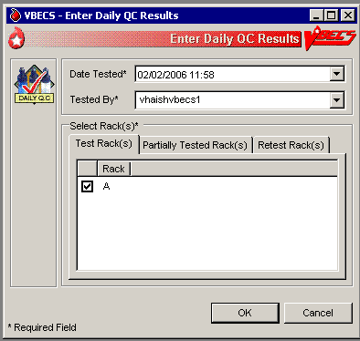
Figure 39: Record Lot Numbers for Daily QC Testing
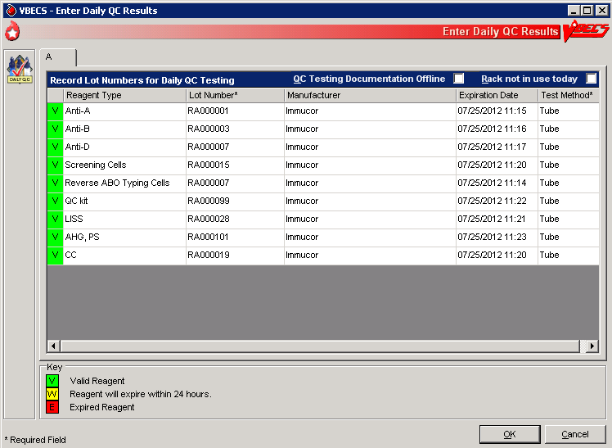
Figure 40: Enter Daily QC Results with Serologic Reactions
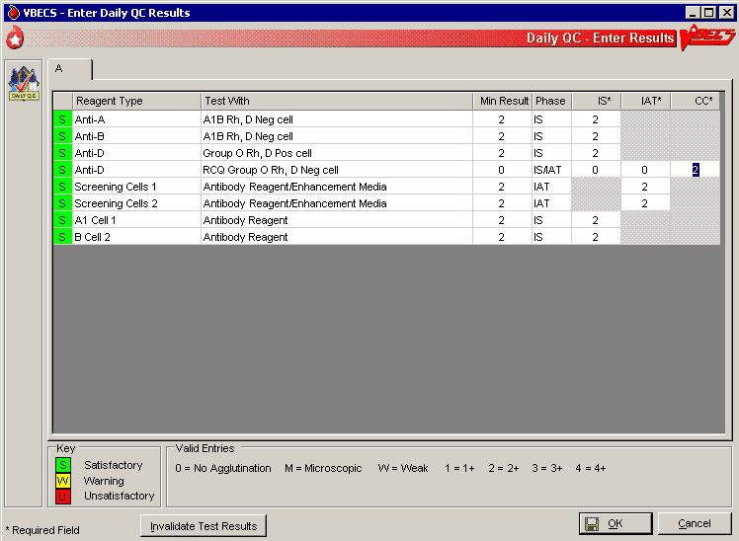

Reagents
The options related to reagent inventory control record the receipt of specific reagents by reagent type for each division.

Log In Reagents, Update Inventory, View/Print Inventory, Maintain Minimum Levels
The reagent log is maintained by individual division even in a multidivisional database. Update Inventory allows the user to update reagent inventory by changing the number of vials available. The user may view inventory online using various search criteria and print a copy of the search results.

Assumptions
- The division is “full service.”
- Reagents are in the inventory of the user’s division.

Outcome
- A user may select previously logged-in reagents through Enter Daily QC Results, Patient Testing: Record a Patient Antigen Typing, and Unit Antigen Typing.
- Reagents entered are accessible only within the division in which they were entered.
- If workload codes are assigned for this process, workload-related data collected as the result of this process are stored for inclusion in Workload Reports.

Limitations and Restrictions
- VBECS does not display a reagent report by invoice number.
- The unsatisfactory portion of a shipment must be recorded individually.
- There is no retrospective data entry or user selection for these options.
- Each site must set a standard for recording quantity: it may use the number of cases or the number of units within the cases.
- When a user enters a lot number in the Lot # field and clicks the magnifying glass, VBECS displays only the first instance of a duplicate lot number.
- When reagents with the same Manufacturer Reagent Name and Lot Number are entered from multiple invoices, only one of the reagents is visible for update.
- Reagents that have had their Number of Vials Available set to zero (0) are no longer visible on the Update Reagent Inventory screen or the Reagent Inventory Report. Print a copy of the Reagent Inventory Report prior to setting the Number of Vials Available to zero (0).

Additional Information
- This option is disabled for transfusion-only facilities.
- VBECS displays alerts, as appropriate, during execution of Enter Daily QC Results to notify the user when reagent inventory levels fall below minimum inventory levels, as defined in Maintain Minimum Levels.
- Local policies and procedures must define the use of patient antisera as reagents.

User Roles with Access to This Option
All users

Log in Reagents
A user records the receipt of specific reagents by type. The reagent record includes the date the shipment was received, reagent name, lot number, expiration date, manufacturer, and number of vials received in a shipment.
User Action | VBECS
- Select Reagents from the main menu. | - Displays options for Quality Control functions.  - Displays options for processing reagents.
- Select Log In Reagents. | - Displays fields for entering invoice and reagent information.
- Invoice Information:  Select or edit the date and time in the Date Received field.  Enter the invoice number in the Invoice Number field.  Enter the name of the manufacturer in the Manufacturer field, or select a name from the drop-down list. | NOTES  More than one technologist at a time may process a large shipment of reagents; only one technologist at a time may process individual reagents in the shipment.  The default date received is the current date and time. The user may edit it to a past date and time only.  When the reagent type and lot number were already entered for this invoice, VBECS warns that the user is trying to enter a reagent that was already logged into the system for this invoice. Yes takes the user to the “Update Reagent Inventory” screen where VBECS displays the reagent type and lot number for update. No clears all fields on the screen, allowing the user to log in another reagent.
- Reagent Information:  Enter the reagent name and reagent type in the Manufacturer Reagent Name and Reagent Type fields, or select from the drop-down lists.  Enter the lot number in the Lot Number field.  Select or edit the date and time in the Lot Expiration Date field.  Enter (or select) a quantity (1–999) in the Vials Received per Lot Number field. | NOTES  The default lot expiration date is one minute before midnight (23:59) of the current date.
- Visual Inspection Information:  Click the Satisfactory radio button, or click the Unsatisfactory radio button and select a comment from the drop-down list or enter a free text comment in the Comment field.  Click Add to add the reagents to the inventory list. | NOTES  Satisfactory reagents are available for later selection, unsatisfactory reagents are not.  When a user selects Other from the drop-down list in the Comment field, entry of additional text in the Details field is required.
- Repeat Steps 3 through 5 to log in more supplies, as desired. | NOTES  Click Clear to clear all but the Invoice Number, Date Received, Manufacturer, and Lot Expiration Date fields.
- Click OK to save.  Click Yes to confirm the save and exit. | - Requests confirmation to update the database.

Update Reagent Inventory
The user changes the number of available items in the reagent inventory.
User Action | VBECS
- Select Reagents from the main menu. | - Displays options for Quality Control functions.  - Displays options for processing reagents.
- Select Update Inventory. | - Lists existing satisfactory reagents by default.
- Select a reagent to edit.  To view reagents with a specific lot number, enter the lot number in the Lot # field and click the magnifying glass. | NOTES  Click a reagent type to reveal manufacturer names. Click a manufacturer name to reveal lot numbers.
- Click a lot number to enable the Number of Vials Available field.  Enter (or select) a quantity that is less than or equal to the current entry in the Quantity Available field.  Select or edit the date and time in the Date Changed field (Figure 40). | NOTES  The default change date is the current date and time. The user may edit it to a past date and time only.  The list of selectable comments in Reason for Change field is not associated with a canned comment category. When a user selects Other from the drop-down list in the Reason for Change field, he may enter additional text in the Comments field.  To avoid a system error, do not remove the reason for change before saving.
- Repeat Steps 3 and 4 to edit more reagents, as desired.
- Click OK to save.  Click Yes to confirm the save and view the updated list. | - Prompts the user to confirm the save.  - Saves the record and redisplays current inventory, as in Step 3.  - Displays an option to exit.  - Click the Clear button to continue if a warning message displays after selecting “No” to the entry confirmation message.
- Click Close to exit.
Figure 41: Update Reagent Inventory
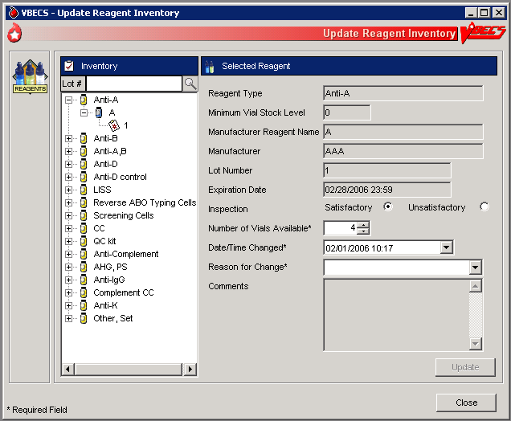

View/Print Reagent Inventory
The user views inventory online based on various search criteria and prints the search results.
User Action | VBECS
- Select Reagents from the main menu. | - Displays options for Quality Control functions.  - Displays options for processing reagents.
- Select View/Print Inventory. | - Lists reagent types.
- Click one or more check boxes in the Reagent Type list to select reagent types. | - Displays or allows the user to print a report of all current in-date, unsatisfactory, expired reagent inventory and minimum stock levels as a read-only display based on the selection criteria entered:  - Reagent type  - In-date (active) reagents  - Unsatisfactory reagents  - Expired (inactive) reagents  - Expiration date range (the user enters a date to begin and end the search)  - Date received (the user enters a date to begin and end the search)  NOTES  VBECS displays only reagents selected based on search criteria.  In a multidivisional environment, the report for a division will print one line-item for each division that has set minimum levels for that reagent type.  Multiple shipments of the same lot number of a reagent type can cause a discrepancy in the total number available displayed on the report. Always refer to the most recent entry of a reagent for the number of vials available when the shipment was received.
- Click OK to accept the displayed selection criteria (Figure 41). | - Compiles the report and displays an option to print or exit the report.
- Click Print to print the list of reagents. | - Sends the report to print on the printer selected by the user.
- Print another report or click Close to exit.
Figure 42: Reagent Search
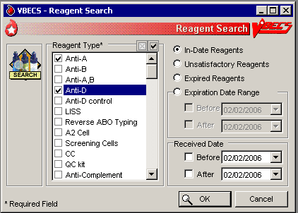

Maintain Minimum Levels
The user sets minimum stock levels for reagent types used in the division.
User Action | VBECS
- Select Reagents from the main menu. | - Displays options for processing reagents.
- Select Maintain Minimum Levels. | - Lists available reagent types and their associated minimum stock levels.
- Select a Reagent Type to edit the minimum level threshold. | - Displays the reagent type selected and allows the user to edit the Minimum Stock Level field or select another reagent.  NOTES  A minimum inventory level (a whole number from 0 to 999) is set for each reagent type. This is related to the reagent type, independent of manufacturer name and lot numbers.
- Enter (or select) a minimum number of vials in the Minimum Stock Level field. | - Displays the changes and allows the user to select another reagent to edit.  NOTES  When the number of vials in stock is at or is less than the stock minimum, VBECS notifies the user and instructs him to check the inventory.  Inventory levels are tied to the reagent type, not to the manufacturer reagent name or the lot number. A particular type may have multiple manufacturer reagent names and multiple lot numbers associated with that manufacturer reagent name, all of which are summed to create the inventory of that reagent type. VBECS tracks the total number of vials in the system for a particular reagent type.  Each reagent type has one minimum inventory level established regardless of manufacturer name and lot numbers. Valid entries are whole numbers from 0 to 999.
- Review the displayed information and click Update (Figure 42). | - Displays the changes and allows the user to select another reagent to edit.  - Prompts the user to confirm the save.
- Repeat Steps 3 through 5 until all minimum reagent levels are set.
- Click OK to save, and Yes to confirm the save. | - Saves the record and exits.
Figure 43: Maintain Minimum Reagent Levels
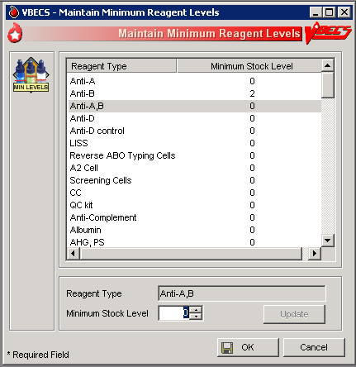

Supplies
The user documents the receipt of supplies, and updates and views the supply inventory.

Assumptions
- A user may maintain supply inventory only in the division logged into.

Outcome
- A supply inventory that is accessible only within the division of entry was established.
- If workload codes are assigned for this process, workload-related data collected as the result of this process are stored for inclusion in Workload Reports.

Limitations and Restrictions
- The division’s modification processes may allow or require the user to select previously entered supplies for association with a blood unit’s modification. An inventory of containers (transfer bags) and sterile connection device (SCD) wafers is required for various modification processes.
- There is no retrospective data entry or user selection for this option.
- The unsatisfactory portion of a shipment must be recorded individually.
- Each site must set a standard for recording quantity: it may use the number of cases or the number of units within the cases.

Additional Information
- Maintaining Blood Bank Equipment (Equipment: Log In Equipment, Equipment: Maintain Equipment) and Reagents (Log In Reagents, Update Inventory, View/Print Inventory, Maintain Minimum Levels) accommodate the maintenance of reagents and equipment, respectively.
- VBECS saves the lot number, manufacturer name, and expiration date of supplies used in a unit’s modification process as part of a unit’s modification record when associated during the modification transaction.
- VBECS creates a list of manufacturers as they are entered and makes the list available for selection. Users may not edit entries.

User Roles with Access to This Option
All users

Log in Supplies
The user records the receipt of specific supplies by type. The supply record includes the date the shipment was received, supply name, lot number, expiration date, manufacturer, and number of items received in a shipment.
User Action | VBECS
- Select Tools from the main menu.  Select Supplies. | - Displays options for processing administrative functions.  - Displays options for processing supplies.
- Select Log In Supplies. | - Displays fields for entering invoice and supply information.
- Invoice Information:  Enter the invoice number in the Invoice Number field.  Select or edit the date and time in the Date Received field.  Enter the name of the manufacturer in the Manufacturer field, or select a name from the drop-down list. | NOTES  More than one technologist at a time may process a large shipment of supplies; only one technologist at a time may process individual supplies in the shipment.  The default date received is the current date and time. The user may edit it to a past date and time only.  When the supply type and lot number were already entered for this invoice, VBECS warns that the user is trying to enter a supply that was already logged into the system for this invoice. Yes takes the user to the “Update Supply Inventory” screen where VBECS displays the supply type and lot number for update. No clears all fields on the screen, allowing the user to log in another supply.
- Supply Information:  Enter the name of the manufacturer and supply type in the Manufacturer and Supply Type fields, or select from the drop-down lists.  Enter the lot number in the Lot Number field.  Select or edit the date and time in the Lot Expiration Date field.  Enter (or select) a quantity (1–999) in the Quantity Received field. | NOTES  The default lot expiration date is one minute before midnight (23:59) of the current date.
- Visual Inspection Information:  Click the Satisfactory radio button, or click the Unsatisfactory radio button and select a comment from the drop-down list in the Comment field.  Click Add to add the supplies to the inventory list (Figure 43). | NOTES  Satisfactory inventory is available for later selection, unsatisfactory inventory is not.  When a user selects Other from the drop-down list in the Comment field, entry of additional text in the Details field is required.
- Repeat Steps 3 through 5 to log in more supplies, as desired. | NOTES  Click Clear to clear all but the Invoice Number, Date Received, Manufacturer, and Lot Expiration Date fields.
- Click OK to save.  Click Yes to confirm the save and exit. | - Requests confirmation to update the database.
Figure 44: Log In Supplies
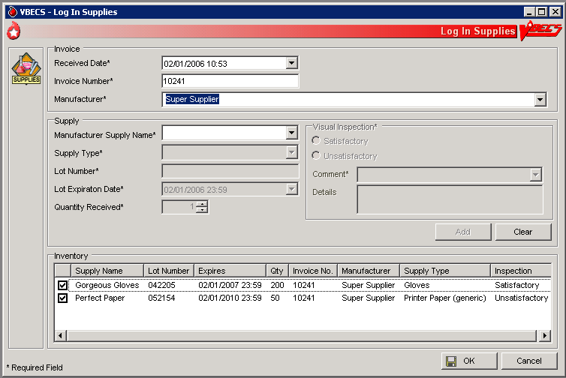

Update Supply Inventory
The user changes the number of available items in the supply inventory.
User Action | VBECS
- Select Tools from the main menu.  Select Supplies. | - Displays options for processing administrative functions.  - Displays options for processing supplies.
- Select Update Supply Inventory.  Click the Include Expired Supplies check box to include expired supplies in the list. | - Lists existing satisfactory supplies by default.
- Select a supply to edit.  To view supplies with a specific lot number, enter the lot number in the Lot # field and click the magnifying glass. | NOTES  Click a supply type to reveal manufacturer supply names. Click a manufacturer supply name to reveal lot numbers.
- Click a lot number to enable the Quantity Available field.  Enter (or select) a quantity that is less than or equal to the current entry in the Quantity Available field.  Select or edit the date and time in the Date Changed field (Figure 44). | NOTES  The default change date is the current date and time. The user may edit it to a past date and time only.  When a user selects Other from the drop-down list in the Reason for Change field, he may enter additional text in the Comments field.
- Repeat Steps 3 and 4 to edit more supplies, as desired.
- Click OK to save.

Click Yes to confirm the save and view the updated list.
- Click Print Supply Inventory to print the list of supplies. | - Displays the Supply Inventory window (see View/Print Supply Inventory).
- Click Cancel to exit.
Figure 45: Update Supplies
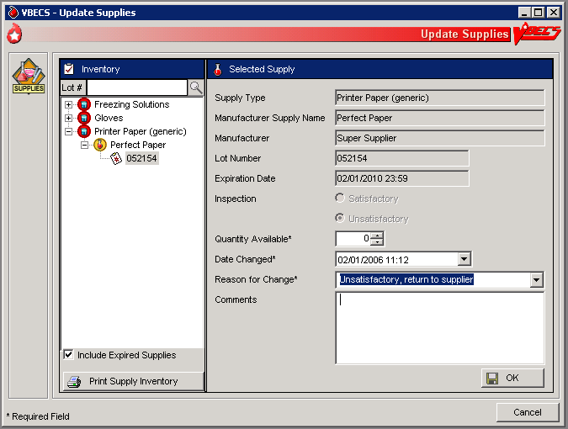

View/Print Supply Inventory
The user views inventory online based on various search criteria and prints the search results.
User Action | VBECS
- Select Tools from the main menu.  Select Supplies. | - Displays options for processing administrative functions.  - Displays options for processing supplies.
- Select View/Print Supply Inventory. | - Lists supply types.
- Click one or more check boxes in the Supply Type list to select supply types. | - Displays or allows the user to print a report of all current in-date, expired, and unsatisfactory supply inventory and minimum stock levels as a read-only display based on the selection criteria entered:  - Date range (the user enters a date to begin and end the search)  - Supply type  - In-date (active) Supplies  - Expired (inactive) Supplies  - Expiration date of the supply  - Date received  NOTES  A user may view the supply inventory by one, some, or all of the selection criteria.
- Click OK to accept the displayed selection criteria. | - Compiles the report and displays an option to print or exit the report.
- Click Print Supply Inventory to print the list of supplies. | - Sends the report to print on the printer selected by the user.  NOTES  VBECS displays and prints the report in the supply type order : in-date by lot number in reverse chronological order of expiration date, followed by expired and unsatisfactory supplies. Details included in the report:  - Supply Type (Unit of Measure)  - Manufacturer  - Manufacturer’s Supply Name  - Lot Number  - Expiration Date  - Number Available  - Inspection upon receipt  - Invoice Number  - Received Date/Time  - Received by Tech Name  - Comments
- Print another report or click Cancel to exit.

Equipment
The user registers blood bank instruments and other equipment (refrigerators, freezers, thawing bath, incubators, centrifuges, etc.) and records associated maintenance activities.

Assumptions
- A user may maintain equipment inventory only in the division currently logged into.

Outcome
- An equipment maintenance record, accessible within the division of entry, was established.
- If workload codes are assigned for this process, workload-related data collected as the result of this process are stored for inclusion in Workload Reports.

Limitations and Restrictions
- VBECS does not check for duplicate entries of equipment names and identifiers.
- There is no retrospective data entry or user selection for this option.

Additional Information
- VBECS does not calculate inventory levels for supplies or equipment.

User Roles with Access to This Option
All users

Equipment: Log In Equipment
A user adds new equipment or maintains existing equipment. After equipment is registered, the user must record periodic maintenance. The equipment records are updated and retained according to local procedure and policy. Once an equipment record is established, it may be selected as equipment used during a blood product modification.
User Action | VBECS
- To add new equipment, select Tools from the main menu.  Select Equipment. | - Displays options to maintain equipment maintenance.
- Select Log In Equipment to create an equipment record or Maintain Equipment to record maintenance (see Equipment: Maintain Equipment). | - Displays an empty equipment property template.  - Displays all in-service equipment items for the blood bank associated with the user’s division and offers the option to display out-of-service equipment.
- Equipment Info area: Enter the equipment information in the appropriate fields. Enter or select an equipment type from the drop-down menu.  Installation Info area: Select or edit the date and time in the Date Received/Installed field.  Click the Expiration/Renewal Date check box when there’s an expiration or renewal date, and edit the date as above.  Manufacturer Info area: Enter the manufacturer name or select a manufacturer from the drop-down list.  Enter the manufacturer’s contact information in the appropriate fields or click the find button to select the manufacturer’s address.  Click Add to add the equipment to inventory (Figure 45). | - Displays fields for entering equipment name, ID, serial number, and type in the Equipment Info area.  - Displays fields for entering the date the equipment was received or installed, warranty or service contract number, and expiration or renewal service contract date in the Installation Info area.  - Displays fields for entering the manufacturer name, address, and phone in the Manufacturer Info area.
- Repeat Step 3 to add new items to the equipment list.  Click OK to save. | - VBECS maintains a historical record for each piece of equipment entered.
- Click Yes to confirm and exit.
Figure 46: Log In Equipment
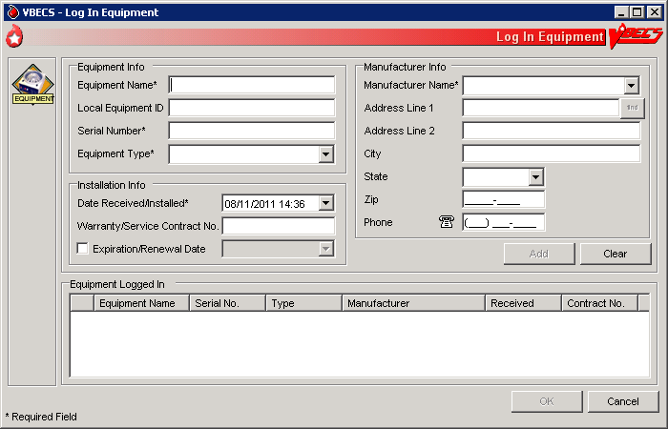

Equipment: Maintain Equipment
The user maintains an online equipment record to record periodic maintenance. Equipment records are updated and retained according to local procedure and policy.
User Action | VBECS
- To maintain equipment, select Tools from the main menu.  Select Equipment. | - Displays options to maintain equipment maintenance.
- Select Maintain Equipment to record maintenance or Log In Equipment to create an equipment record (see Equipment: Log In Equipment). | - Displays entered in-service equipment items for the blood bank associated with the user’s division and offers the option to display out-of-service equipment.
- In the Equipment tab, enter the equipment serial number (or enter part of the serial number and click the magnifying glass to view serial numbers), or click + in front of each equipment type and name to view equipment items.  Select the serial number of the item whose record will be maintained.  Click the Include Out of Service Equipment check box, if desired. | - Displays fields for entering the type of maintenance event performed, the date the maintenance was performed, the results of the event, the next scheduled event, the next scheduled maintenance date, and pending maintenance issues in the Maintenance tab, and allows the user to select a maintenance event type and event details.  - Displays entered information.
- Review and edit the equipment data in the Equipment tab. | - Displays entered information.
- Select the Maintenance tab.  To add a maintenance event, enter the maintenance type or select it from the drop-down list.  Select or edit the date and time in the Maintenance Date field.  Enter details in the Maintenance Results and Pending Issues fields.  Click Add to add the maintenance event to the Maintenance Events list (Figure 46).  Click Print to print the record. | - Displays recorded maintenance information and allows the user to update information.  - Displays an option to print an Equipment Report.
- Click the Out of Service Equipment check box to remove equipment. | - Removes the equipment from the list of currently maintained equipment.
- Repeat Steps 3 through 6, as desired.
- Click OK and Yes to save and continue, or No to return to the screen and continue.  Click Cancel to exit without saving. | - Prompts the user to confirm the save.  - Saves the updates to the equipment record.
Figure 47: Maintain Equipment
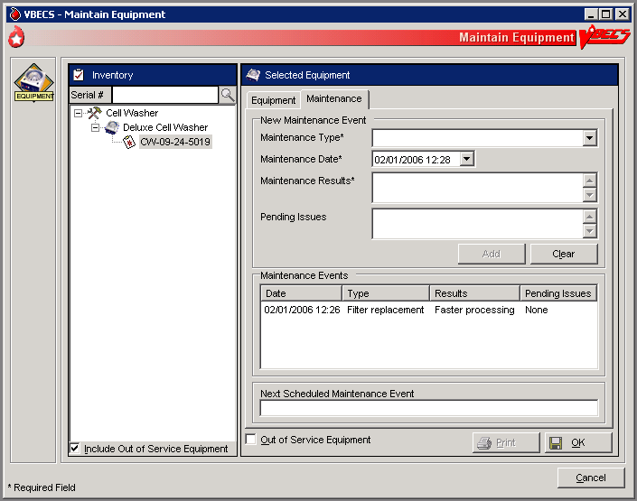

Component Processing

Shipments

Incoming Shipment
A shipment handled in this option contains one or more containers of human blood products.
The user may use a barcode scanner to read information from a unit blood bag (recommended) or enter this information. The user reviews and confirms the information before adding a unit to the database.
The user may enter a comment in the ‘Incoming Shipment’ comment context. The comment will be displayed in the Unit History Report, Incoming Shipment section and may be edited in Edit Unit Information.

Assumptions
- The division is configured.
- The shipper is active.
- Units are inspected and deemed satisfactory for receipt before they are entered in VBECS.

Outcome
- A shipment or partial shipment of blood units was processed and added to the blood bank inventory.
- The initial status for each unit was set in accordance with component class.
- If workload codes are assigned for this process, workload-related data collected as the result of this process are stored for inclusion in Workload Reports.

Limitations and Restrictions
- VBECS does not check whether blood products with the same unit ID and different product codes are the same blood type.
- VBECS does not compare the ABO/Rh of an autologous unit or display a message when the ABO/Rh is incompatible with the restricted for patient.
When a product type, code, or local code is not in VBECS or a blood supplier creates a product code, contact the Service Desk. See Customer Support for contact information.
- The user may not save the unit record until the donation type and its requirements are satisfied.
- No longer supports the entry of blood products labeled in Codabar label type to new or existing invoices.
- The default unit expiration [Maximum Storage Time (MST)] is set to the longest possible storage time based on product type, core condition, attributes, and available references as a guide, but a user with the Traditional Supervisor role or higher can override the default MST (see Blood Products section for more info). The MST is set at a higher level than an individual collection product code. VBECS does not know the specific collection details. It is the responsibility of each user to accurately enter and process any one blood unit based on its expiration date/time as labeled by the collection facility.
- When blood products intended for quarantine are scanned, VBECS does not automatically quarantine them: the user must do so.
- VBECS does not recognize scanned labels for para-Bombay or Bombay ISBT units.
- VBECS does not allow duplicate IDs for the same product code.
- When a user scans a product code or expiration date barcode in the Unit ID field, VBECS does not display the entered information.
- VBECS supports the scanning of ISBT 128 special testing information barcodes by detecting the appropriate hidden identifiers. Once the hidden identifier is removed, the special testing code is a varying length of digits, depending on the type of special testing barcode scanned.
- When a user scans an ISBT blood product code ID with “0” as the donation type (sixth character), VBECS indicates that the donation type is not specified. When the user selects a donation type from the drop-down menu, VBECS replaces “0” with a recognizable character in the product code text box and stores it as such. When the user rescans the product ID, he must manually replace “0” or search using the unit ID alone, or the unit ID and the first five characters of the product ID. When scanning a blood product derivative, this does not apply.
- Blood product code entries in the blood product table include those from ICCBBA for ISBT 128. Product codes created after the release of VBECS cannot be entered until the updated tables are incorporated through patches to VBECS. Refuse acceptance of the unit, if possible. Users may not edit the blood product table.
- ISBT 128 tables include blood product codes labeled as not for manufacturing or transfusion. VBECS does not restrict such products from being entered, issued, or transferred (local policy controls their use), but does not accommodate blood modification for these products.
- No entry of an ICCBBA Product Description Code starting with A, B, C, or D aka National or Local Codes A0000-D9999. If use of such a code is necessary for patient care, contact Service Desk and file a request for the code to be added to VBECS.

Additional Information
- A unique blood unit record is defined by the following data elements:
- VBECS Division
- Unit ID
- Product code
    - ISBT 128 (8 alphanumeric characters).
- VBECS stores scanned ISBT 128 product codes and displays them as eight characters:
- Characters 1–5: product type
- Character 6: donation type
- Characters 7 and 8: division code (split)
- When ISBT 128 units received during downtime must be issued, it is recommended that the user record the check character. When a blood unit is to be logged in after downtime and the unit is unavailable for scanning, the user must enter the ISBT unit ID and the case-sensitive check character (the character in the square following the unit ID).
- To calculate a check character, see the Quick K Calculator on the ICCBBA Web page under ISBT 128, Other Tools. Follow the instructions to download the application.
- Each division may have only one blood unit record of the same product type, product code, and unit ID. A unit shipped out (transferred) and subsequently shipped to (received by) a division in the same database will maintain individual records of the unit ID and product code for each division.
- Several data elements, including the unit ID and product code, define a blood unit record as unique. The unit record also includes expiration date and time, blood type, and donation type. These data elements are not editable.
- Some suppliers relabel blood products and do not affix their own FDA Registration Number to those units. It is recommended that the user obtain FDA Registration Number barcodes from their suppliers and use them for scanning the shipper.

User Roles with Access to This Option
All users

Incoming Shipment
In a “transfusion-only” facility, units must be restricted for use by a specific patient while an incoming shipment is processed. VBECS identifies the original collection facility to determine the presence of an eye-readable prefix. A user may enter unique unit information regarding special testing and antigen phenotyping. The user confirms that all entered units from the shipment were added to the database in the blood bank.
User Action | VBECS
- Select Shipments from the main menu.  Select Incoming Shipment. | - Displays options for processing blood product shipments.  - Displays invoice information fields for entering shipment information.  NOTES  The system is set as a default to ISBT 128 label type.
- Scan the invoice number barcode or enter the invoice number.  To search for an existing invoice, click the find button. Enter an invoice number and/or select a shipper from the drop-down list, then click Search. Click an invoice number to select it and click OK. | - When an identified invoice does not exist, asks the user whether he wants to create an invoice and add units to it.  - Displays the option to search for existing invoices by invoice number and/or by active shipper. When no match is found, notifies the user.  NOTES  When a user chooses to select an existing invoice to add units, VBECS ensures that the shipper is marked as active. VBECS displays and allows the user to edit existing invoices associated with active shippers.  To correct an invoice associated with an inactive shipper, the user must reactivate the shipper. (See FAQ CAP Comprehensive Transfusion Medicine Crossmatch Survey)  Multiple users may process different units from a shipment. A large shipment of blood can be physically processed by more than one tech simultaneously, however, each individual unit in the shipment can only be processed by one tech.  When more than one user intends to work on an invoice, one user must create the invoice. The other users must select that invoice and add units to it.  When using a scanner to read barcodes on blood product bags, the system must display the input to the user in the eye-readable form that appears on the blood bag.  When processing a shipment, the system should provide an indication to the user which specific barcode the system is expecting. Once the scan is complete, the system automatically ‘moves’ the indication to the next logical input. The user can override this progression by manually selecting a different input field. It is assumed that the scanners are configured to append the proper command at the completion of each scan.  If the user entered shipment properties for an existing invoice, VBECS displays a message: Do you want to continue and add units to an existing invoice? (Select “No” to use another invoice.) If the user responds “No,” the shipment property fields are cleared, allowing the user to enter data for another invoice; otherwise, VBECS continues to the next step.  If the user entered shipment properties for a new invoice, VBECS displays a message: Do you want to continue and add units to the new invoice? (Select “No” to use another invoice.) If the user responds “No,” the shipment property fields are cleared, allowing the user to enter data for another invoice; otherwise, the system continues to the next step.  The combination of invoice number, shipper, and date received uniquely identifies an incoming shipment for data retrieval.
- Select a source from the Source (Shipper) drop-down list. If needed, edit the date received in the Date Received field. | NOTES  After a user enters or selects an invoice number, the user may enter information in the shipper, date received, and processing technologist fields.  During retrospective entry, the user must enter the shipment date and time before entering any other unit transaction.  Shipment received date/time cannot be a future date/time.
- Click OK again to continue. | NOTES  Entry of Codabar labeled blood units is disabled.
- Click Yes to add units to the invoice or click No to select another invoice. | - When a user selects an existing invoice, displays the shipment information and blood unit details associated with the invoice.
- Select a unit to add.  For an ISBT 128-labeled unit, scan the label or enter the unit ID and check character (in that order). | - Disables the FDA Registration Number field.  - Displays information corresponding to the unit ID barcode scanned. When a user enters an ISBT 128-labeled unit ID, VBECS prompts the user to enter the check character from the blood bag.  - When a user scans ISBT 128 labels units and the cursor is in an inappropriate field, VBECS warns that the incorrect barcode was scanned.  NOTES  For ISBT 128-labeled units:  When the user-entered check character from the label does not match the VBECS-generated check character, VBECS warns the user.  When VBECS does not find a matching entry for the ICCBBA Registration Number on the local facility table, the user must activate or add a local facility before continuing.  A scanned ISBT 128 Unit ID barcode or 2-d barcode is identified by the presence of hidden identifiers. Once the hidden identifier is removed or when the Unit ID is manually entered, the Unit ID is validated to ensure that the first five characters are alphanumeric and the remaining eight characters are numeric; totaling a 13-character unit ID. The Unit record is flagged as scanned during initial receipt only if the hidden identifier was present.
- Scan the product code barcode or the 2-d barcode or enter the product code. | - When a user scans a product code barcode that is not activated in the user’s division, prompts the user to activate the code. (See Blood Products.)  - Displays the corresponding product code, product name, and (for ISBT) donation type (see Step 10).  - When a unit ID of the same product type and code exists in a division, the expiration date is in the future, and there is no record of inactivation or transfer of that unit ID and product code in the division’s record:  - Warns that the blood unit already exists in the division.  - Clears the data entry fields. The user may enter a different unit ID and product code.  - When a unit ID of the same product type and code exists in a division and the unit in the division has an expiration date in the past, warns that the blood unit already exists in the division.  - When a unit ID of the same product type and code exists in a division, the unit status is “Transferred,” and the ABO/Rh and unit expiration date are identical to the existing unit of record:  - Makes the existing unit record available.  - Warns that the user is attempting to reenter a unit in inventory. No clears the unit. Yes and saves the unit.  - Updates the unit status to “Limited” or “Available.”  - Updates the unit record to reflect the reentry of the unit in the division’s inventory. The user may add new information about this unit through Edit Unit Information.  - System determines barcode type(s) scanned based on hidden identifiers. System interprets and displays product name and donation type, as appropriate.  - System determines if the facility it full service or transfusion only.  - System assigns the donation type to the unit or requires user input, as appropriate.  NOTES  Scanned Product Codes  When a unit is transferred between facilities in a multidivisional database or is reentered after transfer to an unrelated facility, VBECS records all unit activity.  OK returns the user to a blank screen to enter a different product. The user may enter a different product code.  VBECS requires the full 8-digit ISBT 128 product code. The user should enter the 8-digit ISBT 128 product code as it appears on the blood unit label of the actual blood unit being entered into VBECS. When a user does not enter the sixth through eighth characters, VBECS automatically completes the required information with defaults, V and 00, respectively. This may be changed by clearing the unit information and entering the complete 8-digit ISBT 128-unit product code.  When adding an individual blood unit to the database, the volume default is based on the volume field from the Blood Product table entry that corresponds to the blood product code of the unit. The volume may be edited by the user within the range of 1 mL to 2000 mL  For each product type in a shipment, site parameters must indicate that the product is marked as active for the division and that a cost is associated with the shipper. If not, VBECS prompts the user to mark the component as active. Blood product data entry cannot continue until the product is marked as active and a base unit cost is associated with the shipper.  For ISBT 128-labeled units:  VBECS stores scanned ISBT 128 product codes and displays them as eight characters:  - Characters 1–5 are used to search the ISBT Blood Product Table to identify the product type.  - Character 6 indicates donation type.  - Character 7 indicates a division at the time of collection.  - Character 8 indicates an additional aliquot.  VBECS supports the scanning of ISBT-128 2-d barcodes by detecting the appropriate hidden identifier.  When the user does not enter a donation type and unit division codes when manually entering a unit, the donation type is defaulted to "V" and defaults to "00" for the division characters. These are not editable after the unit is saved to the invoice.  Allow the entry of individual products associated with the active product categories.  When a blood product code in the RED BLOOD CELLS or WHOLE BLOOD component class is entered, VBECS enables data entry of sickle cell negative and antigen typing.  The cytomegalovirus (CMV) negative data entry option is always enabled.  The system presents an indicator for RBC contamination of equal to or greater than (= >) 2 mL. RBC, WB and plasma products are set and not editable. PLATELET and OTHER products require evaluation and entry by the user.  The RBC contamination indicator setting as saved is recorded as part of the unit record. The indicator displays with the Incoming Shipment entry on the Unit History Report.  When the site parameter indicates that the site is a ‘Transfusion Only’ facility when units are added to the database, they are given a status of Available regardless of the required need for ABO/Rh confirmation testing as it is not required in this configuration.  When processing units labeled using ISBT 128, all eight (8) characters are required when either:  - The site parameter indicates the site is a ‘transfusion only’ facility  - The donation type requires restriction. The blood unit processed must be restricted with a specific patient.  An ISBT 128 ABO/Rh barcode is identified by the presence of hidden identifiers. Once the hidden identifier is removed, the ABO/Rh is a four-character code.
- For ISBT 128-labeled units, scan the ABO/Rh number barcode, enter the ABO/Rh, or select the ABO/Rh from the drop-down list. | - Displays the corresponding ABO/Rh.  - Allows the selection of only ABO/Rh types acceptable for ICCBBA component classes.  - Enables the ABO/Rh field when a valid product code is entered.
- Scan the expiration date barcode or enter the expiration date and time when an expiration time is required. | - Displays the corresponding expiration date and time.  NOTES  A scanned ISBT 128 expiration date barcode is identified by the presence of hidden identifiers. Once the hidden identifier is removed, there are two possible formats of the barcode, one involving the date only and another involving date and time. If no time in the barcode, the default expiration time is 23:59.  VBECS compares the entered blood product’s expiration date to the maximum storage date and time limit for the blood product. The date and time of shipment receipt are used as the collection date and time. When the expiration date entered exceeds the defined maximum storage time, VBECS displays an error message and clears the field. The user may reenter an expiration date and time for the product.  Products with a maximum expiration date and time of <24 hours default to an expiration time <24 hours from the time of the incoming shipment. Blood products with a maximum expiration date and time of > 24 hours have a default expiration time of 23:59.  Expiration date entries can be corrected before saving, as the date is presented for review before final acceptance. To correct a saved, invalid Expiration Date, inactivate and reenter the unit.   When a unit expiration date precedes the incoming shipment date and time, VBECS emits an audible alert, warns that the user is attempting to enter an expired unit, and asks whether the user wishes to continue.  No clears the unit expiration date field. The user must enter a new, acceptable expiration date. Yes requires the user to enter a comment.  VBECS captures details of this override in an Exception Report.
- For ISBT 128-labeled units, accept the donation type based on character 6 of the product code (cannot be edited) or, when character 6 is “0,” indicate a donation type. | - Assigns the donation type to the unit or requires user input, as needed.  - Requires data entry of the “reserved for” patient name and/or patient ID and the disease market testing status for “autologous” and “directed” donation types.  NOTES  When a site is a transfusion-only facility, each unit processed must be restricted to a specific patient regardless of donation type.
- Click the find button next to the Restricted For Patient field to indicate the patient for whom the unit is reserved, as needed. | - Allows the user to search for active VistA patients to associate with the unit.  - Requires data entry of a patient name and/or patient ID to associate the unit with that patient when a unit has a “directed” or “autologous” donation type or the receiving facility is a “transfusion-only” facility.  - When no match exists, warns the user.  - When the unit is autologous, requires a user to indicate the disease marker testing status:  - NEG: unit fully tested and negative for all disease markers  - POS: unit tested and positive for one or more disease markers (biohazard)  - NFT: unit not fully tested for one or more disease markers (biohazard)  NOTES  Displays a message when the user selects a patient with a blank first or last name, or the name is too long. The user is instructed to contact the VBECS Administrator for assistance.  The Patient Blood Availability Report does not include restricted units not assigned to a patient. To track such units, the user may enter restricted units’ IDs in the Special Instruction field in Special Instructions & Transfusion Requirements: Enter and Remove Special Instructions. When a user restricts a unit to a patient and VBECS does not find that patient in its database, VBECS searches VistA. When it finds a valid patient, VBECS adds the patient to the database.
- Do one or more:  Accept the blank check boxes or click a check box to indicate that a unit is CMV Negative or Sickle Cell Negative.  Enter an additional cost.  Enter an antigen phenotype for a unit (Figure 47). | - Displays an option to save or clear unit information.  - Allows the user to enter a comment.  NOTES  VBECS accommodates data entry of:  - A single special testing cost (the sum of charges from $0.00 to $9,999.99, other than the base unit cost) to associate with a unit.  An antigen type may be positive or negative for any antigen listed as a VBECS corresponding antigen in Appendix B: Table 14: Antibody and Antigen Table: Irregular Antibodies. An antigen may not be positive and negative for the same unit.  The shipper of the shipment is used to determine the actual costs of the blood products contained in the shipment. The shipper is the “ship from/ship to” shipper and may or may not be the same as the shipper that collected and/or processed the blood product as indicated on the blood component label. A user can select a shipper from previously activated shipper entries that have been marked as active shipper for a division.  The user may enter a comment in the "Incoming Shipment" comment context and a free text comment. The comment will be displayed in the Unit History Report, Incoming Shipment section and may be edited in Edit Unit Information.  VBECS supports the scanning of ISBT 128 special testing information barcodes by detecting the appropriate hidden identifiers. The scanned special testing value may populate the CMV Negative field, the Antigen list, and/or the Comment, based on the value scanned.
- Review and click Save to accept the unit. | - The confirmation message presented when saving a unit record states: “Are you sure you want to add this unit, by clicking Yes, you acknowledge that you inspected this unit and that it is satisfactory.”  - When the user clicks yes, the unit record is added to the division’s inventory. When the user clicks no, the user is allowed to edit information, clear the unit information or may attempt to save again. The visual inspection indicator will be displayed in the Unit History Report, Incoming Shipment section.  - Adds the unit to the database.  - Lists summary information for the accepted unit.  - Allows the user to begin processing a new unit.  NOTES  If the unit is not satisfactory per the visual inspection, the user must click no. The unit is not entered into VBECS inventory and should be processed according to local procedure and policy.  VBECS assigns unit statuses based on a site’s configuration in Configure Division. For a:  - “Full-service” facility, VBECS assigns “Limited” status to blood products that contain red cells and “Available” status to all other components.  - “Transfusion-only” facility, VBECS assigns “Available” status to the units. ABO/Rh confirmation testing is not required.  Units are available only to users in the division in which the units were processed (separate inventories are maintained in a multidivisional site).  To edit incorrect saved information, inactivate the unit through Edit Unit Information, then reenter unit information in Incoming Shipment.  Existing invoices continue to display historic ISBT 128 labeled units.  The user may not save the unit record until the donation type and its requirements are satisfied.  The system determines that valid required data exist for individual units before adding to the database. The newly added unit displays in a list. This list includes Unit ID, ABO/Rh, Product Code, and Expiration date.  When units are added to the database, the records must be created in a manner that the units are retrievable for other VBECS functionality by scanning the Unit ID and Product Code barcodes.
- Repeat until all units are entered. | - Displays all unit data entries.
- Click Close.
Figure 48: Process Incoming Shipment
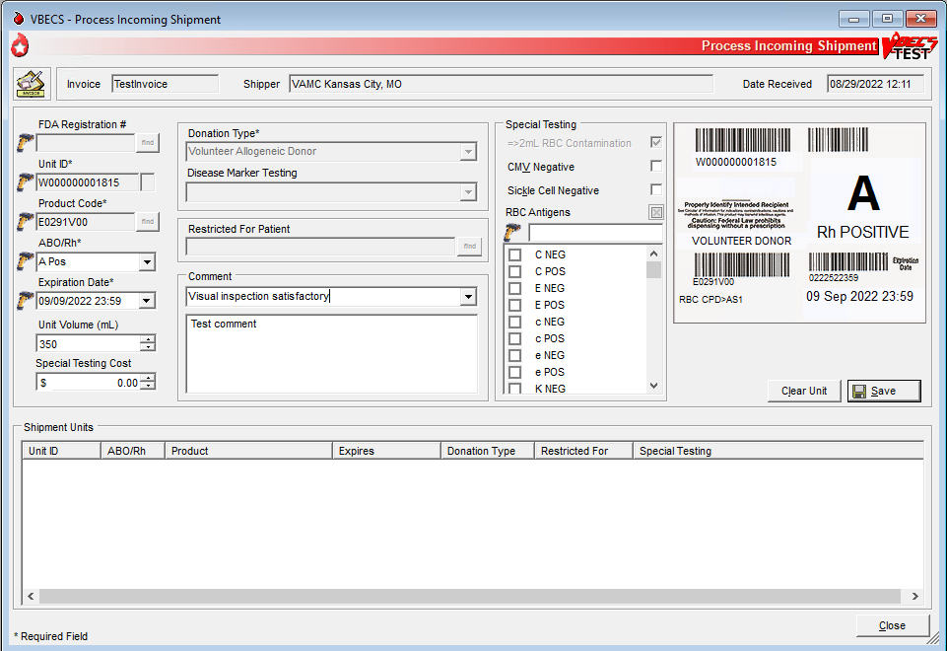

Outgoing Shipment
The user processes and ships available blood units from his division to an outside facility, blood center, or hospital.
The user may edit return credits (additional fees or credits may be issued from one site to another) before processing the shipment.
VBECS generates a shipping invoice.
The user may enter a comment in the ‘Outgoing Shipment’ comment context. The comment will be displayed in the Unit History Report, Outgoing Shipment section.

Assumptions
- Users are authorized to release units from inventory.
- Blood units being shipped:
- Are available for scanning.
- Are located in the user’s division.

Outcome
- An invoice for a confirmed shipment is closed and may not be modified.
- An invoice for a shipment that is not confirmed is open and may be edited.
- The units are not available in the division’s inventory.
- When a unit is transferred out of one division and logged into another division in the database, VBECS keeps the history of the unit individually at both divisions.
- A credit for a returned product may be assigned.
- If workload codes are assigned for this process, workload-related data collected as the result of this process are stored for inclusion in Workload Reports.

Limitations and Restrictions
- A user may edit only unconfirmed invoices.
- The unit testing data displayed on an invoice is limited to 8,000 characters per unit.

Additional Information
- None

User Roles with Access to This Option
All users

Outgoing Shipment
A user ships blood units from his division’s inventory to a facility that is not a transfusion location of his division. These units were removed from inventory and are available for scanning and packaging.
The user identifies the shipment destination, scans the unit ID and product code for the first unit in the shipment, and repeats this process for each unit added to the shipment. The user completes the data entry and then reviews and accepts the shipment information. A user may edit return credits (additional fees or credits may be issued from one site to another) before confirming the shipment. When the shipment is confirmed, the user may print a shipping invoice.
VBECS generates an invoice that includes information for the blood units.
User Action | VBECS
- Select Shipments from the main menu.  Select Outgoing Shipment. | - Displays options for processing shipments.  - Displays options for selecting a new invoice or an existing (recent) invoice.
- To process a new invoice, select New Invoice. (To process an existing invoice, continue at Step 3.)  Enter the invoice number provided by the outside facility or leave the Invoice Number field blank.  Select a shipment destination from the drop-down list.  Click the Return to Shipper or Send to Unrelated Shipper radio button to select a shipment type (Figure 48).  Continue at Step 4. | - Displays fields for entering shipment information.  - Generates an invoice number when the Invoice Number field is blank.  NOTES  To select an existing invoice while in the new invoice window, click Use Existing Invoice.  The combination of invoice number and shipper uniquely identifies an outgoing shipment for data retrieval.
- To process an existing invoice, select Recent Invoice from the Outgoing Shipment menu.  Select an invoice. | - Displays a list of open (unconfirmed) invoices.  NOTES  To select a new invoice while in the existing invoice window, click Create New Invoice.  A user may edit only saved, unconfirmed invoices.
- Click OK to proceed to unit selection (Figure 48). | - Displays fields for entering unit information.
- For each unit to be added to the shipping invoice, scan the unit ID and product barcodes or enter them in the Unit ID and Product fields.  Click Select to add the entered unit to the shipping invoice or click Clear to remove the entered unit (Figure 49).  Respond to warnings, when indicated. | - Displays corresponding unit data.  - Adds the unit to the list of selected units.  NOTES  VBECS allows the shipment or transfer of units located only in the same division as the user and in the blood bank (for “Limited,” “Available,” “Assigned,” and “Crossmatched” unit statuses only).  When a unit is quarantined, VBECS warns the user.  When a unit is expired, VBECS warns the user.  When units selected for shipment are assigned or crossmatched to a patient, VBECS warns the user and asks the user whether to release the unit before shipping.  Yes releases all patient assignments from the unit prior to adding the unit to the invoice.  The confirmation message displays: “Are you sure you want to add this unit? By clicking Yes, you acknowledge that you have inspected this unit and it is satisfactory.”  If the user clicks Yes, the unit is added to the selected units list. When the user clicks No, the unit is cleared. The visual inspection indicator will be displayed in the Unit History Report, Outgoing Shipment section.
- To change the return credit amount for a unit in a “Return to Shipper” unconfirmed shipment, select a unit and click Return Credit.  Enter the return credit amount.  Click OK to save the amount entered or Cancel to return to the invoice. | - Displays the unit’s financial information and allows the user to edit the return credit amount.  - Prompts the user to accept the new amount.  - Returns to the invoice and displays the return credit amount on the invoice.  NOTES  VBECS applies a return credit (equal to the return credit percentage of the original cost of the unit) to units processed in an outgoing shipment to the original shipper. Users may edit return credits for individual units.
- To add or edit a comment for a unit, select a unit from the list of selected units and click Comment (Figure 50). | - Displays the current unit's outgoing shipment comment, allowing edit of the comment.  NOTES  The user may select an "Outgoing Shipment" canned comment context and enter free text details. The comment will be displayed in the Unit History Report, Outgoing Shipment section and printed invoice.
- Repeat Steps 5, 6 and 7 until all units for the current invoice are entered.  Click Save to save the information entered (Figure 51) and Yes to confirm the save. | - Confirms the user action. Yes saves all changes to the invoice.
- To cancel the shipment, click Cancel Shipment. | - Confirms the user action. Yes deletes the invoice and all selected units are returned to their previous status.  NOTES  Canceled shipments are not visible on any report or menu option within VBECS.
- To confirm the shipment, it must first be saved. Click Confirm Shipment. | - Displays an “Edit Shipment Date” window.
- Select or edit the date and time in the Shipment Date/Time field (Figure 52).  Click OK to save the information entered or Cancel to return to leave the invoice unconfirmed. | - Displays shipment information, including the shipment date and time. When a user accepts the entered date and time, displays the invoice to be printed.  - Updates the status of each unit in the shipment to show that each unit was transferred to the ship-to facility and assigns the shipment date and time as the date and time of the transaction.  NOTES  When VBECS confirms an outgoing shipment, it:  - Upon confirmation of an outgoing shipment, the system updates the unit record with the shipment information. The system updates the status of each unit in the shipment to “transferred”.  - (Transfusion-Only division configuration only) removes the unit restriction.  - The system captures the logged on user as the processed by information (Tech ID, print Tech name). The date and time entered are saved as the actual date/time of shipment. No future date/time may be entered. A default of the current date/time is displayed for the user to accept or edit.
- Click Print Invoice to generate and view an invoice or click Cancel to exit. | - Displays the information to be printed on the invoice.  - Displays an option to send the shipping invoice to a printer.  NOTES  When a shipment is saved but not confirmed, VBECS displays “NOT CONFIRMED” as the shipment date.  The shipping invoice includes patient restriction, quarantine status, biohazard information, antigen typing (specificity and interpretation only), special testing information, the autologous unit testing status, and comment.
Figure 49: Process Outgoing Shipment
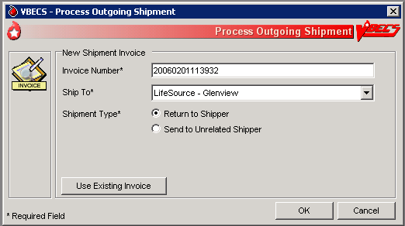
Figure 50: Select Units
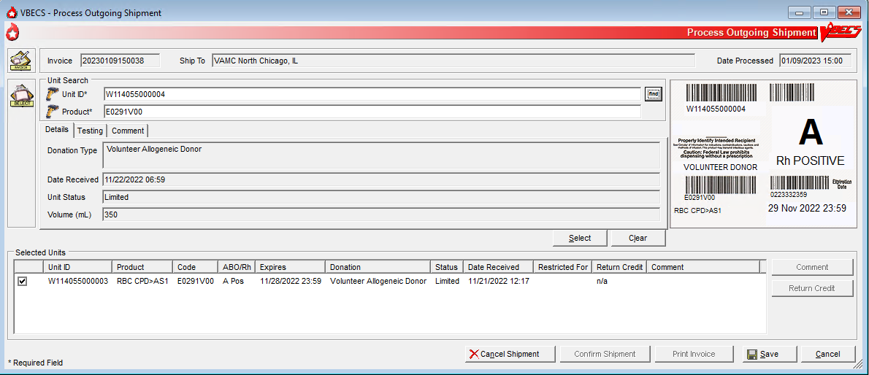
Figure 51: Outgoing Shipment Comment
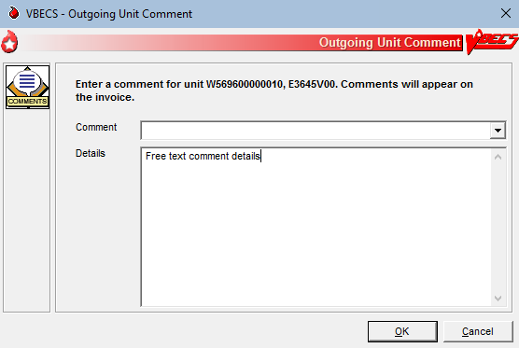
Figure 52: Saving Outgoing Shipment
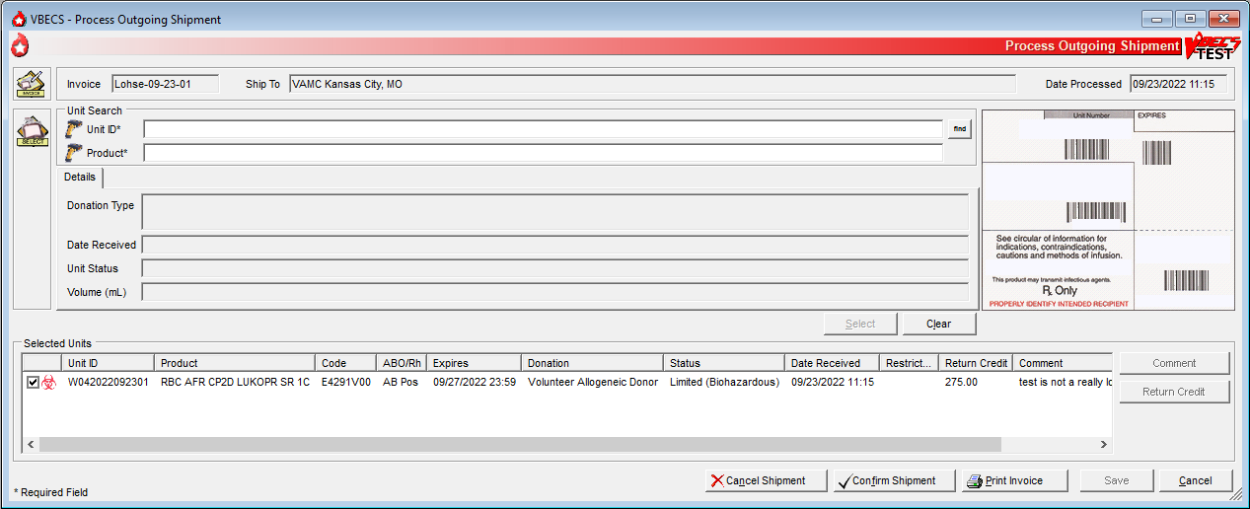

Figure 53: Confirm Shipment Date
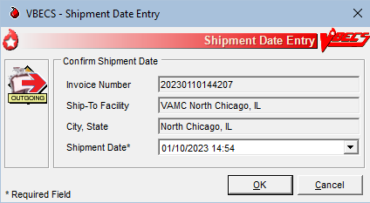

Edit Invoice Text
VBECS includes a shipping invoice. The user may edit the explanatory text above the signature on the last page of a shipping invoice.

Assumptions
- Information on the outgoing shipment invoice is generated during Outgoing Shipment.

Outcome
- A division customized the text displayed on an outgoing shipment invoice.

Limitations and Restrictions
- None

Additional Information
- The default explanatory text reads: “I certify that the blood products listed were properly maintained, in accordance with the Code of Federal Regulations, while in storage at this institution. Components were inspected when packed for shipment and found to be satisfactory in color and appearance.”

User Roles with Access to This Option
 Enhanced Supervisor

Edit Invoice Text
The blood bank user needs to edit the shipping invoice text box to conform to changes in regulations or division requirements. When the edit is complete, the user saves the altered text for future shipping invoices. An audit trail of changes is maintained.
User Action | VBECS
- Select Shipments from the main menu.  Select Edit Invoice Text. | - Displays options for processing blood product shipments.  - Displays the current text for outgoing shipment invoice.
- Edit the text. | - Displays entered data and changes for review.  - Prompts the user to save or reject the changes.
- Review the changes.  Click OK to save the text.  Click Yes to confirm the save and exit. | - Saves the new text and makes it available for outgoing shipment invoices.

Unit Search Screen
VBECS displays the Unit Search screen (Figure 53) when the user clicks the find button to select a unit through some of the Blood Units, Patients, Shipments, and Supervisor main menu items. The title of the screen may vary (e.g., Select Unit for Printing, Unit ABO/Rh Confirmation, Unit Antigen Typing, Edit Unit Information) depending on the option selected. (The user then selects criteria to continue the search.)
User Action | VBECS
- Select an item from the main menu and the desired option.  Click additional buttons as needed. | - Displays the Unit Search screen.  NOTES  Although multiple search criteria can be checked, the Unit Search screen performs independent searches not a summary search for all the selected variables.  Users can obtain a listing of all available unit specifics by creating a custom Blood Availability Report allowing them to make the appropriate selections without looking at each unit’s record.
- To search for a unit, enter the full or partial unit ID and click the find button, or just click the find button (Figure 53).  Click a check box to select a unit.  Click OK. | - Lists units that meet the search criteria.  - Displays unit-associated data.  NOTES  To speed the search, enter a full or partial unit ID instead of just clicking the find button (which causes VBECS to search the entire database and takes longer).
VBECS checks unit IDs and product codes after the user enters the product code. When there is a discrepancy, VBECS displays the Input Error icon and allows the user to edit the data.
Figure 54: Click the Find Button
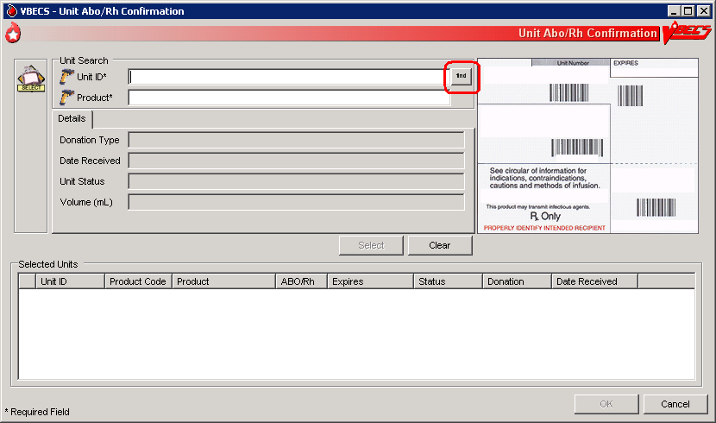
Figure 55: Display Unit Search Screen
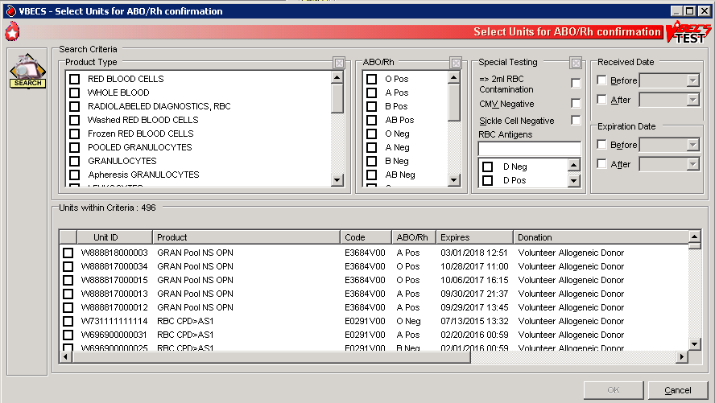

Test Units

ABO/Rh Confirmation
Blood products that contain equal to or greater than (= >) of red blood cells (Red Blood Cells, Whole Blood, Granulocytes and Leukocytes) require ABO/Rh confirmation. The user may process ABO/Rh confirmation results by selecting an invoice or individual units of blood received in a shipment. VBECS records the ABO/Rh test results for the list of blood units tested.

Assumptions
- The division is “full service.”
- A unit’s labeled ABO/Rh was entered in the same division as the user during login of an incoming shipment.
- Only invoices processed within a user’s division may be accessed to create an ABO/Rh confirmation worklist.

Outcome
- Unit ABO/Rh observed test results and interpretations are available for selection for patient use.

Limitations and Restrictions
- This option is disabled for transfusion-only facilities.
- When building a worklist by invoice number, only invoiced units not previously tested and confirmed appear on the worklist. The user may deselect or add additional units.
- For batch processing, the user can select incoming shipment invoices from his division, processed within the previous five days.
- VBECS does not display product codes associated with unit IDs in ABO/Rh Confirmation. Therefore, do not create ABO/Rh confirmation worklists containing units with the same unit ID.
- POOLED GRANULOCYTES labeled with an Rh type of “Pooled” is considered an Rh Positive unit which does not require confirmation testing.
- POOLED GRANULOCYTES labeled with an ABO group of “Pooled” cannot be confirmed. A blood component unit received as “POOLED ABO” will have to be transfused using the Supervisory option, Document ABO Incompatible Transfusion.
- Patient assignment is not released automatically when a unit is quarantined due to discrepant ABO/Rh retype testing. The unit is quarantined and cannot be selected for a different patient or issued for the current patient. Quarantined units are clearly marked in VBECS and cannot be issued.

Additional Information
- Within a multidivisional facility when ABO/Rh confirmation is repeated on units from a facility within the same database, both the originating facility ABO/Rh confirmation testing results and the current testing results are stored.

User Roles with Access to This Option
All users

ABO/Rh Confirmation Testing
To confirm ABO/Rh testing, the user creates a worklist of individual units from an invoice, or creates a custom worklist. The user records observed test reactions and interpretations. VBECS uses truth tables to verify that user-entered interpretations are consistent with observed reactions. VBECS compares ABO and/or Rh interpretations to units labeled “ABO/Rh” during login and displays warnings when there are inconsistencies.
When a unit’s ABO/Rh confirmation test is repeated after issue to a patient, VBECS does not compare the test results to the patient’s blood type at time of issue. The user must detect discrepancies and notify clinical personnel, in accordance with local policy.
User Action | VBECS
- When processing a shipment, select Shipments from the main menu.  When processing selected units, select Blood Units from the main menu.  Select ABO/Rh Confirmation.  Select an invoice or units.  Click OK. | - Displays options for processing blood product shipments. By default, displays units in the worklist in the order in which they were entered during Incoming Shipment.  - Lists invoices processed within the last five days in reverse chronological order.  - Displays fields for entering rack information.  - Allows units to be deleted from or added to the worklist.  NOTES  The user may select only active units and those not in an inactive or final status.  To create a customized list of units:  - Enter a unit ID or click the find button to search for a unit. VBECS lists units with “limited” status.  - Select parameters from the options on the Select Units for ABO/Rh Confirmation screen.  - Select Units within Criteria to work with.  - Click OK.  - Repeat this step until all units are included in the Selected Units list on the Unit ABO/Rh Confirmation screen.  - Click OK.
- Select a rack.  Select a date or accept the default.  Select a Tested By name.  Click Using Automated Instrument, as appropriate.  Click the Perform Anti-D Testing check box, when appropriate.  Click OK. | - Displays the racks available using the pick list provided.  - Displays the date and time testing was performed. The default is the current date and time. The date may be edited using the pick list provided.  - Displays the testing technologist’s identification. The default is the current user. Select a name from the pick list of valid division users to show a different testing technologist.  - Displays warnings and the option to indicate that the user is ready to begin entering results after all warnings are addressed.  - Generates an Exception Report entry when the user inactivates or deletes the partially completed result grids and enters a comment.  NOTES  A user may disable the anti-D testing grid column in the ABO/Rh unit confirmation worksheet. When the Anti-D testing grid display is disabled, the user may select only RH Positive labeled units for confirmation testing.
- Select a unit for which to record test results.  Select a cell and enter an observed test result from the legend at the bottom of the screen.  Enter a valid interpretation, then press the Enter key to go to the next data grid interpretation or Comment cell.  Select enter comments from the Unit Testing for the ABO and Rh interpretations, as needed.  Repeat until all test results for the selected unit are entered. | - Creates a grid for data entry of results and interpretations, displaying units in the order selected.  - Allows the user to select a blood test type and enter a test result for the unit.  - Restricts data entry to valid selections for testing results. Displays testing results and interpretations entered.  - An interpretation indicates that all appropriate test results were entered for the unit.  NOTES   VBECS emits an audible alert and generates a warning requiring override when the ABO and/or Rh confirmation interpretation does not match the ABO and/or Rh of the unit at initial login. When the user confirms the discrepancy, inventory units whose ABO/Rh confirmation does not match the ABO/Rh at login are marked “Quarantined.” VBECS captures details for inclusion in an Exception Report (exception type: Unit ABO/Rh login vs. confirmation do not match, unit quarantined).  ABO/Rh confirmation testing data grids accommodate uniform data entry for Forward ABO testing.  The cursor moves with a single valid keystroke from the top left cell across the row, returning to the leftmost cell in the next row, and so on down the worksheet grid. The cursor stays in the reaction results cells by default (the technologist may use the mouse to click in the interpretation area) until the last entry is made in the reaction result portion of the grid. The cursor then goes to the first (top) interpretation cell.  The user may enter free-text comments or comments from the Unit Testing for the ABO and Rh interpretations (Table 4).  Table 4: Valid Interpretations  When a user saves a partially completed ABO/Rh testing worklist, VBECS clears unit entries with incomplete or no results, releases them from the worklist, and makes them available for inclusion in a future worklist.  Row validation is established for the interpretation vs. reaction results pattern by system rules.  ABO/Rh interpretations are consistent with observed test results based on system rules. Discrepancies are resolved before VBECS can verify ABO/Rh confirmation results and add them to the database. The user may reenter valid results or delete entries and start over.
  ABO | Rh
  A | P, POS (positive)
  B | N, NEG (negative)
  AB | I, Inconclusive
  O
  I, Inconclusive
- Confirm that all results were reviewed and are acceptable. | - Repeats data validation and prompts the user to save.  NOTES  VBECS warns that it doesn’t save partially completed unit ABO/Rh confirmation worksheets.   When VBECS verifies that the ABO or Rh interpretation is “Inconclusive,” it assigns the unit a “Quarantine” indicator, emits an audible alert, and captures details for inclusion in an Exception Report (exception type: Unit ABO/Rh confirmation Inconclusive, unit quarantined). An Exception Report entry is not created when a unit is resulted as weak D positive or weak D inconclusive and is properly quarantined.  Upon successful completion of ABO/Rh confirmation, the unit status is updated. Successful completion means that the ABO and Rh (if required) interpretation is consistent with recorded observed results and matches the ABO/Rh at unit login and any repeat ABO/Rh tests on the unit that are not invalidated.
- Click OK to save the ABO/Rh confirmation testing. | - Prompts the user to confirm that all results were reviewed and are acceptable.
- Click OK.

Unit Antigen Typing
The user performs antigen typing for one or more of the antigens in a blood unit and records the results in a worklist.

Assumptions
- The division is “full service”.
- The units and the user are in the same division.
- Antiserum inventory is entered during Log In Reagents.

Outcome
- Antigen typing was applied in the unit record for informational purposes in other options.
- VBECS stores the lot number, vial identifier, manufacturer, and expiration date of the positive and negative control cells with the testing record.
- If workload codes are assigned for this process, workload-related data collected as the result of this process are stored for inclusion in Workload Reports.

Limitations and Restrictions
- Antigen typing applies only to red blood cell antigens. This option does not address platelet, histocompatibility locus antigens (HLAs), or Immunoglobulin A (IgA) antigenicity.
- Only blood units of the “WHOLE BLOOD” and “RED BLOOD CELLS” ICCBBA component classes can be selected for inclusion in the antigen type worklist.
- Antigen typing is not required on products with = > 2 mL of RBC contamination that are not Red Blood Cells or Whole Blood.
- VBECS does not check whether the lot and vial numbers selected for the positive control cells differ from those of the negative control cells.
- D antigen typing must not be combined in batch testing of Rh positive units.
- The sort order of the selected units may not be inherited by the testing grid. Organize physical test materials according to the order of units presented on the testing grid.

Additional Information
- This option is disabled for transfusion-only facilities.
- Clinical significance and availability of typing reagents are not implied when antigens are included in the list of antigen type tests.
- A CPRS patient order is not required to perform antigen typing of units.
- A user may query the database for the presence of antigen-typed units and display or print the query results in Blood Availability.
- A user may retrieve evidence of antigen typing for any date or date range. Regulatory agencies require documentation of the reagent name, lot number, reagent expiration date, and positive and negative control.
- A user is required to complete antigen typing QC in order to save test results. If an antigen testing worklist is started but not saved and a second testing worklist is started for the same antigen, the QC grid will display and require completion because the first worklist has not been saved.
- When invalidating results from Unit Antigen Typing, the Exception Report does not show all invalidated values. View the invalidated tests on the Testing Worklist Report and the Unit History Report.

User Roles with Access to This Option
All users

Unit Antigen Typing
The user performs antigen typing for one or more of the antigens on blood units. VBECS creates a list of available antigen specificities, including weak D, that can be tested. For each antigen tested, the user must select a reagent from available inventory. VBECS will check to see if valid positive and negative controls were tested for the selected reagent on the calendar day of testing. When controls are not tested, VBECS adds tests for the positive and negative controls to the worksheet.
Red cell units prepared for patient transfusion may need to be negative for this antibody specificity based on their setting in the antibody table defined in Antibodies.
Deletion of a partially completed antigen typing worklist invalidates any completed tests contained on the worklist regardless of the status of the unit, including transfused units.
It is the user’s responsibility to verify that the records are being invalidated appropriately.

User Action | VBECS
- Select Blood Units from the main menu.  Select Unit Antigen Typing. | - Displays options for processing blood units.  - Displays options for processing antisera.
- Click Create New Worklist  (Figure 55, Figure 56).  When partially completed worklists exist, click a check box to select an existing worklist and go to Step 5 (Figure 57).  Click Delete to delete the worklist from the list or OK to continue. | - Accommodates selection of a partially completed testing worklist or creation of a new testing worklist.  - Displays an option to select or delete a partially completed worksheet.  - When selecting a partially completed worklist, the user verifies the lot numbers, manufacturer name, and expiration date of the antiserum and control cells previously selected. These may not be edited. When a discrepancy is found, the user must delete the worklist and start over.  NOTES  VBECS displays the date and time the testing was performed (default: current date and time). These are editable to allow for retrospective entry.  VBECS displays the testing technologist ID (default: current user). A pick list of valid division users is available for the user’s selection.  When an automated instrument was used for testing, the user enters the name of the instrument and may indicate that successful quality control testing was done for the date.
- To create a new testing worklist, select a date or accept the default.  Select a “Tested By” name.  Click a radio button to select Tube, Gel, or Solid Phase.  Click Using Automated Instrument, as appropriate.  Click OK. | - Displays an option to select antiserum types.  - Displays an option to select a lot number for each antiserum type selected.  - Displays the lot number information.  - Prompts the user to select the correct antiserum entry for the specificity selected.  NOTES  VBECS lists available antigen type tests from which the user may select and allows the user to enter the specificity to expedite the search. The list of antigen type tests is derived from the Corresponding Antigens field from Appendix B: Table 14: Antibody and Antigen Table: Irregular Antibodies.   VBECS displays data fields for the user to select or enter the lot number, and displays the manufacturer and expiration date of each antiserum to be used in this transaction to allow the user to choose the correct antiserum. VBECS displays in-date antisera and allows the selection of outdated antisera, if needed, emits an audible alert, and requires an override and generation of an Exception Report (exception type: expired antisera used). A comment from the "Unit Testing" context is required.   When a user attempts to change the phases of reactivity, VBECS emits an audible alert, warns that the user selected phases that were not used previously for this reagent, and asks whether the user wishes to continue.  No returns the user to the screen to select the correct testing phases. Yes requires the user to enter a comment from the “Reagent and Supply” context explaining why different testing phases are selected, and captures details for inclusion in an Exception Report (exception type: antigen testing phase change).  When a user selects a reagent rack for which quality control (QC) testing was never performed in Enter Daily QC Results, VBECS displays a warning message, clears the selection, and allows the user to select a different rack.  When the user QC’d the antigen typing reagent lot number and performed patient antigen typing on the same date under different testing phases, VBECS enables the QC grid for the antisera in the phases the user selected.
- Define the antiserum used.  Enter a lot number for each antiserum specificity.  Select the testing phase:  - IS  - IS/RT  - IS/37  - AHG/CC.  Select the rack, if applicable.  Select Add.  Select additional antisera, if desired.  Respond to warnings and enter comments, when indicated.  Select OK (Figure 58). | - Displays an option to select the testing phases for the antiserum specificity by lot number.  - Displays a testing grid disabling the phases not to be entered.  - Stores the antiserum information and checks whether the positive and negative controls need to be tested with this batch.  - Prompts the user to enter the lot number and vial identifier for the positive and negative control used for each antiserum tested.  NOTES  When VBECS displays lot numbers for selection, it checks the inventory system for the reagent name and lot numbers in a rack. The user cannot force the entry of a lot number that VBECS disallowed on the selection list. The user must choose a different reagent. The user may not select a reagent with an “unsatisfactory” value in the Inspection field or with a quantity of zero.   VBECS compares the expiration date of each reagent on the selected rack to the testing date, emits an audible alert, and warns when the reagent is expired.  VBECS enables the rack identifier field when a user selects the weak D or AHG/CC phase and disables the field when a user selects other phases.  VBECS automatically adds the positive and negative control tests to the selected reagent type worklist if they have not been tested on that calendar date for the selected antisera lot number.  Reagent lot numbers that are selectable for positive and negative control cells:  - Reverse ABO Typing Cells (set)  - A2 cell (vial)  - Screening Cells (set)  - Check Cells (vial)  - Panel (set)  - Other (set)  VBECS requests information about an antigen lot number only the first time it is used on a specific day.  If there are multiple test tabs, VBECS displays a message that may not correspond to the selected tab, but will correspond to information required by one of the requested tests.
- Select one or more blood units to add to the worklist.  Enter the unit ID and the product code from the inventory, or click the find button to search for a blood unit and select from the list of available units.  Click OK when all units are selected. | - Allows the user to scan or enter units to be included in the worklist or select them from a list.  - Lists the selected units.
- Select the lot number for the reagent and the positive and negative control cells. Enter the vial identifiers, if required. Enter “0” when not using panel cells.  Verify the reagent type and the positive and negative control cell lot numbers selected and vial identifiers entered, if required. | - Displays the reagent type and lot numbers, including the vial identifier.  NOTES  The vial identifier, comprising one or two digits, identifies the vial contained in a kit of reagent red blood cells. A vial contains antigen positive or antigen negative blood cells to be used in quality control of the antisera.
- Respond to warnings and continue with antigen typing.  Review the lot number, manufacturer name, and expiration date for the antiserum and control cells. If they are not correct, start over.  Select a control cell or unit to begin entering serologic reactions and interpretations in the data entry grid. | - Displays each selected unit in a separate tab for each selected specificity with its own grids and quality control.  - Displays a direct data entry (DDE) grid to enter serologic reaction results for antigen typing of units. This may already be filled with results from a previously saved partially completed worksheet.  - Allows a user to select a unit or control cell and enter a test result.  - Allows only valid data entries in the grid reaction result and interpretation cells.  - Restricts data entry to valid selections for testing results.  - Keeps all testing results and entered interpretations on the screen until the user saves them.  NOTES  VBECS displays the worklist for the grids by antiserum types.  Valid observed test results entered by a user:  - 1 [1+ (positive)]  - 2 [2+ (positive)]  - 3 [3+ (positive)]  - 4 [4+ (positive)]  - W [Weak (positive)]  - F [Mixed Field (positive)]  - M [Microscopic (positive)]  - R [rouleaux (negative)]  - 0 (zero) [No Agglutination (negative)]  - X (Not Tested) (does not indicate a disabled cell)  When the AHG phase is selected for testing, the AHG must be negative and the CC must be at least 1+ positive to consider the test negative for a unit or for the negative control cell.  The column heading of the data grid specifies the phases of reactivity that may be used in a test selected for the specificity.  The row heading of the data grid specifies the unit ID being tested. These fields cannot be edited.  The rows for each antiserum type grid display the positive and negative control cells, then units, in the order in which a user added units to the worklist.  A comment can be associated with any antigen test performed. A user may select canned comments required by an override from the drop-down list or select Other to enter free-text comments.
- Enter results for the control cells and for all selected units. Refer to the legend at the bottom of the screen (Figure 59). | - Prompts the user to confirm that all results were reviewed and are acceptable.  NOTES  The positive and/or negative control cell test results on the date of testing must be a valid positive or negative.  When a weak D interpretation is positive or inconclusive and is verified for a tested blood unit that was labeled as (Rh) D negative, VBECS warns the user and adds the quarantine indicator to the unit.  VBECS compares the antigen typing interpretation a user enters to previously assigned antigen typings for the same antigen (as assigned during Incoming Shipment, Edit Unit Information, or previous testing). When the previous interpretation was not “inconclusive” and the current interpretation does not match the previously identified antigen type, VBECS warns the user and quarantines the unit.  When a unit has had a quarantine indicator assigned, VBECS releases any patient assignments. Patient restrictions associated with the unit remain intact.  System rules establish row validation for the interpretation vs. reaction results pattern [for all user-indicated phase(s) of reactivity] for blood unit and quality control tests.
- Repeat Steps 4 through 8 for each antiserum type. | - Displays the option to save.
- Respond to warnings and save. | - Saves the completed QC results with partially or fully completed unit testing data.  - Reconfirms that all appropriate test results were entered, repeats all data validation, and saves the information on the worksheet displayed.  NOTES  VBECS saves the testing of one antiserum specificity at a time.  The Positive and Negative control cells must be complete and valid prior to the save of a unit antigen typing result. VBECS will display a tooltip message to the user if an attempt to save is made and the QC is not valid.  VBECS stores the lot number, vial identifier, manufacturer, and expiration date of the positive and negative control cells with the testing record.
- Click OK to exit.
Figure 56: Unit Antigen Typing (Initial screen)
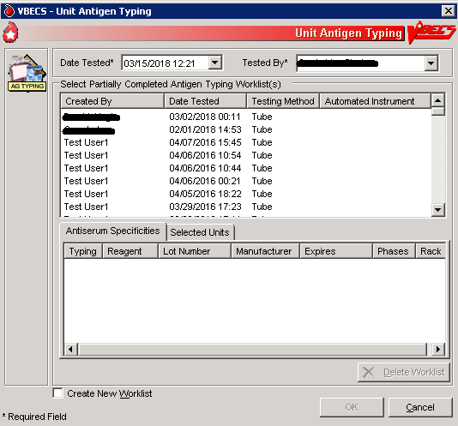
Figure 57: Unit Antigen Typing (New worklist)
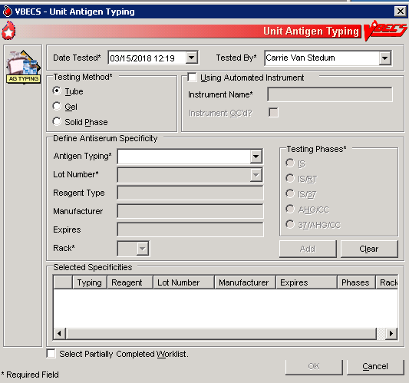
Figure 58: Unit Antigen Typing (Partially Completed Worklist)
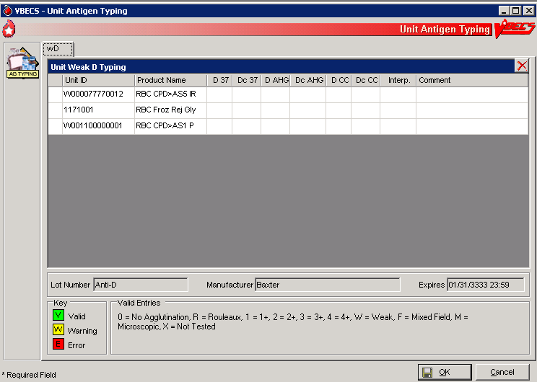
Figure 59: Unit Antigen Typing
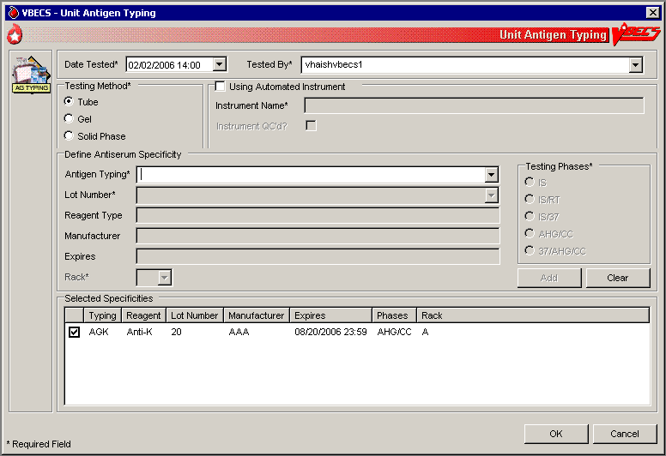
Figure 60: Unit Antigen Typing Serologic Results
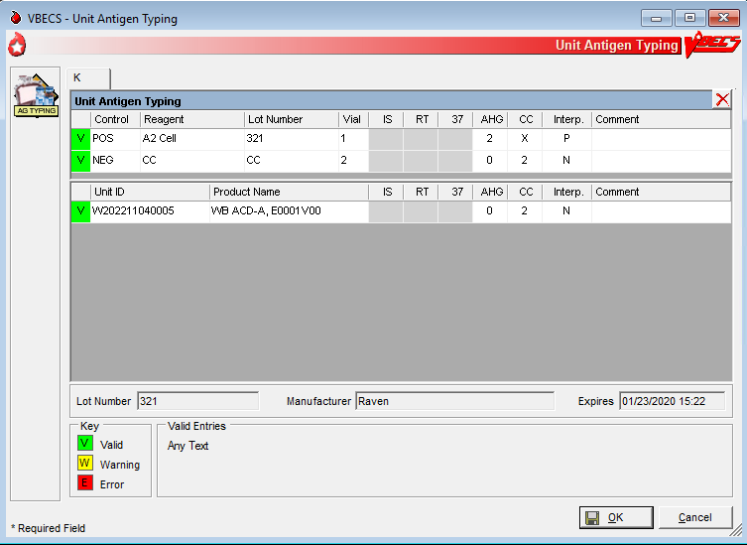

Modify Components

Modify Units
The user modifies a unit, which results in a different blood product (target product) with its own properties. A division’s configuration determines the available modification types.

Assumptions
- Product Modifications was executed.
- The division is the active shipper for target blood products.
- A unit may be modified with or without patient assignment or restriction.
- A unit may be modified with or without a patient order.
- Units selected for modification must be in the same division as the user.
- Product labels and unit numbers for modified products are on hand.
- Supplies needed for the unit modification were entered in VBECS.

Outcome
- Data generated for an Exception Report are stored for inclusion in the next Exception Report.
- If workload codes are assigned for this process, workload-related data collected as the result of this process are stored for inclusion in Workload Reports.
- At the completion of a unit modification, VBECS assigns the original unit a final status of “modified.”
- A permanent virtual link exists between the original unit and target units created.
- The shipper of the target unit created is the division in which the modification was performed. The cost assigned to the target unit is based on what was defined in Blood Products.

Limitations and Restrictions
- VBECS allows modification of units only in limited, assigned, crossmatched, and available statuses.
- VBECS presents the conservative expiration date for target units. VBECS does not know the specific collection details. It is the responsibility of each user to accurately enter and process any one blood unit based on its expiration date/time as labeled by the collection facility.
- Pooling of units that have the attribute form V0013 (irradiated) and attribute V0021005 (psoralen treatment) does not produce a target.

Additional Information
- VBECS requires the identification of the transferred-to container when using an open method or a sterile connection device (SCD).
- VBECS requires the identification of the SCD wafer data when using an SCD.
- When a user extends an expiration date beyond the default expiration date, the override message displays the original expiration date.
- Due to the variations in supplies and equipment used for other modification types, VBECS does not require supply or equipment entry, but allows entry of those data as part of the modification record.
- During the modification options (Modify Units: Pool Units; Modify Units: Split a Unit; Modify Units), a user may select an assigned blood unit for modification and transfer one patient assignment to the target units created.
- To reverse other modifications, remove the “modified” status from each unit through Supervisor Menu, Remove Final Status.
- To edit the number of units in an existing pool, use Add/Remove Units from a Pool.
- The user can scan to select the target, but it will only present the product codes available as a target by VBECS (See FAQ Modification Target Not Available).
- The user can change the expiration date and time prior to completing blood unit’s modification.

User Roles with Access to This Option
All users

Modify Units
The user selects the units to be modified. The user indicates the type of modification to be performed, then enters (preferably by scanning) the unit ID and product code.
VBECS displays a creation date and time (default: current date and time) for the target units, which the user may change to a date and time in the past and not before the login date and time of the original unit. VBECS calculates a new expiration date for the target unit (based on the creation date and time, modification type, method, and original unit product type) and records the date and time the original unit was modified. Some modification procedures require materials in addition to the new container. VBECS requires the entry of a new container lot number and SCD wafer, if indicated.
The modified target unit is now available for use.
User Action | VBECS
- Select Blood Units from the main menu.  Select Modify Units. | - Displays options for processing blood units.  - Displays valid modification options configured for the division and allows the user to select an option.
- Enter the date and time of the unit modification.  Enter the name of the user who modifies the unit. | - Displays the default (current) date and time as the modification date and time.  - Allows the user to change the date and time to a past date and time.  NOTES  The user may not enter a future date and time.  When a unit is modified, the processing fee is added to the cost of a modified unit target.  A single unit modification has the processing fee added to the target unit.  When split, the processing fee is divided and a portion is added to each target unit.  When pooling, the processing fee is multiplied for each original unit included in the pool.
- Click a radio button to select a modification type:  - Thaw  - Pool (See Modify Units: Pool Units.)  - Thaw/Pool Cryo (See Modify Units: Pool Units.)  - Split/Divide (See Modify Units: Split a Unit.)  - Irradiate  - Leukoreduce  - Volume Reduce  - Wash  - Rejuvenate  - Freeze  - Deglycerolize  - Add/Remove Units from Pool (See Add/Remove Units from a Pool.) | - Allows the user to enter data based on the modification type selected.  - Allows the user to select a different processing technologist.  - Displays only modifications enabled for the division.
- Click a radio button to select a modification method, if required:  - Open  - Closed  - Sterile Connection Device  (Figure 60)  Click the Weld Complete or Weld Incomplete radio button to indicate the integrity of the SCD weld, when indicated. | - Displays the selected method.  NOTES  VBECS stores the date and time for the original unit when it is modified. The modification date and time are also stored as the creation time for the target unit for splits and pools only.  When the modification method is “Open” or “Sterile Connection Device (SCD),” the user must select a container supply type. When the modification method is “Closed,” VBECS does not allow the user to select a container supply type.  For an SCD modification method, the user must indicate the completeness of the weld, in accordance with local policy and procedures. VBECS defines weld status as:  - Complete: the weld is complete and has no leakage or air bubbles.  - Incomplete: the weld has a leak or air bubbles are present. VBECS changes the expiration date and time of the unit to those of an open system for that product type. VBECS stores this weld check with the historic record of the target unit created in the modification.  The system stores this weld check with the longitudinal record of the target unit created.
- Click OK to accept the selected method, or edit it. | - Allows the user to scan, enter, or select units to modify.
- Scan, enter, or select the ID and product code of the unit to be modified. | - Displays current data for the selected unit.  - Verifies the appropriateness of the selected unit based on system rules and truth tables and displays error and warning messages based on the modification type selected and the user’s security level.  - Prompts the user to continue with the selected unit or select a new unit based on the data in the review window.  NOTES  The modification types are presented in the sort order displayed followed by Add/Remove Units from Pool.  The user may select only active units and those not in an inactive or final status.  When the user selects a status other than “limited,” “available,” “assigned,” or “crossmatched” for an original unit, VBECS warns the user. There is no override.  When the selected unit is not appropriate for the modification type selected, VBECS warns the user and instructs him to verify the selected unit and modification type. There is no override. When the unit is expired or quarantined, VBECS displays an error message. When multiple selected units that individually may be pooled or thaw/pooled, but together do not have a target product, the system does not display this warning message.  The user may select units containing red blood cells chosen for rejuvenation within three full days past their labeled expiration date. (For example, when a unit’s expiration date is the current day, VBECS counts this day as “day 0,” the next day as “day 1,” etc. The last acceptable date and time for selection is day 3 at 23:59). After this three-day period, VBECS considers the unit to be expired.  When the modification type is “volume reduce,” VBECS records the discarded plasma volume on the unit record. Otherwise, the user may not edit the Discarded Plasma Volume field. The discarded plasma volume may not be “0” (zero).   See Table 5 for alerts that may occur during this option.
- Click OK to accept the unit for modification. | - When the modification type is “thaw” or “irradiate,” allows the user to select additional units to process or to continue processing the selected units. Otherwise, go to Step 8.  NOTES  The user may process multiple products in a batch when the units are thawed or irradiated. The creation date and time apply to all units in the batch.  VBECS records the codes/costs assigned or unassigned with a date/time stamp and the user ID and user name on any reports of the person creating the update.
- Click the Container, Supplies, Equipment, or SCD Wafer tab and enter another supply and/or equipment lot or ID number (Figure 61). | - Calculates and displays a default expiration date and time of the target unit based on rules specific to the original blood product, the modification type, and processing conditions (open, closed); prompts the user to accept the date and time; and allows the user to edit them.  NOTES  VBECS maintains lot and ID numbers entered, the new container lot number in the unit modification record, and the historic record of the target unit.  VBECS checks the inventory system for the supply name, lot numbers, expiration date, and a quantity greater than “0” (zero). VBECS does not allow the user to select supplies with an “unsatisfactory” value in the Inspection field. When the user enters an unsatisfactory supply lot number, VBECS warns the user. The user must select a different supply item.   See Table 5 for alerts that may occur during this option.
- Select a target product type from the drop-down list in the Product field. | - Displays target component types for the modification, conditions selected, and the original unit product type, and allows the user to select a single product type.  - Verifies that an active target component was selected and warns the user.  - Allows the user to enter lot and ID numbers (with auto-completion) or select multiple items from the supply and equipment lists.  - Warns that the target unit is not active and allows the user to activate the target component.  NOTES  The user must select a modification method (open, closed, Sterile Connection Device) for modification types.  VBECS displays available target component types based on ISBT 128 modification rules and site parameters for the division. When no target is found, VBECS indicates this to the user and prevents the modification from being saved.  When the user selects a target component type not marked as active, VBECS warns the user, allows him to mark the target component as active, and returns him to this step in the modification process. Otherwise, VBECS returns the user to this step and allows him to select another target component type.  When the original unit type did not require ABO/Rh confirmation, the target unit, when created, does not either. The target unit is immediately available for assignment, crossmatch, issue, or transfusion on completion of the modification.  When the original (parent) unit type required ABO/Rh confirmation, the target (child) unit, when created, does too.  - If the target is not inheriting ABORh confirmation testing, then the target unit’s status is Limited.  - If the target is inheriting ABORh confirmation testing, then the target unit is immediately available for assignment, crossmatch, issuance, or transfusion upon completion of modification.  When the original unit is assigned or crossmatched to a patient at the time of modification, VBECS notifies the user and asks whether he wishes to automatically assign the modified units to the patient. Yes (default) applies the unit’s assignment or crossmatch data to the target component. No does not apply the assignment to the target, and changes the target unit status to “available.” The original unit retains patient assignment in both cases.  The user may select the target product code from available targets by scanning.  When the Blood Group (V0076) attribute group, is present in the original it is required in the target but is not used by VBECS.  When a unit is modified, the processing fee as set in Configure Division is added to the cost of a modified unit target.  When split, the processing fee is divided and a portion is added to each target unit.   See Table 5 for alerts that may occur during this option.
- Accept or edit the expiration date. | - Verifies the validity of the expiration date and warns the user, if indicated.  NOTES  VBECS calculates an expiration date for the target component type and the system integrity (Open or Closed).  The system will calculate an expiration date for the target component based on the following. (Due to the nature of the process, the calculated expiration date will greatly exceed the original expiration date of the original unit for Rejuvenate and Freeze, and will supersede the unit’s original expiration date.)  Expiration Date is the shortest of:  - Original unit’s expiration date/time (For Rejuvenate and Freeze, the Original unit’s expiration is not factored in the calculation)  - If Expiration hours is > 0, the Modification date/time + Expiration hours**  - Modification date/time + Target blood product’s maximum storage time (MST)**  **If Expiration hours or Target blood product’s MST is greater than (>) 24 hours: divide the hours by 24 to get the number of days (no rounding); add the number of days to the Modification date/time and the time will be 23:59.
- Review the displayed unit data and click OK to confirm the modification.  If the unit has been relabeled, click Yes to verify the label (Figure 62).  Click No to cancel and continue at Step 14. | - When the original unit is currently assigned to a patient, notifies the user and asks whether he wishes to transfer the status to the target unit.
- Scan the label barcodes to verify the target labels, based on local practice and labeling type of the modified unit.  Enter a comment to complete the verification. (This step is optional.) | - Displays the label verification window.  - Indicates whether the scanned barcodes match those in the label.  - For each target created, system prompts user to indicate readiness to verify the labeling of the modified product.  - No new labels applied to modified product. Proceed to save the unit.  - Displays a screen to accommodate data entry of the modified unit’s:  - ABO/Rh  - Product Code  - Expiration Date  - This step repeats until all targets have been labeled and/or are ready for continued processing.  NOTES  The user may select “Verify modified unit label” to verify the modified unit label. When the user does not verify the label, he must enter a comment and then click Cancel to exit.  When the user does not select “Verify modified unit label,” he may continue at Step 14. VBECS bypasses the label verification and does not create an Exception Report.  When a component is modified and a new label is applied, American Association of Blood Banks (AABB) standards require the labeling process to include a method to ensure the correctness of the unit number, ABO/Rh, expiration date, and component label.  To verify the label, VBECS compares the entered data with the data of the target unit from the database. The user may scan or enter:  - Unit ABO/Rh Label (scan or manual entry)  - Unit Product Code (scan or manual entry)  - Unit Expiration Date (scan or manual entry)  If all comparisons are okay, VBECS displays a message stating that label verification is complete and asks whether the user wishes to continue.  If there is not a match, VBECS provides an audible alert and displays an error message stating that <data element> does NOT match <data element> of record and asks the user to verify labeling and reenter, or select Continue.  If there is a null or no user entry for one of the fields, VBECS displays an error message stating that <data element> was not entered and asks the user to enter a value or select Continue.  If checks were either invalid or incomplete, VBECS will not allow unit issue to this or any other patient. VBECS displays a warning message: “Unit is unacceptable for transfusion. Releasing all patient assignments and quarantining the unit.” VBECS clears the unit data and allows for entry of a different unit number. When the user selects Continue, a comment is required and details are captured in an exception report. Details in the exception report include:  - Exception type: Target Product Label Failed checks  - Type of modification: <insert type defined by the transaction>  - Target Unit ID  - Target Unit ABO/Rh  - Target Unit Product Code  - Target Unit Product (Short) Name  - Target Expiration Date  - Date/Time of Modification (transaction)  - Data Field User Entered Value or “no entry” if null  - Data Field Correct or Expected Value  - Comment  - Modifying Tech ID, print Tech name on report  - Login Tech ID, print Tech name on report  - Division
- Scan or enter each label on the target unit. | - Compares the data entered in each field to the database.  - Asks whether the user wishes to save the data. When the user confirms that the data are correct, notifies him that the label verification is complete.  - Records the modified or restriction-released unit relabeling data as part of the unit record and stores the data for inclusion in the unit history report.  - When the user confirms that the comparisons are correct, notifies him and asks whether he wishes to continue.  NOTES  When there is no previous entry for a field, VBECS notifies the user and instructs him to enter a value or select Cancel.  VBECS requires a comment when the user selects Cancel, and captures details for inclusion in an Exception Report (exception type: target product label failed checks).
- Click OK to confirm the save. | - Saves the new modified unit data.  - Updates the status of the original unit to “modified.”  - Records the unit ID of the target unit on the record of the original unit.  - Prompts the user to modify another unit.  NOTES  The target unit automatically inherits original unit data:  - Additional unit testing (CMV, Sickle Cell, antigen typings, = > 2 mL RBC contamination)  - Unit ABO/Rh (from login)  - ABO/Rh confirmation testing information (when performed)  - Unit ID  - Unit Volume (exceptions – target unit created as a result of Split or Volume Reduce does not inherit original unit volume. Target unit volume must be manually entered for volume reduced units)  - Donation type  - Disease marker testing information, when autologous.  - Restricted for patient name, ID.  - Current status  - Biohazard Indicator  - Quarantine Indicator  - Division
- Repeat Steps 3 through 14 to modify another unit or exit.
Figure 61: Modify Unit(s)
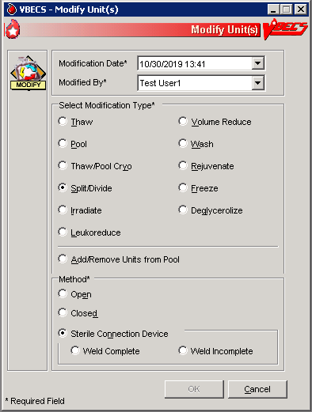
Figure 62: Split/Divide Unit
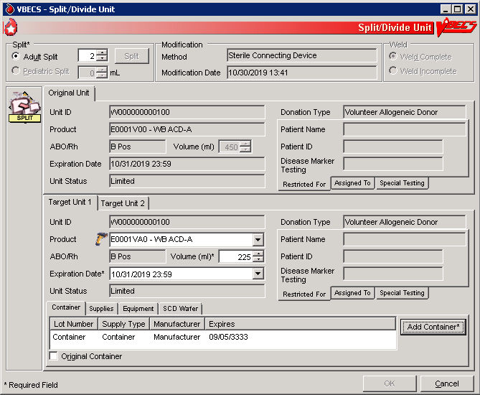
Figure 63: Verify Printed Label
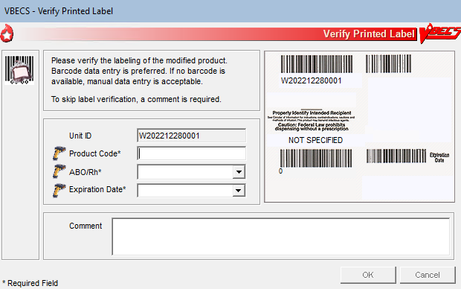

 Alerts
Table 5: Alerts That May Occur in Modify Units
Step | Alerts
6 | VBECS compares the original unit’s expiration date and time to those of the modification to determine whether the selected unit was expired at the time of modification. When the user is a Blood Bank Technologist and the unit selected for modification expired, VBECS emits an audible alert, displays an error message, clears the selected unit, and allows the user to select another unit for modification.   When the user is an Enhanced Technologist and the unit selected for modification is expired, VBECS emits an audible alert, notifies the user, and asks him to verify to continue, or cancel to correct the entry data. Override requires a comment from the “Unit Modification” context and VBECS captures details for inclusion in an Exception Report (exception type: expires unit modified). Cancel clears the selected unit and allows the user to select another unit for modification.
6 | When ABO/Rh confirmation testing is required but not performed, VBECS notifies the user that testing must be completed before issuing a target unit. The user may continue with the modification.
6 | When a unit has an indicator of “quarantined,” VBECS notifies the user that it must be released before processing may continue, clears the selected unit, and allows the user to select another unit.   When the user is an Enhanced Technologist and a unit has an indicator of “quarantined,” VBECS notifies the user that it must be released before processing may continue and asks whether the user wishes to release the unit. Cancel clears the selected unit and allows the user to select another unit. Override releases the unit through Discard or Quarantine.
6 | When the selected unit has a positive biohazard Indicator, VBECS will not allow modification unless the user role is Enhanced Technologist, VBECS security levels 2 and above. When the user role is Technologist, VBECS security level 1, the system emits an audible alert and displays a warning message stating that the user does not have the proper security to perform this function. The system does not allow an override.  When the user role is Enhanced Technologist, VBECS security levels 2 and above, VBECS provides an audible alert and displays a warning message: "<Unit ID, Product Name> is Biohazardous. Do you wish to continue with the modification?" If the user responds “No,” the unit is cleared from the screen and a new unit can be selected. If the user responds “Yes,” a comment (context: Unit modification) is required. Details of this override are captured for inclusion in an exception report.
8 | When a supply item is expired, VBECS emits an audible alert, warns the user, and asks whether the user still wishes to use the item. Yes requires a comment and VBECS captures details for inclusion in an Exception Report (exception type: expires supply used in unit modification). No requires the user to select another supply lot number.
10 | When the user extends the system-recommended expiration date and time, VBECS warns the user, asks him to reenter the unit expiration date, and redisplays the original entry. The user may enter another expiration date and time for the target unit.   When an Enhanced Technologist extends the target unit expiration date and time past the system-recommended expiration date and time, VBECS emits an audible alert, warns the user, and asks whether he wishes to continue. Cancel restores the expiration date. Override allows the user to continue with this date, requires a comment, and captures details for inclusion in an Exception Report (exception type: target product outdate extended). Information about this transaction and the comment are queued for an exception report.
13 | When there is no match, VBECS emits an audible alert, notifies the user, and instructs him to verify the labeling and reenter label data or select Cancel.

Modify Units: Split a Unit
The user selects the unit to be split (divided) for transfusion.

Assumptions
- See Modify Units.

Outcome
- See Modify Units.

Limitations and Restrictions
- A unit previously split in VBECS cannot be split again. Only an ISBT unit that was split outside of VBECS can be split again.
- A unit pooled in VBECS may not be split.
- A unit that has a division code present upon receipt in incoming shipment may be split in VBECS.

Additional Information
- To reverse other modifications, remove the “modified” status from each unit through Supervisor Menu, Remove Final Status.

User Roles with Access to This Option
All users

Modify Units: Split a Unit
The user selects the unit to be split for transfusion. VBECS automatically applies directed and autologous restrictions to aliquots created. The user may or may not maintain patient assignments (usually, these units are crossmatched and available for the patient before the split is made). This section lists only rules unique to the division of a blood unit.
User Action | VBECS
- Select Blood Units from the main menu.  Select Modify Units. | - Displays options for processing blood units.  - Displays valid modification types for selection.
- Click the Split/Divide radio button.  Click a radio button to select a modification method, if required:  - Open  - Closed  - Sterile Connection Device  For a Sterile Connection Device modification method, click the Weld Complete or Weld Incomplete radio button to indicate the condition of the weld.  Click OK. | - Allows the user to search for a unit.
- Select a unit and click OK.  Click Select to confirm the unit selected. | - Displays data for the original and target units.
- Edit the number of adult splits to be created, if required (Figure 61).  Click Split* to verify the number of splits to be created and add the appropriate number of target unit tabs. | - Displays the number of splits to be created (default: 2) for verification.  - Requires entry of the number of splits to be created.  NOTES  The user may split a unit into 2 to 26 subunits (or however many available alphabetic characters remain) until the volume of the original container is consumed. The system will calculate the patient charge of each split (fraction) as its portion of the original unit cost in U.S. dollars ($0,000.00).  When split is selected, users must indicate the number of split units to be created if other than the default number of 2.
- Select or confirm the desired target component type.  Click the Container, Supplies, Equipment, or SCD Wafer tab and enter another supply and/or equipment lot or ID number. | - Allows the user to enter lot and ID numbers or select multiple items from the supply and equipment lists.  NOTES  When multiple aliquot/split units are created, the user must associate a container lot number with each unit created. “Original container” may serve as the lot number for one of the aliquots created.  The original blood facility must keep a record of the original container lot numbers so that, when a lot number is recalled, it is known which patient was exposed to it.  The user may select the target product code from available targets by scanning.  For THAW modification type:  - There is no attribute assigned for thaw.  - The product class, modifier and Blood Core (V001) change.  - The system integrity should not change (V0012)  - Maintain original attribute groups to the target; do not add any attribute values.  - Maintain the original anticoagulant or NS.  - Temperature must change to a non-frozen temperature  - Target volume may be XX, or match the volume of the parent
- Accept or edit the displayed expiration date. | - Displays the expiration date.  - Calculates and displays the volume of each split unit.  NOTES  VBECS calculates and displays default volumes for each target split (does not include pediatric aliquots) based on the volume of the original unit and the number of splits being created, consuming the total volume of the original unit. The system will restrict the user to enter a value between 1 and 2000.  The system will split the volume evenly among the splits and add the remainder to the first split.
- Accept or edit the displayed unit volumes. | - Displays the original and target unit data for review.  NOTES  The user may not edit original unit data.  For Split modification type:  - Do not allow splitting frozen products.  - There is no attribute assigned for split.  - Maintain original product type attributes to the target.
- Review the displayed data for the target units and confirm the modification type. | - Displays the target unit’s ID number.  NOTES  - ISBT 128: the unit ID, five-digit product description code, and sixth-character donation code remain the same. Characters 7 and 8 of the ISBT 128 product code barcode reflect the aliquot level: when a previously undivided unit is split, character 7 of the unique eight-digit ISBT 128 product code is incremented alphabetically in uppercase letters, resulting in characters 7 and 8: A0, B0, C0, D0 … Z0.
- Click OK to save.  Click Yes to verify the label. | - Prompts the user to save the data, including patient assignment and restriction information, if any.  - Saves aliquots created from the modified unit.  - Records the unit ID of the target unit on the record of the original unit.  - Saves only the technologist name and the date and time the label was verified. When the user indicates that a new label applied fails to complete the verification process, releases the assignment, quarantines the unit, and captures details for inclusion in an Exception Report (exception type: target product label failed checks).
- Click Yes to save.  Repeat Steps 2 through 9 to split additional units, or return to Step 1 to use a different modification method on another unit. | - Prompts the user to split or modify another unit.
- Exit.

Modify Units: Pool Units
The user selects units to be pooled.

Assumptions
- See Modify Units.

Outcome
- See Modify Units.

Limitations and Restrictions
- VBECS allows modification of units only in limited, assigned, crossmatched, and available statuses.
- When a user adds a biohazardous unit to a pool, VBECS does not designate the pool as biohazardous on the Blood Transfusion Record Form (BTRF) or Caution Tag.

Additional Information
- When autologous or directed units are pooled, the “restricted for” patient must be the same for all units. VBECS assigns the same donation type and applies the “restricted for” patient data to the pool.
- To reverse the pooling of units:
- Inactivate the target through Edit Unit Information.
- Remove the “modified” status from each unit in the pool through Remove Final Status.
- To edit the number of units in an existing pool, use Add/Remove Units from a Pool.

User Roles with Access to This Option
All users

Modify Units: Pool Units
When the pooling is in process or almost complete, the user records it in VBECS. Data entry may also be completed retrospectively. The user pools units and enters the ID and product code of the original unit and the IDs and product codes for each unit added to the pool.
VBECS records the date and time the units are pooled, uses the date and time to calculate a new expiration date for the pool, and assigns a unit ID and ABO/Rh, as defined by system rules. When an original unit in a pool was previously assigned to a patient, VBECS asks the user whether the entire pool is to be assigned to that patient. VBECS automatically assigns autologous and directed patient restriction data from an individual unit to the pool. VBECS determines the volume of the pool based on the sum of the volumes of the units in the pool.
The new, pooled unit needs a full set of unit properties, some of which were defined by the original units’ properties. VBECS assigns new properties such as volume, date and time created, container lot number, and expiration date to the target.
VBECS uses system rules to check pertinent blood bank requirements associated with pooling and displays appropriate target unit information for review. The user reviews and edits the information, as needed, and completes the transaction. VBECS updates internal records, including the collection of workload and unit statuses, for each unit involved.
The user may now assign the units or print the BTRF and Caution Tag, and notify appropriate personnel that the ordered units are ready for issue.
User Action | VBECS
- Select Blood Units from the main menu.  Select Modify Units. | - Displays options for processing blood units.  - Displays valid modification types for selection.  NOTES  The  Enhanced Technologist or above is authorized to modify expired blood products.
- Click the Pool or Thaw/Pool Cryo radio button.  Click OK. | - Allows the user to search for a unit.
- Scan, enter, or select the ID and product code of the most restricted (e.g., biohazardous, autologous, directed) unit to be pooled. | - Displays current data for the selected unit.  NOTES  VBECS applies the restriction of the first unit selected to the pool.   Based on the product code, VBECS determines the component class of each selected unit to verify that the component class of the selected unit matches that of the first unit selected for the pool (only units from the same component class may be pooled). When they do not match, VBECS warns the user and clears the entry. The user may enter another unit.  If one unit containing = > 2 mL of red blood cell contamination is added to a pool, the target is marked as containing = > 2 mL of red blood cell contamination.
- Enter the ID and product code of another unit of the same donation type for inclusion in the pool. | - May warn the user and asks whether to release the unit from “restricted for patient.”  NOTES  When the donation type of a unit selected for inclusion in a pool is restricted, the user may release the directed unit to the general blood supply, if indicated, and complete the pooling process.  When the first unit entered for a pool is labeled in ISBT 128, VBECS determines the unit ID of the pool created from ISBT-labeled units using the country and ICCBBA-assigned facility code (division preparing the pool), two-number year, and six-number sequential number of the pool event at the division, and displays it for acceptance only.  If one unit containing = > 2 mL of red blood cell contamination is added to a pool, the target is marked as containing = > 2 mL of red blood cell contamination.
- Accept the previously selected unit and repeat Step 4 to select another unit to add to the pool. | - Displays all data for all original units.  NOTES  The system will tally the total number of units pooled for this transaction. The system will not allow the user to edit this number. The user may not edit this number. The system will calculate sum of the pooled unit’s cost.  VBECS does not allow a unit to be entered twice in a pool. A split unit created in VBECS may not be pooled. A unit that has a division code (7th/8th characters in the ISBT Product code) present upon receipt in incoming shipment may be pooled.
- Accept the displayed units’ data for the pool. | - Displays target component types for the modification, conditions selected, and the original unit product type, and allows the user to select a single modification type.
- Select or confirm the desired target component type.  Click the Container, Supplies, Equipment, or SCD Wafer tab and enter another supply and/or equipment lot or ID number. | - Verifies that an active target component was selected. Requires activation, as needed.  - Allows the user to enter lot and ID numbers (with auto-completion) or select multiple items from the supply and equipment lists.
- Accept the displayed expiration date or edit it. | - Calculates and displays the expiration date of the pooled unit based on rules specific to the participant blood product.  - Verifies the validity of the expiration date and warns the user, when indicated.  NOTES  When the method selected is “Thaw/Pool Cryo”, The system shall ‘thaw’ frozen components automatically when they are being pooled.  The workload for thawing each unit in the pool is collected in addition to the pool workload.  The new expiration date of the thawed unit is determined by the date/time of pooling.  VBECS calculates an expiration date for the pool based on the product type, the date and time created, and the expiration dates and times of each pool participant. When one or more participants in the pool have an expiration date that is earlier than the calculated expiration date, VBECS uses the earlier date as the default expiration date for the pool.   For each unit in the pool that was previously assigned or crossmatched to a patient, VBECS warns the user and asks whether he wishes to assign the entire pool to that patient. Yes applies the patient-assigned data to the pool. No releases the unit from the patient. VBECS offers the user the ability to carry over any past assignment.
- Click OK to save. | - Calculates the volume, total number of participants, ID, and ABO/Rh for the pool. Applies CMV negative status to the pool, when indicated.  - Determines whether any pool participants were previously assigned to a patient and queries the user to maintain the association, when indicated.  NOTES  When the ABO/Rh of each unit in a pool is identical, VBECS assigns that ABO/Rh to the pool. When the ABO and/or Rh of the units in a pool are not identical, VBECS assigns “mixed” as the ABO and/or Rh group and type.  VBECS determines the volume of the pooled unit based on the sum of the individual volumes of the original units included in the pool and displays that as the default. VBECS will restrict the user to a value between 1 and 2,000 mL.  If all of the parent units selected for a pool are CMV negative, the child (pooled unit) will also be labeled CMV negative by the system. If any one unit is not CMV negative, the pool cannot be labeled CMV negative.  A pooled unit cannot be labeled as “Pre-treated to Prevent GVHD” unless all of the parent (original) units used in creating that pool have at least one attribute form from attribute group V0013 indicating that the unit is irradiated or the attribute form indicating the unit was psoralen treated, V0021005. There is no override.  A pooled unit cannot be labeled as “Leukocyte Reduced” unless all of the parent (original) units used in creating that pool have at least one of the attribute forms from attribute group V0014, indicating that the unit has an altered “Residual Leukocyte Content”.  Example, a pool is created from 5 units, if any one of the units is not irradiated or psoralen related, then the target cannot be labeled as Pre-treated to Prevent GVHD”.  Example, a pool is created from 5 units, if any one of the units does not contain at least one of the attribute forms from the attribute group indicating that the unit has an altered “Residual Leukocyte Content” then the target cannot be labeled as “Leukocyte Reduced”  If one biohazardous unit is added to a pool, the target is marked biohazardous.
- Click Yes to verify the label.  Click OK to save. | - Saves the new pooled unit.  - Updates the status of each participant unit to “modified.”  - Records the unit ID of the target unit on the record of the original unit.  - Prompts the user to modify another unit.  - Saves only the technologist name and the date and time the label was verified. When the user indicates that a new label applied fails to complete the verification process, releases the assignment, quarantines the unit, and captures details for inclusion in an Exception Report (exception type: target product label failed checks).
- Repeat Steps 2 through 10 to modify another unit, or exit.

Add and/or Remove Units from a Pool
The user selects a pooled unit to add and/or remove some of the participants.

Assumptions
- See Modify Units.

Outcome
- See Modify Units.

Limitations and Restrictions
- See Modify Units.

Additional Information
- None.

User Roles with Access to This Option
 Enhanced Technologist (add/remove prior to patient associations)
 Traditional Supervisor (add/remove with patient associations)

Add/Remove Units from a Pool
The user adds or deletes units to or from a pool.
User Action | VBECS
- Select Blood Units from the main menu.  Select Modify Units. | - Displays options for processing blood units.  - Displays valid modification types and allows the user to select an option.
- Click the Add/Remove Units from a Pool radio button.  Click OK. | - Allows the user to search for a pooled unit.
- Scan, enter, or select the ID and product code for a pooled unit. | - Displays current data for the selected unit.  NOTES  The user must select a unit that was previously pooled within the user’s division.  The user may edit a pooled unit only once.   VBECS does not list units (for selection) with a final status. When a user enters a unit with a final status, VBECS alerts the user and clears the screen. The user may select another unit.
- Review the existing pooled unit data.  Select one or more units to add to the pool.  Clear one or more check boxes to remove units from the pool. | - Allows the user to select one or more units to add to or remove from the pool.  NOTES  The user may not remove all of the original units.  The user may add only units with the same product and donation types as those of the previously pooled unit.  Properties that may be changed based on the edit of the target pool are:  - Patient Assignment  - ABO/RH  - Expiration date  - Volume  - CMV Negative indicator  - SC Negative indicator  - Biohazardous indicator  Required crossmatch if = > 2 mL contamination changes
- Confirm to add the selected units to or remove them from the pool (Figure 63). | - Displays the updated pooled unit data.  - Requires the user to confirm to continue.  - Requires a comment.  NOTES  All units in a pool must be of the same restriction type (allogeneic, autologous, directed). The specific donation type within the restriction type of the first unit selected for the pool is assigned to the target.  For each individual unit removed from a pool, the status is available.  When the unit’s original expiration date and time is in the future, VBECS assigns units removed from the pool a status of “available.” When the unit’s original expiration date and time is in the past, VBECS assigns units removed from the pool a status of “available.”   When the user adds a unit to a pool and the unit expires before the pool expires, VBECS emits an audible alert, warns the user, and asks the user to continue or cancel. Override requires a comment from the “Unit Modification” context and VBECS captures details for inclusion in an Exception Report (exception type: expired unit modified). Cancel clears the selected unit data and allows the user to select another unit to modify.
- Review the entered data and save the updated pool record. | - Saves the modified pooled unit. Updates the status of each added unit to “modified.” Updates the status of each removed unit. Records the unit ID of the target unit on the record of the original unit.
- Repeat Steps 1 through 6 to modify another unit or exit. | - Allows the user to modify another unit.

Figure 64: Add/Remove Units from Pool
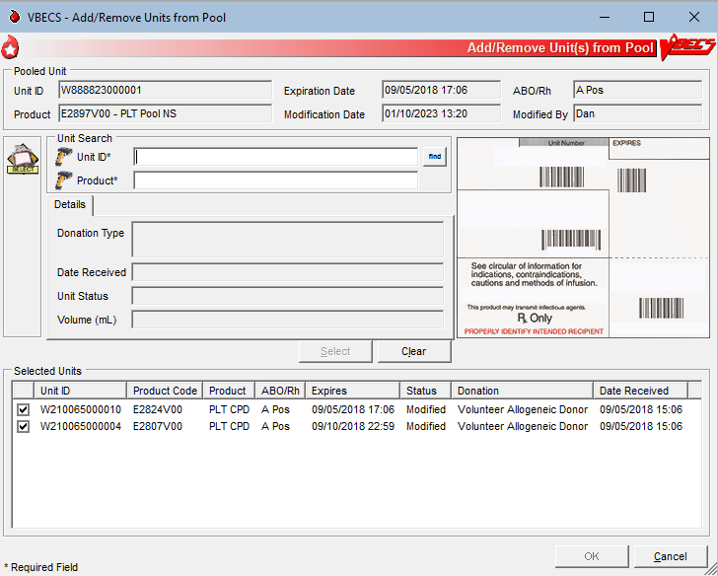

Maintain Unit Records

Edit Unit Information
The user may inactivate unit tests, correct a data entry error from login, and add information about the unit that was not recorded during login.

Assumptions
- The user is logged into the division that contains the unit record.
- The connection to VistA is active.

Outcome
- The unit’s new or changed information was saved with its record.
- If workload codes are assigned for this process, workload-related data collected as the result of this process are stored for inclusion in Workload Reports.

Limitations and Restrictions
- VBECS does not limit the discarded plasma volume.
- If errors are found in the unit’s product code, division or blood type at login, supplier, or donation type, the user must inactivate the unit and reenter it correctly.
- When a unit does not have a patient association, editable fields are available to an  Enhanced Technologist.
- Only units in a Limited or Available status may be edited.
- Inactivation of the unit record is required when the user needs to change the unit’s information recorded at login: unit identification number, blood type, product code, unit expiration date, unit donation type, VA division or supplier.
- VBECS supports the scanning of ISBT 128 special testing information barcodes by detecting the appropriate hidden identifiers. Once the hidden identifier is removed, the special testing code is a varying length of digits, depending on the type of special testing barcode scanned.

Additional Information
- Units must be in “Limited” or “Available” status to have information inactivated regardless of historic patient associations.
- Crossmatches are considered a patient test and are inactivated in Invalidate Test Results.

User Roles with Access to This Option
 Enhanced Technologist

Edit Unit Information
The user records additional unit information normally recorded during incoming shipment (login), i.e., CMV negative, sickle cell negative, RBC Contamination of => 2 mL setting, antigen typing provided by the supplier, and blood unit comment.
To inactivate a unit, remove the final status, return the unit from issue, and release it from previous assignment. No changes may be made to units in a final status.
User Action | VBECS
- Select Blood Units from the main menu.  Select Edit Unit Information. | - Displays options for processing blood units.  - Displays options for selecting and editing a unit.
- Scan or enter a unit ID and product code. May cancel and select a different unit.  When the unit entered is in a final status, click Clear to clear the Unit ID and Product fields and enter another unit. | - Allows the user to scan or enter a unit ID and product code or select a unit.  - Displays the editable unit information based on the user‘s security level.  NOTES  VBECS does not allow selection of a unit when it:  - Is currently assigned to a patient.  - Has a final unit status.  - Has a previous patient assignment record and the user is a Lead or Enhanced Technologist.  There is no override. VBECS clears the screen and allows the user to select a new unit.
- Review and enter or edit the data (Figure 64),  or  Go to Inactivate a Unit. | - Displays tabs to select and edit:  - Unit information  - Unit ABO/Rh confirmation  - Antigen typing  - Displays fields to add or inactivate unit information and an option to inactivate a unit based on the condition of the unit and the user’s security level.  NOTES  The user may add data to a field with no previous entry. When the blood product code within the ICCBBA component classes is RED BLOOD CELLS, WHOLE BLOOD, the Technologist and above may add unit information: sickle cell negative, CMV negative, red blood cell contamination of = > 2 mL, and antigen typing to a unit when the unit has no patient assignments.  Users may edit unit volume, add special testing and RBC antigens (manually or by scanning a special testing barcode), mark a unit biohazardous, and change the patient restriction.  When a blood product code in the RED BLOOD CELLS or WHOLE BLOOD component class is entered, VBECS enables data entry of sickle cell negative and antigen typing. The CMV negative data entry option is always enabled.  An antigen type may be positive or negative for any antigen listed as a VBECS corresponding antigen in Appendix B: Table 14: Antibody and Antigen Table: Irregular Antibodies. An antigen may not be positive and negative for the same unit.  Only unit antigen type results originally entered through Incoming Shipment are available for invalidation. An Enhanced Technologist must invalidate unit antigen type results originally entered through Unit Antigen Typing by selecting Inactivate Unit Testing.  VBECS restricts the editing of disease marker testing to autologous units.  When changing the disease marker testing of an autologous unit from “NEG” to “POS” or “NFT (not fully tested)”, VBECS automatically enables the biohazard indicator.  The user may not clear the biohazard indicator for a unit when:  - The disease marker testing is POS or NFT,  - The ISBT 128 Donation Type codes are “X, For Autologous Use Only, Biohazardous” or “3, For Directed Donor Use Only, Biohazardous,” or 6, Designated Donor Biohazardous”  - The unit is quarantined.  When editing the “restricted for” patient name for a unit, the user may change the name of a restricted patient but may not save the transaction without a new patient name for the restriction.  When the user restricts a unit to a patient, the patient ID is the primary identifier of the intended recipient. When VBECS searches the VistA PATIENT File (#2) and finds a match, it populates the VBECS database with the selected patient name. When the intended recipient is not in the VistA database, VBECS warns the user, clears the screen, and does not allow the unit to be further processed.   The Enhanced Technologist may edit items associated with a unit and add the new data to the unit. The system will require a comment from the "Incoming Shipment" context. VBECS displays only the latest entry for these fields to the Enhanced Technologist before the unit has any patient associations:  - Restrictions  - CMV negative  - Sickle Cell negative  - Biohazard indicator  - Disease marker testing  - Antigen typing entered at log-in  - Unit volume  - Discarded plasma volume, if one  - Red blood cell contamination of equal to or greater than (= >) 2 mL (non-RBC units)  - Blood unit comment   The Traditional Supervisor may edit items associated with a unit and add the new data when the unit has a history of patient associations.
- Select a test for inactivation (Figure 65). | - Displays the previously recorded results for the selected test.  - Requires a comment from the “Incoming Shipment” context to process the inactivation.  NOTES  The user may view, not edit, previously entered serologic results and interpretations.  When the user selects the unit antigen typing test, VBECS displays antigen typing reagent types and interpretations available for invalidation at the user’s division. Inherited testing is not available for invalidation.  When the user selects the ABO/Rh confirmation test, VBECS displays the unit confirmation test interpretations available for invalidation at the user’s division.  The system will check if the selected blood unit has current, valid ABO/Rh Confirmation or Antigen Typing associated with it. If the unit does have associated current, valid tests, the system does not allow the user to inactivate the unit and displays a warning message to the user: “Unit has current, valid tests, previous patient assignments, or crossmatches that must be invalidated before the unit can be inactivated." There is no override.
- Verify the test to be inactivated and enter a comment.  Click OK to confirm and exit. | - Displays “Test Result Invalidated” in the unit record for the selected test.  NOTES  When the last (or only) ABO/Rh confirmation testing is invalidated, VBECS returns the unit to a limited status and requires an ABO/Rh confirmation test for Red Blood Cell contamination of equal to or greater than (= >) 2 mL indicator.  When a unit that requires ABO/Rh confirmation testing no longer has a valid test result in VBECS due to invalidation of previous unit tests, VBECS treats the unit as though no ABO/Rh confirmation testing was performed.  VBECS flags invalidated test results with a message describing the reason for invalidation and captures details for inclusion in an Exception Report.  VBECS does not inactivate workload associated with the invalidated test.  Replacement results are entered according to local policy.  If the user invalidates unit ABO/Rh confirmation or unit antigen testing, the user is required to enter a comment from the "Unit Testing" context.
- Return to Step 1 to edit another unit.
- Click OK to save. | - Updates and saves the data.
Figure 65: Edit Unit Information
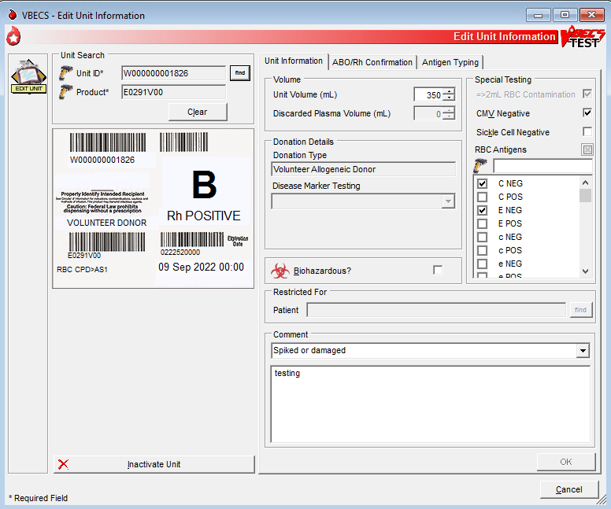
Figure 66: Edit Unit Information Invalidate Test
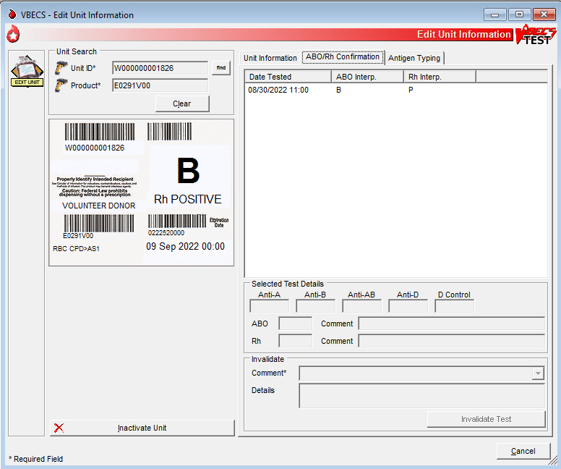

Inactivate a Unit
User Action | VBECS
- Select Blood Units from the main menu.  Select Edit Unit Information. | - Displays options for processing blood units.  - Displays options for selecting and editing a unit.
- Scan or enter a unit ID and product code. May cancel and select a different unit. | - Allows the user to scan or enter a unit ID and product code or select a unit.  - Displays the editable unit information based on the user‘s security level.  NOTES  VBECS does not allow selection of a unit when it:  - Is currently assigned to a patient.  - Has a final unit status.  - Has a previous patient assignment record and the user is a Lead or Enhanced Technologist.  There is no override. VBECS clears the screen and allows the user to select a new unit.
- Click Inactivate Unit, as desired. | - Displays fields to add or inactivate unit information and an option to inactivate a unit, based on the condition of the unit and the user’s security level.  - Displays unit data.  - Requires a comment to process the unit inactivation.  NOTES   When the Traditional Supervisor attempts to inactivate a unit’s record, VBECS warns the user. A blood unit’s record cannot be destroyed or removed from the database for any reason. The system displays a warning message with no override to all users: “Inactivated unit records cannot be destroyed.”  An inactivated unit is not accessible. The record is available in the Audit Trail and Unit History Reports and in division statistical and informational reports. When VBECS inactivates a unit, it also inactivates costs previously associated with that unit.  The user may inactivate the unit with prior but no current patient assignments. VBECS requires a comment from the “Unit Inactivation” context to explain the inactivation.  Unit inactivation appears on the Audit Trail Report.
- Enter a comment.  Click OK to save. | - Marks the selected unit record “inactive.”  - Saves the record.

Edit Financial Data
The user enters and/or edits charges associated with a unit after it is logged into inventory.

Assumptions
- The user is logged into the division containing the unit to be edited.

Outcome
- Unit billing information was changed.

Limitations and Restrictions
- When a Technologist enters a unit ID and product code for a unit that is not in final status, VBECS does not enable the Special Test Cost field. An Enhanced Technologist or higher access can change the Special Test Cost field in the Edit Financial Data option.
- Base Cost entry is capped at 99,999.00
- Special Testing Cost is capped at 9,999.99
- Return Credit is capped at 99,999.00

Additional Information
- None

User Roles with Access to This Option
All users

Edit Financial Data
The user adds and/or edits a unit charge. The user confirms the unit selection, enters the dollar amount of the charge, and reviews and accepts the charge entered.
User Action | VBECS
- Select Blood Units from the main menu.  Select Edit Financial Data. | - Displays options for processing blood units.  - Displays fields for selecting a unit and editing its financial data.
- Scan or enter a unit ID or product code, or click the find button to select a unit from the drop-down list. | - Displays unit data.
- Edit the Base Cost, Special Test Cost, and/or Return Credit fields (Figure 66). | - Allows the user to edit the fields in the Financial Information area.  - Displays the edited data.  NOTES   The Enhanced Technologist may edit existing amounts.  VBECS allows the user to enter a single special testing cost (the sum of charges from $0.00 to 9,999.99, other than the base unit cost, added to a unit by the shipper) to associate with a unit.  When no special typing costs are entered through Incoming Shipment, a user may enter them in this option until the unit is in a final status.   The Enhanced Technologist may add/edit a previously entered unit cost (unit base cost, return credit or special testing cost).  VBECS displays a return credit in U.S. currency (defined by the return credit percentage multiplied by the base unit cost for the blood product type in Blood Products). A user may enter a return credit amount only when VBECS assigned the return credit percentage through Outgoing Shipment or Discard or Quarantine. Otherwise, VBECS disables the Return Credit field.
- Review the data, click OK to save, and click OK again to confirm the save. | - Requests confirmation to update the database.  - Saves and updates the unit record.
- Repeat Steps 2 through 4, as needed, to update additional unit financial data.
- Click Cancel to exit.
Figure 67: Edit Unit Financial Data
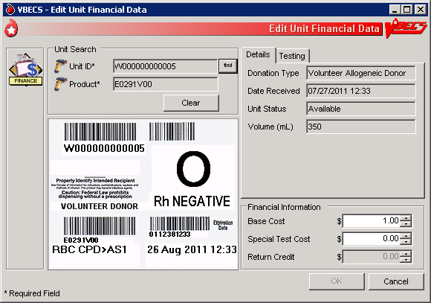

Free Directed Unit For Crossover
The user removes a patient restriction from a directed unit that is eligible for crossover, making that unit available for any patient, according to system rules.

Assumptions
- The division is “full service.”
- The unit and the user are in a blood bank in the same division.
- The unit is restricted for a patient.
- The unit is not autologous.
- The unit is not in a final status.

Outcome
- The unit has no restrictions.
- VBECS documents the restriction and its removal in the unit record.
- If workload codes are assigned for this process, workload-related data collected as the result of this process are stored for inclusion in Workload Reports.

Limitations and Restrictions
- The unit must not be in a final status to release the restriction.
- This option does not allow the removal of patient restrictions for most of the ISBT donation types that are eligible for crossover.
- This option cannot process multiple directed units simultaneously.

Additional Information
- This option is disabled for transfusion-only facilities.

User Roles with Access to This Option
 Enhanced Technologist

Free Directed Unit For Crossover
The user releases the restriction on a directed donor unit to make the unit available in general inventory.
User Action | VBECS
- Select Blood Units from the main menu.  Select Free Directed Unit For Crossover. | - Displays options for processing units.  - Prompts the user to scan or enter the unit ID and product code.
- Scan or enter the unit ID and product code for each unit. | - Displays the unit information.  NOTES  When a user adds a directed unit to an undirected pool, VBECS queries the user regarding releasing the unit’s restriction.   The unit must have a donation type of one of the following:  - Volunteer Directed, Eligible for Crossover  - Dedicated/Designated/Elgb for Crossover  - Family Reserved.  If not, VBECS warns that the unit has an invalid donation type and is in a final status. The unit must not be autologous.”   The unit must not be assigned to a patient to release the restriction. VBECS warns that the unit is currently assigned and that he must release the assignment before continuing.
- Enter a date and time and possibly a different user, or accept the defaults (Figure 67).  Enter the required comment. | - Displays the unit information.  - Requires a comment, and captures details for inclusion in an Exception Report (exception type: released patient restriction).
- Click OK to process the unit and add it to available inventory. | - Displays the return time, the editable (past date and time) field (default: current date and time), and the list of users for selection.  - Saves the information to the database.  - Changes the donation type of the unit to “Voluntary Allogeneic” and removes the restriction associated with the unit.
- Click Yes to confirm the save.
Figure 68: Free Directed Unit For Crossover
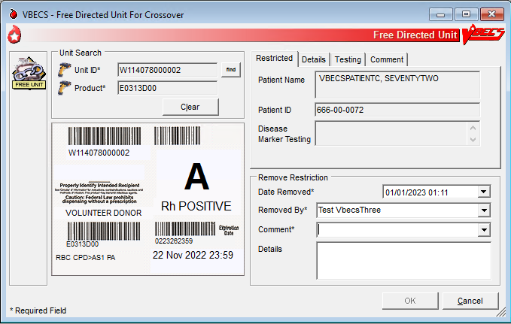

Discard or Quarantine
The user discards, quarantines, or releases from quarantine one or more units of blood.

Assumptions
- The unit of blood is in the same division as the user.

Outcome
- Discarded units are not available.
- Quarantined units are available for limited processing, not for patient assignment.
- Units released from quarantine are available.
- If workload codes are assigned for this process, workload-related data collected as the result of this process are stored for inclusion in Workload Reports.

Limitations and Restrictions
- When a user retroactively updates a unit status through this option, the Unit History Report displays the updated information, but does not display the date the change was made.
- The option does not accommodate the entry of a second user for retrospective data entry.
- Cost entry is capped at 999.00.

Additional Information
- None

User Roles with Access to This Option
All users
 Enhanced Technologist (release blood products from quarantine)

Discard or Quarantine
The user changes the status (discard, quarantine, release from quarantine) of one or more units of blood. The user must indicate the ID and product code of the units to be updated. VBECS also allows batch data entry to process all units from an invoice.
A quarantined unit has limited availability for continued processing. Under certain circumstances, VBECS assigns quarantine status automatically; otherwise, the user determines and enters the status. The user must specify whether a discarded unit is for credit or for waste, which determines whether or not a return credit is assigned to the selected unit.

Discard or Quarantine Individual Units
User Action | VBECS
- Select Blood Units from the main menu.  Select Discard or Quarantine. | - Displays options for processing blood units.  - Displays fields for entering unit information.  - Allows the user to discard or quarantine individual units.
- Enter an ID and product code for a blood unit. | - When a unit is appropriate for processing, displays unit information, including the current status.  NOTES  The user may deselect units prior to editing.
- Click Select to add the selected unit to the worklist, or click Clear to select another unit. | - Adds the unit to a temporary list of selected units.
- Repeat Step 3, as needed, to process multiple blood units as a single batch.  Click OK to continue. | - Displays selected units.
- In the Activity area, click the Discard, Quarantine, or Release from Quarantine radio button (Figure 68). | NOTES   The Enhanced Technologist may release a unit from quarantine.
- Select or enter a comment in the Comment field to explain the change in status, when indicated. Enter details, as needed. | - Displays entered data.  NOTES  When a status of “Discard” is assigned to a unit, the user must enter a comment.   When a blood unit is assigned an indicator of “quarantined,” VBECS emits an audible alert, requires a comment, and captures details for inclusion in an Exception Report (exception type: Quarantine, Discard or Release from Quarantine, depending on the user action).   When a unit is released from quarantine, a new status must be assigned. VBECS assigns the previous status as the default status. When the unit expiration date is in the past, VBECS emits an audible alert, warns the user, and asks whether he wishes to continue.  Yes accepts the default status, requires a comment from the “Release From Quarantine” context, and captures details for inclusion in an Exception Report (exception type: expired unit released from quarantine). No stops the process; the unit remains marked as quarantined.  When the user assigns a status of “Discard,” he must indicate whether the discard is waste or credit.  When VBECS processes a unit as a discard that is waste, it does not apply a return credit to the discarded unit. (There is no refund of monies from the blood shipper.)  When VBECS saves a unit as “discard for credit,” it applies a default return credit. A user may edit the default return credit applied to the unit before updating the database.  When a unit has had a quarantine indicator assigned, VBECS releases any patient assignments. Patient restrictions associated with the unit remain intact.  When a user attempts to release a unit from quarantine and the unit was quarantined because of a data conflict, VBECS checks the inconsistency before allowing the unit to be released. VBECS warns the user. There is no override. The user must invalidate the incorrect information or test to resolve the data conflict.  - When quarantining an assigned or crossmatched unit, the system displays a message to the user before asking the user to confirm the save. “The unit has been assigned/crossmatched, so if you quarantine it, then we will need to remove the assignment.” If the user confirms, the system will release the assignment.  - When discarding an assigned or crossmatched unit, the system will leave the assignment in place.
- Enter the date and time of the status update.  Click the Waste or Credit radio button. | - VBECS defaults the date and time of the status update to the date and time the user opened the Discard or Quarantine option  - Displays entered data.  NOTES  The default date and time are the current date and time.  When the user updates the status of a unit and enters a date or time in the past, VBECS compares the retrospective date and time with the last record update for the unit. VBECS allows the user to update a unit record with a date and time between the last record update and the current date and time.   When the user attempts to update a unit record prior to the last record update, VBECS emits an audible alert, warns the Enhanced Technologist, and instructs him to check the date and time entered. There is no override.   When the user is a Lead Technologist, VBECS also requires a comment and asks whether the user wishes to continue. Yes accepts the date and time entered, requires a comment from the “Quarantine/Discard” context, and captures details for inclusion in an Exception Report (exception type: retrospective update prior to last record update). No allows the user to correct the entry.
- Review the unit status update information and click Save to save. | - Evaluates the unit’s current status to determine whether it is eligible for the selected function.  - Displays appropriate error messages when the unit cannot be processed.  - Prompts the user to confirm the save.
- Click Yes to confirm the save. | - Saves the data.  NOTES  During batch data entry of “Discard,” “Quarantine,” and “Release from Quarantine,” VBECS saves transaction details, including user-entered comments, to each blood unit included in the batch.
Figure 69: Discard or Quarantine Units
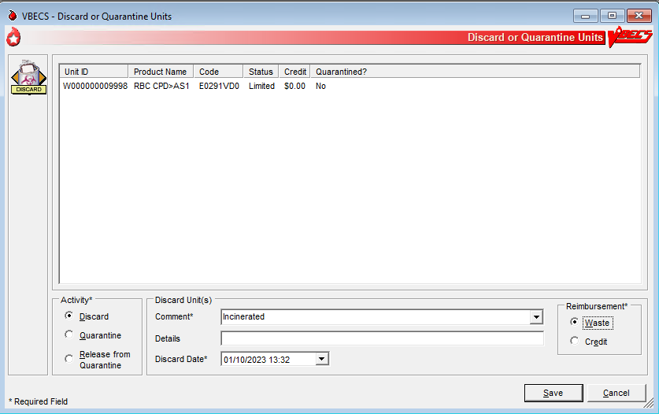

Discard or Quarantine Units by Invoice
User Action | VBECS
- Select Shipments from the main menu.  Select Discard or Quarantine.  Select an invoice and click OK. | - Displays options for processing blood product shipments.  - Displays fields for entering shipment information.  - Allows the user to discard or quarantine units by invoice.
- Click (clear) one or more check boxes to remove units from the invoice.  Click OK. | - Allows the user to select individual units.  - Displays unit information, including the current status included in the invoice.  - Allows the user to deselect units from the batch prior to editing.  NOTES  For batch processing, the user may select incoming shipment invoices from the previous five days processed in the same division as the user.  Only incoming shipment invoices processed within the user’s division may be accessed for batch processing.
- In the Activity area, click the Discard, Quarantine, or Release from Quarantine radio button. | NOTES   The Enhanced Technologist may release a unit from quarantine.
- Select or enter a comment in the Comment field to explain the change in status, when indicated. Enter details, as needed. | - Displays entered data.  NOTES  When a status of “Discard” is assigned to a unit, the user must enter a comment.  When a blood unit is assigned an indicator of “quarantined,” VBECS emits an audible alert, requires a comment, and captures details for inclusion in an Exception Report (exception type: Quarantine, Discard or Release from Quarantine, depending on the user action).   When a unit is released from quarantine, a new status must be assigned. VBECS assigns the previous status as the default status. When the unit expiration date is in the past, VBECS emits an audible alert, warns the user, and asks whether he wishes to continue.  Yes accepts the default status, requires a comment from the “Release From Quarantine” context, and captures details for inclusion in an Exception Report (exception type: expired unit released from quarantine). No stops the process; the unit remains marked as quarantined.  When the user assigns a status of “Discard,” he must indicate whether the discard is waste or credit.  When VBECS processes a unit as a discard that is waste, it does not apply a return credit is not applied to the discarded unit. (There is no refund of monies from the blood shipper.)  When VBECS saves a unit as “discard for credit,” it applies a default return credit. A user may edit the default return credit applied to the unit before updating the database.  When a unit has had a quarantine indicator assigned, VBECS releases any patient assignments. Patient restrictions associated with the unit remain intact.  When a user attempts to release a unit from quarantine and the unit was quarantined because of a data conflict, VBECS checks the inconsistency before allowing the unit to be released. VBECS warns the user. There is no override. The user must invalidate the incorrect information or test to resolve the data conflict.
- Enter the date and time of the status update.  Click the Waste or Credit radio button. | - VBECS defaults the date and time of the status update to the date and time the user opened the Discard or Quarantine option  - Displays entered data.  NOTES  The default date and time are the current date and time.  When the user updates the status of a unit and enters a date or time in the past, VBECS compares the retrospective date and time with the last record update for the unit. VBECS allows the user to update a unit record with a date and time between the last record update and the current date and time.   When the user attempts to update a unit record prior to the last record update, VBECS emits an audible alert, warns the Enhanced Technologist, and instructs him to check the date and time entered. There is no override.   When the user is a Lead Technologist, VBECS also requires a comment and asks whether the user wishes to continue. Yes accepts the date and time entered, requires a comment from the “Quarantine/Discard” context, and captures details for inclusion in an Exception Report (exception type: retrospective update prior to last record update). No allows the user to correct the entry.
- Review the unit status update information and click Save to save. | - Evaluates the unit’s current status to determine whether it is eligible for the selected function.  - Displays appropriate error messages when the unit cannot be processed.  - Prompts the user to confirm the save.
- Click Yes to confirm the save. | - Saves the data.  NOTES  During batch data entry of “Discard,” “Quarantine,” and “Release from Quarantine,” VBECS saves transaction details, including user-entered comments, to each blood unit included in the batch.

Select Units
A user selects a patient component order and assigns one or more products to a patient for possible transfusion.

Assumptions
- An appropriate current order was accepted through Accept Orders: Accept an Order.
- The division may or may not allow electronic crossmatch (eXM).
- When a division is “transfusion only,” eXM is not available. The user must enter a serologic crossmatch (XM) interpretation.
- Current patient TAS specimen is required for (ABO/Rh and Antibody Screen) required tests for “WHOLE BLOOD” and “RED BLOOD CELLS” component classes and individual “PLATELET” and “OTHER” units that contain equal to or greater than (= >) 2 mL of RBC contamination which requires crossmatch.

Outcome
- The status of the unit and the associated component order task status are updated.
- VBECS indicates that units are available for issue when units do not require XM or other additional testing.
- VBECS allows the user to print a Blood Transfusion Record Form (BTRF) and a Caution Tag for available blood products.
- When serologic XM is required, VBECS automatically adds units to the XM data entry grid when Patient Testing: Record a Crossmatch is accessed.
- When eXM is enabled for the facility, the patient is eligible for eXM in accordance with system rules (see Table 22: Rules for Electronic and Serologic Crossmatch), and the user selects a unit, and processes the eXM. VBECS assigns the unit to the patient without further testing.
- If workload codes are assigned for this process, workload-related data collected as the result of this process are stored for inclusion in Workload Reports.

Limitations and Restrictions
- When a user checks the “D Pos” or “D Neg” check box to modify a search for blood, VBECS returns no units, regardless of the availability of units.
- VBECS displays a component order as “Filled” when the number of units transfused and the number of units ordered are the same and continues to display the component order until the order expires. CPRS displays a component order as “Completed”. Therefore, CPRS displays the order as “Completed” before VBECS displays the order as “Filled.” The associated LAB order will then also be marked as “Completed”.
- A Specimen UID must be accepted in VBECS to associate it with a component order. Any VBECS maintained TAS specimen UID may be associated with a component order by entering the number in the UID field.
- When associating a specimen with a patient in the “Select Unit for a Patient” window, the “Expires” field within the “Associate with Specimen” panel displays the time in AM/PM format. VBECS normally displays date/time fields in “military” time format. The workaround is to look in Maintain Specimen and check the expiration time military time format.
- When an Rh positive unit is selected for an Rh negative patient with an antigen negative requirement for D, the user receives a message about unit not satisfying patient negative requirements for D instead of a message about unit being positive for D. The proper message is displayed upon unit issue.

Additional Information
- Under certain conditions in a blood bank, more than one user can select units for the same blood component order at the same time.
- When a patient order is selected, the system must search for physically available (in limited, available, or crossmatched unit status and with a future expiration date) autologous and directed units within a multidivisional database regardless of the unit’s current division, display the unit information to the user, and allow assignment of the unit if it is in the same division as the user.
- Multiple users may select units associated with a component order.
- Product codes associated with a component order are limited to those in that Component Class.
- When a user selects a patient order within a multidivisional database, VBECS searches for available autologous and directed units regardless of the unit’s current division, displays the unit information, and allows the user to assign the unit when it is in the user’s division.
- A user may select units for only one component order at a time.
- An existing specimen and its associated component order(s) remains available to select additional units, until its expiration date.
- The selection of blood units completes a CPRS order when the number of units are selected that “fill” the order per the number requested.
- Each component task is accepted or cancelled individually.
- When a component order is cancelled or rejected, the order is no longer retrievable.
- When a patient has only Component Requirements, the system does not prohibit the use of electronic crossmatch.
- A user must accept or cancel each component task in its entirety.
- The user reserves autologous and directed units and all units processed in a “transfusion-only” facility, regardless of donation type, for a specific patient. VBECS displays this information to all divisions in a multidivisional database and accommodates immediate selection of the unit for the patient when the user is in the same division.
- When VBECS compares a patient’s current and previous ABO/Rh results, it does not evaluate previously recorded ABO/Rh results marked “Test Result Invalidated.”
- An ABO/Rh confirmation test interpretation is required when a unit is indicated to contain = > 2 mL of RBC contamination. The confirmation test must match the unit ABO/Rh at login and repeat tests, when repeat tests are not invalidated. The unit must have a satisfactory confirmation result before VBECS allows the unit to be available for selection for patient use.
- When the CPRS order is WB or RBC, the user may select products from either product class, RBC or WB to fill the order
- When Whole Blood is selected for a WB or RBC CPRS order and the unit is not ABO compatible for the selected patient, the system presents a message to the user stating that the unit is not ABO compatible and releases the unit from selection (assignment).
- Users can view the Lab Order number using the Pending Order List or the Order History Report, if it is needed in areas where it is not already provided.
- In a multidivisional database, restricted units residing in another division are displayed but are not selectable. The tooltip (mouseover) message wording incorrectly states "Unit is not in division ###". The division shown will be the division where the unit IS located.
- The "Success" message received after electing to print caution tags is a message that the job has queued to the print queue, and does not verify that the printing has actually occurred.

User Roles with Access to This Option
All users

Select Units
A user selects a patient’s component order and assigns one or more products to a patient. The user may then enter individual units or select units from a list of selectable, potentially compatible units for each component order.
User Action | VBECS
- Select Patients from the main menu and select Patient Testing, or  Select Blood Units from the main menu and select Select Units. | - Displays options for processing patient-related functions.  - Displays the Pending Task List (PTL) and PTL search parameters in the Diagnostic Tests tab or in the Component Orders tab.
- Enter or select PTL search parameters, if appropriate (Figure 69).  Click the check boxes in the PTL to select one to four component orders.  Click OK to continue (Figure 70). | - Displays information for each component order.  - When the user selects a blood unit to fill a component order or RED BLOOD CELLS, “PLATELETS” or “OTHER” and has = > 2 mL RBC contamination, and the unit is ABO compatible, VBECS requires a crossmatch test and must require the user to associate a TAS specimen UID to the order to proceed to crossmatch of the unit.  - Upon completion of the selection process, evaluates the unit for eXM when enabled at the site or added to the serologic crossmatch data grid as appropriate.  - When the user selects blood units to fill a component order of “PLATELETS” or “OTHER” and is indicated as having less than (<) 2 mL RBC contamination, electronic or serologic crossmatch are not required.  NOTES   See Table 6 for alerts that may occur during this option.
- Steps 3 through 8 are optional. If a specimen is already associated with the order, skip to Step 9. To associate a specimen UID with a unit requiring XM that was not previously associated with a specimen, select (highlight) an issued unit in the Order Group tree view in the left pane (Figure 71). | - Enables the Associate Specimen check box.  - When an order is accepted without a specimen, the user must associate the specimen prior to performing crossmatch testing. VBECS will not allow an expired specimen to be associated with the order unless the Unit Assigned Date is modified to be earlier than the Specimen Expiration Date (for retrospective data entry). See Figure 71.  NOTES  If eXM is enabled, complete the TAS prior to associating the specimen UID with the emergency-issued units.  When eXM is enabled at the division and blood units require XM, VBECS determines whether the patient and units are eligible for eXM. When indicated, specific warning messages explaining the reason for the ineligibility are displayed. Users are given the opportunity to accept or reject the selected unit for selection and may or may not process the eXM. All parameters listed in Appendix B: Table 22: Rules for Electronic and Serologic Crossmatch must be met. Units not eligible for eXM must have serologic XM performed.  When eXM is not enabled, the user must enter serologic XM results for red blood cell classes or when the unit has = > 2 mL RBC contamination. VBECS does not change the unit status to “crossmatched,” make units available for issue, or allow the Caution Tag or BTRF to be printed until a user enters a valid XM result, unless an emergency-issued unit is being processed.
- Click the Associate with Specimen check box.  Click the find button to select a specimen UID (Figure 71). | - Opens the Select Patient Specimen window.
- Scan or enter the correct specimen UID and click Search. | - Displays the selected patient specimen information.
- Click OK. | - Saves the specimen information and returns the user to the Select Units window.  - Displays the associated specimen UID in the Specimen UID field.
- Repeat Steps 3 through 6 to associate the specimen UID with other emergency-issued units, or click OK to save. | - When the user clicks OK, displays a message asking the user if he wishes to complete serologic crossmatch when at least one unit requires crossmatch.
- Click Yes to complete the serologic crossmatch.  Click No to return to the VBECS desktop. | - Allows the user to enter results in the Serologic Crossmatch (XM) cells in the patient testing grid.
- Click Add Units to add units to the component orders selected. | - Searches the database and displays available restricted autologous and directed units that the user must select before selecting allogeneic units of the same component class.  - Displays the unit ID, product type, unit ABO/Rh, unit expiration date, specimen UID, if applicable, of units assigned to the patient in the division’s blood bank on a different specimen or order. The user may add and remove the units to the current order until saved.  - When eXM was configured for the facility, displays the eXM status (eligible or not eligible) for the patient.  - When the component order is for “PLATELETS” or “OTHER”, the units with = > 2 mL of RBC contamination must be presented and will display before products with less than (<) 2 mL of RBC contamination.  - VBECS will present all available units when the Product Type is “PLATELETS” or “OTHER” non-plasma components that have less than (<) 2 mL RBC contamination.  NOTES   See Table 6 for alerts that may occur during this option.  Units that are selectable with an override do not appear on the list of available units and must be scanned or entered by the user.  A patient’s historical ABO/Rh is displayed, when present. When the current specimen is not yet tested, is normally not required, or must be saved as inconclusive, a unit of blood can be selected based on the patient’s historical ABO/Rh.  When the patient’s historic ABO/Rh is “NR,” “inconclusive”, from database conversion, or the current specimen has an “emergency issue” order indicator present and/or the required ABO/Rh specimen testing is incomplete, the user may select components as follows, including autologous units:  For RBC or WB order:  - Group O, Rh positive or O Rh negative RBC  - WHOLE BLOOD is not selectable  For FFP order:  - Group AB, Rh positive, Rh negative, or not specified  For PLT order:  - All units with < 2 mL RBC contamination are available  - Units with (= >) 2 mL RBC contamination are not available  For CRYO order:  - All available units are selectable.  For OTHER order:  - All units with < 2 mL RBC contamination are available  - Units with > 2 mL RBC contamination are not available
- Scan, enter or select *allogeneic units. Units may be selected from the Order Group tree view or by clicking the find button for a list of compatible units.  * when typing in a unit ID and Product Code, use the tab key or mouse to leave the field.  Enter or select a date in the Selection Date field. Each unit may have its own selection date and time.  Click Add Units to display the unit selection form. | - Maintains a list of selected units. The user may deselect selected units.  - Evaluates the selected unit:  - For the ABO/Rh compatibility of each unit and warns the user.  - Against patient Transfusion Requirements (TRs) and warns the user.  - For unit antigen negative compatibility and warns the user.  - Performs additional checks that include days remaining until the unit’s expiration date, the current status, assignments to other patients, quarantine and biohazard indicators, when applied, and associated special testing.  NOTES   See Table 6 for alerts that may occur during this option.  When the user selects a unit in the tree view, he may accept or edit the current date and time displayed; the date and time must be in the past.  Restricted (autologous or directed) unit selection eligibility criteria:  - Restricted For Patient ID: must match  - Restricted For Patient Name: must match  - Unit expiration date must be in the future.  - Component class (transfusion only requires restriction of all units)  The criteria for selecting or including an individual unit in a pick list include evaluating a unit for:  - Considered substitutable for the order  - Same division as the user  - Current location is in the blood bank  - Is not already assigned or crossmatched to the patient  - Is not “restricted” for a different patient  - Meets ABO/Rh compatibility requirements specific to the component class  - Future expiration date  VBECS lists only ABO and Rh compatible units for selection. The “select units” utility creates a system-generated pick list that is sorted and displayed using the following criteria: first, ABO/Rh identical, then expiration date (oldest units first); then, ABO/Rh compatible.  The pick list or individually selected unit field display includes:  - Unit ID  - Product Short Name  - ABO/Rh  - Expiration Date  - Unit Status  - Donation Type  - Restricted for Patient Name and ID  - Patient Assigned (if unit assigned to other patient but with location of blood bank)  - Antigen Type Results (if available)  When ABO/Rh results were not created for the specimen associated with the component order and the order is not designated “emergency issue,” VBECS allows the user to select units using historic records, and notifies the user that ABO/Rh testing must be performed at this division on this patient before any selected units can be issued.  VBECS displays and allows the user to complete a pending XM associated with a patient order without a final unit status.
- Repeat Step 10 until all units are selected. | - Requests the user to confirm the list of selected blood units.  NOTES  The user may select or deselect additional units.
- Click OK to confirm the selection of units. | - Determines whether the units are available for issue or whether they require additional modification and/or testing based on the component class.  - Updates the database, as appropriate.  - Sends selected blood units with patient details to the BCE COTS system via an HL7 message when that BCE COTS is available.  NOTES  When the total number of blood units eligible for issue, issued, or transfused is greater or equal to the number of ordered units, VBECS sends an order completion message to CPRS.   See Table 6 for alerts that may occur during this option.
- Select another component order to continue selecting units, or exit. | - Displays orders for the next patient.
Figure 70: Pending Task List Component Orders
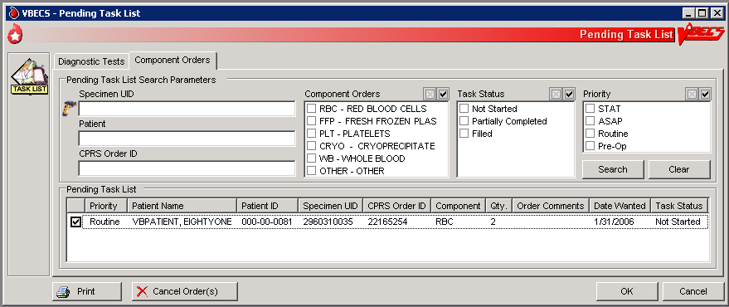
Figure 71: Select Units for a Patient
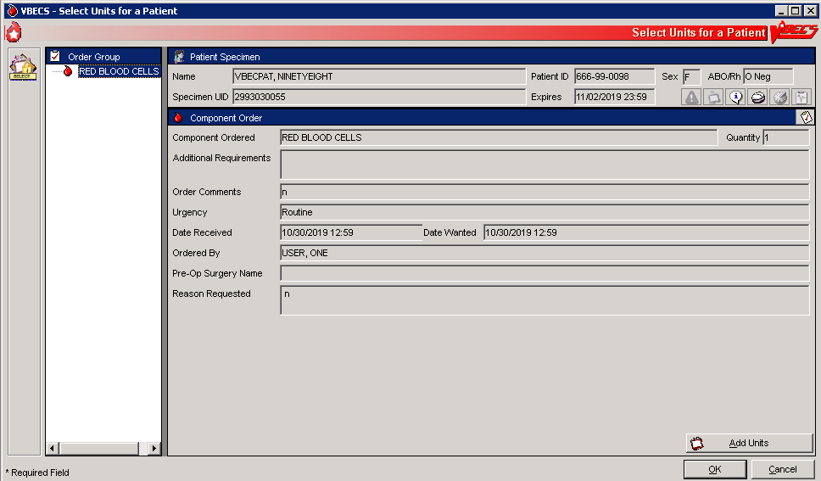
Figure 72: Associate a Specimen with an Emergency-Issued Unit
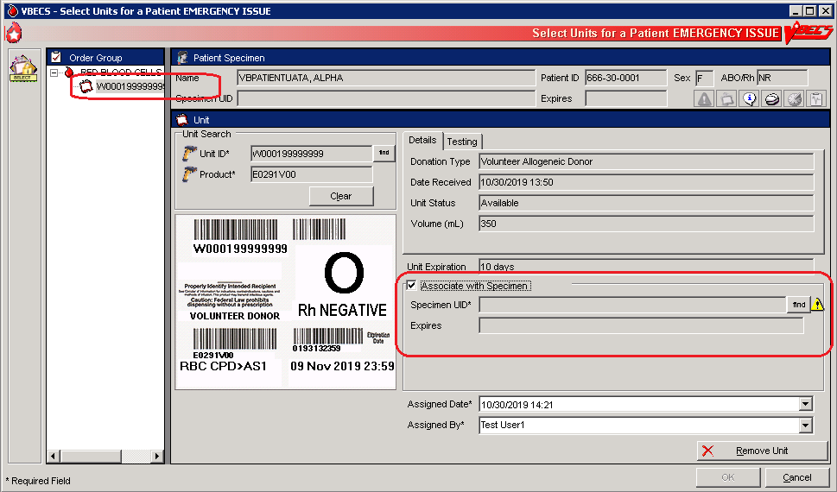

 Alerts
Table 6: Alerts That May Occur in Select Units
Step | Alerts
2 | VBECS displays and emits an audible alert when there are Special Instructions (SIs) or TRs for the patient.
2 | When the user selects blood units that require XM, and eXM is enabled at the division but the current patient is not eligible for eXMs, VBECS displays a warning that includes the reason for the ineligibility. Selected units must have serologic XM performed. The user may not print the Caution Tag or the BTRF. VBECS does not change the unit status to “crossmatched” until the user enters a valid serologic XM result in Patient Testing: Record a Crossmatch.
2 | When the user clicked the Emergency Order check box during specimen acceptance and selects blood units requiring crossmatch, VBECS does not allow the user to perform an electronic or serologic crossmatch.
9 | When a current specimen is required for the selected component class based on Component Classes and one does not exist for the patient, the user may not select ABO type-specific blood products. VBECS notifies the user that he is selecting units using the emergency issue compatibility rules.
9 | When the patient record is marked as having a previous ABO/Rh discrepancy that was justified, a current specimen is required. The user must select units based on the current specimen ABO/Rh. When the current specimen ABO/Rh was not performed, VBECS warns that the patient had a previous ABO/Rh discrepancy and instructs the user to perform ABO/Rh on the current specimen to continue using normal rules and policies or follow emergency issue rules and policies.
9 | When there is a current specimen and ABO/Rh testing was performed, VBECS compares the ABO/Rh of the current specimen to the historical ABO/Rh. When there is a discrepancy, the ABO type is inconclusive, and there is no previous justification for the discrepancy on the patient record, VBECS notifies the user that the ABO/Rh on the current specimen does not agree with the historical ABO/Rh and instructs the user to resolve the discrepancy to continue using normal rules and policies, and recommends that the user release previously selected units or follow emergency issue rules and local policies.
9 | When a repeat ABO/Rh is performed on the patient specimen and the interpretation does not match the original ABO/Rh interpretation.
9 | When a user selects a blood unit that is evaluated as ABO incompatible (based on comparison of the patient's current ABO/Rh entered by the user with the ABO/Rh on record), VBECS emits an audible alert and warns the user that the unit is not ABO compatible for this patient and that the user may not select the unit. There is no override; VBECS clears the screen and allows the user to select another unit.
9 | When a blood component belongs to a Product Type and is indicated as “Frozen” and is selected for a patient, VBECS emits an audible alert and displays a warning message: “Selected blood unit must be thawed and may require additional processing prior to issue”. There is no user response required and the blood unit is not eligible for issue. The status of the units is updated to “assigned” to the indicated patient.
10 | The user may override the selection of restricted units. VBECS warns that more restricted units were not selected for the patient and asks whether the user wishes to continue. The override requires a comment from the “Unit Modification” context and captures details for inclusion in an Exception Report (exception type: less restrictive unit issued).
10 | VBECS warns the user when he selects type-specific FFP/PLASMA products that do not require a specimen, according to the division configuration of component classes, for a patient with a history of justified ABO/Rh change.  Note: VBECS does not enforce type-specific compatibility rules for product types in the CRYOPRECIPITATE and PLATELETS [with less than (<) 2 mL of RBC contamination] component classes.
10 | Once a valid XM interpretation is verified and the unit is compatible, VBECS does not allow a user to select that unit (ID and product code) for the same specimen. The user may select the unit for a XM with the same patient’s new specimen after the unit is released from the current assignment. VBECS warns that the unit has a valid current XM with this patient. The user clears the warning and may continue or enter a new unit number for selection.
10 | When a selected unit is currently assigned to another patient, VBECS warns the user and asks whether the user wishes to continue to select for this patient.  Yes allows the user to continue. No clears the screen and allows the user to select a new unit.
10 | When a user is a Technologist and selects an expired unit, VBECS warns him. There is no override.   When the user is an Enhanced Technologist or above, VBECS warns that the unit is expired and asks whether the user wishes to continue to select.  No clears the screen. Yes requires a comment and captures details for inclusion in an Exception Report (exception type: expired unit selected).
10 | When a unit is selected for a patient, VBECS displays a tool tip stating that the unit may not be selected or removed.
10 | When the user selects a unit and these conditions exist, VBECS warns the user. There is no override. VBECS clears the screen and the user may select another unit:  - For XM for the same patient, VBECS warns that the unit was already selected for the patient.  - That is not substitutable for the order, VBECS warns that the selected unit is not valid for order.  - That is quarantined, VBECS warns that the unit is quarantined and may not be selected.  - That is on a pending outgoing shipment list, VBECS warns that the unit is currently included on a pending outgoing shipment invoice and must be removed from the shipment invoice before it can be selected.  - That is not in the blood bank or is issued to another patient, VBECS warns that the unit is not in the blood bank and may not be selected.  - That is restricted for a different patient, VBECS warns that the unit is restricted for a different patient and may not be selected.  - The confirmation is not performed or is incomplete, VBECS emits an audible alert and warns that the unit ABO/Rh confirmation was not performed or is incomplete and that the unit may not be selected.
10 | When the selected unit had an incompatible crossmatch result with the current patient in the past, VBECS warns the user. The user may continue with this unit and proceed with electronic or serologic crossmatch testing.
10 | When the user selects an antigen positive (or inconclusive for testing) unit and the patient has the corresponding antigen negative requirement, VBECS warns the user and requires action determined by the user’s security level.
10 |  When the user is an Enhanced Technologist or below, VBECS emits an audible alert and warns that the patient has a history of an antibody, that the unit does not have a negative test for the corresponding antigen, and that the user does not have the proper security level to select the unit. There is no override.
10 |  When the user is a Lead Technologist or above, VBECS emits an audible alert, warns that the patient has a history of an antibody and that the unit is positive or inconclusive for the corresponding antigen, and asks whether the user wishes to continue to select the unit.  No allows the user to continue to select units for the patient. Yes requires a comment and captures details for inclusion in an Exception Report (exception type: antigen positive units selected).
10 | When a unit was not antigen typed for the corresponding antigen, VBECS emits an audible alert, warns that the unit must be typed and found negative to be available for this patient, and asks whether the user wishes to continue to select this unit. The user may continue to select units for the patient.  Yes requires a comment and captures details for inclusion in an Exception Report (exception type: antigen positive units selected).  See Appendix B: Table 14: Antibody and Antigen Table: Irregular Antibodies.
10 | When an Rh negative patient has an active anti-D antibody or a D antigen negative requirement set in Special Instructions and Transfusion Requirements, VBECS verifies the presence or absence of the corresponding antigen based on the ABO/Rh of the selected blood unit. When a user selects an Rh positive blood unit for a patient with anti-D, VBECS warns the user and requires action based on the user’s security level.  The antigen negative requirement for anti-D is D, not AGwD. AGwD is not a selectable antigen negative requirement in Special Instructions & Transfusion Requirements: Antigen Negative RBCs.
10 | For an Rh negative, unknown, or inconclusive patient: when the selection of Rh positive or Rh pooled units from the WHOLE BLOOD, RED BLOOD CELLS, PLATELETS, and OTHER VBECS component classes are individually entered and confirmed as required, VBECS emits an audible alert, warns that the patient is Rh negative and the selected unit is Rh positive, instructs the user to check the patient sex and hospital policy before continuing, and asks whether the user wishes to continue to select the unit.  No clears the unit data and allows the user to select a different unit. Yes requires additional comment (unit selection canned comment context) and captures details for inclusion in an Exception Report (exception type: Rh positive units selected).
10 | When the user selects a blood unit to fill a component order of RED BLOOD CELLS, “PLATELETS” or “OTHER” and has = > 2 mL RBC contamination, the unit will be evaluated for ABO/Rh red cell compatibility. When the unit is not ABO compatible for the selected patient, VBECS presents a message to the user stating that the unit is and releases the unit from selection (assignment).
10 | When a patient has TRs other than CMV negative or Sickle Cell negative, VBECS verifies whether the selected unit satisfies the requirement based on system rules Blood Unit Substitution and the Fulfillment of Transfusion Requirements. When the TR is not satisfied, VBECS emits an audible alert, warns that the unit does not satisfy all of the patient’s TRs, and asks whether the user wishes to continue to select the unit.  No clears the screen. Yes allows the user to continue without comment.
10 | When a patient has a TR of CMV negative or Sickle Cell negative, VBECS verifies the selected unit for compliance. When the selected unit does not fit the criteria, VBECS emits an audible alert and warns the user:  -  Enhanced Technologist or below: VBECS warns that the patient requires CMV negative or Sickle Cell negative blood, that the selected unit is not CMV negative or Sickle Cell negative, and that the user does not have the proper security level to select the unit. There is no override. VBECS clears the screen, and the user must select another unit.  -  Lead Technologist or above: VBECS warns that the patient requires CMV negative or Sickle Cell negative blood, that the selected unit is not CMV negative or Sickle Cell negative, and asks whether the user wishes to continue to select. No clears the screen and the user must select a new blood unit. Yes requires a comment from the “Unit Selection” context and captures details for inclusion in an Exception Report (exception type: Transfusion Requirement incompatible unit selected).
10 | When a user selects a unit with a biohazardous indicator for a patient, VBECS emits an audible alert, warns the user, and asks whether the user still wishes to select the unit.  No clears the entry and allows the user to select a new unit. Yes requires a comment from the “Unit Selection” context and captures details for inclusion in an Exception Report (exception type: biohazardous unit selected).
10 |  When the user selects blood components from the frozen product types for a patient, VBECS emits an audible alert and warns that the selected blood unit must be thawed and may require additional processing prior to issue. VBECS updates the blood unit status to “assigned” and the unit is no longer available for issue.
10 | When a user selects a unit requiring XM, eXM is enabled, and the patient is eligible, the selected unit ABO/Rh must be compatible with the patient ABO/Rh. VBECS displays a message based on Appendix B: Table 22: Rules for Electronic and Serologic Crossmatch. If the user continues to select that unit in which VBECS requires a serologic XM, VBECS does not allow the Caution Tag or BTRF to be printed, and does not update the unit status to “crossmatched”’ under normal system rules and policies. When the selected unit is available for emergency issue to the patient, VBECS allows the Caution Tag and BTRF to be printed.
12 | When eXM is enabled and the patient and selected units are eligible, VBECS notifies the user and asks whether he wishes to continue with eXM.  Yes assigns a XM result of “Compatible: Electronically Crossmatched.” VBECS updates the database with the XM result, date and time of XM, XM technologist, division, specimen UID, specimen phlebotomist, and specimen expiration date and time. VBECS allows a Caution Tag and BTRF to be printed and the unit is ready for issue and transfusion. VBECS changes the unit status to “crossmatched.”  No keeps the unit assigned to the patient and available for data entry of serologic XM. VBECS does not allow the Caution Tag or BTRF to be printed and does not change the unit status to “crossmatched.” When a division is “transfusion only,” the unit remains assigned to the patient and is available for the user to enter the serologic XM interpretation, VBECS does not allow the Caution Tag or BTRF to be printed, and the unit is not crossmatched.
12 | When the user selects a unit requiring XM, the division is defined as “full service,” eXM is enabled, and the patient is not eligible for eXM, VBECS warns the user that the selected units require serologic XM and asks whether he wishes to continue.  Yes adds the units to the XM data entry grid and transfers the user to Patient Testing: Record Patient Test Results to begin the XM process. No records that a serologic XM test is needed. The user may not print a Caution Tag or Blood Transfusion Record Form; the unit status does not change to “crossmatched.”

Issue Blood Components
The user issues one or more patient-assigned blood units to a transporter for storage in a remote location or for possible transfusion.

Assumptions
- The facility has a procedure for the emergency issue of blood products.
- The unit and the user are in the same division.
- The unit is assigned and/or crossmatched for the patient currently selected for issue.
- VistA is available for the user to choose a physician and valid hospital locations.
- All issue-to locations must be valid entries in the VistA HOSPITAL LOCATION (#44).

Outcome
- The unit status was updated to “issued.”
- The unit’s current location was updated to the “issue-to” location.
- If workload codes are assigned for this process, workload-related data collected as the result of this process are stored for inclusion in Workload Reports.

Limitations and Restrictions
- VBECS does not check for restricted units (not assigned to the patient) received between selection and issue.
- All issue-to locations must be valid entries in the VistA HOSPITAL LOCATION (#44).
- If VistA link is not available, the user may proceed with the issue process but the current issue-to hospital location is not recorded. All of the associated report records display “VistALink Down” in the Issue To location field.
- ISBT 128 tables include blood product codes labeled as not for manufacturing or transfusion. VBECS does not restrict such products from being entered, issued, or transferred (local policy controls their use) and does not accommodate blood modification for these products.
- When a site has configured subservient VistA institutions to the VBECS division, users can only issue units to locations in the primary VistA. Sites may add locations to VistA to account for the relocations to the subservient VistA institutions.
- BCE information applies ONLY when a BCE COTS product is available for communication and is configured.
- Changing a patient's transfusion requirements (component requirements, antigen negative requirement or antibody identified) after a unit is crossmatched does not provide an alert at Issue Unit regarding the type of crossmatch (electronic or serologic) performed on a unit available for issue.
- VBECS asks for a comment when issuing a unit that is assigned to two different patients. Enter a comment to issue the unit or release one of the patient assignments before issuing. The comment will appear on the Unit History Report in the Issue section.
- Users should issue units in a timely manner to avoid the units being released from patient assignment by another user prior to the issue unit process completion.
- When no VistA order is available, the user must process the request manually until VistA provides them to VBECS. The user must print blank Caution Tags and Blood Transfusion Record Forms (BTRFs) to accommodate this rare occurrence. When VistA does not provide a pseudonym or associated pseudo-ID for the patient that allows placement of a VistA order, VBECS cannot create a patient order for emergency issue of blood.

Additional Information
- “Issue with Medical Director Approval” components must be approved prior to this option and do not require special handling by VBECS.
- Emergency issue processing accommodates the issue of blood to patients without completed specimen testing, as required.
- Sites may enter the lot number of blood administration sets and leukoreducing filters when they enter the name of the individual picking up the blood product. VBECS retains this information in the unit history record.
- User must date all signature lines on the BTRF dating of the signatures [i.e., Inspected and issued by, Issued to, First Identifier, Second Identifier, Transfusion Data section completed by, Transfusion Reaction Data section completed by (as needed)].

User Roles with Access to This Option
All users
To correct issue time and other errors, return the unit from issue and reissue it with the correct information.

Issue Blood Components (Routine)
The user issues assigned or crossmatched blood to a transporter for patient transfusion at valid inpatient and outpatient hospital locations, and records issue details, including the transporter’s name or identifier.
User Action | VBECS
- Select Patients from the main menu.  Select Issue Blood Components. | - Displays options for processing patient-related functions.  - Displays an option to scan the Caution Tag or enter a patient name or ID.  NOTES  The user must verify the correct patient selection.  The  Enhanced Technologist or above is authorized to issue expired blood products.  The  Lead Technologist or above is authorized to issue antigen positive and untyped red blood cells.
- Select a patient. | - Displays patient data, including entries that meet the entered patient criteria, and allows the user to select the correct patient.  NOTES   See Table 7 for alerts that may occur during this option.  Not all possible error messages may display when multiple messages may apply to the unit/patient. Correction of any one of the patient/unit problems and subsequent re-attempts to issue the unit to the patient will display another of the possible messages until all errors are corrected.
- Click OK to verify that the correct patient was selected. | - Displays fields for the user to enter data for the issue transaction.
- Enter the required data in the transporter name, issue-to location, and date and time fields (Figure 72).  Click OK. | NOTES  The user may edit the transfusion-ordering clinician, which does not change the blood-ordering clinician.  When the user updates the transfusion-ordering-clinician field, VistALink queries VistA for valid providers only. The user may narrow the search by entering the provider’s name.  The user may edit the issue date and time (default: current date and time) to allow retrospective data entry; no future issue date or time is allowed. When the issue time is incorrect, the user must undo the issue and reissue the unit with the correct date and time.  A remote storage indicator is optional (default: No). The transporter name field allows free text and does not display a selection list. The issue-to location is a listing of current hospital locations, provided by VistALink when available. When VistALink is not available, the system indicates that an issue-to location is not available and disables the issue-to location field. This is related to billing reimbursement and is not an enabled field in the issue option.  A user could return the unit from issue and reissue it with a hospital location when VistALink is up again.  When a remote storage location indicator is checked, the user may select from a list of previously entered locations or enter a new, free-text location. Each location entered and saved is available for future selection as a remote location.  When the component order is for PLATELETS or OTHER, the units with = > 2 mL of RBC contamination must be presented and checked for compatibility and will display before products with less than (< ) 2 mL of RBC contamination. The system will present all available units when the Product Type is PLATELETS or OTHER non-plasma components that have < 2 mL RBC contamination.
- Scan the unit ID and product code, or click one or more check boxes to select units for issue to the selected patient (Figure 73). | - Displays the option to select units from the Assigned Units or Emergency Issue Units tabs.  - Lists the selected units, allows the user to select additional units or deselect units, and prompts the user to indicate that the selections are complete.  - Allows the user to select the unsatisfactory unit and edit its issue selections.  NOTES   See Table 7 for alerts that may occur during this option.  When the user attempts to issue a unit with an inconclusive crossmatch result, VBECS warns the user that the repeat crossmatch is required before the unit can be issued.  When the user attempts to issue a unit that is not assigned or crossmatched to the patient, VBECS warns the user that the unit is not assigned to the patient and allows the user to enter another unit number.  When the current division is configured as "full service" in Maintain VAMC Division, ABO confirmation is required for all blood units contained in the WB or RBC or PLT or OTHER units with = > 2 mL RBC contamination When performed, ABO confirmation must match unit ABO at log-in.  The unit must have a satisfactory confirmation result before it is considered available for issue and the Blood Transfusion Record Form and Unit Caution Tag may be generated.  Rh confirmation results are required on all blood units from the “WHOLE BLOOD”, “RED BLOOD CELLS” component classes or OTHER units with = > 2 mL RBC contamination labeled as Rh negative during shipment receipt. When performed, Rh confirmation must match Rh at log-in.  When a current specimen is required, VBECS compares the current and previous ABO/Rh results. It does not evaluate results marked “Test Result Invalidated.”  When issuing blood components from the Any unit that contains > = 2 mL of RBC contamination, the associated specimen’s TAS must be completed and the unit status must be crossmatched to the selected patient to routine issue. Optionally, the unit may be emergency issued.  Whole blood is not allowed for the emergency issue process. Completed Type and Screen and compatible crossmatch tests are required for whole blood issuance.
- Click OK to save and complete the unit issue. | - Displays entries for review and editing.  NOTES  When the user selects multiple units for a patient and creates a batch for issue, all units in the batch are issued simultaneously to the same location. VBECS assigns the issue information to all units in the batch. The user may not enter different information, including any override comment, for an individual unit in the batch.  If the user clicks Cancel, VBECS closes without displaying a confirmation message that data will be lost.
- Click Yes when the unit is satisfactory to save, or No when the unit is unsatisfactory. | - Saves the data.  - Displays the unit inspection indicator (satisfactory or unsatisfactory) listing each selected unit.  - Sends updated patient and blood unit information to the BCE COTS system via an HL7 message. The message contains the date time when VBECS creates the message and not the date time the user selects the unit for issue.  NOTES   See Table 7 for alerts that may occur during this option.  Sites using BCE COTS must issue blood components in real-time for BCE COTS to be able to perform transfusion verification.  The area to mark a unit unsatisfactory for issue extends beyond the checkbox. A user that clicks in that area, but not the checkbox, could inadvertently mark a unit unsatisfactory for issue. A VBECS Confirmation message window appears to verify the user wants to remove patient association and quarantine the unit. The user must click No if he mistakenly indicated that the unit was unsatisfactory for issue.
- Exit.
Figure 73: Issue Blood Components (1)
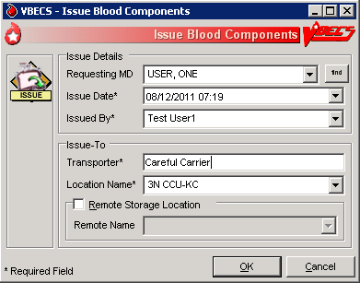
Figure 74: Issue Blood Components (2)
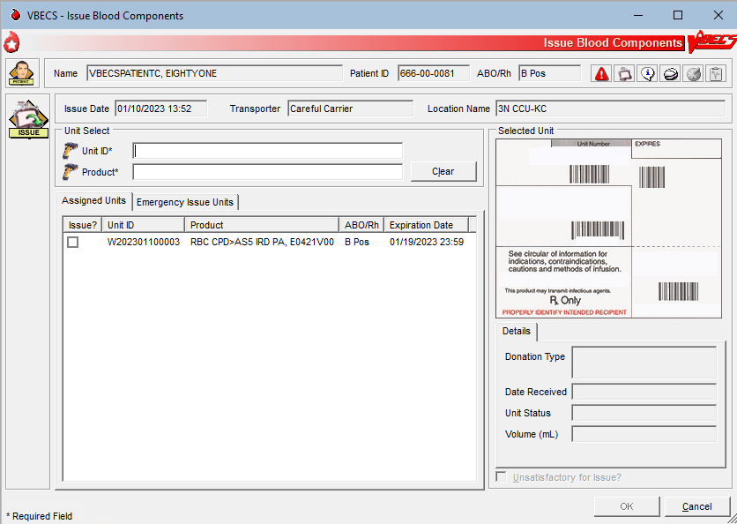

Issue Blood Components (Emergency)
The user issues assigned or crossmatched blood to a transporter for patient transfusion that does not meet routine issue conditions at valid inpatient and outpatient hospital locations, and records issue details, including the transporter’s name or identifier.
User Action | VBECS
- Select Patients from the main menu.  Select Issue Blood Components. | - Displays options for processing patient-related functions.  - Displays an option to scan the Caution Tag or enter a patient name or ID.
- Select a patient. | - Displays patient data, including entries that meet the entered patient criteria, and allows the user to select the correct patient.  NOTES   See Table 8 for alerts that may occur during this option.
- Click OK to verify that the correct patient was selected. | - Displays fields for the user to enter the data for the issue transaction.
- Enter the required data. | - Displays the option to select units from the Assigned Units or Emergency Issue Units tabs.
- Click the Emergency Issue Units tab.  Scan or click one or more check boxes to select units for issue to the selected patient (Figure 74).  Click OK. | - Lists the selected units, allows the user to select additional units or deselect units, and prompts the user to indicate that the selections are complete.  - Allows the user to select the unsatisfactory unit and edit its issue selections.  NOTES   See Table 8 for alerts that may occur during this option.
- Click OK to accept the entries and complete the unit issue. | - Displays entries for review and editing.
- Click Yes when the unit is satisfactory or No when the unit is unsatisfactory. | - Saves the data.  - Displays the unit inspection indicator (satisfactory or unsatisfactory) listing each selected unit.  - Sends updated patient and blood unit information to the BCE COTS system via an HL7 message.  NOTES   See Table 8 for alerts that may occur during this option.
- Exit.
Figure 75: Issue Blood Components Emergency Issue Units Tab
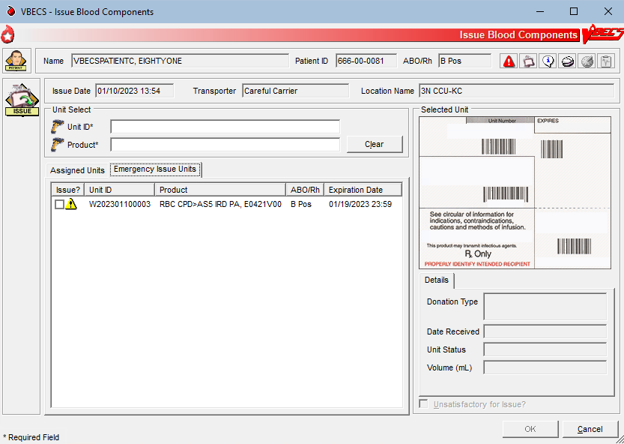

Figure 76: Emergency Issue
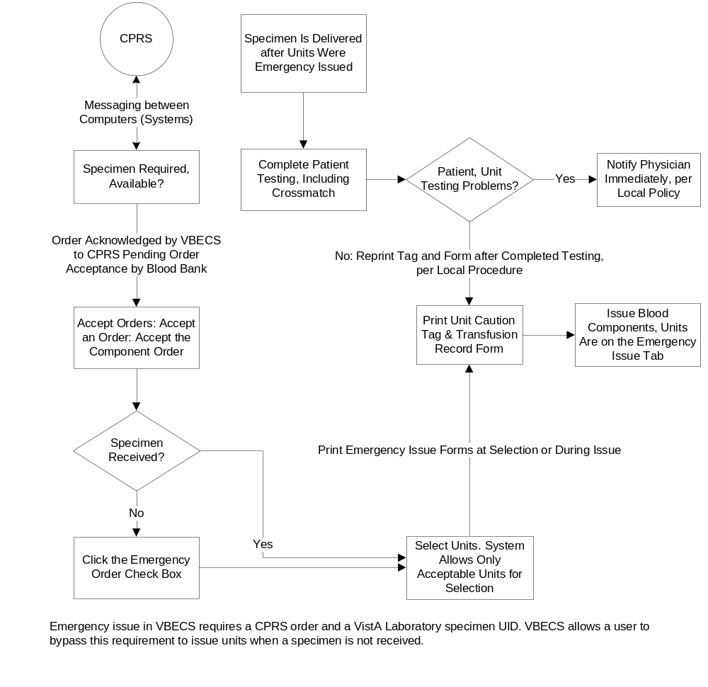

 Alerts
Table 7: Alerts That May Occur in Issue Blood Components (Routine)
User Action Step | Alerts
2 | VBECS displays and emits an audible alert when there are Special Instructions (SIs) or Transfusion Requirements (TRs) for the patient.
2 | When no patient is found, VBECS warns the user and does not allow the user to continue.
2 | When the patient has no components available for issue, VBECS warns the user and does not allow the user to continue.
2 | When required testing is incomplete at issue, VBECS emits an audible alert, warns the user, and asks whether to emergency issue the unit in accordance with hospital policy.  No stops the user from issuing the unit and requires selection of another unit. Yes requires a comment from the “Unit Issue” context, creates an Exception Report entry for the issue, indicates on the unit record that the unit was issued emergently, and asks whether the user wishes to print the Caution Tags and Blood Transfusion Record Forms. No allows the user to continue with the emergency issue. Yes prints a Caution Tag and/or Blood Transfusion Record Form and proceeds with the issue.
5 | When the user attempts to issue a unit located in a different division, VBECS warms him that the unit cannot be issued and does not allow him to continue.
5 | When autologous or directed, or designated or dedicated blood units of the same component class are available in the same division as the user, VBECS requires blood units to be issued in this order:  - Autologous units  - Restricted units  - Voluntary allogeneic units  When the user attempts to issue a unit out of order, VBECS warns him that more restrictive units are available for issue and asks whether he wishes to continue. No allows the user to enter another unit number. Yes requires a comment from the “Unit Issue” context and captures transaction details for inclusion in an Exception Report (exception type: less restrictive unit issued).
5 | When a user indicates that the inspected unit is unsatisfactory, VBECS does not allow the unit to be issued, releases it from assignment, and warns the user that the unit is unacceptable for transfusion. VBECS allows the user to enter another unit number.
5 | When the user attempts to select frozen blood components, VBECS warns the user. Units selected in their frozen state must be thawed before issue.
5 | When the patient has Component Requirements (CRs) and Antigen Negative Requirements, the user attempts to issue (including emergency issue) red blood cells that do not satisfy the requirements, and the user is:   An Enhanced Technologist or below, VBECS emits an audible alert and warns the user that the unit is not selectable and he is not authorized to issue the unit. The unsatisfied requirements are not detailed.  VBECS does not allow an override.
5 | When the patient has Component Requirements, the user attempts to issue (including emergency issue) red blood cells that do not satisfy the requirement, and the user is:  -  An Enhanced Technologist or below, VBECS emits an audible alert and warns the user that the patient's component requirement is not satisfied and he is not authorized to issue the unit. VBECS does not allow an override.  -  A Lead Technologist or above, VBECS emits an audible alert and warns the user that the patient's component requirement is not satisfied and allows for an override. No clears the screen. Yes requires a comment from the “Unit Issue” context and captures details for inclusion in an Exception Report (exception type: unit issued with unsatisfied TR).
5 | When a repeat ABO/Rh performed on the patient specimen does not match the original ABO/Rh interpretation and the unit doesn’t qualify for emergency issue, VBECS warns the user and instructs him to resolve the discrepancy before issuing the unit. There is no override. Units that qualify for emergency issue may continue and VBECS will display a message that the ABO/Rh on the current specimen does not agree with the historic ABO/Rh.
5 | When a unit has a biohazard indicator, VBECS emits an audible alert, warns the user, and asks whether he still wishes to issue the unit. No clears the entry and allows the user to select a new unit. Yes requires a comment from the “Unit Issue” context and captures details of the transaction for inclusion in an Exception Report (exception type: biohazardous unit issued).
5 | For an Rh negative, unknown, or inconclusive patient: the user may enter and confirm Rh positive or Rh pooled units from the WHOLE BLOOD, RED BLOOD CELLS, PLATELETS, and OTHER VBECS component classes. When VBECS component classes are individually entered and confirmed by the user, VBECS emits an audible alert, warns the user, and asks whether he wishes to issue the unit. No clears the unit data and allows the user to select a different unit. Yes requires additional comment from the “Unit Issue” context and captures details for inclusion in an Exception Report (exception type: antigen positive/untested units issued).  Additional details to be included in the exception report when the user overrides this business rule:  - Exception Type: Antigen positive/untested units issued  - Patient Antibody Identified  - Unit Antigen Phenotype Result
5 | The system will not allow the issue of units assigned/crossmatched or that require an ABO/Rh associated with an expired specimen when compared to the issue date and time unless the user role is Enhanced Technologist, VBECS security levels 2 and above.  When the user role is Technologist, VBECS security level 1, the system will display the warning message: Patient specimen is expired. You do not have the proper security to issue this unit. The system will not allow an override.  When the user role is Enhanced Technologist, VBECS security levels 2 and above, the system will provide an audible alert and display the warning message: Patient specimen is expired. Continue to issue? Yes/No. If the user responds “No” the system will clear the screen. If the user responds “Yes” the system will require a comment (free text or canned, “unit issue” context) and captures the transaction details for inclusion in an exception report entry for the issue.  Additional details to be included in the exception report when the user overrides this business rule:  - Exception Type: Unit issued on expired specimen
5 | When the user attempts to issue an expired unit, VBECS warns him. There is no override.   When the user is an Enhanced Technologist or above, VBECS emits an audible alert, warns him, and asks whether he wishes to continue to issue. No clears the screen. Yes requires a comment from the “Unit Issue” context and captures details for inclusion in an Exception Report (exception type: issued expired unit).
5 | When the user selects units from the WHOLE BLOOD or RED BLOOD CELLS component classes, VBECS determines when the patient has a calculated or a persistent antigen negative requirement. This does not apply when selecting autologous (ISBT 128 units with an autologous donation type). When the selected unit was antigen typed and is positive for the corresponding antigen or is untested for the antigen, VBECS warns the user and requires action based on his security level.   When the user is an Enhanced Technologist or below, VBECS warns that he does not have the proper security level to issue the unit. There is no override.   When the user is a Lead Technologist or above, VBECS emits an audible alert, warns him, and asks whether he wishes to continue to issue. No clears the screen. Yes requires a comment from the “Unit Issue” context and captures details for inclusion in an Exception Report entry (exception type: antigen-positive/untested units issued).  Additional details to be included in the exception report when the user overrides:  - Exception Type: Antigen-positive/untested units issued  - Patient Antibody(ies) Identified  - Unit Antigen Phenotype Result or “untested”
5 | VBECS compares the ABO/Rh of the current specimen to the historic ABO/Rh. When there is a discrepancy, there is no previous justification for the discrepancy on the patient record, as described in Justify ABO/Rh Change, and the unit does not qualify for emergency issue, VBECS warns the user and instructs him to resolve the discrepancy before issuing the unit. There is no override. VBECS exits the option, clears the screen, and returns the user to the point of entry. Units that qualify for emergency issue may continue and VBECS will display a message that the ABO/Rh on the current specimen does not agree with the historic ABO/Rh.
5 | When no valid ABO exists for the patient, the user may select components, including autologous units:  - For RBC or WB order: group O, Rh positive or O Rh negative RBC. WHOLE BLOOD is not selectable.  - For FFP order only: group AB, Rh positive or Rh negative.  - For PLT, CRYO, or OTHER order, all available units are selectable.
5 | When the division is “transfusion only” and a blood unit is ABO incompatible at issue based on the interpretation of the current patient specimen’s ABO test, VBECS warns the user that the unit is not ABO compatible for the patient’s current specimen and may not be issued. The user must resolve pending ABO discrepancies before issuing the unit.
7 | When the division is “full service” and a blood unit is ABO incompatible at issue based on the system interpretation of the current patient specimen’s ABO test result, VBECS emits an audible alert, warns that the unit is not ABO compatible with the patient’s current specimen results, and asks whether he wishes to continue. No clears the screen and allows the user to select another unit. Yes requires a comment and captures details for inclusion in an Exception Report (exception type: ABO discrepant unit issue).
Table 8: Alerts That May Occur in Issue Blood Components (Emergency)
User Action Step | Alerts
2 | VBECS displays and emits an audible alert when there are Special Instructions (SIs) or Transfusion Requirements (TRs) for the patient.
2 | When no patient is found, VBECS warns the user and does not allow the user to continue.
2 | When the patient has no components available for issue, VBECS warns the user and does not allow the user to continue.
2 | When required testing is incomplete at issue, VBECS emits an audible alert, warns the user, and asks whether to emergency issue the unit in accordance with hospital policy.  No stops the user from issuing the unit and requires selection of another unit. Yes requires a comment from the “Unit Issue” context, creates an Exception Report entry for the issue, indicates on the unit record that the unit was issued emergently, and asks whether the user wishes to print the Caution Tags and Blood Transfusion Record Forms. No allows the user to continue with the emergency issue. Yes prints a Caution Tag and/or Blood Transfusion Record Form and proceeds with the issue.
5 | When the user attempts to issue a unit located in a different division, VBECS warms him that the unit cannot be issued and does not allow him to continue.
5 | When a user indicates that the inspected unit is unsatisfactory, VBECS does not allow the unit to be issued, releases it from assignment, and warns the user that the unit is unacceptable for transfusion. VBECS allows the user to enter another unit number.
5 | When the user attempts to select frozen blood components, VBECS emits an audible alert and warns the user. Units selected in their frozen state must be thawed before issue.
5 | When the patient has Component Requirements and Antigen Negative Requirements, the user attempts to issue (including emergency issue) red blood cells that do not satisfy the requirements, and the user is:   An Enhanced Technologist or below, VBECS emits an audible alert and warns the user that the unit is not selectable and he is not authorized to issue the unit. The unsatisfied requirements are not detailed.  VBECS does not allow an override.
5 | When the patient has Component Requirements, the user attempts to issue (including emergency issue) red blood cells that do not satisfy the TR, and the user is:  -  An Enhanced Technologist or below, VBECS warns the user that he is not authorized to issue untyped red blood cells (for the clinically significant antibodies in the table). VBECS does not allow an override.  -  A Lead Technologist or above, VBECS emits an audible alert and warns the user. No clears the screen. Yes requires a comment from the “Unit Issue’ context and captures details for inclusion in an Exception Report (exception type: unit issued with unsatisfied TR).
5 | When a repeat ABO/Rh performed on the patient specimen does not match the original ABO/Rh interpretation and the unit does not qualify for emergency issue, VBECS warns the user and instructs him to resolve the discrepancy before issuing the unit. There is no override. Emergency issue may continue for qualifying units.
5 | When a unit has a biohazard indicator, VBECS emits an audible alert, warns the user, and asks whether he still wishes to issue the unit. No clears the entry and allows the user to select a new unit. Yes requires a comment from the “Unit Issue” context and captures details of the transaction for inclusion in an Exception Report (exception type: biohazardous unit issued).
5 | For an Rh negative, unknown, or inconclusive patient, the user may enter and confirm Rh positive and Rh pooled units from the WHOLE BLOOD, RED BLOOD CELLS, PLATELETS, and OTHER VBECS component classes. VBECS emits an audible alert, warns that the patient is Rh negative and the selected unit is Rh positive, instructs the user to check the patient sex and hospital policy before continuing, and asks whether the user wishes to continue to select the unit. No clears the unit data and allows the user to select a different unit. Yes requires additional comment from the “Unit Issue” context and captures details for inclusion in an Exception Report (exception type: antigen positive/untested units issued).
5 | When the user attempts to issue an expired unit, VBECS emits an audible alert and warns him. There is no override.   When the user is an Enhanced Technologist or above, VBECS emits an audible alert, warns him, and asks whether he wishes to continue to issue. No clears the screen. Yes requires a comment from the "Unit Issue" context and captures details for inclusion in an Exception Report (exception type: issued expired unit).
5 | When the user selects units from the WHOLE BLOOD or RED BLOOD CELLS component classes, VBECS determines when the patient has a calculated or a persistent antigen negative requirement. This does not apply when selecting autologous (ISBT 128 units with an autologous donation type). When the selected unit was antigen typed and is positive for the corresponding antigen or is untested for the antigen, VBECS warns the user and requires action based on his security level.   When the user is an Enhanced Technologist or below, VBECS emits an audible alert and warns that he does not have the proper security level to issue the unit. There is no override.   When the user is a Lead Technologist or above, VBECS emits an audible alert, warns him, and asks whether he wishes to continue to issue. No clears the screen. Yes requires a comment from the “Unit Issue” context and captures details for inclusion in an Exception Report entry (exception type: antigen-positive/untested units issued). Additional details to be included in the exception report when the user overrides:  - Exception Type: Antigen-positive/untested units issued  - Patient Antibody(ies) Identified  - Unit Antigen Phenotype Result or “untested”
5 | VBECS compares the ABO/Rh of the current specimen to the historic ABO/Rh. When the unit was electronically crossmatched, the current and historic ABO/Rh results must have been recorded in the login user’s division. When there is a discrepancy, there is no previous justification for the discrepancy on the patient record, as described in Justify ABO/Rh Change, and the unit does not qualify for emergency issue, VBECS warns the user and instructs him to resolve the discrepancy before issuing the unit. There is no override. VBECS exits the option, clears the screen, and returns the user to the point of entry. Emergency issue may continue for qualifying units.
5 | When no valid ABO exists for the patient, the user may select components, including autologous units:  - For RBC or WB order: group O, Rh positive or O Rh negative RBC. WHOLE BLOOD is not selectable.  - For FFP order only: group AB, Rh positive or Rh negative.  - For PLT, CRYO, or OTHER order, all available units are selectable.
5 |  When the user selects blood components from the frozen product types for a patient, VBECS emits an audible alert and warns that the selected blood unit must be thawed and may require additional processing prior to issue. VBECS updates the blood unit status to “assigned” and the unit is no longer available for issue.
5 | When a Caution Tag or BTRF is printed for an emergency-issued unit, “Emergency Issue” is included on the form.  The recipient ABO/Rh prints as “Unk” or “Unknown” during emergency issue when no current specimen results are on file; VBECS may not use a historic record blood type (from any source) for the typing printed on the tag/form.  VBECS prints “Emergency Issue” in the TR section of the form.
  Compatibility Interpretation | Text on BTRF
  Crossmatch | TESTING INCOMPLETE
  Crossmatch Not Required | Not Required
5 | When blood products are emergency issued (units has an emergency issue” order indicator, or the testing is incomplete or inconclusive on the current specimen), the remarks section of the Blood Transfusion Record Form includes “This unit is issued for transfusion BEFORE the completion of required compatibility testing. The blood bank staff will continue to test the compatibility of the unit using the current patient specimen. If you are alerted to a unit’s incompatibility by the blood bank, stop the transfusion immediately.”  When “***” prints for the patient ABO/Rh and crossmatch, the form includes “Specimen testing incomplete at time of issue.”
5 | When a unit was issued and a conflicting test result found that indicates a potential unit incompatibility with the patient, such as a patient ABO/Rh discrepancy, the unit XM is incompatible with the patient, the patient ABS is positive, the patient DAT is positive, or the unit is antigen positive where antigen negative is required on the tested specimen, VBECS warns the user and instructs him to notify the physician of this potential problem immediately, according to hospital policy. VBECS warns the user during the execution of the various tests related to the compatibility of a blood unit and captures details for inclusion in an Exception Report (exception type: unit issued, testing problem).
7 | When the division is “full service” and a blood unit is ABO incompatible at issue based on the system interpretation of the current patient specimen’s ABO test result, VBECS emits an audible alert and warns that the unit is not ABO compatible with the patient’s current specimen results and asks whether he wishes to continue. No clears the screen and allows the user to select another unit. Yes requires a comment and captures details for inclusion in an Exception Report (exception type: ABO discrepant unit issue).

Return Issued Units To Blood Bank
An issued unit was returned to the blood bank in satisfactory condition after issue to a valid hospital location.
The user may enter a comment in the ‘Unit Return' comment context and a free text comment. The comment will be displayed in the Unit History Report, Issue Information section and the Issued/Returned Report.

Assumptions
- The user is logged into the division that contains the unit.
- The blood unit is in the “issued” status.
- The connection to VistA is active.

Outcome
- The unit is returned to a hospital location of a blood bank.
- The unit retains its patient assignment at the time of issue when returned in satisfactory condition.
- The user may mark the unit “unsatisfactory” and quarantine the unit to generate an Exception Report, if needed per hospital policy.
- If workload codes are assigned for this process, workload-related data collected as the result of this process are stored for inclusion in Workload Reports.

Limitations and Restrictions
- None

Additional Information
- None

User Roles with Access to This Option
All users

Return Issued Units To Blood Bank
An issued unit was returned to the blood bank in satisfactory condition after issue to a valid hospital location. The user updates VBECS to reflect the change in location.
User Action | VBECS
- Select Blood Units or Patients from the main menu.  Select Return Issued Units To Blood Bank. | - Displays options for processing blood units or for processing patient-related functions.
- Enter the patient data. | - Prompts the user to enter the unit ID and product code or enter patient data to retrieve the records for the units issued.  - Displays an option to search for or enter a patient or unit based on the original menu option selected.
- Select a patient or unit. | - Lists the units in “issued” status that are assigned to the patient.
- Enters a return date and time (or accepts the default) and selects a returned by user (or accepts the default). | - Displays the return date and time and the name of the user who returned the issued unit.  NOTES  The user may edit the return date and time (default: current date and time) to a past date and time.  VBECS assigns the same return date and time to all units processed in a batch.
- Select one or more units to return from issue.  Scan the unit ID and product code, or click one or more check boxes to select units to return from issue. | - Displays the units selected for return for review and allows the user to select or deselect additional units.  - Displays the data entered and allows the user to enter additional units and indicate that he completed the entry for this transaction.  - Displays data for each unit entered.  - Allows the user to enter a comment per unit.  NOTES  When a selected unit is not in “issued” status, VBECS warns the user, clears the unit field, and allows the user to enter a different unit number.  VBECS allows the user to select multiple units to create a worklist for simultaneous processing.  VBECS requires the user to enter a “returned-from” location (default: “issue-to” location) and allows the user to change this location to a different valid hospital location. To do this, click the find button and select a hospital location.  The system provides an audible alert and displays a warning message to the user for each unit returned after issue to a non-remote storage location: "Unit has been out of controlled storage. Check division policy for unit acceptability." The system will require the user to enter a comment regarding the return ("unit return" context). The system will create an exception report entry for the unit accepted from prolonged issue in uncontrolled storage. Exception report entry details include:  - Exception Type: Unit out of controlled storage found acceptable  - Patient Name  - Patient ID  - Patient ABO/Rh  - Returned Unit ID  - Returned Unit Product Short Name  - Returned Unit ABO/Rh  - Returned Unit Expiration Date  - Issue-to Location  - Visual Inspection Information (Note that although the exception type display on the report is “Unit out of controlled storage found acceptable”, the Visual Inspection Information will display “Unsatisfactory” if entered by the user in the comment field.)  - Required Comment  - Processing Tech Name  - Log-in Tech Name  - Division  - Date/Time of Transaction  The user may enter a comment in the "Unit Return" comment context and a free text comment. The comment will be displayed in the Unit History Report, Issue Information section and the Issued/Returned Report.
- Respond to the warnings and messages (Figure 76). | - Allows the user to indicate that each unit or batch of units was visually inspected and marked satisfactory or unsatisfactory.  NOTES   When the user indicates that the unit is unsatisfactory, VBECS emits an audible alert and quarantines the unit, relocates it to the hospital location of the blood bank, and captures details for inclusion in an Exception Report (exception type: unit unsatisfactory upon return from issue). Upon quarantining the unit, VBECS releases it from assignment and requires a comment regarding the return.  When a unit has had a quarantine indicator assigned, VBECS releases any patient assignments. Patient restrictions associated with the unit remain intact.  VBECS places units returned from issue to the blood bank in satisfactory condition in the status they had prior to issue.  When the unit returned and/or the specimen used for assignment or crossmatch is expired, VBECS warns the user.
- Click OK to accept the entries, and complete the unit return.  Exit. | - Saves the data.  - Sends update to the BCE COTS system via an HL7 message to remove the unit from the system.  NOTES  VBECS returns units to the blood bank location within the division.
Figure 77: Return Issued Units
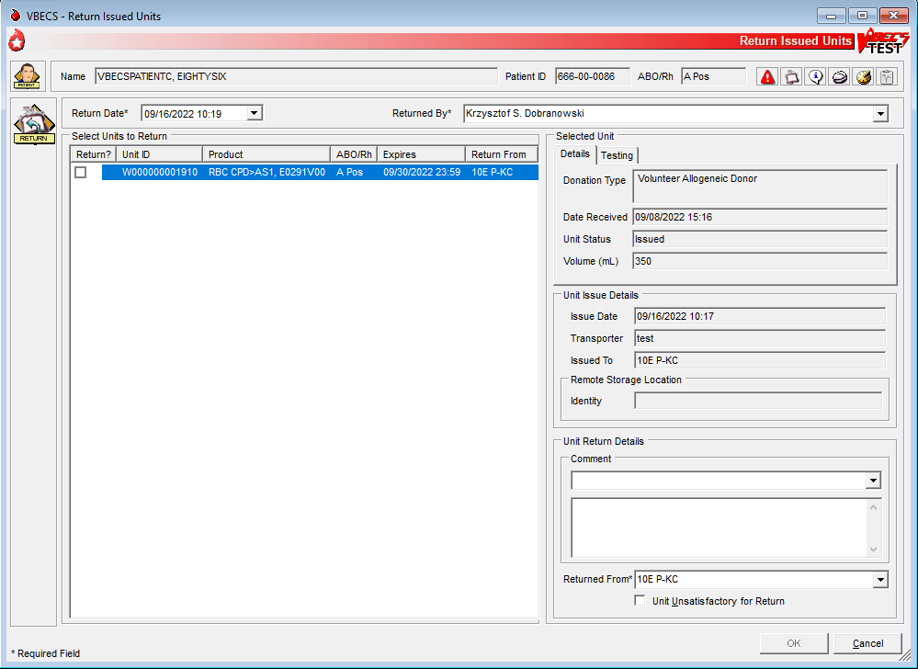

Release Units From Patient Assignment
The user releases crossmatched and assigned blood units not issued after a period determined by regulatory standards and by internal policy.

Assumptions
- The blood unit is assigned or crossmatched to at least one patient.

Outcome
- Patient restrictions still apply to a unit even after it is released from assignment and made available.
- If workload codes are assigned for this process, workload-related data collected as the result of this process are stored for inclusion in Workload Reports.

Limitations and Restrictions
- This option does not apply to the release of patient restrictions (autologous and directed).
- When a patient, specimen, or blood unit expires, VBECS does not automatically release an assigned blood unit: a user must release the unit.

Additional Information
- A user may release units from assignment as a group or individually from a patient’s list of units.

User Roles with Access to This Option
All users

Release Units From Patient Assignment
A user may select one or more blood units for release from patient assignment and return to “available” status. A user may release one of multiple patient assignments without affecting other patient assignments on a unit.
User Action | VBECS
- To release units by patient, select Patients from the main menu.  To release units by unit, select Blood Units from the main menu.  Select Release Units From Patient Assignment. | - Displays options for processing patient-related functions or for processing units.
- Scan or enter a unit ID or select a patient to release units from patient assignment and/or crossmatch (XM). | - Allows the user to edit the date and time and the user who released the units.  - Lists currently assigned units.  - Allows the user to list assigned units by patient, by unit ID, or by unit expiration date.  NOTES  VBECS indicates which specimens and units are expired.  VBECS displays a unit’s donation type only when it is restricted.  VBECS displays all currently assigned/crossmatched units located in the blood bank. When the user enters a unit ID that is not currently in the blood bank location, VBECS warns the user, clears the unit ID entry, and allows the user to enter another unit or patient.
- Indicate which units to release.  Click OK.  Indicate a reason for release of units (Figure 77). | - Allows the user to enter a reason for releasing for an individual unit.  - Allows the user to review the selections, select additional units, and deselect units before saving.  NOTES  VBECS allows the user to select no units or one or more units for each patient on the list.
- Review the entered information and click OK to save.  Click OK to exit. | - Updates the patient record, the unit record, and the status.  - Sends update to the BCE COTS system via an HL7 message to remove the unit from the system.  NOTES  When a unit has a future expiration date and holds no other assignments, VBECS updates the unit to “available” status. When a unit is assigned to a different patient, it remains assigned to that patient.  VBECS alerts the user when the unit is expired and reminds him to remove additional patient assignments and the unit from the available inventory according to local policies. VBECS instructs the user to release the unit from all assignments and remove it from the available inventory per hospital policy.
Figure 78: Confirm Release
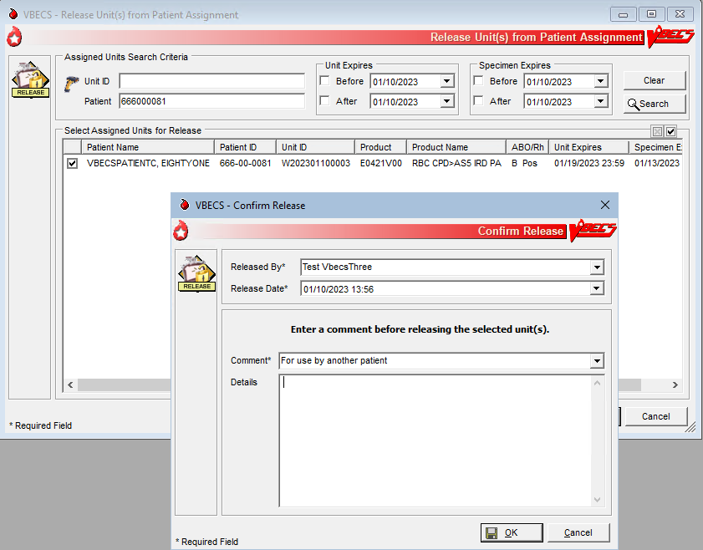

Print Unit Caution Tag & Transfusion Record Form
The user may print a Caution Tag and/or a Blood Transfusion Record Form (BTRF) when crossmatch compatibility, assignment, or emergency issue are completed or as an independent action.

Assumptions
- The blood unit, patient order, and user are in the same division.
- There is a current component class or emergency issue order for the patient, and the blood unit printed on the Caution Tag fulfills the patient order requirements.
- When the blood unit belongs to a component class that does not require crossmatch, it has a status of “assigned” (non-emergency issue only).
- For non-emergency issue, the blood unit meets all patient Transfusion Requirements (TRs).

Outcome
- The barcode generated on the Caution Tag may be used in bedside verification procedures, in accordance with local policy and procedures.
- A user may reprint a BTRF and Caution Tag.

Limitations and Restrictions
- VBECS cannot reprint a Caution Tag on an expired unit or expired patient order.
- VBECS does not print a unit’s biohazardous status on the BTRF or Caution Tag.
- If a unit has been crossmatched by two different technologists, the Compatibility Interpretation section of the BTRF displays the technologist that performed the earlier XM testing. Handwrite the missing current technologist initials on the printed BTRF.

Additional Information
- The informational barcode printed on the Caution Tag includes only the patient and unit IDs and the unit product code.
- A user may print multiple Caution Tags and BTRFs for a blood unit when it is assigned to multiple patients.
- Attach the Caution Tag labels to blood bags in accordance with local policy and procedures.

User Roles with Access to This Option
All users

Print Backup Caution Tags and Blood Transfusion Record Forms
It is recommended that blank Caution Tags and BTRFs be kept on hand in case the system or printer is not available to generate them.
User Action | VBECS
- Select Tools from the main menu.  Select Print Backup Forms.  Enter or select the number of blank tags or forms to print (Figure 78).  Click OK to print and exit. | - Displays options for processing administrative functions.  - Prompts the user to enter the number of Caution Tags to be printed.  - Prints the blank Caution Tags.  NOTES  VBECS displays an option to print a Caution Tag or a BTRF when the user selects a unit or a patient.  The user may print blank Caution Tags and BTRFs to use in case of downtime.  VBECS interrupts or cancels a print job to accommodate the printing of an emergency issue tag. VBECS notifies the user of the number of tags printed and instructs the user to enter a new request to print more tags.
Figure 79: Print Backup Forms
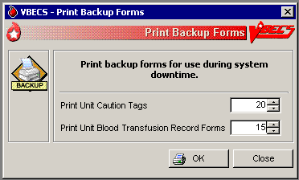

Print Unit Caution Tag & Transfusion Record Form
The user may need to generate Caution Tags when they were not printed immediately after unit selection and crossmatch data entry, emergency issue, or when there is a problem with the printed Caution Tag. According to local policy, the user selects a current patient order and one or more units to print from the VBECS-generated list of units eligible for immediate transfusion.
VBECS does not allow a user to print a Caution Tag unless the unit is satisfactory for immediate issue.
User Action | VBECS
- Select Patients or Blood Units from the main menu.  Select Print Unit Caution Tag & Transfusion Record Form. | - Displays options for processing patient-related functions or for processing units.  - Displays the option to select a patient, if one is not already selected.  NOTES  For patient with an Rh that is not Positive (negative, unknown, or inconclusive): When Rh “Positive” or Rh “Pooled” units from the WHOLE BLOOD, RED BLOOD CELLS, PLATELETS, and OTHER VBECS component classes are individually entered and confirmed by the user, the system provides an audible alert and displays the alert: "Patient is an Rh negative and the selected unit is Rh positive. Check patient sex and hospital policy before continuing. Proceed?" The user will click OK to continue.
- Enter the patient name or ID and click Search to select a patient, or  Click Search by Unit (Figure 79).  Enter the unit ID and/or product. | - Requests that the user select a Caution Tag and/or a BTRF to print by unit ID or by patient.  - Displays an informational message, when appropriate.
- Select a patient, or  Select or scan a blood unit. | - Compiles and displays the information associated with the user’s selection.  - Displays the patient’s name, ID, date of birth, the unit ID, and the long product name of units to appear on the Caution Tags.  - Prompts the user to select the units when selecting by patient.  - Allows the user to select and deselect blood units to print.  -  See Table 9 for alerts that may occur during this option.  NOTES  VBECS retrieves the most recent crossmatch result (original or repeat) to determine unit availability and compatibility status to allow printing the Caution Tag and/or BTRF and to allow the unit to be issued.  When the “Emergency Issue” indicator is present and/or the required ABO/Rh specimen testing is incomplete or inconclusive, enforce the following:  - For RBC or WB order:  - Group O, Rh positive or O Rh negative RBC  - WHOLE BLOOD is not selectable  - For FFP order:  - Group AB, Rh positive or Rh negative, or not specified.  - For PLT order:  - All units with < 2 ML RBC containment are available  - Units with > 2 mL RBC contamination are not available  - For CRYO order:  - All available units are selectable  For OTHER order:  - All units with < 2 mL contamination are available  - Units with > 2 mL RBC contamination are not available  When a user selects a Caution Tag and/or BTRF from the Blood Unit Menu and the units are assigned or have been assigned and/or crossmatched to multiple patients, the selected form may be printed for only one patient during that session. The message will display that the form cannot be printed again for another assigned patient. VBECS must be closed and re-opened to print a tag for one of the other patients. If you need to print tags on the same unit for multiple assigned patients, access the option from the Patient Menu.  When VBECS searches for units available for a patient name, it makes available for printing only units considered available for issue (standard processing or emergency issue).  See Appendix B: Table 22: Rules for Electronic and Serologic Crossmatch . The user may select only active units and those not in an inactive or final status. See Appendix B: Figure 118: Unit Status Flowchart.
- Acknowledge the selected patient and blood units for printing.  Click Print Unit Caution Tag, Print Transfusion Record Form, or Print Both.  Click OK to confirm and exit. | - Displays an option to print the Caution Tag and BTRF for units with a patient assignment.  - Generates a separate Caution Tag and BTRF for each blood unit.  NOTES  If a VBECS system error occurs when a Caution Tag is requested, the printer may not be correctly configured. Configure the printer as detailed in the VBECS 2.4.0 Technical Manual-Security Guide, with subsequent testing.  When a Caution Tag or BTRF is printed for an emergency-issued unit, “Emergency Issue” is included on the form.  The recipient ABO/Rh prints as “Unk” or “Unknown” during emergency issue when no current specimen results are on file; VBECS may not use a historic record blood type (from any source) for the typing printed on the tag/form.  VBECS prints “Emergency Issue” in the TR section of the form.  The text that appears in the compatibility section is based on the crossmatch interpretation applied.  The printed form has two general areas, one for patient and unit identification, and another to document the transfusion.  Information that appears on the form follows. All information is provided by VBECS unless stated. Information matching the caution tag will be printed to look alike for the users on both forms.  - Transfusion Division Name, City, State  - Patient ID  - Patient Name (Last, First MI)  - Patient DOB  - Unit/Pool ID  - Recipient (Patient) Blood Type  - Unit Blood Type  - Compatibility Interpretation, Tech name, Date/time  - Assigned Date/Time  - Technologist Initials (This is the Assigning/Crossmatching Blood Bank Technologist Name.)  - Transfusion Requirements  - Blood Product Component Class  - Blood Component selected (the unit’s blood product long name)  - Product Code (Full, Eye-readable)  - Donation type  - Unit Expiration Date/Time  - Number of Units in Pool  - Specimen UID Number, expiration date and time  - Order Location  Transfusion documentation section: This section of the form provides prompts/placeholders for information to be entered at the bedside during the transfusion. Each listed item must provide adequate room for a transfusionist to manually record the appropriate, required information:  - First identifier (signature)  - Second identifier (signature)  - Date/time transfusion was started  - Respiration  - Pretransfusion temperature  - Pretransfusion pulse  - Pretransfusion blood pressure  - 15-minute temperature  - 15-minute pulse  - 15-minute blood pressure  - Mid-transfusion temperature  - Mid-transfusion pulse  - Mid-transfusion blood pressure  - Post-transfusion temp  - Post-transfusion pulse  - Post-transfusion blood pressure  - Amount given (mL)  - Date/time transfusion was completed or interrupted  - Completing transfusionist (place for wet signature)  - Reverification of patient area  - Transfusion reaction indicator (No reaction/Reaction suspected)  - Description of Reaction (includes Urticaria, Chill, Pain, Fever, Dyspnea, Other)  - Other difficulties  - Signature of person noting the transfusion reaction  - Instructions for suspected transfusion reaction immediate response (see sample form for text)  Bedside verification statement (see sample form for text)  Facility Name is the name and address of the compatibility testing facility. If a full-service facility, “Facility Name” is the user’s current division. If a transfusion-only facility, “Facility Name” is the testing facility entered. For a transfusion-only facility, both the testing facility and the current division must appear on the form.  Patient Special Instructions and patient Transfusion Requirements do not print on the Blood Transfusion Record Form when the requirement isn’t appropriate (listed as “NA”) for the blood product.  When blood products are emergency issued (indicator or the testing is incomplete or inconclusive on the current specimen), print in the remarks section of the Blood Transfusion Record Form: “This unit is issued for transfusion BEFORE the completion of required compatibility testing. The blood bank staff will continue to test the compatibility of the unit using the current patient specimen. If you are alerted to a unit’s incompatibility by the blood bank, stop the transfusion immediately.”  When “***” prints for the patient ABO/Rh and crossmatch, include “Specimen testing incomplete at time of issue” in the printout.
  Compatibility Interpretation | Text on BTRF
  Crossmatch | TESTING INCOMPLETE
  Crossmatch Not Required | Not Required
  Compatibility Interpretation | Text on BTRF
  Crossmatch Compatible | Compatible
  Compatible: Electronically Crossmatched | Compatible
  Crossmatch Not Required | Not Applicable
  Crossmatch Incompatible: Give only with Medical Director Approval | Incompatible: Given with Medical Director Approval
- Print and exit.
Figure 80: Print Unit Caution Tag and Transfusion Record Form
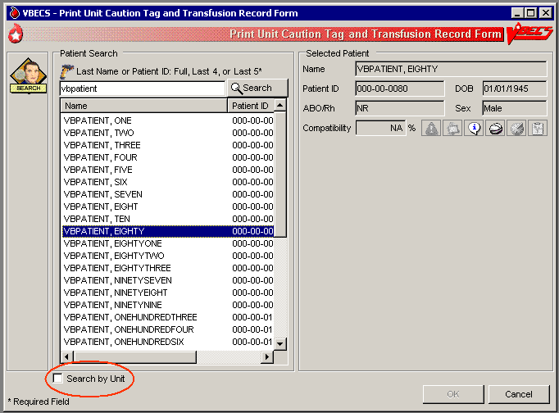
 Alerts
Table 9: Alerts That May Occur in Print Unit Caution Tag & Transfusion Record Form (Step 3)
User Action Step 3: When This Condition Exists … | …  VBECS Emits an Audible Alert and Warns the User: | User Role
VBECS determines whether the patient has a calculated or persistent antigen negative requirement (except when selecting autologous units). The selected unit was antigen typed and is positive for the corresponding antigen or is untested for the antigen. | The patient has a history of a clinically significant antibody, the unit is positive or untested for the corresponding antigen, the user does not have the proper security level. There is no override. | Enhanced Technologist or below
 | The patient has a history of an antibody(s) and the unit ID is positive or untested for the corresponding antigen(s). Continue to print Caution Tag or BTRF? No clears the screen. Yes requires a comment and captures details for inclusion in an Exception Report (exception type: Caution Tag or BTRF printed for antigen positive or untested unit). | Lead Technologist
When the patient has TRs, VBECS evaluates the selected unit to see whether a TR was satisfied based on system rules, including emergency issue. | The patient has at least one TR that is not satisfied, the user does not have the proper security level to print the Caution Tag or BTRF for this unit. Further processing is needed and must be documented in VBECS. There is no override. | Enhanced Technologist or below
 | The patient has at least one TR that is not satisfied. Continue to print Caution Tag or BTRF? No clears the screen. Yes requires a comment and captures details for inclusion in an Exception Report (exception type: Caution Tag printed with unsatisfied TR). | Lead Technologist
The patient specimen is expired. | The patient specimen is expired. There is no override. | Technologist
The patient specimen is expired. | The patient specimen is expired. Continue to print the Caution Tag and/or the BTRF? No clears the screen. Yes requires a comment and captures details for inclusion in an Exception Report (exception type: Caution Tag printed on expired specimen). | Enhanced Technologist
The user attempts to print Caution Tags for emergency issue and:  - The current specimen has an “Emergency Issue” order.  - The patient has no record of ABO/Rh typing.  - The required ABO/Rh specimen testing is incomplete.  The user may select:  - For WB or RBC order only: group O, Rh positive or O Rh negative (WHOLE BLOOD is not available).  - For FFP order only: group AB, Rh positive or Rh negative.  - For PLT order: all available units are issuable. | The unit does not meet these requirements. Testing is incomplete and this unit is not eligible for emergency issue. The Caution Tag cannot be printed. There is no override. | All users
VBECS determines whether a blood unit that does require crossmatch (electronic or serologic) is ready for issue based on the following rules:  - Unit is not in a frozen state.  - The unit is crossmatched to the patient (eXM, or serologic XM).  - TAS Specimen testing is complete and valid (ABO/Rh and ABS results are entered).  One of these crossmatch interpretations was entered:  - Crossmatch Compatible  - Compatible: Electronically crossmatched  - Crossmatch Incompatible: Give only with Medical Director approval | All of the conditions for the unit are met but an emergency issue order indicator is in place or the testing is incomplete or inconclusive on the current specimen and units were selected. Do you want to print emergency issue tags/forms for the unit/patient? Yes prints the emergency issue tags and forms. No does not allow the user to continue. | All users
For blood units that do not require crossmatch when the unit is assigned to the patient and is not in a frozen state, VBECS determines when a blood unit is ready for issue. | All of the conditions for the unit are not met. The Caution Tag and/or the BTRF cannot be printed at this time and the reason they cannot be printed. Additional patient testing or unit processing must be performed. | All users
Figure 81: Caution Tag
Product Code 2D Barcode

Division Name
City, State
^{Patient Name:}

^{Patient ID:} |  | ^{Recipient Blood Type:}
^{Unit/Pool ID:} |  | ^{Donor Blood Type:}
^{Compatibility Interpretation:}

CAUTION: Before transfusing this blood component, perform bedside verification of the patient’s identity by matching the patient identification on this tag with the patient wristband and the Blood Transfusion Record Form.
^{Assigned Date/Time:} | Assigning Tech/ Crossmatch Tech:
Figure 82: Blood Transfusion Record Form
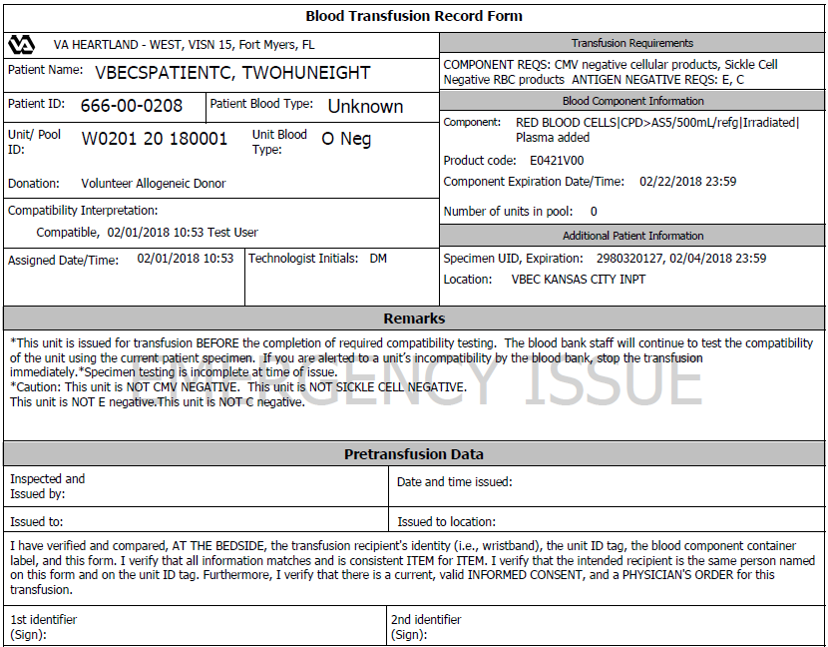

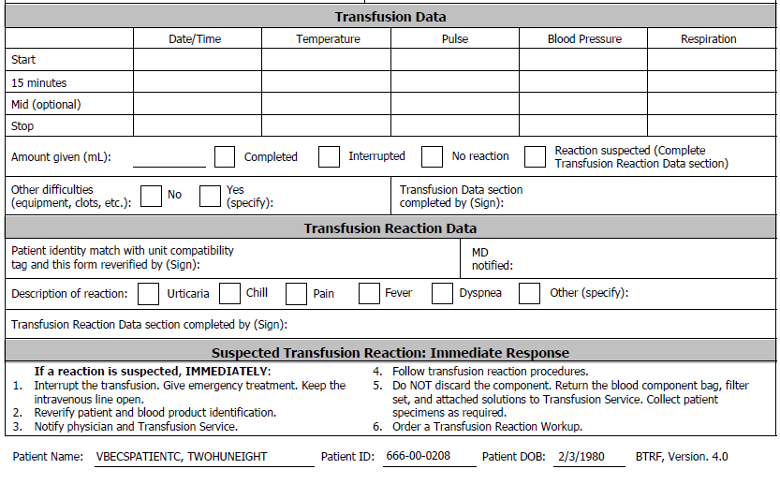

Invalidate Test Results
The user invalidates incorrectly entered patient test results and reenters correct patient test results and interpretations.

Assumptions
- A completed patient order exists in VBECS.

Outcome
- Test results are invalidated.
- VBECS may assign “correction” status to a task to allow the user to repeat a test and add it to the Pending Task List (PTL).
- If workload codes are assigned for this process, workload-related data collected as the result of this process are stored for inclusion in Workload Reports.

Limitations and Restrictions
- A user may not inactivate a component task in this option.
- This option does not release units from patient assignment. The user must release “assigned” units before invalidating the test results.
- To maintain a clear record and system checks, the user must invalidate both original and repeat ABO/Rh tests.
- Do not invalidate part of the configured test. Doing this will put the specimen into a state where it cannot be processed. Invalidate all tests configured as part of the TAS regardless of which sub test (ABO/Rh, ABS or DAT) is the problem.

Additional Information
- VBECS invalidates the entire test group during this option. The user must reenter results to replace the invalidated results.
- Workload and billing are inactivated or rescinded from the inactivated testing.
- VBECS invalidates transfusion reaction workups (TRWs) in total and crossmatches (XMs) by unit.
- Invalidation of an antibody identification (ABID) task invalidates all antibody specificities entered in that task.
- VBECS displays results and interpretations of the tests but not any QC performed with the tests.
- VBECS flags invalidated results with a message describing the reason for invalidation.

User Roles with Access to This Option
 Enhanced Technologist

Invalidate Test Results
The user may invalidate one or more previously entered test results and replace them with corrected results.
User Action | VBECS
- Select Patients from the main menu.  Select Invalidate Test Results. | - Displays options for processing patient-related functions.  NOTES  Click the Component Orders tab to view its PTL.
- Enter the patient name and/or specimen UID.  Edit the “expires after” date, if required.  Click Search, if needed. | - Displays an option to enter a specimen UID or a patient for a specific date or for a range of dates.  - Displays the complete diagnostic tests associated with the entry.
- Select a test result from the Specimen Test Results list. | - Displays the original results for the user to review.  NOTES  When the user chooses to invalidate an ABID, VBECS warns that the invalidation of the antibody specificity also invalidates the corresponding calculated antigen negative requirements. No user action is required.   When the user is a Traditional Supervisor and the selected specimen is the most recent specimen tested for the selected patient, the user may invalidate a previously justified ABO/Rh test result. When the specimen ABO/Rh test associated with a justification is invalidated, VBECS removes the justification information from the patient record.  When the user attempts to invalidate a non-XM test for a patient specimen and blood units are currently associated with the specimen (assigned, electronically or serologically crossmatched, issued or transfused), VBECS warns that blood components are associated to this specimen and that the associated units must be removed before testing can be invalidated. The user may not continue to invalidate the test.  When the user attempts to invalidate a XM test for a patient specimen and the associated blood units are currently issued or transfused, VBECS warns the user that the selected test cannot be invalidated because the unit was issued based on the XM result. The user may not continue to invalidate the XM test.
- Verify the accuracy of the selected patient specimen and patient information (Figure 82).  Click OK to accept the results. | - Marks these test results as “invalid” and asks the user whether he needs to replace the invalidated results with new test results.  - Yes (test result replacement is needed) changes the task status to “correction” to return the task to the PTL for completion.  - No (test replacement is not needed) marks the erroneous test results as “Test Result Invalidated”; the task status does not change.  - When the user selects all the diagnostic tests associated with a specimen, displays an option to mark the specimen unacceptable and invalidate the tests.
- Select the test to invalidate from the Patient Test Results list.  Click Invalidate Results (Figure 83).  Enter a comment.  Click the Add test to the Pending Task List to allow for replacement results check box, if appropriate.  Click OK. | - Asks the user whether he wishes to change the specimen status to “unacceptable.”  NOTES  To maintain a clear record and system checks, invalidate both original and repeat ABO/Rh tests.  When the user invalidated all of the diagnostic tests associated with a given specimen, VBECS asks whether the user wishes to change the specimen to “unacceptable.” No allows the user to invalidate the test results without making the specimen unacceptable. Yes changes the specimen to “unacceptable” and requires a comment.  When the user chooses to invalidate patient test results, the user is required to enter a comment (free text or canned from the “Patient Testing” context) to continue. The comment and the details of the transaction are captured for inclusion in an exception report. The user may choose to add the invalidated test back to the Pending Task List for replacement results.
- Click OK to exit.
Figure 83: Invalidate Patient Test Results
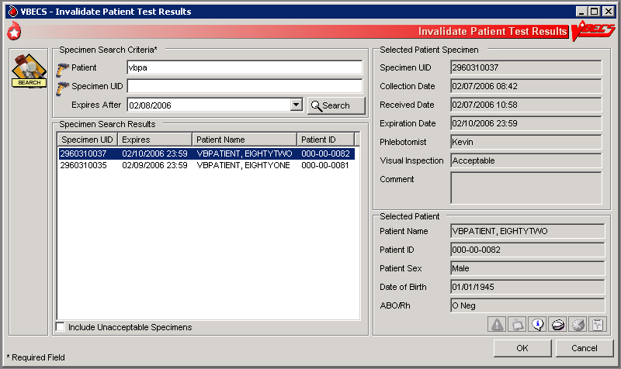
Figure 84: Confirm Invalidation
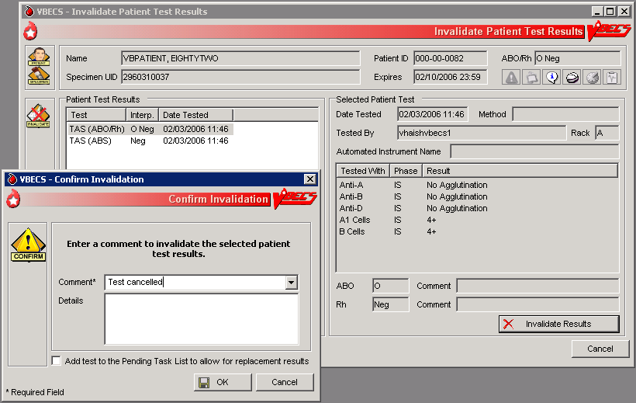

Remove Final Status
The user removes a final status from a unit. All other statuses are manipulated through normal system rules and practices.

Assumptions
- The user is logged into the division containing the unit record.
- The unit is in a final (transfused, transferred, modified, discarded) status.
- The user must invalidate the modification status of the split or pooled units, and then the original unit or pool.

Outcome
- The new information was saved with the unit’s historic record.
- The unit is in the status immediately prior to the final status.
- If workload codes are assigned for this process, workload-related data collected as the result of this process are stored for inclusion in Workload Reports.

Limitations and Restrictions
- This option applies only to the release of units in final statuses.

Additional Information
- This option allows a user to restore a unit to inventory from a final status. It may be used to begin undoing a transfusion episode (step by step in reverse order) or correct a unit modification record.
- “Issued” is not a final unit status.
- This option is not used to add units to or remove them from a pool.

User Roles with Access to This Option
 Traditional Supervisor

Remove Final Status
The user corrects a clerical error: a unit was processed and moved to a final status in the computer incorrectly.
Removing final status of a unit reported as transfused by the Transfusion Verification application will create a discrepancy between the systems. Changes or updates to a transfusion record must be made in the Transfusion Verification application first.
User Action | VBECS
- Select Supervisor from the main menu.  Select Remove Final Status. | - Displays options available to supervisors.  - Displays fields for selecting a unit and removing its final status.
- Scan or enter a unit ID or product code, or click the find button to select a unit from the drop-down list. | - Displays unit data, including the previous and current unit statuses.  - Warns the user to proceed with caution.  NOTES  VBECS warns the user when the unit does not have a final status or was not modified (other than pool, thaw/pool, and split). The user may select another unit.  When the final status is “modified” (pooled, thaw/pooled, or split), VBECS verifies that the target unit is invalidated. When the target unit was not invalidated, the user may not continue.
- Verify that the unit selected is the desired unit.  Click OK.  Enter a comment (Figure 84). | - Asks the user if he would like to remove the final status.  - Requires the user to enter an explanatory comment.  NOTES  VBECS updates the unit status to the previous status and maintains restrictions on the original unit.
- Review the data, click OK to save, and click OK again to confirm the save. | - Displays the unit data and asks the user to verify the return to the previous status.  - Allows the user to review his entries and choices and save the correction to the unit record or exit without saving.  - Updates the unit record.  NOTES  When VBECS removes a final status of “discard” or “transfer,” it also removes return credits previously assigned to the unit.
Figure 85: Remove Final Unit Status
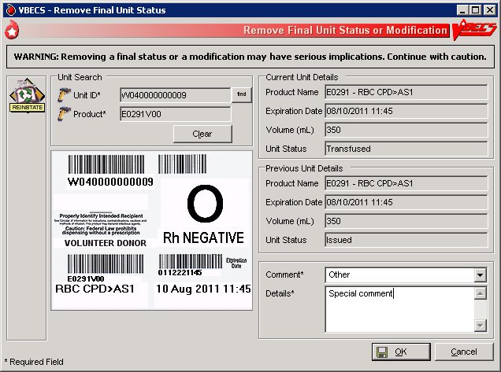

Processing Orders

Accept Orders: Accept an Order
The user accepts the receipt of an order.

Assumptions
- Orders were placed in CPRS for a patient and a VBECS order number was generated.
- When a specimen is required, the user located it.
- Inappropriate Transfusion Request parameters are defined for orderable component classes.
- The connection to VistA is active.

Outcome
- Ordered tests may be processed and are available to various worklists.
- If workload codes are assigned for this process, workload-related data collected as the result of this process are stored for inclusion in Workload Reports.

Limitations and Restrictions
- An order for TAS must be accepted before the component order if the user wants to include the component request to the Inappropriate Transfusion Request Report. Accepting the TAS after the component order is marked inappropriate and accepted clears the user’s indication that this is an inappropriate request.
- When no CPRS order exists, the user processes the specimen offline. The emergency order check box is not enabled unless there is a CPRS order and a patient specimen accessioned in VistA. If necessary, process the emergency issue of units manually, per local policy, until the specimen is received and accessioned.
- The user must accept the Type & Screen (TAS) before he accepts other diagnostic tests or component orders.
- The user cannot click (Restricted or Assigned Units) to access information on autologous or directed units that may be restricted to a patient.
- Orders placed for patients with names that exceed the database standard for File #2 (30 characters) or do not have a last name in VistA are rejected and do not appear in VBECS. The VBECS System Administrator is notified of each rejection via an email to the address entered in VBECS Administrator “Email Alerts” field.

Additional Information
- VBECS automatically cancels previously accepted orders the day after they expire.
- To maintain a specimen with a TAS and diagnostic test orders, the TAS must be processed first, before any diagnostic test order (see Maintain Specimen).
- The user may investigate patient clinical information using VistA and CPRS.
- A facility may capture the phlebotomist's signature and the date and time of specimen collection on a printed order from CPRS. [Local IRM personnel may configure CPRS to print the blood bank order: refer to Setup Guide (August 2000) in VistA Document Library, Computerized Patient Record System (CPRS)].

User Roles with Access to This Option
All users

Accept Orders: Accept an Order
The user reviews the list of pending orders and the specimen, determines that local policy requirements are satisfied, and accepts all or part of a routine order. The user accepts the VBECS order and associates the Laboratory generated specimen UID number with the order.
Changes made in the VBECS Administrator option mapping orders to another VBECS division do not affect delivered orders. Orders delivered to a VBECS division must be completed, rejected, or cancelled in that division. Resubmit orders after mapping is completed to send an order to another VBECS division.

User Action | VBECS
- Select Orders from the main menu.  Select Accept Orders. | - Displays options for processing orders.  - Displays the POL and POL search criteria.
- Select an order to accept from the POL (Figure 85), or  In the Pending Order List Search Criteria area, enter the known data, including the date wanted.  Click Search to find an order. | - Displays options for selecting, reviewing, and processing patient data and pending orders.  - Allows the user to associate a specimen with an order.  - Displays the Patient Information Toolbar that allows the user to review.  NOTES  Select an order for TAS before selecting a corresponding order for diagnostic tests or components.   VBECS emits an audible alert when there are patient Special Instructions or Transfusion Requirements.  VBECS alerts the user when the component class ordered requires a specimen. The status may be REQ (specimen required) or NRQ (no specimen required). The user may not continue until specimen information is added.   When modifiers are included in the physician's component order, VBECS provides visual and audible alerts to remind the user to evaluate the request. VBECS does not monitor subsequent action.  VBECS alerts the user when units (autologous, directed, or assigned/crossmatched) with a future expiration date are associated with the patient in any division in the database.
- Scan or enter the specimen UID in the Specimen UID field. (See Maintain Specimen.) (Figure 86)  When the component requires a current specimen and a valid sample is not available, click the Emergency Order check box.  Click Accept to accept the order without an associated specimen. | - Allows the user to enter new specimen information or correct problems with an existing specimen with the current VBECS order.  - Allows the user to process an order without an associated specimen for emergency issue and retroactively associate a specimen with the order.  NOTES  Alphabetical characters in specimen UIDs must be capitalized: VBECS recognizes only uppercase letters.  A specimen must be processed in Maintain Specimen prior to selecting for a component order.  When the order status is “In BloodBank”, a specimen was associated with the order; when the status is “Specimen Required”, the user must identify a specimen by its UID and enter specimen details according to Maintain Specimen.  Specimens collected for diagnostic tests only are to be used for performing the specifically ordered tests and are not available for processing blood component orders.  Within an order group containing orders for blood components and the Type & Screen (TAS) test, the specimen associated with the TAS test applies to the TAS test and to all blood component orders contained in the order group.  For all orders requiring a specimen, VBECS queries VistALink to verify that the lab order numbers are consistent with the specimen. If they are not consistent, VBECS notifies the user that the specimen’s lab number does not match the number associated with the order. VBECS does not accept the order until the user identifies a specimen with a matching lab order number.  When an order for a component class requires a specimen (WHOLE BLOOD and RED BLOOD CELLS component classes, and, optionally, based on Setting Component Classes) the user must select this function and replace the existing specimen with a new one. However, when VBECS displays the “emergency issue” order indicator, the user may continue without identifying an associated specimen. VBECS captures details for inclusion in an Exception Report [exception type: Emergency order accepted (no specimen)].
- Click to review order details. | - Displays order details that may not be edited.
- When the urgency is “Pre-Op,” click in the Patient Information Toolbar to review the MSBOS information for the division.  View and/or search entries in the MSBOS for possible matches with the patient surgery. | - Allows the user to review current MSBOS settings.  - Lists the current MSBOS site parameters, based on generic surgery types.  NOTES  When the pre-op indicator is “Yes,” the user may access the MSBOS to determine whether to include details of the component order in the Inappropriate Request Report.
- Based on the review of the MSBOS parameter associated with the surgery type and the details of the current order, click the Include In Inappropriate Transfusion Request Report check box, according to local policy. | - Adds the details of the order to the Inappropriate Transfusion Request Report when the user completes Accept Orders: Accept an Order.  NOTES  To display a list of available autologous and/or directed units in the system for the selected patient, see Blood Availability.  A user must accept the corresponding TAS order before including a component order in Inappropriate Transfusion Request Report.
- Click in the Patient Information Toolbar to review patient data, Transfusion Requirements and Special Instructions. | - Displays read-only TR and SI patient VBECS data.
- Click Accept or Reject for each order. | - For each order accepted, updates the:  - Status to “accepted” and adds it to the PTL for further processing.  - Existing lab accession number to collect data associated with every order.  NOTES  When a user rejects an order, VBECS acknowledges the order and cancels it through Accept Orders: Cancel a Pending Order.  When there is no specimen required for the component order, an order expiration date is assigned to ten days in the future, with the date the component order as accepted and moved to the Pending Task List being day 0. If a specimen is required, the order expiration date is the same as the associated specimen. The system needs to automatically expire the associated component order when the specimen is expired.  When a specimen is required, the order expiration date is the same as the associated specimen. VBECS automatically expires the associated component order when the specimen is expired. (See Appendix B: Figure 117: Order Status Flowchart.)  The user evaluates each diagnostic test and component order separately.  When the pre-op indicator is “No,” VBECS compares the Laboratory test values included in the order message from CPRS to the threshold values defined for the ordered component class requirements in Configure ICCBBA Component Classes Inappropriate Request Parameters setting (see Component Classes). When the threshold values were exceeded for one or more ordered component classes, VBECS notifies the user that the Laboratory test value exceeds site parameters for the component class orders and asks whether to add the order to the Inappropriate Transfusion Request report. Yes adds the details of the order to the Inappropriate Request Report. No requires a comment to be associated with the order.  The user may cancel one or more components of an order through Accept Orders: Cancel a Pending Order to cancel while working in Accept Orders: Accept an Order. When this occurs, VBECS sends a message to CPRS and notifies the VistA Laboratory application that the order was cancelled.  The confirmation message presented when accepting an order states: “Are you sure you want to accept this order, by clicking Yes, you acknowledge that you performed a patient historical data check.” When the user clicks yes, the order is accepted. The HL7 order acceptance message is sent to CPRS. When the user clicks no, the order remains pending. The patient historical data check indicator will be displayed in the Order History Report (single and multiple) and the Patient History Report .
- Repeat Steps 2 through 8 to accept another order, or click Close to exit.
Figure 86: Accept Orders
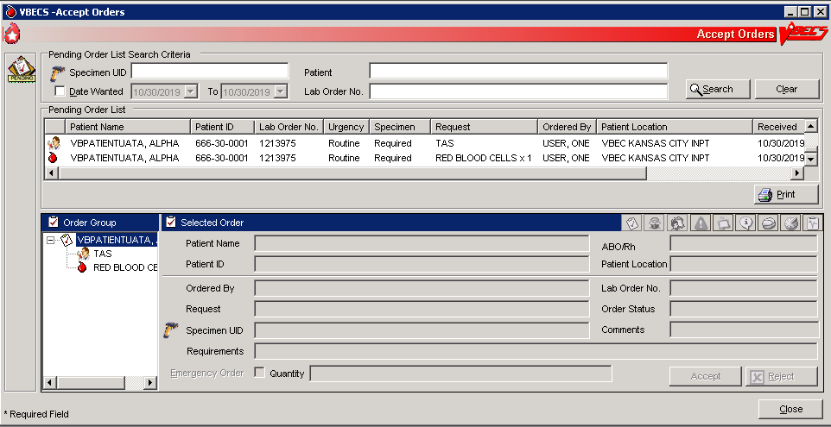
Figure 87: Maintain Specimen
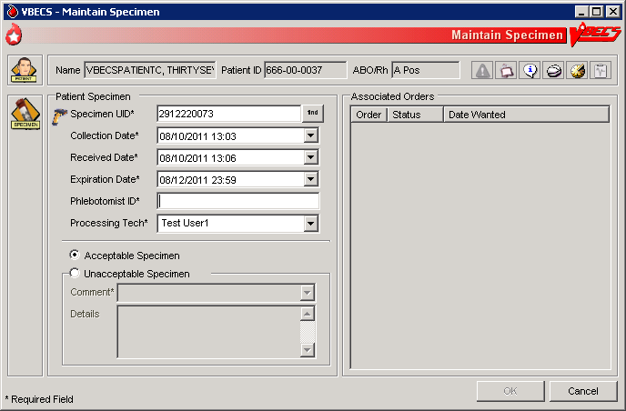

Accept Orders: Pending Order List
The Pending Order List (POL) lists pending blood bank orders.

Assumptions
- A CPRS order is acknowledged by VBECS.
- An order is printed or an alert is issued per site parameters.
- The connection to VistA is active.

Outcome
- A list of pending orders displays and may be sorted and searched.
- A list of pending orders may be printed in the default sort presentation.

Limitations and Restrictions
- Orders placed for patients with names that exceed the database standard for File #2 (30 characters) or do not have a first or last name in VistA are rejected and do not appear in VBECS. The VBECS System Administrator is notified of each rejection via an email to the address entered in VBECS Administrator “Email Alerts” field.
- TAS must be accepted prior to any diagnostic test associated with the same specimen UID to allow the specimen to be used for the TAS.

Additional Information
- This option is used for diagnostic and blood component test orders.
- Blood derivatives, for example: Octoplas, are processed using CPRS FFP order.

User Roles with Access to This Option
All users

Accept Orders: Pending Order List
VBECS displays the POL with search criteria, which allows the user to limit the number of viewable items. The user may review details of an order without taking action on it.
User Action | VBECS
- Select Orders from the main menu.  Select Accept Orders, or  Click the Pending Orders alert icon, if available, in the status bar at the bottom of the screen (Figure 85). | - Displays options for processing orders.  - Displays the Pending Order List and Pending Order List search criteria.  - Allows the user to search for specific orders.  - Provides the criteria to limit the search and subsequent presentation and processing.  - Allows acceptance of an order.  NOTES  VBECS displays orders directed to the division by a user during system configuration.  See Appendix B: Figure 117: Order Status Flowchart.  When searching for pending orders based on patient name, the system displays all pending and current accepted orders for the patient. A current order is a previously accepted order with a future order/specimen expiration date.
- Change the selection criteria, as needed, to prepare the list or to accept the default presentation. | - Displays the POL requested by user’s selection(s).  NOTES  The POL can be sorted by Patient, Procedure, Urgency, Date/time received or date/time wanted.  The user may select an entry on the POL to view additional details for the order, including:  - Patient Name  - Patient ID  - Additional component class or diagnostic tests included in the same order group as the selected order. (These are displayed whether they are “in progress” or still on the POL. There should be some indication to distinguish those that are already in progress.)  - Order comments (additional requirements from CPRS)  - Quantity (component class orders only)  - Patient hospital location  - Lab order #  - Patient ABO/Rh (if known)  - The CPRS Order ID, Group Order ID for all diagnostic tests and component orders placed in one CPRS order is the CPRS Order ID used by VBECS on the Order History Report and the Pending Task Lists.
- To continue processing the POL, review the displayed list, print the list, or go to Accept Orders: Accept an Order. | - Allows the user to return to Step 1 to change the presentation of the list, review details of pending orders, print the list, or select an order or proceed to Accept Orders: Accept an Order.  NOTES  When a user requests a POL report and VBECS does not find any information, VBECS notifies the user and asks whether he wishes to continue to print. The user may cancel or print the report, which will include “No pending orders found.”
- Exit.

Display Order Alerts
VBECS notifies the user of new and updated patient orders.

Assumptions
- VBECS receives a new order or an order update message from VistA for the user’s division.

Outcome
- VBECS displays notification icons only to users logged into VBECS.

Limitations and Restrictions
- VBECS issues no notifications for order cancellations.
- The Order alert notification icon and functionality is disabled when VBECS is set to Read-Only.

Additional Information
- The user may set VBECS to automatically print an order alert with limited information on the designated printer when VBECS acknowledges the order.
- The alert displays the individual test’s (child) CPRS ID. The individual test’s (child) CPRS ID is not displayed on the Pending Order List, elsewhere in VBECS or on reports and is not usable in search functions. (See FAQ CPRS VBECS Order Details)

User Roles with Access to This Option
All users

Display Order Alerts
VBECS notifies the user that order updates occurred and allows him to accept the new orders.
User Action | VBECS
- Hold the mouse over the icon to view a tool tip, or  Click to view a panel showing new or updated orders and hide the icon.  Click again to hide the panel. | - Acknowledges a new or updated patient order.  - Displays an order notification icon in the status bar when new orders are received, according to local settings.  - Displays information regarding new orders and order updates and allows the user to accept them.  NOTES  When the division is configured to alert the user of orders received by VBECS, VBECS notifies the user of ordered components or ordered tests that were:  - Directed to the user’s division.  - Added or updated in VistA since the system last checked.  When the division is configured to alert the user of orders needed in the next specified number of hours, VBECS also notifies the user of ordered components or ordered tests with a required time less than a specified number of hours in the future.  The system displays the following information for each entry in the summary:  - Urgency  - Patient Name  - Patient ID  - Ordered Item  - Wanted Date  - Lab Order ID  - CPRS Order ID  If the notification icon was already visible, the system appends new notification information to the summary. If it was not visible, the system displays only the new notification information in the summary.

CPRS Order Status Alert
An order’s status changes when it is accepted, completed or cancelled. VBECS transmits these status changes to CPRS using a message queueing system so that CPRS reflects the same order status as VBECS. If the status transmission is successful, that message is removed from the queue, otherwise it stays for additional attempts. The CPRS Order Status Alert (Figure 87) indicates the current transmission status by displaying one of the following icons:
CPRS Communications Error. Some orders in CPRS will not reflect the same status as VBECS. Contact Customer Support to have the issue investigated and resolved. Most problems can typically be resolved by restarting the VBECS-OERR HL7 link in VistA.
CPRS Communications Good. All VBECS order status messages have been sent to CPRS.
Figure 88: Example of the CPRS Order Status Alert
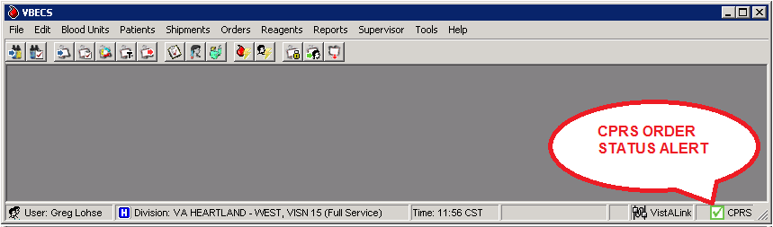

Additional Information
- The CPRS Order Status Alert checks for pending transmission messages when VBECS is started and will then refresh/recheck every 10 minutes. The 10-minute refresh interval is not configurable.
- Hovering over the alert icon will display a tooltip indicating how many messages (if any) were pending at the time of the last refresh, as well as the time of the next refresh.
- Order status messages are processed by the following services:
  - Sender: CPRS HL7 OERR (VBECS Interface / Windows Service)
  - Listener: VBECS-OERR (VistA HL7 Logical Link)
Refer to the VBECS Administrator User Guide for additional information on VBECS interfaces.

User Roles with Access to This Option
All users

Display Patient Update Alerts
VBECS notifies the user of patient update, death, and merge events.

Assumptions
- A patient demographic update is received from VistA for the user’s division for a VBECS patient with an active order.

Outcome
- The patient demographics are updated in VBECS.

Limitations and Restrictions
- VBECS does not notify users of additional VistA patient updates or merges while the icon is displayed. When a user views an update and there is an unprocessed VistA patient merge, the Patient Alert icon remains on the screen until the Traditional Supervisor updates the patient records and clears the icon.
- Patient updates involving patient’s with names that exceed the database standard for File #2 (30 characters) or do not have a first or last name in VistA are rejected and do not appear in VBECS. The VBECS System Administrator is notified of each rejection via an email to the address entered in VBECS Administrator “Email Alerts” field.
- Patient update alerts only display when active component or diagnostic test orders are pending or active at the time the update occurs.

Additional Information
- None

User Roles with Access to This Option
All users

Display Patient Update Alerts
VBECS notifies the user that patient updates occurred and allows him to view additional details.
User Action | VBECS
- Hold the mouse over the Patient Alert icon to view a tool tip, or  Click to view a menu and select Updated Patients, Deceased Patients, or Patient Merge to view the updates.  Click again to hide the menu. | - Displays a Patient Alert icon in the status bar when it receives a patient update or death event message and the patient has active or pending orders in the user’s VBECS division.  - Displays a Patient Alert icon in the status bar when it receives a merge event message from VistA.  - The system displays a patient update or merge icon alert to all users until all merge events are cleared and all updates, including death notices are viewed.  NOTES  The user may also select Patients from the main menu, Patient Updates, and Updated Patients, Deceased Patients, or Patient Merge to view the updates.

Display Patient Merge Alerts
VBECS notifies the user of VistA patient merges.

Assumptions
- A patient demographic merge alert is received from VistA for the user’s division for a VBECS patient.

Outcome
- VBECS notified the user that patient records were merged in VistA and that the user must take action to match the records in VBECS.

Limitations and Restrictions
- VBECS does not notify users of additional VistA patient updates or merges while the icon is displayed. When a user views an update and there is an unprocessed VistA patient merge, the Patient Alert icon remains on the screen until the Traditional Supervisor updates the patient records and clears the icon.

Additional Information
- VBECS notifies users of VistA patient merges until a Traditional Supervisor clears the Patient Alert icon. See Patient Merge for instructions.
- VBECS displays an alert to users for a VistA patient merge event if either the merge-from or merge-to patient exists in the VBECS system when the merge message is received.

User Roles with Access to This Option
All users

Display Patient Merge Alerts
VBECS notifies the user that patient merges occurred in VistA and allows him to view additional update details.
User Action | VBECS
- Hold the mouse over the Patient Alert icon to view a tool tip, or  Click to view a menu and select Updated Patients, Deceased Patients, or Patient Merge to view the updates.  Click again to hide the menu. | - When it receives a patient update or death event message and the patient has active or pending orders in the user’s VBECS division, displays a Patient Alert icon in the status bar.  - When it receives a merge event message from VistA, displays a Patient Alert icon in the status bar.  NOTES  The user may also select Patients from the main menu, Patient Updates, and Patient Merge to view the updates.  VBECS displays a patient update or merge icon alert to all users until all merge events are cleared and all updates, including death notices are viewed.

Emergency Transfusion Order Processing
Question: How do I Process an Emergency Transfusion Order for red blood cells when no specimen is collected?
Important Note: If the patient is not found in VistA, you must process the request manually. When the patient’s CPRS order is placed, enter your testing results and unit processing information with correct dates and times recreating the record as retrospective data entry.
Answer: No Specimen Available: Below are the steps for processing a component order when no specimen is available but required. This example is for a Red Blood Cell order.
- A CPRS order for a TAS and RBC must be placed to process the order in VBECS.
- Accession only the RBC order in the VistA LAB package. If the TAS is accessioned but not physically available, it will not interfere with the next step (Figure 88).
Figure 89: Example of Red Blood Cells Accession
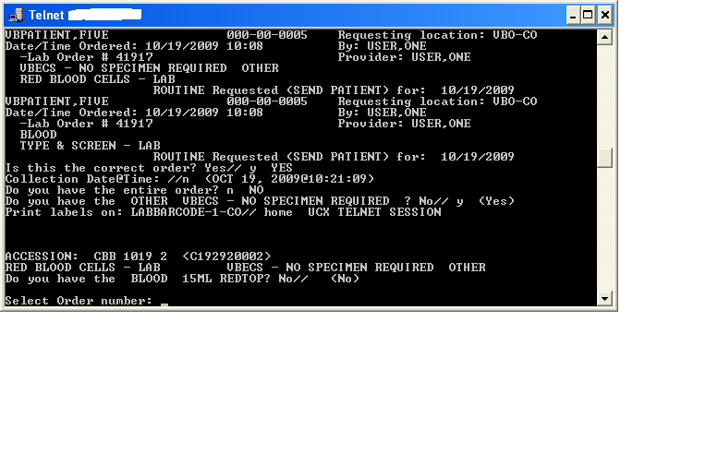
- Accept the RBC order in VBECS by checking the Emergency Order checkbox [Orders, Accept Orders (Figure 89)].
Figure 90: Example of Emergency Order checkbox
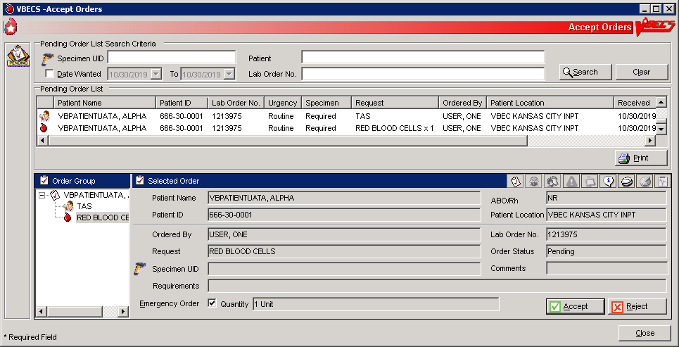
- Select Units and issue from the Emergency Issue tab until a specimen is received.
- Associate the specimen with the RBC order in Select Units by selecting one of the ISSUED units to perform retrospective crossmatch testing. Click the Find button to search for an available specimen UID (Figure 90). See the Select Units section for additional information.
Figure 91: Example of Specimen UID

Maintain Specimen
A specimen for testing is received in the blood bank and is processed as part of initial order acceptance, as described in Accept Orders: Accept an Order.

Assumptions
- Pending CPRS orders and active orders require an acceptable specimen.
- A specimen was collected and previously accessioned in the VistA Laboratory system, which generated the specimen’s universal ID (UID).

Outcome
- The user accepted or rejected a specimen.
- If workload codes are assigned for this process, workload-related data collected as the result of this process are stored for inclusion in Workload Reports.

Limitations and Restrictions
- When a search by UID causes VBECS to time out, repeat the search by UID and patient name or by patient name only.
- Specimen recollection requests must be made offline.
- Designating a specimen as “unacceptable” after accepting a CPRS order closes that order and requires a new CPRS order and sample.

Additional Information
- A specimen may be marked unsuitable for use after its acceptance.
- A specimen expiration date may be edited after acceptance.
- A specimen may be recollected without canceling or reordering the VistA order. This practice is dictated by local policy and procedures.
- Specimens marked as originally associated with diagnostic tests only or unacceptable are not considered available specimens when CPRS is queried for specimen availability.

User Roles with Access to This Option
All users

Maintain Specimen
A specimen for testing is received in the blood bank and is processed as part of initial order acceptance, as described in Accept Orders: Accept an Order.
Information about a previously accepted specimen may be updated. The user may verify whether an active specimen is currently in the blood bank or update the information concerning a previously accepted specimen. After the user checks the physician’s order against the specimen requirement, the user verifies the specimen’s condition, labeling, and accompanying paperwork, according to local policy. The user verifies the specimen information and acceptability and prepares the specimen for testing.
The user may edit specimen information, such as extending the expiration time according to local policy, and marking a specimen as unsatisfactory or expired so that future orders require that a new specimen be collected.
When a specimen is required, the user must find that specimen before acknowledging that order, as described in Accept Orders: Accept an Order.
User Action | VBECS
- Select Orders from the main menu.  Select Maintain Specimen. | - Displays options for processing orders.  - Displays fields for entering patient specimen information.
- Scan or enter the specimen’s UID. | - Displays a field to enter the specimen UID and allows the user to search for existing specimens.  - Displays previously entered information for the specimen and accommodates data entry of new specimen information.  NOTES  The user may:  - Create and/or maintain a specimen associated with an order from Accept Orders: Accept an Order.  - Update specimen information from a previously received specimen.  Specimens associated with blood bank diagnostic tests are not available in Maintain Specimen. Specimens collected for diagnostic tests only are to be used for performing the specifically ordered tests and are not available for processing blood component orders.  See Configure Division for how long the orders and associated specimens can be maintained before they expire: Type & Screen (TAS), component orders (RBC, FFP, CRYO, PLT, WB, OTHER).  The list of orderable and reflex tests below may be added to a specimen maintained for a component order, but may not have a component order added to them: they do not have maintained specimens.  These tests have a specimen drawn and used for their ordered test. The specimens are not maintained for component preparation:  - DAT  - ABS  - ABO/Rh  - Transfusion Reaction Workup (TRW)  VBECS allows the user to search all existing patient specimens associated with a specific patient. The user may enter the patient name or a specimen UID to access the list.  The specimen collection date/time must be in the past and be before or equal to the specimen received date/time.  The specimen received date/time must be in the past and be before or equal to the specimen expiration date/time.  The specimen expiration date/time may be in the past or future and it must be within the specimen collection date/time plus the maximum specimen expiration days.
- Enter new specimen information or edit previously entered information (Figure 86). | - Displays uneditable patient demographic information.  - Displays an option to edit.  NOTES  When the user extends the specimen expiration date and time, VBECS calculates the number of days by which the specimen was extended (based on the originally calculated expiration date) and the newly entered expiration date. VBECS compares the difference to the site parameter for the maximum number of extension days allowed for a specimen. When the entered expiration date exceeds the parameter, VBECS warns the user. There is no override.  When a specimen expiration date is extended on patients with transfusions greater than 3 months in the past, it will trigger the warning that patient has been transfused in the past 3 months. Users should complete the override as requested to proceed per local policy and procedure.  The default expiration date is calculated as three days in the future with the day of the original specimen collection as “0.” For example, a specimen collected on September 16, 2007 (regardless of the time), is day “0” and the calculated expiration date and time are September 19, 2007 @ 23:59.  When a new or existing specimen is being associated with a pending component order during Accept Orders: Accept an Order, the specimen must be acceptable.  When there is a specimen requirement for orders, each order must be evaluated for a valid specimen before it can be accepted.  VBECS displays specimen UIDs for selection by CPRS-associated maintainable specimen and then by acceptable and unexpired maintainable specimens, in reverse chronological order.  VBECS allows the user to include expired and unacceptable specimens.   When the user attempts to save an expiration date past the default of three days, VBECS checks the patient’s record for evidence of transfusion within the previous three months and the history of antibody identification, regardless of the division. If either is found, VBECS emits an audible alert, warns that the patient has evidence of transfusion within previous three months and/or antibody formation, and instructs the user to enter a comment to extend the specimen expiration date beyond three days. The user must enter a canned comment (with the specimen extension) and/or free-text comment to continue. VBECS captures details for inclusion in an Exception Report (exception type: Specimen expiration date extended).  When the specimen is deemed unacceptable, the status of the orders associated with the specimen remains “pending” or “active.”   When a user attempts to reactivate a previously expired or unacceptable specimen, VBECS emits an audible alert, warns that this is a previously expired or unacceptable specimen, and instructs the user to enter a comment to make it available. A comment is required to continue. VBECS captures details for inclusion in an Exception Report (exception type: unacceptable/expired specimen used).  VBECS requires the date and time a specimen was collected and the phlebotomist ID.  When a specimen is processed, VBECS displays the details of associated orders (read only).  The user must enter a comment when marking a specimen as unacceptable.
- Enter or verify specimen-related information from Step 3. | - Allows the user to review and edit previously entered information.
- Review the entered information and click OK to save. | - Saves the data for use in further specimen order processing and subsequent retrieval.  NOTES  When saving or updating an expired specimen, VBECS warns the user and asks whether he wishes to continue. The user may continue without entering a comment.  The UID initially used to identify the specimen becomes the VBECS specimen number, which VBECS retains and uses to process subsequent orders during the life of the specimen, including CPRS, VBECS, and Laboratory orders, and UIDs associated with the specimen. A historical record lists changes made to the specimen and is available for review.  A permanent link remains between an exhausted or unacceptable specimen UID and its order, which allows the user to document the recollection of a new specimen, according to local policy.
- Click OK to exit.

Patient Testing: Cancel an Active Order
The user cancels an accepted order on the Pending Task List (PTL) and adds a comment to justify the cancellation.

Assumptions
- The order and the user are in the same division.
- A user accepted an order that originated in CPRS through Accept Orders: Accept an Order, or created a reflex test order through Order Reflex Tests.
- The connection to VistA is active.

Outcome
- The order was removed from the PTL.
- An order update message was sent to CPRS.
- If workload codes are assigned for this process, workload-related data collected as the result of this process are stored for inclusion in Workload Reports.

Limitations and Restrictions
- Cancellation of one order does not affect other orders placed with it.
- Before a user may cancel a partially completed task, he must invalidate the results for that task, thereby changing its status to “not started.”
- If VistALink is not running when an order is cancelled, CPRS will not be updated about the order status.

Additional Information
- None

User Roles with Access to This Option
All users

Patient Testing: Cancel an Active Order
The user selects one or more tasks to cancel from the PTL, cancels the accepted order from within VBECS, and adds a comment regarding the cancellation.
User Action | VBECS
- Select Patients from the main menu.  Select Patient Testing. | - Displays options for processing patient-related functions.  - Displays the Pending Task List in the Diagnostic Tests tab.  NOTES  Click the Component Orders tab to view its PTL.
- Click one to four check boxes in the PTL in the Diagnostic Tests tab or the Component Orders tab to select tasks (Figure 91).  Click OK to continue, or click Cancel Order(s) to cancel the selected tasks.  Select or enter a comment.  Click OK to confirm the cancellation. | - Deletes the selected tasks from the PTL and sends a message to CPRS with an order status update.  NOTES  Select a canned comment and/or free-text comment  VBECS allows a user to cancel only tasks that are not started.  See Appendix B: Figure 117: Order Status Flowchart.
Figure 92: Pending Task List Diagnostic Tests
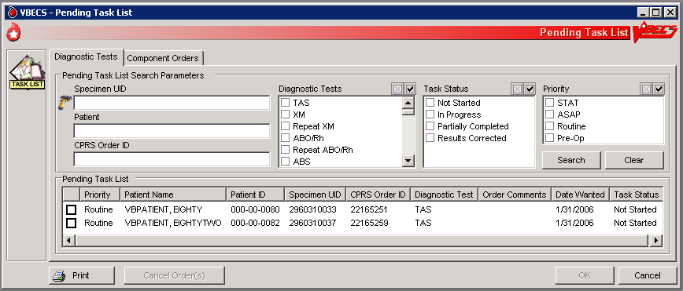

Patient Testing: Pending Task List
The user accesses a Pending Task List (PTL) to select tasks (accepted orders), organize a batch of tests to be performed in a session, process patient component requests, and view and/or print a list of outstanding blood bank tasks.

Assumptions
- CPRS orders were accepted or a reflex order was placed within the VBECS division.

Outcome
- The task is available for further processing.

Limitations and Restrictions
- This option is for diagnostic, blood component, and reflex test orders placed in or directed to the user’s division.
- The PTL does not include daily quality control, equipment maintenance schedules, or pending ABO/Rh confirmation and auxiliary tests on red blood cell units.
- Users may perform testing for no more than four patients in one VBECS session.

Additional Information
- This is the main entry point for other testing options.
- The PTL does not display completed diagnostic tests. (See FAQ Retrieving an Expired Order)
- When a specimen is not associated with a component order, partially completed and filled component orders remain on the Pending Task List for 10 days from date of order acceptance.
- When a specimen is associated with a diagnostic test or component order, partially completed diagnostic tests and filled component orders remain on the Pending Task List until the specimen expires.
- VBECS cancels accepted orders (tasks) the day after they expire.
- Multiple users are prohibited from performing the same task on the same unit of blood for the same patient.
- The task may be selected and assigned to a technologist, preventing duplicate selection by another technologist.

User Roles with Access to This Option
All users

Patient Testing: Pending Task List
The user accesses a list of pending tasks. VBECS displays the PTL with search criteria to allow the user to limit the number of items viewed.
User Action | VBECS
- Select Patients from the main menu.  Select Patient Testing (Figure 91). | - Displays options for processing patient-related functions.  - Displays the PTL and PTL search parameters in the Diagnostic Tests tab or in the Component Orders tab.  NOTES  Entering a random string consisting of letters and digits into the Patient search field returns the full pending task list. The correct combinations (full SSN, last 4 digits of SSN, first letter of last name + last 4 digits of SSN) will return a patient list.
- Click the check boxes in the PTL to select one to four tasks for processing and click OK, or  Click Print to print the list. | - Allows the user to limit the search and display.  - Prompts the user to select a task for continued processing, print a task list, or return to Step 1 to change the display of the list.  NOTES  Additional information is available in Appendix H: Frequently Asked Questions.  The user may click Cancel Order(s), select a comment, and click OK to exit.  The user may select one to four tasks for testing at a time. The tasks may be component class order tasks, diagnostic test tasks, or a combination of both.  VBECS displays “NRQ” (not required) when the task does not require a specimen for processing.  For each order, VBECS displays the specific diagnostic test or component order. The default searches for the current date’s tasks, then yesterday’s tasks, and so on until the task status is “completed.” The display includes the task’s status and a username, when applicable.  The Pending Task List (PTL) and its report display the following:  - Diagnostic Tests tab includes only unexpired diagnostic tests that are not completed.  - Component Orders tab includes only unexpired component orders (Filled orders are included).  - Report contain both unexpired component orders (Filled orders are included) and unexpired diagnostic tests that are not completed.  The following data are included:  - Patient Location (report only)  - Priority  - Patient Name  - Patient ID  - Specimen UID  - CPRS Order ID (PTL only)  - Order (Diagnostic Test or Component)  - Quantity (Component order only)  - Ordering Physician (report only)  - Order Comments  - Date Ordered (report only)  - Date Wanted  - Task Status  VBECS alerts the user when he attempts to select multiple tasks of the same type for a patient, and does not allow the selection of two or more tasks of the same type ordered for a patient during a testing session. Tasks are considered to be of the same type when they need to accommodate the use of the same testing grid in Patient Testing: Record Patient Test Results. For example, a user may not select a TAS task and one of its subtests that is ordered in a testing session. VBECS provides for one testing grid display per patient per test, not per specimen UID. If the user selected a TAS and an ABS, VBECS displays only the first one selected for result entry.  Task and order statuses and functions that are displayed on the PTL:  - Not Started: the order was not selected.  - Partially Completed <user ID>: allows selection by another user for a diagnostic test to complete, invalidate, or delete the work on this specimen. Component orders remain in this status until the specimen and order expire.  - Filled: This order status is assigned when the total number of units ordered is updated to a unit status of “issued” or “transfused.”  - Correction: previous results were invalidated; a corrected entry is required.  - Instrument Results Pending Review: displayed on the Pending Task List: Diagnostic tests: does not allow the selection by another user for manual testing.  Task and order statuses that are not displayed for selection on the PTL:  - Completed: applies to diagnostic tests  - Expired: applies to component orders at expiration of the associated specimen.  See Appendix B: Figure 117: Order Status Flowchart for the transmission of orders between CPRS and VBECS.  When a user prints a PTL and no pending tasks are found, VBECS asks whether the user wishes to continue to print. The user may cancel or print the report, which states that no pending orders were found.
- Click OK or Cancel to exit.

Accept Orders: Cancel a Pending Order
The user cancels an unaccepted order on the Pending Order List (POL).

Assumptions
- An order was not accepted by a user.
- The connection to VistA is active.

Outcome
- An order update message was sent to CPRS.
- The order was removed from the POL.
- If workload codes are assigned for this process, workload-related data collected as the result of this process are stored for inclusion in Workload Reports.

Limitations and Restrictions
- Cancellation of one order does not affect other orders placed with it.

Additional Information
- Each pending order is managed individually.
- VBECS does not automatically clear or cancel pending or unaccepted orders from the POL.

User Roles with Access to This Option
All users

Accept Orders: Cancel a Pending Order
The user selects an unaccepted order for cancellation.
User Action | VBECS
- Select Orders from the main menu.  Select Accept Orders. | - Displays options for processing orders.  - Displays the Pending Order List and Pending Order List search criteria.
- Select an order to cancel from the Pending Order List (Figure 92).  Click Reject. | - Requires the user to enter a comment.  - Requires the user to confirm the cancellation of the pending order.
- Enter or select a comment in the Comment field.  Enter details in the Details field, if desired.  Click OK and Close to confirm the order cancellation. | - Removes the order from the Pending Order List and sends a message to CPRS with an order status update.  NOTES  VBECS does not cancel a lab order if the lab order has already been accessioned.
Figure 93: Accept Orders: Reject an Order
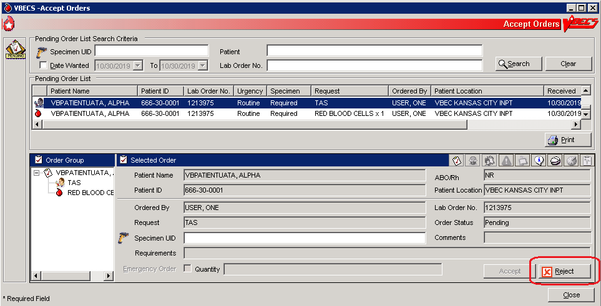

Order Reflex Tests
The user may order additional blood bank tests for a complete or incomplete accepted patient specimen to add to the Pending Task List (PTL). The ordered test or test group limits the type of reflex and repeat test order that may be associated with a specimen.

Assumptions
- A patient’s test result requires further investigation or repetition of a diagnostic test.

Outcome
- One or more reflex orders are in the PTL with a “routine” urgency.

Limitations and Restrictions
- A crossmatch (XM) and a repeat XM cannot be ordered unless they are associated with a specimen with a future expiration date and a phlebotomist is associated with that specimen.
- When a user selects weak D for the antigen typing test and the selected patient is Rh positive, VBECS warns that weak D testing cannot be performed (See FAQ Weak D Policy). There is no override and VBECS does not add the test.

Additional Information
- Unlimited repeat tests may be ordered and completed, but are not available to CPRS or to billing.

User Roles with Access to This Option
All users

Order Reflex Tests
The user orders additional blood bank tests for a patient specimen that was already accepted and that may or may not be completed. The ordered reflex test(s) are added to the PTL.
User Action | VBECS
- Select Orders from the main menu.  Select Order Reflex Tests. | - Displays options for processing orders.  - Displays specimen search criteria and search results.  NOTES  The user may also access Order Reflex Tests by clicking Order Reflex Tests when executing Patient Testing or by right-clicking the testing grid that generates the reflexive order.
- Enter the patient name and/or the specimen UID.  Click Search, if necessary. | NOTES  The user may identify specific specimen for reflex test ordering by scanning or by manual data entry of the UID on the specimen.
- Select an item from Specimen Search Results.  Review the information in the Selected Patient Specimen area and in the Patient Details and Order Details tabs (Figure 93).  Click OK to accept the order.  Respond to messages, as required. | - Displays an option to search for specimens currently available (in-date) for a patient by standard patient search conventions.  - Accommodates direct selection of a specimen by scanning or by entering a specimen UID.  - Displays available (in-date) patient specimens or orders in reverse chronological order within a date range defined by the site parameter. Only one patient specimen may have reflex tests added in one session. The expired and unacceptable specimens will follow.  - Displays a message directing the user to complete Patient Testing when the selected test is not completed. User returns to Patient Testing.  - Displays a message when a specimen is expired or unacceptable. User may click Yes to continue with the order or No to select or request another specimen, as appropriate.  - Displays the date/time/division of the specimen collection when selecting a specimen for ordering reflex tests.  NOTES   VBECS emits an audible alert, warns that the specimen is expired, and instructs the user to enter a comment to continue. When a user enters or scans an expired specimen. VBECS requires a comment and captures details for inclusion in an Exception Report (exception type: reflex test ordered on an expired specimen).  See Appendix N: Orderable Reflex Tests
- When a specimen is already selected, go to Step 5.  Select or enter a patient specimen that requires the additional test. | - Displays all orders associated with a specimen that can be used to request reflex tests for an existing diagnostic test order within an order group.  - Automatically associates the reflex test with the order when there is only one order associated with the specimen.
- Click one or more check boxes to select reflex tests from the Order Reflex Test(s) list. | - Displays the selected tests for review.  - Allows the user to select or to deselect reflex tests.
- Click OK to save and exit.  Enter a comment, if required. cancellation. | - Adds the ordered patient reflex tests to the PTL.
Figure 94: Order Reflex Test(s)
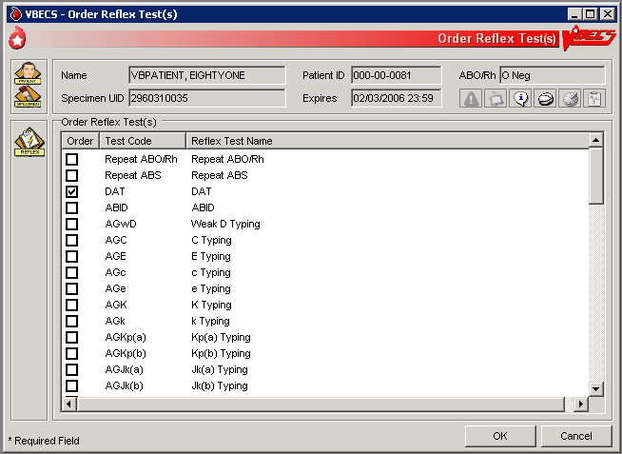

Patient Services

Patient Search Screen
VBECS displays the Patient Search screen to search for a specific patient in VBECS.

Assumptions
- The patient record exists in VBECS with the exception of specific searches that return patient information from VistA. For the Edit Unit Information, Incoming Shipment, and Document ABO Incompatible Transfusion options, VBECS searches VistA.

Outcome
- VBECS presents the user with a list of patients for selection based on their search input.

Limitations and Restrictions
- VBECS updates information from VistA File #2, not VistA File #20. Name changes made in VistA File #20 will not appear in VBECS. Align File #2 with those changes to update VBECS.
- Searching for non-alphanumeric characters (e.g., hyphens, etc.) is not supported.
- Data retrieval from VBECS is only available with project approval.

Additional Information
- The Patient Search Screen is used by options throughout VBECS to select patients.

User Roles with Access to This Option
All users

Patient Search Screen
User Action | VBECS
- To access the Patient Search screen, open one of the options listed in Notes. To search for a patient, enter the patient’s full name (last name first) or ID (Figure 94), or  Enter the last four digits of the ID, or the initial of the last name and the last four digits of the ID, and click Search. | - Displays the Patient Search screen.  - Lists patients that meet the search criteria.  NOTES  Options that allow the user to search for a patient:  - Blood Units from the main menu. Select Edit Unit Information (for restricted units only).  - Patients from the main menu. Select:  - Recent Orders  - Blood Availability  - Recent Transfusions/Issued Units  - Patient Testing Worklist Report  - Print Unit Caution Tag & Transfusion Record Form  - Issue Blood Components  - Post-Transfusion Information  - Return Issued Units To Blood Bank.  - Special Instructions & Transfusion Requirements  - Transfusion Reaction History  - Patient History Report  - Shipments from the main menu. Select Incoming Shipment (for restricted units only).  - Orders from the main menu. Select Recent Patient Orders.  - Reports from the main menu. Select:  - Blood Availability (for individual patient only)  - Medication Profile  - Patient History Report  - Transfusion Effectiveness Report (for individual patient report only)  - Supervisor from the main menu. Select:  - Document ABO Incompatible Transfusion  - Justify ABO/Rh Change  Selecting a patient record that is not found in the VBECS database will insert a new patient record from VistA.
- Select a patient from the list. | - Displays patient-associated data.  - Displays the Patient Information Toolbar.  - Displays Special Instructions (SIs) and Transfusion Requirements (TRs), when appropriate.  NOTES  Displays a message when the user selects a patient with a blank first or last name, or the name is too long. The user is instructed to contact the VBECS Administrator for assistance.
Figure 95: Patient Search

Patient Merge
VBECS notifies the user of VistA patient merges and displays details for his review.

Assumptions
- The connection to VistA is active.
- VBECS received the message about a VistA patient merge.
- VBECS accepts merge messages when either or both the merge from or merge to patients exist in VBECS.

Outcome
- VBECS notified the user that patient records were merged in VistA.

Limitations and Restrictions
- The Traditional Supervisor or above must update patient records manually.
- VBECS does not notify users of additional VistA patient updates or merges while the icon is displayed. When a user views an update and there is an unprocessed patient merge, the Patient Alert icon remains on the screen until the Traditional Supervisor completes the update and clears the icon.
- Patient merges involving patients with names that exceed the database standard for File #2 (30 characters) or do not have a first or last name in VistA are rejected and do not appear in VBECS. The VBECS System Administrator is notified of each rejection via an email to the address entered in VBECS Administrator “Email Alerts” field

Additional Information
- If more than two records are merged in VistA, VBECS will receive a corresponding number of merge messages.

User Roles with Access to This Option
All users

Patient Merge
The VBECS user examines records that were merged in VistA and decides whether to update them.
VBECS does not create links for merged records. Users must update patient information and Special Instructions to show the merged-patient relationship.

Patient merges that do not change the patient name or social security number (e.g. patient record moved to a new DFN) are displayed to the VBECS user. However, the records displayed in the Merge window will not appear to have any differences. Users are advised to contact customer support if a record merge of this type occurs.
User Action | VBECS
- Select Patients from the main menu.  Select Patient Updates.  Select Patient Merge, or  Click in the Patient Information Toolbar. | - Displays and notifies the user of the VistA patient merge.  - Lists the patient records to be updated.  - Displays limited merge-from and merge-to patient information for evaluation, including:  - Patient name  - Patient ID, if available  - Date and time the merge message was received from VistA  NOTES  VBECS displays at the first instance of a VistA patient update or merge. The icon remains on the screen until the Traditional Supervisor clears the patient merge alert.  The list of patient records is sorted in chronological order: the oldest received updated record appears at the top of the list.  The user may update both patients’ VBECS files in accordance with local policy and procedure.
- Select a VistA patient merge event from the list and review the data (Figure 95). | - Displays data about merged VistA patient records:  - Patient name  - Patient ID, if available  - Patient sex, if available  - Date and time the merge message was received from VistA  - Patient ABO/Rh, if available  - Patient Transfusion Requirements (TRs) and Special Instructions (SIs), if available  - Recent orders and recent transfusion records for the patient (available only by clicking Patient Information Toolbar icons), if available  NOTES  “Patient has no VBECS records at the receipt of the merge message” displays when the merge-from or merge-to patient is not found in VBECS.
Merge-to Patients  - Update the merge-to patient record to include SIs and TRs from the merge-from patient record.  Insert a comment in the Special Instruction field to note that a merge occurred. | NOTES  A user cannot update SIs or TRs if the merge to patient does not have a VBECS record.  Local policy must define how to handle records when the merge to patient does not exist in VBECS.  The merge-to patient record is the active record in VBECS.  Use Special Instructions & Transfusion Requirements: Enter a Transfusion Requirement, and Special Instructions & Transfusion Requirements: Enter and Remove Special Instructions to enter, update, or delete relevant component requirements, antibodies, or antigen requirements.  Enter an SI comment in the merge-to patient record, for example, “This patient record was merged with <insert merge-from patient name> in VistA and is used to process orders after <insert merge date and time>. Refer to the records of <insert merge-from patient name> for testing and transfusion information prior to the merge event.”
- Resolve ABO/Rh discrepancies among patients.  Determine which blood type is correct for use. | NOTES  Use Justify ABO/Rh Change to finalize blood type changes for the merge-to patient.
- Complete pending orders for the merge-to patient.
Merge-from Patients  - Update the merge-from patient record to include SIs and TRs from the merge-to patient record  Insert a comment in the Special Instruction field to note that a merge occurred. | NOTES  A user cannot update SIs or TRs if the merge from patient does not have a VBECS record.  Local policy must define how to handle records when the merge from patient does not exist in VBECS.  The merge-from patient record is the inactive record in VBECS.  Use Special Instructions & Transfusion Requirements: Enter a Transfusion Requirement, and Special Instructions & Transfusion Requirements: Enter and Remove Special Instructions to enter, update, or delete relevant component requirements, antibodies, or antigen requirements.  Enter an SI comment in the merge-from patient record, for example, “This patient record was merged with <insert merge-to patient name> in VistA and must not be used to process orders after <insert merge date and time>. Refer to the records of <insert merge-to patient name> for testing and transfusion information after the merge event.”
- Cancel pending orders on the merge-from patient. Request replacement orders for the merge-to patient, as appropriate. | NOTES  Local policy must define how to handle orders when the merge from patient or merge to patient does not exist in VBECS.
- To confirm that the merge-from and merge-to patient SIs and TRs match on the Patient Merge display. | NOTES  Local policy must define how to handle records when the merge from patient or merge to patient does not exist in VBECS.
- Click Clear Patient Merge Alert. | - When there are no pending patient updates, clears (the Patient Alert icon) from the main status bar.  - Displays an information message stating that the user viewed the record.  NOTES   The Clear Patient Merge Alert function is available only to the Traditional Supervisor and above.
- Click OK to acknowledge the message. | - Clears the icon when the user acknowledges the message.
- Click Close to exit, or return to Step 2.
Figure 96: Patient Merge
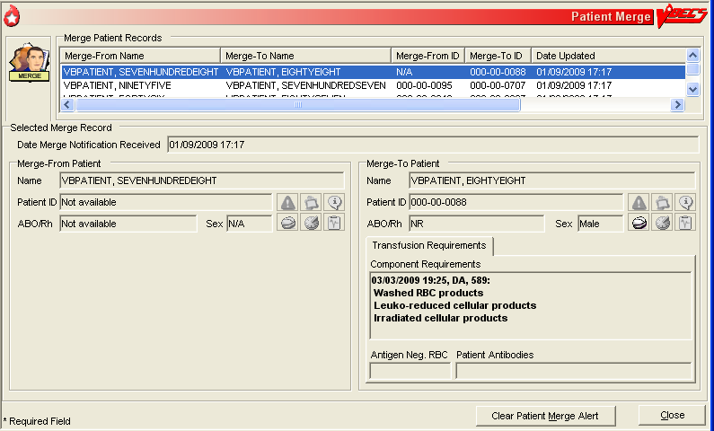

Updated Patients and Deceased Patients
The user views patient updates and death events for patients with pending or active orders in VBECS.

Assumptions
- The connection to VistA is active.
- The patient record was updated in VistA.
- VBECS received a message from VistA about a patient record update or death.
- The affected patient’s records are in the VBECS database.
- The affected patient has a pending or active order in VBECS for updates and/or death event.

Outcome
- The user reviews updated patient records.

Limitations and Restrictions
- Demographic and death event updates do not display information for patients without pending or active orders in VBECS. Updates will occur without user input.
- VBECS does not notify users of additional VistA patient updates or merges while the icon is displayed. When a user views an update and there is an unprocessed patient merge, the Patient Alert icon remains on the screen until the Traditional Supervisor completes the update and clears the icon.
- When VBECS notifies a user of an update to a patient’s prefix or suffix, VBECS does not display the updated information: the user must access VistA to view the updated information.
- Suffix data may be outdated but will be refreshed upon a new order for a patient.

Additional Information
- None

User Roles with Access to This Option
All users

Updated Patients and Deceased Patients
The user views updated patient records.
User Action | VBECS
- Select Patients from the main menu.  Select Patient Updates.  Select Updated Patient or Deceased Patient, or  Click in the Patient Information Toolbar, when it is active. | - Displays options for processing patient-related functions.  - Lists updated or deceased patients (also lists these data after the update if they changed), including:  - Patient name  - Patient ID  - Patient date of birth  - Date and time of the update, or date of death
- Click Close to exit, or return to Step 1 to view another patient’s data.

Patient Testing: General Instructions
The user records a patient’s serologic test results.

Assumptions
- The patient specimen and order were processed and found satisfactory for testing.
- The user selected one to four diagnostic and/or component tasks for testing from the Pending Task List (PTL).
- The patient may or may not have a previous blood bank record. Previously saved VBECS data related to this patient are available for comparison with the user’s test results and interpretations.

Outcome
- The test record was filed, is unique, and is retrievable for the life of VBECS.
- Partially completed testing is available for completion or invalidation but is not available to the patient record or reports.
- Completed, current specimen test results are available for inclusion in various reports.
- VBECS changes the task status to “completed” and triggers the generation of a message to CPRS that the order is complete.
- The test record includes the details of the verified, completed testing.
- If workload codes are assigned for this process, workload-related data collected as the result of this process are stored for inclusion in Workload Reports.

Limitations and Restrictions
- This test record is not editable after the user completes a test and saves it to the database. When a correction needs to be filed, a corrected report must be generated, as described in Invalidating Patient Test Results.
- User selection of partially completed testing grids with different phases of testing (All Phases or AHG Only) as previously selected creates a testing discrepancy in VBECS.
- Limited batch testing to partially completed orders with the same testing grid selection, either All Phases or AHG Only.
- VBECS cannot compare test results for a patient when two users are entering test results for the same patient at the same time.
- Cost entry is capped at 999.00.

Additional Information
- Partially completed tests may be invalidated within the testing option.

User Roles with Access to This Option
All users

Patient Testing: General Instructions
A user records a patient’s test results: Type & Screen (TAS), ABO/Rh, Antibody Screen Test (ABS), Direct Antiglobulin Test (DAT), and crossmatches (XMs) on units selected for a patient. This option describes the configuration of reflex or repeat testing and patient antigen typing.
User Action | VBECS
- Select Patients from the main menu.  Select Patient Testing. | - Displays options for processing patient-related functions.  - Displays the Pending Task List (PTL) in the Diagnostic Tests tab.  NOTES  A user may search for specific tasks using search criteria detailed in Pending Task List.
- Click one to four check boxes in the Pending Task List to select tasks for testing (Figure 91).  Click OK. | - Displays patient names and associated task information.
- Click a check box to select a reagent rack.  In the ABS or XM Testing Phases area, click the All Phases or AHG Only radio button (Figure 96).  Click OK to continue with testing. | - Allows the user to select the All Phases or AHG Only radio buttons only when applicable.  - Displays reagent rack names and associated information.  - Requires the user to select the reagent rack name. The testing grid configuration for serologic testing defaults to the setting selected in the Configure Division option. The user is allowed to indicate whether an automated instrument was used.  - Displays the date and time testing was performed.  - Displays the testing technologist name.  NOTES  When the testing method selected is AHG only, VBECS enables specific phases for the ABS and XM data grid boxes for:  - Antibody Screen (ABS): AHG phase  - Serologic crossmatch (XM): IS and AHG phases  Rack configuration of AHG applies only to the antibody screen and crossmatch testing grids.  The user may select another user’s name from the list, as appropriate. The logged on user’s name appears on the Testing Worklist Report as the Processing Tech in addition to the selected user name.  The user may indicate that testing was performed at a past date and time.   See Table 10 for alerts that may occur during this option.
- Respond to warnings, which may include entering a comment and details, and click OK to continue. | -  Displays and emits an audible alert when there are SIs or TRs for the patient.  - Prepares a direct data entry (DDE) grid for the user to enter the serologic reaction results for testing associated with the selected tasks.  - Displays testing results and entered interpretations until the user saves them.
- Select a patient to begin entering his serologic reactions (Figure 97).  Repeat this step for each selected patient until all test results and interpretations are entered in the test grid. | - Allows the user to select one patient at a time and enter a test result for that patient.  - Allows only valid data entries in the grid reaction result and interpretation cells.  - Allows a user to save partially completed tests.  - When the user enters interpretation data, allows the save with or without warnings and overrides based on the test results entered for the patient and the user’s security level.  NOTES  The user may order a reflex test and may update the patient’s TRs and SIs.  The ABO and Rh tests are considered one test and must be resulted together before a save is permitted.
- Respond to warnings for the selected patient and confirm that appropriate test results were entered.  Repeat Steps 5 and 6 for each patient until all patient work is saved. | - When a user enters a valid interpretation and saves it for a test, updates the order status to “completed.”  - Displays each patient’s data for review before allowing the user to save them.  - Saves patient testing results for retrieval from completed tests.  - Saves only the patient testing displayed.  NOTES  The user may save part or all of one patient’s testing results at a time. When all data for a patient are saved, the patient tab is no longer visible.  When a user saves a test with a “correction” task status, VBECS saves the results and interpretations and adds a comment to the Testing Worklist Report.  VBECS sends an order completion message to CPRS when the user enters and successfully saves all test results and interpretations for a diagnostic test.  If the antibody screen is positive, the system shall emit an audible alert and warning that displays Patient has a POSITIVE Antibody Screen Result. Please perform Antibody Identification on this patient prior to issue of blood components.   May display multiple warning and override messages for the user’s response.
- When the selected patient testing is complete, click OK and Yes to confirm changes and continue to the next patient, or exit.
Figure 97: Testing Details
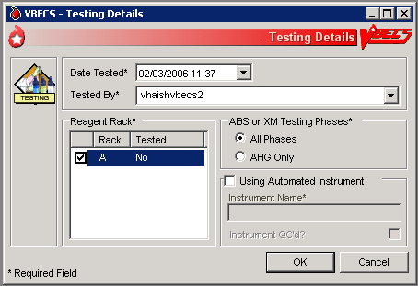
Figure 98: Patient Testing
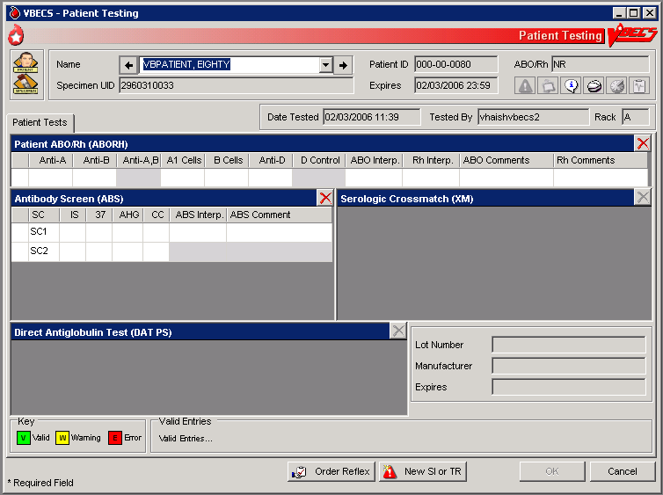

 Alerts
Table 10: Alerts That May Occur in Patient Testing: General Instructions
User Action Step | Alerts
4 | When the division is configured as “full service” in Configure Division, VBECS displays data fields for the user to select or enter the lot number, and displays the manufacturer and expiration date of each antiserum to be used in this transaction to allow the user to choose the correct antiserum. VBECS displays in-date antisera and allows the user to select outdated antisera, if needed, emits an audible alert, and requires an override. VBECS captures details for inclusion in an Exception Report (exception type: expired antisera used). A comment from the "Patient Testing" context is required.
5 | The user may cancel or delete a partially completed grid. VBECS:  - Emits an audible alert and requires a comment.  - Clears previously entered observed results from the data grid and allows the user to enter new data.  - Captures details for inclusion in an Exception Report (exception type: previously recorded results inactivated). Note that the time displayed in the "Date/Time results invalidated" field is the time the results were entered.
6 | Warns that the user is saving the first instance of a historic ABO/Rh.
6 | When the ABO/Rh interpretation matches observed results, is not inconclusive, and does not match the patient’s historic ABO/Rh (if any, including from database conversion), VBECS emits an audible alert, warns that the current ABO/Rh does not match previous results, and instructs the user to enter a comment to continue, or click Cancel to clear the ABO/Rh testing results and interpretation from the screen. VBECS captures details for inclusion in an Exception Report (exception type: ABO/Rh discrepancy).
6 | When the interpretation of a repeat ABO/Rh does not match the original interpretation, VBECS:  - Verifies the retest results.  - Emits an audible alert and warns the user.  - Instructs the user to resolve the discrepancy before the specimen may be used.  - Asks whether the user wishes to continue to save. No clears the ABO/Rh testing results and interpretation from the screen. Yes requires a comment and captures details for inclusion in an Exception Report (Exception type: ABO/Rh discrepancy).
6 | When a user documents an ABO/Rh discrepancy, VBECS releases units with “assigned” and “crossmatched” statuses associated with this specimen from the patient.
6 | When a unit was issued and a conflicting test result found that indicates a potential unit incompatibility with the patient, such as a patient ABO/Rh discrepancy, the unit XM is incompatible with the patient, the patient ABS is positive, the patient DAT is positive, or the unit is antigen positive where antigen negative is required on the tested specimen, VBECS warns the user and instructs him to notify the physician of this potential problem immediately, according to hospital policy. VBECS warns the user during the execution of the various tests related to the compatibility of a blood unit and captures details for inclusion in an Exception Report (exception type: unit issued, testing problem).
6 | If the antibody screen is positive, the system shall emit an audible alert and warning that displays Patient has a POSITIVE Antibody Screen Result. Please perform Antibody Identification on this patient prior to issue of blood components.

Patient Testing: Record a Patient ABO/Rh
The user records observed results when performing ABO/Rh blood typing.

Assumptions
- A CPRS order exists that includes an ABO/Rh typing [ABO/Rh Test or Type & Screen (TAS)].
- The user accesses patient ABO/Rh grids through Patient Testing: Record Patient Test Results.

Outcome
- The ABO/Rh result is used to determine overall blood component compatibility.
- When ABO/Rh is ordered as a stand-alone test, VBECS changes the task status to “completed” and triggers the generation of a message to CPRS that the order is completed.

Limitations and Restrictions
- VBECS does not allow entry of ABO or Rh subgroups as a 'group' and/or 'type' when the previous blood group/type is "NR", indicating no record of previous testing. See FAQ ABO Subgroup Interpretation and contact the Service Desk for assistance, prior to adding patient transfusion records in VBECS, when possible.
- When the patient has no previous ABO/Rh test record (NR), the ABO/Rh test associated with the Type and Screen test (TAS) must be completed and saved prior to entering and saving a repeat ABO/Rh test on this specimen.
- A user is permitted to select two partially completed tests with different test phases (e.g., AHG only and All Phases) along with a not started test. The testing phase for the not started test will present as AHG only even though results for all phases are required by VBECS. Entering only AHG test results for the specimen that was not started and saving will result in a partially completed test that cannot be completed or invalidated. Contact the Service Desk when you encounter this problem. Specimens that cannot be completed or invalidated require the attention of Tier 3 support. Select partially completed orders that have been previously saved with the same grid test pattern. Optionally, a not started test may be selected with these but must be tested with the same grid pattern to avoid the problem.
- When canceling out of a Discrepant ABO/Rh Typing override, the interpretations are cleared, but the testing results are not cleared. Correct the testing entries or click the red ‘X’ to clear the testing results.

Additional Information
- When an ABO/Rh discrepancy exists, VBECS releases assigned and crossmatched units. These units are then available for emergency issue based on system rules.
- VBECS does not enforce local policies that require running a D control for AB positive patients.
- The most recent instance of ABO/Rh testing in the database serves as the historic ABO/Rh record.
- Weak D testing results recorded in Patient Antigen Typing do not interact or change the Rh typing recorded for the patient by an ABO/Rh test.

User Roles with Access to This Option
All users

Patient Testing: Record a Patient ABO/Rh
This option describes a test to determine the patient’s ABO/Rh typing from a blood specimen. The user enters the serologic reaction results in the data entry grid using the instructions and rules in this option. The grid is used for the Confirm Patient ABO/Rh reflex test as part of a TAS and crossmatch (XM) test battery. VBECS monitors the user’s entries and interpretations and maintains the records for patient reports.
These steps describe the entry of data for a patient ABO/Rh test when the test is ordered individually or as part of a TAS.
User Action | VBECS
- Select Patients from the main menu.  Select Patient Testing. | - Displays options for processing patient-related functions.  - Displays the Pending Task List (PTL) in the Diagnostic Tests tab.  NOTES  A user may search for specific tasks using search criteria detailed in Pending Task List.
- Click one to four check boxes in the Pending Task List to select tasks for testing.  Click OK. | - Displays patient names and associated task information.
- Enter patient ABO/Rh testing results. | - Displays a direct data entry (DDE) grid for entering serologic reaction results for ABO/Rh patient testing.  NOTES  The user may reenter valid results or delete entries and start over before saving the results. The user may invalidate, but not edit, data in a grid from a previous session by clicking the red “X” in the upper right corner of the testing grid, as described in Invalidate Test Results.  VBECS determines the validity of the user-entered patient ABO/Rh interpretation by comparing the reaction results pattern of the row with the truth table and with the previous ABO/Rh entries for the patient.
- Select a patient to begin entering his serologic reactions. | - Allows the user to select one patient at a time and enter a test result for that patient.  - Allows only valid data entries in the grid reaction result and interpretation cells.  NOTES  When A,B or D control is not part of the daily QC configuration, VBECS disables it in the ABO/Rh test grid.  When an AB Positive patient requires the performance of a control cell, the user must order a repeat ABO/Rh test.  When A,B is enabled, the user enters a result for Anti-A,B as part of the patient test, it is included in determining the interpretation for that patient test. “X” is an acceptable entry.  A,B and D control are always enabled for the repeat ABO/Rh test grid, regardless of the QC configuration.  Reflex testing grid fields are available for data entry regardless of QC rack configuration.  See Table 4: Valid Interpretations.  Row validation is established for the interpretation vs. reaction results pattern defined by system rules.
- Repeat Steps 2 through 4 until some or all portions of the test grid for the selected patient are entered.  Enter the interpretation for the patient ABO/Rh typing, if appropriate. | - Prompts the user to confirm that all results were reviewed and are acceptable.  NOTES  When the ABO/Rh interpretation matches observed results, is not inconclusive, and does not match the patient’s historic ABO/Rh (if any, including from database conversion), VBECS emits an audible alert, warns that the current ABO/Rh does not match previous results, and instructs the user to enter a comment to continue, or click Cancel to clear the ABO/Rh testing results and interpretation from the screen. VBECS captures details for inclusion in an Exception Report (exception type: ABO/Rh discrepancy).    VBECS allows the Enhanced Technologist to enter an ABO/Rh interpretation that matches the patient’s previously recorded (historic) ABO/Rh interpretation when the system interpretation is inconclusive. This allows unit selection to continue based on the patient’s ABO/Rh interpretation entered by the user. VBECS requires the user to document the findings of any offline investigation, alerting the reviewer to appropriately follow up, according to local policy. VBECS emits an audible alert and warns the user. VBECS allows an override with comment and captures details for inclusion in an Exception Report (exception type: discrepant ABO/Rh override) that includes all interpretations and historic patient information.
- When all required fields are complete, click OK to save and continue to the next patient, or exit. | - Saves the data.  NOTES  In a Transfusion Only ABO/Rh testing grid, free text comments cannot be saved. Create the comment in Canned Comments, Patient Testing context, and then select it. Inactivate the Canned Comment, if it is not to be used again.

Patient Testing: Record a Patient Antibody Screen
The user records the serologic results when performing the Antibody Screen Test (ABS).

Assumptions
- The user accesses patient ABO/Rh grids through Patient Testing: Record Patient Test Results.
- A CPRS order exists that includes an ABO/Rh typing [ABO/Rh Test or Type & Screen (TAS)]. An ABS may also be ordered as a reflex patient test.
- Configure Daily QC and Configure Testing are complete.

Outcome
- When an ABS is ordered as a stand-alone test, VBECS changes the task status to “completed” and triggers the generation of a message to CPRS that the order is complete.

Limitations and Restrictions
- This option is for patient testing only.

Additional Information
- The user performs lab tests and enters data simultaneously.

User Roles with Access to This Option
All users

Patient Testing: Record a Patient Antibody Screen
The user tests the patient’s specimen for the presence of antibodies-to-irregular red cell antigens. The user may perform this test alone or as part of a battery of tests.
The user accesses patient antibody screen grids through Patient Testing: Record Patient Test Results and enters observations of the serologic reactions in the data entry grid during testing. VBECS makes the interpretation available to CPRS and patient reports.
User Action | VBECS
- Select Patients from the main menu.  Select Patient Testing. | - Displays options for processing patient-related functions.  - Displays the Pending Task List (PTL) in the Diagnostic Tests tab.  NOTES  A user may search for specific tasks using search criteria detailed in Pending Task List.
- Click one to four check boxes in the Pending Task List to select tasks for testing.  Click OK. | - Displays patient names and associated task information.
- Click a check box to select a reagent rack.  In the ABS or XM Testing Phases area, click the All Phases or AHG Only radio button.  Click OK to continue with testing. | NOTES  When the testing method selected is AHG only, VBECS disables the data grid boxes for phases IS, 37, and CC.
- When processing more than one patient, select a name from the drop-down list in the Name field (or click the right or left arrow) to record testing for that patient. | - Allows the user to select a patient and enter a test result for the patient.  - Allows only valid data entries in the grid reaction result and interpretation cells.  NOTES  The logic described in Appendix B: Table 16: Antibody Screen Test Interpretation is an integral part of the configuration of the reaction result grid developed for Patient Testing: Record a Patient Antibody Screen.  There may be two to five rows of screening cells to be validated as a group (the ABS). The user enters only one interpretation for the combination of cells tested.  Valid interpretations of an ABS Test are positive or negative.  If the antibody screen is positive, the system emits an audible alert and warning that displays that the Patient has a POSITIVE Antibody Screen Result. Perform Antibody Identification on this patient prior to issue of blood components.
- Repeat Step 4 until results are entered in some or all portions of the test grid for the selected patient. Enter the interpretation for the patient ABS Test, if desired. | - Verifies that appropriate tests are entered.  - Prompts the user to confirm that results were reviewed and are acceptable.  NOTES  When the ABS Test interpretation must be consistent with observed test results based on Table 16: Antibody Screen Test Interpretation, discrepancies must be resolved before VBECS verifies the results and adds them to the database. The user may reenter valid results or delete the entries and start over before saving.
- Enter test results in preparation for updating the database. | - Saves the data.
- Click OK to save, and OK to confirm and exit.

Patient Testing: Record a Direct Antiglobulin Test
The user records observed results when performing a Direct Antiglobulin Test (DAT).

Assumptions
- A CPRS order exists that includes a DAT, which the user may also order as a reflex patient test.
- The user is testing a patient specimen in Patient Testing: Record Patient Test Results.
- VBECS is configured to accommodate the DAT as part of a Type & Screen (TAS).

Outcome
- When a DAT is ordered as a stand-alone test, VBECS changes the task status to “completed” and triggers the generation of a message to CPRS that the order is complete.

Limitations and Restrictions
- VBECS does not check whether the lot and vial numbers selected for the positive control cells are different from those of the negative control cells.

Additional Information
- The site settings determine which reagent types and lot numbers are available.
- VBECS checks the rack for the DAT reagents in use. When the rack testing does not include Poly AHG, Anti-IgG, or anti-complement, VBECS displays additional positive and negative control rows with the test grid for the DAT sera. (See FAQ Polyspecific AHG Not Used for Testing)
- The user may select reagent lot numbers for positive and negative control cells: Reverse ABO Typing Cells (Set), A2 cell (vial), Screening Cells (set), Check Cells (vial), Panel (set), and Other (set).
- DAT tests indicated as performed using GEL with valid control cells no longer require the entry of check cell results. DAT tests performed by manual method will also no longer require entry of check cell results. Test results do not have to be entered, but the cell cannot be blank. An “X” can be entered to indicate “Not Tested”, if testing was not performed.

User Roles with Access to This Option
All users

Patient Testing: Record a Direct Antiglobulin Test
The user performs a DAT on a patient sample.
The DAT may generate additional reflex test orders such as antibody identification. VBECS saves the reactions and interpretation in the database as part of the patient’s record.
User Action | VBECS
- Select Patients from the main menu.  Select Patient Testing. | - Displays options for processing patient-related functions.  - Displays the Pending Task List (PTL) in the Diagnostic Tests tab.  NOTES  A user may search for specific tasks using search criteria detailed in Pending Task List.
- Click one to four check boxes in the Pending Task List to select tasks for testing.  Click OK. | - Displays patient names and associated task information.
- When QC was not performed, enter a lot number for the antiserum. | - Displays reaction result grids for DAT tests for each patient.  - Lists the AHG antisera related to the test.  - Displays information about the lot number, including the manufacturer and expiration date.  - Prompts the user to select the correct antisera and possibly the control cell entry.  NOTES  Reagent lot numbers that are selectable for positive and negative control cells:  - Reverse ABO Typing Cells (set)  - A2 cell (vial)  - Screening Cells (set)  - Check Cells (vial)  - Panel (set)  - Other (set)  VBECS lists the AHG antisera related to the test from previously entered inventory. When VBECS displays multiple DAT tests or the full battery, the user selects each DAT serum separately by repeating this step until all are selected.  Each positive and negative control cell requires the user to select a lot number.  VBECS displays options to select the lot number of the antisera and check cells used for QC of the antiglobulin sera. The user must select complement check cells for Anti-Complement AHG tests.   VBECS compares the control cell results entered to those of the previous day for the same rack number and alerts the user when there is a decrease in reactivity of 2 or more within the acceptable limits for each reagent type by lot number. VBECS emits an audible alert, warns that there is a decrease in reagent reactivity of two or more, and asks whether the user wishes to continue to use this vial.  Yes allows the user to continue, with comment. VBECS captures details for inclusion in an Exception Report (exception type: QC decrease reagent reactivity ≥ 2).  No allows the user to reenter the lot number for this reagent type and allows the approval of this same lot number (different vial) or the entry of a new lot number, returning to the testing worksheet where the user left off. (The user may replace an individual vial that is losing its reactivity with one of the same lot number.)  When the user-entered test results indicate a satisfactory interpretation, VBECS indicates that testing is satisfactory and allows the user to save the results. VBECS considers the affected QC incomplete until it is retested with satisfactory results. VBECS generates warnings through other options when QC testing is incomplete.   VBECS compares the expiration date of the reagent on the selected reagent to the testing date. When the reagent is expired, VBECS emits an audible alert, warns the user and asks whether he still wishes to use this reagent. Yes requires a comment and captures details for inclusion in an Exception Report (exception type: expired reagent QC’d).  No removes the unsatisfactory reagent and requires the user to enter a new one. Unsatisfactory lot numbers are never displayed. VBECS captures details for inclusion in an Exception Report (exception type: Expired reagent QC’d).  When the antisera QC is required, the user verifies the lot numbers, manufacturer name, and expiration date and saves them as part of the QC record for the associated test.
- Review and accept the selected reagent information. | - Displays the previously entered information for user review.
- Respond to warnings and continue with DAT testing. | - Displays a direct data entry (DDE) grid for the user to enter serologic reaction results for DAT testing.
- Enter valid test serologic reactions in the data entry grid. | - Allows the user to enter valid data and test results in the interpretation cells.  NOTES  Row validation is established for the interpretation vs. reaction results pattern as defined by system rules.
- Repeat Step 4 until some or all portions of the test grid for the selected patient are entered. When appropriate, enter the interpretation for the patient DAT testing. | - Prompts the user to confirm that all results were reviewed and are acceptable.
- Enter test results in preparation for updating the database.
- Click OK to exit.

Patient Testing: Record a Crossmatch
The user records observed results and interpretations when performing a serologic crossmatch (XM) between a patient and one or more units of blood.

Assumptions
- A CPRS order exists for a blood component that requires a serologic XM. The patient order and the selected units are in the same division as the user.
- A blood unit that contains = > 2 mL red blood cell contamination, selected in Select Units, is acceptable for testing, according to the patient’s current or historic records and ABO/Rh.
- A current specimen was accepted and is in process for ABO/Rh and Antibody Screen Test (ABS), or was previously completed and is not expired.

Outcome
- When patient Transfusion Requirements (TRs), if any, are fulfilled and a user enters a compatible XM interpretation, VBECS makes units available for generating the Blood Transfusion Record Form (BTRF), for printing the Caution Tag, and for issue to the patient.
- When a user enters an unacceptable XM interpretation, VBECS releases the selected units from the patient.

Limitations and Restrictions
- The specimen associated with testing must have an expiration date and time that are later than the testing date and time entered in Patient Testing: Record Patient Test Results. When this is not the case, VBECS warns that the patient specimen expired. There is no override.
- This option does not include electronic crossmatch (eXM).

Additional Information
- AABB Standards (5.16.1) requires a serological XM to detect ABO incompatibility. A local policy must be in place if the site is not performing a IS AHG as part of their serologic crossmatch test, manual or using an instrument.
- When the user saves a partially completed XM testing worklist, VBECS does not clear patient entries without results or release them from the worklist, which VBECS saves for completion later.
- When VBECS saves a partially completed XM worksheet, it maintains a status of “assigned” for selected units until the serologic XM is complete. When VBECS saves the XM test. including interpretation, to the database, it assigns “crossmatched” status to the unit. The user may correct verified patient data only through Invalidate Test Results.
- Units that require antigen typing and/or modification to fulfill a component requirement and/or Sickle Cell testing may be crossmatched pending the completion of further processing of the unit.
- VBECS does not allow users in a transfusion-only facility to save partially completed worksheets. The user must enter interpretations for all selected units before VBECS enables the OK button.
- XM compatibility is one aspect of blood unit compatibility. VBECS takes into account the known requirements for compatibility is taken into account when the user prints Caution Tags and BTRFs, and includes such issues as antigen negative requirements and component requirements.

User Roles with Access to This Option
All users

Patient Testing: Record a Crossmatch
During Select Units, the user selects a blood unit to fill a patient order. If the unit selected contains red blood cells and eXM is not enabled, or the patient or unit does not qualify, VBECS directs the user to enter serologic XM results. (When eXM is enabled, the user may select serologic XM.)
The user performs the serologic XM test and records results in VBECS. VBECS monitors the user’s entries and interpretations to determine (with the user) compatibility for each crossmatched unit.
User Action | VBECS
- Select Patients from the main menu and select Patient Testing, or  Select Blood Units from the main menu and select Select Units. | - Displays options for processing patient-related functions.  - Displays the Pending Task List (PTL) and PTL search parameters in the Diagnostic Tests tab or in the Component Orders tab.
- Enter or select PTL search parameters, if appropriate.  Click the check boxes in the PTL to select one to four component orders.  Click OK to continue. | - Displays information for each component order.  - When the selected order class is RED BLOOD CELLS and the division enabled eXM, evaluates the patient for eXM unit processing.  NOTES   See Table 11 for alerts that may occur during this option.
- Click Add Units to add units to the component orders selected (Figure 70). | - Searches the database and displays available restricted autologous and directed units that the user must select before selecting allogeneic units of the same ICCBBA component class.  - Displays the unit ID, product type, unit ABO/Rh, unit expiration date, specimen UID, if applicable, of units assigned to the patient in the division’s blood bank on a different specimen or order. The user may release and reassign the units to the current order.  - When eXM was configured for the facility, displays the eXM status (eligible or not eligible) for the patient.  NOTES    See Table 11 for alerts that may occur during this option.  When no valid ABO exists for the patient, the user may select components, including autologous units:  - For RBC or WB order:  - Group O, Rh positive or O Rh negative RBC  - WHOLE BLOOD is not selectable  - For FFP order:  - Group AB, Rh positive or Rh negative, or not specified.  - For PLT order:  - All units with < 2 ML RBC containment are available  - Units with = > 2 mL RBC contamination are not available  - For CRYO order:  - All available units are selectable  For OTHER order:  - All units with < 2 mL contamination are available  - Units with = > 2 mL RBC contamination are not available
- Scan or enter allogeneic units, select compatible units from the Order Group list, or click the find button to select units.  Enter or select a date in the Selection Date field. Each unit may have its own selection date and time.  Click Add Units to display the unit selection form.  To change the Assigned Date and Assigned By fields, click a unit in the Order Group list. | - Maintains a list of selected units. The user may deselect selected units.  - Evaluates the selected unit:  - For the ABO/Rh compatibility of each unit and warns the user.  - Against patient Transfusion Requirements (TRs) and warns the user.  - For unit antigen negative compatibility and warns the user.  - Performs additional checks that include days remaining until the unit’s expiration date, the current status, assignments to other patients, quarantine and biohazard indicators, when applied, and associated special testing.  NOTES    See Table 11 for alerts that may occur during this option.  The user may accept or edit the current date and time displayed; the date and time must be in the past.  Restricted (autologous or directed) unit selection eligibility criteria:  - Restricted For Patient ID: must match  - Restricted For Patient Name: must match  - Unit expiration date must be in the future.  - Component class (transfusion only requires restriction of all units)  The criteria for selecting or including an individual unit in a pick list include evaluating a unit for:  - Considered substitutable for the order  - Same division as the user  - Current location is in the blood bank  - Is not already assigned or crossmatched to the patient  - Is not “restricted” for a different patient  - Meets ABO/Rh compatibility requirements specific to the component class  - Future expiration date  VBECS lists only ABO/Rh compatible units for selection.  When ABO/Rh results were not created for the specimen associated with the component order and the order is not designated “emergency issue,” VBECS allows the user to select units using historic records, and notifies the user that ABO/Rh testing must be performed at this division on this patient before any selected units can be issued.  VBECS displays and allows the user to complete a pending XM associated with a patient order without a final unit status.
- Repeat Step 4 until all units are selected. | - Requests the user to confirm the list of selected blood units.  NOTES  The user may select or deselect additional units.
- Click OK to confirm the selection of units. | - Determines whether the units are available for issue or whether they require additional modification and/or testing based on the component class.  - Updates the database, as appropriate.  NOTES   See Table 11 for alerts that may occur during this option.  When eXM is enabled at the division and blood units require XM, VBECS determines whether the patient and units are eligible for eXM. All parameters listed in Appendix B: Table 22: Rules for Electronic and Serologic Crossmatch must be met. Units not eligible for eXM must have serologic XM performed.  When eXM is not enabled, the user must enter serologic XM results for red blood cell classes or when a user orders an optional XM for OTHER component classes. VBECS does not change the unit status to “crossmatched,” make units available for issue, or allow the Caution Tag or BTRF to be printed until a user enters a valid XM result, unless an emergency-issued unit is being processed.
- Select another component order to continue selecting units, or exit. | - Displays orders for the next patient.
- Select a unit to begin entering serologic reactions.  Enter valid text, then press the Enter key to move to the next data grid comment cell. | - Allows only valid data entries in the grid reaction result and interpretation cells.  - Restricts data entry to valid selections for testing results. All testing results and entered interpretations remain on the screen.  NOTES  During XM result data entry within a given row, the IS phase result must be entered first. Once the IS phase has been entered, data entry may progress and an observed result or NT entered in each phase before the XM interpretation is validated by VBECS.  XM interpretations must be consistent with observed test results based on system rules for the testing method. Discrepancies must be resolved before VBECS can verify results and add them to the database. The user may reenter valid results or delete entries and start over.  If the patient has a history of a clinically significant antibody or a persistent antigen negative requirement, VBECS warns that the patient is not eligible for IS-only XM and instructs the user to perform the antiglobulin transaction XM on the patient. There is no override. The user must complete all phases of the XM test.
- Repeat Step 3 until the test grid for the selected patient is complete.  Enter the interpretation for the patient XM test, if desired.  Respond to warnings and enter comments, when indicated. | - Verifies that all appropriate test results have been entered for the patient and the selected unit(s).  - Displays various warnings based on rules.  - Prompts the user to confirm that results were reviewed and are acceptable.  NOTES   When VBECS emits an audible alert and requires a comment, it captures details for inclusion in an Exception Report (exception type: inconclusive crossmatch).  A user may enter a “Compatible” XM interpretation only after entering an observed test result for the IS phase (other phases are NT) when the antibody screen on the current specimen is complete and negative and when the patient has no calculated or persistent antigen negative requirement. (See FAQ Antibodies with No Antigen Negative Requirement)  When observed test result patterns are invalid, VBECS warns that test results are invalid and that the user must repeat tests. VBECS stores these results as documentation and clears the grid for the user to begin again.   VBECS emits an audible alert and requires a comment documenting medical director approval, according to site policy. VBECS captures details for inclusion in an Exception Report (exception type: Crossmatch Incompatible: Give Only with Medical Director Approval).
- Enter test results in preparation for saving. | - Saves data.  - Prompts the user to generate a BTRF and a Caution Tag during Patient Testing: Record Patient Test Results when the crossmatched unit is acceptable for issue.
- Click OK to exit.

Crossmatch Interpretations
In all cases, VBECS saves the crossmatch information to the database.
Table 11: Crossmatch Interpretations for Print Unit Caution Tag & Transfusion Record Form
User Entry | Crossmatch Interpretation | VBECS Updates the Unit Status to: | Is Information Available to CPRS? | May User Print the BTRF and Caution Tag? | Other
C | Crossmatch Compatible | Crossmatched | Yes (unit is available) | Yes
D | Crossmatch Compatible: Don’t Transfuse | Available | No | No
G | Crossmatch Incompatible: Give Only with Medical Director Approval | Crossmatched | Yes (unit is available) | Yes | 
I | Crossmatch Incompatible | Available | No | No
Z | Inconclusive | Available | No | No | Applies to the manual serologic crossmatch test only

Patient Testing: Record a Patient Antigen Typing
The user records observed results when performing a patient antigen typing test other than the ABO/Rh test.

Assumptions
- Patient antigen typing is ordered through Order Reflex Tests.
- The user accesses patient antigen typing grids through Patient Testing: Record Patient Test Results.
- Reagent inventory was entered in Maintain Minimum Levels.

Outcome
- The testing record includes the patient’s antigen typing and the control cell information.

Limitations and Restrictions
- Antigen typing applies only to red blood cell antigens. (This option does not address platelet, HLA, or IgA antigens.)
- VBECS does not check:
- The patient antigen typing with the specificity of any patient’s antibodies entered.
- Whether the lot and vial numbers selected for the positive control cells differ from those of the negative control cells.
- The patient antigen typing result is not available to CPRS.

Additional Information
- Clinical significance and availability of typing reagents are not implied when antigens are included in the list of antigen type tests.
- Unit antigen tests may be added through Incoming Shipment and Edit Unit Information.
- The patient antigen typing test is associated with a CPRS patient order.
- The patient’s antigen typing information does not appear as part of the Transfusion Requirements or Special Instructions in the Patient Information Toolbar.
- When VBECS displays lot numbers for selection, it checks the inventory for the reagent name and lot numbers in use in a rack. VBECS does not offer reagents with an “unsatisfactory” value in the Inspection field or with a quantity of zero as a selectable reagent. The user may not enter a lot number that VBECS disallowed on the selection list. The user must choose a different reagent.
- When a user selects a reagent rack that was never QC’d, VBECS warns the user, clears the selection, and allows the user to select a different rack.
- VBECS automatically adds the positive and negative control tests to the selected reagent type worklist if they have not been tested on that calendar date for the selected antisera lot number.
- VBECS stores the lot number, vial identifier, manufacturer, and expiration date of the positive and negative control cells with the testing record.
- The user may not enter “H” (hemolysis) in antigen typing testing.
- Weak D testing results do not interact or change the Rh typing recorded for the patient by an ABO/Rh test.

User Roles with Access to This Option
All users

Patient Testing: Record a Patient Antigen Typing
This option describes a test to determine the patient antigen typing from a blood specimen.
User Action | VBECS
- Select Patients from the main menu.  Select Patient Testing. | - Displays options for processing patient-related functions.  - Displays the Pending Task List (PTL) in the Diagnostic Tests tab.  NOTES  A user may search for specific tasks using search criteria detailed in Pending Task List.
- Click one to four check boxes in the Pending Task List to select tasks for testing.  Click OK. | - Displays patient names and associated task information.  - Displays a direct data entry (DDE) grid for entering serologic reaction results for antigen typing testing. This grid may be partially populated from a previous session.  - Allows the user to select a unit and enter a test result for the unit.  - Displays options for finding and selecting tests to process.  NOTES  When the user selects a partially completed worksheet, he must verify the lot numbers, manufacturer name, and expiration date of the antiserum and control cells previously selected. These fields may not be edited. (A user who finds a discrepancy must delete the worksheet and start over.)
- Confirm the selected patient.  When control cells were tested for the antiserum, go to Step 7. | - Displays an option to select a lot number for each of the antiserum types selected.  NOTES  VBECS displays grids and quality control cells for each antiserum type.
- Select a lot number for each antiserum specificity. | -  Allows the user to select or enter the lot number and displays the manufacturer and expiration date of each antiserum to be used in this transaction so the user can select the correct antiserum. VBECS displays in-date antisera. When the user selects outdated antisera, VBECS emits an audible alert and requires a comment from the ”Patient Testing” context and an override. VBECS captures details for inclusion in an Exception Report (exception type: expired antisera used).  - Prompts the user to select the correct antiserum entry for the specificity selected.  - Displays the lot number information.  NOTES  VBECS requests information about an antigen lot number only the first time it is used on a specific day.  If there are multiple test tabs, VBECS displays a message that may not correspond to the selected tab, but will correspond to information required by one of the requested tests.
- Verify the antiserum lot number selected (Figure 98). | - Allows the user to select the testing phases for the antiserum specificity by lot number.  - Displays a testing grid and disables the phases that are not to be completed.  - Stores the antiserum information and checks whether the positive and negative controls are needed.  NOTES  The user must indicate the phases of reactivity for each antiserum specificity:  - IS  - IS/RT  - IS/37  - AHG/CC  VBECS enables the Rack Identifier field when the user selects the weak D or AHG/CC phase. VBECS disables the rack identifier field when the user selects other phases.  When the user QC’d the antigen typing reagent lot number and performed patient antigen typing on the same date under different testing phases, VBECS enables the QC grid for the antisera in the phases the user selected.   When the user attempts to change the phases of reactivity previously recorded for the lot number, VBECS emits an audible alert, warns that the user selected phases that were not used previously for this reagent, and asks whether the user wishes to continue. No requires the user to select the correct testing phases. Yes requires the user to enter a comment from the “Patient Testing” context explaining why he is selecting different testing phases. VBECS captures details for inclusion in an Exception Report (exception type: antigen testing phase change). VBECS requires a comment and captures details for inclusion in an Exception Report. Antigen testing phase change
- Select the lot number for the reagent and the positive and negative control cells. Enter the vial identifiers, if required. Enter “0” when not using panel cells.  Verify the reagent type and the positive and negative control cell lot numbers selected and vial identifiers entered, if required (Figure 99). | - Displays the lot number information, including the vial identifier.  NOTES  Selectable reagent lot numbers for positive and negative control cells are:  - Reverse ABO Typing Cells  - A2 cell  - Screening Cells  - Check Cells  - Panel  - Other (set)  The vial identifier, comprising one or two digits, identifies the vial contained in a kit of reagent red blood cells. A vial contains antigen positive or antigen negative blood cells to be used in quality control of the antisera.
- Respond to warnings and continue with antigen typing. | - Displays a DDE grid for entering serologic reaction results for antigen typing testing. This grid may be partially populated with results from a previous session.  NOTES  VBECS organizes the worklist for the grids by antiserum types.  The row title of the data grid specifies the positive and negative control cells; the column title specifies the phases of reactivity that may be used in the test. VBECS fills in this information; the user may not edit it.
- Select one control cell or patient to begin entering serologic reactions and interpretations. | - Allows the user to select a patient or control cell and enter test results.  NOTES  Valid observed test results include:  System rules establish row validation for the interpretation vs. reaction results pattern [for all user-indicated phase(s) of reactivity] for blood unit and quality control tests.  When completing previously saved partially completed testing, the user may not change the antiserum lot number, manufacturer name, or expiration date. The user must invalidate the antiserum testing and start over.
  Entry | VBECS Translation
  1 | 1+ | Positive
  2 | 2+ | Positive
  3 | 3+ | Positive
  4 | 4+ | Positive
  W | Weak | Positive
  F | Mixed Field | Positive
  M | Microscopic | Positive
  X | Not Tested X (Not Tested) (does not indicate a disabled cell) | Not Tested
  0 | No Agglutination | Negative
  R | Rouleaux, No Agglutination | Negative
- Enter results for selected patients and control cells. | - Prompts the user to confirm that results were reviewed and are acceptable.  NOTES   VBECS searches the current order and the patient’s historical record for previously entered red cell antigen results for each specificity within the user’s division and compares the results to prevent a discrepancy with previous test entries. When a discrepancy is found, VBECS emits an audible alert, notifies the user that the current specimen and a previously entered antigen typing on this patient do not match, and asks whether the user wishes to save the current result.  No closes the form and returns to the grid. Yes allows the user to update the conflicting results in the database and/or enter a comment explaining why he is accepting this result. VBECS captures details for inclusion in an Exception Report (exception type: discrepant patient antigen typing).
- Repeat Steps 5 through 9 for each antiserum type. | - Allows the user to save.  NOTES  The positive and/or negative control cell test results on the date of testing must be a valid positive or negative.
- Respond to warnings and click OK to save the data. | - Reconfirms that all appropriate test results are entered, repeats all data validation, and saves the data.
- Click OK to exit. | - Saves the data.
Figure 99: Patient Testing Antigen Typing (1)
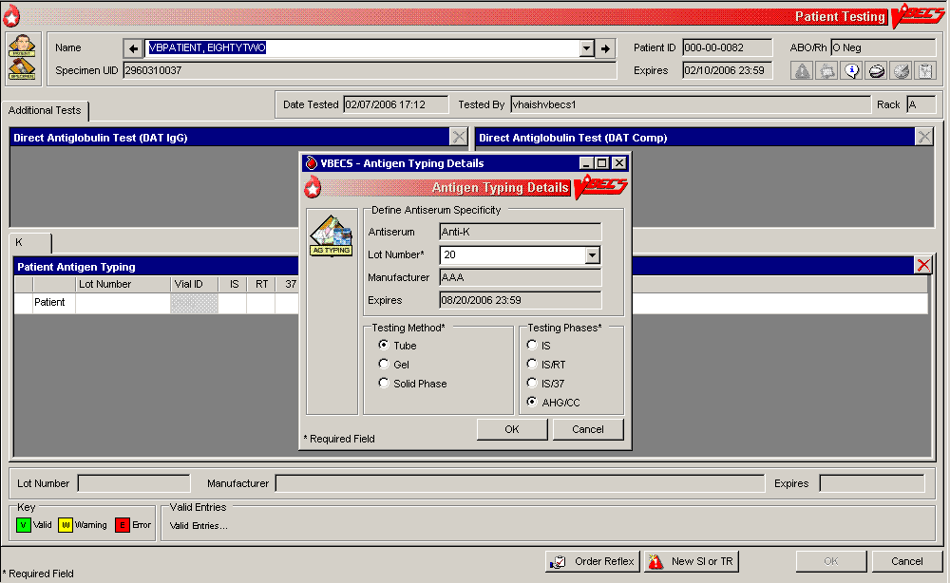
Figure 100: Patient Testing Antigen Typing (2)
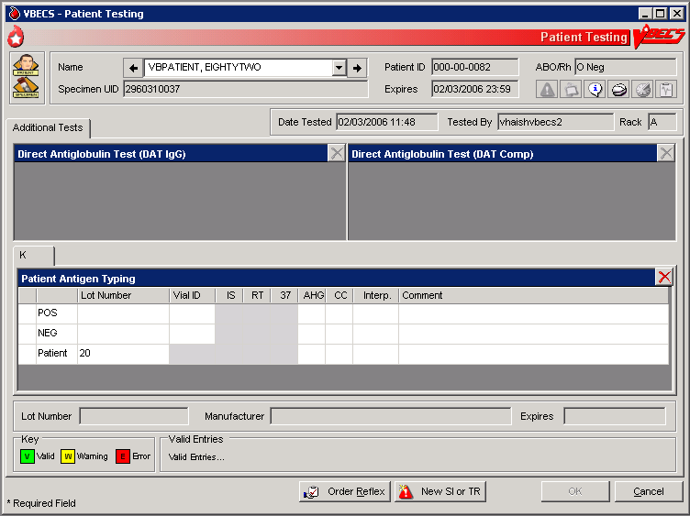

Patient Testing: Enter Antibody Identification Results
The user records results of reflex tests needed to complete a patient blood bank antibody workup.

Assumptions
- An order for an antibody identification (ABID) was placed and is opened in the Pending Task List (PTL).

Outcome
- VBECS displays the ABID in the patient’s record, which the user may review by clicking an icon in the Patient Information Toolbar.
- Entry of antibody specificity through this option may automatically set an antigen negative requirement [Transfusion Requirement (TR)] based on the division-specific parameters.

Limitations and Restrictions
- When an antigen negative requirement is not configured for an antibody, the user may enter the requirement for a patient through Special Instructions & Transfusion Requirements: Enter a Transfusion Requirement.

Additional Information
- Correction to verified patient data may be accessed only through Invalidate Test Results and does require extensive removal of associated units, even if transfused. As this is the case, optionally record workload and billing here but the antibody specificity identified using Special Instructions Transfusion requirements option to allow for future editing.
- Only one technologist at a time can enter test results for a selected PTL task.
- Patient antigen testing is not included in this option.

User Roles with Access to This Option
All users

Patient Testing: Enter Antibody Identification Results
The user may select workload codes for work performed on-site during the ABID workup. When the ABID is performed off-site, the user enters the associated charges.
User Action | VBECS
- Select Patients from the main menu.  Select Patient Testing. | - Displays options for processing patient-related functions.  - Displays the Pending Task List (PTL) in the Diagnostic Tests tab.  NOTES  A user may search for specific tasks using search criteria detailed in Pending Task List.
- Click one to four check boxes in the Pending Task List to select tasks for testing.  Click OK. | - Displays patient names and associated task information.
- Click a check box to select a reagent rack.  Click OK to continue with testing. | NOTES  No serologic testing is recorded for ABID.
- Select antibodies.  Enter associated testing details.  Respond to comments and continue.  Verify Patient information.  Click OK. | - Displays the list of antibodies and allows the user to select from the identified specificities and to add antibodies or to indicate that no antibody was identified.  NOTES  Multiple workload codes may apply when work is performed on-site.
- Review the selections displayed. Return to Step 1 to change selections when necessary.  Accept the reviewed entries. | - Displays applicable data fields for the ordered ABID.  - Allows the user to indicate the testing site and associated billing from outside sources.
- Enter the location where testing was performed and cost, when off-site. | - Requires the user to indicate whether the ABID was performed at the division and/or off-site and saves that information with the ABID.  - Allows the user to enter a charge, but not the workload, when the ABID work was performed off-site.  - Allows the user to indicate multiples of any processes when a test was performed on-site.  - Allows the user to enter comments.  - Do not exceed 50 characters when entering the name of the off-site testing location.
- Review the antibody tests entered and comments selected and, when necessary, change them before accepting (Figure 100). | - Displays the requirements for antigen negative blood components, if any, based on the antibody entered.
- Click OK to save the information to the database. | - Saves the data.
- Click OK to exit.
Figure 101: Patient Testing Antibody Identification
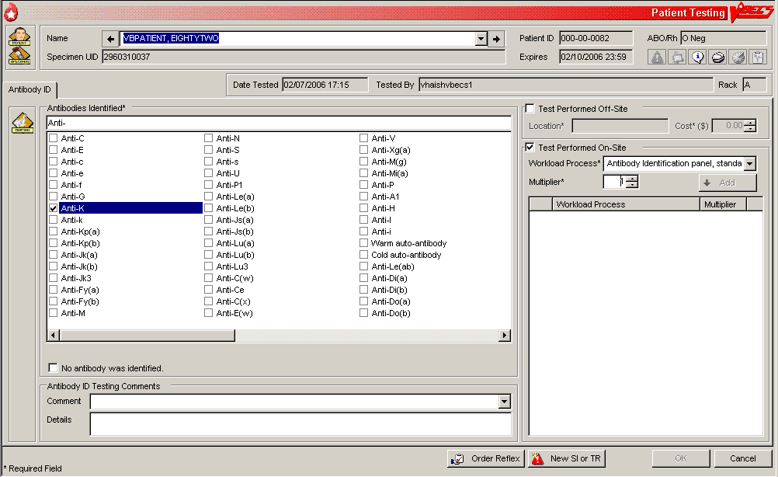

Patient Testing: Record a Transfusion Reaction Workup
The user documents a transfusion reaction workup (TRW).

Assumptions
- A TRW is ordered and is “not started” or “in progress” on the Pending Task List (PTL).

Outcome
- The user views or prints a preliminary TRW report of findings.
- Preliminary report findings are available for display in CPRS.
- If workload codes are assigned for this process, workload-related data collected as the result of this process are stored for inclusion in Workload Reports.

Limitations and Restrictions
- Adverse reactions to transfusion detected at a later time (disease transmission) are not recorded through this option. Refer to Transfusion Complications Report.
- Each tab is completed and saved and is not editable. To change information on a previously completed tab, the TRW must be invalidated and corrected in its entirety.
- If comments are entered when a TRW is finalized as type "Other,” they won’t show on the CPRS Blood Bank Report.
- There is no scroll bar on the TRW Serologic Tests tab. This limits the number of visible implicated units to around ten (10) depending on the display resolution. When more than around ten (10) units are implicated in the transfusion reaction, order additional TRW test(s) as required.

Additional Information
- All implicated units are added to data grids.
- Testing is based on local policies.
- VBECS allows the user to invalidate previously entered and saved information. When the user invalidates specimen data entered, VBECS invalidates the TRW.
- A delayed hemolytic transfusion reaction is typically identified about 7 to 10 days post-transfusion. It may be addressed in this option or as an antibody identification. (See Patient Testing: Enter Antibody Identification Results.)
- This test record is not editable after the user saves it to the database. When a correction needs to be filed, a corrected report must be generated, as described in Invalidate Test Results.
- See the printed chart copy for the medical director’s signature and TRW interpretation, as described in Finalize/Print TRW.
- A user may order a TRW prior to the completion of a unit’s transfusion record.
- The user must complete the unit’s transfusion record prior to implicating a unit in a TRW.
- These data remain encapsulated as part of the TRW and are not saved, compared to the patient record, or associated with other pre-transfusion grid testing.
- TRW ABO/Rh typing results are not saved as historical ABO/Rh typing results. These test records are maintained as part of the TRW only.
- A system error occurs when a user attempts to access a locked TRW.

User Roles with Access to This Option
All users

Patient Testing: Record a Transfusion Reaction Workup
The user accepts the TRW order, inspects the sample for hemolysis, and performs implicated clerical checks. The TRW may require entry of patient data, including vital signs and serologic test results. A signed, printed TRW report must be filed with the patient’s chart.
Transfusion reactions may be worked up in stages depending on patient symptoms and serologic findings. The first stage includes the initial clerical and specimen checks. The second stage includes serologic test interpretations, including pre- and post-patient testing, ABO/Rh, ABS, XM, and DAT.
User Action | VBECS
- Select Patients from the main menu.  Select Patient Testing. | - Displays options for processing patient-related functions.  - Displays the Pending Task List (PTL) in the Diagnostic Tests tab.  NOTES  A user may search for specific tasks using search criteria detailed in Pending Task List.
- Click a check box in the PTL to select a task.  Click OK. | - Displays TRW patient order information and allows the user to indicate which portion of the TRW to perform (initial clerical and specimen checks).  NOTES  The TRW patient name and patient ID are visible at all times.  Initial clerical and specimen checks must be performed before TRW serologic testing is available.
- Enter the date the transfusion reaction was noted and the date it was investigated. | - Allows the user to document observations about the pre- and post-transfusion specimens.
- Click a radio button in the Specimen Checks tab to indicate whether pre- and post-transfusion specimens are available (Figure 101).  Scan or enter specimen UIDs in the Specimen UID fields and enter comments, as required.  Select an item from the drop-down menu in the Hemolysis Inspection field. | - Allows the user to enter the date and time the transfusion reaction was noted (provided by the clinician) and the date and time of the investigation (default: current date and time).  NOTES  When the pre- and/or post-transfusion samples are available to perform the clerical check, VBECS requires the user to indicate whether the clerical check is okay.  VBECS allows the user to scan or enter the pre- and post-transfusion specimen UIDs. VBECS compares the patient name and ID associated with each specimen UID to those associated with the TRW workup.   When the patient name does not match VBECS data for the TRW patient, VBECS emits an audible alert, warns the user, and instructs him to notify the physician immediately. VBECS allows the user to reenter the specimen UID or verify that the data are correct. VBECS requires a comment when there is no match and captures details for inclusion in an Exception Report (exception type: Transfusion Reaction Workup Specimen).  The user may enter “icteric,” “absent,” “1+,” “2+,” “3+,” or “4+” in the Hemolysis Inspection field to identify the presence or absence of hemolysis in the pre- and post-transfusion patient specimens or blood container, when available.  The user may enter a comment in the "Pre-Transfusion Specimen Checks" comment context.  The user may enter a comment in the "Post-Transfusion Specimen Checks" comment context.
- Click the Clerical Check OK or Clerical Check Failed radio button to perform initial clerical and identification checks (Figure 102).
- Click OK to save, and Yes to confirm the save. | NOTES  When the user exits and saves the data, VBECS changes the task status of the TRW to “partially completed.”  A partially completed TRW may be corrected only by invalidating and reentering the TRW.
- Enter the date and time of the transfusion reaction noted by the clinician and the date and time of the reaction investigation. | NOTES  VBECS allows the user to enter the date and time of the reaction noted by the clinician.  When the implicated unit is unknown, VBECS allows the user to continue without identifying a unit or entering implicated unit information.  VBECS requires the user to enter the date and time of the TRW investigation (default: current date and time), including a date and time in the past for retrospective data entry. The user may not enter a future date and time.  If the user indicates that implicated units are unknown, he continues at Step 10.
- In the Implicated Units tab, click the Implicated Unit(s) Identified radio button to select an implicated unit.  Scan or enter the unit ID and product code.  Click the Blood Bag Returned or Blood Bank Not Returned radio button.  Select an item from the drop-down menu in the Hemolysis Inspection field.  Click the Clerical Check OK or Clerical Check Failed radio button to perform initial clerical and identification checks.  Enter a comment and details, as required (Figure 103).  Click Add to add the unit.  or  Click the No Implicated Units radio button.  Click OK to save, and Yes to confirm the save. | - Allows the user to:  - Enter implicated unit information.  - Indicate whether the bag and infusion set were returned.  - Review and/or edit the entered information.  NOTES  When the user indicates that the blood bag was not returned, VBECS disables the hemolysis and clerical checks. The user may enter a comment in the “Transfusion Blood Bag Not Returned” context  All implicated units entered are available for TRW ABO/Rh and TRW crossmatching. Actual data entry of test results for any entries is optional, based on a facility’s local policies and procedures.  The user may enter a free-text comment to document site-specific information such as other solutions or additives, urinary hemoglobin checks, and whether the product was warmed during transfusion.
- Repeat Step 8 for each implicated unit. | - Allows the user to enter the patient’s symptoms.  NOTES  VBECS accepts data for multiple implicated units and stores and reports them as part of the clerical check. When the user enters implicated unit data, VBECS adds the unit to TRW serologic testing.
- In the Symptoms tab, click the Patient Symptoms Identified radio button.  Click the check boxes to select one or more patient symptoms (Figure 104),  or  Click the No Patient Symptoms Identified radio button.  Click OK to save, and Yes to confirm the save. | - Allows the user to review and/or edit the entered data before it saves the record.  - Allows the user to indicate that the TRW is complete.  - The user may enter a comment in the "Symptom Details" comment context.  - The user may enter a comment in the "Patient Testing" comment context.
- In the Serologic Tests tab, click a check box to select which tests to perform.  Select a rack from the drop-down list in the Rack field.  Click the Using Automated Instrument check box, as required.  Enter the name of the instrument in the Name field.  Click the Instrument QC’d? check box, as appropriate.  Enter interpretations for TRW testing (Figure 105). | - Allows the user to enter one or more additional TRW test interpretations:  - TRW ABO/Rh testing  - TRW ABS testing  - TRW DAT testing  - TRW XM testing  - Requires the user to enter the rack name and test method to be applied to the specimens selected in this testing group for serologic testing. The user must also indicate whether an automated instrument was used in testing.  - Displays the date and time the testing was performed (default: current date and time), which the user may edit retrospectively.  - Displays the testing technologist’s identification (default: current user). Lists valid division users for the user’s selection.  NOTES  When no units were implicated or no pre- or post-transfusion specimens are available, VBECS disables those portions of the grid.  VBECS displays the standard TRW tests for the user to select to perform some, none or all.  When a facility is “full service” and an automated instrument was used for testing, a user must enter the name of the instrument and may indicate that successful quality control testing was done for the testing date.  For implicated units, the ABO/Rh TRW, ABS TRW, DAT TRW, and Crossmatch TRW testing data grids are pre-populated with pre- and post-specimen data. Data entry of test results is optional, based on a facility’s local policies and procedures.
- Review the entries.  Click OK to save, and Yes to confirm the save. | - Stores data for retrieval.  - Makes the findings viewable through a CPRS query.  NOTES  VBECS allows the user to indicate that the TRW is complete, then updates the TRW task status to “complete.”  Once the TRW is completed, the summary of results and observations includes the comment, “Final report to follow in hard copy with medical director evaluation of the transfusion reaction workup.”  VBECS indicates on the implicated unit’s patient transfusion record that it was implicated in a transfusion reaction and notes the patient’s name and ID and the date and time.   VBECS saves the record and one or more clerical checks are marked “failed,” VBECS emits an audible alert, requires a comment from the “Transfusion Clerical Checks Failed” context, and captures details for inclusion in an Exception Report (exception type: Transfusion Reaction Workup).
- Click Finalize/Print TRW and continue at Finalize/Print TRW to finalize the TRW (Figure 106), or  Click Cancel to complete the TRW and exit. | NOTES  A completed TRW indicates that serologic testing was completed. A finalized TRW indicates that the medical director reviewed the TRW, classified the reaction, and may make recommendations for future transfusions.
Figure 102: Transfusion Reaction Workup: Specimen Check
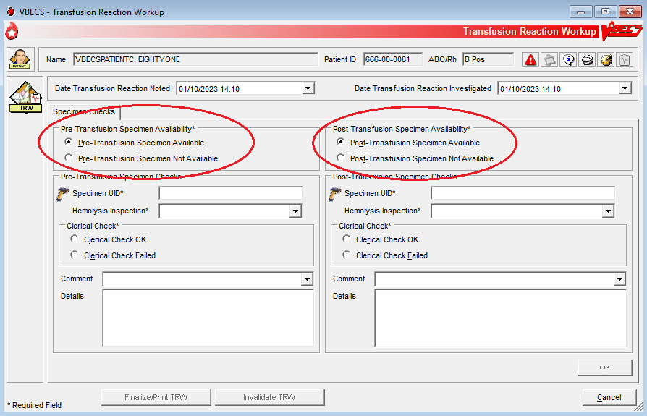
Figure 103: Transfusion Reaction Workup: Clerical Check
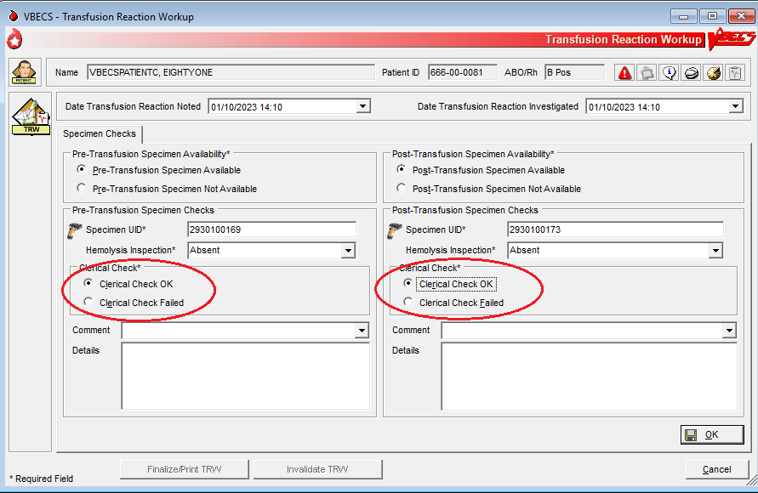
Figure 104: Transfusion Reaction Workup: Implicated Units
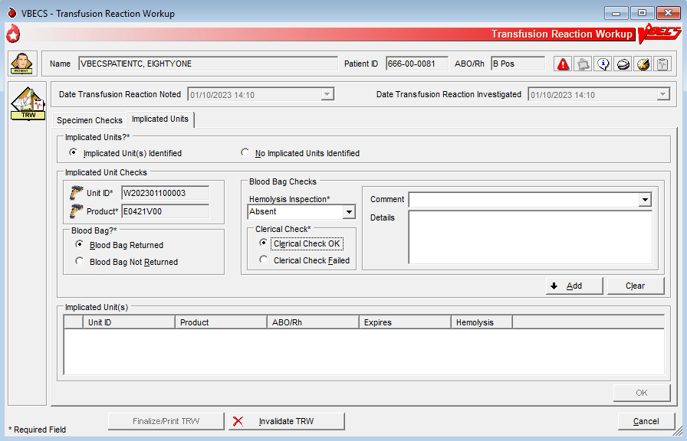
Figure 105: Transfusion Reaction Workup: Symptoms
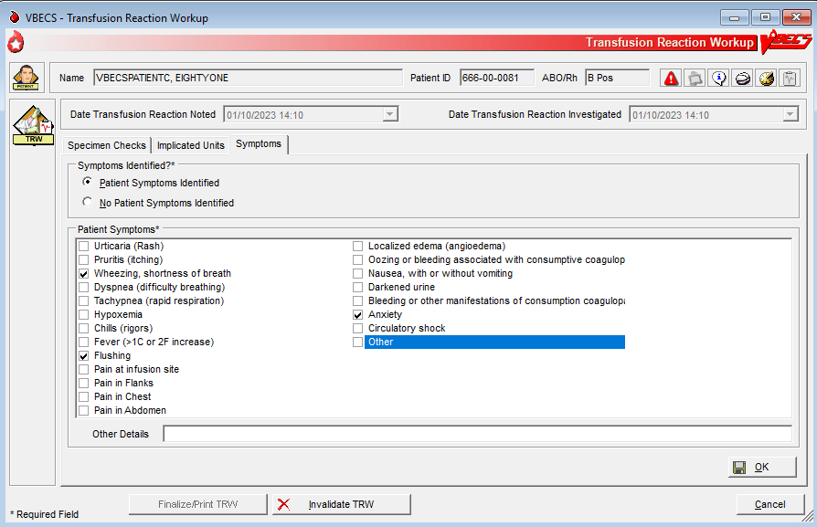
Figure 106: Transfusion Reaction Workup: Serologic Tests
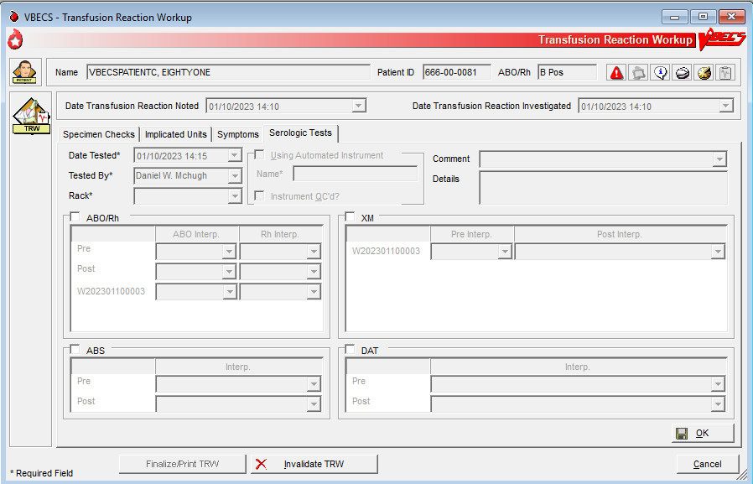
Figure 107: Transfusion Reaction Workup Report
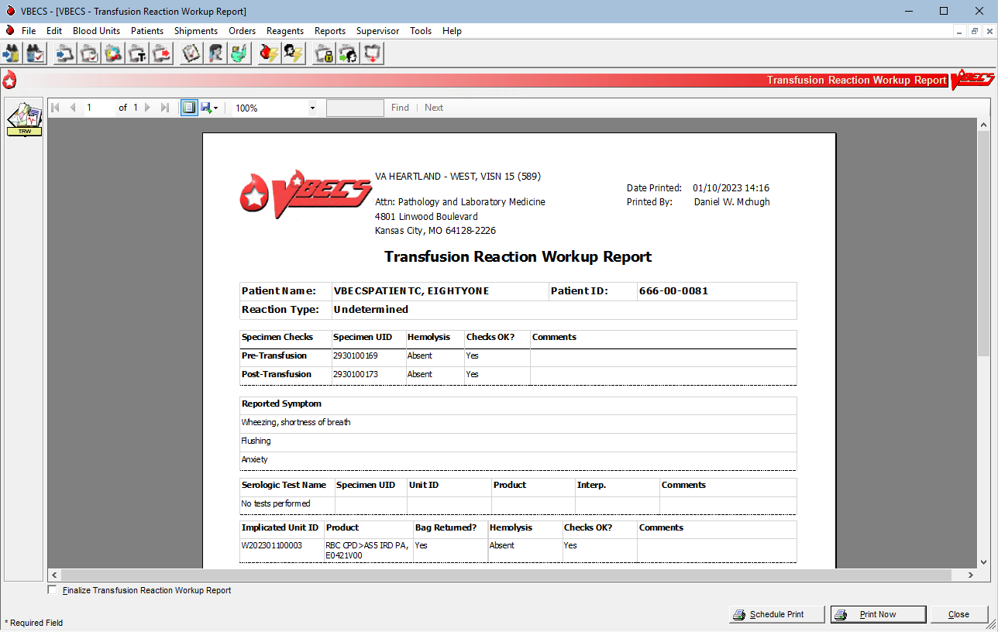

Finalize/Print TRW
The user finalizes and views and/or prints the Transfusion Reaction Workup Report.

Assumptions
- Patient Testing: Record a Transfusion Reaction Workup was completed.

Outcome
- The Transfusion Reaction Workup Report is available for printing and signing.
- Final report findings are available for display in CPRS.
- If workload codes are assigned for this process, workload-related data collected as the result of this process are stored for inclusion in Workload Reports.

Limitations and Restrictions
- The user cannot invalidate or change a finalized TRW. Contact the Service Desk if a TRW needs to be updated after finalization.
- Transfusion reaction reports are not available to clinicians through CPRS: they must be printed and filed with patient charts.
- VBECS displays these default values for transfusion reactions converted from VistA to VBECS. They do not reflect actual interpretations or results:
Converted Transfusion Reaction | Default
Pre-Transfusion Specimen Checks, Hemolysis Checks OK? | Yes
Post-Transfusion Specimen Checks, Hemolysis Checks OK? | Yes
Symptoms | No symptoms identified.
Implicated units | No units implicated in reaction.
Serologic tests | No serologic tests performed.

Additional Information
- The medical director’s signature is on the patient’s printed chart.
- If a report needs to be replaced, the user may retrieve this report after it is complete. The final report is a printed document with the medical director’s signature.
- Do not use the barcode scanner to enter a transfusion reaction specimen UID.
- To avoid a system error, once testing is entered, do not uncheck the testing box and recheck it.
- Limit Finalize TRW comments to <350 characters to allow saving and printing.
- A system error occurs if a user has a TRW open and then attempts to open a second instance of the same TRW. Restart the VBECS session and open one TRW to result and finalize.

User Roles with Access to This Option
All users

Finalize Transfusion Reaction Workup Report
 The Lead Technologist reviews the TRW details, identifies the type of reaction, and adds comments, according to the medical director’s instructions. The user prints a copy for the medical director’s signature and the Lead Technologist finalizes the TRW, generating a preliminary report. The final printed report requires the signature of the medical director.
User Action | VBECS
- Select Reports from the main menu.  Select Finalize/Print TRW.  Click the Include Non-Finalized TRW Reports check box (Figure 107).  Select a completed TRW to finalize.  Click OK. | - Lists report names.  - Lists the completed TRWs for selection.  NOTES  When the user enters and saves the portion recorded in Patient Testing: Record a Transfusion Reaction Workup, the TRW status is “completed.” When the Transfusion Reaction Workup Report is complete, the TRW status is “finalized.”
- Click the Finalize Transfusion Reaction Workup Report check box. | - Prepares the completed report for review.  - Displays the name of the blood bank medical director to sign the final report.  - VBECS recreates the final report for viewing or printing in the future.
- Select the Transfusion Reaction Type and complete the Transfusion Reaction Comments required fields (Figure 108). | - Displays the selected Transfusion Reaction Workup Report data.  - Requires the user to select a transfusion reaction type listed in  - Table 12: Transfusion Reaction Types.  - Allows the user to enter a TRW comment (maximum 1,000 characters).  - Allows the user to save the data entered.  NOTES  The user must indicate one transfusion reaction type. Entry of a comment is optional for all types except O (other), which requires details to be entered.
- Click OK and Yes to save. | - Updates the transfusion reaction to “finalized” in the database and prints a report for the medical director’s signature.  NOTES  VBECS notifies the user when DSS updates cannot be sent because VistALink is not active.  VBECS will attempt to resend the DSS information when VistALink is available after any user logs into the VBECS application’s VistALink connection.
- Select Schedule Print or Print Now and follow the instructions to print. | - Prints the report on the selected printer.
- Click Close to exit.
Figure 108: Select Transfusion Reaction Workup
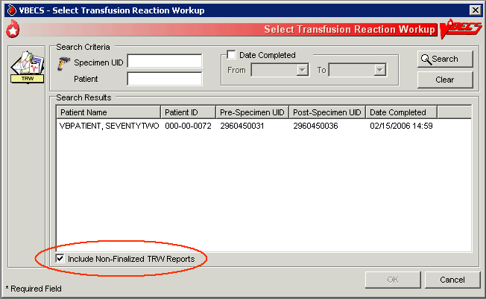
Figure 109: Finalize TRW Report
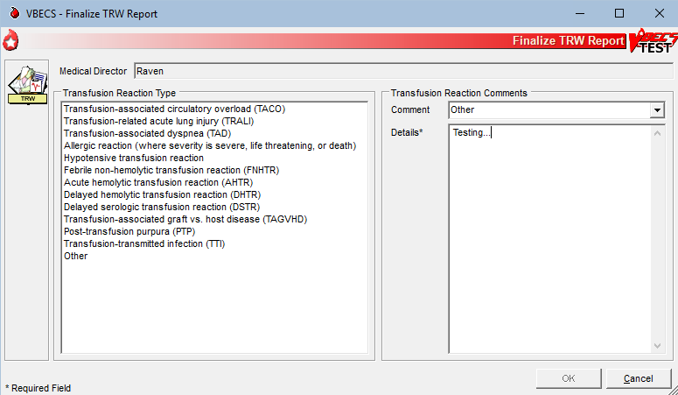

View/Print a Finalized Transfusion Reaction Workup Report
The user views and/or prints the finalized Transfusion Reaction Workup Report.
User Action | VBECS
- Select Reports from the main menu.  Select Finalize/Print TRW.  Select a completed TRW (Figure 106). | - Lists report names.  - Displays the selected Transfusion Reaction Workup Report data.  - Displays an option to view and/or print a finalized TRW by selecting a patient.  NOTES  The user finalizing the report may not edit previously entered TRW data.
- Select a patient. | - Compiles the report and displays an option to print the report or exit.  NOTES  Details included in the finalized TRW report:  - Patient name  - Patient ID  - Specimen UID  - Reported symptoms  - Specimen clerical checks (pre-, post-, and unit)  - Serologic testing (if performed, interpretations only)  - Transfusion reaction type  - Comment <”Transfusion Reaction Workup” comment context>  - Implicated units (include from Patient Testing: Record a Transfusion Reaction Workup)  - TRW report completed by:  - Date and time the report was completed  - Signature line for the medical director  - Line for the date and time the medical director completed the review  - Finalized by  - Finalized date and time
- Select Schedule Print or Print Now and follow the instructions to print. | - Prints the report on the selected printer.
- Click Close to exit.

Table 12: Transfusion Reaction Types
Transfusion Reaction Type Text
Acute hemolytic transfusion reaction (AHTR)
Allergic reaction (where severity is severe, life threatening, or death)
Delayed hemolytic transfusion reaction (DHTR)
Delayed serologic transfusion reaction (DSTR)
Febrile non-hemolytic transfusion reaction (FNHTR)
Hypotensive transfusion reaction
Post-transfusion purpura (PTP)
Transfusion-associated circulatory overload (TACO)
Transfusion-associated dyspnea (TAD)
Transfusion-associated graft vs. host disease (TAGVHD)
Transfusion-related acute lunch injury (TRALI)
Transfusion-transmitted infection (TTI)
Other

Maintain Patient Records

Special Instructions & Transfusion Requirements: Enter a Transfusion Requirement
The user enters or inactivates the Transfusion Requirements (TRs) in the patient’s record by division.

Assumptions
- The patient exists in the VBECS database.

Outcome
- VBECS displays TRs to all divisions within a multidivisional database. The division in which they were entered maintains and controls them.
- VBECS maintains a historic record of changes to the patient’s TRs.

Limitations and Restrictions
- Inactivation is defined and restricted by security level.
- VistA Special Instructions (SIs) from database conversion do not become TRs: they remain SIs. SIs are information only and are not enforced unless entered in the Component Requirements tab in Special Instructions & Transfusion Requirements.

Additional Information
- No current patient specimen or order is required to access this option.
- When TRs are not met, VBECS prohibits the printing of the Caution Tag and Blood Transfusion Record Form (BTRF) and prevents issue of the blood unit.
- User-entered antigen negative requirements are persistent. VBECS enforces them even when they are in conflict with the division’s antibody table settings.
- Patient antibody identifications from VistA are included in the database conversion.
- By default, inactivation of an antibody removes requirements for antigen negative blood derived from the antibody entry.

User Roles with Access to This Option
All users

Special Instructions & Transfusion Requirements: Enter a Transfusion Requirement
The user assigns patient blood component requirements or indicates the need for antigen negative blood to be applied during blood component selection and issue.
VBECS displays TR data and applies requirements during blood unit selection.
All items in these TR categories indicate the need for pre-transfusion processing of a unit before the unit may be issued to the patient. All users may activate entries.  Only a Traditional Supervisor may inactivate a component requirement for a patient. A patient may have one or more TRs:
- Pre-treated to Prevent GVHD
- Leuko-reduce cellular products*
- Washed RBC products
- Washed PLT products
- Sickle Cell Negative RBC products
- CMV negative cellular products*
*All product types in OTHER are evaluated for the requirement including those that are non-cellular.
User Action | VBECS
- Select Patients from the main menu.  Select Special Instructions & Transfusion Requirements, or  Click in the Patient Information Toolbar, when it is active. | - Displays options for processing patient-related functions.  - Displays the option to select a patient, if one is not already selected.  NOTES  The user may also click New SI or TR in Patient Testing to access this option.
- Select the Antigen Negative RBCs, Component Requirements, or Antibodies Identified tab (Figure 109). | - Displays the patient’s TRs.  - Allows the user to add or inactivate information based on his security level.  NOTES  When a user accesses antigen negative requirements, VBECS displays and enforces the antigen negative requirement for the patient, regardless of the division setting for the antibody.  When a user accesses the Antibodies Identified tab, VBECS compares the patient’s antibodies with the division’s antibody table setting. When the antibody is set to require antigen negative blood at issue, VBECS displays and enforces the antigen negative requirement.
- Select a TR from the pick list, or enter an antigen or antibody, as the tab allows.  Click Add to move the selection to the patient’s record.  Click OK when all TRs are selected to save them to the patient’s record.  Click Yes to confirm changes and exit. | - Allows multiple selections from the Component Requirements, Antibodies Identified, and Antigen Negative tabs.  NOTES  VBECS applies the TR to component classes, as indicated.  The user may not add duplicate SIs or TRs in the same session, but may duplicate them in another session.  The division code and date of entry are associated with the entered component or antigen negative requirement, or antibody specificity so that other divisions will know who to contact for further information, when needed. The original entries may have been made through Patient Testing (associated with an antibody identification) or TRs from any division within a multidivisional database.
- Select the TR to be inactivated (Figure 110).  Select and/or enter an explanatory comment and click OK. | - Allows the user to enter a comment.  NOTES  When a Transfusion Requirement is inactivated in any division in a multidivisional configuration, a comment (free text or from a canned comment with the context: Transfusion Requirement Inactivation) must be added that will be saved and printed on the audit trail of originating division alerting the originating division of the change to the patient’s TR setting if they were not consulted regarding that change.  Note: It is best practice that inactivating a TR in the non-originating division involves a consultation with the originating division and allowing the originating to make the change with any locally required documentation.  For inactivation of an item:  -  A Traditional Supervisor from any division may inactivate TRs and persistent antigen negative requirements in a multidivisional database regardless of the source of the TR.  - When an antibody specificity is inactivated, VBECS inactivates the corresponding calculated (VBECS-generated) antigen negative requirement.  - For antibodies identified, VBECS displays a summary of antibodies currently associated with the patient and identifies their source. Additional antibodies may be added and previously identified antibodies may be inactivated.
- Return to Step 2 to continue editing the patient’s TRs.
- Accept entries and exit, or

Return to Step 1 to make entries for a different patient.
Figure 110: Enter Patient Special Instructions and Transfusion Requirements
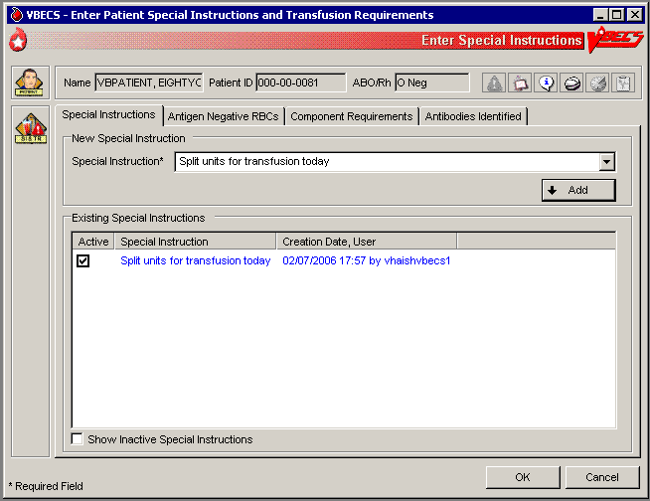
Figure 111: Inactivate Component Requirements
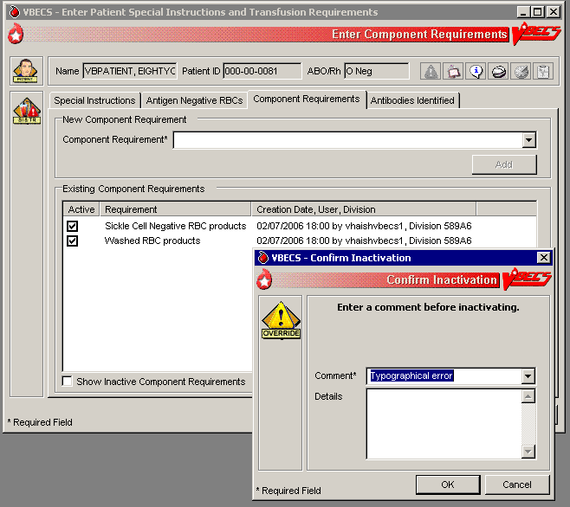

Special Instructions & Transfusion Requirements: Enter and Remove Special Instructions
The user enters comments in a patient’s file that are not enforced by VBECS.

Assumptions
- Fields containing Special Instructions (SIs) may be populated during database conversion.

Outcome
- When the user searches for a patient or when the Patient Information Toolbar is displayed, VBECS displays to alert the user to view the patient’s SI entries.
- When a user retrieves a patient record and is in a multidivisional setting, he may view SIs created in all divisions within the database.

Limitations and Restrictions
- VBECS does not enforce Transfusion Requirements (TRs) or antigen negative requirements entered through this option.
- SIs moved to VBECS during the database conversion may contain information that must be entered as TRs in VBECS. Inactivate the old SI and create a TR and new updated SI: the database conversion software cannot automatically translate the SI from database conversion into a rule-based TR.
- VBECS will truncate SI text from the VistA database conversion.

Additional Information
- Inactivation of patient SI entries is allowed only in the division of entry.
- Only currently active SIs at a division will automatically display via the database to all divisions.
- Inactive SIs are not deleted from the VBECS database. They may not be reactivated but may be viewed in the maintenance fields when requested.
- Canned comments in the Special Instructions context must be entered by the division before they can be selected for use.
- Previously saved Special Instructions that require editing due to context or spelling errors must be inactivated and reentered in total.
- Database conversion entries are labeled as such.
- SIs from database conversion may include component or antigen negative requirements that must be entered in TRs so that VBECS can enforce them.

User Roles with Access to This Option
All users

Special Instructions & Transfusion Requirements: Enter a Special Instruction
A user may add to and inactivate SI comments in a patient’s blood bank record. Users in all divisions in a multidivisional database may view these comments.
User Action | VBECS
- Select Patients from the main menu.  Select Special Instructions & Transfusion Requirements, or  Click in the Patient Information Toolbar, when displayed. | - Displays options for processing patient-related functions.  - Displays the option to select a patient, if one is not already selected.  NOTES  The user may also click New SI or TR in Patient Testing to access this option.
- Select a patient.  Click OK. | - Displays options to select a patient.  - Displays the option to enter a new comment or remove an existing comment in the division.  - Displays the active SI entries in reverse chronological order with all active SIs first, along with date, division code, and text of the entry.  NOTES  The need for SIs is usually temporary and may not be required for all transfusions.  The user may choose to display inactivated SI comments.
- Select the Special Instructions tab (Figure 111).  Click the Show Inactive Special Instructions check box to display inactivated SI entries. | - Allows the user to enter or inactivate comments.  - Displays inactive Special Instructions but does not allow the user to reactivate them.  NOTES  A user may add or inactivate a patient-specific comment at any time in the division in which it was entered.   A Traditional Supervisor may inactivate SIs from database conversion.
- Confirm the activation of the entry and enter a comment.  Click OK.  Return to Step 2 to add more SIs for this patient.  Select another patient and return to Step 1, if desired.  Exit. | - Saves the entry in the database.
Figure 112: Enter Patient Special Instructions and Transfusion Requirements
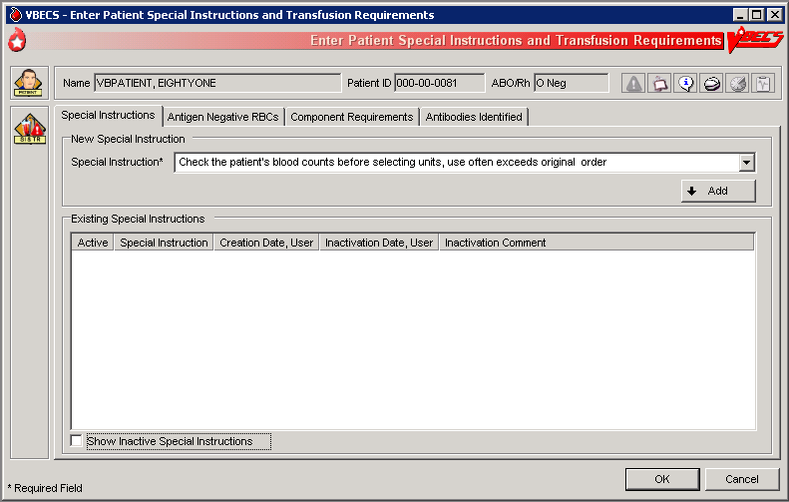

Post-Transfusion Information
The user enters post-transfusion details from the Blood Transfusion Record Form (BTRF) or VBECS saves post-transfusion details received from the Transfusion Verification System.

Assumptions
- The BTRF is returned and completed for each unit.
- The unit status is “issued” or “presumed transfused” in VBECS.
- Interface connections to the BCE COTS system are enabled to receive transfusion update messages.

Outcome
- The unit status is updated to “transfused.”
- The VBECS patient record includes the blood transfusion information.
- If workload codes are assigned for this process, workload-related data collected as the result of this process are stored for inclusion in Workload Reports.

Limitations and Restrictions
- VBECS cannot update a unit record to presumed transfused when a user has that unit record open (locked) in Enter Post Transfusion Information. VBECS will attempt to update the unit the next time the presumed transfused background routing runs if the unit remains in an issued status.
- If post-transfusion information is not transmitted to VBECS by the BCE COTS interface, the user will need to enter that information to update the record from presumed transfused to transfused.
- The transfusion comments and volume transfused entered in the Transfusion Verification application as an update to a completed transfusion are not sent to VBECS.
- Transfusion reaction symptoms are not provided to VBECS by the Transfusion Verification application unless a transfusion reaction has also been indicated for that event.
- The system will not perform unit expiration time-limit checks when remote storage was indicated during issue.

Additional Information
- A user with the appropriate security level may enter or edit bedside verification information unless it is received from BCE COTS interface.
- The user may indicate that a transfusion reaction and symptoms were noted on the BTRF as free text. Noting a transfusion reaction does not create an order for a transfusion reaction workup (TRW).
- Remove a “transfused” status through Remove Final Status unless that unit was transfused by the Transfusion Verification application. See limitations in Remove Final Status.

User Roles with Access to This Option
All users

Post-Transfusion Information
The user verifies the date and time transfused with a returned BTRF, adds other transfusion details, initiates a system check of the bedside verification information, enters that information, and indicates whether a reaction occurred during or immediately after the transfusion, as documented on the BTRF. VBECS does not require entry of post-transfusion information: once a day, without user input, VBECS moves units 48 hours after issue to “presumed transfused” status.
User Action | VBECS
- Select Patients from the main menu.  Select Post-Transfusion Information. | - Displays options for processing patient-related functions.  - Displays an option to scan the Caution Tag or enter a patient name or ID.
- Select a patient and click OK. | - Lists the units issued to the selected patient.  - Displays the issue date and time.  - Displays the units one at a time for update in the order in which the user selected them.  NOTES   VBECS displays an option to obtain a list of transfused (those not received by BCE COTS) units for the patient when the user is a Traditional Supervisor or above.  When post-transfusion information is not entered into VBECS within 48 hours from the date/time the unit was recorded as “issued”, VBECS will change the unit status to “transfused” with a presumed indicator after the execution of a scheduled background job. The unit will then be considered transfused by the system regarding report generation.
- Click one or more check boxes to select units (Figure 112).  Click OK. | - Allows the user to select units for which to enter post-transfusion information.  NOTES   VBECS does not list units (for selection) with a final status. When a user enters a unit with a final status, VBECS alerts the user and clears the screen. The user may select another unit.
- Enter transfusion details for a blood unit.  Verify the unit selection. | - Displays the unit information entered by the bedside verification check and allows the user to enter to edit the information.  - Displays an option to enter or edit unit data.  NOTES   A user with a security setting of Traditional Supervisor may edit user entered bedside verification, transfusion reaction, or post-transfusion detail information.  VBECS displays an option to enter information for each unit. This information is available for patient record retrieval.  To prevent rejection of transfusion information exchanged between VBECS and the Transfusion Verification system, a variance of +/- five (5) minutes is permitted for time of issue and transfusion start and end times. The variance allows the two systems to communicate even when their internal time is not precisely synced to the minute.
- Select one or more units. Enter or edit the bedside verification check information with the proper security level. | - Displays the entries for review, including the comment, until all details are entered.  - Displays an option to save the data and exit.  NOTES  Upon data entry and saving of the post-transfusion information, VBECS assigns a status of “transfused” for the unit of blood assigned to the indicated patient.
- Enter post-transfusion details, including:  - Transfusion start and end dates and times  - Transfusionist ID  - Location of transfusion  - Whether the transfusion was completed or interrupted  - If interrupted, the amount transfused  - Whether there was a transfusion reaction  - If there was a reaction, symptoms (Figure 113)  Click OK to save. | - Displays an option to enter unit data.  - Warns the user or allows the user to continue to the next selected unit.  NOTES  When a user indicates that a transfusion reaction occurred, VBECS does not automatically order a TRW.  VBECS notifies the user when the transfusion end date and time is earlier than the start or issue time. The user may correct the entry.  When the unit was not issued to a remote storage location, VBECS compares the date and time the unit was issued to the start transfusion time entered.  When the difference is greater than 30 minutes, VBECS notifies the user that this is a delayed start time and allows the user to edit the transfusion start date and time. No allows the user to continue. Yes allows the user to edit the date and time the transfusion ended. When the user edits the date and time transfused, VBECS repeats this process until the user stops editing and chooses to continue.  When the unit was not issued to a remote storage location, VBECS compares the date and time recorded as the transfusion end time to the start date, calculates the transfusion time in minutes, and compares this period to the maximum transfusion time for the component class. When the calculated transfusion time for this unit exceeds the defined maximum transfusion time for the component class, VBECS notifies the user that this is a prolonged transfusion and allows the user to edit the transfusion end date and time. No allows the user to continue. Yes allows the user to edit the date and time the transfusion ended. When the user edits the date and time transfused, VBECS repeats this process until the user stops editing and chooses to continue.
- Respond to warnings or continue to enter data for the next unit. | - Allows the user to repeat for subsequent selected units until all details are entered.  - Displays an option to save the data and exit.  NOTES  VBECS saves all transfusion information for future retrieval and reporting as part of the patient and unit historic records.  VBECS notifies the user when DSS updates cannot be sent because VistALink is not active.  VBECS will attempt to resend the DSS information when VistALink is available after any user logs into the VBECS application’s VistALink connection
- Exit.
Figure 113: Post-Transfusion Information
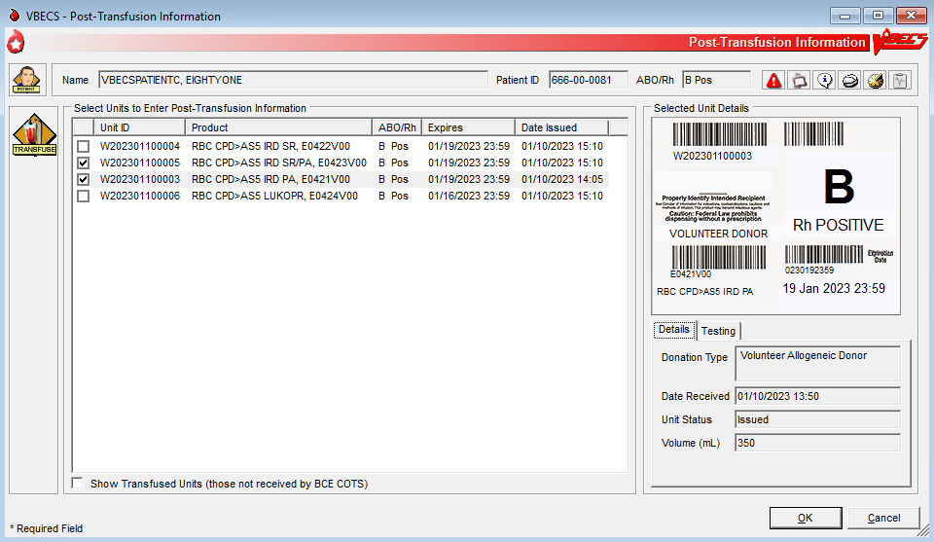
Figure 114: Post-Transfusion Information Details
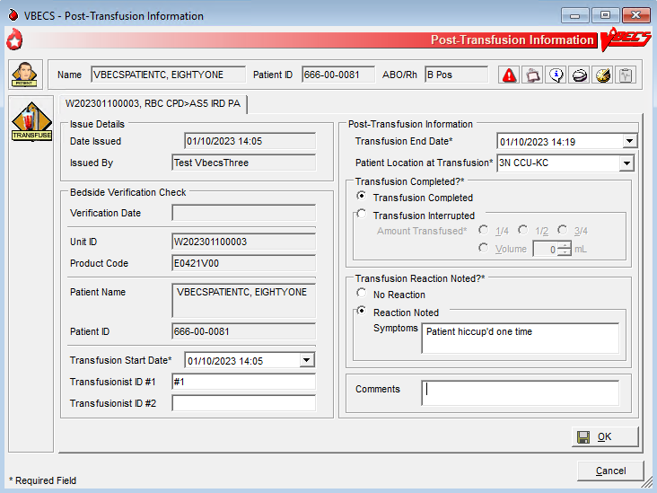

Automated Entry of Post-Transfusion Details from BCE COTS Application
VBECS receives and saves the details of a unit transfusion episode as recorded in the BCE COTS system.
User Action | VBECS
- BCE COTS system user completes a transfusion for a patient which triggers an HL7 message containing transfusion information to VBECS for a blood unit. | - VBECS rejects a BCE COTS HL7 message when data elements are not acceptable per the data entry rules for manual entry.  NOTES  Units that are not updated by a BCE COTS message will be marked presumed transfused 48 hours after issue by a VBECS background process.  Transfusion information is available in the Unit History Report.
- VBECS updates the patient transfusion record with the details received in the successfully acknowledged HL7 message. | - VBECS generates an exception report entry: Electronic Transfusion Record Update when a BCE COTS update to a previously saved manually or electronically entered transfusion record is received.  - When an update to a previously saved transfusion record is made by BCE COTS or a user, VBECS will display the original entry and the updated details in the Patient History and Unit History Reports.  NOTES  The BCE COTS system delivers these patient and unit specific transfusion data elements to VBECS for update  - Bedside verification date and time  - Transfusion verification manual Unit ID entry reason  - Transfusion Start date and time  - Transfusionist ID #1  - Transfusionist ID #2 (may be blank if so configured in BCE COTS application)  - Transfusion End Date and time  - Patient location at Transfusion  - Transfusion interrupted indicator  - Transfused volume, (ml not in fractions by the BCE COTS)  - Transfusion Reaction noted  - Transfusion Reactions symptoms entered, if any  - Transfusion comments, if any

Document ABO Incompatible Transfusions
The user enters post-transfusion details from the Blood Transfusion Record Form (BTRF) to document ABO incompatible and other inadvertent transfusions. (See FAQ Handling ABO Incompatible Transfusion Situations)

Assumptions
- A unit was transfused to a patient other than the intended recipient.
- The connection to VistA is active.

Outcome
- The unit status is updated to “transfused.”
- The patient record includes the blood transfusion information.
- If workload codes are assigned for this process, workload-related data collected as the result of this process are stored for inclusion in Workload Reports.

Limitations and Restrictions
- VBECS does not enforce compatibility checks between the patient and the unit.
- VBECS does not update CPRS component order status when the Document ABO Incompatible Transfusion option is used.

Additional Information
- FDA guidances govern when to file blood product deviation reports.
- Follow local policy and procedures for additional reporting requirements.
- VBECS requires a specimen and an order placed through CPRS to process transfusions. When a patient was transfused and no specimen was collected or order placed for blood components, the user may record the transfusion using this option.
- A record can be saved without entering the amount transfused and the Transfusion Interrupted option is selected. Enter the amount transfused before saving the transfusion.

User Roles with Access to This Option
 Traditional Supervisor

Document ABO Incompatible Transfusions
When a unit is transfused to the incorrect patient, the user enters transfusion details for that unit.
VBECS does not enforce compatibility checks to allow consistent and accurate online availability of a unit’s final disposition. Use of this option is restricted to supervisory blood bank personnel who have thoroughly investigated the transfusion and documented the inability to use normal VBECS business processes to enter the transfusion documentation.
User Action | VBECS
- Select Supervisor from the main menu.  Select Document ABO Incompatible Transfusion. | - Displays options for processing patient-related functions.  - Displays an option to scan the Caution Tag or enter a patient name or ID.
- Select a patient and click OK. | Displays an option to select a patient that may not be available from the VBECS files.  NOTES  Displays a message when the user selects a patient with a blank first or last name, or the name is too long. The user is instructed to contact the VBECS Administrator for assistance.
- Select a unit to document a transfusion that does not follow system rules. | - Displays an option to enter a unit ID and product code or search for one.  NOTES  VBECS presents all units in the system for selection when the search button is used. This search will require time to complete as the number of units to display increases.  VBECS does not enforce compatibility checks in this option.   When a user enters a unit with a final status, VBECS alerts the user and clears the screen. The user may select another unit.
- Enter post-transfusion details and a comment. | - Displays an option to enter or edit unit data. See Post-Transfusion Information.  -  VBECS emits an audible alert, requires a comment, and captures the transaction details for inclusion in an Exception Report (exception type: ABO incompatible unit transfused).  - Displays the entries for review, including the comment, until all details are entered.
- Click OK and Yes to save. | - Saves the data.  - Allows the user to enter comments and details.
- Enter or select a comment and details, in accordance with local policy and procedures.  Click OK. | NOTES  VBECS saves transfusion information for future retrieval and reporting as part of the patient and unit historic records.  Upon data entry and saving of the post-transfusion information, VBECS assigns a status of “transfused” to the unit of blood for the indicated patient.  VBECS captures details of this override in an Exception Report.
- Exit.

Justify ABO/Rh Change
The user changes a patient’s historical blood type only when there is a clinical change in blood type, not to correct an error. (See Invalidate Test Results.)

Assumptions
- The patient has a previous ABO/Rh on record from the user’s current division, from a different division within the database, or from the database conversion.
- The patient has a current specimen test result with an ABO/Rh interpretation that does not match the historical record. Both previous and current specimen test results are valid.

Outcome
- VBECS permanently marks the patient record and the specimen test to indicate that the patient has a justified ABO/Rh change, regardless of the user’s division.
- The justified ABO/Rh on the patient record forces the user’s selection to be used as the new historical record, replacing the current test result as the historic record. VBECS does not check for ABO/Rh discrepancies with tests entered for this patient prior to the justified test result.
- VBECS permanently disallows electronic crossmatch (eXM) for this patient.
- If workload codes are assigned for this process, workload-related data collected as the result of this process are stored for inclusion in Workload Reports.

Limitations and Restrictions
- VBECS does not allow the selection or issue of certain blood components that may appear ABO/Rh compatible when discrepant ABO/Rh results are not justified.

Additional Information
- When the discrepant ABO/Rh tests are on the same specimen, the user may not justify the patient’s ABO/Rh.
- Do not use this option for ABO/Rh discrepancies that occur because the patient had a recent transfusion of a component of a type other than his own.
- ABO/Rh discrepancies that occur because the previously tested or current specimen was tested in error are handled by inactivating the previously recorded test results through Invalidate Test Results.
- Subsequent specimens may need to be justified in the presence of continued discrepant ABO results.
- This option is used in rare clinical situations such as following bone marrow transplant.

User Roles with Access to This Option
 Traditional Supervisor

Justify ABO/Rh Change
The user determines that the patient’s current ABO/Rh testing results are valid, although they differ from previously recorded results, and that the patient requires a justification indicator on his record.
This option is used only when both the previous specimen testing and the current specimen testing are considered valid. There is a valid explanation for why the ABO/Rh interpretations do not match and invalidation of the test result is not appropriate. Once the current patient ABO/Rh result change is justified, VBECS marks the patient’s record so that special handling for component orders for the patient apply from this point forward and remain in effect until the patient record is inactivated by the recording of his death in VBECS or by removing the justification.
User Action | VBECS
- Select Supervisor from the main menu.  Select Justify ABO/Rh Change. | - Displays options available to supervisors.
- Enter a patient name in the Patient field and click Search to select a patient.  Select a patient.  Click OK. | - Displays a screen for patient selection.  - Disallows the justification or allows the user to continue.  NOTES  VBECS compares the results of the current ABO/Rh with the previous ABO/Rh results. When there is no discrepancy, VBECS warns that no justification is required. There is no override. VBECS clears the screen and the user may select another patient.  VBECS warns the user to use this option only when both the current and previous specimen tests are valid, otherwise, use Invalidate Patient Test Results.
- Select an ABO/Rh interpretation as the patient’s justified historical record (Figure 114). | - Displays details of the historic and current ABO/Rh testing for comparison and a list of available ABO and Rh types for user selection.  - Requires a comment to continue.  NOTES  The user may select one ABO group and one Rh type for the patient to serve as the justified ABO/Rh typing in the historic record. VBECS displays the current ABO and Rh interpretations as the defaults.  VBECS requires a comment to continue.
- Confirm the update of the database with the justified ABO/Rh.  Exit. | - Updates the patient record.
Figure 115: Justify ABO/Rh Change
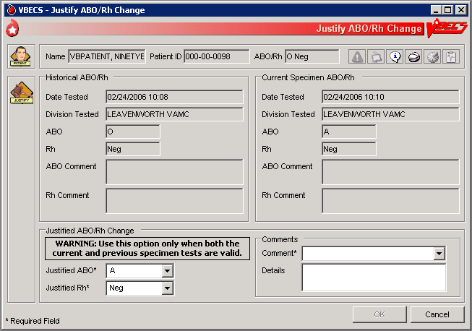

Automated Testing

Automated Testing Interface
The user sends test results to VBECS from an automated instrument.
For details about interface configuration please refer to the VBECS 2.4.0 Admin User Guide.

Assumptions
- Test Results have been reviewed and released on the instrument to be transmitted to VBECS.
- A patient testing order must be accepted in VBECS and pending test results.
- A blood unit must be received in the VBECS division.
- The testing instrument is fully functional and available for use: The instrument QC is completed and valid, no maintenance is required and test results are available for transmission to VBECS.
- Interface Control Parameters have been completed and are enabled for the automated instrument interface in the VBECS Administrator.
- Data Innovations Instrument Manager message interface is properly and completely configured.

Outcome
- Test results are received by VBECS.
- Task status is updated for tests pending completion.

Limitations and Restrictions
- VBECS has only been tested with one automated instrument connected.
- Not available for transmission to Transfusion only facilities.
- The results of Antibody Panels (ABID) will not be accepted by the VBECS Automated Interface.
- The results of QC information from automated instruments will not be accepted by the VBECS Automated Interface.
- Time zone will not be included in HL7 message date time from the broadcasting application (Instrument Manager). The time zone is determined from the division code contained in the message header (MSH) segment of the message.
- For VBECS to process automated test results, a specimen record needs to exist. VBECS cannot accept Automated Instrument test results for specimens that are more than 5 years old. To work around this limitation for maintainable specimens, first change the expiration date and then send the test results.

Additional Information
- VBECS will accommodate antigen typing test results where antigen typing tests are available in VBECS.
- AABB Standards (5.16.1) requires a serological XM to detect ABO incompatibility. A local policy must be in place if the site is not performing a IS AHG as part of their serologic crossmatch test, manual or using an instrument.

User Roles with Access to This Option
All users

Automated Testing Interface
This feature allows the interface of automated blood banking instruments with VBECS through Data Innovations Instrument Manager. It eliminates the potential for human error associated with the manual entry of results from an automated instrument into VBECS. It also eliminates the potential for transcription errors that can lead to a patient safety issue of ABO incompatible transfusion. In addition to safety, these enhancements will also reduce the time spent entering results manually.
User Action | VBECS
- User sends test results from the Automated Instrument to VBECS. | - Updates the task status on the Pending Task List (PTL) upon successful receipt of testing.  - Stores received results for review, processing and acceptance by a user.  NOTES  If the blood unit record is not found, the message is rejected and results are not available for review.  If the patient specimen is not associated with an active patient order, the message is rejected and results are not available for review.  If the cross-matched units are not assigned to a patient order, the message containing crossmatch results is rejected and results are not available for review.  Patient specimen blood test results pending review must be rejected by the user in VBECS before replacement results can be received.  If test results currently exist for a patient order (entered manually or by the Automated Instrument), the replacement test results will not be accepted into VBECS until the user invalidates the existing test results.  When patient test results are sent to VBECS and multiple orders exist for the same test type and the same specimen UID on the VBECS PTL, the message is rejected. For example: When ABS test results and Repeat ABS test results for the same specimen UID are sent to VBECS at the same time, because the Automated Instrument does not indicate which test is primary and which test is reflex, the message must be rejected.  When the testing instrument for the patient ABO/Rh message contains results for Anti-D1 and Anti-D2 which do not conflict (both are positive or both are negative), the Anti-D1 result will be stored in VBECS.  When the testing instrument for the patient ABO/Rh message contains conflicting results for Anti-D1 and Anti-D2 (one is positive and the other negative), the message is rejected and results are not available for review.  The message is processed by the VBECS system. If the message is accepted (per the approved HL7 message profile specification), a success reply is sent; otherwise, a rejection reply is sent to the broadcasting application and results are not available for review.  The system associates interpretation with test results received from an Automated Instrument as follows:  - 1 is a Positive  - 2 is a Positive  - 3 is a Positive  - 4 is a Positive  - 0 is a Negative  See Table 13: HL7 Tests Accepted by VBECS.  VBECS stores the following information:  - Test Results  - Test Interpretations  - Testing Tech ID  - Automated Instrument identifier  - Date and Time Tested  - Automated Instrument Test Comments
- The user logs into VBECS to review and approve messages.

Refer to Automated Testing Review for Blood Units or Automated Testing Review for Patients.

Table 13: HL7 Tests Accepted by VBECS
The first result received is considered the primary test. Once the primary test is accepted into VBECS, a second message with the same testing result will fill the repeat test.

Row ID | Tests
1. | Patient Type and Screen (TAS)
2. | Patient ABO/Rh
3. | Repeat Patient ABO/Rh
4. | Patient ABS
5. | Repeat Patient ABS
6. | Patient AHG DAT
7. | Repeat Patient AHG DAT
8. | Crossmatch
9. | Repeat Crossmatch
10. | Patient IgG DAT AHG
11. | Repeat Patient IgG DAT AHG
12. | Patient C3 DAT AHG
13. | Repeat Patient C3 DAT AHG
14. | Patient Antigen Typing
15. | Repeat Patient Antigen Typing
16. | Unit ABO/Rh
17. | Unit Antigen Typing

Automated Testing Review for Blood Units

Allows the user to review and approve testing results completed on an automated instrument and transmitted to VBECS.

Assumptions
- Division is defined as full service.
- The testing instrument is fully functional and available for use. The instrument QC is completed and valid, no maintenance is required. No QC information is transmitted to VBECS in the HL7 message.
- Message is received successfully as defined in Automated Testing Interface.
- The blood unit records are in the VBECS database for ABO/Rh confirmation or Unit Antigen Typing.
- Each transmitted test must include its results and interpretation.

Outcome
- The test record will capture the details of the verified testing. Completed, current unit and specimen test results will be available for the life of the system for inclusion in various reports generated to document patient and unit testing.
- Unit(s) will have ABO/Rh and antigen test results recorded in the database.
- If workload codes are assigned for this process, workload-related data collected as the result of this process are stored for inclusion in Workload Reports.

Limitations and Restrictions
- VBECS does not accept inconclusive ABO/Rh test results.
- Pooled Product Types labeled with an Rh type of “Pooled” is considered an Rh Positive unit which does not require confirmation testing.
- Pooled Product Types that require confirmation, labeled with an ABO group of “Pooled” cannot be confirmed. A blood component unit received as “POOLED ABO” will have to be transfused using the Supervisory option, Document ABO Incompatible Transfusion.
- Users can select and assign multiple units with the same DIN and different product codes for crossmatch. Users can only process one DIN (e.g., W123400345345) on the Automated Instrument at a time. It is incumbent on the user to verify that the crossmatch result from the Automated Instrument matches the product code (e.g., E0134V00) associated with the patient in VBECS. To decrease the risk of a mislabeled unit at issue, local practice may want to have only one on the units selected in VBECS at a time when crossmatch testing is being performed on the automated instrument.
- When a user chooses to reject a transmitted test, a comment is required. The comment is stored but is not available for review on a report at this time. It is recommended that the test is reviewed in the instrument and not sent to VBECS as a result for rejection.

Additional Information
- When Workload is not configured per Workload Codes, then Workload cannot be collected.

User Roles with Access to This Option
All users

Automated Testing Review
This feature allows the interface of automated blood banking instruments with VBECS through Data Innovations Instrument Manager. It eliminates the potential for human error associated with the manual entry of results from an automated instrument into VBECS. It also eliminates the potential for transcription errors that can lead to a patient safety issue of ABO incompatible transfusion. In addition to safety, these enhancements will also reduce the time spent entering results manually.
User Action | VBECS
- User logs into VBECS and selects Blood Units, Automated Testing from the main menu.  Or  User logs into VBECS and clicks on the Automated Testing Toolbar Icon (blood drop with lightning bolt). | - Displays the Automated Testing – Pending Blood Units window.  - Displays message when no pending blood units were found to review.  NOTES  The functionality is not accessible if division is defined as a Transfusion Only facility.  Only data within the user’s division can be accessed for any type of processing.
- User selects from the testing tabs that are enabled on the Automated Testing – Pending Blood Units window (Figure 115).  Unit ABO-Rh tab  Unit Antigen Typing tab. | - Determines that all appropriate test results were entered for the blood unit. Row validation and test validation are completed.  NOTES  The unit ID and product code are used to identify a specific unit from inventory. The pick list of Units for ABO/Rh or Antigen Typing will only display the product codes of units in an Active status and per the typing requirements.  When a weak D antigen typing test is received on a blood unit that is Rh positive, the test is marked as in error (E) the system provides a warning message:  “Cannot perform weak D testing on Rh positive unit.”  The test cannot be saved in VBECS and must be rejected.  The list view of test results on the Blood Unit windows is sortable by unit ID or date/time of test completion.  Default sort order is on unit ID.  When testing is received for an inactivated unit or unit in final status, the system provides a warning message: “Cannot perform testing on an inactivated unit or a unit in final status.” The test cannot be saved in VBECS and must be rejected.
- User selects a unit for review by clicking the check box next to a unit. | - Allows selection of blood unit test results.  NOTES  Selection of multiple tests with a Valid indicator is permitted.  Tests with a Warning or Error indicator can only be selected and processed one at a time (no batch selection).  If the unit id transferred from the instrument does not uniquely identify the unit In VBECS, then the system will prompt the user to select the correct product code for the unit available in VBECS.  Selection of blood products is based on product codes that require ABO/Rh confirmation.
- User Accepts or Rejects the selected unit test results. | - Processes any applicable overrides.  NOTES  When the test is rejected, the system will:  - Prompt user to confirm they want to reject.  - Prompt user to enter a comment reason for rejection.  - Remove the test from the list for acceptance.  - No rejection message is sent to the instrument.  - The Diagnostic test returns to the previous status and ready for testing.  When an interpretation of “Inconclusive” is verified for either the ABO or Rh interpretation, the unit is given an indicator of “Quarantine” and the details of the testing are captured for inclusion in an exception report. The system provides an audible alert.  The system provides an audible alert and a warning message requiring override is generated if the ABO and/or Rh confirmation interpretation does not match the ABO and/or Rh of the unit at initial login. Upon user confirmation of the discrepancy (override), inventory units whose ABO/Rh confirmation does not match the ABO/Rh at login are given an indicator of “Quarantine” and the details of the transaction are captured for inclusion in an exception report.  The system displays all data input during the session and accommodates editing prior to the user electing to update the database. The system will warn the user that if he chooses to cancel using the cancel or “X” button or by leaving/refreshing the current page, the system will not save any data changes entered during the session.  The unit has had a quarantine indicator assigned. The system will release any patient assignment. Any patient restriction associated with the unit remains intact (e.g., Directed or Autologous).  The system compares the antigen typing interpretation entered by the technologist to any previously assigned antigen typing for the same antigen (Incoming Shipment, Edit Unit Information, or antigen typing test other than weak D). If the current interpretation does not match the previously identified antigen type, the system displays a warning message and quarantines the unit: Current antigen type does not match previously recorded antigen type (login, update, or test). This must be resolved before this unit can be used. Unit has been quarantined.  When a weak D interpretation is positive or inconclusive and is verified for a tested blood unit that was labeled as (Rh) D negative, display a warning message and add the quarantine indicator to the unit: "Unit is weak D positive or inconclusive: unit will be quarantined." No user action is required.  When a unit was issued and a conflicting test result found that indicates a potential unit incompatibility with the patient, such as a patient ABO/Rh discrepancy, or the unit is antigen positive where antigen negative is required on the tested specimen, VBECS displays a warning message such as: Unit has been issued. Notify the physician of this potential problem IMMEDIATELY, per hospital policy! The warning message displays during the execution of the various tests related to the compatibility of a blood unit. An exception report entry is generated at the save.
- User clicks Yes to acknowledge acceptance or rejection of test results. | - Saves user input.  NOTES  Upon successful completion of ABO/Rh confirmation and/or Antigen Typing completion, the unit status is updated. Successful completion means that the ABO and Rh (if required) interpretation is consistent with recorded observed results and matches the ABO/Rh at unit login and any repeat ABO/Rh tests on the unit that are not invalidated  When the test is rejected, the system will:  - Prompt user to confirm they want to reject.  - Remove the test from the list for acceptance.  - No rejection message is sent to the instrument.  - The Diagnostic test returns to the previous status and ready for testing.
Figure 116: Automated Testing – Pending Blood Units Window
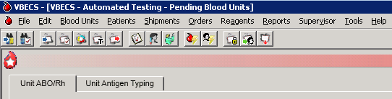

Automated Testing Review for Patients

Allows the user to review and approve testing results completed on an automated instrument and transmitted to VBECS.

Assumptions
- Division is defined as full service.
- The testing instrument is fully functional and available for use. The instrument QC is completed and valid, no maintenance is required. No QC information is transmitted to VBECS in the HL7 message.
- Message is received successfully as defined in Automated Testing Interface.
- VBECS database contains an active patient order for diagnostic tests or blood components including reflex tests that have been accepted and appear on the Pending Task List.
- Blood Units are selected for a patient for serologic crossmatch testing prior to result transmission from an automated instrument.
- Each transmitted test must include its results and interpretation.

Outcome
- The test record will capture the details of the verified testing. Completed, current unit and specimen test results will be available for the life of the system for inclusion in various reports generated to document patient and unit testing.
- The system updates the task status, the workload reporting in VBECS and the order status in VBECS and VistA.
- If workload codes are assigned for this process, workload-related data collected as the result of this process are stored for inclusion in Workload Reports.

Limitations and Restrictions
- VBECS does not accept inconclusive ABO/Rh test results.
- VBECS does not accept inconclusive interpretations for antibody screen tests.
- Immediate spin crossmatch is not allowed via automated test entry.
- Patient Antigen typing applies only to patient specimens that contain red blood cells.
- The system does not check the specificity of a patient’s antibody against an existing patient antigen typing.
- The patient antigen typing result is not reported to the CPRS record.
- Order Rejection comment entry is required but is not visible on a report.

Additional Information
- AABB Standards (5.16.1) requires a serological XM to detect ABO incompatibility. A local policy must be in place if the site is not performing a IS AHG as part of their serologic crossmatch test, manual or using an instrument.
- The patient’s antigen typing information will display in Display Patient VBECS Data, but will not appear as part of the Transfusion Requirements or Special Instructions that display in Display Patient Transfusion Requirements and Special Instructions.
- When the Antibody Screen test is configured with a Direct Antiglobulin Test (DAT) for manual testing, that DAT test must be executed as a separate test when using an automated instrument for testing and displays on the DAT tab, not the TAS tab. Attempts to send the DAT to VBECS without a separate standalone DAT order (either a DAT ordered in CPRS or a Reflex DAT entered in VBECS) will result in a rejection of the DAT result message. Users must have a separate DAT test pending in order to send test results from the Automated Instrument.
- When Workload is not configured per Workload Codes, then Workload cannot be collected.
- Review comment entered for ABO/Rh test results from an automated instrument is associated with both ABO and Rh interpretation and will be displayed for both on reports.

User Roles with Access to This Option
All users

Automated Testing Review
This feature allows the interface of automated blood banking instruments with VBECS through Data Innovations Instrument Manager. It eliminates the potential for human error associated with the manual entry of results from an automated instrument into VBECS. It also eliminates the potential for transcription errors that can lead to a patient safety issue of ABO incompatible transfusion. In addition to safety, these enhancements will also reduce the time spent entering results manually.
User Action | VBECS
- User logs into VBECS and selects Patients, Automated Testing from the main menu.  Or  User logs into VBECS and clicks on the Automated Testing Toolbar Icon (patient face with lightning bolt) | - Displays the Automated Testing – Pending Patient Orders window.  - Allows a user to select a patient.  - Displays message when no pending patient specimens were found to review.  NOTES  The functionality is not accessible if division is defined as a Transfusion Only facility.  The list displayed contains only those patients associated with pending results from an instrument message.  System displays a list of patients who have pending test results from Auto Instrument including the following information:  - Patient name  - Patient ID  - Patient Historic ABO/Rh  - Specimen UIDs  - List of pending auto instrument tests for patient
- User selects the patient to review from the list of pending results and clicks OK. | - Displays information about the patient selected.  NOTES  The list displayed contains only those patients associated with pending results from an instrument message.  System displays a list of patients who have pending test results from Auto Instrument including the following information:  - Patient name  - Patient ID  - Patient Historic ABO/Rh  - Specimen UIDs  - List of pending auto instrument tests for patient  When patient is selected the system displays the following information:  - Patient name  - Patient ID  - Patient DOB  - Patient Historic ABO/Rh  - Patient Sex  - Patient location
- User selects from the testing tabs that are enabled on the Automated Testing – Pending Specimen Tests window (Figure 116).  TAS tab  ABO/Rh tab  ABS tab.  DAT tab.  Antigen Typing tab  See Step 7 for process when the User selects XMatch tab. | - Displays the first tab from the left side of the screen that has test results to review.  - Determines that all appropriate test results were entered for the patient.  - Validates test results and displays Warning or Error indicator when results do not match expected pattern.  - Displays comments from the Automated Instrument.  NOTES  The system provides a visual and audible indication to the user when there are patient Special Instructions or Transfusion Requirements to be viewed.  When the user has unsaved changes and attempts to close the Automated Testing window, the application will warn the user that the changes will not be saved. Clicking Yes closes the form; clicking No returns the user to the Automated Testing – Pending Specimen Tests window.
- User clicks on the checkbox next to the result to be accepted or rejected.  Clicks on the comment balloon to enter Review Comments as needed. | - Presents appropriate warning messages to the user.  - Allows user selection of multiple tests with a Valid indicator.  - Restricts the processing of tests with a Warning or Error indicator to one at a time.  NOTES  When the user selects an expired task for processing, the system will provide an audible alert and generate a warning message: “This order is expired. Do you want to continue processing it?” When the user responds “No”, the task is cleared and a new task can be entered. When the user responds “Yes”, he must enter a comment from the “Patient Testing” context and the system will generate an exception report entry.  When row validation for a patient ABO or Rh test results matches the instrument interpretation and does not match the previous ABO or Rh interpretation on record, the system emits  an audible alert and displays a warning message that the current ABO/Rh does not match previous interpretations. The user is required to enter a comment (free text or canned from the “patient testing” context) to continue. The comment and the details of the transaction are captured for inclusion in an exception report.  The system checks if a repeat ABO/Rh was performed on the patient specimen. When performed, the repeat ABO/Rh interpretation must match the original ABO/Rh interpretation. If they do not match, the system will provide an audible warning and display a warning message: “Original and repeat ABO/Rh interpretation does not match. You must resolve the discrepancy before this specimen may be used.” Continue to save?” A “No” response clears the ABO/Rh testing results and interpretation from the screen. A “Yes” response requires a comment (free text or canned from the “patient testing” context) and the details of the transaction are captured for inclusion in an exception report.  If the antibody screen is positive, the system emits an audible alert and warning that displays that the Patient has a POSITIVE Antibody Screen Result. Perform Antibody Identification on this patient prior to issue of blood components.
- User Accepts or Rejects the selected patient test results. | - Verifies the results for save.  - Gathers comments from user for rejected results prior to saving.  NOTES  When the test is accepted, the system will save the following:  - Reviewing Tech ID (Name)  - Testing Tech ID (Name) as transmitted from instrument  - Interfaced instrument id (Name) as transmitted from instrument,  - Date and time tested as transmitted from instrument  - Date and time reviewed  - Test information: test results, test interpretations, and test comments from instrument  - Comment from the “Automated Testing Review” context.  When the test is rejected, the system will:  - Prompt user to confirm they want to reject.  - Remove the test from the list for acceptance.  - No rejection message is sent to the instrument.  - The Diagnostic test returns to the previous status and is ready for testing.  Changes test Task status Completed for all tests except for Type and Screen which must have ABO/Rh and ABS saved before the TAS goes to a task status of Completed.  If the user saves only the ABO/Rh and rejects ABS or only saves the ABS and rejects the ABO-Rh, the TAS goes to a task status of Partially Completed and is then selectable from the Pending Task List.  The system will update the order status when a valid interpretation is entered and saved for a test, the status of the ordered test is updated to “completed,” and an order status update message is sent to CPRS.  When a unit was issued and a conflicting test result found that indicates a potential unit incompatibility with the patient, such as a patient ABO/Rh discrepancy, the unit crossmatch is incompatible with the patient, the patient antibody screen test is positive, the patient DAT is positive, or the unit is antigen positive where antigen negative is required on the tested specimen, VBECS displays a warning message such as: Unit has been emergency issued. Notify the physician of this potential problem IMMEDIATELY, per hospital policy! The warning message displays during the execution of the various tests related to the compatibility of a blood unit. An exception report entry is generated at the save.  A comment appears on CPRS reports for patients with a positive Antibody Screen or Direct Antiglobulin Test: Preparation of red cell components for transfusion may be delayed due to serologic problems. Contact transfusion service for information on potential clinical significance and availability of blood components.
- User clicks Yes to confirm the acceptance or rejection of the selected test(s). | - Closes the Automated Testing – Pending Specimen Tests window and displays the desktop when there are no more pending tests to review.  - Closes the Automated Testing – Pending Specimen Tests window and displays the Automated Testing – Pending Patient Orders window when there are pending tests to review.
CROSSMATCH  - User selects XMatch from the testing tabs that are enabled on the Automated Testing – Pending Specimen Tests window. | - Determines that all appropriate test results were entered for the patient.  - Validates test results and displays Warning or Error indicator when results do not match expected pattern.  - Displays comments from the Automated Instrument.  NOTES  Units for crossmatch must be selected for the patient prior to results transmission from the Automated Instrument for the results to appear in the Automated Testing – Pending Specimen Tests window on the XMatch tab for review.
- User clicks on the checkbox next to the Unit crossmatch result to be accepted or rejected.  Clicks on the comment balloon to enter Review Comments as needed. | - Presents appropriate warning messages to the user.  - Requires the user to select the product code for the unit crossmatched when there are more than one unit selected for the patient with the same unit ID.  - Allows selection of multiple tests with a Valid indicator.  - Restricts the processing of tests with a Warning or Error indicator to one at a time.  NOTES  When the user selects an expired task for processing, the system will provide an audible alert and generate a warning message: “This order is expired. Do you want to continue processing it?” When the user responds “No”, the task is cleared and a new task can be entered. When the user responds “Yes”, he must enter a comment from the “Patient Testing” context and the system will generate an exception report entry.
- User can change the XMatch Interp by using the drop-down arrow to select another interpretation. | - Displays the crossmatch results from the Automated Instrument and allows the user to edit that interpretation before saving.  NOTES  The system allows a user to change a final crossmatch interpretation of Crossmatch Compatible (C) to Crossmatch Compatible: don’t transfuse (D) prior to saving. The system re-evaluates changes made to the test interpretation and allows saving.  The system allows a user to change a final crossmatch interpretation of Crossmatch Incompatible (I) to Crossmatch Incompatible: give only with Medical Director approval (G) prior to saving. The system re-evaluates changes made to the test interpretation and allows the user to save with appropriate warning messages and overrides.  Refer to Table 11: Crossmatch Interpretations for Print Unit Caution Tag & Transfusion Record Form.
- Refer to Step 5 and Step 6 for process to save the crossmatch results.
Figure 117: Automated Testing - Pending Specimen Tests Window
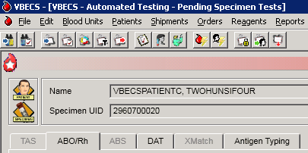

Reports
The report information that is presented on-screen, not the print preview, can be sorted by clicking on each column header. The sort changes made do not apply to the printed reports. Reports print in a default sort order.

Note 1: Switching to Normal layout view from Print layout view so the user can search the report may cause the error message “Error. Thread was being aborted.” to appear for a large report. The report proceeds to load in the different layout view chosen by the user. This is a normal behavior of a report engine and no harm is done.

Note 2: The transfusion count total may indicate a site needs to complete a National Blood Collection and Utilization Survey if the total transfusions is greater than or equal to 100.

Administrative Data Report
The user views and/or prints the Administrative Data Report.

Assumptions
- Data are available for inclusion in the report.

Outcome
- The user views and/or prints the report.

Limitations and Restrictions
- None

Additional Information
- The report is available as a single-division or multidivisional (all divisions) report.

User Roles with Access to This Option
All users

Administrative Data Report
The user views and/or prints the Administrative Data Report, which includes blood product transactions for a given date range.
User Action | VBECS
- Select Reports from the main menu.  Select Administrative Data Report. | - Lists report names.  - Displays report compilation criteria.  - Displays a date range for selection.
- Enter or select start and end dates.  Click the Current Divisions or All Divisions radio button. | - Allows the user to select one or all divisions.  NOTES  For each component class and its subdivisions, VBECS tallies:  - Products received  - Products modified/prepared  - Units transfused  - Units shipped  - Outdated units  Tallies are presented for total units received as well as subtotals for donation type categories, allogeneic, directed, and autologous.  Tallies are presented for total units received as well as subtotals for donation type categories, allogeneic, directed, and autologous.  All categories are calculated within the selected date range, not for a total in the system.  If there is no calculation for a given field, the system will display 0 (zero).  Identify split/divided units using the unit product code in ISBT 128; labeling contains the unit division code in the seventh and eighth characters or may be a separate product code, indicated as 1st container, 2nd container, and so on.  For Pooled totals PREPARED in VBECS, include two numbers, the first being the total number of units included in those pools. The second number is number of pools created, for example, (2) 1.
- In the Report Compilation area, click the Create Report Now radio button. Click OK to view the report, or  Click the Schedule Print Job radio button and OK, then enter or select a print date and printer name. Click OK to view and print the report. | - Compiles and displays the report.  NOTES  The user may choose to schedule a report to run at a future date and time and print on a designated printer. When a date range is supplied for the report, the report's end date must occur before selected date of printing. The report scheduled to run at the future date/time will start processing the data at the time the report is scheduled to print (future date/time). If the date range spans more than 30 days, the system displays the warning message: "You are requesting more than 30 days of data to be printed. Continue?"  When the user chooses to a view report, the system always displays the report. The user may elect to print a hard copy of the report on a designated printer or exit.
- Select Print to print the report, Export to export the report (See Report Export section), or click Close to exit without printing. | - If Print is selected, prints the report on the designated printer.  - If Export is selected, exports the report to the designated file.  - If Close is selected, exits the report preview.

Audit Trail
The user views and/or prints an Audit Trail Report.

Assumptions
- Data are available for inclusion in the report.
- The user must be logged into the division in which the report is to be generated.
- The connection to VistA is active.

Outcome
- The user views and/or prints the report.

Limitations and Restrictions
- VBECS does not accommodate online review (verification, signature) of reports.

Additional Information
- Audit trail entries reflect the actual date and time the change was made.
- When a unit is received with RBC antigens selected, that unit may appear on the Audit Trail Report. See the Unit History Report for RBC antigen typing entered for the unit during Incoming Shipment.

User Roles with Access to This Option
All users

Audit Trail
The user views and/or prints an Audit Trail Report, which lists changes to specific patient, unit, and division configuration settings. It is a regulatory requirement to maintain documentation proving that these changes were reviewed. Modify local record retention policy to instruct users to print, review, document, and save these reports. The Audit Trail Report contains only data changes generated in the user’s login division.
User Action | VBECS
- Select Reports from the main menu.  Select Audit Trail. | - Lists report names.  - Displays report compilation criteria.  - Displays a date range for selection.
- Enter or select start and end dates. | NOTES  The parameter table and Transfusion Requirements Report sections include changes from no previous entry to an entry and from an entry to no entry.  Each entry includes an area for supervisor acknowledgement (signature or initials and date of review) and comment.
- In the Report Compilation area, click the Create Report Now radio button. Click OK to view the report, or  Click the Schedule Print Job radio button and OK, then enter or select a print date and printer name. Click OK to view and print the report. | - Compiles and displays the report.
- Select Print to print the report, Export to export the report (See Report Export section), or click Close to exit without printing. | - If Print is selected, prints the report on the designated printer.  - If Export is selected, exports the report to the designated file.  - If Close is selected, exits the report preview.  - See Appendix B: Table 20: Details in Audit Trail Report.

Blood Availability
The user views and/or prints the Blood Availability Report.

Assumptions
- A blood unit is logged into a division in the database.

Outcome
- VBECS users may view available blood unit data in several formats.

Limitations and Restrictions
- None.

Additional Information
- VBECS displays the defined reports and allows the user to view an individual Patient Blood Availability Report or to create a custom report.
- The report is available as a single-division or multidivisional (all divisions) report.

User Roles with Access to This Option
All users

Blood Availability
The user may check the blood availability for a specific patient and view and/or print a variety of Blood Inventory Reports from the user’s and other divisions, as available. Blood Availability Reports include the product’s unit status, indicators, patient information for units in the “assigned” and “issued” statuses, restrictions, and special testing or handling of a unit.
User Action | VBECS
- For a non-individual report, select Reports from the main menu.  Select Blood Availability, or  For a patient-specific report, select Patients from the main menu.  Select Blood Availability. | - Displays options for generating, viewing, and printing blood reports.  - Displays non-individual report type and compilation criteria.  - Displays options for generating a patient-specific report.
- Click a radio button to select a report format:  - Daily Inventory (All Units)  - Daily Inventory (Available Units)  - Antigen Typed Inventory (Available Units)  - Units with No Disposition (Available Expired)  - Units with Final Disposition (Not Transfused)  - Custom Report  - Individual Patient Blood Availability | - Displays a print preview of the report.  NOTES  The user may click the Custom Report radio button and OK, and then click the appropriate check boxes in the Component Class, Testing, Donation Type, Unit Status, Date Range, ABO/Rh, Product Attributes, and Division tabs to customize the report.  When a user selects the Individual Patient Blood Availability report for his division only, the report includes all units available (unit statuses: assigned, crossmatched, and issued) in his division for the selected patient.  When a user selects Units with Final Disposition, the report includes units with a status of “discarded,” “modified,” or “transferred.”  When a user selects Units with No Disposition, the report includes expired units with a status of “limited” or “available.”
- In the Report Compilation area, click the Create Report Now radio button. Click OK to view the report, or  Click the Schedule Print Job radio button and OK, then enter or select a print date and printer name. Click OK to view and print the report. | - Compiles and displays the report.
- Select Print to print the report, Export to export the report (See Report Export section), or click Close to exit without printing. | - If Print is selected, prints the report on the designated printer.  - If Export is selected, exports the report to the designated file.  - If Close is selected, exits the report preview.

Cost Accounting Report
The user views and/or prints the Cost Accounting Report.

Assumptions
- Data for the report were saved in VBECS.

Outcome
- The report is viewable or printed.

Limitations and Restrictions
- None

Additional Information
- The report is for a single division.
- A unit with an edited return credit in final status will not revert to the original return credit amount when the unit’s final status is removed. Select Edit Financial Data and correct the return credit amount.

User Roles with Access to This Option
All users

Cost Accounting Report
The user views and/or prints the Cost Accounting Report for a division. The Cost Accounting Report itemizes incoming and outgoing shipments, modifications of blood products, and patient testing costs for a given period. The report includes base cost, special testing, modifications, and return credits for units, as applicable.
User Action | VBECS
- Select Reports from the main menu.  Select Cost Accounting Report. | - Lists report names.  - Displays report compilation criteria.  - Displays a date range for selection.
- Enter or select start and end dates. | - Compiles and displays the report.  NOTES  Final calculations appear at the end of each section:  - Subtotal of base cost per invoice (Incoming Shipment section only)  - Subtotal of special testing cost (Incoming Shipment section only)  - Subtotal of return credit for an invoice (Outgoing Shipment section only)  - Total special testing cost of all units  - Total off-site antibody identification testing cost  - Total cost of modifications  - Total cost of units inactivated
- In the Report Compilation area, click the Create Report Now radio button. Click OK to view the report, or  Click the Schedule Print Job radio button and OK, then enter or select a print date and printer name. Click OK to view and print the report. | - Compiles and displays the report.
- Select Print to print the report, Export to export the report (See Report Export section), or click Close to exit without printing. | - If Print is selected, prints the report on the designated printer.  - If Export is selected, exports the report to the designated file.  - If Close is selected, exits the report preview.

C:T Ratio Report
The user views and/or prints the C:T Ratio Report.

Assumptions
- Data for the report are available.

Outcome
- The report is viewed or printed.

Limitations and Restrictions
- None

Additional Information
- This ratio calculation includes all component classes. For component classes that are not crossmatched, the number of blood units assigned to the patient are used as a basis for calculation.
- The report is available as a single-division or multidivisional (all divisions) report.

User Roles with Access to This Option
All users

C:T Ratio Report
This option compiles and calculates the crossmatch/assigned-to-transfusion ratio. The user may select one of five report formats.
User Action | VBECS
- Select Reports from the main menu.  Select C:T Ratio Report. | - Lists report names.  - Displays report type and compilation criteria.  - Displays a date range for selection.
- Enter a date range. | - Displays an option to compile the report for one or all divisions in the database.
- Click the Current Division or All Divisions radio button. | - Allows the user to select a report format.  NOTES  The user may request the Detailed Report, Ordering Physician Summary Report, Treating Specialty Summary Report, Detailed Report with Ordering Physician Summary, or Detailed Report with Treating Specialty Summary.
- Click a radio button to select a report format:  - Detailed Report  - Ordering Physician Summary Report  - Treating Specialty Summary Report  - Detailed Report with Ordering Physician Summary  - Detailed Report with Treating Specialty Summary | - Compiles the report and displays an option to print the report or exit.  NOTES  The physician included in this report is the ordering physician.  VBECS compiles the C:T ratio report as a summary or detailed report. All versions include a single C:T ratio for the division and each component class. When a number of transfused units is 0, the ratio is equal to the number of units assigned and crossmatched.  VBECS determines the C:T ratio for a division by dividing the number of units assigned or crossmatched (electronically or serologic) during the period selected by the number of units transfused at the division.  This calculation does not include units with a XM result of “Compatible - Don’t Transfuse” or “Incompatible - Unsafe to Transfuse.”  The detailed C:T ratio report includes a list of units assigned or crossmatched (electronically or serologic) for a patient during the selected date range. The report includes the unit ID, ordering physician name, unit ABO/Rh, treating specialty, XM interpretation, date and time the XM was completed, product short name, and an indication as to whether the unit was transfused or presumed transfused.  VBECS determines the C:T ratio for a physician by dividing the number of units that were assigned or crossmatched (electronically or serologic) during the period selected by the number of transfused units. When a number of transfused units is 0, the ratio is equal to the number of units assigned and crossmatched.  VBECS determines the C:T ratio for a treating specialty by dividing the number of units assigned or crossmatched (electronically or serologic) for all patients listed in that treating specialty by the number of units transfused to all patients listed for that specialty. When a number of transfused units is 0, the ratio is equal to the number of units assigned and crossmatched.
- In the Report Compilation area, click the Create Report Now radio button. Click OK to view the report, or  Click the Schedule Print Job radio button and OK, then enter or select a print date and printer name. Click OK to view and print the report. | - Compiles and displays the report.
- Select Print to print the report, Export to export the report (See Report Export section), or click Close to exit without printing. | - If Print is selected, prints the report on the designated printer.  - If Export is selected, exports the report to the designated file.  - If Close is selected, exits the report preview.

CPRS Blood Bank Report (Used by JLV and VistA Read Only)
CPRS Blood Bank Report provides an overview of a patient’s blood bank / transfusion information and is available via Computerized Patient Record System (CPRS). It is not part of the main VBECS system; however, since it fully relies on data stored in VBECS, it is included in this guide. Being part of CPRS, this report is available not only to blood bank personnel but to all health providers who utilize CPRS. The CPRS Blood Bank Report is also viewable within the Joint Longitudinal Viewer (JLV) portal. For more information about JLV, consult the JLV website. Note that the VBECS data is not displayed when viewing the report through VistA Read Only.

Navigation (How to generate a CPRS Blood Bank Report)
In CPRS:
- Labs tab, Blood Bank
- Reports tab, Blood Bank Report
- Reports tab, Clinical Reports, Laboratory, Blood Bank Report

Report layout
Report consists of eight sections:
- ABO/Rh - displays a patient’s ABO/Rh based on patient’s ABO/Rh testing history.
- Antibodies Identified and Transfusion Requirements - displays a patient’s antibodies, antigen negative requirements and component requirements.
- Transfusion Reactions – displays the history of a patient’s transfusion reactions.
- Available/Issued Units - displays a list of units assigned, crossmatched and issued to the patient. Issued units that are indicated as transfused or presumed transfused in VBECS no longer show in this section but instead display in the Transfused Units section.
- Diagnostic Tests - displays a history of the patient’s completed diagnostic tests (TAS, ABO/Rh, ABS, DAT Poly, DAT IgG and DAT Comp). Only the test interpretation is displayed. Invalidated tests are not shown unless the replacement results were entered. In such case, the invalidated test is marked as ** Entered in Error ** and a replacement result is marked as ** Corrected Result **.
- Component Requests - displays a history of the patient’s component orders. Cancelled orders are not included.
- Transfused Units - displays the history of a patient’s transfusions.
- Legacy VistA Blood Bank Report - contains a patient’s legacy blood bank information that was not recorded in VBECS.

Limitations and Restrictions
- The report is not multidivisional, meaning it does not combine a patient's transfusion information from all VA hospitals.
- VBECS data is not displayed when viewing the report through VistA Read Only (See Figure 118)

Troubleshooting
Since the CPRS Blood Bank Report relies on data stored in VBECS, it is possible for it to malfunction when the network connection to VBECS is disrupted or if there is a problem with VBECS VistALink service. If that happens, the report will display a message similar to this one:
Figure 118: Example of Report Message
******************************************************************
* *
* Patient data is not available at this time *
* due to a VistALink connection failure. *
* *
* *
******************************************************************

In such case, contact the Service Desk. See the Customer Support section of this guide for contact information.

Missing Division Names
Available/Issued Units and Diagnostic Tests sections of the CPRS Blood Bank Report include the display of the division name. In certain circumstances, the division name might be missing from the report. If that happens, contact the Service Desk and file a ticket for the VBECS team to have it fixed. See the Customer Support section in this guide for contact information.

Division Transfusion Report
The user views and/or prints the Division Transfusion Report.

Assumptions
- Transfused unit data for the report were saved in VBECS.

Outcome
- The user views and/or prints the report.

Limitations and Restrictions
- None

Additional Information
- VBECS compiles data for the report from the user’s login division.

User Roles Access to This Option
All users

Division Transfusion Report
The user views and/or prints a Division Transfusion Report, which lists details of units transfused during a selected period.
User Action | VBECS
- Select Reports from the main menu.  Select Division Transfusion Report. | - Lists report names.  - Displays fields for entering a report date range.
- Enter or select start and end dates.  In the Report Type area, select the Issuing Physician Report, Treating Specialty Report, Issued-To Location Report or Component Class Report radio button.  May select all or specific items to be included in the report. | - Allows the user to compile the report by issuing physician, by treating specialty, or by issued-to location or component classes.  - Allows the user to include some or all issuing physicians, treating specialties, or issued-to locations or component classes.  - At the end, there is a summary table with tallies by Unit ABO/Rh and component class.  NOTES  The user has the option to create the report by component class and to select some or all of the component classes for inclusion. The list includes all VBECS component classes.
- In the Report Compilation area, click the Create Report Now radio button. Click OK to review the report, or  Click the Schedule Print Job radio button and OK, then enter or select a print date and printer name. Click OK to view and print the report. | - Compiles and displays the report.  NOTES  The report displays tallies of units transfused by component class within the date range, by:  - Physician name  - Treating specialty  - Issued-to location  - Component class  Reports include:  - Patient name  - Patient ID  - Unit ID  - Product short name and product code  - If pooled, number of participants in pool  - Unit ABO/Rh  - Date and time Issued  - Issued-to location  - Physician  - Treating specialty  - Transfused or presumed transfused indicator, if present  - Transfusion comments, if any
- Select Print to print the report, Export to export the report (See Report Export section), or click Close to exit without printing. | - If Print is selected, prints the report on the designated printer.  - If Export is selected, exports the report to the designated file.  - If Close is selected, exits the report preview.

Division Workload Report
The user views and/or prints a workload report.

Assumptions
- VistA workload codes were assigned to VBECS processes through Workload Codes.
- Data for the report were saved in VBECS.

Outcome
- The user views and/or prints the report.

Limitations and Restrictions
- A report printed with an end date of today or greater does not print “Preliminary” in the header. Check the subsequent pages of the report and write “PRELIMINARY” on the front page of the report prior to filing. The information included in the report is accurate to the time printed. There is a possibility of a gap of information should the user not overlap the print requests. Generally, this report is printed for the day prior or a time period that does not include the current day.

Additional Information
- The report is available as a single-division or multidivisional (all divisions) report.
- The report will not print as “Preliminary” when the report contains the current day in the range of data requested.

User Roles with Access to This Option
All users

Division Workload Report
The user views and/or prints a workload report, which includes totals of workload types, for one or all divisions.
User Action | VBECS
- Select Reports from the main menu.  Select Division Workload Report. | - Lists report names.  - Displays report division and compilation criteria.  - Displays a date range for selection.
- Click the Current Divisions or All Divisions radio button. | - Allows the user to select one or all divisions.  - Displays a date range for selection.
- Enter or select start and end dates. | - Compiles and displays the report.  - Allows the user to print the report.  NOTES  A multiple-division workload report includes totals for each type of workload for each division requested in the report.  VBECS searches its workload file for entries within the selected date range.
- In the Report Compilation area, click the Create Report Now radio button. Click OK to view the report, or  Click the Schedule Print Job radio button and OK, then enter or select a print date and printer name. Click OK to view and print the report. | - Compiles and displays the report.
- Select Print to print the report, Export to export the report (See Report Export section), or click Close to exit without printing. | - If Print is selected, prints the report on the designated printer.  - If Export is selected, exports the report to the designated file.  - If Close is selected, exits the report preview.

Exception Report
The user views and/or prints an Exception Report.

Assumptions
- Data are available for inclusion in the report.
- The user must be logged into the division in which the report is to be generated.

Outcome
- The user views and/or prints the report.

Limitations and Restrictions
- VBECS does not accommodate online review (verification, signature) of reports.
- Only the first twenty patient antigens will print on the report when an exception is generated for a unit issued with unsatisfied antigen negative requirements.
- In some areas of the report, the user ID is displayed instead of the user name.
- The Exception Date displayed is not consistently recorded to data records. It will either be the time the user entered the exception comment or the time the user saved the data record.

Additional Information
- A supervisor may use a printed report to document the review.
- Exception Report entries reflect the actual date and time an exception occurred.
- Exception report entries associated with testing do not include additional information about method, manual or automated instrument. See the Testing Worklist Report, Patient History Report or Unit History Report for test method information.
- In the Emergency Issue section of the report, VBECS displays ISBT unit ID and product short name, but not the product code. See the Unit History report for the missing data saved in other options.
- Issue Blood Component exceptions that include the Testing Status field displays numeric values 0, 1, 2 or 3. Those numbers represent the unit’s disease marker testing.
  - (0) – N/A for non-autologous units,
  - (1) – NEG – Unit fully tested and negative for all disease markers,
  - (2) – POS – Unit tested and positive for one or more disease markers, Biohazard,
  - (3) – NFT – Unit not fully tested for one or more disease markers, Biohazard.

User Roles with Access to This Option
All users

Exception Report
The user views and/or prints an Exception Report. Exception Reports list details of transactions that involve overrides to warnings and selected transactions of interest to the supervisor (for example, quarantined units).
.User Action | VBECS
- Select Reports from the main menu.  Select Exception Report. | - Lists report names.  - Displays report compilation criteria.  - Displays a date range for selection.
- Enter or select start and end dates. | NOTES  The report is sorted by exception type. Exception types are in chronological order.
- In the Report Compilation area, click the Create Report Now radio button. Click OK to view the report, or  Click the Schedule Print Job radio button and OK, then enter or select a print date and printer name. Click OK to view and print the report. | - Compiles and displays the report.
- Select Print to print the report, Export to export the report (See Report Export section), or click Close to exit without printing. | - If Print is selected, prints the report on the designated printer.  - If Export is selected, exports the report to the designated file.  - If Close is selected, exits the report preview.  - See Appendix B: Table 21: Details in Exception Report.

Finalize/Print TRW (See Patient Services, Finalize/Print TRW)

Inappropriate Transfusion Request Report
The user views and/or prints the Inappropriate Transfusion Request Report.

Assumptions
- The order is flagged as an inappropriate transfusion request during Accepting an Order.
- Setting Component Requirements was processed and there are inappropriate test indicators associated with the component classes in the login division.
- Data for the report were saved in VBECS.

Outcome
- The user view or prints the report.

Limitations and Restrictions
- None

Additional Information
- None

User Roles with Access to This Option
All users

Inappropriate Transfusion Request Report
The user views and/or prints the Inappropriate Transfusion Request Report, which includes inappropriate transfusion orders determined by the division’s configuration of each component class.
User Action | VBECS
- Select Reports from the main menu.  Select Inappropriate Transfusion Request Report. | - Lists report names.  - Displays report compilation criteria.  - Displays a date range for selection.
- Enter or select start and end dates. | - Compiles and displays the report.
- In the Report Compilation area, click the Create Report Now radio button. Click OK to view the report, or  Click the Schedule Print Job radio button and OK, then enter or select a print date and printer name. Click OK to view and print the report. | - Compiles and displays the report.
- Select Print to print the report, Export to export the report (See Report Export section), or click Close to exit without printing. | - If Print is selected, prints the report on the designated printer.  - If Export is selected, exports the report to the designated file.  - If Close is selected, exits the report preview.

Issued/Returned Unit Report
The user views and/or prints the Issued/Returned Unit Report.

Assumptions
- Data for the report were saved in the VBECS database.

Outcome
- The user views and/or prints the report.

Limitations and Restrictions
- None

Additional Information
- The report is compiled for one division.

User Roles with Access to This Option
All users

Issued/Returned Unit Report
The user views and/or prints a report of units issued and/or returned to patients within a specified date range for a division.
User Action | VBECS
- Select Reports from the main menu.  Select Issued/Returned Report. | - Lists report names.  - Displays fields for entering a report date range.
- Enter or select start and end dates. | - Allows the user to sort the report by issued date range, by patient name or by component class.
- In the Report Sort Order area, select the Issue/Return Date, Patient Name or Component Class radio button. | - Compiles the report and, for each unit issued and when units are returned, includes return information.  NOTES  The report includes a unit that is issued or returned within the entered date range. When a unit is identified as issued or returned during the entered date range, the report also includes unit return and issuance data, respectively, even when they fall outside the date range of the report.
- In the Report Compilation area, click the Create Report Now radio button. Click OK to view the report, or  Click the Schedule Print Job radio button and OK, then enter or select a print date and printer name. Click OK to view and print the report. | - Compiles and displays the report.
- Select Print to print the report, Export to export the report (See Report Export section), or click Close to exit without printing. | - If Print is selected, prints the report on the designated printer.  - If Export is selected, exports the report to the designated file.  - If Close is selected, exits the report preview.

Medication Profile (See Patient Information Toolbar)

Order History Report
The user views and/or prints a Single-Order History Report or an Order Summary Report.

Assumptions
- Data for the report are available.

Outcome
- The user may view and/or print a report.

Limitations and Restrictions
- VBECS does not display the identity of the CPRS user who discontinues a signed order in CPRS. The CPRS order details option contains all pertinent order information.
- Cancelled orders are included on the Order Summary Report without a column/data to help identify them as cancelled. The Single Order History Report includes the cancelled order information. When the order is also cancelled in VistA, which would be the norm, there is a lab report that can be referenced (See FAQ Order Status Clarification).
- The Order History Report only displays the first twenty (20) characters of an ordering location. Ordering locations in VistA can be shortened or changed when the uniqueness of a location cannot be determined with the first twenty (20) characters.

Additional Information
- Test counts and workload information for other VBECS processes are in the Workload Report.

User Roles with Access to This Option
All users

Order History Report
The user views and/or prints an Order History Report. The user may retrieve a report for a single order or a summary report for all VBECS orders within a date range. The user may sort the Order Summary Report by treating specialty or by patient location.
User Action | VBECS
- Select Reports from the main menu.  Select Order History Report. | - Lists report names.  - Displays options for generating, viewing, and printing reports.  - Displays report type and compilation criteria.
- Click the Order Summary Report or Single-Order History Report radio button to select a report type.
- For an Order Summary Report, create a report date range:  Select or edit the dates and times in the Start Date and End Date fields.  In the Report Sort Order area, click the Treating Specialty or Ordering Location radio button and continue at Step 5. | - Displays the option to enter a date range for the report based on the date and time VBECS acknowledged the order.  - Displays an option to sort the report by treating specialty or by ordering location. The report tallies orders in a given date range by ordering location and treating specialty.
- For a Single-Order History Report:  Enter the search criteria and/or click the find button to select an order from the list. | - Displays the Select Patient Order window.  NOTES  The user enters a date or a specimen UID, or selects a patient to locate an order. VBECS displays the following information based on the selected search option:  - When a user enters a date, VBECS displays orders accepted or cancelled by VBECS on that date.  - When the specimen UID is entered, VBECS displays only orders associated with that specimen.  - When a patient name is selected, VBECS displays the patient’s orders listed in reverse chronological order for the last 90 days with an option to display all of the patient’s accepted and cancelled orders.
- In the Report Compilation area, click the Create Report Now radio button and OK to view the report, or  Click the Schedule Print Job radio button and OK, then enter or select a print date and printer name, then click OK to view and print the report. | - Compiles and displays the report.  NOTES  The Order Summary Report includes a section for each treating specialty or ordering location, including accepted and cancelled VBECS orders and the Diagnostic Test or Component Orders for the selected date range. The report lists individual orders by order type, including the Patient Name, ID, CPRS and Lab Order Numbers, and Date.  The Single-Order History Report contains details of an individual order group, including:  - Patient Name  - Patient ID  - CPRS Order Name  - CPRS and Lab Order Numbers  - Order Urgency  - CPRS MODIFIER(S)  - CPRS Reason for Request  - CPRS Order Comment(s)  - Specimen Accession Number  - Specimen UID, if any  - Specimen unacceptable comment, if any  - Received Date, original and any updates  - Expiration Date, original and any updates  - Accepting Technologist Name  - Acceptance Date and Time  - Cancellation Date, if any  - Cancellation Division  - Cancellation Tech ID, if any  - Cancellation Comment, if any  - Ordering Provider  - Ordering Location  - Treating Specialty (patient at time of order)  - Component or Diagnostic Test originally ordered  - All Added Reflex Tests, Date(s), and Requesting Tech Name  - Inappropriate Request Information, if any  - Workload name and VistA (LMIP) code after completion  - Exception report section message: Exception report details are available as part of the patient’s record. Refer to the specimen section of the patient’s record.
- Select Print to print the report, Export to export the report (See Report Export section), or click Close to exit without printing. | - If Print is selected, prints the report on the designated printer.  - If Export is selected, exports the report to the designated file.  - If Close is selected, exits the report preview.

Patient History Report
The user views and/or prints the Patient History Report.

Assumptions
- VBECS displays the report header even when there is no information in the report.

Outcome
- The user views and prints a patient’s VBECS record.

Limitations and Restrictions
- When units are restricted for a patient during Incoming Shipment, VBECS does not display them on the Patient History Report.
- VBECS displays these default values for transfusion reactions converted from VistA to VBECS. They do not reflect actual interpretations or results:
Converted Transfusion Reaction | Default
Pre-Transfusion Specimen Checks, Hemolysis Checks OK? | Yes
Post-Transfusion Specimen Checks, Hemolysis Checks OK? | Yes
Symptoms | No symptoms identified.
Implicated units | No units implicated in reaction.
Serologic tests | No serologic tests performed.

Additional Information
- The patient record report is divided into sections for report retrieval.
- This report includes:
- Post-transfusion details.
- Data from all divisions within the database.

User Roles with Access to This Option
All users

Patient History Report
The user views and/or prints the patient’s VBECS record.
User Action | VBECS
- Select Patients or Reports from the main menu.  Select Patient History Report. | - Displays options for processing patient-related functions, or for generating, viewing, and printing reports.  - Displays report sections and compilation criteria.
- Enter the patient name and/or ID, or click the find button to search for patient data.  Click OK. | - Allows the entry or selection of a patient.  - Displays the patient report section types for selection:  - Patient Demographic History  - Transfusion Requirements  - Testing Details  - Unit Assignment History  - Transfusion History  - Specimen Details  - Special Instructions  - Transfusion Reaction Details  - Exception Report Entries  - Assignments/Releases  - Audit Trail Report
- Select one or more sections to include in the report.
- Click the Schedule Print Job radio button and OK, then enter or select a print date and printer name. Click OK to view and print the report. | - Compiles and displays the report.  - Allows the user to print the report.  NOTES  When the patient has an ABO/Rh as the result of a conversion, VBECS displays a message in the Transfusion History section instructing the user to check the legacy records for additional information.
- Select Print to print the report, Export to export the report (See Report Export section), or click Close to exit without printing. | - If Print is selected, prints the report on the designated printer.  - If Export is selected, exports the report to the designated file.  - If Close is selected, exits the report preview.

Patient Testing Worklist and Testing Worklist Reports
The user views and/or prints the Patient Testing Worklist and Testing Worklist Reports.

Assumptions
- The user must be logged into the division in which the report is to be generated.

Outcome
- The user views and/or prints a report, or schedules a report for future compilation and printing.

Limitations and Restrictions
- Reports do not include Transfusion Reaction Workup (TRW) test results.
- VBECS does not accommodate online review (verification, signature) of reports.
- The Rack QC Testing Worklist Report section of the Testing Worklist Report does not contain a Processed By column. Maintain the original testing records for the QC that was performed offline with the testing tech information. Do not change the testing tech name when entering results in VBECS so that the logged in tech that enters the results is included on the Testing Worklist report.

Additional Information
- In a transfusion-only facility, VBECS does not populate the test cell or phase results sections.
- VBECS collates complete, incomplete, and invalidated unit test results entered in the user’s division when the date tested falls within the supplied date range for the unit testing, reagent QC, and patient testing sections of the report.
- VBECS includes test results on all units, regardless of status, for the unit testing section. CMV and Sickle Cell test results are not included in the report.
- VBECS includes the results of the daily rack QC and patient and unit control testing for the reagent QC section.
- For the patient testing section:
- VBECS collates as above for the selected patient specimens within a specified date range.
- The report does not include TRW test results.
- VBECS includes XMs only in the patient testing section.
- VBECS displays individual tests within the TAS.
- If a rack has only been tested offline (never tested within VBECS) and the QC has expired, the message “Rack was never QC’d and cannot be used.” is displayed.
- The Testing Worklist Report does not display any information for Rack QC when QC Documentation Offline has been checked for that date.

User Roles with Access to This Option
All users

Patient Testing Worklist and Testing Worklist Reports
The user views and/or prints a Patient Testing Worklist Report for a specific patient or a Testing Worklist Report for a division. The reports contain both partially completed and completed testing data entries on patients, units, and reagents created in the same division as the user generating the report. Crossmatch test results are sequenced by date and time on the report. The Interp. Column of the Patient Testing Worklist Report displays "Inc", which can mean “Incompatible” or “Inconclusive”, depending on the test it is displayed with.
User Action | VBECS
- For a Patient Testing Worklist Report (for a single patient, select Patients from the main menu.)  Select Patient Testing Worklist Report.  For a Testing Worklist Report for a division, go to Step 5. | - Displays options for processing patient-related functions.  - Displays patient search criteria.
- Enter the patient name or identification number.  Click Search, as required.  Select a patient and click OK. | - Requires the user to select a patient.  - Displays specimen search criteria.
- Select or edit the dates and times in the Specimen Received Start Date and End Date fields.  Click Search, as required. | - Allows the user to indicate a date range and patient specimens to include in the report.  - Displays specimens with associated testing for the selected patient.  NOTES  The individual Patient Testing Worklist Report includes VBECS specimen UIDs from the last 90 days, by default. The user may remove one or more specimen UIDs and/or edit the default date range.  When the patient record is not found, VBECS notifies the user that no matching patients were found.  When the selected patient has no specimen on file within the division, VBECS warns the user and asks the user to select a different patient.  Requires the user to indicate the format of the report:  - Patient Testing  - Unit Testing  - Daily QC  - Miscellaneous Reagent QC
- Click one or more check boxes to select specimens.  Click OK.  Go to Step 8. | - Displays the report.  - Allows the user to print the report.
- For a Testing Worklist Report for a division, select Reports from the main menu.  Select Testing Worklist Report. | - Lists report names.  - Displays the report date range, sections (Patient Testing, Unit Testing, Rack QC, and Miscellaneous Reagent QC), and compilation criteria.
- Select or edit the dates and times in the Start Date and End Date fields. | - Displays the option to enter a date range for the report based on the date and time VBECS acknowledged the order.
- In the Report Compilation area, click the Create Report Now radio button. Click OK to view the report, or  Click the Schedule Print Job radio button and OK, then enter or select a print date and printer name. Click OK to view and print the report. | - Compiles and displays the report.
- Select Print to print the report, Export to export the report (See Report Export section), or click Close to exit without printing. | - If Print is selected, prints the report on the designated printer.  - If Export is selected, exports the report to the designated file.  - If Close is selected, exits the report preview.

Prolonged Transfusion Time Report
The user views and/or prints the Prolonged Transfusion Time Report.

Assumptions
- Data for the report were saved in VBECS.

Outcome
- The user views and prints the report.

Limitations and Restrictions
- This report does not include presumed transfused units.
- Units issued to a remote storage location are not filtered from the report.
- The Delayed (minutes) column on the report is not subtracting 30 minutes when the Transfusion Start time is greater than 30 minutes from the time of issue. Handwrite the correct Delayed (minutes) on the printed report.

Additional Information
None

User Roles with Access to This Option
All users

Prolonged Transfusion Time Report
The user views and/or prints the Prolonged Transfusion Time Report, which shows transfusions started more than 30 minutes after issue and units transfused for more than the maximum transfusion time set by each division.
User Action | VBECS
- Select Reports from the main menu.  Select Prolonged Transfusion Time Report. | - Displays options for generating, viewing, and printing reports.  - Displays a date range for selection.  - Displays report sort order and compilation criteria.
- Enter a date range.

Click the Transfusion Date (Reverse Chronological) or Issue-To Location radio button to select a sort order.
- In the Report Compilation area, click the Create Report Now radio button. Click OK to view the report, or  Click the Schedule Print Job radio button and OK, then enter or select a print date and printer name. Click OK to view and print the report. | - Compiles and displays the report.  NOTES  The report includes:  - Issue-to location  - Unit ID  - Product short name  - Issue Date/time  - Start Date/time  - End Date/time  - Number of minutes elapsed between unit issue and start time, when exceeds 30 minutes  - Number of minutes elapsed between the unit start and end dates and times, when they exceed the maximum transfusion setting for the component class.  - Patient Name  - Patient ID  - Treating Specialty  The report includes instances of a prolonged start time and/or the prolonged transfusion time.  A prolonged transfusion time is the number of minutes elapsed between the transfusion start and end times and the maximum transfusion time setting for the component class. When the number of minutes exceeds the maximum transfusion time setting for the component class, the unit and its transfusion data are included in the report.  A delayed start of transfusion is the number of minutes elapsed between the issue time and the transfusion start time. When the start time of the unit’s transfusion is greater than 30 minutes from the unit’s issue time and when no remote storage location is indicated, the unit and its transfusion data are included in the report.  The total transfusion time is the number of minutes elapsed between the issue and end times.  The report includes:  - Issue-To Location  - Unit ID  - Product Short Name  - Issue Date/Time  - Start Date/Time  - End Date/Time  - Delayed start interval (the number of minutes elapsed between unit issue and start times, when it exceeds 30 minutes)  - Prolonged transfusion interval (the number of minutes elapsed between unit start and end dates and times, when they exceed the maximum transfusion setting for the component class)  - Patient Name  - Patient ID  - Treating Specialty  The report’s start date and end date must include a blood unit’s issued date for the blood unit to be included in the report.
- Select Print to print the report, Export to export the report (See Report Export section), or click Close to exit without printing. | - If Print is selected, prints the report on the designated printer.  - If Export is selected, exports the report to the designated file.  - If Close is selected, exits the report preview.

Transfusion Complications Report
The user views and/or prints the Transfusion Complications Report.

Assumptions
- VistA tests are defined in Transfusion Complications.
- The connection to VistA is active.
- Transfusion Complications was processed and post-transfusion complication tests are defined.
- Units have a status of presumed transfused or transfused for the patient.

Outcome
- The user views and/or prints the report.

Limitations and Restrictions
- The report does not include units in an issued status.
- The report cannot be scheduled.

Additional Information
- The report searches for VistA tests defined in Transfusion Complications when the report is requested.
- If threshold values are words, they are case insensitive.
- A patient’s test results and transfusions are not directly linked by date, episode, or admission event.
- Lab test data retrieved for the report are not saved in VBECS.
- The report is not saved in VBECS.

User Roles with Access to This Option
All users

Transfusion Complications Report
The user views and/or prints the Transfusion Complications Report, which includes patients transfused in his division with a test result that exceeds the threshold set in Transfusion Complications for that test. Tests associated with possible post-transfusion complications are gathered by searching for results in a user-defined date range for the report. The report also includes the documented patient transfusions from 12 months prior to the start date of the report through the end date of the report.
User Action | VBECS
- Select Reports from the main menu.  Select Transfusion Complications Report. | - Lists report names.  - Displays fields for entering a report date range.
- Enter or select start and end dates. | - Compiles and displays the report and allows the user to print it.  NOTES  VBECS searches the Laboratory files (VistALink) and gathers instances of tests that exceed the threshold result of the tests set in Transfusion Complications within the specified date range. Retrieved test results are then filtered so that the report includes results only for patients who have transfusions documented in VBECS within the last 12 months prior to the start date of the report through the end date.  VBECS includes the evaluated tests and their threshold values in the report criteria section ‘Transfusion Complication Test Name’. All complications and thresholds are reported, not just the ones where the threshold is exceeded.  Details of the report include:  - Patient name  - Patient ID  - Current hospital location  - Date of death (in lieu of location if patient died)  - Unit ID  - Unit short name  - End date and time of the unit’s transfusion, if available  From VistA for each patient’s tests:  - Test name  - Associated test result  - Date and time recorded
- In the Report Compilation area, click the Create Report Now radio button. Click OK to view the report, or  Click the Schedule Print Job radio button and OK, then enter or select a print date and printer name. Click OK to view and print the report. | - Compiles and displays the report.  NOTES  - This report requires a logged on VistA user to retrieve the lab results. It cannot be scheduled to print.
- Select Print to print the report, Export to export the report (See Report Export section), or click Close to exit without printing | - If Print is selected, prints the report on the designated printer.  - If Export is selected, exports the report to the designated file.  - If Close is selected, exits the report preview.

Transfusion Effectiveness Report
The user views and/or prints a Transfusion Effectiveness Report.

Assumptions
- VistA tests are defined in Transfusion Effectiveness.
- The connection to VistA is active.
- Units have a status of presumed transfused or transfused for the patient.
- Data for the report were saved in VBECS and in VistA.

Outcome
- The user views and/or prints the report.

Limitations and Restrictions
- The report does not include VBECS diagnostic tests.

Additional Information
- Only verified Laboratory test results are available from VistA.
- Laboratory test data retrieved for the report from VistA are not saved in VBECS.
- A new page is started for each patient in the report.
- Test results in the report do not include units of measure or normal ranges.
- The report’s start date and end date must include a blood unit’s issue date to be included in the report. If no issue date exists, then the report’s start date and end date must include a blood unit’s transfusion end date to be included in the report.

User Roles with Access to This Option
All users

Transfusion Effectiveness Report
The user views and/or prints the Transfusion Effectiveness Report, which contains transfusion episodes and Laboratory results for patients for a selected period.
User Action | VBECS
- Select Reports from the main menu.  Select Transfusion Effectiveness Report. | - Lists report names.  - Displays report compilation criteria.  - Displays a date range for selection.
- Enter or select start and end dates.
- In the Report Type area, select the All Patients radio button, or  Click the Individual Patient Report radio button and the find button to search for a patient. | - Compiles and displays the report.
- In the Report Compilation area, click the Create Report Now radio button. Click OK to view the report, or  Click the Schedule Print Job radio button and OK, then enter or select a print date and printer name. Click OK to view and print the report. | - Compiles and displays the report.  NOTES  - This report requires a logged on VistA user to retrieve the lab results. It cannot be scheduled to print.  - The report’s start date and end date must include a blood unit’s issue date to be included in the report. If no issue date exists, then the report’s start date and end date must include a blood unit’s transfusion end date to be included in the report.
- Select Print to print the report, Export to export the report (See Report Export section), or click Close to exit without printing. | - If Print is selected, prints the report on the designated printer.  - If Export is selected, exports the report to the designated file.  - If Close is selected, exits the report preview.

Transfusion Reaction Count Report
The user views and/or prints a Transfusion Reaction Count Report.

Assumptions
- Data for the report were saved in VBECS.

Outcome
- The user views and/or prints the report.

Limitations and Restrictions
- Transfusion Reactions are only included on the report if the data were entered/updated during the selected date range. This means that retrospective entry of transfusion reactions may not display in the correct date range. The recorded date of the reaction is not considered in the selection criteria. Rerun the report for a date range that includes the date the data was entered or updated. For example, if a transfusion reaction that occurred on February 28 is retrospectively entered on March 1, it will only display on a report that includes March 1 in its date range.

Additional Information
- The report is available as a single-division or multidivisional (all divisions) report.
- The report only displays text entered in the “details” field of the Finalize Transfusion Reaction Workup screen. The canned comments entered are suppressed on the report. Enter all comments in the “details” field for them to print on the report.

User Roles with Access to This Option
All users

Transfusion Reaction Count Report
The user views and/or prints the Transfusion Reaction Count Report for a single division or for all divisions in the database.
User Action | VBECS
- Select Reports from the main menu.  Select Transfusion Reaction Count Report. | - Lists report names.  - Displays report division, format, and compilation criteria.  NOTES  The report includes transfusion reactions that are ordered, pending, completed, or finalized, and those indicated during Post-Transfusion Information.
- Enter or select start and end dates. | - Compiles and displays the report.  - Allows the user to print the report.
- Click the Current Divisions or All Divisions radio button. | - Allows the user to select one or all divisions.  - Displays a date range for selection.  NOTES  The Transfusion Reaction Count Report by type includes specific patient information indicated by the user. The default report setting excludes patient names.
- Click the Detailed Report or Summary Report radio button. | - Displays an option to compile the report as detailed or summary.  - Compiles and displays the report.  - Allows the user to print the report.  NOTES  The Transfusion Reaction Count Report prints the implicated unit numbers or “no implicated units,” as appropriate.  VBECS reports the total number of patient transfusion reactions in the selected date range.
- In the Report Compilation area, click the Create Report Now radio button. Click OK to view the report, or  Click the Schedule Print Job radio button and OK, then enter or select a print date and printer name. Click OK to view and print the report, or click Close to exit without printing. | - Compiles and displays the report.
- Select Print to print the report, Export to export the report (See Report Export section), or click Close to exit without printing. | - If Print is selected, prints the report on the designated printer.  - If Export is selected, exports the report to the designated file.  - If Close is selected, exits the report preview.

Transfusion Requirements Report
The user views and/or prints a Transfusion Requirements Report.

Assumptions
- The database conversion of VistA patient files is complete.
- Data for the report were saved in VBECS.

Outcome
- The user views and/or prints the report.

Limitations and Restrictions
- Deceased patient records do not appear on the report when they are generated after the patient has been marked as deceased in the VBECS database via a VistA Death Notification Update.
- The cumulative report is not displaying all patients on file. A patient with ABO/Rh testing and no other requirement appears on the partial Transfusion Requirements report, but not on the cumulative report.
- A report printed with an end date of today or greater does not print “Partial” in the header.

Additional Information
- A Transfusion Requirements report is compiled from all VBECS divisions defined in the VBECS database.
- VBECS does not allow a report to be printed when no data are available.
- When the date range includes a future date and time, VBECS displays “Partial” in the report header on each page of the report.
- The “Partial” format of the report does not allow scheduling to print in the future; a full report will print instead.
- Each page containing patient information includes the patient name.
- Divisions in a multidivisional database may view each other’s Special Instructions (SI) comments.
- Important transfusion related information for a patient may appear on more than one page. Always check the next page for additional patient information.

User Roles with Access to This Option
All users

Transfusion Requirements Report
The user views and/or prints the Transfusion Requirements Report for a division. This option describes the continuous compilation of the complete file of patients in the VBECS database for historic record checking during downtime.
User Action | VBECS
- Select Reports from the main menu.  Select Transfusion Requirements Report. | - Lists report names.  - Displays report compilation criteria.  - Displays a date range for selection.
- In the Report Type area, select the Cumulative Report radio button, or  Click the Partial Report radio button and enter or select start and end dates. | - Compiles and displays the report.  NOTES  Patients who do not have a blood type, SI, TR, or Transfusion Reaction in their VBECS record do not display on the Transfusion Requirements Report in either the Cumulative or Partial format.  The Cumulative Report displays patients that have a blood type, SI, TR, or Transfusion Reaction.  The Partial Report displays patients that have a change to their VBECS record within the date range of the requested report.  Changes are defined as:  - New order  - Record of testing  - Patient Update event  - New SI entered  - New TR entered  - New Transfusion Reaction entered
- In the Report Compilation area, click the Create Report Now radio button. Click OK to view the report, or  Click the Schedule Print Job radio button and OK, then enter or select a print date and printer name. Click OK to view and print the report. | - Compiles and displays the report.
- Select Print to print the report, Export to export the report (See Report Export section), or click Close to exit without printing. | - If Print is selected, prints the report on the designated printer.  - If Export is selected, exports the report to the designated file.  - If Close is selected, exits the report preview.

Unit History Report
The user views and/or prints a Unit History Report.

Assumptions
- The unit exists in the user’s division.

Outcome
- The user views and/or prints the report.

Limitations and Restrictions
- The report is not multidivisional.
- When a user retroactively updates a unit status through Discard or Quarantine, the Unit History Report displays the updated information, but does not display the date the change was made.
- The report will not indicate if a unit was returned to shipper, or shipped to another facility. This information can be found in the Cost Accounting Report.
- The report does not display the Antigen Testing Phase Change Exception. See the Exception Report for this information.
- When a user retroactively updates a unit status through the Discard or Quarantine option, the Unit History Report displays the updated information, but does not display the date the change was made.

Additional Information
- There may be multiple instances of the same unit number and product code in the same division. Inactivated unit records may have a unit ID and product code that duplicate an active unit ID and product code.
- VBECS always displays the current unit status when the user selects a blood unit, so there is no need for a separate report option, as is possible in VistA.
- Unit testing details are included in Testing Worklist Report.
- The report header for RBC and WB products does not display the = > 2 mL RBC contamination information.

User Roles with Access to This Option
All users

Unit History Report
The user views and/or prints the complete record for a blood unit, from incoming shipment through final status, including unit activities saved in the VBECS database. VBECS compiles data for that unit for one division.
User Action | VBECS
- Select Reports from the main menu.  Select Unit History Report. | - Lists report names.  - Allows the user to scan or enter a unit ID and product code.  - Displays compilation criteria.
- Scan or enter the unit ID and product code, or click the find button to search for and select a unit. | NOTES  The user may select any unit (active or inactive) in a division. VBECS marks the units so that the active ones are distinct from the inactive ones.  When processing an Autologous unit, the user must indicate the testing status of that unit.  There are three valid choices:  NEG - Unit fully tested and negative for all disease markers  POS - Unit tested and positive for one or more disease markers, Biohazard  NFT - Unit not fully tested for one or more disease markers, Biohazard  When the component order is for PLATELETS or OTHER the units with = > 2 mL of RBC contamination must be presented and checked for compatibility during Issue Blood Component and will display before products with less than (< ) 2 mL of RBC contamination.  The system will present all available units when the Product Type is PLATELETS or OTHER non-plasma components that have < 2 mL RBC contamination.
- In the Include Report Sections area, click one or more check boxes to select report sections. | - Displays the unit report section types for selection:  - Incoming Shipment  - Outgoing Shipment  - Unit Quarantine Information  - Unit Financials  - Patient Associations History  - Restricted Patient  - Issue Information  - Testing  - Antigen Typing  - Crossmatch  - Modification  - Transfused To  - Exception Report
- In the Report Compilation area, click the Create Report Now radio button. Click OK to view the report, or  Click the Schedule Print Job radio button and OK, then enter or select a print date and printer name. Click OK to view and print the report. | - Compiles and displays the report for the user’s login division.  NOTES  The page header includes the standard VBECS header, the unit ID, product, donation type, expiration date, restricted for patient, status, ABO/Rh, division, product long name, and user.  VBECS displays entries from only the related reports (Audit Trail and Exception Reports) specific to the selected unit or patient.  Audit Trail and Exception Reports that record only unit override information are linked to the unit’s historic record. Those that record only patient override information are linked to the patient’s historic record. Those that record both are accessible in unit and patient historic records.  See Appendix B: Table 20: Details in Audit Trail Report and Table 21: Details in Exception Report.  The report displays the product long name.  The report displays “CMV neg”, “SC neg” and/or = > 2 mL RBC contamination (which will display only for non-WB and non-RBC blood products) in the “Special Testing” column when a unit qualifies.  The report displays the unit’s quarantine indicator in the “Quarantined” column: “Yes” when quarantined, and “No” if it was never quarantined.  The report displays the unit’s biohazardous indicator in the “Biohazard” column “Yes” when biohazardous, and “No” if it was never a biohazard.
- Select Print to print the report, Export to export the report (See Report Export section), or click Close to exit without printing. | - If Print is selected, prints the report on the designated printer.  - If Export is selected, exports the report to the designated file.  - If Close is selected, exits the report preview.

References
- Association for the Advancement of Medical Instrumentation, Arlington, Virginia. The Quality System Compendium: GMP Requirements & Industry Practice, 1998.
- Association for the Advancement of Medical Instrumentation. Medical device software—Software life cycle processes (ANSI/AAMI SW68:2001), 2001.
- Brandt, Gwyneth. ClinicalTrialJobs.com. “Preparing for FDA Inspections.” July 18, 2002.
- Clinical Laboratory Technical Procedure Manuals; Approved Guideline—Fourth Edition, NCCLS document GP2-A4 (Wayne, PA: National Committee for Clinical Laboratory Standards, 2002).
- CMMI Product Development Team, Carnegie Mellon Software Engineering Institute. CMMISM-SE/SW, V1.0, Capability Maturity Model®—Integrated for Systems Engineering/Software Engineering, Version 1.0 (Pittsburgh, PA: Carnegie Mellon Software Engineering Institute, August 2000).
- Commission on Laboratory Accreditation, Laboratory Accreditation Program. Laboratory General Checklist (Northfield, IL: College of American Pathologists, 2017).
- Commission on Laboratory Accreditation, Laboratory Accreditation Program. Transfusion Medicine Checklist (Northfield, IL: College of American Pathologists, 2017).
- Joint Commission on Accreditation of Healthcare Organizations. Comprehensive Accreditation Manual for Hospitals: The Official Handbook (CAMH). (Oakbrook Terrace, Illinois: Joint Commission on Accreditation of Healthcare Organizations, 2013).
- Department of Veterans Affairs, Software Engineering Process Group (SEPG) and Software Quality Assurance (SQA), National Documentation Standards (October 2005).
- Department of Veterans Affairs, Veterans Health Administration. VHA Directive 99-053, VBECS Blood Bank Software, November 8, 2007.
- Galloway, Dianne. Mapping Work Processes. (Milwaukee, Wisconsin: ASQ Quality Press, 1994).
- General Principles of Software Validation; Final Guidance for Industry and FDA Staff (U.S. Department Of Health and Human Services, Food and Drug Administration, Center for Devices and Radiological Health, Center for Biologics Evaluation and Research, January 11, 2002).
- Guidance for Industry and FDA Premarket and Design Control Reviewers, Medical Device Use-Safety: Incorporating Human Factors Engineering into Risk Management (U.S. Department of Health and Human Services, Food and Drug Administration, Center for Devices and Radiological Health, Division of Device User Programs and Systems Analysis, Office of Health and Industry Programs, July 18, 2000).
- Guidance for Industry, FDA Reviewers and Compliance on Off-The-Shelf Software Use in Medical Devices (U.S. Department Of Health And Human Services, Food and Drug Administration, Center for Devices and Radiological Health, Office of Device Evaluation, September 9, 1999).
- Guidelines for Implementing the Electronic Crossmatch (Bethesda, MD: American Association of Blood Banks, 2003).
- Guidelines for the Labeling of Specimens for Compatibility Testing. Ed. James P. AuBuchon, MD. (Bethesda, MD: American Association of Blood Banks, 2002).
- Guidelines for the Laboratory Evaluation of Transfusion Reactions (Bethesda, MD: American Association of Blood Banks, 2003).
- IEEE Standard for Software Configuration Management Plans (IEEE Std 828-1998) (New York: Institute of Electrical and Electronic Engineers, Inc., 1998).
- ISBT 128 Bar Code Symbology and Application Specification for Labeling of Whole Blood and Blood Components, Version Number 1.4.0 [York, PA: International Council for Commonality in Blood Banking Automation (ICCBBA), June 2001].
- Jacobson, Ivar, Grady Booch, and James Rumbaugh. The Unified Software Development Process (Boston: Addison-Wesley, 1999).
- Medical devices—Application of risk management to medical devices (ANSI/AAMI/ISO 14971:2000), 2001. Association for the Advancement of Medical Instrumentation.
- Nevalainen, D. E. and M. F. Callery. Applying Self-Assessment and Process Analysis to Create a Quality System (Basel, Switzerland: S. Karger Publishing, 1995).
- Nozick, Robin F. “Demystifying the Information Systems Validation Process,” AABB News 7:6 (2005): 50–51.
- Object-Oriented Analysis and Design Using the UML: Student Manual, Book 1, Version 4.2 (Cupertino, CA: Rational Corporation, 1999).
- Rational Team Concert. Version 6.0.5, Rational Software Corporation.
- Deciding When to Submit a 510(k) for a Software Change to an Existing Device, October 25, 2017.
- Department of Veterans Affairs, Office of Information and Technology (OIT) Documentation Style Guide, October 2016.
- Standards for Blood Banks and Transfusion Services. Twenty-ninth edition (Bethesda, MD: American Association of Blood Banks, 2014).
- Technical Manual. Eighteenth edition (Bethesda, MD: American Association of Blood Banks, 2014).
- The Chicago Manual of Style, 16th ed., (Chicago: The University of Chicago Press, 2014).
- Title 21 Code of Federal Regulations, Part 11, Electronic Records; Electronic Signatures.
- Title 21 Code of Federal Regulations, Part 803, Medical Device Reporting.
- Title 21 Code of Federal Regulations, Part 806, Medical Devices; Reports of Corrections and Removals.
- Title 21 Code of Federal Regulations, Part 807, Establishment Registration and Device Listing for Manufacturers and Initial Importers of Devices.
- Title 21 Code of Federal Regulations, Part 810, Medical Device Recall Authority.
- Title 21 Code of Federal Regulations, Part 820, Quality System Regulation.
- Title 21 Code of Federal Regulations, Parts 200 to 299, Food and Drugs.
- Title 21 Code of Federal Regulations, Parts 600 to 799, Food and Drugs.
- Title 21 Code of Federal Regulations, Parts 800 to 1299, Food and Drugs.
- Trautman, Kimberly A. The FDA and Worldwide Quality System Requirements Guidebook for Medical Devices (Milwaukee, Wisconsin: ASQ Quality Press, 1997).
- U.S. Department Of Health and Human Services, Food and Drug Administration, Center for Devices and Radiological Health. Design Control Guidance for Medical Device Manufacturers, March 11, 1997.
- U.S. Department Of Health and Human Services, Food and Drug Administration, Center for Devices and Radiological Health. Inspection of Medical Device Manufacturers, Final Guidance for Industry and FDA, February 7, 2001.
- U.S. Department Of Health and Human Services, Food and Drug Administration, Center for Devices and Radiological Health. Medical Device Quality Systems Manual: A Small Entity Compliance Guide. First edition, December 1996.
- U.S. Department Of Health And Human Services, Food and Drug Administration, Center for Devices and Radiological Health, Office of Device Evaluation. Guidance for the Content of Premarket Submissions for Software Contained in Medical Devices, May 29, 1998.
- U.S. Department Of Health And Human Services, Food and Drug Administration, Center for Devices and Radiological Health, Office of Regulatory Affairs. Glossary of Computerized System and Software Development Terminology, August 1995.
- U.S. Department Of Health and Human Services, Food and Drug Administration, Center for Devices and Radiological Health. Premarket Approval Manual. January 1998.
- U.S. Food and Drug Administration, Office of Regulatory Affairs and the Center for Devices and Radiological Health. Guide to Inspections of Medical Device Manufacturers, December 1997.
- U.S. Food and Drug Administration, ORA Inspectional References, Quality Inspection System Technique. Guide to Inspections of Quality Systems, August 1999.
- United States Industry Consensus Standard for the Uniform Labeling of Blood and Blood Components Using ISBT 128, Version 1.2.0, prepared by the International Council for Commonality in Blood Banking Automation, Inc. (U.S. Department of Health and Human Services, Food and Drug Administration, Center for Biologics Evaluation and Research, November 1999).
- Office of Enterprise Development Documentation Standards, Version 1.4, June 2009.
- Wilson, Paul F., Larry D. Dell, and Gaylord F. Anderson. Root Cause Analysis: A Tool for Total Quality Management (Milwaukee, Wisconsin: ASQ Quality Press, 1993).
- ZPL II Programming Guide, Customer order # 46530L, Manufacturer part # 46530LB (Zebra Technologies Corporation, November 18, 2016).

Glossary
Acronym, Term | Definition
AABB | American Association of Blood Banks.
ABID | Antibody identification.
ABO | A group for classifying human blood, based on the presence or absence of specific antigens in the blood, which contains four blood types: A, B, AB, and O. The ABO group is the most critical of the human blood systems. It is used to determine general compatibility of donor units to a recipient.
ABS | Antibody screen, Antibody Screen Test.
Access Code | A field in the VistA New Person file used to uniquely identify a user on the VistA system.
Accessioned | Describes an order when a specimen has been collected or has been placed on a current collection list by the VistA Laboratory software. A mechanism for accessioning orders for blood components that do not require a specimen needs to be designed.
Active order | A patient order for blood product(s) that is not completed or expired. Depending on the component class, an accompanying specimen may be required.
Active user | A user with a setting in VistA that allows him to access VBECS. Inactive users may no longer access VBECS.
Activities | Business processes that the product supports.
Activity | An identified verification and validation task.
AHG | Anti-Human Globulin.
Aliquot | A sample/portion divided off or separated as a part of a whole.
Allogeneic | See “Homologous.”
Antibody | A protein in the serum of some people that will react to a specific antigen on the blood cells. In the case of a red blood cell transfusion, a patient with a clinically significant (leading to a transfusion reaction and possible patient harm) identified antibody must receive only red cells that are typed and found negative for the associated antigen. Once a clinically significant antibody is identified, antigen-negative cells must always be transfused even if a current specimen no longer shows the presence of the antibody. The antibody table in VBECS addresses the antibodies associated with red cell antigens. Though many antibodies are considered clinically significant, some are more of a nuisance to testing than a problem for transfusion. Many antibodies have documentation that defines their clinical significance; that information is used to define the VBECS table system warnings and overrides.
Antigen | A substance on the surface of a red cell that stimulates an immune response (formation of an antibody).
Antigen negative requirement | A prerequisite that specified blood product categories must not contain stated characteristics.
Antigen typing | Testing for the presence or absence of an antigen on a red blood cell.
Antiglobulin | An antibody that combines with a specific protein on a different type of antibody.
Anti-Human Globulin | A commercial reagent that binds to immunoglobulin molecules attached to the surface of a red blood cell.
Antisera | Plural of “antiserum.”
Antiserum | Blood serum (human, animal, monoclonal) containing antibodies that are specific for one or more antigens.
Assigned | Describes a unit of blood in a state that can be issued for transfusion and assigned to a patient.
Attribute | ISBT 128 term that describes a property of a collected blood product. Examples include “Irradiated” and “Residual Leukocyte Content” (Leukopoor).
Audit Trail Report | The report of changes made to previously verified data. Regulations require that a mechanism be in place to prevent “electronic white-out.” An audit report contains details of the change, before and after data, date, and who made the change.
Autocontrol | A test using a patient’s serum (plasma) and cells under the same conditions as the accompanying test.
Autodiscriminate | Describes the ability of a barcode scanner to identify and interpret more than one barcode symbology without having to adjust any software or hardware parameters.
Autologous | Describes blood donated in advance for use by the donor in the future, often for elective surgery. Regulations allow for processing patients with diseases that otherwise would preclude them from donating blood to donate for themselves autologously. It is imperative that software guarantee that such blood is never available for use by anyone other than the intended recipient.
Barcode scanner | An electronic device that uses a finely focused beam of light to sense and transmit the data in a barcode image.
Billable | A characteristic of an LMIP workload code that determines if statistics gathered as a result of that workload code should be included in the monthly report to the Austin Automation Center.
Blood product | A specific example of a blood component class (e.g., AS-1 Red Blood Cells in the component class Red Blood Cells). (BloodProduct in VBECS model).
Blood Transfusion Record Form (BTRF) | A form printed in the blood bank used to record the actual events of a transfusion. Examples: start/stop time, transfusionists, vitals, reaction information. Formerly “SF 518 equivalent” (VistA nomenclature).
Blood type (blood group) | The ABO and Rh type of blood determined by testing.
Canned comment | Defined comments, entered in abbreviated form and displayed as expanded text, used to enter supporting information at a variety of data entry points.
Category type | When used in relation to the file of canned comments, the category of the comment that determines in which functionality the comment may be selected and associated with other data.
Caution Tag | A blood bank-generated form attached to a unit of blood when the unit is assigned or crossmatched.
CC | Check Cell.
Check Cell (CC) | A type of reagent red cell used in the blood bank to verify the reactivity of antiglobulin antisera when the results of an antiglobulin test are negative. Also referred to as “Coombs Control cells.”
Check character | A character used to check the integrity of a barcode symbol.
Clinically significant antibodies | If there is a chance of an adverse reaction to a transfusion, the antibodies associated with the antigens in that unit are considered clinically significant. Only clinically significant antibodies require that the patient receive red cells that have been phenotyped as negative for the associated antigen.
CMS | Centers for Medicare and Medicaid Services. The federal agency responsible for administering the Medicare and Medicaid programs as well as certain other healthcare entitlement programs. “CMS” is the new name for HCFA (Health Care Financing Administration) under the Bush administration.
CMV | Cytomegalovirus. Some patients should receive only blood units that have been tested and found negative for CMV.
COTS | Commercial-Off-The-Shelf.
Compatibility testing | Tests performed in the blood bank to determine the suitability of a unit of blood for a patient. Depending on the component class, compatibility testing can be as limited as comparing donor and patient ABO/Rh or as complex as requiring crossmatch.
Completed TRW | A completed TRW indicates that serologic testing was completed.
Component | Any raw material, substance, piece, part, software, firmware, labeling, or assembly that is intended to be included as part of the finished, packaged, and labeled device.
Component class | The general form of a specific product produced by a blood supplier. Example: Red Blood Cells, Fresh Frozen Plasma, and Platelets. (Product Type in VBECS model)
Coombs test | See “Anti-Human Globulin.”
CPRS | Computerized Patient Record System. A VistA software application that provides an integrated patient record system for use by clinicians, managers, quality assurance staff, and researchers.
CPT | Current Procedural Terminology. A proprietary terminology system owned by the AMA that enumerates medical and surgical services typically provided by physicians. Although CPT is proprietary, CMS (formerly HCFA) includes it in HCPCS and requires its use for outpatient claims submitted for Medicare and Medicaid beneficiaries.
Crossmatch | A procedure that demonstrates ABO compatibility and the absence of clinically significant antibody reactions between a patient and a unit of blood. Traditionally, a crossmatch consists of a serological test between the patient’s blood and a sample of the blood unit to be transfused. New regulations allow for what is called “computer/electronic crossmatch” in defined circumstances.
Crossover | A process by which an autologous or directed donor unit is released from the intended recipient and made available for general transfusion. VBECS supports only directed unit crossover.
D | The major antigen of the Rh system. Also “Rh_{o}.” The presence of this antigen on red blood cells determines if a patient or donor is Rh Pos or Rh Neg. A weak expression of the D antigen, referred to as “Du” or “weak D,” may require additional testing to determine its presence. “D negative” is another term for “Rh negative”; “D control” is another term for “Rh control.” The convention for VBECS GUIs is D control.
Data entry grid | A grid that contains observations and interpretations of observations.
Database | A collection of data arranged for ease and speed of retrieval that may or may not contain data from multiple VBECS divisions.
Day of use | The calendar date times (0000–2359) a reagent is used.
DDE | Direct data entry.
Delete | Remove a VBECS record from user access and keep it in the database.
Direct Antiglobulin Test (DAT) | A laboratory test performed in a blood bank in conjunction with pre-transfusion testing or as a diagnostic test. A positive DAT indicates that an antibody-antigen reaction may have occurred in vivo, which may be related to medications or previous transfusions. “Direct Coombs” and “DAT” are used interchangeably.
Direct data entry (DDE) | The process of entering test results in a computer rather than recording them on paper.
Directed | Blood that is donated in advance to be set aside for a specific patient. Directed donation units must meet all of the requirements of any regular unit of donated blood (all disease marker testing must be negative). If not needed by the intended recipient, a directed unit may be released for general use.
Disposition | The recorded final state of a blood unit. A blood unit with a disposition is no longer available for routine processing.
Edit | To enter or change previously saved information. VistA overwrites the data and does not create an audit trail. VBECS overlays the data and creates an audit trail.
Emergency issue | The release of blood prior to pre-transfusion testing and crossmatch.
Exception Report | A report that details a user deviation from a standard process. Example: a user overrides a warning and is required to enter a justification for continuing.
eXM | Electronic crossmatch.
Expiration date | The last date during which a blood component can be considered safe for transfusion. If the expiration date does not include a time, the time is assumed to be at 23:59.
Facility (see “Site”) | A blood bank laboratory where a blood unit is located.
FDA | Food and Drug Administration.
File | Source code, data, and documentation.
Finalized TRW | A finalized TRW indicates that the medical director reviewed the TRW, classified the reaction, and may make recommendations for future transfusions.
FOIA | Freedom of Information Act.
HCPCS | Healthcare Common Procedure Coding System. Codes used to enumerate medical and surgical services and supplies in the outpatient setting. CMS (formerly HCFA) uses HCPCS for Medicare and Medicaid reimbursement. HCPCS are the required code set for medical and surgical services and supplies for the outpatient setting under the final code set standards for HIPAA. There are three levels of HCPCS codes: level I are CPT codes from AMA; level II are additional codes developed by HCFA for services and supplies not covered by CPT; level III are local codes assigned by individual state Medicare carriers. Level III codes are scheduled to be phased out under HIPAA.
HIPAA | Health Insurance Portability and Accountability Act of 1996.
Historical ABO/Rh | The most recent valid entry entered in the same division as the current order/treatment record, not from the database conversion.
Historical record | Cumulative, redundant data, referenced continually throughout VBECS.
HL7 | Health Level 7. An international messaging standard used predominantly in the healthcare industry.
HLA (histocompatibility locus antigens) | Antigens associated with cellular immunity.
Homologous (also “allogeneic”) | The standard type of blood donation: a volunteer donor reports to a blood collection facility and donates a unit of blood. The blood is tested and released for general use.
IAM | Identity and Access Management
ICCBBA | International Council for Commonality in Blood Banking Automation, Inc. The governing body that developed and maintained the database that governs the ISBT 128 blood labeling system.
IEN | Internal Entry Number.
IgA (Immunoglobulin A) | Immune protein usually associated with tissue response (hypersensitivity).
In-date | Describes the state of a unit of blood when the expiration date/time of the unit is in the future.
Interpretation | The evaluation of serologic test reactions.
IRM | Information Resource Management.
Irradiate | To expose blood products to radiation to damage white cells and avoid graft-versus-host disease.
ISBT | International Society of Blood Transfusion.
ISBT 128 | New standardized method for labeling blood units, that has replaced Codabar It includes much more information within the barcodes than is possible with Codabar. Its rules are much more structured than Codabar. It is not backwards compatible with Codabar.
Leukopoor | See “leukoreduce.”
Leukoreduce | To remove white cells from a cellular product through filtration. The resulting product is considered “leukoreduced” or “leukopoor.”
ListServ | An email distribution list to manage discussion groups.
LMIP | Laboratory Management Index Program (LMIP) is the name given to the functionality in Veterans Health Information and Technology Architecture (VistA) software designed to capture and tabulate both technical and professional workload as it relates to the performance of ordered/billable tests in VA laboratories.
Managerial Cost Accounting | MCA means the process of accumulating, measuring, analyzing, interpreting and reporting cost information useful to both internal and external groups concerned with the way the organization uses, accounts for, safeguards and controls its resources to meet its objectives. MCA assists budgeting, financial accounting and reporting and provides useful information to leadership.
Medical device | An instrument, apparatus, implement, machine, contrivance, implant, in vitro reagent, or other similar or related article, including a component part, or accessory that is intended for use in the diagnosis of disease or other conditions, or in the cure, mitigation, treatment, or prevention of disease.
Modifier | An ISBT 128 term that describes a characteristic of a donated unit of blood that distinguishes it from other members of the component class. The VBECS application is concerned with the modifiers “Washed,” “Thawed,” “Liquid,” “Frozen,” “Rejuvenated,” and “Deglycerolized.”
Modifier (order) | Component requirements associated with a specific component order. Example: a component order where red blood cells must be leukoreduced. When a component order is accompanied by special requirements, units issued for transfusion must meet specific criteria that translate into “Modifiers” or “Attributes” in ISBT 128.
MSBOS | Maximum Surgical Blood Ordering Schedule. The appropriate number of specific blood components to be ordered for selected surgeries at a facility. Preoperative blood component orders are compared with this list and details of orders falling outside of these established criteria are recorded and reportable.
Multidivisional database | More than one separate transfusion services share a database.
Negative control | The negative control cell is known to lack the antigen the antiserum type is to detect. This cell should demonstrate negative serologic reaction, and, therefore, have a valid negative interpretation.  The positive and negative control cells must demonstrate a valid positive or negative set of serologic reactions and interpretations for the test of the unit or patient to be considered valid, regardless of the row validation of the unit test itself. (See “Positive control”.)
NFT | Not fully tested.
NLT | National Laboratory Test code. Coding schema used by the VistA Laboratory software to assign numeric identifier code to specific tests. Also known as Workload Code (WKLD CODE).
Order | Request for a service. The request may specify when the order is to be completed, e.g., immediately (STAT). VBECS acts on the order when it has been “accessioned.”
Original unit | A unit before modification.
Outdated | Describes the state of a unit of blood that has passed the expiration date/time.
Patch | Software developed and released to correct a defect, or change or enhance existing functionality; usually a modified subset or small addition to existing software.
Patient care encounter (PCE) | A contact with a patient documented in the patient’s record.
Pending Order List (POL) | A list of orders transmitted from CPRS waiting to be processed.
Pending Task List (PTL) | A list of tasks to be processed in the blood bank.
Phenotype | Describes the presence or absence of specific antigens.
Phenotyping | Testing for the presence or absence of specific antigens. See “Antigen typing.”
Pick list | A system-generated list that allows a user to select one or more entries.
Pool | A blood product from many donors stored for later use.
Positive control | The positive control cell is known to have the antigen that the reagent antiserum type is to detect. This cell should demonstrate positive serologic reaction and, therefore, have a valid positive interpretation.  The positive and negative control cells must demonstrate a valid positive or negative set of serologic reactions and interpretations for the test of the unit or patient to be considered valid, regardless of the row validation of the unit test itself. (See “Negative control.”)
Potential hazard | An event that compromises the safety of the patient or blood supply.
Pre-transfusion testing | A group of tests, including ABO/Rh and an antibody screen, that must be performed on a sample of blood prior to crossmatching red cells for transfusion.
Product | Components, manufacturing materials, in-process devices, finished devices, and returned devices.
Product type | See “Component class.”
Presumed transfused | Unit status that VBECS assigns 48 hours after issue of a blood product.
QC | Quality control. Testing routinely performed to ensure the proper functioning of materials, equipment, and methods.
Quality | The totality of features and characteristics that affect the ability of a device to satisfy fitness-for-use, including safety and performance.
Reagent rack (also “rack”) | A group of reagents used in routine blood bank testing.
Reagent red blood cells | Non-patient testing materials, usually from a commercial source.
Reflex order | An order for additional testing to be performed resulting from observations of previous testing.
Reflex test | A laboratory test not ordered by a physician but performed in response to results of other laboratory tests.
Rh (also “Rh factor”) | Rhesus factor. The major antigen of the Rh system. Also “D.” The presence of this antigen on red blood cells determines if a patient or donor is Rh Pos or Rh Neg. A weak expression of the D antigen, referred to as “Du” or “weak D,” may require additional testing to determine its presence.
SCD | Sterile connection device.
Screening cell (SC)  SD | Antigenically defined cells used to detect alloantibodies.  Service Desk (formerly National Help Desk).
Selected | Status of a unit of red cells when the blood bank technician selects it from available inventory to be crossmatched with a patient specimen. A unit in “selected” state is not available to be issued for transfusion. By entering a crossmatch result of “compatible,” the state changes from “selected” to “assigned.”
Serologic crossmatch | Performance of a laboratory test to predict post-transfusion survival of transfused blood.
Serum | The liquid portion of blood used to detect antibodies.
Server | A computer system in a network shared by multiple users.
SF 518 equivalent | See “Blood Transfusion Reaction Form.”
Site (see also “Facility”) | A blood bank laboratory where a blood unit is located.
SME | Subject matter expert.
Software | Computer programs and associated documentation pertaining to the operation of a system.
Special Instructions (SIs) | Free-text or canned comments entered by the Blood Bank Technologist to communicate problems, restrictions, and considerations not otherwise documented in a patient’s record.
Status | The disposition of a unit of blood.
Sterile connection device | An instrument that connects two plastic tubes while maintaining sterility.
SSRS | SQL Server Reporting Services.
Target unit | A unit formed as a result of a pool or split.
TAS | Type & Screen.
TCP/IP | Transmission Control Protocol/Internet Protocol.
Test (in general and laboratory contexts) | A means of examination to determine a property. In the context of the VBECS database, the contents of a single grid entry (test cell).
Test cell | In the context of the VBECS database: A grid space. In a laboratory: Red cells, in a reagent vial, used in a test.
Testing phase | 1. The portion of a laboratory test in which an interpretation is recorded. 2. The phase of the development process in which the functionality is available for testing.
Transfusion Requirements (TRs) | Mandatory blood product attributes applied to every transfusion.
Truth table | A table, specific to a test or action, listing all possible combinations of user inputs and the corresponding acceptable results and/or interpretations. It allows the system to verify user input based on established parameters.
TRW | Transfusion reaction workup.
UID | Universal ID. An eye-readable and barcode-scannable coded representation of the Accession Number assigned by the laboratory package. UID is unique to the generating information system where the specimen was received.
Unit | A single example of a blood component type. Example: a single unit of red cells, a unit of plasma, a unit of platelets.
Unit ID | The label identifier, consisting of a string of characters, of the unit of blood, barcoded on the blood bag label and scanned when a blood unit is received in the blood bank in a shipment.
Unit status | The state of a unit of blood at any given time.  - Available: Required processing is complete.  - Crossmatched/Assigned: The unit is immediately available for transfusion. All required compatibility testing, including crossmatch if indicated, is performed.  - Discarded: The unit has been destroyed and is no longer available.  - Issued: The unit is not currently located in the blood bank.  - Limited: Required processing is complete, except for ABO/Rh confirmation.  - Quarantine: The unit cannot be selected.  - Selected: The unit is reserved for one or more patients. Additional compatibility testing is required, such as antigen phenotype, crossmatch, and unit ABO/Rh confirmation.  - Transferred: The unit has been returned to the original supplier or transferred to a different facility.  - Transfused: The unit has been infused into a patient and is no longer available.
UTC | Coordinated Universal Time
Validation | Establishment by objective evidence that a specific process or device specification conforms to user needs and intended use.
VDL | VistA Documentation Library.
Verification | Confirmation by examination and provision of objective evidence that requirements were fulfilled.
Verify Code | A field in the VistA New Person file used to verify the identity of a user associated with an Access Code.
Vial identifier | A one- or two-character number that identifies a specific vial contained within a kit of reagents. A vial contains antigen positive or antigen negative blood cells to be used in quality control of antisera. Also referred to as “cell identifier.”
VISN | Veterans Integrated Services Network.
VistA | Veterans Health Information Systems and Technology Architecture.
VistALink | A real-time communication link that provides connectivity and utilities for data exchange between VistA and VBECS.
WAN | Wide Area Network.
Worklist | A list detailing work to be performed.
Workload | Statistical data used to calculate productivity.
XM | Crossmatch.
XML | Extensible Markup Language.

Appendices

Appendix A: Downtime Forms and Instructions
Each site establishes its own policies, procedures, and processes to address unexpected VBECS downtime issues such as:
- The interface is unavailable. It is recommended that blood bank staff notify clinicians when messaging between CPRS and VBECS fails during order completion: clinicians may need to know that blood units are ready for pickup and transfusion.
- Test order handling and completion when the serologic testing is performed off-site or in a non-VA facility. The CPRS test order must be processed and completed even when testing is done off-site.
- The physical handling of a blood unit when it cannot be logged into inventory because VistALink is down and the patient is not in the VBECS database. The unit does not exist in VBECS until it is logged in, but is physically available.
- Manual blood labeling, verification of labels, and tracking documentation of the downtime labeling.
- Some Special Instructions (SIs) that were moved to VBECS during the database conversion must be entered as Transfusion Requirements (TRs) in VBECS. Inactivate the old SI and create a TR and new updated SI: the database conversion software cannot automatically translate the SI from database conversion into a rule-based TR.
- Creating the Audit Trail, Exception, and Testing Worklist Reports.
- Mitigation of the risk of patient identification conflicts due to patient merge issues (changing patient name or ID). It is recommended that staff submit the patient name and ID in writing to the blood bank when picking up blood products.
- VBECS is unavailable. To ensure accurate entry of information when VBECS is running, users must record the unit number and ID on their downtime form.
It is recommended that each site have available:
- Antibody Workup Forms
- Antigen Typing Forms (for patient)
- Antigen Typing Forms (for unit)
- Blood Transfusion Record Forms
- Caution Tags
- Daily QC Forms
- Emergency Issue Forms: developed by each site to reflect site-specific emergency issue policies and procedures
- Reagent Receipt Log
- Supply Receipt Log
- Transfusion Reaction Forms
- Transfusion Requirements Report: current printed version must be available at all times for users to check patient historic records and Transfusion Requirements. (See Appendix J: Recommended Report Usage: Table 36: Recommended Report Usage.)
Each site may use and modify (included in this appendix):
- Patient Testing Forms
- Unit ABO/Rh Confirmation Forms
- Unit Issue and Inspection Logs
- Unit Modification Forms
The information on these forms matches information to be input in VBECS.

Patient Testing Form
Facility Name:
Address:
City, State, Zip Code:
Patient Name | Patient Identification Number | Location | CPRS Order Number |  | Lab Order Number |  |  | Urgency |  | Appropriate? (Yes, No)
Specimen UID | Date and Time Collected | Phlebotomist Name |  | Date and Time Received |  |  | Processed By: |  |  | Acceptable? (Yes, No)
Ordered Tests:
Comments: |  |  |  |  |  | Entered By: |  |  | Date and Time:

Reagent Rack |  | Date and Time |  | Tech Name
Historic ABO/Rh Check | Forward ABO Grouping |  |  |  |  | Rh Typing |  | Reverse ABO Grouping |  | ABO/Rh  Interpretation
Historic ABO/Rh Check | Anti-A |  | Anti-B |  | Anti-A,B | Anti-D | Rh Control | A1 Cell | B Cell | ABO/Rh  Interpretation

Antibody Screening
Screen Cell 1 |  |  |  | Screen Cell 2 |  |  |  | Screen Cell 3 |  |  |  | Screen Cell 4 |  |  |  | Screen Interpretation
RT/IS | 37° | AHG | CC | RT/IS | 37° | AHG | CC | RT/IS | 37° | AHG | CC | RT/IS | 37° | AHG | CC | Screen Interpretation
Comments:

Patient Name | Patient Identification Number |  |  |  |  | Location |  |  | Specimen UID
Compatibility Testing
Unit Identification Number |  | Product Code | ABO/Rh | RT/IS | 37° | AHG | CC | Interpretation |  | Tech Name

Direct Antiglobulin Test
Reagent Antiserum | Lot Number | AHG | CC | Interpretation | Tech Name
Polyspecific
Anti-IgG
Anti-C3d

Direct Antiglobulin QC
Reagent Antiserum | Lot Number | Expiration Date | Reagent Red Cells | Lot Number | Expiration Date | AHG | CC | Interpretation | Tech Name
Polyspecific
Anti-IgG
Anti-C3d
Test Results: Positive, Graded = M, F, W, 1+, 2+, 3+, 4+; Negative = 0; NT = Not Tested

Unit ABO/Rh Confirmation Form
Facility Name:
Address:
City, State, Zip Code:
Invoice Number | Source (Shipper) Name | Reagent Rack | Date and Time | Tech Name

Unit Identification Number | Product Code | Unit ABO/Rh | Anti-A | Anti-B | Anti-A,B | Anti-D | Rh Control | ABO/Rh Interpretation

Unit Issue and Inspection Log
Facility Name:
Address:
City, State, Zip Code:
Patient Last Name, Last Four Digits of SSN | Unit Number | Product Code | Date | Time |  | Unit Satisfactory?  (Yes, No) | Ward | Tech | Issued To:
 |  |  |  | Issue | Return

Unit Modification Form
Facility Name:
Address:
City, State, Zip Code:
Modification Date and Time |  | Modification Type |  | Method (Open, Closed, SCD) |  | Modified By:
Unit Assigned? (Yes, No) | Patient Name |  | Patient Identification Number |  | Specimen UID

Unit(s) to Be Modified
Unit Identification Number | Product Code | ABO/Rh | Container Lot Number | Expiration Date and Time

Unit Assigned? (Yes, No) | Patient Name | Patient Identification Number | Specimen UID

Modified Unit(s)
Unit Identification Number | Product Code | ABO/Rh | Container Lot Number | Expiration Date and Time

Appendix B: Database Table Information

Antibody and Antigen Tables

Antibody and Antigen Table: Irregular Antibodies
VBECS creates a division-specific copy in each division in the database. Setting Antibody Parameters allows the division to reset the calculated antigen negative requirement of antibodies to its medical director’s policy. Each orderable test name has a corresponding repeat test.
Clinical significance of antibody specificity is set using the 14th edition of the AABB Technical Manual. A specific instance of an antibody for certain patients or different treatment conditions may behave quite differently, requiring antigen negative or crossmatch-compatible blood for the patient. The user may edit these settings for an individual patient.
The antigen negative required settings apply to all instances of the antibody. Individual hospital policy may indicate that a setting of “OPT” should be made “REQ.” A policy of a global OPT may remain in the event of a specific clinically significant instance of a specificity in a particular patient. The individual patient’s antigen negative requirement may be set for the specificity in Entering and Removing Transfusion Requirements. In the Antigen Negative Requirement column:
- “REQ” sets an antigen negative requirement that is not editable because these are generally considered to require the provision of antigen negative blood for patient transfusion.
- “NO” does not set an antigen negative requirement and is not editable.
- “OPT” in the Antibody sets an antigen negative requirement is editable and may be reset repeatedly on the division’s copy of the table.
Table 14: Antibody and Antigen Table: Irregular Antibodies
Antibody Name |  | Clinically Significant?§ | Does Antibody Set an Antigen Negative Requirement? | Associated Antigen |  | Antigen Negative Compatibility Percentage | VBECS Antigen Typing Orderable Test
VBECS* | VistA† | Clinically Significant?§ | Does Antibody Set an Antigen Negative Requirement? | VBECS | VistA† | Antigen Negative Compatibility Percentage | VBECS Antigen Typing Orderable Test
Anti-D | Anti-D | Yes | Yes | D | D | 13 | AGD
N/A | N/A | N/A | N/A | N/A | N/A | N/A | AGwD
Anti-C | Anti-C | Yes | Yes | C | C | 53 | AGC
Anti-E | Anti-E | Yes | Yes | E | E | 75 | AGE
Anti-c | Anti-c | Yes | Yes | c | c | 12 | AGc
Anti-e | Anti-e | Yes | Yes | e | e | 2 | AGe
Anti-f | Anti-f | Yes | Yes | c and e  (only one needs to be negative, neither can be positive) | f | N/A | AGc  AGe
Anti-G | Anti-G | Yes | Yes | C and D | G | N/A | AGD  AGC
Anti-K | Anti-K | Yes | Yes | K | K | 91 | AGK
Anti-k | Anti-k | Yes | Yes | k | k | 1 | AGk
Anti-Kp(a) | Anti-Kp(a) | Yes | Optional | Kp(a) | Kp(a) | 98 | AGKp(a)
Anti-Kp(b) | Anti-Kp(b) | Yes | Optional | Kp(b) | Kp(b) | 2 | AGKp(b)
Anti-Jk(a) | Anti-Jk(a) | Yes | Yes | Jk(a) | Jk(a) | 15 | AGJk(a)
Anti-Jk(b) | Anti-Jk(b) | Yes | Yes | Jk(b) | Jk(b) | 42 | AGJk(b)
Anti-Jk3 | Anti-Jk(a)Jk(b) | Yes | Yes | Jk(a) and Jk(b) | None | N/A | AGJk(a)  AGJk(b)
Anti-Fy(a) | Anti-Fy(a) | Yes | Yes | Fy(a) | Fy(a) | 63 | AGFy(a)
Anti-Fy(b) | Anti-Fy(b) | Yes | Yes | Fy(b) | Fy(b) | 47 | AGFy(b)
Anti-M | Anti-M | No | Optional | M | M | 26 | AGM
Anti-N | Anti-N | No | Optional | N | N | 27 | AGN
Anti-S | Anti-S | Yes | Yes | S | S | 58 | AGS
Anti-s | Anti-s | Yes | Yes | s | s | 7 | AGs
Anti-U | Anti-U | Yes | Optional | U | U | 0 | AGU
Anti-P1 | Anti-P1 | No | Optional | P1 | P1 | 21 | AGP1
Anti-Le(a) | Anti-Le(a) | No | Optional | Le(a) | Le(a) | 78 | AGLe(a)
Anti-Le(b) | Anti-Le(b) | No | Optional | Le(b) | Le(b) | 37 | AGLe(b)
Anti-Js(a) | Anti-Js(a) | Yes | Optional | Js(a) | Js(a) | 90 | AGJs(a)
Anti-Js(b) | Anti-Js(b) | Yes | Optional | Js(b) | Js(b) | 10 | AGJs(b)
Anti-Lu(a) | Anti-Lu(a) | No | Optional | Lu(a) | Lu(a) | 92 | AGLu(a)
Anti-Lu(b) | Anti-Lu(b) | No | Optional | Lu(b) | Lu(b) | 2 | AGLu(b)
Anti-Lu3 | Anti-Lu(a)Lu(b) | No | Optional | Lu (a) and Lu(b) | None | N/A | AGLu(a) AGLu(b)
Anti-C(w) | Anti-Cw | Yes | Optional | C(w) | Cw | 99 | AGC(w)
Anti-Ce | Anti-Ce | Yes | Yes | C and e | Ce | N/A | AGC  AGe
Anti-C(x) | Anti-Cx | Yes | Optional | C(x) | Cx | 99 | AGC(x)
Anti-E(w) | Anti-E(w) | Yes | Optional | E(w) | E(w) | 99 | AGE(w)
Anti-V | Anti-V | Yes | Optional | V | V | 85 | AGV
Anti-Xg(a) | Anti-Xg(a) | No | Optional | Xg(a) | Xg(a) | 25 | AGXg(a)
Anti-M(g) | Anti-M(g) | No | Optional | M(g) | M(g) | 99 | AGM(g)
Anti-Mi(a) | Anti-Mi(a) | No | Optional | Mi(a) | Mi(a) | 99 | AGMi(a)
Anti-P | Anti-P | No | Optional | P | P (not otherwise specified) | 25 | AGP
Anti-A1 | Anti-A-1 | No | Optional | A1 | A-1 | 10 | AGA1
Anti-H | Anti-H | No | Optional | H | H | 0 | AGH
Anti-I | Anti-I | No | No | None | None | 0 | None
Anti-i | Anti-i | No | No | None | None | 99 | None
Warm autoantibody | Warm autoantibody | Unknown§ | No | None | None | 0 | None
Cold autoantibody | Cold autoantibody | No | No | None | None | 0 | None
Anti-Le(ab) | Anti-Le(x) | No | Optional | Le(a) and Le(b) | None | N/A | AGLe(a)  AGLe(b)
Anti-Di(a) | Anti-Di(a) | No | Optional | Di(a) | Di(a) | 0 | AGDi(a)
Anti-Di(b) | Anti-Di(b) | No | Optional | Di(b) | Di(b) | 99 | AGDi(b)
Anti-Do(a) | Anti-Do(a) | No | Optional | Do(a) | Do(a) | 33 | AGDo(a)
Anti-Do(b) | None | No | Optional | Do(b) | None | 17 | AGDo(b)
Anti-Co(a) | None | No | Optional | Co(a) | None | 33 | AGCo(a)
Anti-Co(b) | None | No | Optional | Co(b) | None | 17 | AGCo(b)
Anti-LW(a) | None | No | Optional | LW(a) | None | 0 | AG LW(a)
Anti-LW(b) | None | No | Optional | LW(b) | None | 99 | AG LW(b)
Anti-Sc1 | None | No | Optional | Sc1 | None | 0 | AGSc1
Anti-Sc2 | None | No | Optional | Sc2 | None | 99 | AGSc2
Anti-Sd(a) | None | No | Optional | Sd(a) | None | 1 | AGSd(a)
Anti-Au(a) | Anti-Au(a) | No | Optional | Au(a) | Au(a) | 20 | AGAu(a)
Anti-Au(b) | None | No | Optional | Au(b) | None | 50 | AGAu(b)
Anti-Ch | None | No | Optional | Ch | None | 2 | AGCh
Anti-Rg | None | No | Optional | Rg | None | 3 | AGRg
Anti-Cs(a) | None | No | Optional | Cs(a) | None | 4 | AGCs(a)
Anti-Yk(a) | None | No | Optional | Yk(a) | None | 4 | AGYk(a)
Anti-Kn(a) | None | No | Optional | Kn(a) | None | 1 | AGKn(a)
Anti-McC(a) | None | No | Optional | McC(a) | None | 1 | AGMcC(a)
Anti-JMH | None | No | Optional | JMH | None | 1 | AGJMH
Anti-Yt(a) | None | No | Optional | Yt(a) | None | 1 | AGYt(a)
Anti-Yt(b) | None | No | Optional | Yt(b) | None | 92 | AGYt(b)
HTLA (probable) | None | No | No | None | None | 0 | None
Antibody, No Specificity  Identified | Antibody (not otherwise specified) | Unknown§ | No | None | None | 0 | None
Antibody to Low-Incidence Antigen | Antibody, private (not otherwise specified) | Unknown§ | No | None | None | 99 | None
Antibody to High-Incidence Antigen | Antibody, public (not otherwise specified) | Unknown§ | No | None | None | 0 | None
Serologic Crossmatch Test Required | N/A | No | No | None | None | N/A | None
*Specificities written as superscript or subscript letters in blood bank literature are shown as letters enclosed in parentheses in VBECS (the GUI cannot display superscript or subscript letters). Specificities written as subscript characters in blood bank literature are shown as numbers or letters not enclosed in parentheses.
†Examples of common VistA antibody and antigen terminology. Individual sites may vary. Refer to division-specific mapping documents.
‡The user will order the tests for each antigen separately; VBECS does not display a duplicate antigen typing for this combination antibody specificity.
§When the clinical significance is unknown, it is displayed as "No" due to the limitations of the system.

Antibody and Antigen Table: Database Conversion
Users cannot set antigen negative requirements for these antibodies in VBECS [Table 15 (See FAQ Database Conversion Oddballs)]. Clinical significance of antibody specificity is set using the 14th edition of the AABB Technical Manual.
Table 15: Antibody and Antigen Table: Database Conversion
Antibody Name |  | Associated Antigen
VBECS* | VistA† | VBECS* | VistA†
Anti-P1+P+P(k) | Anti-PP1 | P1+P+P(k) | PP1
Anti-Pk | Anti-p(k) | P(k) | p(k)
Anti -M, other | Anti-M, other | None | None
Anti-LW | Anti-LW | None | LW
Anti-Lu | Anti-Lu | None | Lu
Anti-Le, other | Anti-Le, other | None | None
Anti-N, other | Anti-N, other | None | None
Anti-I(int) | Anti-I(int) | None | I(int)
Anti-rhesus (not otherwise specified) | Anti-rhesus (not otherwise specified) | None | None
*Specificities written as superscript or subscript letters in blood bank literature are shown as letters enclosed in parentheses in VBECS (the GUI cannot display superscript or subscript letters). Specificities written as subscript characters in blood bank literature are shown as numbers or letters not enclosed in parentheses.
†Examples of common VistA antibody and antigen terminology. Individual sites may vary. Refer to division-specific mapping documents.

Antibody Screen Test Interpretation
For an Antibody Screen Test (ABS) to be correctly interpreted, the system must take the row validation (Table 16) for each screening cell and test method and determine whether the screening in total is positive or negative. This table is the input from the Blood Bank Technologist. Interpreting the ABS: The Blood Bank Technologist does not enter an interpretation for each row/cell of the antibody screen. The technologist enters an interpretation for the combination of screening cells including the autocontrol when tested. The system must correlate the information from the rows in the test, as described in system rules , to determine the proper interpretation for the ABS. Valid interpretations are positive or negative. A technologist may enter an antibody screen comment with the interpretation.
 SR 1: Valid interpretation. Update database.
 SR 2: Warning message. No override. Do not update database at this time.
 SR 3: Valid interpretation. Update database. Collect comment and exception.
 EM 1: “Interpretation does not match your results.”
 EM 2: “You are attempting to file an invalid antibody screen. This is not allowed.”
Table 16: Antibody Screen Test Interpretation
Antibody Screen Test Interpretation
Antibody Screen Interpretation: includes all cells tested; might be SC 1 and SC 2 only, or SC 1, 2, 3, or SC 1, 2, 3, 4, as indicated by site parameter in Configure Daily QC. Method of Tube, Gel, or Solid Phase | SC 1, SC 2, SC 3, SC 4, Autocontrol Interpretation | Tech Entry | System Interpretation of Screening Cell Test | System Response | Error Message
 | System interpretation if all individual row validations are negative. | Negative | Negative (N) | SR 1 | N/A
 |  | Positive | Negative (N) | SR 2 | EM 1
 | System interpretation if all individual row validations are negative and indicates that a comment is required. | Negative | Negative (N) | SR 3 | N/A
 | System interpretation if one, several, or all rows are positive (P). | Positive | Positive (P) | SR 1 | N/A
 |  | Negative | Positive (P) | SR 2 | EM 1
 | System interpretation if one, several, or all rows are positive (P) and indicates that a comment is required. | Positive | Positive (P) | SR 3 | N/A
 | System interpretation if one, several, or all rows are invalid (I). | Positive or Negative | Invalid (I) | SR 2 | EM2

Canned Comment Category Types and Text
Canned comments are defined comments that can be inserted in a record during execution of a variety of functions. The canned comments available in a function are restricted to the category type associated with that function. Table 17 lists the category types available when defining canned comments.
Table 17: Canned Comment Category Types and Message Text
Canned Comment Category Type | Message Text
ABO Incompatible Issue | Blood shortage  Issued to ER  Massive transfusion  Trauma  Other
Automated Testing Review | Control NEG  Control POS  Post-transfusion reaction  Remote Data Record reviewed, history  Remote Data Record reviewed, no history  Results confirmed with tube testing  Rh (D) control negative  Other
Crossmatch | Other
Incoming Shipment | Prolonged storage outside of monitored storage area  Spiked or damaged  Unit returned unused  Visual inspection unsatisfactory  Other
Justify ABO/Rh Change | Other
Order Cancellation | Inappropriate blood component ordered  Inappropriate test ordered  Max time for active orders exceeded  Patient deceased  Patient discharged or transferred  Patient refuses treatment  Patient unavailable  Other
Order Processing | Verbal order  Other
Outgoing Shipment | Other
Parameter Setting Change | No longer applies  Resetting due to policy change  Other
Patient Testing | Lab equipment failure  New lot numbers in use  New specimen required  Specimen ruined during test process  Test cancelled  Test complete, results inconclusive  Test compromised  Testing inconclusive  Testing interrupted  Other
Post-Transfusion Specimen Checks | Incomplete label  Incorrectly labeled  Specimen and paperwork do not match  Specimen misplaced  Other
Pre-Transfusion Specimen Checks | Incomplete label  Incorrectly labeled  Specimen and paperwork do not match  Specimen misplaced  Other
Quarantine/Discard | ABO inconclusive  Disposition for research  Expired  Incinerated  Incomplete donor screening tests  Positive donor screening test(s)  Prolonged storage outside of monitored storage area  Punctured  Ruptured during thaw  Visual inspection unsatisfactory  Other
Reagent and Supply | Broken upon receipt  Contaminated  Improperly stored  Product shortage  Spilled  Unsatisfactory, return to supplier  Updated inventory  Other
Reason for Release | 24-hour post-op  Biohazardous  Counts or levels exceed transfusion trigger  For use by another patient  Order cancelled  Patient deceased  Patient discharged or transferred  Specimen expired  Transfusion reaction  Unit expired  Other
Release from Quarantine | Other
Special Instruction Inactivation | No longer applies  Other
Special Instructions | Check the patient’s blood counts before selecting units, use often exceeds original order  Patient has rouleaux; saline replacement crossmatches are needed  Split units for transfusion today  Volume reduce platelet pools over 300 mL
Specimen Extension | Pre-op Workup  Surgery rescheduled  Other
Specimen General | Patient eligible for specimen extension  Specimen recollected  Other
Specimen Unacceptable | Broken during processing  Incomplete label  Incomplete or unreadable Phlebotomist ID  Incorrectly labeled  No phlebotomist ID  QNS (quantity not sufficient)  Specimen and paperwork do not match  Specimen hemolyzed  Specimen misplaced  Specimen not received  Wrong specimen type collected  Other
Symptom Details | Other
Transfusion Blood Bag Not Returned | Other
Transfusion Clerical Checks Failed | Other
Transfusion Processing | Other
Transfusion Reaction Workup | Other
Transfusion Requirement Inactivation | Clerical error  No longer applied  Order cancelled  Typographical error  Other
Unit Inactivation | Clerical error  Typographical error  Other
Unit Issue | Blood shortage  Critical need  Incomplete donor screening tests  Issued to ER  Massive transfusion  Positive donor screening test(s)  Remote storage cooler A  Trauma  Visual inspection unsatisfactory  Other
Unit Modification | Contaminated  Punctured  Ruptured during thaw  Other
Unit Restriction | No longer applied  Other
Unit Return | Blood shortage  Broken during processing  Broken upon receipt  Expired  Improperly stored  Massive transfusion  Patient deceased  Patient discharged or transferred  Patient refuses treatment  Patient unavailable  Punctured  Ruptured during thaw  Spiked or damaged  Surgery rescheduled  Trauma  Unsatisfactory, return to supplier  Other
Unit Selection | Blood shortage  Critical need  Massive transfusion  Rh mismatch selection necessary  Trauma  Other
Unit Status Removal | Other
Unit Testing | Incomplete donor screening tests  Lab equipment failure  Positive donor screening test(s)  Unit test cancelled  Other

Table 18 is a partial list of where comments appear in the options based on the requirements documents.
The comment list that appears in the “Reason for Change” field in Update Reagent Inventory is a fixed list and is not locally editable.
Table 18: Canned Comment Category vs Option
Canned Comment Category | Option Appears In
ABO Incompatible Issue | ABO Incompatible Unit Transfused override during Issue Unit
Automated Testing Review | Automated Testing
Crossmatch | “G” (Give with Medical Director Approval) compatibility Override
Incoming Shipment | Expired Unit Received override
Justify ABO/Rh Change | No use identified at this time.
Order Cancellation | Accept Order, Patient Testing Task List
Order Processing | Accept Order, Patient Testing Task List
Parameter Setting Change | All the configure division options
Patient Testing | All patient test grid comment boxes including crossmatch test and ABID comment, TRW Serologic test entry. Invalidate patient testing in grid and option. Discrepant Repeat ABO/Rh Typing override.
Quarantine/Discard | Discard, Quarantine
Reagent and Supply | Enter Reagents, when unacceptable, when unacceptable, QC overrides
Release from Quarantine | Release from Quarantine.
Reason for Release | Release unit from assignment
Special Instruction Inactivation | SI when inactivating an SI entry.
Special Instructions | SI actual message is considered a canned comment.
Specimen Extension | Maintain specimen
Specimen General | Accept Order
Specimen Unacceptable | Accept Order
Transfusion Processing | Post transfusion data
Transfusion Reaction Workup | TRW Finalization Canned Comment
Pre-Transfusion Specimen Checks | TRW when pre is marked not available
Post-Transfusion Specimen Checks | TRW when post is marked not available
Symptom Details | No use identified at this time.
Transfusion Blood Bag Not Returned | TRW when an implicated unit is entered and marked as not returned.
Transfusion Clerical Checks Failed | TRW when specimen is marked available  TRW when an implicated unit is entered and marked as returned
Transfusion Requirement Inactivation | TR tabs, including antigen negative requirement, Transfusion requirement and antibody identified tabs.
Unit Inactivation | Edit Unit Information.
Unit Issue | Unit Issue Override for TR not satisfied.
Unit Modification | Any modification override
Unit Return | Return unit from Issue when unit is marked unsatisfactory
Unit Restriction | No use identified at this time.
Unit Selection | Select Unit
Unit Status Removal | Remove Final Status, Inactivate unit
Unit Testing | ABO/RH confirmation and Unit Antigen Typing Testing  Edit Unit Information (Invalidate test results and unit inactivation)

CPRS Orderable Blood Components (Component Classes) Mapped to ICCBBA Component Classes
Table 19 is used to map the CPRS/VistA orderables available to clinicians to the ICCBBA component classes. (See FAQ VBECS Blood Product Hierarchy for additional information.)
Table 19: CPRS Orderable Blood Components (Component Classes) Mapped to ICCBBA Component Classes
CPRS Orderable Item | Blood Product Component Class
WHOLE BLOOD | RED BLOOD CELLS
WHOLE BLOOD | WHOLE BLOOD
RED BLOOD CELLS | RED BLOOD CELLS
RED BLOOD CELLS | WHOLE BLOOD
FRESH FROZEN PLASMA | FRESH FROZEN PLASMA
PLATELETS | PLATELETS
CRYOPRECIPITATE | CRYOPRECIPITATE
OTHER | OTHER

Details in Audit Trail Report
Changes include the date and time of the change, ID of the user who made the change, and required comments (Table 20).
Table 20: Details in Audit Trail Report
Report Section | Generating Options | GUI Fields Monitored | Accessible in:
Report Section | Generating Options | GUI Fields Monitored | Unit History Report? | Patient History Report?
Blood Unit Changes | Modify Units: Pool Units (when a previously pooled unit is edited) | For each pooled unit edited (unit ID, long name, product code):  - Added or Removed Unit IDs and Product Codes  - Comment | Yes | No
Blood Unit Changes | Editing A Unit | For each unit edited (unit ID, long name, product code):  - Unit Antigen Information  - Special Testing Information  - Discarded Plasma Volume  - Unit Volume  - Biohazardous Indicator  - Unit ABO/Rh Confirmation Test, Invalidation Indicator  - Unit Antigen Typing Test, Invalidation Indicator  - Unit Record Inactivation Indicator  - Restricted For Patient Name and Patient ID  - Comment | Yes | No
Blood Unit Financial Changes | Edit Financial Data | For each unit edited (unit ID, long name, product code):  - Unit Base Cost  - Special Test Cost  - Return Credit | Yes | No
Patient Testing Changes | Invalidate Test Results | For each patient (name, ID):  - Ordered Test Original Results, Invalidation Indicator  - Comment | No | Yes
Patient Testing Changes | Justify ABO/Rh Change | For each patient (name, ID):  - Patient ABO/Rh  - Comment | No | Yes
Patient Transfusion Requirements | Special Instructions & Transfusion Requirements: Enter a Transfusion Requirement  Patient Testing: Record Patient Test Results (new TR created from ABID data entry) | For each Transfusion Requirement category or Special Instruction:  - Status Indicator  - Comment | No | Yes
Maintenance: Local Facilities | Local Facilities | For each facility name and FDA Registration Number:  - Eye-readable prefix  - ICCBBA Registration Number  - Alpha Characters Indicator  - Active Facility Indicator  - Collection Facility Indicator  - Testing Facility Indicator  - Address Line 1  - Address Line2  - Address Line 3  - City  - State  - Zip  - Phone  - Fax | No | No
Maintenance: Blood Product | Blood Products | For each blood product (name, code):  - HCPCS Code and Text  - Maximum Storage Time  For each shipper of this product code (name, ID):  - Cost  - Return Credit Percentage  - Status Indicator | No | No
Maintenance: Division Configuration | Configure Division | For each Division (Name and Code):  - Full Service, Transfusion Only Indicator  - Facility Name  - Active Status  - Full-Face-Label Printer Status  - Full-Face-Label Printer Port Number  - Full-Face-Label Printer IP address  - Full-Face-Label Printer COM  - Report Printer Name  - Accession Area Name  - Lock Inactivity Timeout Setting  - Time Zone Setting  - Daylight savings time Setting  - Daylight savings time start date  - Daylight savings time end date  For each Associated Institution (Division Code)  - Status indicator | No | No
Maintenance: Division Configuration | Configure Division | For each division (name, code):  - Electronic Crossmatch Enabled Indicator  - ICCBBA Registration Number  - Maximum Specimen Expiration Days  - Blood Bank MD | No | No
Maintenance: Division Configuration | Edit Invoice Text | For each division (name, code):  - Invoice Text | No | No
Maintenance: Division Configuration | Configure Testing | For each division (name, code):  - Antibody Screen Indicator  - ABS and XM Testing Phases | No | No
Maintenance: Division Configuration | Order Alerts | For each division (name, code):  - Login Message | No | No
Maintenance: Modifications Configuration | Product Modifications | For each modification type:  - Enabled or Disabled Indicator  - Cost | No | No
Maintenance: User Role Changes | Update User Roles | For each user:  - User Role Security Setting | No | No
Maintenance: User Role Changes | Configure Users | For each NT user (name, ID):  - VistA DUZ  - VistA User Name  - Email Address  - User Initials  - Active VBECS User Indicator  - Active Division Indicator | No | No
Maintenance: Antibody Configuration | Antibodies | For each antibody specificity:  - Compatibility Percentage  - Higher Level Override Required Indicator | No | No
Maintenance: Workload Configuration | Workload Codes | For each workload process and for each LMIP procedure and LMIP/NLT code:  - Start Date  - Stop Date  - Status Indicator | No | No
Maintenance: MSBOS Configuration | MSBOS | For each surgery name:  - Surgery Status Indicator  For each MSBOS recommendation:  - TAS Indicator  - No Blood Required Indicator  For each selected component class:  - Number of Units  - Recommendation Status Indicator | No | No
Maintenance: Transfusion Effectiveness Changes | Transfusion Effectiveness | For each Laboratory test name, for each VistA Laboratory test Internal Entry Number (IEN), and for each specimen type:  - Status Indicator | No | No
Maintenance: Transfusion Complications Changes | Transfusion Complications | For each Laboratory test name, for each VistA Laboratory test IEN, and for each specimen type:  - Threshold Result  - Threshold Setting Status  - Status indicator | No | No
Maintenance: Component Class | Component Classes | For each component class configured:  - Current ABO/Rh Specimen Results Required Indicator  - Maximum Transfusion Time  - For each Laboratory Test Name, for each VistA Laboratory Test Internal Entry Number (IEN), and for each Specimen Type: Lab Test Status  - Threshold Result | No | No
Maintenance: Daily QC Configuration | Configure Daily QC | For each daily QC setup changed:  - Commercial or Non-Commercial QC Indicator  - Rack Name Indicator (A through Z or 1 through 26)  - Number of Racks to Test  - Daily Alert Time  - Primary Enhancement Media  - Secondary Enhancement Media  - Comment  For each reagent type and test with combination:  - Status Indicator  - Minimum Reaction Entry | No | No
Maintenance: Minimum Reagent Inventory Levels | Maintain Minimum Levels | For each reagent type:  - Minimum Inventory Level | No | No
Maintenance: User Alert Configuration | Order Alerts | For each division (name, code):  - Printer Alerts On  - Printer Name  - (Printer) Order Alert Type  - (Printer) Orders Needed In  - Icon Alerts On  - Refresh Rate  - (Icon) Order Alert Type  - (Icon) Orders Needed In | No | No
Maintenance: Interface Control | Configure Interfaces | - VistA IP Address or Server Name  - VistA Port Number  - VBECS VistALink Service IP Address or Server Name  - VBECS VistALink Service Port Number  - Broker IP Address or Server Name  - Broker Port Number | No | No
Maintenance: Interface Control | Configure Interfaces | For each interface defined:  - Interface IP Address or Server Name  - Interface Port Number  - Interface Facility ID  - Interface Status  Common Interface settings  - VBECS IP Address or Server Name  - VBECS Port Number  - Ack Timeout  - Retransmit Attempts  - Interface Administrator Email | No | No

Details in Exception Report
Table 21 lists exception types and the reports in which they appear.
Table 21: Details in Exception Report
Exception Type | Available to Role | Available in Option | Accessible in:
Exception Type | Available to Role | Available in Option | Unit History Report? | Patient History Report?
ABO discrepant unit issue | All | Issue Unit | No | Yes
ABO incompatible unit transfused | > Traditional Supervisor | Document ABO Incompatible Transfusion | Yes | Yes
Antigen positive unit selected | > Lead Tech | Select Unit | No | Yes
Antigen positive/untested units issued | > Lead Tech | Issue Blood | No | Yes
Antigen testing phase change | All | Unit or Patient Antigen typing | Yes (Antigen Typing) | Yes (Patient Testing: Record a Patient Antigen Typing)
Biohazardous unit issued | All | Issue Blood | No | Yes
Biohazardous unit modified | All | Modification | Yes | No
Biohazardous unit selected | All | Select Unit | No | Yes
Caution Tag or Blood Transfusion Record Form printed for antigen positive or untested unit | > Lead Tech | Print Unit Caution Tag & Transfusion Record Form | No | Yes
Caution Tag or Blood Transfusion Record Form printed on expired specimen | > Enhanced Tech | Print Unit Caution Tag & Transfusion Record Form | No | Yes
Caution Tag or Blood Transfusion Record Form printed on expired unit | > Enhanced Tech | Print Unit Caution Tag & Transfusion Record Form | No | Yes
Caution Tag or Blood Transfusion Record Form printed with unsatisfied Transfusion Requirement | > Lead Tech | Print Unit Caution Tag & Transfusion Record Form | No | Yes
Crossmatch incompatible: Give only with MD approval | All | Patient Testing, serologic crossmatch | No | Yes
Deletion of partially completed QC | All | Enter Daily QC | No | No
Discrepant ABO/Rh override | > Enhanced Tech | Patient Testing | No | Yes
Discrepant patient antigen typing | All | Patient Testing | No | Yes
Electronic Transfusion Record Update | BCE COTS system | Post –Transfusion Information | No | No
Emergency issue request (no specimen) | All | Accept Order | No | Yes
Emergency issue, require testing incomplete | All | Patient Testing | No | Yes
Expired antisera used | All | Enter Rack QC, Patient and Unit Antigen typing | Yes (Antigen Typing) | Yes (Patient Testing: Record a Patient Antigen Typing)
Expired reagent QC’d | All | Enter Daily QC | No | No
Expired supply used in modification | All | Modify Units | Yes | No
Expired task processed | All | Pending Task List | No | Yes
Expired unit modified | > Enhanced Tech | Modify Units | Yes | No
Expired unit received | All | Incoming Shipment | Yes | No
Expired unit released from quarantine | > Enhanced Tech | Release from Quarantine | Yes | No
Expired unit selected | > Enhanced Tech | Select Unit | No | Yes
Final unit status or modification removed | > Traditional Supervisor | Remove Final Status | Yes | No
Inconclusive crossmatch | All | Patient Testing, serologic crossmatch grid | No | Yes
Issued expired unit | > Enhanced Tech | Issue Blood | No | Yes
Less restrictive unit issued | All | Issue Blood | No | Yes
Less restrictive unit selected | All | Select Unit | No | Yes
Non-standard test procedure | All | Patient Testing, Antibody screen, serologic crossmatch | No | Yes
(Patient) ABO/Rh discrepancy | All | Patient testing, ABO/Rh test | No | Yes
Previously recorded results inactivated | All | All testing grids where the red x is used to clear a grid. | No | Yes
Previously recorded results invalidated | All | Invalidate Patient Testing | Yes | No
QC decrease reagent reactivity >=2 | All | All testing where Rack is selected | No | No
QC not performed on rack used for testing | All | All testing where Rack is selected | No | Yes
Reflex test ordered on expired specimen | All | Order Reflex Test | No | Yes
Released patient restriction | > Enhanced Tech | Free Directed Donor | No | Yes
Retrospective update prior to last record update | > Lead Tech | Discard/Quarantine | Yes | No
Rh positive units selected | All | Select Units | No | Yes
Specimen expiration date extended | All | Maintain Specimen | No | Yes
Target product label failed checks | All | All modification processes | Yes | No
Target product outdate extended | > Enhanced Tech | All modification processes | Yes | No
Transfusion Reaction Workup | All | Transfusion Reaction Workup | No | Yes
Transfusion Requirement incompatible unit selected | > Lead Tech | Select Unit | No | Yes
Unacceptable/expired specimen used | All | Patient Testing | No | Yes
Unit ABO/Rh confirmation inconclusive, unit quarantined | All | ABO/Rh Confirmation | Yes | No
Unit ABO/Rh log-in vs. confirmation do not match, unit quarantined | All | ABO/Rh Confirmation | Yes | No
Unit discarded | All | Discard | Yes | No
Unit issued, testing problem | All | Patient testing, unit antigen typing | No | Yes
Unit issued on expired specimen | > Enhanced Tech | Issue Unit | No | Yes
Unit issued with unsatisfied Transfusion Requirement | > Lead Tech | Issue Unit | No | Yes
Unit quarantined | All | Quarantine | Yes | No
Unit released from quarantine | > Enhanced Tech | Release Unit from Quarantine | Yes | No
Unit unsatisfactory upon return from issue | All | Return Issued Units to Blood Bank | Yes (quarantined) | No
Unit unsatisfactory upon return from issue | All | Return Issued Units to Blood Bank | Yes (quarantined with patient assignment) | Yes
Unit out of controlled storage found acceptable | All | Return Issued Units to Blood Bank | Yes | No

Product Modification Targets
If a product modification does not find a target product, see FAQ Modification Target Not Available.

Calculation of the Expiration Date
VBECS calculates the expiration date of the new unit based on system rules specific to the blood product and modification types, and on whether the system is open or closed. The user may accept or edit this expiration date.

Order Status Flowchart
Figure 119: Order Status Flowchart
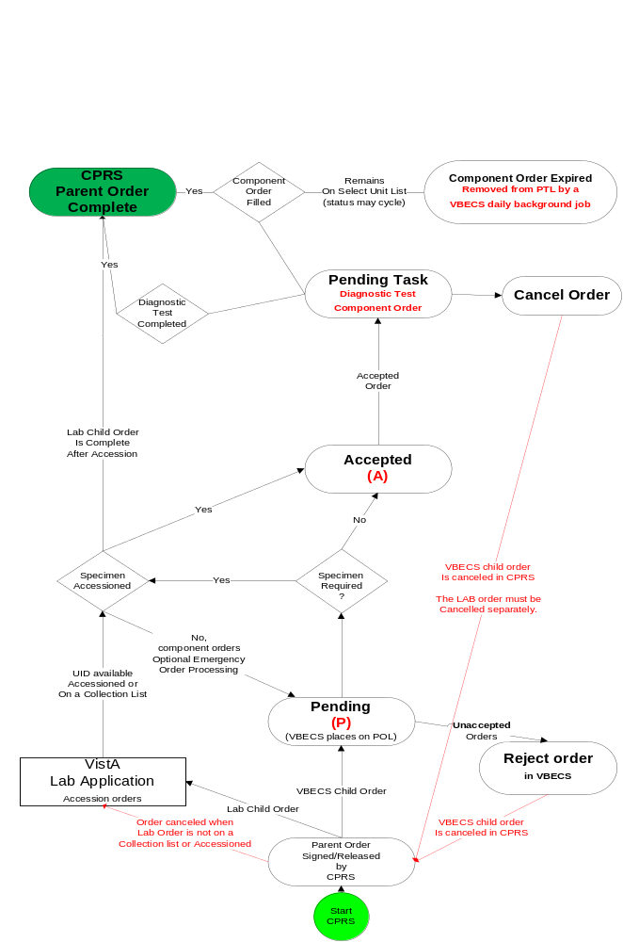

Rules for Electronic and Serologic Crossmatch
Component Classes with greater than (>) 2 mL RBC contamination require crossmatch evaluation, serologic or electronic (when enabled). For component classes in the component class “OTHER”, a reflex crossmatch test has been ordered per the technologist’s evaluation of the unit itself. Each collection is different and the tech must evaluate the red blood cell content of the unit at the time of selection.
When electronic crossmatch is enabled at a division and units that require crossmatch (Component Classes “WHOLE BLOOD”, “RED BLOOD CELLS”, or a reflex crossmatch test has been ordered) are selected, VBECS performs a comprehensive set of data validation, which does not include inactivated patient or units tests. This patient and unit data validation is to ensure that the combination of patient and blood unit testing allows the unit to be eligible for electronic crossmatch. To assist the user, when the combination does not allow for electronic crossmatch, a warning message is displayed with a short explanation as to why the electronic crossmatch will not be applied.
Table 22 provides the mapping for the actual parameters verified and associated error messages. All parameters must comply in order for the unit to be eligible for electronic crossmatch: there are no exceptions or overrides. The parameters are checked in the order listed and once a parameter fails, VBECS displays the appropriate error message, no further checking occurs, and the selected unit must have serologic crossmatch performed. (See FAQ VBECS Computer Crossmatch Decision Tree for additional information.)
To use the electronic crossmatch function, sites must perform additional validation of electronic crossmatch to meet regulatory requirements. See Guidelines for Implementing the Electronic Crossmatch (Bethesda, MD: American Association of Blood Banks, 2003).
Table 22: Rules for Electronic and Serologic Crossmatch
Parameter Checked | Error Message When Parameter Fails
Current specimen ABO/Rh and Antibody Screen testing must be complete. | Patient not eligible for eXM. Current specimen not fully tested.
Current specimen Antibody Screen interpretation must be negative. VBECS checks only the last Antibody Screen entered. | Patient not eligible for eXM due to positive Antibody Screen.
Patient must have no history of previously identified antibodies, regardless of clinical significance based on system rules or division (or from conversion) of the antibody ID. | Patient not eligible for eXM due to previous antibody history.
Patient cannot have a persistent antigen negative requirement regardless of the division of the requirement entry. | Patient not eligible for eXM due to transfusion antigen negative requirement.
The patient current ABO/Rh must match the historical record when there is a historical record, and there must be no previous justifications. An ABO/Rh marked as “entered in error” is not considered part of the patient’s record. | Patient not eligible for eXM due to ABO/Rh discrepancy from previous record.
The patient cannot have a documented instance of current or previous Inconclusive ABO/Rh typing. | Patient not eligible for eXM due to ABO/Rh typing difficulty.
There must be at least two valid instances of ABO/Rh typing performed in the same division for the patient. One instance must be a valid ABO/Rh on the current specimen and not “unknown” or “inconclusive”; the other may be from a previous typing episode or a repeat ABO/Rh performed on the current specimen. The patient ABO/Rh interpretations must match in all instances. The user must enter valid forward and reverse typing for the system to use as the second test performed in the division. | Patient not eligible for eXM: he must have two instances of ABO/Rh typing at the division for eXM, including the current specimen.
Selected unit must be ABO compatible based on system rules. | Unit not eligible for eXM. Unit is ABO incompatible with the patient.

Unit Status Flowchart

Types of Unit Statuses
- Temporary: awaiting ABO/Rh confirmation (lime green on the flowchart)
- Adjustable: may move in and out of the status as part of normal processing
- Issued: pending an update to transfusion or return (bright green in the flowchart)
- Final: the unit is no longer available for most processes in the division; the unit record remains active (pink and stop signs in the flowchart)

Indicators Associated with Units
- Quarantined: attaches to the unit record and status when the unit is quarantined. Removed by releasing the unit from quarantined.
- Presumed: attaches to the unit record only when the unit is in an issued unit status for more than 48 hours. Remains on the unit record if no transfusion information is entered through Post-Transfusion Information and Document ABO Incompatible Transfusion.
Figure 120: Unit Status Flowchart
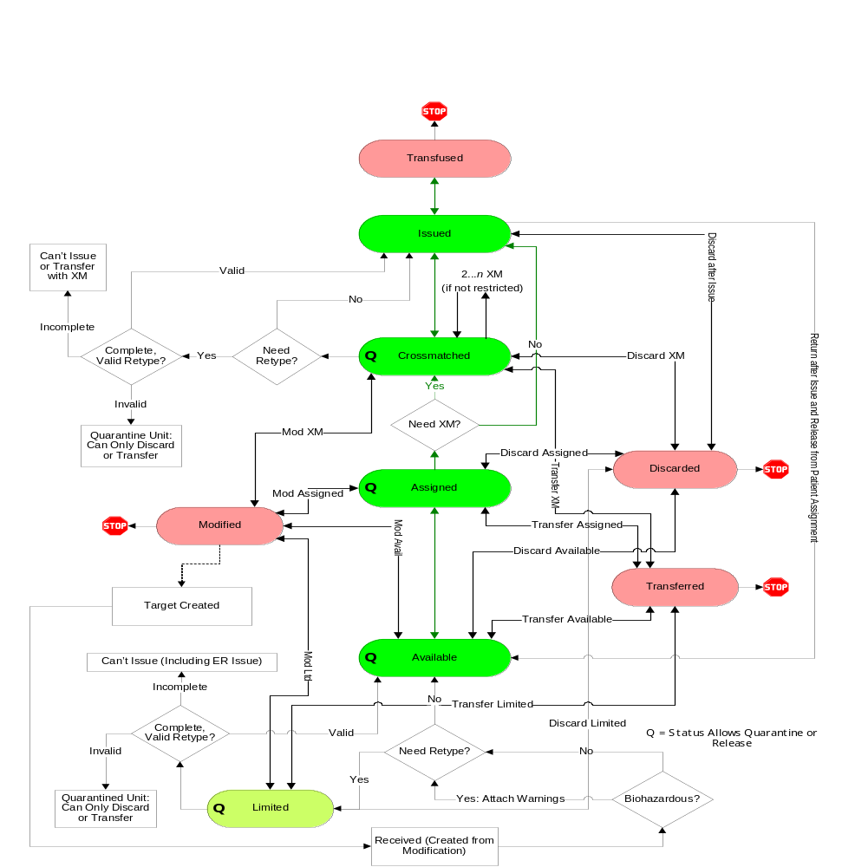

VBECS Maximum Surgical Blood Order Schedule
Table 23: VBECS Maximum Surgical Blood Order Schedule (MSBOS)
VBECS Maximum Surgical Blood Order Schedule (MSBOS)
Abdominal-Perineal resection | Keratectomy
Adrenalectomy | Hernia repair
Amputation (A/K, B/K) | Hip Replacement, total
Aneurysm, aortic | Hip Replacement, revision
Aneurysm, abdominal | Knee Replacement, total
Aneurysm, thoracic | Laminectomy, cervical, thoracic, or lumbar
Aneurysm, cranial | Laminectomy, disk repair
Aorto-Femoral Bypass | Laparotomy, exploratory
Appendectomy | Laryngectomy
Coronary Bypass Graft (CABG) | Lobectomy, pulmonary
Coronary Bypass Graft (CABG), redo | Mandibulectomy
Carotid Endarterectomy | Mastectomy, radical
Cervical Discectomy | Maxillectomy
Cervical Fusion | Nephrectomy
Cholecystectomy | Pancreatectomy
Colostomy | Parathyroidectomy
Colectomy | Portocaval Shunt
Colon Resection | Prostatectomy
Craniotomy | Prostatectomy, total
Cystectomy | Radical Neck Dissection
Cystolithotomy | Renal Transplant
Cystoscopy | Skin Flap
Embolectomy | Skin Graft
Esophageal Resection | Splenectomy
Esophagectomy | Thyroidectomy
Femoral-Popliteal Bypass | Tracheostomy
Fracture, open reduction | Transurethral Resection (TURP)
Fusion, cervical or lumber | Vagotomy
Gastrectomy | Valve replacement, aortic or mitral
Gastric Bypass | Other*
Glossectomy
Hematoma Evacuation, sub- or epidural
*Other surgeries entered in the Surgery Name field during order entry. (Local facilities may add surgeries to this list.) Entries made during order entry will not have MSBOS component order recommendations. VBECS does not display “Other” in MSBOS.

BCE COTS Message Updates
Table 24: BCE COTS Message Updates
This table identifies the specific subsequent processing of an assigned unit for one patient unit association that may or may not result in a change to the unit status or other quality and how that may or may not trigger a status change that requires update to the BCE COTS product.

Unit status code legend:
A | Available | S | Assigned
C | Crossmatched | T | Transfused
D | Discarded | X | Transferred
I | Issued | DS | Dispense Unit (Issued)
L | Limited | RE | Release Unit
M | Modified | RS | Reserve Unit

BCE COTS Message Updates
Row # | Initial Unit Status | Processing Option | Additional Information About the Processing Option | Unit Status Exiting  the Option | Unit Status Reported to BCE COTS
1 | A | Select Unit for Patient | Normal flow | S | RS
2 | A | Select Unit for Patient | Emergency issue flow | S | RS
3 | A | Select Unit for Patient | Electronic Crossmatch processed | C | RS
4 | C | Process Outgoing Shipment | Maintain Assignment | X | RE upon confirmation
5 | C | Process Outgoing Shipment | Release Assignment upon confirmation | A (then X when confirmed) | RE sent when release processed
6 | S | Process Outgoing Shipment | Maintain Assignment | X | RE upon confirmation
7 | S | Process Outgoing Shipment | Release Assignment upon confirmation | A (then X when confirmed) | RE sent when release processed
8 | D | Remove Final Unit Status | Unit was previously Crossmatched | C | RS
9 | D | Remove Final Unit Status | Unit was previously Assigned | S | RS
10 | S | Remove Final Unit Status | Remove Modification | A | No message resent
11 | X | Remove Final Unit Status | Unit was previously Crossmatched | C | RS
12 | X | Remove Final Unit Status | Unit was previously Assigned | S | RS
13 | T | Remove Final Unit Status | Normal flow | I | DS
14 | S | Pool Units | Maintain Assignment | M | RE-original
15 | S | Pool Units | Maintain Assignment | S | RS-target
16 | S | Pool Units | Release Assignment | M | RE-original
17 | S | Pool Units | Release Assignment | A | Target, no message sent
18 | C** | Pool Units | Maintain Assignment | M | RE-original(s), may be multiple messages.
19 | C** | Pool Units | Maintain Assignment | C | RS-target
20 | C** | Pool Units | Release Assignment | M | RE-original
21 | C** | Pool Units | Release Assignment | A | Target, no message sent
22 | S | Split Units | Maintain Assignment | M | RE-original
23 | S | Split Units | Maintain Assignment | S | RS-targets, one message for each target created.
24 | S | Split Units | Release Assignment | M | RE-original
25 | S | Split Units | Release Assignment | A | Target, no message sent
26 | C | Split Units | Maintain Assignment | M | RE-original
27 | C | Split Units | Maintain Assignment | C | RS-target
28 | C | Split Units | Release Assignment | M | RE-original
29 | C | Split Units | Release Assignment | A | Target, no message sent
30 | S | Modify Units | Maintain Assignment | M | RE-original (when processing in batch, multiple messages are sent)
31 | S | Modify Units | Maintain Assignment | S | RS-target (when processing in batch, multiple messages are sent)
32 | S | Modify Units | Release Assignment | M | RE-original (when processing in batch, multiple messages are sent)
33 | S | Modify Units | Release Assignment | A | Target, no message sent
34 | C | Modify Units | Maintain Assignment | M | RE-original (when processing in batch, multiple messages are sent)
35 | C | Modify Units | Maintain Assignment | C | RS-target (when processing in batch, multiple messages are sent)
36 | C | Modify Units | Release Assignment | M | RE-original (when processing in batch, multiple messages are sent)
37 | C | Modify Units | Release Assignment | A | Target, no message sent
38 | C | Discard or Quarantine Unit | Discarded or Wasted | D | RE
39 | S | Discard or Quarantine Unit | Discarded or Wasted | D | RE
40 | S | Discard or Quarantine Unit | Quarantine | A | RE
41 | C | Discard or Quarantine Unit | Quarantine | A | RE
42 | S | Record Testing when saving Crossmatch Results | Compatible (C) | C | No message is sent
43 | S | Record Testing when saving Crossmatch Results | Incompatible (I) | A | RE
44 | S | Record Testing when saving Crossmatch Results | Crossmatch Compatible: Don’t Transfuse (D) | A | RE
45 | S | Record Testing when saving Crossmatch Results | Compatible-Give with MD approval (G) | C | No message is sent
46 | S | Record Phenotype Results | Unit is antigen positive for a patient's antigen negative requirement | S | No message is sent
47 | C | Record Phenotype Results | Unit is antigen positive for a patient's antigen negative requirement | C | No message is sent
48 | S | Record Phenotype Results | Antigen typing result creates a discrepant antigen typing. | A | RE
49 | C | Record Phenotype Results | Antigen typing result creates a discrepant antigen typing. | A | RE
50 | S | Release Unit from Patient Assignment | Normal flow, or any overrides processed | A | RE
51 | C | Release Unit from Patient Assignment | Normal flow, or any overrides processed | A | RE
52 | I | Return Issued Units to Blood Bank | Unit without a crossmatch | S | RS
53 | I | Return Issued Units to Blood Bank | Crossmatched unit | C | RS
54 | I | Return Issued Units to Blood Bank | Unit without a crossmatch, unit is unsatisfactory | A | RE
55 | I | Return Issued Units to Blood Bank | Unit crossmatched, unit is unsatisfactory | A | RE
56 | S | Issue Blood Components | Normal flow with or without overrides | I | DS
57 | C | Issue Blood Components | Normal flow with or without overrides | I | DS
58 | S | Issue Blood Components | Unit is marked as unsatisfactory for issue | A | RE
59 | C | Issue Blood Components | Unit is marked as unsatisfactory for issue | A | RE
60 | C | Invalidate Patient Test Results | Invalidate Crossmatch results for the unit-patient association | S | No message is sent as the unit has not been released from assignment from the patient.
**Pooling of products that also require crossmatch is not currently possible.

Workload Process to Use Case Mapping Table
Table 25: Workload Process to Use Case Mapping Table
Workload Process to Use Case Mapping Table
VBECS Process | Record Saved in This Use Case | Positive or Negative Workload Accrued | Transaction Type* | Explanation
ABO Forward and reverse typing (patient) | Transfusion Reaction Workup | Positive | P | An ABO/Rh test for pre or post is enabled and a valid interpretation other than Not Tested is selected. A workload event is accrued separately for Pre and Post entries.
ABO Forward and reverse typing (patient) | Record Testing: Patient ABO-Rh | Positive | P | Accrue workload when an ABO/Rh test performed from the ordered test ABO/Rh only (Record Patient ABO-Rh is completed and saved by Record Testing).
ABO Forward and reverse typing (patient) | Invalidate Patient Testing: Patient ABO/Rh | Negative | P | Accrue workload when a completed ABO/Rh test is invalidated.
ABO Forward and reverse typing (patient) Repeat Test | Record Testing: Patient ABO-Rh | Positive | M | Accrue workload when a reflex or repeat ABO/Rh test is performed, completed and saved via Record Patient ABO-Rh. (Record Patient ABO-Rh is completed and saved by Record Testing).  Note: ABO/Rh ordered in Order Reflex Test from main menu or via use of Order Reflex Test from Record Testing
ABO Forward and reverse typing (patient) Repeat Test | Invalidate Patient Testing: Patient ABO/Rh | Negative | M | Accrue workload when a reflex or repeat ABO/Rh test is invalidated.
ABO forward typing (unit) | Unit ABO/RH confirmation test | Positive | U | An ABO confirmation test is performed. When multiple units are selected in a batch, each unit in the batch accrues a workload event.  Note: Workload generated when Anti-D testing is not included in the unit’s confirmation test. Workload is not accrued when an ABO discrepancy override is processed and VBECS releases all patient assignments. No special handling for workload collection for additional confirmation tests on a unit.
ABO forward typing (unit) | Invalidate Unit ABO/RH Confirmation test | Negative | U | Accrue workload when an ABO confirmation test is invalidated
ABO/Rh forward typing (unit) | Unit ABO/RH confirmation test | Positive | U | An ABO/Rh confirmation test is performed. When multiple units are selected in a batch, each unit in the batch accrues a workload event.  Note: Workload generated when Anti-D is part of the unit’s confirmation test. Workload is not accrued when an ABO or Rh discrepancy override is processed and VBECS releases all patient assignments. Any unit successfully confirmed accrues workload. For modification Split: Workload is not inherited by split units. A split unit that requires confirmation accrues confirmation workload at the time of testing. No special handling for workload collection for additional confirmation tests on a unit.
ABO/Rh forward typing (unit) | Invalidate Unit ABO/RH Confirmation test | Negative | U | Accrue workload when an ABO/Rh confirmation test is invalidated
Accept Order | Accept Order | Positive | M | Accrue workload when an order is accepted. When a multiple orders are selected, each order accrues workload.
Antibody identification Work-Up | Record Testing: Patient ABID | Positive | P | User enters additional workload associated with the individual reflex ordered ABID (Record Patient Antibody Identification is completed and saved by Record Testing). The selected VBECS multiplier will multiple against the VistA multiplier and display the (multiplication) product on the report in Division Workload Report.
Antibody identification Work-Up | Invalidate ABID Test | Negative | P | Accrue workload when the ABID is invalidated. All workload processes associated in Enter Reflex Test Results, including the selected VBECS multiplier, are invalidated
Antibody Screen (patient) | Transfusion reaction workup | Positive | P | An ABS test for pre or post is enabled and a valid interpretation other than Not Tested is selected. A workload event is accrued separately for Pre and Post entries.
Antibody Screen (patient) | Record Testing: Patient ABS test | Positive | P | Accrue workload when an ordered ABS test performed from the CPRS ordered test ABS only (Record Patient Antibody Screen is completed and saved by Record Testing). The workload accrues when the ABS is completed and saved via Record Testing no matter how many cells (rows) are required by the division configuration.
Antibody Screen (patient) | Invalidate Patient Testing ABS test | Negative | P | Accrue workload when a completed ABS test is invalidated.
Antibody Screen (patient) Repeat Test | Record Testing: Patient ABS test | Positive | M | Accrue workload when a reflex or repeat ABS test is performed, completed and saved via Record Testing.  Note: ABS ordered in Order Reflex Test from main menu or via use of Order Reflex Test from Record Testing.
Antibody Screen (patient) Repeat Test | Invalidate Patient Testing ABS test | Negative | M | Accrue workload when a reflex or repeat ABS test is invalidated.
Antigen phenotyping, Single Test phase (QC) | QC for unit or Record Testing: Patient antigen typing | Positive | M | Accrue workload when Antiserum QC is included in Record Phenotype Results or Record Patient Antigen Types includes the testing of both the positive and negative control cells, per specificity by lot number, when only one phase of reactivity is chosen for the test grid, IS or AHG. One workload event is collected per completed tab for regular or repeat antigen tests. (Record Patient Antibody Typing is completed and saved by Record Testing).
Antigen phenotyping, Multiple Test phases (QC) | QC for unit or Record Testing: Patient antigen typing | Positive | M | Accrue workload when Antiserum QC is included in Record Phenotype Results or Record Patient Antigen Types includes the testing of both the positive and negative control cells, per specificity by lot number, when only multiple phases of reactivity is chosen for the test grid, IS/RT, RT/37 or weak D. One workload event is collected per completed tab for regular or repeat antigen tests.  When weak D is the selected test, QC may not be accrued for the rack selection. QC is accrued when positive and negative cells must be tested for the lot number. (Record Patient Antibody Typing is completed and saved by Record Testing).
Cancel Order | Accept Order, Reject Order | Positive | M | Accrue workload when an order on the pending order list is cancelled. When a multiple orders are cancelled, each order accrues workload.
Cancel Order | Patient Testing List, Cancel order | Positive | M | Accrue workload when an order on the pending task list is cancelled. When multiple orders are cancelled, each order accrues workload.
Crossmatch unit, electronic | Select Unit | Positive | P | This process is invoked when an individual unit is selected for patient assignment and the unit is electronically crossmatched. When multiple units are selected, each unit accrues workload.
Crossmatch unit, serologic immediate spin | Record Testing: Patient serologic crossmatch | Positive | P | Accrue workload when an individual unit (row) crossmatch, selected to include only the IS phase, Record Patient Serologic Crossmatch is completed and is saved by Record Testing. When multiple units are selected, each unit (row) accrues workload.
Crossmatch unit, serologic immediate spin | Invalidate Patient Testing, serologic crossmatch | Negative | P | Accrue workload when a completed crossmatch test is invalidated. The workload originally saved with the test, serologic immediate spin.
Crossmatch unit, serological Coombs | Transfusion Reaction Workup, serologic crossmatch | Positive | P | A crossmatch test for pre or post is enabled and a valid interpretation other than Not Tested is selected. A workload event is accrued separately for Pre and Post entries.  When multiple units are selected, each unit accrues workload.
Crossmatch unit, serological Coombs | Record Testing: Patient serologic crossmatch | Positive | P | Accrue workload when an individual unit (row) crossmatch, selected to include all phases or only AHG phase, Record Patient Serologic Crossmatch is completed and is saved by Record Testing. When multiple units are selected, each unit (row) accrues workload.
Crossmatch unit, serological Coombs | Invalidate  Patient Testing, serologic crossmatch | Negative | P | Accrue workload when a completed crossmatch test is invalidated. The workload originally saved with the test, serological Coombs.
Crossmatch, Repeat Test | Record Testing: Patient serologic crossmatch | Positive | M | Accrue workload when an individual unit (row) crossmatch, selected to include all phases or IS or only AHG phase, Record Patient Serologic Crossmatch is completed and is saved by Record Testing. When multiple units are selected, each unit (row) accrues workload.  Note: ordered via Order Reflex Test from main menu or the use of Order Reflex Test by Record Testing.
Crossmatch, Repeat Test | Invalidate  Patient Testing, serologic crossmatch | Negative | M | Accrue workload when an individual unit crossmatch is invalidated.
Daily Rack Quality Control (QC) | Enter Daily Reagent Rack QC | Positive | M | Accrue workload when Daily QC rack completed for one individual rack includes all rows in configured QC. When multiple racks are tested, each completed and saved tab accrues a workload event.
DAT (QC) | Enter Daily Reagent Rack QC or Record Testing: Patient DAT | Positive | M | Accrue workload when Reagent QC completed or in Record Patient Direct Antiglobulin Test (Record Patient Direct Antiglobulin Test is completed and saved by Record Testing) includes the testing of both the positive and negative control cells, per specificity per lot number, when only one phase of reactivity is chosen for the test grid, IS or AHG. One workload event is collected per completed tab for regular or repeat antiglobulin tests (PS, IgG, Comp) tests.
Direct Antiglobulin Test (DAT) | Transfusion Reaction Workup, DAT test | Positive | P | A DAT test for pre or post is enabled and a valid interpretation other than Not Tested is selected. A workload event is accrued separately for Pre and Post entries.
Direct Antiglobulin Test (DAT) | Record Testing: Patient DAT | Positive | P | Accrue workload when a DAT completed and saved (Record Patient Direct Antiglobulin Test is saved by Record Testing) as part of a TAS configuration or individual test ordered. This count is used for all antiglobulin tests (PS, IgG, Comp) when ordered from CPRS or Reflex testing.
Direct Antiglobulin Test (DAT) | Invalidate Patient Testing, DAT | Negative | P | Accrue workload when a completed DAT, PS, IgG, or Comp is invalidated.
Direct Antiglobulin Test (DAT) Repeat test | Record Testing: Patient DAT | Positive | M | Accrue workload when a reflex or repeat DAT test is performed, Record Patient Direct Antiglobulin Test is completed and saved via Record Testing. This applies to all repeat antiglobulin tests (PS, IgG, Comp)  Note: Any DAT ordered in Order Reflex Test from main menu or via use of Order Reflex Test from Record Testing.
Direct Antiglobulin Test (DAT) Repeat test | Invalidate Patient Testing, DAT | Negative | M | Accrue workload when a completed Repeat DAT, PS, IgG, or Comp is invalidated.
Deglycerolize unit | Modify Unit, Deglycerolize | Positive | U | Accrue workload when an individual blood unit is processed by the modification type: Deglycerolize.  Note: Workload is not accrued when a patient assignment is processed and VBECS releases all other patient assignments. Workload is not accrued when VBECS is required to quarantine the unit.
Deglycerolize unit | Invalidate Unit Status, Deglycerolize | Negative | U | An individual blood unit’s status is invalided when the original modification process was Deglycerolize.
Discard unit | Discard Unit | Positive | U | Accrue workload when an individual blood unit’s status is invalided. When a batch of units is selected, each unit accrues workload.
Discard unit | Invalidate Unit Status, Discard | Negative | U | Accrue workload when a unit is discarded for waste or credit. When a batch of units is selected, each unit accrues workload.
Freeze unit | Modify Unit, Freeze | Positive | U | Accrue workload when an individual blood unit is processed by the modification type: Freeze.  Note: Workload is not accrued when a patient assignment is processed and VBECS releases all other patient assignments. Workload is not accrued when VBECS is required to quarantine the unit.
Freeze unit | Invalidate Unit Status, Freeze | Negative | U | An individual blood unit’s status is invalided when the original modification process was Freeze.
Irradiate unit | Modify Unit, Irradiate | Positive | U | Accrue workload when an individual blood unit is processed by the modification type: Irradiate. When a batch of units is irradiated, each unit accrues workload.  Note: Workload is not accrued when a patient assignment is processed and VBECS releases all other patient assignments. Workload is not accrued when VBECS is required to quarantine the unit.
Irradiate unit | Invalidate Unit Status, Irradiate | Negative | U | An individual blood unit’s status is invalided when the original modification process was Irradiate.
Leukoreduce unit | Modify Unit, Leukoreduce | Positive | U | Accrue workload when an individual blood unit is processed by the modification type: Leukoreduce.  Note: Workload is not accrued when a patient assignment is processed and VBECS releases all other patient assignments. Workload is not accrued when VBECS is required to quarantine the unit.
Leukoreduce unit | Invalidate Unit Status, Leukoreduce | Negative | U | An individual blood unit’s status is invalided when the original modification process was Leukoreduce.
Split unit | Modify Unit, Split | Positive | U | Accrue workload when a unit modification of Split and a single workload event is recorded regardless of the number of units created by the modification.  Note: Workload is not accrued when a patient assignment is processed and VBECS releases all other patient assignments. Workload is not accrued when VBECS is required to quarantine the unit. Workload accrued by splitting is invalidated in Remove Final Unit Status with the inactivation of the modification
Split unit | Invalidate Unit Status, Split | Negative | U | A Split Unit has its unit status invalidated. A single workload event is recorded regardless of the number of units originally created by the modification.
Rejuvenate unit | Modify Unit, Rejuvenate | Positive | U | Accrue workload when an individual blood unit is processed by the modification type: Rejuvenate.  Note: Workload is not accrued when a patient assignment is processed and VBECS releases all other patient assignments. Workload is not accrued when VBECS is required to quarantine the unit.
Rejuvenate unit | Invalidate Unit Status, Rejuvenate | Negative | U | An individual blood unit’s status is invalided when the original modification process was Rejuvenate.
Thaw | Modify Unit, Thaw | Positive | U | Accrue workload when an individual blood unit is processed by the modification type: Thaw. When a batch of units is thawed, each unit accrues workload. This applies to Thaw FFP and Thaw Cryo.  Note: Workload is not accrued when a patient assignment is processed and VBECS releases all other patient assignments. Workload is not accrued when VBECS is required to quarantine the unit.
Thaw | Invalidate Unit Status, Thaw | Negative | U | An individual blood unit’s status is invalided when the original modification process was Thaw. This modification type is applicable to Thaw FFP and Thaw Cryo.
Wash unit | Modify Unit, Wash | Positive | U | Accrue workload when an individual blood unit is processed by the modification type: Wash.  Note: Workload is not accrued when a patient assignment is processed and VBECS releases all other patient assignments. Workload is not accrued when VBECS is required to quarantine the unit.
Wash unit | Invalidate Unit Status, Wash | Negative | U | An individual blood unit’s status is invalided when the original modification process was Wash.
Volume Reduce | Modify Unit, Volume Reduce | Positive | U | Accrue workload when an individual blood unit is processed by the modification type: Volume Reduce.  Note: Workload is not accrued when a patient assignment is processed and VBECS releases all other patient assignments. Workload is not accrued when VBECS is required to quarantine the unit.
Volume Reduce | Invalidate Unit Status, Volume Reduce | Negative | U | An individual blood unit’s status is invalided when the original modification process was Volume Reduce.
Issue unit | Issue Blood Unit | Positive | P | Accrue workload when a unit (row) is issued or is returned from issue to a patient. When a batch of units is processed, each unit invokes one workload process.
Justification | Justify ABO/Rh Change | Positive | M | Workload is accrued when a patient’s ABO or Rh typing is justified. One workload event per patient justification.
Login Equipment | Equipment, Login | Positive | M | Accrue workload when a lot number of any type of equipment is logged into the system.
Login Reagent | Reagent, Login | Positive | M | Accrue workload when a lot number of any type of reagent is logged into the system. When multiple lot numbers are processed in a batch, each lot number’s workload is counted.
Login Supply | Supply, Login | Positive | M | Accrue workload when a lot number of any type of supply is logged into the system. When multiple lot numbers are processed in a batch, each lot number’s workload is counted.
Maintain Specimen | Maintain Specimen | Positive | M | Accrue workload when a specimen is maintained during order acceptance when a specimen is requirement for the order.  Note: This event is accrued when the specimen is maintained in Maintain Specimen. This is collected in addition to the accept order workload accrued by Accept Order. Marking a specimen unacceptable does not create a negative workload event.
Patient antigen phenotype (multiple phases) | Record Testing: Patient Antigen typing | Positive | P | Accrue workload when a patient antigen phenotype test [specificity (tab)] with IS/RT or IS/37 phases is completed and saved (when completed and saved via Record Testing). One workload event is collected per completed tab for repeat or regular antigen tests. (Record Patient Antigen Typing is completed and saved by Record Testing).
Patient antigen phenotype (multiple phases) | Invalidate, Patient Antigen typing | Negative | P | Accrue workload when a patient antigen phenotype test as defined by the antiserum specificity tested with any phases is invalidated.
Patient antigen phenotype (single phase) | Record Testing: Patient Antigen typing | Positive | P | Accrue workload when a patient antigen phenotype test [specificity (tab)] with AHG or IS phase is completed and saved (when completed and saved via Record Testing). One workload event is collected per completed tab for repeat or regular antigen tests. (Record Patient Antigen Typing is completed and saved by Record Testing).
Patient antigen phenotype (single phase) | Invalidate, Patient Antigen typing | Negative | P | Accrue workload when a patient antigen phenotype test as defined by the antiserum specificity tested with a single phase is invalidated.
Pool unit | Modify, Pool | Positive | U | Accrue workload when a pooled unit is created and a single workload event is recorded regardless of the number of units included in the pooled unit. This applies to modification type: Pool. Add/Remove unit from a pool does not accrue any workload.  Note: Workload is not accrued when a patient assignment is processed and VBECS releases all other patient assignments. Workload is not accrued when VBECS is required to quarantine the unit.  Workload accrued by Pooling is invalidated in Edit Unit Processing Information with the inactivation of the pooled unit.
Pool unit | Edit Unit, Inactive Unit (that was in a Pool) | Negative | U | Accrue workload when a unit is inactivated (unit record inactivated) when the pooled unit was created in VBECS.
Pool unit | Invalidate unit status, Pool | None | N/A | No effect on workload accrual when a unit is removed from a modified status that was included in a pool.
Quarantine unit | Discard/Quarantine, Quarantine unit | Positive | U | Accrue workload when a unit is marked for quarantine. When a batch of units is selected, each unit accrues workload.
Release directed unit | Free Directed Unit | Positive | U | Accrue workload when an individual blood unit with the restriction type of directed is released for use as an allogeneic unit.
Release unit from patient back to inventory | Release Unit from Patient Assignment | Positive | U | Accrue workload when an individual unit is released from patient assignment. When multiple units are selected, each unit accrues workload.
Release unit from Quarantine | Discard/Quarantine, Release Unit from Quarantine | Positive | U | Accrue workload when a unit is released from quarantine. When a batch of units is selected, each unit accrues workload.
Return Issued unit | Return Issued unit to Inventory | Positive | U | Accrue workload when a unit is returned from issue status.
Thaw/pool Cryo | Modify Unit, Thaw/Pool | Positive | U | Accrue workload when an individual unit modification of Thaw/Pool Cryo. A single workload event is recorded regardless of the number of units included in the pooled unit.  Note: Workload is not accrued when a patient assignment is processed and VBECS releases all other patient assignments. Workload is not accrued when VBECS is required to quarantine the unit.
Thaw/pool Cryo | Edit, Unit, Inactivate Unit (that was in a Thaw/Pool) | Negative | U | Accrue workload when a unit is inactivated (unit record inactivated) when the pooled unit was created in VBECS.
Thaw/pool Cryo | Invalidate Unit status, Thaw/Pool | None | N/A | No effect on workload accrual when a unit is removed from a modified status that was included in a Thaw/pool Cryo pool.
Transfuse Unit | Enter Post Transfusion Data | Positive | U | Accrue workload when an individual blood unit’s status is updated to transfused by Enter Post-Transfusion Details basic flow or Alt Flow A.
Transfuse Unit | Invalidate Unit Status, Transfused | Negative | U | An individual blood unit’s status is invalided when the unit was in a status of transfused.
Transfusion Reaction Investigation | Patient Testing, TRW | Positive | P | Accrue workload when a transfusion reaction investigation is saved by Record Transfusion Reaction Workup. This does not include workload accrued by the optional TRW serologic testing.  Note: The Division Workload Report workload report reports the sum of Workload Events recorded in Record Transfusion Reaction Workup for an individual TRW.
Transfusion Reaction Investigation | Invalidate Patient Testing, TRW | Negative | P | Accrue workload when a transfusion reaction investigation previously saved by Record Transfusion Reaction Workup is invalidated. The workload for the transfusion reaction, as well as all of the workload accrued by the optional TRW serologic testing (pre- and post-ABO/Rh, pre- and post-ABS, pre- and post-DAT) are invalidated, as included in selected TRW (Record Transfusion Reaction Workup).  Note: Any pre- or post-crossmatch tests performed as part of the TRW must be invalidated individually.
Unit Antigen phenotyping, Multiple Test phases | Unit Antigen typing | Positive | U | Accrue workload when a unit antigen phenotype test [specificity (tab)] with IS/RT or IS/37 phases is selected and completed for an individual blood unit (row).  No special handling for workload collection for additional repeat antigen typing tests on a unit.
Unit Antigen phenotyping, Multiple Test phases | Edit Unit, Invalidate Unit Antigen Typing | Negative | U | Accrue workload when a unit antigen phenotype test (specificity) with Multiple Test phases is invalidated for an individual blood unit.
Unit Antigen phenotyping, Single Test phase | Unit Antigen typing | Positive | U | A unit (row) antigen phenotype test [specificity (tab)] with AHG or IS phase is selected and completed for an individual blood unit (row).  No special handling for workload collection for additional repeat antigen typing tests on a unit.
Unit Antigen phenotyping, Single Test phase | Edit Unit, Invalidate Unit Antigen Typing | Negative | U | Accrue workload when a unit antigen phenotype test (specificity) with Single Test phase is invalidated for an individual blood unit.
Unit login | Incoming Shipment | Positive | U | An individual unit record is activated as saved to an incoming shipment invoice. When multiple units are entered, each unit added to the database accrues workload.
Unit login | Edit Unit, Invalidate Unit Antigen Typing | Negative | U | Accrue workload when a unit is inactivated (unit record inactivated) when logged in thru incoming shipment or is a pooled unit created in VBECS. When the unit was created by split modification no workload is invalidated in this option.
Unit logout | Outgoing Shipment | Positive | U | An individual unit’s status is updated to transferred on a confirmed outgoing shipment invoice. When multiple units are selected, each unit accrues workload.  Accrue workload upon the confirmation of the invoice, not the addition of a unit to a temporary outgoing shipment invoice as an invoice may be confirmed only once.
Unit logout | Invalidate Unit Status, Transferred | Negative | U | An individual unit status is invalidated when the unit had a previous unit status of transferred.
Update Equipment Record | Equipment, Update | Positive | M | Accrue workload when a lot number of any type of equipment is updated in the system.
Update Reagent Inventory | Reagents, Update | Positive | M | Accrue workload when a lot number of any type of reagent is updated in the system. When multiple lot numbers are processed in a batch, each lot number’s workload is counted.
Update Supply Inventory | Supplies, Update | Positive | M | Accrue workload when a lot number of any type of supply is updated in the system. When multiple lot numbers are processed in a batch, each lot number’s workload is counted.
Patient ABO Automated | Automated Interface | Positive | P | Accrue workload when an ABO/Rh test, primary or reflex, is reviewed, and saved.
Patient ABO Automated | Invalidate patient testing, ABO/Rh | Negative | P | Accrue workload when a reviewed ABO/Rh test is invalidated.
Antibody Screen/Indirect Coombs Automated | Automated Interface | Positive | P | Accrue workload when an ordered ABS test, primary or reflex, is reviewed, and saved.  Apply to primary or reflex tests.
Antibody Screen/Indirect Coombs Automated | Invalidate patient testing, Antibody Screen | Negative | P | Accrue workload when a completed ABS test is invalidated.
Serologic Crossmatch, Major, Automated | Automated Interface | Positive | P | Accrue workload when an individual unit (row) crossmatch, selected to include all phases or only AHG phase, primary or reflex, is reviewed, and saved. When multiple units are selected, each unit (row) accrues workload.
Serologic Crossmatch, Major, Automated | Invalidate patient testing, crossmatch | Negative | P | Accrue workload when a reviewed crossmatch test is invalidated. The workload originally saved with the test, serological Coombs.
Direct Antiglobulin Test Automated | Automated Interface | Positive | P | Accrue workload when a DAT, primary or reflex, is reviewed, and saved.
Direct Antiglobulin Test Automated | Invalidate patient testing, Direct Antiglobulin test | Negative | P | Accrue workload when a reviewed DAT is invalidated.
Patient Antigen Typing Automated | Automated Interface | Positive | P | Accrue workload when a patient antigen phenotype test (tab) is reviewed and saved.
Patient Antigen Typing Automated | Invalidate patient testing, patient antigen typing | Negative | P | Accrue workload when a reviewed patient antigen test (phenotype) is invalidated.
Blood Unit ABO Confirmation Test Automated | Automated Interface | Positive | U | An ABO confirmation test, primary or repeat, is reviewed, and saved. When multiple units are selected in a batch, each unit in the batch accrues a workload event.  - Note: Workload generated when Anti-D testing is not included in the unit’s confirmation test. Workload is not accrued when VBECS quarantines the unit due to a discrepancy. No special handling for workload collection for additional confirmation tests on a unit.
Blood Unit ABO Confirmation Test Automated | Invalidate unit testing, ABO Test | Negative | U | Accrue workload when an ABO confirmation test is invalidated
Blood Unit ABO/Rh Confirmation Test Automated | Automated Interface | Positive | U | An ABO/Rh confirmation test, primary or repeat, is reviewed, and saved. When multiple units are selected in a batch, each unit in the batch accrues a workload event.  Any unit successfully confirmed accrues workload.  - Note: Workload is not accrued when VBECS quarantines the unit due to a discrepancy.
Blood Unit ABO/Rh Confirmation Test Automated | Invalidate unit testing, ABO/Rh | Negative | U | Accrue workload when an ABO/Rh confirmation test is invalidated
Blood Unit Antigen Typing Automated | Automated Interface | Positive | U | A unit (row) antigen phenotype test, primary or repeat, is reviewed, and saved for an individual blood unit (row).  No special handling for workload collection for additional repeat antigen typing tests on a unit.
Blood Unit Antigen Typing Automated | Invalidate unit testing, Antigen Typing | Negative | U | Accrue workload when a unit antigen test is invalidated for an individual blood unit.

*Transaction type: Patient (P), Unit (U), Misc (M), (N/A) No donor workload types in VBECS at this time.

Appendix C: VBECS Work Flow
Each of the six user roles is associated with a security level (see Table 1). Privileges accumulate as the security level increases. For example, a Lead Technologist’s privileges include those of a Blood Bank Technologist and Enhanced Technologist.
Figure 121: VBECS Work Flow (left)
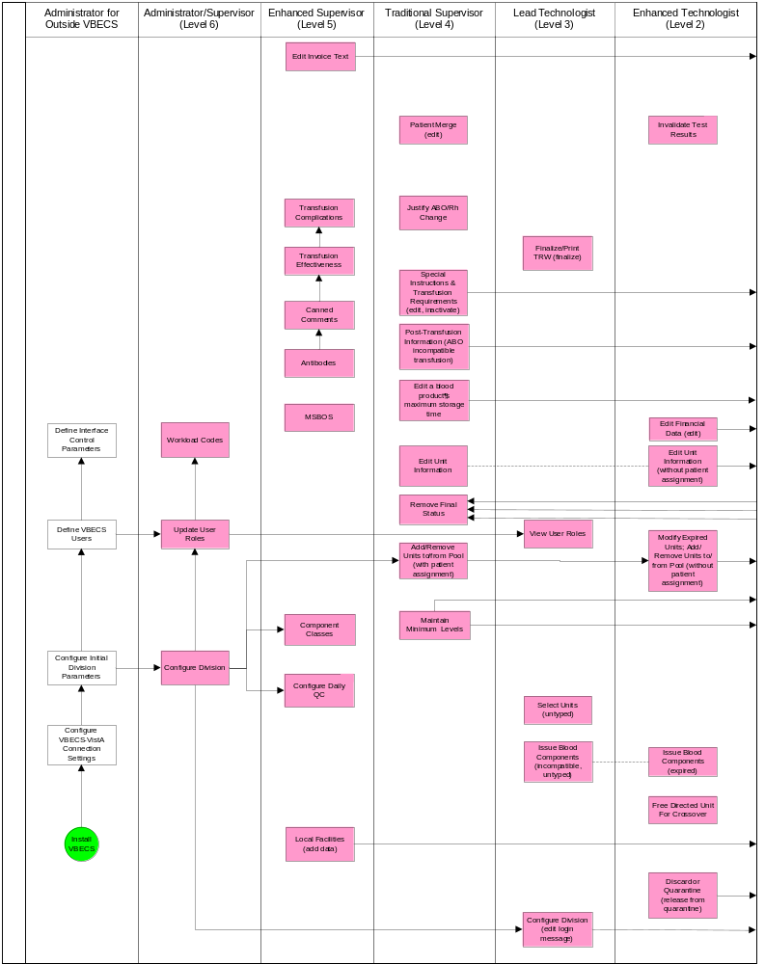
Figure 122: VBECS Work Flow (right)
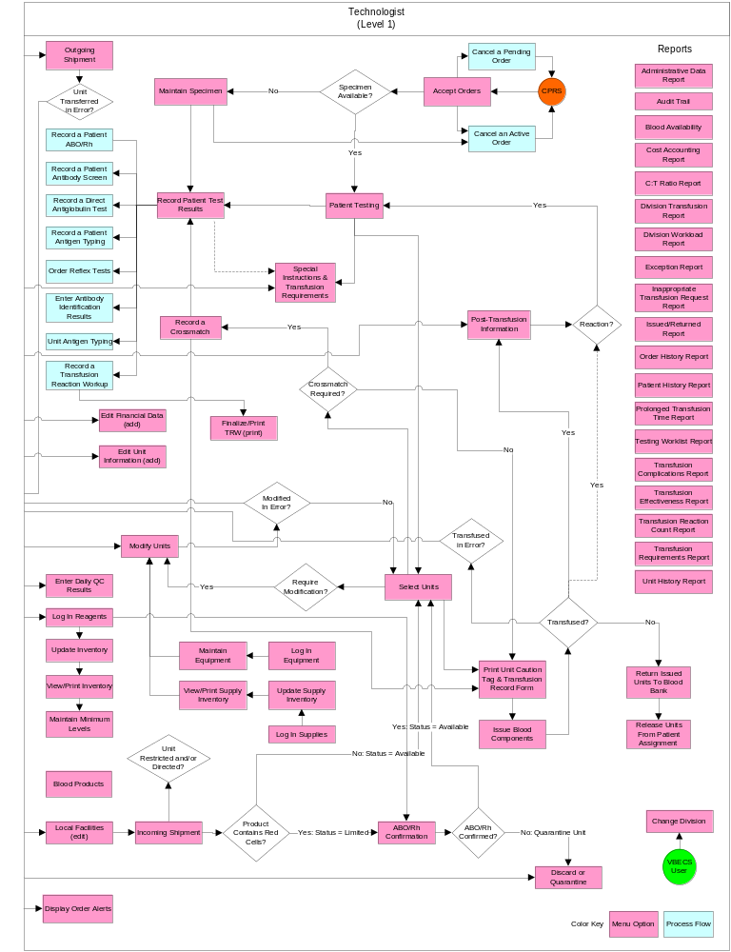

Appendix D: Limitations and Restrictions
Limitations and restrictions are listed by the options in which they occur.
Table 26: Limitations and Restrictions
Functions Not Supported
Blood donor collection activities (donor module)
Direct data entry of antibody identification
Direct data entry of transfusion reaction workups
Patient testing, transfusions, and blood components recorded in Legacy VistA are not available in VBECS
Pediatric blood product preparation
Printing of blood product labels
User defined customized queries or reports
User editing blood product, antigen, antibody, or transfusion reaction tables
Validation record storage

Throughout VBECS
After entering a canned or free-text comment in the testing comment field of the testing grid, the user must press Enter to store the comment.
Although the copy-and-paste function is enabled, do not use it to enter patient identification information. It is highly recommended that the user scan this information when possible; otherwise, enter it .
The report data that is output from VBECS is not controlled by the medical device and must be strictly regulated by local facility personnel. Many of the reports contain patient sensitive information and must be treated as such. Use of the exported reports, including alteration of data, is the responsibility of the user.
Patient names in VistA that exceed the database standard for File #2 (30 characters) or do not have a last name do not convert to VBECS.
Information may not be transferred from one window to another without refreshing the screen. When a window is partially displayed or freezes; or when you move from one window to another, enter information, return to the original window, and the entered information is not available, minimize then maximize the window to refresh it.
A maximized window cannot be resized or moved.
Keyboard navigation of VBECS does not accommodate the presentation of error providers or tool tips. A mouse is required to reveal this information as needed.
Initial blood orders must be placed in CPRS. Tests and products may be added to existing orders in VBECS.
Set the local machine’s desktop resolution to 1024 by 768 pixels or higher for optimal display. Failure to maintain these settings may result in partial display of safety-critical information.
The date and time displayed in VBECS depend on the date and time set on the server. Sites are not notified when an administrator changes the date or time on the server. Users must contact their System Administrator when the date or time is incorrect.
VBECS depends on a connection to VistA and CPRS to retrieve patient information and orders, respectively.
When a message window requires a user response and VBECS displays it behind the active window, the user must minimize the active window or click and drag dialog boxes to expose the message window.
When the default screen resolution is changed, division or VistALink information may not be entirely visible.
When the user does not enter a full or partial unit ID and clicks the find button in the Unit Search Screen, response time will vary based on the size of the database.

ABO/Rh Confirmation
This option is disabled for transfusion-only facilities.
When building a worklist by invoice number, only invoiced units not previously tested and confirmed appear on the worklist. The user may deselect or add additional units.
For batch processing, the user can select incoming shipment invoices from his division, processed within the previous five days.
VBECS does not display product codes associated with unit IDs in ABO/Rh Confirmation. Therefore, do not create ABO/Rh confirmation worklists containing units with the same unit ID.
POOLED GRANULOCYTES labeled with an Rh type of “Pooled” is considered an Rh Positive unit which does not require confirmation testing.
POOLED GRANULOCYTES labeled with an ABO group of “Pooled” cannot be confirmed. A blood component unit received as “POOLED ABO” will have to be transfused using the Supervisory option, Document ABO Incompatible Transfusion.
Patient assignment is not released automatically when a unit is quarantined due to discrepant ABO/Rh retype testing. The unit is quarantined and cannot be selected for a different patient or issued for the current patient. Quarantined units are clearly marked in VBECS and cannot be issued.

Accept Orders: Accept an Order
An order for TAS must be accepted before the component order if the user wants to include the component request to the Inappropriate Transfusion Request Report. Accepting the TAS after the component order is marked inappropriate and accepted clears the user’s indication that this is an inappropriate request.
When no CPRS order exists, the user processes the specimen offline. The emergency order check box is not enabled unless there is a CPRS order and a patient specimen accessioned in VistA. If necessary, process the emergency issue of units manually, per local policy, until the specimen is received and accessioned.
The user must accept the Type & Screen (TAS) before he accepts other diagnostic tests or component orders.
The user cannot click (Restricted or Assigned Units) to access information on autologous or directed units that may be restricted to a patient.
Orders placed for patients with names that exceed the database standard for File #2 (30 characters) or do not have a last name in VistA are rejected and do not appear in VBECS. The VBECS System Administrator is notified of each rejection via an email to the address entered in VBECS Administrator “Email Alerts” field.

Accept Orders: Cancel a Pending Order
Cancellation of one order does not affect other orders placed with it.

Accept Orders: Pending Order List
Orders placed for patients with names that exceed the database standard for File #2 (30 characters) or do not have a first or last name in VistA are rejected and do not appear in VBECS. The VBECS System Administrator is notified of each rejection via an email to the address entered in VBECS Administrator “Email Alerts” field.
TAS must be accepted prior to any diagnostic test associated with the same specimen UID to allow the specimen to be used for the TAS.

Accessing the System
VBECS automatically logs a user with access to only one division into that division.
Connectivity by IAM services access approval (PIV Card) is not possible when IAM services are not available.
Connectivity by IAM services access approval (PIV Card) is not required when a user has a PIV exemption or when IAM services are not available.
An Access and Verify code is required to connect to VistA when the IAM services are not available.
Connectivity is not possible when VistA is not available.
The user’s Active Directory account is a member of the proper VBECS security groups and configured with the AES256 bit encryption flag. Refer to the Active Directory section of the VBECS Technical Manual Security Guide.
For Remote Desktop constraints, consult the VBECS Technical Manual Security Guide.

Add and/or Remove Units from a Pool
See Modify Units.

Audit Trail
VBECS does not accommodate online review (verification, signature) of reports.

Automated Testing Interface
VBECS has only been tested with one automated instrument connected.
Not available for transmission to Transfusion only facilities from a blood center due to constraints of VA’s security software.
The results of Antibody Panels (ABID) will not be accepted by the VBECS Automated Interface.
The results of QC information from automated instruments will not be accepted by the VBECS Automated Interface.
Time zone will not be included in HL7 message date time from the broadcasting application (Instrument Manager). The time zone is determined from the division code contained in the message header (MSH) segment of the message.
For VBECS to process automated test results, a specimen record needs to exist. VBECS cannot accept Automated Instrument test results for specimens that are more than 5 years old. To work around this limitation for maintainable specimens, first change the expiration date and then send the test results.

Automated Testing Review for Blood Units
VBECS does not accept inconclusive ABO/Rh test results.
Pooled Product Types labeled with an Rh type of “Pooled” is considered an Rh Positive unit which does not require confirmation testing.
Pooled Product Types that require confirmation, labeled with an ABO group of “Pooled” cannot be confirmed. A blood component unit received as “POOLED ABO” will have to be transfused using the Supervisory option, Document ABO Incompatible Transfusion.
Users can select and assign multiple units with the same DIN and different product codes for crossmatch. Users can only process one DIN (e.g., W123400345345) on the Automated Instrument at a time. It is incumbent on the user to verify that the crossmatch result from the Automated Instrument matches the product code (e.g., E0134V00) associated with the patient in VBECS. To decrease the risk of a mislabeled unit at issue, local practice may want to have only one on the units selected in VBECS at a time when crossmatch testing is being performed on the automated instrument.
When a user chooses to reject a transmitted test, a comment is required. The comment is stored but is not available for review on a report at this time. It is recommended that the test is reviewed in the instrument and not sent to VBECS as a result for rejection.

Automated Testing Review for Patients
VBECS does not accept inconclusive ABO/Rh test results.
VBECS does not accept inconclusive interpretations for antibody screen tests.
Immediate spin crossmatch is not allowed via automated test entry.
Patient Antigen typing applies only to patient specimens that contain red blood cells.
The system does not check the specificity of a patient’s antibody against an existing patient antigen typing.
The patient antigen typing result is not reported to the CPRS record.
Order Rejection comment entry is required but is not visible on a report.

Blood Products
Blood product records distributed through VBECS are national standards.
The division must have activated the valid target blood products for modification.

Canned Comments
The user may not edit comments provided with VBECS, but may create additional comments. Although comments can also be removed, there should remain at least one comment per category available for selection (e.g., “Other”).
Site personnel must enter comments in accordance with local policy and procedures.
Canned comments cannot include an apostrophe (‘).

Component Classes
The user may not change the specimen requirement for a component class when there are incomplete orders for that component class.
There is no retrospective data entry or user selection for this option.

Configure Daily QC
This option pertains only to routine reagents.
When there are partially or currently QC’d racks in the system, the user may not change the QC template.

Configure Division
Changes made to the division setting are not applied to a user until they re-connect to VBECS after the change is made. It is highly recommended that all users sign out of VBECS prior to any configuration setting change.
It is recommended that users configure a division before configuring testing (click the Configure Testing tab).

CPRS Blood Bank Report
The report is not multidivisional, meaning it does not combine a patient's transfusion information from all VA hospitals.

Discard or Quarantine
When a user retroactively updates a unit status through this option, the Unit History Report displays the updated information, but does not display the date the change was made.
The option does not accommodate the entry of a second user for retrospective data entry.
Cost entry is capped at 999.00.

Display Order Alerts
VBECS issues no notifications for order cancellations.
The Order alert notification icon and functionality is disabled when VBECS is set to Read-Only.

Display Patient Merge Alerts
VBECS does not notify users of additional VistA patient updates or merges while the icon is displayed. When a user views an update and there is an unprocessed VistA patient merge, the Patient Alert icon remains on the screen until the Traditional Supervisor updates the patient records and clears the icon.

Display Patient Update Alerts
VBECS does not notify users of additional VistA patient updates or merges while the icon is displayed. When a user views an update and there is an unprocessed VistA patient merge, the Patient Alert icon remains on the screen until the Traditional Supervisor updates the patient records and clears the icon.
Patient updates involving patient’s with names that exceed the database standard for File #2 (30 characters) or do not have a first or last name in VistA are rejected and do not appear in VBECS. The VBECS System Administrator is notified of each rejection via an email to the address entered in VBECS Administrator “Email Alerts” field.
Patient update alerts only display when active component or diagnostic test orders are pending or active at the time the update occurs.

Division Workload Report
A report printed with an end date of today or greater does not print “Preliminary” in the header. Check the subsequent pages of the report and write “PRELIMINARY” on the front page of the report prior to filing. The information included in the report is accurate to the time printed. There is a possibility of a gap of information should the user not overlap the print requests. Generally, this report is printed for the day prior or a time period that does not include the current day.

Document ABO Incompatible Transfusions
VBECS does not enforce compatibility checks between the patient and the unit.
VBECS does not update CPRS component order status when the Document ABO Incompatible Transfusion option is used.

Edit Financial Data
When a Technologist enters a unit ID and product code for a unit that is not in final status, VBECS does not enable the Special Test Cost field. An Enhanced Technologist or higher access can change the Special Test Cost field in the Edit Financial Data option.
Base Cost entry is capped at 99,999.00.
Special Testing Cost is capped at 9,999.99
Return Credit is capped at 99,999.00.

Edit Unit Information
VBECS does not limit the discarded plasma volume.
If errors are found in the unit’s product code, division or blood type at login, supplier, or donation type, the user must inactivate the unit and reenter it correctly.
When a unit does not have a patient association, editable fields are available to an  Enhanced Technologist.
Only units in a Limited or Available status may be edited.
Inactivation of the unit record is required when the user needs to change the unit’s information recorded at login: unit identification number, blood type, product code, unit expiration date, unit donation type, VA division or supplier.
VBECS supports the scanning of ISBT 128 special testing information barcodes by detecting the appropriate hidden identifiers. Once the hidden identifier is removed, the special testing code is a varying length of digits, depending on the type of special testing barcode scanned.

Enter Daily QC Results
Additional user-defined reagent types not available in Configure Daily QC or Enter Daily QC Results are not part of a reagent rack’s daily QC testing.

Equipment
VBECS does not check for duplicate entries of equipment names and identifiers.
There is no retrospective data entry or user selection for this option.

Exception Report
VBECS does not accommodate online review (verification, signature) of reports.
Only the first twenty patient antigens will print on the report when an exception is generated for a unit issued with unsatisfied antigen negative requirements.
In some areas of the report, the user ID is displayed instead of the user name.
The Exception Date displayed is not consistently recorded to data records. It will either be the time the user entered the exception comment or the time the user saved the data record.

Finalize/Print TRW
The user cannot invalidate or change a finalized TRW. Contact the Service Desk if a TRW needs to be updated after finalization.
Transfusion reaction reports are not available to clinicians through CPRS: they must be printed and filed with patient charts.
VBECS displays these default values for transfusion reactions converted from VistA to VBECS. They do not reflect actual interpretations or results:
 | Converted Transfusion Reaction | Default
 | Pre-Transfusion Specimen Checks, Hemolysis Checks OK? | Yes
 | Post-Transfusion Specimen Checks, Hemolysis Checks OK? | Yes
 | Symptoms | No symptoms identified.
 | Implicated units | No units implicated in reaction.
 | Serologic tests | No serologic tests performed.

Free Directed Unit For Crossover
The unit must not be in a final status to release the restriction.
This option does not allow the removal of patient restrictions for most of the ISBT donation types that are eligible for crossover.
This option cannot process multiple directed units simultaneously.

Incoming Shipment
VBECS does not check whether blood products with the same unit ID and different product codes are the same blood type.
VBECS does not compare the ABO/Rh of an autologous unit or display a message when the ABO/Rh is incompatible with the restricted for patient.
When a product type, code, or local code is not in VBECS or a blood supplier creates a product code, contact the Service Desk. See Customer Support for contact information.
The user may not save the unit record until the donation type and its requirements are satisfied.
No longer supports the entry of blood products labeled in Codabar label type to new or existing invoices.
The default unit expiration [Maximum Storage Time (MST)] is set to the longest possible storage time based on product type, core condition, attributes, and available references as a guide, but a user with the Traditional Supervisor role or higher can override the default MST (see Blood Products section for more info). The MST is set at a higher level than an individual collection product code. VBECS does not know the specific collection details. It is the responsibility of each user to accurately enter and process any one blood unit based on its expiration date/time as labeled by the collection facility.
When blood products intended for quarantine are scanned, VBECS does not automatically quarantine them: the user must do so.
VBECS does not recognize scanned labels for para-Bombay or Bombay ISBT units.
VBECS does not allow duplicate IDs for the same product code.
When a user scans a product code or expiration date barcode in the Unit ID field, VBECS does not display the entered information or an error icon.
VBECS supports the scanning of ISBT 128 special testing information barcodes by detecting the appropriate hidden identifiers. Once the hidden identifier is removed, the special testing code is a varying length of digits, depending on the type of special testing barcode scanned.
When a user scans an ISBT product ID with “0” as the donation type (sixth character), VBECS indicates that the donation type is not specified. When the user selects a donation type from the drop-down menu, VBECS replaces “0” with a recognizable character in the product code text box and stores it as such. When the user rescans the product ID, he must manually replace “0” or search using the unit ID alone, or the unit ID and the first five characters of the product ID. When scanning a blood product derivative, this does not apply.
Blood product code entries in the blood product table include those from ICCBBA for ISBT 128. Product codes created after the release of VBECS cannot be entered until the updated tables are incorporated through patches to VBECS. Refuse acceptance of the unit, if possible. Users may not edit the blood product table.
ISBT 128 tables include blood product codes labeled as not for manufacturing or transfusion. VBECS does not restrict such products from being entered, issued, or transferred (local policy controls their use) and does not accommodate blood modification for these products.
No entry of an ICCBBA Product Description Code starting with A, B, C, or D aka National or Local Codes A0000-D9999. If use of such a code is necessary for patient care, contact Service Desk and file a request for the code to be added to VBECS.

Invalidate Test Results
A user may not inactivate a component task in this option.
This option does not release units from patient assignment. The user must release “assigned” units before invalidating the test results.
To maintain a clear record and system checks, the user must invalidate both original and repeat ABO/Rh tests.
Do not invalidate part of the configured test. Doing this will put the specimen into a state where it cannot be processed. Invalidate all tests configured as part of the TAS regardless of which sub test (ABO/Rh, ABS or DAT) is the problem.

Issue Blood Components
VBECS does not check for restricted units (not assigned to the patient) received between selection and issue.
All issue-to locations must be valid entries in the VistA HOSPITAL LOCATION (#44).
If VistA link is not available, the user may proceed with the issue process but the current issue-to hospital location is not recorded. All of the associated report records display “VistALink Down” in the Issue To location field.
ISBT 128 tables include blood product codes labeled as not for manufacturing or transfusion. VBECS does not restrict such products from being entered, issued, or transferred (local policy controls their use) and does not accommodate blood modification for these products.
When a site has configured subservient VistA institutions to the VBECS division, users can only issue units to locations in the primary VistA. Sites may add locations to VistA to account for the relocations to the subservient VistA institutions.
BCE information applies ONLY when a BCE COTS product is available for communication and is configured.
Changing a patient's transfusion requirements (component requirements, antigen negative requirement or antibody identified) after a unit is crossmatched does not provide an alert at Issue Unit regarding the type of crossmatch (electronic or serologic) performed on a unit available for issue.
VBECS asks for a comment when issuing a unit that is assigned to two different patients. Enter a comment to issue the unit or release one of the patient assignments before issuing. The comment will appear on the Unit History Report in the Issue section.
Users should issue units in a timely manner to avoid the units being released from patient assignment by another user prior to the issue unit process completion.
When no VistA order is available, the user must process the request manually until VistA provides them to VBECS. The user must print blank Caution Tags and Blood Transfusion Record Forms (BTRF) to accommodate this rare occurrence. When VistA does not provide a pseudonym or associated pseudo-ID for the patient that allows placement of a VistA order, VBECS cannot create a patient order for emergency issue of blood.

Justify ABO/Rh Change
VBECS does not allow the selection or issue of certain blood components that may appear ABO/Rh compatible when discrepant ABO/Rh results are not justified.

Local Facilities
A user may:
- Activate and edit local facility records distributed with VBECS.
- Add and edit active local facilities.
- Activate and/or deactivate local facilities.
- Edit a division name, which may result in a mismatch between VistA and VBECS division names.
- The Local Facility Address maximum length is 45 characters including spaces to allow the address to display on VBECS reports. The third line of the facility address is not displayed on VBECS reports.
- FDA registration number is limited to 7 or 10 characters. Copy and paste can be used for entry of 10 characters.

Maintain Specimen
When a search by UID causes VBECS to time out, repeat the search by UID and patient name or by patient name only.
Specimen recollection requests must be made offline.
Designating a specimen as “unacceptable” after accepting a CPRS order closes that order and requires a new CPRS order and sample.

Modify Units
VBECS allows modification of units only in limited, assigned, crossmatched, and available statuses.
VBECS presents the conservative expiration date for target units. VBECS does not know the specific collection details. It is the responsibility of each user to accurately enter and process any one blood unit based on its expiration date/time as labeled by the collection facility.
Pooling of units that have the attribute form V0013 (irradiated) and attribute V0021005 (psoralen treatment) does not produce a target.

Modify Units: Pool Units
VBECS allows modification of units only in limited, assigned, crossmatched, and available statuses.
When a user adds a biohazardous unit to a pool, VBECS does not designate the pool as biohazardous on the Blood Transfusion Record Form (BTRF) or Caution Tag.

Modify Units: Split a Unit
A unit previously split in VBECS cannot be split again. Only an ISBT unit that was split outside of VBECS can be split again.
A unit pooled in VBECS may not be split.
A unit that has a division code present upon receipt in incoming shipment may be split in VBECS.

Order Alerts
This is an alert only and contains limited information from the CPRS order.
This option does not create a mechanism to accept or reject orders or specimens or define reports for viewing orders.
The user may select the option to display printer alerts only when the designated printer is configured and available.
The printer must be configured by the System Administrator.
The Order alert functionality is disabled when VBECS is set to Read-Only.

Order History Report
VBECS does not display the identity of the CPRS user who discontinues a signed order in CPRS. The CPRS order details option contains all pertinent order information.
Cancelled orders are included on the Order Summary Report without a column/data to help identify them as cancelled. The Single Order History Report includes the cancelled order information. When the order is also cancelled in VistA, which would be the norm, there is a lab report that can be referenced (See FAQ Order Status Clarification).
The Order History Report only displays the first twenty (20) characters of an ordering location. Ordering locations in VistA can be shortened or changed when the uniqueness of a location cannot be determined with the first twenty (20) characters.

Order Reflex Tests
A crossmatch (XM) and a repeat XM cannot be ordered unless they are associated with a specimen with a future expiration date and a phlebotomist is associated with that specimen.
When a user selects weak D for the antigen typing test and the selected patient is Rh positive, VBECS warns that weak D testing cannot be performed (See FAQ Weak D Policy). There is no override and VBECS does not add the test.

Outgoing Shipment
A user may edit only unconfirmed invoices.
The unit testing data displayed on an invoice is limited to 8,000 characters per unit.

Patient Information Toolbar
Recent Orders is showing Order Status values like “Not Started” and “Filled”, which are actually Task Statuses.
Completed TRWs do not display on the Recent Orders screen. Completed TRWs can be found by searching in the Reports, Finalize/Print TRW option.

Patient History Report
When units are restricted for a patient during Incoming Shipment, VBECS does not display them on the Patient History Report.
VBECS displays these default values for transfusion reactions converted from VistA to VBECS. They do not reflect actual interpretations or results:
 | Converted Transfusion Reaction | Default
 | Pre-Transfusion Specimen Checks, Hemolysis Checks OK? | Yes
 | Post-Transfusion Specimen Checks, Hemolysis Checks OK? | Yes
 | Symptoms | No symptoms identified.
 | Implicated units | No units implicated in reaction.
 | Serologic tests | No serologic tests performed.

Patient Merge
The Traditional Supervisor or above must update patient records manually.
VBECS does not notify users of additional VistA patient updates or merges while the icon is displayed. When a user views an update and there is an unprocessed patient merge, the Patient Alert icon remains on the screen until the Traditional Supervisor completes the update and clears the icon.
Patient merges involving patients with names that exceed the database standard for File #2 (30 characters) or do not have a first or last name in VistA are rejected and do not appear in VBECS. The VBECS System Administrator is notified of each rejection via an email to the address entered in VBECS Administrator “Email Alerts” field.

Patient Search Screen
VBECS updates information from VistA File #2, not VistA File #20. Name changes made in VistA File #20 will not appear in VBECS. Align File #2 with those changes to update VBECS.
Searching for non-alphanumeric characters (e.g., hyphens, etc.) is not supported.
Data retrieval from VBECS is only available with project approval.

Patient Testing: Cancel an Active Order
Cancellation of one order does not affect other orders placed with it.
Before a user may cancel a partially completed task, he must invalidate the results for that task, thereby changing its status to “not started.”
If VistALink is not running when an order is cancelled, CPRS will not be updated about the order status.

Patient Testing: Enter Antibody Identification Results
When an antigen negative requirement is not configured for an antibody, the user may enter the requirement for a patient through Special Instructions & Transfusion Requirements: Enter a Transfusion Requirement.

Patient Testing: General Instructions
This test record is not editable after the user completes a test and saves it to the database. When a correction needs to be filed, a corrected report must be generated, as described in Invalidating Patient Test Results.
User selection of partially completed testing grids with different phases of testing (All Phases or AHG Only) as previously selected creates a testing discrepancy in VBECS.
Limited batch testing to partially completed orders with the same testing grid selection, either All Phases or AHG Only.
VBECS cannot compare test results for a patient when two users are entering test results for the same patient at the same time.
Cost entry is capped at 999.00.

Patient Testing: Pending Task List
This option is for diagnostic, blood component, and reflex test orders placed in or directed to the user’s division.
The PTL does not include daily quality control, equipment maintenance schedules, or pending ABO/Rh confirmation and auxiliary tests on red blood cell units.
Users may perform testing for no more than four patients in one VBECS session.

Patient Testing: Record a Crossmatch
The specimen associated with testing must have an expiration date and time that are later than the testing date and time entered in Patient Testing: Record Patient Test Results. When this is not the case, VBECS warns that the patient specimen expired. There is no override.
This option does not include electronic crossmatch (eXM).

Patient Testing: Record a Direct Antiglobulin Test
VBECS does not check whether the lot and vial numbers selected for the positive control cells are different from those of the negative control cells.

Patient Testing: Record a Patient ABO/Rh
VBECS does not allow entry of ABO or Rh subgroups as a 'group' and/or 'type' when the previous blood group/type is "NR", indicating no record of previous testing. See FAQ ABO Subgroup Interpretation and contact the Service Desk for assistance, prior to adding patient transfusion records in VBECS, when possible.
When the patient has no previous ABO/Rh test record (NR), the ABO/Rh test associated with the Type and Screen test (TAS) must be completed and saved prior to entering and saving a repeat ABO/Rh test on this specimen.
A user is permitted to select two partially completed tests with different test phases (e.g., AHG only and All Phases) along with a not started test. The testing phase for the not started test will present as AHG only even though results for all phases are required by VBECS. Entering only AHG test results for the specimen that was not started and saving will result in a partially completed test that cannot be completed or invalidated. Contact the Service Desk when you encounter this problem. Specimens that cannot be completed or invalidated require the attention of Tier 3 support. Select partially completed orders that have been previously saved with the same grid test pattern. Optionally, a not started test may be selected with these but must be tested with the same grid pattern to avoid the problem.
When canceling out of a Discrepant ABO/Rh Typing override, the interpretations are cleared, but the testing results are not cleared. Correct the testing entries or click the red ‘X’ to clear the testing results.

Patient Testing: Record a Patient Antibody Screen
This option is for patient testing only.

Patient Testing: Record a Patient Antigen Typing
Antigen typing applies only to red blood cell antigens. (This option does not address platelet, HLA, or IgA antigens.)
VBECS does not check:
- The patient antigen typing with the specificity of any patient’s antibodies entered.
- Whether the lot and vial numbers selected for the positive control cells differ from those of the negative control cells.
The patient antigen typing result is not available to CPRS.

Patient Testing: Record a Transfusion Reaction Workup
Adverse reactions to transfusion detected at a later time (disease transmission) are not recorded through this option. Refer to Transfusion Complications Report.
Each tab is completed and saved and is not editable. To change information on a previously completed tab, the TRW must be invalidated and corrected in its entirety.
If comments are entered when a TRW is finalized as type "Other,” they won’t show on the CPRS Blood Bank Report.
There is no scroll bar on the TRW Serologic Tests tab. This limits the number of visible implicated units to around ten (10) depending on the display resolution. When more than around ten (10) units are implicated in the transfusion reaction, order additional TRW test(s) as required.

Patient Testing Worklist and Testing Worklist Reports
Reports do not include Transfusion Reaction Workup (TRW) test results.
VBECS does not accommodate online review (verification, signature) of reports.
The Rack QC Testing Worklist Report section of the Testing Worklist Report does not contain a Processed By column. Maintain the original testing records for the QC that was performed offline with the testing tech information. Do not change the testing tech name when entering results in VBECS so that the logged in tech that enters the results is included on the Testing Worklist report.

Post-Transfusion Information
VBECS cannot update a unit record to presumed transfused when a user has that unit record open (locked) in Enter Post Transfusion Information. VBECS will attempt to update the unit the next time the presumed transfused background routing runs if the unit remains in an issued status.
If post-transfusion information is not transmitted to VBECS by the BCE COTS interface, the user will need to enter that information to update the record from presumed transfused to transfused.
The transfusion comments and volume transfused entered in the Transfusion Verification application as an update to a completed transfusion are not sent to VBECS.
Transfusion reaction symptoms are not provided to VBECS by the Transfusion Verification application unless a transfusion reaction has also been indicated for that event.
The system will not perform unit expiration time-limit checks when remote storage was indicated during issue.

Print Unit Caution Tag & Transfusion Record Form
VBECS cannot reprint a Caution Tag on an expired unit or expired patient order.
VBECS does not print a unit’s biohazardous status on the BTRF or Caution Tag.
If a unit has been crossmatched by two different technologists, the Compatibility Interpretation section of the BTRF displays the technologist that performed the earlier XM testing. Handwrite the missing current technologist initials on the printed BTRF.

Prolonged Transfusion Time Report
This report does not include presumed transfused units or units issued to a remote storage location.
Units issued to a remote storage location will display on the report when the transfusion start time is greater than 30 minutes after issue time.
Units issued to a remote storage location should not display to have a prolonged issue time as this setting indicates that the unit is issued to a monitored location maintained at the proper temperature for the product type.
The Delayed (minutes) column on the report is not subtracting 30 minutes when the Transfusion Start time is greater than 30 minutes from the time of issue. Handwrite the correct Delayed (minutes) on the printed report.

Reagents
VBECS does not display a reagent report by invoice number.
The unsatisfactory portion of a shipment must be recorded individually.
There is no retrospective data entry or user selection for these options.
Each site must set a standard for recording quantity: it may use the number of cases or the number of units within the cases.
When a user enters a lot number in the Lot # field and clicks the magnifying glass, VBECS displays only the first instance of a duplicate lot number.
When reagents with the same Manufacturer Reagent Name and Lot Number are entered from multiple invoices, only one of the reagents is visible for update.
Reagents that have had their Number of Vials Available set to zero (0) are no longer visible on the Update Reagent Inventory screen or the Reagent Inventory Report. Print a copy of the Reagent Inventory Report prior to setting the Number of Vials Available to zero (0).

Release Units From Patient Assignment
This option does not apply to the release of patient restrictions (autologous and directed).
When a patient, specimen, or blood unit expires, VBECS does not automatically release an assigned blood unit: a user must release the unit.

Remove Final Status
This option applies only to the release of units in final statuses.

Select Units
When a user checks the “D Pos” or “D Neg” check box to modify a search for blood, VBECS returns no units, regardless of the availability of units.
VBECS displays a component order as “Filled” when the number of units transfused and the number of units ordered are the same and continues to display the component order until the order expires. CPRS displays a component order as “Completed”. Therefore, CPRS displays the order as “Completed” before VBECS displays the order as “Filled.” The associated LAB order will then also be marked as “Completed”.
A Specimen UID must be accepted in VBECS to associate it with a component order. Any VBECS maintained TAS specimen UID may be associated with a component order by entering the number in the UID field.
When associating a specimen with a patient in the “Select Unit for a Patient” window, the “Expires” field within the “Associate with Specimen” panel displays the time in AM/PM format. VBECS normally displays date/time fields in “military” time format. The workaround is to look in Maintain Specimen and check the expiration time military time format.
When an Rh positive unit is selected for an Rh negative patient with an antigen negative requirement for D, the user receives a message about unit not satisfying patient negative requirements for D instead of a message about unit being positive for D. The proper message is displayed upon unit issue.

Special Instructions & Transfusion Requirements: Enter a Transfusion Requirement
Inactivation is defined and restricted by security level.
VistA Special Instructions (SIs) from database conversion do not become TRs: they remain SIs. SIs are information only and are not enforced unless entered in the Component Requirements tab in Special Instructions & Transfusion Requirements.

Special Instructions & Transfusion Requirements: Enter and Remove Special Instructions
VBECS does not enforce Transfusion Requirements (TRs) or antigen negative requirements entered through this option.
SIs moved to VBECS during the database conversion may contain information that must be entered as TRs in VBECS. Inactivate the old SI and create a TR and new updated SI: the database conversion software cannot automatically translate the SI from database conversion into a rule-based TR.
VBECS will truncate SI text from the VistA database conversion.

Supplies
The division’s modification processes may allow or require the user to select previously entered supplies for association with a blood unit’s modification. An inventory of containers (transfer bags) and sterile connection device (SCD) wafers is required for various modification processes.
There is no retrospective data entry or user selection for this option.
The unsatisfactory portion of a shipment must be recorded individually.
Each site must set a standard for recording quantity: it may use the number of cases or the number of units within the cases.

Transfusion Complications Report
The report does not include units in an issued status.
The report cannot be scheduled.

Transfusion Effectiveness Report
The report does not include VBECS diagnostic tests.

Transfusion Reaction Count Report
Transfusion Reactions are only included on the report if the data were entered/updated during the selected date range. This means that retrospective entry of transfusion reactions may not display in the correct date range. The recorded date of the reaction is not considered in the selection criteria. Rerun the report for a date range that includes the date the data was entered or updated. For example, if a transfusion reaction that occurred on February 28 is retrospectively entered on March 1, it will only display on a report that includes March 1 in its date range.

Transfusion Requirements Report
Deceased patient records do not appear on the report when they are generated after the patient has been marked as deceased in the VBECS database via a VistA Death Notification Update.
The cumulative report is not displaying all patients on file. A patient with ABO/Rh testing and no other requirement appears on the partial Transfusion Requirements report, but not on the cumulative report.
A report printed with an end date of today or greater does not print “Partial” in the header.

Unit Antigen Typing
Antigen typing applies only to red blood cell antigens. This option does not address platelet, histocompatibility locus antigens (HLAs), or Immunoglobulin (IgA) antigenicity.
Only blood units of the “WHOLE BLOOD” and “RED BLOOD CELLS” ICCBBA component classes can be selected for inclusion in the antigen type worklist.
Antigen typing is not required on products with = > 2 mL of RBC contamination that are not Red Blood Cells or Whole Blood.
VBECS does not check whether the lot and vial numbers selected for the positive control cells differ from those of the negative control cells.
D antigen typing must not be combined in batch testing of Rh positive units.
The sort order of the selected units may not be inherited by the testing grid. Organize physical test materials according to the order of units presented on the testing grid.

Unit History Report
The report is not multidivisional.
When a user retroactively updates a unit status through Discard or Quarantine, the Unit History Report displays the updated information, but does not display the date the change was made.
The report will not indicate if a unit was returned to shipper, or shipped to another facility. This information can be found in the Cost Accounting Report.
The report does not display the Antigen Testing Phase Change Exception. See the Exception Report for this information.
When a user retroactively updates a unit status through the Discard or Quarantine option, the Unit History Report displays the updated information, but does not display the date the change was made.

Update User Roles
One role at a time may be assigned to a user at a division. The role may be reset.
VBECS does not allow users to edit or delete the sole Administrator/Supervisor.

Updated Patients and Deceased Patients
Demographic and death event updates do not display information for patients without pending or active orders in VBECS. Updates will occur without user input.
VBECS does not notify users of additional VistA patient updates or merges while the icon is displayed. When a user views an update and there is an unprocessed patient merge, the Patient Alert icon remains on the screen until the Traditional Supervisor completes the update and clears the icon.
When VBECS notifies a user of an update to a patient’s prefix or suffix, VBECS does not display the updated information: the user must access VistA to view the updated information.
Suffix data may be outdated but will be refreshed upon a new order for a patient.

View Special Instructions and Transfusion Requirements
Changing a patient's antigen negative requirement or antibody identified after a unit is crossmatched does not provide an alert at Issue Unit regarding the type of crossmatch (electronic or serologic) performed on a unit available for issue.
This icon will be disabled when the icon is displayed:
- within the patient search window because special instructions and transfusion requirements are already displayed automatically within this option.
- within this option, the selected patient does not have SIs or TRs to display.

Workload Codes
Transfusion-only sites must not map workload codes to processes such as ABO/Rh testing not performed on site.
Retrieved LMIP/NLT codes from VistA may have multiple CPT codes. Inactivating any of the associated CPT codes in VBECS will inactivate the LMIP/NLT code. Editing of the LMIP/NLT code associations must be done in VistA.
Invalidating split units will result in extra workload equal to the number of splits created applied to the total number of units logged in. This occurs when split units are incorrectly processed in VBECS.

Appendix E: Known Defects and Anomalies
Users may retrieve a copy of the VBECS 2.4.0 Known Defects and Anomalies document from:
- VistA Documentation Library (VDL) Web site (content may have redactions)
- REDACTED

Appendix F: System Validation

Introduction
Each facility is responsible for validating the VBECS installation, operation, and performance before using VBECS in a live (production) environment. This includes evaluating local intended uses of the software and changing settings to conform to the facility’s procedures, processes, and policies. Use internal operating procedures and policies to validate that the software performs in accordance with your site’s parameters. Determine the level of validation required for changes to hardware and software. (See FAQ Ancillary VistA Validation).
This section describes only basic system validation. Sample test scripts are available from the National Training & Education Office (NT&EO).

Validation Plan
Write a validation plan with clearly stated goals and strategies to demonstrate that the system hardware, application, new features, and software patches function as expected in your facility’s environment. Include descriptions of documents, hardware and software Verification & Validation (V&V) tools, techniques, methods, and operating and test environments to be used. Determine and document when an option is not applicable to your facility and does not require testing.
You may separate this plan into three major sections:

Installation Qualification
The Installation Qualification (IQ) section includes system identification, definition of physical properties, interfaces and peripheral devices, and general functionality. Determine what types of testing must be done. Create test cases in accordance with your internal procedures and intended use.
Apply review, analysis, and testing techniques to determine whether VBECS hardware and peripheral components comply with requirements, including functionality and attributes such as consistency, safety, and security.

Operational Qualification
The Operational Qualification (OQ) section includes testing the software (the primary validation activity). Use your OQ to challenge VBECS and the connection to VistA. Base the number and types of tests on the criticality of the software function. The focus of this validation is to test the limits of what the system allows you to do, not how the system will be used. Each facility will have a different level of validation based on local practices.
Analyze risks to ensure that the scope and degree of validation are appropriate. (A system error that may result in direct and severe patient harm requires more detailed and rigorous testing than one that may have minor consequences.)
Create a testing environment as much like the production environment as possible. Design test cases to:
- Address critical software functions.
- Detect failures and flaws.
- Verify and challenge system functions and limitations, and user documentation.
Verify data from VistA displayed in VBECS and data from VBECS displayed in VistA. (Results will vary based on your VBECS settings.) Evaluate the output of the testing and determine whether the test passed or failed.
Maintain evidence of software testing, as part of the validation record, in accordance with standards established by accrediting agencies associated with the blood bank and laboratory. Include, at minimum, your inputs, outputs, and evidence that tests performed were satisfactory or unsatisfactory. (You may record input manually, make copies of unit labels or patient information, capture screen shots from VistA and VBECS, print various reports, etc.)

Performance Qualification
The Performance Qualification (PQ) section focuses on the integration of the application and processes into your facility. This begins with the revision of Standard Operation Procedures (SOPs) and policies to include the proper use of the new system. Once the SOPs are in place and validated, train the users. Ensure that training materials and records are complete before allowing users to operate the system. Document the validation, including:
- Personnel participating in validation activities
- Hardware and software change controls
- Testing results
- SOP reviews, training plans, installation and implementation
- Evaluation and acceptance
- Review and approval authority and dates

Record System Settings
These sections describe how to capture system settings in preparation for validation.

Configure Division
A user defines site parameters that affect how VBECS behaves at a specific division. VBECS may be configured to function differently at each division within a multidivisional database. Site parameters may be redefined. For more information, see Appendix G: Work Process Flowcharts.

User Roles with Access to This Option
 Administrator/Supervisor

Preparation for Testing
- Select Configure Division.
- Record:
- ICCBBA registration number:
- Blood Bank Medical Director’s name as you want it to appear on reports:
- Latest expiration date (default: three days) for specimens, in accordance with local policies and procedures:
- Is your division full service (FS) or transfusion only (TO)?
- If your site does not perform on-site testing, continue at Order Alerts.
- If your division is full service, do you want to enable electronic crossmatch?
- Print, sign, date, and save an Audit Trail Report for your validation record.

Configure Testing: Full Service
The user sets testing preferences in accordance with a division’s medical policies. For more information, see Appendix G: Work Process Flowcharts.

User Roles with Access to This Option
 Administrator/Supervisor

Preparation for Testing
- Set testing preferences.
- Capture and save a screen shot of each piece of information.
- Print, sign, date, and save an Audit Trail Report for your validation record.

Product Modifications: Full Service
The user enables the types of modifications made at a division. For more information, see Appendix G: Work Process Flowcharts.

User Roles with Access to This Option
 Administrator/Supervisor

Preparation for Testing
Modification processes are disabled by default. You must activate modification types performed at your facility. You may select none, some, or all. Enter a processing cost for each modification type, as applicable. You may update these settings later.
Table 27: Modification Types and Costs
Modification Type | Modification Processes |  | Processing Cost
Modification Type | Enabled | Disabled | Processing Cost
Thaw
Pool
Thaw/Pool Cryo
Split/Divide
Irradiate
Leukoreduce
Volume Reduce
Wash
Rejuvenate
Freeze
Deglycerolize

- Capture and save a screen shot of each piece of information.
- Print, sign, date, and save an Audit Trail Report for your validation record.

Order Alerts
The user configures diagnostic test or component order alerts that appear at login, and turns them on or off. The alerts notify users when new orders are entered, updated, or cancelled in VistA. For more information, see Appendix G: Work Process Flowcharts.

User Roles with Access to This Option
 Administrator/Supervisor

Preparation for Testing
- Capture and save a screen shot of each piece of information.
- Print, sign, date, and save an Audit Trail Report for your validation record.

Configure Daily QC: Full Service
The user sets up the routine reagent racks and QC template for the division before performing daily reagent QC. For more information, see Appendix G: Work Process Flowcharts.

User Roles with Access to This Option
 Enhanced Supervisor

Preparation for Testing
- If you perform daily reagent rack quality control using a commercial kit, select the commercial kit template. If not, select the non-commercial kit template. Template selected:
- Daily alert time at which users will be prompted to perform QC:
- Do you want to use letters or numbers as rack names?
- Maximum number of reagent racks for daily use:
- Primary enhancement medium:
- Secondary enhancement medium:
The template contains the minimum number of tests required to test the reagents. Select additional tests that are part of your daily reagent rack QC, in accordance with local policies and procedures.
- Capture and save a screen shot of each piece of information.
- Print, sign, date, and save an Audit Trail Report for your validation record.

Maintain Minimum Levels: Full Service
The user sets minimum stock levels for reagent types used in the division. For more information, see Appendix G: Work Process Flowcharts.

User Roles with Access to This Option
 Traditional Supervisor

Preparation for Testing
You may enter the minimum number of vials for each reagent type that your blood bank stocks to alert staff when it reaches a critical level.
- Capture and save a screen shot of each piece of information.
- Print, sign, date, and save an Audit Trail Report for your validation record.

Log In Reagents: Full Service
A user records the receipt of specific reagents by type. The reagent record includes the date the shipment was received, reagent name, lot number, expiration date, manufacturer, and number of vials received in a shipment. For more information, see Appendix G: Work Process Flowcharts.

User Roles with Access to This Option
All users

Preparation for Testing
- Enter reagent types and quantities used. (For QC validation, enter a lot number that was received and found unsatisfactory, and a lot number that expires at 23:59 on the day that you test the reagent rack QC.)
- Capture and save a screen shot of all entries.
- Print, sign, date, and save the View/Print Inventory (Reagent) Report for your validation record.

Blood Products
The user activates, deactivates, and edits a limited number of variables for an existing blood product site parameter. VBECS provides an ISBT 128 Blood Product reference table to facilitate these and other actions. For more information, see Appendix G: Work Process Flowcharts.

User Roles with Access to This Option
All users

Preparation for Testing
Activate blood products here or during incoming shipment. It may be helpful to set up your most common products before entering blood inventory in the system.
Healthcare Common Procedure Coding System (HCPCS) codes are provided by your hospital’s VistA file. Select the code that is associated with the blood product.
- Use the sample worksheet to record information.
- Capture and save a screen shot of each piece of information before continuing.
- Print, sign, date, and save an Audit Trail Report for your validation record.
Table 28: Sample Blood Products Worksheet
Blood Product |  | HCPCS |  |  | Product Shippers
Product  Code | Short Product Name |  | HCPCS Code | Shipper Name |  | FDA Reg. # | Cost ($) | Return Credit %
E0142 | RBC ACD-A |  | P2028 | Abington Memorial Hospital |  | 2577690 | $150.00 | 0
Table 29: Blood Products Worksheet
Blood Product |  | HCPCS |  |  | Product Shippers
Product  Code | Short Product Name |  | HCPCS Code | Shipper Name |  | FDA Reg. # | Cost ($) | Return Credit %

Local Facilities
The user customizes local facility information. For more information, see Appendix G: Work Process Flowcharts.

User Roles with Access to This Option
All users (activate a facility)
 Enhanced Supervisor (add a facility)

Preparation for Testing
- Use the sample worksheet to record information.
- Capture and save a screen shot of each piece of information.
- Print, sign, date, and save an Audit Trail Report for your validation record.
Table 30: Sample Local Facilities Worksheet
FDA Reg. No. | Facility Name | ICCBBA Reg. No. | Facility Type |  | Active Facility?
FDA Reg. No. | Facility Name | ICCBBA Reg. No. | Collection Facility? | Testing Facility? | Active Facility?
2577690 | Abington Memorial Hospital | W0002
Table 31: Local Facilities Worksheet
FDA Reg. No. | Facility Name | ICCBBA Reg. No. | Facility Type |  | Active Facility?
FDA Reg. No. | Facility Name | ICCBBA Reg. No. | Collection Facility? | Testing Facility? | Active Facility?

Component Classes
The user configures the component class parameters for the selected division. For more information, see Appendix G: Work Process Flowcharts.

User Roles with Access to This Option
 Enhanced Supervisor

Preparation for Testing
- Use the sample worksheet to record information.
- Capture and save a screen shot of each piece of information.
- Print, sign, date, and save an Audit Trail Report for your validation record.
Table 32: Component Class Requirements Worksheet
Component Class | Require Current Specimen ABO/Rh Results? | Maximum Transfusion Time | Laboratory Test Name | Specimen Type | Threshold Result
RED BLOOD CELLS | (uneditable)
FRESH FROZEN PLASMA
PLATELETS
CRYOPRECIPITATE
WHOLE BLOOD | (uneditable)
OTHER

Transfusion Complications
The user defines Laboratory tests and threshold values used to generate a report listing patients transfused within a specified period who may have developed a transfusion-associated disease. For more information, see Appendix G: Work Process Flowcharts.

User Roles with Access to This Option
 Enhanced Supervisor

Preparation for Testing
- Use the sample worksheet to record information.
- Capture and save a screen shot of all entries.
- Print, sign, date, and save an Audit Trail Report for your validation record.
Table 33: Transfusion Complications Worksheet
Laboratory Test Name | Specimen Type | Threshold Result

Transfusion Effectiveness
The user defines Laboratory tests to monitor the effectiveness of transfusions. For more information, see Appendix G: Work Process Flowcharts.

User Roles with Access to This Option
 Enhanced Supervisor

Preparation for Testing
- Use the sample worksheet to record information.
- Capture and save a screen shot of all entries.
- Print, sign, date, and save an Audit Trail Report for your validation record.
Table 34: Transfusion Effectiveness Worksheet
Laboratory Test Name | Specimen Type | Threshold Result

Workload Codes
The user assigns workload Laboratory Management Index Program/National Laboratory Test (LMIP/NLT) tests to processes performed through VBECS. VBECS test names are associated with VistA workload codes, used when compiling and storing data to provide workload-related reports to VistA. For more information, see Appendix G: Work Process Flowcharts.

User Roles with Access to This Option
 Administrator/Supervisor

Preparation for Testing
Print, sign, date, and save an Audit Trail Report for your validation record.

Canned Comments
The user defines canned comments, by category, for a division. For more information, see Appendix G: Work Process Flowcharts.

User Roles with Access to This Option
 Enhanced Supervisor

Preparation for Testing
Print, sign, date, and save an Audit Trail Report for your validation record.

MSBOS
The user defines parameters for comparing blood component orders placed by a clinician with the Maximum Surgical Blood Ordering Schedule (MSBOS). For more information, see Appendix G: Work Process Flowcharts.

User Roles with Access to This Option
 Enhanced Supervisor

Preparation for Testing
Print, sign, date, and save an Audit Trail Report for your validation record.

Edit Invoice Text
The user may edit the explanatory text above the signature on the last page of a shipping invoice.

User Roles with Access to This Option
 Enhanced Supervisor

Preparation for Testing
Print, sign, date, and save an Audit Trail Report for your validation record.

Antibodies
The user may edit certain fields in the supplied antibody table (Table 14). Use Table 35 (extracted from Table 14) to document local decisions on antigen-negative settings. For more information, see Appendix G: Work Process Flowcharts.
Table 35: User-Defined Antigen Negative Requirements
Antibody Name |  | Clinically Significant? | VBECS Antigen Negative Setting Default | Local comments and decisions on antigen-negative settings.
VBECS | VistA | Clinically Significant? | VBECS Antigen Negative Setting Default | Local comments and decisions on antigen-negative settings.
Anti-Kp(a) | Anti-Kp(a) | Yes | No
Anti-Kp(b) | Anti-Kp(b) | Yes | No
Anti-M | Anti-M | No | No
Anti-N | Anti-N | No | No
Anti-U | Anti-U | Yes | No
Anti-P1 | Anti-P1 | No | No
Anti-Le(a) | Anti-Le(a) | No | No
Anti-Le(b) | Anti-Le(b) | No | No
Anti-Js(a) | Anti-Js(a) | Yes | No
Anti-Js(b) | Anti-Js(b) | Yes | No
Anti-Lu(a) | Anti-Lu(a) | No | No
Anti-Lu(b) | Anti-Lu(b) | No | No
Anti-Lu3 | Anti-Lu(a)Lu(b) | No | No
Anti-C(w) | Anti-Cw | Yes | No
Anti-C(x) | Anti-Cx | Yes | No
Anti-E(w) | Anti-E(w) | Yes | No
Anti-V | Anti-V | Yes | No
Anti-Xg(a) | Anti-Xg(a) | No | No
Anti-M(g) | Anti-M(g) | No | No
Anti-Mi(a) | Anti-Mi(a) | No | No
Anti-P | Anti-P | No | No
Anti-A1 | Anti-A-1 | No | No
Anti-H | Anti-H | No | No
Anti-Le(ab) | Anti-Le(x) | No | No
Anti-Di(a) | Anti-Di(a) | No | No
Anti-Di(b) | Anti-Di(b) | No | No
Anti-Do(a) | Anti-Do(a) | No | No
Anti-Do(b) | None | No | No
Anti-Co(a) | None | No | No
Anti-Co(b) | None | No | No
Anti-LW(a) | None | No | No
Anti-LW(b) | None | No | No
Anti-Sc1 | None | No | No
Anti-Sc2 | None | No | No
Anti-Sd(a) | None | No | No
Anti-Au(a) | Anti-Au(a) | No | No
Anti-Au(b) | None | No | No
Anti-Ch | None | No | No
Anti-Rg | None | No | No
Anti-Cs(a) | None | No | No
Anti-Yk(a) | None | No | No
Anti-Kn(a) | None | No | No
Anti-McC(a) | None | No | No
Anti-JMH | None | No | No
Anti-Yt(a) | None | No | No
Anti-Yt(b) | None | No | No

User Roles with Access to This Option
 Enhanced Supervisor

Preparation for Testing
- Change the antigen negative requirement setting on those currently not invoked. Change the percent compatible for your donor population.
- Print, sign, date, and save an Audit Trail Report for your validation record.

Update User Roles
The user reviews and changes the user roles and associated security levels that determine which options and functions are available to a user in the division. For additional information, see Appendix G: Work Process Flowcharts.

User Roles with Access to This Option
 Administrator/Supervisor (change user roles)
 Lead Technologist (view user roles)

Preparation for Testing
- It is recommended to assign one Lead Technologist on each shift to respond to system overrides.
- Print, sign, date, and save an Audit Trail Report for your validation record.

Testing
Sample test scripts will be provided during the implementation of VBECS. Each site must evaluate the intended uses of the software and make appropriate changes (additions or deletions) to the facility’s procedures, processes, policies, and test scripts.
You are required to validate your process and how you use the software. You must also validate the software itself. Training users is an integral part of the validation process.

VBECS Forms and Reports
Print and review these reports and forms at the end of validation testing. (See FAQ Documenting Unhandled Exceptions)
Administrative Data
Audit Trail
Blood Availability
Cost Accounting
C:T Ratio
Division Transfusion
Division Workload
Exception
Finalize/Print TRW
Inappropriate Transfusion Request
Issued/Returned
Maintain Equipment (Print)
Order History
Patient History
Print Unit Caution Tag & Transfusion Record Form
Prolonged Transfusion Time
Testing Worklist
Transfusion Complications
Transfusion Effectiveness
Transfusion Reaction Count
Transfusion Requirements
Unit History
View/Print Equipment Inventory
View/Print Inventory (Reagent)
View/Print Supply Inventory

Appendix G: Work Process Flowcharts
Figure 123: Configure Division Settings: Full-Service Divisions
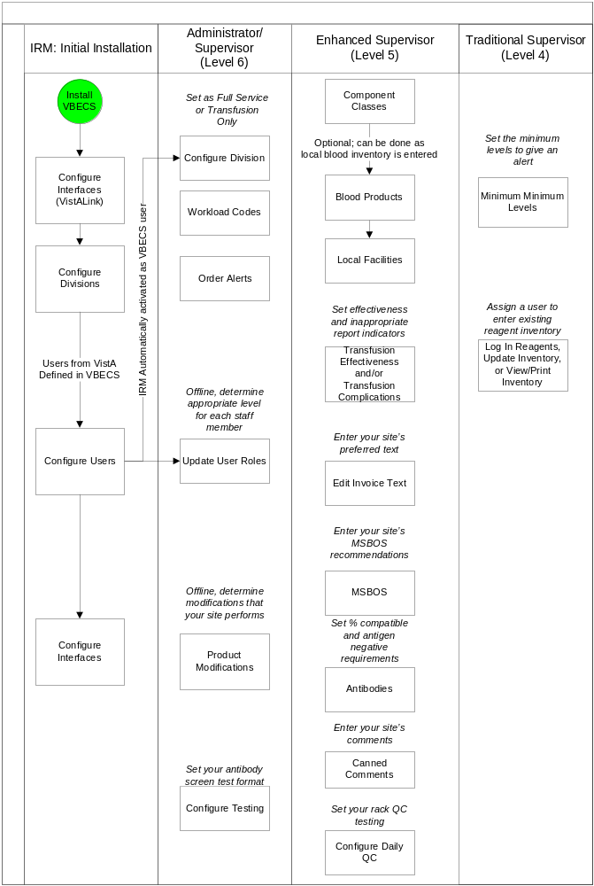
Figure 124: Configure Division Settings: Transfusion-Only Divisions
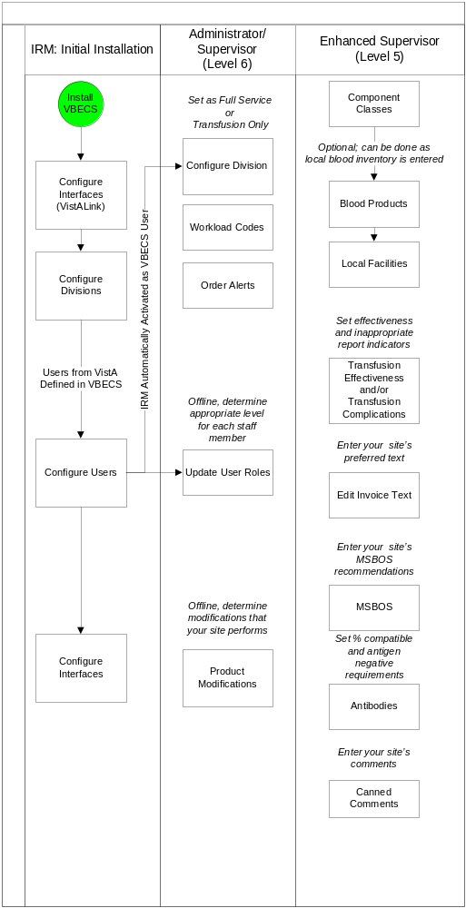
Figure 125: Maintain Reagents and Daily QC: Full Service Divisions
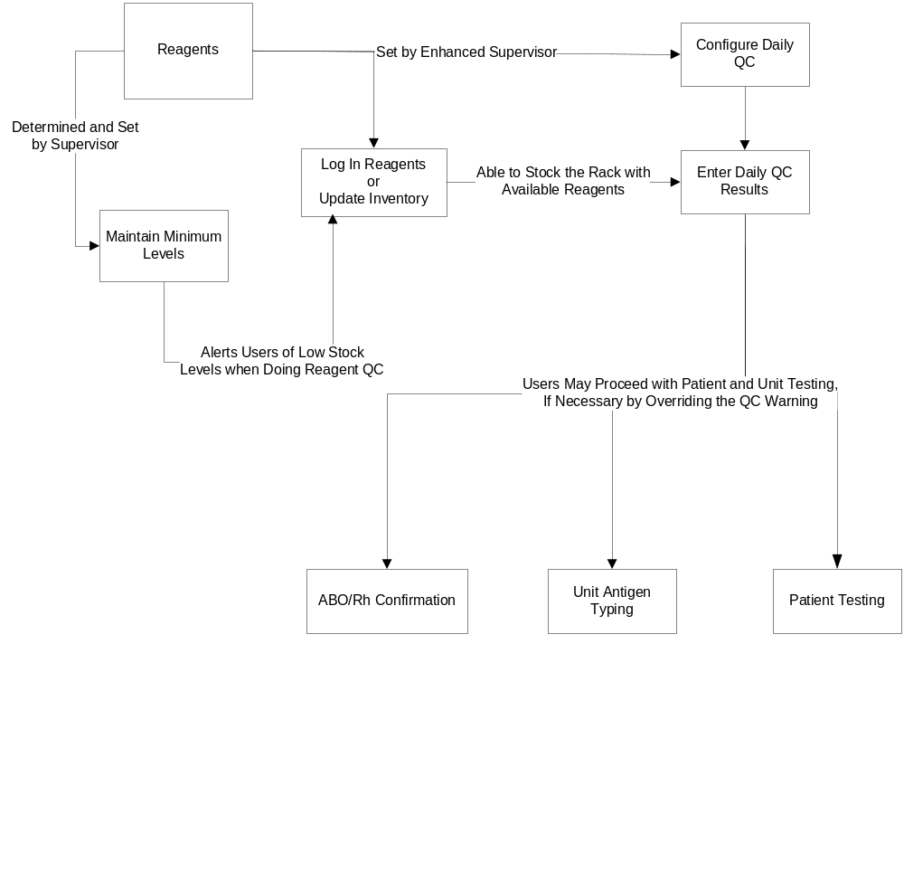

Figure 126: Process Incoming Shipment: Full-Service Divisions
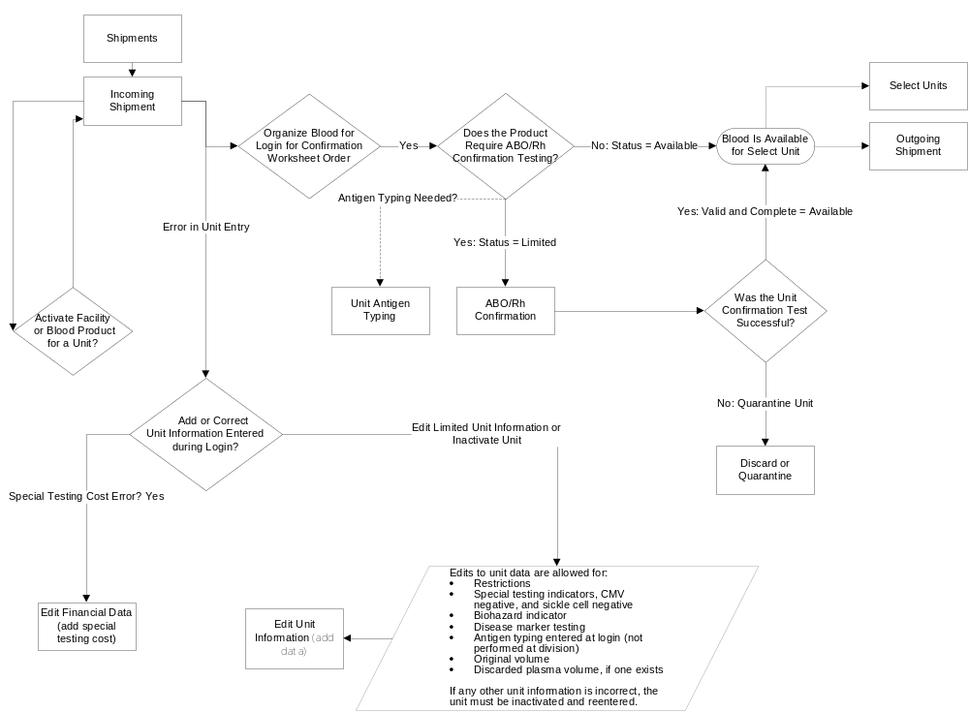
Figure 127: Process Incoming Shipment: Transfusion-Only Divisions
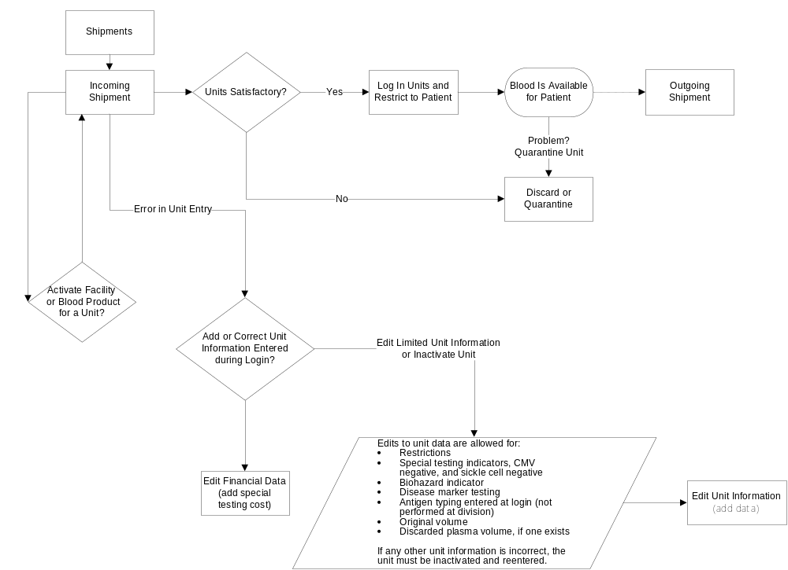
Figure 128: Modify Units
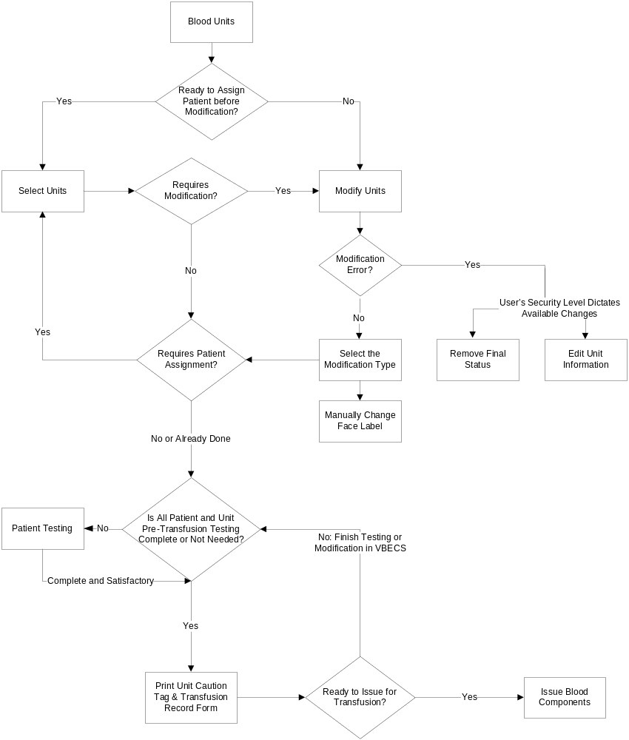
Figure 129: Issue, Return or Transfuse Units: Full Service Divisions
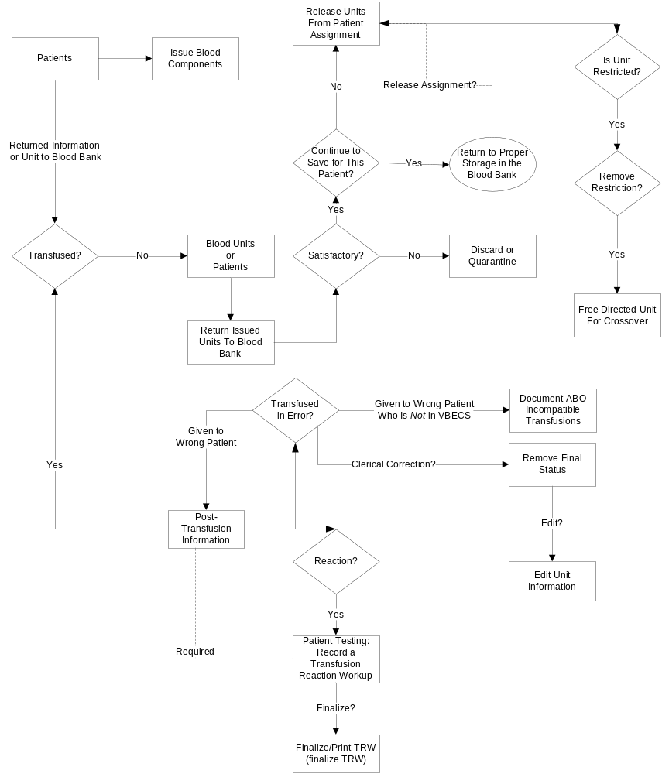
Figure 130: Issue, or Transfuse: Transfusion-Only Divisions
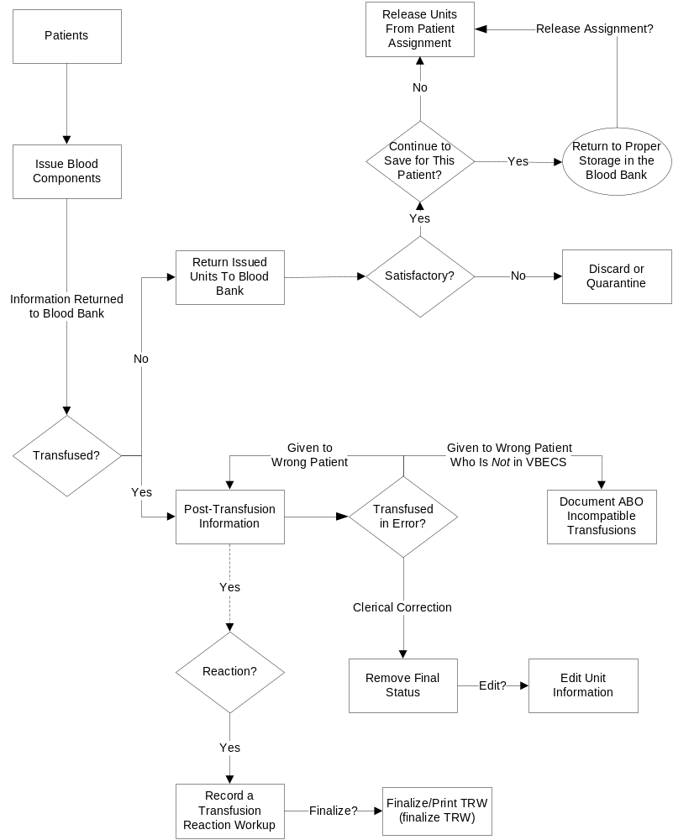
Figure 131: Process a Patient Order
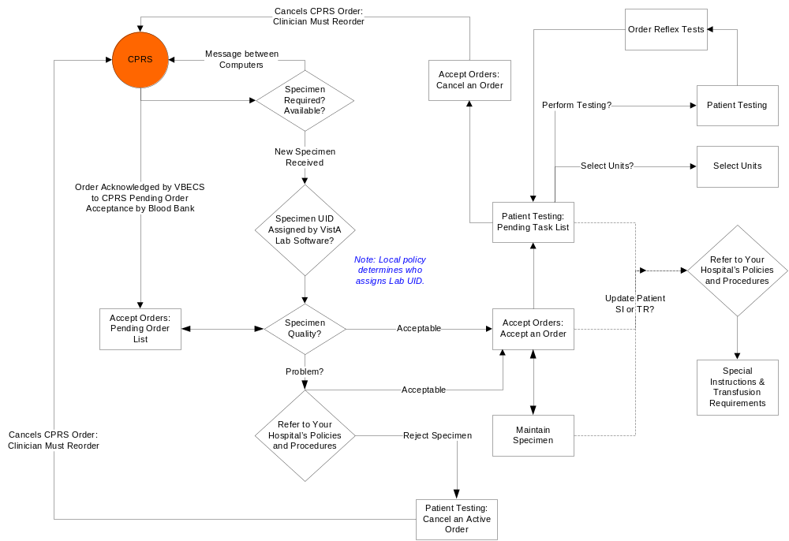
Figure 132: Patient Testing
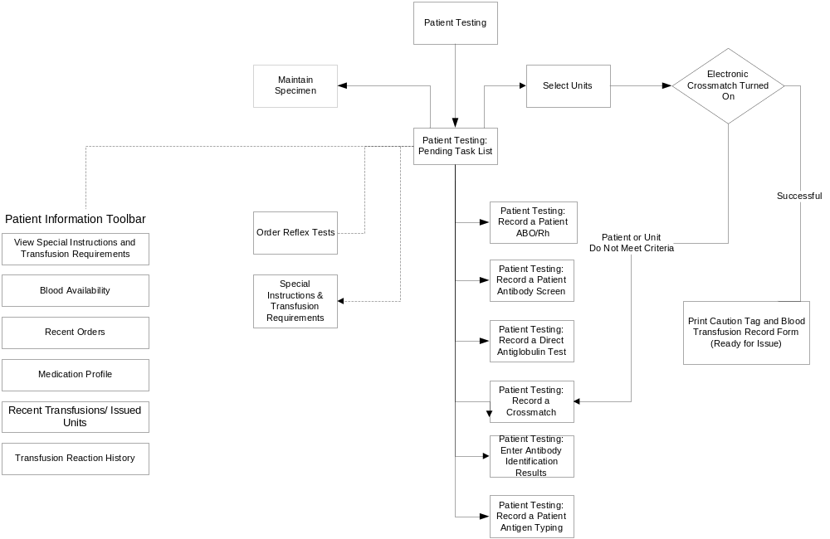

Appendix H: Frequently Asked Questions
Frequently Asked Questions (FAQs) are released as standalone documents.
Topics are explained in a question and answer format.
FAQs are available at the REDACTED and are version specific.

Appendix I: Common Error Corrections

Correct Patient Test Results
Define the problem:
Specifically what data needs correction?
Is it a patient test?
Are any units assigned to the specimen UID associated with this patient order?

The path to transfusion is linear and follows the path from assignment to issue to transfusion. VBECS requires the unit-patient connection to be severed in order to change patient testing used to evaluate compatibility.
All the units must be released from assignment, no matter when the error occurred and needs correction. VBECS requires undoing all of the unit associations so the computer can re-evaluate the corrected information entered and present any warnings or overrides based on that new information.

Information to gather before you start trying to correct any test results:
- Actual dates/times of processing for retrospective data entry
  - Testing Worklist Report: Test result entry information details from the testing grids, reaction results, tech who did the work, any comments they entered
  - Unit History Report: Unit modification, Issue and Transfusion details
  - Patient History Report: Other patient information
  - Order History report: See the search option only for the CPRS Order Number if you have to retrieve an expired order. You do not need to actually open the report.
  - Any offline results that may need to be entered.
  - Tracking system numbers from the Known Defects and Anomalies document related to this problem. Have the user enter this number in the comment details field for all overrides processed.
  - Any local incident number that they may need to enter as a comment.

Invalidate Test Results
Important nuances about invalidating tests:
- When a Type and Screen (TAS) test needs to be invalidated, all the tests in the TAS test configuration must be invalidated to be able to select a test on the Pending Task List (PTL) (It is a loop of a partially completed test).
- When an Antibody Identification (ABID) test is invalidated:
  - The antibody specificities will be removed from the Special Instructions/Transfusion requirements Antibodies Identified at the same time. This also clears any antigen negative requirements that are created by the antibody identified.
  - If separate antigen negative requirements for each of these were entered in SI/TR, they will require update separately.
  - If you need to enter corrected results for the ABID, be sure you check the box to “Add test to the Pending Task List to allow for replacement results”. If not, you will have to reorder the reflex test.

A finalized Transfusion Reaction Workup (TRW) cannot be invalidated. Invalidation requires a Service Desk ticket to have the development team intervene and make that correction. A TRW that has not been finalized can be invalidated and re-entered as any other VBECS test.
Where to start...
- Are the units transfused?
Go to Supervisor, Remove Final Status to get the unit back to an issued status.
- Are the units issued?
Go to Return Unit from Issue by either the patient or blood unit menu.
Return the unit from issue at the current date and time.
- Are the units selected for a patient?
Go to Release Units from Assignment by either the patient or blood unit menu.

When the units are no longer assigned to the patient, go into Invalidate Patient Testing by the Patient Menu and invalidate the patient test.

STOP and make sure the user checks the box “Add test to the Pending Task List to allow for replacement results” if they want the test to appear on the PTL for correction.

UN-Pooling a Pooled Unit (in the computer only)
This may happen when a pool is created in the computer and the physical pool was not created after all.
If there is a patient assignment, issue or transfusion, that must be removed first as described above in the Where to start section.
- Go to Blood Unit, Edit Unit Information and INACTIVATE the Pooled Unit.
- Go to Supervisor, Remove Final Status, select each original unit removing the MODIFIED status and making each available.
- Repeat Step 2 for each original unit included in the pool.

UN-Modifying a Unit
Go to Supervisor, Remove Final Status.
If there is a patient assignment, issue or transfusion, that must be removed first as described above in the Where to start section.

Appendix J: Recommended Report Usage
Table 36 lists reports, how often to run them, and how to use them. These are recommendations for meeting regulatory requirements. Reports, including the non-individual Blood Availability Report, are available through the Reports menu item. The patient-specific Blood Availability Report is available through the Patients menu item.
Table 36: Recommended Report Usage
Run This Report: | Report Option | Purpose | To Meet Regulatory Requirements:
Daily | Audit Trail | Quality assurance (QA) report details data changes in system. | Print, review, sign, date, and save hard copy.
Daily | Blood Availability | Inventory report | This report may not be needed by transfusion-only or other sites.
Daily | Exception Report | QA report details overrides of system rules processed by users. | Print, review, sign, date, and save hard copy.
Daily | Testing Worklist Report | QA report displays all testing within a division. | Print Patient Testing, Unit testing, Rack QC and miscellaneous reagent QC. Print, review, sign, date, and save hard copy.
Daily or Weekly | Issued/Returned Report | QA report displays all relocation transactions. | Review for anomalies and take corrective action.
Daily, Weekly, and Monthly | Transfusion Requirements Report | A compendium of patient blood types, SIs, and TRs are printed for use during downtime. | - Days 1–6: print report daily.  - Day 7: print report for previous week; discard daily reports.  - Start of month: print report for previous month; discard weekly reports.  - Start of year: print report for previous year; discard monthly reports.  Generate cumulative reports starting with the date of first data entry through the current date to include all patient records. Store reports so that they are easily accessible.
Weekly | Prolonged Transfusion Time Report | Details units that were not infused within the required time frame. | Generate these reports for blood utilization committee and other quality management activities.
Weekly | Transfusion Effectiveness Report | Compares transfusions with user-configured lab data indicators to monitor appropriate blood usage.
Weekly or Monthly | C:T Ratio Report | Details crossmatch-to-transfusion ratio by physician or treating specialty.
Weekly or Monthly | Transfusion Complications Report | Compares transfusions with user configured lab data indicators to monitor adverse effects from transfusion.
Weekly or Monthly | Inappropriate Transfusion Request Report | Details requests for blood products that did not meet the facility’s transfusion criteria.
Monthly | Administrative Data Report | Management report details products received, transfused, and returned. | Generate these reports for administrative purposes.
Monthly | Cost Accounting Report | Management report of expenditure by invoice number. | Generate these reports for administrative purposes.
Monthly | Division Transfusion Report | Details of units transfused during a selected period. | Generate these reports for administrative purposes.
Monthly | Division Workload Report | Totals workload types for one or all divisions. | Generate these reports for administrative purposes.
Monthly | Transfusion Reaction Count Report | Details transfusion reactions that are ordered, pending, completed, or finalized for one or all divisions. | Generate this report for blood utilization committee and other quality management activities.
As needed | Finalize/Print TRW | Patient Transfusion Reaction Report details a transfusion reaction episode. | Print, review, sign, date, and save hard copy.

Appendix K: Barcode Scanner Configuration and Troubleshooting
Make sure the cord is plugged into the scanner and the computer. Point the scanner at a piece of white paper and squeeze the trigger to verify that the laser works.
For correct barcode scanning results, the Caps Lock key must not be engaged.

Never look directly at the laser. Never direct the laser beam toward yourself or another person. Avoid mirror-like surfaces such as glass, metal, watches, jewelry, and other highly reflective materials when directing the laser beam.
To configure a barcode scanner, scan the barcode in Figure 131. Repeat this process if scanned data are incorrectly displayed on the terminal. Consult the product reference guide or call the Service Desk for further assistance.
If your site uses barcode symbology for specimens not covered in these instructions, use the configuration barcodes in the manual included with the scanner.
Figure 133: Barcode Scanner Configuration
REDACTED

Appendix L: System Responses to Active Transfusion Requirements in Select Unit and Issue Blood Component

The following series of tables detail VBECS response to an active transfusion requirement, component class of the unit selected and the user’s VBECS role at unit selection and blood component issue.

Figure 132: Irradiate Cellular Products Only and Select Blood Unit
Figure 133: Irradiate Cellular Products Only and Issue Blood Component
Figure 134: Leuko-reduce Cellular Products and Select Blood Unit
Figure 135: Leuko-reduce Cellular Products and Issue Blood Component
Figure 136: Washed Red Blood Cell (RBC) Products and Select Blood Unit
Figure 137: Washed Red Blood Cell (RBC) Products and Issue Blood Component
Figure 138: Washed PLATELET (PLT) Products and Select Blood Unit
Figure 139: Washed PLATELET (PLT) Products and Issue Blood Component
Figure 140: Sickle Cell Negative RBC Products and Select Blood Unit
Figure 141: Sickle Cell Negative RBC Products and Issue Blood Component
Figure 142: CMV Negative Cellular Products* and Select Blood Unit
Figure 143: CMV Negative Cellular Products* and Issue Blood Component

Figure 134: Irradiate Cellular Products Only and Select Blood Unit
Select Unit: IRRADIATED
Patient Active Transfusion Requirement | Ordered Component Class* | Selected Unit is | User Role | VBECS Response
Irradiate  Cellular  Products  Only | RED BLOOD CELLS  WHOLE BLOOD  PLATELETS  OTHER | Irradiated | ALL VBECS Users | No warning message will display.
Irradiate  Cellular  Products  Only | RED BLOOD CELLS  WHOLE BLOOD  PLATELETS  OTHER | Not Irradiated | ALL VBECS Users | The Transfusion Requirement is not satisfied; the system emits an audible alert and displays a warning message: This unit does not currently satisfy all of the patient’s Transfusion Requirements. Further processing is needed. Continue to select this unit?  If the user clicks “No,” the screen is cleared.  If the user clicks “Yes,” selection can continue to select the unit.

Figure 135: Irradiate Cellular Products Only and Issue Blood Component
Issue Blood Component: IRRADIATED
Patient Active Transfusion Requirement | Ordered Component Class* | Selected Unit is | User Role | VBECS Response
Irradiate  Cellular  Products  Only | RED BLOOD CELLS  WHOLE BLOOD  PLATELETS  OTHER | Irradiated | ALL VBECS Users | No warning message will display.
Irradiate  Cellular  Products  Only | RED BLOOD CELLS  WHOLE BLOOD  PLATELETS  OTHER | Not Irradiated | Technologist  Enhanced Technologist | The system displays the warning message: Patient’s Transfusion Requirement is not satisfied. You do not have the proper security to issue this unit. Further processing is needed and must be documented in VBECS.  The tech may not issue this unit in the computer.
Irradiate  Cellular  Products  Only | RED BLOOD CELLS  WHOLE BLOOD  PLATELETS  OTHER | Not Irradiated | Lead Technologist  Traditional Supervisor  Enhanced Supervisor  Administrator/Supervisor | The system displays the warning message: Patient’s Irradiate Cellular Products Only Transfusion Requirement is not satisfied and prompts the user whether to proceed.  If the user responds “No”, the system will clear the selected unit.  If the user responds “Yes”, the system will require a comment (free text or canned, “unit issue” context) and capture the transaction details for inclusion in an Exception Report entry: Unit issued with unsatisfied Transfusion Requirement.

Figure 136: Leuko-reduce Cellular Products and Select Blood Unit
Select Unit: Leuko-reduce Cellular Products
Patient Active Transfusion Requirement | Ordered Component Class* | Selected Unit is | User Role | VBECS Response
Leuko-reduce Cellular Products | RED BLOOD CELLS  WHOLE BLOOD  PLATELETS | Leuko-reduced | ALL VBECS Users | No warning message will display.
Leuko-reduce Cellular Products | RED BLOOD CELLS  WHOLE BLOOD  PLATELETS | Not Leuko-reduced | ALL VBECS Users | The Transfusion Requirement is not satisfied; the system emits an audible alert and displays a warning message: This unit does not currently satisfy all of the patient’s Transfusion Requirements. Further processing is needed. Continue to select this unit?  If the user clicks “No,” the screen is cleared.  If the user clicks “Yes,” selection can continue to select the unit.

Figure 137: Leuko-reduce Cellular Products and Issue Blood Component
Issue Blood Component: Leuko-reduce Cellular Products
Patient Active Transfusion Requirement | Ordered Component Class* | Selected Unit is | Selected User Role | Expected System Response
Leuko-reduce Cellular Products | RED BLOOD CELLS  WHOLE BLOOD  PLATELETS | Leuko-reduced | ALL VBECS Users | No warning message will display.
Leuko-reduce Cellular Products | RED BLOOD CELLS  WHOLE BLOOD  PLATELETS | Not Leuko-reduced | Technologist  Enhanced Technologist | The system displays the warning message: Patient’s Transfusion Requirement is not satisfied. You do not have the proper security to issue this unit. Further processing is needed and must be documented in VBECS.  The tech may not issue this unit in the computer.
Leuko-reduce Cellular Products | RED BLOOD CELLS  WHOLE BLOOD  PLATELETS | Not Leuko-reduced | Lead Technologist  Traditional Supervisor  Enhanced Supervisor  Administrator/Supervisor | The system displays the warning message: Patient’s Leuko-reduce Cellular Products Transfusion Requirement is not satisfied and prompts the user whether to proceed.  If the user responds “No”, the system will clear the selected unit.  If the user responds “Yes”, the system will require a comment (free text or canned, “unit issue” context) and capture the transaction details for inclusion in an Exception Report entry: Unit issued with unsatisfied Transfusion Requirement.

Figure 138: Washed Red Blood Cell (RBC) Products and Select Blood Unit
Select Unit: Washed Red Blood Cell (RBC) products
Patient Active Transfusion Requirement | Ordered Component Class* | Selected Unit is | User Role | VBECS Response
Washed RBC products | RED BLOOD CELLS  WHOLE BLOOD | Washed | ALL VBECS Users | No warning message will display.
Washed RBC products | RED BLOOD CELLS  WHOLE BLOOD | Not Washed | ALL VBECS Users | The Transfusion Requirement is not satisfied; the system emits an audible alert and displays a warning message: This unit does not currently satisfy all of the patient’s Transfusion Requirements. Further processing is needed. Continue to select this unit?  If the user clicks “No,” the screen is cleared.  If the user clicks “Yes,” selection can continue to select the unit.

Figure 139: Washed Red Blood Cell (RBC) Products and Issue Blood Component
Issue Blood Component: Washed RBC products
Patient Active Transfusion Requirement | Ordered Component Class* | Selected Unit is | Selected User Role | Expected System Response
Washed RBC products | RED BLOOD CELLS  WHOLE BLOOD | Washed | ALL VBECS Users | No warning message will display.
Washed RBC products | RED BLOOD CELLS  WHOLE BLOOD | Not Washed | Technologist  Enhanced Technologist | The system displays the warning message: Patient’s Transfusion Requirement is not satisfied. You do not have the proper security to issue this unit. Further processing is needed and must be documented in VBECS.  The tech may not issue this unit in the computer.
Washed RBC products | RED BLOOD CELLS  WHOLE BLOOD | Not Washed | Lead Technologist  Traditional Supervisor  Enhanced Supervisor  Administrator/Supervisor | The system displays the warning message: Patient’s Washed RBC Products Transfusion Requirement is not satisfied and prompts the user whether to proceed.  If the user responds “No”, the system will clear the selected unit.  If the user responds “Yes”, the system will require a comment (free text or canned, “unit issue” context) and capture the transaction details for inclusion in an Exception Report entry: Unit issued with unsatisfied Transfusion Requirement.

Figure 140: Washed PLATELET (PLT) Products and Select Blood Unit
Select Unit: Washed PLT products
Patient Active Transfusion Requirement | Ordered Component Class* | Selected Unit is | User Role | VBECS Response
Washed PLT products | PLATELETS | Washed | ALL VBECS Users | No warning message will display.
Washed PLT products | PLATELETS | Not Washed | ALL VBECS Users | The Transfusion Requirement is not satisfied; the system emits an audible alert and displays a warning message: This unit does not currently satisfy all of the patient’s Transfusion Requirements. Further processing is needed. Continue to select this unit?  If the user clicks “No,” the screen is cleared.  If the user clicks “Yes,” selection can continue to select the unit.

Figure 141: Washed PLATELET (PLT) Products and Issue Blood Component
Issue Blood Component: Washed PLT products
Patient Active Transfusion Requirement | Ordered Component Class* | Selected Platelet Unit is | Selected User Role | Expected System Response
Washed PLT products | PLATELETS | Washed | ALL VBECS Users | No warning message will display.
Washed PLT products | PLATELETS | Not Washed | Technologist  Enhanced Technologist | The system displays the warning message: Patient’s Transfusion Requirement is not satisfied. You do not have the proper security to issue this unit. Further processing is needed and must be documented in VBECS.  The tech may not issue this unit in the computer.
Washed PLT products | PLATELETS | Not Washed | Lead Technologist  Traditional Supervisor  Enhanced Supervisor  Administrator/Supervisor | The system displays the warning message: Patient’s Washed PLT products Transfusion Requirement is not satisfied and prompts the user whether to proceed.  If the user responds “No”, the system will clear the selected unit.  If the user responds “Yes”, the system will require a comment (free text or canned, “unit issue” context) and capture the transaction details for inclusion in an Exception Report entry: Unit issued with unsatisfied Transfusion Requirement.

Figure 142: Sickle Cell Negative RBC Products and Select Blood Unit
Select Unit: Sickle Cell Negative RBC products
Patient Active Transfusion Requirement | Ordered Component Class* | Selected Unit is | User Role | VBECS Response
Sickle Cell Negative RBC products | RED BLOOD CELLS  WHOLE BLOOD | Sickle Cell Negative | ALL VBECS Users | No warning message will display.
Sickle Cell Negative RBC products | RED BLOOD CELLS  WHOLE BLOOD | Not Sickle Cell Negative | Technologist  Enhanced Technologist | The Transfusion Requirement is not satisfied; the system emits an audible alert and displays a warning message: This unit does not currently satisfy all of the patient’s Transfusion Requirements. Further processing is needed. Continue to select this unit?  If the user clicks “No,” the screen is cleared.  If the user clicks “Yes,” selection can continue to select the unit.
Sickle Cell Negative RBC products | RED BLOOD CELLS  WHOLE BLOOD | Not Sickle Cell Negative | Lead Technologist  Traditional Supervisor  Enhanced Supervisor  Administrator/Supervisor | The following warning(s) is informational: This unit does not currently satisfy the patient’s Sickle Cell Negative Transfusion Requirements. Further processing is needed. Continue to select this unit?  Do you wish to proceed with the selection of unit <insert unit ID number>:?  If “No,” is selected, the screen is cleared and a new blood unit must be selected.  If “Yes,” is selected, a comment is required and the details of the transaction are captured for later inclusion in an exception report entry: Transfusion Requirement incompatible unit selected.

Figure 143: Sickle Cell Negative RBC Products and Issue Blood Component
Issue Blood Component: Sickle Cell Negative RBC Products
Patient Active Transfusion Requirement | Ordered Component Class* | Selected Unit is | Selected User Role | Expected System Response
Sickle Cell Negative RBC products | RED BLOOD CELLS  WHOLE BLOOD | Sickle Cell negative | ALL VBECS Users | No warning message will display.
Sickle Cell Negative RBC products | RED BLOOD CELLS  WHOLE BLOOD | NOT  Sickle Cell Negative | Technologist  Enhanced Technologist | The system displays the warning message: Patient’s Transfusion Requirement is not satisfied. You do not have the proper security to issue this unit. Further processing is needed and must be documented in VBECS.  The tech may not issue this unit in the computer.
Sickle Cell Negative RBC products | RED BLOOD CELLS  WHOLE BLOOD | NOT  Sickle Cell Negative | Lead Technologist  Traditional Supervisor  Enhanced Supervisor  Administrator/Supervisor | The system displays the warning message: Patient’s Sickle Cell Negative RBC products Transfusion Requirement is not satisfied and prompts the user whether to proceed.  If the user responds “No”, the system will clear the selected unit.  If the user responds “Yes”, the system will require a comment (free text or canned, “unit issue” context) and capture the transaction details for inclusion in an Exception Report entry: Unit issued with unsatisfied Transfusion Requirement.

Figure 144: CMV Negative Cellular Products* and Select Blood Unit
Select Unit: CMV Negative Cellular Products
Patient Active Transfusion Requirement | Ordered Component Class* | Selected Unit is | User Role | VBECS Response
CMV negative cellular products* | RED BLOOD CELLS  WHOLE BLOOD  PLATELETS  OTHER | CMV Negative* | ALL VBECS Users | No warning message will display.
CMV negative cellular products* | RED BLOOD CELLS  WHOLE BLOOD  PLATELETS  OTHER* | Not  CMV negative | Technologist  Enhanced Technologist | The Transfusion Requirement is not satisfied; the system emits an audible alert and displays a warning message: This unit does not currently satisfy all of the patient’s Transfusion Requirements. Further processing is needed. Continue to select this unit?  If the user clicks “No,” the screen is cleared.  If the user clicks “Yes,” selection can continue to select the unit.
CMV negative cellular products* | RED BLOOD CELLS  WHOLE BLOOD  PLATELETS  OTHER* | Not  CMV negative | Lead Technologist  Traditional Supervisor  Enhanced Supervisor  Administrator/Supervisor | The system displays the warning message: Patient’s CMV Negative cellular products Transfusion Requirement is not satisfied and prompts the user whether to proceed.  If the user responds “No”, the system will clear the selected unit.  If the user responds “Yes”, the system will require a comment (free text or canned, “unit issue” context) and capture the transaction details for inclusion in an Exception Report entry: Unit issued with unsatisfied Transfusion Requirement.
*VistA test results are not evaluated by VBECS. CMV Negative status is recorded during receipt at Incoming Shipment or added to the unit record in Edit Unit Information. All product types in OTHER are evaluated for the requirement including those that are non-cellular.

Figure 145: CMV Negative Cellular Products* and Issue Blood Component
Issue Blood Component: CMV Negative Cellular Products
Patient Active Transfusion Requirement | Ordered Component Class* | Selected Unit is | Selected User Role | Expected System Response
CMV negative cellular products* | RED BLOOD CELLS  WHOLE BLOOD  PLATELETS  OTHER | CMV Negative* | ALL VBECS Users | No warning message will display.
CMV negative cellular products* | RED BLOOD CELLS  WHOLE BLOOD  PLATELETS  OTHER* | Not  CMV negative | Technologist  Enhanced Technologist | The system displays the warning message: Patient’s Transfusion Requirement is not satisfied. You do not have the proper security to issue this unit. Further processing is needed and must be documented in VBECS.  The tech may not issue this unit in the computer.
CMV negative cellular products* | RED BLOOD CELLS  WHOLE BLOOD  PLATELETS  OTHER* | Not  CMV negative | Lead Technologist  Traditional Supervisor  Enhanced Supervisor  Administrator/Supervisor | The system displays the warning message: Patient’s CMV Negative Cellular Products Transfusion Requirement is not satisfied and prompts the user whether to proceed.  If the user responds “No”, the system will clear the selected unit.  If the user responds “Yes”, the system will require a comment (free text or canned, “unit issue” context) and capture the transaction details for inclusion in an Exception Report entry: Unit issued with unsatisfied Transfusion Requirement.
*VistA test results are not evaluated by VBECS. CMV Negative status is recorded during receipt at Incoming Shipment or added to the unit record in Edit Unit Information. All product types in OTHER are evaluated for the requirement including those that are non-cellular.

Appendix M: Workload Process Mapping to Application Option Table
Table 37 associates record saves with workload processes. The data fields identified for transmission at the completion of a Workload Event are based on current VistA workload-related files and fields. VBECS will transmit information to a new flat file. There are no donor workload types in VBECS.
Table 37: Workload Process Mapping to Application Option
Record Save Option | VBECS Process | Transaction Type [P (Patient), U (Unit), M (Miscellaneous)] | Explanation
Record a Transfusion Reaction Workup | ABO Forward and reverse typing (patient) | P | An ABO/Rh test for “pre” or “post” is enabled and a valid interpretation other than Not Tested is selected. A workload event is accrued separately for “Pre” and “Post” entries.
Record Patient ABO/Rh | ABO Forward and reverse typing (patient) | P | Accrue workload when a CPRS-ordered ABO/Rh test is performed.
Invalidate Patient Test Results* | ABO Forward and reverse typing (patient) | P | Accrue workload when a completed ABO/Rh test is invalidated.
Record Patient ABO/Rh | ABO Forward and reverse typing (patient) Repeat Test | M | Accrue workload when a reflex or repeat ABO/Rh test is performed, completed, and saved.
Invalidate Patient Test Results* | ABO Forward and reverse typing (patient) Repeat Test | M | Accrue workload when a reflex or repeat ABO/Rh test is invalidated.
ABO/Rh Confirmation | ABO forward typing (unit) | U | An ABO confirmation test is performed. When multiple units are selected in a batch, each unit in the batch accrues a workload event. Note: Workload generated during Anti-D testing is not included in the unit’s confirmation test. Workload is not accrued when an ABO or Rh discrepancy override is processed and VBECS releases all patient assignments. Workload is not accrued when VBECS quarantines the unit due to a discrepancy. There is no special handling for workload collection for additional confirmation tests on a unit.
Edit Unit Information* | ABO forward typing (unit) | U | Accrue workload when an ABO confirmation test is invalidated.
ABO/Rh Confirmation | ABO/Rh forward typing (unit) | U | An ABO/Rh confirmation test is performed. When multiple units are selected in a batch, each unit in the batch accrues a workload event. Note: Workload generated during Anti-D is part of the unit’s confirmation test. Workload is not accrued when an ABO or Rh discrepancy override is processed and VBECS releases all patient assignments. Workload is not accrued when VBECS quarantines the unit due to a discrepancy. Any unit successfully confirmed accrues workload. For split modifications: workload is not inherited by split units. A split unit that requires confirmation accrues confirmation workload at the time of testing. There is no special handling for workload collection for additional confirmation tests on a unit.
Edit Unit Information* | ABO/Rh forward typing (unit) | U | Accrue workload when an ABO/Rh confirmation test is invalidated.
Accept Order | Accept Order | M | Accrue workload when an order is accepted. When multiple orders are selected, each order accrues workload.
Enter Antibody Identification Results | Antibody identification Work-Up | P | User enters additional workload associated with the individual reflex-ordered ABID. The selected VBECS multiplier will multiply against the VistA multiplier and display the (multiplication) product on the Division Workload Report.
Invalidate Patient Test Results* | Antibody identification Work-Up | P | Accrue workload when the ABID is invalidated.
Record a Transfusion Reaction Workup | Antibody Screen (patient) | P | An ABS test for “pre” or “post” is enabled and a valid interpretation other than Not Tested is selected. A workload event is accrued separately for “Pre” and “Post” entries.
Record Patient Antibody Screen | Antibody Screen (patient) | P | Accrue workload when an ordered ABS test is performed.
Invalidate Patient Test Results* | Antibody Screen (patient) | P | Accrue workload when a completed ABS test is invalidated.
Record Patient Antibody Screen | Antibody Screen (patient) Repeat Test | M | Accrue workload when a reflex or repeat ABS test is performed, completed, and saved.
Invalidate Patient Test Results* | Antibody Screen (patient) Repeat Test | M | Accrue workload when a reflex or repeat ABS test is invalidated.
Unit Antigen Typing / Patient Antigen Typing | Antigen phenotyping, Single Test phase (QC) | M | Accrue workload when Antiserum QC in Unit or Patient Antigen Typing includes the testing of both the positive and negative control cells, per specificity by lot number, when only one phase of reactivity is chosen for the test grid (IS or AHG). One workload event is collected per completed tab for regular or repeat antigen tests.
Unit Antigen Typing / Patient Antigen Typing | Antigen phenotyping, Multiple Test phases (QC) | M | Accrue workload when Antiserum QC in Unit or Patient Antigen Typing includes the testing of both the positive and negative control cells, per specificity by lot number, when only multiple phases of reactivity are chosen for the test grid, IS/RT, RT/37, or weak D. One workload event is collected per completed tab for regular or repeat antigen tests.  When weak D is the selected test, QC may not be accrued for the rack selection. QC is accrued when positive and negative cells must be tested for the lot number.
Cancel Pending Order | Cancel Order | M | Accrue workload when an order on the pending order list is cancelled. When multiple orders are cancelled, each order accrues workload.
Cancel Active Order | Cancel Order | M | Accrue workload when an order on the pending task list is cancelled. When multiple orders are cancelled, each order accrues workload.
Select Units for Crossmatch | Crossmatch unit, electronic | P | This process is invoked when an individual unit is selected for patient assignment and the unit is electronically crossmatched. When multiple units are selected, each unit accrues workload.
Enter Crossmatch Results | Crossmatch unit, serologic immediate spin | P | Accrue workload when an individual unit crossmatch is selected to include only the IS phase, is completed, and is saved. When multiple units are selected, each unit accrues workload.
Invalidate Patient Test Results* | Crossmatch unit, serologic immediate spin | P | Accrue workload when a completed crossmatch test is invalidated. This applies to the workload originally saved with the serologic immediate spin test.
Record a Transfusion Reaction Workup | Crossmatch unit, serological Coombs | P | A crossmatch test for “pre” or “post” is enabled and a valid interpretation other than Not Tested is selected. A workload event is accrued separately for “Pre” and “Post” entries.  When multiple units are selected, each unit accrues workload.
Enter Crossmatch Results | Crossmatch unit, serological Coombs | P | Accrue workload when an individual unit crossmatch is selected to include all phases or only the AHG phase, is completed, and is saved. When multiple units are selected, each unit accrues workload.
Invalidate Patient Test Results* | Crossmatch unit, serological Coombs | P | Accrue workload when a completed crossmatch test is invalidated. This applies to the workload originally saved with the test, serological Coombs.
Enter Crossmatch Results | Crossmatch, Repeat Test | M | Accrue workload when an individual unit crossmatch is selected to include all phases or IS or only the AHG phase, is completed, and is saved. When multiple units are selected, each unit accrues workload.
Invalidate Patient Test Results* | Crossmatch, Repeat Test | M | Accrue workload when an individual unit crossmatch is invalidated.
Enter Daily QC Results | Daily Rack Quality Control (QC) | M | Accrue workload when Daily QC rack completed for one individual rack includes all rows in configured QC. When multiple racks are tested, each completed and saved tab accrues a workload event.
Record Patient Direct Antiglobulin Test | DAT (QC) | M | Accrue workload when Reagent QC completed in Patient DAT testing includes the testing of both the positive and negative control cells, per specificity per lot number, when only one phase of reactivity is chosen for the test grid (IS or AHG). One workload event is collected per completed tab for regular or repeat antiglobulin tests (PS, IgG, Comp).
Record a Transfusion Reaction Workup | Direct Antiglobulin Test (DAT) | P | A DAT test for “pre” or “post” is enabled and a valid interpretation other than Not Tested is selected. A workload event is accrued separately for “Pre” and “Post “entries.
Record Patient Direct Antiglobulin Test | Direct Antiglobulin Test (DAT) | P | Accrue workload when a DAT is completed and saved. This count is used for all antiglobulin tests (PS, IgG, Comp) when ordered from CPRS or Reflex testing.
Invalidate Patient Test Results* | Direct Antiglobulin Test (DAT) | P | Accrue workload when a completed DAT, PS, IgG, or Comp is invalidated.
Record Patient Direct Antiglobulin Test | Direct Antiglobulin Test (DAT) Repeat test | M | Accrue workload when a reflex or repeat DAT test is performed, completed, and saved. This applies to all repeat antiglobulin tests (PS, IgG, Comp).
Invalidate Patient Test Results* | Direct Antiglobulin Test (DAT) Repeat test | M | Accrue workload when a completed Repeat DAT, PS, IgG, or Comp is invalidated.
Modify Units | Deglycerolize unit | U | Accrue workload when an individual blood unit is processed by the Deglycerolize modification type. Note: Workload is not accrued when a patient assignment is processed and VBECS releases all other patient assignments. Workload is not accrued when VBECS is required to quarantine the unit.
Remove Final Status* | Deglycerolize unit | U | An individual blood unit’s status is invalidated when the original modification process was “Deglycerolize.”
Discard or Quarantine Unit | Discard unit | U | Accrue workload when a unit is discarded for waste or credit. When a batch of units is selected, each unit accrues workload.
Remove Final Status* | Discard unit | U | Accrue workload when an individual blood unit’s status is invalidated. When a batch of units is selected, each unit accrues workload.
Modify Units | Freeze unit | U | Accrue workload when an individual blood unit is processed by the Freeze modification type. Note: Workload is not accrued when a patient assignment is processed and VBECS releases all other patient assignments. Workload is not accrued when VBECS is required to quarantine the unit.
Remove Final Status* | Freeze unit | U | An individual blood unit’s status is invalidated when the original modification process was “Freeze.”
Modify Units | Irradiate unit | U | Accrue workload when an individual blood unit is processed by the Irradiate modification type. When a batch of units is irradiated, each unit accrues workload. Note: Workload is not accrued when a patient assignment is processed and VBECS releases all other patient assignments. Workload is not accrued when VBECS is required to quarantine the unit.
Remove Final Status* | Irradiate unit | U | An individual blood unit’s status is invalidated when the original modification process was “Irradiate.”
Modify Units | Leukoreduce unit | U | Accrue workload when an individual blood unit is processed by the Leukoreduce modification type.  Note: Workload is not accrued when a patient assignment is processed and VBECS releases all other patient assignments. Workload is not accrued when VBECS is required to quarantine the unit.
Remove Final Status* | Leukoreduce unit | U | An individual blood unit’s status is invalidated when the original modification process was “Leukoreduce.”
Split a Unit | Split unit | U | Accrue workload when a unit modification of Split and a single workload event is recorded regardless of the number of units created by the modification. Note: Workload is not accrued when a patient assignment is processed and VBECS releases all other patient assignments. Workload is not accrued when VBECS is required to quarantine the unit.
Remove Final Status* | Split unit | U | A Split Unit has its unit status invalidated. A single workload event is recorded regardless of the number of units originally created by the modification.
Modify Units | Rejuvenate unit | U | Accrue workload when an individual blood unit is processed by the Rejuvenate modification type.  Note: Workload is not accrued when a patient assignment is processed and VBECS releases all other patient assignments. Workload is not accrued when VBECS is required to quarantine the unit.
Remove Final Status* | Rejuvenate unit | U | An individual blood unit’s status is invalidated when the original modification process was “Rejuvenate. “
Modify Units | Thaw | U | Accrue workload when an individual blood unit is processed by the Thaw modification type. When a batch of units is thawed, each unit accrues workload. This applies to Thaw FFP and Thaw Cryo. Note: Workload is not accrued when a patient assignment is processed and VBECS releases all other patient assignments. Workload is not accrued when VBECS is required to quarantine the unit.
Remove Final Status* | Thaw | U | An individual blood unit’s status is invalidated when the original modification process was “Thaw.” This modification type is applicable to Thaw FFP and Thaw Cryo.
Modify Units | Wash unit | U | Accrue workload when an individual blood unit is processed by the Wash modification type. Note: Workload is not accrued when a patient assignment is processed and VBECS releases all other patient assignments. Workload is not accrued when VBECS is required to quarantine the unit.
Remove Final Status* | Wash unit | U | An individual blood unit’s status is invalidated when the original modification process was “Wash.”
Modify Units | Volume Reduce | U | Accrue workload when an individual blood unit is processed by the Volume Reduce modification type. Note: Workload is not accrued when a patient assignment is processed and VBECS releases all other patient assignments. Workload is not accrued when VBECS is required to quarantine the unit.
Remove Final Status* | Volume Reduce | U | An individual blood unit’s status is invalidated when the original modification process was Volume Reduce.
Issue Blood Components | Issue unit | P | Accrue workload when a unit is issued to a patient. When a batch of units is processed, each unit invokes one workload process.
Justify Patient ABO/Rh Change | Justification | M | Workload is accrued when a patient’s ABO or Rh typing is justified. One workload event is accrued per patient justification.
Login Equipment | Login Equipment | M | Accrue workload when a lot number of any type of equipment is logged into the system. When multiple lot numbers are processed in a batch, each lot number’s workload is counted.
Login Reagent | Login Reagent | M | Accrue workload when a lot number of any type of reagent is logged into the system. When multiple lot numbers are processed in a batch, each lot number’s workload is counted.
Login Supply | Login Supply | M | Accrue workload when a lot number of any type of supply is logged into the system. When multiple lot numbers are processed in a batch, each lot number’s workload is counted.
Maintain Specimen | Maintain Specimen | M | Accrue workload when a specimen is maintained during order acceptance and is required for acceptance of the order. Note: This is collected in addition to the accept order workload accrued by accepting an order. Marking a specimen unacceptable does not create a negative workload event.
Patient antigen phenotype | Patient antigen phenotype (multiple phases) | P | Accrue workload when a patient antigen phenotype test with IS/RT or IS/37 phases is completed and saved. One workload event is collected per completed tab for repeat or regular antigen tests.
Invalidate Patient Test Results* | Patient antigen phenotype (multiple phases) | P | Accrue workload when a patient antigen phenotype test as defined by the antiserum specificity tested with any phases is invalidated.
Patient antigen phenotype | Patient antigen phenotype (single phase) | P | Accrue workload when a patient antigen phenotype test with AHG or IS phase is completed and saved. One workload event is collected per completed tab for repeat or regular antigen tests.
Invalidate Patient Test Results* | Patient antigen phenotype (single phase) | P | Accrue workload when a patient antigen phenotype test as defined by the antiserum specificity tested with a single phase is invalidated.
Pool Units | Pool unit | U | Accrue workload when a pooled unit is created and a single workload event is recorded regardless of the number of units included in the pooled unit. This applies to the Pool modification type. Add/Remove unit from a pool does not accrue any workload. Note: Workload is not accrued when a patient assignment is processed and VBECS releases all other patient assignments. Workload is not accrued when VBECS is required to quarantine the unit.
Edit Unit Information* | Pool unit | U | Accrue workload when a unit is inactivated if the pooled unit was created in VBECS.
Remove Final Status | Pool unit | N/A | No effect on workload accrual when a unit is removed from a modified status that was included in a pool.
Discard or Quarantine Unit | Quarantine unit | U | Accrue workload when a unit is marked for quarantine. When a batch of units is selected, each unit accrues workload.
Free Directed Unit For Crossover | Release directed unit | U | Accrue workload when an individual blood unit with the restriction type of “directed” is released for use as an allogeneic unit.
Release Unit from Patient Assignment | Release unit from patient back to inventory | U | Accrue workload when an individual unit is released from patient assignment. When multiple units are selected, each unit accrues workload.
Discard or Quarantine Unit | Release unit from Quarantine | U | Accrue workload when a unit is released from quarantine. When a batch of units is selected, each unit accrues workload.
Return Issued Unit | Return Issued unit | U | Accrue workload when a unit is returned from issue status.
Modify Units | Thaw/pool Cryo | U | Accrue workload when an individual unit has a modification of Thaw/Pool Cryo. A single workload event is recorded regardless of the number of units included in the pooled unit. Note: Workload is not accrued when a patient assignment is processed and VBECS releases all other patient assignments. Workload is not accrued when VBECS is required to quarantine the unit.
Edit Unit Information* | Thaw/pool Cryo | U | Accrue workload when a unit is inactivated (unit record inactivated) when the pooled unit was created in VBECS.
Remove Final Status | Thaw/pool Cryo | N/A | There is no effect on workload accrual when a unit is removed from a modified status that was included in a Thaw/pool Cryo pool.
Enter Post-Transfusion Details | Transfuse Unit | U | Accrue workload when an individual blood unit’s status is updated to “transfused.“
Remove Final Status* | Transfuse Unit | U | An individual blood unit’s status is invalidated when the unit was in a status of “transfused.”
Record a Transfusion Reaction Workup | Transfusion Reaction Investigation | P | Accrue workload when a transfusion reaction investigation is saved. This does not include workload accrued by the optional TRW serologic testing.
Invalidate Patient Test Results* | Transfusion Reaction Investigation | P | Accrue workload when a transfusion reaction investigation previously saved is invalidated.
Unit Antigen Typing | Unit Antigen phenotyping, Multiple Test phases | U | Accrue workload when a unit antigen phenotype test with IS/RT or IS/37 phases is selected and completed for an individual blood unit. There is no special handling for workload collection for additional repeat antigen typing tests on a unit.
Edit Unit Information* | Unit Antigen phenotyping, Multiple Test phases | U | Accrue workload when a unit antigen phenotype test with Multiple Test phases is invalidated for an individual blood unit.
Unit Antigen Typing | Unit Antigen phenotyping, Single Test phase | U | A unit antigen phenotype test with AHG or IS phase is selected and completed for an individual blood unit. There is no special handling for workload collection for additional repeat antigen typing tests on a unit.
Edit Unit Information* | Unit Antigen phenotyping, Single Test phase | U | Accrue workload when a unit antigen phenotype test with Single Test phase is invalidated for an individual blood unit.
Incoming Shipment | Unit login | U | An individual unit record is activated as “saved” to an incoming shipment invoice. When multiple units are entered, each unit added to the database accrues workload.
Edit Unit Information* | Unit login | U | Accrue workload when a unit is inactivated and logged in through incoming shipment or is a pooled unit created in VBECS. When the unit was created by split modification, no workload is invalidated in this option.
Outgoing Shipment | Unit logout | U | An individual unit’s status is updated to “transferred” on a confirmed outgoing shipment invoice. When multiple units are selected, each unit accrues workload. Accrue workload on confirmation of the invoice, not the addition of a unit to a temporary outgoing shipment invoice: an invoice may be confirmed only once.
Remove Final Status* | Unit logout | U | An individual unit status is invalidated when the unit had a previous unit status of “transferred.”
Update Equipment Record | Update Equipment Record | M | Accrue workload when a lot number of any type of equipment is updated in the system.
Update Reagent Inventory | Update Reagent Inventory | M | Accrue workload when a lot number of any type of reagent is updated in the system. When multiple lot numbers are processed in a batch, each lot number’s workload is counted.
Update Supply Inventory | Update Supply Inventory | M | Accrue workload when a lot number of any type of supply is updated in the system. When multiple lot numbers are processed in a batch, each lot number’s workload is counted.
*Accumulates negative workload when it is associated with inactivation of a unit or removal of a final status.

Appendix N: Orderable Reflex Tests
This is a finite list distributed with VBECS; no local entries may be added.
Table 38: Orderable Reflex Tests
Orderable Reflex Tests
CPRS Ordered Tests | VBECS Orderable Reflex Tests
CPRS Ordered Tests | Orderable Reflex tests displayed in UC_45 | Orderable Reflex Tests on Reflex Tests  Orderable Reflex tests displayed in UC_45  *No limit to repeat orders unless otherwise indicated. Repeat orders may not be used to place other repeat orders.
TAS (Type & Screen)  May be configured as:  - ABS only  - ABS plus Autocontol  - ABS plus DAT | Repeat ABO/Rh  If discrepant with the previous specimen test, cannot order additional repeat tests. | If discrepant, cannot order additional repeat ABO/Rh tests.
 | Repeat ABS*
 | Patient Antigen Typing | Repeat Patient Antigen Typing*
 | DAT (or Repeat DAT, if configured to ABS plus DAT) | Repeat DAT*
 | DAT (or Repeat DAT, if configured to ABS plus DAT) | DAT IgG | Repeat DAT lgG*
 | DAT (or Repeat DAT, if configured to ABS plus DAT) | DAT Comp | Repeat DAT Comp*
 | ABID | Repeat ABID*
 | ABID | Repeat DAT*
 | ABID | DAT IgG | Repeat DAT lgG*
 | ABID | DAT Comp | Repeat DAT Comp*
 | ABID | Patient Antigen Typing | Repeat Patient Antigen Typing*
ABO/Rh | Repeat ABO/Rh  If discrepant with the previous specimen test, cannot order additional repeat test | If discrepant, cannot order additional repeat ABO/Rh tests.
ABO/Rh | DAT | Repeat DAT *
ABO/Rh | DAT | DAT IgG | Repeat DAT lgG*
ABO/Rh | DAT | DAT Comp | Repeat DAT Comp*
ABO/Rh | ABID | Repeat ABID*
ABO/Rh | ABID | Repeat DAT*
ABO/Rh | ABID | DAT IgG | Repeat DAT lgG*
ABO/Rh | ABID | DAT Comp | Repeat DAT Comp*
ABO/Rh | ABID | Patient Antigen Typing | Repeat Patient Antigen Typing*
ABS (Patient Antibody Screen)  May be configured as:  ABS only  ABS plus Autocontol  ABS plus DAT | Repeat ABS*
 | DAT (or Repeat DAT, if configured to ABS plus DAT) | DAT IgG | Repeat DAT lgG*
 | DAT (or Repeat DAT, if configured to ABS plus DAT) | DAT Comp | Repeat DAT Comp*
 | DAT (or Repeat DAT, if configured to ABS plus DAT) | Repeat DAT*
 | ABID | Repeat ABID*
 | ABID | Repeat DAT*
 | ABID | DAT IgG | Repeat DAT lgG*
 | ABID | DAT Comp | Repeat DAT Comp*
 | ABID | Patient Antigen Typing | Repeat Patient Antigen Typing*
 | Patient Antigen Typing | Repeat Patient Antigen Typing*
DAT | Repeat DAT*
DAT | Patient Antigen Typing | Repeat Patient Antigen Typing*
DAT | ABID | Repeat ABID*
DAT | DAT IgG (Patient lgG DAT) | Repeat DAT lgG*
DAT | DAT Comp (Patient Complement DAT) | Repeat DAT Comp*
TRW (Transfusion Reaction Workup) | ABID | Repeat ABID*
TRW (Transfusion Reaction Workup) | May not order repeat tests as there are no original reaction result entries for comparison. For pre-transfusion specimen, repeats can be ordered. Post-transfusion specimen will need to have CPRS ordered tests to allow order of repeat tests.
CPRS component order that autogenerates a crossmatch test | Repeat XM (Patient Crossmatch)*
CPRS component order that autogenerates a crossmatch test | (RBC, WB, and when an individual unit has > 2 mL RBC contamination)

Index

A
Accept Orders: Accept an Order 233
Accessing the System 24
Administrative Data Report 348
Appendices 9
Application Architecture 11
Assumptions 145
Audit Trail 350
Automated Entry of Post-Transfusion Details from BCE COTS Application 328
Automated Testing Interface 334
B
Background and Basic Knowledge 8
Barcode Scanner Configuration and Troubleshooting 499
Blood Availability 352
C
C:T Ratio Report 356
check character 109
Collecting Workload 42
Common Error Corrections 495
Commonly Used System Rules 16
Component Processing 108
Configure Division 52
Configuring Site Parameters 43
Cost Accounting Report 354
CPRS Blood Bank Report 358
CPRS Order Status Alert 243
Creating and Viewing Reports 21
Crossmatch Interpretations 289
D
Database Table Information 410
Date and Time 16
Discard or Quarantine Individual Units 179
Discard or Quarantine Units by Invoice 182
Display Order Alerts 241
Display Patient Merge Alerts 245
Display Patient Update Alerts 244
Division Transfusion Report 360
Division Workload Report 362
Document ABO Incompatible Transfusions 329
Downtime Forms and Instructions 402
Drop-Down Menus 33
E
Enter Daily QC Results 81
Equipment 103
Equipment: Log In Equipment 103
Equipment: Maintain Equipment 106
Exception Report 364
F
Figures
Barcode Scanner Configuration 499
Blood Transfusion Record Form 224
Caution Tag 223
Order Status Flowchart 428
Unit Status Flowchart 430
VBECS Work Flow 446
Figures and Tables 8
Finalize Transfusion Reaction Workup Report 311
Finalize/Print TRW 310
Forms
Patient Testing Form 403
Unit ABO/Rh Confirmation Form 406
Unit Issue and Inspection Log 407
Unit Modification Form 408
Freeware Disclaimer 7
Frequently Asked Questions 494
G
Glossary 392
H
How This User Guide Is Organized 8
I
Icons and Buttons 33
Inactivate a Unit 172
Inappropriate Transfusion Request Report 366
Introduction 6
Issue Blood Components 195
Issue Blood Components (Emergency) 200
Issue Blood Components (Routine) 196
Issued/Returned Unit Report 367
J
Justify ABO/Rh Change 331
K
Keyboard Shortcuts for Windows 32
Known Defects and Anomalies 466
L
Limitations and Restrictions 449
Local Machine Screen Resolution 31
Log in Reagents 90
Log in Supplies 98
Login Message 60
M
Main Status Bar 41
Main Toolbar 34
Maintain Minimum Levels 96
Maintain Patient Records 315
Maintain Specimen 249
Maintain Unit Records 167
Medication Profile 36
Modify Component 145
MSBOS 76
O
Options 8
Order Alerts 58
Order History Report 368
Order Reflex Tests 260
Orderable Reflex Tests 517
Orientation 8
Other VBECS Functions 42
P
Patient Blood Availability 35
Patient History Report 371
Patient Information Toolbar 35
Patient Merge 265
Patient Search Screen 263
Patient Services 263
Patient Testing Form 403
Patient Testing Worklist and Testing Worklist Reports 373
Patient Testing: Cancel an Active Order 253
Patient Testing: Enter Antibody Identification Results 296
Patient Testing: General Instructions 271
Patient Testing: Pending Task List 255
Patient Testing: Record a Crossmatch 285
Patient Testing: Record a Direct Antiglobulin Test 282
Patient Testing: Record a Patient ABO/Rh 277
Patient Testing: Record a Patient Antibody Screen 280
Patient Testing: Record a Patient Antigen Typing 290
Patient Testing: Record a Transfusion Reaction Workup 299
Post-Transfusion Information 323
Print Backup Caution Tags and Blood Transfusion Record Forms 216
Processing an Emergency Transfusion Order 246
Processing Orders 233
Product Modifications 56
Prolonged Transfusion Time Report 376
Q
Quick K Calculator 109
R
Reagents 89
Reagents and Supplies 81
Recommended Report Usage 497
References 389
Related Manuals and Materials 7
S
Screen Display 31
Search Tab 22
Searching the Database 17
Security 9
Service Desk 12
Setting Transfusion Parameters 72
Shipments 108
Software Basics 13
Special Instructions & Transfusion Requirements: Enter and Remove Special Instructions 320
Supplemental Information 9
Supplies 98
System Responses to Active Transfusion Requirements in Select Unit and Issue Blood Component 500
System Validation
Antibodies 481
Blood Products 475
Canned Comments 480
Component Classes 477
Configure Daily QC: Full Service 472
Configure Division 469
Configure Testing: Full Service 469
Edit Invoice Text 480
Installation Qualification 467
Introduction 467
Local Facilities 476
Log In Reagents: Full Service 474
Maintain Minimum Levels: Full Service 473
MSBOS 480
Operational Qualification 467
Order Alerts 471
Performance Qualification 468
Product Modifications: Full Service 470
Record System Settings 469
Testing 482
Transfusion Complications 478
Transfusion Effectiveness 479
Update User Roles 482
Validation Plan 467
VBECS Forms and Reports 483
Workload Codes 480
System Validation 467
T
Tables
Alerts That May Occur in Issue Blood Components (Emergency) 206
Alerts That May Occur in Issue Blood Components (Routine) 204
Alerts That May Occur in Modify Units 155
Alerts That May Occur in Patient Testing - General Instructions 275
Alerts That May Occur in Print Unit Caution Tag & Transfusion Record Form 222
Alerts That May Occur in Select Units 191
Antibody and Antigen Table, Database Conversion 413
Antibody and Antigen Table, Irregular Antibodies 410
Antibody Screen Test Interpretation 414
BCE COTS Message Updates 433
Blood Products Worksheet 475
Canned Comment Category Types and Text 414
Canned Comment Category vs Option 419
Component Class Requirements Worksheet 477
CPRS Orderable Blood Components (Component Classes) Mapped to ICCBBA Component Classes 420
Crossmatch Interpretations for Print Unit Caution Tag & Transfusion Record Form 289
Details in Audit Trail Report 420
Details in Exception Report 425
HL7 Tests Accepted by VBECS 337
Limitations and Restrictions 449
Local Facilities Worksheet 476
Modification Types and Costs 470
Orderable Reflex Tests 517
Recommended Exportable Formats for Reports 20
Recommended Report Usage 497
Rules for Electronic and Serologic Crossmatch 429
Sample Blood Products Worksheet 475
Sample Local Facilities Worksheet 476
Transfusion Complications Worksheet 478
Transfusion Effectiveness Worksheet 479
Transfusion Reaction Types 314
User Roles and Functions 10
User-Defined Antigen Negative Requirements 481
Valid Interpretations 132
Valid Observed Test Results Entries 19
VBECS Maximum Surgical Blood Order Schedule (MSBOS) 432
Workload Process Mapping to Application Option 509
Terms 8
Test Units 130
Testing 18
Throughout VBECS 41
Tool Tips 33
Toolbars 34
Transfusion Complications Report 378
Transfusion Effectiveness 74
Transfusion Effectiveness Report 380
Transfusion Reaction Count Report 382
Transfusion Requirements Report 384
U
Unit ABO/Rh Confirmation Form 406
Unit History Report 386
Unit Issue and Inspection Log 407
Unit Modification Form 408
Unit Search Screen 127
Update Reagent Inventory 92
Update Supply Inventory 100
Updated Patients and Deceased Patients 270
Using the Software 13
Using VBECS 22
V
VBECS User Report 45
VBECS Work Flow 446
View/Print a Finalized Transfusion Reaction Workup Report 313
View/Print Reagent Inventory 94
View/Print Supply Inventory 102
VistA Records in VBECS 23
W
Work Process Flowcharts 484
Working with Data 16
Workload Codes 78
Workload Process Mapping to Application Option Table 509

Revision History
Date | Revision | Description | Author
4/10/24 | 1.0 | VBECS 2.4.0 Rev A  Modified VBECS 2.3.4 User Guide, Version 3.0 to create VBECS 2.4.0 User Guide, Version 1.0. | BBM Team
12/5/24 | 2.0 | VBECS 2.4.0 Rev B  Clarification updates. | BBM Team
7/21/25 | 3.0 | VBECS 2.4.0 Rev B-02  Clarification updates | BBM Team

This is the last page of VBECS 2.4.0 User Guide.

There is a slight difference in terminology between VistA and VBECS: VistA uses “log on” and “logon,” and VBECS uses “log in” and “login.” Therefore, both terms are used throughout this guide. “Log in” and “login” are used generically when referring to both systems at one time.
Larger versions of these icons appear throughout VBECS in the corresponding option windows. They cannot be used to access options.
Active: VBECS order that is not rejected, cancelled or completed. When the patient update is received and the order is ‘active’, the update is displayed regardless of order cancelation until it is viewed by a VBECS user.
Room Temperature/Immediate Spin
Anti-Human Globulin
Coated cell
Active: VBECS order that is not rejected, cancelled or completed. When the patient update is received and the order is ‘active’, the update is displayed regardless of order cancelation until it is viewed by a VBECS user.
- To make a copy of the active window, press Alt+Print Screen. To copy the entire screen as it appears on your monitor, press Print Screen. To paste the image into a file in an Office program, open the file you want to paste the image into, click Edit, and then click Paste.
Default is 270 minutes (4 hours, 30 minutes).

