Mental Health YS*5.01*238

Deployment, Installation, Back-Out, and Rollback Guide

February 2024
Version 1.0

Department of Veterans Affairs
Office of Information and Technology (OIT)

Revision History

Date | Version | Description | Author
11/06/2023 | 1.0 | Initial Version | Booz Allen Hamilton

Table of Contents

1 Introduction 1
1.1 Purpose 1
1.2 Dependencies 1
1.3 Constraints 1
2 Roles and Responsibilities 1
3 Deployment 2
3.1 Timeline 2
3.2 Site Readiness Assessment 2
3.2.1 Deployment Topology (Targeted Architecture) 2
3.2.2 Site Information (Locations, Deployment Recipients) 2
3.2.3 Site Preparation 2
3.3 Resources 3
3.3.1 Facility Specifics (optional) 3
3.3.2 Hardware 3
3.3.3 Software 3
3.3.4 Communications 3
4 Installation 3
4.1 Pre-installation and System Requirements 3
4.2 Platform Installation and Preparation 3
4.3 Access Requirements and Skills Needed for the Installation 4
4.4 Installation Procedure 4
4.5 Post-installation 4
4.6 Installation Verification Procedure 5
4.7 Database Tuning 5
5 Back-Out Procedure 5
5.1 Back-Out Strategy 5
5.2 Back-Out Considerations 5
5.3 Back-Out Criteria 5
5.4 Back-Out Risks 5
5.5 Authority for Back-Out 5
5.6 Back-Out Procedure 5
5.7 Back-out Verification Procedure 6
6 Rollback Procedure 6
6.1 Rollback Considerations 6
6.2 Rollback Criteria 7
6.3 Rollback Risks 7
6.4 Authority for Rollback 8
6.5 Rollback Procedure 8
6.6 Rollback Verification Procedure 10
7 Appendix A – Acronyms 11

List of Tables
Table 1: Deployment, Installation, Back-out, and Rollback Roles and Responsibilities 1
Table 2: Acronyms 11

Introduction
This document describes how to deploy and install the patch YS*5.01*238 of the Mental Health package, as well as how to back-out the product and rollback to a previous version or data set.
This document is a companion to the Project Charter and Management Plan for this effort.

Purpose
The purpose of this plan is to provide a single, common document that describes how, when, where, and to whom Mental Health patch YS*5.01*238 will be deployed and installed, as well as how it is to be backed out and rolled back, if necessary. The plan also identifies resources, communications plan, and rollout schedule. Specific instructions for installation, back-out, and rollback are included in this document.

Dependencies
It is assumed that this patch is being installed into a fully patched Veterans Health Information System and Technology Architecture (VistA) system. Patches YS*5.01*37, YS*5.01*218, YS*5.01*221, YS*5.01*228, and YS*5.01*234 must be installed prior to this patch.

Constraints
For all other VistA sites, there are no constraints beyond the installation into an up-to-date VistA system.

Roles and Responsibilities
The following describes the roles and responsibilities associated with the testing and release of YS*5.01*238. This application requires both a VistA installation and an update to the web application. The Azure application manager will install the web application part of the patch. The VistA patch will be deployed via the normal PackMan route.
Table 1: Deployment, Installation, Back-out, and Rollback Roles and Responsibilities
Team | Phase / Role | Tasks | Project Phase (See Schedule)
Project Manager | Deployment | Determine and document the roles and responsibilities of those involved in the deployment | Design
Software Quality Assurance (SQA), Test Sites | Deployment | Test for operational readiness | Test
Project Manager, Release Manager | Deployment | Execute deployment | Release
Individual VistA Sites | Installation | Plan and schedule installation | Release
Azure Manager | Installation | Plan and schedule installation | Release
Release Manager | Back-out | Confirm availability of back-out instructions and back-out strategy (what are the criteria that trigger a back-out) | Release
Sustainment Team | Post Deployment | Hardware, Software and System Support | Sustain

Deployment
The deployment is planned as a simultaneous (National Release) rollout. Once approval has been given to nationally release, YS*5.01*238 will be available for installation and deployment at all sites.
Scheduling of test installs, testing, and production deployment will be at the site’s discretion. It is anticipated there will be a 30-day compliance period.

Timeline
The deployment and installation are scheduled to run during January and February 2024.

Site Readiness Assessment
This section discusses the locations that will receive the YS*5.01*238 deployment.

Deployment Topology (Targeted Architecture)
The web part of the application for YS*5.01*238 will be deployed to the Azure application server and will be available at each site once the Veterans Health Information System and Technology Architecture (VistA) patch is installed. Local sites, as well as regional data centers, will need to execute the VistA installation steps during the required installation period to stay synchronized with the updates to the web application.

Site Information (Locations, Deployment Recipients)
The initial deployment will be to Initial Operating Capability (IOC) sites for verification of functionality. Once testing is completed and approval is given for national release, YS*5.01*238 will be deployed to all VistA systems.
The Production IOC testing sites are:
      - Clement J. Zablocki VAMC (Milwaukee, WI)
      - Orlando VAMC (Orlando, FL)
      - St. Louis VAMC (St. Louis, MO)

Site Preparation
YS*5.01*238 requires a fully patched VistA system. Patches YS*5.01*37, YS*5.01*218, YS*5.01*221, YS*5.01*228 and YS*5.01*234 must be installed prior to the installation of YS*5.01*238.

Resources

Facility Specifics (optional)
No specific facility instructions needed.

Hardware
No hardware instructions needed.

Software
No software instructions needed.

Communications
When YS*5.01*238 is released, the released-patch notification will be sent from the National Patch Module to all personnel who have subscribed to notifications for the Mental Health package patch.

Installation

Pre-installation and System Requirements
There are no pre-installation requirements.

Platform Installation and Preparation
This patch can be loaded with users in the system. Installation time will be less than 5 minutes.
To ensure the integrity of the transport global, use the “Verify Checksums in Transport Global” to compare the checksums with the list that follows:
The checksums below are new checksums, and
can be checked with CHECK1^XTSUMBLD.

Select BUILD NAME: YS*5.01*238 MENTAL HEALTH
YS238PST value = 23336671
YTMMPI2P value = 18211271
YTPAI value = 23229730
YTQREST value = 42822757
YTQRQAD value = 116288133
YTQRQAD2 value = 62067908
YTQRQAD3 value = 107441781
YTQRQAD5 value = 65910181
YTREPT value = 17337915
YTRPWRP value = 17861594
YTSBBGS value = 5530164
YTSCMIXG value = 37550798
YTSMIOS2 value = 20864216
YTSSDSQ value = 3464691
YTSSODU value = 7172529
done

Access Requirements and Skills Needed for the Installation
Installation of YS*5.01*238 requires access to Kernel Installation and Distribution System (KIDS) options to be able to load and install the KIDS build.

Installation Procedure
This patch may be installed with users on the system although it is recommended that it be installed during non-peak hours to minimize potential disruption to users. This patch should take less than 5 minutes to install.
- Choose the PackMan message containing this build. Then select the INSTALL/CHECK MESSAGE PackMan option to load the build.
- From the KIDS Menu, select the Installation Menu. From this menu:
  - Select the Verify Checksums in Transport Global option to confirm the integrity of the routines that are in the transport global. When prompted for the INSTALL NAME enter the patch or build name (YS*5.01*238).
  - Select the Backup a Transport Global option to create a backup message. You must use this option for each patch contained in the Host File. For each patch you can specify what to backup, the entire Build or just Routines. The backup message can be used to restore just the routines or everything that will restore your system to pre-patch condition.
  - You may also elect to use the following options:
    - Print Transport Global - This option will allow you to view the components of the KIDS build.
    - Compare Transport Global to Current System - This option will allow you to view all changes that will be made when this patch is installed. It compares all of the components of this patch, such as routines, DDs, templates, etc.
  - Select the Install Package(s) option and choose the patch to install (YS*5.01*238).
    - If prompted 'Want KIDS to Rebuild Menu Trees Upon Completion of Install? NO//', answer NO.
    - When prompted 'Want KIDS to INHIBIT LOGONs during the install? NO//', answer NO.
    - When prompted 'Want to DISABLE Scheduled Options, Menu Options, and Protocols? NO//', answer NO.

Post-installation
A post-install routine will run to update instrument categories and set the MIOS+B-IPF status to Dropped. It will also update the URL for launching Mental Health Assistant (MHA) in the Computerized Patient Record System (CPRS) Tools menu.

Installation Verification Procedure
Open CPRS and launch the MHA application. Verify that the URL starts with:
https://mha.med.va.gov/app/home/a/
Close the browser without logging in.

Database Tuning
No database tuning required.

Back-Out Procedure

Back-Out Strategy
This patch updates the MHA application. If MHA does not perform as desired, it is possible to back out to the previous implementation.

Back-Out Considerations
If the YS*5.01*238 patch is backed out, there will be minimal impact to users.

Back-Out Criteria
A back-out should only be considered if there is a patient safety issue, if MHA no longer functions; or if there is some other catastrophic failure.

Back-Out Risks
The risks vary depending on what is causing the failure of the system. The main risk is that the MHA will be unavailable.

Authority for Back-Out
The VistA system manager determines if a back-out of YS*5.01*238 should be considered.

Back-Out Procedure
The following routines need to be restored to their previous versions:
- YTMMPI2P
- YTPAI
- YTQREST
- YTQRQAD
- YTQRQAD2
- YTQRQAD3
- YTQRQAD5
- YTREPT
- YTRPWRP
- YTSCMIXG

Use the KIDS utility restore the routines backed up in section 4.4, 2B.
The link in CPRS will need to be reverted to its original format. Log into VistA and go to the GUI TOOL MENU. Select SYS for system level. Identify the Sequence number for the MHA option. Replace /a/ in the URL with /c/. In the example screenshot below, the Sequence is 14 and the station is 965. At the Replace prompt, enter /a/. At the With prompt, enter /c/ and press [Enter].
Select GUI Parameters <**SPPSQA**> Option: GUI tool Menu Items

CPRS GUI Tools Menu may be set for the following:

1 User USR [choose from NEW PERSON]
2 Location LOC [choose from HOSPITAL LOCATION]
2.5 Service SRV [choose from SERVICE/SECTION]
3 Division DIV [SPPSQA]
4 System SYS [SPPSQA.DEVSLC.FO-SLC.MED.VA.GOV]
9 Package PKG [ORDER ENTRY/RESULTS REPORTING]

Enter selection: 4 System SPPSQA.DEVSLC.FO-SLC.MED.VA.GOV

-- Setting CPRS GUI Tools Menu for System: SPPSQA.DEVSLC.FO-SLC.MED.VA.GOV --
Select Sequence: ?

Sequence Value
-------- -----
1 VistA Imaging Display="C:\Program Files\VistA\Imaging\MagImageDisplay
2 VistA Imaging Capture="C:\Program Files\VistA\Imaging\MagImageCapture
3 Mental Health Assistant="C:\Program files (x86)\Vista\YS\MHA3\YS_MHA.
14 MHA=cmd /c start msedge.exe -new-window "https://mha.med.va.gov/a

Select Sequence: 14

Sequence: 14// 14
Name=Command: MHA=cmd /c start msedge.exe -new-window "https://mha.med.va.gov
/app/home/a/?poi=%DFN&station=965" Replace /a/ With /c/
Replace
MHA=cmd /c start msedge.exe -new-window "https://mha.med.va.gov/app/home/c/?p
oi=%DFN&station=965"
Select Sequence:
*NOTE:
In the example above, the station is 965. Your actual station number should be substituted.

Back-out Verification Procedure
Open CPRS and launch MHA. After logging in with your Personal Identity Verification (PIV) card, look at the URL. Verify that it now has /c/ in it.

Rollback Procedure

Rollback Considerations
To rollback this patch, entries in the MH TESTS AND SURVEYS File (#601.71) need to be updated. The five new instruments that were added in this patch need to be set to DROPPED in the MH TESTS AND SURVEYS File (#601.71) and are listed below:

- Brief Biosocial Gambling Screen (BBGS)
- Gambling Symptom Assessment Scale (G-SAS)
- Single Drug Screening Question (SDSQ)
- Screen of Drug Use (SODU)
- Cohen-Mansfield Agitation Inventory (CMAI)
- Moral Injury Outcome Scale and Brief Inventory of Psychological Functioning V2 (MIOS+B-IPF_V2)
The one instrument that was DROPPED by this patch will need to be reactivated in the MH TESTS AND SURVEYS File (#601.71) and are listed below:
- Moral Injury Outcome Scale and Brief Inventory of Psychological Functioning (MIOS+B-IPF)
The twenty-one instruments that were modified by this patch will need to be evaluated on an instrument-by-instrument basis and, if needed, be updated in a future patch, and are listed below:
- Minnesota Multiphasic Personality Inventory 2 (MMPI2)
- Abnormal Involuntary Movement Scale (AIMS)
- Automatic Thoughts Questionnaire (ATQ)
- Brief Psychiatric Rating Scale (BPRS)
- Buss-Durke Hostility Inventory (BUSS)
- CAGE Alcohol Screening Tool (CAGE)
- Center for Epidemiologic Studies Depression Scale (CESD)
- Employment Readiness Scale (ERS)
- Multidimensional Health Locus of Control: Form A (MHLA)
- Multidimensional Health Locus of Control: Form B (MHLB)
- Mississippi Scale (MISS)
- Personality Assessment Inventory (PAI)
- Symptom Checklist-90-Revised (SLC90R)
- SF-36 Health Survey (SF36)
- State-Trait Anxiety Inventory (STAI)
- Personality Assessment Inventory (PAI)
- Geriatric Depression Scale (GDS)
- Brief Addiction Monitor - Consumption Items (BAM-C-CBT-SUD)
- Brief Addiction Monitor - IOP version (BAM-IOP-CSG-SUD)
- Brief Addiction Monitor - Revised (BAM-R-CSG-SUD)
- Case Mix & Budget Tool (CASE MIX)

Rollback Criteria
If the patch is backed out, the MH TESTS AND SURVEYS File (#601.71) must be rolled back.

Rollback Risks
By only changing the OPERATIONAL flag, LAST EDIT DATE, and LAST EDITED BY fields in the MH TESTS AND SURVEYS File (#601.71), the risks are minimal, as any existing MH ADMINISTRATION File (#601.84) entries that used these instruments will still be available.

Authority for Rollback
If the backout of the patch is authorized, then that same authorization is required for rollback.

Rollback Procedure
Deactivate:
- Brief Biosocial Gambling Screen (BBGS)
- Gambling Symptom Assessment Scale (G-SAS)
- Single Drug Screening Question (SDSQ)
- Screen of Drug Use (SODU)
- Cohen-Mansfield Agitation Inventory (CMAI)
- Moral Injury Outcome Scale and Brief Inventory of Psychological Functioning V2 (MIOS+B-IPF_V2)
The example below is for the BBGS but will be the same for each instrument.
Log in to VistA.
Go to the VA FileMan menu
Go to Enter or Edit File Entries

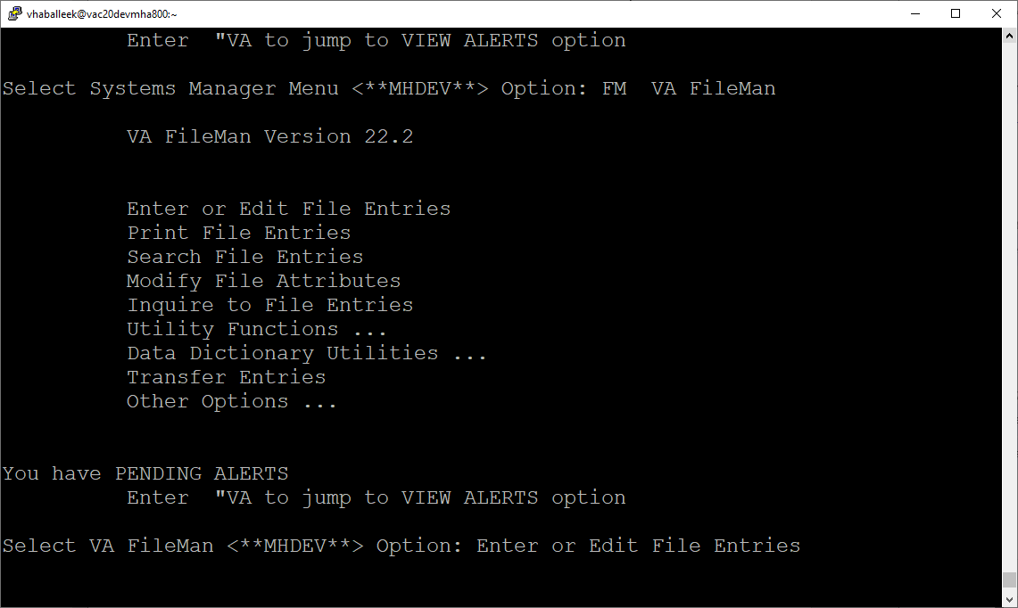

At the Input to what File: prompt enter MH TESTS AND SURVEYS
At the EDIT WHICH FIELD prompt enter:

OPERATIONAL
LAST EDIT DATE
LAST EDITED BY

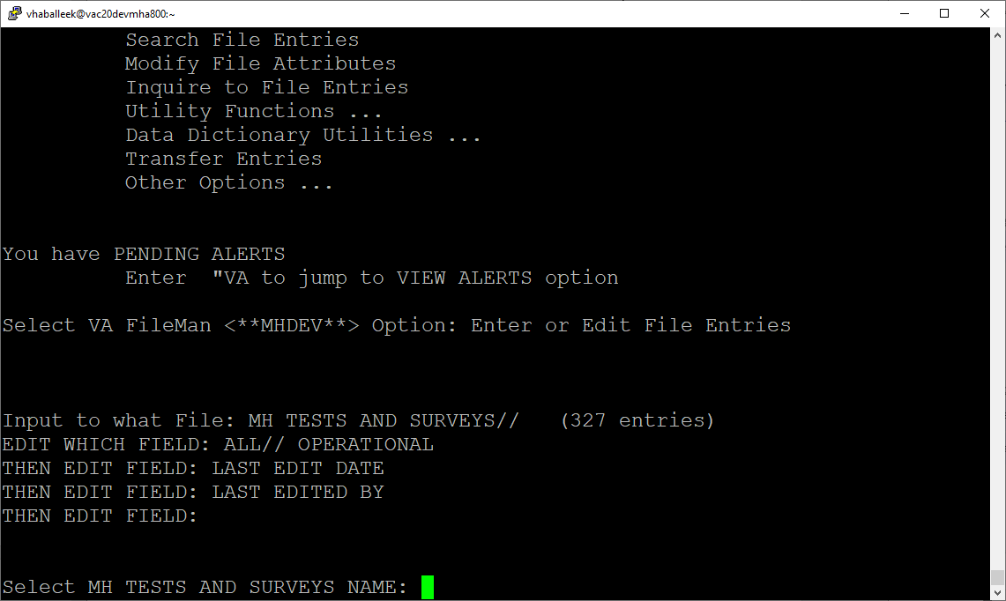

At the Select MH TESTS AND SURVEYS NAME: prompt enter MDQ
At the OPERATIONAL prompt enter DROPPED
At the LAST EDIT DATE prompt enter N for NOW
At the LAST EDITED BY prompt enter your name.

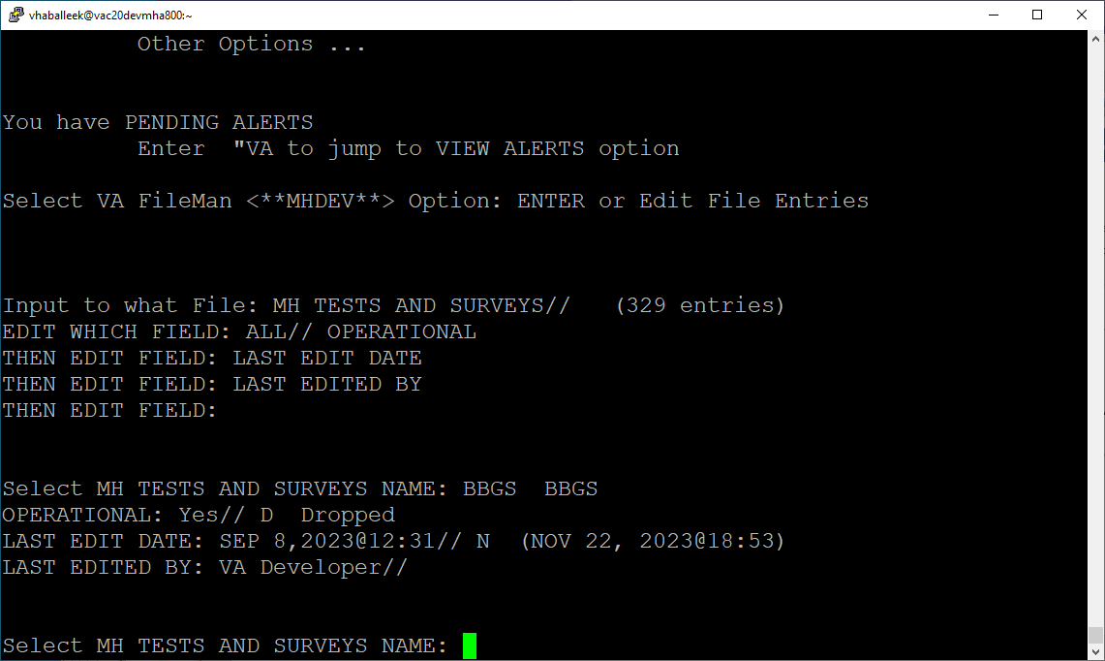

Repeat this process for the G-SAS, SDSQ, SODU, and MIOS+B-IPF_V2 instruments.

Reactivate
- MIOS+B-IPF
At the Select MH TESTS AND SURVEYS NAME: prompt enter MIOS+B-IPF
At the OPERATIONAL prompt enter YES
At the LAST EDIT DATE prompt enter N for NOW
At the LAST EDITED BY prompt enter your name.
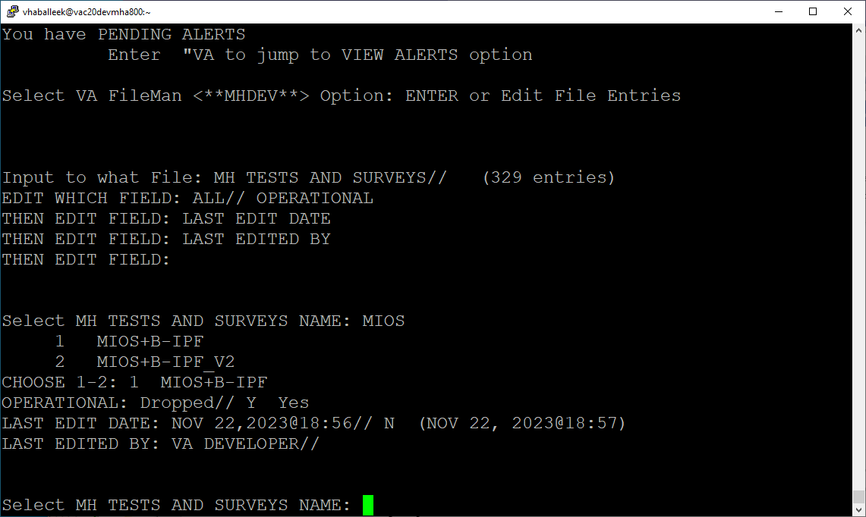
Log out as usual.
All other file updates may remain without rolling back.

Rollback Verification Procedure\
`
Go to CPRS and log in. Go to the Tools Menu and launch MHA. Click on the plus sign to create a new Assignment. Click on View All Instruments to see the full instrument list. Verify that the BBGS, G-SAS, SDSQ, SODU, and MIOS+B-IPF_V2 instruments do not appear and that the MIOS+B-IPF instrument appears.

Appendix A – Acronyms
Table 2: Acronyms
Acronym | Definition
AIMS | Abnormal Involuntary Movement Scale
ATQ | Automatic Thoughts Questionnaire
BBGS | Brief Biosocial Gambling Screen
BPRS | Brief Psychiatric Rating Scale
BAM-C-CBT-SUD | Brief Addiction Monitor - Consumption Items
BAM-IOP-CSG-SUD | Brief Addiction Monitor - IOP version
BAM-R-CSG-SUD | Brief Addiction Monitor - Revised
BUSS | Buss-Durke Hostility Inventory
CAGE | CAGE Alcohol Screening Tool
CASE MIX | Case Mix & Budget Tool
CESD | Center for Epidemiologic Studies Depression Scale
CMAI | Cohen-Mansfield Agitation Inventory
CPRS | Computerized Patient Record System
ERS | Employment Readiness Scale
G-SAS | Gambling Symptom Assessment Scale
GDS | Geriatric Depression Scale
IOC | Initial Operating Capability
KIDS | Kernel Installation and Distribution System
MH | Mental Health
MHA | Mental Health Assistant
MHLA | Multidimensional Health Locus of Control: Form A
MHLB | Multidimensional Health Locus of Control: Form B
MISS | Mississippi Scale
MMPI2 | Minnesota Multiphasic Personality Inventory 2
MIOS+B-IPF_V2 | Moral Injury Outcome Scale and Brief Inventory of Psychological Functioning V2
OIT | Office of Information and Technology
PAI | Personality Assessment Inventory
PIV | Personal Identity Verification
SF36 | SF-36 Health Survey
SPP | Suicide Prevention Package
SDSQ | Single Drug Screening Question
SODU | Screen of Drug Use
SQA | Software Quality Assurance
STAI | State-Trait Anxiety Inventory
VA | Department of Veterans Affairs
VAMC | Veterans Affairs Medical Center
VistA | Veterans Health Information System and Technology Architecture

