MENTAL HEALTH ASSISTANT

VERSION 3 (MHA3)

Patch YS*5.01*105

Installation Guide



Version 1.0

**September 2013**

**Revision History**

|  |  |  |  |
| --- | --- | --- | --- |
| Date | Revision | Description | Author(s) |
| 9/13/13 | 0.8 | Adding updated screens for MHA3 install and removing some of MHA3 install steps that do not apply to Windows 7. | REDACTED |
| 9/6/13 | 0.7 | Added REDACTED comments from SQA review. Add YS*5.01*83 as a patch to be installed prior to YS*105 (p8). Added info for Window 7 users to use Drive:\Program Files (x86)\Vista\YS\MHA as the directory to install program. (p13). Client: GUI Software Installation section, removed “Windows XP” and just referenced “Windows”. | REDACTED |
| 7/15/13 | 0.6 | Peer review comments incorporated, editing review. Added note and example to Client: GUI Software Installation section. Added note to Non-M Software Distributed with Mental Health Assistant 3 (MHA3)Section. | REDACTED |
| 2/14/2013 | 0.5 | Removed Technical Manual reference from Software and Documentation Retrieval Information section, added deleted routine to Routine Summary section. | REDACTED |
| 6/25/2012 | 0.4 | Removed Patch 96 from Required Patches. | REDACTED |
| 6/5/2012 | 0.3 | Changed GUI version to 1.0.3.60; added version check section; enhanced installation instructions; minor grammatical edits; deleted preinstallation text | REDACTED |
| 5/30/2012 | 0.2 | Added Alt Text to screenshots for 508 compliance | REDACTED |
| 4/26/2012 | 0.1 | Initial draft | REDACTED |

Table of Contents

Preface 1

Section 508 of the Rehabilitation Act 1

Test Sites 1

Software and Documentation Retrieval Information 2

MHA3 Documentation Website Locations 2

VistA Documentation Library (VDL): 2

Anonymous Software Directory 2

MHA3 Software and Documentation Files Retrieval Formats 3

Introduction 4

Security Information 4

Security Management 4

Security Features: 4

Remote Systems: 5

Archiving/Purging: 5

Contingency Planning: 5

Interfacing: 5

Electronic Signatures: 5

Menus 5

Security Keys 5

File Security: 6

References: 6

Official Policies: 6

Recommended Users: 7

Information Resources Management (IRM) Staff 7

Clinicians 7

Windows Conventions 7

VistA Operating System 7

VistA Operating System Performance Capacity 7

MHA3 Software Application Installation Time 7

Users on the System 7

Kernel Installation and Distribution System (KIDS) 7

Namespace 7

MHA3 Software Application Requirements 8

Required Patch 8

MHA3 Menu/Options Changes 8

YS Broker1 [YS BROKER1] Option 8

Routine Summary 8

Version Check 9

Installation Instructions 10

Server: 10

Client: GUI Software Installation 11

Mental Health Assistant Installation, Windows Illustrations 12

Installing Mental Health Assistant on your Computer 12

Choose Destination Location 13

Folder Does Not Exist 14

Select Start Menu Folder 15

Select Additional Tasks 16

Installing Mental Health Assistant 3 18

Completing the Mental Health Assistant 3 Setup Wizard 19

Non-M Software Distributed with Mental Health Assistant 3 (MHA3) 19

Post Installation Instructions 21

Uninstalling MHA3 21

Installing SecureDesktop Functionality in MHA3 22

SecureDesktop & Screen Pass: How to correct Windows-Registry problems. 32

SecureDesktop: How to correct dwlGina2.dll problems. 32

Setting up VistA MHA3 on CPRS GUI Tools Menu 33

Setting up VistA so that individual MHA3 assessments are also listed on the CPRS GUI Tools Menu 35

# Preface

The Veterans Health Information Systems and Architecture (VistA) Mental Health Assistant Version 3 (MHA3) Installation Guide Patch YS*5.01*105 provides detailed instructions and requirements for installing and implementing the Graphical User Interface (GUI) software application.

## Section 508 of the Rehabilitation Act

**NOTE:** The Veterans Health Administration (VHA) fully supports Section 508 of The Rehabilitation Act and is committed to equal access for all users. While every effort has been made to ensure Section 508 compliance, we realize that there may be other issues. If you have questions or would like to see a copy of the Compliance Action Plan for future releases, please contact:

REDACTED

Mental Health Enhancements

Product Development

Project Management Team 5

## Test Sites

VistA MHA3 Patch YS*5.01*105 has been tested by the following Veteran Affairs Medical Centers (VAMCs) and Healthcare Network Systems (HCS):

|  |  |  |
| --- | --- | --- |
| **Test Sites/Integrated** | **Operating System Platform** | **Test Site Size** |
| REDACTED | Cache/VMS | Large/Integrated |
| REDACTED | Cache/VMS | Large |
| REDACTED | Cache/VMS | Large/Integrated |

# Software and Documentation Retrieval Information

## MHA3 Documentation Website Locations

VistA MHA3 Installation Guide (YS501105_MHA3_IG.pdf and YS501105_MHA3_IG.docx), User Manual (YS501105_MHA3_UM.pdf and YS501105_MHA3_UM.docx) and Release Notes (YS501105_MHA3_RN.pdf and YS501105_MHA3_RN.docx) are available in MS Word Format (docx) and Portable Document Format (pdf) at the following Website location:

### VistA Documentation Library (VDL):

<http://www.va.gov/vdl/>

### Anonymous Software Directory

Office of Information Field Offices (OIFOs) ANONYMOUS SOFTWARE directory File Transfer Protocol (FTP) addresses listed below:

**NOTE:** All sites are encouraged to use the File Transfer Protocol (FTP) capability. Use the FTP address “download.vista.med.va.gov” (without the quotes) to connect to the first available FTP server where the files are located.

|  |  |  |
| --- | --- | --- |
| **OIFOs** | **FTP ADDRESS** | **DIRECTORY** |
| REDACTED | REDACTED | REDACTED |
|  |  |  |
| REDACTED | REDACTED | REDACTED |
|  |  |  |
| REDACTED | REDACTED | REDACTED |

### MHA3 Software and Documentation Files Retrieval Formats

MHA3 Patch YS*5.01*105 exports the following folders and files:

|  |  |  |
| --- | --- | --- |
| **FILE NAMES** | **CONTENTS** | **RETRIEVAL FORMATS** |
| YS_501_105.ZIP | Include all software and manuals for patch YS*5.01*105 | BINARY |
| YS_501_105.KID | MHA Server Components | ASCII |
| YS_501_105_SETUP.exe | Mental Health Assistant  **YS_MHA.exe**  **YS_MHA_A.dll**  **YS_MHA_AUX.dll**  **borlndmm.dll** | BINARY  This file is the complete install for the Mental Health Assistant GUI Version 1.0.3.66, client. |
| YS_MHA.exe | MHA3 Executable  1.0.3.66  5/28/2013 3:01pm | BINARY |
| YS_MHA_A.dll | DLL interface to Clinical Reminders functions in CPRS. This DLL is deployed to C:\Program Files\vista\Common Files  1.0.3.60  5/28/2013 3:01pm | BINARY |
| YS_MHA_AUX.dll | Required by YS_MHA_A.DLL and  YS_MHA.exe. This DLL is deployed to C:\Program Files\vista\Common Files  1.0.3.2  5/28/2013 3:01pm | BINARY  DLL used by MHA3 for scoring complex instruments. |
| YS501105_MHA3_IG.pdf | Mental Health Assistant Version 3 (MHA3) Installation Guide Patch YS*5.01*105 | BINARY |
| YS501105_MHA3_IG.docx | Mental Health Assistant Version 3 (MHA3) Installation Guide Patch YS*5.01*105 | BINARY |
| YS501105_MHA3_UM.pdf | Mental Health Assistant Version 3 (MHA3) User Manual Patch YS*5.01*105 | BINARY |
| YS501105_MHA3_UM.docx | Mental Health Assistant Version 3 (MHA3) User Manual Patch YS*5.01*105 | BINARY |
| YS501105_MHA3_RN.pdf | Mental Health Assistant Version 3 (MHA3) Release Notes Patch YS*5.01*105 | BINARY |
| YS501105_MHA3_RN.doc | Mental Health Assistant Version 3 (MHA3) Patch Release Notes | BINARY |
| Borlndmm.dll | DLL used by Delphi applications. Installed in same directory as YS_MHA.exe.  10.0.2288.42451 | BINARY |
| YS50185_SD_SETUP_1_0_2_77.EXE;1 | REDACTED | BINARY |

# Introduction

The Veterans Health Information System and Technology Architecture (VistA) Mental Health Assistant (MHA) is the graphical user interface (GUI) for the VistA Mental Health Package (MHP). MHA was developed to create an effective and efficient tool for clinicians (not just mental health clinicians) and their patients to use for the administration and scoring of assessment instruments and interviews. Additionally, results are displayed in report and graphical formats. MHA and MHP support mental health assessments (e.g., psychological testing, structured interviews, questionnaires, etc.) that are not available elsewhere in the Computerized Patient Record System (CPRS)/VistA. MHA has enjoyed widespread usage among mental health clinicians over the past several years, and the current revisions of MHA and MHP initiate steps toward re-engineering VistA Mental Health functionality.

To better meet the needs of clinicians and patients in different programs, particularly non-traditional settings, MHA can now run in a standalone mode to administer instruments offline for later uploading to VistA.

# Security Information

This section addresses any unique legal requirements and responsibilities pertaining to the Mental Health Assistant Version 3, software application and necessary security measures to protect the integrity of the software and its data.

## Security Management

There are no unique legal requirements pertaining to Mental Health Assistant software application with the exception that some of the psychological tests are copyrighted. Copyrighted tests are used by permission of the copyright holders. Use of these tests must be consistent with contracts between VHA and copyright holders.

### Security Features:

#### SecureDesktop

SecureDesktop is a set of security features intended to prevent unattended patients taking on-line tests from using the Personal Computer (PC) for other purposes. The SecureDesktop features construct a screen to cover the entire PC desktop. Non-alphanumeric keys are trapped to keep the patient from using the task bar and operating system functions (such as Task Manager). The Patient Entry button on the Instrument Administrator form is the only instrument data entry method that activates the SecureDesktop features. The **Patient Entry button** should **only** be used for the on-line patient administration of data entry of forms, instruments and surveys. The SecureDesktop security features **cannot** be defeated once the Patient Entry button becomes active. Excessive non-alphanumeric keystrokes are interpreted as “hacking” efforts and MHA is terminated. At the conclusion of the patient’s data entry session, MHA is terminated. Upon termination of the Windows session the user is logged off and the PC is shut down, which means that the user has to enter their network username and password to log back on to the desktop.

#### Alerts

Alerts are not required for this release.

### Remote Systems:

All Global Assessment of Functioning (GAF) scores entered through the Mental Health Assistant GAF form are dynamically sent to the National Patient Care Database (NPCD) at the Austin Automation Center (AAC).

### Archiving/Purging:

MHA3 software does not include archiving and/or purging capabilities.

### Contingency Planning:

Each facility using the MHA software application **must** develop a local contingency plan to be used in the event of application problems in a live environment. The facility contingency plan **must** identify procedures used for maintaining the functionality provided by the software in the event of a system outage.

### Interfacing:

The non-menu option, YS BROKER1 [YS BROKER1] contains the context necessary to interface MHA Version 3, software application to the **V***ist***A** database.

### Electronic Signatures:

MHA Version 3, Addiction Severity Index (ASI) software component utilizes the electronic signature functionality.

### Menus

MHA3 software does not contain any menu options of particular interest to Information Security Officers (ISOs).

### Security Keys

MHA3, software application did not release any new security keys. However, the YSP security key is required to control access to the results of “non-exempt” tests. Holders of the YSP security key are controlled (i.e., given out by the Chief of Psychology or a senior psychologist at a facility that does not have a Chief of Psychology). The Chief of Psychology or senior psychologist also determines which tests are “exempt” (i.e., the results can be seen by anyone), and which are “non-exempt” (i.e., require the YSP key to see the results).

### File Security:

There is no file security associated with the release of MHA Version 3 software application.

### References:

Kernel V. 8.0 Systems Manual

### Official Policies:

There is no official policy unique to the MHA Version 3 software application regarding the modification of the software and distribution of the product.

## Recommended Users:

### Information Resources Management (IRM) Staff

IRM staff is recommended for installing and supporting MHA3, Patch YS*5.01*105 requirements.

### Clinicians

It is recommended that clinicians enter the patient demographics data and define the interviews parameters. Any user who would normally use CPRS should also have access to MHA.

## Windows Conventions

MHA3 software application uses a Graphical User Interface (GUI) for the startup, setup, and assignment functions.

## VistA Operating System

Mental Health V. 5.01 Package currently runs on the standard hardware platforms used by the Department of Veterans Affairs Health Care System facilities. These systems consist of standard or upgraded Alpha AXP clusters, and run either Cache-VMS or Cache-NT and the Open M product.

## VistA Operating System Performance Capacity

There are no significant changes in the performance capacity of the VistA operating system once the Mental Health Assistant Version 3 Patch YS*5.01*105 is installed. The software application should not create any appreciable global growth or network transmission problems. There are no memory constraints.

## MHA3 Software Application Installation Time

MHA3 Patch YS*5.01*105 installation time takes at least 10 minutes during off peak hours.

## Users on the System

MHA users may remain on the system. However, installation of Patch YS*5.01*105 should be done during off peak hours.

## Kernel Installation and Distribution System (KIDS)

Mental Health Assistant Version 3 Patch YS*5.01*105 distribution is using KIDS.

## Namespace

Mental Health Assistant Version 3 Patch YS*5.01*105 namespace is YS and YT.

## 

## MHA3 Software Application Requirements

The following software applications **MUST** be installed prior to installing MHA3 Patch YS*5.01*105:

|  |  |
| --- | --- |
| **SOFTWARE APPLICATIONS** | **VERSIONS** |
| Kernel | 8.0 |
| VA FileMan | 22.0 |
| Mailman | 8.0 |
| RPC Broker | 1.1 |
| Toolkit | 7.3 |
| Mental Health | 5.01 |
| CPRS | 28 (or later) |
| Text Integration Utility | 1.0 |
| Consult/Request Tracking | 3.0 |

## Required Patch

The following patch **MUST** be installed prior to installing MHA3 Patch YS*5.01*105:

S**oftware Applications Patch**

Mental Health V. 5.01 YS*5.01*103

Mental Health V. 5.01 YS*5.01*83

## MHA3 Menu/Options Changes

### YS Broker1 [YS BROKER1] Option

The non-menu option, YS BROKER1 [YS BROKER1] contains the context necessary to interface the **V***ist***A** Mental Health Assistant Version 3 software application to the VistA database.

## Routine Summary

MHA3 Patch YS*5.01*105 exports the following VistA Mental Health routines:

YS105PRE

YTMBMD

YTMBMD1

YTMBD2

MHA3 Patch YS*5.01*105 deletes the following VistA Mental Health routines:

YSGAF3

YSKFASI3

YSKFASIK

YSKFASIP

## Version Check

MHA3 uses a Dynamic Link Library (DLL) file to verify, score and create reports for some instruments. The DLL is YS_MHA_AUX.dll. Starting with the release of Patch YS*5.01*105, MHA3 will verify that the proper YS_MHA_AUX.dll is installed and available for use. If the DLL is outdated, or not present, the user will be notified and in some instances, MHA will not continue.

The MENU TEXT field (#1) of the YS BROKER1 option in OPTION file (#19) is re-named. This change is important because the version numbers listed in the MENU TEXT value are used by the MHA GUIs to determine if the GUI invoked by the user is current.

  Before patch: YS BROKER1 version 1.0.3.45~1.0.3.45~1.0.3.45

After patch: YS BROKER1 version 1.0.3.60~1.0.3.60~1.0.3.60

# Installation Instructions

**NOTE:** VistA Mental Health Assistant Patch YS*5.01*105 uses the Kernel Installation and Distribution System (KIDS). For further instructions on using KIDS, please refer to the Kernel V. 8.0 Systems Manual.

## Server:

**NOTE:** This patch should be installed during ‘OFF PEAK’ hours when few or no users are on the system. Installation of the patch will take less than 10 minutes.

**IMPORTANT:** The directory where you will install your files will vary depending on which Windows Operating System (OS) you are running.

For example:

If you are running Windows 7 the Program Files folder will be:  C:\Program Files (x86)\...

If you are running a prior version it will be: C:\Program Files\...

1. Use the ‘LOAD A DISTRIBUTION’ option on the PackMan menu. The Host File name is YS_501_105.KID. Answer YES to the question: “Want to Continue with Load? YES??”
2. The patch has now been loaded into a Transport global on your system. You now need to install the Transport global. [Optional] On the KIDS menu, under the ‘Installation’ menu, use the following options:

Print Transport Global

Compare Transport Global to Current System

Verify Checksums in Transport Global

Backup a Transport Global

1. Users may remain on the system, but installation should be done at off peak hours.
2. Installation will take less than ten minutes.
3. From the ‘Installation Menu’ of the KIDS menu, run the option ‘Install Package(s)’ Select the package ‘YS*5.01*105’ and proceed with the installation.
4. Want KIDS to Rebuild Menu Trees Upon Completion of Install? NO//

Please answer according to your site's policy.

When prompted 'Want KIDS to INHIBIT LOGONs during the install//', respond NO.

When prompted 'Want to DISABLE Scheduled Options, Menu Options, and Protocols? YES//', respond YES

Place the following options out of order:

YS BROKER1

1. Please refer to the INSTALL WINDOWS ILLUSTRATION section of the MENTAL HEALTH ASSISTANT VERSION 3 INSTALLATION GUIDE to install the MHA graphical user interface files.
2. Ensure that the option YS BROKER1 [YS BROKER1] is on the Mental Health user's secondary menu, if it is not already there.
3. Place the MHA3 application on the CPRS Tools menu, if it is not already there. For instructions on how to add the MHA3 application to the CPRS Tools menu, see the “Setting up VistA MHA3 on CPRS GUI Tools Menu” section in the Installation Guide.

10. Delete the YS105PRE routine when the installation is complete.

## Client: GUI Software Installation

**NOTE:** This version of the client software must be installed as a **new** installation.

**IRM Staff:**

**NOTE:** USERS installing SecureDesktop software on a Windows environment **must** have Administrator privileges on the PC Workstation platform.

1. Copy the YS_501_105_SETUP.exe to temporary (or scratch) directory.

2. Run the YS_501_105_SETUP.exe file (i.e., double click on it). This starts the MHA3, installation process. (See the Mental Health Assistant Install Windows Illustrations section on the following pages).

3. If the optional SecureDesktop functionality is desired, be sure to first install MHA3 using YS_501_105_SETUP.EXE file and then run the file named YS50185_SD_SETUP_1_0_2_77.exe (Released with Patch YS*5.01*85).

As an alternate method of installing the software, ensure that the YS_MHA.exe and borlndmm.dll files are placed in the C:\Program Files\Vista\YS\MHA3 directory (workstation or application server). The two files YS_MHA_A.dll and YS_MHA_AUX.dll must be placed in the C:\Program Files\Vista\Common Files on the workstations of all users.

**IMPORTANT: VA policy requires that the two files YS_MHA_A.dll and YS_MHA_AUX.dll be placed in the C:\Program Files\Vista\Common Files on the workstation of all users.**

### Mental Health Assistant Installation, Windows Illustrations

The following illustrates the **Mental Health Assistant Setup windows**. When the default responses are accepted, MHA3 is installed into the appropriate **V***ist***A** directory on the user’s workstation.

### Installing Mental Health Assistant on your Computer

Double click on YS_501_105_Setup.exe

**Example:** From the **Mental Health Assistant Welcome** dialog box, **click** on the **Next** command button (located at the bottom of the window) to continue with the installation. The **Choose Destination Location** dialog box will appear.

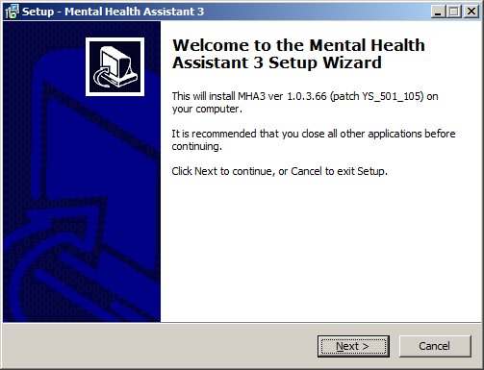

Choose Destination Location

**Example**: The **Choose Destination Location** dialog box text asks “Which directory do you want to install this program into? We strongly recommend that, while the drive may be modified, the default directory structure be used (Drive:\Program Files (x86)\Vista\YS\MHA).

To install to the directory displayed below, click on the Next button.

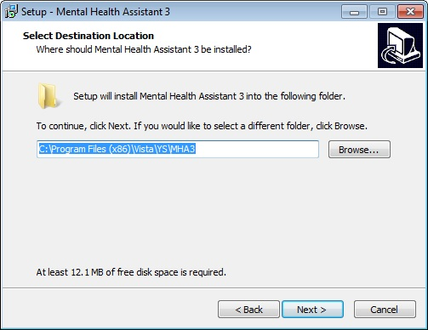

To install to a different directory, click **Browse** and select another directory.

**Note**: If you are using a WIN XP machine, your directory will look like the following: C:\Program Files\Vista\YS\MHA3

Select Start Menu Folder

**Example**: The **Select Start Menu Folder** dialog box text asks “Where should Setup place the program’s shortcuts? We strongly recommend that the program’s shortcuts be placed in the Start Menu Folder.

To install to the Mental Health Assistant 3 folder, click Next.

To install to a different folder, click Browse and select another directory.

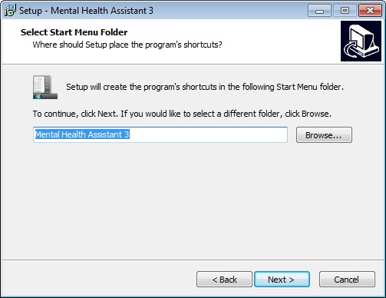

Select Additional Tasks

**Example**: Which additional tasks should be performed?

To install desktop icon, check the box.

To install quick launch, check the box.

Click **Next**.

Ready to Install

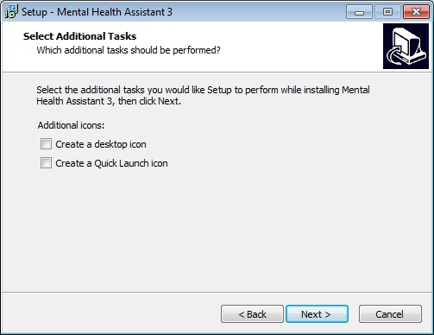

**Example**: The **Ready to Install** dialog box text states “Setup is now ready to begin installing Mental Health Assistant 3 on your computer. Click Install to continue with the installation, or click Back if you want to review or change any settings. Destination location: C:\Program Files\(x86)\Vista\YS\MHA3. Start Menu folder: Mental Health Assistant 3.

To continue the setup, Click Install.

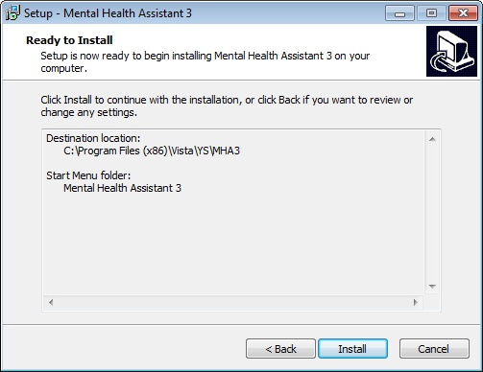

### Installing Mental Health Assistant 3

**Example**: The **Mental Health Assistant 3** **Installing** dialog box text states “Please wait while Setup installs Mental Health Assistant 3 on your computer.”

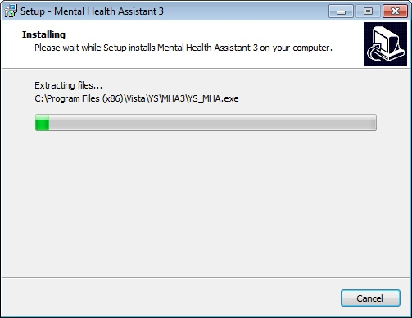

### Completing the Mental Health Assistant 3 Setup Wizard

**Click** on the **Finish command button** (located within the Setup - Mental Health Assistant 3 dialog box bottom right side) to exit Setup.

**Example:** The **Setup** - **Mental Health Assistant 3** dialog box text displays “Setup has finished installing Mental Health Assistant 3 on your computer. The application may be launched by selecting the installed icons.”

The first time “Instrument Administrator” is launched, it may take a couple of minutes to load all of the instruments. Subsequent launches of “Instrument Administrator” should be much quicker.

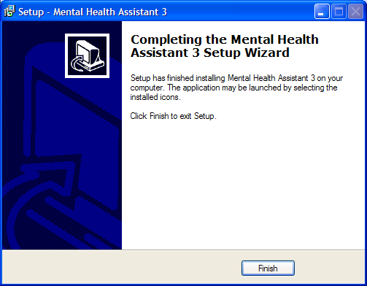

### Non-M Software Distributed with Mental Health Assistant 3 (MHA3)

Please refer to the [MHA3 Technical Manual and Security Guide](http://www.va.gov/vdl/application.asp?appid=78) for additional information.

**Examples:** A typical MHA3 file tree after installing MHA3:

**C:\Program Files\(x86)\Vista\YS\MHA3**

YS_MHA.exe

YS_MHA.HLP (From Patch YS*5.01*85)

YS_MHA.JCF (From Patch YS*5.01*85)

Borlndmm.dll

Unins000.dat  
 unins000.exe

C:\Program Files\(x86)\Vista\YS\MHA3

YS_MHA_A.dll  
YS_MHA_AUX.dll

**C:\Documents and Settings\VHAXXXCliniJ.VHAXX\Application Data\MHA3** is an example path. The actual path will vary with the current user’s configuration.

**C:\Documents and Settings\VHAXXXCliniJ.VHAXX\Application Data\MHA3\Answer Files**

This is usually empty, unless there are off-line records that haven’t been uploaded to VistA yet. Example filename: 2~3050623-134647~AUDIT.rsc.

**IMPORTANT**: the location of the answer and instrument files depends on whether your workstation is running Windows XP or Windows 7.

For Windows 7, the directory paths are:

 1) C:\Users\_username_\AppData\Roaming\MHA3\Instrument Files

  2) C:\Users\_username_\AppData\Roaming\MHA3\Answer Files

**C:\Documents and Settings\VHAXXXCliniJ.VHAXX\Application Data\MHA3\ Instrument Files**

Usually, there are many files in this folder; all of them are instrument definition files. Example filename: AUDIT~3040624.rsc.

**Example:** Files added to the MHA3 file tree after installing the optional SecureDesktop software from Patch YS*5.01*85, YS50185_SD_SETUP_1_0_2_77.exe.

**c:\Program Files\(x86)\Vista\YS\MHA3**

YS_MHA_SD_INSTALLGINA.exe

YS_MHA_SD_UNINSTALLGINA.exe

YS_MHA_VASD.exe

C:\Windows\System32

dwlGina2.dll

# Post Installation Instructions

## Uninstalling MHA3

1. Click on the **Start Button.**
2. Select **All Programs.**
3. Find the **Mental Health Assistant 3** icon group.
4. Select **Uninstall Mental Health Assistant**, as shown below.

**Example:** MHA3 menu entries on the Windows Start menu. Click on the Uninstall Mental Health Assistant entry.



**Example:** Confirmation screen to remove Mental Health Assistant 3. Click on Yes.

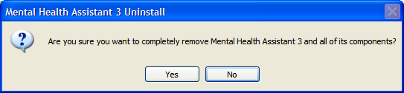

**Example:** Confirmation screen to that Mental Health Assistant 3 has been uninstalled. Click on the Ok button. MHA3 is now uninstalled.

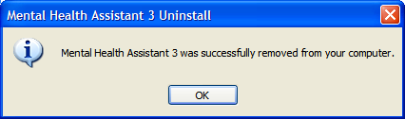

# Installing SecureDesktop Functionality in MHA3

The optional Patient-Entry functions built into MHA3 are disabled by default and by design, and should only be enabled if there is a need to use MHA3 for patient-self-administered assessments. If SecureDesktop is installed, it must be installed after MHA3 is installed.

**NOTE:** Only users with Windows Administrator Privileges are able to install or uninstall SecureDesktop.

SecureDesktop files are installed or uninstalled using a separate setup file than the one for installing MHA3. All the files necessary to use SecureDesktop are bundled in a single setup file. The SecureDesktop files MUST be installed to the same folder as the one containing the main MHA3 file (YS_MHA.exe)—this is why MHA3 must be installed first.

**NOTE:** MHA3 requires a custom version of SecureDesktop, which is distributed along with MHA3. No other distributions of SecureDesktop will work with MHA3 at this time.

**PRIOR to installing the Secure Desktop**, the **Patient Entry** button on MHA3’s **Instrument Administrator** form is disabled, and these functions are not available to the user.

**Example:** To start the installation process, execute the file named YS50185_SD_SETUP_1_0_2_77.exe. This is available on the Office of Information Field Offices (OIFOs) ANONYMOUS SOFTWARE_ARCHIVE directory FTP sites. Download as a binary type of file.

This action will display the following **Setup – SecureDesktop for** **Mental Health Assistant 3** screen. Click on the **Next** button to continue the installation process.

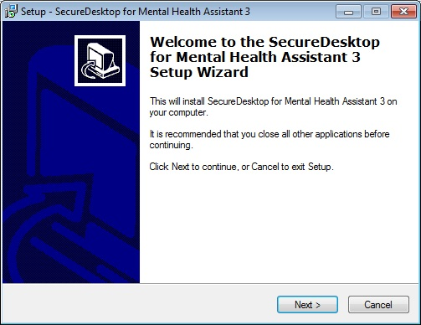

**NOTE:** SecureDesktop **must** be installed to the same folder where MHA3 was installed.

**Example:** Folder selection screen. Click on the **Next** button.

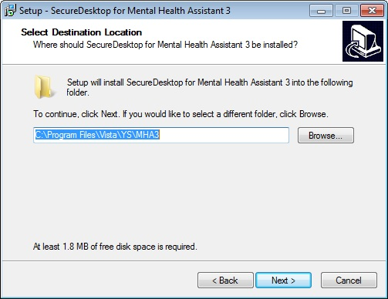

**Example:** Folder Exists screen. If MHA3 is already installed—as recommended, the **Folder Exists** confirmation dialog is shown. Click on the Yes button to install to that folder.

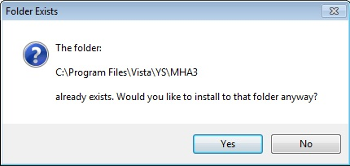

**Example: Select Start Menu Folder** screen. To continue creating the program’s shortcuts in the **Start Menu Folder** - click on the **Next** button.



**Example: Setup** screen. Click on the **Install** button to continue with installing SecureDesktop for Mental Health Assistant 3 on your computer.

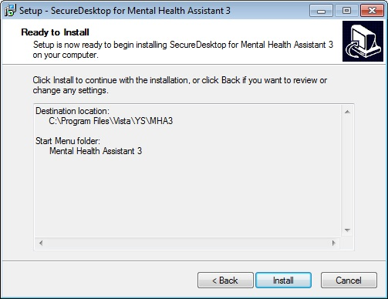

**Example:** **Installation** progress screen.

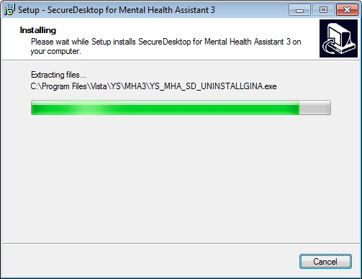

**NOTE:** Clicking on the **Finish** button will cause your computer to restart, so be sure to save any unsaved data before you click on Finish.

**Example: Restart** computer screen. Click Finish, to complete the installation procedure.

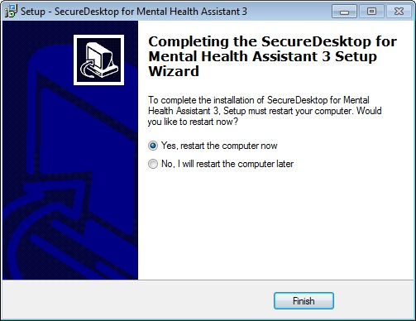

#### Note: If you are installing on Windows 7, your destination location will be the following:

C:\Program Files (x86)\Vista\YS\MHA

**Example: Before** installing SecureDesktop, the **Patient Entry** button on MHA3’s **Instrument Administrator** form is disabled, and these functions are not available to the user, as shown below.

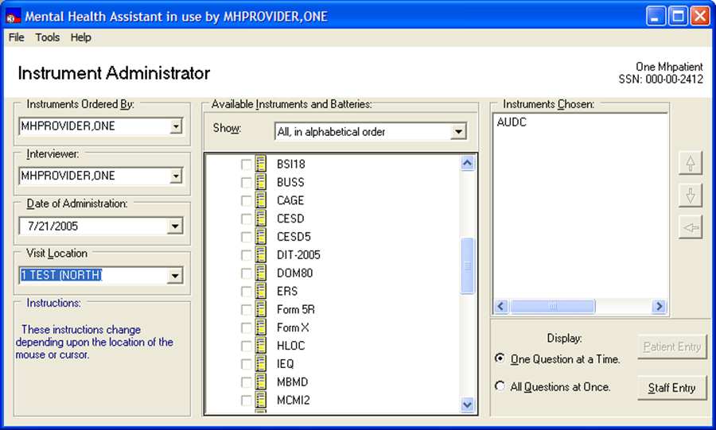

**Example: After** installing SecureDesktop, the **Patient Entry** button on MHA3’s Instrument Administrator form is enabled, and these functions become available to the user, as shown below. A test must also be selected in order to activate the Patient Entry button.

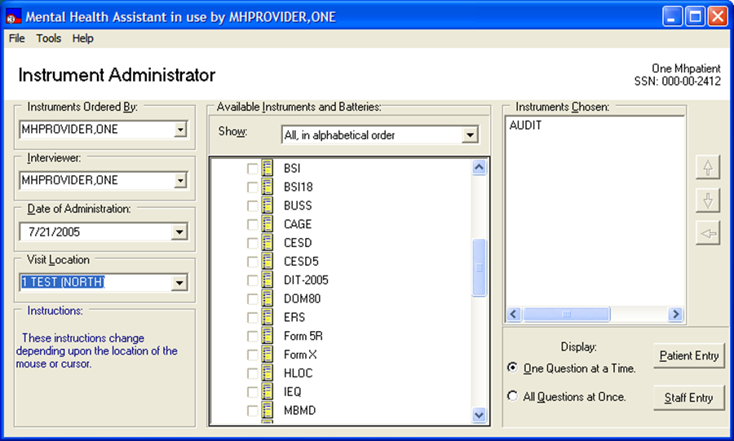

**NOTE:** These requirements **must** be met to activate SecureDesktop:

* MHA3 is properly installed on the LOCAL workstation (NOT a fileserver).
* The dwlGina2 DLL has been installed successfully. This is done automatically, when installing SecureDesktop.
* The PC was rebooted after installing SecureDesktop

#### Uninstalling SecureDeskstop

1. Click on the Start Button
2. Click on All Programs
3. Find the Mental Health Assistant 3 icon group
4. Click on the Uninstall SecureDesktop for MHA3 entry, as shown below.

**Example:** MHA3 menu entries on the Windows Start menu. Click on the Uninstall SecureDesktop for MHA3 entry.

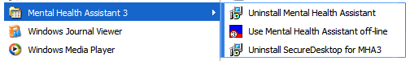

**Example:** Confirmation screen to remove SecureDesktop. Click on Yes.

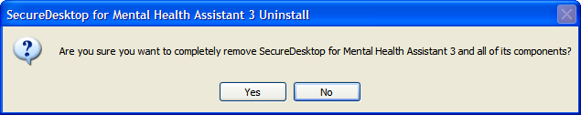

**Example:** Confirmation screen to **restart** computer. You must restart the computer after uninstalling SecureDesktop. Click on the Yes button. Be sure to save any unsaved data before you click on Yes. The **Patient-Entry** feature will no longer be available on MHA3.

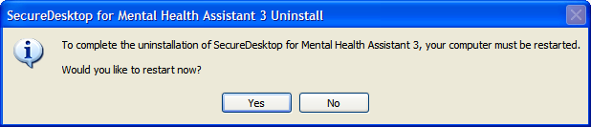

## SecureDesktop & Screen Pass: How to correct Windows-Registry problems.

According to the Birch Grove Software site:

“Screen Pass is a screen locking system for Windows® that extends the capability of the standard workstation lock and gives network administrators complete control over idle workstations.

With Screen Pass, network administrators can enforce screensaver password use, screensaver timeout, and screen saver selection. Advanced features include automatic logout, automatic shutdown, customizable administrator override, and auditing of all logon/logoff and lock/unlock events.

Intended primarily for workstations connected to Novell Netware or Microsoft networks, Screen Pass can be distributed and managed remotely with or without group policy. The central management feature makes Screen Pass ideal for small, medium, and large networks - anywhere that security of idle workstations is a concern.”

Screen Pass installs its own version of a gina.dll and it may take precedence over the one used by Secure Desktop. If SecureDesktop does operate properly these changes may be necessary in the Windows Registry:

HKEY_LOCAL_MACHINE\SOFTWARE\Microsoft\Windows NT\CurrentVersion\Winlogon\GinaDLL=dwlgina2.dll

HKEY_LOCAL_MACHINE\SOFTWARE\Microsoft\Windows NT\CurrentVersion\Winlogon\GinaDLL_ScreenPass=msgina2.dll

See Remedy Ticket # HD0000000278953.

## SecureDesktop: How to correct dwlGina2.dll problems.

A dwlGina2.dll error problem may occur when a non-administrator uninstalls MHA3 without an administrator first de-activating SecureDesktop.

Here is how to fix it:

1. Turn off defective PC, if on.

2. Start the PC and Windows in SAFE mode.

3. Logon as Administrator.

4. Find the media containing the YS_MHA_SD_UNINSTALLGINA.exe file. These files are typically found at C:\Program Files\Vista\YS\MHA3. Run YS_MHA_SD_UNINSTALLGINA.exe. Click Yes, to uninstall it.

5. Reboot in normal mode.

If this doesn’t work, then modify step five by first finding and running YS_MHA_SD_INSTALLGINA.exe. Click Yes, to install it. Then follow the remainder of step five.

# Setting up VistA MHA3 on CPRS GUI Tools Menu

**WARNING:** THIS STEP IS MANDATORY, TO COMPLETE THE VistA MHA3 INSTALLATION PROCESS.

This procedure configures VistA so that “Mental Health Assistant” appears as a choice on a user’s Tools menu on the CPRS desktop software. Unlike previous versions of MHA, where this was optional, Version 3 of VistA MHA MUST be started from the CPRS Tools Menu. Selecting this choice from the CPRS Tools menu will offer the user full MHA3 functionality, based on a user’s particular access permissions in VistA.

The basic steps for setting up VistA MHA3 on the Tools menu are no different from doing it for other applications. The main difference lies in how the Name=Command entry is formatted. The following text capture is taken from the CPRS Setup documentation, to serve as an example of how to perform this step for MHA3:

**Example:** Setting up VistA MHA3 on the CPRS Tools menu, GUI Parameters [ORW PARAM GUI]

Select GUI Parameters Option: **tm** **GUI<ENTER>** Tool Menu Items

CPRS GUI Tools Menu may be set for the following: **<ENTER>**

1 User USR [choose from NEW PERSON]

2 Location LOC [choose from HOSPITAL LOCATION]

3 Division DIV [REGION 5]

4 System SYS [OEX.ISC-SLC.VA.GOV]

Enter selection: **1<ENTER>** User NEW PERSON

Select NEW PERSON NAME: **MHPROVIDER,ONE <ENTER>**------------- Setting CPRS GUI Tools Menu for User: MHPROVIDER,ONE----------

Sequence: **? <ENTER>**

Enter the sequence in which this menu item should appear.

Select Sequence: **2**

Are you adding 2 as a new Sequence? Yes//**<ENTER>** **YES**

Sequence: 2// **<Enter>**

Name=Command: **Mental Health Assistant=C:\Progra~1\Vista\YS\MHA3\YS_MHA.exe s=%SRV p=%PORT c=%DFN u=%DUZ m=%MREF**

From the previous example, adjust according to your own system’s settings, such as New Person Name and other parameters—consult the CPRS Setup Guide for the meaning of these parameters. The pertinent portion of the example is the “Name=Command:” field. This field should be entered exactly as shown, in a single line—no line-breaks allowed, including all the % parameters that follow the filename and path to the MHA3 executable file.

The path shown represents a typical path used during a default installation. If your path is different, adjust accordingly. **ALL five parameters must be included as shown above, in the precise order in which they are found in the example.** Here is what the Name=Command line should look like:

Mental Health Assistant=C:\Progra~1\Vista\YS\MHA3\YS_MHA.exe s=%SRV p=%PORT c=%DFN u=%DUZ m=%MREF

Sequence number 2 is shown in the example, but, if you have other entries in the Tools Menu, then the next free sequence number will do just fine. (Sometimes when cutting and pasting, unseen control characters can be included in the text and will cause the command line to malfunction.)

After this step is completed, a new choice will appear in the user’s CPRS Tools Menu labeled “Mental Health Assistant”. Clicking on this menu entry will start MHA3 with a selected patient synchronized to the one currently selected in CPRS.

Refer to the Computerized Patient Record System (CPRS) Setup Guide for more information about this procedure.

## Setting up VistA so that individual MHA3 assessments are also listed on the CPRS GUI Tools Menu

**NOTE:** THIS STEP IS OPTIONAL

This procedure configures VistA so that you can add a variable number of individual, specific assessment-types choices, to the Tools menu in the CPRS GUI. This is in addition, or instead of, the Mental Health Assistant choice described above. This step is optional and will have no effect on the procedure described above.

The steps for setting up individual assessment types are identical to setting up MHA3, with one significant difference: The Name=Command line has one added parameter at the end of the parameter list. This parameter indicates the “code” name of the instrument to be added to the Tools menu. In this example, CAGE is added to the Tools menu. Here is what the Name=Command line should look like to add CAGE:

Mental Health Assistant=C:\Progra~1\Vista\YS\MHA3\YS_MHA.exe s=%SRV p=%PORT c=%DFN u=%DUZ m=%MREF CAGE

As above, this entire Name=Command line should be on one line—no carriage returns, and the next open sequence number on the menu will work fine.

**Example**: Two new entries on the CPRS Tools menu; Mental Health Assistant and CAGE (individual assessment type).

