Mental Health YS*5.01*174

Deployment, Installation, Back-Out, and Rollback Guide

May 2021
Version 1.0

Department of Veterans Affairs
Office of Information and Technology (OI&T)

Revision History

Date | Version | Description | Author
May 2021 | 1.0 | Initial Version | Liberty IT Solutions

Table of Contents

- Introduction 5
  - Purpose 5
  - Dependencies 5
  - Constraints 5
- Roles and Responsibilities 5
- Deployment 6
  - Timeline 6
  - Site Readiness Assessment 6
    - Deployment Topology (Targeted Architecture) 6
    - Site Information (Locations, Deployment Recipients) 6
    - Site Preparation 6
  - Resources 7
    - Facility Specifics (optional) 7
    - Hardware 7
    - Software 7
    - Communications 7
- Installation 7
  - Pre-installation and System Requirements 7
  - Platform Installation and Preparation 7
  - Access Requirements and Skills Needed for the Installation 7
  - Installation Procedure 7
  - Installation Verification Procedure 9
  - System Configuration 9
  - Database Tuning 9
- Back-Out Procedure 9
  - Back-Out Strategy 9
  - Back-Out Considerations 9
  - Back-Out Criteria 9
  - Back-Out Risks 10
  - Authority for Back-Out 10
  - Back-Out Procedure 10
  - Back-out Verification Procedure 10
- Rollback Procedure 11
  - Rollback Considerations 11
  - Rollback Criteria 11
  - Rollback Risks 11
  - Authority for Rollback 11
  - Rollback Procedure 11
  - Rollback Verification Procedure 11
Appendix A - Acronyms 11

List of Tables
Table 1: Deployment, Installation, Back-out, and Rollback Roles and Responsibilities 5
Table 2: Acronyms 12

List of Figures
Figure 1: Instrument Administrator 10

Introduction
This document describes how to deploy and install the patch YS*5.01*174 of the Mental Health package, as well as how to back-out the product and rollback to a previous version or data set.
This document is a companion to the project charter and management plan for this effort in this document.

Purpose
The purpose of this plan is to provide a single, common document that describes how, when, where, and to whom Mental Health patch YS*5.01*174 will be deployed and installed, as well as how it is to be backed out and rolled back, if necessary. The plan also identifies resources, communications plan, and rollout schedule. Specific instructions for installation, back-out, and rollback are included in this document.

Dependencies
It is assumed that this patch is being installed into a fully patched Veterans Health Information System and Technology Architecture (VistA) system.

Constraints
There are no constraints beyond the installation into an up-to-date VistA system.

Roles and Responsibilities
The following describes the roles and responsibilities associated with the testing and release of YS*5.01*174. This is a VistA patch that will be deployed via the normal Mailman route.
Table 1: Deployment, Installation, Back-out, and Rollback Roles and Responsibilities
Team | Phase / Role | Tasks | Project Phase (See Schedule)
Project Manager | Deployment | Determine and document the roles and responsibilities of those involved in the deployment. | Design
Software Quality Assurance (SQA), Test Sites | Deployment | Test for operational readiness | Test
Project Manager, Release Manager | Deployment | Execute deployment | Release
Individual VistA Sites | Installation | Plan and schedule installation | Release
Release Manager | Back-out | Confirm availability of back-out instructions and back-out strategy (what are the criteria that trigger a back-out) | Release
Sustainment Team | Post Deployment | Hardware, Software and System Support | Sustain

Deployment
The deployment is planned as a simultaneous (National Release) rollout. Once approval has been given to nationally release, YS*5.01*174 will be available for installation and deployment at all sites.
Scheduling of test installs, testing and production deployment will be at the site’s discretion. It is anticipated there will be a 30-day compliance period.

Timeline
The deployment and installation are scheduled to run during May 2021.

Site Readiness Assessment
This section discusses the locations that will receive the YS*5.01*174 deployment.

Deployment Topology (Targeted Architecture)
YS*5.01*174 will be deployed to each VistA instance. This includes local sites as well as regional data centers.

Site Information (Locations, Deployment Recipients)
The initial deployment will be to Initial Operating Capability (IOC) sites for verification of functionality. Once testing is completed and approval is given for national release, YS*5.01*174 will be deployed to all VistA systems.
The Production IOC testing sites are:
      - Clement J. Zablocki VAMC (Milwaukee, WI)
      - Orlando VAMC

Site Preparation
YS*5.01*174 requires a fully patched VistA system. In particular, YS*5.01*172 (New Instrument – Personal Health Inventory) should have been installed prior to the installation of YS*5.01*174.

Resources

Facility Specifics (optional)
No specific facility instructions needed.

Hardware
No hardware instructions needed.

Software
No software instructions needed.

Communications
When YS*5.01*174 is released, the released-patch notification will be sent from the National Patch Module to all personnel who have subscribed to notifications for the Mental Health package.

Installation

Pre-installation and System Requirements
There are no pre-installation requirements.

Platform Installation and Preparation
This patch can be loaded with users in the system. Installation time will be less than 5 minutes.
To ensure the integrity of the transport global, use the “Verify Checksums in Transport Global” to compare the checksums with the list that follows:
The checksums below are new checksums, and can be checked with CHECK1^XTSUMBLD. Routine Name: YS174PST Before: n/a After: B1729463 **174**
Routine Name: YTSCMIXG Before: n/a After: B34567569 **174**

Access Requirements and Skills Needed for the Installation
Installation of YS*5.01*174 requires access to KIDS options to be able to load and install the KIDS build.

Installation Procedure
This patch may be installed with users on the system although it is recommended that it be installed during non-peak hours to minimize potential disruption to users. This patch should take less than 5 minutes to install.
- Choose the PackMan message containing this build. Then select the INSTALL/CHECK MESSAGE PackMan option to load the build.
- From the Kernel Installation and Distribution System Menu, select the Installation Menu. From this menu:
  - Select the Verify Checksums in Transport Global option to confirm the integrity of the routines that are in the transport global. When prompted for the INSTALL NAME enter the patch or build name (YS*5.01*174).
  - Select the Backup a Transport Global option to create a backup message. You must use this option for each patch contained in the Host File. For each patch you can specify what to backup, the entire Build or just Routines. The backup message can be used to restore just the routines or everything that will restore your system to pre-patch condition.
  - You may also elect to use the following options:
    - Print Transport Global - This option will allow you to view the components of the KIDS build.
    - Compare Transport Global to Current System - This option will allow you to view all changes that will be made when this patch is installed. It compares all of the components of this patch, such as routines, DDs, templates, etc.
  - Select the Install Package(s) option and choose the patch to install (YS*5.01*174).
    - If prompted 'Want KIDS to Rebuild Menu Trees Upon Completion of Install? NO//', answer NO.
    - When prompted 'Want KIDS to INHIBIT LOGONs during the install? NO//', answer NO.
    - When prompted 'Want to DISABLE Scheduled Options, Menu Options, and Protocols? NO//', answer NO.

Installation Verification Procedure
This patch adds a new instrument, the Case Mix & Budget Tool (CASE MIX). You may verify installation by looking in the MH TESTS AND SURVEYS file (#601.71) for the CASE MIX entry:
VA FileMan 22.2

Select OPTION: INQUIRE TO FILE ENTRIES

Output from what File: REMOTE PROCEDURE// MH TESTS AND SURVEYS
(262 entries) Select MH TESTS AND SURVEYS NAME: CASE MIX CASE MIX
Another one:
Standard Captioned Output? Yes// (Yes)
Include COMPUTED fields: (N/Y/R/B): NO// - No record number (IEN), no Computed Fields

NAME: CASE MIX PRINT TITLE: Case Mix & Budget Tool
AUTHOR: VHA HCBS PUBLISHER: VHA PUBLICATION DATE: OCT 01, 2016 OPERATIONAL: Yes
etc. . . .

System Configuration
No system configuration required.

Database Tuning
No database tuning required.

Back-Out Procedure

Back-Out Strategy
This patch updates the Mental Health database with all new records that support the new CASE MIX instrument. The back-out procedure will leave these records in place, but inoperative since they pertain only to that instrument. If there is a compelling reason to back-out the new CASE MIX records themselves, you will need to contact the development team for a patch. The back- out procedure below will restore MHA to its state prior to the patch installation.

Back-Out Considerations
If the YS174* routines are removed, the CASE MIX will not score correctly.

Back-Out Criteria
A back-out should only be considered if there is a patient safety issue, if MHA no longer functions, or if there is some other catastrophic failure.

Back-Out Risks
The risks vary depending on what is causing the failure of the system. The main risk is that the CASE MIX instrument will be unavailable.

Authority for Back-Out
The VistA system manager determines if a back-out of YS*5.01*174 should be considered.

Back-Out Procedure
There are only new routines in YS*5.01*174, so there are no previous versions of routines to restore.
Disable the CASE MIX by editing the OPERATIONAL field (#10) and the LAST EDIT DATE field (#18) in the MH TESTS AND SURVEYS file (#601.71). Set OPERATIONAL to "Dropped" and set LAST EDIT DATE to "Now".

Back-out Verification Procedure
To verify the back-out procedure, run Mental Health Assistant (MHA), select Instrument Administrator, and verify that CASE MIX does not appear Available Instruments and Batteries list.
Figure 1: Instrument Administrator
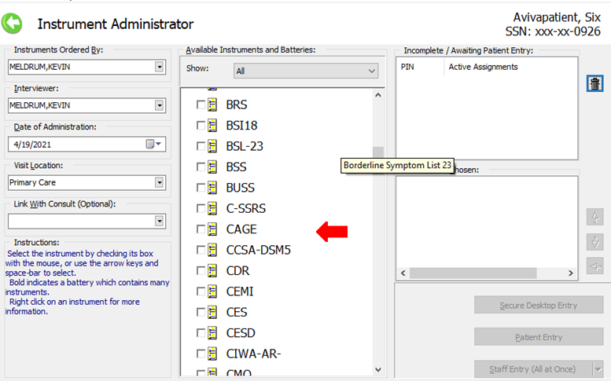

Rollback Procedure

Rollback Considerations
YS*5.01*174 only adds new routines and a new instrument. If the back-out instructions are completed, there is nothing to rollback.

Rollback Criteria
No rollback criteria.

Rollback Risks
No rollback risks.

Authority for Rollback
Authority for rollback not needed.

Rollback Procedure
No rollback procedure needed.

Rollback Verification Procedure
No rollback verification procedure needed.

Appendix A – Acronyms
Table 2: Acronyms
Acronym | Definition
CAG | Citrix Access Gateway
CD | Critical Decision
DIBRG | Deployment, Installation, Back-out, and Rollback Guide
IOC | Initial Operating Capability
KIDS | Kernel Installation and Distribution System
MHA | Mental Health Assistant
PIN | Personal Identification Number
PIV | Personal Identity Verification
SPP | Suicide Prevention Package
SQA | Software Quality Assurance
SSOi | Single Sign-On Integration
VA | Department of Veterans Affairs
VAMC | Veterans Affairs Medical Center
VIP | Veteran-focused Integration Process
VistA | Veterans Health Information System and Technology Architecture

