Multiple Sclerosis Surveillance Registry (MSSR) User Guide

Department of Veterans Affairs
Office of Information and Technology (OI&T)

Software Version 2.0
Original Software Release: August 2014 MSSR v2.0 Release: February 2016

User Guide Release: January 2016

Revision History
NOTE: The revision history cycle begins once changes or enhancements are requested after the document has been baselined.

Date | Revision | Description | Author
01/25/2016 | 2.1 | Updated with Death fields and application elements added from development site demo | REDACTED
12/23/2015 | 2.0 | Updated the messaging structure from MDWS to VIA. | REDACTED
11/21/2015 | 1.0 | Initial release per CLIN 0003AG. | REDACTED
11/14/2015 | 0.1 | Placed MSSR user info into latest ProPath template | REDACTED

Table of Contents
- Introduction 5
  - Purpose 5
  - Document Orientation 5
    - Organization of the Manual 5
    - Assumptions 6
    - Coordination 6
    - Disclaimers 6
      - Software Disclaimer 6
      - Documentation Disclaimer 7
    - Documentation Conventions 7
    - References and Resources 7
  - National Service Desk and Organizational Contacts 7
- System Summary 8
  - System Configuration 8
  - Data Flows 8
  - User Access Levels 10
  - Continuity of Operation 11
- Getting Started 11
  - System Menu 11
  - Administration 12
    - Users 12
    - Medications 12
    - Role Matrix 14
    - System Availability 14
  - Basic System Elements 15
  - Exit System 17
  - Caveats and Exceptions 17
- Using the Application 17
  - MSAT 17
  - MSSR 26
    - MSSR Patients 26
    - MSSR Assessments 33
    - MSSR Reporting 33
- Troubleshooting 34
- Acronyms and Abbreviations 35
- Appendix 37

List of Tables
Table 1: Business Processes for MSSR 9
Table 2: MSSR User Characteristics Attributes 10

List of Figures
Figure 1: MSSR Data Flow and System Diagram 9
Figure 2: MSSR Menu Options 11
Figure 3: Administration > Users 12
Figure 4: Administration > Medications 13
Figure 5: Administration > Role Matrix 14
Figure 6: Administration > System Availability 14
Figure 7: Tool Tip for Text Box 15
Figure 8: MSAT Linkage (URL) in CPRS Tools Menu 17
Figure 9: Confirm Patient 18
Figure 10: MSAT – 1 of 3 19
Figure 11: MSAT – 2 of 3 20
Figure 12: MSAT – 3 of 3 21
Figure 13: Progress Note Setup 22
Figure 14: Multiple Sclerosis Assessment Tool 23
Figure 15: Multiple Sclerosis Assessment Tool Link to Consult 23
Figure 16: Link to Encounter Type 24
Figure 17: Link to Encounter Type Hospital Admission 24
Figure 18: Link to Encounter Type Unscheduled or New Visit 25
Figure 19: Note Summary 25
Figure 20: Submit Note 26
Figure 21: MSSR Notice Screen 26
Figure 22: MSSR Patients 28
Figure 23: MSSR Patient Details 29
Figure 24: MSSR Assessments 33
Figure 25: MSSR Reporting – Smart Charts 34

Introduction
In response to Congressional legislation, the VHA established two Multiple Sclerosis Centers of Excellence (MSCoE) in 2003. These Centers (East and West) were subsequently made permanent by “The Veteran’s Benefits, Healthcare and Information Technology Act of 2006.” The MSCoEs were mandated to report on the epidemiology, healthcare use, and costs of the Veteran Multiple Sclerosis (MS) population. Current tools to date have failed to fulfill this mandate that is critical to all MSCoE functions. A VHA Handbook entitled Multiple Sclerosis System of Care Procedures 1011.06, was released to the field on December 7, 2009. This approved Handbook (which includes reference to the Congressional Mandate for the MSCoE) established policy and procedure for healthcare services for patients with MS and requires ongoing surveillance of this patient population.
The goal of this procurement is to create a surveillance system for the entire MS patient population within VHA. This objective will be met through the collection of clinical utilization, demographic, and epidemiologic data. The scope entails the creation of a front end portal within the Computerized Patient Record System (CPRS) for the entry of data by clinicians, as well as a back end data storage capability. The portal tool will be triggered annually for any patient with an MS diagnosis and will provide a user interface for data entry into the database. The tool will prompt providers to enter standard demographic and clinical variables important for clinical, quality improvement, and research activities mandated by VHA (which can be found in Appendix C of the VHA Handbook, Multiple Sclerosis System of Care Procedures 1011.06).
Data shall be stored centrally at the enterprise level.
VA also requires development of a new registry system leveraging VA’s existing Converged Registries Solution (CRS) to provide clinical data surveillance tools and a back end registry database for surveillance of the entire MS population within VHA, along with software enhancements to the following existing systems: Converged Registries Solution, Traumatic Brain Injury Registry, Oncology Registry, and Clinical Case Registry. Both MSCoE (East and West) require real-time access to this data, so to provide up-to-date surveillance data on the MS patient population. Relevant clinical and administrative data from other VHA databases, such as VistA, (made available to the MS Registry) shall be aggregated and reported as required to allow for systematic evaluation and analysis. This effort is intended to provide VHA with a population- focused perspective for the MS patient population.

Purpose
The Purpose of this User Guide is to familiarize users with the important features and navigate elements of the enhancements made to the Multiple Sclerosis Surveillance Registry (MSSR).

Document Orientation

Organization of the Manual
Section 1 Introduction contains the Purpose, Document Orientation, and National Service Desk (NSD) and Organizational Contacts.

Section 2 System Summary contains the System Configuration, Data Flows, User Access Levels, and Continuity of Operations.
Section 3 Getting Started contains the Logging On, System Menu, Changing User ID and Password, Exit System, and the Caveats and Exceptions.
Section 3.4 Using the Software contains the specific instructions for using the application. Section 5 Troubleshooting contains the Special Instructions for Error Correction.
Section 6 Acronyms and Abbreviations contains the specific terminology necessary to understand and use the MSSR.
Section 0 Appendix contains supplementary and ancillary material helpful for the usage of the MSSR.

Assumptions
This guide was written with the following assumed experience and skills of the audience:
- User has basic knowledge of the Computerized Patient Record System (CPRS) and the Converged Registries Solution (CRS), such as the use of commands, menu options, and navigation tools.
- User has been provided the appropriate active roles, menus, and security keys required for the MSSR.
- User has validated access to the AITC Active Directory group for MSSR.
- User has set up the Multiple Sclerosis Assessment Tool (MSAT) linkage in CPRS.

Coordination
The coordination necessary between the MSSR implementation, and the hospital services it addresses, is as follows:
- The site Clinical Application Coordinator (CAC) is responsible for the implementation and coordination of the CPRS with hospital users and services, such as Nursing Services, Pathology and Laboratory Medicine Service (P&LMS), Pharmacy, and local Information Technology (IT) Application Support.
- The MSSR Administrators are responsible for the implementation and coordination of the MSSR application.
- The audience for this User Guide includes the MSSR Directors and Clinicians, who would review, analyze, and monitor longitudinal data for the MS patient pool via MSSR and who would enter pertinent MS data via MSAT, respectively.

Disclaimers

Software Disclaimer
The MSSR has no IP law protections (patent/copyright/trademark) and can be distributed freely via the Freedom of Information Act (FOIA). The Office of General Counsel submitted the following official disclaimer to the OI&T PD Documentation Standards Committee via email on 9/26/2014 to be used as a “boilerplate” legal disclaimer in software documentation:

For VA applications (apps) developed in-house and distributed internally or externally to the VA, this software was developed at the Department of Veterans Affairs (VA) by employees of the Federal Government in the course of their official duties. Pursuant to title 17 Section 105 of the United States Code this software is not subject to copyright protection and is in the public domain. VA assumes no responsibility whatsoever for its use by other parties, and makes no guarantees, expressed or implied, about its quality, reliability, or any other characteristic. We would appreciate acknowledgement if the software is used. This software can be redistributed and/or modified freely provided that any derivative works bear some notice that they are derived from it, and any modified versions bear some notice that they have been modified.

Documentation Disclaimer
The appearance of external hyperlink references in this manual does not constitute endorsement by the Department of Veterans Affairs (VA) of this Web site or the information, products, or services contained therein. The VA does not exercise any editorial control over the information you may find at these locations. Such links are provided and are consistent with the stated purpose of the VA.

Documentation Conventions
The documentation conventions used in this user guide are as follows:
- Screen shots of the computer online displays, e.g., character-based screen captures and dialogs, are shown in a non-proportional font and enclosed within a box. Also included are Graphical User Interface (GUI) Microsoft Windows image, e.g., dialogs or forms.
- Conventions for displaying TEST data in this manual are as follows:
  - Social Security Numbers (SSNs) and any other Personally Identifiable Information (PII) as defined in OMB Memorandum M-07-1616, have been grayed out and conveyed in a manner such that the patient is indiscernible.
  - Additionally, patient and user names are also grayed out and indiscernible, in the same manner as the SSNs above. Port Numbers, IP addresses, URLs, Fully Qualified Domain Names (FQDN), Mail Groups used to receive data, and sensitive information identified in the ProPath “Displaying Sensitive Data Guide” are prohibited from inclusion in artifacts published external to the VA, such as the VA Software Document Library (VDL), Freedom of Information Act (FOIA), Open Source Electronic Health Record Agent (OSEHRA) and other open source organizations (Code in Flight), and any other non-VA external organization.

References and Resources
This User Guide is an output of the MSSR System Design Document (SDD) and the formal documentation located in the Technical Services Project Repository (TSPR) at: REDACTED

National Service Desk and Organizational Contacts
REDACTED

System Summary
MSSR is a web-based registry application that provides clinical data surveillance tracking and longitudinal patient data analysis and reporting for the entire MS population within VHA. Due to the VA mandate for the Multiple Sclerosis Centers of Excellence (MSCoEs) to report on the epidemiology, healthcare use, and costs of the Veteran Multiple Sclerosis (MS) population, the new development of a national health registry for MSSR is required. The benefits of developing MSSR include, but are not limited to, providing the MSCoE Directors the ability to track and monitor the MS patient population at a national level, wherein all clinicians can enter and track MS data for their patients, and the ability to retrieve, extract, analyze, and report data. The major users of the registry application include the MSCoE Directors and any approved Clinicians, who will engage in the data entry, analysis, and reporting functionalities of MSSR. The participants in its operation include the MSSR Administrators at both the Local Facility and National levels, who will provide technical support and maintenance of MSSR.

System Configuration
The equipment, communications, and networks used by the MSSR are depicted in Figure 1
below. The System Design Document (SDD), located in TSPR, provides additional details.

Data Flows
Below you will find the overview of the business processes that MSSR plans to support, depicted as a Conceptual Data Flow and System Diagram in Figure 1 below. Each process in the diagram traces to the list of business processes in Table 1 below.

MS Assessment

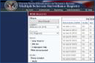
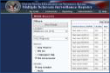
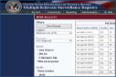
Figure 1: MSSR Data Flow and System Diagram
Veteran visits
Clinician for
Consult*
*Initial or Follow Up

CPRS Tools Menu
has link to MSAT
(web) in CRS
MSAT (web) creates
TIU Note with MSAT (web) sends Text Integration Utility
Health Factors (TIU) Note with Health Factors through a VistA
Integration Adapter (VIA) message, which is
routed through the through VistA Integration Engine (VIE) to VistA.
Data Values only
VistA
VIA
VIE
MSSR dB
CDW
MSSR pulls common
Patient Data from CRS
CRS
MSSR Standard /
Ad Hoc Reports
MSSR requests Patient Data
from CDW via ETL
Health Factors are
stored in VistA
MS files
Perform MS Assessment using MSAT (web) in CRS
Version 2.0
Multiple Sclerosis Surveillance Registry (MSSR) Data Flow and System Diagram
CRS requests common
Patient Data from CDW via ETL
MSSR Longitudinal
Data Analysis
MSSR Data Analysis
& Reporting
Data Transfer & Storage

Below you will find Table 1, which maps to the MSSR Data Flow and System Diagram above. Each business process is assigned a unique numeric identifier that traces back to the MSSR Data Flow and System Diagram in Figure 1 above.

Table 1: Business Processes for MSSR

ID | Business Process Name | Type | Owner | Description
1 | Veteran visits Clinician for Consult | Existing | VA | Veteran visits the Clinician (Neurologist or MS Specialist) for Initial or Follow Up Consult.
2 | CPRS Tools Menu has link to MSAT (web) in CRS | Existing | VHA  Clinician | Currently, MS Assessments are done using the MS Clinical Reminder in CPRS, but once MSAT and MSSR are developed, the CPRS Tools Menu should be configured to contain a link to MSAT (web) in CRS.
3 | Perform MS Assessment using MSAT (web) in CRS | Existing | VHA  Clinician | Clinician uses MSAT (web), which is part of MSSR (inside CRS framework), to complete the MS Assessment.
4 | MSAT (web) creates TIU Note with Health Factors | Existing | VA OI&T  Health Registries | MSAT (web) creates the TIU Progress Note with Health Factors to be eventually transmitted to VistA.
5 | MSSR Back End DB | Existing | VA OI&T  Health Registries | MSAT (web) sends data values only to be stored in the MSSR Back End Database.

ID | Business Process Name | Type | Owner | Description
6 | VIA | Existing | VA OI&T | MSAT (web) sends TIU Note with Health Factors via VistA Integration Adapter (VIA).
7 | VIE | Existing | VA OI&T | HL7 message is routed through VIE to VistA.
8 | VistA | Existing | VA OI&T | Health Factors are stored in VistA MS files via VIE.
9 | CDW | Existing | VA OI&T | VistA stores MS Clinical Data in CDW.
10 | CRS | Existing | VHA OI&T  Health Registries | CRS requests common Patient Data from CDW via ETL.
11 | MSSR pulls common Patient Data from CRS | Existing | VHA OI&T  Health Registries | MSSR pulls common Patient Data from CRS.
12 | MSSR requests Patient Data from CDW via ETL | Existing | VHA OI&T  Health Registries | MSSR requests Patient Data from CDW via ETL
13 | MSSR Back End DB | Existing | VHA OI&T  Health Registries | Receives Common Patient Data from CRS and MS- related Clinical Data from CDW.
14 | MSSR Longitudinal Data Analysis | Existing | VHA OI&T  Health Registries | With comprehensive MS-related Clinical Data from both MSAT and CDW, MSSR is able to provide Longitudinal Data Analysis.
15 | MSSR Standard / Ad Hoc Reports | Existing | VHA OI&T  Health Registries | With comprehensive MS-related Clinical Data from both MSAT and CDW, MSSR is able to provide Standard and Ad Hoc Reports.

User Access Levels
Table 2 describes the attributes of the user community (and their proficiency with the software system), and the technical community (and their familiarity with support and maintenance) for MSSR. See section 4.2.1 for further detail on permission levels within MSSR Patient records.

Table 2: MSSR User Characteristics Attributes

User Role | User Community | Background / Experience | System Proficiency | Tech Support / Maint Expertise | Access Privileges
MSSR System Administrator | Health Registries Administrator | Mid | High | High | Full
MSSR Local Administrator | Local Facility Registry Administrator | Mid | Mid | Mid | Full (Local)
MSSR National | MSCoE Directors, NW Innovation Center | High | Mid | Low | Full
MSSR National Read Only | MSCoE  Administrative / Clerical Staff | Varies | Varies | Low | Reporting

User Role | User Community | Background / Experience | System Proficiency | Tech Support / Maint Expertise | Access Privileges
MSSR Local | Clinicians | Varies | Varies | Low | Local VISN
MSSR Local Read Only | Administrative / Clerical Staff | Varies | Varies | Low | None

Continuity of Operation
There is no system criticality or high availability with regards to MSSR. However, the system is availability and business continuity level routine support is administered by the CRS relational database framework.
Under CRS, it is designated as a Disaster Recovery (DR) Routine Support system with the following Recovery Time Objectives (RTO) and Recovery Point Objectives (RPO):
- RTO of 30 days – to ensure that the 30-day RTO can be met, a DR site has to be identified and infrastructure should be acquired for inventory or contract should be in place for vendors who are able to provide a drop shipment option in-time to rapidly acquire infrastructure to satisfy the 30-day RTO requirement. In addition, provisions must be made for the restoration of the backup at the DR site.
- RPO of 24 hours – to ensure the 24-hour RTO requirement can be met, system must be configured to be able to perform daily backups or weekly full backups with either incremental or differential daily backups. To ensure that the backups are usable, backup data integrity must be periodically checked and validated. In a case of a disaster, the backups will need to be made available at the DR site within the specified 30-day RTO.

Getting Started

System Menu
The System menu consists of the following menu options, as shown in Figure 2 below.

Figure 2: MSSR Menu Options

- Patients: contains all of the details for the patients and assessments
- Reporting: contains the smart charts for various longitudinal data analysis, such as medication types and usages.
- Administration: contains the administrative functions for adding, editing, and deleting user accounts, profiles, and medications.
- Help: contains the screen tips, instructions, and troubleshooting tips.

Administration
The Administration page provides four (4) administrative functions as follows:
- Users: add, edit, and delete user accounts
- Medications: add, edit, and delete medications
- Role Matrix: add, edit, and delete user permissions
- System Availability: add, edit, and delete system warnings, messages, and other administrator messages to the end user community

Users
The Users page allows the MSSR Administrator to add, delete, and edit end users (see Figure 3 below).

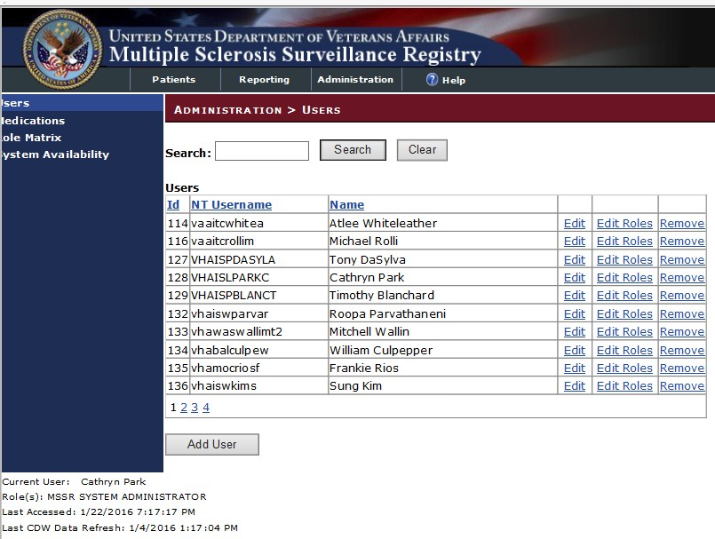
Figure 3: Administration > Users

Medications
For the MSSR Administrator only, the Medications page allows the MSSR Administrator to add, edit, and delete medications (see Figure 4 below).

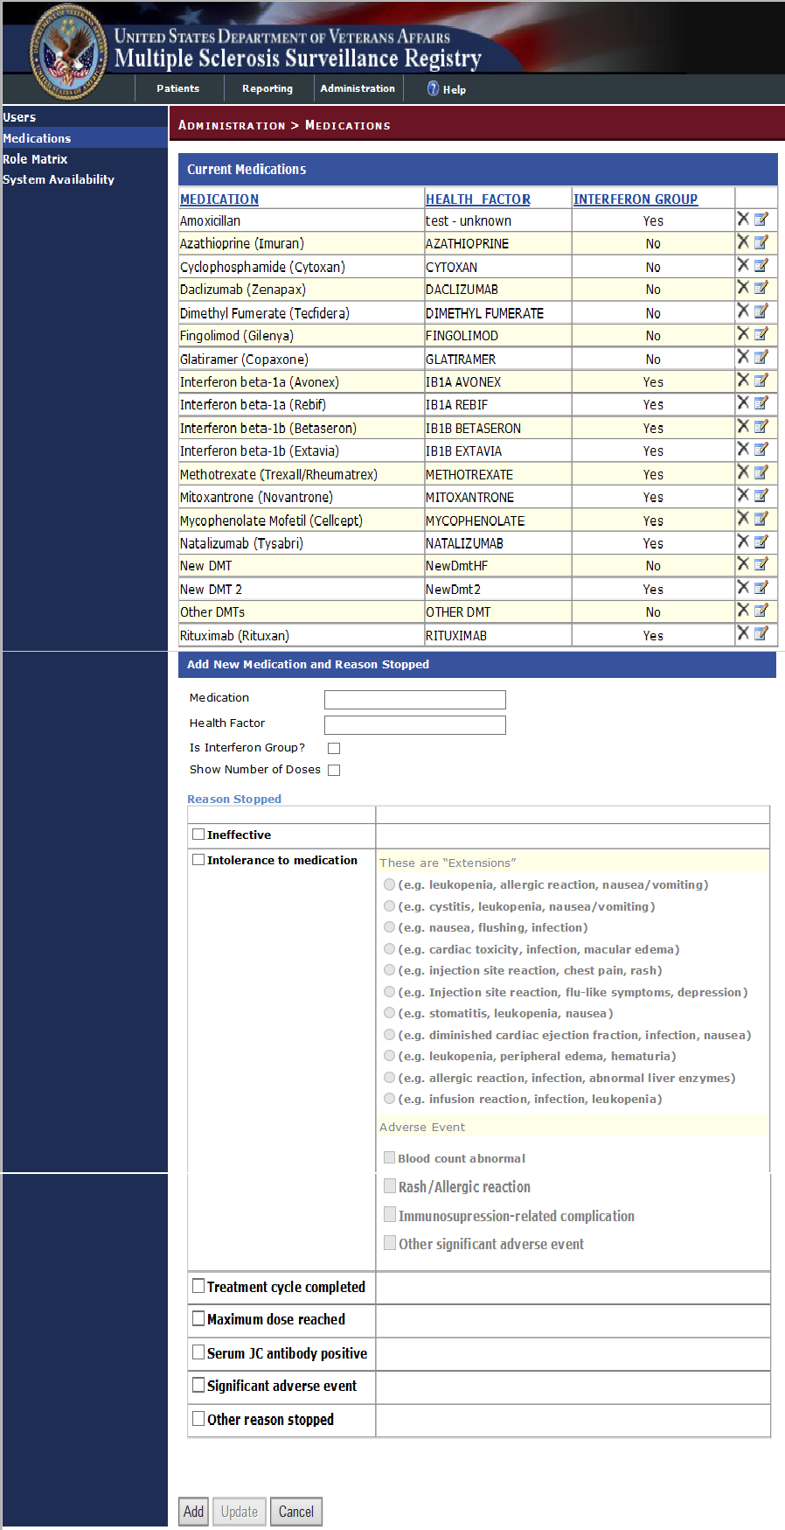
Figure 4: Administration > Medications

Role Matrix
For the MSSR Administrator only, the Role Matrix page allows the MSSR Administrator to add, edit, and delete user permissions (see Figure 5 below).

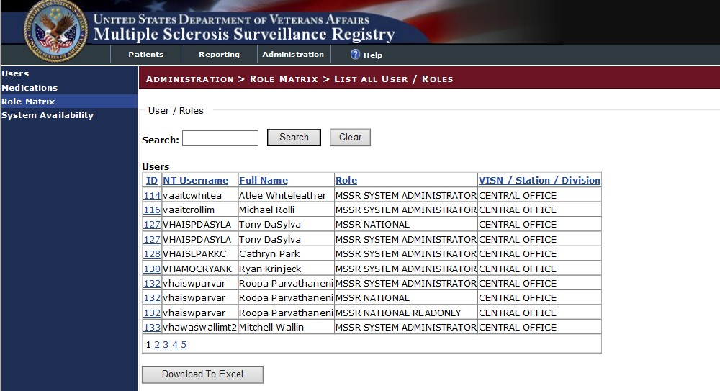
Figure 5: Administration > Role Matrix

System Availability
The System Availability page allows the MSSR Administrator to add, edit, and delete system warnings, messages, and other administrator messages to the end user community (see Figure 6 below).
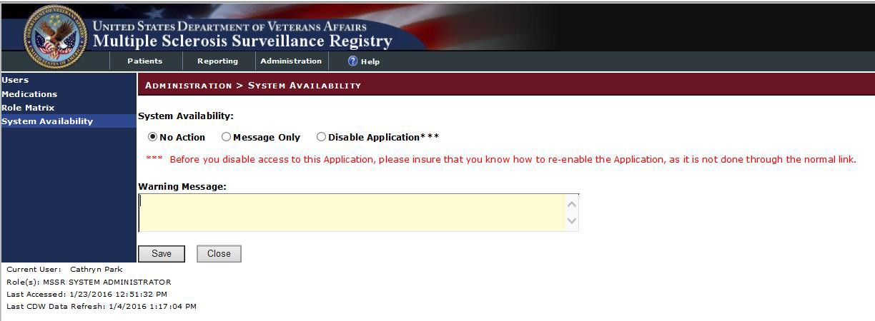
Figure 6: Administration > System Availability

Basic System Elements
The basic web-based registry elements for the MSSR are as follows:

Text Box
SAMPLES: 1 2

Note how the appearance of the box changes: from a plain line border (SAMPLE 1) to an almost three-dimensional, pale yellow-highlighted field when you tab to it or click in it (SAMPLE 2).
Type your entry into the text box. The entry will not be saved until you tab away from or otherwise exit from the text box. In cases where the format of your entry is important, a sample will appear near the box. The relative width of these boxes is usually a reflection of the number of characters you are allowed to enter. Sometimes (as with date fields) there may also be a “date picker” next to the field.
You should see a “tool tip” pop up when you hover your mouse pointer over the text box.
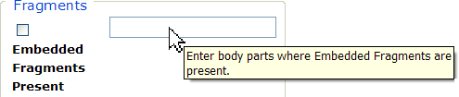
Figure 7: Tool Tip for Text Box

Checkbox
SAMPLE:
A checkbox “toggles” (changes) between a YES / NO, ON / OFF setting. It is typically a square box which can contain a check mark or an “X” ☒ and is usually accompanied by text.
Clicking the box or tabbing to the field and pressing the spacebar toggles the checkbox setting. In some instances, checkboxes may be used to provide more than one choice; in such cases, more than one box can be selected. Sometimes, a pre-determined “default” entry will be made for you in a checkbox; you can change the default if needed.

Radio Button
SAMPLE:
A radio button, also known as an option button, is a small, hollow circle adjacent to text. Radio buttons usually appear in sets, with each button representing a single choice; normally, only one button in the set may be selected at any one time. Clicking on the radio button places a solid dot in the circle, selecting the option. Clicking a selected radio button de-selects it, removing the dot. As one radio button is selected, others within the category switch off. For example, Male or Female may be offered as choices through two radio buttons, but you can only select one of the choices.

Command Buttons
^{SAMPLES} A command button initiates an action. It is a rectangular “3-dimensional” shape with a label that specifies what action will be performed when the button is clicked. Common examples are shown at left. Command buttons that end with three dots indicate that selecting the command may evoke a subsidiary window.
In the text of this document, command button names appear inside square brackets. Examples: [Search], [Save].

The [Cancel] command allows you to cancel the action about to be taken, or to discard changes made on a form. For example, when closing an application, you may be prompted to validate the action to close. If you click the [Cancel] button, the application will not close and you will resume from the point at which the close action was initiated. Or, on a data screen, you may use the [Cancel] button to discard any changes you may have made to the data and close the tab.
The [Select] command is used to select records for editing.

The [Search] command is used to find one or more records. When at least one character is typed in a lookup dialog box, clicking the [Search] button will bring up matching entries. In many cases, leaving the lookup box blank will find all such records. Enter the search string and click [Search]. Searches are case- insensitive and use “contains” logic.
The [OK] command is used to accept a default choice, or to agree with performing an action.

Drop-down List
SAMPLE 1:

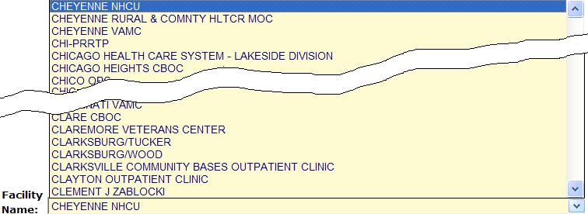
SAMPLE 2:

A drop-down list (sometimes called a “pull-down” list) is displayed as a box with an arrow button on the right side (SAMPLE 1). Such a list allows you to select one item from the list. The current choice (or a prompt) is visible in a small rectangle; when you click on the arrow, a list of

items is revealed (SAMPLE 2). Click on one of the entries to make it your choice; the list disappears.

Exit System
As a web-based intranet application, MSSR requires no special instructions to properly exit the system, other than shutting down the browser. However, for security purposes, the system will time-out after approximately 15 minutes, and the end user should not leave the application unattended, to avoid PII and PHI theft risk.

Caveats and Exceptions
As a web-based intranet application, MSSR requires no special actions to ensure that data is properly saved or that some other function executes properly, other than selecting the “Save” button.

Using the Application

MSAT
To enter MS assessment data, ensure that the MSAT linkage (URL) is added to the CPRS Tools Menu, as displayed below in Figure 8 below. Detailed instructions for MSAT linkage in CPRS is detailed in Section 0.0

Appendix.

Select “MSSR-PROD-VIA”, which should direct you to the external Confirmation page on the MSSR intranet website, which contains the MSAT.
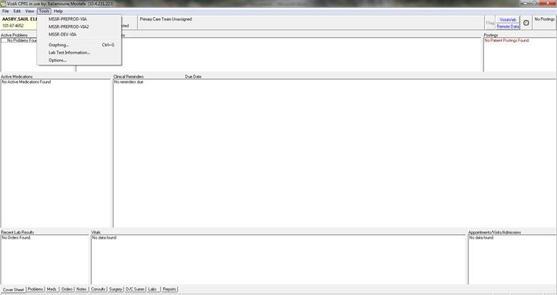

Figure 8: MSAT Linkage (URL) in CPRS Tools Menu

- In the Confirm Patient page, verify that the patient name and SSN match between CPRS and the MSSR intranet website (see Figure 9 below).
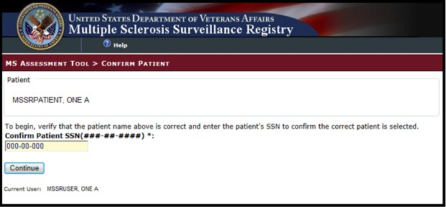

Figure 9: Confirm Patient

- Once the patient is confirmed, the MSAT online form will appear, and the user should enter

patient data as described in Figure 10, Figure 11, and Figure 12 below. Some questions are mandatory, while others are user-intuitive and intelligent, which trigger more selections.

- If more time is required to complete the MSAT online form, press the ‘Save Draft’ button.

- If the note should be cancelled for any reason, press the ‘Cancel’ button to cancel the progress note.

- Once the MSAT online form is complete, press the ‘Save and Prepare Note’ button.

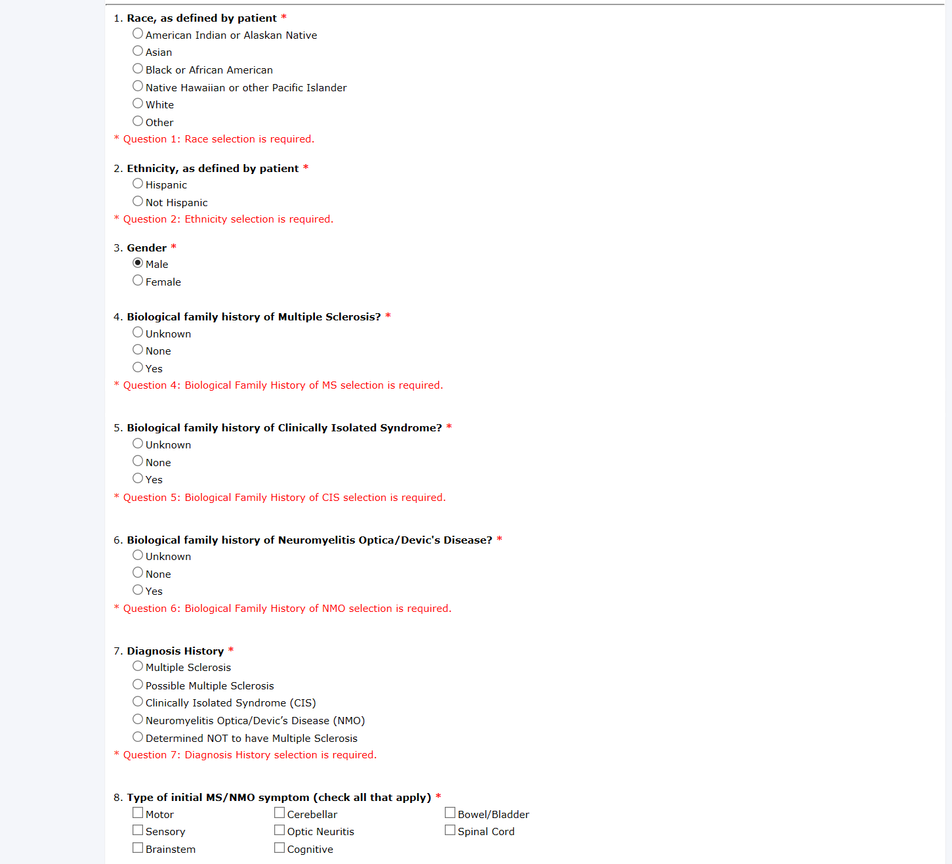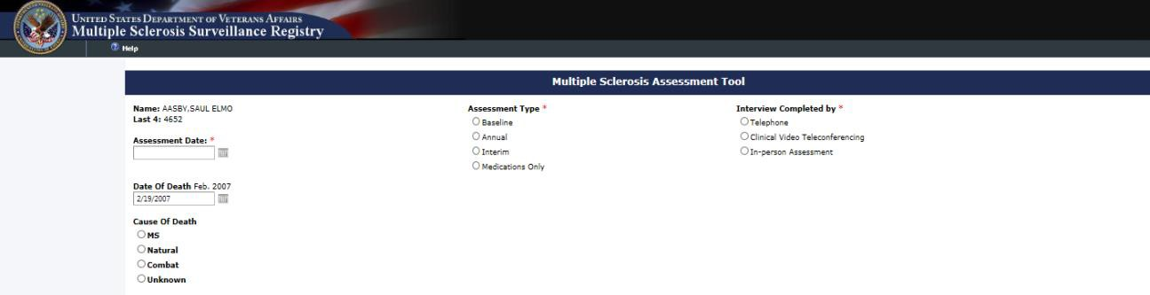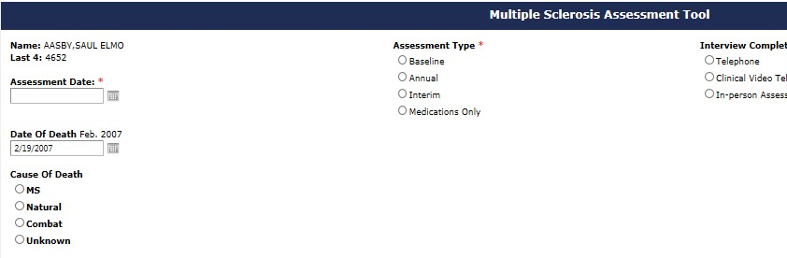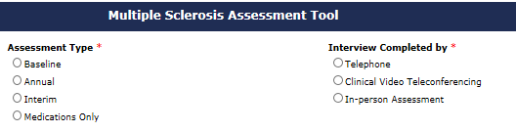

Figure 10: MSAT – 1 of 3

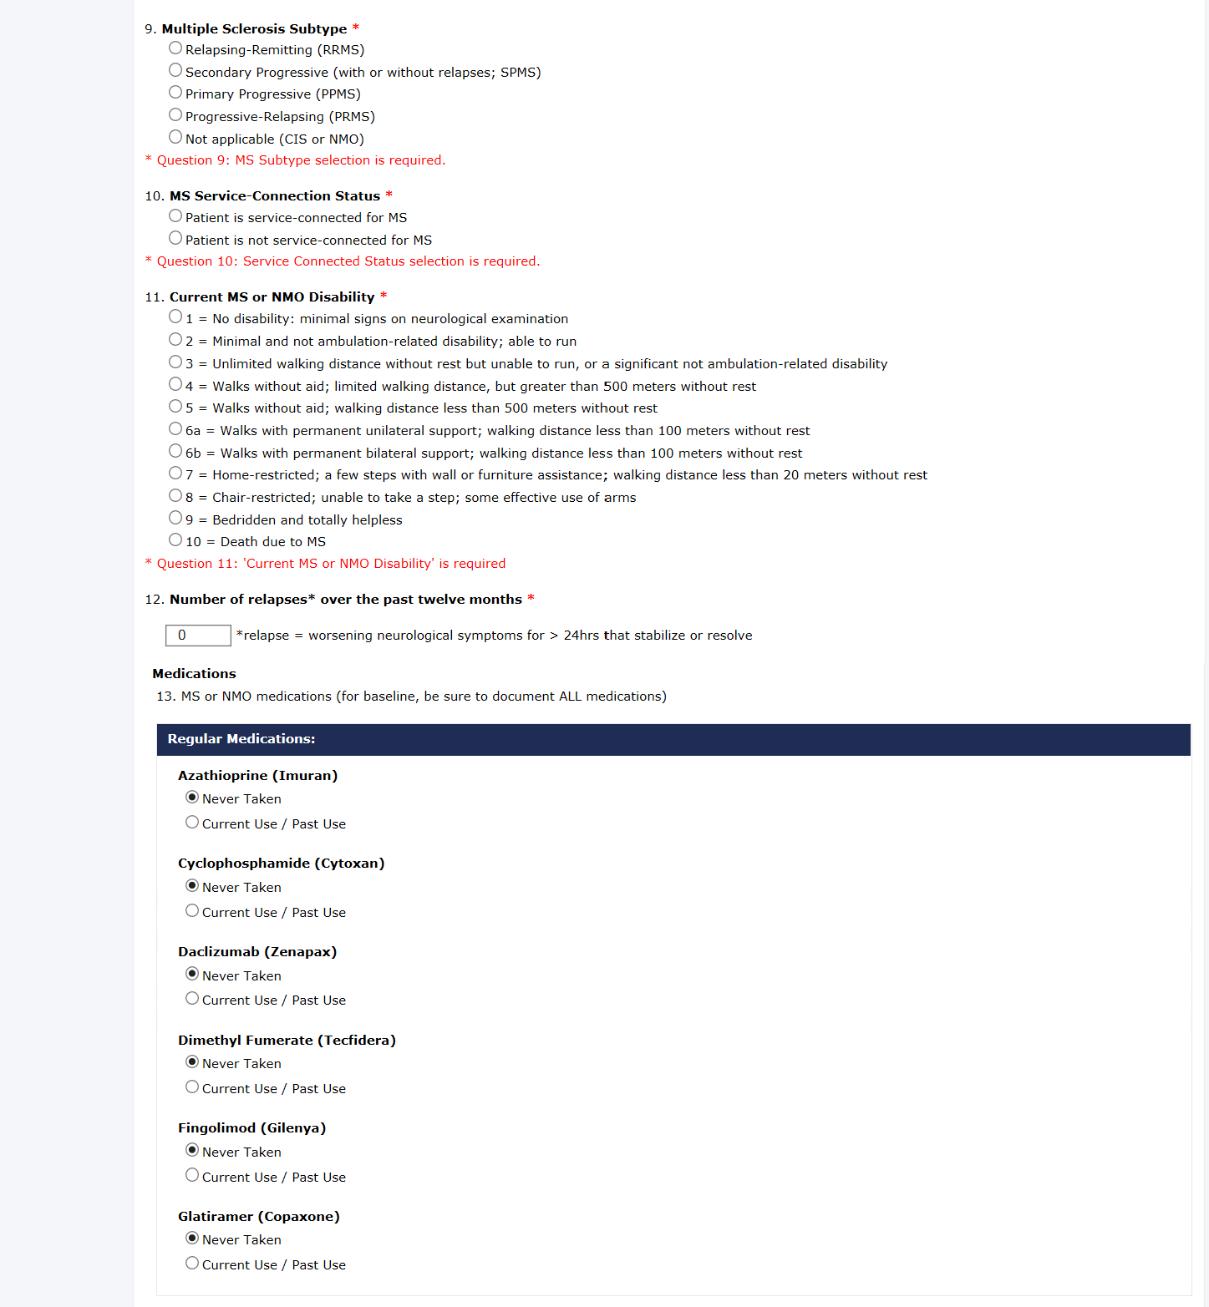

Figure 11: MSAT – 2 of 3

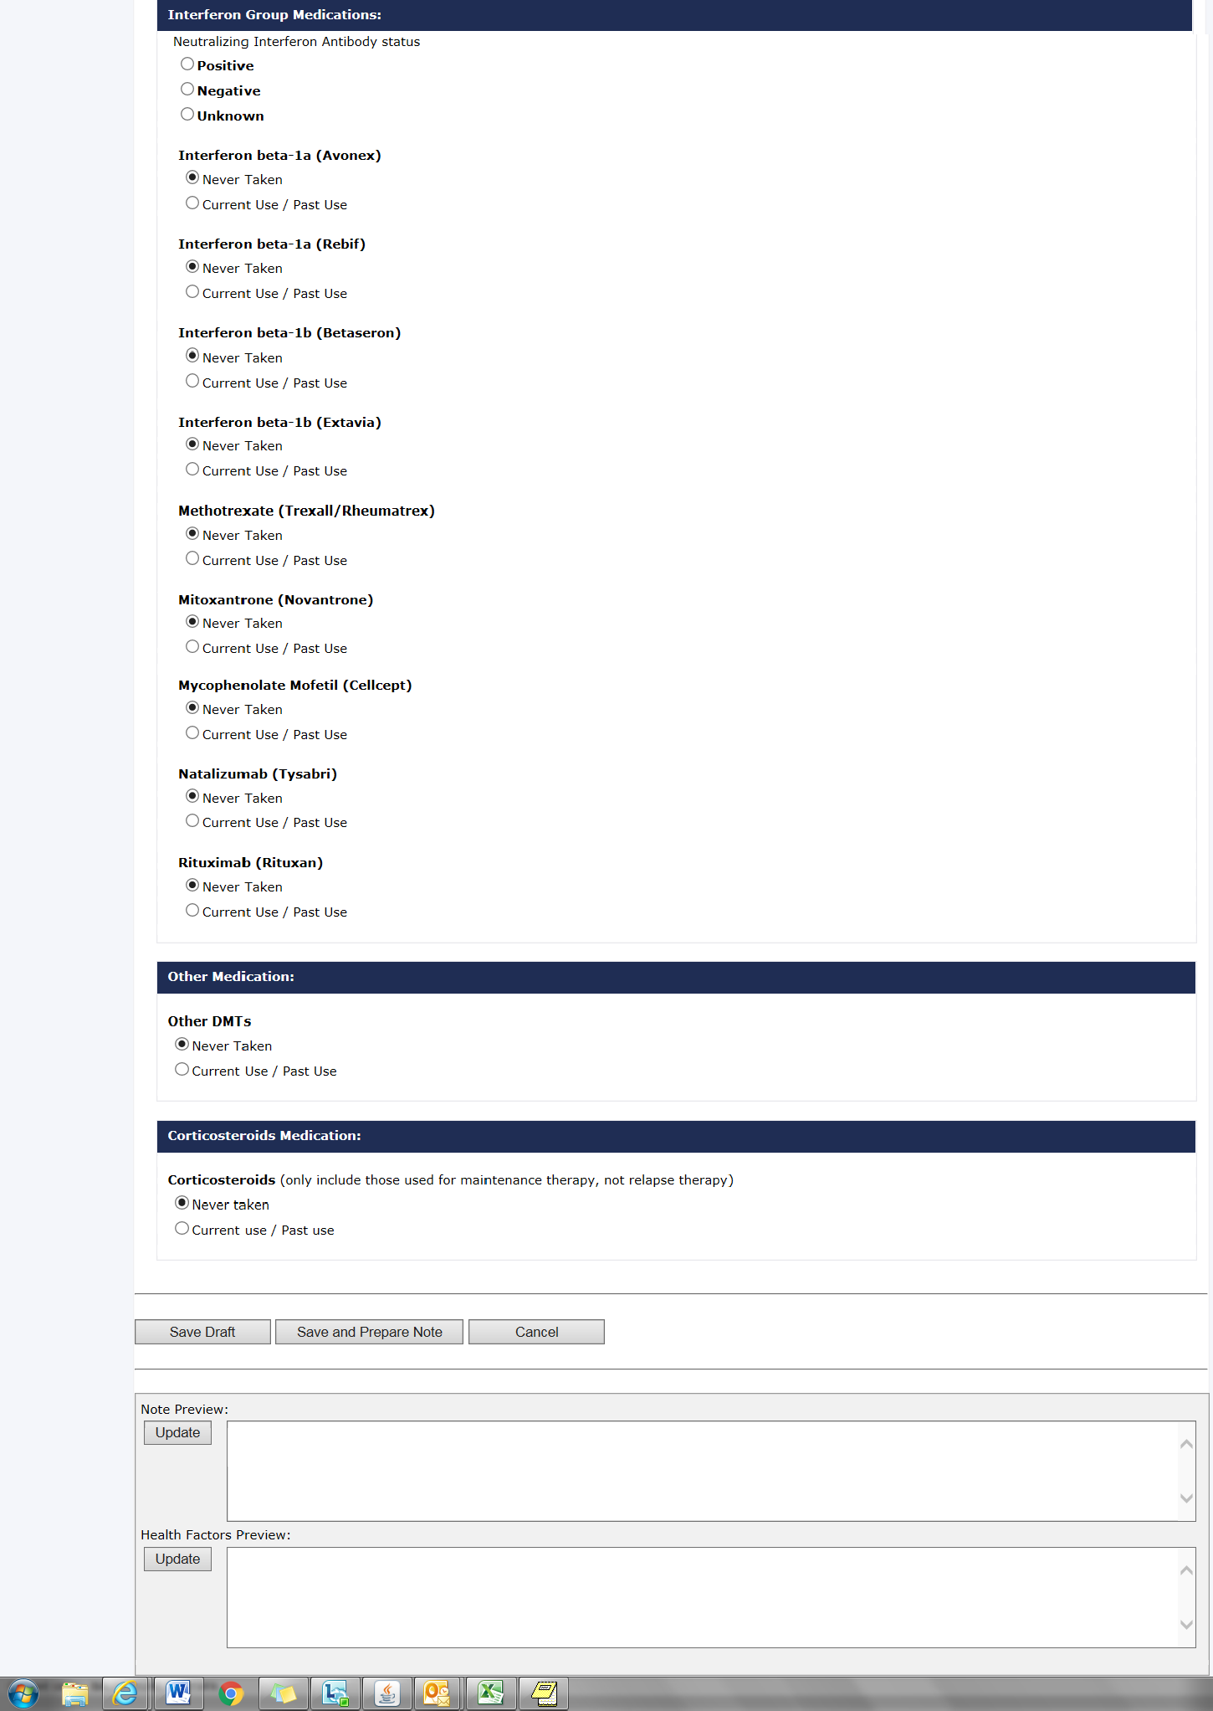

Figure 12: MSAT – 3 of 3

- Once the ‘Save and Prepare Note’ button is pressed, the Progress Note Setup page (as shown in Figure 13 below) is displayed, and the Patient Name and Instrument Type that was previously selected appears.
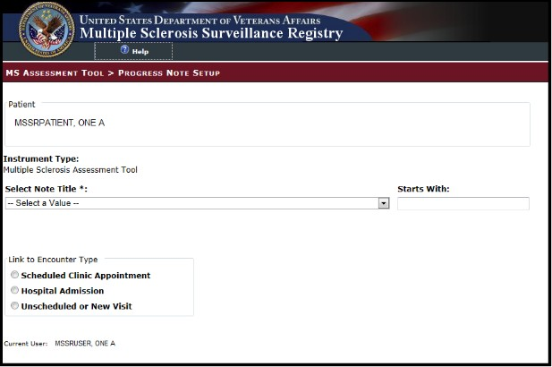

Figure 13: Progress Note Setup

- Select the appropriate Note Title from the Select Note Title drop-down list, i.e., “Neurology…” (See Figure 14 below).

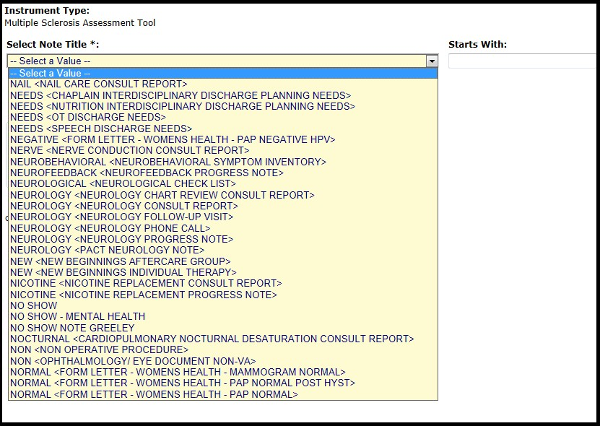

Figure 14: Multiple Sclerosis Assessment Tool

- If the note title selected is classified as a “Consult Report”, the user entry will complete a consult in CPRS. Use the Link to Consult drop-down list to select the appropriate consult to which the entry should be linked in CPRS. The Link to Consult drop-down list is populated with previously ordered consults for this patient. If the user selects a consult from the drop- down list, the data then entered via the Multiple Sclerosis Assessment Tool will be associated with the selected consult.
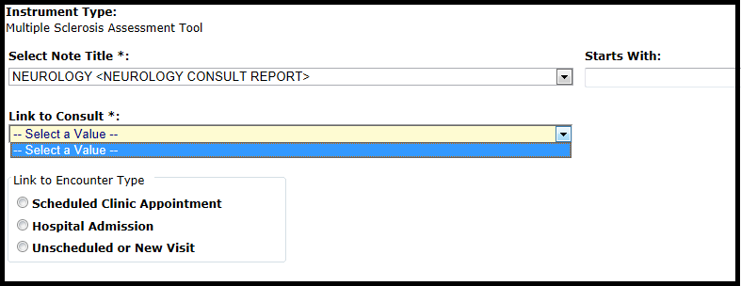

Figure 15: Multiple Sclerosis Assessment Tool Link to Consult

- Use the radio buttons to select the appropriate Link to Encounter Type from the list.

- If you select Scheduled Clinic Appointment, the application searches the period of time one month before today through one month after today. If any appointments are found, they are loaded into the Select the Scheduled Clinic Appointment drop down list. Select an appointment to proceed to the next step. If the user wishes to expand the date range for the

search, the user can input new start and end dates and click Get Appointments and then proceed to the next step. This step associates the current instrument with the selected appointment.
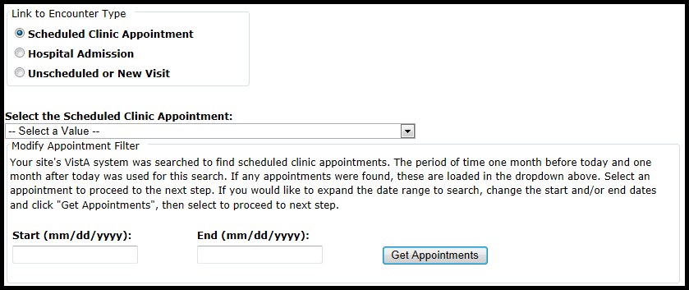

Figure 16: Link to Encounter Type

- If you select Hospital Admission, the application searches for previous hospital stays. If any are found, they are loaded into the Select the Hospital Admission drop down list, and the user can make the appropriate selection. If no previous stays are found for the patient, the user must select a different encounter type from the Link to Encounter Type list in order to proceed.
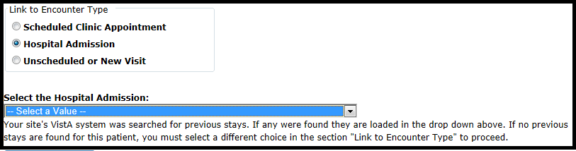

Figure 17: Link to Encounter Type Hospital Admission

- If you select Unscheduled or New Visit, the application searches to find all locations at your site which contain Multiple Sclerosis. If any locations are found, they are loaded into the Location drop down list. If the user wants to search using a different location, the user can change the default search string and click Get Locations. After selecting a location, the user can click Continue to move to the next screen.

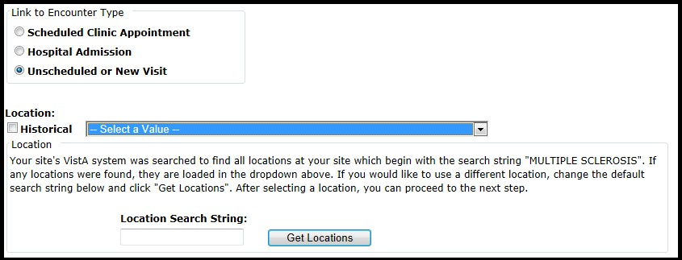

Figure 18: Link to Encounter Type Unscheduled or New Visit

- The application reformats the information entered into the questionnaire and displays the resulting information on the screen.

- If the material displayed is correct, click Submit Note to complete the note transfer.

- If the material needs changed or corrected, click Cancel to re-enter the choice selections.
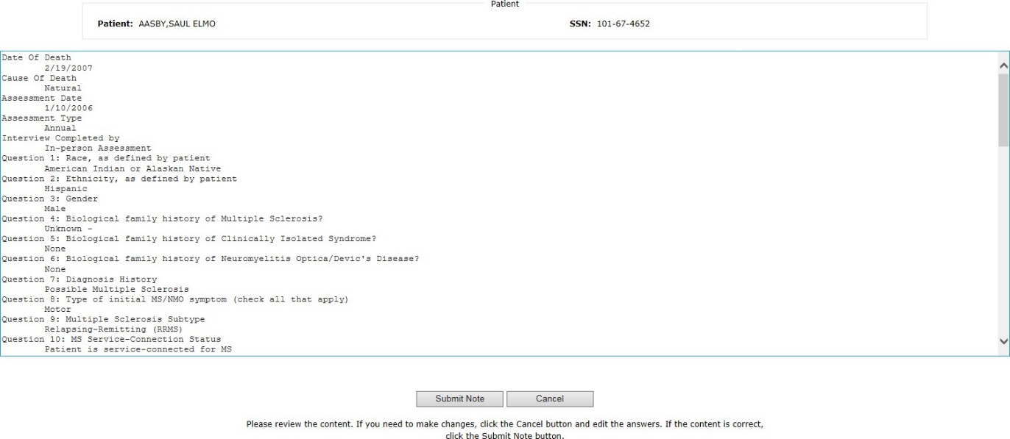

Figure 19: Note Summary

- Be aware that once the note is submitted, it is no longer editable within the Multiple Sclerosis Assessment Tool and any updates will have to be made within CPRS.

- The clinician must sign the note in CPRS.

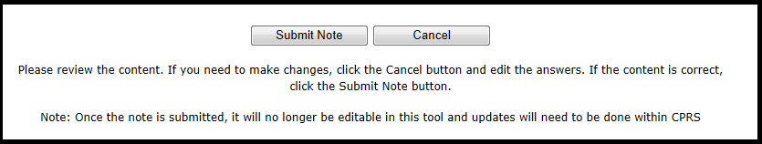

MSSR

Figure 20: Submit Note

To log onto the MSSR intranet website, go to: REDACTED. If you cannot access the site, please submit a Remedy ticket to request access, with Category “Applications-HealtheVet-Vista” and with Type “MSSR Registry”.

Once logged in, a notice will appear, select “OK” to move to enter the MSSR application.
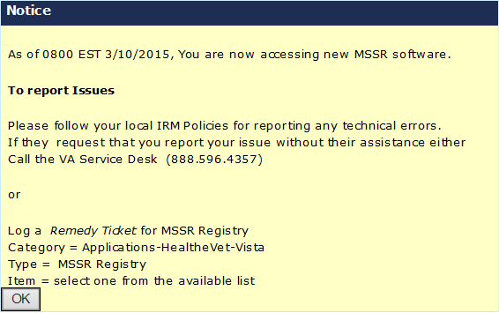
Figure 21: MSSR Notice Screen

    - MSSR Patients
The MSSR Patients screen (shown in the figure below) displays relevant patient information in a grid format.
Use the Filters area of the page to customize the data that is shown in the grid below. Once the appropriate filters have been selected click View Results to see the applicable data, or click Reset to reset the filter fields.
Use the Sort feature, which are the clickable column headers, to sort the data in ascending or descending order, for each column heading.
Use the Paging buttons at the bottom of the screen to navigate through the grid results. The
Results per page drop down list changes the number of rows displayed in the grid per page. The Export button allows the current data in the grid to be exported into an Excel spreadsheet.

Permission levels include the following:
- Administrator will be able to choose from the following 3 options:
  - MS Assessment – Patients with assessment only
  - Culpepper Algorithm – All patients pulled based on Master list
  - Non-MS Assessment – Delta between the above two categories
- Non-Administrator National will have access to only:
  - MS Assessment – Patients with assessment only
- Non-Administrator VISN level
  - MS Assessment – Patients for given VISN only

Upon entering the MSSR Patients page, the default will be set on MS Assessment.

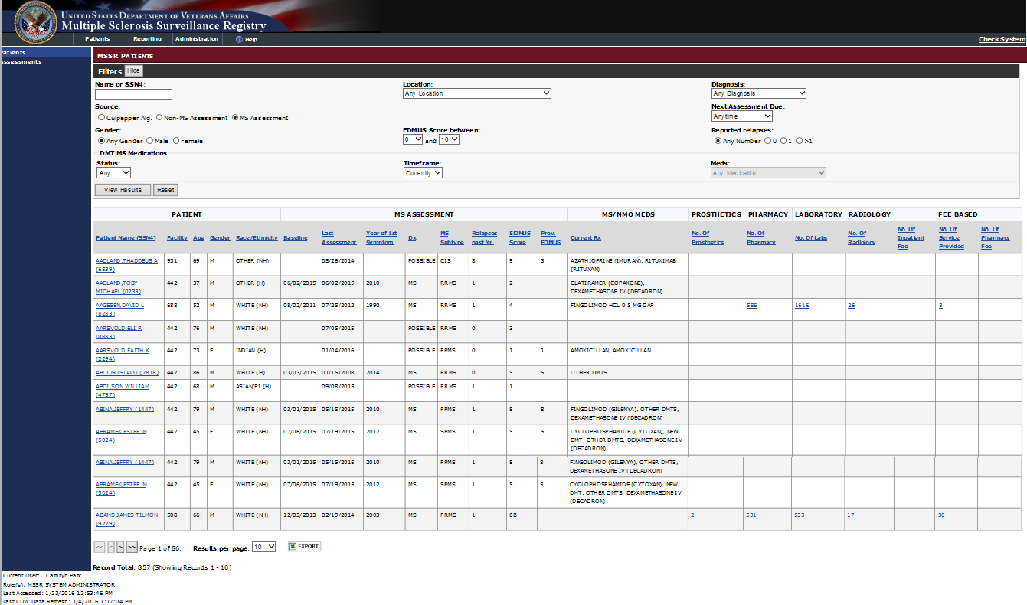

Figure 22: MSSR Patients

The MSSR Patient Details screen displays relevant information for a specific patient.
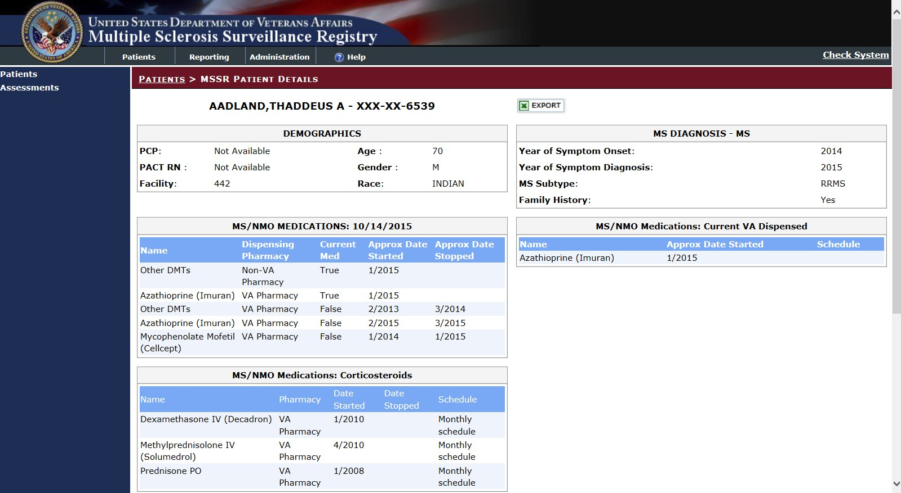
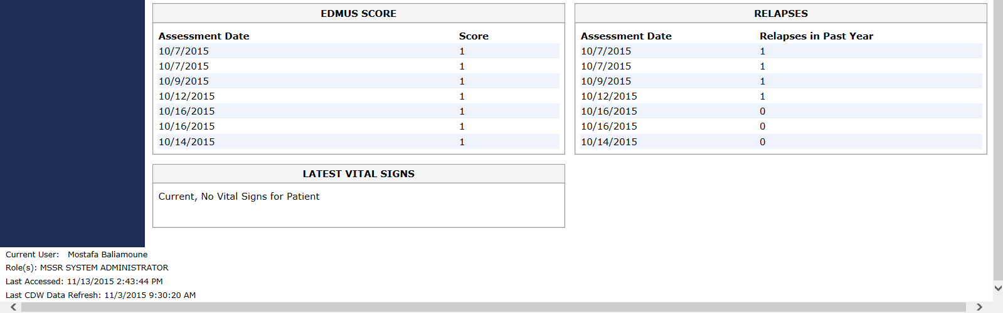
The Export button allows the current data in the grid to be exported into an Excel spreadsheet.

Figure 23: MSSR Patient Details

Select the numerical count under Prosthetics for a specific patient to display member demographics, facility, HCPC number, HCPC code, issue date, provider, quantity, description, source and source of procurement.

Enter a specified issue date range or Prosthetic Type to filter further details of the patient’s record.

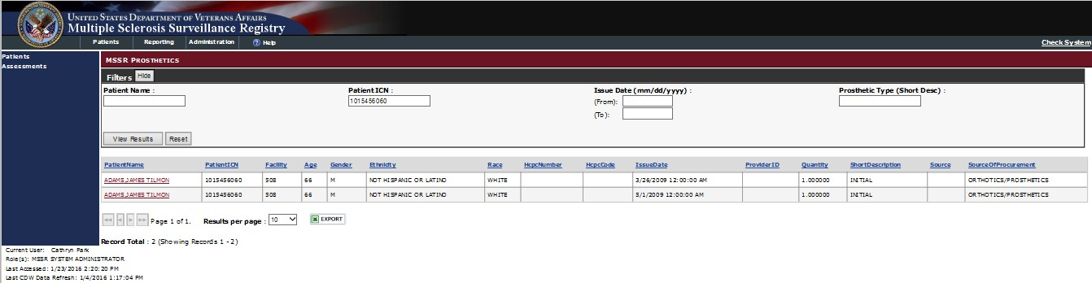

Figure 23: MSSR Prosthetics

Selecting the numerical count under Pharmacy for a specific patient will display member demographics, facility, action date, action status, drug classification, local drug name with dosage and type of patient procedure (e.g. inpatient, outpatient).

The data may be further filtered by selecting date ranges for Action Date and Drug Name/Classification.
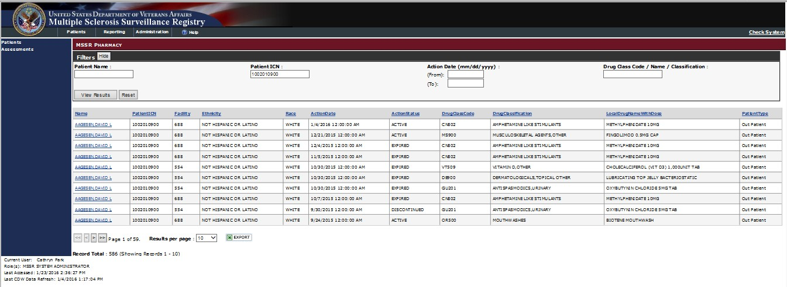

Figure 24: MSSR Pharmacy

Selecting the numerical count under Lab for a specific patient will display member demographics, facility, lab type and results.

The data may be further filtered by entering a Lab Test Date range or Lab Chem Test Name.

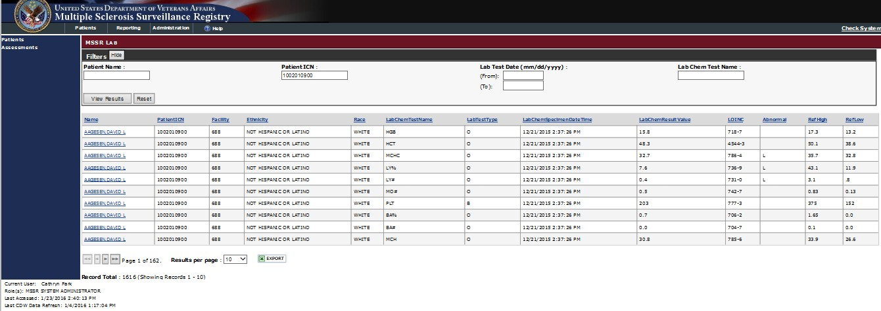

Figure 25: MSSR Lab

Selecting the numerical count under Radiology for a specific patient will display member demographics, facility, procedure name, exam date, whether services was completed inpatient or outpatient, free text field for clinical impressions, source, type of imaging, requesting physician and verifying physician.

The data may be further filtered by entering an Issue Date range or Type of Imaging/Procedure Name.
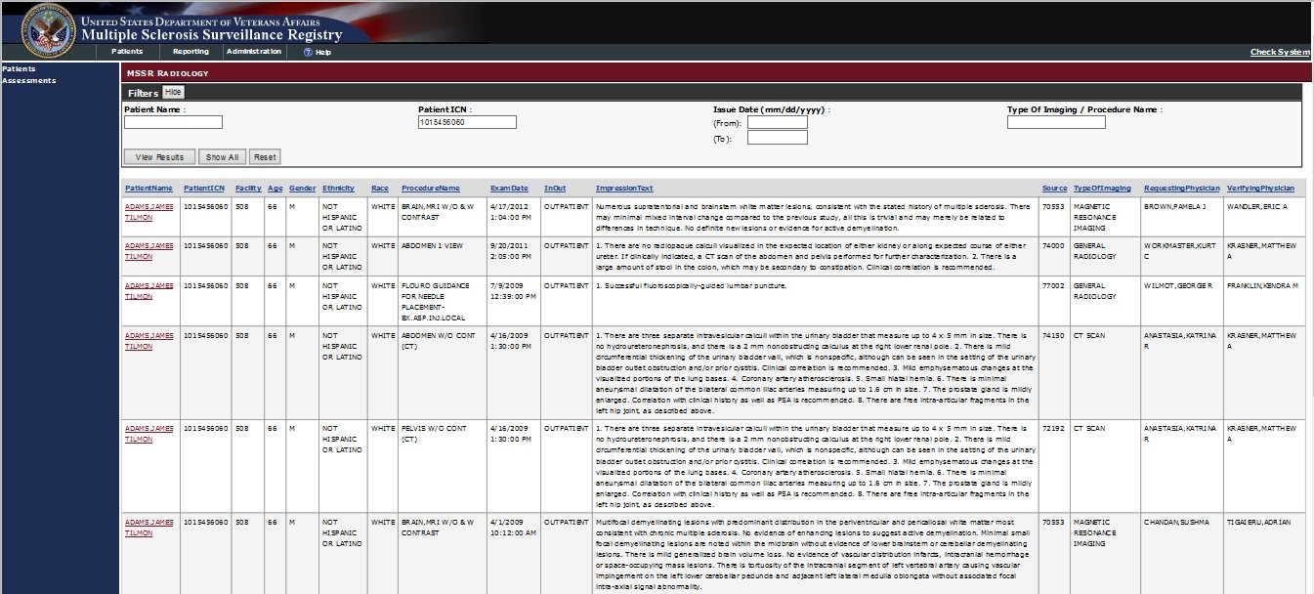

Figure 26: MSSR Radiology

Selecting the numerical count under Fee Inpatient for a specific patient will display member demographics, facility, diagnosis, procedure, vendor invoice date, claimed amount and amount paid.

The data may be further filtered by entering a Vendor Invoice Date range or Diagnosis / Procedure.

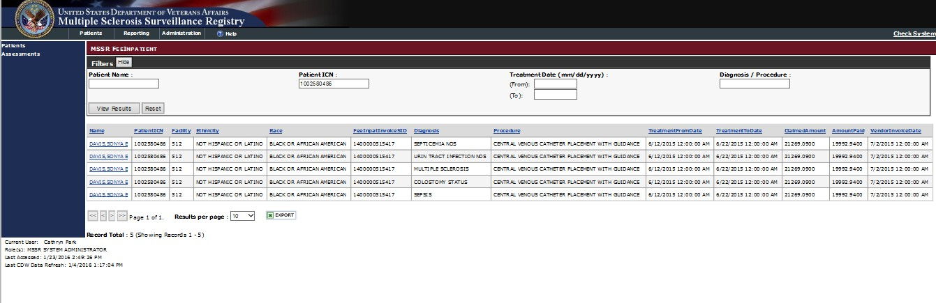

Figure 27: MSSR Fee Inpatient

Selecting the numerical count under Fee Service Provided for a specific patient will display member demographics, facility, CPT Name, diagnosis, payment type code, amount claimed, amount paid, vendor invoice date, IBT type of service and IB place of service.

The data may be further filtered by entering an Invoice Date range or Diagnosis.
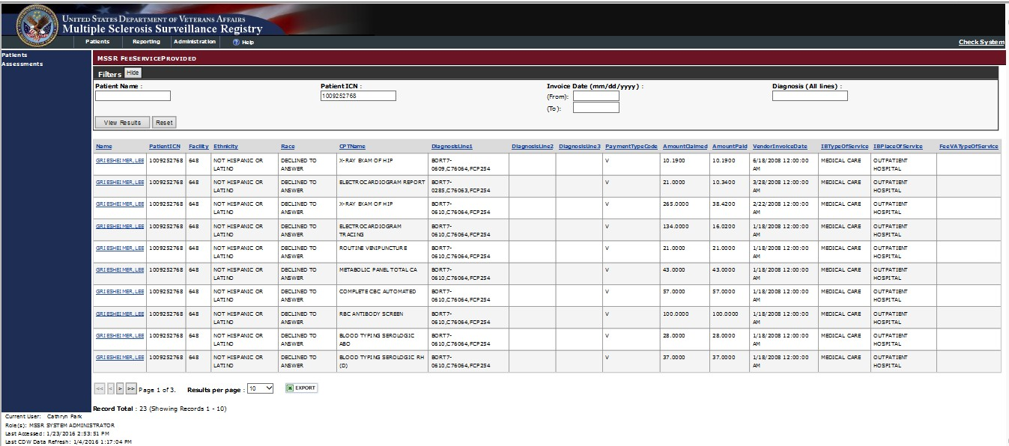

Figure 28: MSSR Fee Service Provided

Selecting the numerical count under Fee Pharmacy for a specific patient will display member demographics, facility, drug name, strength, quantity, prescription fill date, amount claimed, amount paid, drug class code and drug classification name.

The data may be further filtered by entering a Prescription Date range or Drug Name/Classification.

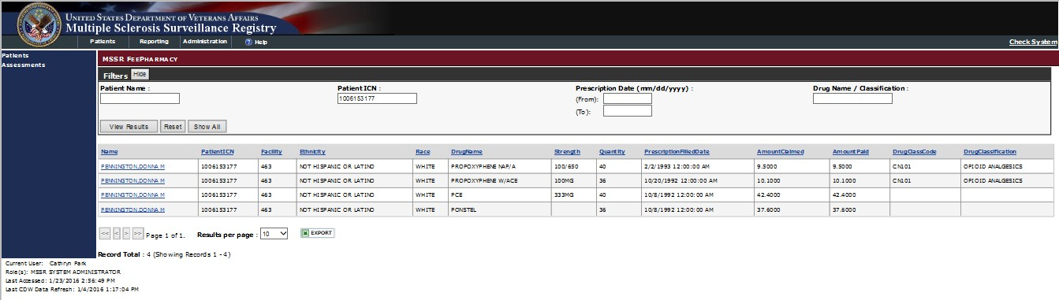
Figure 29: MSSR Fee Pharmacy

MSSR Assessments
The MSSR Assessments screen displays relevant assessment data by patient in a grid format.
Use the Filters area of the page to customize the data that is shown in the grid below. Once the appropriate filters have been selected click View Results to see the applicable data, or click Reset to reset the filter fields.
The column headers are clickable and change the sorting order for the data column.
Use the Paging buttons at the bottom of the screen to navigate through the grid results. The
Results per page drop down list changes the number of rows displayed in the grid per page. The Export button allows the current data in the grid to be exported into an Excel spreadsheet.
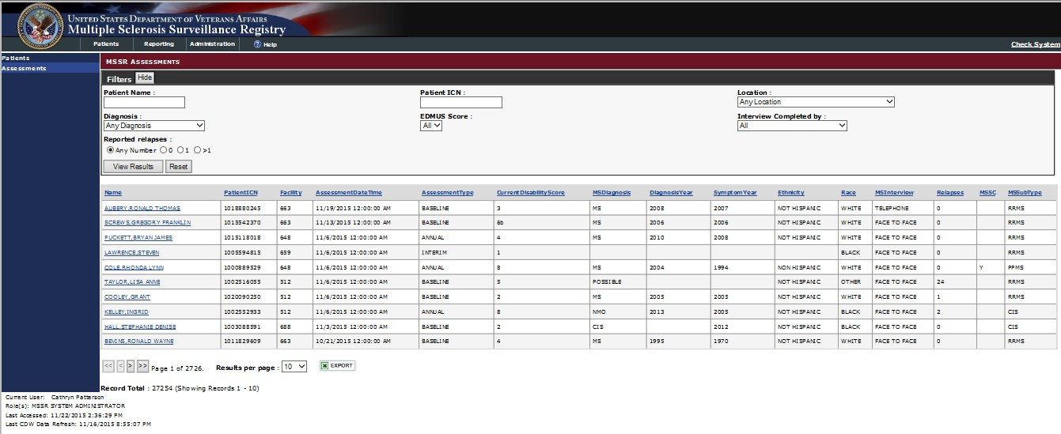
Figure 24: MSSR Assessments

MSSR Reporting
The MSSR Reporting is displayed as graphical “smart charts”, generated by data pulled in from CDW and the MSSR database itself (see Figure 25 below). Additional charts have been added in the enhancements to MSSR: a clickable Prosthetics pie chart and an aggregate Pharmacy Average Cost per Patient graph. Once additional data is input, the reporting will be updated to reflect the new data.

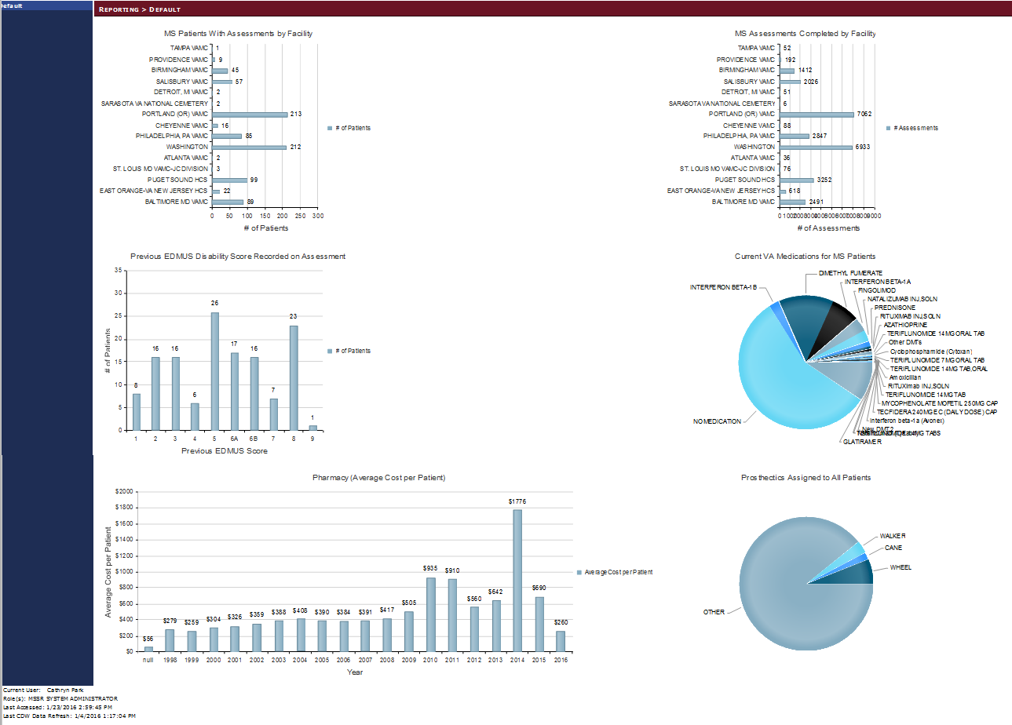
Figure 25: MSSR Reporting – Smart Charts

Troubleshooting
Each page has a dedicated Help page, with general instructions, as exemplified in Figure 32
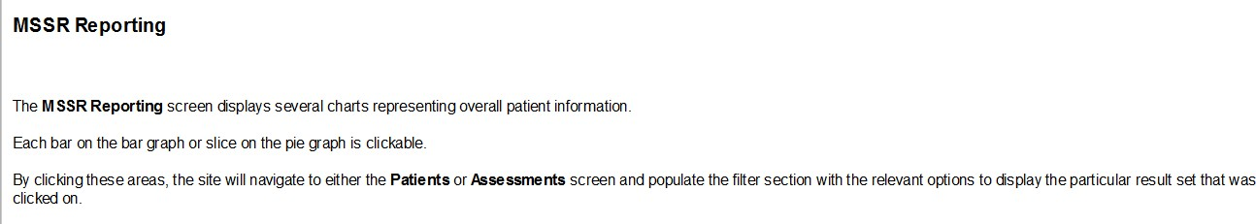
below for the MSSR Reporting screen.
Figure 32: MSSR Help

Acronyms and Abbreviations
Below is a list of the acronyms and abbreviations that has been used in this document.

Term | Description
C&P Mini | Compensation and Pension Mini Master
CARA | Criticality Analysis and Risk Assessment
CDS | Clinical Data Surveillance
CDW | Corporate Data Warehouse
CPRS | Computerized Patient Record System
CRS | Converged Registries Solution
DR | Disaster Recovery
DSS | Decision Support System
ESE | Enterprise Systems Engineering
GAT | Government Acceptance Testing
GUI | Graphical User Interface
HERC | Health Economics Resource Center
IAL | IVV Analysis Level
IDR | Initial Document Review
IIS | Internet Information Services
IOC | Initial Operating Capabilities
IVV | Independent Verification and Validation
MS | Multiple Sclerosis
MSCoE | Multiple Sclerosis Centers of Excellence
MSAT | Multiple Sclerosis Assessment Tool
MSSR | Multiple Sclerosis Surveillance Registry
OI&T, OIT | Office of Information and Technology
ORR | Operational Readiness Review
PM | Project Manager
PMAS | Project Management Accountability System
PMP | Project Management Plan
PWS | Performance Work Statement
R2 | Release 2
RATSR | Risk Analysis and Testing Scope Report
RDW | Regional Data Warehouse
RED | Requirements Elaboration Document
RRM | Rational Requirements Manager
RSD | Requirements Specification Document
RTM | Requirements Traceability Matrix
SDD | System Design Document
SDLC | System Development Life Cycle
SME | Subject Matter Expert
SQA | Software Quality Assurance
SQL | Structured Query Language
TBD | To Be Determined
TIA | Testing Intake Assessment

Term | Description
UAT | User Acceptance Test
UFT | User Functionality Test
UI | User Interface
VA | Veterans Affairs
VIA | VistA Integration Adapter
VBA | Veterans Benefits Administration
VDW | VISN Data Warehouse
VetsNet | Veterans Service Network
VHA | Veterans Health Administration
VISN | Veterans Integrated Service Network
VistA | Veterans Health Information System and Technology Architecture

Appendix
Below you will find the instructions for creating the MSAT linkage (URL) in CPRS.

Use the following steps to change the URL for MS Assessment Tool on the CPRS Tools menu.
- Double click on a test center connection file (see Note 1). Use the Creating a Test Center Connection Using Reflection.docx for creating the file. Skip to step 7.
- Click on the Windows Start button.
- From the Start menu, select the All Programs | Attachmate Reflections | Host – UNIX and OpenVMS menu options (see Figure 1).
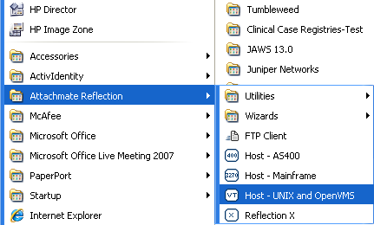

Figure 1
- The Untitled – Reflection for UNIX and OpenVMS dialog (see Figure 2) should appear.
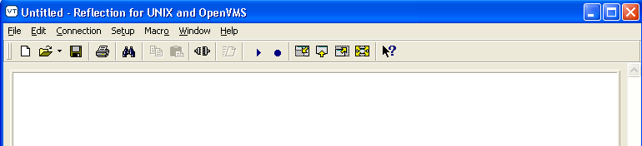

Figure 2
- Select File | Open from the menu bar and browse to the location of the test center connection file you want to use. The default location for saved connection files is the My Documents\Attachmate\Reflection folder.
- Highlight the test center connection file (see Note 1) and click on the Open button.

NOTE 1: Currently, MS Assessment Tool testing is done in the CHEY243 test center.

- At the Reflection Secure Shell dialog (see Figure 3), click on the OK button.
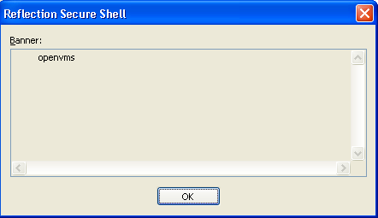

Figure 3
- At the Reflection Secure Shell dialog (see Figure 4), click on the OK button.
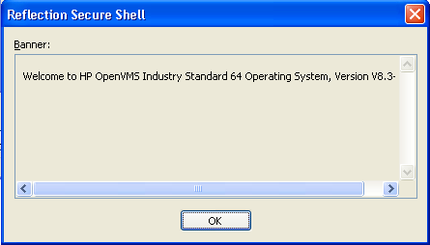

Figure 4
- At the Reflection Secure Shell Client dialog (see Figure 5), leave the password field blank and click on the OK button.
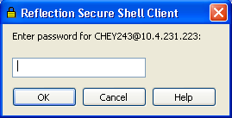

Figure 5
- You should see a screen similar to Figure 6.

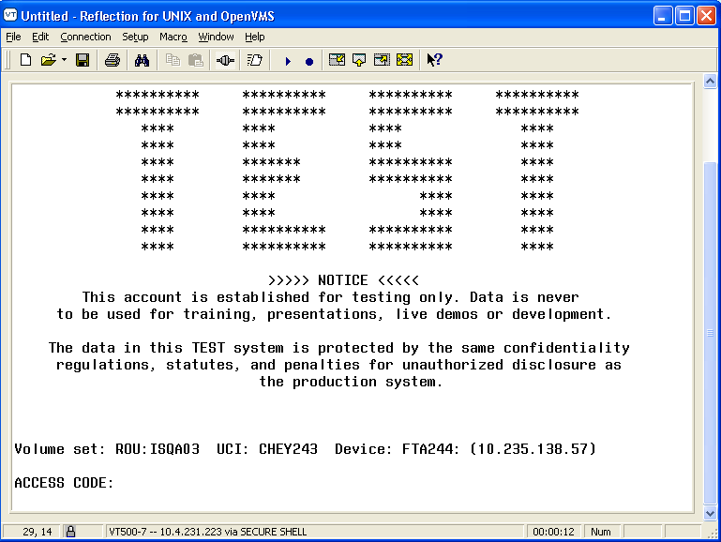

Figure 6
- At the ACCESS CODE prompt, enter your access code and press the Enter key.
- At the VERIFY CODE prompt, enter your verify code and press the Enter key.
- At the Select TERMINAL TYPE NAME: C-VT100// prompt (see Figure 7), press the
Enter key to accept the default of VT-100.
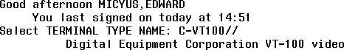

Figure 7
- At the Select System Manager Menu Option prompt (see Figure 8), type P and press the Enter key.

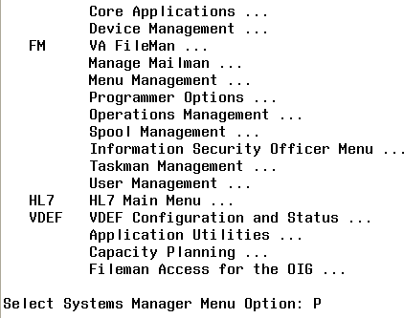

Figure 8
- At the Select Programmer Options Option prompt (see Figure 9), type P and press the
Enter key.
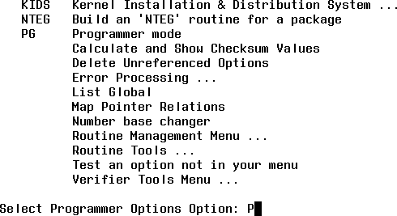

Figure 9
- You should see a command prompt similar to the one in Figure 10. The actual prompt will be different based upon the test center you are accessing.
- At the command prompt (see in Figure 10), type D ^XUP and press the Enter key.

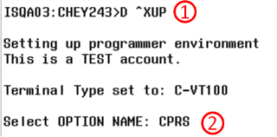

Figure 10
- At the Select OPTION NAME prompt (see in Figure 10), type CPRS and press the
Enter key.
- At the CHOOSE 1-5 prompt (see in Figure 11), press the Enter key.
- At the CHOOSE 1-10 prompt (see in Figure 11), type 9 and press the Enter key.
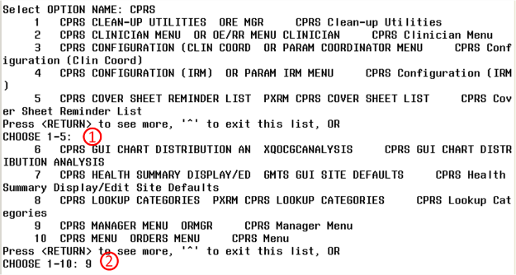

Figure 11
- At the CPRS Manager Menu Option prompt (see Figure 12), type PE and press the
Enter key.

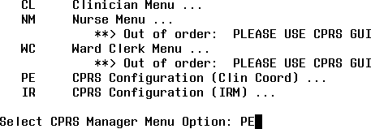

Figure 12
- At the Select CPRS Configuration (Clin Coord) Option prompt (see Figure 13), type
GP and press the Enter key.
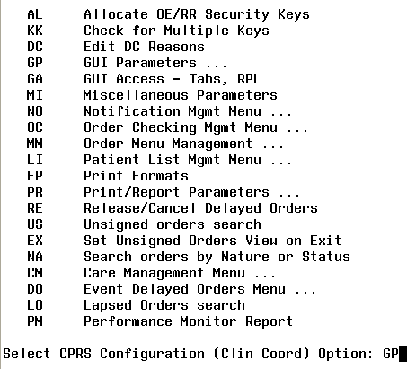

Figure 13
- At the GUI Parameters Option prompt (see Figure 14), type TM and press the Enter
key.

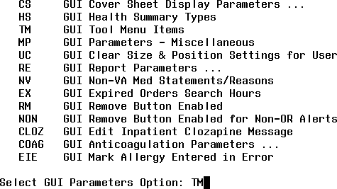

Figure 14
- At the Enter Selection prompt (see in Figure 15), type 1 and press the Enter key to modify the Tools menu for a specific user.
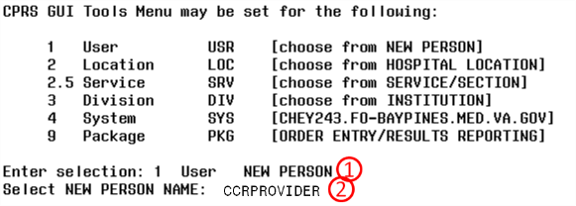

Figure 15
- At the Select NEW PERSON NAME prompt (see in Figure 15), type all or part of the user last name and press the Enter key. The value you type will depend on the user in the test account and will probably be different. We used CCRPROVIDER in this example. This will be the user that the link should be added to. Note: Setting the link for a Location or Division may also be used.
- If there is more than one matching person, a list of the matching person will be displayed (see Figure 16). Type the number of the user and press the Enter key. We used 4 in this example.
- At the CHOOSE 1-5 prompt (see Figure 16), enter the number of the desired person and press the Enter key. The number 4 was entered in this example.

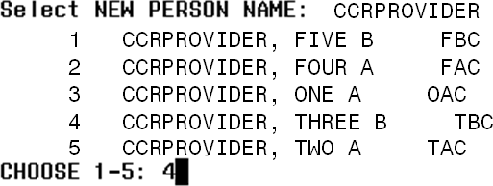

Figure 16
- At the Select Sequence prompt (see Figure 17), type ? and press the Enter key to see a list of the entries on the user’s CPRS | Tools menu.
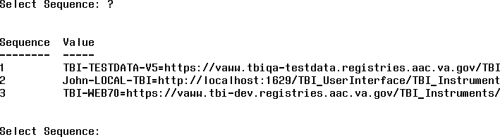

Figure 17
- At the Select Sequence prompt (see Figure 17), type 1 and press the Enter key to modify the TBI Prod or Pre-Prod/Dev entry. Below is the Pre-Production URL – replace XXX with your facility code (i.e. 442 = Cheyenne VAMC. Our example uses 931)

Note: After replacing the ‘XXX’ with the facility code, you may copy the URL and “Right-Click / Paste” into AttachMate Reflection:

URL (for use within CPRS): REDACTED
DEV: REDACTED

Figure 18
- At the Sequence: 1// prompt (see Figure 18), press the Enter key to accept the default and leave the sequence number unchanged.

- At the Replace prompt (see Figure 18), type the value to be replaced and press the Enter
key.
- At the With prompt, type the new value and press the Enter key.
- Multiple changes can be made at the same time by repeating steps 31 and 32 until the user presses the Enter key at the Replace prompt.
- Type ^ and press the Enter key to navigate back through the menu system until the Logged out message appears (see Figure 19).

Figure 19
- Click on the X in the upper right hand corner to exit.
- At the Exit Reflection dialog (see Figure 20), click on the OK button.
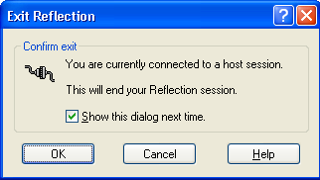

Figure 20

