Bar Code Medication Administration (BCMA)
BCMA Backup System (BCBU)
InterSystems IRISHealth
Installation and Setup Guide
October 2022
Department of Veterans Affairs (VA)
Office of Information and Technology (OIT)
Product Development (PD)

Revision History
Date | Revision | Description | Author
10/2022 | PSB*3*138 | Document updated for IRISHealth  Image caption updates  Fixed Table of Contents  Renumbered steps | Booz Allen Hamilton
3/2019 | PSB*3*122 | Document updated for Cache version 2017 | Redacted
4/2015 | PSB*3*84 | Document updated by Kevin Cownie. Entire document reformatted. | Redacted
07/11 | PSB*3*65 | Footers updated; removed HSITES and added Product Development, removed VistA. Renamed instances of CACHE to CACHE throughout the document. Updated version to reflect BCMA v3.0 version.
08/03 | PSB*2*17 | Original Released Bar Code Medication Administration Backup System (BCBU) InterSystems CACHE Workstation Installation Setup Guide.
Table of Contents
1 Introduction 1
1.1. General Background Information 1
1.2. Prerequisites 2
1.3. License/Key 2
1.4. Overview 2
2. Retrieve and Unzip Files 2
2.1. List of Files Required for Installation 2
3. Converting From Cache to IRISHealth 3
3.1. Software Conversion 3
3.2. License Conversion 5
4. New BCBU Workstation Installation Instructions 6
4.1. IRISHealth EXE Installation 7
4.2. Stop IRIS application 12
4.3. Copy files to “C:\InterSystems\IRISHealth” 13
4.4. Restart IRIS Service 14
4.5. Management Portal Configuration Steps 14
4.6. Stop and Restart IRIS Service 26
5. Setting up BCMA Backup Shortcut 27
6. BCBU Printer Set Up 34
6.1. Connect the printer to the workstation 34
6.2. Install the Windows printer drivers. Use Generic Drivers (Recommended) 34
6.3. Rename Windows printer to BCBU PRINTER 34
7. Initialize new BCBU with user and patient data 35
Appendix A. Apache Security Updates 37
A.1 Apache Patch Information 37
A.2 Example Workstation Installation 38

Introduction
This document contains instructions for the installation of IrisHealth on Microsoft Windows workstations.

General Background Information
These instructions are specific to installing IRIS on Windows workstations for the use of IRISHealth with BCMA Backup system (BCBU). These instructions cover two types of installations:
- Conversion of an existing BCBU Cache workstation to IRISHealth
- Installation of Intersystems IRISHealth on workstations which have never had Intersystems Cache or IRISHealth installed before.

Intended Audience
This document is intended for VA personnel responsible for the installation of IRISHealth for the use of IRISHealth with BCMA Backup (BCBU) system.
This document presumes a working knowledge of Microsoft Windows Operating Systems.

Software Disclaimer
This software was developed at the Department of Veterans Affairs (VA) by employees of the Federal Government in the course of their official duties. Pursuant to title 17 Section 105 of the United States Code this software is not subject to copyright protection and is in the public domain. VA assumes no responsibility whatsoever for its use by other parties, and makes no guarantees, expressed or implied, about its quality, reliability, or any other characteristic. We would appreciate acknowledgement if the software is used. This software can be redistributed and/or modified freely provided that any derivative works bear some notice that they are derived from it, and any modified versions bear some notice that they have been modified.

Documentation Disclaimer
The appearance of external hyperlink references in this manual does not constitute endorsement by the Department of Veterans Affairs (VA) of this Web site or the information, products, or services contained therein. The VA does not exercise any editorial control over the information you may find at these locations. Such links are provided and are consistent with the stated purpose of the VA.

Document Conventions
This document uses the following typographic conventions:
- Controls, options, and button names are shown in Bold.
- A vertical bar is used to separate successive menu choices. For example: “Click File | Open” means: “Click the File menu; then click the Open option.”
- Keyboard key names are shown in bold and in brackets.
- Sample output is shown in monospace. For example: BCBUIRISDATmmddyy.zip
- Important or required information is shown in a Note.

Prerequisites
Installation requires administrator privileges through local admin account logon or via user’s eToken with admin rights to the machine.

License/Key
BCMA BU systems require an IRIS license – also referred to as a “key” – to run properly. Please note the following about the license:
- Each site has one point of contact (POC) for IRIS Licenses
- Each site has a single key for all their BCMA BU workstations, i.e. one key per site
- Keys have a 30 year expiration date
For new licenses enter a Service Now Ticket to group: [REDACTED]
Once you receive the key, save it as “iris.key” to folder “C:\BCMABU” on the BCBU workstation.

Overview
This document contains instructions for the installation of InterSystems IRISHealth or conversion of InterSystems Cache to IRISHealth on Microsoft Windows workstations.

Retrieve and Unzip Files

List of Files Required for Installation
These files are required for installation and can be downloaded from [REDACTED].

Table 1. Required Installation Files
Filename | Type | Location
BCBUIRISDATmmddyy.zip  Note: “mmddyy” is a placeholder for the date and will change as the file is periodically updated to include all current patch installs. | ZIP | [REDACTED]
IRISHealth-2020.1.0.xxx.xxx-win_x64.exe  This is the Windows 64-bit executable.  Note: “xxx.xxx” is a placeholder for the version number and will change as the file is periodically updated with Intersystems updates. This directory should only contain the latest version. | EXE | [REDACTED]

Create directory C:\BCMABU
- If it does not already exist, create directory C:\BCBAMU. Save both files listed in the previous step to this directory.

Unzip BCBUIRISDATmmddyy.zip to C:\BCMABU
After unzipping the contents for the .ZIP file, the resulting C:\BCMABU directory should contain the following files:
- BCBU Workstation IrisHealth Install-Conversion 2022.doc
- bcma.ico
- cube.ico
- export.ro
- iris.cpf
- iris.dat
- Read Me First.txt

Converting From Cache to IRISHealth
NOTE: If you are installing onto a workstation which has never installed BCMA Backup before, then skip this chapter and proceed to chapter “New BCBU Workstation Installation Instructions”.
This chapter provides instructions for converting a workstation with an existing Intersystems Cache installation to Intersystems IRISHealth. If you are installing onto a system which has never had Intersystems Cache installed, skip this chapter and go to chapter New BCBU Workstation Installation Instructions.
Be sure to complete the steps in the chapter Retrieve and Unzip Files before proceeding with the instructions in this chapter.

Software Conversion
- Delete C:\BCMABU\iris.dat
- For conversions, this file must be deleted before starting.
- During this process the existing “cache.dat” will be renamed to “iris.dat” for you.
- If it is not deleted before starting, this will require user and patient inits to be resent from Vista. See chapter Initialize New BCBU with User/Patient Data for instructions on how to resend the inits.
- Run the EXE file as Administrator
- Right-click the file C:\BCMABU\IRISHealth-2020.1.0.xxx.xxx-win_x64.exe and select “Run as Administrator”.
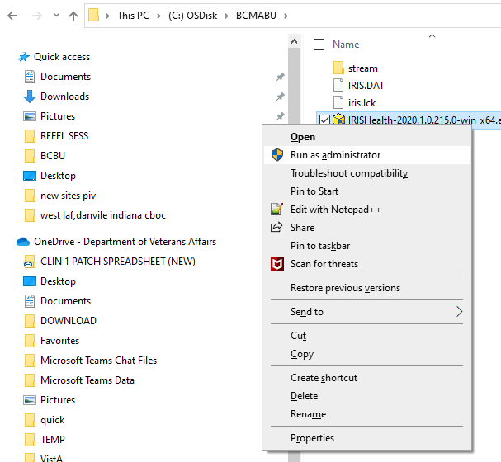
Figure 3. Run the EXE file as Administrator
At this point you will have to select the appropriate etoken account or enter administrator account and password at Windows User Account Control dialog pop up. If the Windows user account being used does not have required administrator privileges to perform this installation then you will need to seek assistance from a privileged workstation administrator.

- Cache to IRIS Conversion Question
- At the Select Instance dialog box “Select Cache (conversion)” and then click “OK”.
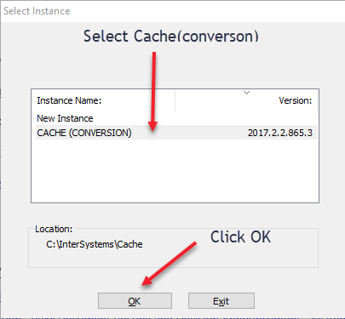
Figure 4. Cache to IRIS Conversion Question

License Conversion
- Click on the “License” button.

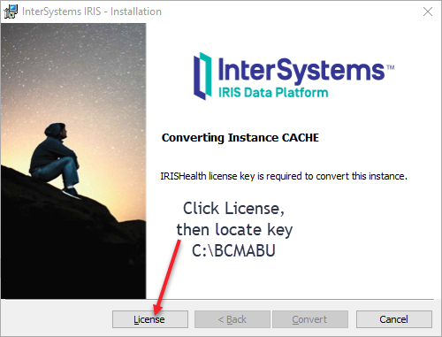
Figure 5. Convert Cache License to IRISHealth
- Locate “iris.key” file previously saved to C:\BCMABU\iris.key
- Navigate to the directory “C:\BCMABU” and locate the file “iris.key”.
- After locating the file, click “Open”. This will copy the iris.key file to the c:\intersystems\cache\mgr directory.
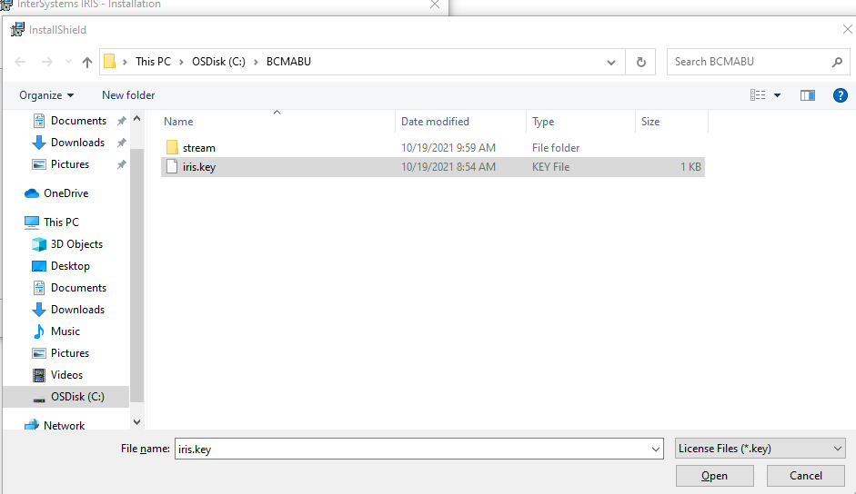
Figure 6. Locating “iris.key” file
- After License Process Completes, select “Convert”

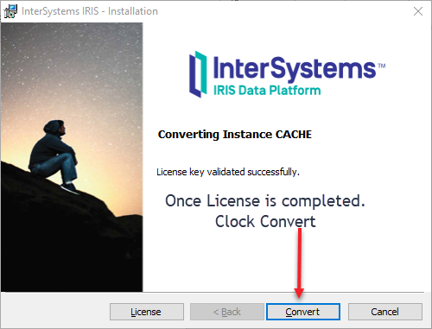
Figure 7 Final Conversion Step
- Click “Finish”
- Once the convert process is done, then the “Finish” button is available to click.

- Go to “Setting up BCMA Backup Shortcut” to complete conversion
- See Setting up BCMA Backup Shortcut to complete the conversion to IRIS

New BCBU Workstation Installation Instructions
NOTE: If you are converting a workstation from Cache to IRISHealth, please do not use this chapter. Instead, follow the instructions in chapter Conversion Instructions From Cache to IRISHealth.
This section provides instructions for installing Intersystems IRISHealth on workstations which have never had Intersystems Cache or IRIS installed before. If you are doing an conversion from Cache to IRISHealth, please do not use this chapter and follow the instructions in chapter Conversion Instructions From Cache to IRISHealth instead.
Be sure to complete the steps in the chapter Retrieve and Unzip Files before proceeding with the instructions in this chapter.

IRISHealth EXE Installation

Run the EXE file as Administrator
- Right-click the file C:\BCMABU\IRISHealth-2020.1.0.xxx.xxx-win_x64.exe and select “Run as Administrator”.
Figure 9. Run the EXE file as Administrator

- At this point you will have to select the appropriate etoken account or enter administrator account and password at Windows User Account Control dialog pop up. If the Windows user account being used does not have required administrator privileges to perform this installation then you will need to seek assistance from a privileged workstation administrator.
- At “Instance Name” select “New Instance”
- At the “Select Instance” dialog box, click on “New Instance” then Click OK. 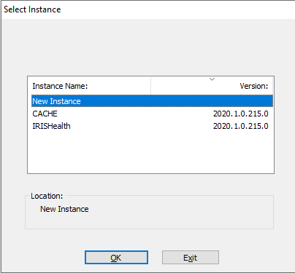
Figure 10. At “Instance Name” select “New Instance”

- Accept License Agreement and click “Next”
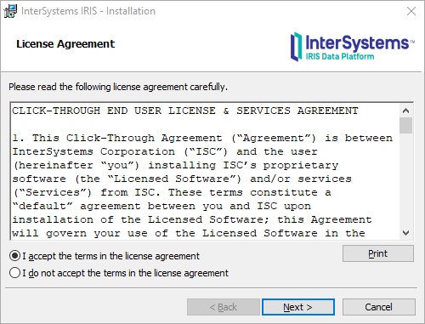
Figure 11. Accept License Agreement and click “Next”
- At “IRIS Instance Name” enter “CACHE”
NOTE: Be sure to change the Instance Name from the default value to CACHE. Failure to do so will result in an improperly configured BCMA BU system which may not work correctly. If this happens, the recommendation is to uninstall IRISHealth and restart the installation from scratch.
- At the “InterSystems IRIS Instance Name” box, type in “CACHE”, then click “Next”.
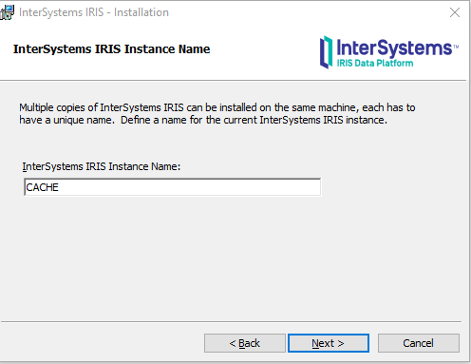
Figure 12. “IRIS Instance Name” Window

- “Destination Folder” should Default to “C:\InterSystems\IRISHealth” and click “Next”

- At “Setup Type” select “Development”, then click “Next”
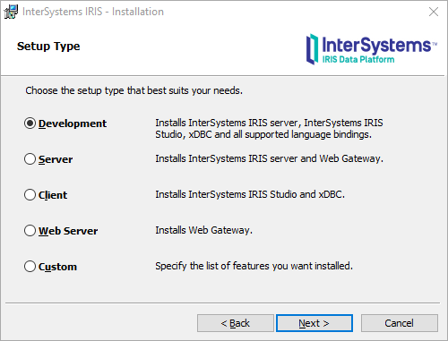
Figure 14. Setup Type Window Selection
- At “Install Unicode Support” select “8-bit” then click “Next”.
- At “Initial Security Settings” select “Normal” then click “Next”.
- Accept Default Credentials for InterSystems IRIS Service
- Confirm that the first option is selected: “Run InterSystems IRIS under default SYSTEM account”, then click “Next”.
- “IRIS Users Configuration” Password
- IRIS now requires user/password for Management Portal access. For ease of OIT administration, use the same password with all BCBU workstations.
- Please store this password in a secure location where OIT staff who administer the workstation will have access to it. If the password is lost, then submit a Service Now ticket to REDACTED for instructions on resetting this password.
- Enter the chosen password in both fields in the “InterSystems IRIS Users configuration” dialog box, then click “Next”.
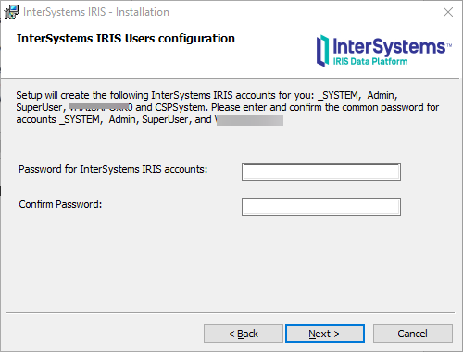
Figure 18. “IRIS Users Configuration” Password
- “CPSsystem Account” Password
Use the same password as the “IRIS Users Configuration” password from the previous step.
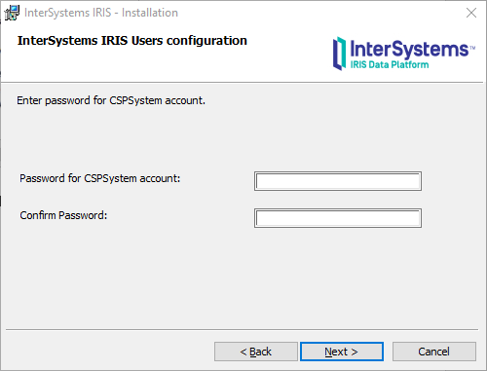
Figure 19. “CPSsystem Account” Password
- Ready to Install the Program: Click “Install”
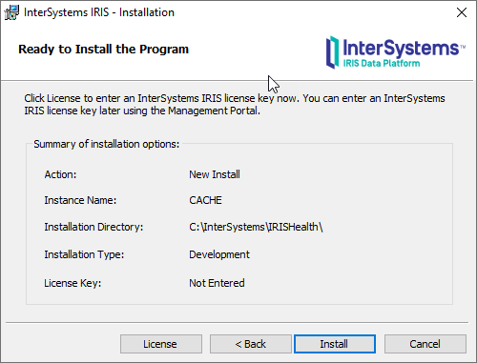
Figure 20. Ready to Install the Program: Click “Install”

- Wait for Install to complete and click “Finish”
- Once installation is complete, click the “Finish” button.

Stop IRIS application
You need to stop then restart IRIS application in order to configure IRIS for BCMA BCBU.
- In the Windows Start menu, type “stop InterSystems IRIS [CACHE]”
Figure 22. Windows Start Menu Search
- On the right, select “Open”
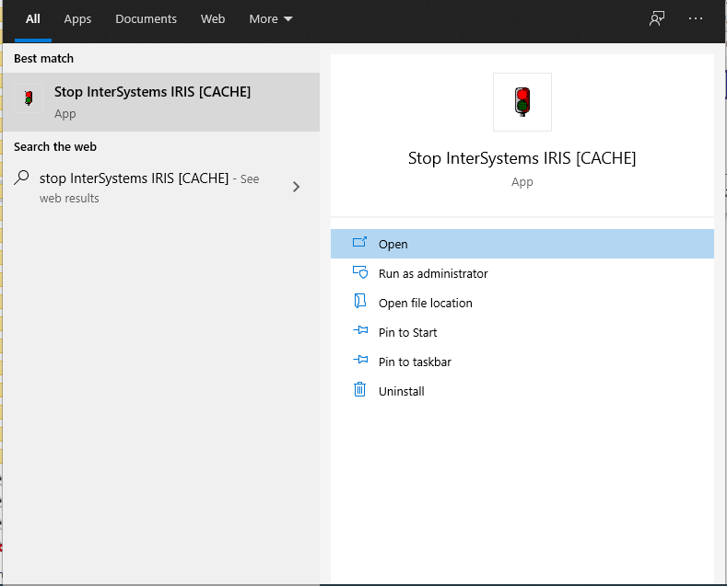
Figure 23. Open IRIS Stop Utility

- Select Shut Down and Click OK
Figure 25. “Stopping…” Dialog
- Wait for it to stop.
- In the lower left hand corner of your monitor, the IRIS Tray Icon will be greyed out.

Copy files to “C:\InterSystems\IRISHealth”

The file iris.cpf already contains most of the setup (namespace, mapping etc). Copy these files to the IRISHealth directory.

Table 2. Copy ".cpf" and ".key" files
Copy This File | To This Directory
C:\BCMABU\iris.cpf | C:\InterSystems\IRISHealth\
C:\BCMABU\iris.key | C:\InterSystems\IRISHealth\mgr\

Restart IRIS Service
- In the Windows Start menu, type “start InterSystems IRIS [CACHE]”

- On the right, select “Open”
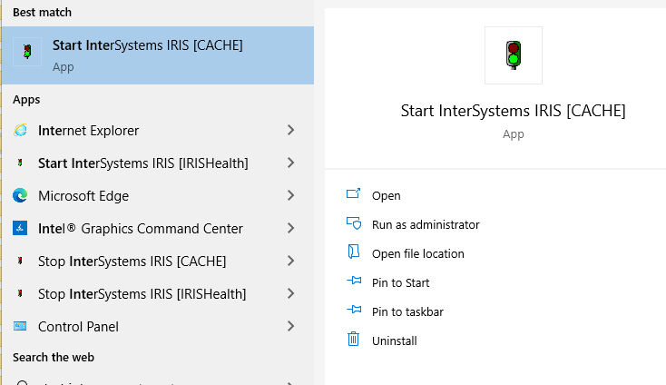
Figure 28. Open IRIS Start Utility

Management Portal Configuration Steps
This section covers Management portal configuration tasks to manage the console, user account, and start up processes.
The IRIS service must be started before you can access the “Management Portal [CACHE]”.
- In the Windows Start menu, open “Management Portal [CACHE]”
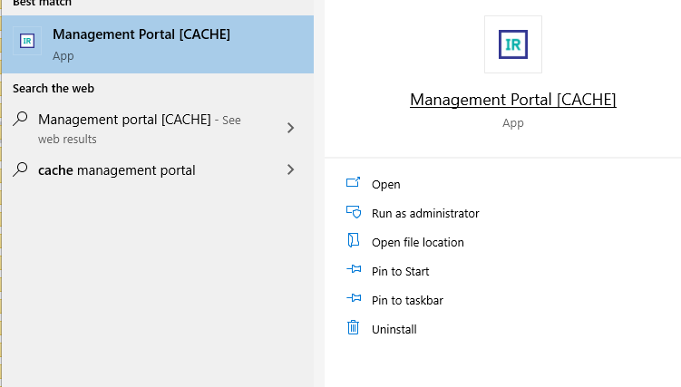
Figure 29. “Management Portal [CACHE]” In the Windows Start Menu

- You will be prompted for Username and Password. The user name is “admin” and the password is what you specified in step 5.1.10 “IRIS Users Configuration”.
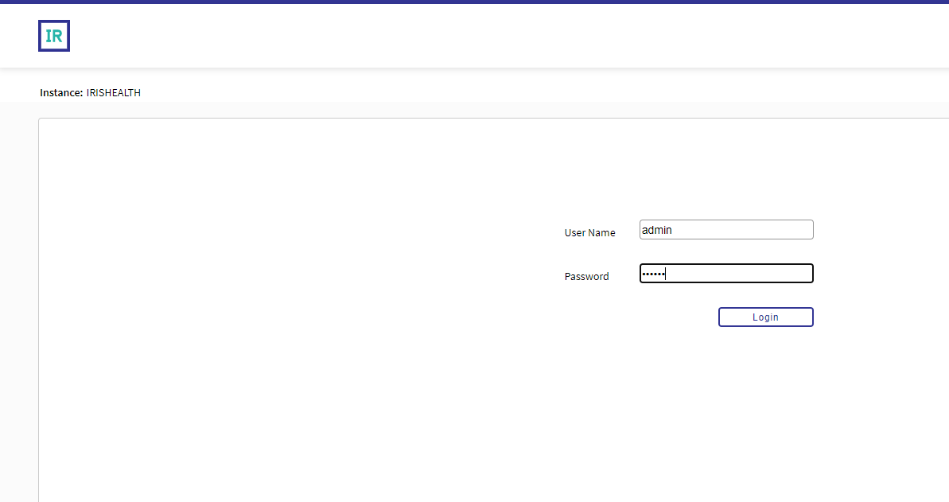
Figure 30. IRIS Username and Password Dialog

- If you log in successfully, you will see the “Welcome” message screen.
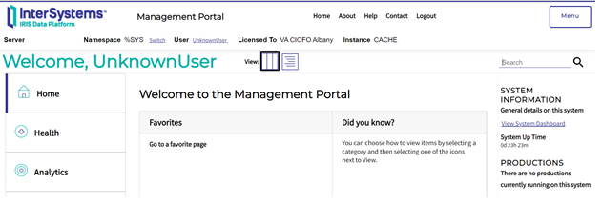
Figure 31. “Welcome” message screen.

Configure IRIS Services

IRIS services control how the BCMA Backup terminal client will interact with the user.

- Click “Menu” in upper right then select “Manage Services”
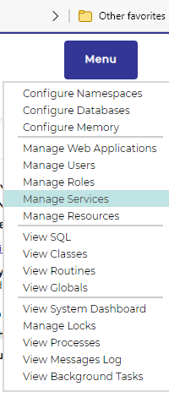
Figure 32. View of Menu Options
- In “Services”: click “%Service Console”
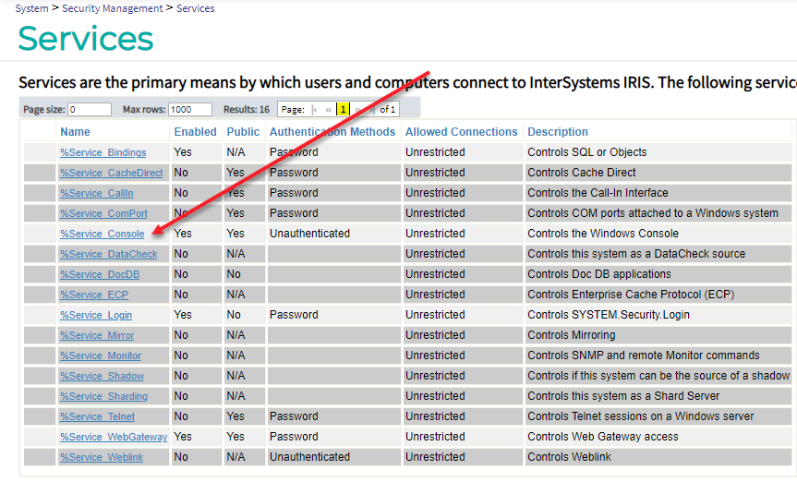
Figure 33. “%Service Console” Location within Services

- In “Edit Service”: make sure only “Unauthenticated” is selected
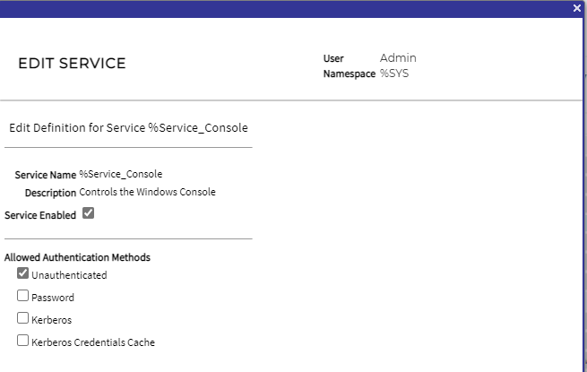
Figure 34. “Edit Service” Dialog

- Click “Save”

Configure IRIS “UnknownUser” User
This configures the IRIS terminal session to prompt for “Access/Verify” code.
- Click “Menu” in upper right then select “Manage Users”
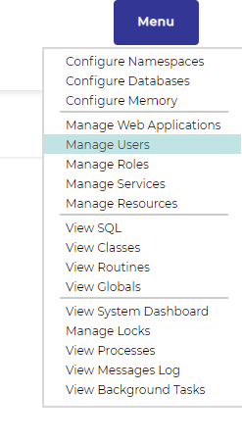
Figure 35. “Manage Users” within Menu
- Click on “UnknownUser”
- This takes you to the “Edit User” screen for user “UnknownUser” which has the Full Name “Unauthenticated user”.
- Click “Roles” tab
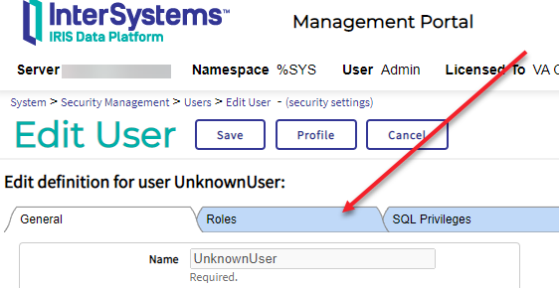
Figure 36. “Roles” tab in IRIS

- Select “%All” and click right arrow
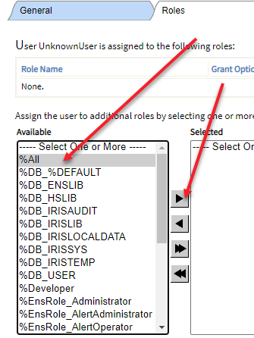
Figure 37. “%All” in Dropdown Menu
- “%All” is now on the right and click “Assign”
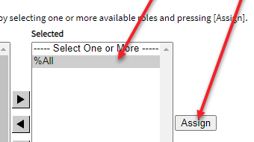
Figure 38. Assigning “%All”
- Observe “%All” is now assigned under “Role Name”
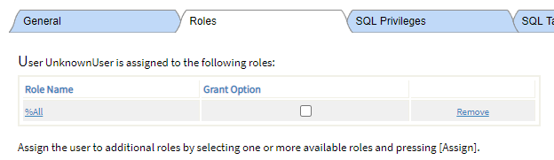
Figure 39. Observe “Role Name”

- Click on “General” tab
- For “Startup Namespace” select “VISTA”
- See next step for screen shot for this field.
- For “Startup Tag^Routine” enter “^ZU”
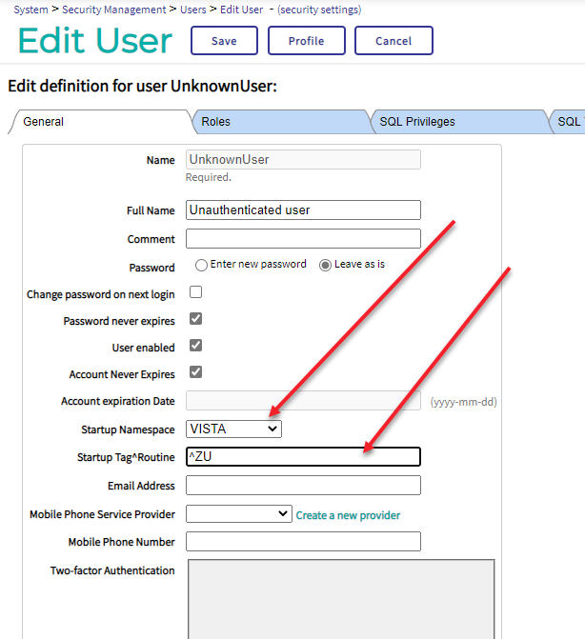
Figure 40. “Startup Tag^Routine” Entry
- Click “Save”
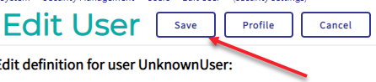
Figure 41. “Save” Button

Import ZSTU into %SYS
The ZSTU routine performs start up tasks when BCBU launches.
NOTE: If the above step is not completed then BCBU will not auto start correctly.
- Click “Home” to return to the “Welcome” screen
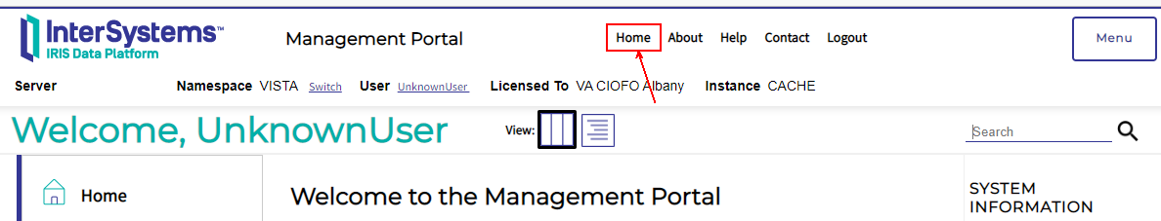
Figure 42. “Home” Button Location within IRIS
- Select “Switch”
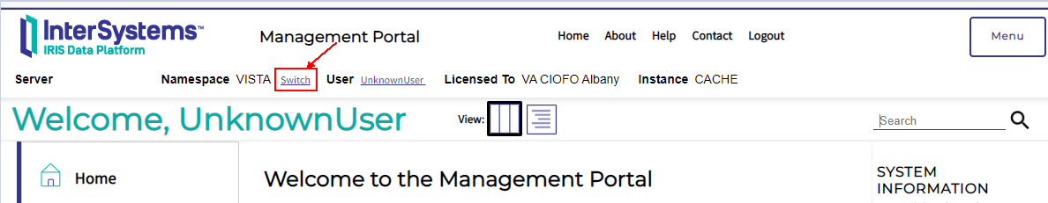
Figure 43. “Switch” Location within IRIS
- “Namespace Chooser”: Select “%SYS” then click “Ok”
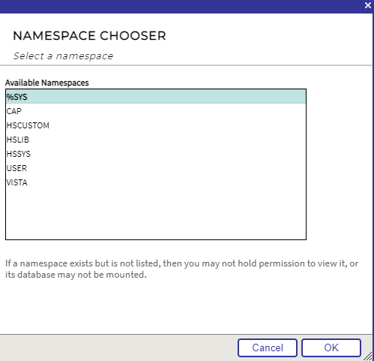
Figure 44. Namespace Chooser Dialog

- Click “Menu” in upper right and select “View Routines”
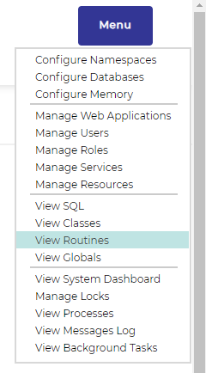
Figure 45. “View Routines” Location in Menu
- Click “Import”
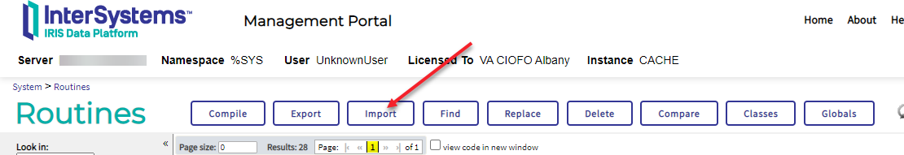
Figure 46. IRIS Tabs: Import Location

- Browse for file “C:\BCMABU\export.ro” and click “OK”
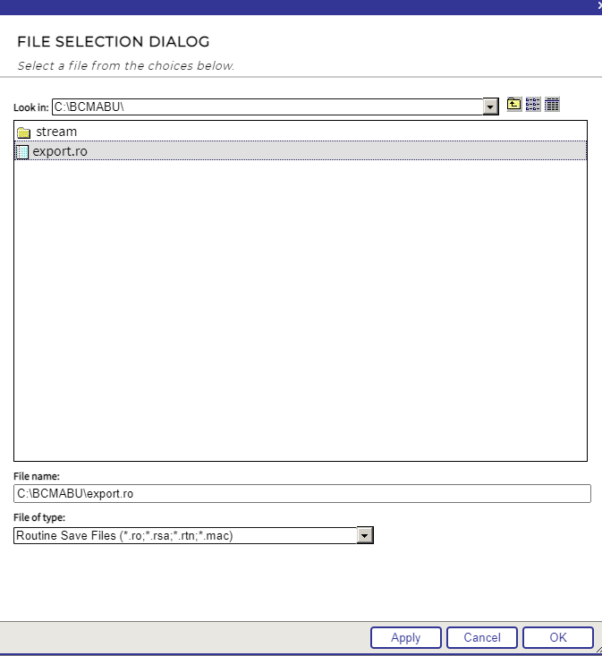
Figure 47. Locating Routines
- “Import Routines”: Click “Next”
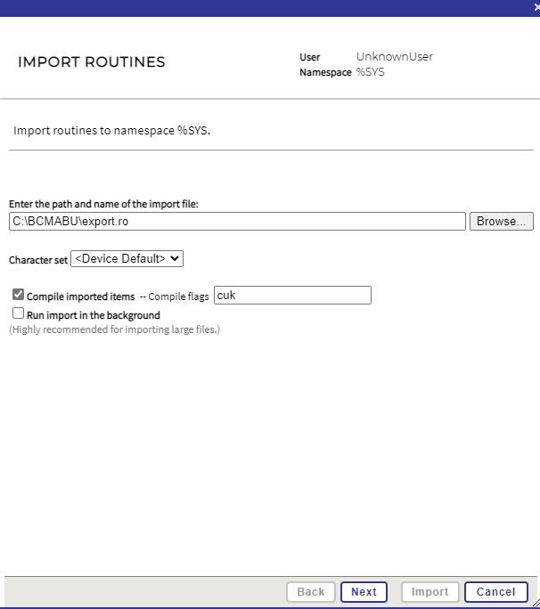
Figure 48. “Import Routines”: Click “Next”
- Click “Import”
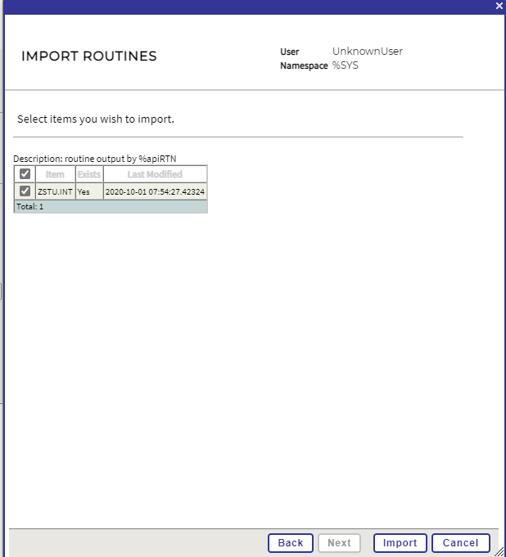
Figure 49. Importing Routines
- Click “Done”

Configure Auto-Start
- Click “Menu” in upper right then “Configure Memory”
- Confirm “Auto-start on System Boot” is checked and click “Save”
- If “Auto-start on System Boot” is not checked, then check it, then click “Save”.
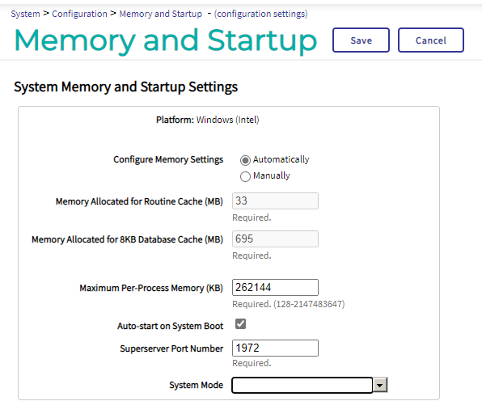
Figure 51. “Memory and Startup” Dialog
- Exit Management Portal
- Click the “Logout” button or close the browser window.

Stop and Restart IRIS Service
- In the Windows Start menu, type “stop InterSystems IRIS [CACHE]”

- Select “Open”
Figure 53. Open Stop IRIS Utility

- Select “Restart” and Click “OK”
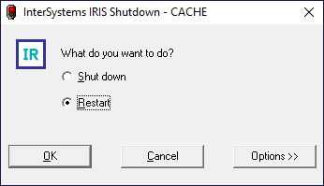
Figure 54. IRIS Shutdown/Restart Dialog

Setting up BCMA Backup Shortcut
In this section you will create the desktop shortcut to the BCMA Backup software.
- Delete existing BCMA Backup Icon
NOTE: This step should only be performed on workstations which did a conversion from Cache to IRISHealth.
Workstations which did a new installation of IRISHealth should skip this step.
Delete the existing “BCMA Backup” icon on the workstation desktop. This icon only works with Cache and will not work with the IRISHealth software and so should be deleted.
- Create shortcut on desktop
To create the shortcut, right click anywhere on the desktop and select “New/Shortcut”.

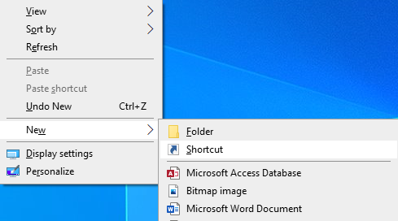
Figure 55. Creating New Shortcut
- Enter path to shortcut location
- In the “Type the location of the item” dialog box, the correct location will depend upon whether the workstation was converted from Cache to IRISHealth, or if it was a brand new BCBU IRISHealth installation. Please select the correct location from the table below.
Table 3. BCMA Backup Shortcut Path/Location
Workstation Installation Type | Location/Path
Converted Cache to IRISHealth | C:\InterSystems\cache\bin\Iristerm.exe /console=cn_ap:cache[VISTA]
New BCBU IRISHealth installation | C:\InterSystems\IRISHealth\bin\Iristerm.exe /console=cn_ap:cache[VISTA]
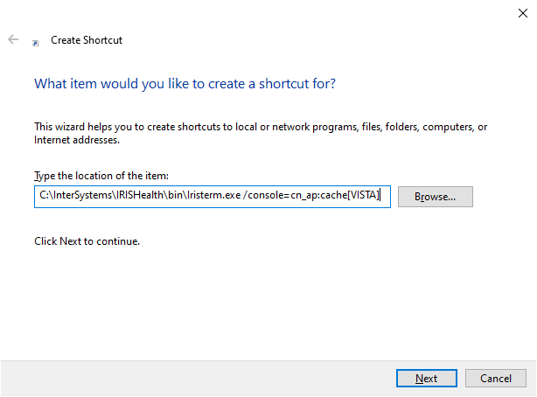
Figure 56. Entering path to shortcut location

- Then click the “Next” button.

- Enter shortcut name
- When prompted, enter a name that will be displayed with the shortcut. A suggested name is “BCMA BACKUP” but sites can use any name they choose.

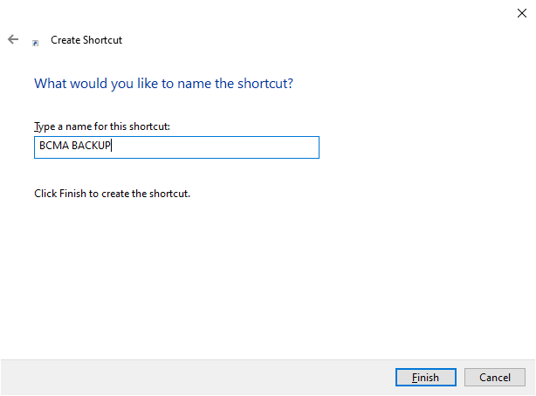
Figure 57. Entering shortcut name

- Then click the “Finish” button.

- Change BCBU icon
- Click the right mouse button on the new icon, then select “Properties”
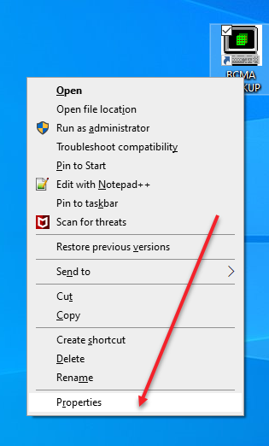
Figure 58. Right click Location of "Properties"
- Click “Change Icon”
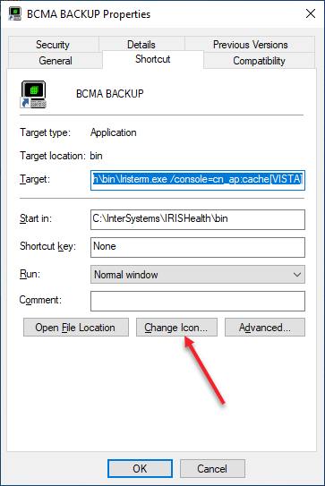
Figure 59. “Change Icon” Button

- Select “C:\BCMABU\bcma.ico” or sites may choose their own icon. Included icons are “bcma.ico” and “cube.ico” (old Cache), then click OK
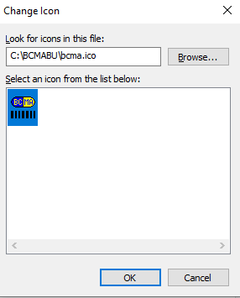
Figure 60. Selecting icon

- Click Apply and then OK
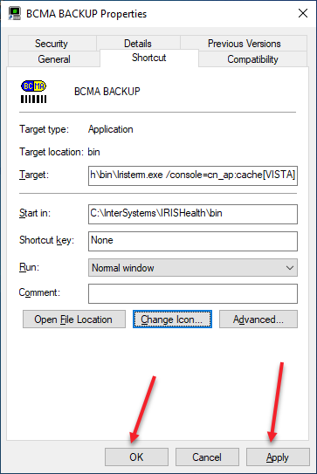
Figure 61. Accepting Changes

- If you used the “bcma.ico” icon provided with the ZIP file, it will look like this on the desktop:
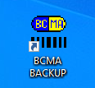

- Copy shortcut BCBU icon to “All User” desktop
- Double-Click the BCBU shortcut icon to enter the Backup system on the PC Workstation. Use the appropriate access and verify code to access the system.

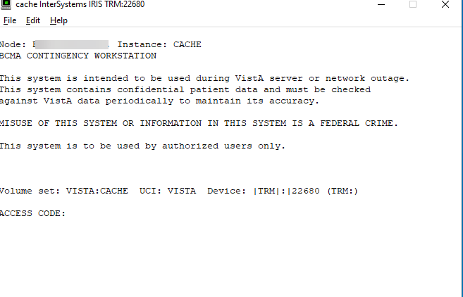
Figure 63. After Double-Clicking the BCBU shortcut icon
- Workstation setup is complete
This completes the setup of InterSystems IRISHealth on the BCBU contingency workstation. Refer to the “BCMA V.3.0 Backup System (BCBU) Version 3 Installation Guide” to complete the VistA side of the package setup.

BCBU Printer Set Up

Connect the printer to the workstation

Install the Windows printer drivers. Use Generic Drivers (Recommended)
Some workstations may work correctly with the model specific printer driver. If printing still does not work, then this is often fixed by changing the printer driver to “Generic / Text Only”.

Rename Windows printer to BCBU PRINTER
- The Windows printer name should be renamed to “BCBU PRINTER” (case sensitive) in order to match the name of the printer defined within the BCBU application.

Initialize new BCBU with user and patient data
On a new BCBU system installation, the BCBU database is not populated with patients or users. It must be initialized with this information from the site’s VistA system before patient data is available and users can access the new BCBU system. The tasks for initializing a new BCBU system are described in detail in the “BCMA V.3.0 Backup System (BCBU) Version 3 Installation Guide” section “Sample PC Workstation Database Initialization”. This document can be found in the VistA Virtual Documentation Library at REDACTED
As an overview, initializing a new system consists of performing the following tasks on the site’s VistA system. You may need to contact your VistA support personnel for assistance.
Table 4 New BCBU Workstation Initialization Tasks
Task | VistA Option | Purpose
1. Configure the HL7 logical links | Link Edit [HL EDIT LOGICAL LINKS] | Defines the IP address or DNS name of the BCBU workstation
2. Associate the HL7 logical link to VistA BCBU application | Associate Backup Workstations with a Division [PSB BCBU LINK ASSOCIATIONS] | Associates the HL7 logical link as a subscriber to the VistA BCMA Backup software so the workstation will receive BCMA HL7 messages from VistA
3. Run workstation initialization to populate patient data | Depending upon your site’s configuration, run ONE of the following options:  Default Workstation Initialize [PSB BCBU INIT WRKSTN DFT]  OR  Divisional Workstation Initialize [PSB BCBU INIT WRKSTN DIV | Sends current patient demographics and Inpatient Pharmacy orders to the BCBU workstations
4. Run the VistA user initialization to populate users’ access/verify codes: | Initialize a Backup Workstation with BCMA User [PSB BCBU USER INIT] | Sends all BCMA authorized users’ access/verify code information to the BCBU workstations

Initialization options 3 and 4 are under menu option BCMA Backup System (Vista) [PSB BCBU VISTA MAIN]. Vista SECURITY KEY assignment of PSB BUMGR is required.

Select OPTION NAME: PSB BCBU VISTA MAIN BCMA Backup System (Vista)
LNK Associate Backup Workstations with a Division
DFT Default Workstation Initialize
DIV Divisional Workstation Initialize
USR Initialize a Backup Workstation with BCMA Users
PAT Single Patient Init

Appendix
- Apache Security Updates
InterSystems IRISHealth runs the Apache server software which must be regularly patched according to OIT security policies. Local IT services must manually install the patches on BCMA Backup workstations. Workstations which are not patched will be flagged during CRISP reviews. These patches will be distributed by OIT Infrastructure Operations and OIT may send out Action Items to direct sites when updates are available.
Required updates should be installed on any workstations running InterSystems IRISHealth.
- Apache Patch Information
The Apache Security Updates may be found in the location below. This location will be regularly maintained with the latest security updates.
Security Patch Location: | REDACTED
Installation Script Name: | REDACTED
Installation Permissions: | REDACTED
Service Now Group: | REDACTED

- Example Workstation Installation
This is a example of the output when running the Apache patch installation on a workstation.
REDACTED

