Indian Health Service and Section 508 Compliance for BCMA v3.0

RELEASE NOTES

PSB*3*42

January 2011

Department of Veterans Affairs
Product Development

Table of Contents

1. Introduction 1
2. Enhancements 2
2.1. Indian Health Service 2
2.2. Section 508 Compliance 2
3. New Features 3
3.1. Indian Health Service 3
3.2. Section 508 Compliance 5
3.3. BCMA Site Parameters Application 6
4. VMP Corrections 7
5. BCMA Online Help Update 11

(This page included for two-sided copying.)

Introduction

This document provides a feature summary of the Indian Health Service – Parameterization of BCMA Patient Identifier and Section 508 Compliance for BCMA v3.0 project, patch PSB*3*42. In addition to the enhancements, several VMP Remedy Ticket corrections have been included with this patch.

Highlights

Indian Health Service – Parameterization of BCMA Patient Identifier
- Recognizes either VA or IHS Operational Environment.
- In the IHS environment:
  - Displays and prints the IHS patient identifier, referred to as Health Record Number (HRN) on applicable BCMA GUI screens, reports, and e-mail notifications.
  - Displays the appropriate default Patient ID Label of “SSN” in the VA operating environment or “HRN” in the IHS operating environment.
  - Provides a site parameter to customize the IHS Patient ID label to something other than “HRN.”
  - Recognizes either VA or IHS Vital Signs Application.
  - Provides IHS Output Device Support.

Section 508 Compliance
- Recognizes JAWS Application when loading BCMA.
- Adds JAWS screen reader compatibility to the BCMA GUI VDL and Unit Dose, IVP/IVPB and IV tabs.
- Adds keyboard shortcuts, field focus, and modified tab order, where necessary, to enhance accessibility.

VistA Maintenance Project (VMP) Corrections
- Several Remedy tickets have been resolved by the VMP team and are included in this patch. (See page 7.)

BCMA Online Help System Update
- The Online Help system has been updated for both the BCMA Client and Site Parameters application.

Enhancements

Indian Health Service

The BCMA application is now able to determine if it is operating in the Indian Health Service (IHS) or Veterans Health Administration (VHA) environment and recognize and display the appropriate patient identifier. This enables a single version of BCMA to be maintained by VHA and be installed and operate in a “plug and play” fashion in an IHS or Tribal facility running Resource and Patient Management System (RPMS).

BCMA principally interacts with the Patient Information Management System (PIMS), Inpatient Pharmacy, and Order Entry/Results Reporting (OE/RR) packages. Each of these has a native VistA version and a modified Resource and Patient Management system (RPMS) version maintained by IHS. With this enhancement, BCMA is able to work seamlessly alongside these packages regardless of the operating environment. In addition, the BCMA Graphical User Interface (GUI) displays vital measurements from the Veterans Administration (VA) VITALS/MEASUREMENTS package or the PCC V MEASUREMENT files, if operating in an RPMS system.

Section 508 Compliance

Section 508 of the Rehabilitation Act of 1973 and Rehabilitation Act Amendments of 1998 mandates that all software developed by federal agencies allow access to and use of information and data by individuals with disabilities. The updated BCMA V. 3.0 GUI ensures compliance with the requirements of the Section 508 Checklist for Software Applications and Operating Systems. Section 508 enhancements to BCMA ensure accessibility for color-blind, mobility-impaired, and visually-impaired users, without impacting software usability for sighted staff administering medications to patients.

The Delphi Components for Section 508 Compliance functionality and screen reader compatibility to the BCMA GUI VDL are incorporated in this enhancement as required and specified by the VA Section 508 Compliance Office. Section 508 Compliance requirements for software applications can be accessed via the following link: REDACTED

New Features

Indian Health Service

Identifies Operational Environment
BCMA recognizes the operational environment (VistA or RPMS) by referencing the agency variable DUZ (“AG”).

Recognizes IHS Patient Identifier
When operating in the RPMS environment, BCMA reads the 12-digit bar code IHS patient identifier and splits the 12-digit identifier into its component parts, Area, Service Unit Facility ASUFAC (characters 1-6) and Health Record Number (HRN) (characters 7-12), to correctly identify and match patient identifiers associated with drug orders.

Provides IHS Site Parameter for Customizing IHS Patient ID Label
When operating in the RPMS environment, the application provides a Site Parameter to customize the IHS Patient ID label in BCMA. By default, the IHS Patient ID Label defaults to “HRN.” The features below are described using the default IHS Patient ID Label. Please note that the application will display the customized label, if applicable. See Section 3.3 below for details.

Displays IHS Patient Identifier on BCMA GUI Screens
When operating in the RPMS environment, the application displays the default IHS Patient ID Label of “HRN” instead of “SSN” on the following BCMA GUI screens that display a label for the patient identifier, as well as the patient’s 6-digit IHS HRN:

- BCMA Virtual Due List (VDL)
- Patient Confirmation form
- Edit Med Log Administration Select form
- Edit Med Log form
- Patient Select form

Displays IHS Patient Identifier on BCMA GUI Reports
When operating in the RPMS environment, the patient’s entire 6-digit HRN and corresponding IHS Patient ID Label, instead of the SSN, are displayed and printed on the following reports:

- Administration Times
- Cover Sheet Medication Overview
- Cover Sheet PRN Overview
- Cover Sheet IV Overview
- Cover Sheet Expired/DC’d/Expiring Orders
- Display Order
- Due List
- IV Bag Status
- Medication Admin History
- Medication History
- Medication Log
- Medication Therapy
- Medication Variance Log
- Missed Medications
- Patient Demographics/Inquiry
- PRN Effectiveness
- Unable to Scan Detailed Report
- Cumulative Vitals Report
- Patient Record Flag Report

Transmits HRN in HL7 Messages
The application transmits the patient’s entire 6-digit HRN and corresponding IHS Patient ID Label, instead of the SSN, in any Health Level Seven (HL7) messages that it generates.

Displays HRN in BCMA E-mail Notifications
When operating in the RPMS environment, the patient’s entire 6-digit HRN and corresponding IHS Patient ID Label, instead of the SSN, will be displayed and formatted appropriately in the following BCMA e-mail notification messages:

- Due List Error
- Missing Dose Notification
- Unknown Actions
- Unable to Scan

Detects Vital Signs Application
BCMA determines which vital signs application is in use at the facility (VA VITALS/MEASUREMENTS or PCC V MEASUREMENTS) and retrieves, displays, and files vitals measurement data in the appropriate locations.

Whether a facility uses the VA VITALS/MEASUREMENTS (VHA origin) or the PCC V MEASUREMENTS (IHS origin) to record vital measurements, its use is determined independent of the agency variable, because some IHS facilities may ultimately adopt the VA VITALS/MEASUREMENTS package.

Provides IHS Output Device Support
If BCMA recognizes the RPMS operating environment, it adds the output device of OTH “OTHER” to support printing of reports in the IHS AIX operating system.

Sets System Level IHS Patient ID Label Default
Upon installation of the server package, the System level “IHS Patient ID Label” variable default value, PSB PATIENT ID LABEL, must be set.
- If the operating environment is RPMS, and the System level variable has no value, the script sets the System level “IHS Patient ID Label” variable to a default value of “HRN.”
- If the operating environment is VistA, the script sets the System level “IHS Patient ID Label” variable to a default value of “SSN.”
- A Division level “IHS Patient ID Label” variable having an assigned value takes precedence and overrides the value in the System level “IHS Patient ID Label” variable.
See the BCMA User Manual, Appendix E: IHS – Parameterization.

Section 508 Compliance

Recognizes JAWS Application
When launching BCMA, the application recognizes whether the JAWS screen reader is currently running. If the screen reader is detected, the BCMA title bar displays “s508”. An alternate interface is launched that runs Delphi components, providing a framework allowing keyboard navigation of the BCMA VDL that is compatible with the JAWS screen reader.

Implemented for BCMA GUI Tabs
Screen reader functionality is implemented for the following medication tabs on the BCMA VDL: Unit Dose, Intravenous Push (IVP)/Intravenous Piggy Back (IVPB), and Intravenous (IV). Note that the BCMA Cover Sheet tab is not compatible with the JAWS screen reader at this time.

Provides Compatible Drug Administration Dialogs
Drug administration dialogs are compatible with the JAWS screen reader.

Provides Enhanced Accessibility
Keyboard shortcuts, field focus, and modified tab order have been added, where necessary, to enhance accessibility.

See the BCMA User Manual, Appendix D: 508 Compliance.

BCMA Site Parameters Application

A new parameter has been added to the BCMA Parameters application allowing IHS to customize the patient identifier label used in their environment.

New Tab Added to BCMA Site Parameters Application
If the operating environment is RPMS, a new tab entitled “IHS” is added to the Parameters application which can only be seen when operating in the RPMS environment.

Field Added to BCMA Site Parameters Application
If the operating environment is RPMS, the field entitled “IHS Patient ID Label” is added to the “IHS” tab. This text entry field allows the user to enter a patient ID textual label of up to 5 characters. The contents of this field are displayed throughout BCMA GUI forms, reports, and e-mail notifications.

Patient ID Label Displayed
If the operating environment is RPMS and the Division level “IHS Patient ID Label” variable has no value, the program displays the System level “IHS Patient ID Label” variable value in the “IHS Patient ID Label” field.

If the Division level “IHS Patient ID Label” variable has a value assigned to it, the program displays the Division level “IHS Patient ID Label” variable value in the “IHS Patient ID Label” field.

If the operating environment is RPMS and both Division and System level “IHS Patient ID Label” variables have no value, the program displays the “IHS Patient ID Label” field as blank and BCMA displays “PtID” as the default value for “IHS Patient ID Label.”

User Selected Patient ID Label Stored
If the operating environment is RPMS and the user entry for “IHS Patient ID Label” differs from the System level value, the program stores the user entry to the Division level variable.

See the BCMA Manager’s User Manual, Appendix A: Setting Site Parameters for IHS.

VMP Corrections

Several Remedy tickets have been resolved by the VistA Maintenance Project team and are included in this patch. They are listed below with their corresponding HD number. Two of the corrections are patient safety issues and are listed with their PSPO numbers.

HD221177 – PSPO #823 - IV Infusion Hold Orders Not Working Properly
- Problem – If an IV order is already infusing when it is placed on provider hold, the IV can be stopped and then infused again while still on provider hold.
- Solution – If an IV bag is at a Stopped status and the order is placed on Provider Hold, the only available option is to Complete the bag. See below example.
Example: Scan IV Dialog Box
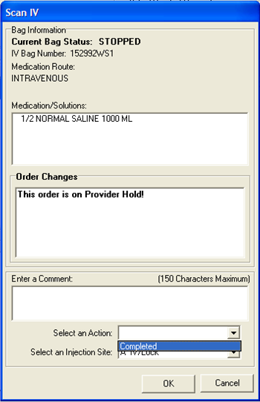
HD390027 – PSPO #1678 - Multi-tab Dose Popup Blocks Dosage
- Problem – The Multiple Dose pop up box covers the Dosage on the BCMA VDL.
- Solution - The field “Dosage Ordered” will be added to the “Multiple Dose” Form. See below example.
Example: Multiple Dose Dialog Box
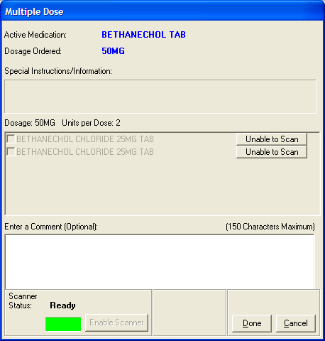
HD293514 – BCMA Order Problem Messages - Replicating
- Problem – An infinite loop with the reoccurring Mailman messages occurs when the Administration Times Report is run from a laptop with an invalid MUMPS date (a date prior to 12/31/1845).
- Solution – The infinite loop will be corrected by PSB*3*56. This patch will only change the default time for the reports. The default time for reports is currently the Laptop time. This correction will change the default time to the server time.
HD102421 – Comment Will Accept a Space
- Problem – When an order is given outside of the Allowable Time Limit, the Medication Log form will allow a space instead of a valid comment.
- Solution – A valid character will be required in the comment field before OK can be clicked.
HD380321 – Reason for Missing Dose Issue
- Problem – Barcode/IEN Illegible, Package Integrity Damaged, Wrong Dose/Drug Delivered and are missing from the Missing Dose Request Reasons Drop Down.
- Solution – Barcode/IEN Illegible, Package Integrity Damaged, Wrong Dose/Drug Delivered and have been added to the Missing Dose Request Reasons Drop Down. See below example.
Example: Missing Dose Request Dialog Box
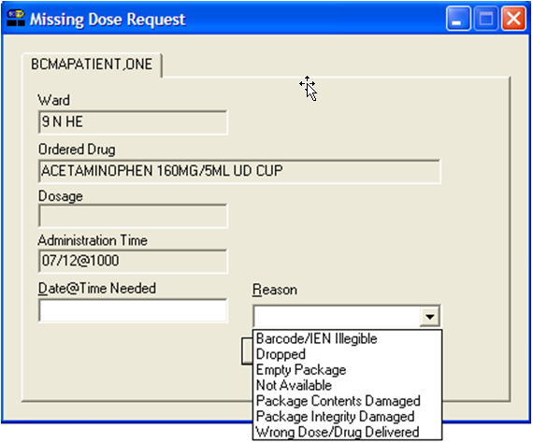
HD380330 – Remove Scratch HFS Directory from BCMA Parameters GUI
- Problem – The Scratch HFS Directory still displays on the BCMA Site Parameters Tab, even though patch PSB*3*46 has made this field obsolete.
- Solution – The Scratch HFS Directory will be removed from the BCMA Site Parameters Tab. See below example.
Example: Updated Site Parameters Tab
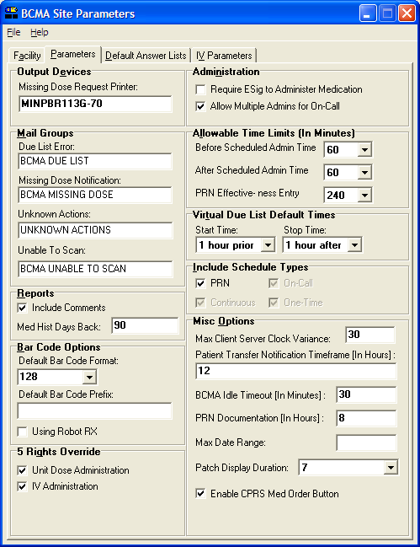
HD235723 – Units Given Do Not Show Up on Log
- Problem - If a missing dose is requested for an IVPB, the order is marked as held, and the order is then given, the Units ordered do not display on the Medication Log Report.
- Solution - Display the “Units Ordered” for all given orders. See below example.
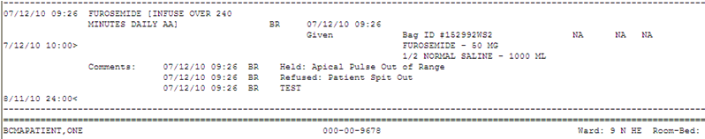Example: Medication Log Report

BCMA Online Help Update
The BCMA GUI Online Help system has been updated to include all released BCMA patch functionality, improved consistency with user manuals, and overall enhanced usability of the help system.

(This page included for two-sided copying.)

