Appendix C: Clinical Context Object Workgroup (CCOW)
What Is CCOW? | Clinical Content Object Workgroup (CCOW), more commonly known as Clinical Context Management, enables the clinical end-user to experience the simplicity of interacting with one system, when in reality he or she may be using multiple independent applications through varying interfaces.  Clinical Context Management is a method used to synchronize multiple GUI clinical computer applications to one subject, for example, the same patient.  Defined by HL7 standards, CCOW ensures secure and consistent access to patient data from varied sources. Benefits include applications that are easier to use, utilization of electronically available information, and an increase in patient safety. CCOW support for secure context management provides for HIPAA compliant communications and patient coordination.  In instances where one of the applications cannot accept the change request without adverse consequences, the user is informed of the circumstances and allowed to cancel the change request to resolve the issue in question. Canceling a change request does not close an application.
 | The purpose of the CCOW implementation is to provide the ability to synchronize patients across multiple VistA applications, for example, between BCMA and CPRS. For example, when CCOW is active, synchronization is done by automatically switching patients in BCMA “to follow” a patient open in CPRS. In addition, other applications are informed when BCMA is changing patients–thereby allowing the other application “to follow” BCMA.

Appendix C: Clinical Context Object Workgroup (CCOW)
How It Works | CCOW’s Context Management Architecture operates on the principle that common context information can be established across applications by identifying the common element, such as a patient.  The user sets the context using any CCOW-compliant application, for example, by selecting a patient of interest. The application then tells the CCOW-compliant context manager that it wants to set the patient context, and provides the context manager with an identifier that indicates the context subject, such as patient social security number. The context manager then notifies the other applications that the context has been changed, and each application obtains the patient’s identifier from the context manager. Each application then adjusts its internal state and data display accordingly. BCMA is CCOW-compliant and can synchronize with other VistA CCOW-compliant applications.  When BCMA receives a request from another application to switch to a new patient BCMA and the switch is performed successfully, BCMA will always enter “Read-Only” mode. This is done as a safety precaution that prevents the user from changing the patient’s record or documenting a medication administration. To modify the patient record or administer medications, the user must explicitly open a patient record by scanning the bar code on a patient’s wristband.
What You Will See | The example below displays the main screen of the BCMA CCOW application. This CCOW icon identifies the Patient Context as being linked or joined.  Example: BCMA CCOW Main Screen:  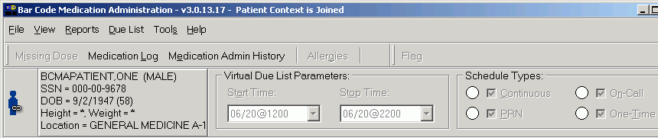  CCOW Icon

Appendix C: Clinical Context Object Workgroup (CCOW)
Icons | BCMA enables users to join or break context with other applications. The icons below display whether BCMA is joined in context or not. The following three icons will display on the BCMA VDL, to reflect the current state of CCOW. In addition to the icons, the BCMA title bar displays whether or not the patient is joined (linked) in context.  Changing – Displayed whenever the Clinical Link is changing. This icon may appear so briefly that the user may not see it. It is displayed when the common (linked) patient is changing. For example, if BCMA is linked with CPRS and CPRS changes from one patient to anther, this icon will display during the change process.  When this icon is displayed, the text “Patient Context is Changing” will be displayed in the BCMA title bar.  Broken – Displayed whenever an application is not linked or the application is “out of patient context”. For example, if CPRS is linked and displaying one patient and BCMA is displaying a different patient, then BCMA is said to be “out of patient context” and will display this icon.  When this icon is displayed, the text “Patient Context is Broken” will be displayed in the BCMA title bar.  Linked – Displayed whenever an application is utilizing CCOW to maintain patient context with the CCOW server. For example, if BCMA is open and displaying the same patient (as defined by the CCOW server) for all linked applications, then BCMA will display this icon.  When this icon is displayed, the text “Patient Context is Joined” will be displayed in the BCMA title bar.

Appendix C: Clinical Context Object Workgroup (CCOW)
Using CCOW Commands | To join context  - Select the Rejoin Patient Link option from the File menu.  Example: Rejoin Patient Link Option  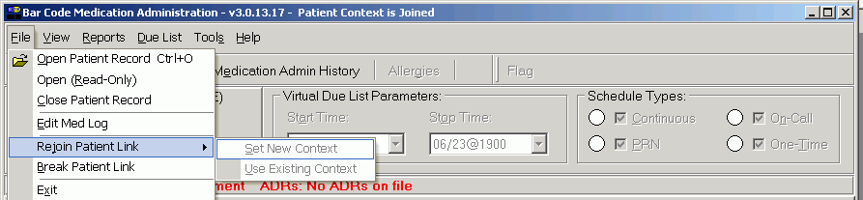  Keyboard Shortcut: Press alt+f to display the File menu, and then press j to Rejoin Patient Link.  - Perform one of the following actions:  - Select Set New Context if you want other applications to synchronize with the patient you have open in BCMA.  - Select Use Existing Context if you want the current application to synchronize with the current patient in the other application(s) you have opened.  To break context between applications  - Select the Break Patient Link option from the File menu.  Example: Break Patient Link Option  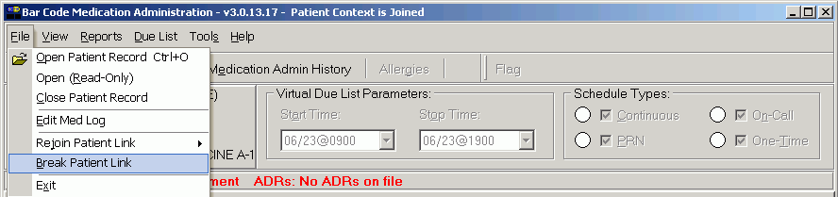  Keyboard Shortcut: Press alt+f to display the File menu, and then press b to Break Patient Link.

Appendix C: Clinical Context Object Workgroup (CCOW)
CCOW Error Messages | In some cases, CCOW will change context without prompting the user, while at other more critical transitions, the user will be prompted before switching.  In the screen below, a user is trying to access the CPRS Med Order Button dialog and is not able to switch.  Example: Problem Changing Clinical Data Dialog Box  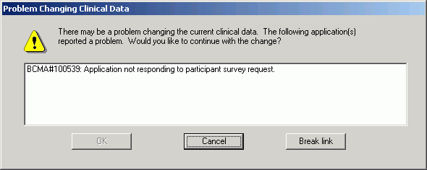  In the screen below, a user is being prompted to approve switching patients.  Example: Problem Changing Clinical Data Dialog Box  