Revision History

|  |  |  |  |
| --- | --- | --- | --- |
| **Date** | **Revised Pages** | **Patch Number** | **Description** |
| 09/2022 | Global | PSB*3*93 | All revisions are in BCMA Chapters 1 – 6  BCMA Chapters 7 – 13 revisions are for the date in Footers and the TOC (Global) |
| 07/2021 |  | PSB*3*82 | For Medication Administration History (MAH) and Medication History reports sections:   * Added Note and text under "Read Me First" section for MAH and Med History (refer to Chapters 1 thru 6 Revision History) * Added Note for MAH Report (refer to Chapters 1 thru 6/Revision History) * Added new MAH Report example * Added Note for Med History Report (refer to Chapters 1 thru 6 Revision History) * Added new Medication History Report example * Added Note and text under Viewing/Printing a MAH Report * Updated Footers and TOC (Global) |

Table of Contents

Working with IV Medications 240

Benefits of this Chapter 240

Preparing to Administer IV Medications 240

Viewing a Patient’s Active IV Medications 246

Administering IV Bags with Unique ID Number 248

How BCMA Validates IV Bags with Unique Identifier Number 248

Scanning and Verifying Medication Information 250

Unable to Scan IV Medication 260

Changing the Status of an IV Bag 270

Administering Ward Stock Items 272

How BCMA Validates Ward Stock Items 272

Scanning and Verifying Medication Information 272

Unable to Scan IV Medication – Ward Stock 276

Changing the Status of a Ward Stock Item 282

Administering a Patient’s IV Medications 285

Administering an Order with Other Print Info 285

Marking an IV Bag as Held or Refused 288

Adding Comments to a Patient’s Medication Record 291

Marking Single Administration as Held or Refused 294

Submitting a Missing Dose Request 297

Understanding the CPRS Med Order Button 303

Benefits of this Chapter 303

Providing a Link to CPRS 303

Enabling the CPRS Med Order Button Functionality 304

Workflow for CPRS Med Order Button 305

Using the CPRS Med Order Button 307

Ordering and Documenting STAT or NOW Orders 307

Accepting an Administered Unit Dose Order 310

Accepting an Administered IV Order 311

Reviewing and Signing STAT or NOW Orders 312

Processes Completed By Each Application 314

Editing the Medication Log 315

Benefits of this Chapter 315

Accessing the Edit Med Log Option 315

Using the Edit Med Log Option 322

Read-Only and Limited Access BCMA 331

Benefits of this Chapter 331

What is Read-Only BCMA? 331

Accessing Read‑Only BCMA 334

Using Read‑Only BCMA 338

What is Limited Access BCMA? 341

Accessing Limited Access BCMA 344

Using Limited Access BCMA 345

Working with the Cover Sheet 349

Benefits of this Chapter 349

What is the Cover Sheet? 349

Features of the Cover Sheet 349

Cover Sheet Screen: Medication Overview 355

Cover Sheet Screen: PRN Overview 362

Cover Sheet Screen: IV Overview 367

Cover Sheet Screen: Expired/DC’d/ Expiring Orders 370

Accessing the Cover Sheet 374

Using the Cover Sheet 376

Viewing and Printing BCMA Reports 378

Benefits of this Chapter 378

Enhancements to Report Printing 378

Mutually Exclusive Reports 381

Combined Reports 383

Viewing/Printing Demographics Data 385

Viewing/Printing an Order from Inpatient Medications (Display Order) 389

Provider Override Reasons/Pharmacist Interventions 391

Viewing/Printing BCMA Reports with Special Instructions / Other Print Info 395

Viewing/Printing a Due List Report 397

Viewing/Printing a Medication Log Report 409

Viewing/Printing a MAH Report 416

Viewing/Printing a Missed Medications Report 422

Viewing/Printing a PRN Effectiveness List Report 434

Viewing/Printing an Administration Times Report 438

Viewing/Printing a Medication History Report 450

Viewing/Printing a Medication Variance Log Report 453

Viewing/Printing a Cumulative Vitals/ Measurement Report 456

Viewing/Printing the Patient Record Flag Report 459

Viewing/Printing an Unknown Actions Report 462

Viewing/Printing Cover Sheet Reports 465

Viewing/Printing Cover Sheet–Medication Overview Report 466

Viewing/Printing Cover Sheet– PRN Overview Report 475

Viewing/Printing Cover Sheet– IV Overview Report 484

Viewing/Printing Cover Sheet– Expired/DC’d/ Expiring Orders Report 492

Viewing/Printing a Medication Therapy Report 500

Viewing/Printing an IV Bag Status Report 505

Viewing/Printing an Unable to Scan (Detailed) Report 509

Viewing/Printing an Unable to Scan (Summary) Report 514

Glossary 517

BCMA Lingo 517

This page intentionally blank.

Working with IV Medications

|  |  |
| --- | --- |
| Benefits of this Chapter | Use this chapter when you need to administer active large-volume IV and continuous syringe medications to patients on your ward. The options and features available within the BCMA VDL apply specifically to active IV medication orders only. |
|  |  |
| Preparing to Administer IV Medications  tip:  A medication displays on the VDL if it has an “active” status *and* the patient has a status and location of “inpatient.”  Tips  tip:  You can skip steps 2 and 3 by typing your Access Code, then your Verify Code, separated by a semi-colon in the Access Code field. Press ENTER after typing the codes. | Before administering any activeIV medications to a patient, review this section to learn more about the medication orders that display on the BCMA VDL, the different display areas for the IV Medication Tab, and how BCMA indicates “actions” taken on IV bags displayed in the IV Bag Chronology display area of the BCMA VDL.  Then you will be ready to administer active IV medications to your patients.  Schedule Types that You Can Administer  The Schedule Types area of the BCMA VDL is grayed out for IV medications since they are not applicable to these types of medications.  **Note:** Each time that you open a VDL (i.e., patient record), BCMA defaults to the Unit Dose Medication Tab and the Schedule Types of Continuous, One-Time, and On-Call already selected. This occurs even if you change the Schedule Types or Medication Tab during a medication pass. The PRN Schedule Type controls the default display of PRN medications on the BCMA VDL, and is based on the GUI BCMA Site Parameters entry for “Include Schedule Types.”  Start and Stop Times for IV Medications  The Virtual Due List Time Parameters area of the BCMA VDL is grayed out since administration times are not used for large-volume IV or continuous syringe medications. |

Working with IV Medications

|  |  |
| --- | --- |
| Preparing to Administer IV Medications (cont.)  tip:  IV medications display on the VDL until the Stop Time of the order.  Tips | Medication Orders that Display on the VDL  Once a large-volume IV or continuous syringe medication order becomes active, it displays on the BCMA VDL under the IV Medication Tab. This includes all active IV medication types listed below:   * Admixture * Hyperal * “Syringe,” with the “INTERMITTENT SYRINGE?” prompt set to “NO” * “Chemotherapy,” with the “CHEMOTHERAPY TYPE:” prompt set to “Admixture” or “Syringe,” and the “INTERMITTENT SYRINGE?” prompt set to “NO”   An “active” status occurs once a pharmacist or a nurse verifies a medication order using Inpatient Medications V. 5.0 or CPRS. This includes orders on “Hold” and any orders entered through the IV package. Orders placed “On Hold” by a provider display grayed out on the BCMA VDL. You can only mark these order types as “Held,” although it is notnecessary that you do so.  BCMA determines *when* to display an order on the BCMA VDL by subtracting the information in the “Before Scheduled Admin Time” site parameter field from the Start Date/Time of the medication order. You can define this parameter using the Parameters Tab in the GUI BCMA Site Parameters application.  **Note:** If an IV medication order becomes expired or discontinued while an IV bag is Infusing or Stopped, the order will continue to display on the BCMA VDL until you mark the IV bag as “Completed.” |

Working with IV Medications

|  |  |
| --- | --- |
| Preparing to Administer IV Medications (cont.) | Medications Available for Scanning  Administering IV medications to a patient involves the scanning of the patient’s medication (drug) bar code, which was applied by the Pharmacy. BCMA recognizes the following numbers on the IV Medication Tab.   * Internal Entry Number (IEN): Drug numbers provided on medication bar codes are considered a unique drug identifier by the Pharmacy. BCMA reviews the SYNONYM field (#.01) of the DRUG file (#50), after a medication bar code is scanned, to ensure that a valid number exists for the dispensed drug and strength scheduled for administration. * Unique Identifier Number: This number is generated (with a “V”) for IV medications when the Pharmacy prints a bar code label for an IV bag. It is designed to communicate which IVs have been manufactured by the Pharmacy. This number displays in the IV Bag Chronology display area of the BCMA VDL. * Ward Stock Number: This number is generated when you use a “Ward Stock” item to complete an IV medication order because the IV bag is not available from the Pharmacy (with a Unique Identifier Number). When you scan the Bar Code number on the bag, BCMA generates a Ward Stock number (with a “WS”) and displays this number in the IV Bag Chronology display area of the BCMA VDL. You must scan every Additive and Solution for the Ward Stock item. When you do, BCMA then searches for a match to the Bar Code number in any of the active IV orders displayed on the BCMA VDL.   **Note:** If an IV bag is administered using Unable to Scan – Create WS, or Unable to Scan – Five Rights Override, BCMA generates a Ward Stock Number for the bag.  **Note:** Most Pharmacies use a combination of bar codes to identify drug products at the point of administration. |

Working with IV Medications

|  |  |
| --- | --- |
| Preparing to Administer IV Medications (cont.)  tip:  A Ward Stock Number displays on the VDL with the letters “WS” *only* after you scan the related Additives and Solutions. See first Example on this page.  Tips | IV Bag Chronology Display Area on the VDL  Unlike Unit Dose, IV Push, and IV Piggyback medications, large-volume IV or continuous syringe medications administered under the IV Medication Tab display the status (and related icon) in the IV Bag Chronology display area of the BCMA VDL opposite the Unique Identifier Number or Ward Stock Number. The display area lists IV bags labeled by the Pharmacy and any Ward Stock bags that you have created. This information also displays on the Medication Log Report and the MAH Report.  The examples provided below show the various “actions” that you can take on an IV bag (or the status that you can mark an IV bag), and the related icons in the IV Bag Chronology display area of the BCMA VDL.  Example: Ward Stock IV Bag with Status of “Infusing”  Example: Ward Stock IV Bag with Status of “Infusing” screen  Example: IV Bag with Other Possible Statuses  Example: IV Bag with Other Possible Statuses screen |

Working with IV Medications

|  |  |
| --- | --- |
| Preparing to Administer IV Medications (cont.) | Understanding the Status of a Medication Order  You can change a large-volume IV or continuous syringe medication with the following status:   * **Available to Infusing, Missing, Held, or Refused** * **Infusing to Stopped or Completed** * **Stopped to Infusing, Completed, Missing, Held, or Refused** * **Missing to Infusing, Held, or Refused**   **NOTE**: Status changes may be made by use of medication bar code scanning, as well as Unable to Scan, Take Action on Bag, or Mark menu options.  Meds on Patient Indicators  Three separate indicators display on the VDL to the left of BCMA Clinical Reminders, in a group entitled “Meds on Patient,” when the patient has currently Infusing IV’s, Stopped IV’s, or Patches that are not removed. The indicators are applicable to active Inpatient or Clinic orders of if there is action that can be taken on an active, Expired, and/or Discontinued order.  See the section entitled “Meds on Patient Indicators” for more information. |

Working with IV Medications

|  |  |
| --- | --- |
| Preparing to Administer IV Medications (cont.) | Information Stored by BCMA  BCMA stores the following information each time you administer an active large-volume IV medication to a patient:   * Patient * Location of the patient (i.e., bed, ward, division, or clinic) * Clinician administering the medication * Clinician who created the Medication Log Entry * Entered date and time * Audit information (i.e., clinician, text, date and time) * Administration date and time * Status of the administration, such as Available, Infusing, Stopped, Completed, Held, Refused, or Missing * “Cancelled” administrations are not stored in the Medication Log. * IV Additive (strength), IV Solution (volume), and/or number of units given * Infusion (flow) rate * Any comments associated with the drug administration dose * Injection site for the medications |

Working with IV Medications

|  |  |
| --- | --- |
| Viewing a Patient’s Active IV Medications  tip:  If the number of medications that need administered is greater than the VDL can display, use the Scroll Bar to view all of them.  Tips  tip:  Press **f11** or click the IV Medication Tab to display active large-volume IV or continuous syringe medication orders under this Tab.  Tips | The “view” or active window shown below, displays when you select the IV Medication Tab on the BCMA VDL.  The IV Medication Tab provides an “alert light” which turns **GREEN** *only* when the patient has active medication orders associated to them. When you click a “lit” Tab, BCMA displays the patient’s active medication orders on the BCMA VDL. This safeguard is provided to ensure that all large-volume IV medications that are due are given to the patient in the correct dosage and on time.  **Note:** Discontinued and expired orders, with a Stop Date/Time greater than 72 hours from NOW, will not display on the BCMA VDL even if an Infusing or Stopped bag exists on the order.  Example: BCMA VDL for Active IV Medications  Example: BCMA VDL for Active IV Medications screen |

Working with IV Medications

|  |  |
| --- | --- |
| High Risk/High Alert Witness Column | Take a few minutes to get better acquainted with the various elements comprising the display areas of the BCMA VDL for IV medications. |

Example: Elements Comprising the Display Areas for IV Medications

VDL lists Orderable Item, Additive, and Solution

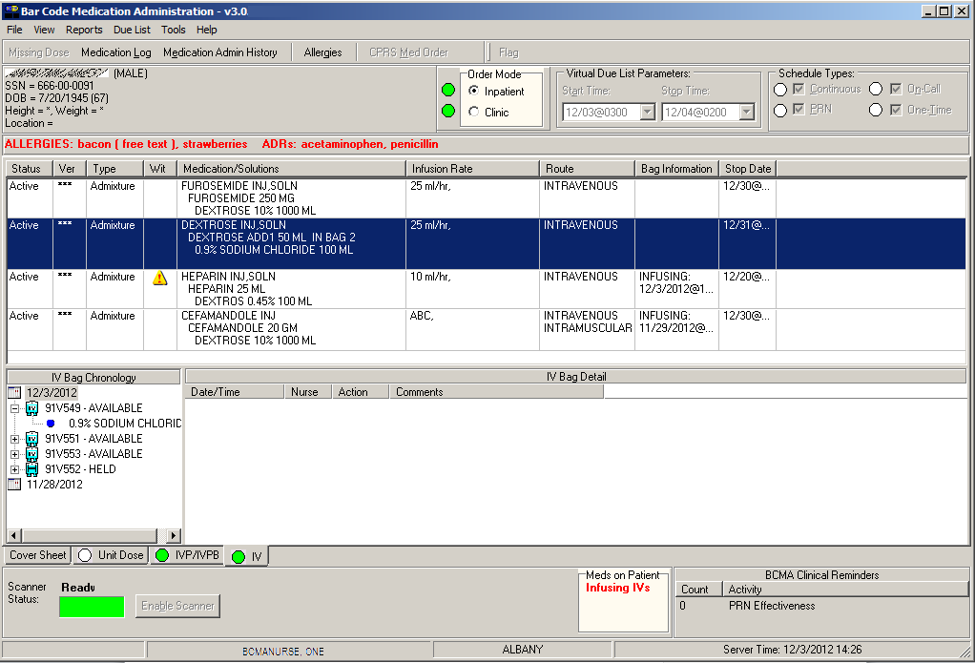

Select order to display available bags

Action date

Click to display bag contents

Bag information identifies an action of Infusing or Stopped, and when an order has been changed.

Information displays here when an  
IV bag is selected in the IV Bag Chronology display area

Action taken  
on an IV bag

Contents of  
an IV bag

Meds on Patient Indicator

Administering IV Bags with Unique ID Number

|  |  |
| --- | --- |
| How BCMA Validates IV Bags with Unique Identifier Number  tip:  BCMA uses the default settings in the IV Parameters fields of the GUI BCMA Site Parameters application when an IV bag is scanned *and* an order has been changed.  tips | When you scan the bar code on a patient’s IV bag, BCMA verifies whether the IV bag has a valid Unique Identifier Number, and if the patient has an active order entered into Inpatient Medications V. 5.0 for the bag scanned.  A variety of dialog boxes will display for a patient, depending on the IV bag scheduled for administration. (See the descriptions provided below to learn when a dialog will display on the VDL.) If the administration is successful, the patient’s VDL displays the word “Infusing” in the IV Bag Chronology display area of the BCMA VDL opposite the Unique Identifier Number that you just scanned.   * If you scan a new IV bag, and have not marked the previous IV bag as “Completed,” BCMA displays a message. * If the IV PARAMETERS fields in the GUI BCMA Site Parameters application are set to “Warning,” and an IV field is edited in Inpatient Medications V. 5.0, a Warning message displays. * If no order exists for the medication scanned, the medication has already been given, it’s not time to give it yet, or the Unique Identifier Number is not located, an Error message displays. * If no IV bags are available for the medication displayed on the BCMA VDL, an Information message displays.   If you experience a scanning failure while administering an IV bag with a Unique Identifier Number labeled by your Pharmacy, you can select the Unable to Scan feature to infuse the IV bag and inform your support staff of the failure. After entering a reason for the failure and an optional comment, the Medication Verification dialog displays, where you can choose one of the following options:   * **Verify Medication:** This (default) option provides an entry field in which the user types the Unique Identifier Number from the bar code label on the IV bag to verify the medication being administered to the patient. BCMA validates the entry against available bags on the order and displays the bag components. Best practice dictates that you always attempt to verify the medication first. You may retry if your entry does not result in a match.   **Note:** It is vital that you type the Unique Identifier Number from the IV bag label in your hand, not the number you see in the IV Bag Chronology in the BCMA VDL. |

Administering IV Bags with Unique ID Number

|  |  |
| --- | --- |
| How BCMA Validates IV Bags with Unique Identifier Number (cont.) | * **Verify Five Rights:** This option provides a method for administering an IV bag in the event that Verify Medication failed, or, for example, when the number on the bar code label is not readable, or there is no label. You must confirm that each of the five rights of medication administration have been physically verified (right patient, right medication, right dose, right route, right time) before you can continue the administration process.   **Note:** Refer to your BCMA Coordinator and site policy for guidance on the use of the Verify Five Rights option.  **Note:** The Verify Five Rights option is only available if the Five Rights Override Parameters are enabled for Unit Dose and IV medications in the BCMA Site Parameters application. If the Five Rights Override Parameter is turned off, the option will be grayed out and you will not be able to administer the medication. Refer to your site policies regarding how to contact pharmacy to address the problem**.** |

Administering IV Bags with Unique ID Number

|  |  |
| --- | --- |
| Scanning and Verifying Medication Information  tip:  BCMA does *not* require that you scan the Unique Identifier Number for IV medications, in sequence.  tips  tip:  You do *not* have to select an active IV medication order on the VDL before scanning the Unique Identifier Number.  tips  tip:  If the Scanner Status Indicator is **RED**, click in the Indicator field to activate the **GREEN** Ready Light *before* scanning a medication bar code.  tips | Now you are ready to scan (and verify) the patient’s active IV bags to officially begin the medication administration process.  To scan and verify IV bag with Unique Identifier Number   1. At the patient’s VDL, first check the status of the scanner at the lower left corner of the VDL.  * **If the Scanner Status is “Ready” and** GREEN, scan the bar code of one of the patient’s available IV bags. (The Pharmacy generates the Unique Identifier Number when they print labels for the bag.). * **If the Scanner Status is “Not Ready” and RED**, click the enable scanner button to enable the scanner, and scan the bar code on the medication.   **Keyboard Shortcut:** Press **alt‑b** to enable the scanner.  Example: Scanner Status and Enable Scanner button  Example: Scanner Status and Enable Scanner button screen     1. If you are unable to scan the medication bar code for any reason, right-click **on the IV order**, and select the Unable to Scan option from the right click or Due List menu. Proceed to the section entitled, “Unable to Scan IV Medication.” |

Administering IV Bags with Unique ID Number

|  |  |
| --- | --- |
| Scanning and Verifying Medication Information (cont.)  tip:  If the Scanner Status Indicator is red, click in the Indicator field to activate the green Ready Light *before* scanning a medication bar code.  Example: Scanner Status and Enable Scanner button | Example: Unable to Scan IV Bag  Right-Click Option  Example: Unable to Scan IV Bag  Right-Click Option screen   1. Perform one of the following actions if you receive an Error or Information message.  * If an Error or Warning message indicates that the order is non-nurse verified, see the section entitled, “If Non-Nurse Verified Orders Site Parameter ‘Prohibit Administration’ is Selected.” * If an Error message indicates that the Unique Identifer number was not located, see the section entitled, “If Unique Identifier Number Not Located.”. * If an Error message indicates that no order exists for the medication that you just scanned, see the section entitled, “If No Order Exists for Medication Scanned.” * If no bags are available for the medication displayed on the BCMA VDL, see the section entitled, “If No IV Bags Available for Medication Displayed on the VDL.” * If IV Parameters fields set to “Warning” and a field is edited in Inpatient Medications V. 5.0, see the section entitled, “If IV Parameters Fields Set to “Warning” and Field Edited in Inpatient Medications V. 5.0.” |

Administering IV Bags with Unique ID Number

|  |  |
| --- | --- |
| Scanning and Verifying Medication Information (cont.)  tip:  If the Scanner Status Indicator is red, click in the Indicator field to activate the green Ready Light *before* scanning a medication bar code. | * If Non-Nurse Verified Orders Site Parameter “Prohibit Administration” is Selected   The error message provided below displays when administration of a non-nurse verified order is attempted.   * Click **OK** to acknowledge the message then click **OK** at the “Order Administration Cancelled” dialog to acknowledge the cancellation and return to the VDL without administering the medication.   **Note:** Check your site policy to determine the correct workflow for verifying the order in CPRS.  Example: Error Message When Prohibit Administration Parameter is Selected   * If Non-Nurse Verified Orders Site Parameter “Allow Administration with Warning” is Selected   The warning message provided below displays when administration of a non-nurse verified order is attempted.   * Click **OK** to acknowledge that the order has not been nurse verified and to continue the administration. All medication administration dialogs will display as appropriate to the workflow for the selected administration. * Click **Cancel** to display the “Order Administration Cancelled” dialog. Click **OK to a**cknowledge the cancellation and to return to the VDL.   **Note:** C**he**ck your site policy to determine the correct workflow for verifying the order in CPRS. |

Administering IV Bags with Unique ID Number

|  |  |
| --- | --- |
| Scanning and Verifying Medication Information (cont.)  tip:  If the Scanner Status Indicator is red, click in the Indicator field to activate the green Ready Light *before* scanning a medication bar code. | Example: Warning Message When Allow Administration with Warning Parameter is Selected  **Note:** When the “Allow Administration with Warning” or “Prohibit Administration” parameter setting is selected, the resulting warning/error pop-up message will usually precede other BCMA pop-ups during the medication administration process. Exceptions to this are:   * **Ward Stock Bags:** When the user scans bag components into the Ward stock dialog thus creating a ward stock bag, BCMA will not match the list of components to the order until the user selects **OK**. At that time, if the order is not nurse-verified, the Non-Nurse Verify pop-up will then display. * **Currently Infusing IV Bags:** When attempting to scan a new bag while an existing bag is currently infusing, the user must complete the infusing bag before the Non-Nurse Verify pop-up displays.   **Note:** Site parameters for non-nurse verified orders do not affect the CPRS med order button functionality.   * If Unique Identifier Number Not Located   The Error message, provided below, displays when BCMA does not locate the Unique Identifier Number. This occurs if the Unique Identifier Number is invalid.  This error message also displays during an Unable to Scan event, whenever the IV bag Unique Identifier Number entered at the Medication Verification dialog does not match an available bag on the IV order.  **Note:** If you receive this Error message more than once, contact the Pharmacy directly about the problem. |

Administering IV Bags with Unique ID Number

|  |  |
| --- | --- |
| Scanning and Verifying Medication Information (cont.)  tip:  If the Scanner Status Indicator is red, click in the Indicator field to activate the green Ready Light *before* scanning a medication bar code. | To review the Error message   1. Review the Error message, and then click **ok** to return to the patient’s VDL.   **Keyboard Shortcut:** Press **tab** to activate the **ok** button, and then press **enter** to return to the patient’s VDL.  Example: Error Message When Unique Identifier Number Not Located  Example: Error Message When Unique Identifier Number Not Located screen   1. Continue administering active IV medication orders. |

Administering IV Bags with Unique ID Number

|  |  |
| --- | --- |
| Scanning and Verifying Medication Information (cont.) | * If No Order Exists for Medication Scanned   The Error message, provided below, displays if the patient does nothave an order for the medication that you just scanned.  To review the Error message   1. Review the Error message, and then click **ok** to return to the patient’s VDL.   **Keyboard Shortcut:** Press **tab** to activate the **ok** button, and then press **enter** to return to the patient’s VDL.  Example: Error Message When No Order Exists for Medication Scanned  Example: Error Message When No Order Exists for Medication Scanned screen   1. Continue administering active IV medications to the patient. |

Administering IV Bags with Unique ID Number

|  |  |
| --- | --- |
| Scanning and Verifying Medication Information (cont.) | * If No IV Bags Available for Medication Displayed on the VDL   The Information message, provided below, displays if the medication is incorrect.  To review the Information message   1. Review the Information message, and then click **ok** to return to the patient’s VDL.   **Keyboard Shortcut:** Press **tab** to activate the **ok** button, and then press **enter** to return to the patient’s VDL.  Example: Information Message When No Bags Available for Medication Displayed on VDL  Example: Information Message When No Bags Available for Medication Displayed on VDL screen   1. Continue administering active IV medications to the patient. |

Administering IV Bags with Unique ID Number

|  |  |
| --- | --- |
| Scanning and Verifying Medication Information (cont.) | * If IV Parameters Fields Set to “Warning” and Field Edited in Inpatient Medications V. 5.0   The Warning message, provided below, displays when the IV Parameters fields in the GUI BCMA Site Parameters application are set to “Warning” and an IV field is edited in Inpatient Medications V. 5.0. The message could include changes to the Start/Stop Times and Infusion Rate.  To acknowledge IV Parameters Warning message   1. Review the Warning message, and then click **ok** to return to the patient’s VDL.   **Keyboard Shortcut:** Press **tab** to activate the **ok** button, and then press **enter** to return to the patient’s VDL.  Example: Warning Message When IV Field Edited in Inpatient Medications V. 5.0  Example: Warning Message When IV Field Edited in Inpatient Medications V. 5.0 screen   1. Continue administering active IV medications to the patient. |

Administering IV Bags with Unique ID Number

|  |  |
| --- | --- |
| Scanning and Verifying Medication Information (cont.)  tip:  The Action drop-down list box in the Scan IV dialog box automatically defaults to “Infusing” when you administer an IV bag with an “Available” status.  Tips  tip:  In the Scan IV dialog box, IV bags marked as “Infusing” do *not* require a Comment; however, you can add a Comment later using the Right Click drop-down menu.  Tips | To scan and verify IV Bag with Unique Identifier Number (cont.)   1. The Scan IV dialog box displays and BCMA marks the IV bag as “Infusing” in the IV Bag Chronology display area of the BCMA VDL. In the Injection Site list box, select an injection site, and then click **ok**.   **Note:** If an existing IV bag is already infusing for the selected order, BCMA will prompt you to complete the Infusing IV bag.  **Note:** BCMA automatically populates the Scan IV dialog box with pertinent information about the IV bag. Changes to an IV order, with an Infusing or Stopped IV bag, display in the “Order Changes” area of the dialog box.  Example: Scan IV Dialog Box for Scanned Unique Identifier Number  Example: Scan IV Dialog Box for Scanned Unique Identifier Number screen  THEN —  (See Next Page) |

Administering IV Bags with Unique ID Number

|  |  |
| --- | --- |
| Scanning and Verifying Medication Information (cont.) | To scan and verify IV Bag with Unique Identifier Number (cont.)  Example: IV Bag Marked As Infusing in IV Bag Chronology Display Area of VDL  Example: IV Bag Marked As Infusing in IV Bag Chronology Display Area of VDL screen   1. Continue administering active IV medications to the patient. |

Administering IV Bags with Unique ID Number

|  |  |
| --- | --- |
| Unable to Scan IV Medication  tip:  You can report scanning failures without interrupting the medication administration process. | If you experience a scanning failure while trying to administer an IV medication, you can use the Unable to Scan option or the Unable to Scan – Create WS option.  It is important to note that the Unable to Scan options are only available at the order level on the IV tab, meaning you must select an order before selecting the Unable to Scan command. You cannot select Unable to Scan or Unable to Scan – Create WS for a particular bag in the IV Bag Chronology window.  To administer an IV medication using Unable to Scan   1. At the IV tab, select an IV order that you want to administer. Then select the Unable to Scan command from the right-click or the Due List menu. The Unable to Scan dialog box displays.   **Note:** If an existing IV bag is already infusing for the selected order, BCMA will prompt you to complete the Infusing IV bag.  Example: Unable to Scan Right Click Option  Example: Unable to Scan Right Click Option screen   * If Non-Nurse Verified Orders Site Parameter “Prohibit Administration” is selected   The Error Message: “Order NOT Nurse-Verified! DO NOT GIVE!” displays. |

Administering IV Bags with Unique ID Number

|  |  |
| --- | --- |
| Unable to Scan IV Medication (cont.) | To administer an IV medication using Unable to Scan (cont.)   * Click **OK** to acknowledge the message and click **OK** at the “Order Administration Cancelled” dialog to acknowledge the cancellation and return to the VDL without administering the medication. * If Non-Nurse Verified Orders Site Parameter “Allow Administration with Warning” is selected   The Warning Message: “Order NOT Nurse-Verified! Do you want to continue?” displays.   * Click **OK** to acknowledge that the order has not been nurse verified and to continue the administration or click **Cancel** to display the “Order Administration Cancelled” dialog then click **OK** to acknowledge the cancellation and return to the VDL.   **Note:** Check your site policy to determine the correct workflow for verifying the order in CPRS.   1. If applicable, the Other Print Info box displays. Review the Information message and click **OK** to continue.   Example: Other Print Info Box  Example: Other Print Info Box screen   1. At the Unable to Scan dialog box, verify the administration information displayed at the top of the box, including: Medication, Dosage/Infusion rate, Medication Route, Other Print Info, and Dispensed Drugs/Medications Solutions. |

Administering IV Bags with Unique ID Number

|  |  |
| --- | --- |
| Unable to Scan IV Medication (cont.)  tip:  If the Scanning failure is not an equipment problem, you can scan the problematic bar code directly into the Comment field. This may help your IRM and Pharmacy staff zero in on the source of problem more quickly.  Tips | To administer an IV medication using Unable to Scan (cont.)  Example: Unable to Scan IV Dialog Box  Example: Unable to Scan IV Dialog Box screen   1. Select an “Unable to Scan Reason” from the drop-down list box. Selections include: Damaged Medication Label, Dose Discrepancy, No Bar Code, Scanning Equipment Failure, and Unable to Determine.   Example: Unable to Scan Medication Reasons  Example: Unable to Scan Medication Reasons screen  Note: If you click **Cancel** at any point in the Unable to Scan process, the Unable to Scan event is not logged, an email is not sent, and the “Order Administration Cancelled” message displays. Click **ok** to return to the VDL. |

Administering IV Bags with Unique ID Number

|  |  |
| --- | --- |
| Unable to Scan IV Medication (cont.) | To administer an IV medication using Unable to Scan (cont.)   1. You may enter an optional text comment. Click **OK**. The Medication Verification dialog box displays with the Verify Medication option selected by default.   Example: Medication Verification Dialog Box (Verify Medication Option)  Example: Medication Verification Dialog Box (Verify Medication Option) screen   1. To verify the IV bag being administered, enter the Unique Identifier Number from the bar code label on the IV bag. BCMA validates the entry against available bags on the order and displays the bag components.   Note: Best practice dictates that you always attempt to verify the medication first. You may retry if your entry does not result in a match. Note: It is vital that you type the Unique Identifier Number from the IV bag label in your hand, not the number you see in the IV Bag Chronology in the BCMA VDL. Note: When entering the bar code number, remember that no spaces or punctuation marks are allowed. |

Administering IV Bags with Unique ID Number

|  |  |
| --- | --- |
| Unable to Scan IV Medication (cont.) | To administer an IV medication using Unable to Scan (cont.)   1. Click **Submit**.  * If the number entered matches an available bag on the selected IV order, the IV bag components Confirmation dialog box displays, confirming the additives and solutions. * Click **YES** to confirm the information and return to the Medication Verification dialog box. The IV bag number, Infusion Rate, Route, Additives, Solutions and Other Print Info display. * Click **NO** to return to the Medication Verification dialog box and retry.   Example: Confirmation Dialog Box  Example: Confirmation Dialog Box screen  Example: Medication Verification Dialog Box (After Medication is Verified)  Example: Medication Verification Dialog Box (After Medication is Verified) screen |

Administering IV Bags with Unique ID Number

|  |  |
| --- | --- |
| Unable to Scan IV Medication (cont.) | To administer an IV medication using Unable to Scan (cont.)   * If the number entered from the IV bag being administered does not match the IV bag number on the selected order: * An “Invalid Medication – Do not Give” error message displays. Click **OK** to return to the Medication Verification dialog box. You may reenter the bag number to try again.   Example: Error Message When Drug IEN Code Not Found  Example: Error Message When Drug IEN Code Not Found screen   * If the number entered does not match, or the bar code number is not readable, or there is no label, you may select the Verify Five Rights option. Place a checkmark in each of the five checkboxes to document that the five rights of medication administration have been physically verified (right patient, right medication, right dose, right route, right time) and continue with the medication administration without entering a matching IV bag Unique Identifier Number for the medication.   **Note**: This option is only available if the Five Rights Override Parameter is enabled for IV medications in the BCMA Site Parameters application. If the Five Rights Override parameter is turned off, you will not be able to administer the medication. Refer to your site policies regarding how to contact pharmacy to address the problem. |

Administering IV Bags with Unique ID Number

|  |  |
| --- | --- |
| Unable to Scan IV Medication (cont.) | To administer an IV medication using Unable to Scan (cont.)  Example: Medication Verification Dialog Box (Verify Five Rights Option)  Example: Medication Verification Dialog Box (Verify Five Rights Option) screen   1. Review the contents of the Medication Verification dialog box and click **OK.** |

Administering IV Bags with Unique ID Number

|  |  |
| --- | --- |
| Unable to Scan IV Medication (cont.) | To administer an IV medication using Unable to Scan (cont.)   1. The Scan IV dialog box displays and BCMA marks the IV bag as “Infusing” in the Action drop-down list box. 2. In the Injection Site selection drop-down list box, select the location where you are injecting the medication into the patient, then click **ok**.   Example: Scan IV Dialog Box |

Administering IV Bags with Unique ID Number

|  |  |
| --- | --- |
| Unable to Scan IV Medication (cont.) | To administer an IV medication using Unable to Scan (cont.)  Example: Injection Site Selection Drop-Down List  Example: Injection Site Selection Drop-Down List screen  Note: The comment field is optional unless the action taken is “Stopped.”   1. The IV Bag Chronology section of the VDL displays a status of “Infusing” for the bag you administered.   Example: IV Bag Chronology |

Administering IV Bags with Unique ID Number

|  |  |
| --- | --- |
| Unable to Scan IV Medication (cont.) | To administer an IV medication using Unable to Scan (cont.)  MailMan Message Sent After Medication Bar Code Scanning Failure  When you create a medication scanning failure entry, a MailMan message will be sent to the mail group you specified. The subject line of the message will indicate a medication scanning failure. The body of the message will contain the following information:   * User: Last name, First Name (for identifying system issues only/educational needs) * Date/Time of event * Patient: Last Name, First Name, and last four digits of patient’s Social Security Number. * Order Number * Ward Location/Room * Type of Bar Code issue: Medication * Medication * Unit Dose orders will display dispense drug; drug IEN; dosage ordered * IV Orders will display: unique ID (Bag ID typed by User or Wardstock); orderable item. * Reason for scan failure * User’s comment   Note: Inclusion of the last four digits of the patient’s SSN is currently allowed in VistA clinical alert messaging. If there are changes to this policy due to a future VHA directive, the format of this field is subject to change. |

Administering IV Bags with Unique ID Number

|  |  |
| --- | --- |
| Changing the Status of an IV Bag  tip:  In the Scan IV dialog box, you must enter a “Comment” for an IV bag with a status of “Stopped.”  Tips | Use this section when you want to change the status of an IV bag from the Pharmacy from “Infusing” to “Stopped” or “Completed” or from “Stopped” to “Infusing” or “Completed.”  To change the status of an IV bag from the Pharmacy   1. Perform one of the following actions:  * Scan the Unique Identifier Number for the IV bag, from the Pharmacy, for which you want to change the status. BCMA processes the scan and displays the Scan IV dialog box. * In the IV Bag Chronology window, select the IV bag that you want to take action on, then select the Take Action on Bag command from the right-click or Due List menu. The Scan IV dialog box displays.   Example: Take Action on Bag command  Example: Scan IV Dialog Box for Scanned Unique Identifier Number |

Administering IV Bags with Unique ID Number

|  |  |
| --- | --- |
| Changing the Status of an IV Bag (cont.) | To change the status of an IV bag from the Pharmacy (cont.)   1. In the Action drop-down list box, select the “action” that you want to take on the IV bag that you just scanned. 2. In the Comment area, enter the comments that you want to associate with the action just taken on the IV bag. 3. Click **ok**. BCMA marks the IV bag as “Infusing,” “Stopped” or “Completed” in the IV Bag Chronology display area of the BCMA VDL.   Note: Meds on Patient Indicators display to the left of BCMA Clinical Reminders when the patient has any Infusing IV’s, Stopped IV’s or Patches that are not removed for Inpatient and Clinic orders. See the section entitled, “Meds on Patient Indicators.”  Example: IV Bag Marked As Completed in IV Bag Chronology Display Area of VDL   1. Continue administering active IV medications to the patient. |

Administering Ward Stock Items

|  |  |
| --- | --- |
| How BCMA Validates Ward Stock Items | When you scan the bar code on a Ward Stock Item, BCMA recognizes that it is a number other than a Unique Identifier Number. BCMA then displays the Ward Stock dialog box, requiring you to scan every Additive and Solution associated with the order on the BCMA VDL.  If you are unable to scan one or more Ward Stock items, you can use the Unable to Scan—Create WS command. After documenting the reason for the scanning failure and an optional comment, BCMA then displays the Ward Stock dialog, where you can type the IEN or National Drug Code number of every Additive and Solution associated with the order on the BCMA VDL.  After you complete the scanning (or Unable to Scan) process, you then select the injection site where you are administering the medication on the patient. BCMA marks the Ward Stock Item (IV bag) as “Infusing” in the IV Bag Chronology display area of the BCMA VDL. Unlike IV bags, which display with a “V” in the Unique Identifier Number, Ward Stock Items display with a “WS” and a system-assigned Unique Identifier Number. |
|  |  |
| Scanning and Verifying Medication Information  tip:  You do *not* have to select a medication order on the VDL, for a Ward Stock Item, before scanning the IEN on the Item.  Tips | Now you are ready to scan (and verify) the patient’s Ward Stock Items, and to officially begin the medication administration process.  To scan and verify Ward Stock Item with an IEN   1. At the patient’s VDL, first check the status of the scanner at the lower left corner of the VDL.  * **If the Scanner Status is “Ready” and GREEN**,scan the bar code on the Ward Stock Item. BCMA processes the scan and displays the Ward Stock dialog box.). * **If the Scanner Status is “Not Ready” and RED,** click the **enable scanner** button to enable the scanner, and scan the bar code on the medication.   Example: Scanner Status and Enable Scanner button  Example: Scanner Status and Enable Scanner button screen  Example: Scanner Status and Enable Scanner button screen |

Administering Ward Stock Items

|  |  |
| --- | --- |
| Scanning and Verifying Medication Information (cont.) | To scan and verify Ward Stock Item with an IEN (cont.)   1. If applicable, the Other Print Info pop-up box displays. Review the Information message and click **OK** to continue.   Example: Other Print Info Pop-up Box  Example: Other Print Info Pop-up Box screen   1. If you are unable to scan one or more Ward Stock components for any reason, right-click on the Ward Stock order, and select the Unable to Scan option from the right click or Due List menu. Proceed to the section entitled, “Unable to Scan IV Medication–Ward Stock.” 2. At the Ward Stock dialog box, scan **each** Additive and Solution for the Ward Stock Item that you want to administer to the patient.   Example: Ward Stock Dialog Box for Scanned Ward Stock Item  Example: Ward Stock Dialog Box for Scanned Ward Stock Item screen   1. When finished scanning the related Additives and Solutions, click **ok**. BCMA processes the information, and searches for a “match” (order) on the BCMA VDL. If multiple orders match, it then displays the Multiple Orders for Scanned Drug dialog box, provided below. |

Administering Ward Stock Items

|  |  |
| --- | --- |
| Scanning and Verifying Medication Information (cont.) | To scan and verify Ward Stock Item with an IEN (cont.)  **Keyboard Shortcut:** Press **tab** to activate the **ok** button, and then press **enter** to display the Multiple Orders for Scanned Drug dialog box.  Example: Multiple Orders for Scanned Drug Dialog Box  Example: Multiple Orders for Scanned Drug Dialog Box screen  **Note:** If an existing IV bag is already infusing for the selected order, BCMA will prompt you to complete the Infusing IV bag.   * If Non-Nurse Verified Orders Site Parameter “Prohibit Administration” is selected   The Error Message: “Order NOT Nurse-Verified! DO NOT GIVE!” displays.   * Click **OK** to acknowledge the message and click **OK** at the “Order Administration Cancelled” dialog to acknowledge the cancellation and return to the VDL without administering the medication. * If Non-Nurse Verified Orders Site Parameter “Allow Administration with Warning” is selected   The Warning Message: “Order NOT Nurse-Verified! Do you want to continue?” displays.   * Click **OK** to acknowledge that the order has not been nurse verified and to continue the administration or click **Cancel** to display the “Order Administration Cancelled” dialog then click **OK** to acknowledge the cancellation and return to the VDL.   **Note:** Check your site policy to determine the correct workflow for verifying the order in CPRS. |

Administering Ward Stock Items

|  |  |
| --- | --- |
| Scanning and Verifying Medication Information (cont.)  tip:  BCMA assigns a Unique Identifer Number (with the letters “WS”), *after* you complete the administration process for the Item.  Example: Ward Stock Item Marked As Infusing in IV Bag Chronology Display Area of VDL screen | To scan and verify Ward Stock Item with an IEN (cont.)   1. Select the order related to the Additives and Solutions that you just scanned, and then click **ok**. The Injection Site Selection dialog box displays.   Example: Injection Site Selection Dialog Box  Example: Injection Site Selection Dialog Box screen   1. In the Injection Site Selection drop-down list box, select the location where you are injecting the medication into the patient, and then click **ok**. BCMA processes the information, and then marks the IV bag as “Infusing” in the IV Bag Chronology display area of the BCMA VDL opposite the Unique Identifier Number assigned to the bag.   Example: Ward Stock Item Marked As Infusing in IV Bag Chronology Display Area of VDL  Example: Ward Stock Item Marked As Infusing in IV Bag Chronology Display Area of VDL screen   1. Write the Ward Stock Unique Identifier Number on the bag to identify the order related to its contents. 2. Continue administering active IV medications to the patient. |

Administering Ward Stock Items

|  |  |
| --- | --- |
| Unable to Scan IV Medication – Ward Stock  tip:  You can report scanning failures without interrupting the medication administration process.  Tips | To administer an IV medication using Unable to Scan – Create WS   1. From the IV tab, select an IV order, then select the Unable to Scan – Create WS command from either the right-click or the Due List menu.   **Note:** If an existing IV bag is already infusing for the selected order, BCMA will prompt you to complete the Infusing IV bag.  Example: Unable to Scan – Create WS Right Click Option  Example: Unable to Scan – Create WS Right Click Option screen   * If Non-Nurse Verified Orders Site Parameter “Prohibit Administration” is selected   The Error Message: “Order NOT Nurse-Verified! DO NOT GIVE!” displays.   * Click **OK** to acknowledge the message and click **OK** at the “Order Administration Cancelled” dialog to acknowledge the cancellation and return to the VDL without administering the medication. |

Administering Ward Stock Items

|  |  |
| --- | --- |
| Unable to Scan IV Medication – Ward Stock (cont.) | To administer an IV medication using Unable to Scan – create WS (cont.)   * If Non-Nurse Verified Orders Site Parameter “Allow Administration with Warning” is selected   The Warning Message: “Order NOT Nurse-Verified! Do you want to continue?” displays.   * Click **OK** to acknowledge that the order has not been nurse verified and to continue the administration or click **Cancel** to display the “Order Administration Cancelled” dialog then click **OK** to acknowledge the cancellation and return to the VDL.   **Note:** Check your site policy to determine the correct workflow for verifying the order in CPRS.   1. If applicable, the Other Print Info pop-up box displays. Review the Information message and click **OK** to continue.   Example: Other Print Info Pop-up Box  Example: Other Print Info Pop-up Box screen   1. At the Unable to Scan dialog box, verify the administration information displayed at the top of the box, including: Medication, Dosage/Infusion rate, Medication Route, Other Print Info, and Dispensed Drugs/Medications Solutions. |

Administering Ward Stock Items

|  |  |
| --- | --- |
| Unable to Scan IV Medication – Ward Stock (cont.)  tip:  If the Scanning failure is not an equipment problem, you can scan the problematic bar code directly into the Comment field. This may help your IRM and Pharmacy staff zero in on the source of problem more quickly.  Tips | To administer an IV medication using Unable to Scan – create WS (cont.)  Example: Unable to Scan IV Dialog Box  Example: Unable to Scan IV Dialog Box screen   1. Select an “Unable to Scan Reason” from the drop-down list box. Selections include: Damaged Medication Label, Dose Discrepancy, No Bar Code, Scanning Equipment Failure, and Unable to Determine.   Example: Unable to Scan Medication Reasons  Example: Unable to Scan Medication Reasons screen  Note: If you click **Cancel** at any point in the Unable to Scan process, the Unable to Scan event is not logged, an email is not sent, and the “Order Administration Cancelled” message displays. Click **ok** to return to the VDL |

Administering Ward Stock Items

|  |  |
| --- | --- |
| Unable to Scan IV Medication – Ward Stock (cont.) | To administer an IV medication using Unable to Scan – create WS (cont.)   1. You may enter an optional text comment. Click **OK**. The Ward Stock dialog box displays. If you click **Cancel,** the “Order Administration Cancelled” message displays.   Example: Ward Stock Dialog Box  Example: Ward Stock Dialog Box screen   1. Enter the Drug IEN or National Drug Code (NDC) of **each** additive and solution from the medication package in the entry field. Press **Enter** after the entry. Verify that all necessary bag components are displayed correctly in the Ward Stock dialog box before continuing to the next step.   Example: Completed Ward Stock Dialog Box  Example: Completed Ward Stock Dialog Box screen |

Administering Ward Stock Items

|  |  |
| --- | --- |
| Unable to Scan IV Medication – Ward Stock (cont.) | To administer an IV medication using Unable to Scan – create WS (cont.)  **Note:** When entering the IEN or NDC number, remember that no letters, spaces or punctuation marks are allowed.   1. Click **ok**. BCMA processes the information, searches for a “match” (order) on the BCMA VDL. The Injection Site Selection dialog box displays.   Example: Injection Site Selection Dialog Box  Example: Injection Site Selection Dialog Box screen   1. In the Injection Site Selection drop-down list box, select the location where you are injecting the medication into the patient. 2. Click **ok**. A new bag is created and BCMA processes the information and marks the IV bag as “Infusing” in the IV Bag Chronology display area of the BCMA VDL opposite the Unique Identifier Number assigned to the bag. The new bag has a “WS” in the bag identifier indicating that it is a ward stock bag.   Example: Ward Stock Item Marked As Infusing in IV Bag Chronology Display Area of VDL  Example: Ward Stock Item Marked As Infusing in IV Bag Chronology Display Area of VDL screen |

Administering Ward Stock Items

|  |  |
| --- | --- |
| Changing the Status of a Ward Stock Item  tip:  Marking an IV medication as “Stopped” is particularly helpful when a patient needs lab work completed. Then you can scan it again and mark it as “Infusing.”  Tips | Use this section when you want to change the status of a Ward Stock Item (IV bag) from “Infusing” to “Stopped” or “Completed” or from “Stopped” to “Infusing” or “Completed.”  To change the status of a Ward Stock Item   1. In the IV Bag Chronology display area of the BCMA VDL, select the Ward Stock Item (IV bag) that you want to take an action on. 2. Select the Take Action on Bag command from the right-click or Due List menu. The Scan IV dialog box displays.   Example: Scan IV Dialog Box for Selected Ward Stock Unique Identifier Number  Example: Scan IV Dialog Box for Selected Ward Stock Unique Identifier Number screen   1. In the Action drop-down list box, select the “action” that you want to take on the IV bag that you just selected on the BCMA VDL. |

Administering Ward Stock Items

|  |  |
| --- | --- |
| Changing the Status of a Ward Stock Item (cont.)  TIP:  In the Scan IV dialog box, you must enter a “Comment” for an IV bag with a status of “Stopped.”  Tips | To change the status of a Ward Stock Item (cont.)   1. In the Comment area, enter the comments that you want to associate with the action just taken on the IV bag. 2. Click **ok**. BCMA marks the IV bag as “Infusing,” “Stopped” or “Completed” in the IV Bag Chronology display area of the BCMA VDL.   Example: IV Bag Marked As Stopped in IV Bag Chronology Display Area of VDL  Example: IV Bag Marked As Stopped in IV Bag Chronology Display Area of VDL screen   1. Continue administering active IV medications to the patient. |

Administering a Patient’s IV Medications

|  |  |
| --- | --- |
| Administering an Order with Other Print Info  tip:  Other Print Info helps to ensure that the patient receives the medication dosage required by the provider.  Tips | Information messages, like the ones provided below, display when the Pharmacy answers “YES” to a question in Inpatient Medications V. 5.0 about including Other Print Info in a Pop-up box after a nurse scans a medication. If the Pharmacy answers “NO” to the question, Other Print Info *only* displays in RED below the dispensed drug name in the Medication Order Display Area. You must acknowledge the message after administering the medication.  For example, Other Print Info may include information on titrating an IV, when to call the doctor, when to hold the medication based on patient vitals, and when to use standard protocols.  The default size of the Other Print Info popup window is approximately 80 characters wide with a minimum height of 6 lines. The width cannot be changed, and the height will automatically resize to accommodate the length of the message. If the vertical height of the message exceeds the size of the screen, a vertical scroll bar displays.  If the total height of the administration row, including Other Print Info, is equal to or greater than 19 lines, the following message displays in place of Other Print Info (bold red text): “Too much information to display. Use right-click menu to display full text.”  The following methods for displaying Other Print Info are provided on all three medication tabs:   * Right-click menu option entitled “Special Instructions / Other Print Info.” * Due List Menu option entitled “Special Instructions / Other Print Info.” * Shortcut function key (F6)   The following dialog boxes display Other Print Info:   * PRN Effectiveness Log * PRN Medication Log * Unable to Scan * Medication Log * Scan IV |

Administering a Patient’s IV Medications

|  |  |
| --- | --- |
| Administering an Order with Other Print Info (cont.) | The vertical height of the Other Print Info display in the above dialog boxes is 6 lines. If text exceeds 6 lines, a scroll bar and “Display Instructions” button appear, and the following message displays in bold red text: “<Scroll down or click ‘Display Instructions’ for full text>.” When the “Display Instructions” button is clicked, Other Print Info will display in the pop-up.  Following is an example of the Scan IV dialog box with Other Print Info text that exceeds 6 lines.  Example: Scan IV Dialog Box  Example: Scan IV Dialog Box screen  To review Other Print Info from the Pharmacy   1. Review the Information message from the Pharmacy, and then click **ok** to return to the BCMA VDL.   **Keyboard Shortcut:** Press **tab** to activate the **ok** button, and then press **enter** to continue the medication administration process. |

Administering a Patient’s IV Medications

|  |  |
| --- | --- |
| Administering an Order with Other Print Info (cont.) | To review Other Print Info from the Pharmacy (cont.)  Example: Other Print Info Pop-up Box  Example: Other Print Info Pop-up Box screen   1. Continue administering active IV medications to the patient. |

Administering a Patient’s IV Medications

|  |  |
| --- | --- |
| Marking an IV Bag as Held or Refused  tip:  You can quickly mark an IV bag as “Held” or “Refused” using the Mark command from the Right Click drop-down menu.  Tips | Use this section when you need to “mark” an IV bag listed as “Available” or “Missing Dose” to “Held” or “Refused.” The action taken on the IV bag displays in the IV Bag Chronology display area of the BCMA VDL.  **Note:** You can mark an IV bag that is on “Hold” to “Held,” although it is not necessary that you do so unless required by your medical center.  To mark an IV bag as Held or Refused   1. Select the IV bag in the IV Bag Chronology display area of the BCMA VDL that you want to mark as “Held” or “Refused.” 2. Select the Mark command from the Due List menu. The Mark drop-down menu displays, with the “actions” available for the IV bag selected in the IV Bag Chronology display area of the BCMA VDL.   **Keyboard Shortcut:** Press **alt+d** to display the Due List menu, and then press **m** to display the Mark drop-down menu.   1. In the Action drop-down list box, select the action that represents how you want to “mark” the IV bag selected in the IV Bag Chronology display area of the BCMA VDL.   **Keyboard Shortcut:** Use the **arrow** keys to select the command that represents the “action” that you want to take on the IV bag selected on the BCMA VDL.  **Note:** Held and Refused IV bags as well as IV bags marked as Missing Dose can be set to the Infusing state via scanning and via the Unable to Scan process. The “Take Action on Bag” option is not available for Held or Refused IV bags. |

Administering a Patient’s IV Medications

|  |  |
| --- | --- |
| Marking an IV Bag as Held or Refused (cont.)  tip:  The Mark options, available to you, will depend on the current Status of the IV bag.  Tips | To mark an IV bag as Held or Refused (cont.)  Example: Selecting a Reason for Marking an IV Bag as Held or Refused  Example: Selecting a Reason for Marking an IV Bag as Held or Refused screen |

Administering a Patient’s IV Medications

|  |  |
| --- | --- |
| Marking an IV Bag as Held or Refused (cont.) | To mark an IV bag as Held or Refused (cont.)   1. Specify a reason, from the drop-down list box, why you are changing the status of the IV bag selected on the BCMA VDL. BCMA processes the information, and then lists the “action” in the IV Bag Chronology display area of the BCMA VDL.   Example: An IV Bag Marked as Held on the VDL  Example: An IV Bag Marked as Held on the VDL screen   1. Continue administering active IV medications to the patient. |

Administering a Patient’s IV Medications

|  |  |
| --- | --- |
| Adding Comments to a Patient’s Medication Record  tip:  You can quickly add comments to a patient’s IV bag that is Infusing, Held, or Refused by selecting the IV bag, and then selecting the Add Comment command from the Right Click drop-down menu.  Tips | You can add a comment (free text), up to 150 characters in length, to a patient’s IV medication marked as “Infusing,” “Stopped,” “Completed,” “Held,” or “Refused” in the IV Bag Chronology display area of the BCMA VDL. Your comments will also display in the Medication Log Report.  To add comments to a patient’s medication record   1. Select an IV bag in the IV Bag Chronology display area of the BCMA VDL that you want to add Comments. 2. Select the Add Comment command from the Due List menu. The Medication Log dialog box displays.   **Keyboard Shortcut:** Press **alt+d** to display the Due List menu, and then press **a** to display the Medication Log dialog box.   1. In the Add Comment area, enter the comments that you want to associate with the medication selected on the BCMA VDL.   Example: Medication Log Dialog Box  Example: Medication Log Dialog Box screen   1. Click **ok** once you’ve read your entry and are satisfied with it. Your comment is displayed in the IV Bag Detail window.   **Keyboard Shortcut:** Press **tab** to activate the **ok** button, and then press **enter** to continue. |

Administering a Patient’s IV Medications

|  |  |
| --- | --- |
| Adding Comments to a Patient’s Medication Record (cont.)  tip:  BCMA automatically wraps words in the Comments section.  Tips | To add comments to a patient’s medication record (cont.)  **Example: IV Bag Detail with Comments Entered**    Example: IV Bag Detail with Comments Entered screen   1. Verify that your comments were entered in the patient’s record by clicking the Med Log button in the Tool Bar to access the Medication Log Report.   Example: Medication Log with Comments Entered  Example: Medication Log with Comments Entered screen  Comments entered by a clinician  **Note:** You can view comments on the Medication Log Report if you select the “Audits” check box in the Include area of the Patient Medication Log dialog box. See the chapter entitled, "Viewing and Printing BCMA Reports” for more information. |

Administering a Patient’s IV Medications

|  |  |
| --- | --- |
| Marking Single Administration as Held or Refused  tip:  In all cases, if nurse initials are displayed in the “Ver” column of the BCMA VDL for a particular administration, BCMA will allow the held, refused or missing dose actions to be taken with no warning to the user, regardless of which non-nurse verified orders parameter option is selected.  Tips | You can mark an Available or Stopped IV Bag as Held or Refused from the IV Bag Chronology window. This feature is particularly helpful when a patient is temporarily off their ward, or if they refuse to take their medications.  To mark single administrations as Held or Refused   1. Select the IV Bag you want to mark as Held or Refused.   **Note:** The options available on the Mark menu will depend on the current Status and Type of medication order. PRN administrations cannot be marked as Held or Refused.   1. Select the Mark command from the Right Click or Due List menu. The Mark drop-down menu displays with the “actions” available for these medications.   **Keyboard Shortcut:** Press **alt+d** to display the Due List menu, and press **m** to display the Mark drop-down menu.   1. Select Held or Refused from the Mark menu.  * If a Warning message indicates that the order is not nurse verified, see section entitled, “If ‘Allow Administration with Warning’ or ‘Prohibit Administration’ parameter option is selected.”.  1. Select a Reason from the List on the Medication Log and click **OK**. BCMA processes the information and displays a letter in the Status column of the BCMA VDL to document the action taken on the medications.   Example: Medication Log when Medication Order is Marked Held  Example: Medication Log when Medication Order is Marked Held screen |

Administering a Patient’s IV Medications

|  |  |
| --- | --- |
| Marking Single Administration as Held or Refused (cont.) | To mark single administrations as Held or Refused (cont.)  Example: Medication Log when Medication Order is Marked Refused  Example:  Medication Log when Medication Order is Marked Refused screen   1. Continue administering active IV medications to the patient. |

Administering a Patient’s IV Medications

|  |  |
| --- | --- |
| Marking Single Administration  as Held or Refused (cont.) | To mark single administrations as Held or Refused (cont.)   * If “Allow Administration with Warning” or “Prohibit Administration” parameter option is selected   Example: Warning Message when Marking  Single Non‑Nurse Verified Administration  as Held or Refused   * Click **OK** to continue the selected action. The Medication Log with Held or Refused reasons will display as appropriate to the workflow for the selected action. * Click **Cancel** to return to the VDL. |

Administering a Patient’s IV Medications

|  |  |
| --- | --- |
| Submitting a Missing Dose Request  tip:  When the Pharmacy reprints a bar code label, the Unique Identifer Number falls off the VDL and a new one is assigned.  Tips  tip:  You can quickly submit a Missing Dose Request by selecting an IV bag in the IV Bag Chronology display area of the VDL, and then clicking once on the Missing Dose button in the Tool Bar.  Tips | You can submit a Missing Dose request on an available IV Bag, as well as a bag marked Held or Refused. You can use the Missing Dose command or the Missing Dose button on the Tool Bar to send Missing Dose Requests directly to the Pharmacy. Your request will automatically print on a dedicated printer in the Pharmacy that your medical center predefined using the GUI BCMA Site Parameters application. BCMA will also send a MailMan message to a predefined mail group. If both are predefined, both will be notified.  BCMA V. 3.0 displays the words “MISSING DOSE” in the IV Bag Chronology display area, opposite the related Unique Identifier Number, after you submit a Missing Dose Request to the Pharmacy. This functionality will benefit the Pharmacy by identifying requests that have already been submitted, and by reducing the number of duplicate submissions that they receive on a daily basis.  To submit a Missing Dose Request   1. Select an IV bag, in the IV Bag Chronology display area of the BCMA VDL that is considered “Missing.” 2. Select the Missing Dose command from the Due List menu.  * If an Error or Warning message indicates that the order is not nurse verified, see the section entitled, “If Non-Nurse Verified Orders Site Parameter “Allow Administration with Warning” is selected.” |

Administering a Patient’s IV Medications

|  |  |
| --- | --- |
| Submitting a Missing Dose Request (cont.) | To submit a Missing Dose Request (cont.)   * If Non-Nurse Verified Orders Site Parameter “Allow Administration with Warning” is selected, the following warning message displays.   Example: Warning Message when submitting  Missing Dose Request for  Non‑Nurse Verified Administration   * Click **OK** to acknowledge that the order has not been nurse verified. The Missing Dose Request dialog box will display. You may continue submitting the Missing Dose Request for the non-nurse verified order.. * Click **Cancel** to cancel the request. * If Non-Nurse Verified Orders Site Parameter “Prohibit Administration” is selected, the following error message displays.   Example: Error Message when submitting  Missing Dose Request for  Non‑Nurse Verified Administration   * Click **OK** to return to the VDL without submitting the Missing Dose Request. |

Administering a Patient’s IV Medications

|  |  |
| --- | --- |
| Submitting a Missing Dose Request (cont.) | To submit a Missing Dose Request (cont.)  **Note:** Check your site policy to determine the correct workflow for verifying the order in CPRS.  **Keyboard Shortcut:** Press **alt+d** to display the Due List menu, and then press **i** (not“L”) to display the Missing Dose Request dialog box.  **Note:** You cannot submit a Missing Dose Request for an IV bag marked as “Complete” in the IV Bag Chronology display area of the BCMA VDL. You can, however, change the status from Missing to Held or Refused. IV bags marked as Missing Dose can be set to the Infusing state via scanning and via the Unable to Scan process.   1. Verify the patient’s name on the Tab at the top of the dialog box, and their location and medication information within the dialog box.   Example: Missing Dose Request Dialog Box |

Administering a Patient’s IV Medications

|  |  |
| --- | --- |
| Submitting a Missing Dose Request (cont.)  tip:  Enter “N” (for NOW) if you want BCMA to automatically enter the current date and time in the dialog box for you when you move to the Reason drop-down list box.  Tips  tip:  When you select the Missing Dose option, BCMA automatically populates the fields in the Missing Dose Request dialog box. You must complete all fields *before* submitting the request to the Pharmacy.  Tips | To submit a Missing Dose Request (cont.)   1. In the [Date@Time](mailto:Date@Time) Needed field, enter the day and time when you need the medication for the patient using the VA FileMan Date/Time formatting guidelines listed below. You can use a date in the future or the past.   Date Formatting   * February 15, 2013, 15 FEBRUARY 13, 2/15/13, 021513 * N (for NOW) * T (for Today)   Time Formatting   * 00:00 (For example, 14:00 for 2:00 p.m.)   **Keyboard Shortcut:** Press **tab** to move among the fields on the dialog box.  **Note:** If the year is omitted, the computer uses the current year. A two-digit year assumes no more than 20 years in the future, or 80 years in the past.   1. In the Reason field, click once on the drop-down arrow to display pre-defined reasons why you are sending this request to the Pharmacy.   **Keyboard Shortcut:** Use the **arrow** keys to locate and select a Reason in the drop-down list box.  Example: Missing Dose Request Dialog Box |

Administering a Patient’s IV Medications

|  |  |
| --- | --- |
| Submitting a Missing Dose Request (cont.) | To submit a Missing Dose Request (cont.)   1. Verify the information in the dialog box, and then click **submit** to send the request to the Pharmacy, where it prints on a predefined printer. An Information message displays. A MailMan message will also be sent to a mail group if predefined using the GUI BCMA Site Parameters application.   **Note:** Refer to Manager’s Manual to see how Missing Dose Request Printers are configured in Inpatient and Clinic settings.  **Keyboard Shortcut:** Press **tab** to activate the **submit** button, and then press **enter** to display the Information message.   1. Read the Information message, and then click **ok**. BCMA processes the request, and then displays the word “Missing” in the IV Bag Chronology display area opposite the related Unique Identifier Number.   Example: Missing Dose Submission Message  Example: Missing Dose Submission Message screen |

Understanding the CPRS Med Order Button

|  |  |
| --- | --- |
| Benefits of this Chapter | This chapter describes the process for using the CPRS Med Order Button (or “Hot Button”) in BCMA V. 3.0. It describes the many benefits of this new enhancement, and the steps for using it — plus it provides a flow chart for you to discover the workflow using this button.  **Note:**  At this time, Clinic Orders cannot be created using the CPRS Med Order Button. This functionality is scheduled to be implemented in a future release of CPRS. |
|  |  |
| Providing a Link to CPRS  tip:  Unit Dose and IV Piggyback orders do *not* display on the VDL since One-Time orders only display until the Stop Date/Time of the order or once it is Given.    tip:  The CPRS Med Order button is particularly useful in ICU-type environments, where STAT and medication orders are quite common.  Tips  tip:  Bookmark these sites for future reference. | BCMA V. 3.0 includes the CPRS Med Order Button, a “link” to CPRS for electronically ordering, documenting, reviewing, and signing verbal- and phone-type STAT and (One-Time) medication orders for Unit Dose and IV medications that you have already administered to patients. This feature is particularly beneficial in ICU-type environments, as it helps streamline the workflow in such a busy setting. For instance, this button provides a secure, seamless environment for interfacing with three VistA applications to electronically document the medication administration process. They include BCMA V. 3.0, CPRS V. 1.0, and Inpatient Medications V. 5.0.  How the CPRS Med Order Button Works  Using the “Hot Button” in BCMA is quick and easy. Simply click the CPRS Med Order button on the BCMA VDL Tool Bar to perform tasks using the BCMA Order Manager and CPRS Order dialog boxes. These order types are then passed to the Inpatient Medications V. 5.0 software application as “nurse-verified” expired orders with a priority of “Done.” A pharmacist must still verify these order types. The provider selected during the Ordering process will receive an “alert,” requesting their electronic signature on the order.  Verifying the Documentation Process  Order types documented with the CPRS Med Order button do notdisplay on the BCMA VDL *unless* they are large-volume IV or non-intermittent syringe type orders administered over a period of time. In that case, they display on the BCMA VDL under the IV Medication Tab as “Infusing.”  You can, however, print the Medication Log and the MAH Reports from the Reports menu (or Tool Bar) within BCMA, or using the Reports Tab in CPRS, to verify that these orders were properly documented. On the Medication Log, the text titled “BCMA/CPRS Interface Entry,” displays opposite the order. You can edit these orders using the *Edit Medication Log* [PSB MED LOG EDIT] option in the CHUI version of BCMA. |

Understanding the CPRS Med Order Button

|  |  |
| --- | --- |
| Enabling the CPRS Med Order Button Functionality | You can enable the CPRS Med Order Button functionality, at your division, by performing the steps listed below.  To enable the CPRS Med Order Button functionality   1. Select the “Enable CPRS Med Order Button” check box under the Parameters Tab of the GUI BCMA Site Parameters application. 2. Assign the secondary menus “PSB GUI CONTEXT – USER” and “OR BCMA ORDER COM” to each BCMA user. 3. Assign the PSB CPRS MED BUTTON security key to appropriate site personnel. 4. Verify that the user has been assigned the ORELSE security key associated with CPRS. |

Workflow for CPRS Med Order Button



Using the CPRS Med Order Button

|  |  |
| --- | --- |
| Ordering and Documenting STAT or NOW Orders  tip:  You can enter Unit Dose and IV orders using the same CPRS Med order Button session, regardless of the Medication Tab selected on the VDL  Tips  tip:  Enter “n” (for ) if you want BCMA to automatically enter the current date and time in this field. | Follow the instructions in this section to use the CPRS Med Order Button from the BCMA VDL. Once you activate the button, BCMA passes patient data from the BCMA Order Manager dialog box to CPRS, for ordering, documenting, reviewing, and signing STAT or NOW medication orders already administered to patients.  **Note:** The patient that you are ordering and documenting orders about must have a status andlocation of “inpatient.”  To order/document STAT or NOW orders   1. Click the **cprs med order** button on the Tool Bar of the BCMA VDL. The BCMA Order Manager Dialog box then displays.   Example: BCMA Order Manager Dialog Box  Example: BCMA Order Manager Dialog Box screen |

Using the CPRS Med Order Button

|  |  |
| --- | --- |
| Ordering and Documenting STAT or NOW Orders (cont.)  tip:  You can document/order several Unit Dose medications, one after the other, provided you are scanning (or entering) the same *orderable item*.  Tips  tip:  If you omit the year, the computer uses the current year. A two-digit year assumes no more than 20 years in the future, or 80 years in the past.  Tips | To order/document STAT or NOW orders (cont.)   1. Under the Order Type area of the dialog box, perform one of the following actions:  * Select the Unit Dose Radio button if you want to order/document a STAT or NOW Unit Dose medication. Proceed to step #3. * Select the IV Radio button if you want to order/document a STAT or NOW IV medication. Then complete the IV’s area of the dialog box, and proceed to step #3. * The fields that need completed under the IVs area of the dialog box relate to the IV Type selected.  1. Complete the Provider field, and then press **tab** to move to the Injection Site field, and complete that field if applicable to the order.  * If you enter the provider’s full last name and first name, BCMA finds an exact match. * If you enter the provider’s last name or a portion of their last name and then press **tab,** BCMA provides matches in a list box so you can select the correct provider for the order. * The provider selected for this field will receive an “alert” notifying them that they need to sign the order.   **Keyboard Shortcut:** Press **tab** to move among the fields within the dialog box. Use the **down arrow**, within a list box, to make your selection.   1. Complete the Action Date/Time field, and then press **tab** to display your date/time entry and continue with the order/document process.  * Enter the date and time when you administered the medication to the patient, using the VA FileMan Date/Time formatting guidelines listed below. Keep in mind that the system does not accept a date/time in the future.   Date Formatting   * May 1, 2010, 01 MAY 10, 5/01/10, 050110 * N (for NOW) * T (for Today) * T-1 (for Yesterday)   Time Formatting   * 00:00 (For example, 14:00 for 2:00 p.m.) |

Using the CPRS Med Order Button

|  |  |
| --- | --- |
| Ordering and Documenting STAT or NOW Orders (cont.) | To order/document STAT or NOW orders (cont.)   1. Scan the bar code number on the Unit Dose medication or IV Additive/Solution ordered for the patient. BCMA will process the scan, and then display the medication or additive/solution in the Medications and/or Solutions Scanned list box.  * If multiple drugs are available for the selected order, BCMA provides a list box with choices. Select the medication that you want to document/order, and then click **ok** to enter your selection in the Medications and/or Solutions Scanned list box. * If the bar code is missing or unreadable, enter one or more alpha characters in the Scan Medication Bar Code field, and then press enter. BCMA will perform a look-up for you, and then display its findings. Select a drug name, and then click ok to enter your selection directly into the Medications and/or Solutions Scanned list box.   **Note:** If your Scanner setting has an **enter** (carriage return) defined at the end of each scanning session, the medication look-up will occur without you having to press **enter**.   1. Click the **order** button to continue the ordering process. A CPRS Order dialog box displays related to the type of medication order that you entered.  * If you placed a Unit Dose medication order, proceed to the section entitled, “Accepting an Administered Unit Dose Order.” * If you placed an IV medication order, proceed to the section entitled, “Accepting an Administered IV Order.” |

Using the CPRS Med Order Button

|  |  |
| --- | --- |
| Accepting an Administered Unit Dose Order  tip:  CPRS provides a message if information is missing from fields, or needs corrected.  Tips | The CPRS Medication Order dialog box displays so you can complete and accept the STAT or NOW Unit Dose medication order that you just ordered/documented for your patient.  Example: CPRS Medication Order Dialog Box  Example: CPRS Medication Order Dialog Box screen  To accept an administered Unit Dose order   1. Enter data in the Dosage, Route, and Schedule fields of the dialog box, if they are not populated from BCMA. You can enter information in the Comments field, if desired. 2. When you are done entering the data, click the **accept order** button. CPRS will perform order checks, and prompt you to address these checks should they occur. CPRS returns you to the BCMA Order Manager Dialog box to order/document additional administered STAT or NOW Unit Dose orders, or to the Review/Sign Changes dialog box to review and sign this order. Proceed to the section entitled, “Reviewing and Signing STAT or NOW Orders.”   **Keyboard Shortcut:** Press **tab** to move among the fields of the dialog box and to activate the **accept order** button. Once activated, press **enter** to display the BCMA Order Manager dialog box again for ordering/documenting additional Unit Dose medication orders.  **Note:** If you click **quit**, CPRS displays a message asking if you want to save the order. If you click **no,** CPRS cancels the order and returns you to the BCMA Order Manager dialog box so you can begin again. |

Using the CPRS Med Order Button

|  |  |
| --- | --- |
| Accepting an Administered IV Order  tip:  CPRS provides a message if information is missing from fields, or needs corrected.  Tips | The CPRS IV Fluid Order dialog box displays so you can complete and accept the STAT or NOW IV Additives/Solutions medication order that you just ordered/documented for your patient.  Example: CPRS IV Fluid Order Dialog Box  Example: CPRS IV Fluid Order Dialog Box screen  To accept an administered IV order   1. Enter the volume or strength for the additive or solution, and then enter data in the Infusion Rate field of the dialog box, if it is not populated from BCMA. You can enter information in the Comments field, if desired. 2. When you are done entering the data, click the **accept order** button. CPRS will perform order checks, and prompt you to address these checks should they occur. CPRS returns you to the BCMA Order Manager Dialog box to order/document additional administered STAT or NOW IV orders, or to the Review/Sign Changes dialog box to review and sign this order. Proceed to the section entitled “Reviewing and Signing STAT or NOW Orders.”   **Keyboard Shortcut:** Press **tab** to move among the fields of the dialog box and to activate the **accept order** button. Once activated, press **enter** to display the BCMA Order Manager dialog box again for ordering/documenting additional IV medication orders.  **Note:** If you click **quit**, CPRS displays a message asking if you want to save the order. If you click **no,** CPRS cancels the order and returns you to the BCMA Order Manager dialog box so you can begin again. |

Using the CPRS Med Order Button

|  |  |
| --- | --- |
| Reviewing and Signing STAT or NOW Orders  tip:  The Example provided on this page shows information for a Unit Dose order.  Tips | To review/sign STAT or NOW orders   1. At the BCMA Order Manager dialog box, perform one of the following actions:  * Order/document another STAT or NOW medication order, beginning at step #1 of this chapter. * Proceed to the next step to submit orders for review and signature.  1. Click the **review/sign** button to display the Review/Sign Changes dialog box.   Example: Review/Sign Changes Dialog Box  Example: Review/Sign Changes Dialog Box screen   1. Review the medication orders to ensure that they are accurate and properly entered.  * If a medication is not applicable to the patient’s order, click inside the appropriate check box to de-select the medication.   **Keyboard Shortcut:** Use the **arrow** keys to move among the medication orders in the list box, and the **spacebar** to deselect an order listed.   1. Under the Release to Service area, select the Radio button (Verbal or Telephone) that applies to the STAT or NOW medication orders that are “selected” in this dialog box, and then click **ok**. The Electronic Signature Code dialog box displays. Proceed to the next step.   **Keyboard Shortcut:** Press **tab** to move among the Radio buttons. |

Using the CPRS Med Order Button

|  |  |
| --- | --- |
| Reviewing and Signing STAT or NOW Orders (cont.) | To review/sign STAT or NOW orders (cont.)   1. At the Electronic Signature dialog box, enter your signature code, and then click **ok** to finalize the order(s).  * If there are ***no*** problems with the order, it will process and you will be returned to the BCMA VDL. * If there is a problem with the order, a message displays noting the problems, and the order is cancelled. You are returned to the BCMA VDL. The provider also receives an alert message about the order(s).   **Keyboard Shortcut:** Enter your signature code, and then press **tab** to activate the **ok** button. Once activated, press **enter** to finalize the order.  Example: Electronic Signature Dialog Box  Example: Electronic Signature Dialog Box screen |

Using the CPRS Med Order Button

|  |  |
| --- | --- |
| Processes Completed By Each Application | This section describes the many tasks that are completed in the “background” by BCMA, CPRS, and Inpatient Medications — and those tasks that involve your Pharmacy staff.   * BCMA processes the orders by passing the administration date/time to Inpatient Medications, and creates an entry in the Medication Log. It then refreshes the BCMA VDL with any IV Admixture or Non-Intermittent syringe type STAT or NOW orders. * Unit Dose and IV Piggyback orders will not display on the BCMA VDL. * An IV bag will display on the BCMA VDL as “Infusing” in the IV Bag Chronology display area. * CPRS performs order checks, marks all medications as “nurse-verified” with a priority of “Done,” and sends them to Inpatient Medications V. 5.0. The order displays under the Orders Tab in CPRS. * Inpatient Medications displays orders as “nurse-verified,” expired orders requiring verification by the Pharmacy. A pharmacist can enter a Progress Note after verifying the order. * The letter “d” (lowercase letter) immediately precedes the order on the Inpatient Profile to indicate that the order is done. * The Inpatient Medications Order View screen displays “(DONE)” in the upper left-hand corner of the screen, after the order type designation of Unit Dose or IV. |

Editing the Medication Log

|  |  |
| --- | --- |
| Benefits of this Chapter | Use this chapter when you need to edit a specific medication administration entry that has been created during the medication administration process. Using this option, you can even perform a patient lookup to complete edits to past medications, even after the patient has been discharged or deceased.  This chapter describes how to use the Edit Med Log option in GUI BCMA for editing a patient’s medication log. It is divided into two sections—Accessing the Edit Med Log Option and Using the Edit Med Log Option. |
| Accessing the Edit Med Log Option | You can access the Edit Med Log option for an open patient record on the screen, or from a blank BCMA screen. This section describes how to access the Edit Med Log option and how to change the administration date.  **Notes:**   * You can only edit a medication entry for an order that you have administered unless you hold the PSB MANAGER Security key. With this key, you can also edit other user’s medication entries. BCMA tracks all edits, which you can include on the Medication Log Report by selecting the “Audits” option when requesting a report. * The Edit Med Log option is also available while using Limited Access mode. * The Edit Med Log option is not available for users with the PSB READ ONLY security key, or when users open a patient record in Read-Only mode. For more information, please refer to Chapter 8, “Read-Only and Limited Access BCMA.”   To access the Edit Med Log option   1. Select the Edit Med Log option from the File menu.   Example: Edit Med Log Option  Example: Edit Med Log Option screen  **Keyboard Shortcut:** Press **alt+f** to display the File menu, and then press **e** to display the Edit Med Log Administration Selection dialog box or the Patient Select dialog box. |

Editing the Medication Log

|  |  |
| --- | --- |
| Accessing the Edit Med Log Option (cont.)  tip:  You can double-click on a patient record to open it in the Edit Med Log window.  Tips | To access the Edit Med Log option (cont.)   1. Perform one of the following actions:  * If you have an open patient record on the VDL, the Edit Med Log Administration Selection dialog box displays the current patient’s medications that were administered today. Proceed to step #5 to change the Administration Date if necessary.   Example: Edit Med Log  Administration Selection Dialog Box  Example: Edit Med Log  Administration Selection Dialog Box screen   * If no patient record is currently open on the VDL, the Patient Select dialog box displays. Enter the patient’s Social Security Number (SSN), patient’s name (last,first with no spaces), Rm-Bd, or Ward. Proceed to step #3.   **Note:** The system automatically searches for patient records that match your search criteria as it is being entered. For example, if you enter a partial name or SSN, it searches for records that match your entry.   1. Select the patient name from the Patient Select dialog box and click **ok**. The Patient Confirmation dialog box then displays.   Example: Edit Med Log Patient Select Dialog Box  Example: Edit Med Log Patient Select Dialog Box screen |

Editing the Medication Log

|  |  |
| --- | --- |
| Accessing the Edit Med Log Option (cont.) | To access the Edit Med Log option (cont.)   1. At the Patient Confirmation dialog box, perform one of the following actions:  * If the patient lookup is correct, click **yes**. The Edit Med Log Administration Selection dialog box then displays. * If the patient lookup is incorrect, click **cancel** and repeat steps #2-3 to select another patient.   **Note:** If any active PRF assignments exist for this patient, the **details** button will be enabled in the Patient Flags section of the dialog box. It is strongly recommended that you click the **details** button to view the Patient Record Flag report, especially for behavioral flags, to view information which may be critical to patient and employee safety.  **Keyboard Shortcut:** Press **tab** to activate the **yes** or **cancel** button, and then press **enter** to continue.  Example: Patient Confirmation Dialog Box  Example: Patient Confirmation Dialog Box screen |

Editing the Medication Log

|  |  |
| --- | --- |
| Accessing the Edit Med Log Option (cont.)  TIP:  Before you can manually enter a date, make sure that you highlight the existing date so that it will be replaced by the new date entry.  Tips | To access the Edit Med Log option (cont.)  Example: Edit Med Log  Administration Selection Dialog Box  Example: Edit Med Log  Administration Selection Dialog Box screen  Displays  Next Day  Displays  Calendar  Displays  Previous Day   1. The Edit Med Log Administration Selection dialog box displays all of the medications administered for the selected patient for the date shown. By default, it displays medications that were administered today. To change the date, perform one of the following actions:  * In the date field, type a valid date and then press **enter**. Valid date formats include NOV 24 2010, 24 NOV 10, 11/24/10, or 112410.   **Keyboard Shortcut:** Press **tab** or **shift-tab** to move among the different areas of the dialog box.   * Use the left or right **arrow** buttons on either side of the date field to display medications administered on the previous or next day. * Click the **down arrow** button to display a calendar. You can use the scroll arrows in the upper corners of the calendar to display a different month, and then click on a date on the calendar. Click **ok** to close the calendar.   **Note:** The Edit Med Log option does not allow access to future dates. See example below for other calendar options. |

Editing the Medication Log

|  |  |
| --- | --- |
| Accessing the Edit Med Log Option (cont.)  tip:  You can right-click on the month name in the titlebar to display a drop-down list of months, or on the year to display a drop-down list of years.  Tips | Example: Date Selection Calendar  Example: Date Selection Calendar screen  Display  Previous Day  Display  Next Day  Display  Previous Month  Go To  Today  Display  Next Month   1. After selecting a medication administration date, perform one of the following actions:  * If the administered medication(s) you intend to edit is displayed, proceed to the next section “Using the Edit Med Log Option.” * If no medications were administered on the date you selected, BCMA displays a “No Meds Found!” message. Repeat step #5 to select another date. |

Editing the Medication Log

|  |  |
| --- | --- |
| Using the Edit Med Log Option  tip:  For instructions on accessing the Edit Med Log option and changing the administration date, refer to the previous section “Accessing the Edit Med Log Option”.  Tips  tip:  You can double-click on a medication to open it in the Edit Med Log dialog box.  Tips | This section describes how to edit a patient’s medication log using the Edit Med Log option. You edit the Admin Status, Action Date/Time, Injection Site (if applicable), and PRN Reason and Effectiveness (if applicable). You can edit the Dispensed Drug, Units Given, and Units for Unit Dose orders only. You may also add a Dispensed Drug if needed.  **Note:** Every field on the Edit Med Log dialog box is audited and displays on the Medication Log Report when you select the “Audits” option.  **Note:** Witness information captured during High Risk/High Alert administrations is not displayed, nor available for editing in the Edit Med Log feature.  After you have selected the desired administration date, the Edit Med Log Administration Selection dialog box displays the patient’s name, Social Security Number (SSN) and the following data for medications administered on that date:   * **Type:** Schedule Types, such as C for Continuous, OC for On-Call, O for One-Time, and P for PRN. * **Medication:** Name of the orderable item. * **Status:** Displays the administration status information for a medication, such as Given, Refused, Held, Removed, Missing Dose, Infusing, Stopped, Complete, and Unknown. * **Action Date/Time:** Displays the date and time of the last action taken on the medication. * **Int:** Displays the initials of the individual who documented the last action.   Example: Edit Med Log  Administration Selection Dialog Box  Example: Edit Med Log Administration Selection Dialog Box screen  To edit an administered medication   1. From the Edit Med Log Administration Selection dialog box, click on the administered medication that you want to edit, and then click **ok**. The Edit Med Log dialog box then displays. |

Editing the Medication Log

|  |  |
| --- | --- |
| Using the Edit Med Log Option (cont.)  tip:  To see a table of valid actions for the Admin Status field, click on the field and then press the **F1** key or right-click on the field, and then click “What’s this?”  Tips  tip:  If an order created in BCMA CHUI *Manual Medication Entry* is not completed with a valid administration status, the Admin Status will be stored as null (blank), display as Unknown (U) on the VDL, and must be corrected in Edit Med Log.  Tips | To edit an administered medication (cont.)  **Note:** If you are about to edit an administration associated with an order that has a “Provider Hold” status, a warning message will display.   1. In the Admin Status field, select an action from the drop-down list box that reflects the correct status of the medication administration. The drop-down list will only display valid actions based on the current order type, the current action status, and the action status of other administrations for the same order (when applicable).   **Note:** If the administration status is Unknown, the Admin Status field will be blank, and the user must change the status to Given, Not Given, Held, or Refused. Administrations cannot be changed to a status of Missing.  **Keyboard Shortcut:** Use the **arrow** keys to locate and select an Admin Status in the drop-down list box.  Example: Edit Med Log Dialog Box |

Editing the Medication Log

|  |  |
| --- | --- |
| Using the Edit Med Log Option (cont.)  tip:  A two-digit year assumes no more than 20 years in the future, or 80 years in the past.  Tips | To edit an administered medication (cont.)   1. In the Action Date/Time field, specify the actual date and time the action was taken. You can type a valid date@time entry (see formatting examples below) or click on the **down arrow** to use the calendar.   **Keyboard Shortcut:** Press **tab** to advance to the drop-down arrow, then **enter** to use the calendar.  **Note:** The Edit Med Log option does not allow entry of future dates or times.  Example: Action Date/Time Status Field  Example: Action Date/Time Status Field screen  Date Formatting   * Nov 30, 2010, 30 NOV 10, 11/30/10, 113010 * N (for NOW) * T (for Today), T-1 (Yesterday), T-3W (3 weeks ago) * Omitting the year assumes the current year.   Time Formatting   * HH:MM or HHMM * Omitting the time assumes the current time   Date@Time Formatting Examples   * T@11:20 (Today at 11:20 a.m.) * 113010@1120 (November 30, 2010 at 11:20 a.m.) * 113010@1300 (November 30, 2010 at 1:00 p.m.) |

Editing the Medication Log

|  |  |
| --- | --- |
| Using the Edit Med Log Option (cont.)  tip:  You can enter a new time manually in the Time field, or click in the Hour and Minutes columns to set a new time.  Tips | To edit an administered medication (cont.)  Example: Date/Time Selection Calendar  Example: Date/Time Selection Calendar screen   1. In the Injection Site drop-down list box, select the location on the patient where the medication was injected (if applicable).   **Keyboard Shortcut:** Use the **arrow** keys to locate and select an injection site in the drop-down list box.  Example: Edit Med Log Dialog Box Injection Site Field  Example: Edit Med Log Dialog Box Injection Site Field screen |

Editing the Medication Log

|  |  |
| --- | --- |
| Using the Edit Med Log Option (cont.) | To edit an administered medication (cont.)   1. In the PRNs Reason drop-down list box, select one of the pre-defined reasons (if applicable).   **Keyboard Shortcut:** Use the **arrow** keys to locate and select a Reason in the drop-down list box.  Example: Edit Med Log Dialog Box PRN Reason Field  Example: Edit Med Log Dialog Box PRN Reason Field screen   1. In the PRN Effectiveness comment field, enter an optional comment to describe the effectiveness of the medication given to the patient, up to 150 characters in length.   **Note:** PRN required pain scores are not supported by the Edit Med Log option. The preferred method for documenting PRN Effectiveness is via the BCMA Clinical Reminders marquee.  Example: Edit Med Log Dialog Box PRN Effectiveness Field  Example: Edit Med Log Dialog Box PRN Effectiveness Field screen |

Editing the Medication Log

|  |  |
| --- | --- |
| Using the Edit Med Log Option (cont.)  tip:  Use your arrow keys to move from field to field in the Dispensed Drug area.  Tips | To edit an administered medication (cont.)  The Dispensed Drugs area of the Edit Med Log dialog box shows a list of dispensed drugs, additives, and/or solutions, including the units ordered, units given, and units (TAB, CAP, etc.). You can only edit this area for Unit Dose orders. You can also add a dispensed drug (if necessary).  **Note:** When editing or adding Dispensed Drugs, the Name field is restricted to 50 characters, the Units Given must be a number less than 50, and the Units column must be 40 characters or less.   1. To edit a Dispensed Drug, perform the following actions as needed:  * To edit the Dispensed Drug Name, right-click on the Name cell that you want to edit, and then select **edit** from the drop-down menu. Enter a full or partial dispensed drug name and then press **enter** to display a list of drugs that matches the drug orderable item for the medication order. Select the appropriate drug from the list and then click **ok**. * To edit the Units Given, right-click on the Units Given cell that you want to edit and then select **edit** from the drop-down menu. Enter the number of Units Given, and then press **enter**. * To edit the Units column, right-click on the Units cell you want to edit and then select **edit** from the drop-down menu. Enter the new value for Units, and then press **enter**.   **Keyboard Shortcut:** Use **ctrl-e** to Edit a drug in the Dispensed Drugs area of the dialog box.  Example: Edit Med Log  Edit Dispensed Drug  Example: Edit Med Log Edit Dispensed Drug screen |

Editing the Medication Log

|  |  |
| --- | --- |
| Using the Edit Med Log Option (cont.)  tip:  Use your arrow keys to move from field to field in the Dispensed Drug area.  Tips | To edit an administered medication (cont.)  Example: Edit Med Log  Dispensed Drugs Area – Drug Name Lookup  Example: Edit Med Log Dispensed Drugs Area – Drug Name Lookup screen   1. To add a Dispensed Drug, perform the following actions:  * To add a dispensed drug, right-click anywhere in the Dispensed Drugs area, and then select the Add Dispensed Drug command from the drop-down menu. A new row displays for editing purposes, and the cursor is in the Dispensed Drug Name field. * In the Dispensed Drug Name column, type a full or partial dispensed drug name and then press enter to display a list of dispensed drugs that matches the drug orderable item for the medication order. Select the appropriate drug from the list and then click ok. * Right-click in the Units Given cell that corresponds to the drug you just added, and then select edit from the drop-down menu. Enter the number of Units Given, and then press enter. * Right-click in the Units cell that corresponds to the drug you just added, and then select edit from the drop-down menu. Enter the value for Units, and then press enter.   **Keyboard Shortcut:** Use **ctrl-a** to add a drug in the Dispensed Drugs area of the dialog box. |

Editing the Medication Log

|  |  |
| --- | --- |
| Using the Edit Med Log Option (cont.) | To edit an administered medication (cont.)  Example: Edit Med Log  Add Dispensed Drug  Example: Edit Med Log Add Dispensed Drug screen   1. Enter the reason the medication entry is being edited in the Comment field. This information displays on the Medication Log Report when a user selects the “Comments” option.   **Note:** BCMA will not save your changes to the Medication Log until you enter the required Comment.  Example: Edit Med Log Dialog Box Comment Field  Example: Edit Med Log Dialog Box Comment Field screen   1. Click **ok** to save all changes made to the patient’s Medication Log, or **cancel** to cancel the changes. |

Read-Only and Limited Access BCMA

|  |  |
| --- | --- |
| Benefits of this Chapter | Use this chapter when you need to access BCMA in a Read-Only mode to view the VDL and run reports, or in a Limited Access mode, when you want to access BCMA and are not at the patient’s bed side.  This chapter describes what BCMA Read-Only and Limited Access is, the various ways to access each mode, and how to open a patient record in Read-Only or Limited Access mode. |
|  |  |
| What is Read-Only BCMA? | Read-Only BCMA provides non-medication administering users the ability to access the BCMA application without performing any actions against a patient’s medical record. The Read-Only functionality outlined here extends access to BCMA data to other end users at VAMCs. Each site will determine which of its users will have access to BCMA in a Read-Only mode.  **Note:** Read-Only users cannot access or make changes to the BCMA GUI Site Parameter application, nor can they serve as a witness for High Risk/High Alert administrations.  Features Not Available in Read-Only BCMA  When a user with Read-Only access is logged on, the following features will not be available:   * Administration of a medication via Scan Medication Bar Code. While a Read-Only user is signed-on to BCMA, the Scanner Status displays as “Not Ready” and the Enable Scanner button is not available. * Modification of any administration via Unable to Scan functionality. The modification of any administration via Unable to Scan functionality will not be available. * Edit Med Log option. The Edit Med Log option is disabled in BCMA Read-Only mode. * CPRS Med Order button. The entry of an order via the CPRS Med Order button will not be available. * Mark option. Modification of any administration via any Mark option will not be available. * Add Comment option. Adding a comment to an administration via any Add Comment option will not be available. * Missing Dose Request. Submission of a Missing Dose Request via any Missing Dose option will not be available. * Modification of any Ward Stock administration. The Take Action on Bag option will not be available. * PRN Effectiveness comment. The entry of a PRN Effectiveness comment via the PRN Effectiveness Log dialog will not be available. |

Read-Only and Limited Access BCMA

|  |  |
| --- | --- |
| What is Read-Only BCMA? (cont.) | The following example shows a sample patient record being viewed in Read-Only BCMA. Note the “READ-ONLY” message in the title bar, and the tool bar buttons that are unavailable display as grayed-out. In addition, the Scanner Status displays as “Not Ready” and the Enable Scanner button is not available.  Example: BCMA Read-Only VDL  Example: BCMA Read-Only VDL screen  The following example shows how menu options that are unavailable in Read-Only BCMA display as grayed-out.  Example: BCMA Read-Only VDL Due List Menu  Example: BCMA Read-Only VDL Due List Menu screen |

Read-Only and Limited Access BCMA

|  |  |
| --- | --- |
| What is Read-Only BCMA? (cont.) | Features Available in Read-Only BCMA  When a user with Read-Only access is logged on, the following features will be available:   * Inpatient Order Mode and Clinic Order Mode are available in Read-Only BCMA. * The Unit Dose, IVP/IVPB, and IV medication tabs will display the patient’s Virtual Due list. * The medication administration right-click menu will allow access to the Display Order, Med History, PRN Effectiveness, and Available Bags options. * Patient demographics will be available by performing a mouse click on the patient demographics box. * The ability to view Allergies from the Allergies button will be available. * Virtual Due List Parameters and Schedule Types selections will be available. * BCMA Clinical Reminders will be available. * All options within the File, View, Reports, Tools, and Help menus will be available except for Edit Med Log. * BCMA Patient Record Flag functionality will be available. * Within the Due List menu, only Display Order, Med History, PRN Effectiveness, Sort By, and Refresh will be available. * All BCMA reports will be available, by patient and by ward. * When a user with Read-Only access opens the PRN Effectiveness Log dialog, they will be limited to viewing the PRN List table, Med History, and Order Detail for a select PRN administration. * On the IV medication tab within the IV Bag Chronology tree view, the user will be able to expand and collapse the tree view, but will not be able to take action on any item in the tree view. * The Cover Sheet tab is available and fully functional in Read-Only mode. |

Read-Only and Limited Access BCMA

|  |  |
| --- | --- |
| Accessing Read‑Only BCMA | This section describes the three methods for accessing BCMA in Read-Only mode, and provides instructions for signing on to Read-Only BCMA.  Methods to access BCMA in Read-Only Mode   * If you are a user who is assigned the PSB READ ONLY security key, you can only access BCMA in the Read-Only mode. Users who are assigned the PSB READ ONLY security key cannot administer medications, nor can they use BCMA in Limited Access mode. The PSB READ ONLY security key overrides all other BCMA security keys. * If you are a nursing student with the PSB STUDENT security key, and access BCMA without an instructor present, BCMA defaults to Read-Only mode. In order to administer medications, you must exit BCMA and sign on with your instructor. * If you are a user who does not hold the PSB READ ONLY security key, you now have an additional option to retrieve a patient record in Read-Only mode by selecting the Open (Read-Only) command from the File menu (see the following example.) For instance, this feature allows a clinician to view the patient’s record and run reports—without inadvertently making changes to medication administration data. Upon closing the Read-Only patient record, BCMA reverts back to the mode that was originally enabled with the user’s security key.   Example: Open (Read-Only) Option on File Menu  Example: Open (Read-Only) Option on File Menu screen  **Note:** All users, including users who are assigned the PSB READ ONLY security key, will be required to have the PSB GUI CONTEXT – USER secondary menu option. |

Read-Only and Limited Access BCMA

|  |  |
| --- | --- |
| Accessing Read‑Only BCMA (cont.)  tip:  For complete information on the sign-on process, please refer to Chapter 3, “Let’s Get Started: Signing on to BCMA.”  Tips | To sign on to Read-Only BCMA   1. To sign in using two-factor authentication (2FA) you will select the appropriate PIV credentials.   Example: Select PIV Credentials  Example: Select PIV Credentials screen   1. Enter your PIV PIN.   Example: Enter PIV PIN  Example: Enter PIV PIN screen   1. Perform one of the following actions:  * If you are a user with Read-Only access to BCMA, enter your VistA signon credentials. The system will verify that you have been assigned the PSB READ ONLY security key. * If you are a nursing student, enter your VistA signon credentials. The system will verify that you have been assigned the PSB STUDENT security key. Click cancel at the Instructor Sign-on dialog box. BCMA automatically defaults to Read-Only mode.  1. When sign-on is complete, “READ-ONLY” will display in the title bar, and the BCMA - Patient Select dialog box displays. Proceed to the next section for instructions on opening a patient record in Read-Only BCMA. |

Example: Read-Only BCMA with Patient Select Dialog Box

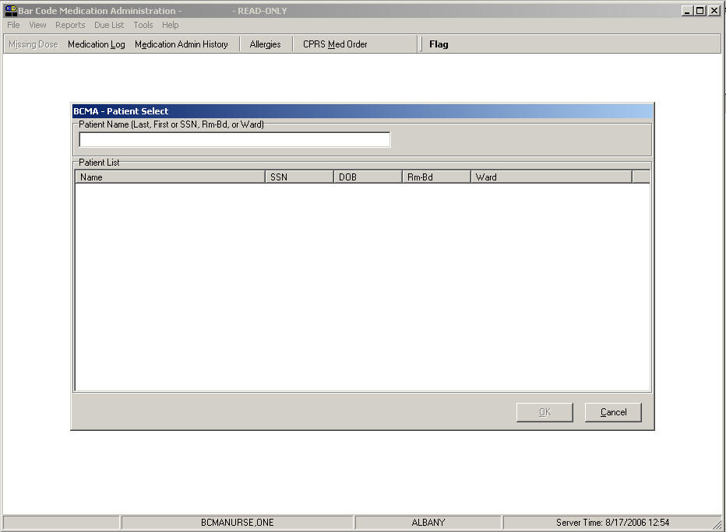

Read-Only and Limited Access BCMA

|  |  |
| --- | --- |
| Using Read‑Only BCMA  tip:  Read-Only users can also press **ctrl+o** to quickly access a patient record.  Tips | To Open a Patient Record in Read-Only BCMA   1. Perform one of the following actions:  * If you are signed on as a Read-Only user (including a nursing student without an instructor): * If the BCMA - Patient Select dialog box is displayed, proceed to step #2 to access a patient record. * If the BCMA VDL is displayed, select the Open Patient Record command from the File menu. The BCMA - Patient Select dialog box displays. Proceed to step #2 to access a patient record.   **Keyboard Shortcut:** Press **alt+f** to display the File menu, and then press **o** to display the BCMA - Patient Select dialog box.   * If you are a user who does not hold the PSB READ ONLY security key, and you want to open a patient record in Read-Only mode, select the Open (Read-Only) command from the File menu. The BCMA - Patient Select dialog box displays. Proceed to step #2 to access a patient record.   **Keyboard Shortcut:** Press **alt+f** to display the File menu, and then press **r** to display the BCMA - Patient Select dialog box.  **Note:** If you are signed on as a Read-Only user and you **cancel** out of the BCMA - Patient Select dialog box, only BCMA ward‑specific reports will be available. |
|  | 1. At the BCMA – Patient Select dialog box, enter one of the following search criteria in the Patient Name field:  * Patient name (Last, First) * Patient Social Security Number (SSN) * Rm-Bed * Ward   **Note:** BCMA automatically searches for the patient record(s) that match the criteria in the Patient Name field – as you are typing. You must enter at least 2 characters to initiate the search. There is no need to press **enter**. Note that the search is not case-sensitive. |

Read-Only and Limited Access BCMA

|  |  |
| --- | --- |
| Using Read‑Only BCMA (cont.)  tip:  To broaden your search, you can enter *partial* search criteria for Last Name, SSN, Rm‑Bed, or Ward in the BCMA – Patient Select dialog box.  Tips  tip:  You can double-click on the patient name to quickly open the record on the VDL.  Tips | To Open a Patient Record in Read-Only BCMA (cont.)   1. Perform one of the following actions:  * **If the patient you are requesting is displayed in the Patient List,** click on the patient record you want to access, then click ok to access the patient’s VDL in Read-Only mode.   **Keyboard Shortcut:** Press **tab** to go to the Patient List, then if multiple records are displayed, use the **arrow** keys to select the patient record. Press **tab** to activate the **ok** button, and then press **enter** to access the patient’s VDL in Read-Only mode.  Example: BCMA – Patient Select Dialog box Search by SSN  Example: BCMA – Patient Select Dialog box Search by SSN screen   * If the patient you are requesting is not displayed in the Patient List: * If more records are retrieved than can be displayed in the Patient List, scroll bars will appear to allow you to scroll through the data. Scroll to the patient record, click on the patient record you want to access, then click ok to access the patient’s VDL in Read-Only mode. * If records are retrieved, but you do not see the intended patient record, re-enter your patient search criteria, as indicated in step #2 above. * If you see a “No patients matching…” message, re-enter your patient search criteria, as indicated in step #4 above. * If you see a “Too many patients matching…” message, then the system found more than 100 records that matched your criteria. Re-enter more specific patient criteria, as indicated in step #2 above. |

Read-Only and Limited Access BCMA

|  |  |
| --- | --- |
| Using Read‑Only BCMA (cont.) | Example: BCMA – Patient Select Dialog box Partial SSN Search  Example: BCMA – Patient Select Dialog box Partial SSN Search screen  Example: BCMA – Patient Select Dialog box No Records Found  Example: BCMA – Patient Select Dialog box No Records Found screen |

Read-Only and Limited Access BCMA

|  |  |
| --- | --- |
| What is Limited Access BCMA? | Limited Access BCMA provides medication administering users the ability to access the BCMA application without being at the patient’s bed side. Active, discharged, and deceased patient records can be opened in Limited Access mode without scanning or using Unable to Scan.  Features Not Available in Limited Access BCMA  When a user logs on and selects Open (Limited Access) from the File menu, the following features will not be available:   * **Administration of a medication via scanning.** The scanner status remains in a Not Ready state whenever a patient record is opened in BCMA Limited Access mode. * **Administration of a medication via Unable to Scan functionality.** The Unable to Scan and Unable to Scan-Create WS options will be disabled. * **Modification of any IV or Ward Stock administration.** Unable to Scan, Unable to Scan-Create WS, and Take Action on Bag options will be disabled. * **Marking a patch as Removed.** The option to mark a patch as Removed will be disabled. * **Use of the CPRS Med Order button.** The entry of an order via the CPRS Med Order button will be disabled. |

Read-Only and Limited Access BCMA

|  |  |
| --- | --- |
| What is Limited Access BCMA? (cont.) | The following example shows a sample patient record being viewed in Limited Access BCMA. Note the “LIMITED ACCESS” message in the title bar, and the tool bar buttons that are unavailable display as grayed-out. In addition, the Scanner Status displays as “Not Ready” and the Enable Scanner button is not available.  Example: BCMA Limited Access VDL  Example: BCMA Limited Access VDL screen  The following example shows how menu options that are unavailable in Limited Access BCMA display as grayed-out.  Example: BCMA Limited Access VDL Due List Menu  Example: BCMA Limited Access VDL Due List Menu screen |

Read-Only and Limited Access BCMA

|  |  |
| --- | --- |
| What is Limited Access BCMA? (cont.) | Features Available in Limited Access BCMA  When a user logs on and selects Open (Limited Access) from the File menu, the following features will be available:   * Inpatient Order Mode and Clinic Order Mode are available in Limited Access BCMA. * The Unit Dose, IVP/IVPB, and IV medication tabs will display the patient’s Virtual Due list. * The Edit Med Log option will be available. * Patient demographics will be available by performing a mouse click on the patient demographics box. * The ability to view Allergies from the Allergies button will be available. * Virtual Due List Parameters and Schedule Types selections will be available. * All options within the File, View, Reports, Tools, and Help menus will be available. * BCMA Patient Record Flag functionality will be available. * All BCMA reports will be available, by patient and by ward. * Within the Due List menu, all options will be available except for Unable to Scan, Unable to Scan – Create WS, and Take Action on Bag. * Submission of a Missing Dose Request via any Missing Dose option will be available. * Adding a comment to an administration via any Add Comment option will be available. * Marking appropriate administrations as Held or Refused will be available. * Marking a Given administration as Undo Given will be available. * The ability to document PRN Effectiveness will be available through the right click menu, Due List menu and via BCMA Clinical Reminders. * The Cover Sheet tab is available and fully functional in Limited Access BCMA. |

Read-Only and Limited Access BCMA

|  |  |
| --- | --- |
| Accessing Limited Access BCMA | This section describes the method for accessing BCMA in Limited Access mode.  Methods to access BCMA in Limited Access Mode   * The Open (Limited Access) option is available on the File Menu; all users, except for those users with the PSB READ ONLY security key, can select the Open (Limited Access) option.   **Keyboard Shortcut:** Press **alt+f** to display the File menu, and then press **l** to access Open (Limited Access).  Example: Open (Limited Access) Option on File Menu  Example: Open (Limited Access) Option on File Menu screen |

Read-Only and Limited Access BCMA

|  |  |
| --- | --- |
| Using Limited Access BCMA  tip:  Users accessing BCMA in the Limited Access mode can press **ctrl+o** to quickly access a patient record. This opens a patient record in with full BCMA access.  Tips | To Open a Patient Record in Limited Access BCMA   1. Perform one of the following actions:  * If you are accessing BCMA in the Limited Access mode: * If the BCMA - Patient Select dialog box is displayed, proceed to step #2 to access a patient record. * If the BCMA VDL is displayed, select the Open Patient Record command from the File menu. The BCMA - Patient Select dialog box displays. Proceed to step #2 to access a patient record.   **Keyboard Shortcut:** Press **alt+f** to display the File menu, and then press **l** to display the BCMA - Patient Select dialog box.  **Note:** If you are accessing BCMA in the Limited Access mode and you **cancel** out of the BCMA - Patient Select dialog box, only BCMA ward‑specific reports will be available.  Example: Limited Access BCMA  with Patient Select Dialog Box  Example: Limited Access BCMA  with Patient Select Dialog Box screen |
|  | 1. At the BCMA – Patient Select dialog box, enter one of the following search criteria in the Patient Name field:  * Patient name (Last, First) * Patient Social Security Number (SSN) * Rm-Bed * Ward   **Note:** BCMA automatically searches for the patient record(s) that match the criteria in the Patient Name field – as you are typing. You must enter at least 2 characters to initiate the search. There is no need to press **enter**. Note that the search is not case-sensitive. |

Read-Only and Limited Access BCMA

|  |  |
| --- | --- |
| Using Limited Access BCMA (cont.)  tip:  To broaden your search, you can enter *partial* search criteria for Last Name, SSN, Rm‑Bed, or Ward in the BCMA – Patient Select dialog box.c  Tips | To Open a Patient Record in Limited Access BCMA (cont.)   1. Perform one of the following actions:  * **If the patient you are requesting is displayed in the Patient List,** click on the patient record you want to access, then click ok to access the patient’s VDL in Limited Access mode.   **Keyboard Shortcut:** Press **tab** to go to the Patient List, then if multiple records are displayed, use the **arrow** keys to select the patient record. Press **tab** to activate the **ok** button, and then press **enter** to access the patient’s VDL in Limited Access mode.  Example: BCMA – Patient Select Dialog box Search by SSN  Example: BCMA – Patient Select Dialog box Search by SSN screen   * **If** the patient you are requesting is not displayed in the Patient List: * If more records are retrieved than can be displayed in the Patient List, scroll bars will appear to allow you to scroll through the data. Scroll to the patient record, click on the patient record you want to access, then click **OK** to access the patient’s VDL in Limited Access mode. * If records are retrieved, but you do not see the intended patient record, re-enter your patient search criteria, as indicated in step #2 above. * If you see a “No patients matching…” message, re-enter your patient search criteria, as indicated in step #2 above. * If you see a “Too many patients matching…” message, then the system found more than 100 records that matched your criteria. Re-enter more specific patient criteria, as indicated in step #2 above. |

Read-Only and Limited Access BCMA

|  |  |
| --- | --- |
| Using Limited Access BCMA (cont.) | Example: BCMA – Patient Select Dialog box Partial SSN Search  Example: BCMA – Patient Select Dialog box Partial SSN Search screen  Example: BCMA – Patient Select Dialog box No Records Found  Example: BCMA – Patient Select Dialog box No Records Found screen |

Working with the Cover Sheet

|  |  |
| --- | --- |
| Benefits of this Chapter | Use this chapter when you need to access the BCMA Cover Sheet to display alternate views of medication data related to the selected patient.  This chapter describes features and functionality of the Cover Sheet, how to access the four user-selectable views, and how to manipulate the data within each view. |
| What is the  Cover Sheet? | The BCMA Cover Sheet supplements the VDL medication tabs by providing users with four alternate views of primary medication data related to the selected patient – all in a single, easy-to-use location. The Cover Sheet tab increases the amount of information available to the user by displaying data related to expired, discontinued, and future orders. Each view has a unique data set and format, and allows users to drill down to view additional order and/or IV bag details, when applicable.  The Cover Sheet tab functions as a display tool only, and does not allow the user to edit any data, administer medications, or take action against a patient’s record. No special security key is required to access the Cover Sheet – it is available to all users that have access to the BCMA GUI application, and it is fully functional in Read-Only mode.  Upon opening a patient record, BCMA opens to the Unit Dose tab by default. In order to display the Cover Sheet, the user must select the Cover Sheet tab by clicking the tab to the left of the Unit Dose tab.  The Cover Sheet supports both Inpatient Order Mode and Clinic Order Mode. While the Cover Sheet is displayed, you can switch between Order Modes. The Clinic Order Mode displays a column for Clinic location and omits the HSM column. |
| Features of the  Cover Sheet | Views  The Cover Sheet tab provides four user-selectable views for the current patient:   * **Medication Overview:** This is the default view. It displays all Active and Future orders, as well as orders that have Expired/Discontinued (DC'd) within the last 24 hours. This view includes all Unit Dose, IVP/IVPB, and large volume IV orders. * **PRN Overview:** Displays Active and Future PRN orders, as well as PRN orders that have Expired/DC'd within the last 24 hours. * **IV Overview:** Displays large volume IV bag information from Active orders, as well as from orders that have Expired/DC’d within the last 24 hours. |

Working with the Cover Sheet

|  |  |
| --- | --- |
| Features of the  Cover Sheet (cont.) | * **Expired/DC’d/Expiring Orders:** * When Inpatient Order Mode is selected, this view defaults to displaying all orders that have Expired/DC'd within the last 24 hours, as well as orders expiring today and tomorrow. In addition, the user can temporarily expand the display to include orders that have expired within the last 48 and 72 hours, as well as future orders expiring within 48 and 72 hours after midnight tonight. * When Clinic Order Mode is selected, and the Medication Overview or PRN Overview is selected, the Expired/DC'd orders sections will display orders that have Expired or have been Discontinued within the last 7 days. When the Expired/DC'd view is selected, orders will display that have Expired or have been Discontinued within the last 7 days, Today, and within the next 7 days.   Display Features   * Displays the Medication Overview by default. * Allows the user to select alternate views from a drop-down field; a table then displays the data associated with the selected view. * Displays data in groups that the user can expand and collapse as desired. Each group is expandable to display data or collapsible to hide data. * Each group within a view is named and displays the number of items within the group to the right of the group name in brackets, e.g., Active [10 Orders]. * Each group has a header row that identifies the columns of data displayed in the group. As the user expands order and/or bag detail rows to reveal more data, appropriate headers appear to describe the data displayed. * Displays up to 4 previous actions per order. |

Working with the Cover Sheet

|  |  |
| --- | --- |
| Features of the  Cover Sheet (cont.) | * Displays information by order, instead of administration, as shown on the existing BCMA medication tabs. * Displays Active, Expired, and Discontinued (DC'd) orders, including orders Expiring Today and Expiring Tomorrow. * The default timeframe for displaying Expired or DC’d orders in each view is the current time minus 24 hours from the date/time the VDL is accessed, unless otherwise stated below. * Allows the user to temporarily expand the display to include Inpatient orders that have expired within the last 48 and 72 hours, as well as future orders expiring within 48 and 72 hours after midnight tonight. Group headings change dynamically, based on selected timeframe. When Clinic Order Mode is selected, the Expired/DC'd view displays orders that have Expired or have been Discontinued within the last 7 days, Today, and within the next 7 days * Displays Future orders, i.e., any active order with a future start date. * Displays icons for: STAT; Order Flag; IV Order – No action taken yet; Witness required/recommended for High Risk/High Alert Administrations; Requires Removal; Hazardous to Handle; and, Hazardous to Dispose. * Displays icons for STAT, Order Flag, and IV Order – No action taken yet, and Witness required/recommended for High Risk/High Alert Administrations. * In Special Instructions column, displays message in cell: “Too much information to display. Use right-click menu to display full text” for orders containing Special Instructions / Other Print Info that exceed 180 characters. Displays this same message as hover text when hovering over a field containing Special Instructions / Other Print Info that exceed 180 characters.   **Note:** The STAT icon will display for STAT, ASAP, and NOW orders only if the PRIORITIES FOR ACTIVE NOTIFY is properly set in the Inpatient Medications system parameters.  **Note:** The Cover Sheet tab does not display the green/white Schedule Type indicators found on the existing BCMA medication tabs (Unit Dose, IVP/IVPB, and IV). |
|  |  |

Working with the Cover Sheet

|  |  |
| --- | --- |
| Features of the  Cover Sheet (cont.) | Limitations by Design   * When the Inpatient Order Mode is selected, the Cover Sheet displays only Inpatient Orders. When the Clinic Order Mode is selected, the Cover Sheet displays only Clinic Orders. Each Order Mode is mutually exclusive. * In Inpatient Order Mode, when the Cover Sheet is accessed, the Virtual Due List Parameters and Schedule Types groups are disabled (grayed out). * In Clinic Order Mode, when the Cover Sheet is accessed, the Clinic Order Date and Schedule Types groups are disabled (grayed out).   Example: Disabled Virtual Due List Parameters  and Schedule Types  Example: Disabled Virtual Due List Parameters and Schedule Types screen   * While the Cover Sheet is active, the Scanner Status is  “Not Ready.” This means you cannot: * Scan a medication * Manually enter an IEN number * Edit order data * Take action against a patient's record * The IV Overview does not display IV bags for ward stock or future orders. * The Cover Sheet does not include printing or reporting functions.   Similarities to the VDL   * While the Cover Sheet is active (any view), you can document PRN Effectiveness. * Cover Sheet columns can be sorted in ascending or descending order by clicking a column header. Note that all groups within a view will sort, and whenever BCMA loads, the default sort order set by the user returns. * Cover Sheet columns can be resized by placing the mouse pointer over the vertical border (line) of a column header, and dragging the crosshair to increase or decrease the column width. The column widths set by the user are saved on the Cover Sheet screen. * Patient Demographics can be accessed by clicking the patient information box on the Cover Sheet. * Refresh can be used to reload Cover Sheet data. * Right-clicking on a Cover Sheet row will provide the following standard BCMA options: |

Working with the Cover Sheet

|  |  |
| --- | --- |
| Features of the  Cover Sheet (cont.) | * Available Bags (for IV orders) * Display Order * Special Instructions / Other Print Info * Display Reason for Order Flag, if applicable * Med History   Keyboard Shortcuts  The Cover Sheet includes several keyboard shortcuts as shown below: |

Example: Cover Sheet Shortcut Keys

|  |  |
| --- | --- |
| Use This Shortcut: | To Make This Occur: |
| **F2** | Switch to Inpatient Order Mode |
| **F3** | Switch to Clinic Order Mode |
| **F9** | Display Cover Sheet tab |
| **Alt-V** | Activate Cover Sheet View drop-down list box |
|  |  |
| **Shift-Tab/Tab** | Shift focus from group to group (previous/next group) and through active fields on screen. |
| **Up/Down Arrow** | Shift focus from one row to the next (previous/next row) |
| **Left/Right Arrow** | Expand or collapse a row, if applicable. |
| **Alt-Up/Down Arrow** | Scroll entire Cover Sheet up and down |
|  |  |
| **Shift-F9** | Expand/Collapse the first group in a view |
| **Shift-F10** | Expand/Collapse the second group in a view |
| **Shift-F11** | Expand/Collapse the third group in a view |
|  |  |
| **Ctrl-Alt-V** | Show Available Bags for highlighted item |
| **Ctrl-Alt-O** | Display Order for highlighted item |
| **Ctrl-Alt-E** | Display Med History for highlighted item |
| **Ctrl-Alt-S** | Display Special Instructions / Other Print Info |

An Icon Legend is accessible via the View Menu, showing icons and indicators used on the Cover Sheet and medication tabs.

Example: Icon Legend

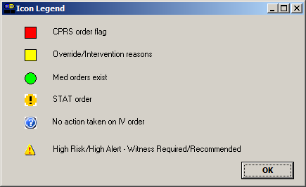

Working with the Cover Sheet

|  |  |
| --- | --- |
| Cover Sheet Screen: Medication Overview | The Medication Overview displays and groups active, expired or discontinued (DC’d), and future orders for the current patient. The total number of orders per group displays in brackets next to each group heading. The groups are displayed top down as follows:   * **Active** orders are those orders with an order start date/time less than or equal to the current date/time minus the “Before Scheduled Admin Time” site parameter, and an order stop date/time greater than the current date/time. * **Future** orders are those orders whose start date/time is *greater than* the current date/time plus the “Before Scheduled Admin Time” site parameter. * **Expired/DC’d** orders are those orders that have expired or have been discontinued within the last 24 hours for Inpatient orders, and last 7 days for Clinic orders. |

Example: View: Medication Overview (Inpatient Order Mode)

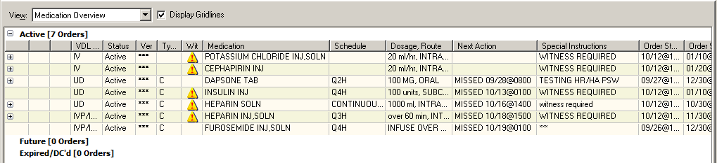

Example: View: Medication Overview (Clinic Order Mode)

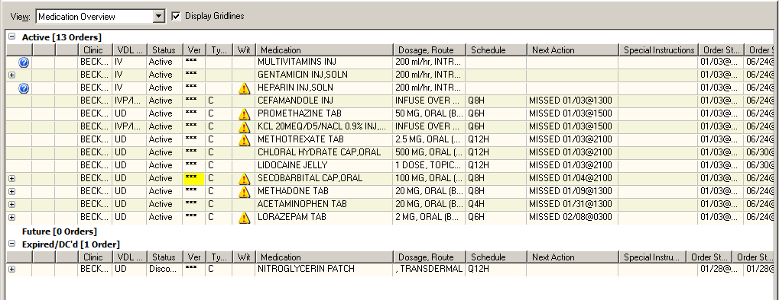

Working with the Cover Sheet

|  |  |
| --- | --- |
| Cover Sheet Screen:  Medication Overview (cont.)  TIP:  You can use the F2  and F3 shortcut  keys to switch between Inpatient  and Clinic order modes.  Tips | The Medication Overview provides three levels of detail for each order displayed.   1. The top level displays order and next administration data, and includes the following header and information in the order listed below.   Icons: When applicable, the following icons or indicators will display:   * **STAT:** (Black exclamation Point on yellow circle) displays for STAT orders. * **Order Flag:** (Red block) indicator displays for any flag from CPRS/ Pharmacy, with the corresponding “Reason for Flag” comment available from the right-click menu. * **Override/Intervention reasons:** (Yellow block) indicator displays in verified “Ver” cell when provider overrides or pharmacist interventions are associated with an order. * **IV Order – No action taken yet:** (Question mark) Displays for large volume IV orders, where no action has been taken yet. * **High Risk/High Alert – Witness Required/Recommended: (**Red exclamation point on yellow triangle) displays High Risk/High Alert medication orders that require or recommend a witness during administration. * **Requires Removal: (**Black arrow on orange patch) displays when a transdermal medication requires removal. * **Hazardous to Handle:** (Red ‘X’ superimposed on white hand) displays when a drug, additive or solution requires use of Personal Protective Equipment (PPE). * **Hazardous to Dispose:** (Red ‘X’ superimposed on lidded trash can) displays when a drug, additive or solution necessitates the user follow proper disposal procedures.   VDL Tab: the name of the tab within BCMA where administrations are displayed.  Status: the current status of the order (i.e., Active, Expired, Hold)  Ver: the initials of the nurse who verified the order or three asterisks (***) indicating non-nurse verified.  Type: the schedule type of the order (C for Continuous, O for One Time, OC for On Call, P for PRN)  Medication: the orderable item associated with the order  Dosage, Route: the dosage and route of the order, separated by a comma  Schedule: the order schedule (i.e., Q2H, BID) |

Working with the Cover Sheet

|  |  |
| --- | --- |
| Cover Sheet Screen:  Medication Overview (cont.) | Next Action: one of the following:   * **“DUE”** followed by the next scheduled administration time after the last action taken for active orders that have defined administration times in MM/DD@HHMM format. * **“Missed”** followed by the next scheduled administration time after the last action taken if administration date/time exceeds the “After Scheduled Admin Time” site parameter in MM/DD@HHMM format. * **“Provider Hold”** for active orders on provider hold * **Blank** for PRN, On Call, and One-Time orders   Special Instructions: special instructions or “Other Print Info” associated with the order  Order Start Date: the order’s start date/time displayed in MM/DD@HHMM format  Order Stop Date: the order’s stop date/time displayed in MM/DD@HHMM format |

Working with the Cover Sheet

|  |  |
| --- | --- |
| Cover Sheet Screen:  Medication Overview (cont.)  tip:  Actions that display a status of “Unknown” are due to incomplete documentation of an administration in the BMCA CHUI *Manual Medication Entry*, and must be corrected using Edit Med Log.  Tips | 1. The second level displays a maximum of four previous actions taken against this specific order, and includes the following header and information in the order listed below.   **Note:** Actions whose activity date exceeds the “Med History Days Back” site parameter will not be displayed.   * **Bag ID:** If the order is an IV order, then the Bag ID header and field displays, which is the unique identifier for the bag associated with this action. * **Action By:** the initials of the person that performed the action, and the date/time of the action in MM/DD@HHMM format * **Action:** the status of the administration (i.e., Given, Held, Refused, Missing, etc.). * If the order has a PRN schedule type, the following headers and fields will display: * **PRN Reason:** the PRN reason associated with the action * **PRN Effectiveness:**  the PRN Effectiveness comment for this action |

Example: Medication Overview with 3 Levels of Data (Inpatient Order Mode)

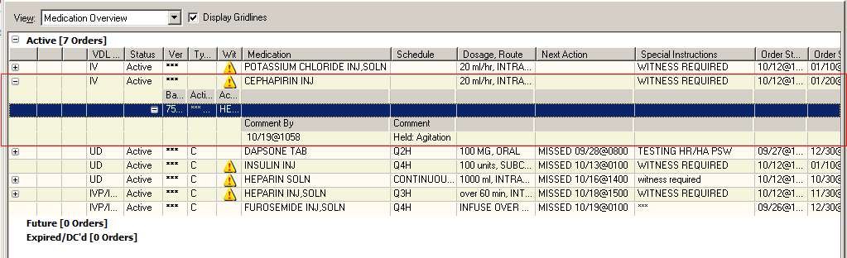

Working with the Cover Sheet

|  |  |
| --- | --- |
| Cover Sheet Screen:  Medication Overview (cont.) | 1. The third level displays comments associated with the action and includes the following header and information in the order listed below.  * **Comment By:** the initials of the person that entered the comment and the date/time the comment was entered in MM/DD@HHMM format * **Comment:** the text of the comment |

Working with the Cover Sheet

|  |  |
| --- | --- |
| Cover Sheet Screen:  PRN Overview | The PRN Overview displays and groups active expired or discontinued and future orders with a schedule type of PRN for the current patient. The total number of orders per group displays in brackets next to each group heading.  **Note:** Actions whose activity date exceeds the “Med History Days Back” site parameter will not be displayed.  The groups are displayed top down as follows:   * **Active** orders are those orders with an order start date/time less than or equal to the current date/time minus the “Before Scheduled Admin Time” site parameter, and an order stop date/time greater than the current date/time. * **Future** orders are those orders whose start date/time is greater than the current date/time plus the “Before Scheduled Admin Time” site parameter. * **Expired/DC’d** orders are those orders that have expired or have been discontinued within the last 24 hours for Inpatient orders, and last 7 days for Clinic orders. |
|  |  |

Example: View: PRN Overview (Inpatient Order Mode)

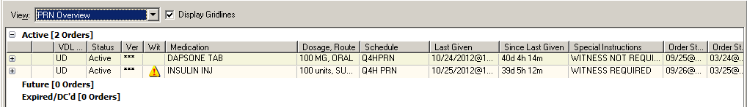

Example: View: PRN Overview (Clinic Order Mode)

|  |  |
| --- | --- |
| Example:  View: PRN Overview (Clinic Order Mode) screenWorking with the Cover SheetCover Sheet Screen:  PRN Overview (cont.) | This view will provide three levels of detail for each order displayed.   1. The top level displays order and next administration data and contains the following header and information in the following order.  * **Icons**: When applicable, the following icons or indicators will display: * **STAT:** (Black exclamation Point on yellow circle) displays for STAT orders. * **Order Flag:** (Red block) displays for any flag from CPRS/ Pharmacy, with the corresponding “Reason for Flag” comment available from the right-click menu. * **Override/Intervention reasons:** (Yellow block) indicator displays in verified “Ver” cell when provider overrides or pharmacist interventions are associated with an order. * **IV Order – No action taken yet:** (Question mark) Displays for large volume IV orders, where no action has been taken yet. * **High Risk/High Alert – Witness Required/Recommended:** (Red exclamation point on yellow triangle) displays High Risk/High Alert medication orders that require or recommend a witness during administration. * **Requires Removal: (**Black arrow on orange patch) displays when a transdermal medication requires removal. * **Hazardous to Handle:** (Red ‘X’ superimposed on white hand) displays when a drug, additive or solution requires use of Personal Protective Equipment (PPE). * **Hazardous to Dispose:** (Red ‘X’ superimposed on lidded trash can) displays when a drug, additive or solution necessitates the user follow proper disposal procedures. * **VDL Tab:** the name of the tab within BCMA where administrations are displayed. * **Status:** the current status of the order (i.e. Active, Hold, Expired) * **Ver:** the initials of the nurse who verified the order or three asterisks (***) indicating non-nurse verified. * **Medication:** the orderable item associated with the order * **Schedule:** the order schedule (i.e., Q4H PRN) * **Dosage, Route:** the dosage and route of the order separated by a comma * **Last Given:** the last administration and the date/time the action was performed for the orderable item in ACTION MM/DD@HHMM format Note: Last Given may not be associated with this PRN order. It may be the last time the medication was given on a separate order. * **Since Last Given:** the number of hours and minutes since the last administration of the orderable item in ##d ##h ##m format. (e.g. 1d 10h 23m ago) * **Special Instructions:** special instructions associated with the order |

Working with the Cover Sheet

|  |  |
| --- | --- |
| Cover Sheet Screen:  PRN Overview (cont.)  tip:  Actions that display a status of “Unknown” are due to incomplete documentation of an administration in the BMCA CHUI *Manual Medication Entry*, and must be corrected using Edit Med Log.  Tips | Order Start Date: the order’s start date/time displayed in MM/DD@HHMM format  Order Stop Date: the order’s stop date/time displayed in MM/DD@HHMM format   1. The second level displays a maximum of four previous actions taken against this specific order, and will contain a header and information in the following order.   Action By: the initials of the person that performed the action and the date/time of the action in MM/DD@HHMM format   * **Action:** the status of the administration (i.e., Given, Held, Refused, Missing, etc.) * **PRN Reason**: the PRN reason associated with the action * **PRN Effectiveness:** the PRN Effectiveness comment for this action  1. The third level of the PRN Overview displays comments associated with the action and includes the following header and information.  * **Comment By:** the initials of the person that entered the comment and the date/time the comment was entered in MM/DD@HHMM format * **Comment:** the text of the comment   The IV Overview displays and groups IV bag information on active, expired, and discontinued large volume IV orders for the current patient selected. The number of IV bags per group displays in brackets next to each group heading. The groups are displayed top down as follows:   * **Infusing** is any bag that is currently infusing on an active, expired, or discontinued order. * **Stopped** is any bag that is currently stopped on an active, expired, or discontinued order. * **All Other** is any bag that is not infusing or stopped on an active order. |
|  |  |

Working with the Cover Sheet

|  |  |
| --- | --- |
| Cover Sheet Screen:  IV Overview |  |
|  |  |

Example: View: IV Overview (Inpatient Order Mode)

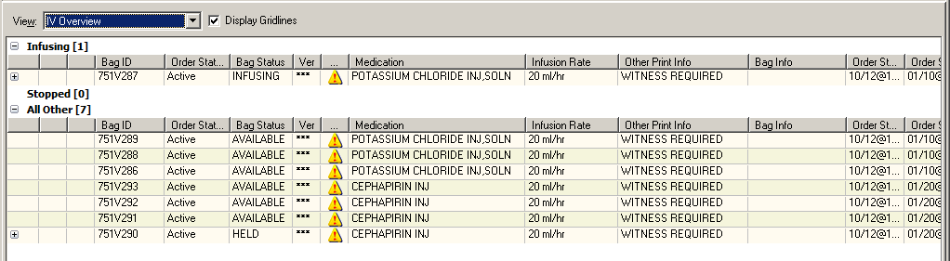

Example: View: IV Overview (Clinic Order Mode)

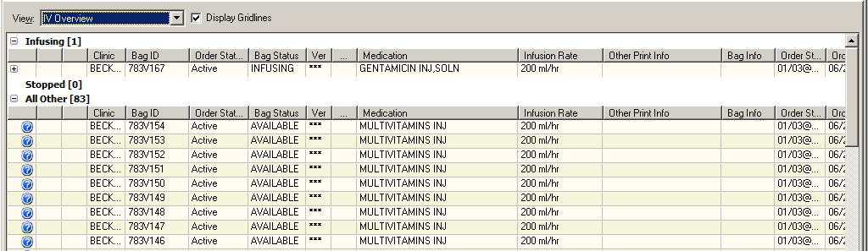

Working with the Cover Sheet

|  |  |
| --- | --- |
| Cover Sheet Screen:  IV Overview (cont.)  tip:  Actions that display a status of “Unknown” are due to incomplete documentation of an administration in the BMCA CHUI *Manual Medication Entry*, and must be corrected using Edit Med Log.  Tips | The IV Overview provides two levels of detail for each bag displayed.   1. The top level displays bag and order data. It includes the following header and information in the order listed below.  * **Icons**: When applicable, the following icons or indicators will display: * **Order Flag:** (Red block) displays for any flag from CPRS/ Pharmacy, with the corresponding “Reason for Flag” comment available from the right-click menu. * **Override/Intervention reasons:** (Yellow block) indicator displays in verified “Ver” cell when provider overrides or pharmacist interventions are associated with an order. * **IV Order – No action taken yet:** (Question mark) Displays for large volume IV orders, where no action has been taken yet. * **High Risk/High Alert – Witness Required/Recommended:** (Red exclamation point on yellow triangle) displays High Risk/High Alert medication orders that require or recommend a witness during administration. * **Bag ID**: the unique identifier for the bag * **Order Status**: the current status of the order to which the bag belongs * **Bag Status**: the current status of the bag * **Ver:** the initials of the nurse who verified the order or three asterisks (***) indicating non-nurse verified. * **Medication:** the orderable item associated with the order * **Infusion Rate:** the infusion rate associated with the order * **Other Print Info:** other print info associated with the order * **Bag Info:** “changed order” if the bag is associated with an order that has been edited * **Order Start Date:** the order’s start date/time displayed in MM/DD@HHMM format |
|  |  |

Working with the Cover Sheet

|  |  |
| --- | --- |
| Cover Sheet Screen:  IV Overview (cont.) | * **Order Stop Date:** the order’s stop date/time displayed in MM/DD@HHMM format  1. The second level displays the bag history (actions and comments) and includes the following header and information in the order listed below.  * **Date/Time:** date/time associated with action or comment being displayed in MM/DD@HHMM format * **By:** the initials of the person that performed the action or entered the comment * **Action:** the status of the administration (i.e., Given, Held, Refused, Missing, etc.) * **Comment:** text of the comment being displayed |

Working with the Cover Sheet

|  |  |
| --- | --- |
| Cover Sheet Screen:  Expired/DC’d/ Expiring Orders | The Expired/DC’d/Expiring Orders functions differently, depending on whether the Inpatient Order Mode or the Clinic Order Mode is selected.  **Inpatient Orders**  By default, the Expired/DC’d/Expiring Orders view in Inpatient Order Mode displays and groups expired, discontinued, and expiring orders within a 24 hour period. Using drop-down lists, the user can temporarily expand the display timeframe of this view to 48 or 72 hours in the past or future.  Example: Fields to Expand Display Timeframe (Inpatient Order Mode)  Example: Fields to Expand Display Timeframe (Inpatient Order Mode) screen  The specified timeframe and the total number of orders per group displays in brackets next to each group heading. The groups are displayed top down as follows:   * **Expired/DC’d within last (24) Hours:** those orders that have expired or have been discontinued within the last 24 hours. If the user specifies an expanded timeframe for past orders, the heading and orders will dynamically update according to the number of hours specified. * **Expiring Today:** those orders that have not yet expired, but will expire before midnight of the current day. * **Expiring within next (24) Hours** (after Midnight tonight): those orders that expire 24 hours after midnight of the current day, but before midnight of the following day (tomorrow). If the user specifies an expanded timeframe for future orders, the heading and orders will dynamically update according to the number of hours specified.   Example: View: Expired/DC’d/Expiring Orders (Inpatient Order Mode)  Example: View: Expired/DC’d/Expiring Orders (Inpatient Order Mode) screen |

Working with the Cover Sheet

|  |  |
| --- | --- |
| Cover Sheet Screen:  Expired/DC’d/ Expiring Orders (cont.) | **Clinic Orders**  By default, the Expired/DC’d/Expiring Orders view in Clinic Order Mode displays and groups expired, discontinued, and expiring orders within the past 7 days and the future 7 days.  Example: Fields to Expand Display Timeframe (Clinic Order Mode)  Example: Fields to Expand Display Timeframe (Clinic Order Mode) screen  The specified timeframe and the total number of orders per group displays in brackets next to each group heading. The groups are displayed top down as follows:   * **Expired/DC’d within last 7 days:** those orders that have expired or have been discontinued within the last 7 days. * **Expiring Today:** those orders that have not yet expired, but will expire before midnight of the current day. * **Expiring within next 7 days** (after Midnight tonight): those orders that expire 7 days after midnight of the current day, but before midnight of the following day (tomorrow).   Example: View: Expired/DC’d/Expiring Orders (Clinic Order Mode)  EXPDCDORDERS |

Working with the Cover Sheet

|  |  |
| --- | --- |
| Cover Sheet Screen:  Expired/DC’d/ Expiring Orders (cont.) | The Expired/DC’d/Expiring Orders view provides three levels of detail for each order displayed.   1. The top level displays order and next administration data, and includes a header and information in the order listed below.  * **Icons:** When applicable, the following icons will display: * **STAT:** (Exclamation Point) displays for STAT orders * **Order Flag:** (Red block) displays for any flag from CPRS/ Pharmacy, with the corresponding “Reason for Flag” comment available from the right-click menu * **Override/Intervention reasons:** (Yellow block) indicator displays in verified “Ver” cell when provider overrides or pharmacist interventions are associated with an order. * **IV Order –** No action taken yet: (Question mark) Displays for large volume IV orders, where no action has been taken yet. * **High Risk/High Alert –** Witness Required/Recommended: (Red exclamation point on yellow triangle) displays High Risk/High Alert medication orders that require or recommend a witness during administration. * **VDL Tab:** the name of the tab within BCMA where administrations are displayed. * **Status:** the current status of the order (i.e., Active, Hold, Expired) * **Ver:** the initials of the nurse who verified the order or three asterisks (***) indicating non-nurse verified. * **Type:** the schedule type of the order (C for Continuous, O for One-Time, OC for On-Call, P for PRN) * **Schedule:** the order schedule (i.e., Q2H, BID) * **Medication:** the orderable item associated with the order * **Dosage, Route:** the dosage and route of the order separated by a comma * **Next Action:** one of the following: * **“DUE”** followed by the next scheduled administration time after the last action taken for |

Working with the Cover Sheet

|  |  |
| --- | --- |
| Cover Sheet Screen:  Expired/DC’d/ Expiring Orders (cont.)  tip:  Actions that display a status of “Unknown” are due to incomplete documentation of an administration in the BMCA CHUI *Manual Medication Entry*, and must be corrected using Edit Med Log.  Tips | active orders that have defined administration times in MM/DD@HHMM format.   * **“Missed”** followed by the next scheduled administration time after the last action taken if administration date/time exceeds the After Scheduled Admin Time site parameter in MM/DD@HHMM format. * **“Provider Hold”** for active orders on provider hold * Blank for PRN, On Call, and One-Time orders * **Special Instructions:** special instructions associated with the order * **Order Start Date**: the order’s start date/time displayed in MM/DD@HHMM format * **Order Stop Date**: the order’s stop date/time displayed in MM/DD@HHMM format  1. The second level displays a maximum of four previous actions taken against this specific order, and includes a header and information in the order listed below.   **Note:** Actions whose activity date exceeds the “Med History Days Back” site parameter will not be displayed.   * **Bag ID:** If the order is an IV order, then the Bag ID header and field displays, which is the unique identifier for the bag associated with this action. * **Action By:** the initials of the person that performed the action and the date/time of the action in MM/DD@HHMM format * **Action:** the status of the administration (i.e., Given, Held, Refused, Missing, etc.) * If the order has a PRN schedule type, the following headers and fields will display: * **PRN Reason: the PRN reason associated with the action** * **PRN Effectiveness: the PRN Effectiveness comment for this action**  1. The third level displays comments associated with the action and includes the following header and information.  * **Comment By:** the initials of the person that entered the comment and the date/time the comment was entered in MM/DD@HHMM format * **Comment:** the text of the comment |

Working with the Cover Sheet

|  |  |
| --- | --- |
| Accessing the Cover Sheet | BCMA opens to the Unit Dose tab by default. You must select the Cover Sheet tab in order to view the Cover Sheet.  When a patient record is open, if the patient status is admitted, the Inpatient order mode defaults. If the patient status is not admitted, the Clinic order mode defaults.  To Access the Cover Sheet   1. Open a patient record using any of the available methods. 2. Click on the Cover Sheet tab to display the Cover Sheet for the current patient.   **Keyboard Shortcut:** Press F9 to display the Cover Sheet tab for the current patient.  Example: Cover Sheet Tab  Example: Cover Sheet Tab screen   1. After a brief “Loading Cover Sheet” message, the Cover Sheet displays the default Cover Sheet view, the Medication Overview, for the current patient.   Example: Default Cover Sheet View  (Inpatient Order Mode)  **Example: Default Cover Sheet View  (Inpatient Order Mode) screen** |
|  |  |

Working with the Cover Sheet

|  |  |
| --- | --- |
| Accessing the  Cover Sheet (cont.) | The Cover Sheet opens to the Medication Overview by default, for the selected Order Mode, either Inpatient or Clinic. You may select one of the four available Cover Sheet views.  To select a Cover Sheet View   1. From the Cover Sheet tab, click on the View drop-down list box, and then select one of the available views from the list.   **Keyboard Shortcut:** Press alt-w to activate the View drop-down list box, and then press any arrow key to quickly switch to another view.  Example: View Drop-down List Box  Example: View Drop-down List Box screen   1. The Cover Sheet displays the selected view for the current patient. |

Working with the Cover Sheet

|  |  |  |  |  |  |  |  |
| --- | --- | --- | --- | --- | --- | --- | --- |
| Using the Cover Sheet  tip:  Press the **tab** and shift**-tab** keys to move from group to group.  Press the **up** and **down** **arrow** keys to move from row to row within a group.  Tips  tip:  Press the **F5** key to refresh and reload Cover Sheet data.  All current Cover Sheet display settings will remain during refresh.  Tips | You can control the way data is displayed on any Cover Sheet view by using the mouse and keyboard shortcuts. By default, all groups are expanded per view, and all rows are collapsed. When the user expands or collapses data in a view, it remains that way until the user exits BCMA.  To Expand and Collapse Groups and Rows   1. From the Cover Sheet tab, perform one of the following actions:  * Click on the  to expand a collapsed group or row. * Click on the  to collapse an expanded group or row. * Click anywhere on a row that begins with or  to expand/collapse the group or row.   **Keyboard Shortcuts:** To Expand/Collapse the selected data row: Press the **left** or **right** **arrow** key.  To Expand/Collapse groups within a view:   |  |  | | --- | --- | | **shift-f9** | Expand/Collapse the first group in a view | | **shift-f10** | Expand/Collapse the second group in a view | | **shift-f11** | Expand/Collapse the third group in a view | |
|  | **Note:** These shortcuts function when data rows exist in a group.   1. The selected group or row expands or collapses. The following example shows a fully expanded row of data, along with the conditional headers that display.   Example: Cover Sheet Displaying  Fully Expanded Data  Example: Cover Sheet Displaying  Fully Expanded Data screen |

Working with the Cover Sheet

|  |  |
| --- | --- |
| Using the  Cover Sheet (cont.) | You may choose to display or hide the gridlines in the Cover Sheet. This feature has no effect on functionality; it is a matter of user preference. By default, the gridlines are displayed when the Cover Sheet loads.  To Hide/Display Cover Sheet Gridlines   1. From the Cover Sheet tab, click on the Display Gridlines checkbox to turn off/on the display of grid lines on the Cover Sheet.   **Keyboard Shortcut:** Press **tab** or **shift-tab** to shift focus to the Display Gridlines field, then press **spacebar** to check/uncheck the box.  Example: Display Gridlines Checkbox  Example: Display Gridlines Checkbox screen   1. If the Display Gridlines checkbox is unchecked, the gridlines are hidden from all Cover Sheet views, as shown in the example below.   Example: Cover Sheet with Gridlines Hidden  Example: Cover Sheet with Gridlines Hidden screen |
|  |  |

Viewing and Printing BCMA Reports

|  |  |
| --- | --- |
| Benefits of this Chapter | This chapter describes a variety of reports originating from BCMA that you can view and print on-screen via the BCMA VDL or via Tabs in CPRS. You can also use the reports to view patient demographic and allergy information. |
| Enhancements to Report Printing  tip:  All reports from BCMA print in a 132-column format.  Tips | Here are the changes to the original report printing functionality in BCMA V. 3.0:   * Removal times have been added where there are admin times for medications requiring removal (MRR). * Both “Removal” and “Given” administration information is available for reporting. * The new anatomic locations for MRRs are included in BCMA reports. * The word “Injection Site” has been replaced with “Body Site” in report column headers that could include both Dermal Sites for MRRs and Injection Sites for non-MRRs. * The word “Injection Site” has been replaced with “Dermal Site” when the orderable item for the medication order is an MRR for reports with one specific medication. * Mutually Exclusive and Combined reports added containing Inpatient as well as Clinic order data. * **Medication Administration History (MAH) Report:** The Date column lists three asterisks (***) to indicate that a medication is notdue. This information is also noted in the Legend at the bottom of the MAH Report.   The report also includes information about when an order is placed “On Hold” and taken “Off Hold” by a provider, and the order Start and Stop Date/Time for the medication.   * **Medication Variance Report:** Provides “exceptions” (variances) to the medication administration process. It also lists “event” information within a selected date range, such as the type and number of events, and the total percentage of events that occurred. A variance preceded by a minus sign (such as –24) indicates the number of minutes that a medication was given before the administration time. |

Viewing and Printing BCMA Reports

|  |  |
| --- | --- |
| Enhancements to Report Printing (cont.) | * **Cumulative Vitals/Measurement Report:** Lists a patient’s vitals from the Vitals package, along with their demographics and hospital location information. You cannot print this report by ward. * **Ward-based Reports:** Simply click **cancel** at the Patient Lookup dialog box to access the Menu Bar — without opening a patient record — and print ward-based reports only, except for the Cumulative Vitals/Measurement Report. A patient’s file must be opened to access patient-specific reports. * **CHUI Missing Dose Report:** Changed the line item “Dosage Schedule” on the BCMA CHUI Missing Dose Report to “Schedule” to coincide with the Missing Dose Email Notification change described on the next page. * **Missed Medications Report:** Indicates when a medication order is placed “On Hold” and taken “Off Hold” in CPRS or Inpatient Medications V. 5.0. The Hold information is provided below the medication information on the report, and only applies to administrations due within the Hold timeframe.   The “Order Num” column on the report lists the actual order number and order type (i.e., Unit Dose or IV). This information is quite helpful when troubleshooting problems with BCMA.   Enhancements to the Missed Medications Report allow the user to selectively include or exclude Held and Refused orders in the report. A verified “Ver” column contains the initials of the nurse who verified the order or three asterisks (***) indicating the order was not nurse verified.   * **Cover Sheet–Medication Overview Report:** Displays and groups active, expired or discontinued, and future orders for the current patient or by selected patients on a ward. User specified criteria includes order status (Active, Future, Expired/DC’d), and whether to include actions and comments. * **Cover Sheet–PRN Overview Report:** Displays and groups active, expired or discontinued, and future orders with a schedule type of PRN for the current patient or by selected patients on a ward. User specified criteria includes order status (Active, Future, Expired/DC’d), and whether to include actions and comments. * **Cover Sheet–IV Overview Report:** Displays and groups IV bag information on active, expired, and discontinued orders for the current patient or by selected patients on a ward. User specified criteria includes order status (Infusing bags, Stopped bags, All others), and whether to include actions and comments. |

Viewing and Printing BCMA Reports

|  |  |
| --- | --- |
| Enhancements to Report Printing (cont.) | * **Cover Sheet–Expired/DC’d/Expiring Orders Report:** Displays and groups expired and discontinued orders, as well as orders that will expire for the current patient or by selected patients on a ward. User specified criteria includes order status (Expired/DC’d, Expiring Today, Expiring Tomorrow), and whether to include actions and comments. * **Medication Therapy Report:** Includes information similar to the Medication History Report but does not require a patient record to be open. The report can be run for the current patient or by selected patients on a ward. User can select medications by searching by VA Drug Class, Orderable Item, or Dispense Drug. Other user specified criteria includes date range, schedule types, and whether to include/exclude comments. * **IV Bag Status Report:** Provides status on large volume IV bags, excluding available bags, by patient or selected patients on a ward. User can include/exclude by IV bag status: completed, infusing, stopped, missing dose, held, refused, and IV bags for which no action has been taken on the order. Other user specified criteria includes date range, order status (Active, DC’d, Expired), and whether to include/exclude comments. |

|  |  |
| --- | --- |
| Mutually Exclusive Reports  tip:  Bookmark these sites for future reference. | Since BCMA includes both Inpatient and Clinic order data, the reports are segregated into two different categories: “Mutually Exclusive” reports that separate Inpatient data from Clinic order data, and “Combined” reports that include both Inpatient data and Clinic order data. See chapter entitled, “Clinic Orders.”  Mutually Exclusive reports allow you to select either Inpatient or Clinic order data to be included in the report. When printed, the report header displays “Include Inpatient Orders Only” for reports that include only Inpatient order data or “Include Clinic Orders Only” for reports that include only Clinic order data. Mutually Exclusive reports include the following:   * + Admin Times Report   + Due List Report   + Missed Meds Report   + Cover Sheet Reports * If a patient record is open: * The report dialog Print by selection always defaults to “Patient.” * If you select the “Inpatient” order mode on the VDL, the report dialog Include Orders selection defaults to “Inpatient Orders.” The Print by selection defaults to “Patient,” Print by “Ward” is enabled, and Print by “Clinic” is disabled. * If you select the “Clinic” order mode on the VDL, the report dialog Include Orders selection defaults to “Clinic Orders.”Th**e** Print by selection defaults to “Patient,” Print by “Ward” is disabled, and Print by “Clinic” is enabled.   Example: Clinic Orders/Default to Print by Patient  Example: Clinic Orders/Default to Print by Patient screen  If you change the report dialog Include Orders selection from “Inpatient Orders” to “Clinic Orders” (or vice versa), the dependent corresponding Print by option must also change. |

Viewing and Printing BCMA Reports

|  |  |
| --- | --- |
| Mutually Exclusive Reports (cont.)  tip:  Bookmark these sites for future reference. | * If no patient record is open: * The report dialog Print by selection defaults to “Ward” or “Clinic,” based on user parameter that indicates the last mode that you selected, and Print by “Patient” is disabled. * If you choose “Inpatient Orders” for the Include Orders selection, the report dialog Print by selection defaults to “Ward.”   Example: Include Inpatient Orders/Default to Print by Ward  Example: Include Inpatient Orders/Default to Print by Ward screen   * If you choose “Clinic Orders” for the Include Orders selection, the report dialog Print by selection defaults to “Clinic.”   Example: Include Clinic Orders/Default to Print by Clinic  Example: Include Clinic Orders/Default to Print by Clinic screen |

Viewing and Printing BCMA Reports

|  |  |
| --- | --- |
| Combined Reports  tip:  Bookmark these sites for future reference. | Combined reports automatically include both Inpatient and Clinic order data in the report. The inpatient nurse can see any IVs that were infused in Clinic that must be marked as completed. The clinic nurse can see any IVs that were infused in Inpatient that must be marked as completed.  Combined reports include the following:   * MAH Report * Med Log Report * Med History Report * IV Bag Status Report * Med Therapy Report * PRN Effectiveness Report   The inpatient nurse can run a PRN Effectiveness report that combines both inpatient and clinic data for a single patient to help document PRN effectiveness for medications administered in the Clinic. The clinic nurse, likewise, can document PRN effectiveness for medications administered in the Ward.  Each report dialog contains the following message: “This report includes both Inpatient and Clinic Order data.”  The Print by “Clinic” option is disabled since selecting clinics is not allowed when printing these combined reports.   * If a patient record is open: * The Print by “Patient” option is enabled, and the report dialog Print by selection defaults to “Patient.”   Example: Default to Print by Patient  Example: Default to Print by Patient screen |

Viewing and Printing BCMA Reports

|  |  |
| --- | --- |
| Combined Reports (cont.)  tip:  Bookmark these sites for future reference. | * If no patient record is open: * The Print by “Patient” option is disabled, and the report dialog Print by selection defaults to “Ward.”   Example: Default to Print by Ward  Example: Default to Print by Ward screen |

Viewing and Printing BCMA Reports

|  |  |
| --- | --- |
| Viewing/Printing Demographics Data  tip:  Use the Patient Demographics Button in the upper left-hand corner of the VDL, below the Tool Bar, to quickly display patient demographics data.  Tips  tip:  Bookmark these sites for future reference. | You can use the Patient Demographics command (or button) to view or print personal, admission, eligibility, and appointment information about the patient whose orders are displayed on the BCMA VDL. This information was electronically documented when the patient was admitted to your medical center.  To view/print a patient’s demographics data   1. Select the Patient Demographics command from the View menu. The Patient Inquiry dialog box displays, with the patient’s demographics data.   **Keyboard Shortcut:** Press **alt+v** to display the View menu, and then press **p** to display the Patient Inquiry dialog box.  Example: Patient Inquiry Dialog Box  Example: Patient Inquiry Dialog Box screen |

Viewing and Printing BCMA Reports

|  |  |
| --- | --- |
| Viewing/Printing Demographics Data (cont.) | To view/print a patient’s demographics data (cont.)   1. Perform one of the following actions:  * Review the patient’s demographics data, and then click **cancel** to return to the patient’s VDL. * Click **print** to display the Printer dialog box. Proceed to step #3.   **Keyboard Shortcut:** Use **tab** to move among the **print** and **cancel** buttons.   1. Select a printer from the drop-down list box that you want to use for outputting a report with the patient’s demographics data. Then click **ok**.   **Note:** The printer that you select becomes the “default” printer for *all* reports printed from BCMA. |

Viewing and Printing BCMA Reports

|  |  |
| --- | --- |
| Viewing/Printing Allergy and ADR Information  tip:  Use the Allergies Button on the Tool Bar to quickly display an alphabetical listing of all food, drug, and “other” allergy and ADR information documented about the patient.  Tips | Clicking on the Allergies command (or button) displays allergy and adverse drug reaction (ADR) information documented about the patient in the Adverse Reaction Tracking (ART) package. This includes the causative agent, drug class, signs and symptoms, and whether the allergy/ADR was verified and observed. If the Allergies command/ button is grayed out, no allergies or adverse drug reactions were documented about the patient.  **Note:** BCMA only displays allergy information, not a drug “interaction” check.  To view/print a patient’s allergy and ADR information   1. Select the Allergies command from View menu. The Patient Allergy List dialog box displays, with the patient’s allergy and ADR information.   **Keyboard Shortcut:** Press **alt+v** to display the View menu, and then press **a** to display the Patient Allergy List dialog box.  Example: Patient Allergy List Dialog Box  Example: Patient Allergy List Dialog Box screen |

Viewing and Printing BCMA Reports

|  |  |
| --- | --- |
| Viewing/Printing Allergy and ADR Information (cont.) | To view/print a patient’s allergy and ADR information (cont.)   1. Perform one of the following actions:  * Review the patient’s allergy and ADR information, and then click **cancel** to return to the patient’s VDL. * Click **print** to display the Printer dialog box. Proceed to step #3.   **Keyboard Shortcut:** Use **tab** to move among the **print** and **cancel** buttons.   1. Select a printer from the drop-down list box that you want to use for outputting a report with the patient’s allergy and ADR information. Then click **ok**.   **Note:** The printer that you select becomes the “default” printer for *all* reports printed from BCMA. |

Viewing and Printing BCMA Reports

|  |  |
| --- | --- |
| Viewing/Printing an Order from Inpatient Medications (Display Order)  tip:  Double-click on a medication order, displayed on the VDL, to view the details of the order from Inpatient Medications.  Tips | BCMA provides several ways for you to display (and print) the order details for Unit Dose and IV medication orders from Inpatient Medications V. 5.0. They include the following:   * Select a medication on the BCMA VDL, and then press f4 * Double-click on an order displayed on the BCMA VDL * Use the Display Order command in the Due List menu * Use the Display Order command in the right-click drop-down menu (on VDL or Cover Sheet)   Note: The Display Order detail report is especially useful for the nurse to view if CPRS Provider Override Reasons/Pharmacist Interventions are associated with an order, as indicated by a yellow highlighted cell in the verified “Ver” column.  To view/print an order from Inpatient Medications   1. Select a medication order on the patient’s VDL. 2. Select the Display Order command from the Due List menu. The Display Order dialog box displays, with the details of the medication order.   **Keyboard Shortcut:** Press **f4** to display the Display Order dialog box.  Example: Display Order Dialog Box for Unit Dose Medication Order  Example: Display Order Dialog Box for Unit Dose Medication Order |

Viewing and Printing BCMA Reports

|  |  |
| --- | --- |
| Viewing/Printing an Order from Inpatient Medications (Display Order) (cont.) | To view/print an order from Inpatient Medications (cont.)  This section provides examples of an IV Piggyback and IV medication order as they were entered using Inpatient Medications V. 5.0.  Example: Display Order Dialog Box for IV Piggyback Medication Order  Example: Display Order Dialog Box for IV Piggyback Medication Order screen  Example: Display Order Dialog Box for IV Medication Order  Example: Display Order Dialog Box for IV Medication Order screen |

Viewing and Printing BCMA Reports

|  |  |
| --- | --- |
| Viewing/Printing an Order from Inpatient Medications (Display Order) (cont.) | To view/print an order from Inpatient Medications (cont.)   1. Perform one of the following actions:  * Review the patient’s medication order, and then click **cancel** to return to the patient’s VDL. * Click **print** to display the Printer dialog box. Proceed to step #4.   **Keyboard Shortcut:** Use **tab** to move among the **print** and **cancel** buttons.   1. Select a printer from the drop-down list box that you want to use for outputting a report, with the patient’s medication order. Then click **ok**.   **Note:** The printer that you select becomes the “default” printer for *all* reports printed from BCMA. Provider Override Reasons/Pharmacist Interventions If CPRS Provider override reasons and/or Pharmacist interventions exist for an order, a summary of the order’s current CPRS Order Checks, Provider override reasons and Pharmacist intervention information will be included in the BCMA Order Detail report, below “Spec Inst.” The following pages show various examples of this report. |

Viewing and Printing BCMA Reports

|  |  |
| --- | --- |
| Viewing/Printing an Order from Inpatient Medications (Display Order) (cont.) | To view/print an order from Inpatient Medications (cont.)  This section provides examples of BCMA Display Order Detail reports containing provider override and pharmacist intervention information. |

In the following example, both current CPRS Provider Overrides and current Pharmacist Interventions exist for a critical drug-drug interaction or an allergy/ADR associated with the order.

Example: Order Detail Report with   
Provider Override and Pharmacist Intervention

Example: Order Detail Report with 
Provider Override and Pharmacist Intervention screen


Viewing and Printing BCMA Reports

|  |  |
| --- | --- |
| Viewing/Printing an Order from Inpatient Medications (Display Order) (cont.) | To view/print an order from Inpatient Medications (cont.) |

In the following example, a current CPRS Provider Override exists for a critical drug-drug interaction or an allergy/ADR associated with the order. No Pharmacist Intervention exists for the order.

Example: Order Detail Report with   
Provider Override

Example: Order Detail Report with 
Provider Override screen


Viewing and Printing BCMA Reports

|  |  |
| --- | --- |
| Viewing/Printing an Order from Inpatient Medications (Display Order) (cont.) | To view/print an order from Inpatient Medications (cont.) |

In the following example, a current Pharmacist Intervention exists for a critical drug-drug interaction or an allergy/ADR associated with the order. No CPRS Provider Override exists for the order.

Example: Order Detail Report with   
Pharmacist Intervention

Example: Order Detail Report with 
Pharmacist Intervention screen


Viewing and Printing BCMA Reports

|  |  |
| --- | --- |
| Viewing/Printing BCMA Reports with Special Instructions / Other Print Info | The following BCMA reports invoke a 74 character word wrap for Special Instructions and Other Print Info to accommodate unlimited text:   * Medication Administration History (MAH) Report * Display Order Detail Report * Due List Report * IV Bag Status Report * Cover Sheet Report – Medication Overview Report * Cover Sheet Report – PRN Overview Report * Cover Sheet Report – IV Overview * Cover Sheet Report – Expired/DC’d/Expiring Report   When printing the MAH report to a printer the following applies:  If Special Instructions / Other Print Info need to flow to another printed page, a blank line with the message: “CONTINUED ON NEXT PAGE***” is printed before the page break. The message: “***CONTINUED FROM PREVIOUS PAGE ***” and a blank line is printed on the subsequent page after the page headers. |

Viewing and Printing BCMA Reports

|  |  |
| --- | --- |
| Viewing/Printing a Due List Report  tip:  BCMA lists information on the Due List Report by IV orders, then by Unit Dose orders. Within each section, medications are listed alphabetically.  Tips  tip:  The Patient Due List dialog box “defaults” include all check boxes selected, and today’s date listed.  The Patient Due List dialog box “defaults” include all check boxes selected, and today’s date listed.  Tips | BCMA lets you print and preview a Due List Report directly from the BCMA VDL. This report provides detailed information about active andfuture Unit Dose and IV Inpatient and Clinic medication orders that are “due” for administering to a patient — during a timeframe that you specify — within a 24-hour period.  The Due List Report includes patient demographic data, allergies and ADR information, plus detailed information about an order, such as whether (or not) the medication is a self-med; the medication type, schedule, dose, and route; Special Instructions; administration times; Last Given date and time; Start/Stop date and time; and the individual(s) who verified the order.  **Note:** When including Clinic Orders in the Due List Report, parameters for Allowable Time Limits (Before Scheduled Admin Time and After Scheduled Admin Time) are ignored.  To view/print a Due List Report   1. Select the Due List command from the Reports menu. The Patient Due List dialog box displays.   **Keyboard Shortcut:** Press **alt+r** to display the Reports menu, and then press **d** to display the Patient Due List dialog box.  Example: Patient Due List Dialog Box  Example: Patient Due List Dialog Box screen |

Viewing and Printing BCMA Reports

|  |  |
| --- | --- |
| Viewing/Printing a Due List Report (cont.)  tip:  The bottom of the Due List Report includes blank lines for making any “Changes/ Addendums” to the patient's orders. Future orders display on a separate page.  Tips  tip:  You can type the information in the list boxes, or use the drop-down arrows to make your selection.  Tips | To view/print a Due List Report (cont.)   1. Use the **down arrow**, within the list boxes, to select the Date, and Start and Stop Times of the Due List Report that you want to view on-screen or print.   **Note:** Clicking on the **down arrow** on the Date for Report list box displays a calendar. You can use the scroll arrows in the upper corners of the calendar to display a different month, and then click on a date to select it and close the calendar. Clicking inside the Start/Stop Time list boxes provides selections.  Example: Date/Time Selection Calendar  Example: Date/Time Selection Calendar screen  **Keyboard Shortcut:** Use **tab** to move among the different areas of the dialog box.   1. In the Include Schedule Types and Include Order Types areas, click inside a check box to exclude your selection from the report (i.e., uncheck the selection).   **Keyboard Shortcut:** Press **spacebar** to select a check box.   1. In the Include Detail area, click inside the check box to include Special Instructions / Other Print Info in the report. 2. In the Include Orders area, click inside the check box to select either Inpatient or Clinic order data to include in the report.  * If a patient record is open, and the selected order mode is “Inpatient:” * The report dialog Include Orders selection defaults to “Inpatient Orders.” * If the selected order mode is “Clinic:” |

Viewing and Printing BCMA Reports

|  |  |
| --- | --- |
| Viewing/Printing a Due List Report (cont.)  tip:  The bottom of the Due List Report includes blank lines for making any “Changes/ Addendums” to the patient's orders. Future orders display on a separate page.  Tips  tip:  You can type the information in the list boxes, or use the drop-down arrows to make your selection.  Tips | To view/print a Due List Report (cont.)   * The report dialog Include Orders selection defaults to “Clinic Orders.” * If no patient record is open: * The report dialog Print by selection defaults to Ward or Clinic, based on the last order mode that you selected.  1. In the Print by area, select to print by Patient or Ward.  * If a patient record is open: * The report dialog Print by selection always defaults to “Patient.” * If the “Inpatient” Order Mode is selected on the VDL, the report dialog Include Orders selection defaults to “Inpatient Orders” and Print by “Ward” is enabled, and Print by “Clinic” is disabled.   Example: Inpatient Orders/Default to Print by Patient  Example: Inpatient Orders/Default to Print by Patient screen   * If the “Clinic” Order Mode is selected on the VDL, the report dialog Include Orders selection defaults to “Clinic Orders” and Print by “Clinic” is enabled, and Print by “Ward” is disabled. |

Viewing and Printing BCMA Reports

|  |  |
| --- | --- |
| Viewing/Printing a Due List Report (cont.) | To view/print a Due List Report (cont.)  Example: Clinic Orders/Default to Print by Patient  Example: Clinic Orders/Default to Print by Patient screen   * If you change the report dialog Include Orders selection from “Inpatient Orders” to “Clinic Orders” (or vice versa), the dependent corresponding Print by options will also change.   Example: Clinic Orders/Default to Print by Patient  Example: Clinic Orders/Default to Print by Patient screen   * If no patient record is open: * BCMA remembers the last Order Mode that you selected, and sets the Print by selection default to “Ward” for Inpatient Orders or “Clinic” for Clinic Orders. Print by “Patient” is disabled. * If you choose “Inpatient Orders” for the Include Orders selection, the report dialog Print by selection defaults to “Ward.” |

Viewing and Printing BCMA Reports

|  |  |
| --- | --- |
| Viewing/Printing a Due List Report (cont.) | To view/print a Due List Report (cont.)  Example: Inpatient Orders/Default to Print by Ward  Example: Inpatient Orders/Default to Print by Ward screen   * If you choose “Clinic Orders” for the Include Orders selection, the report dialog Print by selection defaults to “Clinic.”   Example: Clinic Orders/Default to Print by Clinic  Example: Clinic Orders/Default to Print by Clinic screen   * If you change the report dialog Include Orders selection from “Inpatient Orders” to “Clinic Orders” (or vice versa), the dependent corresponding Print by options will also change. |

Viewing and Printing BCMA Reports

|  |  |
| --- | --- |
| Viewing/Printing a Due List Report (cont.) | To view/print a Due List Report (cont.)  Example: Clinic Orders/Default to Print by Clinic  Example: Clinic Orders/Default to Print by Clinic screen  **Note:** If you choose to print the report by Patient, go to step 9.  **Note:** If you choose to print the report by Ward, make your selection from the Ward list box provided.  **Keyboard Shortcut:** Use the **down arrow** to select the Ward, and then select a ward location from the drop-down list box.   1. To include Inactive Wards, click inside the check box to deselect the default “Exclude Inactive Wards.” 2. Select Sort by Patient (default), Sort by Room-Bed, or Print   Selected Patients on Ward.  **Note:** If you choose to print selected patients, you must click **select patients** and then select the patients you want to preview or print, then click **ok**.  **Keyboard Shortcut:** Use the **down arrow** to select the Ward, and then select a ward location from the drop-down list box.   1. Perform one of the following actions:  * Click **preview** to display the report on-screen. * Click **print** to display the Printer dialog box. * Click **cancel** to return to the patient’s VDL.   **Keyboard Shortcut:** Use the **down arrow** to select the Ward, and then select a ward location from the drop-down list box. |

Viewing and Printing BCMA Reports

|  |  |
| --- | --- |
| Viewing/Printing a Due List Report (cont.)  tip:  The bottom of the Due List Report includes blank lines for making any “Changes/ Addendums” to the patient's orders. Future orders display on a separate page.  Tips  tip:  You can type the information in the list boxes, or use the drop-down arrows to make your selection.  Tips | To view/print a Due List Report (cont.)  **Keyboard Shortcut:** Use **tab** to move among the **preview, print** and **cancel** buttons.  Example: Print Screen  Example: Print Screen   1. Perform one or more of the following actions, then click **ok**:  * Select a printer from the drop-down list box * Check the Queuing check box and enter the Date and Time you want the report to print. Click the **down arrow** in the drop-down list box to display a choice of dates and times.   Example: Date/Time Selection for Print Queuing  Example: Date/Time Selection for Print Queuing screen  **Note:** The printer that you select becomes the “default” printer for *all* reports printed from BCMA. |

Viewing and Printing BCMA Reports

|  |  |
| --- | --- |
| Viewing/Printing a Due List Report (cont.) | To view/print a Due List Report (cont.)  This section provides an example of an Inpatient Due List Report by Patient.  The report header displays “Include Inpatient Orders Only” for reports that include only Inpatient order data. |

Example: Inpatient Due List Report by Patient

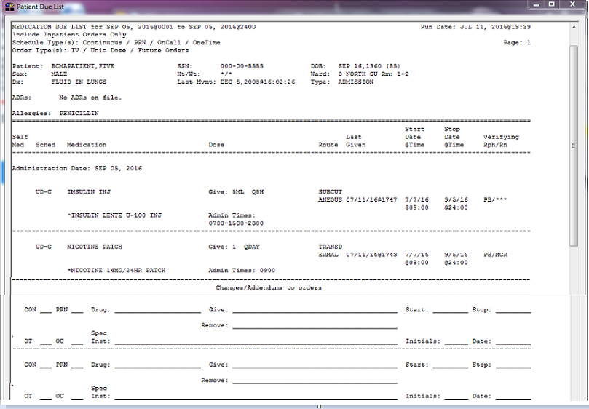

Viewing and Printing BCMA Reports

|  |  |
| --- | --- |
| Viewing/Printing a Due List Report (cont.) | This section provides an example of an Inpatient Due List Report by Ward/Patient. |

Example: Inpatient Due List Report by Ward  
Sort by Patient

Example: Inpatient Due List Report by Ward Sort by Patient screen


Viewing and Printing BCMA Reports

|  |  |
| --- | --- |
| Viewing/Printing a Due List Report (cont.) | This section provides an example of an Inpatient Due List Report by Ward/Room-Bed. |

Example: Due List Report by Ward  
Sort by Room-Bed

Example: Due List Report by Ward
Sort by Room-Bed screen


Viewing and Printing BCMA Reports

|  |  |
| --- | --- |
| Viewing/Printing a Due List Report (cont.) | This section provides an example of a Clinic Due List Report by Clinic.  The report header displays “Include Clinic Orders Only” for reports that include only clinic order data.  When printing mutually exclusive reports for clinic orders only, the system includes the Clinic Name associated with the clinic administration and displays the word “Location” in the header, where appropriate, to indicate where the administration took place. |

Example: Clinic Due List Report Sort by Clinic

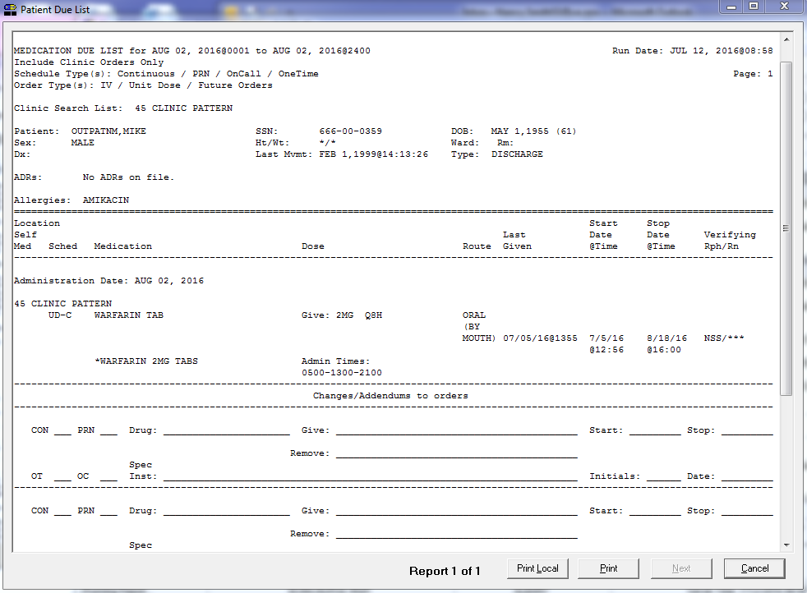

Viewing and Printing BCMA Reports

|  |  |
| --- | --- |
| Viewing/Printing a Medication Log Report  tip:  Use the Med Log Button on the BCMA Tool Bar, or the Reports Tab in CPRS, to quickly display the Patient Medication Log dialog box.  Tips  tip:  Medications ordered and documented using the CPRS Med Order Button in BCMA display on the Med Log Report opposite the text titled “BCMA/CPRS Interface Entry.”  Tips | You can print (and still view on-screen) a patient’s Medication Log Report (or Med Log Report), listing *every* action taken on an Inpatient or Clinic medication order within a user-specified date range. The following message appears on each report dialog: “This report includes both Inpatient and Clinic Order data. The inpatient Ward name, where the medication was administered, displays above the Start Date for each medication administered in an inpatient ward. The Clinic name, where the medication was administered, displays above the Start Date for each medication administered in a clinic. You can choose to include/exclude Comments and Audits performed on the patient’s medication orders. Audits include “actions” taken on a medication.  The Medication Log Report also includes patient demographic data, allergies and ADR information, plus detailed information about the order, such as the drug/additive/solution; the orderable item dose, schedule, route, and injection site; Action date and time; Activity Start/Stop date and time; Unique Identifier Number for the bag; Unit ordered and given, and the clinician(s) who took an action on the medication.  Witness for High Risk/High Alert Drugs information also displays in the Medication Log Report, when applicable, if you select Include Comments on the Patient Medication Log Report Dialog box. Witness name, date, time and comments appear below the user comments and above audit areas in the report. If you choose to exclude comments from the report, the report will not display witness sign-on information or witness comments.  See Example: Medication Log with Witness Information at the end of this section.  **Note:** The Medication Log Report lists medications with a “Not Given” status in the Audit Trail section of the Log, noton the BCMA VDL. Administrations that were Cancelled are not listed on the Report.  To view/print a Medication Log Report   1. Select the Medication Log command from the Reports menu. The Patient Medication Log dialog box displays.   **Keyboard Shortcut:** Press **alt+r** to display the Reports menu, and then press **l** to display the Patient Medication Log dialog box. |

Viewing and Printing BCMA Reports

|  |  |
| --- | --- |
| Viewing/Printing a Medication Log Report (cont.) | To view/print a Medication Log Report (cont.)  Example: Patient Medication Log Report Dialog Box  Example: Patient Medication Log Report Dialog Box screen |

Viewing and Printing BCMA Reports

|  |  |
| --- | --- |
| Viewing/Printing a Medication Log Report (cont.)  tip:  See the section “Viewing/Printing a Due List Report” to see how a Ward Report by Room-Bed looks when printed.  Tips  tip:  You can type the information in the list boxes, or use the drop-down arrows to make your selection.  Tips | To view/print a Medication Log Report (cont.)   1. Use the **down arrow**, within the list boxes, to select the Start and Stop Dates, and Start and Stop Times of the Medication Log Report that you want to view on-screen or print.   **Note:** Clicking on the **down arrow** on the Date for Report list box displays a calendar. You can use the scroll arrows in the upper corners of the calendar to display a different month, and then click on a date to select it and close the calendar. Clicking inside the Start/Stop Time list boxes provides selections.  **Keyboard Shortcut:** Use **tab** to move among the different areas of the dialog box.   1. In the Include Detail area, click inside the check boxes to include Audits and/or Comments in the report.   **Keyboard Shortcut:** Press **spacebar** to select a check box.   1. In the Print by area, select to print by Patient or Ward. The Inpatient nurse may print by Patient or by Ward. The Clinic nurse may print this report by Patient, only.  * If a patient record is open, * “Print by Patient” is enabled, and the report dialog defaults to “Print by Patient.” * If no patient record is open, * “Print by Patient” is disabled, and the report dialog defaults to “Print by Ward.” Print by Clinic is disabled.   **Note:** If you choose to print the report by Patient, go to step 7.  **Note:** If you choose to print the report by Ward, make your selection from the Ward list box provided.  **Keyboard Shortcut:** Use the **down arrow** to select the Ward, and then select a ward location from the drop-down list box.   1. To include Inactive Wards, click inside the check box to deselect the default “Exclude Inactive Wards.” 2. Select Sort by Patient (default), Sort by Room-Bed, or Print Selected Patients on Ward.   **Note:** If you choose to print selected patients, you must click **select patients** and then select the patients you want to preview or print, then click **ok**. |

Viewing and Printing BCMA Reports

|  |  |
| --- | --- |
| Viewing/Printing a Medication Log Report (cont.)  tip:  See the section “Viewing/Printing a Due List Report” to see how a Ward Report by Room-Bed looks when printed.  Tips  tip:  You can type the information in the list boxes, or use the drop-down arrows to make your selection.  Tips | To view/print a Medication Log Report (cont.)   1. Perform one of the following actions:  * Click **preview** to display the report on-screen. * Click **print** to display the Printer dialog box. * Click **cancel** to return to the patient’s VDL.   **Keyboard Shortcut**: Use **tab** to move among the **preview, print** and **cancel** buttons.  Example: Print Dialog Box  Example: Print Dialog Box screen   1. Perform one or more of the following actions, then click **ok**:  * Select a printer from the drop-down list box that you want to use for outputting the Medication Log Report. * Check the Queuing check box and enter the Date and Time you want the report to print. Click the **down arrow** in the drop-down list box to display a choice of dates and times.   Example: Date/Time Selection for Print Queuing  Example: Date/Time Selection for Print Queuing screen |

Viewing and Printing BCMA Reports

|  |  |
| --- | --- |
| Viewing/Printing a Medication Log Report (cont.) | To view/print a Medication Log Report (cont.)  The report header displays “Include Inpatient and Clinic Orders” for reports that include inpatient and clinic order data.  **Note:** The printer that you select becomes the “default” printer for *all* reports printed from BCMA. |

Example: Medication Log Report by Patient

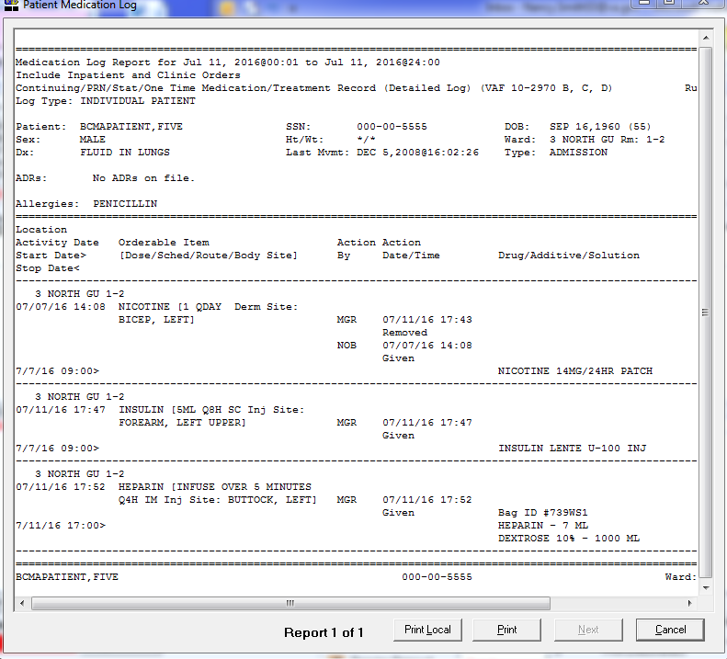Viewing and Printing BCMA Reports

|  |  |
| --- | --- |
| Viewing/Printing a Medication Log Report (cont.) | To view/print a Medication Log Report (cont.)  The report header displays “Include Inpatient and Clinic Orders” for reports that include inpatient and clinic order data.  The following is an example of the Medication Log Report with witness information. |

Example: Medication Log Report with Witness Information

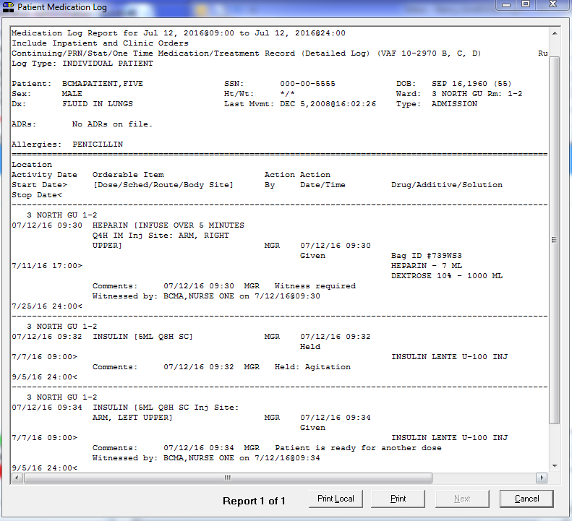

Viewing and Printing BCMA Reports

|  |  |
| --- | --- |
| Viewing/Printing a MAH Report  tip:  Use the Med Admin Hist Button on the BCMA Tool Bar, or the Reports Tab in CPRS, to quickly display the Patient Medications Given dialog box.  Tips  tip:  You can specify the date range (as defined for CPRS), for an MAH Report. See “Note” on this page for more information.  Tips | You can view on-screen andprint a Medication Administration History (MAH) Report for Unit Dose and IV Inpatient and Clinic medication orders. The following message appears on each report dialog: “This report includes both Inpatient and Clinic Order data.” The word “INPATIENT” displays above the Order Start Date for each medication administered in an inpatient ward. All Inpatient orders are grouped together followed by all Clinic orders. With each group, orders are sorted according to existing MAH sort functionality.  **Note:** The Date column lists three asterisks (***) to indicate that a medication is notdue. This information is also noted in the Legend at the bottom of the MAH Report.  The report also includes information about when an order is placed “On Hold” and taken “Off Hold” by a provider, and the order Start and Stop Date/Time for the medication.  This report lists a clinician’s name and initials, and the exact time that an action was taken on an order (in a conventional MAR format). Each order is listed alphabetically by the orderable item. The Date column lists three asterisks (***) to indicate that a medication is notdue. This information is also noted in the Legend at the bottom of the MAH Report.  An MAH Report includes patient demographic data, allergies and ADRs, plus detailed information about the order, such as the drug/additive/solution; the medication schedule, dose, route, and injection site; the actual administration times; the name and initials of the clinician who administered the medication; and the individuals who verified the order. It also includes information about when an order is placed “On Hold” and taken “Off Hold” by a provider, and the order Start and Stop Date/Time for the medication.  **Note:** If no parameter is defined in CPRS, the maximum date range defaults to a seven-date range. For example, a Report would list the Sunday proceeding, and the Saturday following, the date that you selected for the Report.  To view/print an MAH Report   1. Select the Medication Admin History command from the Reports menu. The Medication Admin History dialog box displays.   **Keyboard Shortcut:** Press **alt+r** to display the Reports menu, and then press **h** to display the Medication Admin History dialog box.  Example: Medication Admin History Dialog Box  Example: Medication Admin History Dialog Box screen |

Viewing and Printing BCMA Reports

|  |  |
| --- | --- |
| Viewing/Printing an MAH Report (cont.)  tip:  See the section “Viewing/Printing a Due List Report” to see how a Ward Report by Room-Bed looks when printed.  Tips  tip:  You can type the information in the list boxes, or use the drop-down arrows to make your selection.  Tips | To view/print an MAH Report (cont.)   1. Use the **down arrow**, within the list boxes, to select the Start and Stop Dates of the MAH Report that you want to view on-screen or print.   **Note:** Clicking on the **down arrow** on the Start and Stop Date list boxes displays a calendar. You can use the scroll arrows in the upper corners of the calendar to display a different month, and then click on a date to select it and close the calendar. Clicking inside the Start/Stop Time list boxes provides selections.  **Keyboard Shortcut:** Use **tab** to move among the different areas of the dialog box.   1. In the Print by area, select to print by Patient or Ward. The Inpatient nurse may print by Ward or by Patient. The Clinic nurse may print this report by Patient, only. Print by Clinic is disabled.  * If a patient record is open: * The Print by “Patient” option is enabled, and the report dialog Print by selection defaults to “Patient.”   Example: MAH Report Dialog with Patient Record Open  Example: MAH Report Dialog with Patient Record Open screen   * If no patient record is open: * The Print by “Patient” option is disabled, and the report dialog Print by selection defaults to “Ward.” |

Viewing and Printing BCMA Reports

|  |  |
| --- | --- |
| Viewing/Printing an MAH Report (cont.) | To view/print an MAH Report (cont.)  **Example: MAH Report Dialog with No Patient Record Open**  Example: MAH Report Dialog with No Patient Record Open screen  **Note:** If you choose to print the report by Patient, go to step 6.  **Note:** If you choose to print the report by Ward, make your selection from the Ward list box provided.  **Keyboard Shortcut:** Use the **down arrow** to select the Ward, and then select a ward location from the drop-down list box.   1. To include Inactive Wards, click inside the check box to deselect the default “Exclude Inactive Wards.” 2. Select Sort by Patient (default), Sort by Room-Bed, or Print Selected Patients on Ward.   **Note:** If you choose to print selected patients, you must click **select patients** and then select the patients you want to preview or print, then click **ok**.   1. Perform one of the following actions:  * Click **PREVIEW** to display the report on-screen. * Click **PRINT** to display the Printer dialog box. * Click **CANCEL** to return to the patient’s VDL.   **Keyboard Shortcut:** Use **tab** to move among the **preview, print** and **cancel** buttons. |

Viewing and Printing BCMA Reports

|  |  |
| --- | --- |
| Viewing/Printing an MAH Report (cont.)  tip:  You can print this report, after a patient has been discharged, using CHUI BCMA.  Tips | To view/print an MAH Report (cont.)   1. Perform one or more of the following actions, then click **ok**:  * Select a printer from the drop-down list box that you want to use for outputting the MAH Report. * Check the Queuing check box and enter the Date and Time you want the report to print. Click the down arrow in the drop-down list box to display a choice of dates and times.   Example: Date/Time Selection for Print Queuing  Example: Date/Time Selection for Print Queuing screen  **Note:** The printer that you select becomes the “default” printer for *all* reports printed from BCMA.  **Note:** If you select dates that do not have applicable data, the MAH Report will appear “empty” when displayed on-screen or printed.  **Note:** For orders containing Special Instructions/Other Print Info, if Special Instructions/Other Print Info flow to another page, a blank line and the message “***CONTINUED ON NEXT PAGE***” will be printed before the page break, only if printing to an external printer. The message “***CONTINUED FROM PREVIOUS PAGE***” and a blank line will be printed on the subsequent page after the page headers, only if printing to an external printer. |

Viewing and Printing BCMA Reports

|  |  |
| --- | --- |
| Viewing/Printing an MAH Report (cont.) | To view/print an MAH Report (cont.)  The report header displays “Include Inpatient and Clinic Orders” for reports that include inpatient and clinic order data.   * + The Status and Schedule Type will have their own columns with their values spelled out, e.g., G will be 'Given' and P will be 'PRN'   + Units Ordered is being added as a new column   + Previous statuses will be displayed in reverse chronological order   Example: MAH Report by Patient  *MAH Report: Screen 1*  Example: Medication History Report  *MAH Report: Screen 1 (Continued)*  MAH Report (Continued) |

|  |  |
| --- | --- |
| Viewing/Printing a Missed Medications Report | BCMA V. 3.0 lets you print a Missed Medications Report (or Missed Meds Report), for Continuous and One-Time Unit Dose and IV Piggyback Inpatient and Clinic medications that were notadministered to a patient during a medication pass.  A Missed Medications Report includes patient demographic data, allergies and ADR information, plus detailed information about the order, such as the medication type; the administration date and time; and the order number. The report also includes a “Ver” column containing the initials of the nurse who verified the order or three asterisks (***) indicating the order was not nurse verified.  Users can specify a Start and Stop Date/Time for the report, defaulting to a 24-hour period but with a maximum limit based on a CPRS site parameter. The following items can also be included in the report:   * Active, On Hold, DC’d, and Expired orders * Held and Refused administrations and missing doses   Comments/ reasons  **Note:** The Held, Refused and Comments/Reasons checkboxes will automatically be selected as a default when the report dialog initially displays. These settings will always be in effect when the report is executed. The Comments/Reasons checkbox will be selected regardless of parameter settings for Reports-Include Comments. Upon display of the dialog, you will be able to uncheck these checkboxes if desired.  **Note:** Self-medications do not display on the Missed Medications Report.  To view/print a Missed Medications Report   1. Select the Missed Medications command from the Reports menu. The Patient Missed Medications dialog box displays.   **Keyboard Shortcut:** Press **alt+r** to display the Reports menu, and then press **m** to display the Patient Missed Medications dialog box. |

Viewing and Printing BCMA Reports

|  |  |
| --- | --- |
| Viewing/Printing a Missed Medications Report (cont.) | To view/print a Missed Medications Report (cont.)  Example: Patient Missed Medications Dialog Box  Example: Patient Missed Medications Dialog Box screen   1. Use the **down arrow**, within the list boxes, to select the Start and Stop Dates, and Start and Stop Times for the Missed Medications Report that you want to view on-screen or print.   **Note:** Clicking on the **down arrow** on the Date for Report list box displays a calendar. You can use the scroll arrows in the upper corners of the calendar to display a different month, and then click on a date to select it and close the calendar. Clicking inside the Start/Stop Time list boxes provide selections.  **Keyboard Shortcut:** Use **tab** to move among the different areas of the dialog box. |

Viewing and Printing BCMA Reports

|  |  |
| --- | --- |
| Viewing/Printing a Missed Medications Report (cont.)  tip:  You can type the information in the list boxes, or use the drop-down arrows to make your selection.  Tips  tip:  See the section “Viewing/Printing a Due List Report” to see how a Ward Report by Room-Bed looks when printed.  Tips | To view/print a Missed Medications Report (cont.)   1. In the Include areas, select the order status, admin status, and/or comments you want to include on the report. 2. In the Include Orders area, click the check boxes to select either Inpatient or Clinic orders to include in the report.  * If a patient record is open, and the selected Order Mode is “Inpatient:” * The report dialog Include Orders selection defaults to “Inpatient Orders.” * If the selected Order Mode is “Clinic:” * The report dialog Include Orders selection defaults to “Clinic Orders.” * If no patient record is open: * The report dialog Print by selection defaults to Ward or Clinic, based on the last order mode that you selected.   **Note:** Active orders with a status of Missing Dose are always included in this report.   1. In the Print by area, select to print by Patient or Ward.  * If a patient record is open: * The report dialog Print by selection always defaults to “Patient.” * If the “Inpatient” Order Mode is selected on the VDL, the report dialog Include Orders selection defaults to “Inpatient Orders” and Print by “Ward” is enabled, and Print by “Clinic” is disabled   Example: Inpatient Orders/Default to Print by Patient  Example: Inpatient Orders/Default to Print by Patient screen |

Viewing and Printing BCMA Reports

|  |  |
| --- | --- |
| Viewing/Printing a Missed Medications Report (cont.) | To view/print a Missed Medications Report (cont.)   * If the “Clinic” Order Mode is selected on the VDL, the report dialog Include Orders selection defaults to “Clinic Orders” and Print by “Clinic” is enabled, and Print by “Ward” is disabled.   Example: Clinic Orders/Default to Print by Patient  Example: Clinic Orders/Default to Print by Patient screen   * If you change the report dialog Include Orders selection from “Inpatient Orders” to “Clinic Orders” (or vice versa), the dependent corresponding Print by options will also change.   Example: Clinic Orders/Default to Print by Patient  Example: Clinic Orders/Default to Print by Patient screen |

Viewing and Printing BCMA Reports

|  |  |
| --- | --- |
| Viewing/Printing a Missed Medications Report (cont.)  tip:  You can type the information in the list boxes, or use the drop-down arrows to make your selection.  Tips  tip:  See the section “Viewing/Printing a Due List Report” to see how a Ward Report by Room-Bed looks when printed.  Tips | To view/print a Missed Medications Report (cont.)   * If no patient record is open: * BCMA remembers the last Order Mode that you selected, and sets the Print by selection default to “Ward” for Inpatient Orders or “Clinic” for Clinic Orders. Print by “Patient” is disabled. * If you choose “Inpatient Orders” for the Include Orders selection, the report dialog Print by selection defaults to “Ward.”   Example: Inpatient Orders/Default to Print by Ward  Example: Inpatient Orders/Default to Print by Ward screen   * If you choose “Clinic Orders” for the Include Orders selection, the report dialog Print by selection defaults to “Clinic.”   Example: Clinic Orders/Default to Print by Clinic  Example: Clinic Orders/Default to Print by Clinic scrfeen |

Viewing and Printing BCMA Reports

|  |  |
| --- | --- |
| Viewing/Printing a Missed Medications Report (cont.) | To view/print a Missed Medications Report (cont.)   * If you change the report dialog Include Orders selection from “Inpatient Orders” to “Clinic Orders” (or vice versa), the dependent corresponding Print by options will also change.   Example: Clinic Orders/Default to Print by Patient  Example: Clinic Orders/Default to Print by Patient screen  **Note:** If you choose to print the report by Patient, go to step 8.  **Note:** If you choose to print the report by Ward, make your selection from the Ward list box provided.  **Keyboard Shortcut:** Use the **down arrow** to select the Ward, and then select a ward location from the drop-down list box.   1. To include Inactive Wards, click inside the check box to deselect the default “Exclude Inactive Wards.” 2. Select Sort by Patient (default), Sort by Room-Bed, or Print Selected Patients on Ward.   **Note:** If you choose to print selected patients, you must click **select patients** and then select the patients you want to preview or print, then click **ok**.   1. Perform one of the following actions:  * Click **PREVIEW** to display the report on-screen. * Click **PRINT** to display the Printer dialog box. * Click **CANCEL** to return to the patient’s VDL.   **Keyboard Shortcut:** Use **tab** to move among the **preview, print** and **cancel** buttons. |

Viewing and Printing BCMA Reports

|  |  |
| --- | --- |
| Viewing/Printing a Missed Medications Report (cont.) | To view/print a Missed Medications Report (cont.)   1. Perform one or more of the following actions, then click **OK**:  * Select a printer from the drop-down list box that you want to use for outputting the Missed Medications Report. * Check the Queuing check box and enter the Date and Time you want the report to print. Click the **down arrow** in the drop-down list box to display a choice of dates and times.   Example: Date/Time Selection for Print Queuing  Example: Date/Time Selection for Print Queuing screen  **Note:** The printer that you select becomes the “default” printer for *all* reports printed from BCMA. |

Viewing and Printing BCMA Reports

|  |  |
| --- | --- |
| Viewing/Printing a Missed Medications Report (cont.) | To view/print a Missed Medications Report (cont.)  The report header displays “Include Inpatient Orders Only” for reports that include only Inpatient order data.  **Note:** Medications placed “On Hold” or taken “Off Hold,” in CPRS or Inpatient Medications V. 5.0, display on the Missed Medications Report with the Hold information below the medication. The Hold information applies only to administrations due within the Hold timeframe. The “Order Num” column on the report lists the actual order number and order type (i.e., Unit Dose or IV). This information is quite helpful when troubleshooting problems with BCMA. |

Example: Inpatient Missed Medications Report by Patient

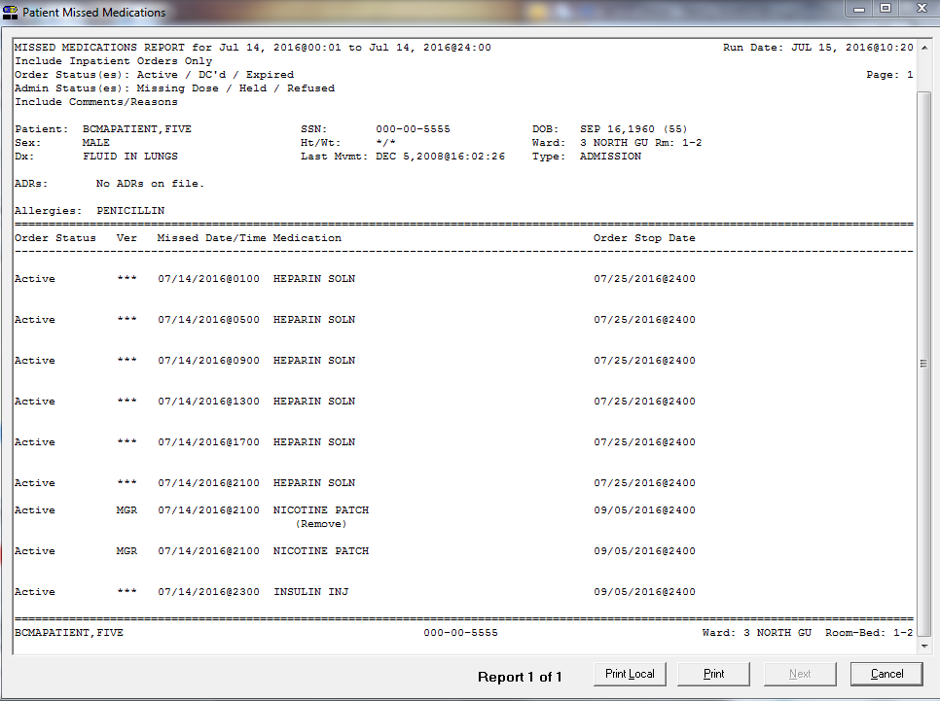

Viewing and Printing BCMA Reports

|  |  |
| --- | --- |
| Viewing/Printing a PRN Effectiveness List Report  tip:  You can print this report, after a patient has been discharged, using CHUI BCMA.  Tips | You can view (and print) a PRN Effectiveness List Report using BCMA V. 3.0. This Report lists PRN Inpatient and Clinic medications administered to a patient that need Effectiveness comments. The following message appears on each report dialog: “This report includes both Inpatient and Clinic Order data.” It also includes patient demographic data, allergies and ADR information; plus the PRN medication, administration date and time; and the individual(s) who administered the order.  To view/print a PRN Effectiveness Report   1. Select the PRN Effectiveness List command from the Reports menu. The PRN Effectiveness List dialog box displays.   **Keyboard Shortcut:** Press **alt+r** to display the Reports menu, and then press **p** to display the PRN Effectiveness List dialog box.  Example: PRN Effectiveness List Dialog Box  Example: PRN Effectiveness List Dialog Box screen   1. Use the **down arrow**, within the list boxes, to select the Start and Stop Dates, and Start and Stop Times for the PRN Effectiveness List Report that you want to view on-screen or print. |

Viewing and Printing BCMA Reports

|  |  |
| --- | --- |
| Viewing/Printing a PRN Effectiveness List Report (cont.)  tip:  You can type the information in the list boxes, or use the drop-down arrows to make your selection.  Tips | To view/print a PRN Effectiveness List Report (cont.)  tip:  See the section “Viewing/Printing a Due List Report” to see how a Ward Report by Room-Bed looks when printed.  Tips  **Note:** Clicking on the **down arrow** on the Date for Report list box displays a calendar. You can use the scroll arrows in the upper corners of the calendar to display a different month, and then click on a date to select it and close the calendar. Clicking inside the Start/Stop Time list boxes provides selections.  **Keyboard Shortcut:** Use **tab** to move among the different areas of the dialog box.   1. In the Print by area, select to print by Patient or Ward. The Inpatient nurse may print by Patient or Ward. The Clinic nurse may print by Patient, only. “Print by Clinic” is disabled.  * If a patient record is open: * The Print by “Patient” option is enabled, and the report dialog Print by selection defaults to “Patient.”   Example: PRN Effectiveness Report Dialog with Patient Record Open  Example: PRN Effectiveness Report Dialog with Patient Record Open screen   * If no patient record is open: * The Print by “Patient” option is disabled, and the report dialog Print by selection defaults to “Ward.” |

Viewing and Printing BCMA Reports

|  |  |
| --- | --- |
| Viewing/Printing a PRN Effectiveness List Report (cont.) | To view/print a PRN Effectiveness List Report (cont.)  **Example: PRN Effectiveness Report Dialog with No Patient Record Open**  Example: PRN Effectiveness Report Dialog with No Patient Record Open screen  **Note:** If you choose to print the report by Patient, go to step 6.  **Note:** If you choose to print the report by Ward, make your selection from the Ward list box provided.  **Keyboard Shortcut:** Use the **down arrow** to select the Ward, and then select a ward location from the drop-down list box.   1. To include Inactive Wards, click inside the check box to deselect the default “Exclude Inactive Wards.” 2. Select Sort by Patient (default), Sort by Room-Bed, or Print Selected Patients on Ward.   **Note:** If you choose to print selected patients, you must click **select patients** and then select the patients you want to preview or print, then click **ok**.   1. Perform one of the following actions:  * Click **PREVIEW** to display the report on-screen. * Click **PRINT** to display the Printer dialog box. * Click **CANCEL** to return to the patient’s VDL.   **Keyboard Shortcut:** Use tab to move among the preview, print and cancel buttons.   1. Perform one or more of the following actions, then click **ok**:  * Select a printer from the drop-down list box that you want to use for outputting the PRN Effectiveness List Report. |

Viewing and Printing BCMA Reports

|  |  |
| --- | --- |
| Viewing/Printing a PRN Effectiveness List Report (cont.) | To view/print a PRN Effectiveness List Report (cont.)   * Check the Queuing check box and enter the Date and Time you want the report to print. Click the down arrow in the drop-down list box to display a choice of dates and times.   Example: Date/Time Selection for Print Queuing  Example: Date/Time Selection for Print Queuing screen  **Note:** The printer that you select becomes the “default” printer for *all* reports printed from BCMA.  The report header displays “Include Inpatient and Clinic Orders” for reports that include inpatient and clinic order data. |

Example: PRN Effectiveness List Report by Patient

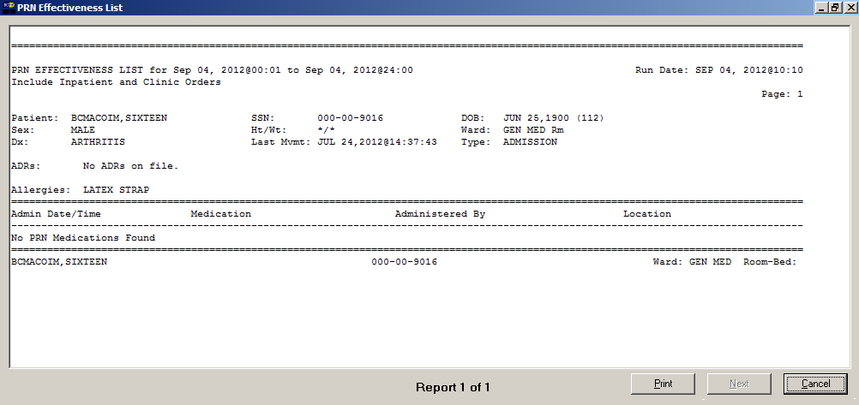

Viewing and Printing BCMA Reports

|  |  |
| --- | --- |
| Viewing/Printing an Administration Times Report | You can print, and still view on-screen, an Administration Times Report. This report lists a patient’s Inpatient and Clinic Order medications by the scheduled administration time (from the earliest to the latest).  The Administration Times Report includes patient demographic data, allergies and ADR information, plus detailed information about the order, such as the medication type, dose, route, and the administration time.  To view/print an Administration Times Report   1. Select the Administration Times command from the Reports menu. The Patient Ward Administration Times dialog box displays.   **Keyboard Shortcut:** Press **alt+r** to display the Reports menu, and then press **a** to display the Patient Ward Administration Times dialog box.  Example: Patient Ward Administration Times Dialog Box  Example: Patient Ward Administration Times Dialog Box screen |

Viewing and Printing BCMA Reports

|  |  |
| --- | --- |
| Viewing/Printing an Administration Times Report (cont.)  tip:  See the section “Viewing/Printing a Due List Report” to see how a Ward Report by Room-Bed looks when printed.  Tips  tip:  You can type the information in the list boxes, or use the drop-down arrows to make your selection.  Tips | To view/print an Administration Times Report (cont.)   1. Use the **down arrow**, within the list box, to select the Start and Stop Dates of the Administration Times Report that you want to view on-screen or print.   **Note:** Clicking on the **down arrow** on the Date for Report list box displays a calendar. You can use the scroll arrows in the upper corners of the calendar to display a different month, and then click on a date to select it and close the calendar.  **Keyboard Shortcut:** Use **tab** to move among the different areas of the dialog box.   1. In the Include Orders area, click the check boxes to select either Inpatient Orders or Clinic Orders to include in the report.  * If a patient record is open, and the selected Order Mode is “Inpatient:” * The report dialog Include Orders selection defaults to “Inpatient Orders.” * If the selected Order Mode is “Clinic:” * The report dialog Include Orders selection defaults to “Clinic Orders.” * If no patient record is open: * The report dialog Print by selection defaults to Ward or Clinic, based on the last Order Mode that you selected.  1. In the Print by area, select to print by Patient or Ward.  * If a patient record is open: * The report dialog Print by selection always defaults to “Patient.” * If the “Inpatient” Order Mode is selected on the VDL, the report dialog Include Orders selection defaults to “Inpatient Orders” and Print by “Ward” is enabled, and Print by “Clinic” is disabled. |

Viewing and Printing BCMA Reports

|  |  |
| --- | --- |
| Viewing/Printing an Administration Times Report (cont.) | To view/print an Administration Times Report (cont.)  Example: Inpatient Orders/Default to Print by Patient  Example: Inpatient Orders/Default to Print by Patient screen   * If the “Clinic” Order Mode is selected on the VDL, the report dialog Include Orders selection defaults to “Clinic Orders” and Print by “Clinic” is enabled, and Print by “Ward” is disabled.   Example: Clinic Orders/Default to Print by Patient  Example: Clinic Orders/Default to Print by Patient screen   * If you change the report dialog Include Orders selection from “Inpatient Orders” to “Clinic Orders” (or vice versa), the dependent corresponding Print by options will also change. |

Viewing and Printing BCMA Reports

|  |  |
| --- | --- |
| Viewing/Printing an Administration Times Report (cont.) | To view/print an Administration Times Report (cont.)  Example: Clinic Orders/Default to Print by Clinic  Example: Clinic Orders/Default to Print by Clinic screen   * If no patient record is open: * BCMA remembers the last Order Mode that you selected, and sets the Print by selection default to “Ward” for Inpatient Orders or “Clinic” for Clinic Orders. Print by “Patient” is disabled. * If you choose “Inpatient Orders” for the Include Orders selection, the report dialog Print by selection defaults to “Ward.”   Example: Inpatient Orders/Default to Print by Ward  Example: Inpatient Orders/Default to Print by Ward screen |

Viewing and Printing BCMA Reports

|  |  |
| --- | --- |
| Viewing/Printing an Administration Times Report (cont.) | To view/print an Administration Times Report (cont.)   * If you choose “Clinic Orders” for the Include Orders selection, the report dialog Print by selection defaults to “Clinic.”   Example: Clinic Orders/Default to Print by Clinic  Example: Clinic Orders/Default to Print by Clinic screen   * If you change the report dialog Include Orders selection from “Inpatient Orders” to “Clinic Orders” (or vice versa), the dependent corresponding Print by options will also change.   Example: Clinic Orders/Default to Print by Patient  Example: Clinic Orders/Default to Print by Patient screen  **Note:** If you choose to print the report by Patient, go to step 7.  **Note**: If you choose to print the report by Ward, make your selection from the Ward list box provided**.** |

|  |  |
| --- | --- |
| Viewing and Printing BCMA ReportsViewing/Printing an Administration Times Report (cont.) | To view/print an Administration Times Report (cont.)  **Keyboard Shortcut:** Use t Use the **down arrow** to select the Ward, and then select a ward location from the drop-down l from the Ward list box.   1. To include Inactive Wards, click inside the check box to deselect the default “Exclude Inactive Wards.” 2. Select Sort by Patient (default), Sort by Room-Bed, or Print Selected Patients on Ward.   **Note:** If you choose to print selected patients, you must click **select patients** and then select the patients you want to preview or print, then click **ok**.   1. Perform one of the following actions:  * Click **PREVIEW** to display the report on-screen. * Click **PRINT** to display the Printer dialog box. * Click CANCEL to return to the patient’s VDL.   **Keyboard Shortcut:** Use tab to move among the **preview, print** and **cancel** buttons.   1. Perform one or more of the following actions, then click **ok**:  * Select a printer from the drop-down list box that you want to use for outputting the Administration Times Report. * Check the Queuing check box and enter the Date and Time you want the report to print. Click the **down arrow** in the drop-down list box to display a choice of dates and times.   Example: Date/Time Selection for Print Queuing  Example: Date/Time Selection for Print Queuing screen |

Viewing and Printing BCMA Reports

|  |  |
| --- | --- |
| Viewing/Printing an Administration Times Report (cont.) | To view/print an Administration Times Report (cont.)  The report header displays “Include Inpatient Orders Only” for reports that include only Inpatient order data.  **Note:** The printer that you select becomes the “default” printer for *all* reports printed from BCMA.  **Note:** The printed format of the Administration Times report varies by type of report: Inpatient Orders by Patient; Inpatient Orders by Ward; Clinic Orders by Patient; and Clinic Orders by Clinic.  Following is an example of the Administration Times Report for Inpatient Orders by Patient.  Patient demographics are shown first followed by the Date/Time of the Medication, Medication Name, and the Dosage/Route. |

Example: Inpatient Administration Times Report by Patient

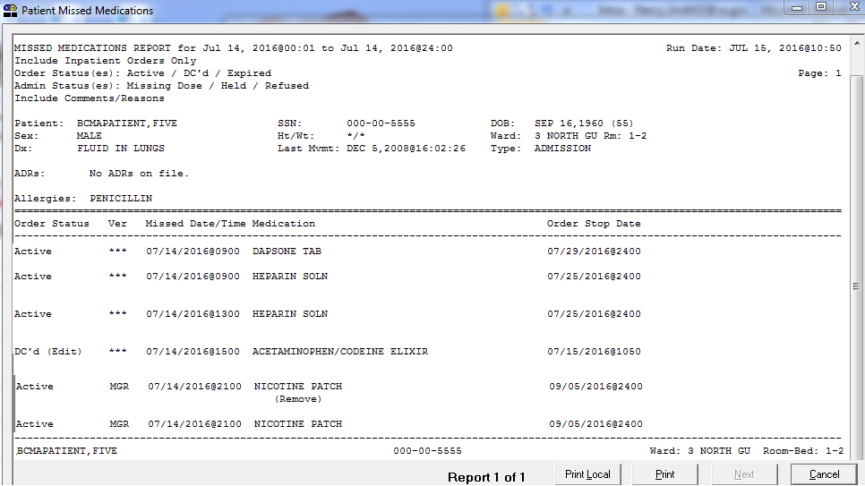

Viewing and Printing BCMA Reports

|  |  |
| --- | --- |
| Viewing/Printing an Administration Times Report (cont.) | To view/print an Administration Times Report (cont.)  Following is an example of the Administration Times Report for Inpatient Orders by Ward.  Ward location is shown first, followed by administration times for each Patient by Name, Patient SSN, Ward Name and Room/Bed. |

Example: Administration Times Report for Inpatient Orders by Ward

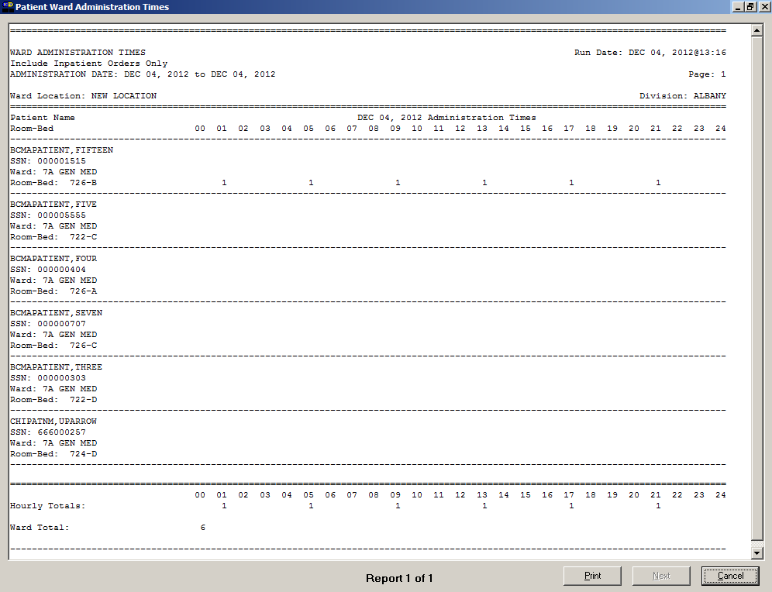Viewing and Printing BCMA Reports

|  |  |
| --- | --- |
| Viewing/Printing an Administration Times Report (cont.) | To view/print an Administration Times Report (cont.)  The report header displays “Include Clinic Orders Only” for reports that include only clinic order data.  When printing mutually exclusive reports for clinic orders only, the system includes the Clinic Name associated with the clinic administration and displays the word “Location” in the header, where appropriate, to indicate where the administration took place.  Following is an example of the Clinic Administration Times Report by Patient.  Patient demographic information is shown first followed by the Date/Time of the Medication, Medication Name, and Dosage/Route. |

Example: Clinic Administration Times Report by Patient

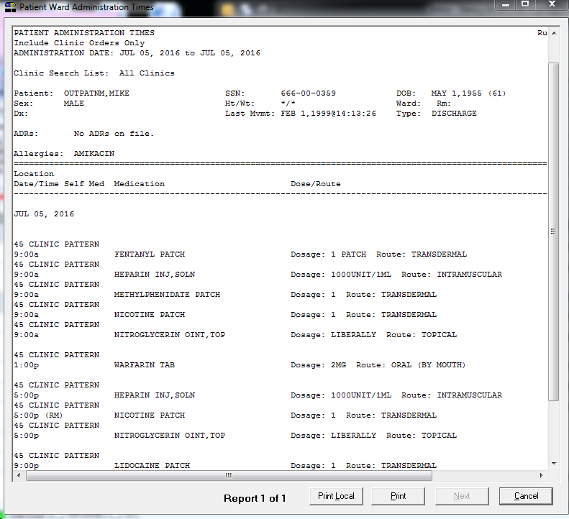

Viewing and Printing BCMA Reports

|  |  |
| --- | --- |
| Viewing/Printing an Administration Times Report (cont.) | To view/print an Administration Times Report (cont.)  Following is an example of the Clinic Administration Times Report by Clinic.  The Clinic Search List Name is shown first followed by the administration times for each Patient by Name, Patient SSN, and the Clinic Name. |

Example: Clinic Administration Times Report by Clinic

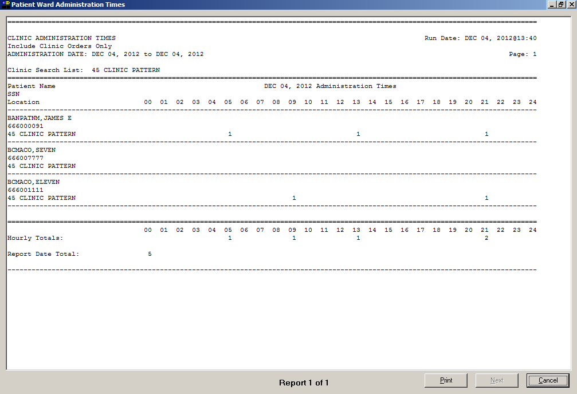

Viewing and Printing BCMA Reports

|  |  |
| --- | --- |
| Viewing/Printing a Medication History Report  tip:  Right click on a medication displayed on the VDL, and then select the Med History command in the Right Click drop-down menu to display the Medication History dialog box.  Tips | BCMA provides two ways to access a patient’s Medication History Report (or Med History Report). They include the Med History command in the Due List menu and in the Right Click drop-down menu.  This Report lists the administration date and time, and orderable item of an Inpatient or Clinic medication selected on the BCMA VDL. The following message appears on each report dialog: “This report includes both Inpatient and Clinic Order data.” It also includes the medication status, schedule type, and dose; room location; and initials of the clinician who administered the medication.  **Note:** A Medication History Report is called an “Administration History Report” in CPRS. You can access it by selecting the Meds Tab in CPRS, and then right clicking on a medication.  **Note:** The Date column lists three asterisks (***) to indicate that a medication is notdue. This information is also noted in the Legend at the bottom of the MAH Report.  The report also includes information about when an order is placed “On Hold” and taken “Off Hold” by a provider, and the order Start and Stop Date/Time for the medication.  To view/print a Medication History Report   1. Select the Med History command from the Due List menu. The Medication History dialog box displays.   **Keyboard Shortcut:** Press **alt+d** to display the Due List menu, and then press **e** to display the Medication History dialog box.  Example: Medication History  Dialog Box  Example: Medication History  Dialog Box screen |

Viewing and Printing BCMA Reports

|  |  |
| --- | --- |
| Viewing/Printing a Medication History Report (cont.) | To view/print a Medication History Report (cont.)   1. Use the **down arrow**, within the list box, to select the Start and Stop Dates of the Medication History Report that you want to view on-screen or print.   **Note:** Clicking on the **down arrow** on the Date for Report list box displays a calendar. You can use the scroll arrows in the upper corners of the calendar to display a different month, and then click on a date to select it and close the calendar.  **Keyboard Shortcut:** Use **tab** to move among the different areas of the dialog box.   1. In the Include Detail area, select the check box to include/exclude comments on the report. 2. In the Print by area, select to “Print by Patient.” The Medication History report can only be printed by Patient. “Print by Ward” and “Print by Clinic” are disabled. 3. Perform one of the following actions:  * Click **PREVIEW** to display the report on-screen. * Click **PRINT** to display the Printer dialog box. * Click **CANCEL** to return to the patient’s VDL.   **Keyboard Shortcut:** Use tab to move among the **preview, print** and **cancel** buttons.   1. Select a printer from the drop-down list box that you want to use for outputting the Medication History Report for the medication selected on the BCMA VDL. Then click **ok**.   **Note:** The printer that you select becomes the “default” printer for *all* reports printed from BCMA. |

Viewing and Printing BCMA Reports

|  |  |
| --- | --- |
| Viewing/Printing a Medication History Report (cont.) | To view/print a Medication History Report (cont.)  The report header displays “Include Inpatient and Clinic Orders” for reports that include inpatient and clinic order data.   * **The Status and Schedule Type will have their own columns with their values spelled out, e.g., G will be 'Given' and P will be 'PRN'** * **Units Ordered is being added as a new column** * **Previous statuses will be displayed in reverse chronological order** |

Example: Medication History Report

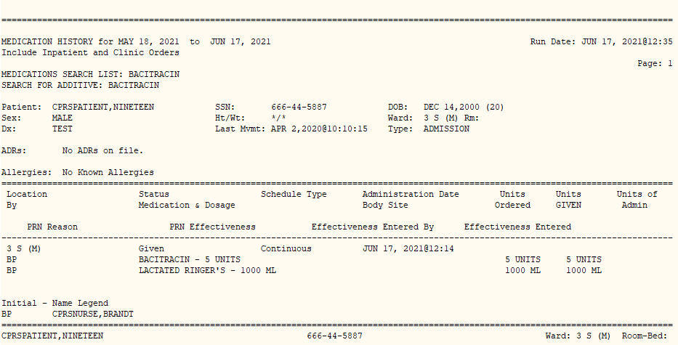

Viewing and Printing BCMA Reports

|  |  |
| --- | --- |
| Viewing/Printing a Medication Variance Log Report  tip:  The Medication Variance Log dialog box “defaults” include today’s date listed, and the Patient report selected for printing.  Tips  tip:  A variance preceded by a minus sign (such as –24), indicates the number of minutes that a medication was given *before* the administration time.  Tips | With GUI BCMA, you can print the Medication Variance Log Report by patient or by ward, using the Medication Variance Log in the Reports menu.  This Report lists “event” information within a selected date range, such as the type and number of events (i.e., Early/Late/PRN), and the total percentage of events that occurred. It also includes the medication type, date/time of the variance, and the initials of and comments by the clinician who administered the medication.  **Note:** Clinic orders are excluded from the Medication Variance Log report.  To view/print a Medication Variance Log Report   1. Select the Medication Variance Log command from the Reports menu. The Medication Variance Log dialog box displays.   **Keyboard Shortcut:** Press **alt+r** to display the Reports menu, and then press **e** to display the Medication Variance Log dialog box.  Example: Medication Variance Log Dialog Box  Example: Medication Variance Log Dialog Box screen |

Viewing and Printing BCMA Reports

|  |  |
| --- | --- |
| Viewing/Printing a Medication Variance Log Report (cont.)  tip:  You can type the information in the list boxes, or use the drop-down arrows to make your selection.  Tips | To view/print a Medication Variance Log Report (cont.)   1. Use the **down arrow**, within the list boxes, to select the Start and Stop Dates and Times of the Medication Variance Log Report that you want to view on-screen or print.   **Note:** Clicking on the **down arrow** on the Start/Stop Date list boxes displays a calendar. You can use the scroll arrows in the upper corners of the calendar to display a different month, and then click on a date to select it and close the calendar. Clicking inside the Start/Stop Time list boxes provides selections.  **Keyboard Shortcut:** Use **tab** to move among the different areas of the dialog box.   1. In the Print by area, select to print by Patient or Ward.   **Note:** If you choose to print the report by Patient, go to step 6.  **Note:** If you choose to print the report by Ward, make your selection from the Ward list box provided.  **Keyboard Shortcut:** Use the **down arrow** to select the Ward, and then select a ward location from the drop-down list box.   1. To include Inactive Wards, click inside the check box to deselect the default “Exclude Inactive Wards.” 2. Select Sort by Patient (default), Sort by Room-Bed, or Print Selected Patients on Ward.   **Note:** If you choose to print selected patients, click **select patients** and then select the patients’ orders you want to preview or print.   1. Perform one of the following actions:  * Click **PREVIEW** to display the report on-screen. * Click **PRINT** to display the Printer dialog box. * Click CANCEL to return to the patient’s VDL.   **Keyboard Shortcut:** Use **tab** to move among the **preview, print** and **cancel** buttons.   1. Perform one or more of the following actions, then click ok:  * Select a printer from the drop-down list box that you want to use for outputting the Medication Variance Log Report. * Check the Queuing check box and enter the Date and Time you want the report to print. Click the down arrow in the drop-down list box to display a choice of dates and times. |

Viewing and Printing BCMA Reports

|  |  |
| --- | --- |
| Viewing/Printing a Medication Variance Log Report (cont.) | To view/print a Medication Variance Log Report (cont.)  **Note:** The printer that you select becomes the “default” printer for *all* reports printed from BCMA. |

Example: Medication Variance Log Report by Patient

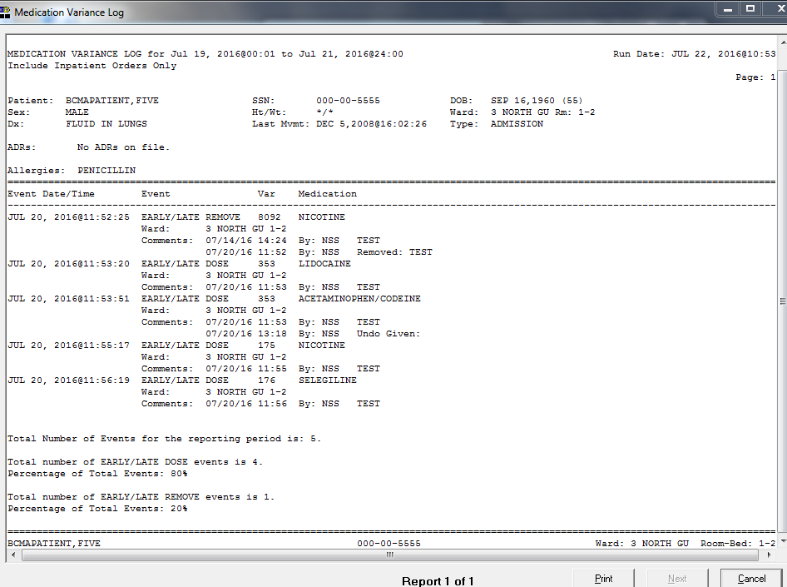

Viewing and Printing BCMA Reports

|  |  |
| --- | --- |
| Viewing/Printing a Cumulative Vitals/ Measurement Report  tip:  The Vitals Cumulative dialog box “defaults” include today’s date listed, and the Patient report selected for printing. The Ward Radio button is disabled for this report.  Tips | BCMA lets you view/print the Cumulative Vitals/Measurement Report, which lists a patient’s vitals from the Vitals package, along with their demographics and hospital location information. You can print the report using the Vitals Cumulative command from the Reports menu.  To view/print a Cumulative Vitals/Measurement Report   1. Select the Vitals Cumulative command from the Reports menu. The Vitals Cumulative dialog box displays.   **Keyboard Shortcut:** Press **alt+r** to display the Reports menu, and then press **v** to display the Vitals Cumulative dialog box.  Example: Vitals Cumulative Dialog Box  Example: Vitals Cumulative Dialog Box screen   1. Use the **down arrow**, within the list boxes, to select the Start and Stop Date of the Cumulative Vitals/Measurement Report that you want to view on-screen or print.   **Note:** Clicking on the **down arrow** on the Start/Stop Date list boxes displays a calendar. You can use the scroll arrows in the upper corners of the calendar to display a different month, and then click on a date to select it and close the calendar  **Keyboard Shortcut:** Use **tab** to move among the different areas of the dialog box.   1. Perform one of the following actions:  * Click **PREVIEW** to display the report on-screen. * Click **PRINT** to display the Printer dialog box. * Click **CANCEL** to return to the patient’s VDL. |

Viewing and Printing BCMA Reports

|  |  |
| --- | --- |
| Viewing/Printing a Cumulative Vitals/ Measurement Report (cont.)  tip:  You can type the information in the list boxes, or use the drop-down arrows to make your selection.  Tips | To view/print a Cumulative Vitals/Measurement Report (cont.)  **Keyboard Shortcut:** Use **tab** to move among the **preview, print** and **cancel** buttons.   1. Perform one or more of the following actions, then click **ok**:  * Select a printer from the drop-down list box that you want to use for outputting the report. * Check the Queuing check box and enter the Date and Time you want the report to print. Click the **down arrow** in the drop-down list box to display a choice of dates and times.   **Note:** The printer that you select becomes the “default” printer for *all* reports printed from BCMA. |

Example: Cumulative Vitals/Measurement Report

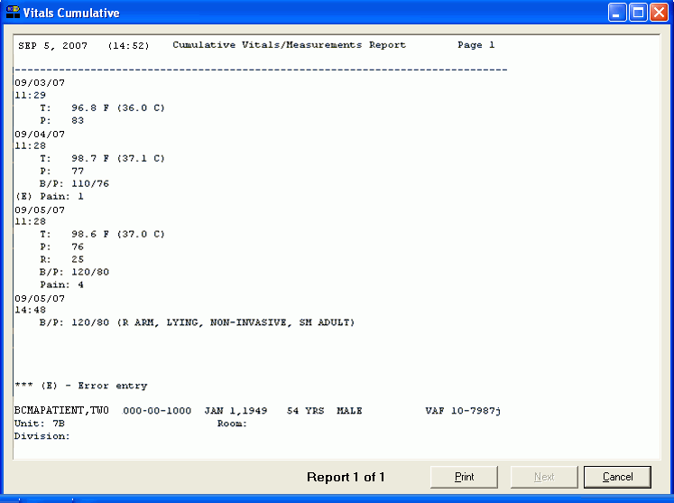

Viewing and Printing BCMA Reports

|  |  |
| --- | --- |
| Viewing/Printing the Patient Record Flag Report  tip:  Bookmark these sites for future reference.    tip:  For more information on PRFs, see the “Patient Record Flags User Guide” in the Admission Discharge Transfer (ADT) section of the VistA Documentation Library.  Tips | The Patient Record Flag report displays all active PRF assignments associated with the patient. Applicable National (Category I) and Local (Category II) flag types are displayed. When the **flag** button is enabled on the tool bar, it signifies that the current patient on the VDL has one or more active Patient Record Flags (PRFs). The PRF alerts VHA employees to patients whose behavior or characteristics may pose a threat either to their safety, the safety of other patients, or compromise the delivery of quality health care.  There are two ways to access the Patient Record Flag Report:   * **From the VDL:** Click the flag button (displayed in RED) on the tool bar to view and print the Patient Record Flag Report. A Patient Flag option is also available on the View menu. * **During the patient look-up process:** Click the **details** button on the Patient Confirmation dialog box.   **Note:** If any active PRFs exist for a patient, it is strongly recommended that you run the Patient Record Flag report to view the active patient record flag details, especially for behavioral flags, to view information which may be critical to patient and employee safety.  In addition to patient demographic data, the following information is displayed on the Patient Record Flag Report:   * **Flag Name:** The nationally or locally assigned name of patient record flag. * **Flag Type:**  Identifies the usage classification of the Patient Record Flag, e.g., BEHAVIORAL, CLINICAL, OTHER, RESEARCH. * **Flag Category**: Category I Behavioral National PRFs are nationally approved and are to be used by all facilities. Category II Local PRFs may be locally established by individual Veterans Integrated Service Networks (VISNs) or facilities. * **Assignment Status:** Active or Inactive; only Active PRFs display on the PRF Report. * **Initial Assigned Date:** The date the PRF was initially assigned to the patient. * **Approved by:** The provider who approved the assignment. * **Next Review Date:** The date that the flag assignment is due for review to determine continuing appropriateness. |

Viewing and Printing BCMA Reports

|  |  |
| --- | --- |
| Viewing/Printing the Patient Record Flag Report (cont.)  tip:  The Patient Record Flag Report can also be accessed by clicking the Details button in the  Patient Confirmation Dialog box.  Tips  tip: Bookmark these sites for future reference. | * **Owner Site:** The current site that owns this patient flag assignment. Patient assignments may only be edited by the owner site. The owner site normally corresponds to the site providing primary care to the patient. * **Originating Site:** The site that initially assigned the patient record flag to this patient. The site that assigns the flag is not required to be the owner of the assignment. * **Assignment Narratives:** Description of the incident or reason that generated the need for this patient record flag assignment. The description is followed by recommended actions that should be performed by a person working with this specific patient.   To view/print a Patient Record Flag Report   1. Click the **flag** button (displayed in RED) on the tool bar to view the Patient Record Flag Report on-screen. The Patient Record Flag Report displays only active PRF assignments associated with the current patient record.   **Note:** If the **flag** button is disabled, there are no active PRFs for this patient.  **Keyboard Shortcut:** Press **ctrl+f** to display the Patient Record Flag report.   1. Perform one of the following actions:  * Click **PREVIEW** to display the report on-screen. * Click **PRINT** to display the Printer dialog box. * Click **CANCEL** to return to the patient’s VDL.   **Keyboard Shortcut:** Use **tab** to move among the **preview, print** and **cancel** buttons.   1. Perform one or more of the following actions, then click **ok**:  * Select a printer from the drop-down list box that you want to use for outputting the Patient Record Flag Report. * Check the Queuing check box and enter the Date and Time you want the report to print. Click the **down arrow** in the drop-down list box to display a choice of dates and times. |

Viewing and Printing BCMA Reports

|  |  |
| --- | --- |
| Viewing/Printing the Patient Record Flag Report (cont.)  tip:  Bookmark these sites for future reference. | To view/print a Patient Record Flag Report (cont.)  **Note:** The printer that you select becomes the “default” printer for *all* reports printed from BCMA.  Example: PRF Report (National)  Example: PRF Report (National) screen  Example: PRF Report (Local)  Example: PRF Report (Local) screen |

Viewing and Printing BCMA Reports

|  |  |
| --- | --- |
| Viewing/Printing an Unknown Actions Report | You can use the Unknown Actions Report to print a listing of administrations that have an unknown action status within a specified date range. When a user is in the process of documenting an administration in BCMA CHUI *Manual Medication Entry*, the administration status initially defaults to blank (null). If the order is not completed with a valid administration status, the Admin Status will be listed as unknown, and appear on the Unknown Actions Report.  The unknown (null) status can occur during *Manual Medication Entry* when the user’s network connection is broken, their terminal emulator software malfunctions, or if the user improperly exits out of the application.  Use the BCMA GUI Edit Med Log to correct the administration status of any entries found on this report.  **Note:** This report is only accessible to users with the PSB MANAGER security key.  The Unknown Actions Report includes information about the administration with the Unknown status, including patient name and ID, ward/bed, the order number, orderable item, schedule and scheduled administration time, who created the order, and the time the order was created.  To view/print an Unknown Actions Report   1. Select the Unknown Actions command from the Reports menu. The Unknown Actions dialog box displays.   **Keyboard Shortcut:** Press **alt+r** to display the Reports menu, and then press **u** to display the Unknown Actions dialog box. |

Viewing and Printing BCMA Reports

|  |  |
| --- | --- |
| Viewing/Printing an Unknown Actions Report (cont.)  tip:  You can type the information in the list boxes, or use the drop-down arrows to make your selection.  Tips | To view/print an Unknown Actions Report (cont.)  Example: Unknown Actions Dialog Box  Example: Unknown Actions Dialog Box screen   1. Use the **down arrow**, within the list boxes, to select the Start Date and Stop Date for the Unknown Actions Report that you want to view on-screen or print.   **Note:** Clicking on the **down arrow** on the Start Date and Stop Date list boxes displays a calendar. You can use the scroll arrows in the upper corners of the calendar to display a different month, and then click on a date to select it and close the calendar.  **Keyboard Shortcut:** Use **tab** to move among the different areas of the dialog box.   1. Perform one of the following actions:  * Click **PREVIEW** to display the report on-screen. * Click **PRINT** to display the Printer dialog box. * Click **CANCEL** to return to the patient’s VDL.   **Keyboard Shortcut:** Use **tab** to move among the **preview, print** and **cancel** buttons.   1. Perform one or more of the following actions, then click **ok**:  * Select a printer from the drop-down list box that you want to use for outputting the Unknown Actions Report. * Check the Queuing check box and enter the Date and Time you want the report to print. Click the down arrow in the drop-down list box to display a choice of dates and times. |

Viewing and Printing BCMA Reports

|  |  |
| --- | --- |
| Viewing/Printing an Unknown Actions Report (cont.) | To view/print an Unknown Actions Report (cont.)  **Note:** The printer that you select becomes the “default” printer for *all* reports printed from BCMA. |

Example: Unknown Actions Report

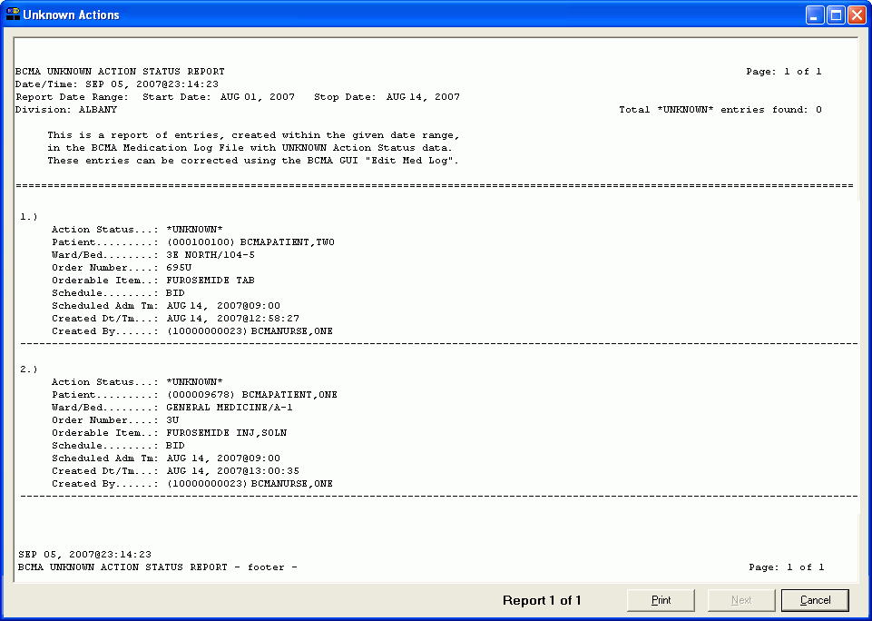

|  |  |
| --- | --- |
| Viewing/Printing Cover Sheet  Reports | Cover Sheet Reports can be accessed from the BCMA GUI Reports menu and then previewed and/or printed. They include the following:   * Medication Overview * PRN Overview * IV Overview * Expired/DC’d/Expiring Orders   The Cover Sheet Reports mimic the Coversheet, which is patient based, so the reports are designed to be patient based as well, not ward based like the other reports. To print for a group of patients, you must select multiple patients. When selecting multiple patients, a single patient report is printed for each patient selected.  **Note:** When including Clinic Orders in the Cover Sheet Reports, parameters for Allowable Time Limits (Before Scheduled Admin Time and After Scheduled Admin Time) are ignored.  Example: Cover Sheet Reports Menu  Example: Cover Sheet Reports Menu screen  To view/print a Cover Sheet Report   1. Select the Cover Sheet command from the Reports menu and then select the Cover Sheet Report you want to see.   **Note:** It is not necessary to display the Cover Sheet in order to run a Cover Sheet Report. Cover Sheet reports can be run from the Reports Menu at any time.   1. The appropriate report dialog box displays. Refer to the following sections for more information on each report dialog box.   **Keyboard Shortcut:** Press **alt+r** to display the Reports menu, and then press **c** to display the Cover Sheet dialog box.   * Press **e** to display the Medication Overview dialog box. * Press r to display the PRN Overview dialog box. * Press o to display the IV Overview dialog box. * Press x to display the Expired/DC’d/Expiring dialog box. |

Viewing and Printing BCMA Reports

|  |  |
| --- | --- |
| Viewing/Printing Cover Sheet–Medication Overview  Report | The Cover Sheet–Medication Overview Report displays and groups active, expired or discontinued, and future orders for the current patient and by ward. The total number of orders per group displays in brackets next to each group heading.  The Cover Sheet–Medication Overview Report can be accessed from the Reports menu and then previewed and/or printed.  The Cover Sheet–Medication Overview Report provides three levels of detail for each order displayed.   1. The top level displays order and next administration data, and includes the following header and information in the order listed below.  * **VDL Tab**: the name of the tab within BCMA where administrations are displayed. * **Order Status**: the current status of the order (i.e., Active, Expired, Hold) * **Type:** the schedule type of the order (C for Continuous, O for One Time, OC for On Call, P for PRN) * **Medication; Dosage, Route**: the orderable item associated with the order; plus the dosage and route of the order separated by a comma * **Schedule:** the order schedule (i.e., Q2H, BID) * **Next Action:**  one of the following: * **“DUE”** followed by the next scheduled administration time after the last action taken for active orders that have defined administration times in MM/DD/YYYY@HHMM format. * **“Missed”** followed by the next scheduled administration time after the last action taken if administration date/time exceeds the “After Scheduled Admin Time” site parameter in MM/DD/YYYY@HHMM format. * **“Provider Hold”** for active orders on provider hold * Blank for PRN, On Call, and One-Time orders * **Special Instructions**: special instructions associated with the order * **Order Start Date:** the order’s start date/time displayed in MM/DD/YYYY@HHMM format. |

Viewing and Printing BCMA Reports

|  |  |  |
| --- | --- | --- |
| Viewing/Printing Cover Sheet–Medication Overview  Report (cont.) | * **Order Stop Date**: the order’s stop date/time displayed in MM/DD/YYYY@HHMM format  1. The second level displays a maximum of four previous actions taken against this specific order, and includes the following header and information in the order listed below.   **Note:** Actions whose activity dates exceed the “Med History Days Back” site parameter will not be displayed.   * **Bag ID:** If the order is an IV order, then the Bag ID header and field displays, which is the unique identifier for the bag associated with this action. * **Action By:** the initials of the person that performed the action, and the date/time of the action in MM/DD/YYYY@HHMM format * **Action:** the status of the administration (i.e., Given, Held, Refused, Missing, etc.). * If the order has a PRN schedule type, the following headers and fields will display: * **PRN Reason:** the PRN reason associated with the action * **PRN Effectiveness:**  the PRN Effectiveness comment for this action |  |

Example: Medication Overview Report

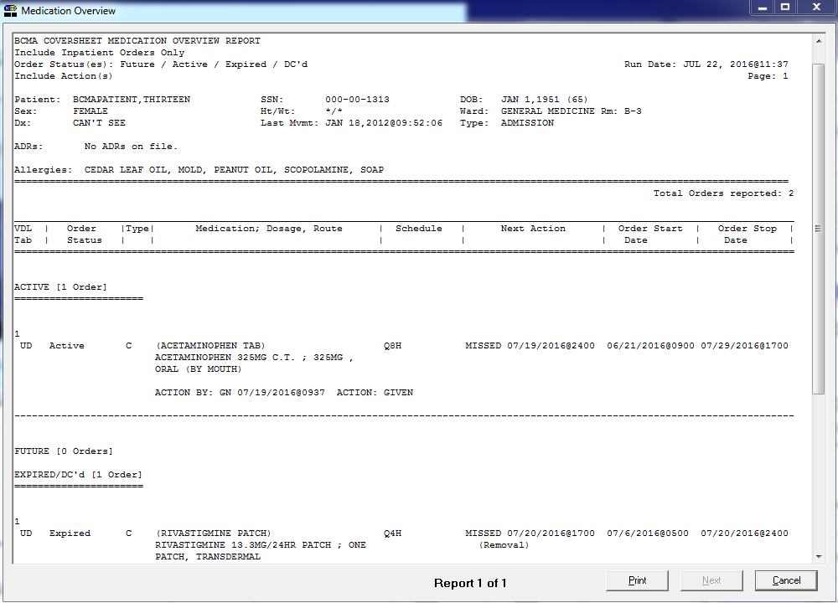Viewing and Printing BCMA Reports

|  |  |
| --- | --- |
| Viewing/Printing Cover Sheet–Medication Overview  Report (cont.) | 1. The third level displays comments associated with the action and includes the following header and information in the order listed below.  * **Comment By:** the initials of the person that entered the comment and the date/time the comment was entered in MM/DD/YYYY@HHMM format * **Comment:** the text of the comment   To view/print a Cover Sheet Medication Overview Report   1. Select the Cover Sheet command from the Reports menu, and then select the Medication Overview report. The Medication Overview dialog box displays.   **Keyboard Shortcut:** Press **alt+r** to display the Reports menu, and then press **C** to display the Cover Sheet reports. Press **e** to display the Medication Overview dialog box.    Example: Cover Sheet Medication Overview  Dialog Box  Example: Cover Sheet Medication overview Dialog Box screen   1. In the Include Order Status area, click inside the check boxes to exclude Active, Future, or Expired/DC’d orders. 2. In the Include Orders area, select either Inpatient Orders or Clinic Orders data to include in the reports.  * If a patient record is open, and the selected Order Mode is “Inpatient:” * The report dialog Include Orders selection defaults to “Inpatient Orders.” * If the selected Order Mode is “Clinic:” * The report dialog Include Orders selection defaults to “Clinic Orders.” |

Viewing and Printing BCMA Reports

|  |  |
| --- | --- |
| Viewing/Printing Cover Sheet–Medication Overview  Report (cont.) | To view/print a Cover Sheet Medication Overview Report (cont.)   * If no patient record is open: * The report dialog Print by selection defaults to Ward or Clinic, based on the last Order Mode that you selected.  1. In the Include Detail area, click inside the checkboxes to include/exclude Actions and Comments.   **Keyboard Shortcut:** Use **tab** to move among the different areas of the dialog box. Press **spacebar** to click inside a check box.   1. In the Print by area, select to print by Patient or Ward.  * If a patient record is open * The report dialog Print by selection always defaults to “Patient.” * If the “Inpatient” Order Mode is selected on the VDL, the report dialog Include Orders selection defaults to “Inpatient Orders” and Print by “Ward” is enabled, and Print by “Clinic” is disabled.   Example: Inpatient Orders/Default to Print by Patient  Example: Inpatient Orders/Default to Print by Patient screen |

Viewing and Printing BCMA Reports

|  |  |
| --- | --- |
| Viewing/Printing Cover Sheet–Medication Overview  Report (cont.) | To view/print a Cover Sheet Medication Overview Report (cont.)   * If the “Clinic” Order Mode is selected on the VDL, the report dialog Include Orders selection defaults to “Clinic Orders” and Print by “Clinic” is enabled, and Print by “Ward” is disabled.   Example: Clinic Orders/Default to Print by Patient  Example: Clinic Orders/Default to Print by Patient screen   * If you change the report dialog Include Orders selection from “Inpatient Orders” to “Clinic Orders” (or vice versa), the dependent corresponding Print by options will also change.   Example: Clinic Orders/Default to Print by Clinic  Example: Clinic Orders/Default to Print by Clinic screen |

Viewing and Printing BCMA Reports

|  |  |
| --- | --- |
| Viewing/Printing Cover Sheet–Medication Overview  Report (cont.) | To view/print a Cover Sheet Medication Overview Report (cont.)   * If no patient record is open: * BCMA remembers the last Order Mode that you selected, and sets the Print by selection default to “Ward” for Inpatient Orders or “Clinic” for Clinic Orders. Print by “Patient” is disabled. * If you choose “Inpatient Orders” for the Include Orders selection, the report dialog Print by selection defaults to “Ward.”   Example: Inpatient Orders/Default to Print by Ward  Example: Inpatient Orders/Default to Print by Ward screen   * If you choose “Clinic Orders” for the Include Orders selection, the report dialog Print by selection defaults to “Clinic.”   Example: Clinic Orders/Default to Print by Clinic  Example: Clinic Orders/Default to Print by Clinic screen |

Viewing and Printing BCMA Reports

|  |  |
| --- | --- |
| Viewing/Printing Cover Sheet–Medication Overview  Report (cont.) | To view/print a Cover Sheet Medication Overview Report (cont.)   * If you change the report dialog Include Orders selection from “Inpatient Orders” to “Clinic Orders” (or vice versa), the dependent corresponding Print by options will also change.   Example: Clinic Orders/Default to Print by Patient  Example: Clinic Orders/Default to Print by Patient screen  **Note:** If you choose to print the report by Patient, go to step 7.   1. If you choose to print the report by Ward, make your selection from the list box provided. Clicking on the **down arrow** on the Ward list box displays an alphabetical list of MAS wards and Nurse Units.   **Note:** After selecting a ward, you must select patients within that ward before running the report. Click **select patients** and then select the patients you want to preview or print, then click **ok**.  **Note:** To include Inactive Wards, click inside the check box to deselect the default “Exclude Inactive Wards.”   1. Perform one of the following actions:  * Click **preview** to display the report on-screen. * Click **print** to display the Printer dialog box. * Click **cancel** to return to the patient’s VDL.   **Keyboard Shortcut:** Use **tab** to move among the **preview, print** and **cancel** buttons. |

Viewing and Printing BCMA Reports

|  |  |
| --- | --- |
| Viewing/Printing Cover Sheet–Medication Overview  Report (cont.) | To view/print a Cover Sheet Medication Overview Report (cont.)   1. Perform one or more of the following actions, then click **ok**:  * Select a printer from the drop-down list box that you want to use for outputting the Cover Sheet Medication Overview Report. * Check the Queuing check box and enter the Date and Time you want the report to print. Click the **down arrow** in the drop-down list box to display a choice of dates and times.   **Note:** The printer that you select becomes the “default” printer for *all* reports printed from BCMA. |

Viewing and Printing BCMA Reports

|  |  |
| --- | --- |
| Viewing/Printing Cover Sheet– PRN Overview  Report | The Cover Sheet–PRN Overview Report displays and groups active expired or discontinued and future orders with a schedule type of PRN for the current patient and by ward. The total number of orders per group displays in brackets next to each group heading. The Cover Sheet–PRN Overview Report can be accessed from the Reports menu and then previewed and/or printed.  The Cover Sheet–PRN Overview Report provides three levels of detail for each order displayed.   1. The top level displays order and next administration data, and includes the following header and information in the order listed below.  * **VDL Tab:** the name of the tab within BCMA where administrations are displayed. * **Status:** the current status of the order (i.e., Active, Expired, Hold) * **Medication; Dosage, Route**: the orderable item associated with the order, including multiple dispense drugs, additives, and solutions; plus the dosage and route of the order separated by a comma * **Last Given:** the last administration and the date/time the action was performed for the orderable item in ACTION MM/DD/YYYY@HHMM format * **Since Last Given**: the number of hours and minutes since the last administration of the orderable item in ##d ##h ##m format (e.g., 1d 10h 23m) * **Special Instructions:** special instructions associated with the order * **Order Start Date:** the order’s start date/time displayed in MM/DD/YYYY@HHMM format * **Order Stop Date**: the order’s stop date/time displayed in MM/DD/YYYY@HHMM format  1. The second level displays a maximum of four previous actions taken against this specific order, and includes the following header and information in the order listed below.   **Note:** Actions whose activity dates exceed the “Med History Days Back” site parameter will not be displayed. |

Viewing and Printing BCMA Reports

|  |  |
| --- | --- |
| Viewing/Printing Cover Sheet– PRN Overview  Report (cont.) | * **Bag ID**: If the order is an IV order, then the Bag ID displays, which is the unique identifier for the bag associated with this action. The Bag ID header will not display unless the order type of the order is “IV.” * **Action By**: the initials of the person that performed the action, and the date/time of the action in MM/DD/YYYY@HHMM format * **Action:** the action that was performed. * **PRN Reason**: the PRN reason associated with the action * **PRN Effectiveness:** the PRN Effectiveness comment for this action  1. The third level displays comments associated with the action and includes the following header and information in the order listed below.  * **Comment By**: the initials of the person that entered the comment and the date/time the comment was entered in MM/DD/YYYY@HHMM format * **Comment:** the text of the comment   The report header displays “Include Inpatient Orders Only” for reports that include only Inpatient order data. |

Example: Inpatient PRN Overview Report

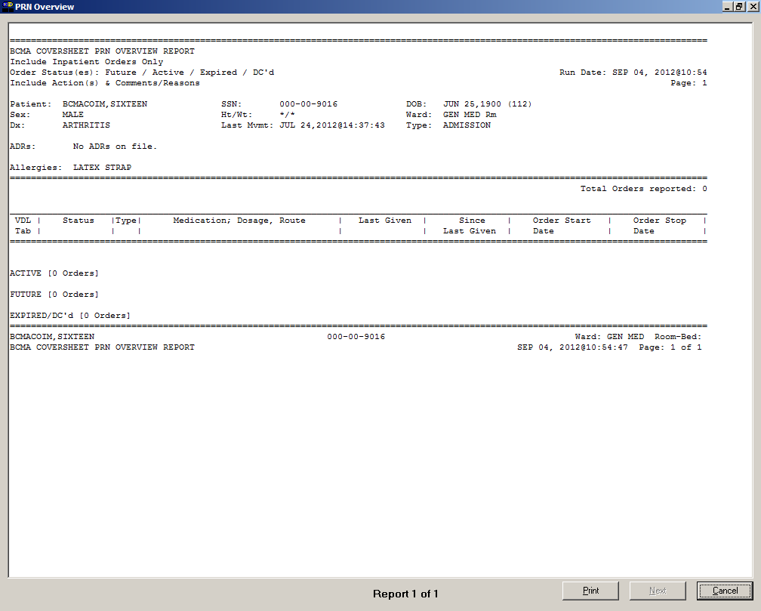

Viewing and Printing BCMA Reports

|  |  |
| --- | --- |
| Viewing/Printing Cover Sheet– PRN Overview  Report (cont.) | To view/print a Cover Sheet PRN Overview Report   1. Select the Cover Sheet command from the Reports menu and then select the PRN Overview report. The PRN Overview dialog box displays.   **Keyboard Shortcut:** Press **alt+r** to display the Reports menu, and then press **C** to display the Cover Sheet reports. Press **r** to display the PRN Overview dialog box.  Example: Cover Sheet PRN Overview  Dialog Box  Example: Cover Sheet PRN Overview  Dialog Box screen   1. In the Include Order Status area, click inside the check boxes to exclude Active, Future, or Expired/DC’d orders. 2. In the Include Orders area, select either Inpatient Orders or Clinic Orders to include in the report.  * If a patient record is open, and the selected Order Mode is “Inpatient:” * The report dialog Include Orders selection defaults to “Inpatient Orders.” * If the selected Order Mode is “Clinic:” * The report dialog Include Orders selection defaults to “Clinic Orders.” |

Viewing and Printing BCMA Reports

|  |  |
| --- | --- |
| Viewing/Printing Cover Sheet– PRN Overview  Report (cont.) | To view/print a Cover Sheet PRN Overview Report   * If no patient record is open: * The report dialog Print by selection defaults to Ward or Clinic, based on the last Order Mode that you selected.  1. In the Include Detail area, click inside the checkboxes to include/exclude Actions, Comments, or Special Instructions / Other Print Info.   **Keyboard Shortcut:** Use **tab** to move among the different areas of the dialog box. Press **spacebar** to click inside a check box.   1. In the Print by area, select to print by Patient or Ward.  * If a patient record is open: * The report dialog Print by selection always defaults to “Patient.” * If the “Inpatient” Order Mode is selected on the VDL, the report dialog Include Orders selection defaults to “Inpatient Orders” and Print by “Ward” is enabled, and Print by “Clinic” is disabled.   Example: Inpatient Orders/Default to Print by Patient  Example: Inpatient Orders/Default to Print by Patient screen. |

Viewing and Printing BCMA Reports

|  |  |
| --- | --- |
| Viewing/Printing Cover Sheet– PRN Overview  Report (cont.) | To view/print a Cover Sheet PRN Overview Report (cont.)   * If the “Clinic” Order Mode is selected on the VDL, the report dialog Include Orders selection defaults to “Clinic Orders” and Print by “Clinic” is enabled, and Print by “Ward” is disabled.   Example: Clinic Orders/Default to Print by Patient  Example: Clinic Orders/Default to Print by Patient screen   * If you change the report dialog Include Orders selection from “Inpatient Orders” to “Clinic Orders” (or vice versa), the dependent corresponding Print by options will also change.   Example: Clinic Orders/Default to Print by Clinic  Example: Clinic Orders/Default to Print by Clinic screen |

Viewing and Printing BCMA Reports

|  |  |
| --- | --- |
| Viewing/Printing Cover Sheet– PRN Overview  -Report (cont.) | To view/print a Cover Sheet PRN Overview Report (cont.)   * If no patient record is open: * BCMA remembers the last Order Mode that you selected, and sets the Print by selection default to “Ward” for Inpatient Orders or “Clinic” for Clinic Orders. Print by “Patient” is disabled. * If you choose “Inpatient Orders” for the Include Orders selection, the report dialog Print by selection defaults to “Ward.”   Example: Inpatient Orders/Default to Print by Ward  Example: Inpatient Orders/Default to Print by Ward screen   * If you choose “Clinic Orders” for the Include Orders selection, the report dialog Print by selection defaults to “Clinic.”   Example: Clinic Orders/Default to Print by Patient  Example: Clinic Orders/Default to Print by Patient screen |

Viewing and Printing BCMA Reports

|  |  |
| --- | --- |
| Viewing/Printing Cover Sheet– PRN Overview  Report (cont.) | To view/print a Cover Sheet PRN Overview Report (cont.)     * If you change the report dialog Include Orders selection from “Inpatient Orders” to “Clinic Orders” (or vice versa), the dependent corresponding Print by options will also change.   Example: Clinic Orders/Default to Print by Patient  Example: Clinic Orders/Default to Print by Patient screen  **Note:** If you choose to print the report by Patient, go to step 7   1. If you choose to print the report by Ward, make your selection from the list box provided. Clicking on the **down arrow** on the Ward list box displays an alphabetical list of MAS wards and Nurse Units.   **Note:** After selecting a ward, you must select patients within that ward before running the report. Click **select patients** and then select the patients you want to preview or print, then click **ok**.  **Note:** To include Inactive Wards, click inside the check box to deselect the default “Exclude Inactive Wards.”   1. Perform one of the following actions:  * Click **preview** to display the report on-screen. * Click **print** to display the Printer dialog box. * Click **cancel** to return to the patient’s VDL. |

Viewing and Printing BCMA Reports

|  |  |
| --- | --- |
| Viewing/Printing Cover Sheet– PRN Overview  Report (cont.) | To view/print a Cover Sheet PRN Overview Report (cont.)    **Keyboard Shortcut:** Use **tab** to move among the **preview, print** and **cancel** buttons.   1. Perform one or more of the following actions, then click **ok**:  * Select a printer from the drop-down list box that you want to use for outputting the report. * Check the Queuing check box and enter the Date and Time you want the report to print. Click the **down arrow** in the drop-down list box to display a choice of dates and times.   **Note:** The printer that you select becomes the “default” printer for *all* reports printed from BCMA. |
| Viewing/Printing Cover Sheet– IV Overview  Report | The Cover Sheet–IV Overview Report displays and groups IV bag information on active, expired, and discontinued orders for the current patient and by ward. The total number of IV bags per group displays in brackets next to each group heading.  The Cover Sheet–IV Overview Report can be accessed from the Reports menu and then previewed and/or printed.  The groups display top down in the following order:   * **Infusing:** any bag that is currently infusing on an active, expired, or discontinued order * **Stopped**: any bag that is currently stopped on an active, expired, or discontinued order * **All Other**: any bag that is not infusing or stopped on an active order   The Cover Sheet–IV Overview Report provides two levels of detail for each order displayed.   1. The top level displays bag and order data, and includes the following header and information in the order listed below.  * **Bag ID**: the unique identifier of the bag. * **Order Status:** the current status of the order to which the bag belongs * **Bag Status**: the current status of the bag (Infusing, Stopped, Available, Complete).   **Note:** Bag status is blank for active IV orders that have no bags associated with them.   * **Medication; Dosage, Route:** the orderable item associated with the order, including additives and solutions; plus the dosage and route of the order separated by a comma. * **Infusion Rate:** the infusion rate associated with the order. * **Other Print Info:** other print information associated with the order * **Bag Info:** “changed order” if the bag is associated with an order that has been edited * **Order Start Date:** the order’s start date/time displayed in MM/DD/YYYY@HHMM format |

Viewing and Printing BCMA Reports

|  |  |
| --- | --- |
| Viewing/Printing Cover Sheet– IV Overview  Report (cont.) | * **Order Stop Date:** the order’s stop date/time displayed in MM/DD/YYYY@HHMM format  1. The second level displays the bag history (actions and comments) and contains the following header and information>   **Note:** A maximum of four previous actions display at the second level. Actions with activity date exceeding the “Med History Days Back” site parameter do not display.   * **Date/Time:** If the order is an IV order, then the Bag ID displays, which is the unique identifier for the bag associated with this action. * **By:** the initials of the person that performed the action or entered the comment. * **Action:** the action that was performed. * **Comment:** the text of the comment. |

Example: IV Overview Report

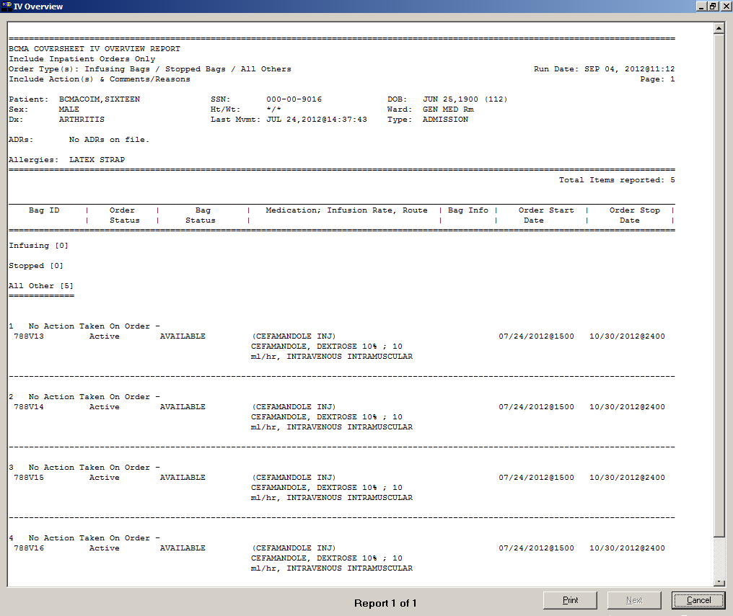

Viewing and Printing BCMA Reports

|  |  |
| --- | --- |
| Viewing/Printing Cover Sheet– IV Overview  Report (cont.) | To view/print a Cover Sheet IV Overview Report   1. Select the Cover Sheet command from the Reports menu, and then select the IV Overview report. The IV Overview dialog box displays.   **Keyboard Shortcut:** Press **alt+r** to display the Reports menu, and then press **C** to display the Cover Sheet reports. Press **o** to display the IV Overview dialog box.  Example: Cover Sheet IV Overview  Dialog Box  Example: Cover Sheet IV Overview  Dialog Box screen   1. In the Include Order Status area, click inside the check boxes to exclude Infusing Bags, Stopped Bags, or All Others. 2. In the Include Orders area, select either Inpatient Orders or Clinic Orders to include in the report.  * If a patient record is open, and the selected Order Mode is “Inpatient:” * The report dialog Include Orders selection defaults to “Inpatient Orders.” * If the selected Order Mode is “Clinic:” * The report dialog Include Orders selection defaults to “Clinic Orders.” |

Viewing and Printing BCMA Reports

|  |  |
| --- | --- |
| Viewing/Printing Cover Sheet– IV Overview  Report (cont.) | To view/print a Cover Sheet IV Overview Report (cont.)   * If no patient record is open: * The report dialog Print by selection defaults to Ward or Clinic, based on the last order mode that you selected.  1. In the Include Detail area, click inside the checkboxes to include/exclude Actions, Comments or Other Print Info.   **Keyboard Shortcut:** Use **tab** to move among the different areas of the dialog box. Press **spacebar** to click inside a check box.   1. In the Print by area, select to print by Patient or Ward.  * If a patient record is open: * The report dialog Print by selection always defaults to “Patient.” * If the “Inpatient” Order Mode is selected on the VDL, the report dialog Include Orders selection defaults to “Inpatient Orders” and Print by “Ward” is enabled, and Print by “Clinic” is disabled.   Example: Inpatient Orders/Default to Print by Patient  Example: Inpatient Orders/Default to Print by Patient screen |

|  |  |
| --- | --- |
| Viewing/Printing Cover Sheet– IV Overview  Report (cont.) | To view/print a Cover Sheet IV Overview Report (cont.)   * If the “Clinic” Order Mode is selected on the VDL, the report dialog Include Orders selection defaults to “Clinic Orders” and Print by “Clinic” is enabled, and Print by “Ward” is disabled.   Example: Clinic Orders/Default to Print by Patient  Example: Clinic Orders/Default to Print by Patient screen   * If you change the report dialog Include Orders selection from “Inpatient Orders” to “Clinic Orders” (or vice versa), the dependent corresponding Print by options will also change.   Example: Clinic Orders/Default to Print by Clinic  Example: Clinic Orders/Default to Print by Clinic screen   * If no patient record is open: * BCMA remembers the last Order Mode that you selected, and sets the Print by selection default to “Ward” for Inpatient Orders or “Clinic” for Clinic Orders. Print by “Patient” is disabled. |

Viewing and Printing BCMA Reports

|  |  |
| --- | --- |
| Viewing/Printing Cover Sheet– IV Overview  Report (cont.) | To view/print a Cover Sheet IV Overview Report (cont.)   * If you choose “Inpatient Orders” for the Include Orders selection, the report dialog Print by selection defaults to “Ward.”   Example: Inpatient Orders/Default to Print by Ward  Example: Inpatient Orders/Default to Print by Ward screen   * If you choose “Clinic Orders” for the Include Orders selection, the report dialog Print by selection defaults to “Clinic.”   Example: Clinic Orders/Default to Print by Patient  Example: Clinic Orders/Default to Print by Patient screen   * If you change the report dialog Include Orders selection from “Inpatient Orders” to “Clinic Orders” (or vice versa), the dependent corresponding Print by options will also change. |

Viewing and Printing BCMA Reports

|  |  |
| --- | --- |
| Viewing/Printing Cover Sheet– IV Overview  Report (cont.) | To view/print a Cover Sheet IV Overview Report (cont.)  Example: Clinic Orders/Default to Print by Patient  Example: Clinic Orders/Default to Print by Patient screen  **Note:** If you choose to print the report by Patient, go to step 7.   1. If you choose to print the report by Ward, make your selection from the list box provided. Clicking on the **down arrow** on the Ward list box displays an alphabetical list of MAS wards and Nurse Units.   **Note:** After selecting a ward, you must select patients within that ward before running the report. Click **select patients** and then select the patients you want to preview or print, then click **ok**.  **Note:** To include Inactive Wards, click inside the check box to deselect the default “Exclude Inactive Wards.”  **Keyboard Shortcut:** Use the **down arrow** to select the Ward, and then select a ward location from the drop-down list box.   1. Perform one of the following actions:  * Click **preview** to display the report on-screen. * Click **print** to display the Printer dialog box. * Click **cancel** to return to the patient’s VDL.   **Keyboard Shortcut:** Use **tab** to move among the **preview, print** and **cancel** buttons. |

Viewing and Printing BCMA Reports

|  |  |
| --- | --- |
| Viewing/Printing Cover Sheet– IV Overview  Report (cont.) | To view/print a Cover Sheet IV Overview Report (cont.)   1. Perform one or more of the following actions, then click:  * Select a printer from the drop-down list box that you want to use for outputting the report. * Check the Queuing check box and enter the Date and Time you want the report to print. Click the **down arrow** in the drop-down list box to display a choice of dates and times.   **Note:** The printer that you select becomes the “default” printer for *all* reports printed from BCMA. |

Viewing and Printing BCMA Reports

|  |  |
| --- | --- |
| Viewing/Printing Cover Sheet– Expired/DC’d/ Expiring Orders  Report | The Cover Sheet–Expired/DC’d/Expiring Orders Report displays and groups expired and discontinued orders, as well as orders that will expire for the current patient and by ward. For each group, the total number of IV bags per group is displayed in brackets next to the group heading. The Cover Sheet– Expired/DC’d/Expiring Orders Report can be accessed from the Reports menu and then previewed and/or printed.  The groups display top down in the following order:   * **Expired/DC’d:** orders that have expired or discontinued within the last 24 hours. * **Expiring Today**: orders that have not yet expired, but will expire before midnight of the current day * **Expiring Tomorrow:** orders that expire after midnight of the current day but before midnight of the next day   The Cover Sheet Expired/DC’d/Expiring Orders Report provides three levels of detail for each order displayed.   1. The top level displays order and next administration data, and includes the following header and information in the order listed below.  * **VDL Tab:** the name of the tab within BCMA where administrations are displayed. * **Status:** the current status of the order (i.e., Active, Expired, Hold) * **Type:** the schedule type of the order * **Medication; Dosage, Route:** the orderable item associated with the order, including multiple dispense drugs, additives, and solutions; plus the dosage and route of the order separated by a comma * **Schedule:** the order schedule (i.e., Q2H, BID). * **Special Instructions**: special instructions associated with the order * **Order Start Date**: the order’s start date/time displayed in MM/DD/YYYY@HHMM format * **Order Stop Date**: the order’s stop date/time displayed in MM/DD/YYYY@HHMM format |

Viewing and Printing BCMA Reports

|  |  |
| --- | --- |
| Viewing/Printing Cover Sheet– Expired/DC’d/ Expiring Orders  Report (cont.) | 1. The second level displays a maximum of four previous actions taken against the order and contains the following header and information:  * **Bag ID:** if the order is an IV order, the Bag ID displays. * **Action By:** the initials of the person that performed the action and the date/time of the action in MM/DD/YYYY@HHMM format. * **Action:** the action that was performed. * If the order has a PRN schedule type, the following headers and fields will display: * PRN Reason: the PRN reason associated with the action * PRN Effectiveness: the PRN Effectiveness comment for this action  1. The third level displays comments associated with the action and includes the following header and information in the order listed below.  * **Comment By:** the initials of the person that entered the comment and the date/time the comment was entered in MM/DD/YYYY@HHMM format. * **Comment:** the text of the comment. |

Example: Expired/DC’d/Expiring Orders Report

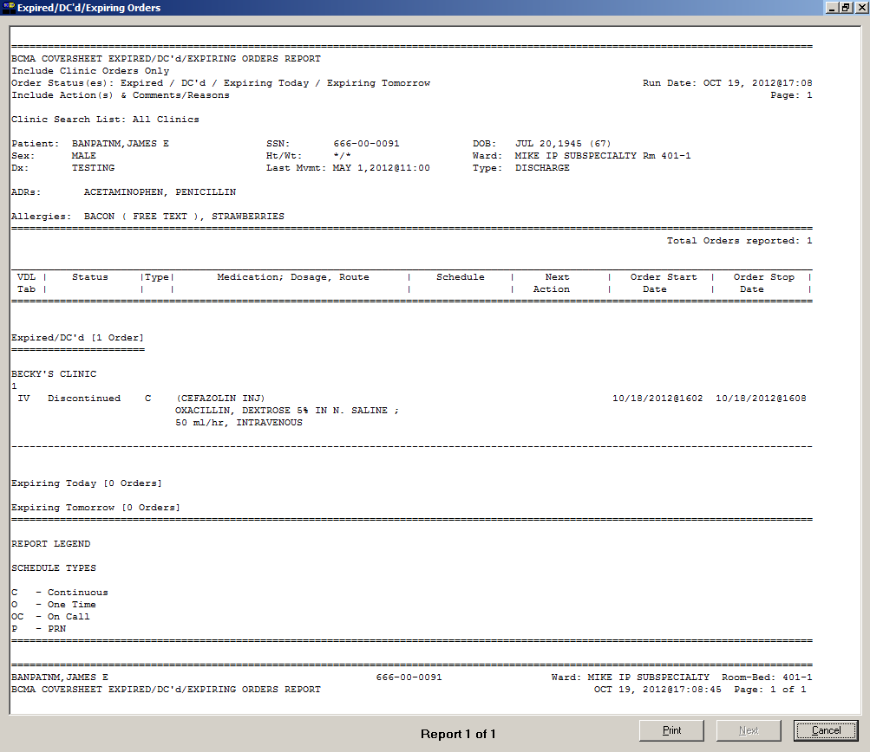

Viewing and Printing BCMA Reports

|  |  |
| --- | --- |
| Viewing/Printing Cover Sheet– Expired/DC’d/ Expiring Orders  Report (cont.) | To view/print a Cover Sheet Expired/DC’d/Expiring Orders Report   1. Select the Cover Sheet command from the Reports menu, and then select the Expired/DC’d/Expiring Orders report. The Expired/DC’d/Expiring Orders dialog box displays.   **Keyboard Shortcut:** Press **alt+r** to display the Reports menu, and then press **C** to display the Cover Sheet reports. Press **x** to display the Expired/DC’d/Expiring Orders dialog box.  Example: Cover Sheet Expired/DC’d/Expiring Orders  Dialog Box  Example: Cover Sheet Expired/DC’d/Expiring Orders Dialog Box screen   1. In the Include Order Status area, click inside the check boxes to exclude Expired/DC’d, Expiring Today, or Expiring Tomorrow orders. 2. In the Include Orders area, click inside the check box to select either Inpatient or Clinic orders to include in the report.  * If a patient record is open, and the selected Order Mode is “Inpatient:” * The report dialog Include Orders selection defaults to “Inpatient Orders.” |

Viewing and Printing BCMA Reports

|  |  |
| --- | --- |
| Viewing/Printing Cover Sheet– Expired/DC’d/ Expiring Orders  Report (cont.) | To view/print a Cover Sheet Expired/DC’d/Expiring Orders Report (cont.)   * If the selected Order Mode is “Clinic:” * The report dialog Include Orders selection defaults to “Clinic Orders.” * If no patient record is open: * The report dialog Print by selection defaults to Ward or Clinic, based on the last Order Mode that you selected.  1. In the Include Detail area, click inside the checkboxes to include/exclude Actions, Comments or Special Instructions / Other Print Info.   **Keyboard Shortcut:** Use **tab** to move among the different areas of the dialog box. Press **spacebar** to click inside a check box.   1. In the Print by area, select to print by Patient or Ward.  * If a patient record is open: * The report dialog Print by selection always defaults to “Patient.” * If the “Inpatient” Order Mode is selected on the VDL, the report dialog Include Orders selection defaults to “Inpatient Orders” and Print by “Ward” is enabled, and Print by “Clinic” is disabled.   Example: Inpatient Orders/Default to Print by Patient  Example: Inpatient Orders/Default to Print by Patient screen |

Viewing and Printing BCMA Reports

|  |  |
| --- | --- |
| Viewing/Printing Cover Sheet– Expired/DC’d/ Expiring Orders  Report (cont.) | To view/print a Cover Sheet Expired/DC’d/Expiring Orders Report (cont.)   * If the “Clinic” Order Mode is selected on the VDL, the report dialog Include Orders selection defaults to “Clinic Orders” and Print by “Clinic” is enabled, and Print by “Ward” is disabled.   Example: Clinic Orders/Default to Print by Patient  Example: Clinic Orders/Default to Print by Patient screen   * If you change the report dialog Include Orders selection from “Inpatient Orders” to “Clinic Orders” (or vice versa), the dependent corresponding Print by options will also change.   Example: Clinic Orders/Default to Print by Clinic  Example: Clinic Orders/Default to Print by Clinic screen |

Viewing and Printing BCMA Reports

|  |  |
| --- | --- |
| Viewing/Printing Cover Sheet– Expired/DC’d/ Expiring Orders  Report (cont.) | To view/print a Cover Sheet Expired/DC’d/Expiring Orders Report (cont.)   * If no patient record is open: * BCMA remembers the last Order Mode that you selected, and sets the Print by selection default to “Ward” for Inpatient Orders or “Clinic” for Clinic Orders. Print by “Patient” is disabled. * If you choose “Inpatient Orders” for the Include Orders selection, the report dialog Print by selection defaults to “Ward.”   Example: Inpatient Orders/Default to Print by Ward  Example: Inpatient Orders/Default to Print by Ward screen   * If you choose “Clinic Orders” for the Include Orders selection, the report dialog Print by selection defaults to “Clinic.”   Example: Clinic Orders/Default to Print by Patient  Example: Clinic Orders/Default to Print by Patient screen |

Viewing and Printing BCMA Reports

|  |  |
| --- | --- |
| Viewing/Printing Cover Sheet– Expired/DC’d/ Expiring Orders  Report (cont.) | To view/print a Cover Sheet Expired/DC’d/Expiring Orders Report (cont.)   * If you change the report dialog Include Orders selection from “Inpatient Orders” to “Clinic Orders” (or vice versa), the dependent corresponding Print by options will also change.   Example: Clinic Orders/Default to Print by Patient  Example: Clinic Orders/Default to Print by Patient screen  **Note:** If you choose to print the report by Patient, go to step 7.   1. If you choose to print the report by Ward, make your selection from the list box provided. Clicking on the **down arrow** on the Ward list box displays an alphabetical list of MAS wards and Nurse Units.   **Note:** After selecting a ward, you must select patients within that ward before running the report. Click **select patients** and then select the patients you want to preview or print, then click **ok**.  **Note:** To include Inactive Wards, click inside the check box to deselect the default “Exclude Inactive Wards.”   1. Perform one of the following actions:  * Click **preview** to display the report on-screen. * Click **print** to display the Printer dialog box. * Click **cancel** to return to the patient’s VDL.   **Keyboard Shortcut:** Use **tab** to move among the **preview, print** and **cancel** buttons. |

Viewing and Printing BCMA Reports

|  |  |
| --- | --- |
| Viewing/Printing Cover Sheet– Expired/DC’d/ Expiring Orders  Report (cont.) | To view/print a Cover Sheet Expired/DC’d/Expiring Orders Report (cont.)   1. Perform one or more of the following actions, then click **ok**:  * Select a printer from the drop-down list box that you want to use for outputting the Cover Sheet Expired/DC’d/Expiring Orders Report. * Check the Queuing check box and enter the Date and Time you want the report to print. Click the **down arrow** in the drop-down list box to display a choice of dates and times.   **Note:** The printer that you select becomes the “default” printer for *all* reports printed from BCMA. |

Viewing and Printing BCMA Reports

|  |  |
| --- | --- |
| Viewing/Printing a Medication Therapy Report | The Medication Therapy Report is similar to the Medication History Report, but contains additional information and does not require a patient record to be open. If no patient record is open, it defaults to a ward-based report. If a patient record is open, the report searches the current patient’s administrations.  The Medication Therapy Report allows users to search by VA Drug Class, orderable item, or dispense drug on an Inpatient or Clinic medication order. The following message appears on each report dialog: “This report includes both Inpatient and Clinic Order data.” The report searches through all of currently admitted patients’ previous administrations that fall within the specified date range and match the specified schedule types and selected medications.  To view/print a Medication Therapy Report   1. Select the Medication Therapy command from the Reports menu. The Medication Therapy dialog box displays.   **Keyboard Shortcut:** Press **alt+r** to display the Reports menu, and then press **t** to display the Medication Therapy dialog box.  Example: Medication Therapy Dialog Box  Example: Medication Therapy Dialog Box  screen |

Viewing and Printing BCMA Reports

|  |  |
| --- | --- |
| Viewing/Printing a Medication Therapy Report (cont.) | To view/print a Medication Therapy Report (cont.)   1. Use the **down arrow**, within the list boxes, to select the Start and Stop Dates of the Medication Therapy Report that you want to view on-screen or print.   **Note:** Clicking on the **down arrow** on the Date for Report list box displays a calendar. You can use the scroll arrows in the upper corners of the calendar to display a different month, and then click on a date to select it and close the calendar. Clicking inside the Start/Stop Time list boxes provides selections.  **Keyboard Shortcut:** Use **tab** to move among the different areas of the dialog box.   1. In the Include Schedule Types area, click inside the check boxes to exclude Continuous, PRN, On-Call, and One-Time in the Medication Therapy Report.   **Keyboard Shortcut:** Press **spacebar** to select a check box.   1. In the Include Detail area, click inside the check box to include/exclude comments. 2. Click **select medications** to display the Medication Therapy – Medication Selection dialog box.   **Note:** You must select medications prior to running this report.  Example: Medication Therapy – Medication Selection Dialog Box  Example: Medication Therapy – Medication Selection Dialog Box screen |

Viewing and Printing BCMA Reports

|  |  |
| --- | --- |
| Viewing/Printing a Medication Therapy Report (cont.) | To view/print a Medication Therapy Report (cont.)   1. In the Drug Search Category, click a category to choose the method by which you want to search for a medication. Choices include Dispensed Drugs, IV Medications, Orderable Item (default), and VA Drug Class. Regardless of the drug category you choose for searching, the search results will return Dispensed Drugs.   **Note:** Currently, when searching by VA Drug Class, BCMA accepts only VA Drug Class Classification Text, not VA Drug Class Codes.   1. In the Search Criteria area, enter search text as applicable. If you are unsure of the spelling of an item, you can enter a partial name. Press **enter** or click the **search** button. 2. When Search Results display, select the medications you want on the report using one of the following methods:  * To select only one medication, click its name and then click **add**. * To select all listed medications, click one and then click **add all**. * To remove a medication that was selected by mistake, click its name in the Selected Medications area and then click **remove**. * To remove all medications in the Selected Medications area, click one name and then click **remove all**.   **Keyboard Shortcut:** To select medications from the Search Results or Selected Medications lists, use **ctl+click** or **shift+click** for each name. To select all medications in a list, use **alt+a**.   1. Click **ok** to return to the Medication Therapy – Medication Selection dialog box. 2. In the Print by area, select to print by Patient or Ward. The Inpatient nurse and Clinic nurse will print by Patient.  * If a patient record is open: * The “Print by Patient” option is enabled, and the report dialog Print by selection defaults to “Patient.” |

Viewing and Printing BCMA Reports

|  |  |
| --- | --- |
| Viewing/Printing a Medication Therapy Report (cont.) | To view/print a Medication Therapy Report (cont.)   * If no patient record is open: * The “Print by Patient” option is disabled, and the report dialog Print by selection defaults to “Ward.” The nurse can select one patient on the Ward. * Print by Clinic is disabled.   **Note:** If you choose to print the report by Patient, go to step 12.   1. If you choose to print the report by Ward, make your selection from the list box provided. Clicking on the **down arrow** on the Ward list box displays an alphabetical list of MAS wards and Nurse Units.   **Note:** After selecting a ward, you must select patients within that ward before running the report.  **Note:** To include Inactive Wards, click inside the check box to deselect the default “Exclude Inactive Wards.”  **Keyboard Shortcut:** Use the **down arrow** to select the Ward, and then select a ward location from the drop-down list box.  **Note:** If you choose to print selected patients, you must click **select patients** and then select the patients you want to preview or print, then click **ok**.   1. Perform one of the following actions:  * Click **preview** to display the report on-screen. * Click **print** to display the Printer dialog box. * Click **cancel** to return to the patient’s VDL.   **Keyboard Shortcut:** Use **tab** to move among the **preview, print** and **cancel** buttons.   1. Perform one or more of the following actions, then click **ok**:  * Select a printer from the drop-down list box that you want to use for outputting the report. * Check the Queuing check box and enter the Date and Time you want the report to print. Click the **down arrow** in the drop-down list box to display a choice of dates and times. |

Viewing and Printing BCMA Reports

|  |  |
| --- | --- |
| Viewing/Printing a Medication Therapy Report (cont.) | To view/print a Medication Therapy Report (cont.)  **Note:** The printer that you select becomes the “default” printer for *all* reports printed from BCMA. |

Example: Medication Therapy Report

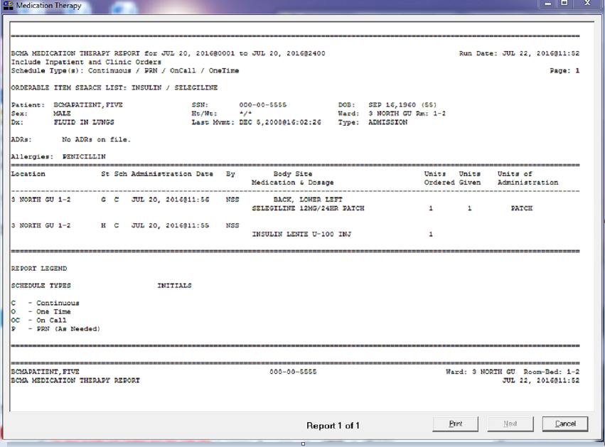

Viewing and Printing BCMA Reports

|  |  |
| --- | --- |
| Viewing/Printing an IV Bag Status Report | You can print (and view) a patient’s IV Bag Status Report, which provides status on IV bags, excluding available bags, by patient or by selected patients on the ward for Inpatient or Clinic orders. The following message appears on each report dialog: “This report includes both Inpatient and Clinic Order data.” Users can include/exclude completed, infusing, stopped, missing, held, and refused IV bags, as well as bags for which no action has been taken on the order.  To view/print an IV Bag Status Report   1. Select the IV Bag Status command from the Reports menu. The Medication Therapy dialog box displays.   **Keyboard Shortcut:** Press **alt+r** to display the Reports menu, and then press **b** to display the IV Bag Status dialog box.  Example: IV Bag Status Dialog Box  Example: IV Bag Status Dialog Box screen   1. Use the **down arrow**, within the list boxes, to select the Start and Stop Dates of the IV Bag Status Report that you want to view on-screen or print.   **Note:** Clicking on the down arrow on the Date for Report list box displays a calendar. You can use the scroll arrows in the upper corners of the calendar to display a different month, and then click on a date to select it and close the calendar. Clicking inside the Start/Stop Time list boxes provides selections.  **Keyboard Shortcut:** Use **tab** to move among the different areas of the dialog box. |

Viewing and Printing BCMA Reports

|  |  |
| --- | --- |
| Viewing/Printing an IV Bag Status Report (cont.) | To view/print an IV Bag Status Report (cont.)   1. Use the **down arrow**, within the list boxes, to select the Start and Stop Times to include on the report. 2. In the Include Order Status area, click inside the check boxes to exclude Active, DC’d or Expired orders. 3. In the Include Bag Status area, click inside the check boxes to include/exclude Completed, Infusing, Stopped, Missing Dose, Held, Refused and No Action Taken, status.   **Keyboard Shortcut:** Press **spacebar** to select a check box.   1. In the Include Detail area, click inside the check box to include/exclude comments or Other Print Info. 2. In the Print by area, select to print by Patient or Ward. The Inpatient nurse may print by Patient or by Ward. The Clinic nurse may print this report by Patient, only. Print by Clinic is disabled.  * If a patient record is open: * The Print by “Patient” option is enabled, and the report dialog Print by selection defaults to “Patient.”   Example: IV Bag Status Report Dialog with Patient Record Open  Example: IV Bag Status Report Dialog with Patient Record Open screen   * If no patient record is open: * The Print by “Patient” option is disabled, and the report dialog Print by selection defaults to “Ward.” |

Viewing and Printing BCMA Reports

|  |  |
| --- | --- |
| Viewing/Printing an IV Bag Status Report (cont.) | To view/print an IV Bag Status Report (cont.)  Example: IV Bag Status Report Dialog with No Patient Record Open  Example: IV Bag Status Report Dialog with No Patient Record Open screen  **Note:** If you choose to print the report by Patient, go to step 9.  **Keyboard Shortcut:** Use the **down arrow** to select the Ward, and then select a ward location from the drop-down list box.   1. If you choose to print the report by Ward, make your selection from the list box provided. Clicking on the **down arrow** on the Ward list box displays an alphabetical list of MAS wards and Nurse Units.   **Note:** After selecting a ward, you must select patients within that ward before running the report. Click **select patients** and then select the patients you want to preview or print, then click **ok**.  **Note:** To include Inactive Wards, click inside the check box to deselect the default “Exclude Inactive Wards.”   1. Perform one of the following actions:  * Click **preview** to display the report on-screen. * Click **print** to display the Printer dialog box. * Click **cancel** to return to the patient’s VDL.   **Keyboard Shortcut:** Use **tab** to move among the **preview, print** and **cancel** buttons. |

Viewing and Printing BCMA Reports

|  |  |
| --- | --- |
| Viewing/Printing an IV Bag Status Report (cont.) | To view/print an IV Bag Status Report (cont.)   1. Perform one or more of the following actions, then click **ok**:  * Select a printer from the drop-down list box that you want to use for outputting the IV Bag Status Report. * Check the Queuing check box and enter the Date and Time you want the report to print. Click the **down**   **arrow** in the drop-down list box to display a choice of dates and times.  **Note:** The printer that you select becomes the “default” printer for *all* reports printed from BCMA. |

Example: IV Bag Status Report

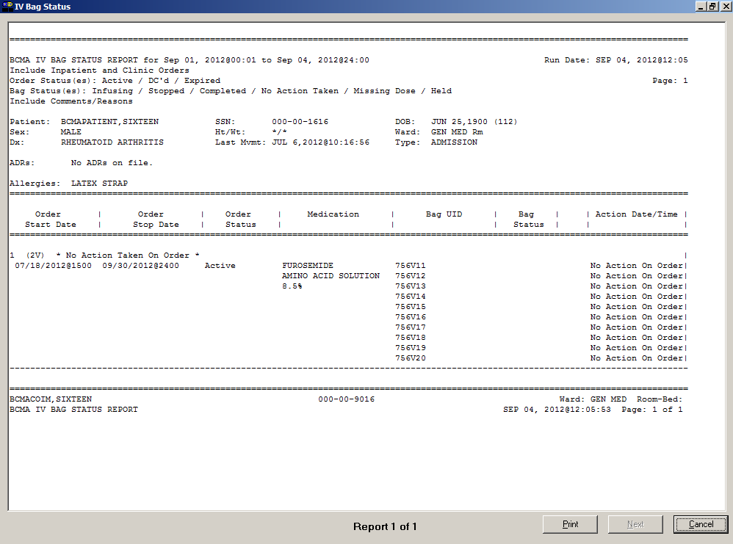

Viewing and Printing BCMA Reports

|  |  |
| --- | --- |
| Viewing/Printing an Unable to Scan (Detailed) Report  tip:  You can type the information in the list boxes, or use the drop-down arrows to make your selection.  Tips | You can use the Unable to Scan (Detailed) Report to view/print detailed information for each scanning failure logged via Unable to Scan functionality. Report data for a wristband scanning failure is collected after you complete the Unable to Scan process and successfully select, confirm, and open the patient record. Report data for a medication scanning failure is collected after you complete the Unable to Scan process and complete all steps of the medication administration. Canceling out of the Unable to Scan process or canceling a medication administration at any point in the process will not log the Unable to Scan event. Only logged Unable to Scan events print on the Detailed report. It is not necessary to open a patient record in order to view/print this report.  **Note:** This report is only accessible to users with the PSB UNABLE TO SCAN security key. The report only includes data for Inpatient administrations.  To view/print an Unable to Scan (Detailed) Report   1. Select the Unable to Scan (Detailed) command from the Reports menu. The Unable to Scan (Detailed) dialog box displays.   **Keyboard Shortcut:** Press **alt+r** to display the Reports menu, and then press **n** to display the Unable to Scan (Detailed) dialog box.  Example: Unable to Scan (Detailed) Dialog Box  Example: Unable to Scan (Detailed) Dialog Box screen   1. Use the **down arrow**, within the list boxes, to select the Start and Stop Dates of the Unable to Scan (Detailed) Report that you want to view on-screen or print. |

Viewing and Printing BCMA Reports

|  |  |
| --- | --- |
| Viewing/Printing an Unable to Scan (Detailed) Report (cont.) | To view/print an Unable to Scan (Detailed) Report (cont.)  **Note:** Clicking on the **down arrow** on the Start Date and Stop Date list boxes displays a calendar. You can use the scroll arrows in the upper corners of the calendar to display a different month, and then click on a date to select it and close the calendar. Clicking inside the Start/Stop Time list boxes provides selections.  **Keyboard Shortcut:** Use **tab** to move among the different areas of the dialog box.   1. Use the **down arrow**, within the list boxes, to select the Start and Stop Times of the Unable to Scan (Detailed) Report that you want to view on-screen or print.   **Note:** Report will begin searching for Unable to Scan events that occurred on or after the Start Date @ Start Time specified and will stop searching for Unable to Scan events that occurred before or on the Stop Date @ Stop Time specified.   1. In the Type of Scanning Failure area, select the type of scanning failure to include in the report. 2. Use the **down arrow**, within the Select Reason list box, to select the reason for the scanning failure.   **Note:** Reasons are filtered by Type of Scanning Failure selection.   1. In the For area, select the All Wards/Patients radio button or the Ward radio button and choose the individual ward or Nurse Unit from the list box.   **Note:** To include Inactive Wards in the list box, click inside the check box to deselect the default “Exclude inactive Wards.”  **Note:** To include MAS Wards in the list box, click inside the check box to deselect the default “Exclude MAS Wards.”   1. In the Sort area, specify the criteria by which you would like to sort your report. You can select up to three levels of fields to sort by. By default, the report is sorted by Date/Time of Scanning Failure (ascending). Select Primary and optional Second and Third Sort By options. 2. Perform one of the following actions:  * Click **PREVIEW** to display the report on-screen. * Click **print** to display the Printer dialog box. * Click **CANCEL** to return to the patient’s VDL. |
|  |  |

Viewing and Printing BCMA Reports

|  |  |
| --- | --- |
| Viewing/Printing an Unable to Scan (Detailed) Report (cont.) | To view/print the Unable to Scan (Detailed) Report (cont.)  **Keyboard Shortcut:** Use **tab** to move among the **PREVIEW, print** and **cancel** buttons.   1. Perform one or more of the following actions, then click **OK**:  * Select a printer from the drop-down list box that you want to use for outputting the Unable to Scan (Detailed) report. * Check the Queuing check box and enter the Date and Time you want the report to print. Click the DOWN ARROW in the drop-down list box to display a choice of dates and times.   **Note:** The printer that you select becomes the “default” printer for *all* reports printed from BCMA. |

Example: Unable to Scan (Detailed) Report

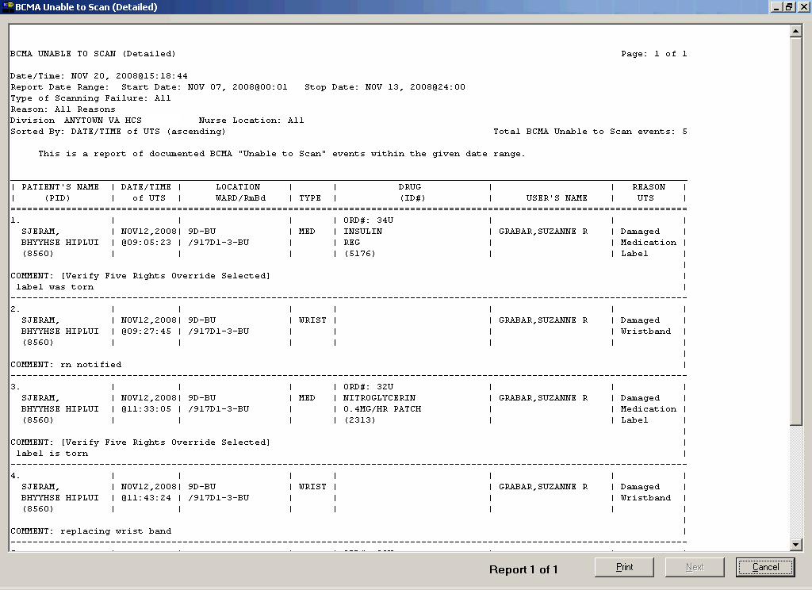

Viewing and Printing BCMA Reports

|  |  |
| --- | --- |
| Viewing/Printing an Unable to Scan (Summary) Report  tip:  You can type the information in the list boxes, or use the drop-down arrows to make your selection.  Tips | You can use the Unable to Scan (Summary) Report to view/print the total number and percentages of wristbands scanned, wristbands by-passed, medications scanned, and medications by-passed. It is not necessary to open a patient record in order to view/print this report.  **Note:** This report is only accessible to users with the PSB UNABLE TO SCAN security key. The report only includes data for Inpatient administrations.  To view/print an Unable to Scan (Summary) Report   1. Select the Unable to Scan (Summary) command from the Reports menu. The Unable to Scan (Summary) dialog box displays.   **Keyboard Shortcut:** Press **alt+r** to display the Reports menu, and then press **s** to display the Unable to Scan (Summary) dialog box.  Example: Unable to Scan (Summary) Dialog Box  Example: Unable to Scan (Summary) Dialog Box screen   1. Use the **down arrow**, within the list boxes, to select the Start and Stop Dates for the Unable to Scan (Summary) Report that you want to view on-screen or print.   **Note:** Clicking on the **down arrow** on the Start Date and Stop Date list boxes displays a calendar. You can use the scroll arrows in the upper corners of the calendar to display a different month, and then click on a date to select it and close the calendar. Clicking inside the Start/Stop Time list boxes provides selections.  **Keyboard Shortcut:** Use **tab** to move among the different areas of the dialog box. |

Viewing and Printing BCMA Reports

|  |  |
| --- | --- |
| Viewing/Printing an Unable to Scan (Summary) Report (cont.) | To view/print an Unable to Scan (Summary) Report (cont.)   1. In the For area, select the Entire Facility radio button, Nurse Unit/Location radio button, or the Ward radio button.  * The Entire Facility option prints a one page report containing grand totals and percentages for your entire Division. This option is filtered by the Division you selected when you logged into BCMA. * The Nurse Unit/Location option prints a summary report page for each Nurse Unit in your Division (one unit per page). This option is filtered by the Division you selected when you logged into BCMA. * The Ward option allows you print a summary report for a selected MAS Ward or Nurse Unit.  1. If you choose to print the report by Ward, make your selection from the list box provided. Clicking on the **DOWN** **ARROW** on the Ward list box displays an alphabetical list of MAS Wards and/or Nurse Units.   **Note:** To include Inactive Wards in the list box, click inside the check box to deselect the default “Exclude Inactive Wards.”  **Note:** To include MAS Wards in the list box, click inside the check box to deselect the default “Exclude MAS Wards.”   1. Perform one of the following actions:  * Click **PREVIEW** to display the report on screen. * Click **print** to display the Printer dialog box. * Click **CANCEL** to return to the patient’s VDL.   **Keyboard Shortcut:** Use **tab** to move among the **PREVIEW**, **print** and **cancel** buttons.   1. Perform one or more of the following actions, then click **OK**:  * Select a printer from the drop-down list box that you want to use for ouputting the Unable to Scan (Summary) report. * Check the Queuing check box and enter the Date and Time you want the report to print. Click the DOWN ARROW in the drop-down list box to display a choice of dates and times. |

Viewing and Printing BCMA Reports

|  |  |
| --- | --- |
| Viewing/Printing an Unable to Scan (Summary) Report (cont.) | To view/print an Unable to Scan (Summary) Report (cont.)  **Note:** The printer that you select becomes the “default” printer for *all* reports printed from **BCMA.** |

Example: Unable to Scan (Summary) Report

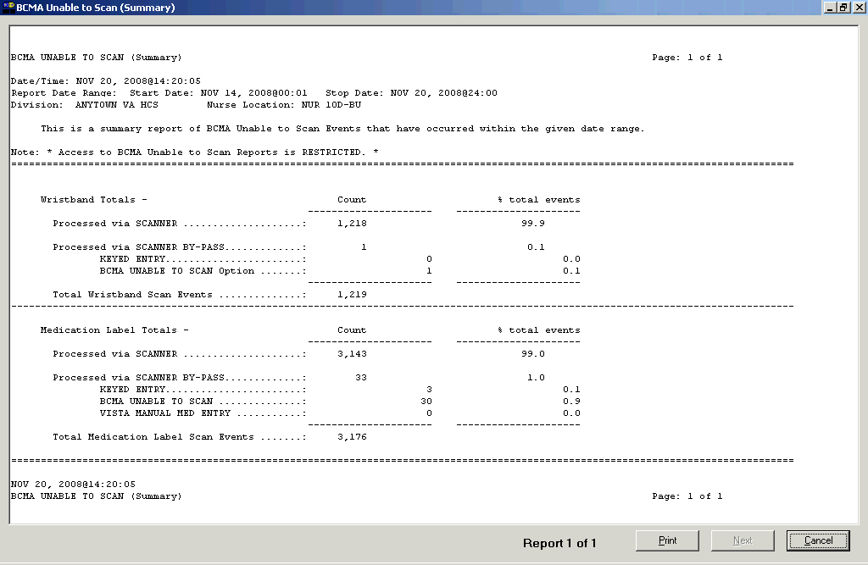

Glossary

|  |  |
| --- | --- |
| BCMA Lingo | The alphabetical listings, in this chapter, are designed to familiarize you with the many acronyms and terms used within this manual and the BCMA software. |

Example: Alphabetical Listing of BCMA Acronyms and Terms

|  |  |
| --- | --- |
| Acronym/Term | Definition |
| Active | When a medication has been verified, it becomes “active,” and displays on the VDL under the related Medication Tab. A nurse can then administer the medication to the patient. Under the IV Medication Tab, this information is listed in the Status column. |
| Additive | A drug added in small amounts to an IV solution to improve, strengthen, or otherwise alter it for parenteral administration. |
| Administration History Report | A report in CPRS that lists the date, time, and orderable item of a medication selected on the CPRS Meds Tab. This report is called “Medication History Report” in BCMA. |
| Administration Times Report | A report that lists a patient’s medications by the scheduled administration time (from the earliest to the latest). |
| ADR | **A**dverse **D**rug **R**eaction. See definition under “Adverse Drug Reaction.” |
| Adverse Drug Reaction | Also called “ADR," any response to a drug which is noxious and unintended, and which occurs at doses normally used in humans for treatment, diagnosis, or therapy of a disease, or for modifying physiological functions, including toxicity caused by overdose, drug interaction, drug abuse, drug withdrawal, significant failure of expected action, food-drug interaction, or allergy. |
| Allergy | A type of Adverse Drug Reaction (ADR) that involves a hypersensitivity (i.e., shortness of breath, hives) to a specific substance (i.e., food, drug, chemical). |
| Audits | The process that tracks the activities of nurses administering medications, by recording selected types of events in the patient’s Medication Log. |
| Available | This status for an IV bag indicates that the Pharmacy has printed a bag label, and the bag is either being prepared, has been prepared, or has been delivered to the ward for administration. Multiple available bags may display for any specific IV order at any given point in time. |
| BCMA | **B**ar **C**ode **M**edication **A**dministration. A **V***IST***A** software application used in VAMCs for validating patient information and medications against active medication orders *before* being administered to a patient. |
| BCMA Clinical Reminders | A marquee located in the lower, right-hand corner of the VDL that identifies PRN medication orders needing effectiveness documentation. The setting is based on the “PRN Documentation” site parameter, and applies to current admissions or to the site parameter timeframe (whichever is greater). A mouse-over list displays when the pointer is placed over the PRN Effectiveness Activity, or a full list is available by double clicking on the Activity. |

Glossary

Example: Alphabetical Listing of BCMA Acronyms and Terms

|  |  |  |
| --- | --- | --- |
| Acronym/Term | Definition | |
| CHUI | **Ch**aracter-based **U**ser **I**nterface. |
| Clinician | VAMC personnel who administer active medication orders to patients. |
| Clinic Order Mode | When the Clinic Order mode is selected, clinic medication orders,only, display on the Cover Sheet, Unit Dose, IVP/IVPB and IV tabs. If the patient status is not admitted, the Clinic order mode defaults, and the Virtual Due List Parameters area is replaced by the Clinic Order Date area, the Clinic column is added, and the HSM column is removed from the Unit Dose tab. The “Clinic” column displays the clinic name associated with the order. A GREEN “alert light” indicates that active medication orders exist and/or an action needs to be taken on an expired or discontinued order. |
| Completed | This status for an IV bag indicates that the infusion has been completed, and the bag is being taken down or replaced with a new bag. No additional actions may be taken on a bag marked as “Completed,” other than to enter comments. |
| Continuous Order | A medication given continuously to a patient for the life of the order, as defined by the order Start and Stop Date/Time. |
| Cover Sheet | An optional tab on the VDL that provides four alternate user-selectable views of medication data related to the selected patient, and allows the user to drill down to view additional data. The Cover Sheet displays information by order, instead of by administration, as is displayed on the Medication Tabs, and does not allow the user to edit or take action against a patient record. |
| Cumulative Vitals/ Measurement Report | A report that lists a patient’s vitals from the Vitals package, along with their demographics and hospital location information |
| CPRS | **C**omputerized **P**atient **R**ecord **S**ystem. A **V***IST***A** software application that allows users to enter patient orders into different software packages from a single application. All pending orders that appear in the Unit Dose and IV packages are initially entered through the CPRS package. Clinicians, managers, quality assurance staff, and researchers use this integrated record system. | |
| CPRS Med Order Button | Also called the “Hot Button,” a direct link to CPRS for electronically ordering, documenting, reviewing and signing verbal- and phone-type STAT and medication orders that a clinician has already administered to patients. This feature is particularly useful in ICU-type environments, as it helps to streamline the workflow in such a busy setting. | |
| Dispensed Drug | A drug whose name has the strength associated with it (e.g., Acetaminophen 325 mg). The name without the strength is called the “Orderable Item Name.” | |
| Due List Report | A report that provides detailed information about active *and* future Unit Dose and IV medication orders that are “due” for administering to a patient during a time frame that you specify within a 24-hour period. | |
| Electronic Signature Code | Authorizes that you are the user logged in to BCMA. This code is a site parameter setting in GUI BCMA. | |
| Finish | The process in which the pharmacist adds the information necessary to make the order active. For example: dispense drug, and start/stop date. | |
| Frequency | Intervals between medication doses administered to a patient. | |

Glossary

Example: Alphabetical Listing of BCMA Acronyms and Terms

|  |  |
| --- | --- |
| Acronym/Term | Definition |
| Given | When a medication is administered to a patient, it is considered to be “Given” and marked as such (with a “G”) in the Status column of the VDL. |
| GUI | **G**raphical **U**ser **I**nterface. The type of interface chosen for BCMA. |
| Held | When a medication is not actually taken by a patient, it is considered to be “Held” and marked as such (with an “H”) in the Status column of the VDL. Reasons might include the patient being temporarily off the ward. You can select and mark multiple medications as Held on the VDL using the Right Click drop-down menu. In the case of IV bags, this status indicates that the dose was Held. The only actions available for this type of IV bag are to mark the bag as Infusing or Refused, or to submit a Missing Dose Request to the Pharmacy. |
| Provider Hold | To display a medication order grayed out on the VDL until its Stop Date/Time or until it is Given. Some medical centers require that a nurse mark these order types as “Held,” although it is *not* necessary that they do so. |
| High Risk/High Alert Medications | Medications that require a second signature by licensed personnel prior to administration. When High Risk/High Alert medications exist, the witness indicator icon appears in the Witness column on all tabs. |
| Hospital-supplied Self Medication | Also called “HSM,” a medication supplied to a patient by a VAMC’s Pharmacy, but administered by a patient. |
| HSM | **H**ospital-supplied **S**elf **M**edication. A medication supplied to a patient by a medical center’s Pharmacy, but administered by a patient. |
| IEN | **I**nternal **E**ntry **N**umber. The internal entry drug number entered by Pharmacy personnel into the DRUG file (#50) to identify Unit Dose and IV medications. |
| Inactive Date | The date that a medication order is no longer active and cannot be administered to a patient. |
| Infusing | This status, for an IV bag, indicates that the bag is actively being infused. A nurse can enter a comment by right clicking on the bag. If an IV bag is scanned, the only allowable actions are to mark the IV bag as Stopped or Completed. |
| Infusion Rate | The flow rate at which medication (fluid) in an IV Bag is given to a patient. |
| Injection Site History | To assist in rotating injection sites where applicable, the Injection Site History summarizes the previous injection site for the orderable item (up to 4) and all injection sites within the time frame (nn), specified by the BCMA Site Parameter, “Injection Site History Max Hours.” The default is 72 hours. |
| Inpatient Order Mode | When the Inpatient Order Mode is selected, inpatient medication orders, only, display on the Cover Sheet, Unit Dose, IVP/IVPB, and IV tabs. When a patient record is open, if the patient status is admitted, the Inpatient order mode defaults. A GREEN “alert light” indicates that active medication orders exist and/or an action needs to be taken on an expired or discontinued order. |

Glossary

Example: Alphabetical Listing of BCMA Acronyms and Terms

|  |  |
| --- | --- |
| Acronym/Term | Definition |
| Internal Entry Number | Also called “IEN,”the internal entry drug number entered by Pharmacy personnel into the DRUG file (#50) to identify Unit Dose and IV medications. |
| IHS | Indian Health Service |
| IV | A medication given intravenously (within a vein) to a patient from an IV Bag. IV types include Admixture, Chemotherapy, Hyperal, Piggyback, and Syringe. |
| IVP | Also called “IV Push,” a Unit Dose order with a Medication Route of “IVP” or “IV PUSH.” |
| IVPB | Also called “IV Piggyback,” an IV order with an IV type of Piggyback. |
| IV Bag Chronology | On the IV Medication Tab, the area of the VDL that displays the components (with related icons) for all displayable IV bags or Ward Stock bags. |
| IV Bag Detail | Provides detailed information about the actions taken on the IV bag or Ward Stock bag identifier currently selected in the IV Bag Chronology display area such as the date/time, clinician, action, and comments. |
| Last Action Column | Based on the orderable item (*not* the medication), to identify to the nurse the last action that occurred on the active medication displayed. |
| Last Site Column | On the Unit Dose and IVP/IVPB tabs of the VDL, the Last Site column displays the location of the last injection site for the orderable item, when applicable. Applies to administrations that participate in injection site rotation, i.e., with medication routes of Intramuscular, Intradermal, or Subcutaneous. |
| Limited Access BCMA | A mode in which BCMA can be accessed that provides medication administering users the ability to access the BCMA application without being at the patient’s bed side. Active, discharged, and deceased patient records can be opened in Limited Access mode without scanning or using Unable to Scan. |
| MAH | **M**edication **A**dministration **H**istory. A patient report that lists a clinician’s name and initials, and the exact time that an action was taken on an order (in a conventional MAR format). Each order is listed alphabetically by the orderable item. The Date column lists three asterisks (***) to indicate that a medication is not due. The report also lists information about when an order is placed “On Hold” and taken “Off Hold” by a provider, and the order Start and Stop Date/Time for the medication. |
| MAR | **M**edication **A**dministration **R**ecord. The traditional, handwritten record used for noting when a patient received a medication. BCMA replaces this record with an MAH. |
| Medication Administration History Report | Also called “MAH,” **M**edication **A**dministration **H**istory. A patient report that lists a clinician’s name and initials, and the exact time that an action was taken on an order (in a conventional MAR format). Each order is listed alphabetically by the orderable item. The Date column lists three asterisks (***) to indicate that a medication is not due. The report also lists information about when an order is placed “On Hold” and taken “Off Hold” by a provider, and the order Start and Stop Date/Time for the medication. |
| Medication History Report | A report in BCMA that lists the date, time, and orderable item of a medication selected on the VDL. This report is called “Administration History Report” in CPRS. |

Glossary

Example: Alphabetical Listing of BCMA Acronyms and Terms

|  |  |
| --- | --- |
| Acronym/Term | Definition |
| Medication Log Report | Also called “Med Log,” a report that lists every action taken on a medication order within a specified 24-hour period. You can choose to include/exclude comments and Audits performed on the patient’s medication orders. |
| Medication Order Display Area | The area of the VDL that displays active medication orders, scheduled for administration, according to the Virtual Due List Parameters and Schedule Types selected. |
| Medication Route | Also called “Route” or “Med Route,” the method by which a patient receives medication (i.e., PO, IV, IM, ID, SQ, and SC). Each VAMC determines routes and associated abbreviations, which cannot exceed five characters in length. Otherwise they will *not* fit on bar code labels and the MAH. |
| Medication Tab | Used to separate and view a type of active medication order (i.e., Unit Dose IV Push, IV Piggyback, and large-volume IVs) that needs to be administered to a patient. The Tab under which an order displays depends on how it was entered. The “alert light” on a Tab turns **GREEN** *only* when a medication order exists for the Schedule Type selected within the respective start/stop date and time selected on the BCMA VDL. If grayed out, then none exist. |
| Medication Variance Log Report | A report in BCMA that provides “exceptions” (variances) to the medication administration process. It also lists “event” information within a selected date range, such as the type and number of events, and the total percentage of events that occurred. A variance preceded by a minus sign (such as –24) indicates the number of minutes that a medication was given before the administration time. |
| Missing Dose | A medication considered “Missing.” BCMA automatically marks this order type (with an “M”) in the Status column of the VDL after you submit a Missing Dose Request to the Pharmacy. If an IV bag displayed in the IV Bag Chronology display area of the VDL is *not* available for administration, you may mark the IV bag as a “Missing Dose” using the Missing Dose button or by right clicking the IV bag and selecting the Missing Dose command in the Right Click drop-down menu. |
| Missed Medications Report | A report that lists information about Continuous and One-Time Unit Dose and IV Piggyback medications that were *not* administered to a patient. |
| National Drug Code | Also called “NDC,” the number assigned by a manufacturer to each item/medication administered to a patient. |
| NDC | **N**ational **D**rug **C**ode. The number assigned by a manufacturer to each item/medication administered to a patient. |
| Non-Nurse Verified | Medication orders that are not verified by a nurse. |
| Not Given | The status that a scanned medication marked as “Given,” but *not* actually taken by a patient, is changed to on the VDL. The administration will display on the VDL as it appeared *before* it was marked as “Undo–Given.” BCMA notes the status change only in the Audit Trail section of the Medication Log (*not* on the VDL). |

Glossary

Example: Alphabetical Listing of BCMA Acronyms and Terms

|  |  |
| --- | --- |
| Acronym/Term | Definition |
| NOW Order | A medication order given ASAP to a patient, entered as a One-Time order by Providers and Pharmacists. This order type displays for a fixed length of time on the VDL, as defined by the order Start and Stop Date/Time. | |
| Order | A medication order given ASAP to a patient, entered as a One-Time order by providers and pharmacists. This order type displays for a fixed length of time on the VDL, as defined by the order Start and Stop Date/Time. | |
| On-Call Order | A specific order or action dependent upon another order or action taking place *before* it is carried out. For example, “Cefazolin 1gm IVPB On Call to Operating Room.” Since it may be unknown when the patient will be taken to the operating room, the administration of the On-Call Cefazolin is dependent upon that event. | |
| One-Time Order | A medication order given one time to a patient such as a STAT or NOW a order. This order type displays for a fixed length of time on the VDL, as defined by the order Start and Stop Date/Time or until it is Given. | |
| Orderable Item | A drug whose name does NOT have the strength associated with it (e.g., Acetaminophen 325 mg). The name with a strength is called the “Dispensed Drug Name.” | |
| Patient Record Flag | Also called “PRF” or “Patient Flag.” The Patient Record Flag alerts VHA employees to patients whose behavior or characteristics may pose a threat either to their safety, the safety of other patients, or compromise the delivery of quality health care. | |
| Patient Record Flag Report | A report that displays all active PRF assignments associated with a patient. Applicable National (Category I) and Local (Category II) flag types are displayed. | |
| Patient Transfer Notification | A message that displays when a patient’s record is opened or the Unit Dose or IVP/IVPB Medication Tab is viewed for the first time. It indicates that the patient has had a movement type (usually a transfer) within the site-definable parameter, and the last action for the medication occurred before the movement, but still within the defined timeframe. | |
| Pending Order | An order entered by a provider through CPRS without Pharmacy personnel verifying the order. | |
| PRF | The abbreviation for **P**atient **R**ecord **F**lag. See definition under “Patient Record Flag.” | |
| PRN Effectiveness List Report | A report that lists PRN medications administered to a patient that needs Effectiveness comments. | |
| PRN Order | The Latin abbreviation for **P**ro **R**e **N**ata. A medication dosage given to a patient on an “as needed” basis. | |
| Provider | Another name for the “Physician” involved in the prescription of a medication (Unit Dose or IV) to a patient. | |
| PSB CPRS MED BUTTON | The name of the security “key” that must be assigned to nurses who document verbal- and phone-type STAT and medication orders using the CPRS Med Order Button on the BCMA VDL. | |

Glossary

Example: Alphabetical Listing of BCMA Acronyms and Terms

|  |  |  |
| --- | --- | --- |
| Acronym/Term | Definition | |
| PSB INSTRUCTOR | The name of the security “key” that must be assigned to nursing instructors, supervising nursing students, so they can access user options within BCMA V. 3.0. |
| PSB MANAGER | The name of the security “key” that must be assigned to managers so they can access the PSB Manager options within BCMA V. 3.0. |
| PSB READ ONLY | The name of the security “key” that must be assigned to users that can only access BCMA in Read-Only mode. Users who are assigned the PSB READ ONLY security key will never be able to administer medications or perform any actions against a patient’s medical record. The PSB READ ONLY security key overrides all other BCMA security keys. |
| PSB STUDENT | The name of the security “key” that must be assigned to nursing students, supervised by nursing instructors, so they can access user options with BCMA V. 3.0. This key requires that a nursing instructor sign on to BCMA V. 3.0. |
| PSB UNABLE TO SCAN | The name of the security “key” that must be assigned to allow the user to run the Unable to Scan detailed and summary reports. |
| Read-Only BCMA | A mode in which BCMA can be accessed that provides non-medication administering users the ability to view a patient’s VDL and print reports, without performing any actions against a patient’s medical record. |
| Refused | The status for an IV bag or Unit Dose to indicate that the patient refused to take the dose. |
| Removed | The status for a patch (i.e., Nitroglycerin, Fentanyl, or Nicotine) to indicate that it has been removed from a patient. Once removed, the letters “RM” (for “Removed”) display in the Status column of the VDL. |
| Schedule | The frequency at which a medication is administered to a patient. For example, QID, QDAILY, QAM, Q4H. |
| Schedule Type | Identifies the type of schedule (i.e., Continuous, PRN, On-Call, and One-Time) for the medication being administered to a patient. |
| Schedule Type Indicator | A **GREEN** “alert light” indicates that a medication order exists for the Schedule Type selected within the respective start/stop date and time selected on the BCMA VDL. If grayed out, then none exist. |
| Security Keys | Used to access specific options within BCMA that are otherwise “locked” without the security key. Only users designated as “Holders” may access these options. |
| SM | **S**elf **M**edication. A medication supplied *and* administered by a patient. |
| Solution | A homogeneous mixture of two or more substances. For IVs, these would be liquids. |
| Start Date/Time | The date and time that a medication is scheduled for administration to a patient. |
| STAT Order | A medication order given immediately to a patient, entered as a One-Time order by providers and pharmacists. This order type displays for a fixed length of time on the VDL, as defined by the order Start and Stop Date/Time. |

Glossary

Example: Alphabetical Listing of BCMA Acronyms and Terms

|  |  |
| --- | --- |
| Acronym/Term | Definition |
| Status | A code used to inform a clinician about the condition or progress of a medication order. For Unit Dose and IVP/IVPB orders, status codes include G=Given, H=Held, R=Refused, M=Missing, and RM=Removed (patch removal only). For IV orders, status codes include I=Infusing, H=Held, R=Refused, S=Stopped, C=Completed, and M=Missing. |
| Status Bar | Includes the name of the clinician(s) administering medications, plus the name of the division, and the time current Server time (system time). |
| Stop Date/Time | The date and time that a medication order will expire, and should no longer be administered to a patient. |
| Stopped | This status, for an IV bag, indicates that the IV bag was scanned as Infusing, but was then stopped by a nurse. An IV bag may be stopped and restarted for a variety of reasons. The only actions allowed on a “Stopped” IV bag is to mark the bag as Infusing, Completed, Held, or Refused. |
| Strength | The degree of concentration, distillation, or saturation of a medication. |
| Unable to Scan (Detailed) Report | A report in BCMA that provides a list of scanning failures and the reasons that were provided for the scanning failures of patient wristbands and medication administrations. |
| Unable to Scan (Summary) Report | A report in BCMA that provides the total number of wristbands scanned, wristbands bypassed, medications scanned, and medications bypassed. |
| Unique Identifier Number | The number generated for IV and IV Piggyback medications when the Pharmacy prints a bar code label for an IV bag. It helps to identify which IVs have been manufactured by the Pharmacy. For IV Piggyback orders, use the Available Bags command in the Right Click drop-down menu. For IV orders, locate it in the IV Bag Chronology display area of the VDL. |
| Unit Dose | A medication given to a patient, such as tablets or capsules. |
| Unknown Status | If an order created in BCMA CHUI Manual Medication Entry is not completed with a valid administration status, the Admin Status will be stored as null (blank), but will display as “U” (unknown) in the BCMA VDL Status column and “Unknown” in the Last Action column. An Unknown administration status must be corrected using Edit Med Log. The unknown (null) status can occur during Manual Medication Entry when the user’s network connection is broken, their terminal emulator software malfunctions, or if the user improperly exits out of the application. |
| Verify | When a nurse or a pharmacist confirms that a medication order is accurate and complete, according to the information supplied by the provider. |
| VDL | **V**irtual **D**ue **L**ist. An on-line “list” used by clinicians when administering active medication orders (i.e., Unit Dose, IV Push, IV Piggyback, and large-volume IVs) to a patient. This is the Main Screen in BCMA. |
| Virtual Due List | Also called “VDL,”an on-line list used by clinicians when administering active medication orders to a patient. This is the Main Screen in BCMA. |
| Ward Stock | Unit Dose and IV medications that are “stocked” on an ongoing basis on wards and patient care areas. They are packaged in a ready-to-use form or compounded by the medication administrator. |
| Witness for High Risk/High Alert Medications | An authorized witness required or recommended, who must sign on, before the user is allowed to administer High Risk/High Alert medications. The witness must have valid sign-on credentials. |