Pharmacy Reengineering (PRE) Inbound ePrescribing (IEP) 3.1 User Manual

June 2020

Version 3.0 (Unit 5)

Department of Veterans Affairs (VA) Office of Information and Technology (OIT)

Revision History

Date | Version | Description | Author
06/15/2020 | 3.0 | PSO*7.0*610:  - Added NOTE to indicate a minor change in the display of the Station ID drop-down list in the Reports tab  - Updated Title page, Revision History, and Footers | REDACTED
03/23/2020 | 2.9 | PSO*7.0*590:  - Added production application URL  - Updated Title page, Revision History, and Footers | REDACTED
03/05/2020 | 2.8 | PSO*7.0*591:  - Updated Figure 3-44 and Figure 3-53.  - Updated Title page, Revision History, and Footers | REDACTED
08/27/2019 | 2.7 | PSO*7.0*567:  - Help Desk contact information/name  - Screen capture dates for ERX Lookback Days beginning with page 98 through 189.  - Corrected Figure 3-12 and reworded the bullets above  - Added Figure 3-13  - Title page, TOC, LOF, and Footers | REDACTED
05/07/2019 | 2.6 | PSO*7.0*551:  Updated document for the following:  - Standardized images throughout document.  - Clarified patient DOB format under Table 3.  - Added Note to replace text “Dispense Notes” with “Substitutions” under Track/Audit Details screen in the Inbound/Outbound Message Detail section.  - Added Note to indicate the change of screen/page title from “Users” to “User Management” in the User Management section.  - Included description for ERX LOOK-BACK DAYS display on the Holding Queue’s Traditional View and Patient Centric Views in the eRx Default Lookback Days section.  - Replaced column label “LAST USER” with “LOCKED BY” and updated the description under Table 9. | Technatomy
- Added the information for LOCKED BY column in the Patient Centric View section.
- Replaced Figure 3-14, Figure 3-16, Figure 3-17, Figure 3-18, Figure 3-19, Figure 3-42,
Figure 3-52, Figure 3-55, Figure 3-56, Figure
3-57, Figure 3-59, Figure 3-60, Figure 3-61, and Figure 3-68 for updated layout
- Added Note and included Figure 3-48 to indicate to the user that a Provider’s DEA# has expired in the Edit Provider section.
- Removed reference to “Limited Duration” field from Validate Drug/SIG for the modified workflow in the Edit Drug/SIG section.
- Added description under Note for modified workflow in the Edit Drug/SIG section.
- Updated description for VistA Days Supply calculation in the Additional Field-level Information: section.
- Added scenarios for Quantity/Days Supply workflow under VD Edit screen based on Available Dosage(s) in the Quantity/Days Supply work flow under Validate Drug/SIG >> Edit: section.
- Added Note to replace text “Qty Qualifier” with “Code List Qualifier” and replace, “DAW Code’ with “Substitutions” in the Complete Orders from OERR and Patient Prescription Processing section.
- Added Note describing eRx Date, Date Written, Issue Date and Written Date fields in the Complete Orders from OERR and Patient Prescription Processing section.
11/09/2018 | 2.5 | Updated per HPS Review pgs.: 55, 57, 87, 88, 90,  92, 194, and 195.  Updated Cover page to month of November (pg. i) (TWR, 508 accessibility checks, document is compliant). | Technatomy
10/24/2018 | 2.4 | Update TOC – Remove Graphic and reran TOC. | Technatomy
08/27/2018 | 2.3 | Technical Writer Review and 508 accessibility checks. | Technatomy
08/01/2018 | 2.2 | Updated screenshots and added Refill Requests and Responses and Cancel Rx Requests and Responses sections. | REDACTED
07/28/2018 | 2.1 | Updated screenshots and added 30-day Lookback | Technatomy
04/12/2018 | 2.0 | Updated screenshots to include 2.1 changes | REDACTED
11/15/2017 | 1.0 | Baseline release: Updated Table of Figures. | Technatomy

Date | Version | Description | Author
Updates based on feedback from HPS.
Updated screenshots and verbiage throughout the document, formatting and sections Inbound ePrescribing Workflow and Summary Screen, Pharmacy Management section.
Updates made based on changes made during SureScripts Certification and IOC Production Testing

Table of Contents

Unit 5
Cancel R_{x} Requests and Responses 1
Cancel R_{x} Request in the eR_{x} Holding Queue 1
Cancel R_{x} Response in the eR_{x} Holding Queue 1
Approved 2
Denied 2
Cancel R_{x} Request Message Details View 2
Cancel R_{x} Response Message Details View 4
Cancel R_{x} Process 5
Cancel R_{x} Process - eR_{x} Records in the Holding Queue 5
Cancel R_{x} Process - eR_{x} Records in Outpatient Profile 11
Cancel R_{x} Request Failed (CAF) 18
Cancel R_{x} Request Received (CAR) 19
Inbound Error – CNE 19
Acknowledge: Hidden Action for Cancel R_{x} Request 19
Acknowledge: Automated Cancel R_{x} Response Sent 20
Acknowledge: No Automated Cancel R_{x} Response Sent 22
Add Comments: Hidden Action for Cancel R_{x} Request/Response 26
APPENDIX A. ACRONYMS AND ABBREVIATIONS 29
APPENDIX B. HOLDING QUEUE STATUS CODES & DESCRIPTIONS 31
APPENDIX C. NCPDP ERROR CODES 36
APPENDIX D. REFILL REQUEST PRECONDITIONS AND WARNINGS 37

List of Figures
Figure 5-1: CAO Status in Holding Queue 1
Figure 5-2: Holding Queue List View 3
Figure 5-3: Cancel Rx Request Details 3
Figure 5-4: Cancel Rx Request Details – Cancel Request Information 4
Figure 5-5: Holding Queue List View - Cancel Response 4
Figure 5-6: Cancel Rx Response Details 5
Figure 5-7: Holding Queue List View – CAP 7
Figure 5-8: CAP Details Screen 1 7
Figure 5-9: CAP Details Screen 2 8
Figure 5-10: CAO Status in Holding Queue List View 9
Figure 5-11: CAO Details Screen 1 9
Figure 5-12: CAO Details Screen 2 10
Figure 5-13: CAH Status in Holding Queue List View 11
Figure 5-14: CAH Details Screen 11
Figure 5-15: Medication Profile 13
Figure 5-16: Rx Activity Log 1 14
Figure 5-17: Rx Activity Log 2 14
Figure 5-18: Cancel Rx Details Screen in Holding Queue 1 15
Figure 5-19: Cancel Rx Details Screen in Holding Queue 2 15
Figure 5-20: New Rx Details Screen 16
Figure 5-21: Cancel Completed in Holding Queue 18
Figure 5-22: Holding Queue – eRx in CAO Status 20
Figure 5-23: Additional Action - ACK 21
Figure 5-24: Acknowledge Record 21
Figure 5-25: Holding Queue – CAA Status 22
Figure 5-26: Cancel Request Acknowledged 22
Figure 5-27: Holding Queue – eRx in CAH Status 23
Figure 5-28: Additional Action - ACK 24
Figure 5-29: Select Response Type 24
Figure 5-30: Acknowledge Record 25
Figure 5-31: Holding Queue – CAA Status 25
Figure 5-32: Cancel Request Acknowledged 26
Figure 5-33: Add Comments 27
Figure 5-34: Cancel Rx Request Comments 27
Figure 5-35: Cancel Rx Request Comments 28
Figure 5-36: Cancel R_{x} Request Comments Updated 28

List of Tables
Table 10: Cancel Rx Request and Response 6
Table 11: Scenarios for Automated Approved Cancel Rx Responses 8
Table 12: Scenarios for Manual Approved or Denied Cancel Rx Responses 10
Table 13: Scenarios for Automated Approved Cancel Rx Responses 12
Table 14: Scenarios for Manual Approved or Denied Cancel Rx Responses 17
Table 15: Scenarios for Cancel Rx Failed 18
Table 16: Acronyms and Abbreviations 29

Cancel R_{x} Requests and Responses
The Cancel Rx Request is sent by the external/non-VA provider for an original New Rx so it is not processed and dispensed by VA Pharmacy. Upon successfully canceling a New Rx (or auto- Discontinue in Outpatient), VA Pharmacy sends back either an automated or manual Cancel Rx Response. When an automated Cancel Rx Response is sent to the provider’s EHR system, user intervention is not required. When a user has to take action on the prescription for which a Cancel Rx Request has been received, the user may send a manual Cancel Rx Response.

Cancel R_{x} Request in the eR_{x} Holding Queue
When a Cancel Rx Request is received in the Holding Queue, it is displayed in the list view in one of the actionable statuses until it is acknowledged. Depending on the status of the New Rx on which the Cancel Rx Request has been received, the status of the request is changed according to the status of the New Rx prior to canceling or auto-Discontinuing. For a full list of Cancel Rx Request statuses, please refer to Table 20: Holding Queue Status Codes & Descriptions for Cancel Request Message Type in this guide.
Once the request is acknowledged, it is no longer displayed in the list view. Cancel Rx Request messages may be retrieved at any point using <MV> Message View and/or <SR> Search.
- From the eRx Holding Queue List screen, type <MV> Message View.
- Type Cancel Request.
The Cancel Rx Request message statuses are displayed in the “Status” column on the eRx Holding Queue. For Cancel Rx Request statuses, refer to Table 20: Holding Queue Status Codes & Descriptions for Cancel Request Message Type in Appendix B.

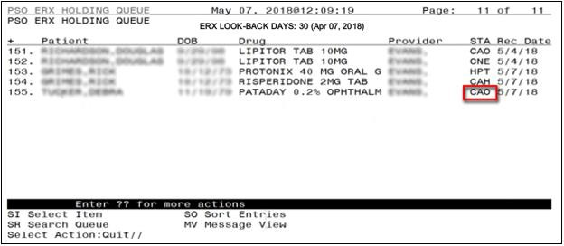
Figure 5-1: CAO Status in Holding Queue

Cancel R_{x} Response in the eR_{x} Holding Queue
There are two types of Cancel Rx Responses:

- Approved
- Denied

Approved
An Approved Cancel Rx Response is sent back to the requesting non-VA Provider when either the system or the user has been able to successfully cancel or auto-Discontinue the original New Rx.
- In most cases, the system sends an automated Approved Cancel Response to the requesting non-VA Provider.
- In certain cases, the system only cancels the original New Rx in the Holding Queue and does not send an automated response. In these scenarios, the user can acknowledge the request and send a manual response.

Denied
A Denied Cancel Rx Response is sent back to the requesting non-VA Provider when either the system or the user has not been able to successfully cancel or auto-Discontinue the original New Rx.
- At this time, there is no automated Denied Cancel Rx Response sent from VA Pharmacies to the requesting non-VA Provider.
- When the user has not been able to locate and cancel/auto-Discontinue the original New Rx or when the user has chosen not to cancel/auto-Discontinue the original New Rx, the user may acknowledge the request and send a manual Denied response.
For more information on this, please refer to the Cancel Rx Process section in this guide. For more information on how to acknowledge a Cancel Rx Request, please refer to Acknowledge: Hidden Action for Cancel Rx Request section in this guide.

Cancel R_{x} Request Message Details View
The Pharmacy user may select the Cancel Rx Request message from the Holding Queue to view the message details in the Message Details View.
- From the eRx Holding Queue List screen, type <MV> Message View.
- Type Cancel Request.

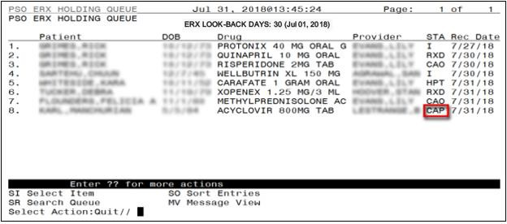
Figure 5-2: Holding Queue List View

- Select the desired record from the list. The Cancel Rx Request message details display.
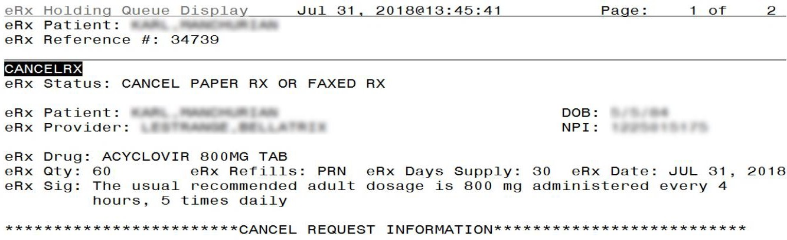
Figure 5-3: Cancel Rx Request Details
The user may continue to scroll through the Cancel Rx Request Details page to view Cancel Request Information.

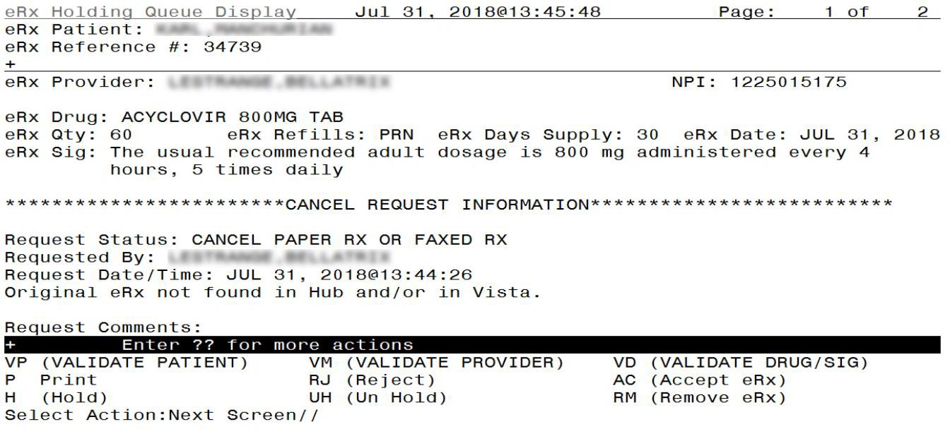
Figure 5-4: Cancel Rx Request Details – Cancel Request Information

Cancel R_{x} Response Message Details View
The Pharmacy user may select the Cancel Rx Response message from the Holding Queue to view the message details in the Message Details View.
- From the eRx Holding Queue List screen, type <MV> Message View.
- Type Cancel Response.
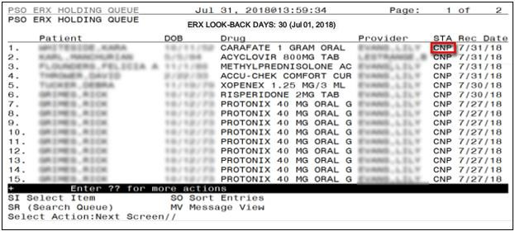
Figure 5-5: Holding Queue List View - Cancel Response

- Select the desired record from the list.

The Cancel Rx Response message details display.
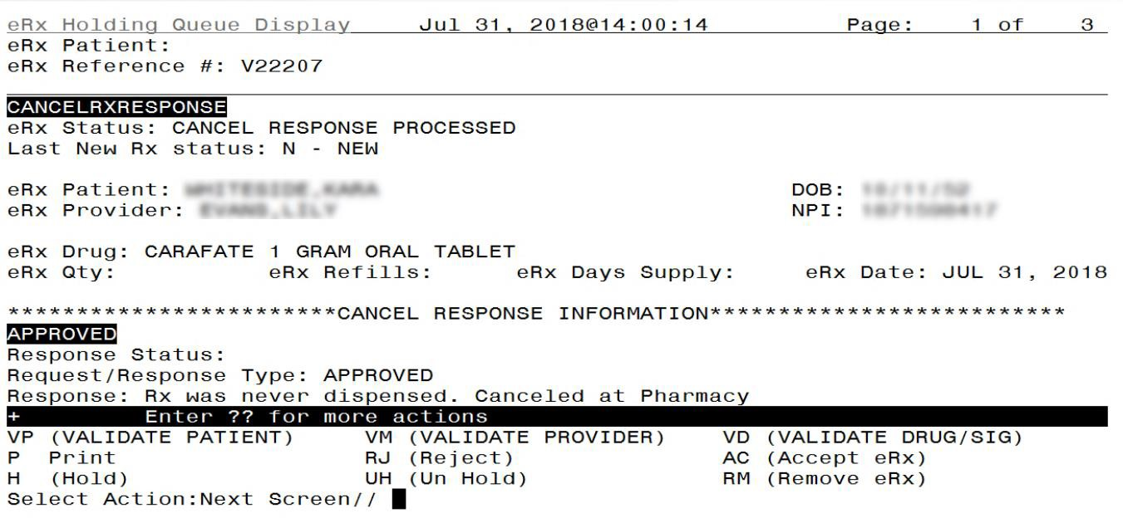
Figure 5-6: Cancel Rx Response Details

Cancel R_{x} Process
The Cancel Rx Process involves auto-Canceling an original New Rx in the Holding Queue and auto-Discontinuing the record in the Outpatient Profile if it is already processed from the Holding Queue. In most cases, the system also sends an Approved Cancel Rx Response.
In some scenarios, the user must manually discontinue the prescription in the Outpatient Profile and then send a manual Approved Cancel Rx Response at the time of acknowledging the request.
If the user is unable to locate the original New Rx and/or if the user is not going to cancel/discontinue the prescription, the user may send a manual Denied Cancel Rx Response.
If a manual Approved Cancel Rx Response, an automated Approved Cancel Rx Response, or a manual Denied Cancel Rx Response is sent successfully from VistA, the status of the Cancel Rx Response is marked CNP (Cancel Response Processed). If the Cancel Rx Response is not successfully sent from VistA to the eRx Transaction Hub, then the corresponding Cancel Rx Request is marked CAX (Cancel Response from VistA Unsuccessful). CNP is a non-actionable status and CAX is an actionable status. They can be retrieved in the Holding Queue using <MV> Message View or <SR> Search actions.

Cancel R_{x} Process - eR_{x} Records in the Holding Queue
When a Cancel Rx Request is received, the eRx Transaction Hub sends the record to the Holding Queue. There are scenarios that apply both when there is no matching New Rx record for the Cancel Rx Request received and when there is a matching New Rx record for the Cancel Rx Request received.

No Matching New Rx or No Auto-Cancel
The following scenarios apply when there is no matching New Rx record for the Cancel Rx Request received:
- If there is no matching New Rx in the eRx Transaction Hub, the request is received and displayed in the Holding Queue’s list view in status CAP (Cancel Paper Rx or Faxed Rx).
- When the Cancel Rx Request is received in the Holding Queue but does not auto-Cancel a record, it is marked with the status CAR (Cancel Request Received).
In cases where the Cancel Rx Request status is marked as CAR or CAP, the user must acknowledge the requests and send out manual Approved or Denied Cancel Rx Responses.
The following table provides the Cancel Rx Request statuses before and after Acknowledging, Cancel Rx Response status, and the information sent back to the requesting non-VA provider on Approved and Denied Cancel Rx Responses.
Table 10: Cancel Rx Request and Response
Cancel Rx Request Status (Before ACK) | Cancel Rx Request Status (After ACK) | Cancel Rx Response Status (After ACK) | Manual Approved Cancel Rx Response >> Note | Manual Denied Cancel Rx Response >> Denial Reason
CAR (CANCEL REQUEST RECEIVED) | CAA (CANCEL REQUEST ACKNOWLEDGED) | CNP (CANCEL RESPONSE PROCESSED) | Rx was never dispensed.  Canceled at Pharmacy. | Rx Not Canceled - Rx not found in pharmacy system.
CAP (CANCEL PAPERRX OR FAXED RX) | CAA | CNP | Rx was never dispensed.  Canceled at Pharmacy. | Rx Not Canceled - Rx not found in pharmacy system.
For more information on <ACK> Acknowledge action, please refer to Acknowledge: Hidden Action for Cancel Rx Request section in this guide.
To view a Cancel Rx Request details screen, select the desired record from the Holding Queue.

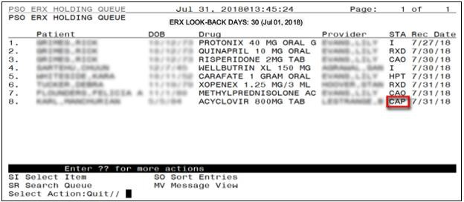
Figure 5-7: Holding Queue List View – CAP

The details screen displays the eRx information along with the Cancel Rx Request information.
Figure 5-8: CAP Details Screen 1

Figure 5-9: CAP Details Screen 2

Matching New Rx Prescription found
When the Cancel Rx Request is received in the Holding Queue and finds a matching New Rx record to be canceled, the status of the New Rx record changes to CAN (Original eRx Canceled in Holding Queue), from its previously known status: N, I, W, H**, RJ or RM. (H** refers to one of the Hold statuses). Once the original prescription is marked CAN, it is not an actionable entry and will not be displayed in the Holding Queue’s list view.

Automated Approved Cancel Rx Responses
Table 11: Scenarios for Automated Approved Cancel Rx Responses
New Rx Status | Cancel Rx Request Status (Before ACK) | Cancel Rx Response Status | Automated Approved Cancel Rx Response >> Note
N (NEW) | CAO (CANCEL PROCESS COMPLETE) | CNP (CANCEL RESPONSE PROCESSED) | Rx was never dispensed. Canceled at Pharmacy.
RJ (REJECTED) | CAO | CNP | Rx was never dispensed. Rejected at Pharmacy.
To view an Automated Cancel Rx Response details screen, select the desired record from the Holding Queue.

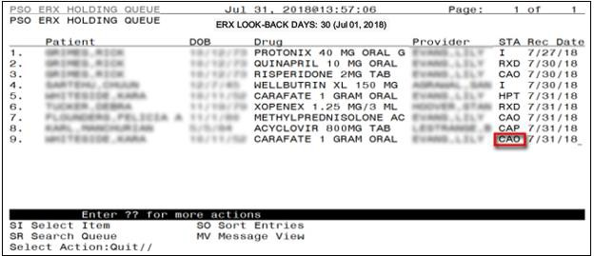
Figure 5-10: CAO Status in Holding Queue List View

The details screen displays the eRx information along with the Cancel Rx Request information.
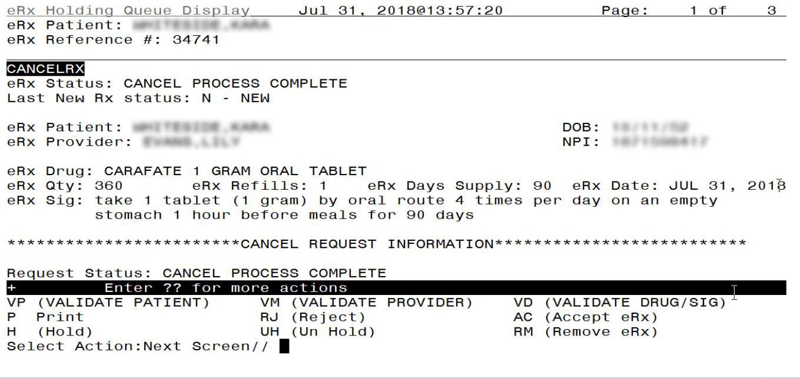
Figure 5-11: CAO Details Screen 1

As the user continues to scroll, the Cancel Response Information displays.

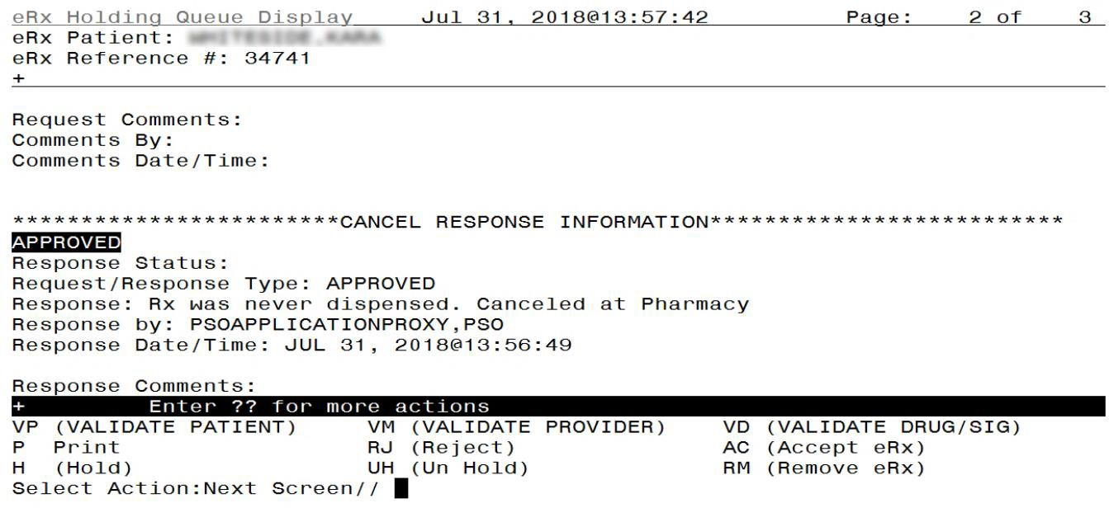
Figure 5-12: CAO Details Screen 2

Manual Approved or Denied Cancel Rx Responses
Table 12: Scenarios for Manual Approved or Denied Cancel Rx Responses
New Rx Status | Cancel Rx Request Status (Before ACK) | Cancel Rx Request Status (After ACK) | Cancel Rx Response Status (After ACK) | Manual Approved Cancel Rx Response  >> Note | Manual Denied Cancel Rx Response >> Denial Reason
I (IN PROCESS) | CAH (CANCEL COMPLETED IN HOLDING QUEUE) | CAA (CANCEL REQUEST ACKNOWLEDGED) | CNP (CANCEL RESPONSE PROCESSED) | Rx canceled at Pharmacy. | Rx Not Canceled  - Rx not found in pharmacy system.
H** (Hold Status) | CAH | CAA | CNP | Rx canceled at Pharmacy. | Rx Not Canceled  - Rx not found in pharmacy system.
W (WAIT) | CAH | CAA | CNP | Rx canceled at Pharmacy. | Rx Not Canceled  - Rx not found in pharmacy system.
RM (REMOVED) | CAH | CAA | CNP | Rx canceled at Pharmacy. | Rx Not Canceled  - Rx not found in pharmacy system.
To view a manually approved Cancel Rx Response details screen, select the desired record from the Holding Queue.

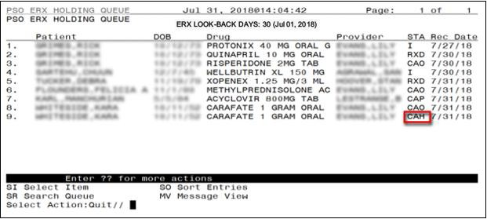
Figure 5-13: CAH Status in Holding Queue List View

The details screen displays the eRx information along with the Cancel Rx Request information. In the example below, the Last New Rx Status displays as I – In Process.
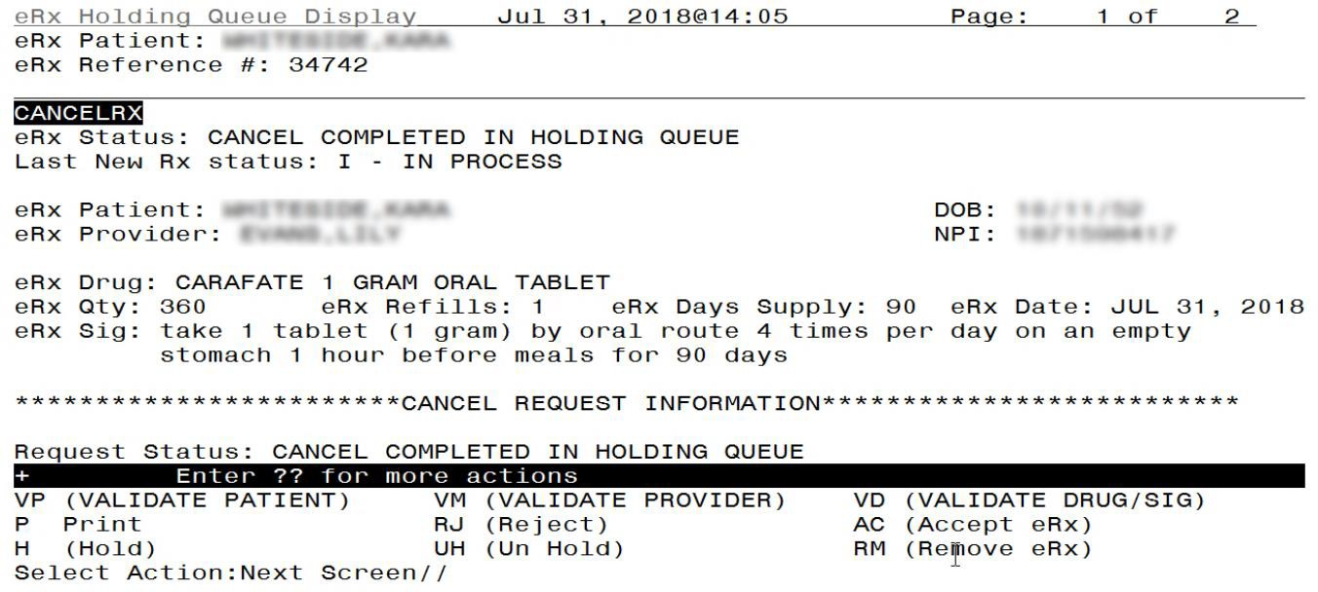
Figure 5-14: CAH Details Screen

Cancel R_{x} Process - eR_{x} Records in Outpatient Profile
When the Cancel Rx Request is received in the Holding Queue for a New Rx record to be canceled, and the status of the New Rx record is PR (Processed), an entry exists on the Outpatient side, the status changes to CAN (Original eRx Canceled in Holding Queue). Once the original prescription is marked CAN, it is not an actionable entry and will not be displayed in the Holding Queue’s list view.

When the New Rx is in one of the statuses as specified in the table below, an automated Approved Cancel Rx Response is sent outbound after auto-Discontinuing the Prescription in OP. The Activity log for the prescription captures the auto-Discontinue activity from this process.

Automated Approved Cancel Rx Responses
Table 13: Scenarios for Automated Approved Cancel Rx Responses
New Rx Prescription Status in OP | Cancel Rx Request Status (Before ACK) | Cancel Rx Response Status | Automated Approved Cancel Rx Response >> Note
Active | CAO (CANCEL PROCESS COMPLETE) | CNP (CANCEL RESPONSE PROCESSED) | First Fill:6/12/18, Last Fill:6/12/18, Refills Remaining:0 (Example only)
Pending | CAO | CNP | Rx was never dispensed. Canceled at Pharmacy.
Discontinued | CAO | CNP | Prescription is already discontinued at the Pharmacy.
Refill | CAO | CNP | First Fill:6/12/18, Last Fill:6/12/18, Refills Remaining:0 (Example only)
Hold | CAO | CNP | First Fill:6/12/18, Last Fill:6/12/18, Refills Remaining:0 (Example only)
Suspended | CAO | CNP | First Fill:6/12/18, Last Fill:6/12/18, Refills Remaining:0 (Example only)
Expired | CAO | CNP | First Fill:6/12/18, Last Fill:6/12/18, Refills Remaining:0 (Example only)
Discontinued by Provider | CAO | CNP | First Fill:6/12/18, Last Fill:6/12/18, Refills Remaining:0 (Example only)
Discontinued (Edit) | CAO | CNP | First Fill:6/12/18, Last Fill:6/12/18, Refills Remaining:0 (Example only)
Provider Hold | CAO | CNP | First Fill:6/12/18, Last Fill:6/12/18, Refills Remaining:0 (Example only)
Navigate to the patient Medication Profile and select the desired eRx record.

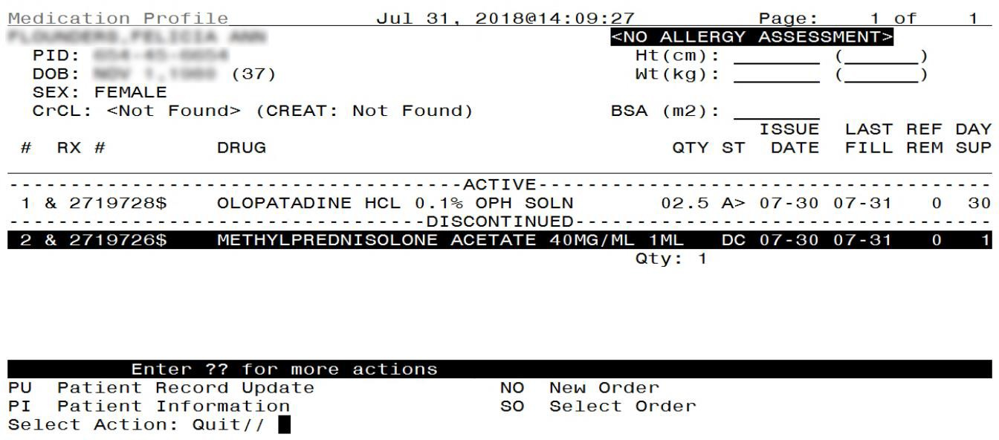
Figure 5-15: Medication Profile

The Rx Activity Log displays.

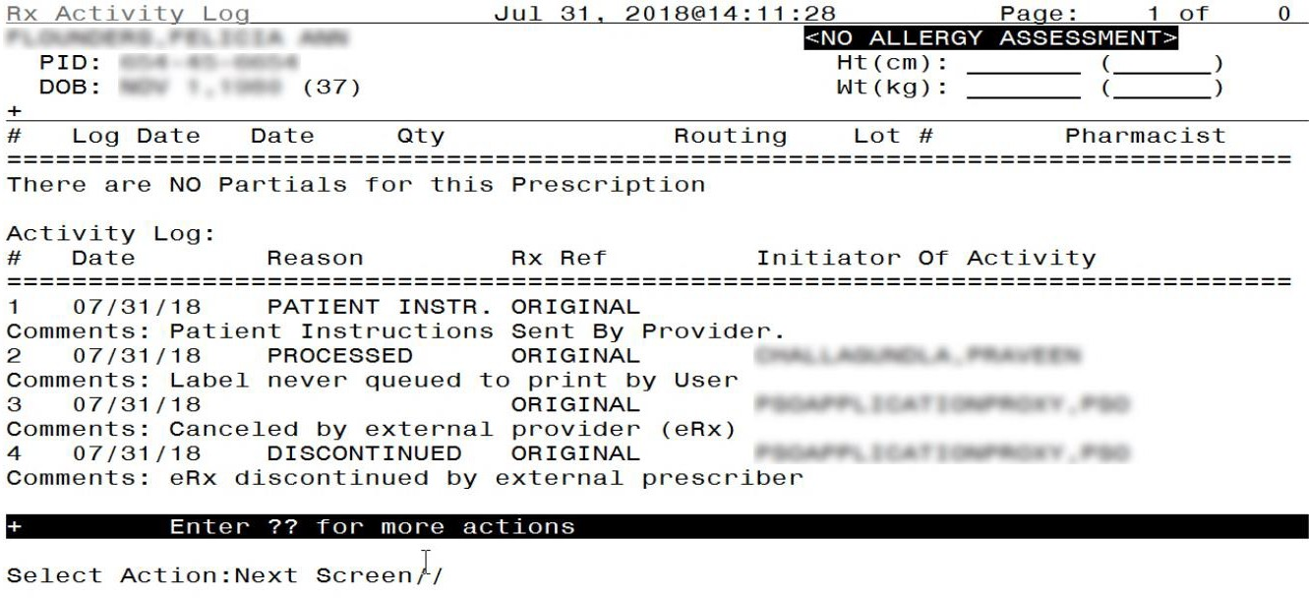
Figure 5-16: Rx Activity Log 1
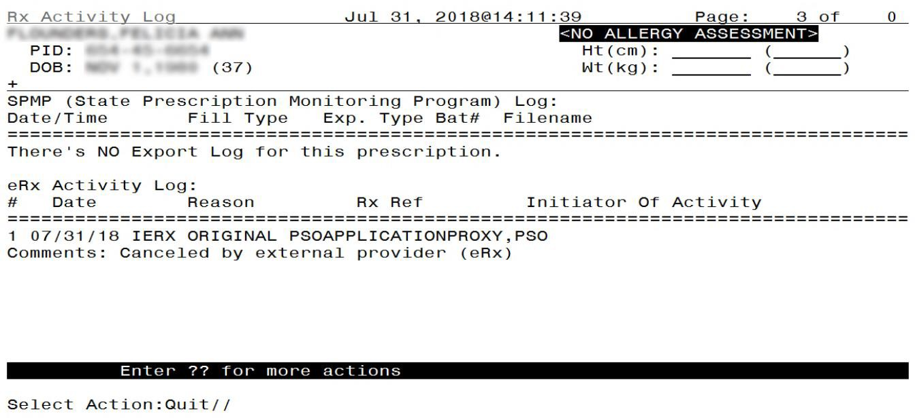
Figure 5-17: Rx Activity Log 2

The details of the Cancel Rx can be viewed in the Holding Queue on the Cancel Rx Details screen.

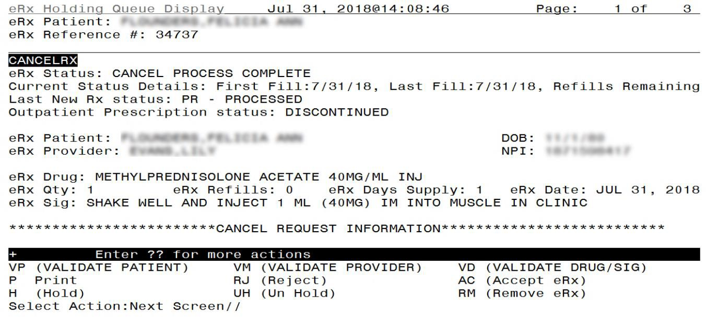
Figure 5-18: Cancel Rx Details Screen in Holding Queue 1

As the user continues to scroll, the section for Cancel Request Information displays.
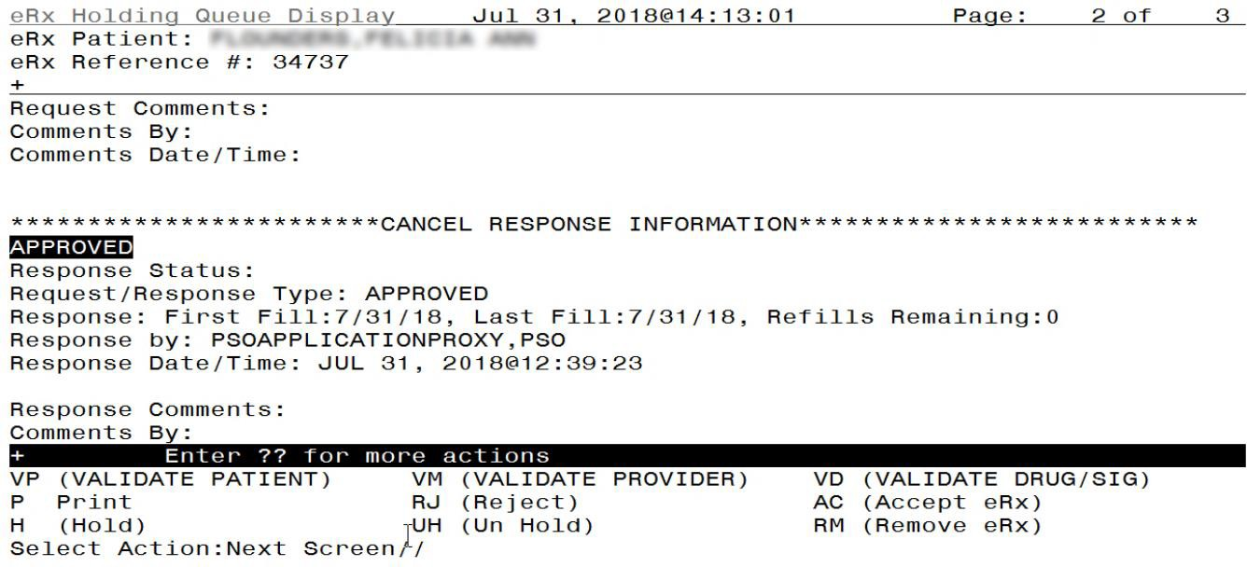
Figure 5-19: Cancel Rx Details Screen in Holding Queue 2

The New Rx Details screen includes an eRx status stating, “Original eRx Canceled in the Holding Queue”.

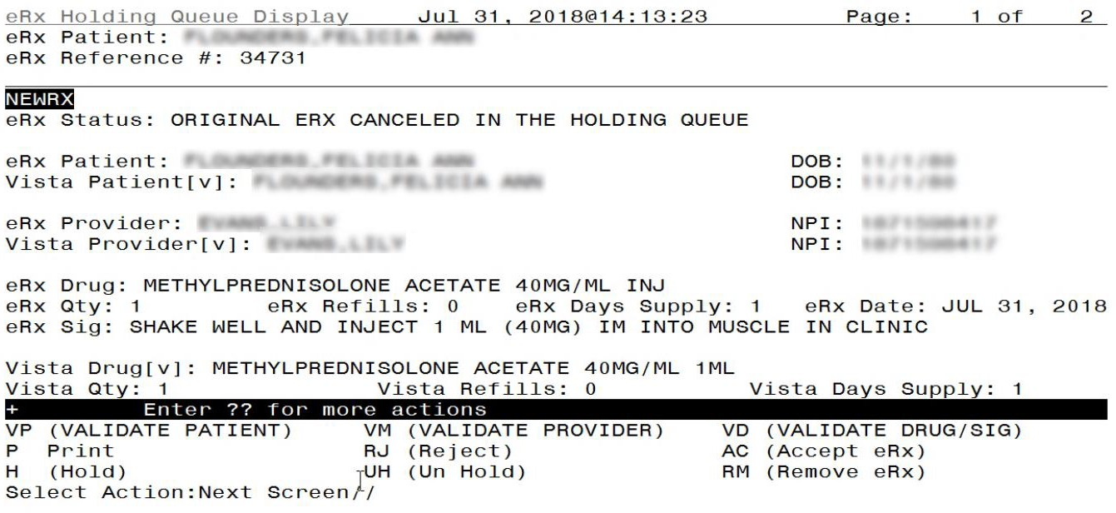
Figure 5-20: New Rx Details Screen

In addition to the above scenarios, the following also go through the same workflow in the case of an ‘Active’ Prescription being auto-Discontinued by a Cancel Rx Request:
- Auto-Cancel on New eRxs in the Holding Queue in PR status, when there is an outstanding Denied Refill Response in the Holding Queue.
- Auto-Cancel on New eRxs in the Holding Queue in PR status, when corresponding eRx record is also in Outpatient with a subsequent electronic renewal fill.
- Auto-Cancel on New eRxs in the Holding Queue in PR status and in Outpatient, when there is an outstanding Approved or Approved with Changes Refill Response not in the Holding Queue's List View.
- Auto-Cancel on New eRxs in the Holding Queue in PR status and in Outpatient, when there is an outstanding Approved with Changes Refill Response in the Holding Queue's List View (Approved with Changes Refill Response has been <AC> Accepted in the Holding Queue).
- Auto-Cancel on New eRxs in the Holding Queue in PR status and in Outpatient, when there is an outstanding Approved with Changes Refill Response in the Holding Queue's List View (Approved with Change Refill Response has not been <AC> Accepted in the Holding Queue).

Manual Approved or Denied Cancel Rx Responses
When eRxs are renewed within VA using either RN function or using CPRS Renewal, the eRx is deemed as a VA Prescription. The ‘&’ symbol used to denote eRx Prescriptions separately in OP does not display against such Prescriptions anymore. When Cancel Rx Requests are sent for New Rx Prescriptions that are taken over by VA, the system will not auto-Discontinue the Prescriptions in OP. However, the corresponding Holding Queue New Rx record is changed to CAN status and the Cancel Rx Request will be marked CAH, indicating that there is user intervention required.

Table 14: Scenarios for Manual Approved or Denied Cancel Rx Responses
New Rx Prescription Status in OP | Cancel Rx Request Status (Before ACK) | Cancel Rx Request Status (After ACK) | Cancel Rx Response Status (After ACK) | Manual Approved Cancel Rx Response  >> Note | Manual Denied Cancel Rx Response >> Denial Reason
Prescription renewed in VA using RN function | CAH (CANCEL COMPLETED IN HOLDING QUEUE) | CAA (CANCEL REQUEST ACKNOWLEDGED) | CNP (CANCEL RESPONSE PROCESSED) | Rx canceled at Pharmacy. | Rx Not Canceled  - Rx not found in pharmacy system.
Prescription renewed using CPRS Renewal | CAH | CAA | CNP | Rx canceled at Pharmacy. | Rx Not Canceled  - Rx not found in pharmacy system.
Deleted | CAH | CAA | CNP | Rx canceled at Pharmacy. | Rx Not Canceled  - Rx not found in pharmacy system.
Drug Interactions | CAH | CAA | CNP | Rx canceled at Pharmacy. | Rx Not Canceled  - Rx not found in pharmacy system.
Non-Verified | CAH | CAA | CNP | Rx canceled at Pharmacy. | Rx Not Canceled  - Rx not found in pharmacy system.

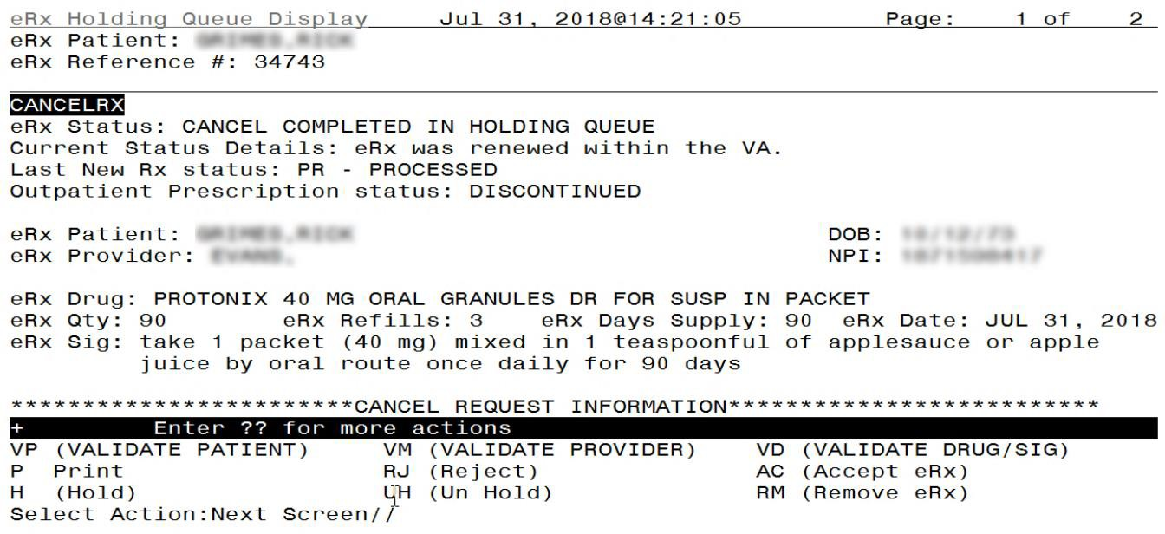
Figure 5-21: Cancel Completed in Holding Queue

Cancel R_{x} Request Failed (CAF)
Cancel Rx Failed (CAF) is an actionable status used for Cancel Rx process when a failure occurs. One scenario is when the Outpatient Profile of a patient is locked in OERR and the system is attempting to auto-discontinue an eRx.
Table 15: Scenarios for Cancel Rx Failed
# | Scenario | Lock in OERR | Lock in Backdoor Orders >> Edit Mode | Lock in Backdoor Orders
1 | When a user selects an Active eRx from OP and locks it, and at the same time a Cancel Rx Request is sent for that prescription. | The Cancel Rx Request status is marked as CAF in the Holding Queue and the OP prescription continues to be Active. | The Cancel Rx Request status is marked as CAF in the Holding Queue and the OP prescription continues to be Active. | The Cancel Rx Request status is marked as CAO in the Holding Queue and the OP prescription is discontinued.
2 | When a user selects a Pending eRx from OP and locks it, and at the same time a Cancel Rx  Request is sent | The Cancel Rx Request status is marked as CAF in the Holding Queue. | The Cancel Rx Request status is marked as CAF in the Holding Queue. | The Cancel Rx Request status is marked as CAO in the Holding Queue and the OP prescription is discontinued.

# | Scenario | Lock in OERR | Lock in Backdoor Orders >> Edit Mode | Lock in Backdoor Orders
 | for that prescription.
3 | When a user selects an eRx from OP that is on Hold, and at the same time a Cancel Rx Request is sent for that prescription. | The Cancel Rx Request status is marked as CAF in the Holding Queue and the OP prescription continues to be on Hold. | The Cancel Rx Request status is marked as CAF in the Holding Queue and the OP prescription continues to be on Hold. | The Cancel Rx Request status is marked as CAO in the Holding Queue and the OP prescription is discontinued.

Cancel R_{x} Request Received (CAR)
Cancel Rx Request Received is an actionable status used for Cancel Rx process when a New eRx record in PR status in the Holding Queue is successfully canceled. However, the corresponding eRx in OP could not be auto-discontinued because the patient on the New eRx record did not match the VistA patient in the Outpatient record. In this case, no automated Cancel Rx Response is sent. The user must acknowledge and send a manual response.

Inbound Error – CNE
Inbound Error message is the NCPDP 10.6 format for Inbound Error message received in VistA under situations including the Prescriber’s EHR system being unable to receive and process a certain transaction sent from the Pharmacy or a connection between the Transaction Hub and Change Healthcare is not working.
When a Cancel Rx Response sent from VistA Outpatient Pharmacy results in an Inbound Error, it is retrieved but not displayed in the Holding list view, with the status CNE (Cancel Response/Inbound Error). This is not an actionable entry and does not require the user to acknowledge it.

Acknowledge: Hidden Action for Cancel R_{x} Request
When a Cancel Rx Request is displayed in the Holding Queue’s list view, it is in an actionable status. The user can use the hidden action <ACK> Acknowledge to review and remove it from the list view. For a full list of Cancel Request statuses, please refer to Table 20: Holding Queue Status Codes & Descriptions for Cancel Request Message Type in Appendix B. of this guide.

Acknowledge: Automated Cancel R_{x} Response Sent
In cases in which the automated Cancel Rx Response has already been sent to the requesting non- VA Provider, the user does not have the ability to select the response type and send it out. This applies to the Cancel Rx Request records in the Holding Queue’s list view, in CAO (Cancel Completed in Holding Queue) actionable status only.
To Acknowledge a Cancel Rx Request:
- Select the Cancel Rx Request from the Holding Queue.
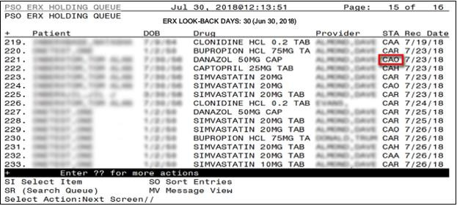
Figure 5-22: Holding Queue – eRx in CAO Status

- Enter <??> to display additional actions.

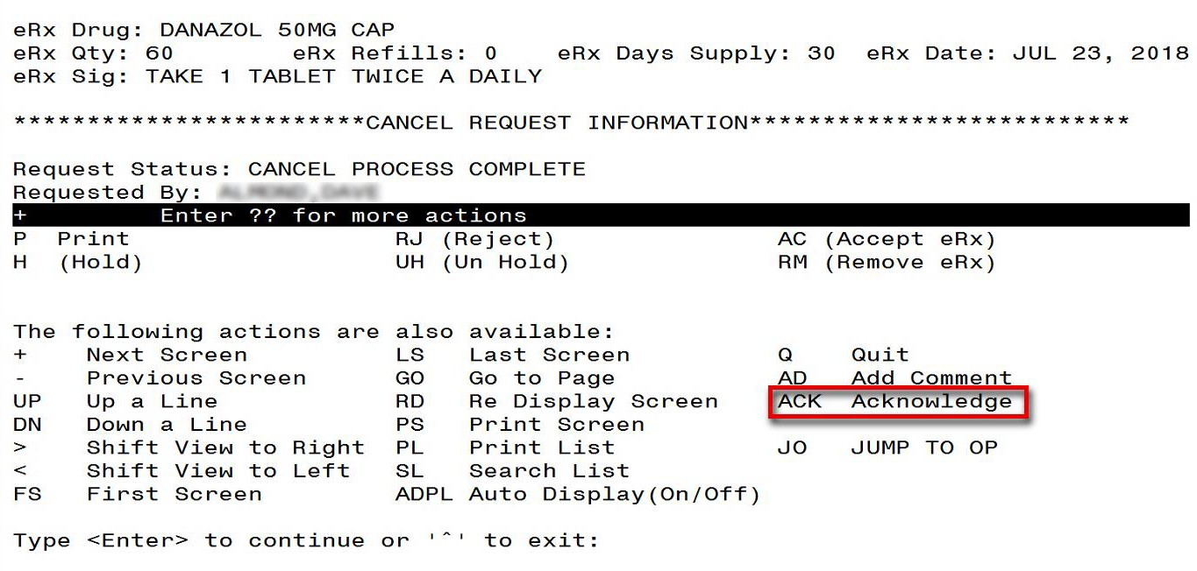
Figure 5-23: Additional Action - ACK

- Enter <ACK>.

- Enter Yes to acknowledge the record.
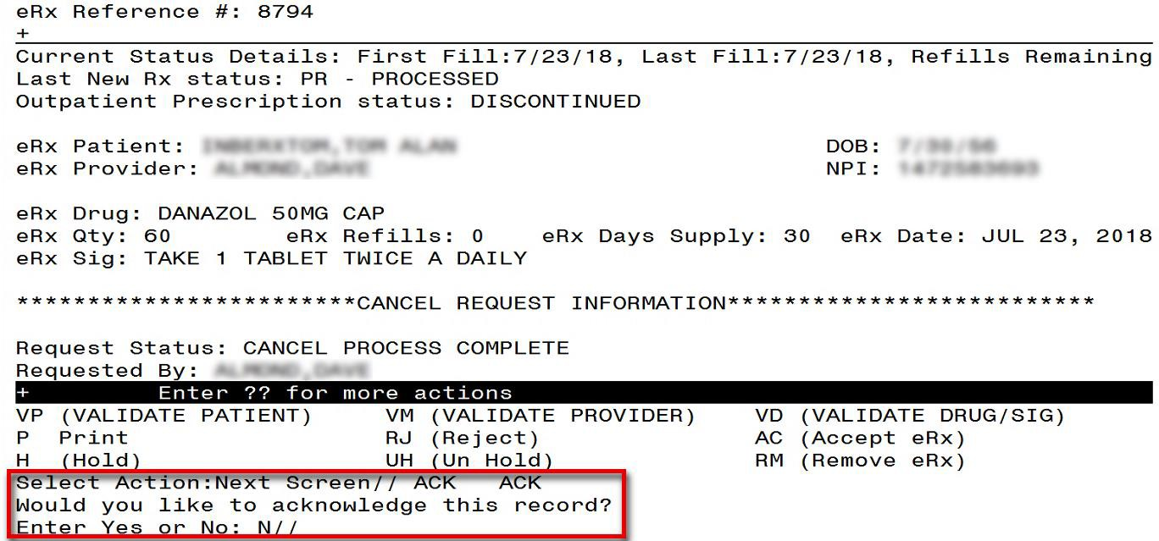
Figure 5-24: Acknowledge Record

The Cancel Rx Request is acknowledged and Status is changed to CAA in the Holding Queue.

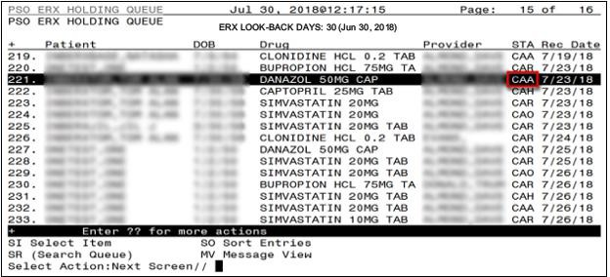
Figure 5-25: Holding Queue – CAA Status

When viewing the details of the record, the status of the Cancel Rx Request displays as “Cancel Request Acknowledged”.
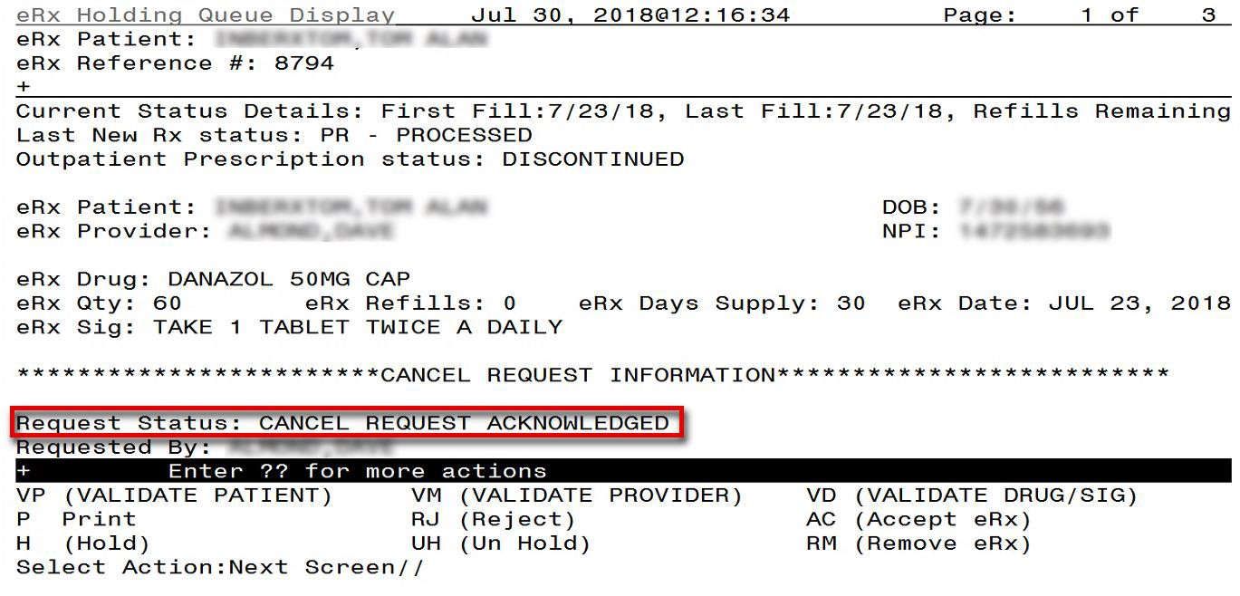
Figure 5-26: Cancel Request Acknowledged

Acknowledge: No Automated Cancel R_{x} Response Sent
In cases in which no automated Cancel Rx Response has been sent to the requesting non-VA Provider, the user has the ability to select the response type and send it out. This applies to the Cancel Rx Request records in the Holding Queue’s list view, in the following actionable statuses only:
- CAR (Cancel Request Received)

- CAP (Cancel Paper Rx or Faxed Rx)
- CAH (Cancel Completed in Holding Queue)
- CAX (Cancel Response from VistA Unsuccessful)
- CAF (Cancel Process Failed) To Acknowledge a Cancel Rx Request:
- Select the Cancel Rx Request from the Holding Queue.
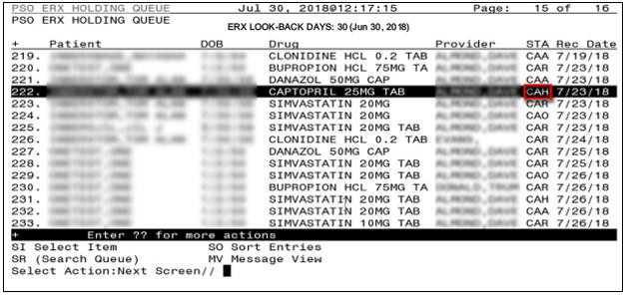
Figure 5-27: Holding Queue – eRx in CAH Status

- Enter <??> to display additional actions.

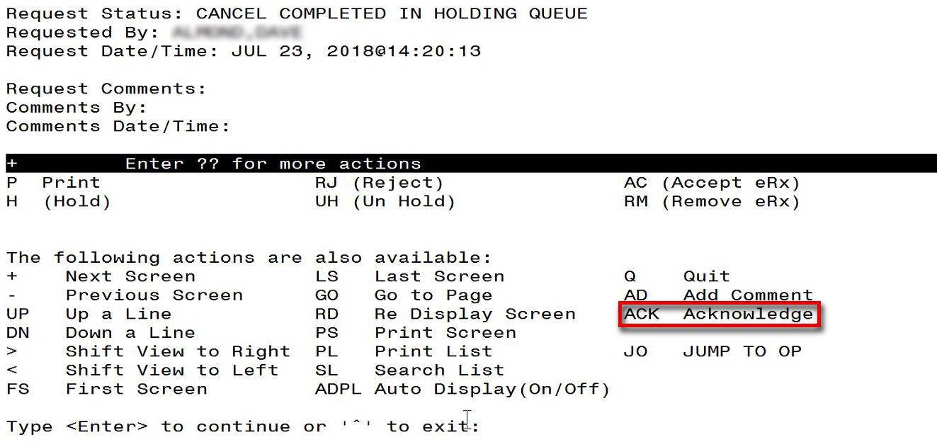
Figure 5-28: Additional Action - ACK

- Enter <ACK>.

- Select the response type, <A> Approved or <D> Denied.
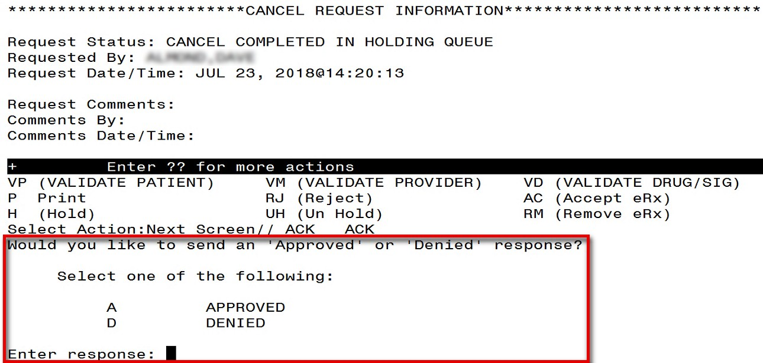
Figure 5-29: Select Response Type

- Enter Yes to acknowledge the record.

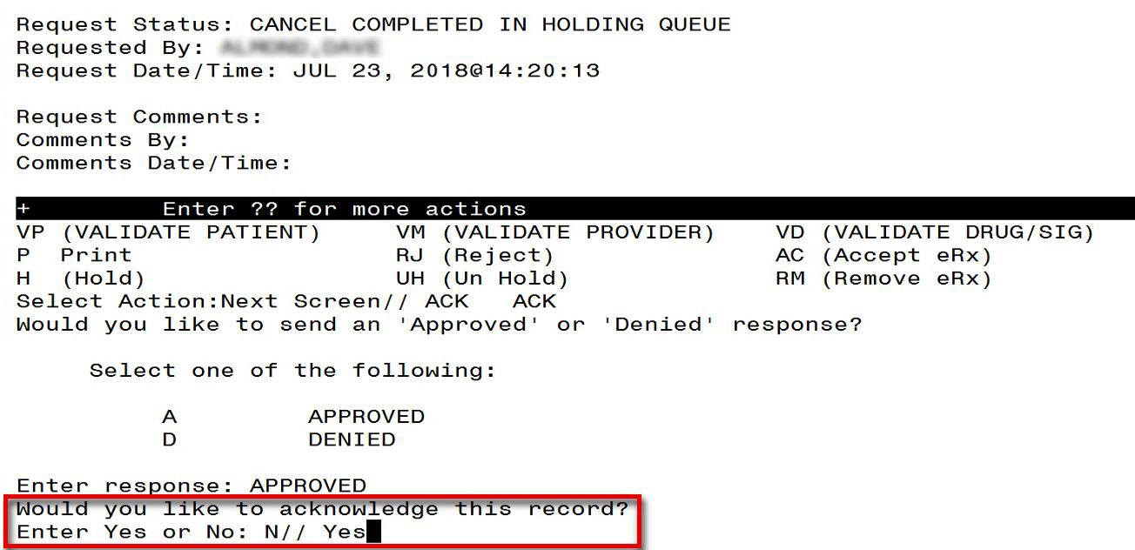
Figure 5-30: Acknowledge Record

The Cancel Rx Request is acknowledged and the Status is changed to CAA in the Holding Queue.
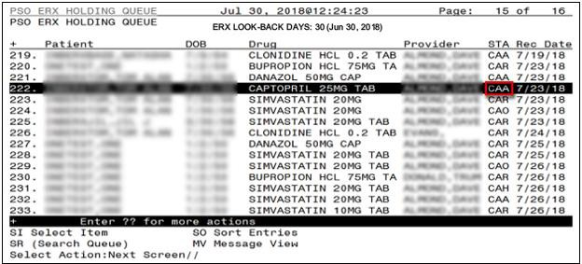
Figure 5-31: Holding Queue – CAA Status
When viewing the details of the record, the status of the Cancel Rx Request displays as “Cancel Request Acknowledged”.

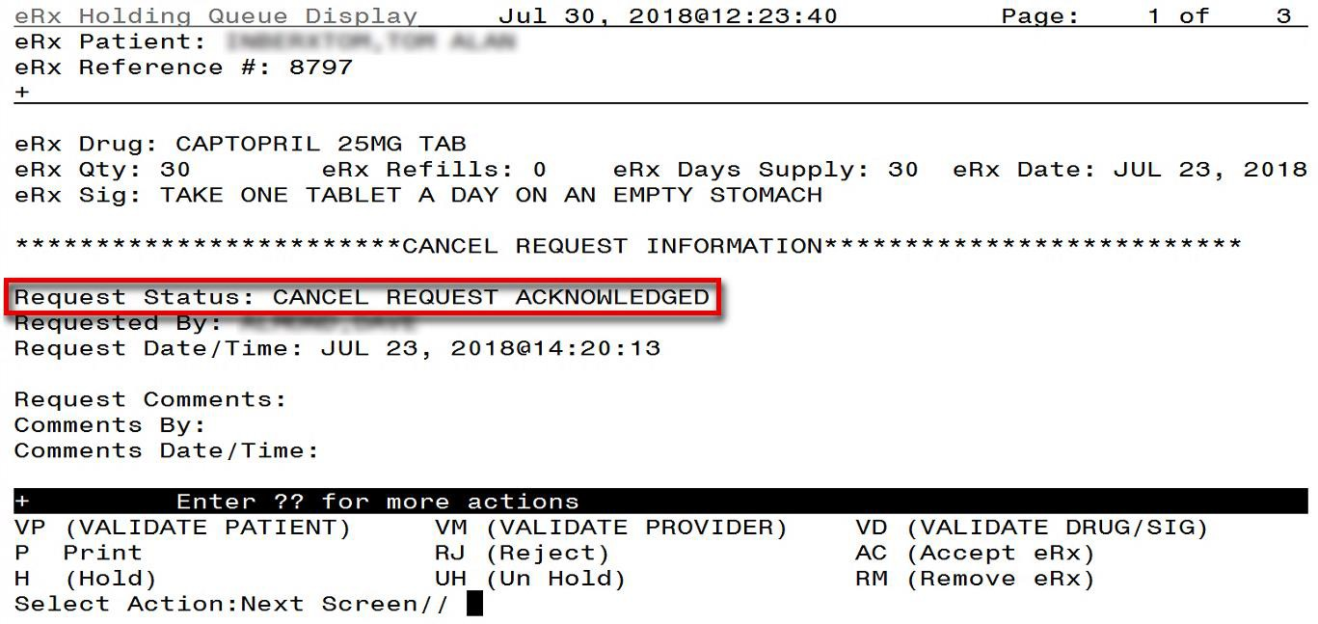
Figure 5-32: Cancel Request Acknowledged

Add Comments: Hidden Action for Cancel R_{x} Request/Response
There is a free-text Comment field in the Message Details view for Cancel Rx Request and Response messages. This field allows users to enter additional comments on the Cancel Rx Request and Response messages. To add a comment:
- Type action <AD>.
- Type Request/Response comments.

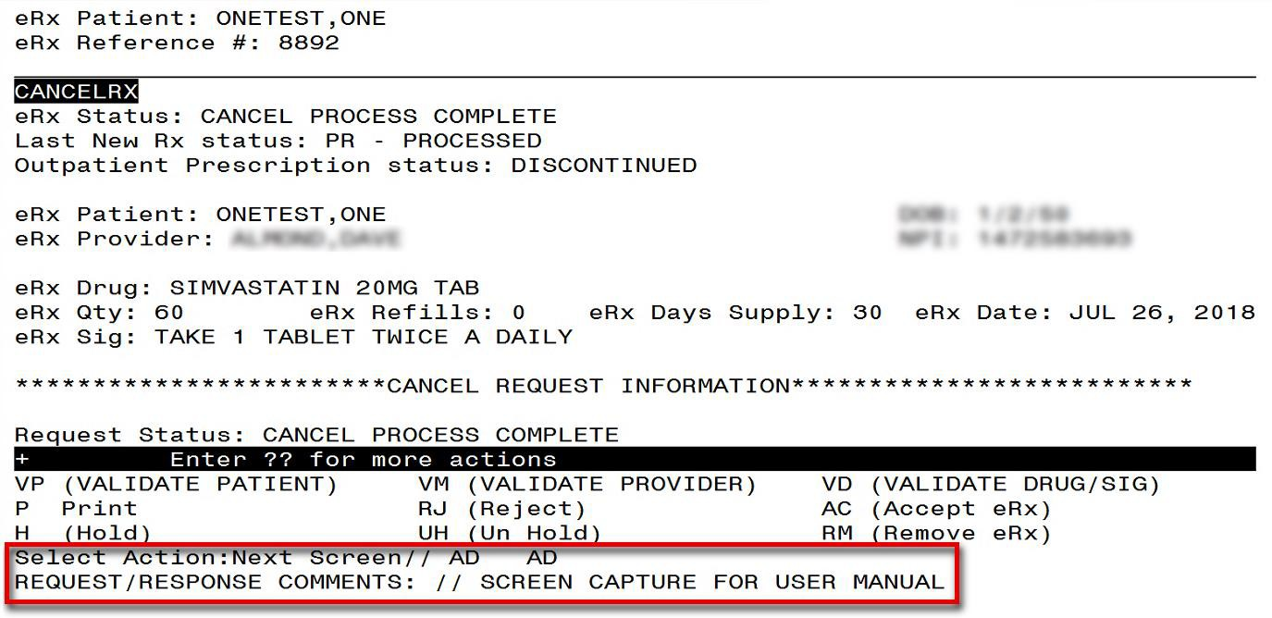

- Select <Enter>.
Figure 5-33: Add Comments

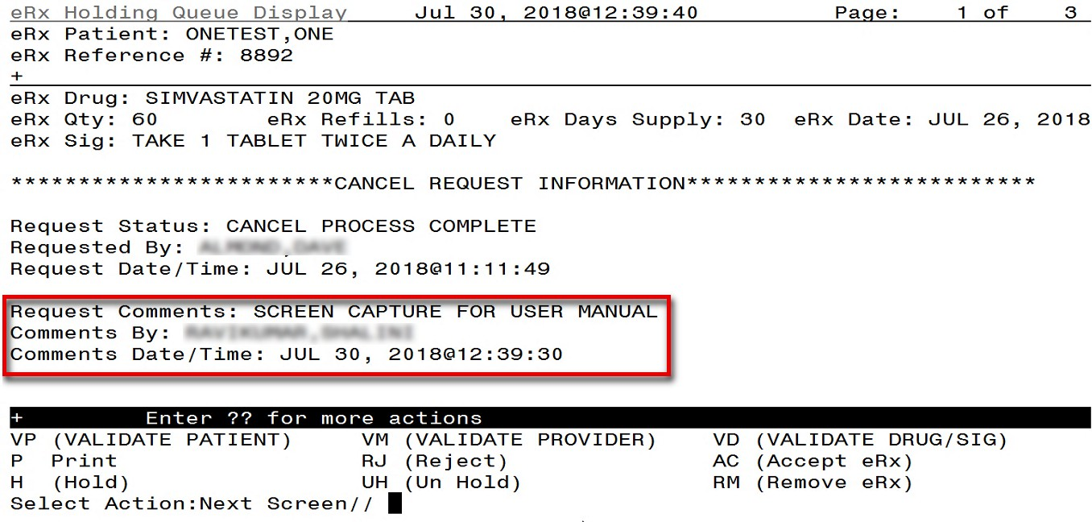
Figure 5-34: Cancel Rx Request Comments
The name of the user who made the comment displays in the “Comments By” field and the date/time the comments were made display in the “Comments Date/Time” field. Users can replace the existing comments with updated comments. When comments are replaced, the last user who made comments displays in the “Comments By” field and the date/time the comments were updated display in the “Comments Date/Time” field. To update or replace comments:
- Type action <AD>.

- Replace with updated comments.
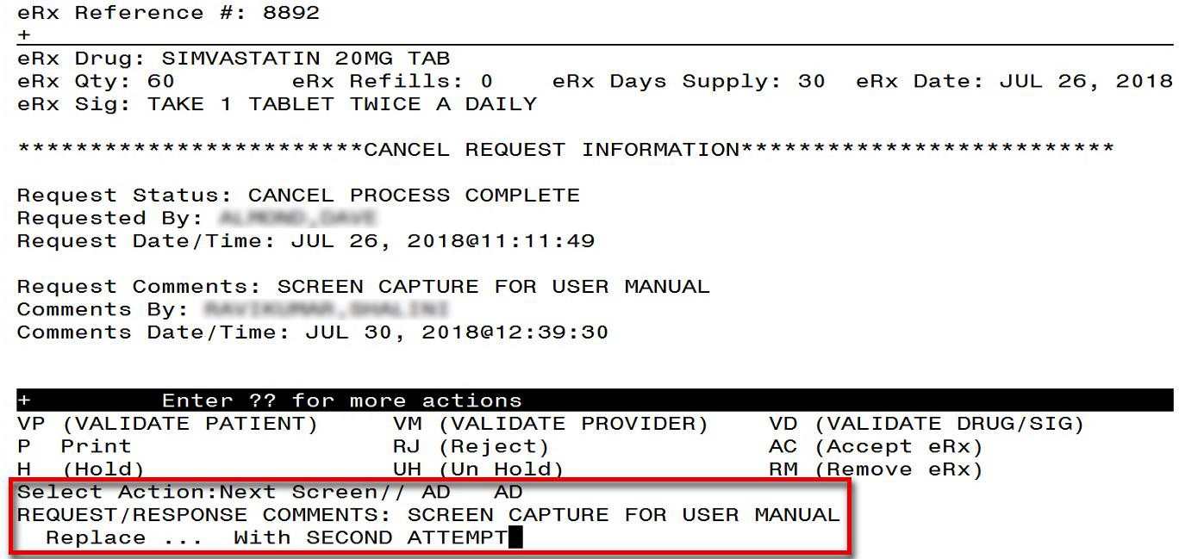
Figure 5-35: Cancel Rx Request Comments

- Select <Enter>.

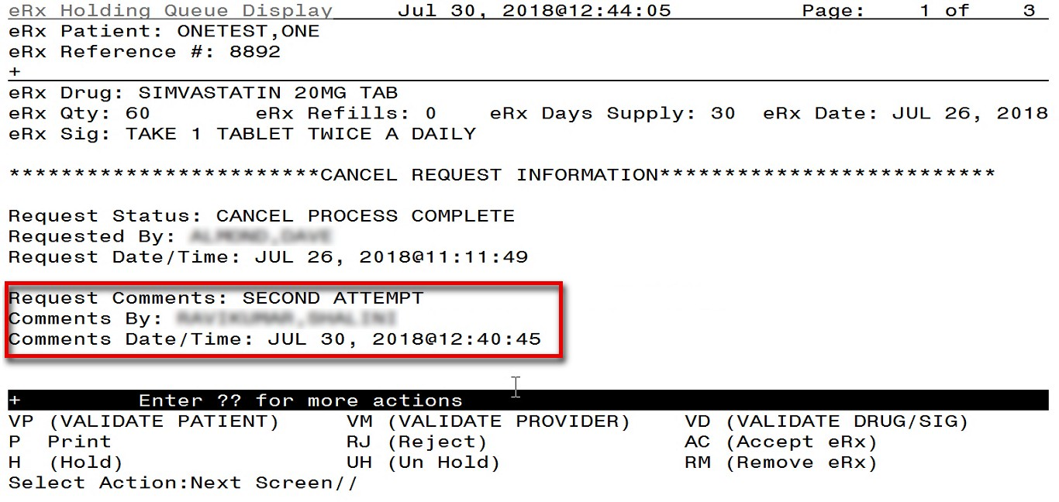
Figure 5-36: Cancel R_{x} Request Comments Updated

APPENDIX A. ACRONYMS AND ABBREVIATIONS
The table below defines the acronyms referenced in this document.

Table 16: Acronyms and Abbreviations
Term | Description
AITC | Austin Information Technology Center
CH | Change Healthcare
CHAMPVA | Civilian Health and Medical Program of the VA
CPRS | Computerized Patient Record System
CSV | Comma-separated value
DAS | Data Access Service
DEA | Drug Enforcement Administration
DME | Durable Medical Equipment
DOB | Date of Birth
DoD | Department of Defense
E&E | Enrollment & Eligibility
EHR | Electronic Health Record
ES | Enrollment System
HIN | Holder Identification Number
ePA | Electronic Prior Authorization
eRx | ePrescription
ESD | Enterprise Service Desk
FQDN | Fully Qualified Domain Name
IEP | Inbound ePrescribing
MbM | Meds by Mail
MVI | Master Veteran Index
NAIC | North American Industry Classification
NAICS | North American Industry Classification System
NCPDP | National Council for Prescription Drug Programs
NDC | National Drug Code
NPI | National Provider Identifier
OIT | Office of Information & Technology
OP | Outpatient Pharmacy
PBM | Pharmacy Benefits Management
PCS | Patient Care Services
PIN | Personal Identification Number

Term | Description
POC | Point of Contact
PPO | Program Planning Oversight
PRE | Pharmacy Reengineering
PHI | Protected Health Information
PHR | Personal Health Record
PII | Personal Identifiable Information
PIV | Personal Identification Verification
PRE | Pharmacy Reengineering
SSN | Social Security Number
Tech | Technician
UI | User Interface
UPN | Universal Product Number
UPC | Universal Product Code
VA | Department of Veterans Affairs
VAMC | VA Medical Center
VDL | VA Documentation Library
VHA | Veterans Health Administration
VISN | Veterans Integrated Service Network
VistA | Veterans Health Information Systems and Technology Architecture

APPENDIX B. HOLDING QUEUE STATUS CODES & DESCRIPTIONS
Table 17: Holding Queue Status Codes & Descriptions for New Rx Message Type
Status Code | Description | Actionable Status in the Holding Queue
N | N/New: Status of the eRx when it first arrives in the Holding Queue and has not been acted upon in any way. | Yes
I | I/In Process: Status of the eRx when a user has taken an action on the eRx in the Holding Queue, including via the automatic patient or provider validation process. | Yes
W | W/Wait: Status of the eRx when a user has completed all 3 validations (Accept Validation/AV), on Patient, Provider and Drug/SIG, and has not yet completed the Accept (AC) action to process the eRx into the Pending Queue. | Yes
HPT | PATIENT NOT FOUND | Yes
HPD | PROVIDER NOT FOUND | Yes
HNF | NON-FORMULARY DRUG THAT NEEDS APPROVAL | Yes
HSO | INSUFFICIENT STOCK | Yes
HDI | DRUG-DRUG INTERACTION | Yes
HAD | ADVERSE DRUG INTERACTION | Yes
HBA | BAD ADDRESS | Yes
HPC | PROVIDER CONTACTED | Yes
HPA | PRIOR APPROVAL NEEDED | Yes
HOR | OTHER REASON | Yes
HPP | PATIENT CONTACTED | Yes
HPR | HOLD DUE TO PATIENT REQUEST | Yes
HQY | QUANTITY OR REFILL ISSUE | Yes

Status Code | Description | Actionable Status in the Holding Queue
RJ | RJ/Rejected: Status of the eRx when it has been rejected by a user. A message is sent back to the external provider indicating the eRx was rejected and the reason for rejection. Refer to the various reject reasons below. | No
RM | RM/Removed: Status of the eRx when it has been removed by a user. Note that a message is NOT sent back to the external provider when an eRx is removed. Refer to the various remove reasons below. | No
CAN | Original eRx Canceled in Holding Queue | No

Table 18: Holding Queue Status Codes & Descriptions for Refill Request Message Type
Status Code | Description | Actionable Status in the Holding Queue
RRN | REFILL REQUEST - NEW | No
RRC | REFILL REQUEST COMPLETE | No
RRP | REFILL REQUEST PROCESSED | No
RRX | REFILL REQUEST EXPIRED  (Refill Request message changes to “Expired” status if a response is not received after two weeks) | No
RRR | REFILL REQUEST RESPONSE RECEIVED | No
RRE | REFILL REQUEST ERROR | No

Table 19: Holding Queue Status Codes & Descriptions for Refill Response Message Type
Status Code | Description | Actionable Status in the Holding Queue
RXN | REFILL RESPONSE - NEW | Yes
RXP | REFILL RESPONSE PROCESSED | No
RXC | REFILL RESPONSE COMPLETE | No
RXD | REFILL RESPONSE DENIED/DNTF | Yes
RXW | REFILL RESPONSE WAITING | Yes
RXA | REFILL RESPONSE ACKNOWLEDGED | No
RXF | REFILL RESPONSE FAILED | Yes

Table 20: Holding Queue Status Codes & Descriptions for Cancel Request Message Type
Status Code | Description | Actionable Status in the Holding Queue
CAA | CANCEL REQUEST ACKNOWLEDGED | No
CAH | CANCEL COMPLETED IN HOLDING QUEUE | Yes
CAO | CANCEL PROCESS COMPLETE | Yes
CAP | CANCEL PAPERRX OR FAXED RX | Yes
CAR | CANCEL REQUEST RECEIVED | Yes
CAX | CANCEL RESPONSE FROM VISTA UNSUCCESSFUL | Yes
CAF | CANCEL PROCESS FAILED | Yes

Table 21: Holding Queue Status Codes & Descriptions for Cancel Response Message Type
Status Code | Description | Actionable Status in the Holding Queue
CNE | CANCEL RESPONSE/INBOUND ERROR | No
CNP | CANCEL RESPONSE PROCESSED | No
CNX | MANUAL OR AUTO-CANCEL RESPONSE NOT SENT | No

Table 22: Holding Queue Status Codes & Descriptions for Inbound Error Message Type
Status Code | Description | Actionable Status in the Holding Queue
RRE | REFILL REQUEST ERROR | Yes
E | ERROR | No
CNE | CANCEL RESPONSE/INBOUND ERROR | No

Table 23: Reject Reason Codes (New Rx Message Only)
Status Code | Description
PTT01 | Patient not eligible
PTT02 | Cannot resolve patient
PVD01 | Provider not eligible
PVD02 | Cannot resolve provider
DRU01 | Not eligible for refills
DRU02 | Non-formulary drug
DRU03 | Duplicate prescription found for this patient
DRU04 | Invalid quantity
DRU05 | Duplicate therapeutic class
DRU06 | Controlled substances are disallowed
ERR01 | Multiple errors, please contact the pharmacy
ERR02 | Incorrect pharmacy
ERR03 | Issues with prescription, please contact the pharmacy

Table 24: Remove Reason Codes (New Rx Message Only)
Status Code | Description
REM01 | Drug out of stock or on backorder and unavailable for processing
REM02 | Patient was not able to pick up
REM03 | Prescription canceled by provider
REM04 | Prescription processed manually
REM05 | Provider will cancel this eRx and submit another
REM06 | Unable to mail prescription and patient unable to pick up
REM07 | Unable to contact patient
REM08 | Unable to contact provider
REM91 | Undefined system error
REM92 | Other

APPENDIX C. NCPDP ERROR CODES
This appendix outlines common NCPD error codes and their descriptions, which will be visible in the Detail View of a message in the IEP web-based application.

Table 25: NCPDP Error Codes
Element Name | M/O | Datatype | Possible Values | Description
Code | M | String | 600|601|602|900 | 6ØØ Communication problem - try again later  6Ø1 Receiver unable to process 6Ø2 Receiver System Error  9ØØ Transaction rejected
Description Code | O | String | 001|002|003 | ØØ1 Sender ID not on file. ØØ2 Receiver ID not on file.  ØØ3 Invalid password for sender. ØØ4 Invalid password for receiver ØØ5 No password on file for sender.  ØØ6 No password on file for receiver.  ØØ7 Internal processing error has occurred.  ØØ8 Request timed out before response could be received.  ØØ9 Required segment UIB is missing.  Ø1Ø Required segment UIH is missing.  Ø11 Required segment UIT is missing.  Ø12 Required segment UIZ is missing.  Ø13 Unknown segment has been encountered.  etc.
Description | O | an (70) | Free text

APPENDIX D. REFILL REQUEST PRECONDITIONS AND WARNINGS
This appendix outlines when warnings are triggered for an outbound Refill Request. A warning is received when:
- Refills are remaining for the prescription; therefore a refill request cannot be created.
- <RR> is being used on a non-eRx prescription.
- <RR> is used on an eRx that already has a Refill Request generated. Warning text will include the user who initiated the request, when each request was sent, any response received for the request or if it ended up in an ERROR scenario, and the number of requests sent in the last 30 days.
- <RN> (Renew) function is initiated for an eRx.
- VistA SIG has more than 140 characters, the warning message displays, “The NCPDP
10.6 standard does not support communication with a SIG longer than 140 characters. Please use alternative methods to communicate with the provider, i.e. call the provider”.
- Place Order # contains “S” or it is not a positive integer.
- Prescription does not exist in File #52.
- Orderable item is in Inactive status.
- Prescription is in CMOP Transmission state.
- Prescription has been expired for greater than 120 days.
- Prescription has been discontinued for greater than 120 days.
- Drug mismatch.
- Invalid dosage.
- Missing SIG.
- Drug is no longer used by Outpatient Pharmacy.
- DEA Special Handling filed has 1, 2, or W.
- Schedule I Narcotic Drug.
- Maximum number of renewals (26) has been reached.
19. Status in File #52 is 2, 5, 6, 11, 14.
- Rx has Forward Order # field, 39.5 in File #52.
- Same as previous, but checks cross-referenced AQ.
- Titration – Tapering Dose/Complex.

