Pharmacy Reengineering (PRE) Inbound ePrescribing (IEP) 4.1 VistA Patch # PSO*7.0*635 Implementation Guide

April 2021
Version 3.9 Department of Veterans Affairs
Office of Information and Technology (OIT)

Revision History

Date | Version | Description | Author
04/09/21 | 3.9 | Updated for PSO*7.0*635-T3 (pg1) | Technatomy
04/06/21 | 3.8 | HPS Review. Update file #52.45 to ERX SERVICE REASON CODES file (#52.45)  (pg1), Updated section 1.1 content to bullet list (pg1), section 1.1.1 Install Vista Patch item to reference Patch Description (pg1) | Technatomy
03/26/21 | 3.7 | Updated for PSO*7.0*635. Updated all references to PSO*7.0*635, section 1.1 VistA PSO*7.0*635 Patch (pg1), section  1.1.1 Install VistA Patch (pg1) | Technatomy
10/28/20 | 3.6 | Updated sections 1.1.1 Install VistA Patches pg1, section 1.1.1 URL Reference, pg1. | Technatomy
09/2020 | 3.5 | Updated sections 1.1.3.1, 1.1.5, and screenshots under section 1.2 | Technatomy
05/2019 | 3.4 | Updated link under Training section. | Technatomy
11/2018 | 3.3 | Added Pre-Installation instruction for sites configured and running PSO*7.0*527. Pg. 1. | Technatomy
10/2018 | 3.2 | Updated cover page to month of November | Technatomy
10/2018 | 3.1 | Update per HPS Review, pg. 1, 8,15, 21,  25 | Technatomy
09/2018 | 3.0 | New Document, Baseline release Technical Writer Review, 508 accessibility checks, document is compliant. | Technatomy

Table of Contents

Unit 1. Implementation 1
  - VistA PSO*7.0*635 Patch 1
    - Install VistA Patch 1
    - Training 2
    - Assign Security Keys in VistA to eRX Holding Queue Users 2
      - VistA Security Keys for accessing eRX Holding Queue 2
      - Steps to assign Security Keys in VistA 4
    - Configuration 5
    - Verify NCPDP NUMBER used by ePharmacy 5
    - OUTPATIENT SITE file (#59) 5
    - When to contact ePharmacy Implementation Team 6
    - Configure Default eRX Clinic (OPTIONAL) 6
    - NPI Institution 8
    - Configure ERX DEFAULT LOOKBACK DAYS (OPTIONAL) 10
    - Ready to Go Live 11
    - Help Desk 13
      - Help Desk Ticket Instructions 13
  - Inbound ePrescribing Web-based Application 15
    - Create Shortcut on Workstation (Desktop) 15
    - Turn off Compatibility Setting 16
    - Assign Roles in IEP Web-based Application 17
      - Add New User 18
      - Modify User Role 21
      - Enable/Disable Users 21
    - Pharmacy Management 22
      - Search Pharmacy 22
      - Add Pharmacy 23
        - Enable Pharmacy 23
          - Enrollment and Eligibility Check 24
        - Temporarily Disable Pharmacy 24
        - Disable Pharmacy 26
Unit 2. Post Implementation Reporting Problems 27
Unit 3. Release Documentation 28
List of Figures
Figure 1-1: OUTPATIENT SITE file (#59) in Inquire Mode 6
Figure 1-2: INSTITUTION f ile (#4), OUTPATIENT SITE f ile (#59) and HOSPITAL LOCATION f ile (#44) Configuration 7
Figure 1-3: HOSPITAL LOCATION f ile (#44) in Enter or Edit File Entries Mode 8
Figure 1-4: OUTPATIENT SITE file (#59) in Enter or Edit File Entries Mode 8
Figure 1-5: INSTITUTION f ile (#4) in Inquire Mode 9
Figure 1-6: OUTPATIENT SITE file (#59) in Inquire Mode 10
Figure 1-7: OUTPATIENT SITE file (#59) ERX DEFAULT LOOKBACK DAYS Updated 11
Figure 1-8: Your IT Desktop Icon 13
Figure 1-9: Incident Selection 13
Figure 1-10: Create New Selection 14
Figure 1-11: New Incident 14
Figure 1-12: Create Shortcut Dialog Box 15
Figure 1-13: Name Shortcut 16
Figure 1-14: Compatibility View Settings 16
Figure 1-15: Add User - User ID, First Name, Last Name 18
Figure 1-16: Add User - Select User Roles 18
Figure 1-17: Add User – Select Station ID 19
Figure 1-18: Add User – Add and Remove Station ID 19
Figure 1-19: All Selection Error Message 20
Figure 1-20: Add User - Save and Cancel 20
Figure 1-21: Select User Roles 21
Figure 1-22: User Management Table – Enable/Disable User 21
Figure 1-23: User Disabled 22
Figure 1-24: User Disabled Error Message 22
Figure 1-25: Search for a Pharmacy 23
Figure 1-26: Enable Pharmacy 23
Figure 1-27: Enrollment and Eligibility Check Enabled 24
Figure 1-28: Edit Pharmacy Screen 25
Figure 1-29: Inbound eRX Enabled Drop Down 25
Figure 1-30: Update Pharmacy Information 26

List of Tables
Table 1: NewRx, Ref ill/RxRenewal Request and Response, CancelRx Request and Response (v2.0 and v3.0) 2
Table 2: RxRenewal Response – Replace Type (v4.0) 3
Table 3: RxChange Response – Replace Type (v4.0) 4
Table 4: Inbound ePrescribing Web-Based Application User Roles & Capabilities 17
Table 5: Inbound ePrescribing Release Documents 28

Unit 1. Implementation
This document provides implementation instructions for the Veterans Health Information
Systems and Technology Architecture (VistA) PSO*7.0*635 patch release /Inbound ePrescribing (IEP) Warranty defect remediation.

VistA PSO*7.0*635 Patch
The IEP VistA Patch PSO*7.0*635 Warranty defect remediation provides software fixes for:
    - SIG text is supposed to be up to 1000 characters, Inbound eRx software assigns wrong unit of measure in RxRenewal Request, RxRenewal Request failing at hub because "IndicationForUse" segment is not sending in "Sig" segment
    - Inbound eRx software assigns wrong unit of measure in RxRenewal Request
    - NewRx coming in with ObservationDateTime, causing a failure at the eRx processing hub when generating an RxRenewal Request
    - Updated Data Dictionary – ERX SERVICE REASON CODES file (#52.45), ACR
codes in ERX SERVICE REASON CODES file (#52.45) have an extra space at the end
    - ACR codes in ERX SERVICE REASON CODES file (#52.45) have an extra space at the end
    - VA 'Refills' displaying incorrectly for RxRenewal response replace response messages
    - VA 'Refills' displaying incorrectly for RxRenewal response replace response messages extend the logic from 365 days to 1 and half year for messages related to display at hub (Track/Audit page), a backlog of messages is queueing up and waiting for outbound
delivery to CH during peak hours, reports page columns are missing in the last three reports
    - NewRx counts not showing for summary new Rx Only and report totals at the bottom of the tables do not align with the correct column
    - Reports - number of records not being displayed at the bottom of all reports and column width for Message Type in Track/Audit not wide enough.
    - When editing the Validate Drug/SIG for Replace RxRenewal Response, eRx refills are not decrementing correctly and incorrectly displays the # of Refills.
The steps required for full implementation are listed. However, this document is limited to the technical changes required for implementation. Please refer to the Inbound ePrescribing User Guide in the VA Software Document Library (VDL) for more information on the VistA eR_{X} Holding Queue functionality and other eR_{X} user functions.

Install VistA Patch
Once the patch is received from Forum for National Deployment the local Site IT Administrator for each Pharmacy site needs to install the PSO*7.0*635 patch. The software for this patch is
being released in a PackMan message.

      - Install VistA Patch PSO*7.0*635 – For detailed instructions, refer to Installation Guide - Inbound ePrescribing (pso_7_0_p635_ig.pdf).
      - See Pre-Installation Instructions in the Patch Description for sites configured and running PSO*7.0*635.
      - Validate that the Inbound eR_{X} patch was installed successfully.

Training
Once the Pharmacy Manager has decided that their site will be processing live eR_{X}’s they need to first ensure that their pharmacists/users have been trained on using the ePrescribing application.
To train the end users on using the application, refer to Training Material at Inbound ePrescribing (IEP) Training Materials.

Assign Security Keys in VistA to eRX Holding Queue Users
Assign keys for users who need access to the VistA eR_{X} Holding Queue.
NOTE: Only one (1) security key should be assigned to a user. Users will only be able to use options based on the lowest available key.

VistA Security Keys for accessing eR_{X} Holding Queue
The following keys are available:
        - PSDRPH: PSDRPH key is assigned to Pharmacists only. Most Pharmacists may already have been allocated this key, and therefore no additional action is required for these users.

PSO ERX ADV TECH
        - PSO ERX TECH

PSO ERX VIEW
NOTE: Some test sites have stated that they don’t allow technicians to process prescriptions. If this is the case the PSO ERX VIEW key can be given to the technicians which allows them to look up data.

Table 1: NewRx, Refill/RxRenewal Request and Response, CancelRx Request and Response (v2.0 and v3.0)

VistA Security Key | PSD RPH | PSO ERX ADV TECH | PSO ERX TECH | PSO ERX VIEW
Validate Patient | X | X | X
Validate Provider | X | X | X
Validate Drug/SIG | X | X | X
Accept Validation | X | X

VistA Security Key | PSD RPH | PSO ERX ADV TECH | PSO ERX TECH | PSO ERX VIEW
Accept eRX | X | X
Reject | X | X | X
Remove | X | X | X
Hold | X | X | X
Un Hold | X | X | X
Search/Sort | X | X | X | X
Print | X | X | X | X
Message View | X | X | X | X
Ack – RxRenewal Response | X | X | X
RxChange Request | X | X | X
RxRenewal Request (OP) | X | X | X
Ack – CancelRx | X | X
Ack – Inbound RxRenewal Error | X | X | X

Table 2: RxRenewal Response – Replace Type (v4.0)

VistA Security Key | PSD RPH | PSO ERX ADV TECH | PSO ERX TECH | PSO ERX VIEW
Validate Patient | X | X | X
Validate Provider | X | X | X
Validate Drug/SIG | X | X | X
Accept Validation | X | X
Accept eRX | X | X
Reject | X | X | X
Remove | X | X | X
Hold | X | X | X
Un Hold | X | X | X
Search/Sort | X | X | X | X
Print | X | X | X | X
Message View | X | X | X | X

Table 3: RxChange Response – Replace Type (v4.0)

VistA Security Key | PSD RPH | PSO ERX ADV TECH | PSO ERX TECH | PSO ERX VIEW
Validate Patient | X | X | X
Validate Provider | X | X | X
Validate Drug/SIG | X | X | X
Accept Validation | X | X
Accept eRX | X | X
Reject | X | X | X
Remove | X | X | X
Hold | X | X | X
Un Hold | X | X | X
Search/Sort | X | X | X | X
Print | X | X | X | X
Message View | X | X | X | X
Ack – RxChange Response | X | X | X

X – This means have ability to use option.

Steps to assign Security Keys in VistA
The following outlines the steps for assigning keys (may need to be done by local Site IT Administrator):
- Log in to VistA.
- At the “Select OPTION NAME” prompt, type “eve” and then press the <Enter> key.
- At the “Choose 1-5” prompt, type “1” (for EVE Systems Manager Menu) and then press the <Enter> key.
- At the “Select Systems Manager Menu Option” prompt, type “menu” (for Menu Management) and then press the <Enter> key.
- At the “Select Menu Management Option” prompt, type “key” (for Key Management) and then press the <Enter> key.
- At the “Select Key Management Option” prompt, type “allocation” (for Allocation of Security Keys) and then press the <Enter> key.
- At the “Allocate key” prompt, type the name of the security key you want to assign and then press the <Enter> key.
- At the “Holder of key” prompt, type the name of the first user to whom you are assigning the key and then press the <Enter> key.

- At the “Another holder” prompt, type the name of a second user to whom you are
assigning the key and then press the <Enter> key. Repeat this step for all users to whom you are assigning the key.
- At the “You are allocating keys. Do you wish to proceed? YES//” prompt, press the
<Enter> key to accept the default response.

Configuration
The sites need to determine which outpatient pharmacy site is going live. A pharmacy site is
considered a Division in outpatient pharmacy. All inbound eR_{X} sites must be physical locations, already have an NCPDP NUMBER, and have an NPI NUMBER.
NOTE: Sites should not create a new division to process inbound eR_{X}es.

Verify NCPDP NUMBER used by ePharmacy
Review the local pharmacy information by contacting the ePharmacy Team via email at VHA ePharmacy Implementation Team.
For each dispensing pharmacy, verify the following data in the columns of the spreadsheet maintained by the ePharmacy Team:
- Physical Address (columns J-M)
- Pharmacy Phone Number (column N)
- Pharmacy Fax Number (column O)
- Pharmacy email address (column P)
- Date Pharmacy Logistics Updated (column U)
- Updates Completed by (column V)
Make, or request ePharmacy Team to make, the changes on the spreadsheet. Once a pharmacy goes live with Inbound eR_{X}, the NCPDP information is published to providers and others,
therefore accuracy is essential. In addition, if the eR_{X} fails, the clearing house sends an
automated fax of the eR_{X} to the pharmacy. So, ensure that your pharmacy’s fax number is correct. If changes are made, they update at the NCPDP and the clearinghouse. Updating NCPDP and the clearinghouse is a manual process and takes time.
NOTE: Sites should not make any edits to the VistA ECME Setup during the Inbound ePrescribing implementation. Updating the ECME Setup may negatively impact the ePharmacy process.

OUTPATIENT SITE file (#59)
Using FileMan, inquire into the OUTPATIENT SITE file (#59), check the NCPDP NUMBER file (#1008), NPI Institution field (#101), and CPRS Order Institution field (#8).
- Ensure that the NCPDP NUMBER is the same as the one that is listed in the ECME Setup-Pharmacies Report (see Section 1.1.5 above).
- Make note of the NPI Institution entry.

- Add the pharmacy (in the NPI Institution field) as a CPRS Ordering Institution, so the
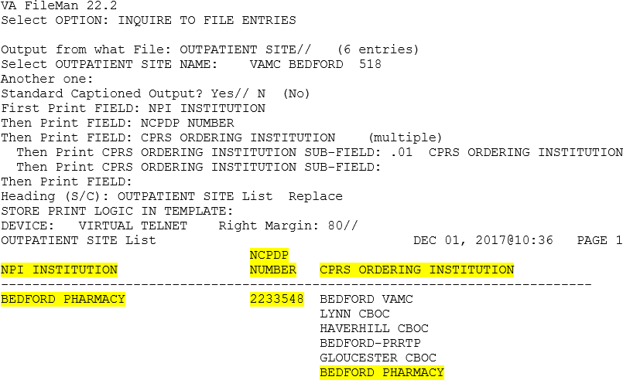
eRX orders can be pulled using Complete orders from OERR [PSO LMOE FINISH].
NOTE: Add the CPRS Ordering Institution entry using the Site Parameter Enter/Edit [PSO SITE PARAMETERS] option. Keep the existing values in that list and do not remove or modify any existing entries.

Figure 1-1: OUTPATIENT SITE file (#59) in Inquire Mode

When to contact ePharmacy Implementation Team:
Sites should contact the ePharmacy Team prior to making any changes to the VistA Electronic Claims Management Engine Number (ECME) Setup.
The ePharmacy Team should be notified of changes to the Physical Address, Telephone Number,
Fax Number, when new pharmacies open and/or if a pharmacy closes. The ePharmacy Team coordinates any needed changes with NCPDP, NPI Team and the clearinghouse. Contact
ePharmacy Team by e-mail at VHA ePharmacy Implementation Team.

Configure Default eRX Clinic (OPTIONAL)
The Default eR_{X} Clinic allows the local user to locate non-processed eR_{X} prescriptions by clinic name, in the existing pending queue.
Sites can add a Default eR_{X} Clinic in OUTPATIENT SITE file (#59), DEFAULT ERX CLINIC field (#10). A new Hospital Location entry with type as ‘Clinic’ needs to be created for the
purpose of Inbound ePrescribing.

NOTE: Existing Hospital Location entries should not be used as a Default eR_{X} Clinic. For creating a new clinic for Inbound ePrescribing use, additional assistance from Medical
Administration may be required.
The diagram below depicts the relationship between OUTPATIENT SITE file (#59), HOSPITAL LOCATION file (#44), and INSTITUTION file (#4).
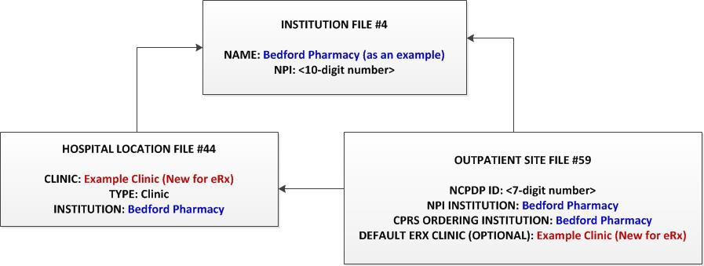
Figure 1-2: INSTITUTION file (#4), OUTPATIENT SITE file (#59) and HOSPITAL LOCATION file (#44)
Configuration
To confirm setup of Default eR_{X} Clinic, using FileMan “Enter or Edit File Entries” option, in the HOSPITAL LOCATION file (#44). This setup may require assistance from Medical Administration Team:
- Check the field: INSTITUTION field (#3).
- If it is blank, use the NPI INSTITUTION identified in OUTPATIENT SITE file (#59).
- If it is not blank, ensure that the NPI INSTITUTION is same as the one identified in OUTPATIENT SITE file (#59).

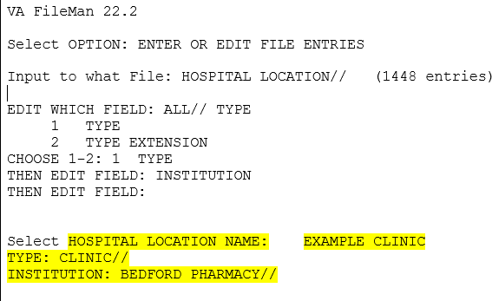

Figure 1-3: HOSPITAL LOCATION file (#44) in Enter or Edit File Entries Mode
Using FileMan “Enter or Edit File Entries”, in the OUTPATIENT SITE file (#59), enter the DEFAULT ERX CLINIC field (#10).
- If it is blank, populate it with the Clinic created for the purpose of Inbound ePrescribing.
- If it is not blank, ensure that the Clinic used is same as the one created for the purpose of Inbound ePrescribing.
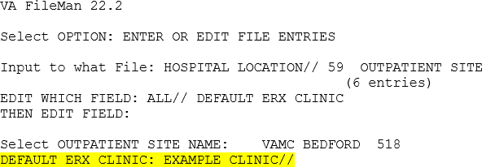

Figure 1-4: OUTPATIENT SITE file (#59) in Enter or Edit File Entries Mode

NPI Institution
Using FileMan Inquiry into the INSTITUTION file (#4), select the NPI Institution identified in the OUTPATIENT SITE file (#59) from section 1.1.6, step b. Make note of the Pharmacy NPI Number.
NOTE: When the Pharmacy record is configured on IEP Web-based application, the NCPDP NUMBER identified in OUTPATIENT SITE file (#59) and NPI Number identified in INSTITUTION file (#4) will be used. These two (2) values also must match with the values published for the Pharmacy.
- If there is no Pharmacy NPI, contact the ePharmacy Team and the NPI Team by e-mail at VHA ePharmacy Implementation Team and VHA NPI Team.

- The ePharmacy Team collaborates with the site and the NPI Team to determine if a new NPI is needed. If a new NPI is needed, the NPI Team submits the request to National Plan and Provider Enumeration System (NPPES) and notifies the site when the NPI
number is assigned by NPPES.
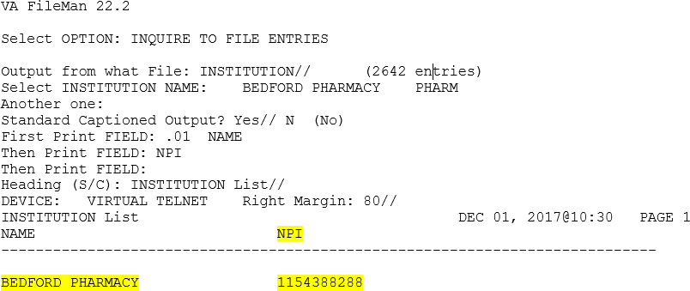
Figure 1-5: INSTITUTION file (#4) in Inquire Mode

Configure ERX DEFAULT LOOKBACK DAYS (OPTIONAL)
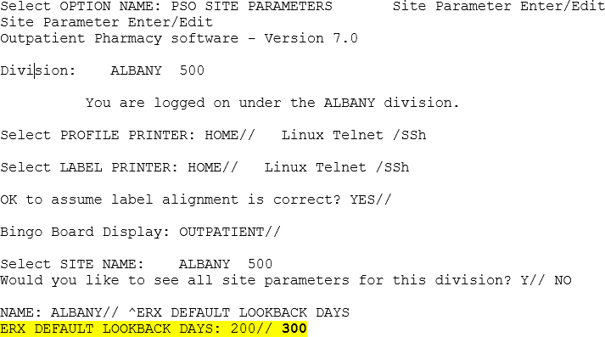
Using Site Parameter Enter/Edit [PSO SITE PARAMETERS] option, update the value for ERX DEFAULT LOOK BACK DAYS (field #10.2), in OUTPATIENT SITE file (#59), as required by the site. Navigate and jump (^) to the ERX DEFAULT LOOKBACK DAYS.
NOTE: By default, ERX DEFAULT LOOKBACK DAYS value is set to 365.

Figure 1-6: OUTPATIENT SITE file (#59) in Inquire Mode
NOTE: Initial site installation of patch PSO*7*635 will be blank and will default to a value of 365 which can be changed to the desired site LOOKBACK DAYS value. For example, a site can update the value to 300 days as shown above.

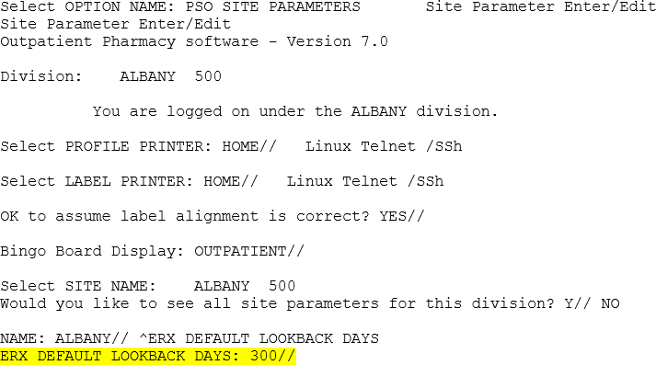

Figure 1-7: OUTPATIENT SITE file (#59) ERX DEFAULT LOOKBACK DAYS Updated

Ready to Go Live
Once the site confirms the users have been trained and the NCPDP and NPI information is correct the site is then ready to proceed with enabling their pharmacy to start receiving live eR_{X}es. The Inbound eR_{X} Support Team assists the site with the final steps to enable their pharmacy.
      - To Go Live, submit a help desk ticket to the VA National Service Desk (NSD) at 855- NSD-HELP (673-4357) and reference “Inbound eR_{X}”.
      - Provide the following site information for the ticket: NCPDP NUMBER, NPI #, VISN, VA Station ID, Pharmacy Name (External/Published), Address, Phone Number and Fax Number.
        - NSD Team routes the ‘go live’ request to Inbound eRX Support Team.
        - Once the Inbound eRX Support Team receives the NSD help ticket they contact the site point of contact (POC) to complete the steps to enable the pharmacy.
      - The Support Team helps the local Site IT Administrator to setup the Connector Proxy.
      - The local Site IT Administrator sets up the Connector Proxy and provides the access and verify codes to the Support Team.
        - Select XOBU SITE SETUP MENU.
        - Select CP - Enter/Edit Connector Proxy User.
        - Answer the prompts, naming the connector: CONNECTORPROXY, PSO.
        - At the “Want to edit ACCESS CODE (Y/N)” prompt, type “Y” (for Yes).
        - Enter the access code for the connector proxy.
        - Re-enter the access code for the connector proxy.
        - At the “Want to edit VERIFY CODE (Y/N)” prompt, type “Y” (for Yes).
        - Enter a verify code for the proxy connector.

        - Re-enter the verify code for the proxy connector.
      - The local Site IT Administrator also provides the VistA link FQDN, TCP Port, and primary Station ID to the Support Team.
      - The Support Team will uses this configuration information to create and test a new VistA link connection from the Inbound eR_{X} Processing Hub to the site.
      - The Support Team provides the FQDN, PORT, and USERNAME/PASSWORD for WEB SERVER entry to the local Site IT Administrator.
      - The Site IT Administrator configures the WEB SERVER entry.
        - Select option XOBW WEB SERVER MANAGER.
        - Select ES for Edit Server.
        - At the “NAME” prompt, enter “PSO WEB SERVER”.
        - At the “SERVER:” prompt, enter the target server FQDN. The target server name and port are given to the site during implementation.
        - At the “PORT:” prompt, enter the target server port number.
        - At the “STATUS:” prompt, ensure status is set to “ENABLED”.
        - At the “LOGIN REQUIRED:” prompt, answer “YES”.
        - At the “USERNAME:” prompt, enter the assigned username.
        - At the “Want to edit PASSWORD (Y/N)” prompt, type “Y” (for YES).
        - Enter the password associated with the username.
        - Re-enter the password to verify the password.
        - At the “SSL ENABLED” prompt, accept the default of “FALSE”.
        - At the “Select Web Service” prompt, enter “PSO ERX WEB SERVICE”.
NOTE: It is recommended to test the configuration of the outbound web server and service. This is performed by choosing/entering option “CK” for “Check Web Service Availability”. When prompted for the server number, select the server number associated with the PSO WEB SERVER entry.
      - The Support Team assigns user privileges for the IEP Web-based Graphical User Interface (GUI) Hub to the respective users from the site. Please see section 1.2.3 for additional details.
      - The Support Team notifies the clearinghouse that the site is ready to Go Live.
      - The Support Team coordinates with the site to determine the expected go live date.
      - On the go live date, the clearinghouse sends a test eR_{X} message to the site to confirm inbound connectivity and receipt of the message in the VistA Holding Queue.
      - Upon confirming the receipt of the Test message successfully in VistA, the support team checks if a Verify message was sent successfully to test the outbound connection to the
clearing house.
      - The site responds with a reject message to test the outgoing connection to the Transaction Hub.
      - Once successfully confirmed, the clearinghouse enables the Pharmacy in their directory and has SureScripts enable it in their directory.

      - The Pharmacy is now Live and enabled to receive eR_{X}es.

Help Desk
For issues with the IEP web-based application that cannot be resolved by this manual or the site administrator, please contact the National Service Desk at 855-NSD-HELP (673-4357) and
reference “Inbound eRX”.

Help Desk Ticket Instructions
To submit a Help Desk ticket:
        - Select the “Your IT” icon on your desktop.
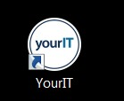

Figure 1-8: Your IT Desktop Icon
The homepage displays.
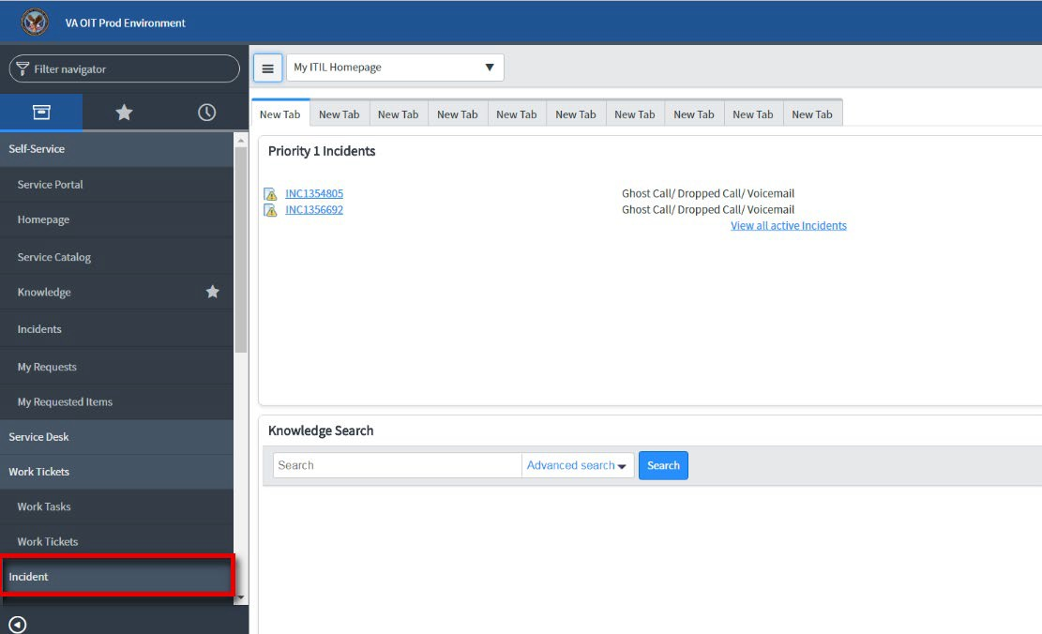
        - Select Incident.
NOTE: Do not select “Incidents” under the Self-Service section. Scroll to the Incident section. If the Incident section is collapsed, select Incident to expand the section.

Figure 1-9: Incident Selection

        - Select Create New.
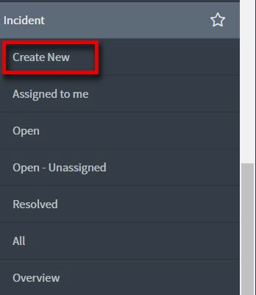
Figure 1-10: Create New Selection
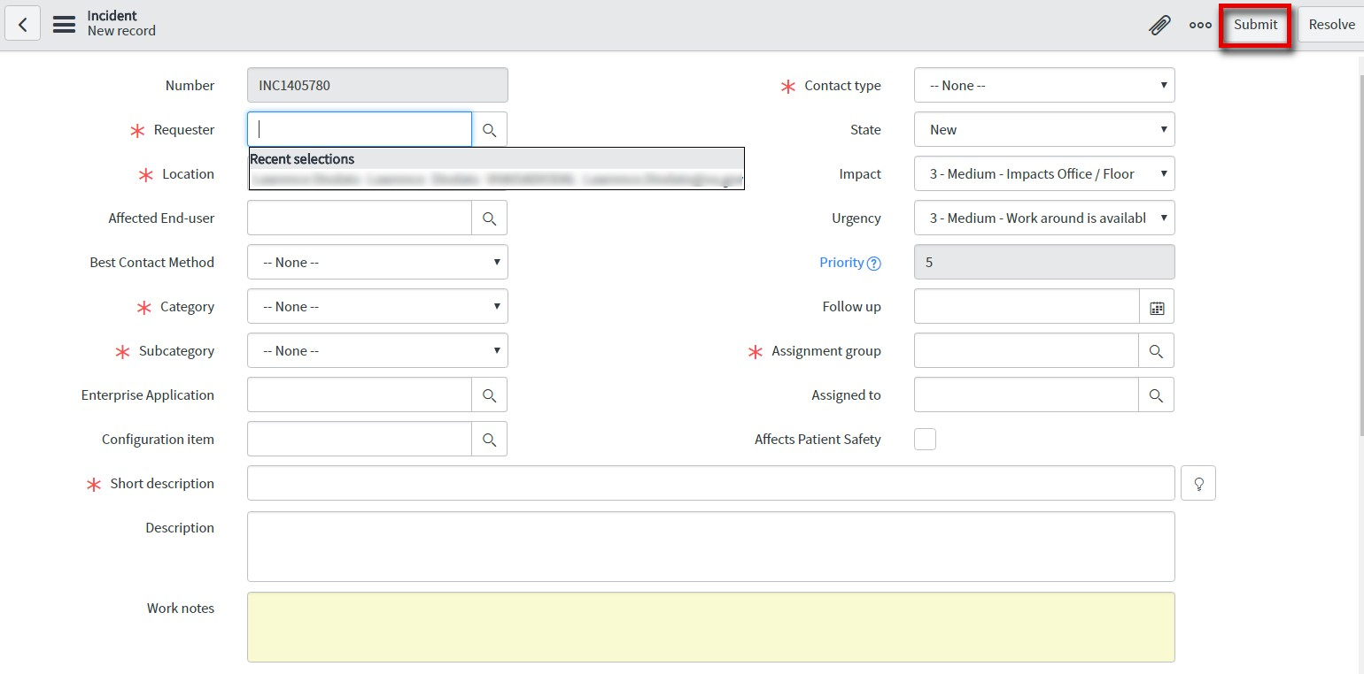
        - Populate the required fields.
NOTE: In the “Assignment Group” field, select Pharmacy Reengineering Inbound e-Prescriptions.

        - Select Submit.
Figure 1-11: New Incident

Inbound ePrescribing Web-based Application
The IEP Web-based application provides eR_{X} management, administration, and monitoring
capabilities. There are four modules of the IEP Web-based application: Pharmacy Management, Track/Audit, User Management, and Help. Please refer to the Inbound ePrescribing User Guide for more information on the functionality found within the application.
The IEP Web-based application is accessed at the following link: Inbound ePrescribing Web Application.

Create Shortcut on Workstation (Desktop)
While at a user’s workstation, create shortcuts to the IEP Web-based application. To create a shortcut on a user’s desktop:
      - Right-click the desktop and select New and then select Shortcut.
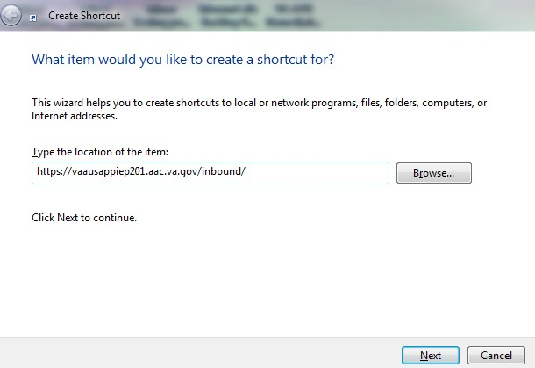
      - Type the URL provided by IT support or the local Site IT Administrator in the “Type the location of the item” field and then select Next. A “Create Shortcut” dialog, similar to the one in the figure below, displays.

Figure 1-12: Create Shortcut Dialog Box

      - Type a name for the shortcut in the “Type a name for this shortcut” field (e.g., Inbound ePrescribing).
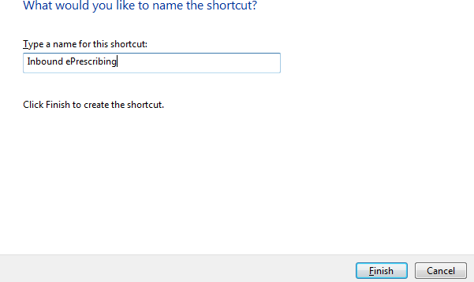
Figure 1-13: Name Shortcut
      - Select Finish to place the shortcut on the desktop.

Turn off Compatibility Setting
The IEP Web-based application runs in Internet Explorer 11 or greater. Note that Compatibility View must be turned off for the application to run effectively.
To turn off Compatibility View:
      - In Internet Explorer, select Tools > Compatibility View Settings.
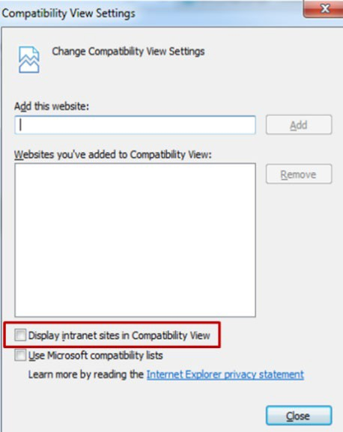
      - Verify that the “Display intranet sites in Compatibility View” checkbox is not selected.

Figure 1-14: Compatibility View Settings

Assign Roles in IEP Web-based Application
A local Site IT Administrator needs to be identified and assigned for administering the IEP Web- based application. The local Site IT Administrator manages user access and permissions of the Web-based application at the site. The following roles are available in the application:
Table 4: Inbound ePrescribing Web-Based Application User Roles & Capabilities

User Role | Functionality
Administrator | Full Control, access to all tabs
Pharmacy Management | Home  Pharmacy Management Track/Audit  Reports Help
PBM Administrator | Home  Pharmacy Management Track/Audit  Reports  Help
Pharmacy Users | Home Track/Audit Reports Help
Def ault VA User (Read Only) | Home Reports Help
The Support Team assigns user privileges for the IEP Web-based Graphical User Interface (GUI) Hub to the respective users from the site, including the Site IT Administrator role. For continued support in assigning user privileges, the local Site IT Administrators can use the User
Management screen to add new users, modify user roles, and disable users. This module only displays for users with the Administrator role assigned.

Add New User
System Administrators can add new users from the User Management screen. To add a new user:
        - Enter the new user’s User ID, First Name, and Last Name.
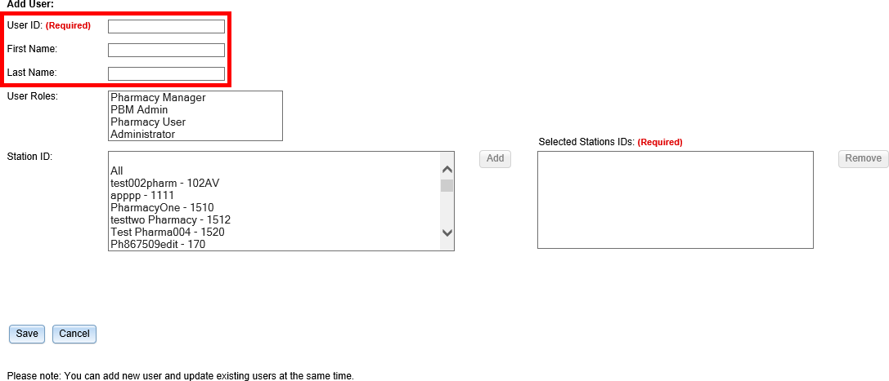
Figure 1-15: Add User - User ID, First Name, Last Name

        - Select the new user’s role(s). Multiple roles may be selected by holding <Ctrl> while selecting more than one role.
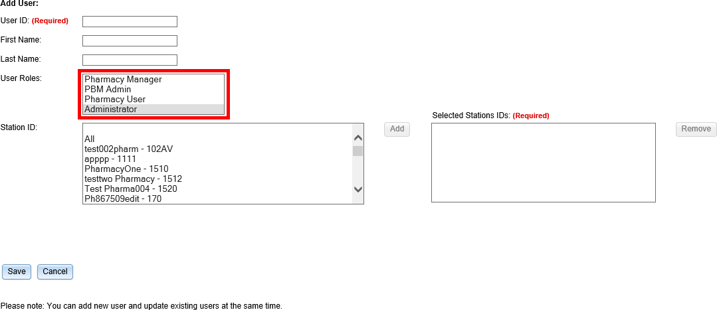
Figure 1-16: Add User - Select User Roles

        - Select the Station ID(s) for the user to have access to. Use the drop down menu to display the Station ID selection Multiple Station IDs may be selected by holding <Ctrl> while selecting more than one Station ID.
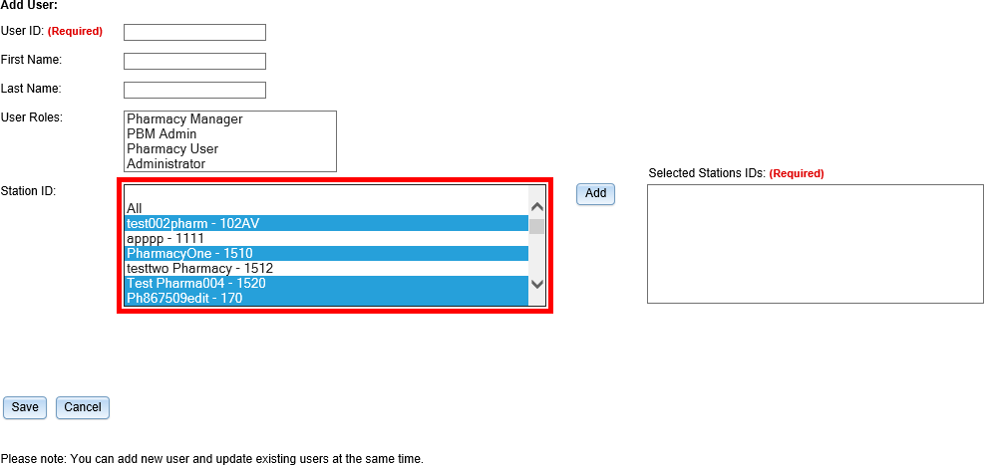
Figure 1-17: Add User – Select Station ID

        - Select the Add button to add the selected Station ID to the “Selected Station IDs” field. To remove Station IDs from the “Selected Station IDs” field, select Remove (not shown).
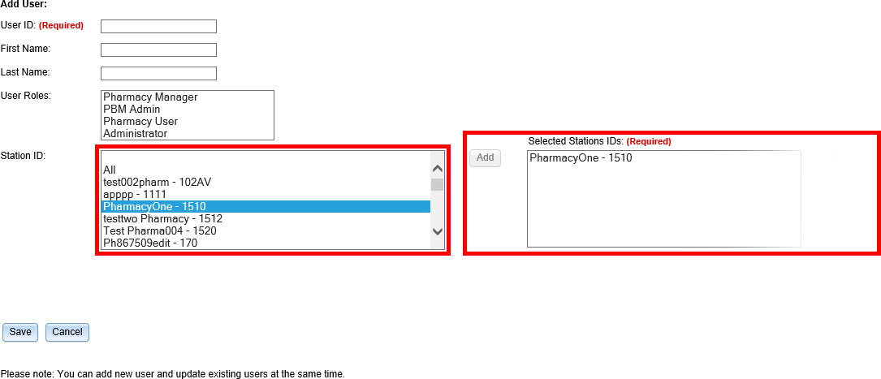
Figure 1-18: Add User – Add and Remove Station ID

When a user is assigned to a Station ID, they are only able to see other users and information within that Station ID. For example, in the User Management table they only see users also
assigned to that Station ID and under Pharmacy Management, they only see information for pharmacies within that Station ID.
If All is selected from the “Station ID” field and added to the “Selected Station IDs” field, the user has access to all Station IDs. Additional Station ID values cannot be added if All has been
selected and added to the “Selected Station IDs” field. If a user attempts to add additional values an error message displays.
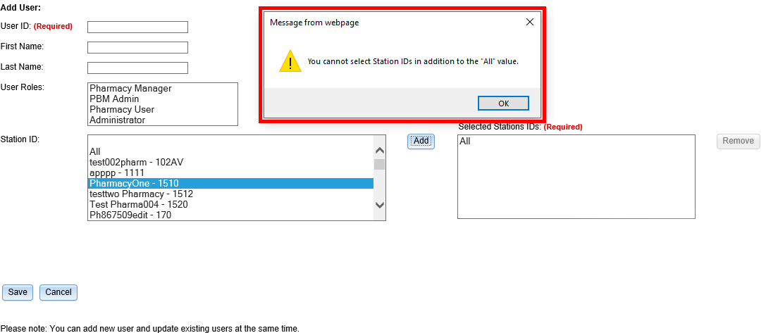
Figure 1-19: All Selection Error Message

        - Select Save to add the new user to the users list. To cancel adding a new user, select

Cancel.
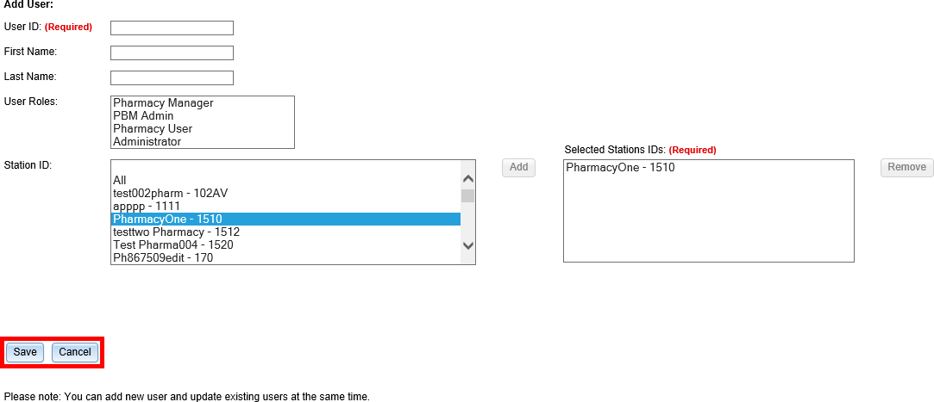
Figure 1-20: Add User - Save and Cancel

Modify User Role
System Administrators can modify user roles from the User Management screen. User roles include:
- Pharmacy Manager
- PBM Admin
- Pharmacy User
- Administrator
For further information on user roles and capabilities, please refer to the Inbound ePrescribing User Guide.
To modify user roles:
        - From the users list, locate the user and select the checkbox(es) for the desired user role(s).
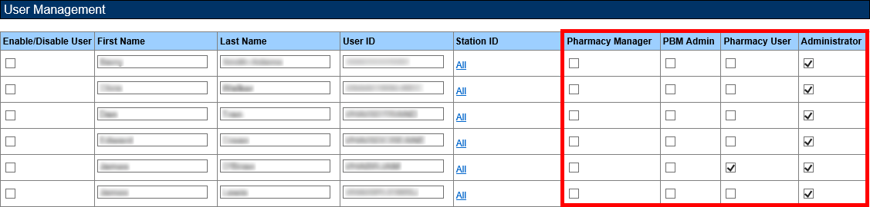
Figure 1-21: Select User Roles

        - Select Save at the bottom of the screen. A message displays indicating that the user was updated successfully.
        - Select Cancel to cancel modifying user roles.

Enable/Disable Users
Users can be disabled and/or re-enabled to use the web application. To update a user’s access to the application, locate the user in the User Management table and select the checkmark in the “Enable/Disable” column. Select Save from the bottom of the screen to update the user’s access.
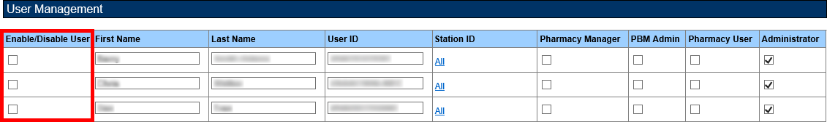
Figure 1-22: User Management Table – Enable/Disable User

When a user is disabled, their information is greyed in the User Management table. To modify the user’s access again, select the checkbox in the “Enable/Disable” column again.
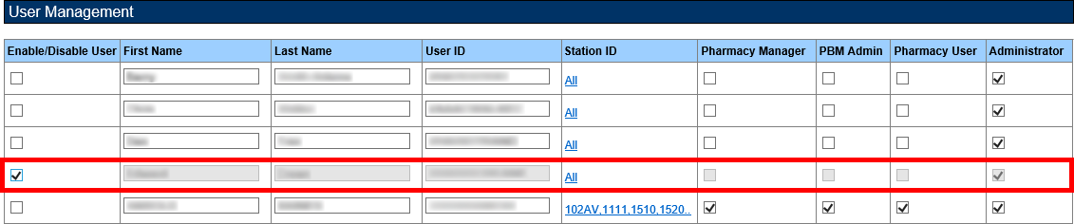
Figure 1-23: User Disabled
If a user that has been disabled attempts to log in to the application, an error message displays.
Figure 1-24: User Disabled Error Message

Pharmacy Management
The Pharmacy Management screen displays the Pharmacy Management table. The default view displays all VA pharmacies. Actions available to users include:
- Search Pharmacy
- Add Pharmacy
- Update Pharmacy

Search Pharmacy
Users can search for a pharmacy from the Pharmacy Management screen. The default view lists all VA pharmacies.
To search for a pharmacy:
        - Enter the NCPDP ID (if known).
        - Enter the Pharmacy Name.
        - Select the desired VISN number from the “VISN” drop down.
        - Select the desired Station ID from the “Station ID” drop down. If viewing All VISNs, the user is unable to select a Station ID. To select a specific Station ID, the VISN must be
selected.
        - Select Search.
The Pharmacy Management table displays results for the selected search criteria.

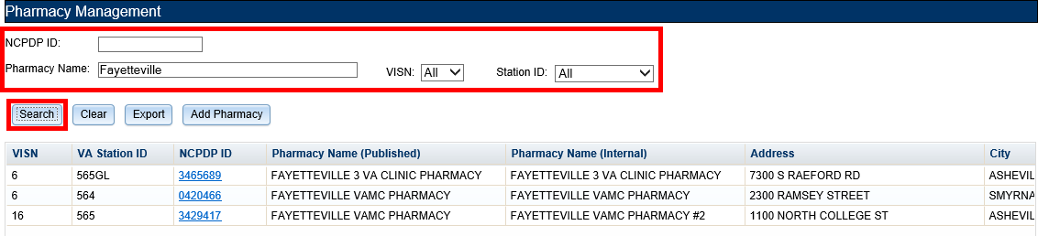

Add Pharmacy
Figure 1-25: Search for a Pharmacy

To add a new pharmacy, please submit a help desk ticket to the VA National Service Desk (NSD) at 1-855-NSD-HELP (673-4357) and reference “Inbound eRX”.
NOTE: The clearinghouse has only one pharmacy directory for all electronic pharmacy transaction types. Therefore, all enumerated dispensing pharmacies should already be available in the clearinghouse directory utilized by Inbound eR_{X}. For IEP, the clearinghouse must enable eR_{X} support for the pharmacy in their Directory. The pharmacy must be “registered” with IEP by adding the pharmacy through the IEP Web-based application.

Enable Pharmacy
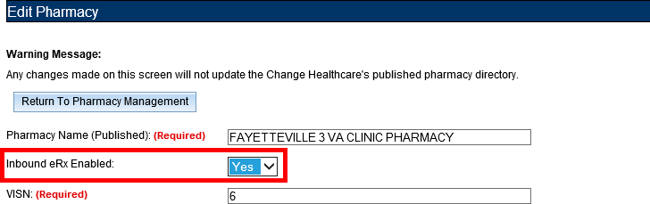
The pharmacy can be enabled to receive eR_{X}es during initial go live or if it has been previously disabled. To enable a pharmacy select Yes from the “Inbound eR_{X} Enabled” drop down on the Edit Pharmacy screen.
Figure 1-26: Enable Pharmacy
NOTE: If a pharmacy is not enabled and a prescription comes in for that pharmacy, an error message is sent back to the provider’s Electronic Health Record (EHR) system. This notifies the provider that the pharmacy is not currently receiving eR_{X}es.

          - Enrollment and Eligibility Check
The Enrollment and Eligibility (E&E) check may be enabled or disabled for individual
pharmacies. This option is provided so each pharmacy may decide whether to turn the E&E check on or off depending on whether the patients whose eRXes are filled at the pharmacy are enrolled in the E&E system. For example, MbM does not currently have any patient enrolled with the E&E system.
To ensure the Enrollment and Eligibility Check is enabled for a pharmacy, select the desired
pharmacy from the Pharmacy Management table and ensure “Yes” displays in the “Enrollment and Eligibility Check Enabled” field. If required, select Yes in the “Enrollment and Eligibility Check Enabled” drop down and then select Update.
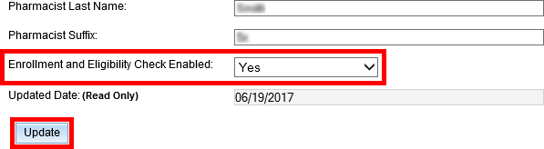

Figure 1-27: Enrollment and Eligibility Check Enabled

Temporarily Disable Pharmacy
In a case where a site needs to halt receiving ePrescriptions temporarily, use Disable eR_{X}/Enable eR_{X} fields.
Disabling a pharmacy allows users the ability to temporarily disable the pharmacy from
receiving eR_{X}es in the event of a natural or facility disaster, maintenance, or move. This disables the pharmacy from receiving New eR_{X}es, but outbound messages still go back to the external
provider via Change Healthcare (CH). The pharmacy is disabled on the Processing Hub, but no changes are made in CH.
NOTE: The enable/disable in the Processing Hub is for a temporary disable, which will also allow outgoing messages (rejection messages for any new eR_{X}es still in process) to continue
flowing from VistA. Additionally, incoming messages will still flow from the clearinghouse to the Processing Hub for the pharmacy, however an error message will be returned to the provider notifying that the Inbound eR_{X} messaging is currently not available.

To temporarily disable a pharmacy:
- On the Pharmacy Management screen, select Search and then, select the hyperlink for the desired pharmacy under the “NCPDP ID” column. The Edit Pharmacy screen
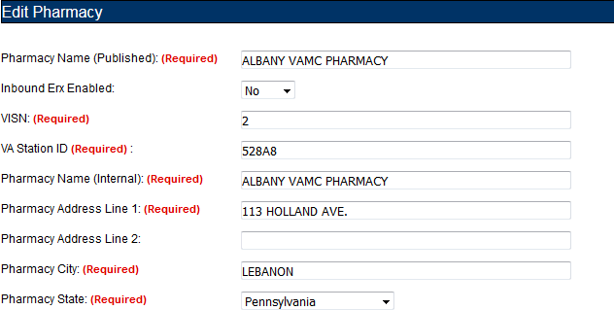
displays.
Figure 1-28: Edit Pharmacy Screen
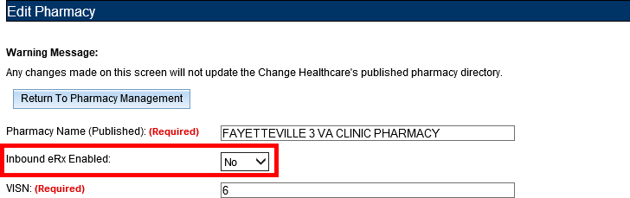
- Select No from the “Inbound eR_{X} Enabled” drop down.
Figure 1-29: Inbound eRX Enabled Drop Down

- At the bottom of the Edit Pharmacy screen, select Update to save all changes. The date that the fields were modified displays in the “Updated Date” field.
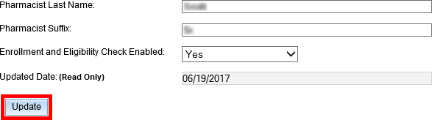
Figure 1-30: Update Pharmacy Information

- Selecting the Return to Pharmacy Information button returns the user to the Pharmacy Management screen.

Disable Pharmacy
To completely halt a specific Pharmacy from receiving ePrescriptions, please submit a help desk ticket to the VA National Service Desk (NSD) at 1-855-NSD-HELP (673-4357) and reference “Inbound eR_{X}”.
NOTE: If a pharmacy is to be disabled for a long duration, a request must be made to the clearinghouse. Note that the NSD will route the ticket to an IEP Administrator to assist with this step. the clearinghouse can switch the pharmacy to fax only or turn off eR_{X} delivery (electronic or fax) completely.

Unit 2. Post Implementation Reporting Problems
- If a site no longer wishes to receive eR_{X}, they need to submit a help desk ticket to the VA Service Now (SNow)) at 1-855-673-4357) and reference “Inbound eR_{X}”.
- SNow Team routes the ‘turn off’ request to the eR_{X} Support Team who notifies the
clearinghouse, ensuring that only eR_{X} and NOT existing ePharmacy operations need to be disabled.
- To report all issues/problems submit a help desk ticket to the VA Snow at 1-855-673- 4357 and reference “Inbound eR_{X}”.
- Sites should notify the VHA ePharmacy Implementation Team of changes to the Physical Address, Telephone Number, and Fax Number when new pharmacies open and/or if a pharmacy closes. The ePharmacy Team coordinates the needed changes with NCPDP, the NPI Team and the clearinghouse.

Unit 3. Release Documentation
The following documents and files are available on the anonymous software directories identified in the table below.
Table 5: Inbound ePrescribing Release Documents
File Name | Title | FTP Mode
pso_7_0_p635_ig | Installation Guide - Inbound ePrescribing (pso*7*0*p635) | Binary
pso_7_0_p635_um | User Manual - Inbound ePrescribing (pso*7*0*p635) | Binary
pso_7_0_p635_tm | Technical Manual/Security Guide - Outpatient Pharmacy V.7.0 | Binary
pso_7_0_p635_rn | Release Notes - Inbound ePrescribing (pso*7*0*p635) | Binary
pso_7_0_p635_img | Implementation Guide - Inbound ePrescribing (pso*7*0*p635) | Binary
The documents are also available on the Outpatient Pharmacy VA Software Document Library (VDL), which is located at Outpatient Pharmacy VDL.

