Outpatient Pharmacy
Inbound ePrescribing (IEP)
Meds-by-Mail (MbM) Class 3 to Class 1 Conversion
VistA Patch # PSO*7.0*700

Release Notes

December 2023
Version 1.0

Department of Veterans Affairs
Office of Information and Technology (OI&T)

Table of Contents

1. Introduction 3
1.1 Related Patches 3
1.2 Summary of Changes 3
2. Reflection Terminal Display Settings 17
3. Product Documentation 20

Introduction
The Inbound Electronic Prescribing (eRx) v5.0 enhancements released in the stand-alone VistA patch PSO*7*700 introduces a new option called eRx Holding Queue Processing [PSO ERX QUEUE PROCESSING] for processing inbound eRx records more safely and efficiently. The existing option Complete Orders from eRx [PSO ERX FINISH] will still be available to the users with a message that it will be retired soon (Patch PSO*7*746), and they should use the new option. This new option also includes a few enhancements that were originally created by MbM (Meds-by-Mail) in-house (class 3) to address some of their specific needs. These enhancements are now available to all VA Medical Centers. This patch also addresses 3 Service Now Tickets. A summary of the changes can be found below.

Related Patches
This functionality enhancement is being released via a single VistA patch:

APPLICATION/VERSION PATCH
----------------------------------------------------------
OUTPATIENT PHARMACY (PSO) V. 7.0 PSO*7*700

Summary of Changes
Below is a list of the changes made to the existing Outpatient Pharmacy eRx functionality. Please, refer to the patch description and documentation for more detailed information.

- ‘Semi-retirement’ of the Complete Orders from eRx [ PSO ERX FINISH] option
While this option is not being deleted or blocked from being accessed by this patch, its functionality is being 100% replaced by a new option described below. Upon entering this option, the users will now see the following message:

************************** NOTICE ****************************
This option will be retired soon. Please, use the new option:

ERX eRx Holding Queue Processing [PSO ERX QUEUE PROCESSING]

It fully replaces this option and provides some additional
functionality that will help you process incoming eRx records
more efficiently.
**************************************************************

NOTE: A subsequent patch scheduled to be released in the second half of 2024 will disable this option.

- New option eRx Holding Queue Processing [PSO ERX QUEUE PROCESSING]
This new option includes 100% of the functionality in the option mentioned above while making great improvements on the sorting, searching, grouping and especially the display of the outside data compared to VistA corresponding elements. It goes a little further and introduces the suggestion functionality for VistA Patient, Provider and Drug/SIG when the users try to match the incoming data to VistA records. Below are some of the main features included in this new option. For more detailed information look for the ePrescribing User Documentation on the VDL (www.va.gov/vdl).

  - VistA Patient Suggestion
When matching eRx Patient to a corresponding VistA Patient before the user is prompted for the VistA entry, it will first be presented with suggestion (if any) based on the following logic:
- Once a VistA Patient is matched and later validated to an eRx Patient it is then "remembered."
- When a new eRx prescription is received for the same eRx Patient the "remembered" VistA Patient(s) are then presented as suggestions for the user to select, as shown below (Validate Patient Screen - Edit action):

Select Item(s): Next Screen// E Edit
|Sugg. 1 of 1 - 08/08/23|
ERX PATIENT VISTA PATIENT |From eRx#: 123123 |
__________________________________________________________________________
Name:OPEKXAQDY,XUISCSD |Name:OPEKXAQDY,XUISCSD F
DOB :XXX 99, 9999 |DOB :XXX 99, 9999
Sex :MALE |Sex :MALE
SSN :999999999 |SSN :999-99-9999
Address: |Address:
123 FAKE STREET #101 | 123 FLAKE ST SUITE 101
XXXXX,XX 99999 | PLANO,TX 75025
Primary Phone: 0236663417 |
_____________________________________|____________________________________
ACTION on SUGGESTION: (A)CCEPT (F)ORGET (E)XIT: EXIT//

- The left column has information about the eRx Patient while the right column has information about the VistA Patient. The 'Last Match' field indicates the last time the VistA Patient was matched to the eRx Patient and validated. When a corresponding field does not match it will display in reverse video.

- When presented with a suggestion the user is given 3 options: (A)ccept, (F)orget or (E)xit:

- ACCEPT - Accepts the suggested VistA Patient and matches it to the eRx
- FORGET - Forgets this suggested VistA Patient so that it is not presented again in the future to any user
- EXIT - Exits and proceed to match the VistA Patient manually

If more than one suggestion exists, then a 4th option is included: (N)ext:

ACTION on SUGGESTION: (A)CCEPT (F)ORGET (N)EXT (E)XIT: EXIT//

- NEXT - Ignores the current suggestion and view the next one

  - VistA Provider Suggestion
When matching eRx Provider to a corresponding VistA Provider before the user is prompted for the VistA entry it will first be presented with suggestion (if any) based on the following logic:

- Once a VistA Provider is matched and later validated to an eRx Provider it is then "remembered."

- When a new eRx prescription is received for the same eRx Provider the "remembered" VistA Provider(s) are then presented as suggestions for the user to select, as shown below (Validate Provider Screen - Edit action):

|Sugg. 1 of 1 - 08/08/23|
ERX PROVIDER VISTA PROVIDER|From eRx#: 123123 |
__________________________________________________________________________
Name:AEXRFGRI,APSKACWHZ |Name:AEXRFGRI,APSKACWHZ
NPI :999999999 |NPI : 999999999
DEA#:XX9999999 |DEA#: XX9999999
Phone #: 555-220-0303 |Phone #: (555) 220-0303
Address: |Address:
123 NOWHERE RD |123 NOWHERE RD
XXXXXXXXXX,XX 99999 |XXXXXXXXXX,XX 99999
___________________________________|_____________________________________
ACTION on SUGGESTION: (A)CCEPT (F)ORGET (E)XIT: EXIT//

- When presented with a suggestion the user is given 3 options: (A)ccept, (F)orget or (E)xit:

- ACCEPT - Accepts the suggested VistA Provider and matches it to the eRx
- FORGET - Forgets this suggested VistA Provider so that it is not presented again in the future to any user
- EXIT - Exits and proceed to match the VistA Provider manually

If more than one suggestion exists, then a 4th option is included: (N)ext:

ACTION on SUGGESTION: (A)CCEPT (F)ORGET (N)EXT (E)XIT: EXIT//

- NEXT - Ignores the current suggestion and view the next one

  - VistA Medication (Drug, Dosage, Qty, SIG, etc.) Suggestion
When matching the eRx Drug to a corresponding VistA Drug before the user is prompted for the VistA entry it will first be presented with suggestion (if any) based on the following logic:

- Once an eRx is accepted, it moves to the Pending Queue as a Pending Order. After the Pending Order is finished it becomes an Active prescription. At this point the software will "create a memory" of how the prescription was entered (Drug, Dosage, Days Supply, Qty, # of refills, etc.).

- When a new eRx prescription is received for the same eRx Drug, NDC Code, SIG, Qty, Days Supply, # of Refills and Substitution allowance. The "remembered" VistA fields are then presented as suggestions for the user to select, as shown below (Validate Drug Screen - Edit action):

|Sugg. 1 of 1 - 06/11/23|
RX MED VISTA MED |From Rx#: 2297913 |
________________________________________________________________________
Drug: Meloxicam 15mg Tablet |Drug: MELOXICAM 15MG TAB
Substitution? YES Renewals? YES |Drug Message:
| NATL FORM (2/10)
____________________________________|___________________________________
SIG: |SIG:
TAKE 1 TAB PO Q6H PRN | TAKE ONE TABLET BY MOUTH ONCE EVERY
| 6 HOURS AS NEEDED
____________________________________|___________________________________
Provider Notes/Comments: |Provider Comments:
____________________________________|___________________________________
Quantity: 90 |Quantity: 90
Dispense Unit: |Dispense Unit: TAB
Qty Qualifier: Original Quantity |
____________________________________|_______________________________________
Days Supply: 23 Refills: 5 |Days Supply: 23 Refills: 5
____________________________________|_______________________________________
ACTION on SUGGESTION: (A)CCEPT (F)ORGET (E)XIT: EXIT//

- When presented with a suggestion the user is given 3 options: (A)ccept, (F)orget or (E)xit:

- ACCEPT - Accepts the suggested VistA Rx data and matches it to the eRx
- FORGET - Forgets this suggested VistA Rx data so that it is not presented again in the future to any user
- EXIT - Exits and proceed to match the Rx data manually

If more than one suggestion exists, then a 4th option is included: (N)ext:

ACTION on SUGGESTION: (A)CCEPT (F)ORGET (N)EXT (E)XIT: EXIT//

- NEXT - Ignores the current suggestion and view the next one

  - Patient Validation Screen
The content of the Patient Validation screen was completely re-arranged to show the eRx Patient and the VistA Patient side-by-side. In addition, the eRx Patient allergy list (received from the outside prescriber) will be displayed as well as the ChampVA Rx Benefit eligibility (MBM sites only). Besides displaying the patient’s information side-by-side, a few other features were introduced to make the screen more user friendly, such as:
- When there is a mismatch for field (e.g., Name, DOB, etc.) the content of such field will display in reverse video in for both records, eRx and VistA Patients.
- The content will display in highlight to stand out from the field label.

Note: These features depend on the terminal display settings being set differently for reverse video and highlighted font for it to work. See below on how to set them.

Below is an example of how the new screen will be displayed (without the reverse or highlighted video features):

eRx Reference #: 999999 Eligibility: SC
Status: AUTO-MATCHED/EDITED & VALIDATED by TEST,USER on 1/28/23@14:52:29
ERX PATIENT VISTA PATIENT
_________________________________________________________________________
Name: XXXX,XXXXXXX XXXX |Name: XXXX,XXXXXXX XXXX
DOB : XXX 99, 9999 |DOB : XXX 99,9999
SSN : 999999999 |SSN : 999-99-9999
Sex : MALE |Sex : MALE
Address: |Address:
123 PATIENT WAY | 123 PATIENT WAY
XXXXXXXX,XX 99999 | XXXXXXXX,XX 99999
Home Phone: 9999999999 |Home Phone: 999-999-9999
_______________________________________|_________________________________
Allergy: |Allergy:
NO ALLERGY ASSESSMENT | NO KNOWN ALLERGIES
_______________________________________|_________________________________
|Pharmacy Narrative:
_______________________________________|_________________________________
Weight(Kg): |Weight(Kg):
Height(cm): |Height(cm):
_______________________________________|_________________________________

  - Provider Validation Screen
The content of the Provider Validation screen was completely re-arranged to show the eRx Provider and the VistA Provider side-by-side. In addition, the Besides displaying the providers side-by-side, a few other features were introduced to make the screen more user friendly, such as:
- When there is a mismatch for field (e.g., Name, DEA#, etc.) the content of such field will display in reverse video in for both records, eRx and VistA providers.
- The content will display in highlight to stand from the field label.

Note: These features depend on the terminal display settings being set differently for reverse video and highlighted font for it to work. See below on how to set them.

Below is an example of how the new screen will be displayed (without the
reverse or highlighted video features):

Provider Validation Apr 16, 2023@17:52:07 Page: 1 of 1
eRx Reference #: 344422 eRx Patient: TEST,PATIENT
Status: AUTO-MATCHED
ERX PROVIDER VISTA PROVIDER
_____________________________________________________________________
Name: TEST,PROVIDER |Name: TEST,PROVIDER
NPI : 1073579710 |NPI : 1073579710
DEA : AV4538419 |DEA : CC4796237 DEA EXP: 12/23/20
|
Address: |Address:
123 FAKE STREET SOUTH | 123 FAKE STREET NORTH
XXXXXX,XX 99999 | XXXXXX,XX 99999
Tel: 999-999-9999 | Tel: (999) 999-9999
Fax: | Fax:
______________________________________|__________________________________

  - Drug/SIG Validation Screen
The content of the Drug Validation screen was completely re-arranged to show the eRx Drug information and the VistA corresponding fields in a side-by-side arrangement. In addition, the eRx Patient allergy list (received from the outside prescriber) will be displayed as well as the list of allergies from the VistA patient.

Besides displaying the information side-by-side, a few other features were introduced to make the screen more user friendly, such as:
- When there is a mismatch for field (e.g., Drug Name, Qty, etc.) the content of such field will display in reverse video for both fields, eRx and VistA.
- The content will display in highlight to stand from the field label.

Note: These features depend on the terminal display settings being set differently for reverse video and highlighted font for it to work. See below on how to set them.

Below is an example of how the new screen will be displayed (without the
reverse or highlighted video features):

Drug Validation Aug 18, 2023@13:58:45 Page: 1 of 3
eRx Reference #: 123211 Date Written: 8/10/23 Effective Date:
Status: MANUALLY-MATCHED
ERX MED | VISTA MED
Allergy: |Allergy:
NO ALLERGY INFORMATION RECEIVED | NO KNOWN ALLERGIES
________________________________|_____________________________________
Drug: BREZTRI AEROSPHERE 160 MCG|1)Drug: BREZTRI AEROSPHERE 160 MCG
-9MCG-4.8MCG/ACTUATION HFA|
AEROSOL INHALER |
Substitution? YES Renewals? YES|Drug Message:
| NATL FORM (10-01) (NDC)
________________________________|_____________________________________
SIG: |SIG:
Inhale 2 puffs twice a day by | INHALE 1 PUFF PSIV EVERY MORNING
inhalation route for 30 days. |
________________________________|_____________________________________
|2) Dosage: 1 PUFF
| Verb: INHALE
|Disp. Units:
| Noun:
| Route: NASAL
| Schedule: QAM
________________________________|_____________________________________
|3)Patient Instructions:
|
________________________________|_____________________________________
Provider Notes/Comments: |4)Provider Comments:
|
________________________________|_____________________________________
|5)Pat. Status: OTHER FEDERAL
________________________________|_____________________________________
Quantity: 30 |6)Quantity: 30
Dispense Unit: | Dispense Unit: BX
Qty Qualifier: Original Quantity|
________________________________|_____________________________________
Days Supply: 30 Refills: 5 |7)Days Supply: 30 8)Refills: 5
________________________________|_____________________________________
|9)Routing: MAIL
________________________________|_____________________________________
|10)Clinic: CCNRX CLINIC
________________________________|_____________________________________

  - New action View History Log (HL)
This new action added eRx Holding Queue Display screen will allow the user to view a comprehensive history of the eRx as it moves through the OP application, including activities in Backdoor Pharmacy. Please, refer to the user documentation for more information about this new option.

  - Batch Hold and Un-Hold Functionality
The current Hold and Un-Hold actions were modified to perform the following additional function: every time a prescription is put on Hold or removed from Hold, the software will check if other prescriptions exist for that patient that were sent by the same prescriber on the same day. If any are found, the software will ask the user if they want to Hold (or Un-Hold) those additional eRx records as well, as shown below:

Select Action: Next Screen// H Hold

Select HOLD reason code: HAL NO ALLERGY ASSESSMENT
Additional Comments (Optional): TESTING BATCH HOLD
Updating...done.

The following prescriptions are from the same provider and received on the
same day:

PROVIDER: TEST,PROVIDER eRx RECEIVED DATE: JAN 28, 2023@10:57:14
ERX ID DRUG NAME PROVIDER STATUS
--------------------------------------------------------------------------
123011 GABAPENTIN 300MG CAP TEST,PROVIDER N
123012 CITALOPRAM HYDROBROMIDE 20MG T TEST,PROVIDER N
123013 IBUPROFEN 400MG TAB TEST,PROVIDER N
123014 ACETAMINOPHEN 325MG TAB TEST,PROVIDER N

Do you want to put them on HOLD-HAL? No// YES Updating...done.

  - New Allergy Functionality Enhancements
Functionality related allergies is being improved through the following modifications:

- When matching or accepting validation of a VistA patient it will display in the warnings if the VistA patient selected has no Allergy Assessment:

******************************* WARNING(S) *************************
VistA Patient does not have an Allergy Assessment.
***********************************************************************

- A new screen titled 'Patient Allergies' was created to show the eRx Patient allergies side-by-side with the VistA Patient allergies in detail. This new Screen can be invoked by using the PA (Patient Allergy) hidden action from the following screens:

- eRx Holding Queue Display Screen (eRx Holding Queue)
- Patient Validation Screen (eRx Holding Queue)
- Drug Validation Screen (eRx Holding Queue)
- Pending Order Orders Screen (Backdoor OP)

This new screen contains an action called VPA (VistA Patient Allergies), which allows the user to update the VistA Patient Allergies without leaving the option.

Note: In order to use the VPA action the VistA Patient must have been previously matched.
  - Change View Action – All 3 lists
Most of the prompts when entering the option have been converted into User Preferences changed after loading the list and can be saved by each user as their preferred View through the hidden action CV (Change View) in all 3 lists: Patient Centric Queue, Single Patient Queue and Rx Medication Queue. The change made with this action can be saved for the individual user as a preferred view for every time the enter the option. It can also be deleted later.

  - Header Section Changes – All 3 lists
The header part of the option was modified to display information about the parameters used to compose the list, such as LOOK BACK DAYS, MAX. QUEUE SIZE, ERX STATUS, etc.

  - Grouping/Un-Grouping by CS – All 3 lists
The Grouping by CS (Controlled Substances) have a new format, which separates entries in the queue.

  - Switching from Patient Centric to Rx Medication Queue
The user will be able to switch views more easily between the Patient Centric and the Rx Medication queues via the PC and RX actions.

  - New choices for Searching records
Queue Search/Filter adds 4 new options in the Patient Centric View: RX#, VISTA PATIENT, VISTA PROVIDER and MATCH STATUS. In addition, the interface for performing searches was changed to display information about the selected filters, including in the header part of the list. The current filters can easily be reset via the RAF (Remove Filters) action.

  - Match Status Search (explained)
The Match Status filter was added to the Patient Centric and Rx Medication View and it has 4 different choices shown below:

- PATIENT NOT MATCHED
- PROVIDER NOT MATCHED
- DRUG NOT MATCHED
- PATIENT, PROVIDER AND DRUG MATCHED

1: Includes records where the patient has not been matched
2: Includes records where the provider has not been matched yet, but the patient is matched
3: Includes records where the drug has not been matched yet, but the patient and the provider are matched
4: Includes records with the patient, provider and drug matched

  - Filter information on the Header section
The header in the Patient Centric and Medication views will display information about the selected filters, as shown below:

Rx Medication Queue Nov 28, 2023@15:46:17 Page: 1 of 1
LOOK BACK DAYS: 200 CS/NON-CS: BOTH (II-V) MAX. QUEUE SIZE: 999
FILTERED BY: 01/08/23-01/18/23|PATIENT(TEST,PATIENT)
# PATIENT DOB DRUG PROVIDER STA REC.DAT
...

Note: The current filters can easily be reset via the RAF (Remove All Filters) action.

  - Simplified Sorting
Queue Sorting was streamlined to allow the user to quickly sort the list through specific actions for each column and allows for Descending Sorting (not available in the replaced option). For example: SPAT sorts the list by PATIENT in an ascending order, a subsequent SPAT will sort it in a descending order.

  - Refresh Action
A new action called Refresh (REF) was added to allow the user to re-display the queue. This feature allows the user to view the latest 'locks' from other users that have been placed since the queue was last built as well as the changes in the records that have already been processed since the last time the list was loaded.

  - Look Back Days Action
A new action called Change Look Back Days (LBD) was created to quickly allow the user to change the number of days to look back for records.

  - Next Patient Action
A new action called Next Patient (NP) was created to assist users in selecting the next eRx Patient with the oldest actionable record on the queue to be worked on without too many keystrokes.

  - Show/Hide Details Action
A new action called Show/Hide Details (DET) under the Single Patient Queue as well as the Rx Medication Queue and it will show/hide additional information about each one of the eRx on the list. It will display Qty, # of Refills, Days Supply, and the SIG (medication instructions).

  - Include All Statuses Action
A new action called Include All Statuses (IAS) under the Single Patient list will show/hide non-actionable statuses like Processed (PR), Removed (RM), etc. Furthermore, a field on the header will indicate which statuses are being displayed: ALL or ACTIONABLE only.

  - Quick Filter by Message Type
Within the Rx Medication Screen (or Rx List View Screen) the user will have the ability to easily filter the list by Message Type by selecting one of the following hidden actions.

NEW New Rx's Only
CR Change Request Only
RXF Rx Refill Only
IE Inbound Errors Only
OE Outbound Errors Only
CA Cancel Rx's Only
CN Cancel Response Only
CX Change Response Only
RRQ Renewal Request Only
RRP Renewal Response Only

Note: The same result can be accomplished via the SQ (Search Queue) action and selecting #7 and then the specific message type.

  - NDC Code include on the Print eRx output
The NDC code will now be printed under the eRx Drug in the output print from the Print eRx action, as shown below:

***************PRESCRIPTION INFORMATION******************
eRx Drug: MELOXICAM 15MG TAB
NDC: 00378108901
eRx Written Date: MAR 17, 2023 eRx Issue Date:
...

  - Remove Action to work on held eRx records
The Remove eRx (RM) action will now work for eRx records that are currently on Hold. Before, the user had to Un-Hold the record before removing it.

  - Changes to Jump to OP Action
The Jump to OP (JO) action only allowed the user to 'jump' to Backdoor Pharmacy option if the patient had pending orders to be finished. This restriction is being removed by this patch. Furthermore, the jump will be restricted to the VistA Patient matched being validated first before the user can jump.

- Complete Orders from OERR [PSO LMOE FINISH] - Pending Order Queue
A few changes have been made to this option regarding the processing of eRx prescriptions.

  - Routing Field edit enabled for CS eRx Orders
Users will now be allowed to edit the Routing (Mail/Window) field for a CS eRx Pending order.

  - Pending Order Side-by-Sie Interface for eRx Orders
Similar to the eRx Drug Validation screen shown above the view of a pending order that originated from an eRx will be displayed differently in the Patient Prescription Processing [PSO LM BACKDOOR ORDERS] and Complete Orders from OERR [PSO LMOE FINISH] options. When these options identify the pending order an eRx prescription it will automatically switch the display of the data to a side-by-side viewing where the left side shows the eRx prescription information (from the outside doctor) while the right-side shows the VistA corresponding information.

Besides displaying the information side-by-side, a few other features were introduced to make the screen more user friendly, such as:
  - When there is a mismatch for field (e.g., Drug Name, Qty, etc.) the content of such field will display in reverse video for both fields, eRx and VistA.
  - The content will display in highlight to stand from the field label.

Note: These features depend on the terminal display settings being set differently for reverse video and highlighted font for it to work.

Below is an example of how the new screen will be displayed (without the reverse or highlighted video features) for a new eRx Pending Order:

Pending OP Orders (ROUTINE) Aug 18, 2023@14:22:27 Page: 1 of 6
SPLYFX,KUNLYS JELUAHT
PID: 999-99-9999 Ht(cm): 187.96 (12/28/2010)
DOB: APR 28,1947 (76) Wt(kg): 112.94 (01/07/2011)
SEX: MALE Non-VA Meds on File Last entry on 06/24/23
CrCL: 53.8(est.) (CREAT: 1.51mg/dL 12/16/10) BSA (m2): 2.39
-------------------------------------------------------------------------
ERX (123360) | VISTA PENDING ORDER
-------------------------------------------------------------------------
PATIENT MANUALLY-MATCHED | VALIDATED by TESTONE,USER1 on 8/17/23@14:51:21
Name: SPLYFX,KUNLYS JELUAHT |Name: SPLYFX,KUNLYS JELUAHT
DOB : XXX 99, 9999 |DOB : XXX 99, 9999
SSN : 999999999 |SSN : 999-99-9999
Sex : MALE |Sex : MALE
__________________________________|_____________________________________
|Pharmacy Narrative:
|terbinafine ok x 90 days (5/06);
|ROSIGLITAZONE; PANTOPRAZOLE; ZOLPIDEM
__________________________________|_____________________________________
Allergy: |Allergy:
NO ALLERGY INFORMATION RECEIVED | NO KNOWN ALLERGIES
__________________________________|_____________________________________
PROVIDER AUTO-MATCHED | VALIDATED by TESTONE,USER01 on 8/17/23@14:51:40
Name: TEST,PROVIDER |Name: TEST,PROVIDER MD
NPI : 9999999999 |NPI : 9999999999
DEA : XX9999999 |DEA :
__________________________________|_____________________________________
DRUG MANUALLY-MATCHED | VALIDATED by TESTONE,USER01 on 8/17/23@14:51:55
Substitution? YES |1) Orderable Item: ***(N/F)***
Renewals? YES | PANTOPRAZOLE NA TAB,EC
__________________________________|_____________________________________
Drug: |2) Drug: ***(N/F)***
PANTOPRAZOLE NA 40MG EC TAB | PANTOPRAZOLE NA 40MG EC TAB UD
|Drug Message:
| NATL N/F; INCREMENT OF 100s
__________________________________|_____________________________________
SIG: |SIG:
TAKE ONE TABLET BY MOUTH EVERY DAY| TAKE ONE TABLET BY MOUTH ONCE DAILY
__________________________________|_____________________________________
|3) *Dosage: 40 (MG)
| Verb: TAKE
| Disp. Units: 1
| Noun: TABLET
| *Route: ORAL
| *Schedule: ONCE DAILY
__________________________________|_____________________________________
|4)Patient Instruction:
|
__________________________________|_____________________________________
Provider Notes/Comments: |Provider Comments:
__________________________________|_____________________________________
|5) Pat.Status: OUTPATIENT CARE
__________________________________|_____________________________________
Date Written: AUG 10, 2023 |6) Issue Date: AUG 10,2023
Effective Date: |7) Fill Date: Sep 12, 2023
__________________________________|_____________________________________
Days Supply: 30 |8) Days Supply: 30
__________________________________|_____________________________________
Quantity: 30 |9) QTY (TAB): 30
Dispense Unit: |
Qty Qualifier: Original Quantity |
__________________________________|_____________________________________
Refills: 5 |10) Refills: 5
__________________________________|_____________________________________
|11) Routing: MAIL
__________________________________|_____________________________________
|12) Clinic:
__________________________________|_____________________________________
Provider: TEST,PROVIDER |13)Provider: TEST,PROVIDER MD
__________________________________|_____________________________________
|14)Copies: 1
__________________________________|_____________________________________
|15)Remarks:
__________________________________|_____________________________________
eRx Received on 9/20/23@11:44 | Accepted by TEST,USER on 9/26/23@10:30

Below is an example of how the new screen will be displayed (without the reverse or highlighted video features) for a renewal eRx Pending Order:

Prescription Renew Sep 12, 2023@14:28:50 Page: 1 of 1
OUTDYX,JALN ILAH <A>
PID: 999-99-9999 Ht(cm): 182.88 (02/24/2011)
DOB: JUN 21,1954 (69) Wt(kg): 93.44 (02/24/2011)
--------------------------------------------------------------------------
ERX (123360) | VISTA PENDING ORDER
-------------------------------------------------------------------------
PATIENT MANUALLY-MATCHED | VALIDATED by TESTONE,USER01 on 8/11/23@14:31:33
Name: OUTDYX,JALN I |Name: OUTDYX,JALN ILAH
DOB : XXX 99, 9999 |DOB : XXX 99, 9999
SSN : 999999999 |SSN : 999-99-9999
Sex : MALE |Sex : MALE
_______________________________________|___________________________________
|Pharmacy Narrative:
_______________________________________|___________________________________
Allergy: |Allergy:
NO ALLERGY INFORMATION RECEIVED | Verified:
| IBUPROFEN,PERCODAN,VALIUM
_______________________________________|___________________________________
PROVIDER AUTO-MATCHED/EDITED | VALIDATED by TESTONE,USER01 on 8/16/23@14:49
Name: TESTONE,USER02 |Name: TESTONE,USER01
NPI : 1033270160 |NPI : 1033270160
DEA : AV4538419 |DEA :
_______________________________________|___________________________________
DRUG MANUALLY-MATCHED | VALIDATED by TESTONE,USER01 on 8/16/23@14:50:55
Substitution? YES |Orderable Item:
Renewals? YES | MELOXICAM TAB
_______________________________________|___________________________________
Drug: |CMOP Drug:
MELOXICAM 7.5MG TAB | MELOXICAM 7.5MG TAB
|Drug Message:
| NATL FORM (2/10)
_______________________________________|___________________________________
SIG: |SIG:
TAKE 1 TABS ORALLY ONCE DAILY | TAKE ONE TABLET BY BY MOUTH ONCE
| DAILY WITH FOOD - IF SPLITTING
| TABLET, SPLIT JUST PRIOR TO USE
_______________________________________|___________________________________
| *Dosage: 15 (MG)
| Verb: TAKE
| Disp. Units: 1
| Noun: TABLET
| *Route: ORAL
| *Schedule: ONCE DAILY-WITH FOOD
_______________________________________|___________________________________
|Patient Instruction:
| - IF SPLITTING TABLET, SPLIT JUST
| PRIOR TO USE
_______________________________________|___________________________________
Provider Notes/Comments: |Provider Comments:
_______________________________________|___________________________________
|Pat.Status: OUTPATIENT CARE
_______________________________________|___________________________________
Date Written: AUG 09, 2023 |1) Issue Date: Aug 09, 2023
Effective Date: |2) Fill Date: Sep 12, 2023
_______________________________________|___________________________________
Days Supply: 30 |Days Supply: 30
_______________________________________|___________________________________
Quantity: 30 |QTY (TAB): 30
Dispense Unit: |
Qty Qualifier: Original Quantity |
_______________________________________|___________________________________
Refills: 10 (Renewal) |3) Refills: 11
_______________________________________|___________________________________
|4) Routing: MAIL
_______________________________________|___________________________________
|5) Clinic:
_______________________________________|___________________________________
Provider: TESTONE,USER02 |6) Provider: TESTONE,USER02
_______________________________________|___________________________________
|7) Copies: 1
_______________________________________|___________________________________
|8) Remarks:
| RENEWED FROM RX # 2297959
_______________________________________|___________________________________
eRx Received on 9/20/23@11:44 | Accepted by TESTONE,USER01 on 9/26/23@10:30

The following documents will describe this new functionality in greater details:
- PSO*7*700 Patch Description
- Inbound ePrescribing User Manual (Unit 7 Part 1)
- Inbound ePrescribing User Manual (Unit 7 Part 2)

- Three ServiceNow tickets are being addressed by this patch:

  - Ticket INC25762338 - Broken eRx drug auto-match on RxRenewalResponses
This issue was caused by PSO*7*706 released on December 12th, 2022. The auto-matching functionality of provider and drug was moved from the eRx Hub to VistA. However, VistA did not implement drug auto-matching for RxRenewalResponse records forcing the users to match the VistA dispense drug manually. This patch will fix the issue by extending the VistA auto-matching functionality to RxRenewalResponse records as well.

  - Ticket INC28342622 - PSOERXR1 - DEA # display
After the release of patch PSO*7*545 it was reported that the VistA Provider DEA# was no long being displayed on the eRx Holding Queue Display screen. This patch addresses the problem.

  - Ticket INC28554236 - Un-Accept/EC/HC Hold Issue
It was reported that an eRx record was wrongly automatically being marked as PR (PROCESSED) after the user un-accepted an order from the Pending Queue back into the eRx Holding Queue and a placed a Change Request for it. The PR status was assigned as soon as the user removed the eRx record from Hold.

Reflection Terminal Display Settings
Although not required to use the new eRx Holding Queue Processing [PSO ERX QUEUE PROCESSING] option, for you to have a better user interface experience it’s important that you adjust a few settings on your Reflection Terminal application. Below you will find a step-by-step on how to set the colors on your terminal display that works best for you.

STEP 1 – Click on Display below to open the Terminal Display Settings on your Reflection application. Some Reflection applications may have a different top menu layout, which you will have to find this “Display” menu item via a different path.
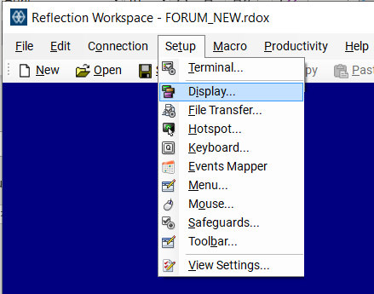

STEP 2 – When the window below opens, click on Modify the currently selected theme file.
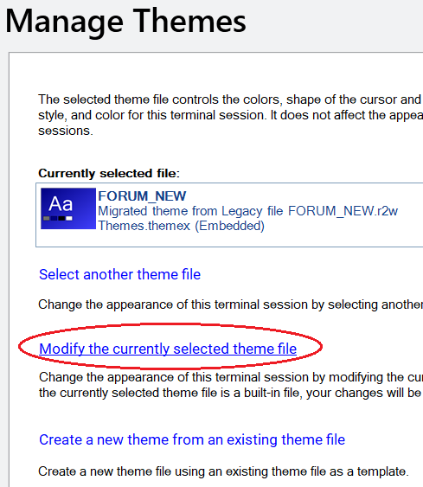
STEP 3 – Scroll down until you find the “Text Color Mapping” section. Here is where you will be able to set the color scheme that works best for you.
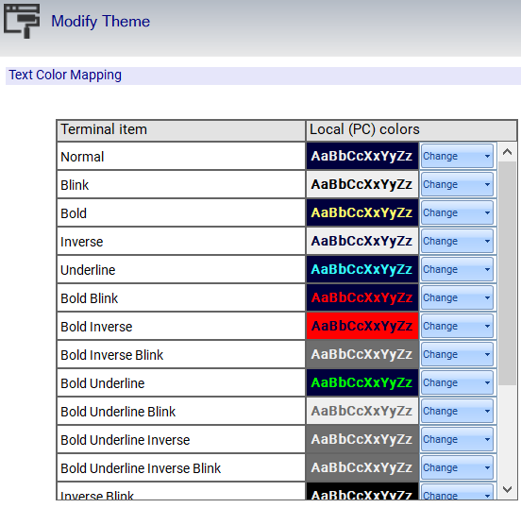

Once you reach this color mapping you can adjust the colors by clicking on the “Change” button specific to each text feature supported by the terminal. See below for a few examples on where each setting is used in the new option:

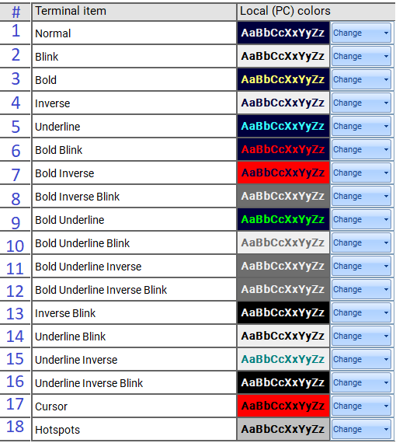

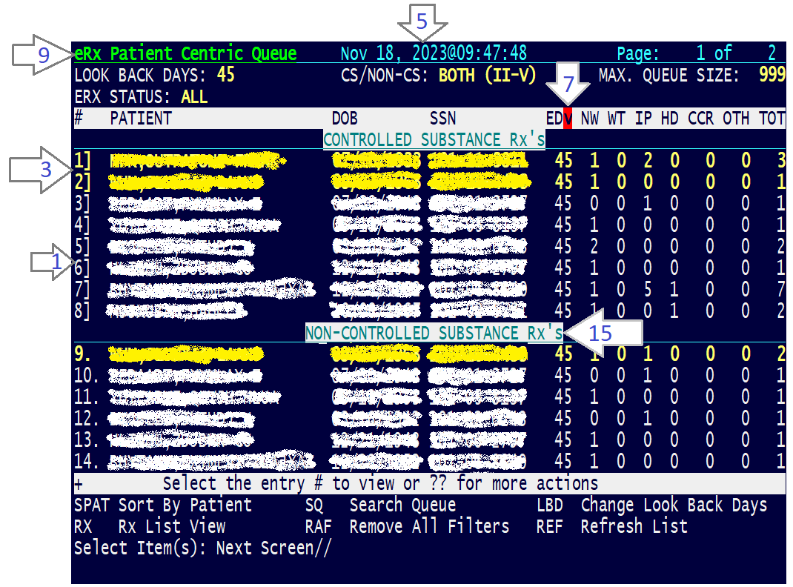

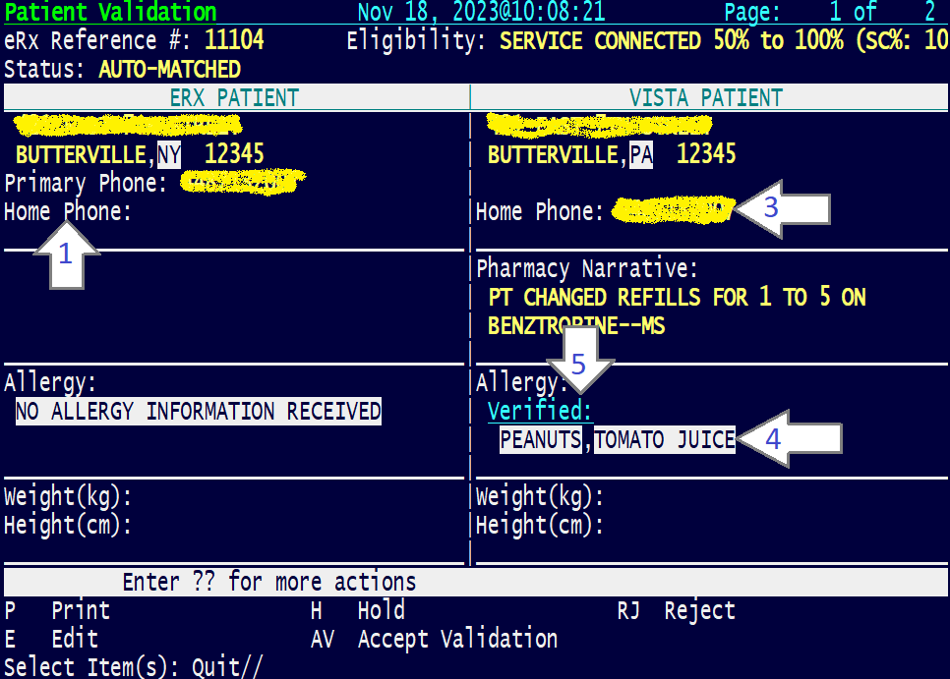

Product Documentation
Documentation describing the new functionality introduced by this patch is available. The preferred method is to retrieve files from download.vista.med.va.gov. This transmits the files from the first available server. Sites may also elect to retrieve files directly from a specific server.

Sites Software and Documentation Retrieval Instructions:

Upon National Release the documentation will be in the form of Adobe Acrobat files. Documentation will be found on the VA Software Documentation Library at:

https://www.va.gov/vdl/

Title | File Name | FTP Mode
Installation Guide - Inbound ePrescribing (PSO*7.0*700) | PSO_7_0_P700_DIBRG.docx  PSO_7_0_P700_ DIBRG.pdf | Binary
User Manual – Inbound ePrescribing – Unit 7 Part 1 (PSO*7.0*700)  User Manual – Inbound ePrescribing – Unit 7 Part 2 (PSO*7.0*700)  Outpatient Pharmacy Version 7 Manager's User Manual (PSO*7.0*700)  Outpatient Pharmacy Version 7 Pharmacist's User Manual (PSO*7.0*700)  Outpatient Pharmacy Version 7 Technician's User Manual (PSO*7.0*700) | PSO_7_0_P700_UM_71.docx  PSO_7_0_P700_UM_71.pdf  PSO_7_0_P700_UM_72.docx  PSO_7_0_P700_UM_72.pdf  PSO_7_0_P700_MAN_UM.docx  PSO_7_0_P700_MAN_UM.pdf  PSO_7_0_P700_PHARM_UM.docx  PSO_7_0_P700_ PHARM_UM.pdf  PSO_7_0_P700_TECH_UM.docx  PSO_7_0_P700_TECH_UM.pdf | Binary
Technical Manual/Security Guide - Outpatient Pharmacy V.7.0 (PSO*7.0*700) | PSO_7_0_P700_TM.docx  PSO_7_0_P700_TM.pdf | Binary
Release Notes – Inbound ePrescribing (PSO*7.0*700) | PSO_7_0_P700_RN.docx  PSO_7_0_P700_RN.pdf | Binary

