Pharmacy Reengineering (PRE)

Inbound ePrescribing (IEP) 5.0

User Guide
December 2023
Version 5.0 (Unit 7 Part 2)
Department of Veterans Affairs (VA)
Office of Information and Technology (OI&T)

Revision History
Date | Version | Description | Author
11/30/2023 | 5.0 | PSO*7*700:  - New menu option: eRx Holding Queue Processing [PSO ERX QUEUE PROCESSING] | Booz Allen Hamilton
Table of Contents
Unit 7. – Part 2: Matching, Validations and Acceptance of an eRx and Pending Order Overview 5
7.1 Introduction 5
7.2 Purpose of eR_{X} Matching 5
7.3 Reverse Vs. Highlight Video 5
7.4 Manual Validation 7
7.4.1 Validate Patient 8
7.4.1.1 Patient Auto-Match in the Processing Hub 9
7.4.1.2 Patient Manual Matching Screen Overview 10
7.4.1.3 Edit Patient 16
7.4.1.4 Selected Patient Warnings 16
7.4.1.5 Patient Accept Validation 19
7.4.1.6 Batch Patient Validation 21
7.4.2 Validate Provider 22
7.4.2.1 Provider Auto-Match 22
7.4.2.2 Provider Auto-Validation (MbM Only) 23
7.4.2.3 Provider Manual Validation Screen Overview 23
7.4.2.4 Edit Provider 24
7.4.2.5 Accept Provider Validation 29
7.4.2.6 Batch Provider Validation 34
7.4.3 Validate Drug/SIG 35
7.4.3.1 Drug Auto-Match 35
7.4.3.2 Drug/SIG Manual Validation Screen Overview 35
7.4.3.3 Drug Suggestion 37
7.4.3.4 Edit Drug/SIG 41
7.4.3.4.1 Additional Field-level Information: 49
7.4.3.4.2 Quantity/Days Supply Work Flow under Validate Drug/SIG > Edit: 50
7.4.3.5 Accept Drug/SIG Validation 51
7.4.3.6 Wait Status Flag “W” 53
7.5 Accepting eR_{X} 54
7.6 Rejecting eR_{X} in the eR_{X} Holding Queue 55
7.7 Do Not Fill 57
7.8 Printing in the eR_{X} Holding Queue 58
7.9 Placing eR_{X} on Hold in the eR_{X} Holding Queue 60
7.10 Un Hold eR_{X} in the eR_{X} Holding Queue 63
7.11 Removing eR_{X} in the eR_{X} Holding Queue 63
7.12 eR_{X} in the Backdoor Pharmacy Pending Queue 64
7.12.1 Patient Medication Profile 64
7.12.2 eRx Pending Order 65
7.12.3 Renewal eRx Pending Order 66

– Part 2: Matching, Validations and Acceptance of an eRx and Pending Order Overview

Introduction
Inbound eR_{X} VistA Outpatient Pharmacy is comprised of two sections:
- Inbound eR_{X} VistA Holding Queue Edits and Accept Validation options
- Inbound eR_{X} VistA Outpatient Profile - Complete Orders from Order Entry/Results Reporting (OERR) and Patient Prescription Processing

Purpose of eR_{X} Matching
One of the most important features of the eR_{X} Holding Queue is the matching of the outside information sent by the prescriber to corresponding VistA records so that an Outpatient VistA prescription can be created. For the fillable prescriptions, VA Pharmacy users can validate patient, provider, and drug/SIG information.

Reverse Vs. Highlight Video
The reverse video feature is being utilized in this new option as a mechanism to alert users of a discrepancy between two equivalent fields, one value being received from the outside prescriber in comparison to the equivalent VistA field value.
For more information on terminal display settings, please refer to the VistA Patch # PSO*7.0*700 Release Notes in the Veteran's Documentation Library (VDL).
There are some important rules and exceptions when comparing the two fields:
- If the VistA record has not been matched yet, the reverse video will not apply, as seen on the example below:
Name: XXXXX,XXXXXXXXXX |Name:
DOB : XXX 99, 9999 |DOB :
SSN : 999999999 |SSN :
Sex : MALE |Sex :
Address: |Address:
1234 ERX TEST WAY |
XXXXXXXX,XX 99999 |
- Lowercase and Uppercase discrepancies are ignored:
|
Name: Xxxx,Xxxxxxxxxxx |Name: XXXXX,XXXXXXXXXX
|
- Special characters, including blank spaces are ignored:
Example 1:
|
SSN : 999999999 |SSN : 999-99-9999
|
Example 2:
|
Phone: (999) 999-9999 |SSN : 9999999999
|
- Dates formatted differently are ignored:
|
DOB : Xxx 99, 9999 |DOB : XXX 99, 9999
|
- Only the first 5 digits of a Zip Code is compared:
|
1234 ERX TEST WAY | 1234 ERX TEST WAY
XXXXXXXX,XX 99999 | XXXXXXXX,XX 99999-9999
|
- If either a non-numeric text on the left or on the right contains the other side text, it is ignored as well (exception: MALE & FEMALE):
Example 1:
|
Name: XXXXX,XXXXXXXXXX XXX |Name: XXXXX,XXXXXXXXXX
Sex : MALE |Sex : FEMALE
|
Example 2:
|
1234 ERX TEST ST | 1234 ERX TEST STREET
XXXXXXXX,XX 99999 | XXXXXXXX,XX 99999-9999
|
- In the case of phone numbers, if the same number is found on different fields (e.g., Cell Phone for one record and Home Number for another) it is ignored as well:
|
Primary Phone: 9999999999 |
Home Phone: |Home Phone: (999) 999-9999
|
- Allergy information comparison is performed the following way:
Example 1:
_____________________________________________________________________________
Allergy: |Allergy:
NO ALLERGY INFORMATION RECEIVED | NO ALLERGY ASSESSMENT
_____________________________________________________________________________

Example 2:
_____________________________________________________________________________
Allergy: |Allergy:
NO ALLERGY INFORMATION RECEIVED | NO KNOWN ALLERGIES
_____________________________________________________________________________

Example 3:
_____________________________________________________________________________
Allergy: |Allergy:
HONEY BEE STINGS,LATEX GLOVES,PEANUTS | Verified:
TOMATO,ZOLPIDEM | ABOLENE,ACEBUTOLOL,HONEY BEE STINGS
| LATEX GLOVES,MOLD,POLLEN,PEANUTS
| TOMATO PRODUCTS,TYLENOL,ZOLPIDEM
|
- Fields without a corresponding value on the other side will not reverse video:
Example 1 (Patient Instructions):
_____________________________________________________________________________
|3)Patient Instructions:
| - IF SPLITTING TABLET, SPLIT JUST
| PRIOR TO USE
_____________________________________|______________________________________

Example 2 (Routing):
_____________________________________________________________________________
Days Supply: 30 Refills: 11 |7)Days Supply: 90 8)Refills: 3
_____________________________________|_______________________________________
|9)Routing: WINDOW
_____________________________________|_______________________________________

- Substitution field exception. Although there is no equivalent VistA value for this field, it will always reverse video if the value is NO to alert users that no substitution is allowed:
_____________________________________________________________________________
Drug: MELOXICAM 15MG TAB |1)Drug: MELOXICAM 15MG TAB
Substitution? NO Renewals? YES |Drug Message:
| NATL FORM (2/10)
_______________________________________|_____________________________

- SIG field exception. Since the VistA SIG is automatically composed by the dosage fields along with the VistA patient instructions, it becomes extremely hard to match it letter-by-letter with the SIG sent in by the outside prescriber; therefore, the SIG field value will never reverse video:
_____________________________________________________________________________
SIG: |SIG:
Take 1 Tablet (40 mg total) by mouth | TAKE ONE TABLET BY MOUTH EVERY DAY
Once a day |
________________________________________|____________________________________

- DEA EXP field exception. This DEA Expiration Date for the VistA Provider will display in reverse video when it is expired:
Name: XXXXXXXX,XXXXXXX MD |Name: XXXXXXXX,XXXXXXX
NPI : 9999999999 |NPI : 9999999999
DEA : XX9999999 |DEA : XX9999999 DEA EXP: 99/99/99

Manual Validation
Prior to accepting a fillable eR_{X} <AC> and moving the eR_{X} to Pending Outpatient Orders file, the VistA patient, provider, and drug/SIG must be validated. The eR_{X} is then further processed using Complete Orders from OERR [PSO LMOE FINISH] or Patient Prescription Processing [PSO LM BACKDOOR ORDERS].
The validation process begins by selecting one of the validate actions from the Summary/Details screen. For training, the sections further will show examples of NewRx processing. The remaining inbound fillable prescriptions follow the same workflow.
NOTE: Before the Drug/SIG on an eR_{X} can be manually validated, the eR_{X} Patient must have a linked VistA patient. The <VD> (Validate Drug/SIG) action has parentheses around the action to signify this action is not available until a VistA patient is linked, as illustrated in the figure below.
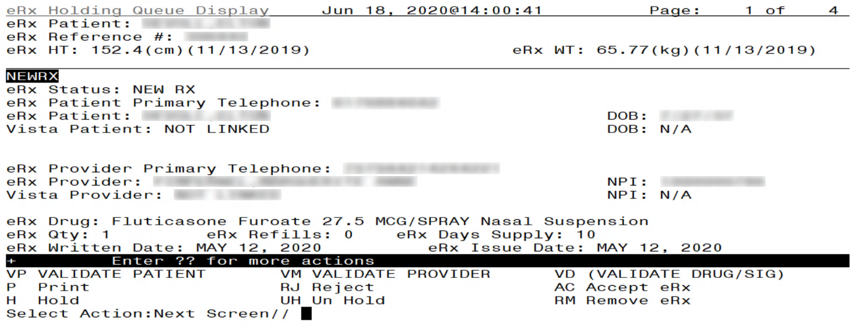
Summary/Details Screen Actions

Validate Patient
The patient must be matched and validated before a fillable eR_{X} can be accepted. Information about the Patient Validation screen and editing the patient information is described in the following sections.
To match and validate patient information, type <VP> VALDIATE PATIENT from the Summary/Details screen.
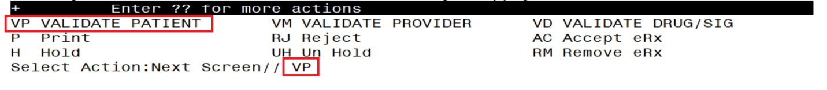
Validate Patient

Patient Auto-Match in the Processing Hub
The following outlines the scenarios for a patient auto-match in the Inbound ePrescribing (IEP) Processing Hub before being sent down to VistA:
Patient Match - Primary Hub
- Master Veteran Index (MVI) Check - receive Integrated Control Number (ICN) and Social Security Number (SSN) from MVI if successful:
- If SSN is sent on a NewRx, then the SSN is used in the auto-match with the MVI along with Last Name, First Name, Date of Birth (DOB), Gender, Address Line 1, and Home Telephone Number. If Home Telephone Number is not sent, Primary Telephone is used.
- If SSN is not sent on the NewRx, then the match is done with MVI against Last Name, First Name, DOB, Gender, Address Line 1, and Home Telephone Number. If Home Telephone Number is not sent, Primary Telephone is used.
- Since only the Last Name, First Name, DOB, and Gender are mandatory on a fillable prescription, the match is done against all the data pieces that are received.
- When a patient is successfully matched, the patient registration at the sites is checked.
- Eligibility and Enrollment (E&E) Check - Then E&E Services is checked to see if the patient is both enrolled and eligible to their system to receive pharmacy benefits (This is done using ICN retrieved from MVI).
Patient Secondary Match in VistA
- Case 1: Patient Auto match successful (MVI record found, E&E check passed, and Patient Site Registration passed).
- Use the ICN received from MVI and check against the local Patient file entry; if passed, then link this VistA patient to eR_{X} Patient.
- If ICN check fails, use the SSN received from MVI and check against the local Patient file entry; if passed, then link this VistA patient to eR_{X} Patient.
- Case 2: MVI Match successful, but E&E check failed at the Hub:
- Use the ICN received from MVI and check against the local Patient file entry; if passed, then link this VistA patient to eR_{X} Patient.
- If ICN check fails, use the SSN received from MVI and check against the local Patient file entry; if passed, then link this VistA patient to eR_{X} Patient.
- Case 3: MVI match unsuccessful at the Hub:
- No secondary match.

Patient Manual Matching Screen Overview
The header of the Patient Validation screen contains the eR_{X} Reference # and the Status. Below the header is the eR_{X} and VistA information for the patient, including any known allergies where applicable.
If the patient was not auto-matched at the eR_{X} Hub, the screen looks similar to the below figure. The Status field has “NOT MATCHED” in the header. No VistA patient information displays.
NOTE: The Status will not contain validation details until the user Accepts Validation (AV)
Patient Validation Sep 21, 2023@11:25:30 Page: 1 of 1
eRx Reference #: 99999999
Status: NOT MATCHED
ERX PATIENT | VISTA PATIENT
Name: XXXXX,XXXXXXXXXX |Name:
DOB : XXX 99, 9999 |DOB :
SSN : 999999999 |SSN :
Sex : MALE |Sex :
Address: |Address:
1234 ERX TEST WAY |
XXXXXXXX,XX 99999 |
Primary Phone: 9999999999 |
_______________________________________|________________________________________
|Pharmacy Narrative:
_______________________________________|________________________________________
Allergy: |Allergy:
NO ALLERGY INFORMATION RECEIVED |
_______________________________________|________________________________________
Weight(kg): |Weight(kg):
Enter ?? for more actions
P Print H Hold RJ Reject
E Edit AV Accept Validation
Select Item(s): Edit//
Patient Validation Screen Display - Patient Not Auto Matched/Not Validated
If the patient was auto-matched at the eR_{X} Hub the Status in the header will show “AUTO-MATCHED” and the header will look similar to the below figure. In this case, the information for the VistA Patient will display on the right side. The reverse video on a field value indicates a discrepancy between the two records.
Patient Validation Sep 21, 2023@11:47:12 Page: 1 of 2
eRx Reference #: 99999999 ChampVA Rx Benefit: ELIGIBLE
Status: AUTO-MATCHED
ERX PATIENT | VISTA PATIENT
Name: XXXXX,XXXXXXXXXX |Name: XXXXX,XXXXXXXXXX
DOB : XXX 99, 9999 |DOB : XXX 99, 9999
SSN : 999999999 |SSN : 999-99-9999
Sex : MALE |Sex : MALE
Address: |Address:
1234 ERX TEST WAY | 1234 ERX TEST ROAD
XXXXXXXX,XX 99999 | XXXXXXXX,XX 99999
Primary Phone: 9999999999 |
Home Phone: |Home Phone: (999) 999-9999
_______________________________________|________________________________________
|Pharmacy Narrative:
|
_______________________________________|________________________________________
Allergy: |Allergy:
NO ALLERGY INFORMATION RECEIVED | NO ALLERGY ASSESSMENT
_______________________________________|________________________________________
Weight(kg): |Weight(kg):
Height(cm): |Height(cm):
_______________________________________|________________________________________

+ Enter ?? for more actions
P Print H Hold RJ Reject
E Edit AV Accept Validation
Select Item(s): Next Screen//
Patient Validation Screen Display – Patient Auto-Matched/Not Validated

Once the Patient has been validated by using the Accept Validation (AV) action, the Status in the header will show “AUTO-MATCHED | VALIDATED by ” with the user who performed the validation and date/time stamp.

Patient Validation Sep 21, 2023@11:59:40 Page: 1 of 2
eRx Reference #: 99999999 ChampVA Rx Benefit: ELIGIBLE
Status: AUTO-MATCHED | VALIDATED by USER,USER on 9/21/23@11:59:38
ERX PATIENT | VISTA PATIENT
Name: XXXXX,XXXXXXXXXX |Name: XXXXX,XXXXXXXXXX
DOB : XXX 99, 9999 |DOB : XXX 99, 9999
SSN : 999999999 |SSN : 999-99-9999
Sex : MALE |Sex : MALE
Address: |Address:
1234 ERX TEST WAY | 1234 ERX TEST ROAD
XXXXXXXX,XX 99999 | XXXXXXXX,XX 99999
Primary Phone: 9999999999 |
Home Phone: |Home Phone: (999) 999-9999
_______________________________________|________________________________________
|Pharmacy Narrative:
|
_______________________________________|________________________________________
Allergy: |Allergy:
NO ALLERGY INFORMATION RECEIVED | NO ALLERGY ASSESSMENT
_______________________________________|________________________________________
Weight(kg): |Weight(kg):
Height(cm): |Height(cm):
_______________________________________|________________________________________

+ Enter ?? for more actions
P Print H Hold RJ Reject
E Edit AV Accept Validation
Select Item(s): Next Screen//

Patient Validation Screen Display – Patient Auto-Matched/Validated
If the patient was not auto-matched at the eR_{X} Hub, the user can choose the Edit (E) action to select a Vista Patient to manually match. If the eR_{X} Patient has never been matched to a VistA Patient, the screen looks similar to the below figure. After the eR_{X} is matched to a VistA patient, the Status in the header shows “MANUALLY-MATCHED”.

Patient Validation Sep 21, 2023@12:33:23 Page: 1 of 1
eRx Reference #: 99999999
Status: NOT MATCHED
ERX PATIENT | VISTA PATIENT
Name: XXXXX,XXXXXXXXXX |Name:
DOB : XXX 99, 9999 |DOB :
SSN : 999999999 |SSN :
Sex : MALE |Sex :
Address: |Address:
1234 ERX TEST WAY |
XXXXXXXX,XX 99999 |
Primary Phone: 9999999999 |
Home Phone: |Home Phone:
_______________________________________|________________________________________
|Pharmacy Narrative:
_______________________________________|________________________________________
Allergy: |Allergy:
NO ALLERGY INFORMATION RECEIVED |
_______________________________________|________________________________________
Weight(kg): |Weight(kg):
Height(cm): |Height(cm):
_______________________________________|________________________________________

+ Enter ?? for more actions
P Print H Hold RJ Reject
E Edit AV Accept Validation
Select Item(s): Edit// E Edit

VISTA PATIENT: XXXXX,XXXXXXXXXX 99/99/9999 999999999 XXXXXXXXXX,XX

Enrollment Priority: Category: NOT ENROLLED End Date:

ERX PATIENT VISTA PATIENT
________________________________________________________________________________
Name: XXXXX,XXXXXXXXXX |Name: XXXXX,XXXXXXXXXX X
DOB : XXX 99, 9999 |DOB : XXX 99, 9999
SSN : 999999999 |SSN : 999-99-9999
Sex : MALE |Sex : MALE
Address: |Address:
1234 ERX TEST WAY | 1234 ERX TEST WAY
XXXXXXXX,XX 99999 | XXXXXXXX,XX 99999
________________________________________|_______________________________________
Would you like to use this patient? NO// YES

Patient Validation Sep 21, 2023@12:37:52 Page: 1 of 2
eRx Reference #: 99999999 Eligibility: NON-SERVICE CONNECTED
Status: MANUALLY-MATCHED
ERX PATIENT | VISTA PATIENT
Name: XXXXX,XXXXXXXXXX |Name: XXXXX,XXXXXXXXXX X
DOB : XXX 99, 9999 |DOB : XXX 99, 9999
SSN : 999999999 |SSN : 999-99-9999
Sex : MALE |Sex : MALE
Address: |Address:
1234 ERX TEST WAY | 1234 ERX TEST WAY
XXXXXXXX,XX 99999 | XXXXXXXX,XX 99999
Primary Phone: 9999999999 |
Home Phone: |Home Phone: (999) 999-9999
_______________________________________|________________________________________
|Pharmacy Narrative:
|
_______________________________________|________________________________________
Allergy: |Allergy:
NO ALLERGY INFORMATION RECEIVED | NO KNOWN ALLERGIES
_______________________________________|________________________________________
Weight(kg): |Weight(kg):
Height(cm): |Height(cm):
_______________________________________|_______________________________________
+ Enter ?? for more actions
P Print H Hold RJ Reject
E Edit AV Accept Validation
Select Item(s): Next Screen//
Patient Validation Screen Display – Patient Manually-Matched/Not Validated

Patient Auto-suggestion
When the user chooses the Edit (E) action to select a Vista Patient, if the eR_{X} Patient has been previously matched to a VistA Patient, the user will be prompted for the VistA entry, and they will be presented with a suggestion based on the following logic below.
- Once a VistA Patient is matched and later validated to an eR_{X} Patient it is then “remembered”.
- When a new eR_{X} prescription is received for the same eR_{X} Patient the “remembered” VistA Patient(s) are then presented as suggestions for the user to select.
- When there is only one suggestion the user is given 3 options: (A)ccept, (F)orget or (E)xit the suggested VistA record.
  - (A)ccept effectively matches the suggest VistA Patient with the eR_{X}
  - (F)orget removes the VistA Patient as a valid suggestion for the eR_{X} Patient so it is no longer presented in the future for any user
  - (E)xit Exits and proceed to match the VistA Patient manually
- If more than one suggestion exists, an additional action is presented:
  - (N)ext ignores the suggestion and moves on the next suggestion

Below is an example of auto-suggestion and prompting for the VistA patient. The suggestions will be numbered (i.e. 1 of 1) and it will also display the eR_{X} # from the previously matched eR_{X}.
Patient Validation Oct 18, 2023@11:42:32 Page: 1 of 1
eRx Reference #: 99999999
Status: NOT MATCHED
ERX PATIENT | VISTA PATIENT
Name: XXXXX,XXXXXXXXXX |Name:
DOB : XXX 99, 9999 |DOB :
SSN : 999999999 |SSN :
Sex : MALE |Sex :
Address: |Address:
1234 ERX TEST WAY |
XXXXXXXX,XX 99999 |
Primary Phone: 9999999999 |
Home Phone: |Home Phone: (999) 999-9999
_______________________________________|________________________________________
|Pharmacy Narrative:
_______________________________________|________________________________________
Allergy: |Allergy:
NO ALLERGY INFORMATION RECEIVED |
_______________________________________|________________________________________
Weight(kg): |Weight(kg):
Height(cm): |Height(cm):
_______________________________________|________________________________________
+ Enter ?? for more actions
P Print H Hold RJ Reject
E Edit AV Accept Validation
Select Item(s): Edit// E Edit
|Sugg. 1 of 1 - 10/04/23|
ERX PATIENT VISTA PATIENT |From eRx#: 123444 |
________________________________________________________________________________
Name: XXXXX,XXXXXXXXXX |Name: XXXXX,XXXXXXXXXX
DOB : XXX 99, 9999 |DOB : XXX 99, 9999
SSN : 999999999 |SSN : 999-99-9999
Sex : MALE |Sex : MALE
Address: |Address:
1234 ERX TEST WAY | 1234 ERX TEST ROAD
XXXXXXXXXXX,XX 99999 | XXXXXXXXXXX,XX 99999
________________________________________|_______________________________________
ACTION on SUGGESTION: (A)CCEPT (F)ORGET (E)XIT: EXIT//
Patient Validation Screen Display – Auto-Suggestion
The suggestion above is presented to the user because another eR_{X} (#123444) was received in the past for the exact same eR_{X} Patient and it was matched to the VistA Patient on the right and validated.

NOTE: The software limits the number of distinct suggestions to 3. The order in which the suggestions are presented are from the newest (most recently “remembered”) to the oldest (last “remembered”).

Patient Allergies
If the VistA patient has known allergies, verified allergies display in the Allergies section.
Patient Validation Oct 18, 2023@13:37:41 Page: 1 of 2
eRx Reference #: 999999 Eligibility: NSC
Status: AUTO-MATCHED
ERX PATIENT | VISTA PATIENT
Name: XXXXX,XXXXXXXXXX |Name: XXXXX,XXXXXXXXXX X
DOB : XXX 99, 9999 |DOB : XXX 99, 9999
SSN : 999999999 |SSN : 999-99-9999
Sex : MALE |Sex : MALE
Address: |Address:
1234 ERX TEST WAY | 1234 ERX TEST WAY
XXXXXXXX,XX 99999 | XXXXXXXX,XX 99999
Primary Phone: 9999999999 |
Home Phone: |Home Phone: (999) 999-9999
_______________________________________|________________________________________
|Pharmacy Narrative:
_______________________________________|________________________________________
Allergy: |Allergy:
NO ALLERGY INFORMATION RECEIVED | Verified:
| PEANUTS
_______________________________________|________________________________________
Weight(kg): |Weight(kg):
+ Enter ?? for more actions
P Print H Hold RJ Reject
E Edit AV Accept Validation
Select Item(s): Next Screen//
VistA Patient with Known Allergies
A hidden action is available on the Patient Validation screen that allows the user to display the Patient Allergies in greater detail. This hidden action can be invoked from the following screens listed below:
- Patient Validation screen
- Drug Validation screen
- eR_{X} Holding Queue Display screen
- Pending Orders screen (Backdoor Outpatient Pharmacy)
+ Enter ?? for more actions
P Print H Hold RJ Reject
E Edit AV Accept Validation
Select Item(s): Next Screen// ??

The following actions are also available:
PA Patient Allergies DN Down a Line PS Print Screen
+ Next Screen FS First Screen PT Print List
- Previous Screen LS Last Screen SL Search List
UP Up a Line GO Go to Page QU Quit

Type <Enter> to continue or '^' to exit:

When the user selects the Patient Allergies (PA) hidden action from the Patient Validation screen, a new screen displays titled Patient Allergies. The Patient Allergies screen was created to show the eR_{X} patient allergies side-by-side with the VistA patient allergies in detail.
The Patient Allergies screen also contains a new action called VistA Patient Allergies (VPA). The VPA action invokes a new screen titled Detailed Allergy List and this screen allows the user to edit allergy data.

NOTE: A VistA Patient must be matched to use the VistA Patient Allergies (VPA) action.
Patient Allergies Oct 18, 2023@14:18:39 Page: 1 of 2
eRx Reference #: 99999 ChampVA Rx Benefit: ELIGIBLE
Status: AUTO-MATCHED
ERX PATIENT | VISTA PATIENT
Name: XXXXX,XXXXXXXXXX |Name: XXXXX,XXXXXXXXXX X
DOB : XXX 99, 9999 |DOB : XXX 99, 9999
SSN : 999999999 |SSN : 999-99-9999
_______________________________________|________________________________________
Allergy: |Allergy:
NO ALLERGY INFORMATION RECEIVED | Verified:
| Drug:
| IBUPROFEN
| Effective Date: Dec 10, 2008@15:29
| Reaction: OBSERVED
| Severity: MODERATE
| Symptoms:
| RASH
| PERCODAN
| Effective Date: Nov 07, 2008@13:28
| Reaction: HISTORICAL
| Symptoms:
+ Enter ?? for more actions
VPA Vista Patient Allergies
Select Item(s): Next Screen// VPA Vista Patient Allergies

DETAILED ALLERGY LIST Oct 18, 2023@14:50:25 Page: 1 of 1
XXXXX,XXXXXXXXXX <A>
PID: 999-99-9999 Ht(cm): 182.88 (02/24/2011)
DOB: JUN 21,1954 (69) Wt(kg): 93.44 (02/24/2011)

Verified
Drug:
1 ALBUTEROL
2 IBUPROFEN
3 PERCODAN
4 VALIUM
Drug/Food:
5 EGG PRODUCTS
6 PEANUTS
Food:
7 HONEY
8 TOMATO PRODUCTS

+ Enter ?? for more actions
EA Enter/Edit Allergy/ADR Data SA Select Allergy
Select Item(s): Quit//

VistA Patient Allergies

The actions at the bottom of the Patient Validation screen include:
- <P> Print – Prints display of the eR_{X} for printing to network or local printer.
- <H> Hold – Places an eR_{X} on hold.
- <E> Edit – User edits if the information is empty or incorrect.
- <AV> Accept Validation – User accepts the validation if information is correct.
- <RJ> Reject – Rejects the eR_{X.}

Edit Patient
- Enter <E> Edit to edit the patient information.
- If a VistA patient already exists for the eR_{X}, the system displays a message confirming the edit.
Edit Patient on a VistA Match
- If a VistA patient match does not exist, the system prompts to select a patient at the “Select Patient Name” prompt. The partial or full name of the patient, DOB or SSN can be entered.
- Select the correct patient and press <Enter>.
- A message displays confirming the patient selection. Enter <Y> Yes.
- The select patient information populates the VistA Patient fields on the Patient Validation screen.
CS NOTE: For Controlled Substance eR_{X} records, an additional check is performed for the presence of at least a ZIP CODE for a patient residing in the US or a POSTAL for patients residing abroad. If not found, the message below will be displayed.

Selected Patient Warnings
The following checks will be performing, and the warnings below will display when the patient is selected, if applicable:
- VistA Patient does not have an Allergy Assessment.
- VistA Patient does not have a current mailing or residential address on file. (Digitally Signed eR_{X} only)
MbM Only
Additional Warnings
For MbM, two additional warnings will be performed:
- VistA Patient is not eligible for ChampVA Rx Benefit.
- The following VistA Patient(s) has been identified as potential duplicate(s):
XXXXXXXX,XXXXXX XXX 99,9999 999-99-9999 XXXXXXXXXXX,XX

Duplicate Patient
The criterion for a duplicate patient is determined the following way:
Full Name matches exactly
OR
Last Name matches exactly + First letter of First Names matches + Dates of Birth matches

Eligibility
For MbM the ChampVA Eligibility is currently being checked by a Class 3 API ($$CHVAELIG^PSOZRXU0), which can return one of the following values:
- ELIGBILE
- NOT ELIGIBLE
- SB (SPINA BIFIDA)

MbM Only
When a VistA Patient that is not eligible for ChampVA benefit is matched to an eR_{X} the software will first warn the user before the confirming the match:

Select Item(s): Edit// E Edit

VISTA PATIENT: XXXXX,XXXXXXXXXX 99/99/9999 999999999 XXXXXXXXXX,XX

Enrollment Priority: Category: NOT ENROLLED End Date:

ERX PATIENT VISTA PATIENT
________________________________________________________________________________
Name: XXXXX,XXXXXXXXXX |Name: XXXXX,XXXXXXXXXX X
DOB : XXX 99, 9999 |DOB : XXX 99, 9999
SSN : 999999999 |SSN : 999-99-9999
Sex : MALE |Sex : MALE
Address: |Address:
1234 ERX TEST WAY | 1234 ERX TEST WAY
XXXXXXXX,XX 99999 | XXXXXXXX,XX 99999
________________________________________|_______________________________________

************************** WARNING(S) *******************************
VistA Patient is not eligible for ChampVA Rx Benefit.
************************************************************************
Would you like to use this patient? NO//

If the user confirms the selection above the current eR_{X} will automatically be put on Hold with the HEL (ELIGIBILITY ISSUE) hold code. Furthermore, all the other prescriptions for the same eR_{X} Patient (if any) will also be put on hold with the same Hold code:

...
Would you like to use this patient? NO// Y YES
Updating...

This eRx has been put on Hold (HEL) because the VistA Patient (XXXXX,XXXXXXXXXX)
is not Eligible for ChampVA Rx Benefit.

Type <Enter> to continue or '^' to exit:

The following eRx record(s) have been put on Hold (HEL) because the VistA
Patient (XXXXX,XXXXXXXXXX) is not Eligible for ChampVA Rx Benefit.
ERX ID DRUG NAME PROVIDER STS
---------------------------------------------------------------------------
11142 BENAZEPRIL HCL 40MG TAB XXXXXXXX,XXXXX MD HEL
11143 SERTRALINE HCL 50MG TAB XXXXXXXX,XXXXX MD HEL

Type <Enter> to continue or '^' to exit:

MbM Only
No Allergy Assessment
For MbM the fact that a VistA patient does not have an allergy assessment presents a risk; therefore, all the prescriptions matched to this VistA patient are automatically put on Hold right after the VistA patient w/out an allergy assessment is selected.

MbM Only
When a VistA Patient that does not have an allergy assessment on file is matched to an eR_{X} the software will first warn the user before the confirming the match:

Select Item(s): Edit// E Edit

VISTA PATIENT: XXXXX,XXXXXXXXXX 99/99/9999 999999999 XXXXXXXXXX,XX

Enrollment Priority: Category: NOT ENROLLED End Date:

ERX PATIENT VISTA PATIENT
________________________________________________________________________________
Name: XXXXX,XXXXXXXXXX |Name: XXXXX,XXXXXXXXXX X
DOB : XXX 99, 9999 |DOB : XXX 99, 9999
SSN : 999999999 |SSN : 999-99-9999
Sex : MALE |Sex : MALE
Address: |Address:
1234 ERX TEST WAY | 1234 ERX TEST WAY
XXXXXXXX,XX 99999 | XXXXXXXX,XX 99999
________________________________________|_______________________________________

************************** WARNING(S) *******************************
VistA Patient does not have an Allergy Assessment.
************************************************************************
Would you like to use this patient? NO//

If the user confirms the selection above the current eR_{X} will automatically be put on Hold with the HAL (NO ALLERGY ASSESSMENT) hold code. Furthermore, all the other prescriptions for the same eRx Patient (if any) will also be put on hold with the same Hold code:

...
Would you like to use this patient? NO// Y YES
Updating...

This eRx has been put on Hold (HEL) because the VistA Patient (XXXXX,XXXXXXXXXX)
does not have an Allergy Assessment...

Type <Enter> to continue or '^' to exit:

The following eRx record(s) have been put on Hold (HAL) because the VistA
Patient (XXXXX,XXXXXXXXXX) does not have an Allergy Assessment.
ERX ID DRUG NAME PROVIDER STS
---------------------------------------------------------------------------
11142 BENAZEPRIL HCL 40MG TAB XXXXXXXX,XXXXX MD HAL
11143 SERTRALINE HCL 50MG TAB XXXXXXXX,XXXXX MD HAL

Type <Enter> to continue or '^' to exit:

Patient Accept Validation
Once the patient information has been edited and reviewed for accuracy, the validation needs to be accepted on the Patient Validation screen.
- Select <AV> Accept Validation on the Patient Validation screen to accept the provider validation.
- A message displays confirming whether to mark the patient as validated. Enter <Y> Yes.
If the validation is successful, a message displays indicating that the validation was updated.
The Status changes to “VALIDATED” on the Patient Validation screen, along with the user who performed the validation and date/time stamp.
Select Item(s): Next Screen// AV Accept Validation
Would you like to mark this patient as VALIDATED?
Enter Yes or No: NO// YES
Validation Updated!!
Confirm Acceptance of Patient Validation
A “[v]” displays to the right of the VistA Patient field on the Summary/Details screen.
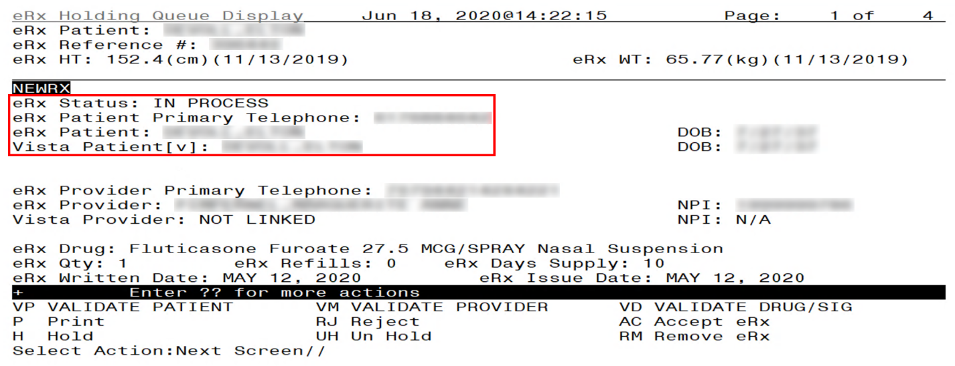
Patient Validation Complete: Summary/Details Screen Indicator

CS NOTE: For Controlled Substance eRx records, the presence of at least a ZIP CODE for a patient residing in the US or a POSTAL CODE for patients residing abroad will be required. If not found, the message below will be displayed, and the user will not be able to proceed with the Validation as shown below.

Patient Validation Oct 19, 2023@09:35:15 Page: 1 of 2
eRx Reference #: 9999999 Eligibility:
Status: MANUALLY-MATCHED
ERX PATIENT | VISTA PATIENT
Name: XXXXX,XXXXXXXXXX |Name: XXXXX,XXXXXXXXXX
DOB : XXX 99, 9999 |DOB : XXX 99, 9999
SSN : 999999999 |SSN : 999-99-9999
Sex : MALE |Sex : MALE
Address: |Address:
1234 ERX TEST WAY |
XXXXXXXX,XX 99999 |
_______________________________________|________________________________________
|Pharmacy Narrative:
|
_______________________________________|________________________________________
Allergy: |Allergy:
NO ALLERGY INFORMATION RECEIVED | Verified:
| EGG PRODUCTS,PEANUTS
_______________________________________|________________________________________
Weight(kg): |Weight(kg):
+ Enter ?? for more actions
P Print H Hold RJ Reject
E Edit AV Accept Validation
Select Item(s): Next Screen// AV Accept Validation

Unable to validate - VistA Patient does not have a current mailing
or residential address on file.

Type <Enter> to continue or '^' to exit:
Patient Validation Unable To Validate Address Warning

Batch Patient Validation
When a patient validation is accepted on one eR_{X} and there are additional eR_{X} in the Holding Queue for the same patient, received on the same day, a message displays asking if the patient validation should be applied to the other eR_{X}. Error! Reference source not found.If the user selects <Y> Yes, the system links and applies the patient validation for the eR_{X} currently in the Holding Queue for that patient.
NOTE: Automatic Patient Validation is only available for NewRx.
The determination of the same patient is based on unique records from the ERX EXTERNAL PATIENT file (#52.46). The system only validates the same patients on eR_{X} that are currently in the ERX HOLDING QUEUE file (#52.49) received at the time of the automatic patient validation. Patient validation is not applied for eR_{X} received for that patient after the auto validation is applied. For example, if VA receives six eR_{X} for the same patient on the same day, the user only has to validate the patient once. If eR_{X} are received later that same day, those eR_{X} need to be revalidated.
Select Item(s): Next Screen// AV Accept Validation
Would you like to mark this patient as VALIDATED?
Enter Yes or No: NO// YES
Validation Updated!!

This patient has other prescriptions for: Oct 04, 2023
Patient: XXXXXXXXXXXXX,XXXXXXXXXX

DRUG PROVIDER STA REC DATE
-------------------------------------------------------------------------------
1.) OXYCODONE 5MG ACETAMINOPHEN 325MG T XXXXXXXXX,XXXXX XX I 10/04/23
2.) CLINDAMYCIN HCL 150MG CAP XXXXXXXXX,XXXXX XX I 10/04/23
3.) CYANOCOBALAMIN 1000MCG/ML INJ XXXXXXXXX,XXXXX XX I 10/04/23

Would you like to apply the above validation to these prescriptions?
Enter Yes or No: N//
Batch Patient Validation
To apply patient validation to other eR_{X} in the Holding Queue for the same patient, received on the same day:
- The system asks the user if the previous validation should be applied to the other eR_{X} received for the patient.
- Enter Y for Yes to apply the validation to the other eR_{X} for the patient. After selecting Yes, the patient validation is applied to the other eR_{X}. As previously noted, any eR_{X} received after this action will not be validated.
- A message displays indicating that the validation was updated.
- A “[v]” displays to the right of the VistA Patient field on the Summary/Details screen and the Status field changes to “VALIDATED” on the Patient Validation screen, along with the user who performed the validation and date/time stamp. This occurs for all the eR_{X} validated via the automatic patient validation process.
- The statuses on all eR_{X} validated by the automatic patient validation process changes to “I” for In Process.
NOTE: When doing a batch validation for a patient, it is possible that one or more of the records for the patient is for Controlled Substance which requires the presence of at least a ZIP CODE for a patient residing in the US or a POSTAL CODE if they reside abroad. So, a check will be performed for such records and if the requirement is not fulfilled, the record will not be validated. The message below will be displayed for each record with this issue:
Patient Validation Oct 19, 2023@09:35:15 Page: 1 of 2
eRx Reference #: 9999999 Eligibility:
Status: MANUALLY-MATCHED
ERX PATIENT | VISTA PATIENT
Name: XXXXX,XXXXXXXXXX |Name: XXXXX,XXXXXXXXXX
DOB : XXX 99, 9999 |DOB : XXX 99, 9999
SSN : 999999999 |SSN : 999-99-9999
Sex : MALE |Sex : MALE
Address: |Address:
1234 ERX TEST WAY |
XXXXXXXX,XX 99999 |
_______________________________________|________________________________________
|Pharmacy Narrative:
|
_______________________________________|________________________________________
Allergy: |Allergy:
NO ALLERGY INFORMATION RECEIVED | Verified:
| EGG PRODUCTS,PEANUTS
_______________________________________|________________________________________
Weight(kg): |Weight(kg):
+ Enter ?? for more actions
P Print H Hold RJ Reject
E Edit AV Accept Validation
Select Item(s): Next Screen// AV Accept Validation

Unable to validate - VistA Patient does not have a current mailing
or residential address on file.

Type <Enter> to continue or '^' to exit:
Patient Validation Unable To Validate Address Warning

Validate Provider
The provider must be validated before a fillable eR_{X} can be accepted.
To validate provider information, from the Summary/Details screen, type <VM> VALIDATE PROVIDER. The eR_{X} Provider Validation screen displays.
Summary/Details Screen Action - Validate Provider
Information about the Validate Provider display and editing the provider information is described in the following sections.

Provider Auto-Match
The auto-match on an external provider is based upon the NPI of the prescriber coming in on the new eR_{X}. The NPI is matched against the VistA instance’s NEW PERSON file (#200) entry. If the NPI matches and if the Provider is marked “Authorized to Write Meds” that is considered a match. Upon a successful match, the VistA provider is linked with the incoming provider’s record in VistA.
NOTE: The Provider Auto-Match feature is not enabled for Controlled Substances.

Provider Auto-Validation (MbM Only)
MbM Only
For MbM sites, the auto-matched VistA Provider will also be auto-validated if the following conditions are met:
- VistA Provider was auto matched
- eR_{X} was not Digitally Signed (possible CS prescription)
- Last name of eRx Provider matches exactly to the last name of VistA Provider
- First letter of first name of eR_{X} Provider matches with the first letter of the first name of VistA Provider
- First 5 digits of eR_{X} Provider zip code matches with the first 5 digits of VistA Provider zip code.
This implies that users will not need to manually validate the VistA Provider (AV action) to accept the eR_{X} (AC action).

Provider Manual Validation Screen Overview
The Provider Validation screen was replaced with a new format to show the eR_{X} Provider and VistA Provider side-by-side and identify discrepancies in the data with reverse video.
The header of the Provider Validation screen contains the eR_{X} Reference # and the Status. Below the header is the eR_{X} and VistA information for the provider, where applicable.
If a match was NOT found for the eR_{X} provider, the screen looks similar to the below figure. The Status field has “NOT MATCHED” in the header. No provider information displays.
NOTE: The Status will not contain validation details until the user Accepts Validation (AV)
Provider Validation Oct 19, 2023@09:54:27 Page: 1 of 1
eRx Reference #: 999999 eRx Patient: XXXXX,XXXXXXXXXX
Status: NOT-MATCHED
ERX PROVIDER | VISTA PROVIDER
Name: XXXXXXXX,XXXXX X |Name:
NPI : 9999999999 |NPI :
DEA : XX9999999 |DEA :
_______________________________________|________________________________________
Address: |Address:
1234 ERX TEST WAY |
XXXXXXXX,XX 99999 |
Tel: |Tel:
Fax: |Fax:
_______________________________________|________________________________________

+ Enter ?? for more actions
P Print H Hold RJ Reject
E Edit AV Accept Validation
Select Item(s): Quit//
Provider Not Auto Matched / Not Validated
If an auto-match is found, the Status in the header will show “AUTO-MATCHED” and the header will look similar to the below figure.
Provider Validation Oct 19, 2023@12:57:41 Page: 1 of 1
eRx Reference #: 999999 eRx Patient: XXXXX,XXXXXXXXXX
Status: AUTO-MATCHED
ERX PROVIDER | VISTA PROVIDER
Name: XXXXXXXX,XXXXXXX |Name: XXXXXXXX,XXXXXXX
NPI : 9999999999 |NPI : 9999999999
DEA : XX9999999 |DEA : XX9999999
_______________________________________|________________________________________
Address: |Address:
99999 ERX TEST ST | 99999 ERX TEST ST
XXXXXXX,XX 99999-9999 | XXXXXXX,XX 99999
Tel: 888-888-8888 |Tel: 888-888-8888
_______________________________________|________________________________________

+ Enter ?? for more actions
P Print H Hold RJ Reject
E Edit AV Accept Validation
Select Item(s): Quit//
Provider Not Auto Matched / Not Validated

Edit Provider
To edit the provider information:
- Press the <E> Edit action on the Provider Validation screen.
- If no VistA provider information is in the system for the eR_{X}, the “Select Provider Name” prompt displays for searching for and selecting a provider.
- Enter either the partial name or full name of the provider or the NPI of the Provider, or DEA of the Provider at the “Select Provider Name” prompt. If multiple providers exist with the same name exist, a list of providers is provided with additional identifying information (e.g., middle initial, mail code, and title, where applicable, etc.).
- Select the provider.
- If a VistA provider is currently linked for the eR_{X}, the system will ask if the current provider should be modified.
- Enter <Y> Yes.
- Enter either the partial name or full name of the provider at the “Select Provider Name” prompt.
- Select the provider.
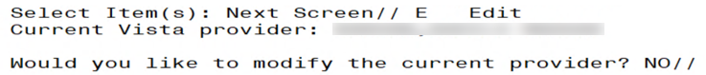
Modify Current VistA Provider
- Once the VistA provider is selected, the VistA provider fields populate on the Provider Validation screen, along with information whether the DEA of the Provider has expired or not.
- The next step in the provider validation process is to accept the validation, which is described in the next section.
NOTE: The DEA Expiration Date is displayed next to the DEA # for the VistA Provider, and it will display in reverse video when the DEA # of the selected VistA Provider has expired in File #200. See below.
Provider Validation Oct 19, 2023@10:21:35 Page: 1 of 1
eRx Reference #: 9999999 eRx Patient: XXXXX,XXXXXXXXXX
Status: AUTO-MATCHED
ERX PROVIDER | VISTA PROVIDER
Name: XXXXXXXX,XXXXXXX |Name: XXXXXXXX,XXXXXXX
NPI : 9999999999 |NPI : 9999999999
DEA : XX9999999 |DEA : XX9999999 DEA EXP.: 12/12/20
_______________________________________|________________________________________
Select Provider Warning for Expired DEA#
CS NOTE: The following message displays upon selecting the Provider if the Provider’s DEA date is expired.
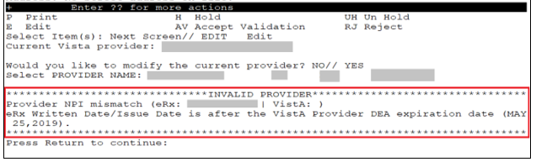
Select Provider DEA Expiration Date Message
CS NOTE: The following block message displays upon selecting the Provider if the Provider’s eR_{X} DEA number is missing.
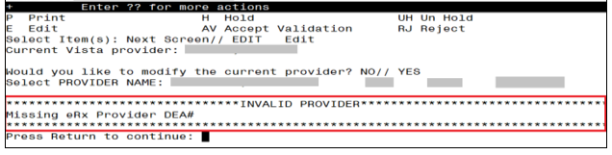
Select Provider Missing DEA Number Message
CS NOTE: The following warning message displays upon selecting the Provider if the VistA Provider does not have a valid DEA number on file.
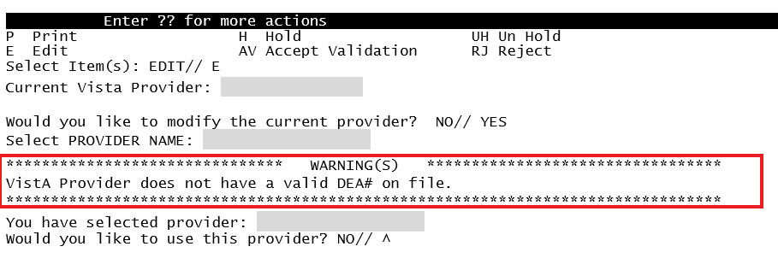
Select VistA Provider Missing DEA Number Warning Message
CS NOTE: The following warning message displays upon selecting the Provider if the eR_{X} Provider does not have a valid DEA number on file.
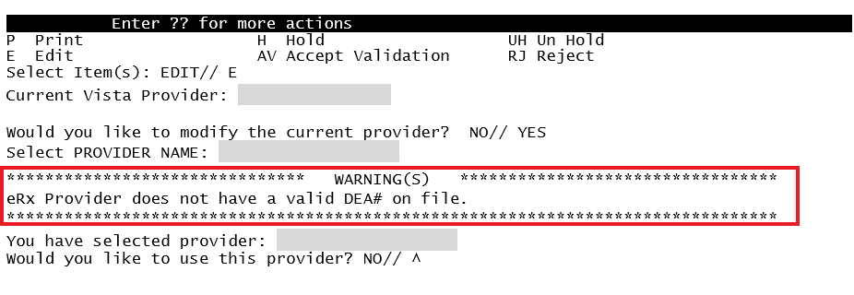
Select eRx Provider Missing DEA Number Warning Message
CS NOTE: The following warning message displays upon selecting the Provider if the eR_{X} Provider’s DEA number does not match the VistA DEA number on file.
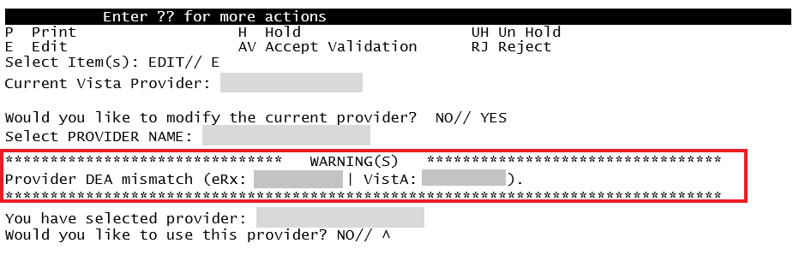
Select Provider DEA Number Mismatch Warning Message
CS NOTE: The following warning message displays upon selecting the Provider if the VistA Drug selected is a Controlled Substance, but the VistA Provider is not authorized to write for the Schedule of the Drug.
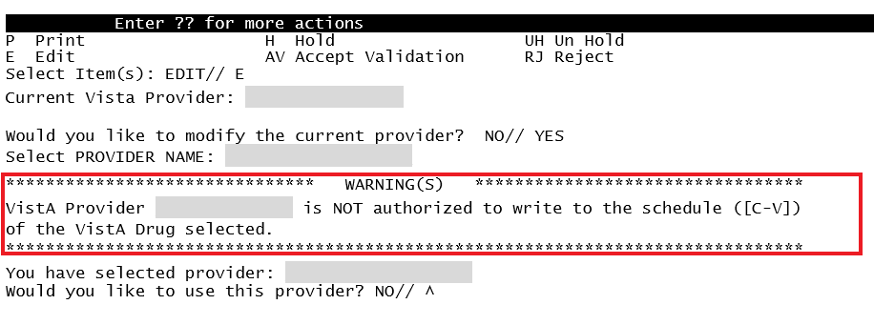
Select VistA Provider Not Authorized Warning Message
CS NOTE: The following warning message displays upon selecting the Provider if the VistA Drug selected is a detox Drug and the VistA Provider does not have a valid detox number on file.
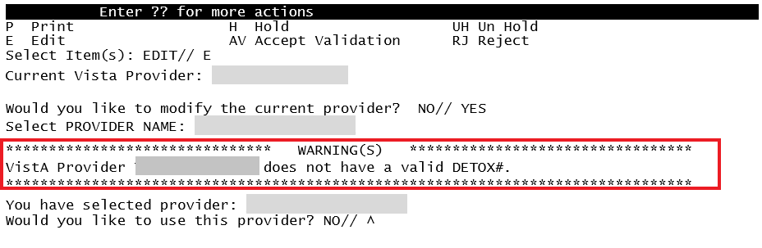
Select VistA Provider Missing DEA Number Warning Message
Provider Auto-Suggestion
When the user chooses the Edit (E) action to select a Vista Provider, if the eR_{X} Provider has been previously matched to a VistA Provider, the user will be prompted for the VistA entry, and they will be presented with a suggestion based on the following logic below.
- Once a VistA Provider is matched and later validated to an eR_{X} Provider it is then “remembered”.
- When a new eR_{X} prescription is received for the same eR_{X} Provider the “remembered” VistA Provider (s) are then presented as suggestions for the user to select.
- When there is only one suggestion the user is given 3 options: (A)ccept, (F)orget or (E)xit the suggested VistA record.
  - (A)ccept effectively matches the suggest VistA Provider with the eR_{X}
  - (F)orget removes the VistA Provider as a valid suggestion for the eR_{X} Patient so it is no longer presented in the future for any user
  - (E)xit Exits and proceed to match the VistA Provider manually
- If more than one suggestion exists, an additional action is presented:
  - (N)ext ignores the suggestion and moves on the next suggestion

Below is an example of auto-suggestion and prompting for the VistA Provider. The suggestions will be numbered (i.e. 1 of 1) and it will also display the eR_{X} # from the previously matched eR_{X}.

P Print H Hold RJ Reject
E Edit AV Accept Validation
Select Item(s): Edit// E Edit
|Sugg. 1 of 1 - 08/08/23|
ERX PROVIDER VISTA PROVIDER|From eRx#: 123555|
____________________________________________________________________
Name:XXXXXXXX,XXXXXXXXX |Name:XXXXXXXX,XXXXXXXXX
NPI :9999999999 |NPI :9999999999
DEA#:XX9999999 |DEA#:XX9999999
Phone #: 999-999-9999 |Phone #: (999) 999-9999
Address: |Address:
9999 NOWHERE RD |9999 NOWHERE AVE
XXXXXXXXXXXXX, XX 99999 |XXXXXXXXXXXXX, XX 99999
__________________________________|________________________________
ACTION on SUGGESTION: (A)CCEPT (F)ORGET (E)XIT: EXIT//
Provider Validation Screen Display – Auto-Suggestion
The suggestion above is presented to the user because another eR_{X} (#123555) was received in the past for the exact same eR_{X} Provider and it was matched to the VistA Provider on the right and validated.
NOTE: The software limits the number of distinct suggestions to 3. The order in which the suggestions are presented are from the newest (most recently “remembered”) to the oldest (last “remembered”).

Accept Provider Validation
Once the correct provider has been selected and reviewed for accuracy, the next step is to accept the validation using the following steps.
- Select <AV> ACCEPT VALIDATION on the Provider Validation screen to accept the provider validation.
NOTE: The following warning message displays upon selecting the validation if there is a DEA # and/or NPI mismatch.
Select Provider Warning Message
CS NOTE: The following block message displays upon selecting the validation if the Provider’s Vista DEA number is missing.
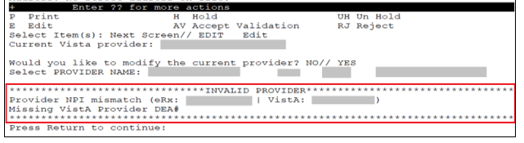
Select Provider Missing VistA DEA Number Message
CS NOTE: The following block message displays upon selecting the validation if the Provider’s not authorized to write a scheduled Controlled Substance prescription.
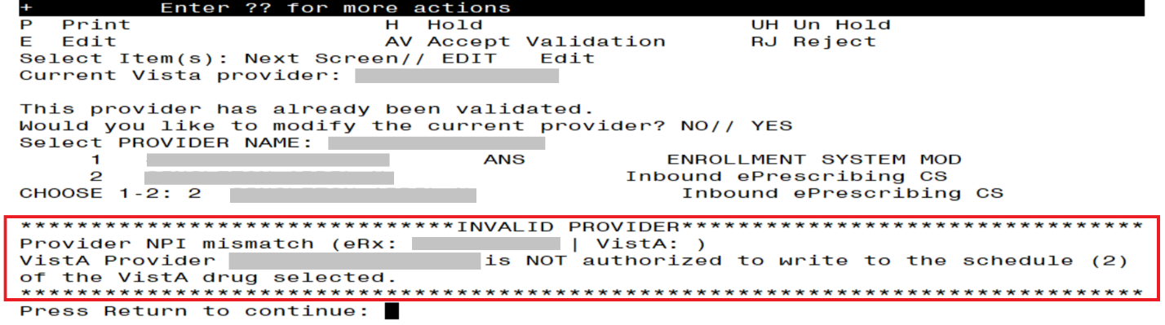
Select Provider Not Authorized Message
CS NOTE: The following warning message displays upon selecting the validation if the eR_{X} Provider does not have a valid DEA number and the Drug is not selected or the Drug selected is a Non-Controlled Substance.
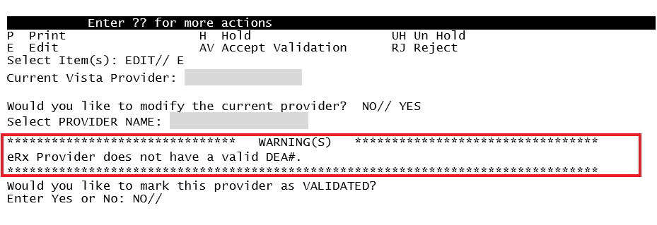
Select eRx Provider Missing DEA Number Warning Message
NOTE: The following warning message displays upon selecting the validation if the VistA Provider does not have a valid DEA number on file and Drug is not selected or Drug selected is a Non-Controlled Substance.
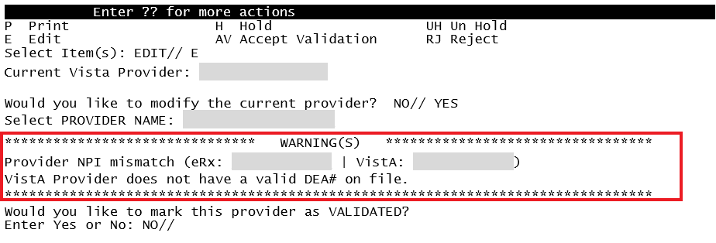
Select VistA Provider Missing DEA Number Warning Message
NOTE: The following block message displays upon selecting the validation if the eR_{X} Provider’s DEA number does not match the VistA DEA number and Drug is not selected or Drug selected is a Non-Controlled Substance.
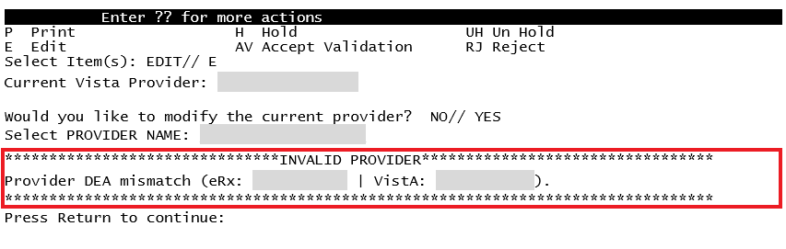
Select Provider DEA Mismatch Message
CS NOTE: The following block message displays upon selecting the validation if the VistA Drug selected is a Controlled Substance, but the VistA Provider is not authorized to write for the Schedule of the Drug.
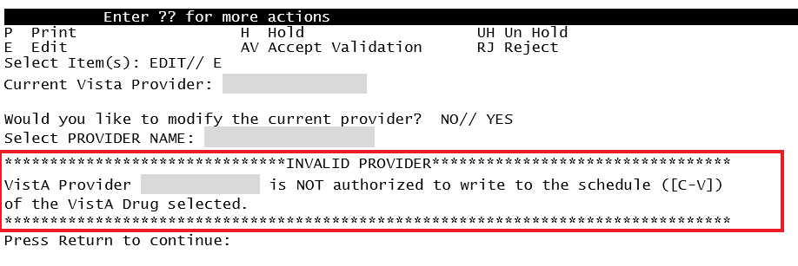
Select Provider Not Authorized Message
CS NOTE: The following block message displays upon selecting the validation if the VistA Drug selected is a detox Drug, but the VistA Provider does not have a valid Detox number on file.
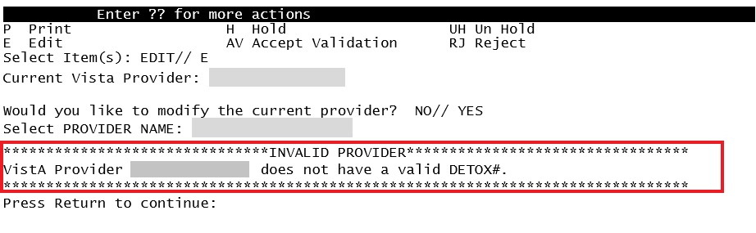
Select VistA Provider Invalid Detox Number Message
A message displays confirming whether to mark the provider as validated.
- Enter <Y> Yes.
- If the validation is successful, a message displays indicating that the validation was updated. Type <Enter> to continue or <Shift>₊<^> to Quit.
NOTE: If there are other eR_{X} for the patient, written by the same provider, received on the same day for that patient, a message displays asking if the provider validation should be applied to those eR_{X}.
- The Status field changes to “VALIDATED” on the Provider Validation screen and the user who accepted the validation and date/time stamp displays to the right of “VALIDATED”.
- A “[v]” displays to the right of the VistA Provider field on the Summary/Details screen.

NOTE: The Status will not contain validation details until the user Accepts Validation (AV)
Provider Validation Oct 19, 2023@11:25:44 Page: 1 of 1
eRx Reference #: 99999999 eRx Patient: XXXXX,XXXXXXXXXX
Status: NOT MATCHED
ERX PROVIDER | VISTA PROVIDER
Name: XXXXXXXX,XXXXXXX |Name:
NPI : 9999999999 |NPI :
DEA : XX9999999 |DEA :
_______________________________________|________________________________________
Address: |Address:
123 FAKE STREET |
PLANO,TX 75024 |
Tel: |Tel:
_______________________________________|________________________________________

+ Enter ?? for more actions
P Print H Hold RJ Reject
E Edit AV Accept Validation
Select Item(s): Edit//
Before Provider Validation (Validate Provider Screen)
Provider Validation Oct 19, 2023@11:31:16 Page: 1 of 1
eRx Reference #: 99999999 eRx Patient: XXXXX,XXXXXXXXXX
Status: MANUALLY-MATCHED | VALIDATED by XXXXXXXX,XXXX on 10/19/23@11:31:15
ERX PROVIDER | VISTA PROVIDER
Name: XXXXXXXX,XXXXXXX |Name: XXXXXXXX,XXXXXXX
NPI : 9999999999 |NPI : 9999999999
DEA : XX9999999 |DEA : XX9999999
_______________________________________|________________________________________
Address: |Address:
123 FAKE STREET | 123 FAKE STREET
PLANO,TX 75024 | PLANO,TX 75024
Tel: |Tel:
_______________________________________|________________________________________

+ Enter ?? for more actions
P Print H Hold RJ Reject
E Edit AV Accept Validation
Select Item(s): Quit//
After Provider Validation (Validate Provider Screen)
eRx Holding Queue Display Oct 19, 2023@11:38:22 Page: 1 of 2
eRx Patient: XXXXX,XXXXXXXXXX
eRx Reference #: 99999999
eRx HT: (cm)() eRx WT: (kg)()

NEWRX
eRx Status: IN PROCESS
eRx Patient: XXXXX,XXXXXXXXXX DOB: 4/21/90
Vista Patient[v]: XXXXX,XXXXXXXXXX DOB: 4/21/90

eRx Provider: XXXXXXXX,XXX
DEA#: XX9999999 NPI: 9999999999
Vista Provider[v]: XXXXXXXX,XXX
DEA#: XX9999999 NPI: 9999999999

eRx Drug: ACETAMINOPHEN 325MG TAB
eRx Qty: 180 eRx Refills: 2 eRx Days Supply: 30
eRx Written Date: OCT 18, 2023 eRx Issue Date:
Prohibit Renewals: No
+ Enter ?? for more actions
VP VALIDATE PATIENT VM VALIDATE PROVIDER VD (VALIDATE DRUG/SIG)
P Print RJ Reject AC Accept eRx
H Hold UH Un Hold RM Remove eRx
Select Action:Next Screen//
After Provider Validation (Summary/Details Screen)

Batch Provider Validation
When a provider validation is accepted on one eR_{X} and there are additional eR_{X} in the Holding Queue for the same patient by the same provider, received on the same day, a message displays asking if the other eR_{X} for the patient written by the provider should be validated. If the user selects <Y> Yes, the system links and applies the provider validation for the eR_{X} currently in the Holding Queue for the patient by the same provider.
NOTE: Automatic Provider Validation is available only for NewRx and non-controlled substances.
The determination of the same provider is based on unique records from the ERX EXTERNAL PERSON file (#52.48). The system only validates the same provider on eR_{X} that are currently in the ERX HOLDING QUEUE file (#52.49) for the same patient received on the same date. Provider validation is not applied for the same provider received after the auto validation is applied once. For example, if VA receives six eR_{X} for the same patient on the same day from the same provider, the user only has to validate the provider once; however, if eR_{X} are received after the automatic provider validation is applied (e.g., later that same day by that provider), the provider for those eR_{X} needs to be validated.
Would you like to mark this provider as VALIDATED?
Enter Yes or No: NO// y YES
Validation Updated!!

There are other prescriptions for this patient, written by this provider on
Oct 04, 2023
Provider: XXXXXXXX,XXXXX
Patient: XXXXXXXXXXX,XXXXXXXXXX

DRUG PROVIDER STA REC DATE
-------------------------------------------------------------------------------
1.) LORATADINE 10MG TAB XXXXXXXX,XXXXX I 10/04/23

Would you like to apply the above validation to these prescriptions?
Enter Yes or No: N//
Batch Provider Validation
To apply the provider validation to the other eR_{X} enter <Y> Yes. A message displays indicating that the validation was updated.
- The Status field on all the eR_{X}, where the provider validation has been applied, changes to “VALIDATED” on the Provider Validation screen and the user who accepted the validation and date/time stamp displays to the right of “VALIDATED”.
- A “[v]” displays to the right of the VistA Provider field on the Summary/Details screen.
- The statuses on all eR_{X} validated by the automatic provider validation process changes to “I” for In Process.

Validate Drug/SIG
The drug/SIG information on the eR_{X} must be validated before a fillable eR_{X} can be accepted.
NOTE: A VistA patient must be linked (matched) before the Validate Drug/SIG action is available.
To validate drug/SIG information for the eR_{X}, type <VD> Validate Drug/SIG from the Summary/Details screen. The Drug Validation screen displays and is described in the following sections.
Validate Drug / SIG

Drug Auto-Match
The preconditions for a drug auto-match are that the drug should be a one-to-one match, should not be a Compound, not a Controlled Substance, should be Active, not Investigational and should be marked for Outpatient use in the local DRUG file (#50).
First, the drug description on the new eR_{X} is matched against the Drug Generic Name entry in the VistA instance’s DRUG file (#50). If successful, the match stops right here, and the drug is linked in VistA.
If the match is not successful, the drug description is then matched against the VA Product Name entry in the VistA instance’s VA PRODUCT file (#50.68). Then a drug in local file for the matched VA Product Name is identified, which should satisfy the preconditions. If the match is successful, the drug is linked in VistA.
If the match is not successful, the NDC is used to match against the VistA instance’s NDC/UPN file (#50.67). Using the VA Product Name identified at this step, a drug in the local file for the matched VA Product Name is identified, which should satisfy the preconditions. If the match is successful, the drug is linked in VistA.
NOTE: The NDC is an optional field and may or may not be included with the new eR_{X}. For a supply, if UPC is sent, it is not matched against the NDC/UPN file (#50.67). Only the Drug Description match is attempted.

Drug/SIG Manual Validation Screen Overview
The Drug/SIG Validation screen was replaced with a new format to show the eR_{X} Drug and VistA Drug side-by-side and identify the discrepancies in the data with reverse video.
The header of the Drug/SIG Validation screen contains the eR_{X} Reference # and the Status. Below the header is the eR_{X} and VistA information for the drug/SIG, where applicable.
If a match was NOT found for the VistA drug, the screen looks similar to the below figure. The Status field has “NOT MATCHED” in the header. The other VistA drug/SIG fields may or may not be populated.

NOTE: The Status will not contain validation details until the user Accepts Validation (AV)
Drug Validation Oct 19, 2023@12:10:49 Page: 1 of 2
eRx Reference #: 99999999 Date Written: 10/18/23 Effective Date:
Status: NOT MATCHED
ERX MED | VISTA MED
Allergy: |Allergy:
NO ALLERGY INFORMATION RECEIVED | NO KNOWN ALLERGIES
_______________________________________|________________________________________
Drug: ACETAMINOPHEN 325MG TAB |1)Drug:
Substitution? YES Renewals? YES |
_______________________________________|________________________________________
SIG: |SIG:
TAKE ONE TABLET PO EVERY FOUR HOURS |
AS NEEDED |
_______________________________________|________________________________________
|2) Dosage:
_______________________________________|________________________________________
|3)Patient Instructions:
|
_______________________________________|________________________________________
Provider Notes/Comments: |4)Provider Comments:
___________________________________|____________________________________
|5)Pat. Status: OUTPATIENT CARE
___________________________________|____________________________________
Quantity: 90 |6)Quantity:
Dispense Unit: Tablet | Dispense Unit:
Qty Qualifier: Original Quantity |
___________________________________|____________________________________
Days Supply: 30 Refills: 11 |7)Days Supply: 8)Refills:
___________________________________|____________________________________
|9)Routing:
___________________________________|____________________________________
|10)Clinic:
___________________________________|____________________________________
+ Enter ?? for more actions
P Print H Hold UH Un Hold
E Edit AV Accept Validation RJ Reject
Select Item(s): Edit//
Drug Validation Screen Display - VistA Drug Not Validated / Not Auto Matched
If a VistA match was found for the drug, the screen looks similar to the below figure. The Status field has “AUTO-MATCHED”, with VistA drug/SIG information displaying in the VistA Drug field (#1).
Drug Validation Oct 19, 2023@12:47:59 Page: 1 of 3
eRx Reference #: 99999999 Date Written: 10/18/23 Effective Date:
Status: AUTO-MATCHED
ERX MED | VISTA MED
Allergy: |Allergy:
NO ALLERGY INFORMATION RECEIVED | Verified:
| EGG PRODUCTS,PEANUTS
_______________________________________|________________________________________
Drug: ACETAMINOPHEN 325MG TAB |1) Drug: ACETAMINOPHEN 325MG TAB
Substitution? YES Renewals? YES |Drug Message:
| NATL FORM; DU: INCREMENTS OF 100 ONLY
| *** TCGRx & SCRIPTPRO ***
_______________________________________|________________________________________
SIG: |SIG:
TAKE ONE TABLET PO EVERY FOUR HOURS |
AS NEEDED |
_______________________________________|________________________________________
|2) Dosage:
_______________________________________|________________________________________
|3)Patient Instructions:
+ Enter ?? for more actions
P Print H Hold UH Un Hold
E Edit AV Accept Validation RJ Reject
Select Item(s): Next Screen//
Drug Validation Screen Display - VistA Drug Auto Matched / Not Validated

Drug Suggestion
This functionality was designed for two purposes: 1) Save the users time and; 2) Improve accuracy of the VistA fields entered to match the incoming eR_{X}. It works by first creating a “memory” of how each incoming eR_{X} are being translated into a VistA prescription. This memory is recorded at the moment the corresponding Pending Order of an eR_{X} is finished and becomes an Active (or Suspended) VistA prescription (when a record is created in the PRESCRIPTION file (#52)). At this point the software will gather the following field values from the incoming eR_{X} record:
- Drug Name
- Drug NDC Code
- Quantity
- Substitutions Allowed?
- Days Supply
- Number of Refills
- SIG
If Drug Name, Drug NDC Code or Quantity are not present the software will not proceed.
The software then generates a long number composed of the following numbers concatenated:

NDC Code_Drug Hash (Name+SIG)_Subs_Quantity_Days Supply_Number of Refills
Drug Hash is a number generated by summing the ASCII values of the Drug Name concatenated with the SIG, where each letter/number on the string are multiplied by their position on the string with an ascending and then a descending order.
The result of the algorithm above is a unique long number for the specific eR_{X} received from outside, which is recorded on the eR_{X} record as a cross-reference.
At the moment that the user selects to edit the Drug for another eR_{X}, the same long number is generated for the eR_{X} and is checked against the database to find if matches with a previous eR_{X} that was already completed and finished. If a perfect match is found, then the software will retrieve the information from the VistA Prescription and will present it to the user as an option to automatically pre-fill all the fields related to the drug, as shown below:
|Sugg. 1 of 1 - 06/11/23|
ERX MED VISTA MED |From Rx#: 9999999 |
________________________________________________________________________________
Drug: Meloxicam 15mg Tablet |Drug: MELOXICAM 7.5MG TAB
Substitution? YES Renewals? YES |Drug Message:
| NATL FORM (2/10)
________________________________________|_______________________________________
SIG: |SIG:
TAKE ONE TABLET PO EVERY SIX HOURS | TAKE TWO TABLETS BY MOUTH ONCE EVERY
AS NEEDED | SIX HOURS WITH FOOD - IF SPLITTING
| TABLET, SPLIT JUST PRIOR TO USE
________________________________________|_______________________________________
|Patient Instructions:
| - IF SPLITTING TABLET, SPLIT JUST
| PRIOR TO USE
________________________________________|_______________________________________
Provider Notes/Comments: |Provider Comments:
|
________________________________________|_______________________________________
Quantity: 90 |Quantity: 180
Dispense Unit: |Dispense Unit: TAB
Qty Qualifier: Original Quantity |QTY Dispense Message:
| TEST DISPENSE MESSAGE
________________________________________|_______________________________________
Days Supply: 90 Refills: 3 |Days Supply: 30 Refills: 11
________________________________________|_______________________________________
ACTION on SUGGESTION: (A)CCEPT (F)ORGET (E)XIT: EXIT// ?

ACCEPT - Accepts the suggested data (right column) and pre-populates the
VistA fields
FORGET - Forgets the current suggestion so that it is not presented again
in the future to any user
EXIT - Exits and continue to filling the VistA fields manually

Select one of the following:

A ACCEPT
F FORGET
E EXIT

ACTION on SUGGESTION: (A)CCEPT (F)ORGET (E)XIT: EXIT//

NOTE: The software limits the number of distinct suggestions to 3. The order in which the suggestions are presented are from the newest (most recently “remembered”) to the oldest (last “remembered”).
If more than one distinct suggestion exists, the software will display slightly different. It will start with the latest matched VistA Rx and will go back to the previous ones, one by one if the user selects NEXT below:
|Sugg. 1 of 2 - 06/11/23|
ERX MED VISTA MED |From Rx#: 9999999 |
________________________________________________________________________________
Drug: Meloxicam 15mg Tablet |Drug: MELOXICAM 15MG TAB
Substitution? YES Renewals? YES |Drug Message:
| NATL FORM (2/10)
________________________________________|_______________________________________
SIG: |SIG:
TAKE ONE TABLET PO EVERY SIX HOURS | TAKE ONE TABLET BY MOUTH ONCE EVERY
AS NEEDED | SIX HOURS WITH FOOD - IF SPLITTING
| TABLET, SPLIT JUST PRIOR TO USE
________________________________________|_______________________________________
|Patient Instructions:
| - IF SPLITTING TABLET, SPLIT JUST
| PRIOR TO USE
________________________________________|_______________________________________
Provider Notes/Comments: |Provider Comments:
|
________________________________________|_______________________________________
Quantity: 90 |Quantity: 30
Dispense Unit: |Dispense Unit: TAB
Qty Qualifier: Original Quantity |QTY Dispense Message:
| TEST DISPENSE MESSAGE
________________________________________|_______________________________________
Days Supply: 90 Refills: 3 |Days Supply: 30 Refills: 11
________________________________________|_______________________________________
ACTION on SUGGESTION: (A)CCEPT (N) EXT (F)ORGET (E)XIT: EXIT// ?

ACCEPT - Accepts the suggested data (right column) and pre-populates the
VistA fields
NEXT - Ignores the current suggestion and view the next one
FORGET - Forgets the current suggestion so that it is not presented again
in the future to any user
EXIT - Exits and continue to filling the VistA fields manually

Select one of the following:

A ACCEPT
N NEXT
F FORGET
E EXIT

ACTION on SUGGESTION: (A)CCEPT (N)EXT (F)ORGET (E)XIT: NEXT//

If the user selects ACCEPT above, the VistA fields for the drug will be auto-populated and the users will be taken back to the Validate Drug/SIG where they can edit the fields manually by selecting each field number.
ACTION on SUGGESTION: (A)CCEPT (F)ORGET (E)XIT: EXIT// ACCEPT
Updating...done.

Drug Validation Nov 11, 2023@14:21:45 Page: 1 of 3
eRx Reference #: 9999999 eRx Patient: XXXXXXXXX,XXXXXXXXXX
Date Written : 6/10/23 Effective Date:
Status: MANUALLY-MATCHED
ERX MED | VISTA MED
Allergy: |Allergy:
NO ALLERGY INFORMATION RECEIVED | Verified:
| ABOLENE,ACEBUTOLOL,MOLD,POLLEN
_______________________________________|________________________________________
Drug: Meloxicam 15mg Tablet |1)Drug: MELOXICAM 15MG TAB
Substitution? NO Renewals? YES |Drug Message:
| NATL FORM (2/10)
_______________________________________|________________________________________
SIG: |SIG:
TAKE ONE TABLET PO EVERY SIX HOURS | TAKE ONE TABLET BY MOUTH EVERY SIX
AS NEEDED | HOURS - IF SPLITTING TABLET, SPLIT
| JUST PRIOR TO USE
_______________________________________|________________________________________
|2) Dosage: 15 (MG)
| Verb: TAKE
|Disp. Units: 1
| Noun: TABLET
| Route: ORAL
| Schedule: Q6H
___________________________________|___________________________________
|3)Patient Instructions:
| - IF SPLITTING TABLET, SPLIT JUST
| PRIOR TO USE
___________________________________|___________________________________
Provider Notes/Comments: |4)Provider Comments:
|
___________________________________|___________________________________
|5)Pat. Status: SC LESS THAN 50%
___________________________________|___________________________________
Quantity: 90 |6)Quantity: 30
Dispense Unit: Tablet | Dispense Unit: TAB
Qty Qualifier: Original Quantity |
___________________________________|___________________________________
Days Supply: 90 Refills: 3 |7)Days Supply: 30 8)Refills: 11
___________________________________|___________________________________
|9)Routing: MAIL
___________________________________|___________________________________
|10)Clinic: CC CLINIC
___________________________________|___________________________________

+ Enter ?? for more actions
P Print H Hold UH Un Hold
E Edit AV Accept Validation RJ Reject
Select Item(s): Next Screen//
If the user selects FORGET the following message will be presented:
ACTION on SUGGESTION: (A)CCEPT (F)ORGET (E)XIT: EXIT// F FORGET

Are you sure this suggestion match should be forgotten? NO// ?

This suggestion originated from a VistA Rx previously dispensed for an
eRx with the exact Drug Name, NDC, SIG, Quantity, Days Supply, # of
Refills and Substitution allowance. Once you forget this match it will
no longer be suggested as a match for future eRx's with the same fields.

Select one of the following:

Y YES
N NO

Are you sure this suggestion match should be forgotten? NO// YES
Forgetting...Ok.
NOTE: If the user chooses YES to forget the entry it will no longer be presented as a suggestion to any user when a similar prescription to this eR_{X} is received again in the future.
If no perfect match exists for the number generated, the user will be prompted to enter the drug manually, as shown below:
Select Item(s): Edit// Edit

eRx Drug: GABAPENTIN 300MG CAP

eRx Sig:
TAKE THREE CAPSULES BY MOUTH THREE TIMES A DAY FOR PAIN

eRx Notes:
Drug Form: Strength:
Code List Qualifier: Original Quantity Quantity Unit of Measure:
Substitutions? :YES
Qty: 270 Days Supply: 30 Refills: 3

Select DRUG GENERIC NAME:
If the user selects EXIT, the user will be prompted to enter the drug information manually:
ACTION on SUGGESTION: (A)CCEPT (F)ORGET (E)XIT: EXIT// EXIT

eRx Drug: Meloxicam 15mg Tablet

eRx Sig:
TAKE ONE TABLET PO EVERY SIX HOURS AS NEEDED

eRx Notes:
Drug Form: Strength:
Code List Qualifier: Original Quantity Quantity Unit of Measure:
Substitutions? :YES
Qty: 90 Days Supply: 23 Refills: 5

Current Vista Drug: MELOXICAM 7.5MG TAB
Select DRUG GENERIC NAME:

Edit Drug/SIG
- To edit the drug/SIG information, use the <E> Edit action on the Drug Validation screen.
- If the VistA drug/SIG information has been linked for the eR_{X}, the edit drug/SIG sequence prompts the user to select a field or select All fields.
  - Select Item (s): Quit// <E> Edit or enter the field(s) at this prompt (i.e. 1, 1-3, etc.)
  - Which fields (s) would you like to edit? (1-10) or “A” 11: A//
- Under eR_{X} Holding Queue > Validate Drug/SIG screen > Edit, if a drug is already matched in the hub, that drug is displayed at the “select” prompt. The user is still allowed to change the drug by entering the drug name.
- Under eR_{X} Holding Queue > Validate Drug/SIG screen > Edit, if a drug is not matched in the hub, at the “select” prompt, it is blank wherein the user can enter the drug name.
- When a Yes/No confirmation is asked for the selected drug, if the user hits enter or selects “No”, the control comes out of Edit mode back to VD screen.
NOTE: The eR_{X} Drug/SIG information from the external provider displays throughout the edit drug/SIG process as reference.
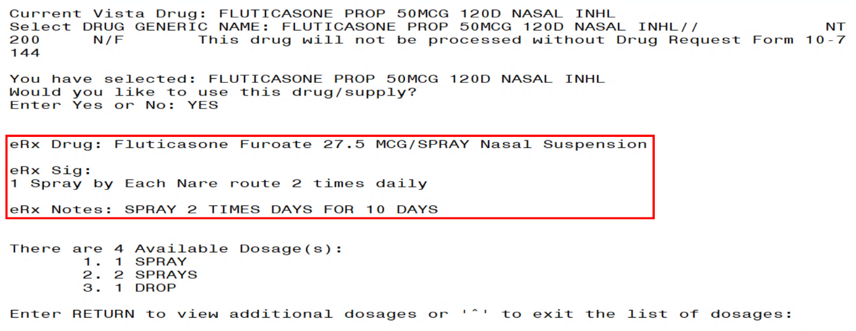
eR_{X} Display during Edit Drug / SIG
- Next, enter the Dosage. Either enter a free text dose or enter a question mark <?> to view a list of available dosages. The system prompts the user to confirm the selected dosage.
- Enter the Verb, Route, and Schedule.
- Patient Instructions are default/consistent instructions that come from the Orderable Item. VA Patient Instructions are auto populated when either a drug is auto matched or manually matched, or the drug’s Pharmacy Order Item has an entry for those instructions. If it is blank, enter VA Patient Instructions. If it needs to be edited, use the Replace function. Even abbreviated Patient Instructions from Medication Instruction files are allowed, which expand upon saving. This field holds the patient instructions for an eR_{X}. This field is transferred to the Pending Queue upon acceptance of an eR_{X}.
- Provider Comments are additional free text comments that the provider may enter. The VA Provider Comments field contains the eR_{X} Notes from the external provider and can be edited by entering <Replace>. Even abbreviated Provider Comments from Medication Instruction files are allowed, which expand upon saving. This field is transferred to the Pending Queue upon acceptance of an eR_{X}.
- Enter Patient Status and edit the Patient Status as required.
- Enter/edit VistA Quantity, VistA Days Supply, and VistA Renewals as needed.
NOTE: The Vista Days Supply prompt is pre-populated with an auto-calculated value given to the user as a suggested value for the Days Supply prompt. This value is displayed as [DAYS SUPPLY:(1-90): 90//], with suggested value behind two forward slashes. This value is derived from the values entered by the user in the Quantity prompt, the Units Per Dose prompt, and the Schedule prompt. The auto-calculated value is the result of dividing the Quantity by the Units Per Dose, then dividing the resulting value by the Schedule (Units Per Dose/Quantity/Schedule). This auto-calculated value is only a suggested entry for the user. The user can enter any amount that fits within the Days Supply range supplied by the eRX software.
When editing the Quantity field after the VistA drug has been linked, the Vista Quantity prompt is pre-populated with an auto-calculated value as a suggested value to the user. This value is displayed as [QTY:(1-90): 90//], with the suggested value behind two forward slashes. This value is derived from the values entered by the user in the Days Supply prompt, the Units Per Dose prompt, and the Schedule prompt. The auto-calculated value is the result of dividing the Days Supply by the Units Per Dose, then dividing the resulting value by the Schedule (Units Per Dose/Days Supply/Schedule). This auto-calculated value is only a suggested entry for the user. The user can enter any amount that fits within the Quantity range supplied by the eRX software.
- Enter Routing. Either <M> for Mail or <W> for Window.
- The system displays the Default eR_{X} Clinic setup by the site. If it is not configured, this field is blank. The user can select a clinic as required in either case.
NOTE: Setting up the Default eR_{X} Clinic is optional. Sites are encouraged to edit their OUTPATIENT SITE file (#59) to define the default eR_{X} clinic. The following field is added to the OUTPATIENT SITE file (#59): DEFAULT ERX CLINIC field (#10).
Please reference the Implementation Guide – Inbound ePrescribing (PSO*7.0*p581) on the VA Documentation Library (VDL) at the following link for details on setting up the default eR_{X} clinic for a site.
Outpatient Pharmacy VDL URL: https://www.va.gov/vdl/application.asp?appid=90
- Once all the drug/SIG fields have been edited and the drug/SIG sequence is complete, the edited information displays on the Drug Validation screen.
- The next step is to accept the validation <AV>, which is described in the next section.
- If you have to edit after this, you can pick the fields:
  - Select Item (s): Quit// E Edit
  - Which fields (s) would you like to edit? (1-10) or “A” 11: A//
NOTE: If the Default eR_{X} Clinic is changed from the one that is configured with the NPI Institution, of the receiving Pharmacy, the eR_{X} may not show up in OERR when processed. Refer to the Implementation Guide – Inbound ePrescribing (PSO*7.0*p581) on the VA Documentation Library (VDL) for details on setting up the Default eR_{X} Clinic for a site.

CS NOTE: The following block message displays upon selecting the Drug validation if the Provider is not authorized to write a scheduled Controlled Substance prescription.
Select Provider Not Authorized Message
CS NOTE: The following warning message displays upon selecting the validation if the Provider does not have a valid Detox number.
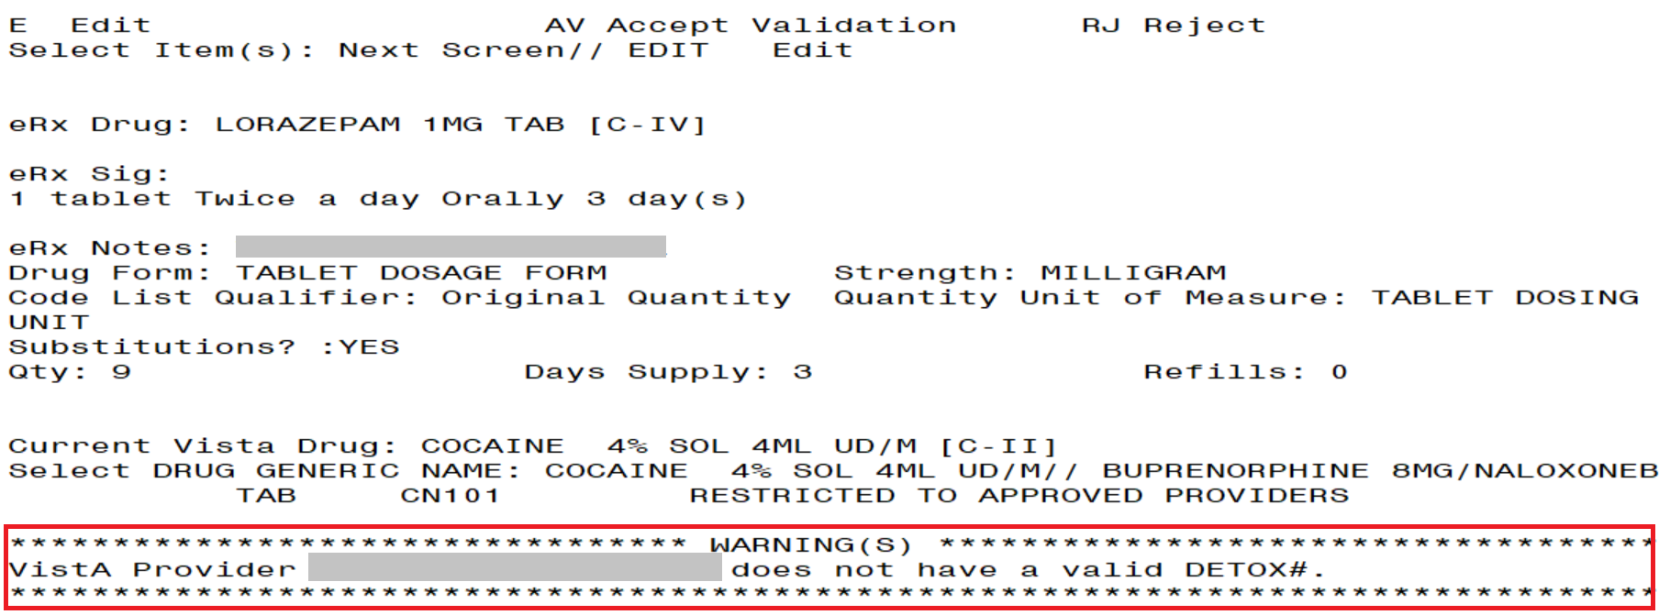
Select Provider Missing Valid Detox Number Warning Message
CS NOTE: The following block message displays upon selecting the Drug validation if the eR_{X} is Non-Controlled Substance and the VistA drug is a Controlled Substance. The Accept Validation will be blocked.
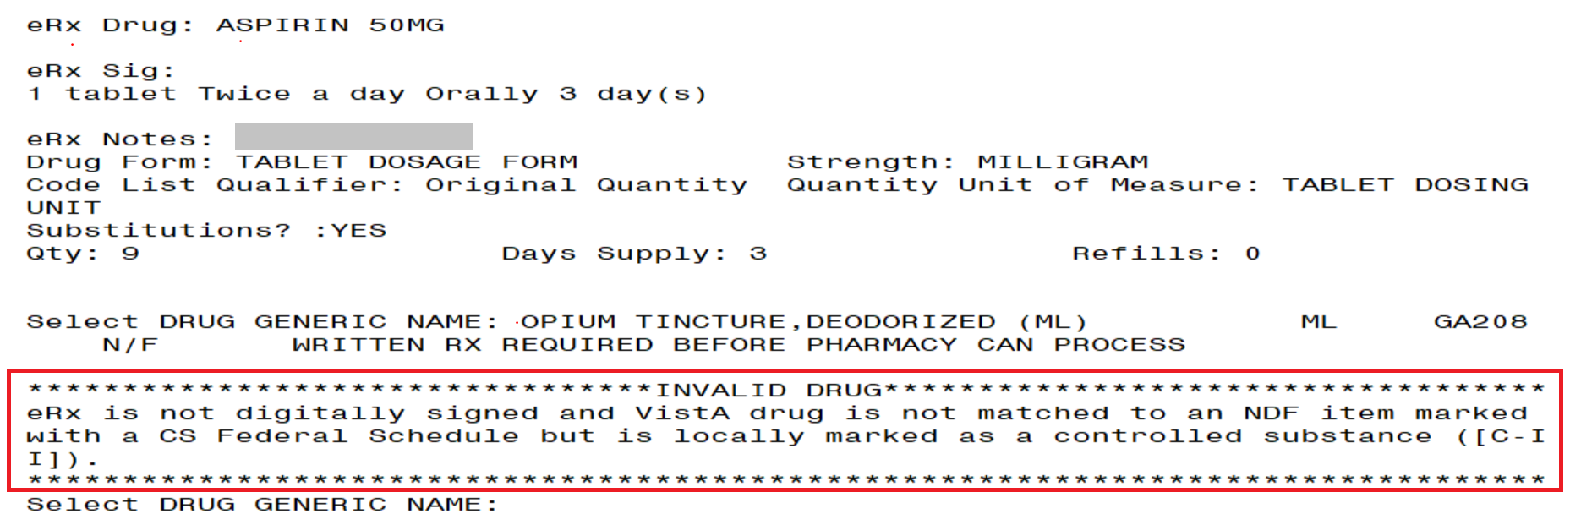
Blocked Accept Validation Message
CS NOTE: The following warning message displays upon selecting an eRx that is a Controlled Substance, but the VistA drug selected is a Non-Controlled Substance.
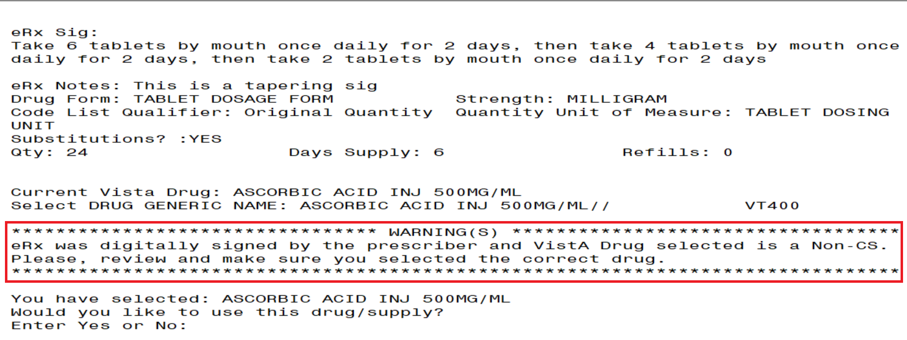
Drug Validation Warning Message
CS NOTE: The following block message displays upon selecting an eR_{X} that is not digitally signed, and the VistA drug is a Controlled Substance.
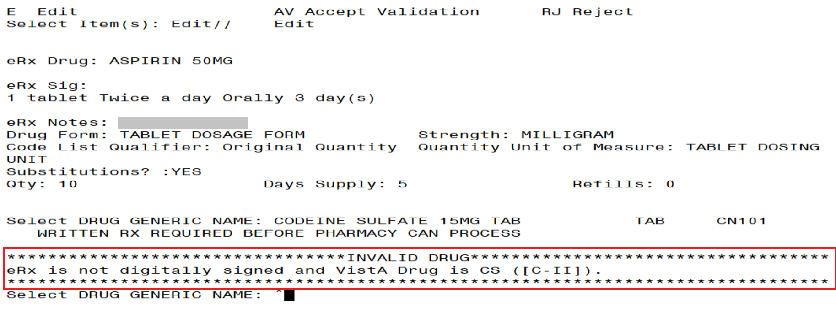
Drug Validation eRx without DS Message
NOTE: The following block message displays upon selecting an eRx that is digitally signed, and the VistA drug is a Non-Controlled Substance.
Drug Validation eRx without DS Message

CS NOTE: The following block message displays upon selecting an eR_{X} that does not have a valid DEA number on file for the eR_{X} Provider.
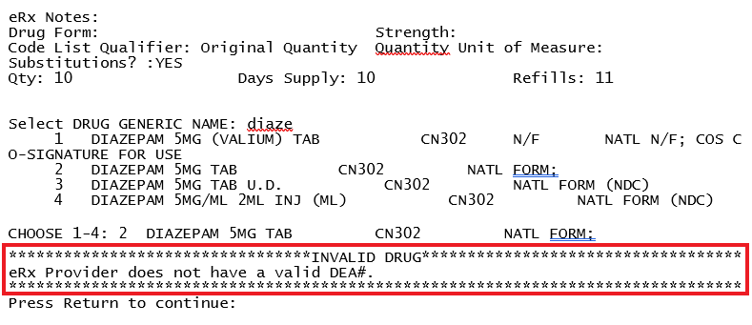
Drug Validation eRx with Invalid eRx Provider DEA Number Message
CS NOTE: The following block message displays upon selecting an eRx that doesn’t have a valid DEA number on file for the VistA Provider.
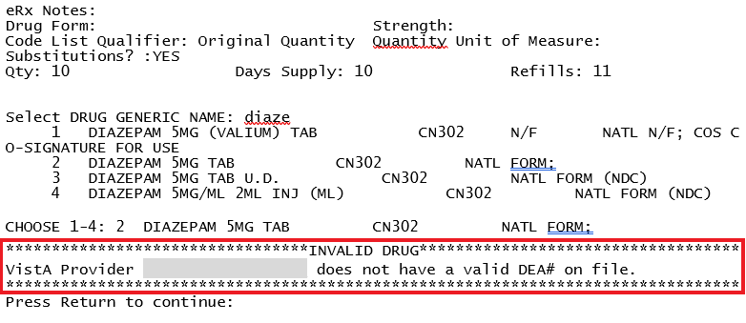
Drug Validation eRx with Invalid VistA Provider DEA Number Message
NOTE: The following block message displays upon selecting an eR_{X} that has a mismatched DEA number on file for the Provider.
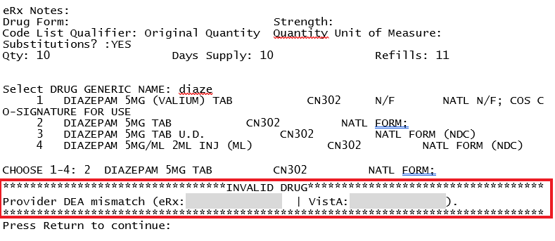
Drug Validation eRx with Provider DEA Number Mismatch Message
CS NOTE: The following warning message displays upon selecting an eR_{X} that was written or issues after the VistA Provider’s DEA number has expired.
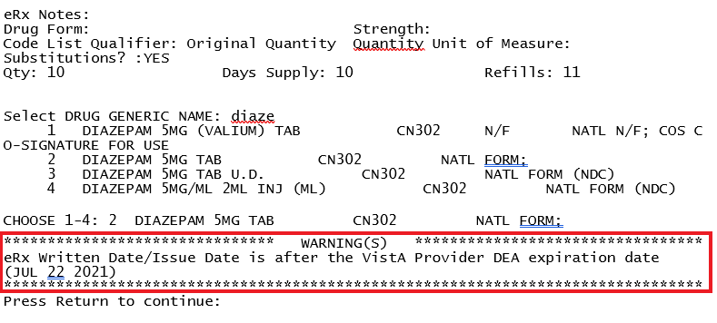
Drug Validation eRx Written After VistA Provider DEA Expiration Warning Message
CS NOTE: The following block message displays upon selecting an eR_{X} that does not have a valid VistA Provider detox number on file.
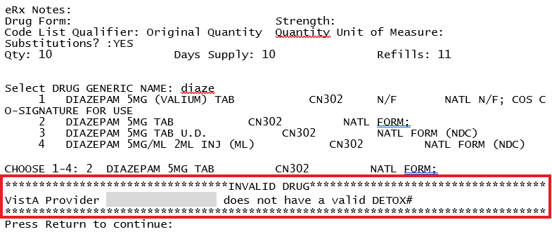
Drug Validation eRx VistA Provider Invalid DEA Number Message
CS NOTE: The following warning message displays upon selecting an eR_{X} that does not have a valid VistA Provider authorization to write the drug schedule.
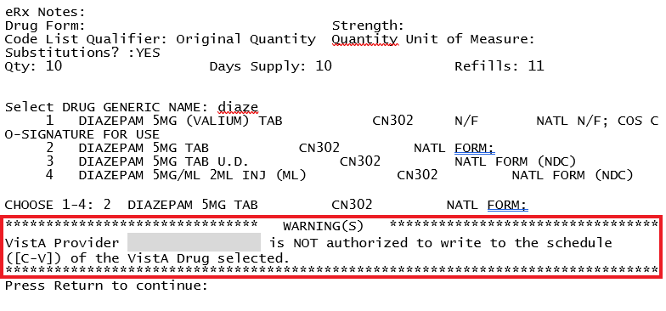
Drug Validation eRx VistA Provider Not Authorized Warning Message
CS NOTE: The following warning message displays upon selecting an eR_{X} that is written/issued after the VistA Provider’s DEA expiration date.
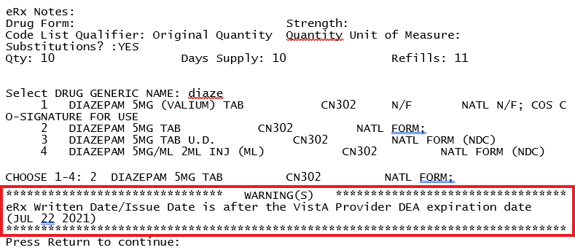
Drug Validation eRx VistA Provider Not Authorized Warning Message

Additional Field-level Information:
- Quantity Unit of Measure is displayed in the eR_{X} Holding Queue > Validate Drug/SIG screen > Edit, along with the reference eR_{X} information.
- eR_{X} Quantity displays up to 5 digits after the decimal in the eR_{X} Holding Queue Summary/Details screen and VD > Edit screen.
- VistA Quantity is displayed same as eR_{X} Quantity if there are 2 digits after decimal places. If there are more than 2 digits after decimal places, VistA Quantity field is left blank so that the user can key in.
- eR_{X} Days Supply displays up to 999 in the eR_{X} Holding Queue Summary/Details screen and VD > Edit screen.
- VistA Days Supply is auto-calculated based on Units Per Dose, Quantity, and Schedule values. User can also key in a desired value in this field.
- eR_{X} Renewals displays up to 99 in the eR_{X} Holding Queue Summary/Details screen and VD > Edit screen.
- VistA Renewals allows a value between 0 and 11 only.
- VistA Renewals is auto-populated based on Dispensing Units, Quantity, and Days Supply values.
- Help text for VistA Quantity is under eR_{X} Holding Queue > Validate Drug/SIG screen > Edit.

Quantity/Days Supply Work Flow under Validate Drug/SIG > Edit:
Scenario 1: The updated Quantity/Days Supply work flow works in the holding queue for only available dosages such as 40MG, 80MG and so on. The Quantity divided by schedule is then divided by units per dose to provide the Days Supply value.
Available Dosage(s):
1. 40MG
2. 80MG
Scenario 2: Quantity/Days Supply auto-calculation does not function for available dosages such as SMALL AMOUNT/LIBERAL AMOUNT, DROP/DROPS, TEASPOONFUL, PATCH etc. For these available dosages, Holding queue VD screen works similar to CPRS, not auto-calculating Days Supply based on Quantity, Schedule, and Units per dose.
There are 2 Available Dosage(s):
1. 1 DROP
2. 2 DROPS
There are 4 Available Dosage(s):
1. 1 TEASPOONFUL
2. 2 TEASPOONFULS
3. 1 TABLESPOONFUL
There are 3 Available Dosage(s):
1. LIBERAL AMOUNT
2. SMALL AMOUNT
3. MODERATE AMOUNT
Scenario 3: Quantity/Days Supply auto-calculation does not function for drugs when there are no available dosages. Holding queue VD screen works similar to CPRS, not auto-calculating Days Supply based on Quantity, Schedule, and Units per dose.
There are NO Available Dosage(s).
Please Enter a Free Text Dose:

Accept Drug/SIG Validation
Once the VistA Drug/SIG information has been edited and reviewed for accuracy, the next step is to accept the validation <AV> on the Drug Validation screen. The system prompts the user to confirm the validation. After entering <Y> Yes, a message displays that the drug validation has been updated.
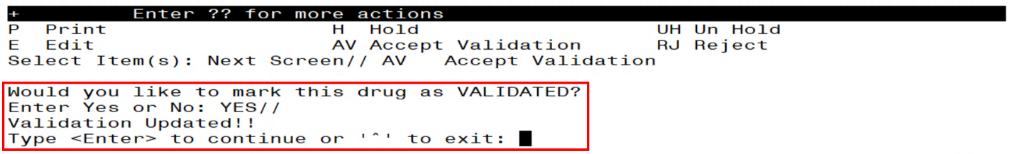
Confirm Acceptance of Drug / SIG Validation
CS NOTE: The following block message displays upon selecting an eR_{X} that does not have a valid VistA Provider authorization to write the drug schedule.
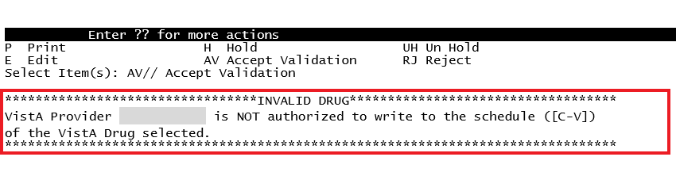
Drug Accept Validation eRx VistA Provider Not Authorized Block Message
CS NOTE: The following block message displays upon selecting an eR_{X} that is written/issued after the VistA Provider’s DEA expiration date.
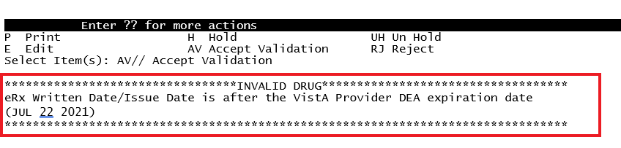
Drug Accept Validation eRx VistA Provider Not Authorized Block Message
The Status changes to “VALIDATED” on the Drug Validation screen, along with the user who performed the validation and date/time stamp. “[v]” also displays to the right of the VistA Drug field on the Summary/Details screen.

Drug Validation Oct 19, 2023@13:43:44 Page: 1 of 3
eRx Reference #: 99999999 Date Written: 10/18/23 Effective Date: 10/18/23
Status: AUTO-MATCHED | VALIDATED by USER,USER on 10/19/23@13:43:36
ERX MED | VISTA MED
Allergy: |Allergy:
NO ALLERGY INFORMATION RECEIVED | Verified:
| EGG PRODUCTS,PEANUTS
_______________________________________|________________________________________
Drug: ACETAMINOPHEN 325MG TAB |1)Drug: ACETAMINOPHEN 325MG TAB
Substitution? YES Renewals? YES |Drug Message:
| NATL FORM; DU: INCREMENTS OF 100 ONLY
| *** TCGRx & SCRIPTPRO ***
_______________________________________|________________________________________
SIG: |SIG:
TAKE ONE TABLET PO EVERY FOUR HOURS | TAKE ONE TABLET PO EVERY FOUR HOURS AS
AS NEEDED | NEEDED
_______________________________________|________________________________________
|2) Dosage: 325 (MG)
| Verb: TAKE
|Disp. Units: 1
+ Enter ?? for more actions
P Print H Hold UH Un Hold
E Edit AV Accept Validation RJ Reject
Select Item(s): Next Screen//
Drug / SIG Validation Complete (Validate Drug / SIG Screen)
The modified VistA Drug/SIG information populates on the Drug/SIG Validation screen.
Press <Enter> to display Pages 2 and 3 of the Drug/SIG Validation screen.

eRx Holding Queue Display Oct 19, 2023@13:49:18 Page: 1 of 3
eRx Patient: XXXXX,XXXXXXXXXX
eRx Reference #: 99999999
eRx HT: (cm)() eRx WT: (kg)()
+
eRx Drug: ACETAMINOPHEN 325MG TAB
eRx Qty: 180 eRx Refills: 2 eRx Days Supply: 30
eRx Written Date: OCT 18, 2023 eRx Issue Date:
Prohibit Renewals: No
eRx Sig:
TAKE ONE TABLET PO EVERY FOUR HOURS AS NEEDED

Vista Drug[v]: ACETAMINOPHEN 325MG TAB
Vista Qty: 180 Vista Refills: 2 Vista Days Supply: 30
Substitutions? :YES
Vista Sig: TAKE ONE TABLET PO EVERY FOUR HOURS AS NEEDED
Pat Inst:
Hold Status:
Hold Reason:
+ Enter ?? for more actions
VP VALIDATE PATIENT VM VALIDATE PROVIDER VD VALIDATE DRUG/SIG
P Print RJ Reject AC Accept eRx
H Hold UH Un Hold RM Remove eRx
Select Action:Next Screen//
Drug / SIG Validation Complete (Summary/Details Screen)

Wait Status Flag “W”
When the user completes validating Patient, Provider and Drug/SIG for an eR_{X}, the status of the prescription changes from “I” In Process to “W” Wait in the Holding Queue’s list view.
eRx Holding Queue Display Oct 19, 2023@13:59:02 Page: 1 of 3
eRx Patient: XXXXX,XXXXXXXXXX
eRx Reference #: 99999999
eRx HT: (cm)() eRx WT: (kg)()
+
NEWRX
eRx Status: WAIT
eRx Patient: XXXXXXXX,XXX DOB: 4/21/90
Vista Patient[v]: XXXXXXXX,XXX DOB: 4/21/90

eRx Provider: LIBERTY,LEA
DEA#: XX9999999 NPI: 9999999999
Vista Provider[v]: LIBERTY,LEA
DEA#: XX9999999 NPI: 9999999999

eRx Drug: ACETAMINOPHEN 325MG TAB
eRx Qty: 180 eRx Refills: 2 eRx Days Supply: 30
eRx Written Date: OCT 18, 2023 eRx Issue Date:
Prohibit Renewals: No
+ Enter ?? for more actions
VP VALIDATE PATIENT VM VALIDATE PROVIDER VD VALIDATE DRUG/SIG
P Print RJ Reject AC Accept eRx
H Hold UH Un Hold RM Remove eRx
Select Action:Next Screen//
eR_{X} Holding Queue Summary/Details Screen with Validations Complete
“W” can now be seen in the status column.
eRx Medication Queue Nov 11, 2023@11:57:59 Page: 1 of 3
LOOK BACK DAYS: 45 CS/NON-CS: BOTH (II-V) MAX. QUEUE SIZE: 999
ERX STATUS: ALL
# PATIENT DOB DRUG PROVIDER STA REC.DAT^
1. XXXXXXXXXXX,XXXXXXXX 07/10/33 ACETAMINOPHEN 325MG TA XXXXXXX,XXX W 10/04/23

+ Select the entry # to view or ?? for more actions
SPAT Sort By Patient SQ Search Queue LBD Change Look Back Days
PC Patient Centric View RAF Remove All Filters REF Refresh List
Select Item(s): Next Screen//
eR_{X} Holding Queue List View with eR_{X} Record in “W” Status

Accepting eR_{X}
The following conditions must be met, before a fillable eR_{X} can be accepted and transmitted to the Pending Queue for further processing:
- The eR_{X} cannot be on Hold. If the eR_{X} is on Hold, the eR_{X} status on the Holding Queue List has one of the Hold Status codes, and the Hold Status, Hold Reason, and the user who placed the eR_{X} on hold is displayed on the Summary/Details screen.
- The eR_{X} cannot have a status of “Rejected” RJ, “Removed” RM, “Processed” PR or “Canceled” CAN/CXQ.
All validation steps, for patient, provider, and drug/SIG must be completed, including the <AV> Accept Validation action on the validate screens. For additional information on the validation steps, refer to section User Manual Unit 1 available on the Veteran's Documentation Library (VDL).

MbM Only
When MbM users accept an eR_{X,} the software will check if the Clinic they are currently logged on (the one they chose when entering the option) matches the clinic in the eR_{X} (edited during Validate Drug/SIG). If they are different, MbM users will see the following message/prompt:

Select Action:Next Screen// AC Accept eRx

Current Clinic assigned to the eRx: ADMISSION MED

Send to eRx Clinic: EMERGENCY ROOM*//

The default value will always be the clinic they are logged on. This will give them a chance to select/change the clinic they want to send the eR_{X} to.

If a user attempts to accept an eR_{X} where one or more of the conditions have not been met, an error message displays indicating that the eR_{X} cannot be processed and the reason.
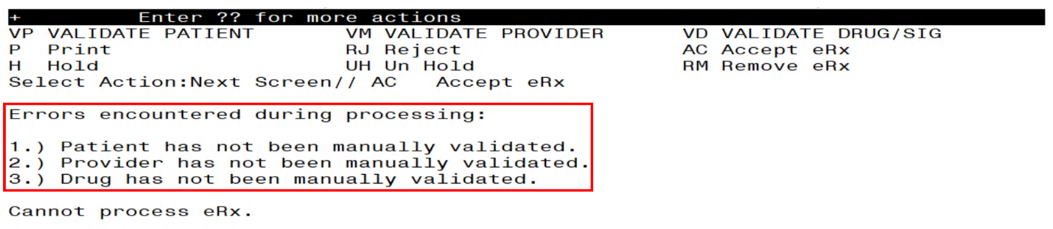
Accept eR_{X} - Sample Validation Errors
After all the above preconditions have been met, to Accept an eR_{X} <AC> from the Summary/Details screen, complete the following steps.
From the Summary/Details screen, type <AC> Accept eR_{X}.
Accept eR_{X}es
A message displays notifying the user that the eR_{X} was sent to Pending Outpatient Orders for further processing.
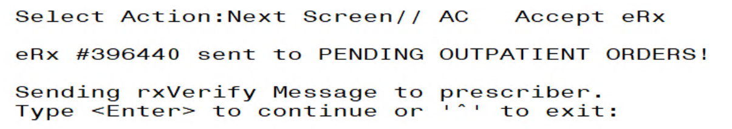
eR_{X}es Sent to Pending Outpatient Orders
The user can then go to Complete Orders from OERR or Patient Prescription Processing to view the eR_{X} information.
Complete Orders from OERR and Patient Prescription Processing.
NOTE: RxVerify messages are stored in the Hub for reporting purposes only. Unlike in the past, no NCPDP message will be sent back to the originating EHR system indicating that eR_{X} has been accepted.
CS NOTE: All Controlled Substance prescriptions checks for Patient, Provider, and Drug are re-performed at Accept eRx and any issues will prevent the eRx from being accepted.

Rejecting eR_{X} in the eR_{X} Holding Queue
Reject is used to remove a fillable eR_{X} from the eR_{X} Holding Queue. Reject must be accompanied by a reject code/reason.
NOTE: Reject messages are stored in the Hub for reporting purposes only. Unlike in the past, no NCPDP message will be sent back to the originating EHR system indicating that eR_{X} has been rejected.
To reject an eR_{X}, complete the following steps:
- From the Summary/Details screen, type <RJ> Reject.
- Enter <Y> Yes to confirm the reject.
- Enter a reason for the rejection. The following reasons are available:
- PTT01 – Patient not eligible
- PTT02 – Cannot resolve patient
- PVD01 – Provider not eligible
- PVD02 – Cannot resolve provider
- DRU01 – Not eligible for renewals
- DRU02 – Non-formulary drug
- DRU03 – Duplicate prescription found for this patient
- DRU04 – Invalid quantity
- DRU05 – Duplicate therapeutic class
- DRU06 – Controlled substances are disallowed
- ERR01 – Multiple errors, please contact the pharmacy
- ERR02 – Incorrect pharmacy
- ERR03 – Issues with prescription, please contact the pharmacy
- PVD03 – Missing/bad digital signature on inbound CS ERX
- PVD04 – Prescriber’s CS credential is not appropriate
- PTT03 – Patient’s mailing address is missing/mismatched
- ERR99 - Other
- Type additional comments as to why the eR_{X} is being rejected and press <Enter>. These comments are optional.
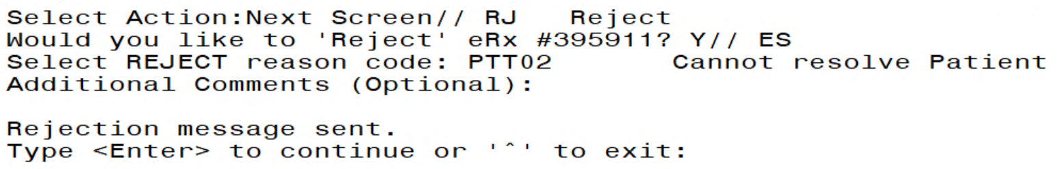
Rejecting an eR_{X}
Once the eR_{X} is rejected, the details of the reject message are available in the IEP Processing Hub as reference. Error! Reference source not found.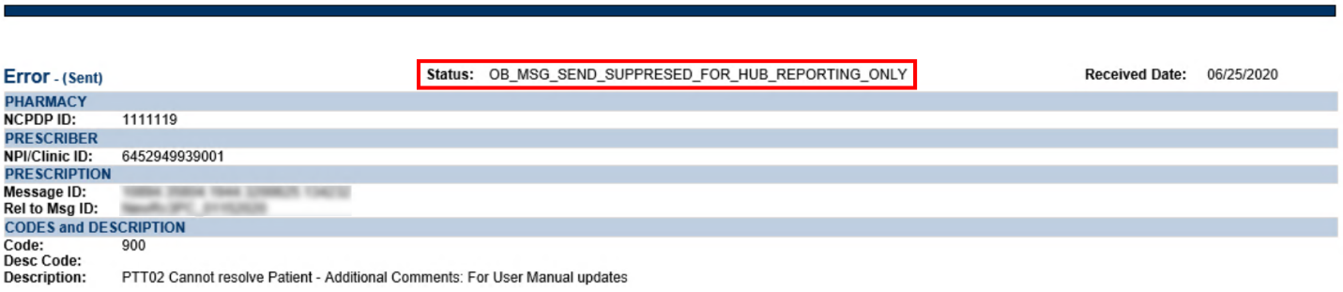
Reject Message in Processing Hub

Do Not Fill
If a Controlled Substance record contains a value of ‘E’, the following message will display to inform the user that this is a DO NOT FILL record per the Provider.
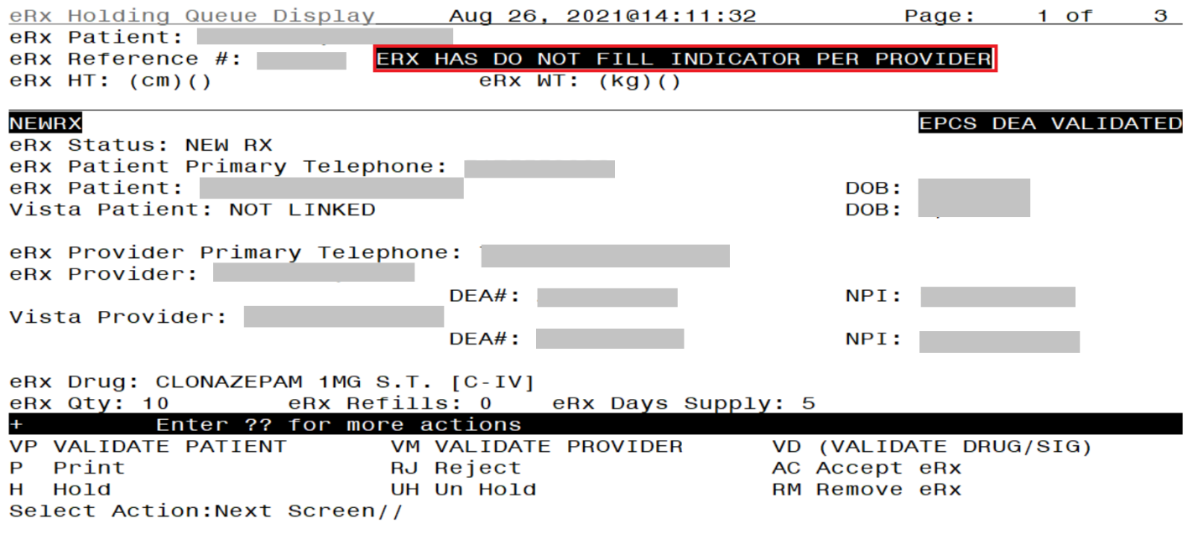
eRx has Do Not Fill Indicator Per Provider

The user will be prompted to select REMOVE or REJECT actions.
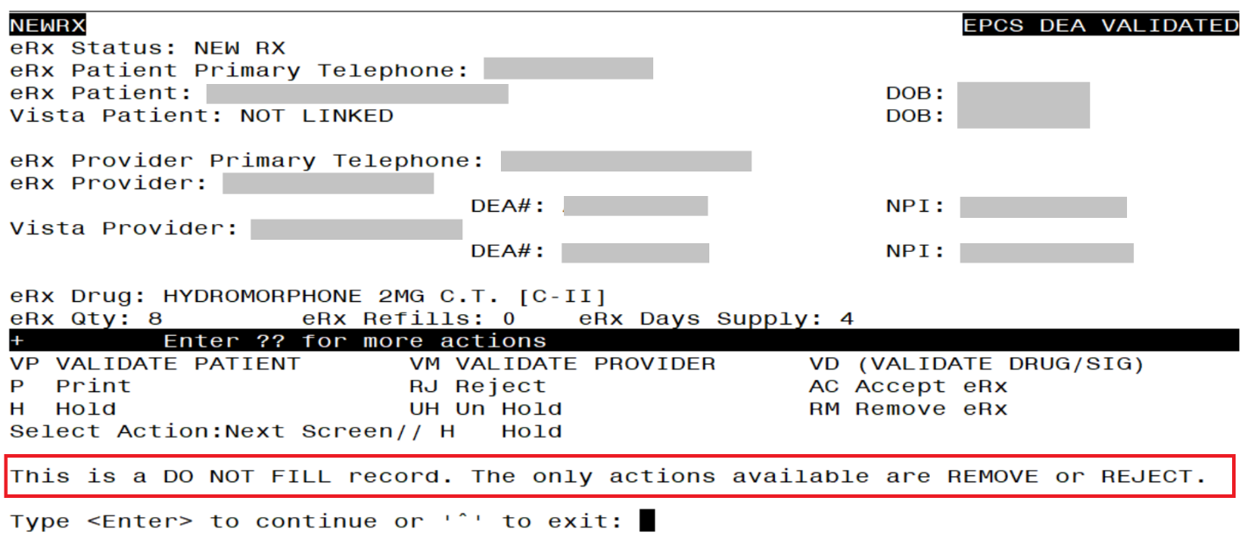
Do Not Fill Error Message

Printing in the eR_{X} Holding Queue
From the Summary/Details screen and from any of the validate screens, the <P> Print action is available to print the eR_{X}. <P> Print action is available for all records in the Holding Queue.
- Enter <P> Print.
- Enter the Device (local or network printer) and press <Enter>.
The print display of the eR_{X} prints to the selected printer.
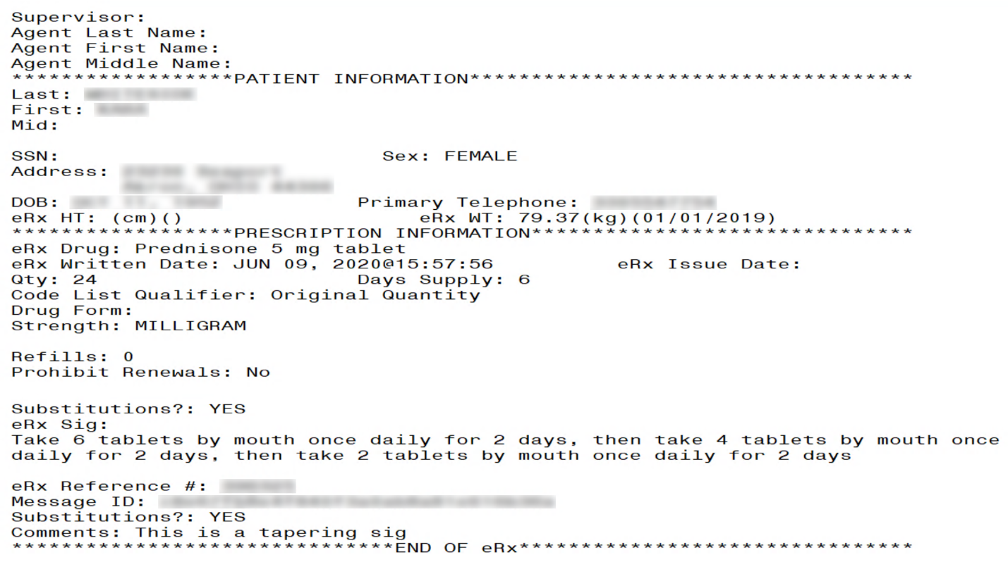
Print Display of Non-Controlled Substance eR_{X}

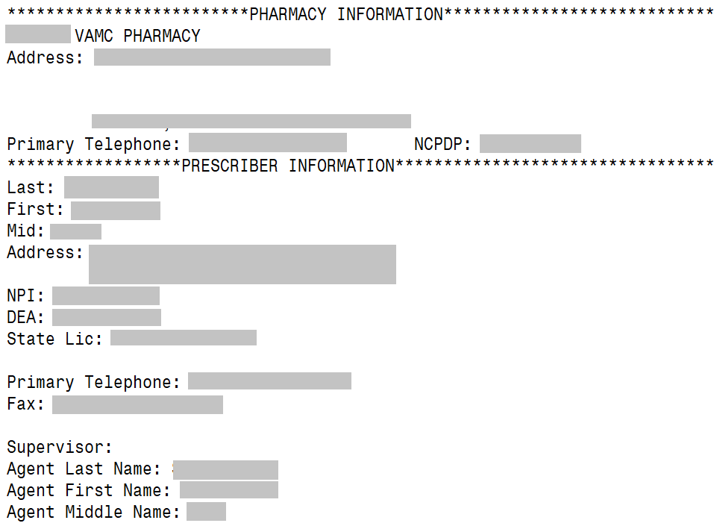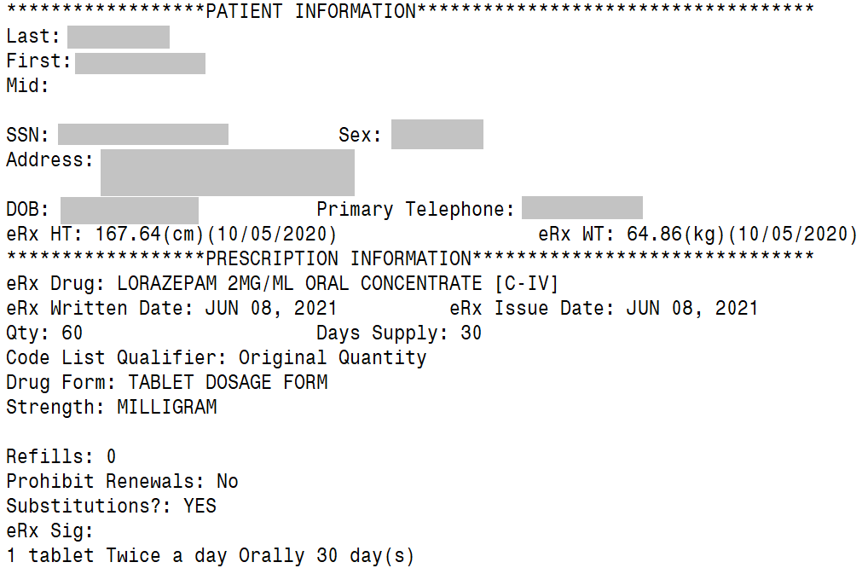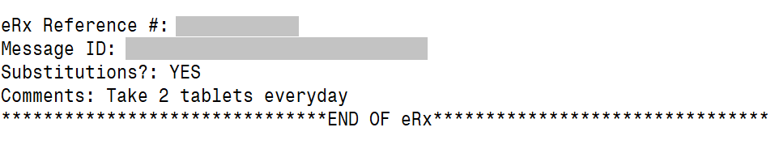
Print Display of Controlled Substance eR_{X}

Placing eR_{X} on Hold in the eR_{X} Holding Queue
A fillable eR_{X} can be placed on hold for several reasons indicating that there is an issue with the eR_{X}.
- To place an eR_{X} on hold, type <H> Hold from the Summary/Details screen or any of the validate screens.
- Enter a hold reason from the available reasons. The following reasons are available:
- HPT – PATIENT NOT FOUND
- HPD – PROVIDER NOT FOUND
- HNF – NON-FORMULARY DRUG THAT NEEDS APPROVAL
- HSO – INSUFFICIENT STOCK
- HDI – DRUG-DRUG INTERACTION
- HAD – ADVERSE DRUG INTERACTION
- HBA – BAD ADDRESS
- HPC – PROVIDER CONTACTED
- HPA – PRIOR APPROVAL NEEDED
- HOR – OTHER REASON
- HPP – PATIENT CONTACTED
- HPR – HOLD DUE TO PATIENT REQUEST
- HQY – QUANTITY OR REFILL ISSUE
- HCR – PRESCRIBER’S CS CREDENTIAL IS NOT APPROPRIATE
- HWR – CS PRESCRIPTION WRITTEN/ISSUE DATE HAS PROBLEMS
- HIS – PROVIDER DEA# ISSUE
- HRX – HOLD FOR RX EDIT
- HDE – DRUG USE EVALUATION
- HTI – THERAPUTIC INTERCHANGE
- HAL – NO PATIENT ALLERGY ASSESSMENT
- HEL – PATIENT ELIGIBILITY ISSUE
- HUR – HOLD UN-REMOVED

To view the available hold reasons, enter a double question mark <??> at the “Select HOLD reason code” promptError! Reference source not found.. The available hold reasons display.

Select Action:Next Screen// H Hold
Select HOLD reason code: ??

Choose from:
118 HPT PATIENT NOT FOUND
119 HPD PROVIDER NOT FOUND
120 HNF NON-FORMULARY DRUG THAT NEEDS APPROVAL
121 HSO INSUFFICIENT STOCK
122 HDI DRUG-DRUG INTERACTION
123 HAD ADVERSE DRUG INTERACTION
124 HBA BAD ADDRESS
125 HPC PROVIDER CONTACTED
126 HPA PRIOR APPROVAL NEEDED
127 HOR OTHER REASON
128 HPP PATIENT CONTACTED
129 HPR HOLD DUE TO PATIENT REQUEST
130 HQY QUANTITY OR REFILL ISSUE
1618 HCR PRESCRIBER'S CS CREDENTIAL IS NOT APPROPRIATE
1619 HWR CS PRESCRIPTION WRITTEN/ISSUE DATE HAS PROBLEMS
1620 HIS PROVIDER DEA# ISSUE
1621 HRX HOLD FOR RX EDIT
1622 HDE DRUG USE EVALUATION
1623 HTI THERAPUTIC INTERCHANGE
1624 HSC SCRIPT CLARIFICATION
1625 HGS GENERIC SUBSTITUTION
1631 HAL NO PATIENT ALLERGY ASSESSMENT
1632 HEL ELIGIBILITY ISSUE
1633 HUR HOLD UNREMOVE

Select HOLD reason code:

Hold eR_{X}
- Enter the reason code at the “Select HOLD Reason code:” prompt and press <Enter>.
- A prompt displays asking for additional comments on the reason for the hold. These comments are optional. Either press <Enter> to complete the hold process or add comments and then press <Enter>.
Select Hold Reason Code
The Hold Status, Hold Reason, and the user placing the eR_{X} on hold display below the VistA Drug section on the Summary/Details screen.
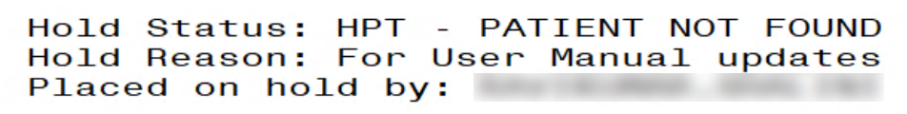
Hold Status and Reason
The hold status also displays in the “Status” column (STA) on the Holding Queue List screen.
eRx Medication Queue Nov 11, 2023@11:57:59 Page: 1 of 3
LOOK BACK DAYS: 45 CS/NON-CS: BOTH (II-V) MAX. QUEUE SIZE: 999
ERX STATUS: ALL
# PATIENT DOB DRUG PROVIDER STA REC.DAT^
1. XXXXXXXXXX,XXXXXXXXX 07/10/33 MELOXICAM 15MG TAB XXXXX,XXXXX I 10/04/23
2. XXXXXXXXXX,XXXXXXXXX 04/26/80 ACETAMINOPHEN 325MG T XXXXX,XXXXX N 10/04/23
3] XXXXXXXXXX,XXXXXXXXX 09/22/63 PHENOBARBITAL 32MG TA XXXXX,XXXXX N 10/04/23
4] XXXXXXXXXX,XXXXXXXXX 07/30/48 AZITHROMYCIN 250MG TA XXXXX,XXXXX I 10/04/23
5] XXXXXXXXXX,XXXXXXXXX 07/10/33 DIAZEPAM 2MG TAB XXXXX,XXXXX I 10/04/23
6. XXXXXXXXXX,XXXXXXXXX 08/01/62 NAPROXEN 250MG TAB XXXXX,XXXXX N 10/04/23
7] XXXXXXXXXX,XXXXXXXXX 04/20/80 ALPRAZOLAM 0.5MG TAB XXXXX,XXXXX HAL 10/04/23
8] XXXXXXXXXX,XXXXXXXXX 05/13/53 AZITHROMYCIN 250MG TA XXXXX,XXXXX N 10/04/23
9. XXXXXXXXXX,XXXXXXXXX 12/31/70 FORMOTEROL 5/MOMETASO XXXXX,XXXXX N 10/04/23
10. XXXXXXXXXX,XXXXXXXXX 10/01/23 SALMETEROL 50MCG/BLST XXXXX,XXXXX HEL 10/04/23
11] XXXXXXXXXX,XXXXXXXXX 10/08/67 DIAZEPAM 5MG/ML 2ML I XXXXX,XXXXX HSO 10/04/23
12. XXXXXXXXXX,XXXXXXXXX 03/16/42 OMEPRAZOLE 20MG EC CA XXXXX,XXXXX N 10/04/23
13. XXXXXXXXXX,XXXXXXXXX 01/25/43 CIPROFLOXACIN HCL 500 XXXXX,XXXXX I 10/04/23
14. XXXXXXXXXX,XXXXXXXXX 10/05/44 COLON ELECTROLYTE LAV XXXXX,XXXXX N 10/04/23
15] XXXXXXXXXX,XXXXXXXXX 03/16/42 CEPHALEXIN 250MG CAP XXXXX,XXXXX N 10/04/23
16] XXXXXXXXXX,XXXXXXXXX 12/21/48 SORBITOL 70% SOLN XXXXX,XXXXX N 10/04/23
+ Select the entry # to view or ?? for more actions
SPAT Sort By Patient SQ Search Queue LBD Change Look Back Days
PC Patient Centric View RAF Remove All Filters REF Refresh List
Select Item(s): Next Screen//
Hold Status in Status Column
NOTE: When a fillable eR_{X} is put on ‘Hold’ the only actions available for the user are UH/Un Hold, P/Print and SH/Status History.

Un Hold eR_{X} in the eR_{X} Holding Queue
eR_{X} may be removed from a hold by typing <UH> Un Hold. Users who see the Un Hold function in parentheses “()” are not able to remove an eR_{X} from a hold.
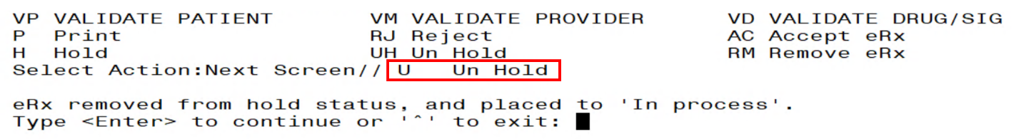
Un Hold eR_{X}
NOTE: When a user exercises Un Hold option on a NewR_{X} record that is in one of the Hold statuses, if all the 3 validations (Patient, Provider, and Drug/SIG) are complete, the eR_{X} record’s status changes to “W” (Wait). When a user exercises Un Hold option on a NewR_{X} record that is in one of the Hold statuses, if all the 3 validations (Patient, Provider, and Drug/SIG) are not complete, the eR_{X} record’s status changes to “I” (In Process).

Removing eR_{X} in the eR_{X} Holding Queue
A fillable eR_{X} can be removed from the Holding Queue without sending a message back to the originating external provider. Sample scenarios include, but are not limited to, the patient requested that the eR_{X} not be filled, or the user has been unable to contact the provider or patient for a significant amount of time.
To remove an eR_{X} from the Holding Queue:
- From the Summary/Details screen, type <RM> Remove.
- Enter a reason for the eR_{X} removal. The following removal reasons are available:
- REM01 - Drug out of stock or on backorder and unavailable for processing
- REM02 - Patient was not able to pick up
- REM03 - Prescription canceled by Provider
- REM04 - Prescription processed manually
- REM05 - Provider will cancel this eR_{X} and submit another
- REM06 - Unable to mail prescription and patient unable to pick up
- REM07 - Unable to contact patient
- REM08 - Unable to contact provider
- REM91 - Undefined system error
- REM92 – Other
- REM09 – ERX Issue not resolved - Provider contacted

- Type additional comments as to why the eR_{X} is being removed and press <Enter>. These comments are optional.
Once the eR_{X} is removed, the status changes to “RM” and it no longer displays in the default Holding Queue List; however, the eR_{X} can be accessed via the search action from the main Holding Queue List screen using one or more of the search criteria.
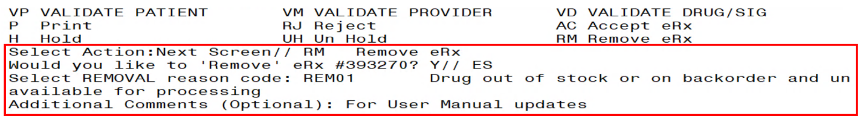
Removing an eR_{X}
NOTE: If the Remove function is in parentheses “()”, the user is not able to remove an eR_{X}. If the action is still attempted, the user receives a message that the action is not available.

eR_{X} in the Backdoor Pharmacy Pending Queue
Once the eR_{X} is accepted in the Holding Queue it moves to the Patient Medication Profile under the Pending Orders section, which is the same queue where CPRS outpatient pharmacy orders are sent to by the VA Providers after they sign them.

Patient Medication Profile
The Patient Medication Profile can be accessed through these two different options: Complete Orders from OERR [PSO LMOE FINISH] or Patient Prescription Processing [PSO LM BACKDOOR ORDERS]. An eR_{X} Pending Order or a finished prescription are marked by an ampersand (&) before the prescription number or drug name in the case of pending orders.

Medication Profile Nov 12, 2023@09:20:13 Page: 1 of 2
XXXXXXXXXXX,XXXXXXX <A>
PID: 999-99-9999 Ht(cm): 999.99 (99/99/9999)
DOB: XXX 99,9999 (99) Wt(kg): 99.99 (99/99/9999)
SEX: MALE
CrCL: 99.9(est.) (CREAT: 9.99mg/Dl 99/99/99) BSA (m2): 9.99
ISSUE LAST REF DAY
# RX # DRUG QTY ST DATE FILL REM SUP
________________________________________________________________________________
-------------------------------------ACTIVE-------------------------------------
1 & 2297959$ MELOXICAM 7.5MG TAB 30 A> 08-09 08-16 11 30
2 2297948$ METFORMIN HCL 1000MG TAB 30 A> 08-10 08-10 5 30
3 2297920$ NAPROXEN 250MG TAB 60 A> 06-20 06-20 11 30
------------------------------------PENDING-------------------------------------
4 & ATENOLOL 25MG TAB QTY: 60 ISDT: 09-18> REF: 11
5 GABAPENTIN 100MG CAP QTY: 30 ISDT: 08-09> REF: 11
6 LEVOTHYROXINE (LEVOTHROID) 0.125MG TAB
QTY: 30 ISDT: 08-10 REF: 5
7 & LOSARTAN 25MG TAB QTY: 60 ISDT: 09-20> REF: 11
8 & MELOXICAM 15MG TAB QTY: 30 ISDT: 08-09> REF: 11
+ Enter ?? for more actions
PU Patient Record Update NO New Order
PI Patient Information SO Select Order
Select Action: Next Screen//
Patient Medication Profile

eRx Pending Order
An eR_{X} pending order will display similar to the split screen in the eR_{X} Holding Queue for validating patient, provider, and drug/SIG, including the reverse video for discrepancies. The main difference is that it will contain all sections (patient, provider, and drug/SIG) in one screen, as seen below.

Pending OP Orders (ROUTINE) Nov 12, 2023@09:18:09 Page: 1 of 1
XXXXXXXXX,XXXXXXX <A>
PID: 999-99-9999 Ht(cm): 999.99 (99/99/9999)
DOB: XXX 99,9999 (99) Wt(kg): 99.99 (99/99/9999)
ERX (999999) | VISTA PENDING ORDER
PATIENT AUTO-MATCHED/EDITED | VALIDATED by XXXXX,XXXXXXX on 9/20/23@11:47:15__
Name: XXXXXXXXX,XXXXXXX |Name: XXXXXXXXX,XXXXXXX
DOB : XXX 99, 9999 |DOB : XXX 99,9999
SSN : 999-99-9999 |SSN : 999-99-9999
Sex : MALE |Sex : MALE
_______________________________________|________________________________________
|Pharmacy Narrative:
_______________________________________|________________________________________
Allergy: |Allergy:
NO ALLERGY INFORMATION RECEIVED | Verified:
| ALBUTEROL,EGG PRODUCTS,HONEY
| IBUPROFEN,PEANUTS,PERCODAN
_______________________________________|________________________________________
PROVIDER AUTO-MATCHED | VALIDATED by PSOAPPLICATIONPROXY on 9/20/23@11:44:29
Name: XXXXXXXX,XXXXXX |Name: XXXXXXXX,XXXXXX
NPI : 9999999999 |NPI : 9999999999
DEA : XX9999999 |DEA : XX9999999
_______________________________________|________________________________________
DRUG AUTO-MATCHED | VALIDATED by XXXXX,XXXXXXX on 9/20/23@11:48:05
Substitution? NO |1) Orderable Item: <DIN>
Renewals? YES | ATENOLOL TAB
_______________________________________|________________________________________
Drug: |2) CMOP Drug: <DIN>
Atenolol 25mg tablet | ATENOLOL 25MG TAB
Drug Form: Tablet |Drug Message:
| NATL FORM *** TCGRx & SCRIPTPRO ***
_______________________________________|________________________________________
SIG: |SIG:
TAKE 1 TABLET QD | TAKE ONE TABLET BY MOUTH ONCE DAILY
_______________________________________|________________________________________
|3) *Dosage: 25 (MG)
| Verb: TAKE
| Disp. Units: 1
| Noun: TABLET
| *Route: ORAL
| *Schedule: ONCE DAILY
_______________________________________|________________________________________
|4) Patient Instruction:
_______________________________________|________________________________________
Provider Notes/Comments: |Provider Comments:
|
_______________________________________|________________________________________
|5) Pat.Status: SERVICE CONNECTED
_______________________________________|________________________________________
Date Written: SEP 18, 2023 |6) Issue Date: SEP 18,2023
Effective Date: |7) Fill Date: Nov 12, 2023
_______________________________________|________________________________________
Days Supply: 30 |8) Days Supply: 90
_______________________________________|________________________________________
Quantity: 30 |9) QTY (TAB): 90
Dispense Unit: |
Qty Qualifier: Original Quantity |QTY Dispense Message:
|
_______________________________________|________________________________________
Refills: 11 |10) Refills: 3
_______________________________________|________________________________________
|11) Routing: MAIL
_______________________________________|________________________________________
|12) Clinic: CC
_______________________________________|________________________________________
Provider: XXXXXXXX,XXXXXX |13) Provider: XXXXXXXX,XXXXXX
_______________________________________|________________________________________
|14) Copies: 1
_______________________________________|________________________________________
|15) Remarks:
_______________________________________|________________________________________
eRx Received on 9/20/23@11:44 | Accepted by XXXXXX,XXXXXXX on 9/26/23@10:30
+ Enter ?? for more actions
AC Accept DC Discontinue FL Flag/Unflag
BY Bypass ED Edit
Select Item(s): Next Screen//

MbM Only
If the VistA patient is not eligible for ChampVA benefits the message “PATIENT NOT ELIGIBLE” will blink on the header section of the pending order:

Pending OP Orders (ROUTINE) Nov 12, 2023@09:18:09 Page: 1 of 1
XXXXXXXXX,XXXXXXX PATIENT NOT ELIGIBLE <A>
PID: 999-99-9999 Ht(cm): 999.99 (99/99/9999)
DOB: XXX 99,9999 (99) Wt(kg): 99.99 (99/99/9999)
ERX (999999) | VISTA PENDING ORDER
...

Renewal eRx Pending Order
An eR_{X} renewal pending order will display slightly different than a regular eR_{X}, which is in line with how these two types of orders display for CPRS orders. See the differences highlighted below:

Prescription Renew Nov 12, 2023@09:18:09 Page: 1 of 1
XXXXXXXXX,XXXXXXX <A>
PID: 999-99-9999 Ht(cm): 999.99 (99/99/9999)
DOB: XXX 99,9999 (99) Wt(kg): 99.99 (99/99/9999)
ERX (999999) | VISTA PENDING ORDER
PATIENT PREVIOUSLY MATCHED/VALIDATED (RENEWAL)_______________
Name: XXXXXXXXX,XXXXXXX |Name: XXXXXXXXX,XXXXXXX
DOB : XXX 99, 9999 |DOB : XXX 99,9999
SSN : 999-99-9999 |SSN : 999-99-9999
Sex : MALE |Sex : MALE
_______________________________________|________________________________________
|Pharmacy Narrative:
_______________________________________|________________________________________
Allergy: |Allergy:
NO ALLERGY INFORMATION RECEIVED | Verified:
| ALBUTEROL,EGG PRODUCTS,HONEY
| IBUPROFEN,PEANUTS,PERCODAN
_______________________________________|________________________________________
PROVIDER PREVIOUSLY MATCHED/VALIDATED (RENEWAL)___________
Name: XXXXXXXX,XXXXXX |Name: XXXXXXXX,XXXXXX
NPI : 9999999999 |NPI : 9999999999
DEA : XX9999999 |DEA : XX9999999
_______________________________________|________________________________________
DRUG PREVIOUSLY MATCHED/VALIDATED (RENEWAL)_______________
Substitution? NO |Orderable Item: <DIN>
Renewals? YES | ATENOLOL TAB
_______________________________________|________________________________________
Drug: |CMOP Drug: <DIN>
Atenolol 25mg tablet | ATENOLOL 25MG TAB
Drug Form: Tablet |Drug Message:
| NATL FORM *** TCGRx & SCRIPTPRO ***
_______________________________________|________________________________________
SIG: |SIG:
TAKE 1 TABLET QD | TAKE ONE TABLET BY MOUTH ONCE DAILY
_______________________________________|________________________________________
| *Dosage: 25 (MG)
| Verb: TAKE
| Disp. Units: 1
| Noun: TABLET
| *Route: ORAL
| *Schedule: ONCE DAILY
_______________________________________|________________________________________
|Patient Instruction:
_______________________________________|________________________________________
Provider Notes/Comments: |Provider Comments:
|
_______________________________________|________________________________________
|Pat.Status: SERVICE CONNECTED
_______________________________________|________________________________________
Date Written: SEP 18, 2023 |1) Issue Date: SEP 18,2023
Effective Date: |2) Fill Date: Nov 12, 2023
_______________________________________|________________________________________
Days Supply: 30 |Days Supply: 90
_______________________________________|________________________________________
Quantity: 30 |QTY (TAB): 90
Dispense Unit: |
Qty Qualifier: Original Quantity |QTY Dispense Message:
|
_______________________________________|________________________________________
Refills: 10 (Renewal)0 |3) Refills: 3
_______________________________________|________________________________________
|4) Routing: MAIL
_______________________________________|________________________________________
|5) Clinic: CC
_______________________________________|________________________________________
Provider: XXXXXXXX,XXXXXX |6) Provider: XXXXXXXX,XXXXXX
_______________________________________|________________________________________
|7) Copies: 1
_______________________________________|________________________________________
|8) Remarks:
| RENEWED FROM RX # 999999999
_______________________________________|________________________________________
eRx Received on 9/20/23@11:44 | Accepted by XXXXXX,XXXXXXX on 9/26/23@10:30
+ Enter ?? for more actions
AC Accept DC Discontinue FL Flag/Unflag
BY Bypass ED Edit
Select Item(s): Next Screen//

The main differences indicated above are:
- Header will display Prescription Renew instead of Pending OP Orders (ROUTINE)
- Some eR_{X} renewals pass through the eR_{X} Holding Queue and go straight to the Pending Order and that is why there will be no information about the patient, provider, and drug matching/validation.
- The number of Refills will be reduced by one and the note (Renewal) will display beside it on the eR_{X} side (left).
- The field numbers will change completely for an eR_{X} Pending Renewal. This is because a reduced number of fields are editable for a renewal compared to regular pending order. This is also in line with a CPRS Pending Renewal.

