Advanced Medication Platform (AMPL)
Graphic User Interface (GUI)

Technical Manual
Version 1.0
February 2021
Department of Veterans Affairs
Office of Information and Technology (OIT)

Revision History
NOTE: The revision history cycle begins once changes or enhancements are requested after the document has been baselined.

Date | Revision | Description | Author
01/15/2021 | Pg 7  Pg 4 | PREA*1*3  Post-implementation Access or Removal Requests added to Appendix A.  PREAPO3 added to Section 4 Routines. New option added. | Liberty ITS
09/16/2020 | Pg 4 | PREA*1*2  Document Baseline and Reviewed for 508 Compliance. Added Stand-Alone Options and included AMPL GUI option. | Liberty ITS
Table of Contents
1. Introduction 1
1.1 System Overview 1
1.2 Document Orientation 2
1.2.1 Software Disclaimer 2
1.2.1.1 Documentation Disclaimer 2
1.2.2 References 3
2. Implementation and Maintenance 3
2.1 System Requirements 3
2.1.1 Hardware Requirements 3
2.1.2 Software Requirements 3
2.1.3 Database Requirements 3
2.2 System Setup and Configuration 3
3. Files 3
4. Routines 4
5. Exported Options 4
5.1 Stand-Alone Options 4
6. Mail Groups, Alerts, and Bulletins 4
7. Public Interfaces 4
7.1 Integration Control Registrations 4
7.2 Application Programming Interfaces 4
7.3 Remote Procedure Calls 4
7.4 HL7 Messaging 4
7.5 Web Services 4
8. Standards and Conventions Exemptions 5
8.1 Internal Relationships 5
8.2 Software-wide Variables 5
9. Security 5
9.1 Security Menus and Options 5
9.2 Security Keys and Roles 5
9.3 File Security 5
9.4 Electronic Signatures 5
9.5 Secure Data Transmission 5
10. Archiving 5
11. Non-Standard Cross-References 5
12. Troubleshooting 5
12.1 Special Instructions for Error Correction 5
12.2 National Service Desk and Organizational Contacts 5
13. Acronyms and Abbreviation 6
14. Appendix A: Post-implementation Access or Removal Requests 7

List of Figures
Figure 1: Logical High-Level AMPL GUI HealthShare Data Flow 2

List of Tables
Table 1: Minimum Version of Software Packages 3
Table 2: Acronyms 6

Introduction
The Advanced Medication Platform (AMPL) Graphic User Interface (GUI) is a
front-end application supporting the Department of Veterans Affairs (VA) pharmacists by fulfilling the need for medical knowledge during patient care. Access to relevant medical knowledge can lead to increased quality of care, better efficiency, and improved health results. It can also decrease the potential for errors and adverse events resulting in decreased cost and increased provider and patient satisfaction. Incorporating GUI capabilities into the processing of pharmacy medication orders is a way to minimize risks and enhance healthcare.
This manual documents the Veterans Health Information Systems and Technology Architecture (VistA) components released in support of the AMPL GUI.

System Overview
The AMPL GUI is a GUI application tailored to users of the VistA Pharmacy packages. The AMPL GUI provides pharmacists with a single point of access to patients’ medical data from all VA medical centers in a clearer and more user-friendly display. The AMPL GUI intends to advance VA’s ongoing efforts to employ robust electronic health records and improve the efficiency and safety of the medication order process.
The AMPL GUI supports the current workflow as well as the development and incorporation of new technology/functionality and techniques. It will allow users to make more informed decisions using clinical knowledge and patient-specific information, intelligently filtered, organized and presented as care is being delivered.
The AMPL GUI displays data from the following domains:
- Allergy
- Appointments
- Consults
- Demographics
- Immunizations
- Lab
- Pharmacy
- Problem List
- Progress Notes
- Vitals
Figure 1 below shows the data flow of an AMPL GUI user requesting allergy data from all VA facilities.
Figure 1: Logical High-Level AMPL GUI HealthShare Data Flow
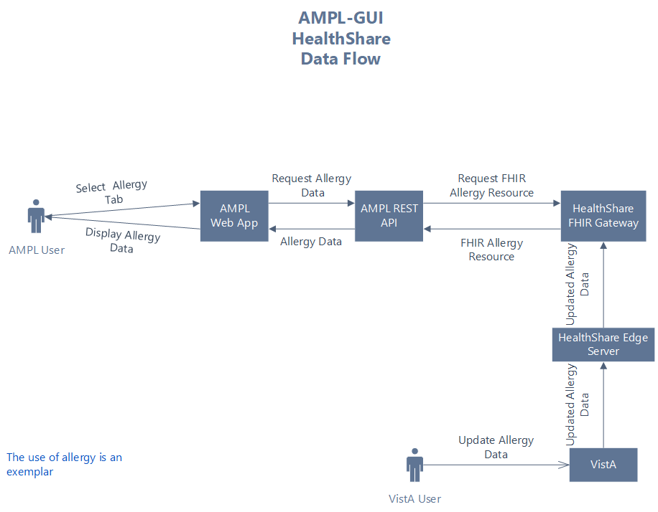

Document Orientation
The intended audience of this document is local Information Technology Support, Office of Information and Technology (OIT) personnel, and anyone who needs to know the VistA components that support the AMPL GUI.

Software Disclaimer
During their official duties, this software was developed by employees of the Federal Government at the Department of Veterans Affairs (VA). Pursuant to Title 17 Section 105 of the United States Code, this software is not subject to copyright protection and is in the public domain. VA assumes no responsibility whatsoever for its use by other parties and makes no guarantees, expressed or implied, about its quality, reliability, or any other characteristic. We would appreciate acknowledgment if the software is used. This software can be redistributed and/or modified freely provided that any derivative works bear some notice that they are derived from it, and any modified versions bear some notice that they have been modified.

Documentation Disclaimer
The appearance of external hyperlink references in this manual does not constitute an endorsement by the Department of Veterans Affairs (VA) of this website or the information, products, or services contained therein. The VA does not exercise any editorial control over the information you may find at these locations. Such links are provided and are consistent with the stated purpose of the VA.

References
All AMPL GUI documentation is available on the REDACTED and then located under the Advanced Medication Platform section.

Implementation and Maintenance
There are no VistA parameters in the AMPL GUI application.

System Requirements
There is no initial VistA software package release of the AMPL GUI. All updates to VistA components of the AMPL GUI will occur as patches using the Kernel Installation and Distribution (KIDS) system.

Hardware Requirements
Not applicable for this release.

Software Requirements
The AMPL GUI package requires the minimum version, stated on the following external packages, to run effectively:
Table 1: Minimum Version of Software Packages
Package | Minimum Version Needed
Kernel | 8.0
VA FileMan | 22.2
MailMan | 8.0
Master Patient Index | 1.0
Virtual Patient Record | 1.0
Outpatient Pharmacy | 7.0
Inpatient Medications | 5.0
Pharmacy Data Management | 1.0

Database Requirements
Not applicable for this release.

System Setup and Configuration
Not applicable for this release.

Files
Not applicable for this release.

Routines
The following routines are used by the Advanced Medication Platform application:
PREAPO2, PREAPO3

Exported Options

Stand-Alone Options
The information is a list of all stand-alone options that are NOT exported as part of any pharmacy menu:
AMPL GUI option
[PREA AMPL GUI]
The purpose of this option is to serve as the context option for the ADVANCED MEDICATION PLATFORM entry in the REMOTE APPLICATION (#8994.5) File
AMPL GUI USER IDENTIFICATION
[PREA AMPL GUI ACCESS]
This option is run at the request of the Advanced Medication Platform (AMPL) GUI Implementation Manager. It identifies which users will get AMPL access based on Keys and Person Class, upon initial rollout of the AMPL GUI. This option will be disabled after the task
is complete.

Mail Groups, Alerts, and Bulletins
Not applicable for this release.

Public Interfaces
Not applicable for this release.

Integration Control Registrations
Integration Control Registrations (ICRs) are available on the Database Administrator menu
on Forum.

Application Programming Interfaces
Not applicable for this release.

Remote Procedure Calls
Not applicable for this release.

HL7 Messaging
Not applicable for this release.

Web Services
Not applicable for this release.

Standards and Conventions Exemptions
Not applicable for this release.

Internal Relationships
Not applicable for this release.

Software-wide Variables
Not applicable for this release.

Security
Not applicable for this release.

Security Menus and Options
Not applicable for this release.

Security Keys and Roles
Not applicable for this release.

File Security
Not applicable for this release.

Electronic Signatures
Not applicable for this release.

Secure Data Transmission
Not applicable for this release.

Archiving
Not applicable for this release.

Non-Standard Cross-References
Not applicable for this release.

Troubleshooting
Not applicable for this release.

Special Instructions for Error Correction
Not applicable for this release.

National Service Desk and Organizational Contacts
For problems or questions with the Advanced Medication Platform application, contact the Enterprise Service Desk at REDACTED.

Acronyms and Abbreviation
The following table lists acronyms found in this document and provides a definition for
each acronym:
Table 2: Acronyms
Acronym | Definition
AD | Active Directory
AMPL | Advanced Medication Platform
ePAS | Electronic Permissions Access
EUO | End-User Operations
GUI | Graphic User Interface
ICR | Integration Control Registrations
ITOPS | IT Operations and Services
KIDS | Kernel Installation and Distribution System
NARS | Network Access Request
OIT | Office of Information and Technology
VDL | Veterans Document Library
VistA | Veterans Health Information Systems and Technology Architecture

Appendix A: Post-implementation Access or Removal Requests
Access to AMPL GUI is granted by membership in an Active Directory (AD) group. After initial implementation, a site may request access or removal of an individual by following the process used by their site. There are several processes for requesting and removing membership to the AD group, including ePAS, Network Access Requests (NARS) or helpdesk requests. Each region may use a different process. Please check with local IT end-user operations (EUO), or IT Operations and Services (ITOPS) to find the current process for your site.

