Advanced Medication Platform (AMPL)
Graphic User Interface (GUI)

Deployment, Installation, Back-out, and Rollback Guide
August 2023
Department of Veterans Affairs
Office of Information and Technology (OIT)

Revision History
Date | Version | Description | Author
08/2023 | 1.0 | - Document Baseline | AMPL GUI Team

Artifact Rationale
This document describes the Deployment, Installation, Back-out, and Rollback Plan for new products going into the VA Enterprise. The plan includes information about system support, issue tracking, escalation processes, and roles and responsibilities involved in all those activities. Its purpose is to provide clients, stakeholders, and support personnel with a smooth transition to the new product or software, and should be structured appropriately, to reflect particulars of these procedures at a single or at multiple locations.
Per the Veteran-focused Integrated Process (VIP) Guide, the Deployment, Installation, Back-out, and Rollback Plan is required to be completed prior to Critical Decision Point #2 (CD #2), with the expectation that it will be updated throughout the lifecycle of the project for each build, as needed.

Table of Contents
1 Introduction 1
1.1 Purpose 1
1.2 Dependencies 1
1.3 Constraints 1
2 Roles and Responsibilities 2
3 Deployment 3
3.1 Timeline 3
3.2 Site Readiness Assessment 4
3.2.1 Deployment Topology (Targeted Architecture) 4
3.2.1.1 Elastic Container Service (ECS) 5
3.2.1.2 Presentation Tier 6
3.2.1.3 Service Tier 6
3.2.1.4 Data Tier 6
3.2.2 Site Information (Locations, Deployment Recipients) 6
3.2.3 Site Preparation 7
3.3 Resources 7
3.3.1 Facility Specifics 7
3.3.2 Hardware 8
3.3.3 Software 8
3.3.4 Communications 9
3.3.4.1 Deployment / Installation / Back-out Checklist 10
4 Installation 10
4.1 Pre-installation and System Requirements 10
4.1.1 AMPL GUI Application 10
4.2 Platform Installation and Preparation 10
4.2.1 Install AWS ECS Instance 10
4.3 Download and Extract Files 10
4.4 Database Creation 11
4.5 Installation Scripts 11
4.5.1 Create AWS ECS Cluster 11
4.6 Cron Scripts 11
4.7 Access Requirements and Skills Needed for the Installation 12
4.8 Installation Procedure 12
4.9 Installation Verification Procedure 12
4.10 System Configuration 12
4.11 Database Tuning 12
5 Back-out Procedure 12
5.1 Back-out Strategy 13
5.2 Back-out Considerations 13
5.2.1 Load Testing 13
5.2.2 User Acceptance Testing 13
5.3 Back-out Criteria 13
5.4 Back-out Risks 13
5.5 Authority for Back-out 13
5.6 Back-out Procedure 13
5.7 Back-out Verification Procedure 13
6 Rollback Procedure 14
6.1 Rollback Considerations 14
6.2 Rollback Criteria 14
6.3 Rollback Risks 14
6.4 Authority for Rollback 14
6.5 Rollback Procedure 14
6.6 Rollback Verification Procedure 14
7 Acronyms 14

List of Tables
Table 1: Dependencies 1
Table 2: Roles and Responsibilities 2
Table 3: AMPL GUI Task Names and Start Dates 4
Table 4: Site Preparation 7
Table 5: Facility-Specific Features 8
Table 6: Hardware Specifications 8
Table 7: Software Specifications 9

List of Figures
Figure 1: AMPL Deployment Logical 5
Figure 2: AMPL Deployment on ECS 6

Introduction
This document describes how to deploy and install the AMPL GUI as well as how to back-out the product and rollback to a previous version or data set. This document is a companion to the project charter and management plan for this effort. In cases where a non-developed commercial off-the-shelf (COTS) product is being installed, the vendor provided User and Installation Guide may be used, but the Back-Out Recovery strategy still needs to be included in this document.

Purpose
The purpose of this plan is to provide a single, common document that describes how, when, where, and to whom the AMPL GUI will be deployed and installed, as well as how it is to be backed out and rolled back, if necessary. The plan also identifies resources, communications plan, and rollout schedule. Specific instructions for installation, back-out, and rollback are included in this document.

Dependencies
Table 1: Dependencies
Dependency | Type | Dependency Type | Purpose
VDIF – Veterans Data Integration and Federation (Healthshare) | Service | Backend Data Source | Mapped data will be provided via Veterans Data Integration & Federation (VDIF) Enterprise Platform (EP) with the use of Fast Healthcare Interoperability Resources (FHIR) messages. Screens display the appropriate fields and map to the appropriate underlining source element. VDIF also provides certain data through custom services that pull data directly from VistA.
Clinical Context Objective Workgroup (CCOW) | Service | Patient Context Support | Synchronizes AMPL GUI patient context with other clinical applications.
Identity and Access Management (IAM) SSOi (Single Sign-On) | Service | Access Authorization | Authentication and Authorization Security provider

Constraints
The AMPL GUI project team, software, and test servers will adhere to the following directives, policies, procedures, standards, and guidelines:
- Veteran-focused Integration Process (VIP)
- Section 508 Information Technology (IT) accessibility standards governed under 29 U.S.C 794d
- Health Insurance Portability and Accountability Act (HIPAA)
- VA DIRECTIVE 6508 - Privacy Impact Assessments
- VA Directive 6500 – Information Security Program
- One-VA Technical Reference Model (TRM)
- VA Standards & Conventions Committee (SACC) Codes Standards and Conventions
- Pass WASA scans
- No Critical or High issues identified by a Fortify scan

Roles and Responsibilities
List the teams that will perform the steps described in this plan, and include the following information:
Who is involved in these procedures?
What teams are involved?
Who is responsible for doing what tasks?
What is the breakdown of labor and responsibilities?
Who is in charge?
Who will authorize the beginning of these procedures?
Identify technical and support personnel who will be involved in the deployment, installation, back-out, and rollback, including installers, testers, implementation team, transition to sustainment team, end users, and others at each affected site. Identify the person(s) responsible for issuing the go / no-go prior to initial deployment, installation and back-out / rollback order.
You may wish to include a Roles and Responsibilities Table to capture these activities, when they will be performed, and who will responsible. Tailor the table to the attributes / circumstances of the project.
Table 2: Roles and Responsibilities
ID | Team | Phase / Role | Tasks | Project Phase (See Schedule)
1 | GovernmentCIO, Booz Allen Hamilton | Enterprise Architecture | Plan and schedule deployment (including orchestration with vendors
2 | GovernmentCIO | Deployment | Determine and document the roles and responsibilities of those involved in the deployment
3 | GovernmentCIO | Configuration Management | Test for operational readiness
4 |  | Deployment | Execute deployment
5 | Booz Allen Hamilton | Scrum Master | Manage scrum team efforts
6 | GovernmentCIO | System Administrator | Plan and schedule installation
7 | GovernmentCIO | SQA (Software Quality Assurance) | Ensure authority to operate and that certificate authority security documentation is in place
8 | Booz Allen Hamilton | Technical Writer | Validate through facility POC to ensure that IT equipment has been accepted using asset inventory processes
9 | VA | Product Development | Coordinate training
10 | Health Product Support Sustainment | Back-out | Confirm availability of back-out instructions and back-out strategy (what are the criteria that trigger a back-out)
11 | Health Product Support Sustainment | Post Deployment | Hardware, Software and System Support
12 | VA | Business Owners | Coordinate Training

Deployment
The deployment is planned as a phased rollout.The deployment will consist of 3 phases. The initial phase will include partner test sites, followed by phase 2 rollout to a single Veterans Integrated Service Network (VISN). The third phase will include all remaining sites, deployed by region.
This section provides the schedule and milestones for the deployment.

Timeline
The deployment and installation is scheduled to run for 07/07/2022 to 10/07/2022, as depicted in the master deployment schedule
Table 3: AMPL GUI Task Names and Start Dates
Task Name | Start Date | End Date
Deploy VistA Patch PSS*1*238 into Production | 03/23/2020 | 04/22/2020
Deploy VistA Patch PREA*1*2 into Production | 12/15/2020 | 01/14/2020
Deploy VPR*1*14 into Production | 02/02/2021 | 03/04/2021
Deploy VistA Patch PREA*1*3 into Production | 03/09/2021 | 04/08/2021
AMPL GUI IOC Production | 04/25/2022 | 06/24/2022
AMPL GUI National Deployment | 07/07/2022 | 10/07/2022

Site Readiness Assessment
This section discusses the locations that will receive the AMPL GUI deployment. The AMPL GUI application will exist within the VA Enterprise Cloud for DEV, PREPROD, and Production environments. The AMPL GUI development team will maintain a local DEV to be used for sprint development and testing processes. All environments will maintain parity to reduce maintenance and development issues, at the same time providing foundations for a full-scale Continuous Integration and Continuous Delivery (CI/CD) environment.

Deployment Topology (Targeted Architecture)
The deployment topology is a mapping of the three tiers to a given number of physical nodes (machines). AMPL is being deployed to the Amazon Web Services (AWS) GOV cloud. The exact number and location of the cloud nodes necessary to support AMPL depends on an anticipated client load defined by the VA. The deployment nodes shown in Figure 1 illustrate the nominal physical topology of the AMPL deployment architecture.
Figure 1: AMPL Deployment Logical
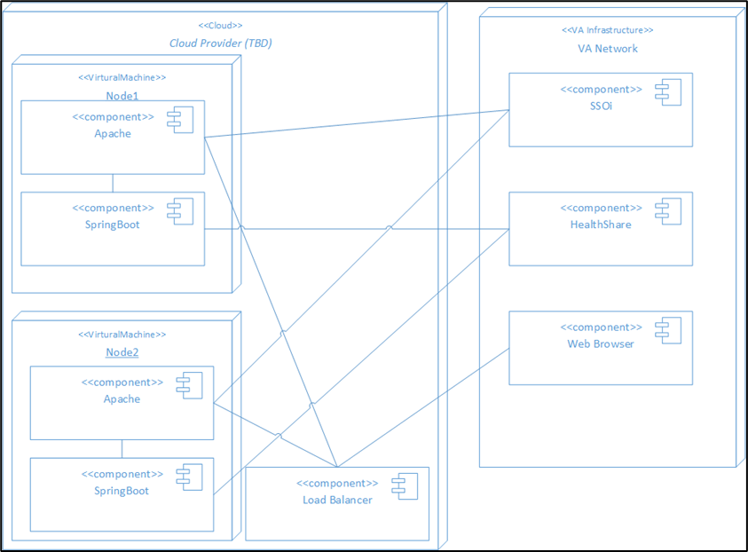
In Figure 1, the overall system deployment model is illustrated. Shown is the internal make-up of AMPL system and the associated external dependencies. The deployment architecture seeks to maintain symmetry with respect to the function and configurations of the individual nodes.
Each processing node of AMPL two core systems components includes:
- Apache – The open-source Apache web server runs on each node. It serves the AMPL web application static content and acts as a proxy for the REST services of the AMPL application programming interface (API).
- Spring Boot – The open-source Spring Boot framework provides the structure for the REST endpoints of the AMPL API.
As currently implemented, AMPL does not persist any application data and as a result there is no database or other data persistence mechanism in the application. All application data is accessed from VDIF FHIR services and VDIF Vista REST services.

Elastic Container Service (ECS)
ECS is a set of platform-as-a-service products that use operating system (OS) level virtualization to deliver software in packages called containers. Containers are isolated from one another and bundle their own software, libraries and configuration files; they can communicate with each other through well-defined channels. Containers allow a developer to package up an application with all the needed parts, such as libraries and other dependencies, and ship it all out as one package. ECS is used to Deploy the AMPL GUI application to production environment as required by Ops.

Figure 2: AMPL Deployment on ECS
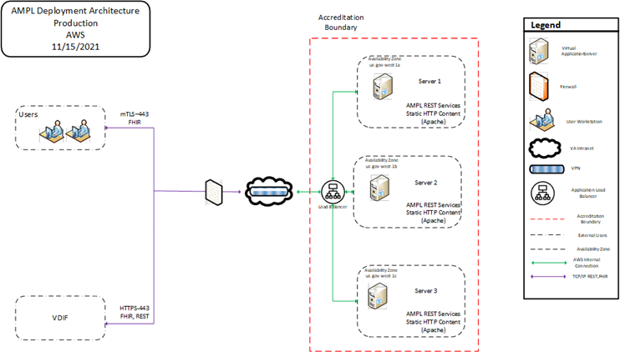

Presentation Tier
The Presentation tier of the AMPL system is composed of an Angular 15.x framework (JavaScript) web application. The application is deployed as static content on the Apache web server located on each production node.

Service Tier
The Service Tier of the AMPL system is comprised of a set of REST services developed under the Spring Boot framework. The Services are implemented as Java 2 Enterprise Edition (J2EE) Servlets and are executing in a Tomcat Servlet container.

Data Tier
The Data Tier of the AMPL system is external to the application’s boundary. The data visualized by the AMPL application is obtained from the Veterans Data Integration & Federation (VDIF) service via HL7 FHIR compliant REST services and VDIF custom services. The authoritative source for all of the enterpricse federated data is VistA.

Site Information (Locations, Deployment Recipients)
List the sites at which deployment is planned, including pilot and IOC sites, according to the schedule.
The initial deployment of AMPL GUI will be to Initial Operating Capability (IOC) sites so that users can verify the functionalities of AMPL GUI. Once testing is completed and AMPL GUI is approved for national release, AMPL GUI will be deployed nationally.
AMPL GUI will be deployed to the following IOC sites.
- West Palm Beach VA Medical Center (VAMC)- West Palm Beach, FL
- Eastern Colorado Health Care System- (HCS) Denver, CO
- VA Central California Heath Care System– (HCS) Fresno, CA
- Fayetteville VA Medical Center (VAMC) – Fayetteville, NC
- John J. Cochran Veterans Hospital VA St. Louis Health Care System – (HCS) St. Louis, MO

Site Preparation
The following table describes preparation required by the site prior to deployment.
Table 4: Site Preparation
Site / Other | Problem / Change Needed | Features to Adapt / Modify to New Product | Actions / Steps | Owner
Production Site | Create list of users that require AMPL access using | Send email with (Veterans Health Administration) VHA Identifications (IDs) of eligible AMPL users to email group | Option PREA AMPL GUI ACCESS invoked | Site ADPAC
AMPL Team | Request access to Active Directory (AD) group for eligible users | Eligible AMPL users will receive AD entry request for access to AMPL GUI | Service Now ticket entered to Infrastructure Operations (IO) | Implementation Manager
Infrastructure Operations (IO) | Eligible AMPL GUI users placed in AD group | Eligible AMPL users will receive AD entry for access to AMPL GUI | Service Now (Snow) ticket processed by IO | IT Specialist Infrastructure Operations IO
IAM Team | Make OAuth available | IAM features deployed by checklist | Deploy SSOi OAuth in Production | IAM Team
VDIF Team | Make HealthShare and Operational Data Store (ODS) services available | VDIF features deployed by checklist | Deploy HealthShare and ODS to Production | VDIF Team

Resources
Use this section to describe hardware, software, facilities, and documentation, and any other resources, other than personnel, required for the deployment and installation.

Facility Specifics
The following table lists facility-specific features required for deployment.
Table 5: Facility-Specific Features
Site | Space / Room | Features Needed | Other
Amazon Web Services (AWS) | N/A | Servers and infrastructure to host the Production installation

Hardware
The following table describes hardware specifications required at each site prior to deployment.
Table 6: Hardware Specifications
Required Hardware | Model | Version | Configuration | Manufacturer | Other
AMPL is hosted on AWS. AWS is responsible for procuring and configuring the required hardware to provide the hosting platform. | N/A | N/A | Determined by AWS | Determined by AWS

Environment | Server Count | Availability Zones | Server Type | vCPU/MEM | Storage
Production | 4 | 2 | AMZLNX2 on m5a.xlarge | 4/16GB | 100GB
PREPROD | 3 | 2 | AMZLNX2 on m5a.xlarge | 4/16GB | 100GB
Development/SQA/UAT | 3 | 2 | AMZLNX2 on m5a.xlarge | 4/16GB | 100GB

Please see Table 2: Roles and Responsibilities for details about who is responsible for preparing the site to meet these hardware specifications.

Software
The following table describes software specifications required at each site prior to deployment.
Table 7: Software Specifications
Required Software | Make | Version | Configuration | Manufacturer | Other
No site specific software is required

Technology | Approval Status | Reference
AWS Simple Storage Service (S3) | FedRAMP Approved | AWS S3
AWS Elastic Compute (EC2) | FedRAMP Approved | AWS EC2
AWS CloudWatch | Under Third Party Assessment Organization (3PAO) Assessment | AWS CloudWatch
AWS DynamoDB | FedRAMP Approved | AWS DynamoDB
AWS Elastic Load Balancer | FedRAMP Approved | AWS Elastic Load Balancer
AWS Elastic Container Service | FedRAMP Approved | AWS Elastic Container Service
Amazon Corretto Java 17.x | TRM Approved | Amazon Corretto
Angular Development Tool 15.x | TRM Approved | Angular Development Tool
Spring Boot 3.0.x | TRM Approved | Spring Boot

Please see Table 2: Roles and Responsibilities for details about who is responsible for preparing the site to meet these software specifications.

Communications
Notification of scheduled maintenance periods that require the service to be offline or that may degrade system performance will be disseminated to the business user community a minimum of forty-eight (48) hours prior to the scheduled event.
Notification to VA users for unscheduled system outages or other events that impact the response time will be distributed within thirty (30) minutes of the occurrence.
Notification will be distributed to VA users regarding technical help desk support for obtaining assistance with receiving and processing.
Notification will be distributed to Software Product Management, Health, Patient Care Services sub-product line 1 team SPM.Health.PCS.Sub_1 and Business Owner, Pharmacy Benefits Management (PBM) for scheduled and unscheduled maintenance.

Deployment / Installation / Back-out Checklist
The AMPL application is installed using ECS and has no database associated with the application. Rolling back to a previous installation is accomplished by deployment of the previous build/ECS. There is no need for a Rollback process.

Installation

Pre-installation and System Requirements
- AMPL GUI is wholly dependent on VDIF FHIR and VistA REST services for access to all data utilized by the application. If there are service interruptions with these services, then AMPL GUI will fail to operate.
- AMPL GUI is dependent on IAM SSOi/OAuth services for all authentication and authorization. If these services are unavailable than users will be unable to access the system.
- The most significant component of the system is the AMPL GUI web application. The AMPL Single Page Application (SPA) was developed using the Angular framework (currently Version 15.x).
- As a SPA the AMPL GUI web application executes entirely on the user’s workstation in a web browser and interacts with the AMPL REST API. Angular uses a language called Typescript which is an extension of JavaScript.

AMPL GUI Application
The AMPL GUI application ECS images include the graphic user interface, and APIs required to retrieve data from VDIF, interact with IAM SSOi, and CCOW.
Comprehensive SQA and User Acceptance testing of the AMPL GUI application in production will require the PREA*1*2 patch to already be deployed nationally. The tester’s workstations require CCOW installed in order to utilize the CCOW functionality in AMPL GUI.

Platform Installation and Preparation

Install AWS ECS Instance
Follow VA Enterprise Cloud (VAEC) approved practices to install and choose the Amazon Machine Images (AMI) to be used for the installation. The VAEC AMI for ECS includes the ECS software and all that is needed to use as an AWS ECS instance.

Download and Extract Files
There is no additional software to install when using the VAEC ECS instance AMI.

Database Creation
As currently implemented, AMPL GUI does not persist any application data and as a result there is no database or other data persistence mechanism in the application.

Installation Scripts

Create AWS ECS Cluster
An Amazon ECS cluster is a logical grouping of tasks or services.
To create an AWS ECS cluster using the classic console follow the steps in:
- Open the Amazon ECS console at https://console.aws.amazon.com/ecs/.
- From the navigation bar, select the Region to use.
- In the navigation pane, choose Clusters.
- On the Clusters page, choose Create Cluster.
- For Select cluster compatibility, choose one of the following options and then choose Next Step:
  - Networking only– This cluster template creates an empty cluster. Optionally, you can create a new VPC to use. This cluster template is typically used for workloads hosted on either AWS Fargate or external instances (ECS Anywhere). The FARGATE and FARGATE_SPOT capacity providers will be automatically associated with the cluster. For more information, see AWS Fargate capacity providers.
  - EC2 Linux + Networking– This cluster template is used to create a cluster of Amazon EC2 instances to run Linux-based containers on. An Auto Scaling group is created for the Amazon EC2 instances.
  - EC2 Windows + Networking – This cluster template is used to create a cluster of Amazon EC2 instances to run Windows-based containers on. An Auto Scaling group is created for the Amazon EC2 instances. For more information, see Amazon EC2 Windows containers.

Cron Scripts
Not applicable to the AMPL GUI application.

Access Requirements and Skills Needed for the Installation
Installers will need to have a proper Electronic Protocols Application Software (ePAS) in order to gain access to the server with elevated privileges. The installers will need to have knowledge of Apache, ECS, GIT and will require elevated access to the server.
Must have access to these groups:
- vaecunixc_aws_amp_nprod
- vaecunixc_aws_amp_prod
- cldunixs_amp_user_dev
- cldunixs_amp_admin_test
- cldunixs_amp_admin_prod
- cldunixs_amp_admin_prep
- cldunixs_amp_admin_os_test
- cldunixs_amp_admin_os_prod
- cldunixs_amp_admin_os_dev

Installation Procedure
The systems that the ECS Swarm runs on is provided by the AWS Cloud VA agency VA Enterprise Cloud (VAEC). The VAEC designs the Amazon Linux ECS AMI needed to build the AMPL GUI systems.

Installation Verification Procedure
- To verify the Amazon Web Service (AWS) ECS cluster is running follow these steps:
- Log into the AWS Web console
- Navigate to the ECS page
- Locate the production cluster
- Verify that the services (Production-API-Service, Production -Web-Service) and tasks (Production-API, Production-Web) are running.

System Configuration

Database Tuning
Not applicable to the AMPL GUI application.

Back-out Procedure
The following sections describe the Back-Out procedures.

Back-out Strategy
No special Back-Out strategy considerations are required for AMPL GUI.

Back-out Considerations
There are no special Back-Out considerations for AMPL GUI.

Load Testing
There are no provisions for Load Testing in the production environment. Load testing was conducted within the Pre-Production environment.

User Acceptance Testing
User Acceptance Testing (UAT) ensures the GUI does not interfere with normal system operations. UAT data is available in the VA AMPL GUI Product Repository on GitHub.

Back-out Criteria
AMPL GUI is a read-only application. It does not store or modify any data. Therefore, there is no impact on data integrity from back-out of any specific version. The Back-Out criteria is entirely dependent on the severity of defect or another factor precipitating the back-out request.

Back-out Risks
For Back-Out Risks, see Section 5.5: Back-Out Criteria.

Authority for Back-out
The order would come from: Application Coordinator (product support), Development Team, and Portfolio Director. This should be done in consultation with the development team and project stakeholders.

Back-out Procedure
The AMPL GUI application running in an AWS ECS can easily be backed out by stopping the current task, removing it and deploying the previous version of the build.
- Log into the AWS Web console
- Navigate to the ECS page
- Located the production cluster
- Change task definition revision number to a previous version
- Click “Update” to update the service and re-deploy

Back-out Verification Procedure
After the backout is performed, the general functionality of the application can be verified by opening the application, confirming the data is loading, and that patient data can be retrieved.

Rollback Procedure

Rollback Considerations

Rollback Criteria
If a severe issue is reported for AMPL, the project/sustainment team will determine if if the issue can be addressed through resolution of the defect in a subsequent build or if a roll-back to a previous version/build is require.
The criterion for rolling back is if the project is canceled, the requested changes implemented by AMPL GUI are no longer desired by VA OIT, or the release produces catastrophic problems.

Rollback Risks
For Rollback Risks, see Section 5.5: Back-Out Criteria.

Authority for Rollback
The order would come from: Application Coordinator (product support), Development Team, and Portfolio Director. This is done in consultation with the development team and project stakeholders.

Rollback Procedure
The Rollback Procedure is the same as the Back-Out Procedure. See Section 5.8: Back-Out Procedure.

Rollback Verification Procedure
AMPL GUI is a read-only application and there is no data verification after Rollback.

Acronyms
Acronym | Abbreviation
3PAO | Third Party Assessment Organization
AD | Active Directory
AMI | Amazon Machine Images
AMPL | Advanced Medication Platform
API | Application Programming Interface
AWS | Amazon Web Service
CCOW | Clinical Context Object Workgroup
CD2 | Critical Decision Point 2
CI/CD | Continuous Integration and Continuous Delivery
COTS | Commercial off-the-shelf
DIBR | Deployment, Installation, Back-out, Roll Back
EC2 | Elastic Compute Cloud
ECS | Elastic Container Service
EMPD | Enterprise Project Management Division
EP | Enterprise Platform
EPMO | Office of Information and Technology Enterprise Program Management Office
ETL | Extract, Transform, and Load
FHIR | Fast Healthcare Interoperability Resources
GUI | Graphic User Interface
HIPAA | Health Insurance Portability and Accountability Act
HL7 | Health Level 7
HPS | Health Product Support
IAM | Identity and Access Management
ID | Identity
IOC | Initial Operating Capability
IT | Information Technology
J2EE | Java 2 Enterprise Edition
MPI | Master Patient Index
OIT | Office of Information & Technology
OS | Operating System
PBM | Pharmacy Benefits Management
S3 | Simple Storage Service
SACC | Standards & Conventions Committee
SNow | Service Now
SQA | Software Quality Assurance
SSOi | Single Sign-On Internal
TRM | Technical Reference Model
UAT | User Acceptance Testing
VAEC | VA Enterprise Cloud
VAMC | VA Medical Center
VDIF | Veterans Data Integration & Federation
VHA | Veteran Health Administration
VIP | Veteran-focused Integrated Process
VistA | Veteran Health Information Systems and Technology Architecture

