Advanced Medication Platform (AMPL)
Graphic User Interface (GUI)

Frequently Asked Questions (FAQ)

Version 1.0
August 2023
Department of Veterans Affairs

Revision History
Date | Version | Description | Author
07/2023 | 1.0 | Baseline Document | AMPL Team

Artifact Rationale
The FAQ provides answers to frequently asked questions which may be needed by the AMPL GUI and AMPL GUI support teams to answer questions as they arise during the development and continuation of AMPL GUI. The FAQ is an optional resource which serves as addition to required documentation support for AMPL GUI users and testers.
Table of Contents
Introduction 8
1.1. What is AMPL GUI? 8
Logging On 8
2.1. How do I log on to AMPL GUI? 8
2.1.1. How do I know what my 3-digit station number is? 9
Pending Orders Manager (POM) 10
3.1. What is the “Pending Orders Manager”? 10
3.2. Why are patients not showing under the Pending Orders Manager? 10
3.3. What does the “Select Ordering Institution” button do? 10
3.4. What are those numbers I see in the blue bubbles on the tabs? 11
3.5. What are those green arrows in the column headers? 11
3.6. What is the black funnel symbol I see in the column headers? 11
3.7. How can I get more information about the column headers? 12
3.8. Can I sort the patients by the age of the orders? 12
3.9. How can I take advantage of Clinic Sort Groups or Ward Groups that are set-up in VistA? 13
3.10. For Inpatient pending orders, do ASAP orders show up under the STAT heading? 13
3.11. Can I find flagged Outpatient orders in AMPL? 14
3.12. I have my patient list, now what? 14
3.13. How do I change patients? 14
3.14. What is the “i” symbol next to Pending Orders Manager? 15
3.15. What if I just want to go to an individual patient not on the Pending Orders Manager? 15
3.16. What is the “i” symbol next to VISTA Patient Lookup? 16
Patient Coversheet 16
4.1. How do I view more detailed patient demographics? 16
4.2. How do I get more detailed Allergy/ADR information? 17
4.3. What is CWAD and how do I find that information? 17
4.4. How do I see recent additions or changes to the patient's data from VistA or CPRS? 17
4.5. What is the number that I sometimes see next to the Tab Name? 18
4.6. Is there a way to see allergies or ADRS that were “Entered in Error”? 18
4.7. How do I know what facility entered the allergy/ADR? 18
4.8. Okay, but how do I know what facility corresponds to that facility number? 19
4.9. How do I find more information about column headers? 20
4.10. It would be nice to be able to graph vitals to see trends, can I do that with AMPL? 20
4.11. How many progress note titles are displayed per page? 20
4.12. How can I see a particular date range or an earlier date range than what is shown? 21
4.13. There are a lot of progress notes, how do I sort and filter them? 21
4.14. How do I see the actual progress note? 21
4.15. How do I see Remote meds? 22
4.16. How do I see a more detailed view of the meds? 22
4.17. Okay, but how do I see an even MORE detailed view of the medication orders? 23
4.18. I see buttons at the bottom of that view, what are those for? 23
4.19. For Inpatient and Clinical Med Orders, can I see PADE inventory amounts for the associated device? 23
Filter and Sort 24
5.1. Can I get more information on sort and filter functionality for Allergies and ADRs, Labs, Consults, Progress Notes, Immunizations, Problem List, and Appointments tabs? 24
5.1.1. Meds 24
5.1.2. Allergies 25
5.1.3. Vitals 29
5.1.4. Labs 31
5.1.5. Progress Notes 36
5.1.6. Consults 40
5.1.7. Problem List 45
5.1.8. Immunizations 48
5.1.9. Appointments 53

Table of Figures
Figure 1: VA Advanced Medication Platform Login Page 8
Figure 2: VA Single Sign-On 9
Figure 3: Set VistA Context 3-Digit Station Number 9
Figure 4: Station Number in VistA 10
Figure 5: POM Number of Orders 11
Figure 6: Green Arrows Sorting Columns 11
Figure 7: Black Funnel Symbol 11
Figure 8: Hover Text 12
Figure 9: VA Order Aging Summary 12
Figure 10: Current Query: All Records 12
Figure 11: Select Patient(s) to Process 13
Figure 12: Priority Indication Screen 13
Figure 13: Flagged Outpatient Pending Orders 14
Figure 14: Patient Queue for Multiple Patients 14
Figure 15: POM Button Toggle to Coversheet and Retained in Patient Queue 14
Figure 16: Patient Cover Sheet with Patient Queue List 14
Figure 17: Pending Orders Manager "i" Button 15
Figure 18: Pending Order Manager VistA Patient Lookup 15
Figure 19: VistA Patient Lookup Help Text 16
Figure 20: More Patient Demographics 16
Figure 21: More Information for Allergies and ADRs 17
Figure 22: Postings CWAD Button 17
Figure 23: Refresh Patient Data 17
Figure 24: Total Number of Allergy and Adverse Reactions 18
Figure 25: Allergies Entered in Error 18
Figure 26: Originating Facility for Allergies and ADRs 18
Figure 27: Hover for Facility Name 19
Figure 28: Hover Text for Column Headers 20
Figure 29: Graph Vitals 20
Figure 30: Query Editor for Date Range 21
Figure 31: Progress Notes Sort and Filter 21
Figure 32: Remote Meds 22
Figure 33: Detailed View of Meds 22
Figure 34: Even More Detailed View of Medication Order 23
Figure 35: Order Checks, Drug Restrictions/Guidelines, Drug Info, Provider Info, PADE Inventory Activity, Admin Hx, and Close 23
Figure 36: PADE Inventory Activity 23
Figure 37: Remote Order Button 24
Figure 38: More Button 24
Figure 39: Current Query 25
Figure 40: Allergies Filtering and Sorting 25
Figure 41: Allergies Adding Filter Criteria 25
Figure 42: Allergies Adding Filter 26
Figure 43: Allergies Date Range Filter 26
Figure 44: Allergies Selecting a Value 27
Figure 45: Allergies Adding Sort Field 27
Figure 46: Allergies New Filter Add Button 28
Figure 47: Allergies Refresh Button 28
Figure 48: Allergies Red "X" Button 28
Figure 49: Allergies Reset Button 29
Figure 50: Vitals Display 29
Figure 51: Vitals Date Range 29
Figure 52: Vitals Commonly Used Date Ranges 30
Figure 53: Vitals Graphing 30
Figure 54: Labs Current Query 31
Figure 55: Labs Select Filter Field 31
Figure 56: Labs Filter Contains Field 32
Figure 57: Labs Filter Contains Field 32
Figure 58: Labs Selecting a Value 32
Figure 59: Labs Selecting a Date Range 33
Figure 60: Labs Adding Sort Criteria 34
Figure 61: Labs Results Per Page 34
Figure 62: Labs Add Button for Sort criteria 35
Figure 63: Labs Refresh Button 35
Figure 64: Labs Red "X" Buttons 35
Figure 65: Labs Reset Button 36
Figure 66: Progress Notes Current Query 36
Figure 67: Progress Notes Select Filter Field 36
Figure 68: Progress Notes Add Filter Contains 37
Figure 69: Progress Notes Add Filter 37
Figure 70:Progress Notes Add Sort Field 38
Figure 71: Progress Notes Results Per Page 38
Figure 72: Progress Notes Add Buttons 39
Figure 73: Refresh Button 39
Figure 74: Remove single criteria Notes tab 40
Figure 75: Reset button for Notes 40
Figure 76: Consults current query 40
Figure 77:Consults Select Filter Field 41
Figure 78:Consults Filter Contains 41
Figure 79:Consults Selecting a Value 41
Figure 80: Consult Date/time filter 42
Figure 81: Consults Add Sort Field 42
Figure 82: Consults New Filter Add button 43
Figure 83: Consults Results Per Page 43
Figure 84: Refresh/Reset Buttons 44
Figure 85: Consult Remove Single Criteria 44
Figure 86: Consult Reset Button 44
Figure 87: Problem List Current Query 45
Figure 88: Problem List Select Filter Field 45
Figure 89: Problem List Add Filter Operators 45
Figure 90: Problem List Selecting a Value 46
Figure 91: Problem List Add Date Range Filter 46
Figure 92: Problem List Adding Sort Field 47
Figure 93: Problem List Add Buttons 47
Figure 94: Problem List Refresh Button 48
Figure 95: Problem List Remove single Filter or Sort 48
Figure 96: Problem List Reset button 48
Figure 97: Immunizations Current Query 48
Figure 98: Immunizations Select Filter Field 49
Figure 99: Immunizations Add Filter Operators 49
Figure 100: Immunizations Selecting a Value 50
Figure 101: Immunization Date Filter 50
Figure 102: Immunizations Adding Sort Criteria 51
Figure 103: Immunizations Add Buttons 51
Figure 104: Immunizations Refresh Button 52
Figure 105: Immunization Remove Single Criteria 52
Figure 106: Immunization Reset button 52
Figure 107: Appointments Current Query 53
Figure 108: Appointments Select Filter Field 53
Figure 109: Appointments Add Filter Operators 53
Figure 110: Appointments Filter 54
Figure 111: Appointments Date Filter 54
Figure 112: Appointments Add Sort Criteria 55
Figure 113: Appointments Results Per Page 55
Figure 114: Appointments Add Buttons 56
Figure 115: Appointments Refresh Button 56
Figure 116: Appointments Remove Single Criteria 56
Figure 117: Appointments Reset Button 56

Introduction

What is AMPL GUI?
The Advanced Medication Platform (AMPL) Graphic User Interface (GUI) is a front-end application supporting the Department of Veterans Affairs (VA) pharmacists by fulfilling the need for medical knowledge during patient care. AMPL GUI provides a single point of access for pharmacists to do their work, such as reviewing patient records and processing pending orders.
Currently, AMPL GUI is a READ ONLY application. Writing and processing of orders as well as note writing, etc. is planned for a later phase.

Logging On

How do I log on to AMPL GUI?
- Enter the AMPL URL (https://ampl.vaec.va.gov/login) into the address bar of your internet browser.

- After selecting Login, users are redirected to the VA SSOi page.
- Click on Sign In with VA Personal Identity Verification (PIV) Card graphic.
- Select the appropriate certificate.
- Enter your Personal Identification Number (PIN) and select OK.
Figure 1: VA Advanced Medication Platform Login Page
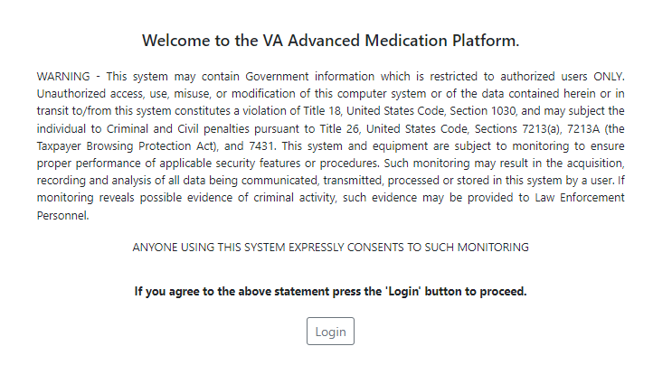

Figure 2: VA Single Sign-On
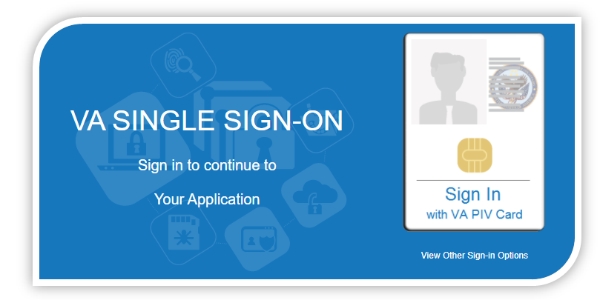

How do I know what my 3-digit station number is?
Figure 3: Set VistA Context 3-Digit Station Number
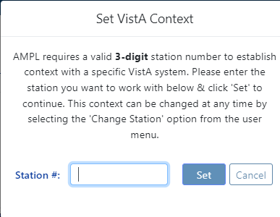
The links below can be used to get a report of facilities and their station number:
Internet - To Facility Listing - Locations (va.gov)
Intranet - Report - Facility Listing - Facilities Locator & Leadership Directory (va.gov)

Your station number is also found in VistA, it is displayed when you enter your division. See example below:

Figure 4: Station Number in VistA
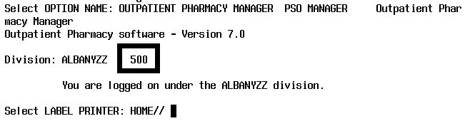

Pending Orders Manager (POM)

What is the “Pending Orders Manager”?
The pending orders manager of POM is a dashboard intended to help pharmacists manage and process pending orders for their facility.

Why are patients not showing under the Pending Orders Manager?
To display a list of patients under the Pending Orders Manager, select an outpatient site from the dropdown list next to Select Outpatient Site.

What does the “Select Ordering Institution” button do?
Select Ordering Institution allows users to drill down to see orders for a specific CBOC or VAMC included under a Station.

What are those numbers I see in the blue bubbles on the tabs?
In the category tabs on the POM, the number of orders within that tab are displayed in the blue bubble on the tab.
Figure 5: POM Number of Orders
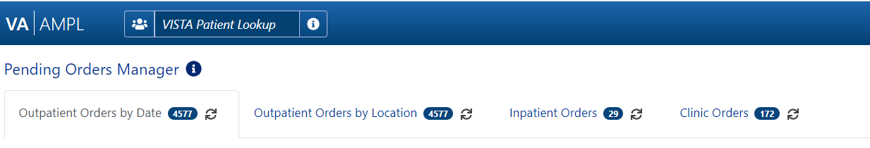

What are those green arrows in the column headers?
To reveal if a column is sortable, click the column header. If it is sortable, the icon will display. Repeatedly clicking the sortable column will toggle between ascending, descending then back to default. If more than 1 column is sorted, a small number by the arrow indicates the order.
Figure 6: Green Arrows Sorting Columns

What is the black funnel symbol I see in the column headers?
The black funnel symbol indicates that column is included in the current query.
Figure 7: Black Funnel Symbol
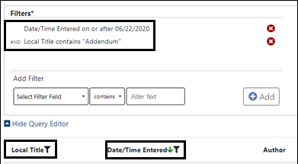

How can I get more information about the column headers?
Hovering your mouse over the column headers will reveal help text providing additional information. The hover functionality is available throughout AMPL, if you are not sure, hover!
Figure 8: Hover Text
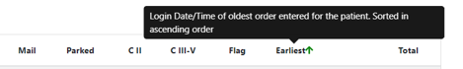

Can I sort the patients by the age of the orders?
By default, pending orders are displayed oldest first.

Clicking on the desired date range in the Order Aging Summary, located near the upper right-hand section of your screen will display only the orders that fall within that date range.
Figure 9: VA Order Aging Summary
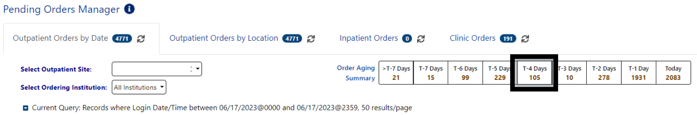

Orders that display in any of the Pending Orders tabs may also be filtered using the Query Editor. Clicking on the blue arrow will expand the Query Editor.
Figure 10: Current Query: All Records
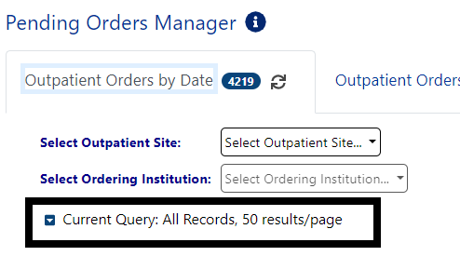

How can I take advantage of Clinic Sort Groups or Ward Groups that are set-up in VistA?
Choose the Outpatient Orders by Location, Inpatient Orders, or Clinic Orders tab near the top of your screen. You will find Outpatient Clinic Sort Groups, Inpatient Ward Groups and Clinic Groups for Clinic Orders if you have them set up at your facility.
When you check a box for a clinic group or ward group, patients in the clinic or ward group with pending orders will be viewable below in the Select Patients to Process section (you may have to scroll down if there are a lot of groups).
There is also a Query Editor available in the Select Patients to Process section to further filter the list of patients. To filter the list, click on the down arrow to access the Query Editor (shown below).
Note: Currently, AMPL is read only. The ability to process orders will be added in a later version.
Figure 11: Select Patient(s) to Process
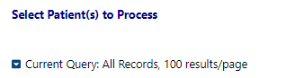

For Inpatient pending orders, do ASAP orders show up under the STAT heading?
Yes. The red symbol displays next to STAT orders, so they are easy to locate.
Figure 12: Priority Indication Screen
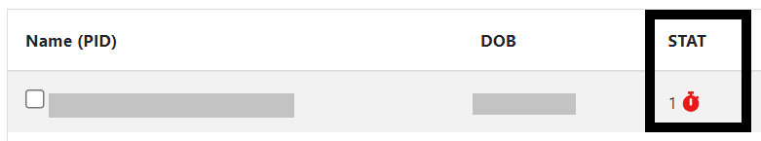

Can I find flagged Outpatient orders in AMPL?
Yes. The red flag symbol displays next to Flagged orders, so they are easy to locate.
Figure 13: Flagged Outpatient Pending Orders
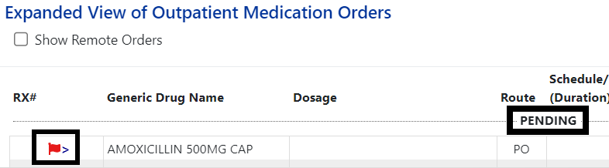

I have my patient list, now what?
One or more patients may be selected from the list for processing using the Process Selected or Process All buttons. If multiple patients are selected, the first one will open to the Patient Coversheet and the rest will be added to the patient queue and their names will display at the bottom of the screen and using the patient queue button at the top of the screen.
Figure 14: Patient Queue for Multiple Patients

How do I change patients?
Once patient(s) are selected, you will be taken to the Patient Coversheet. If you want to go back into the Pending Orders Manager, you can select Pending Orders from the upper right corner of your screen. If you selected multiple patients and want to change patients, click on the Patient Queue button.
Figure 15: POM Button Toggle to Coversheet and Retained in Patient Queue
Figure 16: Patient Cover Sheet with Patient Queue List

What is the “i” symbol next to Pending Orders Manager?
The “i” next to Pending Orders Manager text gives informational text regarding POM Navigational help once it is clicked.
Figure 17: Pending Orders Manager "i" Button
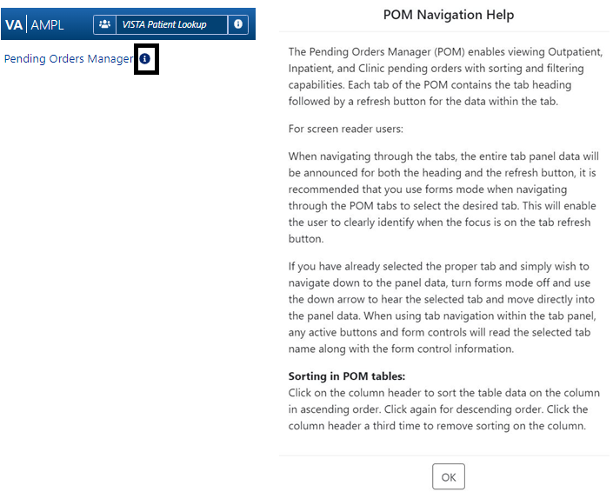

What if I just want to go to an individual patient not on the Pending Orders Manager?
You can locate and select individual patients from the VISTA Patient Lookup located in the upper left corner of your screen.
Figure 18: Pending Order Manager VistA Patient Lookup

What is the “i” symbol next to VISTA Patient Lookup?
When you click on the “i” next to VISTA Patient Lookup, it will display help text on different ways to search for the patient you need.
Figure 19: VistA Patient Lookup Help Text
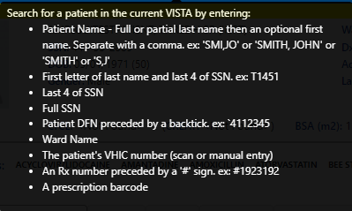

Patient Coversheet

How do I view more detailed patient demographics?
Click the down arrow to the left of More (below where the patient’s picture would be) to get more patient demographics.
Figure 20: More Patient Demographics
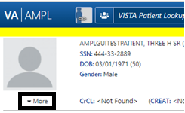

How do I get more detailed Allergy/ADR information?
Click on the allergen in the allergy summary ribbon, on the Allergies and ADRs tab or in the CWAD section.
Figure 21: More Information for Allergies and ADRs
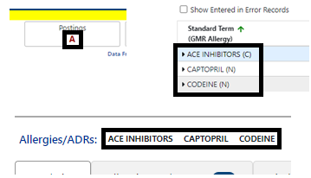

What is CWAD and how do I find that information?
CWAD is Crisis, Warnings, Allergies, and Directives found in the Postings button in the upper right corner. Click on this button, to see the CWAD entries for that patient. Hovering over the Postings button shows additional information.
Figure 22: Postings CWAD Button
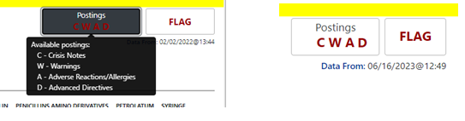

How do I see recent additions or changes to the patient's data from VistA or CPRS?
Like VistA and CPRS, new changes made to patient data after the patient’s record is accessed in AMPL (entering a new order, discontinuing an active order) are not seen until the patient is refreshed. See figure below:
- In AMPL, the Refresh button is used
- In CPRS, the File/Refresh Patient Information is used
- In VistA, close the patient in a backdoor pharmacy option and open the patient again.
Figure 23: Refresh Patient Data

What is the number that I sometimes see next to the Tab Name?
A numeric value indicates the total number of Allergy and Adverse Reaction records for the selected patient and the “+" sign indicates that patient has "allergies/ADRs that were entered in error".
Figure 24: Total Number of Allergy and Adverse Reactions
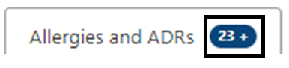

Is there a way to see allergies or ADRS that were “Entered in Error”?
Yes, click on the check box to the left of Show Entered in Error Records.
Figure 25: Allergies Entered in Error
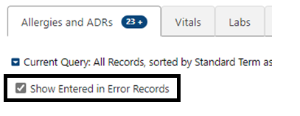

How do I know what facility entered the allergy/ADR?
The facility number where the allergy/ADR originated is in the last column to the right in the Allergies and ADRs tab.
Figure 26: Originating Facility for Allergies and ADRs
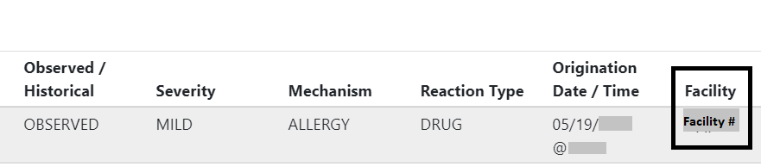

Okay, but how do I know what facility corresponds to that facility number?
Hover over the facility number and the facility name will appear.
Figure 27: Hover for Facility Name
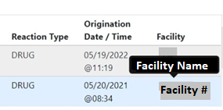

How do I find more information about column headers?
Hover over the header and information about that header will appear.
Figure 28: Hover Text for Column Headers
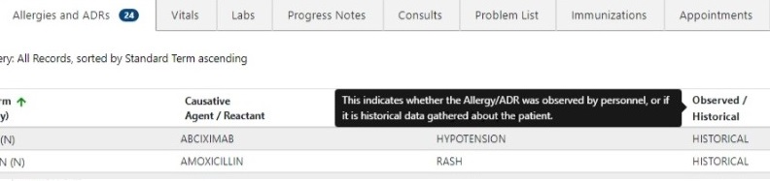

It would be nice to be able to graph vitals to see trends, can I do that with AMPL?
Yes, you can select date ranges, toggle between metric and US Standard units, and graph the vitals. The graph button is on the far right and next to it is the table button to return to table view.
Figure 29: Graph Vitals
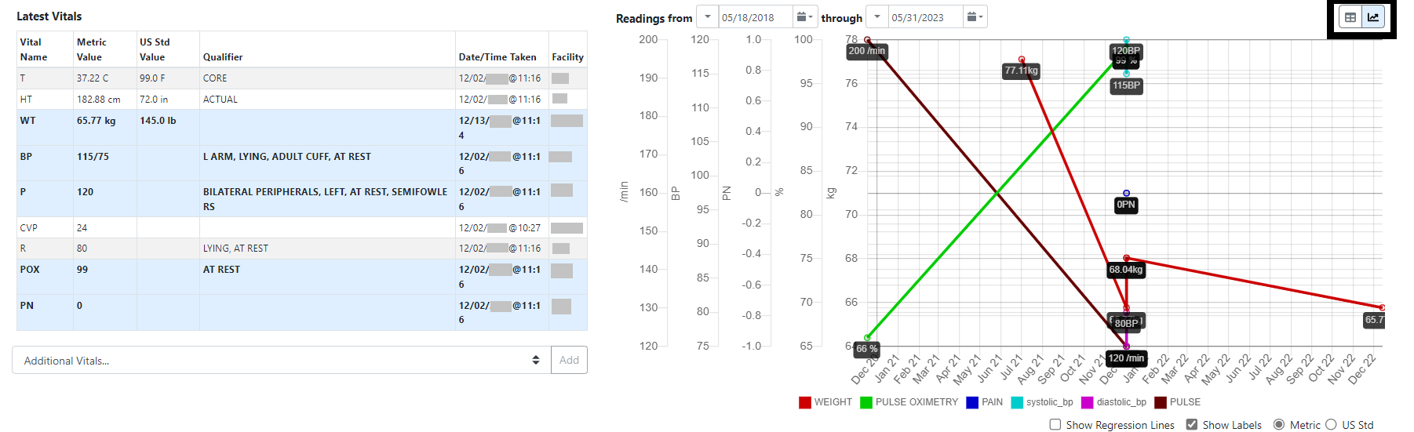

How many progress note titles are displayed per page?
A maximum of 100 progress notes can be displayed per page. Additional notes may be viewed, 100 at a time, by clicking the Next button at the bottom of the page.

How can I see a particular date range or an earlier date range than what is shown?
The Query Editor can be used to filter and/or sort data for a date range. The Query Editor is opened by selecting the down arrow next to the Current Query button. Choose the Add Filter button to show filter options. Date/Time Entered is one of the options. See Section 5: Filter and Sort for more info on the Query Editor.
Figure 30: Query Editor for Date Range
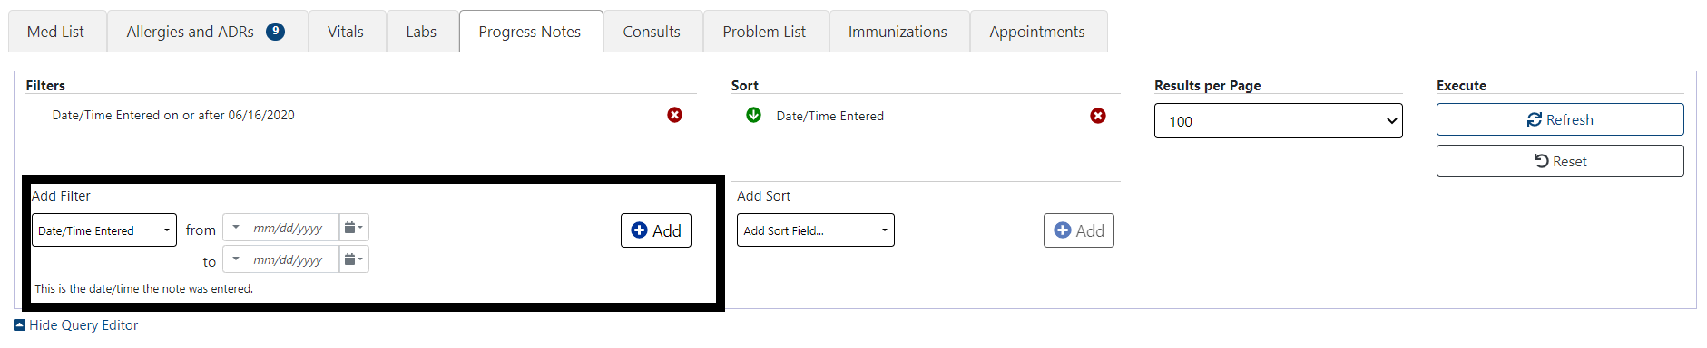

There are a lot of progress notes, how do I sort and filter them?
In the Progress Notes Tab, is a Current Query with a down arrow to the left of it. Select the down arrow to bring up the Sort and Filter options. Choose the Add Filter button to show filter options.
If Add Sort Field is selected, the same options appear, but will sort by those fields instead of filter.
Don’t forget to click Add after you make your selection (multiple filters and sort fields may be added at once). Execute the new filter and sort criteria by clicking on the Refresh button to the right of the page.

See 5.1.5: Progress Notes for more info on sorting and filtering Progress Notes
Figure 31: Progress Notes Sort and Filter
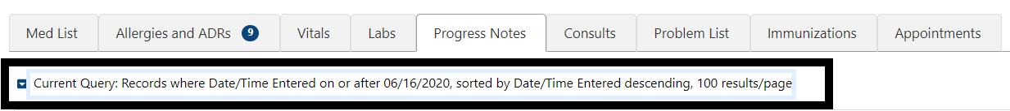

How do I see the actual progress note?
Click on the note title to get a detailed view.

How do I see Remote meds?
If there are remote meds, under the Med List Tab, there will be a circle with an “R” inside to the right of the column header. Click on that “R”.
Note: There will be no “inpatient” remote medications.
Figure 32: Remote Meds
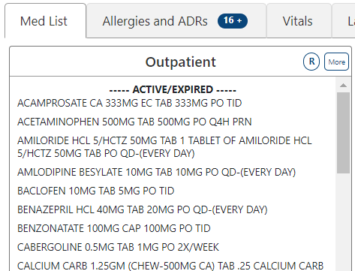

How do I see a more detailed view of the meds?
Click on More to the right of the header. This will give more information about all the meds in that section.
Figure 33: Detailed View of Meds
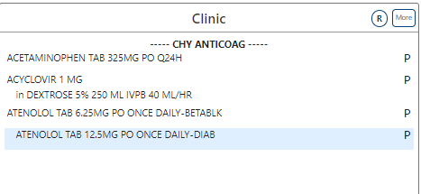

Okay, but how do I see an even MORE detailed view of the medication orders?
Click on the medication name in the section and it will give you a detailed view of the medication order.
Figure 34: Even More Detailed View of Medication Order
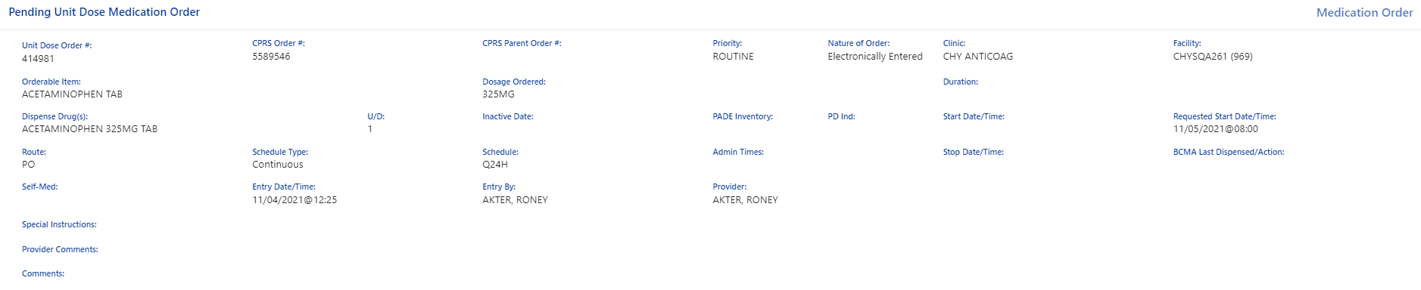

I see buttons at the bottom of that view, what are those for?
A screenshot of those buttons is below. They include Order Checks, Drug Restrictions/Guidelines, Drug Info, Provider Info, PADE Inventory Activity, Admin Hx, and Close. These buttons put often needed information that you can find in VistA and CPRS, but in a much easier to find and read format for each order. If the button is greyed out, there is no information for that item.
Figure 35: Order Checks, Drug Restrictions/Guidelines, Drug Info, Provider Info, PADE Inventory Activity, Admin Hx, and Close

For Inpatient and Clinical Med Orders, can I see PADE inventory amounts for the associated device?
Yes, click on the PADE Inventory Activity button at the bottom of the screen when in a medications detailed view.
Figure 36: PADE Inventory Activity

Filter and Sort

Can I get more information on sort and filter functionality for Allergies and ADRs, Labs, Consults, Progress Notes, Immunizations, Problem List, and Appointments tabs?
Each tab has its own unique filter and sort criteria to easily filter and sort to find the information you need quickly and efficiently.
There are several things to remember. After selecting the filter or sort, don’t forget to click the Add button to add your new criteria to the filter or sort section above the options. You can add multiple filter or sort criteria if needed. Once you have your filter and sort criteria finished, click the Refresh button to the right side of the screen. Below the Refresh button is a Reset button to return to the default search and sort settings.

Listed below are figures and information for each tab to show what types of data may be used to filter or sort data.

Meds
Starting out with an exception, the Med List tab doesn’t currently include a Query Editor. Instead, it displays all Active/Recently Expired, Pending and Non-Verified orders. Remote Outpatient, Clinic and Non-VA orders may be added by checking the R button in the section header.
Figure 37: Remote Order Button
An expanded view for orders in a category may be accessed by clicking the More button for that category. Additional details for a specific order are displayed by clicking on the order from the Expanded View.
Figure 38: More Button
NOTE: The Outpatient medications included in the discontinued and expired categories are determined by RECENTLY DC’D/EXPIRED DAYS Field (#3.2) in the OUTPATIENT SITE (#59) File. Inpatient Medication Order include orders that were discontinued or expired in the last 24 hours in the RECENTLY DC’D/EXPIRED section.
For more FAQs about the Meds tab, see Section 4.14 of this document.

Allergies
Allergies/ADRs and Assessments are displayed for all sites where a patient has been seen. Records may be further filtered or sorted using the Query Editor. It is accessed by clicking on the down arrow next to the Current Query.
Figure 39: Current Query
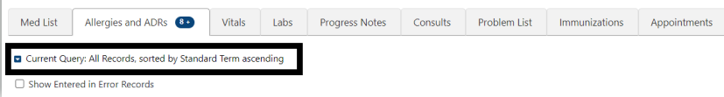

After adding new filter or sort criteria, don’t forget to click the Add button to add your new criteria to the Filters or Sort sections above the options. You may add multiple filter or sort criteria. Once you have completed filter and sort criteria changes, click the Refresh button to the right side of the screen. Below the Refresh button is a Reset button to return to the default search and sort settings.
Figure 40: Allergies Filtering and Sorting
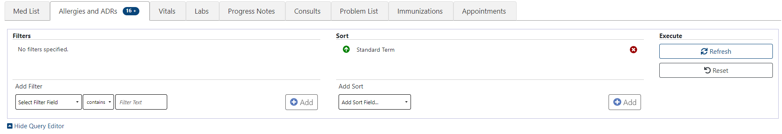

Adding Filter Criteria:
The drop-down list of Filter Fields displays a list of fields that can be used to restrict the list. The list of operators’ changes based on the type of data selected in the filter field.
Figure 41: Allergies Adding Filter Criteria
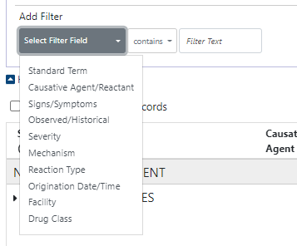
Figure 42: Allergies Adding Filter
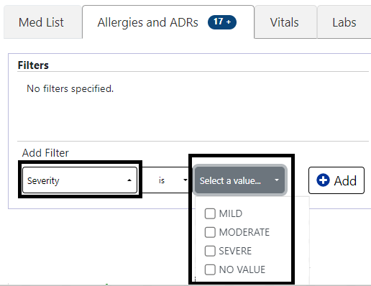

If the filter is a date range, there are several ways to enter dates - typing the date, clicking on the calendars or select from common date ranges by clicking on the down arrows to the left of the date/time as shown below:
Figure 43: Allergies Date Range Filter
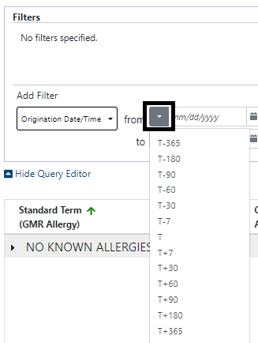

If a text field is selected, the Filter Text box turns into a Select a Value drop down that includes only values included in the patient’s data. In the example below for causative agent, the possible options are displayed and as many or few as you like can be checked.
Figure 44: Allergies Selecting a Value
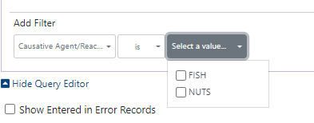
Adding Sort Criteria:
Setting Sort criteria is like setting filter criteria. A dropdown box shows the fields that can be used for sorting.
Figure 45: Allergies Adding Sort Field
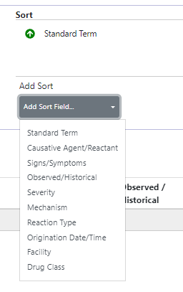

As each filter or sort is defined, click the Add button to add it to the query.
There is an Add button for both filter and Sort sections, located on the right side of the section.
Figure 46: Allergies New Filter Add Button
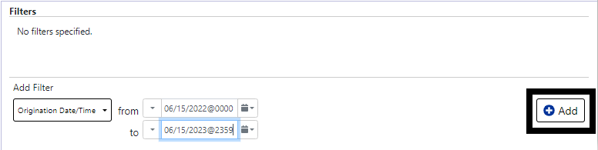

The Refresh and Reset buttons are in the Execute section on the right of the Query Editor. Refresh will apply any new filters. Reset will return the display to the default criteria.
Figure 47: Allergies Refresh Button
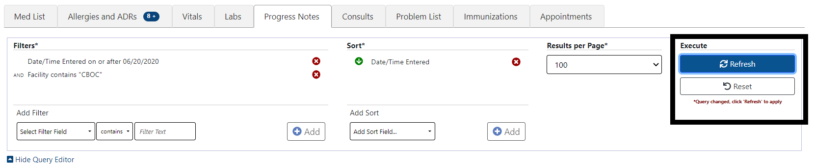
To remove single filter or sort criteria, including one of the defaults, click the Red X next to it.
Figure 48: Allergies Red "X" Button

To clear all filters and sorts added by the user and return to the tab’s default, click the Reset button.
Figure 49: Allergies Reset Button
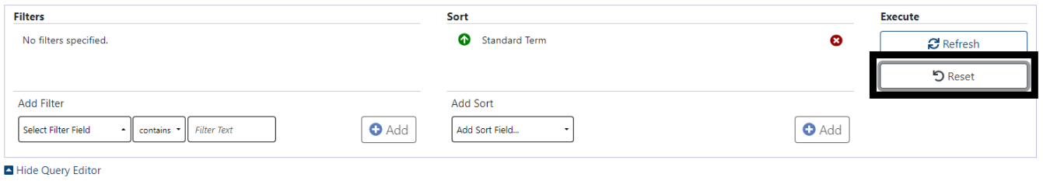

Vitals
Vitals is the second tab that does not include a query editor. Instead, the vitals tab initially displays a table of the latest common vitals. You can view past readings by clicking on the vital name, results will display to the right with a default date range of one year for Outpatient and one week for Inpatient. Additional Vitals may be added to the table by clicking on the Vital name. They can be removed by clicking again.
Figure 50: Vitals Display
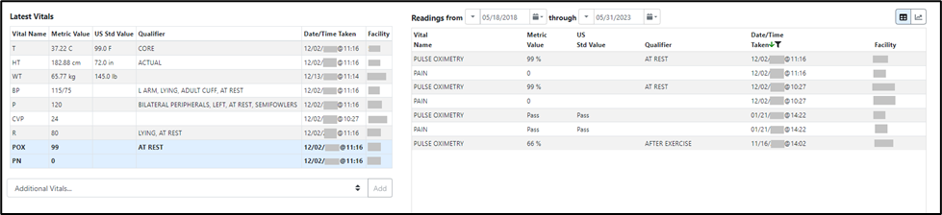

To change the date range, modify the Readings from or through dates.
Figure 51: Vitals Date Range
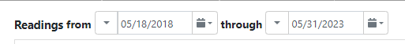

There are several ways to enter dates - typing the date, clicking on the calendars or select from common date ranges by clicking on the down arrows to the left of the date/time as shown below.
Figure 52: Vitals Commonly Used Date Ranges
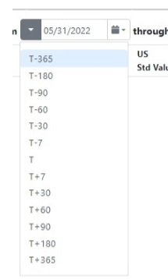

Vital types in the date range table may also be shown in a graph by selecting the graphing icon located in the top right corner of the Vitals screen.

Figure 53: Vitals Graphing
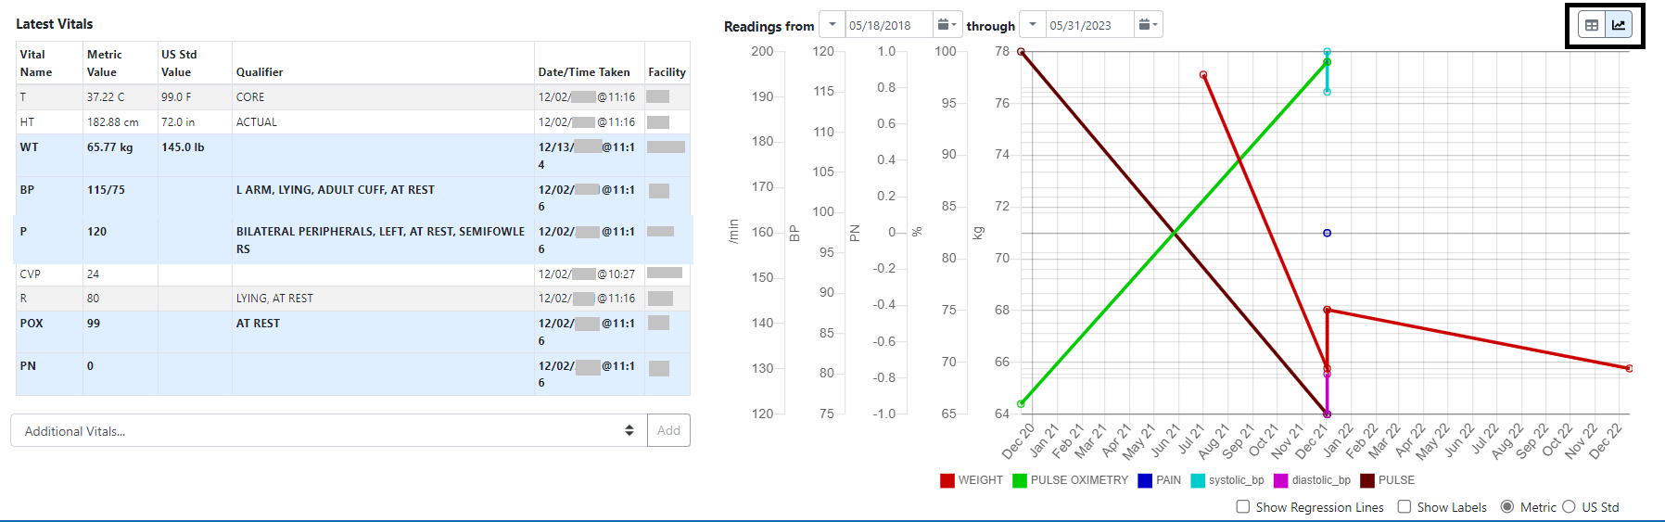

Labs
The Current Query default for Labs is Collection Date/Time within the past year, sorted by Collection Date/Time with newest results first, and 100 records per page. The Filter and sort criteria can be changed using the Query Editor. The Query Editor is accessed by clicking the blue down arrow.
Figure 54: Labs Current Query
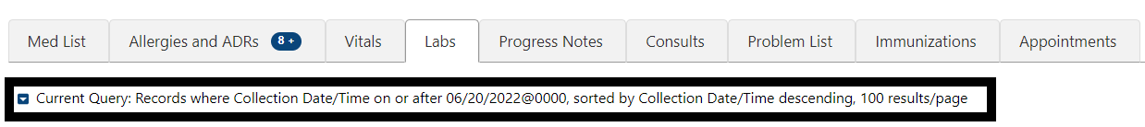

Adding Filter Criteria:
The drop-down list of Filter Fields displays a list of fields that can be used to restrict the list. The list of operators’ changes based on the type of data selected in the filter field.
Figure 55: Labs Select Filter Field
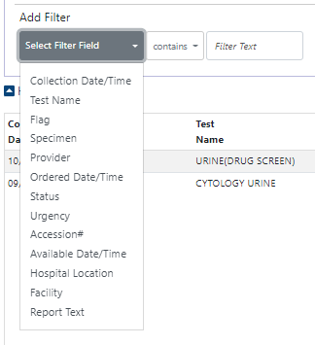
Figure 56: Labs Filter Contains Field
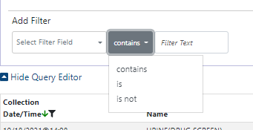

For efficiency, the Filter Text box turns into a Select a Value drop down with options specific to the patient’s data.
Figure 57: Labs Filter Contains Field
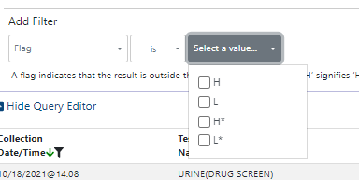

Figure 58: Labs Selecting a Value
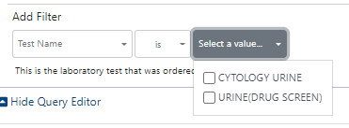

If the filter is a date range, there are several ways to enter dates - typing the date, clicking on the calendars, or clicking on the down arrows to the left of the date/time box which displays common date ranges as shown below:

Figure 59: Labs Selecting a Date Range
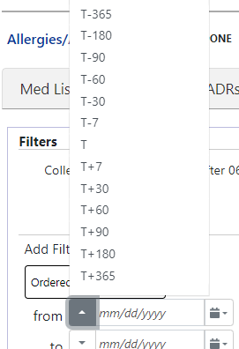

Adding Sort Criteria:
Setting Sort criteria is like setting filter criteria. A dropdown box shows the fields that can be used for sorting.
Figure 60: Labs Adding Sort Criteria
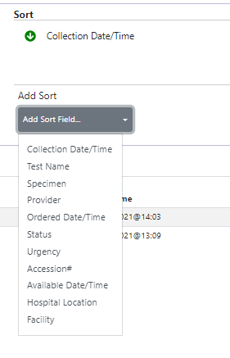

By selecting Results per Page, you can decrease the number of results per page as below, the default is 100.
Figure 61: Labs Results Per Page
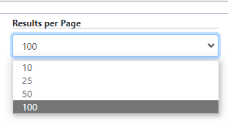

As each filter or sort is defined, click the Add button to add it to the query.
There is an Add button for each section, located in the right side of the section.
Figure 62: Labs Add Button for Sort criteria
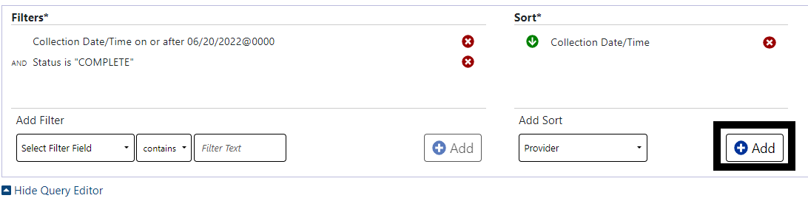

To process the list with your new criteria, click the Refresh button.
Figure 63: Labs Refresh Button
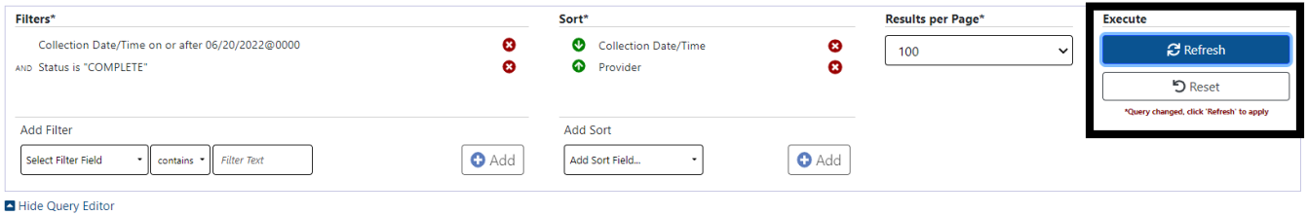

To remove single filter or sort criteria, including one of the defaults, click the Red X next to it.

Figure 64: Labs Red "X" Buttons
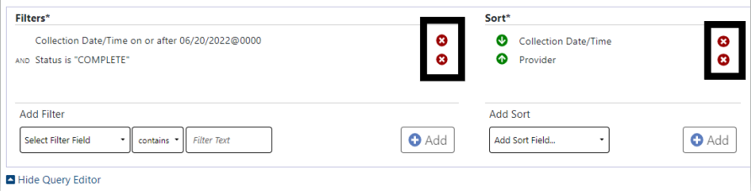

To clear all filters and sorts added by the user and return to the tab’s default, click the Reset button.
Figure 65: Labs Reset Button
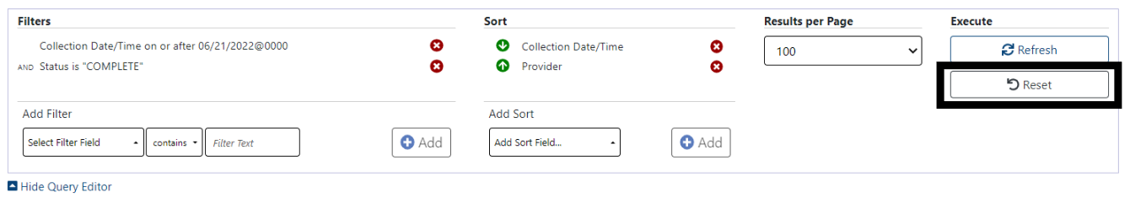

Progress Notes
The default filter/sort criteria for Progress Notes is: Records within the last year, sorted by Date/Time Entered with most recent notes first, 100 results per page. These criteria may be changed using the Query Editor by clicking on the blue drop-down arrow to the left of the Current Query.
Figure 66: Progress Notes Current Query
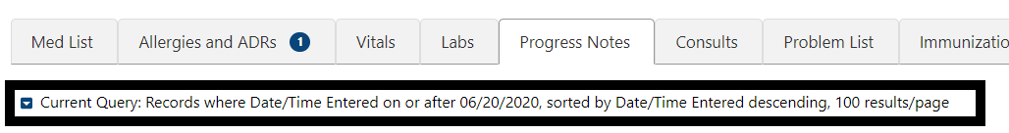

Adding Filter Criteria:
The drop-down list of Filter Fields displays a list of fields that can be used to restrict the list. The list of operators’ changes based on the type of data selected in the filter field.
Figure 67: Progress Notes Select Filter Field
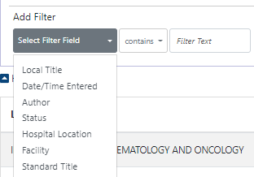
Figure 68: Progress Notes Add Filter Contains
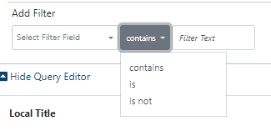

If the filter is a date range, there are several ways to enter dates - typing the date, clicking on the calendars, or clicking on the down arrows to the left of the date/time box which displays common date ranges as shown below:
Figure 69: Progress Notes Add Filter
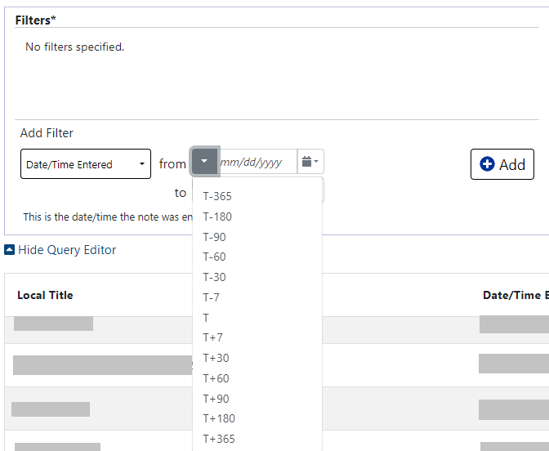
Adding Sort Criteria:
Setting Sort criteria is like setting filter criteria. A dropdown box shows the fields that can be used for sorting.
Figure 70:Progress Notes Add Sort Field
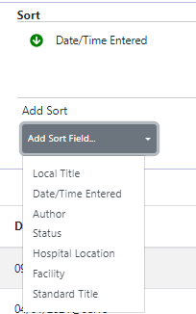

Selecting Results per Page. You can decrease the number of results per page as below, the default is 100.
Figure 71: Progress Notes Results Per Page
As each filter or sort is defined, click the Add button to add it to the query. There is an Add button for each section, located in the right side of the section.
Figure 72: Progress Notes Add Buttons
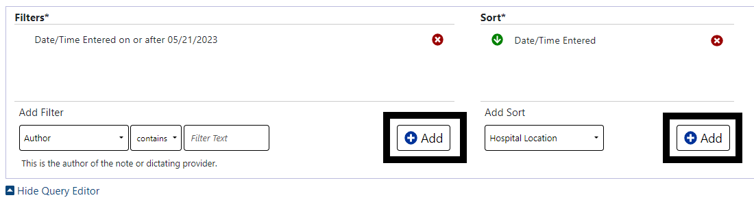

To process the list with your new criteria, click the Refresh button.

Figure 73: Refresh Button
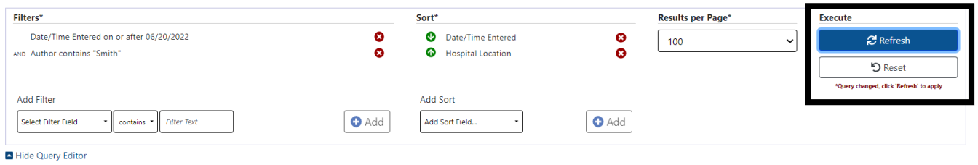

To remove single filter or sort criteria, including one of the defaults, click the Red X next to it.
Figure 74: Remove single criteria Notes tab
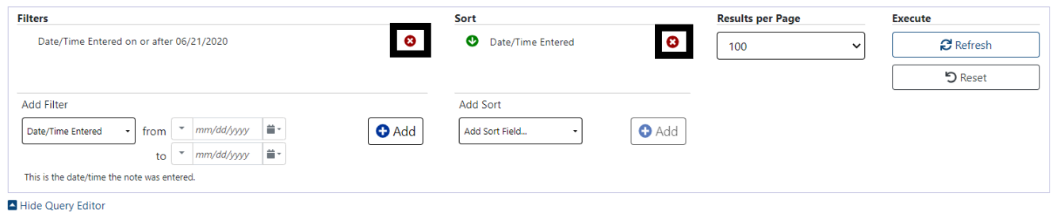

To clear all filters and sorts added by the user and return to the tab’s default, click the Reset button.
Figure 75: Reset button for Notes
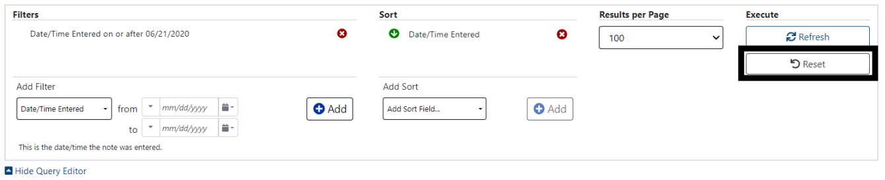

Consults
The default display for the Consults tab is All Records, sorted by Date/Time descending, 100 results/page. The filter and sort criteria maybe changed using the Query Editor.

Figure 76: Consults current query
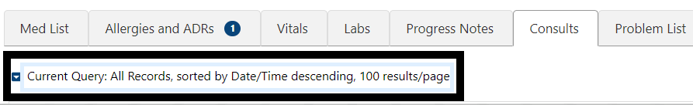

Adding Filter Criteria:
The drop-down list of Filter Fields displays a list of fields that can be used to restrict the list. The list of operators’ changes based on the type of data selected in the filter field.

Figure 77:Consults Select Filter Field
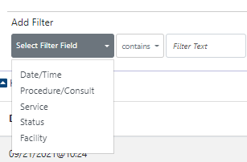
Figure 78:Consults Filter Contains
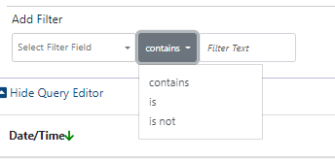

To make it easy to add filters, the Filter Text box turns into a Select a Value drop down with options specific to the patient’s data.

Figure 79:Consults Selecting a Value
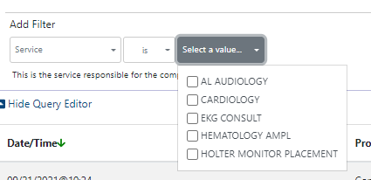

If the filter is a date range, there are several ways to enter dates - typing the date, clicking on the calendars, or clicking on the down arrows to the left of the date/time box which displays common date ranges as shown below:

Figure 80: Consult Date/time filter
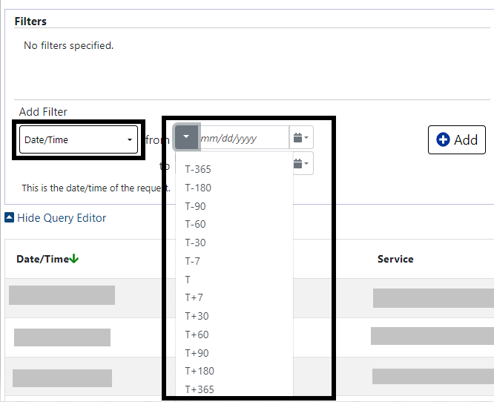

Adding Sort Criteria:
Setting Sort criteria is like setting filter criteria. A dropdown box shows the fields that can be used for sorting.

Figure 81: Consults Add Sort Field
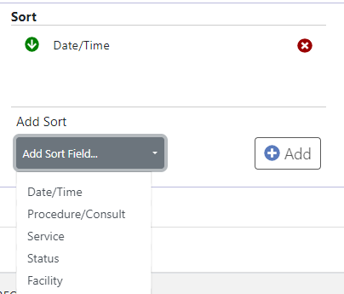

As each filter or sort is defined, click the Add button to add it to the query.
There is an Add button for each section, located in the right side of the section.

Figure 82: Consults New Filter Add button
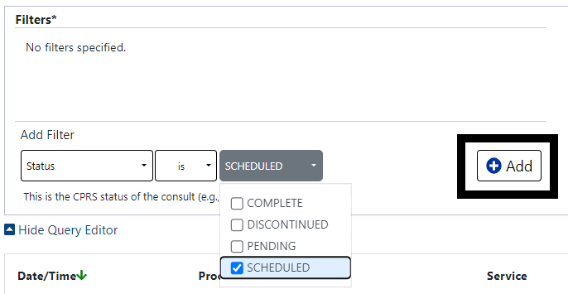

Selecting Results per Page. You can decrease the number of results per page as shown below, the default is 100.

Figure 83: Consults Results Per Page

To process the list with your new criteria, click the Refresh button.
Figure 84: Refresh/Reset Buttons
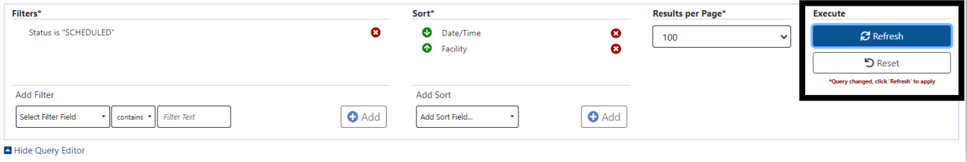

To remove single filter or sort criteria, including one of the defaults, click the Red X next to it.

Figure 85: Consult Remove Single Criteria
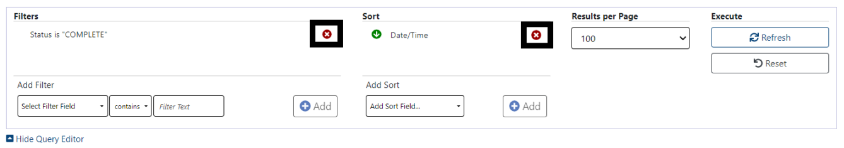

To clear all filters and sorts added by the user and return to the tab’s default, click the Reset button.
Figure 86: Consult Reset Button
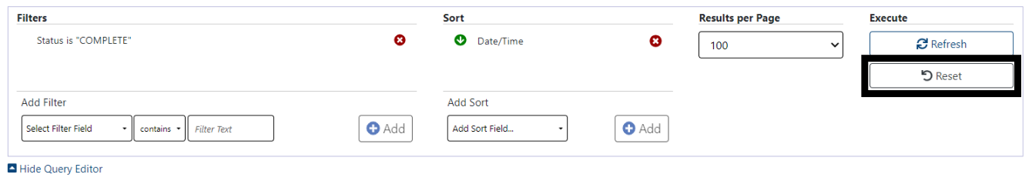

Problem List
The default view for the Problem List tab is all active problems sorted by Immediacy (Acute, Chronic or Unknown) in alphabetical order, then by Description in Alphabetical order.
Figure 87: Problem List Current Query
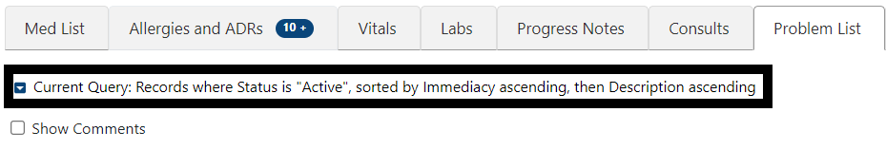

Adding Filter Criteria:
The drop-down list of Filter Fields displays a list of fields that can be used to restrict the list. The list of operators’ changes based on the type of data selected in the filter field.
Figure 88: Problem List Select Filter Field
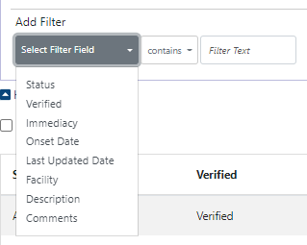
Figure 89: Problem List Add Filter Operators
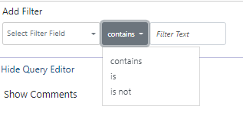
To make it easy to add filters, the Filter Text box turns into a Select a Value drop down with values specific to the patient’s data.
Figure 90: Problem List Selecting a Value
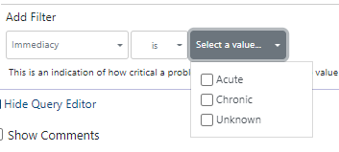

If the filter is a date range, there are several ways to enter dates - typing the date, clicking on the calendars, or clicking on the down arrows to the left of the date/time box which displays common date ranges as shown below:
Figure 91: Problem List Add Date Range Filter
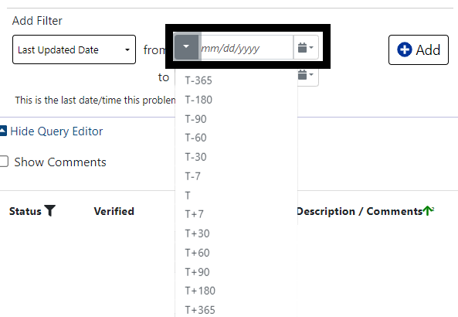

Adding Sort Criteria:
Setting Sort criteria is like setting filter criteria. A dropdown box shows the fields that can be used for sorting.

Figure 92: Problem List Adding Sort Field
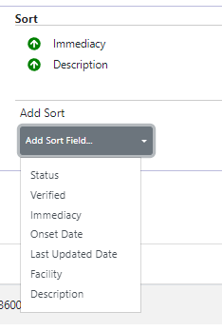

As each filter or sort is defined, click the Add button to add it to the query.
There is an Add button for each section, located in the right side of the section.
Figure 93: Problem List Add Buttons
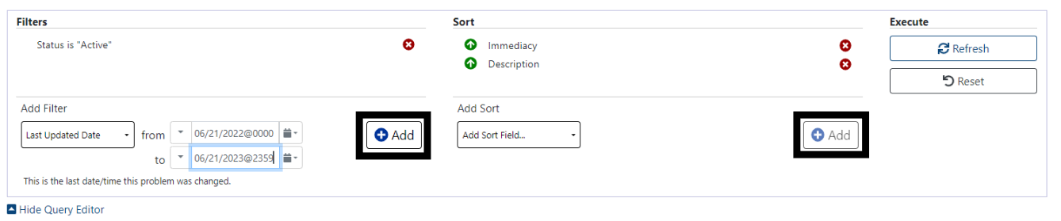

To process the list with your new criteria, click the Refresh button.
Figure 94: Problem List Refresh Button
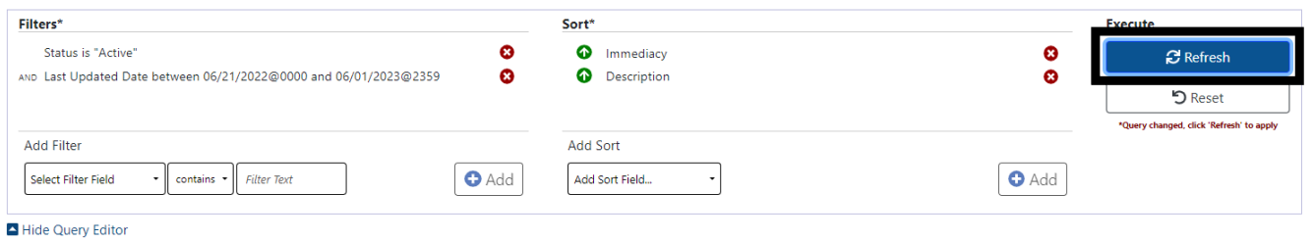

To remove single filter or sort criteria, including one of the defaults, click the Red X next to it.
Figure 95: Problem List Remove single Filter or Sort
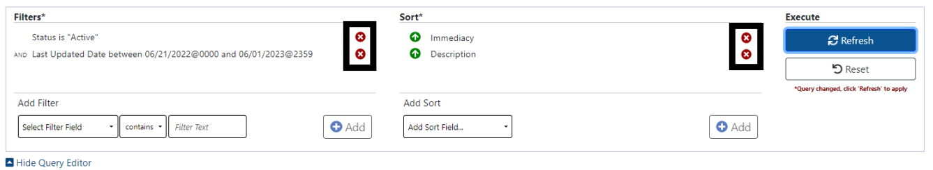

To clear all filters and sorts added by the user and return to the tab’s default, click the Reset button.
Figure 96: Problem List Reset button
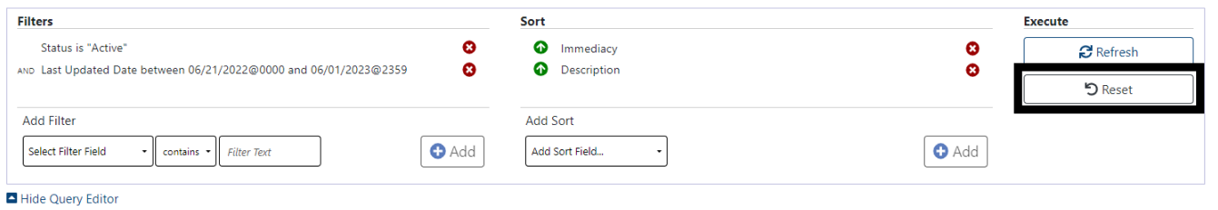

Immunizations
The default view for the Immunizations tab is All Records, sorted by Name (of immunization), most recent record first. The filter and sort criteria may be changed using the Query Editor. It is access by be clicking on the blue down-arrow next to the Current Query.
Figure 97: Immunizations Current Query
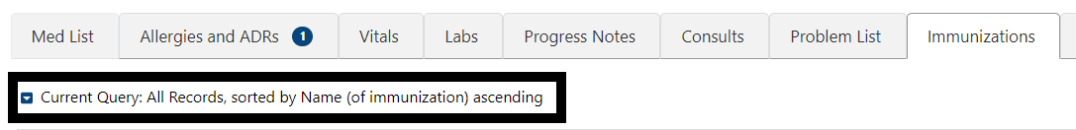

Adding Filter Criteria:
The drop-down list of Filter Fields displays a list of fields that can be used to restrict the list. The list of operators’ changes based on the type of data selected in the filter field.

Figure 98: Immunizations Select Filter Field
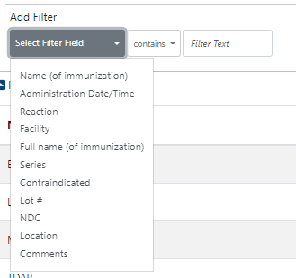
Figure 99: Immunizations Add Filter Operators
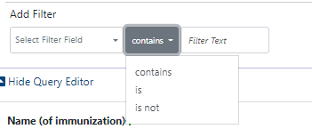
To make it easy to add filters, the Filter Text box turns into a Select a Value drop down with options specific to the patient’s data.
Figure 100: Immunizations Selecting a Value
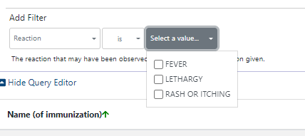

If the filter is a date range, there are several ways to enter dates - typing the date, clicking on the calendars, or clicking on the down arrows to the left of the date/time box which displays common date ranges as shown below:
Figure 101: Immunization Date Filter
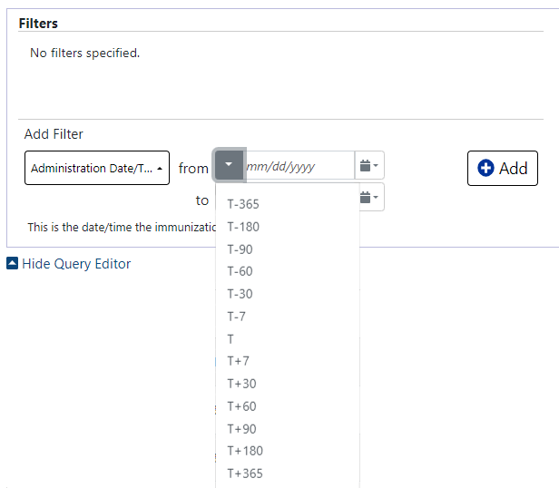

Adding Sort Criteria:
Setting Sort criteria is like setting filter criteria. A dropdown box shows the fields that can be used for sorting.
Figure 102: Immunizations Adding Sort Criteria
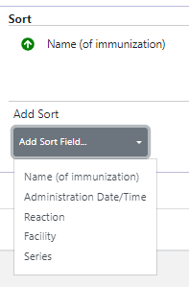

As each filter or sort is defined, click the Add button to add it to the query.
There is an Add button for each section, located on the right side of the section.
Figure 103: Immunizations Add Buttons
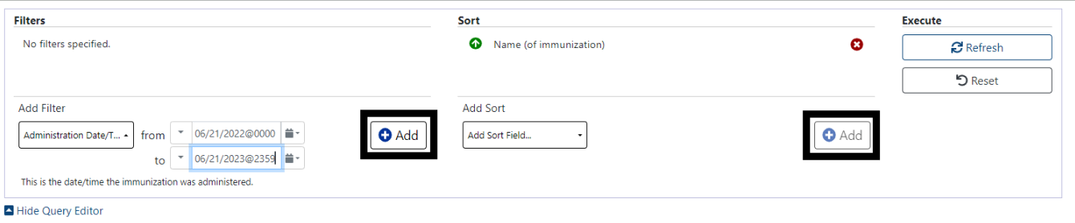

To process the list with your new criteria, click the Refresh button.
Figure 104: Immunizations Refresh Button
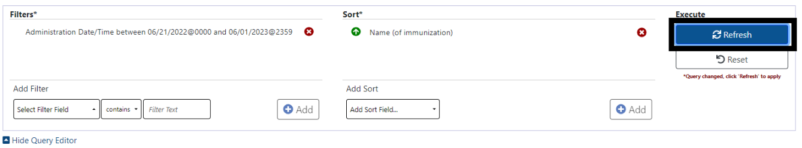

To remove single filter or sort criteria, including one of the defaults, click the Red X next to it.
Figure 105: Immunization Remove Single Criteria
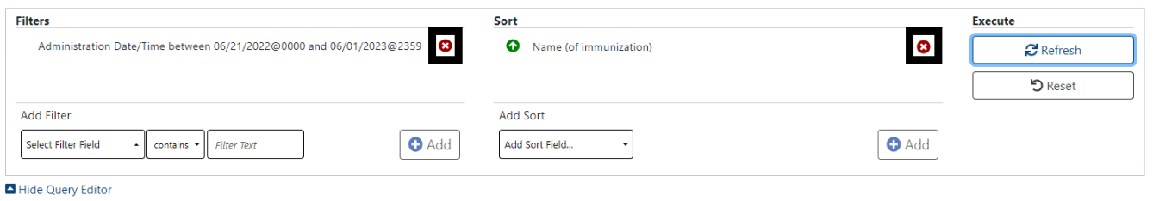

To clear all filters and sorts added by the user and return to the tab’s default, click the Reset button.

Figure 106: Immunization Reset button
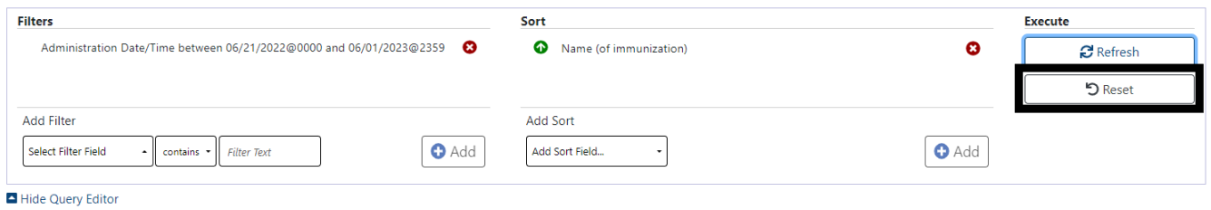

Appointments
The default display for the Appointments tab is Records within the last year, sorted by Date/Time descending, 100 results/page. The filter and sort criteria may be changed using the Query Editor. It is access by be clicking on the blue down-arrow next to the Current Query.
Figure 107: Appointments Current Query

Adding Filter Criteria:
The drop-down list of Filter Fields displays a list of fields that can be used to restrict the list. The list of operators’ changes based on the type of data selected in the filter field.

Figure 108: Appointments Select Filter Field
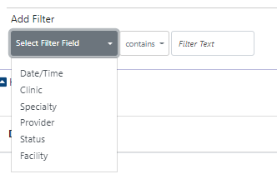
Figure 109: Appointments Add Filter Operators
To make it easy to add filters, the Filter Text box turns into a Select a Value drop down with options specific to the patient’s data.

Figure 110: Appointments Filter
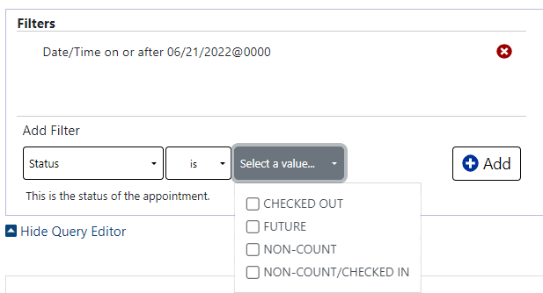

If the filter is a date range, there are several ways to enter dates - typing the date, clicking on the calendars, or clicking on the down arrows to the left of the date/time box which displays common date ranges as shown below:
Figure 111: Appointments Date Filter
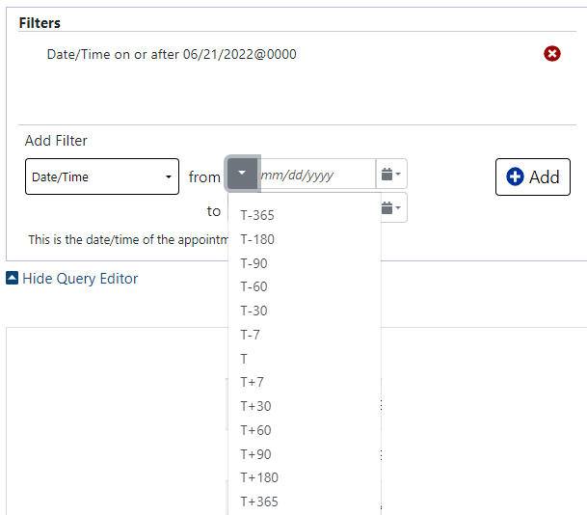

Adding Sort Criteria:
Setting Sort criteria is like setting filter criteria. A dropdown box shows the fields that can be used for sorting.

Figure 112: Appointments Add Sort Criteria
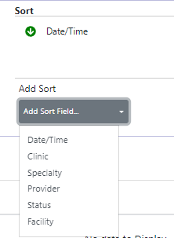

Selecting Results per Page. You can decrease the number of results per page as below, the default is 100.
Figure 113: Appointments Results Per Page

As each filter or sort is defined, click the Add button to add it to the query.
There is an Add button for each section, located in the right side of the section.
Figure 114: Appointments Add Buttons
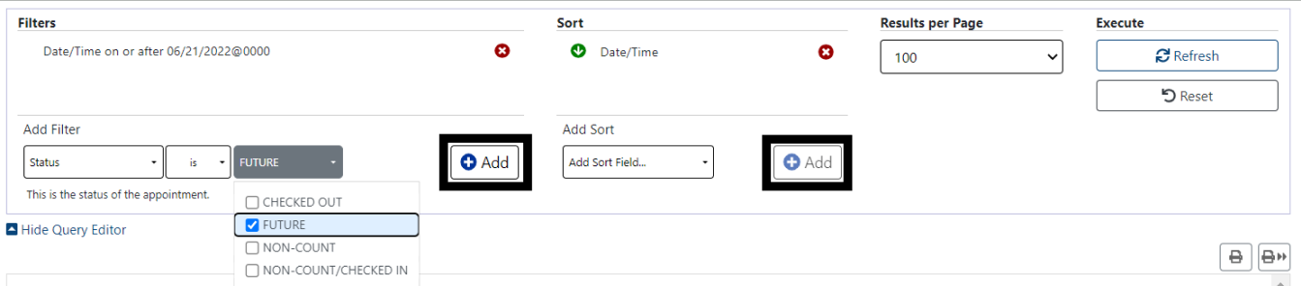

To process the list with your new criteria, click the Refresh button.
Figure 115: Appointments Refresh Button
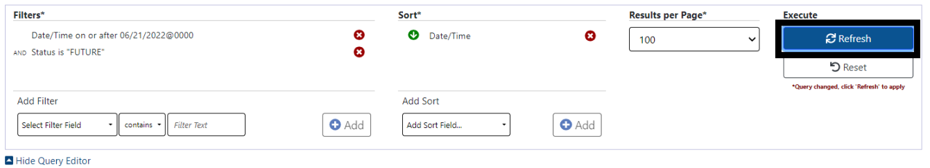

To remove single filter or sort criteria, including one of the defaults, click the Red X next to it.
Figure 116: Appointments Remove Single Criteria
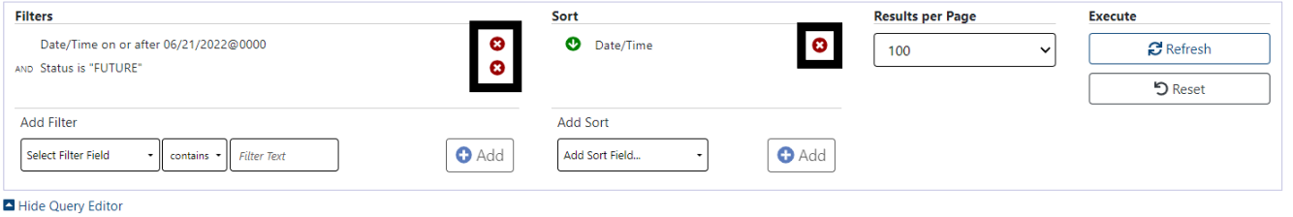

To clear all filters and sorts added by the user and return to the tab’s default, click the Reset button.
Figure 117: Appointments Reset Button
