Advanced Medication Platform (AMPL)
Graphic User Interface (GUI)
User Guide

August 2023

Department of Veterans Affairs

Office of Information and Technology (OIT)

Revision History
Date | Version | Description | Author
08/2023 | 0.1 | Document Baseline | AMPL GUI Team

Table of Contents
1. Introduction 1
1.1. Purpose 1
1.2. Document Orientation 1
1.2.1. Organization of the Guide 1
1.2.2. Assumptions 2
1.2.3. Disclaimers 2
1.2.3.1. Software Disclaimer 2
1.2.3.2. Documentation Disclaimer 2
1.2.4. Documentation Conventions 2
1.2.5. References and Resources 4
1.3. Getting Help 4
1.3.1. Hover for Help Text 4
2. System Summary 5
2.1. System Configuration 5
2.2. Data Flows 5
2.3. User Access Levels 6
2.4. Continuity of Operation 6
3. Getting Started 7
3.1. Logging On 7
4. Pending Orders Manager Landing Page 10
4.1. Selecting a Patient 10
4.2. Outpatient Orders by Date 12
4.2.1. Query Editor 14
4.3. Outpatient Orders by Location 17
4.4. Inpatient Orders 22
4.5. Clinic Orders 25
5. Patient Coversheet 28
5.1. Patient Banner 28
5.2. Patient Detailed Demographics 29
5.3. Patient Banner Allergies/Adverse Reactions (ADRs) 33
5.4. Crisis, Warnings, Allergies, and Directives (CWAD) Postings 34
6. Patient Domain Tabs 37
6.1. Med List Tab 37
6.1.1. Outpatient Med List 37
6.1.1.1. Outpatient Med List - Expanded View 39
6.1.1.2. Outpatient Med List – Expanded View Help Text 39
6.1.1.3. Outpatient Med List - Expanded View Indicators 40
6.1.1.4. Outpatient Med List - Expanded View Remote Orders 41
6.1.1.5. Outpatient Med Order - Details 41
6.1.2. Inpatient Med List 44
6.1.2.1. Inpatient Med List - Expanded View 44
6.1.2.2. Inpatient Med List - Expanded View Help Text 45
6.1.2.3. Inpatient Med Order - Details 45
6.1.3. Clinic Med List 48
6.1.3.1. Clinic Med List - Expanded View 49
6.1.3.2. Clinic Med List - Expanded View Help Text 50
6.1.3.3. Clinic Med Order – Details 50
6.1.4. Non-VA Med List 52
6.1.4.1. Non-VA Med Orders - Expanded View 53
6.1.4.2. Non-VA Med List – Expanded View Help Text 54
6.1.4.3. Non-VA Med Orders – Details 54
6.2. Allergies and ADRs Tab 55
6.2.1. Allergy and ADRs - Query Editor 56
6.2.2. Allergies and ADRs – Accordion View 57
6.3. Vitals Tab 58
6.3.1. Vitals – Expanded View 61
6.3.2. Vitals – Graphing Capabilities 61
6.4. Labs Tab 62
6.4.1. Labs - Laboratory Test Record Expanded View 63
6.4.2. Labs - Query Editor 64
6.5. Progress Notes Tab 64
6.5.1. Progress Notes – Expanded View 65
6.5.2. Progress Notes – Query Editor 66
6.6. Consults Tab 67
6.6.1. Consults Tab – Expanded View 68
6.6.2. Consults Tab – Query Editor 69
6.7. Problem List Tab 69
6.7.1. Problem List – Expanded View 70
6.7.2. Problem List – Query Editor 71
6.8. Immunization Tab 72
6.8.1. Immunization Tab – Expanded View 72
6.8.2. Immunization Tab – Query Editor 73
6.9. Appointments Tab 74
6.9.1. Appointments Tab – Expanded View 75
6.9.2. Appointments Tab – Query Editor 75
7. Version and Build Information 77
7.1. Date Formats for Entry 77
7.2. Time Display 77
8. Joint Legacy Viewer (JLV) Button 78
9. Patient Record Flag 79
9.1. Patient Record Flag Window Display 79
9.2. Patient Record Flag – Category I Flags (National) 80
9.3. Patient Record Flag – Category II Flags (Clinical) 81
10. Clinical Context Object Workgroup (CCOW) 83
10.1. Desktop Patient Context – Context Status 83
10.2. Desktop Patient Context – Suspend (Break) Context Links 83
10.3. Desktop Patient Context – Re-establish (Rejoin) Context Link 83
10.4. Desktop Patient Context – Notification of Failed Context Changes 84
11. VistA ‘Spacebar Return’ Functionality in AMPL GUI Application 85
11.1. VistA Logo Button 85
11.2. VistA Patient Context – Change Cannot be Done in AMPL 85
11.3. Vista ‘Spacebar Return’ Function 86
12. Changing User ID and Password 87
13. Exit System 88
14. Caveats and Exceptions 89
15. Troubleshooting 90
16. Acronyms and Abbreviations 91
17. Appendix A: Post-implementation Access or Removal Requests 92
18. Appendix B: AMPL Desktop Shortcut 93

List of Figures
Figure 1: Logical High Level AMPL GUI HealthShare Data Flow 6
Figure 2: AMPL GUI Login Page 7
Figure 3: SSOi Page for VA Users 8
Figure 4: Set VistA Context 8
Figure 5: Change Station 9
Figure 6: Pending Orders Manager Landing Page 9
Figure 7: Pending Orders Manager Tabs 10
Figure 8: Current Query 10
Figure 9: Column Sort Arrow 10
Figure 10: Patient Queue 11
Figure 11: VistA Patient Lookup 11
Figure 12: VistA Patient Lookup Info Button 11
Figure 13: Patient Lookup Search Criteria Help 11
Figure 14: Patient Cover Sheet with Patient Queue List 12
Figure 15: POM Button Toggle to Coversheet and Retained in Patient Queue 12
Figure 16: Outpatient Orders by Date Tab 12
Figure 17: Outpatient Orders by Date - Site Selection 12
Figure 18: Outpatient Orders by Date - Aging Summary 13
Figure 19: Outpatient Orders by Date – Aging Summary Quick Filter 13
Figure 20: Outpatient Orders by Date - Selecting an Ordering Institution 13
Figure 21: Outpatient Orders by Date - Site and Institution Selected 14
Figure 22: Outpatient Orders by Date - Patient List 14
Figure 23: Outpatient Orders by Date - Query Editor Filters 14
Figure 24: Outpatient Orders by Date - Query Editor Filter 15
Figure 25: Outpatient Orders by Date - Query Editor Filter Applied 15
Figure 26: Outpatient Orders by Date - Results of Query Filter Applied to List 15
Figure 27: Supply Filter - Defaults Other Fields 16
Figure 28: Provider Filter - Defaults 16
Figure 29: Date Filter - Commonly Used Date Ranges 16
Figure 30: Query for Date Field Quick List 17
Figure 31: Outpatient Orders by Location Tab 17
Figure 32: Outpatient Orders by Location - Site Selection 18
Figure 33: Outpatient Orders by Location - Selecting an Ordering Institution 18
Figure 34: Outpatient Orders by Location - Site and Institution Selected 18
Figure 35: Outpatient Orders by Location - STAT Symbol 19
Figure 36: Outpatient Orders by Location - Clinic Selected 19
Figure 37: Outpatient Orders by Location - Select Patient(s) to Process List 19
Figure 38: Outpatient Orders by Location - Process All Button 20
Figure 39: Outpatient Orders by Location - Query Editor Filters 20
Figure 40: Outpatient Orders by Location - Query Editor Filter Operators 21
Figure 41: Outpatient Orders by Location - Query Editor Filters Drug Selected 21
Figure 42: Outpatient Orders by Location - Query Editor Search Criteria 21
Figure 43: Outpatient Orders by Location - Query Editor Delete Icon 22
Figure 44: Outpatient Orders by Location - Patient Filter 22
Figure 45: Inpatient Orders Tab 22
Figure 46: Inpatient Orders - Division Selection 23
Figure 47: Inpatient Orders - Division Selected 23
Figure 48: Inpatient Orders - Ward Group Selected 23
Figure 49: Inpatient Orders - Select Patient(s) to Process List 23
Figure 50: Inpatient Orders - Query Editor Filters 24
Figure 51: Inpatient Orders - Query Editor Filter Applied 24
Figure 52: Inpatient Orders - Query Editor Filters Drug Value 25
Figure 53: Inpatient Orders - Query Editor Search Criteria 25
Figure 54: Inpatient Orders - Query Editor Delete Icon 25
Figure 55: Clinic Orders Tab 26
Figure 56: Clinic Orders - Select Division 26
Figure 57: Clinic Orders - Division Selected 26
Figure 58: Clinic Orders - Clinic Group Selected 27
Figure 59: Clinic Orders - Query Editor Filters 27
Figure 60: Clinic Orders - Select Patient(s) to Process List 27
Figure 61: Patient Coversheet 28
Figure 62: Patient Banner 28
Figure 63: Covid-19 Testing Status 29
Figure 64: Patient Reload Button 29
Figure 65: Patient Information Banner 29
Figure 66: Patient Demographic - Details 29
Figure 67: Contact Info Tab 30
Figure 68: Pharmacy Info Tab 30
Figure 69: Eligibility Tab 31
Figure 70: Social, Primary Care, Clinic Info Tab 31
Figure 71: Military Service Tab 32
Figure 72: Health Plans/Insurance Tab 32
Figure 73: Primary Care Team Information 32
Figure 74: Primary Care Details - Outpatient 33
Figure 75: Primary Care Details - Inpatient 33
Figure 76: Allergies/ADRs Listed in Patient Banner 33
Figure 77: Allergy Banner Pop-Up Window 34
Figure 78: Postings Buttons - Indicating Critical Information 35
Figure 79: Postings Buttons - Indicating No Postings 35
Figure 80: CWAD - List Window 35
Figure 81: CWAD - Detailed Display 36
Figure 82: Patient Data Domain Tabs 37
Figure 83: Med List Tab 37
Figure 84: Outpatient Med List 38
Figure 85: Outpatient Med List - Remote Orders Button 38
Figure 86: Outpatient Med List - Remote Orders 38
Figure 87: Outpatient Med List - More Button 39
Figure 88: Outpatient Med List - Expanded View 39
Figure 89: Outpatient Med List - Help Text 39
Figure 90: CMOP Indicator 41
Figure 91: Outpatient Med List - Show Remote Orders Checkbox 41
Figure 92: Outpatient Med Order – Active Order Detail Screen 42
Figure 93: Outpatient Med Order – Additional Details 42
Figure 94: Outpatient Med Order – Order Check 42
Figure 95: Outpatient Med Order - Drug Restriction/Guideline Information 42
Figure 96: Outpatient Med Order - Drug Info 43
Figure 97: Outpatient Med Order - Provider Info 43
Figure 98: Outpatient Med Order - Activity Log 43
Figure 99: Inpatient Med List 44
Figure 100: Inpatient Med List - More Button 44
Figure 101: Inpatient Med List - Expanded View 45
Figure 102: Inpatient Med List - Help Text 45
Figure 103: Inpatient Med Order - Active Orders Detail Screen 46
Figure 104: Inpatient Med Order - Additional Details 46
Figure 105: Inpatient Med Order - Order Check 46
Figure 106: Inpatient Med Order - Drug Restriction/Guideline Information 47
Figure 107: Inpatient Med Order - Drug Info 47
Figure 108: Inpatient Med Order - Provider Information 47
Figure 109: Inpatient Med Order - PADE Inventory 48
Figure 110: Inpatient Med Order - Administration Hx 48
Figure 111: Clinic Med List 48
Figure 112: Clinic Med List - Remote Orders Button 49
Figure 113: Clinic Med List - Remote Orders 49
Figure 114: Clinic Med List - Expanded View 49
Figure 115: Clinic Med List - Help Text 50
Figure 116: Clinic Med Order – Active Order Detail Screen 50
Figure 117: Clinic Med Order - IV Med Order Details 50
Figure 118: Clinic Med Order - Additional Details 51
Figure 119: Clinic Med Order - Order Check 51
Figure 120: Clinic Med Order - Drug Restriction/Guideline Information 51
Figure 121: Clinic Med Order - Drug Info 51
Figure 122: Clinic Med Order - Provider Information 52
Figure 123: Clinic Med Order - PADE Activity 52
Figure 124: Clinic Med Order - Administration Hx 52
Figure 125: Non-VA Med List 53
Figure 126: Non-VA Med List - Remote Orders Button 53
Figure 127: Non-VA Med List - Remote Orders 53
Figure 128: Non-VA Med List - More Button 54
Figure 129: Non-VA Med List - Expanded View 54
Figure 130: Non-VA Med List - Help Text 54
Figure 131: Non-VA Med Orders - Details for Active Medication 55
Figure 132: Allergies and ADRs Tab 55
Figure 133: Allergies and ADRs - Allergy Assessment Needed 55
Figure 134: Allergies and ADRs Column Header Help Text 56
Figure 135: Allergies and ADRs - Entered in Error Records Indicator 56
Figure 136: Allergies and ADRs - Entered in Error Records 56
Figure 137: Allergies and ADRs - Query Editor 56
Figure 138: Allergies and ADRs - Filter Options 57
Figure 139: Allergies and ADRs - Sorting Options 57
Figure 140: Allergies and ADRs - Accordion View 57
Figure 141: Allergies and ADRs - Accordion View – Records Entered in Error 58
Figure 142: Vitals Tab 58
Figure 143: Vitals - Column Headers 58
Figure 144: Vitals - Help Text 59
Figure 145: Vitals - Additional Vitals 59
Figure 146: Vitals - Display 60
Figure 147: Vitals - Date Range 60
Figure 148: Vitals – Commonly Used Date Ranges 60
Figure 149: Vitals - Date Range Display 61
Figure 150: Vitals - Expanded View 61
Figure 151: Vitals - Graphing 61
Figure 152: Vitals - Regression Lines and Labels 62
Figure 153: Labs Tab 62
Figure 154: Labs - Column Headers 62
Figure 155: Labs - Help Text 62
Figure 156: Labs - Test Record Expanded View 63
Figure 157: Labs - Lab Results Pending 63
Figure 158: Labs - No Lab Data 63
Figure 159: Labs - Show Query Editor Button 64
Figure 160: Labs - Filter and Sorting Options 64
Figure 161: Progress Notes Tab 64
Figure 162: Progress Notes - Column Headers 65
Figure 163: Progress Notes - Help Text 65
Figure 164: Progress Notes - Expanded View 65
Figure 165: Progress Notes - Interdisciplinary Note 66
Figure 166: Progress Notes - Query Editor Button 66
Figure 167: Progress Notes - Filter and Sorting Options 67
Figure 168: Consults Tab 67
Figure 169: Consults Tab - Column Headers 67
Figure 170: Consults Tab - Help Text 68
Figure 171: Consults Tab - Expanded View 68
Figure 172: Consults Tab - Filter and Sort 69
Figure 173: ‘OR’ing’ for Text Filters 69
Figure 174: Problem List Tab 70
Figure 175: Problem List Tab - Column Headers 70
Figure 176: Problem List - Help Text 70
Figure 177: Problem List - Expanded View 71
Figure 178: Problem List - Filter and Sort Options 71
Figure 179: Problem List - “Or” Filter Option 72
Figure 180: Immunization Tab 72
Figure 181: Immunization Tab - Column Headers 72
Figure 182: Immunization Tab - Help Text 72
Figure 183: Immunization Tab - Expanded View 73
Figure 184: Immunization Tab - Filters and Sort Options 73
Figure 185: Appointments Tab 74
Figure 186: Appointments Tab - Column Headers 74
Figure 187: Appointments Tab - Help Text 74
Figure 188: Appointments Tab - Print Buttons 74
Figure 189: Appointments Tab - Expanded View 75
Figure 190: Appointments - Filter and Sort Options 76
Figure 191: Version and Build Information 77
Figure 192: Joint Legacy Viewer (JLV) Button 78
Figure 193: Patient Record Flag Indicator 79
Figure 194: Patient Record Flags 79
Figure 195: Patient Record Flag Window 80
Figure 196: Patient Record Flag Category I Flag Signed, Linked Notes 80
Figure 197: Patient Record Category Flag I Progress Note Window 81
Figure 198: Category II Flags 82
Figure 199: Patient Record Flag Category II Flag Signed, Linked Notes 82
Figure 200: Patient Record Category Flag II Progress Note Window 82
Figure 201: Context Status 83
Figure 202: Context Sharing Confirmation Window 83
Figure 203: CCOW Button 84
Figure 204: Re-establishing Context Confirmation 84
Figure 205: Notification of Failed Context Changes Window 84
Figure 206: VistA Logo Button 85
Figure 207: Notification of Patient Change in AMPL 85
Figure 208: Patient Context Change Cannot be Made in AMPL Notification Window 85
Figure 209: VistA Spacebar Return Function 86
Figure 210: Logout Button 88
Figure 211: Desktop Shortcut 93

Introduction
Advanced Medication Platform (AMPL) Graphic User Interface (GUI) is a front-end application supporting the Department of Veterans Affairs (VA) pharmacists by fulfilling the need for medical knowledge during patient care. Access to relevant medical knowledge can lead to increased quality of care, better efficiency, and improved health outcomes. It can also decrease the potential for errors and adverse events resulting in decreased cost and increased provider and patient satisfaction. Incorporating GUI capabilities into the processing of pharmacy medication orders is a way to minimize risks and enhance health care.

Purpose
AMPL GUI is a Graphic User Interface application tailored to users of the Veterans Health Information Systems and Technology Architecture (VistA) Pharmacy packages. AMPL GUI provides pharmacists with a single point of access to patients’ medical data from all VA Medical Centers in a clearer and more user-friendly display. AMPL GUI is intended to advance VA’s ongoing efforts to employ robust electronic health records and improve the efficiency and safety of the medication order process.
AMPL GUI supports the current workflow as well as the development and incorporation of modern technology, functionality, and techniques. It will allow users to make more informed decisions using clinical knowledge and patient-specific expandable information, intelligently filtered, sorted, organized, and presented within a single application as care is being delivered.
AMPL GUI displays data from the following domains as well as the Pending Order Manager Display:
- Allergies/ADRs
- Appointments
- Consults
- Demographics
- Immunizations
- Lab
- Pharmacy
- Problem List
- Progress Notes
- Vitals

Document Orientation
The AMPL User Guide is formatted comparable to the Computerized Patient Record System (CPRS) User Manual: GUI Version.

Organization of the Guide
This guide is organized in the way users will initially access AMPL GUI. It is organized in a way to help the reader understand the basic layout of AMPL GUI and provide the reader with information about the specific tasks that pharmacy staff need to perform. The contents are organized as a functionality listing, starting with the features of the patient header, then going tab by tab through each set of clinical offerings.

Assumptions
The user guide is written from the perspective of VA users, assuming the following:
- User can open, navigate, and use a web browser.
- User can use web-based applications, their menu options, and navigation tools.
- User has completed any prerequisite training specific to the AMPL GUI application.
- User has been provided access to the AMPL GUI application.
- Pharmacy staff who have access to AMPL GUI will use their Personal Identity Verification (PIV) card to sign on. A URL will be given during implementation.
- The functionality of AMPL GUI will be used to support Veterans Health Administration (VHA) and/or Veterans Benefits Administration (VBA) workflows.

Disclaimers

Software Disclaimer
This software was developed at the Department of Veterans Affairs by employees of the Federal Government in the course of their official duties. Pursuant to Title 17 Section 105 of the United States Code this software is not subject to copyright protection and is in the public domain. VA assumes no responsibility whatsoever for its use by other parties, and makes no guarantees, expressed or implied, about its quality, reliability, or any other characteristic. We appreciate acknowledgement if the software is used. This software can be redistributed and/or modified freely if any derivative works bear some notice that they are derived from it, and any modified versions bear some notice that they have been modified.

Documentation Disclaimer
The appearance of external hyperlink references in this guide does not constitute endorsement by the VA of this website or the information, products, or services contained therein. The VA does not exercise any editorial control over the information you may find at these locations. Such links are provided and are consistent with the stated purpose of the VA.

Documentation Conventions
Various symbols are used throughout the documentation to alert the reader to special information. The following shows the symbols being used and the description of each:
The Information symbol indicated especially important or helpful information.

In addition, the AMPL GUI application uses several symbols. The following figures list these symbols and include a brief description of how it is used:
This icon designates that the column is sorted – Ascending (the number listed next to the arrow is showing the sort order for that column if more than one column is sorted).
This icon designates that the column is sorted – Descending (the number listed next to the arrow is showing the sort order for that column if more than one column is sorted).
This icon is used to indicate columns are hidden from view.
This symbol, located next to a clinic record, indicates that there is at least one order for that clinic with a priority of STAT, ASAP, or a schedule of NOW.
Patient Context Indicator – Indicates whether CCOW is synchronizing patients with other GUIs
VistA button - Allows the user to choose the last patient accessed in VistA similar to ‘Spacebar Return’ functionality
Refresh icon
Reset icon
Filter icon
Medication List tab – Indicates Remote Orders
Patient Lookup icon
Add icon
More button – Displays Expanded view of Medication Orders
Table icon
The Caution/Warning symbol indicates that data within a tab may be incomplete. The information may be updated by refreshing the patient.
Entered in Error NOTE: Notice the difference between these two icons, the Entered in Error icon has a pink background.
Other Important Notes:
- For all instances where time is displayed, the time will reflect the time zone of where the item was entered and not update to the user’s time zone.
- Some data fields in VistA, along with certain data changes done through FileMan will NOT trigger an update to AMPL GUI. See the list below for specific data trigger issues. More details are provided in Section 2.2 Data Flows.
  - Date of Birth
  - Temporary Mailing Information Phone Numbers
  - Emergency Contact Info Relationship
  - Emergency Contact Info Phone Numbers
  - POW War Field
  - Combat from Date
  - Combat to Date
  - Combat Location
  - Nature of Order
  - Prescription Refills without Status Change

References and Resources
Additional information on AMPL GUI can be found in the following documents:
- AMPL Technical Manual
- AMPL GUI Deployment, Installation, and Rollback Guide (DIBR)

Getting Help
A future version of this document will include online help for how-to information, AMPL GUI Resources, access to AMPL GUI training videos, and additional training materials.
Prior to contacting the Enterprise Service Desk (ESD) for support, please refer to 3.1: Logging On for detailed information about how to access AMPL GUI and to section 15: Troubleshooting for suggested resolution steps and troubleshooting information.
If you are an authorized user that has trouble logging in to AMPL or experiencing other application issues, please contact the Enterprise Service Desk via telephone or by using the Your IT self-service portal for assistance.
If you are unable to retrieve community partner documents for a patient, please contact your local Veterans Health Information Exchange (VHIE) Coordinator.

Hover for Help Text
Help text is widely available throughout AMPL by hovering over text or data fields including column headers, symbols, facility numbers (hovering provides facility name), and Query Editors (date box and filter text box).
Examples are included in sections as applicable.

System Summary
AMPL GUI is a web-based application that is intended to assist with accessing and displaying of pharmacy orders and relevant patient data in the support of processing pharmacy orders.
It consists of two primary functions, the Pending Order Manager (POM) and the Patient Coversheet. The POM is used to find and organize pharmacy orders that need actions. It supports the ability to create a queue of orders that then can be used to retrieve a patient’s record in the coversheet. The AMPL GUI patient coversheet, through a series of tabs, displays pharmacologically relevant aspects of the patient medical record. AMPL GUI is read-only for the initial release, with urgent future plans to convert to read/write functionality.

System Configuration
The system is hosted in the Veterans Affairs Enterprise Cloud (VAEC) Amazon Web Services (AWS) cloud. It is solely accessed through a web browser. The preferred browser is Google Chrome, but most modern web browsers should be acceptable. Microsoft Explorer is not supported.
Access to the VA network and a web browser is needed to access AMPL GUI. To utilize the AMPL GUI’s Clinical Context Object Workgroup (CCOW) functionality, CCOW needs to be installed and configured on the workstation.

Data Flows
When a patient’s record is accessed in AMPL, the pharmacist is provided a comprehensive view of local and remote clinical patient data to provide enhanced decision support by bringing together several domains of patient data including patient demographics, CWAD, allergies and adverse reactions, consultations, immunizations, vitals, progress notes, problem lists, labs, medications, and appointments. All this data is obtained from VistA through the Veterans Data Integration and Federation (VDIF) service which aggregates data from all VA Medical Centers where that patient has been seen.
Most data updates made in VistA trigger propagation of that data through several systems in VDIF to ultimately be available to AMPL. This process is designed to occur quickly such that changes in VistA are reflected in AMPL within minutes. There are times that the system has a backlog with a queue of data to be processed, which may degrade the response time for data changes to be available to AMPL.
Patient demographics by themselves do not trigger propagation of data to VDIF. If a change is made only to a patient’s demographic information in VistA, those changes will not be immediately reflected in VDIF or AMPL. See section 1.2.4 for a list. Once other changes are made for the patient that do trigger data propagation, such as addition of a medication order or allergy, status change of a medication order or allergy, or any other changes that trigger propagation to VDIF, the patient demographics changes will be propagated to AMPL at that time.
Patient data flowing from VistA is stored by VDIF. It is transmitted upon request to AMPL in either Fast Healthcare Interoperability Resources (FHIR) format, a standard mechanism for sharing health data or using custom requests.
In addition to patient data, AMPL also provides functionality to assist pharmacists with managing pending orders. The data in the Pending Orders Manager is pulled using VDIF custom service calls to the currently selected VistA site. An AMPL user can select a VistA station and see the Pending Orders for that site or search for patients and open their records from that site. Please refer to section 3.1: Logging On for details on how to change the selected station.
Figure 1: Logical High Level AMPL GUI HealthShare Data Flow
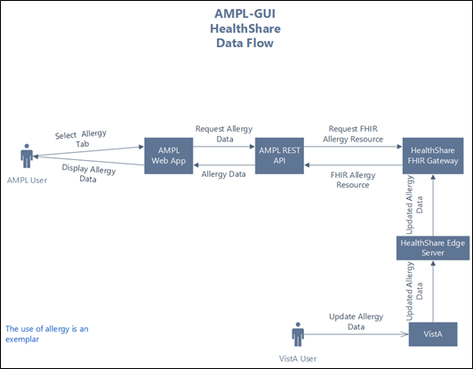

User Access Levels
AMPL GUI implements a single level of user access. Access is granted at the enterprise level via an Active Directory (AD) group. No local VistA credentials are necessary to use AMPL GUI.

Continuity of Operation
AMPL GUI is hosted on the Amazon Web Service (AWS) cloud, managed by the Veterans Affairs Enterprise Cloud (VAEC) group. This environment is highly available and is unlikely to experience an extended outage. AMPL GUI is an enhancement to existing pharmacy systems and does not replace any existing system. In the unlikely event that AMPL GUI is unavailable, traditional pharmacy systems can still be utilized.

Getting Started
Pharmacy staff will be granted access to AMPL GUI and will use their Personal Identity Verification (PIV) card for sign on. If you currently do not have access to AMPL GUI, please refer to Appendix A: Post-implementation Access or Removal Requests for access instructions.

Logging On
The following steps will display the process of logging on to AMPL GUI using Single Sign-On Integration (SSOi) and PIV authentication, similar to other web applications.
The application can be easily accessed by creating a Desktop Shortcut. Please refer to Appendix B: AMPL Desktop Shortcut.

- Enter the AMPL URL (https://ampl.vaec.va.gov) into the address bar of your internet browser. The following login page will appear:
Figure 2: AMPL GUI Login Page
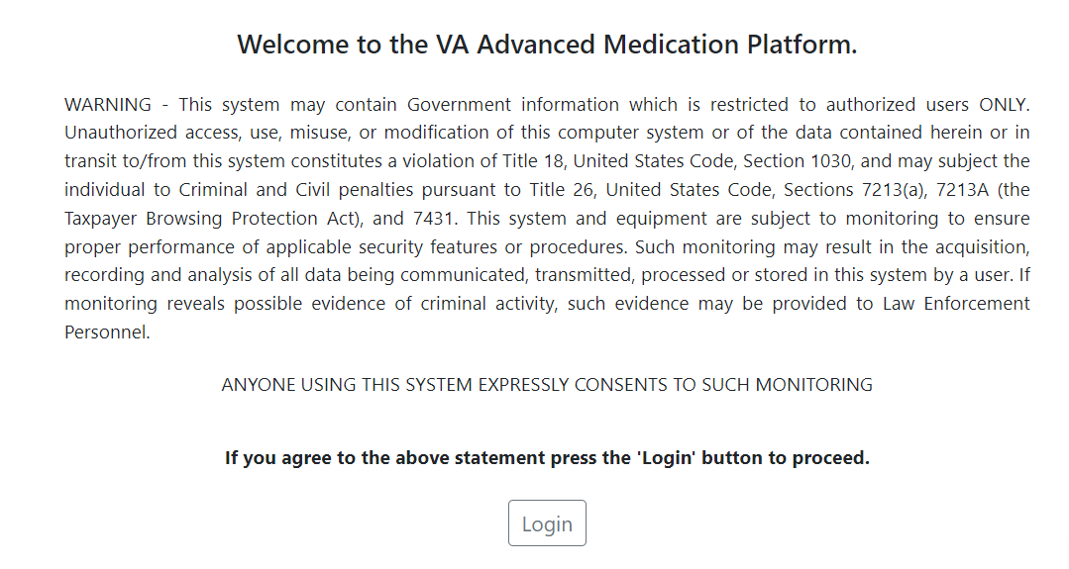
- After clicking Login, users are redirected to the VA SSOi page (see image below)
  - Click the Sign in with VA Personal Identity Verification (PIV) Card graphic
  - Select the appropriate certificate and click OK.
  - Enter your Personal Identification Number (PIN) and click OK.
  - If PIV card is unavailable, user can sign in with network credentials by clicking View Other Sign-in Options.
Figure 3: SSOi Page for VA Users
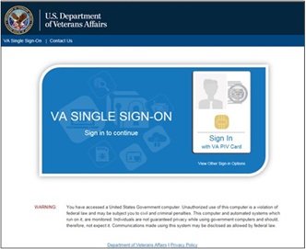
- A pop-up window will appear and require the user to enter their 3-digit Station #. This allows AMPL GUI to retrieve local data from the correct database. Previous station number will be retained if the computer is the same and cookies do not get cleared.
NOTE: If the user moves to another computer, they will have to re-enter the station number. Additionally, if the browser gets cleared of cookies and site data on a computer, then they will be prompted to re-select the station number again.
Figure 4: Set VistA Context
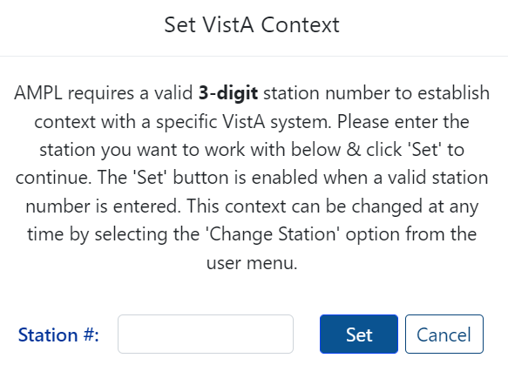
NOTE: Once logged in, the selected Station may be changed at any time by clicking the dropdown next to your username in the upper right-hand corner of the screen. See figure below:
Figure 5: Change Station
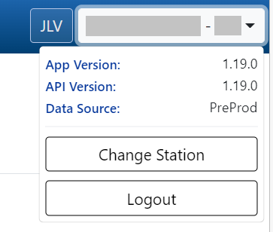
- Once logged in, The Pending Orders Manager Landing Page will display.
To view a specific patient record and be taken to the Patient Coversheet, select VistA Patient Lookup. Please refer to section 5: Patient Coversheet for additional information on search options. See figure below:
Figure 6: Pending Orders Manager Landing Page
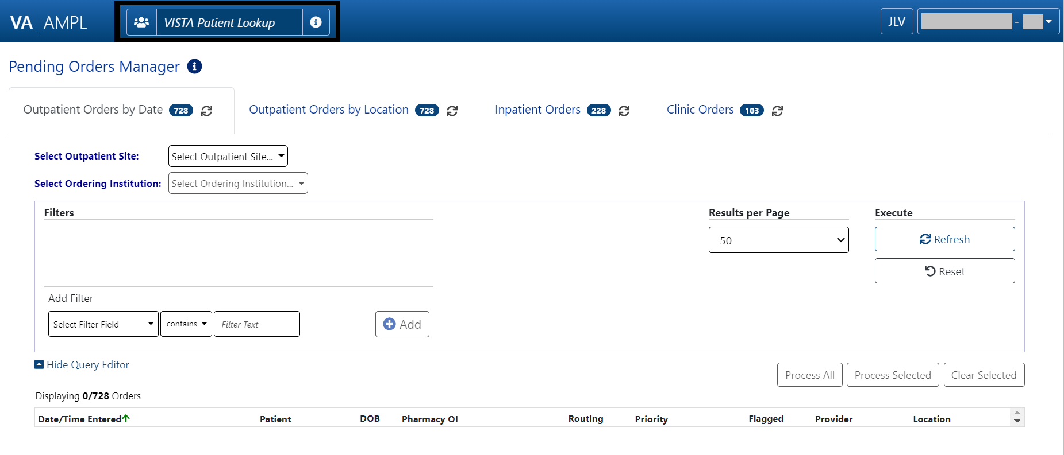

Pending Orders Manager Landing Page
This section describes in general terms, the AMPL GUI application screen first encountered by the user and navigation paths to functions noted on the screen.
On the Pending Orders Manager landing page, the tabs available to view the specific orders are Outpatient Orders by Date, Outpatient Orders by Location, Inpatient Orders and Clinic Orders. See figure below:
Figure 7: Pending Orders Manager Tabs
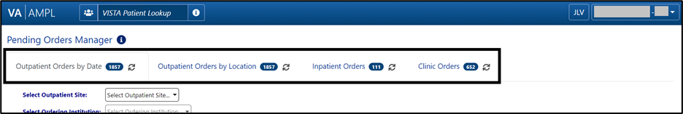
On each tab header there is a count of the number of orders currently pending at the station the user is signed into. Each tab may open with a filter and sort applied, which can be seen in the Current Query display. See figure below:
Figure 8: Current Query
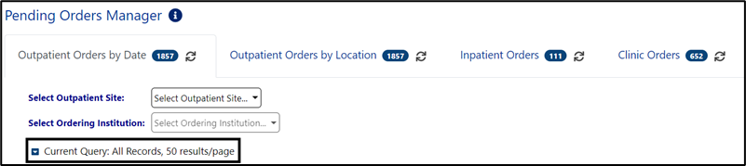
To reveal if a column is sortable, click the column header. If it is sortable, the icon will display. Repeatedly clicking the sortable column will toggle between ascending, descending then back to default. If more than 1 column is sorted, a small number by the arrow indicates the order. See figure below:
Figure 9: Column Sort Arrow
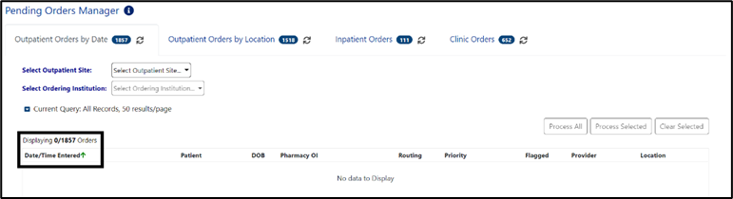

Selecting a Patient
Once a tab is selected and the Outpatient site, Ordering Institution, Ward group, Ward or Clinic is chosen, a list of patients with related pending orders will display. One or more patients may be selected from the list for processing. If multiple patients are selected, they will be added to the patient queue and their names will display at the bottom of the screen. See figure below:
Figure 10: Patient Queue
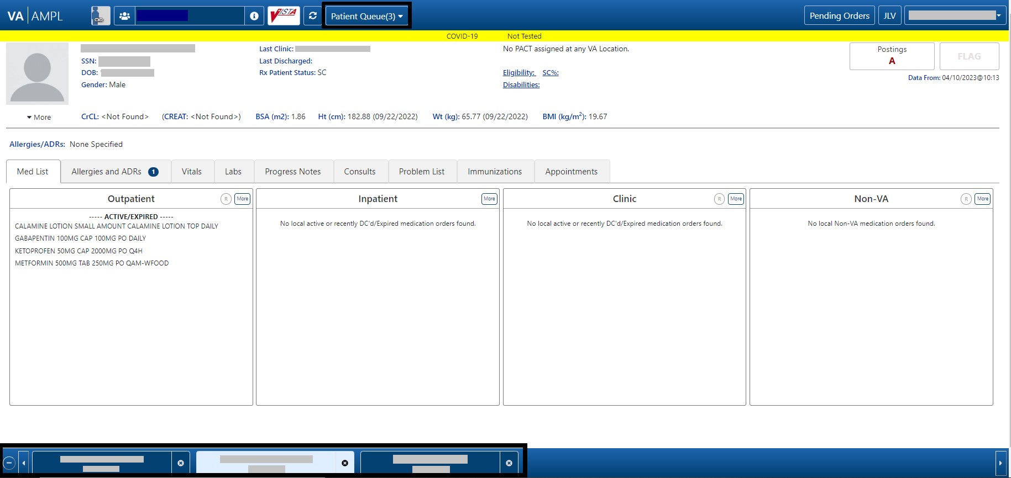
To find a patient not included in the Pending Orders Manager lists, use the VistA Patient Lookup box in the header. See figure below:
Figure 11: VistA Patient Lookup
For a list of available criteria that can be used for patient lookup, click the “i” Button to display Search Criteria Help. See figures below:
Figure 12: VistA Patient Lookup Info Button
Figure 13: Patient Lookup Search Criteria Help
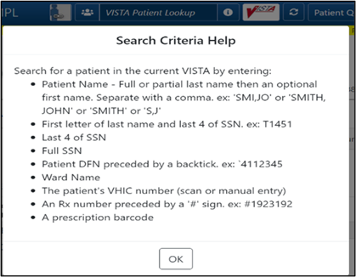
If a patient is selected in the VistA Patient Lookup box, the name will be added to the Patient Queue. Each additional patient(s) selected is added to the Patient Queue. The Queue is retained if the user toggles from Pending Orders Manager and back to the Coversheet. See figures below:
Figure 14: Patient Cover Sheet with Patient Queue List
Figure 15: POM Button Toggle to Coversheet and Retained in Patient Queue
The Patient Queue is cleared if user returns to the Pending Orders Manager page by changing stations or logging out of AMPL and logging back in. It is not retained in future sessions.

Outpatient Orders by Date
Outpatient Orders by Date is the default tab on the Pending Orders Manager page. To display orders, select a specific Outpatient Site from the dropdown menu. All sites related to the login facility will display. The total number of orders will be visible in the blue bubble in the tab, as well as a Refresh button to update the list. See figure below:
Figure 16: Outpatient Orders by Date Tab
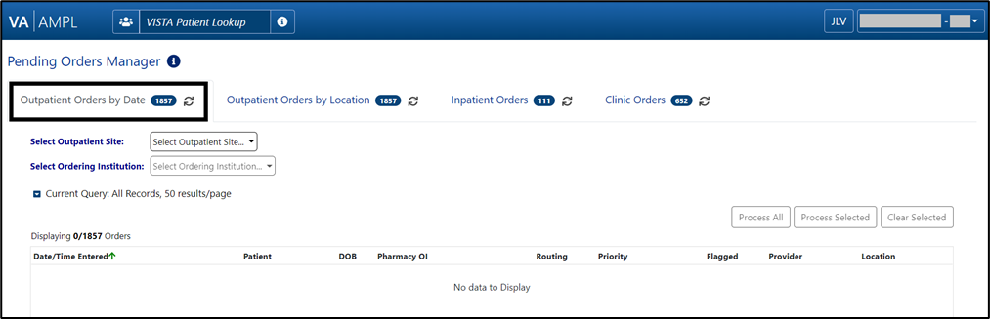
To change the Outpatient Site or Ordering Institution, click on the dropdown menu and all sites related to the login facility will display. See figure below:
Figure 17: Outpatient Orders by Date - Site Selection
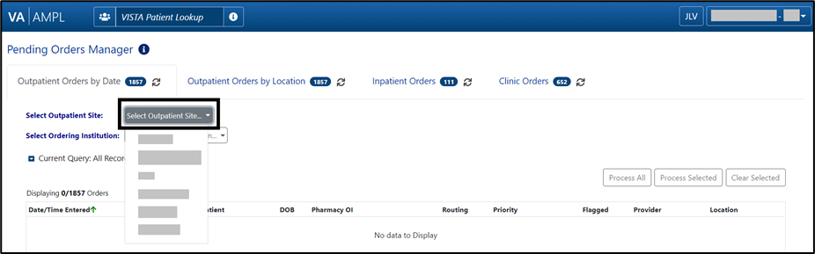
Once an Outpatient Site is selected, a chronological list of orders, oldest to newest is displayed, as well as an Order Aging Summary. Neither will display until the Outpatient Site is selected.
NOTE: Total number of orders and the Order Aging Summary counts will update if Ordering Institution is selected to further filter the orders.
Figure 18: Outpatient Orders by Date - Aging Summary
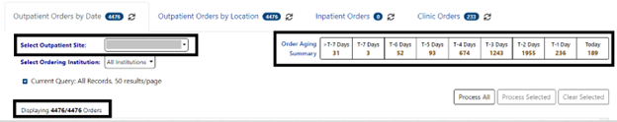
In the figure below, T-5 Days is selected, and the patient selection list will be filtered to only patients with orders from that date range.
This quick filter feature uses the same Reset button as all other query filters. For additional details, please refer to section 4.2.1: Query Editor
Figure 19: Outpatient Orders by Date – Aging Summary Quick Filter
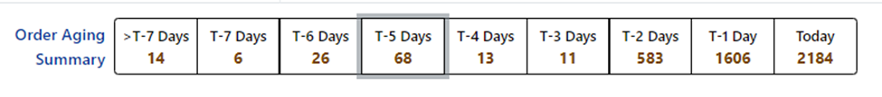
When an Outpatient Site is selected, the order display defaults to All Ordering Institutions or to the single Ordering Institution if the Outpatient site only has one. To further filter the orders for the site, select a specific Ordering Institution by using the dropdown menu and selecting from the list. See figure below:
Figure 20: Outpatient Orders by Date - Selecting an Ordering Institution
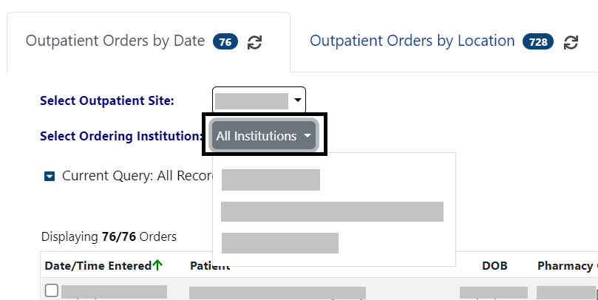
Once the Ordering Institution is selected, the orders for that institution will display in chronological order, oldest to newest. The display also includes the Order Aging Summary and the total number of orders for that Ordering Institution. See figure below:
Figure 21: Outpatient Orders by Date - Site and Institution Selected
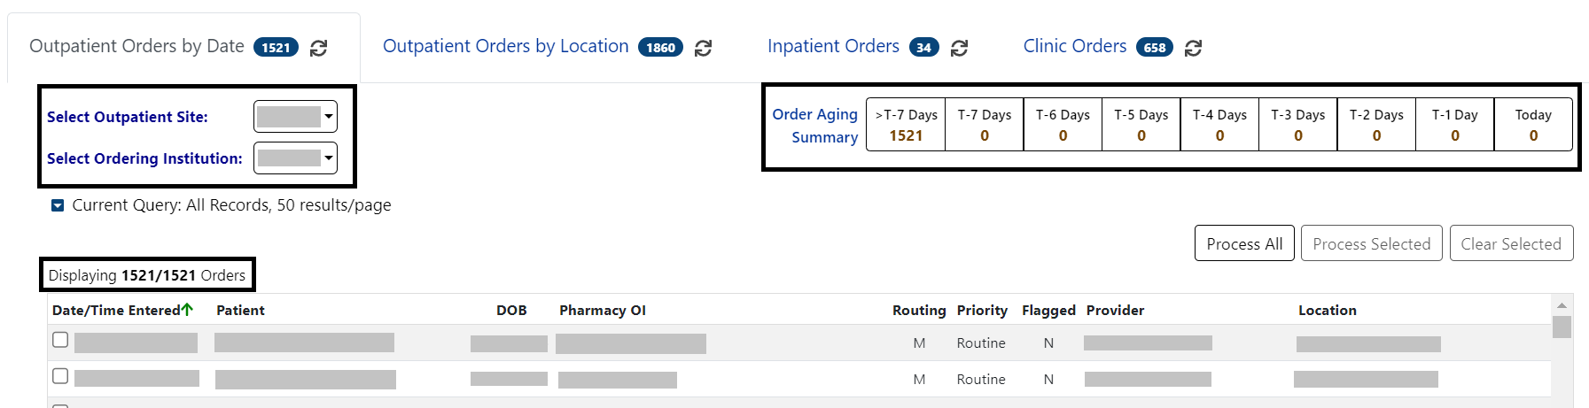
Orders will display for the patients who meet the criteria above.
The column headers include Date/Time Entered, Patient, DOB, Pharmacy OI, Routing, Priority, Flagged, Provider and Location. The default view includes All Records, 50 Results/page.
Figure 22: Outpatient Orders by Date - Patient List
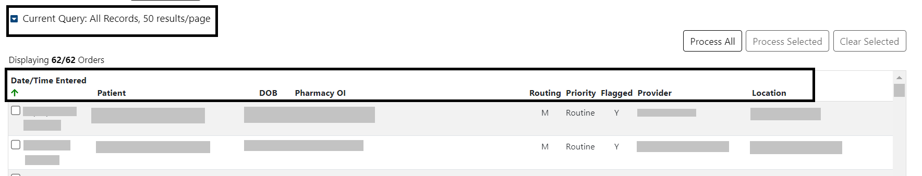
From the list of Orders, specific orders for one or more patients may be selected by checking the order(s) and the Process Selected button. The complete list of patients may be loaded by using the Process All button.

Query Editor
To filter this list before processing, open the Query Editor by clicking the arrow next to “Current Query” and select the criteria to use for further filtering by selecting from the Select Filter Field dropdown list. See figure below:
Figure 23: Outpatient Orders by Date - Query Editor Filters
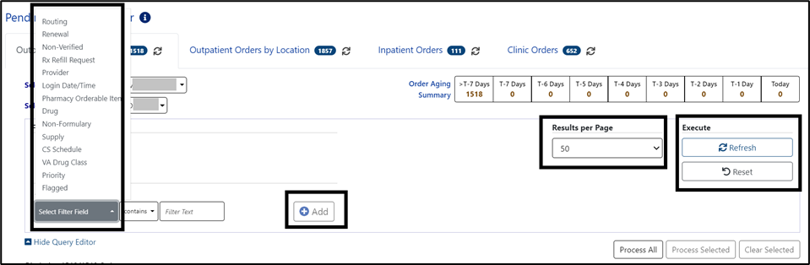
Continue building a filter by selecting from the dropdown list of operators “contains”, “is”, or “is not” as appropriate. For this example, Routing was selected, then the “is” operator was selected to further restrict output and “Window” was chosen as the Routing. See figure below:
Figure 24: Outpatient Orders by Date - Query Editor Filter
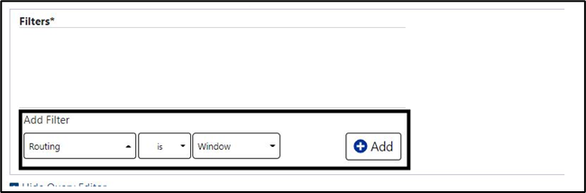
Click Add to have the filter added to the search criteria. Continue this process with other filters, as needed. Once completed, click on Refresh to update the display. To delete a filter, select the red “X” icon to the right of it. To clear filters added by the user and return to the tab’s default, click the Reset button. See figure below:
Figure 25: Outpatient Orders by Date - Query Editor Filter Applied
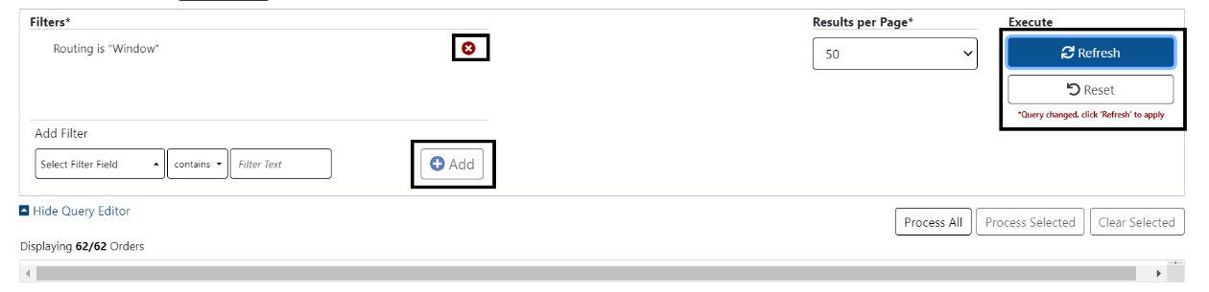
This filter reduced the results from 292 to 8.
Figure 26: Outpatient Orders by Date - Results of Query Filter Applied to List
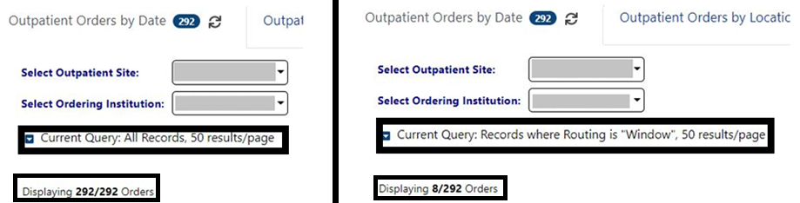
For some filters, default values are added to the operator and criteria. For example, if the Supply filter is chosen, the other fields default to “is” and “true”. See figure below:
Figure 27: Supply Filter - Defaults Other Fields
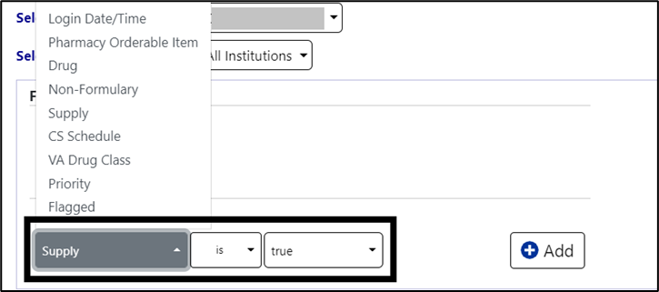
When the Provider filter is selected, the operator defaults to “is” and a dropdown list of providers is added. See figure below:
Figure 28: Provider Filter - Defaults
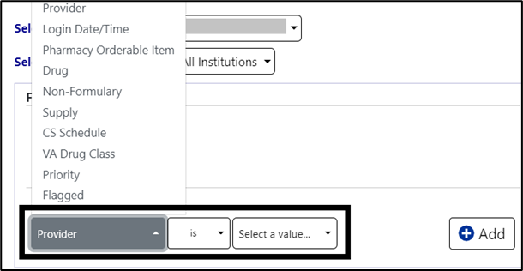
If a date filter is selected, a list of common date ranges is available by clicking the arrow to the left of the date field. See figure below:
Figure 29: Date Filter - Commonly Used Date Ranges
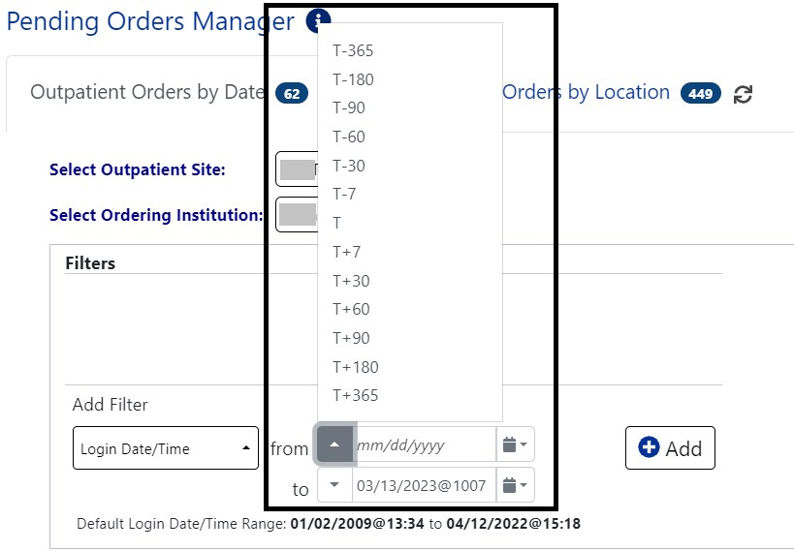
Help Text is available by hovering over the date box. This is a widely available feature throughout AMPL.
Figure 30: Query for Date Field Quick List
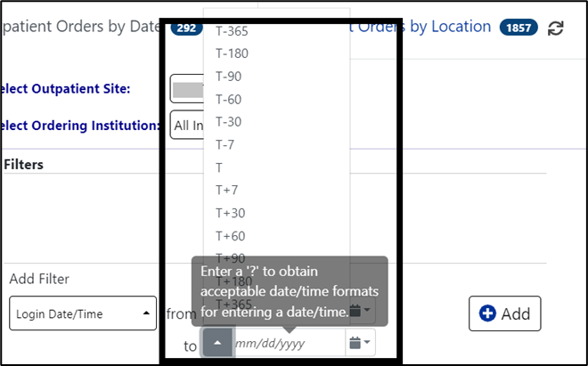

Outpatient Orders by Location
To display Outpatient Orders by Location, click on that tab from the Pending Orders Manager page, then select a specific Outpatient Site and Ordering Institution. The total number of orders will be visible in the blue bubble in the tab, as well as a Refresh button to update the list. See figure below:
Figure 31: Outpatient Orders by Location Tab
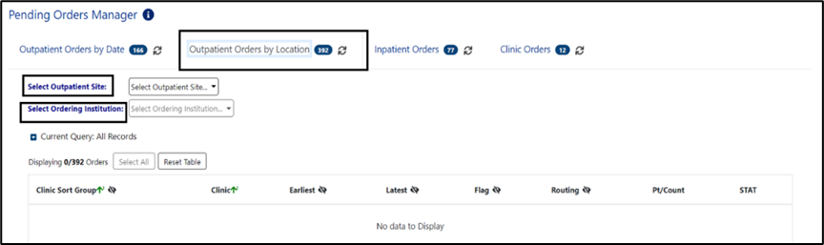
To select or change the Outpatient Site, click the dropdown menu and all sites related to the login facility will display. See figure below:
Figure 32: Outpatient Orders by Location - Site Selection
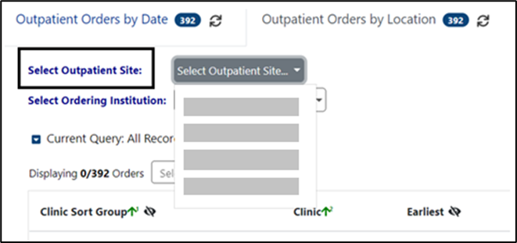
When an Outpatient Site is selected, the order display defaults to All Ordering Institutions. To further filter the orders for the site, select a specific Ordering Institution by using the dropdown menu and selecting from the list. See figure below:
Figure 33: Outpatient Orders by Location - Selecting an Ordering Institution
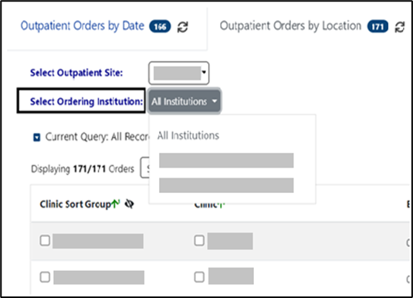
Once the Ordering Institution is selected, a list of orders for the location will display with the total number of orders. See figure below:
Figure 34: Outpatient Orders by Location - Site and Institution Selected
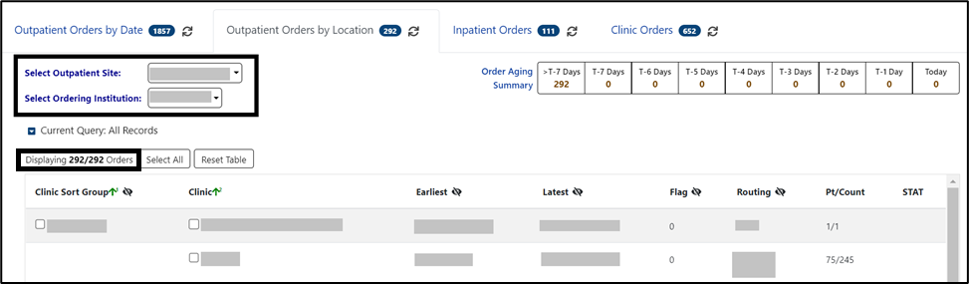
Some orders may display a STAT symbol in the last column. Hovering over the icon displays help text, “Indicates that there is at least one order for the clinic that has a priority of ‘STAT’, ‘ASAP (EMERGENCY)’ or has a schedule of ‘NOW’. See figure below:
Figure 35: Outpatient Orders by Location - STAT Symbol
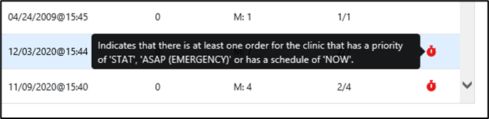
From this location list, orders may be processed for some or all locations. Selecting specific Clinic Group(s) or Clinic(s) adds the patients with orders from those clinics to the Select Patients(s) to Process list. The Select All button above the Clinic Group list adds all patients to the Patient(s) to Process list. A list of patients will display in the Select Patient(s) to Process list below the Location List. See figure below:
Figure 36: Outpatient Orders by Location - Clinic Selected
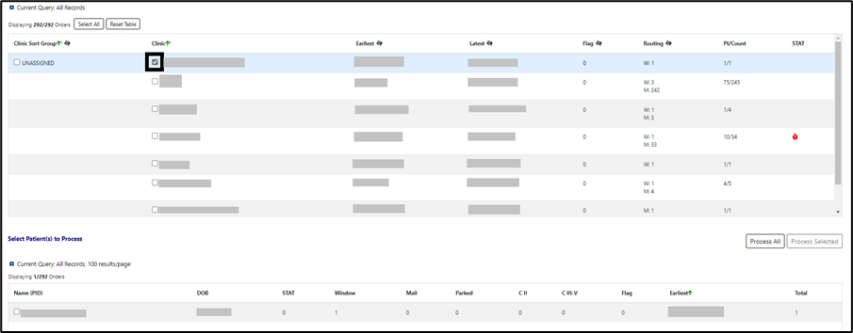
From the Select Patient(s) to Process List, select one or more patients and click the Process Selected button located above the Select Patient list at the top right. The Process All button adds all orders to the Patient Queue list for processing. See figures below:
Figure 37: Outpatient Orders by Location - Select Patient(s) to Process List
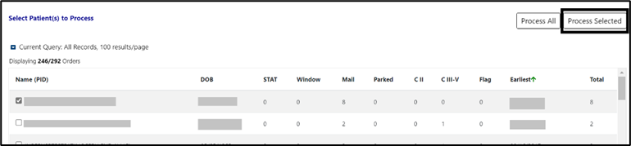
Figure 38: Outpatient Orders by Location - Process All Button
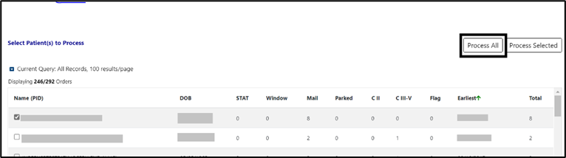
On the Outpatient Orders by Location Tab, there are two places to filter the list, the Group(s) and Clinic(s) section and the Patient(s) to Process section. The process is the same to modify both queries.
To filter the Orders list before processing, open the Query Editor by clicking on the arrow next to “Current Query” and selecting additional criteria from the Select Filter Field dropdown list. See figure below:
Figure 39: Outpatient Orders by Location - Query Editor Filters
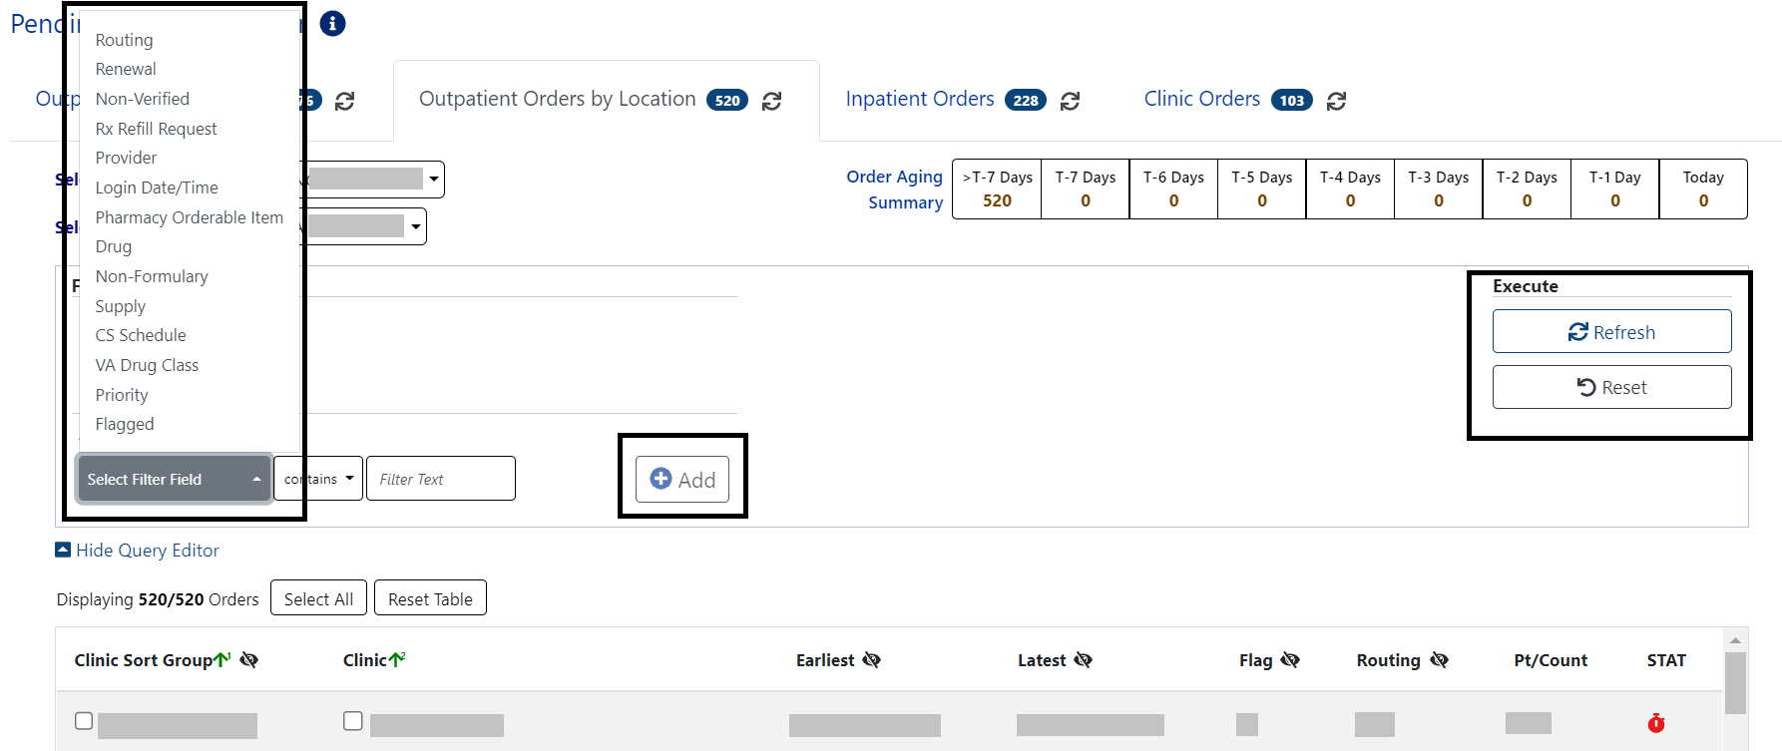
Choosing a field allows filtering by selecting from the dropdown list of operators “contains”, “is”, or “is not” as appropriate. For this example, Drug was selected, then the “is” operator was selected to further restrict output. See figure below:
Figure 40: Outpatient Orders by Location - Query Editor Filter Operators
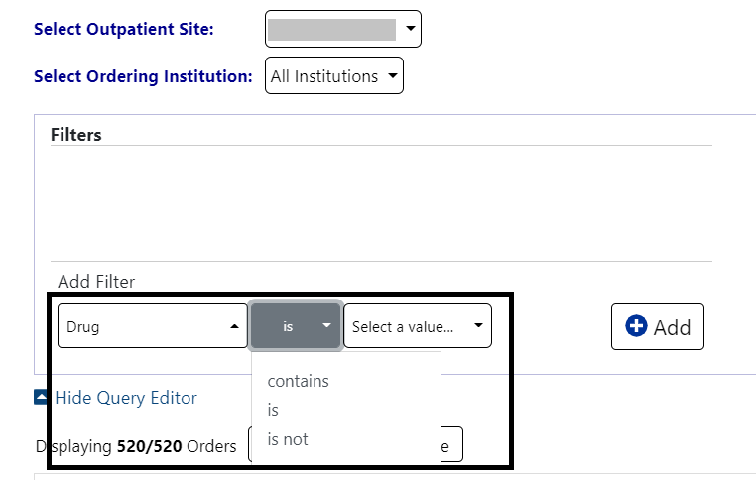
Next, click on the “Select a value” dropdown and a list of the available drugs with check boxes will display. Only drugs in the orders are displayed, not the entire drug file list. See figure below:
Figure 41: Outpatient Orders by Location - Query Editor Filters Drug Selected
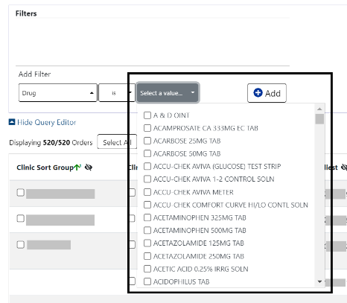
Multiple drugs can be selected from the list. Once finished, click Add to have the filter added to the search criteria. See figure below:
Figure 42: Outpatient Orders by Location - Query Editor Search Criteria
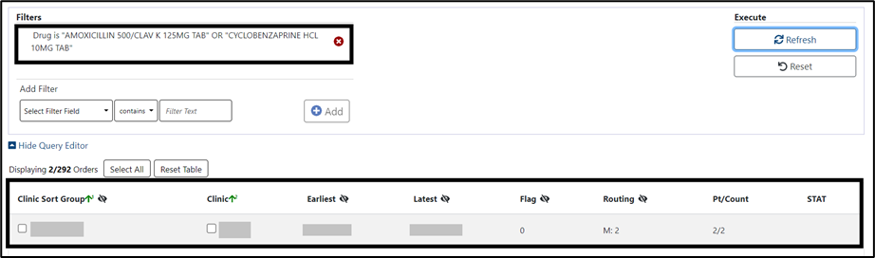
Other filters may be added as needed. When finished, click on Refresh to update the display. To delete a filter, select the red “X” icon to the right of it. To clear filters/sorts added by the user and return to the tab’s default, click the Reset button. See figure below:

Figure 43: Outpatient Orders by Location - Query Editor Delete Icon
Queries can be set at both the Location and Patient Level.
To add a query at the patient level, select the query editor box in the Select Patient(s) to Process section. Build the filter using the process described above. In this example, the Patient List will be filtered by Priority. To filter the patient list, open the Query Editor by clicking on the arrow next to “Current Query” and selecting additional criteria from the Select Filter Field dropdown list. When the filter is completed, click Add to have the filter added to the search criteria. To apply filters in one or both sections, click the Refresh button in that section. See figure below:
Figure 44: Outpatient Orders by Location - Patient Filter
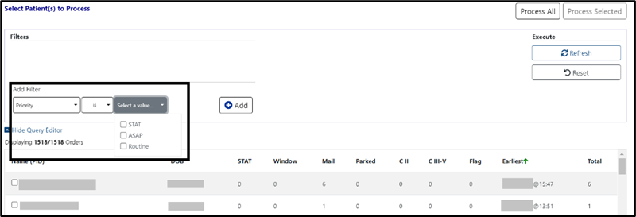

Inpatient Orders
When the Inpatient Orders tab is selected from the Pending Orders Manager page, choose a Division. The total number of orders will be visible in the blue bubble in the tab, as well as a Refresh button to update the list. See figure below:
Figure 45: Inpatient Orders Tab
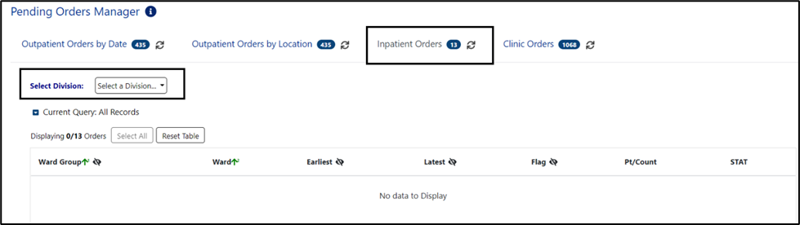
To select or change the Division, click on the dropdown menu to display a list of Divisions. Once a Division is selected, the ward group(s) or wards with pending Inpatient Orders will display. An Order Aging Summary is also included. If all pending inpatient orders are less than 1 hour old, the Order Aging Summary will show 0 orders in all columns. See figures below:
Figure 46: Inpatient Orders - Division Selection
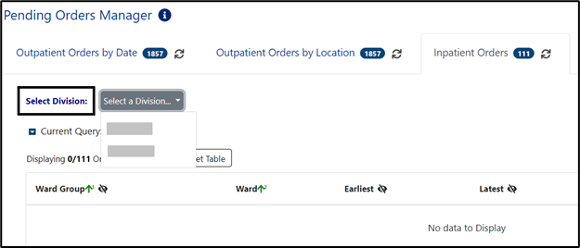
Figure 47: Inpatient Orders - Division Selected
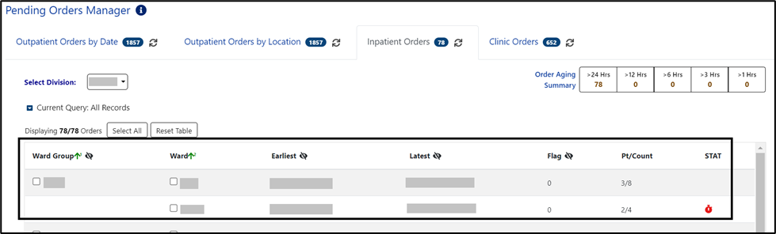
From this list, the user may select a Ward Group, ward or the Select All button. This will populate a list of patients in the Select Patient(s) to Process list. See figure below:
Figure 48: Inpatient Orders - Ward Group Selected
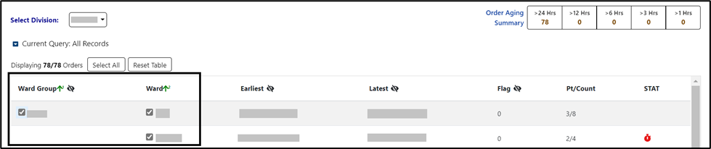
From the Select Patient(s) to Process list, one or more patients may be selected by checking the patient’s name(s) and the Process Selected button. The complete list of patients may be loaded by using the Process All button. See figure below:
Figure 49: Inpatient Orders - Select Patient(s) to Process List
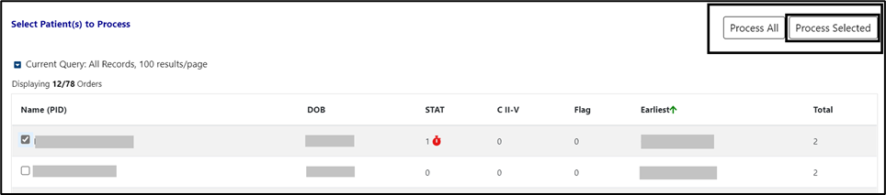
To further filter this list before processing, open the Query Editor by clicking on the arrow next to “Current Query”. Select the criteria for further filtering from the Select Filter Field dropdown list. See figure below:
Figure 50: Inpatient Orders - Query Editor Filters
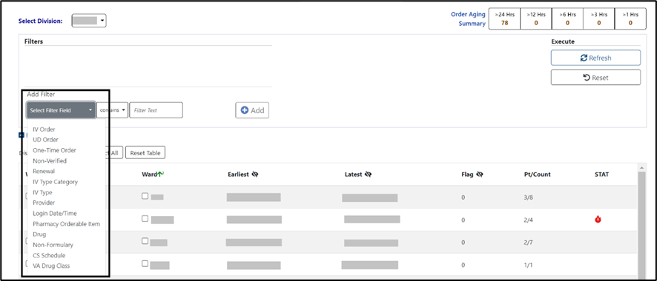
Continue building a filter by selecting from the dropdown list of operators “contains”, “is”, or “is not” as appropriate. For this example, Drug was selected, then the “is” operator was selected to further restrict output. See figure below:
Figure 51: Inpatient Orders - Query Editor Filter Applied
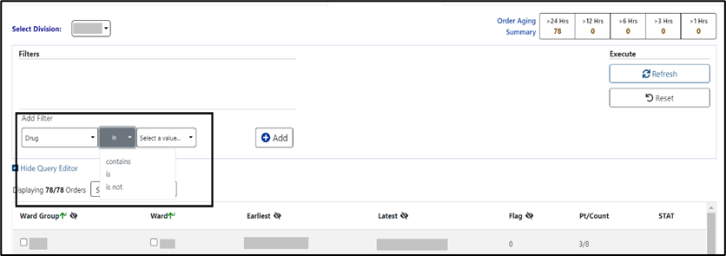
Next, click on the “Select a value” dropdown and a list of the available drugs with check boxes will display. Only drugs in the orders are displayed, not the entire drug file list. See figure below:
Figure 52: Inpatient Orders - Query Editor Filters Drug Value
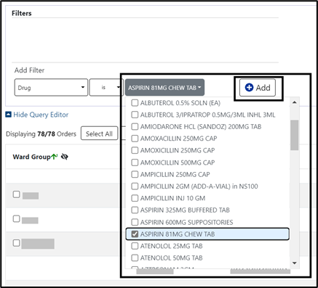
Multiple drugs may be selected from the list. Click Add to have the filter added to the search criteria. See figure below:
Figure 53: Inpatient Orders - Query Editor Search Criteria
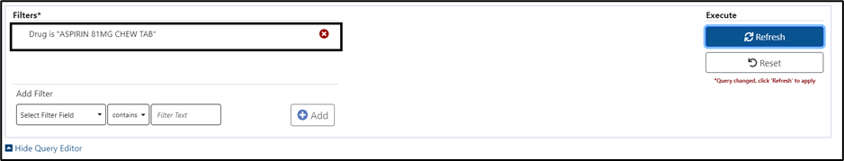
Continue this process with other filters as needed. When finished, click on Refresh to update the display. To delete a filter, select the red “X” icon to the right of it. To clear filters/sorts added by the user and return to the tab’s default, click the Reset button. See figure below:
Figure 54: Inpatient Orders - Query Editor Delete Icon
The list may be filtered at the Ward Group level or the Select Patient(s) to Process level.

Clinic Orders
When the Clinic Orders tab is selected from the Pending Orders Manager page, choose a Division. The total number of orders will be visible in the blue bubble on the tab, as well as a Refresh button to update the list. See figure below:
Figure 55: Clinic Orders Tab
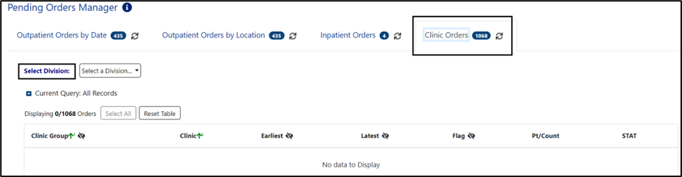
To select or change the Division, click on the dropdown menu, it will display a list of Divisions. Once the Division is selected, the Clinic Group(s) and Clinic(s) associated with that Division will display. See figures below:
Figure 56: Clinic Orders - Select Division
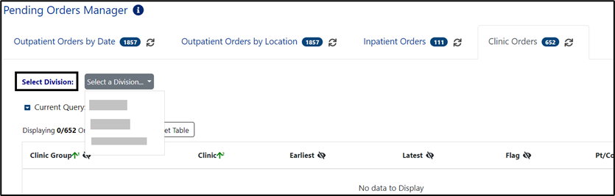
Figure 57: Clinic Orders - Division Selected
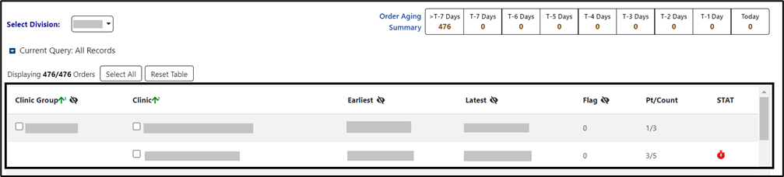
From this list, orders can be processed by selecting a Clinic Group, Clinic or the Select All button. The Select Patient(s) to Process list will populate with patients who have pending orders from the clinic(s) selected. See figure below:
Figure 58: Clinic Orders - Clinic Group Selected
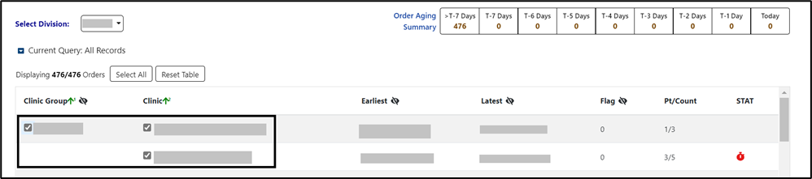
Both the Clinic group and Select Patient(s) to Process lists may be further filtered using the Query Editor. To filter the list before processing, open the Query Editor for either the Clinic Group or Select Patient(s) to Process sections by clicking on the arrow next to “Current Query” in that section and choose the criteria to use by selecting from the Select Filter Field dropdown list. Additional filters may be added. See figure below:
Figure 59: Clinic Orders - Query Editor Filters
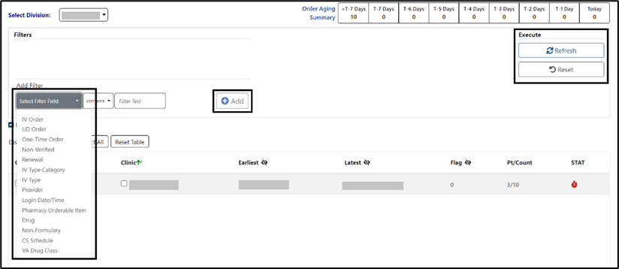
From the Select Patient(s) to Process list, one or more patients may be selected by checking the box in front of patient’s name and processed by clicking the Process Selected button. The cover sheet will open for the first patient chosen and other patients selected will be added to the Patient Queue. To add all the patients to the Patient Queue, select the Process All button. See figure below:
Figure 60: Clinic Orders - Select Patient(s) to Process List
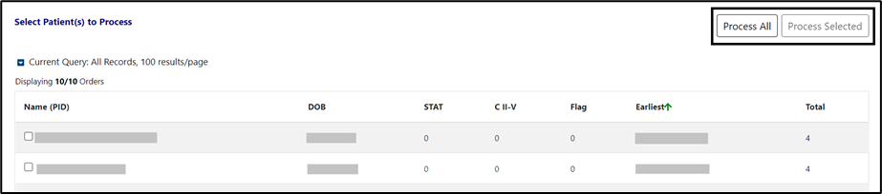

Patient Coversheet
Once a patient has been selected, the Patient Coversheet displays with a header, footer, patient banner and Tabs for domains, where the patient may have data stored. See figure below:
Figure 61: Patient Coversheet
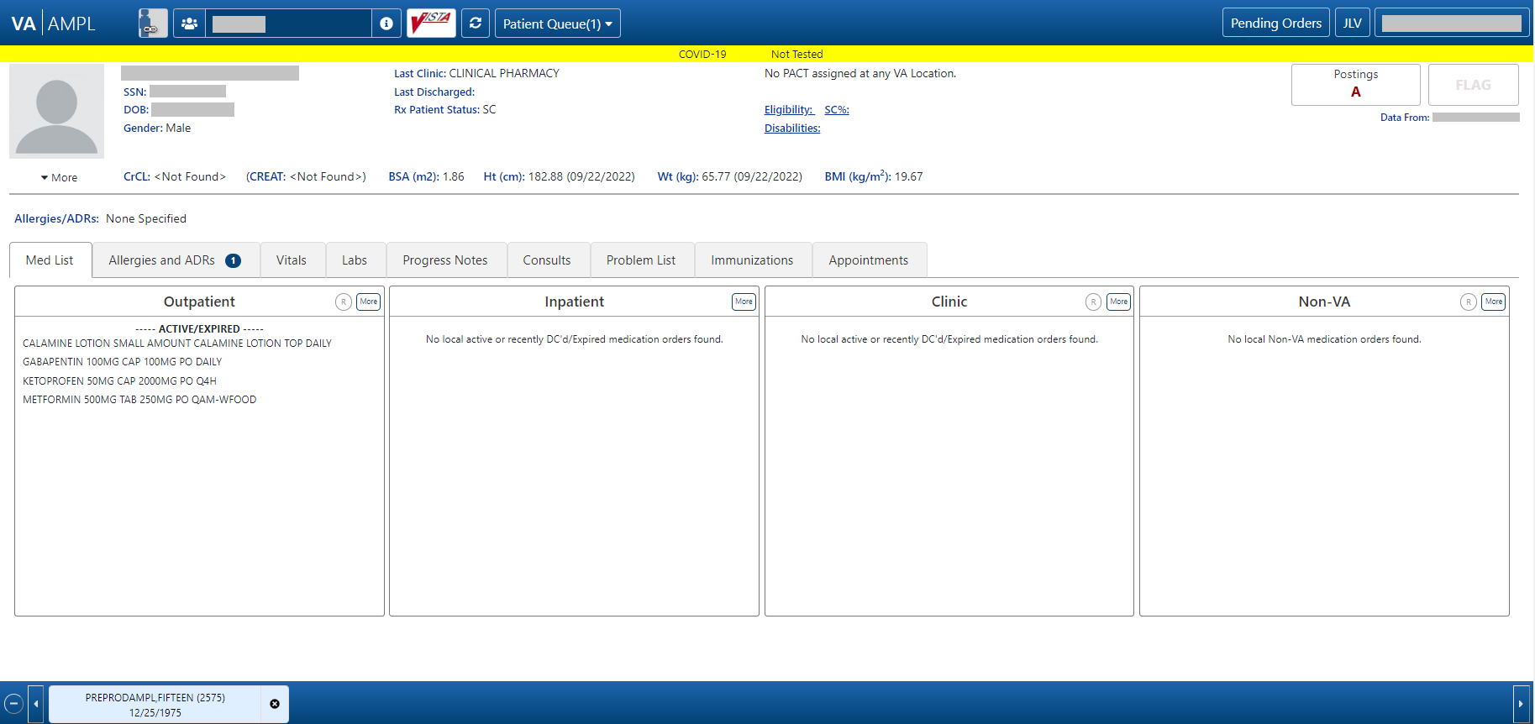

NOTE: Like VistA and CPRS, new changes made to patient data after the patient’s record is accessed in AMPL (entering a new order, discontinuing an active order) are not seen until the patient is refreshed. See figure below:
In AMPL, the Refresh button is used
In CPRS, the File/Refresh Patient Information is used
In VistA, close the patient in a backdoor pharmacy option and open the patient again
Figure 62: Refresh Patient Data

Patient Banner
The patient banner with Covid-19 testing status, basic demographics, Creatinine Clearance, most recent Serum Creatinine lab result, Body Surface Area (BSA), Height, Weight, Body Mass Index (BMI) and Allergies/ADRs displays on the Coversheet. It also displays on all pages of the patient’s record.
Basic patient demographics included in the patient banner are Patient Name, Social Security Number (SSN), Date of Birth (DOB), Gender, Last Clinic, Last Discharge, RX Patient Status, PCMM info, Eligibility, Service Connection % and Disabilities. See figure below:
Figure 63: Patient Banner
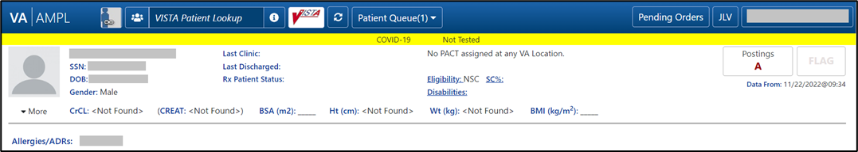
Figure 64: Covid-19 Testing Status
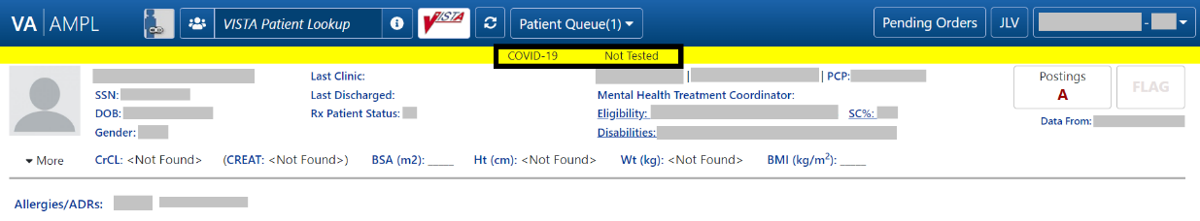
NOTE: To update a patient record, a Reload button is available. See figure below:
Figure 65: Patient Reload Button
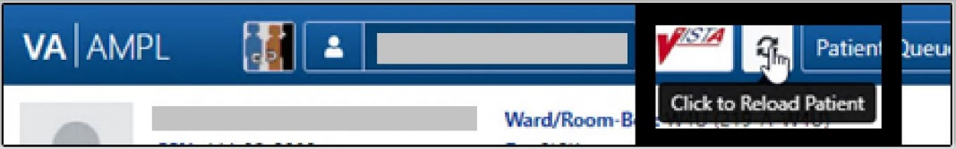

Patient Detailed Demographics
In addition to the basic demographics on the Patient Coversheet, additional detailed Patient Demographic information can be accessed and viewed by selecting the More button in the patient header or on the patient picture. See figure below:
Figure 66: Patient Information Banner
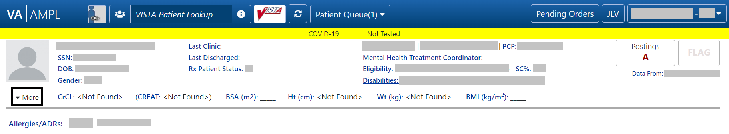
The expanded view will display tabs that contain additional information on Contact Info, Pharmacy Info, Eligibility, Social, Primary Care, Clinic Info, Military Service, and Health Plans/Insurance. See figure below:
Figure 67: Patient Demographic - Details
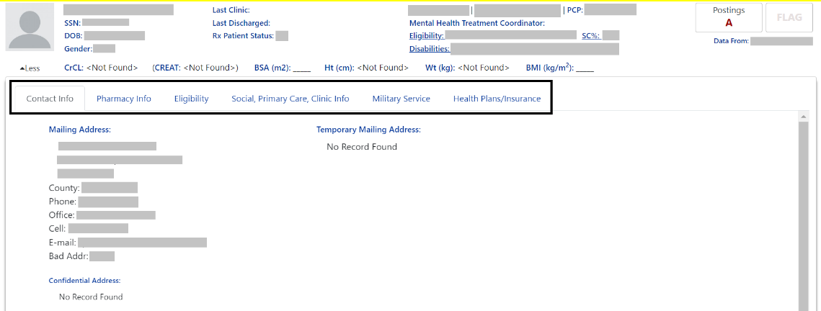
The Contact Info tab includes Permanent Mailing Address, Temporary Mailing Address, Confidential Address, Emergency Response Indicator, Emergency Contact Information, Next of Kin Information, Language, Date/Time, Preferred Language, and Confidential Address Categories. See figure below:
If a patient has been seen at multiple facilities, the Emergency Response Indicator will be displayed from the last facility where the patient was treated.
Figure 68: Contact Info Tab
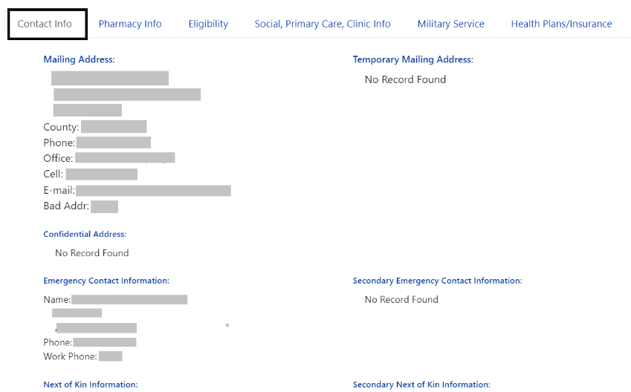
The Pharmacy Info tab includes CAP, Mail, Dialysis Patient, CNH Current, Nursing Home Contract, Respite Patient Start Date, Other Language Preference, Remarks, Inpatient/Outpatient Narrative, Mail Status Expiration Date, Patient Rx Status, Community Nursing Home, Last Date of Contract, Respite Patient End Date, and PMI Language Preference. See figure below:
Figure 69: Pharmacy Info Tab
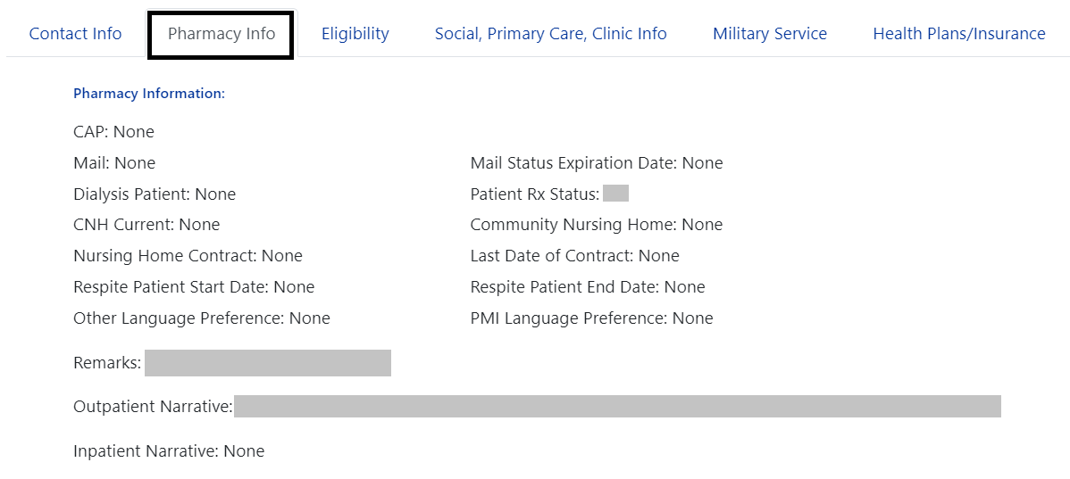
The Eligibility tab includes Combat Vet Status, Unemployable, Permanent & Total Disabled, Current Means Test Status, Medication Copayment Exemption Status, Rx Patient Status, Primary Eligibility, SC Percent, Rated Disabilities and Environmental Factors. See figure below:
If a patient has been seen at multiple facilities, the following eligibility data will be displayed from the last facility where the patient was treated:
• Current Means Test
• Copay Income Exemption Status
• Primary Eligibility
• Service-Connected
• Service-Connected Percentage
• Environmental Factors (Agent Orange, Radiation, Persian Gulf, Head Neck Cancer (HNC), and Military Sexual Trauma (MST))
Figure 70: Eligibility Tab
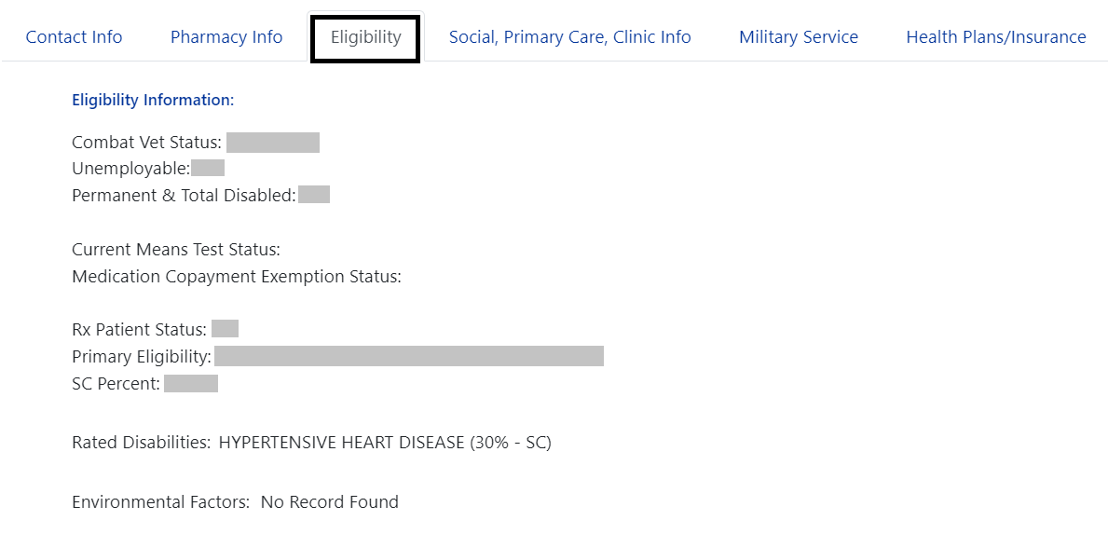
The Social, Primary Care, Clinic Info tab includes Marital Status, Race, Ethnicity, Religious Preference, Method of Collection, Inpatient Attending, Inpatient Provider, Currently enrolled in clinics, and Future Appointments. Primary Care information for patients who are currently admitted includes local Inpatient Attending and Inpatient Provider with Remote site’s PACT and Primary Care Provider with phone number. For Outpatients, it includes local and remote sites’ PACT and Primary Care Provider with phone number. See figure below:
Figure 71: Social, Primary Care, Clinic Info Tab
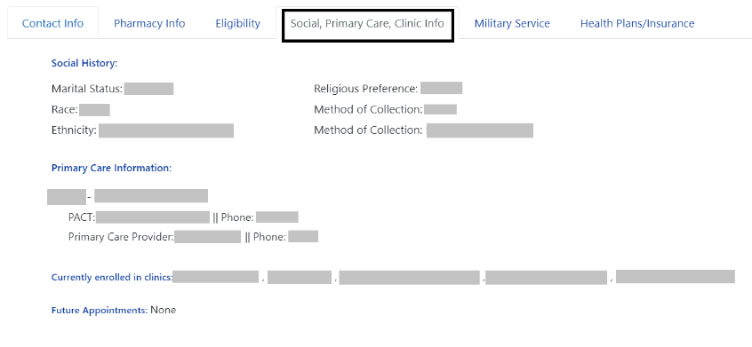
The Military Service tab includes a Service Branch/Component table including the Service #, Entered, Separated, and Discharge. Additional information displays including Conflict Locations, Environmental Factors, Prisoner of War (POW) including From/To, Combat including From/To, War, Location, Military Disability Retirement, Discharge due to Disability, Dental Injury, Teeth Extracted, Purple Heart, and Purple Heart Status. See figure below:
If a patient has been seen at multiple facilities, the following military data will be displayed from the last facility where the patient was treated:
- Military service episodes
- Military conflict locations (Vietnam, Lebanon, Grenada, Panama, Persian Gulf, Somalia, and Yugoslavia)
- Military POW information
- Military Combat information
- Military Service Environmental Factors (Agent Orange, Radiation, Persian Gulf, Head Neck Cancer (HNC), and Military Sexual Trauma (MST))
- Purple Heart information
Figure 72: Military Service Tab
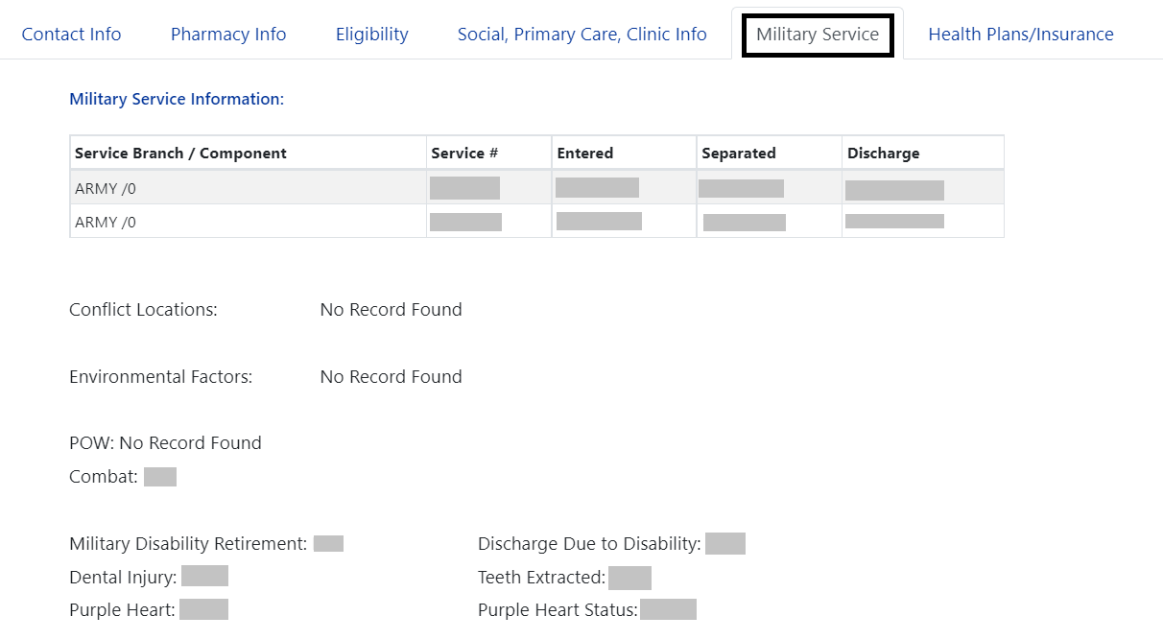
The Health Plans/Insurance tab includes Health Benefit Plans Currently Assigned to Veteran and a Health Insurance Information table including the Insurance name, Phone Number, Subscriber ID, Group, Holder, Effective date, and Expiration date. See figure below:
Figure 73: Health Plans/Insurance Tab
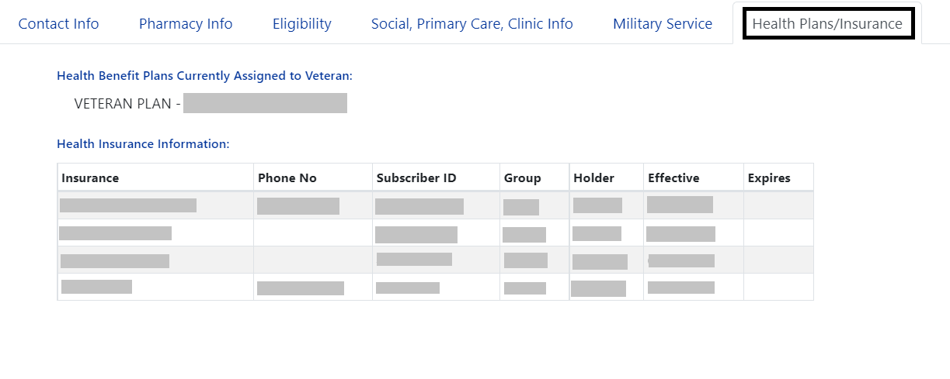
For additional Primary Care information, click on the Primary Care Provider (PCP) information and a pop-up window will display. For an outpatient, local and remote PACT and Primary Care provider information displays. If patient is currently admitted, the display includes Inpatient Attending and Inpatient Provider. See figures below:
Figure 74: Primary Care Team Information
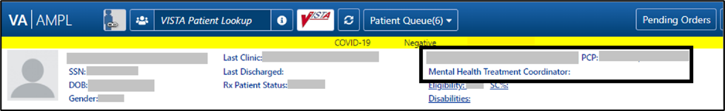
Figure 75: Primary Care Details - Outpatient
Figure 76: Primary Care Details - Inpatient
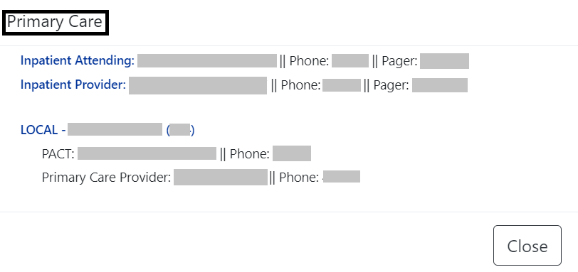

If a user makes changes to only patient demographics information in VistA, those changes will not be reflected in VDIF or AMPL. Patient demographics by themselves do not trigger propagation of data to VDIF.
When other changes are made for the patient that will trigger data propagation from VistA to VDIF, patient demographics changes will also be propagated to AMPL. Examples of data that will trigger propagation are addition of a medication order or allergy or a status change of a medication order or allergy.

Patient Banner Allergies/Adverse Reactions (ADRs)
As part of the patient banner, details of an Allergy/ADR listed can be viewed by selecting the entry without having to go into the Allergy/ADR tab to find the record(s). See figure below:
Figure 77: Allergies/ADRs Listed in Patient Banner
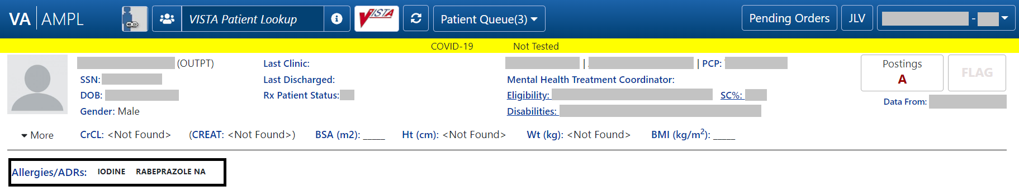
Figure 78: Allergy Banner Pop-Up Window
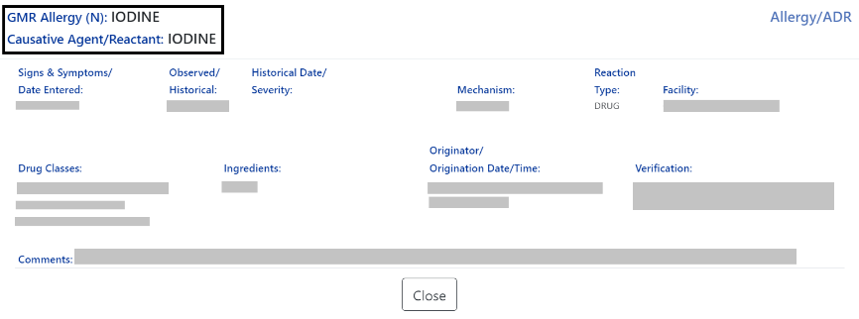
The Allergy/ADR window information lists the GMR Allergy with identifier of the originating file, Causative Agent/Reactant, Signs & Symptoms/Date Entered, Observed/Historical, Observation/Historical Date/Severity, Mechanism, Reaction Type, Facility, Drug Classes, Ingredients, Originator/Origination Date/Time, Verification, and Comments.
The GMR Allergy identifier is determined by the file source of the allergen as shown in the table below:

Table 1: Allergy Identifier
Identifier | Originating File | VistA File Name/Number
N | National Drug file, Generic name | VA GENERIC file (#50.6)
N | National Drug file, Trade name | NDC/UPN file (#50.67)
A | VA Allergies file | GMR ALLERGIES (#120.82)
C | VA Drug Class | VA DRUG CLASS (#50.605)
I | Ingredients | DRUG INGREDIENTS (#50.416)

Crisis, Warnings, Allergies, and Directives (CWAD) Postings
The Crisis, Warnings, Allergies, and Directives (CWAD) Postings button, contained in the header of the AMPL GUI application coversheet, will display only applicable letters from CWAD if the patient record contains any critical information. The CWAD postings are signed/completed progress notes for a patient and the posting letters are:
“C” represents Crisis Notes and is cautionary information about critical behavior or patient health (i.e., suicide attempt).
“W” represents Warning Notes and are notifications that inform about possible risks associated with the patient (i.e., violent patient)
“A” represents any Allergy/ADR that is recorded for the patient or if no allergy assessment has been performed for the patient.
“D” represents Directives (advanced directives) and recorded agreements made by the patient and/or family with clinical staff (i.e., Do Not Resuscitate [DNR]).
If the record does not contain any postings, the CWAD Posting button will be labeled ‘No Postings’.
If the record contains No Known Allergies (NKA), the CWAD button will say ‘No Posting’ however when you click on the CWAD button it will display ‘No Known Allergies’ on the top half of the posting window.
See figures below:
Figure 79: Postings Buttons - Indicating Critical Information
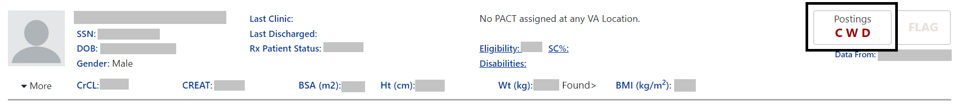
Figure 80: Postings Buttons - Indicating No Postings
If letters are shown, indicating postings, click on the Posting button and a list will appear in a pop-up window. See figure below:
Figure 81: CWAD - List Window
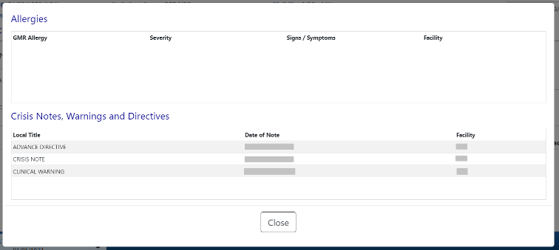
The information under Allergies includes GMR Allergy, Severity, Signs/Symptoms, and Facility. The information under Crisis Notes, Warnings, and Directives includes Local Title, Date of Note, and Facility.
For more detail on any of the postings, click on the individual listing in the CWAD list window, and more information will display. The information displayed includes Standard Title, Report Text, Date of Note, Exp Signer, Status, Signed By, Entry Date, Exp Cosigner, Facility/Locations, Signature Date/Time, Author, Urgency, Signature Block Name and Signature Block Title. See figure below:
Figure 82: CWAD - Detailed Display
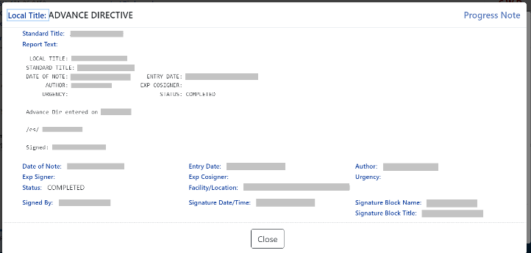

Patient Domain Tabs
Below the Patient header, data is organized under domain tabs. These tabs include Med List, Allergies and ADRs, Vitals, Labs, Progress Notes, Consults, Problem List, Immunizations, and Appointments.
Figure 83: Patient Data Domain Tabs
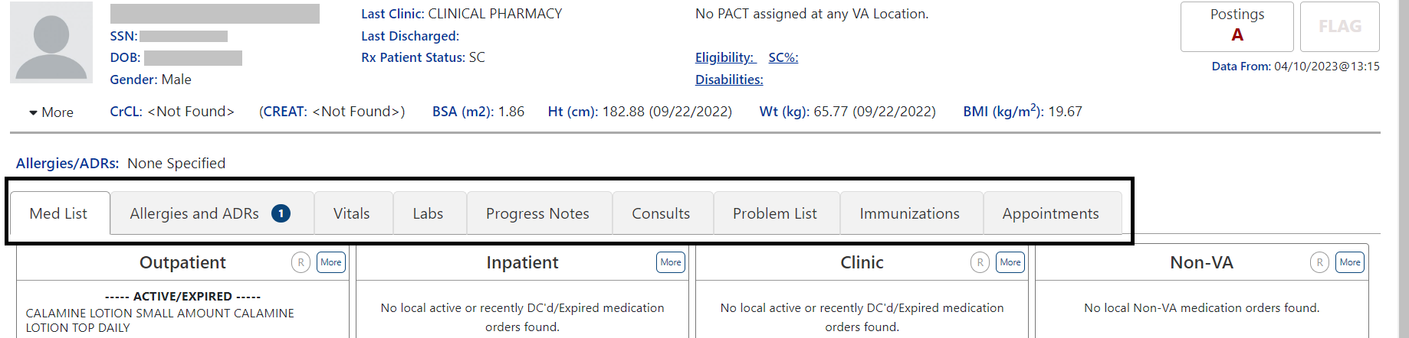

Med List Tab
The Med List Tab displays med orders for Outpatient, Inpatient, Clinic, and Non-VA. See figure below:
Figure 84: Med List Tab
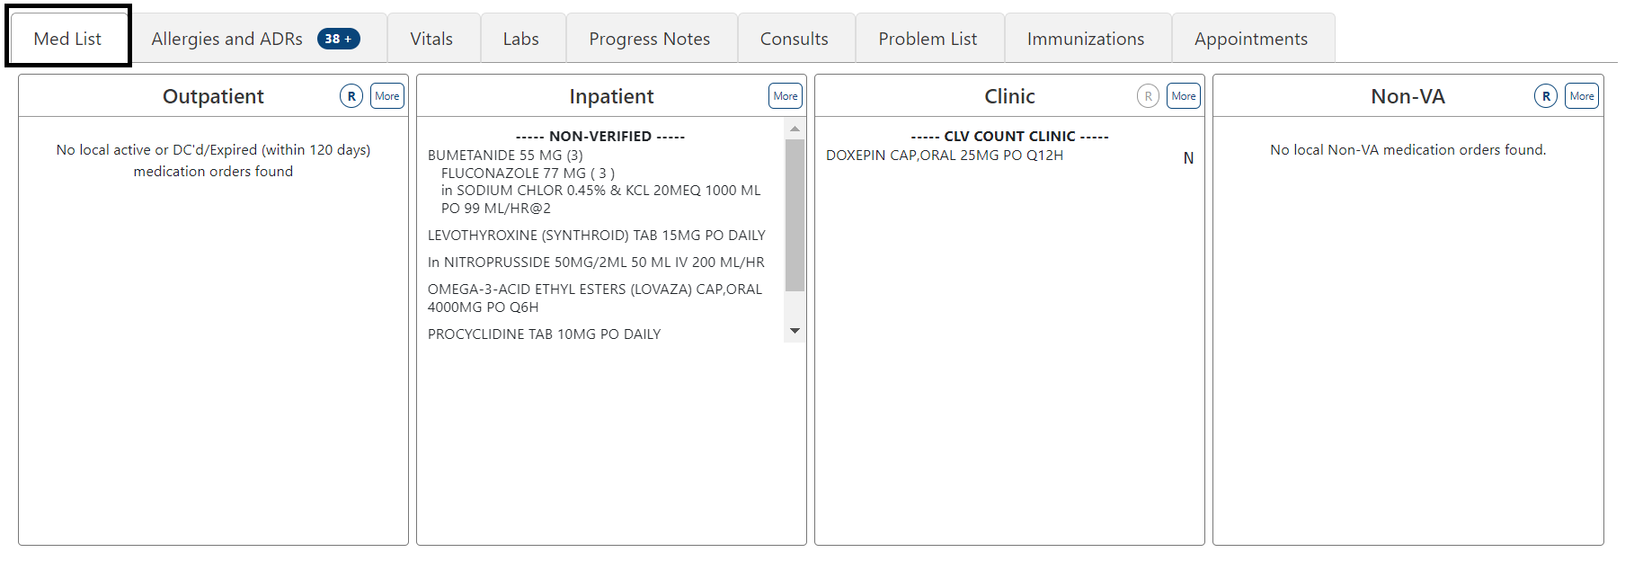

Outpatient Med List
The Outpatient Med list displays Active/Expired, Non-verified, Pending orders. The medications included in the discontinued and expired categories are determined by RECENTLY DC’D/EXPIRED DAYS Field (#3.2) in the OUTPATIENT SITE (#59) File.
Figure 85: Outpatient Med List
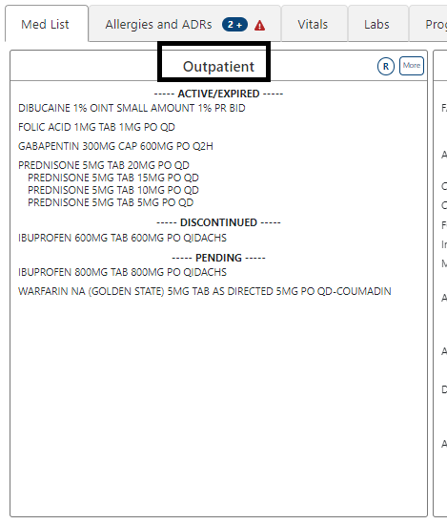
To include Remote clinic orders, click on the Remote Orders (R) button in the Non-VA header. If Remote button is disabled, it indicates patient does not have remote orders. See figures below:
Figure 86: Outpatient Med List - Remote Orders Button
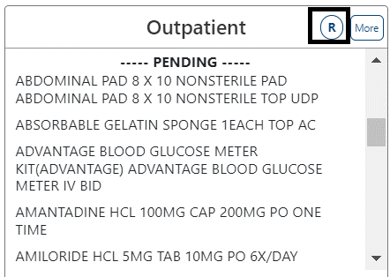
Figure 87: Outpatient Med List - Remote Orders
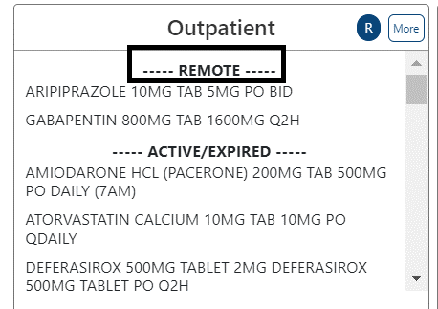

Outpatient Med List - Expanded View
The More button will bring up the Expanded View. See figure below:
Figure 88: Outpatient Med List - More Button
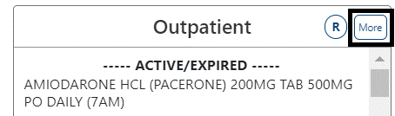
The Expanded view displays additional details, including RX#, Generic Drug Name, Dosage, Route, Schedule/(Duration), Issue Date, Quantity, Days’ Supply, Route, Refills (total and remaining), Last Fill Date, Status and Provider. See figure below:
Figure 89: Outpatient Med List - Expanded View
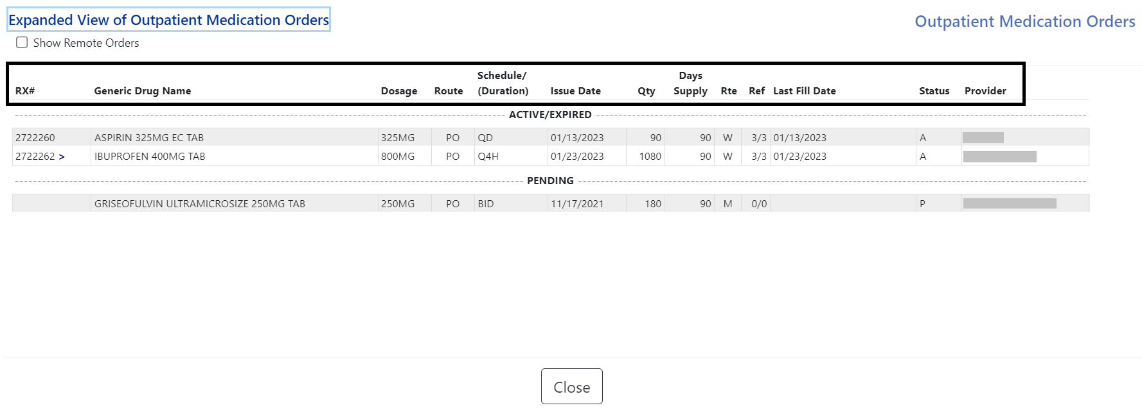

Outpatient Med List – Expanded View Help Text
Help text for each column of the Expanded View of Outpatient Med Orders is displayed by hovering over the column header. See figure below:
Figure 90: Outpatient Med List - Help Text
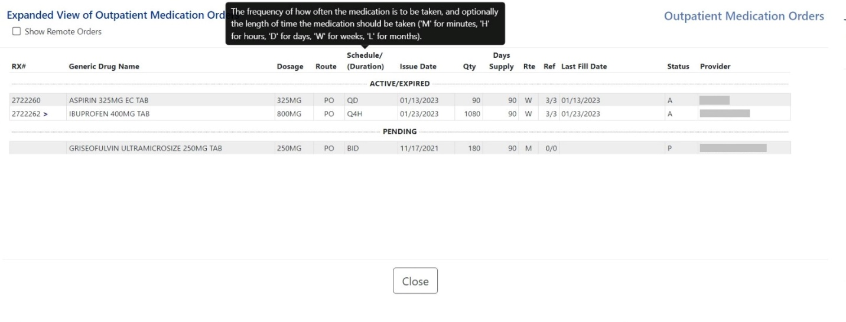

Outpatient Med List - Expanded View Indicators
Outpatient med orders can display various indicators such whether a prescription is copay eligible or marked for Consolidated Mail Outpatient Pharmacies (CMOP), highly automated facilities that fill and mail prescriptions to Veterans. Indicators such as the greater sign (>), an indicator for a CMOP drug, displays after the RX#. Other indicators include “t” for a Titration RX, $ for copay eligible, “T” for last fill in transmitted or retransmitted CMOP state and “e” for electronic third party billable are displayed immediately after the Prescription Number. See figure below:
Table 2: Indicators
Indicators | Description
CMOP Indicators | There are two separate indicators when the drug in an order is marked for Consolidated Mail Outpatient Pharmacy (CMOP) processing. This indicator is displayed after the Order Status if applicable.  > Drug for the prescription is marked for CMOP  T Displayed when the last fill is either in a Transmitted or Retransmitted  CMOP state. (This indicator can overwrite the “>” indicator.
Copay Indicator | A “$” displayed to the right of the prescription number indicates the prescription is copay eligible.
ePharmacy Indicator | An ‘e’ displayed to the right of the prescription number indicates that the prescription is electronic third party billable.
Inbound eRX Indicator | An “&” indicates the prescription was received from an outside provider as an Inbound ePrescription.
Return to Stock Indicator | An “R” displayed to the right of the Last Fill Date indicates the last fill was returned to stock.
Titration Indicator | A ‘t’ indicates the prescription is a complex order that includes ‘then’ conjunction
Maintenance RX (Titration) | An “m” displayed to the right of the prescription number indicates the prescription has been converted to a maintenance RX from a Titration RX (complex order with a ‘then’ conjunction)
Figure 91: CMOP Indicator
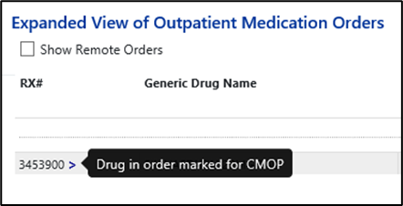

Outpatient Med List - Expanded View Remote Orders
A checkbox for Remote Orders is located at the upper left of the window. By checking this box, the remote orders will display at the bottom. See figure below:
Figure 92: Outpatient Med List - Show Remote Orders Checkbox
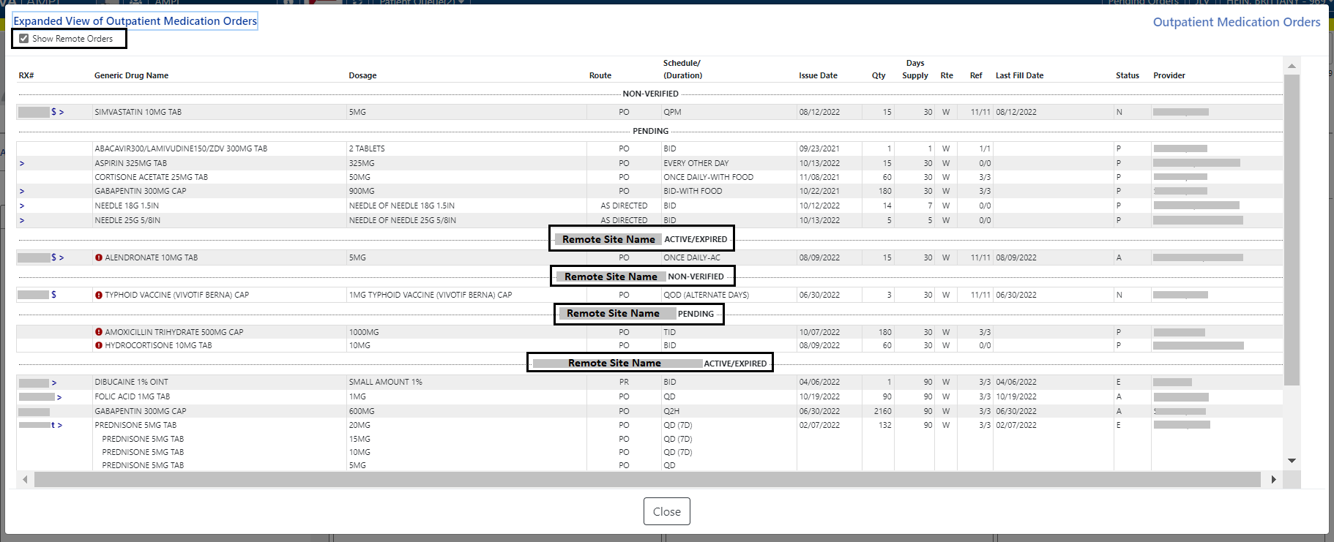

Outpatient Med Order - Details
To view details of an Outpatient Med Order, click on it in the Med List or the Expanded View. A pop-up will display with details about the order.
At the bottom of the display, buttons are available to display additional information related to the order including Order Checks, Drug Restrictions/Guidelines, Drug Info, Provider Info and Activity Log. See figures below:
Figure 93: Outpatient Med Order – Active Order Detail Screen
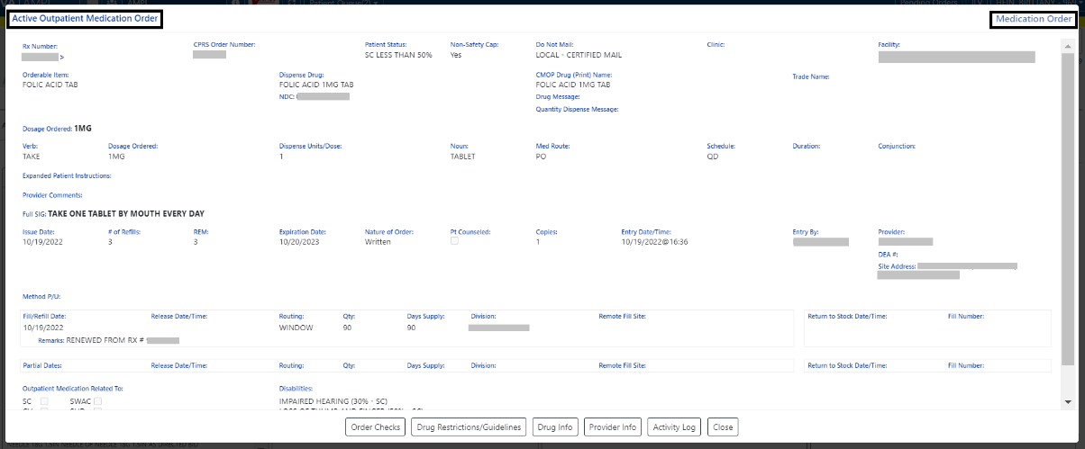
Figure 94: Outpatient Med Order – Additional Details
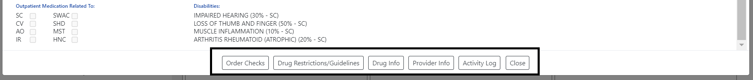
Clicking on one of the buttons displays order details relevant to the button selected. See figures below for examples of each:
Figure 95: Outpatient Med Order – Order Check
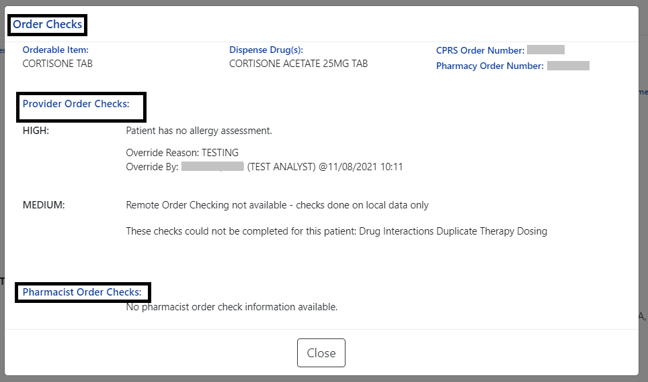
Figure 96: Outpatient Med Order - Drug Restriction/Guideline Information
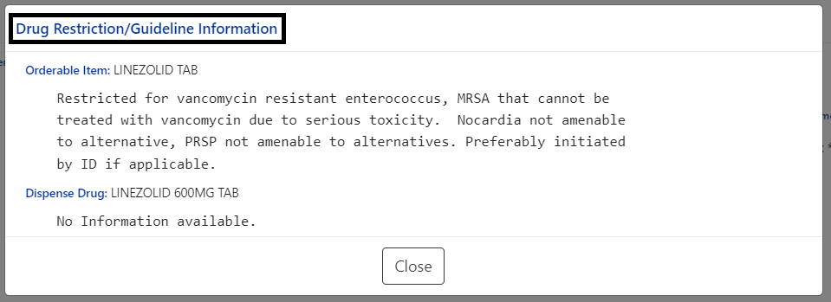
Figure 97: Outpatient Med Order - Drug Info
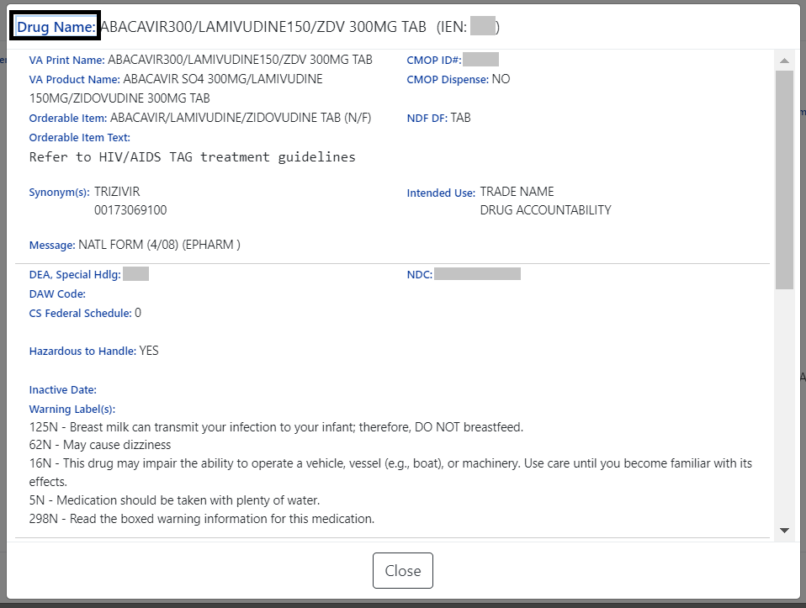
Figure 98: Outpatient Med Order - Provider Info
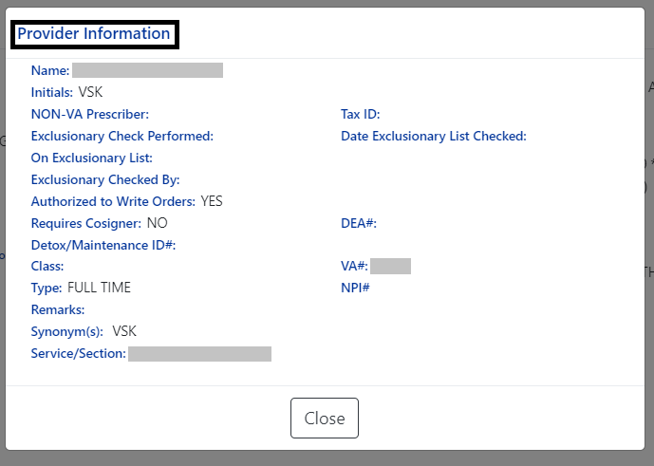
Figure 99: Outpatient Med Order - Activity Log
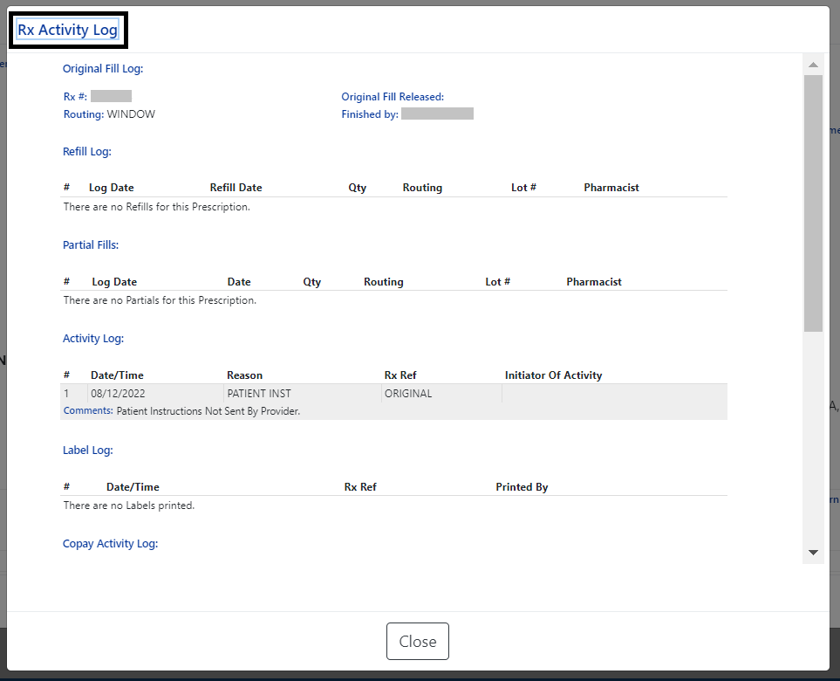

Inpatient Med List
The Inpatient Med List displays Active, Non-Verified, Pending and Recently DC’d/Expired (Last 24 Hours) for patients currently admitted at the local facility. See figure below:
Figure 100: Inpatient Med List
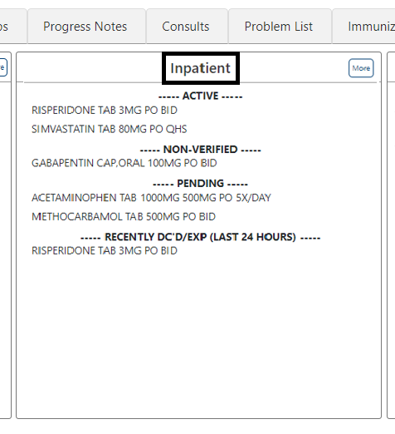

Inpatient Med List - Expanded View
The More button will bring up the Expanded View. See figure below:
Figure 101: Inpatient Med List - More Button
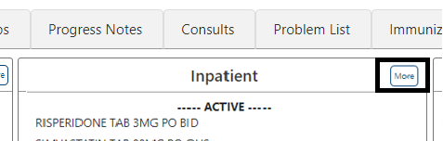
The Expanded View includes Generic Drug Name, Dosage/Infusion Rate, Route, Schedule/Duration, Schedule Type, Start Date/Time, Stop Date/Time, Status, Last BCMA Action, Action Status, Missing Dose Indicator, WS/PD Indicator, and Provider. See figure below:
Figure 102: Inpatient Med List - Expanded View
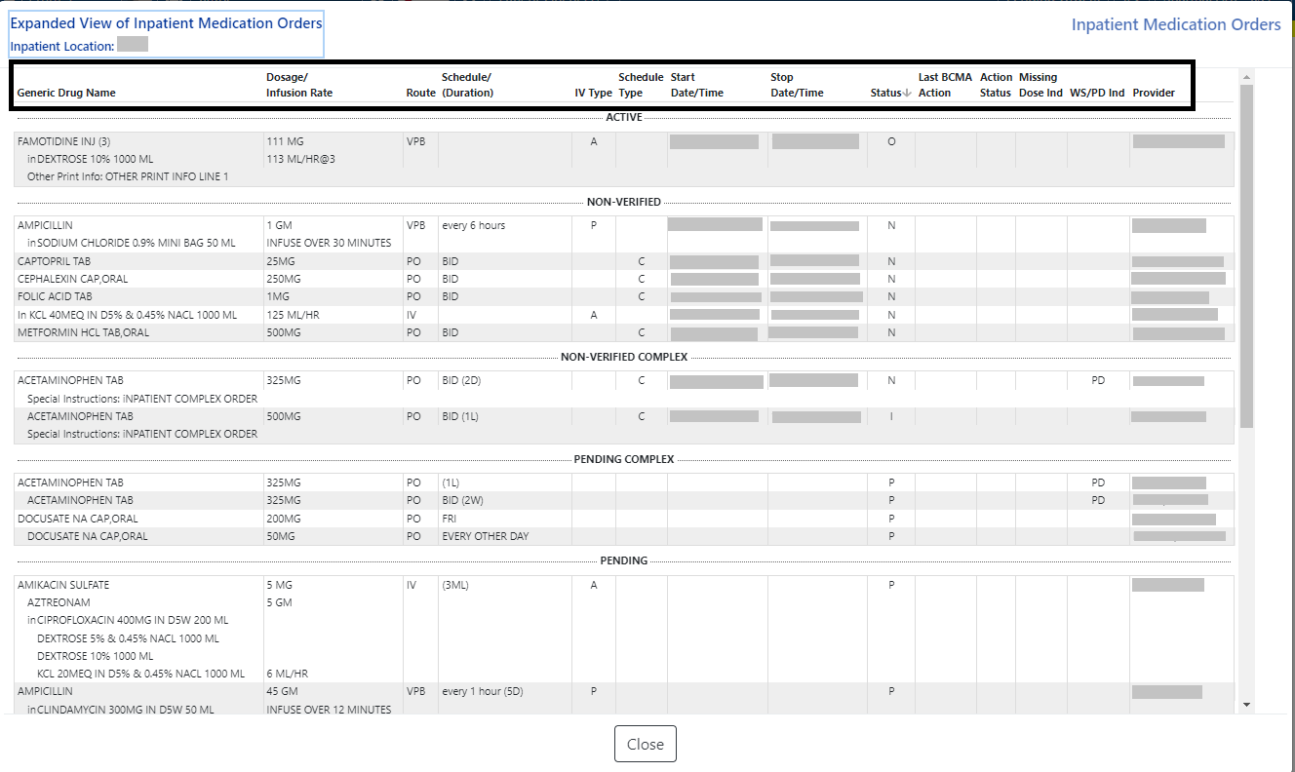

Inpatient Med List - Expanded View Help Text
Help text for each column of the Expanded View - Inpatient Med Orders is displayed by hovering over the column header. See figure below:
Figure 103: Inpatient Med List - Help Text
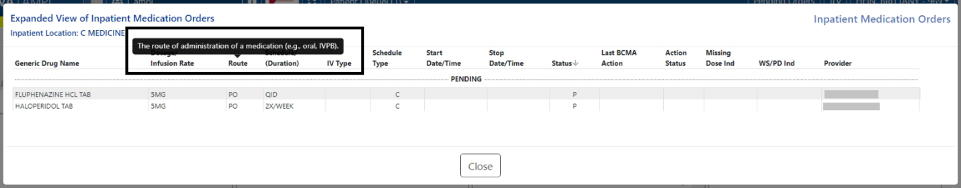

Inpatient Med Order - Details
To view details of an Inpatient Med Order, click on it in the Med List or the Expanded View. A pop-up will display with details about the order. See figure below:
Figure 104: Inpatient Med Order - Active Orders Detail Screen
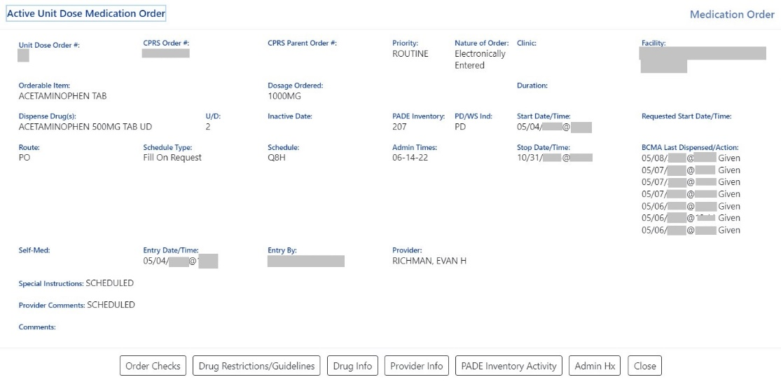
At the bottom of the Inpatient Med Order screen, buttons are available that will display additional information related to the order including Order Checks, Drug Restrictions/Guidelines, Drug Info, Provider Info, Pharmacy Automated Dispensing Equipment (PADE) Inventory Activity, and Admin Hx (History). See figure below:
Figure 105: Inpatient Med Order - Additional Details
Clicking on one of the buttons displays order details relevant to the button selected. See figures below for examples of each:
Figure 106: Inpatient Med Order - Order Check
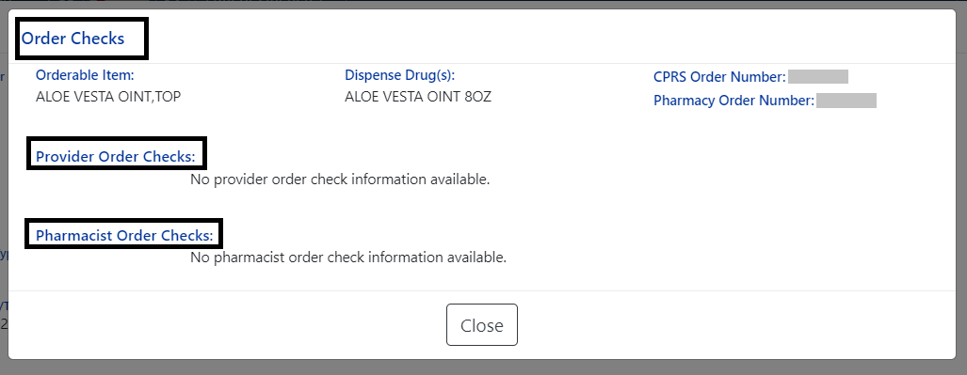
Figure 107: Inpatient Med Order - Drug Restriction/Guideline Information
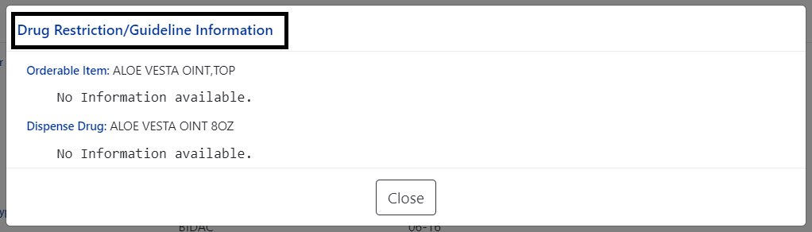
Figure 108: Inpatient Med Order - Drug Info
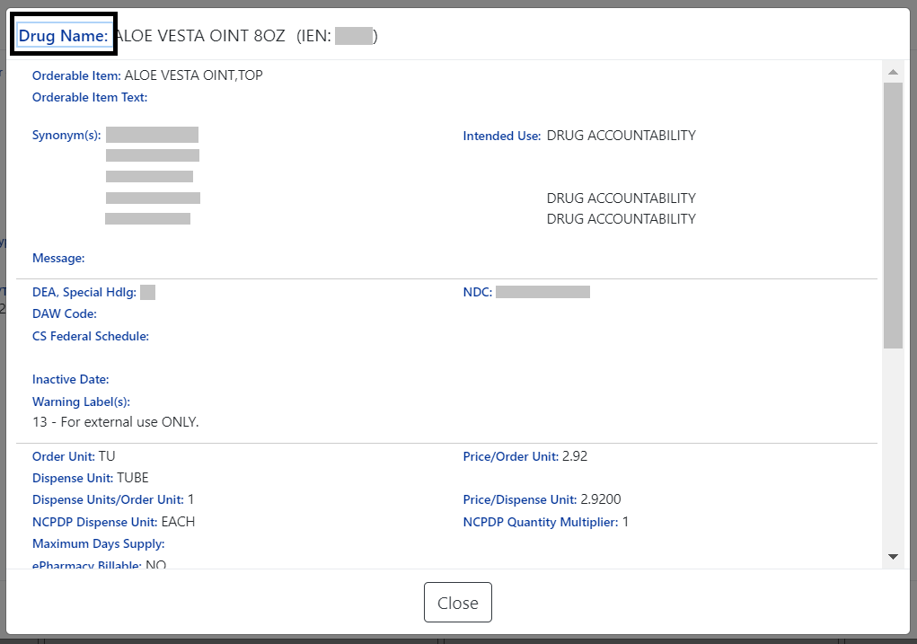
Figure 109: Inpatient Med Order - Provider Information
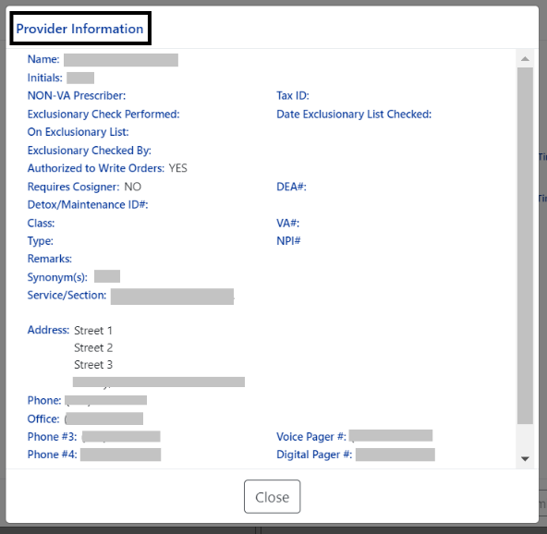
If the Inpatient location has a PADE dispensing device, the PADE Inventory Activity button will display the PADE activity log of all meds dispensed in the past thirty days. It includes current and historical activity from previous admissions or visits. See figure below:
Figure 110: Inpatient Med Order - PADE Inventory
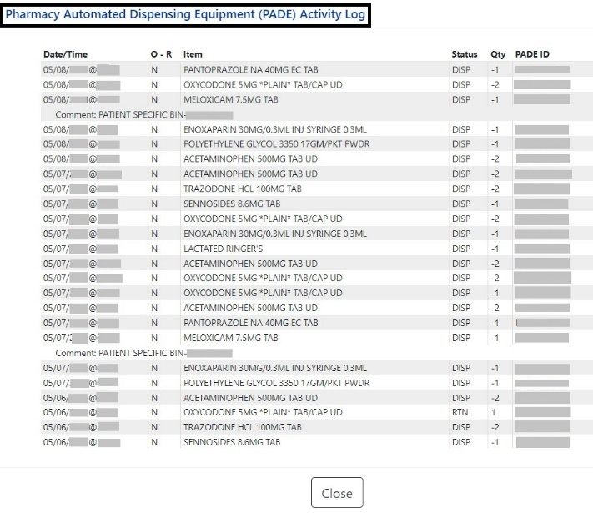
If the Inpatient location uses BCMA, the Administration History (Admin HX) button will display administrations recorded in BCMA for the medication. See figure below:
Figure 111: Inpatient Med Order - Administration Hx
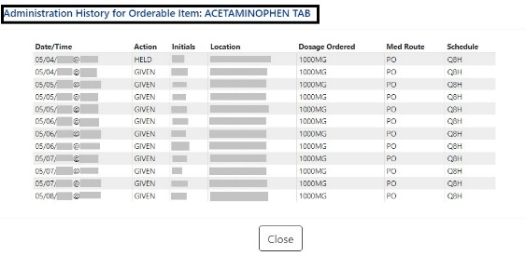

Clinic Med List
The Clinic Med List displays active clinic med orders by location at the local facility. See figure below:
Figure 112: Clinic Med List
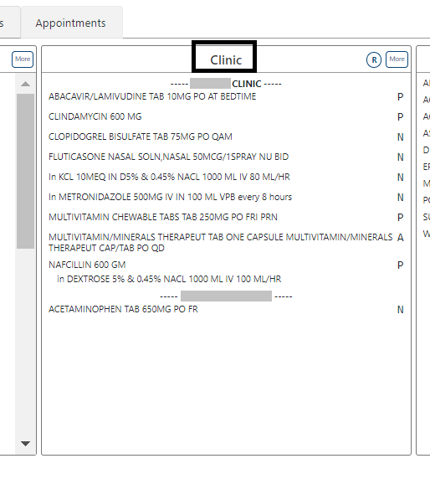
To include Remote clinic orders, click on the Remote Orders (R) button in the Clinic header. If Remote button is disabled, it indicates patient does not have remote orders. See figures below:
Figure 113: Clinic Med List - Remote Orders Button
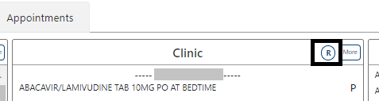
Figure 114: Clinic Med List - Remote Orders
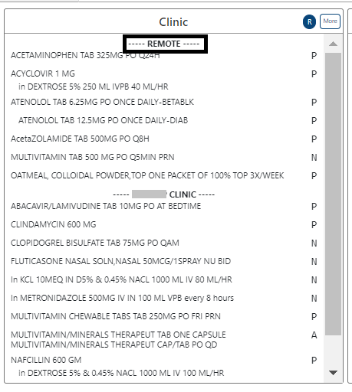

Clinic Med List - Expanded View
To access an Expanded View of Clinic Med Orders for a patient, click the MORE button.
The Expanded View of Clinic Med Orders includes Generic Drug Name, Dosage/Infusion Rate, Route, Schedule/(Duration), IV Type (if applicable), Schedule Type, Start Date/Time, Stop Date/Time, Status, Last BCMA Action, Action Status, Missing Dose Indicator, PADE/Ward Stock Indicator (PD Ind), and Provider. See figure below:
Figure 115: Clinic Med List - Expanded View
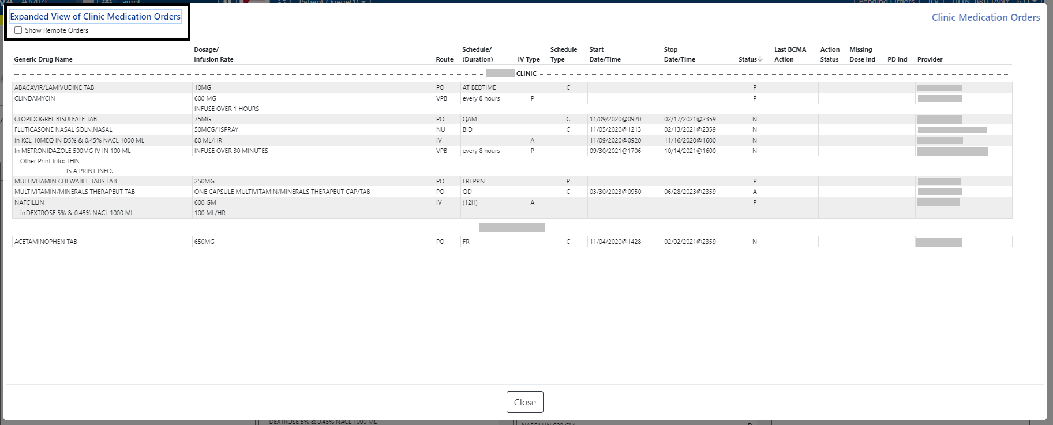

Clinic Med List - Expanded View Help Text
The column header for the Expanded View of the Clinic Med Orders records displays help text by hovering over the column header. See figure below:
Figure 116: Clinic Med List - Help Text

Clinic Med Order – Details
To view additional details of a Unit Dose Clinic Med Order, click on it in the Med List or Expanded View list. A new pop-up window will display the Unit Dose Med Order details. See figure below:
Figure 117: Clinic Med Order – Active Order Detail Screen
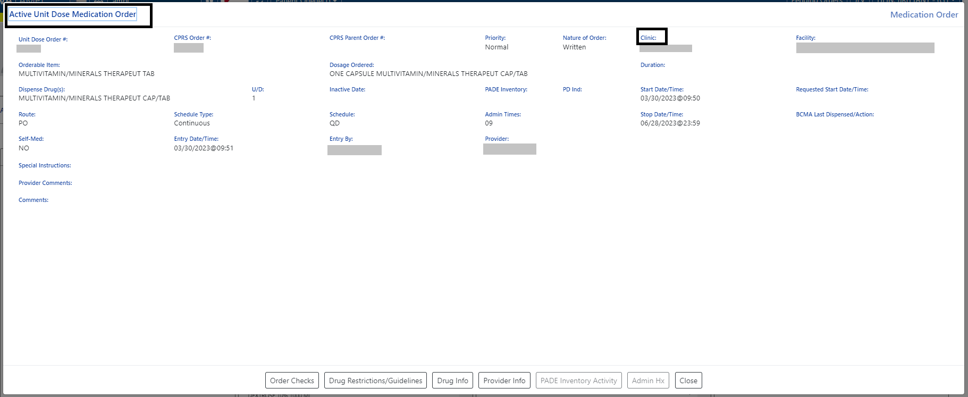
An IV Clinic Med will display fields specific to an IV order in the pop-up. See figure below:
Figure 118: Clinic Med Order - IV Med Order Details
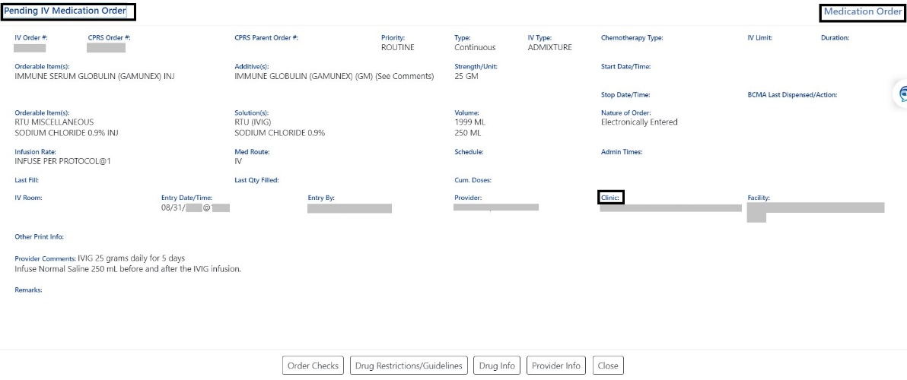
At the bottom of the Clinic Med Order screen, additional details are available including Order Checks, Drug Restrictions/Guidelines, Drug Info, Provider Info, PADE Inventory Activity, and Admin Hx. See figure below:
Figure 119: Clinic Med Order - Additional Details
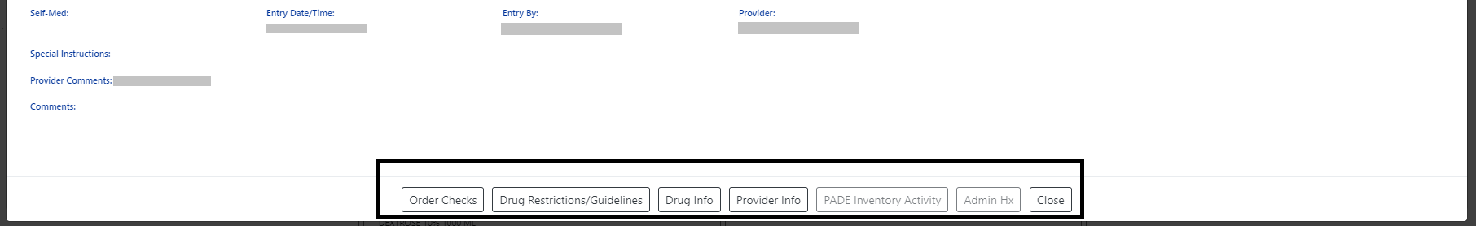
Selecting a button will display additional details in a pop-up window. See figures below for examples of each:
Figure 120: Clinic Med Order - Order Check
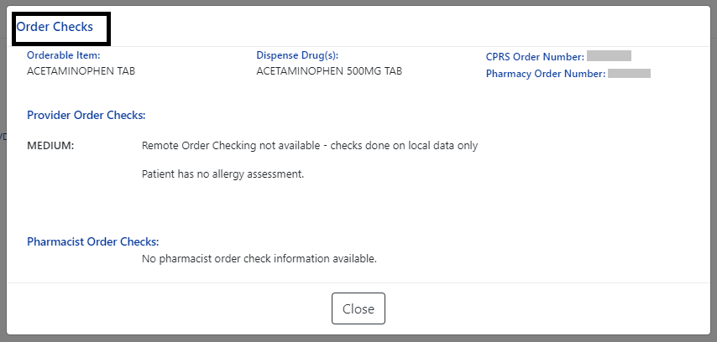
Figure 121: Clinic Med Order - Drug Restriction/Guideline Information
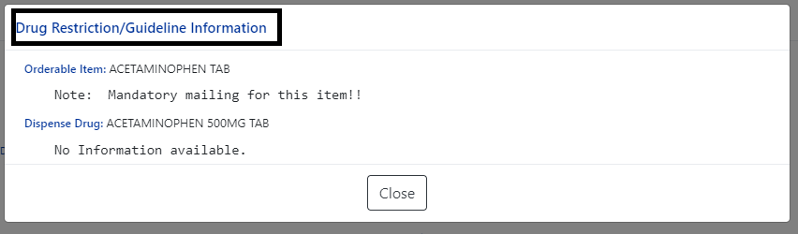
Figure 122: Clinic Med Order - Drug Info
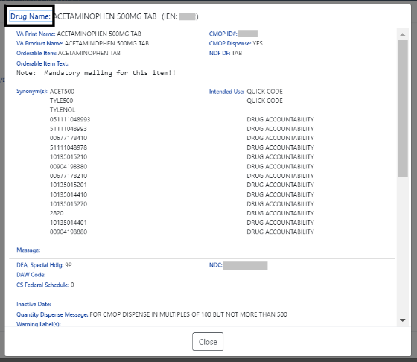
Figure 123: Clinic Med Order - Provider Information
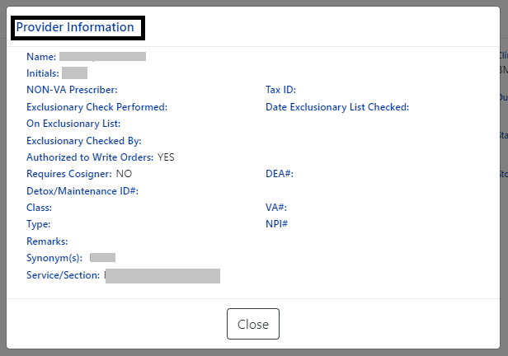
If the clinic has a PADE dispensing device the PADE Inventory Activity button will display the PADE activity log of all medications dispensed in the past thirty days. The PADE inventory will display current and historical activity from previous admissions or visits. See figures below:
Figure 124: Clinic Med Order - PADE Activity
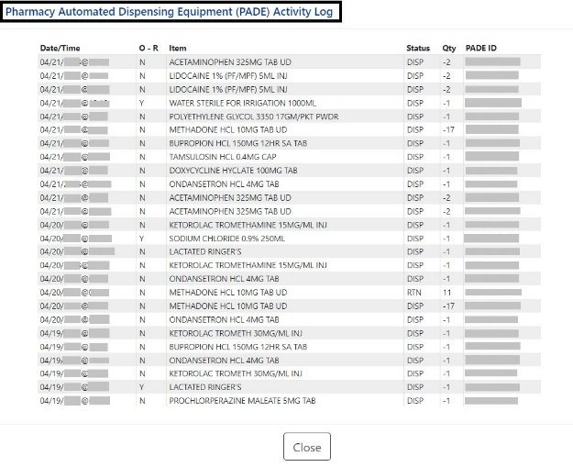
Figure 125: Clinic Med Order - Administration Hx
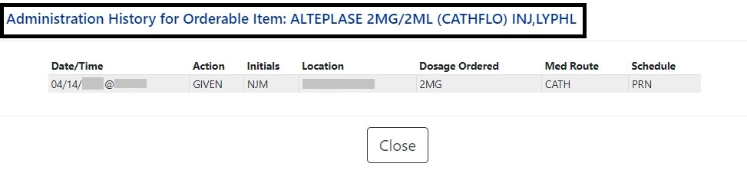

Non-VA Med List
The Non-VA Med List displays active Non-VA med orders from the local station.
Figure 126: Non-VA Med List
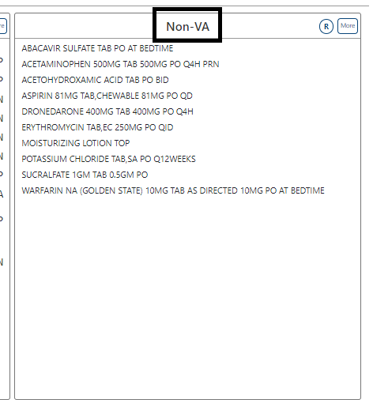
To include Remote clinic orders, click on the Remote Orders (R) button in the Non-VA header. If Remote button is disabled, it indicates patient does not have remote orders. See figures below:
Figure 127: Non-VA Med List - Remote Orders Button
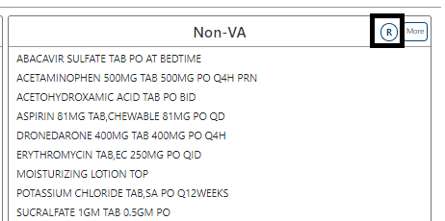
Figure 128: Non-VA Med List - Remote Orders
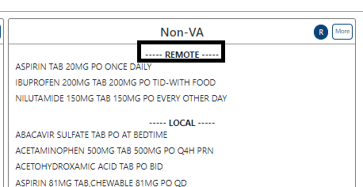

Non-VA Med Orders - Expanded View
The More button will bring up the Expanded View. See figure below:
Figure 129: Non-VA Med List - More Button
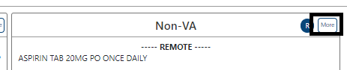
The Expanded view displays additional details, including Generic Drug Name, Dosage, Route, Schedule, Start Date, Documented Date, and Documented By. See figure below:
Figure 130: Non-VA Med List - Expanded View
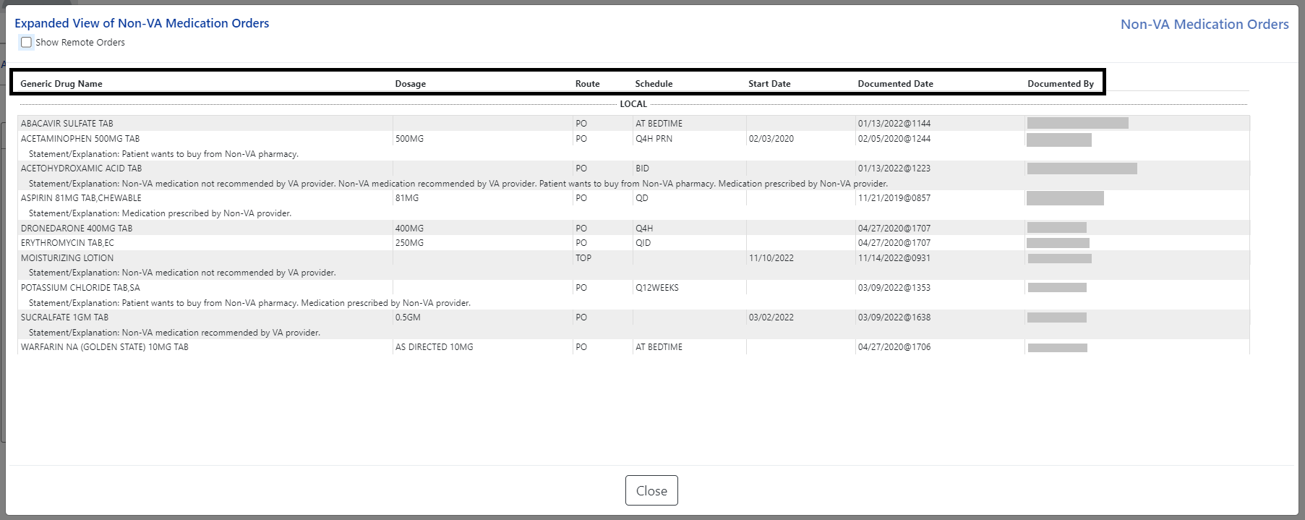

Non-VA Med List – Expanded View Help Text
Help text for each column of the Expanded View of Non-VA Med Orders is displayed by hovering over the column header. See figure below:
Figure 131: Non-VA Med List - Help Text
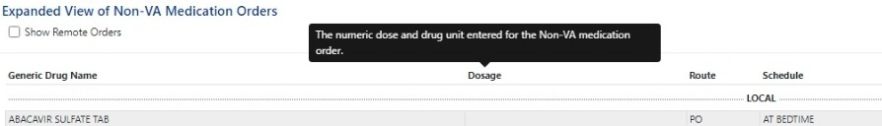

Non-VA Med Orders – Details
To view details of a Non-VA Med Order, click on it in the Non-VA section or the Expanded View. A pop-up will display with details about the order. See figure below:
Figure 132: Non-VA Med Orders - Details for Active Medication
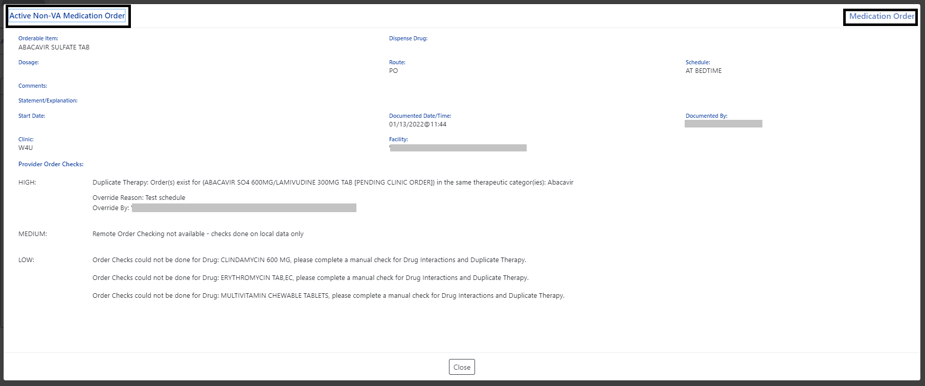

Allergies and ADRs Tab
All allergy records for the selected patient in the Allergies and ADRs tab, including the total number of records in the blue circle in the tab will be displayed.
The column headers include Standard Term (GMR Allergy), Causative Agent/Reactant, Signs/Symptoms, Observed/Historical, Severity, Mechanism, Reaction Type, Origination Date/Time, and Facility. The default view is All Records sorted by Standard Term ascending. See figure below:
Figure 133: Allergies and ADRs Tab
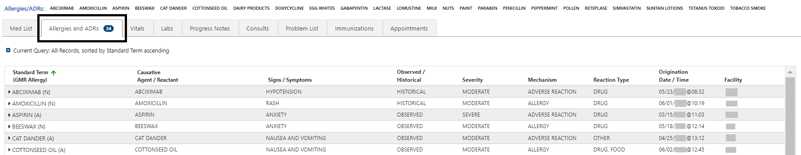
If the patient has no allergy assessment at the local facility, a pop-up window will display, indicating that an allergy assessment is needed. See figure below:
Figure 134: Allergies and ADRs - Allergy Assessment Needed
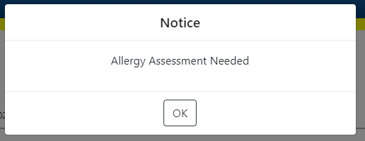
NOTE: If a patient has an allergy assessment at the local facility, but no assessment at a remote facility, the remote information will be included in the table, but no pop-up will display.

When hovering over the column headers, help text is shown. See figure below:
Figure 135: Allergies and ADRs Column Header Help Text
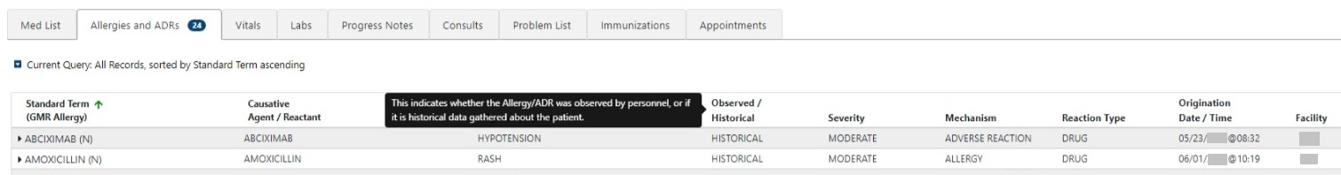
A plus sign (+) indicator will display with the total number in the tab if a patient has Entered in Error records. See figure below:
Figure 136: Allergies and ADRs - Entered in Error Records Indicator
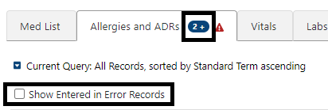
To show the Entered in Error records, click on the checkbox and the following information will display. The Enter in Error records are highlighted in red and include an Entered in Error indicator. See figure below:
Figure 137: Allergies and ADRs - Entered in Error Records
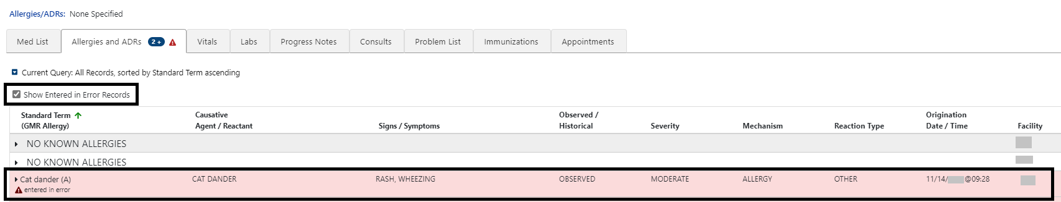

Allergy and ADRs - Query Editor
A Query Editor is available to filter records in the Allergies and ADRs tab. To add a filter, open the Query Editor by clicking on the Query Editor button. See figure below:
Figure 138: Allergies and ADRs - Query Editor
Filtering and sorting options are available by using the dropdown menus shown below. Both options include Standard Term, Causative Agent/Reactant, Signs/Symptom, Observed/Historical, Severity, Mechanism, Reaction Type, Origination Date/Time, Facility, and Drug Class.
Once a filter/sort is selected, click Add to have the filter added to the search criteria. Continue this process with other filters, as needed. Once completed, click on Refresh to update the display. To delete a filter, select the red “X” icon to the right of it. To clear filters added by the user and return to the tab’s default, click the Reset button. To close the Query Editor, click on the Hide Query Editor Button. See figures below:
Figure 139: Allergies and ADRs - Filter Options
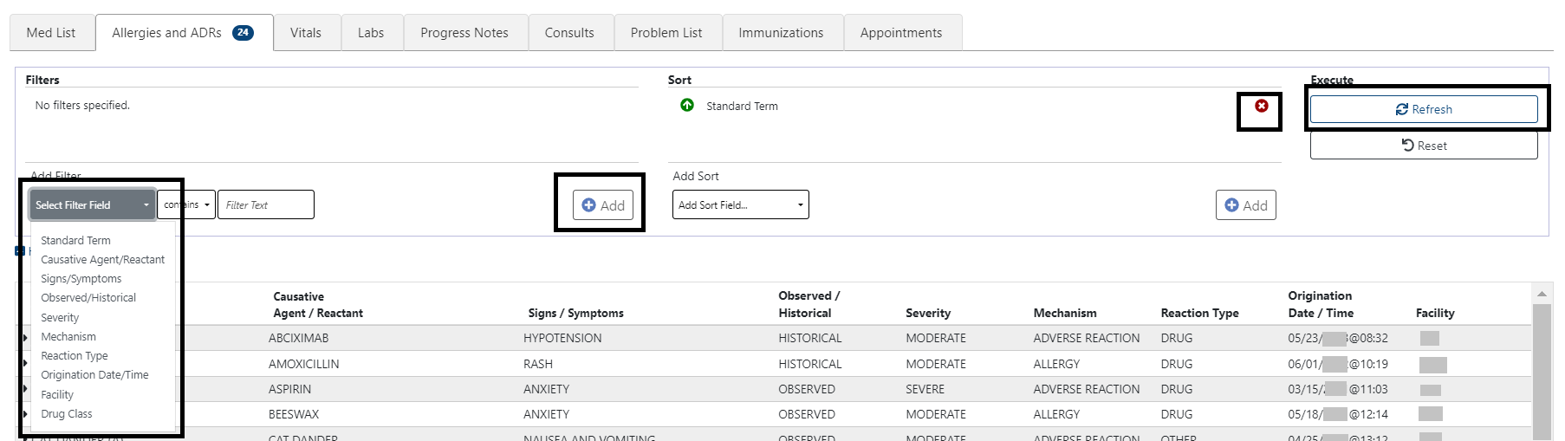
Figure 140: Allergies and ADRs - Sorting Options
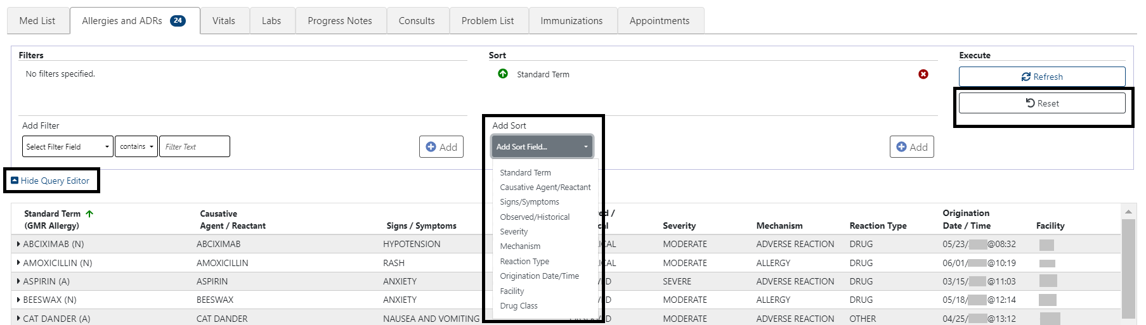

Allergies and ADRs – Accordion View
The Allergies and ADRs’ records are available in an accordion view. To access this information, click on the allergy record and additional details will display. See figure below:
Figure 141: Allergies and ADRs - Accordion View
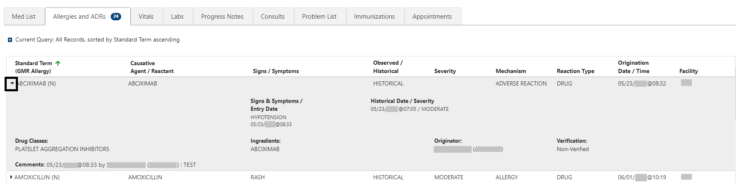
The accordion view is also available for Records Entered in Error. See figure below:
Figure 142: Allergies and ADRs - Accordion View – Records Entered in Error
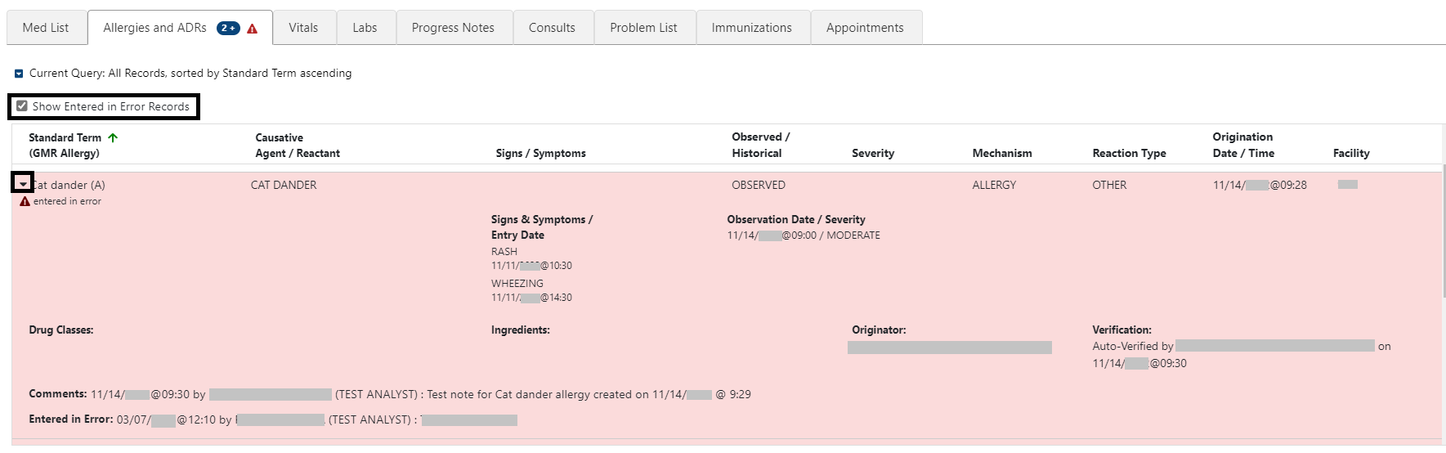

Vitals Tab
NO INTRO WRITTEN
Figure 143: Vitals Tab
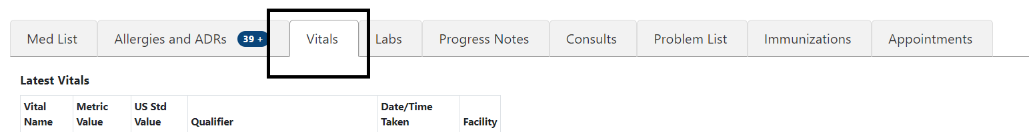
Upon selecting the Vitals tab, the most recent Vitals will be shown in a table that includes the following column headers: Vital Name, Metric Value, US Std Value, Qualifier, Date/Time Taken, and Facility. See figure below:
Figure 144: Vitals - Column Headers
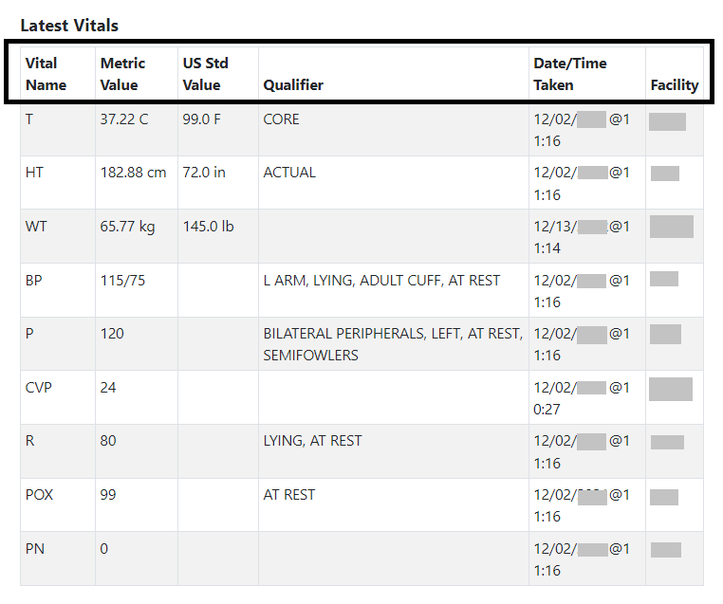
NOTE: The AMPL GUI application converts imperial values provided for a vital type to metric values where appropriate so that both values displays.
Help text will display when hovering over the column headers. See figure below:
Figure 145: Vitals - Help Text
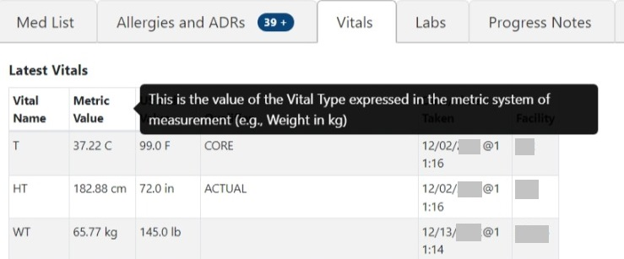
To display additional Vital types to the Latest Vitals table, use the dropdown menu below the table, select the Vital type, and then click the Add button. See Figure below:
Figure 146: Vitals - Additional Vitals
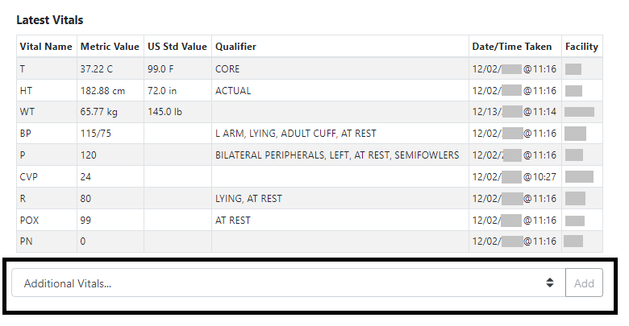
The Vitals tab includes the ability to display readings for a date range. To display multiple values for a Vital, click on that Vital and results will display to the right with a default date range of one year for Outpatient and one week for Inpatient. Additional Vitals may be added by clicking on the Vital name. They can be removed by clicking again. See figure below:
Figure 147: Vitals - Display
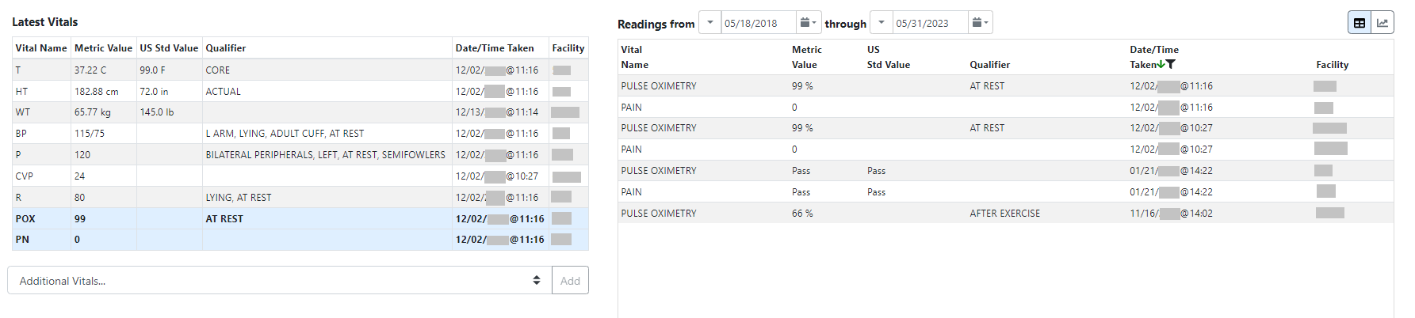
To change the date range, modify the Readings from or through dates. See figure below:
Figure 148: Vitals - Date Range
NOTE: To obtain the acceptable Date/Time formats, enter ’?’ in the date range box.
In addition, commonly used date ranges can be chosen using the date dropdown arrow to the right of the date box. See figure below:
Figure 149: Vitals – Commonly Used Date Ranges
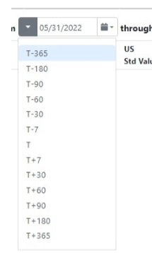
Once a date range is chosen, the results for the selected vitals taken within the date range will display in the table. See figure below:
Figure 150: Vitals - Date Range Display
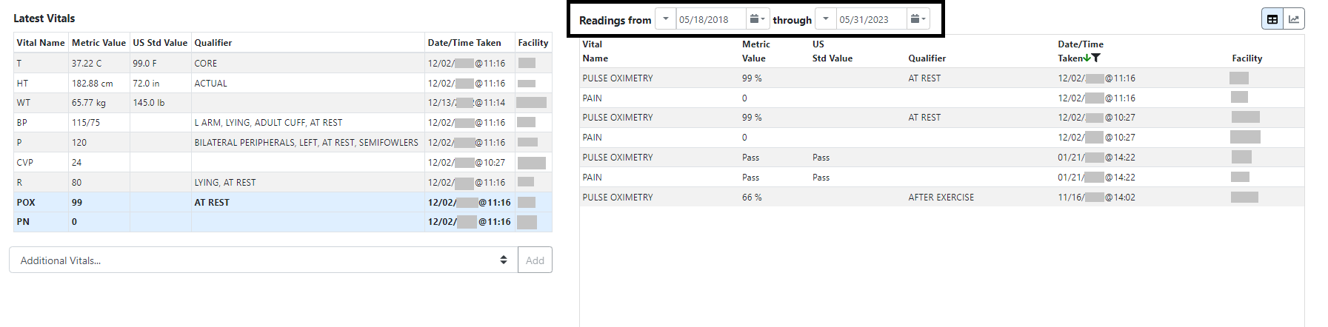

Vitals – Expanded View
To see additional details on a Vital, click on the Vital in the date range table on the right and a pop-up box will display. Details include Date/Time Vitals Taken, Date/Time Vitals Entered, Entered By, Hospital Location, Facility, Rate, Qualifier. See figure below:
Figure 151: Vitals - Expanded View
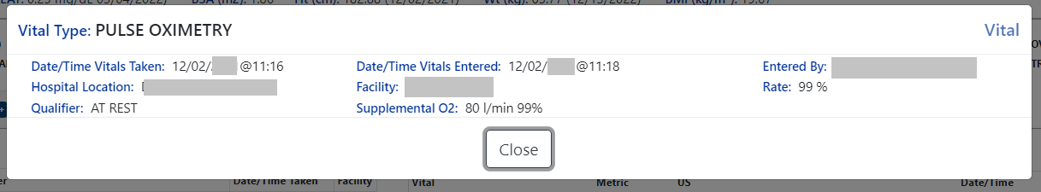

Vitals – Graphing Capabilities
Vital types in the date range table may also be shown in a graph by selecting the graphing icon located in the top right corner of the Vitals screen. See figure below:
Figure 152: Vitals - Graphing
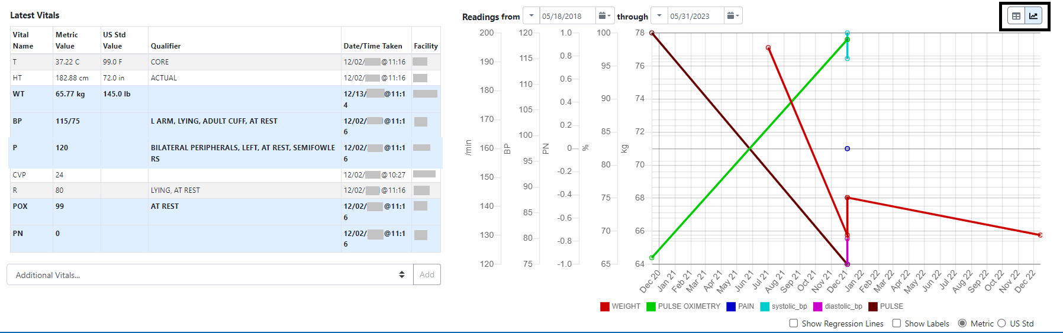
Regression lines and labels may be added by checking the buttons below the graph. To return to the Table format, click on the Table icon in the upper right corner. See figure below:
Figure 153: Vitals - Regression Lines and Labels
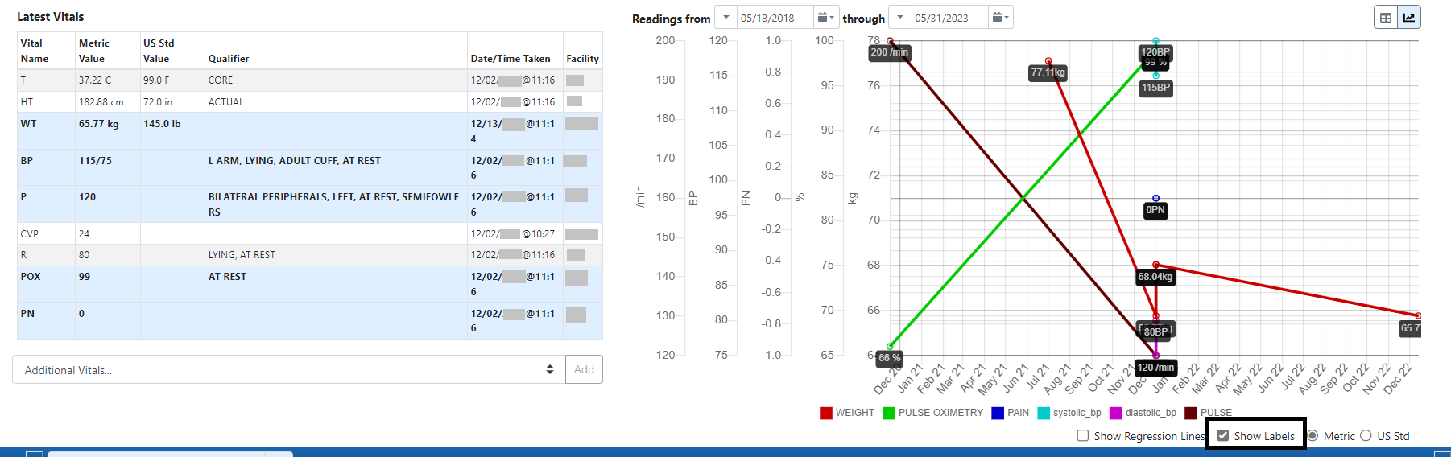

Labs Tab
The Labs tab displays lab data for the last year, sorted by Collection Date/Time descending, 100 results per page. Laboratory records from all VHA facilities are included. See figure below:
Figure 154: Labs Tab
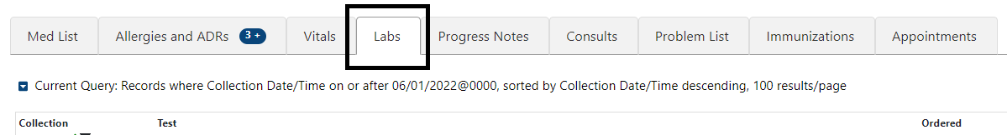
The column headers include Collection Date/Time, Test Name, Flag, Specimen, Provider, Ordered Date/Time, Status, Urgency, Accession #, Available Date/Time, Hospital Location and Facility. See figure below:
Figure 155: Labs - Column Headers
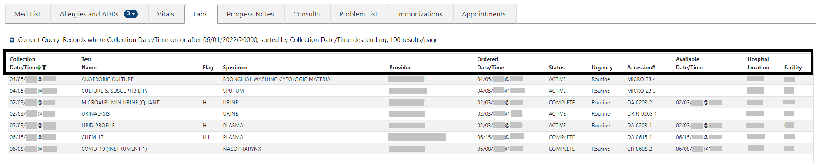
Help text will display when hovering over the column headers. See figure below:
Figure 156: Labs - Help Text
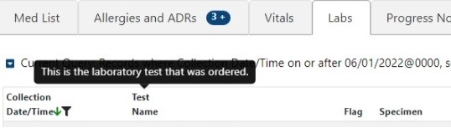

Labs - Laboratory Test Record Expanded View
To view results, if available, for a Lab record click on the individual record. A pop-up window displays data in four columns: Name, Value, Flag and Reference Range. See figure below:
Figure 157: Labs - Test Record Expanded View
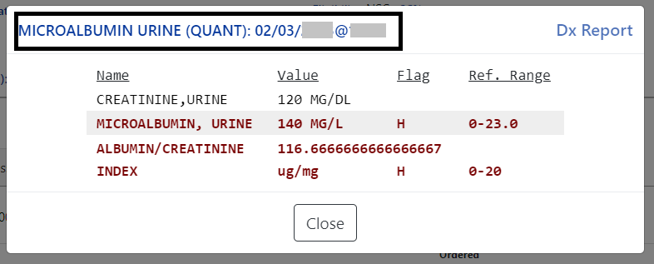
When the results are pending, the name and collection date and time will display. To close the pop-up, click on the Close button or click outside the expanded view window. See figure below:
Figure 158: Labs - Lab Results Pending
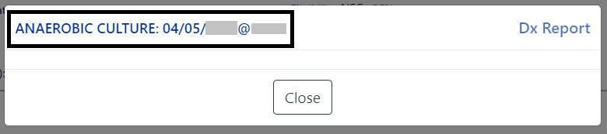

When there are no laboratory test records to display for the selected patient, the Labs Label tab will indicate that. See figure below:
Figure 159: Labs - No Lab Data
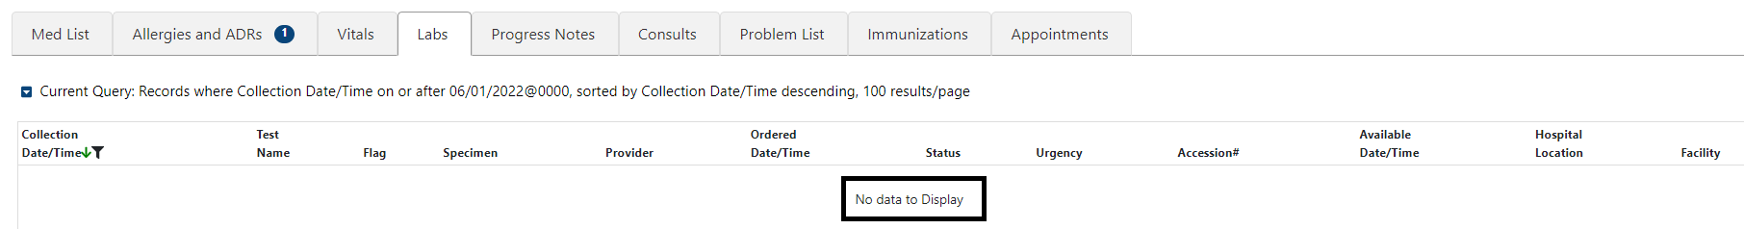

Labs - Query Editor
A Query Editor is available to filter and sort records in the Labs tab. To add a filter or change the sort, open the Query Editor by clicking on the Current Query button. See figure below:
Figure 160: Labs - Show Query Editor Button
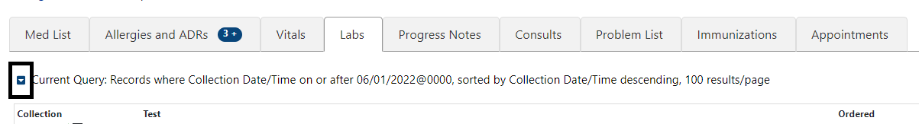
Filtering and sorting options are available by using the dropdown menus shown below. Both options include Standard Term, Causative Agent/Reactant, Signs/Symptom, Observed/Historical, Severity, Mechanism, Reaction Type, Origination Date/Time, Facility, and Drug Class.
Once a filter/sort is selected, click Add to have the filter added to the search criteria. Continue this process with other filters, as needed. Once completed, click on Refresh to update the display. To delete a filter, select the red “X” icon to the right of it. To clear filters added by the user and return to the tab’s default, click the Reset button. To close the Query Editor, click on the Hide Query Editor Button. See figure below:
Figure 161: Labs - Filter and Sorting Options
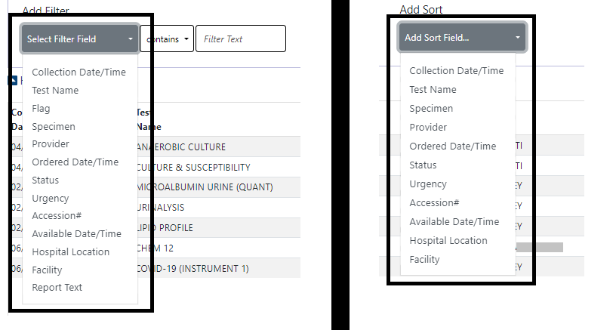

Progress Notes Tab
On the Progress Notes tab, all signed notes entered within the last year, sorted by Date/Time Entered descending, 100 results per page will display. See figure below:
Figure 162: Progress Notes Tab
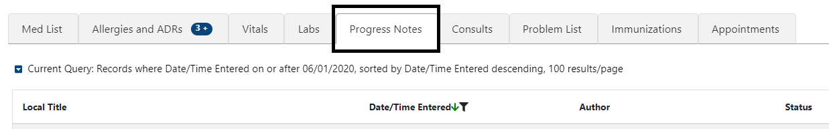
The column headers include Local Title, Date/Time Entered, Author, Status, Hospital Location, and Facility. See figure below:
Figure 163: Progress Notes - Column Headers
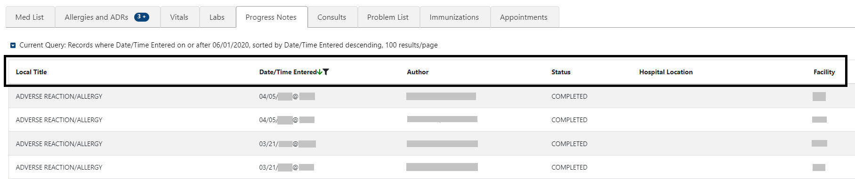
When hovering over the column headers, help text is shown. See figure below:
Figure 164: Progress Notes - Help Text
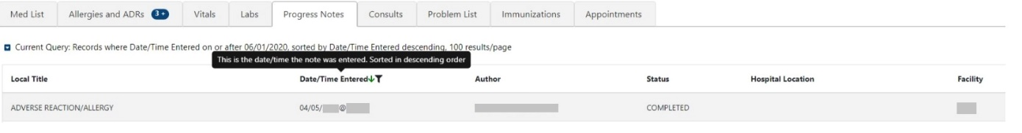

Progress Notes – Expanded View
To view details for a single Progress Note, click on the individual record. A pop-up window displays. To close the pop-up, click on the Close button or click outside the expanded view window. See figure below:
Figure 165: Progress Notes - Expanded View
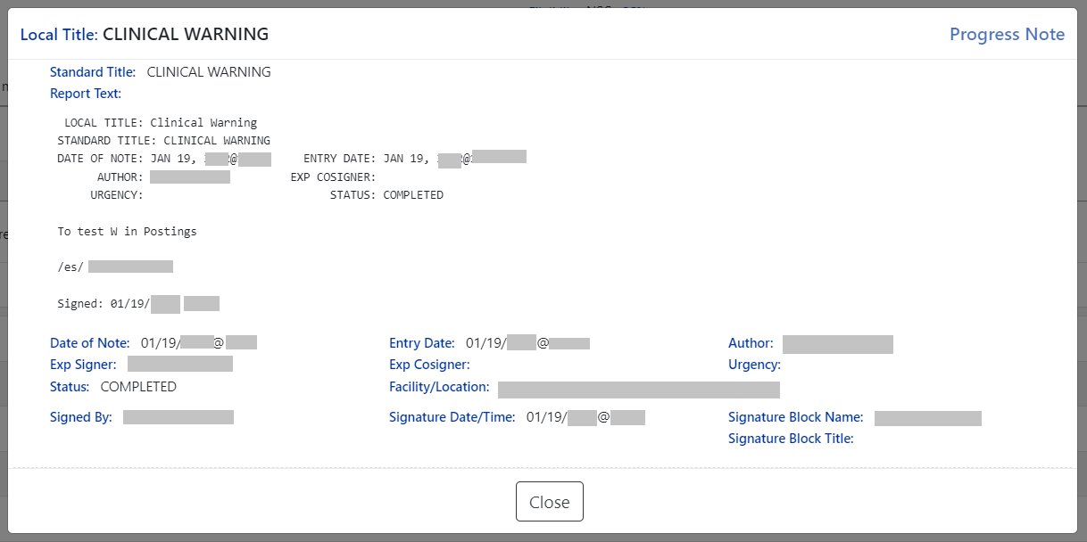
NOTE: Interdisciplinary Notes can be directly viewed from the parent Progress Note, where applicable. See figure below:
Figure 166: Progress Notes - Interdisciplinary Note
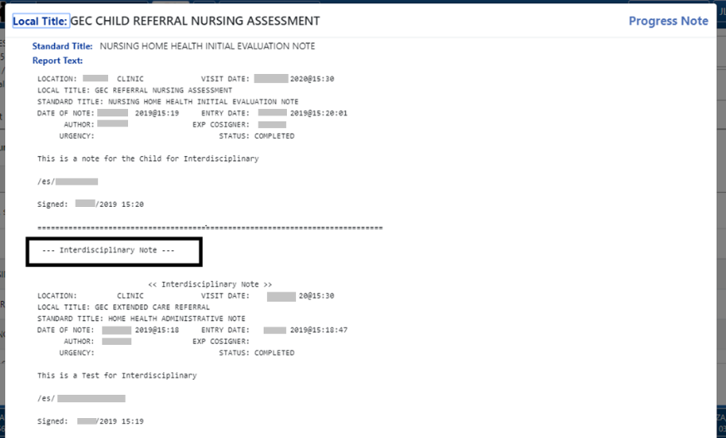

Progress Notes – Query Editor
A Query Editor is available to filter and sort records in the Progress Notes tab. To add a filter or change the sort order, open the Query Editor by clicking on the Current Query button. See figure below:
Figure 167: Progress Notes - Query Editor Button
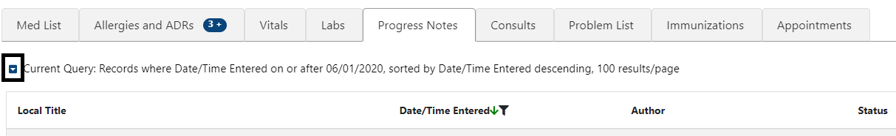
Filtering and sorting options are available by using the dropdown menus shown below. Both options include Local Title, Date/Time Entered, Author, Status, Hospital Location, Facility, and Standard Title.
Once a filter/sort is selected, click Add to have the filter added to the search criteria. Continue this process with other filters, as needed. Once completed, click on Refresh to update the display. To delete a filter, select the red “X” icon to the right of it. To clear filters added by the user and return to the tab’s default, click the Reset button. To close the Query Editor, click on the Hide Query Editor Button. See figure below:
Figure 168: Progress Notes - Filter and Sorting Options
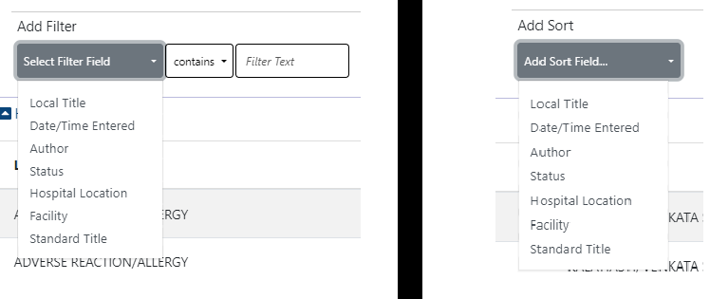

Consults Tab
From the Consults tab, consult records from all Veterans Health Administration (VHA) facilities will display for the selected patient. The default view includes all records sorted by Date/Time in descending order, with 100 records per page. See figure below:
Figure 169: Consults Tab
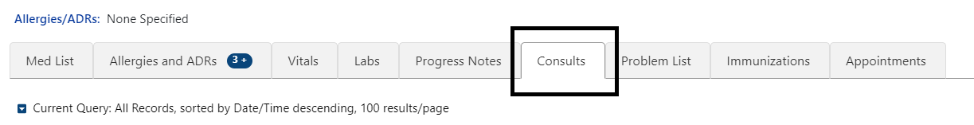
The column headers include Date/Time, Procedure/Consult, Service, Status, and Facility. See figure below:
Figure 170: Consults - Column Headers
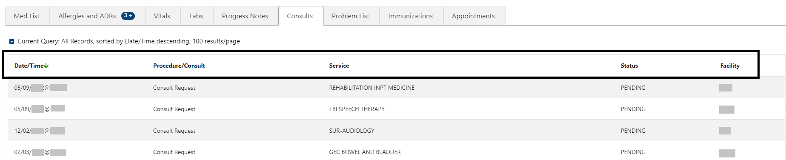
Help text will display when hovering over the column headers. See figure below:
Figure 171: Consults - Help Text
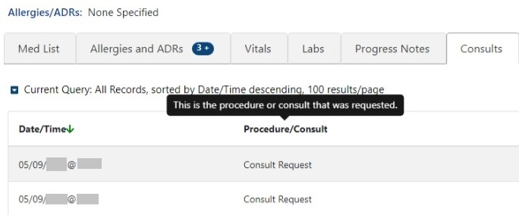

Consults Tab – Expanded View
To view details for a single Consult record, click on the individual record. A pop-up window displays with data divided into three sections.
In the first section of the window, the information includes To Service, From Service, Requesting Provider, Service Rendered as, Place of Consultation, Patient Location, Urgency, Date/Time Requested, Status, Orderable Item, Clinically Indicated Date, Last Action, Significant Findings, Ordering Facility, and Reason for Request.
The second section includes: Consult or Procedure, Provisional Diagnosis, Attention, Provisional Diagnosis Date, Provisional Diagnosis System, and Report Text.
The last section includes Activity, Date/Time, Responsible Person, Entered By.
To close the pop-up, click on the Close button or click outside the expanded view window. See figure below:
Figure 172: Consults - Expanded View
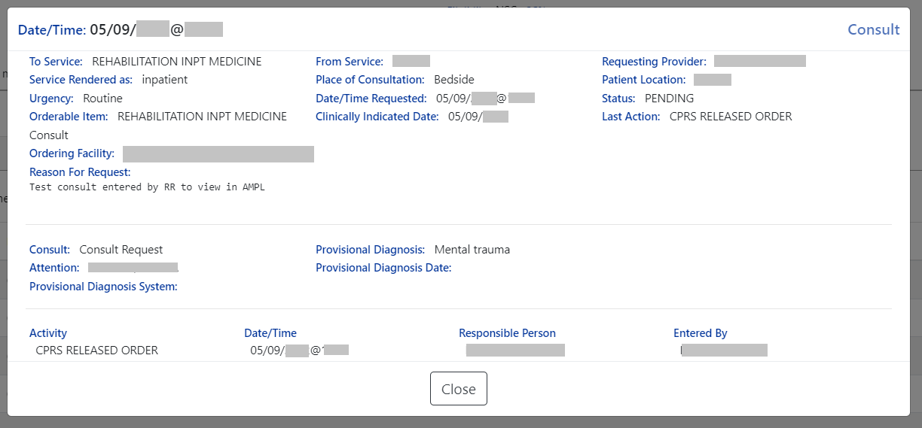

Consults Tab – Query Editor
Filtering and sorting options are available by using the dropdown menus shown below. Both options include Date/Time, Procedure/Consult, Service, Status, and Facility.
Once a filter/sort is selected, click Add to have the filter added to the search criteria. Continue this process with other filters, as needed. Once completed, click on Refresh to update the display. To delete a filter, select the red “X” icon to the right of it. To clear filters added by the user and return to the tab’s default, click the Reset button. To close the Query Editor, click on the Hide Query Editor Button. See figure below:
Figure 173: Consults - Filter and Sort
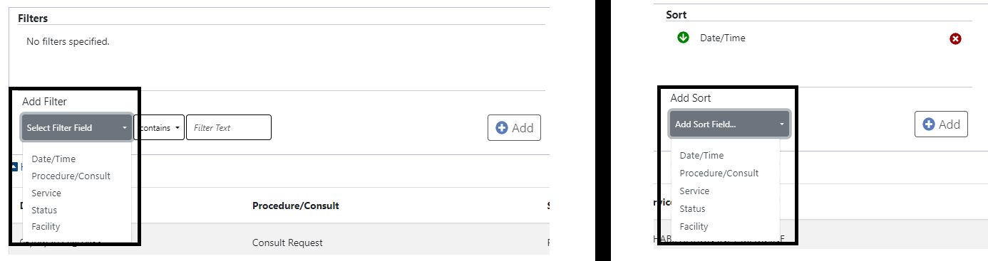
NOTE: For filter results containing text, the following “OR” option is also available to search for multiple words:
Figure 174: ‘OR’ing’ for Text Filters
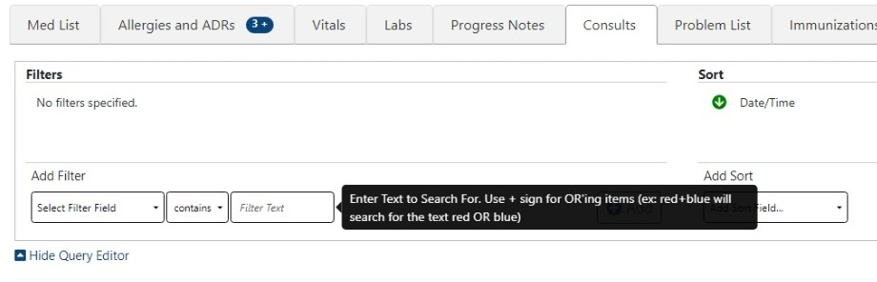

Problem List Tab
From the Problem List tab, all ‘Active’ problems display. The default view includes all ‘Active’ records sorted by Immediacy ascending, then Description ascending. See figure below:
Figure 175: Problem List Tab
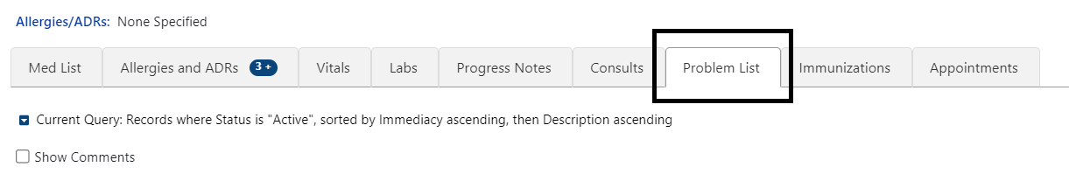
The column headers include Status, Verified, Immediacy, Description/Comments, Onset Date, Last Updated Date, and Facility. See figure below:
Figure 176: Problem List - Column Headers
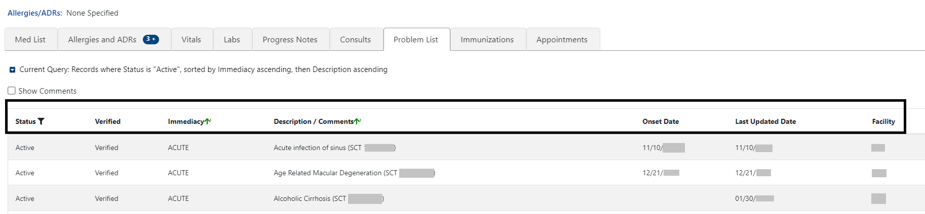
Help text will display when hovering over the column headers. See figure below:
Figure 177: Problem List - Help Text
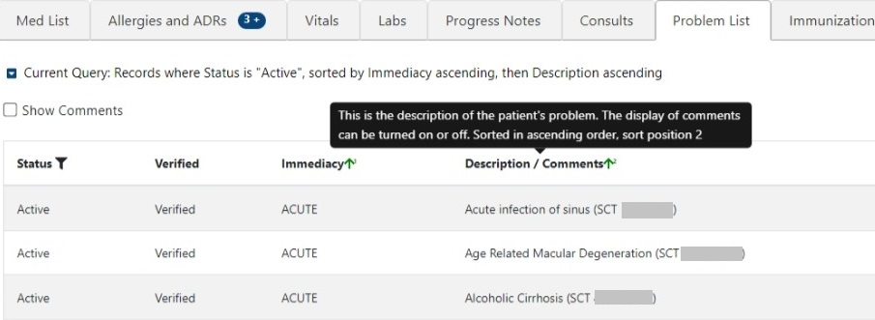

Problem List – Expanded View
To view additional details on a Problem List record, click on the record.
The information includes Problem Category(ies), Diagnosis, Coding System, Code Number, Onset Date, Status/Verified/Immediacy, Service-Connected Condition, Exposure, Provider, Service, Clinic, Facility, Date Entered, Entered By, Last Updated, Comments, and Audit History.
To close the pop-up, click on the Close button or click outside the expanded view window. See figure below:

Figure 178: Problem List - Expanded View
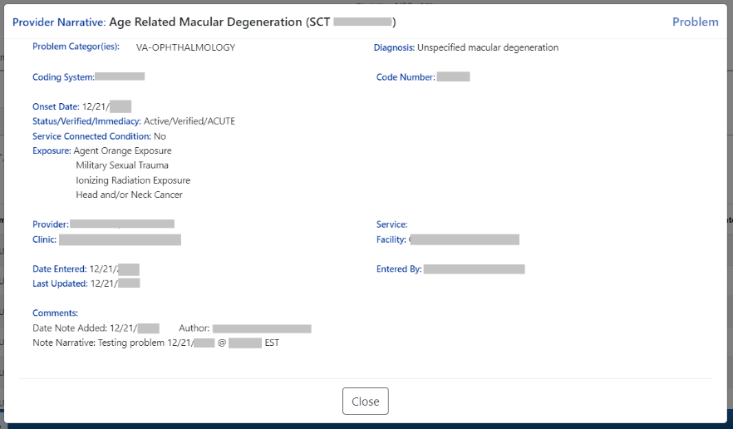

Problem List – Query Editor
Filtering and sorting options are available by using the dropdown menus shown below. Filtering options include Status, Verified, Immediacy, Onset Date, Last Updated Date, Facility, Description, and Comments.
Sorting options include Status, Verified, Immediacy, Onset Date, Last Updated Date, Facility and Description.
Once a filter/sort is selected, click Add to have the filter added to the search criteria. Continue this process with other filters, as needed. Once completed, click on Refresh to update the display. To delete a filter, select the red “X” icon to the right of it. To clear filters added by the user and return to the tab’s default, click the Reset button. To close the Query Editor, click on the Hide Query Editor Button. See figure below:
Figure 179: Problem List - Filter and Sort Options
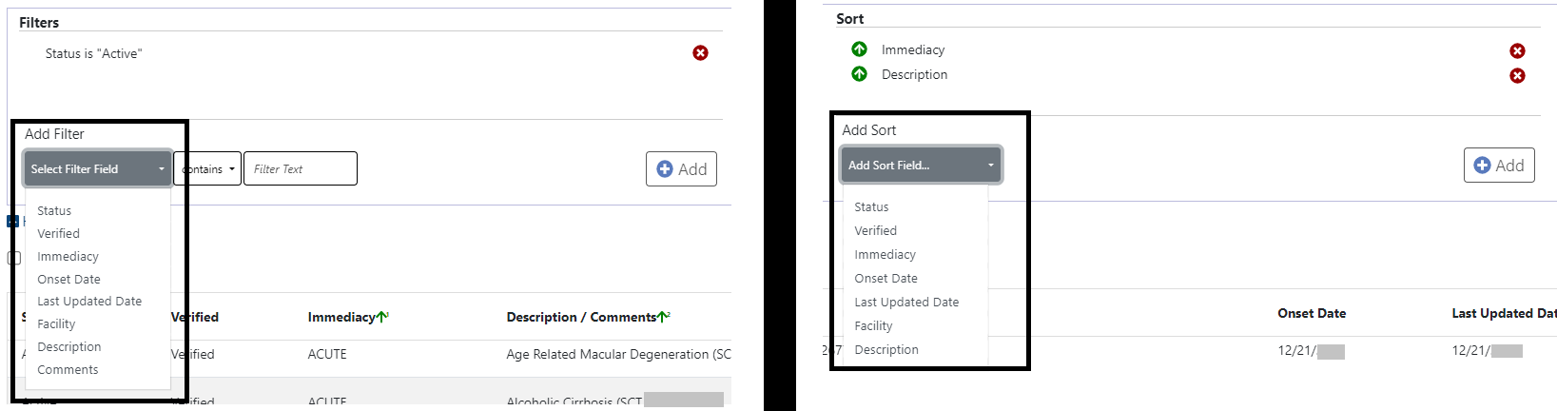
Figure 180: Problem List - “Or” Filter Option
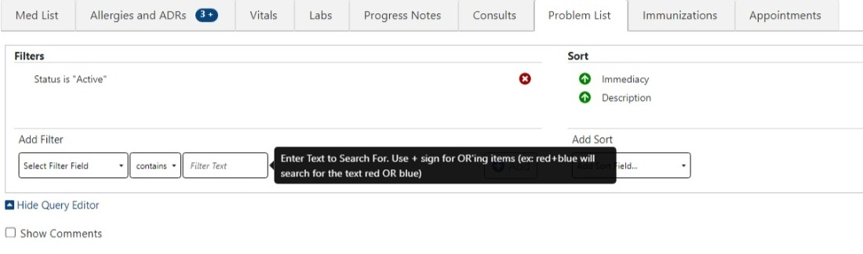

Immunization Tab
From the Immunizations tab, the most current Immunizations available.
Figure 181: Immunization Tab
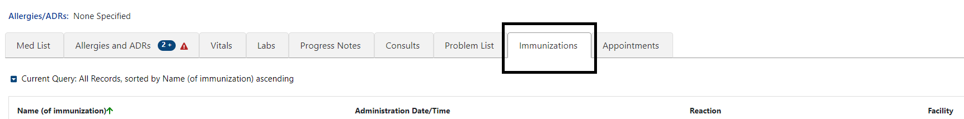
The column headers include Name (of immunization), Administration Date/Time, Reaction and Facility.
Figure 182: Immunization - Column Headers
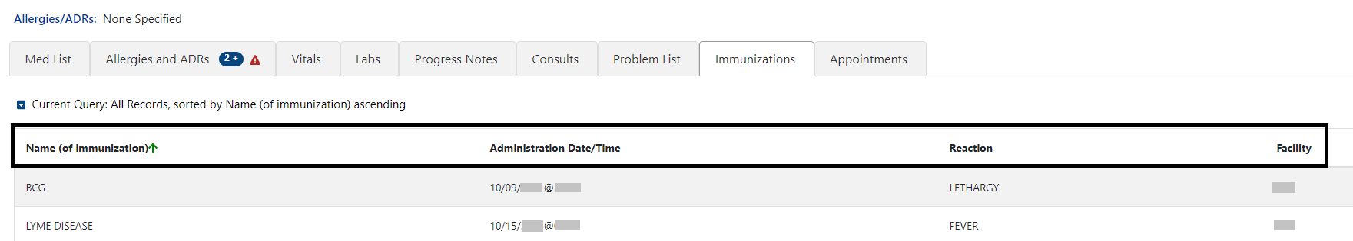
Help text will display when hovering over the column headers. See figure below:
Figure 183: Immunization - Help Text
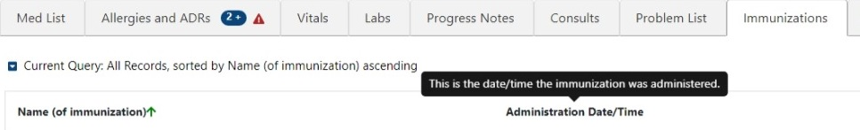

Immunization Tab – Expanded View
To view additional details on an immunization, click on the record and a pop-up window will display. The information includes Full Name, Vaccine Information Statement(s) Offered, VIS (Vaccine Information Statement) Name, Edition Date, Language, Date Administered, Dose/Dose Units, Series, Max # In Series, Admin Route/Site, Reaction, Contraindicated, Manufacturer, Lot Number, Expiration Date, NDC, Location Facility, Administered By, Ordered By, and Comments. To close the pop-up, click on the Close button or click outside the expanded view window. See figure below:
Figure 184: Immunization - Expanded View
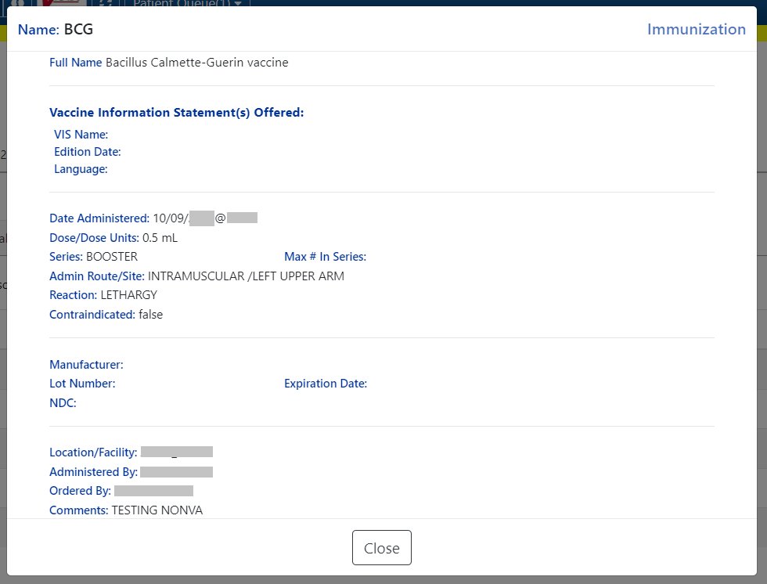

Immunization Tab – Query Editor
Filtering and sorting options are available by using the dropdown menus shown below. Filtering options include Name (of immunization), Administration Date/Time, Reaction, Facility, Full Name (of immunization), Series, Contraindicated, Lot #, NDC, Location, and Comments.
Sorting options include Name (of immunization), Administration Date/Time, Reaction, Facility, and Series.
Once a filter/sort is selected, click Add to have the filter added to the search criteria. Continue this process with other filters, as needed. Once completed, click on Refresh to update the display. To delete a filter, select the red “X” icon to the right of it. To clear filters added by the user and return to the tab’s default, click the Reset button. To close the Query Editor, click on the Hide Query Editor Button. See figure below:
Figure 185: Immunization - Filters and Sort Options
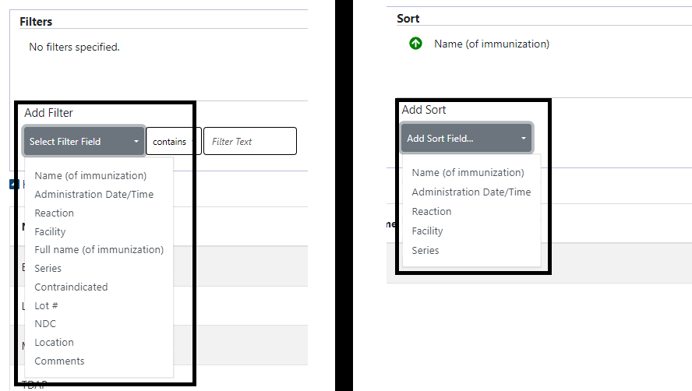

Appointments Tab
The Appointments tab displays data for the last year, sorted by Date/Time descending order, 100 results per page will display. See figure below:
Figure 186: Appointments Tab
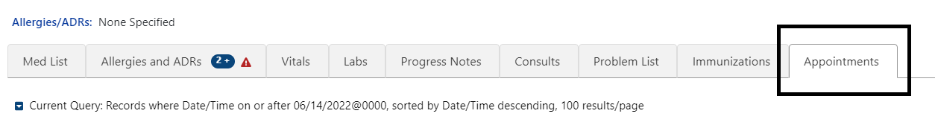
The column headers include Date/Time, Clinic, Specialty, Provider, Status, and Facility. See figure below:
Figure 187: Appointments - Column Headers
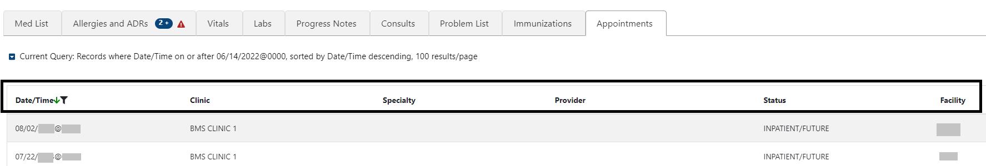
Help text will display when hovering over the column headers. See figure below:
Figure 188: Appointments - Help Text
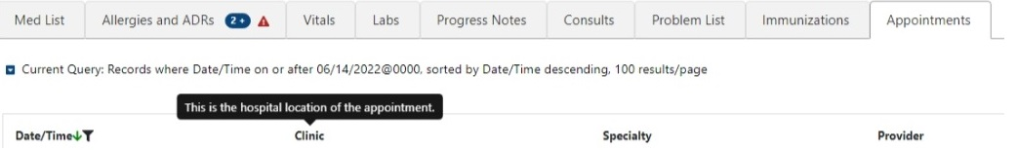
Two print buttons are in the top right corner of the Appointments tab, Print Current List or Print Upcoming Appointments. See figure below:
Figure 189: Appointments - Print Buttons
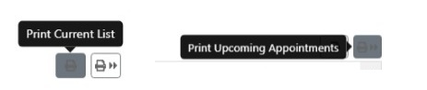

Appointments Tab – Expanded View
To view details for an Appointment record, click on the individual record. For past appointments, a pop-up window displays the Progress Note(s) associated with the visit. If multiple notes are associated with the visit, all will be displayed. Information includes Standard Title, Report Text, Date of Note, Entry Date, Author, Exp Signer, Exp Cosigner, Urgency, Status, Facility/Location, Signed By, Signature Date/Time, Signature Block Name, and Signature Block Title. See figure below:
Figure 190: Appointments - Expanded View
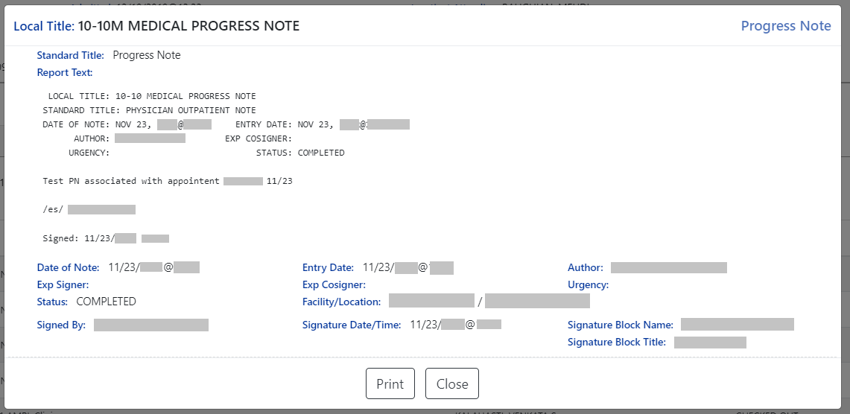

Appointments Tab – Query Editor
Filtering and sorting options are available by using the dropdown menus shown below. Filtering options include Status, Verified, Immediacy, Onset Date, Last Updated Date, Facility, Description, and Comments.
Sorting options include Status, Verified, Immediacy, Onset Date, Last Updated Date, Facility and Description.
Once a filter/sort is selected, click Add to have the filter added to the search criteria. Continue this process with other filters, as needed. Once completed, click on Refresh to update the display. To delete a filter, select the red “X” icon to the right of it. To clear filters added by the user and return to the tab’s default, click the Reset button. To close the Query Editor, click on the Hide Query Editor Button. See figure below:
Figure 191: Appointments - Filter and Sort Options
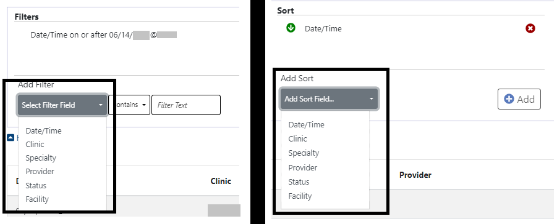

Version and Build Information
From AMPL GUI application, version and build information is available by clicking in the user-station number box in the upper right corner of the header. See figure below:
Figure 192: Version and Build Information
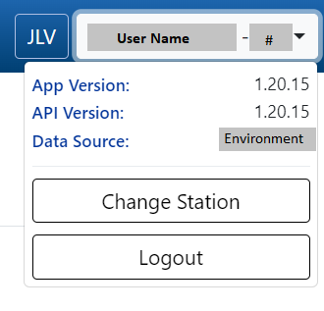

Date Formats for Entry
When searching, enter dates in the customary format of mm/dd/yyyy format.

Time Display
The remote orders times will remain in the time zone where they were given or recorded.

Joint Legacy Viewer (JLV) Button
Joint Legacy Viewer (JLV) is accessible by clicking the JLV button in the upper right corner of the screen. It includes data from external partners (e.g. (Department of Defense (DOD)). See figure below:
Figure 193: Joint Legacy Viewer (JLV) Button

Patient Record Flag
Patient Record Flags alert VHA employees of patients whose behavior or characteristics may pose a threat to the safety of the employee, other patients, or compromise the delivery of quality health care. Patient Record Flags are divided into types: Category I (national) and Category II (local). Each type is described in sections below.
The Patient Record Flag indicator is included in the Patient Header on the coversheet. The button will display “FLAG” in red when Patient Records Flags are available. If no Patient Record Flags are available, the button will be disabled. See figure below:
Figure 194: Patient Record Flag Indicator
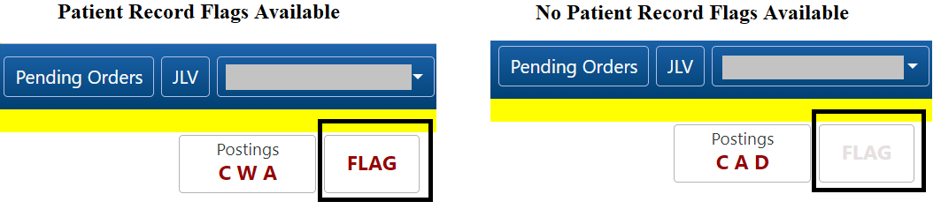

Patient Record Flag Window Display
Patient Record Flags are accessible by clicking on the Patient Record Flag button. The Patient Record Flag information includes Category I Flags, Category II Flags, Flag Name, Assignment Narrative, Flag Type, Approved By, Flag Category, Next Review Date, Assignment Status, Owner Site, Initial Assigned Date, Originating Site, and Signed, Linked Notes of Title. See figure below:
Figure 195: Patient Record Flags
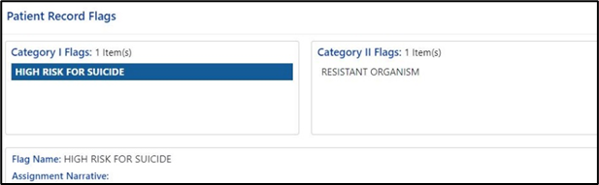
If multiple Patient Record Flags exist for a patient, details of each flag are accessible by clicking on it. See figure below:
Figure 196: Patient Record Flag Window
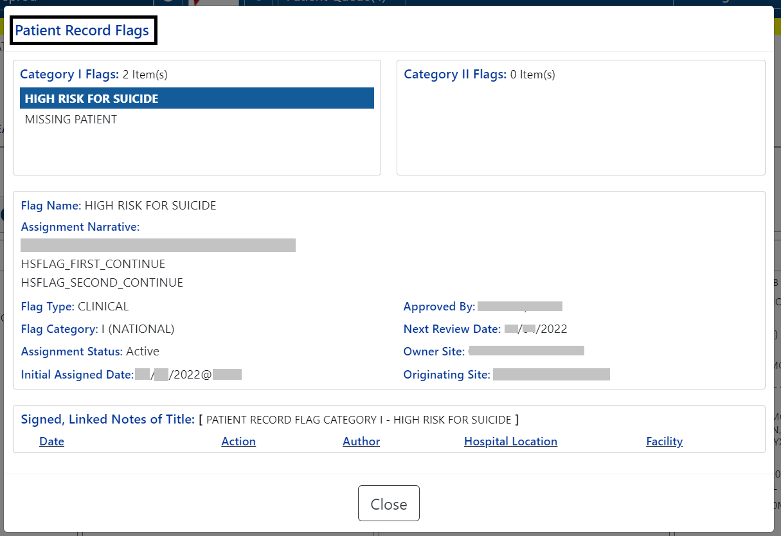

Patient Record Flag – Category I Flags (National)
Category I Patient Record Flags are established and approved at a national level and are transmitted to all facilities, ensuring that these flags are universally available.
Each flag includes a narrative that describes the reason for the flag and may include some suggested actions for users to take when they encounter the patient.
Category I Patient Record Flags will display in a pop-up when the patient’s record is opened. They may also be accessed by clicking on the Flag button in patient demographics.
The Progress Note for the Category I Patient Record Flag is also available. To access the note, click on the note link under the Signed, Linked Notes of Title section. See figure below:
Figure 197: Patient Record Flag Category I Flag Signed, Linked Notes
Upon clicking the link for the Linked Note, a new window displays the Progress Note for the Patient Record Flag Category including the Date of Note, Entry Date, Author, Expiration Signer, Expiration Cosigner, Urgency, Status, Facility/Location, Signed By, Signature Date/Time, Signature Block Name, and Signature Block Title. See figure below:
Figure 198: Patient Record Category Flag I Progress Note Window
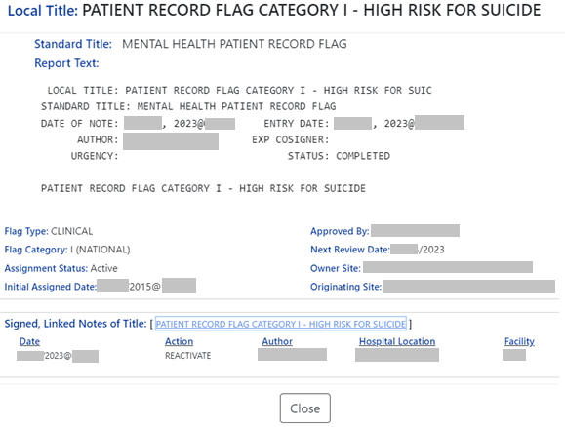

Patient Record Flag – Category II Flags (Clinical)
Category II Patient Record Flags are established and approved at a local level by individual VISNs or facilities. They are not shared between sites. When a flag is selected, details for the flag will be displayed, including Flag Name, Assignment Narrative, Flag Type, Flag Category, Assignment Status, Initial Assignment Date, Approved By, Next Review Date, Owner Site, Originating Site and a link to the related Progress Note. The Progress Note for the Category II Patient Record Flag is also available. To access the note, click on the note link under the Signed, Linked Notes of Title section. See figure below:
Figure 199: Category II Flags
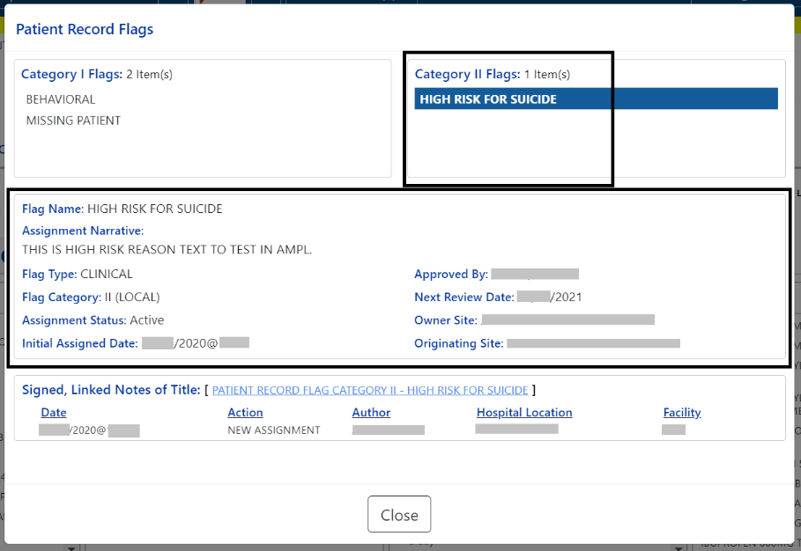
Figure 200: Patient Record Flag Category II Flag Signed, Linked Notes
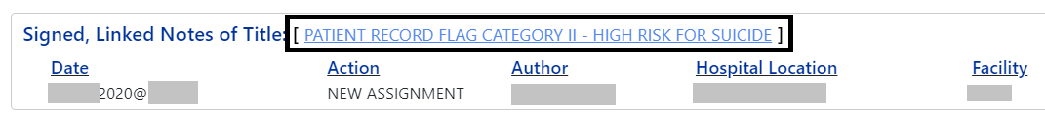

Upon clicking on the link for the Progress Note, a new window displays the Progress Note for the Patient Record Flag Category II including the Date of Note, Entry Date, Author, Expiration Signer, Expiration Cosigner, Urgency, Status, Facility/Location, Signed By, Signature Date/Time, Signature Block Name, and Signature Block Title.
To Close the Progress Note, use the button at the bottom of the window.
Figure 201: Patient Record Category Flag II Progress Note Window
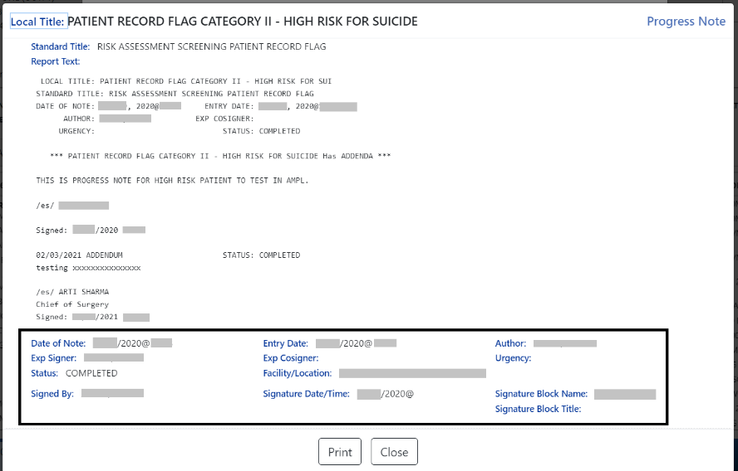

Clinical Context Object Workgroup (CCOW)
Clinical Context Object Workgroup (CCOW) is a Health Level Seven (HL7) International standard protocol designed to enable disparate applications to synchronize patient context in real time and at interface level.
AMPL GUI participates in patient context sharing both with the VA’s existing enterprise desktop CCOW software and with individual VistA systems.
When switching patients in AMPL GUI, participating applications such as CPRS will be notified of the change and switch to the new patient. Similarly, switching patients in a participating application will cause AMPL GUI to change to the new patient.
AMPL GUI allows sharing patient context with individual VistA systems, integrating with VistA’s ‘Last Selected Patient’ functionality.

Desktop Patient Context – Context Status
A visual indicator of current context-sharing status is displayed in the AMPL GUI header using the same iconography as CPRS.
Figure 202: Context Status

Desktop Patient Context – Suspend (Break) Context Links
Clicking on the status button will turn off context sharing, prompting for confirmation beforehand. See figure below:
Figure 203: Context Sharing Confirmation Window
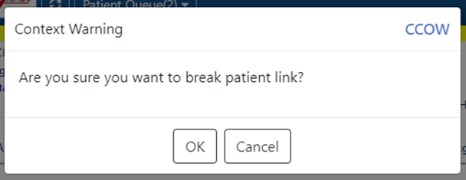
Once context is broken, switching patients in AMPL will no longer change the current patient in other participating GUI applications and vice versa.

Desktop Patient Context – Re-establish (Rejoin) Context Link
Re-establish patient context by clicking the CCOW button in the AMPL GUI header. See figure below:
Figure 204: CCOW Button
A prompt to confirm prior to re-establishing context will display. See figure below:
Figure 205: Re-establishing Context Confirmation
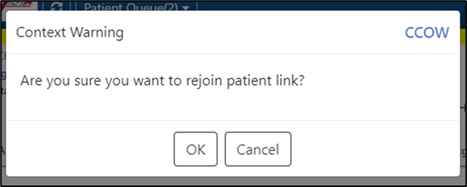

Desktop Patient Context – Notification of Failed Context Changes
If changing context or checking for context changes in AMPL GUI fails, context will be broken, and an error message will display. See figure below:
Figure 206: Notification of Failed Context Changes Window
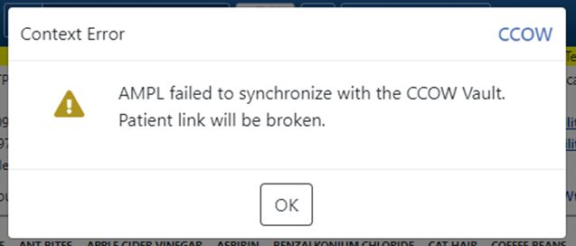

VistA ‘Spacebar Return’ Functionality in AMPL GUI Application
AMPL GUI provides functionality to mimic VistA’s “Last Selected Patient” functionality.

VistA Logo Button
To switch to the patient that is currently selected in VistA, click on the VistA logo button located in the AMPL GUI header. See figure below:
Figure 207: VistA Logo Button
After clicking on the VistA logo button, the option to choose whether a patient change should be made in AMPL. See figure below:
Figure 208: Notification of Patient Change in AMPL
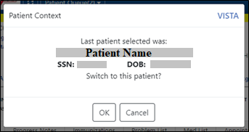

VistA Patient Context – Change Cannot be Done in AMPL
When using the VistA logo button, when a VistA context cannot be made in AMPL an error message will display. See figure below:
Figure 209: Patient Context Change Cannot be Made in AMPL Notification Window
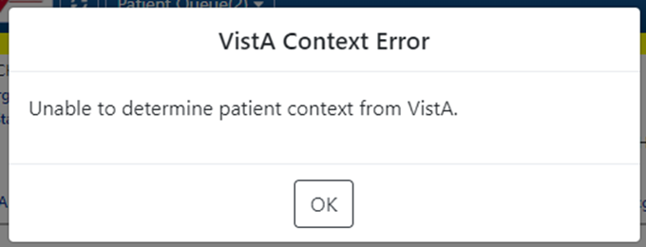

Vista ‘Spacebar Return’ Function
In VistA, using the existing ‘Spacebar Return’ function at a ‘Select Patient’ prompt will select the currently selected AMPL GUI patient. The user must be in the AMPL Cover Sheet.
Figure 210: VistA Spacebar Return Function
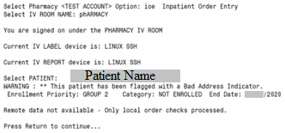

Changing User ID and Password
A PIV card is used to validate users for access.

Exit System
To exit the system, navigate to the dropdown next to your username in the upper right-hand corner of the AMPL GUI header. click on the Logout button found under the Change Station button. See figure below:
Figure 211: Logout Button
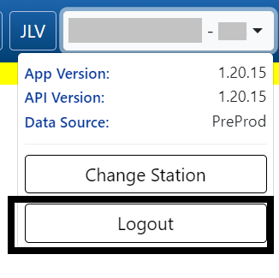

Caveats and Exceptions
Caveats and Exceptions are not applicable to AMPL GUI.

Troubleshooting
This section includes general information regarding errors, probable causes, and resolutions.
Symptom | Cause | Resolution
When logging into AMPL, you see a blank page. | AMPL is designed for Chrome-based browsers. | Use a Chrome-based browser.
When logging into AMPL, you receive a message saying, "You do not have sufficient permissions to use the application." | Your user account has not been added to the required Active Directory Group. | Contact support to have your windows account added to the proper security group.
While using the application, the display is poorly formatted, or user interface elements do not perform as intended. | AMPL is designed for Chrome-based browsers with a minimum window size of 1024x768 pixels. | Use a Chrome-based browser and try increasing the size of the browser window.
While using the application you are taken back to the login page. | Your IAM user session has expired. | Log back into the application.
While using the application you receive a message saying an error occurred while retrieving data. | A system-level error has occurred. | Contact support to report the issue.
When a patient record loads user receives a Pre-Check error | Error occurred while performing the patient pre-check. | Patient record will be loaded without additional user interaction
When a patient record loads in AMPL, on rare occasions some data may be missing. | Technical Issues in AMPL. | A warning indicator icon displays on a domain TAB on the Cover Sheet if any such data is missing for the domain. The icon will remain as long as the patient’s record is open.
A patient record loads in AMPL missing recent updates to patient demographic data. | Updates to patient demographic data in VistA do not trigger propagation to VDIF. | When other data updates for that patient such as medication order changes are made, VistA will trigger the updates including the patient demographics changes to be propagated to VDIF. This will make the data changes available in AMPL.

Acronyms and Abbreviations
The following table lists acronyms found in this document and provides definitions.
Acronym | Definition
ACOE | Agile Center of Excellence
AD | Active Directory
ADRs | Adverse Reactions
AITC | Austin Information Technology Center
AMPL GUI | Advanced Medication Platform Graphic User Interface
BMI | Body Mass Index
BSA | Body Surface Area
CCOW | Clinical Context Object Workgroup
CD | Critical Decision (Used in the VIP Process)
CMOP | Consolidated Mail Outpatient Pharmacies
CPRS | Computerized Patient Record System
CrCL | Creatine Clearance
CREAT | Creatine
CVP | Central Venous Pressure
CWAD | Crisis Notes, Warning Notes, Allergies/ADRs, and Directives
DNR | Do Not Resuscitate
DOD | Department of Defense
EKG | Electrocardiogram
eMI | Enterprise Messaging Infrastructure
ePAS | Electronic Permissions Access
EUO | End-User Operations
FHIR | Fast Healthcare Interoperability Resources
GMR | General Medical Record
HL7 | Health Level Seven
ID | Identification
IEN | Internal Entry Number
ITOPS | IT Operations and Services
JVL | Joint Longitudinal Viewer
mg/dL | Milligrams per deciliter
MHA | Mental Health Assistant
MPI | Master Patient Index
NAA | No Allergy Assessment
NARS | Network Access Request
NKA | No Known Allergies
OIT | Office of Information and Technology
PADE | Pharmacy Automated Dispensing Equipment
PBM | Pharmacy Benefits Management
PIV | Personal Identity Verification
POW | Prisoner of War
Q12H | Taking medication every 12 Hours
Q8H | Taking medication every 8 Hours
SSN | Social Security Number
SSOI | Single Sign-On Internal
TIU | Text Integration Utility
URL | Uniform Resource Locator
VAEC | Veterans Affairs Enterprise Cloud
VAMC | Veterans Affairs Medical Center
VBA | Veterans Benefits Administration
VHA | Veterans Health Administration
VIP | Veterans-focused Integration Process
VIS | Vaccine Information Statement
VistA | Veterans Health Information Systems and Technology Architecture
VPR | Virtual Patient Record

Appendix A: Post-implementation Access or Removal Requests
Access to AMPL GUI is granted by membership in an Active Directory (AD) group. After initial implementation, a site may request access or removal of an individual by following the process used by their site. There are several processes for requesting and removing membership to the AD group, including ePAS, Network Access Requests (NARS) or helpdesk requests. Each region may use a different process. Please check with local IT end-user operations (EUO), or IT Operations and Services (ITOPS) to find the current process for your site.

Appendix B: AMPL Desktop Shortcut
The AMPL application can be easily accessed by creating a Desktop Shortcut. Follow the step-by-step instructions below to create a shortcut for your desktop.
- Right-click on a blank area of your desktop and select “New” and then “Shortcut“.
- For the location, type the path to the browser you wish to use followed by the AMPL URL (https://ampl.vaec.va.gov). The following figure depicts Google Chrome as an example.
Figure 212: Desktop Shortcut
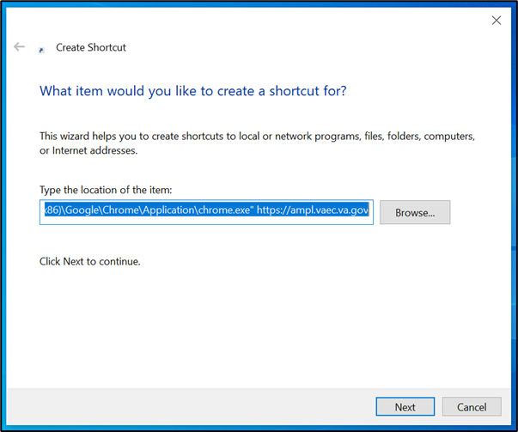
- Type the name for the shortcut: “AMPL”.
- Select “Next”.
- Select “Finish”. The shortcut is now created and will be found on your Desktop.

