`

Scheduling V. 5.3

Primary Care Management Module (PCMM)

Installation Guide/
Release Notes

Patch SD*5.3*148

September 1998

Department of Veterans Affairs
VISTA Software Development
Technical Services
Albany CIO Field Office

Table of Contents

Installation Guide 1

I. Introduction 1
II. Pre Installation 2
Server 2
Client 2
III. Installation Activities 3
Server 3
Client 5
IV. Installation of the PCMM Client Software 6

Release Notes 11

I. User Release Notes 11
GUI Side 11
Server Side 12
II. Technical Release Notes 14
GUI Client Software 14
Options 14
New 14
Changed 15
Mail Messages 15
Protocols 15
Remote Procedures 16
Security Keys 16
Data Dictionary Changes 17

Installation Guide

I. Introduction

This manual provides details on the preparation for and installation of Patch SD*5.3*148 to the PCMM software. It includes instructions on the installation of both the Client software and the Server software.

If PCMM has not been installed at your site, you must start with Scheduling Patch SD*5.3*41 and load all subsequent patches. Patch SD*5.3*148 is not a virgin install patch.

This patch provides updates to the Scheduling software only. There are no changes to any other VISTA applications.

II. Pre Installation

Server
The following package versions (or higher) must be installed prior to loading the PCMM software. Since this patch is to existing PIMS software, all preceding PIMS patches should be installed.

Application Name Minimum Version or Patch Checked for in build SD*5.3*148
Kernel | V. 8.0 | NO
RPC Broker | V. 1.1 | YES
FileMan | V. 21.0 Patch #34 | YES
PIMS | V. 5.3 Patch #51 | YES

Client

- The workstation must have one of the following operating systems.
MS Windows 95
MS Windows NT Workstation V. 3.51

- You must have a workstation with V. 1.1 of the RPC Broker running.

- Have Network Capability
- Each workstation should be networked into your VISTA Server
through a local area network.
- Have successfully run the RPC Broker’s RPC Broker Test on each
client workstation.

III. Installation Activities

Server
Installation of the server can occur first because it will not affect the running of the previous version of PCMM. The current version of PCMM on the workstations will continue to function as it does now.

The installation of the server software takes less than 5 minutes.

- Download the KIDS file SD_53_P148.KID from the appropriate CIO Field Office ANONYMOUS.SOFTWARE directory to a directory on your system.

- Review your mapped set. If any of the routines listed in the Routine Summary section of this guide are mapped, they should be removed from the mapped set at this time.

- From the Kernel Installation and Distribution System menu, select the installation menu.

- From this menu, select the Load a Distribution option. At the Enter a Host File: prompt, enter SD_53_P148.KID.

- You may now elect to use the following options (when prompted for INSTALL NAME, enter SD*5.3*148).

- Backup a Transport Global – This option will create a backup message of any routines exported with the patch. It will NOT backup any changes such as DDs or templates.

- Compare Transport Global to Current System – This option will allow you to view all changes that will be made when the patch is installed. It compares all components of the patch (routines, DDs, templates, etc.).

- Verify Checksums in Transport Global – This option will allow you to ensure the integrity of the routines that are in the transport global.

- Use the Install Package(s) option and select package SD*5.3*148.
- When prompted to select the options you would like to place out of order, enter the following.

SDAPP Appointment Menu
SDMGR Scheduling Manager’s Menu
SDNEXT Find next Available Appointment
SDOUTPUT Outputs
SDSUP Supervisor Menu
SDM Make Appointment
SDAM APPT MGT Appointment Management
SDPATIENT Patient Profile MAS
SC PCMM GUI WORKSTATION PCMM GUI Workstation
SC PCMM PT LIST W/TEAM ASSIGN Patient w/Team Assignments
SC PCMM PRACT PATIENTS Practitioner's Patients
SC PCMM REPORTS MENU PCMM Reports

- If routines were unmapped as part of Step 2, they should be returned to the mapped set once the installation has run to completion. Consider mapping the following routines: SCAP* SCUTBK* SCMCT*.

- A new security key, SC PCMM ROLL, is added as part of the installation. This key can be assigned to applicable users at this point.

10) Two new options have been installed onto your system that are not part of any existing user menu. These options are meant for IRM or select ADPAC personnel. You may want to distribute these options at this time.

SCMC MU MASS TEAM UNASSIGNMENT Mass Team/Position Unassignment
SC PCMM POSITION ASSIGN REVIEW Patient Team Position Assignment Review
Client
The installation of the client software should take less than 5 minutes per workstation. The following steps must be taken for each PCMM workstation.

- Download the SD_53_P148.EXE file from the appropriate CIO Field Office ANONYMOUS.SOFTWARE directory.

- Make sure to set transfer as BINARY.
- Get the SD_53_P148.EXE;1 file. Depending on the FTP software, this file might be placed in C:\WINDOWS, C:\, or some other directory. If you cannot find it, use Window’s File Manager’s Search functionality.
- VMS requires the “;1” extension on this file. It is necessary to rename the file to SD_53_P148.EXE (without the “;1”).

- Copy the SD_53_P148.EXE file into an empty (temporary or scratch) directory.

- Run the SD_53_P148.EXE file (double click on it). This starts the PCMM installation. See Section IV, Installation of the PCMM Client Software, for information on the files installed in the Client Workstation.

IV. Installation of the PCMM Client Software

The following screens illustrate the installation of the PCMM client software. If all the default responses are accepted, the PCMM software will be installed into the appropriate VISTA directory on the user’s workstation.

This version of the client software can be installed as either a patch to the existing client software or as a new installation.

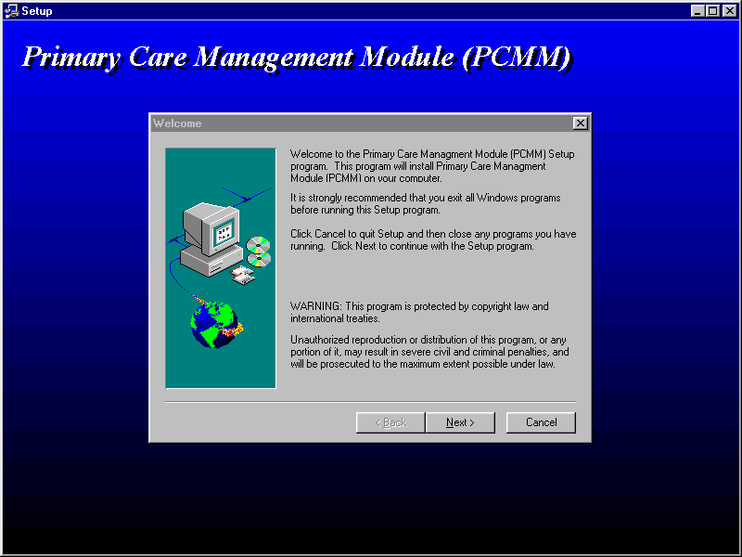

The first screen is a welcome or introduction screen. After reading and following the instructions, click on the NEXT button to continue.

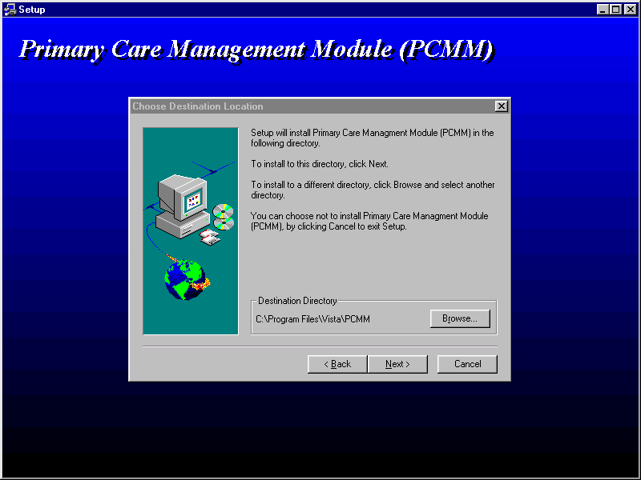

The second screen displays the directory into which the software will be installed. This is the default directory used for VISTA software. It is recommended that you accept this directory.

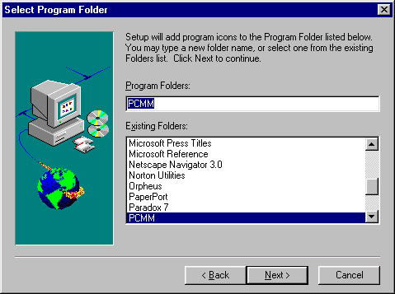

This next screen allows the installer to define the program icon that is created. Accepting the default is recommended.

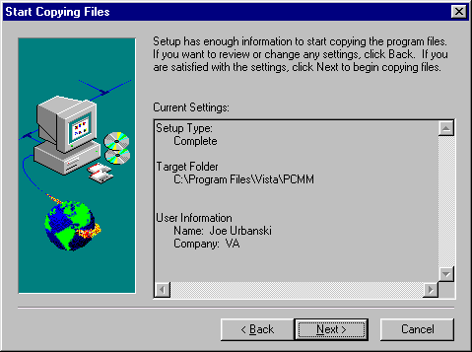

This screen displays the type of installation, where the software is going to be placed, and who is performing the installation.

Upon selecting the NEXT button on this screen, Install Shield will install the PCMM software in the target folder and set up the program icon. It will also create/update a subfolder of PCMM\docs in which it stores all the documentation files in a .PDF format.

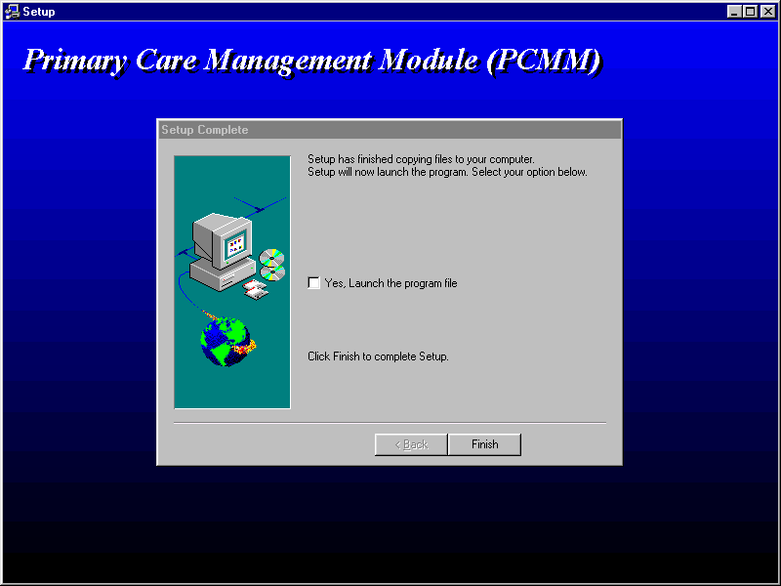

This is the last window in the installation. At this point, the software is installed. Install Shield asks the installer if they wish to run the application. There are no recommended responses at this point. If the YES box is checked, Install Shield will start PCMM. If it is not checked, Install Shield will finish and close.

Release Notes

I. User Release Notes

This patch makes changes to the PCMM software, addressing some of the reported usability and NOIS issues and adding new functionality. The changes and additions are defined below. If necessary, please refer to the PIMS User Manual - Scheduling Module, the Practice Profiling Software Requirements Specifications, or the online help for further information.

GUI Side

- A new GUI option, Multiple Reassignments, has been added that allows the reassignment of patients between teams. The option is available through the Patient drop down menu. The new functionality allows a user to reassign a single patient or group of patients from one team to another. When the patients are reassigned, they are automatically unassigned from the previous team. Upon completion of this process, a bulletin notifies the user of any failed reassignments. This patch addresses half of NOIS (SDC-0997-62502). Patch SD*5.3*157 will address the remaining half.

- The GUI option, Patient Assignment, allows the user to edit the team assignment information for a patient on a particular team. Currently, the user is allowed to enter a discharge date for the selected team. The user is not prompted to discharge the patient from the active position assignments. This leaves the positions active with no active team assignment. The software has been adjusted so that when a user enters a discharge date for a team, a check is performed for active positions. If active positions are found, they are displayed to the user. If the discharge continues, the positions are discharged as well.
Related NOIS Messages: (DAY-0898-41175) (MIA-0298-32684) (ELP-0298-72791)

- The Multiple Patient Assignment function was allowing an additional primary care assignment when the patient already had a primary care assignment and the primary care role was attending. This has been corrected.
Related NOIS Message: (SDC-1097-62019)

- The Team – Position Assignments form no longer prompts the user to enroll a patient in a clinic associated with the position if the patient is already enrolled in that clinic.
Related NOIS Messages: (TAM-1297-31132) (BED-0697-12105)
- A new role, Clinical Nurse Specialist, has been added to the STANDARD POSITION file. Clinical Nurse Specialist is now a selectable role when creating and editing team positions.

- The following changes have been made to the processing of Multiple Patient Team Assignments and Multiple Patient Position Assignments.

- Assignments are queued to run in the background. The GUI only provides a Warning Message in the event the task was unsuccessfully queued on the server.
- “Fail to Assign” and other error messages are not displayed to the GUI. They are included in a mail message sent to the user performing the assignment. This also includes “failure to assign” due to a date of death entry.
- Team message bulletins will not be generated.

- The Patient Lookup dialog box has been changed. A SEARCH button and RETURN key functionality have been added.

Server Side

- The Patient with Team Assignments report was not correctly pulling the last four digits of the patient social security number. This has been corrected.
Related NOIS messages: (TAM-0398-31294) (CHY-0498-50320) (JAC-0898-71573)
(LEX-0898-41916) (HAM-0598-21158)

- The Practitioner’s Patient report was not printing all similarly spelled patient names for a position. This has been corrected.
Related NOIS Message: (TAM-1297-31132)

- If a medical center was not using the PCMM application to store Primary Care Team and Provider information, they may have been using the CURRENT PC TEAM and CURRENT PC PRACTITIONER fields from the PATIENT file. Those fields are no longer used to store or obtain that information. Primary Care Team and Provider information now only comes from the PCMM application.
Related NOIS Messages: (POR-0997-51348) (HUN-0397-20290)

- The new option, Mass Team/Position Unassignment, allows the user to unassign large groups of patients from teams and positions. This is a List Manager option that unassigns selected patients from either a team and all the associated positions or from a specific position within a team. A MailMan message is distributed to the user initiating the change. The message details the result of the action.
- The new Primary Care Team/Posn Assign or Unassign option is a roll and scroll option that allows the user to assign/unassign patients to/from a Primary Care Team or Position. If there is a clinic associated with the position, users are asked if they wish to enroll/discharge the patient from that clinic. The option is locked with the SC PCMM ROLL security key.

- The new Patient Team Assignment Review option is a diagnostic tool that reviews all PATIENT TEAM POSITION ASSIGNMENT file (#404.43) entries with the corresponding PATIENT TEAM ASSIGNMENT file (#404.42) file entries. The comparison checks to make sure that the position assignment active timeframe is within the team assignment active timeframe.

A MailMan message is sent to the initiator listing those position assignments that fall outside the team assignment active timeframe. The results in the message should be used to correct those problem position assignments.

The option is not assigned to any general PIMS menus during installation. Only specific medical center personnel should be assigned this option.
II. Technical Release Notes

GUI Client Software

- PCMM has been updated from the 16 bit to the 32 bit version. This allows for the use of the new V. 1.1 32 bit broker and the new File Manager components and RPCs. All the client Delphi code has been upgraded to Delphi 3.
Related NOIS Messages: (CMO-0898-40401) (WPB-0898-30002) (NIN-0698-40768)

- A new option, Multiple Reassignments, has been added to the Patient drop down menu. This option allows a user to reassign patients from one team to another.
Related NOIS Message: (SDC-0997-62502)

- The Multiple Assignment procedures, [SC FILE PAT POS ASGN] and [SC FILE PAT TM ASGN], queues processing on the server and returns processing information to the user via a mail message. This was done to minimize user waiting time.
Related NOIS Message: (CON-0398-11638)

Options

New
Mass Team/Position Unassignment [SCMC MU MASS TEAM UNASSIGNMENT]
This roll and scroll option is not being distributed as part of an existing menu. It is intended for IRM or select ADPAC personnel. This option allows a user to discharge a large number of patients from teams and/or positions.

Primary Care Team/Posn Assign or Unassign [SC PC PATIENT ASSIGN/UNASSIGN]
This option is a roll and scroll version of the GUI interface used to assign/unassign patients to Primary Care teams and positions. It is distributed on the Appointment Menu [SDAPP] as well as a protocol, SC PC PATIENT ASSIGN/UNASSIGN, in the Appointment Management option.

Patient Team Position Assignment Review [SC PCMM POSITION ASSIGN REVIEW]
This option compares all PATIENT TEAM POSITION ASSIGNMENT file (#404.43) entries with the corresponding PATIENT TEAM ASSIGNMENT file (#404.42) entries. The comparison checks to make sure that the position assignment active timeframe is within the team assignment active timeframe. This roll and scroll option is not being distributed as part of an existing menu. It is intended for IRM or select ADPAC personnel.
Changed
Patient w/Team Assignments [SC PCMM PT LIST W/TEAM ASSIGN]
This option was not pulling the last four digits of the patient social security number for display. This has been corrected.
Related NOIS messages: (TAM-0398-31294) (CHY-0498-50320) (JAC 0898-71573)
(LEX 0898-41916) (HAM-0598-21158)

Practitioner's Patients [SC PCMM PRACT PATIENTS]
This option was not printing all similarly named patients for a position. This has been corrected.
Related NOIS Message: (TAM-1297-31132)

Mail Messages

- The team mail messages sent upon completion of Multiple Patient Assignments are now sent only to the user who initiated the process.
- A mail message is generated from the Mass Unassignment functionality, summarizing the mass unassignment attempt. It lists what discharges were successful and what discharges could not take place and the reason why.
- The Multiple Reassign generates a mail message to the initiator listing which reassignments were not successful.
- The Patient Team Position Assignment Review option generates a mail message to the initiator listing those position assignments that fall outside the team assignment active timeframe.

Protocols

The Mass Team/Position Unassignment option has added several new protocols, which are the actions available as a result of adding this functionality.

SCMC MU SELECT ALL
SCMC MU DESELECT ALL
SCMC MU SELECT SOME
SCMC MU DESELECT SOME
SCMC MU VIEW ALL
SCMC MU VIEW SELECTED
SCMC MU VIEW DESELECTED
SCMC MU UNASSIGN PATIENTS
SCMC MU QUIT
As a result of the roll and scroll functionality of assigning and unassigning a patient to Primary Care Teams, a new protocol, SC PC PATIENT ASSIGN/UNASSIGN, has been added. This protocol is available as an action in the Appointment Management option. This action provides the same functionality as that found in the Primary Care Team/Posn Assign or Unassign option.

Remote Procedures

Six new remote procedures have been added.

The server-side logic of the Multiple Patient Assignment procedures, [SC FILE PAT POS ASGN] and [SC FILE PAT TM ASGN], has been changed.

- The code was not checking for Primary Care Attending role. This improperly allowed for the assignment of more than one attending to a patient. This has been corrected. The problem was reported in NOIS (SDC-1097-62019).

- The code queues off the assignment logic and only returns a boolean value concerning whether or not tasking was successful. Information from the assignment processing is returned only to the process initiator in the form of a MailMan message. Assignment is not allowed for deceased patients, and this reason is also returned in the mail message. Multiple assignment procedures retain backward compatibility with the first release of PCMM.

Security Keys

A new security key is being distributed, SC PCMM ROLL. This key is used to lock the SC PC PATIENT ASSIGN/UNASSIGN option. It should be assigned to the appropriate users.
Data Dictionary Changes

- A KIDS Post Install routine, ^SD148PT, updates the STANDARD POSITION file (#403.46) with the Clinical Nurse Specialist role. This should be the 22nd entry in this file. The routine ^SD148PT may be deleted after the new role has been successfully added.

- A partial DD of the PATIENT file is being distributed. Two fields, CURRENT PC PRACTITIONER (404.01) and CURRENT PC TEAM (404.42), are being starred for deletion. These fields are no longer used to store or obtain the current Primary Care Practitioner or current Primary Care Team. As a result, the supported API that uses the PATIENT file fields has been adjusted to only pull data from the appropriate PCMM fields.
Related NOIS Messages: (POR-0997-51348) (HUN-0397-20290)

