Hmm, if only I could electronically transmit this MDS to the AAC!!
MDS
MDS
Section S

RAI/MDS Electronic Transmission
Training Manual

Veterans Health Administration Office of Information
OI National Training and Education Office

Content for the appendices A, B, and C of this manual was developed by REDACTED and REDACTED, University of Rochester consultants for VISN 2 and VHA OI Implementation and Training Services.

Purpose
This booklet is to help facilitate the electronic transmission of the MDS to the AAC (Austin Automation Center) through the VA intranet.

Audience
Those assigned to electronically transmit the MDS.

Objectives
Upon completion of this training the user will be able to:

- Access Internet Explorer and enter the correct address to access the Austin server.
- Generate and locate the proper file to submit to the AAC and populate that file name in the proper field in the correct web page.
- Send the electronic MDS report.
- Validate acknowledgement from the AAC that the file was accepted.
- Check for pertinent information in the initial and final validation report and use that information accordingly.
- Save and print reports as needed.
- Explain the MDS electronic transmission process.
- Log successful and unsuccessful transmissions and re-transmit individual records as needed.

Introduction
The RAI/MDS implementation is a national project for the VA. One of the many purposes of this project is to provide computerized storage, access, and analysis of the MDS 2.0 long-term care data on patients in nursing homes across Veterans Affairs medical centers (VAMCs).
The MDS system is intended to create a standard, nationwide system for connecting VAMCs with nursing home facilities to the Austin Automation Center (AAC) for the purpose of electronic interchange of data, reports, and other information. The MDS transmission system provides the following functions:

- Receipt of MDS records from the AAC by VAMCs.
- Authentication and validation of MDS records received from VAMC facilities.
- Feedback to VAMCs indicating acknowledgment of the transmission of the data and
specifying the status of record validation.
- Storage of MDS records in the database repository at the AAC.
- Will replace PAI and provide RUG III codes to the ARC (Allocation Resource Center).

At each VAMC, the user will use the RAI/MDS program to electronically send MDS data records to the AAC over the VA intranet. Once minimal file checks are completed, a message is sent back to the VAMC indicating whether the file (referred to as batch submission) has been received successfully or rejected.

The user remains on-line to ensure the submission has been accepted. If the submission passes the initial validation check, then each record is checked for errors or exceptions to the data specifications and a Final Validation Report is generated.

How to use this Training Manual
This manual may be used while transmitting data to and accessing the AAC MDS database. The manual describes the step-by-step processes needed to transmit the data in the order they occur – Accessing, Transmitting, and Validation.

Additionally, each step of the process contains an explanation and the action needed to complete a particular part of the process.

The Appendices (A, B, C and D) are very helpful and should be referenced for creating batch files, (Appendix A) re-transmitting rejected files, (Appendix B), helpful hints (Appendix C), and troubleshooting transmission errors (Appendix D).

Creating MDS Batch File
Before accessing the intranet to submit MDS files, it’s imperative to create an MDS Batch File. Appendix A offers step-by-step instructions to create an MDS Batch File.

Accessing

Figure 1.0

Internet Explorer Icon

Explanation
First access Internet Explorer to gain entrance to the Intranet.

Action
Use the mouse to move the cursor to the Internet Explorer icon; double-click the icon to access the Intranet.

Figure 1.1
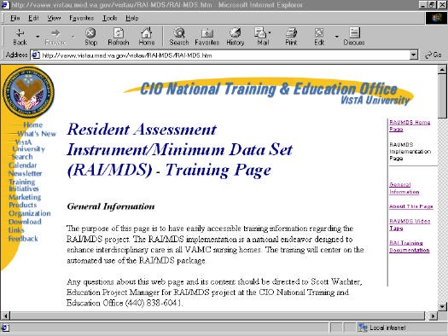
Address Bar

Comment
- At this point, a screen will display what is commonly known as the home page. The content of the page may look different than figure 1.1, but there are some similarities.
- Most importantly there should be an address bar.

Figure 1.2
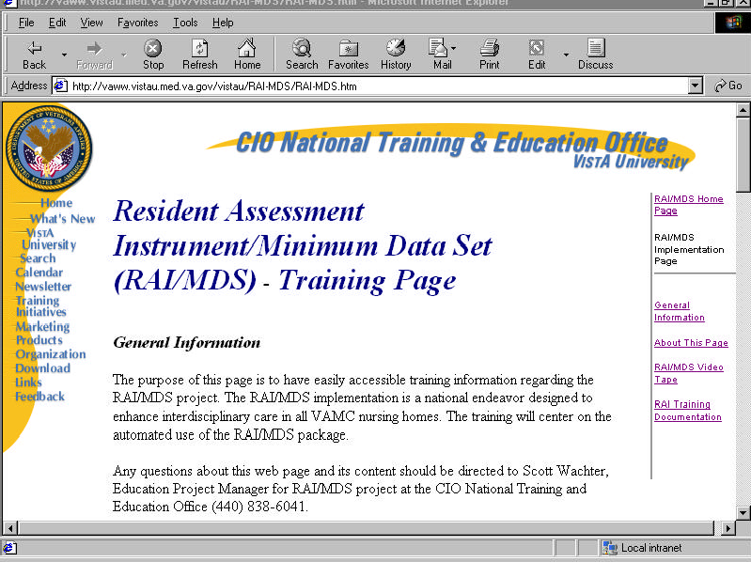
http://152.125.158.225
Address Bar

Action
Using the mouse, highlight the address bar (click and drag the mouse) and enter the new address REDACTED to connect with Austin (as shown in figure 1.2) and press Enter; the mouse will turn into a timepiece and the VHA MDS System home page will soon display.

Suggested Action
Open Favorites from the menu bar and click Add to Favorites. Then click OK in the dialogue box. This will allow easy access to this web site. From this point on, you can access this web site by opening Favorites from the menu choice and clicking the name of this page.
Figure 1.3
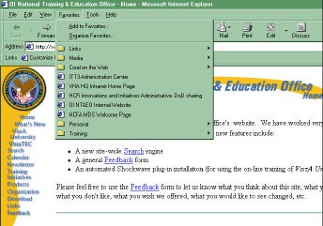

Transmitting

Figure 2.1
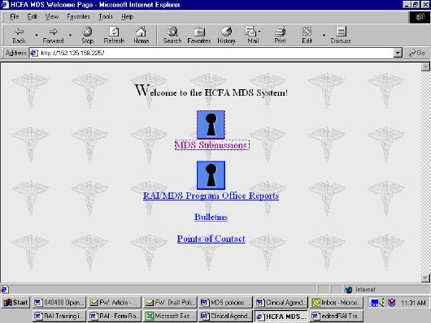
1
2
3
4

Comment
- There are four options available on the VHA MDS System page. They include:
  - MDS Submissions - accesses the main MDS System menu.
  - RAI MDS Program Office Reports – central office and VISN reports.
  - Bulletins - contains news from AAC. This will be updated on a regular basis. This is currently under development.
  - Points of Contact - provides a list of AAC contacts. This is currently under development.
- Moving the cursor with the mouse over the underlined text will change to a hand.
Clicking while the cursor is a hand will access the information as needed.

Action
Move the cursor to MDS Submissions and click to access the Enter Network Password dialogue box. Figure 2.2 displays this box.

Figure 2.2
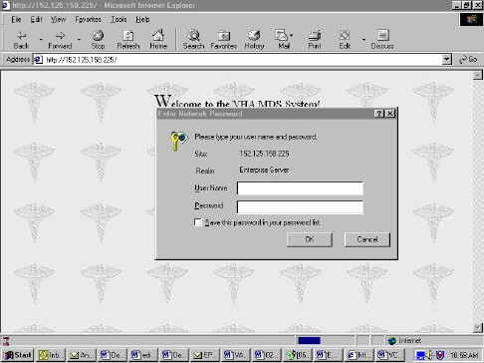
If user name and password are not valid, or if one is needed, contact the RAI site coordinator.
The Enter Network Password dialogue box will appear when only when accessing the VHA MDS Main screen.
The RAI site coordinator will have user name and passwords.

Comment
- The Enter Network Password dialogue box will display.

Action
Point and click on the Austin Automation Assigned User Name field and enter a User Name. Press the Tab key or point and click the Austin Automation Assigned Password field to type enter the password.

Comment
- Clicking Cancel will discontinue the login process.
- Clicking the OK button or pressing the Enter key will continue the login process.

Action
Point and click OK to continue after entering the user name and password to access the VHA MDS Main Screen.

Comment
- Enter the data again if there is a message indicating an invalid user name and password.
- If this message displays repeatedly, contact the Austin Automation Center administrator.

Figure 2.3

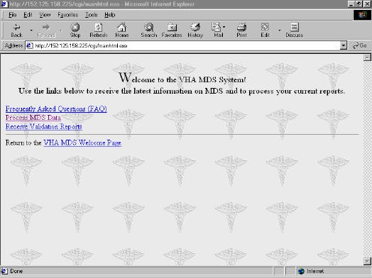
1
2
4
3

Comment
- The VHA MDS Main Menu (Figure 2.3) will display.
- The primary functions of processing HCFA MDS Main menu are to:
- Process MDS data - this continues the processing of MDS data.
- Receive validation reports - a step used near the completion of the MDS submission process.
- FAQs – Frequently asked questions, provide answers to frequently asked questions. This is a means of helping with any common issues or problems that may arise regarding the MDS System. If The AAC has not posted anything, nothing will be displayed when making this selection.
- VHA MDS Welcome Page – returns user VHA MDS Welcome Page.

Action
Point and click Process MDS Data to continue. (Remember the cursor will change into a hand when moved over the underlined text on the web page.)

Figure 2.4
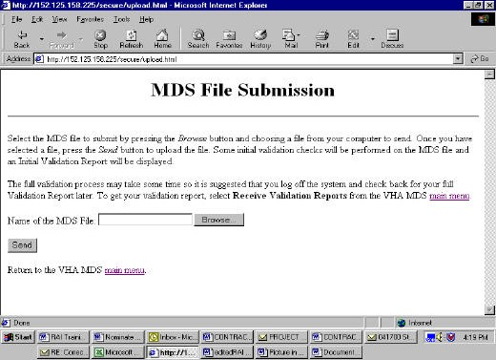
2
1
3
4
Type the file name into the Name of the MDS File field, or use the Browse ­ File Upload method of selecting the file to send.
This ensures the correct path for the file is indicated. If entering a file name, it must be the entire path, e.g., C:\mds\myfile.xxx.
If submitting a file from a diskette, put it in the disk drive before clicking Browse or entering the name of the file.

Comment
- Selecting Process MDS Data will access the MDS File Submission window (Figure 2.4).
- The MDS File Submission window includes instructions and information about submitting MDS files and a data entry field for the name of the MDS file. It contains one data entry field for the Name of the MDS File and the Browse button allows for the selection of a file to submit from a list of files.
- There are two ways to enter a file for submission.
- Enter the name of the file in the MDS File field (see number 1). Ensure you enter the entire path/name (e.g., C:\mds\myfile.xxx).
- Point and click the Browse button (number 2) to select a file for submission from the MDS File Submission window (see Figure 2.4).
- Clicking Send will transmit the file to Austin. This will only once the file has been selected.
- VHA MDS Welcome Page – returns user VHA MDS Welcome Page.
Action
After selecting a file for submission using Browse, the file name will appear in the name of the MDS File field. Point and click the Send button to submit the file (refer to number 3 in Figure 2.4).

Comment
- Clicking VHA MDS Main menu (refer to number 4 in Figure 2.4) will return the program back to the main menu.
Figure 2.5
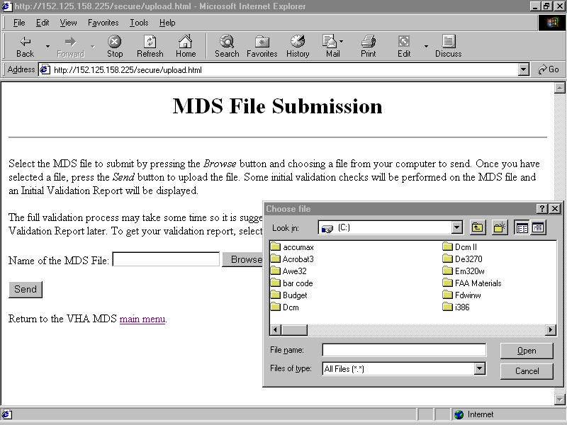
2
3
1
4

Comment
- You can browse through files by clicking the Browse button.
- Ensure that the List Files of Type field indicates “All Files” [*. *] (number 1 in Figure 2.5) and the correct drive (number 2 in Figure 2.5) are selected (A: B: or C:).
- The list of file names will display in the area below the File Name: (number 3 in Figure 2.5).

Action
- Select a file for submission by pointing and clicking a file name and then clicking OK, or you can point and double-click the name of the file to send.
- It will appear in the File Name: field (number 4 in Figure 2.5).
- Point and click OK or press Enter after selecting the file for submission.

Comment
  - Selecting Cancel will exit the File Upload and return to the MDS File Submission window without selecting a file.
Figure 2.6
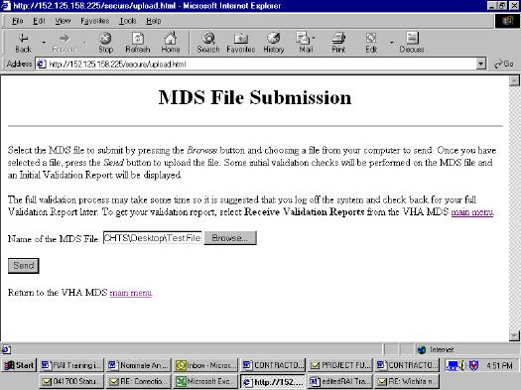
1

Comment
  - The file name should now appear in the name of the MDS File field in the MDS File Submission window (number 1 in Figure 2.6).

Action
Point and click the Send button to submit the file.

Figure 2.7
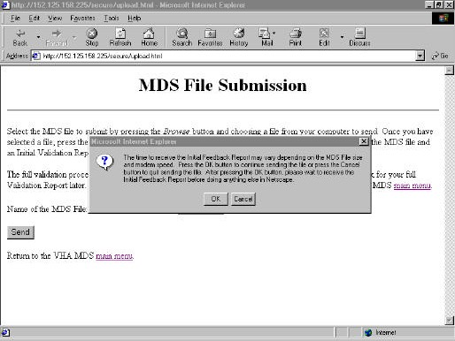

Comment
  - The Confirm window (Figure 2.7) serves as a reminder that the time required to generate the Initial Feedback Report will vary.
  - It is essential to wait for the Initial Feedback Report (which will indicate whether the submission was accepted or rejected) prior to continuing with any other MDS or Internet Explorer functions.
  - Click OK with the mouse to allow the Initial Feedback process to continue.
  - Click Cancel with the mouse to interrupt the file submission process.

Action
Upon confirming the Send command, remain at the MDS File Submission window and do not execute any additional MDS or Internet Explorer functions until receipt of an Initial Feedback Report.

The Initial Feedback Report indicates that the MDS System has performed a basic validation check on the file and whether the submission has been accepted or rejected.

  - If rejected, the Initial Feedback Report includes the rejection error.
  - The Initial Feedback Report should be received shortly after submitting the file.
Figure 3-1

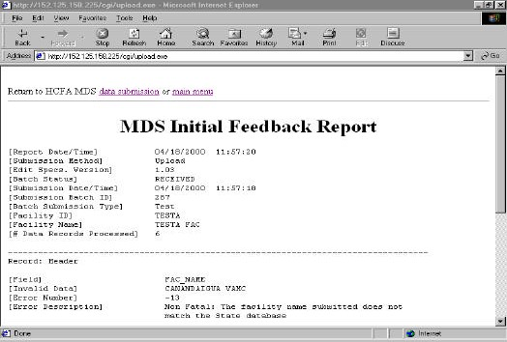
1

Comment
  - The Initial Feedback Report will only display errors found on the header and trailer records. It will not include errors that may be found on the data records. Those errors will be displayed on the Final Validation Report.
  - When the Initial Feedback Report (Figure 3-1) is accessed and is displayed, the first Report Field to check is the status of the submission that will be either received or rejected (number 1 in Figure 3-1).
- If rejected, corrections may need to be made to the file pursuant to the error correction policy defined by HCFA and resubmit.
- Examples of rejection criteria include corrupted file structure or invalid facility identification. In either case, no data will be extracted.
  - Check the Submission Date/Time and the Submission Batch ID number (refer to number 2 in Figure 3-1) for use when troubleshooting any problems with the AAC. You should save and/or print the report.

Action
You can print the report by pointing to and clicking the File menu off the Menu Bar, and highlighting and clicking Print and OK off the Dialogue Box.

You can save the report by pointing to and clicking the File menu off the Menu Bar, highlighting and clicking the Save As command, entering the name of the file and clicking OK. Remember the path where the file was saved.
Figure 3.2
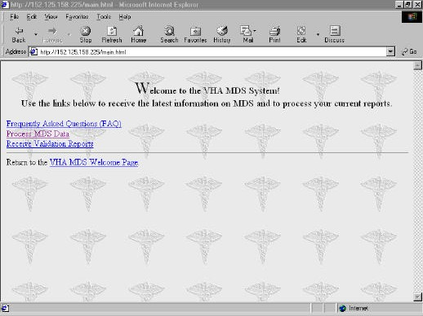
1

Comment
  - Once Initial Feedback Report has been received and reviewed either return to the VHA MDS data submission process (i.e., the MDS File Submission screen) or the VHA MDS Main Menu by pointing and clicking on either of the underlined options.
  - The time required to generate a Final Validation Report may vary depending on the file size and system activity. If rejected, there will be no final report.

Action
To exit the system, simply exit Internet Explorer. You can do this by selecting Exit from the File menu, or clicking the small box with the X at the top left corner of the screen.

Comment
  - The Final Validation Report should be accessible within 45 minutes the of the file submission.
  - Click the Receive Validation Reports to validate the receipt of the report (number 1 in Figure 3.2).
  - Note - See Appendix B to retransmit rejected individual or batch records from the Initial Feedback Report.

Figure 3.3
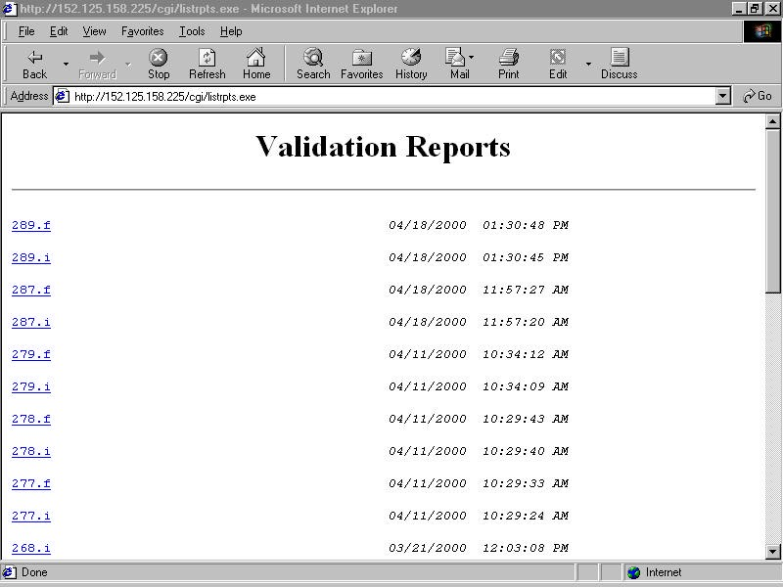

Comment
  - The Validation Report Listing window (Figure 3.3) will display.
  - The Submission Batch ID number identifies the reports. If the report does not correspond with what was submitted, go back to the main menu by pointing and clicking the underlined text to access the available reports.

Action
Point and click the underlined file name to access a particular report. It is important to wait for the report. The time to wait should only be seconds.

Figure 3.4
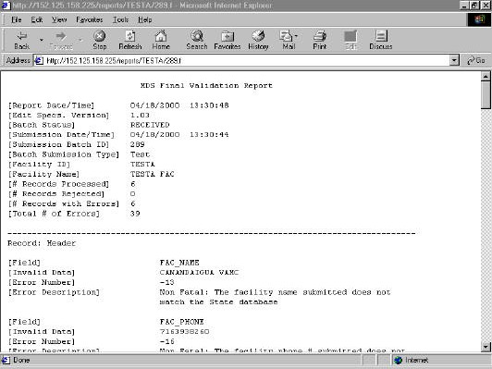
Submission batch identification (ID) number assists in finding the corresponding Final Validation Report.
Additionally, and more importantly, the submission batch ID will be used in troubleshooting any issues pertaining to that specific submission.

Comment
  - The top portion of the Initial Validation Report and the Final Validation Report are the same except for the information on the number of records rejected, number of records with errors, and total number of errors.
  - Batch status indicates whether the file has been received successfully or rejected based on the initial validation check. If it is rejected, review the file for any errors in the header,
such as facility identification information, and resubmit the file.
  - The submission date and time will be in the same format as the report date and time.
  - A submission batch ID is assigned to the submission batch submission type.
  - Facility name is indicated on the report.
  - The number of records processed will indicate the number of records per file that have been processed.

Printing and Terminating
Comment
The following steps may be taken to print, save and exit the program.

Action
- If the computer is connected to a printer, select Print from the Internet Explorer File menu to print a copy of the Final Validation Report.
- Save the file by Save As from the Internet Explorer File menu to save the report to a floppy disk or hard drive.
- Exit the MDS System by selecting Exit from the Internet Explorer File menu.
- Click and point to Disconnect in the window in the upper right corner of the window to end the communications connection to the AAC

For other helpful hints see Appendix C.

Appendix A
Creating a batch
To create a file with all the locked assessments needed for transmission, begin by clicking the Transmissions menu (at the top of the screen in the Assessments module). Click Move Assessments Records.

A Move Assessments Records window will appear. All locked MDS assessments, not already batched, will display on the left side (Hold Assessments) of the screen. Highlight the assessments for transmission and click the right arrow to move them to the right side of the screen.

Once the assessments are located on the Live Assessments side, click the Create Batch button. This will open the Assessments Transmission File Selection dialog box. Click the ellipsis button (…) to the right of the File Name field; this opens a File dialog box.

Click the down arrow in the Save In field. A list of available drives will appear in the box. Select the drive required. (We recommend a public drive that has had a folder created for each long-term care unit. Users will need permissions to access the folders on the public drive.) A folder for each LTC unit will display. Double-click the folder for the desired unit and that folder’s name will move into the Save In field.

In the File Name field, enter the MDS Batch file name by using the following naming convention:

Use the current date followed by a period, a dash, and a sequence number. The first unique batch file created should have the sequence number of 1. For example, a file created on September 27, 1999 for Unit 7A would look like 092799.7A-1.
The sequence number for the second transmission for Unit 7A on September 27, 1999, would be 2, so the file name would be 092799.7A-2.

Click the Save button. The Assessment Transmission File Selection box will reappear with the File Name field completed with the newly created file name. Tab to, or click, the Batch Comment field. The date and user’s initials are entered in the Comment field. Click OK.

The system will prompt the user to send this as a test transmission. If this is a practice batch, click Yes; if this is an actual transmission, click No. The system will display the message “Batch Created Successfully!” Click OK.

Occasionally, the system might send a message indicating that a particular assessment did not batch successfully. The system will prompt the user to go back to that assessment to correct the problem. Ensure the corrected assessment is included in a new batch.

Close the Move Assessment Record window.

After successful creation of the file, click the Transmissions menu, located at the top of the screen in the Assessment module, and then click Data Exports History.

An Assessment Transmission Batch Summary window will display. Highlight the newly created batch file by clicking it. Click the Print button. This will print a Transmitted Batch Report to the screen. Click the Print icon for a hard copy. Click the Close icon. Click OK.

The end user now has a batch file of the assessment records for transmission, and a printout of the assessments contained in that unique batch that is available for future reference.

Appendix B
Verifying transmission results and taking corrective action
The MDS Initial Feedback Report should appear on the screen. Click Print, located in the upper right hand corner of the screen. Note the submission batch ID in this report; this ID is needed in the next step. Check the Batch Status on this report.

  - It will indicate Received if the transmission was successful. Review any non-fatal errors to determine if action is required to reconcile these for future transmissions.
  - It will indicate Rejected if the transmission was not successful. Review the fatal errors that must be reconciled before transmission. Refer to the instructions below for retransmission.

After printing the report, click the Main Menu link at the top of the page. Click the link named Receive Validation Reports; a list will display. Click on the batch ID number that noted in the Initial Feedback Report. Click the Print icon. This provides a printout of the MDS Final Validation Report. This report will identify any errors in any of the assessments included in this batch. Reconcile any non-fatal errors, and determine if any significant correction assessments will need to be initiated.

If individual records in a batch, or an entire batch of records, were rejected in the Initial Feedback Report, retransmit the batch after reconciliation of fatal errors.

To re-transmit
Login to the Accu-Med software, and click the Assessments icon at the Main Menu. Click the Transmissions menu, and then click Data Exports History.

The Assessment Transmission Batch Summary window will appear. Highlight the file name of the batch requiring retransmission, by clicking it. Then, click the Re-Transmit button.

A Flag Selected Assessment Records for Re-Transmittal window will display. Highlight each assessment that needing retransmission, and click Toggle. A Yes will display in the Re-Transmit column for that assessment. Click the Close button. When the next window appears, click OK.

Click the Transmissions menu and then click Move Assessment Records. The flagged assessments (just flagged by toggling to Yes), will display in the Live Assessments window. Click the Create Batch button.

The Assessment Transmission File Selection window will appear. Click the ellipsis button (…) to the right of the File Name field; this opens a File dialog box.

Click the down arrow in the Save In field. A list of available drives will appear in the box. Click the drive you will be using. (We recommend a public drive that has had a folder created for each long-term care unit. Users will need permissions to access the folders on the public drive.) Now displayed should be a folder for each LTC unit. Double-click the folder for the desired unit and that folder’s name will move into the Save In field.

In the File Name field, enter the MDS Batch file name by using the naming convention described earlier, but increment the sequence number by 1 (i.e., use a 2 instead of a 1, a 3 instead of a 2, etc., after the unit name).

Click the Save button. The Assessment Transmission File Selection box will redisplay with the File Name field completed with the selected file name. Tab to, or click, the Batch Comment field. Enter ReTransmission, the date and initials in the Comment field. Click the OK button.

Appendix C
Helpful hints
  - We have developed a procedure at the Canandaigua VA Medical Center so that assessments are locked at the weekly Interdisciplinary Care Plan Conference, after final review and error check by the team. Assessments locked at that meeting are immediately batched and transmitted to Austin so the team can review and reconcile any transmission errors together. This process is helpful in assuring timely submission and promotes ease of tracking, because assessments that show up as locked in the Resident list in Accu- Med’s software can also be identified as transmitted. Only rejected records require additional monitoring.
  - Using a public drive (as opposed to a drive designated to an individual user) allows managers and administrators (with appropriate permissions) to access MDS files batched by other staff across the facility. Having individual folders on this drive for each long- term care unit, helps organize the batch files for easy retrieval.
  - Standardizing the naming of batch files with the naming convention helps everyone track records as needed. Identifying the person who creates the batch (using initials in the Batch Comments) gives managers someone to go to with questions.
  - Maintaining a file with the following reports (and notations of corrective action with regard to error reconciliation and retransmission) for each batch is helpful:
Transmitted Batch Report Initial Feedback Report Final Validation Report

Appendix D

Troubleshooting Transmission Errors
The following errors are considered fatal file errors and will result in the rejections of the entire submission batch.
Table 3-2
ERROR NUMBER | ERROR MESSAGE | ERROR DESCRIPTION
-1 | The FACID in the header does not match the current Internet Explorer Login ID. | The facility ID in the header record of this submission file does not match the facility ID used for the Internet Explorer Login ID. Facility staff should verify the facility ID in the header record and the Internet Explorer Login ID.
-2 | The FACID in the header was not found in the State database. | The facility ID in the header record of this submission file does not match the facility ID entered in the State database. Facility staff should contact the State Coordinator and verify that the facility ID in the header record matches the facility ID in the State database.
-4 | The header was missing from the submitted file. | This submission file does not contain the required header record. Refer to the edit specifications for the correct record layout. This error will also occur if the file is submitted to the incorrect URL address. The facility should verify they are using the correct URL ad dress.
-5 | The header was not the correct length. | The header record in each MDS submission file should be 1814 bytes in length. Refer to the edit specifications for the correct record layout.
-7 | This data record was not the correct length. | The data record in each MDS submission file should be 1814 bytes in length. Refer to the edit specifications for the correct record layout.
-8 | No data records were found in the  submission file. | This submission file does not contain any resident data  records.
-10 | The trailer was missing from the submitted file. | This submission file does not contain the required trailer record. Refer to the edit specifications for the correct record layout.
-11 | More records found in the MDS file than the trailer indicates. | The trailer record of each submission file indicates the number of records in the submission file (including the  header record, all data records, and the trailer record). The number of records indicated in the trailer record is greater that the number of records submitted in this submission file.
-12 | Less records found in the MDS file than the trailer indicates. | The trailer record of each submission file indicates the number of records in the submission file (including the header record, all data records, and the trailer record). The number of records indicated in the trailer record is less than the number of records submitted in this submission file.

ERROR NUMBER | ERROR MESSAGE | ERROR DESCRIPTION
-26 | The submitted FACID does not match the FACID in the header record. | The facility ID in any one of the submitted resident data records does not match the facility ID contained in the header record. Facility staff should verify the facility ID in the header record and all data records.
-100 | Invalid data found in the Record ID (Rec_ID) field. | The format for the Record ID field is an upper case A followed by 0 (zero) for the header record, an upper case  B followed by 0 (zero) for all data records and an upper case Z followed by O (zero) for the trailer record. The Record ID for one or more records is not in the correct format in this submission file.
-101 | A space or null occurred in the AA8a field on one or more records. | The AA8a field (primary reason for assessment) contains a space or null (a null is stored in this field if an invalid code is submitted in this field) on one or more records.
-103 | Unable to update MDS_upload table - Please re-submit this file. | The MDS Main program which validates submission files failed. This should not happen frequently and the reason  for the failure may be unknown. If this message is received, facility staff should submit the file again.

The following errors are considered fatal record errors and will result in the rejections of the individual records.
Table 3-3
ERROR NUMBER | ERROR MESSAGE | ERROR DESCRIPTION
-27 | Records was rejected -The effective date of the record is missing. | The effective date of this record is missing. The effective date is R4 for record type D, A4a for record type R, and R2b for record type A, AM, AO,Y, YM, YO, Q, QM, QA, and OM.
-28 | Invalid AA8a/AA8b combination  Record was rejected. | This record does not contain a valid combination in fields  AA8a (primary reason for assessment) and AA8b (special assessment code). Refer to the record type definition matrix in the edit specifications.
-78 | SSN/last name mission or invalid – Record was rejected. | The resident Social Security Number or last name in this data record was missing or invalid. This record could not pass through the validation process.
-80 | Duplicate assessment -Record rejected. | This record is a duplicate of a previously submitted record for this resident.
-104 | SSN/last name missing or invalid ­ Resident matching could not occur. | The resident Social Security Number or last name in this data record was missing or invalid. The resident matching procedure could not occur.
-105 | Resident matching procedure failed ­  Contact State coordinator. | The MDS database resident matching procedure failed.  Facility staff should contact their MDS State Coordinator. Facility staff will need to re-submit this record after they contact the State Coordinator.

The following errors are considered non-fatal (warning) errors and will be displayed on the Final Validation Report.
Table 3-4
ERROR NUMBER | ERROR MESSAGE | ERROR DESCRIPTION
-3 | Software vendor submitted was not found in the State database. | The Software vendor in the header record of this submission file does not match with a vendor entered in the State database.
-9 | The trailer was not the correct length. | The trailer record in all MDS submission files should be 1814 bytes in length. Refer to the edit specifications for the correct record layout.
-13 | The facility name submitted does not  match the State database. | The facility name in the header record of this submission  file does not match the facility name entered for this facility ID number in the State database.
-14 | The Medicare number submitted does not match the State database. | The facility Medicare number in the header record of this submission file does not match the facility Medicare number for this facility ID number in the State database.
-15 | The Medicaid number submitted does not match the State database. | The facility Medicaid number in the header record of this submission file does not match the facility Medicaid number for this facility ID number in the State database.
-16 | The facility phone number submitted does not match the State database. | The facility phone number in the header record of this submission file does not match the facility phone number for this facility ID number in the State database.
-17 | There was not file creation date  submitted. | The header record of this submission file does not contain  the date this submission file was created. Refer to the edit specifications for the correct record layout.
-18 | The test indicator was invalid. | The test indicator in the header record of this submission file was not in the correct format of a 0 (zero) or a 1 for production.
-20 | The facility address was not submitted in the header. | The header of this submission file does not contain the facility address.
-21 | The facility city was not submitted in the header. | The header record of this submission file does not contain the facility's city.
-22 | The facility state was not submitted in the header. | The header record of this submission file does not contain the facility's state.
-23 | The facility zip code was not submitted in the header. | The header record of this submission file does not contain the facility's zip code.
-24 | The facility contact was not submitted in the header. | The header record of this submission file does not contain the name of the facility contact person.
-29 | Invalid data value. | The submitted data for this field(s) is not in the valid range  of acceptable values. Refer to the edit specifications for this field to determine the acceptable values.

ERROR NUMBER | ERROR MESSAGE | ERROR DESCRIPTION
-31 | Incorrect format for this field. | The submitted data is not in the correct format for this field(s). Refer to the edit specifications for this field to determine the acceptable format.
-40 | Inconsistent dates. | The identified dates are inconsistent with each other. Refer to the edit specifications for each date field to determine the consistency requirements.
-50 | The REC_TYPE is inconsistent with AA8a and AA8b. | The submitted REC_TYPE (record type) does not match the submitted data combination for AA8a (primary reason for assessment) and AA8b (special assessment code). Refer to the record type definition matrix in the edit specifications.
-51 | Inconsistent AB2 value. | The AB2 value (admitted from at entry) must not be blank on admission records or discharge prior to completion of initial assessment records. If AB2 is submitted optionally, on any other type of assessment, it must be the same as what was submitted with prior admission assessment.
-52 | Inconsistent AB8a/AB8 b value. | If AB8a equals 3 (language-other), then AB8b (description of language) must not be blank.
-53 | Inconsistent AB10a. | If AB10a (not applicable-No MR/DD) equals 1, then AB10b  thru AB10f (MR/DD with organic condition) must be blank. If AB10a (not applicable-No MR/DD) is a dash, then AB10b thru AB10f must consist of at least one dash and the rest 0 (zero).
-54 | Inconsistent B1. | If B1 (comatose) equals 1, then B2 thru F3 (cognitive patterns, communications/hearing patterns, vision patterns,  mood and behavior patterns, and psycho social well-being) and N2 thru N5 (activity pursuit patterns) must be blank or &; if B1 (comatose) equals 0 or dash, then B2 thru F3 and N2 thru N5 cannot be blank.
-55 | Inconsistent K6a. | K6a (total calories received in the last 7 days) must be blank or & if neither K5a (parenteral IV) or K5b (feeding tube) is equal to 1; K6a (total calories received in the last 7 days) must be 0 thru 4 if either K5a (parenteral IV) or K5b (feeding tube) equals 1.
-56 | Inconsistent K6b. | K6b (average daily fluid intake in the last 7 days) must be blank or & if neither K5a (parenteral IV) nor K5b (feeding tube) is equal to 1; K6b (average daily fluid intake in the last 7 days) must be 0 thru 5 if either K5a (parenteral IV) or K5b (feeding tube) equals 1.
-57 | Inconsistent M1/M2. | If M1a thru M1d (stage 1 thru stage 4 pressure ulcers) is 0 (zero), then M2a and M2b (type of pressure ulcers) must be 0 (zero).

ERROR NUMBER | ERROR MESSAGE | ERROR DESCRIPTION
-58 | Inconsistent T1. | If AA8b (special assessment code) does not equal 01 (admission) or 05 (readmission), T1b thru T1d (ordered therapies, days, and minutes must be blank. If T1b (ordered therapies) is 0 (zero), then T1c and T1d must be blank.
-59 | Inconsistent U. | If the route of administration is blank, then frequency, amount administered, and PRN must be blank. If the route of administration is not blank, then frequency, amount administered, and PRN must not be blank.
-60 | Inconsistent AC1y. | Section AC (customary routine) is required on all admission records. If any item in AC1a thru AC1y are optionally submitted, then all of section AC must be completed. If AC1y equals 1, then AC1a thru AC1x must be blank or dash. If AC1y is a 0 (zero), then at least one of AC1a thru AC1x must be 0(zero) or 1. If all of section AC is unknown, then each of AC1a thru AC1x must be blank or a dash, with AC1y being a 1 for unknown.
-61 | Inconsistent J2a. | If the value of J2a (pain frequency) equals 0 (zero), then J2b (intensity) thru J3j (pain site) must be blank.
-62 | None of the above inconsistent with related fields - Has been updated. | Value must be 0 (zero) if any of the correlating fields are equal to one. Value must be 1 if all of the correlating fields  are 0 (zero) or ampersand. Value must be a dash if any of the correlating fields are a dash and no correlating fields are a 1. "Has been updated" means that the None of the Above field has been updated to reflect the correct value based on the information that was submitted.
-64 | Inconsistent AB11. | If this date is completed, it must be later than or the same as the dates in AA3 (birth date) and AB1 (date of entry). If  this date is completed, it must be earlier than or the same as the present date. If AB11 is submitted optionally, all of Section AB must be completed. Items AB1 and AB2 should be the same as on the prior admission assessment when it is submitted optionally on a non-admission assessment.  Items in Section AB are required only on an admission record.

ERROR NUMBER | ERROR MESSAGE | ERROR DESCRIPTION
-65 | AB1 is inconsistent with previous AB1. | If the submitted record is an admission or a discharge where AA8a equals 8, the date must not be blank. If the  record is a discharge where AA8a equals 6 or 7, AB1 may be submitted optionally. If AB1 is submitted, all of Section AB must be completed. If this date is submitted, it must be later than or the same as AA3 (birth date). If this date is submitted, it must be earlier than or the same as A3a (last day of MDS observation), P_Rec_DT (previous record date), AB11 (date background information completed), R4 (discharge date), A4a (date of re-entry), R2b (date RN signed assessment as being complete), ASMT LCK (assessment lock date), VB2 (RAP signature date), VB4 (care plan lock date), and CARE_LCK (care lock date). If this date is completed, it must be the same as or earlier than the present date. If AB11 is submitted optionally, all of Section AB must be completed. Items AB1 and AB2 should be the same as on the prior admission assessment when it is submitted optionally on a non-admission assessment. Items in Section AB are required only on an admission record.
-66 | AB2 is inconsistent with previousAB2. | If the submitted record is an admission, the value must not be blank. If the record type is a discharge where AA8a equals 8, the value must not be blank. If the record type is a discharge where AA8a equals 6 or 7, the value may be optionally submitted. If AB2 is submitted optionally, all of Section AB must be completed. Items AB1 and AB2 should be the same as on the prior admission assessment when it is submitted optionally on a non-admission assessment.  Items in Section AB are required only on an admission record.
-70 | Assessment was late. | The submitted assessment was not submitted within HCFA timing guidelines. Date R2b (date the RN signed the assessment as being complete) from the previous assessment must be within 92 days of the date of the subsequent assessment. Date VB2 (date the RN signed the RAPS as being completed) from the previous full assessment with RAPS must be within 366 days of VB2 from the subsequent full assessment with RAPS.
-71 | Assessment was submitted out of sequence. | The sequence of records must conform to certain requirement. (The requirements do not address Medicare PPS requirements.) The initial record for a resident in a facility must be an admission record type or a discharge assessment where AA8a=08 or a None of the Above record type where AA8a=00 and AA8b=1. When an admission assessment occurs for a resident in a facility, the only record type that can precede the admission is a discharge record where AA8a=08, a re-entry record, a None of the Above record where AA8b=1 or AA8b=5. When an assessment record occurs, the next record can be of any record type except a re-entry, a discharge prior to completion of an admission assessment where AA8b=8, or an admission assessment. When a Medicare 5 day or a  Medicare re-admission assessment occurs, then the

ERROR NUMBER | ERROR MESSAGE | ERROR DESCRIPTION
 |  | subsequent record may be an admission assessment or discharge prior to completion of an admission assessment. If a discharge record with no expectation of return where AA8a=6 occurs, the next record type can be an admission record or a Medicare 5 day assessment (type OM where AA8b=1), a Medicare re-admission assessment (type OM where AA8b=5), or a discharge prior to completion of initial assessment record (type D where AA8a=8). If a discharge record with return expected where AA8a=7 occurs, a re- entry or closeout discharge record where AA8a=6 is expected. If a discharge prior to completion of initial assessment record is submitted and the resident later returns to the facility, a re-entry, admission, discharge where AA8a=6, discharge where AA8b=8, Medicare 5 day assessment, or a Medicare re-admission assessment can be submitted. If a re-entry record is submitted, then any annual, significant change, significant correction, quarterly, Medicare PPS or discharge record may be submitted.
-75 | The submitted RAP value was incorrectly calculated. | The RAP value that was submitted in Section V was incorrect based on the information submitted in this assessment. The value has been corrected based on the assessment information.
-102 | Extra lines found after the first trailer record have been ignored. | The submission contains extra data after the trailer record. This information has not been stored in the database.
-200 | ASMT_LCK should be no more than 21 days after RB2. | The assessment lock date (the date that all of Sections A through V except the care planning items are completed)  should be no more than 21 days after the R2B date (Date the RN coordinator signed the assessment as complete).
-201 | ASMT_LCK should be no more than 21 days after A3a. | The assessment lock date (the date that all of Sections A through V except for the care planning items are completed) should be no more than 21 days after the A3a date (Last day of MDS observation period).
-202 | ASMT_LCK should be no more than 14 days before VB4. | The assessment lock date (the date that all of Sections A through V except for the care planning items are completed) should be no more than 14 days after the VB4 date (RAP Care Plan signature date).
-203 | ASMT_LCK should be no more than  21 days before CARE_LCK date. | The assessment lock date (the date that all of Sections A  through V except for the care planning items are completed) should be no more than 21 days before the CARE_LCK date (the date that all sections of the MDS record and care planning decisions are completed).
-204 | CARE_LCK should be no more than  28 days after A3a. | The CARE_LCK date ( the date that all sections of the MDS  record and care planning decisions are completed) should be no more than 28 days after A3a (Last day of MDS observation period).

ERROR NUMBER | ERROR MESSAGE | ERROR DESCRIPTION
-205 | CARE_LCK should be no more than 14 days after VB2. | The CARE _LCK date (the date that all sections of the MDS record and care planning decisions are completed) should  be no more than 14 days after VB2 (RAP assessment signature date).
-206 | CARE_LCK should be no more than 28 days after R2B. | The CARE-LCK date ( the date that all sections of the MDS record and care planning decisions are completed) should be no more than 28 days after R2B (Date the RN coordinator signed the assessment as complete).
-207 | CARE_LCK should be no more than 7 days after VB4. | The CARE_LCK date (the date that all sections of the MDS record and care planning decisions are completed) should be no more than 7 days after VB4 (RAP Care Plan signature date).
-208 | P1baB must be>=15*P1baA. | P1baB (Speech Therapy--# of minutes received therapy in the last 7 days) must be a number greater than or equal to 15 minutes if P1baB is a 1-7.
-209 | P1bbB must be >=15*P1bbA. | P1bbB (Occupational Therapy--total # of minutes received therapy in the last 7 days) must be a number greater than or equal to 15 minutes if P1bbA is a 1-7.
-210 | P1bcB must be >=15*P1bcA. | P1bcB (Physical Therapy--total # of minutes received  therapy in the last 7 days) must be a number greater than or equal to 15 minutes if P1bcA is a 1-7.
-211 | P1bdB must be >=15*P1bdA. | P1bcB (Respiratory Therapy--total # of minutes received therapy in the last 7 days) must be a number greater than or equal to 15 minutes if P1bdA is a 1-7.
-212 | P1beB must be >=15*P1beA. | P1beB (Psychological Therapy--total # of minutes received  therapy in the last 7 days) must be a number greater than or equal to 15 minutes if P1beA is 1-7.
-213 | If T1c is zero, then T1d must be zero. | If T1c (estimate of days of therapy until day 15) is zero then T1d (estimate of minutes of therapy until day 15) must be zero.
-214 | If T1c is nonzero, then T1d must be nonzero. | If T1c (estimate of days of therapy until day 15) is not zero, then T1d (estimate of minutes of therapy until day 15) must be zero.
-215 | AB1 should be no more than 14 days earlier than A3a. | AB1 ( Date of entry) should be no more than 14 days earlier than A3a ( Last day of MDS observation period).
-216 | AB1 should be no more than 14 days earlier than R2b. | AB1 ( Date of entry) should be no more than 14 days earlier than R2b ( Date RN coordinator signed assessment as complete).
-217 | AB1 should be no more than 14 days earlier than VB2. | AB1(Date of entry) should be no more than 14 days earlier than VB2 (RAP assessment signature date).

ERROR NUMBER | ERROR MESSAGE | ERROR DESCRIPTION
-218 | AB1 should be no more than 21 days earlier than ASMT_LCK date. | AB1 (Date of entry) should be no more than 21 days earlier than ASMT_LCK date (the date that all of Sections A  through V except for the care planning items are completed).
-219 | AB1 should be no more 21 days earlier than VB4 date. | AB1 (date of entry should be no more than 21 days earlier than VB4 (RAP care plan signature date).
-220 | AB1 should be no more than 28 days  earlier than CARE_LCK date. | AB1 (Date of entry) should be no more than 28 days  earlier than CARE_LCK date (the date that all sections of the MDS record and care planning decisions are completed).
-221 | A3a should be no more than 14 days earlier than R2b date. | A3a (Last Day of MDS observation period) should be no more than 14 days earlier than R2b date (Date RN coordinator signed assessment as complete).
-222 | A3a should be no more than 14 days earlier than VB2 date. | A3a (Last Day of MDS observation period) should be no more than 14 days earlier than VB2 date (RAP assessment signature date).
-223 | A3a should be no more 21 days earlier than ASMT_LCK date. | A3a (Last Day of MDS observation period) should be no more than 21days earlier than ASMT_LCK date (the date  that all of Sections A through V except for the care planning items are completed).
-224 | A3a should be no more 21 days earlier than VB4 date. | A3a (Last Day of MDS observation period) should be no more than 21 days earlier than VB4 date (RAP care plan signature date).
-225 | A3a should be no more than 28 days earlier than CARE_LCK date. | A3a (Last Day of MDS observation period) should be no more than 28 days earlier than CARE_LCK date (the date  that all sections of the MDS record and care planning decisions are completed).
-226 | R2b should be no more than 14 days after A3a date. | R2b (Date the RN coordinator signed the assessment as complete) should be no more than 14 days after A3a date (Last Day of MDS observation period).
-227 | R2b should be no more than 21 days  earlier than ASMT_LCK date. | R2b (Date the RN coordinator signed the assessment as  complete) should be no more than 21 days earlier than the ASMT_LCK date (the date that all Sections A through V except for the care planning items are completed).
-228 | R2b should be no more than 21 days earlier than VB4 date. | R2b (Date the RN coordinator signed the assessment as complete) should be no more than 21 days earlier than VB4 date (RAP care plan signature date).
-229 | R2b should be no more than 28 days earlier than CARE_LCK date. | R2b (Date the RN coordinator signed the assessment as complete) should be no more than 28 days earlier than the CARE _LCK date (the date that all sections of the MDS record and care planning decisions are completed).
-230 | VB2 should be no more 14 days after A3a date. | VB2 (RAP assessment signature date) should be no more than 14 days after A3a date (Last Day of MDS observation period).

ERROR NUMBER | ERROR MESSAGE | ERROR DESCRIPTION
-231 | VB2 should be no more 7 days earlier than VB4 date. | VB2(RAP assessment signature date) should be no more than 7 days earlier than VB4 date (RAP care plan signature date).
-232 | VB2 should be no more than 14 days earlier than CARE_LCK date. | VB2 (RAP assessment signature date) should be no more than 14 days earlier than the CARE_LCK date (the date that  all sections of the MDS record and care planning decisions are completed).
-233 | VB4 should be no more than 21 days after A3a date. | VB4 (RAP care plan signature date) should be no more than 21 days after A3a date (Last Day of MDS observation period).
-234 | VB4 should be no more than 7 days after VB2 date. | VB4 (RAP care plan signature date) should be no more than 7 days after VB2 date (RAP assessment signature  date).
-235 | VB4 should be no more than 7 days earlier than CARE_LCK date. | VBA (RAP care plan signature date) should be no more than 7 days earlier than the CARE_LCK date (the date that all sections of the MDS record and care planning decisions are completed).
-300 | Could not find entry in RUG options  table. | Field A3a (Last Day of MDS observation period) is  compared to the Beginning and End dates on the Data Management Software RUG options table on the Configure items window. If the submitted date in field A3a does not occur within this date range, this error is generated.  Facility staff should verify that the A3a date is accurate. If it is correct, contact the State Coordinator to verify the entry in RUGs option table.
-301 | RUGs program requested not found. | The program specified by the State Administrator in the Data Management Software on the Configure Items  window is invalid or does not exist. The facility staff should contact the State MDS Coordinator to verify their entries in the RUGS options table.
-302 | Assessment_internal_id is NULL. | The requested Assessment_internal_id was stored as a null value. The requested Assessment_internal_id was stored as null value. The internal assessment ID is assigned by the MDS system when the assessment is submitted. This message is used internally by development staff and will  not be seen on a validation report. The internal assessment ID is assigned by the MDS system when the assessment is submitted. This message is used internally by development staff and will not be seen on validation report.
-303 | BC1_M3PI group not calculated due to dat a errors. | Invalid date values were submitted in a required RUGS fields. The default RUGs value of BCI was returned.
-304 | AA8b column is NULL. | The required AA8b field for this assessment is null. RUGS cannot be calculated.

ERROR NUMBER | ERROR MESSAGE | ERROR DESCRIPTION
-305 | Assessment_internal_id requested was not found on assessment table. | The requested Assessment_internal_id could not be found on the Assessment table. The internal assessment ID is assigned by the MDS system when the assessment is submitted. This message is used internally by development staff and will not be seen on a validation report.
-306 | Submitted assessment logic version does not match State database. | The logic version submitted in fields T3MDCR or T3State on this assessment does not match the logic version that was calculated by the State database. The last 2 digits of this field indicate the RUGS logic version (512 model 34-08;512 model 44-07; 511 model 34-06;511 model 44-05).
-307 | Submitted assessment RUG codes not match RUG calculated by State system. | The RUG value submitted in fields T3MDCR or T3State on this assessment does not match the RUG that was calculated by the State system.
-309 | Oracle error has occurred. | The MDS system was unable to complete the SQL  statement applied to a particular table. Facility staff should contact the State Coordinator to report this message. The State Coordinator should refer to the Oracle Server Message manual for information on how to correct this problem.
-311 | MSA data not available for this facility, defaulted RUGs to rural. | The MSA county code is not entered for this facility in the facility table. The submitted assessment has defaulted the RUGs value to the rural code. Contact your State Administrator to update your facility table.
-312 | Section A record not found for this assessment ID. | The Assessment_internal-id that was submitted to the RUGs calculation program does not contain data values in Section A of the assessment record. The internal assessment ID is assigned by the MDS system when the assessment is submitted. This message is used internally by development staff and will not be seen on a validation report.

The following error is considered a field update message and is an informational message only.
Table 3-5
ERROR NUMBER | ERROR MESSAGE | ERROR DESCRIPTION
-81 | The above field was updated on the resident table. | This is an informational message. If resident information in this assessment is similar enough to resident information on the State database based on a set of resident matching criteria, a match occurs and certain fields on the resident table in the State database will be updated. Examples are: the patient's first name was spelled differently, the birth date was entered incorrectly, or the facility may be submitting information that was unknown previously (such as the Medicare or Medicaid number). This also occurs when the resident is in the database under one facility and now is in a different facility. The current facility ID will be updated in the State database. Fields that may be updated are Resident Last Name, First Name, Birth Date, Death Date, Race/Ethnicity, Current Facility, Social Security Number (SSN), Medicare Number and Medicaid Number.

MANUAL SUBMISSIONS In situations where the standard communication method cannot be
used and a LTC facility has received prior approval from its state agency, the facility may submit records saved to 3.5-inch diskettes to the appropriate state agency. The state agency system administrator will upload the data into the MDS System. The file will undergo all the validation checks described in the previous sections. Validation reports will be saved on 3.5-inch diskettes and will then be forwarded along with the original MDS data submission diskette to the LTC facility for review and actions, as appropriate.

ACTIVITY REPORT The Activity Report displays a list of assessments that were submitted by
a facility in the previous calendar month. Information includes resident ID, SSN, resident name, AA8a, AA8b, Rec_Type, effective date and submission date. This report runs automatically on the fifth of each month and is stored in the Reports directory for each facility. This report may be access through Validation Reports. The name of the report will be AR mm/yyyy. The Activity Report for the previous calendar month will be displayed. Refer to the date (mm/yyyy) at the top of the report to determine which of submissions is being displayed.

