Radiology/Nuclear Medicine
Release Notes

Patch RA*5.0*70
March 2009

Department of Veterans Affairs
Health Systems Design & Development
Provider Systems

This page intentionally left blank for double-sided printing.

Release Notes for Patch RA*5.0*70
Patch RA*5.0*70 supports the EVC R2 Project 112/SHAD - Southwest Asia Conditions. The implementation of EVC R2 at all sites is an emergency release with 24-hour compliance, scheduled for installation on March 28, 2009.

Overview
Patch RA*5.0*70 allows sites to collect and store the Project 112/Shipboard Hazard and Defense (SHAD) exposure information related to the medical care the sites provide, and to share that information with PCE. The patch also renames the Environmental Contaminants (EI) label to Southwest Asia Conditions (SWAC), while keeping internal values for EI the same.
Note: Associated patches RA*5*57 and SD*5.3*441 must be installed before you install RA*5*70.

Patch RA*5.0*70 Features
Patch RA*5.0*70 provides new prompts and some reformatted screens/reports.

- This patch adds two data dictionary fields.
- PRIMARY DX RELATED TO SHAD field (#100) of the RAD/NUC MED ORDERS file (#75.1)
- SECONDARY DX RELATED TO SHAD field (#9) of the RAD/NUC MED ORDERS subfile (#75.13)

- This patch modifies two data dictionary fields.
- PRIMARY DX RELATED TO SWAC field (#95) of the RAD/NUC MED ORDERS file (#75.1)
- SECONDARY DX RELATED TO SWAC field (#5) of the RAD/NUC MED ORDERS subfile (#75.13)

- New prompts are displayed in Radiology options that are used to place new orders: Add Exams to Last Visit [RA ADDEXAM], Register Patient for Exams [RA REG], and Request an Exam [RA ORDEREXAM].

Example of ordering a detailed procedure

User has the PROVIDER key. You can select diagnoses and associated clinical indicators from a previous order. The SC and SHAD indicators are displayed (if available), as well as the “Copy Diagnosis?” prompt.

Select Radiology/Nuclear Med Order Entry Menu Option: Request an Exam

Select PATIENT NAME: RADPATIENT,ONE 8-12-50 000000001 YES
SC VETERAN FHCFLGJ
Enrollment Priority: GROUP 2 Category: ENROLLED End Date:

RADPATIENT,ONE (000-00-0001) SC VETERAN

* * * Eligibility Information and Service Connected Conditions * * *

Primary Eligibility: SC LESS THAN 50%
A/O Exp.: NO ION Rad.: NO SWAC: NO SHAD: NO

Patient Location: EMERGENCY ROOM
Person Requesting Order: RADPROVIDER,FOUR// FR OI&T STAFF

Case # Last 5 Procedures/New Orders Exam Date Status of Exam Imaging Loc.
------ ---------------------------- --------- -------------- ------------
3 + GASTRIC EMPTYING SCAN (SOLID JUL 17,2007 WAITING FOR NUC MED DIV
4 . ACUTE GI BLOOD LOSS IMAGING JUL 17,2007 WAITING FOR NUC MED DIV
5 . CARDIAC BLOOD POOL IMAGING JUL 17,2007 WAITING FOR NUC MED DIV
ABDOMEN 1 VIEW JUL 14,2006 COMPLETE RADIOLOGY DI
CHEST 2 VIEWS PA&LAT Ord 7/17/07 RADIOLOGY DI
SINUSES 3 OR MORE VIEWS Ord 7/17/07 RADIOLOGY DI

Press <RETURN> key to continue.
Copy a previous order's ICD codes and SC/EI values? NO// YES

# Last Procedures/New Orders Order Date Imaging Loc.
------ ---------------------------- ------------ ------------
1 ABDOMEN 1 VIEW 7/14/06 RADIOLOGY DI
2 CHEST 2 VIEWS PA&LAT 7/17/07 RADIOLOGY DI
3 SINUSES 3 OR MORE VIEWS 7/17/07 RADIOLOGY DI
4 GASTRIC EMPTYING STUDY 7/17/07 NUC MED DIV
Select Order # to copy: 1

Select one of the following imaging types:
GENERAL RADIOLOGY
NUCLEAR MEDICINE
ULTRASOUND
CT SCAN
VASCULAR LAB

Select IMAGING TYPE: GENERAL RADIOLOGY

COMMON RADIOLOGY/NUCLEAR MEDICINE PROCEDURES (GENERAL RADIOLOGY)
----------------------------------------------------------------
1) ABDOMEN 1 VIEW 8) HIP 2 OR MORE VIEWS
2) ABDOMEN 2 + PA CHEST 9) KNEE 3 VIEWS
3) CHEST 2 VIEWS PA&LAT 10) SHOULDER 2 OR MORE VIEWS
4) CHEST SINGLE VIEW 11) FOOT 3 OR MORE VIEWS
5) SPINE CERVICAL MIN 2 VIEWS 12) UPPER GI W/O KUB
6) SPINE LUMBOSACRAL MIN 2 VIEWS 13) COLON BARIUM ENEMA
7) SINUSES 3 OR MORE VIEWS 14) DEXA SCAN
Select Procedure (1-14) or enter '?' for help: 10

Processing procedure: SHOULDER 2 OR MORE VIEWS
Select PROCEDURE MODIFIERS: LEFT
Select PROCEDURE MODIFIERS:
DATE DESIRED (Not guaranteed): T (JUL 17, 2007)
REASON FOR STUDY: Followup
CLINICAL HISTORY FOR EXAM
1>This is the clinical history
2>
EDIT Option:

Primary Ordering ICD-9 Diagnosis: LEPTOSPIROS ICTEROHEM 100.0
SC Related? YES SHAD Related? YES
Ordering ICD-9 Diagnosis: 100.0// 100.0 LEPTOSPIROS ICTEROHEM
...OK? Yes// (Yes)

Was treatment for a SC Condition? Yes// YES
Was treatment related to PROJ 112/SHAD? Yes// YES

Secondary Ordering ICD-9 Diagnosis: RETICULOSARCOMA HEAD 200.01
SC Related? NO SHAD Related? YES
Secondary Ordering ICD-9 Diagnosis: 200.01// 200.01 RETICULOSARCOMA HEAD (C/
C)
...OK? Yes// (Yes)

Was treatment for a SC Condition? NO//
Was treatment related to PROJ 112/SHAD? Yes// YES

Secondary Ordering ICD-9 Diagnosis:
-------------------------------------------------------------------------------
Patient: RADPATIENT,ONE
Procedure: SHOULDER 2 OR MORE VIEWS
Proc. Modifiers: LEFT
Category: OUTPATIENT Mode of Transport: AMBULATORY
Desired Date: Jul 17, 2007 Isolation Procedures: NO
Request Urgency: ROUTINE Scheduled for Pre-op: NO
Request Location: EMERGENCY ROOM Nature of order: SVC CORRECTION
Reason for Study: Followup

Primary Ordering ICD-9 Diagnosis: LEPTOSPIROS ICTEROHEM 100.0
SC Related? YES SHAD Related? YES

Secondary Ordering ICD-9 Diagnosis: RETICULOSARCOMA HEAD 200.01
SC Related? NO SHAD Related? YES

Clinical History:
This is the clinical history
-------------------------------------------------------------------------------
Do you want to change any of the above? NO//

...request submitted to: RADIOLOGY DIV 442 OOS ID 105
- This patch displays the new SHAD indicator (if available) and corrects a defect in the display of a comma (,) between two or more clinical indicators in these Radiology options: Print Rad/Nuc/ Med Requests by date [RA ORDERPRINTS], Print Selected Requests by Patient [RA ORDERPRINTPAT], and Detail Request Display [RA ORDERDISPLAY].
The defect was reported in Remedy ticket #138200.

Example of where the new SHAD data is displayed in a request report and the proper display of a comma (,) for two or more clinical indicators

Select Radiology/Nuclear Med Order Entry Menu Option: Detailed Request Display

Select PATIENT NAME: RADPATIENT,ONE 8-12-50 000000001
YES SC VETERAN FHCFLGJ
Enrollment Priority: GROUP 2 Category: ENROLLED End Date:

Select Rad/Nuc Med Location: All//

Another one (Select/De-Select):

Imaging Location(s) included: ADMISSIONS BASE HOSPITAL
CT SCAN DIV 442 OOS ID 150 DEXA
INTERMEDIATE MEDICINE
NUC MED DIV 442 OOS ID 109
RADIOLOGY DIV 442 OOS ID 105
ULTRASOUND DIV 442 OOS ID 115 Unknown
VASCULAR LAB ZZ2 MEDICINE ZZOUTPATIENT NURSE
ZZPT

Enter RETURN to continue or '^' to exit:

**** Requested Exams for RADPATIENT,ONE **** 1 Requests
St Urgency Procedure / (Img. Loc.) Desired Requester Req'g Loc
-- ------- ------------------------- ---------- ----------- -----------
1 c ROUTINE ABDOMEN 1 VIEW 07/14/2006 RADPROVIDER TELEPHONE R
(RADIOLOGY DIV 442 OOS I)

Select Request(s) 1-1 to Display or '^' to Exit: Exit// 1

**** Detailed Display ****
Name: RADPATIENT,ONE (000-00-0001) Date of Birth: AUG 12,1950
------------------------------------------------------------------------------
Requested : ABDOMEN 1 VIEW (RAD Detailed 74000)

Current Status: COMPLETE (c)
Requester: RADPROVIDER,TWO
Tel/Page/Dig Page: Unknown
Patient Location: TELEPHONE RAD/NUC ME
Entered: Jul 14, 2006 10:12 am by RAPROVIDER,TWO
Desired Date: Jul 14, 2006
Transport: AMBULATORY
Ordering Diagnoses:
100.0 LEPTOSPIROS ICTEROHEM
Clinical Indicator(s): SC,SHAD
200.01 RETICULOSARCOMA HEAD
Clinical Indicator(s): SHAD
Clinical History: TEST 2

Exam Status: COMPLETE
Request Submitted to: RADIOLOGY DIV 442 OOS ID 105

Do you wish to display request status tracking log? NO// YES

*** Request Status Tracking Log ***
Date/Time Status User Reason
----------------- ------------ ----------- ------------------------------------
07/14/06 10:12 AM PENDING RADPROVIDER
07/14/06 10:13 AM ACTIVE RADPROVIDER
07/14/06 10:16 AM COMPLETE RADPROVIDER

Press return to continue or "^" to escape

- This patch sets Yes as the default for the "Was treatment related to Combat Vet (Combat Related)?" prompt. If the provider copies a previous order's ordering diagnoses and clinical indicators, the default is still Yes for this prompt, even though its value from the previous order may be No.
Note: This enhancement supports a VA Chief Business Office request that the care provided to combat veterans is related to their combat experience.
Example of the “Yes” default for the Combat Vet indicator

Please select a sign-on Imaging Location: RADIOLOGY DIV 442 OOS ID 105//
(GENERAL RADIOLOGY-442)
Default Flash Card Printer: HOME// TELNET TERMINAL

Default Jacket Label Printer: HOME// TELNET TERMINAL

-------------------------------------------------------------------------------
Welcome, you are signed on with the following parameters:

Printer Defaults
Version : 5.0 ----------------
Division : CHEYENNE VAMC Flash Card : None
Location : RADIOLOGY DIV 442 OO No cards
Img. Type: GENERAL RADIOLOGY Jacket Label: None
User : RADPROVIDER,ONE
Report : B101 RADIOLOGY
-------------------------------------------------------------------------------

Select Rad/Nuc Med Total System Menu Option: RADiology/Nuclear Med Order Entry M
enu

Cancel a Request
Detailed Request Display
Hold a Request
Log of Scheduled Requests by Procedure
Pending/Hold Rad/Nuc Med Request Log
Print Rad/Nuc Med Requests by Date
Print Selected Requests by Patient
Rad/Nuc Med Procedure Information Look-Up
Request an Exam
Schedule a Request
Ward/Clinic Scheduled Request Log

Select Radiology/Nuclear Med Order Entry Menu Option: REQuest an Exam

Select PATIENT NAME: RADPATIENT,ONE RADPATIENT,ONE 7-7-71 000000000
YES SC VETERAN
Combat Vet Status: ELIGIBLE End Date: 12/31/2008

RADPATIENT,ONE (000-00-0000) SC VETERAN

* * * Eligibility Information and Service Connected Conditions * * *

Primary Eligibility:
A/O Exp.: NO ION Rad.: NO SWAC: NO SHAD: NO

Patient Location: DENVER-PAIN CLINIC
Person Requesting Order: RADPROVIDER,ONE// OR OI&T STAFF

Case # Last 5 Procedures/New Orders Exam Date Status of Exam Imaging Loc.
------ ---------------------------- --------- -------------- ------------

No registered exams filed for this patient.

Press <RETURN> key to continue.

Select one of the following imaging types:
GENERAL RADIOLOGY
NUCLEAR MEDICINE
ULTRASOUND
CT SCAN
VASCULAR LAB

Select IMAGING TYPE: GENERAL RADIOLOGY

COMMON RADIOLOGY/NUCLEAR MEDICINE PROCEDURES (GENERAL RADIOLOGY)
----------------------------------------------------------------
1) ABDOMEN 1 VIEW 8) HIP 2 OR MORE VIEWS
2) ABDOMEN 2 + PA CHEST 9) KNEE 3 VIEWS
3) CHEST 2 VIEWS PA&LAT 10) SHOULDER 2 OR MORE VIEWS
4) CHEST SINGLE VIEW 11) FOOT 3 OR MORE VIEWS
5) SPINE CERVICAL MIN 2 VIEWS 12) UPPER GI W/O KUB
6) SPINE LUMBOSACRAL MIN 2 VIEWS 13) COLON BARIUM ENEMA
7) SINUSES 3 OR MORE VIEWS 14) DEXA SCAN
Select Procedure (1-14) or enter '?' for help: 10

Processing procedure: SHOULDER 2 OR MORE VIEWS
Select PROCEDURE MODIFIERS: LEFT
Select PROCEDURE MODIFIERS:
DATE DESIRED (Not guaranteed): T (SEP 12, 2007)
REASON FOR STUDY: This is a test
CLINICAL HISTORY FOR EXAM
1>This is the clinical history
2>
EDIT Option:
Ordering ICD-9 Diagnosis: 719.41 JOINT PAIN-SHLDER
Was treatment related to Combat Vet (Combat Related)? Yes// YES

Secondary Ordering ICD-9 Diagnosis: 719.42 719.42 JOINT PAIN-UP/ARM
...OK? Yes// (Yes)

Was treatment related to Combat Vet (Combat Related)? Yes// YES

Secondary Ordering ICD-9 Diagnosis:

-------------------------------------------------------------------------------
Patient: RADPATIENT,ONE
Procedure: SHOULDER 2 OR MORE VIEWS
Proc. Modifiers: LEFT
Category: OUTPATIENT Mode of Transport: AMBULATORY
Desired Date: Sep 12, 2007 Isolation Procedures: NO
Request Urgency: ROUTINE Scheduled for Pre-op: NO
Request Location: DENVER-PAIN CLINIC Nature of order: SVC CORRECTION
Reason for Study: This is a test

Primary Ordering ICD-9 Diagnosis: JOINT PAIN-SHLDER 719.41
CV Related? YES

Secondary Ordering ICD-9 Diagnosis: JOINT PAIN-UP/ARM 719.42
CV Related? YES

Clinical History:
This is the clinical history

-------------------------------------------------------------------------------
Do you want to change any of the above? NO//

DATE DESIRED (Not guaranteed): Sep 12, 2007// (SEP 12, 2007)
...request submitted to: RADIOLOGY DIV 442 OOS ID 105

- When orders are placed via CPRS, this patch stores the new SHAD data in two new fields described in item 1 on page 3.
Example of entering an order via CPRS and where the Primary diagnosis for the order is stored in the new PRIMARY DX RELATED TO SHAD field (#100) of the RAD/NUC MED ORDERS file (#75.1)

In the Order an Imaging Procedure window, data is entered for Imaging Type, Imaging Procedure, Modifiers, Reason for Study, Clinical History, and Date Desired.
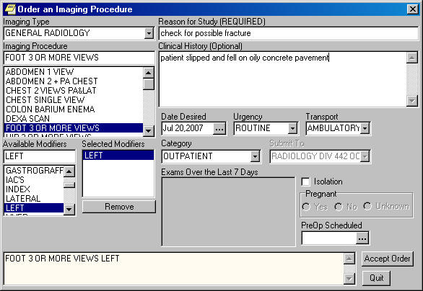
The Sign Orders window shows ? in the SC and SHD boxes for this patient.
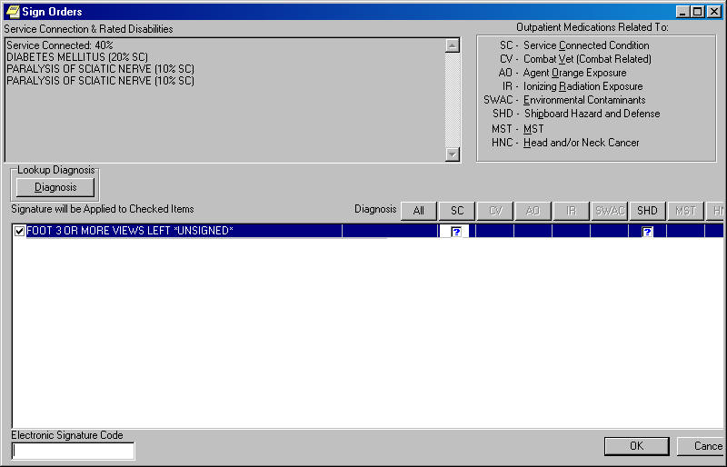
In the Sign Orders window, click Diagnosis and select ordering diagnosis 729.5 as the Primary Diagnosis.
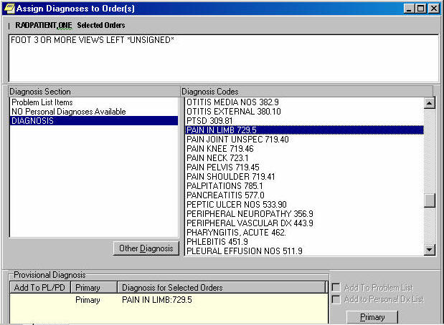

Select the SC check box to indicate Yes, and clear the SHD check box to indicate No. Enter your electronic signature.
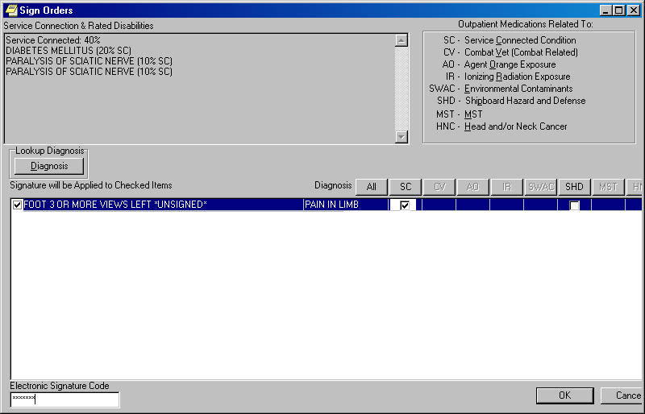
In the Radiology application, the ordering ICD diagnosis 729.5 and its associated clinical indicators are stored in the RAD/NUC MED ORDER file #75.1.

RAD/NUC MED ORDERS LIST JUL 20,2007 11:41 PAGE 1
--------------------------------------------------------------------------------

NAME: RADPATIENT,ONE PROCEDURE: FOOT 3 OR MORE VIEWS
TYPE OF IMAGING: GENERAL RADIOLOGY CATEGORY OF EXAM: OUTPATIENT
REQUEST STATUS: PENDING REQUEST URGENCY: ROUTINE
ORDER: 2595790 REQUESTING PHYSICIAN: RADPROVIDER,TWO
USER ENTERING REQUEST: RADPROVIDER,TWO
REQUEST ENTERED DATE/TIME: JUL 20, 2007@11:39:56
LAST ACTIVITY DATE/TIME: JUL 20, 2007@11:39:56
MODE OF TRANSPORT: AMBULATORY
IMAGING LOCATION: RADIOLOGY DIV 442 OOS ID 105
DATE DESIRED (Not guaranteed): JUL 20, 2007
REQUESTING LOCATION: EMERGENCY ROOM ISOLATION PROCEDURES: NO
REASON FOR STUDY: check for possible fracture
PRIMARY ORDERING ICD DIAGNOSIS: 729.5
PRIMARY DX RELATED TO SC: YES PRIMARY DX RELATED TO SHAD: NO
CLINICAL HISTORY FOR EXAM: patient slipped and fell on oily concrete
pavement
PROCEDURE MODIFIERS: LEFT
STATUS CHANGE DATE/TIME: JUL 20, 2007@11:39:56
NEW STATUS: PENDING COMPUTER USER: RADPROVIDER,TWO

- This patch replaces the “Environmental Contaminants” label on reports and screen prompts with the “Southwest Asia Condition” label.

