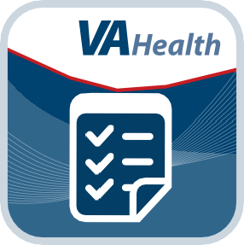
Airborne Hazards and Open Burn Pit Registry
User Manual for Veterans

User Manual
Table of Contents
Overview 1
The Basics 2
Prerequisites 2
Accessing the Registry 2
Logging In 3
Getting to know the process and the screen 5
Logging Out 6
Messages 6
Reading your messages 7
Contact Information 8
Verifying or updating your contact information 8
The Questionnaire 9
Answering the questionnaire 10
Monitoring your progress through the questionnaire 11
Saving your answers 11
Questions you will be asked 11
Submitting the completed questionnaire 13
Next Steps and Resources 14
Follow-Up Questions 15
Answering follow-up questions 16
Help and Additional Information 17
Additional Airborne Hazards and Open Burn Pit Registry Training Materials 17
Help Desk Information 17
DS Logon Help 17
Emergencies 17
Appendices 17
Appendix #1: Project References 17
Appendix #2: Glossary 17

Overview

As required by Public Law 112-260, Dignified Burial and Other Veterans’ Benefits Improvement Act of 2012, the Department of Veterans Affairs (VA) launched the Airborne Hazards and Open Burn Pit Registry. The Registry is a database of health information from Operation Enduring Freedom/Operation Iraqi Freedom/Operation New Dawn (OEF/OIF/OND) or 1990-1991 Gulf War Veterans and Servicemembers collected through a questionnaire about exposures to airborne hazards (such as smoke from burn pits, oil-well fires or pollution during deployment), as well as other exposures and health concerns.

The Registry will help participants become more aware of their own potential health issues and help VA better understand the potential health effects of deployment-related exposures. By enrolling in the Registry, you can create a snapshot from which to identify changes in your health, print and use your completed questionnaire to discuss concerns with your provider and learn about follow-up care. NOTE: Participation in the Registry is voluntary and will not affect your access to health care or benefits.

This app is available for iOS, Android and Windows operating systems, and is supported by these Internet browsers:

Google Chrome 17+

Mozilla Firefox 12+

Internet Explorer 10+

Safari 5+

Safari iOS 5+

Android 2.3+

The following User Manual provides an in-depth, step-by-step guide for using the Registry.

- 1 -

The Basics

Prerequisites
Veterans and Servicemembers who served in the Southwest Asia theater of operations (as defined in 38 CFR 3.317 (e)(2)) after August 2, 1990, or in Djibouti, Africa or Afghanistan after September 11, 2001, are eligible to participate in the Registry. To use the Registry, you must have a DS Logon Level 2 (Premium) Account. If you do not have a DS Logon Level 2 (Premium) Account, or you are not sure, you can:
  - Select the Need a DS Logon? button in the column on the Home screen of the Registry.
  - Visit mobile.va.gov/dslogon, or call 1-800-983-0937.

Accessing the Registry
You can access the Registry from the:
- VA Launchpad, which you can access at mobile.va.gov/appstore. The VA Launchpad is an easy way to consolidate VA’s Mobile Applications (Apps) and websites that require a DS Logon and enables you to sign in once to access multiple tools.
- Directly from the Registry Home screen at https://veteran.mobilehealth.va.gov/AHBurnPitRegistry/.
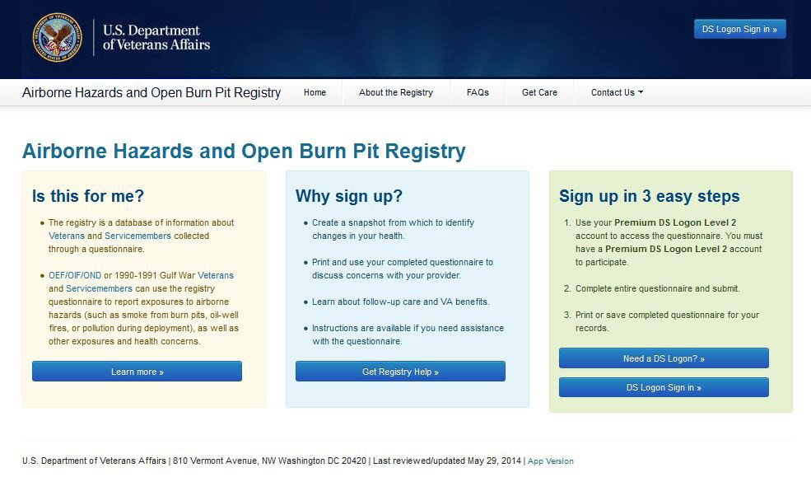
- Directly from the eBenefits portal after you are logged in.

Logging In
There are two ways you can log into the Registry:
- When you access the Registry through the VA App Store and reach the Registry Home screen, select DS Logon Sign in (either with the button in the upper right corner or in the right-hand column) > Enter your DS Logon Level 2 (Premium) Account credentials > Select Sign In.
- Log into your eBenefits account > Under the main menu, select Manage Health> You will go to a Manage Your Health Care Benefits screen > Scroll down the page until you reach the Health Studies section > Select Airborne Hazards and Open Burn Pit Registry.
The first time you log in, you will be taken to a screen that asks you to confirm your consent to the End User License Agreement (“EULA”) and Notice of Privacy Practices (“Notice”). Read the EULA and Notice. Select the I Consent, take me to the registry button if you wish to proceed, or the I Do Not Consent, exit button to exit.
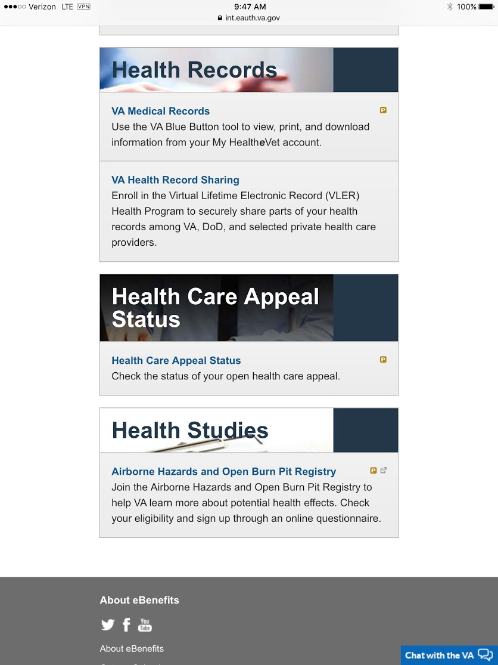
- 3 -

Eligible Users
- If you consent, and you are eligible, you will be taken to a Welcome screen where you will be asked to verify that your name is listed correctly.
  - If your name is listed correctly, select the Yes, It’s Me button.
  - If your name is not listed correctly, select the No, It’s Not Me button. You will be taken to a screen and asked to confirm if you are sure the Service History displayed on the Welcome screen is not yours. If you are sure the Service History is not yours, select the Yes button. You will be taken to a screen and instructed to contact the Health Resource Center at 1-877-470-5947. If you are not sure whether the Service History displayed on the Welcome screen is yours, select the No button to return to the Welcome screen.
- If you proceed, select the Please Continue button to confirm that you have read the Important Safety Message and are aware that the information you enter into the Registry will not be sent to your health care provider and cannot be used to obtain immediate medical care. If you continue, you will be taken to a screen that asks you to verify your contact information.

Not Eligible Users
- If you consent, and you are ineligible, you will be taken to a screen that allows you to request an eligibility review.
VA determines eligibility for the Airborne Hazards and Open Burn Pit Registry based on deployment information from the Department of Defense (DoD). In some cases, the records VA has for you do not contain an eligible deployment. This may be a result of missing or inaccurate data in VA’s deployment system.
NOTE: You will only have the option to request an eligibility review if the records VA has for you do not contain eligible deployment information.

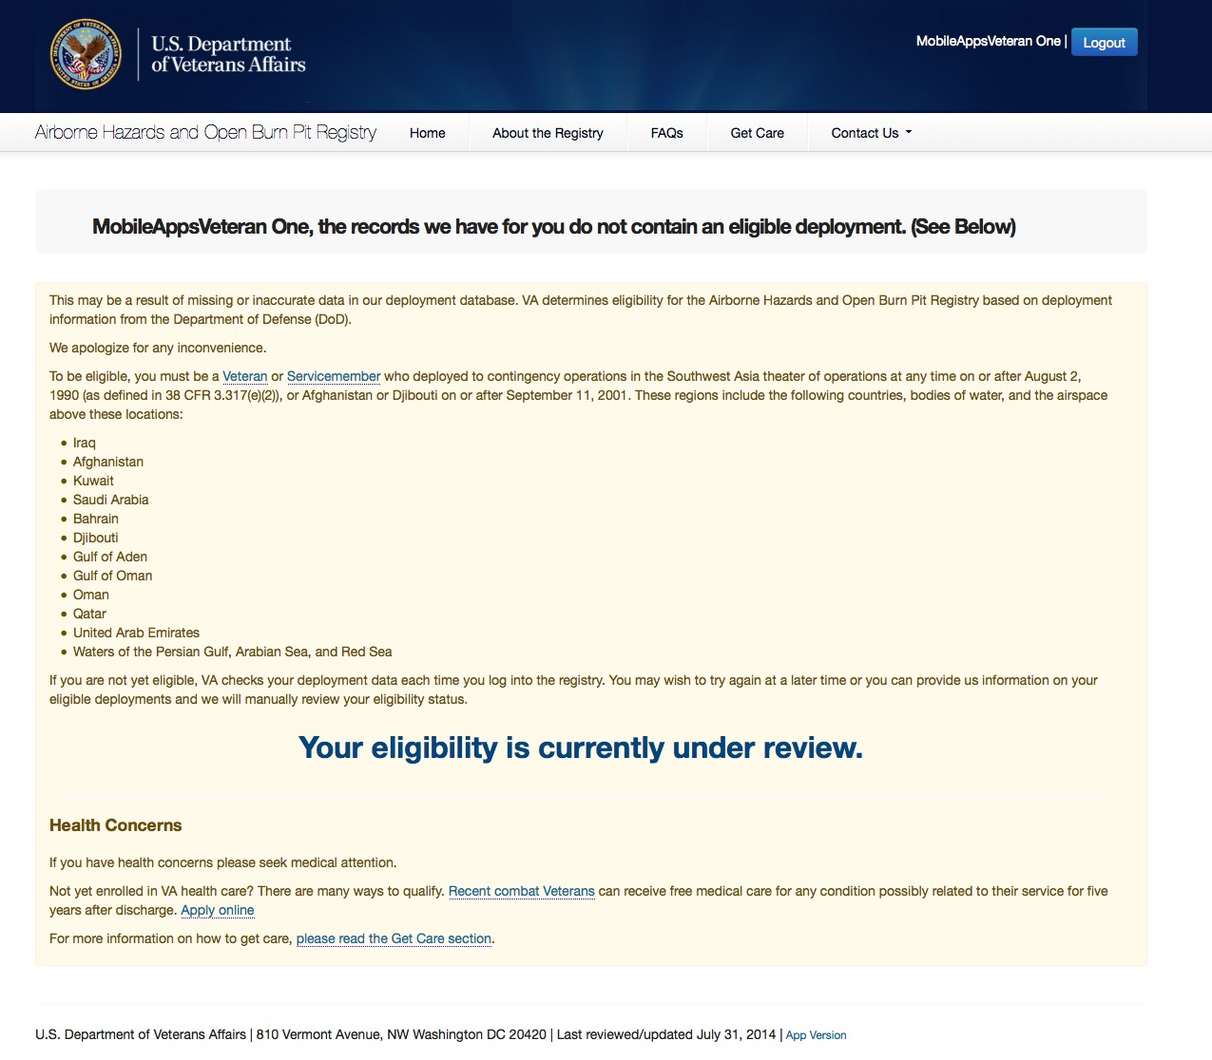
- To request an eligibility review, select the Request an Eligibility Review button then follow the three steps to request a review of your registry eligibility.
  - Step 1: Contact Information – enter your contact information
  - Step 2: Eligible Deployment information – verify and/or add details about your deployment
  - Step 3: Submit Request – verify your information and select the Send My Information button to request a review of your registry eligibility
After you have completed Step 3, you will be taken to an Information Submitted screen. You can monitor the status of your review by logging into the registry.

Getting to know the process and the screen
The Registry provides background and resources about Airborne Hazards and Open Burn Pits. Along the top of the screen, there are five tabs to direct you to the information and assistance you need:
  - Home
  - About the Registry – what it is, how it will be used and who can participate

  - FAQs – frequently asked questions about the Registry
  - Get Care – links to fact sheets and numbers for Veterans and Servicemembers to learn more about health care options
  - Contact Us – a drop-down list for telephone numbers for health care and TDD (Hearing Impaired) assistance
These tabs will always be visible so that you can consult the information at any time. Underneath these five tabs, you can view a status bar that measures where you are in the process of completing the Registry. There are three overall phases:
- Contact Information – verify or update your contact information
- The Questionnaire – start and continue the questionnaire
- Next Steps and Resources
As you move through each phase, the text in the status bar will change.

Logging Out
To exit, select the Logout button in the upper right corner of the screen.

Messages
View messages from VA about your data or general information about burn pits, airborne hazards or the Registry.
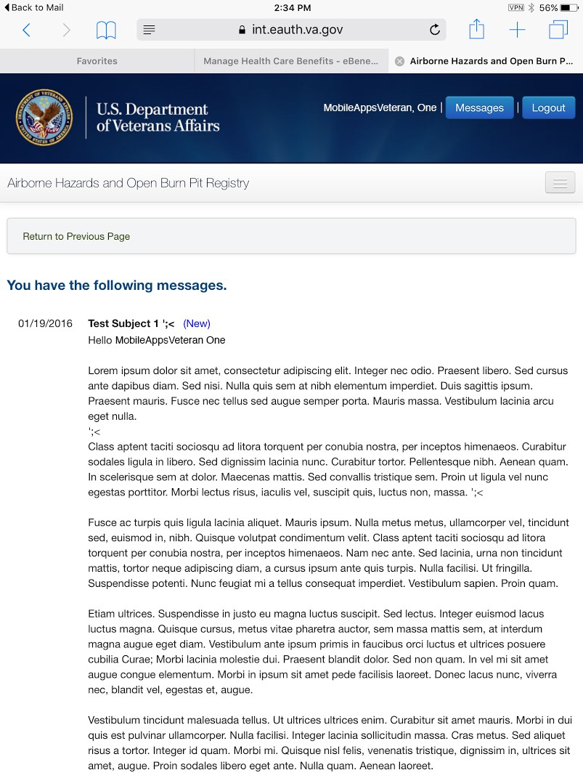
NOTE: The below message is a test message.
- 6 -

Reading your messages
Various departments within VA may send you messages, which could be about topics ranging from requests to complete follow-up questions based on the information you initially provided or VA’s response after you have requested an eligibility review. If you have received a new message, you will see a notification banner at the top of your screen when you log into the app that reads: “You have
a new message. Click here to view.” You can access the messages either by (1) selecting here in the notification’s message, or (2) by
selecting Messages in the upper right corner of your screen > You will go to a screen that shows your message, the date and the sender. If you reviewed a new message, the notification banner will disappear, but you can always review the message by selecting Messages again at the top of your screen.
NOTE: A duplicate of the message you received in the app will also be sent to the personal email you provided in your Contact Information section. You cannot reply to a message within the app, but some messages may allow you to reply via your personal email to the VA department’s email that sent the message.

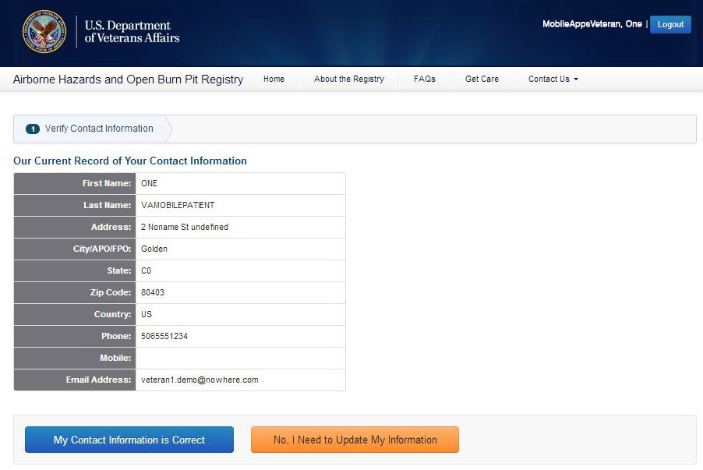
Contact Information
Verifying or updating your contact information is the first of three phases for participating in the Airborne Hazards and Open Burn Pit Registry.

Verifying or updating your contact information
From the Verify Contact Information screen you can change the information in the required fields. To finalize changes, select the
Update Contact Information button at the bottom of the screen. You can also select Cancel to clear the form.
If your information is up to date, select the My Contact Information is Correct button beneath the chart. If you need to change your contact information, select the No, I Need to Update My Information button beneath the chart. You will be taken to a screen that allows you to change the information in the required fields. You must confirm that your contact information is correct before you can start the questionnaire.
NOTE: If you would like to update your contact information later, you can return to the Contact Information screen by tapping
Update Contact Information in the progress bar above the Questionnaire.

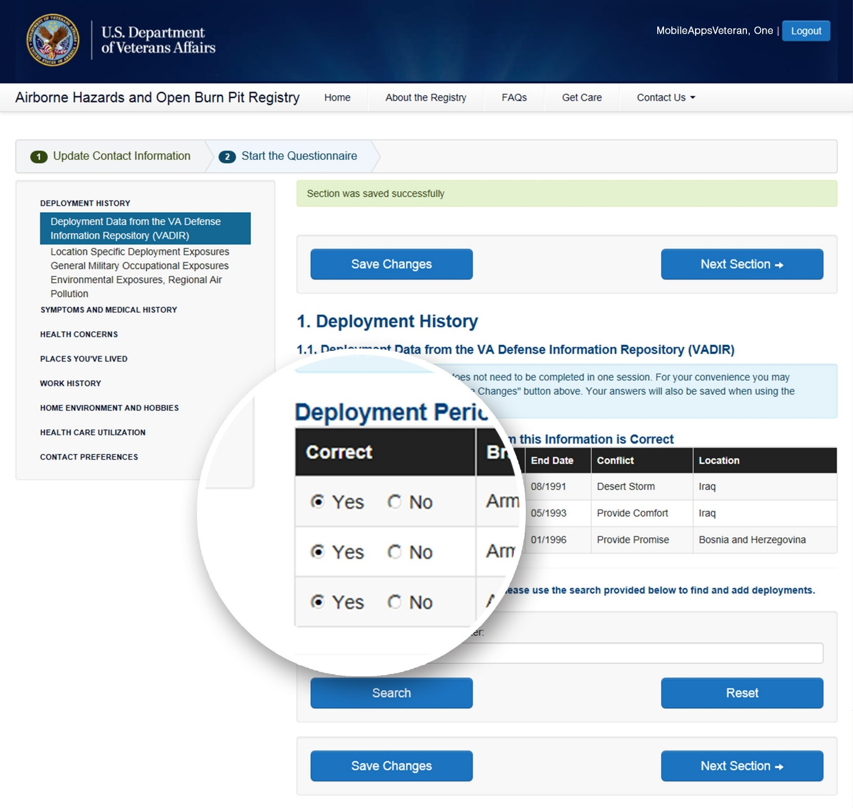
The Questionnaire
This is the second of three phases for participating in the Airborne Hazards and Open Burn Pit Registry. The questionnaire takes approximately 40 minutes to complete. You will be asked about your health history, deployment history and current work environment and lifestyle. The questions are designed to provide a broad and complete picture of your health. Even if you do not think some of your deployment information is related to exposures or that your lifestyle affects your health, you should still provide as much information as possible.

Answering the questionnaire
Depending on the structure of each question, you will answer by:
  - Selecting answers from a drop-down list
  - Selecting the circle next to the answer that corresponds to your situation
  - Searching for the appropriate response
  - Typing in your answer
The questionnaire also provides you with options to indicate that you do not know an answer or that a situation did/does not apply to you. A red Answer Required box will appear next to each question. This will disappear once you have answered the question. When you have finished answering all the questions on a screen, you can either:
  - Go back to the Previous Section
  - Save changes to your answers
  - Progress to the Next Section
    - NOTE: Progressing to the Next Section automatically saves your answers.
    - NOTE: While you can go back to previous sections and save changes as needed, you cannot advance to the Next Section unless you have answered all of the questions.
Because some questions are related to others, questions may appear or disappear based upon how you answered previously. For example, if you answer a question about your job, you may see another question appear asking how long you were in your position. Similarly, if you answer you do not smoke, you may see that subsequent questions about specific smoking habits no longer appear.
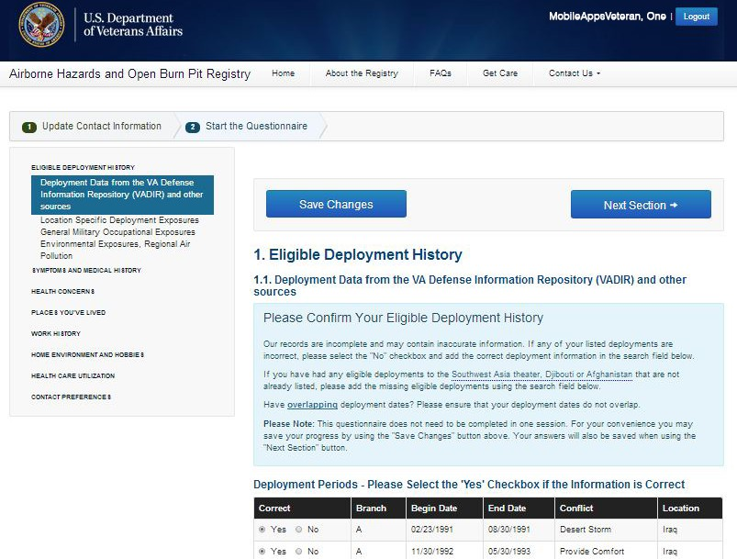
This may impact the numbering and lettering of questions. It is also possible you may see screens that are entirely blank with no questions.

Monitoring your progress through the questionnaire
There are two ways to watch your questionnaire progress.
- There are eight sections of information within the questionnaire, which are outlined on the left side of the screen. Each section has sub-sections, which will appear in the outline if you are answering questions in that section. As you progress through the questionnaire, the sub-section you are working on will be highlighted.
- There is also a status bar at the top of the screen that shows you the percent of the questionnaire completed. The status bar becomes filled in gradually as you answer more questions.

Saving your answers
You do not have to complete the questionnaire in one sitting. You have the option to save your answers at any time by selecting the
Save Changes button at the bottom of each screen.
NOTE: Your answers will not be submitted into the Registry until you have completed the entire questionnaire.

Questions you will be asked
The questionnaire covers eight major topics and asks primarily about your health history, deployment history and current work environment and lifestyle.
The first section of the questionnaire auto-populates information about your deployment history, which is pulled from VA’s records, and requests you confirm or update it. Review the deployment periods listed, and select the circle next to either Yes or No to indicate if the information is complete and accurate. If deployments are missing from the list, you can search to find and add information by typing a base, country or body of water in the search bar > Select Search > Next to the deployment information that applies to your service, select Add > Fill out the branch, dates, conflict, base and country by tapping the drop-down menus or typing in the information > Select Add. When you have finished updating your deployment history, select Save Changes.
NOTE: The Registry will not allow you to enter overlapping deployment dates.
- SECTION I: DEPLOYMENT HISTORY
(1.1) DEPLOYMENT DATA FROM THE VA DEFENSE INFORMATION REPOSITORY (VADIR) AND OTHER SOURCES (1.2) LOCATION SPECIFIC DEPLOYMENT EXPOSURES
(1.3) GENERAL MILITARY OCCUPATIONAL EXPOSURES
(1.4) ENVIRONMENTAL EXPOSURES, REGIONAL AIR POLLUTION
- SECTION 2: SYMPTOMS AND MEDICAL HISTORY
(2.1) FUNCTIONAL LIMITATION AND REPORTED CAUSE (2.2) HEALTH CONDITIONS
(2.3) HEIGHT AND WEIGHT (2.4) CANCER HISTORY
(2.5) TOBACCO EXPOSURE
(2.6) DEPLOYMENT SMOKING HISTORY (2.7) 12 MONTH ALCOHOL USE
- SECTION 3: HEALTH CONCERNS
- SECTION 4: PLACES YOU’VE LIVED
- SECTION 5: WORK HISTORY
(5.1) CURRENT OCCUPATIONAL STATUS (5.2) MAIN OCCUPATION
(5.3) DUST EXPOSURES
(5.4) GAS, SMOKE, VAPORS OR FUMES EXPOSURE (5.5) ASBESTOS EXPOSURE

- SECTION 6: HOME ENVIRONMENT AND HOBBIES
(6.1) HOME ENVIRONMENT, COMMUNITY, AND HOBBIES (ENVIRONMENTAL EXPOSURES)
- SECTION 7: HEALTH CARE UTILIZATION
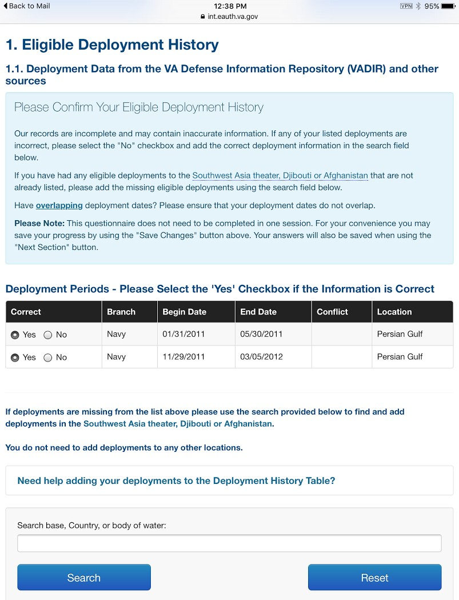
- SECTION 8: CONTACT PREFERENCES

Submitting the completed questionnaire
After you have answered all of the questions, select Submit Questionnaire. The status bar at the top will change from Continue Questionnaire to Review Completed Questionnaire. A screen will appear to congratulate you for finishing the questionnaire and inform you that you are a participant in the Registry.
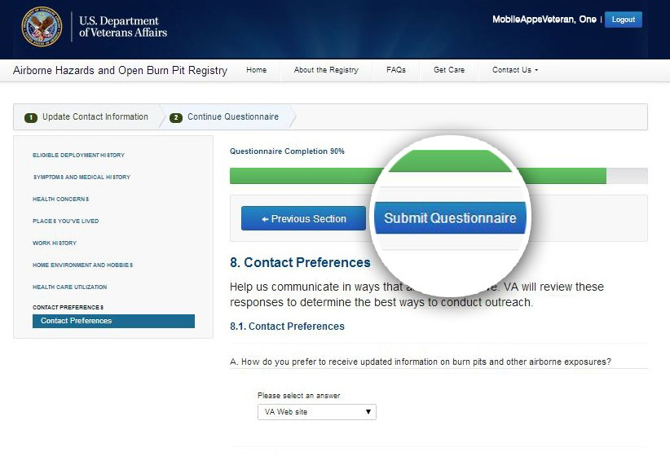
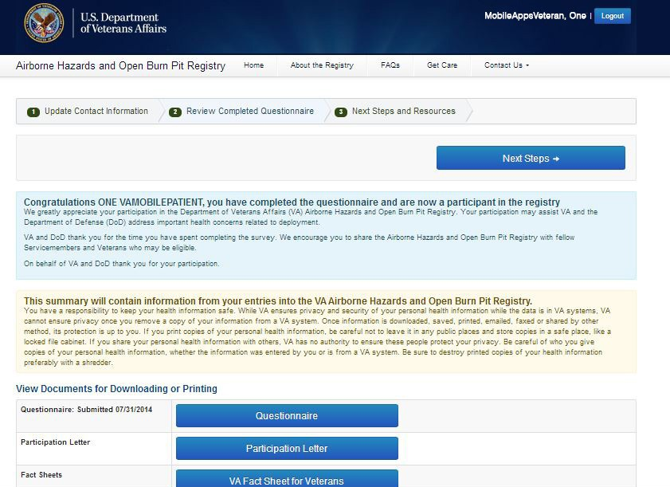
The screen will contain a View Documents for Downloading or Printing section. In the View Documents for Downloading or Printing section, there will be four buttons available:
  - Questionnaire – Select the Questionnaire button to open a copy of the questionnaire that you submitted. The questionnaire will include your Name, Service Status, Registry Status, the date you started the questionnaire, the date you completed the questionnaire, the date the questionnaire was generated and the answers you supplied for all questions. You can print or download the questionnaire as you would print or download most documents. Select the go back button to return to the Airborne Hazards and Open Burn Pit Registry screen.
  - Participation Letter – Select the Participation Letter button to open a letter that will express appreciation to you for your willingness to participate in the Airborne Hazards and Open Burn Pit Registry and to thank you for your
service. You can print or download the Participation Letter as you would print or download most documents. Select the go back button to return to the Airborne Hazards and Open Burn Pit Registry screen.
  - VA Fact Sheet for Servicemembers – Select this button to open a Post-Registration Fact Sheet for Servicemembers that will contain information on what to expect next now that you are registered. You can print or download the Post-Registration Fact Sheet for Servicemembers as you would print or download most documents. Select the go back button to return to the Airborne Hazards and Open Burn Pit Registry screen.

  - VA Fact Sheet for Veterans – Select this button to open a Post-Registration Fact Sheet that will contain information on what to expect now that you are registered. You can print or download the Post-Registration Fact Sheet as you would print or download most documents. Select the go back button to return to the Airborne Hazards and Open Burn Pit Registry screen.
NOTE: If you download or print the questionnaire, ensure that you are taking steps to protect your personal information. You should always be careful with whom you give copies of your personal health information, whether the information was entered by you or is from a VA system. Be sure to destroy printed copies of your health information preferably with a shredder

Next Steps and Resources
After you review the completed questionnaire you will enter the Next Steps and Resources phase. The Next Steps and Resources phase is the third of three phases for participating in the Airborne Hazards and Open Burn Pit Registry.
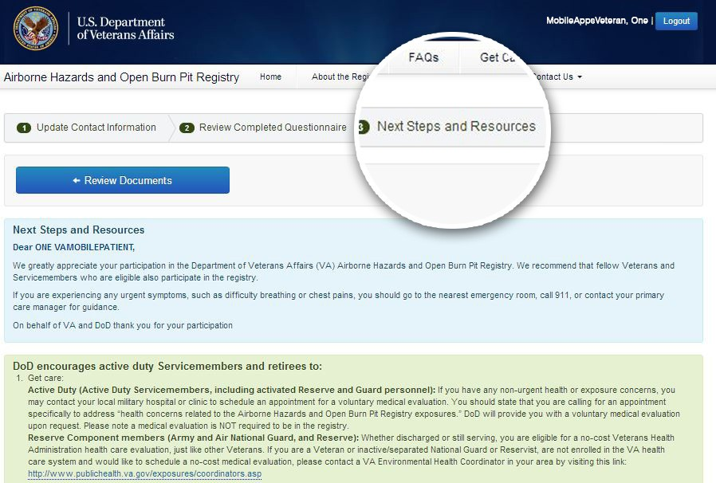
Select one of the two Next Steps buttons to be taken to a screen where you can learn about next steps and resources available for active duty Servicemembers and retirees as well as Veterans. Select the Review Documents button to return to the previous screen.

Follow-Up Questions
The Office of Public Health may send follow-up questions after you complete the questionnaire to learn more about your deployment or gather additional information for the Registry.
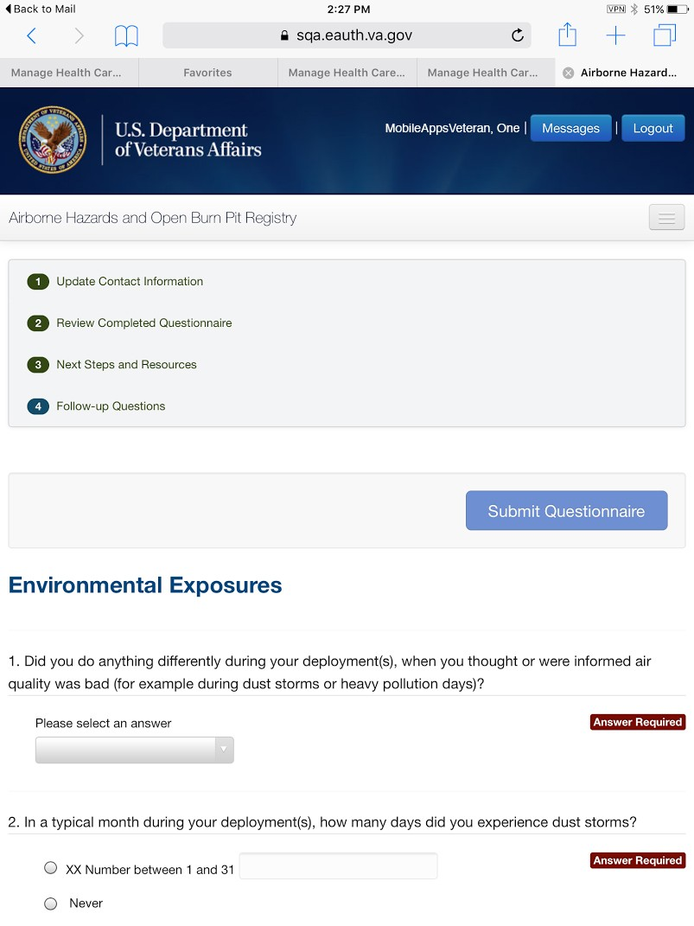

Answering follow-up questions
Depending on how you answered some questions when you initially completed the questionnaire, VA may send you more questions requesting details about your answers. If you are asked to complete follow-up questions, you will receive a message notification, and you will see that a Follow-up Questions heading appears in the menu bar at the top of the screen. Select Follow-up Questions from your menu > You will go to a screen with the questions > Select the header for the question you would like to answer, and answer the questions as you did for the main questionnaire > When you are finished, select Submit Questionnaire. Once you have submitted the answers, you can print out a copy. Next to the group of follow-up questions you would like to print, select Follow-up Questions PDF > A new browser window will open showing the questions and your answers > Print as you would most documents.
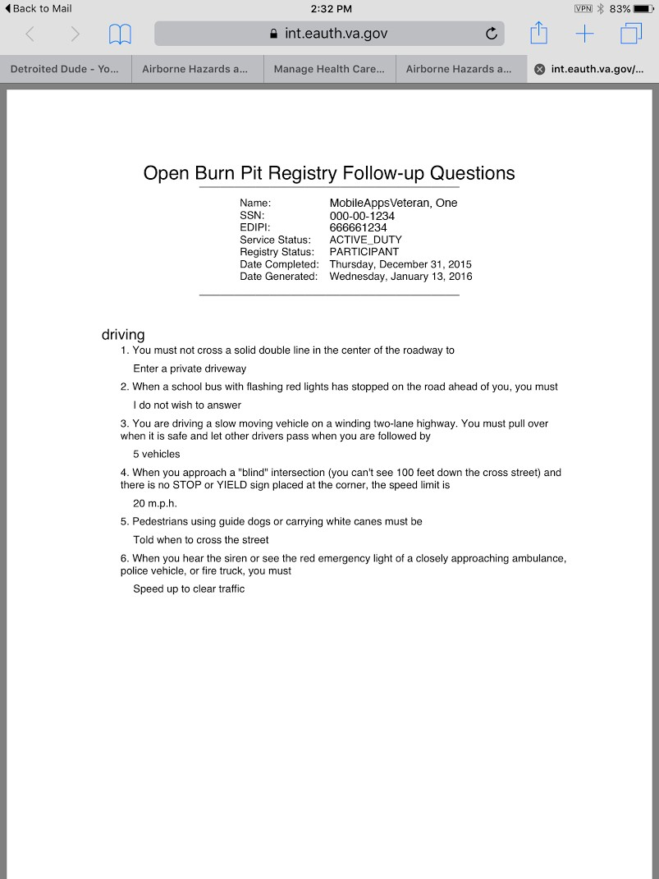

Help and Additional Information

Additional Airborne Hazards and Open Burn Pit Registry Training Materials
More resources, such as a Quick Start Guide, Slideshow and FAQs, can be found on mobile.va.gov/training.

Help Desk Information
If you need assistance with the Airborne Hazards and Open Burn Pit Registry, dial 1-877-470-5947 to speak with a VA representative. The Help Desk is open weekdays from 7 a.m. to 7
p.m. CT. For TTY assistance, dial 711.

DS Logon Help
If you have questions about your DS Logon account, visit mobile.va.gov/dslogon or dial 1-800-983-0937 for assistance.

Appendices

Emergencies
If you feel that your information may have been compromised, contact your local VA facility to obtain the contact information for your Privacy Officer. To locate your local VA facility, visit VA’s Facility Locator [http://www.va.gov/directory/guide/home. asp?isflash=1]. Note that you should never use this app in an emergency situation. If you encounter an emergency, dial 911.

Appendix #1: Project References
The Registry was developed by VA because studies have shown that many Veterans, particularly those who served after September 2001, use the Internet frequently to seek information on VA benefits and services and to obtain news and information. Therefore, the development of the online Registry was a natural way to easily reach and engage the target audience.
The Registry was tested in a demo environment to ensure optimal functionality.

Appendix #2: Glossary
App – an application, or software program, that can be accessed through a website or mobile device and is designed to fulfill a particular purpose
Burn Pit – a common waste disposal practice at military sites outside of the U.S., such as in Iraq and Afghanistan from which smoke and other emissions contained an unknown mixture of substances that may have short- and long-term health effects, especially for individuals who were exposed for longer periods or those with pre-existing conditions such as asthma or other lung or heart conditions
DoD – Department of Defense
DS Logon (Department of Defense Self-Service Logon) – a secure logon ID, created by the Department of Defense (DoD), that verifies the identities of individuals affiliated with DoD or the Department of Veterans Affairs (VA) and allows them to access secure websites and digital resources across DoD and VA using a single username and password
- DS Logon Level 1 (Basic) Account: Provides limited access to website features
- DS Logon Level 2 (Premium) Account: Offers the highest level of access to website features, including access to your VA Electronic Health Record. (NOTE: You must have a DS Logon Level 2 (Premium) Account to use VA’s mobile apps.)

eBenefits – an online portal that allows Veterans, Servicemembers and their families to research, find, access and manage their benefits and personal information
Electronic Health Record (EHR) – a digital record of a patient’s treatment plan and health care interactions with his or her providers
OEF/OIF/OND (Operation Enduring Freedom/Operation Iraqi Freedom/Operation New Dawn) – For the purposes of the Airborne Hazards and Open Burn Pit Registry, OEF is defined as Afghanistan and Djibouti after September 11, 2001. In contexts outside of this Registry, OEF may refer to operations taking place in the Philippines, Pankisi Gorge, Trans Sahara, and the Caribbean and Central America. However, for the purposes of this Registry, OEF refers only to Afghanistan and Djibouti after September, 11, 2001. Operation Iraqi Freedom (OIF) began in March of 2003 when U.S. and coalition forces moved in to Iraq from Kuwait. OIF continued until August 2010. Operation New Dawn (OND) began in August 2010 in Iraq and ended in December 2011.
Southwest Asia theater of operations – The Southwest Asia theater of operations includes the following countries, bodies of water, and the airspace above these locations: Iraq, Kuwait, Saudi Arabia, Bahrain, Gulf of Aden, Gulf of Oman, Oman, Qatar, United Arab Emirates, and waters of the Persian Gulf, Arabian Sea, and Red Sea.
VA – Department of Veterans Affairs
VA Mobile Health – an initiative that aims to improve the health of Veterans by providing technologies that will expand care beyond the traditional office visit and includes the creation of secure mobile apps that will leverage the popularity of wireless technologies to support Veterans, Caregivers and VA clinical teams [More at: mobile.va.gov]
1990-1991 Gulf War Veterans – For the purposes of the Airborne Hazards and Open Burn Pit Registry, a 1990-1991 Gulf War Veteran is a person who served in the first Persian Gulf War after August 2, 1990, or in 1991.

