VS GUI User Guide Addendum
  - Release 1.7.3 Update

Revision History

Date | Revision | Description | Author
2/19/2021 | 1.1 | All changes accepted. | VSE PMO  REDACTED
2/16/2021 | 1.0 | Created Release Documentation | VSE PMO  OVAC  REDACTED

Table of Contents
1 Introduction 4
1.1 Purpose 4
1.2 Overview 4
1.3 Disclaimers 4
1.3.1 Software Disclaimers 4
1.3.2 Documentation Disclaimers 4
2 System Summary 5
3 Key Feature Update in Version 1.7.3 5
3.1 Addition of “Labs” section to the Appointment Request Window 5

List of Figures
Figure 1: APPT Request Dialog Window showing the “Labs" Section. 6

Introduction
Department of Veterans Affairs (VA) Veterans Health Information Systems and Technology Architecture (VistA) Scheduling Graphical User Interface (VS GUI) module is the Windows GUI version of the Patient Information Management System (PIMS) Scheduling module. It provides appointment management functions included in PIMS Scheduling, but with the added convenience and usability of a GUI.

Purpose
The Veterans Health Administration (VHA) Office of Veterans Access to Care (OVAC) requested an enterprise enhancement for the VS package that supports COVID-19 response. The enhancement reduces operating costs for VHA and improves operational efficiencies, resulting in patient-centered access to care, coordinated care, increased customer satisfaction, and the reduction of excessive cycle/wait time for scheduling patients.

Overview
VS GUI is a software module that allows schedulers to make appointments quickly by viewing multiple appointment request types and multiple clinics in one screen. A scheduler can easily view patient requests for service, find the next available open appointment, view the provider’s availability in multiple clinics, and track a patient’s appointment process. Refer to System Summary for a more detailed description of VS GUI functionality.

Disclaimers

Software Disclaimers
This software was developed at the Department of Veterans Affairs (VA) by employees of the Federal Government in the course of their official duties. Pursuant to title 17 Section 105 of the United States Code this software is not subject to copyright protection and is in the public domain. VA assumes no responsibility whatsoever for its use by other parties, and makes no guarantees, expressed or implied, about its quality, reliability, or any other characteristic. We would appreciate acknowledgement if the software is used. This software can be redistributed and/or modified freely if any derivative works bear some notice that they are derived from it, and any modified versions bear some notice that they have been modified.

Documentation Disclaimers
The appearance of external hyperlink references in this manual does not constitute endorsement by the Department of Veterans Affairs (VA) of this Web site or the information, products, or services contained therein. The VA does not exercise any editorial control over the information you may find at these locations. Such links are provided and are consistent with the stated purpose of the VA.

System Summary
The VSE project delivers a series of enhancements to legacy VistA Scheduling Version 5.3 via the VS GUI application.

This update is for the nationally released version 1.7.3, which includes VS GUI 1.7.3 and Emergency VistA patch SD*5.3*774. At time of publishing, install period is projected for March 2021.
VS GUI Release 1.7.3/Emergency Patch SD*5.3*774 addresses defects in the VS GUI application. Specifically, this release corrects an issue with Recall Reminder letters incorrectly stating labs are required by providing an additional “Labs” section on the Appointment Request to indicate “Fasting,” “Non-fasting,” or “None,” and modifies application behavior so that when an appointment made from an Electronic Wait List (EWL) entry is cancelled, an APPT request is reopened instead of an EWL entry. This release also corrects performance issues related to the SDEC RESGPUSR Remote Procedure Call (RPC), which when called can result in long clinic calendar load times for sites with a large number of resource groups.

Key Feature Update in Version 1.7.3

Addition of “Labs” section to the Appointment Request Window
This release corrects an issue with Recall Reminder letters incorrectly stating labs are required by providing an additional “Labs” section on the Appointment Request to indicate “Fasting,” “Non-fasting,” or “None”.
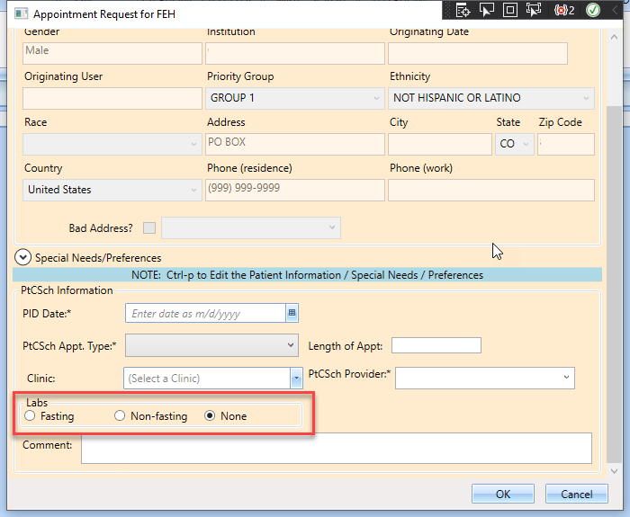
Figure 1: APPT Request Dialog Window showing the “Labs" Section.

