VS GUI User Guide Addendum
  - Release 1.7.5 Update

Revision History

Date | Revision | Description | Author
4/30/2021 | 1.3 | All changes have been accepted. | REDACTED  VSE PMO
4/20/2021 | 1.2 | Document updated to VSE GUI release 1.7.5, listed the additional functionalities to the system summery, updated table of contents and list of figures. | VSE PMO  REDACTED
3/29/2021 | 1.1 | All changes have been accepted and updated the release number to VS GUI 1.7.4.1. | REDACTED  VSE PMO
3/25/2021 | 1.0 | Created Release Documentation | VSE PMO  OVAC  REDACTED

Table of Contents
1 Introduction 4
1.1 Purpose 4
1.2 Overview 4
1.3 Disclaimers 4
1.3.1 Software Disclaimers 4
1.3.2 Documentation Disclaimers 4
1.4 Project References 5
1.4.1 Information 5
2 System Summary 6
3 Key Feature Update in Version 1.7.5 6
3.1 Set Preferred Clinic Order in Clinic Groups Calendar View 6

List of Figures
Figure 1: Clinic Group Window with Sort Clinic Dialog Box Opened 7
Figure 2: Sort Clinics Dialog Box: Rearranging the Order of the Clinic Groups. 8
Figure 3: Clinic Groups with the New Preferred Order 9

Introduction
Department of Veterans Affairs (VA) Veterans Health Information Systems and Technology Architecture (VistA) Scheduling Graphical User Interface (VS GUI) module is the Windows GUI version of the Patient Information Management System (PIMS) Scheduling module. It provides appointment management functions included in PIMS Scheduling, but with the added convenience and usability of a GUI.

Purpose
The Veterans Health Administration (VHA) Office of Veterans Access to Care (OVAC) requested an enterprise enhancement for the VS package that supports COVID-19 response. The enhancement reduces operating costs for VHA and improves operational efficiencies, resulting in patient-centered access to care, coordinated care, increased customer satisfaction, and the reduction of excessive cycle/wait time for scheduling patients.

Overview
VS GUI is a software module that allows schedulers to make appointments quickly by viewing multiple appointment request types and multiple clinics in one screen. A scheduler can easily view patient requests for service, find the next available open appointment, view the provider’s availability in multiple clinics, and track a patient’s appointment process. Refer to System Summary for a more detailed description of VS GUI functionality.

Disclaimers

Software Disclaimers
This software was developed at the Department of Veterans Affairs (VA) by employees of the Federal Government in the course of their official duties. Pursuant to title 17 Section 105 of the United States Code this software is not subject to copyright protection and is in the public domain. VA assumes no responsibility whatsoever for its use by other parties, and makes no guarantees, expressed or implied, about its quality, reliability, or any other characteristic. We would appreciate acknowledgement if the software is used. This software can be redistributed and/or modified freely if any derivative works bear some notice that they are derived from it, and any modified versions bear some notice that they have been modified.

Documentation Disclaimers
The appearance of external hyperlink references in this manual does not constitute endorsement by the Department of Veterans Affairs (VA) of this Web site or the information, products, or services contained therein. The VA does not exercise any editorial control over the information you may find at these locations. Such links are provided and are consistent with the stated purpose of the VA.

Project References

Information
The VS GUI points of contact (POCs) include:
- OVAC Program Office – REDACTED
- OIT VistA Scheduling Enhancement (VSE) Technical Manager – REDACTED
- OVAC Emerging Technologies Project Manager – REDACTED
- OVAC Emerging Technologies Acting Legacy Program Manager – REDACTED
- OVAC Emerging Technologies VSE Subject Matter Expert (SME) – REDACTED
- OVAC Emerging Technologies VSE Subject Matter Expert (SME) – REDACTED
- OVAC Emerging Technologies VSE Subject Matter Expert (SME) – REDACTED

VSE Resources
- Veterans Health Administration (VHA) VSE SharePoint: REDACTED
- VA Software Document Library (VDL) – Scheduling (VSE manuals near the bottom)
- National Return to Clinic (RTC) Order: REDACTED

System Summary
The VSE project delivers a series of enhancements to legacy VistA Scheduling Version 5.3 via the VS GUI application.
This update is for the nationally released version 1.7.5, which includes VS GUI 1.7.5 and Emergency VistA patch SD*5.3*781. At time of publishing, install period is projected for May 2021.
This update includes the following:
- Enhancement to allow users to set their preferred clinic order in the Clinic Groups calendar view.
- Updates the contact attempts logic to associate contact attempts with specific appointment requests using appointment request Internal Entry Number (IEN).
- Lays the backend groundwork for Video Visit Service (VVS) enhancements coming in next release.
- Expands functionality to record scheduling actions for reporting purposes.
- Defects:
    - Corrects a defect identified in production where the patient Data File Number (DFN) was incorrectly set in certain instances when cancellation comments were used.
    - Corrects a defect where inactivate/reactivated dates were improperly excluding clinics from the GUI.
    - Fixes an issue where spaces in clinic group search would cause the GUI to crash.
    - Corrects a bug in SDEC RECGET.
    - Fixes a defect where a midnight contact attempt would cause the GUI to crash.
    - Fixes the login screen so 's' isn't cut off from 'Affairs'.
- Updates the Telerik controls for 508 functionalities.

Key Feature Update in Version 1.7.5

Set Preferred Clinic Order in Clinic Groups Calendar View
With this release users can set their preferred clinic order in the clinic calendar view.
- Go to Clinic Groups and click the “Sort” button to open the Sort Clinics dialog box.
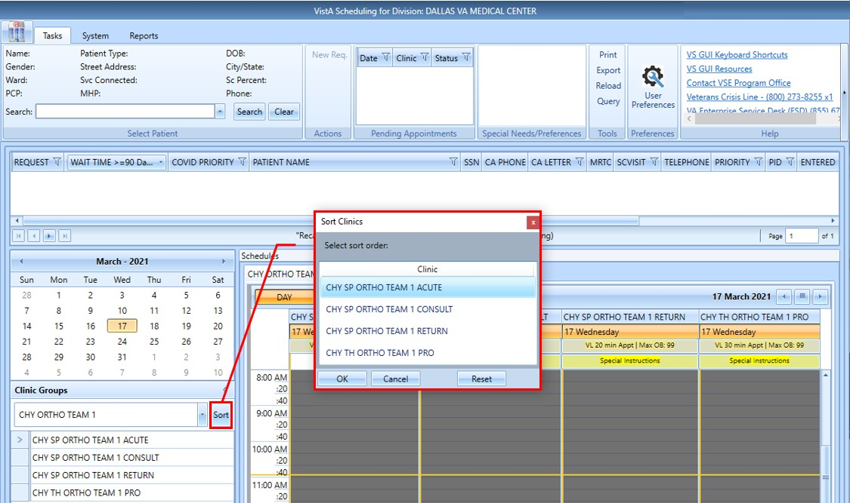
Figure 1: Clinic Group Window with Sort Clinic Dialog Box Opened
- In the Sort Clinics dialog box click on the clinic then drag and drop to rearrange clinics to preferred order.
    - Click OK to save. The Clinic Groups will reload to new preferred order.
    - Reset button restores the order to the previous clinic order.
    - Cancel button closes the Sort Clinics dialog box and discards any changes.

NOTE: Each user’s configuration is saved locally to the workstation, so preferences will not carry over from one workstation to another.
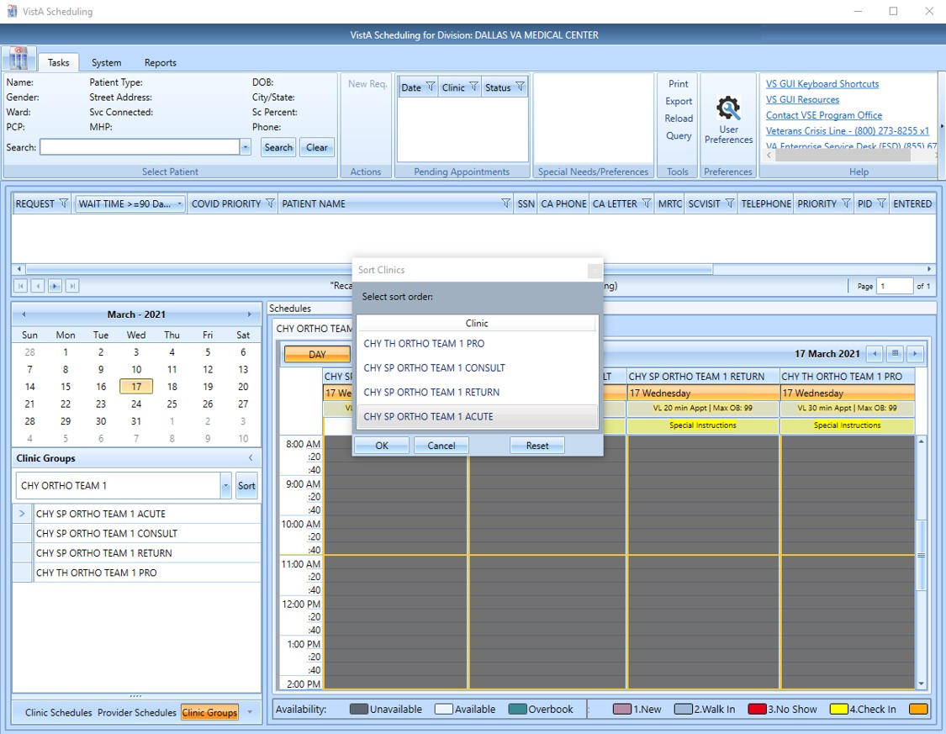
Figure 2: Sort Clinics Dialog Box: Rearranging the Order of the Clinic Groups.
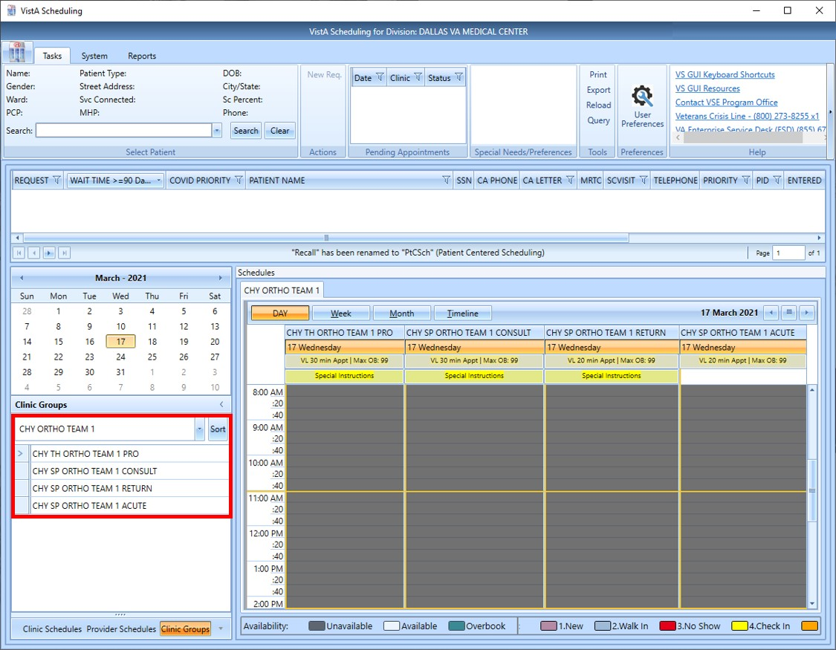
Figure 3: Clinic Groups with the New Preferred Order

