VS GUI User Guide Addendum
  - Release 1.7.7.4 Update

Revision History
Date | Revision | Description | Author
6/29/2021 | 1.3 | Changes accepted and updated Table of Contents and Figure. | HSP  VSE PMO
6/29/2021 | 1.2 | Increment release version to VS GUI 1.7.7.4 and removed content about VVS Appointment | VSE PMO  Liberty IT Solutions
6/22/2021 | 1.1 | Increment release version to VS GUI 1.7.7.1 | VSE PMO
6/7/2021 | 1.0 | Created Release Documentation | VSE PMO  Liberty IT Solutions

Table of Contents
1 Introduction 4
1.1 Purpose 4
1.2 Overview 4
1.3 Disclaimers 4
1.3.1 Software Disclaimers 4
1.3.2 Documentation Disclaimers 4
1.4 Project References 5
1.4.1 Information 5
2 System Summary 6
3 Key Feature Update in Version 1.7.7.4 6
3.1 New Patient Search 6
3.2 Modified Patient Letter 7
3.3 Pending Return to Clinic (RTC) Order Clean-Up 8
3.3.1 Pending RTC Clean-Up – By Date 9
3.3.2 Pending RTC Clean-Up – Full 11

List of Figures
Figure 1: Search Patients Link 6
Figure 2: Patient Search Pop-Up Window 7
Figure 3: Selected Patient Records 7
Figure 4: Patient Appointment Letter 8
Figure 5: Running Pending RTC Clean-Up By Date Or Full. 9
Figure 6: Pending RTC Clean-Up By Date Results. 10
Figure 7: Pending RTC Clean-Up Results. 11

Introduction
Department of Veterans Affairs (VA) Veterans Health Information Systems and Technology Architecture (VistA) Scheduling Graphical User Interface (VS GUI) module is the Windows GUI version of the Patient Information Management System (PIMS) Scheduling module. It provides appointment management functions included in PIMS Scheduling, but with the added convenience and usability of a GUI.

Purpose
The Veterans Health Administration (VHA) Office of Veterans Access to Care (OVAC) requested an enterprise enhancement for the VS package that supports COVID-19 response. The enhancement reduces operating costs for VHA and improves operational efficiencies, resulting in patient-centered access to care, coordinated care, increased customer satisfaction, and the reduction of excessive cycle/wait time for scheduling patients.

Overview
VS GUI is a software module that allows schedulers to make appointments quickly by viewing multiple appointment request types and multiple clinics in one screen. A scheduler can easily view patient requests for service, find the next available open appointment, view the provider’s availability in multiple clinics, and track a patient’s appointment process. Refer to System Summary for a more detailed description of VS GUI functionality.

Disclaimers

Software Disclaimers
This software was developed at the Department of Veterans Affairs (VA) by employees of the Federal Government in the course of their official duties. Pursuant to title 17 Section 105 of the United States Code this software is not subject to copyright protection and is in the public domain. VA assumes no responsibility whatsoever for its use by other parties, and makes no guarantees, expressed or implied, about its quality, reliability, or any other characteristic. We would appreciate acknowledgement if the software is used. This software can be redistributed and/or modified freely if any derivative works bear some notice that they are derived from it, and any modified versions bear some notice that they have been modified.

Documentation Disclaimers
The appearance of external hyperlink references in this manual does not constitute endorsement by the Department of Veterans Affairs (VA) of this Web site or the information, products, or services contained therein. The VA does not exercise any editorial control over the information you may find at these locations. Such links are provided and are consistent with the stated purpose of the VA.

Project References

Information
The VS GUI points of contact (POCs) include:
- OVAC Program Office – REDACTED
- OIT VistA Scheduling Enhancement (VSE) Technical Manager – REDACTED
- OVAC Emerging Technologies Project Manager – REDACTED
- OVAC Emerging Technologies Acting Legacy Program Manager – REDACTED
- OVAC Emerging Technologies VSE Subject Matter Expert (SME) – REDACTED
- OVAC Emerging Technologies VSE Subject Matter Expert (SME) – REDACTED
- OVAC Emerging Technologies VSE Subject Matter Expert (SME) – REDACTED

VSE Resources
- Veterans Health Administration (VHA) VSE SharePoint: REDACTED
- VA Software Document Library (VDL) – Scheduling (VSE manuals near the bottom):
- National Return to Clinic (RTC) Order: REDACTED

System Summary
The VSE project delivers a series of enhancements to legacy VistA Scheduling Version 5.3 via the VS GUI application.
This update is for the nationally released version 1.7.7.4, which includes VS GUI 1.7.7.4 and Emergency VistA patch SD*5.3*785. At time of publishing, install period is projected for July 2021.
VS GUI Release 1.7.7.4 update includes enhancements to the Request Management (RM) Grid to improve overall performance, an update to the patient search function, an update to patient letters to remove title from the salutation and 508 issue fixes.
Accompanying patch SD*5.3*785 enhances two options available in the Scheduling Supervisor menu:
- Pending Return to Clinic (RTC) clean-up - by Date
- Pending Return to Clinic (RTC) clean-up – FULL
These options now include prompts for the user before running, as well as a report of changes made.

Key Feature Update in Version 1.7.7.4

New Patient Search
Patient search is now a pop-up window. Click on the Search Patients link to open patient search.
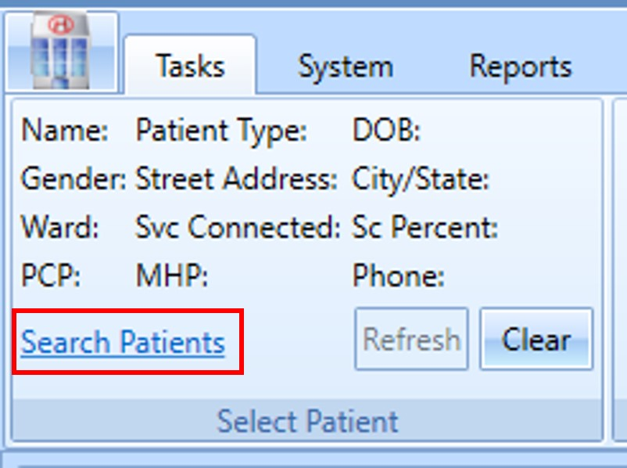
Figure 1: Search Patients Link
Enter search criteria—results will display in real time in the results pane.
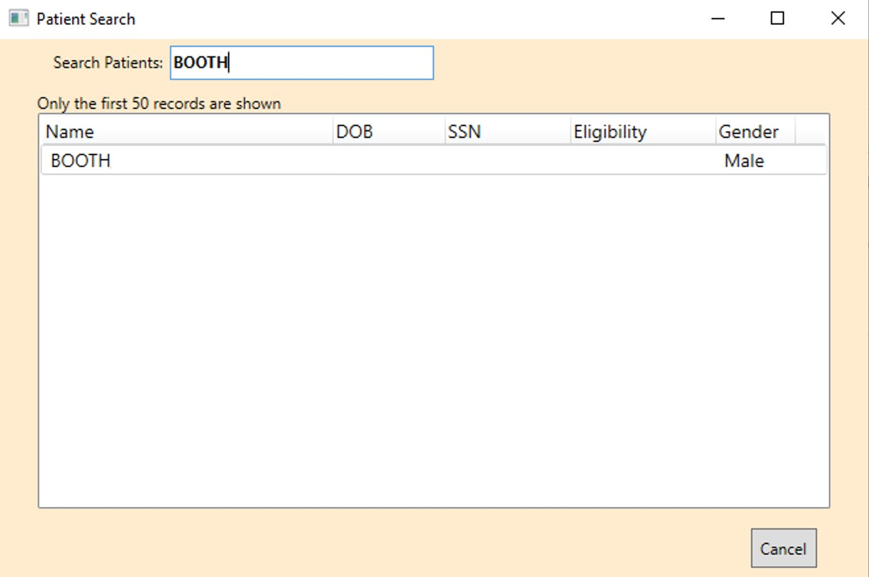
Figure 2: Patient Search Pop-Up Window
Select a patient from the list to pull up that patient record.
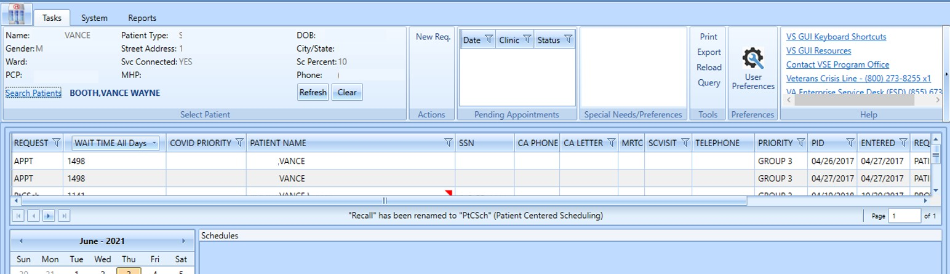
Figure 3: Selected Patient Records

Modified Patient Letter
Patient letters now address the patient by name only, rather than by title (Mr./Ms.) and name.
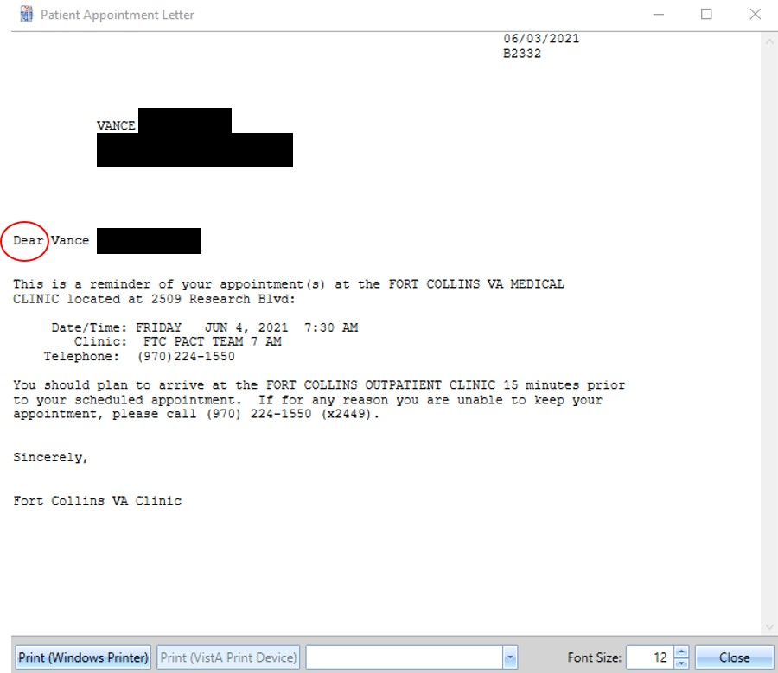
Figure 4: Patient Appointment Letter

Pending Return to Clinic (RTC) Order Clean-Up
The Pending RTC Order Clean-up options address a scenario where RTC orders with scheduled appointments are stuck in “Pending” status in CPRS. The option is for emergency use to address a data issue resulting from improper use of FileMan to disposition RTC requests and is available only to users with the SDSUP key.
To run the Pending RTC Clean-up option, navigate to the Scheduling Supervisor menu.
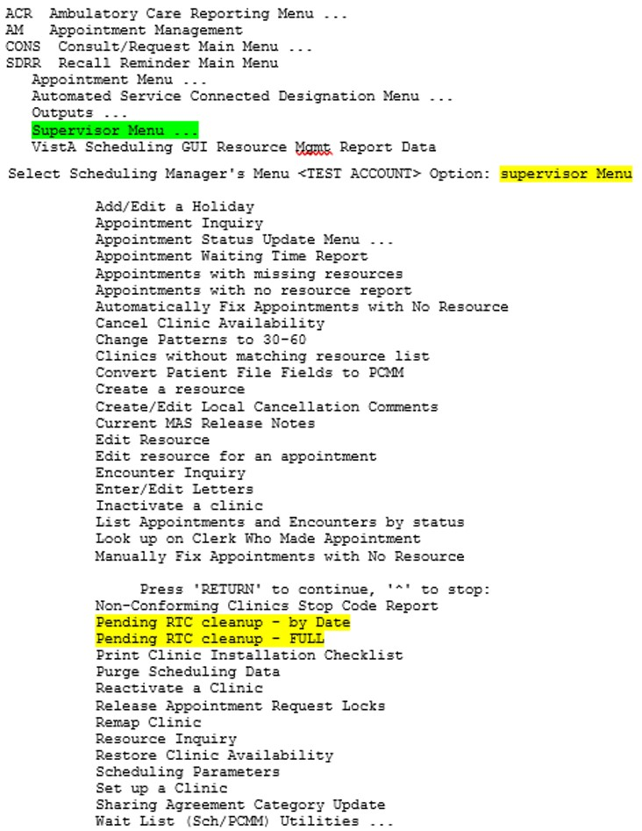
Figure 5: Running Pending RTC Clean-Up By Date Or Full.

Pending RTC Clean-Up – By Date
To run the clean-up by date, select Pending RTC clean-up – by Date.
You will be prompted to enter a start date, as shown below.
Selection will be made based off of the create date of the Request
SDEC APPOINTMENT REQUEST CREATE DATE to start selection: 5/4/2021//
Input a start date and press Enter.
SDEC APPOINTMENT REQUEST CREATE DATE to start selection: 5/4/2021// 4/1/2021 (APR 01, 2021)

Input an end date and press Enter.
SDEC APPOINTMENT REQUEST CREATE DATE to end selection: 6/3/2021// (JUN 03, 2021)
You will be prompted to confirm that you want to run the clean-up. Enter Y or N.
Are you sure you would like to run the SDEC PENDING RTC clean-up? Y (Yes)
DEVICE: HOME// HOME (CRT) Right Margin: 80//
Starting search and clean-up....
When complete, the option will print results to the screen, including specific orders updated, their original status, and any orders skipped and why.
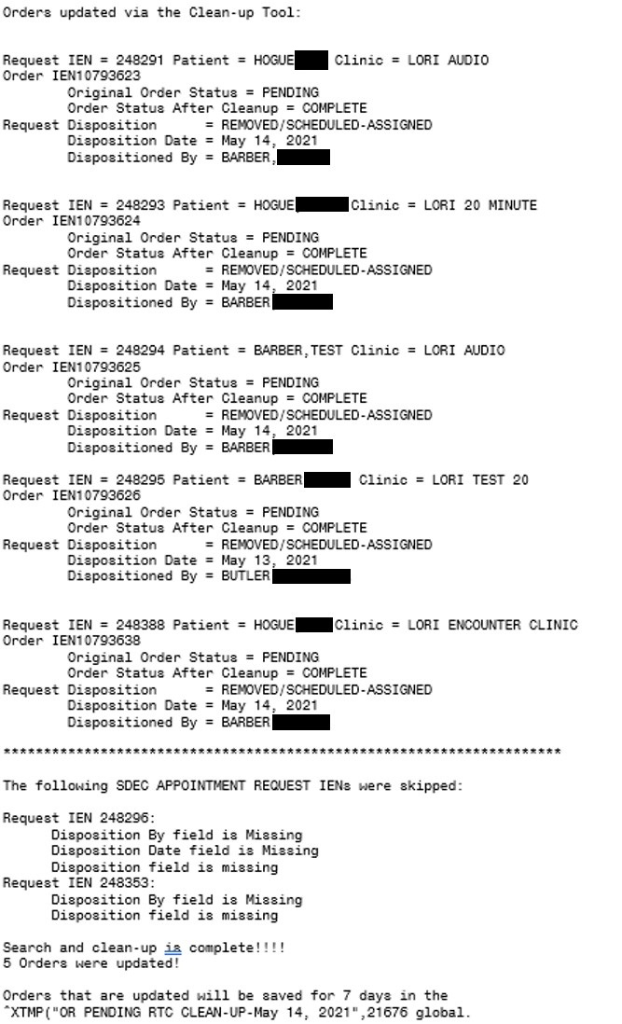
Figure 6: Pending RTC Clean-Up By Date Results.

Pending RTC Clean-Up – Full
To run the clean-up in full, select Pending RTC clean-up – FULL. You will be prompted to confirm you want to run the clean-up.
This routine will search through existing Closed Return to Clinic SDEC Appointment Requests with a corresponding Order that is in a Pending status and update as needed.
Are you sure you would like to run the FULL SDEC PENDING RTC clean-up?
Enter Y or N
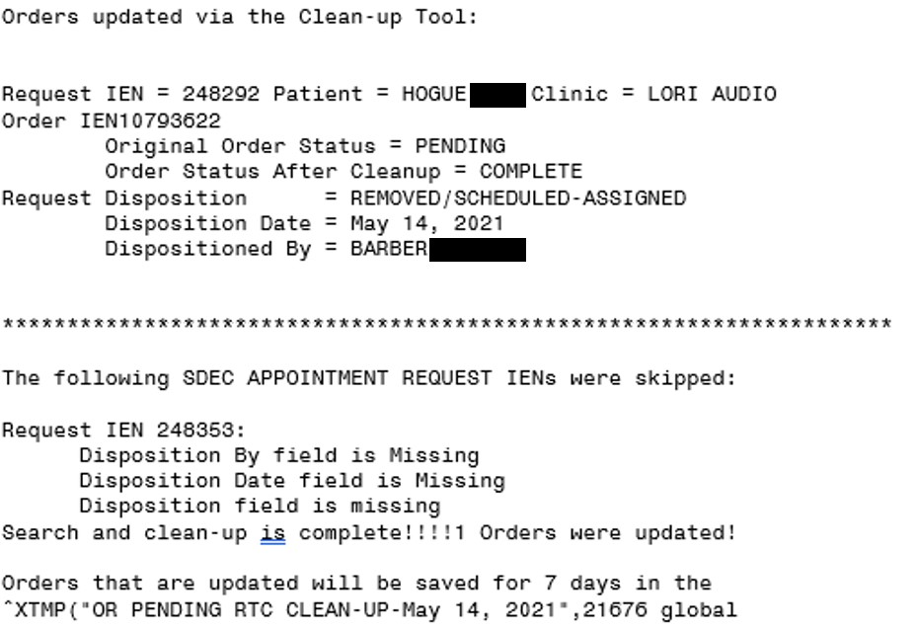
Figure 7: Pending RTC Clean-Up Results.

