VS GUI User Guide Addendum
  - Release 1.7.9 Update

Revision History
Date | Revision | Description | Author
08/19/2021 | 1.3 | Updated Section 3.2.1 - Add VVS to an existing non-VVS Appointment, Changes accepted, updated table of contents and list of figures. | HSP  VSE PMO  Liberty IT Solutions
08/10/2021 | 1.2 | All changes accepted | HSP  VSE PMO
08/6/2021 | 1.1 | Updated section 3.2.2 – View/Edit VVS Appointments, Changes accepted, updated table of contents and list of figures. | HSP  VSE PMO  Liberty IT Solutions
07/26/2021 | 1.0 | Created Release Documentation | VSE PMO  Liberty IT Solutions

Table of Contents
1 Introduction 5
1.1 Purpose 5
1.2 Overview 5
1.3 Disclaimers 5
1.3.1 Software Disclaimers 5
1.3.2 Documentation Disclaimers 5
1.4 Project References 6
1.4.1 Information 6
2 System Summary 7
3 Key Feature Update in Version 1.7.9 7
3.1 Making a Video Visit Service (VVS) Appointment 7
3.2 View/Edit a Video Visit Service (VVS) Appointment 10
3.2.1 Add VVS to an existing non-VVS Appointment 10
3.2.2 View/Edit VVS Appointments 13
3.3 Updates to User Preferences UI 17
3.4 Correction to Clinic Search 18
3.5 PID Updates when Changed during Cancel by Patient 19
3.6 Correction to Parent MRTC Behavior 19
3.7 Update to GUI Behavior for Appointments with No Resource 19

List of Figures
Figure 1: Create Video Visit Appointment Dialog Box 8
Figure 2: Create Video Visit Window 9
Figure 3: Staff/Guest Detail Entry Form Window 10
Figure 4: Edit Non-VVS Appointment 11
Figure 5: Create Video Visit Window With “Addt’l Contact” Drop Down List 12
Figure 6: Create Video Visit Window And “Addt’l Contact” Drop Down List Selected To Both And That Displays Additional Provider Notification Options. 13
Figure 7: View Appointment Window for VVS Appointments 14
Figure 8: Video Visit Form Window 15
Figure 9: Pop-up Window notifying The Video Visit Notifications Have Been Resent 15
Figure 10: Edit Appointment Window 16
Figure 11: Edit Video Visit Window 17
Figure 12: The Left Side Of The Figure Shows Prior Version Of VS GUI User Preference Window And The Figure On The Right Side Shows The Newly Updated VS GUI User Preference Window. 18
Figure 13: The Appointment Request Window On The Left Shows The Previous Version Of The GUI Where The CHY MH 10 AM Is Truncated To MH 10 AM Because Its Abbreviation Is CHY. Whereas The Appointment Request Window On The Right Is The Newly Updated VS GUI That Displays The Clinic Name Without Truncation. 18
Figure 14: When Updating The PID Date To 07/23, The New PID Updates In The RM Grid. 19
Figure 15: Previously, Appointments Could Be Made With No Resource And Showed As (*CORRUPT DATA) In The Pending Appointments Box 20

Introduction
Department of Veterans Affairs (VA) Veterans Health Information Systems and Technology Architecture (VistA) Scheduling Graphical User Interface (VS GUI) module is the Windows GUI version of the Patient Information Management System (PIMS) Scheduling module. It provides appointment management functions included in PIMS Scheduling, but with the added convenience and usability of a GUI.

Purpose
The Veterans Health Administration (VHA) Office of Veterans Access to Care (OVAC) requested an enterprise enhancement for the VS package that supports COVID-19 response. The enhancement reduces operating costs for VHA and improves operational efficiencies, resulting in patient-centered access to care, coordinated care, increased customer satisfaction, and the reduction of excessive cycle/wait time for scheduling patients.

Overview
VS GUI is a software module that allows schedulers to make appointments quickly by viewing multiple appointment request types and multiple clinics in one screen. A scheduler can easily view patient requests for service, find the next available open appointment, view the provider’s availability in multiple clinics, and track a patient’s appointment process. Refer to System Summary for a more detailed description of VS GUI functionality.

Disclaimers

Software Disclaimers
This software was developed at the Department of Veterans Affairs (VA) by employees of the Federal Government in the course of their official duties. Pursuant to title 17 Section 105 of the United States Code this software is not subject to copyright protection and is in the public domain. VA assumes no responsibility whatsoever for its use by other parties, and makes no guarantees, expressed or implied, about its quality, reliability, or any other characteristic. We would appreciate acknowledgement if the software is used. This software can be redistributed and/or modified freely if any derivative works bear some notice that they are derived from it, and any modified versions bear some notice that they have been modified.

Documentation Disclaimers
The appearance of external hyperlink references in this manual does not constitute endorsement by the Department of Veterans Affairs (VA) of this Web site or the information, products, or services contained therein. The VA does not exercise any editorial control over the information you may find at these locations. Such links are provided and are consistent with the stated purpose of the VA.

Project References

Information
The VS GUI points of contact (POCs) include:
- OVAC Program Office – REDACTED
- OIT VistA Scheduling Enhancement (VSE) Technical Manager – REDACTED
- OVAC Emerging Technologies Project Manager – REDACTED
- OVAC Emerging Technologies Acting Legacy Program Manager – REDACTED
- OVAC Emerging Technologies VSE Subject Matter Expert (SME) – REDACTED
- OVAC Emerging Technologies VSE Subject Matter Expert (SME) – REDACTED
- OVAC Emerging Technologies VSE Subject Matter Expert (SME) – REDACTED

VSE Resources
- Veterans Health Administration (VHA) VSE SharePoint: REDACTED
- VA Software Document Library (VDL) – Scheduling (VSE manuals near the bottom):
- National Return to Clinic (RTC) Order: REDACTED

System Summary
The VSE project delivers a series of enhancements to legacy VistA Scheduling Version 5.3 via the VS GUI application.
This update is for the nationally released version 1.7.9, which includes VS GUI 1.7.9 and Emergency VistA patch SD*5.3*790. At time of publishing, install period is projected for August 2021.
VS GUI Release 1.7.9 user-facing changes include the ability to schedule a Video Visit Service (VVS) appointment from VS GUI and updates to the User Preferences user interface. These updates are detailed in the sections below, along with user-facing defect corrections.
This release also addresses several defects, including parent Multiple Return to Clinic (MRTCs) requests returning to the Release Management (RM) grid when a user closes a child request, the GUI crashing when taking an action on an appointment with no resource, the Patient Indicated Date (PID) not updating appropriately when changed during cancel by patient, and clinic name truncation on clinic search for clinics with an abbreviation that matches the clinic name. Additionally, the release includes back-end changes to improve efficiency and ensure data accuracy.

Key Feature Update in Version 1.7.9

Making a Video Visit Service (VVS) Appointment
Schedulers can now Make, View, Edit and Cancel VVS appointments from the VS GUI.
When a scheduler selects “Add Appointment” in a video clinic, a dialog displays asking if they want to create a video visit for the appointment.
Note: When making VVS appointment, if a tester is logged in using access/verify codes they will be prompted to select a Personal Identification Verification (PIV) certificate. Otherwise, they will just be prompted for their PIN (password).
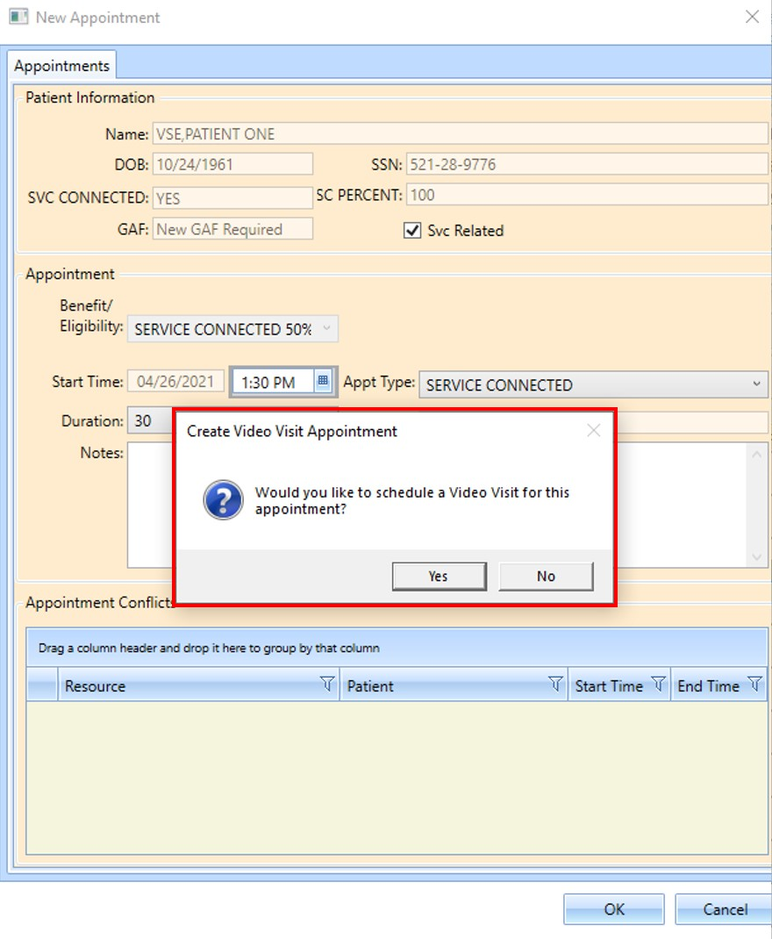
Figure 1: Create Video Visit Appointment Dialog Box
If the scheduler selects “Yes,” the Create Video Visit window displays. (see below)
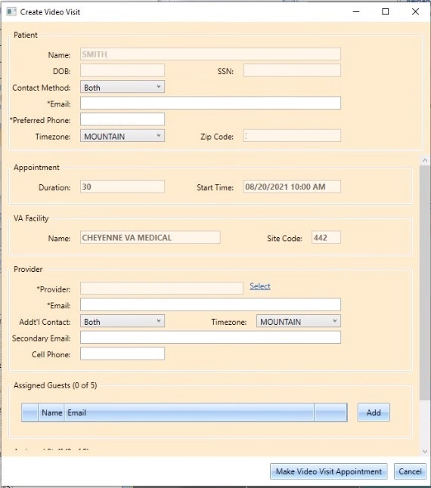
Figure 2: Create Video Visit Window
The patient contact information will be pre-populated in the Make Video Visit form if it is available. If not, the scheduler must enter the patient’s email, as well as provider information. Schedulers may also enter guest and staff information to the appointment.
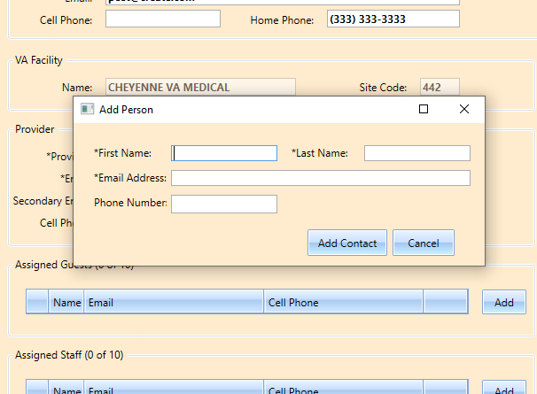
Figure 3: Staff/Guest Detail Entry Form Window
After filling out the necessary details the scheduler clicks “Make Video Visit Appointment,” the video appointment is created, and a corresponding VistA appointment is created.
Cancelling a VVS appointment from VS GUI follows the same workflow as cancelling a regular appointment.

View/Edit a Video Visit Service (VVS) Appointment

Add VVS to an existing non-VVS Appointment
- Open the Edit Appointment window for the non-VVS appointment. Click on the “Create Video Visit” Button at the bottom of the window.
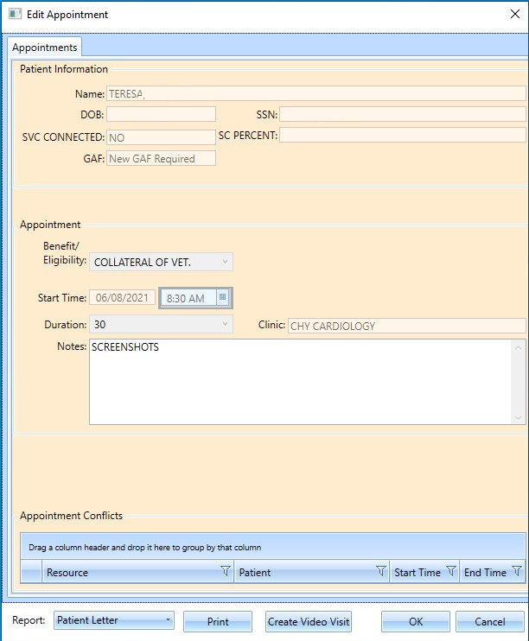
Figure 4: Edit Non-VVS Appointment
- A “Create Video Visit” form displays. When entering the provider information, you can select from the “Addt’l Contact” drop down and that selection determines if other notification methods will be used for the provider. (Note: A primary email is always required for the provider & notifications will always go to the primary email)
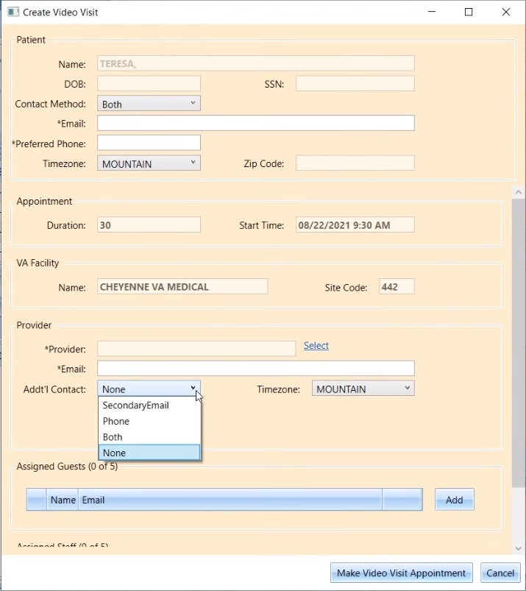
Figure 5: Create Video Visit Window With “Addt’l Contact” Drop Down List
- After filling out all the information click on “Make Video Visit Appointment” button.

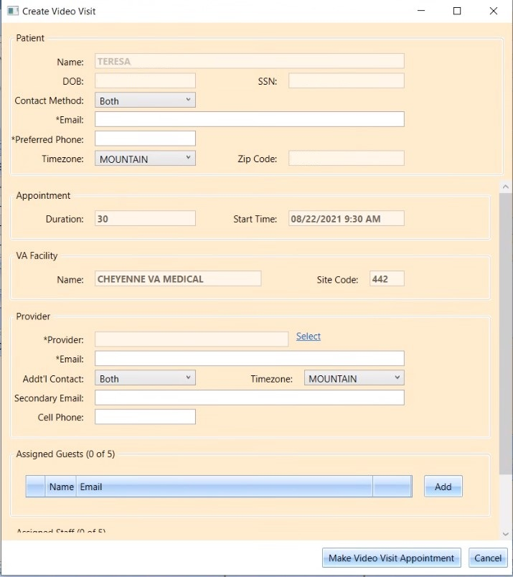
Figure 6: Create Video Visit Window And “Addt’l Contact” Drop Down List Selected To Both And That Displays Additional Provider Notification Options.

View/Edit VVS Appointments
- To view VVS Appointments, open the View Appointment window and click on the “View Video Visit” button at the bottom of the appointment window.
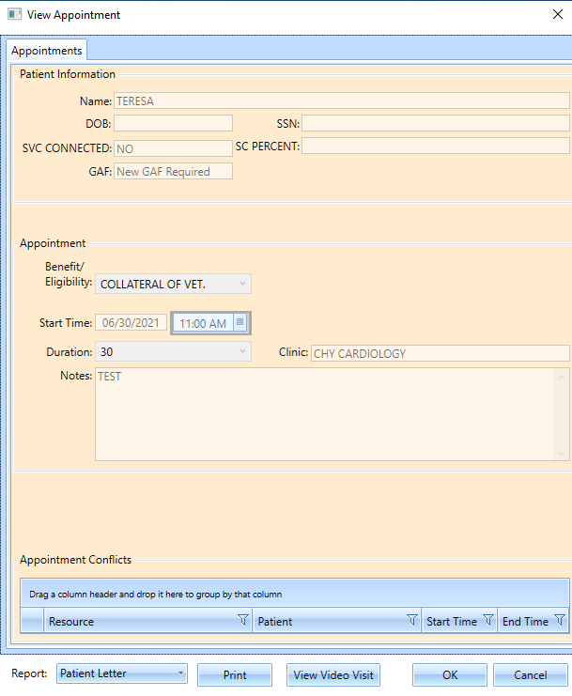
Figure 7: View Appointment Window for VVS Appointments
- After clicking the “View Video Visit” button a video visit form window displayed.
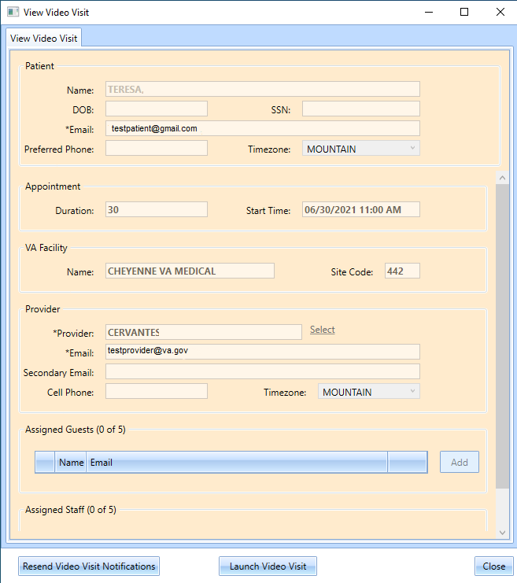
Figure 8: Video Visit Form Window
  - On the Video Visit Window when clicking the Resend Video Visit Notifications button it will send a notification to the patient and provider and pop-up window displays confirming the Video Visit notifications have been resent.
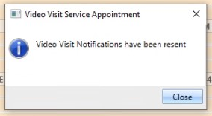
Figure 9: Pop-up Window notifying The Video Visit Notifications Have Been Resent
  - Again, on the Video Visit Window when clicking the Launch Video Visit button, it will automatically open a Video Visit session in Edge browser logged in as a provider.
- To edit existing VVS appointments, open the Edit Appointment window and click on the Edit Video Visit button at the bottom of the window.
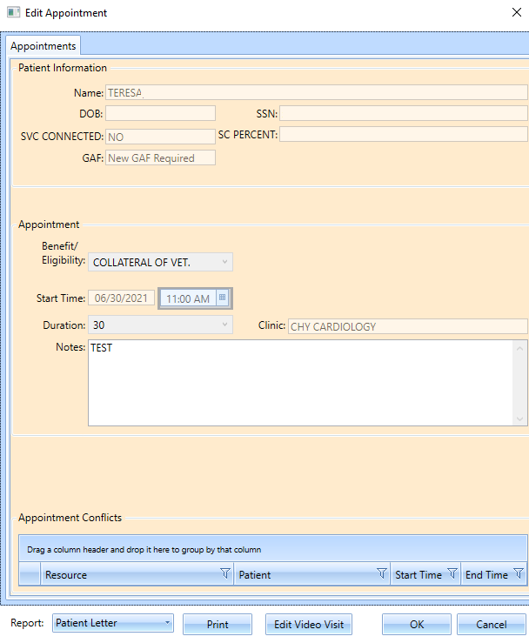
Figure 10: Edit Appointment Window
- After making the changes to the appointment detail click on the “update Video Visit Appointment” button and that will update the record.
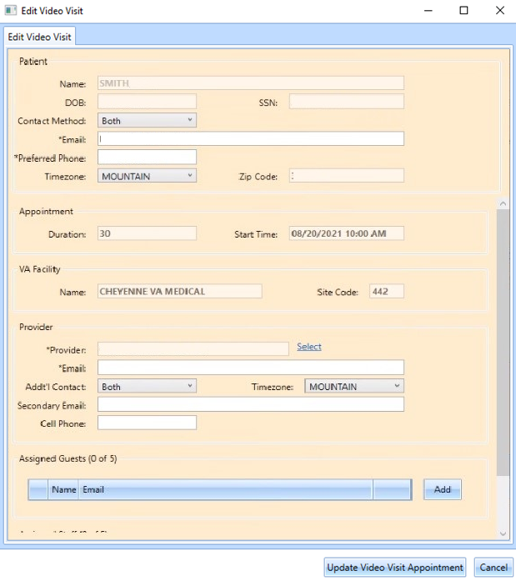
Figure 11: Edit Video Visit Window

Updates to User Preferences UI
Release 1.7.9 improves the usability of User Preferences by providing users brief instructions for adjusting column order and removing the “persist changes to Vista” checkbox.
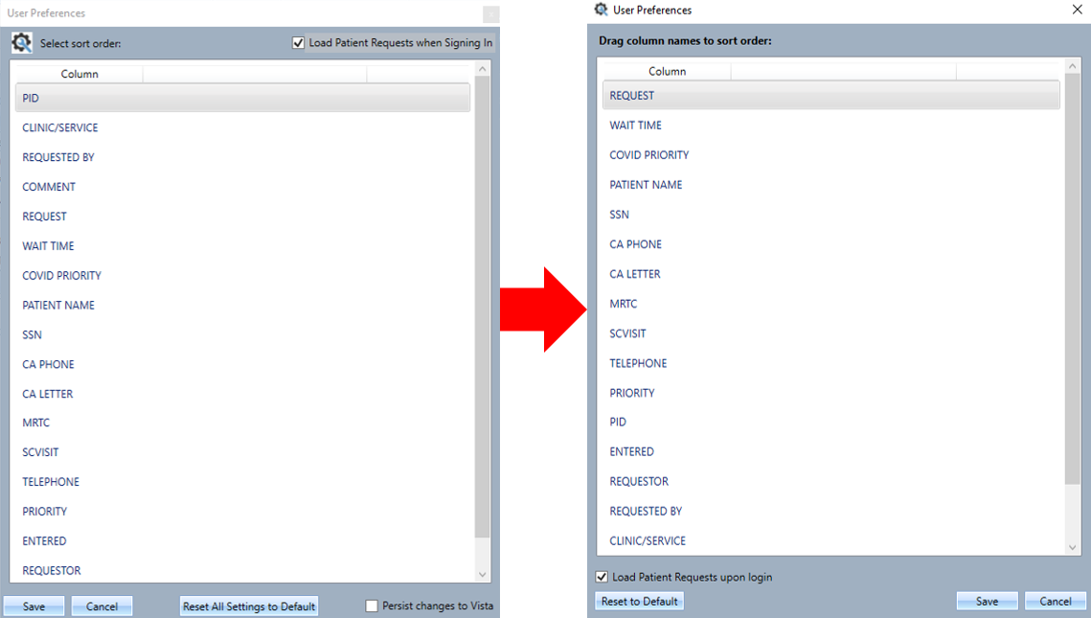
Figure 12: The Left Side Of The Figure Shows Prior Version Of VS GUI User Preference Window And The Figure On The Right Side Shows The Newly Updated VS GUI User Preference Window.

Correction to Clinic Search
This release corrects an issue where clinic search would truncate clinic name when the clinic abbreviation is the same as the first part of the clinic name, preventing appointment request creation.
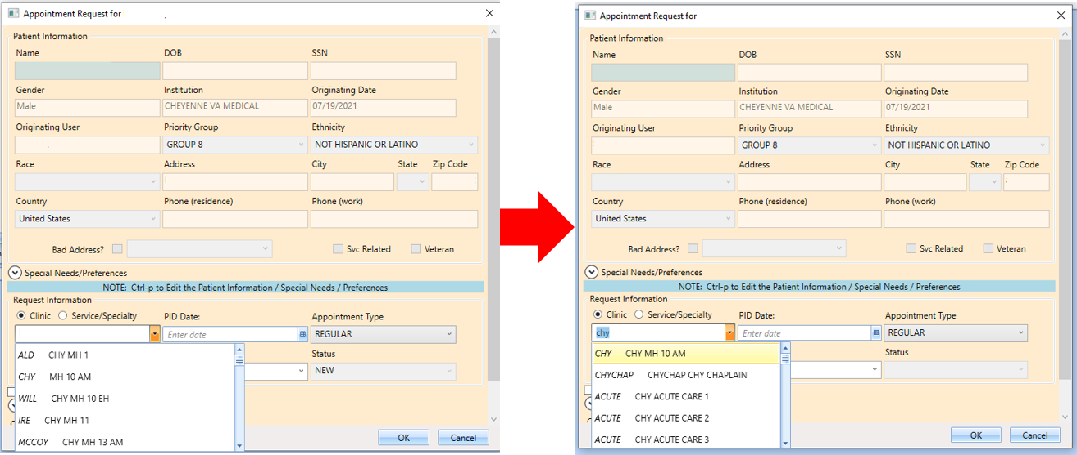
Figure 13: The Appointment Request Window On The Left Shows The Previous Version Of The GUI Where The CHY MH 10 AM Is Truncated To MH 10 AM Because Its Abbreviation Is CHY. Whereas The Appointment Request Window On The Right Is The Newly Updated VS GUI That Displays The Clinic Name Without Truncation.

PID Updates when Changed during Cancel by Patient
In prior versions, if a user updated the PID when cancelling an appointment by patient, the updated PID would not write to the appointment request. In this release, the PID is updated on the request. The new version of VS GUI comes with a fix that enables the new PID to display as expected in the RM Grid.
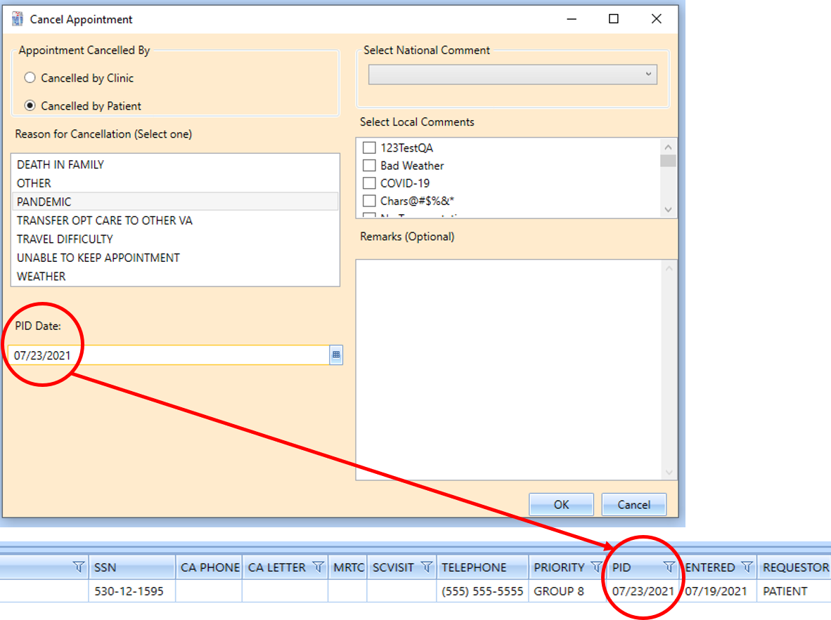
Figure 14: When Updating The PID Date To 07/23, The New PID Updates In The RM Grid.

Correction to Parent MRTC Behavior
In prior versions, if a user canceled a Computerized Patient Record System (CPRS) MRTC appointment and selected not to reopen the associated appointment request, the child MRTC request would not reopen, but the parent would return to the RM grid.

Update to GUI Behavior for Appointments with No Resource
In prior versions, the GUI would crash when an end user tried to take an action on an appointment with no resource, which shows as “*CORRUPT DATA” in the pending appointments list. This release prevents appointments from being created with no resource and updates the GUI so that the user can view the appointment without the system crashing.
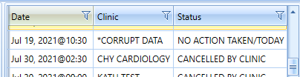
Figure 15: Previously, Appointments Could Be Made With No Resource And Showed As (*CORRUPT DATA) In The Pending Appointments Box

