
OFFICE OF
INFORMATION
AND TECHNOLOGY

Clinic Configurations Manager
User Interface (CCM-UI)
User Guide

Version 1.14.0 | June 2026

Table of Contents
1. Introduction 10
1.1 Overview 10
1.2 Prerequisite Credentials 10
1.3 PIV Login 10
2. Familiarizing Yourself with CCM-UI 12
2.1 Changing Site Locations 12
2.2 My Account 13
2.2.1 User Preferences 13
2.2.1.1 Default Site Location Preferences 14
2.2.1.2 Locations in Site Selector Preferences 15
2.2.1.3 Default Create New Clinic Accordion Preferences 16
2.2.2 Logging Out of CCM-UI 17
2.3 Resources 18
2.4 Filters 19
2.4.1 Sort by Ascending and Descending 19
2.4.2 Toggle Density 20
2.4.3 Filtering Rows 20
2.4.4 Filtering Columns 21
2.4.5 Show, Hide, and Search Filters 23
2.4.6 Search Function 25
3. Search and View Clinic Configurations 26
3.1 Search for a Clinic Configuration 26
3.2 View Current Clinic Configurations 28
3.2.1 Viewing Clinic Settings 29
3.2.2 Viewing Preselected Settings 30
3.2.3 Viewing Optional Settings 30
3.2.4 Viewing Clinic Availability 31
4. Editing Clinic Configurations 34
4.1 Editing Mandatory Fields 35
4.2 Editing Preselected Default Fields 37
4.3 Editing Optional Fields 38
4.4 Editing Clinic Availability 40
4.4.1 Add or Modify Timeslots for Single Day Modification 42
4.4.1.1 Adding Timeslots for Single Day Modification 44
4.4.1.2 Removing Timeslots for Single Day Modification 53
4.4.2 Add or Modify Timeslots for Indefinite Modification 58
4.4.2.1 Adding Timeslots for Indefinite Modification 60
4.4.2.2 Removing Timeslots for Indefinite Modification 69
4.4.3 Add or Modify Timeslots for Multi-select Modification 75
4.4.3.1 Adding Timeslots for Multi-select Modification 77
4.4.3.2 Removing Timeslots for Multi-select Modification 87
4.4.4 Add or Modify Timeslots for Recurring Modification 93
4.4.4.1 Adding Timeslots for Recurring Modification 95
4.4.4.2 Removing Timeslots for Recurring Modification 104
4.5 Cancelling and Restoring Timeslots 110
4.5.1 Cancelling a Timeslot 111
4.5.1.1 Cancelling for a Single Timeslot 112
4.5.1.2 Entire Day Cancellation 115
4.5.2 Restoring a Timeslot 118
4.5.2.1 Restoring for a Single Day Timeslot 118
4.5.2.2 Entire Day Restoration 120
4.6 Creating a New Clinic 121
4.6.1 Mandatory Fields 123
4.6.2 Preselected Settings 124
4.6.3 Optional Settings 125
4.7 Inactivating and Reactivating a Clinic 126
4.7.1 Inactivating a Clinic 127
4.7.2 Reactivating a Clinic 129
4.8 Replicating a Clinic 133
5. Clinic Audit Report 139
5.1 Familiarizing Yourself with the Clinic Audit Report 139
5.2 Filtering Reports and Exporting Data 141
5.2.1 Filtering Results 141
5.2.2 Filtering with Dropdowns 142
5.2.3 Filtering by Date Range 142
5.3 Exporting Data 143
6. Letters 144
6.1 Create a Letter 144
6.2 View a Letter 146
6.3 Edit a Letter 148
6.4 Delete a Letter 150
7. VA Tool Set 151
7.1 Veteran Self Scheduling 152
7.1.1 View Veteran Self Scheduling 152
7.1.2 Edit Veteran Self Scheduling 153
7.2 Veteran Appointment Requests 156
7.2.1 View Veteran Appointment Requests 156
7.2.2 Edit Veteran Appointment Requests 158
8. Annual Clinic Profile Review 161
9. References 163
9.1 Additional Features and Options for CCM-UI 163
9.2 Tool Tip Descriptions 163
9.3 Additional Help with Errors 168
9.3.1 Connection Issues Error 168
9.3.2 Server Issue Error 168

Table of Figures
Figure 1: Access Permissions Notification 10
Figure 2: PIV Card Sign-On Image 11
Figure 3: ActivClient Login Pop-Up Window 11
Figure 4: Change Site Locations Buttons 12
Figure 5: Change Site Location Accordion 12
Figure 6: View Settings Button 13
Figure 7: My Account Button for User Preferences 13
Figure 8: Preferences Button 14
Figure 9: Default Site Location Dropdown Button 14
Figure 10: Save Changes Button for Default Site Locations 14
Figure 11: Clear Selection Button for Default Site Location 15
Figure 12: Toggle Button for Locations in Site Selector 15
Figure 13: Save Changes Button for Locations in Site Selector 16
Figure 14: Show All Button for Locations in Site Selector 16
Figure 15: Checkbox for Default Accordions to Open 16
Figure 16: Save Changes Button for Default Accordions to Open 17
Figure 17: My Account Button for CCM-UI 17
Figure 18: Log Out Button for CCM-UI 18
Figure 19: Logged Out of Mobile Applications Page 18
Figure 20: Example of Additional Links for CCM-UI 19
Figure 21: Ascending/Descending Filter Arrow 19
Figure 22: Toggle Density Button 20
Figure 23: Rows per Page Option 20
Figure 24: Grid Navigation 21
Figure 25: Show/Hide Columns Button 21
Figure 26: Active Column Slider Example 22
Figure 27: Hidden Column Slider Example 22
Figure 28: Hide All Button 23
Figure 29: Show All Button 23
Figure 30: Show/Hide Filter Options Buttons 23
Figure 31: Example of Filter Search Menu on Grid View 24
Figure 32: Example of Filtered Results in Grid View 24
Figure 33: Clearing Filter Button 24
Figure 34: Selecting Show/Hide Filters Button to Hide Filter Menu 25
Figure 35: Show/Hide Search Button 25
Figure 36: Highlighted Search Example 26
Figure 37: Clear Button for Search Bar 26
Figure 38: Clinic Configurations Tab 27
Figure 39: Search Bar for Clinic Configurations 27
Figure 40: Error Message When Searching for a Clinic 27
Figure 41: Clinic Configurations Grid Table 28
Figure 42: Clinic Configurations Accordions 28
Figure 43: View Clinic Data Button 29
Figure 44: Clinic Settings View 29
Figure 45: Preselected Settings View 30
Figure 46: Optional Settings View 31
Figure 47: Viewing Clinic Availability Calendar Button 31
Figure 48: Viewing Clinic Availability Search Button 32
Figure 49: Viewing Clinic Availability Timeslots Example 32
Figure 50: Viewing Clinic Availability Timeslot Page View Options 32
Figure 51: Viewing Clinic Availability Filter Dates Button 33
Figure 52: Viewing Clinic Availability Filter Date Range Example 33
Figure 53: Authorization Error Message for Clinic Configurations 34
Figure 54: Edit Clinic Page 34
Figure 55: Editing Clinic Availability Accordions 35
Figure 56: Editing Mandatory Fields 35
Figure 57: Update Clinic Button for Mandatory Fields 36
Figure 58: Changes Unsaved Message for Mandatory Fields 36
Figure 59: Editing Preselected Default Fields 37
Figure 60: Update Clinic Button for Preselected Default Fields 38
Figure 61: Changes Unsaved Message for Preselected Default Fields 38
Figure 62: Editing Optional Fields 39
Figure 63: Update Clinic Button for Optional Fields 40
Figure 64: Changes Unsaved Message for Optional Fields 40
Figure 65: Timeslot Manager Button on Clinic Availability Accordion 41
Figure 66: Calendar Button for Editing Clinic Availability 41
Figure 67: Available Timeslots Example for Editing Clinic Availability 42
Figure 68: Timeslot Manager Button for Editing Clinic Availability for Single Modification 42
Figure 69: Timeslot Manager Page for Single Day 43
Figure 70: Add Grid Availability Radio Button for Single Day Modification 44
Figure 71: Calendar for Adding Grid Availability in Single Day Modification 45
Figure 72: Check for Cancelled Timeslots Button for Single Day Modification 46
Figure 73: Cancelled Timeslot Information for Single Day 47
Figure 74: Add Timeslots for Single Day Modification 47
Figure 75: Cancelled Timeslots Information for Single Day Modification 48
Figure 76: Adding Multiple Timeslots in Single Day Modification 49
Figure 77: Duplicate Timeslot Error for Single Day Modification 49
Figure 78: Overlap Timeslot Error for Single Day Modification 50
Figure 79: Removing Timeslots for Single Day Modification 50
Figure 80: Review Changes Button for Single Day Modification 51
Figure 81: Review Page for Adding Single Day Timeslots 52
Figure 82: Save Successful Message for Single Day Modification 53
Figure 83: Remove Grid Availability Radio Button for Single Day Modification 54
Figure 84: Calendar for Removing Grid Availability in Single Day Modification 55
Figure 85: Review Changes Button for Removing Single Day Modification 56
Figure 86: Review Page for Removing Single Day Timeslots 57
Figure 87: Save Successful for Remove Timeslot(s) in Single Day Modification 58
Figure 88: Timeslot Manager Button for Adding Clinic Availability for Indefinite Modification 58
Figure 89: Timeslot Manager Page for Indefinite Modification 59
Figure 90: Add Grid Availability Radio Button for Indefinite Modification 60
Figure 91: Calendar for Add Grid Availability in Indefinite Modification 61
Figure 92: Check for Cancelled Timeslots for Indefinite Modification 62
Figure 93: Cancelled Timeslot Information for Indefinite 63
Figure 94: Add Timeslot for Indefinite Modification 63
Figure 95: Cancelled Timeslots Information for Indefinite Modification 64
Figure 96: Adding Multiple Timeslots for Indefinite Modification 65
Figure 97: Duplicate Timeslot Error for Indefinite Modification 65
Figure 98: Overlap Timeslot Error for Indefinite Modification 66
Figure 99: Removing Timeslots for Indefinite Modification 66
Figure 100: Review Changes Button for Indefinite Modification 67
Figure 101: Review Page for Adding Indefinite Timeslots 68
Figure 102: Save Successful Message for Indefinite Modification 69
Figure 103: Remove Grid Availability Radio Button for Indefinite Modification 70
Figure 104: Calendar for Removing Grid Availability in Indefinite Modification 71
Figure 105: Option to Remove Day Indefinitely for Indefinite Modification 72
Figure 106: Choosing Multiple Days to Remove in Indefinite Modification 72
Figure 107: Review Changes Button for Removing Indefinite Timeslots 73
Figure 108: Review Page for Removing Indefinite Timeslots 74
Figure 109: Save Successful for Remove Timeslot(s) in Indefinite Modification 75
Figure 110: Timeslot Manager Button for Editing Clinic Availability for Multi-select 75
Figure 111: Timeslot Manager Page for Multi-select Modification 76
Figure 112: Add Grid Availability Radio Button for Multi-select Modification 77
Figure 113: Calendar for Multi-select Modification 78
Figure 114: Invalid Date Format Error 78
Figure 115: Check for Cancelled Timeslots Button for Multi-select Modification 79
Figure 116: Bulk Paste Example for Multi-select Timeslots 80
Figure 117: Cancelled Timeslot Information for Multi-select 80
Figure 118: Add Timeslot for Multi-select Modification 81
Figure 119: Cancelled Timeslots Information for Multi-select Modification 82
Figure 120: Adding Multiple Timeslots in Multi-select Modification 83
Figure 121: Duplicate Timeslot Error for Multi-select Modification 83
Figure 122: Overlap Timeslot Error for Multi-select Modification 84
Figure 123: Removing Timeslots for Multi-select Modification 84
Figure 124: Review Changes Button for Multi-select Modification 85
Figure 125: Review Page for Adding Multi-select Timeslots 86
Figure 126: Save Successful Message for Multi-select Modification 87
Figure 127: Remove Grid Availability Radio Button for Multi-select Modification 88
Figure 128: Calendar for Removing Grid Availability in Multi-select Modification 89
Figure 129: Review Changes Button for Removing Multi-select Timeslots 90
Figure 130: Bulk Paste Example for Removing Multi-select Timeslots 91
Figure 131: Review Page for Removing Multi-Select Timeslots 92
Figure 132: Save Successful for Remove Timeslot(s) in Multi-select Modification 93
Figure 133: Timeslot Manager Button for Editing Clinic Availability for Recurring 93
Figure 134: Timeslot Manager Page for Recurring Modification 94
Figure 135: Add Grid Availability Radio Button for Recurring Modification 95
Figure 136: Calendar Dropdown for Recurring Modification 96
Figure 137: Check for Cancelled Timeslots Button for Recurring Modification 96
Figure 138: Cancelled Timeslot Information for Recurring 97
Figure 139: Recurrence Pattern Dropdown 97
Figure 140: Example of Monthly Recurrence Pattern 98
Figure 141: Example of Weekly Recurrence Pattern 98
Figure 142: Add Timeslot for Recurring Modification 99
Figure 143: Cancelled Timeslots Information for Recurring Modification 100
Figure 144: Adding Multiple Timeslots in Recurring Modification 100
Figure 145: Duplicate Timeslot Error for Recurring Modification 101
Figure 146: Overlap Timeslot Error for Recurring Modification 101
Figure 147: Removing Timeslots for Recurring Modification 101
Figure 148: Review Changes Button for Recurring Modification 102
Figure 149: Review Page for Adding Recurring Timeslots 103
Figure 150: Save Successful Message for Recurring Modification 104
Figure 151: Remove Grid Availability Radio Button for Recurring Modification 105
Figure 152: Calendar Dropdown for Removing Grid Availability in Recurring Modification 106
Figure 153: Recurrence Pattern Dropdown for Removing Grid Availability 107
Figure 154: Example of Monthly Recurrence Pattern for Removing Grid Availability 107
Figure 155: Example of Weekly Recurrence Pattern for Removing Grid Availability 107
Figure 156: Review Changes Button for Removing Recurring Timeslots 108
Figure 157: Review Page for Removing Recurring Timeslots 109
Figure 158: Save Successful for Remove Timeslot(s) in Recurring Modification 110
Figure 159: Cancel and Restore Buttons for Timeslots 110
Figure 160: Date Search for Cancel and Restore 111
Figure 161: Cancel Timeslot Button 111
Figure 162: Cancel Timeslot Window 112
Figure 163: Single Timeslot Cancellation Option 112
Figure 164: Manual Time Entered for Timeslot Cancellation Example 113
Figure 165: Reason for Cancellation Example for Single Timeslot Cancellation 113
Figure 166: Reason for Cancellation Error for Single Timeslot Cancellation 114
Figure 167: Patient Association Window for Single Timeslot Cancellation 114
Figure 168: Save Successful for Cancelling Single Timeslot 115
Figure 169: Single Timeslot Cancellation Example in Grid 115
Figure 170: Entire Day Timeslot Cancellation Option 116
Figure 171: Reason for Cancellation Example for Entire Day Cancellation 116
Figure 172: Reason for Cancellation Error for Entire Day Cancellation 117
Figure 173: Patient Association Window for Entire Day Timeslots Cancellation 117
Figure 174: Save Successful for Cancelling All Timeslots 118
Figure 175: Entire Day Timeslot Cancellation Example in Grid 118
Figure 176: Restore Timeslot Button for Single Timeslot Restoration 118
Figure 177: Restore Timeslot Window for Single Timeslot 119
Figure 178: Restore Timeslot(s) Button for Single Day Timeslot 119
Figure 179: Save Successful Window for Single Timeslot Restoration 120
Figure 180: Restore Timeslot Button for Entire Day Restoration 120
Figure 181: Restore Timeslot Window for Entire Day Timeslots Restoration 120
Figure 182: Save Successful Window for Entire Day Timeslots Restoration 121
Figure 183: Authorization Error Message for Creating a Clinic 121
Figure 184: Create a Clinic Button 122
Figure 185: Create a Clinic Accordions 122
Figure 186: Create a Clinic Button after Entering Required Information 123
Figure 187: Editing Mandatory Fields for Create a Clinic 124
Figure 188: Error Message from Lack of Required Fields 124
Figure 189: Editing Preselected Default Fields for Create a Clinic 125
Figure 190: Editing Optional Fields for Create a Clinic 126
Figure 191: Inactivate Clinic Button 127
Figure 192: Clinic Search Example for Inactivating a Clinic 127
Figure 193: Error Message for Inactivating a Clinic 127
Figure 194: Inactivate Clinic Button for Inactivating a Clinic 128
Figure 195: Inactivate Date Pop-up 128
Figure 196: Inactivate Status Date 129
Figure 197: Clinic is Inactive Message 129
Figure 198: Clinic Search Example for Reactivating a Clinic 130
Figure 199: Reactivate Clinic Button 130
Figure 200: Reactivate Clinic Pop-up 131
Figure 201: Calendar Button for Reactivating a Clinic 131
Figure 202: Provider Field for Reactivating a Clinic 132
Figure 203: Confirmation Checkbox for Reactivating a Clinic 132
Figure 204: Reactivate Clinic Button 133
Figure 205: Authorization Error Message for Replicating a Clinic 134
Figure 206: Clinic Actions Button for Replicating a Clinic 134
Figure 207: Replicate Clinic Option from the Clinic Action Menu 135
Figure 208: Example of Auto-populated Fields for Replicating a Clinic 135
Figure 209: Replicate Clinic Accordions 136
Figure 210: Clinic Availability Not Replicated Notification 136
Figure 211: Replicate Clinic Button after Entering Required Information 137
Figure 212: Unable to Replicate Clinic Availability Window 138
Figure 213: Clinic Successfully Replicated Window 138
Figure 214: Clinic Audit Report Tab 139
Figure 215: CCM Clinic Audit Report Homepage 140
Figure 216: Clinic Modification Trends 140
Figure 217: Filter Options 141
Figure 218: Reset Filters Button 141
Figure 219: Example of Choosing Filter Selection 142
Figure 220: Example of Filter Selection Dropdown 142
Figure 221: Calendar Button for Enter Start Date 143
Figure 222: Calendar Button for Enter End Date 143
Figure 223: Export Button for Clinic Audit Report 143
Figure 224: View Existing Letters 144
Figure 225: Letters Tab 144
Figure 226: Create Letter Button on the Letters Page 145
Figure 227: Example of Letter 145
Figure 228: Create Letter Button on the Create New Letter Page 146
Figure 229: Search Button for Viewing Letters 146
Figure 230: View Letter Button from Action Menu 146
Figure 231: View Letter Page Example 147
Figure 232: Search Button for Editing Letters 148
Figure 233: Edit Letter Button from the Action Menu 148
Figure 234: Edit Letter Page 149
Figure 235: Save Changes Button for Edit Letter Page 149
Figure 236: Search Button for Deleting Letters 150
Figure 237: Delete Letter Button from the Action Menu 150
Figure 238: Delete Letter Button 151
Figure 239: VA Tool Set Tab 151
Figure 240: VA Tool Set Accordion View 152
Figure 241: Viewing Veteran Self Scheduling 152
Figure 242: Pinned Services Button for Viewing VA Self Scheduling 153
Figure 243: Expanded Accordions of Viewing VA Self Scheduling Settings 153
Figure 244: Authorization Error Message for VA Self Scheduling Settings 153
Figure 245: Editing Veteran Self Scheduling 154
Figure 246: Pinned Services Button for Editing VA Self Scheduling 154
Figure 247: Accordion View of Editing VA Self Scheduling Settings 154
Figure 248: Save Button for VA Self Scheduling Settings 155
Figure 249: Error Field for Saving in VA Self Scheduling 155
Figure 250: Saving in VA Self Scheduling 156
Figure 251: Time Stamp after Saving in VA Self Scheduling 156
Figure 252: Viewing Veteran Appointment Requests 157
Figure 253: Pinned Services Button for Viewing VA Appointment Requests 157
Figure 254: Expanded Accordions of Viewing VA Appointment Requests 157
Figure 255: Authorization Error Message for VA Appointment Requests Settings 158
Figure 256: Veteran Appointment Requests Tab 158
Figure 257: Pinned Services Button for VA Appointment Requests 159
Figure 258: Accordion View of VA Appointment Requests 159
Figure 259: Save Button for VA Appointment Requests Settings 159
Figure 260: Error Field for Saving in VA Appointment Requests 160
Figure 261: Saving in VA Appointment Requests 160
Figure 262: Time Stamp after Saving in VA Appointment Requests 161
Figure 263: Annual Clinic Profile Review Tab 161
Figure 264: Run Report Button for Annual Clinic Profile Review 161
Figure 265: Download Link for Annual Clinic Profile Review 162
Figure 266: No Results Found Notification for Annual Clinic Profile Review 162
Figure 267: Resource Information Link for Annual Clinic Profile Review 162
Figure 268: 500 Error Message for Connection 168
Figure 269: 500 Error Message for Server Issues 169

Table of Tables
Table 1: Filter Descriptions for Clinic Audit Report 141
Table 2: Tool Tip Descriptions 163

Revision History
Date | Version | Description | Author
6/4/2026 | 1.14.0 | Updated information for section 4.4 | Booz Allen Hamilton
5/11/2026 | 1.13.0 | Updated information on User Preferences and Letters | Booz Allen Hamilton
4/27/2026 | 1.12.0 | Updated UI for Veteran Self Scheduling | Booz Allen Hamilton
3/17/2026 | 1.11.0 | Added information to Letters section, updated outdated information for Clinic Audit Report, updated UI for Editing Timeslots | Booz Allen Hamilton
3/3/2026 | 1.10.0 | Updated UI changes to Multi-select timeslots and Timeslot Recovery | Booz Allen Hamilton
12/4/2025 | 1.7.0 | Updated UI changes to v3, added Letters and Annual Clinic Review Section | Booz Allen Hamilton

Introduction

1.1 Overview
The Clinic Configuration Manager User Interface (CCM-UI) is a user friendly, easy to navigate application that will help users View, Edit and Create data attribution changes to and from either the VA Tool Set or VistA systems.

1.2 Prerequisite Credentials
- The user’s PIV card must be linked to the VistA site. (See link for guidance)
- After confirming that the user’s PIV card is linked to the user’s VistA account, the user will be able to sign into the CCM-UI.
- To access the Clinic Configuration Manager Clinic Audit Report, users will need to be added to the VHACLINICPROFILEMANAGERS@VA.GOV email distribution group.
- Note: Users who have not been added to the VHACLINICPROFILEMANAGERS@VA.GOV email distribution group will need to contact their supervisor to be added.
- Note: If a user has not been added to the appropriate email distribution group, the user will receive the following message seen in ⁠⁠⁠⁠⁠⁠Figure 1⁠⁠⁠⁠⁠⁠ below notifying them that the correct access permissions have not been allocated to the account.
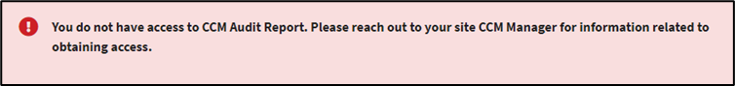
Figure 1: Access Permissions Notification

1.3 PIV Login
- Begin by opening a browser and going to the following web address: link. The VA Single Sign-On page will then appear. Select the “Sign in with PIV” option, as seen in ⁠⁠⁠⁠⁠⁠Figure 2⁠⁠⁠⁠⁠⁠, to proceed with the log in process.
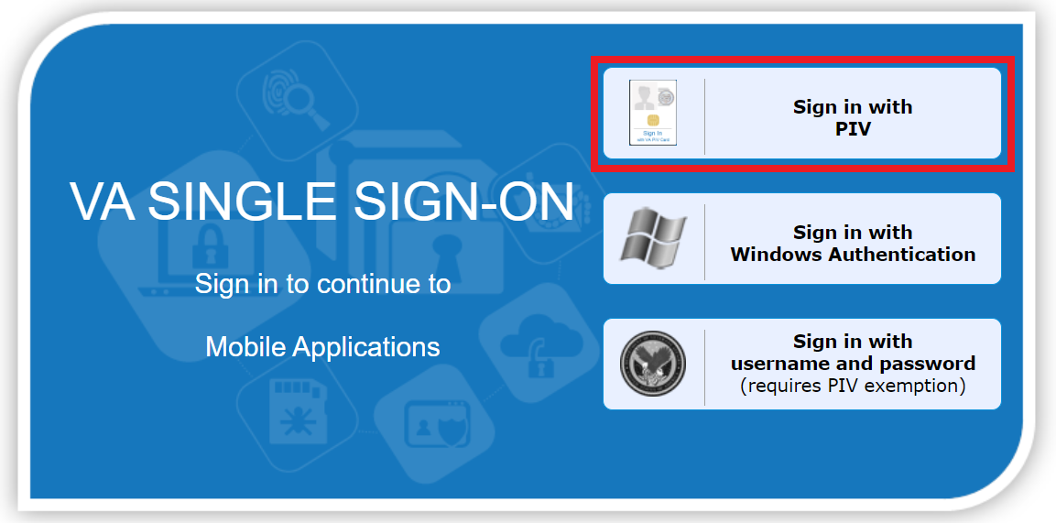
Figure 2: PIV Card Sign-On Image
- After selecting, an ActivClient Login dialog box will appear to prompt you to enter your PIN. Type the numbers of your PIN as prompted in ⁠⁠⁠⁠⁠⁠Figure 3⁠⁠⁠⁠⁠⁠. If authentication is successful, CCM-UI will load. If it is not successful, you will be prompted to enter your correct PIN instead.
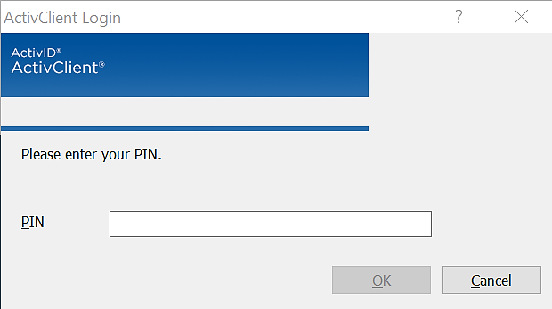
Figure 3: ActivClient Login Pop-Up Window

Familiarizing Yourself with CCM-UI

2.1 Changing Site Locations
- To change site locations, the user must first select the green box in the upper right-hand corner of the page as shown in ⁠⁠⁠⁠⁠⁠Figure 4⁠⁠⁠⁠⁠⁠.
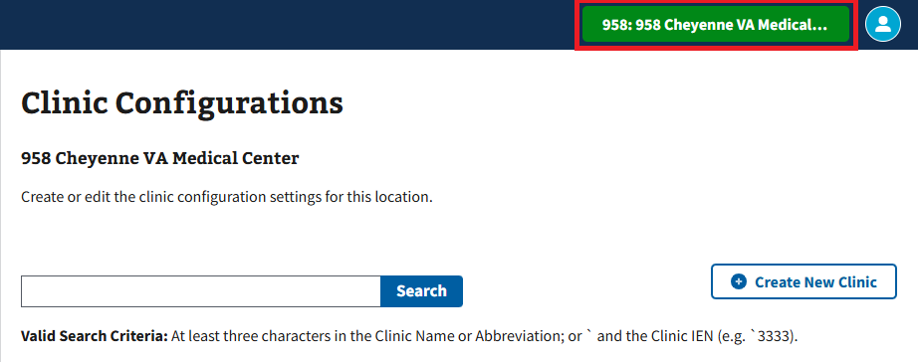
Figure 4: Change Site Locations Buttons
- The user will then need to select the requested site location by clicking the arrow shown in ⁠⁠⁠⁠⁠⁠Figure 5⁠⁠⁠⁠⁠⁠ if it is not already the default selection.
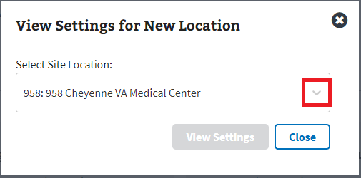
Figure 5: Change Site Location Accordion
- Note: The user will only see sites that are provisioned to their account after selecting the arrow shown in ⁠⁠⁠⁠⁠⁠Figure 5⁠⁠⁠⁠⁠⁠. If sites assigned to the user are not shown, please contact the local Clinical Applications Coordinator or Supervisor for assistance.

- The user can then select the button boxed below in ⁠⁠⁠⁠⁠⁠Figure 6⁠⁠⁠⁠⁠⁠ to view the selected settings.
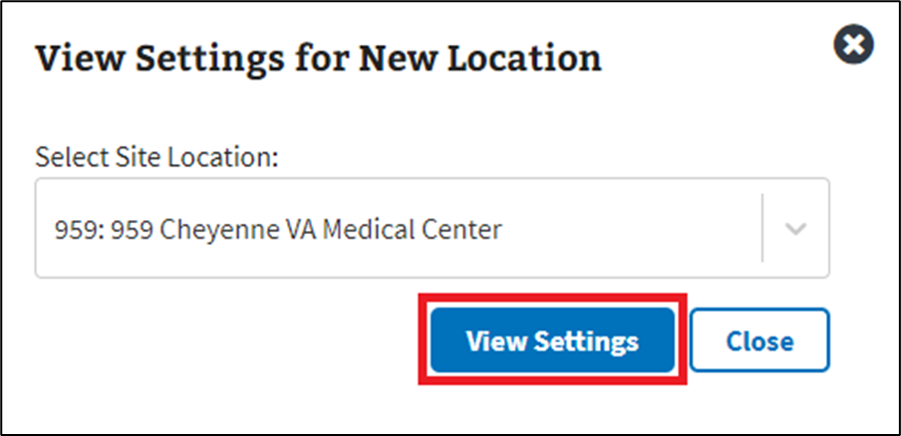
Figure 6: View Settings Button

2.2 My Account

2.2.1 User Preferences
Disclaimer: The first two sub-sections for User Preferences are only applicable to CCM users with more than one site location provisioned to their account. For users provisioned with only a single site location, please skip to section ⁠⁠⁠2.2.1.3 Default Create New Clinic Accordion Preferences⁠⁠⁠.
- To change user preferences, the user can select the “My Account” button in the upper right-hand corner, seen in ⁠⁠⁠⁠⁠⁠Figure 7⁠⁠⁠⁠⁠⁠, to open the dropdown.
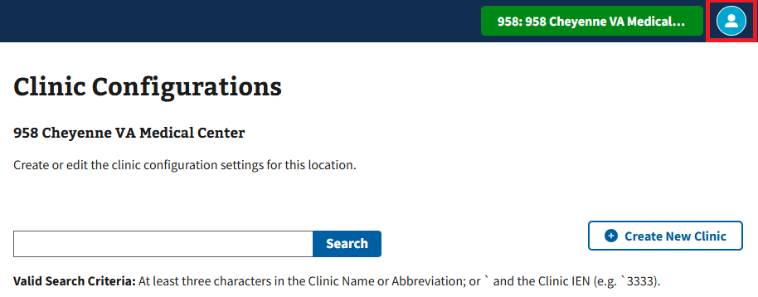
Figure 7: My Account Button for User Preferences
- The user can then select the “Preferences” button shown in ⁠⁠⁠⁠⁠⁠Figure 8⁠⁠⁠⁠⁠⁠ to be taken to the User Preferences page.
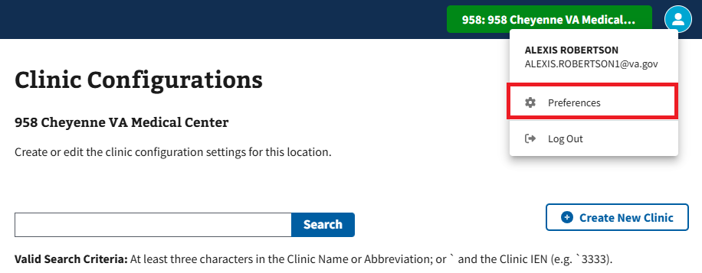
Figure 8: Preferences Button

2.2.1.1 Default Site Location Preferences
- To adjust the default site location, the user will need to select the arrow, seen in ⁠⁠⁠⁠⁠⁠Figure 9⁠⁠⁠⁠⁠⁠ below, to choose a location from the dropdown.
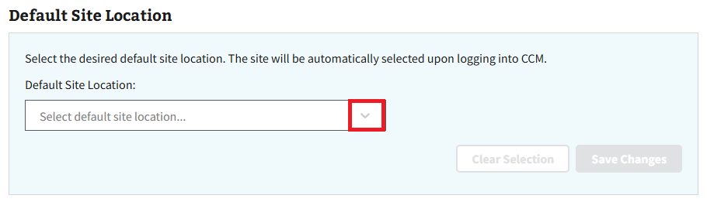
Figure 9: Default Site Location Dropdown Button
- After selecting a location, the user can then select the “Save” button in ⁠⁠⁠⁠⁠⁠Figure 10⁠⁠⁠⁠⁠⁠ to save the change.
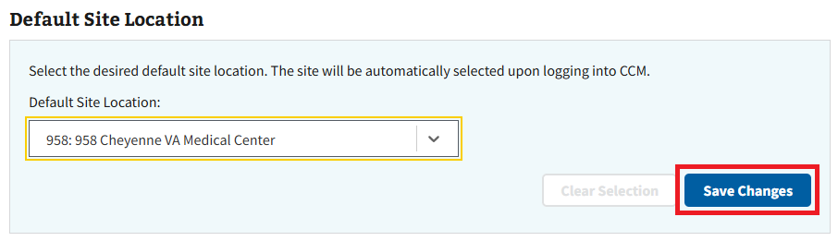
Figure 10: Save Changes Button for Default Site Locations
- To reset the default location, select the “Clear Selection” button seen in ⁠⁠⁠⁠⁠⁠Figure 11⁠⁠⁠⁠⁠⁠.
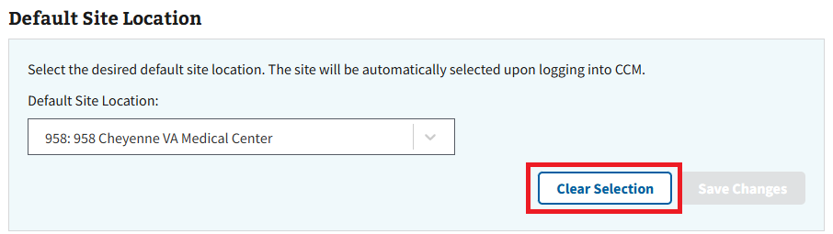
Figure 11: Clear Selection Button for Default Site Location
- Note: User preferences will be reset whenever the user clears their browser cache.

2.2.1.2 Locations in Site Selector Preferences
- To change the locations in the site selector, the user will need to select the buttons boxed in ⁠⁠⁠⁠⁠⁠Figure 12⁠⁠⁠⁠⁠⁠. The user will know that the site is hidden when a “\” displays through the icon as shown in ⁠⁠⁠⁠⁠⁠Figure 13⁠⁠⁠⁠⁠⁠.
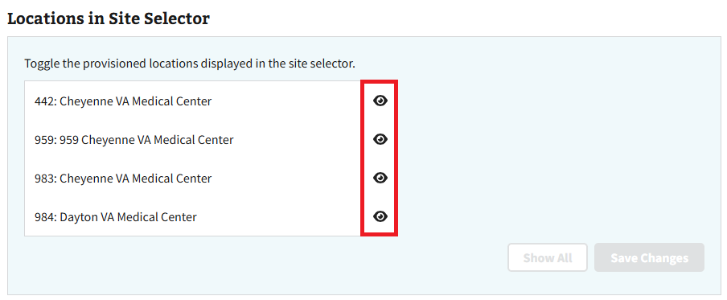
Figure 12: Toggle Button for Locations in Site Selector
- The user can then select the “Save” button seen in ⁠⁠⁠⁠⁠⁠Figure 13⁠⁠⁠⁠⁠⁠ to save their changes.
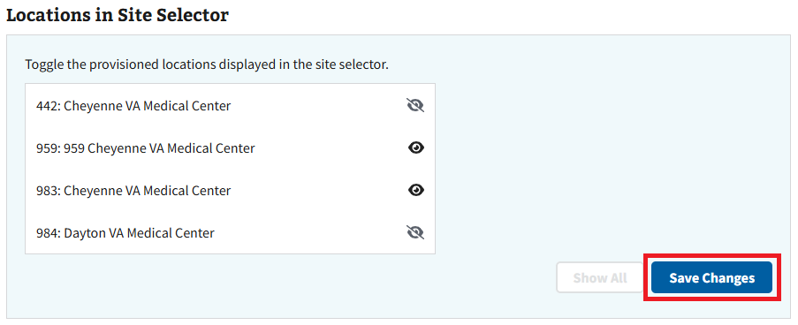
Figure 13: Save Changes Button for Locations in Site Selector
- To reset preferences, select the “Show All” button within the individual sections as seen in ⁠⁠⁠⁠⁠⁠Figure 14⁠⁠⁠⁠⁠⁠.
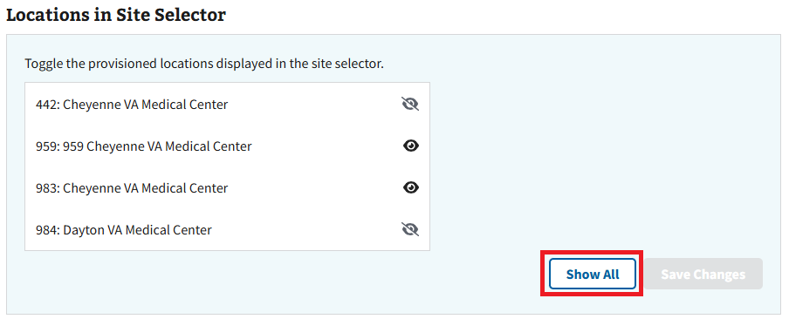
Figure 14: Show All Button for Locations in Site Selector
- Note: User preferences will be reset whenever the user clears their browser cache.

2.2.1.3 Default Create New Clinic Accordion Preferences
- To adjust the default state of the accordions when creating a new clinic to open, the user will need to select the checkbox shown below in ⁠⁠⁠⁠⁠Figure 15⁠⁠⁠⁠⁠.
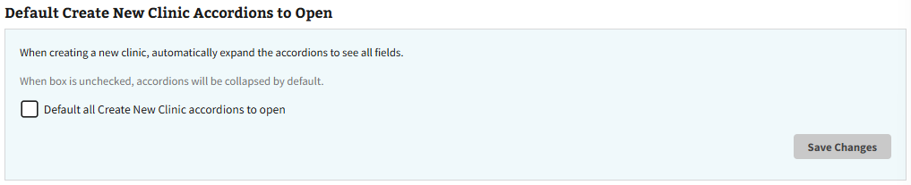
Figure 15: Checkbox for Default Accordions to Open
- The user can then select the “Save Changes” button, seen in ⁠⁠⁠⁠⁠Figure 16⁠⁠⁠⁠⁠, to save their new preference.
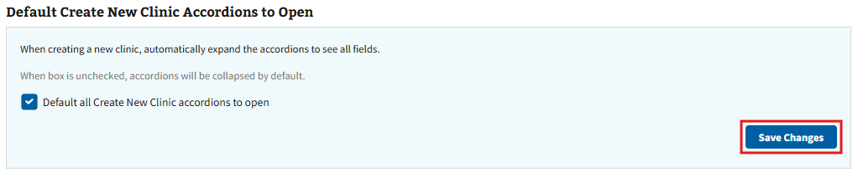
Figure 16: Save Changes Button for Default Accordions to Open
- To reset the default state of the accordions to collapsed, the user will simply need to uncheck the box and save their changes to confirm.

2.2.2 Logging Out of CCM-UI
- To log out of CCM-UI, the user will need to select the “My Account” button in the upper-right hand corner, as seen in ⁠⁠⁠⁠⁠Figure 17⁠⁠⁠⁠⁠.
Figure 17: My Account Button for CCM-UI
- The user will then need to select the “Log Out” button from the dropdown menu shown in ⁠⁠⁠⁠⁠Figure 18⁠⁠⁠⁠⁠.
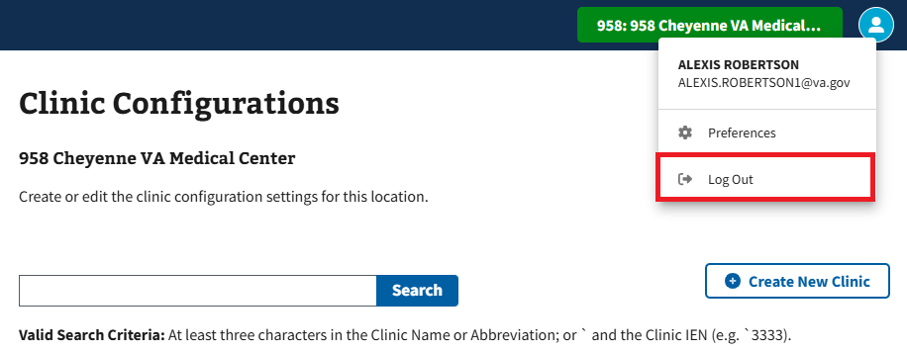
Figure 18: Log Out Button for CCM-UI
- Upon logging out of the CCM-UI application, the user will be taken to the page seen in ⁠⁠⁠⁠⁠Figure 19⁠⁠⁠⁠⁠ that will prompt them to log out of the VA SSOi and close the browser.
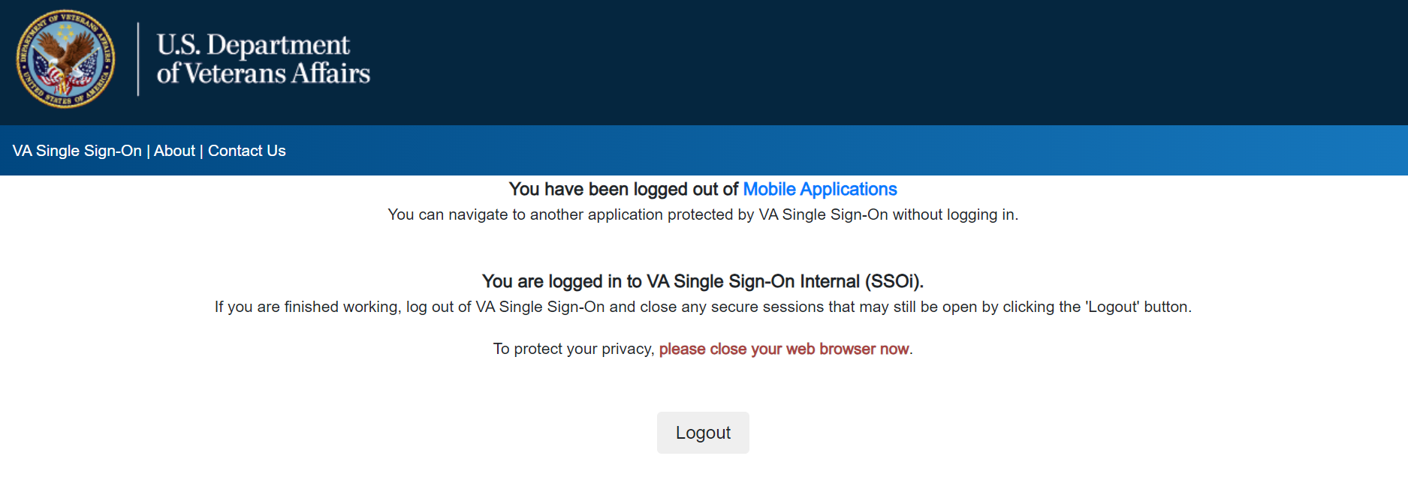
Figure 19: Logged Out of Mobile Applications Page

2.3 Resources
For additional information or help with the CCM-UI application, the user can select the “Resources” tab to the left of the CCM-UI page. See ⁠⁠⁠⁠⁠Figure 20⁠⁠⁠⁠⁠ below for reference.
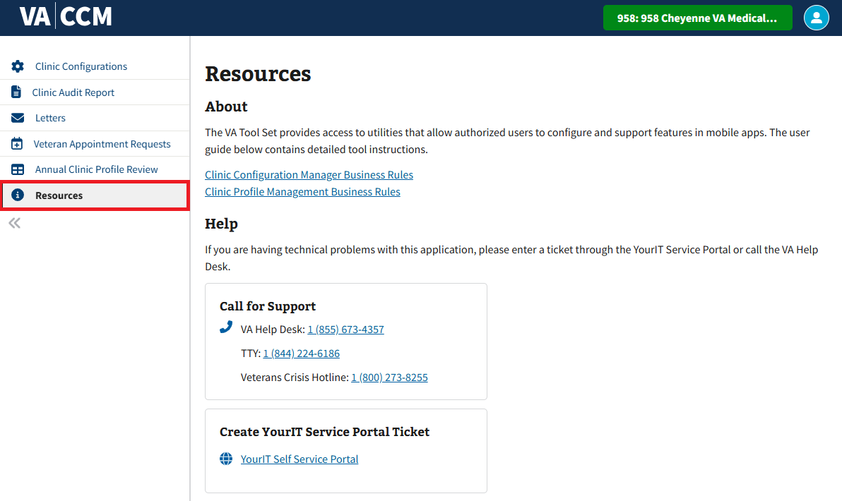
Figure 20: Example of Additional Links for CCM-UI

2.4 Filters

2.4.1 Sort by Ascending and Descending
- When looking for clinics within the grid, the user can sort rows by hovering the cursor next to a column’s name and selecting the arrow button that appears in ⁠⁠⁠⁠⁠Figure 21⁠⁠⁠⁠⁠.
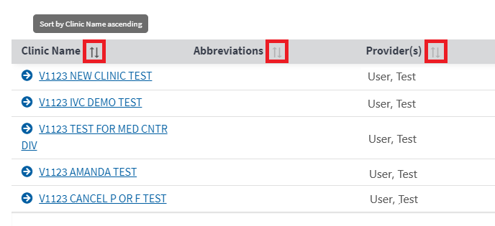
Figure 21: Ascending/Descending Filter Arrow
- Selecting the arrow once will cause results to sort by ascending order (↑), a second time to sort by descending order (notated by ↓), and a third time to cause results to appear in the default order again (notated with no arrow).

2.4.2 Toggle Density
- The user has the option to adjust toggle density of the grid. To begin adjusting the toggle density, select the button shown in ⁠⁠⁠⁠⁠Figure 22⁠⁠⁠⁠⁠.
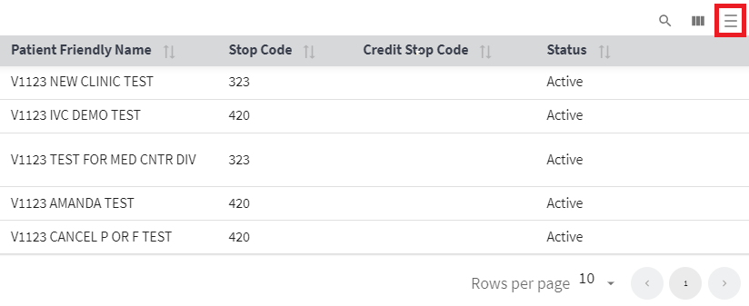
Figure 22: Toggle Density Button
- There are three different options for the user to choose from depending on the user’s preference. Simply keep selecting the “Toggle Density” button to rotate through the options until the user finds their preferred density.

2.4.3 Filtering Rows
- Users can increase or decrease the number of rows shown on the page by selecting the arrow shown in ⁠⁠⁠⁠⁠Figure 23⁠⁠⁠⁠⁠.
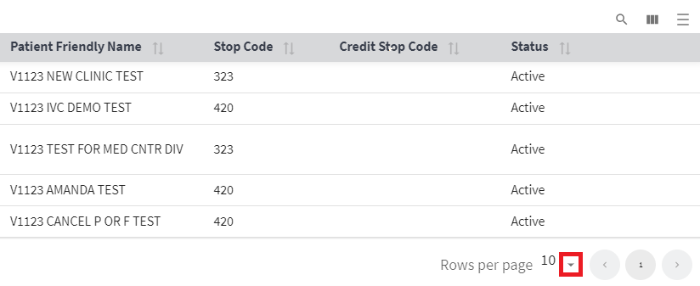
Figure 23: Rows per Page Option
- Users can also navigate the grid to more available clinics by selecting the arrows “<” to navigate one page backwards and “>” to navigate one-page forwards, as seen in ⁠⁠⁠⁠⁠Figure 24⁠⁠⁠⁠⁠.
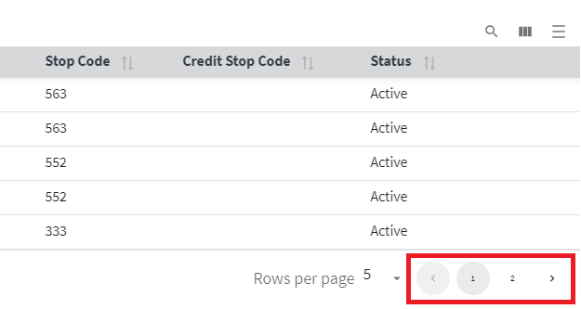
Figure 24: Grid Navigation
- Note: Arrows will be greyed out and un-selectable if the user cannot navigate in a certain direction.

2.4.4 Filtering Columns
- Users can filter columns by selecting the three vertical bars pictured in ⁠⁠⁠⁠⁠Figure 25⁠⁠⁠⁠⁠ titled “Show/Hide Columns.” This action will cause a dropdown (see ⁠⁠⁠⁠⁠Figure 26⁠⁠⁠⁠⁠) to appear.
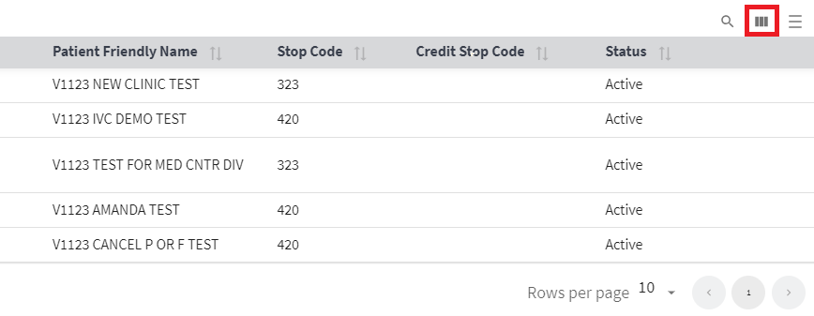
Figure 25: Show/Hide Columns Button
- To hide a column, users will need to select the slider, shown below in ⁠⁠⁠⁠⁠Figure 26⁠⁠⁠⁠⁠, next to an active column (indicated by slider’s blue appearance). The slider will become grey, and the column will be hidden from view within the grid.
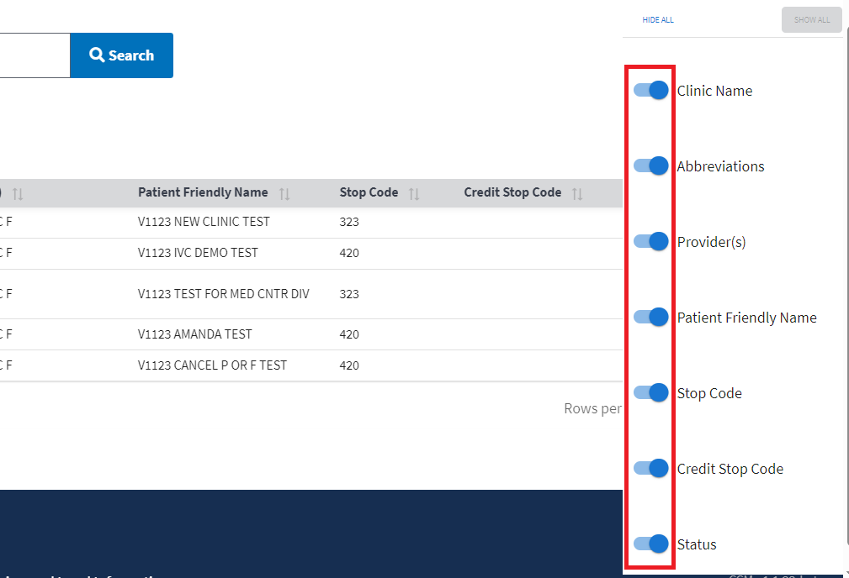
Figure 26: Active Column Slider Example
- To show a column, users will need to select the slider, shown below in ⁠⁠⁠⁠⁠Figure 27⁠⁠⁠⁠⁠, next to a hidden column (indicated by slider’s grey appearance). The slider will then become blue, and the column will be shown within the grid once more.
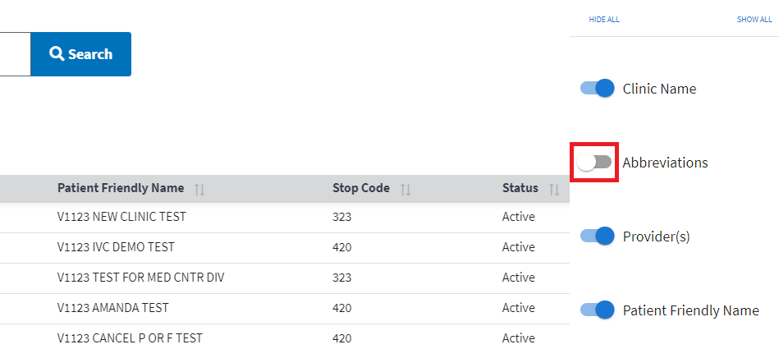
Figure 27: Hidden Column Slider Example
- Optionally, users can choose to hide all columns within the grid at once by selecting the “Hide All” button seen in ⁠⁠⁠⁠⁠Figure 28⁠⁠⁠⁠⁠.
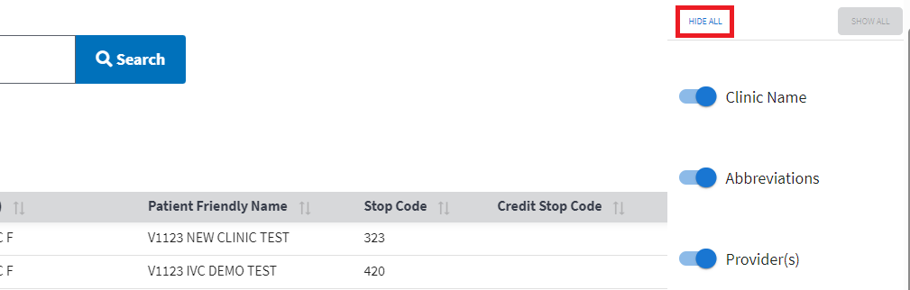
Figure 28: Hide All Button
- Users can also select the “Show All” button seen below in ⁠⁠⁠⁠⁠Figure 29⁠⁠⁠⁠⁠ to show all hidden columns within the grid at one time.
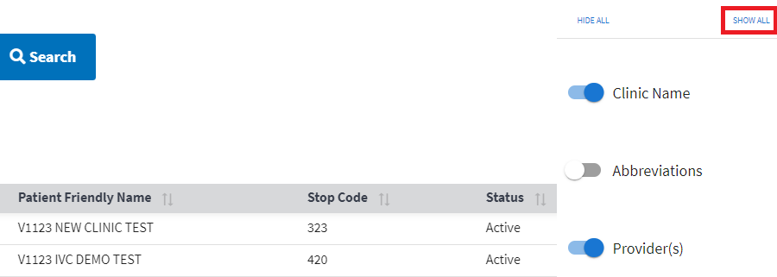
Figure 29: Show All Button
- Note: The “Show All” button will not be selectable until at least one column has been hidden.

2.4.5 Show, Hide, and Search Filters
- When looking for availability within the grid, the option to show and hide filters is available. To begin the user will need to select the “Show/Hide Filters” button shown in ⁠⁠⁠⁠⁠Figure 30⁠⁠⁠⁠⁠. Selecting either will cause the search functions to appear under each column name.
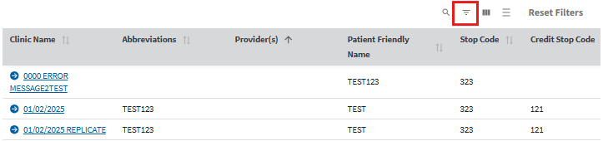
Figure 30: Show/Hide Filter Options Buttons
- Once the search options appear as seen in ⁠⁠⁠⁠⁠Figure 31⁠⁠⁠⁠⁠, the user can select the search bar or dropdown menu under the desired column to be filtered and enter or select the required information needed.
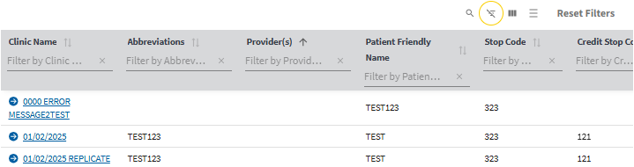
Figure 31: Example of Filter Search Menu on Grid View
- Once the filter field has been populated, results will automatically refresh and show items based on the filtered criteria as seen below in ⁠⁠⁠⁠⁠Figure 32⁠⁠⁠⁠⁠.
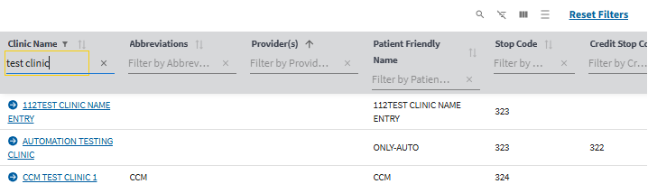
Figure 32: Example of Filtered Results in Grid View
- To clear the search, the user will need to select the “X” next to the search bar seen in ⁠⁠⁠⁠⁠Figure 33⁠⁠⁠⁠⁠. Selecting this will cause all results to appear within the table.
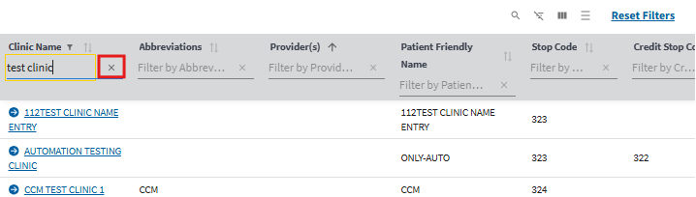
Figure 33: Clearing Filter Button
- Once finished searching, the user can then select the “Show/Hide Search” button seen in ⁠⁠⁠⁠⁠Figure 34⁠⁠⁠⁠⁠ to hide the search bar.
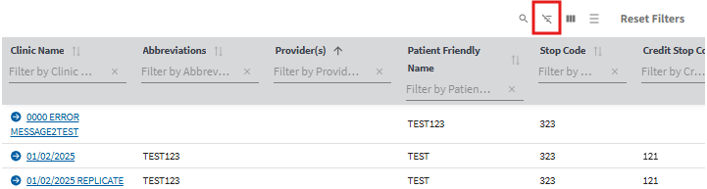
Figure 34: Selecting Show/Hide Filters Button to Hide Filter Menu

2.4.6 Search Function
- The user can search through all items within the grid by selecting the “Show/Hide Search” button seen in ⁠⁠⁠⁠⁠Figure 35⁠⁠⁠⁠⁠.
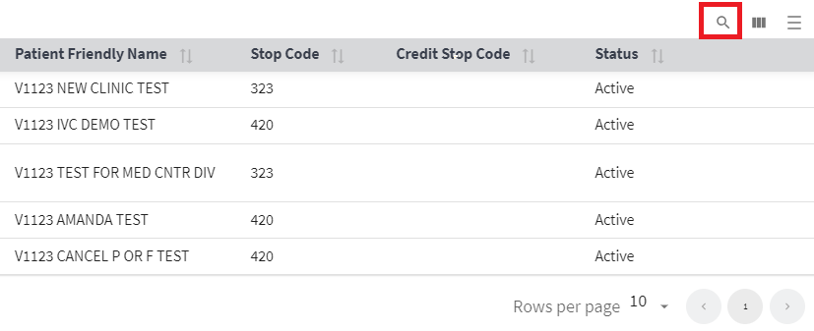
Figure 35: Show/Hide Search Button
- The user can then type the requested information into the search function. This will cause matching results to appear automatically highlighted within the grid as shown in ⁠⁠⁠⁠⁠Figure 36⁠⁠⁠⁠⁠.
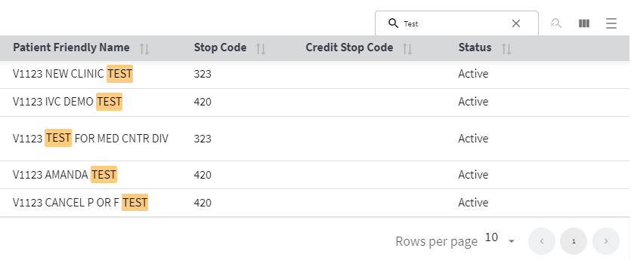
Figure 36: Highlighted Search Example
- To clear the search, the user will need to select the “X” next to the search bar seen in ⁠⁠⁠⁠⁠Figure 37⁠⁠⁠⁠⁠. Selecting this will cause all results to appear within the grid.
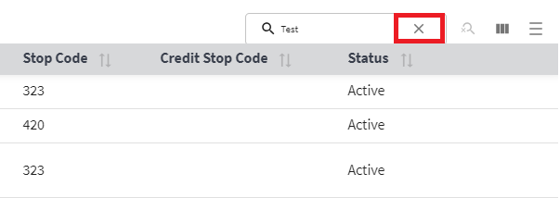
Figure 37: Clear Button for Search Bar
- Once finished searching, the user can then select the “Show/Hide Search” button seen in ⁠⁠⁠⁠⁠Figure 35⁠⁠⁠⁠⁠ above to hide the search bar from view.

Search and View Clinic Configurations
Within the Clinic Configuration page, users can search and view clinic configurations for a specific clinic.
- Note: Users with the correct user access will default to edit mode when entering Clinic Configurations.

3.1 Search for a Clinic Configuration
- Select the “Clinic Configurations” tab shown in ⁠⁠⁠⁠⁠Figure 38⁠⁠⁠⁠⁠.
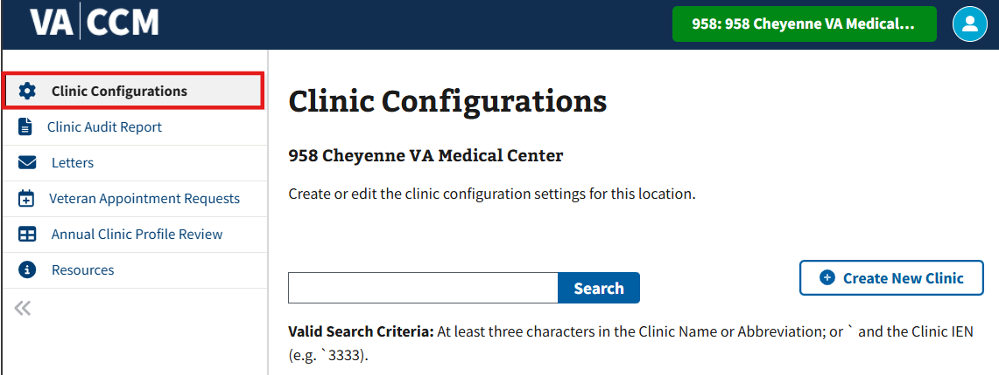
Figure 38: Clinic Configurations Tab
- To search for a desired clinic, select the search bar shown in ⁠⁠⁠⁠⁠Figure 39⁠⁠⁠⁠⁠.
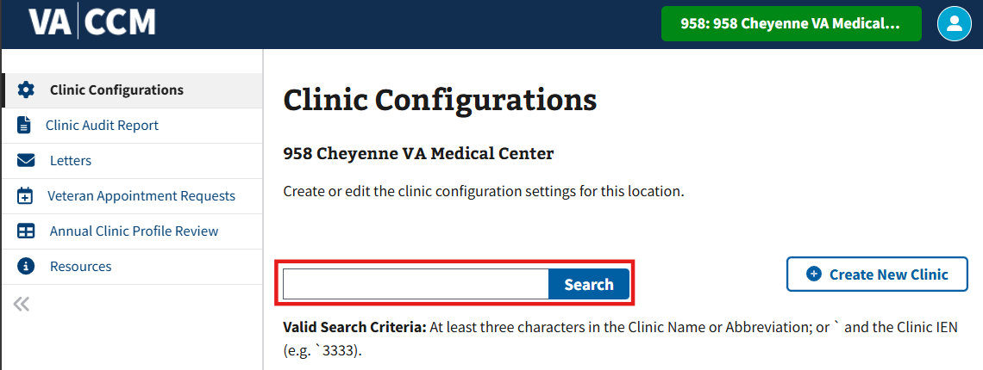
Figure 39: Search Bar for Clinic Configurations
- A user must enter the first 3+ characters of the clinic name to begin a search.
- Note: Search input must be at least three characters and can only include uppercase or lowercase letters, numbers, spaces, hyphens, and forward slashes. If the user does not adhere to the aforementioned rules, the error message shown in ⁠⁠⁠⁠⁠Figure 40⁠⁠⁠⁠⁠ will appear.

Figure 40: Error Message When Searching for a Clinic
- Once entering a valid search, the user must select enter or select “Search” shown in ⁠⁠⁠⁠⁠Figure 39⁠⁠⁠⁠⁠.
- The user will then see the grid shown below in ⁠⁠⁠⁠⁠Figure 41⁠⁠⁠⁠⁠ which displays the following: Clinic Name, Abbreviations, Provider(s), Patient Friendly Name, Stop Code, Credit Stop Code, and Status (Active or Inactive).
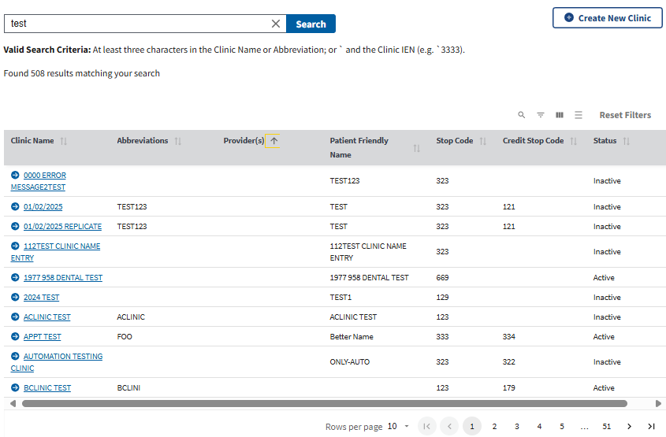
Figure 41: Clinic Configurations Grid Table

3.2 View Current Clinic Configurations
- After searching and selecting the desired clinic outlined in ⁠⁠⁠⁠⁠⁠3.1 Search for a Clinic Configuration⁠⁠⁠⁠⁠⁠ (see ⁠⁠⁠⁠⁠Figure 39⁠⁠⁠⁠⁠ for guidance), ⁠⁠⁠⁠⁠Figure 42⁠⁠⁠⁠⁠ will appear.
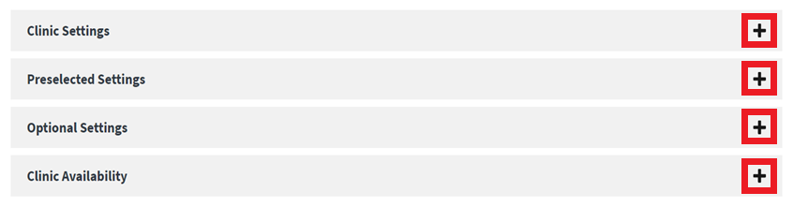
Figure 42: Clinic Configurations Accordions
- Note: Users with Edit access will need to select the “View Clinic Data” button seen below in ⁠⁠⁠⁠⁠Figure 43⁠⁠⁠⁠⁠ to only view clinic data.
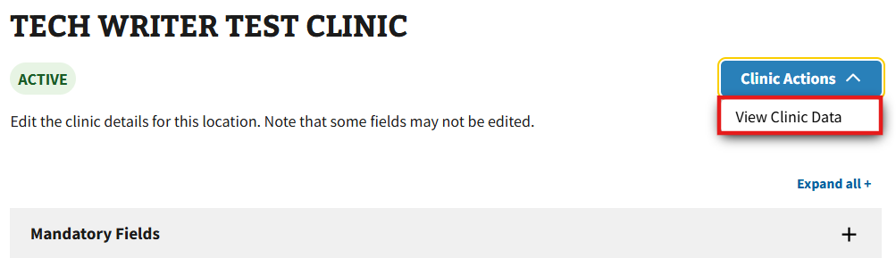
Figure 43: View Clinic Data Button
- The user will see the four clinic configuration settings: Clinic Settings, Preselected Settings, Optional Settings, and Clinic Availability, which can be viewed by selecting the “+” button highlighted in ⁠⁠⁠⁠⁠Figure 42⁠⁠⁠⁠⁠. Optionally, the user can select the “Expand All” button to open all accordions at once.
- Note: This function is available to Read Only and Write Access users. Only Write Access users will be able to edit.
- Note: The first menu option labeled “Clinic Settings” is only available when attempting to view details. This accordion will change to “Mandatory Fields” when attempting to edit.

3.2.1 Viewing Clinic Settings
In ⁠⁠⁠⁠⁠Figure 44⁠⁠⁠⁠⁠ below, users can view the fields that appear within Clinic Settings.
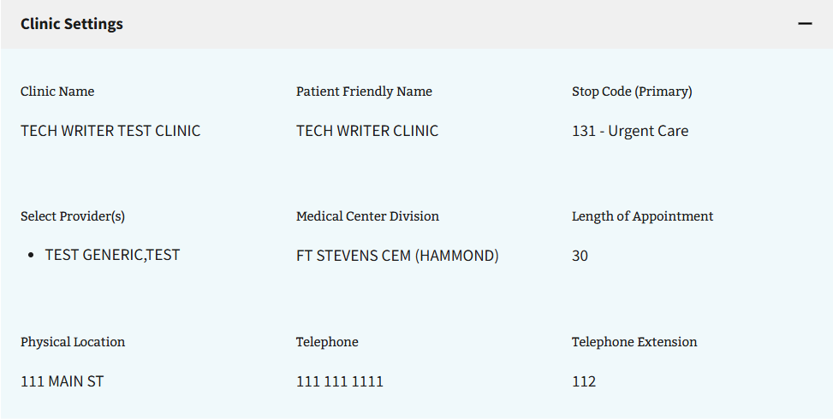
Figure 44: Clinic Settings View

3.2.2 Viewing Preselected Settings
In ⁠⁠⁠⁠⁠Figure 45⁠⁠⁠⁠⁠ below, users can view the fields that appear within Preselected Settings.
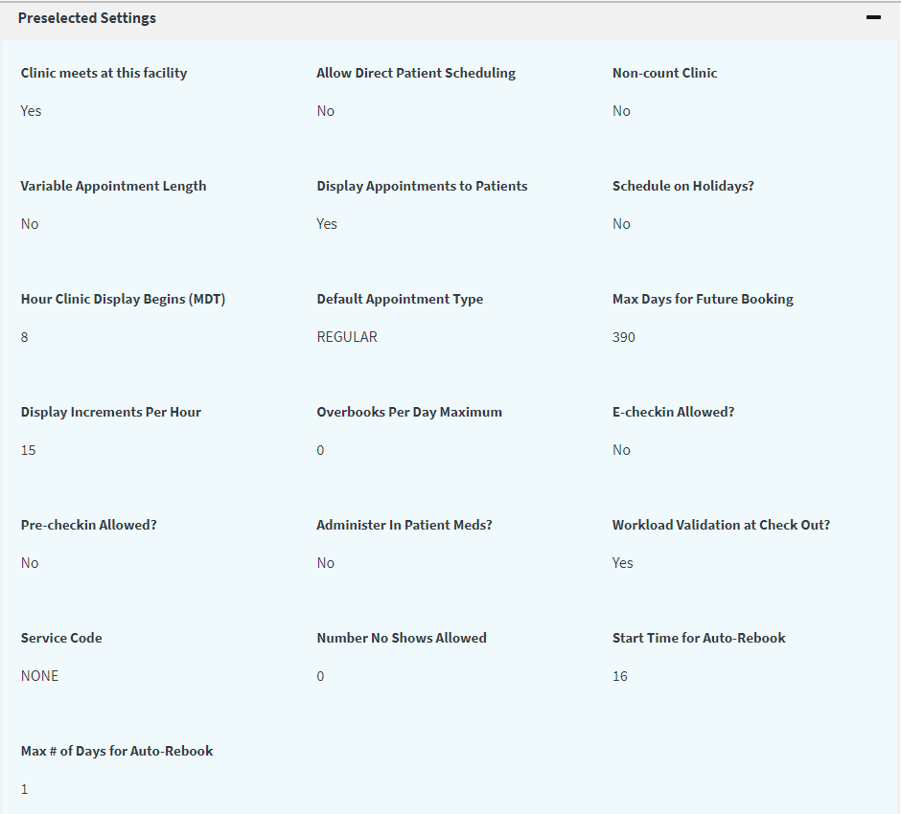
Figure 45: Preselected Settings View

3.2.3 Viewing Optional Settings
In ⁠⁠⁠⁠⁠Figure 46⁠⁠⁠⁠⁠ below, users can view the fields that appear within Optional Settings.
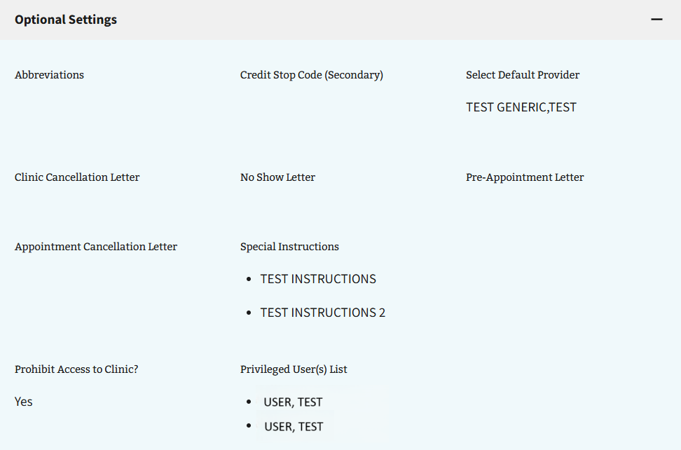
Figure 46: Optional Settings View

3.2.4 Viewing Clinic Availability
- View-only users can search for clinic availability by choosing a date (mm/dd/yyyy format) from the calendar shown below in ⁠⁠⁠⁠⁠Figure 47⁠⁠⁠⁠⁠.
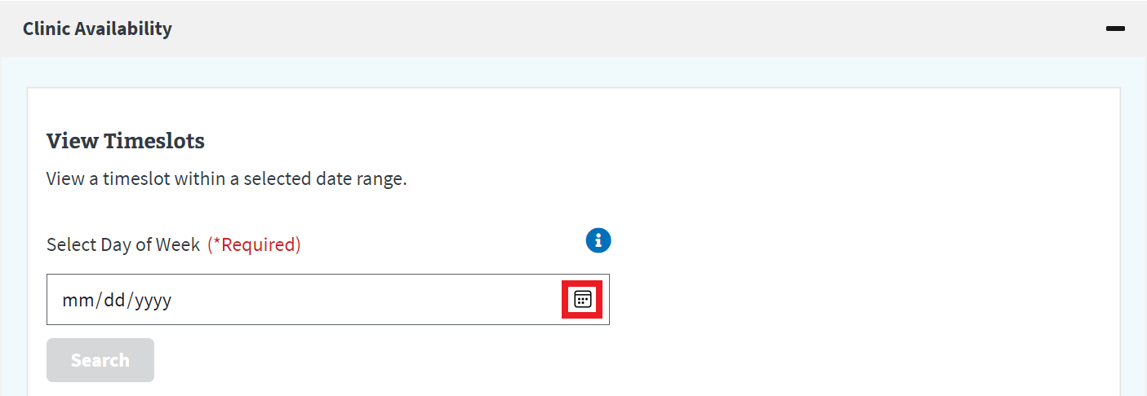
Figure 47: Viewing Clinic Availability Calendar Button
- Note: The “Search” button will remain greyed out until a date is chosen; once chosen, the button will become available for selection as seen in ⁠⁠⁠⁠⁠Figure 48⁠⁠⁠⁠⁠.
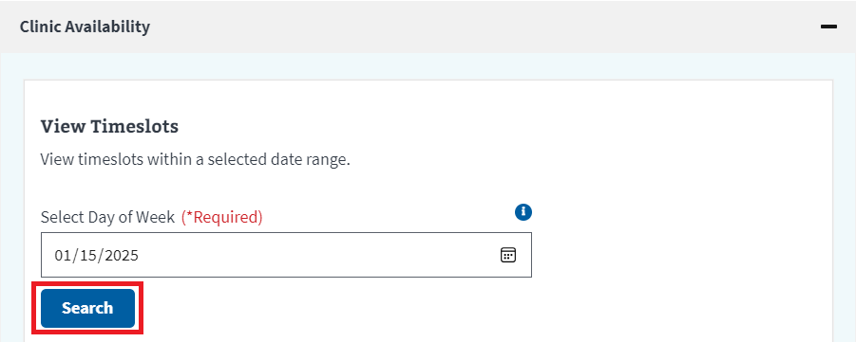
Figure 48: Viewing Clinic Availability Search Button
- After selecting search, the user will see the “Clinic Timeslots” table as seen below in ⁠⁠⁠⁠⁠Figure 49⁠⁠⁠⁠⁠ that will show the timeslots available for the most recent Sunday to the upcoming Saturday of that week.
- Note: Selecting the “Hide Table” button shown below in ⁠⁠⁠⁠⁠Figure 49⁠⁠⁠⁠⁠ will reset the “Clinic Timeslots” table completely.
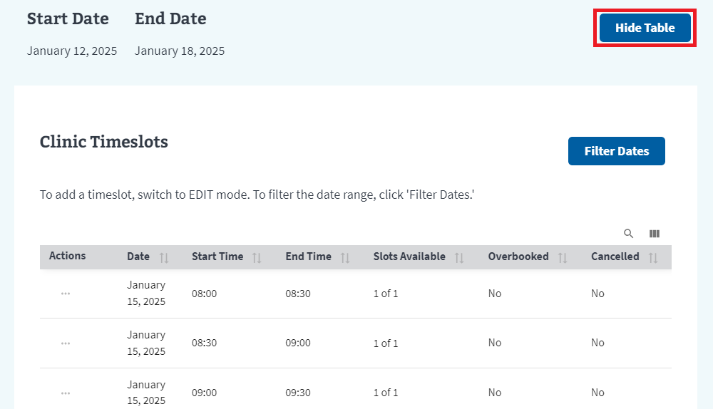
Figure 49: Viewing Clinic Availability Timeslots Example
- Note: Users can edit the number of timeslots shown on the page by selecting the arrows shown in ⁠⁠⁠⁠⁠Figure 50⁠⁠⁠⁠⁠.

Figure 50: Viewing Clinic Availability Timeslot Page View Options
- The user can either look through the dates manually, or select the button shown below in ⁠⁠⁠⁠⁠Figure 51⁠⁠⁠⁠⁠ to filter the search results to a specific date. Once selected, the window shown in ⁠⁠⁠⁠⁠Figure 52⁠⁠⁠⁠⁠ will appear.
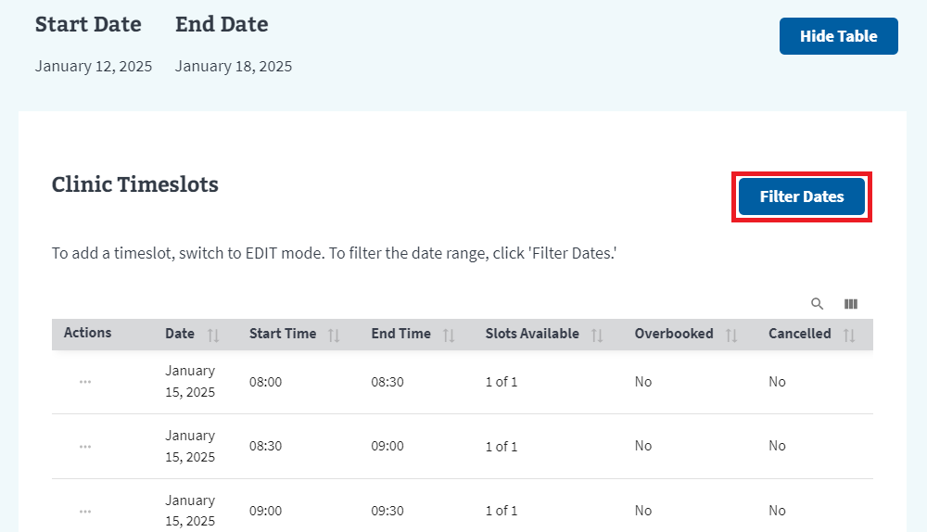
Figure 51: Viewing Clinic Availability Filter Dates Button
- After entering the required dates, the user can then select the filter dates button. The user will be shown an updated “Clinic Timeslots” table with the requested results.
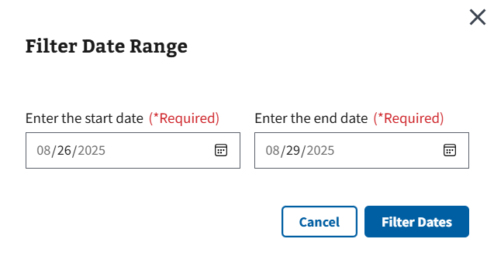
Figure 52: Viewing Clinic Availability Filter Date Range Example

Editing Clinic Configurations
Disclaimer: This section of the guide is only applicable to users with the correct write access permissions. If the user does not have write access permissions set to the account, the user will receive the error message shown in ⁠⁠⁠⁠⁠Figure 53⁠⁠⁠⁠⁠. If a user needs access to make changes on this application, please contact the local Clinical Applications Coordinator or Supervisor for assistance.
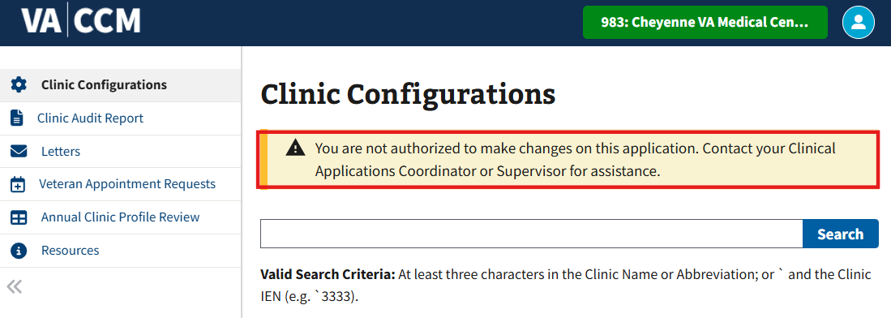
Figure 53: Authorization Error Message for Clinic Configurations
- After searching and selecting the desired clinic outlined in ⁠⁠⁠⁠⁠⁠3.1 Search for a Clinic Configuration⁠⁠⁠⁠⁠⁠, (see ⁠⁠⁠⁠⁠Figure 39⁠⁠⁠⁠⁠ for guidance), ⁠⁠⁠⁠⁠Figure 54⁠⁠⁠⁠⁠ will appear.
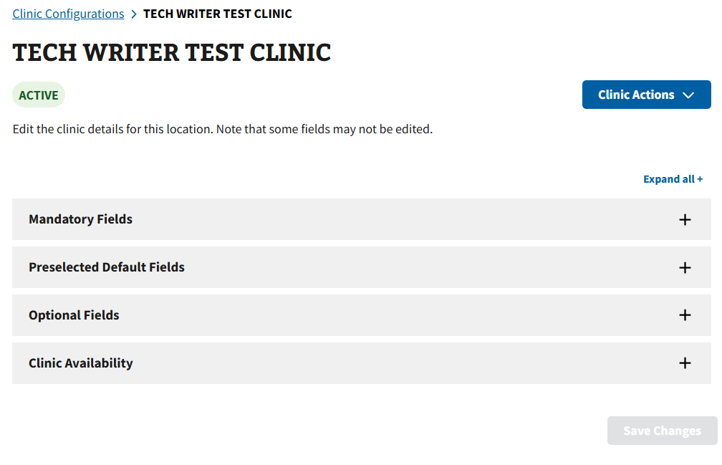
Figure 54: Edit Clinic Page
- The user will see the four clinic configuration settings: Mandatory Fields, Preselected Default Fields, Optional Fields, and Clinic Availability, which can be expanded by selecting the “+” next to each in ⁠⁠⁠⁠⁠Figure 55⁠⁠⁠⁠⁠. Optionally, the user can select the “Expand All” button to open all accordions at once.
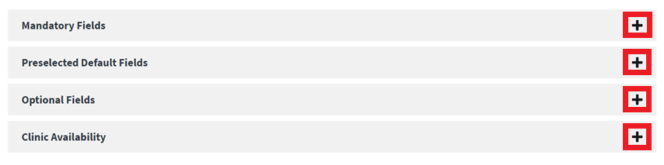
Figure 55: Editing Clinic Availability Accordions
- Note: Users will not be able to update certain fields. If these fields need editing, users must create a new clinic.
- Note: User are allowed to add additional time slots. Basic functions of adding days of the week, Start Times, End Times, and number of slots are available.

4.1 Editing Mandatory Fields
- Users with Write Access can edit the fields that appear within Mandatory Fields as shown in ⁠⁠⁠⁠⁠Figure 56⁠⁠⁠⁠⁠ below. The field(s) labeled “Required” must be edited before saving.
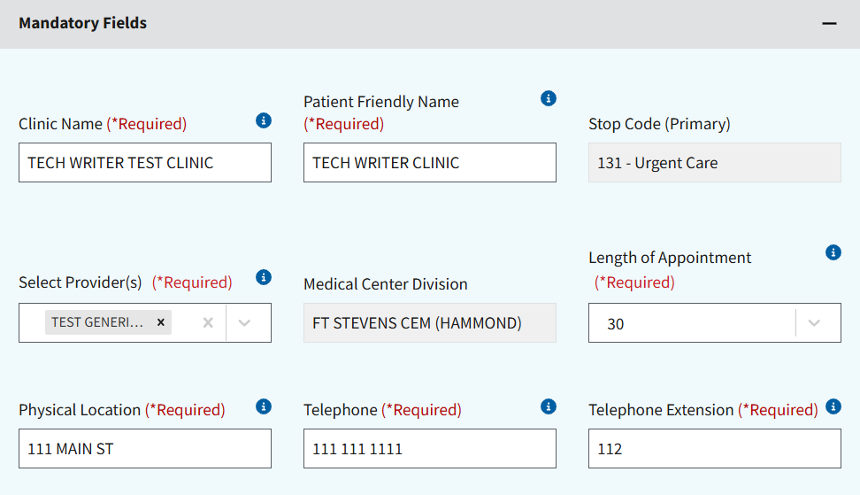
Figure 56: Editing Mandatory Fields
- Note: Please go to Section ⁠⁠⁠⁠⁠⁠9.2 Tool Tip Descriptions⁠⁠⁠⁠⁠⁠ for more information on populating clinic settings.
- Once the desired edits have been made, the user must be sure to select the “Save Changes” button shown in ⁠⁠⁠⁠⁠Figure 57⁠⁠⁠⁠⁠ in the lower right-hand corner of the page.
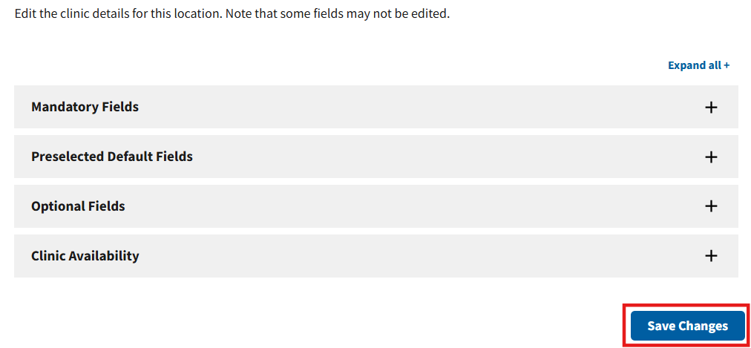
Figure 57: Update Clinic Button for Mandatory Fields
- Note: The “Save Changes” button only becomes available when a minimum of one change has been made; if no change is made, the “Save Changes” button will remain greyed out.
- Note: The user must confirm their changes by selecting the “Save Changes” button, otherwise the user will receive the error message shown in ⁠⁠⁠⁠⁠Figure 58⁠⁠⁠⁠⁠.
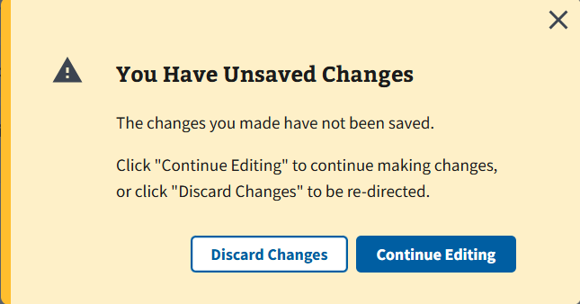
Figure 58: Changes Unsaved Message for Mandatory Fields

4.2 Editing Preselected Default Fields
- Users with Write Access can edit the fields that appear within Preselected Default Fields as shown in ⁠⁠⁠⁠⁠Figure 59⁠⁠⁠⁠⁠ below.
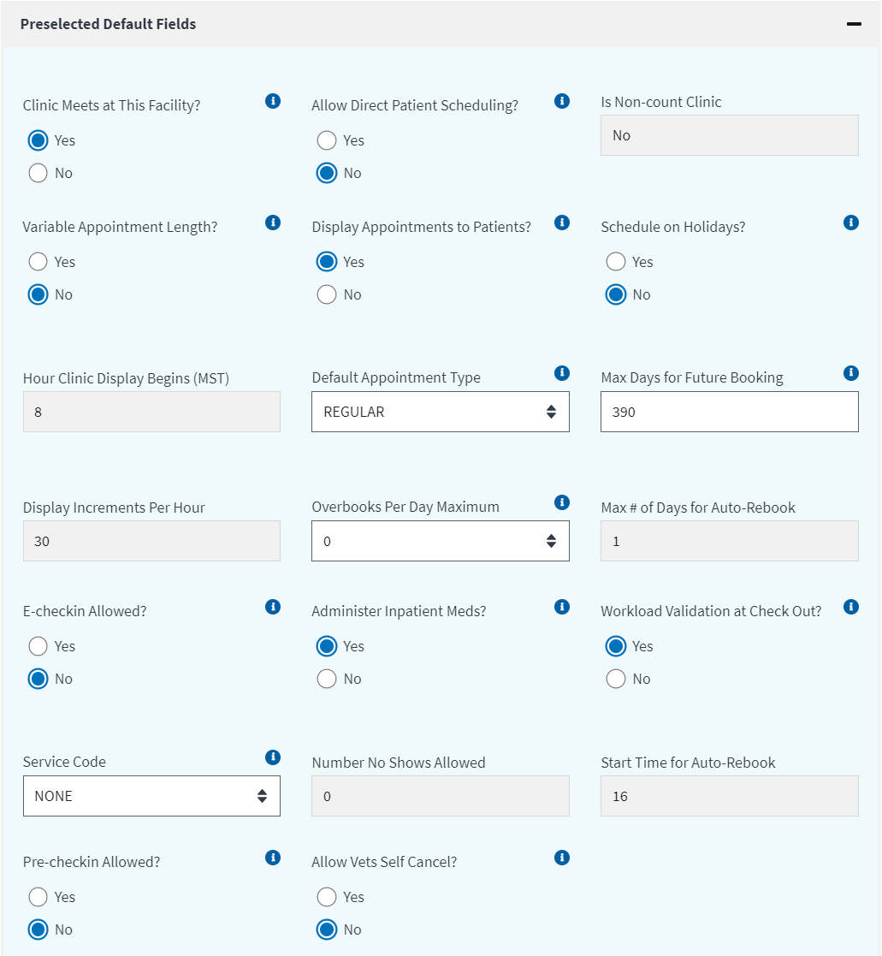
Figure 59: Editing Preselected Default Fields
- Note: Please go to Section ⁠⁠⁠⁠⁠⁠9.2 Tool Tip Descriptions⁠⁠⁠⁠⁠⁠ for more information on populating clinic settings.
- Once the desired edits have been made, the user must select the “Update Clinic” button shown in ⁠⁠⁠⁠⁠Figure 60⁠⁠⁠⁠⁠ in the lower right-hand corner of the page.
Figure 60: Update Clinic Button for Preselected Default Fields
- Note: The “Save Changes” button only becomes available when a minimum of one change has been made; if no change is made, the “Save Changes” button will remain greyed out.
- Note: The user must confirm their changes by selecting the “Save Changes” button, otherwise the user will receive the error message shown in ⁠⁠⁠⁠⁠Figure 61⁠⁠⁠⁠⁠.
Figure 61: Changes Unsaved Message for Preselected Default Fields

4.3 Editing Optional Fields
- Users with Write Access can edit the fields that appear within Preselected Default Fields as shown in ⁠⁠⁠⁠⁠Figure 62⁠⁠⁠⁠⁠ below.
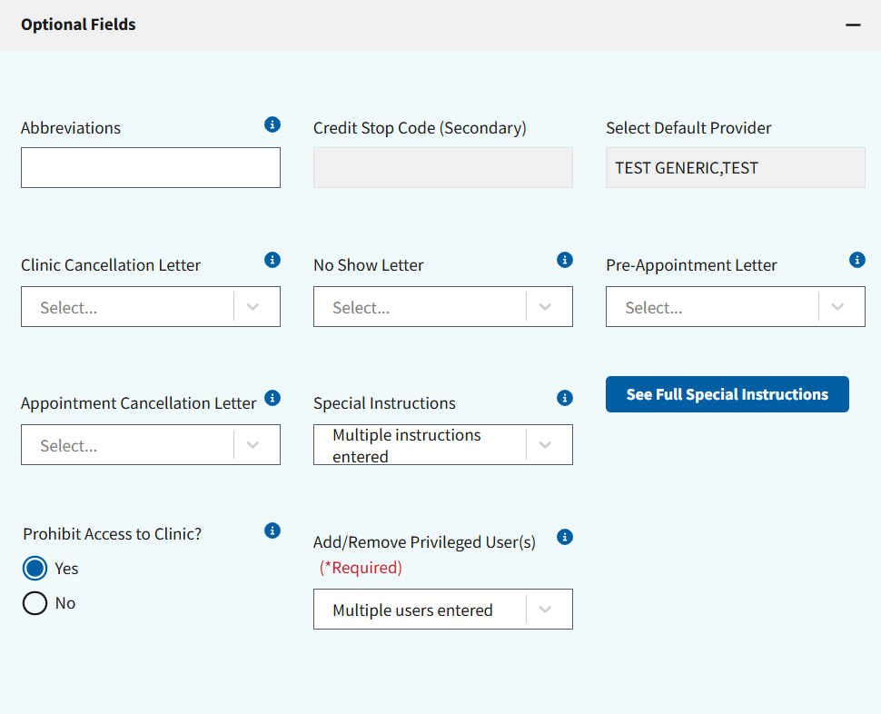
Figure 62: Editing Optional Fields
- Note: Please go to Section ⁠⁠⁠⁠⁠⁠9.2 Tool Tip Descriptions⁠⁠⁠⁠⁠⁠ for more information on populating clinic settings.
- Note: The “See Full Special Instructions” button only becomes available when a minimum of one special instructions change has been made; if no change is made, the “See Full Special Instructions” button will not appear.
- Note: The “Add/Remove Privileged User(s)” dropdown only becomes available when the “Prohibit Access to Clinic?” radio button is toggled to yes; if toggled to no, the ‘Add/Remove Privileged User(s)” dropdown will not appear.
- Once the desired edits have been made, the user must select the “Save Changes” button shown in ⁠⁠⁠⁠⁠Figure 63⁠⁠⁠⁠⁠ in the lower right-hand corner of the page.
Figure 63: Update Clinic Button for Optional Fields
- Note: The “Save Changes” button only becomes available when a minimum of one change has been made; if no change is made, the “Save Changes” button will remain greyed out.
- Note: The user must confirm their changes by selecting the “Save Changes” button, otherwise the user will receive the error message shown in ⁠⁠⁠⁠⁠Figure 64⁠⁠⁠⁠⁠.
Figure 64: Changes Unsaved Message for Optional Fields

4.4 Editing Clinic Availability
Disclaimer: The section below is a brief overview on searching timeslots. The user may select the “Timeslot Manager” button seen in ⁠⁠⁠⁠⁠Figure 65⁠⁠⁠⁠⁠ and skip to section ⁠⁠⁠⁠⁠⁠4.4.1 Add or Modify Timeslots for Single Day Modification⁠⁠⁠⁠⁠⁠ if needed.
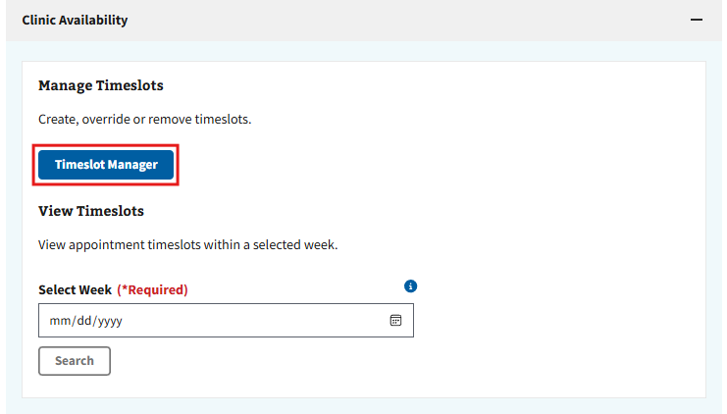
Figure 65: Timeslot Manager Button on Clinic Availability Accordion
- Users with correct Write Access will be asked to select a date (mm/dd/yyyy format) from the calendar seen in ⁠⁠⁠⁠⁠Figure 66⁠⁠⁠⁠⁠.
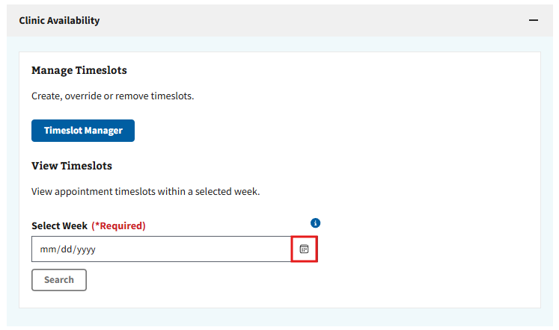
Figure 66: Calendar Button for Editing Clinic Availability
- After selecting the “Search” button, the Clinic Timeslots table (see ⁠⁠⁠⁠⁠Figure 67⁠⁠⁠⁠⁠ for example) will appear that will show the timeslots available for the most recent Sunday to the upcoming Saturday of that week.
- Note: The “Search” button will remain greyed out until a date is chosen; once chosen, the button will become available for selection.
- The user can either look through the dates manually or filter the search results to a specific date (see ⁠⁠⁠⁠⁠⁠2.4 Filters⁠⁠⁠⁠⁠⁠ for more information on filtering within grids).
- Note: Selecting the “Clear Search” button shown below in ⁠⁠⁠⁠⁠Figure 67⁠⁠⁠⁠⁠ will reset the “Clinic Timeslots” table completely.
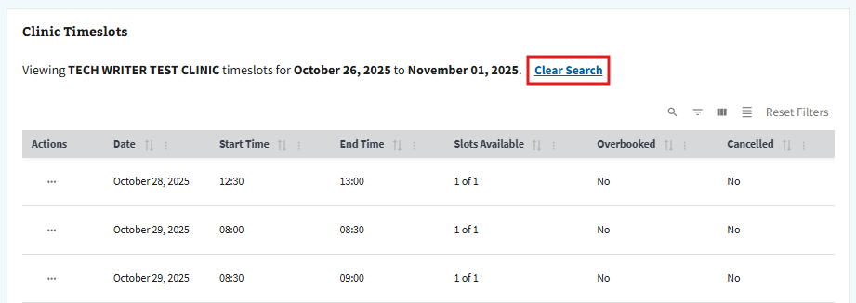
Figure 67: Available Timeslots Example for Editing Clinic Availability

4.4.1 Add or Modify Timeslots for Single Day Modification
- Select the “Timeslot Manager” button shown in ⁠⁠⁠⁠⁠Figure 68⁠⁠⁠⁠⁠ to add a timeslot.
Figure 68: Timeslot Manager Button for Editing Clinic Availability for Single Modification
- After selecting the “Timeslot Manager” button, the user will be taken to the Timeslot Manager page shown in ⁠⁠⁠⁠⁠Figure 69⁠⁠⁠⁠⁠. This will allow the user to add or remove timeslot(s) for a selected day.
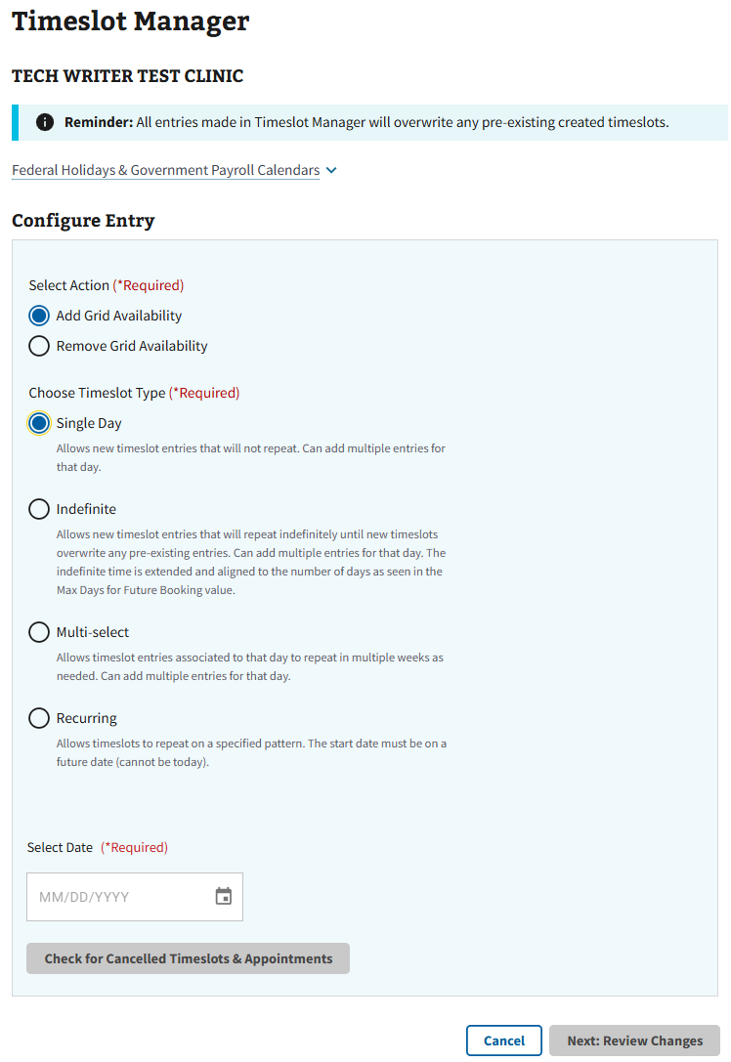
Figure 69: Timeslot Manager Page for Single Day

4.4.1.1 Adding Timeslots for Single Day Modification
- To add a timeslot, select the radio button next to “Add Grid Availability” shown in ⁠⁠⁠⁠⁠Figure 70⁠⁠⁠⁠⁠.
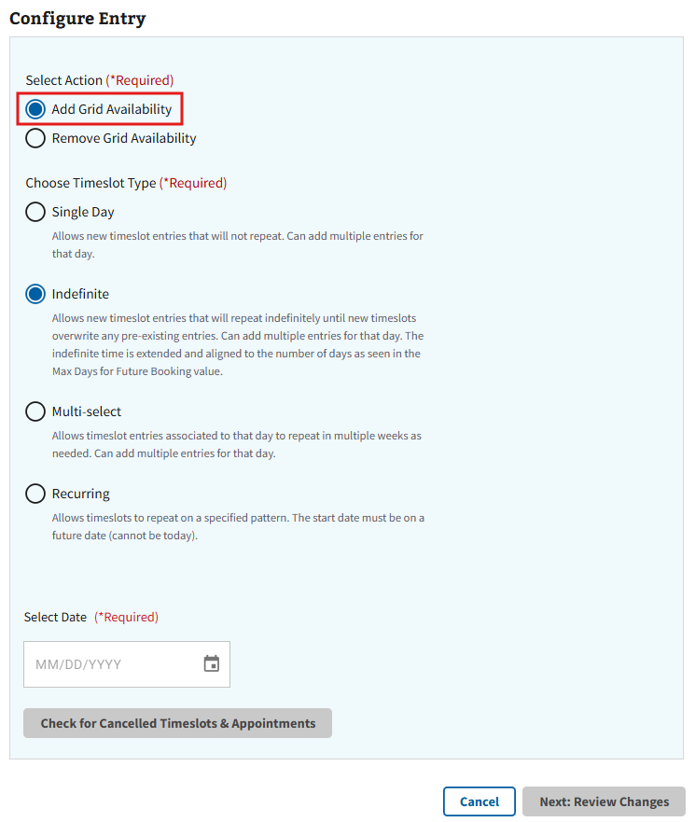
Figure 70: Add Grid Availability Radio Button for Single Day Modification
- The user will then need to either select the button shown below in ⁠⁠⁠⁠⁠Figure 71⁠⁠⁠⁠⁠ to choose a date from the calendar or manually enter a date in the selection box.
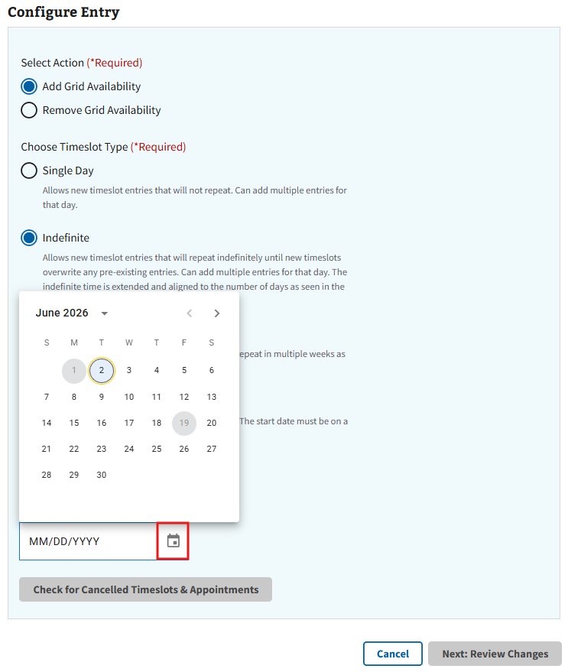
Figure 71: Calendar for Adding Grid Availability in Single Day Modification
- After selecting a date, the user will be prompted to check for cancelled timeslots as seen in ⁠⁠⁠⁠⁠Figure 72⁠⁠⁠⁠⁠.
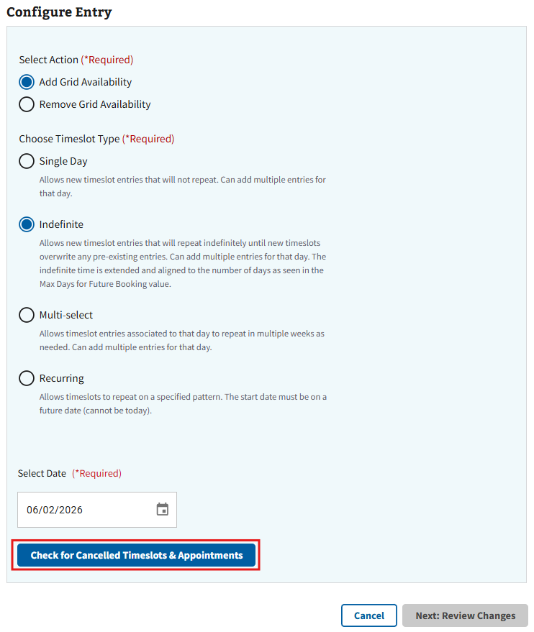
Figure 72: Check for Cancelled Timeslots Button for Single Day Modification
- Note: If a user attempts to add timeslots to a day with previous cancellations, the following information will display after selecting “Check for Cancelled Timeslots” (see ⁠⁠⁠⁠⁠Figure 73⁠⁠⁠⁠⁠ for example).
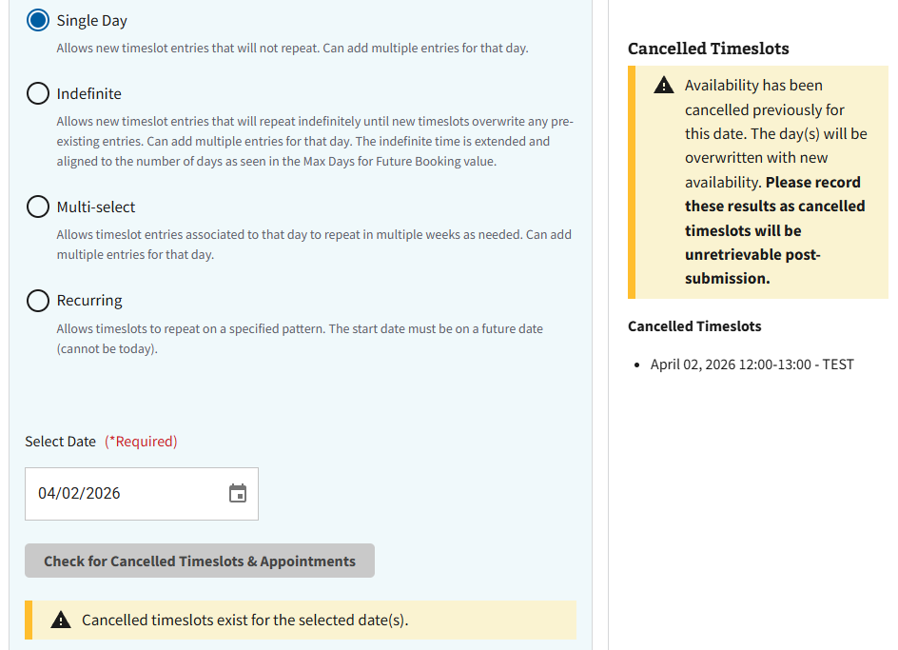
Figure 73: Cancelled Timeslot Information for Single Day
- The page will then expand to full view, and the user will be required to populate the fields shown below in ⁠⁠⁠⁠⁠Figure 74⁠⁠⁠⁠⁠.
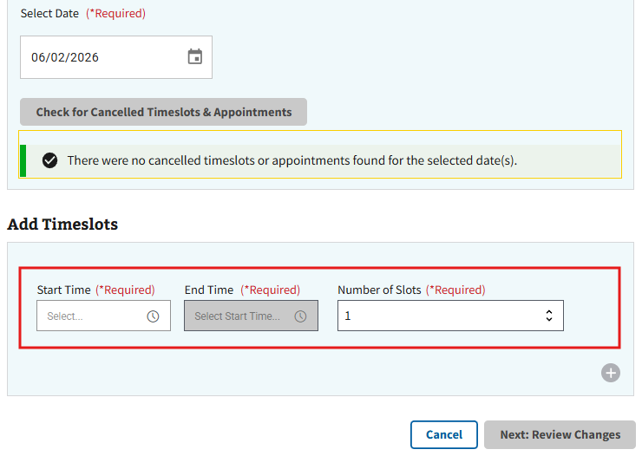
Figure 74: Add Timeslots for Single Day Modification
- Note: If a timeslot has been previously cancelled for the chosen date, the user will receive a notification prompting them to either keep the previously cancelled timeslots or overwrite the cancellation, as seen in ⁠⁠⁠⁠⁠Figure 75⁠⁠⁠⁠⁠. After selecting an action, the user will need to select “Continue” to move forward with the modification.
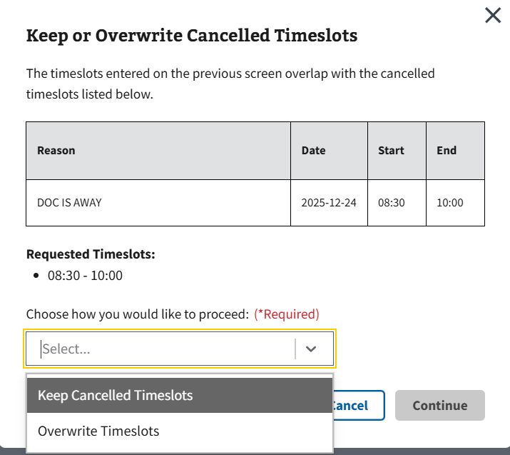
Figure 75: Cancelled Timeslots Information for Single Day Modification
- The user can also add multiple timeslots for the chosen day by selecting the “+” button seen in ⁠⁠⁠⁠⁠Figure 76⁠⁠⁠⁠⁠ and populating the same required fields.
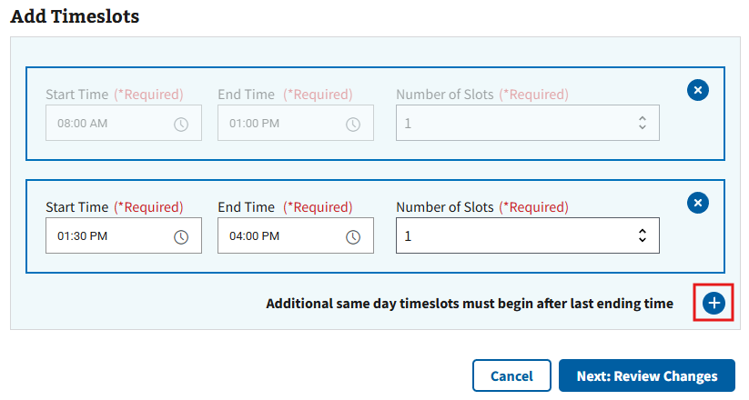
Figure 76: Adding Multiple Timeslots in Single Day Modification
- Note: The user is only allowed to create multiple timeslots for different times. If duplicate or overlapping times are attempted, the user will receive the error seen below in either ⁠⁠⁠⁠⁠Figure 77⁠⁠⁠⁠⁠ or ⁠⁠⁠⁠⁠Figure 78⁠⁠⁠⁠⁠.
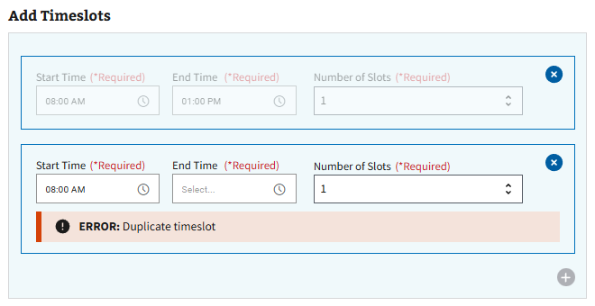
Figure 77: Duplicate Timeslot Error for Single Day Modification
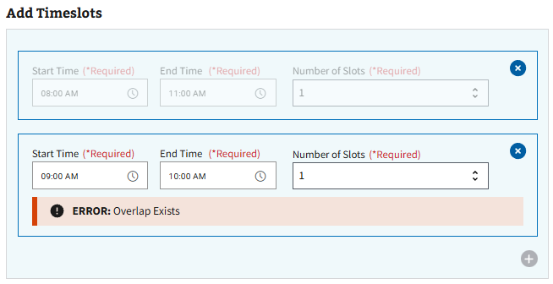
Figure 78: Overlap Timeslot Error for Single Day Modification
- Note: To remove additional timeslots, select the “x” button seen in ⁠⁠⁠⁠⁠Figure 79⁠⁠⁠⁠⁠.
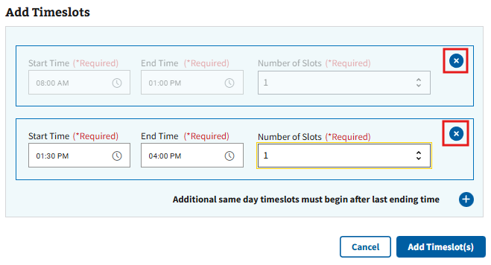
Figure 79: Removing Timeslots for Single Day Modification
- When all required information has been entered, the user can select the “Next: Review Changes” button seen in ⁠⁠⁠⁠⁠Figure 80⁠⁠⁠⁠⁠ to continue to the next page for review.
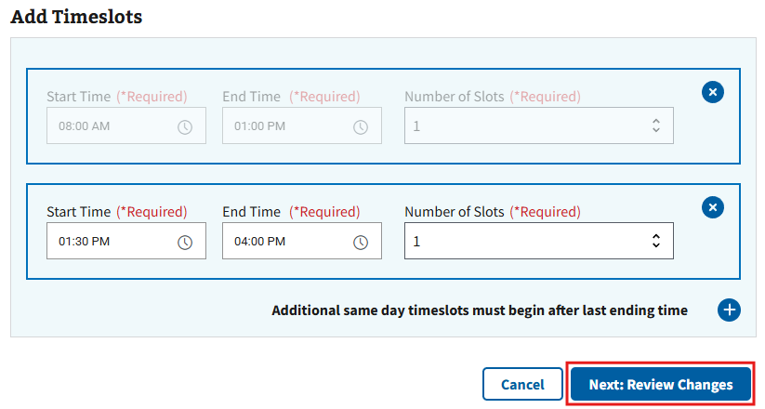
Figure 80: Review Changes Button for Single Day Modification
- Note: The user is required to select options from the hour and minutes field in “Start Hour” for the “Next: Review Changes” button to become highlighted.
- On the Review & Save Changes page (see ⁠⁠Figure 81⁠⁠ for example), the user will need to review the timeslot changes and select the “Save Changes” button to confirm. If further changes are necessary, the user can select the “Go Back” button to return to the configuration page.
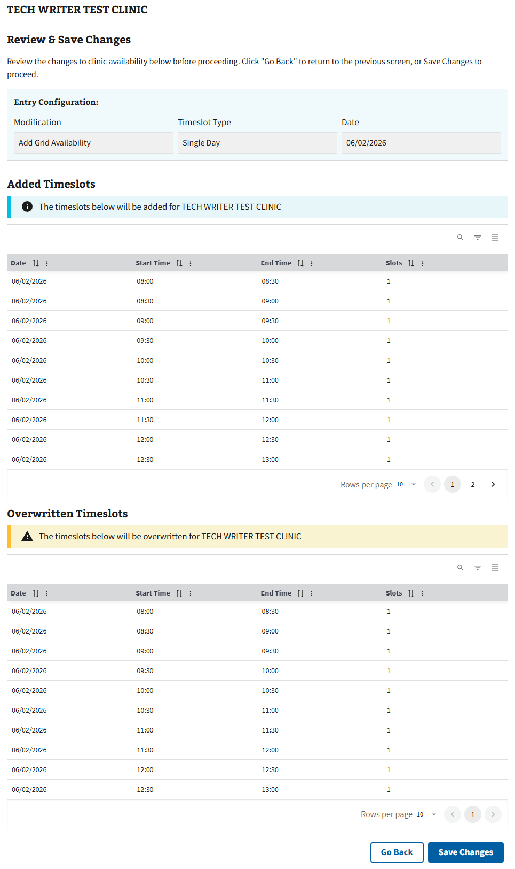
Figure 81: Review Page for Adding Single Day Timeslots
- The user can confirm the changes have been made successfully when the pop-up seen in ⁠⁠Figure 82⁠⁠ appears.
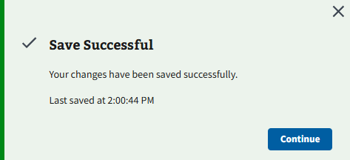
Figure 82: Save Successful Message for Single Day Modification
- After successfully saving the edit, the user can select the “Continue” button shown in ⁠⁠⁠⁠⁠⁠Figure 82⁠⁠⁠⁠⁠⁠ to be returned to the clinic configurations page for the specified clinic.

4.4.1.2 Removing Timeslots for Single Day Modification
- Select the radio button next to “Remove Grid Availability” as seen in ⁠⁠Figure 83⁠⁠ to remove a timeslot.
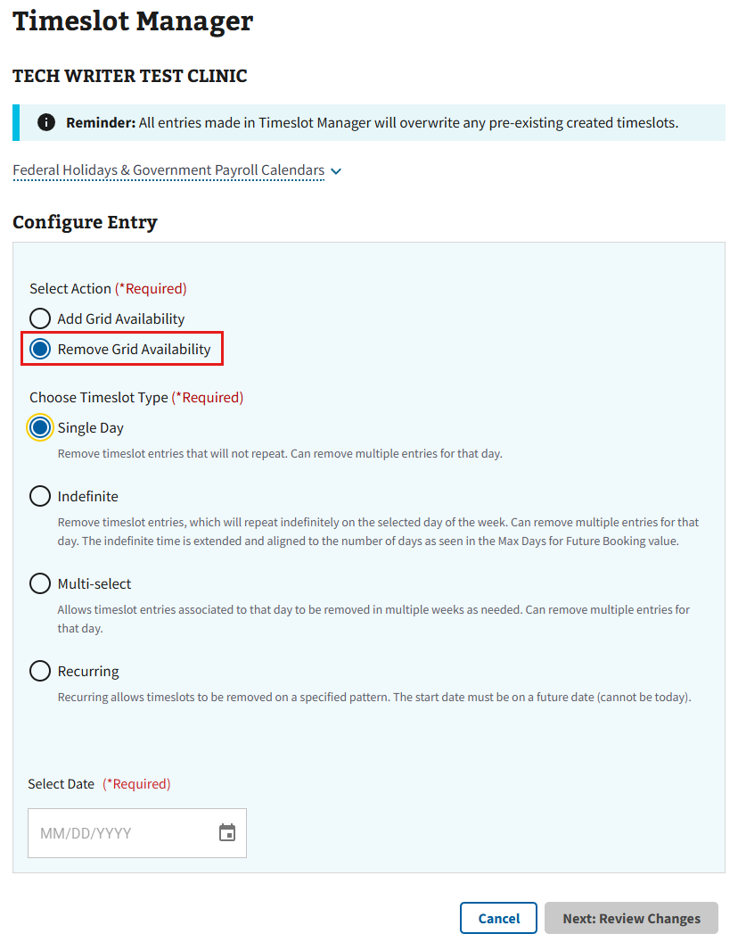
Figure 83: Remove Grid Availability Radio Button for Single Day Modification
- The user will then need to either select the button shown below in ⁠⁠Figure 84⁠⁠ to choose a date from the calendar or manually enter a date in the selection box.
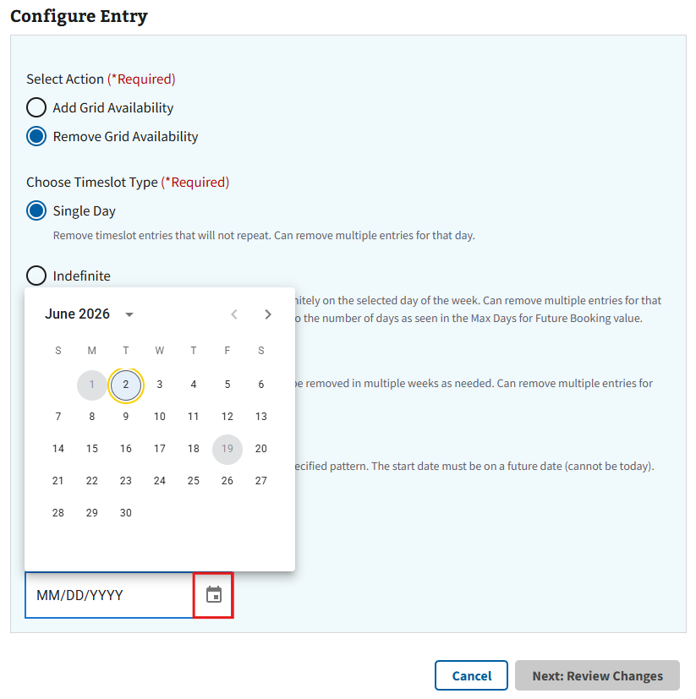
Figure 84: Calendar for Removing Grid Availability in Single Day Modification
- After choosing the specific date, the user will need to select the “Next: Review Changes” button shown in ⁠⁠Figure 85⁠⁠ to review the intended change.
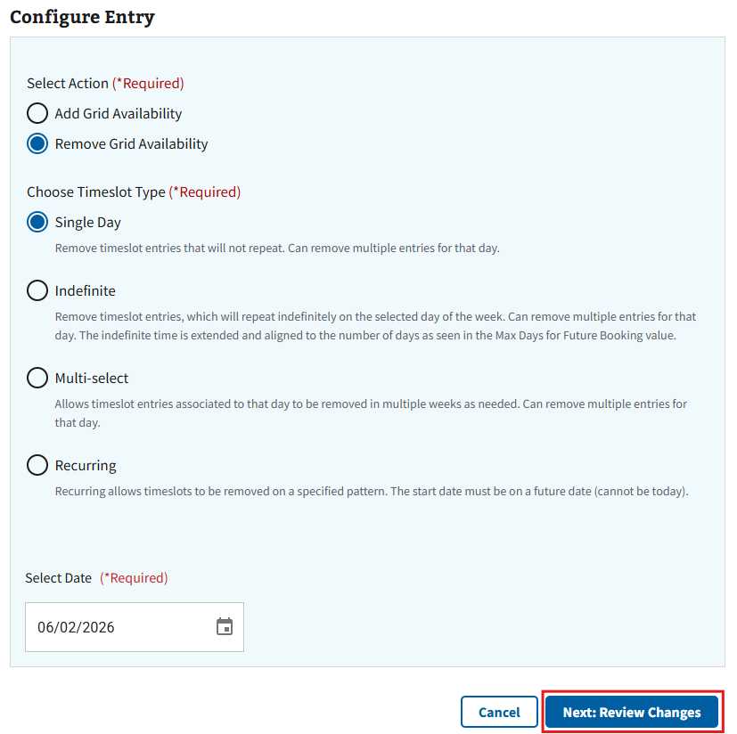
Figure 85: Review Changes Button for Removing Single Day Modification
- On the Review & Save Changes page (see ⁠⁠Figure 86⁠⁠ for example), the user will need to review the timeslot changes and select the “Save Changes” button to confirm. If further changes are necessary, the user can select the “Go Back” button to return to the configuration page.
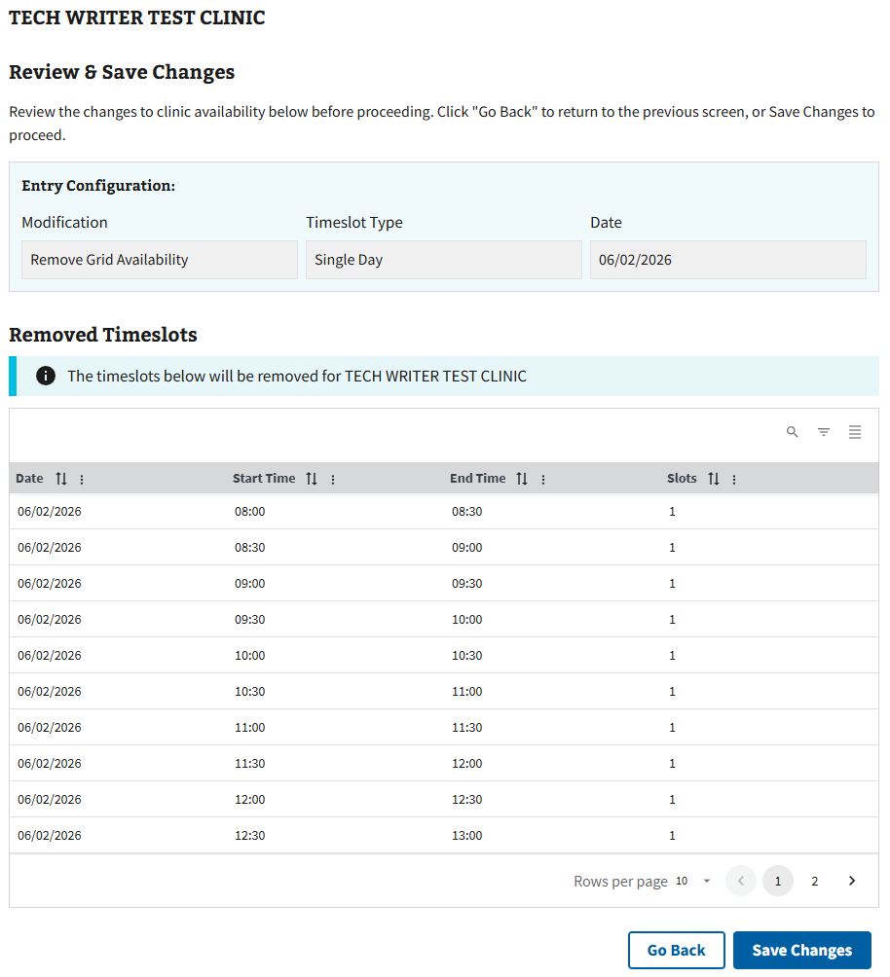
Figure 86: Review Page for Removing Single Day Timeslots
- The user can confirm the changes have been made successfully when the pop-up seen in ⁠⁠⁠⁠⁠⁠Figure 87⁠⁠⁠⁠⁠⁠ appears.
Figure 87: Save Successful for Remove Timeslot(s) in Single Day Modification

4.4.2 Add or Modify Timeslots for Indefinite Modification
- Select the “Timeslot Manager” button shown in ⁠⁠Figure 88⁠⁠ to add a timeslot.
Figure 88: Timeslot Manager Button for Adding Clinic Availability for Indefinite Modification
- After selecting the “Timeslot Manager” button, the user will be taken to the Timeslot Manager page shown in ⁠⁠Figure 89⁠⁠.
- Note: This will allow the user to add or remove grid availability for an indefinite period on any consecutive day of the week. For example, if the user chooses to change timeslots on a Wednesday, indefinite modification will allocate the changes to every Wednesday thereafter.
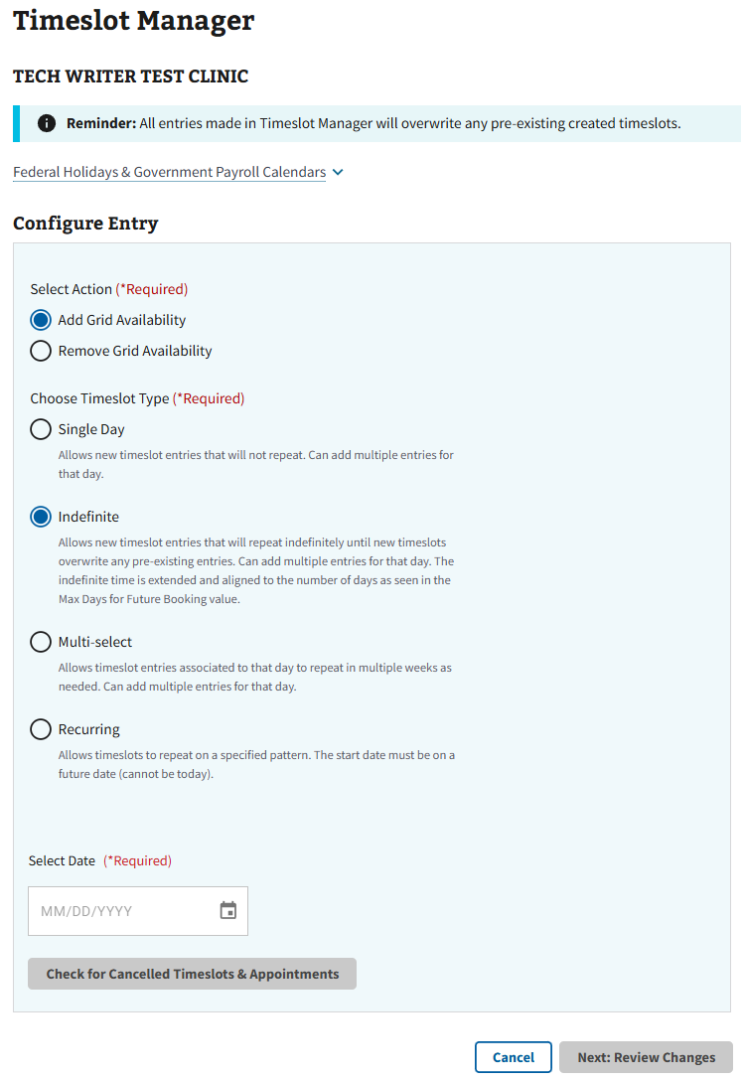
Figure 89: Timeslot Manager Page for Indefinite Modification

4.4.2.1 Adding Timeslots for Indefinite Modification
- To add a timeslot, select the radio button next to “Add Grid Availability” shown in ⁠⁠Figure 90⁠⁠.
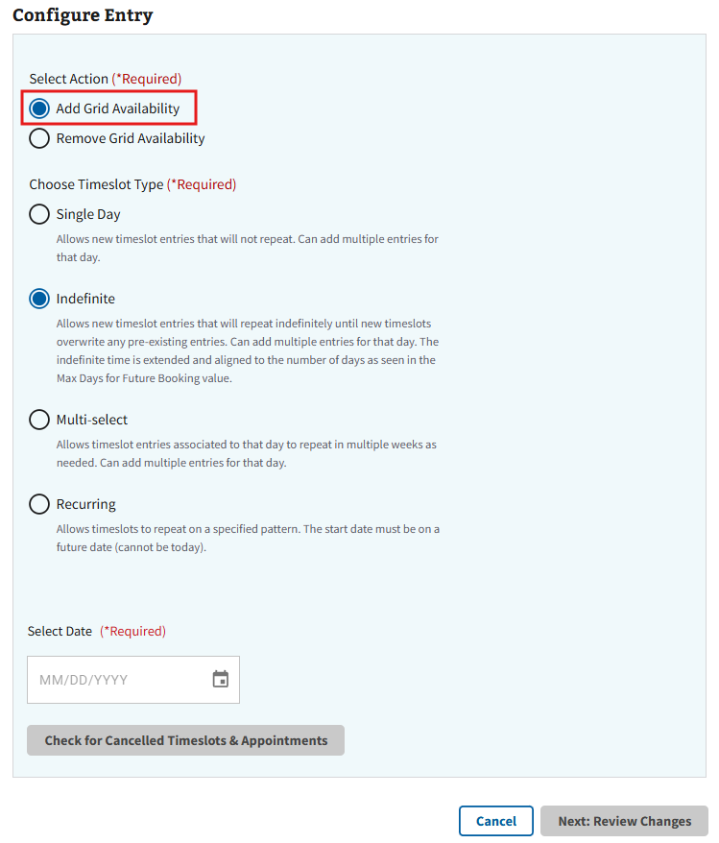
Figure 90: Add Grid Availability Radio Button for Indefinite Modification
- The user will then need to either select the button shown below in ⁠⁠Figure 91⁠⁠ ⁠to choose a date from the calendar or manually enter a date in the selection box.
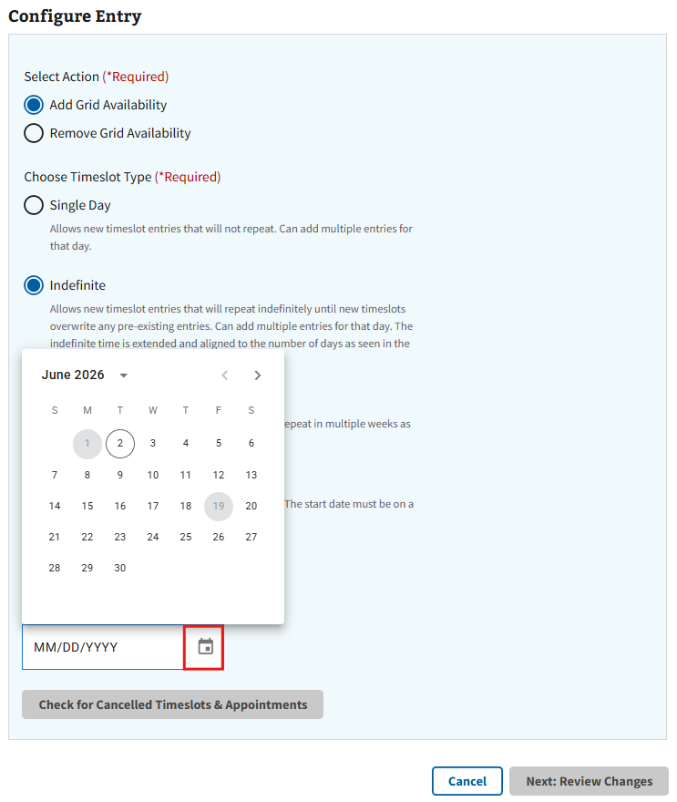
Figure 91: Calendar for Add Grid Availability in Indefinite Modification
- After selecting a date, the user will be prompted to check for cancelled timeslots as seen in ⁠⁠⁠⁠⁠⁠Figure 92⁠⁠⁠⁠⁠⁠.
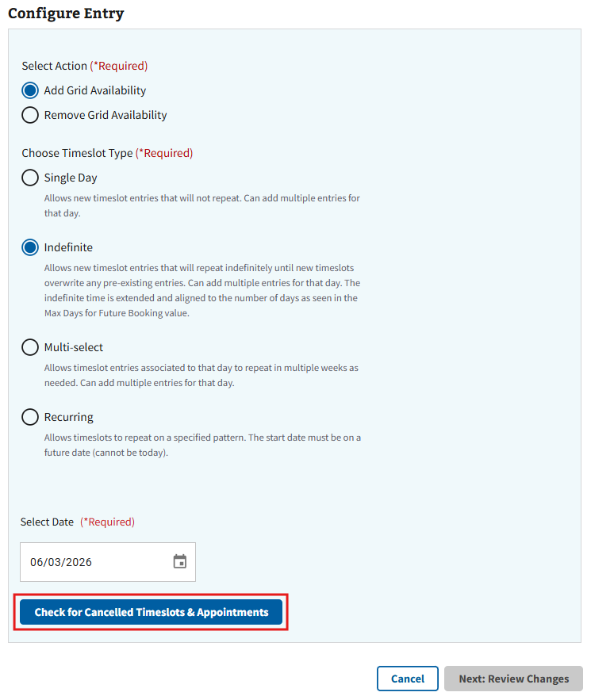
Figure 92: Check for Cancelled Timeslots for Indefinite Modification
- Note: If a user attempts to add timeslots to a day with previous cancellations, the following information will display after selecting “Check for Cancelled Timeslots” (see ⁠⁠⁠⁠⁠⁠Figure 93⁠⁠⁠⁠⁠⁠ for example).
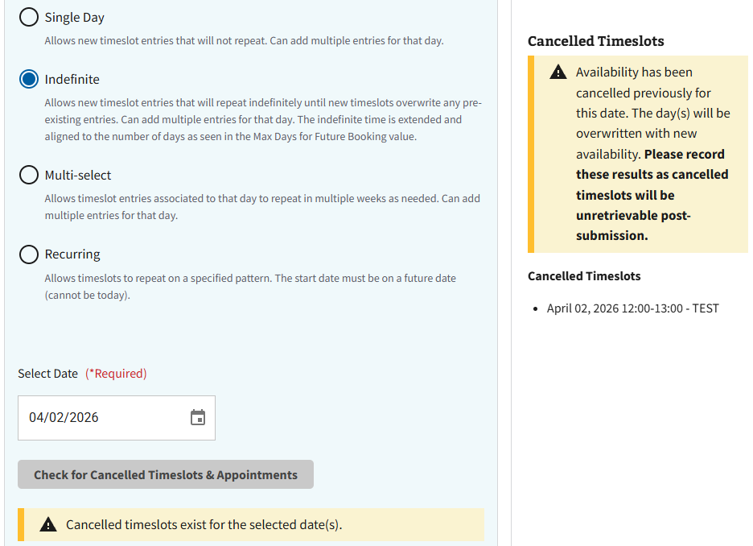
Figure 93: Cancelled Timeslot Information for Indefinite
- The page will then expand to full view, and the user will be required to populate the fields shown below in ⁠⁠⁠⁠⁠Figure 94⁠⁠⁠⁠⁠⁠.
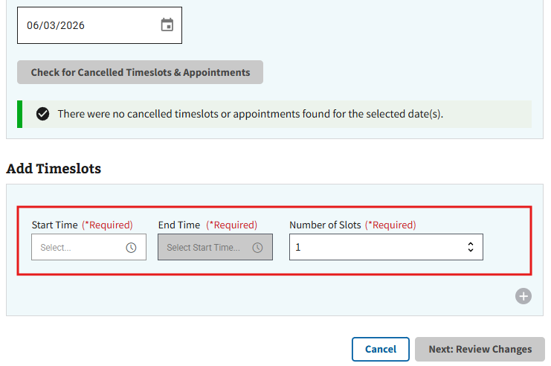
Figure 94: Add Timeslot for Indefinite Modification
- Note: If a timeslot has been previously cancelled for the chosen date, the user will receive a notification prompting them to either keep the previously cancelled timeslots or overwrite the cancellation, as seen in ⁠⁠Figure 95⁠⁠. After selecting an action, the user will need to select “Continue” to move forward with the modification.
Figure 95: Cancelled Timeslots Information for Indefinite Modification
- The user can also add multiple timeslots for the chosen day by selecting the “+” button seen in ⁠⁠⁠⁠⁠⁠Figure 96⁠⁠⁠⁠⁠⁠ and populating the same required fields.
Figure 96: Adding Multiple Timeslots for Indefinite Modification
- Note: The user is only allowed to create multiple timeslots for different times. If duplicate or overlapping times are attempted, the user will receive the error seen below in either ⁠⁠Figure 97⁠⁠ or ⁠⁠⁠⁠⁠⁠Figure 98⁠⁠⁠⁠⁠⁠.
Figure 97: Duplicate Timeslot Error for Indefinite Modification
Figure 98: Overlap Timeslot Error for Indefinite Modification
- Note: To remove additional timeslots, select the “x” button seen in ⁠⁠Figure 99⁠⁠.
Figure 99: Removing Timeslots for Indefinite Modification
- When all required information has been entered, the user can select the “Next: Review Change” button seen in ⁠⁠Figure 100⁠⁠ to continue to the next page for review.
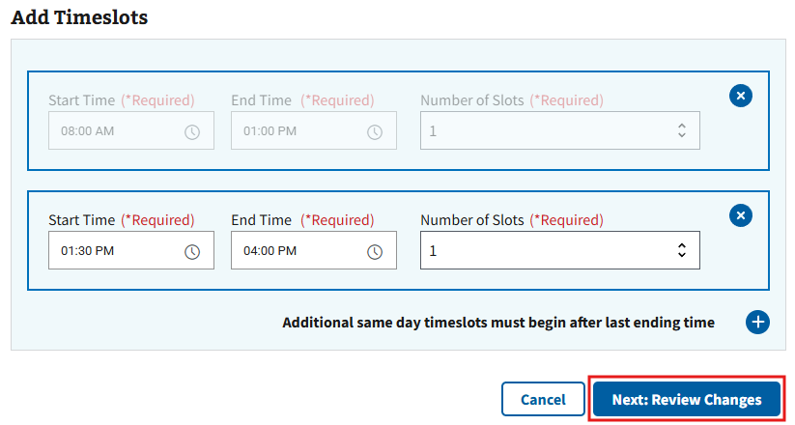
Figure 100: Review Changes Button for Indefinite Modification
- Note: The user is required to select options from the hour and minutes field in “Start Hour” for the “Next: Review Changes” button to become highlighted.
- On the Review & Save Changes page (see ⁠⁠Figure 101⁠⁠ for example), the user will need to review the timeslot changes and select the “Save Changes” button to confirm. If further changes are necessary, the user can select the “Go Back” button to return to the configuration page.
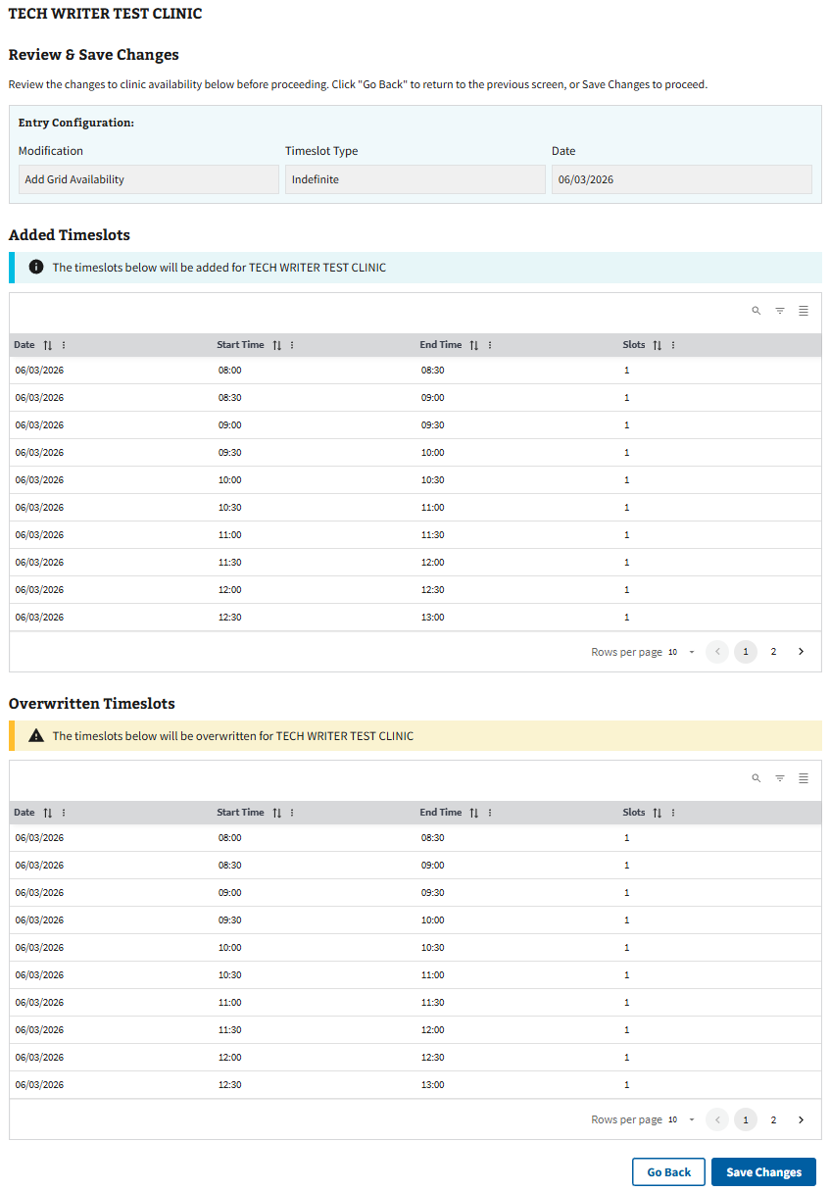
Figure 101: Review Page for Adding Indefinite Timeslots
- The user can confirm the changes have been made successfully when the pop-up seen in ⁠⁠⁠⁠⁠⁠Figure 102⁠⁠⁠⁠⁠⁠ appears.
Figure 102: Save Successful Message for Indefinite Modification
- Note: When using the indefinite option, the indefinite pattern set for the timeslot will go as far as it can until it meets a pre-existing known pattern that has already been established.
- After successfully saving the edit, the user can select the “Continue” button shown in ⁠⁠⁠⁠⁠⁠Figure 102⁠⁠⁠⁠⁠⁠ to be returned to the clinic configurations page of the specified clinic.

4.4.2.2 Removing Timeslots for Indefinite Modification
- Select the radio button next to “Remove Grid Availability” as seen in ⁠⁠⁠⁠⁠⁠Figure 103⁠⁠⁠⁠⁠⁠ to remove a timeslot.
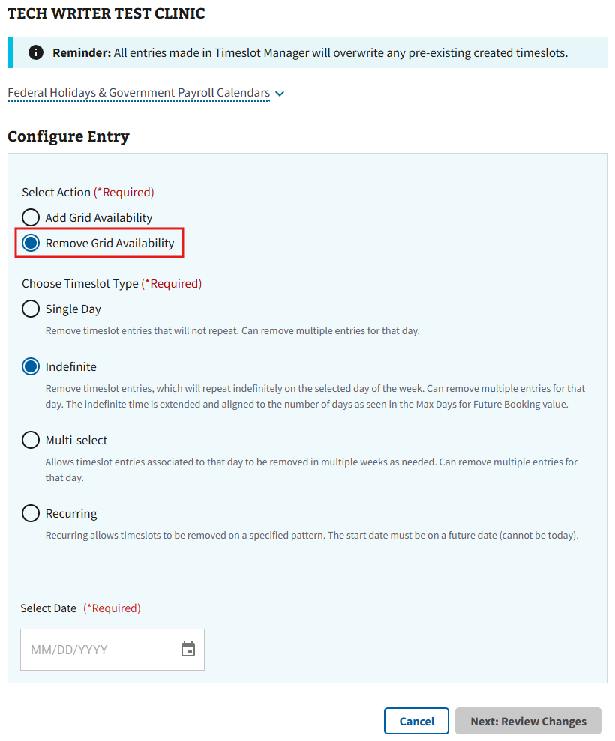
Figure 103: Remove Grid Availability Radio Button for Indefinite Modification
- The user will then need to either select the button shown below in ⁠⁠Figure 104⁠⁠ to choose a date from the calendar or manually enter a date in the selection box.
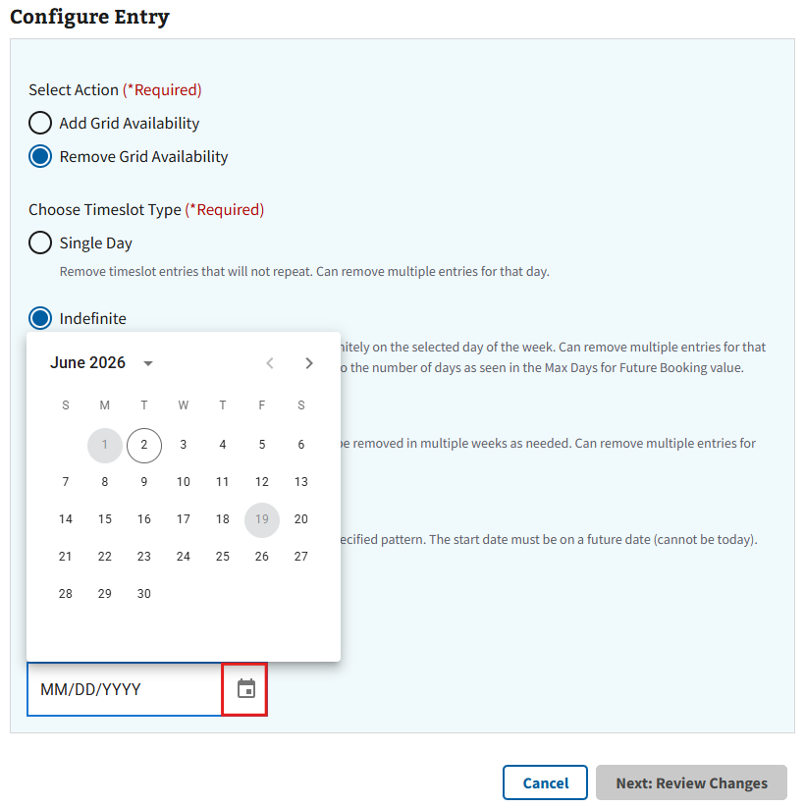
Figure 104: Calendar for Removing Grid Availability in Indefinite Modification
- After selecting a date, the page will expand, and the user will be prompted to choose “Yes” or “No” as shown in ⁠⁠Figure 105⁠⁠. Select “Yes” to remove timeslots indefinitely from the chosen day of the week.
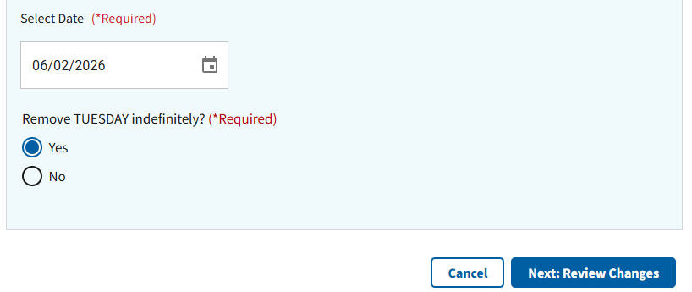
Figure 105: Option to Remove Day Indefinitely for Indefinite Modification
If selecting “No”, the user will be prompted to specify the days to be removed from the calendar as seen in ⁠⁠Figure 106⁠⁠.
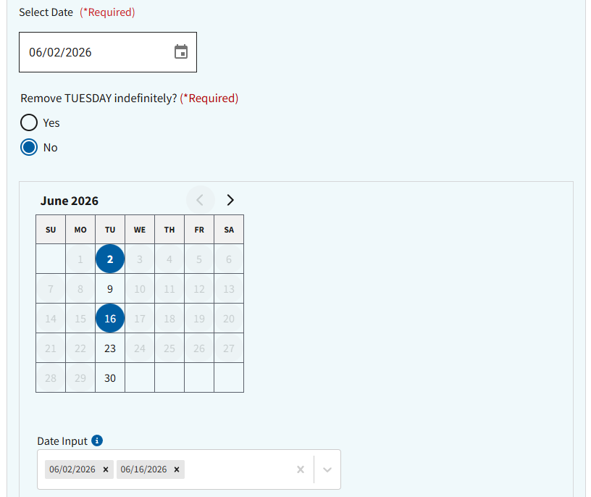
Figure 106: Choosing Multiple Days to Remove in Indefinite Modification
- To review the intended changes, the user will need to select the “Next: Review Changes” button shown in ⁠⁠⁠⁠⁠⁠Figure 107⁠⁠⁠⁠⁠⁠.
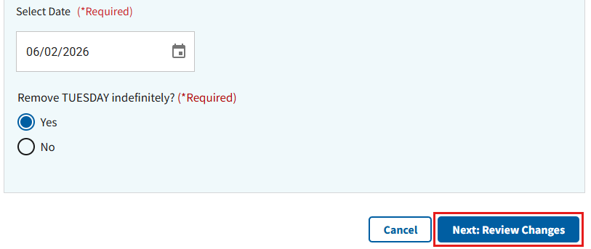
Figure 107: Review Changes Button for Removing Indefinite Timeslots
- On the Review & Save Changes page (see ⁠⁠Figure 108⁠⁠ for example), the user will need to review the timeslot changes and select the “Save Changes” button to confirm. If further changes are necessary, the user can select the “Go Back” button to return to the configuration page.
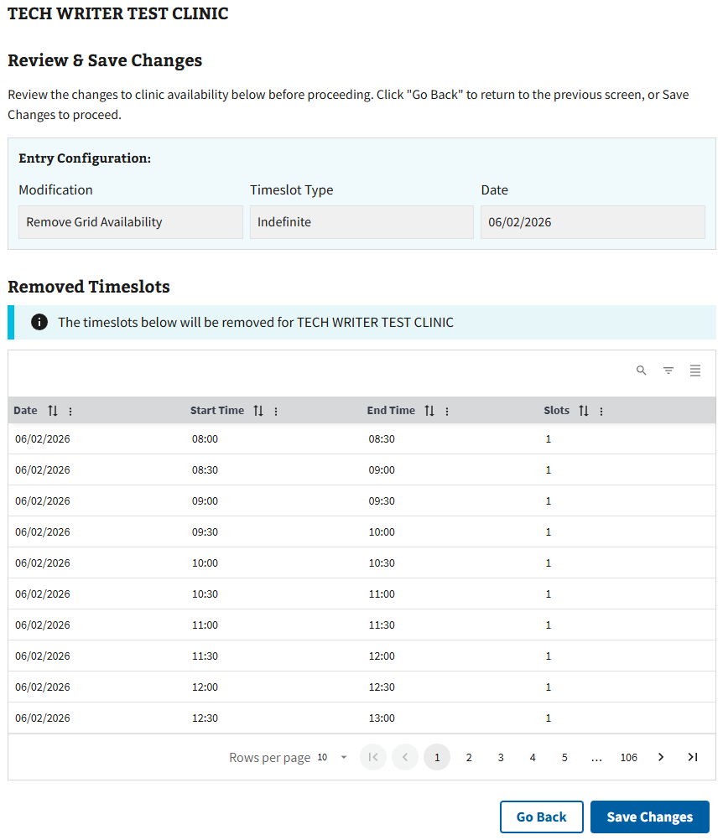
Figure 108: Review Page for Removing Indefinite Timeslots
- The user can confirm the changes have been made successfully when the pop-up seen in ⁠⁠⁠⁠⁠⁠Figure 109⁠⁠⁠⁠⁠⁠ appears.
Figure 109: Save Successful for Remove Timeslot(s) in Indefinite Modification
- After successfully saving the edit, the user can select the “Continue” button shown in ⁠⁠⁠⁠⁠⁠Figure 109⁠⁠⁠⁠⁠⁠ to be returned to the clinic configurations page for the specified clinic.

4.4.3 Add or Modify Timeslots for Multi-select Modification
- Select the “Timeslot Manager” button shown in ⁠⁠⁠⁠⁠⁠Figure 110⁠⁠⁠⁠⁠⁠ to add a timeslot.
Figure 110: Timeslot Manager Button for Editing Clinic Availability for Multi-select
- After selecting the “Timeslot Manager” button, the user will be taken to the Timeslot Manager page shown in ⁠⁠⁠⁠⁠⁠Figure 111⁠⁠⁠⁠⁠⁠.
- Note: This will allow the user to add or remove timeslots for multiple dates on the same consecutive day of the week. For example, if the first date chosen is a Tuesday, only dates from subsequent Tuesdays will be available.
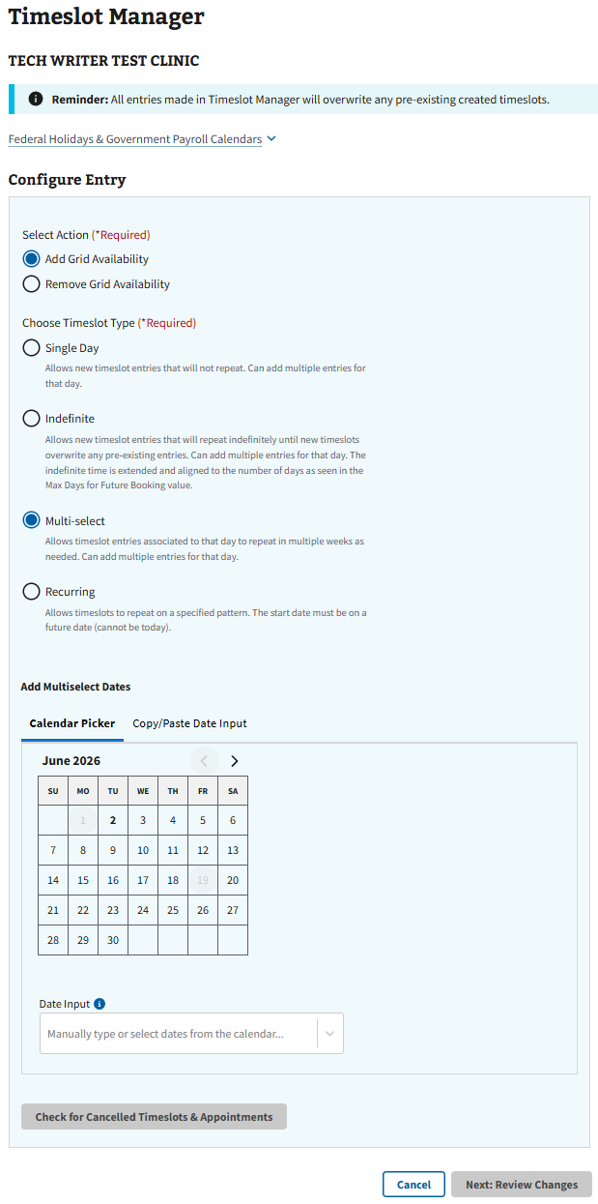
Figure 111: Timeslot Manager Page for Multi-select Modification

4.4.3.1 Adding Timeslots for Multi-select Modification
- To add a timeslot, select the radio button next to “Add Grid Availability” shown in ⁠⁠⁠⁠⁠⁠Figure 112⁠⁠⁠⁠⁠⁠.
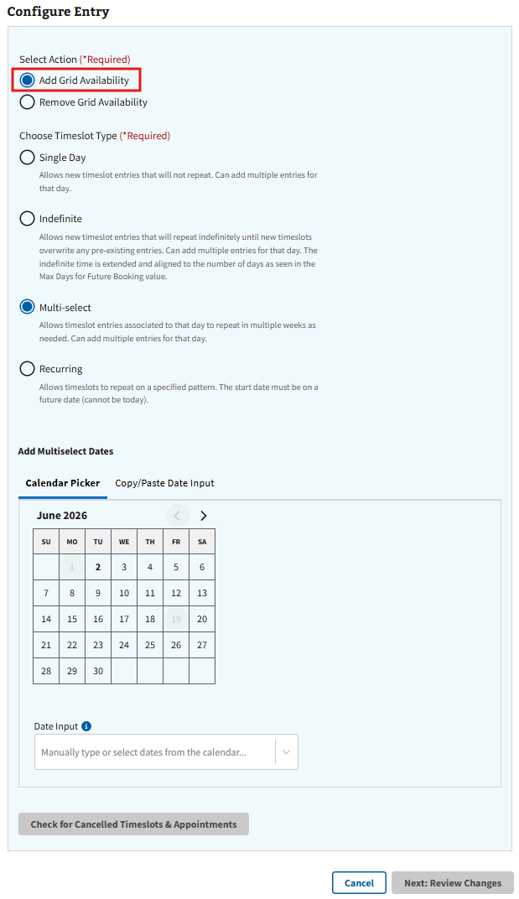
Figure 112: Add Grid Availability Radio Button for Multi-select Modification
- The user will then need to either select the dates using the calendar shown below in ⁠⁠⁠⁠⁠⁠Figure 113⁠⁠⁠⁠⁠⁠, or by manually entering the dates via the “Date Input” field.
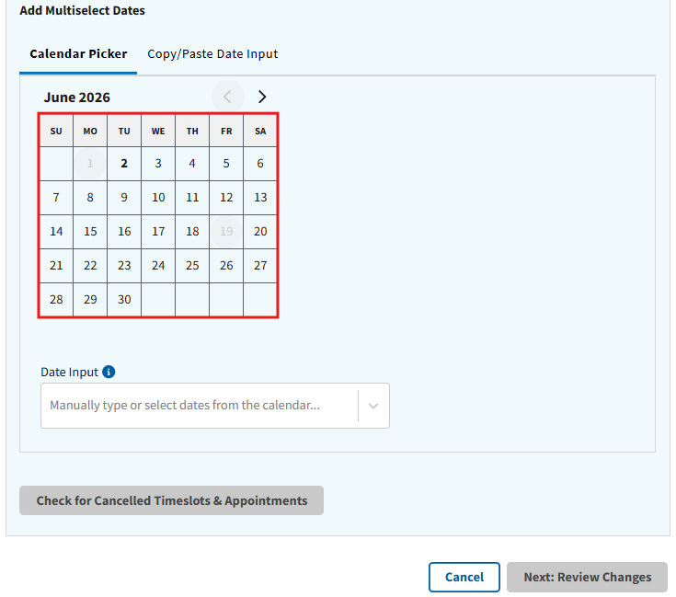
Figure 113: Calendar for Multi-select Modification
- Note: The formats MM-DD-YYYY or MM/DD/YYYY need to be used when manually entering dates into the “Date Input” field. Any other format will result in the error seen below in ⁠⁠⁠⁠⁠⁠Figure 114⁠⁠⁠⁠⁠⁠.
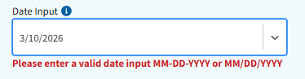
Figure 114: Invalid Date Format Error
- After selecting a date(s), the user will be prompted to check for cancelled timeslots as seen in ⁠⁠⁠⁠⁠⁠Figure 115⁠⁠⁠⁠⁠⁠.
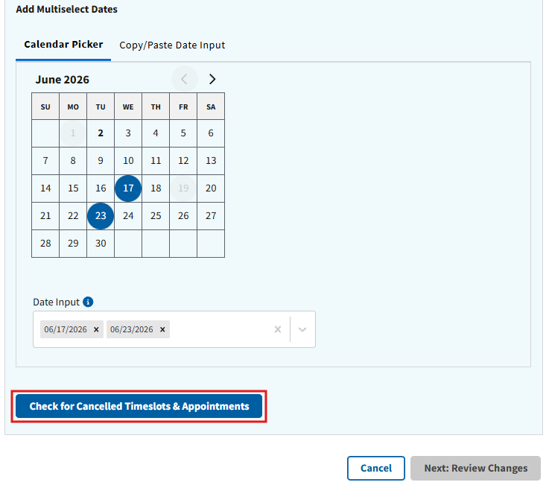
Figure 115: Check for Cancelled Timeslots Button for Multi-select Modification
- Note: When using the Multi-select timeslot type, users can choose to bulk paste dates from another source. If the user enters a date that falls on a federal holiday, in the past, or on a date more than 2 years in the future, an error message will appear (seen in ⁠⁠⁠⁠⁠⁠Figure 116⁠⁠⁠⁠⁠⁠ for example).
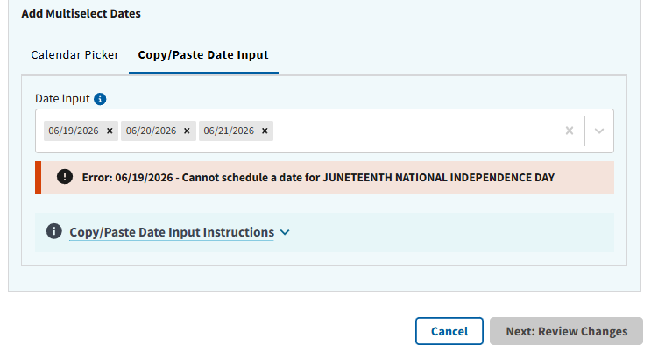
Figure 116: Bulk Paste Example for Multi-select Timeslots
- Note: If a user attempts to add timeslots to a day with previous cancellations, the following information will display after selecting “Check for Cancelled Timeslots” (see ⁠⁠⁠⁠⁠⁠Figure 117⁠⁠⁠⁠⁠⁠ for example).
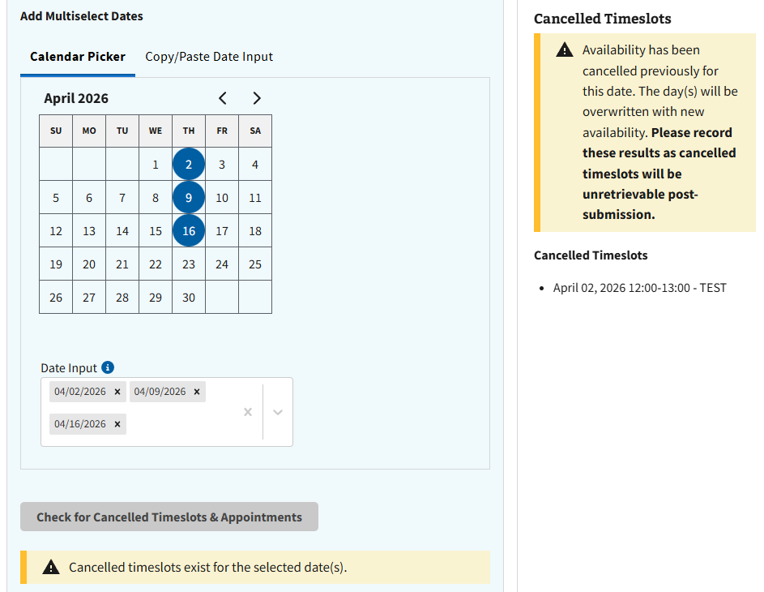
Figure 117: Cancelled Timeslot Information for Multi-select
- The page will expand to full view, and the user will be required to populate the fields shown below in ⁠⁠⁠⁠⁠⁠Figure 118⁠⁠⁠⁠⁠⁠.
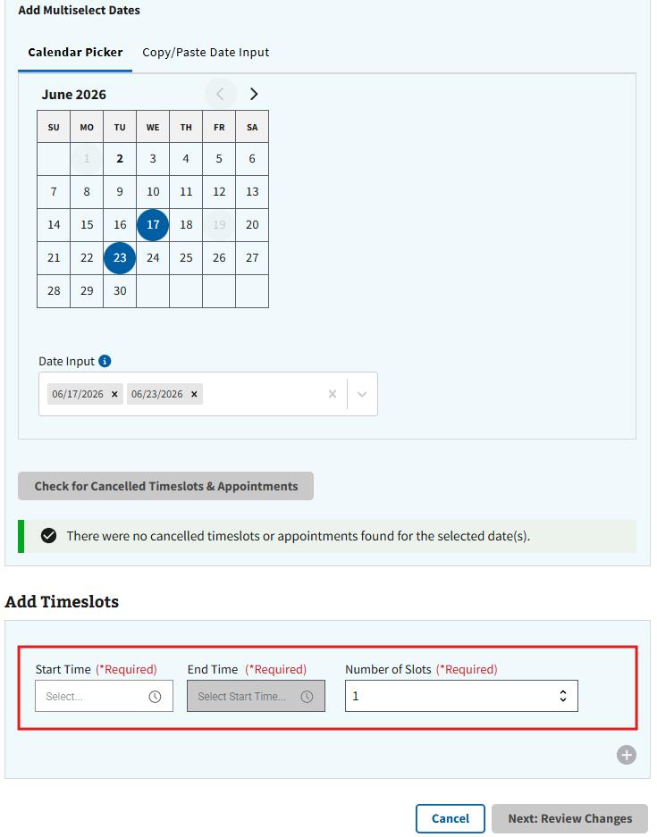
Figure 118: Add Timeslot for Multi-select Modification
- Note: If a timeslot has been previously cancelled for the chosen date, the user will receive a notification prompting them to either keep the previously cancelled timeslots or overwrite the cancellation, as seen in ⁠⁠⁠⁠⁠⁠Figure 119⁠⁠⁠⁠⁠⁠. After selecting an action, the user will need to select “Continue” to move forward with the modification.
Figure 119: Cancelled Timeslots Information for Multi-select Modification
- The user can also add multiple timeslots for the chosen days by selecting the “+” button seen in ⁠⁠⁠⁠⁠⁠Figure 120⁠⁠⁠⁠⁠⁠ and populating the same required fields.
Figure 120: Adding Multiple Timeslots in Multi-select Modification
- Note: The user is only allowed to create multiple timeslots for different times. If duplicate or overlapping times are attempted, the user will receive the errors seen below in either ⁠⁠⁠⁠⁠⁠Figure 121⁠⁠⁠⁠⁠⁠ or ⁠⁠⁠⁠⁠⁠Figure 122⁠⁠⁠⁠⁠⁠.
Figure 121: Duplicate Timeslot Error for Multi-select Modification
Figure 122: Overlap Timeslot Error for Multi-select Modification
- Note: To remove additional timeslots, select the “x” button seen in ⁠⁠⁠⁠⁠⁠Figure 123⁠⁠⁠⁠⁠⁠.
Figure 123: Removing Timeslots for Multi-select Modification
- When all required information has been entered, the user can select the “Next: Review Changes” button seen in ⁠⁠⁠⁠⁠⁠Figure 124⁠⁠⁠⁠⁠⁠ to continue to the next page for review.
Figure 124: Review Changes Button for Multi-select Modification
- Note: The user is required to select options from the hour and minutes field in “Start Hour” for the “Next: Review Changes” button to become highlighted.
- On the Review & Save Changes page (see ⁠⁠Figure 125⁠⁠ for example), the user will need to review the timeslot changes and select the “Save Changes” button to confirm. If further changes are necessary, the user can select the “Go Back” button to return to the configuration page.
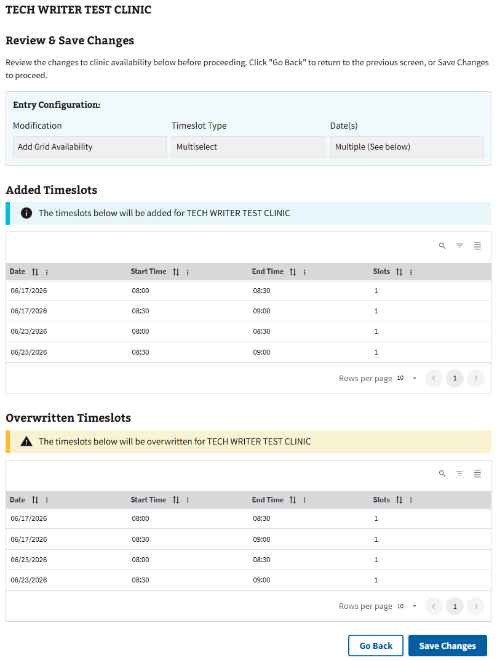
Figure 125: Review Page for Adding Multi-select Timeslots
- The user can confirm the changes have been made successfully when the pop-up seen in ⁠⁠⁠⁠⁠⁠Figure 126⁠⁠⁠⁠⁠⁠ appears.
Figure 126: Save Successful Message for Multi-select Modification
- After successfully saving the edit, the user can select the “Continue” button shown in ⁠⁠Figure 126⁠⁠ to be returned to the clinic configurations page of the specified clinic

4.4.3.2 Removing Timeslots for Multi-select Modification
- Select the radio button next to “Remove Grid Availability” as seen in ⁠⁠⁠⁠⁠⁠Figure 127⁠⁠⁠⁠⁠⁠ to remove a timeslot.
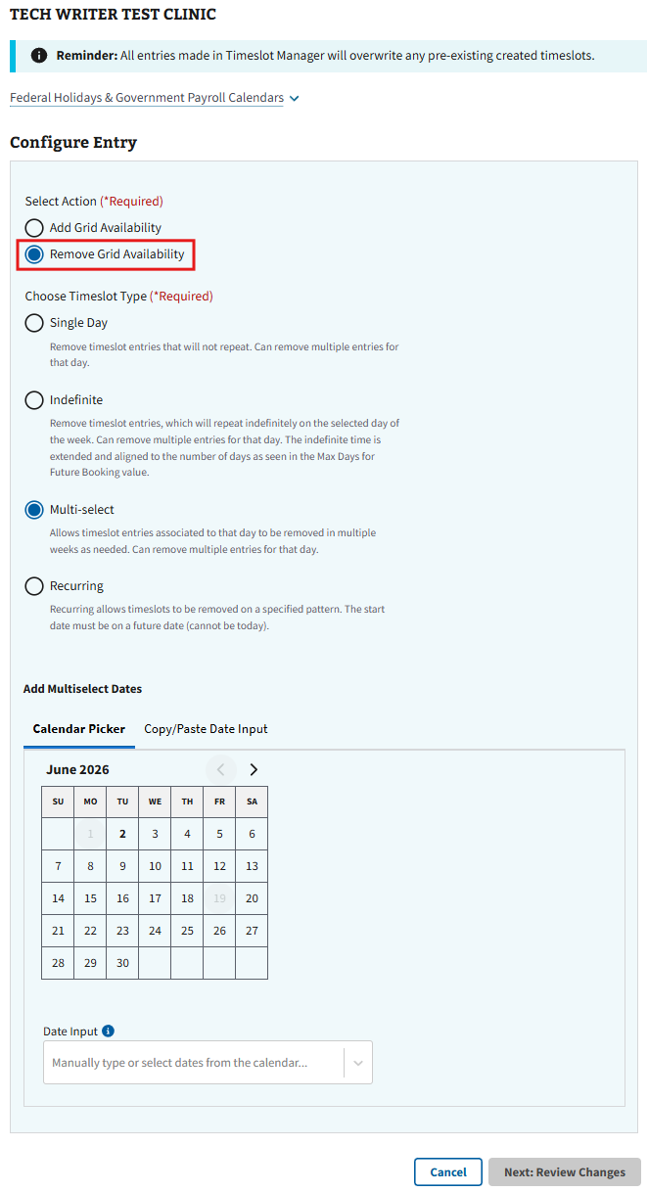
Figure 127: Remove Grid Availability Radio Button for Multi-select Modification
- The user will then need to either select the specified dates from the calendar shown below in ⁠⁠⁠⁠⁠⁠Figure 128⁠⁠⁠⁠⁠⁠, or by manually entering the dates via the “Date Input” field.
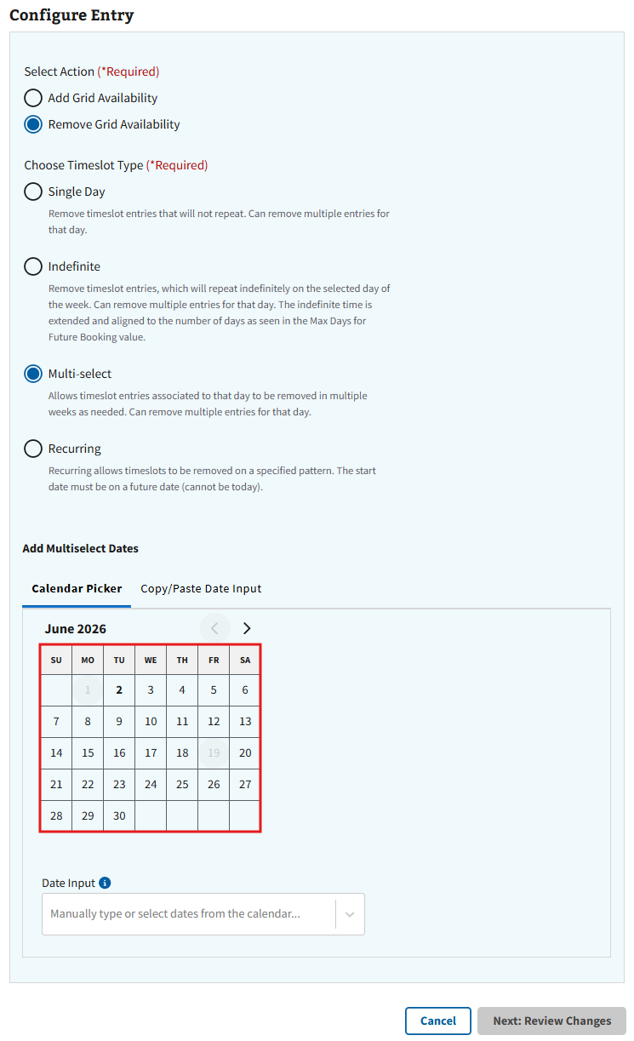
Figure 128: Calendar for Removing Grid Availability in Multi-select Modification
- After choosing the dates, the user will need to select the “Next: Review Changes” button shown in ⁠⁠⁠⁠⁠⁠Figure 129⁠⁠⁠⁠⁠⁠ to review the intended changes.
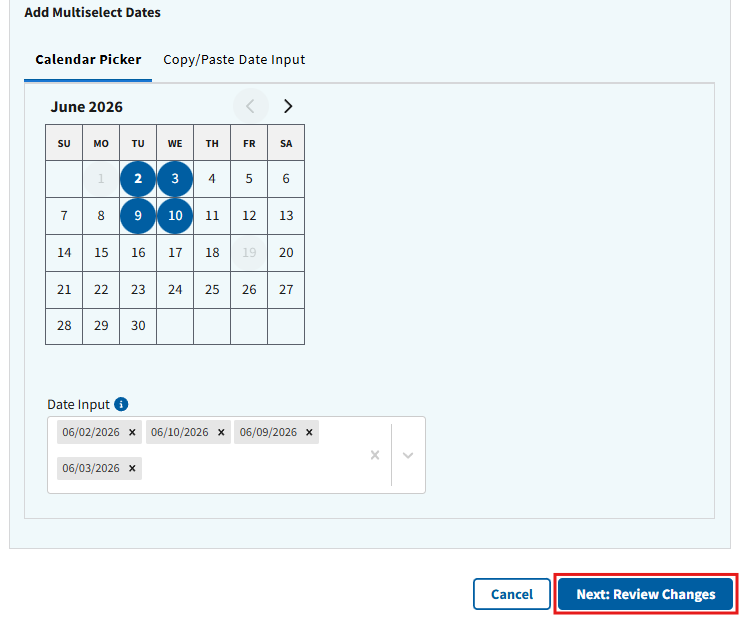
Figure 129: Review Changes Button for Removing Multi-select Timeslots
- Note: When using the Multi-select timeslot type, users can choose to bulk paste dates from another source. If the user enters a date that falls on a federal holiday, in the past, or on a date more than 2 years in the future, an error message will appear (seen in ⁠⁠⁠⁠⁠⁠Figure 130⁠⁠⁠⁠⁠⁠ for example).
Figure 130: Bulk Paste Example for Removing Multi-select Timeslots
- On the Review & Save Changes page (see ⁠⁠Figure 131⁠⁠ for example), the user will need to review the timeslot changes and select the “Save Changes” button to confirm. If further changes are necessary, the user can select the “Go Back” button to return to the configuration page.
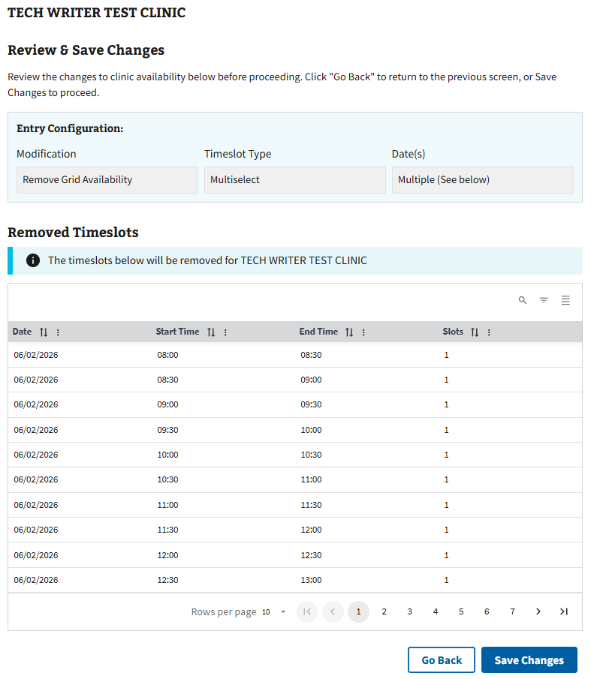
Figure 131: Review Page for Removing Multi-Select Timeslots
- The user can confirm the changes have been made successfully when the pop-up seen in ⁠⁠⁠⁠⁠⁠Figure 132⁠⁠⁠⁠⁠⁠ appears.
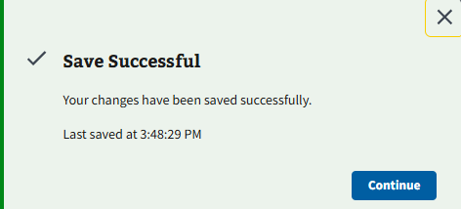
Figure 132: Save Successful for Remove Timeslot(s) in Multi-select Modification
- After successfully saving the edit, the user can select the “Continue” button shown in ⁠⁠Figure 132⁠⁠ to be returned to the clinic configurations page for the specified clinic.

4.4.4 Add or Modify Timeslots for Recurring Modification
- Select the “Timeslot Manager” button shown in ⁠⁠⁠⁠⁠⁠Figure 133⁠⁠⁠⁠⁠⁠ to add a timeslot.
Figure 133: Timeslot Manager Button for Editing Clinic Availability for Recurring
- After selecting the “Timeslot Manager” button, the user will be taken to the Timeslot Manager page shown in ⁠⁠⁠⁠⁠⁠Figure 134⁠⁠⁠⁠⁠⁠.
- Note: This will allow the user to add or remove timeslots on repeat for a specified pattern. For example, if the user chooses to create timeslots for the second Sunday of every month, then that pattern will recur every month until the specified end date.
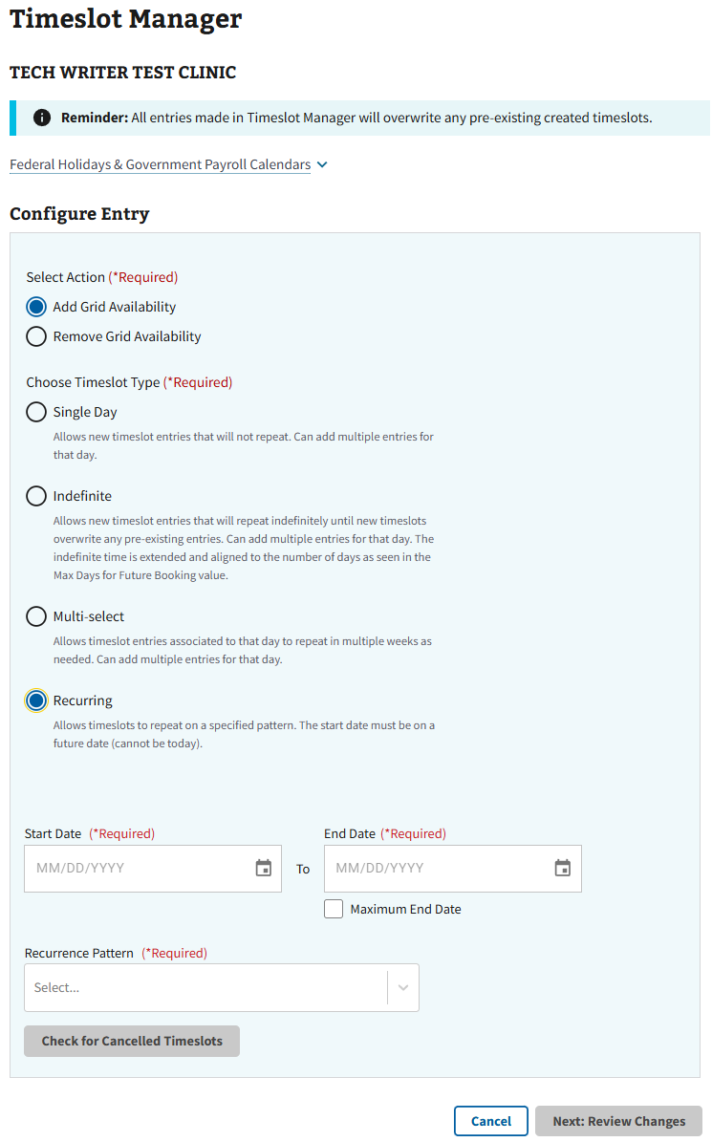
Figure 134: Timeslot Manager Page for Recurring Modification

4.4.4.1 Adding Timeslots for Recurring Modification
- To add a timeslot, select the radio button next to “Add Grid Availability” shown in ⁠⁠⁠⁠⁠⁠Figure 135⁠⁠⁠⁠⁠⁠.
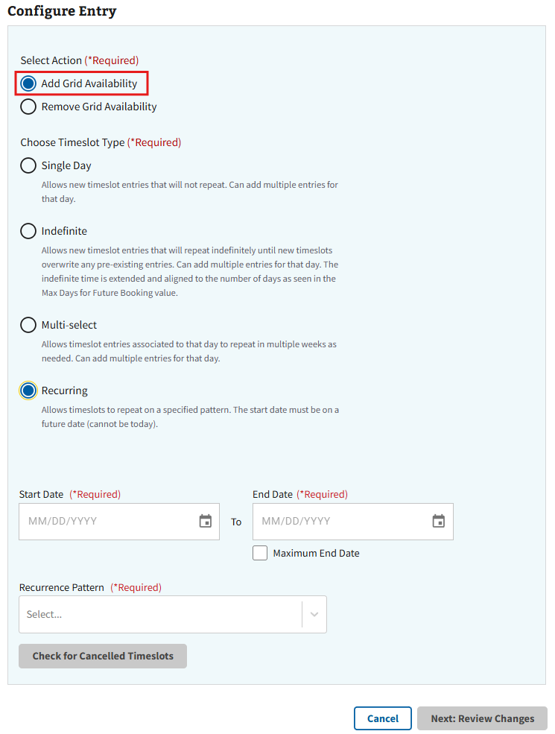
Figure 135: Add Grid Availability Radio Button for Recurring Modification
- The user will then need to select a Start and End date from the dropdowns shown below in ⁠⁠⁠⁠⁠⁠Figure 136⁠⁠⁠⁠⁠⁠.
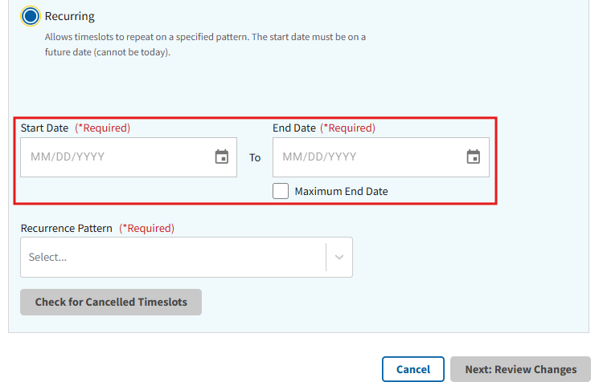
Figure 136: Calendar Dropdown for Recurring Modification
- Note: The user can select the “Maximum End Date” checkbox seen in ⁠⁠⁠⁠⁠⁠Figure 136⁠⁠⁠⁠⁠⁠ above to auto-populate the field with the latest possible end date.
- After selecting a date(s), the user will be prompted to check for cancelled timeslots as seen in ⁠⁠Figure 137⁠⁠.
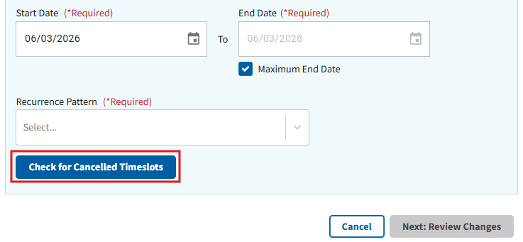
Figure 137: Check for Cancelled Timeslots Button for Recurring Modification
- Note: If a user attempts to add timeslots to a day with previous cancellations, the following information will display after selecting “Check for Cancelled Timeslots” (see ⁠⁠⁠⁠⁠⁠Figure 138⁠⁠⁠⁠⁠⁠ for example).
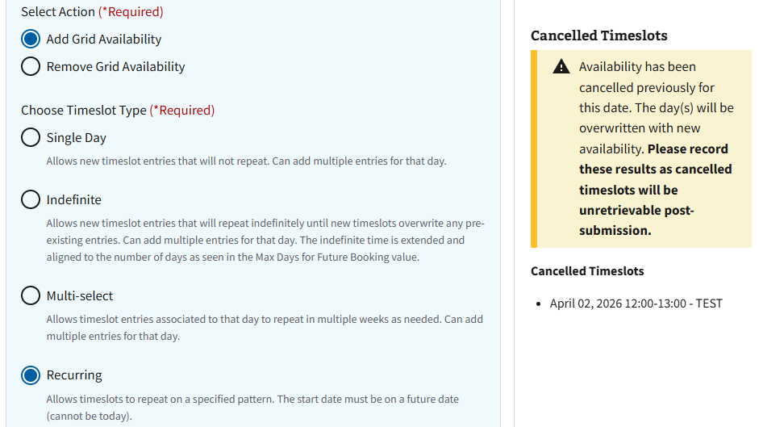
Figure 138: Cancelled Timeslot Information for Recurring
- The user will then need to select from the “Recurrence Pattern” dropdown menu seen in ⁠⁠⁠⁠⁠⁠Figure 139⁠⁠⁠⁠⁠⁠.
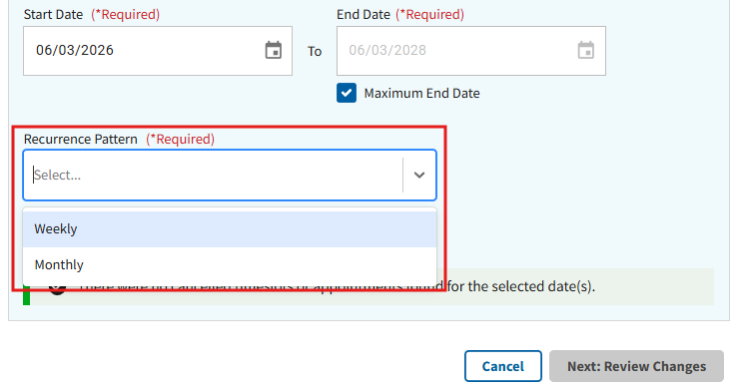
Figure 139: Recurrence Pattern Dropdown

- After selecting a recurrence pattern, the user will be required to specify the information and populate the fields for either a Monthly (see ⁠⁠Figure 140⁠⁠ for example) or Weekly pattern (see ⁠⁠⁠⁠⁠⁠Figure 141⁠⁠⁠⁠⁠⁠ for example).
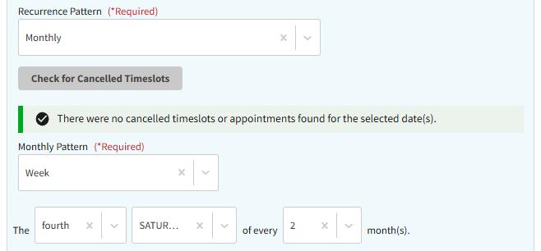
Figure 140: Example of Monthly Recurrence Pattern
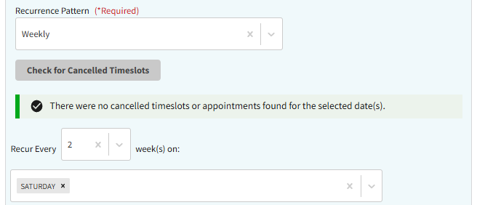
Figure 141: Example of Weekly Recurrence Pattern
- Once all recurrence pattern information has been entered, the user will need to populate the timeslot information seen below in ⁠⁠⁠⁠⁠⁠Figure 142⁠⁠⁠⁠⁠⁠.
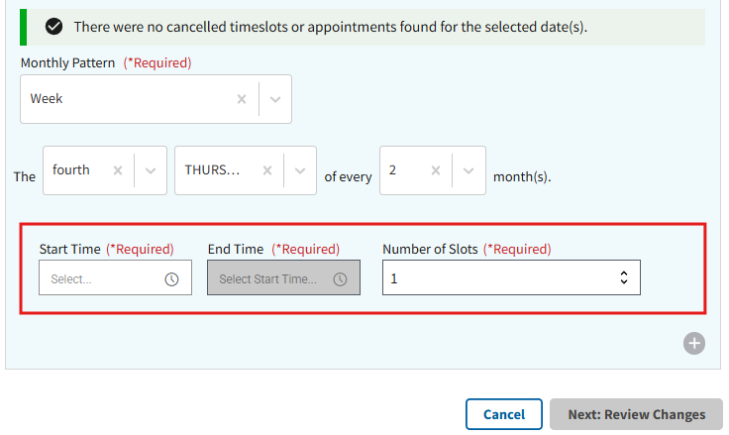
Figure 142: Add Timeslot for Recurring Modification
- Note: If a timeslot has been previously cancelled for the chosen date, the user will receive a notification prompting them to either keep the previously cancelled timeslots or overwrite the cancellation, as seen in ⁠⁠⁠⁠⁠⁠Figure 143⁠⁠⁠⁠⁠⁠. After selecting an action, the user will need to select “Continue” to move forward with the modification.
Figure 143: Cancelled Timeslots Information for Recurring Modification
- The user can also add multiple timeslots for the chosen days by selecting the “+” button seen in ⁠⁠⁠⁠⁠⁠Figure 144⁠⁠⁠⁠⁠⁠ and populating the same required fields.
Figure 144: Adding Multiple Timeslots in Recurring Modification
- Note: The user is only allowed to create multiple timeslots for different times. If duplicate or overlapping times are attempted, the user will receive the errors seen below in either ⁠⁠⁠⁠⁠⁠Figure 145⁠⁠⁠⁠⁠⁠ or ⁠⁠⁠⁠⁠⁠Figure 146⁠⁠⁠⁠⁠⁠.
Figure 145: Duplicate Timeslot Error for Recurring Modification
Figure 146: Overlap Timeslot Error for Recurring Modification
- Note: To remove additional timeslots, select the “x” button seen in ⁠⁠Figure 147⁠⁠.
Figure 147: Removing Timeslots for Recurring Modification
- When all required information has been entered, the user can select the “Next: Review Changes” button seen in ⁠⁠⁠⁠⁠⁠Figure 148⁠⁠⁠⁠⁠⁠ to continue to the next page for review.
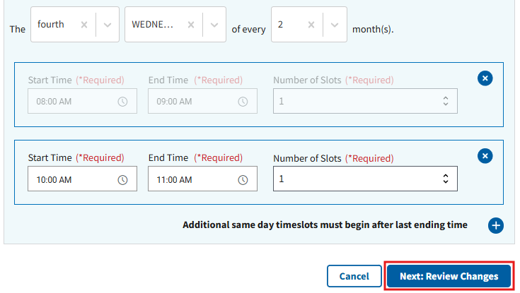
Figure 148: Review Changes Button for Recurring Modification
- Note: The user is required to select options from the hour and minutes field in “Start Hour” for the “Next: Review Changes” button to become highlighted.
- On the Review & Save Changes page (see ⁠⁠Figure 149⁠⁠ for example), the user will need to review the timeslot changes and select the “Save Changes” button to confirm. If further changes are necessary, the user can select the “Go Back” button to return to the configuration page.
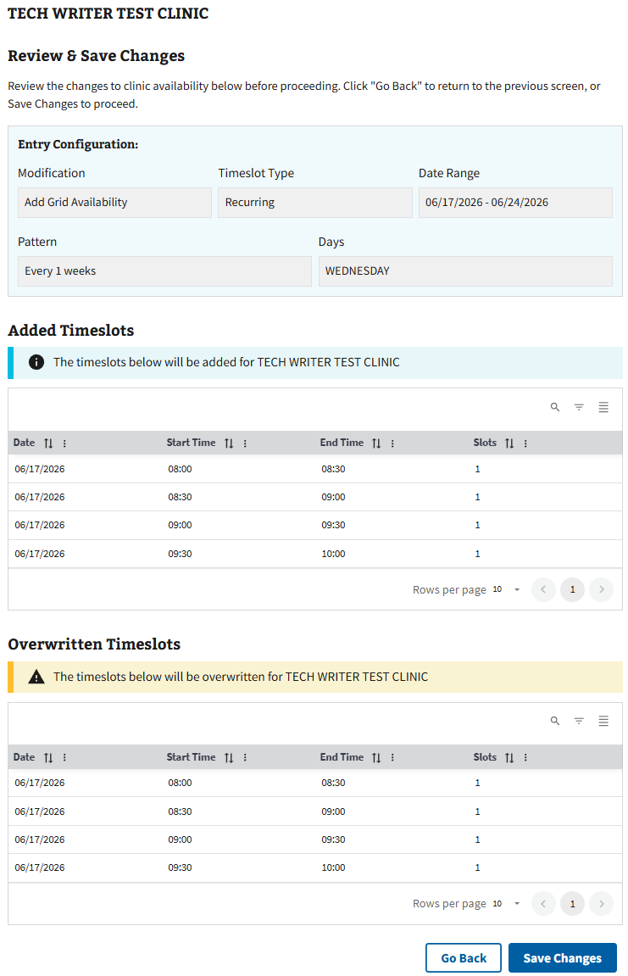
Figure 149: Review Page for Adding Recurring Timeslots
- The user can confirm the changes have been made successfully when the pop-up seen in ⁠⁠⁠⁠⁠⁠Figure 150⁠⁠⁠⁠⁠⁠ appears.
Figure 150: Save Successful Message for Recurring Modification
- After successfully saving the edit, the user can select the “Continue” button shown in ⁠⁠⁠⁠⁠⁠Figure 150⁠⁠⁠⁠⁠⁠ to be returned to the clinic configurations page of the specified clinic

4.4.4.2 Removing Timeslots for Recurring Modification
- Select the radio button next to “Remove Grid Availability” as seen in ⁠⁠⁠⁠⁠⁠Figure 151⁠⁠⁠⁠⁠⁠ to remove a timeslot.
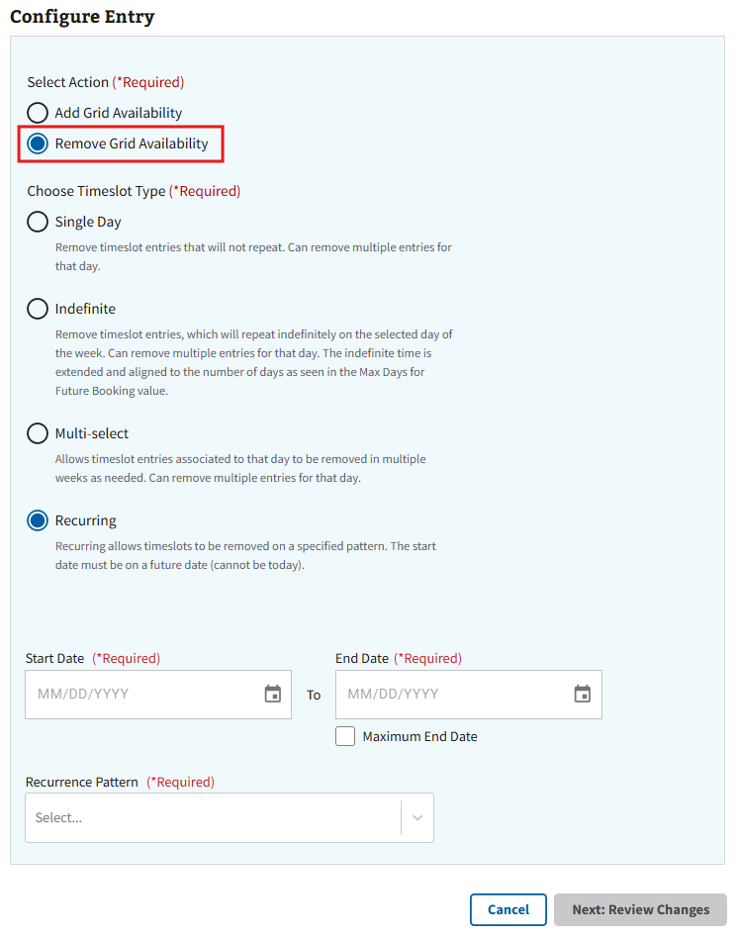
Figure 151: Remove Grid Availability Radio Button for Recurring Modification
- The user will then need to select a Start and End date from the dropdowns shown below in ⁠⁠⁠⁠⁠⁠Figure 152⁠⁠⁠⁠⁠⁠.
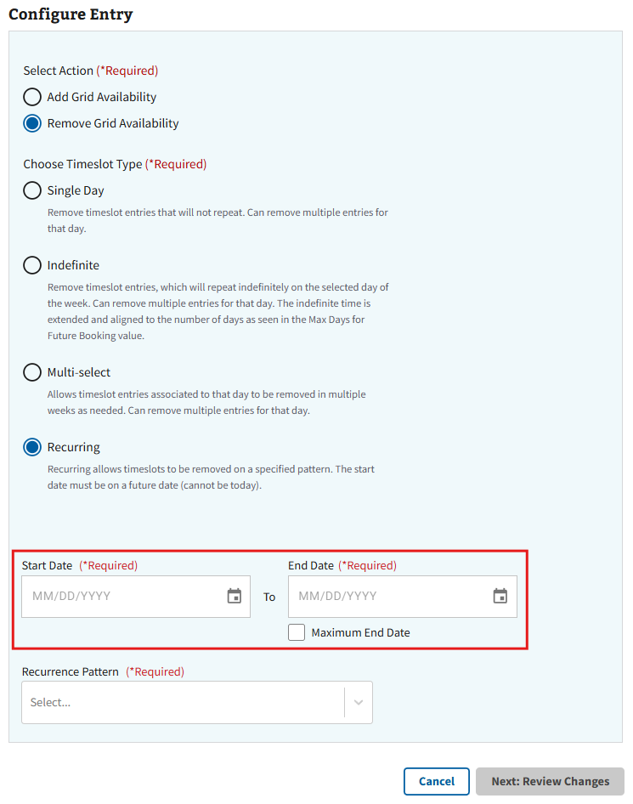
Figure 152: Calendar Dropdown for Removing Grid Availability in Recurring Modification
- The user will also need to select from the “Recurrence Pattern” dropdown menu seen in ⁠⁠⁠⁠⁠⁠Figure 153⁠⁠⁠⁠⁠⁠.
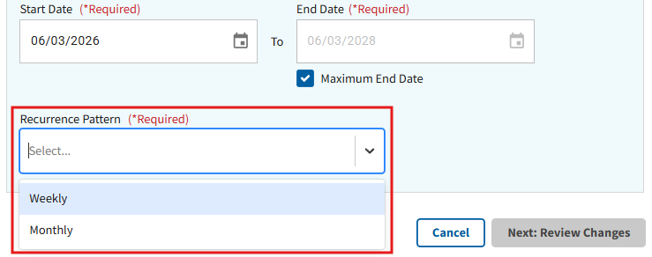
Figure 153: Recurrence Pattern Dropdown for Removing Grid Availability
- After selecting a recurrence pattern, the user will be required to specify the information and populate the fields for either a Monthly (see ⁠⁠⁠⁠⁠⁠Figure 154⁠⁠⁠⁠⁠⁠ for example) or Weekly pattern (see ⁠⁠⁠⁠⁠⁠Figure 155⁠⁠⁠⁠⁠⁠ for example).
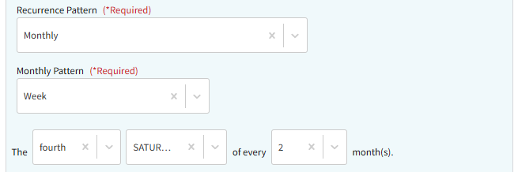
Figure 154: Example of Monthly Recurrence Pattern for Removing Grid Availability
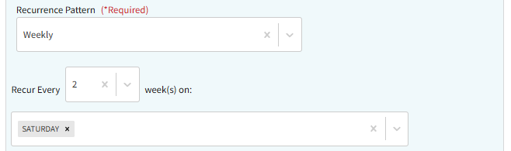
Figure 155: Example of Weekly Recurrence Pattern for Removing Grid Availability
- Once all recurrence pattern information has been entered, the user will need to select the “Next: Review Changes” button shown in ⁠⁠Figure 156⁠⁠ to review the intended changes.
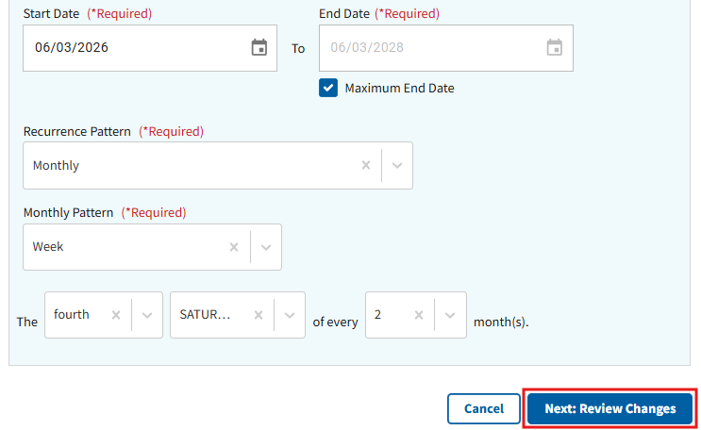
Figure 156: Review Changes Button for Removing Recurring Timeslots
- On the Review & Save Changes page (see ⁠⁠Figure 157⁠⁠ for example), the user will need to review the timeslot changes and select the “Save Changes” button to confirm. If further changes are necessary, the user can select the “Go Back” button to return to the configuration page.
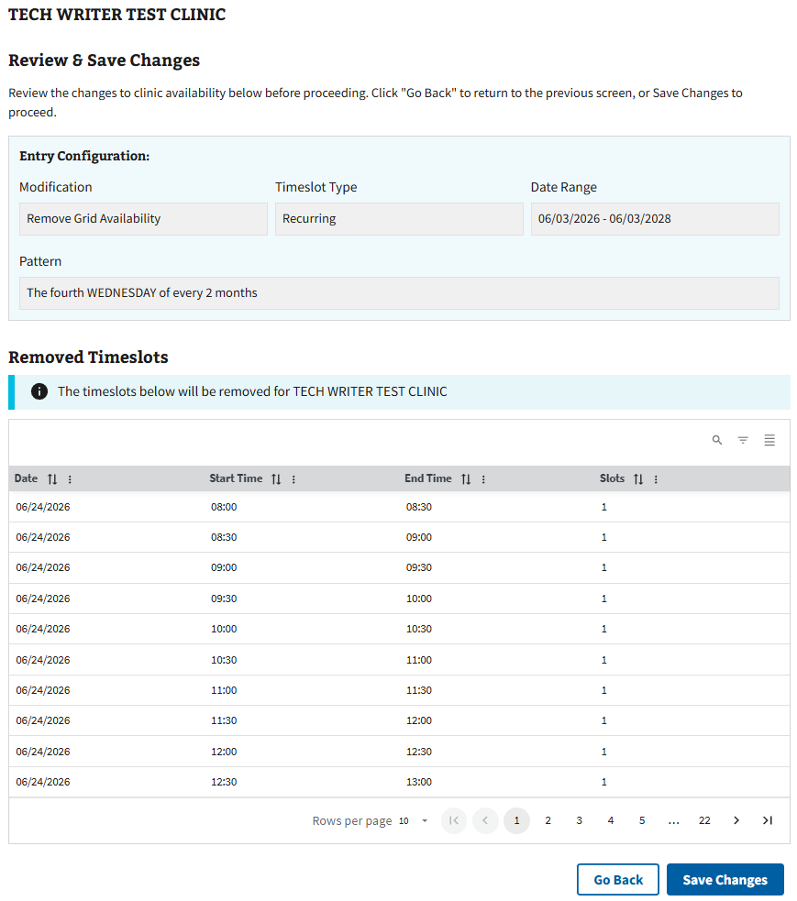
Figure 157: Review Page for Removing Recurring Timeslots
- The user can confirm the changes have been made successfully when the pop-up seen in ⁠⁠⁠⁠⁠⁠Figure 158⁠⁠⁠⁠⁠⁠ appears.
Figure 158: Save Successful for Remove Timeslot(s) in Recurring Modification
- After successfully saving the edit, the user can select the “Continue” button shown in ⁠⁠⁠⁠⁠⁠Figure 158⁠⁠⁠⁠⁠⁠ to be returned to the clinic configurations page for the specified clinic.

4.5 Cancelling and Restoring Timeslots
Disclaimer: This section of the guide is only applicable to users with access permissions SDCANCEL for timeslot cancellations and SDRESTORE for timeslot restorations. If the user does not have elevated access permissions set to their VistA account, the user will not see the “Cancel Timeslot(s)” or “Restore” buttons seen in ⁠⁠⁠⁠⁠⁠Figure 159⁠⁠⁠⁠⁠⁠. If a user needs access to make changes on this application, please contact the local Clinical Applications Coordinator or Supervisor for assistance.
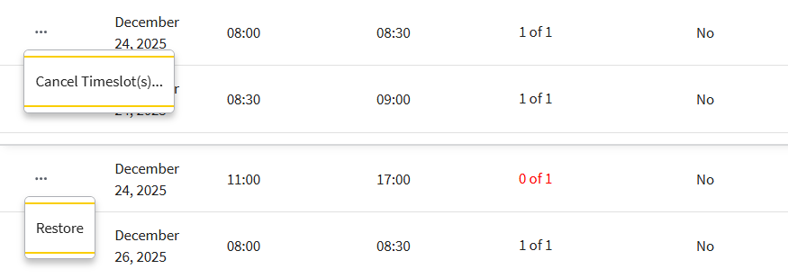
Figure 159: Cancel and Restore Buttons for Timeslots
To cancel and restore clinic timeslots, the user will first need to search and select a clinic within the Clinic Configurations tab. Once a clinic is selected, the user will need to search for a date and then select it within the Clinic Availability accordion (see ⁠⁠⁠⁠⁠⁠Figure 160⁠⁠⁠⁠⁠⁠).
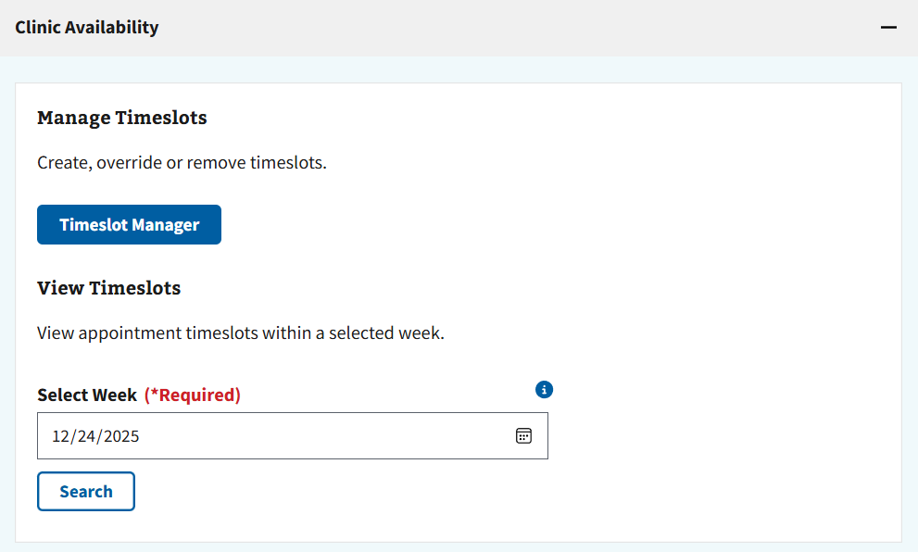
Figure 160: Date Search for Cancel and Restore

4.5.1 Cancelling a Timeslot
- After searching for a specific date, the user will be shown a full week of scheduling clinic availability. The user will then click the ellipsis next to the necessary timeslot and select the “Cancel Timeslot(s)” button seen in ⁠⁠⁠⁠⁠⁠Figure 161⁠⁠⁠⁠⁠⁠.
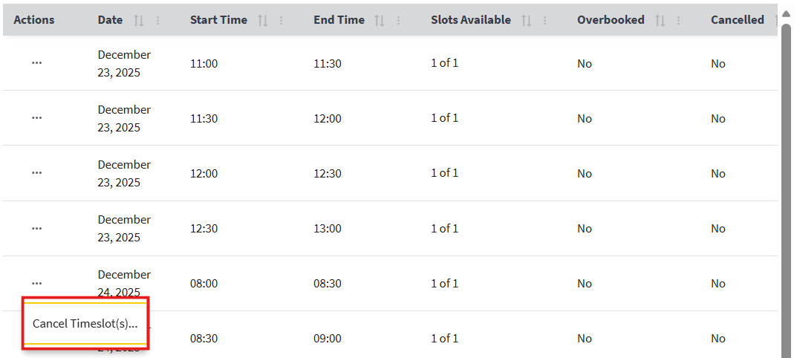
Figure 161: Cancel Timeslot Button
- After selecting the “Cancel Timeslot(s)” button, the pop-up window shown in ⁠⁠⁠⁠⁠⁠Figure 162⁠⁠⁠⁠⁠⁠ will appear.
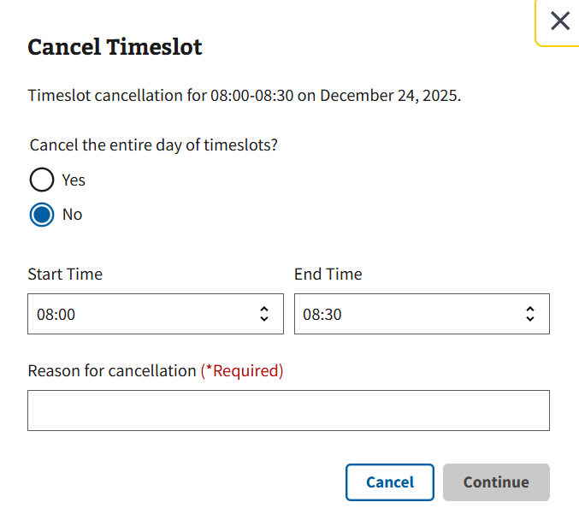
Figure 162: Cancel Timeslot Window

4.5.1.1 Cancelling for a Single Timeslot
- To cancel for a single timeslot, the user will need to select “No” on the Cancel Timeslot window seen in ⁠⁠⁠⁠⁠⁠Figure 163⁠⁠⁠⁠⁠⁠.
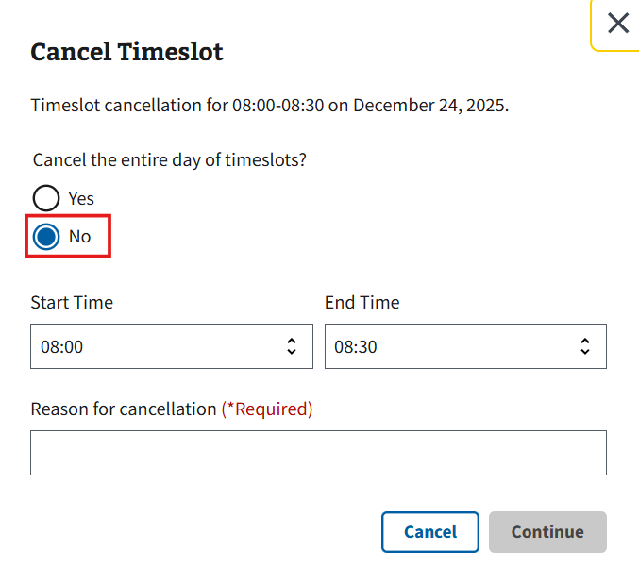
Figure 163: Single Timeslot Cancellation Option
- Next, the user can choose to cancel the single timeslot seen at the top of the window. Optionally, the user may also enter a start and end time or cancel multiple consecutive timeslots, as seen below in ⁠⁠Figure 164⁠⁠.
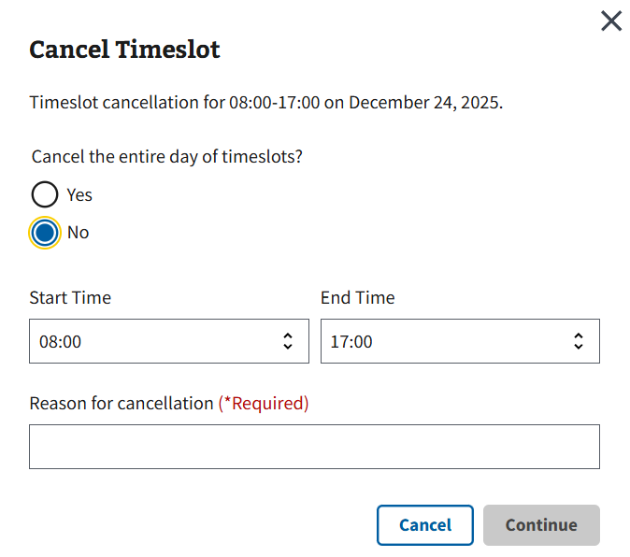
Figure 164: Manual Time Entered for Timeslot Cancellation Example
- The user will then need to enter a reason for cancellation into the box seen in ⁠⁠⁠⁠⁠⁠Figure 165⁠⁠⁠⁠⁠⁠ and select the “Continue” button to proceed with cancelling the timeslot.
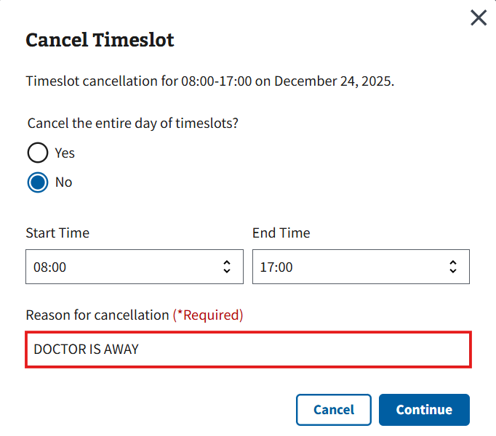
Figure 165: Reason for Cancellation Example for Single Timeslot Cancellation
- Note: The user is only allotted 3 to 30 characters. Going under the minimum or over the maximum amount will result in the error shown in ⁠⁠⁠⁠⁠⁠Figure 166⁠⁠⁠⁠⁠⁠.
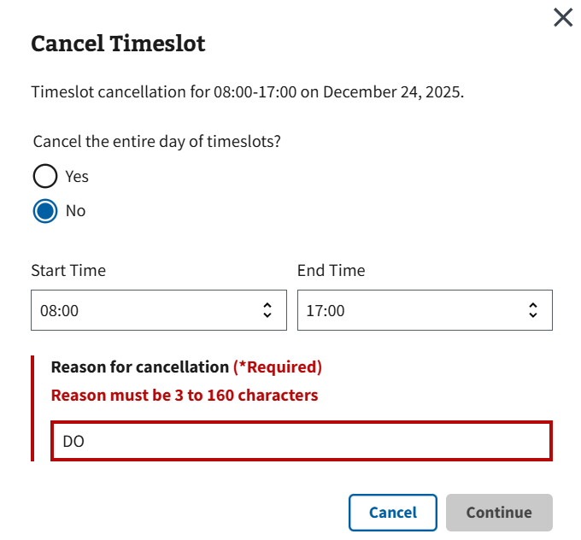
Figure 166: Reason for Cancellation Error for Single Timeslot Cancellation
- Note: If the user attempts to cancel a timeslot with patient association, the user will receive the window shown below in ⁠⁠⁠⁠⁠⁠Figure 167⁠⁠⁠⁠⁠⁠. The user can then choose to either continue with cancellation or return to the grid.
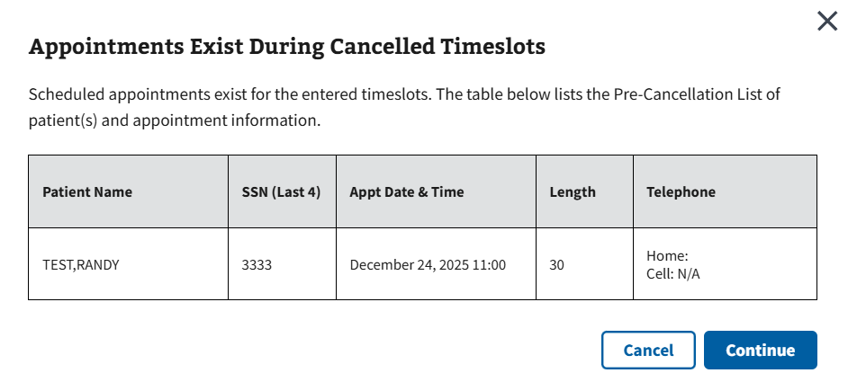
Figure 167: Patient Association Window for Single Timeslot Cancellation

- The user can confirm the changes have been made successfully when the pop-up seen in ⁠⁠⁠⁠⁠⁠Figure 168⁠⁠⁠⁠⁠⁠ appears. The user can select “Continue” to return to the grid.
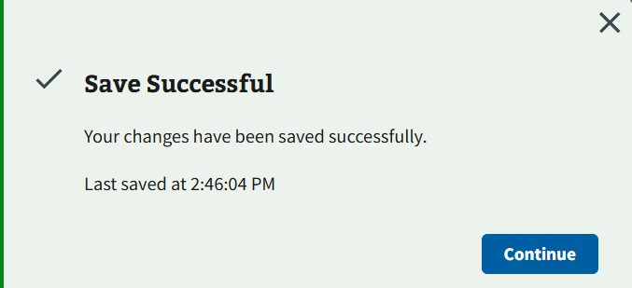
Figure 168: Save Successful for Cancelling Single Timeslot
- Note: The grid will say “Yes/Blocked” within the Cancelled column for single timeslot cancellations (see ⁠⁠⁠⁠⁠⁠Figure 169⁠⁠⁠⁠⁠⁠).
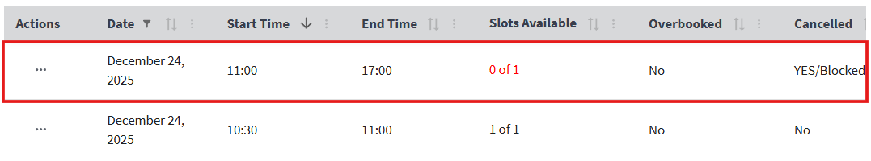
Figure 169: Single Timeslot Cancellation Example in Grid

4.5.1.2 Entire Day Cancellation
- To cancel timeslots for the entire day, the user will need to select “Yes” on the Cancel Timeslot window seen in ⁠⁠⁠⁠⁠⁠Figure 170⁠⁠⁠⁠⁠⁠.
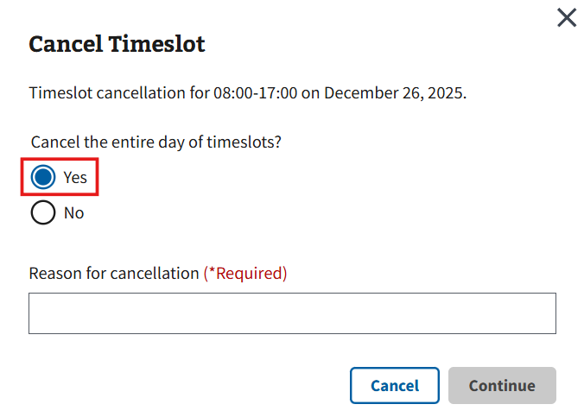
Figure 170: Entire Day Timeslot Cancellation Option
- Note: The user will not be able to cancel timeslots for the entire day if there is already an existing timeslot block for the same day. To cancel the entire day, the user will either need to cancel timeslots one at a time or restore the timeslot block so that the option becomes available (See section ⁠⁠⁠⁠⁠⁠4.5.2 Restoring a Timeslot⁠⁠⁠⁠⁠⁠ for information on restoring timeslots).
- The user will then need to enter a reason for cancellation into the box seen in ⁠⁠⁠⁠⁠⁠Figure 171⁠⁠⁠⁠⁠⁠ and select the “Continue” button to proceed with cancelling all timeslots.
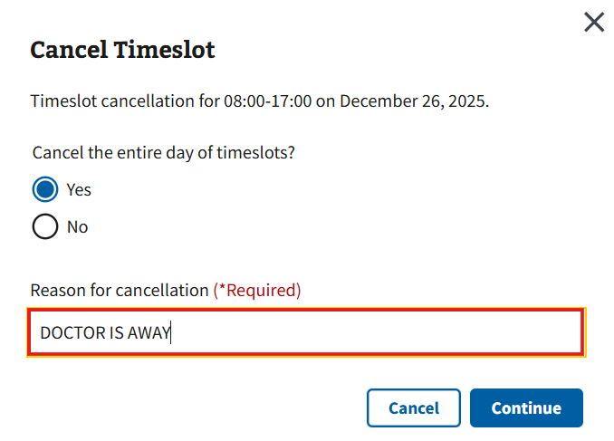
Figure 171: Reason for Cancellation Example for Entire Day Cancellation
- Note: The user is only allotted 3 to 30 characters. Going under the minimum or over the maximum amount will result in the error shown in ⁠⁠⁠⁠⁠⁠Figure 172⁠⁠⁠⁠⁠⁠.
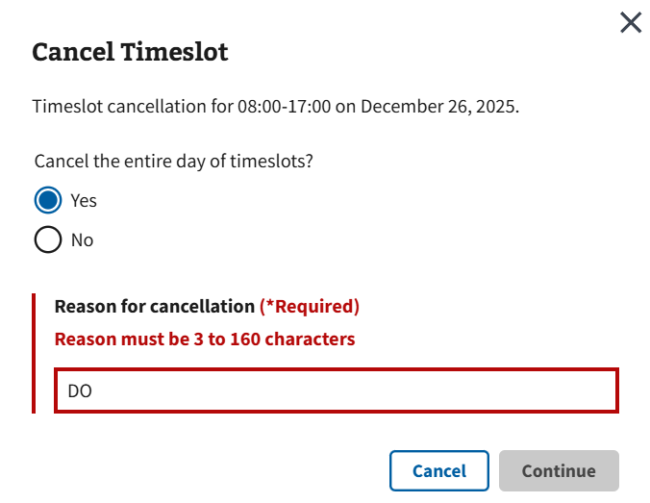
Figure 172: Reason for Cancellation Error for Entire Day Cancellation
- Note: If the user attempts to cancel timeslots with patient association, the user will receive the window seen below in ⁠⁠Figure 173⁠⁠. The user can then choose to either continue with cancellation of the entire day or return to the grid.
Figure 173: Patient Association Window for Entire Day Timeslots Cancellation
- The user can confirm the changes have been made successfully when the pop-up seen in ⁠⁠⁠⁠⁠⁠Figure 174⁠⁠⁠⁠⁠⁠ appears. The user can select “Continue” to return to the grid.
Figure 174: Save Successful for Cancelling All Timeslots
- Note: The grid will say “Yes/Cancelled” within the Cancelled column for entire day timeslot cancellations (see ⁠⁠⁠⁠⁠⁠Figure 175⁠⁠⁠⁠⁠⁠).
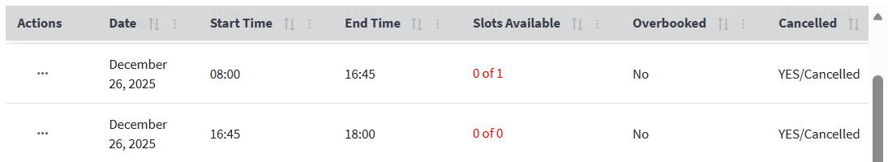
Figure 175: Entire Day Timeslot Cancellation Example in Grid

4.5.2 Restoring a Timeslot

4.5.2.1 Restoring for a Single Day Timeslot
- After searching for a specific date, the user will be shown a full week of scheduling clinic availability. The user will then click the ellipsis next to the necessary timeslot, or grouping of multiple consecutive timeslots, and select the “Restore” button seen in ⁠⁠⁠⁠⁠⁠Figure 176⁠⁠⁠⁠⁠⁠.
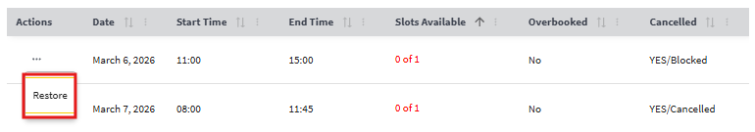
Figure 176: Restore Timeslot Button for Single Timeslot Restoration
- The Restore Timeslot window will appear. From here, the user can then choose to restore the entire blocked timeslot or select a start and end time to restore from the blocked period via the dropdown seen below in ⁠⁠Figure 177⁠⁠.
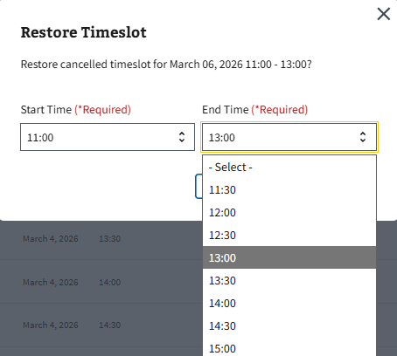
Figure 177: Restore Timeslot Window for Single Timeslot
- After choosing the required times, the user will need to select the “Restore Timeslot(s)” button shown in ⁠⁠Figure 178⁠⁠ save the intended changes.
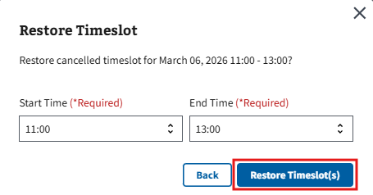
Figure 178: Restore Timeslot(s) Button for Single Day Timeslot

- The user can confirm the changes have been made successfully when the pop-up seen in ⁠⁠⁠⁠⁠⁠Figure 179⁠⁠⁠⁠⁠⁠ appears. The user can select “Continue” to return to the grid.
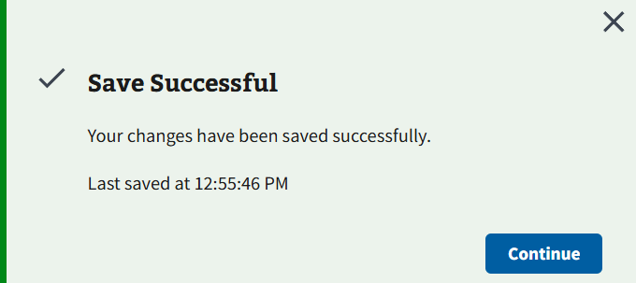
Figure 179: Save Successful Window for Single Timeslot Restoration

4.5.2.2 Entire Day Restoration
- After searching for a specific date, the user will be shown a full week of scheduling clinic availability. The user will then click the ellipsis next to the necessary timeslot and select the “Restore” button seen in ⁠⁠⁠⁠⁠⁠Figure 180⁠⁠⁠⁠⁠⁠.
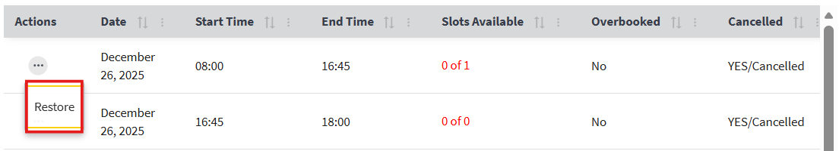
Figure 180: Restore Timeslot Button for Entire Day Restoration
- The Restore Timeslot window will appear. The user will need to select the “Submit” button, seen below in ⁠⁠⁠⁠⁠⁠Figure 181⁠⁠⁠⁠⁠⁠, to continue with restoring timeslots for the entire day.
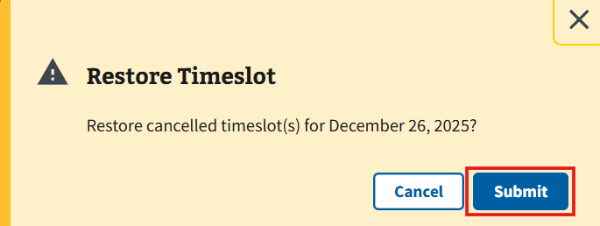
Figure 181: Restore Timeslot Window for Entire Day Timeslots Restoration
- The user can confirm the changes have been made successfully when the pop-up seen in ⁠⁠⁠⁠⁠⁠Figure 182⁠⁠⁠⁠⁠⁠ appears. The user can select “Continue” to return to the grid.
Figure 182: Save Successful Window for Entire Day Timeslots Restoration

4.6 Creating a New Clinic
Disclaimer: This section of the guide is only applicable to users with the correct write access permissions. If the user does not have write access permissions set to the account, the user will receive the error message shown in ⁠⁠Figure 183⁠⁠. If a user needs access to make changes on this application, please contact the local Clinical Applications Coordinator or Supervisor for assistance.
Figure 183: Authorization Error Message for Creating a Clinic
- To create a new clinic, the users must select the “Create New Clinic” button seen in ⁠⁠⁠⁠⁠⁠Figure 184⁠⁠⁠⁠⁠⁠ under the Clinic Configurations tab. Selecting the button will cause the Create New Clinic page shown in ⁠⁠⁠⁠⁠⁠Figure 185⁠⁠⁠⁠⁠⁠ to appear.
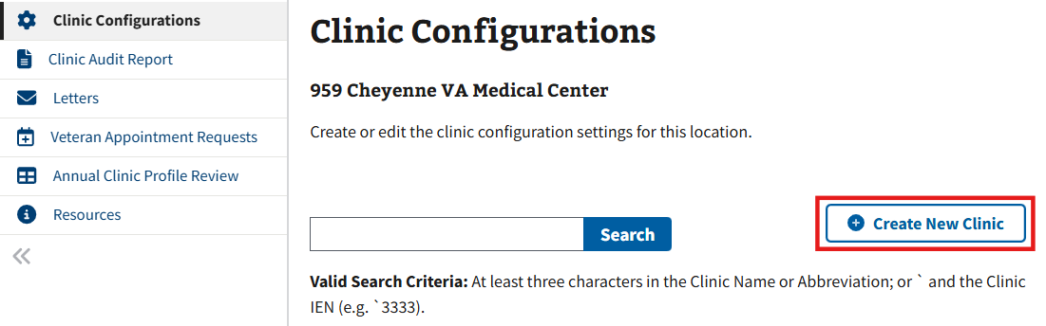
Figure 184: Create a Clinic Button
- The user will then see three configuration accordions: Mandatory Fields, Preselected Settings, and Optional Settings, which can be viewed and edited by selecting the “+” shown in ⁠⁠⁠⁠⁠⁠Figure 185⁠⁠⁠⁠⁠⁠. Optionally, the user can select the “Expand All” button to open all accordions at once.
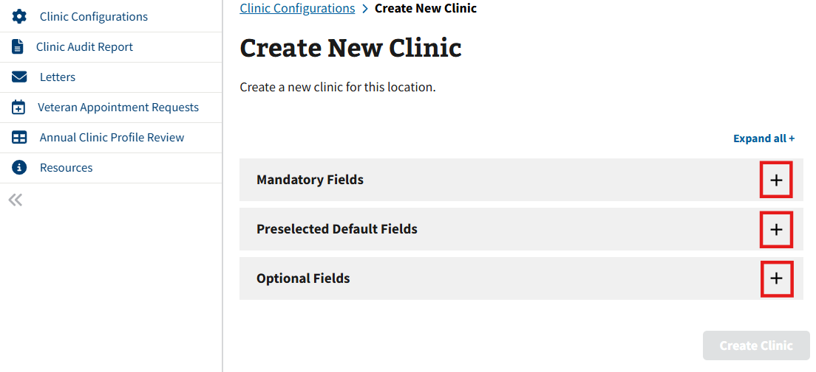
Figure 185: Create a Clinic Accordions
- Note: Users can choose to automatically expand the accordions on the Create New Clinic page via the Preferences settings. Please see section ⁠⁠⁠⁠⁠2.2.1.3 Default Create New Clinic Accordion Preferences⁠⁠⁠⁠⁠ for more information.
- Note: Please see sections ⁠⁠⁠⁠⁠⁠4.6.1 Mandatory Fields⁠⁠⁠⁠⁠⁠, ⁠⁠⁠⁠⁠⁠4.6.2 Preselected Settings⁠⁠⁠⁠⁠⁠, and ⁠⁠⁠⁠⁠⁠4.6.3 Optional Settings⁠⁠⁠⁠⁠⁠ for examples of the accordions.
- Once the required fields have been correctly filled, the “Create Clinic” button seen in ⁠⁠Figure 186⁠⁠ will appear. If not entered correctly, the button will remain greyed out.
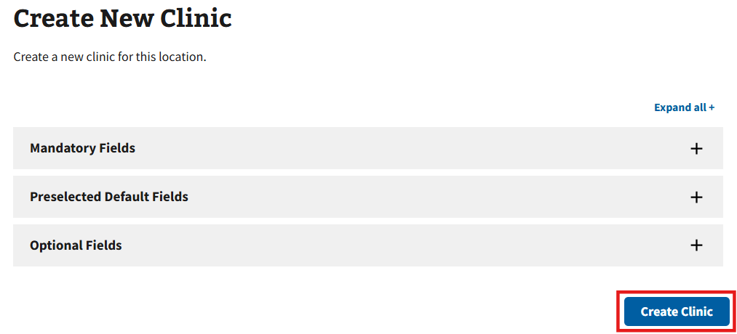
Figure 186: Create a Clinic Button after Entering Required Information
- Note: The user must create a clinic before timeslots can be added; this function cannot be done in the process of creation. After creating a new clinic, the UI will immediately take the user to the Edit Clinic Availability section to add timeslots associated to the clinic. Please refer to the section ⁠⁠⁠⁠⁠⁠Editing Clinic Configurations⁠⁠⁠⁠⁠⁠ for guidance.

4.6.1 Mandatory Fields
Users with Write Access can edit the fields that will appear within Mandatory Fields shown below in ⁠⁠⁠⁠⁠⁠Figure 187⁠⁠⁠⁠⁠⁠. The field(s) labeled “Required” must be edited before saving. Once all the mandatory fields have been populated with data, a new clinic can be created.
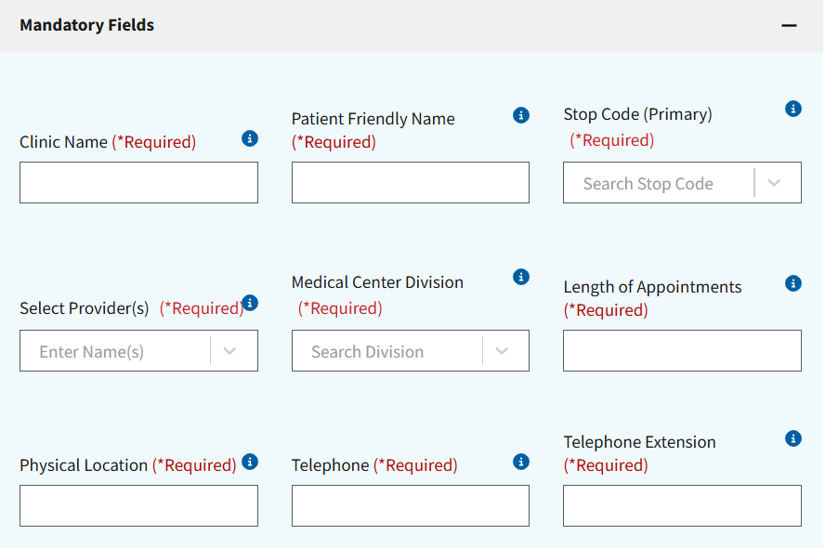
Figure 187: Editing Mandatory Fields for Create a Clinic
- Note: Please go to Section ⁠⁠⁠⁠⁠⁠9.2 Tool Tip Descriptions⁠⁠⁠⁠⁠⁠ for more information on populating clinic settings.
- Note: Users will receive the error message shown in ⁠⁠⁠⁠⁠⁠Figure 188⁠⁠⁠⁠⁠⁠ if users fail to populate any of the required fields.
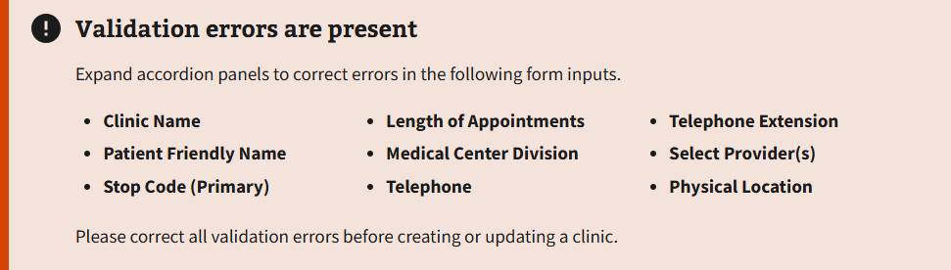
Figure 188: Error Message from Lack of Required Fields

4.6.2 Preselected Settings
Users with Write Access can edit the fields that will appear within Preselected Fields shown below in ⁠⁠⁠⁠⁠⁠Figure 189⁠⁠⁠⁠⁠⁠.
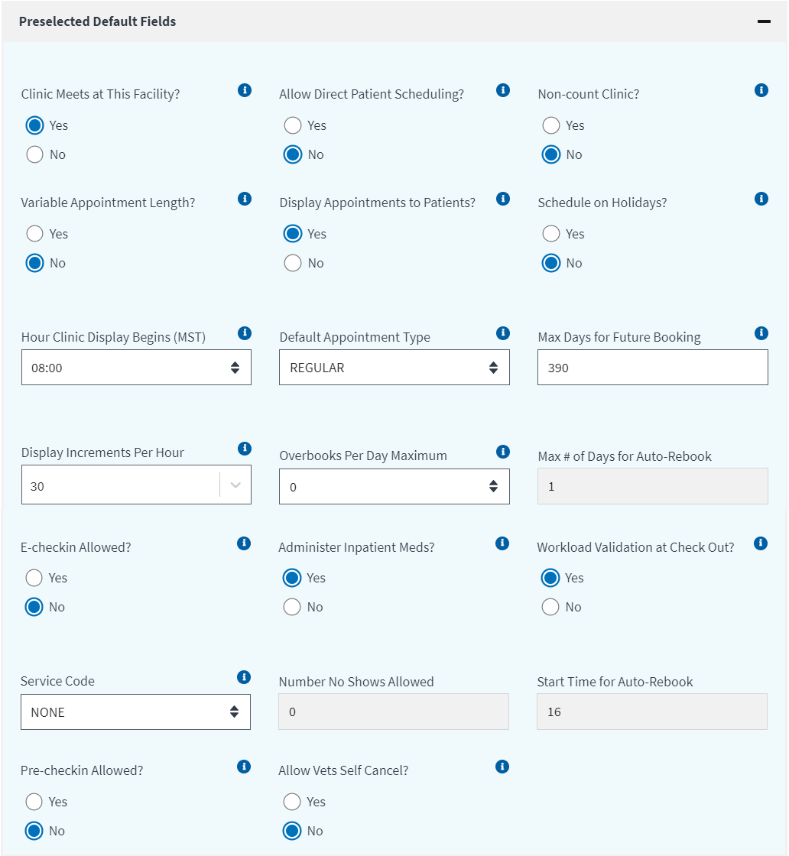
Figure 189: Editing Preselected Default Fields for Create a Clinic
- Note: Please go to Section ⁠⁠⁠⁠⁠⁠9.2 Tool Tip Descriptions⁠⁠⁠⁠⁠⁠ for more information on populating clinic settings.

4.6.3 Optional Settings
Users with Write Access can edit the fields that will appear within Optional Settings shown below in ⁠⁠⁠⁠⁠⁠Figure 190⁠⁠⁠⁠⁠⁠.
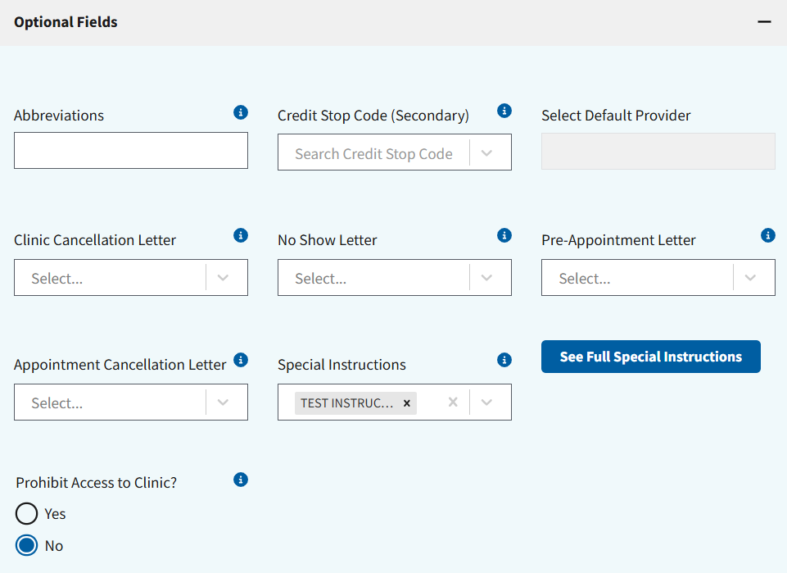
Figure 190: Editing Optional Fields for Create a Clinic
- Note: Please go to Section ⁠⁠⁠⁠⁠⁠9.2 Tool Tip Descriptions⁠⁠⁠⁠⁠⁠ for more information on populating clinic settings.

4.7 Inactivating and Reactivating a Clinic
Disclaimer: This section of the guide is only applicable to users with access permissions SD INACTIVATE for inactivation and SD REACT for reactivation. If the user does not have elevated access permissions set to their VistA account, the user will not see the “Inactivate Clinic” button seen in ⁠⁠⁠⁠⁠⁠Figure 191⁠⁠⁠⁠⁠⁠. If a user needs access to make changes on this application, please contact the local Clinical Applications Coordinator or Supervisor for assistance.
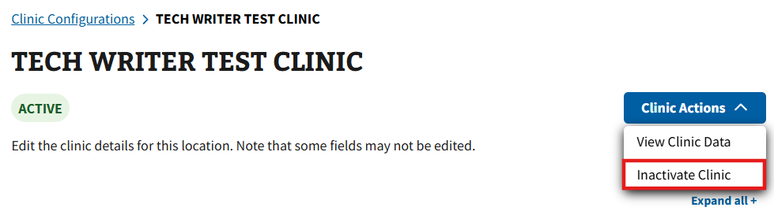
Figure 191: Inactivate Clinic Button

4.7.1 Inactivating a Clinic
- To inactivate a clinic, the user will first need to search and select a clinic within the Clinic Configurations tab (see ⁠⁠⁠⁠⁠⁠Figure 192⁠⁠⁠⁠⁠⁠).
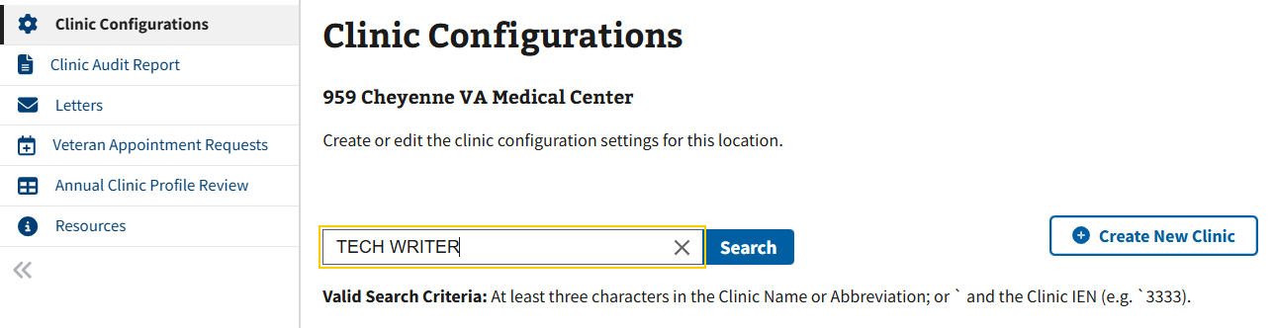
Figure 192: Clinic Search Example for Inactivating a Clinic
- Note: When trying to inactivate a clinic, the user will receive the error seen in ⁠⁠Figure 193⁠⁠ if patients are actively scheduled. Ensure that all future appointments have been canceled to move forward with inactivation.
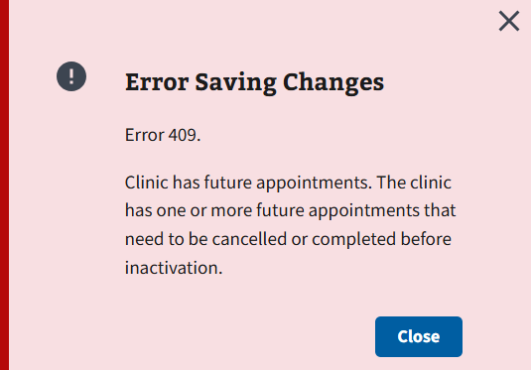
Figure 193: Error Message for Inactivating a Clinic
- Once a clinic is selected, the user will select the “Inactivate” button seen in ⁠⁠⁠⁠⁠⁠Figure 194⁠⁠⁠⁠⁠⁠.
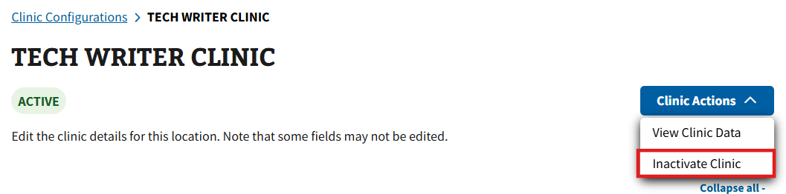
Figure 194: Inactivate Clinic Button for Inactivating a Clinic
- Selecting the “Inactivate” button will cause a pop-up to appear (see ⁠⁠⁠⁠⁠⁠Figure 195⁠⁠⁠⁠⁠⁠) and the user will be asked to select a date of inactivation within a six-month period.
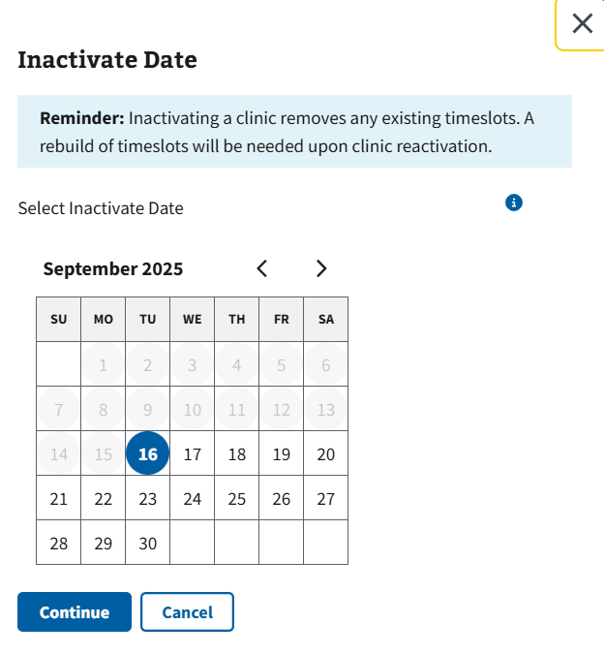
Figure 195: Inactivate Date Pop-up
- Note: Inactivating a clinic will remove all existing timeslots. The user will need to rebuild the timeslots upon reactivation of the clinic.
- Selecting the “Continue” button (see ⁠⁠⁠⁠⁠⁠Figure 195⁠⁠⁠⁠⁠⁠) will place the clinic into an inactive status on the date of selection highlighted in red, as seen in ⁠⁠⁠⁠⁠⁠Figure 196⁠⁠⁠⁠⁠⁠.
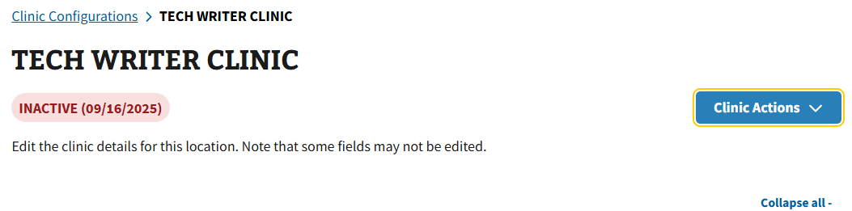
Figure 196: Inactivate Status Date
- Note: A banner of inactivation will display in the Clinic Availability Archive section after the clinic has been inactivated as seen in ⁠⁠⁠⁠⁠⁠Figure 197⁠⁠⁠⁠⁠⁠.
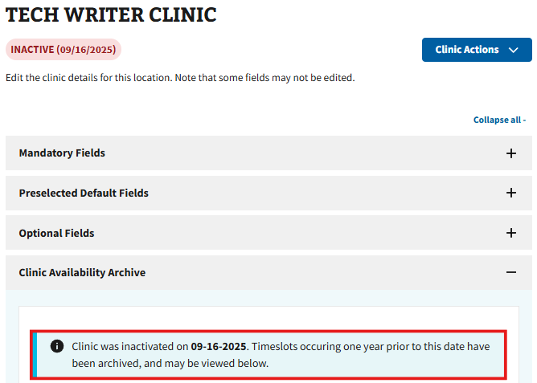
Figure 197: Clinic is Inactive Message

4.7.2 Reactivating a Clinic
- To reactivate a clinic, the user will first need to search and select a clinic within the Clinic Configurations tab (see ⁠⁠Figure 198⁠⁠).
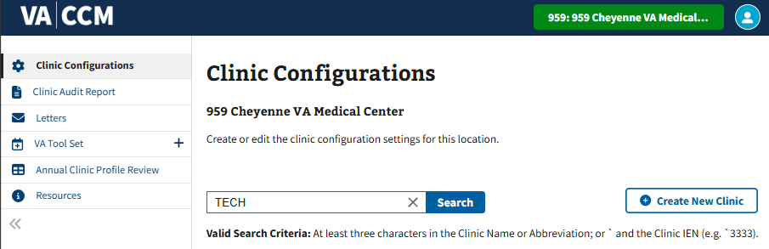
Figure 198: Clinic Search Example for Reactivating a Clinic
- Once a clinic is selected, the user will need to select the “Reactivate Clinic” button located in the “Clinic Actions” dropdown seen in ⁠⁠Figure 199⁠⁠.
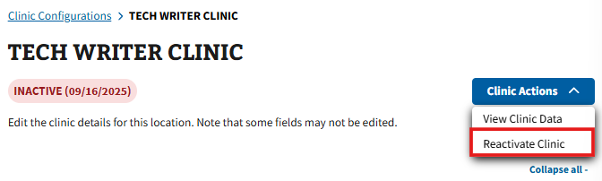
Figure 199: Reactivate Clinic Button
- After selecting the “Reactivate Clinic” button, the pop-up window shown in ⁠⁠Figure 200⁠⁠ will appear. This will allow the user to select a date and provider for the clinic to become reactivated.
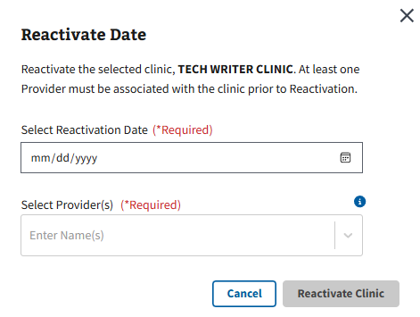
Figure 200: Reactivate Clinic Pop-up
- The user will then need to select a date by clicking the calendar button shown below in ⁠⁠⁠⁠⁠⁠Figure 201⁠⁠⁠⁠⁠⁠.
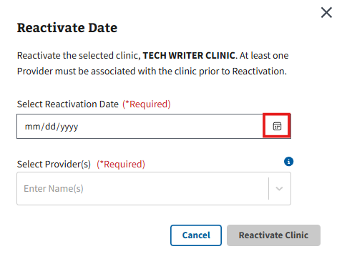
Figure 201: Calendar Button for Reactivating a Clinic
- The user will also need to enter a provider into the field seen in ⁠⁠⁠⁠⁠⁠Figure 202⁠⁠⁠⁠⁠⁠.
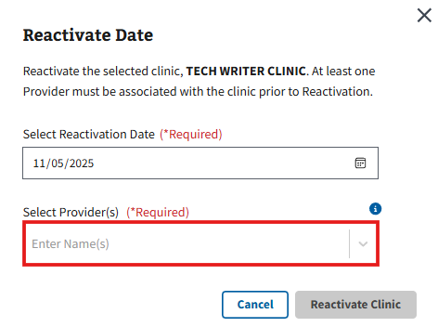
Figure 202: Provider Field for Reactivating a Clinic
- After entering the required information, the user will need to select the checkbox seen in ⁠⁠⁠⁠⁠⁠Figure 203⁠⁠⁠⁠⁠⁠ to confirm.
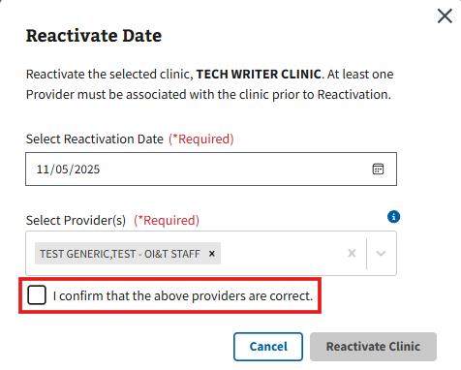
Figure 203: Confirmation Checkbox for Reactivating a Clinic
- Note: The “Reactivate Clinic” button will remain greyed out until a date and provider are chosen; once chosen, the button will become available for selection as seen in ⁠⁠⁠⁠⁠⁠Figure 204⁠⁠⁠⁠⁠⁠.
- Once the information is confirmed, the user can select the “Reactivate Clinic” button seen in ⁠⁠⁠⁠⁠⁠Figure 204⁠⁠⁠⁠⁠⁠.
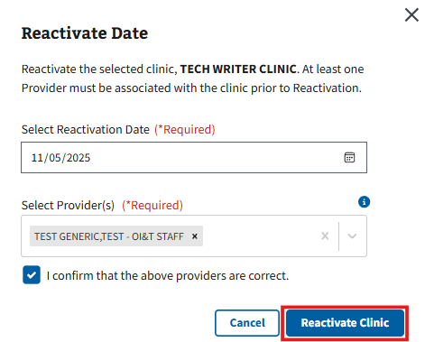
Figure 204: Reactivate Clinic Button
- Note: The user is unable to reactivate a clinic on the same day of inactivation; only future dates are available for selection.

4.8 Replicating a Clinic
Disclaimer: This section of the guide is only applicable to users with the correct write access permissions. If the user does not have write access permissions set to the account, the user will receive the error message shown in ⁠⁠⁠⁠⁠⁠Figure 205⁠⁠⁠⁠⁠⁠. If a user needs access to make changes on this application, please contact the local Clinical Applications Coordinator or Supervisor for assistance.
Figure 205: Authorization Error Message for Replicating a Clinic
- The user will need to follow the steps outlined in section ⁠⁠⁠⁠⁠⁠3.1 Search for a Clinic Configuration⁠⁠⁠⁠⁠⁠ (see ⁠⁠⁠⁠⁠Figure 39⁠⁠⁠⁠⁠ for guidance) to open the clinic configurations for a clinic. On the Clinic Configurations page, the user will need to select the “Clinic Actions” button seen in ⁠⁠⁠⁠⁠⁠Figure 206⁠⁠⁠⁠⁠⁠.
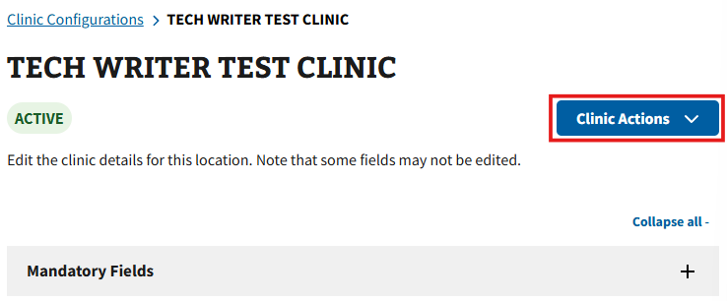
Figure 206: Clinic Actions Button for Replicating a Clinic
- This will cause the action menu to appear, and the user can then select the “Replicate Clinic” option shown in ⁠⁠⁠⁠⁠⁠Figure 207⁠⁠⁠⁠⁠⁠.
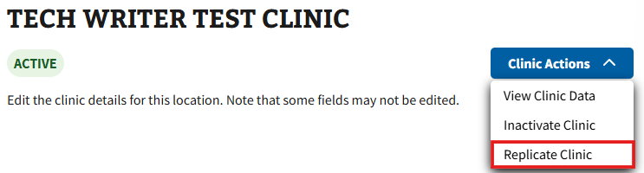
Figure 207: Replicate Clinic Option from the Clinic Action Menu
- The user will be taken to the Replicate Clinic page where the three configuration accordions: Mandatory Fields, Preselected Settings, and Optional Settings, will be auto-populated with information from the selected clinic (see ⁠⁠⁠⁠⁠Figure 208⁠⁠⁠⁠⁠⁠ for example).
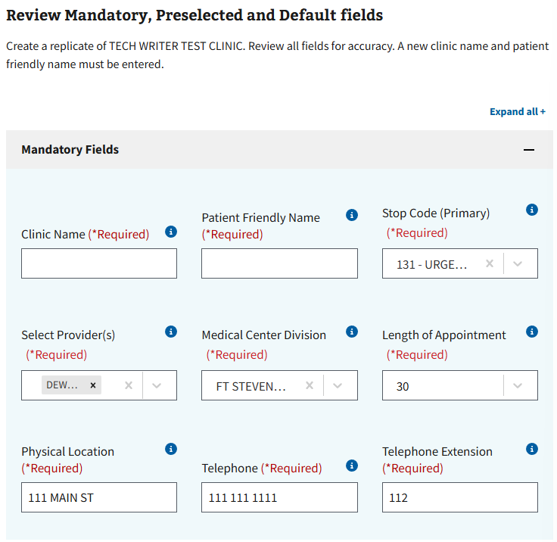
Figure 208: Example of Auto-populated Fields for Replicating a Clinic
- The clinic configurations for the replicated clinic can be edited, if needed, by selecting the “+” shown in ⁠⁠⁠⁠⁠⁠Figure 209⁠⁠⁠⁠⁠⁠. The user will only be required to enter information for the “Clinic Name” and “Patient Friendly Name” fields, located under the Mandatory Fields accordion, if edits are not necessary.
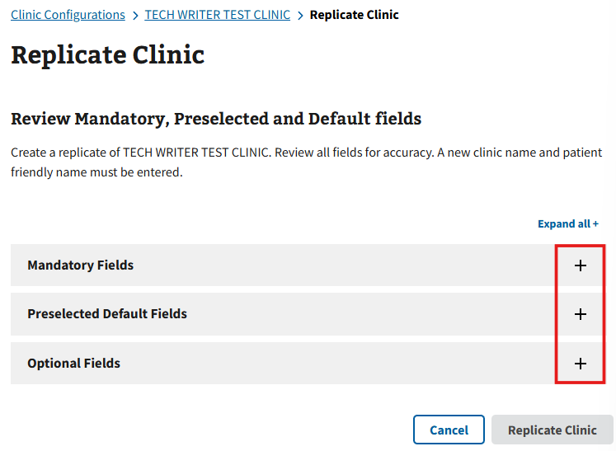
Figure 209: Replicate Clinic Accordions
- Note: Please see sections ⁠⁠⁠⁠⁠⁠4.6.1 Mandatory Fields⁠⁠⁠⁠⁠⁠, ⁠⁠⁠⁠⁠⁠4.6.2 Preselected Settings⁠⁠⁠⁠⁠⁠, and ⁠⁠⁠⁠⁠⁠4.6.3 Optional Settings⁠⁠⁠⁠⁠⁠ for examples of the accordions.
- Note: Editing the “Length of Appointment,” “Display Increments Per Hour,” or the “Hour Clinic Display Begins” fields located in the Mandatory and Preselected Default Fields accordion will remove the timeslots for the new replicated clinic. Users will see the notification seen in ⁠⁠⁠⁠⁠⁠Figure 210⁠⁠⁠⁠⁠⁠ at the bottom of the Replicate Clinic page upon change.
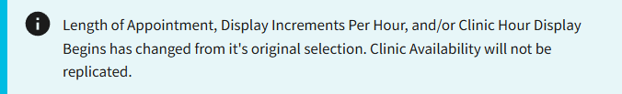
Figure 210: Clinic Availability Not Replicated Notification
- Once the required fields have been correctly filled, the “Replicate Clinic” button seen in ⁠⁠⁠⁠⁠⁠Figure 211⁠⁠⁠⁠⁠⁠ will appear. If not entered correctly, the button will remain greyed out.
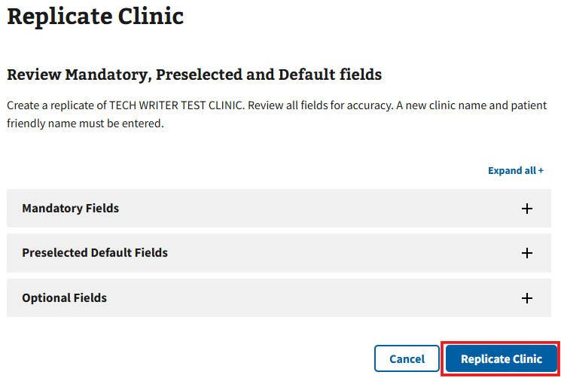
Figure 211: Replicate Clinic Button after Entering Required Information
- Note: Users will see the window shown below in ⁠⁠Figure 212⁠⁠, when selecting the “Replicate Clinic” button, if changes to the “Length of Appointment,” “Display Increments Per Hour,” or “Hour Clinic Display Begins” fields have been made. The user can either continue with replicating the clinic without timeslots included or close the window to edit the mentioned fields.
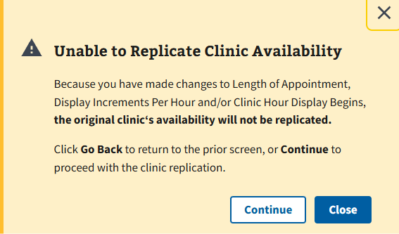
Figure 212: Unable to Replicate Clinic Availability Window
- After selecting “Replicate Clinic,” the user will see the pop-up seen in ⁠⁠⁠⁠⁠⁠Figure 213⁠⁠⁠⁠⁠⁠, where they can choose to either keep the original clinic or select a date of inactivation. The user will then need to select the “Continue” button to save changes.
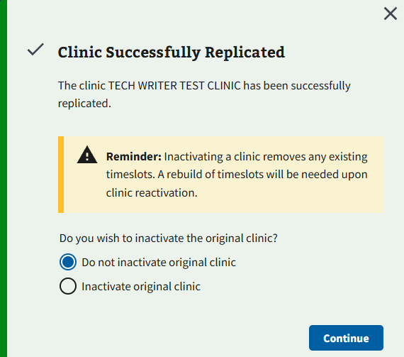
Figure 213: Clinic Successfully Replicated Window
- Note: The user must create a clinic before timeslots can be added or modified; this function cannot be done in the process of creation. After creating a replicate clinic, the UI will immediately take the user to the Edit Clinic Availability section to add or modify timeslots associated to the clinic. Please refer to the section ⁠⁠⁠⁠⁠⁠Editing Clinic Configurations⁠⁠⁠⁠⁠⁠ for guidance.

Clinic Audit Report
To access the Clinic Audit Report, the user will need to select the “Clinic Audit Report” tab seen in ⁠⁠Figure 214⁠⁠.
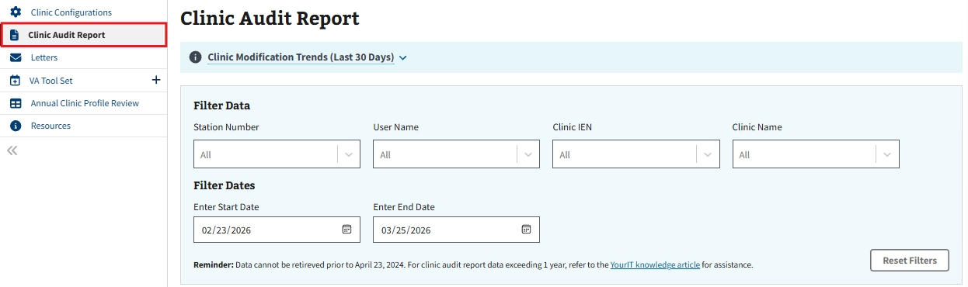
Figure 214: Clinic Audit Report Tab
- Note: Users will see the error in ⁠⁠⁠⁠⁠⁠Figure 1⁠⁠⁠⁠⁠⁠ if they do not have access to the page. Please see ⁠⁠⁠⁠⁠⁠1.2 Prerequisite Credentials⁠⁠⁠⁠⁠⁠ for more information.

5.1 Familiarizing Yourself with the Clinic Audit Report
Once log in is complete, users will see the CCM Clinic Audit Report page as seen in ⁠⁠⁠⁠⁠⁠Figure 215⁠⁠⁠⁠⁠⁠. The user will be able to access reports for both “Edit Clinic” and “Add Clinic” on this webpage. By default, all clinic profile information is shown within these grids until further filtered.
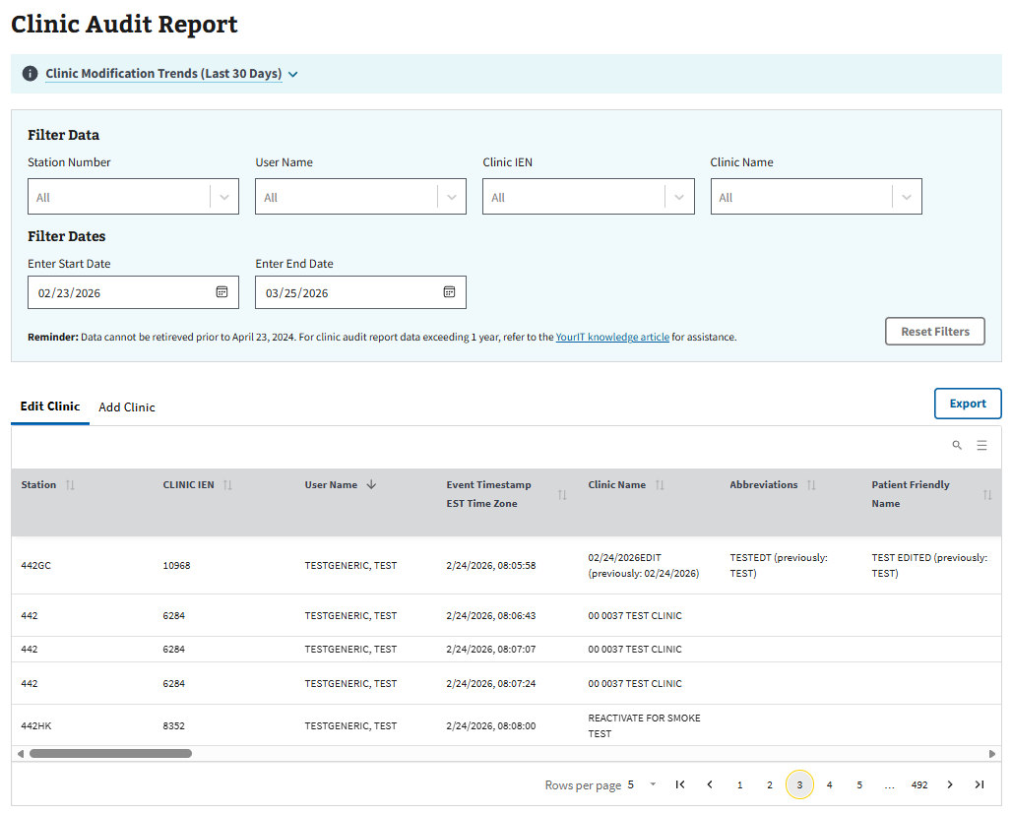
Figure 215: CCM Clinic Audit Report Homepage
- Note: When viewing entries in the Edit Clinic tab, data will only be shown to the user if the value has been changed. The report will have a blank value if there have been no changes to a clinic attribution or will show an “@” symbol if there was once data that has since been removed.
- Note: Users can expand the dropdown labeled “Clinic Modification Trends (Last 30 Days),” seen in ⁠⁠⁠⁠⁠⁠Figure 216⁠⁠⁠⁠⁠⁠ to see an overview of Clinic Modification Trends over the past 30 days.
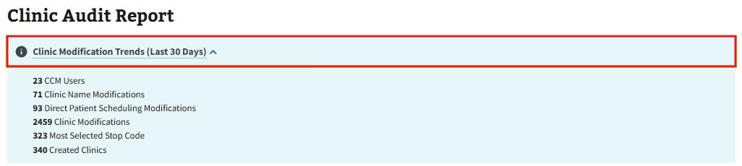
Figure 216: Clinic Modification Trends

5.2 Filtering Reports and Exporting Data

5.2.1 Filtering Results
Users have the ability to filter data for both the Edit Clinic and Add Clinic reports simultaneously by adjusting the filter options shown in ⁠⁠Figure 217⁠⁠.
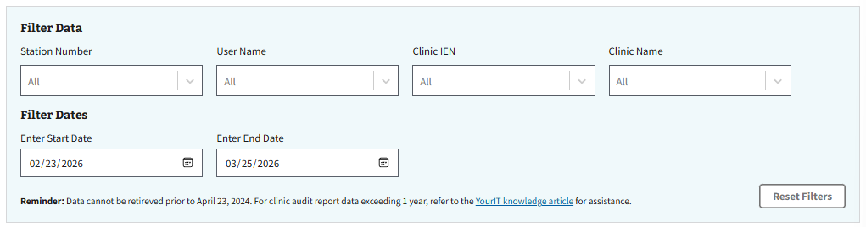
Figure 217: Filter Options
Only one option can be chosen within each of the filter selections at a time. Search results will continue to narrow down further as more of the filters are added. Once any filter is selected, the “Reset Filters” button will become selectable to give users the option to reset any filters that have been applied, as seen in ⁠⁠⁠⁠⁠⁠Figure 218⁠⁠⁠⁠⁠⁠. See the ⁠⁠⁠⁠⁠⁠Table 1⁠⁠⁠⁠⁠⁠ below for a brief description on what each filter does.
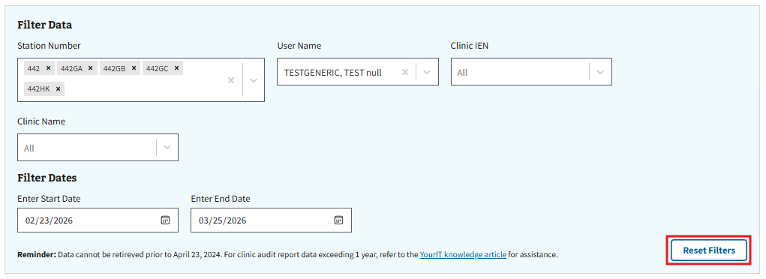
Figure 218: Reset Filters Button
Table 1: Filter Descriptions for Clinic Audit Report
Filter Name | Filter Descriptions
Station Number | Parent and child site numbers
Username | Name of the individual that made the edit or add
Clinic IEN | Clinic Internal Entry Number (referred to as the unique identifier for the clinic)
Clinic Name | Name of the clinic
Filter Dates | Ability to change the report start and end time

5.2.2 Filtering with Dropdowns
- To filter by dropdown, select any of the dropdown arrows located as seen in ⁠⁠⁠⁠⁠⁠Figure 219⁠⁠⁠⁠⁠⁠.
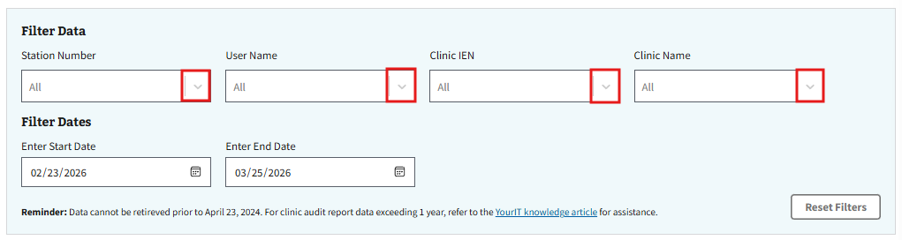
Figure 219: Example of Choosing Filter Selection
- The user will then select the preferred option from the available selection, shown in ⁠⁠⁠⁠⁠⁠Figure 220⁠⁠⁠⁠⁠⁠.
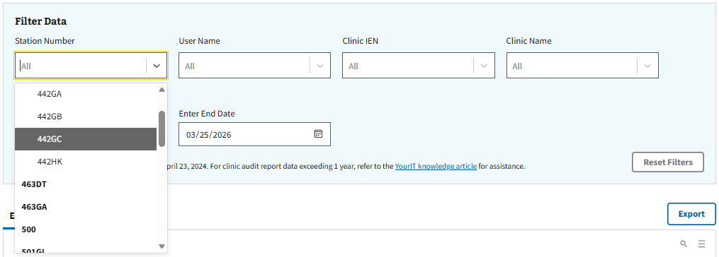
Figure 220: Example of Filter Selection Dropdown
- Once selected, search results within both Edit Clinic and Add Clinic tabs will automatically update. Users can choose to further narrow the report by selecting more filters.

5.2.3 Filtering by Date Range
- To filter by date range, the user will need to select the calendar button, shown below in ⁠⁠⁠⁠⁠⁠Figure 221⁠⁠⁠⁠⁠⁠, to choose a start date.
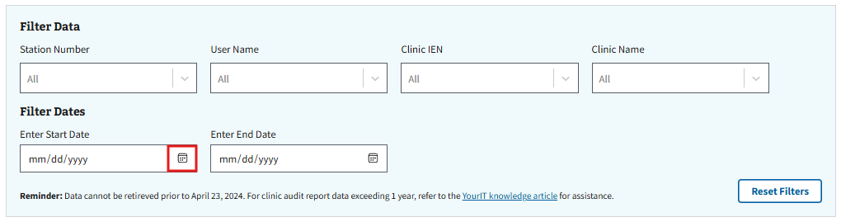
Figure 221: Calendar Button for Enter Start Date
- Users will then need to select the calendar button, shown below in ⁠⁠⁠⁠⁠⁠Figure 222⁠⁠⁠⁠⁠⁠, to choose an end date.
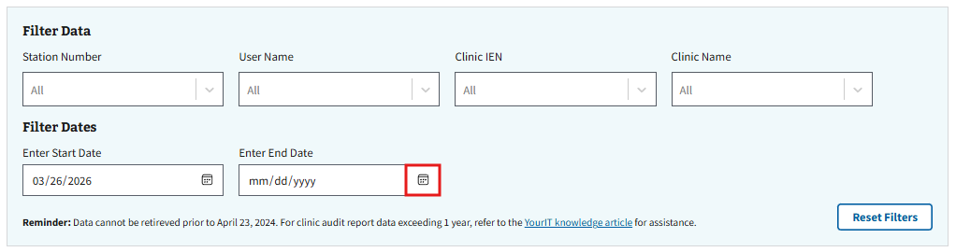
Figure 222: Calendar Button for Enter End Date
- Once selected, search results within both the Edit Clinic and Add Clinic tabs will automatically update. Users can choose to further narrow the report by selecting more filters.

5.3 Exporting Data
Users also have the ability to export data from either the Edit Clinic or Add Clinic tables into an excel document. To do so, select the “Export” button, shown in ⁠⁠⁠⁠⁠Figure 223⁠⁠⁠⁠⁠⁠, found above the table the user wishes to export. Once selected, the user will then need to follow the on-screen browser instructions to save and download the file to the computer.
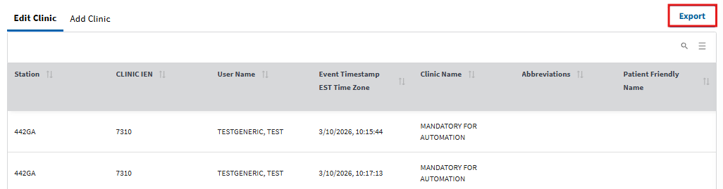
Figure 223: Export Button for Clinic Audit Report

Letters
Disclaimer: This section of the guide is only applicable to users with access permissions SDEDLET. If the user does not have elevated access permissions set to their VistA account, the user will only be able to search for existing letters as seen below in ⁠⁠Figure 224⁠⁠. If a user needs access to make changes on this application, please contact the local Clinical Applications Coordinator or Supervisor for assistance.
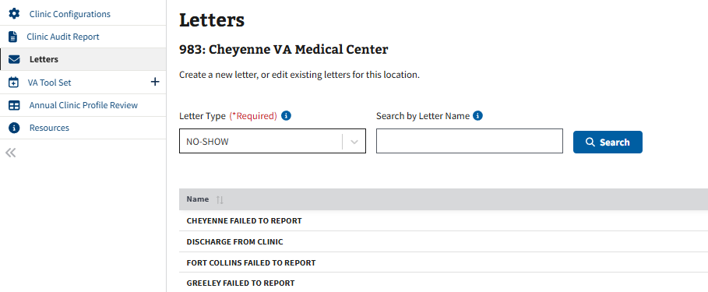
Figure 224: View Existing Letters

6.1 Create a Letter
- To create a new letter, the user will need to select the “Letters” tab shown below in ⁠⁠⁠⁠⁠⁠Figure 225⁠⁠⁠⁠⁠⁠ to be brought to the Letters page.
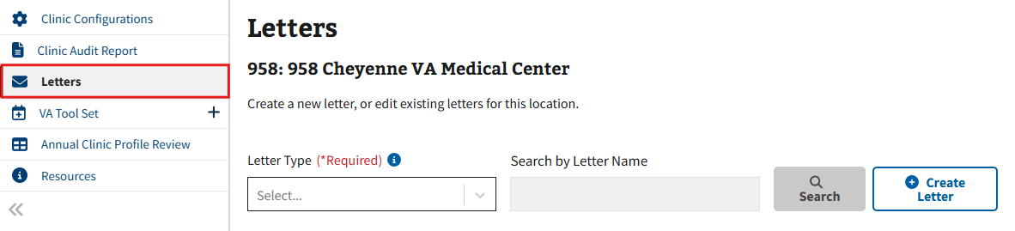
Figure 225: Letters Tab
- The user will then need to select the “Create Letter” button seen in ⁠⁠⁠⁠⁠Figure 226⁠⁠⁠⁠⁠⁠.
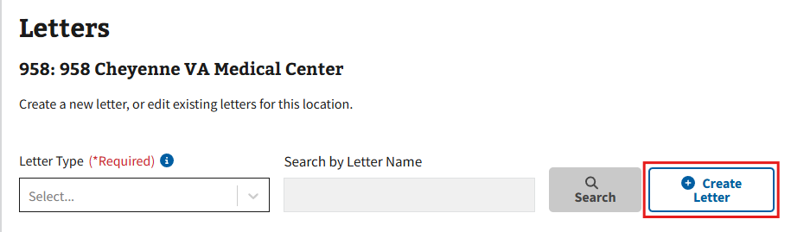
Figure 226: Create Letter Button on the Letters Page
- The Create New Letter page will then appear. Fill in all the required fields and select optional toggle boxes, as needed (See ⁠⁠Figure 227⁠⁠ for example).
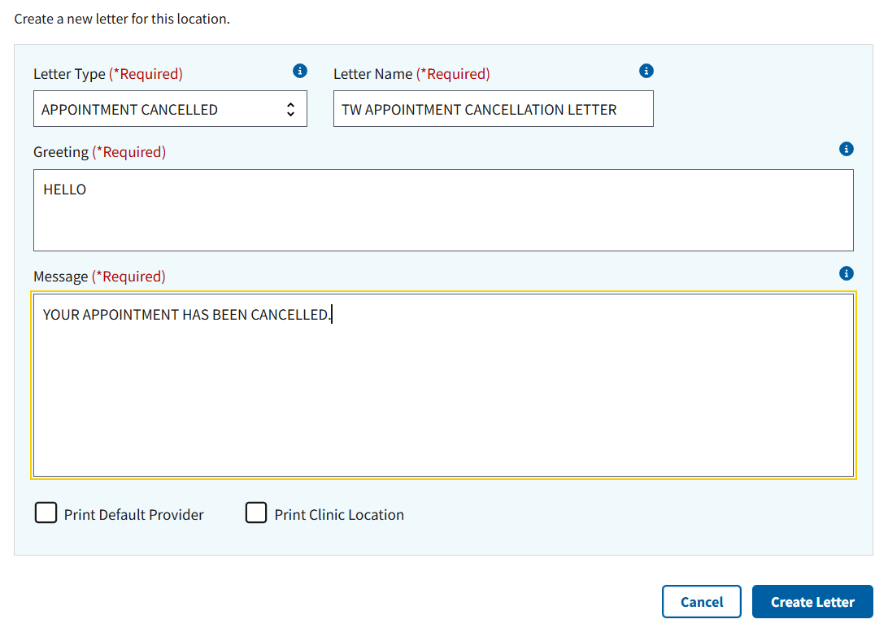
Figure 227: Example of Letter
- Once all the required fields have been filled out, the user will need to select the “Create Letter” button, shown in ⁠⁠⁠⁠⁠⁠Figure 228⁠⁠⁠⁠⁠⁠, to create the letter.
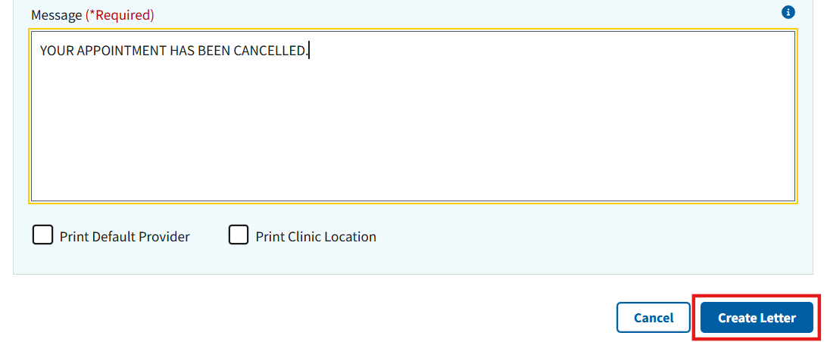
Figure 228: Create Letter Button on the Create New Letter Page

6.2 View a Letter
- To view a letter, the user will need to search for an existing letter by selecting the letter type of the original letter. Optionally, the user can use the “Search by Letter Name” function (case sensitive) to further narrow the results. After inputting the necessary information, the user will need to select the “Search” button, shown below in ⁠⁠Figure 229⁠⁠.
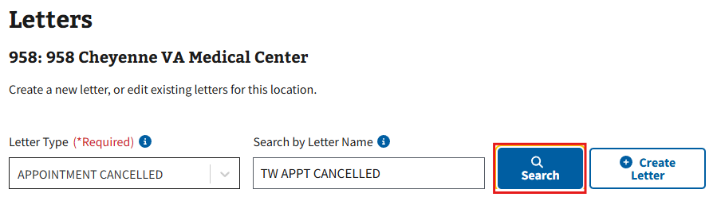
Figure 229: Search Button for Viewing Letters
- All existing letters that match the search criteria will appear. The user will need to select the ellipsis next to the desired letter and then select the “View Letter” option seen in ⁠⁠Figure 230⁠⁠.
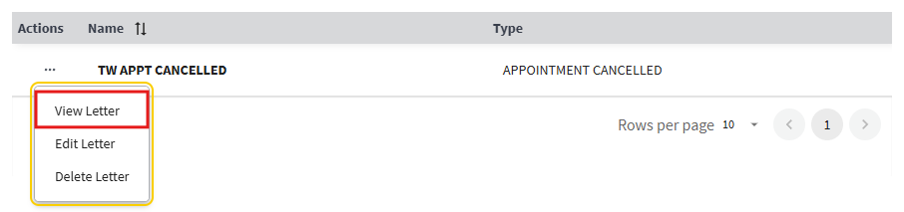
Figure 230: View Letter Button from Action Menu
- The View Letter page will appear with a preview of the chosen letter (see ⁠⁠Figure 231⁠⁠ for example). From here, the user can choose to select the “Edit Letter” button, if needed, to be directed to the Edit Letter page. If no edits need to be made, the user can select the “Close” button to continue viewing other letter options.
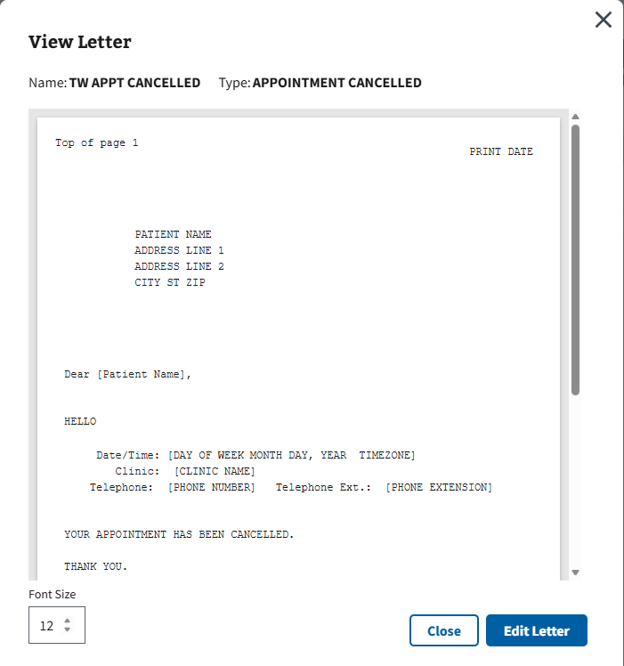
Figure 231: View Letter Page Example

6.3 Edit a Letter
- To edit a letter, the user will need to search for an existing letter by selecting the letter type of the original letter that needs modification. Optionally, the user can use the “Search by Letter Name” function (case sensitive) to further narrow the results. After inputting the necessary information, the user will need to select the “Search” button, shown below in ⁠⁠Figure 232⁠⁠.
Figure 232: Search Button for Editing Letters
- All existing letters that match the search criteria will appear. The user will need to select the ellipsis next to the letter that needs to be edited and then select the “Edit Letter” option seen in ⁠⁠Figure 233⁠⁠.
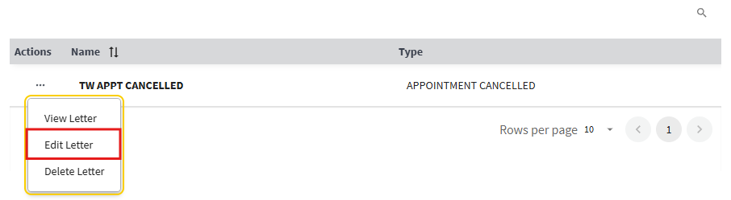
Figure 233: Edit Letter Button from the Action Menu
- The Edit Letter page will appear (see ⁠⁠Figure 234⁠⁠ for example) where users will need to make minimum of one edit to continue.
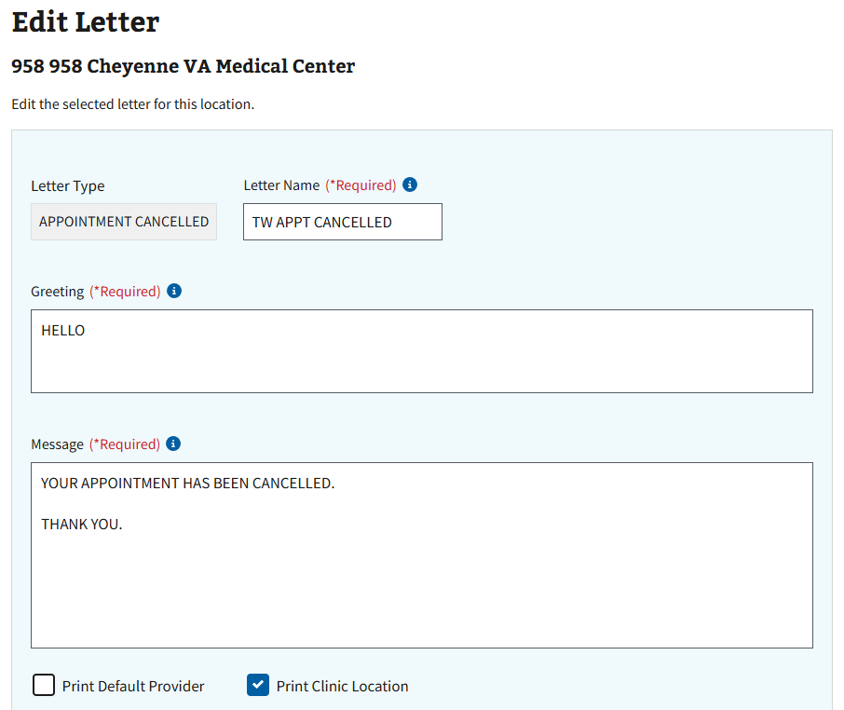
Figure 234: Edit Letter Page
- Once all edits have been made, the user will select the “Save Changes” button shown in ⁠⁠Figure 235⁠⁠ to save all changes.
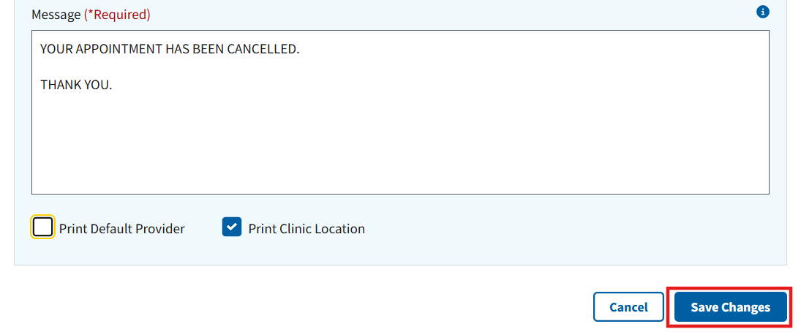
Figure 235: Save Changes Button for Edit Letter Page

6.4 Delete a Letter
- To delete a letter, the user will need to search for an existing letter by selecting the letter type of the original letter that needs to be deleted. Optionally, the user can use the “Search by Letter Name” function (case sensitive) to further narrow the results. After inputting the necessary information, the user will need to select the “Search” button, shown below in ⁠⁠Figure 236⁠⁠.
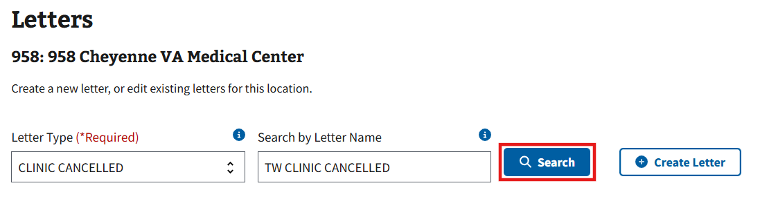
Figure 236: Search Button for Deleting Letters
- All existing letters that match the search criteria will appear. The user will need to select the ellipsis next to the letter that needs to be deleted and then select the “Delete Letter” option, shown in ⁠⁠Figure 237⁠⁠.
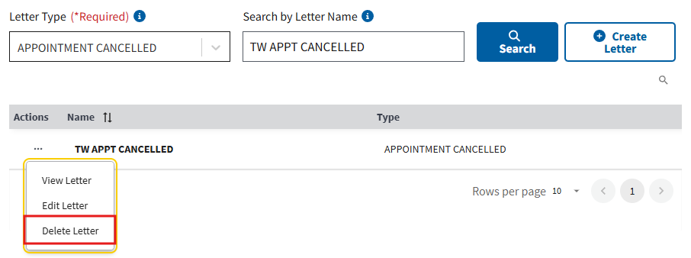
Figure 237: Delete Letter Button from the Action Menu
- The Delete Letter window will appear. The user will need to select the “Delete Letter” button, shown below in ⁠⁠Figure 238⁠⁠, to delete the letter.
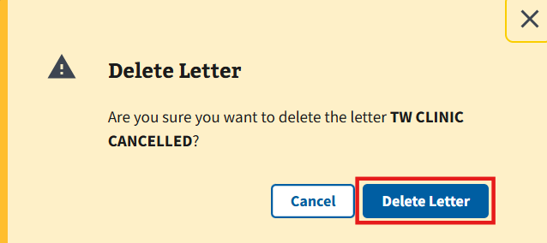
Figure 238: Delete Letter Button

VA Tool Set
To access the pages within VA Tool Set, select the “+” shown below in ⁠⁠Figure 239⁠⁠. Afterwards, the accordion view shown in ⁠⁠Figure 240⁠⁠ will appear.
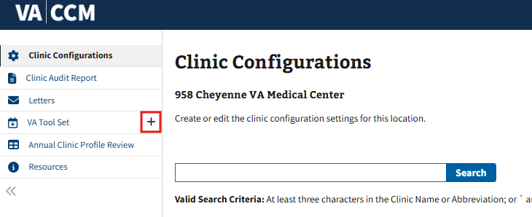
Figure 239: VA Tool Set Tab
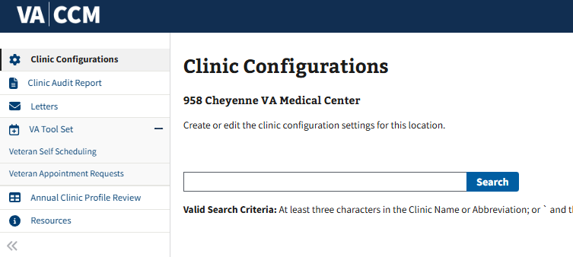
Figure 240: VA Tool Set Accordion View

7.1 Veteran Self Scheduling
Within the Veteran Self Scheduling tab, users can search and view Veteran Self Scheduling for a specific clinic. In addition to these capabilities, users with the correct edit permissions are able to edit in Veteran Self Scheduling. Please note that services vary depending on location.

7.1.1 View Veteran Self Scheduling
- Select the tab labeled “Veteran Self Scheduling” shown below in ⁠⁠Figure 241⁠⁠ to be directed to the Veteran Self Scheduling page.
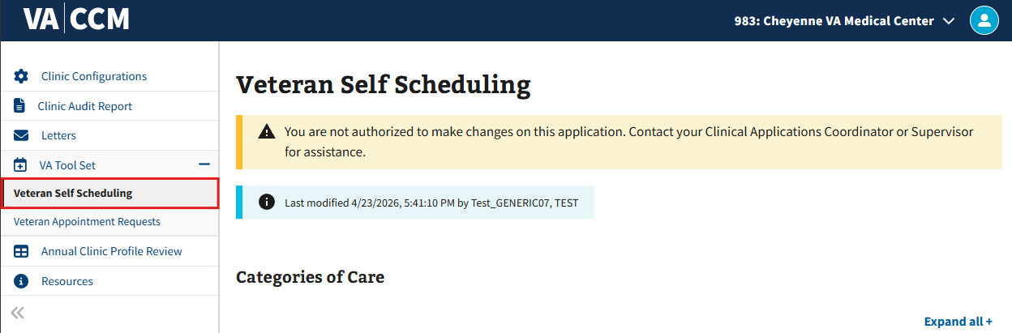
Figure 241: Viewing Veteran Self Scheduling
- Select the “+” shown in ⁠⁠Figure 242⁠⁠ to expand the pinned services accordion. Afterwards, the accordion view shown in ⁠⁠Figure 243⁠⁠ will appear.
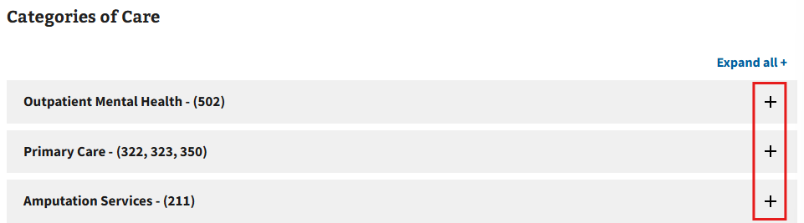
Figure 242: Pinned Services Button for Viewing VA Self Scheduling
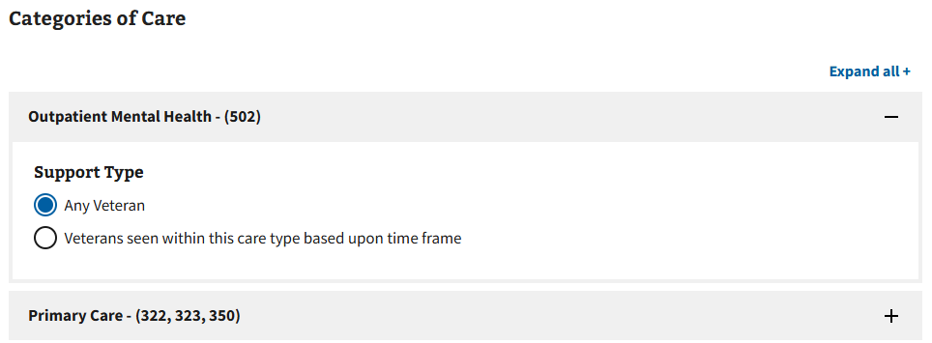
Figure 243: Expanded Accordions of Viewing VA Self Scheduling Settings

7.1.2 Edit Veteran Self Scheduling
Disclaimer: This section of the guide is only applicable to users with the correct write access permissions. If the user does not have write access permissions set to the account, the user will receive the error message shown in ⁠⁠Figure 244⁠⁠. If a user needs access to make changes on this application, please contact the local Clinical Applications Coordinator or Supervisor for assistance.
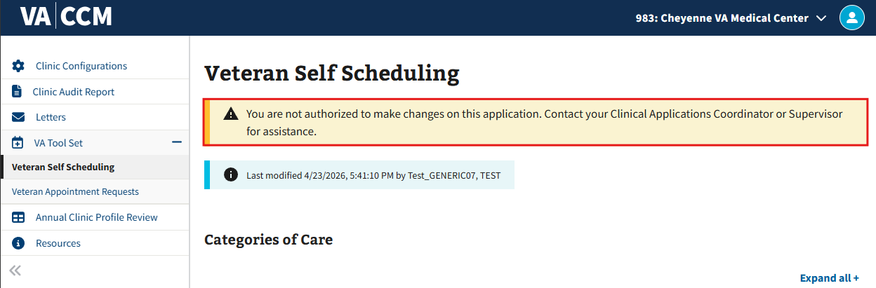
Figure 244: Authorization Error Message for VA Self Scheduling Settings
- Select the tab labeled “Veteran Self Scheduling” shown below in ⁠⁠Figure 245⁠⁠ to be directed to the Veteran Self Scheduling page.
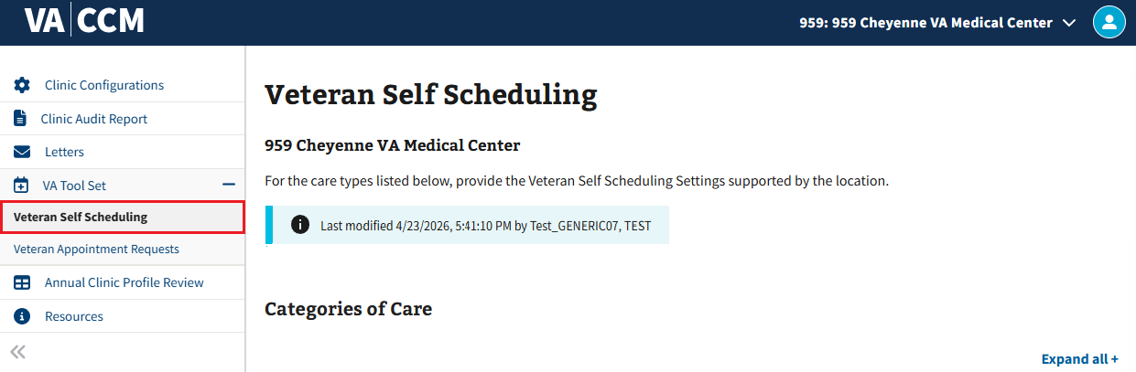
Figure 245: Editing Veteran Self Scheduling
- Select the “+” shown in ⁠⁠Figure 246⁠⁠ to expand the pinned services accordion. Afterwards, the accordion shown in ⁠⁠Figure 247⁠⁠ will appear where the user will be able to edit selections.
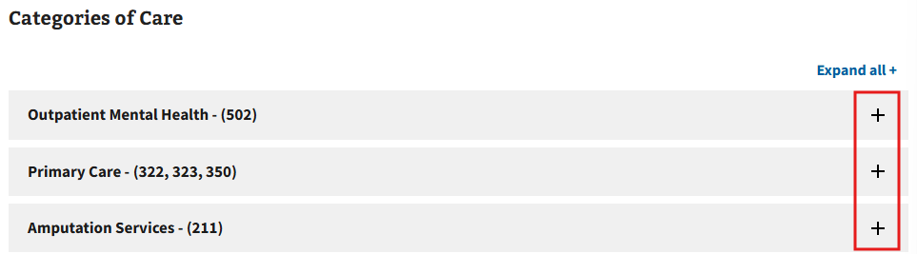
Figure 246: Pinned Services Button for Editing VA Self Scheduling
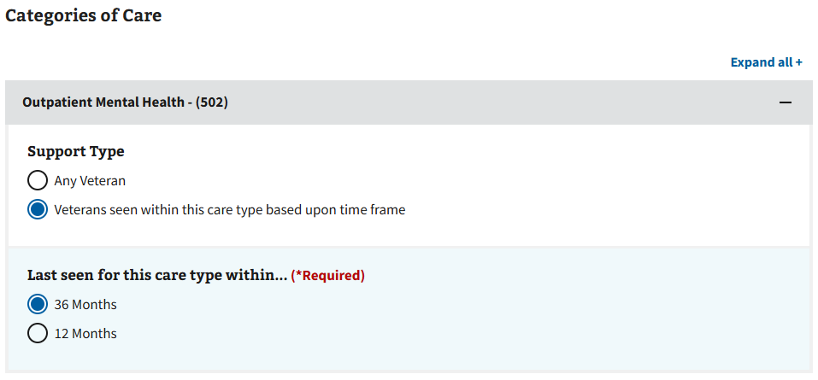
Figure 247: Accordion View of Editing VA Self Scheduling Settings
- After making necessary changes, select the save button shown in ⁠⁠Figure 248⁠⁠.
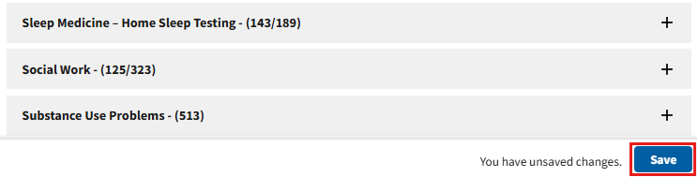
Figure 248: Save Button for VA Self Scheduling Settings
- Note: The “Save” button only becomes available in the bottom right-hand corner on the VA Self Scheduling page when a minimum of one change has been made; if no change is made, the “Save” button as seen in ⁠⁠Figure 248⁠⁠ will not appear.
- Note: Some but not all fields have a mandatory (*Required) field which needs to be populated before saving. If a user tries to save without selecting a mandatory (*Required) field, they will receive the error message shown in ⁠⁠Figure 249⁠⁠.
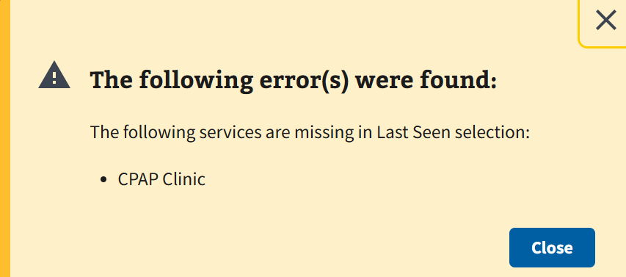
Figure 249: Error Field for Saving in VA Self Scheduling
- Once the save is complete, the user should select “Continue” from the pop-up window shown below in ⁠⁠Figure 250⁠⁠.
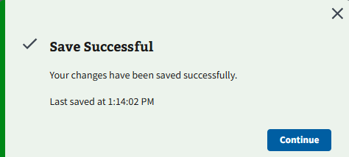
Figure 250: Saving in VA Self Scheduling
- A timestamp will then be presented to the user, which details the date of the last modification(s) and the name of the person who had last modified shown in ⁠⁠Figure 251⁠⁠.
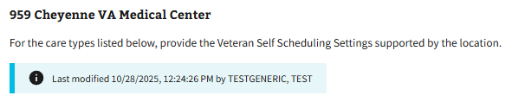
Figure 251: Time Stamp after Saving in VA Self Scheduling

7.2 Veteran Appointment Requests
Within the Veteran Appointment Requests tab, users can search and view Veteran Appointment Requests for a specific clinic. In addition to these capabilities, users with the correct edit permissions are able to edit Veteran Appointment Requests. Please note that services vary depending on location.

7.2.1 View Veteran Appointment Requests
- Select the tab labeled “Veteran Appointment Requests” shown below in ⁠⁠Figure 252⁠⁠ to be directed to the Veteran appointment requests page.

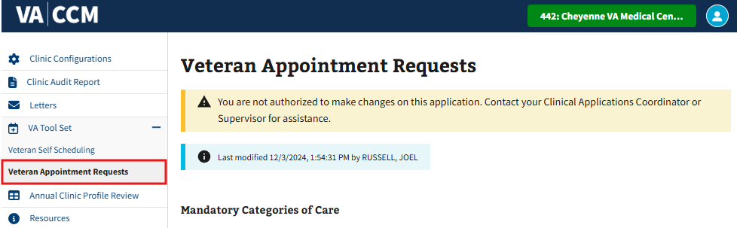
Figure 252: Viewing Veteran Appointment Requests
- Select the “+” shown in ⁠⁠Figure 253⁠⁠ to expand the pinned services accordion. Afterwards, the accordion view shown in ⁠⁠Figure 254⁠⁠ will appear.
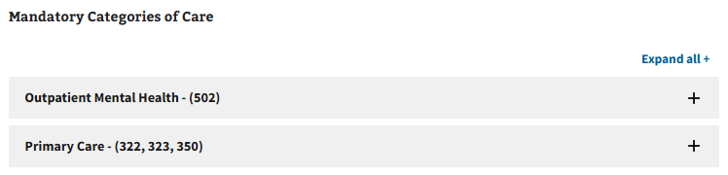
Figure 253: Pinned Services Button for Viewing VA Appointment Requests
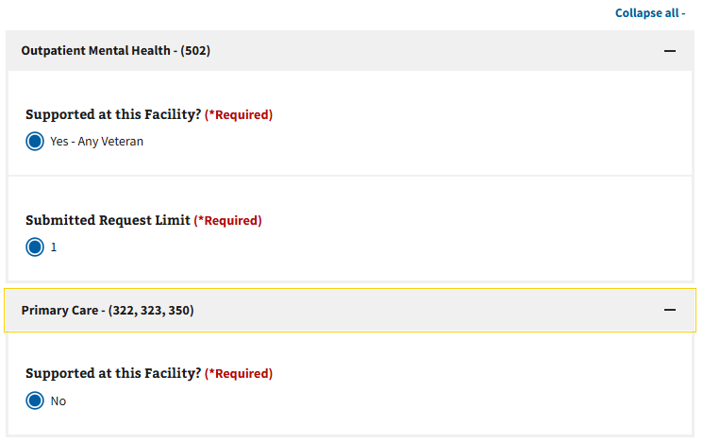
Figure 254: Expanded Accordions of Viewing VA Appointment Requests

7.2.2 Edit Veteran Appointment Requests
Disclaimer: This section of the guide is only applicable to users with the correct write access permissions. If the user does not have write access permissions set to the account, the user will receive the error message shown in ⁠⁠Figure 255⁠⁠. If a user needs access to make changes on this application, please contact the local Clinical Applications Coordinator or Supervisor for assistance.
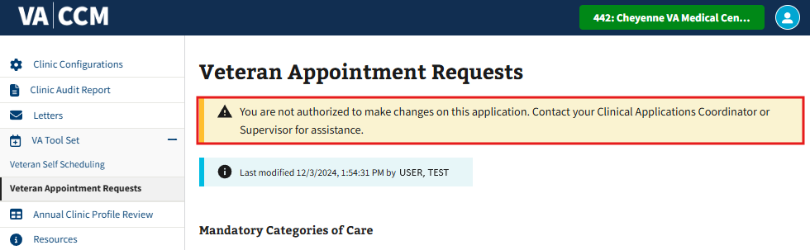
Figure 255: Authorization Error Message for VA Appointment Requests Settings
- Select the tab labeled “Veteran Appointment Requests” shown below in ⁠⁠Figure 256⁠⁠ to be directed to the Veteran appointment requests page.
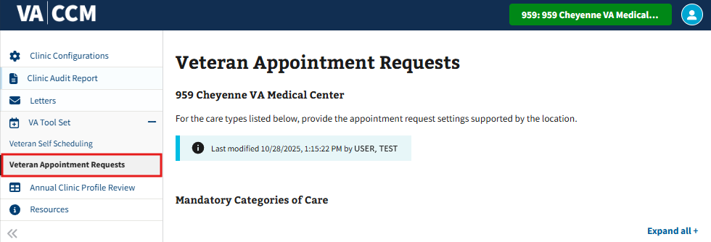
Figure 256: Veteran Appointment Requests Tab
- Select the “+” shown in ⁠⁠Figure 257⁠⁠ to expand the pinned services accordion. Afterwards, the accordion shown in ⁠⁠Figure 258⁠⁠ will appear where the user will be able to edit selections.

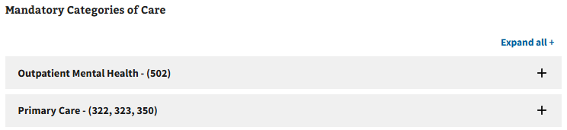
Figure 257: Pinned Services Button for VA Appointment Requests
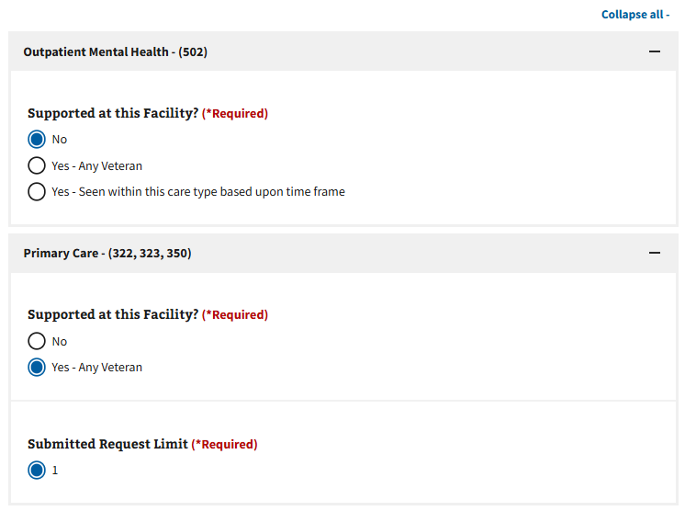
Figure 258: Accordion View of VA Appointment Requests
- After making necessary changes, select the save button shown in ⁠⁠Figure 259⁠⁠.
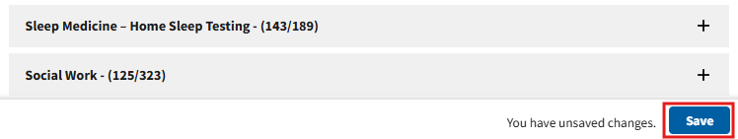
Figure 259: Save Button for VA Appointment Requests Settings
- Note: The “Save” button only becomes available in the bottom right-hand corner on the Veteran Appointment Requests page when a minimum of one change has been made. If no change is made, the “Save” button as seen in ⁠⁠Figure 259⁠⁠ will not appear.
- Note: Some but not all fields are mandatory (*Required) and need to be populated before saving. If a user tries to save without populating a mandatory (*Required) field, the user will receive the error message shown in ⁠⁠Figure 260⁠⁠.
Figure 260: Error Field for Saving in VA Appointment Requests
- Once the save is complete, the user should select “Continue” from the pop-up window shown below in ⁠⁠Figure 261⁠⁠.
Figure 261: Saving in VA Appointment Requests
- A timestamp will then be presented to the user, which details the date of the last modification(s) and the name of the person who had last modified shown below in ⁠⁠Figure 262⁠⁠.
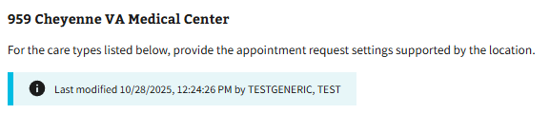
Figure 262: Time Stamp after Saving in VA Appointment Requests

Annual Clinic Profile Review
- The Annual Clinic Profile Review page can be navigated to by selecting the Annual Clinic Profile Review tab shown in ⁠⁠Figure 263⁠⁠.
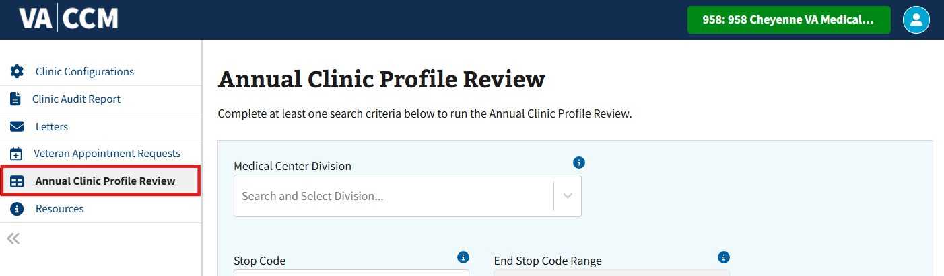
Figure 263: Annual Clinic Profile Review Tab
- Users will need to complete at least one of the search criteria to select the “Run Report” button seen in ⁠⁠Figure 264⁠⁠.
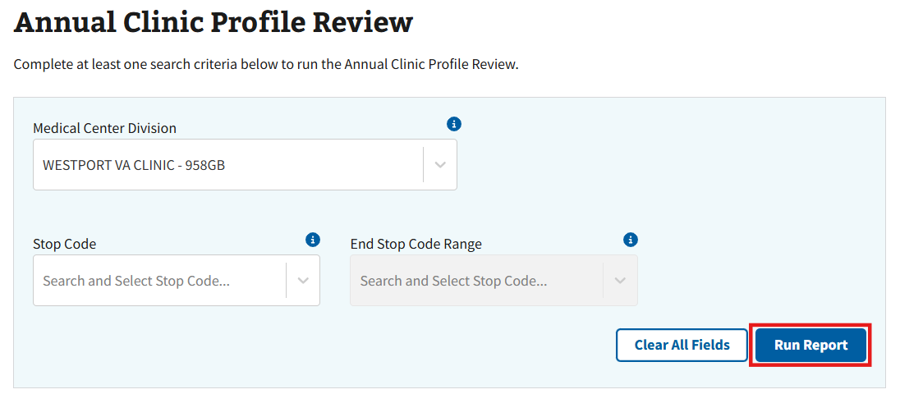
Figure 264: Run Report Button for Annual Clinic Profile Review
- Note: CCM will only return active clinics. Clinics that have been inactivated will not be included in the report.
- Once the report has been run and valid results appear, the Clinic Profile Review Successful message will appear. Users will then select the “Click to download Clinic Profile Review” button, shown in ⁠⁠Figure 265⁠⁠.
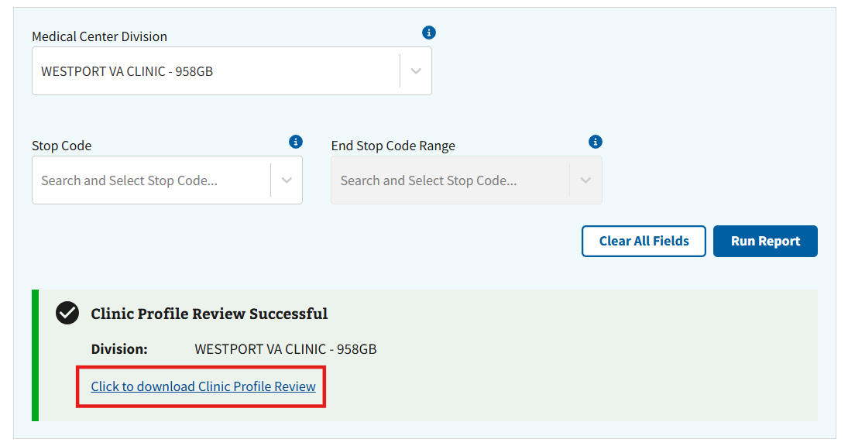
Figure 265: Download Link for Annual Clinic Profile Review
- Note: If the user tries to search for a clinic with no available results, the error message shown in ⁠⁠Figure 266⁠⁠ will appear.
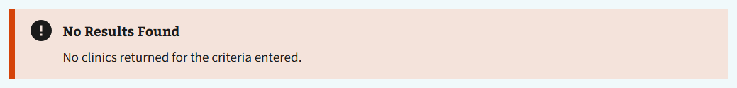
Figure 266: No Results Found Notification for Annual Clinic Profile Review
- Once selected, the user will need to follow the on-screen browser instructions to save and download the file to the computer.
- Note: If the user needs more information regarding annual clinic profile reviews, please select the Annual Clinic Profile Review button shown below in ⁠⁠Figure 267⁠⁠.
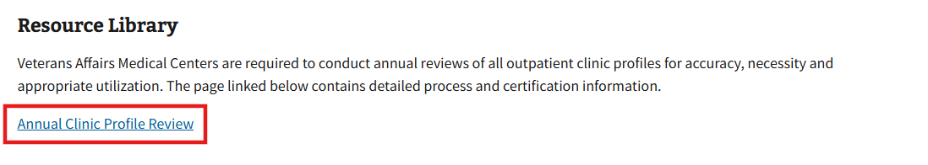
Figure 267: Resource Information Link for Annual Clinic Profile Review

References

9.1 Additional Features and Options for CCM-UI
- Users can stay in their existing browser session to view and/or change their Site or Divisions that they are provisioned to. There is no need to log out and log back in every time.
- Job Guide/pdf link for new user orientation.
- Link to Clinic Profile Management Business Rules.
- Help desk contact info if users need assistance with the new CCM-UI application:
- YourIT Service Portal
- VA Help Desk: 855-673-4357
- TTY: 844-224-6186
- Veterans Crisis Hotline: 800-273-8255

9.2 Tool Tip Descriptions
Table 2: Tool Tip Descriptions
Field Name | Tool Tip Info | Section
Clinic Name (*Required) | Examples: SGV-PACT BLUE TEAM 1 PA or MIA/CVT DERMATOLOGY PRO | Mandatory
Patient Friendly Name (*Required) | Example: MOREHEAD VA VIDEO CONNECT PACT 3 DOCTOR SMITH | Mandatory
Stop Code (Primary)(*Required) | Three digit stop code number assigned to specific location. Each stop code number represents a type of care or Service/treating specialty (clinics only). Example: 001 - 999 Please confirm with your MCA Representative on using the correct stop code. | Mandatory
Medical Center Division (*Required) | Division name assigned to each entry in this file to identify where the specific location is. Only one division per location. | Mandatory
Select Provider(s) (*Required) | Provider must be active and have an active entry in the NEW PERSON file for PERSON CLASS | Mandatory
Length of Appointments (*Required) | Length of appointment designated for clinic. Type a whole number between 10 and 240 - must be a multiple of 10 or 15. | Mandatory
Telephone (*Required) | Example: 303-555-1212 or 303 555 1212 | Mandatory
Telephone Extension (*Required) | Example: 542. If no extension is available, use N/A or n/a | Mandatory
Physical Location (*Required) | Where the Veteran will check-in for an appointment. Limit 25 characters. If the location does not require the patient to travel to a VA facility for the appointments, the service must ensure that the location reflects PHONE for telephone appointments and VIDEO CONNECT for VA connect appoints within all reminders (Pre-Appointment Letters, VEText, AudioCare) | Mandatory
Clinic meets at this facility? | Enter YES unless non-VA care | Preselected Default
Allow Direct Patient Scheduling? | This field will determine if patients can self-schedule into this clinic. A "Yes" in this field will enable patients to directly schedule appointments into this clinic. Default selection is set to Yes. | Preselected Default
Non-count Clinic? | Is this clinic to be a non-count clinic for workload purposes? OR are visits to this clinic to be included in workload statistics? Default selection is set to Yes | Preselected Default
Variable Appointment Length? | Does the clinic have variable appointment lengths? If length of appointment is 10 minutes, can user make longer appointments in increments of 10 minutes when scheduling appointment? | Preselected Default
Display Appointments to Patients? | The Office of Community Care recommends that all appointments are viewable to our Veterans. Allows patients to view appointments in My HealtheVet and VA Online Scheduling. Default selection is set to Yes' | Preselected Default
Schedule on Holidays? | Should the user be able to schedule appointments on holidays for this location? | Preselected Default
Hour Clinic Display Begins | The hour clinic will begin displaying availability (e.g. 8 AM) | Preselected Default
Default Appointment Type | The default or usual appointment type to be associated with this clinic | Preselected Default
Max Days for Future Booking | Maximum number of days that can be available when clerk searching for open clinic slots in the future. Allows for 11 to 999 days in advance for future bookings. | Preselected Default
Display Increments Per Hour | Select the increment that best fits the length of appointment. Choose from: 60-Min; 30-Min; 15-Min; 20-Min; 10-Min. | Preselected Default
Overbooks Per Day Maximum | Number of allowable overbooks per day. If overbooks are not allowed, the number should be set to zero. Only Numeric values of 0 to 9999 are only allowed. | Preselected Default
Pre-Checkin Allowed? | This field will determine if PRE-Checkin is allowed for this clinic | Preselected Default
E-Checkin Allowed? | This field will determine if E-Checkin is allowed for the clinic. | Preselected Default
Administer Inpatient Meds? | This field should contain a YES only if the clinic location is authorized to dispense inpatient medications to outpatients. | Preselected Default
Workload Validation at Check Out? | Yes or 1 will result in a validation being performed on each checked out encounter for this clinic. No or zero will stop the validation of the encounters as they are checked out for this clinic. This validation is to help ensure that the workload data is acceptable to the Austin National Patient Care Database. | Preselected Default
Service Code | Enter the Service Line. Example would be Medicine, Surgery, etc. | Preselected Default
Abbreviations | Consistency will help schedulers have easy access to the clinic. Example: Community Care clinics must enter abbreviation COMCARE. This will be utilized for reporting. | Optional
Credit Stop Code (Secondary) | Enter the Stop Code which should be credited for an appointment to this clinic (only if Code different than the one assigned to this clinic). Appointments to this clinic will receive this stop code credit in addition to the 'normal' stop code credit if a stop code different from the 'normal' stop code for this clinic is entered here. Example: 001 - 999 | Optional
Select Default Provider | Please select one default for Provider | Optional
Clinic Cancellation Letter | Enter the clinic cancellation letter to be associated with this clinic, so if clinic is cancelled, this letter will print as opposed to generic clinic cancellation letter. | Optional
No Show Letter | Enter the no-show letter to be associated with this clinic, so if patient does not show for appointment, this specific no-show letter will print as opposed to the generic no-show letter. | Optional
Pre-Appointment Letter | Enter the pre-appointment letter to be associated with this clinic, so if letters are generated, this specific pre-appointment letter will print as opposed to the generic pre-appointment letter | Optional
Appointment Cancellation Letter | Enter appointment cancellation letter to be associated with this clinic, so if veteran cancels appointment, this letter will print as opposed to generic appointment cancellation letter. | Optional
Special Instructions | Special instructions (free text) entered by clerk at time of making the appointment. If you have new instructions, please remove the old ones. It is preferable to keep this as short and simple as possible. Example instructions: SCHEDULE CONSULTS IN PM, FOLLOW-UPS IN AM. | Optional
Prohibit Access to Clinic? | Should only privileged users have access to book to this clinic? | Optional
Add/Remove Privileged User(s) (*Required) | Current list shows existing Privileged Users associated to this facility/clinic. Please select a name to remove any users from current list. | Optional
Select Day of Week (*Required) | Select week for date range from Sunday through Saturday to view Timeslots of the week. | Clinic Configuration Clinic Availability accordion panel
Single Day | Single Day allows new timeslot entries that will not repeat. Can add multiple entries for that day. | Add/Modify Timeslot Modal
Indefinite | Indefinite allows new timeslot entries that will repeat indefinitely until new timeslots overwrite any pre-existing entries. Can add multiple entries for that day. | Add/Modify Timeslot Modal
Multi-select | Multi-Select allows timeslot entries associated to that day to repeat in multiple weeks as needed. Can add multiple entries for that day. | Add/Modify Timeslot Modal

9.3 Additional Help with Errors

9.3.1 Connection Issues Error
If users receive the 500 Error Message seen below in ⁠⁠Figure 268⁠⁠, please contact IT Support. Go to YourIT Service Portal to open a new ticket or view existing service tickets.
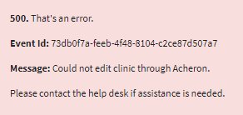
Figure 268: 500 Error Message for Connection
Possible Root Cause: An API connection to the database is down or impaired.
Additional Resources:
- VA Help Desk: 855-673-4357
- TTY: 844-224-6186

9.3.2 Server Issue Error
If users receive the 500 Error Message seen below in ⁠⁠Figure 269⁠⁠, please contact IT support. Go to YourIT Service Portal to open a new ticket or view existing service tickets.
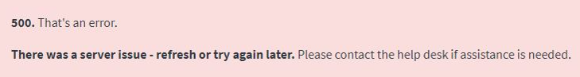
Figure 269: 500 Error Message for Server Issues
Possible Root Cause: Possible recent server reboot. Please select your browser refresh and try again. If the issue persists, please contact your IT support.
Additional Resources:
- VA Help Desk: 855-673-4357
- TTY: 844-224-6186

