Integrated Scheduling Solution (ISS)
Common Questions
for ISS Release 1.37.0


June 2026
Version 1.0
Department of Veterans Affairs

Revision History
Date | Version | Description | Author
6/1/2026 | 1.0 | Finalized Version | Booz Allen Hamilton
5/28/2026 | 0.1 | Baseline for ISS 1.37.0 | Booz Allen Hamilton

Table of Contents
1. Introduction 1
1.1. Purpose 1
2. FAQ 1
2.1. Errors 1
2.1.1. SSOi Login Error 1
2.1.2. JWT Error 1
2.1.3. Internal Server Error 2
2.1.4. No VistA Sites Linked to User Account Error 2
2.1.5. Service Error 3

Introduction
The Integrated Scheduling Solution (ISS) is a web version of the VistA Scheduling Enhancements (VSE) GUI, utilizing the JavaScript React framework and providing equivalent appointment management functions used in the original application. The purpose of ISS is to deliver users with a modernized look and feel while reducing operating costs and improving operational efficiencies.

Purpose
The purpose of this document is to provide possible answers to common questions about the Integrated Scheduling Solution (ISS) application.

FAQ

Errors

SSOi Login Error
If users receive the SSOi error message seen below in ⁠Figure 1⁠, please refresh the page. If problems persist, please contact IT support. Go to YourIT Service Portal to open a new ticket or view existing service tickets.
Figure 1: SSOi Login Error
Possible Root Cause: Various SSOi issues – either a service outage for SSOi or malformed token, etc.
Additional Resources:
- VA Help Desk: 855-673-4357
- TTY: 844-224-6186

JWT Error
If users receive the JWT error message seen below in ⁠Figure 2⁠, please refresh the page. If problems persist, please contact IT support. Go to YourIT Service Portal to open a new ticket or view existing service tickets.
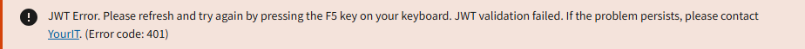
Figure 2: JWT Error
Possible Root Cause: Similar SSOi issues, but related specifically to the JWT – unable to retrieve, bad formatting, etc.
Additional Resources:
- VA Help Desk: 855-673-4357
- TTY: 844-224-6186

Internal Server Error
If users receive the 503 error message seen below in ⁠Figure 3⁠, please refresh the page. If problems persist, please contact IT support. Go to YourIT Service Portal to open a new ticket or view existing service tickets.
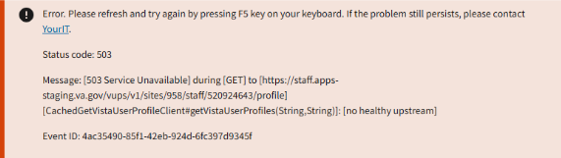
Figure 3: Internal Service Error
Possible Root Cause: 500 error codes are generic – the message itself will vary depending on which endpoint presents the 500 error. Status code will also change, depending.
Additional Resources:
- VA Help Desk: 855-673-4357
- TTY: 844-224-6186

No VistA Sites Linked to User Account Error
If users receive the error message seen below in ⁠Figure 4⁠, please go to the Identity Management Toolkit to link needed VistA sites to your account.
Figure 4: No VistA Sites Linked to Account Error
Possible Root Cause: User has a valid JWT, but no sites are linked to their PIV.
Additional Resources:
- YourIT Knowledge Article
- VA Help Desk: 855-673-4357
- TTY: 844-224-6186

Service Error
If users receive a 400 error message like the one seen below in ⁠Figure 5⁠, please try the action again. If problems persist, please contact IT support. Go to YourIT Service Portal to open a new ticket or view existing service tickets.
Figure 5: Service Error
Possible Root Cause: 400 error codes are generic – the message itself will vary depending on which endpoint presents the 400 error.
Additional Resources:
- VA Help Desk: 855-673-4357
- TTY: 844-224-6186

