OFFICE OF
INFORMATION
AND TECHNOLOGY

Integrated Scheduling Solution
User Guide

Version 1.41.0 | July 2026

Table of Contents
1. Introduction 14
1.1 Overview 14
1.2 Prerequisite Credentials 14
1.3 PIV Login 15
2. Familiarizing Yourself with ISS 16
2.1 Home Page 16
2.1.1 Changing Site Locations 16
2.1.2 Veteran Requests Report 18
2.1.3 CCST 19
2.1.4 Additional Links 20
2.2 My Account 20
2.2.1 User Preferences 20
2.2.2 Logging Out of ISS 24
2.3 Filters 26
2.3.1 Column Order 26
2.3.2 Sort by Ascending and Descending 26
2.3.3 Toggle Density 28
2.3.4 Show, Hide, and Search Filters 29
2.3.5 Filtering Rows 31
2.3.6 Reset Filters 32
2.3.7 Refresh Table 32
2.3.8 Filtering & Navigating on Calendar 32
2.3.9 Pending Appointments & Appointment History 35
3. Patient Overview 36
3.1 Patient Search 36
3.2 Patient Profile Home 38
3.3 Appointments & Requests 38
3.4 Demographics 39
3.4.1 Demographics Banner 42
3.4.2 Temporary Address 44
3.5 Patient Inquiry 46
3.6 Medication 47
3.7 Contact History 47
4. Patient Appointments and Requests 48
4.1 Creating Appointment Requests 49
4.1.1 APPT 49
4.1.2 PtCSch (Recall) 51
4.1.3 MRTC 54
4.1.4 Consult/Procedure 57
4.1.5 RTC 58
4.1.6 VETERAN 58
4.1.7 Dispositioning Duplicate Clinic Requests 59
4.1.8 Dispositioning Duplicate Service Requests 60
4.2 Appointment Request Actions 62
4.2.1 Viewing Appointment Requests 62
4.2.2 Editing Appointment Requests 63
4.2.3 Contact Attempts 66
4.2.4 Disposition an APPT, RTC, or VETERAN Request 69
4.2.5 Disposition a PtCSch Request 71
4.2.6 Disposition an MRTC Parent Request 73
4.2.7 Disposition an MRTC Child Request 75
4.3 Creating a Pending Appointment 77
4.3.1 APPT 77
4.3.2 PtCSch (Recall) 80
4.3.3 MRTC 83
4.3.4 Consult/Procedure 88
4.3.5 RTC 91
4.3.6 VETERAN 95
4.3.7 Overbooking an Appointment 99
4.3.8 MISSION Act 100
4.3.9 Clinic Stop Code 100
4.3.10 Patient Conflicts 100
4.4 Appointment Actions 102
4.4.1 View 102
4.4.2 Edit 104
4.4.3 Cancel an APPT, PtCSch, Consult/Procedure, RTC, or VETERAN Appointment 106
4.4.4 Cancel an MRTC Appointment 109
4.4.5 Expand Entry 112
4.4.6 Block and Move 113
4.4.7 Check In 116
4.4.8 Undo Check In 117
4.4.9 Undo Check Out 118
4.4.10 Mark as No Show 119
4.4.11 Undo Mark as No Show 121
4.4.12 Calendar View 122
4.4.13 Letter Printing 124
4.5 Video Visits 126
4.5.1 Creating Video Visits 126
4.5.2 Viewing Video Visits 128
4.5.3 Editing Video Visits 130
4.5.4 Resending Video Visits 132
4.5.5 Cancelling Video Visits 135
4.5.6 Launch Video Visit 135
4.6 Printing and Exporting Reports for Appointments and Requests 137
4.6.1 Export an Appointment Requests Report 137
4.6.2 Print for Appointments 137
5. Calendar Search 138
5.1 Clinic Search 138
5.1.1 Open Slot Search 139
5.2 Provider Search 145
5.3 Clinic Group Search 147
5.4 Create Walk-in 150
6. Reports 152
6.1 Query Tool 152
6.1.1 Section 1 152
6.1.2 Section 2 154
6.1.3 Section 3 159
6.1.4 Query Actions 161
6.1.5 Export Query Results 162
6.2 Recurring Slot Availability 163
7. System 166
7.1 Privileged Users 166
7.2 Clinic Groups 168
7.2.1 Edit Clinic Group 168
7.2.2 Remove Clinic Group 172
7.2.3 Creating New Clinic Groups 174
7.3 Activity Report 177
8. Appendix 181
8.1 Cancellation Reasons 181
8.2 Additional Help with Errors 182
8.2.1 SSOi Login Error 182
8.2.2 JWT Error 182
8.2.3 Internal Server Error 183
8.2.4 No VistA Sites Linked to User Account Error 183
8.2.5 Service Error 184

List of Figures
Figure 1: PIV Card Sign-On Image 15
Figure 2: ActivClient Login Pop-Up Window 15
Figure 3: ISS Home Page 16
Figure 4: Site Locations 16
Figure 5: Dropdown Arrow for Changing Site Locations 17
Figure 6: Select Button on Changing Site Locations Window 17
Figure 7: Close Button on Changing Site Locations Window 18
Figure 8: No Authorization Error for Sites 18
Figure 9: Run Veteran Request Report Button 18
Figure 10: Veteran Requests Report Page 19
Figure 11: Export Veteran Report Button 19
Figure 12: Link for CCST 20
Figure 13: Example of Additional Links for ISS 20
Figure 14: Selecting My Account Icon when Changing Preferences 20
Figure 15: Preferences Button 21
Figure 16: Adjusting Appointments Table and Appointment Request Column Order from Preferences 21
Figure 17: Save Button for Appointments Table and Appointment Requests Column Order 22
Figure 18: Reset to Default Button for Appointments Table and Appointment Requests 22
Figure 19: Dropdown Arrow for Changing Preferred Tab 22
Figure 20: Dropdown View of Preferred Tab Selections 23
Figure 21: Save Button for Appointment Table Preference 23
Figure 22: Reset to Default Button for Appointment Table Settings 23
Figure 23: Dropdown Arrow for Changing Default Calendar View 23
Figure 24: Dropdown View of Calendar View Selections 24
Figure 25: Save Button for Calendar View Preference 24
Figure 26: Reset to Default Button for Default Calendar View 24
Figure 27: Selecting My Account Icon when Logging Out 24
Figure 28: Log Out Button from My Account Dropdown 25
Figure 29: Logged Out of Mobile Applications Page 25
Figure 30: User Session Ending Notification 25
Figure 31: Move Button from Grid View 26
Figure 32: Example of Changing Column Order from Grid View 26
Figure 33: Selecting Column Actions Button to Sort Order 27
Figure 34: Sort Options for Table Information 27
Figure 35: Clear Sort Button 28
Figure 36: Sort Order Button 28
Figure 37: Toggle Density Button 29
Figure 38: Show/Hide Filter Options Buttons 29
Figure 39: Example of Filter Search Menu on Grid View 30
Figure 40: Example of Filtered Results in Grid View 30
Figure 41: Clearing Filter Button 30
Figure 42: Selecting Show/Hide Filters Button to Hide Filter Menu 31
Figure 43: Arrow Button for Changing Row Number 31
Figure 44: Buttons for Navigating Result Pages on Grid View 31
Figure 45: Reset Filters Button on Grid View 32
Figure 46: Refresh Table Button 32
Figure 47: Arrow Buttons on Calendar to Change Dates 33
Figure 48: Mini Calendar on Calendar View to Choose Specific Date 33
Figure 49: Changing Default Calendar View from Calendar 34
Figure 50: Bringing Calendar Back to Current Date on Calendar View 34
Figure 51: Refresh Button on Calendar 35
Figure 52: Information on the Pending and History Tabs for Appointments 35
Figure 53: Patient Search Bar 36
Figure 54: Valid Search Criteria for Patient Search 36
Figure 55: Patient Eligibility Notification 37
Figure 56: Patient Tab from the Home Screen 37
Figure 57: Clear Button for Patient Search 37
Figure 58: Load Last Selected Button for Patient Search 38
Figure 59: Example of Patient Profile Home Tab 38
Figure 60: Example of Appointments & Requests Tab 39
Figure 61: Demographics Tab 39
Figure 62: Example of the Demographics Page 40
Figure 63: Mailing Address Change Notification with Active Prescription 41
Figure 64: Special Needs/Preferences Options 41
Figure 65: Save Changes Button for the Demographics Page 42
Figure 66: Verify Demographics Button 42
Figure 67: Undo Changes Button for Demographics Page 42
Figure 68: Demographics Banner Expand Button 43
Figure 69: Default Patient Demographics 43
Figure 70: Demographics Link in the Patient Header 43
Figure 71: VVC Ready Pill 43
Figure 72: Temporary Address Accordion Expand Button 44
Figure 73: Activate Temporary Address Toggle Button 44
Figure 74: Temporary Address Information Example 45
Figure 75: Address Validation Failed Notification 45
Figure 76: Save Changes Button for Temporary Address 46
Figure 77: Temporary Address Expiring Soon Notification 46
Figure 78: Active Temporary Address in Demographics Banner Example 46
Figure 79: Example of Patient Inquiry Tab 47
Figure 80: Example of Medication Tab 47
Figure 81: Contact History Tab 48
Figure 82: Export Button for Contact History 48
Figure 83: New Requests Button for APPT Requests 49
Figure 84: APPT Option from the New Request Dropdown 49
Figure 85: New Appointment Request Page for APPT 50
Figure 86: Duplicate Appointment Conflicts Example for APPT 50
Figure 87: Create Request Button for APPT Request 51
Figure 88: Create Request and Schedule Button for APPT Request 51
Figure 89: New Request Button for PtCSch Requests 52
Figure 90: PtCSch Option from the New Request Dropdown 52
Figure 91: New PtCSch Request Page 53
Figure 92: Duplicate Appointment Conflicts Example for PtCSch 53
Figure 93: Create Request Button for PtCSch Requests 54
Figure 94: Create Request and Schedule Button for PtCSch 54
Figure 95: New Request Button for MRTC Requests 55
Figure 96: MRTC Option from New Request Dropdown 55
Figure 97: New MRTC Request Page 56
Figure 98: Create Request Button for MRTC Requests 56
Figure 99: Create Request and Schedule Button for MRTC 57
Figure 100: Expand Button for MRTC Requests 57
Figure 101: Parent and Child Requests Icon for MRTC 57
Figure 102: Example of Consult Requests in the Grid 58
Figure 103: Example of RTC Requests in the Grid 58
Figure 104: Example of VETERAN Requests in the Grid 59
Figure 105: Duplicate Appointments Warning for Clinic Requests 59
Figure 106: Disposition Dropdown for Clinic Requests 60
Figure 107: Duplicate Appointments Warning for Service Requests 60
Figure 108: Disposition Dropdown for Service Requests 61
Figure 109: Reason Text Box for not Dispositioning Service Requests 61
Figure 110: Selecting Action Menu Button to View Requests 62
Figure 111: View Option from the Request Actions Dropdown 62
Figure 112: View APPT Request Page 63
Figure 113: Action Menu from the View Request Page 63
Figure 114: Selecting Action Menu Button to Edit Requests 64
Figure 115: Edit Option from the Request Actions Dropdown 64
Figure 116: Edit Appointment Request Page 65
Figure 117: Save Changes Button for Editing Requests 65
Figure 118: Save Changes and Schedule Button for Editing Requests 66
Figure 119: Selecting Action Menu Button to Create Contact Attempts 66
Figure 120: Contact Attempts Option from the Request Actions Dropdown 67
Figure 121: Contact Attempts Page 67
Figure 122: New Contact Attempt Button 68
Figure 123: Create Contact Attempt Page 68
Figure 124: Create Attempt Button 69
Figure 125: Example of Contact Attempts Grid after Creating Attempt 69
Figure 126: Selecting Action Menu Button to Disposition Requests 70
Figure 127: Disposition Options from the Request Actions Dropdown 70
Figure 128: Notification when Dispositioning Failure to Respond without Attempts 71
Figure 129: Confirm Disposition Request Notification 71
Figure 130: Selecting Action Menu Button to Disposition Requests for PtCSch 72
Figure 131: Disposition Options for PtCSch on the Requests Actions Dropdown 72
Figure 132: Notification when Dispositioning Failure to Respond without Attempts on PtCSch 72
Figure 133: Continue Button for Disposition Comments Window for PtCSch Requests 73
Figure 134: Selecting Action Menu Button to Disposition for MRTC Parent Requests 73
Figure 135: Disposition Options for MRTC Parent Request on the Actions Dropdown 74
Figure 136: Disposition MRTC Button for Parent Requests 74
Figure 137: Cancel MRTC Section Example when Dispositioning Parent Request 75
Figure 138: Selecting Action Menu Button to Disposition for MRTC Child Requests 75
Figure 139: Disposition Options for MRTC Child Requests on the Actions Dropdown 76
Figure 140: Notification when Dispositioning Failure to Respond without Attempts on MRTC Child Requests 76
Figure 141: Disposition MRTC Button for MRTC Child Requests 77
Figure 142: Cancel MRTC Section Example when Dispositioning Child Requests 77
Figure 143: Selecting Action Menu Button to Create APPT Appointment 78
Figure 144: New Option from the Request Actions Dropdown for APPT 78
Figure 145: Create Appointment Button for APPT 79
Figure 146: New Appointment Page for APPT 79
Figure 147: Create Appointment Button for New APPT 80
Figure 148: Preview Patient Letter Window for Creating APPT Appointment 80
Figure 149: Selecting Action Menu Button to Create PtCSch Appointment 81
Figure 150: New Option from the Request Actions Dropdown for PtCSch 81
Figure 151: Create Appointment Button for PtCSch 81
Figure 152: New Appointment Page for PtCSch 82
Figure 153: Create Appointment Button for New PtCSch 83
Figure 154: Preview Patient Letter Window for Creating PtCSch Appointment 83
Figure 155: Example of CPRS MRTC in Grid 84
Figure 156: Orphaned MRTC Child Request Example 84
Figure 157: Selecting Action Menu Button to Create MRTC Appointment 84
Figure 158: New Option from the Request Actions Dropdown for MRTC 85
Figure 159: Create Appointment Button for MRTC 85
Figure 160: New Appointment Page for MRTC 86
Figure 161: Prerequisites Example for MRTC 86
Figure 162: Create Appointment Button for New MRTC 87
Figure 163: Preview Patient Letter Window for Creating MRTC Appointments 87
Figure 164: Example for Finding Consult/Procedure Requests 88
Figure 165: Selecting Action Menu Button to Create Consult/Procedure Appointment 88
Figure 166: New Option from the Request Actions Dropdown for Consult/Procedure 88
Figure 167: Searching for a Clinic when Creating a Consult/Procedure Appointment 89
Figure 168: Clinic Stop Code Window for Consult/Procedure 89
Figure 169: Create Appointment Button for Consult/Procedure 90
Figure 170: New Appointment Page for Consult/Procedure 90
Figure 171: Create Appointment Button for New Consult/Procedure 91
Figure 172: Preview Patient Letter Window for Creating Consult/Procedure Appointment 91
Figure 173: Example for Finding RTC Requests 92
Figure 174: Selecting Action Menu Button to RTC Appointments 92
Figure 175: New Option from the Request Actions Dropdown for RTC 92
Figure 176: Create Appointment Button for RTC 93
Figure 177: New Appointment for RTC 93
Figure 178: Prerequisites Example for RTC 94
Figure 179: Create Appointment Button for Creating RTC Appointments 94
Figure 180: Preview Patient Letter Window for Creating RTC Appointments 95
Figure 181: Example for Finding VETERAN Requests 95
Figure 182: Selecting Action Menu Button to VETERAN Appointments 95
Figure 183: New Option from the Request Actions Dropdown for VETERAN 96
Figure 184: Searching for a Clinic when Creating a VETERAN Appointment 96
Figure 185: Clinic Stop Code Window for VETERAN Appointments 97
Figure 186: Create Appointment Button for VETERAN 97
Figure 187: New Appointment Page for VETERAN 98
Figure 188: Create Appointment Button for Creating VETERAN Appointments 98
Figure 189: Preview Patient Letter Window for Creating VETERAN Appointments 99
Figure 190: Create Appointment (Overbooked) Button 99
Figure 191: Overbook Slot Window 100
Figure 192: No Potential Appointment Conflicts Notification 100
Figure 193: Potential Appointment Conflicts Notification 101
Figure 194: Patient Conflict on Calendar 101
Figure 195: Patient Conflict on New Appointment Page 101
Figure 196: Action Menu Button to View Appointments 102
Figure 197: View Option from Pending Appointments Action Menu 103
Figure 198: View Appointment Page 103
Figure 199: Print Patient Letter Button from View Appointment Page 104
Figure 200: Action Menu Button to Edit Appointments 104
Figure 201: Edit Option from the Pending Appointments Action Menu 104
Figure 202: Edit Appointment Page 105
Figure 203: Save Changes Button for Edit Appointment Page 106
Figure 204: Action Menu Button to Cancel an Appointment 106
Figure 205: Cancel Option from the Pending Appointments Action Menu 107
Figure 206: Cancel Appointment Page 107
Figure 207: Editable PID Example when Cancelled by Patient 108
Figure 208: Cancel Appointment Button on the Cancel Appointment Page 108
Figure 209: Preview Cancellation Letter Window 109
Figure 210: Action Menu Button to Cancel MRTC Appointments 109
Figure 211: Cancel Option from the Pending Appointments Action Menu for MRTC 110
Figure 212: Cancel MRTC Appointment Options for Parent and Child Appointments 110
Figure 213: Cancel MRTC Appointment(s) Page 111
Figure 214: Cancel MRTC Appointment Button 111
Figure 215: Preview Cancellation Letter Window for MRTC 111
Figure 216: Action Menu Button to Expand Entry 112
Figure 217: Expand Entry Option from Pending Appointments Action Menu 112
Figure 218: Expanded Entry Page 113
Figure 219: Action Menu Button to Block and Move an Appointment 113
Figure 220: Block and Move Option from the Pending Appointments Action Menu 114
Figure 221: Block and Move Appointment Page 114
Figure 222: Appointment Information Section for Block and Move 115
Figure 223: Block and Move Button 115
Figure 224: Preview Patient Letter for Block and Move 116
Figure 225: Action Menu Button to Check In Appointments 116
Figure 226: Check In Patient Option from the Pending Appointments Action Menu 117
Figure 227: Check In Button 117
Figure 228: Action Menu Button to Undo Check In 118
Figure 229: Undo Check In Patient Option from the Pending Appointments Action Menu 118
Figure 230: Action Menu Button to Undo Check Out 119
Figure 231: Undo Check Out Patient Option from the Pending Appointments Action Menu 119
Figure 232: Action Menu Button to Mark as No Show 120
Figure 233: Mark as No Show Option from the Pending Appointment Action Menu 120
Figure 234: Confirm Button to Mark as No Show 121
Figure 235: Preview No Show Letter Window 121
Figure 236: Action Menu Button to Undo No Show 122
Figure 237: Undo No Show Option from the Pending Appointments Action Menu 122
Figure 238: Action Menu Button to View on Calendar 123
Figure 239: View on Calendar Option from the Pending Appointments Action Menu 123
Figure 240: Action Menu from Calendar View 124
Figure 241: Print Button for Letter Printing 124
Figure 242: Printer Options Dropdown 125
Figure 243: VistA Print Option 125
Figure 244: Print Button from Patient Appointment Letter Window 125
Figure 245: Changing Font Size for Letter Printing 125
Figure 246: Create Video Visit Button from Creation Window 126
Figure 247: Ok Button to Confirm Patient Contact 126
Figure 248: New Video Visit Page 127
Figure 249: VA-issued Device Selection for Video Visit 127
Figure 250: Create Video Visit Button when Creating Video Visit 128
Figure 251: Action Menu Button to View Video Visits 128
Figure 252: View Option for Video Visits from the Pending Appointments Action Menu 129
Figure 253: View Video Visit Button 129
Figure 254: VVC Link Column when Viewing Video Visits 130
Figure 255: Action Menu Button to Edit Video Visits 130
Figure 256: Edit Option for Video Visits from the Pending Appointments Action Menu 131
Figure 257: Edit Video Visits Button 131
Figure 258: VVC Link Column when Editing Video Visits 132
Figure 259: Save Changes Button on the Video Visits Page 132
Figure 260: Action Menu Button to Resend Video Visits 133
Figure 261: View Option for Resending Video Visits from the Pending Appointments Action Menu 133
Figure 262: View Video Visits Button to Resend Visit 134
Figure 263: VVC Link Column when Resending Video Visits 134
Figure 264: Resend Video Visit Notification Button 134
Figure 265: Action Menu Button to Launch Video Visits 135
Figure 266: View Option for Launching Video Visits from the Pending Appointments Action Menu 135
Figure 267: View Video Visits Button for Launching Visit 136
Figure 268: VVC Link Column when Launching Video Visits 136
Figure 269: Launch Video Visit Button 137
Figure 270: Export Button for Appointment Requests 137
Figure 271: Print Button for Appointment List Options 138
Figure 272: Appointment Print Options 138
Figure 273: Search Bar for Clinic Search 138
Figure 274: Load Last Selected Button for Clinic Search 139
Figure 275: Clinic Calendar Example 139
Figure 276: Clinic Search Bar when Creating an Appointment 140
Figure 277: Open Slot View Button 140
Figure 278: Open Slot Search Function 141
Figure 279: Appointment Types for Open Slot Search 141
Figure 280: Clinical Service Field for Open Slot Search 142
Figure 281: Remove All Selections Button for Clinical Service Field 142
Figure 282: Search Radius Selection for Open Slot Search 143
Figure 283: Date Selection for Open Slot Search 143
Figure 284: Search Button for Open Slot Search 144
Figure 285: Clear Fields Button for Open Slot Search 144
Figure 286: Export Button for Open Slot View 145
Figure 287: Calendar View Button from Open Slot View 145
Figure 288: Provider Tab 145
Figure 289: Provider Search Bar 146
Figure 290: Load Last Selected Button for Provider Search 146
Figure 291: Provider Calendar Example 147
Figure 292: Dropdown to Select a Clinic for Information on Provider Calendar 147
Figure 293: Clinic Group Tab 147
Figure 294: Clinic Group Search Bar 148
Figure 295: Load Last Selected Button for Clinic Group Search 148
Figure 296: Clinic Group Calendar Example 149
Figure 297: Dropdown to Select a Clinic for Information on Clinic Group Calendar 149
Figure 298: Reorder Clinics Window 150
Figure 299: Create Walk-in Button on Calendar 150
Figure 300: New Walk- in Appointment Page 151
Figure 301: Create Appointment Button for New Walk-in 151
Figure 302: Preview Patient Letter Window for Walk-in Appointment 152
Figure 303: Overview of How to Perform a Query 152
Figure 304: Dropdown to Select a Patient for Section 1 of Query Tools 153
Figure 305: Remove Previously Selected Patient Icon 153
Figure 306: Run Query Button using Section 1 of Query Tools 154
Figure 307: Dropdown to Select a Request for Section 2 of Query Tools 154
Figure 308: Button to Add Clinics and Services in Section 2 of Query Tools 155
Figure 309: Clinic/Services Radio Buttons for Query Tool 155
Figure 310: Search Bar for Clinics/Services for Section 2 of Query Tools 156
Figure 311: Button to Add All Clinics/Services 157
Figure 312: Button to Remove All Clinics/Services 157
Figure 313: Apply Button for Clinics/Services for Section 2 of Query Tools 158
Figure 314: Run Query Button using Section 2 of Query Tools 159
Figure 315: Dropdown to Select a Priority Group for Section 3 of Query Tools 160
Figure 316: Dropdown to Select a Wait Time for Section 3 of Query Tools 160
Figure 317: Dropdown to Select an Urgency Status for Section 3 of Query Tools 161
Figure 318: Example of Query Actions 162
Figure 319: Export Query Button 162
Figure 320: Clear Query Button 163
Figure 321: Recurring Slot Availability Tab 163
Figure 322: Appointment for Search Bar 163
Figure 323: Recurring Slot Availability Fields 164
Figure 324: Search Button for Recurring Slot Availability 164
Figure 325: Example of Recurring Slot Availability Search Results 165
Figure 326: Clear Fields Button for Recurring Slot Availability 165
Figure 327: Last Search Button for Recurring Slot Availability 165
Figure 328: Export Button for Recurring Slot Availability 166
Figure 329: Systems Tab on the Homepage 166
Figure 330: Privileged Users Tab 166
Figure 331: Search Bar for Privileged Users 167
Figure 332: Search Users Look Up for Clinics Under Privileged Users 167
Figure 333: Button to Remove All Users from a Clinic 167
Figure 334: Save Changes Button for Privileged Users 168
Figure 335: Selecting Clinic Groups Tab for Editing 168
Figure 336: Search Bar for Finding a Clinic Group to Edit 169
Figure 337: Edit Clinic Group Button 169
Figure 338: Field for Clinic Group Name when Editing a Clinic Group 169
Figure 339: Search Bar to Find Resources when Editing a Clinic Group 170
Figure 340: No Resources Found Notice for Edit a Clinic Group 170
Figure 341: Button to Add All Resources when Editing a Clinic Group 171
Figure 342: Button to Remove All Resources when Editing a Clinic Group 171
Figure 343: Save Changes Button for Editing Clinic Groups 172
Figure 344: Selecting Clinic Groups Tab to Remove 172
Figure 345: Search Bar for Finding a Clinic Group to Remove 173
Figure 346: Remove Clinic Group Button 173
Figure 347: Remove Clinic Group Button from Confirmation Window 173
Figure 348: Selecting Clinic Groups Tab to Create New Clinic Group 174
Figure 349: Create New Clinic Group Button 174
Figure 350: Field for Clinic Group Name when Creating New Clinic Group 174
Figure 351: Search Bar to Find Resources when Creating a New Clinic Group 175
Figure 352: No Resources Found Notice for Create a Clinic Group 175
Figure 353: Button to Add All Resources when Creating a Clinic Group 176
Figure 354: Button to Remove All Resources when Creating a Clinic Group 176
Figure 355: Create Clinic Group Button 177
Figure 356: Activity Report Tab 177
Figure 357: Sub-Tabs for the Activity Report 178
Figure 358: Site Select Dropdown for Activity Report 178
Figure 359: Example of Data within Activity Report Sub-Tabs 179
Figure 360: Date Range Calendar Dropdown for Activity Report 180
Figure 361: Data Point Information on Activity Report Graphs 180
Figure 362: Export Button for Activity Report 181
Figure 363: SSOi Login Error 182
Figure 364: JWT Error 182
Figure 365: Internal Server Error 183
Figure 366: No VistA Sites Linked to User Account Error 183
Figure 367: Service Error 184

List of Tables
Table 1: ISS User Profiles 14
Table 2: List of Cancellation Reasons 181

Revision History
Date | Version | Description | Author
7/17/2026 | 1.41.0 | Updated UI and information for section 4.1 and 4.2, added information to section 2.2.1 | Booz Allen Hamilton
6/29/2026 | 1.40.0 | Updated UI and information to sections 4.5 and 5 | Booz Allen Hamilton
6/22/2026 | 1.39.0 | Update to UI for modals | Booz Allen Hamilton
5/28/2026 | 1.37.0 | Update to appendix | Booz Allen Hamilton
5/7/2026 | 1.36.0 | Updated UI for section 4 | Booz Allen Hamilton
4/22/2026 | 1.35.0 | Updated UI and information in section 3 | Booz Allen Hamilton
3/4/2026 | 1.31.0 | Added information to section 4.4 regarding all appointments, pending, and history tabs | Booz Allen Hamilton
2/9/2026 | 1.30.0 | Added section on Open Slot Search, updated information in CCST section, updated calendar UI changes | Booz Allen Hamilton
11/5/2025 | 1.27.0 | Updated UI changes to Temporary Address section | Booz Allen Hamilton
9/23/2025 | 1.26.0 | Updated for V3 release | Booz Allen Hamilton
8/11/2025 | 1.24.0.2 | Added additional information to Query section and updated UI changes, updated UI changes in section 2 and added information on CCST link, Updated UI changes throughout the guide | Booz Allen Hamilton
7/21/2025 | 1.23.4 | Updated UI for Demographics banner | Booz Allen Hamilton
6/10/2025 | 1.22.3 | Added Section on Temporary Address Feature, Updated UI Changes in Demographics section | Booz Allen Hamilton
6/4/2025 | 1.21.2 | Updated section 6 and added subsection on Recurring Slot Availability | Booz Allen Hamilton
4/15/2025 | 1.19.1 | Added information on Refresh button to section 2.3.8 and Disposition confirmation to section 4.2.4 | Booz Allen Hamilton
3/28/2025 | 1.18.10 | Updated UI for section 4.2, added information on new Action menu on Viewing Requests page | Liberty ITS
3/17/2025 | 1.17.2 | Added information on Active Prescriptions to the Demographics section, updated ISS link | Liberty ITS
2/19/2025 | 1.16.1 | Added sections on Duplicate Appointment Requests for Clinic/Service, added information on duplicate appointment requests to APPT and PtCSch sections, updated UI changes in APPT and PtCSch sections | Liberty ITS
1/30/2025 | 1.15.4 | Updated information on Comment Tracking, Cancellation Reasons, and Video Visits, removed information on Column filters, added information on orphaned requests to MRTC section | Liberty ITS
1/06/2025 | 1.14.0 | Added information on Comment Tracking and a section on the Scheduling Activity Report | Liberty ITS
11/22/2024 | 1.13.3 | Removed Show/Hide Columns section, added section on Refresh Table, added information on VVC Ready and Undo Check out | Liberty ITS
11/05/2024 | 1.12.0 | Updated UI changes in the Check In section | Liberty ITS
10/29/2024 | 1.11.11 | Updated UI changes in the Patient Overview section, and in the System section | Liberty ITS
10/02/2024 | 1.11.2 | Updated UI changes in the Introduction and Contact Attempts section, removed information on VVC Ready Status | Liberty ITS
8/29/2024 | 1.8.6 | Updated Video Visits section to reflect UI changes | Liberty ITS
8/14/2024 | 1.7.1 | Added section about the demographics banner | Liberty ITS
7/31/2024 | 1.5.4 | First Release for ISS User Guide | Liberty ITS

Introduction

1.1 Overview
The Integrated Scheduling Solution (ISS) is a web version of the VistA Scheduling Enhancements (VSE) GUI, utilizing the JavaScript React framework and providing equivalent appointment management functions used in the original application. The purpose of ISS is to deliver users with a modernized look and feel while reducing operating costs and improving operational efficiencies. With this document, users can familiarize themselves with important features and navigational elements of ISS, including patient search, patient appointments and requests, calendar search, query tool, privileged user functionality, and clinic group creation.
This document is intended for ISS users supporting the Veterans Health Administration (VHA). See below for details on the authorized users and their responsibilities.
Table 1: ISS User Profiles
User | Description and Responsibilities
Scheduler | Users responsible for creating and processing patient requests and scheduling appropriate care.
Scheduling Supervisor | Users can create requests and schedule appointments. These users also have additional capabilities such as creating clinic groups or adding privileged users to prohibited clinics.
View Only | This user profile is intended for those who need the ability to view clinic schedules and patient appointment information, but do not need the ability to schedule appointments.

1.2 Prerequisite Credentials
- The user’s PIV card must be linked to the VistA site (See link for guidance).
- After confirming that the user’s PIV card is linked to the user’s VistA account, the user will be able to sign into the ISS.
- The user will also need to ensure that the specific VistA keys are assigned to their account before being able to complete certain tasks. Schedulers will need SDECZMENU. Scheduling Supervisors will need SDECZMGR. For overbook privileges, users will need either SDOB or SDMOB (See ⁠⁠⁠⁠⁠⁠⁠4.3.7 Overbooking an Appointment⁠⁠⁠⁠⁠⁠⁠ for more information).
- Note: For users who do not have the appropriate keys, please contact your Supervisor or yourIT for assistance.

1.3 PIV Login
- Begin by opening a browser and going to the following web address: ISS - Home Page (va.gov). The VA Single Sign-On page will then appear. Select the “Sign in with PIV” option, as seen in ⁠⁠⁠⁠⁠⁠⁠Figure 1⁠⁠⁠⁠⁠⁠⁠, to proceed with the log in process.
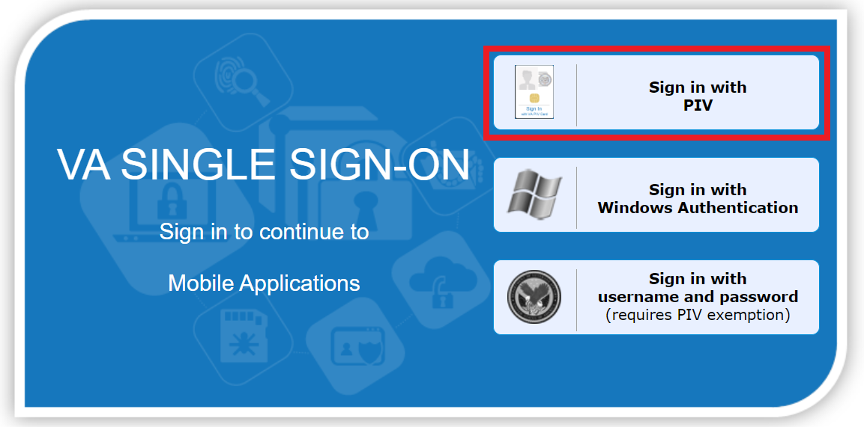
Figure 1: PIV Card Sign-On Image
- After selecting, an ActivClient Login dialog box will appear to prompt you to enter your PIN. Type the numbers of your PIN as prompted in ⁠⁠⁠⁠⁠⁠⁠Figure 2⁠⁠⁠⁠⁠⁠⁠. If authentication is successful, ISS will be loaded. If it is not successful, you will be prompted to enter your correct PIN instead.
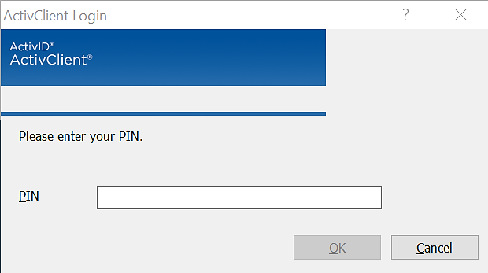
Figure 2: ActivClient Login Pop-Up Window

Familiarizing Yourself with ISS

2.1 Home Page
Once log in is complete, users will see the ISS homepage as seen in ⁠⁠⁠⁠⁠⁠⁠Figure 3⁠⁠⁠⁠⁠⁠⁠.
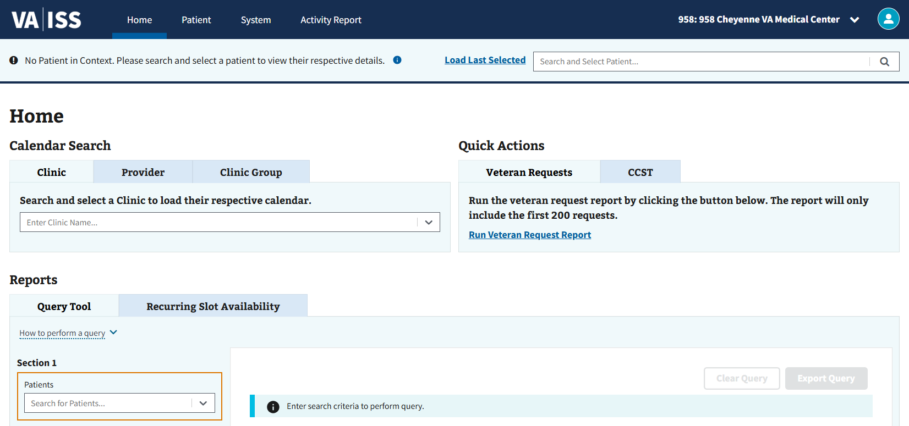
Figure 3: ISS Home Page

2.1.1 Changing Site Locations
- To change site locations, the user must first select the site location dropdown in the upper right-hand corner of the page as shown in ⁠⁠⁠⁠⁠⁠⁠Figure 4⁠⁠⁠⁠⁠⁠⁠.
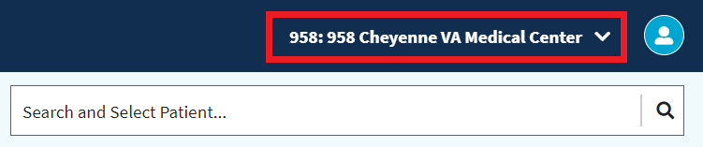
Figure 4: Site Locations
- The user will then need to select the requested site location by clicking the arrow shown in ⁠⁠⁠⁠⁠⁠⁠Figure 5⁠⁠⁠⁠⁠⁠⁠ if it is not already the default selection.
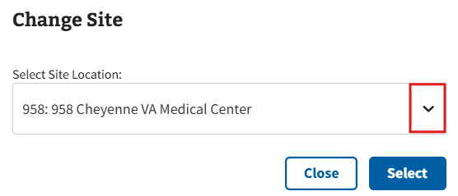
Figure 5: Dropdown Arrow for Changing Site Locations
- Note: The user will only see sites that are provisioned to their account after selecting the arrow shown in ⁠⁠⁠⁠⁠⁠⁠Figure 5⁠⁠⁠⁠⁠⁠⁠. If sites assigned to the user are not shown, please contact the local Clinical Applications Coordinator or Supervisor for assistance.
- The user can then select the “Select” button seen below in ⁠⁠⁠⁠⁠⁠⁠Figure 6⁠⁠⁠⁠⁠⁠⁠ to view the chosen site.
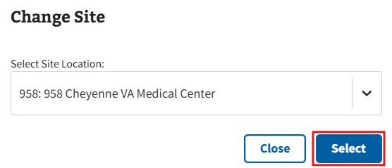
Figure 6: Select Button on Changing Site Locations Window
- Note: The “Close” button shown in ⁠⁠⁠⁠⁠⁠⁠Figure 7⁠⁠⁠⁠⁠⁠⁠ can be selected at any time to close the pop-up window and continue with the default site location.
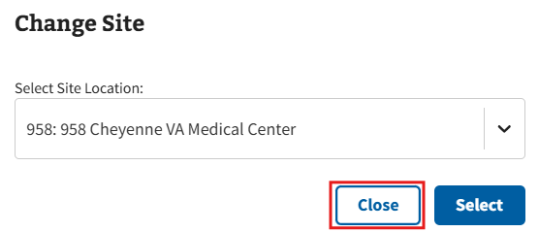
Figure 7: Close Button on Changing Site Locations Window
- Note: Users who do not have authorization to a site will see ⁠⁠⁠⁠⁠⁠⁠Figure 8⁠⁠⁠⁠⁠⁠⁠ upon selection.
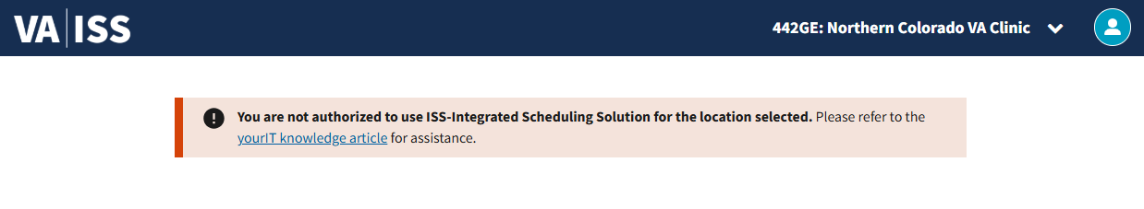
Figure 8: No Authorization Error for Sites

2.1.2 Veteran Requests Report
- To export a Veteran Request report, the user can select the “Run Veteran Request Report” button seen in ⁠⁠⁠⁠⁠⁠⁠Figure 9⁠⁠⁠⁠⁠⁠⁠.
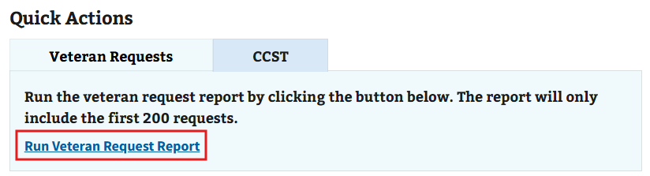
Figure 9: Run Veteran Request Report Button
- After selecting the button, the Veteran Requests page, seen in ⁠⁠⁠⁠⁠⁠⁠Figure 10⁠⁠⁠⁠⁠⁠⁠, will display.
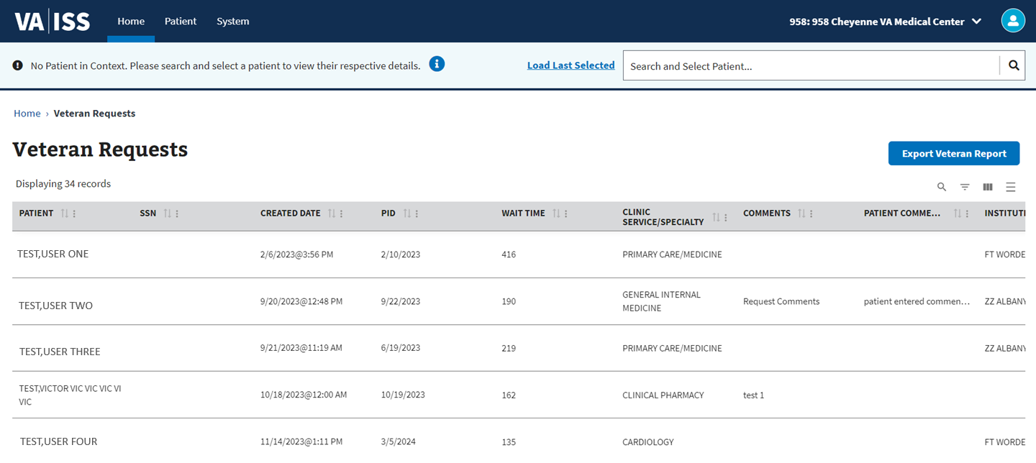
Figure 10: Veteran Requests Report Page
- Note: The report will only include the first 200 requests.
- To export, select the “Export Veteran Report” button seen in ⁠⁠⁠⁠⁠⁠⁠Figure 11⁠⁠⁠⁠⁠⁠⁠. This will allow the user to download the report into an Excel document.
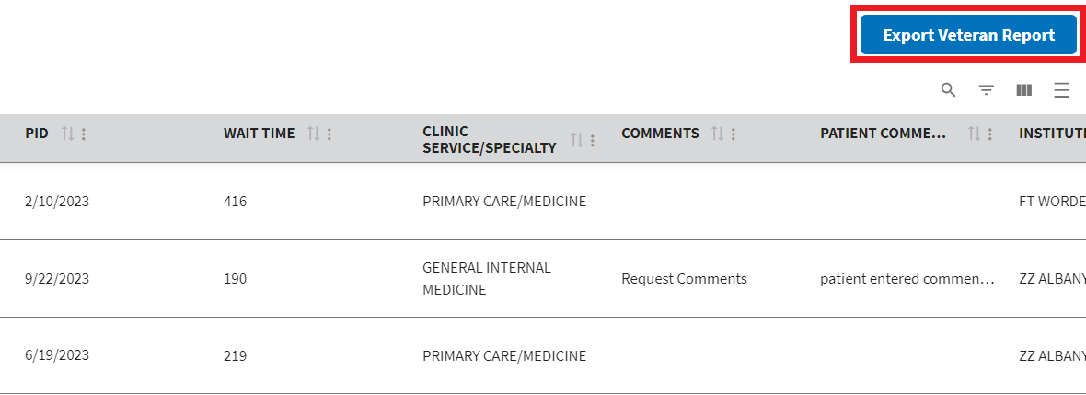
Figure 11: Export Veteran Report Button

2.1.3 CCST
The user can locate a link to the CCST application via the Quick Actions section on the Home Page (see ⁠⁠⁠⁠⁠⁠⁠Figure 12⁠⁠⁠⁠⁠⁠⁠ for example). The CCST application will open in a new browser tab after selecting the link.
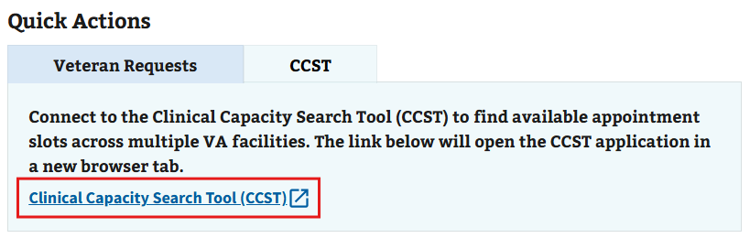
Figure 12: Link for CCST
- Note: CCST is also implemented into the ISS application. For more information on where to find and use CCST within ISS, please see section ⁠⁠⁠⁠⁠⁠⁠5.1.1 Open Slot Search⁠⁠⁠⁠⁠⁠⁠.

2.1.4 Additional Links
The user can locate links at the bottom of the ISS page within the “Getting Started with ISS” and “Help” sections for additional information. Links may vary depending on user and location. See ⁠⁠⁠⁠⁠⁠⁠Figure 13⁠⁠⁠⁠⁠⁠⁠ below for reference.
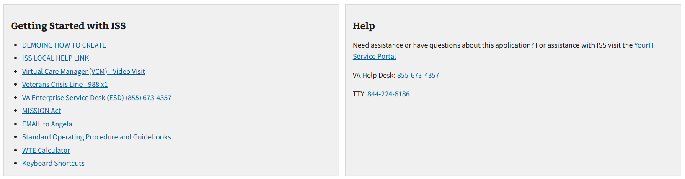
Figure 13: Example of Additional Links for ISS

2.2 My Account

2.2.1 User Preferences
- To change user preferences, the user can select the “My Account” button in the upper right-hand corner, seen in ⁠⁠⁠⁠⁠⁠⁠Figure 14⁠⁠⁠⁠⁠⁠⁠, to open the dropdown.
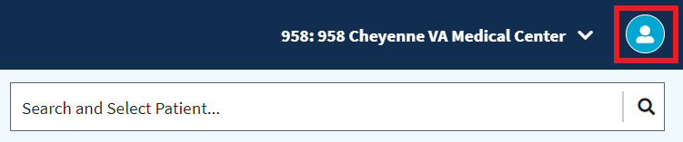
Figure 14: Selecting My Account Icon when Changing Preferences
- The user can then select the “Preferences” button, seen in ⁠⁠⁠⁠⁠⁠⁠Figure 15⁠⁠⁠⁠⁠⁠⁠, to be taken to the User Preferences page.
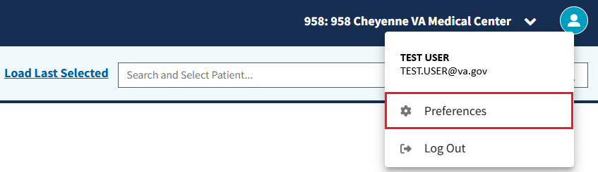
Figure 15: Preferences Button

2.2.1.1 Appointments Table, Appointment Requests, Query Tool Column Order, and Clinic Schedule Slot View – In Person and Virtual & Telehealth Appointments
Disclaimer: The information contained in this section applies to the Appointment Table, Appointment Requests, Query Tool, Clinic Schedule Slot View – In Person Appointments, and Clinic Schedule Slot View – Virtual & Telehealth Virtual Package Appointments sections on the User Preferences page.
- To adjust the default order of the Appointments Table, Appointment Requests, Query Tool, Clinic Schedule Slot View – In Person Appointments, or Clinic Schedule Slot View – Virtual & Telehealth Virtual Package Appointments sections, drag and drop the different selections as seen in ⁠⁠⁠⁠⁠⁠⁠Figure 16⁠⁠⁠⁠⁠⁠⁠ below.
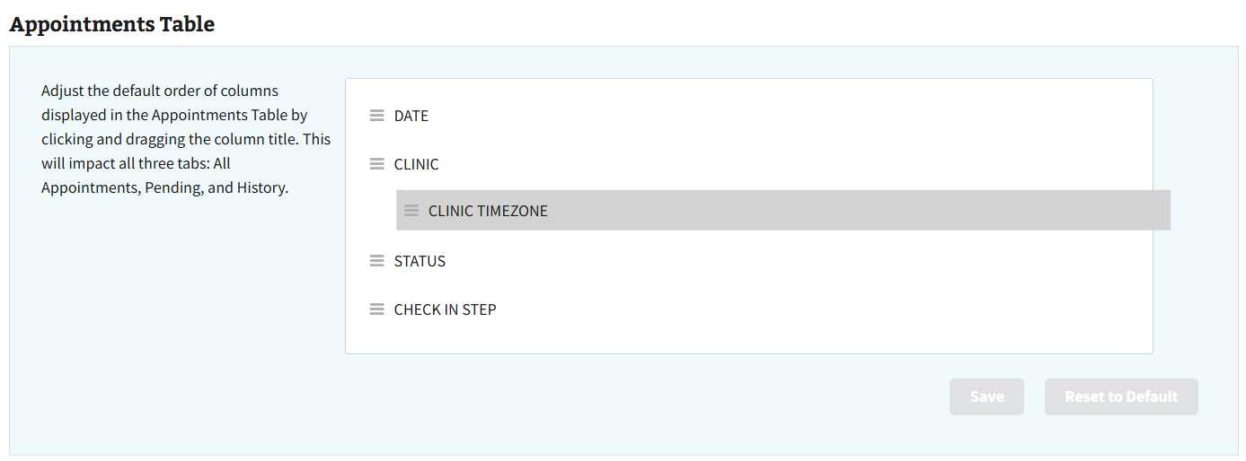
Figure 16: Adjusting Appointments Table and Appointment Request Column Order from Preferences
- The user can then select the “Save” button seen in ⁠⁠⁠⁠⁠⁠⁠Figure 17⁠⁠⁠⁠⁠⁠⁠ to save their changes.
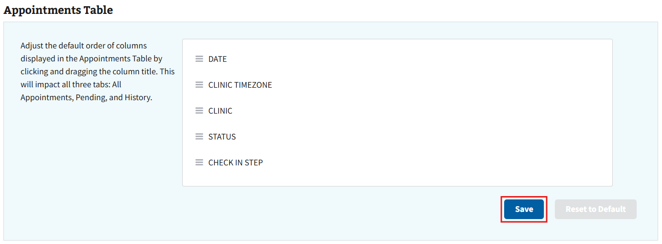
Figure 17: Save Button for Appointments Table and Appointment Requests Column Order
- To reset preferences, select the “Reset to Default” button within the individual sections as seen in ⁠⁠⁠⁠⁠⁠⁠Figure 18⁠⁠⁠⁠⁠⁠⁠.
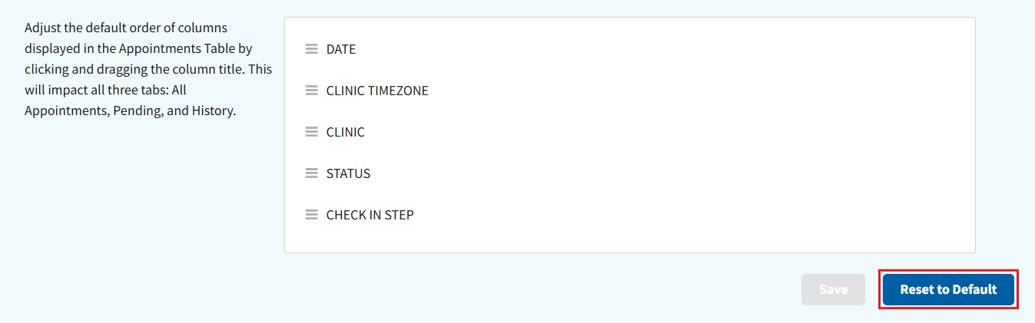
Figure 18: Reset to Default Button for Appointments Table and Appointment Requests

2.2.1.2 Appointment Table Settings
- To change the preferred tab for the Appointments Table, select the arrow shown in ⁠⁠⁠⁠⁠⁠⁠Figure 19⁠⁠⁠⁠⁠⁠⁠.
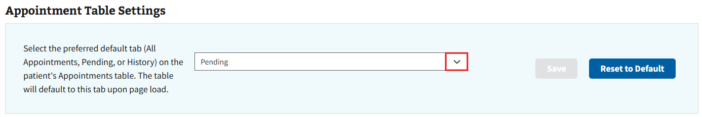
Figure 19: Dropdown Arrow for Changing Preferred Tab
- Once the dropdown displays, the user can select their preferred tab for the Appointment Table from the list seen below in ⁠⁠⁠⁠⁠⁠⁠Figure 20⁠⁠⁠⁠⁠⁠⁠.
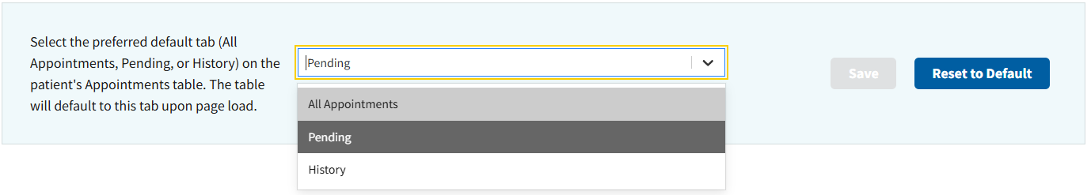
Figure 20: Dropdown View of Preferred Tab Selections
- The user can then select the “Save” button seen in ⁠⁠⁠⁠⁠⁠⁠Figure 21⁠⁠⁠⁠⁠⁠⁠ to save their changes.
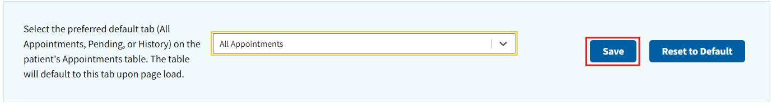
Figure 21: Save Button for Appointment Table Preference
- To reset preferences, select the “Reset to Default” button as seen in ⁠⁠⁠⁠⁠⁠⁠Figure 22⁠⁠⁠⁠⁠⁠⁠.
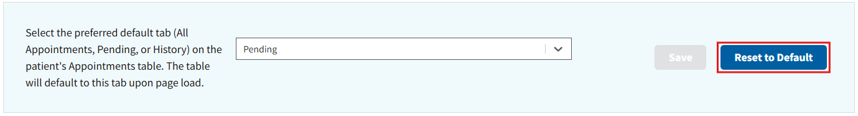
Figure 22: Reset to Default Button for Appointment Table Settings

2.2.1.3 Default Clinic Schedule Calendar View and Default Provider and Clinic Group Schedule Calendar View
Disclaimer: The information contained in this section applies to the Default Clinic Schedule Calendar View and the Default Provider and Clinic Group Schedule Calendar View sections on the User Preferences page.
- To change the default calendar view for Clinic Schedule or Provider and Clinic Group Schedule, select the arrow shown in ⁠⁠⁠⁠⁠⁠⁠Figure 23⁠⁠⁠⁠⁠⁠⁠.
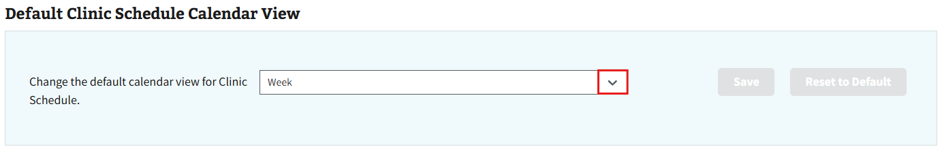
Figure 23: Dropdown Arrow for Changing Default Calendar View
- Once the dropdown displays, the user can select their preferred view option from the list seen below in ⁠⁠⁠⁠⁠⁠⁠Figure 24⁠⁠⁠⁠⁠⁠⁠.
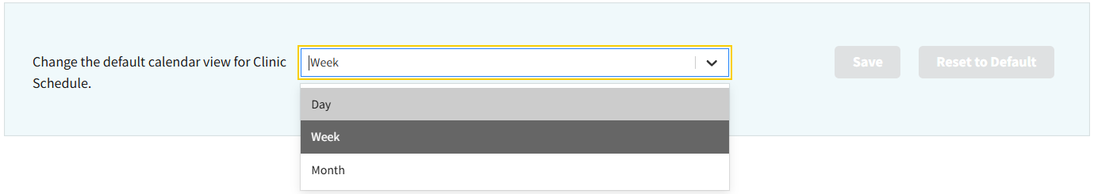
Figure 24: Dropdown View of Calendar View Selections
- The user can then select the “Save” button seen in ⁠⁠⁠⁠⁠⁠⁠Figure 25⁠⁠⁠⁠⁠⁠⁠ to save their changes.
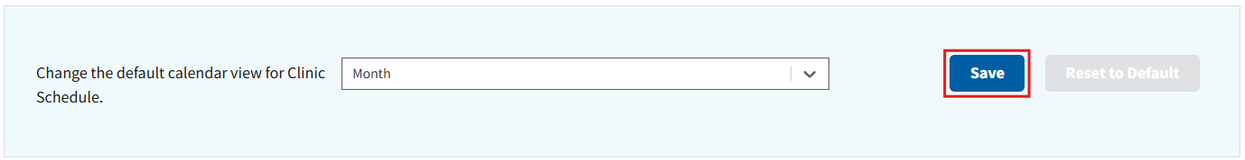
Figure 25: Save Button for Calendar View Preference
- To reset preferences, select the “Reset to Default” button within the individual sections as seen in ⁠⁠⁠⁠⁠⁠⁠Figure 26⁠⁠⁠⁠⁠⁠⁠.
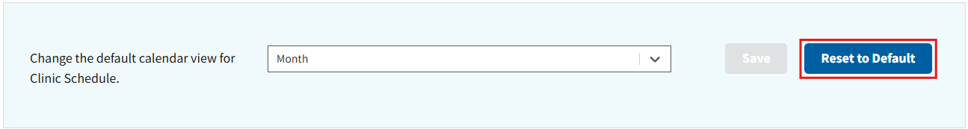
Figure 26: Reset to Default Button for Default Calendar View

2.2.2 Logging Out of ISS
- To log out of ISS, the user will need to select the “My Account” button in the upper right-hand corner, as seen in ⁠⁠⁠⁠⁠⁠⁠Figure 27⁠⁠⁠⁠⁠⁠⁠, to open the dropdown.
Figure 27: Selecting My Account Icon when Logging Out
- The user will then select the “Log out” button shown below in ⁠⁠⁠⁠⁠⁠⁠Figure 28⁠⁠⁠⁠⁠⁠⁠.
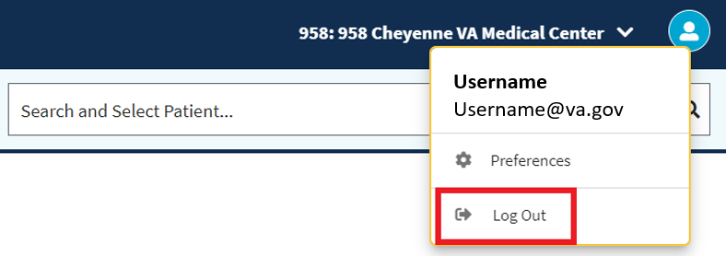
Figure 28: Log Out Button from My Account Dropdown
- Upon logging out of the ISS application, the user will be taken to the page seen in ⁠⁠⁠⁠⁠⁠⁠Figure 29⁠⁠⁠⁠⁠⁠⁠ that will prompt them to log out of the VA SSOi and close the browser.
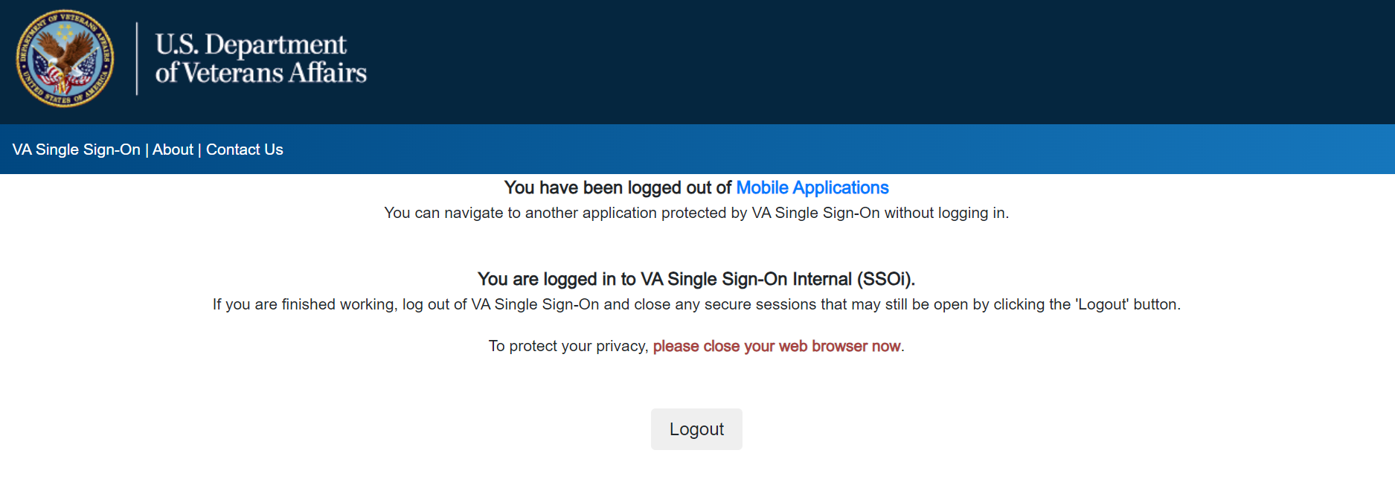
Figure 29: Logged Out of Mobile Applications Page
- Note: If you are logged in but not actively using ISS, the user will automatically be logged out after 60 minutes (see ⁠⁠⁠⁠⁠⁠⁠Figure 30⁠⁠⁠⁠⁠⁠⁠ for reference).
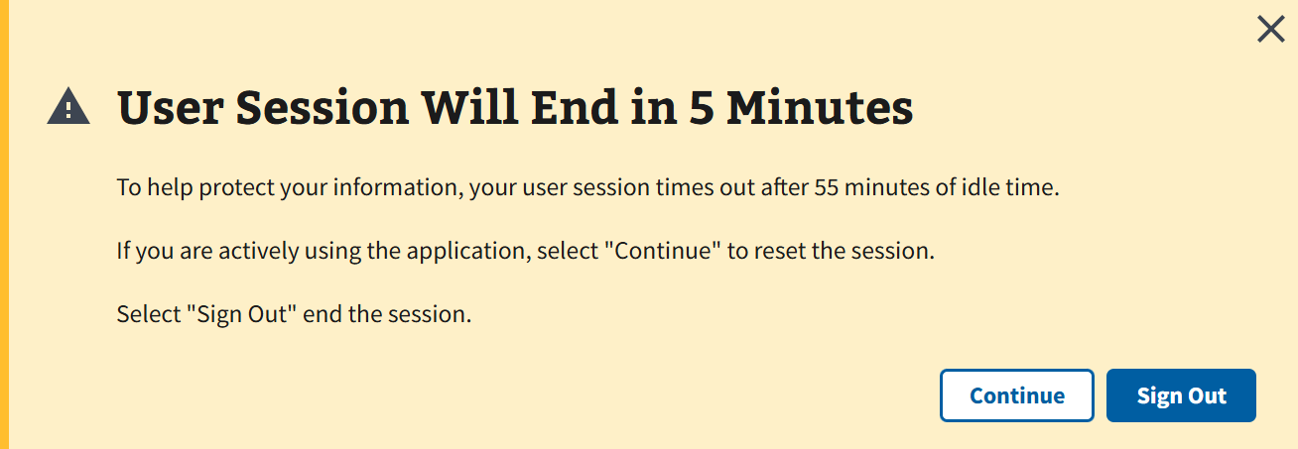
Figure 30: User Session Ending Notification

2.3 Filters

2.3.1 Column Order
- When looking for availability within the grid, the user can rearrange the column order. To begin, the user will need to select the “Move” button pictured in ⁠⁠⁠⁠⁠⁠⁠Figure 31⁠⁠⁠⁠⁠⁠⁠ to grab the column.
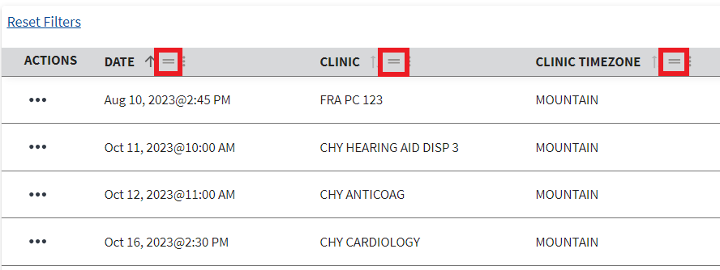
Figure 31: Move Button from Grid View
- The user can then move the column to a different spot by dragging the column and dropping it into the desired spot as seen in ⁠⁠⁠⁠⁠⁠⁠Figure 32⁠⁠⁠⁠⁠⁠⁠.
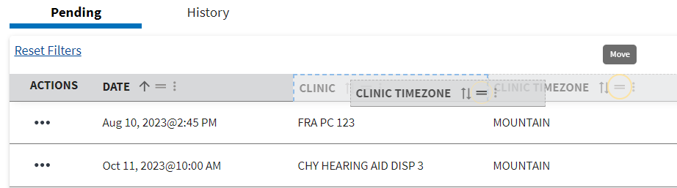
Figure 32: Example of Changing Column Order from Grid View

2.3.2 Sort by Ascending and Descending
- When looking for availability within the grid, the user can sort rows within the table. To begin, the user will need to select the vertical ellipsis next to the desired column, as seen below in ⁠⁠⁠⁠⁠⁠⁠Figure 33⁠⁠⁠⁠⁠⁠⁠.
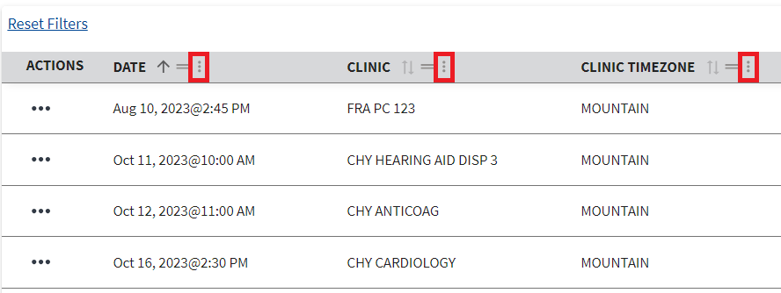
Figure 33: Selecting Column Actions Button to Sort Order
- The user can then select either “Sort by (Column Name) Ascending” or “Sort by (Column Name) descending” to sort rows in an ascending or descending order within the table, outlined within ⁠⁠⁠⁠⁠⁠⁠Figure 34⁠⁠⁠⁠⁠⁠⁠.
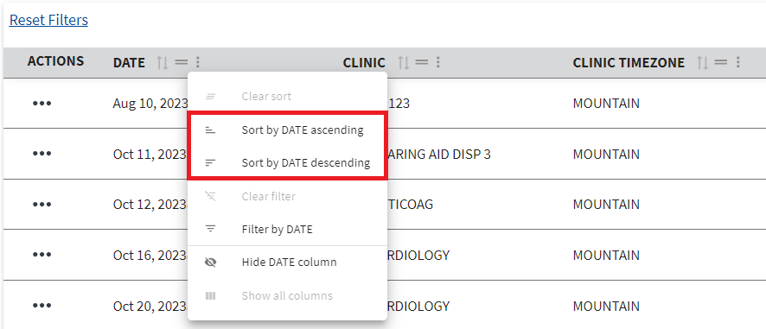
Figure 34: Sort Options for Table Information
- To return the sorting to default, the user will need to select the vertical ellipsis seen in ⁠⁠⁠⁠⁠⁠⁠Figure 33⁠⁠⁠⁠⁠⁠⁠, then select the “Clear Sort” button shown in ⁠⁠⁠⁠⁠⁠⁠Figure 35⁠⁠⁠⁠⁠⁠⁠.
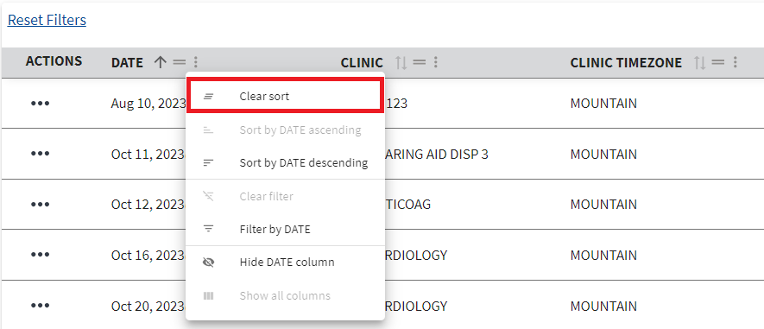
Figure 35: Clear Sort Button
- Optionally, the user can sort rows by hovering the cursor next to a column’s name and selecting the arrow button that appears in ⁠⁠⁠⁠⁠⁠⁠Figure 36⁠⁠⁠⁠⁠⁠⁠.
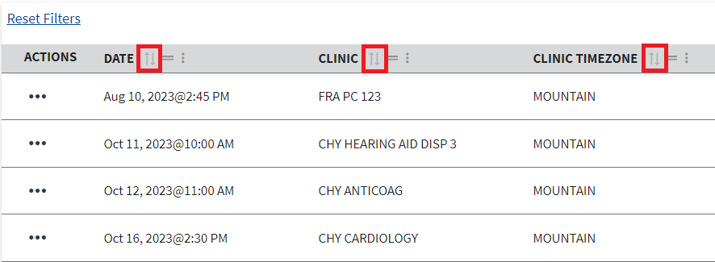
Figure 36: Sort Order Button
- Selecting the arrow once will cause results to sort by ascending order (↑), a second time to sort by descending order (notated by ↓), and a third time to cause results to appear in the default order again (notated with no arrow).

2.3.3 Toggle Density
- When looking for availability within the grid, the option to adjust the toggle density is available. To begin adjusting the toggle density, select the button shown in ⁠⁠⁠⁠⁠⁠⁠Figure 37⁠⁠⁠⁠⁠⁠⁠.
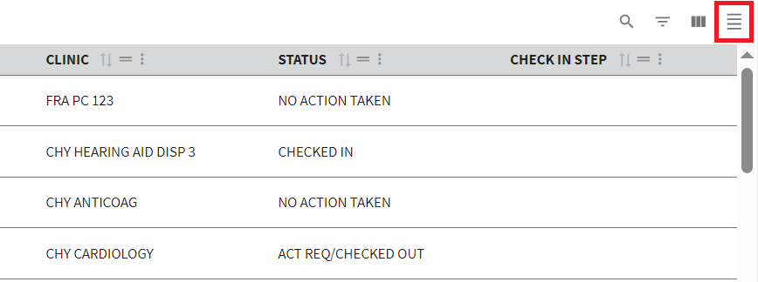
Figure 37: Toggle Density Button
- There are three different options for the user to choose from depending on the user’s preference. Simply keep selecting the “Toggle Density” button to rotate through the options until the user finds their preferred density.

2.3.4 Show, Hide, and Search Filters
- When looking for availability within the grid, the option to show and hide filters is available. To begin the user will need to select the “Show/Hide Filters” button, or the “Filter by (Column Name)” button, both shown in ⁠⁠⁠⁠⁠⁠⁠Figure 38⁠⁠⁠⁠⁠⁠⁠. Selecting either will cause the search functions to appear under each column name.
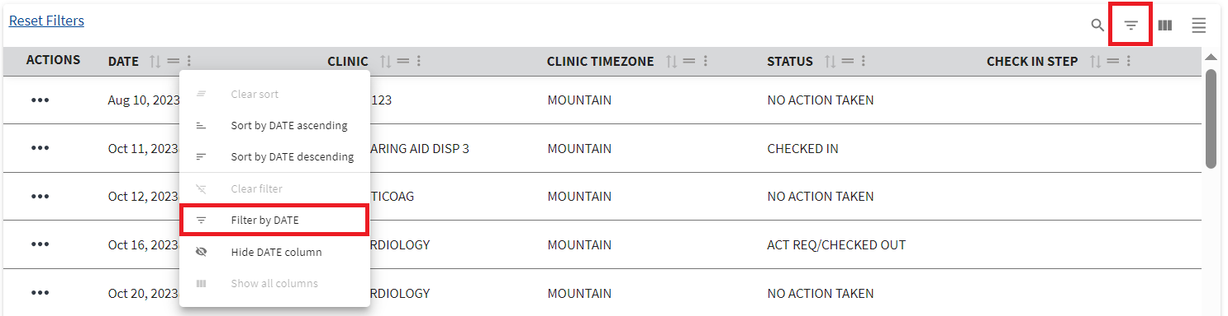
Figure 38: Show/Hide Filter Options Buttons
- Once the search options appear as seen in ⁠⁠⁠⁠⁠⁠⁠Figure 39⁠⁠⁠⁠⁠⁠⁠, the user can select the search bar or dropdown menu under the desired column to be filtered and enter or select the required information needed.
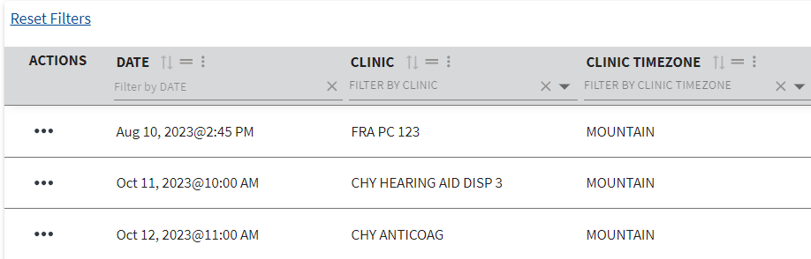
Figure 39: Example of Filter Search Menu on Grid View
- Once the filter field has been populated, results will automatically refresh and show items based on the filtered criteria as seen below in ⁠⁠⁠⁠⁠⁠⁠Figure 40⁠⁠⁠⁠⁠⁠⁠.
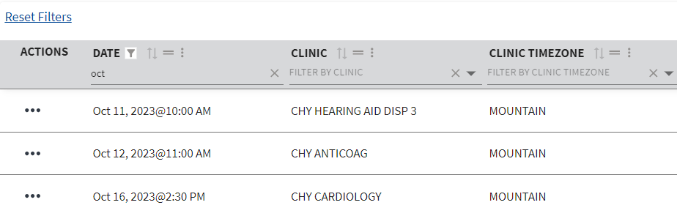
Figure 40: Example of Filtered Results in Grid View
- To clear the search, the user will need to select the “X” next to the search bar seen in ⁠⁠⁠⁠⁠⁠⁠Figure 41⁠⁠⁠⁠⁠⁠⁠. Selecting this will cause all results to appear within the table.
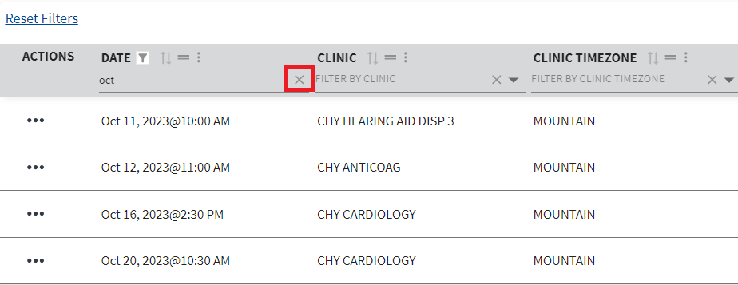
Figure 41: Clearing Filter Button
- Once finished searching, the user can then select the “Show/Hide Search” button seen in ⁠⁠⁠⁠⁠⁠⁠Figure 42⁠⁠⁠⁠⁠⁠⁠ to hide the search bar.
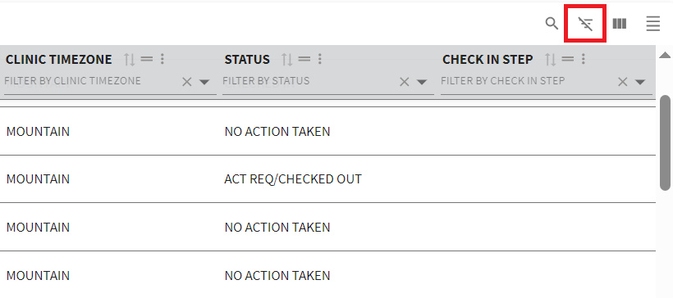
Figure 42: Selecting Show/Hide Filters Button to Hide Filter Menu

2.3.5 Filtering Rows
- Users can increase or decrease the number of rows shown on the page by selecting the arrow shown in ⁠⁠⁠⁠⁠⁠⁠Figure 43⁠⁠⁠⁠⁠⁠⁠.
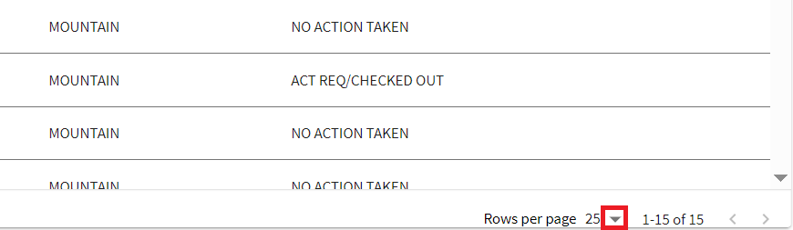
Figure 43: Arrow Button for Changing Row Number
- Users can also navigate the table to more available timeslots by selecting the arrows, shown in ⁠⁠⁠⁠⁠⁠⁠Figure 44⁠⁠⁠⁠⁠⁠⁠ from left to right as follows; “|<” to jump to the first page, “<” to navigate one page backwards, “>” to navigate one page forwards, and “>|” to jump to the last page.
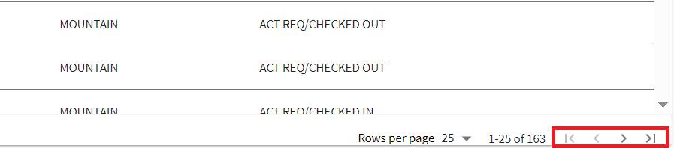
Figure 44: Buttons for Navigating Result Pages on Grid View
- Note: Arrows will be greyed out and un-selectable if the user cannot navigate in a certain direction.

2.3.6 Reset Filters
To reset any filters that are set on either the “Appointments” or “Appointment Requests” grids, the user can select the “Reset Filters” button, as seen in ⁠⁠⁠⁠⁠⁠⁠Figure 45⁠⁠⁠⁠⁠⁠⁠.
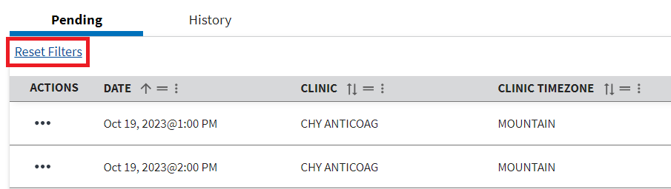
Figure 45: Reset Filters Button on Grid View

2.3.7 Refresh Table
To refresh the table for either the “Appointments” or “Appointment Requests” grids, the user can select the “Refresh Table” button, as seen in ⁠⁠⁠⁠⁠⁠⁠Figure 46⁠⁠⁠⁠⁠⁠⁠.
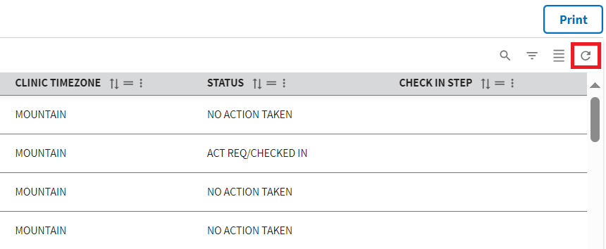
Figure 46: Refresh Table Button

2.3.8 Filtering & Navigating on Calendar
- To navigate through the calendar, the user can use the arrows shown in ⁠⁠⁠⁠⁠⁠⁠Figure 47⁠⁠⁠⁠⁠⁠⁠.
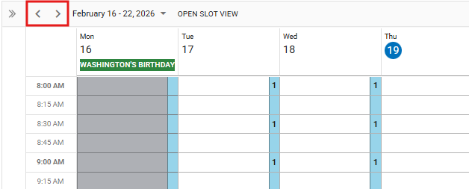
Figure 47: Arrow Buttons on Calendar to Change Dates
- Optionally, the user can choose a specified date, as highlighted in ⁠⁠⁠⁠⁠⁠⁠Figure 48⁠⁠⁠⁠⁠⁠⁠, by selecting the arrow to the right of the date.
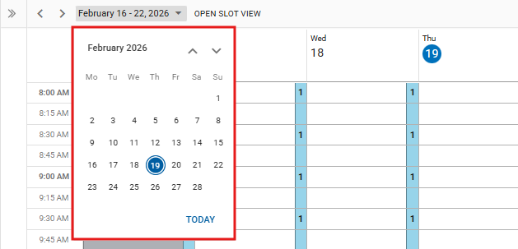
Figure 48: Mini Calendar on Calendar View to Choose Specific Date
- Users can also choose to view the calendar in Day, Week, or Month mode by selecting the associated button shown below in ⁠⁠⁠⁠⁠⁠⁠Figure 49⁠⁠⁠⁠⁠⁠⁠.
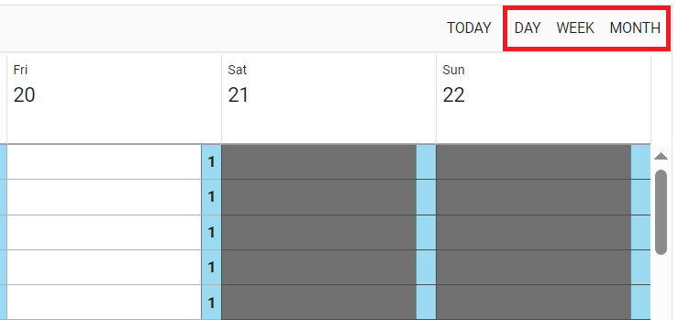
Figure 49: Changing Default Calendar View from Calendar
- The user can also select the “Today” button, seen in ⁠⁠⁠⁠⁠⁠⁠Figure 50⁠⁠⁠⁠⁠⁠⁠, at any point to bring the calendar back to the current date.
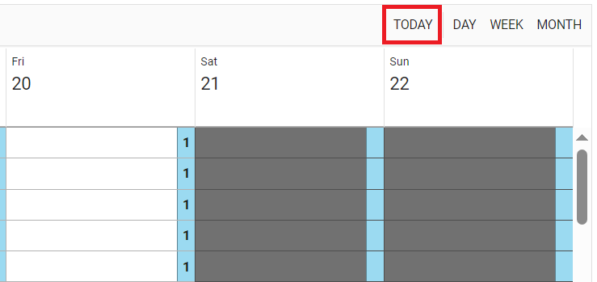
Figure 50: Bringing Calendar Back to Current Date on Calendar View
- Note: The user can refresh the calendar at any time by selecting the “Refresh” button seen in ⁠⁠⁠⁠⁠⁠⁠Figure 51⁠⁠⁠⁠⁠⁠⁠.
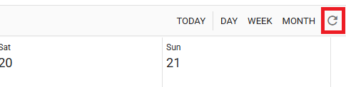
Figure 51: Refresh Button on Calendar

2.3.9 Pending Appointments & Appointment History
Within the “Appointments” section found within ⁠⁠⁠⁠⁠⁠⁠3.3 Appointments & Requests⁠⁠⁠⁠⁠⁠⁠, users can navigate between pending appointments and appointment history for a selected patient. To do so, the user can simply select the desired tab to update the appointment list with the corresponding tab. Please see ⁠⁠⁠⁠⁠⁠⁠Figure 52⁠⁠⁠⁠⁠⁠⁠ for a description on which appointments will appear where depending on the corresponding status.
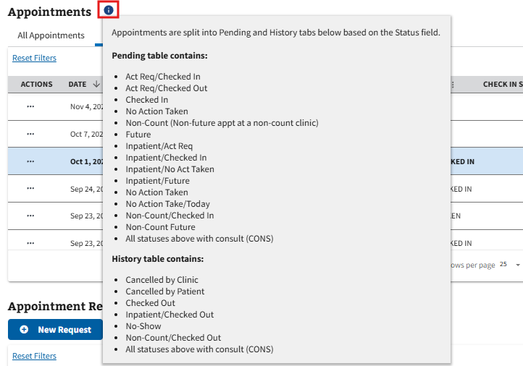
Figure 52: Information on the Pending and History Tabs for Appointments

Patient Overview

3.1 Patient Search
- To search for a patient, the user will select the search bar, seen in ⁠⁠⁠⁠⁠⁠⁠Figure 53⁠⁠⁠⁠⁠⁠⁠, and enter valid search criteria. Once entering the information, a list of patients will appear in a dropdown.
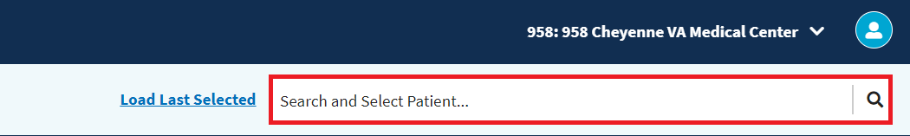
Figure 53: Patient Search Bar
- Note: See ⁠⁠⁠⁠⁠⁠⁠Figure 54⁠⁠⁠⁠⁠⁠⁠ below for a list of valid search criteria for patient search.
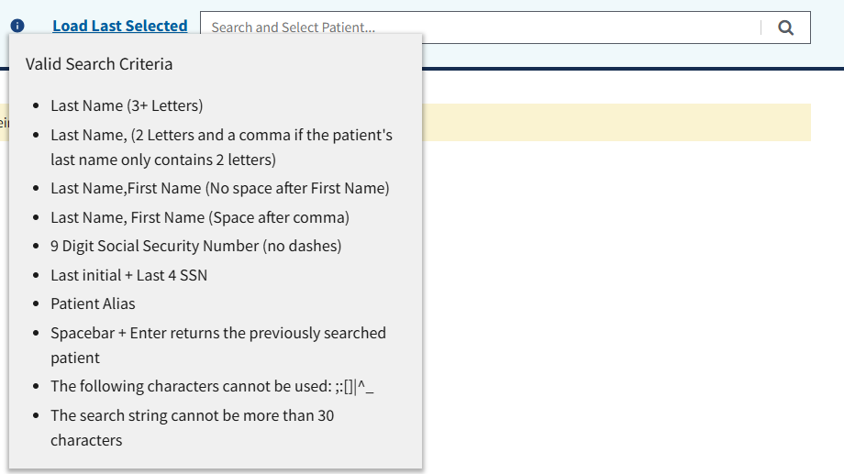
Figure 54: Valid Search Criteria for Patient Search
- The user will then select the intended patient from the available options.
- Once a patient is selected, the user will need to read the “Patient Eligibility” window, shown in ⁠⁠⁠⁠⁠⁠⁠Figure 55⁠⁠⁠⁠⁠⁠⁠, and select “Acknowledge Eligibility” to continue.
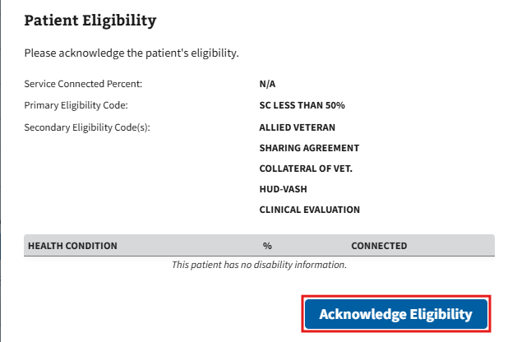
Figure 55: Patient Eligibility Notification
- Note: The user is able to select “Expand” to see more information about the patient in context (see ⁠⁠⁠⁠⁠⁠⁠3.4.1 Demographics Banner⁠⁠⁠⁠⁠⁠⁠ for more information).
- To view information or interact with the patient, the user will need to select the “Patient” tab seen in ⁠⁠⁠⁠⁠⁠⁠Figure 56⁠⁠⁠⁠⁠⁠⁠.

Figure 56: Patient Tab from the Home Screen
- To bring a new patient into context, the user will need to select the “Clear” button seen below in ⁠⁠⁠⁠⁠⁠⁠Figure 57⁠⁠⁠⁠⁠⁠⁠. The page will automatically reload and “No Patient in Context” will be shown.
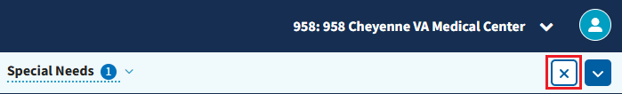
Figure 57: Clear Button for Patient Search
- The user is then able to search for a new patient. To load the last selected patient, the user can select the “Load Last Selected” button, seen in ⁠⁠⁠⁠⁠⁠⁠Figure 58⁠⁠⁠⁠⁠⁠⁠, or type “spacebar + enter” into the search bar.
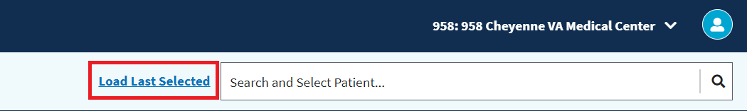
Figure 58: Load Last Selected Button for Patient Search

3.2 Patient Profile Home
The Patient Profile page can be navigated to by selecting the “Patient Profile Home” tab shown in ⁠⁠⁠⁠⁠⁠⁠Figure 59⁠⁠⁠⁠⁠⁠⁠. This page gives a brief overview of the patient’s information.
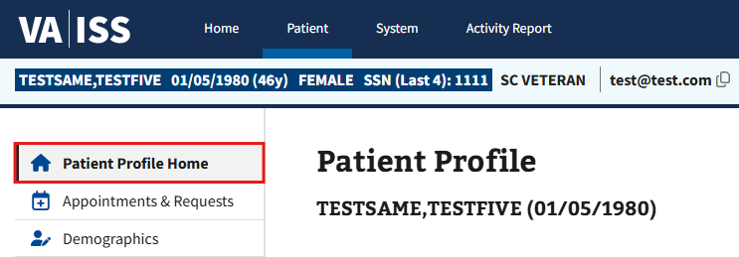
Figure 59: Example of Patient Profile Home Tab

3.3 Appointments & Requests
The Appointments & Requests page can be navigated to by selecting the “Appointments & Requests” tab shown in ⁠⁠⁠⁠⁠⁠⁠Figure 60⁠⁠⁠⁠⁠⁠⁠. The user can use this page to view and schedule appointments and requests. For more information on how to do this please visit ⁠⁠⁠⁠⁠⁠⁠Patient Appointments and Requests⁠⁠⁠⁠⁠⁠⁠.
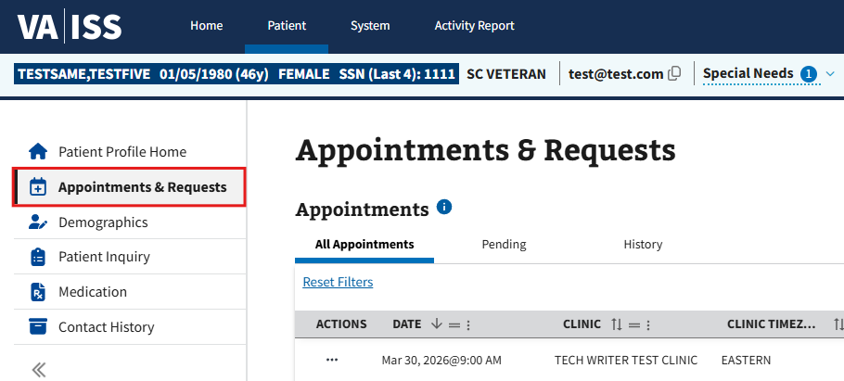
Figure 60: Example of Appointments & Requests Tab

3.4 Demographics
- The Demographics page can be navigated to by selecting the “Demographics” tab shown in ⁠⁠⁠⁠⁠⁠⁠Figure 61⁠⁠⁠⁠⁠⁠⁠.
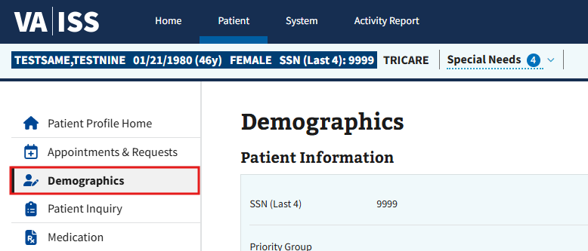
Figure 61: Demographics Tab
- Users can edit the fields that appear within the Demographics page as shown in ⁠⁠⁠⁠⁠⁠⁠Figure 62⁠⁠⁠⁠⁠⁠⁠ below.
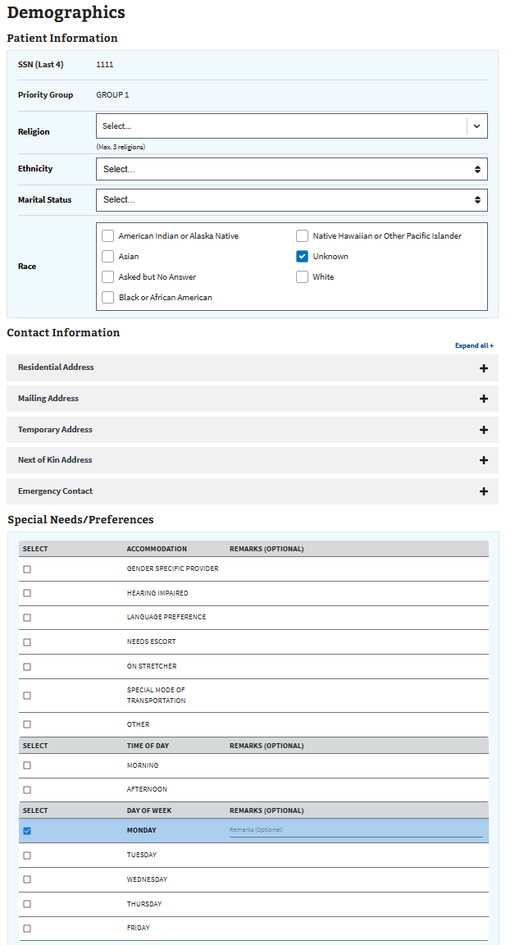
Figure 62: Example of the Demographics Page
- Note: The user can edit the fields under “Contact Information” by either selecting the “+” button next to an individual row, or by selecting “Expand all +.
- Note: When editing a patient’s mailing address who has an active prescription, the user will receive a notification asking to confirm the location change of where the prescriptions are being sent (see ⁠⁠⁠⁠⁠⁠⁠Figure 63⁠⁠⁠⁠⁠⁠⁠ below).
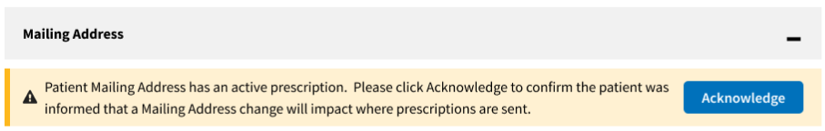
Figure 63: Mailing Address Change Notification with Active Prescription
- Note: When editing Special Needs and Preferences, the user can add remarks to any of the individual options seen below in ⁠⁠⁠⁠⁠⁠⁠Figure 64⁠⁠⁠⁠⁠⁠⁠. To leave a remark, the user will first need to select an option in the special needs/preferences section. Once selected, the Remarks field will become available to edit.
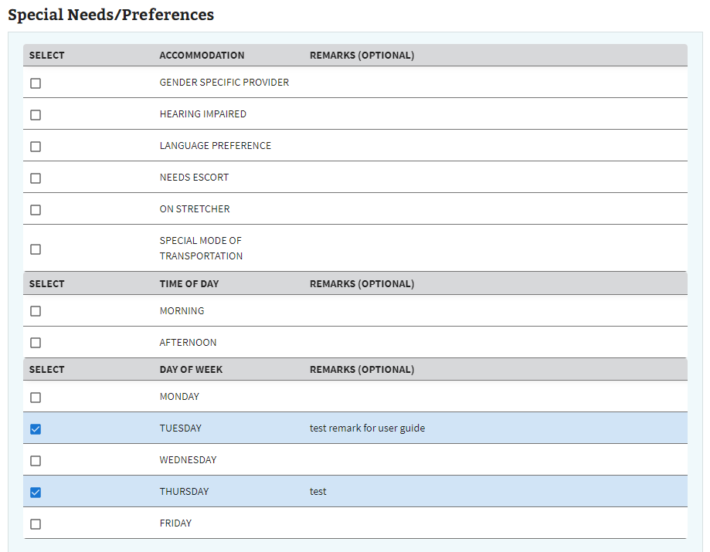
Figure 64: Special Needs/Preferences Options
- Once the user has made their preferred edits to the patient’s demographics, the user will need to select “Save Changes”, as seen in ⁠⁠⁠⁠⁠⁠⁠Figure 65⁠⁠⁠⁠⁠⁠⁠, to save any changes made.
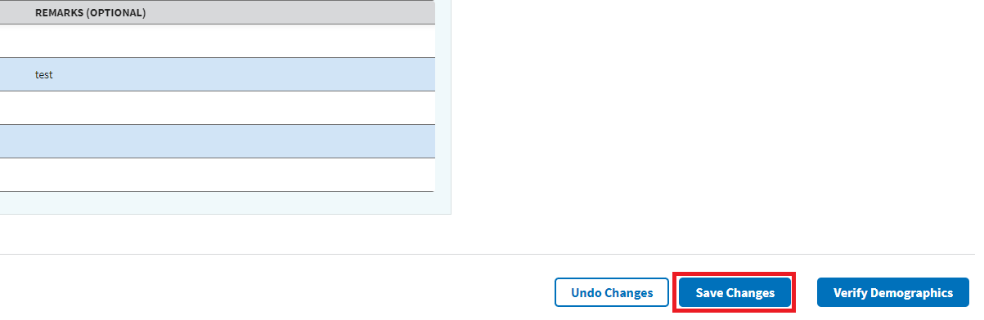
Figure 65: Save Changes Button for the Demographics Page
- Note: The user can verify the patient’s demographics by selecting “Verify Demographics” seen in ⁠⁠⁠⁠⁠⁠⁠Figure 66⁠⁠⁠⁠⁠⁠⁠.
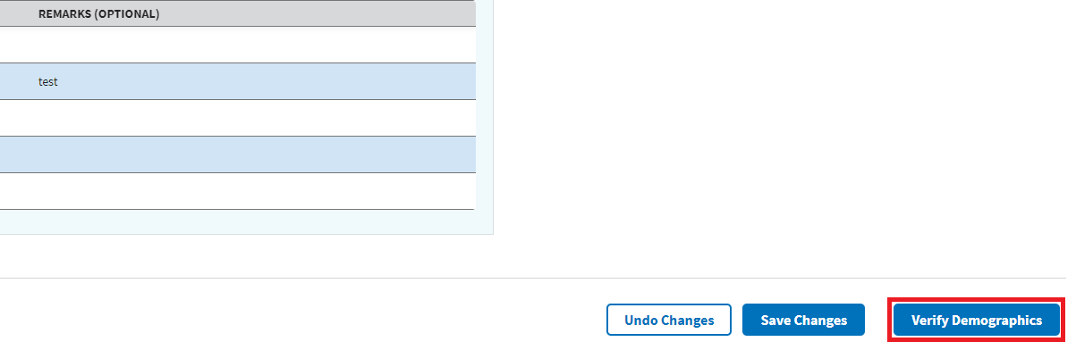
Figure 66: Verify Demographics Button
- Note: If the User would like to undo any changes made within the demographics page, they can select “Undo Changes” at any time as seen in ⁠⁠⁠⁠⁠⁠⁠Figure 67⁠⁠⁠⁠⁠⁠⁠.
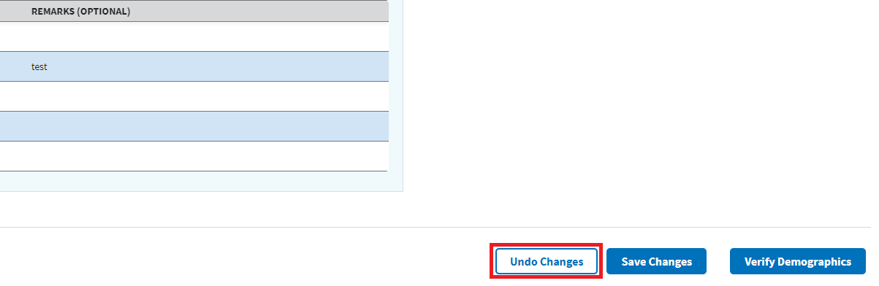
Figure 67: Undo Changes Button for Demographics Page

3.4.1 Demographics Banner
The Demographics banner is located at the top of the page and is populated with the patient’s information when a patient is brought into context. Users may select the expand button, as seen in ⁠⁠⁠⁠⁠⁠⁠Figure 68⁠⁠⁠⁠⁠⁠⁠, to see more information regarding the selected patient and their demographics.
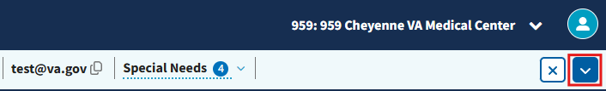
Figure 68: Demographics Banner Expand Button
By default, the user will be able to see the patient’s name, DOB, any patient flags (if applicable), VVC status, birth sex, patient type, and SSN (Last 4), see ⁠⁠⁠⁠⁠⁠Figure 69⁠⁠⁠⁠⁠⁠⁠ for example.

Figure 69: Default Patient Demographics
Users can also see any Special Needs/Preferences that are currently associated with the patient, as well as their current eligibility or providers. If any edits are needed, the user can select the Demographics link, seen in ⁠⁠⁠⁠⁠⁠⁠Figure 70⁠⁠⁠⁠⁠⁠⁠, to take them to the Demographics tab (see ⁠⁠⁠⁠⁠⁠⁠3.4 Demographics⁠⁠⁠⁠⁠⁠⁠ for more information on editing).
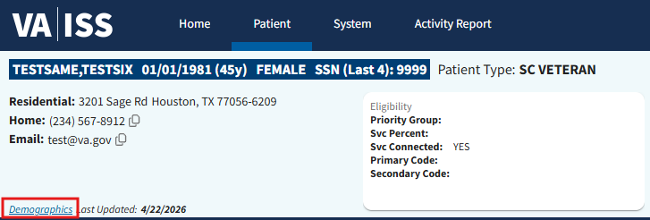
Figure 70: Demographics Link in the Patient Header
- Note: If the patient has joined at least 3 video visit appointments within the past 120 days, the VVC status will state “VVC READY” and be green (see ⁠⁠⁠⁠⁠⁠⁠Figure 71⁠⁠⁠⁠⁠⁠⁠). For more information on video visits please see ⁠⁠⁠⁠⁠⁠⁠4.5 Video Visits⁠⁠⁠⁠⁠⁠⁠.

Figure 71: VVC Ready Pill

3.4.2 Temporary Address
- Users may find the need to edit a patient’s address to a temporary address. To do so the user will need to select the “+” symbol, shown below in ⁠⁠⁠⁠⁠⁠⁠Figure 72⁠⁠⁠⁠⁠⁠⁠, to expand the temporary address accordion.
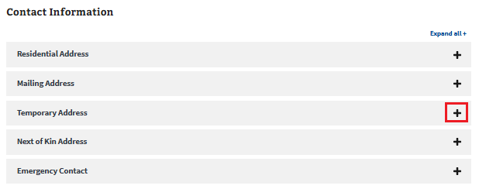
Figure 72: Temporary Address Accordion Expand Button
- Once the accordion has been expanded, the user will need to activate the temporary address function by selecting the “Activate Temporary Address” toggle button seen in ⁠⁠⁠⁠⁠⁠⁠Figure 73⁠⁠⁠⁠⁠⁠⁠.
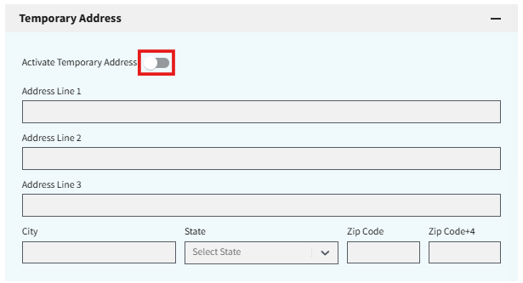
Figure 73: Activate Temporary Address Toggle Button
- The user will then need to fill out all the required information displayed in ⁠⁠⁠⁠⁠⁠⁠Figure 74⁠⁠⁠⁠⁠⁠⁠, as well as any optional information as needed.
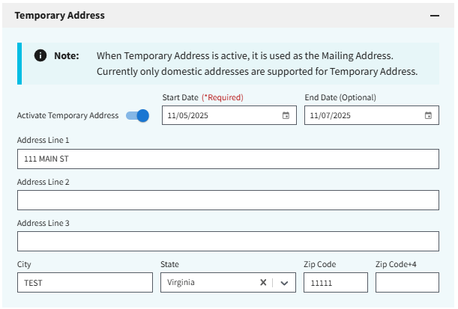
Figure 74: Temporary Address Information Example
- Note: Users may receive the validation notification, seen in ⁠⁠⁠⁠⁠⁠⁠Figure 75⁠⁠⁠⁠⁠⁠⁠, that prompts users to review if the address entered is accurate. If the information is incorrect, the user will need to select cancel and fix the address entered. If the address is correct, the user can select the “Use this address” button and then select OK to continue.
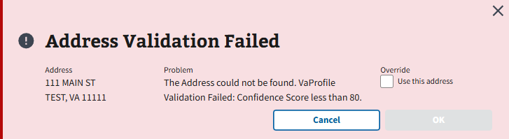
Figure 75: Address Validation Failed Notification
- Once all applicable information has been filled, the user will select the “Save Changes” button, seen in ⁠⁠⁠⁠⁠⁠⁠Figure 76⁠⁠⁠⁠⁠⁠⁠, to save the temporary address.
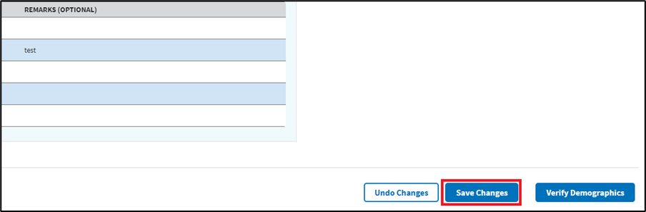
Figure 76: Save Changes Button for Temporary Address
- Note: Users will receive the notification shown in ⁠⁠⁠⁠⁠⁠⁠Figure 77⁠⁠⁠⁠⁠⁠⁠ when accessing the demographics page of a patient whose temporary address will soon expire. The user will need to select Acknowledge to proceed.
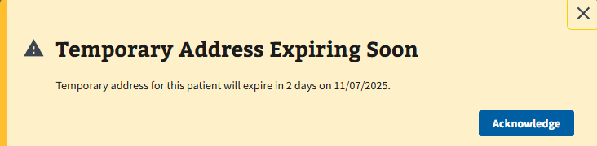
Figure 77: Temporary Address Expiring Soon Notification
- Note: The temporary address will be shown in the demographics banner of the patient with an active temporary address (see ⁠⁠⁠⁠⁠⁠⁠Figure 78⁠⁠⁠⁠⁠⁠⁠).
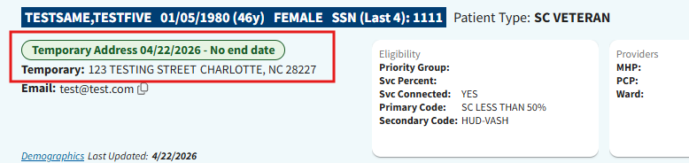
Figure 78: Active Temporary Address in Demographics Banner Example

3.5 Patient Inquiry
The Patient Inquiry page can be navigated to by selecting the “Patient Inquiry” tab shown in ⁠⁠⁠⁠⁠⁠⁠Figure 79⁠⁠⁠⁠⁠⁠⁠. On this page, users can view information about the patient such as contact information, demographics, status, future appointments, etc.
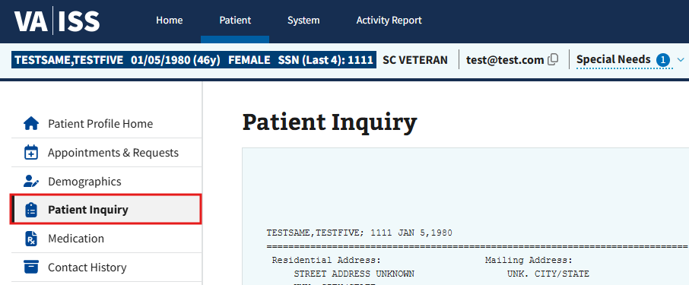
Figure 79: Example of Patient Inquiry Tab

3.6 Medication
The Medication page can be navigated to by selecting the “Medication” tab shown in ⁠⁠⁠⁠⁠⁠⁠Figure 80⁠⁠⁠⁠⁠⁠⁠. This page will list any medications the patient uses or have been prescribed.
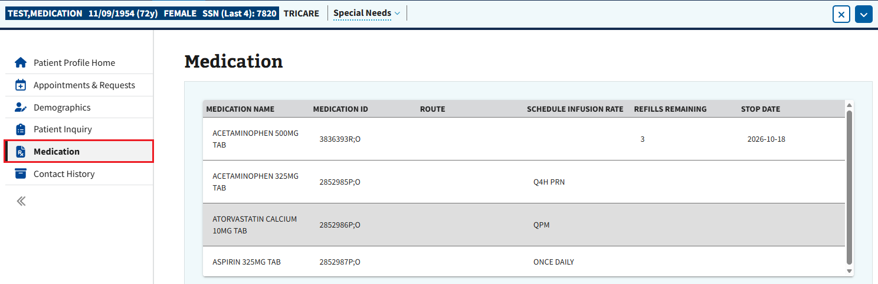
Figure 80: Example of Medication Tab

3.7 Contact History
The Contact History page can be navigated to by selecting the “Contact History” tab shown in ⁠⁠⁠⁠⁠⁠⁠Figure 81⁠⁠⁠⁠⁠⁠⁠. This page will list contact attempts made to a patient for dispositioned requests.
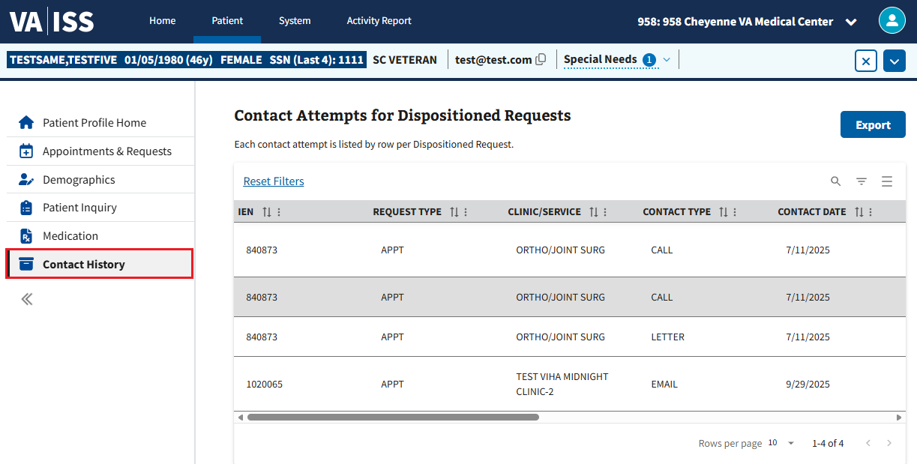
Figure 81: Contact History Tab
The user is also able to export the list via the “Export” button seen below in ⁠⁠⁠⁠⁠⁠⁠Figure 82⁠⁠⁠⁠⁠⁠⁠. Once selected, the user will need to follow the on-screen browser instructions to either open the document in Excel or save and download the file to the computer.
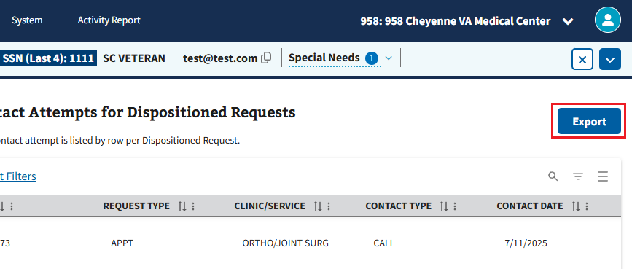
Figure 82: Export Button for Contact History

Patient Appointments and Requests
For all the following sections within ⁠⁠⁠⁠⁠⁠⁠Patient Appointments and Requests⁠⁠⁠⁠⁠⁠⁠, the user will first need to bring a patient into context. The user can find information on how to do so by following the steps outlined in ⁠⁠⁠⁠⁠⁠⁠3.1 Patient Search⁠⁠⁠⁠⁠⁠⁠.

4.1 Creating Appointment Requests

4.1.1 APPT
- To create a new APPT request, the user will first need to select “New Request,” as shown in ⁠⁠⁠⁠⁠⁠⁠Figure 83⁠⁠⁠⁠⁠⁠⁠.
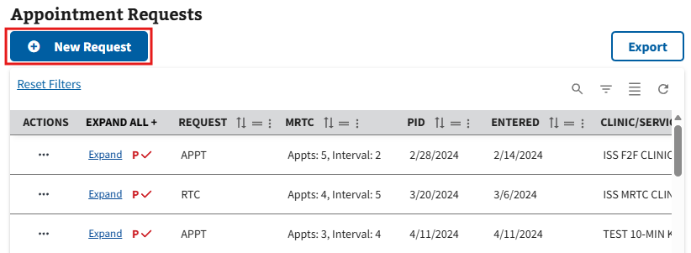
Figure 83: New Requests Button for APPT Requests
- The user will then select “APPT” from the dropdown that appears in ⁠⁠⁠⁠⁠⁠⁠Figure 84⁠⁠⁠⁠⁠⁠⁠ below.
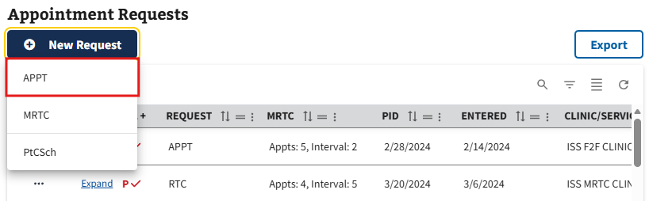
Figure 84: APPT Option from the New Request Dropdown
- The user will be brought to the New Appointment Request page. On this page, the user will need to fill out all the required information displayed in ⁠⁠⁠⁠⁠⁠⁠Figure 85⁠⁠⁠⁠⁠⁠⁠. The user can also fill out any optional information as needed.
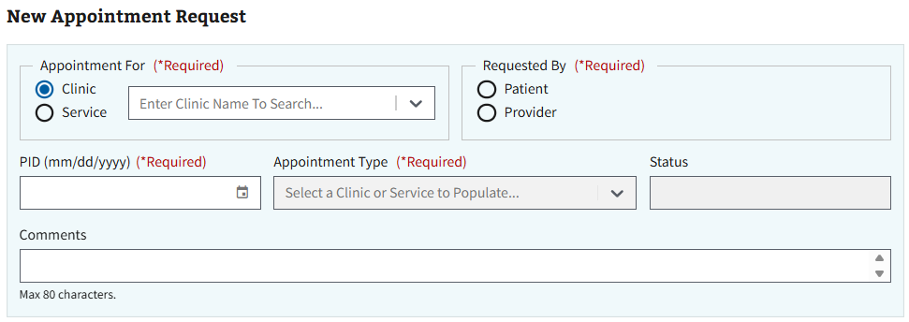
Figure 85: New Appointment Request Page for APPT
- Note: The ISS application will automatically cross check to ensure no duplicate appointment requests are made for the selected clinic/service. If there are no potential duplicate requests, the notification seen in ⁠⁠⁠⁠⁠⁠⁠Figure 87⁠⁠⁠⁠⁠⁠⁠ will appear in green and the user can continue creating the appointment request. If there are potential duplicate appointment request(s), the notification and table shown in ⁠⁠⁠⁠⁠⁠⁠Figure 86⁠⁠⁠⁠⁠⁠⁠ will appear. Please see ⁠⁠⁠⁠⁠⁠⁠4.1.7 Dispositioning Duplicate Clinic Requests⁠⁠⁠⁠⁠⁠⁠ for more information on handling duplicate appointments when creating a request for a clinic and ⁠⁠⁠⁠⁠⁠⁠4.1.8 Dispositioning Duplicate Service Requests⁠⁠⁠⁠⁠⁠⁠ when creating a request for a service.
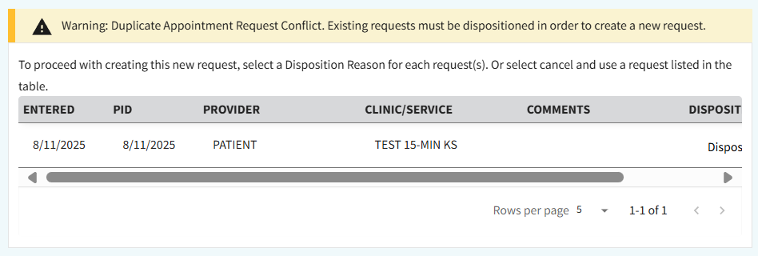
Figure 86: Duplicate Appointment Conflicts Example for APPT
- Once all applicable information has been filled, the user will select the “Create Request” button, seen in ⁠⁠⁠⁠⁠⁠⁠Figure 87⁠⁠⁠⁠⁠⁠⁠, to create the new APPT request.
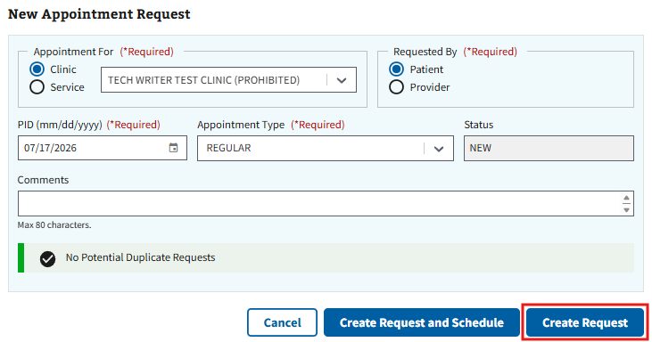
Figure 87: Create Request Button for APPT Request
- Note: The user can select the “Create Request and Schedule” button, seen below in ⁠Figure 88⁠, to create the request and automatically schedule the pending appointment via the clinic calendar. Please see section ⁠4.3.1 APPT⁠ for more information on creating a pending APPT appointment.
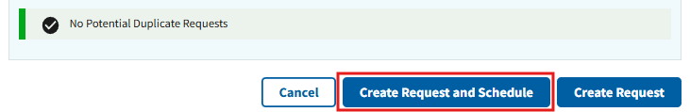
Figure 88: Create Request and Schedule Button for APPT Request
- Note: The user can also select the “Cancel” button seen in ⁠⁠⁠⁠⁠⁠⁠Figure 87⁠⁠⁠⁠⁠⁠⁠ to exit creating a request and go back to the Appointments & Requests page.

4.1.2 PtCSch (Recall)
- To create a new PtCSch request, the user will first need to select “New Request,” as shown in ⁠⁠⁠⁠⁠⁠Figure 89⁠⁠⁠⁠⁠⁠⁠.
Figure 89: New Request Button for PtCSch Requests
- The user will then select “PtCSch” from the dropdown that appears in ⁠Figure 90⁠ below.
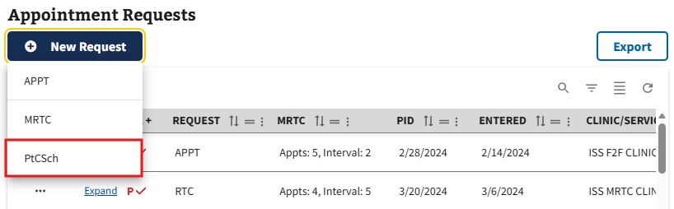
Figure 90: PtCSch Option from the New Request Dropdown
- The user will be brought to the New PtCSch Request page. On this page, the user will need to fill out all the required information displayed in ⁠Figure 91⁠. The user can also fill out any optional information as needed.
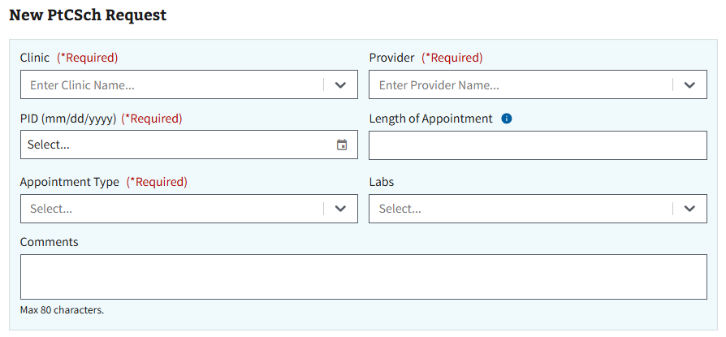
Figure 91: New PtCSch Request Page
- Note: The ISS application will automatically cross check to ensure no duplicate appointment requests are made for the selected clinic/service. If there are no potential duplicate requests, the notification seen in ⁠Figure 93⁠ will appear in green and the user can continue creating the appointment request. If there are potential duplicate appointment request(s), the notification and table shown in ⁠Figure 92⁠ will appear. Please see ⁠⁠⁠⁠⁠⁠⁠4.1.7 Dispositioning Duplicate Clinic Requests⁠⁠⁠⁠⁠⁠⁠ for more information on handling duplicate appointments when creating a request for a clinic and ⁠⁠⁠⁠⁠⁠⁠4.1.8 Dispositioning Duplicate Service Requests⁠⁠⁠⁠⁠⁠⁠ when creating a request for a service.
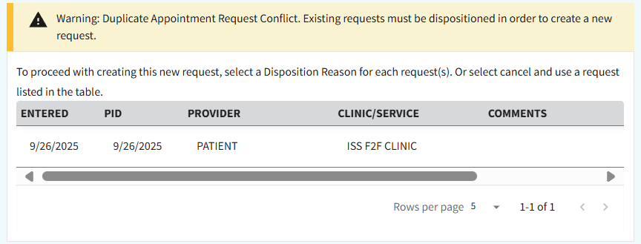
Figure 92: Duplicate Appointment Conflicts Example for PtCSch
- Once all applicable information has been filled, the user will select the “Create Request” button, seen in ⁠Figure 93⁠, to create the new PtCSch request.
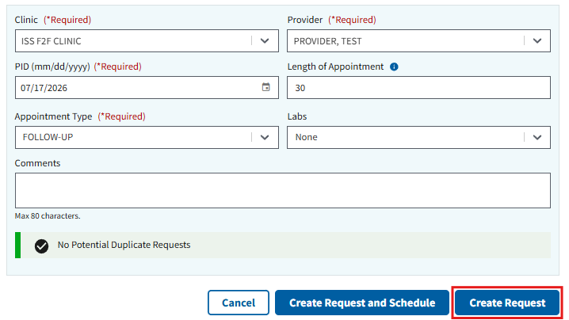
Figure 93: Create Request Button for PtCSch Requests
- Note: The user can select the “Create Request and Schedule” button, seen below in ⁠Figure 94⁠, to create the request and automatically schedule the pending appointment via the clinic calendar. Please see section ⁠4.3.2 PtCSch (Recall)⁠ for more information on creating a pending PtCSch appointment.
Figure 94: Create Request and Schedule Button for PtCSch
- Note: The user can also select the “Cancel” button seen in ⁠Figure 93⁠ to exit creating a request and go back to the Appointments & Requests page.

4.1.3 MRTC
- To create a new MRTC request, the user will first need to select “New Request,” as shown in ⁠Figure 95⁠.
Figure 95: New Request Button for MRTC Requests
- The user will then select “MRTC” from the dropdown that appears in ⁠Figure 96⁠ below.
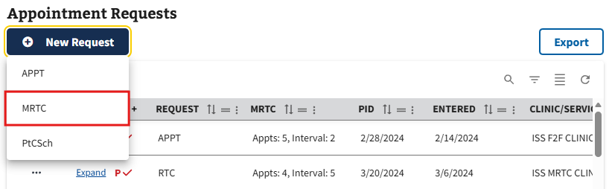
Figure 96: MRTC Option from New Request Dropdown
- The user will be brought to the New MRTC Request (Multiple Returns to Clinic) page. On this page, the user will need to fill out all the required information displayed in ⁠Figure 97⁠. The user can also fill out any optional information as needed.
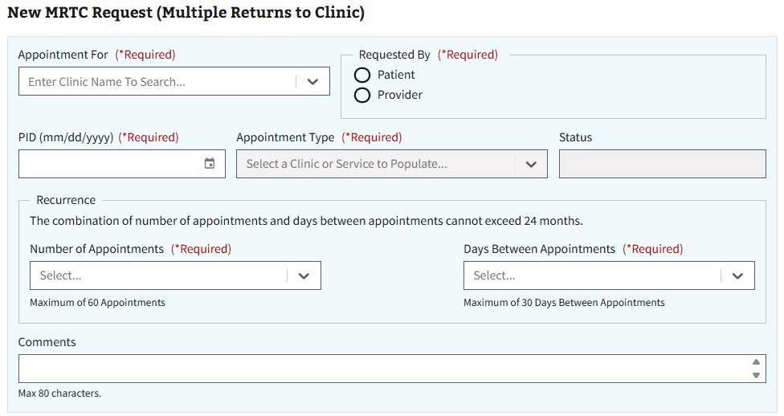
Figure 97: New MRTC Request Page
- Once all applicable information has been filled, the user will select the “Create Request” button, seen in ⁠⁠⁠⁠⁠⁠⁠Figure 98⁠⁠⁠⁠⁠⁠⁠, to create the new MRTC request.
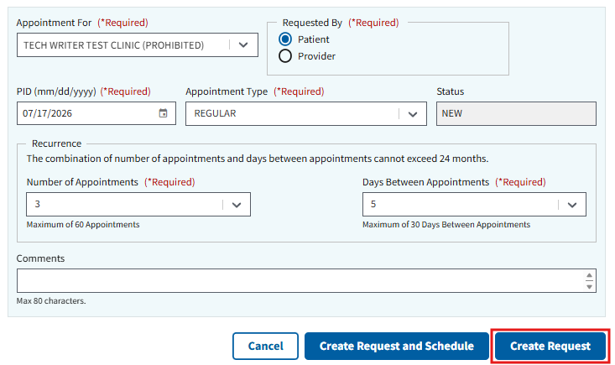
Figure 98: Create Request Button for MRTC Requests

- Note: The user can select the “Create Request and Schedule” button, seen below in ⁠Figure 99⁠, to create the request and automatically schedule the pending appointment via the clinic calendar. Please see section ⁠4.3.3 MRTC⁠ for more information on creating a pending MRTC appointment.
Figure 99: Create Request and Schedule Button for MRTC
- Note: The user can also select the “Cancel” button seen in ⁠Figure 98⁠ to exit creating a request and go back to the Appointments & Requests page.
- Note: Once an MRTC Request has been created, it will appear within the Appointment Requests grid under the request type “APPT.” To interact with an MRTC appointment request, the user can either select the ellipsis next to the parent MRTC request or select the “Expand” button, seen in ⁠⁠⁠⁠⁠Figure 100⁠⁠⁠⁠⁠ below, to bring all requests for the appointment into context to interact with individually.
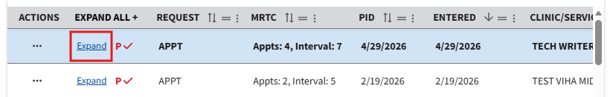
Figure 100: Expand Button for MRTC Requests
- Note: MRTC parent and child requests will be differentiated in the grid via a red “P✓” for parent requests and a red “✓” for child requests (See ⁠⁠⁠⁠⁠Figure 101⁠⁠⁠⁠⁠ below for an example).
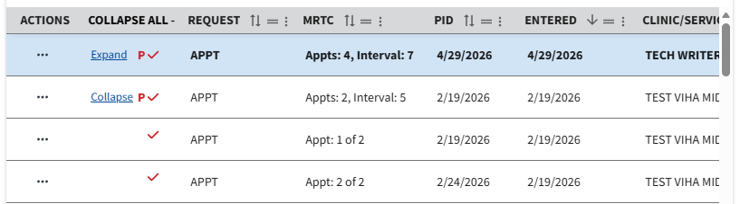
Figure 101: Parent and Child Requests Icon for MRTC

4.1.4 Consult/Procedure
Consult and Procedure requests are not created within the ISS application. To interact with these requests, the user will need to locate any previously created Consult/Procedure requests by navigating the Appointment Requests grid (See ⁠Figure 102⁠ for an example.)
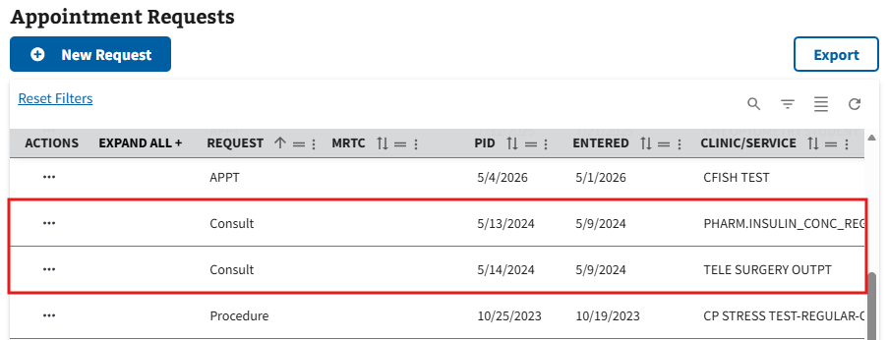
Figure 102: Example of Consult Requests in the Grid

4.1.5 RTC
RTC requests are not created within the ISS application. To interact with these requests, the user will need to locate any previously created RTC requests by navigating the Appointment Requests grid (See ⁠⁠⁠⁠⁠Figure 103⁠⁠⁠⁠⁠ for an example).
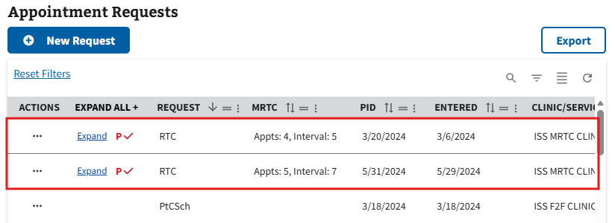
Figure 103: Example of RTC Requests in the Grid

4.1.6 VETERAN
VETERAN requests are not created within the ISS application. To interact with these requests, the user will need to locate any previously created VETERAN requests by navigating the Appointment Requests grid (See ⁠Figure 104⁠ for an example).
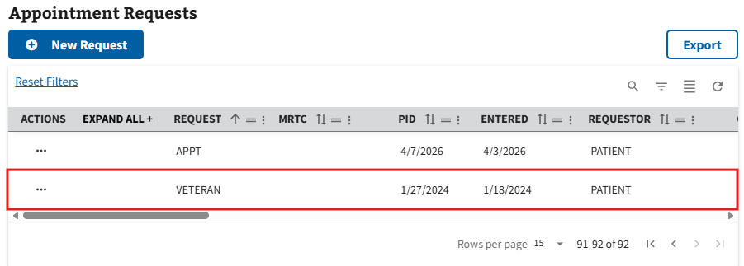
Figure 104: Example of VETERAN Requests in the Grid

4.1.7 Dispositioning Duplicate Clinic Requests
When creating an appointment request for APPT or PtCSch, the ISS application will cross-check duplicate clinic requests within the system for the current patient. The steps below detail how to handle these requests. For more information on APPT or PtCSch, see sections ⁠⁠⁠⁠⁠⁠⁠4.1.1 APPT⁠⁠⁠⁠⁠⁠⁠ and ⁠⁠⁠⁠⁠⁠⁠4.1.2 PtCSch (Recall)⁠⁠⁠⁠⁠⁠⁠.
- Navigate to the “Warning: Duplicate Appointment Request Conflict. Existing requests must be dispositioned in order to create a new request” notification, shown in ⁠⁠⁠⁠⁠Figure 105⁠⁠⁠⁠.
Figure 105: Duplicate Appointments Warning for Clinic Requests
- The user will then need to review each appointment listed in the table and decide whether to cancel a previously made appointment request(s), or to cancel the current request being created. If the user decides to continue with the current request, the other appointment request(s) will need to be dispositioned.
- To remove existing appointments, the user will need to select a disposition reason listed within the dropdown in the Disposition Reason column shown in ⁠Figure 106⁠. This step may need to be repeated if there are multiple duplicate requests that need to be dispositioned.
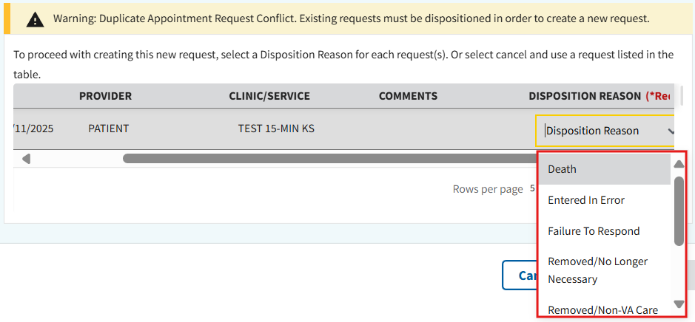
Figure 106: Disposition Dropdown for Clinic Requests
- Note: The user may need to navigate between pages of the table to find all duplicate requests. For more information, please see section ⁠⁠⁠⁠⁠⁠⁠2.3.5 Filtering Rows⁠⁠⁠⁠⁠⁠⁠.
- Once all previously created appointment requests have been given a disposition reason and all the required information has been inputted for the appointment request, the user can then select “Create Request.”

4.1.8 Dispositioning Duplicate Service Requests
When creating an appointment request for APPT, the ISS application will cross-check duplicate service requests within the system for the current patient. The steps below detail how to handle these requests. For more information on APPT, see section ⁠⁠⁠⁠⁠⁠⁠4.1.1 APPT⁠⁠⁠⁠⁠⁠⁠.
- Navigate to the “Warning: Duplicate Appointment Request Conflict. Existing requests must be dispositioned in order to create a new request” notification, seen in ⁠⁠⁠⁠⁠Figure 107⁠⁠⁠⁠⁠.
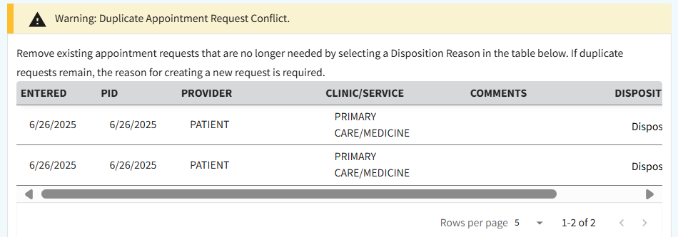
Figure 107: Duplicate Appointments Warning for Service Requests
- The user will then need to review each appointment listed in the table and decide whether to cancel a previously made appointment request(s), to cancel the current request being created, or to do a combination of both. If the user decides to continue with the current request, the other appointment request(s) will either need to be dispositioned or be given a reason for why they should remain with the new request.
- For the appointment requests that need to be dispositioned, select a disposition reason listed within the dropdown in the Disposition Reason column, shown in ⁠⁠⁠⁠⁠Figure 108⁠⁠⁠⁠⁠. This step may need to be repeated if there are multiple duplicate requests that need to be dispositioned.
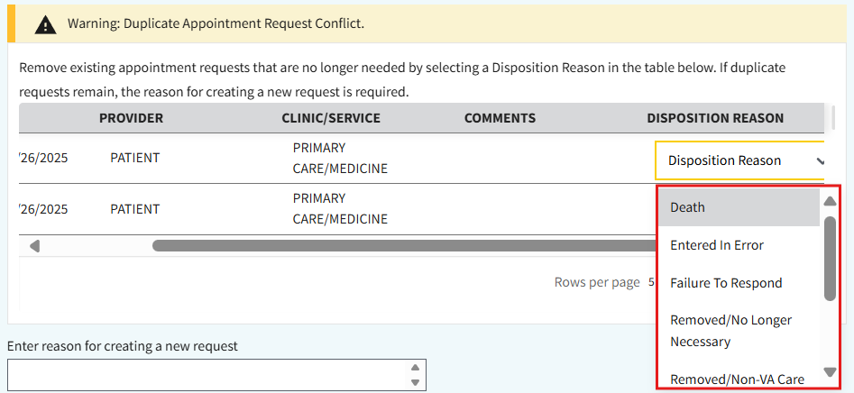
Figure 108: Disposition Dropdown for Service Requests
- Note: The user may need to navigate between pages of the table to find all duplicate requests. For more information, please see section ⁠⁠⁠⁠⁠⁠⁠2.3.5 Filtering Rows⁠⁠⁠⁠⁠⁠⁠.
- For the appointment requests that will remain, the user will need to leave the disposition reason in the default state. The user will then need to enter a reason for creating a new request in the text box shown in ⁠Figure 109⁠.
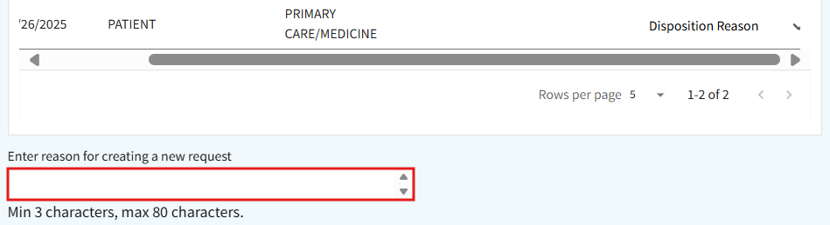
Figure 109: Reason Text Box for not Dispositioning Service Requests
- Once all of the previous steps have been completed successfully and all the required information has been inputted for the appointment request, the user can then select “Create Request.”

4.2 Appointment Request Actions

4.2.1 Viewing Appointment Requests
- To view an appointment request, the user can select the ellipsis, seen in ⁠Figure 110⁠, next to any appointment within the grid.
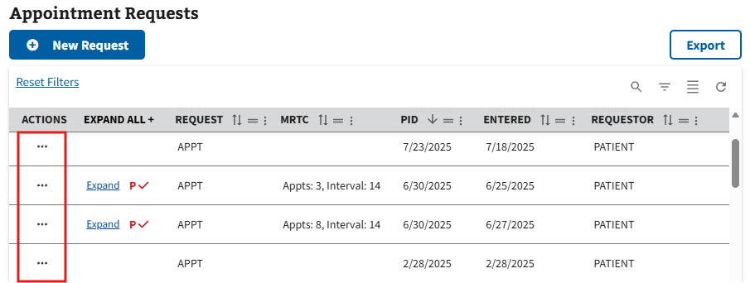
Figure 110: Selecting Action Menu Button to View Requests
- This will cause the action menu to appear. The user will then need to select the “View” option, seen in ⁠Figure 111⁠.
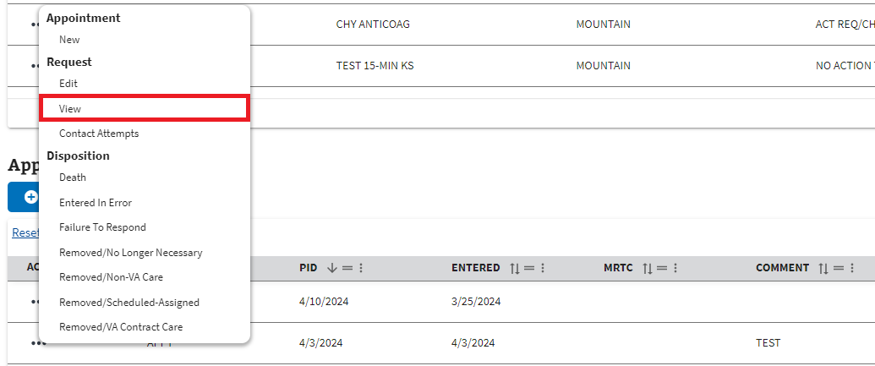
Figure 111: View Option from the Request Actions Dropdown
- The user will be brought to the View (Appointment Request Type) Request page, shown below in ⁠Figure 112⁠.
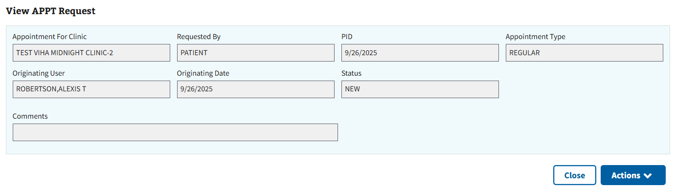
Figure 112: View APPT Request Page
- Note: Users can perform Appointment Requests actions via the view request page by selecting the “Actions” button seen in ⁠⁠⁠⁠⁠Figure 112⁠⁠⁠⁠⁠. This will cause the action menu to appear (see ⁠⁠⁠⁠⁠Figure 113⁠⁠⁠⁠⁠ for example). For more information on Appointment Request actions, see the following sections ⁠⁠⁠⁠⁠⁠⁠4.2.2 Editing Appointment Requests⁠⁠⁠⁠⁠⁠⁠ - ⁠⁠⁠⁠⁠⁠⁠4.2.7 Disposition an MRTC Child Request⁠⁠⁠⁠⁠⁠⁠.
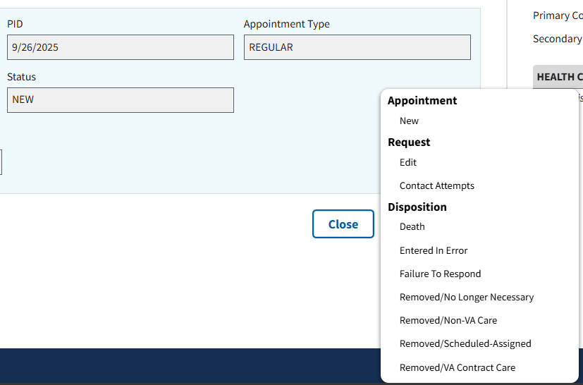
Figure 113: Action Menu from the View Request Page
- Note: Users will be able to track comments via the View page. Comments will show the name of the commenter, as well as the date the comment was added to the appointment request.

4.2.2 Editing Appointment Requests
- To edit an appointment request, the user will select the ellipsis, seen in ⁠Figure 114⁠, next to any appointment within the grid.
Figure 114: Selecting Action Menu Button to Edit Requests
- This will cause the action menu to appear. The user will then need to select the “Edit” option, seen in ⁠⁠⁠⁠⁠Figure 115⁠⁠⁠⁠⁠.
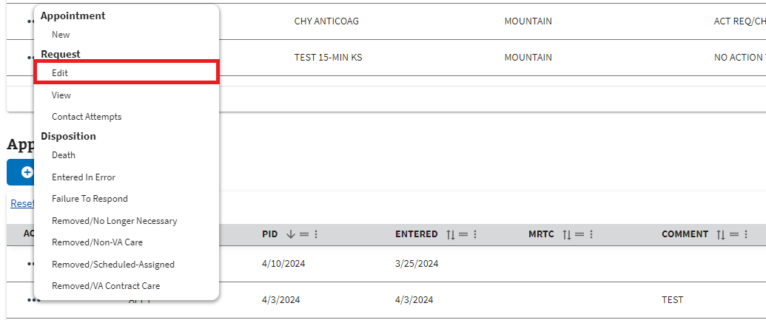
Figure 115: Edit Option from the Request Actions Dropdown
- The user will be brought to the Edit (Appointment Request Type) Request page. On this page, the user can edit any of the fields highlighted below in ⁠⁠⁠⁠⁠Figure 116⁠⁠⁠⁠⁠.
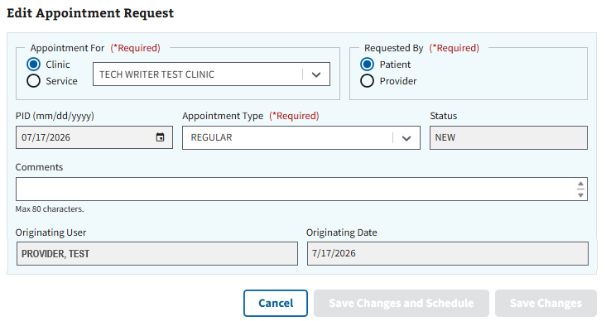
Figure 116: Edit Appointment Request Page
- Note: Users can add additional comments to an appointment request, as well as track previous comments via the Edit page. Previous comments will show the name of the commenter and the date the comment was added.
- Once all edits have been made, the user will need to select the “Save Changes” button, seen in ⁠Figure 117⁠, to save any edits to the request.
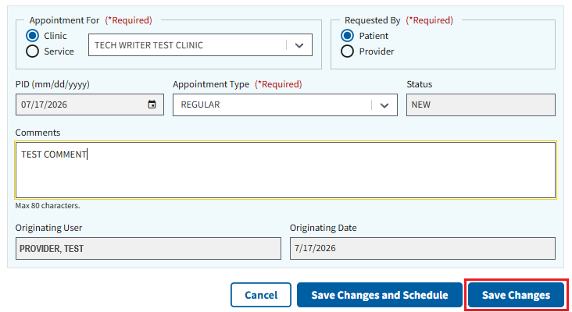
Figure 117: Save Changes Button for Editing Requests

- Note: The user can select the “Save Changes and Schedule” button, seen below in ⁠Figure 118⁠, to save any request edits and automatically open the clinic calendar to schedule a pending appointment. Please see sections ⁠4.3.1 APPT⁠- ⁠4.3.3 MRTC⁠ for more information on creating a pending appointment.
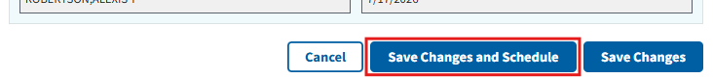
Figure 118: Save Changes and Schedule Button for Editing Requests
- Note: The user can also select the “Cancel” button seen in ⁠⁠⁠⁠⁠Figure 117⁠⁠⁠⁠⁠ to exit editing a request and go back to the Appointments & Requests page.

4.2.3 Contact Attempts
- To create a contact attempt request, the user will select the ellipsis, seen in ⁠Figure 119⁠, next to any appointment within the grid.
Figure 119: Selecting Action Menu Button to Create Contact Attempts
- This will cause the action menu to appear. The user will then need to select the “Contact Attempts” option, seen in ⁠Figure 120⁠.
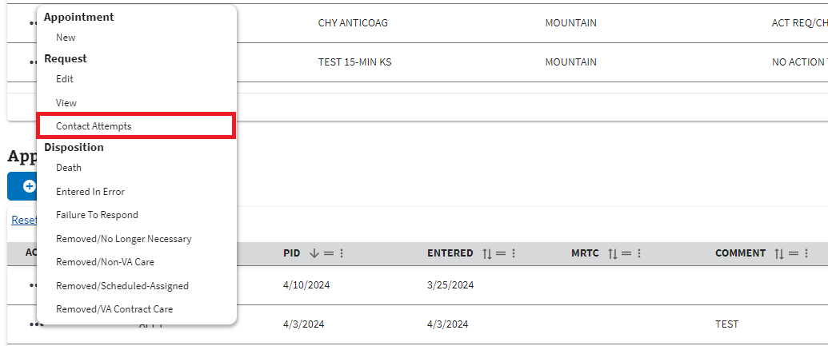
Figure 120: Contact Attempts Option from the Request Actions Dropdown
- The user will be brought to the Contact Attempts page, shown below in ⁠Figure 121⁠.
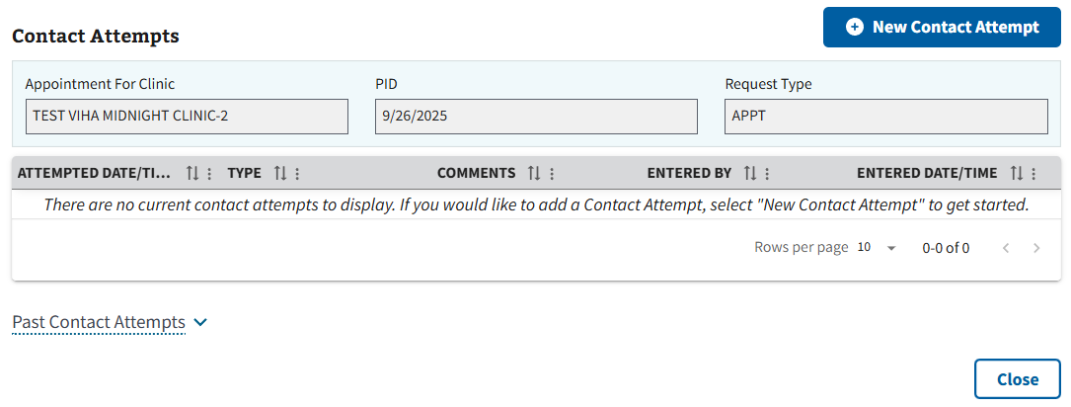
Figure 121: Contact Attempts Page
- To create a new contact attempt, the user will need to select the “New Contact Attempt” button seen in ⁠⁠⁠⁠⁠Figure 122⁠⁠⁠⁠⁠.
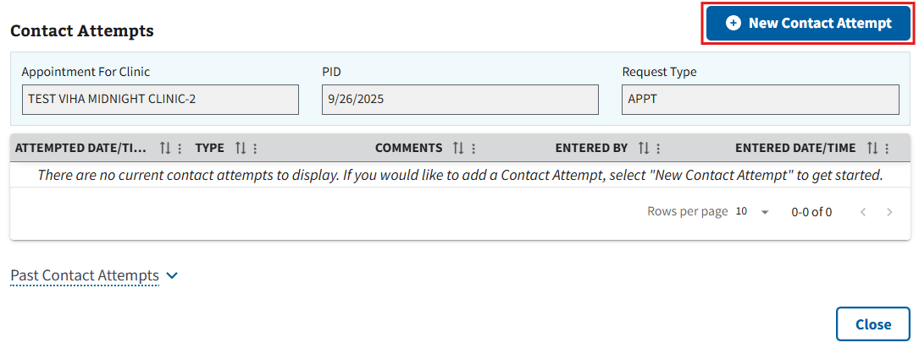
Figure 122: New Contact Attempt Button
- The user will be brought to the Create Contact Attempt Page seen in ⁠Figure 123⁠ below. From here, the user will need to fill out the required information displayed and fill out any optional information as needed.
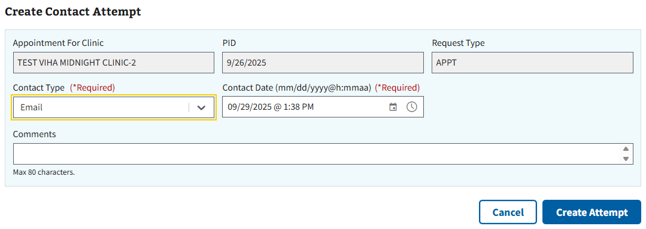
Figure 123: Create Contact Attempt Page
- Note: The first contact attempt cannot be done via a letter. Once the user has made at least one contact attempt, the “Letter” option will be available within the Contact Type field.
- Once the user has filled out all applicable information, the user will need to select the “Create Attempt” button, seen in ⁠⁠⁠⁠⁠Figure 124⁠⁠⁠⁠⁠, to create the contact attempt.
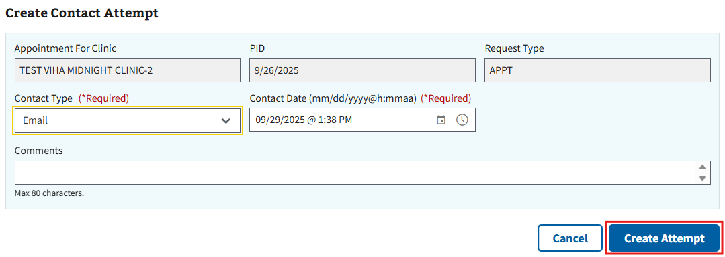
Figure 124: Create Attempt Button
- Note: The user can also select the “Cancel” button seen in ⁠⁠⁠⁠⁠Figure 124⁠⁠⁠⁠⁠ to exit creating a contact attempt and go back to the Contact Attempts page.
- After saving their changes, the user will be brought back to the Contact Attempts page. The grid shown below in ⁠Figure 125⁠ will be updated with the newly created contact attempt information.
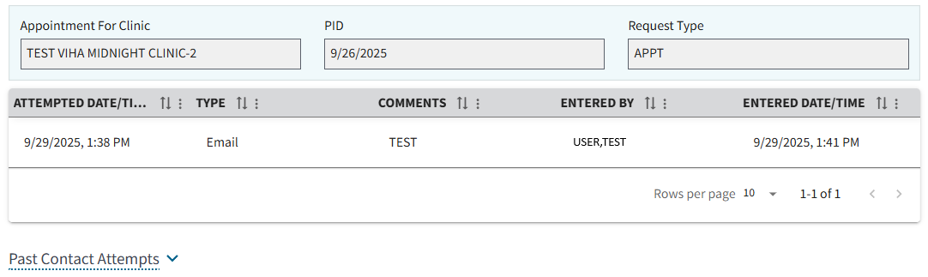
Figure 125: Example of Contact Attempts Grid after Creating Attempt

4.2.4 Disposition an APPT, RTC, or VETERAN Request
- To disposition an APPT, RTC, or VETERAN request, the user will select the ellipsis, seen in ⁠⁠⁠⁠⁠Figure 126⁠⁠⁠⁠⁠, next to any appointment within the grid.
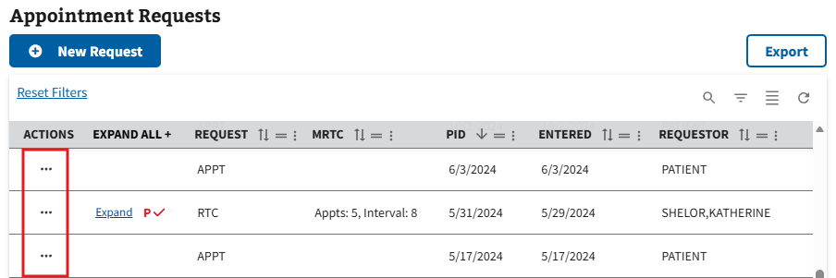
Figure 126: Selecting Action Menu Button to Disposition Requests
- This will cause the action menu to appear. The user will then need to select one of the disposition options highlighted below in ⁠⁠⁠⁠⁠Figure 127⁠⁠⁠⁠⁠.
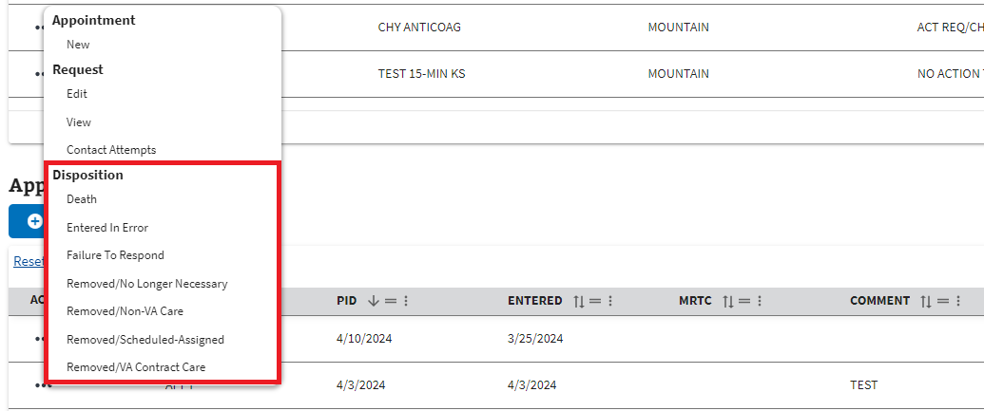
Figure 127: Disposition Options from the Request Actions Dropdown
- Note: When dispositioning a request via failure to respond, the user will need to have made at least 2 contact attempts at least 2 weeks prior to the disposition date. Attempting to disposition otherwise will result in the notification seen in ⁠⁠⁠⁠⁠Figure 128⁠⁠⁠⁠⁠ below.
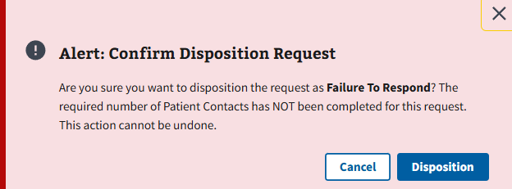
Figure 128: Notification when Dispositioning Failure to Respond without Attempts
- After selecting a disposition type, the user will need to select the “Disposition” button seen below in ⁠⁠⁠⁠⁠Figure 129⁠⁠⁠⁠⁠ to confirm the request.
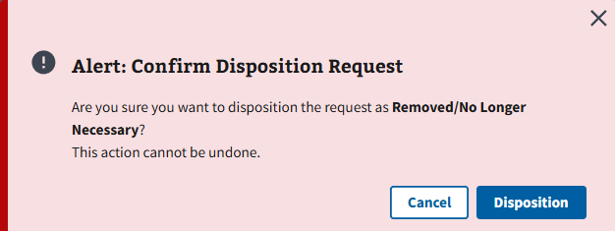
Figure 129: Confirm Disposition Request Notification
- Once the disposition is confirmed, the page will automatically refresh, and the request will be removed from the Appointment Requests grid.

4.2.5 Disposition a PtCSch Request
- To disposition a PtCSch request, the user will select the ellipsis, seen in ⁠Figure 130⁠, next to any appointment within the grid.
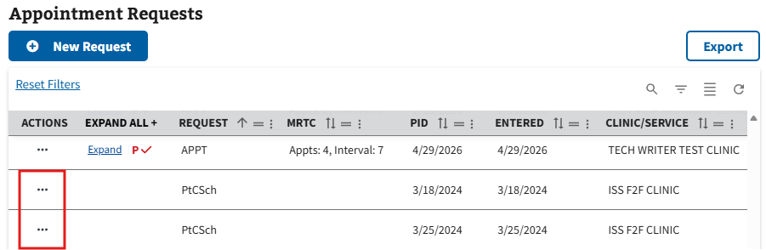
Figure 130: Selecting Action Menu Button to Disposition Requests for PtCSch
- This will cause the action menu to appear. The user will then need to select one of the disposition options highlighted below in ⁠⁠⁠⁠⁠Figure 131⁠⁠⁠⁠⁠.
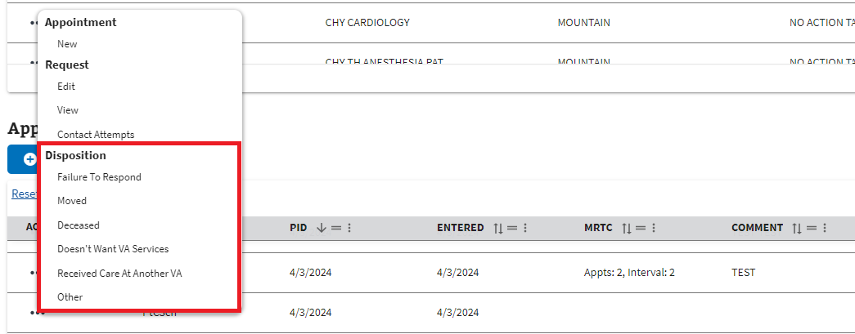
Figure 131: Disposition Options for PtCSch on the Requests Actions Dropdown
- Note: When dispositioning a request via failure to respond, the user will need to have made at least 2 contact attempts at least 2 weeks prior to the disposition date. Attempting to disposition otherwise will result in the notification seen in ⁠⁠⁠⁠⁠Figure 132⁠⁠⁠⁠⁠ below.
Figure 132: Notification when Dispositioning Failure to Respond without Attempts on PtCSch
- After the disposition type is selected, the PtCSch Disposition window will appear. The user can choose to add a comment, if needed, and then select “Continue” to finish the disposition, as seen in ⁠⁠⁠⁠⁠Figure 133⁠⁠⁠⁠⁠.
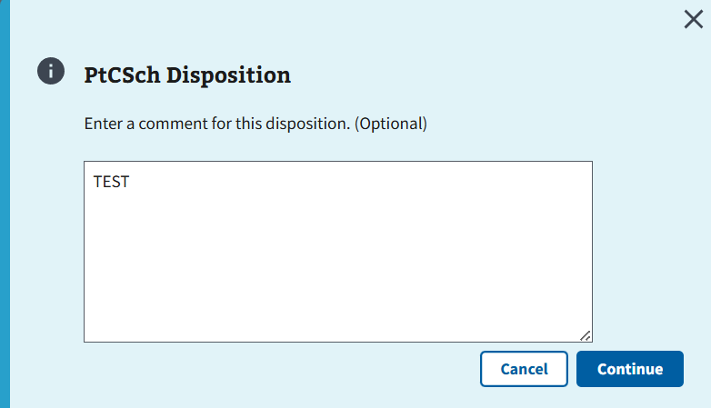
Figure 133: Continue Button for Disposition Comments Window for PtCSch Requests
- Note: The user can also select the “Cancel” button or the “x” button, seen in ⁠Figure 133⁠, to cancel the disposition and go back to the Appointments & Requests page.
- The page will automatically refresh, and the request will be removed from the Appointment Requests grid.

4.2.6 Disposition an MRTC Parent Request
- When dispositioning an MRTC request, the user can choose to either disposition an individual child request (See ⁠⁠⁠⁠⁠⁠⁠4.2.7 Disposition an MRTC Child Request⁠⁠⁠⁠⁠⁠⁠), or the parent request. To disposition a parent request, the user will select the ellipsis, seen in ⁠⁠⁠⁠⁠Figure 134⁠⁠⁠⁠⁠, next to the parent request within the grid.
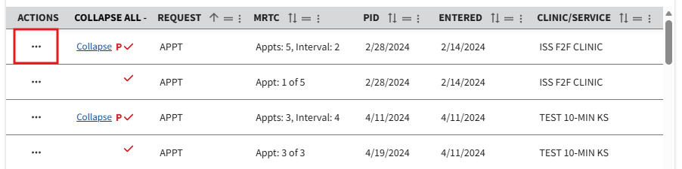
Figure 134: Selecting Action Menu Button to Disposition for MRTC Parent Requests
- This will cause the action menu to appear. The user will then need to select one of the disposition options highlighted below in ⁠⁠⁠⁠⁠Figure 135⁠⁠⁠⁠⁠.
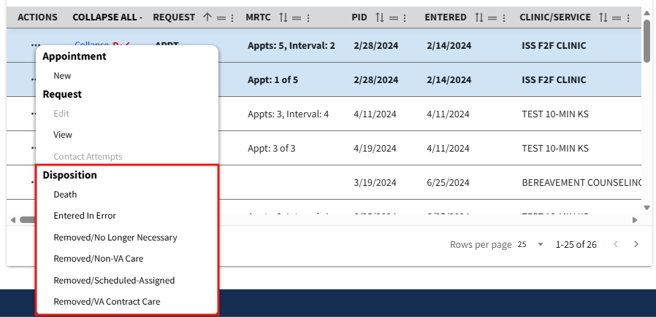
Figure 135: Disposition Options for MRTC Parent Request on the Actions Dropdown
- After the disposition type is selected, the user will be brought to the Close MRTC Request page. For a parent request, all pending appointments and requests will be dispositioned. The user will select the “Disposition MRTC” button, seen in ⁠Figure 136⁠, to finish the disposition.
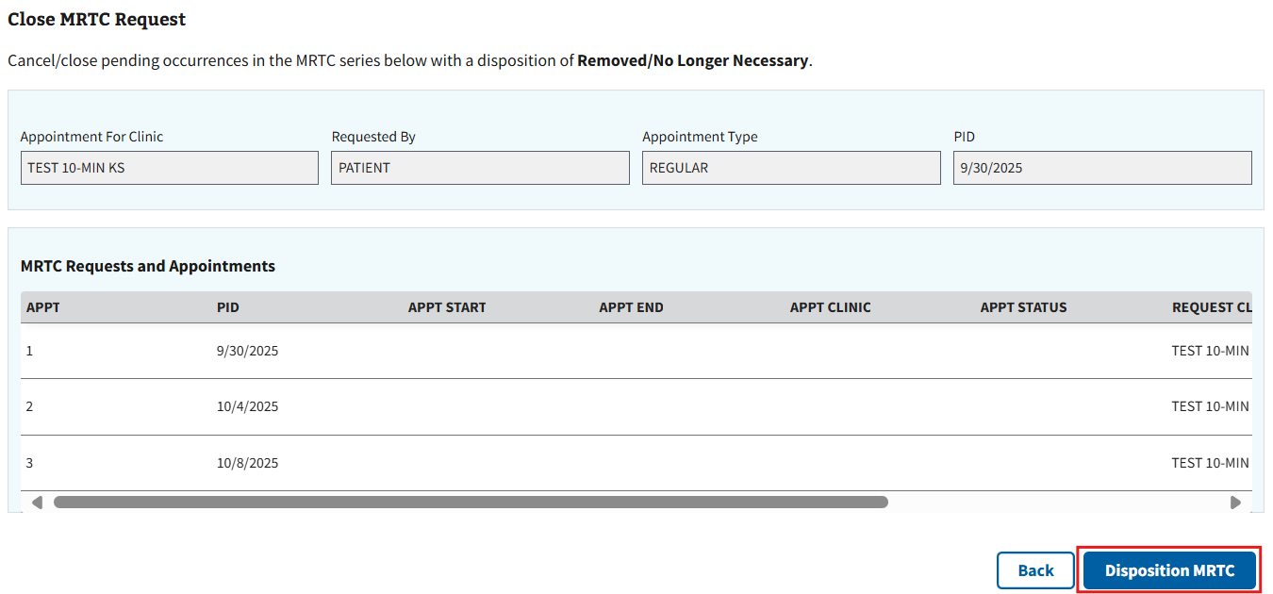
Figure 136: Disposition MRTC Button for Parent Requests
- Note: If a pending appointment exists when dispositioning a parent request, the user will also need to fill out the fields under the Cancel MRTC Appointment(s) section, seen in ⁠Figure 137⁠, before continuing. The user will have the option to preview a cancellation letter, if needed.
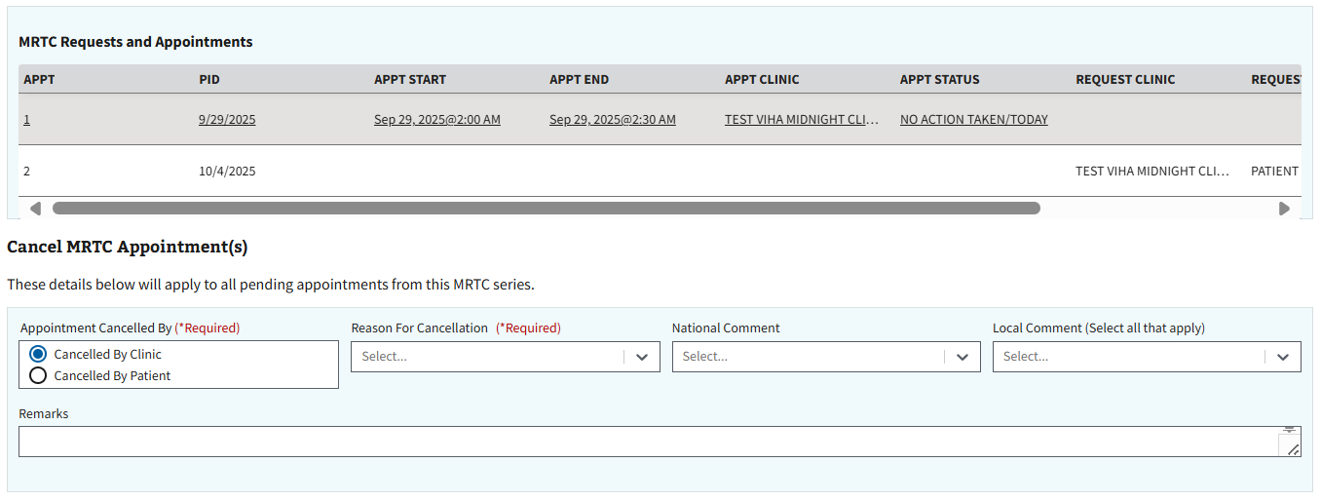
Figure 137: Cancel MRTC Section Example when Dispositioning Parent Request
- Note: The user can also select the “Back” button seen in ⁠Figure 136⁠ to cancel the disposition and go back to the Appointments & Requests page.

4.2.7 Disposition an MRTC Child Request
- To disposition a child request, the user will need to expand the MRTC request by selecting the “Expand” button next to the MRTC parent. The user will then need to select one of the corresponding ellipses next to a child appointment, as shown in ⁠⁠⁠⁠⁠Figure 138⁠⁠⁠⁠⁠ below.
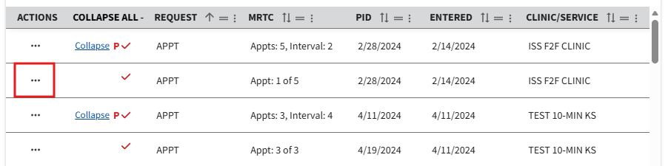
Figure 138: Selecting Action Menu Button to Disposition for MRTC Child Requests
- This will cause the action menu to appear. The user will then need to select one of the disposition options highlighted below in ⁠⁠⁠⁠⁠Figure 139⁠⁠⁠⁠⁠.
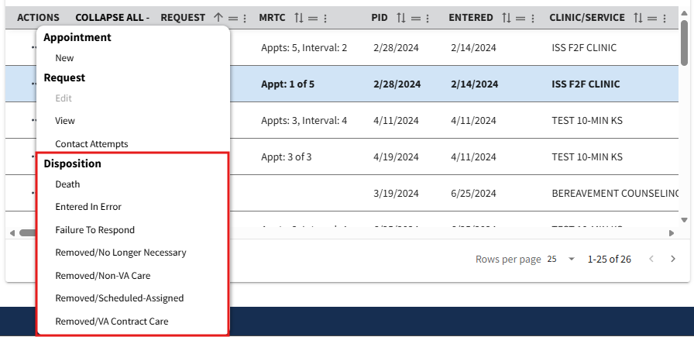
Figure 139: Disposition Options for MRTC Child Requests on the Actions Dropdown
- Note: When dispositioning a request via failure to respond, the user will need to have made at least 2 contact attempts at least 2 weeks prior to the disposition date. Attempting to disposition otherwise will result in the notification seen in ⁠⁠⁠⁠⁠Figure 140⁠⁠⁠⁠⁠ below.
Figure 140: Notification when Dispositioning Failure to Respond without Attempts on MRTC Child Requests
- After the disposition type is selected, the user will be brought to the Close MRTC Request page. For a child request, the user will be given the option to close either the selected appointment request only, or all the appointment requests in the series. Once making their preferred selection, the user will select the “Disposition MRTC” button, seen in ⁠⁠⁠⁠⁠Figure 141⁠⁠⁠⁠⁠, to finish the disposition.
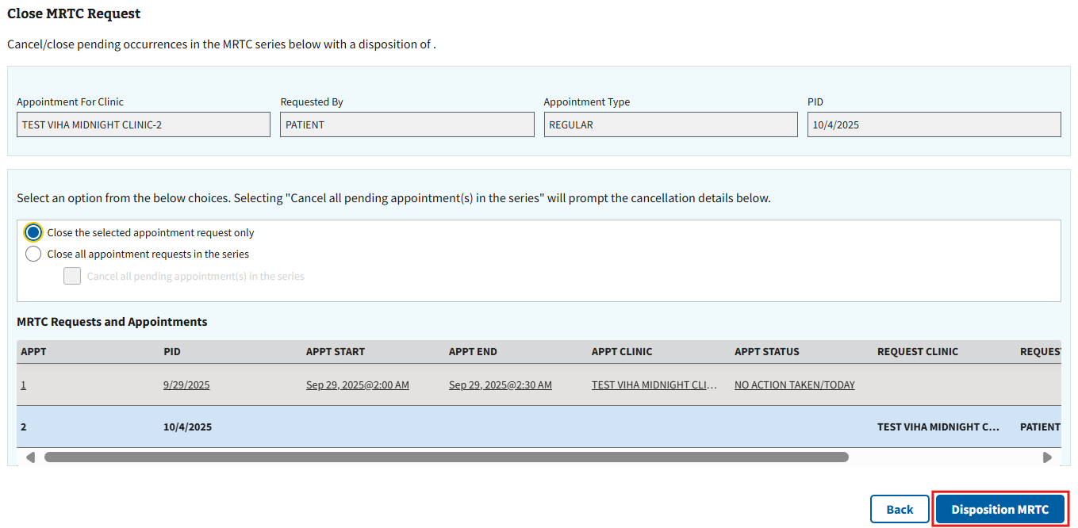
Figure 141: Disposition MRTC Button for MRTC Child Requests
- Note: If the user decides to cancel all appointments and requests and a pending appointment exists when dispositioning a child request, the user will also need to fill out the fields under the Cancel MRTC Appointment(s) section, seen in ⁠Figure 142⁠, before continuing. The user will have the option to preview a cancellation letter, if needed.
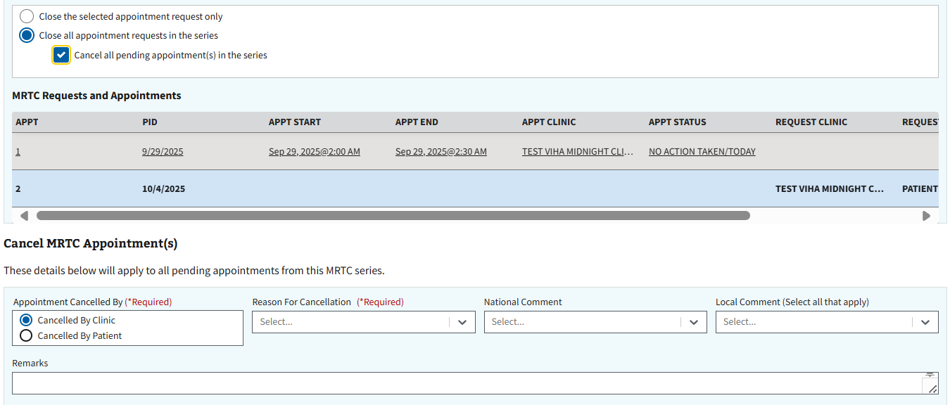
Figure 142: Cancel MRTC Section Example when Dispositioning Child Requests
- Note: The user can also select the “Back” button seen in ⁠Figure 141⁠ to cancel the disposition and go back to the Appointments & Requests page.

4.3 Creating a Pending Appointment

4.3.1 APPT
- To create an APPT appointment, the user will first need to create a request by following the steps in ⁠⁠⁠⁠⁠⁠⁠4.1.1 APPT⁠⁠⁠⁠⁠⁠⁠.
- After creating the appointment request, the user will select the ellipsis, seen in ⁠⁠Figure 143⁠⁠⁠⁠⁠, next to the request within the grid.
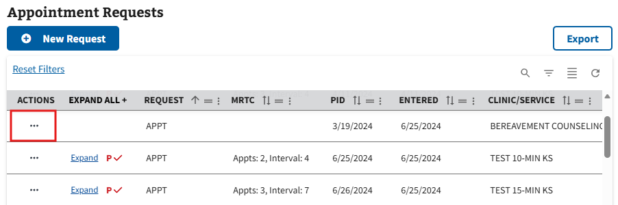
Figure 143: Selecting Action Menu Button to Create APPT Appointment
- This will cause the action menu to appear. The user will then need to select the “New” option, seen in ⁠Figure 144⁠.
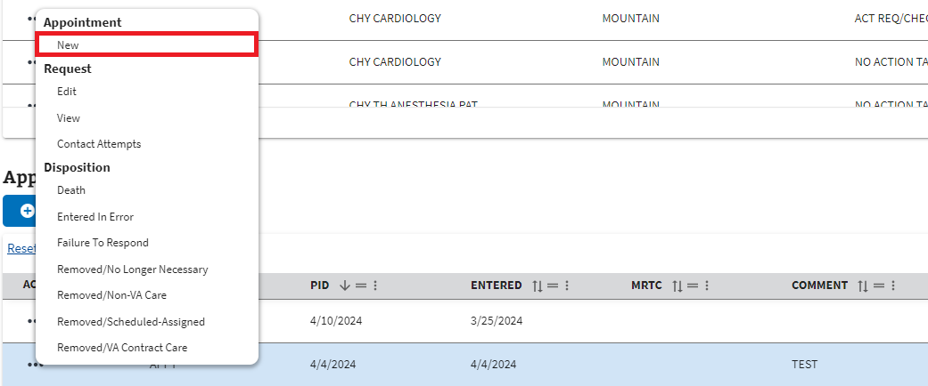
Figure 144: New Option from the Request Actions Dropdown for APPT
- The user will be brought to the Schedule Search page shown below. On this page, the user can right click within the preferred timeslot on the calendar and select the “Create Appointment” option seen in ⁠Figure 145⁠.
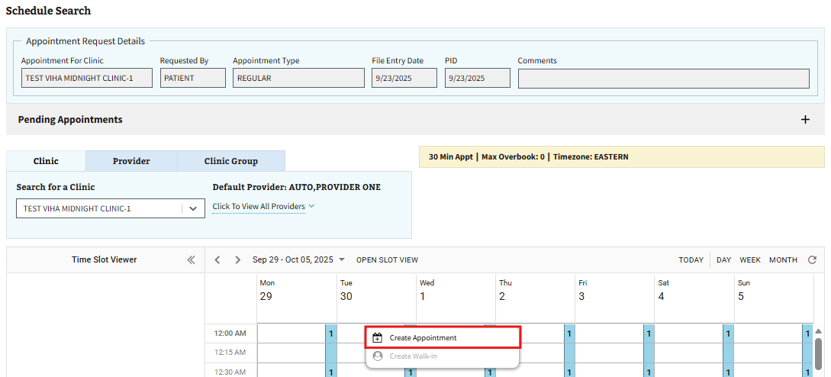
Figure 145: Create Appointment Button for APPT
- The user will be brought to the New Appointment page. On this page, the user will need to fill out all the required information displayed in ⁠⁠⁠⁠⁠⁠⁠Figure 146⁠⁠⁠⁠⁠⁠⁠. The user can also fill out any optional information as needed.
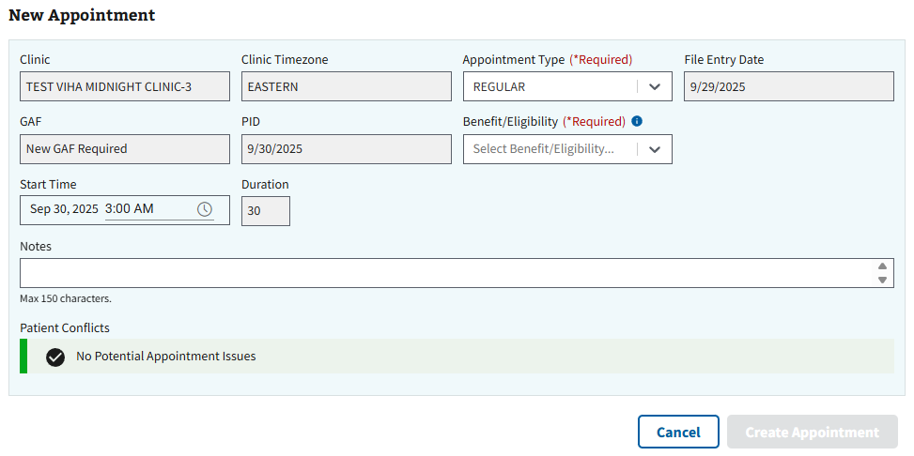
Figure 146: New Appointment Page for APPT
- Note: Users will be able to track comments via the New Appointment page. Comments will show the name of the commenter, as well as the date the comment was added to the appointment request. Comments added under the ‘Notes” section of the page will be added to comment tracking and available for viewing once the appointment has been created.
- Once all applicable information has been filled, the user will select the “Create Appointment” button, seen in ⁠Figure 147⁠, to create the new APPT appointment.
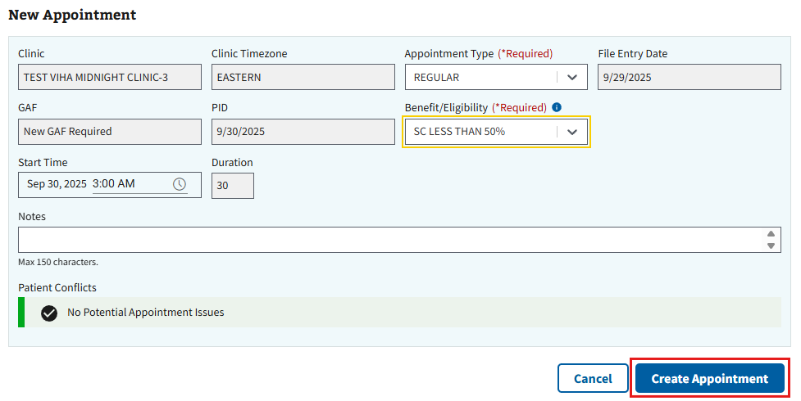
Figure 147: Create Appointment Button for New APPT
- Note: The user can also select the “Cancel” button seen in ⁠⁠⁠⁠⁠Figure 147⁠⁠⁠⁠⁠ to exit creating an appointment and go back to the Appointments & Requests page.
- The Appointment Successfully Created window, shown below in ⁠⁠⁠⁠⁠Figure 148⁠⁠⁠⁠⁠, will appear. The user can choose to preview the patient letter, if needed, or select “Close” to continue.
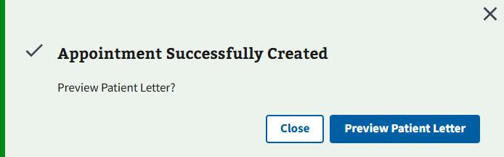
Figure 148: Preview Patient Letter Window for Creating APPT Appointment

4.3.2 PtCSch (Recall)
- To create a PtCSch appointment, the user will first need to create a request by following the steps in ⁠⁠⁠⁠⁠⁠⁠4.1.2 PtCSch (Recall)⁠⁠⁠⁠⁠⁠⁠.
- After creating the appointment request, the user will select the ellipsis, seen in ⁠Figure 149⁠, next to the request within the grid.
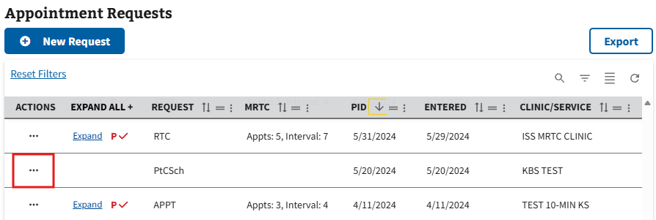
Figure 149: Selecting Action Menu Button to Create PtCSch Appointment
- This will cause the action menu to appear. The user will then need to select the “New” option, seen in ⁠Figure 150⁠.
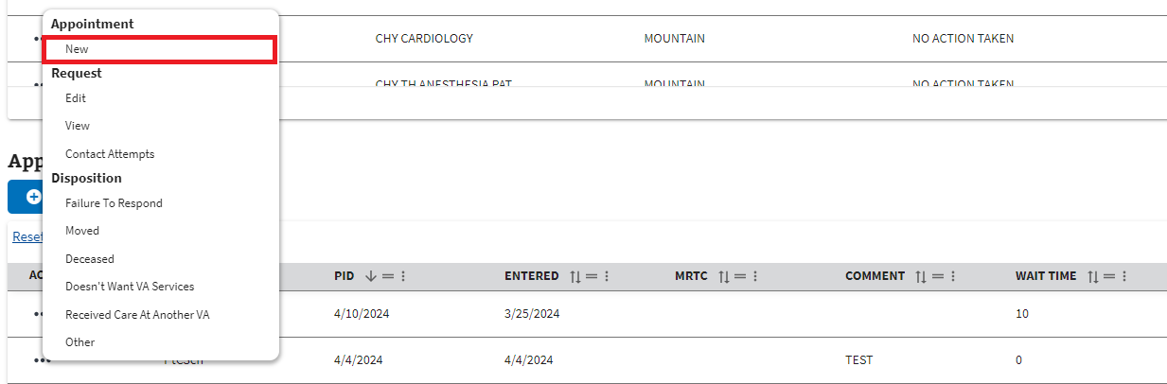
Figure 150: New Option from the Request Actions Dropdown for PtCSch
- The user will be brought to the Schedule Search page shown below. On this page, the user can right click within the preferred timeslot on the calendar and select the “Create Appointment” option seen in ⁠Figure 151⁠.
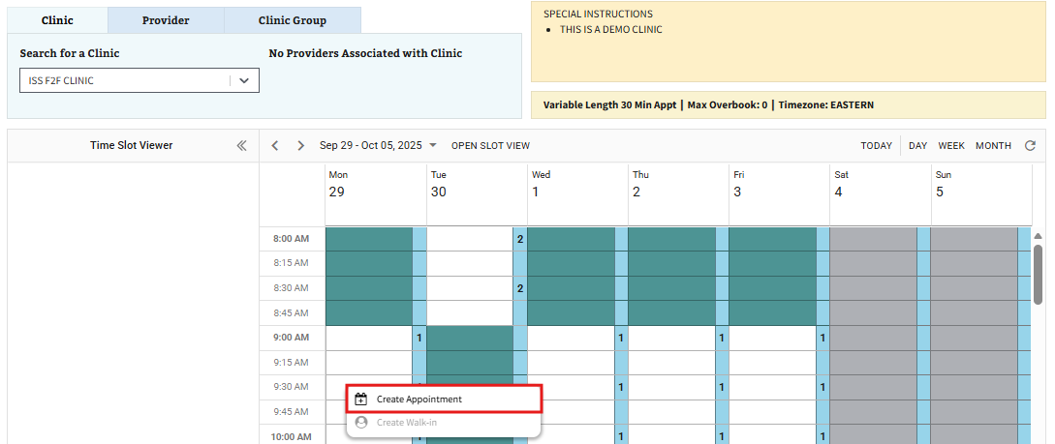
Figure 151: Create Appointment Button for PtCSch
- The user will be brought to the New Appointment page. On this page, the user will need to fill out all the required information displayed in ⁠⁠⁠⁠⁠Figure 152⁠⁠⁠⁠⁠. The user can also fill out any optional information as needed.
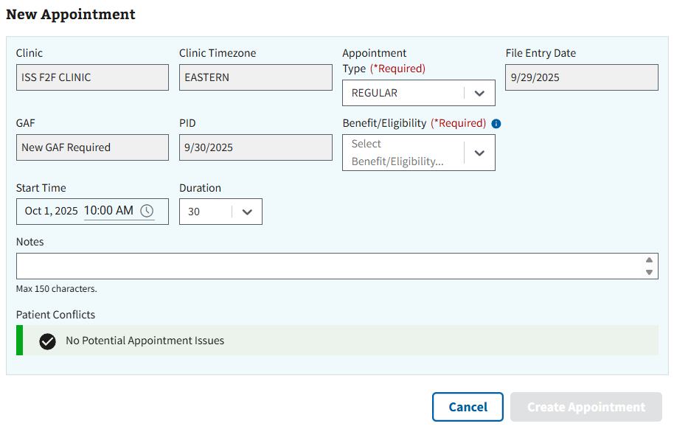
Figure 152: New Appointment Page for PtCSch
- Note: Users will be able to track comments via the New Appointment page. Comments will show the name of the commenter, as well as the date the comment was added to the appointment request. Comments added under the ‘Notes” section of the page will be added to comment tracking and available for viewing once the appointment has been created.
- Once all applicable information has been filled, the user will select the “Create Appointment” button, seen in ⁠⁠⁠⁠⁠Figure 153⁠⁠⁠⁠⁠, to create the new PtCSch appointment.
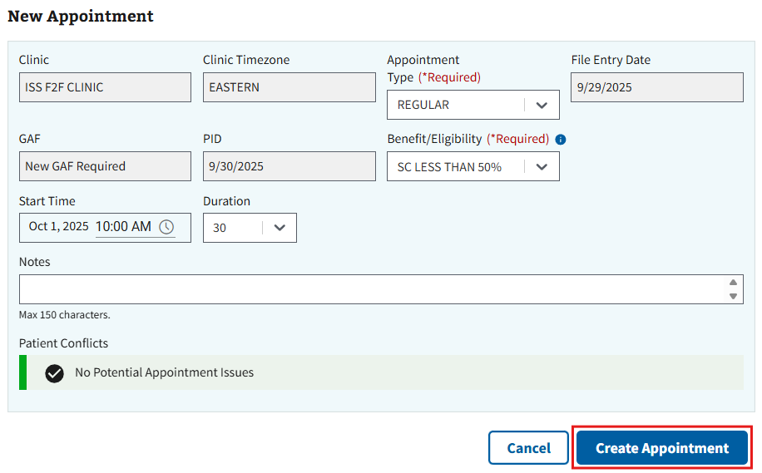
Figure 153: Create Appointment Button for New PtCSch
- Note: The user can also select the “Cancel” button seen in ⁠Figure 153⁠ to exit creating an appointment and go back to the Appointments & Requests page.
- The Appointment Successfully Created window, shown below in ⁠Figure 154⁠, will appear. The user can choose to preview the patient letter, if needed, or select “Close” to continue.
Figure 154: Preview Patient Letter Window for Creating PtCSch Appointment

4.3.3 MRTC
- To create an MRTC appointment, the user will first need to locate an MRTC request created through CPRS, as seen in ⁠Figure 155⁠, or follow the steps in ⁠⁠⁠⁠⁠⁠⁠4.1.3 MRTC⁠⁠⁠⁠⁠⁠⁠ to create a request through ISS.
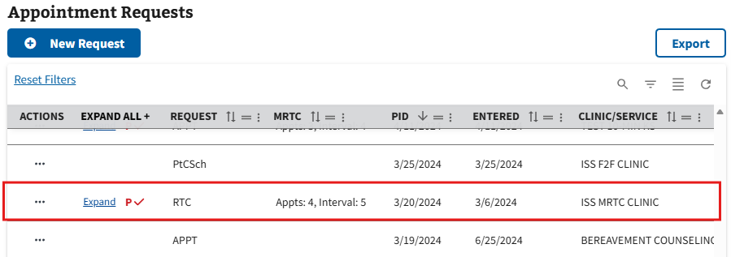
Figure 155: Example of CPRS MRTC in Grid
- Note: MRTC requests created through CPRS will display as “RTC” in the Request column.
- Note: MRTC requests without an existing parent request will display in red as seen below in ⁠Figure 156⁠.
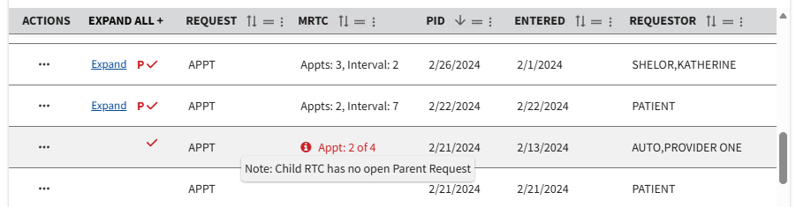
Figure 156: Orphaned MRTC Child Request Example
- After creating the appointment request, the user will select the ellipsis, seen in ⁠Figure 157⁠, next to the request within the grid.
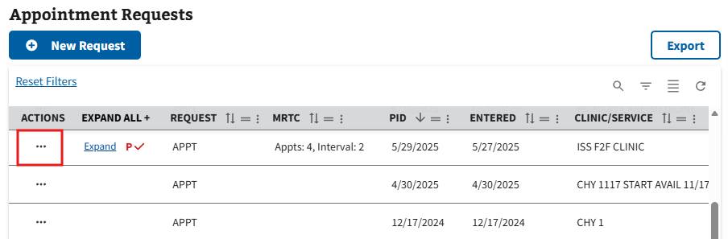
Figure 157: Selecting Action Menu Button to Create MRTC Appointment
- Note: If the user would like to schedule a child request individually, simply expand the parent MRTC request and select the ellipsis next to the child request needed. The user can then follow the steps from ⁠⁠⁠⁠⁠⁠⁠4.3.1 APPT⁠⁠⁠⁠⁠⁠⁠ to create the appointment.
- This will cause the action menu to appear. The user will then need to select the “New” option, seen in ⁠Figure 158⁠.
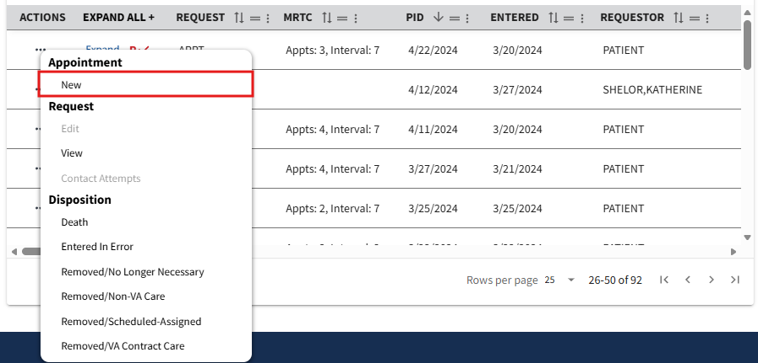
Figure 158: New Option from the Request Actions Dropdown for MRTC
- The user will be brought to the New MRTC Appointment (1 of x) page. On this page, the user can right click within the preferred timeslot on the calendar and select the "Create MRTC Appointment (1 of x)” option seen in ⁠Figure 159⁠.
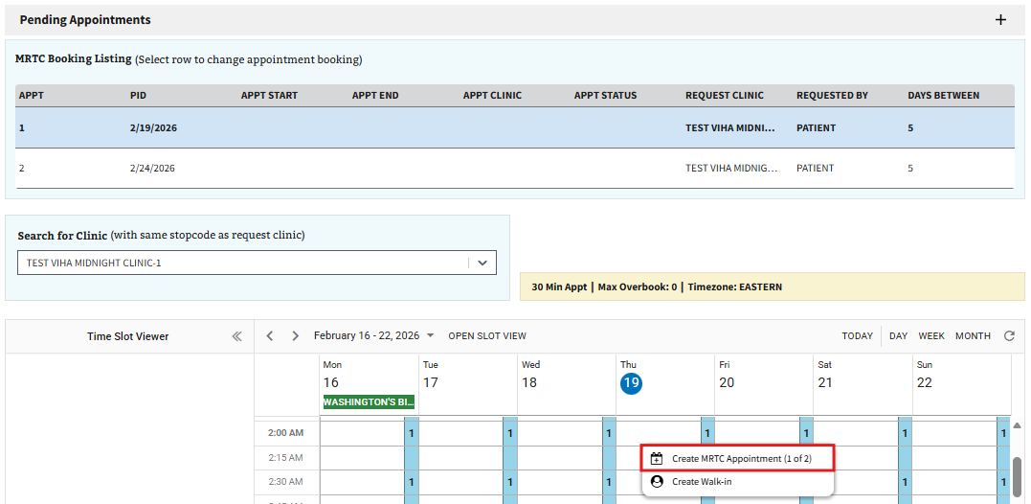
Figure 159: Create Appointment Button for MRTC
- The user will be brought to the New Appointment page. On this page, the user will need to fill out all the required information displayed in ⁠Figure 160⁠. The user can also fill out any optional information as needed.
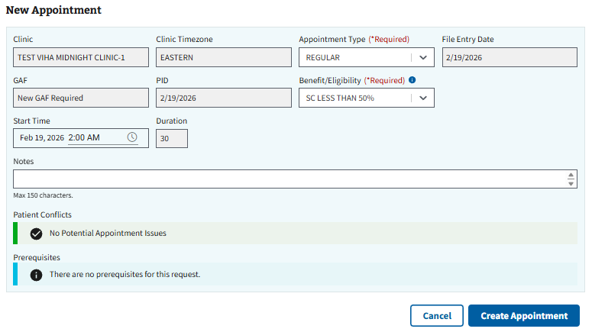
Figure 160: New Appointment Page for MRTC
- Note: When creating an MRTC Appointment, the user may see prerequisites attached to the request, as seen below in ⁠Figure 161⁠.
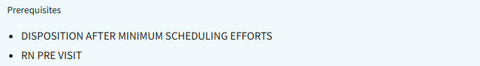
Figure 161: Prerequisites Example for MRTC
- Note: Users will be able to track comments via the New Appointment page. Comments will show the name of the commenter, as well as the date the comment was added to the appointment request. Comments added under the ‘Notes” section of the page will be added to comment tracking and available for viewing once the appointment has been created.
- Once all applicable information has been filled, the user will select the “Create Appointment” button, seen in ⁠⁠⁠⁠⁠Figure 162⁠⁠⁠⁠⁠, to create the new MRTC appointment.
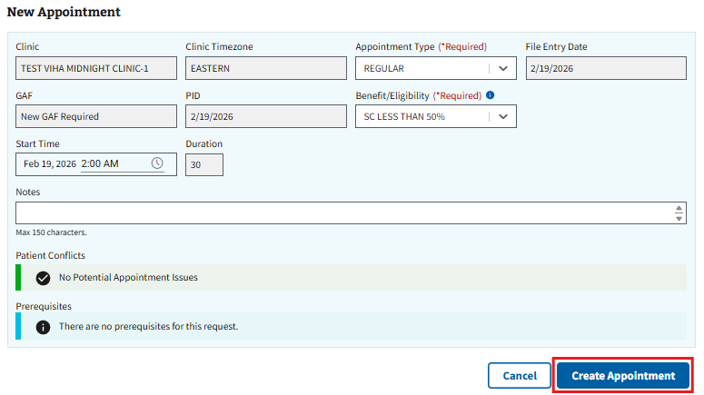
Figure 162: Create Appointment Button for New MRTC
- Note: The user can also select the “Cancel” button seen in ⁠Figure 162⁠ to exit creating an appointment and go back to the Appointments & Requests page.
- The Appointment Successfully Created window, shown below in ⁠Figure 163⁠, will appear. The user can choose to preview the patient letter, if needed, or select “Close” to continue.
Figure 163: Preview Patient Letter Window for Creating MRTC Appointments
- Once the appointment is created, the user will be brought back to the New MRTC Appointment page. From here, the user can follow steps 4-7 to create the other appointments on the MRTC request or select close to exit and return to the Appointments & Requests page.

4.3.4 Consult/Procedure
- To create a Consult/Procedure appointment, the user will need to locate any previously created Consult/Procedure requests by navigating the Appointment Requests grid (See ⁠⁠⁠⁠⁠Figure 164⁠⁠⁠⁠⁠ for an example).
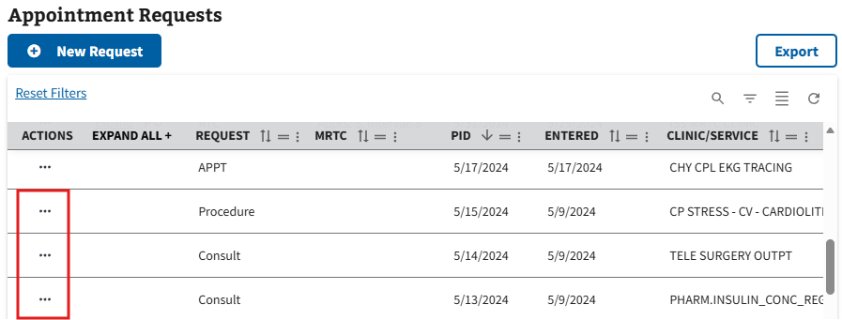
Figure 164: Example for Finding Consult/Procedure Requests
- Once the consult/procedure request is located, the user will select the ellipsis, seen in ⁠⁠⁠⁠⁠Figure 165⁠⁠⁠⁠⁠, next to the request within the grid.
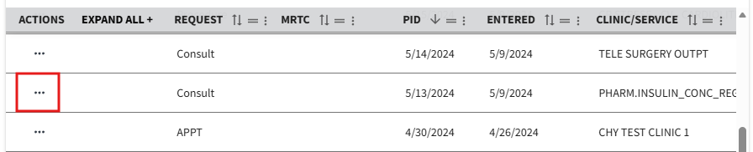
Figure 165: Selecting Action Menu Button to Create Consult/Procedure Appointment
- This will cause the action menu to appear. The user will then need to select the “New” option, seen in ⁠Figure 166⁠.
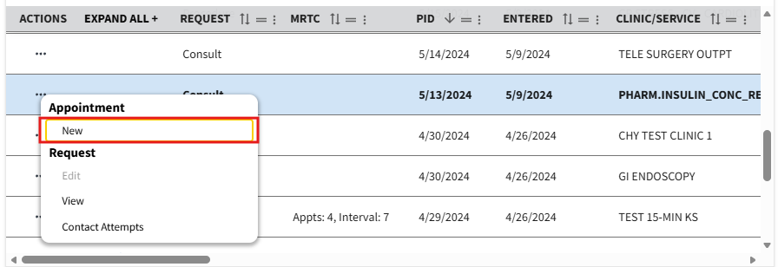
Figure 166: New Option from the Request Actions Dropdown for Consult/Procedure
- The user will be brought to the Schedule Search page shown below. To search for a clinic, the user will select the search bar, seen in ⁠⁠⁠⁠⁠Figure 167⁠⁠⁠⁠⁠, and enter a valid clinic name. Once the information has been entered, a list of clinics will appear in the dropdown.
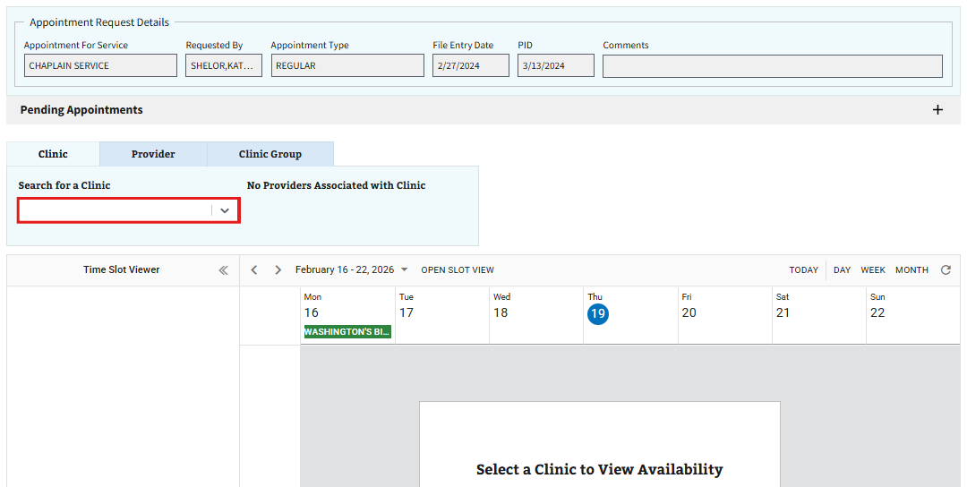
Figure 167: Searching for a Clinic when Creating a Consult/Procedure Appointment
- Note: It is suggested that the user searches for a clinic within the service/specialty of the original appointment request. Attempting to use a clinic outside of the service/specialty in the request will result in the Clinic Stop Code notification seen in ⁠⁠⁠⁠⁠Figure 168⁠⁠⁠⁠⁠ below.
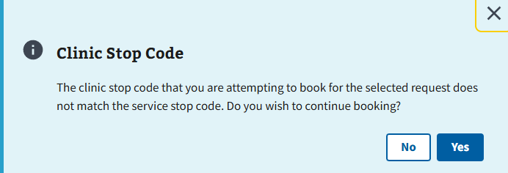
Figure 168: Clinic Stop Code Window for Consult/Procedure
- After selecting a preferred clinic from the available options, the user will be brought to the Time Slot Calendar for the selected clinic. The user can then right click within the preferred timeslot on the calendar and select the “Create Appointment” option seen in ⁠Figure 169⁠.
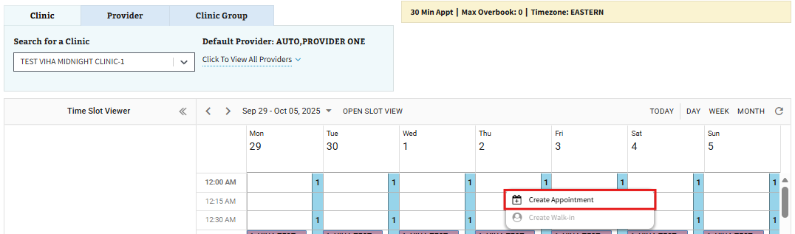
Figure 169: Create Appointment Button for Consult/Procedure
- The user will be brought to the New Appointment page. On this page, the user will need to fill out all the required information displayed in ⁠Figure 170⁠. The user can also fill out any optional information as needed.
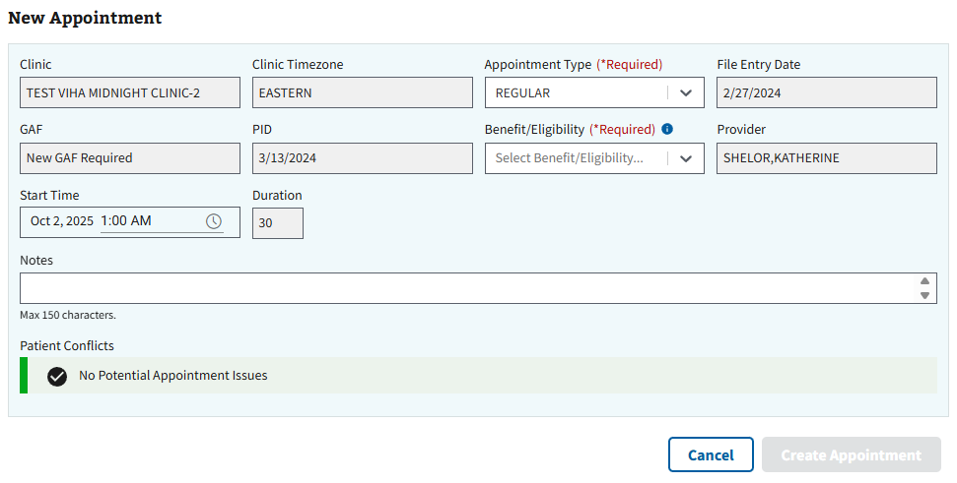
Figure 170: New Appointment Page for Consult/Procedure
- Note: Users will be able to track comments via the New Appointment page. Comments will show the name of the commenter, as well as the date the comment was added to the appointment request. Comments added under the ‘Notes” section of the page will be added to comment tracking and available for viewing once the appointment has been created.
- Once all applicable information has been filled, the user will select the “Create Appointment” button, seen in ⁠⁠⁠⁠⁠Figure 171⁠⁠⁠⁠⁠, to create the new Consult/Procedure appointment.
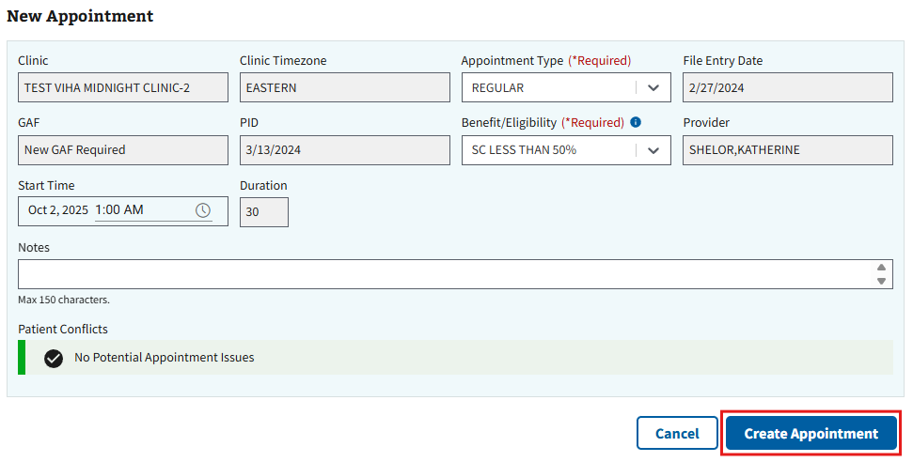
Figure 171: Create Appointment Button for New Consult/Procedure
- Note: The user can also select the “Cancel” button seen in ⁠Figure 171⁠ to exit creating an appointment and go back to the Appointments & Requests page.
- The Appointment Successfully Created window, shown below in ⁠⁠⁠⁠⁠Figure 172⁠⁠⁠⁠⁠, will appear. The user can choose to preview the patient letter, if needed, or select “Close” to continue.
Figure 172: Preview Patient Letter Window for Creating Consult/Procedure Appointment

4.3.5 RTC
- To create an RTC appointment, the user will need to locate any previously created RTC requests by navigating the Appointment Requests grid (See ⁠Figure 173⁠ for an example.)
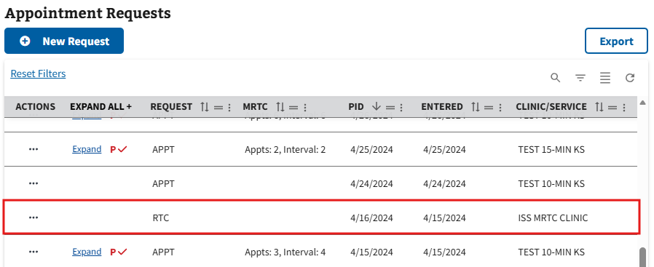
Figure 173: Example for Finding RTC Requests
- Once the RTC request is located, the user will select the ellipsis, seen in ⁠Figure 174⁠, next to the request within the grid.
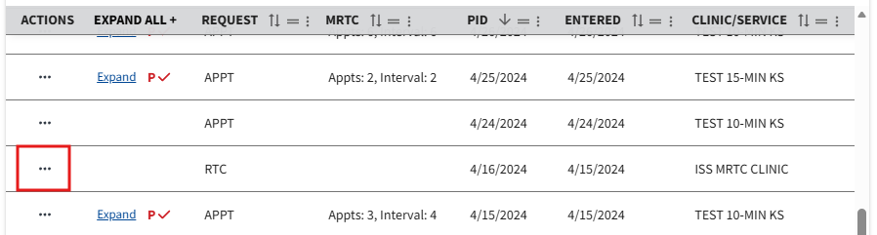
Figure 174: Selecting Action Menu Button to RTC Appointments
- This will cause the action menu to appear. The user will then need to select the “New” option, seen in ⁠Figure 175⁠.
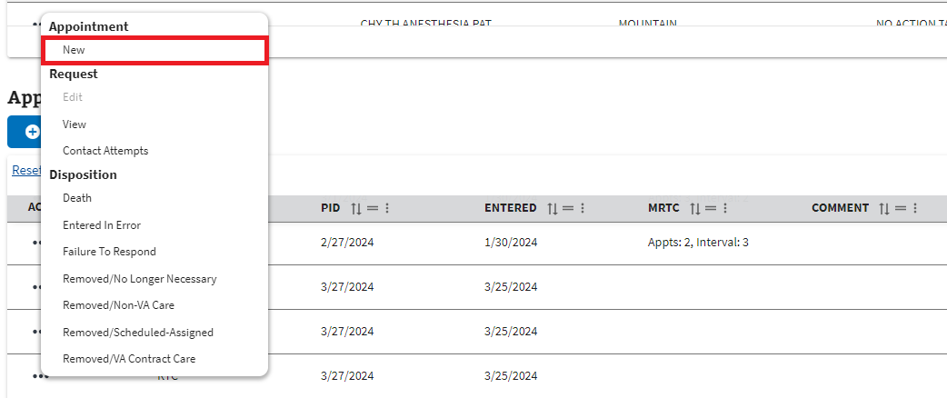
Figure 175: New Option from the Request Actions Dropdown for RTC
- The user will be brought to the Schedule Search page shown below. On this page, the user can right click within the preferred timeslot on the calendar and select the “Create Appointment” option seen in ⁠Figure 176⁠.
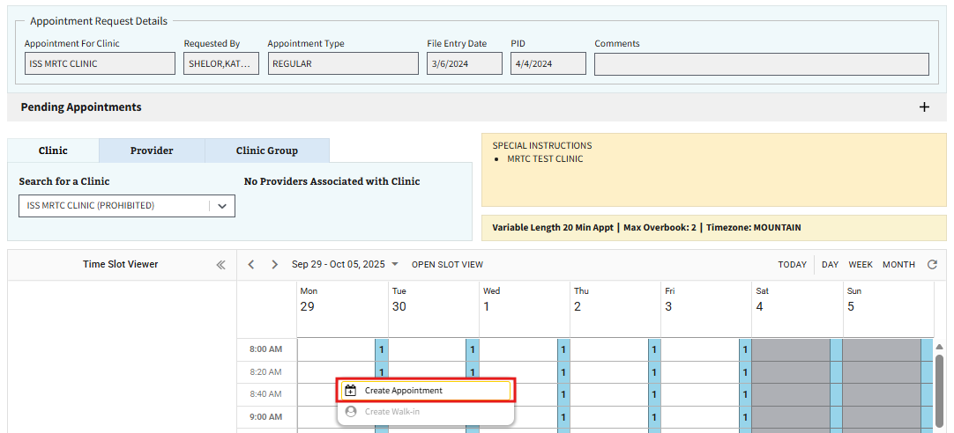
Figure 176: Create Appointment Button for RTC
- The user will be brought to the New Appointment page. On this page, the user will need to fill out all the required information displayed in ⁠⁠⁠⁠⁠Figure 177⁠⁠⁠⁠⁠. The user can also fill out any optional information as needed.
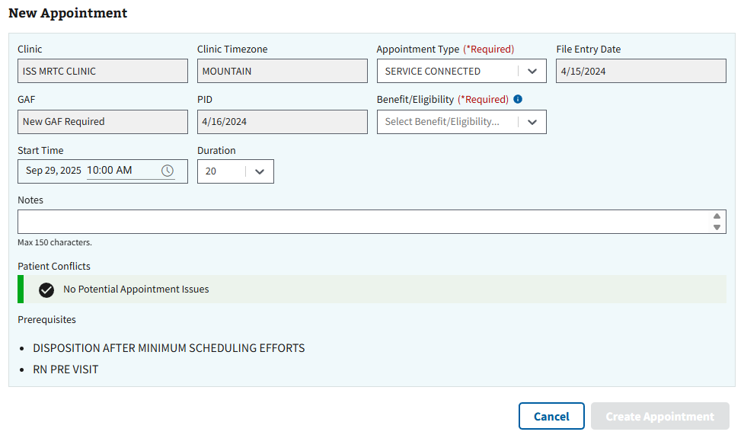
Figure 177: New Appointment for RTC
- Note: When creating an RTC Appointment, the user may see prerequisites attached to the request, as seen below in ⁠Figure 178⁠.
Figure 178: Prerequisites Example for RTC
- Note: Users will be able to track comments via the New Appointment page. Comments will show the name of the commenter, as well as the date the comment was added to the appointment request. Comments added under the ‘Notes” section of the page will be added to comment tracking and available for viewing once the appointment has been created.
- Once all applicable information has been filled, the user will select the “Create Appointment” button, seen in ⁠Figure 179⁠, to create the new RTC appointment.
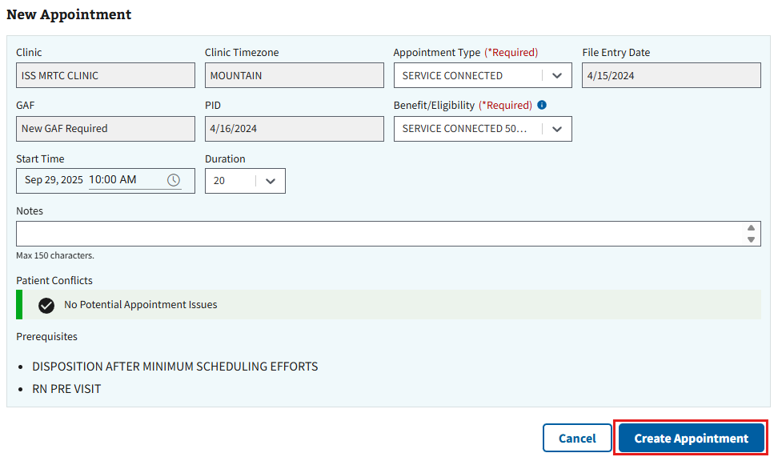
Figure 179: Create Appointment Button for Creating RTC Appointments
- Note: The user can also select the “Cancel” button seen in ⁠Figure 179⁠ to exit creating an appointment and go back to the Appointments & Requests page.
- The Appointment Successfully Created window, shown below in ⁠⁠⁠⁠⁠Figure 180⁠⁠⁠⁠⁠, will appear. The user can choose to preview the patient letter, if needed, or select “Close” to continue.
Figure 180: Preview Patient Letter Window for Creating RTC Appointments

4.3.6 VETERAN
- To create a VETERAN appointment, the user will need to locate any previously created VETERAN requests by navigating the Appointment Requests grid (See ⁠⁠⁠⁠⁠Figure 181⁠⁠⁠⁠⁠ an example.)
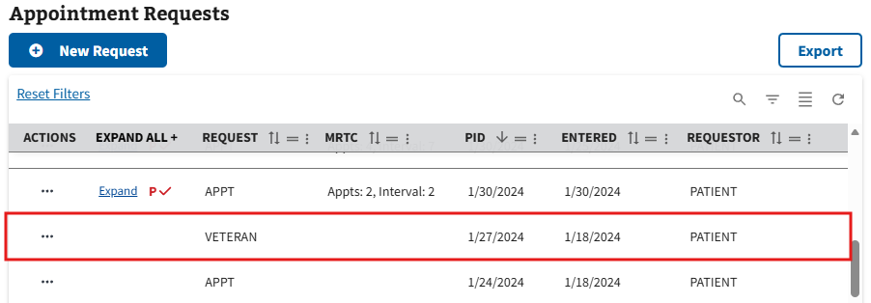
Figure 181: Example for Finding VETERAN Requests
- Once the VETERAN request is located, the user will select the ellipsis, seen in ⁠⁠⁠⁠Figure 182⁠⁠⁠⁠⁠, next to the request within the grid.
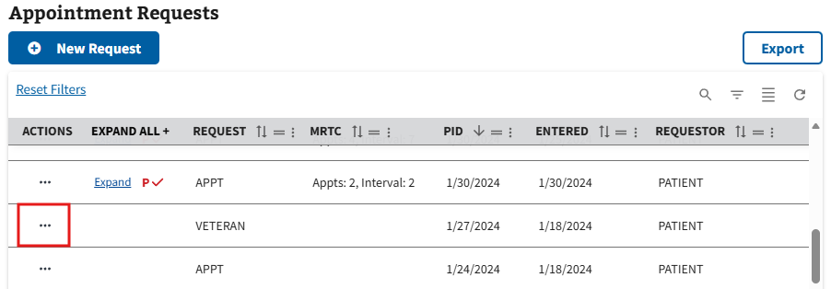
Figure 182: Selecting Action Menu Button to VETERAN Appointments
- This will cause the action menu to appear. The user will then need to select the “New” option, seen in ⁠⁠⁠⁠⁠Figure 183⁠⁠⁠⁠⁠.
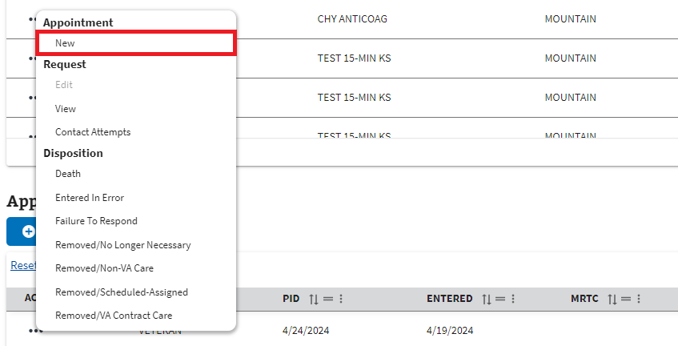
Figure 183: New Option from the Request Actions Dropdown for VETERAN
- The user will be brought to the Schedule Search page shown below. To search for a clinic, the user will select the search bar, seen in ⁠Figure 184⁠, and enter a valid clinic name. Once the information has been entered, a list of clinics will appear in the dropdown.
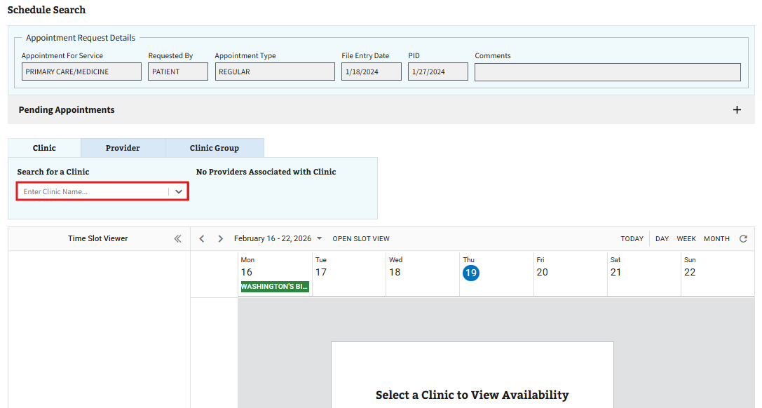
Figure 184: Searching for a Clinic when Creating a VETERAN Appointment

- Note: It is suggested that the user searches for a clinic within the service/specialty of the original appointment request. Attempting to use a clinic outside of the service/specialty in the request will result in the Clinic Stop Code notification seen in ⁠⁠⁠⁠⁠Figure 185⁠⁠⁠⁠⁠ below.
Figure 185: Clinic Stop Code Window for VETERAN Appointments
- After selecting a preferred clinic from the available options, the user will be brought to the Time Slot Calendar for the selected clinic. The user can then right click within the preferred timeslot on the calendar and select the “Create Appointment” option seen in ⁠Figure 186⁠.
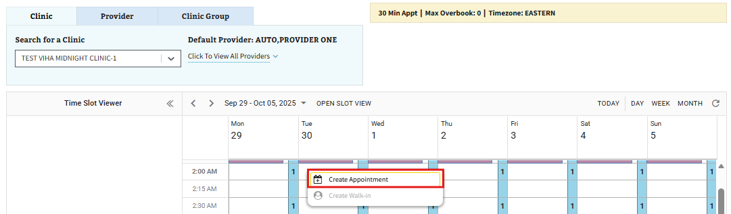
Figure 186: Create Appointment Button for VETERAN
- The user will be brought to the New Appointment page. On this page, the user will need to fill out all the required information displayed in ⁠⁠⁠⁠⁠Figure 187⁠⁠⁠⁠⁠. The user can also fill out any optional information as needed.
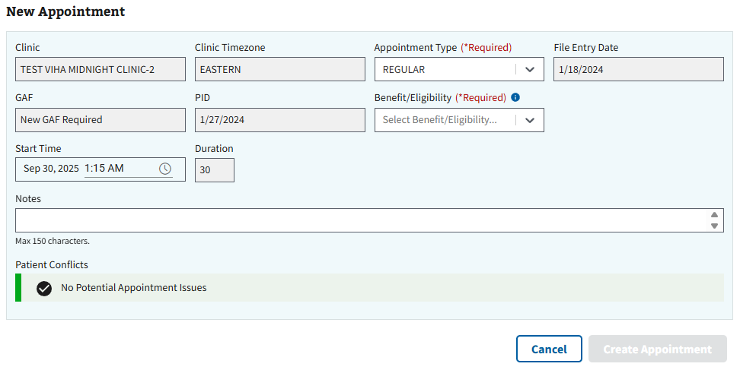
Figure 187: New Appointment Page for VETERAN
- Note: Users will be able to track comments via the New Appointment page. Comments will show the name of the commenter, as well as the date the comment was added to the appointment request. Comments added under the ‘Notes” section of the page will be added to comment tracking and available for viewing once the appointment has been created.
- Once all applicable information has been filled, the user will select the “Create Appointment” button, seen in ⁠⁠⁠⁠⁠Figure 188⁠⁠⁠⁠⁠, to create the new VETERAN appointment.
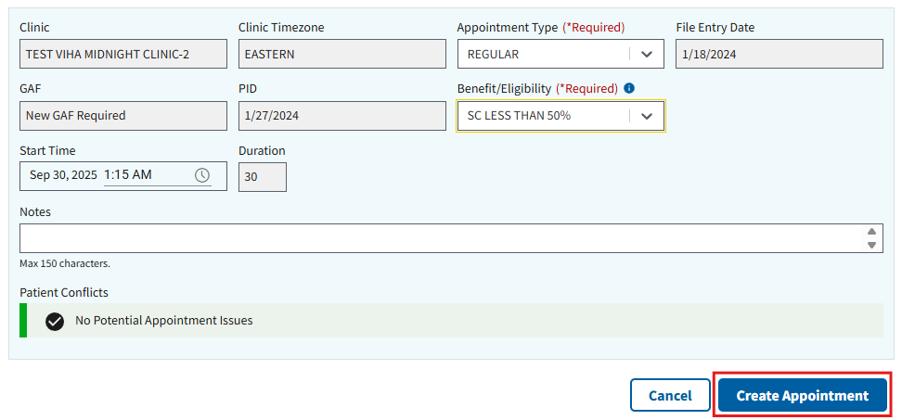
Figure 188: Create Appointment Button for Creating VETERAN Appointments
- Note: The user can also select the “Cancel” button seen in ⁠⁠⁠⁠⁠Figure 188⁠⁠⁠⁠⁠ to exit creating an appointment and go back to the Appointments & Requests page.
- The Appointment Successfully Created window, shown below in ⁠Figure 189⁠, will appear. The user can choose to preview the patient letter, if needed, or select “Close” to continue.
Figure 189: Preview Patient Letter Window for Creating VETERAN Appointments

4.3.7 Overbooking an Appointment
When creating appointments, users have the ability to overbook an appointment slot. To do so, the user will need to follow the steps outlined in ⁠⁠⁠⁠⁠⁠⁠4.3 Creating a Pending Appointment⁠⁠⁠⁠⁠⁠⁠ until asked to select a timeslot on the clinic calendar.
- To overbook an appointment slot, the user will right-click on the preferred timeslot on the calendar and select “Create Appointment (Overbooked),” as seen below in ⁠Figure 190⁠.
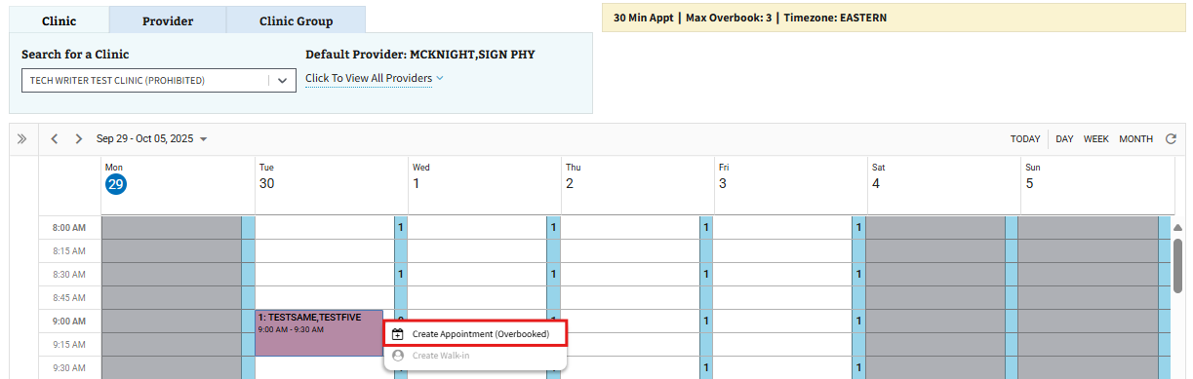
Figure 190: Create Appointment (Overbooked) Button
- The Overbook Slot window will appear, as shown in ⁠Figure 191⁠, and the user will be asked to confirm before proceeding with appointment creation as normal.
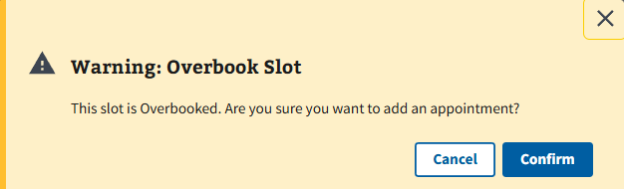
Figure 191: Overbook Slot Window
- Note: Users with an SDOB key will only be able to overbook within clinic hours and up to the maximum number of overbooks allowed per day for a clinic. Users with an SDMOB key will be able to overbook outside of clinic hours and can exceed the maximum allotted overbooks slots per day for a clinic.

4.3.8 MISSION Act
The user may receive an alert when creating an appointment if an appointment is MISSION Act eligible. For more information regarding MISSION Act, please visit this link.

4.3.9 Clinic Stop Code
The user will receive a clinic stop code notification if an appointment is being created in a clinic that is not within the service/specialty of the appointment request.

4.3.10 Patient Conflicts
When creating an appointment, the user will see a Patient Conflict notification at the bottom of the New Appointment page. If no conflict exists, the notification will display “No Potential Appointment Conflicts” in green, as shown in ⁠Figure 192⁠, and the user can move forward with creating the appointment as usual.
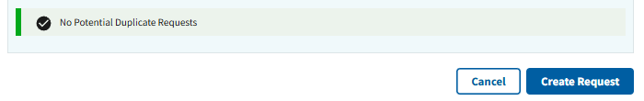
Figure 192: No Potential Appointment Conflicts Notification
If the user attempts to make more than one appointment for a patient on the same day at any clinic, the notification will display “Potential Patient Conflict for [DAY]” in yellow and show the potential conflicting appointment(s) in a grid, as seen below in ⁠Figure 193⁠. The user can then choose to continue making the appointment for the patient or go back and choose a different day and time.
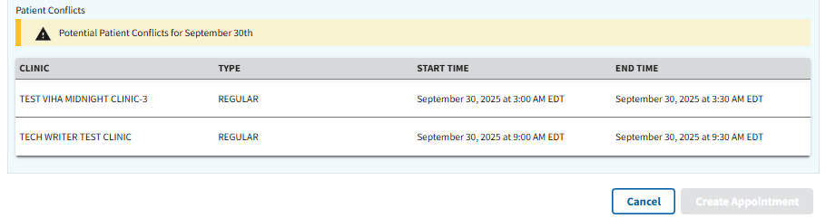
Figure 193: Potential Appointment Conflicts Notification
From the clinic calendar, the calendar will display the “Create Appointment” button as greyed out and unavailable when attempting to create an appointment with a known conflict (See ⁠Figure 194⁠ below).
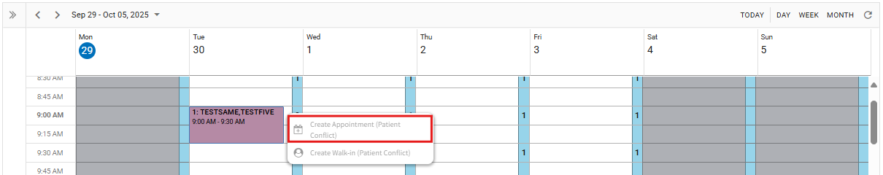
Figure 194: Patient Conflict on Calendar
If the user changes the time to one with a patient conflict on the New Appointment page, the notification will display “This Time Has the Conflict Highlighted Below:” in red and show the conflicting appointment in a grid, as seen below in ⁠Figure 195⁠.
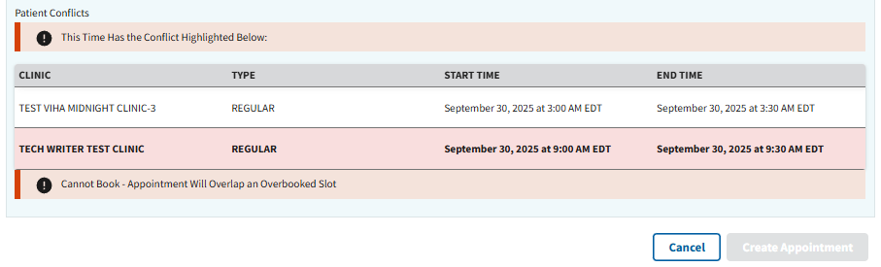
Figure 195: Patient Conflict on New Appointment Page
- Note: The user will be unable to create an appointment with a Patient Conflict displayed in red.

4.4 Appointment Actions
The Appointments section is separated into multiple tabs and organized based on appointment status. The “Pending” tab will contain all current and future appointments that have no action assigned or currently require action in the system, as well as checked in appointments. The “History” tab will contain all appointments that have been checked out with no further action, canceled by the patient or clinic, and have been marked as no shows. The “All Appointments” tab will contain all appointments, regardless of status.
- Note: All non-count appointments will automatically move to the “History” tab once the date for the appointment has passed.

4.4.1 View
- To view an appointment, the user will select the ellipsis, seen in ⁠Figure 196⁠, next to the appointment within the Pending grid under Appointments.
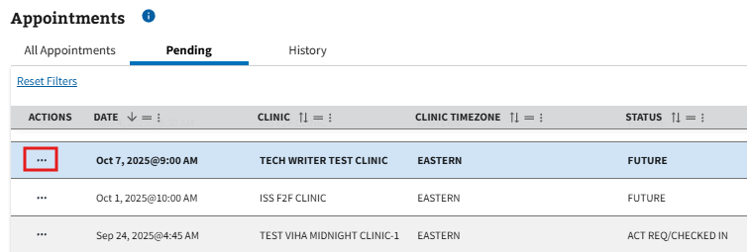
Figure 196: Action Menu Button to View Appointments
- This will cause the action menu to appear. The user will then need to select the “View” option, seen in ⁠Figure 197⁠.
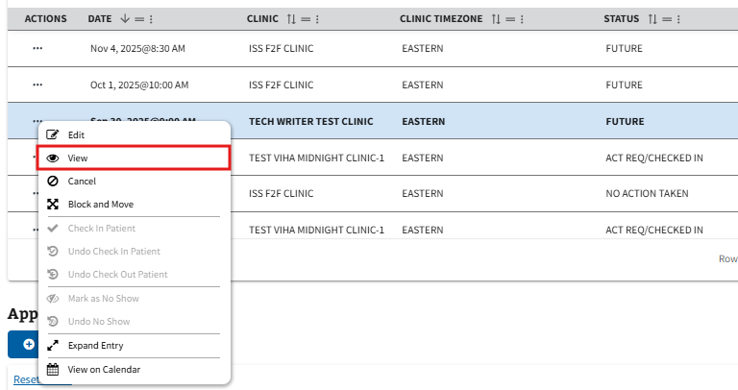
Figure 197: View Option from Pending Appointments Action Menu
- The user will be brought to the View Appointment page, shown below in ⁠Figure 198⁠.
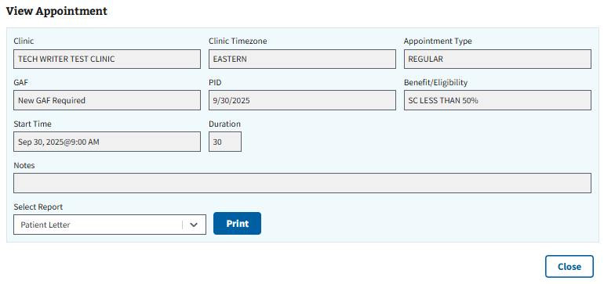
Figure 198: View Appointment Page
- Note: Users will be able to track comments via the View page. Comments will show the name of the commenter, as well as the date the comment was added to the appointment.
- Note: The user has the ability to print a patient letter by selecting the “Print” button seen in ⁠Figure 199⁠.
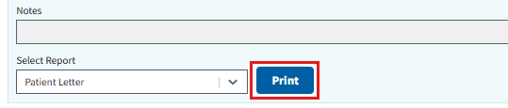
Figure 199: Print Patient Letter Button from View Appointment Page

4.4.2 Edit
- To edit an appointment, the user will select the ellipsis, seen in ⁠Figure 200⁠, next to the appointment within the Pending grid under Appointments.
Figure 200: Action Menu Button to Edit Appointments
- This will cause the action menu to appear. The user will then need to select the “Edit” option, seen in ⁠Figure 201⁠.
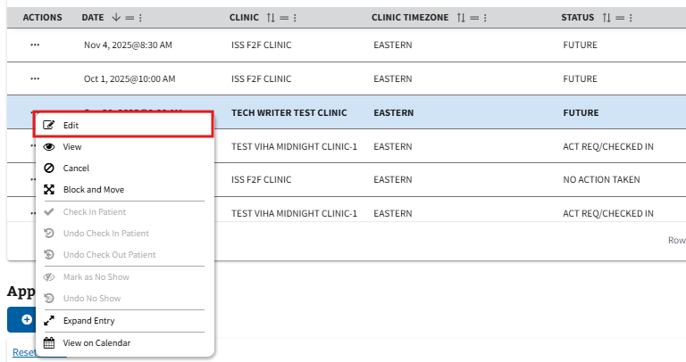
Figure 201: Edit Option from the Pending Appointments Action Menu
- The user will be brought to the Edit Appointment page. On this page, the user can edit any of the fields highlighted below in ⁠Figure 202⁠.
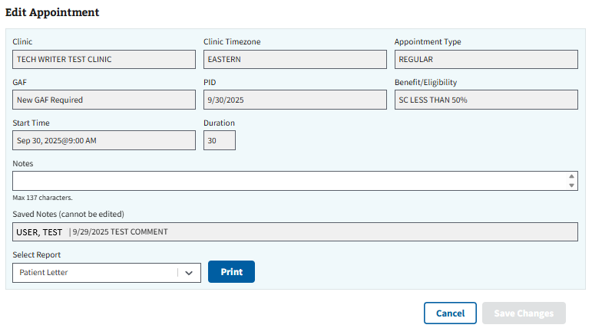
Figure 202: Edit Appointment Page
- Note: Users can add additional comments to an appointment, as well as track previous comments via the Edit page. Previous comments will show the name of the commenter and the date the comment was added (see ⁠Figure 202⁠ for example).
- Once all edits have been made, the user will need to select the “Save Changes” button, seen in ⁠Figure 203⁠, to save any edits to the appointment.
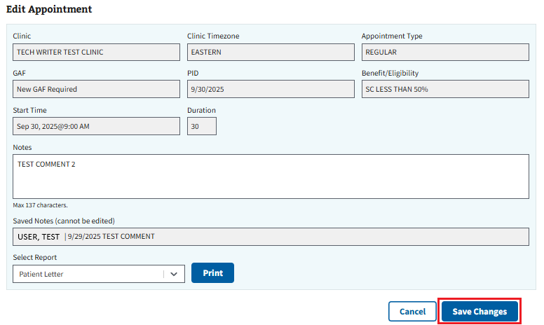
Figure 203: Save Changes Button for Edit Appointment Page
- Note: The user can also select the “Cancel” button seen in ⁠Figure 203⁠ to exit editing an appointment and go back to the Appointments & Requests page.

4.4.3 Cancel an APPT, PtCSch, Consult/Procedure, RTC, or VETERAN Appointment
- To cancel an APPT, PtCSch, Consult/Procedure, RTC, or VETERAN appointment, the user will select the ellipsis, seen in ⁠Figure 204⁠, next to the appointment within the Pending grid under Appointments.
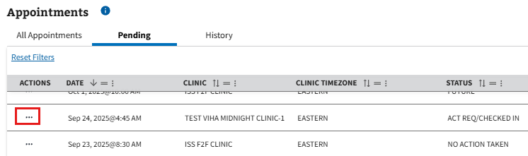
Figure 204: Action Menu Button to Cancel an Appointment
- This will cause the action menu to appear. The user will then need to select the “Cancel” option, seen in ⁠Figure 205⁠.
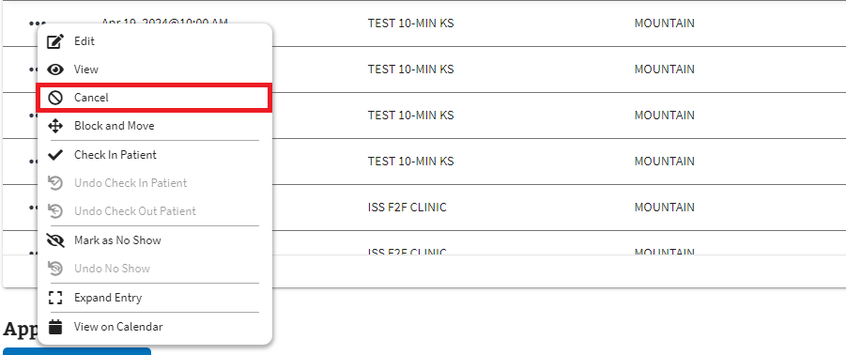
Figure 205: Cancel Option from the Pending Appointments Action Menu
- The user will be brought to the Cancel Appointment page. On this page, the user will need to fill out all the required information displayed in ⁠Figure 206⁠. The user can also fill out any optional information as needed.
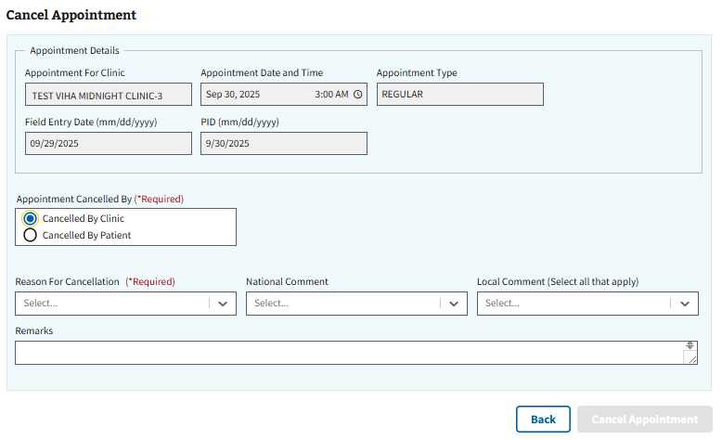
Figure 206: Cancel Appointment Page
- Note: The PID section, highlighted below in ⁠Figure 207⁠, will be editable when an appointment is cancelled by a patient.
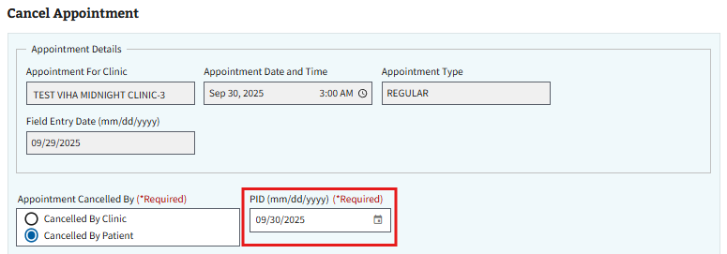
Figure 207: Editable PID Example when Cancelled by Patient
- Once all applicable information has been filled, the user will then select the “Cancel Appointment” button, seen in ⁠Figure 208⁠, to cancel the appointment.
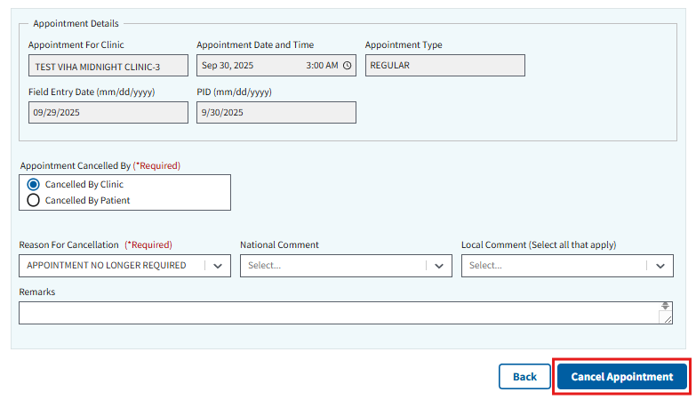
Figure 208: Cancel Appointment Button on the Cancel Appointment Page
- The Appointment Successfully Cancelled window, shown below in ⁠Figure 209⁠, will appear. The user can choose to preview the cancellation letter, if needed, or select “Close” to continue.
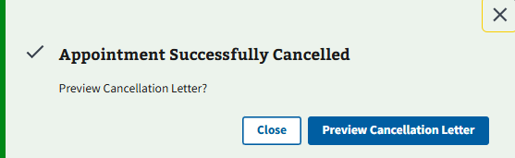
Figure 209: Preview Cancellation Letter Window
- Note: After cancelling, most appointments will return to the Appointment Request grid and the user will have the ability to create a new appointment, if needed. For specific cancellation reasons that do not reopen and return to the grid, see ⁠⁠⁠⁠⁠⁠⁠8.1 Cancellation Reasons⁠⁠⁠⁠⁠⁠⁠ for more information.

4.4.4 Cancel an MRTC Appointment
- To cancel an MRTC appointment, the user will select the ellipsis, seen in ⁠Figure 210⁠, next to the appointment within the Pending grid under Appointments.
Figure 210: Action Menu Button to Cancel MRTC Appointments
- This will cause the action menu to appear. The user will then need to select the “Cancel” option, seen in ⁠Figure 211⁠.
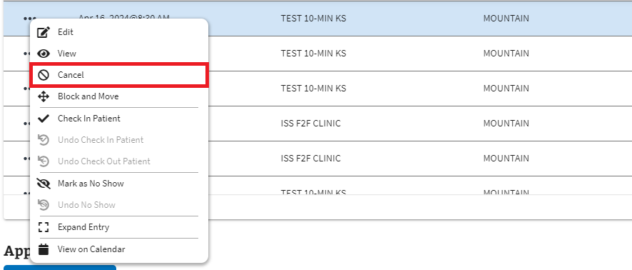
Figure 211: Cancel Option from the Pending Appointments Action Menu for MRTC
- Once selected, the user will be brought to the Cancel MRTC Appointment page, as seen below in ⁠Figure 212⁠. The user will be given the option to cancel either the selected appointment only, or all the appointments in the series. If canceling all appointments, the user also has the option to close the MRTC parent request, which would close all associated appointment request(s) in the series.
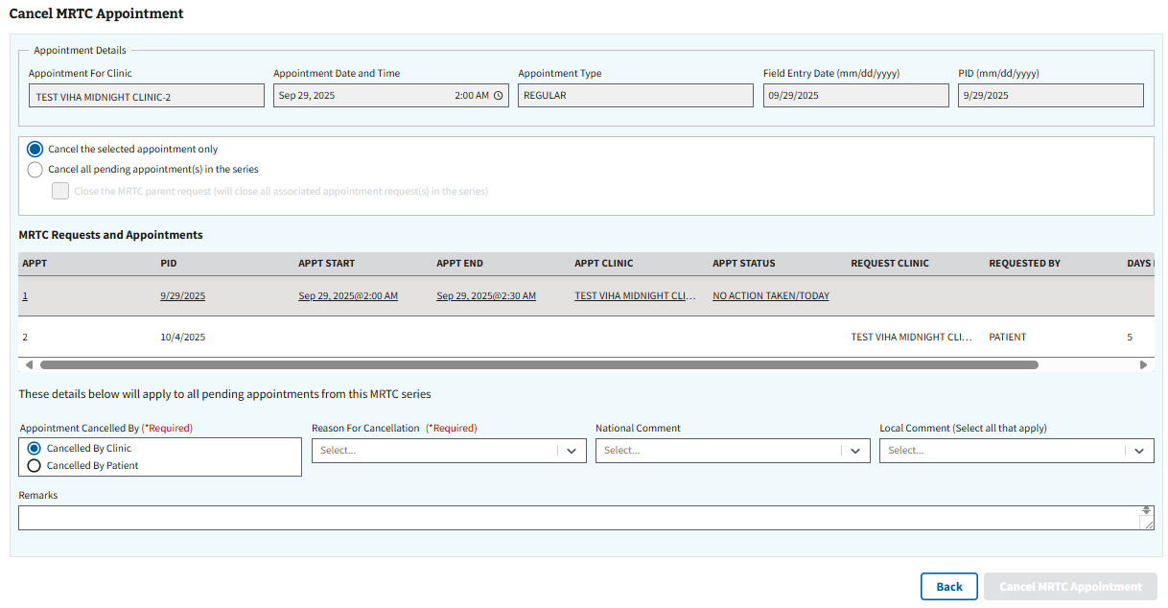
Figure 212: Cancel MRTC Appointment Options for Parent and Child Appointments
- Below are the options for cancelling other associated MRTC appointments and requests, the user will also need to fill out all the required information displayed in ⁠Figure 213⁠ and any optional information as needed.
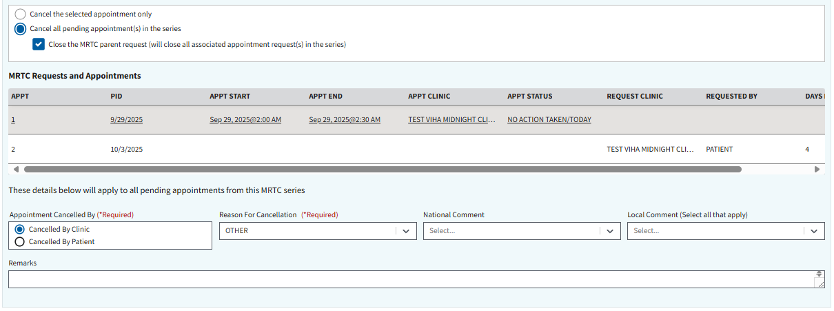
Figure 213: Cancel MRTC Appointment(s) Page
- Once all applicable information has been filled out, the user will then select the “Cancel MRTC Appointment” button, seen below in ⁠Figure 214⁠, to cancel the appointment.
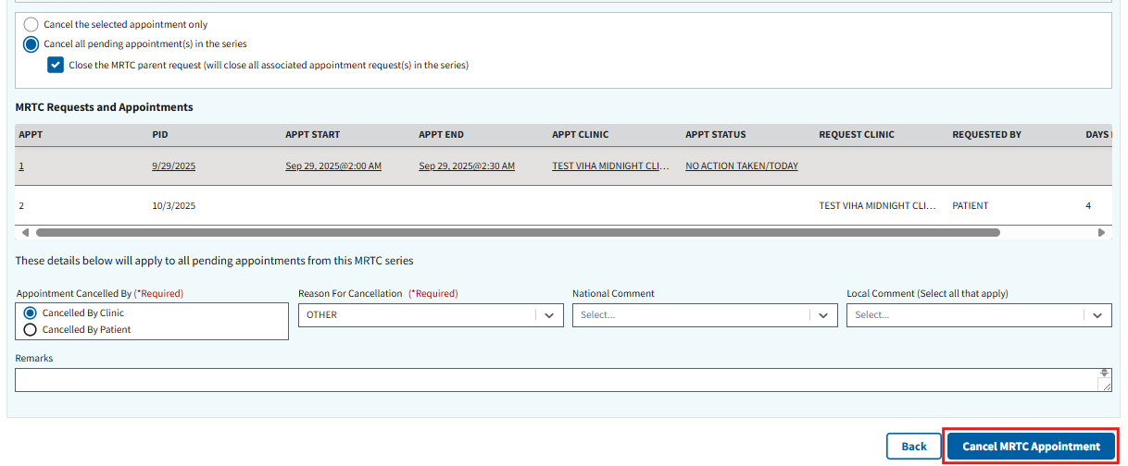
Figure 214: Cancel MRTC Appointment Button
- The Appointment Successfully Cancelled window, shown below in ⁠Figure 215⁠, will appear. The user can choose to preview the cancellation letter, if needed, or select “Close” to continue.
Figure 215: Preview Cancellation Letter Window for MRTC

4.4.5 Expand Entry
- To expand entry on an appointment, the user will select the ellipsis, seen in ⁠Figure 216⁠, next to the appointment within the Pending grid under Appointments.
Figure 216: Action Menu Button to Expand Entry
- This will cause the action menu to appear. The user will then need to select the “Expand Entry” option, seen in ⁠Figure 217⁠.
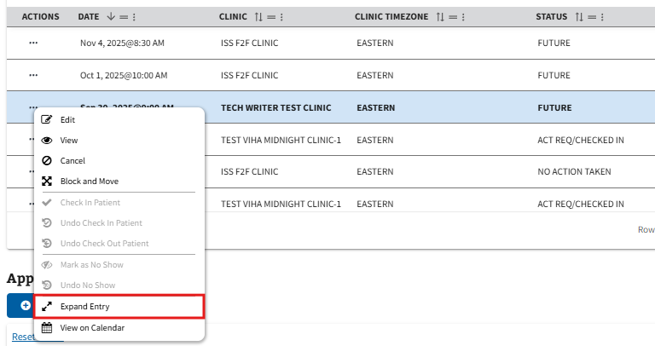
Figure 217: Expand Entry Option from Pending Appointments Action Menu
- The user will be brought to the Expanded Entry page, shown below in ⁠Figure 218⁠. The user can view the fields within expanded entry by either selecting the “+” button next to an individual row, or by selecting “Expand all +.”
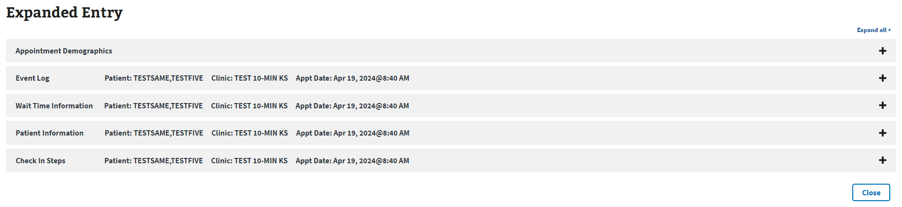
Figure 218: Expanded Entry Page

4.4.6 Block and Move
- To block and move an appointment, the user will select the ellipsis, seen in ⁠Figure 219⁠, next to the appointment within the Pending grid under Appointments.
Figure 219: Action Menu Button to Block and Move an Appointment
- This will cause the action menu to appear. The user will then need to select the “Block and Move” option, seen in ⁠Figure 220⁠.
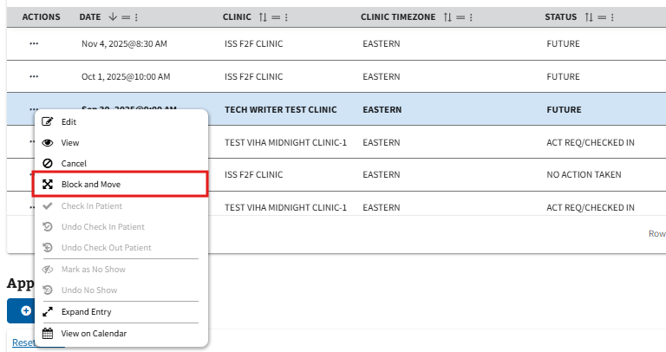
Figure 220: Block and Move Option from the Pending Appointments Action Menu
- The user will be brought to the Block and Move Appointment page, seen below in ⁠Figure 221⁠. The user will need to navigate to the preferred available timeslot on the calendar and left click on the date.
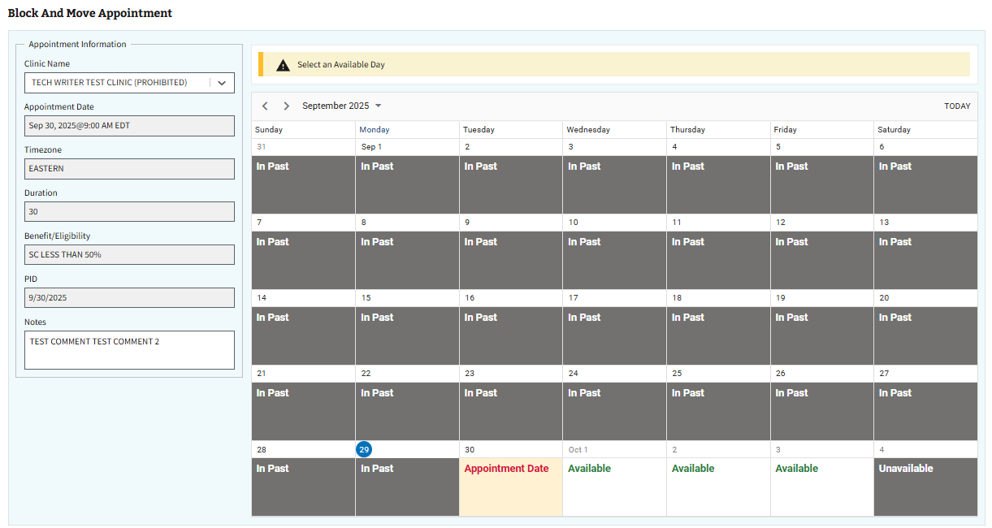
Figure 221: Block and Move Appointment Page
- Note: The user can use the Appointment Information section, seen in ⁠Figure 222⁠, to change any of the editable fields on the appointment.
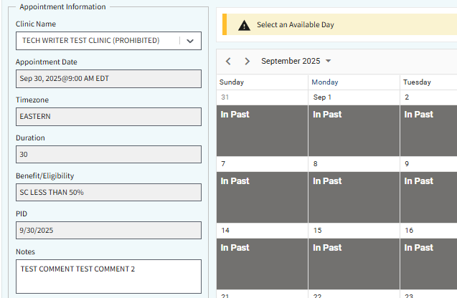
Figure 222: Appointment Information Section for Block and Move
- Once an available date is selected, the user can then select the “Block and Move” button, seen in ⁠Figure 223⁠, to block and move the appointment to the intended date.
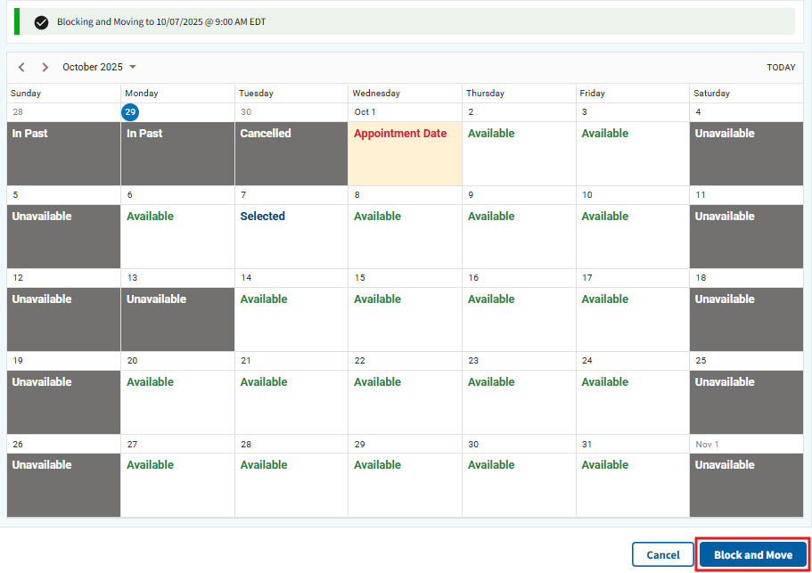
Figure 223: Block and Move Button
- The Appointment Successfully Created window, shown below in ⁠Figure 224⁠⁠⁠⁠⁠⁠⁠⁠⁠⁠⁠⁠⁠, will appear. The user can choose to preview the patient letter, if needed, or select “Close” to continue.
Figure 224: Preview Patient Letter for Block and Move

4.4.7 Check In
- To check in an appointment, the user will select the ellipsis, seen in ⁠Figure 225⁠, next to the appointment within the Pending grid under Appointments.
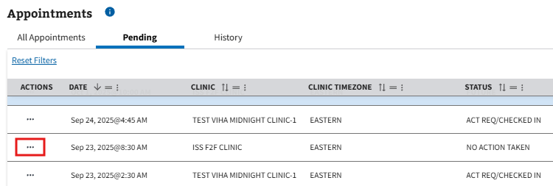
Figure 225: Action Menu Button to Check In Appointments
- Note: Users cannot check in a future appointment.
- This will cause the action menu to appear. The user will then need to select the “Check In” option, seen in ⁠Figure 226⁠.
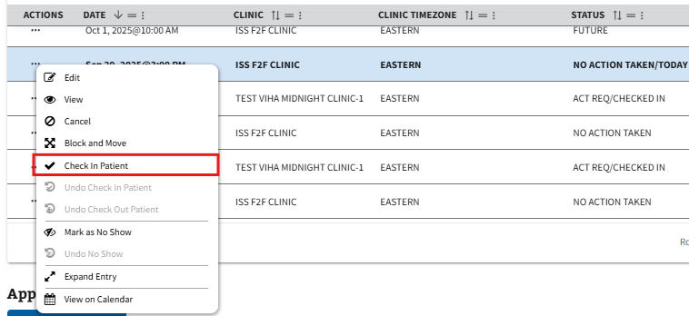
Figure 226: Check In Patient Option from the Pending Appointments Action Menu
- The user will be brought to the Appointment Check In page. On this page, the user will need to select the “Check In” button, seen in ⁠Figure 227⁠, to check the appointment in.
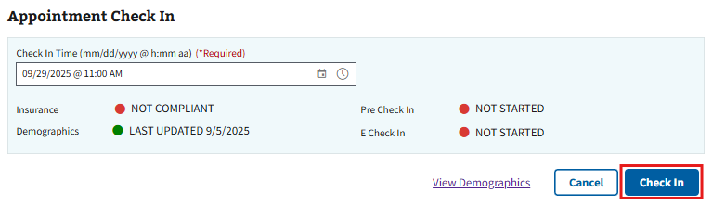
Figure 227: Check In Button
- Note: Users can change the check in time by editing the Check In Time field. The edited time and date must be in the past.
- Note: The user can also select the “Cancel” button seen in ⁠Figure 227⁠ to exit the check in process and go back to the Appointments & Requests page.
- Note: Users can also select the “View Demographics” option to navigate to the patient demographic tab. See section ⁠⁠⁠⁠⁠⁠⁠3.4 Demographics⁠⁠⁠⁠⁠⁠⁠ for more information.

4.4.8 Undo Check In
- To undo check in on a previously checked in appointment, the user will select the ellipsis, seen in ⁠Figure 228⁠, next to the appointment within the Pending grid under Appointments.
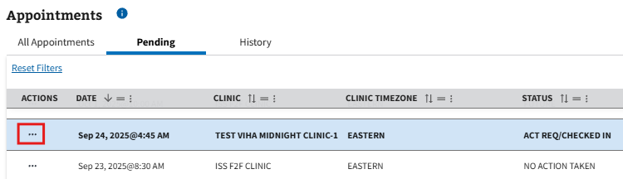
Figure 228: Action Menu Button to Undo Check In
- This will cause the action menu to appear. The user will then need to select the “Undo Check In Patient” option, seen in ⁠Figure 229⁠. This will cause the page to automatically refresh and the appointment to no longer be checked in.
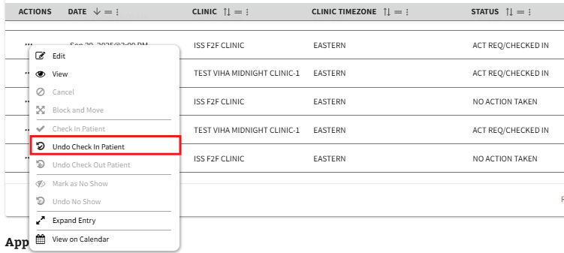
Figure 229: Undo Check In Patient Option from the Pending Appointments Action Menu

4.4.9 Undo Check Out
Disclaimer: This section of the guide is only applicable to users holding the SD SUPERVISOR key. If the user does not have elevated access permissions set to their VistA account, the “Undo Check Out” button in ⁠Figure 231⁠ will be greyed out and unavailable for selection. If a user needs access to make changes on this application, please contact your supervisor for assistance.
- To undo check out on a previously checked out appointment, the user will select the ellipsis, seen in ⁠Figure 230⁠, next to the appointment within the History grid under Appointments.
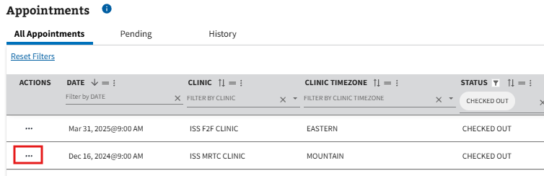
Figure 230: Action Menu Button to Undo Check Out
- This will cause the action menu to appear. The user will then need to select the “Undo Check Out Patient” option, seen in ⁠Figure 231⁠. This will cause the page to automatically refresh, and the appointment moved to the Pending grid where it is no longer checked out.
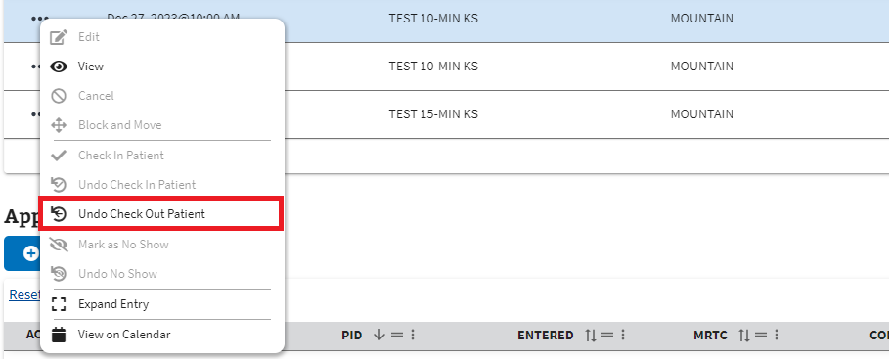
Figure 231: Undo Check Out Patient Option from the Pending Appointments Action Menu
- Note: Users can only undo a checkout on the day of the appointment being checked out.

4.4.10 Mark as No Show
- To mark an appointment as no show, the user will select the ellipsis, seen in ⁠Figure 232⁠, next to the appointment within the Pending grid under Appointments.
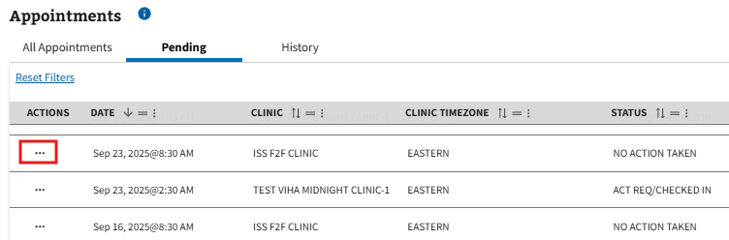
Figure 232: Action Menu Button to Mark as No Show
- This will cause the action menu to appear. The user will then need to select the “Mark as No Show” option, seen in ⁠Figure 233⁠.
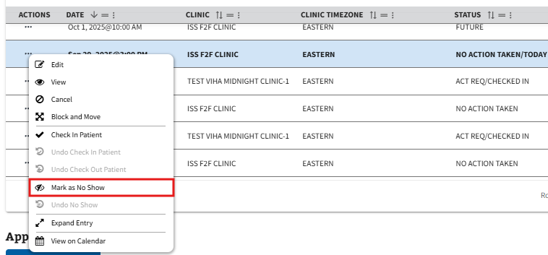
Figure 233: Mark as No Show Option from the Pending Appointment Action Menu
- Note: Users can only mark an appointment as no show on the day of the appointment after the start time of the appointment has passed.
- Once selected, the Confirm No Show window will appear. The user will need to select the “Confirm” button, seen in ⁠Figure 234⁠, to continue.
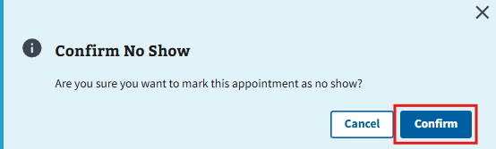
Figure 234: Confirm Button to Mark as No Show
- Note: The user can also select the “Cancel” button seen in ⁠Figure 234⁠ to cancel marking the appointment as no show and go back to the Appointments & Requests page.
- The Successfully Marked as No Show window, shown below in ⁠Figure 235⁠, will appear. The user can choose to preview the no show letter, if needed, or select “Cancel” to continue.
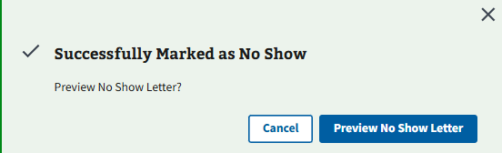
Figure 235: Preview No Show Letter Window

4.4.11 Undo Mark as No Show
- To undo no show on a previously marked as no show appointment, the user will select the ellipsis, seen in ⁠Figure 236⁠, next to the appointment within the History grid under Appointments.
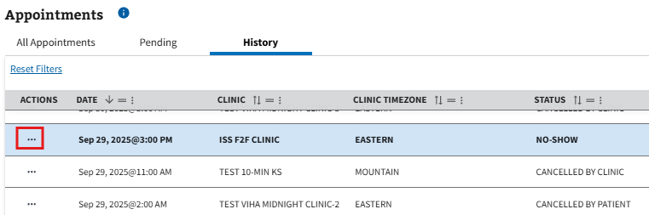
Figure 236: Action Menu Button to Undo No Show
- This will cause the action menu to appear. The user will then need to select the “Undo No Show” option, seen in ⁠Figure 237⁠. This will cause the page to automatically refresh, and the appointment moved to the Pending grid where it is no longer marked as no show.
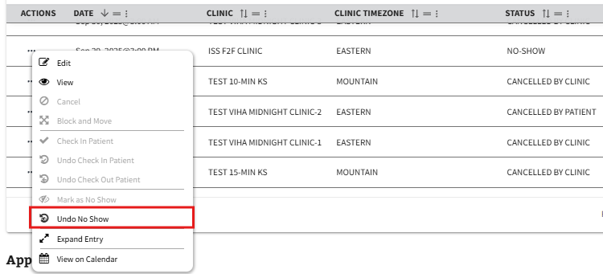
Figure 237: Undo No Show Option from the Pending Appointments Action Menu

4.4.12 Calendar View
Users have the ability to view the calendar for a specific appointment.
- To view, users can select the ellipsis, seen in ⁠Figure 238⁠, next to the appointment within the Pending grid.
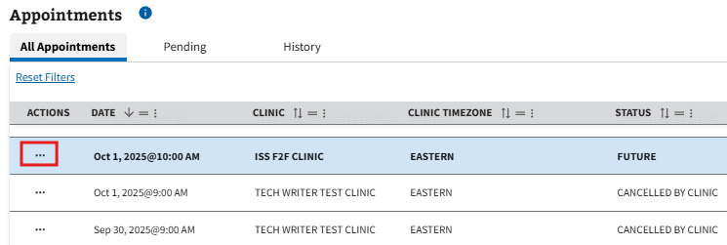
Figure 238: Action Menu Button to View on Calendar
- This will cause the action menu to appear. The user will then need to select the “View on Calendar” option, seen in ⁠Figure 239⁠.
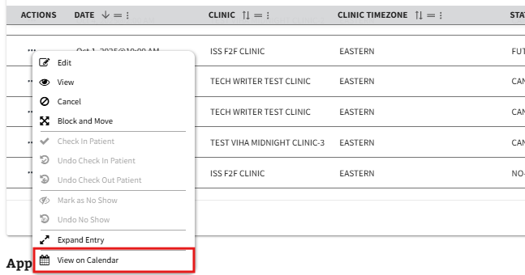
Figure 239: View on Calendar Option from the Pending Appointments Action Menu
- Once on the clinic calendar, the user has the option to utilize all other appointment actions, seen in sections ⁠⁠⁠⁠⁠⁠⁠4.4.1 View⁠⁠⁠⁠⁠⁠⁠ - ⁠⁠⁠⁠⁠⁠⁠4.4.11 Undo Mark as No Show⁠⁠⁠⁠⁠⁠⁠ above, by navigating to a specific appointment on the calendar.
- The user will then need to right-click on the appointment to bring up the action menu to see the available options, as seen below in ⁠Figure 240⁠.
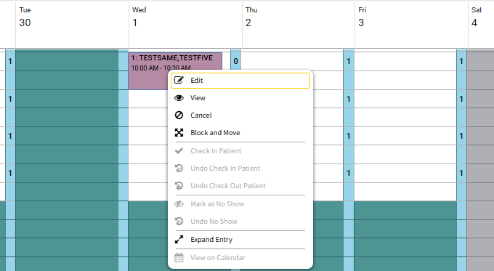
Figure 240: Action Menu from Calendar View
- Note: The user can also create a walk-in appointment on this page by following the steps outlined in ⁠⁠⁠⁠⁠⁠⁠5.4 Create Walk-in⁠⁠⁠⁠⁠⁠⁠.

4.4.13 Letter Printing
Users have the ability to print different letter types within the ISS application. This can be accomplished by either selecting the “Preview Patient Letter” button when prompted, or by following the steps outlined in ⁠⁠⁠⁠⁠⁠⁠4.4.1 View⁠⁠⁠⁠⁠⁠⁠, selecting a letter option in the Select Report dropdown, and clicking “Print” (shown in ⁠Figure 241⁠).
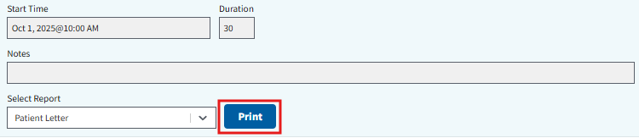
Figure 241: Print Button for Letter Printing
- After choosing to preview or print a letter, the user will be brought to the Patient Appointment Letter window. From here, the user will need to select a printer from the dropdown seen below in ⁠Figure 242⁠.
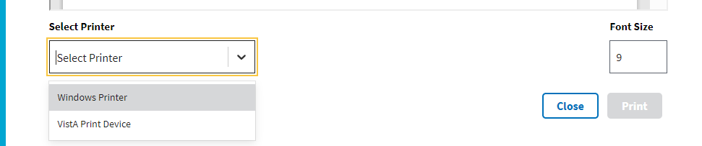
Figure 242: Printer Options Dropdown
- Note: If the user chooses “VistA Print Device” from the printer options, the user will need to search and select a VistA printer, as seen below in ⁠Figure 243⁠, before the print button becomes available to select.
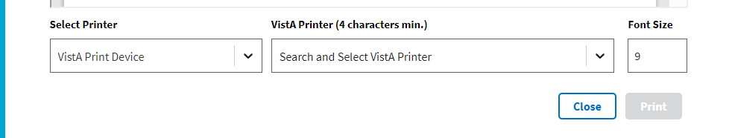
Figure 243: VistA Print Option
- After choosing a printer from the dropdown seen in ⁠Figure 242⁠, the print button will become available to select, as seen in ⁠Figure 244⁠. Selecting this will bring the user to the print preview screen.
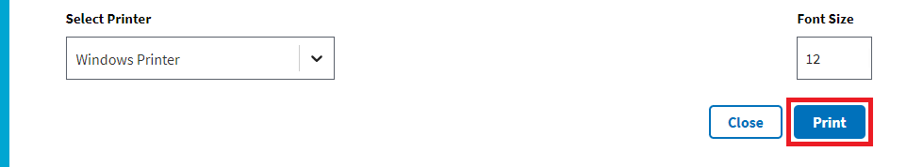
Figure 244: Print Button from Patient Appointment Letter Window
- Note: The user can also change the font of the letter from this screen. To do so, the user can enter a specific font size within the box, seen in ⁠Figure 245⁠, or select the arrows to increase/decrease the size.
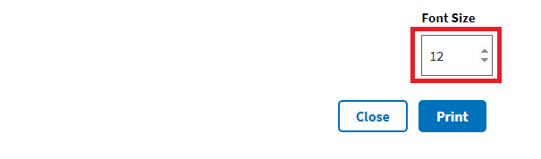
Figure 245: Changing Font Size for Letter Printing

4.5 Video Visits

4.5.1 Creating Video Visits
- To create a video visit, users will need to follow the steps outlined in ⁠⁠⁠⁠⁠⁠⁠4.1 Creating Appointment Requests⁠⁠⁠⁠⁠⁠⁠ and ensure a clinic with video visit eligibility is selected.
- Users will then need to follow the steps outlined in ⁠⁠⁠⁠⁠⁠⁠4.3 Creating a Pending Appointment⁠⁠⁠⁠⁠⁠⁠. Once the Appointment Successfully Created window appears, the user will need to select the “Create Video Visit” button, seen in ⁠Figure 246⁠, to continue.
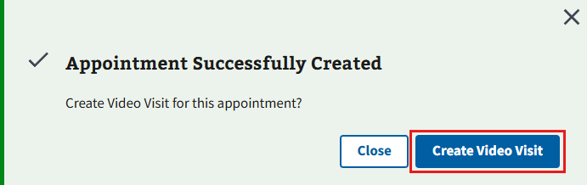
Figure 246: Create Video Visit Button from Creation Window
- The Confirm Patient Contact window will appear. The user will need to select the “OK” button, seen in ⁠Figure 247⁠, to continue to the New Video Visit page.
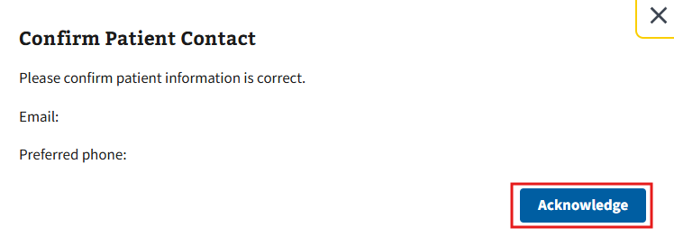
Figure 247: Ok Button to Confirm Patient Contact
- On the New Video Visit page, the user will need to fill out all the required information displayed in ⁠Figure 248⁠. The user can also fill out any optional information as needed.
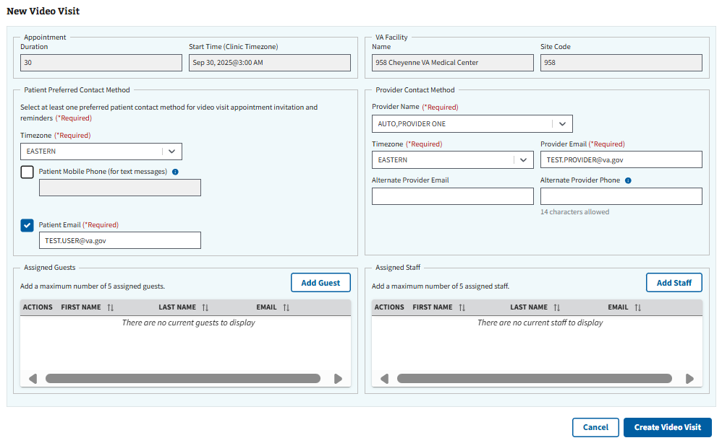
Figure 248: New Video Visit Page
- Note: Users with VA-issued devices will have an additional check box as seen in ⁠Figure 249⁠ below. If checked, the appointment will automatically be sent to the user’s VA-issued device. If unchecked, the user will continue on to video visit creation as normal and enter their preferred email.
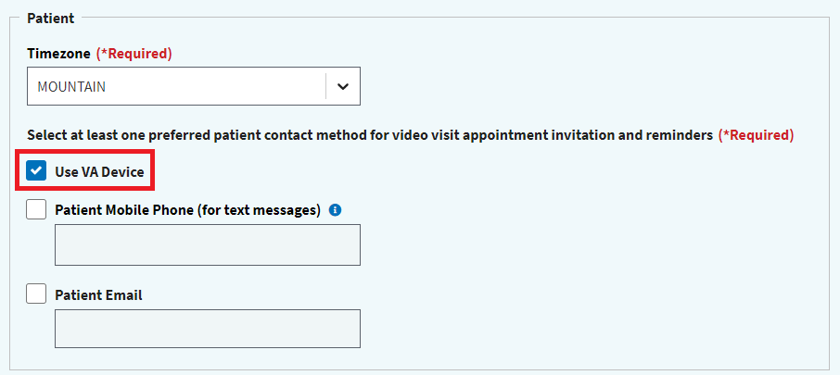
Figure 249: VA-issued Device Selection for Video Visit
- Once all applicable information has been filled, the user will then select the “Create Video Visit” button, seen in ⁠Figure 250⁠, to create the video visit. The user will have the option to preview a patient letter, if needed.
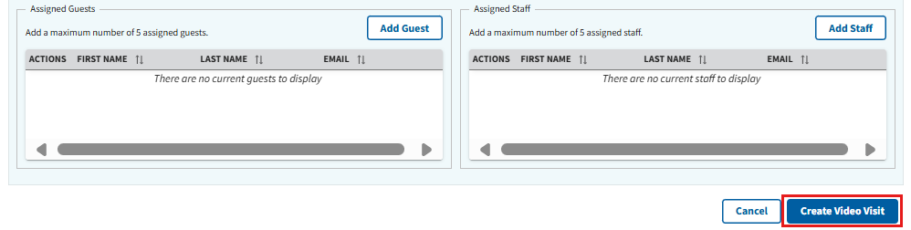
Figure 250: Create Video Visit Button when Creating Video Visit

4.5.2 Viewing Video Visits
- To view a video visit, the user can select the ellipsis, seen in ⁠Figure 251⁠, next to the appointment within the Pending grid under Appointments.
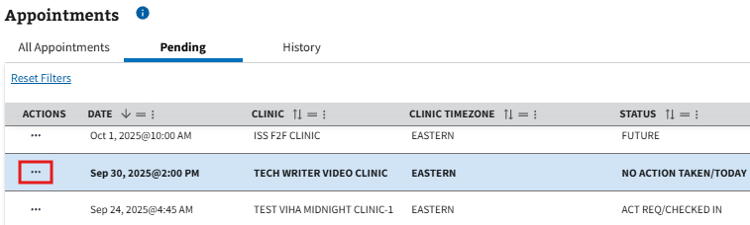
Figure 251: Action Menu Button to View Video Visits
- This will cause the action menu to appear. The user will then need to select the “View” option, seen in ⁠Figure 252⁠.
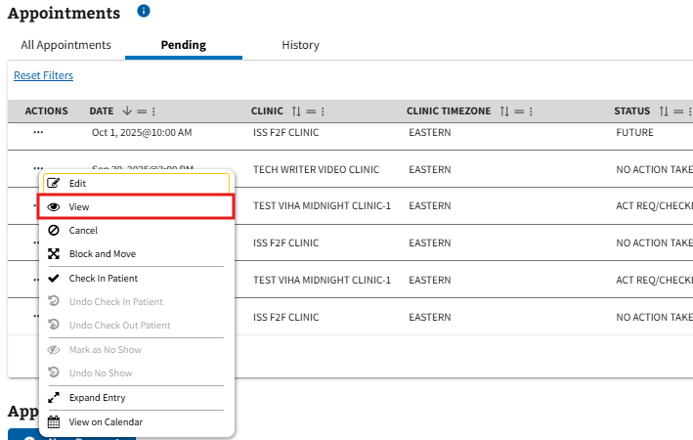
Figure 252: View Option for Video Visits from the Pending Appointments Action Menu
- The user will be brought to the View Appointment page. On this page, the user will need to select the “View Video Visit” button, seen in ⁠Figure 253⁠, to continue to the View Video Visit page.
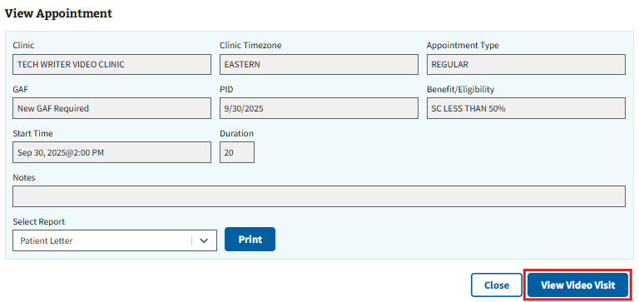
Figure 253: View Video Visit Button

- Note: ISS will alert users when a video visit does or does not have an associated video link via the VVC Link column in the grid (see ⁠Figure 254⁠ for example). Appointments with a missing link will not be viewable on the video visits page until the user creates the video visit (see section ⁠4.5.1 Creating Video Visits⁠ for more information).
Figure 254: VVC Link Column when Viewing Video Visits

4.5.3 Editing Video Visits
- To edit a video visit, the user can select the ellipsis, seen in ⁠Figure 255⁠, next to the appointment within the Pending grid under Appointments.
Figure 255: Action Menu Button to Edit Video Visits
- This will cause the action menu to appear. The user will then need to select the “Edit” option, seen in ⁠Figure 256⁠.
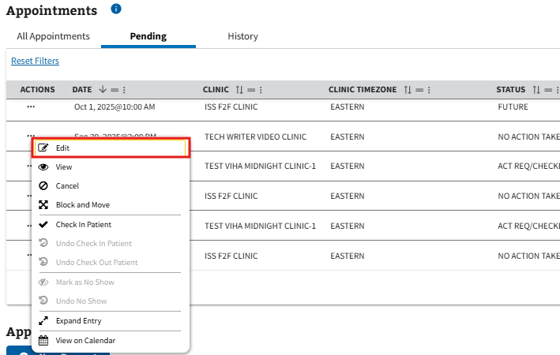
Figure 256: Edit Option for Video Visits from the Pending Appointments Action Menu
- The user will be brought to the Edit Appointment page. On this page, the user will need to select the “Edit Video Visit” button, seen in ⁠Figure 257⁠, to continue to the Edit Video Visit page.
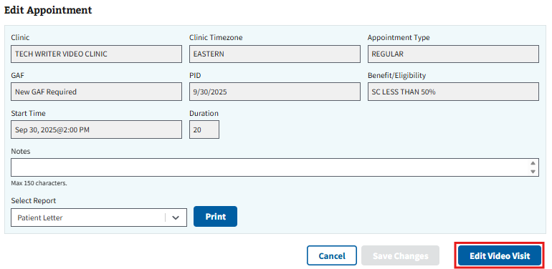
Figure 257: Edit Video Visits Button

- Note: ISS will alert users when a video visit does or does not have an associated video link via the VVC Link column in the grid (see ⁠Figure 258⁠ for example). Appointments with a missing link will be un-editable, except for the notes section, until the user creates the video visit (see section ⁠4.5.1 Creating Video Visits⁠ for more information).
Figure 258: VVC Link Column when Editing Video Visits
- On the Edit Video Visit page, the user can edit any of the editable fields. Once all edits have been made, the user will then select the “Save Changes” button, seen in ⁠Figure 259⁠, to save the edits.
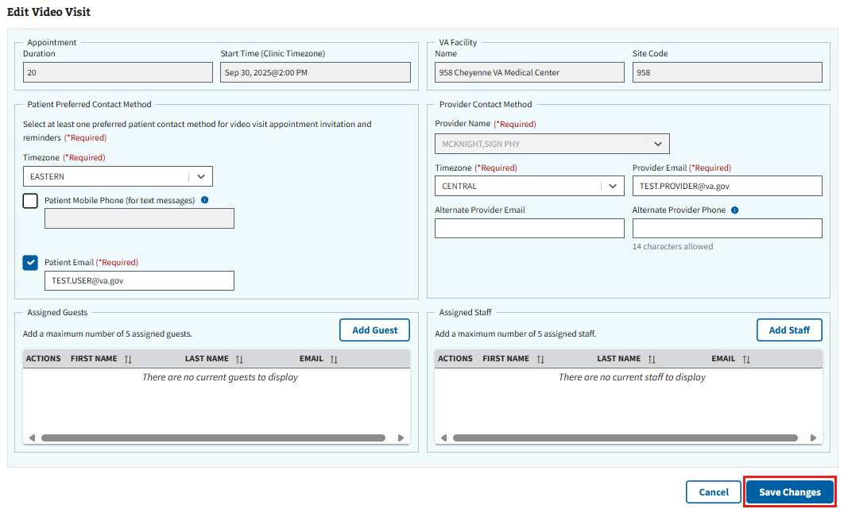
Figure 259: Save Changes Button on the Video Visits Page

4.5.4 Resending Video Visits
- To resend video visit notifications, the user will select the ellipsis, seen in ⁠Figure 260⁠, next to the appointment within the Pending grid under Appointments.
Figure 260: Action Menu Button to Resend Video Visits
- This will cause the action menu to appear. The user will then need to select the “View” option, seen in ⁠Figure 261⁠.
Figure 261: View Option for Resending Video Visits from the Pending Appointments Action Menu
- The user will be brought to the View Appointment page. On this page, the user will need to select the “View Video Visit” button, seen in ⁠Figure 262⁠, to continue to the View Video Visit page.
Figure 262: View Video Visits Button to Resend Visit
- Note: ISS will alert users when a video visit does or does not have an associated video link via the VVC Link column in the grid (see ⁠Figure 263⁠ for example). Appointments with a missing link will not be viewable on the video visits page until the user creates the video visit (see section ⁠4.5.1 Creating Video Visits⁠ for more information).
Figure 263: VVC Link Column when Resending Video Visits
- On the View Video Visit page, the user can select the “Resend Video Visit Notifications” button, seen in ⁠Figure 264⁠, to resend the video visit notification to all attending parties.
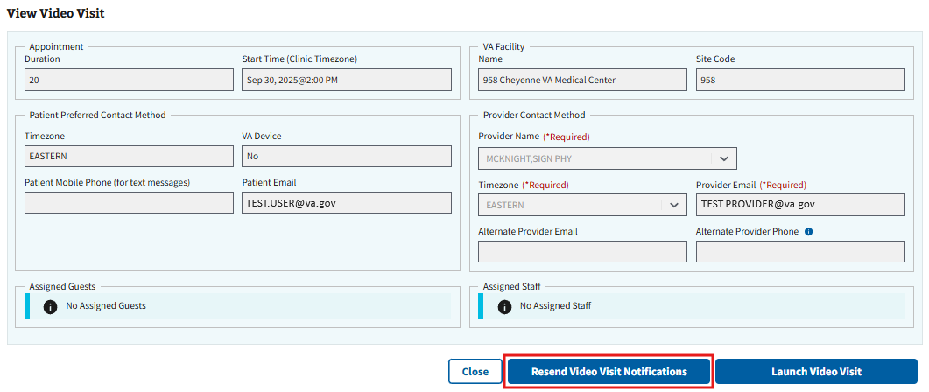
Figure 264: Resend Video Visit Notification Button

4.5.5 Cancelling Video Visits
To cancel a video visit, please follow the steps outlined in either ⁠⁠⁠⁠⁠⁠⁠4.4.3 Cancel an APPT, PtCSch, Consult/Procedure, RTC, or VETERAN Appointment⁠⁠⁠⁠⁠⁠⁠ or ⁠⁠⁠⁠⁠⁠⁠4.4.4 Cancel an MRTC Appointment⁠⁠⁠⁠⁠⁠⁠.

4.5.6 Launch Video Visit
- To launch a video visit, the user will select the ellipsis, seen in ⁠Figure 265⁠, next to the appointment within the Pending grid under Appointments.
Figure 265: Action Menu Button to Launch Video Visits
- This will cause the action menu to appear. The user will then need to select the “View” option, seen in ⁠Figure 266⁠.
Figure 266: View Option for Launching Video Visits from the Pending Appointments Action Menu
- The user will be brought to the View Appointment page. On this page, the user will need to select the “View Video Visit” button, seen in ⁠Figure 267⁠, to continue to the View Video Visit page.
Figure 267: View Video Visits Button for Launching Visit
- Note: ISS will alert users when a video visit does or does not have an associated video link via the VVC Link column in the grid (see ⁠Figure 268⁠ for example). Appointments with a missing link will not be viewable on the video visits page until the user creates the video visit (see section ⁠4.5.1 Creating Video Visits⁠ for more information).
Figure 268: VVC Link Column when Launching Video Visits
- On the View Video Visit page, the user will need to select the “Launch Video Visit” button, seen in ⁠Figure 269⁠, to launch the video visit. This will redirect the user to an external website where the video visit will be conducted.
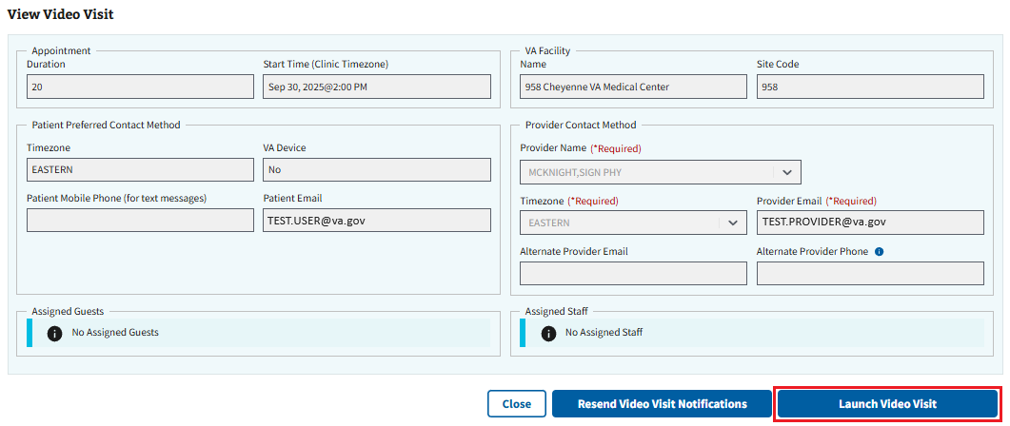
Figure 269: Launch Video Visit Button

4.6 Printing and Exporting Reports for Appointments and Requests

4.6.1 Export an Appointment Requests Report
- To export a report, the user will need to select the “Export” button shown in ⁠Figure 270⁠.
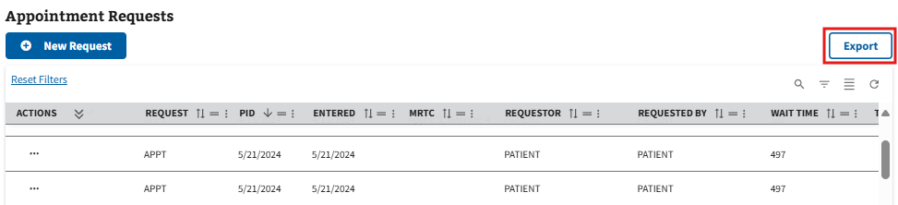
Figure 270: Export Button for Appointment Requests
- The user will then be prompted to open or save an Excel worksheet, where the ability to print the list is accessible.

4.6.2 Print for Appointments
From the Appointments & Requests page, users have the ability to print a Pending Appointment(s) list and a Scheduled Appointment(s) list. The Pending Appointment(s) list will show all future appointments, including those that have been cancelled, whereas the Scheduled Appointment(s) list will only show all future to-be-attended appointments for the patient.
- To print a Pending Appointment(s) list or a Scheduled Appointment(s) list, the user will need to select the “Print” button shown in ⁠Figure 271⁠.
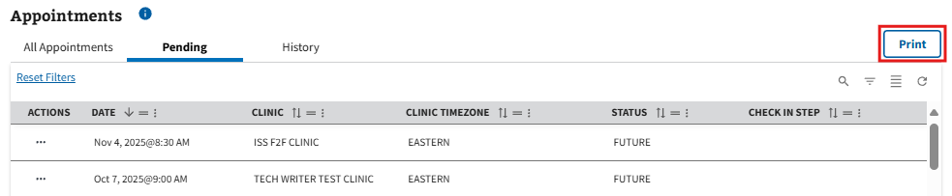
Figure 271: Print Button for Appointment List Options
- The user will then select either “Print Pending” for the Pending Appointment(s) list or “Patient Friendly Print” for the Scheduled Appointment(s) list, as seen in ⁠Figure 272⁠.
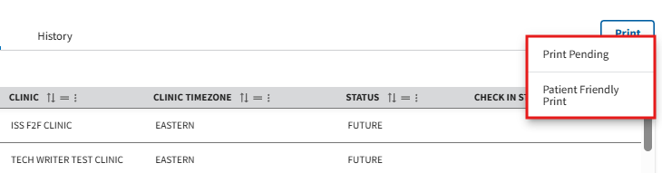
Figure 272: Appointment Print Options
- This will prompt the user to open or save a PDF file, where the ability to print the list is accessible.

Calendar Search

5.1 Clinic Search
- To search for a clinic, the user will select the search bar, seen in ⁠Figure 273⁠, and enter a valid clinic name. Once the information has been entered, a list of clinics will appear in the dropdown.
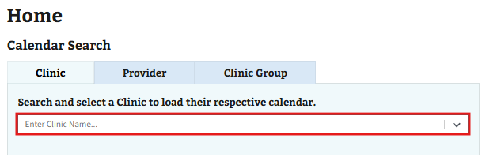
Figure 273: Search Bar for Clinic Search
- Note: Clinic search bar will contain up to the last 10 clinics used in a search. The user can select the dropdown and choose from this list or select the “Load Last Selected” button seen below in ⁠Figure 274⁠ to see the previously used clinic calendar. Please note that saved information will be reset when browser data is cleared.
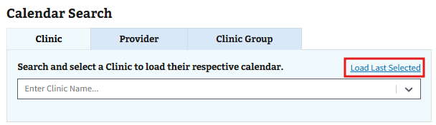
Figure 274: Load Last Selected Button for Clinic Search
- The user can then select their preferred clinic from the available options to be taken to the Time Slot Calendar for the clinic, as shown below in ⁠Figure 275⁠. On this page, the user is able to view available timeslots within the clinic.
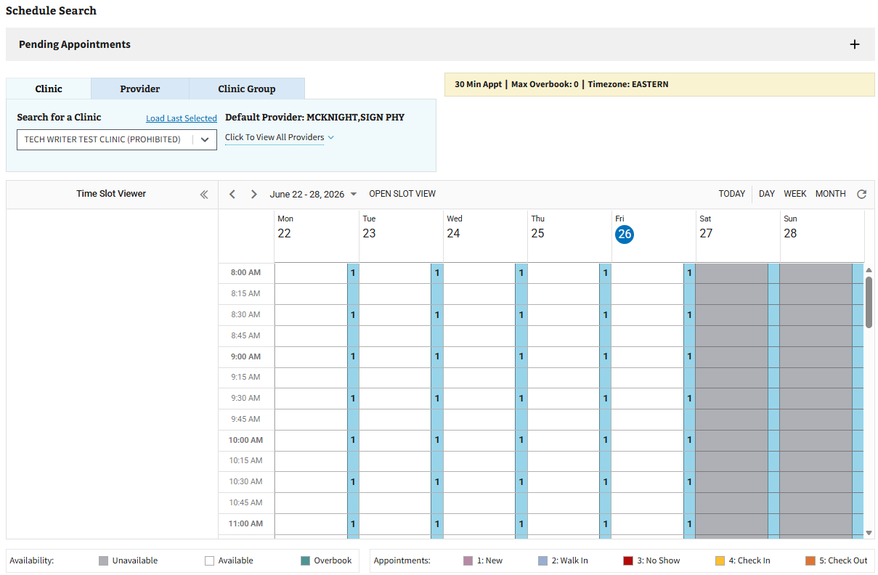
Figure 275: Clinic Calendar Example

5.1.1 Open Slot Search
Disclaimer: The Open Slot Search function is view only. The user will need to navigate to the Appointments & Requests page if a timeslot is found in the search with the necessary criteria and an appointment needs to be made. If the user is already in the process of making an appointment, the necessary clinic will need to be entered into the search bar seen below in ⁠Figure 276⁠ and the found timeslot manually navigated to via the calendar dropdown. For more information on creating an appointment, please see section ⁠⁠⁠⁠⁠⁠⁠4.3 Creating a Pending Appointment⁠⁠⁠⁠⁠⁠⁠.
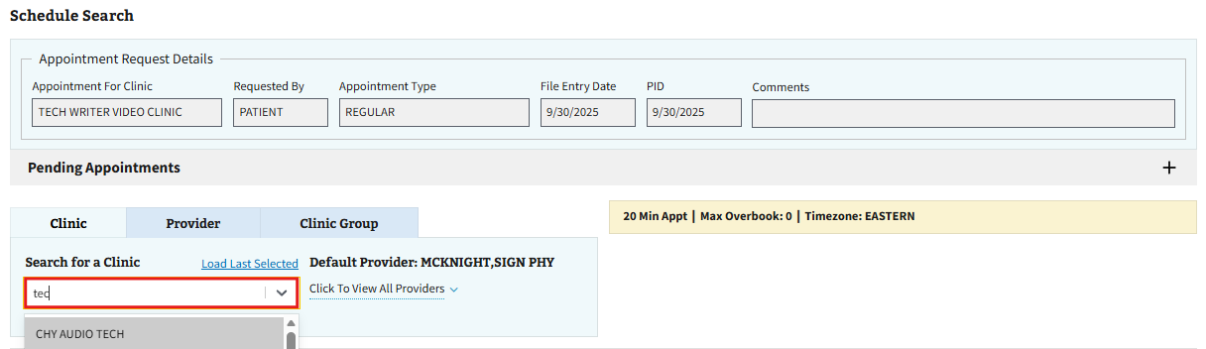
Figure 276: Clinic Search Bar when Creating an Appointment
- To access the Open Slot Search function, the user will need to select the "OPEN SLOT VIEW" button found next to the date shown in ⁠Figure 277⁠.
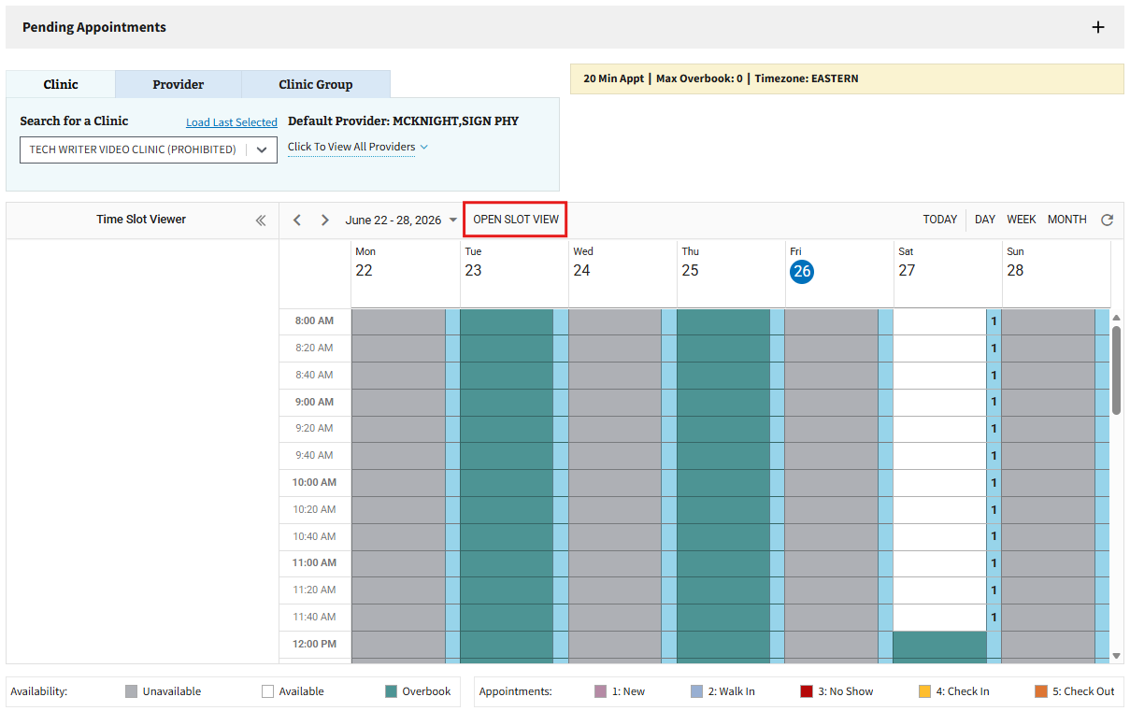
Figure 277: Open Slot View Button
- The user will be brought to the Open Slot Search function. The grid (shown below in ⁠Figure 278⁠) will be populated by default with available appointment time slots for the previously selected clinic.
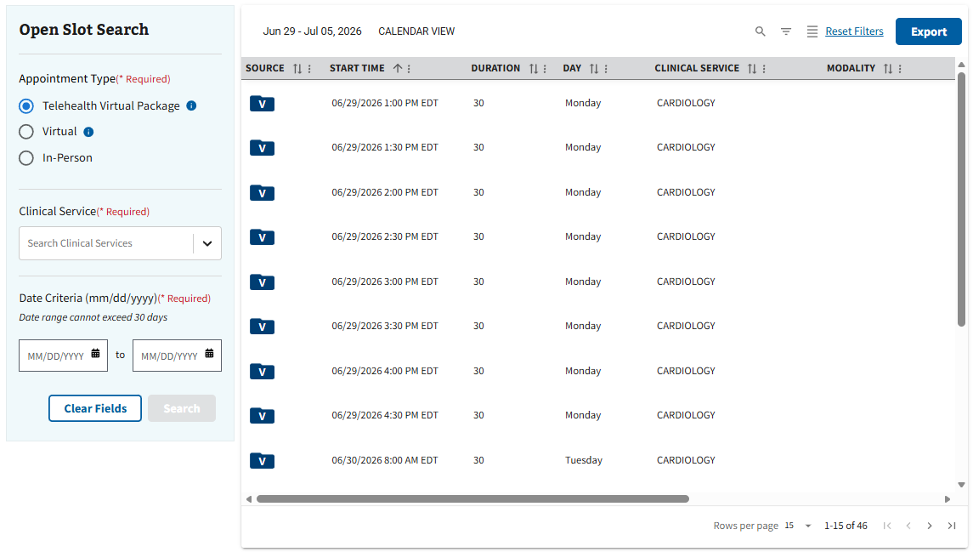
Figure 278: Open Slot Search Function
- Users can use the search function located on the left-hand side of the page to show specific results based on the search criteria. To begin a search, the user will need to select an appointment type, as seen in ⁠Figure 279⁠.
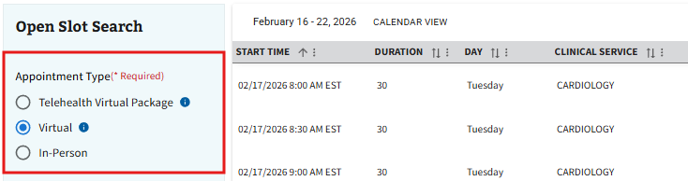
Figure 279: Appointment Types for Open Slot Search
- The user will then need to populate the Clinical Service field (shown in ⁠Figure 280⁠) with at least one clinical service.
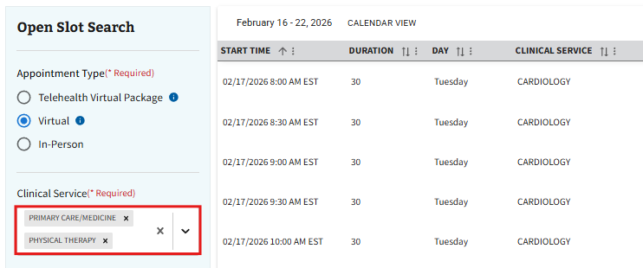
Figure 280: Clinical Service Field for Open Slot Search
- Note: If the user needs to remove any previously selected clinical services, select either the “x” button next to any individual clinical service in the Clinical Service field, or select the “x” button boxed in ⁠Figure 281⁠ to remove all previously selected clinical services.
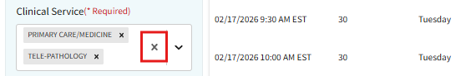
Figure 281: Remove All Selections Button for Clinical Service Field
- If the user selected either the Virtual or In-Person appointment types, a search radius will need to be selected. Users can populate the search radius field seen in ⁠Figure 282⁠ by either using the slider to adjust in increments of 10, by using the arrow buttons located in the selection box to adjust by increments of 10, or by typing a number anywhere between 1-250 into the selection box.
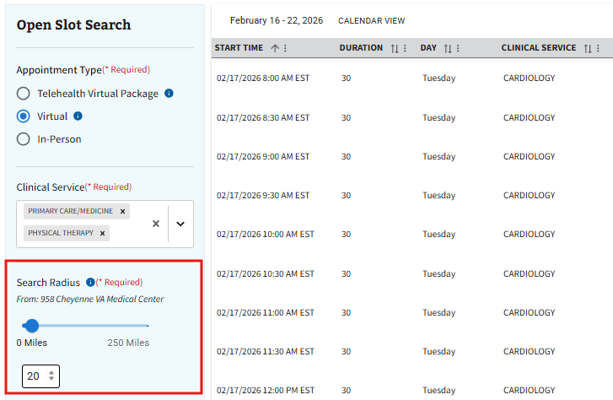
Figure 282: Search Radius Selection for Open Slot Search
- Users will then need to populate the Date Criteria section shown in ⁠Figure 283⁠ with a start date and end date.
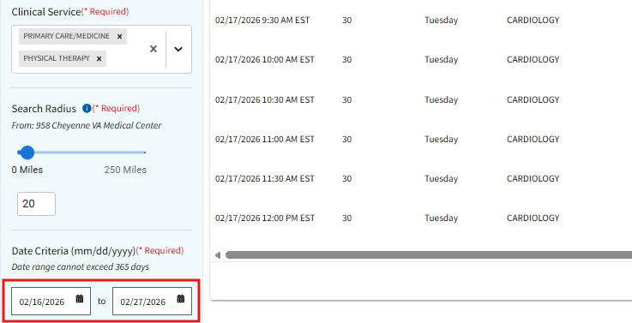
Figure 283: Date Selection for Open Slot Search

- Once all required search criteria is entered, the user will need to select the “Search” button shown in ⁠Figure 284⁠. This will cause the grid to update with available time slots in relation to the specified criteria entered.
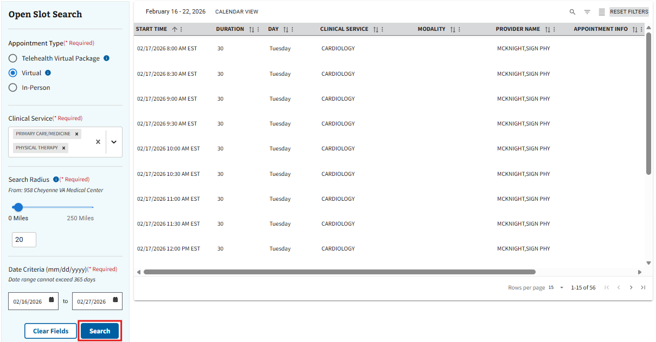
Figure 284: Search Button for Open Slot Search
- Note: For more information on how to navigate the results within the grid, please see section ⁠⁠⁠⁠⁠⁠⁠2.3 Filters⁠⁠⁠⁠⁠⁠⁠.
- Note: To clear results, the user can select the “Clear Fields” button seen in ⁠Figure 285⁠ to reset the search criteria and refresh the grid to default results.
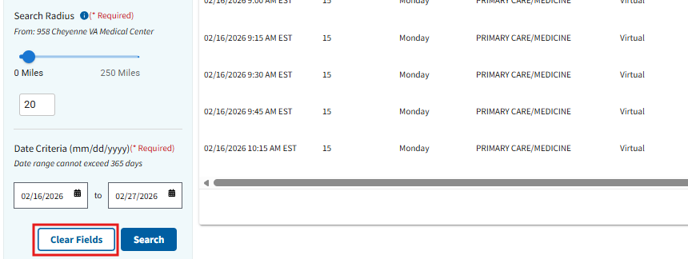
Figure 285: Clear Fields Button for Open Slot Search
- Note: The user can choose to export their search result data via the “Export” button seen below in ⁠Figure 286⁠.
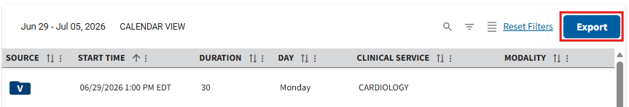
Figure 286: Export Button for Open Slot View
- To return to the calendar, the user will need to select the “CALENDAR VIEW” button shown in ⁠Figure 287⁠.
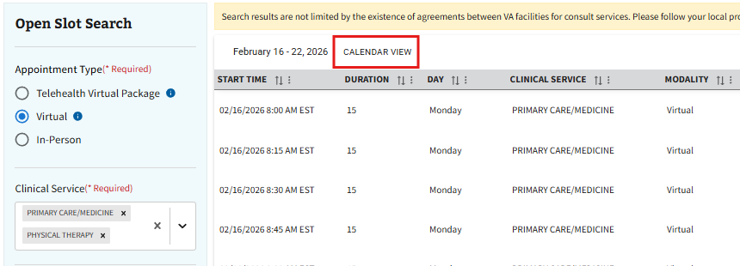
Figure 287: Calendar View Button from Open Slot View

5.2 Provider Search
- To search for a provider, the user will first need to select the “Provider” tab shown in ⁠Figure 288⁠.
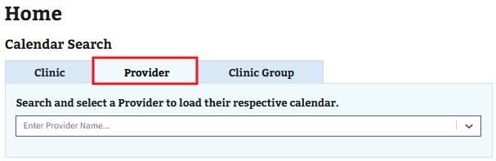
Figure 288: Provider Tab
- The user will then select the search bar, seen in ⁠Figure 289⁠, and enter a valid provider name. Once the information has been entered, a list of providers will appear in the dropdown.
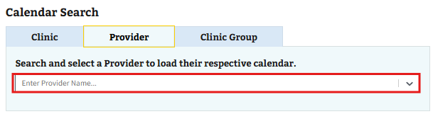
Figure 289: Provider Search Bar
- Note: Provider search bar will contain up to the last 10 providers used in a search. The user can select the dropdown and choose from this list or select the “Load Last Selected” button seen below in ⁠Figure 290⁠ to see the previously used provider’s calendar. Please note that saved information will be reset when browser data is cleared.
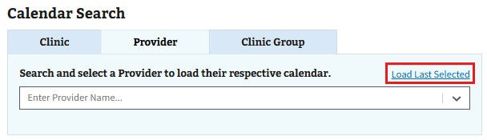
Figure 290: Load Last Selected Button for Provider Search
- After selecting the preferred provider from the available options, the user will be brought to the Time Slot Calendar for the selected provider. The user can view available timeslots on this page within the associated clinics of the provider, as seen in ⁠Figure 291⁠.
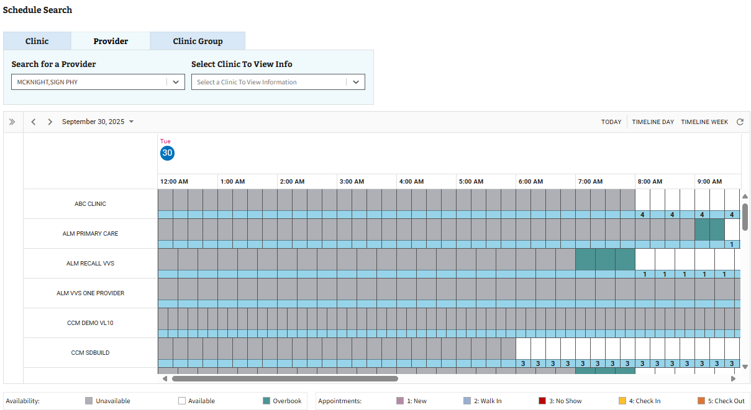
Figure 291: Provider Calendar Example
- Note: The user is able to view information about a clinic by selecting a clinic within the dropdown shown in ⁠Figure 292⁠.
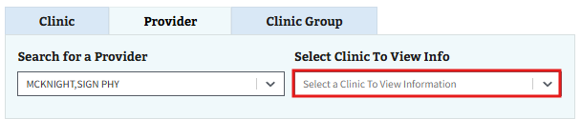
Figure 292: Dropdown to Select a Clinic for Information on Provider Calendar

5.3 Clinic Group Search
- To search for a clinic group, the user will first need to select the “Clinic Group” tab shown in ⁠Figure 293⁠.
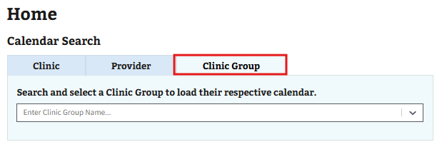
Figure 293: Clinic Group Tab
- The user will then select the search bar, seen in ⁠Figure 294⁠, and enter a valid clinic group name. Once the information has been entered, a list of clinic groups will appear in the dropdown.
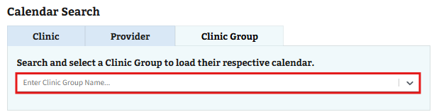
Figure 294: Clinic Group Search Bar
- Note: Clinic Group search bar will contain up to the last 10 clinic groups used in a search. The user can select the dropdown and choose from this list or select the “Load Last Selected” button seen below in ⁠Figure 295⁠ to see the previously used clinic group’s calendar. Please note that saved information will be reset when browser data is cleared.
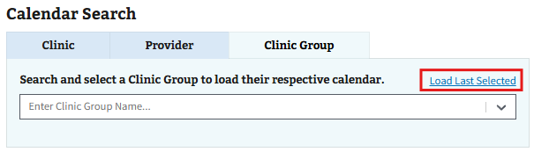
Figure 295: Load Last Selected Button for Clinic Group Search
- After selecting the preferred clinic group from the available options, the user will be brought to the Time Slot Calendar, as shown below in ⁠Figure 296⁠, for the selected clinic group. On this page, the user is able to view available timeslots from entities associated with the clinic group.
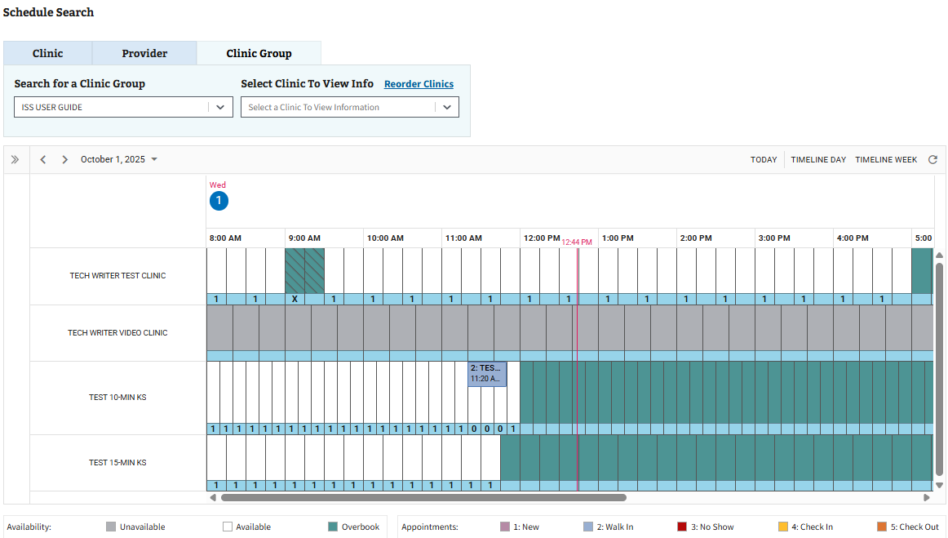
Figure 296: Clinic Group Calendar Example
- Note: The user is able to view information about a clinic by selecting a clinic within the dropdown shown in ⁠Figure 297⁠.
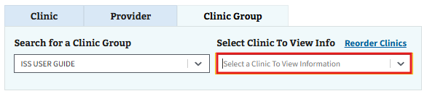
Figure 297: Dropdown to Select a Clinic for Information on Clinic Group Calendar
- Note: The user has the ability to reorder the clinic order. To do so, the user will need to select “Reorder Clinics,” shown is ⁠Figure 298⁠, then drag and drop the clinics into their preferred order. Once completed, the user will need to select “OK” to save the changes.
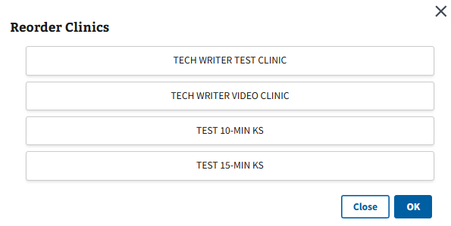
Figure 298: Reorder Clinics Window

5.4 Create Walk-in
- To create a walk-in, the user will first need to follow the steps outlined in ⁠⁠⁠⁠⁠⁠⁠3.1 Patient Search⁠⁠⁠⁠⁠⁠⁠ to bring a patient into context. Then, the user will need to navigate to the intended calendar by following the steps in any of the following; ⁠⁠⁠⁠⁠⁠⁠4.4.12 Calendar View⁠⁠⁠⁠⁠⁠⁠, ⁠⁠⁠⁠⁠⁠⁠5.1 Clinic Search⁠⁠⁠⁠⁠⁠⁠, ⁠⁠⁠⁠⁠⁠⁠5.2 Provider Search⁠⁠⁠⁠⁠⁠⁠, or ⁠⁠⁠⁠⁠⁠⁠Clinic Group Search⁠⁠⁠⁠⁠⁠⁠.
- Once a patient has been brought into context, the user will be able to right click on the preferred timeslot within the calendar and select “Create Walk-in,” seen in ⁠Figure 299⁠.
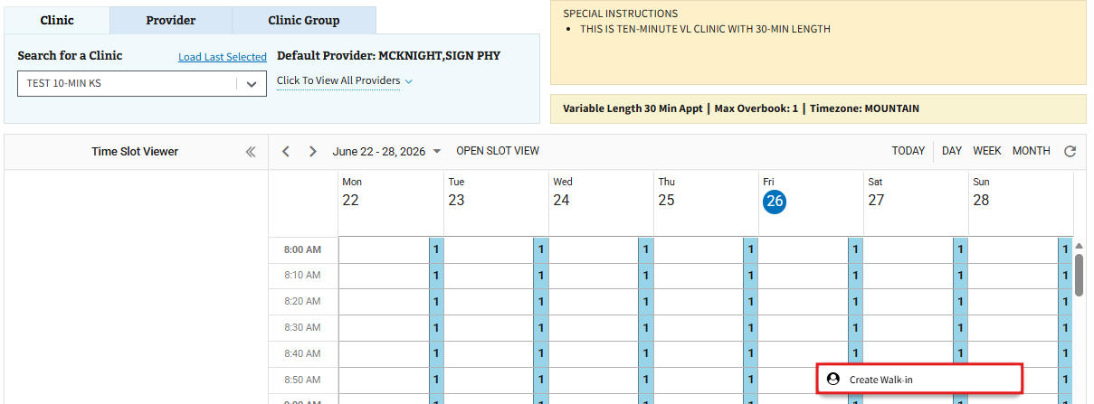
Figure 299: Create Walk-in Button on Calendar
- The user will be brought to the New Walk-in Appointment page. On this page, the user will need to fill out all the required information displayed in ⁠Figure 300⁠. The user can also fill out any optional information as needed.
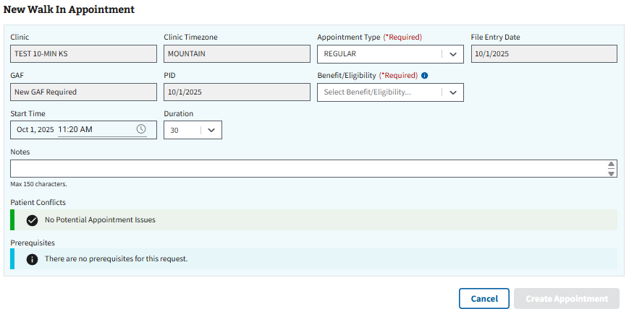
Figure 300: New Walk- in Appointment Page
- Once all applicable information has been filled, the user will select the “Create Appointment” button, seen in ⁠Figure 301⁠, to create the walk-in appointment.
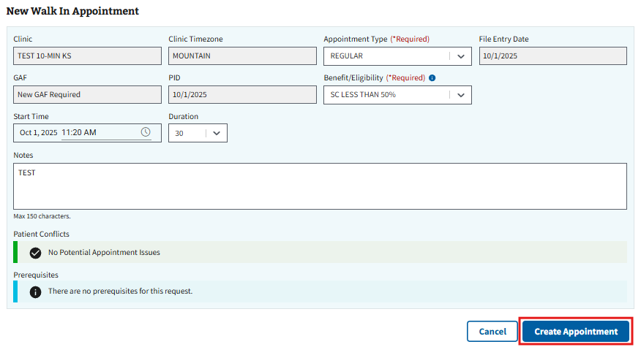
Figure 301: Create Appointment Button for New Walk-in
- Note: The user can also select the “Cancel” button seen in ⁠Figure 301⁠ to exit creating an appointment and go back to the Appointments & Requests page.
- The Appointment Successfully Created window, shown below in ⁠Figure 302⁠, will appear. The user can choose to preview the patient letter, if needed, or select “Close” to continue.
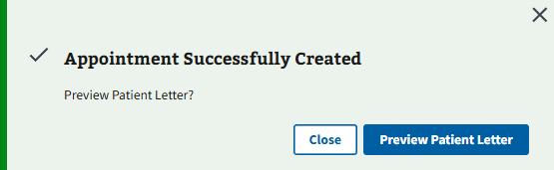
Figure 302: Preview Patient Letter Window for Walk-in Appointment

Reports

6.1 Query Tool
The user will need to navigate to the home screen to find the Query Tool. Please see ⁠Figure 303⁠ below for an overview on how to perform a query and the rules associated for each section. Please note that only the first 200 search results will appear in each query.
Figure 303: Overview of How to Perform a Query
Once the minimum amount of search criteria has been made and the user is ready to make a search, it may be helpful to utilize the Change Sort Order function for better results. Simply select the dropdown under Change Sort Order and select the desired option. Please note that the “Default” sort order is Priority Group, PID, and Origination Date.

6.1.1 Section 1
- Within the query tool, the user will find section 1 where patients will need to be selected for the query. To begin, the user will select the search bar under Patients, seen in ⁠Figure 304⁠, and enter valid search criteria. A dropdown will appear with a list of patients that match the criteria given.
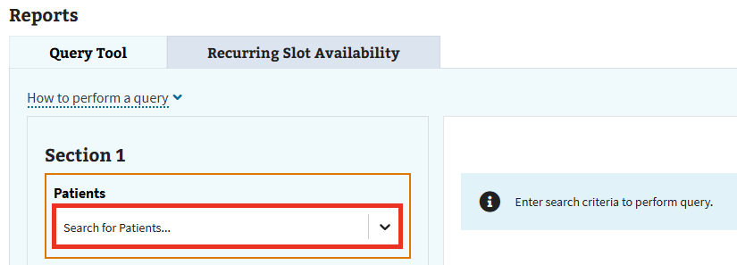
Figure 304: Dropdown to Select a Patient for Section 1 of Query Tools
- The user can then select the patient needed from the available options.
- Repeat steps 1 and 2 for as many patients the user wishes to include in the query.
- Note: The maximum number of patients that can be included in a query search is 50.
- Note: If the user needs to remove any previously selected patients, select either the “x” button next to any individual patient in the Patients field, or select “x” shown in ⁠Figure 305⁠ to remove all previously selected patients.
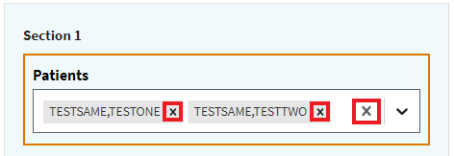
Figure 305: Remove Previously Selected Patient Icon
- After selecting the patients needed, the user can run the query by selecting “Run Query,” shown in ⁠Figure 306⁠. Optionally, the user can narrow down search results by following the steps outlined in either ⁠⁠⁠⁠⁠⁠⁠6.1.2 Section 2⁠⁠⁠⁠⁠⁠⁠ or ⁠⁠⁠⁠⁠⁠⁠6.1.3 Section 3⁠⁠⁠⁠⁠⁠⁠.
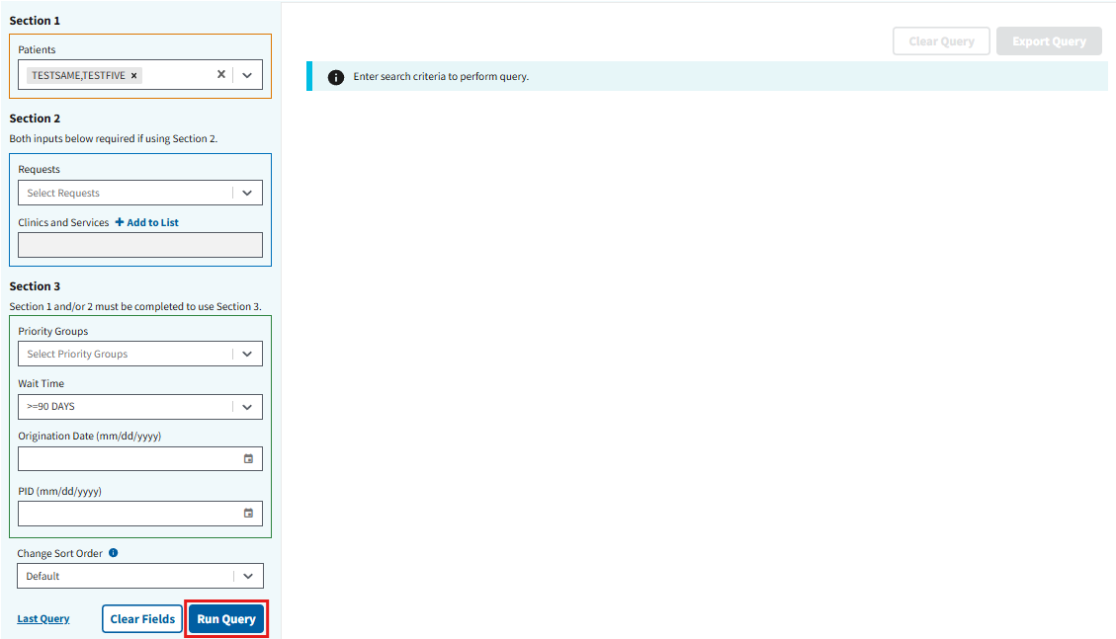
Figure 306: Run Query Button using Section 1 of Query Tools

6.1.2 Section 2
- Within the query tool, the user will find section 2. To begin, the user will select the dropdown under Requests, seen in ⁠Figure 307⁠, and choose a given request option. The user can individually add different requests or choose “Select All” to add all the options shown.
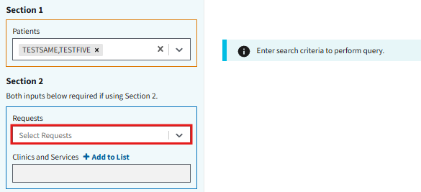
Figure 307: Dropdown to Select a Request for Section 2 of Query Tools
- The user must then select “+ Add to List,” seen in ⁠Figure 308⁠, to open the Clinics/Services window.
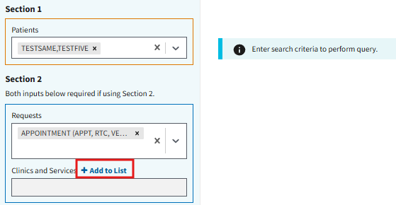
Figure 308: Button to Add Clinics and Services in Section 2 of Query Tools
- On this window, the user can select whether to search for Clinics or Services by selecting one of the radio buttons seen in ⁠Figure 309⁠.
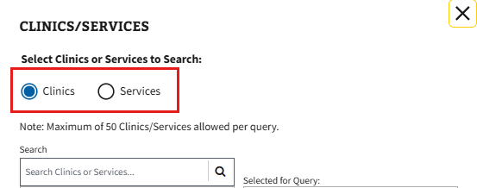
Figure 309: Clinic/Services Radio Buttons for Query Tool
- The user will then need to enter valid search criteria by selecting the search bar shown in ⁠Figure 310⁠. This will cause any applicable results to appear in the box below.
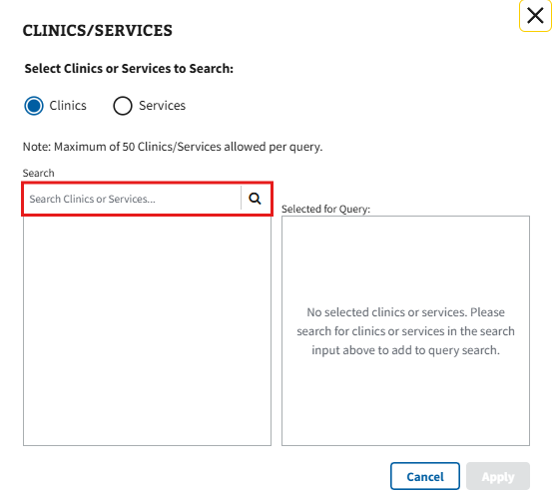
Figure 310: Search Bar for Clinics/Services for Section 2 of Query Tools
- The user will then need to either select the add button next to any individual Clinic/Service option or can select the “Add All” button shown in ⁠Figure 311⁠ to add all the options listed.
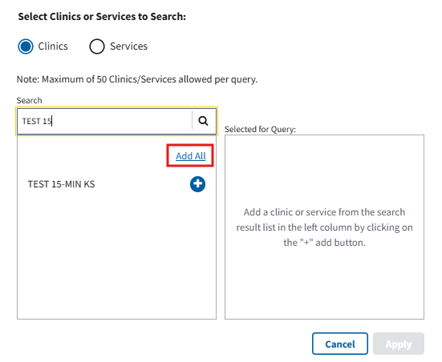
Figure 311: Button to Add All Clinics/Services
- Note: If the user needs to remove any previously selected Clinics/Services from the query, the user can select either the remove button next to an individual Clinic/Service in the Selected for Query section or select the “Remove All” button shown in ⁠Figure 312⁠ to remove all the options listed.
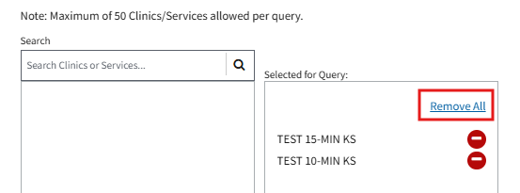
Figure 312: Button to Remove All Clinics/Services
- The user will then select the “Apply” button, as seen in ⁠Figure 313⁠, to be brought back to the query tool with any selected results applied.
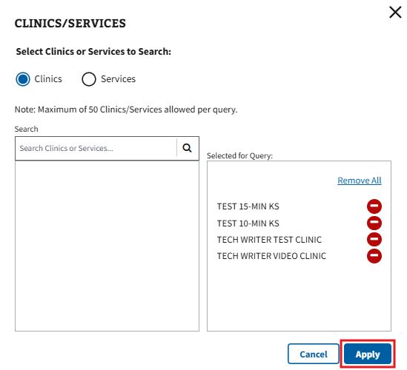
Figure 313: Apply Button for Clinics/Services for Section 2 of Query Tools
- After filling the required fields, the user can run the query by selecting “Run Query,” shown in ⁠Figure 314⁠. Optionally, the user can narrow down search results by following the steps outlined in either ⁠⁠⁠⁠⁠⁠⁠6.1.1 Section 1⁠⁠⁠⁠⁠⁠⁠ or ⁠⁠⁠⁠⁠⁠⁠6.1.3 Section 3⁠⁠⁠⁠⁠⁠⁠.
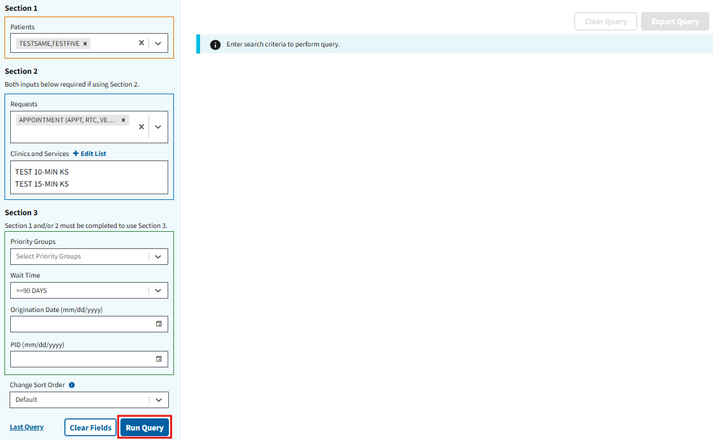
Figure 314: Run Query Button using Section 2 of Query Tools

6.1.3 Section 3
Please note that all search criteria within section 3 are optional. If using section 3, the user must have entered search criteria into either Section 1, Section 2, or both.
- To begin, the user can select the dropdown under Priority Groups, seen in ⁠Figure 315⁠, and choose a given priority group option. The user can individually add different priority groups or choose “Select All” to add all the options shown.
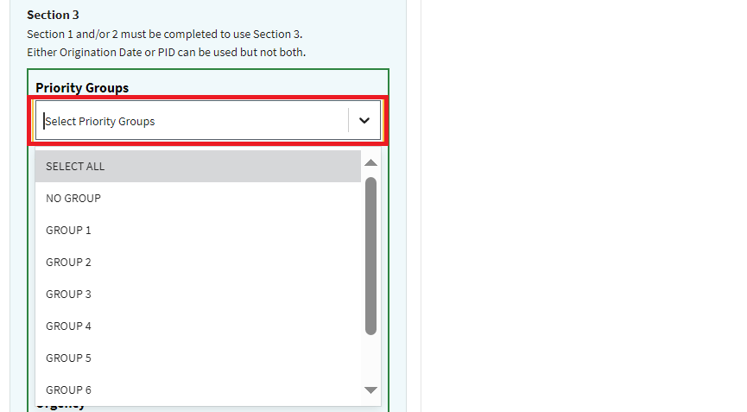
Figure 315: Dropdown to Select a Priority Group for Section 3 of Query Tools
- The user can select the dropdown under Wait Time, seen in ⁠Figure 316⁠, and choose the preferred wait time length. The user can choose “All Days” to view all wait times options.
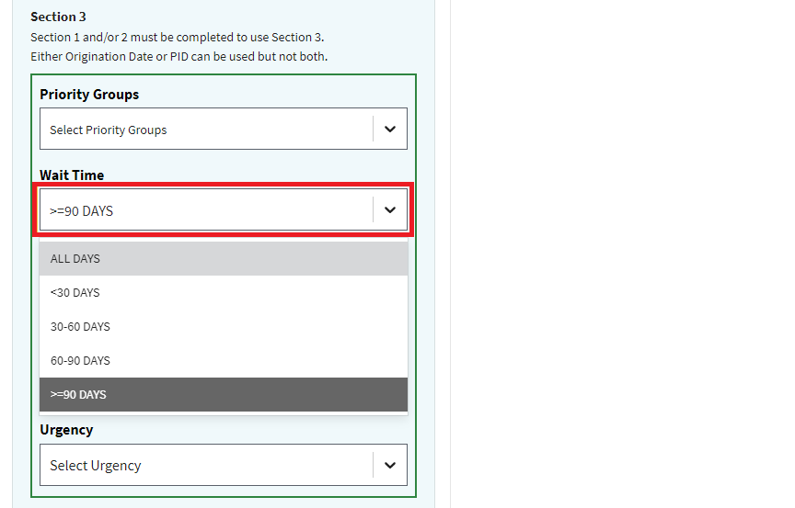
Figure 316: Dropdown to Select a Wait Time for Section 3 of Query Tools

- When narrowing down a specific date, the user can select either an origination date, or PID (not both), if needed.
- If consult was chosen as a requests option from Section 2, the user can select an urgency type by navigating the dropdown selections, as seen in ⁠Figure 317⁠.
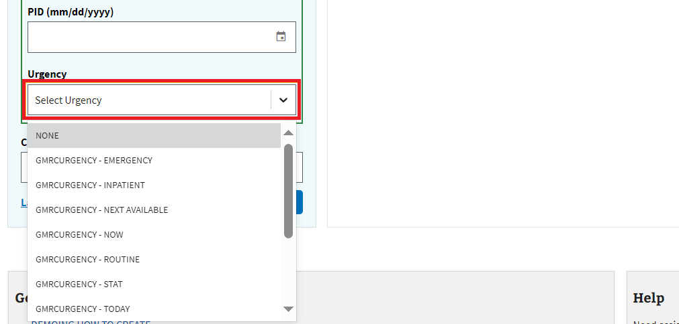
Figure 317: Dropdown to Select an Urgency Status for Section 3 of Query Tools

6.1.4 Query Actions
After running a query search, the user will see a grid table with their requested information. The user can then open the “Actions” menu next to the specified request (see ⁠Figure 318⁠ below) to perform the following: create new appointments, edit and view appointment requests, add contact attempts, and disposition requests. See sections ⁠⁠⁠⁠⁠⁠⁠4.3 Creating a Pending Appointment⁠⁠⁠⁠⁠⁠⁠ and ⁠⁠⁠⁠⁠⁠⁠4.4 Appointment Actions⁠⁠⁠⁠⁠⁠⁠ for more information on appointment actions.
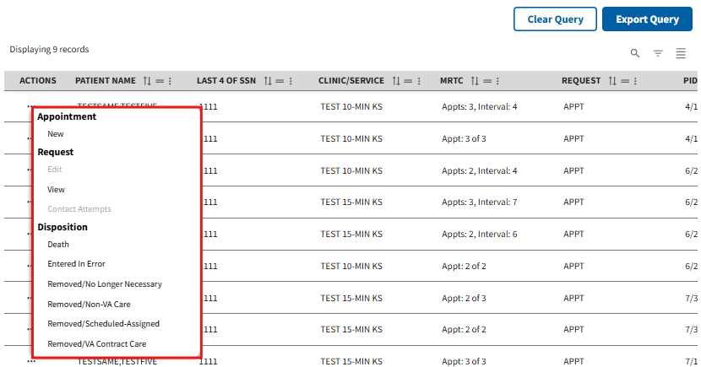
Figure 318: Example of Query Actions

6.1.5 Export Query Results
- To export the query search, the user will need to select the “Export Query” button seen in ⁠Figure 319⁠.
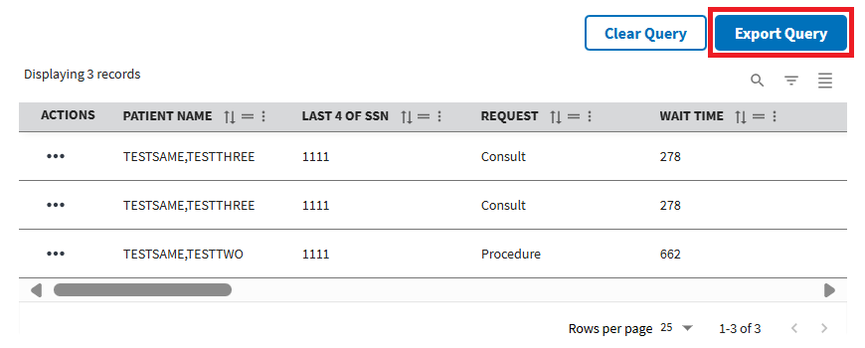
Figure 319: Export Query Button
- The user will then be prompted to open or save an Excel worksheet, where the ability to print the results is accessible.
- Optionally, the user can reset the table at any point by selecting the “Clear Query” button shown below in ⁠Figure 320⁠.
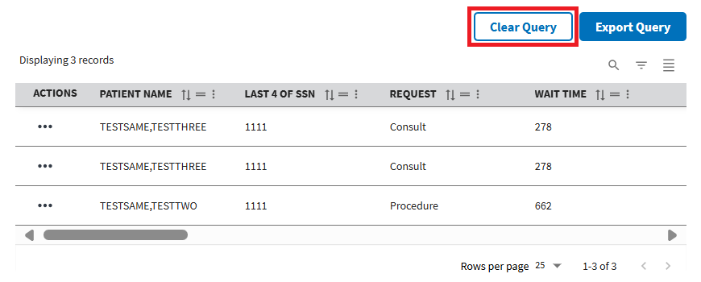
Figure 320: Clear Query Button

6.2 Recurring Slot Availability
- To begin, the user will need to navigate to the Recurring Slot Availability tab on the homepage shown in ⁠Figure 321⁠.
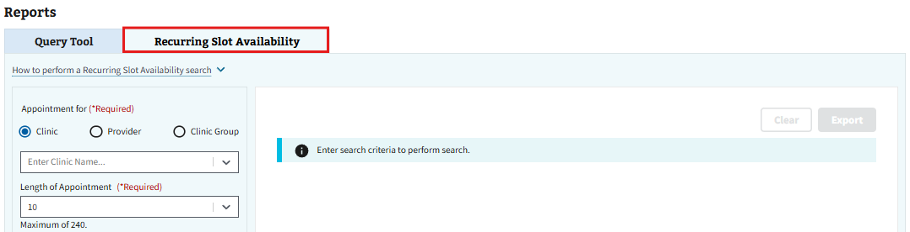
Figure 321: Recurring Slot Availability Tab
- Under the “Appointment For” field, the Clinic radio button will be auto-populated. The user can either continue on and enter a clinic name or select either the “Provider” or “Clinic Group” radio button and enter the appropriate search criteria (see ⁠Figure 322⁠ for example).
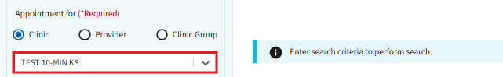
Figure 322: Appointment for Search Bar
- The user will then need to fill out the remaining required and optional fields, as seen below in ⁠Figure 323⁠.
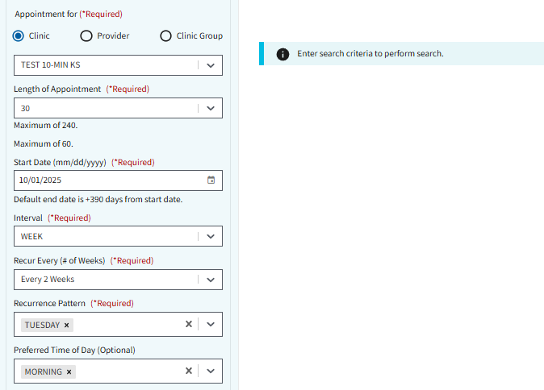
Figure 323: Recurring Slot Availability Fields
- Once all required fields have been populated, the user can select the “Search” button shown below in ⁠Figure 324⁠.
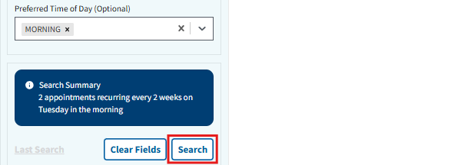
Figure 324: Search Button for Recurring Slot Availability
- Note: After populating all required fields, the user will see a Search Summary of their choices (see ⁠Figure 324⁠ for example).
- Results from the search will populate on the right-hand side of the page, as seen in ⁠Figure 325⁠. For more information on how to navigate these results, see section ⁠⁠⁠⁠⁠⁠⁠2.3 Filters⁠⁠⁠⁠⁠⁠⁠.
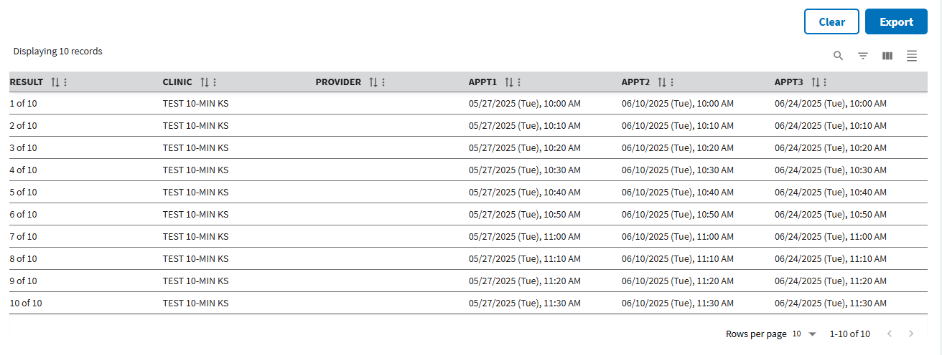
Figure 325: Example of Recurring Slot Availability Search Results
- To clear results, the user can select either the “Clear” button in ⁠Figure 325⁠, or the “Clear Fields” button seen in ⁠Figure 326⁠.
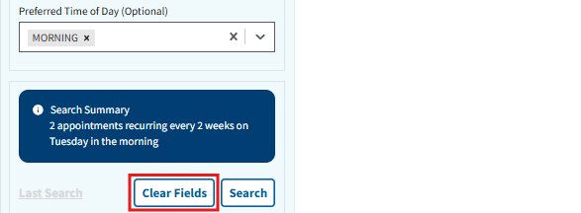
Figure 326: Clear Fields Button for Recurring Slot Availability
- Note: The user can also choose to go back to their previously completed search by selecting the “Last Search” button seen in ⁠Figure 327⁠.
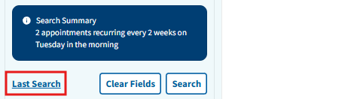
Figure 327: Last Search Button for Recurring Slot Availability
- To export search results, select the “Export” button seen in ⁠Figure 328⁠. This will allow the user to download the report into an Excel document.
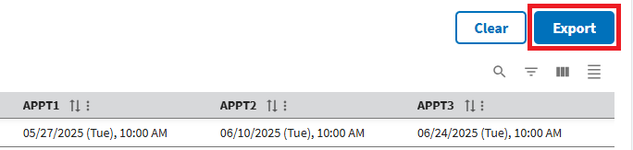
Figure 328: Export Button for Recurring Slot Availability

System
This section of the guide is only applicable to users who have been provisioned with the SDECZMGR key. To access, select the System tab, seen in ⁠Figure 329⁠, at the top of the webpage.
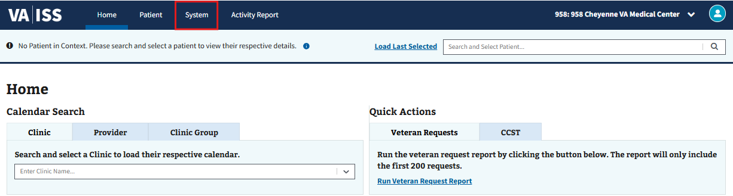
Figure 329: Systems Tab on the Homepage

7.1 Privileged Users
- To add or remove Privileged Users, the user will need to select the “Privileged Users” tab shown in ⁠Figure 330⁠.
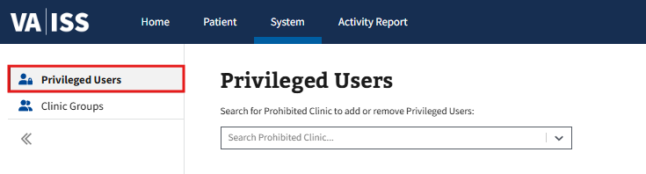
Figure 330: Privileged Users Tab
- The user will then need to enter the name of a prohibited clinic into the search bar. This will cause any applicable results to appear in a dropdown, as seen in ⁠Figure 331⁠ below, where the user can select the intended clinic.
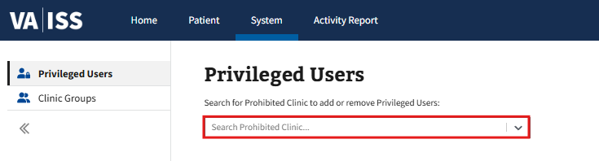
Figure 331: Search Bar for Privileged Users
- The (Clinic Name) window will appear. From here, the user can either search for a user by manually scrolling through the Users section or filter the results by typing in a user’s name into the Search Users search bar, seen in ⁠Figure 332⁠. Once the necessary user is found, select the add button next to the name. Repeat this step for each user that needs to be added to the prohibited clinic.
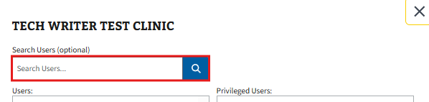
Figure 332: Search Users Look Up for Clinics Under Privileged Users
- Note: If the user needs to remove any previously selected users, select either the remove button next to any individual user, or select the “Remove All” button shown in ⁠Figure 333⁠ to remove all of the users listed.
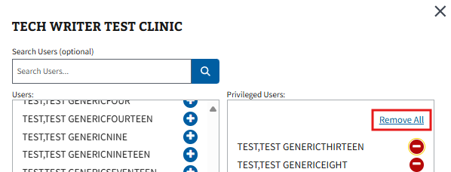
Figure 333: Button to Remove All Users from a Clinic
- Once all Privileged users have been added, select the “Save Changes” button, seen in ⁠Figure 334⁠, to save all changes.
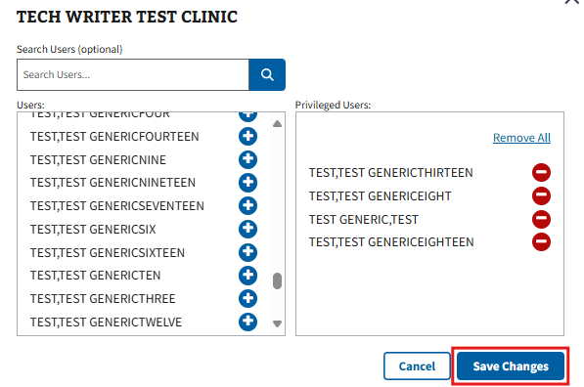
Figure 334: Save Changes Button for Privileged Users

7.2 Clinic Groups

7.2.1 Edit Clinic Group
- To search for a Clinic Group, the user will need to select the “Clinic Groups” tab shown in ⁠Figure 335⁠.
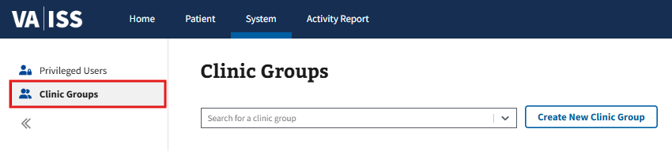
Figure 335: Selecting Clinic Groups Tab for Editing
- The user will then need to enter the name of a clinic group into the search bar. This will cause any applicable results to appear in a dropdown, as seen in ⁠Figure 336⁠ below, where the user can select the intended clinic group.
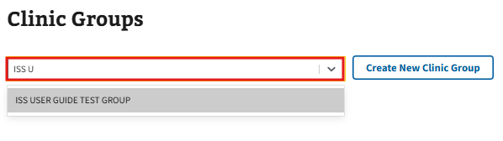
Figure 336: Search Bar for Finding a Clinic Group to Edit
- The user will be brought to the (Clinic Group Name) page. From here, the user can select the “Edit Clinic Group” button, seen in ⁠Figure 337⁠, to open the Edit Clinic Group window.
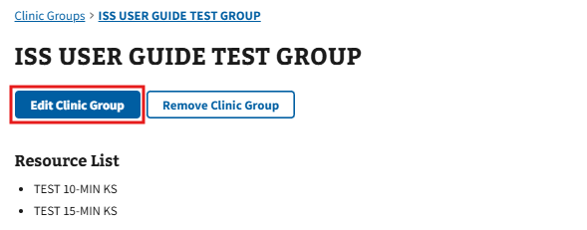
Figure 337: Edit Clinic Group Button
- To change the clinic group name, select the field shown in ⁠Figure 338⁠ and make the necessary changes.
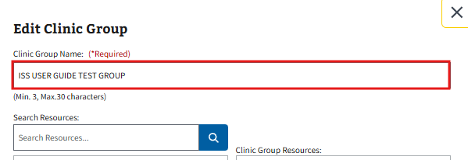
Figure 338: Field for Clinic Group Name when Editing a Clinic Group
- To add resources, the user will need to enter valid search criteria into the search bar seen in ⁠Figure 339⁠. This will cause any applicable results to appear in the box below.
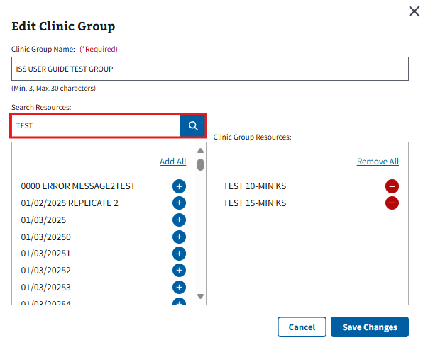
Figure 339: Search Bar to Find Resources when Editing a Clinic Group
- Note: If no resources are available from the search, the user will receive the notice, seen in ⁠Figure 340⁠, and will need to enter new search terms to continue.
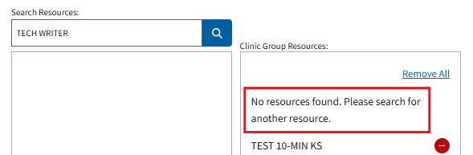
Figure 340: No Resources Found Notice for Edit a Clinic Group
- The user will then need to either select the add button next to any individual resource option or select the “Add All” button shown in ⁠Figure 341⁠ to add all the options listed.
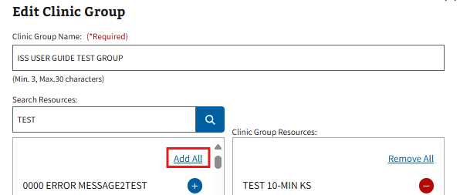
Figure 341: Button to Add All Resources when Editing a Clinic Group
- Note: If the user needs to remove any previously selected resources, the user can select either the remove button next to an individual resource in the Clinic Group Resources section or select the “Remove All” button shown in ⁠Figure 342⁠ to remove all the options listed.
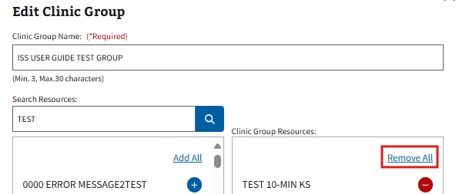
Figure 342: Button to Remove All Resources when Editing a Clinic Group
- After making the necessary edits, the user will need to select the “Save Changes” button, seen in ⁠Figure 343⁠, to save all changes.
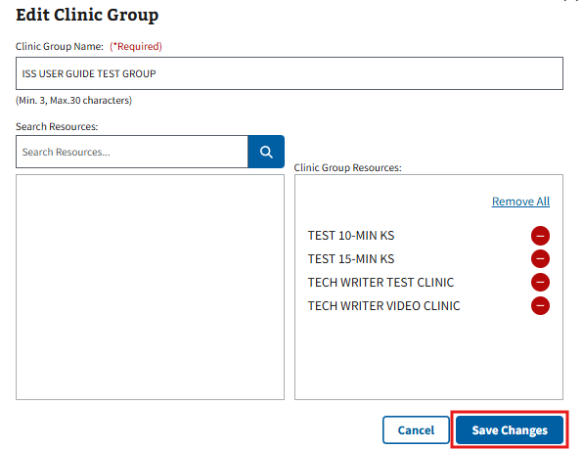
Figure 343: Save Changes Button for Editing Clinic Groups

7.2.2 Remove Clinic Group
- To search for a Clinic Group, the user will need to select the “Clinic Groups” tab shown in ⁠Figure 344⁠.
Figure 344: Selecting Clinic Groups Tab to Remove
- The user will then need to enter the name of a clinic group into the search bar. This will cause any applicable results to appear in a dropdown, as seen in ⁠Figure 345⁠ below, where the user can select the intended clinic group.
Figure 345: Search Bar for Finding a Clinic Group to Remove
- The user will be brought to the (Clinic Group Name) page. From here, the user can select the “Remove Clinic Group” button, seen in ⁠Figure 346⁠. This will cause the Remove Clinic Group? notification to appear.
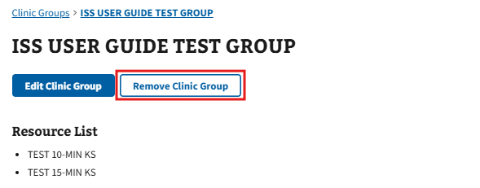
Figure 346: Remove Clinic Group Button
- The user can select the “Remove Clinic Group” button, seen in ⁠Figure 347⁠, to successfully remove the clinic group.
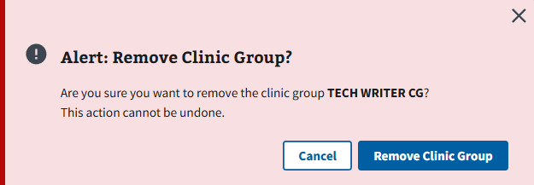
Figure 347: Remove Clinic Group Button from Confirmation Window
- Note: The user can also select the “Cancel” button or the “x” button seen in the upper right-hand corner of the notification in ⁠Figure 347⁠ to exit the process and go back to the (Clinic Group Name) page.

7.2.3 Creating New Clinic Groups
- To search for a Clinic Group, the user will need to select the “Clinic Groups” tab shown in ⁠Figure 348⁠.
Figure 348: Selecting Clinic Groups Tab to Create New Clinic Group
- The user can then select the “Create New Clinic Group” button shown in ⁠Figure 349⁠ to be brought to the Create New Clinic Group window.
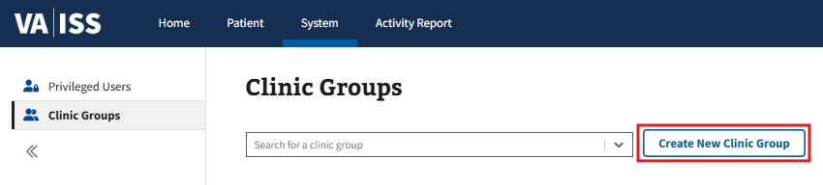
Figure 349: Create New Clinic Group Button
- To add a name for the clinic group, the user will need to enter a preferred name into the Clinic Group Name section seen in ⁠Figure 350⁠.
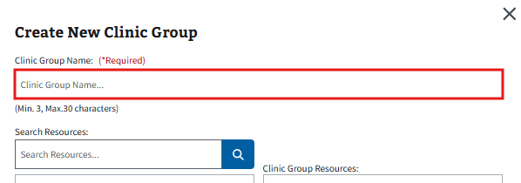
Figure 350: Field for Clinic Group Name when Creating New Clinic Group
- To add resources to the clinic group, the user will need to enter valid search criteria into the search bar seen in ⁠Figure 351⁠. This will cause any applicable results to appear in the box below.
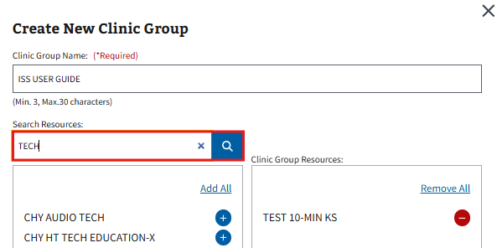
Figure 351: Search Bar to Find Resources when Creating a New Clinic Group
- Note: If no resources are available from the search, the user will receive the notice, seen in ⁠Figure 352⁠, and will need to enter new search terms to continue.
Figure 352: No Resources Found Notice for Create a Clinic Group
- The user will then need to either select the add button next to any individual resource option or select the “Add All” button shown in ⁠Figure 353⁠ to add all the options listed.
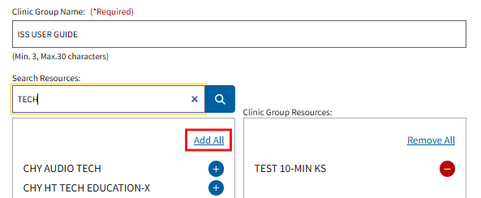
Figure 353: Button to Add All Resources when Creating a Clinic Group
- Note: If the user needs to remove any previously selected resources, the user can select either the remove button next to an individual resource in the Clinic Group Resources section or select the “Remove All” button shown in ⁠Figure 354⁠ to remove all the options listed.
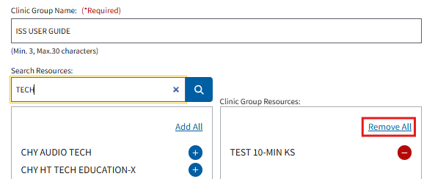
Figure 354: Button to Remove All Resources when Creating a Clinic Group
- Once all necessary clinic group resources have been added, the user will need to select the “Create Clinic Group” button, seen in ⁠Figure 355⁠, to create the new clinic group.
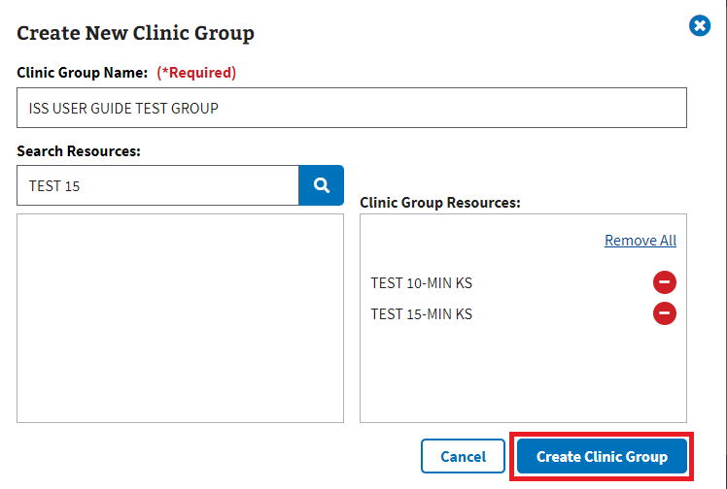
Figure 355: Create Clinic Group Button

7.3 Activity Report
- To access the Activity Report, the user will need to select the “Activity Report” tab seen in ⁠Figure 356⁠.
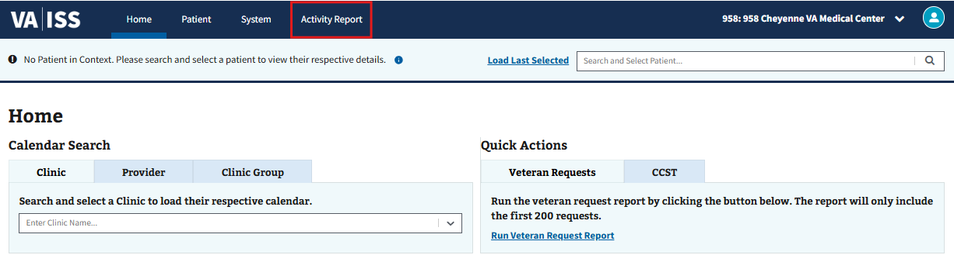
Figure 356: Activity Report Tab
- Upon selecting the “Activity Report” tab, the user will be taken to the Overview page by default. The user can then select any of the sub-tabs seen in ⁠Figure 357⁠ to access them.
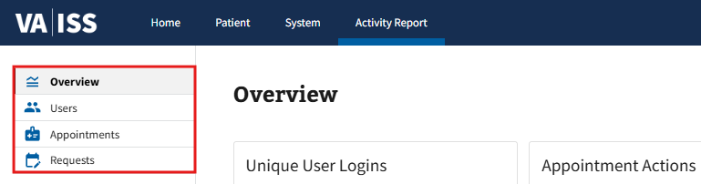
Figure 357: Sub-Tabs for the Activity Report
- Note: Users will need to select a site from the dropdown menu, seen in ⁠Figure 358⁠, to bring information into context within the Activity Report tab. This action will need to be done on each of the sub-tabs upon first view.
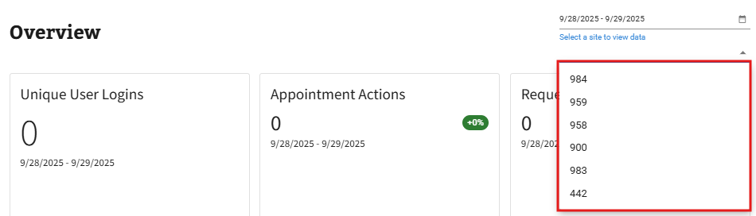
Figure 358: Site Select Dropdown for Activity Report
- Within the sub-tabs, the user can navigate the graphs and tables for information relating to each section’s title (see ⁠Figure 359⁠ for example).
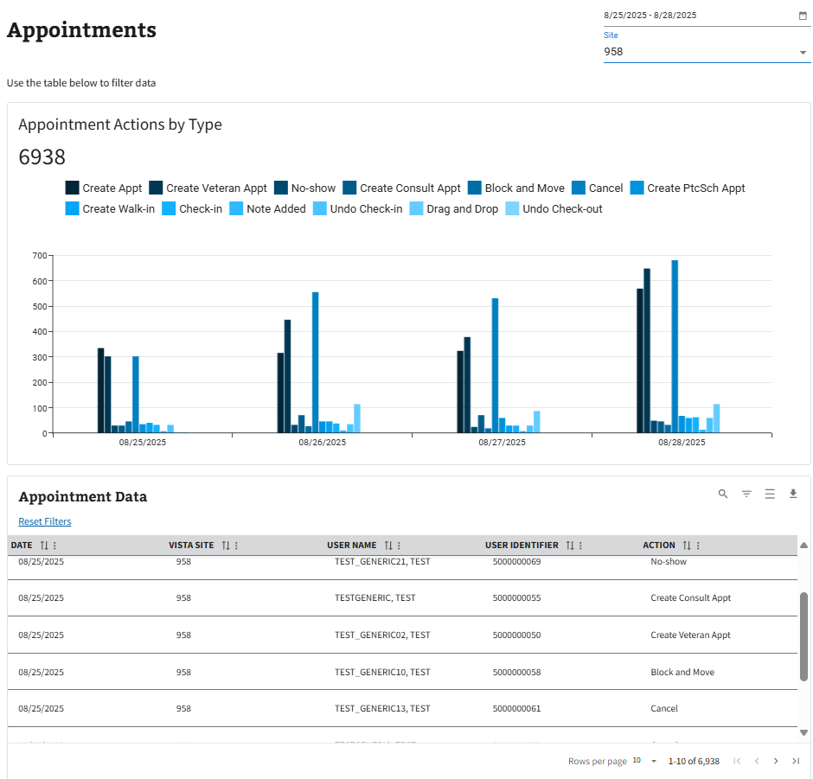
Figure 359: Example of Data within Activity Report Sub-Tabs
- Note: See sections ⁠⁠⁠⁠⁠⁠⁠2.3.2 Sort by Ascending and Descending⁠⁠⁠⁠⁠⁠⁠, ⁠⁠⁠⁠⁠⁠⁠2.3.3 Toggle Density⁠⁠⁠⁠⁠⁠⁠, ⁠⁠⁠⁠⁠⁠⁠2.3.4 Show, Hide, and Search Filters⁠⁠⁠⁠⁠⁠⁠, and ⁠⁠⁠⁠⁠⁠⁠2.3.5 Filtering Rows⁠⁠⁠⁠⁠⁠⁠ for information on filtering tables.
- The user can also filter the results shown within each sub-tab by selecting the preferred date range from the dropdown calendar found in the upper righthand corner of each page (see ⁠Figure 360⁠).
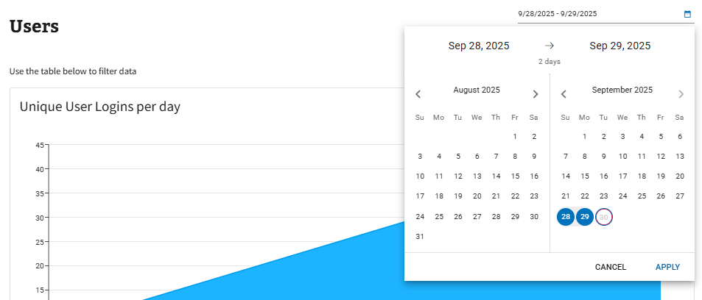
Figure 360: Date Range Calendar Dropdown for Activity Report
- On certain graphs within the “Activity Reports” tab, the user can hover the cursor over data points, as seen in ⁠Figure 361⁠, to receive more context about the information being shown.
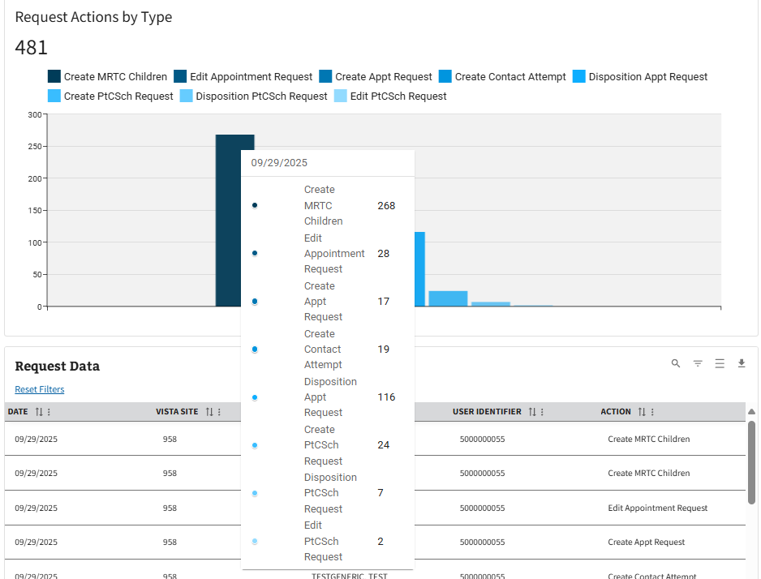
Figure 361: Data Point Information on Activity Report Graphs
- The user can also export data of any table within the tabs by selecting the “Export” button seen in ⁠Figure 362⁠. The user will then be prompted to open or save an Excel worksheet, where the ability to print the information is accessible.
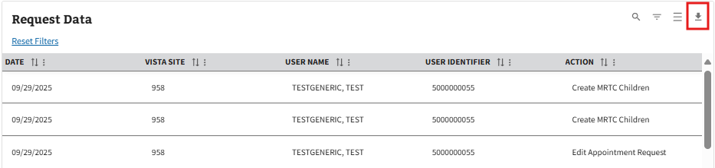
Figure 362: Export Button for Activity Report

Appendix

8.1 Cancellation Reasons
Table 2: List of Cancellation Reasons
Name | Type | Ability to Reopen
Appointment No Longer Required | Clinic | No
Block and Move | Clinic | Yes
Clinic Cancelled | Clinic | Yes
Clinic Staffing | Clinic | Yes
Death in Family | Patient | Yes
Inpatient Status | Clinic | Yes
Other | Clinic and Patient | Yes
Pandemic | Clinic and Patient | Yes
Patient Death | Clinic | No
Patient Not Eligible | Clinic | No
Scheduling Conflict/Error | Clinic | Yes
Transfer Opt Care to Other VA | Clinic and Patient | No
Travel Difficulty | Patient | Yes
Unable to Keep Appointment | Patient | Yes
Walk-In Entered in Error | Clinic | No
Walk-In No Longer Necessary | Patient | No
Weather | Clinic and Patient | Yes

8.2 Additional Help with Errors

8.2.1 SSOi Login Error
If users receive the SSOi error message seen below in ⁠Figure 363⁠, please refresh the page. If problems persist, please contact IT support. Go to YourIT Service Portal to open a new ticket or view existing service tickets.
Figure 363: SSOi Login Error
Possible Root Cause: Various SSOi issues – either a service outage for SSOi or malformed token, etc.
Additional Resources:
- VA Help Desk: 855-673-4357
- TTY: 844-224-6186

8.2.2 JWT Error
If users receive the JWT error message seen below in ⁠Figure 364⁠, please refresh the page. If problems persist, please contact IT support. Go to YourIT Service Portal to open a new ticket or view existing service tickets.
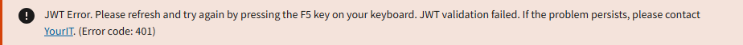
Figure 364: JWT Error
Possible Root Cause: Similar SSOi issues, but related specifically to the JWT – unable to retrieve, bad formatting, etc.
Additional Resources:
- VA Help Desk: 855-673-4357
- TTY: 844-224-6186

8.2.3 Internal Server Error
If users receive the 503 error message seen below in ⁠Figure 365⁠, please refresh the page. If problems persist, please contact IT support. Go to YourIT Service Portal to open a new ticket or view existing service tickets.
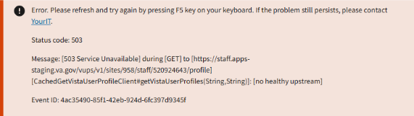
Figure 365: Internal Server Error
Possible Root Cause: 500 error codes are generic – the message itself will vary depending on which endpoint presents the 500 error. Status code will also change, depending.
Additional Resources:
- VA Help Desk: 855-673-4357
- TTY: 844-224-6186

8.2.4 No VistA Sites Linked to User Account Error
If users receive the error message seen below in ⁠Figure 366⁠, please go to the Identity Management Toolkit to link needed VistA sites to your account.
Figure 366: No VistA Sites Linked to User Account Error
Possible Root Cause: User has a valid JWT, but no sites are linked to their PIV.
Additional Resources:
- YourIT Knowledge Article
- VA Help Desk: 855-673-4357
- TTY: 844-224-6186

8.2.5 Service Error
If users receive a 400 error message like the one seen below in ⁠Figure 367⁠, please try the action again. If problems persist, please contact IT support. Go to YourIT Service Portal to open a new ticket or view existing service tickets.
Figure 367: Service Error
Possible Root Cause: 400 error codes are generic – the message itself will vary depending on which endpoint presents the 400 error.
Additional Resources:
- VA Help Desk: 855-673-4357
- TTY: 844-224-6186

