OFFICE OF
INFORMATION
AND TECHNOLOGY

Patient Check In
Clinical Staff Viewer (PCICSV)
User Guide

Version 2.8.0 | August 2026

Table of Contents
1. Introduction 10
1.1 Overview 10
1.2 User Access Levels 10
1.3 PIV Login 10
2. Familiarizing Yourself with PCICSV 12
2.1 My Account 12
2.1.1 User Preferences 12
2.1.1.1 Notifications 13
2.1.1.2 Tips & Guidance 13
2.1.1.3 Daily Appointment and Workflow List 14
2.1.1.4 Workflow Status 16
2.1.2 Signing Out of PCICSV 17
2.2 Help 18
2.3 Filters 19
2.3.1 Sort by Ascending and Descending 19
2.3.2 Toggle Density 19
2.3.3 Show, Hide, and Search Filters 20
2.3.4 Search Function 21
2.3.5 Reset Filters 22
2.4 Application Walkthrough 22
3. Clinic List Management 24
3.1 Create New Clinic List 24
3.2 Edit a Personal Clinic List 27
3.3 Delete a Personal Clinic List 29
4. Daily Appointment and Workflow List 31
4.1 Daily Appointment List 31
4.1.1 Patient Arrived 32
4.1.2 Printing 34
4.2 Daily Workflow List 35
4.2.1 Change A Workflow Status 36
4.2.2 Memos 38
4.2.3 Quick Filters 40
4.3 Commonalities for Both List Pages 41
4.3.1 General Grid Information 41
4.3.1.1 Refresh 41
4.3.1.2 Checked in Appointments 41
4.3.1.3 Check In Column 42
4.3.1.4 Check Out Time Column 43
4.3.1.5 Time Column 43
4.3.1.6 Icon Indicators 43
4.3.2 Expanded Details 44
4.3.3 Messaging 46
4.3.4 Pre-Visit Summary 50
4.3.5 Medications 52
4.3.6 Appointment Comments 53
4.3.7 Current Day Appointments 54
4.3.8 After Visit Summary 55
5. Queue Management 57
5.1 Creating Queues 58
5.2 Editing Queues 59
5.3 Deleting Queues 61
6. Queue 62
6.1 Utilizing Queues 62
6.2 Queue List Memos 64
6.3 Marking Visit as Complete/Undo Mark as Complete in Queue 67
7. Appendix 68
7.1 Alert Notifications 68
7.2 Icon Descriptions 69
7.3 Flag Descriptions 69
7.4 Acronyms and Abbreviations 70

Table of Figures
Figure 1: Single Sign-On Internal (SSOi) Login 11
Figure 2: ActivClient Login Pop-Up Window 11
Figure 3: Logging in to PCICSV 12
Figure 4: Side Menu Button for PCICSV 12
Figure 5: My Account Button for PCICSV 13
Figure 6: Preferences Button 13
Figure 7: Disable Windows Notifications Setting 13
Figure 8: Tips and Guidance Setting 14
Figure 9: Daily Appointment and Workflow List Column Checkbox 14
Figure 10: Button to Adjust Column Order 15
Figure 11: Save Changes Button for Daily Appointment and Workflow List Settings 15
Figure 12: Reset to Default Button for Daily Appointment and Workflow List Settings 15
Figure 13: Workflow Status Checkbox Settings 16
Figure 14: Save Changes Button for Workflow Status Settings 16
Figure 15: Reset to Default Button for Workflow Status Settings 17
Figure 16: My Account Button for PCICSV 17
Figure 17: Sign Out Button for PCICSV 17
Figure 18: Logged Out of Mobile Applications Page 18
Figure 19: Help Page for PCICSV 18
Figure 20: Ascending/Descending Filter Arrow 19
Figure 21: Toggle Density Button 19
Figure 22: Show/Hide Filter Options Buttons 20
Figure 23: Example of Filter Search Menu on Grid View 20
Figure 24: Example of Filtered Results in Grid View 20
Figure 25: Clearing Filter Button 21
Figure 26: Selecting Show/Hide Filters Button to Hide Filter Menu 21
Figure 27: Show/Hide Search Button 21
Figure 28: Filtered Search Example 22
Figure 29: Clear Button for Search Bar 22
Figure 30: Reset Filters Button on Grid View 22
Figure 31: In-App Walkthrough Icon 23
Figure 32: Begin Walkthrough Pop-up 23
Figure 33: Close Button for PCICSV Walkthrough 23
Figure 34: Clinic List Management Tab 24
Figure 35: VistA Access Removed Error for Clinic List Management 24
Figure 36: Create New Clinic List Button 25
Figure 37: Create Clinic List Window 25
Figure 38: Create Clinic List Button 26
Figure 39: Cancel Button for Create Clinic List Window 26
Figure 40: Set as Default Clinic List Button 27
Figure 41: Action Menu Button for Editing Clinic List 27
Figure 42: Edit Clinic List Button 27
Figure 43: Edit Clinic List Window 28
Figure 44: Save Changes Button for Edit Clinic List 29
Figure 45: Cancel Button for Edit Clinic List Window 29
Figure 46: Action Menu Button for Deleting Clinic List 30
Figure 47: Delete Clinic List Button in the Clinic List Management Action Menu 30
Figure 48: Example of Delete Clinic List Button Disabled for Default List 30
Figure 49: Delete List Button 31
Figure 50: Cancel Button for Delete Clinic List Window 31
Figure 51: Daily Appointment List Page 32
Figure 52: Select Clinic List Dropdown for Daily Appointment List 32
Figure 53: Action Menu button for Patient Arrival 33
Figure 54: Patient Arrived Button 33
Figure 55: Confirm Workflow Status Change Window for Patient Arrival 33
Figure 56: Close Button for Patient Arrival 34
Figure 57: Example of Confirming Patient Arrival 34
Figure 58: Print List Button 35
Figure 59: Daily Workflow List Page 35
Figure 60: Select Clinic List Button for Daily Workflow List 36
Figure 61: Workflow Status Column 36
Figure 62: Example of Workflow Status Options 37
Figure 63: Confirm Workflow Status Change Window 37
Figure 64: Close Button for Workflow Status Change 38
Figure 65: New Memo Button 38
Figure 66: Add New Memo to Appointment Window 38
Figure 67: View All Memos Button 39
Figure 68: Add Memo Button 39
Figure 69: Close Button for Add New Memos Window 40
Figure 70: Example of Memo Entered on Appointment 40
Figure 71: View All Memos Button on the Daily Workflow List Page 40
Figure 72: Quick Filters Example 41
Figure 73: Refresh List Button 41
Figure 74: Check-In Data Example 42
Figure 75: Late Patient Example 42
Figure 76: Icon Example 43
Figure 77: Flag Information Example 44
Figure 78: Action Menu Button for Expanded Details 44
Figure 79: Expanded Details Button 45
Figure 80: Expanded Details Accordion Buttons 45
Figure 81: Close Button for Expanded Details 46
Figure 82: eCheck-In Icon for a Completed eCheck-In 46
Figure 83: Action Menu Button for Messaging 46
Figure 84: Messages Button 47
Figure 85: New Message Dropdown Menu 47
Figure 86: New Message for General Template Window 48
Figure 87: New Message for Post Lab/X-Ray Window 48
Figure 88: Send Message Button 49
Figure 89: Close Button for Creating New Message 49
Figure 90: Message Was Not Sent Notification 50
Figure 91: Action Menu Button for Pre-Visit Summary 50
Figure 92: Pre-Visit Summary Button 51
Figure 93: Example of Pre-Visit Summary 51
Figure 94: Action Menu Button for Medications 52
Figure 95: Medications Button 52
Figure 96: Medications Window 52
Figure 97: Action Menu Button for Appointment Comments 53
Figure 98: Appointment Comments Button 53
Figure 99: Appointment Comments Window 54
Figure 100: Action Menu Button for Current Day Appointments 54
Figure 101: Current Day Appointments Button 55
Figure 102: Current Day Appointments Window 55
Figure 103: Action Menu Button for After Visit Summary 56
Figure 104: After Visit Summary Button 56
Figure 105: Example of After Visit Summary 57
Figure 106: Queue Management Page 58
Figure 107: Create New Queue Button 58
Figure 108: Create Queue Window 58
Figure 109: Create Queue Button 59
Figure 110: Action Menu Button for Editing Queues 59
Figure 111: Edit Queue Button 60
Figure 112: Edit Queue Window 60
Figure 113: Save Changes Button for Editing Queue 60
Figure 114: Action Menu Button for Deleting Queues 61
Figure 115: Delete Queue Button 61
Figure 116: Delete Queue Window 61
Figure 117: Queue Deletion Error 62
Figure 118: Queue Page 62
Figure 119: Select Queue Dropdown 63
Figure 120: Add Patient Button 63
Figure 121: Add Patient to Queue Window 63
Figure 122: Add Patient to Queue Button 64
Figure 123: Close Button on the Add Patient to Queue Window 64
Figure 124: New Memo Button for Queue Patients 64
Figure 125: Add New Memo to Visit for Queue Patients 65
Figure 126: View All Memos Button for Queue Patients 65
Figure 127: Add Memo Button for Queue Patients 66
Figure 128: Close Button for Adding Memo to Visit 66
Figure 129: Example of Memo Entered in Queue List 66
Figure 130: All Memos Button for Queue Patients 67
Figure 131: Action Menu Button for Marking a Patient Complete 67
Figure 132: Mark as Complete Button 67
Figure 133: Patient Marked as Complete in Grid of Queue List 68
Figure 134: Undo Mark as Complete Button 68
Figure 135: PCICSV Alert Notification 68
Figure 136: Update to Daily Workflow Example 69

Table of Tables
Table 1: Icons 69
Table 2: Flags 69
Table 3: Acronyms and Abbreviations 70

Revision History
Date | Version | Description | Author
8/7/2026 | 2.8.0 | Added sections 2.1.1.2 and 2.4 | Tech Writers Booz Allen Hamilton
7/15/2026 | 2.7.0 | Updated UI for new check in and check out. Updated outdated figures and information throughout the document.  Added after visit summary. | Tech Writers Booz Allen Hamilton
05/18/2026 | 2.5.0 | Updated UI for Filters | Tech Writers Booz Allen Hamilton
04/10/2026 | 2.4.0 | Added information on Quick Filters, updated UI graphics | Tech Writers Booz Allen Hamilton
02/09/2026 | 2.2.0 | Addition of sections 4.3.1.4 Time Column and 4.3.2 Expanded Details. | Tech Writers Booz Allen Hamilton
08/20/2025 | 2.0.0 | Update to UI and format. Update outdated information throughout document. | Tech Writers Booz Allen Hamilton
05/28/2024 | 1.29 | Updated to add the new Arrived Column on the Daily Appointment List. Also added Arrived as a new Workflow Status selection on the Daily Workflow List. | VSE PMO  Booz Allen Hamilton
02/15/2024 | 1.28 | Updated to add a filter function to the Insurance and Demographics columns of the Daily Appointment List.  Enables users to: undo marking a queue appointment complete; view a list of multiple appointments patients have for the day across all clinics; and select and deselect column filters with more than three filter options. | VSE PMO  Booz Allen Hamilton
12/13/2023 | 1.27 | Updated to add a filter function to Check-In Step column of Daily Appointment List. Reinstated sorting feature to Check-In Time column of Daily Appointment/Daily Workflow Lists. | VSE PMO  Booz Allen Hamilton
11/13/2023 | 1.26 | Updated to add filter to columns for Check-In Times on the Daily Appointment/Daily Workflow Lists, and Pre-Check-In and eCheck-In on the Daily Appointment List. | VSE PMO  Booz Allen Hamilton
08/28/2023 | 1.25 | Updated to display the Clinic List drop-down in alphabetical order. | VSE PMO  Booz Allen Hamilton
07/07/2023 | 1.24 | Updated to implement the ability to provide system notifications to users. | VSE PMO  Booz Allen Hamilton
06/13/2023 | 1.23 | Updated the Queue List to include the Memo Column | VSE PMO  Booz Allen Hamilton
04/04/2023 | 1.22 | Updated to show eCheck-Ins and Pre-Check-Ins completed count on the Daily Appointment and Daily Workflow Lists. Updated verbiage presented when attempting to delete a queue that still has patients in an incomplete status. | VSE PMO  Booz Allen Hamilton
03/20/2023 | 1.21 | Updated document to remove the trash can icon from queuing so users cannot delete patient from a queue | VSE PMO  Booz Allen Hamilton
03/07/2023 | 1.20 | Updated the document to update the phone number field under section 5.6 | VSE PMO  Booz Allen Hamilton
02/14/2023 | 1.19 | Updated the document with section 5.6 on added messaging | VSE PMO  Booz Allen Hamilton
02/07/2023 | 1.18 | Updated the document to revise sections 5.4.1.1 and 5.4.1.3 on queues | VSE PMO  Booz Allen Hamilton
02/03/2023 | 1.17 | Updated the document to revise section 5.4 on queues | VSE PMO  Booz Allen Hamilton
01/25/2023 | 1.16 (not published) | Updated the document with section 5.4 on queues | VSE PMO  Booz Allen Hamilton
12/14/2022 | 1.15 | Updated the document with section 5.2.2 Updates Check In and Check Out Status Logic | VSE PMO  Booz Allen Hamilton
10/19/2022 | 1.14 | Updated the document with section 5.7 Displays Checkout Time and Indicator. | VSE PMO  Booz Allen Hamilton
09/28/2022 | 1.13 | Added section 6.3 Pop-up Message to Ensures Users are Running the Current Version.  Updated 6.1 Enhanced Error message section to include the new error message logic. | VSE PMO  Booz Allen Hamilton
09/21/2022 | 1.12 | Updated document to include removal of insurance column for MANILA – RO 358. | VSE PMO  Booz Allen Hamilton
09/15/2022 | 1.11 | Updated document to include sections 5.6 Display Number of Checked-In Appointments and 6.2 Reset Button | VSE PMO  Booz Allen Hamilton
09/07/2022 | 1.10 | Updated document to include section 5.1.3 Validating User Access to VistA Instances. | VSE PMO  Booz Allen Hamilton
08/30/2022 | 1.9 | Updated document to include the following functionalities: Flag Legend and Toggle to Disable Notifications for Updated Appointments. | VSE PMO  Booz Allen Hamilton
08/22/2022 | 1.8 | Updated document to include the following new functionalities: Display Fugitive Felon, Local/National & Restricted Record Flags, and Enhanced Error Messages. | VSE PMO  Booz Allen Hamilton
08/10/2022 | 1.7 | Updated Section 5.3 Daily Workflow List to include the Memo functionality. | VSE PMO  Booz Allen Hamilton
06/14/2022 | 1.6 | Updated Section 5.4 Medication List and Pre-Visit Summary with Sensitive record pop-up page. | VSE PMO  Booz Allen Hamilton
05/12/2022 | 1.5 | Updated the document with Test Patient Screenshots | VSE PMO
03/03/2022 | 1.4 | Accepted all recommended changes and finalized the document | VSE PMO  Liberty IT Solutions
03/01/2022 | 1.3 | Updated the document with Medications List, Pre-Visit Summary, and Alert Notifications. | VSE PMO  Liberty IT Solutions
02/08/2022 | 1.2 | Final review/proofread and accepted all recommended changes | VSE PMO  Liberty IT Solutions
01/28/2022 | 1.1 | Developers Review | VSE PMO  Liberty IT Solutions
12/30/2021 | 1.0 | Baseline for VSECS | VSE PMO  Liberty IT Solutions

Introduction

1.1 Overview
The Department of Veterans Affairs (VA) Veterans Health Information Systems and Technology Architecture (VistA) Patient Check In Clinical Staff Viewer (PCICSV) module is a VA-internal web application that allows clinical staff to track patient appointments from check-in, through the clinic workflow, and to a completed appointment. The purpose of PCICSV is to improve the overall Veteran check-in experience and reduce operating costs for VHA. With this document, users can familiarize themselves with the features and navigation of PCICSV, including clinic list management, daily appointment and workflow lists, queues, and queue management.

1.2 User Access Levels
PCICSV is accessible to any VA network user who has a Personal Identity Verification (PIV) card and Identity and Access Management (IAM) account provisioned to a VistA station.
- Schedulers are required to have the SDECRPC Menu Option. All scheduling personnel should already have the menu option.
- Non-Schedulers, Nurses, and Providers are required to have SDECRPC Menu Option and SDECVIEW Key.
- Users needing access to the Queue Management tab must have SD SUPERVISOR Key assigned to them.
- Users must have SECONDARY MENU OPTIONS: VIAB WEB SERVICES OPTION to utilize patient search for queuing.
PCICSV will validate a user’s clinic list access upon app load. Clinics that the user no longer has access to will be removed from the drop-down on the Daily Appointment List and Daily Workflow List. Additionally, the clinics the user no longer has access to will only be able to be deleted within the Clinic List Management page to indicate the user no longer has access to that clinic.

1.3 PIV Login
- Begin by opening a browser and going to the PCICSV web application. The VA Single Sign-On page will then appear. Select the “Sign in with PIV” option, as seen in ⁠⁠⁠⁠Figure 1⁠⁠⁠⁠, to proceed with the log in process.
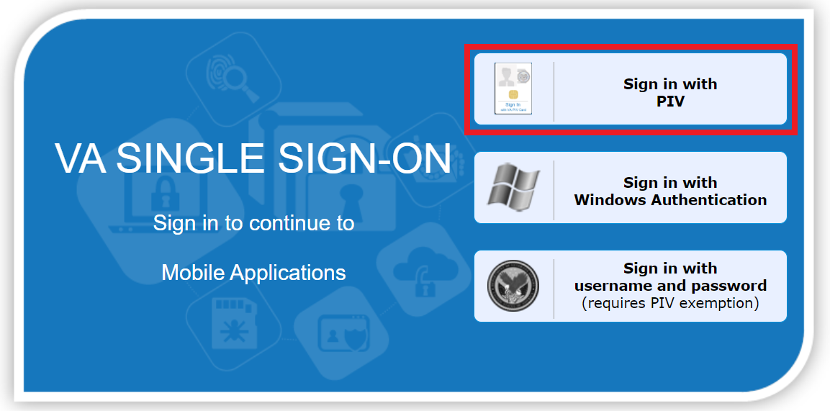
Figure 1: Single Sign-On Internal (SSOi) Login
- After selecting, an ActivClient Login dialog box will appear to prompt you to enter your PIN. Type the numbers of your PIN as prompted in ⁠⁠⁠⁠Figure 2⁠⁠⁠⁠. If authentication is successful, PCICSV will load. If it is not successful, you will be prompted to enter your correct PIN instead.
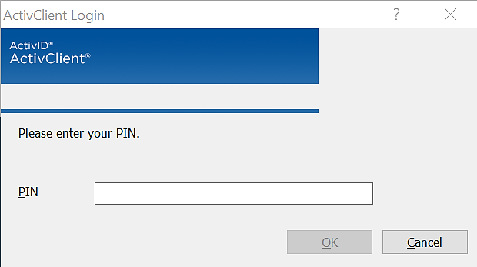
Figure 2: ActivClient Login Pop-Up Window

Familiarizing Yourself with PCICSV
Once log in is complete, the user will see the Daily Appointment List page seen in ⁠⁠⁠⁠Figure 3⁠⁠⁠⁠. The user can then select the tabs on the left-hand side of the page to maneuver through the different features of PCICSV.
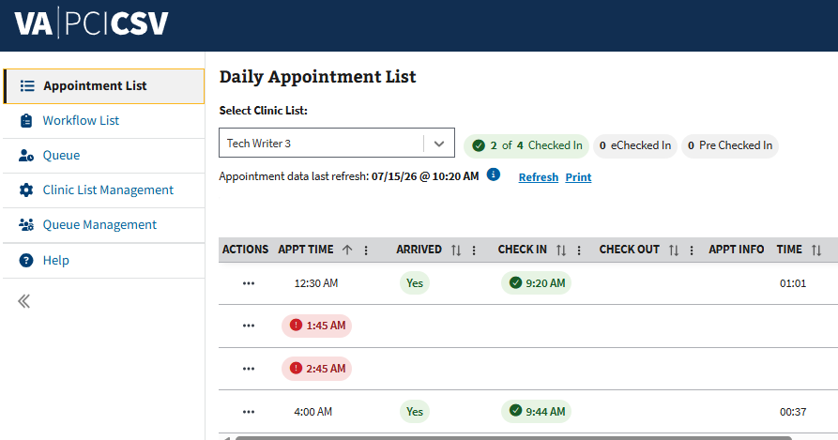
Figure 3: Logging in to PCICSV
- Note: The user can select the “Side Menu” button seen in ⁠⁠⁠⁠Figure 4⁠⁠⁠⁠ to collapse or expand the menu.
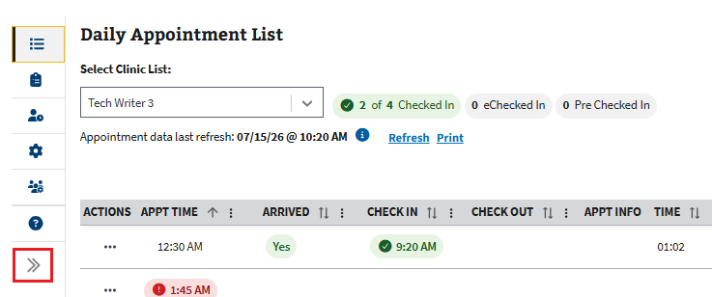
Figure 4: Side Menu Button for PCICSV

2.1 My Account

2.1.1 User Preferences
- To change user preferences, the user can select the “My Account” button in the upper right-hand corner, seen in ⁠⁠⁠⁠Figure 5⁠⁠⁠⁠, to open the dropdown.
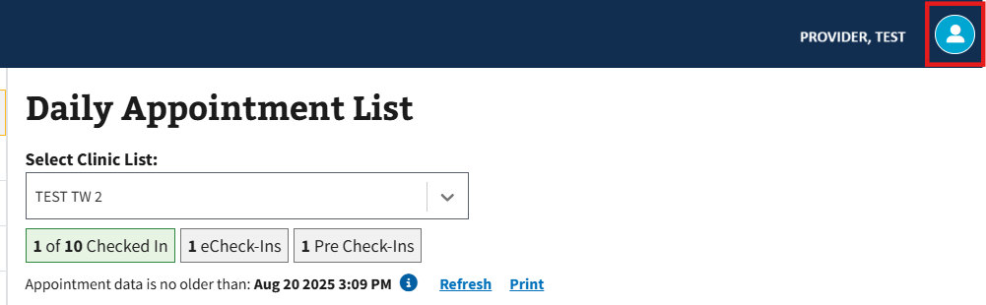
Figure 5: My Account Button for PCICSV
- The user can then select the “Preferences” button, seen in ⁠⁠⁠⁠Figure 6⁠⁠⁠⁠, to be taken to the User Preferences page.
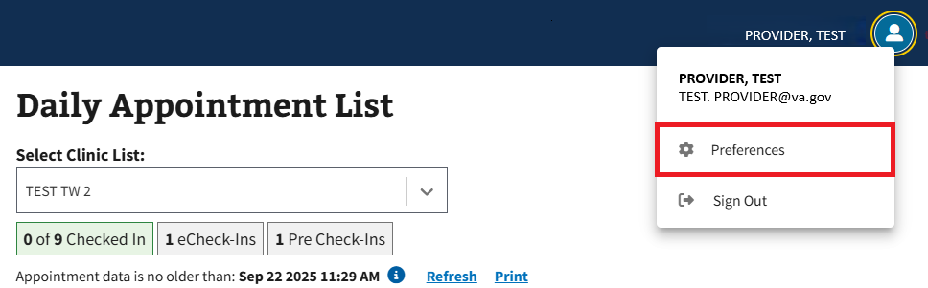
Figure 6: Preferences Button

2.1.1.1 Notifications
On the User Preferences page, the user has the option to disable windows alerts for both new appointments or all other appointment updates and for checked in appointments by selecting the corresponding checkbox seen below in ⁠⁠⁠⁠Figure 7⁠⁠⁠⁠.
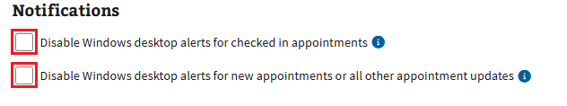
Figure 7: Disable Windows Notifications Setting

2.1.1.2 Tips & Guidance
On the User Preferences page, the user has the option to disable walkthrough popups by selecting the corresponding checkbox seen below in ⁠⁠⁠⁠Figure 8⁠⁠⁠⁠⁠.

Figure 8: Tips and Guidance Setting

2.1.1.3 Daily Appointment and Workflow List
Disclaimer: The information contained in this section applies to both the Daily Appointment List and the Daily Workflow List sections on the User Preferences page. For information on Workflow Status preferences, please see section ⁠⁠2.1.1.4 Workflow Status⁠⁠.
- To adjust the default columns, the user will need to select the checkboxes in ⁠⁠Figure 9⁠⁠ to show or hide columns. The user will know that the column is hidden when the checkbox displays empty (see ⁠⁠Figure 10⁠⁠ for example).
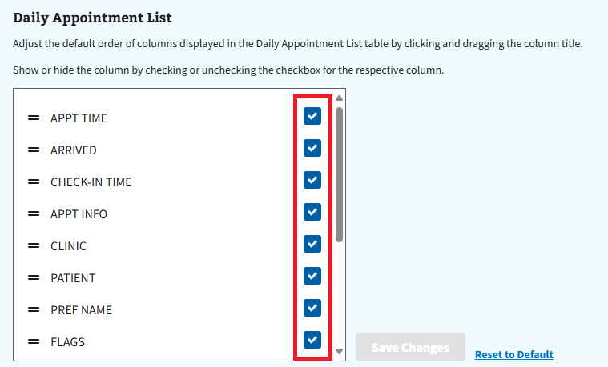
Figure 9: Daily Appointment and Workflow List Column Checkbox
- The user can also select the button seen below in ⁠⁠Figure 10⁠⁠ to drag and drop the column and change the default order.
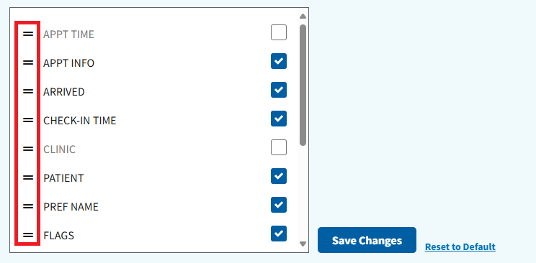
Figure 10: Button to Adjust Column Order
- The user can then select the “Save Changes” button seen in ⁠⁠Figure 11⁠⁠⁠⁠⁠⁠⁠ to save their changes.
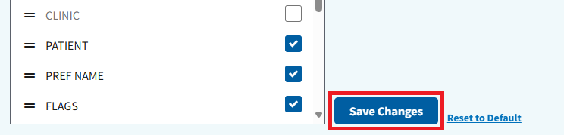
Figure 11: Save Changes Button for Daily Appointment and Workflow List Settings
- To reset preferences, select the “Reset to Default” button shown in ⁠⁠Figure 12⁠⁠.
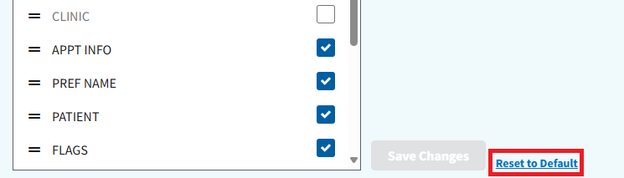
Figure 12: Reset to Default Button for Daily Appointment and Workflow List Settings
- Note: User preferences will be reset whenever the user clears their browser cache.

2.1.1.4 Workflow Status
- To adjust the default options, the user will need to select the checkboxes in ⁠⁠Figure 13⁠⁠ to show or hide status options. The user will know that the options are hidden when the checkbox displays empty (see ⁠⁠Figure 14⁠⁠ for example).
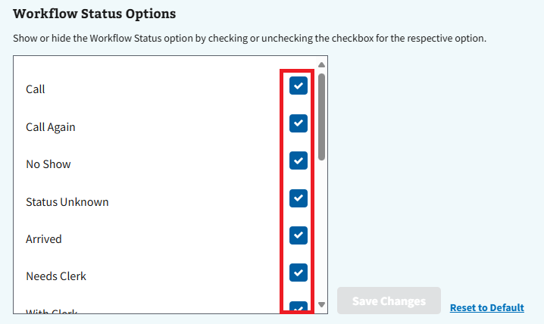
Figure 13: Workflow Status Checkbox Settings
- The user can then select the “Save Changes” button seen in ⁠⁠Figure 14⁠⁠ to save their changes.
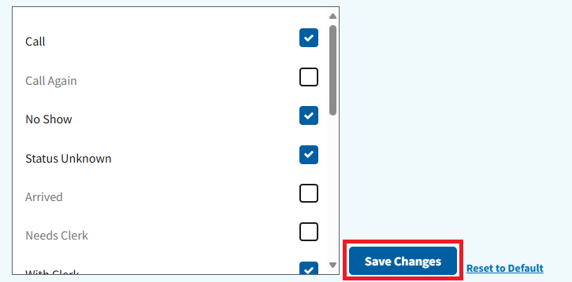
Figure 14: Save Changes Button for Workflow Status Settings
- To reset preferences, select the “Reset to Default” button shown in ⁠⁠Figure 15⁠⁠.
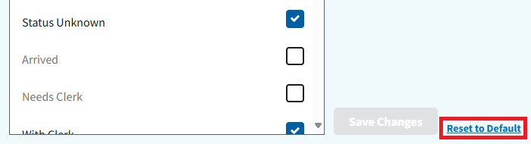
Figure 15: Reset to Default Button for Workflow Status Settings
- Note: User preferences will be reset whenever the user clears their browser cache.

2.1.2 Signing Out of PCICSV
- To sign out of PCICSV, the user will need to select the “My Account” button in the upper-right hand corner, as seen in ⁠⁠Figure 16⁠⁠.
Figure 16: My Account Button for PCICSV
- The user will then need to select the “Sign Out” button from the dropdown menu shown in ⁠⁠Figure 17⁠⁠.
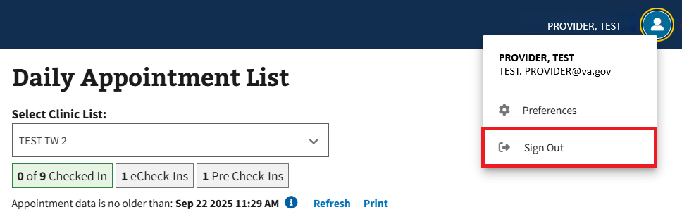
Figure 17: Sign Out Button for PCICSV
- Upon signing out of the PCICSV application, the user will be taken to the page seen in ⁠⁠Figure 18⁠⁠ that will prompt them to log out of the VA SSOi and close the browser.
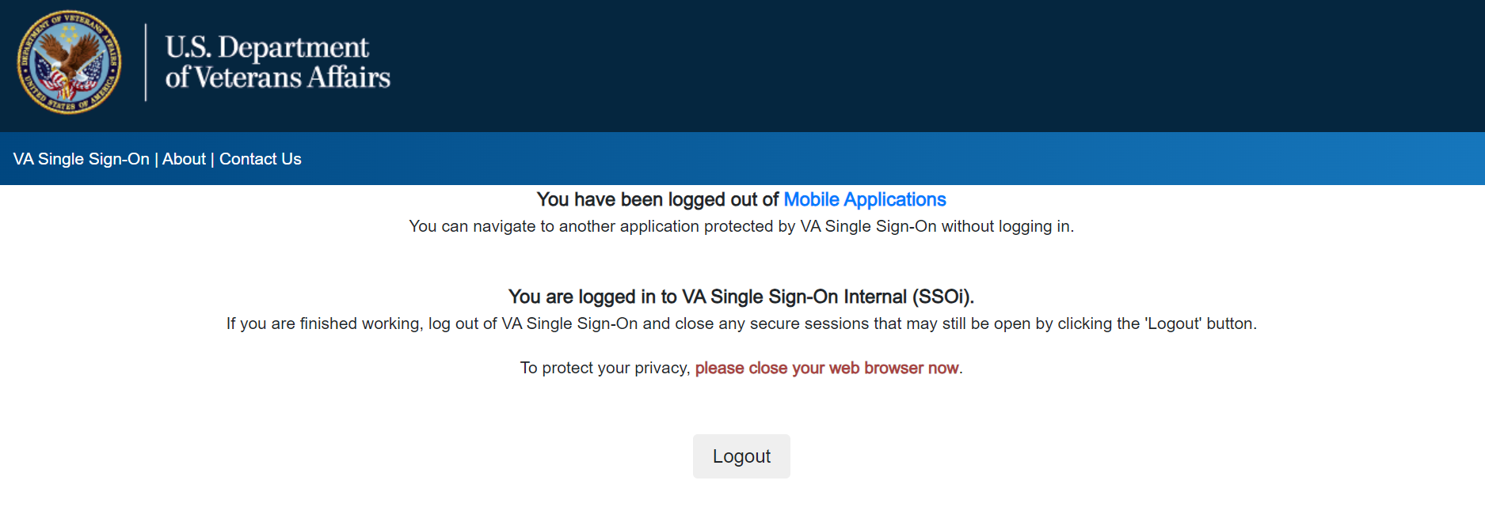
Figure 18: Logged Out of Mobile Applications Page

2.2 Help
Users can select the Help tab to be brought to the Help page. From here, users will be shown quick links to the PCICSV User Guide, YourIT Service Portal, and the most recent Release Notes. as well as the number for the VA Help Desk and a section on frequently asked questions. If a quick reset of the application is needed, users have the option to select the “Reset Session” button seen in ⁠⁠Figure 19⁠⁠ to reload the application.
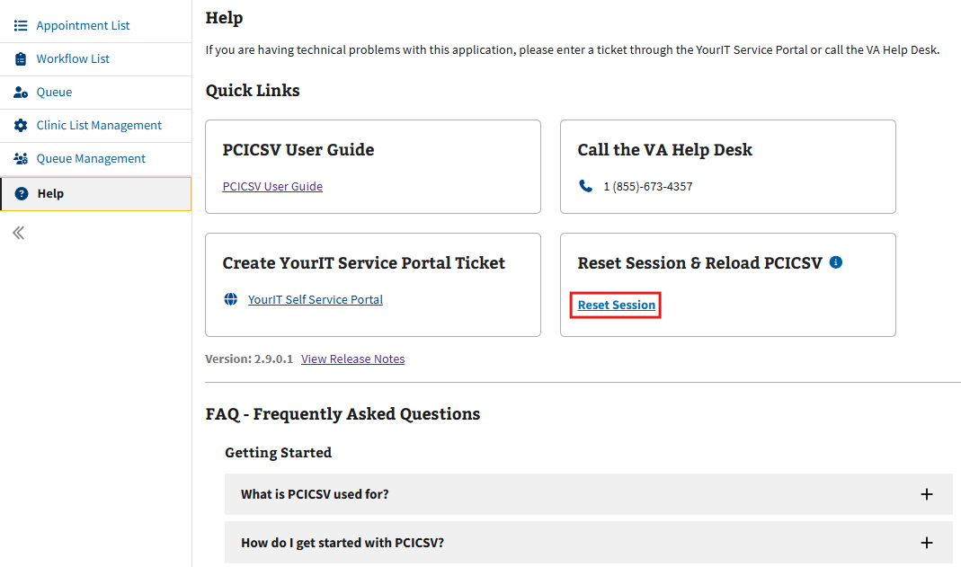
Figure 19: Help Page for PCICSV

2.3 Filters

2.3.1 Sort by Ascending and Descending
- When looking in the grids on PCICSV, the user can sort rows within the table. To begin, the user will need to hover the cursor next to a column’s name and select the arrow button that appears in ⁠⁠Figure 20⁠⁠.
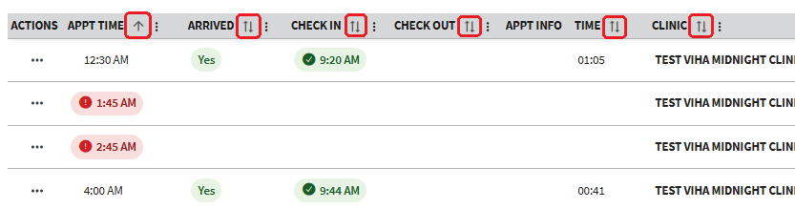
Figure 20: Ascending/Descending Filter Arrow
- Selecting the arrow once will cause results to sort by ascending order (↑), a second time to sort by descending order (notated by ↓), and a third time to cause results to appear in the default order again (notated by ↑↓).

2.3.2 Toggle Density
- The user has the option to adjust toggle density of the grid. To begin adjusting the toggle density, select the button shown in ⁠⁠Figure 21⁠⁠.
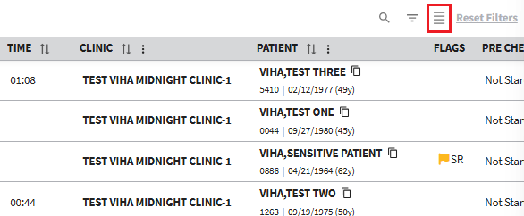
Figure 21: Toggle Density Button
- There are three different options for the user to choose from depending on the user’s preference. Simply keep selecting the “Toggle Density” button to rotate through the options until the user finds their preferred density.

2.3.3 Show, Hide, and Search Filters
- The user has the option to show and hide filters. To begin, the user will need to select the “Show/Hide Filters” button, or the “Filter by (Column Name)” button, both shown in ⁠⁠Figure 22⁠⁠. Selecting either will cause the search functions to appear under each column name.
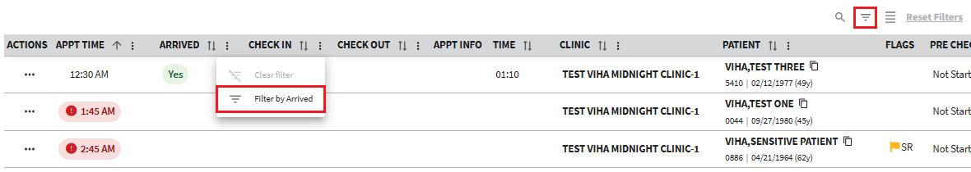
Figure 22: Show/Hide Filter Options Buttons
- Once the search options appear as seen in ⁠⁠Figure 23⁠⁠, the user can select the search bar or dropdown menu under the desired column to be filtered and enter or select the required information needed.
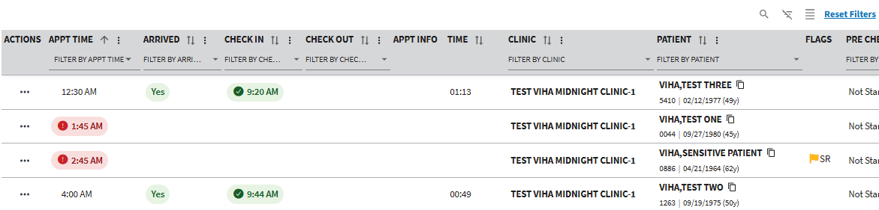
Figure 23: Example of Filter Search Menu on Grid View
- Note: Leaving the individual filters unpopulated will result in the grid showing all unfiltered data.
- Once the filter field has been populated, results will automatically refresh and show items based on the filtered criteria as seen below in ⁠⁠Figure 24⁠⁠.
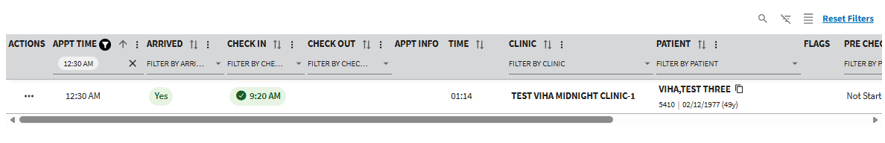
Figure 24: Example of Filtered Results in Grid View
- To clear the search, the user can then select either the “X” next to the search bar or the “Clear Filter” button seen in ⁠⁠Figure 25⁠⁠. Selecting this will cause all results to appear within the table.
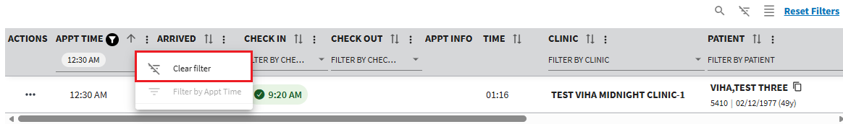
Figure 25: Clearing Filter Button
- Once finished searching, the user can then select the “Show/Hide Filters” button seen in ⁠⁠Figure 26⁠⁠ to hide the search bar.
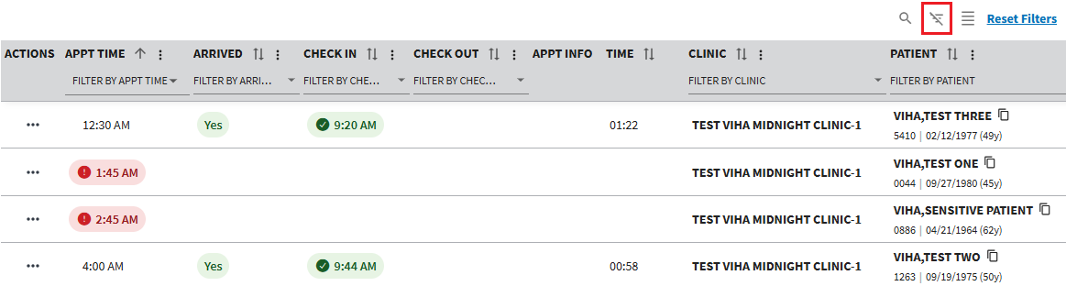
Figure 26: Selecting Show/Hide Filters Button to Hide Filter Menu

2.3.4 Search Function
- The user can search through all items within the grid by selecting the “Show/Hide Search” button seen in ⁠⁠Figure 27⁠⁠.
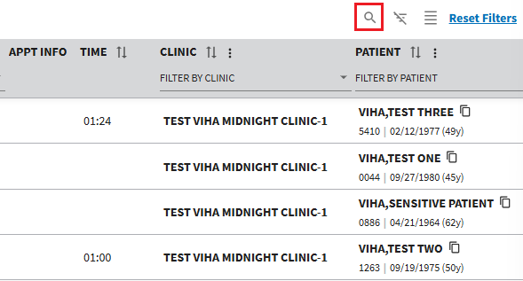
Figure 27: Show/Hide Search Button
- The user can then type the requested information into the search function. This will cause matching results to filter within the grid as shown in ⁠⁠Figure 28⁠⁠ below.
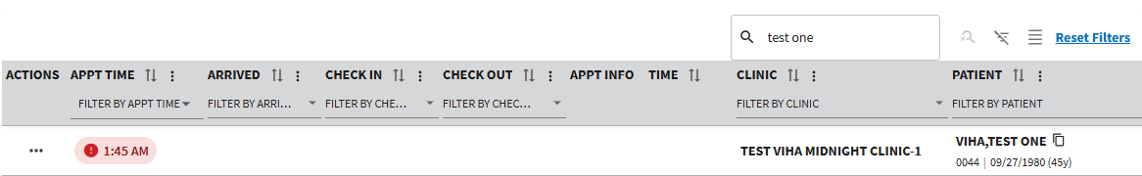
Figure 28: Filtered Search Example
- To clear the search, the user will need to select the “Reset Filters” button seen in ⁠⁠Figure 29⁠⁠. Selecting this will cause all results to appear within the grid.
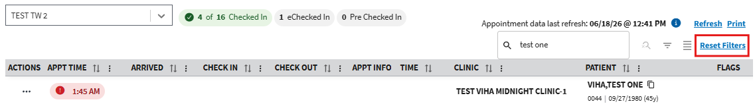
Figure 29: Clear Button for Search Bar
- Once finished searching, the user can then select the “Show/Hide Search” button seen in ⁠⁠Figure 27⁠⁠ above to hide the search bar from view.

2.3.5 Reset Filters
To reset any filters within the grid, the user can select the “Reset Filters” button, as seen in ⁠⁠Figure 30⁠⁠.
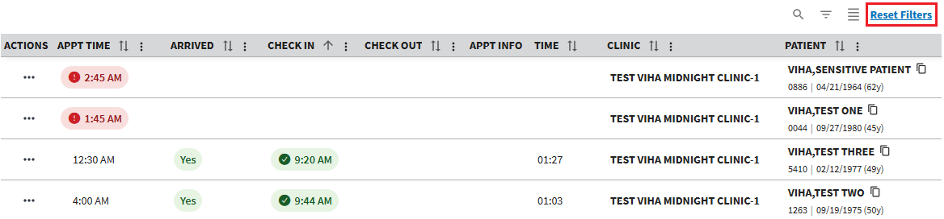
Figure 30: Reset Filters Button on Grid View

2.4 Application Walkthrough
- To access the PCICSV walkthrough, the user will need to select the lightbulb icon seen in ⁠⁠Figure 31⁠⁠.
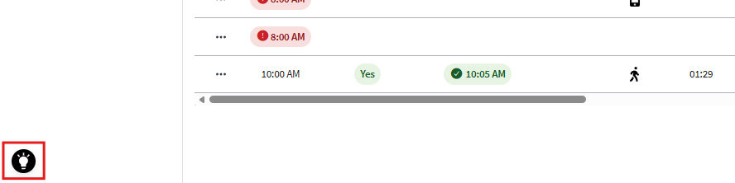
Figure 31: In-App Walkthrough Icon
- Note: The walkthrough icon is available on the Daily Appointment List, Daily Workflow List, and Client List Management pages.
- The user will see the pop up shown in ⁠⁠Figure 32⁠⁠ below. To start the walkthrough, the user will need to select the “Begin Walkthrough” button.
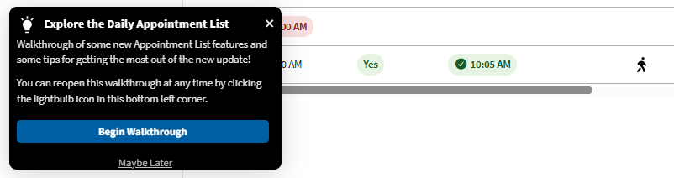
Figure 32: Begin Walkthrough Pop-up
- Once the walkthrough is started, the application will guide the user through a series of pop ups explaining the different features of PCICSV. Selecting the “>” button will guide the user forward through the guide. To go backwards, the user will need to select the “<” button.
- Once the walkthrough is complete, the user will need to select the “x” button seen below in ⁠⁠Figure 33⁠⁠ to close the walkthrough. The user can return to this feature anytime by selecting the lightbulb seen in ⁠⁠Figure 31⁠⁠.
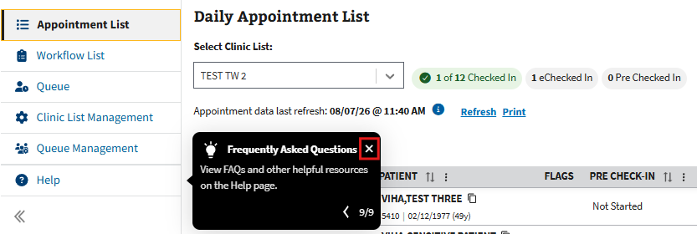
Figure 33: Close Button for PCICSV Walkthrough

Clinic List Management
The Clinic List Management page can be navigated to by selecting the “Clinic List Management” tab shown in ⁠⁠Figure 34⁠⁠. The user can use this page to create new clinic lists, as well as edit and delete personal clinic lists.
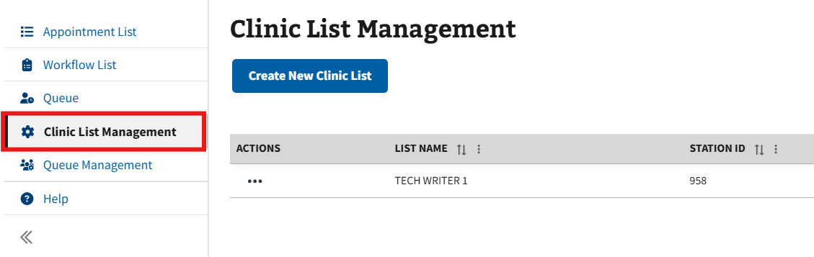
Figure 34: Clinic List Management Tab
- Note: If a user’s VistA access is removed, the lists previously made under Clinic List Management for those instances will receive the error seen in ⁠⁠Figure 35⁠⁠.
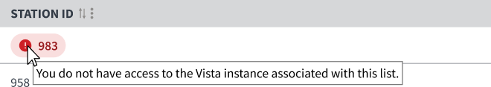
Figure 35: VistA Access Removed Error for Clinic List Management

3.1 Create New Clinic List
Creating a clinic list allows the clinicians to group clinics into one manageable list. The Clinic List grid will display in alphabetical order, with the default clinic list at the top. After successfully logging into PCICSV, follow the steps below to create a new clinic list.
- To create a new clinic list, the user will need to select the “Create New Clinic List” button shown in ⁠⁠Figure 36⁠⁠ to open the Create Clinic List window.
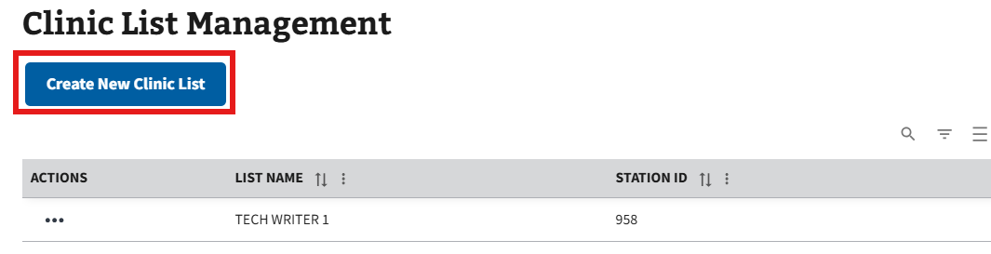
Figure 36: Create New Clinic List Button
- The user will then need to fill in all the required information (see ⁠⁠Figure 37⁠⁠ for example) and any optional information as needed.
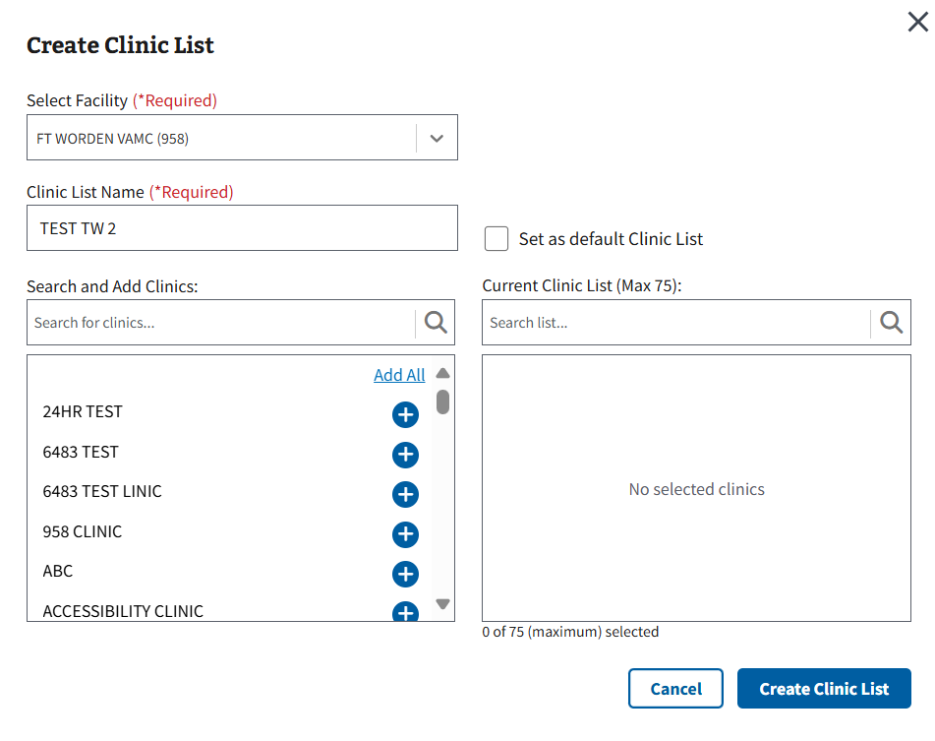
Figure 37: Create Clinic List Window
- Once all applicable information has been filled, the user will select the “Create Clinic List” button, seen in ⁠⁠Figure 38⁠⁠, to create the new clinic list.
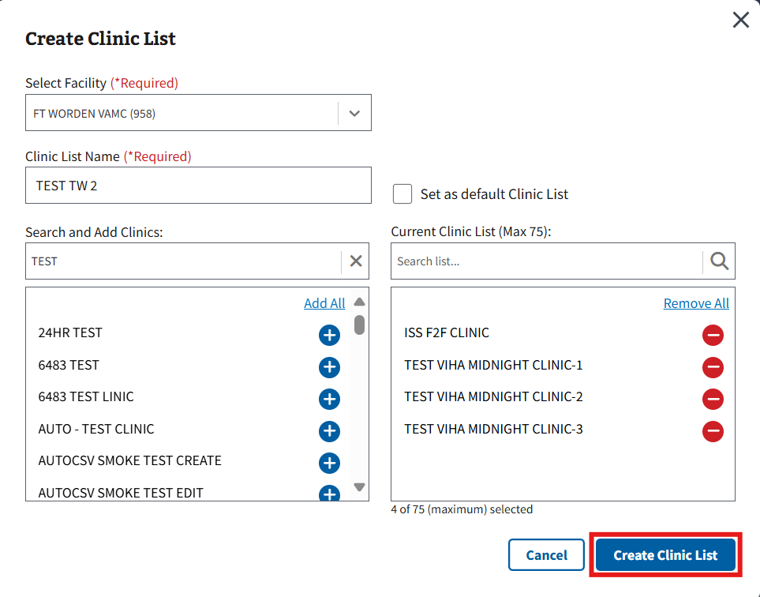
Figure 38: Create Clinic List Button
- Note: The user can select the “Cancel” button seen in ⁠⁠Figure 39⁠⁠ to exit creating a clinic list and go back to the Clinic List Management page.
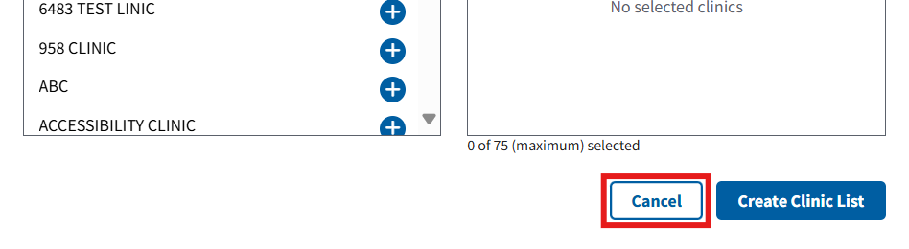
Figure 39: Cancel Button for Create Clinic List Window
- Note: The first clinic list created by the user will automatically be set as the default clinic list. To change the default clinic list once more are created, the user will need to select the “Set as Default” button seen below in ⁠⁠Figure 40⁠⁠.
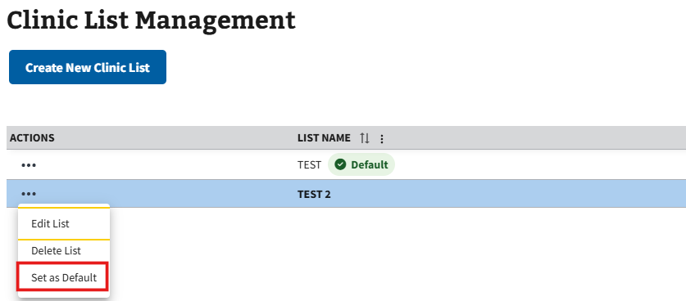
Figure 40: Set as Default Clinic List Button

3.2 Edit a Personal Clinic List
- To edit a clinic list, the user will need to select the ellipsis, seen in ⁠⁠Figure 41⁠⁠, next to any clinic list within the grid.
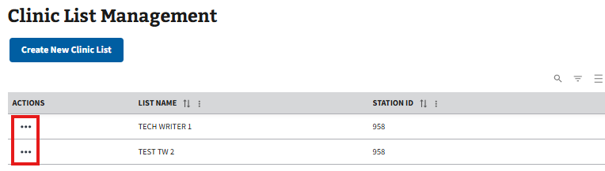
Figure 41: Action Menu Button for Editing Clinic List
- This will cause the action menu to appear. The user will then need to select the “Edit List” button, seen in ⁠⁠Figure 42⁠⁠, to open the Edit Clinic List window.
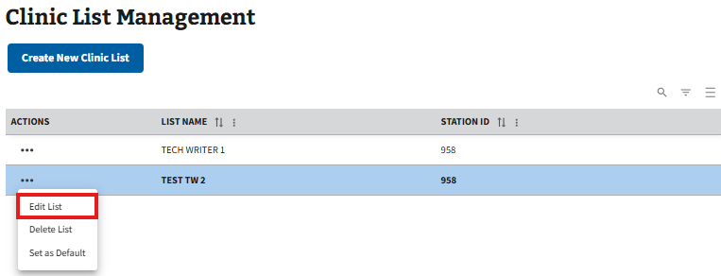
Figure 42: Edit Clinic List Button
- On this window, the user can edit the name of the clinic list, as well as add or delete any clinic(s) included (see ⁠⁠Figure 43⁠⁠).
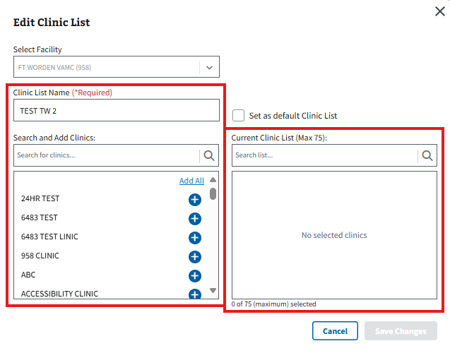
Figure 43: Edit Clinic List Window
- Once all edits have been made, the user will need to select the “Save Changes” button, seen in ⁠⁠Figure 44⁠⁠, to save the edits to the clinic list.
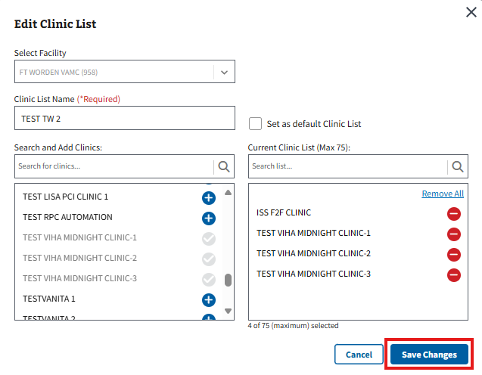
Figure 44: Save Changes Button for Edit Clinic List
- Note: The user can select the “Cancel” button seen in ⁠⁠⁠⁠Figure 45⁠⁠⁠⁠⁠ to exit editing a clinic list and go back to the Clinic List Management page.
Figure 45: Cancel Button for Edit Clinic List Window

3.3 Delete a Personal Clinic List
- To delete a clinic list, the user will need to select the ellipsis, seen in ⁠⁠Figure 46⁠⁠, next to any clinic list within the grid.
Figure 46: Action Menu Button for Deleting Clinic List
- This will cause the action menu to appear. The user will then need to select the “Delete List” button, seen in ⁠⁠Figure 47⁠⁠.
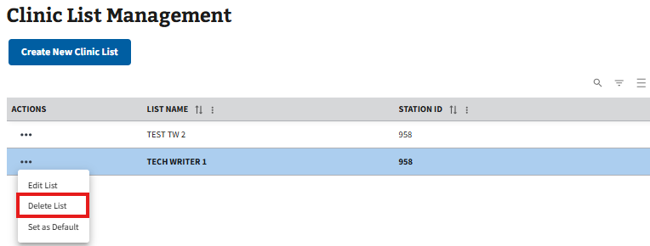
Figure 47: Delete Clinic List Button in the Clinic List Management Action Menu
- Note: The default clinic list is unable to be deleted and the “Delete List” button will always be disabled for that list (see ⁠⁠Figure 48⁠⁠ for example).
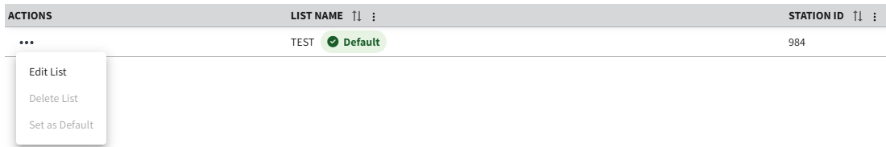
Figure 48: Example of Delete Clinic List Button Disabled for Default List
- The Delete Clinic List window will appear. The user can then select the “Delete List” button, shown in ⁠⁠Figure 49⁠⁠, to confirm clinic list deletion.
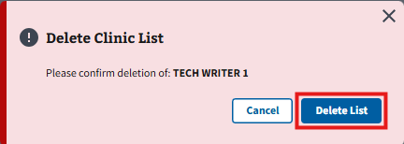
Figure 49: Delete List Button
- Note: The user can select the “Cancel” button seen in ⁠⁠Figure 50⁠⁠ to exit deleting a clinic list and go back to the Clinic List Management page.
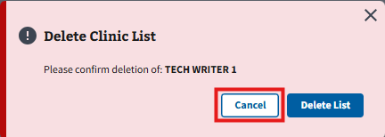
Figure 50: Cancel Button for Delete Clinic List Window

Daily Appointment and Workflow List

4.1 Daily Appointment List
Disclaimer: The Daily Appointment List and Daily Workflow List pages both share similar functionality. Please see the ⁠⁠⁠⁠4.3 Commonalities for Both List Pages⁠⁠⁠⁠ section for steps on how to complete actions for either page.
The Daily Appointment List page can be navigated to by selecting the “Appointment List” tab shown in ⁠⁠Figure 51⁠⁠.
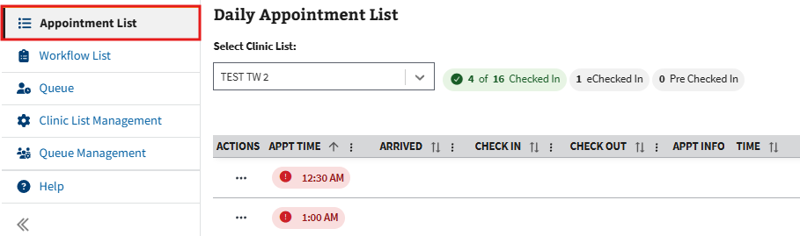
Figure 51: Daily Appointment List Page
Once a clinic list is created and appointments are made within one of the clinics included, the grid will populate with information on the Daily Appointment List page for clinical staff to view and track. The Daily Appointment List displays all current day appointments for the clinics under the selected clinic list. It also tracks patient attributes like Current Check-In Step, Pre-Check-In status, E-Check-In status, Demographics, and Insurance indicators.
- Note: Users can use the dropdown button, shown in ⁠⁠Figure 52⁠⁠, to select a different clinic list.
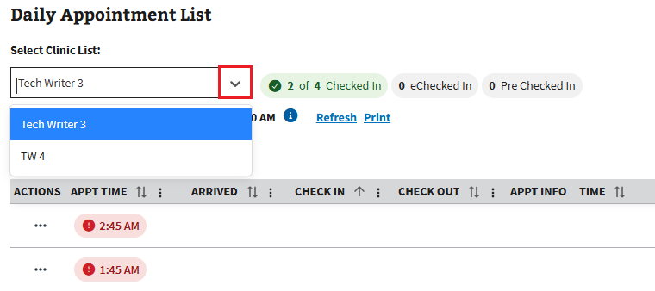
Figure 52: Select Clinic List Dropdown for Daily Appointment List
- Note: Users can select a patient’s name from the Daily Appointment List to copy it to their clipboard.

4.1.1 Patient Arrived
- To mark a patient has arrived, the user will need to select the ellipsis, seen in ⁠⁠Figure 53⁠⁠, next to an eligible patient within the grid.
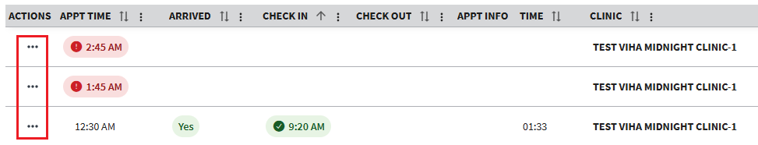
Figure 53: Action Menu button for Patient Arrival
- This will cause the action menu to appear. The user will then need to select the “Patient Arrived” option, seen in ⁠⁠Figure 54⁠⁠.
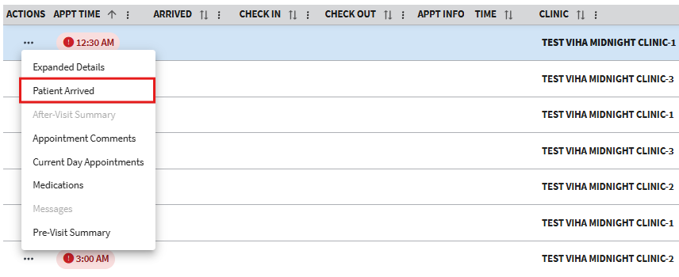
Figure 54: Patient Arrived Button
- This will cause the Confirm Workflow Status Change window to appear. From here, the user will need to select the “Confirm Change” button, seen below in ⁠⁠Figure 55⁠⁠, to mark the patient as arrived.
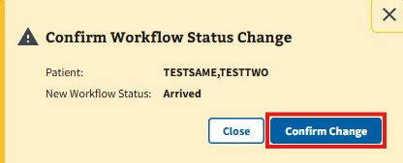
Figure 55: Confirm Workflow Status Change Window for Patient Arrival
- Note: The user can select the “Close” button seen in ⁠⁠Figure 56⁠⁠ to cancel the workflow status change. This will take the user back to the Daily Appointment List page.
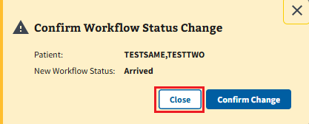
Figure 56: Close Button for Patient Arrival
- Confirming status change will cause the Daily Appointment List grid to update and display a green “Yes” in the Arrived column (see ⁠⁠Figure 57⁠⁠ for example).
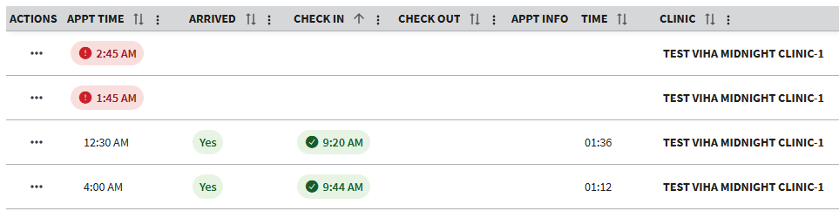
Figure 57: Example of Confirming Patient Arrival
- Note: When a patient is checked in via ISS or VS GUI, the patient will automatically be marked as arrived within the grid. The Arrived column will also display a green “Yes” if the patient’s status is anything past “Checked In.”

4.1.2 Printing
Users can print from the Daily Appointment List page. Selecting the “Print” button, seen in ⁠⁠Figure 58⁠⁠, will prompt the user to open or save a PDF file, where the ability to print the list is accessible.
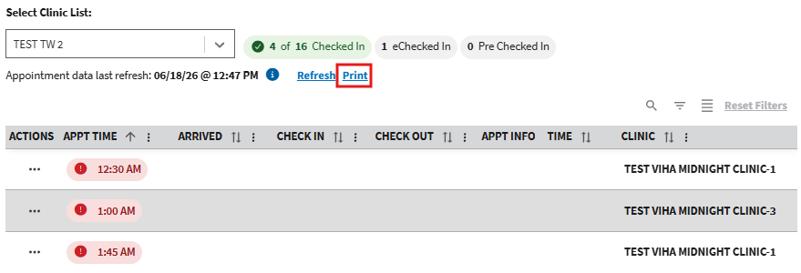
Figure 58: Print List Button

4.2 Daily Workflow List
Disclaimer: The Daily Appointment List and Daily Workflow List pages both share similar functionality. Please see the ⁠⁠⁠⁠4.3 Commonalities for Both List Pages⁠⁠⁠⁠ section for steps on how to complete actions for either page.
The Daily Workflow List page can be navigated to by selecting the “Workflow List” tab shown in ⁠⁠Figure 59⁠⁠.
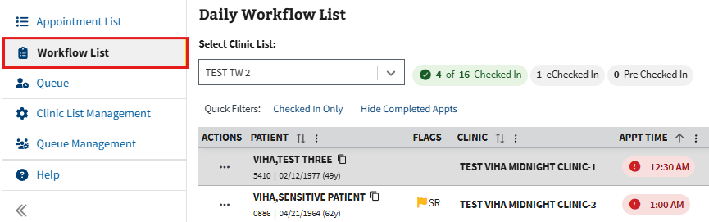
Figure 59: Daily Workflow List Page
Once a clinic list is created and appointments are made within one of the clinics included, the clinic list will show up in the Daily Workflow List for the clinical staff to view. The Daily Workflow List page shows a patient’s current workflow status and allows users to track and change the status of the workflow.
- Note: Users can use the dropdown button shown in ⁠⁠Figure 60⁠⁠ to view different clinic lists.
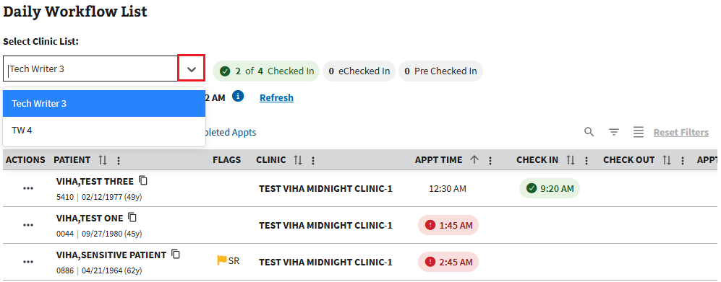
Figure 60: Select Clinic List Button for Daily Workflow List
- Note: Users can select a patient’s name from the Daily Workflow List to copy it to their clipboard.

4.2.1 Change A Workflow Status
- To change a patient’s workflow status, the user will need to navigate to the Workflow Status column seen in ⁠⁠Figure 61⁠⁠.
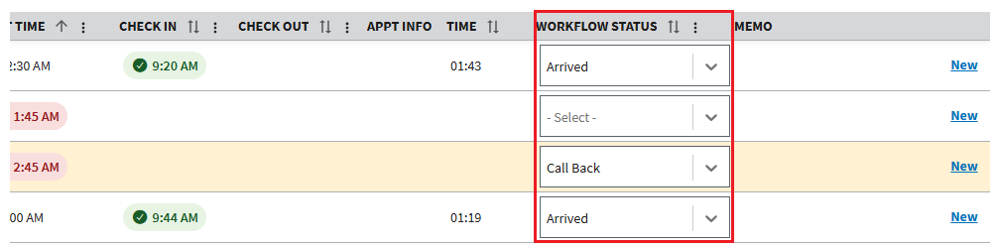
Figure 61: Workflow Status Column
- The user will then need to expand the dropdown menu and select the appropriate status from the options listed (see ⁠⁠Figure 62⁠⁠ for example).
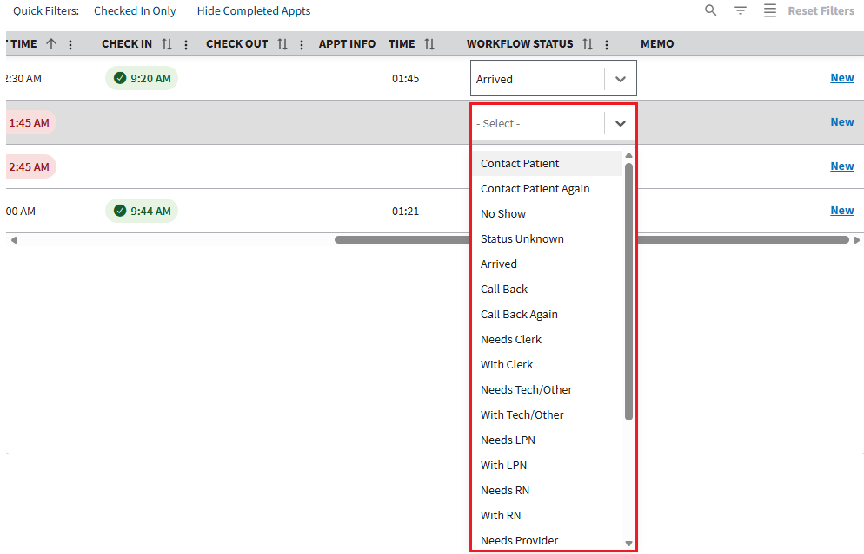
Figure 62: Example of Workflow Status Options
- After selecting a status, the Confirm Workflow Status Change window will display asking the user to confirm. The user will need to select the “Confirm Change” button, seen below in ⁠⁠Figure 63⁠⁠, to save a patient’s status.
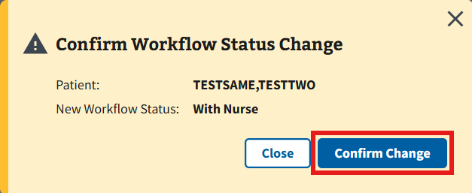
Figure 63: Confirm Workflow Status Change Window
- Note: The user can select the “Close” button seen in ⁠⁠Figure 64⁠⁠ to cancel the workflow status change. This will take the user back to the Daily Workflow List page.
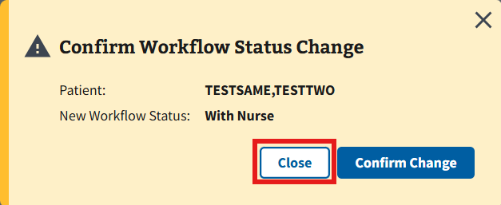
Figure 64: Close Button for Workflow Status Change

4.2.2 Memos
- To add a memo to patient appointments, the user can select the “New” button shown in ⁠⁠Figure 65⁠⁠.
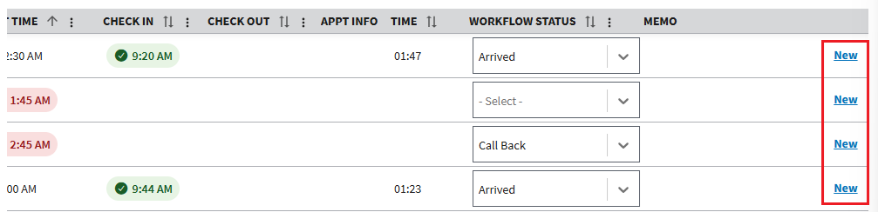
Figure 65: New Memo Button
- The user will be brought to the Add New Memo to Appointment window, shown in ⁠⁠Figure 66⁠⁠. From here, users may add a memo that is up to 100 characters.
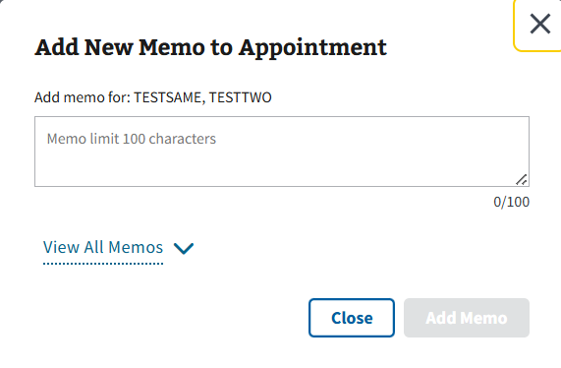
Figure 66: Add New Memo to Appointment Window
- Note: Users may also choose to view all previous memos from this page. Simply select the “View All Memos” button, shown in ⁠⁠Figure 67⁠⁠, to expand the window with all previously entered memos.
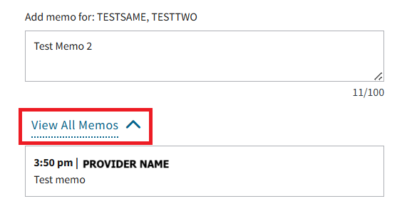
Figure 67: View All Memos Button
- Once the memo has been entered, select the “Add Memo” button, shown in ⁠⁠Figure 68⁠⁠, to add the memo to the appointment.
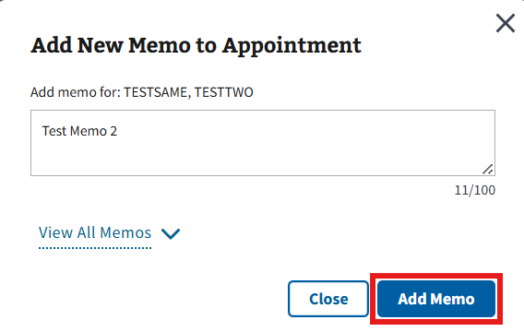
Figure 68: Add Memo Button
- Note: The user can select the “Close” button seen in ⁠⁠Figure 69⁠⁠ to cancel adding a memo to an appointment. This will take the user back to the Daily Workflow List page.
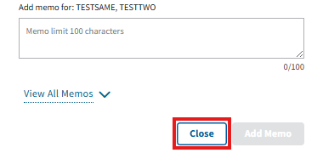
Figure 69: Close Button for Add New Memos Window
- The user will then return to the Daily Workflow List page, where the memo will be displayed in the Memo column of the related appointment with a timestamp and the initials of the user (see ⁠⁠Figure 70⁠⁠ for example).
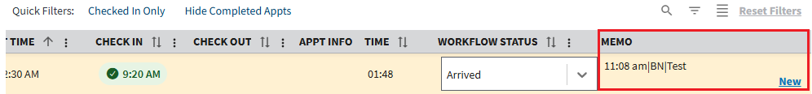
Figure 70: Example of Memo Entered on Appointment
- Note: When users add more than one memo to an appointment, the “All” button will appear in the Memo column of the grid as seen in ⁠⁠Figure 71⁠⁠. When selected, the user will be brought to the View All Memos for Appointment window where they can see all previous memos for the appointment, as well as who made the memo and what time it was created.
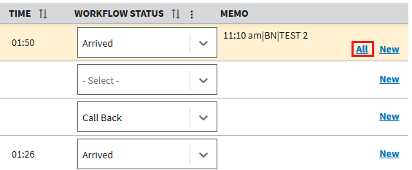
Figure 71: View All Memos Button on the Daily Workflow List Page

4.2.3 Quick Filters
Users can easily toggle on and off general filters via the Quick Filters feature on the Daily Workflow List page (see ⁠⁠Figure 72⁠⁠).
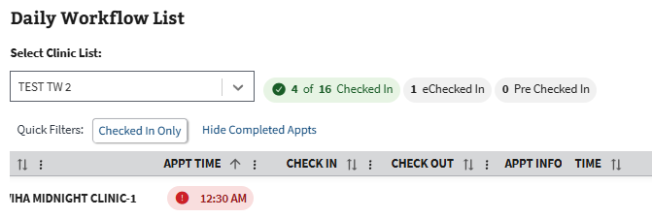
Figure 72: Quick Filters Example
- Note: Please see section ⁠⁠⁠⁠2.3 Filters⁠⁠⁠⁠ for more information on filters.

4.3 Commonalities for Both List Pages
The Daily Appointment List and Daily Workflow List pages both share similar functionality. Please see the sections below for steps on how to complete actions for either page.

4.3.1 General Grid Information

4.3.1.1 Refresh
Users can refresh the grid from the Daily Appointment and Daily Workflow List pages. Selecting the “Refresh” button, seen in ⁠⁠Figure 73⁠⁠, engages the page to refresh and allows any new information to display. Please be aware that the table will refresh automatically every two minutes with updated information.
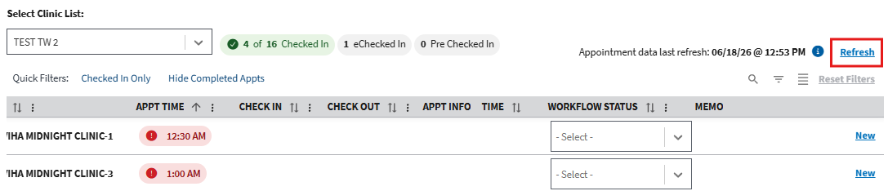
Figure 73: Refresh List Button

4.3.1.2 Checked in Appointments
The number of Checked-in appointments, eCheck-ins, and Pre Check-ins will show on the Daily Appointment and Daily Workflow List page. Please see ⁠⁠Figure 74⁠⁠ for reference.
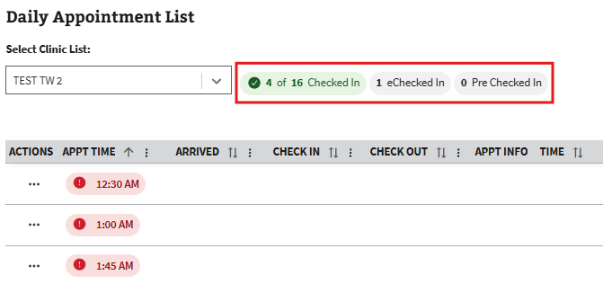
Figure 74: Check-In Data Example
- Note: If a patient is more than 15 minutes late to an appointment, the appointment time will display in red with an “!” icon, as seen in ⁠⁠Figure 75⁠⁠.
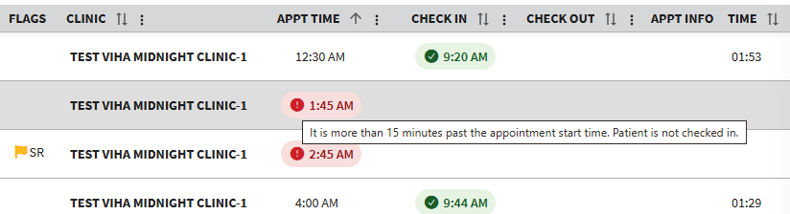
Figure 75: Late Patient Example
Note: If a patient has been checked in during a refresh, the row will highlight yellow, a blue dot indicator icon will appear in the actions and check in columns, and a toast will appear at the top of the page indicating there has been at least one new checked in patient since last refresh. For more information about alert notifications, please see ⁠⁠7.1 Alert Notifications⁠⁠.

4.3.1.3 Check In Column
The Daily Appointment and Daily Workflow List both contain a Check In column within the grid. This column will be blank if the patient has not been checked in or the time of check in.

4.3.1.4 Check Out Time Column
The Daily Appointment and Daily Workflow List both contain a Check Out column within the grid. This column will be blank if the patient has not been checked out or the time of check out.

4.3.1.5 Time Column
The Daily Appointment and Daily Workflow List both contain a Time column within the grid. This column will display the total care time for the visit, i.e., from check-in to check-out. The column will remain blank for patients who have not checked in.

4.3.1.6 Icon Indicators
Users can hover over icons within PCICSV to see a brief description about what the icon is indicating (see ⁠⁠Figure 76⁠⁠ for an example of Walk-In Appointment and Patient eCheck In). For a full list of icons and flags in the application, please see sections ⁠⁠⁠⁠7.2 Icon Descriptions⁠⁠⁠⁠ and ⁠⁠⁠⁠7.3 Flag Descriptions⁠⁠⁠⁠.
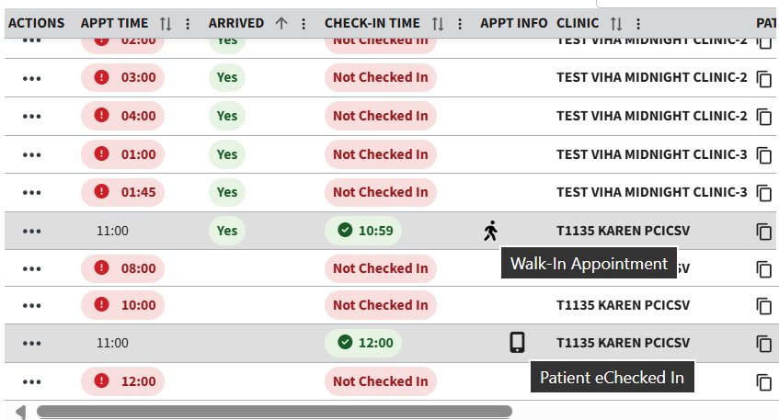
Figure 76: Icon Example
- Note: When hovering over flags, the user will see more detailed information on the patient’s applied flags (see ⁠⁠Figure 77⁠⁠ below).
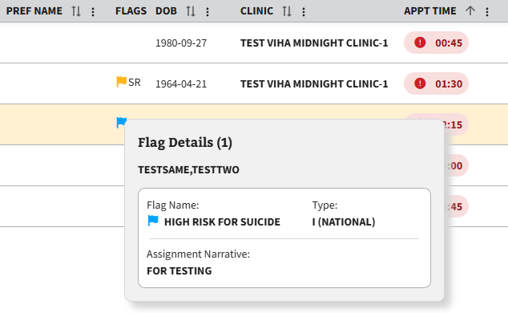
Figure 77: Flag Information Example

4.3.2 Expanded Details
- To access expanded details, the user will need to select the ellipsis, seen in ⁠⁠Figure 78⁠⁠, next to a patient or an appointment within the grid.
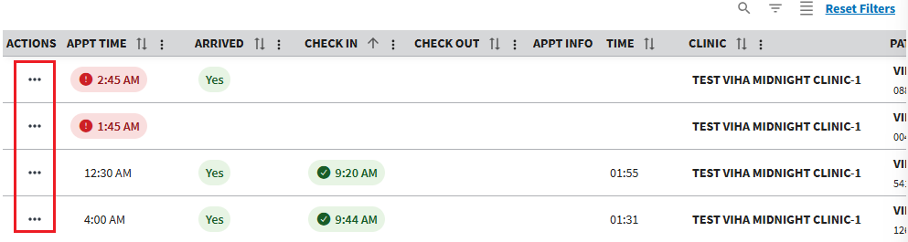
Figure 78: Action Menu Button for Expanded Details
- This will cause the action menu to appear. The user will then need to select the “Expanded Details” option, seen in ⁠⁠Figure 79⁠⁠, where the user will be brought to the Expanded Details window.
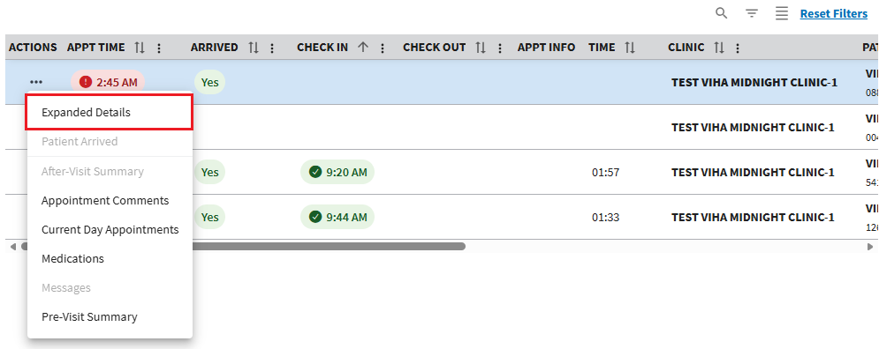
Figure 79: Expanded Details Button
- From here, the user can select the “Expand All+” button to open all of the accordions at once or individually expand each accordion by selecting the “+” button seen in ⁠⁠Figure 80⁠⁠ below.
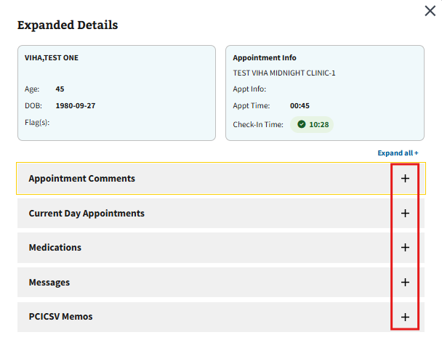
Figure 80: Expanded Details Accordion Buttons
- Note: The user can select the “X” button seen in ⁠⁠Figure 81⁠⁠ to close the Expanded Details window. This will take the user back to either the Daily Appointment or Daily Workflow List pages.
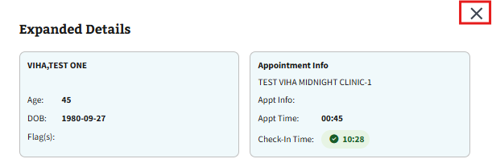
Figure 81: Close Button for Expanded Details

4.3.3 Messaging
- On the Daily Workflow and Daily Appointment Lists pages, patients who have started or completed the eCheck-in process meet the criteria for messaging. Users will see the icon highlighted in ⁠⁠Figure 82⁠⁠ next to a patient who has completed the eCheck-In process.
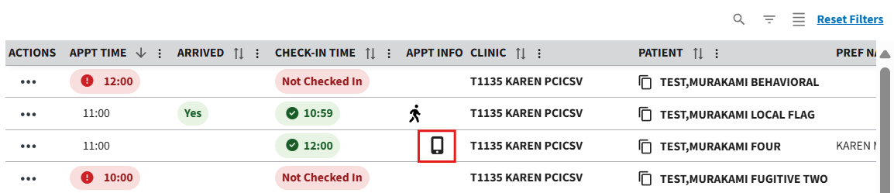
Figure 82: eCheck-In Icon for a Completed eCheck-In
- To send a message, the user will need to select the ellipsis, seen in ⁠⁠Figure 83⁠⁠, next to an eligible patient within the grid.
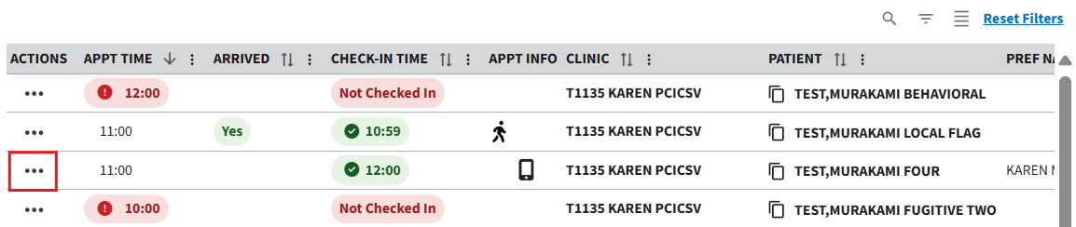
Figure 83: Action Menu Button for Messaging
- This will cause the action menu to appear. The user will then need to select the “Messages” option, seen in ⁠⁠Figure 84⁠⁠, where the user will be brought to the Messages page.
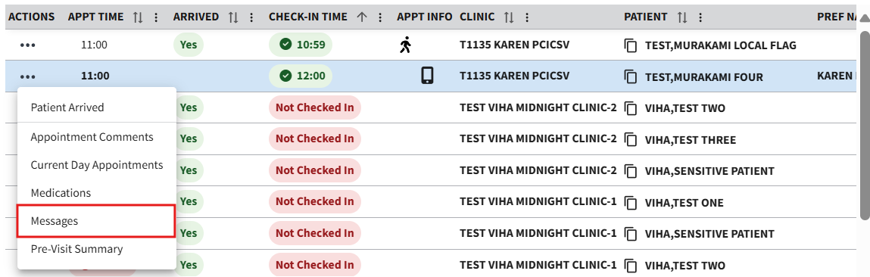
Figure 84: Messages Button
- From here, the user will need to select the “New Message” button to open the dropdown and select a template from the options shown in ⁠⁠Figure 85⁠⁠.
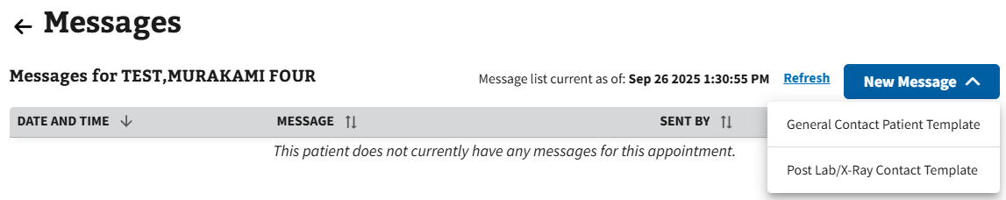
Figure 85: New Message Dropdown Menu
- Once a template has been chosen, the New Message – (Template Name Here) window will appear (see ⁠⁠Figure 86⁠⁠ below for an example of the general new message template and ⁠⁠Figure 87⁠⁠ for an example of the Post Lab/X-Ray template).
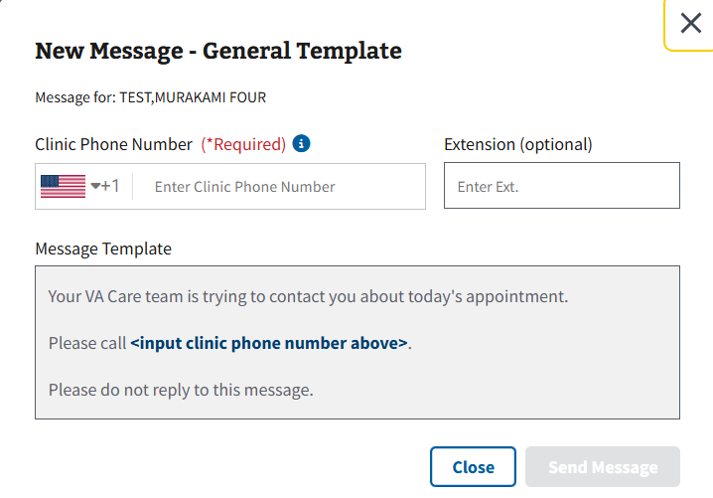
Figure 86: New Message for General Template Window
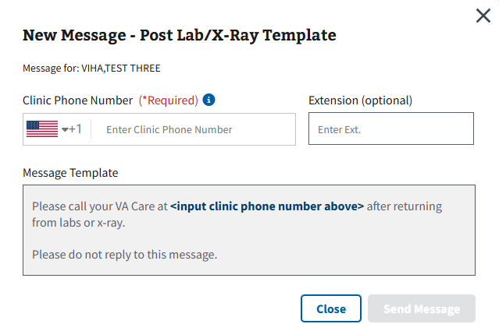
Figure 87: New Message for Post Lab/X-Ray Window
- Users will need to fill in the Clinic Phone Number field with a valid phone number to update the information in the message template section. Once finished, select the “Send Message” button shown in ⁠⁠Figure 88⁠⁠.
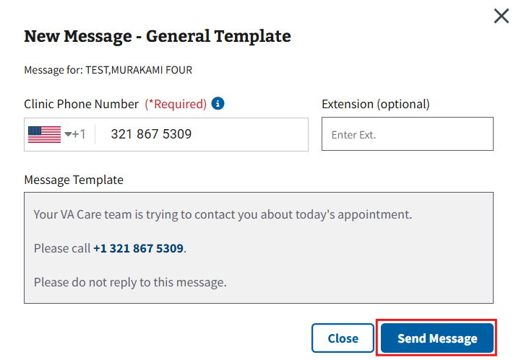
Figure 88: Send Message Button
- Note: The user can select the “Close” button seen in ⁠⁠Figure 89⁠⁠ to cancel creating a message. This will take the user back to the Messages page.
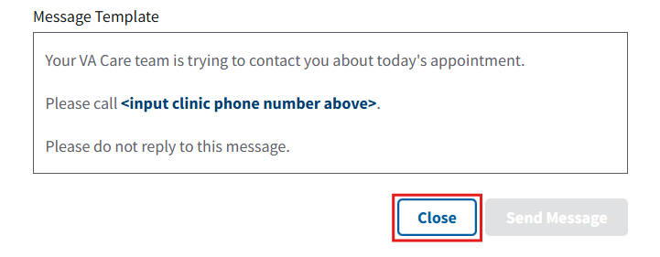
Figure 89: Close Button for Creating New Message
- Note: If the message was not sent, the Message Was Not Sent window will appear (see ⁠⁠Figure 90⁠⁠). The user will need to close the window and retry sending the message.
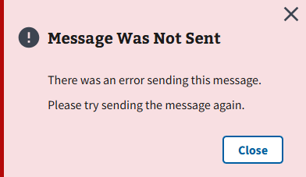
Figure 90: Message Was Not Sent Notification

4.3.4 Pre-Visit Summary
This PCICSV functionality allows users the ability to print or save a PDF format of the Pre-Visit Summary for a patient to ensure patients are informed before their appointment. This functionality is available on both the Daily Appointment and Daily Workflow List.
- To access a patient’s pre-visit summary, the user will need to select the ellipsis, seen in ⁠⁠Figure 91⁠⁠, next to an eligible patient within the grid.
Figure 91: Action Menu Button for Pre-Visit Summary
- This will cause the action menu to appear. The user will then need to select the “Pre-Visit Summary” option, seen in ⁠⁠Figure 92⁠⁠.
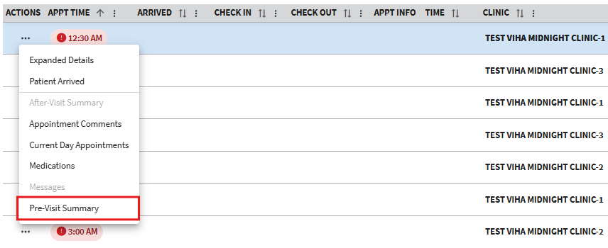
Figure 92: Pre-Visit Summary Button
- Once selected, a new tab will open in the user’s browser with the pre-visit summary (see ⁠⁠Figure 93⁠⁠ for example). From here, the user can choose to print or save the pre-visit summary.
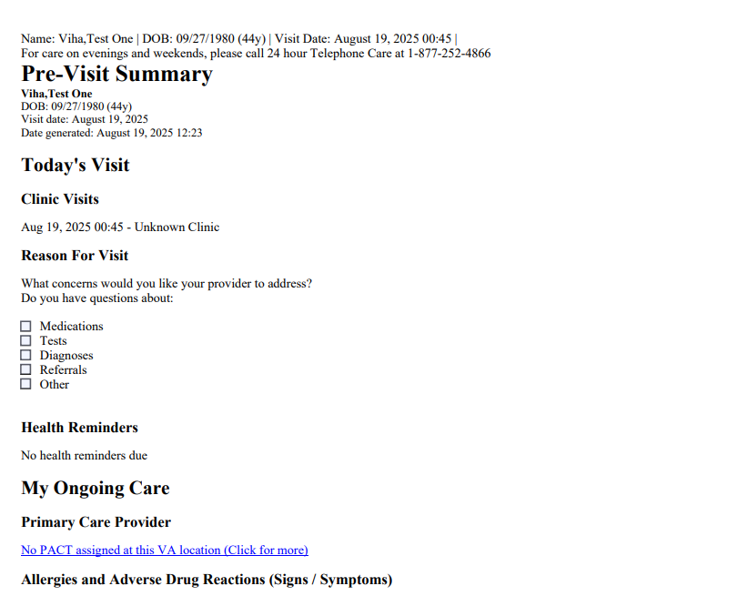
Figure 93: Example of Pre-Visit Summary

4.3.5 Medications
- To access a patient’s medication list, the user will need to select the ellipsis, seen in ⁠⁠Figure 94⁠⁠, next to an eligible patient within the grid.
Figure 94: Action Menu Button for Medications
- This will cause the action menu to appear. The user will then need to select the “Medication” option, seen in ⁠⁠Figure 95⁠⁠.
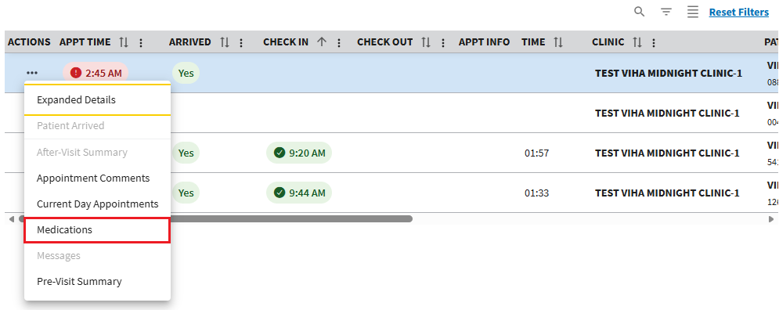
Figure 95: Medications Button
- The user will be brought to the Medications window shown below in ⁠⁠Figure 96⁠⁠, where they can see a list of the patient’s medications.
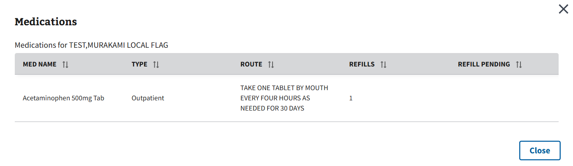
Figure 96: Medications Window

4.3.6 Appointment Comments
Appointment comments will appear in the Daily Appointment and Workflow List sections when a comment is added while making an appointment in the Integrated Scheduling Solution (ISS) application.
- To access the appointment comments, the user will need to select the ellipsis, seen in ⁠⁠Figure 97⁠⁠, next to an eligible patient within the grid.
Figure 97: Action Menu Button for Appointment Comments
- This will cause the action menu to appear. The user will then need to select the “Appointment Comments” option, seen in ⁠⁠Figure 98⁠⁠.
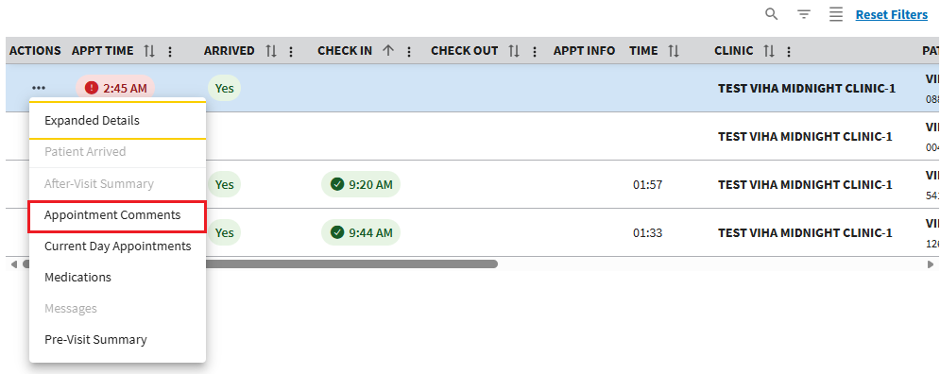
Figure 98: Appointment Comments Button
- The user will be brought to the Appointment Comments window, shown below in ⁠⁠Figure 99⁠⁠, where they can see a list of the appointment comments.
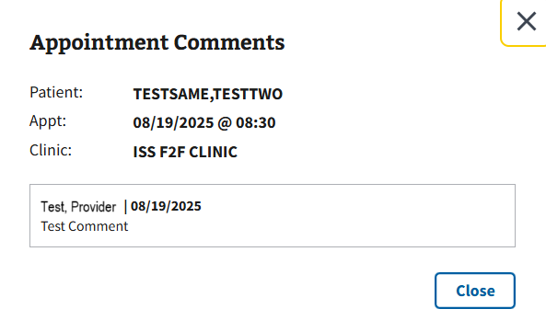
Figure 99: Appointment Comments Window

4.3.7 Current Day Appointments
- To access the current day’s appointments for a patient, the user will need to select the ellipsis, seen in ⁠⁠Figure 100⁠⁠, next to an eligible patient within the grid.
Figure 100: Action Menu Button for Current Day Appointments
- This will cause the action menu to appear. The user will then need to select the “Current Day Appointments” option, seen in ⁠⁠Figure 101⁠⁠.
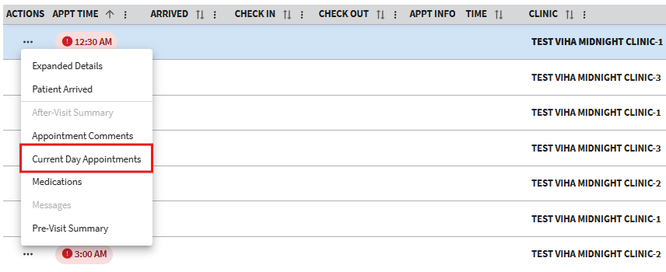
Figure 101: Current Day Appointments Button
- The user will be brought to the Current Day Appointments window, shown below in ⁠⁠Figure 102⁠⁠, where they can see a list of the patients’ appointments for the day.
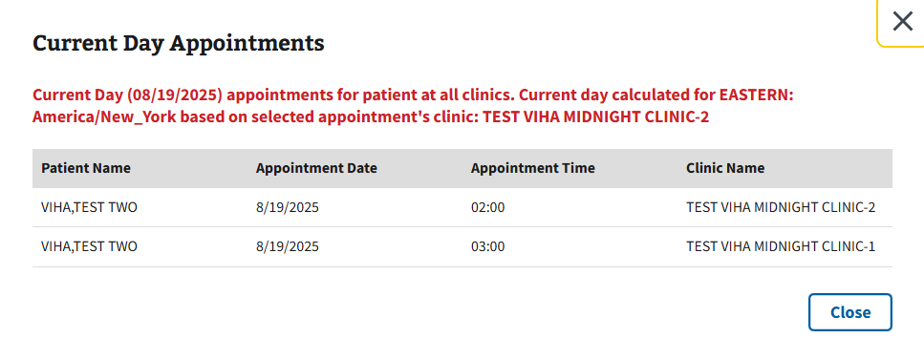
Figure 102: Current Day Appointments Window

4.3.8 After Visit Summary
This PCICSV functionality allows users the ability to print or save a PDF format of the After Visit Summary for a patient to ensure patients are informed of their appointment details. This functionality is available on both the Daily Appointment and Daily Workflow List.
- To access a patient’s after visit summary, the user will need to select the ellipsis, seen in ⁠⁠⁠⁠⁠Figure 103⁠⁠⁠⁠⁠, next to an eligible patient within the grid.
Figure 103: Action Menu Button for After Visit Summary
- This will cause the action menu to appear. The user will then need to select the “After-Visit Summary” option, seen in ⁠⁠Figure 104⁠⁠.
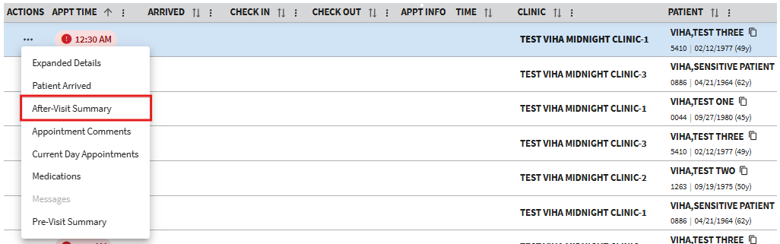
Figure 104: After Visit Summary Button
- Once selected, a new tab will open in the user’s browser with the after visit summary (see ⁠⁠⁠⁠⁠Figure 105⁠⁠⁠⁠⁠ for example). From here, the user can choose to print or save the document.
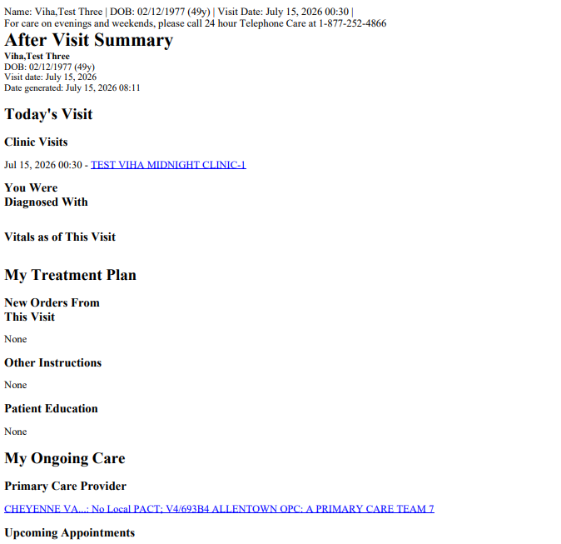
Figure 105: Example of After Visit Summary

Queue Management
Disclaimer: Only users that have SD SUPERVISOR Key assigned to them will have the Queue Management tab within PCICSV. Please see ⁠⁠⁠⁠Queue⁠⁠⁠⁠ for information on how to utilize a Queue.
The Queue Management page can be navigated to by selecting the “Queue Management” tab shown in ⁠⁠Figure 106⁠⁠.
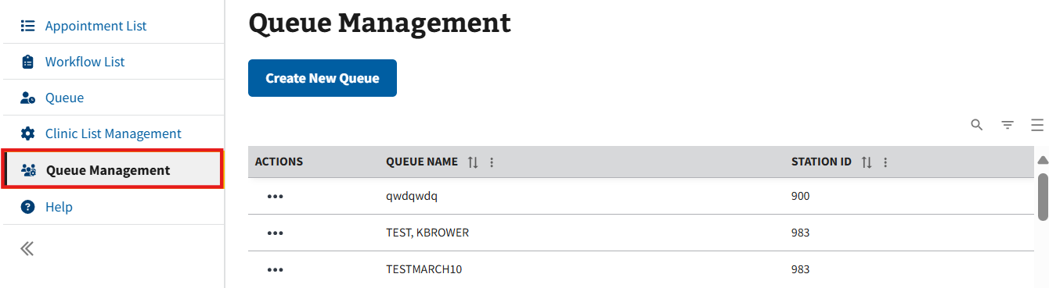
Figure 106: Queue Management Page

5.1 Creating Queues
- To create a queue, the user will need to select the “Create New Queue” button seen in ⁠⁠⁠⁠⁠Figure 107⁠⁠⁠⁠⁠ to open the Create Queue window.
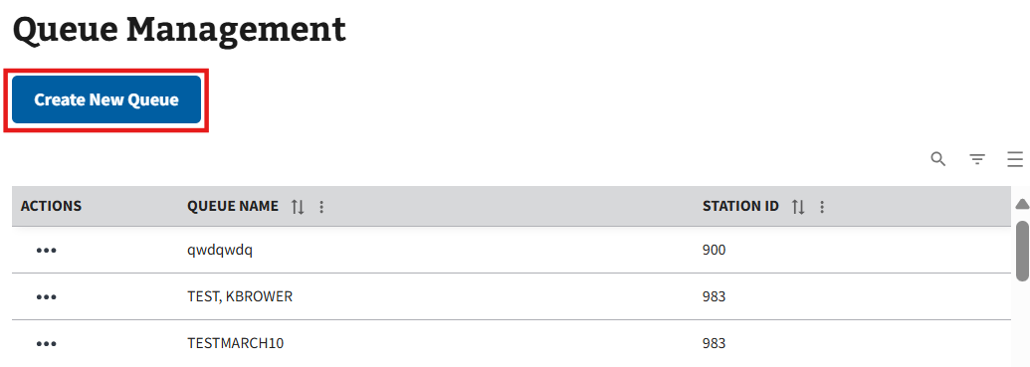
Figure 107: Create New Queue Button
- On this window, the user will need to fill in all required information displayed in ⁠⁠⁠⁠⁠Figure 108⁠⁠⁠⁠⁠.
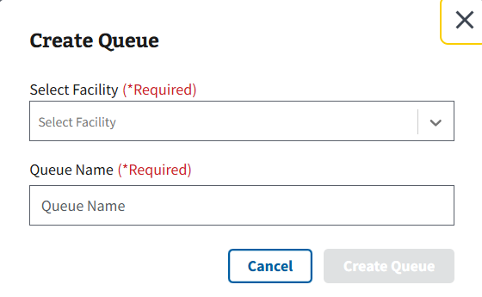
Figure 108: Create Queue Window
- Note: Queue names must be greater than 3 characters, but less than 50.
- Once all applicable information has been filled, the user will select the “Create Queue” button, seen in ⁠⁠⁠⁠⁠Figure 109⁠⁠⁠⁠⁠, to create the new queue.
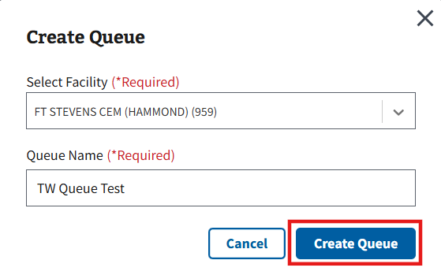
Figure 109: Create Queue Button

5.2 Editing Queues
- To edit a queue, the user will need to select the ellipsis, seen in ⁠⁠⁠⁠⁠Figure 110⁠⁠⁠⁠⁠, next to any queue within the grid.
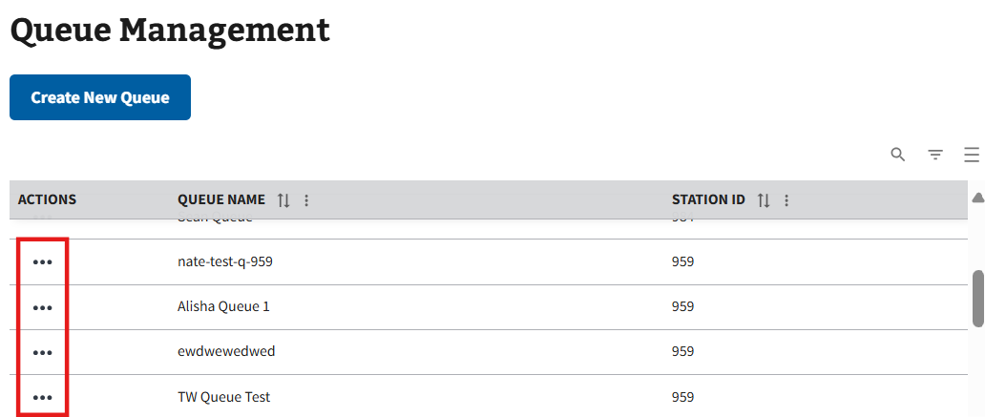
Figure 110: Action Menu Button for Editing Queues
- This will cause the action menu to appear. The user will then need to select the “Edit Queue” option, seen in ⁠⁠⁠⁠⁠Figure 111⁠⁠⁠⁠⁠, to open the Edit Queue window.
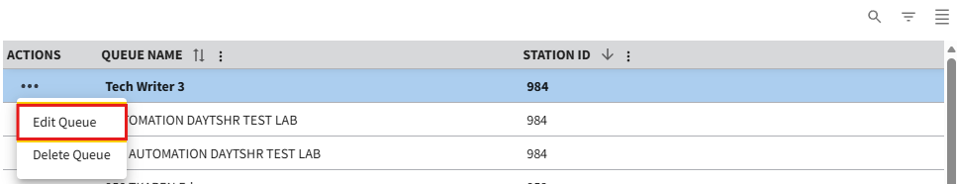
Figure 111: Edit Queue Button
- From here, the user can edit the queue name, as shown in ⁠⁠⁠⁠⁠Figure 112⁠⁠⁠⁠⁠.
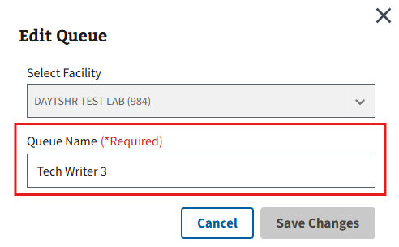
Figure 112: Edit Queue Window
- Once the edits have been made, the user will need to select the “Save Changes” button, seen in ⁠⁠Figure 113⁠⁠, to save any edits to the queue.
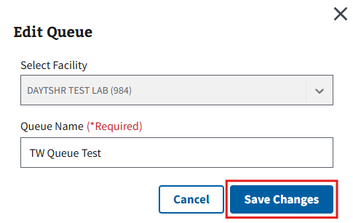
Figure 113: Save Changes Button for Editing Queue

5.3 Deleting Queues
- To delete a queue, the user will need to select the ellipsis, seen in ⁠⁠⁠⁠⁠Figure 114⁠⁠⁠⁠⁠, next to any queue within the grid.
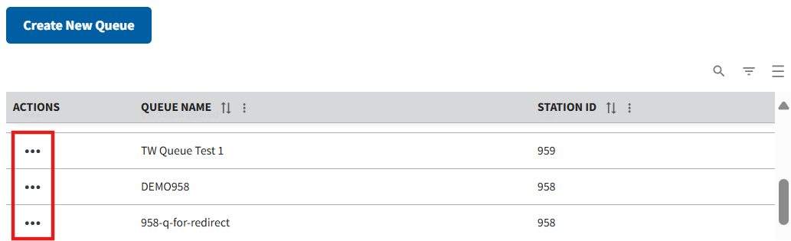
Figure 114: Action Menu Button for Deleting Queues
- This will cause the action menu to appear. The user will then need to select the “Delete Queue” option, seen in ⁠⁠Figure 115⁠⁠, to open the Delete Queue window.
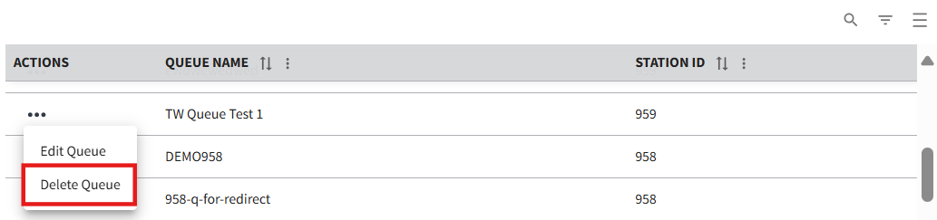
Figure 115: Delete Queue Button
- The user will need to select the “Delete Queue” button, shown in ⁠⁠⁠⁠⁠Figure 116⁠⁠⁠⁠⁠, to confirm deletion.
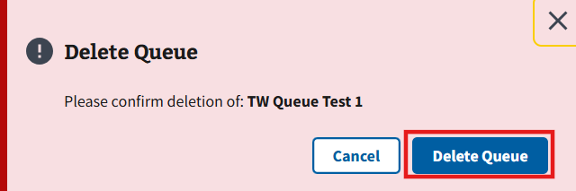
Figure 116: Delete Queue Window
- Note: A queue can only be deleted if no patients are assigned to it, or if the patients that are assigned to the queue are all in a complete status. If a user attempts to delete a queue where these requirements are not met, they will receive the notice shown below in ⁠⁠Figure 117⁠⁠.
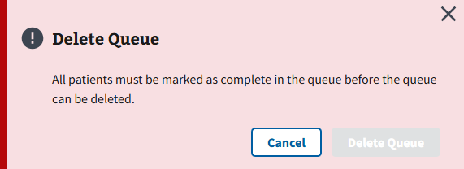
Figure 117: Queue Deletion Error

Queue
PCICSV allows users to add Veterans to a queue regardless of appointment or whether they are in the VA system so they can request services based on their arrival time. The Queue Page can be navigated to by selecting the “Queue” tab shown in ⁠⁠⁠⁠⁠Figure 118⁠⁠⁠⁠⁠.
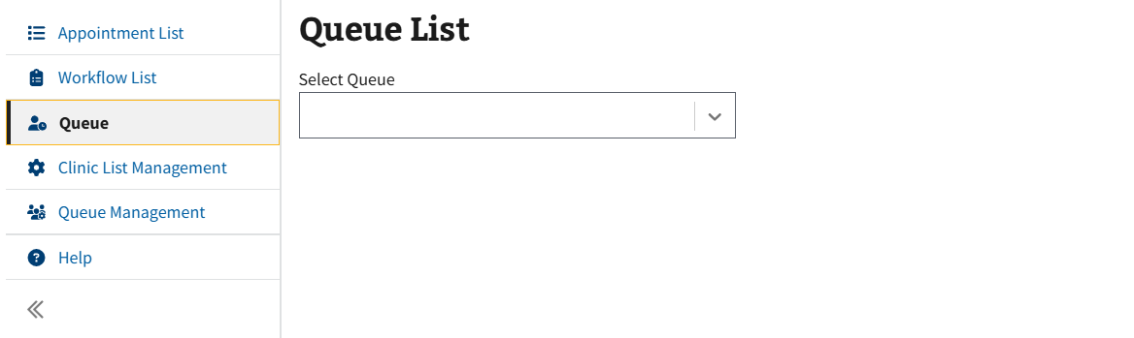
Figure 118: Queue Page

6.1 Utilizing Queues
- To utilize queues, the user will need to select the “Select Queue” dropdown shown in ⁠⁠⁠⁠⁠Figure 119⁠⁠⁠⁠⁠. From here, the user can either scroll and locate a queue or type and search for a specific queue.
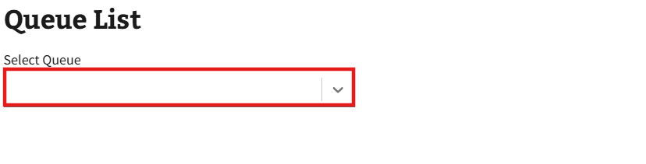
Figure 119: Select Queue Dropdown
- Once the queue is selected, the Queue List page will be displayed. The user will need to select the “Add Patient” button, shown in ⁠⁠Figure 120⁠⁠, to add patients to the queue.
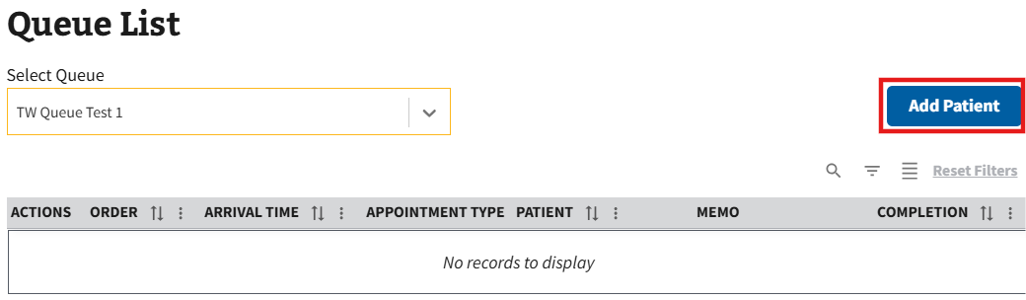
Figure 120: Add Patient Button
- The Add Patient to Queue window will appear (see ⁠⁠⁠⁠⁠Figure 121⁠⁠⁠⁠⁠ for example). On this window, the user can choose to search for a patient already in the system or manually add a patient.
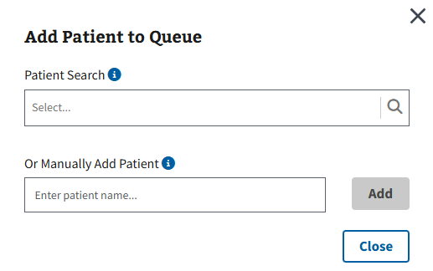
Figure 121: Add Patient to Queue Window
- Once either the Patient Search field or the Manually Add Patient field is populated, the user can select the “Add” button, shown in ⁠⁠Figure 122⁠⁠, to add the patient to the queue.
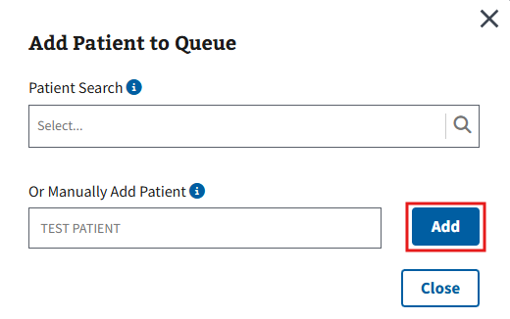
Figure 122: Add Patient to Queue Button
- Note: The user can select the “Close” button seen in ⁠⁠⁠⁠⁠Figure 123⁠⁠⁠⁠⁠ to exit from adding a patient to the queue and return to the Queue List page.
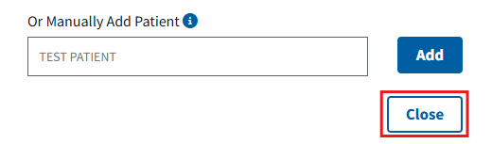
Figure 123: Close Button on the Add Patient to Queue Window
- The user will return to the Queue List page where the grid will refresh with the added patient. Repeat steps 2-4 to add more patients to the queue as needed.

6.2 Queue List Memos
- Users can add a memo to a specific patient in the queue by selecting the “New” button shown in ⁠⁠Figure 124⁠⁠.
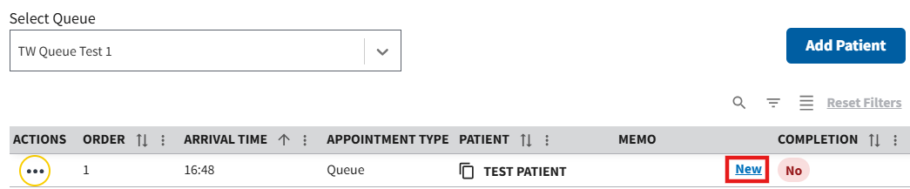
Figure 124: New Memo Button for Queue Patients
- The user will be brought to the Add New Memo to Visit window, shown in ⁠⁠⁠⁠⁠Figure 125⁠⁠⁠⁠⁠. From here, users may add a memo that is up to 100 characters.
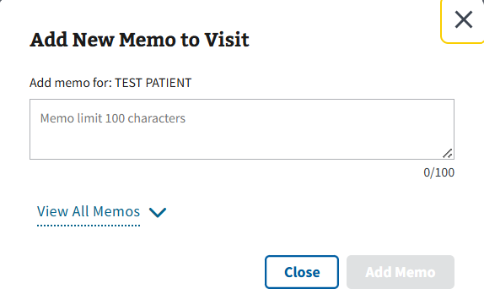
Figure 125: Add New Memo to Visit for Queue Patients
- Note: Users may also choose to view all previous memos from this page. Simply select the View All Memos button, shown in ⁠⁠Figure 126⁠⁠, to expand the window with all previously entered memos.
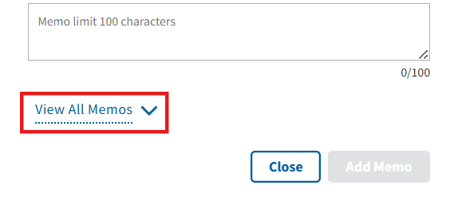
Figure 126: View All Memos Button for Queue Patients
- Once the memo has been entered, select the “Add Memo” button, shown in ⁠⁠⁠⁠⁠Figure 127⁠⁠⁠⁠⁠ to add the memo to the visit.
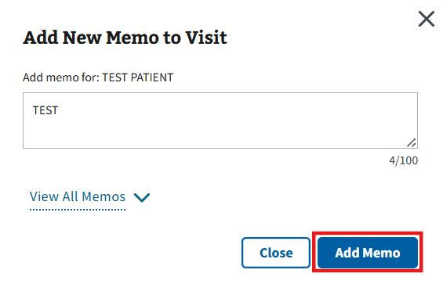
Figure 127: Add Memo Button for Queue Patients
- Note: The user can select the “Close” button seen in ⁠⁠Figure 128⁠⁠ to cancel adding a memo to a visit. This will take the user back to the Queue List page.
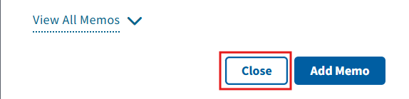
Figure 128: Close Button for Adding Memo to Visit
- The user will then return to the Queue List page, where the memo will be displayed in the Memo column of the related patient with a timestamp and the initials of the user (see ⁠⁠⁠⁠⁠Figure 129⁠⁠⁠⁠⁠ for example).
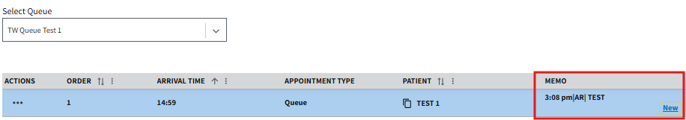
Figure 129: Example of Memo Entered in Queue List
- When users add more than one memo to a visit, the “All” button will appear in the Memo column of the grid as seen in ⁠⁠⁠⁠⁠Figure 130⁠⁠⁠⁠⁠. When selected, the user will be brought to the View All Memos for Queued Patient window where they can see all previous memos for the visit.
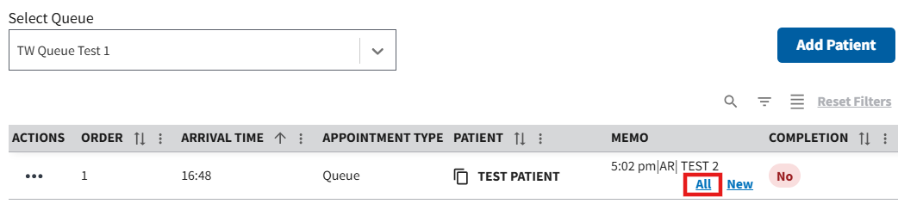
Figure 130: All Memos Button for Queue Patients

6.3 Marking Visit as Complete/Undo Mark as Complete in Queue
- To mark a visit as complete, the user will need to select the ellipsis, seen in ⁠⁠Figure 131⁠⁠, next to a visit within the grid.
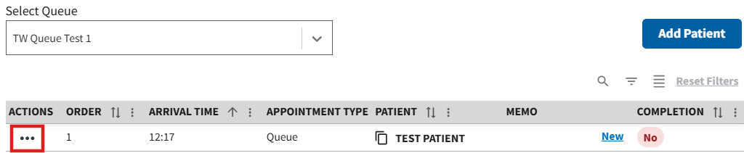
Figure 131: Action Menu Button for Marking a Patient Complete
- This will cause the action menu to appear. The user will then need to select the “Mark as Complete” option, seen in ⁠⁠⁠⁠⁠Figure 132⁠⁠⁠⁠⁠.
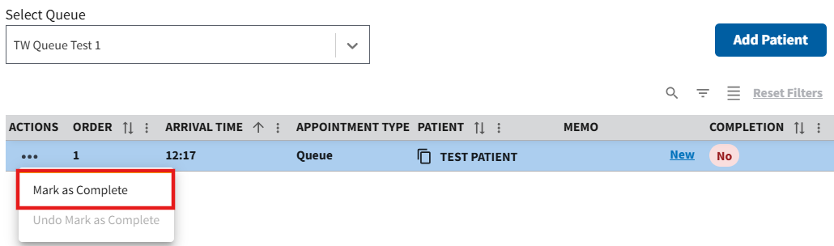
Figure 132: Mark as Complete Button
- Once selected, the grid will refresh and mark the visit as complete (see ⁠⁠⁠⁠⁠Figure 133⁠⁠⁠⁠⁠ for example).
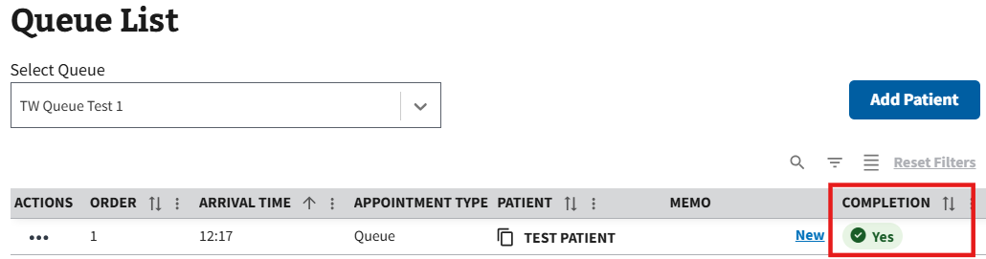
Figure 133: Patient Marked as Complete in Grid of Queue List
- If the visit is not completed and the completion needs to be undone, the user will need to select the ellipsis again and select the “Undo Mark as Complete” option, shown in ⁠⁠⁠⁠⁠Figure 134⁠⁠⁠⁠⁠. This will cause the grid to refresh and update the visit as not completed.
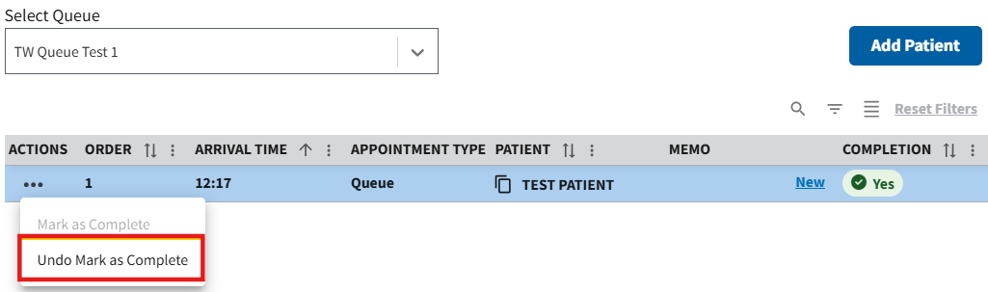
Figure 134: Undo Mark as Complete Button

Appendix

7.1 Alert Notifications
Whenever a change to the Daily Workflow List occurs, an alert notification will be displayed on the Windows taskbar (see ⁠⁠⁠⁠⁠Figure 135⁠⁠⁠⁠⁠). Even if the PCICSV application is in the background, there will still continue to be notifications sent via the taskbar to inform staff of any changes. Changes that trigger an alert include a new appointment on the list or workflow status change.
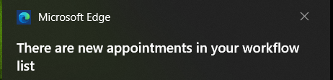
Figure 135: PCICSV Alert Notification
If there is an update on the Daily Workflow List while the user has the application open, the row added or changed will be highlighted as seen ⁠⁠Figure 136⁠⁠.
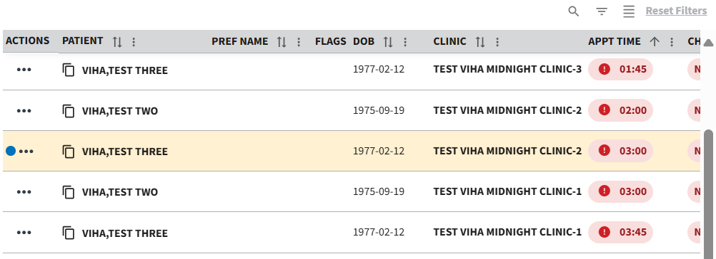
Figure 136: Update to Daily Workflow Example

7.2 Icon Descriptions
Table 1: Icons
Icon | Description
 | Denotes a walk-in appointment
 | Denotes a patient has successfully eChecked In

7.3 Flag Descriptions
Table 2: Flags
Flag | Description
 | Fugitive Felon
 | Sensitive Record – User will see a pop-up notification before viewing a sensitive record. Viewing additional information about this patient will also be logged
 | National/Local

7.4 Acronyms and Abbreviations
Table 3: Acronyms and Abbreviations
Term | Description
IAM | Identity and Access Management
PIV | Personal Identity Verification
SSOi | Single Sign-On Internal
VA | Department of Veterans Affairs
VHA | Veterans Health Administration
VistA | Veterans Health Information Systems and Technology Architecture
VS | VistA Scheduling
VSE | VistA Scheduling Enhancements
PCICSV | Patient Check In Clinical Staff Viewer
ISS | Integrated Scheduling Solution

