VS GUI User Guide Addendum
  - Release 1.7.0.2 Update

Revision History
Date | Revision | Description | Author
8/5/2020 | 1.8 | Updated the document to reflect the new version of VS GUI 1.7.0.2. | REDACTED
7/7/2020 | 1.7 | Updated the document to reflect the new version of VS GUI 1.7.0.1 and VistA Patch SD*5.3*762; updated table of contents and list of figures. | REDACTED
7/1/2020 | 1.6 | Updated section 3.9 - Navigating and Viewing the Trace Log, table of contents and list of figures. | REDACTED
6/23/2020 | 1.5 | Added section 3.10 Clinic ID Required Message Due to Clinic Abbreviation and updated table of contents and list of figures. | REDACTED
05/26/2020 | 1.4 | Added Section 3.8 - Color/Number designation of Appointment status and Section  3.9 - Navigating and Viewing the Trace Log, updated section 3.1.2, table of contents and list of figures. | REDACTED
04/28/2020 | 1.3 | Updated section 3.1.2, table of contents and list of figures. | REDACTED
04/23/2020 | 1.2 | All changes accepted, Updated projected release period | REDACTED
04/21/2020 | 1.1 | Added section 3.7 Midnight Appointment, Provided technical edits - Update table of contents and figures, fixed bullets and numberings. | REDACTED
04/14/2020 | 1.0 | Created 1.7 Release Update Feature Documentation | REDACTED

CLIN Satisfaction Statement
This document is submitted in satisfaction of CLINs 8001BA and 8001BC.

Table of Contents
1 Introduction 5
1.1 Purpose 5
1.2 Overview 5
1.3 Disclaimers 5
1.3.1 Software Disclaimers 5
1.3.2 Documentation Disclaimers 5
1.4 Project References 6
1.4.1 Information 6
2 System Summary 7
3 Key Feature Update in Version 1.7.0.2 7
3.1 More Resilient Login Experience 7
3.1.1 Bypass PIV Login if Service Unavailable 7
3.1.2 Validate VS GUI Version Matches Current Build Release 8
3.2 User Preferences 9
3.3 Help Section 11
3.3.1 Adding Local Links to Help Pane 12
3.3.2 Correct / Update Local Link in VS GUI Help Pane 13
3.3.3 Remove Local Link in VS GUI Help Pane 15
3.4 Drag and Drop Functionality 16
3.5 Multiple Return To Clinic (MRTC) Disposition 21
3.5.1 Parent 21
3.5.2 Child 23
3.6 Variable Length (VL) Appointment 25
3.7 Midnight Appointments 25
3.8 Color/Number Designation Of Appointment Status 27
3.9 Navigating and Viewing the Trace Log 27
3.10 Clinic ID Required Message Due to Clinic Abbreviation 31

List of Figures
Figure 1: User Login 8
Figure 2: Error Message Displayed When User Tries to Login Using 1.6 VS GUI into 1.7+ VistA Environment. 9
Figure 3: Settings – User Preferences 10
Figure 4: Settings – Save As Default View 11
Figure 5: Help Pane 12
Figure 6: Add Local Link To Help Pane 13
Figure 7: New Local Link Added (VHA-COVID-19 RESPONSE) 13
Figure 8: Edit Local Link 14
Figure 9: Remove Local Link From The Help Pane 15
Figure 10: Removed The Local Link (VHA COVID-19 RESPONSE) 16
Figure 11: Example For A Single Clinic In Week View 17
Figure 12: Example For An Appointment Within A Clinic Group Search 17
Figure 13: Drag And Drop Example 18
Figure 14: Drag And Drop Example 19
Figure 15: Standard Cancel Appointment Screen 19
Figure 16: Appointment Verification By Hover And By Pending Appointments Box 20
Figure 17: Pop-Up Message For Drag And Drop Ineligible Appointment Types 21
Figure 18: Error Indicator That An Appointment Cannot Be Moved To The Selected Destination 21
Figure 19: MRTC New Disposition Code For Parent - Removed/Scheduled-Assigned 22
Figure 20: MRTC New Disposition Code For Parent - Removed/VA Contract Care 22
Figure 21: Close MRTC Request Confirmation Box 23
Figure 22: MRTC New Disposition Code For Child - Removed/Scheduled-Assigned 23
Figure 23: MRTC New Disposition Code For Child – Removed/VA Contract Care 24
Figure 24: MRTC New Disposition CHILD – Close MRTC Request 24
Figure 25: Variable Length Appointment - Duration Options Limited To Multiples Of Default Appointment Length 25
Figure 26: Appointment That Starts At Midnight 26
Figure 27: Appointment That Ends At Midnight 26
Figure 28: Appointment That Crosses Over Midnight 26
Figure 29: Calendar View: Appointment Status Visual Indicators Now Include Both Color And Number 27
Figure 30: Navigate To Windows File Explorer From The Task Bar 28
Figure 31: Navigate Inside C: Drive And Open “Users” Folder 28
Figure 32: Navigating To The Username Folder 28
Figure 33: Navigating To Appdata And How To View Hidden Files And Folders 29
Figure 34: Navigating To Local Folder 30
Figure 35: Navigating To VA Vista Scheduler Folder 30
Figure 36: List Of Trace Log Files 31
Figure 37: Message User Gets When An Invalid Clinic Is Selected 32
Figure 38: Appointment Request – When Abbreviation (BR/N) Is Different From The Clinic Name (CHY NEURO) 33
Figure 39: Appointment Request -User Should Search By Only The Clinic Name (CHY NEURO) 34
Figure 40: Appointment Request - When An Abbreviation With A Symbol Is Used To Search For The Clinic 35
Figure 41: Appointment Request - Showing The Clinic Name Truncated 36

Introduction
Department of Veterans Affairs (VA) Veterans Health Information Systems and Technology Architecture (VistA) Scheduling Graphical User Interface (VS GUI) module is the Windows GUI version of the Patient Information Management System (PIMS) Scheduling module. It provides appointment management functions included in PIMS Scheduling, but with the added convenience and usability of a GUI.

Purpose
The Veterans Health Administration (VHA) Office of Veterans Access to Care (OVAC) requested an enterprise enhancement for the VS package that supports COVID-19 response. The enhancement reduces operating costs for VHA and improves operational efficiencies, resulting in patient-centered access to care, coordinated care, increased customer satisfaction, and the reduction of excessive cycle/wait time for scheduling patients.

Overview
VS GUI is a software module that allows schedulers to make appointments quickly by viewing multiple appointment request types and multiple clinics in one screen. A scheduler can easily view patient requests for service, find the next available open appointment, view the provider’s availability in multiple clinics, and track a patient’s appointment process. Refer to System Summary for a more detailed description of VS GUI functionality.

Disclaimers

Software Disclaimers
This software was developed at the Department of Veterans Affairs (VA) by employees of the Federal Government in the course of their official duties. Pursuant to title 17 Section 105 of the United States Code this software is not subject to copyright protection and is in the public domain. VA assumes no responsibility whatsoever for its use by other parties, and makes no guarantees, expressed or implied, about its quality, reliability, or any other characteristic. We would appreciate acknowledgement if the software is used. This software can be redistributed and/or modified freely if any derivative works bear some notice that they are derived from it, and any modified versions bear some notice that they have been modified.

Documentation Disclaimers
The appearance of external hyperlink references in this manual does not constitute endorsement by the Department of Veterans Affairs (VA) of this Web site or the information, products, or services contained therein. The VA does not exercise any editorial control over the information you may find at these locations. Such links are provided and are consistent with the stated purpose of the VA.

Project References

Information
The VS GUI points of contact (POCs) include:
- REDACTED

VSE Resources
- Veterans Health Administration (VHA) VSE SharePoint: REDACTED
- VA Software Document Library (VDL) – Scheduling (VSE manuals near the bottom):
- National Return to Clinic (RTC) Order: REDACTED

System Summary
The VSE project delivers a series of enhancements to legacy VistA Scheduling Version 5.3 via the VS GUI application.
This update is for the nationally released version 1.7.0.2, which includes VS GUI 1.7.0.2 R1, VistA patch SD*5.3*694 and VistA Patch SD*5.3*762. At time of publishing, install period is projected for August 2020.
This update includes the following:
- More Resilient Log-In Experience:
- If Personal Identification Verification (PIV) authentication/Single Sign On (SSOi) is offline, VS GUI will allow users to access VS GUI with their VistA Access/Verify codes.
- VS GUI will ensure only the VS GUI version that matches the current VistA build can be used.
- User preference for column order can be saved as default, and will be remembered from session to session
- Help section with hyperlinks to Veteran Crisis Line (and their new secure chat), VSE resources, and contact information to report a problem or suggestion.
- More robust drag and drop functionality:
- Appointments that were created from Patient Centered Scheduling (PtCSch) (Recall) can now be dragged and dropped.
- Appointments are prevented from being dragged to/from the past to avoid encounter and note issues.
- View Only users are prevented from any drag and drop access.
- Drag and drop across clinics in provider or clinic group search (including across clinics with different stop codes).
- Multiple Return to Clinic (MRTC) appointment requests have two additional disposition reasons available
- Clinics with variable length should only allow time to be added in multiples of the default slot length.
- VS GUI will store trace logs for up to 7 days.
- Updated the location of the VS GUI application and trace log files in order to avoid conflict with Group Policy Objects (GPOs) at facilities installing via VistA Applications Central Server (VACS).

Key Feature Update in Version 1.7.0.2

More Resilient Login Experience

Bypass PIV Login if Service Unavailable
VistA User Access and Verify codes are required to login to the VS GUI, along with VistA options and keys according to the user’s role. Once a user has the appropriate access assigned within VistA, the user will need to link their Personal Identification Verification card (PIV) to their VistA account. Guidance on linking a PIV to VistA can be found in this document: https://mobile.va.gov/sites/default/files/piv-linkage-process.pdf. If a user has already linked their PIV and VistA account, they will not need to repeat this step unless the user changes duty stations or VistA instances.
VS GUI uses two factor authentication with PIV-enabled login and Personal Identification Number (PIN) as the primary method for logging into the system. If the PIV authentication service has an issue authenticating the user, an error may occur, but the users will now be able to bypass the PIV login and enter their Access/Verify Code in the Login Box.

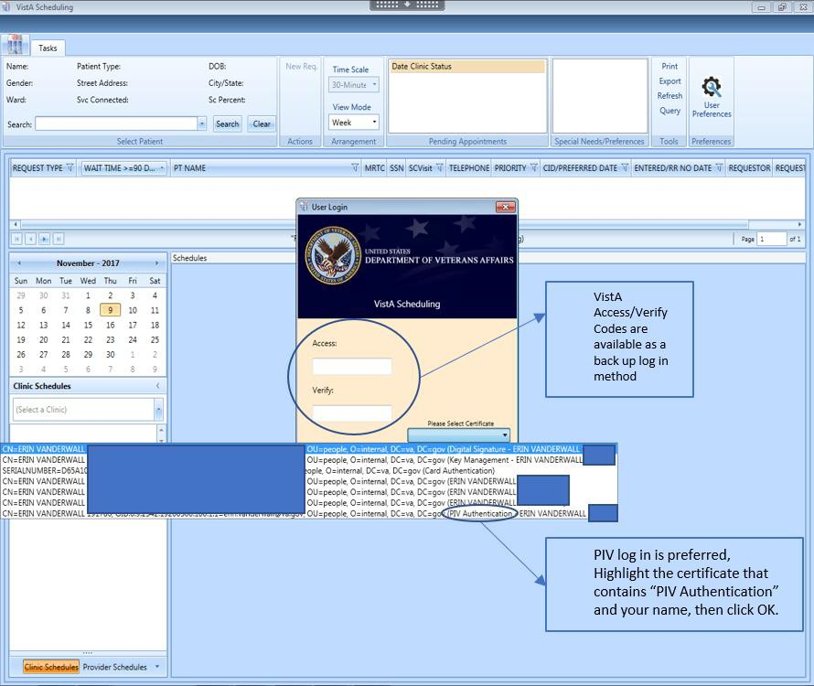
Figure 1: User Login

Validate VS GUI Version Matches Current Build Release
VS GUI will ensure only the VS GUI version that matches the current VistA build can be used. If a user tries to login with the wrong version, the user will get a popup message labeled User Access Rights.
Note: The error message does not specifically state that a user has tried to login with the
wrong version. It states, “The user does not have access rights to this application. Contact the system administration for further information.” The user will be able to see the login version on the login screen and if it displays a version other than v1.7.0.2 R1, the user will need to submit a trouble ticket to request the correct version of VS GUI be installed. If the user has 1.6 VS GUI and are logging into a 1.7+ VistA environment, the user will receive a popup message “The user does not have access rights to this application. Contact the system administration for further information.”

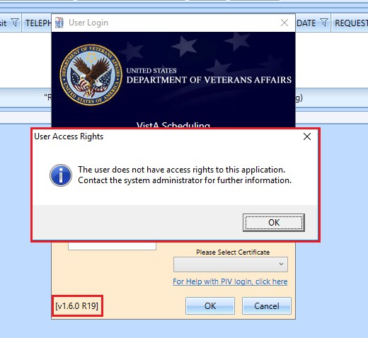
Figure 2: Error Message Displayed When User Tries to Login Using 1.6 VS GUI into 1.7+ VistA Environment.
After the introduction of 1.7.0.2 VS GUI, if a user tries to login with the wrong version of VS GUI, the user will receive a popup message requiring them to install the latest VS GUI version.

User Preferences
Users may now set their own column preferences within a session or as their default view.
Within the session, a user can drag and drop a column in the Request Management grid and move it left or right to rearrange the column order for the length of the session.
The current column order is:
- Request Type
- Wait Time
- Patient (PT) Name
- Multiple Return To Clinic (MRTC)
- SSN
- SC Visit
- Telephone
- Priority
- CID/Preferred Date
- Entered/RR No Date
- Requestor
- Requested By
- Clinic/Service
- Comment

If the user would like to set a new default column order for future sessions, select the User Preferences box in the ribbon bar. The User Preferences Settings icon with a green box around it indicates the user preferences are stored.

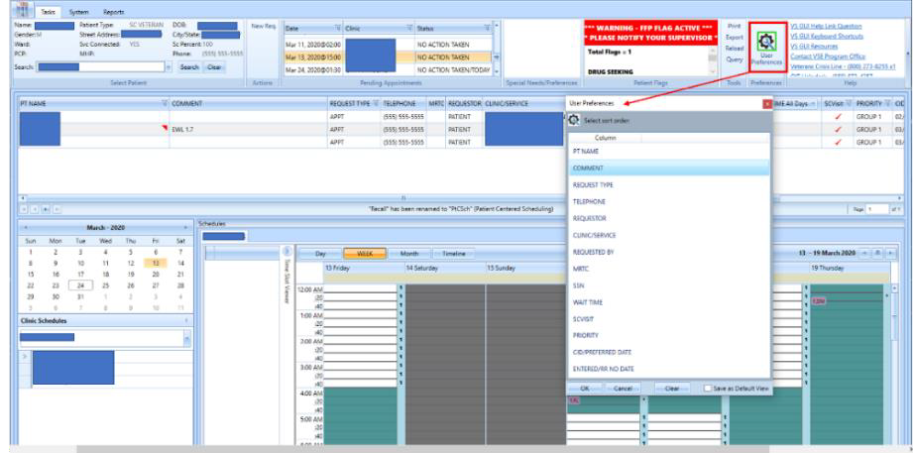
Figure 3: Settings – User Preferences

Note: Filter and sort functionality previously included in User Preferences has been removed in version 1.7.0.2.

To save your user preferences:
- Drag and drop a column up or down to create the new column order.
- To save the selections as your default view, select “Save as Default View” on the bottom
right. If you do not select “Save as Default View,” your selections will only be applicable to your current session.
- Click OK to save.

To remove any existing user preferences for the user’s default view:
- Click the User Preferences icon.
- In the User Preferences window, click Clear, Save as Default View, then click OK to save.

The User Preferences Settings icon will now display without the green highlight when no user preferences have been stored.

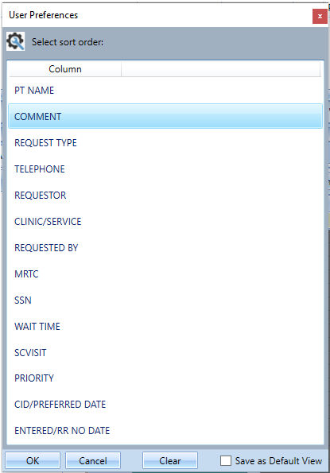
Figure 4: Settings – Save As Default View

Help Section
A Help section has been added with hyperlinks to items such as the Veteran Crisis Line (and their new chat), VSE Resources, and contact information to report a problem or suggestion. The VA National Links that can only be updated through the release of new patches. Local links can be added or updated by the site through a new option VS GUI Help Pane Edit [SDEC HELP PANE EDIT (LOCAL)]. The option has been added to the Supervisor Menu [SDSUP] and cannot be a stand-alone option. Users must hold the SDEC HELP security key in order to access this new option.
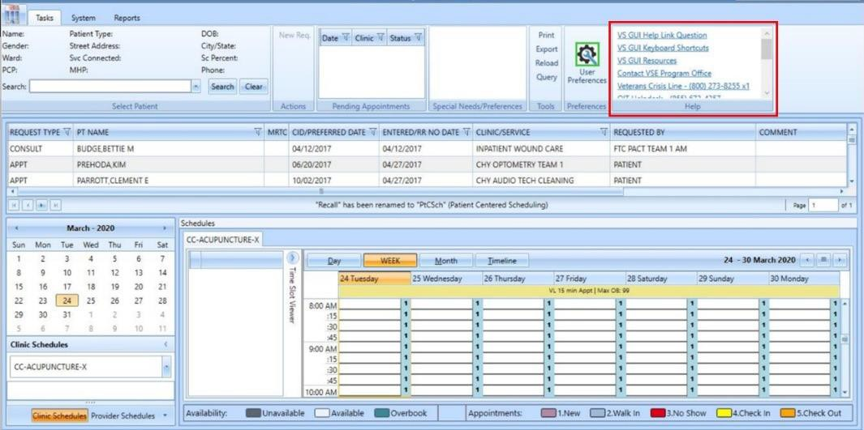
Figure 5: Help Pane

Adding Local Links to Help Pane
- From Supervisor Menu [SDSUP], select VS GUI Help Pane Edit option.
- Select SDEC SETTINGS NAME: VS GUI LOCAL
- Select HELP LINK TEXT: Enter Text to be displayed in Help Pane, such as VHA COVID-19 RESPONSE
- Are you adding ‘VHA COVID-19 RESPONSE’ as a new HELP LINK TEXT (the 2nd for this SDEC SETTINGS)? NO//y (Yes)
- Default setting is NO, Enter y for Yes
- Link Type: Enter ?? for a list of Link Types and select appropriate type
- Example: Enter 2 for HTTPS
- LINK ADDRESS: Enter Link address desired, but do not enter the Link Type (protocol) with the address.
- Example: Enter www.va.gov and not https://www.va.gov
- MAIL SUBJECT:
- If the URL is "mailto:" then this field can store an optional e-mail message subject that is passed to the mail client when it opens a window for the user.
- Hit Enter to return to the previous menu.

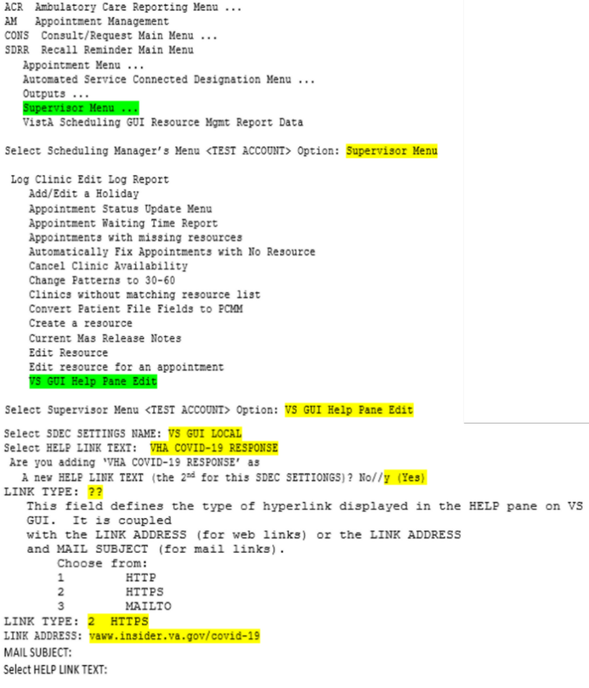
Figure 6: Add Local Link To Help Pane

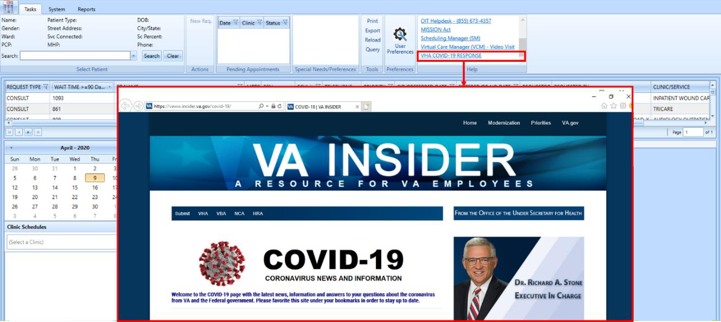
Figure 7: New Local Link Added (VHA-COVID-19 RESPONSE)

Correct / Update Local Link in VS GUI Help Pane
- From Supervisor Menu [SDSUP], select VS GUI Help Pane Edit option.
- Select SDEC SETTINGS NAME: VS GUI LOCAL
- Select HELP LINK TEXT: VHA COVID-19 RESPONSE//
- HELP LINK TEXT: VHA COVID-19
- Enter the Help Link text to be visible in the Help Pane if it needs to be changed
- Link Type: HTTPS//
- Enter ?? to review a list of Link Types if it needs to be changed from the current setting
- LINK ADDRESS: vaww.insider.va.gov/covid-10
- Link address that is currently assigned to the Help Link Text above
- Replace
vaww.insider.va.gov/covid-19
- Enter the Link Address to replace the link address set above, but do not enter the Link Type (protocol) with the address
- MAIL SUBJECT:
- If the URL is "mailto:" then this field can store an optional e-mail message subject that is passed to the mail client when it opens a window for the user.
- Hit Enter to return to the previous menu.

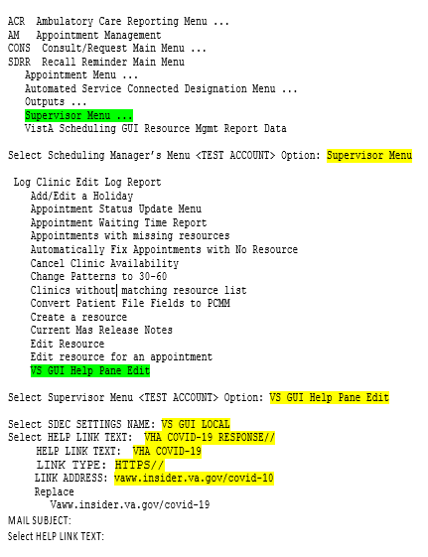
Figure 8: Edit Local Link

Remove Local Link in VS GUI Help Pane
- From Supervisor Menu [SDSUP], select VS GUI Help Pane Edit option.
- Select SDEC SETTINGS NAME: VS GUI LOCAL
- Select HELP LINK TEXT: VHA COVID-19 RESPONSE//??
- Choose from:
VHA COVID-19 RESPONSE
VHA COVID-19 RESPONSE BAD LINK
You may enter a new HELP LINK TEXT, if you wish. This is the text displayed to the user for a help link.
- Select HELP LINK TEXT: @VHA COVID-19 RESPONSE BAD LINK
- HELP LINK TEXT: VHA COVID-19 RESPONSE BAD LINK
Replace ... With @ Replace
- SURE YOU WANT TO DELETE THE ENTIRE 'VHA COVID-19 RESPONSE BAD LINK' HELP LINK TEXT? No//y (Yes)
- Default setting is NO, Enter y for Yes
- Hit Enter to return to the previous menu.

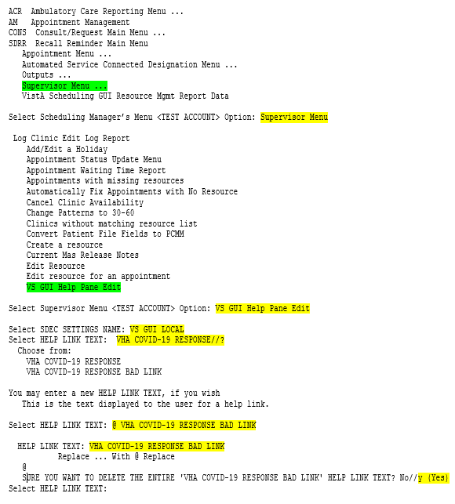
Figure 9: Remove Local Link From The Help Pane
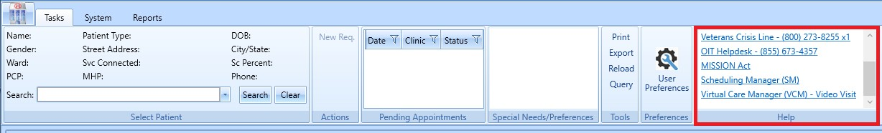
Figure 10: Removed The Local Link (VHA COVID-19 RESPONSE)

Drag and Drop Functionality
Drag and Drop functionality allows a scheduler who intends to cancel and reschedule an appointment to another slot in view to automate that reschedule process. VS GUI v1.7.0.2 enhances the drag and drop functionality to make it more consistent and stable.
The new version prevents:
- Consult appointments from being moved
- Walk-in appointments from being moved
- Appointments in the past from being moved
- Appointments in the future from being dragged into the past
- Appointments from being dragged into a date without any availability (entirely gray)
- View Only users using drag and drop in any scenario
- Encounter “Action Required” errors left behind on the cancelled appointment
- Ghost patients being left behind from the cancelled appointment
- Half slots
- Violations of clinic set up rules such as default appointment length, variable length setting, prohibited user lists, etc.

The new version allows:
- Patient Centered Schedule (PtCSch) (Recall) appointments to be dragged and dropped
- Eligible appointments can be dragged within the viewable portion of clinics within a clinic group
- Eligible appointments can be dragged within the viewable portion of clinics within a provider search results
- Eligible appointments can be dragged across different clinics in view, regardless of stop code
Note: When beginning a drag and drop, hover over the appointment to ensure you have the correct patient, date, and time.
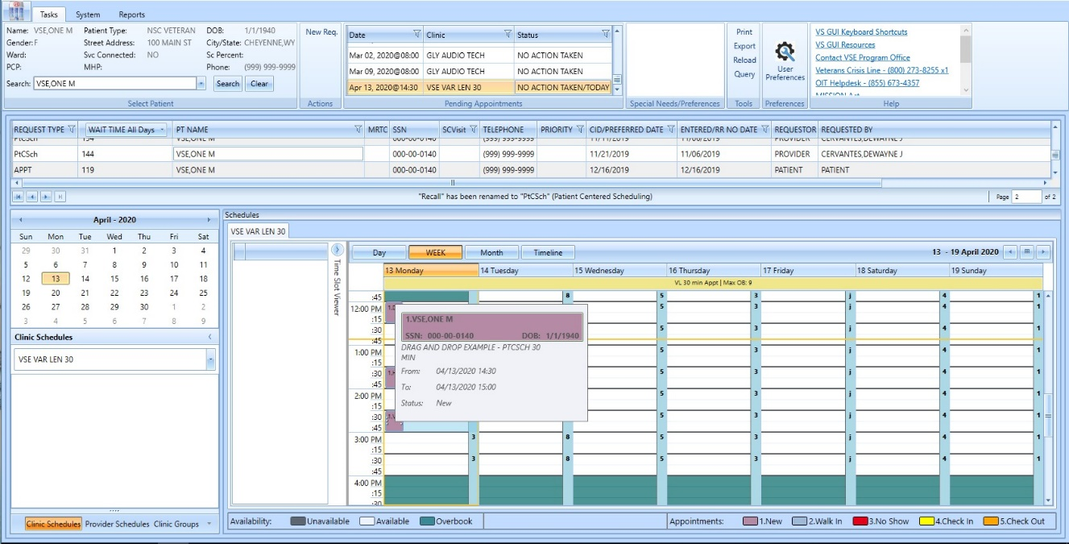
Figure 11: Example For A Single Clinic In Week View

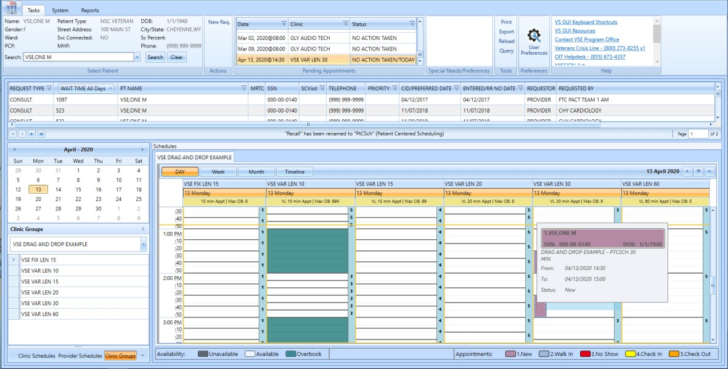
Figure 12: Example For An Appointment Within A Clinic Group Search

Once the appointment is confirmed to be correct, left click and drag it to the new date, time, and clinic (as applicable). VS GUI will show the scheduler a yellow shadow “preview” with the new start time, patient name, and original start time before the scheduler drops the new appointment.
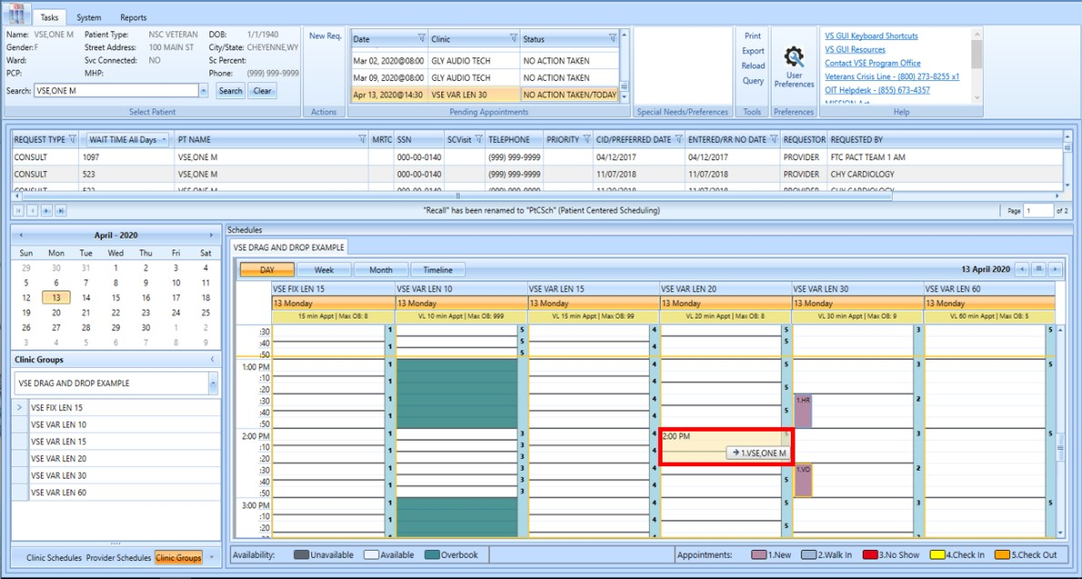
Figure 13: Drag And Drop Example

VS GUI will retain the original appointment’s duration when creating the new appointment within the same clinic location or between two locations with the same default length and variable setting.
If the scheduler is dragging across clinics in clinic group or provider search, the destination clinic may not have the same default length and variable setting as the original clinic. The system will automatically select a new appointment length as close to the original it can manage and confirm with the user.
- If the destination clinic location is NOT variable length, the new appointment will honor that rule and only allow a new appointment to be single slot at the default length.
- If the new clinic is variable and has a default length that allows the original length to be carried forward, it will.
- If the new clinic is variable, but the default length will not allow the original length, the system will try to get it as close as possible. If it cannot decide, it will ask the user to choose the length.

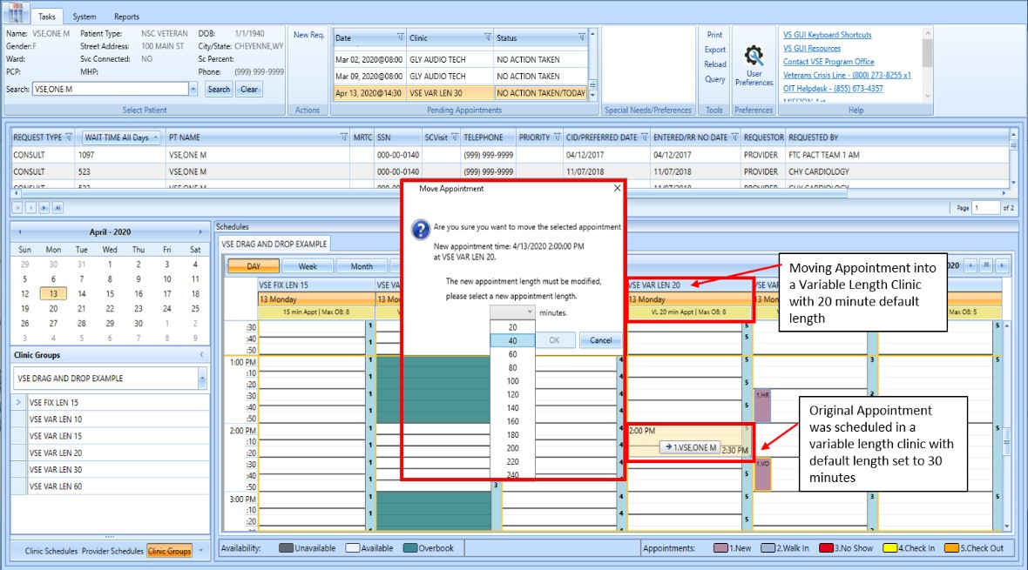
Figure 14: Drag And Drop Example

After confirming the new appointment duration, start time and clinic (if applicable), the system will present the user with the standard Cancel Appointment screen for the original appointment. Proceed to cancel by patient, by clinic, and PID changes, as appropriate. Schedulers will be given a chance to print the cancellation letter, if needed

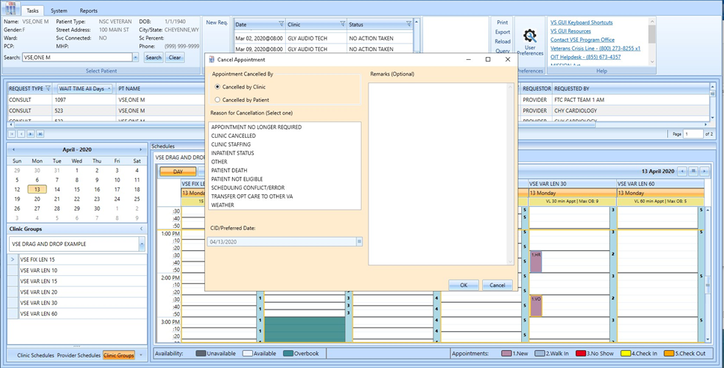
Figure 15: Standard Cancel Appointment Screen

The new appointment is then automatically created. The scheduler cannot edit the start time or duration from what was presented in the confirmation window, so there is some limitation in the custom start time if the patient requires an appointment.
It is recommended, but not required for schedulers to verify the new appointment by hovering over the new appointment and checking the statuses in pending appointments box.

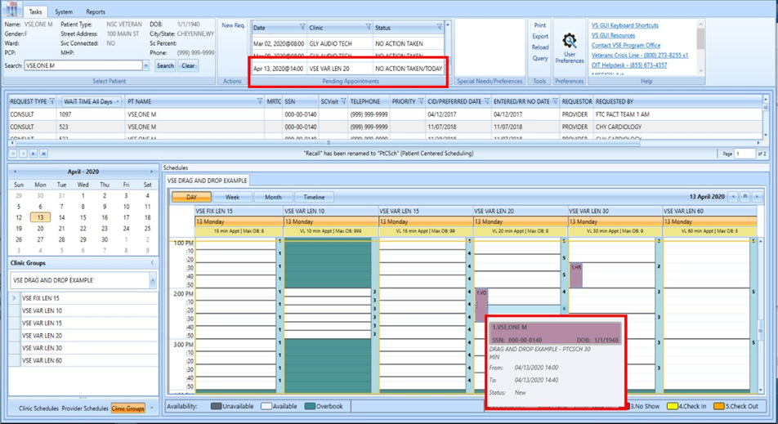
Figure 16: Appointment Verification By Hover And By Pending Appointments Box

If the appointment is ineligible for drag and drop, the system will tell the user in three ways:
- Not allow the user to click and drag an existing appointment (most often for appointments in the past)
- Alert the user that the appointment type is ineligible (most often for consults or walk in appointments)

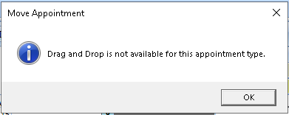
Figure 17: Pop-Up Message For Drag And Drop Ineligible Appointment Types

- Show an indicator (red circle with a slash) that the destination proposed is not available for drop until the scheduler moves the mouse over a valid slot. This typically occurs for appointment destinations in the past, or on a day that does not have any established appointment availability.

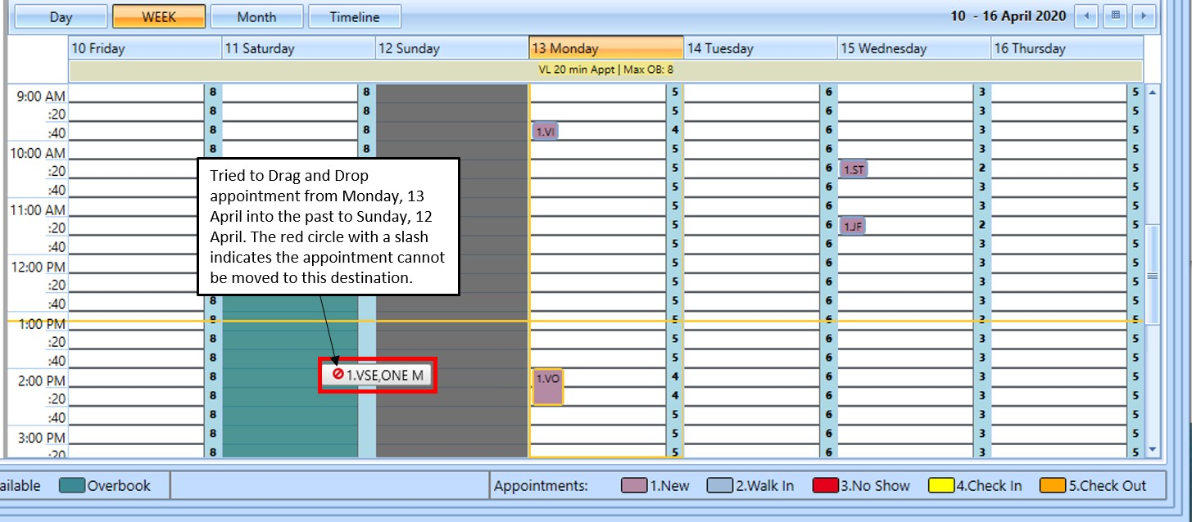
Figure 18: Error Indicator That An Appointment Cannot Be Moved To The Selected Destination

Multiple Return To Clinic (MRTC) Disposition

Parent
A parent request can now be dispositioned directly from the Request Management grid using an expanded set of reasons. If any of the children have been scheduled or dispositioned, any pending appointments will be cancelled and requests for children will not return to the grid.
If the scheduler dispositions the parent series by Removed/Scheduled-Assigned as the first action on that series, the Computerized Patient Record System (CPRS) MRTC order will be closed as Complete.

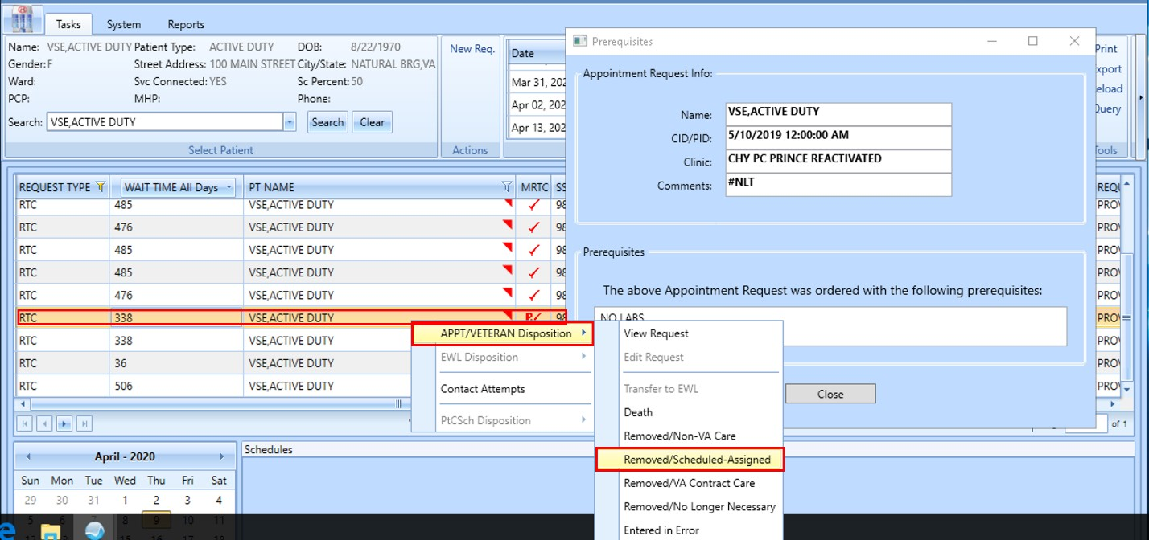
Figure 19: MRTC New Disposition Code For Parent - Removed/Scheduled-Assigned

If the scheduler selects Death, Removed/Non-VA Care, Removed/VA Contract Care, Removed/No Longer Necessary, or Entered in Error as the first action on the series, the CPRS order will be closed as Discontinued.

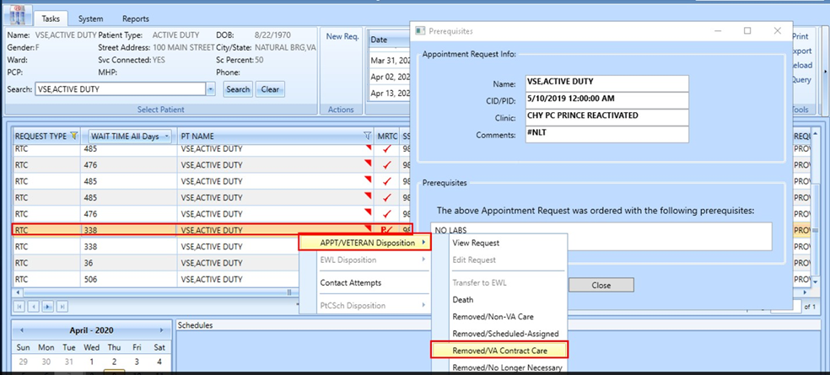
Figure 20: MRTC New Disposition Code For Parent - Removed/VA Contract Care

After the disposition, the following confirmation box displays. If the user selects Cancel, the disposition of this series is aborted. If the user selects Ok, the disposition is processed.

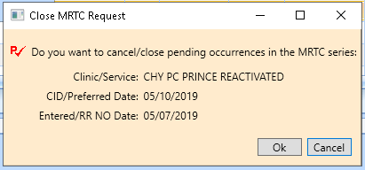
Figure 21: Close MRTC Request Confirmation Box

If the scheduler is closing a parent that has pending appointments, they will be presented with the standard Cancel Appointment pop up box. The scheduler’s choices and free text reasons from that box will apply to all appointments cancelled as part this disposition action.

Child
A single child request within a series also has expanded disposition reasons. The first scheduling action (disposition or scheduled) will be sent to the corresponding CPRS MRTC Order. Once all the children in parent request have been acted on once, CPRS ignores any subsequent scheduling or dispositions from that series.
If the scheduler dispositions the child request by Removed/Scheduled-Assigned as the first action on that child, the CPRS MRTC order will become Partial Results until the rest of the children are addressed.
If the children in the series send the CPRS Order mixed messages (completed vs. discontinued within the same series), CPRS will retain Partial Results as the final order status.

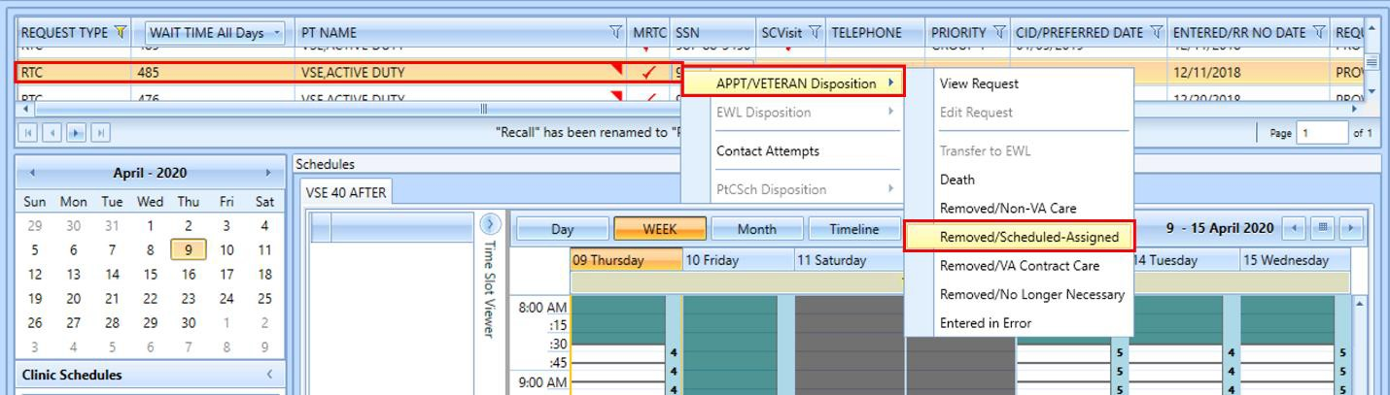
Figure 22: MRTC New Disposition Code For Child - Removed/Scheduled-Assigned

If the scheduler selects Death, Removed/Non-VA Care, Removed/VA Contract Care, Removed/No Longer Necessary, or Entered in Error as the first action on the child request, the CPRS order will be sent a message that that child was Discontinued.
If the children in the series send the CPRS Order mixed messages (completed vs. discontinued within the same series), CPRS will retain Partial Results as the final order status.
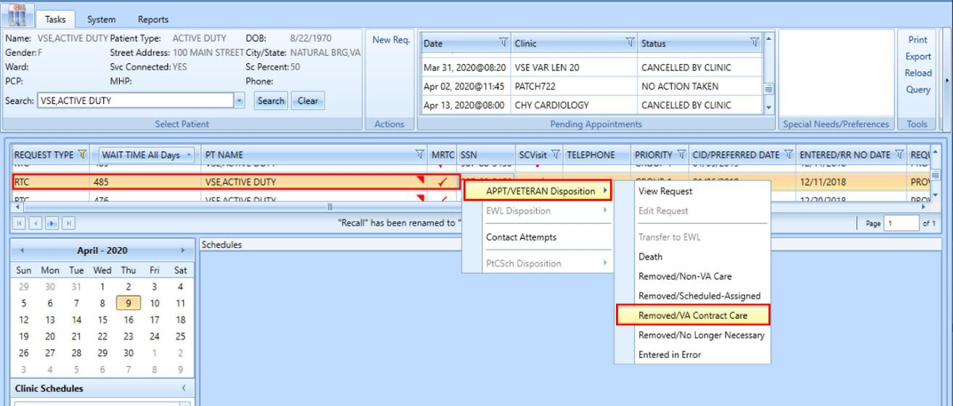
Figure 23: MRTC New Disposition Code For Child – Removed/VA Contract Care

After the disposition of one child, the scheduler will be asked what they would like to do with the remaining pending appointments and requests in the series.
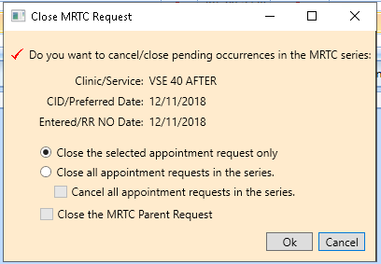
Figure 24: MRTC New Disposition CHILD – Close MRTC Request

If the scheduler cancels pending appointments as part of closing the parent, the scheduler will be presented with the standard Cancel Appointment pop up box. The scheduler’s choices and free text reasons from that box will apply to all appointments cancelled as part this disposition action.

Variable Length (VL) Appointment
Clinics with variable length should only allow time to be added in multiples of the default slot length.

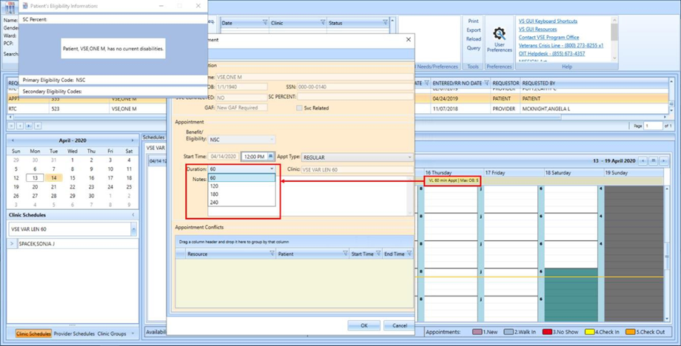
Figure 25: Variable Length Appointment - Duration Options Limited To Multiples Of Default Appointment Length

Midnight Appointments
An Appointment that starts, ends, or crosses over midnight will be handled more gracefully in VS GUI than in previous versions. If the appointment starts or ends at midnight, VS GUI will automatically change the start or end time to 12:01AM. In VS GUI, this change will be displayed as Jan 1, 2020@00:01, even if the scheduler inputs the start time as 12:00AM or types 0000.

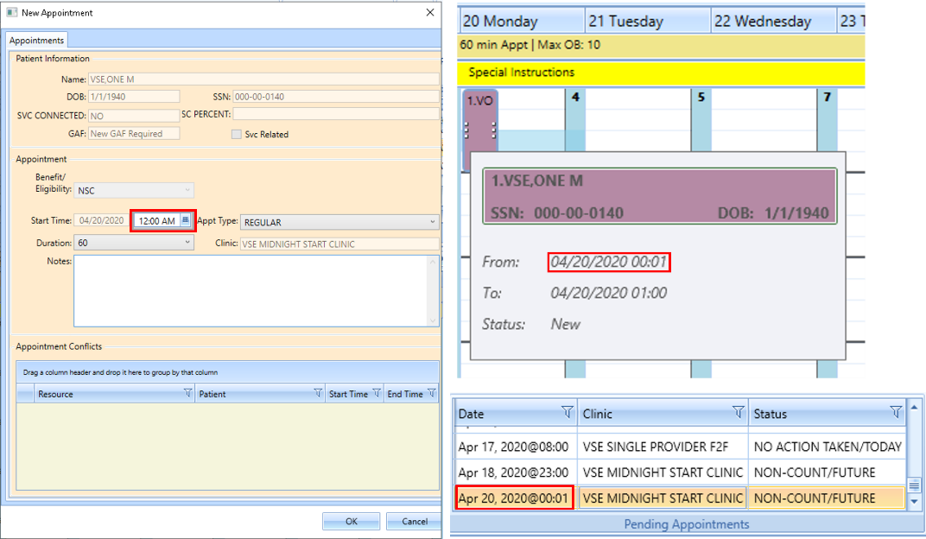
Figure 26: Appointment That Starts At Midnight

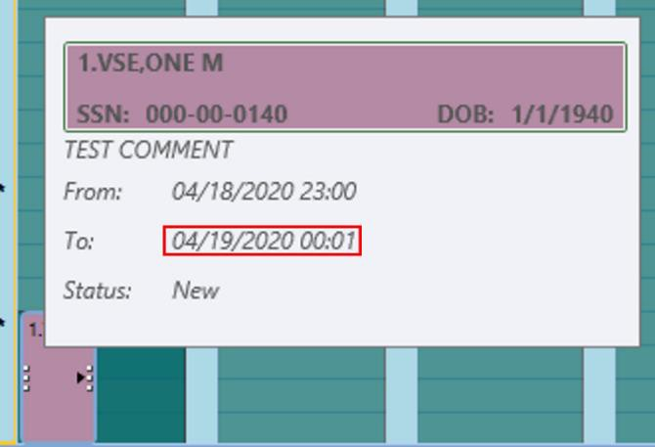
Figure 27: Appointment That Ends At Midnight

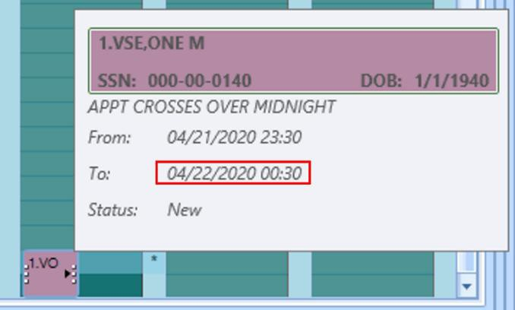
Figure 28: Appointment That Crosses Over Midnight

Color/Number Designation Of Appointment Status
Appointments in the calendar grid now include both a color and number to designate the current status of that appointment. The number will appear before the initials of each patient in the calendar.
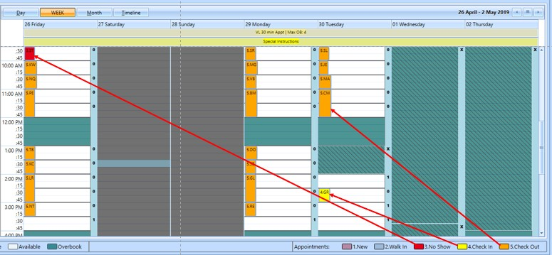
Figure 29: Calendar View: Appointment Status Visual Indicators Now Include Both Color And Number

Navigating and Viewing the Trace Log
VS GUI Version 1.7.0.2 will store trace logs for up to 7 days, greatly increase OIT’s ability to troubleshoot an issue that happened during a user’s previous session. The user may need to retrieve a past trace log for the OIT Helpdesk. Trace log files now resides under 'C:\Users>[userid]>AppData>Local>VA VistA Scheduler'.
The user who experienced the issue should be logged into the computer where the issue happened.
- Once VSE has been installed and the user logs in to VSE, navigate to the taskbar at the bottom and open the Windows File Explorer.
Figure 30: Navigate To Windows File Explorer From The Task Bar

- In Windows File Explorer, click on C: drive from the left side menu and then double click on the “Users” folder.
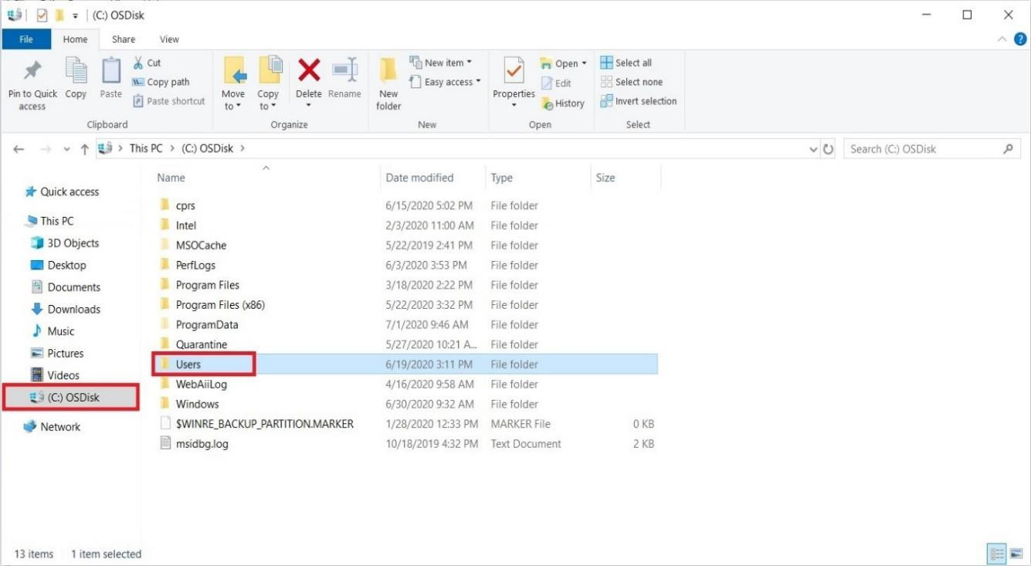
Figure 31: Navigate Inside C: Drive And Open “Users” Folder

- Find your username and double click on the corresponding folder.

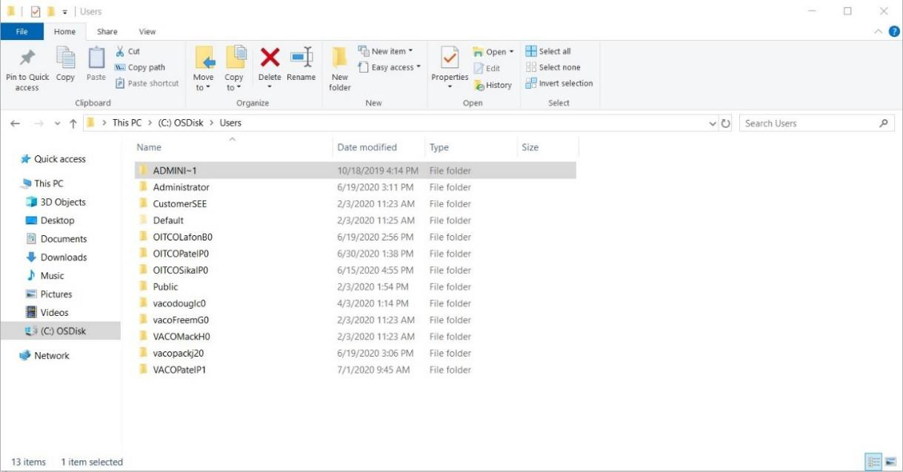
Figure 32: Navigating To The Username Folder

- In the correct user’s folder, locate the “AppData” folder and double click to open the folder. If the “AppData” folder is not visible, select the “View” tab at the top left corner of the File Explorer and make sure that “Hidden Items” is check marked. Once selected, “AppData” should now be visible.
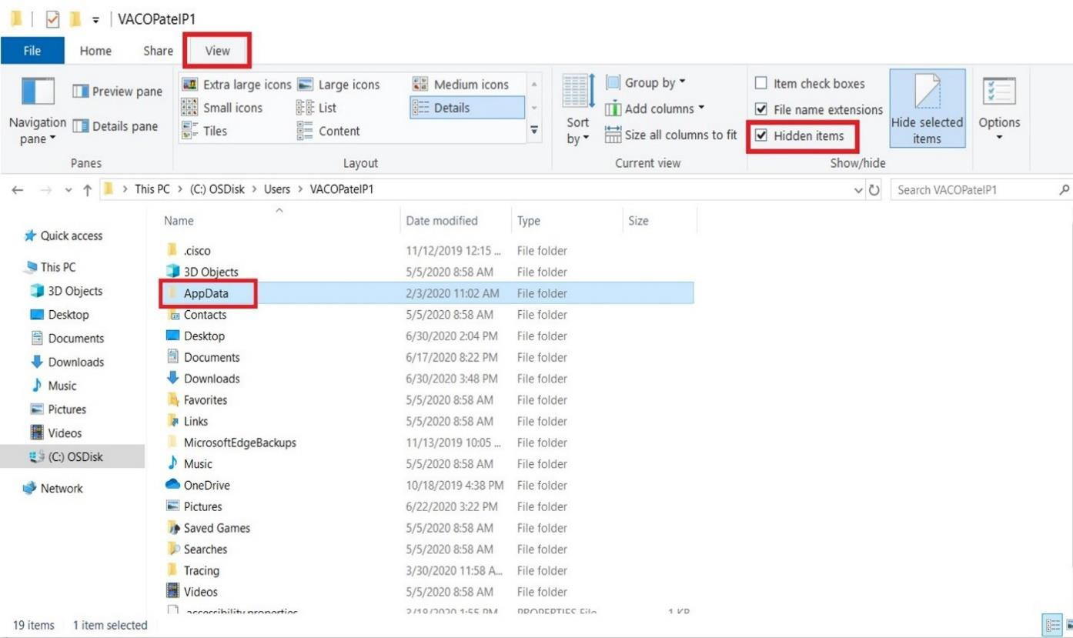
Figure 33: Navigating To Appdata And How To View Hidden Files And Folders

- Then double click on the “Local” folder.

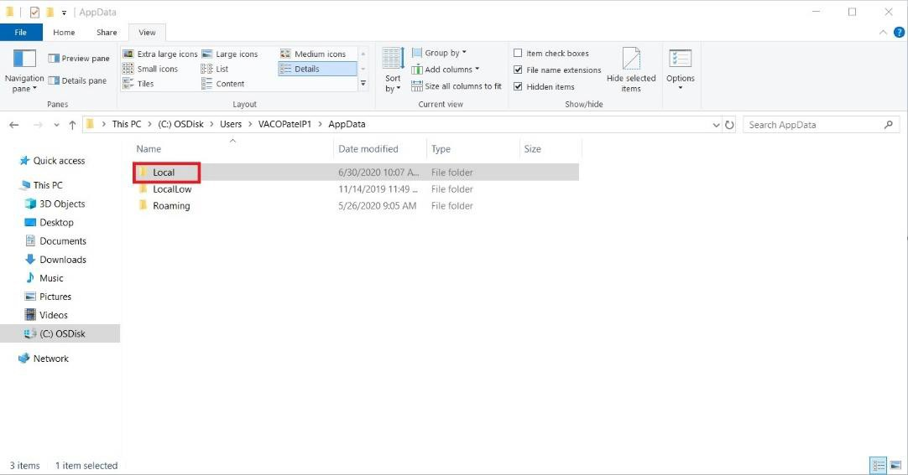
Figure 34: Navigating To Local Folder

- Locate and double click on the “VA VistA Scheduler” folder.

Note: This folder will only be created by VSE once VSE has been started for the first time.

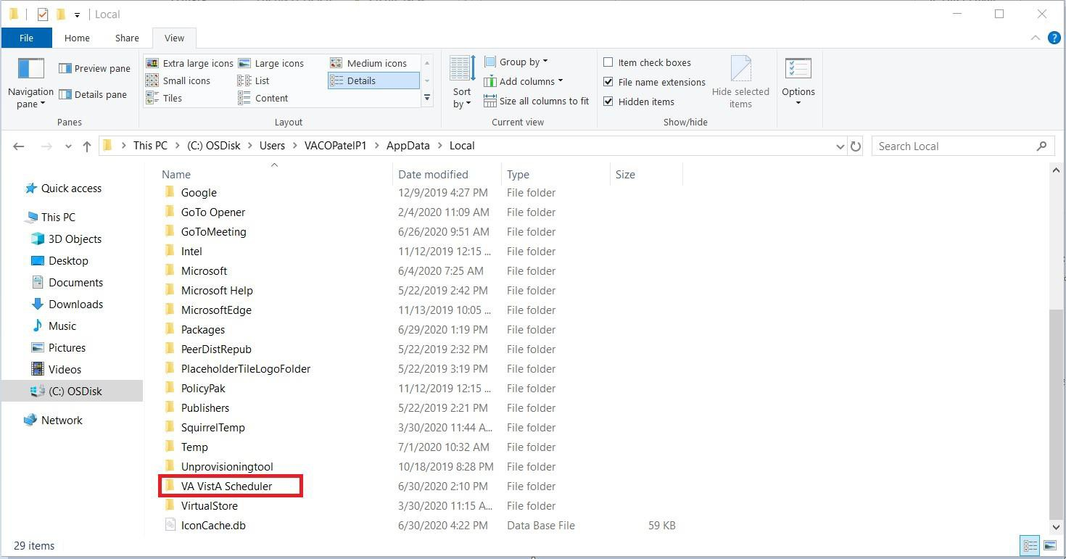
Figure 35: Navigating To VA Vista Scheduler Folder

- In the “VA VistA Scheduler” folder, you should find a file called “VS_GUI_Application” file with a .log extension and other corresponding trace logs. Each trace log will be labeled with the date in the format: VSETraceLog-YYYYMMDD_timelastused. The system will keep up to seven days of trace logs in this folder. If the user needs to open the file, they may need to tell the system what application to use. Notepad is suggested in most circumstances.

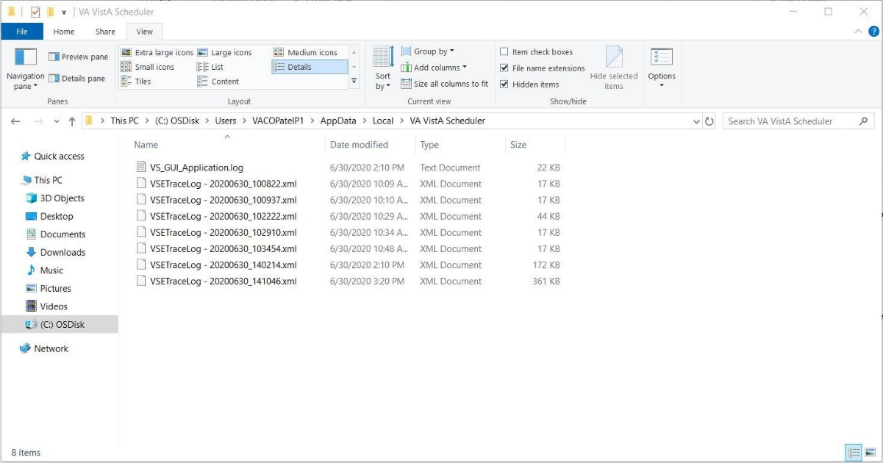
Figure 36: List Of Trace Log Files

Clinic ID Required Message Due to Clinic Abbreviation
When the user attempts to create a Recall/ PtCSch request in VSE, the clinic field does not handle clinic abbreviations that are the same as the starting characters of the clinic name only the second half of the clinic name is populated in the Clinic field. When a clinic abbreviation with a symbol is entered, both the abbreviation and clinic name are populated in the Clinic field and the user gets a "Clinic ID Required" message because the abbreviation is not supposed to populate the Clinic field.
- Message user gets when an invalid clinic is selected.

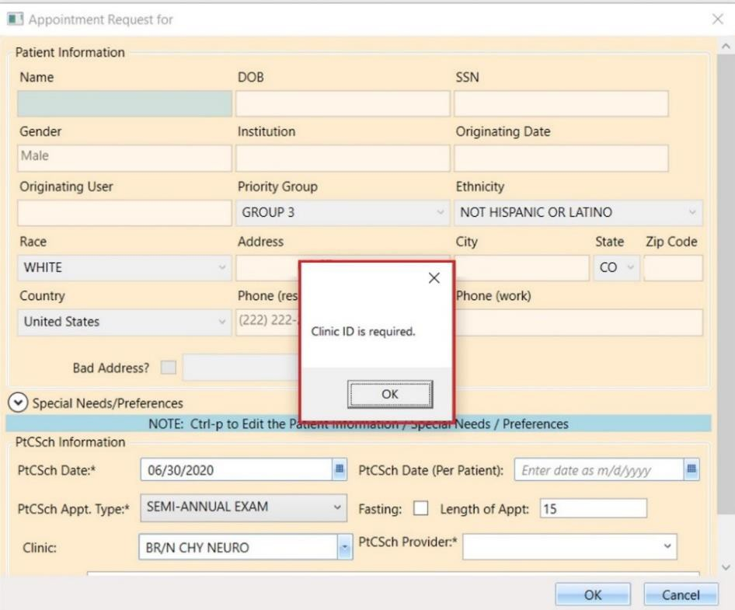
Figure 37: Message User Gets When An Invalid Clinic Is Selected

- When the abbreviation (BR/N) is different from the clinic name (CHY NEURO) but contains a symbol, both the abbreviation and clinic names are incorrectly populated. Only the clinic name should remain in the Clinic Field.

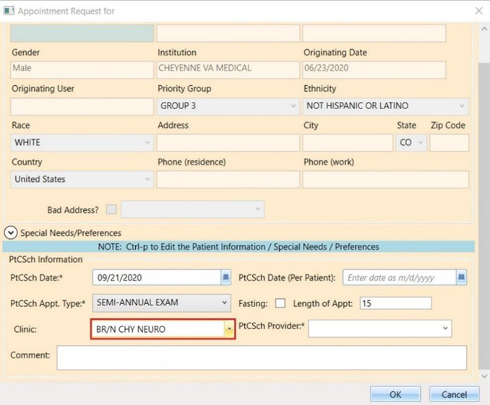
Figure 38: Appointment Request – When Abbreviation (BR/N) Is Different From The Clinic Name (CHY NEURO)

If that is the case, the user should search by only the clinic name (CHY NEURO):

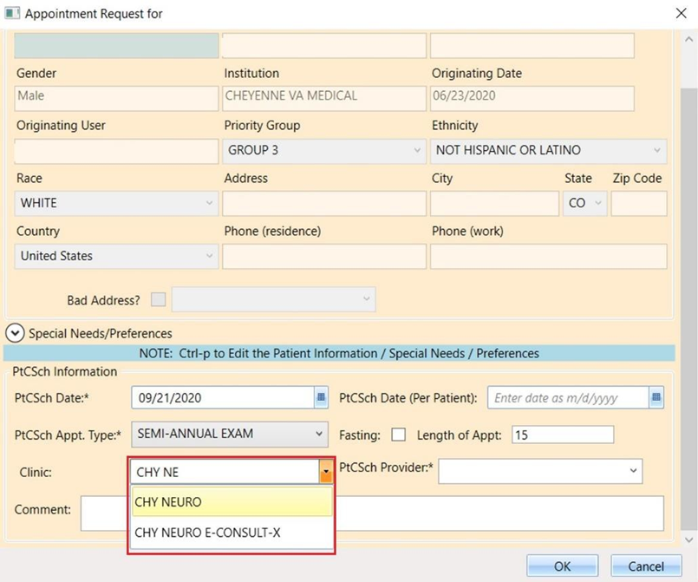
Figure 39: Appointment Request -User Should Search By Only The Clinic Name (CHY NEURO)

- Clinic field shows both the abbreviation (VSE/SPE) and the clinic name (VSE/SPECIALCHARNOLOWER) when an abbreviation with a symbol is used to search for the clinic. In this case because the abbreviation matches the first part of the clinic name, the user would have to enter the Recall/ PtCSch request through VistA. (This also happens to other requests created in VSE).
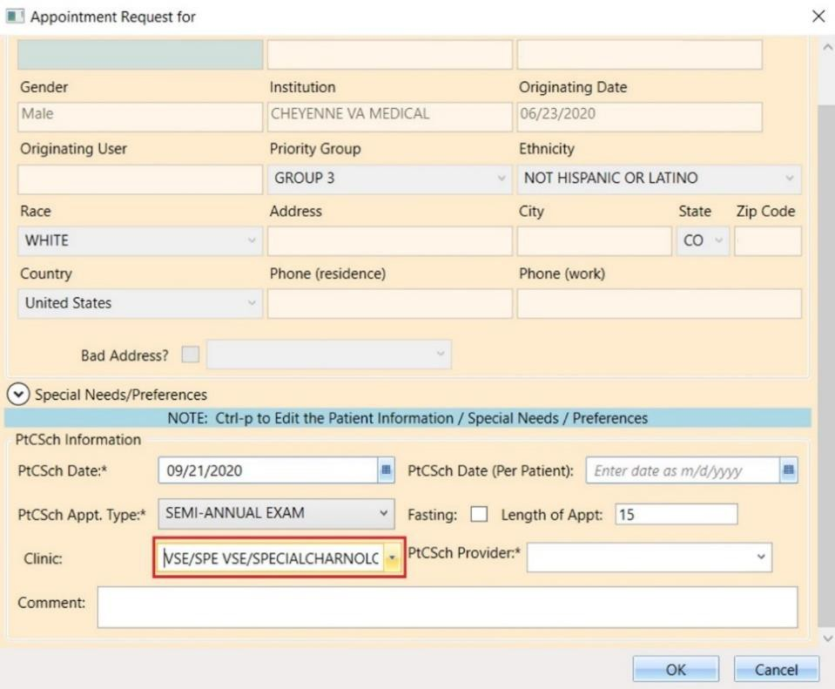
Figure 40: Appointment Request - When An Abbreviation With A Symbol Is Used To Search For The Clinic

If the user attempts to enter the clinic name when the abbreviation that contains a space and is also matching the name of the clinic, then the clinic name becomes truncated. The characters equivalent to the abbreviation are removed from the clinic name. (This also happens to other requests created in VSE).

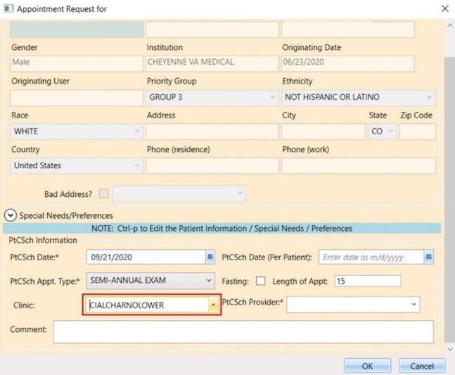
Figure 41: Appointment Request - Showing The Clinic Name Truncated

