

# VS GUI User Guide Addendum

Release 1.7.25.0 Update

Revision History

| Date | Revision | Description | Author |
| --- | --- | --- | --- |
| 06/15/2022 | 1.1 | Approved and finalized the document. | REDACTED  VSE PMO |
| 06/13/2022 | 1.0 | Created Release Documentation | REDACTED  Booz Allen Hamilton  VSE PMO |

Table of Contents

1 Introduction 4

1.1 Purpose 4

1.2 Overview 4

1.3 Disclaimers 4

1.3.1 Software Disclaimers 4

1.3.2 Documentation Disclaimers 4

1.4 Project References 5

1.4.1 Information 5

2 System Summary 6

3 Key Feature Update in Version 1.7.25.0 7

3.1 Verifying Demographics 7

3.2 Order Locked Notification 8

3.3 Sort Feature for Clinic Groups 8

List of Figures

Figure 1: Verify Demographics from the Patient Info Window 7

Figure 2: View/Update Demographics at the Check-in Window 8

Figure 3: Order Locked Notification Pop-up Window 8

Figure 4: Sorting Clinics Groups 9

### Introduction

Department of Veterans Affairs (VA) Veterans Health Information Systems and Technology Architecture (VistA) Scheduling Graphical User Interface (VS GUI) module is the Windows GUI version of the Patient Information Management System (PIMS) Scheduling module. It provides appointment management functions included in PIMS Scheduling, but with the added convenience and usability of a GUI.

#### Purpose

The Veterans Health Administration (VHA) Office of Veterans Access to Care (OVAC) requested an enterprise enhancement for the VS package that supports COVID-19 response. The enhancement reduces operating costs for VHA and improves operational efficiencies, resulting in patient-centered access to care, coordinated care, increased customer satisfaction, and the reduction of excessive cycle/wait time for scheduling patients.

#### Overview

VS GUI is a software module that allows schedulers to make appointments quickly by viewing multiple appointment request types and multiple clinics in one screen. A scheduler can easily view patient requests for service, find the next available open appointment, view the provider’s availability in multiple clinics, and track a patient’s appointment process. Refer to System Summary for a more detailed description of VS GUI functionality.

#### Disclaimers

##### Software Disclaimers

This software was developed at the Department of Veterans Affairs (VA) by employees of the Federal Government in the course of their official duties. Pursuant to title 17 Section 105 of the United States Code this software is not subject to copyright protection and is in the public domain. VA assumes no responsibility whatsoever for its use by other parties, and makes no guarantees, expressed or implied, about its quality, reliability, or any other characteristic. We would appreciate acknowledgement if the software is used. This software can be redistributed and/or modified freely if any derivative works bear some notice that they are derived from it, and any modified versions bear some notice that they have been modified.

##### Documentation Disclaimers

The appearance of external hyperlink references in this manual does not constitute endorsement by the Department of Veterans Affairs (VA) of this Web site or the information, products, or services contained therein. The VA does not exercise any editorial control over the information you may find at these locations. Such links are provided and are consistent with the stated purpose of the VA.

#### Project References

##### Information

The VS GUI points of contact (POCs) include:

* OVAC Program Office – REDACTED
* TeleHealth & Scheduling Technical Manager – REDACTED
* OVAC Emerging Technologies Acting Legacy Program Manager – REDACTED
* OVAC Emerging Technologies VSE Subject Matter Expert (SME) – REDACTED

VSE Resources

* Veterans Health Administration (VHA) VSE SharePoint: REDACTED
* [VA Software Document Library (VDL) – Scheduling (VSE manuals near the bottom)](https://www.va.gov/vdl/application.asp?appid=100)
* National Return to Clinic (RTC) Order: REDACTED

### System Summary

The VSE project delivers a series of enhancements to legacy VistA Scheduling Version 5.3 via the VS GUI application.

This update is for the nationally released version 1.7.25.0, which includes VS GUI 1.7.25.0 and VistA patch SD*5.3*816. At time of publishing, install period is projected for June 2022.

VS GUI Release 1.7.25.0 contains several improvements to scheduling functionality. As of this release, users are prevented from scheduling an appointment from an RTC order that is locked by another user and will instead receive a message that the order is being edited. This release also adds a “Verify” button on the Patient Information window, which allows users to review and verify demographics are correct with no changes and provides a button to Edit Demographics for patients who show “Needs Update” next to Demographics on the Check-In window.

In addition to these changes, VS GUI 1.7.25.0 includes back-end updates to support future functionality, and corrects an issue where drag-and-drop in the clinic groups “Sort” window caused the GUI to crash for large clinic groups.

The following sections detail user-facing functionality changes. Please see the Version Description Document (VDD) for a full account of all back-end and front-end changes with this release.

### Key Feature Update in Version 1.7.25.0

#### Verifying Demographics

As of this release, users will have the ability to verify a patient’s demographics. This addition mirrors the patient experience that allows the user to indicate the existing demographics information is accurate (verified).

Screenshot showing Patient info Window with the addition of the "Verify Demographics" Button where it will give the users the ability to verify the patient information 

Figure 1: Verify Demographics from the Patient Info Window

There is also now an option for the user to view or update patient demographics at the check-in window if demographics are marked as “needs update.”

Screenshot showing View/Update Demographics availability in the Appointment Check-In Window

Figure 2: View/Update Demographics at the Check-in Window

#### Order Locked Notification

As of this release, a notification will be displayed if an appointment cannot be scheduled because it is locked by another user.

Screenshot showing Order Locked Notification Pop-up Window

Figure 3: Order Locked Notification Pop-up Window

#### Sort Feature for Clinic Groups

This release corrects an error where when trying to sort clinics, VSE shuts down as soon as you select a clinic to drag and drop in the correct order. This fix pertains to the sorting of Clinic Groups.

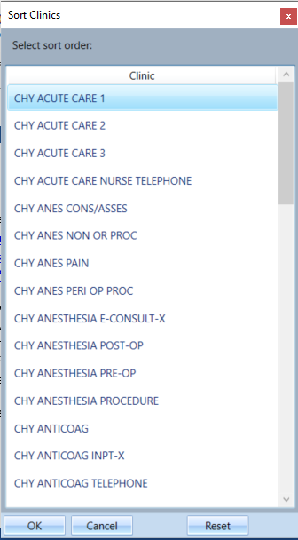

Figure 4: Sorting Clinics Groups