

# VS GUI User Guide Addendum

Release 1.7.26.1 Update

Revision History

| Date | Revision | Description | Author |
| --- | --- | --- | --- |
| 07/12/2022 | 1.1 | Incremented release version to VS GUI 1.7.26.1 | REDACTED  VSE PMO |
| 07/05/2022 | 1.0 | Created Release Documentation | REDACTED  VSE PMO |

Table of Contents

1 Introduction 4

1.1 Purpose 4

1.2 Overview 4

1.3 Disclaimers 4

1.3.1 Software Disclaimers 4

1.3.2 Documentation Disclaimers 4

1.4 Project References 5

1.4.1 Information 5

2 System Summary 6

3 Key Feature Update in Version 1.7.26.1 7

3.1 Visual Indicator for Overbook and Unavailable 7

3.2 Revised MISSION Act Eligibility Notice 7

3.3 Cancel Option Added for Sensitive Records 8

3.4 Display Duration Field on Appointment Edit Form 8

List of Figures

Figure 1: Example of time slot for Overbook (top) and Unavailable (bottom). 7

Figure 2: Revised MISSION Act Eligibility verbiage displayed in this image. 7

Figure 3: Cancel button added. 8

Figure 4: Image of disabled Duration field. 8

### Introduction

Department of Veterans Affairs (VA) Veterans Health Information Systems and Technology Architecture (VistA) Scheduling Graphical User Interface (VS GUI) module is the Windows GUI version of the Patient Information Management System (PIMS) Scheduling module. It provides appointment management functions included in PIMS Scheduling, but with the added convenience and usability of a GUI.

#### Purpose

The Veterans Health Administration (VHA) Office of Veterans Access to Care (OVAC) requested an enterprise enhancement for the VS package that supports COVID-19 response. The enhancement reduces operating costs for VHA and improves operational efficiencies, resulting in patient-centered access to care, coordinated care, increased customer satisfaction, and the reduction of excessive cycle/wait time for scheduling patients.

#### Overview

VS GUI is a software module that allows schedulers to make appointments quickly by viewing multiple appointment request types and multiple clinics in one screen. A scheduler can easily view patient requests for service, find the next available open appointment, view the provider’s availability in multiple clinics, and track a patient’s appointment process. Refer to System Summary for a more detailed description of VS GUI functionality.

#### Disclaimers

##### Software Disclaimers

This software was developed at the Department of Veterans Affairs (VA) by employees of the Federal Government in the course of their official duties. Pursuant to title 17 Section 105 of the United States Code this software is not subject to copyright protection and is in the public domain. VA assumes no responsibility whatsoever for its use by other parties, and makes no guarantees, expressed or implied, about its quality, reliability, or any other characteristic. We would appreciate acknowledgement if the software is used. This software can be redistributed and/or modified freely if any derivative works bear some notice that they are derived from it, and any modified versions bear some notice that they have been modified.

##### Documentation Disclaimers

The appearance of external hyperlink references in this manual does not constitute endorsement by the Department of Veterans Affairs (VA) of this website or the information, products, or services contained therein. The VA does not exercise any editorial control over the information you may find at these locations. Such links are provided and are consistent with the stated purpose of the VA.

#### Project References

##### Information

The VS GUI points of contact (POCs) include:

* OVAC Program Office – REDACTED
* TeleHealth & Scheduling Technical Manager – REDACTED
* OVAC Emerging Technologies Acting Legacy Program Manager – REDACTED
* OVAC Emerging Technologies VSE Subject Matter Expert (SME) – REDACTED

VSE Resources

* Veterans Health Administration (VHA) VSE SharePoint: REDACTED
* VA Software Document Library (VDL) – Scheduling (VSE manuals near the bottom): REDACTED
* National Return to Clinic (RTC) Order: REDACTED

### System Summary

The VSE project delivers a series of enhancements to legacy VistA Scheduling Version 5.3 via the VS GUI application.

This update is for the nationally released version 1.7.26.1, which includes VS GUI 1.7.26.1 and VistA patch SD*5.3*818. At time of publishing, install period is projected for July 2022.

VistA Scheduling (VS) Graphical User Interface (GUI) Release 1.7.26.1 and SD*5.3*818 primarily consists of back-end changes not visible to the user. These include an additional visual indicator within the calendar to acknowledge overbook or unavailable time slots. This release disabled the duration field on the appointment edit form, which now prevents users from changing the duration of an appointment. The verbiage on the MISSION Act Eligibility notice is updated to clearly advise it is for wait time eligibility only as opposed to any of the MISSION Act Eligibility criteria. This release addresses sensitive patient functionality by providing a user the option to back out of or acknowledge a sensitive record before it is loaded. This release corrects issues where the calendar was not opening if more than 25 requests were in the RM grid, and where the GUI would crash when cancelling appointments. Additionally, the originating user field in the View/Edit Request window has been fixed to show the originating user as opposed to the logged in user, and the calculation for Arizona time zone on VVC appointments has been corrected. VS GUI release 1.7.26.1 contains several back-end updates to support future functionality and refactor current architecture to improve operation.

Please see the Version Description Document (VDD) for a full account of all back end and/or front-end changes with this release. The following sections capture key features for this release.

### Key Feature Update in Version 1.7.26.1

#### Visual Indicator for Overbook and Unavailable

With this release, users will have a visual indication besides color to let them know if a timeslot is in Overbook or Unavailable. The key is at the bottom of the Schedules grid, and when the time slot is selected, the appropriate key will be labeled as highlighted in the image below.

Screenshot:  Example of time slot for Overbook (top) and Unavailable (bottom)

Figure 1: Example of time slot for Overbook (top) and Unavailable (bottom).

#### Revised MISSION Act Eligibility Notice

The verbiage displayed in the notification that the appointment is Mission Act eligible has been revised to the below. Additionally, the calculation for determining Mission Act eligibility has been updated.

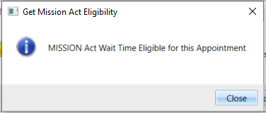

Figure 2: Revised MISSION Act Eligibility verbiage displayed.

**NOTE: This pop up is specific to wait time eligibility only and is not considering or reviewing for other community care eligibility criteria, as outlined in the MISSION Act.**

#### Cancel Option Added for Sensitive Records

Users will have the ability to back out or continue after selecting a patient with a sensitive record. The cancel functionality will allow the user to cancel the request without loading the information.

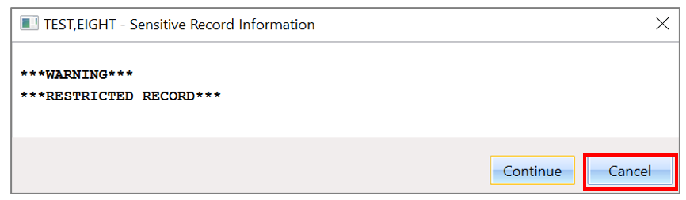

Figure 3: Cancel button added.

#### Display Duration Field on Appointment Edit Form

The Duration field on the appointment edit form has been disabled to prevent users from changing the appointment duration.

Screenshot of Image of Disabled Duration Field

Figure 4: Image Of Disabled Duration Field.