VS GUI User Guide Addendum
  - Release 1.7.27.1 Update

Revision History
Date | Revision | Description | Author
07/20/2022 | 1.1 | Incremented release version to VS GUI 1.7.27.1 | REDACTED  VSA PMO
07/18/2022 | 1.0 | Create Release Documentation | REDACTED  VSE PMO

Table of Contents
1 Introduction 4
1.1 Purpose 4
1.2 Overview 4
1.3 Disclaimers 4
1.3.1 Software Disclaimers 4
1.3.2 Documentation Disclaimers 4
1.4 Project References 5
1.4.1 Information 5
2 System Summary 6
3 Key Feature Update in Version 1.7.27.1 7
3.1 Adds “Day” View to User Preferences 7

List of Figures
Figure 1: Example of “Day” option (top) and “Day” view (bottom). 7

Introduction
Department of Veterans Affairs (VA) Veterans Health Information Systems and Technology Architecture (VistA) Scheduling Graphical User Interface (VS GUI) module is the Windows GUI version of the Patient Information Management System (PIMS) Scheduling module. It provides appointment management functions included in PIMS Scheduling, but with the added convenience and usability of a GUI.

Purpose
The Veterans Health Administration (VHA) Office of Veterans Access to Care (OVAC) requested an enterprise enhancement for the VS package that supports COVID-19 response. The enhancement reduces operating costs for VHA and improves operational efficiencies, resulting in patient-centered access to care, coordinated care, increased customer satisfaction, and the reduction of excessive cycle/wait time for scheduling patients.

Overview
VS GUI is a software module that allows schedulers to make appointments quickly by viewing multiple appointment request types and multiple clinics in one screen. A scheduler can easily view patient requests for service, find the next available open appointment, view the provider’s availability in multiple clinics, and track a patient’s appointment process. Refer to System Summary for a more detailed description of VS GUI functionality.

Disclaimers

Software Disclaimers
This software was developed at the Department of Veterans Affairs (VA) by employees of the Federal Government in the course of their official duties. Pursuant to title 17 Section 105 of the United States Code this software is not subject to copyright protection and is in the public domain. VA assumes no responsibility whatsoever for its use by other parties, and makes no guarantees, expressed or implied, about its quality, reliability, or any other characteristic. We would appreciate acknowledgement if the software is used. This software can be redistributed and/or modified freely if any derivative works bear some notice that they are derived from it, and any modified versions bear some notice that they have been modified.

Documentation Disclaimers
The appearance of external hyperlink references in this manual does not constitute endorsement by the Department of Veterans Affairs (VA) of this website or the information, products, or services contained therein. The VA does not exercise any editorial control over the information you may find at these locations. Such links are provided and are consistent with the stated purpose of the VA.

Project References

Information
The VS GUI points of contact (POCs) include:
- OVAC Program Office – REDACTED
- TeleHealth & Scheduling Technical Manager – REDACTED
- OVAC Emerging Technologies Acting Legacy Program Manager – REDACTED
- OVAC Emerging Technologies VSE Subject Matter Expert (SME) – REDACTED

VSE Resources
- Veterans Health Administration (VHA) VSE SharePoint: - REDACTED
- VA Software Document Library (VDL) – Scheduling (VSE manuals near the bottom):
- National Return to Clinic (RTC) Order: - REDACTED

System Summary
The VSE project delivers a series of enhancements to legacy VistA Scheduling Version 5.3 via the VistA Scheduling (VS) Graphical User Interface (GUI) application.
This update is for the nationally released version 1.7.27.1 which includes VS GUI 1.7.27.1/VistA patch SD*5.3*819 and MBAA*1*12. At time of publishing, the install period is projected for August 2022.
VS GUI Release 1.7.27.1/SD*5.3*819 and MBAA*1*12 contains a few improvements to scheduling functionality. Users will now have the option to set a preferred calendar view as part of their default user preferences. Calendar accessibility has been further improved so that screen-reading software will advise the user when the calendar has been loaded, as well as advise which specific calendar view the user is currently working in. What’s more, users may now open the Context Menu from the keyboard. This release fixes an issue where the GUI freezes or crashes when adding a user to a prohibited clinic and fixes slowness caused by large lists of privileged users for restricted clinics.
In addition to these changes, VS GUI release 1.7.27.1/SD*5.3*819 and MBAA*1*12 contains several back-end updates not visible to the user. These include Remote Procedure Call (RPC) updates to support future functionality, as well as RPC updates to correct an error processing EAS tracking numbers and update the user profile RPC to return all security keys and menu options. Finally, this release contains the addition of a modality field in the appointment request file.
Please see the Version Description Document (VDD) for a full account of all back end and/or front-end changes with this release. The following sections capture key features for this release.

Key Feature Update in Version 1.7.27.1

Adds “Day” View to User Preferences
With this release, users will now have the option within User Preferences to set a default calendar view. If a user selects the “Day” option, for example, the calendar will always load in the “Day” view.

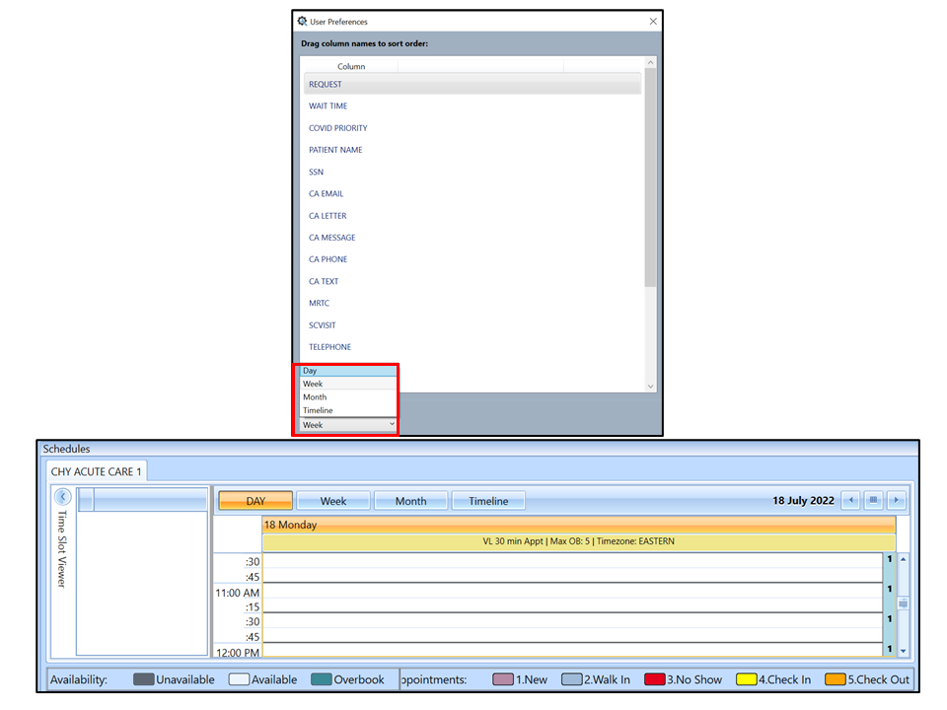
Figure 1: Example of “Day” option (top) and “Day” view (bottom).

