VS GUI User Guide Addendum
  - Release 1.7.29.0 Update

Revision History
Date | Revision | Description | Author
09/1/2022 | 1.1 | Reviewed and approved | REDACTED  VSE PMO
09/1/2022 | 1.0 | Created Release Documentation | REDACTED  VSE PMO

Table of Contents
1 Introduction 4
1.1 Purpose 4
1.2 Overview 4
1.3 Disclaimers 4
1.3.1 Software Disclaimers 4
1.3.2 Documentation Disclaimers 4
1.4 Project References 5
1.4.1 Information 5
2 System Summary 6
3 Key Feature Update in Version 1.7.29.0 7
3.1 Updates Preferred Gender and Gender to Gender Identity and Birth Sex 7
3.2 Adjusts Walk-In Appointment Type to Automatically Generate Appointment Request 7
3.3 Modifies SSN in VS GUI to only Display Last 4 of SSN 8
3.4 Adds Timestamp to Patient Friendly Appointment List 8

List of Figures
Figure 1: Renamed Preferred Gender And Gender To Gender Identity And Birth Sex 7
Figure 2: Creating Walk-In Appointment Will Automatically Generate Appointment Request. 7
Figure 3: VS GUI Now Only Shows Only The Last 4 Of SSN. 8
Figure 4: Addition Of Timestamp to Patient Friendly Appointment List. 8

Introduction
Department of Veterans Affairs (VA) Veterans Health Information Systems and Technology Architecture (VistA) Scheduling Graphical User Interface (VS GUI) module is the Windows GUI version of the Patient Information Management System (PIMS) Scheduling module. It provides appointment management functions included in PIMS Scheduling, but with the added convenience and usability of a GUI.

Purpose
The Veterans Health Administration (VHA) Office of Veterans Access to Care (OVAC) requested an enterprise enhancement for the VS package that supports COVID-19 response. The enhancement reduces operating costs for VHA and improves operational efficiencies, resulting in patient-centered access to care, coordinated care, increased customer satisfaction, and the reduction of excessive cycle/wait time for scheduling patients.

Overview
VS GUI is a software module that allows schedulers to make appointments quickly by viewing multiple appointment request types and multiple clinics in one screen. A scheduler can easily view patient requests for service, find the next available open appointment, view the provider’s availability in multiple clinics, and track a patient’s appointment process. Refer to System Summary for a more detailed description of VS GUI functionality.

Disclaimers

Software Disclaimers
This software was developed at the Department of Veterans Affairs (VA) by employees of the Federal Government in the course of their official duties. Pursuant to title 17 Section 105 of the United States Code this software is not subject to copyright protection and is in the public domain. VA assumes no responsibility whatsoever for its use by other parties, and makes no guarantees, expressed or implied, about its quality, reliability, or any other characteristic. We would appreciate acknowledgement if the software is used. This software can be redistributed and/or modified freely if any derivative works bear some notice that they are derived from it, and any modified versions bear some notice that they have been modified.

Documentation Disclaimers
The appearance of external hyperlink references in this manual does not constitute endorsement by the Department of Veterans Affairs (VA) of this Web site or the information, products, or services contained therein. The VA does not exercise any editorial control over the information you may find at these locations. Such links are provided and are consistent with the stated purpose of the VA.

Project References

Information
The VS GUI points of contact (POCs) include:
- OVAC Program Office – REDACTED
- TeleHealth & Scheduling Technical Manager – REDACTED
- OVAC Emerging Technologies Acting Legacy Program Manager – REDACTED
- OVAC Emerging Technologies VSE Subject Matter Expert (SME) – REDACTED

VSE Resources
- Veterans Health Administration (VHA) VSE SharePoint: REDACTED
- VA Software Document Library (VDL) – Scheduling (VSE manuals near the bottom)
- VDL Archive
- National Return to Clinic (RTC) Order: REDACTED

System Summary
The VSE project delivers a series of enhancements to legacy VistA Scheduling Version 5.3 via the VS GUI application.
This update is for the nationally released version 1.7.29.0, which includes VS GUI 1.7.29.0 and VistA patch SD*5.3*823. At time of publishing, install period is projected for September 2022.
VS GUI release 1.7.29 contains several improvements to scheduling functionality, user interface and back-end logic. As of this release, the logic for walk-in appointments has been updated for efficiency. Additionally, users are now able to navigate the appointment calendar timeslots and the pending appointments grid using only the keyboard.
Display changes for VS GUI as of this release include Preferred Gender and Gender being changed to Gender Identity and Birth Sex as well as only the last four of SSNs being displayed. Also, the patient friendly appointment list now includes a timestamp to show when the list was printed. This release fixes a few issues discovered relating to privileged users and prohibited clinics as well an issue with MRTCs.
Finally, this release includes several new Remote Procedure Calls (RPC) as well as updated RPCs to support current and future functionality.

Key Feature Update in Version 1.7.29.0

Updates Preferred Gender and Gender to Gender Identity and Birth Sex
The field names Preferred Gender and Gender have been renamed to Gender Identity and Birth Sex to align with the VistA field names.
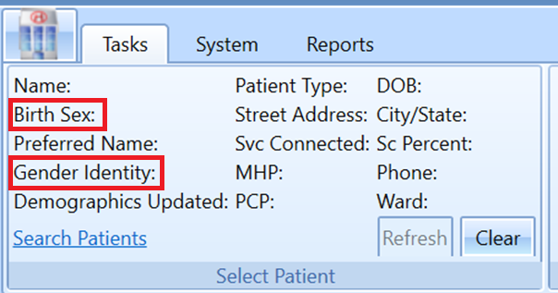
Figure 1: Renamed Preferred Gender And Gender To Gender Identity And Birth Sex

Adjusts Walk-In Appointment Type to Automatically Generate Appointment Request
As of this release, a user will be able to create a walk-in appointment without creating an appointment request. Creating the walk-in will automatically create and disposition the appointment request and check-in the patient.
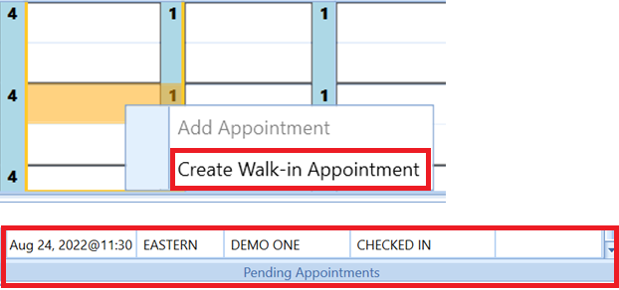
Figure 2: Creating Walk-In Appointment Will Automatically Generate Appointment Request.

Modifies SSN in VS GUI to only Display Last 4 of SSN
Only the last 4 of the SSN will now be displayed in VS GUI to comply with VHA Directive 2012-035.
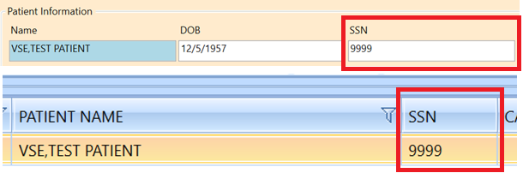
Figure 3: VS GUI Now Only Shows Only The Last 4 Of SSN.

Adds Timestamp to Patient Friendly Appointment List
As of this release, the patient friendly appointment list will have a timestamp so there is visibility to when the list was printed.
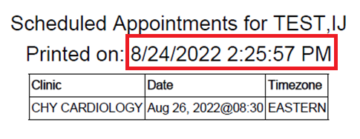
Figure 4: Addition Of Timestamp to Patient Friendly Appointment List.

