VS GUI User Guide Addendum
  - Release 1.7.32.2 Update

Revision History

Date | Revision | Description | Author
10/21/2022 | 1.0 | Created Release Documentation | REDACTED  VSE PMO
10/31/2022 | 1.1 | Updated the document to reflect VS GUI Increment 1.7.32.1 | REDACTED  VSE PMO
11/04/2022 | 1.2 | Updated the document to reflect VS GUI Increment 1.7.32.2 | REDACTED  VSE PMO

Table of Contents
1 Introduction 4
1.1 Purpose 4
1.2 Overview 4
1.3 Disclaimers 4
1.3.1 Software Disclaimers 4
1.3.2 Documentation Disclaimers 4
1.4 Project References 5
1.4.1 Information 5
2 System Summary 6
3 Key Feature Update in Version 1.7.32.2 7
3.1 Enables Context Menu Display for Veteran Appointment Requests 7
3.2 Ability to View Veteran Appointment Requests 8

List of Figures
Figure 1: Image Showing Disabled Edit Request Option In The Context Menu. 7
Figure 2: Image Of The Added Patient Comment Box Which Allows Up To 500 Characters. 8

Introduction
Department of Veterans Affairs (VA) Veterans Health Information Systems and Technology Architecture (VistA) Scheduling Graphical User Interface (VS GUI) module is the Windows GUI version of the Patient Information Management System (PIMS) Scheduling module. It provides appointment management functions included in PIMS Scheduling, but with the added convenience and usability of a GUI.

Purpose
The Veterans Health Administration (VHA) Office of Integrated Veteran Care (IVC) requested an enterprise enhancement for the VS package that supports COVID-19 response. The enhancement reduces operating costs for VHA and improves operational efficiencies, resulting in patient-centered access to care, coordinated care, increased customer satisfaction, and the reduction of excessive cycle/wait time for scheduling patients.

Overview
VS GUI is a software module that allows schedulers to make appointments quickly by viewing multiple appointment request types and multiple clinics in one screen. A scheduler can easily view patient requests for service, find the next available open appointment, view the provider’s availability in multiple clinics, and track a patient’s appointment process. Refer to System Summary for a more detailed description of VS GUI functionality.

Disclaimers

Software Disclaimers
This software was developed at the Department of Veterans Affairs (VA) by employees of the Federal Government in the course of their official duties. Pursuant to title 17 Section 105 of the United States Code this software is not subject to copyright protection and is in the public domain. VA assumes no responsibility whatsoever for its use by other parties, and makes no guarantees, expressed or implied, about its quality, reliability, or any other characteristic. We would appreciate acknowledgement if the software is used. This software can be redistributed and/or modified freely if any derivative works bear some notice that they are derived from it, and any modified versions bear some notice that they have been modified.

Documentation Disclaimers
The appearance of external hyperlink references in this manual does not constitute endorsement by the Department of Veterans Affairs (VA) of this Web site or the information, products, or services contained therein. The VA does not exercise any editorial control over the information you may find at these locations. Such links are provided and are consistent with the stated purpose of the VA.

Project References

Information
The VS GUI points of contact (POCs) include:
- IVC Program Office – REDACTED
- TeleHealth & Scheduling Technical Director – REDACTED
- IVC Emerging Technologies Acting Legacy Program Manager – REDACTED

VSE Resources
- Veterans Health Administration (VHA) VSE SharePoint: REDACTED
- VA Software Document Library (VDL) – Scheduling (VSE manuals near the bottom)
- National Return to Clinic (RTC) Order: REDACTED

System Summary
The VSE project delivers a series of enhancements to legacy VistA Scheduling Version 5.3 via the VistA Scheduling (VS) Graphical User Interface (GUI) application.
This update is for the nationally released version 1.7.32.2, which includes VS GUI 1.7.32.2 and VistA patch SD*5.3*826. At time of publishing, install period is projected for November 2022.
VS GUI Release 1.7.32.2 contains a few user facing updates but primarily consists of back-end changes not visible to the user. User facing updates include enabling the context menu for Veteran appointment requests and allowing Veteran appointment requests to be viewed in VS GUI. Additionally, the number of characters allowed in the patient search has been limited to 30 characters. The back-end changes include Remote Procedure Call (RPC) updates as well as several new RPCs created to support future functionality.

Key Feature Update in Version 1.7.32.2

Enables Context Menu Display for Veteran Appointment Requests
As of this release, the context menu for Veteran appointment requests is enabled. Veteran appointment requests cannot be edited, so the Edit Request option is disabled in the context menu for Veteran appointment requests.

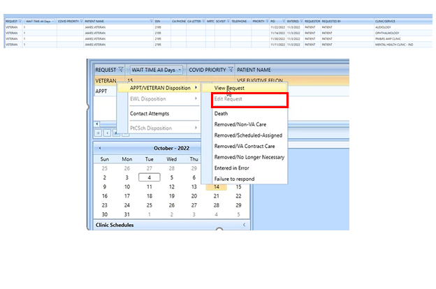
Figure 1: Image Showing Disabled Edit Request Option In The Context Menu.

Ability to View Veteran Appointment Requests
As of this release, Veteran appointment requests can be viewed from VS GUI. The view display also includes a Patient Comment field which allows up to 500 characters.

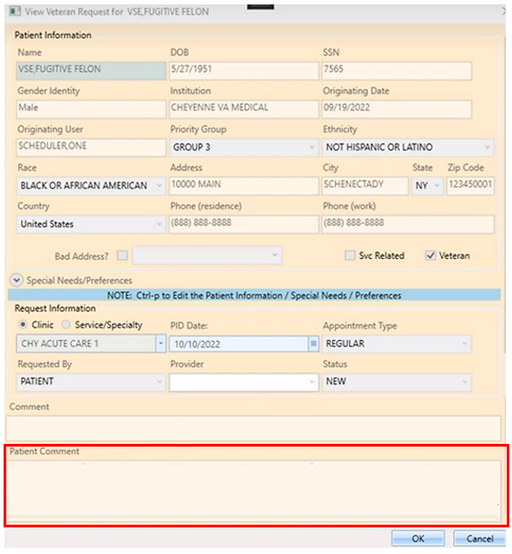
Figure 2: Image Of The Added Patient Comment Box Which Allows Up To 500 Characters.

