VS GUI User Guide Addendum
  - Release 1.7.8.2 Update

Revision History
Date | Revision | Description | Author
07/20/2021 | 1.4 | Increment release version to VS GUI 1.7.8.2 | VSE PMO  Liberty IT Solutions
07/13/2021 | 1.3 | Increment release version to VS GUI 1.7.8.1 | VSE PMO  Liberty IT Solutions
07/08/2021 | 1.2 | Updated document to remove VVS functionalities | VSE PMO  Liberty IT Solutions
07/07/2021 | 1.1 | Updated document to include VVS functionalities | VSE PMO  Liberty IT Solutions
07/06/2021 | 1.0 | Created Release Documentation | VSE PMO  Liberty IT Solutions

Table of Contents
1 Introduction 4
1.1 Purpose 4
1.2 Overview 4
1.3 Disclaimers 4
1.3.1 Software Disclaimers 4
1.3.2 Documentation Disclaimers 4
1.4 Project References 5
1.4.1 Information 5
2 System Summary 6
3 Key Feature Update in Version 1.7.8.2 6
3.1 Usability changes 6
3.1.1 Removed extra word from loading text 6
3.1.2 Updated Tooltips 7
3.1.3 Consolidated Windows 7
3.1.4 Corrected Expand/Collapse Indicator 8
3.2 Stuck MRTC Child Cleanup Tool 8

List of Figures
Figure 1: The Figure At The Top Shows The Prior Version Of VS GUI Clinic Loading Text And The Figure At The Bottom Shows The Newly Updated VS GUI Loading Text. 6
Figure 2: The Left Side Of The Figure Shows Prior Version Of VS GUI Tooltip And The Right Side Shows The Newly Updated VS GUI Tooltip. 7
Figure 3: The Left Side Of The Figure Shows Prior Version Of VS GUI Window And The Right Side Shows The Newly Updated VS GUI Window. 7
Figure 4: The Left Side Figure Shows What The Time Slot Viewer Looks Like On The Prior VS GUI Version Whereas The Figure On The Right Shows The Corrected Time Slot Viewer. 8
Figure 5: Running Stuck MRTC Child Cleanup Tool From The Supervisor Menu. 9

Introduction
Department of Veterans Affairs (VA) Veterans Health Information Systems and Technology Architecture (VistA) Scheduling Graphical User Interface (VS GUI) module is the Windows GUI version of the Patient Information Management System (PIMS) Scheduling module. It provides appointment management functions included in PIMS Scheduling, but with the added convenience and usability of a GUI.

Purpose
The Veterans Health Administration (VHA) Office of Veterans Access to Care (OVAC) requested an enterprise enhancement for the VS package that supports COVID-19 response. The enhancement reduces operating costs for VHA and improves operational efficiencies, resulting in patient-centered access to care, coordinated care, increased customer satisfaction, and the reduction of excessive cycle/wait time for scheduling patients.

Overview
VS GUI is a software module that allows schedulers to make appointments quickly by viewing multiple appointment request types and multiple clinics in one screen. A scheduler can easily view patient requests for service, find the next available open appointment, view the provider’s availability in multiple clinics, and track a patient’s appointment process. Refer to System Summary for a more detailed description of VS GUI functionality.

Disclaimers

Software Disclaimers
This software was developed at the Department of Veterans Affairs (VA) by employees of the Federal Government in the course of their official duties. Pursuant to title 17 Section 105 of the United States Code this software is not subject to copyright protection and is in the public domain. VA assumes no responsibility whatsoever for its use by other parties, and makes no guarantees, expressed or implied, about its quality, reliability, or any other characteristic. We would appreciate acknowledgement if the software is used. This software can be redistributed and/or modified freely if any derivative works bear some notice that they are derived from it, and any modified versions bear some notice that they have been modified.

Documentation Disclaimers
The appearance of external hyperlink references in this manual does not constitute endorsement by the Department of Veterans Affairs (VA) of this Web site or the information, products, or services contained therein. The VA does not exercise any editorial control over the information you may find at these locations. Such links are provided and are consistent with the stated purpose of the VA.

Project References

Information
The VS GUI points of contact (POCs) include:
- OVAC Program Office – REDACTED
- OIT VistA Scheduling Enhancement (VSE) Technical Manager – REDACTED
- OVAC Emerging Technologies Project Manager – REDACTED
- OVAC Emerging Technologies Acting Legacy Program Manager – REDACTED
- OVAC Emerging Technologies VSE Subject Matter Expert (SME) – REDACTED
- OVAC Emerging Technologies VSE Subject Matter Expert (SME) – REDACTED
- OVAC Emerging Technologies VSE Subject Matter Expert (SME) – REDACTED

VSE Resources
- Veterans Health Administration (VHA) VSE SharePoint: REDACTED
- VA Software Document Library (VDL) – Scheduling (VSE manuals near the bottom):
- National Return to Clinic (RTC) Order: REDACTED

System Summary
The VSE project delivers a series of enhancements to legacy VistA Scheduling Version 5.3 via the VS GUI application.
This update is for the nationally released version 1.7.8.2, which includes VS GUI 1.7.8.2 and Emergency VistA patch SD*5.3*788. At time of publishing, install period is projected for July 2021.
VS GUI Release 1.7.8.2 includes a number of usability enhancements, such as updating tooltips and loading text and consolidating windows to remove unnecessary tabs. It also includes improvements to application error handling and other back-end processes and corrects an issue where user preferences column order did not save correctly. The associated VistA patch provides a tool that scheduling supervisors can use to clear stuck Multiple Return To Clinic (MRTC) requests by Patient Indicated Date (PID) date range.
The following sections summarize visible changes to the front end of the application and provide instructions for using the MRTC Child Cleanup option in VistA.

Key Feature Update in Version 1.7.8.2

Usability changes

Removed extra word from loading text
In prior versions, the clinic loading text was not descriptive and included a repeated word. In this update, the repeated word is removed, and the clinic name is included in the loading text.
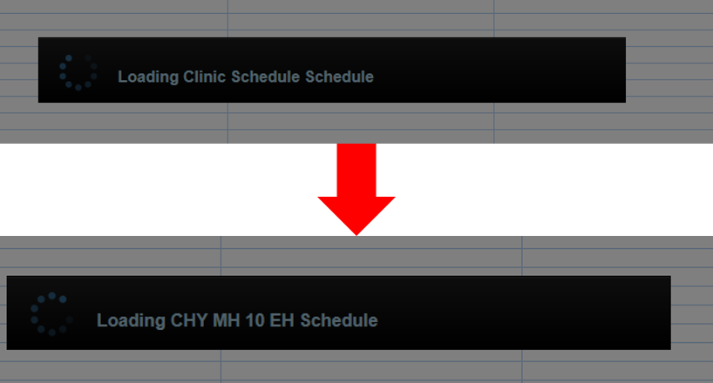
Figure 1: The Figure At The Top Shows The Prior Version Of VS GUI Clinic Loading Text And The Figure At The Bottom Shows The Newly Updated VS GUI Loading Text.

Updated Tooltips
In prior versions, the tooltips referenced a wait list and were not descriptive. In this update, the tooltips reference requests.
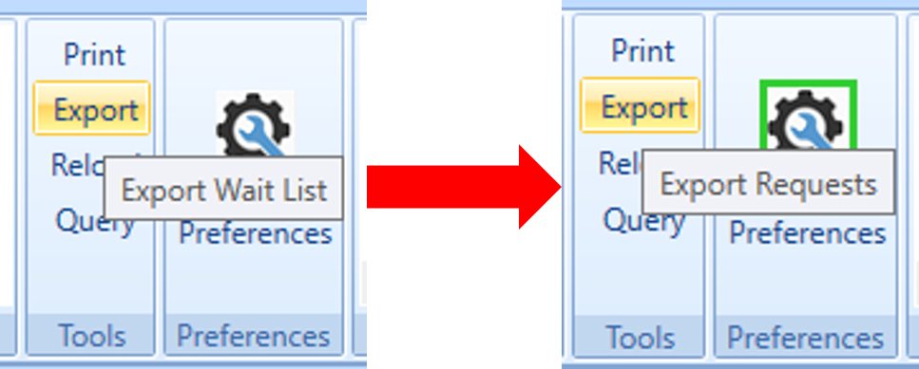
Figure 2: The Left Side Of The Figure Shows Prior Version Of VS GUI Tooltip And The Right Side Shows The Newly Updated VS GUI Tooltip.

Consolidated Windows
In prior versions, certain windows contained an unnecessary tab and cut off fields close to the edge of the window. In this update, the unnecessary tabs are removed, and sufficient space is allowed so that fields are not cut off.
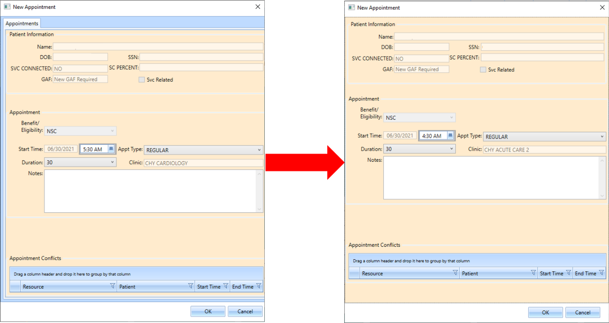
Figure 3: The Left Side Of The Figure Shows Prior Version Of VS GUI Window And The Right Side Shows The Newly Updated VS GUI Window.

Corrected Expand/Collapse Indicator
In prior versions, the expand/collapse indicator on the time slot viewer was reversed, so that the “open” button showed when the viewer was already open, and the “close” button showed when the viewer was already closed. In this update, the time slot viewer button is corrected to match the action of the user.
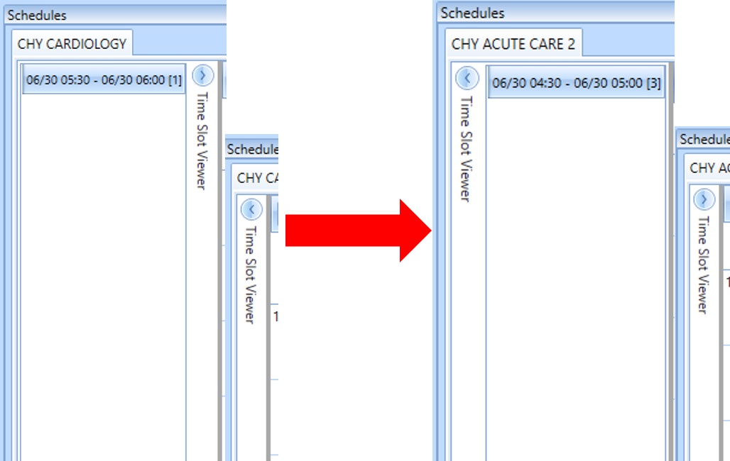
Figure 4: The Left Side Figure Shows What The Time Slot Viewer Looks Like On The Prior VS GUI Version Whereas The Figure On The Right Shows The Corrected Time Slot Viewer.

Stuck MRTC Child Cleanup Tool
The Stuck MRTC child cleanup tool option addresses a scenario where a child Return to Clinic (RTC) gets unlinked from the Parent RTC which usually causes the child to become stuck in the Release Manager (RM) grid. This option will close all children requests where the parent request is closed, but the child request is still in an open status. The option is available only to users with the SDSUP key.
To run the Stuck MRTC child cleanup tool option, navigate to the Scheduling Supervisor menu.
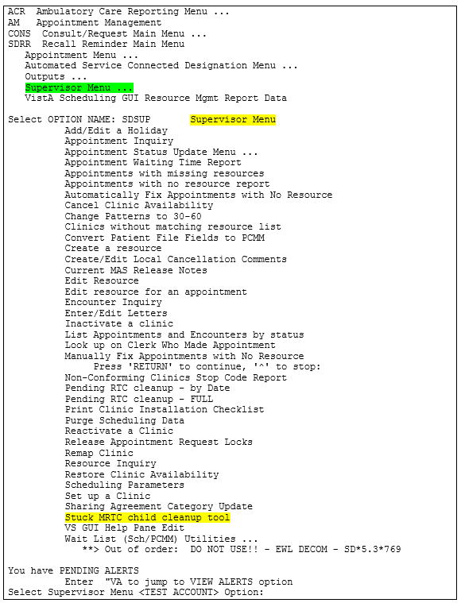
Figure 5: Running Stuck MRTC Child Cleanup Tool From The Supervisor Menu.
To run the Stuck MRTC Child cleanup tool, User will be prompted to confirm that you want to run the cleanup. Enter Y or N.
This OPTION will disposition those Return to Clinic Requests (RTC) that are in a status of OPEN when the parent is in a status of closed
Request that have a Patient Identified Date (PID) within the last 90 days (3/27/2021) will NOT be selected for cleanup.
Are you sure you would like to run the Stuck MRTC child cleanup tool? YES//
To run the cleanup tool, user will be prompted to enter a PID date, as shown below. This date has to be 90 days prior to the current date or earlier.
Enter a PID before or equal to 3/27/2021: 3/27/2021//
Enter a PID; all open children RTCs with a PID before or on the date entered and where the parent is currently closed will be closed.
User will then be prompted to whether they want to UPDATE or PRINT only.
Would you like to UPDATE the records? Enter 'N' to print only.? NO//
User will be prompted for DEVICE. Entering enter will print to screen.
Are you sure you would like to run the SDEC PENDING RTC clean-up? Y (Yes)
DEVICE: HOME// HOME (CRT) Right Margin: 80//

When complete, the option will print results to the screen.
Note: If an ORDER ID exists for the RTC, then the ORDER ID and the status will be printed.
Print Only:
Select Supervisor Menu <TEST ACCOUNT> Option: stuck MRTC child cleanup tool

This OPTION will disposition those Return to Clinic Requests (RTC) that are
in a status of OPEN when the parent is in a status of closed

Request that have a Patient Identified Date (PID) within the last 90 days
(3/31/2021) will NOT be selected for cleanup.

Are you sure you would like to run the Stuck MRTC child cleanup tool? YES//

Enter a PID before or equal to 3/31/2021: 3/31/2021// 03/15/2018 (MAR 15, 2018
)

Would you like to UPDATE the records? Enter 'N'o to print only.? NO//

DEVICE: HOME// HOME (CRT) Right Margin: 80//

Results from the Stuck MRTC child cleanup tool.

PATIENT = LAST4 =
MRTC PARENT = 162491
PARENT STATUS = CLOSED
PARENT DISPOSITION = MRTC PARENT CLOSED
MRTC CHILD = 162495
PID = FEB 10, 2018
BEFORE:
CHILD STATUS = OPEN
CHILD DISPOSITION =

PATIENT = LAST4 =
MRTC PARENT = 162508
PARENT STATUS = CLOSED
PARENT DISPOSITION = MRTC PARENT CLOSED
MRTC CHILD = 162510
PID = FEB 10, 2018
BEFORE:
CHILD STATUS = OPEN
CHILD DISPOSITION =

PATIENT = LAST4 =
MRTC PARENT = 162561
PARENT STATUS = CLOSED
PARENT DISPOSITION = MRTC PARENT CLOSED
MRTC CHILD = 162565
PID = FEB 07, 2018
BEFORE:
CHILD STATUS = OPEN
CHILD DISPOSITION =

PATIENT = LAST4 =
MRTC PARENT = 162611
PARENT STATUS = CLOSED
PARENT DISPOSITION = MRTC PARENT CLOSED
MRTC CHILD = 162613
PID = FEB 10, 2018
BEFORE:
CHILD STATUS = OPEN
CHILD DISPOSITION =

PATIENT = LAST4 =
MRTC PARENT = 162636
PARENT STATUS = CLOSED
PARENT DISPOSITION = MRTC PARENT CLOSED
MRTC CHILD = 162639
PID = FEB 10, 2018
BEFORE:
CHILD STATUS = OPEN
CHILD DISPOSITION =

PATIENT = LAST4 =
MRTC PARENT = 162653
PARENT STATUS = CLOSED
PARENT DISPOSITION = MRTC PARENT CLOSED
MRTC CHILD = 162655
PID = FEB 10, 2018
BEFORE:
CHILD STATUS = OPEN
CHILD DISPOSITION =

PATIENT = LAST4 =
MRTC PARENT = 162668
PARENT STATUS = CLOSED
PARENT DISPOSITION = MRTC PARENT CLOSED
MRTC CHILD = 162670
PID = FEB 10, 2018
BEFORE:
CHILD STATUS = OPEN
CHILD DISPOSITION =

PATIENT = LAST4 =
MRTC PARENT = 191355
PARENT STATUS = CLOSED
PARENT DISPOSITION = REMOVED/NO LONGER NECESSARY
MRTC CHILD = 191360
PID = FEB 12, 2018
BEFORE:
CHILD STATUS = OPEN
CHILD DISPOSITION =

PATIENT = LAST4 =
MRTC PARENT = 191355
PARENT STATUS = CLOSED
PARENT DISPOSITION = REMOVED/NO LONGER NECESSARY
MRTC CHILD = 191361
PID = FEB 26, 2018
BEFORE:
CHILD STATUS = OPEN
CHILD DISPOSITION =

PATIENT = LAST4 =
MRTC PARENT = 191876
PARENT STATUS = CLOSED
PARENT DISPOSITION = MRTC PARENT CLOSED
MRTC CHILD = 191880
PID = FEB 14, 2018
BEFORE:
CHILD STATUS = OPEN
CHILD DISPOSITION =

PATIENT = LAST4 =
MRTC PARENT = 196738
PARENT STATUS = CLOSED
PARENT DISPOSITION = MRTC PARENT CLOSED
MRTC CHILD = 196748
PID = MAR 12, 2018
BEFORE:
CHILD STATUS = OPEN
CHILD DISPOSITION =

PATIENT = LAST4 =
MRTC PARENT = 197269
PARENT STATUS = CLOSED
PARENT DISPOSITION = MRTC PARENT CLOSED
MRTC CHILD = 197277
PID = FEB 06, 2018
BEFORE:
CHILD STATUS = OPEN
CHILD DISPOSITION =

PATIENT = LAST4 =
MRTC PARENT = 199765
PARENT STATUS = CLOSED
PARENT DISPOSITION = MRTC PARENT CLOSED
MRTC CHILD = 199770
PID = FEB 14, 2018
BEFORE:
CHILD STATUS = OPEN
CHILD DISPOSITION =

PATIENT = LAST4 =
MRTC PARENT = 200498
PARENT STATUS = CLOSED
PARENT DISPOSITION = MRTC PARENT CLOSED
MRTC CHILD = 200501
PID = FEB 03, 2018
BEFORE:
CHILD STATUS = OPEN
CHILD DISPOSITION =

PATIENT = LAST4 =
MRTC PARENT = 203950
PARENT STATUS = CLOSED
PARENT DISPOSITION = MRTC PARENT CLOSED
MRTC CHILD = 203956
PID = FEB 12, 2018
BEFORE:
CHILD STATUS = OPEN
CHILD DISPOSITION =

PATIENT = LAST4 =
MRTC PARENT = 212123
PARENT STATUS = CLOSED
PARENT DISPOSITION = MRTC PARENT CLOSED
MRTC CHILD = 212129
PID = MAR 12, 2018
BEFORE:
CHILD STATUS = OPEN
CHILD DISPOSITION =

PATIENT = LAST4 =
MRTC PARENT = 229369
PARENT STATUS = CLOSED
PARENT DISPOSITION = REMOVED/NO LONGER NECESSARY
MRTC CHILD = 229370
PID = FEB 28, 2018
BEFORE:
CHILD STATUS = OPEN
CHILD DISPOSITION =

PATIENT = LAST4 =
MRTC PARENT = 229369
PARENT STATUS = CLOSED
PARENT DISPOSITION = REMOVED/NO LONGER NECESSARY
MRTC CHILD = 229371
PID = MAR 07, 2018
BEFORE:
CHILD STATUS = OPEN
CHILD DISPOSITION =

PATIENT = LAST4 =
MRTC PARENT = 229369
PARENT STATUS = CLOSED
PARENT DISPOSITION = REMOVED/NO LONGER NECESSARY
MRTC CHILD = 229372
PID = MAR 14, 2018
BEFORE:
CHILD STATUS = OPEN
CHILD DISPOSITION =

PATIENT = LAST4 =
MRTC PARENT = 229884
PARENT STATUS = CLOSED
PARENT DISPOSITION = MRTC PARENT CLOSED
MRTC CHILD = 229886
PID = FEB 20, 2018
BEFORE:
CHILD STATUS = OPEN
CHILD DISPOSITION =

PATIENT = LAST4 =
MRTC PARENT = 233295
PARENT STATUS = CLOSED
PARENT DISPOSITION = REMOVED/NO LONGER NECESSARY
MRTC CHILD = 233296
PID = MAR 05, 2018
BEFORE:
CHILD STATUS = OPEN
CHILD DISPOSITION =

PATIENT = LAST4 =
MRTC PARENT = 233295
PARENT STATUS = CLOSED
PARENT DISPOSITION = REMOVED/NO LONGER NECESSARY
MRTC CHILD = 233297
PID = MAR 12, 2018
BEFORE:
CHILD STATUS = OPEN
CHILD DISPOSITION =

PATIENT = LAST4 =
MRTC PARENT = 242990
PARENT STATUS = CLOSED
PARENT DISPOSITION = MRTC PARENT CLOSED
MRTC CHILD = 242997
PID = FEB 12, 2018
BEFORE:
CHILD STATUS = OPEN
CHILD DISPOSITION =

PATIENT = LAST4 =
ORDER ID = 10785072 COMPLETE
MRTC PARENT = 243283
PARENT STATUS = CLOSED
PARENT DISPOSITION = MRTC PARENT CLOSED
MRTC CHILD = 243308
PID = MAR 12, 2018
BEFORE:
CHILD STATUS = OPEN
CHILD DISPOSITION =

PATIENT = LAST4 =
MRTC PARENT = 244664
PARENT STATUS = CLOSED
PARENT DISPOSITION = MRTC PARENT CLOSED
MRTC CHILD = 244669
PID = FEB 02, 2018
BEFORE:
CHILD STATUS = OPEN
CHILD DISPOSITION =

Report finished.
25 requests were selected as needing updated.

Update and print:

Select Supervisor Menu <TEST ACCOUNT> Option: stuck MRTC child cleanup tool

This OPTION will disposition those Return to Clinic Requests (RTC) that are
in a status of OPEN when the parent is in a status of closed

Request that have a Patient Identified Date (PID) within the last 90 days
(3/31/2021) will NOT be selected for cleanup.

Are you sure you would like to run the Stuck MRTC child cleanup tool? YES//

Enter a PID before or equal to 3/31/2021: 3/31/2021// 03/15/2018 (MAR 15, 2018
)

Would you like to UPDATE the records? Enter 'N'o to print only.? NO// YES

DEVICE: HOME// HOME (CRT) Right Margin: 80//

Results from the Stuck MRTC child cleanup tool.

PATIENT = LAST4 =
MRTC PARENT = 162491
PARENT STATUS = CLOSED
PARENT DISPOSITION = MRTC PARENT CLOSED
MRTC CHILD = 162495
PID = FEB 10, 2018
BEFORE:
CHILD STATUS = OPEN
CHILD DISPOSITION =
AFTER:
CHILD STATUS = CLOSED
CHILD DISPOSITION = MRTC PARENT CLOSED

PATIENT = LAST4 =
MRTC PARENT = 162508
PARENT STATUS = CLOSED
PARENT DISPOSITION = MRTC PARENT CLOSED
MRTC CHILD = 162510
PID = FEB 10, 2018
BEFORE:
CHILD STATUS = OPEN
CHILD DISPOSITION =
AFTER:
CHILD STATUS = CLOSED
CHILD DISPOSITION = MRTC PARENT CLOSED

PATIENT = LAST4 =
MRTC PARENT = 162561
PARENT STATUS = CLOSED
PARENT DISPOSITION = MRTC PARENT CLOSED
MRTC CHILD = 162565
PID = FEB 07, 2018
BEFORE:
CHILD STATUS = OPEN
CHILD DISPOSITION =
AFTER:
CHILD STATUS = CLOSED
CHILD DISPOSITION = MRTC PARENT CLOSED

PATIENT = LAST4 =
MRTC PARENT = 162611
PARENT STATUS = CLOSED
PARENT DISPOSITION = MRTC PARENT CLOSED
MRTC CHILD = 162613
PID = FEB 10, 2018
BEFORE:
CHILD STATUS = OPEN
CHILD DISPOSITION =
AFTER:
CHILD STATUS = CLOSED
CHILD DISPOSITION = MRTC PARENT CLOSED

PATIENT = LAST4 =
MRTC PARENT = 162636
PARENT STATUS = CLOSED
PARENT DISPOSITION = MRTC PARENT CLOSED
MRTC CHILD = 162639
PID = FEB 10, 2018
BEFORE:
CHILD STATUS = OPEN
CHILD DISPOSITION =
AFTER:
CHILD STATUS = CLOSED
CHILD DISPOSITION = MRTC PARENT CLOSED

PATIENT = LAST4 =
MRTC PARENT = 162653
PARENT STATUS = CLOSED
PARENT DISPOSITION = MRTC PARENT CLOSED
MRTC CHILD = 162655
PID = FEB 10, 2018
BEFORE:
CHILD STATUS = OPEN
CHILD DISPOSITION =
AFTER:
CHILD STATUS = CLOSED
CHILD DISPOSITION = MRTC PARENT CLOSED

PATIENT = LAST4 =
MRTC PARENT = 162668
PARENT STATUS = CLOSED
PARENT DISPOSITION = MRTC PARENT CLOSED
MRTC CHILD = 162670
PID = FEB 10, 2018
BEFORE:
CHILD STATUS = OPEN
CHILD DISPOSITION =
AFTER:
CHILD STATUS = CLOSED
CHILD DISPOSITION = MRTC PARENT CLOSED

PATIENT = LAST4 =
MRTC PARENT = 191355
PARENT STATUS = CLOSED
PARENT DISPOSITION = REMOVED/NO LONGER NECESSARY
MRTC CHILD = 191360
PID = FEB 12, 2018
BEFORE:
CHILD STATUS = OPEN
CHILD DISPOSITION =
AFTER:
CHILD STATUS = CLOSED
CHILD DISPOSITION = REMOVED/NO LONGER NECESSARY

PATIENT = LAST4 =
MRTC PARENT = 191355
PARENT STATUS = CLOSED
PARENT DISPOSITION = REMOVED/NO LONGER NECESSARY
MRTC CHILD = 191361
PID = FEB 26, 2018
BEFORE:
CHILD STATUS = OPEN
CHILD DISPOSITION =
AFTER:
CHILD STATUS = CLOSED
CHILD DISPOSITION = REMOVED/NO LONGER NECESSARY

PATIENT = LAST4 =
MRTC PARENT = 191876
PARENT STATUS = CLOSED
PARENT DISPOSITION = MRTC PARENT CLOSED
MRTC CHILD = 191880
PID = FEB 14, 2018
BEFORE:
CHILD STATUS = OPEN
CHILD DISPOSITION =
AFTER:
CHILD STATUS = CLOSED
CHILD DISPOSITION = MRTC PARENT CLOSED

PATIENT = LAST4 =
MRTC PARENT = 196738
PARENT STATUS = CLOSED
PARENT DISPOSITION = MRTC PARENT CLOSED
MRTC CHILD = 196748
PID = MAR 12, 2018
BEFORE:
CHILD STATUS = OPEN
CHILD DISPOSITION =
AFTER:
CHILD STATUS = CLOSED
CHILD DISPOSITION = MRTC PARENT CLOSED

PATIENT = LAST4 =
MRTC PARENT = 197269
PARENT STATUS = CLOSED
PARENT DISPOSITION = MRTC PARENT CLOSED
MRTC CHILD = 197277
PID = FEB 06, 2018
BEFORE:
CHILD STATUS = OPEN
CHILD DISPOSITION =
AFTER:
CHILD STATUS = CLOSED
CHILD DISPOSITION = MRTC PARENT CLOSED

PATIENT = LAST4 =
MRTC PARENT = 199765
PARENT STATUS = CLOSED
PARENT DISPOSITION = MRTC PARENT CLOSED
MRTC CHILD = 199770
PID = FEB 14, 2018
BEFORE:
CHILD STATUS = OPEN
CHILD DISPOSITION =
AFTER:
CHILD STATUS = CLOSED
CHILD DISPOSITION = MRTC PARENT CLOSED

PATIENT = LAST4 =
MRTC PARENT = 200498
PARENT STATUS = CLOSED
PARENT DISPOSITION = MRTC PARENT CLOSED
MRTC CHILD = 200501
PID = FEB 03, 2018
BEFORE:
CHILD STATUS = OPEN
CHILD DISPOSITION =
AFTER:
CHILD STATUS = CLOSED
CHILD DISPOSITION = MRTC PARENT CLOSED

PATIENT = LAST4 =
MRTC PARENT = 203950
PARENT STATUS = CLOSED
PARENT DISPOSITION = MRTC PARENT CLOSED
MRTC CHILD = 203956
PID = FEB 12, 2018
BEFORE:
CHILD STATUS = OPEN
CHILD DISPOSITION =
AFTER:
CHILD STATUS = CLOSED
CHILD DISPOSITION = MRTC PARENT CLOSED

PATIENT = LAST4 =
MRTC PARENT = 212123
PARENT STATUS = CLOSED
PARENT DISPOSITION = MRTC PARENT CLOSED
MRTC CHILD = 212129
PID = MAR 12, 2018
BEFORE:
CHILD STATUS = OPEN
CHILD DISPOSITION =
AFTER:
CHILD STATUS = CLOSED
CHILD DISPOSITION = MRTC PARENT CLOSED

PATIENT = LAST4 =
MRTC PARENT = 229369
PARENT STATUS = CLOSED
PARENT DISPOSITION = REMOVED/NO LONGER NECESSARY
MRTC CHILD = 229370
PID = FEB 28, 2018
BEFORE:
CHILD STATUS = OPEN
CHILD DISPOSITION =
AFTER:
CHILD STATUS = CLOSED
CHILD DISPOSITION = REMOVED/NO LONGER NECESSARY

PATIENT = LAST4 =
MRTC PARENT = 229369
PARENT STATUS = CLOSED
PARENT DISPOSITION = REMOVED/NO LONGER NECESSARY
MRTC CHILD = 229371
PID = MAR 07, 2018
BEFORE:
CHILD STATUS = OPEN
CHILD DISPOSITION =
AFTER:
CHILD STATUS = CLOSED
CHILD DISPOSITION = REMOVED/NO LONGER NECESSARY

PATIENT = LAST4 =
MRTC PARENT = 229369
PARENT STATUS = CLOSED
PARENT DISPOSITION = REMOVED/NO LONGER NECESSARY
MRTC CHILD = 229372
PID = MAR 14, 2018
BEFORE:
CHILD STATUS = OPEN
CHILD DISPOSITION =
AFTER:
CHILD STATUS = CLOSED
CHILD DISPOSITION = REMOVED/NO LONGER NECESSARY

PATIENT = LAST4 =
MRTC PARENT = 229884
PARENT STATUS = CLOSED
PARENT DISPOSITION = MRTC PARENT CLOSED
MRTC CHILD = 229886
PID = FEB 20, 2018
BEFORE:
CHILD STATUS = OPEN
CHILD DISPOSITION =
AFTER:
CHILD STATUS = CLOSED
CHILD DISPOSITION = MRTC PARENT CLOSED

PATIENT = LAST4 =
MRTC PARENT = 233295
PARENT STATUS = CLOSED
PARENT DISPOSITION = REMOVED/NO LONGER NECESSARY
MRTC CHILD = 233296
PID = MAR 05, 2018
BEFORE:
CHILD STATUS = OPEN
CHILD DISPOSITION =
AFTER:
CHILD STATUS = CLOSED
CHILD DISPOSITION = REMOVED/NO LONGER NECESSARY

PATIENT = LAST4 =
MRTC PARENT = 233295
PARENT STATUS = CLOSED
PARENT DISPOSITION = REMOVED/NO LONGER NECESSARY
MRTC CHILD = 233297
PID = MAR 12, 2018
BEFORE:
CHILD STATUS = OPEN
CHILD DISPOSITION =
AFTER:
CHILD STATUS = CLOSED
CHILD DISPOSITION = REMOVED/NO LONGER NECESSARY

PATIENT = LAST4 =
MRTC PARENT = 242990
PARENT STATUS = CLOSED
PARENT DISPOSITION = MRTC PARENT CLOSED
MRTC CHILD = 242997
PID = FEB 12, 2018
BEFORE:
CHILD STATUS = OPEN
CHILD DISPOSITION =
AFTER:
CHILD STATUS = CLOSED
CHILD DISPOSITION = MRTC PARENT CLOSED

PATIENT = LAST4 =
ORDER ID = 10785072 COMPLETE
MRTC PARENT = 243283
PARENT STATUS = CLOSED
PARENT DISPOSITION = MRTC PARENT CLOSED
MRTC CHILD = 243308
PID = MAR 12, 2018
BEFORE:
CHILD STATUS = OPEN
CHILD DISPOSITION =
AFTER:
ORDER ID = 10785072 COMPLETE
CHILD STATUS = CLOSED
CHILD DISPOSITION = MRTC PARENT CLOSED

PATIENT = LAST4 =
MRTC PARENT = 244664
PARENT STATUS = CLOSED
PARENT DISPOSITION = MRTC PARENT CLOSED
MRTC CHILD = 244669
PID = FEB 02, 2018
BEFORE:
CHILD STATUS = OPEN
CHILD DISPOSITION =
AFTER:
CHILD STATUS = CLOSED
CHILD DISPOSITION = MRTC PARENT CLOSED

Search and clean-up is complete!!!!
25 requests were updated!

