VS GUI User Guide Addendum
  - Release 1.7.10.1 Update

Revision History
Date | Revision | Description | Author
09/01/2021 | 1.1 | Increment release version to VS GUI 1.7.10.1 | VSE PMO
08/20/2021 | 1.0 | Created Release Documentation | VSE PMO  Liberty IT Solutions

Table of Contents
1 Introduction 4
1.1 Purpose 4
1.2 Overview 4
1.3 Disclaimers 4
1.3.1 Software Disclaimers 4
1.3.2 Documentation Disclaimers 4
1.4 Project References 5
1.4.1 Information 5
2 System Summary 6
3 Key Feature Update in Version 1.7.10.1 6
3.1 “Failure to Respond” Disposition Reason 6
3.2 Check-in Step Status 7

List of Figures
Figure 1: Failure To Respond Disposition Reason. 7
Figure 2: The Most Recent Check-In Step Status Will Be Displayed In The Pending Appointment List. 7

Introduction
Department of Veterans Affairs (VA) Veterans Health Information Systems and Technology Architecture (VistA) Scheduling Graphical User Interface (VS GUI) module is the Windows GUI version of the Patient Information Management System (PIMS) Scheduling module. It provides appointment management functions included in PIMS Scheduling, but with the added convenience and usability of a GUI.

Purpose
The Veterans Health Administration (VHA) Office of Veterans Access to Care (OVAC) requested an enterprise enhancement for the VS package that supports COVID-19 response. The enhancement reduces operating costs for VHA and improves operational efficiencies, resulting in patient-centered access to care, coordinated care, increased customer satisfaction, and the reduction of excessive cycle/wait time for scheduling patients.

Overview
VS GUI is a software module that allows schedulers to make appointments quickly by viewing multiple appointment request types and multiple clinics in one screen. A scheduler can easily view patient requests for service, find the next available open appointment, view the provider’s availability in multiple clinics, and track a patient’s appointment process. Refer to System Summary for a more detailed description of VS GUI functionality.

Disclaimers

Software Disclaimers
This software was developed at the Department of Veterans Affairs (VA) by employees of the Federal Government in the course of their official duties. Pursuant to title 17 Section 105 of the United States Code this software is not subject to copyright protection and is in the public domain. VA assumes no responsibility whatsoever for its use by other parties, and makes no guarantees, expressed or implied, about its quality, reliability, or any other characteristic. We would appreciate acknowledgement if the software is used. This software can be redistributed and/or modified freely if any derivative works bear some notice that they are derived from it, and any modified versions bear some notice that they have been modified.

Documentation Disclaimers
The appearance of external hyperlink references in this manual does not constitute endorsement by the Department of Veterans Affairs (VA) of this Web site or the information, products, or services contained therein. The VA does not exercise any editorial control over the information you may find at these locations. Such links are provided and are consistent with the stated purpose of the VA.

Project References

Information
The VS GUI points of contact (POCs) include:
- OVAC Program Office – REDACTED
- OIT VistA Scheduling Enhancement (VSE) Technical Manager – REDACTED
- OVAC Emerging Technologies Project Manager – REDACTED
- OVAC Emerging Technologies Acting Legacy Program Manager – REDACTED
- OVAC Emerging Technologies VSE Subject Matter Expert (SME) – REDACTED
- OVAC Emerging Technologies VSE Subject Matter Expert (SME) – REDACTED
- OVAC Emerging Technologies VSE Subject Matter Expert (SME) – REDACTED

VSE Resources
- Veterans Health Administration (VHA) VSE SharePoint: REDACTED
- VA Software Document Library (VDL) – Scheduling (VSE manuals near the bottom):
- National Return to Clinic (RTC) Order: REDACTED

System Summary
The VSE project delivers a series of enhancements to legacy VistA Scheduling Version 5.3 via the VS GUI application.
This update is for the nationally released version 1.7.10.1, which includes VS GUI 1.7.10.1 and Emergency VistA patch SD*5.3*792. At time of publishing, install period is projected for September 2021.
VistA Scheduling (VS) Graphical User Interface (GUI) Release 1.7.10.1 and SD*5.3*792 include various enhancements and defect fixes, including fixes for: comments and provider information not correctly being carried over from a canceled/no-showed recall appointment to the new appointment request, the appointment type displaying incorrectly when viewing a new appointment request from a cancelled/no-showed recall appointment, an issue with Contact Attempt (CA) coloring on appointment requests created from cancelled/no-showed recall appointments, and an issue where the user would need to manually refresh the GUI after undoing 'no-show' to get the appointment back to 'scheduled'.
Additional defects resolved include column order not being kept in the User Preferences, and an error in the Create Video Visit window where the required field Patient Integration Control Number (ICN) was missing in pre-production environments.
Enhancements in this release include updates to the code to reopen an appointment request only when certain cancellation reasons are used, open an appointment request when a recall appointment is no-showed, disable the 'Create video visit' button when a Video Visit Service (VVS) appointment already exists, disable the edit button when a VVS appointment does not exist, add 'Failure to Respond' as a disposition reason for SDEC requests, and display most recent Check-In step status in the pending appointments list and time slot viewer in VS GUI.
Visible changes to user workflow/functionality are outlined in the following sections.

Key Feature Update in Version 1.7.10.1

“Failure to Respond” Disposition Reason
In previous versions, “Failure to Respond” was a disposition option only for Recall/Patient Centered Scheduling request types. As of this release, users may use this disposition reason for APPT request types, as shown below.
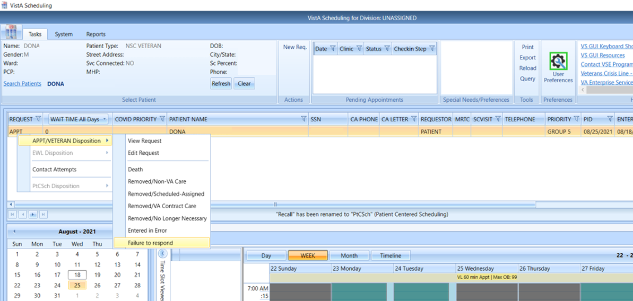
Figure 1: Failure To Respond Disposition Reason.

Check-in Step Status
As part of the effort to improve veteran check-in experience, the check-in status for appointments is displayed in the pending appointments list and in the time slot viewer for each appointment. Please note that this view will only populate for sites participating in the pilot release of the veteran and will be blank for most sites and users.
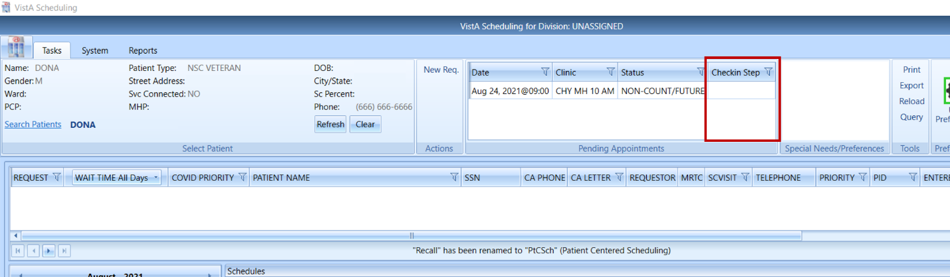
Figure 2: The Most Recent Check-In Step Status Will Be Displayed In The Pending Appointment List.

