VS GUI User Guide Addendum
  - Release 1.7.15.0 Update

Revision History
Date | Revision | Description | Author
12/05/2021 | 1.0 | Created Release Documentation | VSE PMO  Liberty IT Solutions

Table of Contents
1 Introduction 4
1.1 Purpose 4
1.2 Overview 4
1.3 Disclaimers 4
1.3.1 Software Disclaimers 4
1.3.2 Documentation Disclaimers 4
1.4 Project References 5
1.4.1 Information 5
2 System Summary 6
3 Key Feature Update in Version 1.7.15.0 6
3.1 Update to VVS Provider Search 6

List of Figures
Figure 1: Provider Search. 6

Introduction
Department of Veterans Affairs (VA) Veterans Health Information Systems and Technology Architecture (VistA) Scheduling Graphical User Interface (VS GUI) module is the Windows GUI version of the Patient Information Management System (PIMS) Scheduling module. It provides appointment management functions included in PIMS Scheduling, but with the added convenience and usability of a GUI.

Purpose
The Veterans Health Administration (VHA) Office of Veterans Access to Care (OVAC) requested an enterprise enhancement for the VS package that supports COVID-19 response. The enhancement reduces operating costs for VHA and improves operational efficiencies, resulting in patient-centered access to care, coordinated care, increased customer satisfaction, and the reduction of excessive cycle/wait time for scheduling patients.

Overview
VS GUI is a software module that allows schedulers to make appointments quickly by viewing multiple appointment request types and multiple clinics in one screen. A scheduler can easily view patient requests for service, find the next available open appointment, view the provider’s availability in multiple clinics, and track a patient’s appointment process. Refer to System Summary for a more detailed description of VS GUI functionality.

Disclaimers

Software Disclaimers
This software was developed at the Department of Veterans Affairs (VA) by employees of the Federal Government in the course of their official duties. Pursuant to title 17 Section 105 of the United States Code this software is not subject to copyright protection and is in the public domain. VA assumes no responsibility whatsoever for its use by other parties, and makes no guarantees, expressed or implied, about its quality, reliability, or any other characteristic. We would appreciate acknowledgement if the software is used. This software can be redistributed and/or modified freely if any derivative works bear some notice that they are derived from it, and any modified versions bear some notice that they have been modified.

Documentation Disclaimers
The appearance of external hyperlink references in this manual does not constitute endorsement by the Department of Veterans Affairs (VA) of this Web site or the information, products, or services contained therein. The VA does not exercise any editorial control over the information you may find at these locations. Such links are provided and are consistent with the stated purpose of the VA.

Project References

Information
The VS GUI points of contact (POCs) include:
- OVAC Program Office – REDACTED
- OIT VistA Scheduling Enhancement (VSE) Technical Manager – REDACTED
- OVAC Emerging Technologies Acting Legacy Program Manager – REDACTED
- OVAC Emerging Technologies VSE Subject Matter Expert (SME) – REDACTED
- OVAC Emerging Technologies VSE Subject Matter Expert (SME) – REDACTED
- OVAC Emerging Technologies VSE Subject Matter Expert (SME) – REDACTED

VSE Resources
- Veterans Health Administration (VHA) VSE SharePoint: REDACTED
- VA Software Document Library (VDL) – Scheduling (VSE manuals near the bottom):
- National Return to Clinic (RTC) Order: REDACTED

System Summary
The VSE project delivers a series of enhancements to legacy VistA Scheduling Version 5.3 via the VS GUI application.
This update is for the nationally released version 1.7.15.0, which includes VS GUI 1.7.15.0 and Emergency VistA patch SD*5.3*800. At time of publishing, install period is projected for December 2021.
VistA Scheduling (VS) Graphical User Interface (GUI) Release 1.7.15.0 and SD*5.3*800 includes several defect corrections and enhancements. This release adds Email Address, Title, and Provider Class to the VVS provider search results. Back-end updates not visible to end users include new RPCs to prepare for future modernization efforts, and changes to support the front-end VVS search update.

Key Feature Update in Version 1.7.15.0

Update to VVS Provider Search
When searching for a provider to assign to a Video Visit appointment, users now see additional information to help determine the correct provider choice.
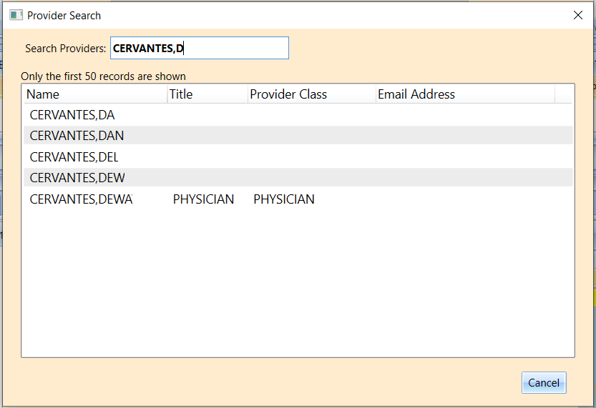
Figure 1: Provider Search.

