VS GUI User Guide Addendum
  - Release 1.7.16.2 Update

Revision History
Date | Revision | Description | Author
12/16/2021 | 1.2 | Incremented release version to 1.7.16.2 | VSE PMO
12/09/2021 | 1.1 | Incremented release version to 1.7.16.1 | VSE PMO
12/06/2021 | 1.0 | Created Release Documentation | VSE PMO  Liberty IT Solutions

Table of Contents
1 Introduction 4
1.1 Purpose 4
1.2 Overview 4
1.3 Disclaimers 4
1.3.1 Software Disclaimers 4
1.3.2 Documentation Disclaimers 4
1.4 Project References 5
1.4.1 Information 5
2 System Summary 6
3 Key Feature Update in Version 1.7.16.2 6
3.1 Block and Move 6
3.2 Errors on Block and Move 9

List of Figures
Figure 1: Block And Move An Appointment From The Calendar Grid. 6
Figure 2: Block And Move An Appointment From The Pending Appointment List. 7
Figure 3: Block And Move Window. 7
Figure 4: Block And Move Window: Select A New Clinic And Date. 8
Figure 5: Calendar Grid View After The Appointment Has Been Blocked And Moved. 8
Figure 6: Block And Move Error: Original Appointment Uses More Than One Appointment Slot. 9
Figure 7: Block And Move Error: Target Timeframe Would Be An Overbook. 9
Figure 8: Block And Move Error: Overbook Not Allowed. 9
Figure 9: Block And Move Error: User Is Not A Privileged User. 10
Figure 10: Block And Move Error: Appointment Currently Overbooked. 10
Figure 11: Block And Move Error: Availability Definition Not Found. 10
Figure 12: Block And Move Error: Destination Clinic Is Not Open On This Date. 11
Figure 13: Block And Move Error: Original Appointment Increment Does Not Match The Target Clinic Increment. 11

Introduction
Department of Veterans Affairs (VA) Veterans Health Information Systems and Technology Architecture (VistA) Scheduling Graphical User Interface (VS GUI) module is the Windows GUI version of the Patient Information Management System (PIMS) Scheduling module. It provides appointment management functions included in PIMS Scheduling, but with the added convenience and usability of a GUI.

Purpose
The Veterans Health Administration (VHA) Office of Veterans Access to Care (OVAC) requested an enterprise enhancement for the VS package that supports COVID-19 response. The enhancement reduces operating costs for VHA and improves operational efficiencies, resulting in patient-centered access to care, coordinated care, increased customer satisfaction, and the reduction of excessive cycle/wait time for scheduling patients.

Overview
VS GUI is a software module that allows schedulers to make appointments quickly by viewing multiple appointment request types and multiple clinics in one screen. A scheduler can easily view patient requests for service, find the next available open appointment, view the provider’s availability in multiple clinics, and track a patient’s appointment process. Refer to System Summary for a more detailed description of VS GUI functionality.

Disclaimers

Software Disclaimers
This software was developed at the Department of Veterans Affairs (VA) by employees of the Federal Government in the course of their official duties. Pursuant to title 17 Section 105 of the United States Code this software is not subject to copyright protection and is in the public domain. VA assumes no responsibility whatsoever for its use by other parties, and makes no guarantees, expressed or implied, about its quality, reliability, or any other characteristic. We would appreciate acknowledgement if the software is used. This software can be redistributed and/or modified freely if any derivative works bear some notice that they are derived from it, and any modified versions bear some notice that they have been modified.

Documentation Disclaimers
The appearance of external hyperlink references in this manual does not constitute endorsement by the Department of Veterans Affairs (VA) of this Web site or the information, products, or services contained therein. The VA does not exercise any editorial control over the information you may find at these locations. Such links are provided and are consistent with the stated purpose of the VA.

Project References

Information
The VS GUI points of contact (POCs) include:
- OVAC Program Office – REDACTED
- OIT VistA Scheduling Enhancement (VSE) Technical Manager – REDACTED
- OVAC Emerging Technologies Acting Legacy Program Manager – REDACTED
- OVAC Emerging Technologies VSE Subject Matter Expert (SME) – REDACTED
- OVAC Emerging Technologies VSE Subject Matter Expert (SME) – REDACTED
- OVAC Emerging Technologies VSE Subject Matter Expert (SME) – REDACTED

VSE Resources
- Veterans Health Administration (VHA) VSE SharePoint: REDACTED
- VA Software Document Library (VDL) – Scheduling (VSE manuals near the bottom):
- National Return to Clinic (RTC) Order: REDACTED

System Summary
The VSE project delivers a series of enhancements to legacy VistA Scheduling Version 5.3 via the VS GUI application.
This update is for the nationally released version 1.7.16.2, which includes VS GUI 1.7.16.2 and Emergency VistA patch SD*5.3*801. At time of publishing, install period is projected for December 2021.
VistA Scheduling (VS) Graphical User Interface (GUI) Release 1.7.16.2 and SD*5.3*801 includes several defect corrections and enhancements. Primarily, this release introduces new “Block and Move” functionality that allows users to move an existing appointment to a new clinic while blocking the slot in the original clinic so that a provider is not double-booked. This version also adds “preferred gender” to the patient information pane and corrects a defect so that the RM grid refreshes after comments are added to a request. Back-end changes not visible to end users include updates to store STS tokens, log VVS service errors to allow for easier troubleshooting, and 508 updates to improve accessibility.

Key Feature Update in Version 1.7.16.2

Block and Move
Block and Move should be used when a scheduler needs to move an appointment from one clinic to another clinic at a specific time and needs the original time slot to be blocked.
- To Block and Move an appointment, right click on the appointment either in the Calendar Grid or in the Pending Appointments list.
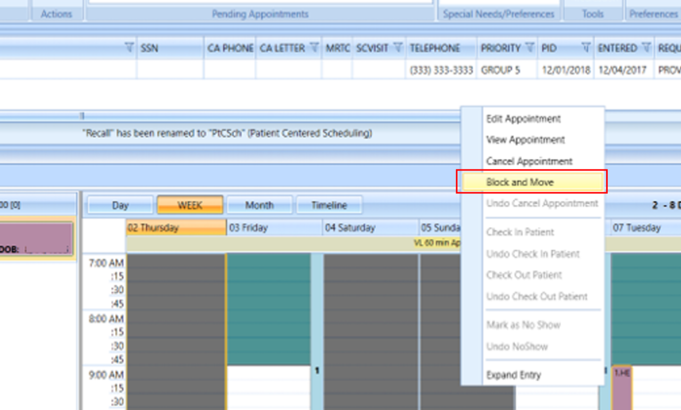
Figure 1: Block And Move An Appointment From The Calendar Grid.
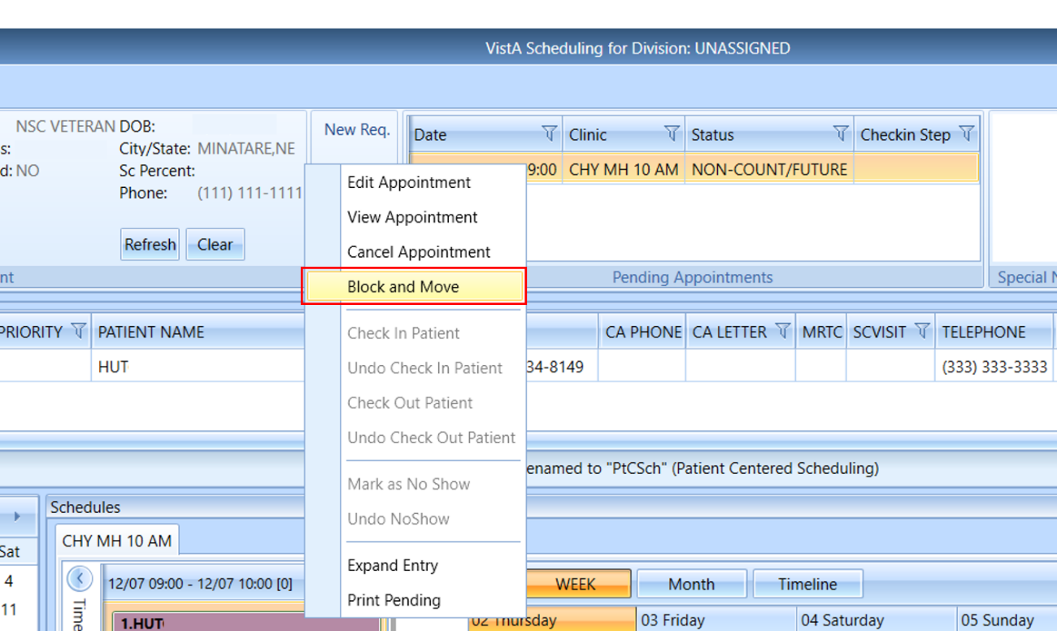
Figure 2: Block And Move An Appointment From The Pending Appointment List.
- Select “Block and Move” from the context menu. A Block and Move window will display.
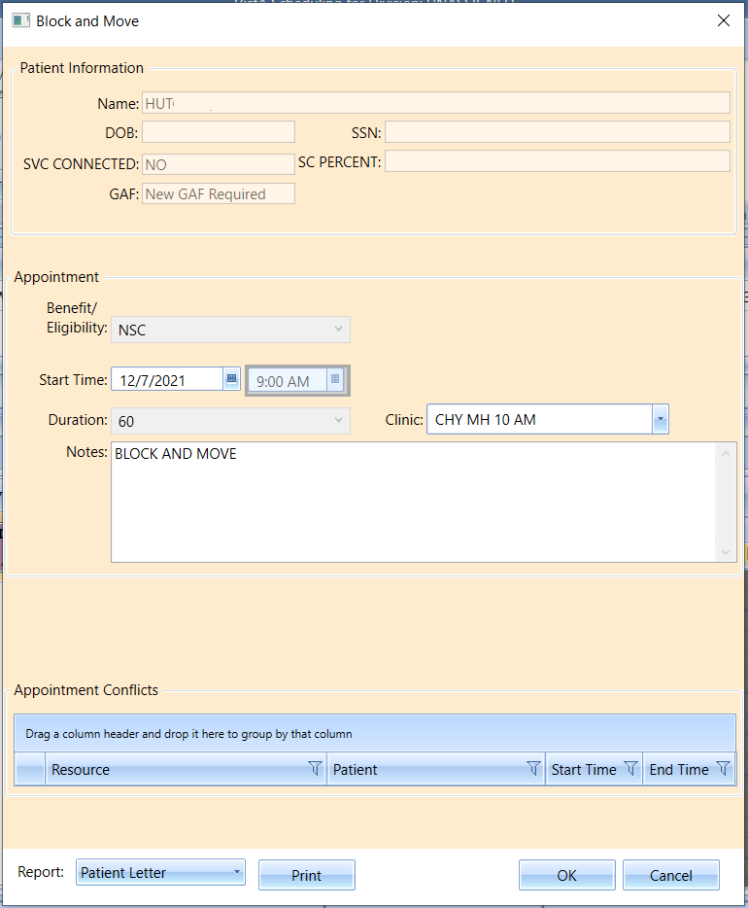
Figure 3: Block And Move Window.
- In the Block and Move window, select a new clinic and/or date for the appointment.
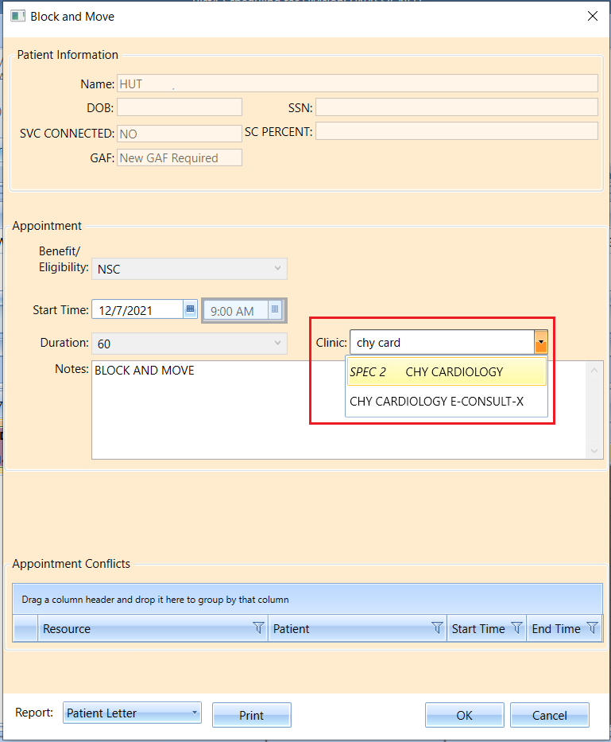
Figure 4: Block And Move Window: Select A New Clinic And Date.
- When you have updated the desired information, click OK. The appointment will be moved, and the original slot will be blocked.
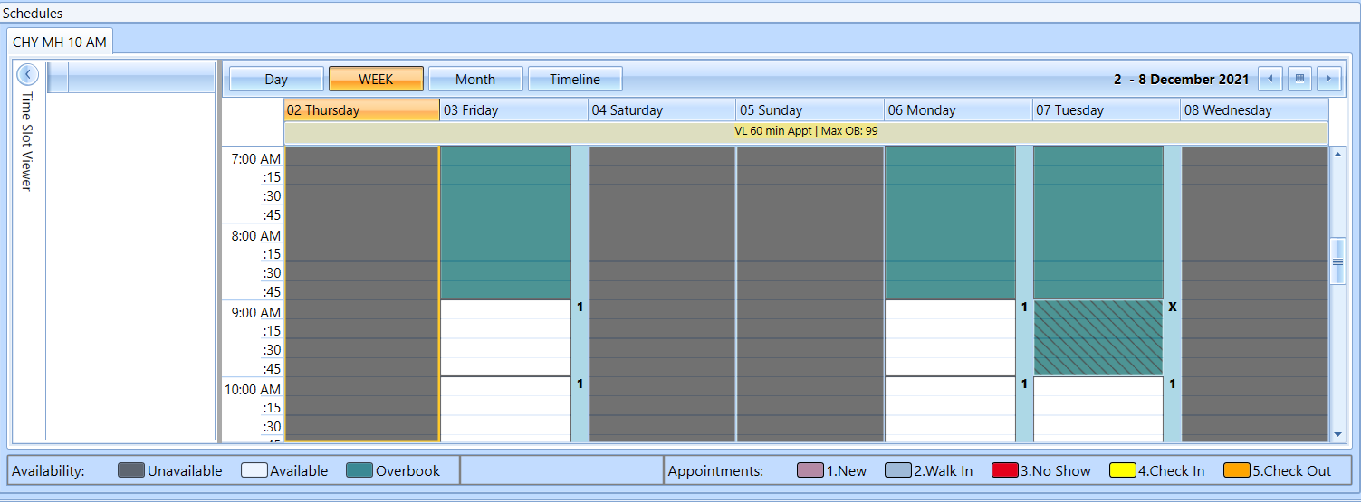
Figure 5: Calendar Grid View After The Appointment Has Been Blocked And Moved.

Errors on Block and Move
Under certain circumstances, the Block and Move functionality cannot be used. Block and Move cannot be used on an appointment if:
  - The original appointment uses more than one appointment slot
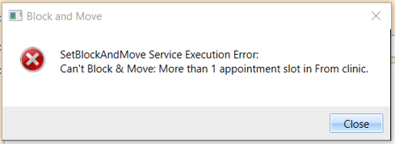
Figure 6: Block And Move Error: Original Appointment Uses More Than One Appointment Slot.
  - The target timeframe would be an overbook, and the user does not have an overbook key.
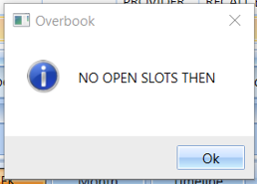
Figure 7: Block And Move Error: Target Timeframe Would Be An Overbook.
  - The target clinic does not have overbooks, and the user does not have the master overbook key.
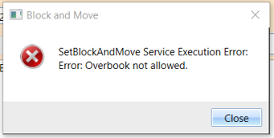
Figure 8: Block And Move Error: Overbook Not Allowed.
  - The target clinic is prohibited, and the user is not a privileged user in that clinic
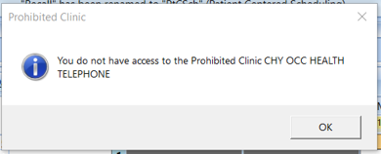
Figure 9: Block And Move Error: User Is Not A Privileged User.
  - The original clinic has an overbook appointment within the timeframe of the appointment the user is trying to Block and Move
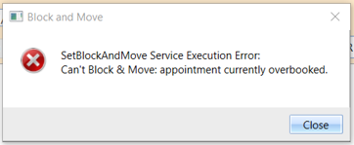
Figure 10: Block And Move Error: Appointment Currently Overbooked.
  - The target clinic does not have availability defined in the timeframe of the appointment
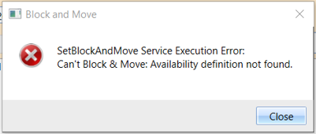
Figure 11: Block And Move Error: Availability Definition Not Found.

  - The target clinic does not have an open slot in the timeframe of the appointment
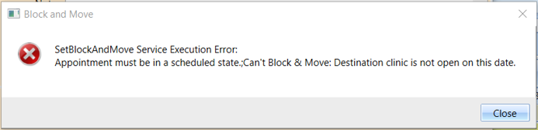
Figure 12: Block And Move Error: Destination Clinic Is Not Open On This Date.
  - The original appointment increment does not match the target clinic increment
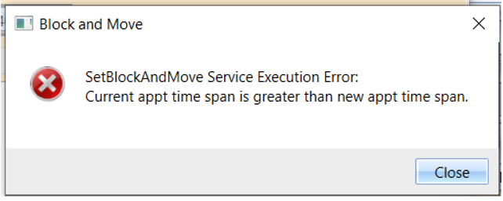
Figure 13: Block And Move Error: Original Appointment Increment Does Not Match The Target Clinic Increment.

