VS GUI User Guide Addendum
  - Release 1.7.19.1 Update

Revision History
Date | Revision | Description | Author
02/18/2022 | 1.1 | - Incremented release version to VS GUI 1.7.19.1  - Added new section – VVS Time Zone Updates | VSE PMO  REDACTED
02/09/2022 | 1.0 | Created Release Documentation | VSE PMO  REDACTED

Table of Contents
1 Introduction 4
1.1 Purpose 4
1.2 Overview 4
1.3 Disclaimers 4
1.3.1 Software Disclaimers 4
1.3.2 Documentation Disclaimers 4
1.4 Project References 5
1.4.1 Information 5
2 System Summary 6
3 Key Feature Update in Version 1.7.19.1 6
3.1 Update the Patient Indicated Date (PID) on a request reopened from appointment that is no-showed 6
3.2 Update Patient Indicated Date (PID) when rescheduling an appointment that was no-showed or cancelled by patient 8
3.3 VVS Time Zone Updates 10

List of Figures
Figure 1: No-showed Appointment 6
Figure 2: Request Returned to the RM Grid 6
Figure 3: Editing an Appointment Request from the RM Grid 7
Figure 4: The PID Date is Now Editable from Edit Appointment Request Window. 7
Figure 5: Clinic Calendar 8
Figure 6: Add an Appointment from the Clinic Calendar 8
Figure 7: New Appointment Window 9
Figure 8: For Appointments Cancelled by Patient or No-Showed the PID Date is Now Editable 10
Figure 9: Video Visit Service Error 10

Introduction
Department of Veterans Affairs (VA) Veterans Health Information Systems and Technology Architecture (VistA) Scheduling Graphical User Interface (VS GUI) module is the Windows GUI version of the Patient Information Management System (PIMS) Scheduling module. It provides appointment management functions included in PIMS Scheduling, but with the added convenience and usability of a GUI.

Purpose
The Veterans Health Administration (VHA) Office of Veterans Access to Care (OVAC) requested an enterprise enhancement for the VS package that supports COVID-19 response. The enhancement reduces operating costs for VHA and improves operational efficiencies, resulting in patient-centered access to care, coordinated care, increased customer satisfaction, and the reduction of excessive cycle/wait time for scheduling patients.

Overview
VS GUI is a software module that allows schedulers to make appointments quickly by viewing multiple appointment request types and multiple clinics in one screen. A scheduler can easily view patient requests for service, find the next available open appointment, view the provider’s availability in multiple clinics, and track a patient’s appointment process. Refer to System Summary for a more detailed description of VS GUI functionality.

Disclaimers

Software Disclaimers
This software was developed at the Department of Veterans Affairs (VA) by employees of the Federal Government in the course of their official duties. Pursuant to title 17 Section 105 of the United States Code this software is not subject to copyright protection and is in the public domain. VA assumes no responsibility whatsoever for its use by other parties, and makes no guarantees, expressed or implied, about its quality, reliability, or any other characteristic. We would appreciate acknowledgement if the software is used. This software can be redistributed and/or modified freely if any derivative works bear some notice that they are derived from it, and any modified versions bear some notice that they have been modified.

Documentation Disclaimers
The appearance of external hyperlink references in this manual does not constitute endorsement by the Department of Veterans Affairs (VA) of this Web site or the information, products, or services contained therein. The VA does not exercise any editorial control over the information you may find at these locations. Such links are provided and are consistent with the stated purpose of the VA.

Project References

Information
The VS GUI points of contact (POCs) include:
- OVAC Program Office – REDACTED
- TeleHealth & Scheduling Technical Manager – REDACTED
- OVAC Emerging Technologies Acting Legacy Program Manager – REDACTED
- OVAC Emerging Technologies VSE Subject Matter Expert (SME) – REDACTED
- OVAC Emerging Technologies VSE Subject Matter Expert (SME) – REDACTED

VSE Resources
- Veterans Health Administration (VHA) VSE SharePoint: REDACTED
- VA Software Document Library (VDL) – Scheduling (VSE manuals near the bottom)
- National Return to Clinic (RTC) Order: REDACTED

System Summary
The VSE project delivers a series of enhancements to legacy VistA Scheduling Version 5.3 via the VS GUI application.
This update is for the nationally released version 1.7.19.1, which includes VS GUI 1.7.19.1 and Emergency VistA patch SD*5.3*805. At time of publishing, install period is projected for February 2022.
VistA Scheduling (VS) Graphical User Interface (GUI) Release 1.7.19.1 and SD*5.3*805 includes several defect corrections and enhancements. These include accessibility improvements in the Help section, the Appointment Letter window, and the Reports tab, as well as back-end updates to correct a check-in step recording issue, updates to support future modernization, and changes to support future time zone conversion fixes. Functionality changes in this release, detailed in later sections, include allowing a user to update the Patient Indicated Date (PID) when rescheduling an appointment that has been Cancelled by Patient or No-Showed, and allowing the user to update the PID on a request reopened due to no-show.

Key Feature Update in Version 1.7.19.1

Update the Patient Indicated Date (PID) on a request reopened from appointment that is no-showed
When an appointment is no-showed or cancelled by patient, the associated request returns to the Request Management (RM) Grid. Users may now edit the PID on requests reopened due to no-show. Editing the PID on requests reopened due to patient cancellation is existing functionality.
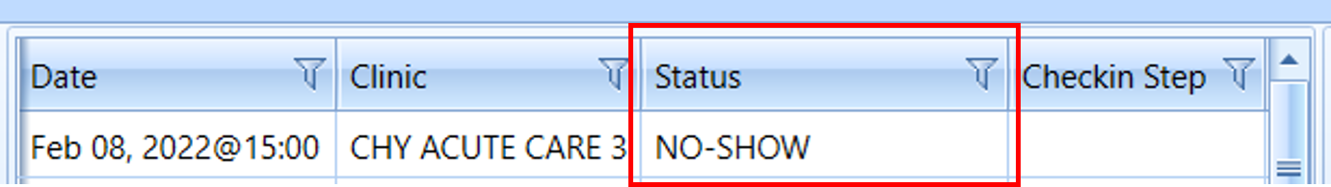
Figure 1: No-showed Appointment
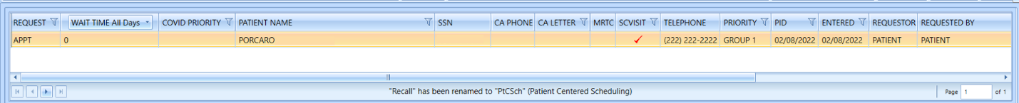
Figure 2: Request Returned to the RM Grid
Users may now edit the PID on reopened Appointment (APPT) or Return to Clinic (RTC) requests resulting from no-shows.
- Right click on the request and select APPT/VETERAN Disposition > Edit Request
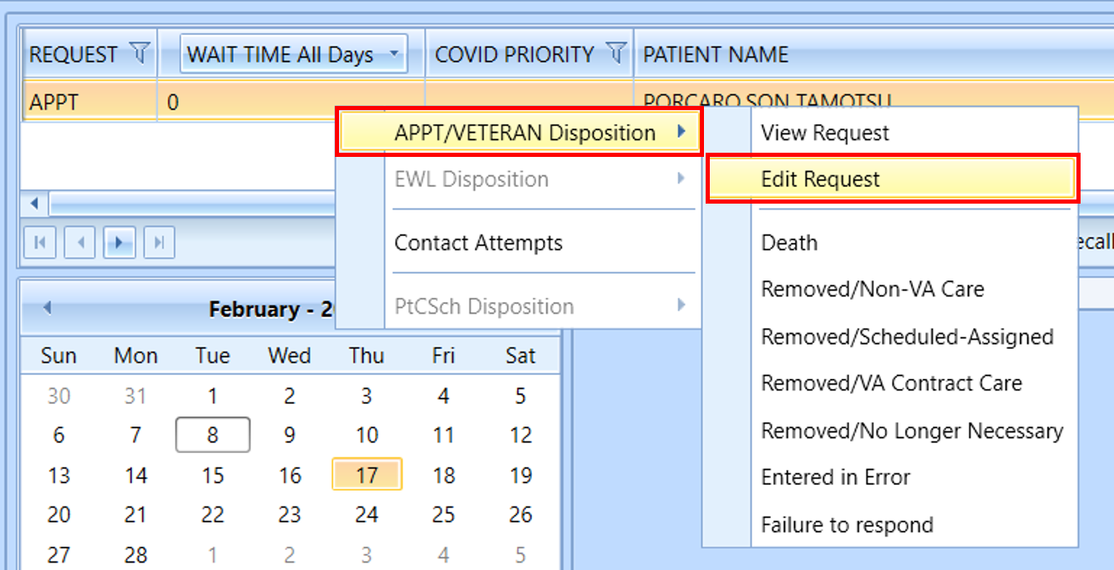
Figure 3: Editing an Appointment Request from the RM Grid
- PID is editable on the Edit Appointment Request window. Enter the desired date of appointment and click OK to update the PID on the request.
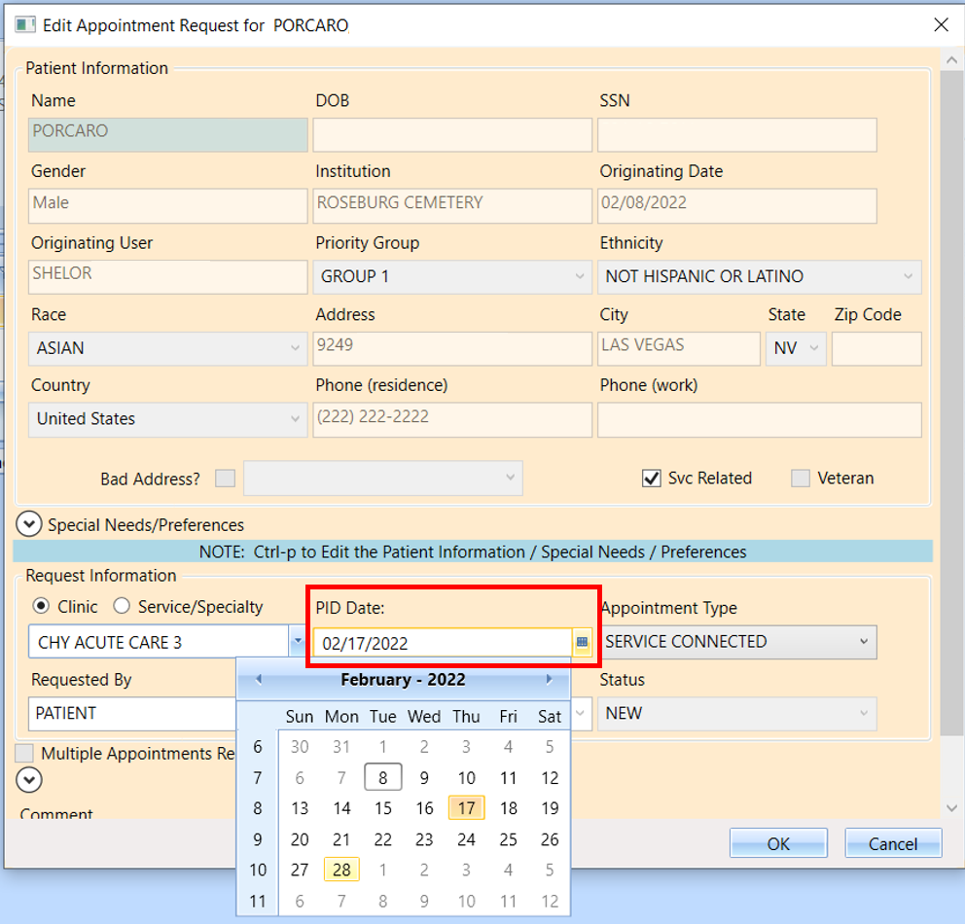
Figure 4: The PID Date is Now Editable from Edit Appointment Request Window.

Update Patient Indicated Date (PID) when rescheduling an appointment that was no-showed or cancelled by patient
As of 1.7.19.1, users may update the PID in the New Appointment window when rescheduling an appointment that was previously no-showed or cancelled by patient. PID can be updated for any appointment type, including those created from Consult or Procedure requests.
- To update the PID, select the request reopened due to the no-show or patient cancellation. This will load the clinic calendar.
Note: If the clinic calendar does not load, or you wish to schedule in a different clinic, search for the clinic using the clinic search under Clinic Schedules.
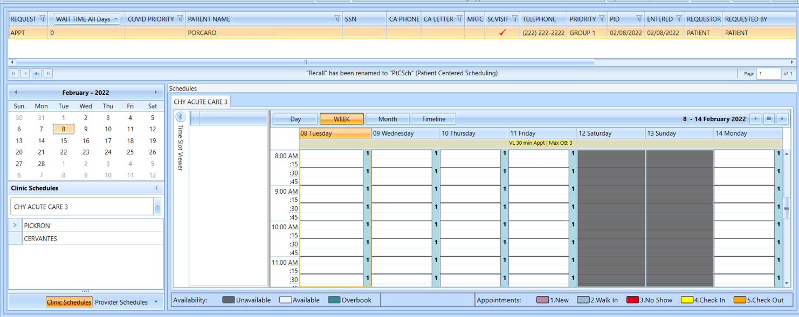
Figure 5: Clinic Calendar
- Right click on the desired appointment slot and select “Add Appointment”.
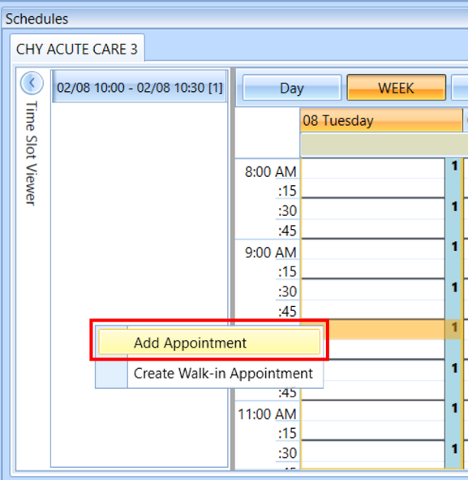
Figure 6: Add an Appointment from the Clinic Calendar
The New Appointment window displays, as shown below.
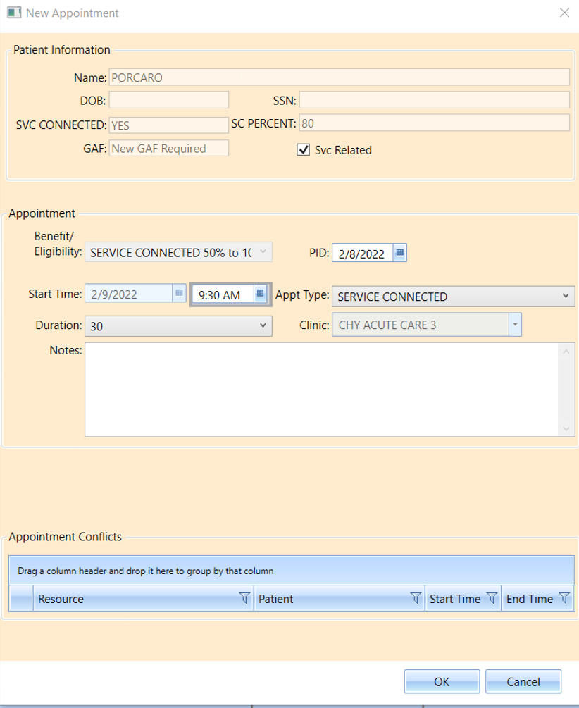
Figure 7: New Appointment Window
- If the patient’s prior requested appointment was cancelled by patient or no-showed, the PID field will be editable. Enter the new PID and click OK to create the new appointment with the updated PID.
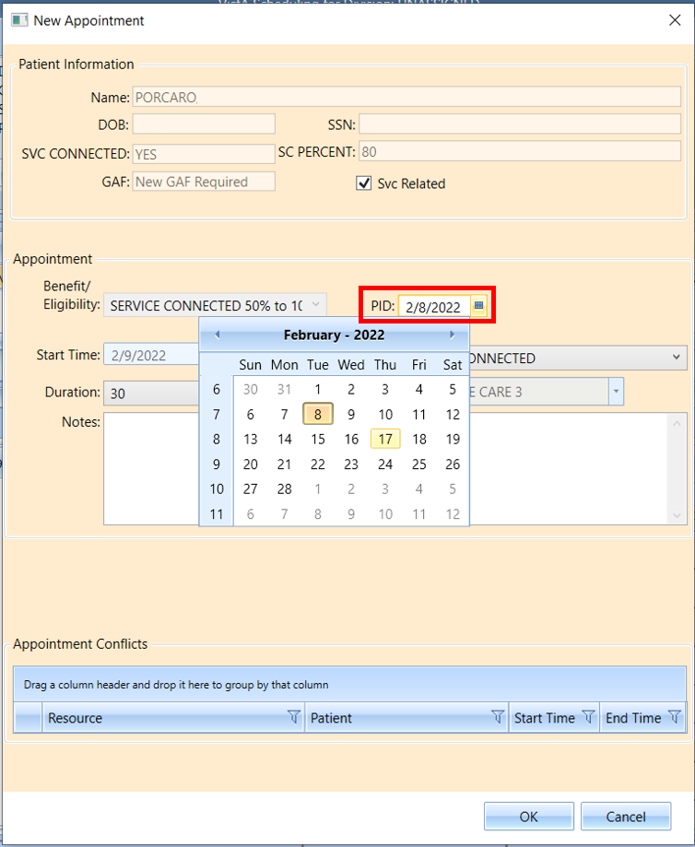
Figure 8: For Appointments Cancelled by Patient or No-Showed the PID Date is Now Editable

VVS Time Zone Updates
This release includes back-end changes to support accuracy of VVS appointment time zones. These changes include requiring that clinic’s associated institution has an assigned time zone. If a user attempts to schedule a VVS appointment through VS GUI and gets the below error, they should have their local VistA administrator confirm that the INSTITUTION file (#4) has a Location Time Zone assigned.
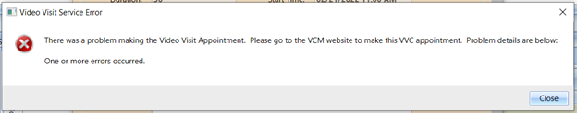
Figure 9: Video Visit Service Error

