VS GUI User Guide Addendum
  - Release 1.7.20.1 Update

Revision History
Date | Revision | Description | Author
03/17/2022 | 1.2 | Added new section 3.3. Fix to Block and Move Patient Indicated Date (PID) Issue. | VSE PMO  REDACTED
03/10/2022 | 1.1 | Incremented release version to VS GUI 1.7.20.1 | VSE PMO
03/03/2022 | 1.0 | Created Release Documentation | VSE PMO  REDACTED

Table of Contents
1 Introduction 4
1.1 Purpose 4
1.2 Overview 4
1.3 Disclaimers 4
1.3.1 Software Disclaimers 4
1.3.2 Documentation Disclaimers 4
1.4 Project References 5
1.4.1 Information 5
2 System Summary 6
3 Key Feature Update in Version 1.7.20.1 6
3.1 Clinic with a Future Inactivation and Reactivation date displays in clinic lookup 6
3.2 Fix to Trace Log Viewer Search 7
3.3 Fix to Block and Move Patient Indicated Date (PID) Issue 8

List of Figures
Figure 1: As Shown Highlighted The Inactivate Date And Reactivate Dates Are In The Future. 6
Figure 2: Clinic Calendar Showing No Availability Between Inactive/Reactive Dates. 7
Figure 3: Accessing VS GUI Trace Log. 7
Figure 4: VS GUI Trace Log. 7
Figure 5: Original APPT Request PID. 8
Figure 6: Blocked And Moved Scheduled Appointment From 3/20/2022 to 3/21/2022. 8
Figure 7: Expand Entry Now Displays Correct PID. 8

Introduction
Department of Veterans Affairs (VA) Veterans Health Information Systems and Technology Architecture (VistA) Scheduling Graphical User Interface (VS GUI) module is the Windows GUI version of the Patient Information Management System (PIMS) Scheduling module. It provides appointment management functions included in PIMS Scheduling, but with the added convenience and usability of a GUI.

Purpose
The Veterans Health Administration (VHA) Office of Veterans Access to Care (OVAC) requested an enterprise enhancement for the VS package that supports COVID-19 response. The enhancement reduces operating costs for VHA and improves operational efficiencies, resulting in patient-centered access to care, coordinated care, increased customer satisfaction, and the reduction of excessive cycle/wait time for scheduling patients.

Overview
VS GUI is a software module that allows schedulers to make appointments quickly by viewing multiple appointment request types and multiple clinics in one screen. A scheduler can easily view patient requests for service, find the next available open appointment, view the provider’s availability in multiple clinics, and track a patient’s appointment process. Refer to System Summary for a more detailed description of VS GUI functionality.

Disclaimers

Software Disclaimers
This software was developed at the Department of Veterans Affairs (VA) by employees of the Federal Government in the course of their official duties. Pursuant to title 17 Section 105 of the United States Code this software is not subject to copyright protection and is in the public domain. VA assumes no responsibility whatsoever for its use by other parties, and makes no guarantees, expressed or implied, about its quality, reliability, or any other characteristic. We would appreciate acknowledgement if the software is used. This software can be redistributed and/or modified freely if any derivative works bear some notice that they are derived from it, and any modified versions bear some notice that they have been modified.

Documentation Disclaimers
The appearance of external hyperlink references in this manual does not constitute endorsement by the Department of Veterans Affairs (VA) of this Web site or the information, products, or services contained therein. The VA does not exercise any editorial control over the information you may find at these locations. Such links are provided and are consistent with the stated purpose of the VA.

Project References

Information
The VS GUI points of contact (POCs) include:
- OVAC Program Office REDACTED
- TeleHealth & Scheduling Technical Manager – REDACTED
- OVAC Emerging Technologies Acting Legacy Program Manager – REDACTED
- OVAC Emerging Technologies VSE Subject Matter Expert (SME) – REDACTED
- OVAC Emerging Technologies VSE Subject Matter Expert (SME) – REDACTED

VSE Resources
- Veterans Health Administration (VHA) VSE SharePoint: REDACTED
- VA Software Document Library (VDL) – Scheduling (VSE manuals near the bottom):
- National Return to Clinic (RTC) Order: REDACTED

System Summary
The VSE project delivers a series of enhancements to legacy VistA Scheduling Version 5.3 via the VS GUI application.
This update is for the nationally released version 1.7.20.1, which includes VS GUI 1.7.20.1 and Emergency VistA patch SD*5.3*807. At time of publishing, install period is projected for March 2022.
VistA Scheduling (VS) Graphical User Interface (GUI) Release 1.7.20.1 and SD*5.3*807 includes several defect corrections and enhancements. Back-end updates include changes to support VVC time zone calculations, revising JSON returns to return an empty array rather than an empty string, and adding several RPCs to support future scheduling development. User-facing changes include a correction to the “inactive” calculation so that clinics with future inactivation and future reactivation dates are not considered “inactive,” a fix to prevent the GUI from crashing when using the trace log viewer Search feature, and a correction for a Block and Move PID issue. This release also addresses 508 findings in the Patient Eligibility and Patient Information forms.

Key Feature Update in Version 1.7.20.1

Clinic with a Future Inactivation and Reactivation date displays in clinic lookup
As of this release, a clinic with a future inactivation and future reactivation date will be viewable in VS GUI. Previously, a clinic with both dates in the future was calculated as “inactive,” and did not display in VS GUI.
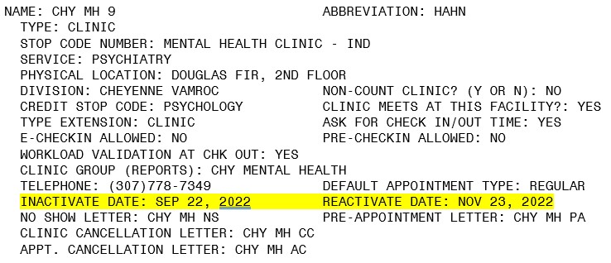
Figure 1: As Shown Highlighted The Inactivate Date And Reactivate Dates Are In The Future.
The clinic will come up in search in the GUI, and if you navigate to a timeframe between the inactivate/reactivate dates, the clinic displays no availability.
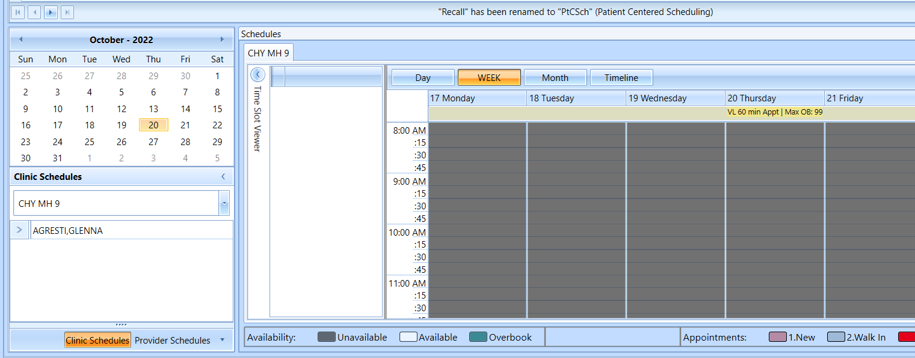
Figure 2: Clinic Calendar Showing No Availability Between Inactive/Reactive Dates.

Fix to Trace Log Viewer Search
With this release, the Trace Log Viewer Search function issue was fixed. This can be used by OIT staff to assist with troubleshooting VS GUI issues.
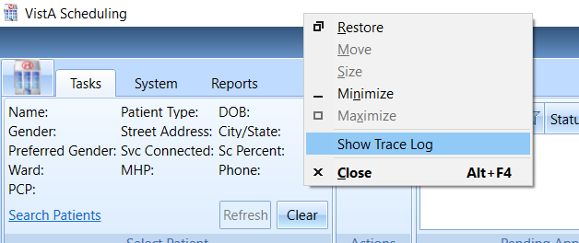
Figure 3: Accessing VS GUI Trace Log.
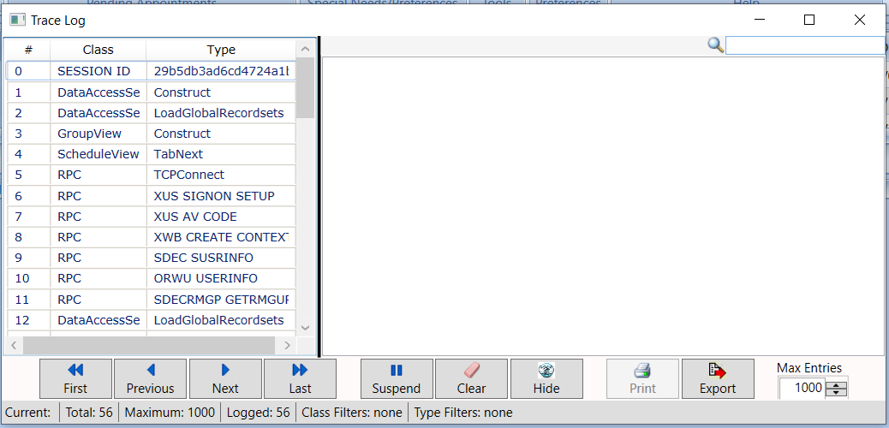
Figure 4: VS GUI Trace Log.

Fix to Block and Move Patient Indicated Date (PID) Issue
This release corrects an issue where an appointment scheduled via Block and Move displayed the incorrect PID in Expand Entry. The date of the new appointment was displayed, instead of the PID from the original appointment request.
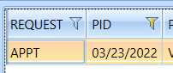
Figure 5: Original APPT Request PID.
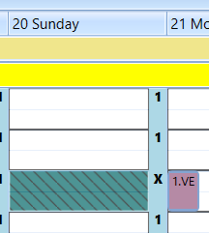
Figure 6: Blocked And Moved Scheduled Appointment From 3/20/2022 to 3/21/2022.
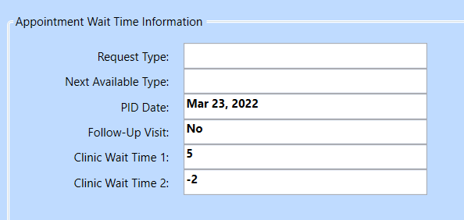
Figure 7: Expand Entry Now Displays Correct PID.

