VS GUI User Guide Addendum
  - Release 1.7.21.0 Update

Revision History
Date | Revision | Description | Author
03/28/2022 | 1.0 | Created Release Documentation | REDACTED  VSE PMO

Table of Contents
1 Introduction 5
1.1 Purpose 5
1.2 Overview 5
1.3 Disclaimers 5
1.3.1 Software Disclaimers 5
1.3.2 Documentation Disclaimers 5
1.4 Project References 6
1.4.1 Information 6
2 System Summary 7
3 Key Feature Update in Version 1.7.21.0 7
3.1 New Contact Attempt Methods 7
3.2 Updates to Patient Information Displayed – Preferred Name and Demographics Updated 8
3.3 Patient Eligibility Warning 10
3.4 Understanding the Updated VA Video Connect (VVC) Error Messages 10
3.5 Update to Special Needs/Preferences 11
3.6 Clinics Time Zone Display 12

List of Figures
Figure 1: Prior Version Of VS GUI New Contact Attempt Window. 7
Figure 2: New Version Of New Contact Attempt Window. 8
Figure 3: New Contact Attempt Window With "Letter" As A Contact Attempt Option. 8
Figure 4: The Patient Information Box Now Displays Preferred Name And Demographics Update. 9
Figure 5: Updating The Patient’s Demographics From The Patient Info Window. 9
Figure 6: Updates The Demographics Updated Date To The Date The Patients Demographics Is Updated. 10
Figure 7: Not Eligible For Care Warning Window. 10
Figure 8: Video Visit Service (VVS) Error that Displays when User Selects The Wrong Certificate 10
Figure 9: Video Visit Service (VVS) Error That Displays When Clinic Does Not Have Time Zone Defined. 11
Figure 10: Video Visit Service (VVS) Error that Displays When Patient Does Not Have ICN Defined. 11
Figure 11: No Selection In Special Needs/Preferences – Remarks Box Is Not Active. 11
Figure 12: Selection In Special Needs/Preferences – Remarks Box Is Active. 12
Figure 13: Clinic With Time Zone. 13
Figure 14: Clinic With No Time Zone Defined. 13
Figure 15: Clinic Time Zone Column Displayed In The Pending Appointments List. 13
Figure 16: Time Zone Displayed In View/Edit Appointment Window. 14

Introduction
Department of Veterans Affairs (VA) Veterans Health Information Systems and Technology Architecture (VistA) Scheduling Graphical User Interface (VS GUI) module is the Windows GUI version of the Patient Information Management System (PIMS) Scheduling module. It provides appointment management functions included in PIMS Scheduling, but with the added convenience and usability of a GUI.

Purpose
The Veterans Health Administration (VHA) Office of Veterans Access to Care (OVAC) requested an enterprise enhancement for the VS package that supports COVID-19 response. The enhancement reduces operating costs for VHA and improves operational efficiencies, resulting in patient-centered access to care, coordinated care, increased customer satisfaction, and the reduction of excessive cycle/wait time for scheduling patients.

Overview
VS GUI is a software module that allows schedulers to make appointments quickly by viewing multiple appointment request types and multiple clinics in one screen. A scheduler can easily view patient requests for service, find the next available open appointment, view the provider’s availability in multiple clinics, and track a patient’s appointment process. Refer to System Summary for a more detailed description of VS GUI functionality.

Disclaimers

Software Disclaimers
This software was developed at the Department of Veterans Affairs (VA) by employees of the Federal Government in the course of their official duties. Pursuant to title 17 Section 105 of the United States Code this software is not subject to copyright protection and is in the public domain. VA assumes no responsibility whatsoever for its use by other parties, and makes no guarantees, expressed or implied, about its quality, reliability, or any other characteristic. We would appreciate acknowledgement if the software is used. This software can be redistributed and/or modified freely if any derivative works bear some notice that they are derived from it, and any modified versions bear some notice that they have been modified.

Documentation Disclaimers
The appearance of external hyperlink references in this manual does not constitute endorsement by the Department of Veterans Affairs (VA) of this Web site or the information, products, or services contained therein. The VA does not exercise any editorial control over the information you may find at these locations. Such links are provided and are consistent with the stated purpose of the VA.

Project References

Information
The VS GUI points of contact (POCs) include:
- OVAC Program Office REDACTED
- TeleHealth & Scheduling Technical Manager – REDACTED
- OVAC Emerging Technologies Acting Legacy Program Manager – REDACTED
- OVAC Emerging Technologies VSE Subject Matter Expert (SME) – REDACTED

VSE Resources
- Veterans Health Administration (VHA) VSE SharePoint: REDACTED
- VA Software Document Library (VDL) – Scheduling (VSE manuals near the bottom):
- National Return to Clinic (RTC) Order: REDACTED

System Summary
The VSE project delivers a series of enhancements to legacy VistA Scheduling Version 5.3 via the VS GUI application.
This update is for the nationally released version 1.7.21.0, which includes VS GUI 1.7.21.0 and Emergency VistA patch SD*5.3*809. At time of publishing, install period is projected for April 2022.
VistA Scheduling (VS) Graphical User Interface (GUI) Release 1.7.21.0 and SD*5.3*809 includes several application updates and defect corrections. Updates to functionality include the addition of text, email, and secure messaging as contact attempt methods in the contact attempts window, the addition of “Preferred Name” to the patient information panel, the addition of a last updated date in the patient information panel, the addition of time zone to displayed clinic information, and a new alert to users when scheduling an appointment for a patient whose primary eligibility code is “ineligible” or “humanitarian emergency.” The release also refines errors returned on scheduling VA Video Connect (VVC) appointments to be more descriptive, improves the patient special needs/preferences form, corrects a defect where appointments scheduled when a patient is in “inpatient” status display an incorrect status, and addresses 508 compliance findings in the Edit and View Appointment forms.
The following sections detail user-facing functionality changes. Please see the Version Description Document (VDD) for a full account of all back-end and front-end changes with this release.

Key Feature Update in Version 1.7.21.0

New Contact Attempt Methods
Prior to this release, VS GUI supported two methods of contact attempt: Call and Letter.
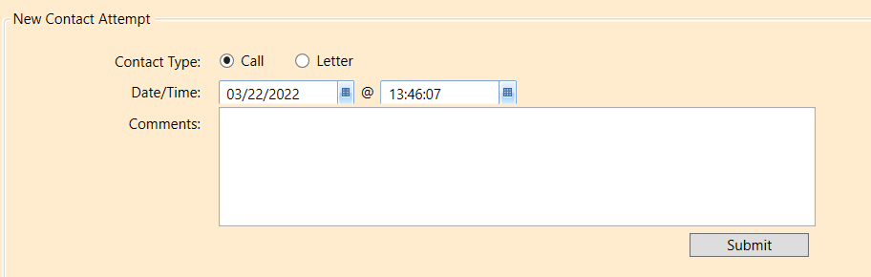
Figure 1: Prior Version Of VS GUI New Contact Attempt Window.
As of version 1.7.21.0, VS GUI also supports text, secure messaging, and email contact attempts. The selection method is updated from a radio button to a drop-down menu.
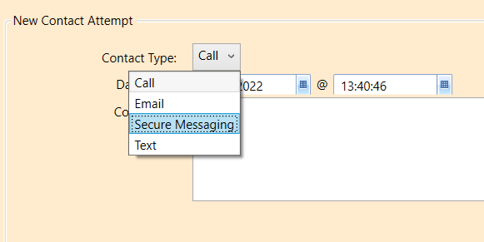
Figure 2: New Version Of New Contact Attempt Window.
As shown above on Figure 2, on the first contact attempt, “Letter” will not be available as an option. For subsequent contact attempts, “Letter” will display as an option.
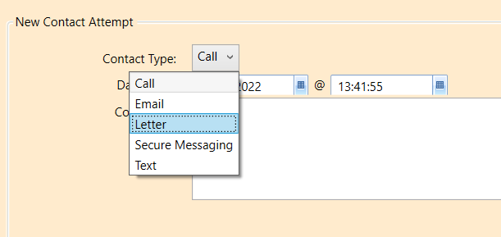
Figure 3: New Contact Attempt Window With "Letter" As A Contact Attempt Option.

Updates to Patient Information Displayed – Preferred Name and Demographics Updated
This release updates VS GUI to display a patient’s preferred name as well as the date a patient’s demographics were last updated. This information displays in the Patient Info box at the top left of the application window.
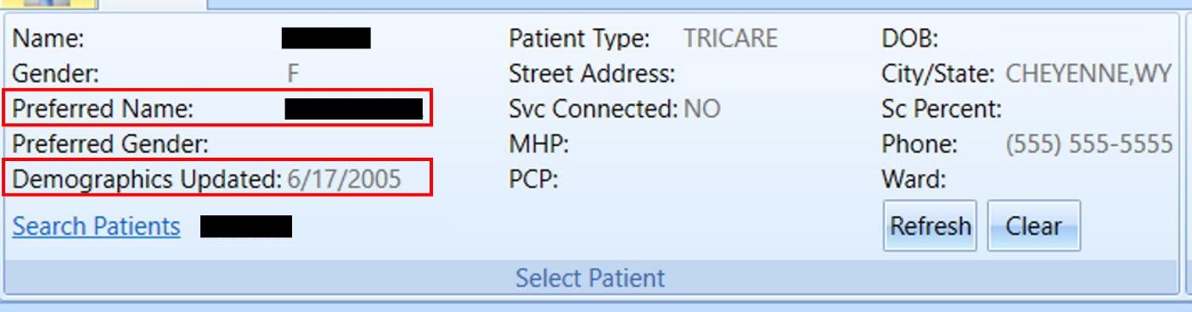
Figure 4: The Patient Information Box Now Displays Preferred Name And Demographics Update.
If a patient’s demographics are updated, the date in the Patient Info box will reflect the date of change.
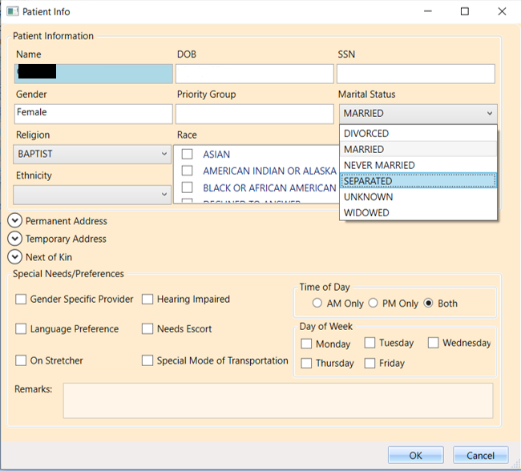
Figure 5: Updating The Patient’s Demographics From The Patient Info Window.
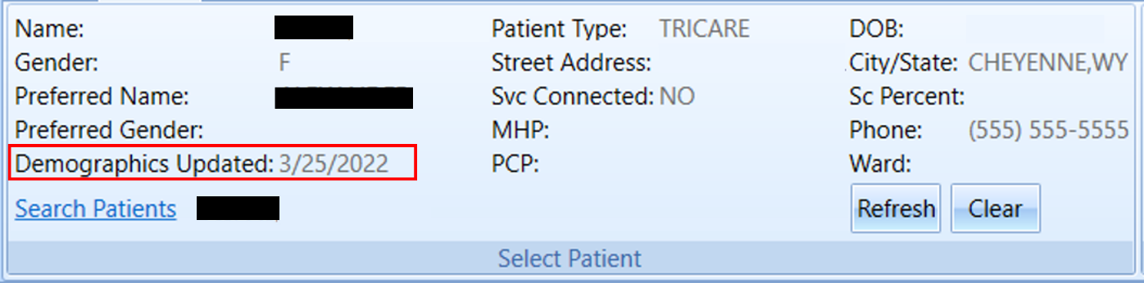
Figure 6: Updates The Demographics Updated Date To The Date The Patients Demographics Is Updated.

Patient Eligibility Warning
If a patient’s primary eligibility code is either INELIGIBLE or HUMANITARIAN EMERGENCY, a warning will display on scheduling an appointment for the patient.
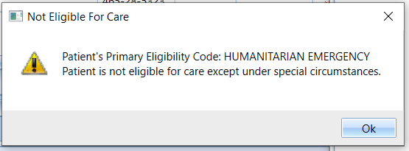
Figure 7: Not Eligible For Care Warning Window.
Click “Ok” to clear the warning dialog. You may then either continue scheduling or cancel out of the New Appointment window.

Understanding the Updated VA Video Connect (VVC) Error Messages
This release updates possible error messages received when scheduling a VVC appointment to make them more descriptive and easier to understand. Three new potential error messages are below.
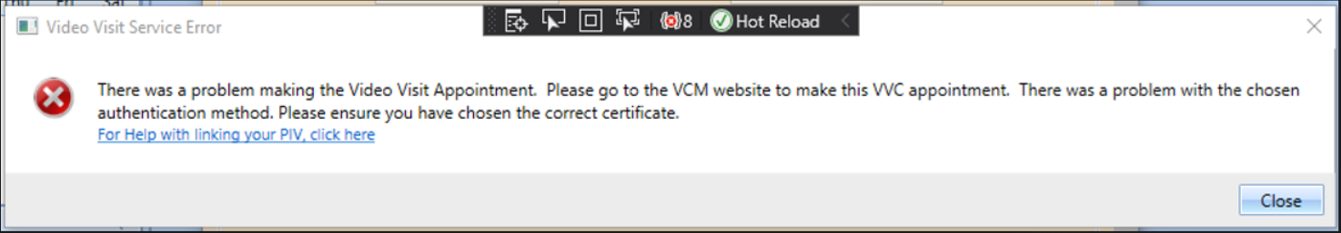
Figure 8: Video Visit Service (VVS) Error that Displays when User Selects The Wrong Certificate
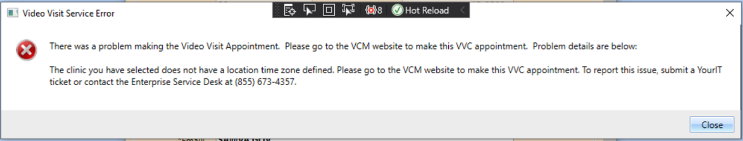
Figure 9: Video Visit Service (VVS) Error That Displays When Clinic Does Not Have Time Zone Defined.
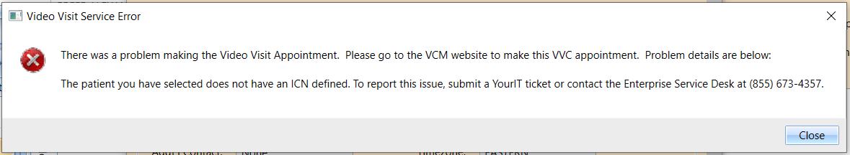
Figure 10: Video Visit Service (VVS) Error that Displays When Patient Does Not Have ICN Defined.

Update to Special Needs/Preferences
Prior to this release, VS GUI was incorrectly allowing users to enter remarks in Patient Info without selecting an option from Special Needs/Preferences to which remarks are linked. As a result, users were entering remarks which would then not be saved, as there was no Special Need/Preference to associate them to. With this release, the Remarks field is disabled unless the user selects a Special Needs/Preferences option.
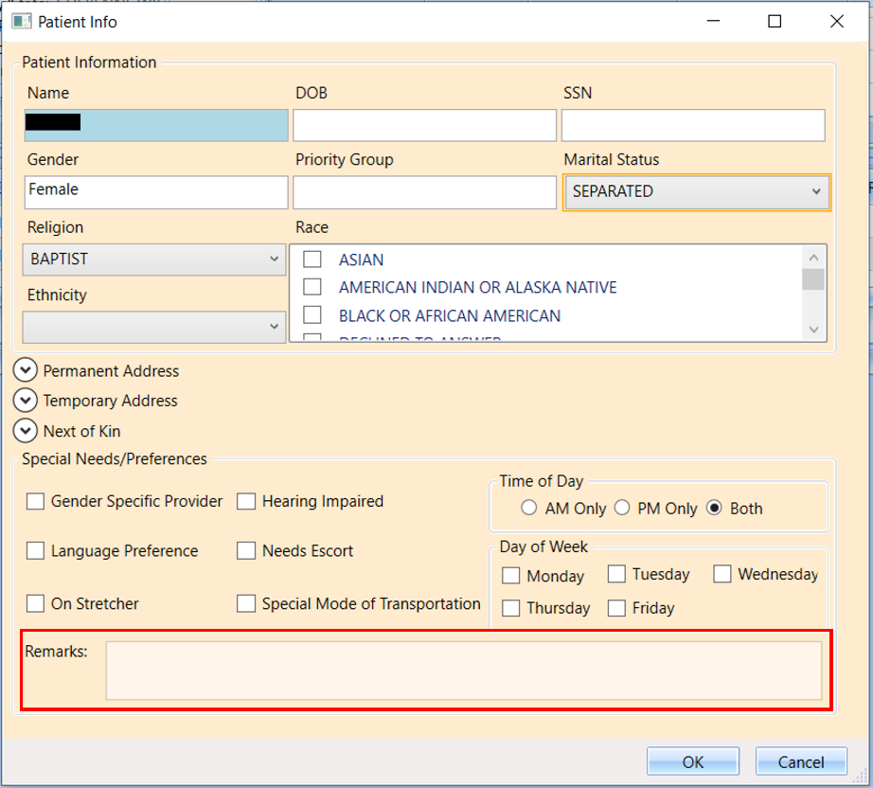
Figure 11: No Selection In Special Needs/Preferences – Remarks Box Is Not Active.
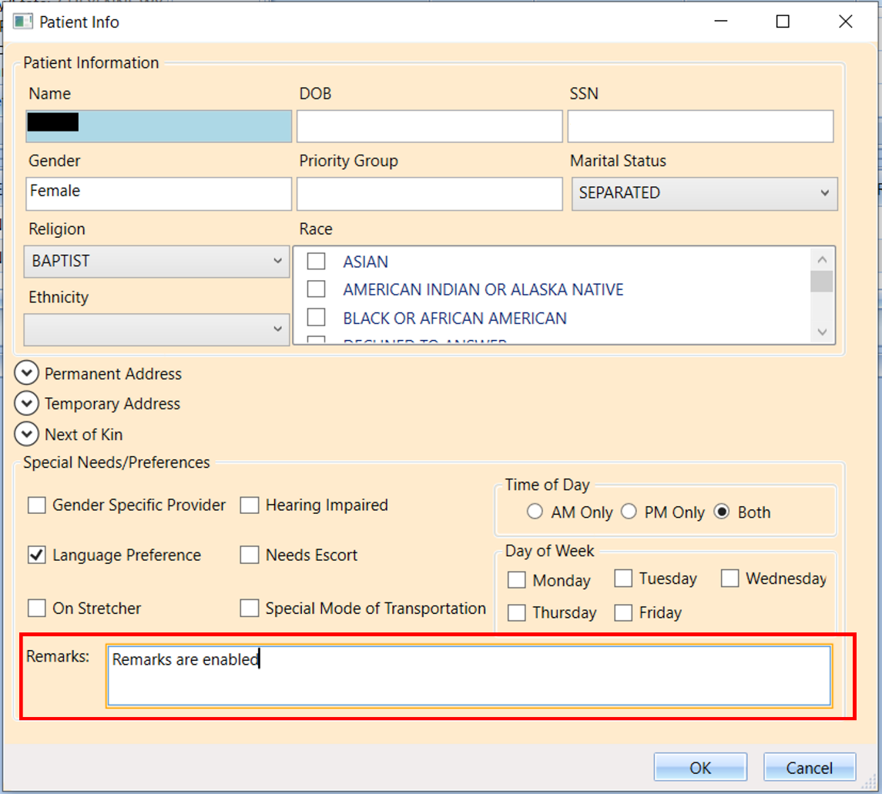
Figure 12: Selection In Special Needs/Preferences – Remarks Box Is Active.

Clinics Time Zone Display
Clinic time zone can now be viewed in several locations within the application. Time zone is displayed at the top of the clinic calendar.
Note: If time zone displays as NOT AVAILABLE, the clinic’s associated institution does not have a time zone defined. Users should submit a YourIT ticket for this issue.
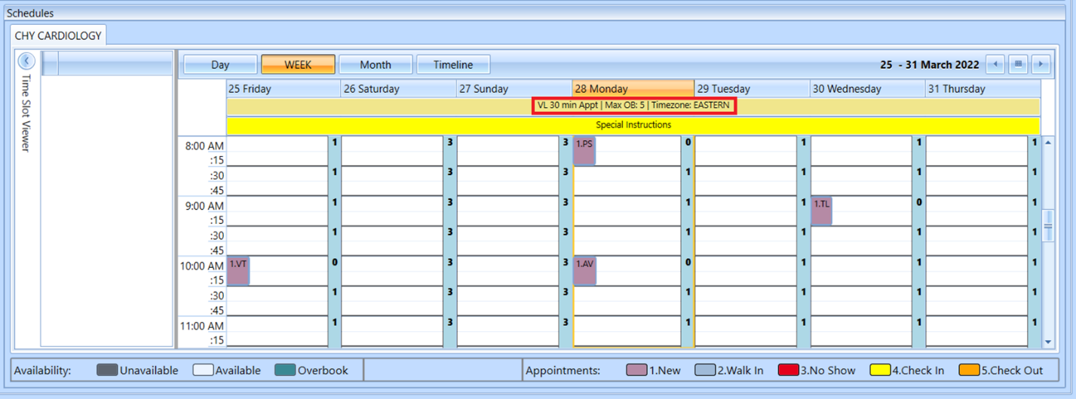
Figure 13: Clinic With Time Zone.
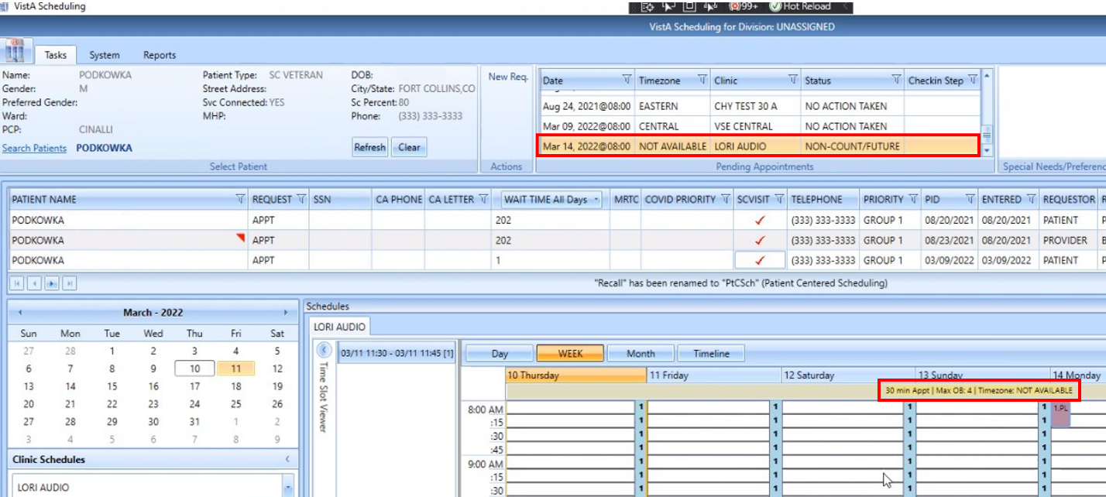
Figure 14: Clinic With No Time Zone Defined.
Time zone is also displayed in the pending appointments list.
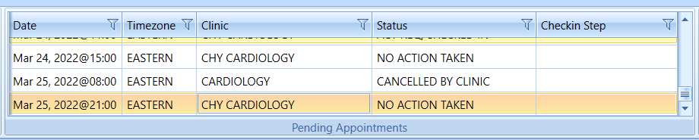
Figure 15: Clinic Time Zone Column Displayed In The Pending Appointments List.
Lastly, time zone is displayed on the View/Edit Appointment windows.
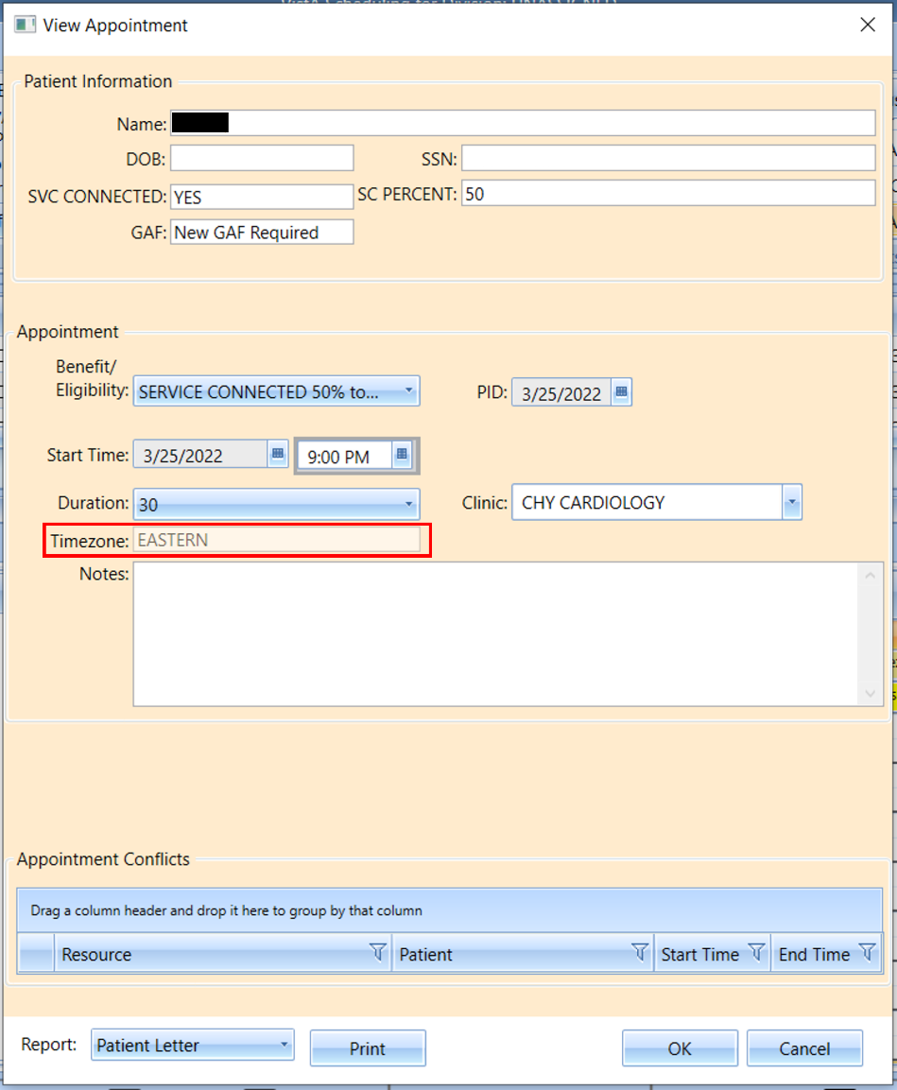
Figure 16: Time Zone Displayed In View/Edit Appointment Window.

