VS GUI User Guide Addendum
  - Release 1.7.22.0 Update

Revision History
Date | Revision | Description | Author
04/20/2020 | 1.1 | Reviewed and approved | VSE PMO  REDACTED
04/15/2022 | 1.0 | Created Release Documentation | REDACTED  VSE PMO

Table of Contents
1 Introduction 4
1.1 Purpose 4
1.2 Overview 4
1.3 Disclaimers 4
1.3.1 Software Disclaimers 4
1.3.2 Documentation Disclaimers 5
1.4 Project References 6
1.4.1 Information 6
2 System Summary 6
3 Key Feature Update in Version 1.7.22.0 7
3.1 View Appointment Time Zone 7
3.2 Contact Attempt Method Columns 8
3.3 Printing a Patient-Friendly Appointment Letter 9

List of Figures
Figure 1: Patient Appointment Letter. 7
Figure 2: Expanded Entry Form. 8
Figure 3: RM Grid With Contact Attempt Method Counts. 8
Figure 4: User Preferences. 9
Figure 5: Printing A Patient Friendly Letter. 10
Figure 6: List Of Patient Future Appointments In PDF Format. 10

Introduction
Department of Veterans Affairs (VA) Veterans Health Information Systems and Technology Architecture (VistA) Scheduling Graphical User Interface (VS GUI) module is the Windows GUI version of the Patient Information Management System (PIMS) Scheduling module. It provides appointment management functions included in PIMS Scheduling, but with the added convenience and usability of a GUI.

Purpose
The Veterans Health Administration (VHA) Office of Veterans Access to Care (OVAC) requested an enterprise enhancement for the VS package that supports COVID-19 response. The enhancement reduces operating costs for VHA and improves operational efficiencies, resulting in patient-centered access to care, coordinated care, increased customer satisfaction, and the reduction of excessive cycle/wait time for scheduling patients.

Overview
VS GUI is a software module that allows schedulers to make appointments quickly by viewing multiple appointment request types and multiple clinics in one screen. A scheduler can easily view patient requests for service, find the next available open appointment, view the provider’s availability in multiple clinics, and track a patient’s appointment process. Refer to OVAC Program Office REDACTED
TeleHealth & Scheduling Technical Manager – REDACTED
OVAC Emerging Technologies Acting Legacy Program Manager – REDACTED
OVAC Emerging Technologies VSE Subject Matter Expert (SME) – REDACTED

- VSE Resources
- Veterans Health Administration (VHA) VSE SharePoint: REDACTED
- VA Software Document Library (VDL) – Scheduling (VSE manuals near the bottom):
- National Return to Clinic (RTC) Order: REDACTED
System Summary for a more detailed description of VS GUI functionality.

Disclaimers

Software Disclaimers
This software was developed at the Department of Veterans Affairs (VA) by employees of the Federal Government in the course of their official duties. Pursuant to title 17 Section 105 of the United States Code this software is not subject to copyright protection and is in the public domain. VA assumes no responsibility whatsoever for its use by other parties, and makes no guarantees, expressed or implied, about its quality, reliability, or any other characteristic. We would appreciate acknowledgement if the software is used. This software can be redistributed and/or modified freely if any derivative works bear some notice that they are derived from it, and any modified versions bear some notice that they have been modified.

Documentation Disclaimers
The appearance of external hyperlink references in this manual does not constitute endorsement by the Department of Veterans Affairs (VA) of this Web site or the information, products, or services contained therein. The VA does not exercise any editorial control over the information you may find at these locations. Such links are provided and are consistent with the stated purpose of the VA.

Project References

Information
The VS GUI points of contact (POCs) include:
- OVAC Program Office REDACTED
- TeleHealth & Scheduling Technical Manager – REDACTED
- OVAC Emerging Technologies Acting Legacy Program Manager – REDACTED
- OVAC Emerging Technologies VSE Subject Matter Expert (SME) – REDACTED

VSE Resources
- Veterans Health Administration (VHA) VSE SharePoint: REDACTED
- VA Software Document Library (VDL) – Scheduling (VSE manuals near the bottom):
- National Return to Clinic (RTC) Order: REDACTED

System Summary
The VSE project delivers a series of enhancements to legacy VistA Scheduling Version 5.3 via the VS GUI application.
This update is for the nationally released version 1.7.22.0, which includes VS GUI 1.7.22.0 and Emergency VistA patch SD*5.3*813. At time of publishing, install period is projected for April 2022.
VistA Scheduling (VS) Graphical User Interface (GUI) Release 1.7.22.0 and SD*5.3*813 includes several application updates and defect corrections to improve user experience. This release adds the appointment time zone to the patient letter and expand entry, updates the RM grid and user preferences with new contact attempt methods added last release, adds the ability to print a patient-friendly appointment list, addresses 508 issues in the cancel appointment window and edit patient info window, and provides several back end updates to address technical debt and support future work.
The following sections detail user-facing functionality changes. Please see the Version Description Document (VDD) for a full account of all back-end and front-end changes with this release.

Key Feature Update in Version 1.7.22.0

View Appointment Time Zone
Locate appointment time zone on the patient letter and expand entry as shown below.
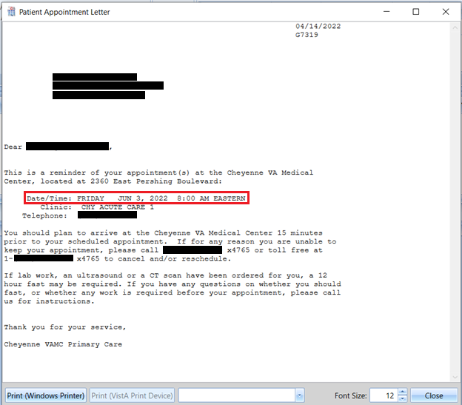
Figure 1: Patient Appointment Letter.
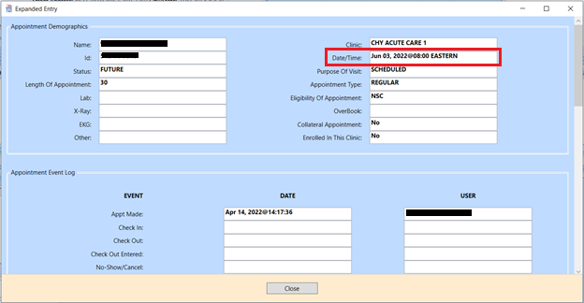
Figure 2: Expanded Entry Form.

Contact Attempt Method Columns
Schedulers will now see the count of Text, Secure Message, and Email when viewing the Request Management (RM) Grid. To view a count of contacts by text, secure messaging, or email for a request, find the request in the RM Grid and view the corresponding contact attempt column.
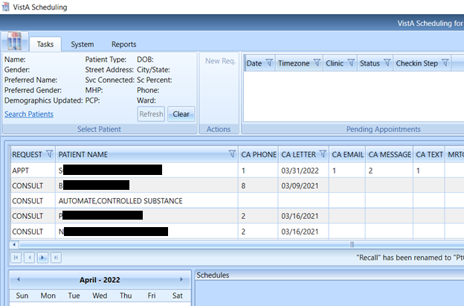
Figure 3: RM Grid With Contact Attempt Method Counts.
These columns can be rearranged on the fly by dragging and dropping in the RM grid, or column order can be saved as default view in User Preferences.
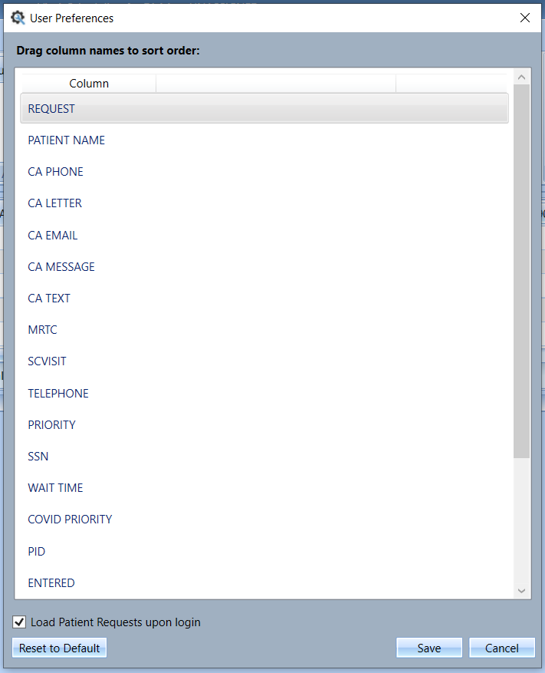
Figure 4: User Preferences.

Printing a Patient-Friendly Appointment Letter
To print a list of a patient’s scheduled over the next 90 days:
- Right click on the appointment in the pending appointments list and select “Patient Friendly Print”.
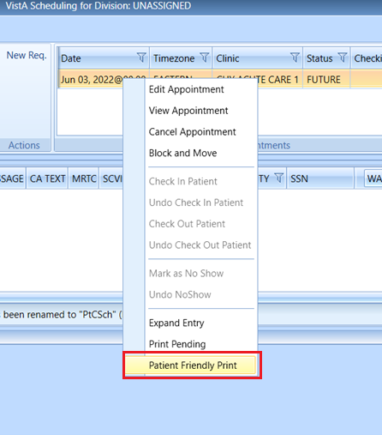
Figure 5: Printing A Patient Friendly Letter.
This will display a list of the patient’s future appointments up to 90 days from today in PDF format.
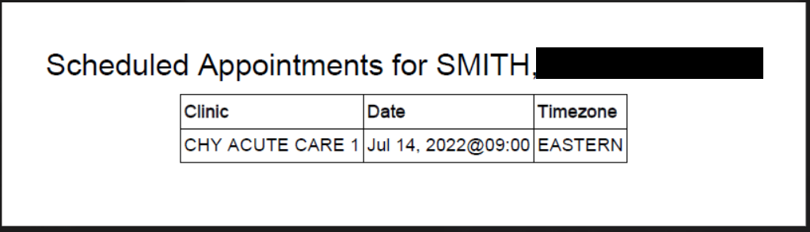
Figure 6: List Of Patient Future Appointments In PDF Format.

