VS GUI User Guide Addendum
  - Release 1.7.23.0 Update

Revision History
Date | Revision | Description | Author
05/17/2020 | 1.2 | Updated section 3.1 MISSION Act Eligibility Notice | VSE PMO
05/06/2020 | 1.1 | Reviewed and approved | REDACTED
04/28/2022 | 1.0 | Created Release Documentation | REDACTED  VSE PMO

Table of Contents
1 Introduction 4
1.1 Purpose 4
1.2 Overview 4
1.3 Disclaimers 4
1.3.1 Software Disclaimers 4
1.3.2 Documentation Disclaimers 4
1.4 Project References 5
1.4.1 Information 5
2 System Summary 6
3 Key Feature Update in Version 1.7.23.0 6
3.1 MISSION Act Eligibility Notice 6
3.2 Banner Displays Institution Name 7
3.3 Patient Contacts Warning 8
3.4 Fasting Selections on the Recall Request Window 9

List of Figures
Figure 1: Mission Act Eligibility Notification. 7
Figure 2: VistA Scheduling Application Window Old And New Top Banners. 8
Figure 3: Patient Contacts Warning Dialog Box. 8
Figure 4: Previous PtCSch Request Window Where Fasting Selection Is Not Displaying. 9
Figure 5: New Version Of PtCSch Request Window Where Fasting Selection Is Now Displaying. 9

Introduction
Department of Veterans Affairs (VA) Veterans Health Information Systems and Technology Architecture (VistA) Scheduling Graphical User Interface (VS GUI) module is the Windows GUI version of the Patient Information Management System (PIMS) Scheduling module. It provides appointment management functions included in PIMS Scheduling, but with the added convenience and usability of a GUI.

Purpose
The Veterans Health Administration (VHA) Office of Veterans Access to Care (OVAC) requested an enterprise enhancement for the VS package that supports COVID-19 response. The enhancement reduces operating costs for VHA and improves operational efficiencies, resulting in patient-centered access to care, coordinated care, increased customer satisfaction, and the reduction of excessive cycle/wait time for scheduling patients.

Overview
VS GUI is a software module that allows schedulers to make appointments quickly by viewing multiple appointment request types and multiple clinics in one screen. A scheduler can easily view patient requests for service, find the next available open appointment, view the provider’s availability in multiple clinics, and track a patient’s appointment process. Refer to System Summary for a more detailed description of VS GUI functionality.

Disclaimers

Software Disclaimers
This software was developed at the Department of Veterans Affairs (VA) by employees of the Federal Government in the course of their official duties. Pursuant to title 17 Section 105 of the United States Code this software is not subject to copyright protection and is in the public domain. VA assumes no responsibility whatsoever for its use by other parties, and makes no guarantees, expressed or implied, about its quality, reliability, or any other characteristic. We would appreciate acknowledgement if the software is used. This software can be redistributed and/or modified freely if any derivative works bear some notice that they are derived from it, and any modified versions bear some notice that they have been modified.

Documentation Disclaimers
The appearance of external hyperlink references in this manual does not constitute endorsement by the Department of Veterans Affairs (VA) of this Web site or the information, products, or services contained therein. The VA does not exercise any editorial control over the information you may find at these locations. Such links are provided and are consistent with the stated purpose of the VA.

Project References

Information
The VS GUI points of contact (POCs) include:
- OVAC Program Office – REDACTED
- TeleHealth & Scheduling Technical Manager – REDACTED
- OVAC Emerging Technologies Acting Legacy Program Manager – REDACTED
- OVAC Emerging Technologies VSE Subject Matter Expert (SME) – REDACTED

VSE Resources
- Veterans Health Administration (VHA) VSE SharePoint: REDACTED
- VA Software Document Library (VDL) – Scheduling (VSE manuals near the bottom):
- National Return to Clinic (RTC) Order: REDACTED

System Summary
The VSE project delivers a series of enhancements to legacy VistA Scheduling Version 5.3 via the VS GUI application.
This update is for the nationally released version 1.7.23.0, which includes VS GUI 1.7.23.0 and Emergency VistA patch SD*5.3*814. At time of publishing, install period is projected for May 2022.
VistA Scheduling (VS) Graphical User Interface (GUI) Release 1.7.23.0 and SD*5.3*814 includes several application updates and defect corrections to improve user experience.
The application now calculates MISSION Act eligibility based on selected appointment date, and alerts schedulers if the appointment they are about to schedule is MISSION Act eligible. Users will also see the name of the institution they are scheduling into at the top of the application window, rather than their assigned division.
Updates also include modification of contact attempts disposition warning calculation to take new contact attempt methods into account, correction to missing fasting selections on the View/Edit Recall request window, correction of “Ctrl+P” keyboard shortcut defect, 508 updates, and numerous back end updates to support future functionality.
The following sections detail user-facing functionality changes. Please see the Version Description Document (VDD) for a full account of all back-end and front-end changes with this release.

Key Feature Update in Version 1.7.23.0

MISSION Act Eligibility Notice
As of this release, users who select an appointment slot on a date that is MISSION Act eligible based on request entry date, Patient Indicated Date (PID), appointment date, and clinic stop code, will be presented with a notification that the appointment is Mission Act eligible, as shown below.
NOTE: This pop up is specific to wait time eligibility only and is not considering or reviewing for other community care eligibility criteria, as outlined in the MISSION Act.
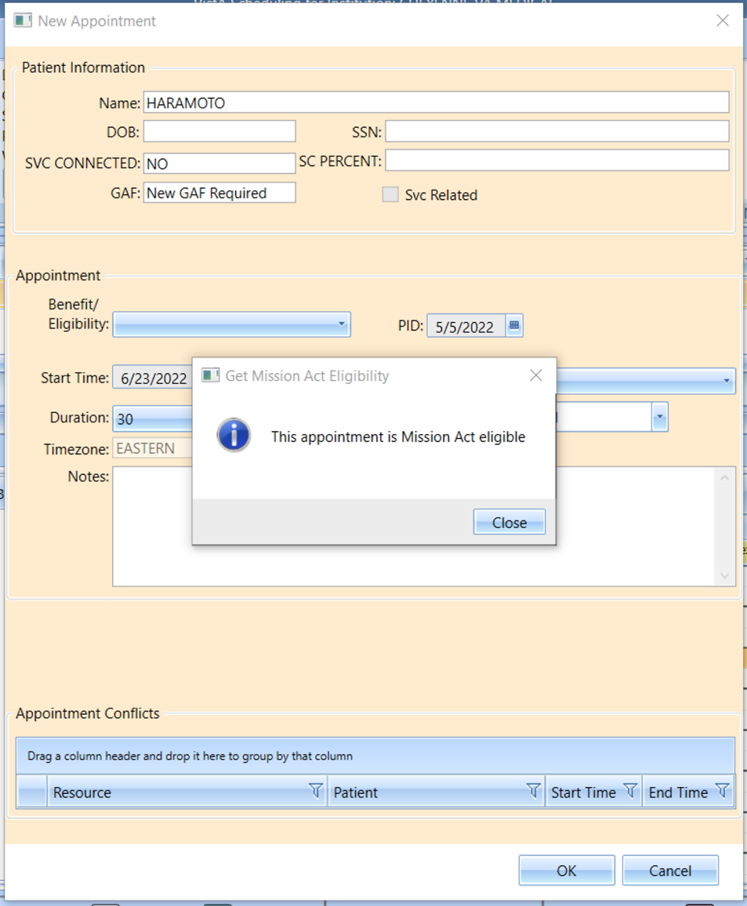
Figure 1: Mission Act Eligibility Notification.

Banner Displays Institution Name
As of this release, users will see the name of the VistA station they are logged into. Previously, the banner displayed the user’s assigned division, if present.
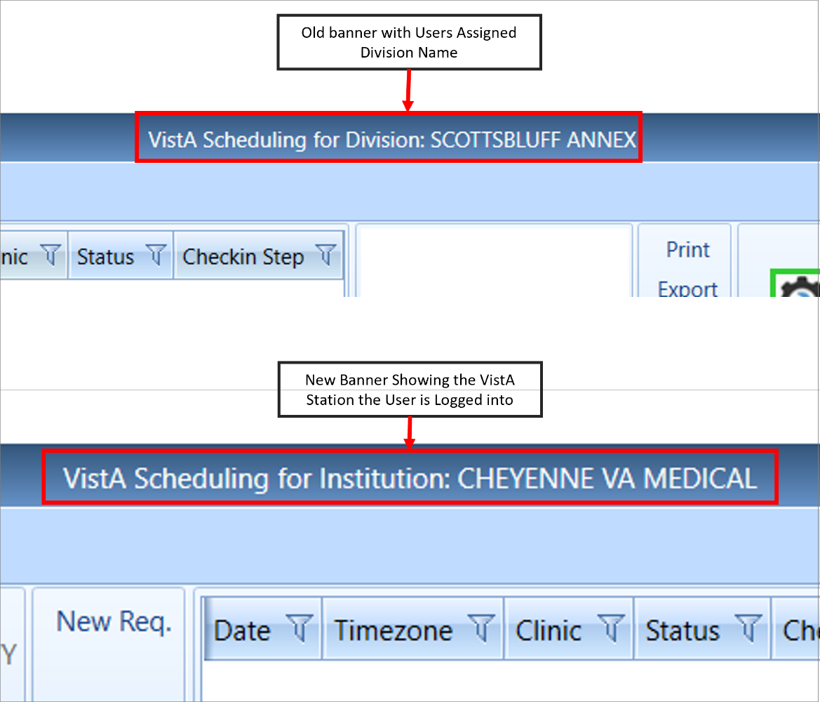
Figure 2: VistA Scheduling Application Window Old And New Top Banners.

Patient Contacts Warning
This release updates the logic behind the Patient Contacts warning dialog to take into account the newly added contact attempt methods. If sufficient contacts have not been completed, the warning will display.
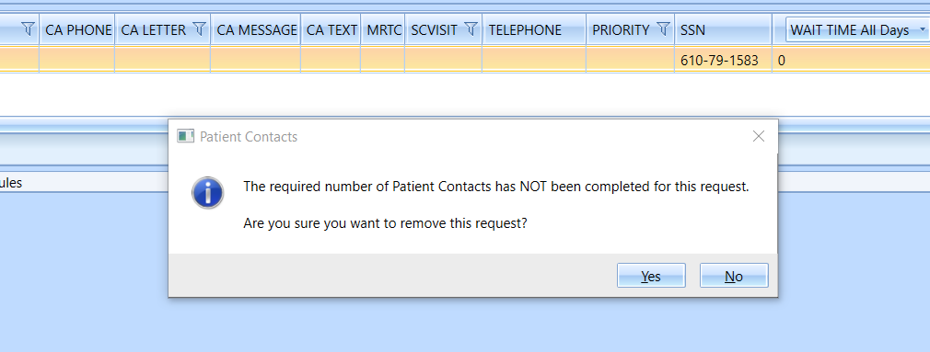
Figure 3: Patient Contacts Warning Dialog Box.

Fasting Selections on the Recall Request Window
This release corrects an issue where fasting selections did not display in the View Request or Edit Request windows for Patient-Centered Scheduling (PtCSch) requests.
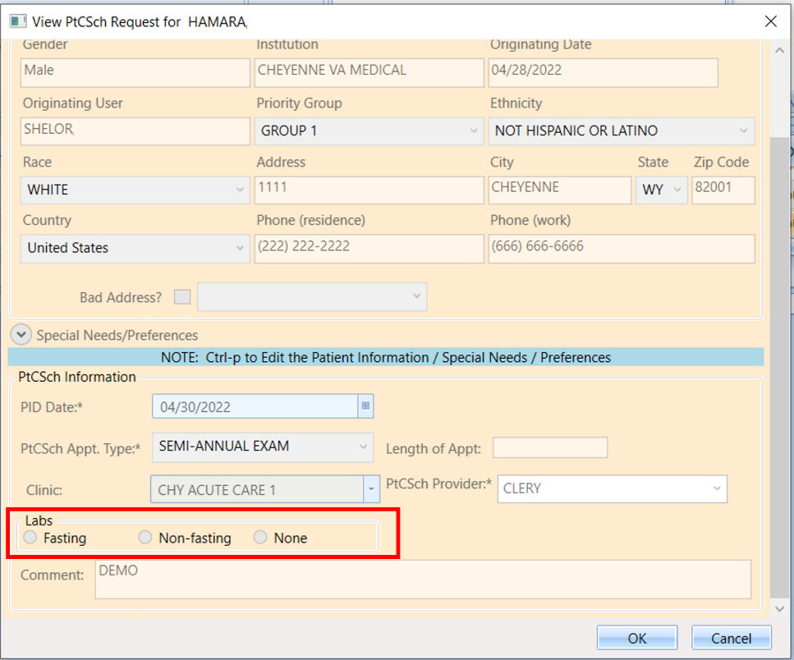
Figure 4: Previous PtCSch Request Window Where Fasting Selection Is Not Displaying.
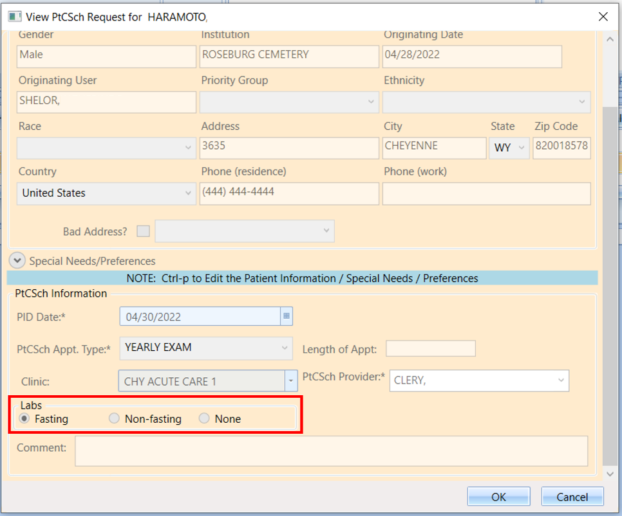
Figure 5: New Version Of PtCSch Request Window Where Fasting Selection Is Now Displaying.

