Shift Handoff Tool

Implementation Guide

and

Technical Manual

Clinician Desktop Service
Veterans Health Information Technology

Version 1
October 2018

Revision History
Date | Description | Author
October 2018 | Setup: New SERVICE/SECTION | REDACTED
June 2008 | Initial Release | REDACTED

Table of Contents
Revision History 2
Introduction 4
Installation 5
Server Installation 5
Client Installation 5
Tools Menu 5
Maintenance 7
Secondary Menu 7
Security Keys 7
Parameters 7
Setup 9
Shift Handoff Manager 9
Creating a New SERVICE/SECTION Entry 10
Preference Configuration 13
Handoff (HOT) Team Manager 20
Create new HOT List 20
Delete HOT List 21
Configure HOT List 22
Exported Items 23
Assign Menu to Secondary Menu 23
Security Keys 23
Files 24
Data Dictionaries 24
Routines 25
Globals 25
Application Programmer Interfaces 26
How to Generate On-Line Documentation 28
Routines 28
Files 28
External Relationships 29
Troubleshooting 30

Introduction
This manual covers technical aspects of the Shift Handoff Tool for Information Resource Management Service (IRMS) staff and Clinical Applications Coordinators (CACs). Included are installation, setup, and maintenance instructions as well as complete technical data.
The Shift Handoff Tool is a utility that assists hospital staff going off shift to create a report for the incoming shift. This report contains demographic and medical information about each patient being handed off. At a minimum it shows medications and allergies, but can be customized to show other medical information that is relevant to the patient’s condition.

Installation
There is both an M (or Server) component and a Windows (or Client) component. All the required files are contained in the distribution zip file: SHIFTHANDOFFTOOL.ZIP
Table 1: Contents of SHIFTHANDOFFTOOL.ZIP
File | Description
ShiftHandoffTool.exe | ShiftHandoffTool Executable
CRHD.HLP | CRHD Help File
CRHDIG.DOC | Install Guide (Word Version)
CRHDIG.PDF | Install Guide
CRHDIGTM.DOC | Implementation Guide and Technical Manual (Word Version)
CRHDIGTM.PDF | Implementation Guide and Technical Manual
CRHDUM.DOC | User Manual (Word Version)
CRHDUM.PDF | User Manual
CRHDRN.DOC | CRHD Release Notes (Word Version)
CRHDRN.PDF | CRHD Release Notes

Server Installation
See the Shift Handoff Tool Install Guide (CRHDIG.PDF) for complete instructions on installation of the M component.

Client Installation
The installation of the Windows component will vary according to your own local management policies. Basically, it consists of the following steps:
- Place the executable, ShiftHandoffTool.exe, and the help file, CRHD.hlp, in the same directory on each workstation or on a network drive accessible from each workstation.
- Add Shift Handoff Tool to the Tools menu of CPRS.
In addition, you can also setup the Shift Handoff Tool to run as a standalone application by doing the following to workstations in the hospital area(s) that are going to use this tool:
- Place a shortcut to ShiftHandoffTool.exe on the desktop. The parameters on the command line of this shortcut (S= and P=) must be the same as the parameters in the CPRS shortcut. S=Vista Server P=RPC Broker Port

Tools Menu
You may set up the tools menu on the User, Location, Service, Division, or System level. The lowest level overrides higher levels.
Select GUI Parameters Option: ?

CS GUI Cover Sheet Display Parameters ...
HS GUI Health Summary Types
TM GUI Tool Menu Items
MP GUI Parameters - Miscellaneous
UC GUI Clear Size & Position Settings for User
RE GUI Report Parameters ...
NV GUI Non-VA Med Statements/Reasons
RM GUI Remove Button Enabled
NON GUI Remove Button Enabled for Non-OR Alerts
EIE GUI Mark Allergy Entered in Error

Enter ?? for more options, ??? for brief descriptions, ?OPTION for help text.

Select GUI Parameters Option: TM GUI Tool Menu Items

CPRS GUI Tools Menu may be set for the following:

1 User USR [choose from NEW PERSON]
2 Location LOC [choose from HOSPITAL LOCATION]
2.5 Service SRV [choose from SERVICE/SECTION]
3 Division DIV [choose from INSTITUTION]
4 System SYS [DEVCUR.FO-SLC.MED.VA.GOV]

Enter selection: 3 Division INSTITUTION
Select INSTITUTION NAME: salt
1 SALT LAKE CITY UT EES 925
2 SALT LAKE CITY UT NHC 6609AA
3 SALT LAKE CITY UT USAF 660CZ
4 SALT LAKE CITY HCS UT VAMC 660
5 SALT LAKE CITY OIFO UT ISC 5000
Press <RETURN> to see more, '^' to exit this list, OR
CHOOSE 1-5: 5 SALT LAKE CITY OIFO UT ISC 5000

------- Setting CPRS GUI Tools Menu for Division: SALT LAKE CITY OIFO -------Select Sequence: 2
Are you adding 2 as a new Sequence? Yes// y YES

Sequence: 2// 2
Name=Command: &Shift Handoff Tool=C:/CPRS/ShiftHandoffTool.exe S=%SVR P=%PORT
Select Sequence:

Maintenance

Secondary Menu
CRHD SHIFT CHANGE HANDOFF is the secondary menu exported with this application. You cannot run ShiftHandoff.exe from a workstation unless you have this menu option or you have programmer access mode. All users of this application should have this menu assigned to them as a secondary menu or as part of their primary menu tree.

Security Keys
The following keys are exported for use with the Shift Handoff Tool:
CRHD SHIFT CHG HANDOFF MGR (This gives access to Preference Page)
CRHD HOT TEAM MGR (This gives access to the configuration Handoff Tool (HOT) list)

Parameters
The following parameters are kept in the CRHD HANDOFF PARAMETERS (#183) file.
Table 2: Content of the CRHD HANDOFF PARAMETERS (#183) file
Parameter Name | Description
TEMP_FLD_1_TITLE | Temporary field 1 Title
TEMP_FLD_2_TITLE | Temporary field 2 Title
TEMP_FLD_3_TITLE | Temporary field 3 Title
TEMP_FLD_4_TITLE | Temporary field 4 Title
TEMP_FLD_COLOR | Temporary field color
TEMP_FLD_FONTCOLOR | Temporary field font color
STUDENT | Medical Students and phone
RESIDENT | Resident and phone
PATIENT_DEMOGRAPHICS | Patient demographics
PATIENT_DEMO_PRINTLBL | Print patient demographics labels
MED_DETAIL_FLG | Include Meds details
MED_EXCLUDE_IV | Exclude IVs from Med list
CONSULTS | Consults request
LABS_IMAGING | Labs and Radiology
PRINT_ORIENTATION | Portrait/Landscape
ORDER_BY | Sort patients by for printed report
MULTI_DNR | Display multiple active DNR orders if found
FILE_Location | Team Info file location
The following parameters are stored in the VistA PARAMETER DEFINITION FILE (#8989.51) file:
Table 3: Contents of the VistA PARAMETER DEFINITION FILE (#8989.51) File
Parameter Name | Description
CRHD DEFAULT PREFERENCE | Default Preference
CRHD DNR ORDER TITLE | DNR search strings
CRHD DNR ORDERABLE ITEMS | DNR search items
CRHD TEMP FLD EXPIRE | Temporary field expiration in days

Setup
Managers and Clinical Application Coordinators (CACs) do not need to use VistA to manage team lists and preferences. Holders of the CRHD SHIFT CHG HANDOFF MGR key have access to the Preference Configuration dialog and can enter and manage multiple configurations. Holders of the CRHD HOT TEAM MGR key have access to the Handoff Team (HOT) list management dialog.
An important point is that each list, including HOT lists, has a different setup associated with it. Many aspects of the final printout can be managed separately for each list. The Shift Handoff Manager or CAC for each service should study the options carefully so lists can be configured to the greatest possible advantage.

Shift Handoff Manager
The Preference Configuration menu command does not appear on the File menu unless the user holds the CRHD SHIFT CHG HANDOFF MGR key.
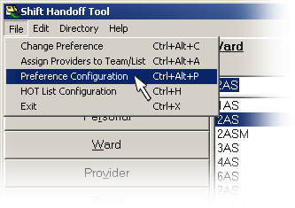
Selecting this menu command brings up the selection dialog:
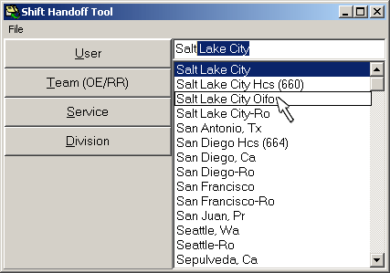
Preferences can only be named after providers, teams, service, or divisions that already exist in the system. Notice, for example, that all medical centers are listed. These are only used as names for profiles and do not interact with any system external to your local site.
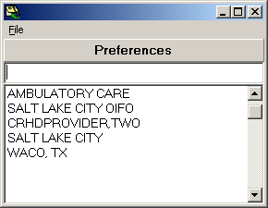
Notice above that we have five preferences defined, one is name after a local clinic, another is names after a provider, and three of them are named after medical centers. All are simply being used as names of preferences in our local system.

Creating a New SERVICE/SECTION Entry
Though VistA is not needed to manage team lists and preferences, it is necessary to use VistA to create a new SERVICE/SECTION.
Note: This file requires programmer access (@) to add or edit items. The requestor will need to work with their local/regional systems manager to request the changes.
VistA FileMan may be used to create the new SERVICE/SECTION entry as in the example below.
VA FileMan 22.2

Select OPTION: ENTER OR EDIT FILE ENTRIES

Input to what File: SERVICE/SECTION// (158 entries)
EDIT WHICH FIELD: ALL//

Select SERVICE/SECTION NAME: TEST THERAPY
Are you adding 'TEST THERAPY' as a new SERVICE/SECTION (the 159TH)? No// Y (Yes)
SERVICE/SECTION MAIL SYMBOL: JSGT
SERVICE/SECTION PARENT SERVICE: 117
1 117 PHYSICAL THERAPY 117
2 117 SPEECH THERAPY 117 SPEECH THERAPY
CHOOSE 1-2: 1 PHYSICAL THERAPY 117
ABBREVIATION: JSGT
DESCRIPTION:
Edit? NO//
MAIL SYMBOL: JSGT//
PARENT SERVICE: PHYSICAL THERAPY//
TYPE OF SERVICE: C PATIENT CARE
CHIEF: Staff, Chief
Select CHIEF PHONE:
ASST CHIEF:
Select ASST CHIEF PHONE:
LOCATION:
MIS COSTING CODE:
COST CENTER:
TYPE OF COSTING SECTION:
AMBULATORY CARE FLAG:
Select DATE CLOSED:
NATIONAL SERVICE:
COORDINATOR (IRM):

Select SERVICE/SECTION NAME:
Once the new SERVICE/SECTION has been created, login to the Shift Handoff Tool GUI application. Select File/Preference Configuration (or < Ctrl > <Alt> < P >) from the top menu bar.
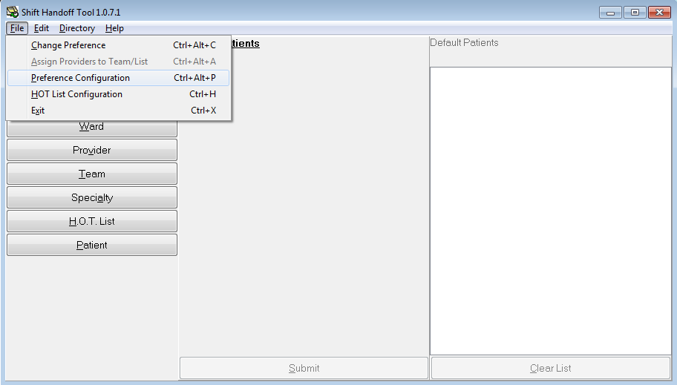
Then select the [ Service ] button. Highlight in the list box the Service you would like to add to the CRHD HANDOFF PARAMETERS NAME file (#183) and double click or select < Enter >. Reminder, the service MUST exist in SERVICE/SECTION file (#49) for it to show up in this list.

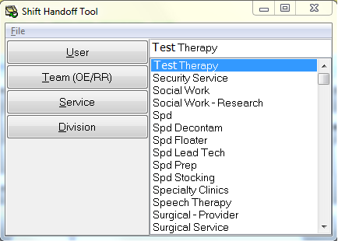

The Shift Handoff Preference Configuration window for the Service Name that was selected will be displayed. Select the [ SUBMIT DATA ] button at the bottom of this window.
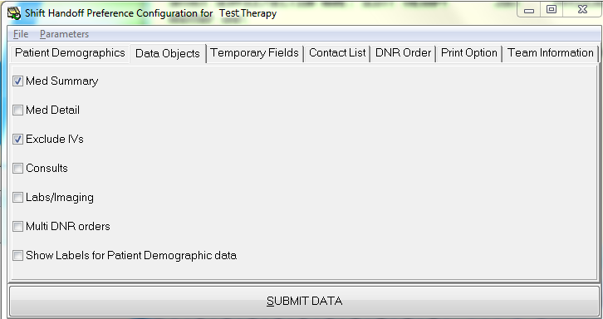
If VistA FileMan is now used to inquire on the CRHD HANDOFF PARAMETERS NAME file (#183), the Service should now be seen.
VA FileMan 22.2
Select OPTION: INQUIRE TO FILE ENTRIES
Output from what File: SERVICE/SECTION// 183 CRHD HANDOFF PARAMETERS (4 entries)
Select CRHD HANDOFF PARAMETERS NAME: ?
Answer with CRHD HANDOFF PARAMETERS NAME
Choose from:
EDUCATION
TEST THERAPY

Select CRHD HANDOFF PARAMETERS NAME: NAME

Searching for a NEW PERSON, (pointed-to by NAME)
Searching for a OE/RR LIST, (pointed-to by NAME)
Searching for a FACILITY TREATING SPECIALTY, (pointed-to by NAME)
Searching for a TEAM, (pointed-to by NAME)
Searching for a SERVICE/SECTION, (pointed-to by NAME)

TEST THERAPY JSGT PHYSICAL THERAPY
...OK? Yes// (Yes)
Another one:
Standard Captioned Output? Yes// (Yes)
Include COMPUTED fields: (N/Y/R/B): NO// BOTH Computed Fields and Record Number (IEN)

NUMBER: 4 NAME (SRV): TEST THERAPY
NAME: PATIENT_DEMOGRAPHICS VALUE: 2,6,7,8,12,,5
NAME: PATIENT_DEMO_PRINTLBL VALUE: 0
NAME: MED_DETAIL_FLG VALUE: 0
NAME: PRINT_ORIENTATION VALUE: L
NAME: CONSULTS VALUE: 0
NAME: LABS_IMAGING VALUE: 0
NAME: MED_EXCLUDE_IV VALUE: 0
NAME: ORDER_BY VALUE: 0
NAME: MULTI_DNR VALUE: 0
NAME: TEMP_FLD_COLOR VALUE: 65535
NAME: TEMP_FLD_FONTCOLOR VALUE: 0

Select CRHD HANDOFF PARAMETERS NAME:

Preference Configuration
The Preference Configuration dialog has seven (7) tabs. They are Patient Demographics, Data Objects, Temporary Fields, Contact List, DNR Order, Print Option, and Team Information. The setting on each of these can be changed using the parameters that are exported with this application. However, all settings can be completely controlled by the Preference Configuration dialog.

Patient Demographics
The Patient Demographics tab looks like this:
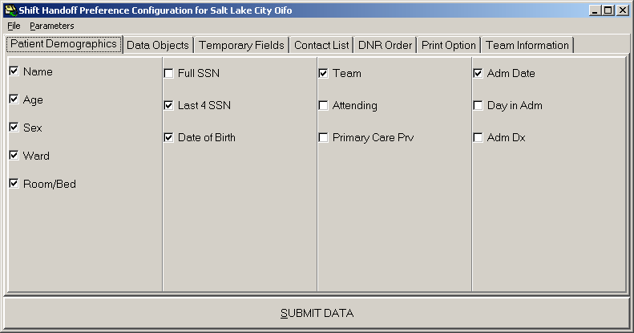
Name, Age, Sex, Ward, and Room/Bed are all mandatory and cannot be unchecked. Full SSN and Last 4 SSN refers to what will print out on the report. The full SSN appears on the screen in either case. (We recommend that you select Last 4 SSN because it is more consistent with privacy considerations.) One or the other must be displayed. Displaying the Date of Birth, Attending, Primary Care Prv, Adm Date, Day of Adm, and Adm Dx are all optional.

Data Objects
The Data Objects control what data objects display on the screen and are printed on the report. The tab appears as such:
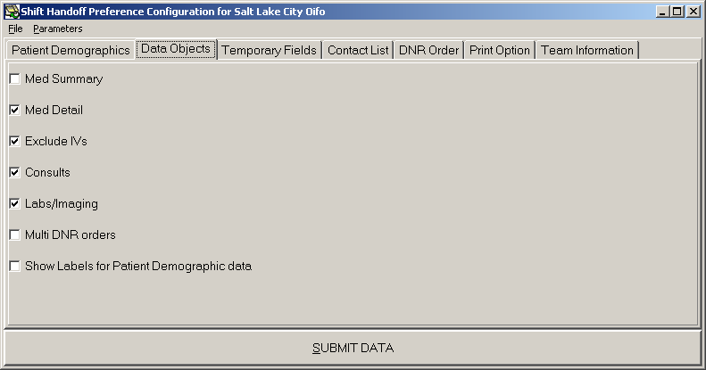Medications will display and be listed, the only option is whether a summary or detailed medication list is used. IVs can be excluded from the medication list (which, if chosen, excludes all IV medications including antibiotics). The Consults and Labs/Imaging check boxes control whether these lists will be present on the screen or report. Multi DNR orders controls whether just the most recent DNR order appears, or all DNR orders are listed. Show Labels for Patient Demographics, if left unchecked, will not label this information on the printout.

Temporary Fields
You can detail up to four additional fields for providers to enter context sensitive information about each patient. In the Patient Data dialog these fields appear with a different background indicating data can be entered. The default color is a deep yellow intended to suggest a Post-it® note. This is because none of the information is kept permanently as part of the patient record. The tab looks like this:
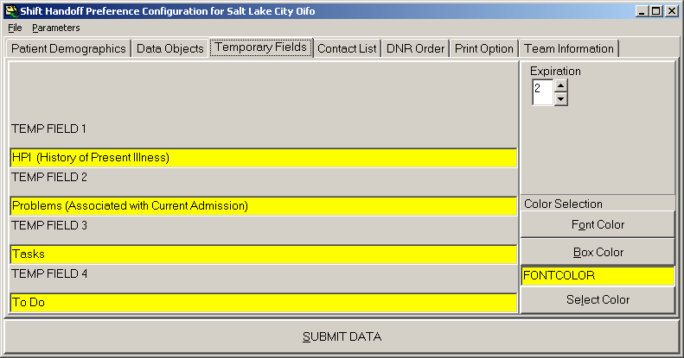
The default is that the title of each field is blank. Blank fields do not appear on the Patient Data dialog, so if you wish to use these temporary fields you must enable them by assigning a name to them (like HPI, etc.)
If you don’t like the bright yellow background, you can select a more preferred background color and font color to use for these fields with the controls in the lower right-hand corner of this tab. You must press both the Select Color and then click on the Submit Data button to make a color change permanent.
In the upper right-hand corner of the tab is a selection box marked Expiration. This is the number of days any information entered in the temp fields is retained. This data is kept in the CRHD TEMPORARY DATA (#183.2) file. The count starts whenever data is entered or modified in one of the temp fields. Once expiration has been reached, the information entered in each temporary field is deleted. The expiration can only be set on the Division level, all lists below Division inherit that value. The intention of this system is to provide a mechanism for the passing of context sensitive information from shift to shift during an incidence of care. Any information that needs to be preserved in the patient record must be entered via CPRS and then signed.
The maximum value of the Expiration field is 7 days. When temporary fields are accessed, the last date edited is checked. If the day plus Expiration is less than the present date, the field is blanked out. This is done on a field by field, patient by patient basis.
Temporary field names are limited to 30 characters.

Contact List
The contact list is only used if there is no defined contact list with the team. The recommendation it to make entries at the Division level, that way all lists in the division inherit the contacts. This is an example of a possible division level contact list:
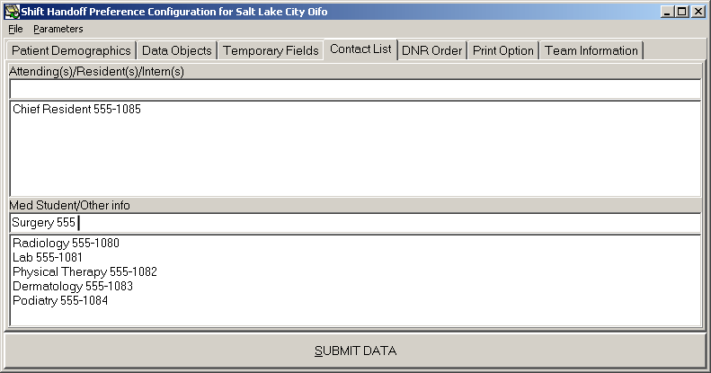

As with other dialogs for maintaining lists in Shift Handoff Tool, items are deleted by double clicking or by right clicking and selecting delete from the drop-down menu.

DNR Order
The DNR Order tab is provided as a way to map local Do Not Resuscitate (DNR) order names. To this point, DNR orders are strictly controlled by the local medical center policy. In some cases, different terminology is used. In other cases, more than one DNR order is present among the orderable items to cover varying situations, such as differentiating between cardiac and pulmonary DNR circumstances. The DNR Order tab looks like this:
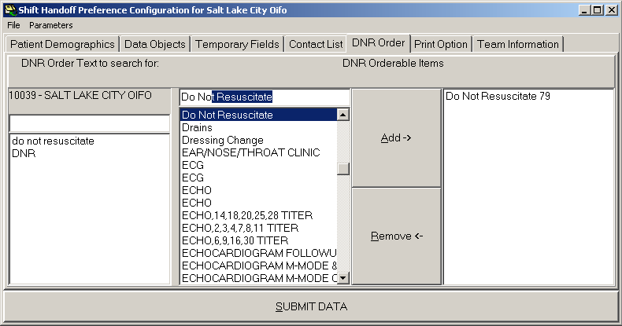
This tab gives you two ways to define DNR orders. The first, in the left hand box, allows you to type in strings and phrases that are typically present in a DNR order. Type the strings or phrases into the text box and press the Enter key. What you type is added to the list. (As with many things in VistA, it is not case sensitive.) You can double click on an item to remove it from the list.
The second, in the remainder of the tab, is to specify specific items from the orderable items file to be included. Type search terms into the text box at the top of the center column. Select orderable items by double clicking on them, or selecting them and hitting the Add key. The list of orderable items with their Internal Entry Numbers (IENs) is built in the right hand frame. To delete items from this list within the right window pane, either double click on the item or select it and then click on the Remove key.

Print Option
The Print Option tab allows you to specify preferences for the printout. It allows you to specify Portrait or Landscape orientation of the printing, and it allows you to select the print order, either alphabetically by patient, by room number, or by patient location. The tab looks like this:
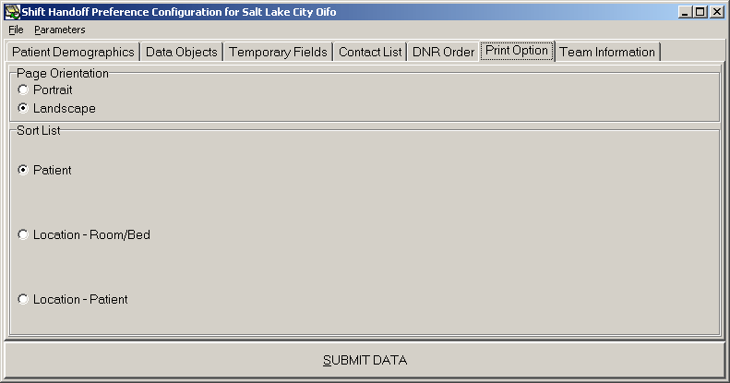

Team Information
The Team Information tab specifies a file location to find text information files about the team. These files can be accessed a number of places while running the application. The default location is the directory which the application is executed from. This is usually, but not always, C:\Program Files\Vista\ShiftHandoff\. When specifying an alternate location be sure to use the backslash character “\” to separate fields and indicate the end of the address as in this example:
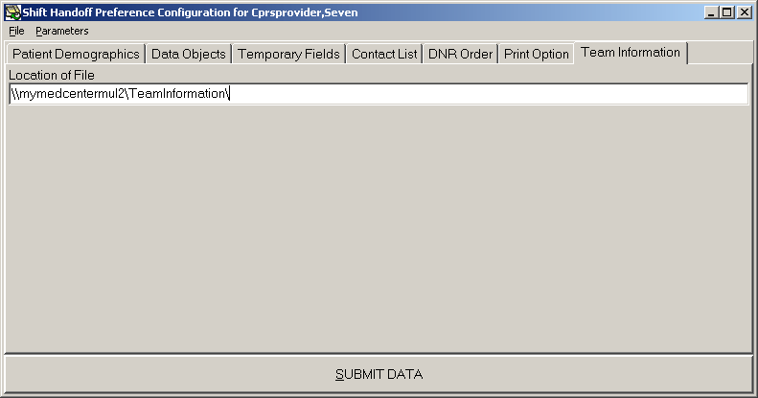
These files can be created by you and must reside either on the workstation that will be used or on a Windows server accessible from a workstation. The naming convention is the name of the team followed by the .TXT extension. Notepad can be used to initially create these files. You can override the file name with the Assign Providers to Team/List dialog.
Note: Back and front slashes (\ and /), asterisks (*), and question marks (?), as well as most other punctuation cannot be used as part of file name. Rather than require sites using this feature to change team names, you can use the Assign Providers to Team/List dialog to supply an alias that the system will use as a file name.
Once created, users with the CRHD HOT TEAM MGR key can edit the team information from ShiftHandoffTool.exe. Holders of this key get the following right-click menu:
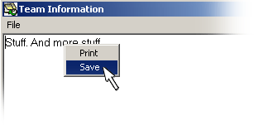
Note: This file is for team-centric information, not patient information. All users need to be cautioned that no patient, individually identifiable information should be placed in this file.

Handoff (HOT) Team Manager
Users with the CRHD HOT TEAM MGR key have access to the Handoff Tool (HOT) List creation and management functions. HOT Lists are only maintained within the Shift Handoff application and have no relation to lists maintained in VistA. When this key is present in a user’s account, the File menu command HOT List Configuration becomes active.
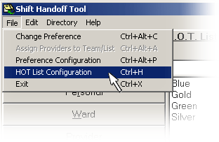
Selecting this command opens the TEAM dialog, that looks like this:
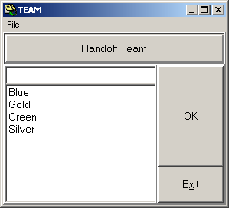
From this dialog your can do three things:
- Create a new HOT List.
- Delete a HOT List.
- Configure a HOT List (i.e., add patients, delete patients, add provider information connected to a specific patient, add providers, delete providers, add information about each provider on the team.
The only constraint on HOT Lists is that they are for inpatients only. Patients cannot be added to HOT lists unless they have been admitted and a patient will be automatically removed when a discharge action is taken on that patient.

Create new HOT List
To create a new HOT List, simply type its name in the text box at the top of the dialog. When you press enter or click the OK button, it asks, “Do you want to Save _____ as a New Team?” If you answer yes, it goes on to the next dialog.

Delete HOT List
To delete a hot list, select it, right click, then select Delete from the drop-down menu. Here is an example:
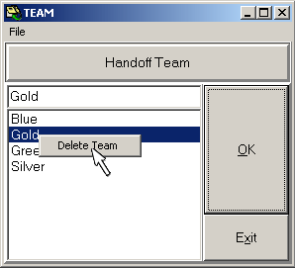

Configure HOT List
Here is an example of the HOT List configuration dialog:
Provider List
Patient List

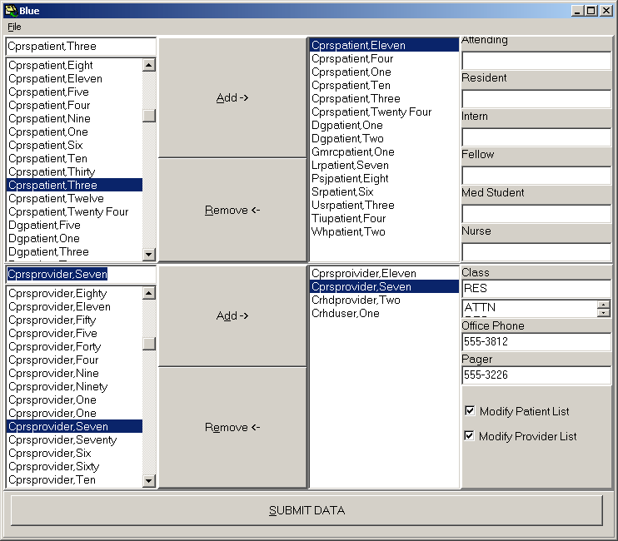
Information added to these fields is for the highlighted patient.
Changes do not take effect until you click here.
Checking these boxes gives the highlighted provider the indicated privilege.
These phone numbers come from the New Person file.
Fill in Class for providers by selecting them from this list.
Double click to add to provider list.
Double click to add to patient list.

Each HOT List has patients and providers associated with it. The providers can be assigned one of six roles: ATTN, RES, INTERN, FELLOW, MED STUDENT, or NURSE. The office phone and digital pager numbers come from the New Person file and are included on the HOT list. These numbers may be overridden from this dialog (but will not update the New Person file). Also, privileges to modify this list can be granted by checking the appropriate box(s) Modify Patient List or Modify Provider List.
Each patient can have an Attending, Resident, Intern, Fellow, Med Student, and Nurse assigned separately to it. Patients are automatically deleted from the list when a discharge action is taken on them.
Note: As with other parts of the Shift Handoff Tool, the information entered into this dialog is not kept in the VistA team files. Thus the assignments of providers is only for the purposes of the HOT list and do not impact team information within CPRS/VistA.

Exported Items

Assign Menu to Secondary Menu
CRHD SHIFT CHANGE HANDOFF must be assigned to a user to use the Shift Handoff Tool. If a user tries to execute the Shift Handoff Tool GUI (from either the tools menu or from an icon) and they have not been assigned the CRHD SHIFT CHANGE HANDOFF option, the program immediately shuts down.

The recommended placement for the CRHD SHIFT CHANGE HANDOFF option is to set it up as a secondary menu. This option can also be added to a provider’s primary menu.

Security Keys
CRHD SHIFT CHG HANDOFF MGR (Preference setup) (only a few should hold this key, maybe the Clinical Application Coordinator)
CRHD HOT TEAM MGR ( HOT Team manager)

Files

CRHD TEMPORARY DATA (#183.2)
This file stores the temporary data entered for each patient. Data fields: Temporary field name, Patient, Author, Date Entered, Last Edit by, Date/Time of Last Edit, Private (not used), Read Only (not used).

CRHD HANDOFF PARAMETERS (#183)
Preference configuration parameters are stored in this file. The following files are pointed to files:
Table 4: CRHD Handoff Configuration File Parameters
File Number | File Name
200 | USER
100.21 | OE/RR TEAM
45.7 | TREATING SPECIALTY (Not used)
404.51 | SD TEAM (Not used)
49 | SERVICE (Not used)
44 | LOCATION
4 | DIVISION
Data fields: Name, Entity Name, Value, List Value

CRHD TEAM CONTACT LIST (#183.4)
This file stores contact information for providers assigned to the selected list.
Data fields: Team, Providers, Class, Pager, Office Phone, Filename.

CRHD HOT TEAM PATIENT LIST (#183.3)
This file stores a list of patients and providers for the lists created within the Shift Handoff Tool.
Data fields: Team, Inactive (not used), Patients, Attending, Resident, Intern, Fellow, Med Student, Nurse, Providers, Class, Modify Patient List, Modify Provider List, Pager, Office Phone.

Data Dictionaries
The number-space for Shift Handoff Tool files is 183. A listing of these files can be obtained by using the VA FileMan option DILIST (List File Attributes). Depending on the FileMan template used to print the listing, this option will print out all or part of the data dictionary for the Shift Handoff Tool files.

Routines
The following routines are exported with the CRHD build:
CRHD GET THE PATIENT DATA ELEMENTS FOR CHANGEOVER LIST
CRHD1 ADDED TO WORK WITH HAND OFF TEAM SECTION
CRHD10 ASSIGN PROVIDERS TO A TEAM LIST
CRHD11 GET USERS PARAMETERS
CRHD2 GET DATA ITEMS FOR CHANGEOVER LIST
CRHD3
CRHD4 GET USERS PARAMETERS
CRHD5 MISC ROUTINE FOR HAND-OFF TOOL
CRHD6 MISC ROUTINE FOR HAND-OFF TOOL
CRHD7 TEAM ROSTER
CRHD8 RETURNS THE TEXTS OF AND ORDER
CRHD9 HANDOFF TEAM LIST
CRHDAM
CRHDDNR GET ACTIVE DNR ORDER
CRHDDR RETRIEVE DNR ORDERS USING ORDER DIALOG
CRHDPL Find personal lists for changeover list
CRHDUD New Person general information
CRHDUT GET THE PATIENT DATA ELEMENTS FOR HANDOFF LIST
CRHDUT2 GET THE PATIENT DATA ELEMENTS FOR HANDOFF LIST CONTINUED

Globals
The shift Handoff Tool creates one global, ^CHRD(.

Application Programmer Interfaces
The following table shows Remote Procedure Calls (RPCs) that are exported with and used by the Shift Handoff Tool along with the corresponding M code entry point:
Table 5: RPC Exported with Shift Handoff Tool
Remote Procedure Call | M Entry Point
CRHD ADDITIONAL USER INFO | AUSRINFO^CRHDUT
CRHD ALL USER PARAMETERS | GETALLP^CRHD4
CRHD AVAILABLE PARAMETERS | GETALLPL^CRHD11
CRHD COMB TM LIST | TMCOMB^CRHD10
CRHD DEFAULT PREFERENCE | DEFPREF^CRHD11
CRHD DELETE A PREFERENCE | DELPREF^CRHD5
CRHD GET CONSULT | CONSULT^CRHDUT
CRHD GET DNR TITLES | GETDNRT^CRHD4
CRHD GET IMAGING | IMAGING^CRHDUT
CRHD GET LABS | LABS^CRHDUT
CRHD GET ONE PARAMETER | GETONEP^CRHD4
CRHD GET ORDERABLE ITEMS | LORDITM^CRHDDR
CRHD GET PAT LIST | GETPTLST^CRHD3
CRHD GET PREFERENCES | GETP^CRHD6
CRHD GET TEAM PHONE NUMBERS | TEAMMEM^CRHD7
CRHD GET TEMP FLD | GTEMPTXT^CRHD3
CRHD GET USER DIVISIONS | USERDIV^CRHD5
CRHD GET USER PARAMETERS | GETIT^CRHD11
CRHD GET XPAR VALUES | GETPAR2^CRHD6
CRHD HOT CAN EDIT | CANEDIT^CRHD9
CRHD HOT DELETE PAT/PRV | DELENTS^CRHD1
CRHD HOT DELETE TEAM LIST | HOTMDEL^CRHD9
CRHD HOT MODIFY LIST | MOD^CRHD9
CRHD HOT PATIENT LIST | HOPLIST^CRHD9
CRHD HOT PATPRV | PATPRV^CRHD9
CRHD HOT PROVIDER BY CLASS | HOTMMEMS^CRHD1
CRHD HOT PROVIDER LIST | HODLIST^CRHD9
CRHD HOT PROVIDER LIST2 | HOTMMEM^CRHD1
CRHD HOT PROVIDER PATIENTS | HOTPRVPT^CRHD1
CRHD HOT PRV INFO | PRVINFO^CRHD9
CRHD HOT TEAM LIST | HOLIST^CRHD9
CRHD HOT TEAM PHONE INFO | HOTEAM^CRHDUD
CRHD HOT TEAM SAVE | HOTMSAVE^CRHD9
CRHD HOT TM MGR | HOTMMGR^CRHD1
CRHD INPT LIST | LISTINPT^CRHD3
CRHD IS RECORD LOCKED | LOCK^CRHD2
CRHD LIST DIVISIONS | DIV^CRHD5
CRHD LIST SERVICES | SRV^CRHD5
CRHD MGR | MGR^CRHD7
CRHD MOD TM PROVIDERS | TMMOD^CRHD10
CRHD PAT ACTMEDS | ACTMED^CRHD
CRHD PAT ALLERGIES | ALG^CRHD
CRHD PAT CODESTS | CODESTS^CRHD
CRHD PAT DEMO | PATDEMO^CRHD
CRHD SAVE DNR TITLES | SAVEP^ CRHD6
CRHD SAVE PARAMETERS | SAVEPARM^CRHD4
CRHD SAVE TEMP FLD | TEMPDATA^CRHD2
CRHD SAVE XPAR PARAMETERS | SAVEP2^CRHD6
CRHD SERVICE INFO | SRV^CRHDUD
CRHD SORT PRINT LIST | SORT^CRHD8
CRHD TM PRV INFO | TMPRVINF^CRHD10
CRHD TM PRV LIST | TMLIST ^CRHD10
CRHD USER PHONE INFO | DISPEMP^CRHDUD
CRHD USER PHONE NUMBERS | USERPHPG^CRHD9

How to Generate On-Line Documentation

Routines
The namespace for the Shift Handoff Tool application is CRHD. A listing/printout of any or all of the Shift Handoff Tool routines can be produced by using the Kernel option XUPRROU (List Routines). This option is found on the XUPROG (Programmer Options) menu, which is a sub-menu of the EVE (Systems Manager Menu) option. When prompted with “routine(s) ? >:” type in CRHD* to get a listing of all Shift Handoff Tool routines.
The first line of each routine contains a brief description of the general function of the routine. A listing of just the first line of each Shift Handoff Tool routine can be produced by using the Kernel option XU FIRST LINE PRINT (First Line Routine Print). This option is found on the XUPROG (Programmer Options) menu, which is a sub-menu of the EVE (Systems Manager Menu) option.

Files
The number-space for Shift Handoff Tool files is 183. A listing of these files can be obtained by using the VA FileMan option DILIST (List File Attributes). Depending on the FileMan template used to print the listing, this option will print out all or part of the data dictionary for the Shift Handoff Tool files.

External Relationships
There are DBIAs (Data Base Integration Agreements) covering the following procedure calls:

ORQPT DEFAULT LIST SORT DEFSORT^ ORQPTQ11
ORQPT DEFAULT LIST SOURCE DEFSRC^ORQPTQ11
ORQPT PROVIDER PATIENTS PROVPTS^ORQPTQ2
ORQPT SPECIALTIES SPEC^ORQPTQ2
ORQPT SPECIALTY PATIENTS SPECPTS^ORQPTQ2
ORQPT TEAM PATIENTS TEAMPTS^ORQPTQ1
ORQPT TEAMS TEAMS^ORQPTQ1
ORQPT WARDS WARD^ORQPTQ2
ORWPT BYWARD BYWARD^ORWPT
ORWPT LAST5 LAST5^ORWPT
ORWPT FULLSSN FULLSSN^ORWPT
ORWPT LIST ALL LISTALL^ORWPT
ORWTPP DELLIST DELLIST^ORWTPP
ORWTPP NEWLIST NEWLIST^ORWTPP
ORWTPP PLISTS PLISTS^ORWTPP
ORWTPP SAVELIST SAVELIST^ORWTPP
ORWU NEWPERS NEWPERS^ORWU
ORWU USERINFO USERINFO^ORWU

Troubleshooting
Question: A user tries to run Shift Handoff Tool, either from the Tools menu or from the icon, and the splash screen just appears for half a second and then it is gone. This user cannot run the application. What is wrong?
Answer: Make sure the user has the CRHD SHIFT CHANGE HANDOFF menu option assigned to them.

Question: We used to use the CAIRO shift handoff software and some of our providers prefer it. However, when members of the same team look at the new Shift Handoff Tool it appears as though data is missing. What’s going on?
Answer: CAIRO and the Shift Handoff Tool use different files. On installation data is copied from the old CAIRO files into the new Shift Handoff Tool files so that operations can proceed seamlessly. However, the two applications do not talk to one another. All providers must use the new Shift Handoff Tool executable in order for the new software to work properly.

Question: Our printed reports go on forever, repeating the same data on the last pages. What’s going on and how can we fix it?
Answer: This is a known bug. Before printing, review the report with the print preview menu option. If a repeat is found in the output causing the printout to loop endlessly, several things can be done:
- Find the patient where the looping starts and reduce the amount of information in the temporary fields. This will change the formatting of the output and may solve the problem.
- Go back to the Preference Configuration, Print Option tab and change the Page Orientation from Landscape to Portrait.
- Go back to the Preference Configuration, Data Objects tab and change the Med Detail to Med Summary.
- Go back to the Preference Configuration, Data Objects tab and select Exclude IVs

