Telehealth Management Platform (TMP)

Release Notes D365 v4.6

Department of Veterans Affairs

Version 1.0
September 2019

TMP D365 v4.6 Release
Telehealth Management Platform
Microsoft TMP Development Team

Sept 2019

- TMP Release 4.6 D365 Notes
- Release Information
- Known Issues
- Legacy Scheduling Process
- 4.6 Scheduling Process
- Legacy Telehealth Process
- Scheduling Packages

Migration to the Cloud
  - TMP is migrated and upgraded from On Premise 2015 to Online D365 v9. This prepares TMP to leverage latest cloud features and workflows.
  - On premise integration layer (VIMT) is replaced with Veterans Enhanced Integration Services (VEIS)
  - Menu Navigation streamlined

VistA Integration Updates
  - VistA integration is now through industry standard HL7 - Make/Cancel Appointments (bi-directional TMP<==>VistA).
  - Realtime Clinic updates (new or updated Clinics flow from VistA to TMP)
  - Support for Return to Clinic Orders in addition to Consults
  - Ability to schedule both Provider and Patient sides of appointment with sign-on to either facility

Scheduling Package Updates
  - Replaces use of TSA/MTSA in the appointment creation process
Scheduling Package selection instead. MTSA’s renamed to Archived Agreements.
  - Scheduling packages include all required resources for each site and user can bundle site resources depending on setup needs.
This works as a template for making appointments (with included Provider, Technology, Room, Paired Resource Groups, VistA Clinics…)

Other Efficiencies
  - Email updates (e.g. Clinic Based Provider email, etc.…)
  - Role name changes (TSA Manager => Scheduling Package Manager)
  - View changes (Appointment, Facility Approvals,…)
  - New/Updated reports (Inventory reports, TSA2.0, Provider Preferences)
  - Bug fixes (CVL attachment, Business Process Error, etc..)

Scheduling Packages

  - Defined by Specialty/Subspecialty/Modality and Provider Facility and Usage Type
    - Naming convention updated
    - Intrafacility/Interfacility
    - Group (for group appointments)
    - Provider Facility indicated on each SP
    - Usage Type of Scheduling or TSA on each SP
    - SPs of usage type TSA generate the Facility Approvals, Scheduling usage type DO NOT
    - Only SPs of usage type Scheduling are selectable in Appointment Scheduling
    - Business users must verify Facility Approvals are in the approved status before enabling the site
level Can Be Scheduled flags

  - Minimal system validations when adding VistA clinic resources (e.g. only one VistA Clinic as necessary on participating sites)

  - SP Manager user must ensure that correct resources are added (e.g. Active VistA Clinics).

- As part of the deployment, existing Scheduling Packages(SPs) in PROD will be deleted and SP data transferred from PROD2 into PROD. All the SPs currently in PROD2 will be of usage type Scheduling.
- The SP Data Transfer includes Resources, Resource groups, Teams, Team memberships and other data used by SPs in PROD2. Any errors in its execution are logged and must be reviewed for next steps (e.g. additional data setups directly in PROD post deployment).
- When creating Scheduling Packages - Create both Scheduling and TSA usage type SPs for the required field combinations (e.g. Provider Facility and Modality (CVT, SFT), Hub Facility...).
- Normal operation of the TMP Application is dependent on the availability of the servers hosting the entire end to end solution: CRM, VEIS, HL7, VistA servers.

The following are known issues with this release that will be addressed in subsequent hotfixes:
- As part of the deployment, existing Scheduling Packages(SPs) in PROD will be deleted and SP data transferred from PROD2 into PROD. All the SPs currently in PROD2 will be of usage type Scheduling.
- The SP Data Transfer includes Resources, Resource groups, Teams, Team memberships and other data used by SPs in PROD2. Any errors in its execution are logged and must be reviewed for next steps (e.g. additional data setups directly in PROD post deployment).
- When creating Scheduling Packages - Create both Scheduling and TSA usage type SPs for the required field combinations (e.g. Provider Facility and Modality (CVT, SFT), Hub Facility...).
- Normal operation of the TMP Application is dependent on the availability of the servers hosting the entire end to end solution: CRM, VEIS, HL7, VistA servers.

- As part of the deployment, existing Scheduling Packages(SPs) in PROD will be deleted and SP data transferred from PROD2 into PROD. All the SPs currently in PROD2 will be of usage type Scheduling.
- The SP Data Transfer includes Resources, Resource groups, Teams, Team memberships and other data used by SPs in PROD2. Any errors in its execution are logged and must be reviewed for next steps (e.g. additional data setups directly in PROD post deployment).
- When creating Scheduling Packages - Create both Scheduling and TSA usage type SPs for the required field combinations (e.g. Provider Facility and Modality (CVT, SFT), Hub Facility...).
- Normal operation of the TMP Application is dependent on the availability of the servers hosting the entire end to end solution: CRM, VEIS, HL7, VistA servers.

The following are identified issues with this release that will be addressed in subsequent hotfixes:
- PostMaster issue: Presently in TMP, when scheduling interfacility appointments and the scheduler doesn’t have a VistA account on both systems, TMP will indicate PostMaster as the Responsible Party scheduling on the remote system. Presently the policy denotes the scheduler ID must be present for auditing. TMP security model is used for scheduling permissions - VistA security keys and menus and restricted clinic access are not checked by TMP.

This will be addressed with Postmaster TMP future fix (see also OVAC documentation). Specifications on all requirements pending approval from VA. Dates are estimates based on requirements approval. Estimated timeframe for repair
development: 10/16 Rational Defect ID: 1119866
- Next Available Time issue: In VistA, the ‘Next Available’ Type fields, within the Appointment wait time fields, are automatically populated with “NO” Scheduling Staff are instructed that this should always be No. TMP is presently using the VSE logic, the field is left blank.

VSE and OR team to provide a future fix (see also OVAC documentation). VSE team is working with OVAC to determine
timeframe for this release. Not a TMP issue. Rational Defect ID: 1119868

- Patient Double Booking – Potential for double booking a patient when both an intrafacility and interfacility appointment
are made for the same time.

This will be addressed with TMP future fix. Repair is completed. This fix will be bundled with the PostMaster issue fix, as
IOC testing has to be completed for both issues concurrently. Rational Defect ID: 1119873

Legacy Scheduling Process
Using a Master Telehealth Service Agreement
Telehealth Management Platform
4.4

- Provider TCT creates Master Telehealth Service Agreement.

Provider TCT creates Master TSA for their Provider Site.
Provider TCT uploads resources to MTSA, including providers, VistA Clinics and technologies.

Provider TCT saves MTSA.
- Patient TCT creates Telehealth Service Agreement using the Provider Site’s MTSA.

Patient TCT finds appropriate Master TSA and creates a TSA.
Patient TCT uploads resources to TSA, including users, VistA Clinics and technologies.

Patient TCT kicks off approvals for the TSA.

TSA is moved into “Production” status.
The TSA’s service can now be scheduled between the Provider and Patient sites.

- Scheduler uses TSA to search for available times between 1 patient site and 1 provider
site.

- TCT (Provider or Patient) adds their Site to existing Scheduling Packages.
TCT finds appropriate Scheduling Package.
TCT adds their Site as a Participating Site.
Is
TSA?
Approvers from each facility pair on the Package receive link to a personalized, printable TSA.

TCT adds Resources.

If the TSA Usage Type Scheduling Package then Approvals triggered
Repeat steps for each appropriate Scheduling Package (e.g. for relevant Provider Facility)

- Scheduler uses the Scheduling Package to find available times between that Site and

Approvers approve the TSA.
specific approved facility.

Scenario: 3 Provider Sites within the same Facility offer a clinic-based Audiology service to 3 Patient Sites.
Previous TSA Structure New Scheduling Package Redesign

Pro Site A Pro Site B Pro Site B
1 MTSA 1 MTSA 1 MTSA

Provider Sites:
  - Provider Site A
  - Provider Site B
  - Provider Site C
Patient Sites:
  - Patient Site 1
  - Patient Site 2
  - Patient Site 3

Pat Site 1
3 TSAs
Pat Site 2
3 TSAs
Pat Site 3
3 TSAs
  - N Scheduling Packages –
1 for each Combination of Specialty/Modality/Provider Facility /Intra or Inter / Group or Ind / Hub

  - Flexible VistA Clinics specified in SP Definition, no longer hardcoded

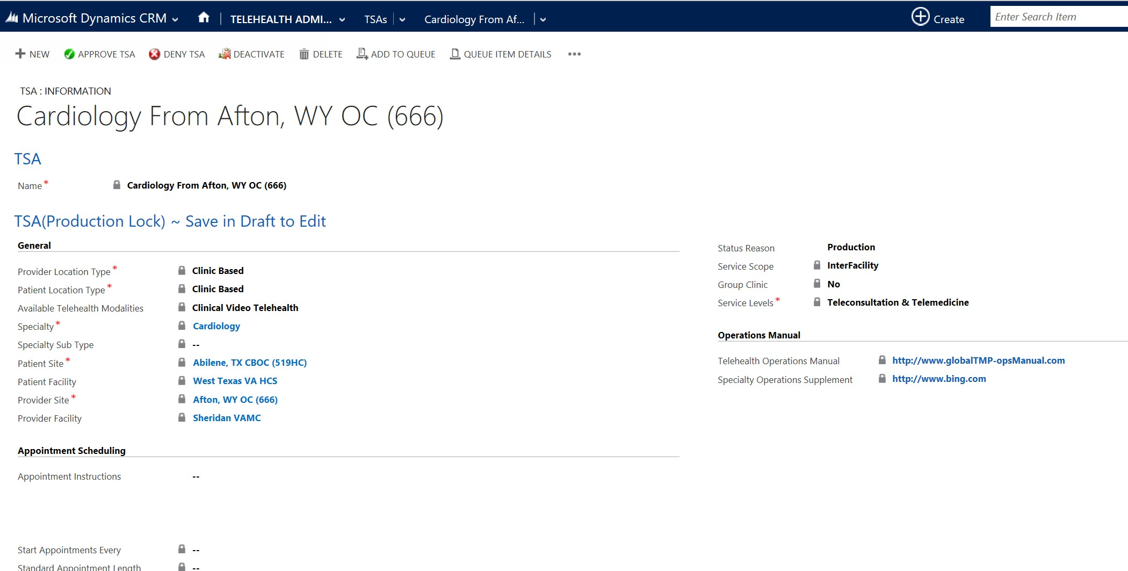
Legacy Telehealth Service Agreement ^{Telehealth} ^{Management} ^{Platform}
4.4

+ E\V ID DB.EYE • c» EM AU RU REPORT • EXCa TEMPI.A ES • • EXPORT O EXCEL • IMPOR DATA • OWHPA E • 0 VIEW
Acfv Sch duling Pac ages y p

l,oat,onT Pn!Yld bOnlyp Group Appoint I In orln 1I I i:>rovid,erF I I Hui T <
0 1 | s I ty | S alty S b-T)'PI' | A
ES CVT • P | AnfflJ!lts:iology |  | Oin | VideoT | ht

("'I
:,-
-
. Oinic Sand 01 icin No lrnra Sheridan V. 5htrid v,,,.. llJ
VI

ES SFT• p
Anesthesiology Store and Fcnvml Oink Based c:r C Bated No

IOM _ Cardiology Qin
CARDIO - Cltdlology 01
Em Color_ & Color_

El fl!\ Cclor...
CAAOIOM | _ | Cardiology | OlnGllVi | nk Bis.eel | 01 cSuecl | YM | lnu | ICili
CAADIO | ... | Cardiology | 0i | Ilic: B.asld | 0,1\ic lat

Color_ a
Video T | he | - Clinic ased | a | C U!d | No |  | East
VideoT | 1,e- | - 1c B.1sed | 01 | B&ed |  | 111 | Eas

Color_

ow:no M _ Cardl01¢gy 01, nic B-acecl 0 <:Buod 111 Eu tmColOr... Bly nt:S ..

lnterf;a,.cj
CARDIOCVT - | Cardiology | Om" |  | Qi ic E 5ed | Oi ·c Ra.md | No
CARDIO | Cardiology | 01 |  | 'nk B.ased | Qi BJ&ed
CAP.DIOM | c.arcllO!oiY | 01,.- | Video T | ht .. inlc:B.asld | Oiniclas | No

I led
Ea5 _ Color...

ity Say ·nes cs

I t«facili &11 tin Color

CARDIO C'.ardiok>gy Oin"Cil Video T ehe - Clinic itied Omic Based No I eff ity Eastern Color...
CAADIO M _ rdlol.ogy Oin1ul Vfdeo T nlc Sued Oink 8:e No East Color_
V
CA.RDIOM Clfcllciogy nlc;BHtd 01nlc las No In ill em Color ..
< ,, >

1 - SO of 99 (0 selected) All
a C 0 E F G H J K l M 0 p Q R s T u V w X V z 14 ◄ p ►

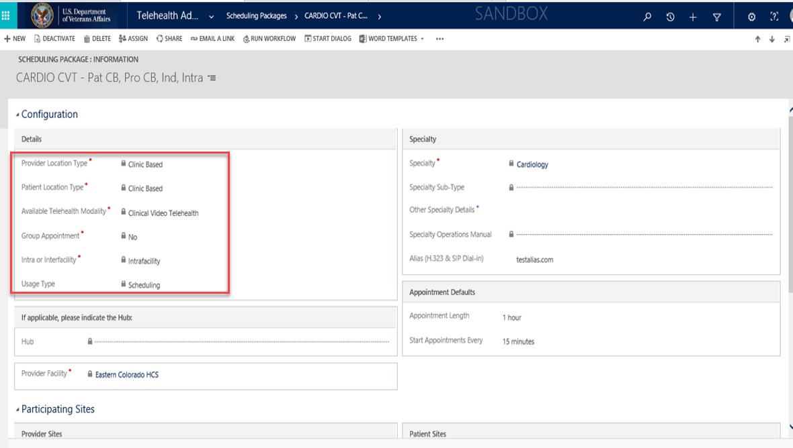

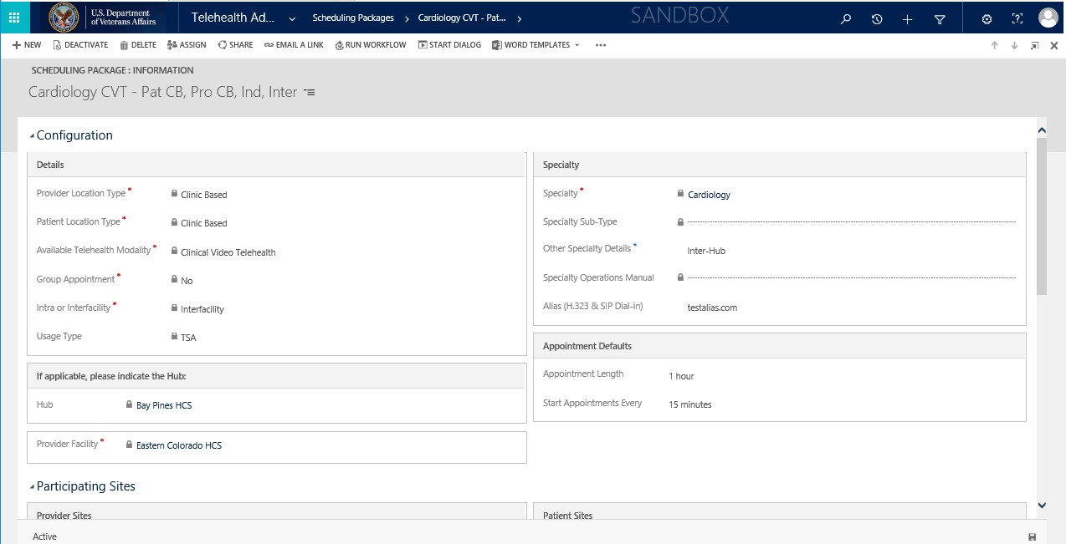

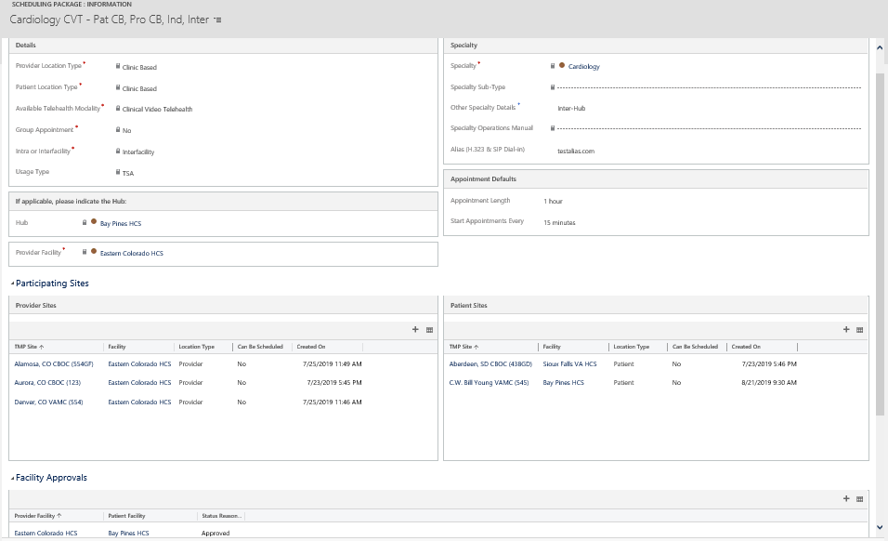
Scheduling Package – InterFacility Sample - TSA Usage Type has Facility Approvals

