Department of Veterans Affairs
Telehealth Management Platform (TMP)

4.8.0 Release Notes

June 2020
Version 1.0

Prepared for
VA
19 October 2021
Version 1.0

Prepared By
MCS

MICROSOFT MAKES NO WARRANTIES, EXPRESS OR IMPLIED, IN THIS DOCUMENT.
Complying with all applicable copyright laws is the responsibility of the user. Without limiting the rights under copyright, no part of this document may be reproduced, stored in or introduced into a retrieval system, or transmitted in any form or by any means (electronic, mechanical, photocopying, recording, or otherwise), or for any purpose, without the express written permission of Microsoft Corporation.
Microsoft may have patents, patent applications, trademarks, copyrights, or other intellectual property rights covering subject matter in this document. Except as expressly provided in any written license agreement from Microsoft, our provision of this document does not give you any license to these patents, trademarks, copyrights, or other intellectual property.
The descriptions of other companies’ products in this document, if any, are provided only as a convenience to you. Any such references should not consider an endorsement or support by Microsoft. Microsoft cannot guarantee their accuracy, and the products may change over time. In addition, the descriptions are intended as brief highlights to aid understanding, rather than as thorough coverage. For authoritative descriptions of these products, please consult their respective manufacturers.
© 2016 Microsoft Corporation. All rights reserved. Any use or distribution of these materials without express authorization of Microsoft Corp. is strictly prohibited.
Microsoft and Windows are either registered trademarks or trademarks of Microsoft Corporation in the United States and/or other countries.
The names of actual companies and products mentioned herein may be the trademarks of their respective owners.
Change Record
Date | Author | Version | Change Reference
06/24/2020 | REDACTED | 1.0 | Initial Version

Table of Contents
1 Introduction 4
2 Release Detail 6
2.1 New Enhancements Implemented 6
2.2 Defects Resolved 16
2.3 Data Migrations/Updates 17
2.4 Considerations/Known Issues 17
2.5 Key Screenshots Updated 18
2.5.1 Yearly TSA Review 18
2.5.2 Scheduling Package Management – VVC Case 21
2.5.3 Appointment screen – VVC case/Patient Side Resources 23
2.5.4 Appointment screen – Cancellation Remarks 24
2.5.5 Appointment screen – RTC/Consults additional date filter: 25
2.5.10 Patient Technology Types Streamlined 26
2.5.7 Resource Group Unique ID field increased to 30 character limit 26
2.5.8 Account 90 Day Report 27

Introduction

This document provides the details of the Telehealth Management Platform(TMP) 4.8 Release including user enhancements and defect remediations implemented. The 4.8 Release builds on the TMP functionality by adding the following updates:
TMP 4.8 Update | Description
TSA Yearly Review and  Re-Approval | Definition of a process and timeline for reviewing Telehealth Service Agreements (TSAs) to ensure they are reviewed and re-approved yearly for compliance purposes. Timeline:  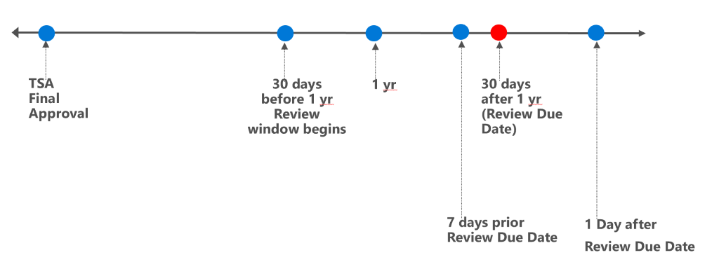  - 5093 Initiate Review Process  - 5090 Initial review notification email  - 5092 Reviewed and confirmed action  - 5094 Reviewed and updated action  - 5107,15183 Additional facility approval views for records needing review  - 5108 Deactivation/Overdue Email Notification  - 5382 Keep history of all reviewers and approvers  - 5590 Final warning email notification  This functionality introduces a Review Due Date on TSAs, such that if the review is not done within the time range, the TSA becomes inactivated and the approval status is EXPIRED. The yearly review due dates of existing TSAs are also calculated as part of the deployment.
TMP Scheduling Enhancements | Addition of key enhancements to allow the field to enter cancellation remarks when an appointment is cancelled as well as add patient side resources for VVC type scheduling packages/appointments.  - 7080 Appointment Screen – Cancellation Remarks  - 7981 Scheduling packaging – VVC case  - 7079 Appointment screen - Consult/RTC table additional filters
TMP Efficiencies | Additional updates to streamline the TMP interface experience and validations.  - 7925 Update Participating Site Default Lookup  - 8313 Update Participating Site Views  - 11219 Managing Patient Technology Types  - 8027 Participating Site Resource Subgrid  - 13741,13770 Update Account 90 Day Report  - 11197 Include Hub name and additional text in Hub related Facility Approvals emails  - 8020 Resource Group – Increase Unique ID Character Limit  - 12901 Preventing AlphaNumeric characters in Clinic IEN number when clinics are created  - 11197 Include Hub name and additional text in Hub related Facility Approvals emails
TMP Defect Remediations | Identified issues were remediated:  - 7854 - Technology with no Refresh Date - "Last Equipment Refresh Date" column has data  - 8594 - Prod: Business Process Error when updating TMP Resource's TMP Site - INC6311634 (RTC ticket #987319)  - 12549 - Production - Appointment - Forward Email messages are not showing under email messages  - 12856 - Production - TMP Intermittent Issues Pulling RTCs and Consults  - 12901 - Pre-Prod- Preventing AlphaNumeric characters in Clinic IEN number when clinics are created  - 13266 - [Internal] Handle error scenarios while canceling an appointment scheduled with TSA (i.e., w/o SP)  - 13457 - Prod: Group Appointment: 2nd Patient Site booking into 1st Patients Site’s Vista IEN  - 13478 - Prod: INC7581991 - TMP Inventory | Screen doesn't refresh  - 14795 - Patient Participating Site - Missing VistA Clinic Message  - 15561 - Prod - Real time clinic updates throws an error when information is missing in the VistA inbound message  - 15734 - QA: Error on Appt Cancel Dialog for CVT INTER Group appointment when the Reserve Resource is already in Canceled status  - 16306 - DEV - Internal - Adding a Non-VA Email on an appointment is not sending the email
For additional detail and history of any of the items, please refer to the Azure DevOps environment that details the discussion/item history. If given access the repository can be found at this link, which is:
https://va-crmprojects.visualstudio.com/TMP

Release Detail

New Enhancements Implemented
This is the list of all the user stories implemented for new functional enhancements:
ID | Title | Work Item Type | Description | Acceptance Criteria
5090 | Initial review notification email | User Story | As a member of the TSA Initial Approval Team (FTCs for non-hub, Hub Director for Hub), I need to be notified that a previously approved interfacility Facility Approval(TSA) needs to be reviewed by a specific 'review due date', so that I can review and confirm the existing Facility Approval or make updates that trigger required approvals all over again. | - notification email is sent to both Provider and Patient side Initial Approval team with the below wording - At 60 days prior to the review due date  if hub: [Initial Approval Team Text] = Hub Director  if non hub: [Initial Approval Team Text]= Provider and Patient FTCs  - clicking on the link included in the email takes user to the appropriate Facility approval record  Subject: [Provider Facility Name] and [Patient Facility Name] agreement needs yearly review  [Provider Facility Name] and [Patient Facility Name] agreement needs review by [Initial Approval Team Text], [Specialty, Specialty Sub-Type] telehealth service.  To review, please click here [link to Facility Approval record]. This review is due by [review due date] or the associated record will be inactivated.
5092 | Reviewed and confirmed action | User Story | As a member of the TSA Initial Approval Team (FTCs for non-hub, Hub Director for Hub), I need to mark an interfacility Facility Approval(TSA) as 'Reviewed and Confirmed', so that the interfacility Facility Approval(TSA) complies with yearly review policy. This should be for both Provider Side and Patient side FTC Teams for non hub approval process, Hub Director team for hub approval process.  Next Review Due Date will be 1 yr+30 days from this action date. | - FTC Approval team member can mark a Facility Approval(TSA) as 'Reviewed and Confirmed' where system keeps the signee and date associated with this review action  - Audit history shows this review action
5093 | Initiate review process | User Story | As a member of the TSA Initial Approval Team (FTCs for non-hub, Hub Director for Hub), I need the system to initiate a review process so that I have a window of time to review previously approved interfacility TSAs according to the yearly review policy. The 'review due date' is calculated as the 1 year anniversary of final approval date +30 calendar days (from Date when Facility Approval Status=Approved). | - review due date is visible and calculated correctly as the 1 year anniversary of final approval date +30 calendar days (11:59pm/10:59pm EST depending on daylight savings adjustment )  - Review due date is read only (on the TSA approval screen, signature page), visible in the page Header to the left of Approval status.  - 60 calendar days prior to the review due date, the review process begins and the initial Approval Team Statuses are updated:  non hub: FTC Approval Status on Patient and Provider side = Review Pending  hub: Hub Director Approval Status = Review Pending  - Approval Status can only go forward to 'Reviewed and Confirmed' or 'Reviewed and Updated' => cannot go back to Approve (Approve is no longer an option). Additionally prior to the review process Reviewed and Update do not appear
5094 | Reviewed and updated action | User Story | As a member of the TSA Initial Approval Team (FTCs for non-hub, Hub Director for Hub), I need to mark an interfacility Facility Approval(TSA) as 'Reviewed and Confirmed', so that an interfacility Facility Approval(TSA) is re-verified on a periodic basis. This should be for both Provider Side and Patient side FTC Teams for non hub approval process and Hub Director for hub approval process. | - TSA Initial Approval Team member (FTCs for non-hub, Hub Director for Hub) can set the Approval Status as 'Reviewed and Updated' where system keeps the signee and date associated with this review action  - Audit history shows this review action​ and any previous signatures  - New approval notifications sent to Service Chief and Chiefs of Staff as required based on Hub vs. non Hub approval process  - non-hub: Both FTC Initial Approval Teams must take action before any Service Chief and Chief of Staffs are notified  (Emails will not be sent out until both FTC teams have changed their Approval Statuses”). If either FTC changes their status to Reviewed and updated then both patient and provider side Service Chiefs and Chiefs of Staff will be notified.  - Service Chief and Chiefs of Staff Approval Status's reset to blank awaiting their new approvals (also the signee and signee date fields also go to blank)  - User is prompted with a popup prompt to continue or cancel this status update:  Title: Warning  Text: This TSA has been Reviewed and Updated. Clicking okay will clear all signatures and dates. Are you sure you want to proceed?
5107 | Additional facility approval views for records needing review | User Story | As a TSA Manager, I need the ability to view all Facility Approvals(TSAs) reviewed so that I can see any outstanding or completed reviews as follows:  - show what is due to be reviewed this quarter => Pending Review  - show what is overdue for review (e.g. based on review due date is past)  - show what was reviewed this quarter as ‘Reviewed and Confirmed’ ​  - show what was reviewed this quarter as ‘Reviewed and Updated’ ​  - user can select the date in a filter option if built as a view  These 8 additional views are required for Facility Approvals within selected time period  non hub:  TSAs Pending Review This Quarter - any record where FTCs Status is Review Pending  TSAs Overdue for Review This Quarter - any record where FTCs Status is Review Pending AND  current date > review due date  TSAs Reviewed and Confirmed This Quarter - any record where (Provider FTC Approval Status=Reviewed and Confirmed) OR Patient (FTC Approval Status=Reviewed and Confirmed)  TSAs Reviewed and Updated This Quarter - any record where (Provider FTC Approval Status=Reviewed and Updated) OR Patient (FTC Approval Status=Reviewed and Updated)  Hub:  Hub TSAs Pending Review This Quarter - any record where Hub Director Status is Review Pending  Hub TSAs Overdue for Review This Quarter - any record where Hub Director Status is Review Pending AND  current date > review due date  Hub TSAs Reviewed and Confirmed This Quarter - any record where Hub Director Approval Status=Reviewed and Confirmed)  Hub TSAs Reviewed and Updated This Quarter - any record where Hub Director Approval Status=Reviewed and Updated) | User has additional view options that lists records with the matching criteria with columns as follows:  For non Hub:  Name  Provider Facility  Patient Facility  Scheduling Package Name  Created On  Created By  Last Modified On  Modified By  Review Due Date  Patient FTC Approval Status  Patient FTC Date Signed  Provider FTC Approval Status  Provider FTC Date Signed  Status Reason  For Hub:  Name  Provider Facility  Patient Facility  Scheduling Package Name  Scheduling Package.Hub  Created On  Created By  Last Modified On  Modified By  Review Due Date  Hub Director Approval Status  Hub Director Date Signed  Status Reason
5108 | Deactivation/Overdue Email Notification | User Story | As a member of the TSA Initial Approval Team (FTCs for non-hub, Hub Director for Hub), I need to be notified that a previously approved interfacility TSA is still waiting to be reviewed by a specific 'review due date' when the review date is past | - current date is the day after the review due date + 1 day  - non hub: notification email is sent to either or both Provider and Patient side FTC Approval team with the below wording - depending who is still outstanding (FTC Approval Status=Pending Review)  Initial Approver Text = Provider and/or Patient FTCs  hub: notification email is sent to Hub Director, Initial Approver Text = Hub Director  - clicking on the link included in the email takes user to the appropriate Facility approval record  Subject: [Provider Facility Name] and [Patient Facility Name] agreement’s yearly review is overdue and service is deactivated <=Subject ends here.  [Provider Facility Name] and [Patient Facility Name] It has been more than a year since this Telehealth service agreement has been reviewed and signed by [Initial Approver Text], [Specialty, Specialty Sub-Type] Telehealth service.  To review, please click here [link to TSA]. This review was due by [review due date] and the associated TSA is no longer active.  - Facility Approval record is de-activated and the overall status = EXPIRED
5382 | Keep history of all reviewers and approvers | User Story | As a TSA Manager, I need the system to keep a history of all previous approvals and reviews for a Facility Approval(TSA), so that any audit would show the entire history of approvals and reviews including dates and signee information. | system shows all history of approvals and reviews, including date and signee information of when the action occurred
5590 | Final Warning Email Notification | User Story | As a member of the TSA Initial Approval Team (FTCs for non-hub, Hub Director for Hub), I need to get a final reminder that the Facility Approval(TSA) will be deactivated 7 calendar days before the deactivation date (review due date), so that I get a final warning to do the overdue review. | non hub: Initial Approver Text= Provider and Patient FTCs  hub: Initial Approver Text = Hub Director  Subject: [Provider Facility Name] and [Patient Facility Name] agreement needs yearly review ASAP  [Provider Facility Name] and [Patient Facility Name] agreement needs review by [Initial Approver Text], [Specialty, Specialty Sub-Type] telehealth service.  To review, please click here [link to Facility Approval]. This review was due by [review due date] and the associated TSA will be inactivated 7 days from this message.
7079 | Appointment screen - Consult/RTC table additional filters | User Story | As a TMP Scheduler, I need the RTC and Consult display to allow me to filter on a date range, so that I don't have to scroll through all the RTC/Consults in one single table (given the 2 year+future VistA criteria). | -user can filter by RTCs/Consults from 30 days past through the future  -user can filter by RTCs/Consults from 90 days past through the future  -user can filter by all RTCs/Consults in the past through the future  -date filter is on RTC/Consult Created Date
7080 | Appointment screen - cancellation remarks | User Story | As a TMP Scheduler, I need to optionally enter cancel remarks/comments so that these comments can flow to VistA for documentation (into the cancel remarks field) | The following updates to the Appointment form:  - Cancel Comments entered on TMP are passed through to VistA when an appointment is cancelled  - Cancel comments text field added with a max size of 160 is optional and not required  -Cancel comments field is shown on Appointment Information section below scheduling package name (only when the whole appointment has been canceled and is read only). Field title is Cancellation Remarks.  -Existing 'Scheduling Comments' field is moved to above the Scheduling Package Name on the form  -for a group appointment, the 'reserve resource' cancellation comments field will be visible on the Reserve Resource if (and only if) it is canceled. NOT on the parent appointment.
7925 | Update Participating Site Default Lookup | User Story | As a TMP Scheduling Package Manager, adding a Participating Site to an intrafacility or interfacility Scheduling Package(SP), I need to efficiently view the TMP Sites that are selectable, so that I don’t have to scroll through all TMP sites.  On the Participating Site form, the user must specify whether it is a Patient or Provider site, prior to selecting the TMP Site.  - Location Type must be placed above TMP Site  - TMP Site must be disabled until the Location Type is selected, as that will help knowing whether the user selected Patient Site or Provider Site and the filtering/non-filtering of TMP Site can be appropriately controlled.  Filtering Rules => See Devops | The TMP Sites listed in the default lookup are specific to the selected SP Facility (Provider Facility and Patient Facility)
7981 | Add Participating Sites and Scheduling Resources to VVC Scheduling Package | User Story | As a TMP Scheduling Package Manager, I need to add sites and scheduling resources to patient side VVC appointments, so that I can add the appropriate administrative VistA Clinic or other scheduling resources | -User has ability to add participating sites and scheduled resources to VVC patient location types on a scheduling package (both Intrafacility and Interfacility).  -Same business rules apply when participating sites are added  -only 1 or zero VistA Clinic scheduling resources allowed. That is:  - Interfacility VVC is required to have 1 Vista Clinic on the patient participating site, when a participating site is added  -Intrafacility VVC must have a provider participating site, and may have a patient participating site but a patient participating site is not required.  -if scheduling resources are added and Can Be Scheduled=Yes, they get scheduled as part of the appointment creation for SPs with Scheduling Usage type of Scheduling.  -In order for an Intrafacility VVC Patient Participating Site ‘CanBe Scheduled’ field to be set to ‘Yes’, the Patient Participating Site must have a scheduling resource (when a patient participating site is added).  -If scheduling resources are added and its a TSA usage type, facility approvals would get initiated as required as well.  -User has option to have zero participating sites on the patient side also (as is today for intrafacility only).  -Assumption is that TCT Staff team exists even for non-VA site would exist with members (e.g. admin person would get the scheduling emails)  -When creating a VVC appointment, user can select a checkbox indicating if Patient Site Resources Required?
8020 | Resource Group – Increase Unique ID Character Limit | User Story | Asa TMP Resource Manager editing a TMP Resource Group, I need to have a bigger text size for the unique identifier, so that up to 30 characters can be entered | User can enter up to 30 characters in the Unique ID field
8027 | Participating site resource subgrid | User Story | As an SP Manager, I need to list out TMP resources under a participating site's associated Paired Resource Group (PRG) so that I don't have to click into each PRG to see what resources are inside of it. | Resources subgrid includes Resources column with concatenation of all included resources when item is a PRG. A redundant TMP Resource Group column is removed since Name is already listed.
8313 | Update participating site views | User Story | As a SP Manager, I need to see the vista clinics associated with a participating site (PS) and audit dates, so that I don't have to click into each record individually | Following updates on the PS views are visible:  For views:  All Patient Participating Sites  My Site's Patient Participating Sites  Patient Participating Sites @ my Facility  All Provider Participating Sites  My Site's Provider Participating Sites  Provider Participating Sites @ my Facility  Non-Schedulable Participating Sites @ my Facility  Schedulable Participating Sites @ my Facility  - Increase TMP Sites to 300 px  - Scheduling Package to 300 px,  - Remove Name column (Not Needed) or reposition to be column 3,  - Added Columns - Modified By and Modified On,  - Added Columns - Created By, and Created On  ==  The following changes specifically to the following views:  All Patient Participating Sites  My Site's Patient Participating Sites  Patient Participating Sites @ my Facility  - Added Column - Patient Side Vista Clinics  ==  All Provider Participating Sites  My Site's Provider Participating Sites  Provider Participating Sites @ my Facility  - Added Column - Provider Side Vista Clinics,  ==  Non-Schedulable Participating Sites @ my Facility  Schedulable Participating Sites @ my Facility  - Added Column - Provider Side Vista Clinics,  - Added Column - Patient Side Vista Clinics
11197 | Include Hub name and additional text in Hub related Facility Approvals emails | User Story | As a TSA Approver, I need to understand information for Hub related approvals so that I know which Hub and Provider Facilities are requiring my approval | The 2 Hub related Facility Approval email templates have the attached text (highlighted text describes the field values inserted/substituted).

ID | Title | Work Item Type | Description | Acceptance Criteria

11219 | Managing Patient Technology Types | User Story | As TMP Resource Manager I need to update available technology types for a Patient so that obsolete names are removed and device names are streamlined for clarity in the field | Patient Form is updated for Technology Type:  Please change CVT Tablet and COTS Tablet value to one value, “SIP Device”.  Please leave SIP Address field. Make all fields visible for the Technology type, but gray out and lock the ones that are not pertinent to the Technology Type in question.  Fields Accessible Technology Type  Fields CVT Tablet (Sip Device) COTS Tablet (Sip Device) VA Issued Device VA Issued Device Personal Device  Tablet SIP Address Available Available Read-only Read-only Read-only  Do Not Allow Emails Read-only Read-only If Allow If Do Not Allow Automatically set it to "Allow" and disable the field  Email Read-only Read-only Available Read-only Available  Static VMR Link  Read-only Read-only Read-only Available Read-only  - VA Issued iOS Device replaced with VA Issued Device  - Static VMR Link, Do Not Allow Emails, would continue to be associated with VA Issued Device (i.e. renamed from VA Issued IOS Device)  - Personal VA Video Connect Device replaced with Personal Device  For Personal VA Video Connect Device – the field that are accessible are based off of the Do Not Allow  - Email address would still be associated with Personal Device (i.e. renamed from Personal VA Video Connect Device). Email Address field needs to be present and accessible to this Technology Type.  Ensure that after the merge of the options sets to SIP Address,  the following table logic holds true:  Emails Sent Technology Type  Emails CVT Tablet (Sip Device) COTS Tablet (Sip Device) VA Issued Device (Allow) VA Issue Device (Do Not Allow) Personal Device  Provider Site Provider & TCT/Staff YES YES YES YES YES  Patient Email NO EMAIL SENT NO EMAIL SENT YES NO EMAIL SENT YES  Scheduler Action YES YES YES YES YES
ID | Title | Work Item Type | Description | Acceptance Criteria

13741 | Update Account 90 Day report | User Story | As a TMP Administrator, I need the Account 90 Day Report updated so that the output can show user's that have logged in in the past 90 days also and are not de-activated. | Report has additional filter: Active  -If Active selected then the date being filtered is LoginDate  -if Disabled selected then the date being filtered is the Disabled Date  -if All is selected all users are listed -report accurately shows User Type value  -Start/End Date filter defaults to 90 Day date range
14031 | Avoid Linking Inappropriate VistA clinic to a Scheduling Resource | User Story | As a Scheduling Package Manager, adding VistA clinic type scheduling resources to an SP, I shouldn't be allowed to select views that explicitly point to invalid clinics, so that I chose valid clinics for scheduling | The following views no longer appear as selections under the Resource Lookup  Patient clinics without IEN (Group Resources)  Patient clinics without IEN (TSA)  Provider clinics without IEN (Group Resources)  Provider clinics without IEN (TSA)  Scheduled Vista Clinics Missing IENs Update  'Type - Vista Clinic' view to omit clinics without an IEN
14064 | Scheduling package validation when adding patient side resources | User Story | As an SchedulingPackage Manager, adding patient side scheduling resources, I should include a VistA clinic for clinic based type appointments, so that I avoid scheduling errors | -When a user doesn’t add a patient side vista clinic type resource for clinic based type appointments and tries to change the Can Be Scheduled to Yes, they get a validation error
15183 | Update TSA review related views | User Story | As a TSA Approver, I need the TSA review related views updated so that I have better readability and additional columns visible | -The following views are updated with below column order and column widths:  TSAs Overdue for Review This Quarter - Hub  TSAs Overdue for Review This Quarter - Non-Hub  TSAs Pending Review This Quarter - Hub  TSAs Pending Review This Quarter - Non-Hub  TSAs Reviewed and Confirmed This Quarter - Hub  TSAs Reviewed and Confirmed This Quarter - Non-Hub  TSAs Reviewed and Updated This Quarter - Hub  TSAs Reviewed and Updated This Quarter - Non-Hub  -Hub views no longer use the Scheduling Package.Hub column and instead include the TSA.Hub Facility column  -the listed records sort alphabetically on the first column (i.e. Name is the default sort, A-Z)  For Hub TSA Views  Order Column Name Column Width  1 Name 300 px  2 Hub Facility 200 px  3 Scheduling Package 300 px  4 Review Due Date 150 px  5 Approval Status Hub Director 200 px  6 Date Signed Hub Director 150 px  7 Status Reason 150 px  8 Provider Facility 200 px  9 Patient Facility 200 px  10 Modified By 150 px  11 Modified On 150 px  12 Created By 150 px  13 Created On 150 px  2300 px  For Non-Hub TSA Views:  Order Column Name Column Width  1 Name 300 px  2 Scheduling Package 300 px  3 Review Due Date 150 px  4 Approval Status (Provider FTC) 200 px  5 Date Signed (Provider FTC) 150 px  6 Approval Status (Patient FTC) 200 px  7 Date Signed (Patient FTC) 150 px  8 Status Reason 150 px  9 Provider Facility 200 px  10 Patient Facility 200 px  11 Modified By 150 px  12 Modified On 150 px  13 Created By 150 px  14 Created On 150 px  2600 px

Defects Resolved
The following are the defects that have been resolved in this release:
ID | Title | Work Item Type | Description | Acceptance Criteria
7854 | Technology with no Refresh Date - "Last Equipment Refresh Date" column has data | Bug | As a TMP Resource Manager, I need to see the technologies with no refresh date in a view so that I know which items need to be modified. | View displays with: Filters: VISN, Facility, Site, System Type, Last Equipment Refresh Date DOES NOT contain data Rows: TMP Resource where Type=Technology​ AND Last Equipment Refresh Date DOES NOT contain data Columns: Name, System Type, Cart Type, Master Serial Number, Room/CEVN, Last Equipment Refresh Date, POC, TMP Site, Facility, VISN​
8594 | Prod: Business Process Error when updating TMP Resource's TMP Site - INC6311634 (RTC ticket #987319) | Bug | TMP Resource Manager is unable to change the TMP Site associated with the Resource and gets a Business Process Error | -TMP Resource Manager can change the TMP Site of a TMP Resource to another TMP Site within the same facility
12549 | Production - Appointment - Forward Email messages are not showing under email messages | Bug | As a TMP scheduler, I need to be able to forward a scheduling email so that it can be resent or forwarded in cases where a recipient may have lost track of the original email | -emails on an appointment can be forwarded (user enters email addresses)
12856 | Production - TMP Intermittent Issues Pulling RTCs and Consults | Bug | As a TMP Scheduler scheduling an appointment, I am able to view the patient's RTCs/Consult orders so that one selected can be linked to the appointment and passed through to VistA | RTCs and Consults consistently are displayed when available
12901 | Pre-Prod- Preventing AlphaNumeric characters in Clinic IEN number when clinics are created | Bug
13266 | [Internal] Handle error scenarios while canceling an appointment scheduled with TSA (i.e., w/o SP) | Bug | As a TMP Scheduler, I need to be prevented from cancelling an appointment that was created prior to 4.6 since the appointment structure has changed and the cancellation will give errors | -when user tries to cancel an appointment created with the prior 4.4 structure that isn't linked to a scheduling package, the user gets an error indicating that this appointment needs to be cancelled in VistA
13457 | Prod: Group Appointment: 2nd Patient Site booking into 1st Patients Site’s Vista IEN | Bug | -the appointment books into the wrong clinic (IEN) ------ As a TMP Scheduler, scheduling a group appointment, I need to verify that each VistA clinic IEN is booked into the expected VistA station when multiple patients are booked either within different facilities (inter) or within the same facility (intra). | -when there are multiple Reserve Resources (RRs) on a CVT group appointment, even if from different patient sites/facilities  - each VistA clinic IEN is booked into the correct facility based on where the Patient was booked (specific RRs patient site)
13478 | Prod: INC7581991 - TMP Inventory | Screen doesn't refresh | Bug | As a TMP Resource Manager I need the Approve and Complete action to refresh so that the status changes without me doing a manual refresh | -inventory status changes to Inactive after the Approve and Complete action is done without the user doing a manual refresh
14133 | Prod - TSA 2.0 Provider Preferences report not showing on TSA or preference report the provider preferences (RTC - 1173733/INC7765921) | Bug | As a TSA Approver, I need the provider preferences to display on the TSA 2.0 report and the Provider Preference report so that the data displays according to the report specs | -provider preferences that are on the associated user records on the SP are shown on those sections of the reports
14795 | Patient Participating Site - Missing VistA Clinic Message | Bug | As an Scheduling Package Manager or Hub SP Manager, trying to save a participating site with Can Be scheduled flag=Yes, there is a Typo in Business process error message when no VistA clinic was added | -error displays with typo corrected: using singular VistA Clinic instead of plural VistA Clinics
15561 | Prod - Real time clinic updates throws an error when information is missing in the VistA inbound message | Bug | As a System Administrator, VistA real time clinic updates aren't processed by TMP if the Station Number is not present in the pay load, which throws an error and TMP doesn't create / update the clinic. Approved by Pauline to include it as part of TMP 4.8. | -​when the station number is not found in the incoming clinic update message, default to the station number of the associated site
15734 | QA: Error on Appt Cancel Dialog for CVT INTER Group appointment when the Reserve Resource is already in Canceled status | Bug | As a TMP Scheduler scheduling a CVT INTER Group appointment, I am able to cancel from the top level appointment, which cancels all the associated patients on each RR | -entire appointment is cancelled including individual RRs when cancellation is from the top level appointment (successfully with no error)
16306 | DEV - Internal - Adding a Non-VA Email on an appointment is not sending the email | Bug | As a TMP Scheduler, I need to be able to add family member/caregiver emails, so that they will also be notified on the VVC appointment | Assumption is that user is on the appropriate scheduling team:  -additional email notifications sent to requested emails (1 or more)

Data Migrations/Updates
The following data updates were included:
1. 4.6 implementation had a Patient Technology type field with possible values including COTS Tablet, CVT Tablet. This 4.8 release removes those values as options while also updating any existing patients with those values to SIP Address instead (see deployment guide and above user story detail for #11219).
2. Any existing TSAs that were approved prior to 4.8 will be updated with a Review Due Date (1 year+30 days from the final approval). This is also part of the deployment guide steps.

Considerations/Known Issues
Please be advised of the following considerations and known issues for this release:
- Although Scheduling Packages (SPs) can now include patient side scheduling resources for VVC type SPs, Patient Side Resources for a VVC group appointment is not fully supported from the scheduling aspect. User should not create a VVC group appointment with Patient Side Resources as checked. This is fully supported for Individual style VVC appointments however. The VVC Group feature will be further enhanced in the future based on backlog priorities and refinements.
- For Group Appointments, cancellation remarks entered when doing a cancellation from the main appointment screen are not passed to VistA (user must do the cancellation at the Reserve Resource level instead so that the comments are passed).

Key Screenshots Updated

Yearly TSA Review
The Review Due Date is calculated and included on a TSA record (1year + 30 days after final approval):
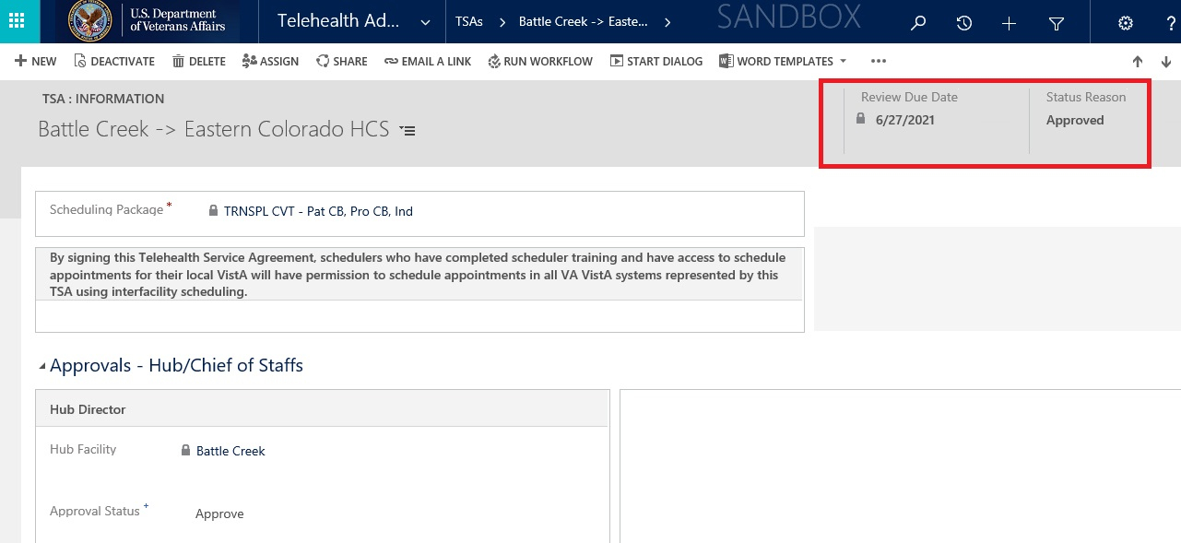

Additional approval Status as part of the process (in addition to previous Approve and Deny):
Review Pending
Reviewed and Confirmed
Reviewed and Updated
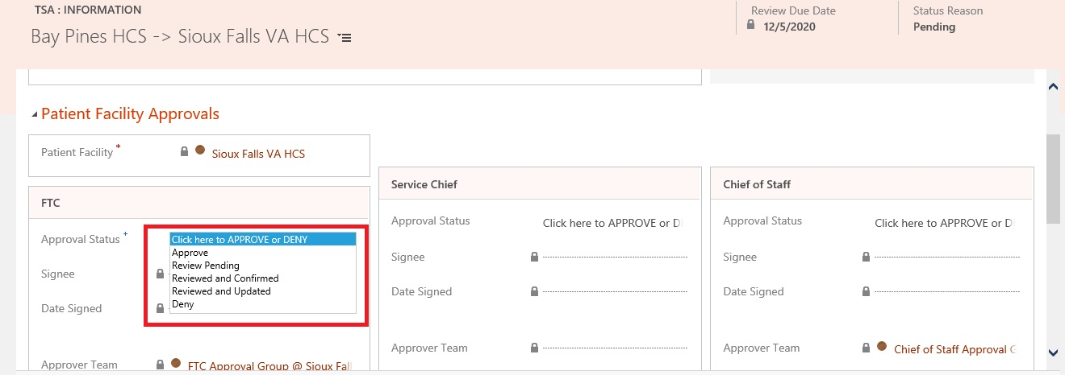
TSA record will be inactivated and the Status reason will change to EXPIRED when the re-approvals are not done in time:
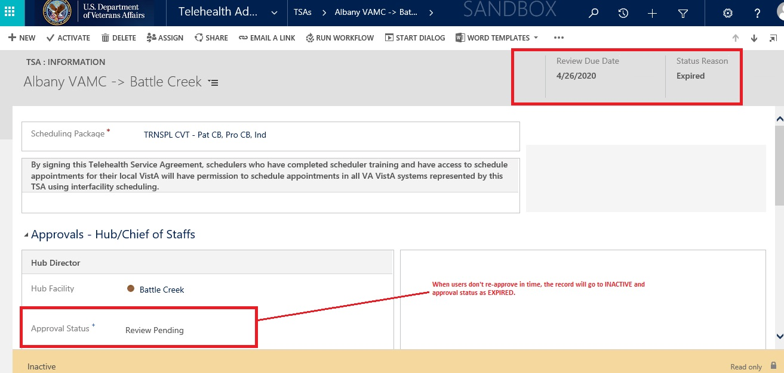
Sample approval flow non-hub data example:
Normal expected flow non hub example: FTCs agree on Review & Updated
Date | Provider FTC | Patient FTC |  | Comment | Provider Service Chief | Provider Chief of Staff | Patient Service Chief | Patient Chief of Staff | Overall Status | Status Date | Review Due Date
1-Jan | Approve | Approve |  | Initial TSA approved | Approve | Approve | Approve | Approve | Approved | 1-Jan | 31-Jan
1-Dec | Review Pending | Review Pending |  | 60 day Review window begins, FTCs are notified, both FTC statuses are Review Pending | Approve | Approve | Approve | Approve | Approved | 1-Jan | 31-Jan
5-Dec | Review Pending | Reviewed & Updated |  | One FTC updates to Reviewed & Updated, Service Chiefs still not notified, since other FTC has not taken action | Blanked out | Blanked out | Blanked out | Blanked out | Approved | 1-Jan | 31-Jan
10-Dec | Reviewed & Updated | Reviewed & Updated |  | Both FTCS have taken action, Service Chiefs and Chiefs of Staff notified | Blanked out | Blanked out | Blanked out | Blanked out | Approved | 1-Jan | 31-Jan
Additional TSA views:
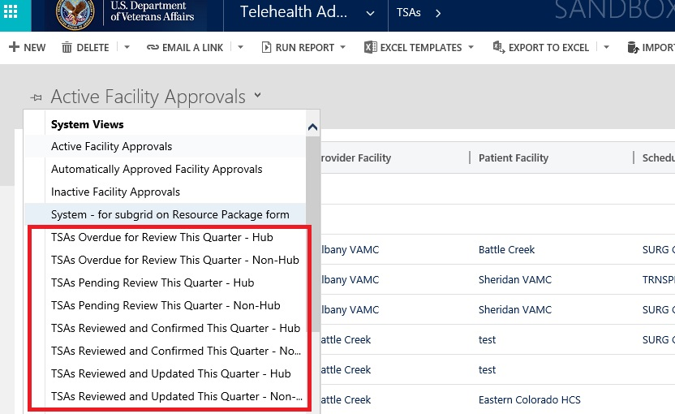

Scheduling Package Management – VVC Case
VVC scheduling packages now support addition of patient side resources (optional)
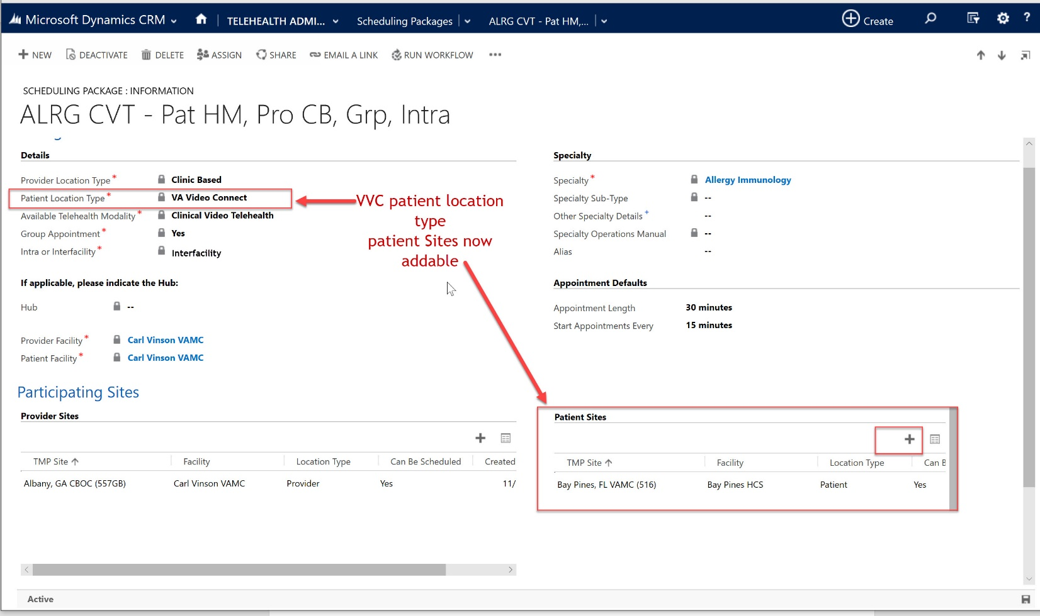

Appointment screen – VVC case/Patient Side Resources
There is also a patient side resource checkbox when scheduling (optional). When this is selected, the user is required to enter a Patient Site instead of Provider site.
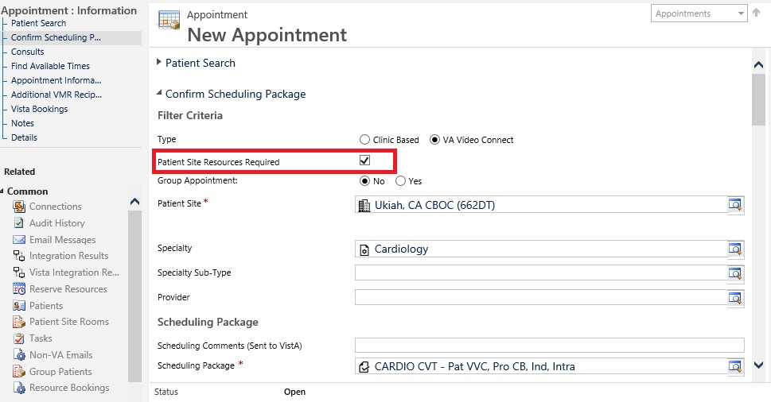

Appointment screen – Cancellation Remarks
User can enter cancellation remarks as part of the cancellation dialog:
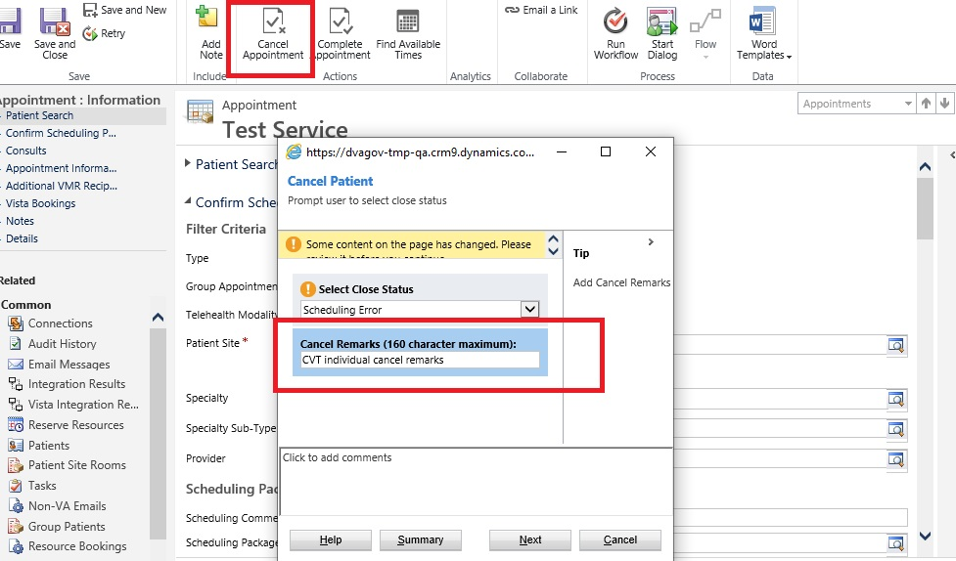
For an individual appointment this is also shown on the main appointment screen once cancelled:
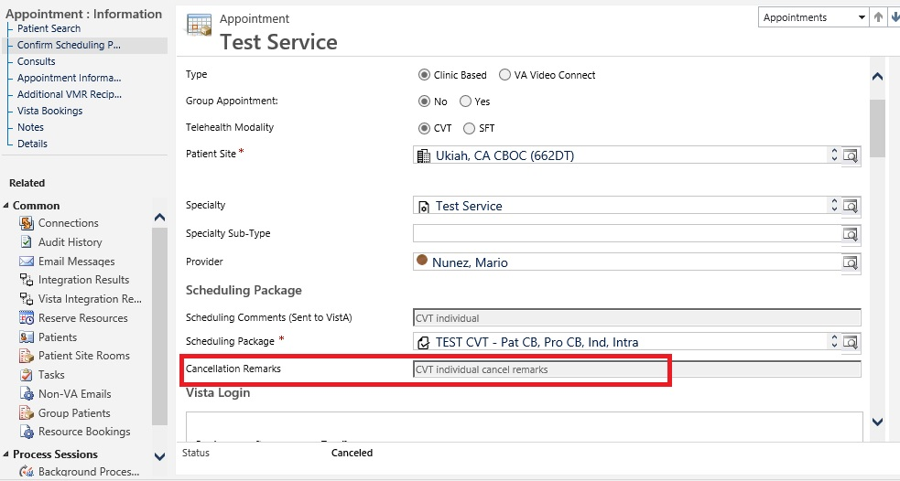
Note for group appointments – the cancel remarks are on the Reserve Resource Level in order for the remarks to flow to VistA as part of the cancellation.

Appointment screen – RTC/Consults additional date filter:
User can filter by date range when viewing RTCs/Consults to attach to an appointment for an individual.
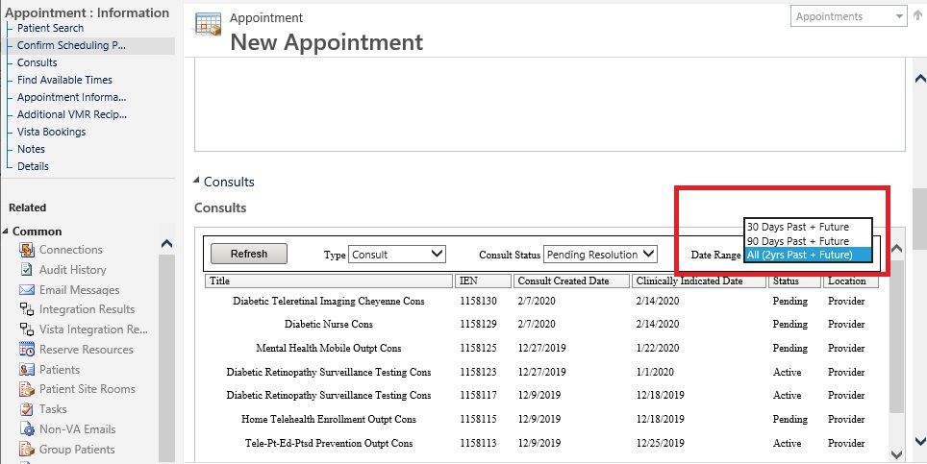

Patient Technology Types Streamlined
The list of values for Patient Technology types have been streamlined/renamed:
COTS Tablet, CVT Tablet => SIP Address
All related fields are now visible though not enterable depending on the selection (locked as read only). Please see the relationship details in the 11219 user story.
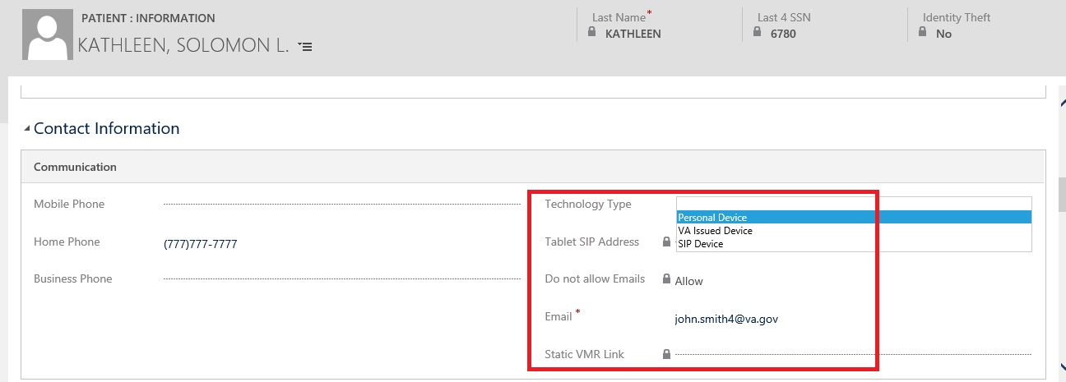

Resource Group Unique ID field increased to 30 character limit
User can now enter additional characters:
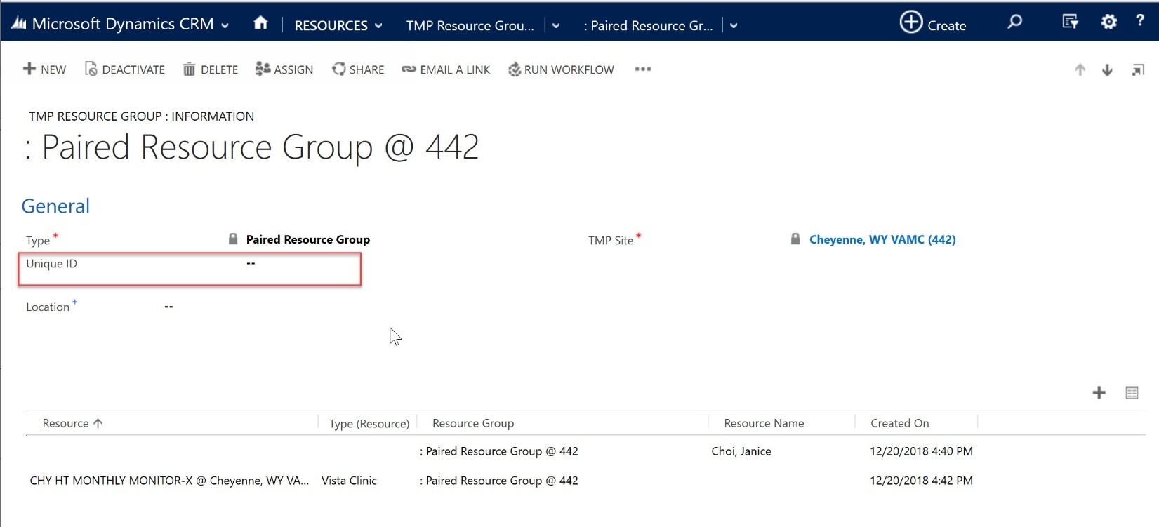

Account 90 Day Report
This report was enhanced to show Disabled as well as Active users. The User Type in the output was also fixed.
