Telehealth Management Platform

Deployment, Installation, Back-Out, and Rollback Guide

Jan 2021
Department of Veterans Affairs
Office of Information and Technology (OI&T)

Revision History
Date | Version | Description | Author
April 29, 2022 | 7.1 | Renamed release 4.9.0.10 to <FUTURE RELEASE> | TMP Team
Jan 11, 2021 | 7.0 | Added URL to CRM code and deployment instructions for VVS version upgrade | TMP Team
September 25, 2020 | 6.0 | Added URL to CRM code and deployment instructions for combined releases TMP 4.8.1 and 4.8.2. | TMP Team
August 4, 2020 | 5.0 | Updated Deployment Date for TMP VistA Patch SD*5.3*754. | TMP Team
June 19, 2020 | 4.0 | Added URL to CRM code and deployment instructions for TMP 4.8.0. | TMP Team
June 18, 2020 | 3.0 | Added URL to CRM code and deployment instructions for TMP 4.6.10 (Hotfix 10) | TMP Team
June 17, 2020 | 2.9 | Updated Deployment Date for TMP VistA Patch SD*5.3*746v1. | TMP Team
May 27, 2020 | 2.8 | Added Deployment instructions for TMP VistA Patch SD*5.3*746v1. | TMP Team
May 27, 2020 | 2.7 | Added URL to CRM code and deployment instructions for TMP 4.6.9 (Hotfix 9) | TMP Team
May 13, 2020 | 2.6 | TMP D365 Product Upgrade Wave 1 | TMP Team
May 6, 2020 | 2.5 | Added URL to CRM code and deployment instructions for TMP 4.6 Hotfix 8. | TMP Team
April 3, 2020 | 2.4 | Added URL to CRM code and deployment instructions for TMP 4.6 Hotfix 7. | TMP Team
March 26, 2020 | 2.3 | Added Deployment instructions for TMP VistA Patch SD*5.3*714v4. | TMP Team
January 21, 2020 | 2.2 | Added URL to CRM code and deployment instructions for TMP 4.6 Hotfix 6. | TMP Team
November 25, 2019 | 2.1 | Added URL to CRM code and deployment instructions for TMP 4.6 Hotfix 5. | TMP Team
November 19, 2019 | 2.0 | Added URL to CRM code and deployment instructions for TMP 4.6 Hotfix 4. | TMP Team
November 6, 2019 | 1.9 | Added URL to CRM code and deployment instructions for TMP 4.6 Hotfix 3. | TMP Team
October 25, 2019 | 1.8 | Added URL to CRM code and deployment instructions for TMP 4.6 Hotfix 2.
September 30, 2019 | 1.7 | Added URL to CRM code and deployment instructions for TMP 4.6 Hotfix 1.

Artifact Rationale
This document describes the Deployment, Installation, Back-out, and Rollback Plan for new products going into the VA Enterprise. The plan includes information about system support, issue tracking, escalation processes, and roles and responsibilities involved in all those activities. Its purpose is to provide clients, stakeholders, and support personnel with a smooth transition to the new product or software, and should be structured appropriately, to reflect particulars of these procedures at a single or at multiple locations.
Per the Veteran-focused Integrated Process (VIP) Guide, the Deployment, Installation, Back-out, and Rollback Plan is required to be completed prior to Critical Decision Point #2 (CD #2), with the expectation that it will be updated throughout the lifecycle of the project for each build, as needed.

Table of Contents
1 Introduction 6
1.1 Purpose 6
1.2 Dependencies 6
1.3 Constraints 7
2 Roles and Responsibilities 8
3 Deployment 10
3.1 Timeline 11
3.2 Site Readiness Assessment 11
3.21 Deployment Topology (Targeted Architecture) 11
3.22 Site Information (Locations, Deployment Recipients) 12
3.23 Site Preparation 12
3.3 Resources 12
3.31 Facility Specifics 12
3.32 Hardware 12
3.33 Software 13
3.34 Communications 13
3.3.4.1 Deployment/Installation/Back-Out Checklist 14
4 Installation 15
4.1 Pre-installation and System Requirements 15
4.2 Platform Installation and Preparation 15
4.3 Download and Extract Files 15
4.4 Access Requirements and Skills Needed for the Installation 15
4.5 Installation Procedure 15
4.6 Installation Verification Procedure 15
4.7 System Configuration 16
5 Back-Out Procedure 16
6 Rollback Procedure 16
6.1 Rollback Considerations 16
6.2 Rollback Criteria 16
6.3 Rollback Risks 16
6.4 Authority for Rollback 16
6.5 Rollback Procedure 16
Rollback Verification Procedure 17
Appendix A – TMP Combined Releases <FUTURE RELEASE> Deployment Instructions 17
Appendix B – TMP Combined Releases <FUTURE RELEASE> Backout and Rollback Plan 18

Table of Tables
Table 1: Deployment, Installation, Back-out, and Rollback Roles and Responsibilities 8
Table 2: General Roles and Responsibilities 9
Table 3: Code Deployment Responsibilities 9
Table 4: Deployment Environments 10
Table 5: High Level Milestones 11
Table 6: Site Preparation 12
Table 7: Facility-Specific Features 12
Table 8: Hardware Specifications 13
Table 9: Software Specifications 13
Table 10: Team Support Information/Role 13
Table 11: Deployment/Installation/Back-Out Checklist 14

Table of Figures
Figure 1: TMP/VEIS (LOB & EC) Environment Mapping 6
Figure 2: TMP/VEIS/MVI Environment Mapping 6
Figure 3: TMP/VEIS/HealthShare Environment Mapping 6
Figure 4: TMP/VEIS/VIA Environment Mapping 6
Figure 5: TMP/VEIS/VVS Environment Mapping 6

Introduction
This document describes how to deploy and install the Telehealth Management Platform (TMP) Phase 3 Combined Releases 4.8.1 and 4.8.2, as well as how to back-out the product and rollback to a previous version or data set. This document is a companion to the project charter and management plan for this effort. In cases where a non-developed COTS product is being installed, the vendor provided User and Installation Guide may be used, but the Back-Out Recovery strategy still needs to be included in this document.

1.1 Purpose
The purpose of this plan is to provide a single, common document that describes how, when, where, and to whom the Telehealth Management Platform (TMP) solution, will be deployed and installed, as well as how it is to be backed out and rolled back, if necessary. The plan also identifies resources, communications plan, and rollout schedule. Specific instructions for installation, back-out, and rollback are included in this document.

1.2 Dependencies
Figures 1, 2, 3, 4 and 5 illustrate the systems interfacing with TMP.

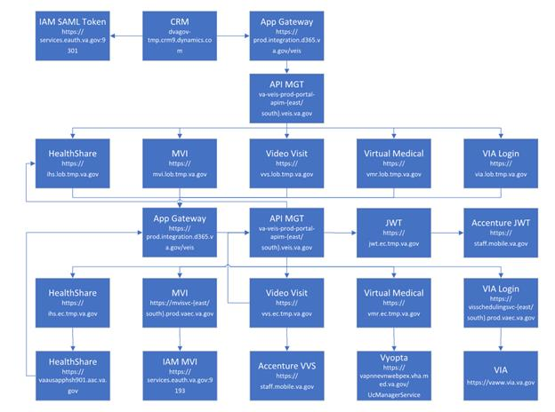
Figure 1: TMP/VEIS (LOB & EC) Environment Mapping

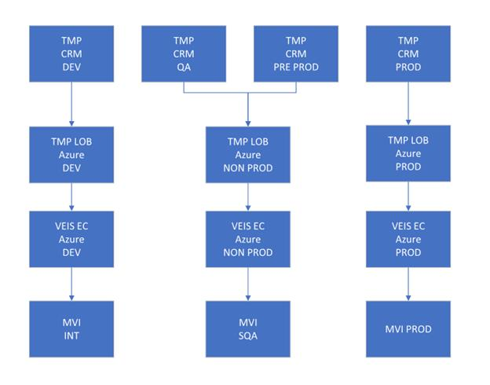

Figure 2: TMP/VEIS/MVI Environment Mapping

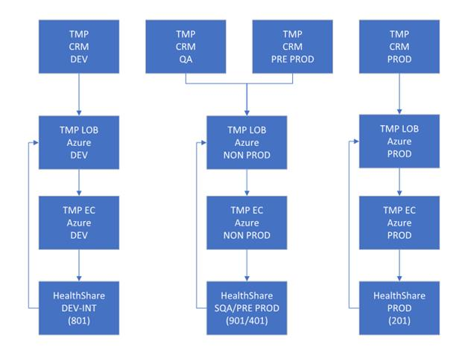
Figure 3: TMP/VEIS/ HealthShare Environment Mapping
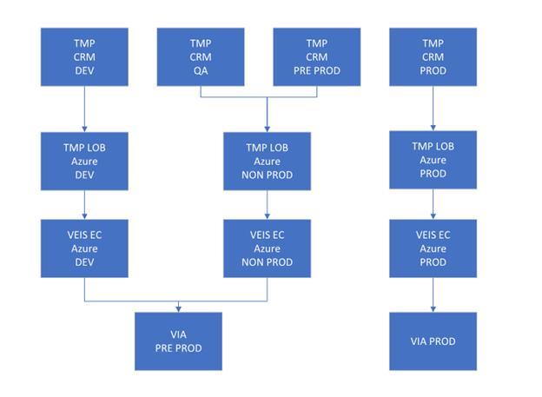Figure 4: TMP/VEIS/VVS Environment Mapping
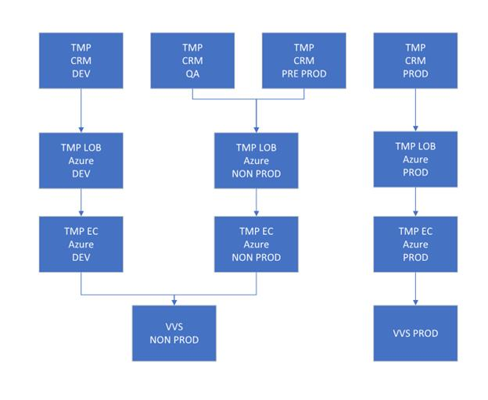Figure 5: TMP/VEIS/VVS Environment Mapping

1.3 Constraints
There are no additional constraints to this project.

Roles and Responsibilities
Table 1: Deployment, Installation, Back-out, and Rollback Roles and Responsibilities
ID | Team | Phase / Role | Tasks | Project Phase (See Schedule)
 | O&M Team, Project Team and Development Team | Deployment | Plan and schedule deployment (including orchestration with vendors) | TMP Release
 | O&M Team and Development Team | Deployment | Determine and document the roles and responsibilities of those involved in the deployment. | TMP Release
 | Enterprise Operations (EO) | Deployment | Test for operational readiness | TMP Release
 | O&M Team | Deployment | Execute deployment | TMP Release
 | O&M Team and Development Team | Installation | Plan and schedule installation | TMP Release
 | O&M Team/Hosting Team | Installation | Ensure authority to operate and that certificate authority security documentation is in place | TMP Release
 | O&M Team/Hosting Team | Installation | Validate through facility POC to ensure that IT equipment has been accepted using asset inventory processes | TMP Release
 | Training | Installations | Coordinate training | TMP Release
 | O&M Team and Development Team | Back-out | Confirm availability of back-out instructions and back-out strategy (what are the criteria that trigger a back-out) | TMP Release
This section describes the teams who perform the steps described in this Plan. Representatives from the teams listed in the following table perform deployment and installation activities. This phase begins after the solution design (including deployment topology) is complete. Design activities are not included in this phase.
Table 2: General Roles and Responsibilities

Team | Tasks / Responsibilities
D365 Product Team | - Deploy code during migrations from lower environments into pre-prod and prod  - Coordinate with VA Project Team members, VA NSOC, and Microsoft Support team  - Receive and process incoming incidents via Cloud Ticket Determine incident types and capture all relevant incident data Create developer user accounts  - Diagnose infrastructure issues  - Troubleshoot basic and complex issues Resolve issues
VA Project Team | - Liaison between the project teams and team members to capture incidents  - Submit incident requests using the Cloud Ticket tool
Liberty Development Team | - Communicate with CRM Cloud Solution team to provide additional information, if necessary  - Identify and submits issues to the VA project POC
Liberty Development Team | - Deploy solutions provided by Microsoft Development Team from lower environments into pre-prod and prod  - Coordinate with VA Project Team members, VA NSOC, and Microsoft Support team  - Receive and process incoming incidents  - Determine incident types and capture all relevant incident data  - Diagnose incident issues Troubleshoot basic and complex issues Resolve issues
Table 3: Code Deployment Responsibilities
Team | Phase | Role
Liberty Development Team | Planning | - Finalize Development Build and Code Compilation Instructions  - Provide listing of developer accounts  - Schedule deployment with the CRM Cloud Hosting team via Cloud Ticket
TMP Project Team | Planning | - Schedule UAT testers and support
Liberty Development Team | Prepare for Deployment | - Provide O&M Team with all relevant data/code including: solution extract for CRM, Compiled Code, and ISV Folder, utilizing a method approved by the Project Team (e.g. FTP, Secure Server, or other)  - Freeze all development activities
Liberty Development Team | Prepare for Deployment | - Review Code Compilation instructions for completion  - Work with project teams if compilation instructions are unclear or incomplete  - Replicate the existing environment configuration and code  - Perform database back-ups
TMP Project Team | Execute Deployment | - Coordinate deployment support by maintaining the bridge and managing all involved stakeholders  - Conduct UAT testing activities
Liberty Development Team | Execute Deployment | Work with O&M team to resolve issues, if necessary
O&M Team | Execute Deployment | Deploy the code into Pre-Prod and Prod
TMP Project Team | Validation & Go- Live | Validate that the new environment functions as expected
O&M Team | Validation & Go- Live | Execute roll-back, if necessary
The following table describes the planned deployment environments.
Table 4: Deployment Environments
Environment | Use | Involved Parties
Developer Workstations | Development, Unit Testing | LITS
VA Hosted (NWA) Dev | Development, Unit Testing | LITS
VA Hosted (NWA) INT | Unit Testing, Integration Testing | LITS, VA (Integration)
VA Hosted (NWA) QA | User Acceptance Testing | LITS, VA
VA Hosted (NWA) Pre- Prod | Fallback for Production | LITS, VA
VA Hosted (NWA) Prod | Production | LITS, VA

Deployment
The deployment is planned as a single rollout.
This section provides the schedule and milestones for the deployment.
This Release and Installation Guide identifies processes and procedures to promote the Telehealth Management Platform (TMP) Dynamics Customer Relationship Management (CRM) system into the Production Environment. The CRM system is web-based and is deployed using files containing configuration information rather than directly from one environment to another.

- TMP Dev
- TMP QA
- TMP Pre-Prod
- TMP Prod
- Git Hub https://github.com/department-of-veterans-affairs/crm-tmp-product

3.1 Timeline
The deployment and installation will run for approximately 1 day, as depicted in the master deployment schedule TMP.
In most Deployment Plans, Enterprise Operations (EO) maintains the master schedule in MS Project Server, Field Operations and Development (FOD) maintains its schedule in Clarity, and FOD provides site scheduling to meet parameters and milestones enumerated above. Given the agile methodology used to develop and deploy TMP, along with the limited scope of this software-only deployment/installation, there is no need for a Master Deployment Schedule. The high-level schedule included below will suffice.
Table 5: High Level Milestones
Milestones | Target Date
Unit Testing Completed | 8/20/2021
Software Quality Assurance Testing Completed | 9/3/2021
Pre-Production Testing Completed | 9/24/2021

3.2 Site Readiness Assessment
This section discusses the locations that will receive the TMP deployment. Topology determinations are made by ESE and vetted with PD, FO, NDCP, and the PMO during the design phase as appropriate. Field site coordination will be completed FO unless otherwise stipulated by FO. The Microsoft team provides input and support to all ESE, PD, FO, NDCP, and the PMO team during the site readiness assessment. TMP is a minor application covered under CRM/UD. Site readiness will be assessed in the hosting environment.
This section discusses the locations that will receive the TMP deployment.

3.21 Deployment Topology (Targeted Architecture)
Deployment will be conducted through web client in a QA, PreProd, and Production environment administered by O&M, managed by Microsoft.
The CRM system is web-based and is deployed using files containing configuration information rather than directly from one environment to another.

3.22 Site Information (Locations, Deployment Recipients)
The CRM system is web-based and is deployed using files containing configuration information rather than directly from one environment to another.

3.23 Site Preparation
TMP will be accessed using the browser.
Table 6: Site Preparation

Site/Other | Problem/Change Needed | Features to Adapt/Modify to New Product | Actions/Steps | Owner
All Sites | Familiarization with application | N/A | Attend training sessions | Office of Connected Care-Telehealth Training Team
All Sites | Data Migration | N/A | Metadata Import into Production | Liberty Development team
All Sites | Establish access to TMP URL | N/A | Grant access to application users of TMP | Will be handled by the appropriate region/site

3.3 Resources
This section describes hardware, software, and facilities required for the TMP deployment and installation.

3.31 Facility Specifics
Current TMP release will deploy on CRM cloud hosted environment. There are no facility-specific features required for deployment.
Table 7: Facility-Specific Features
Site | Space/Room | Features Needed | Other
None

3.32 Hardware
Current TMP release will be supported by the existing cloud hosted environment. No hardware specifications exist.
Table 8: Hardware Specifications
Required Hardware | Model | Version | Configuration | Manufacturer | Other
None
Please see the Roles and Responsibilities table in Section 2 for details about who is responsible for preparing the site to meet these hardware specifications.

3.33 Software
Current TMP release will be utilizing approved existing software on TRM tools list. No software specifications exist.
Table 9: Software Specifications
Required Software | Make | Version | Configuration | Manufacturer | Other
None
Please see the Roles and Responsibilities table in Section 2 above for details about who is responsible for preparing the site to meet these software specifications.

3.34 Communications
A VA Teams meeting will occur for all members involved and/or invested in TMP deployment. All members involved and/or invested in TMP Deployment will receive status emails throughout the deployment activities.
Table 10: Team Support Information/Role
Team Support Information | Role | POC
Communication Lead  Scheduled | Serves as the main communication and coordination POC on behalf of the application to provide regular status updates and issue escalation. | TMP
Functional Tester(s)  Scheduled | Performs testing to verify that application is functioning as expected. | Business
Development  On Call | Development resources are typically on-call for production deployments, unless they are required to serve as advisory resources during the release activities. | TMP
VA OIT  On Call | Engage OIT contacts if decisions need to be made on behalf of the application and as voting members on the Go/No Go calls.
VA Business / TDD  On Call | Engage Business Contacts if decisions need to be made on behalf of the application and as voting members on the Go/No Go calls.
Application Support  Scheduled | Application Support contacts are scheduled to perform Production code releases and infrastructure changes.
Hosting Support  On Call | Hosting Support contacts are scheduled to perform infrastructure changes or otherwise scheduled to be on call.
Integration Partners  Scheduled | Typically, on-call support for the implementation or update of web service partner connections.

3.3.4.1 Deployment/Installation/Back-Out Checklist
This section will be completed once each task is complete.
Table 11: Deployment/Installation/Back-Out Checklist
Activity | Day | Time | Individual who completed task
Deploy | TBD | TBD | All Nationwide VistA Production Sites Patch Installers
Install | TBD | TBD | All Nationwide VistA Production Sites Patch Installers
Back-Out | TBD | TBD | All Nationwide VistA Production Sites Patch Installers

Installation

4.1 Pre-installation and System Requirements
Customer-approved user stories and defects will be stored on the TMP JIRA:
TMP Requirements
https://vajira.max.gov/projects/TMP/versions/27226

4.2 Platform Installation and Preparation
TMP ORG is backed up by a member of the team the night of deployment.
Deployment occurs during off hours.
Software installs within 60-120 minutes.

4.3 Download and Extract Files
The CRM system is web-based and is deployed using files containing configuration information rather than directly from one environment to another.
Table 12: File Inventory List
Filename
https://github.com/department-of-veterans-affairs/crm-tmp-code/tree/Release/Solutions/Release%20<FUTURE RELEASE>

4.4 Access Requirements and Skills Needed for the Installation
Microsoft Dynamics CRM Security Role – System Administrator

4.5 Installation Procedure
Refer to the TMP <FUTURE RELEASE> Deployment Instructions (Appendix A).

4.6 Installation Verification Procedure
Refer to the TMP Releases Deployment Instructions (Appendix A). Verification/Testing Steps begin on page 1 of Appendix A.
For detailed testing, please also refer to the TMP Releases Verification Testing Instructions (Appendix A).
Notification sent to the field via email from Office of Connected Care Help Desk (OCCHD) .
Users were informed of upcoming changes on a weekly call.

4.7 System Configuration
Refer to the TMP Combined Releases <FUTURE RELEASE> Deployment-Verification Testing Instructions (Appendix A).

Back-Out Procedure
Refer to the O&M Backout and Rollback Plan (Appendix B).

Rollback Procedure
TMP ORG is backed up the night of deployment.

6.1 Rollback Considerations
Go/No-Go meeting will enable a decision to provide viability to proceed.

6.2 Rollback Criteria
Restore backup of Production environment taken prior to deployment.

6.3 Rollback Risks
No risks exist.

6.4 Authority for Rollback
Refer to the O&M Backout and Rollback Plan (Appendix B).

6.5 Rollback Procedure
- A member of the Development Team will be assigned to this deployment.
- Evening prior to deployment – Approximately 10 pm a backup of TMP Production Environment
- Deployment Date– Upon completion of deployment activities (Installation, Verification, Testing), Go/No Go meeting will take place involving Stakeholders listed in 6.4. If decision of No Go is made, Rollback procedure will commence.
- Deployment Date – 11/26/2021

Rollback Verification Procedure
Folder | Filename
See Section 4.6 | See Section 4.3

Appendix A – TMP Release Deployment Instructions
This section provides steps to deploy the TMP related changes in the Production environment:

https://github.com/department-of-veterans-affairs/crm-tmp-code/tree/Release/Solutions/Release%20<FUTURE RELEASE>

Appendix B – TMP Release Backout and Rollback Plan

Deployment, Installation, Backup, Restore Instructions for TMP Release 9/24/2021

Backup:
- Navigate to the https://gcc.admin.powerplatform.microsoft.us/environments
- Select the production environment “VA TMP Prod”.
- Create a manual backup as shown below: 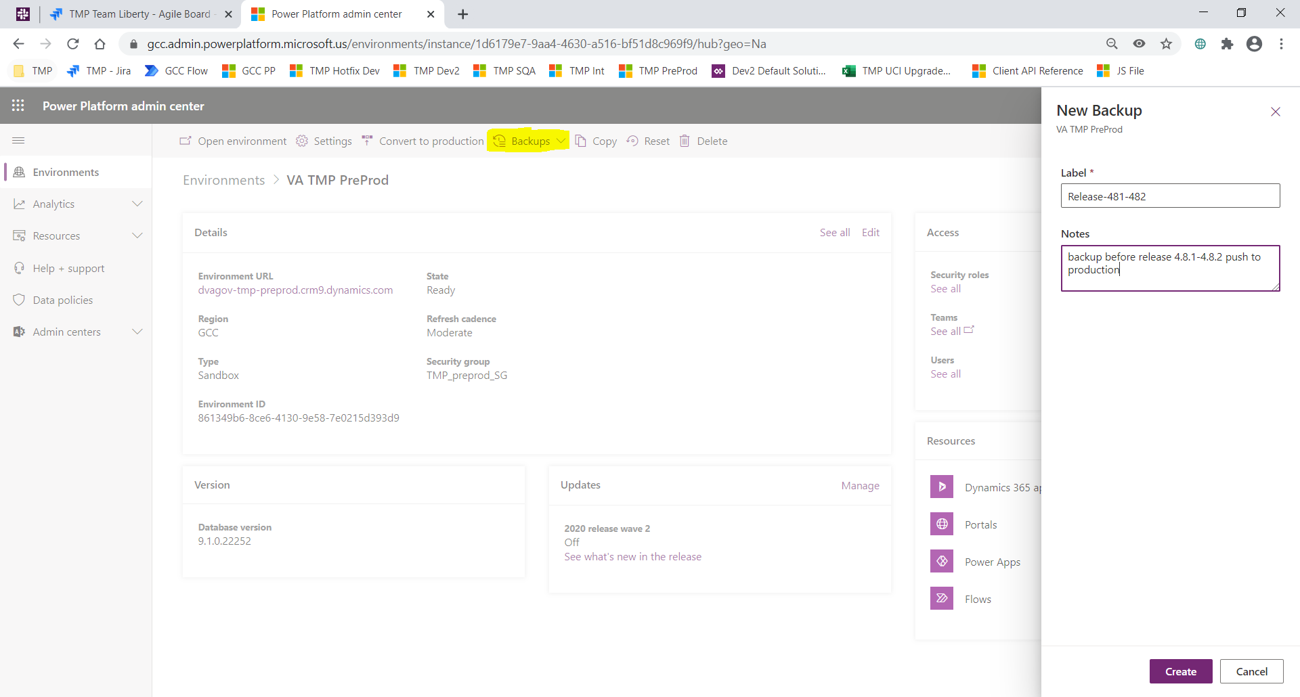
- Please wait till you see a message similar to below:
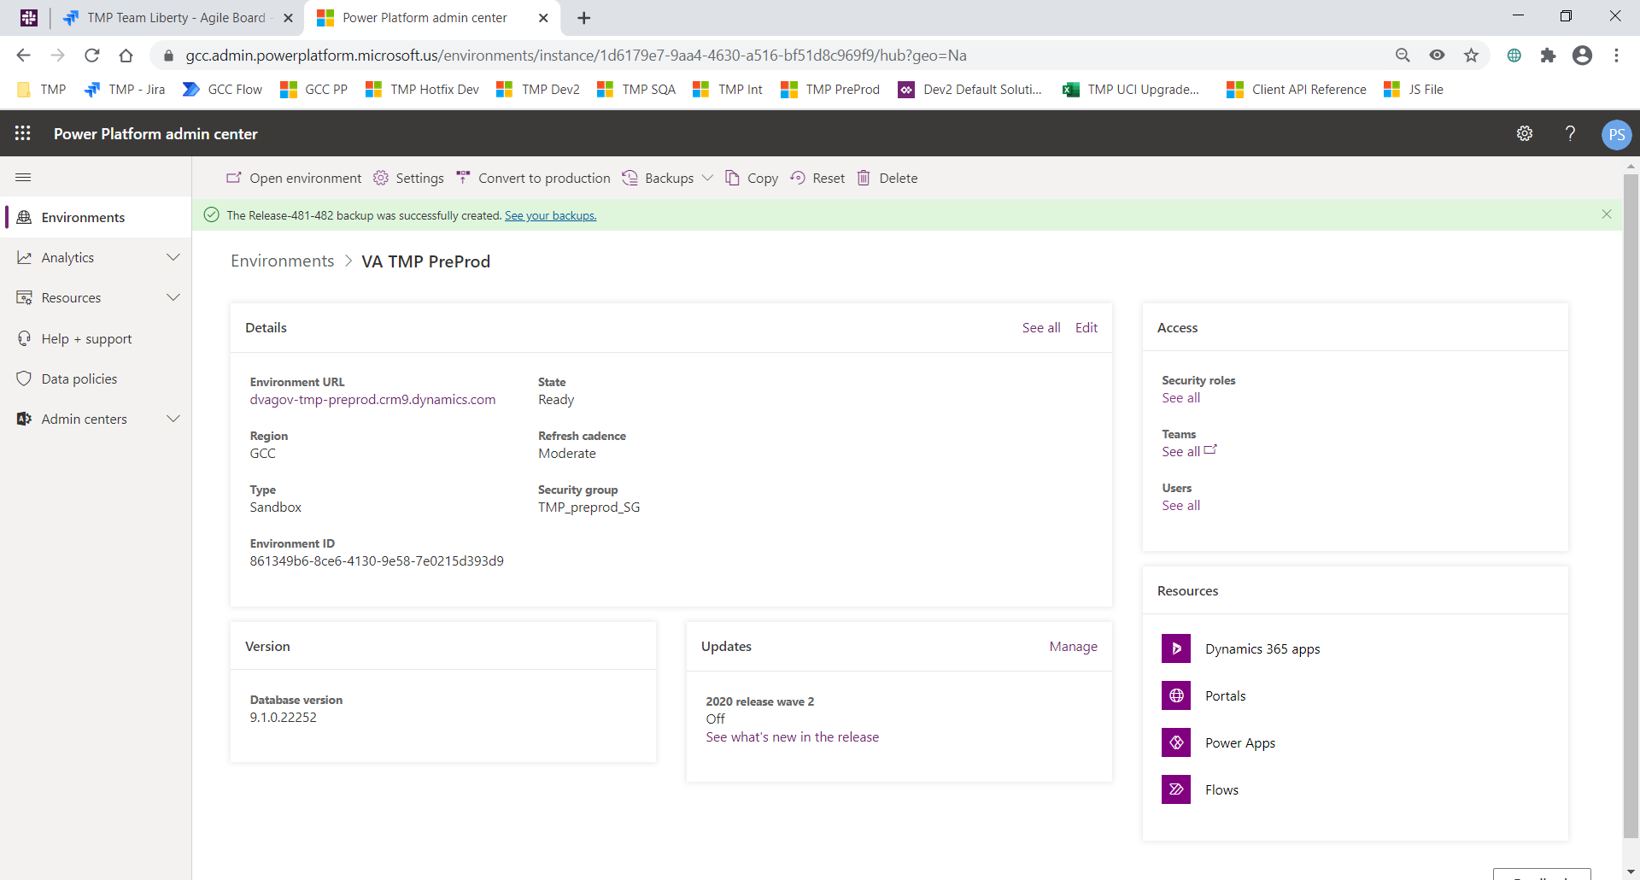

Deployment Instructions:

This section provides steps to deploy the TMP related changes in the Production environment:

Solution Deployment:
- Download the following solutions from Github here:
  - TMPRelease_49012_1_0_0_0.zip
- Import the solution using link Publish all customizations twice.

- Using either XrmToolKit or Plugin Registration Tool:
  - Update the TMPPlugins assembly.
  - Create new Steps for 2 new Plugins: McsGroupResourceCreatePreStage and McsGroupResourceDeletePostStage
    - McsGroupResourceCreatePreStage
      - Message Event: Create
      - Entity: Group Resource
      - Execution Pipeline: Pre-operation
      - Execution Method: Synchronous
    - McsGroupResourceDeletePostStage
      - Message Event: Delete
      - Entity: Group Resource
      - Execution Pipeline: Pre-operation
      - Execution Method: Synchronous
      - Pre-Image
        - Image Name: pre
        - Image Entity Alias: pre
        - Image Attributes: mcs_relatedresourcegroupid, mcs_relatedresourceid, mcs_type
  - Updated Step for ParticipatingSiteUpdatePreStage
    - Added Pre-Image
      - Image Name: pre
      - Image Entity Alias: pre
      - Image Attributes: cvt_scheduleable, cvt_warningtype
- API deployment
- 1. | Log into https://portal.azure.us in IE
2. | Go to App Services and find the relevant LOB/EC for the subscription you are deploying to | SQA: ihs-lob-qa-tmp; vvs-lob-qa-tmp; vvs-ec-qa.tmp; mvi-lob-dev-tmp  PPD: ihs-lob-nprod-tmp; vvs-lob-nprod-tmp; vvs-ec-nprod-tmp; mvi-lob-nprod-tmp  PROD EAST: ihs-lob-prod-tmp-east; vvs-lob-prod-east; vvs-ec-prod-east; mvi-lob-prod-tmp-east  PROD SOUTH: ihs-lob-prod-tmp-south; vvs-lob-prod-west; vvs-ec-prod-south; mvi-lob-prod-tmp-south
3. | Click on Get Publish Profile to download the kudu profile
4. | Log into the App Service, then go to the command prompt and download the Site folder to create a backup | 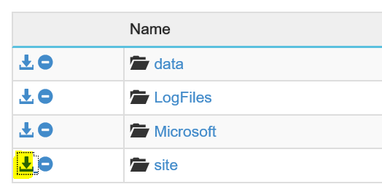
5. | Go to the site\wwwroot\bin folder in Azure | Take a backup of the bin folder
6. | Publish from the VS -> master branch | VA.TMP.Integration.Api.HealthShare; VA.TMP.Integration.Api.VideoVisit; Ec.VideoVisit.Api  VA.TMP.Integration.Api.Mvi
10. | In the Azure Portal, stop and start the app service
11. | In the App Service Configuration Section add a new Setting. Repeat for both East and South Regions.  NOTE: This is a one-time step to be followed. Save changes once they are created which will restart the App Service. | VVS:  1. EC: GetLoanedDevicesUri: /pgs/v1/patients/{0}/devices  2. LOB: EcGetLoanedDevicesUri: /ec/vvs/api/GetLoanedDevices  IHS LOB:  1. MviOrgName:  a: QA/PreProd - TMPNP  B: Prod - TMP  2. MviPersonSearchUri: /lob/mvi/api/PersonSearch  MVI:  1. EcUnattendedPersonSearchUri: /EC/MVIService/api/RetrievePerson
12. | Backup VVS LOB and EC APIs | 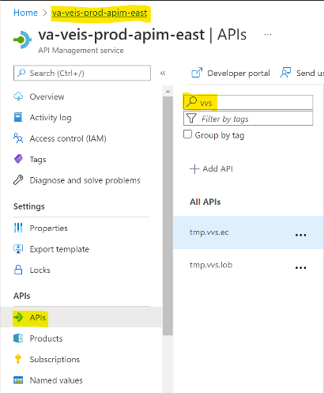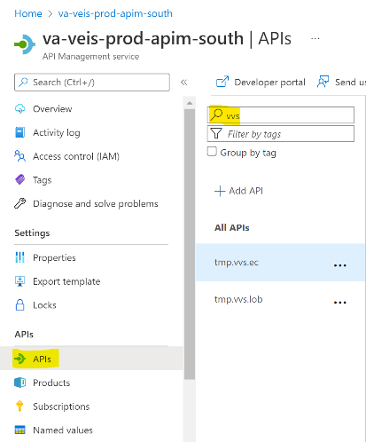
mv13. | Save Swagger definition for both LOB and EC | - Click pencil icon to Edit API definition (i.e. Swagger)  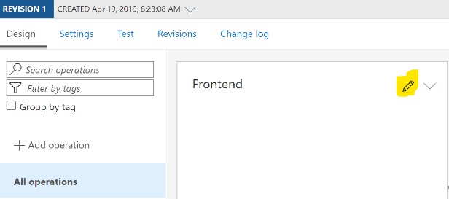  - Save locally to your GFE  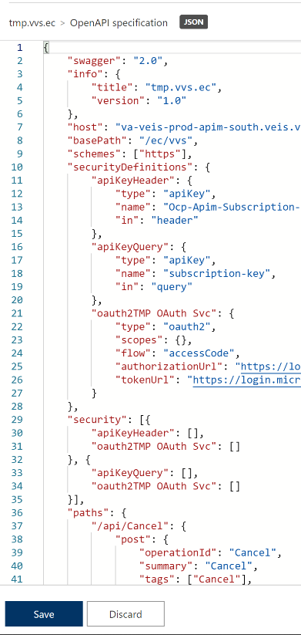  - Repeat for both LOB and EC in both East and South Regions.
14 | Update the new Swagger definition | Copy and paste the info, host, basePath, schemes, securityDefinitions, and security attributes from the backup file to the new Swagger definition update. Repeat for both LOB and EC in both East and South Regions.
15. | Update the Swagger definition | Replace the existing definition with new Swagger definition containing the changes from Step 14 and click Save.
- Migrate Data for VALD Feature
  - Using the XrmToolKit open the Data Migration Tool.
  - Connect to TMP Dev Environment
  - Filter Tables to the mcs_setting Table.
  - Filter the records to by name matching “VALD Feature”.
  - Connect to SQA as the Target Environment.
  - Click on the Export menu and select the Data option.
  - Select the folder in which to save the Export to.
  - Confirm the alert message by clicking on the Yes button. Then click OK to acknowledge the notification.
  - Click on the Import men and select the “From last exported” option.
  - Confirm the alert message by clicking on the Yes button. Then click OK to acknowledge the notification.

Integrations Deployment (Kudu)
Manual Configuration:
Step 1: select any one of the TSA’s which is approved and set the review date to 60 days from the current day for testing and save.
Step 2: Click on advance settings and navigate to email automation Entity and open the entity.
Step 3: click on the facility approval initial email for running the workflow.
Step 4: click on the run workflow.
Step 5: select the one-time trigger facility approval and add it.
Step 6: click OK and the workflow gets triggered.
Create new Integration Setting for new GetLoanedDevices Endpoint
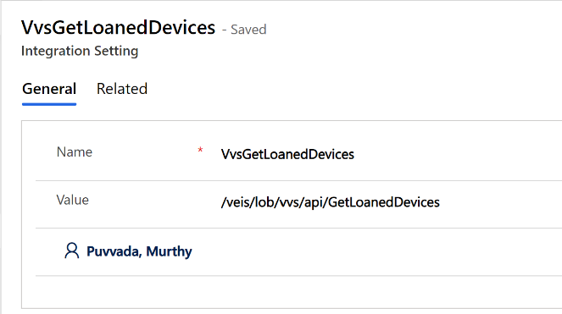
create new Scheduling Package for VVC Test Call
1.Created new scheduling package -VVC Test Call Package
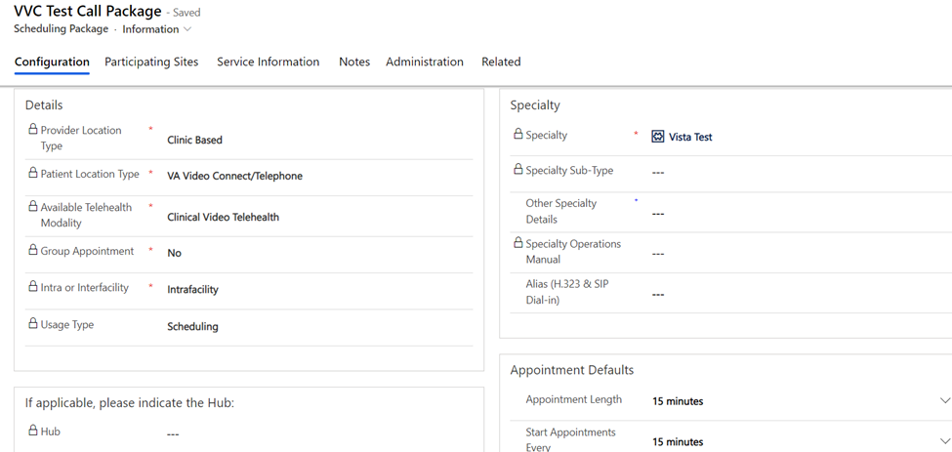

2. Provider Facility

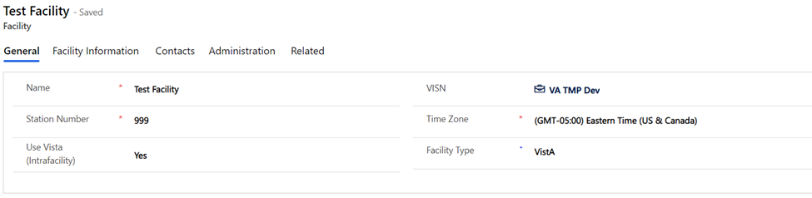

3.Added provider and patient sites under Participating sites tab
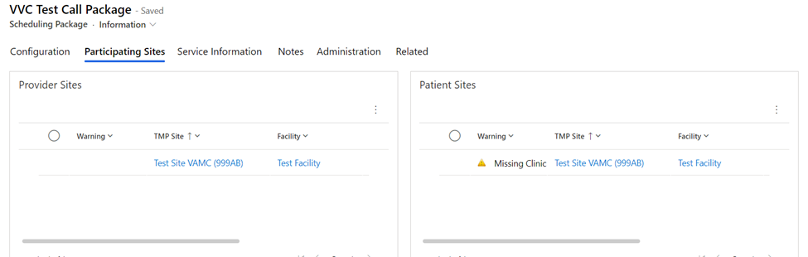

4.created provider site under participating sites tab
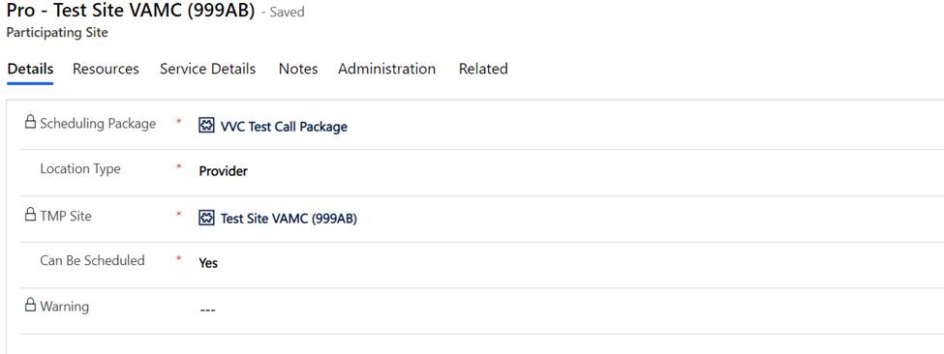

5.added resources for provider site
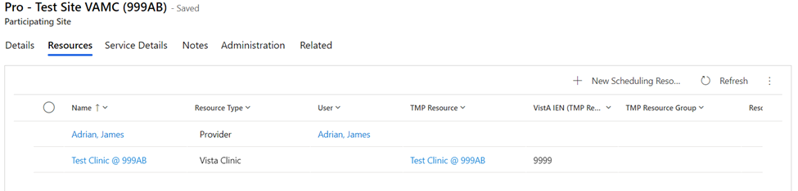

6.created Patient site under participating sites tab
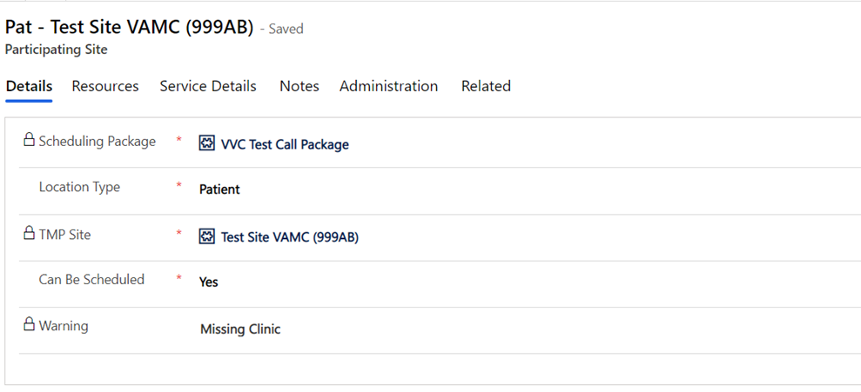
7.added TMP Site details:
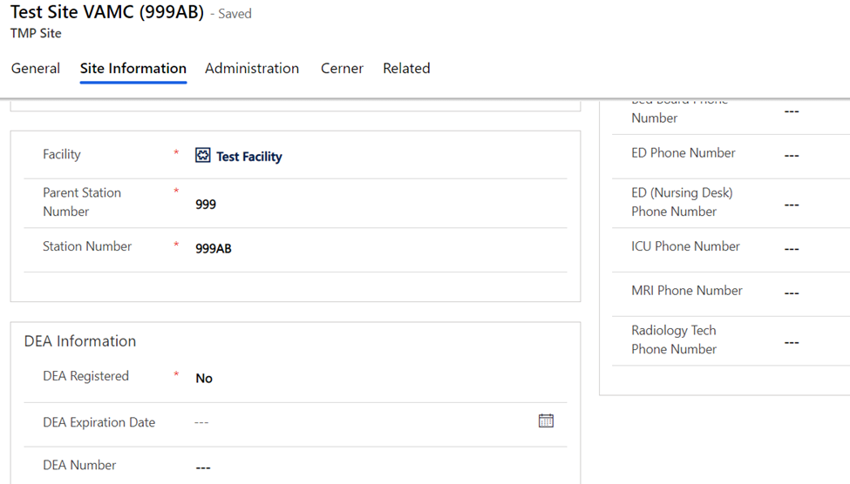
8.added related teams
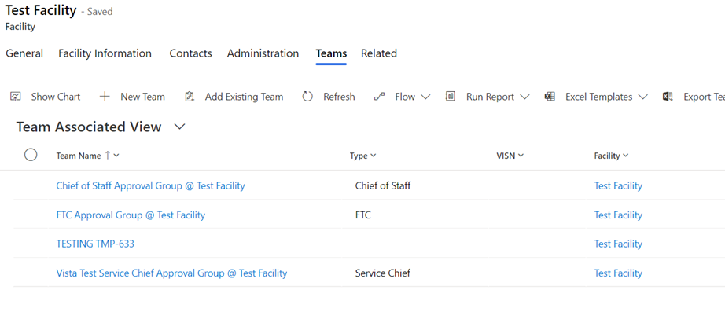
9. added new service.
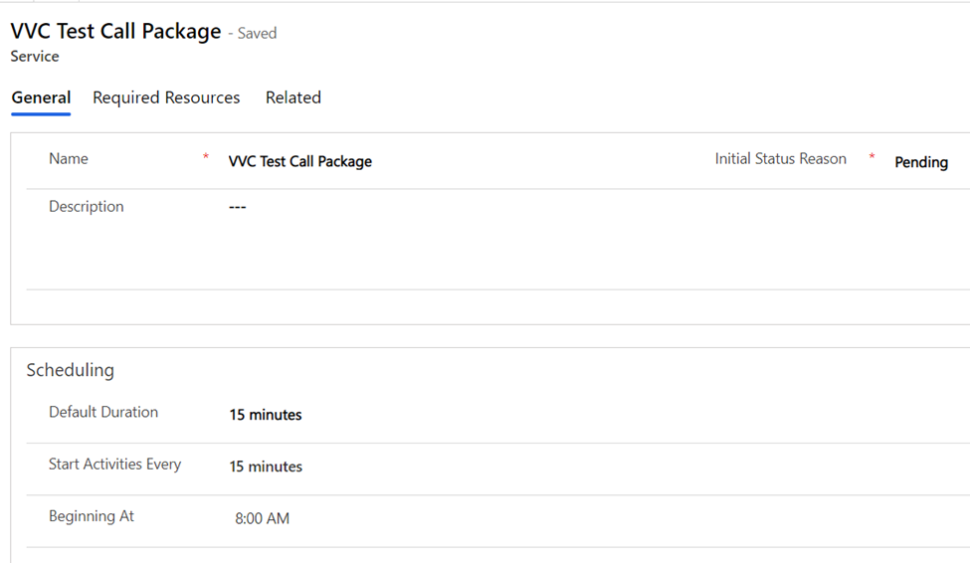
10. added required resources.
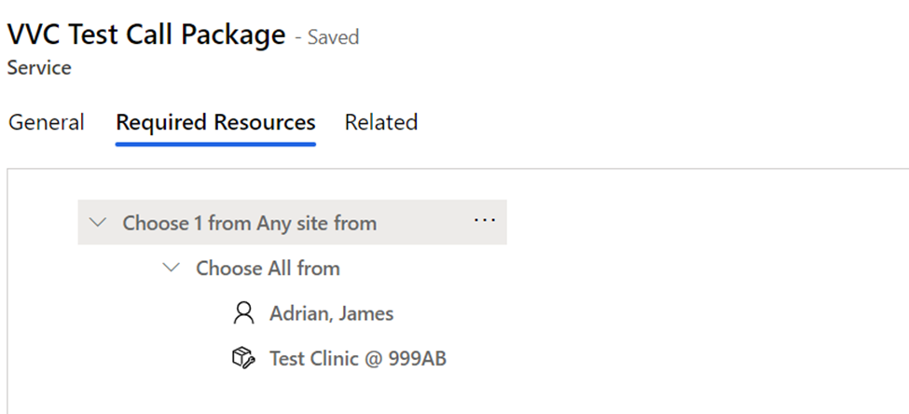
- Migrate the integration settings record where name is VVSLoanedDevices
11. For Patient search, Use XrmToolbox tool bulk updater to update all Patient records to have a new field updated with Lastname+ SSN. To do this use the below fetchxml, and use the option set Touch ‘last name’ on all record.
Select ‘include all records returned’
<fetch version="1.0" output-format="xml-platform" mapping="logical" distinct="false">
<entity name="contact">
<attribute name="fullname" />
<attribute name="telephone1" />
<attribute name="contactid" />
<order attribute="fullname" descending="false" />
</entity>
</fetch>
12. For Appointment search, Use XrmToolbox tool bulk updater to update all Patient records to have a new field updated with Lastname+ SSN. To do this use the below fetchxml, and use the option set Touch on ‘customers’ all record.
Select ‘include all records returned’
<fetch version="1.0" output-format="xml-platform" mapping="logical" distinct="false">
<entity name="serviceappointment">
<attribute name="subject" />
<attribute name="scheduledstart" />
<attribute name="resources" />
<order attribute="createdon" descending="true" />
</entity>
</fetch>
13. For Reserve Respource search, Use XrmToolbox tool bulk updater to update all Patient records to have a new field updated with Lastname+ SSN. To do this use the below fetchxml, and use the option setTouch on ‘optionalattendees’ all record.
Select ‘include all records returned’
<fetch version="1.0" output-format="xml-platform" mapping="logical" distinct="false">
<entity name="appointment">
<attribute name="subject" />
<attribute name="statecode" />
<attribute name="scheduledstart" />
<attribute name="scheduledend" />
<attribute name="instancetypecode" />
<attribute name="cvt_site" />
<attribute name="cvt_serviceactivityid" />
<attribute name="activityid" />
<order attribute="createdon" descending="true" />
</entity>
</fetch>
14. Update System Settings to include appointments and Reserve resources as part of the global search. We can remove Archived Agreements and Leads from the search list.
15. Check for Duplicate buttons on Appointment, and Reserve resource list, form
16. Update Dynamics Feature setting to remove limit on Search result set
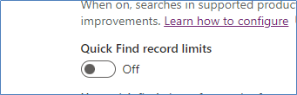

17. Delete the Last 4(tmp_last4) field in patient entity. Kindly make sure the right field is deleted as there are 2 other fields with the same display name of ‘Last 4’.
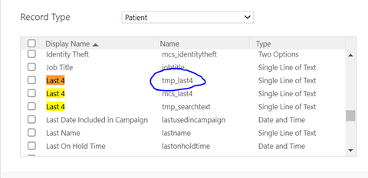
18. Appointments -> Update 'Appointment Advanced Find View' to add 'Last 4' and remove 'Last 4(regarding)'

Restore

- Navigate to the https://gcc.admin.powerplatform.microsoft.us/environments
- Select the production environment “VA TMP Prod”.
- Select Restore or manage under “Backups” link:
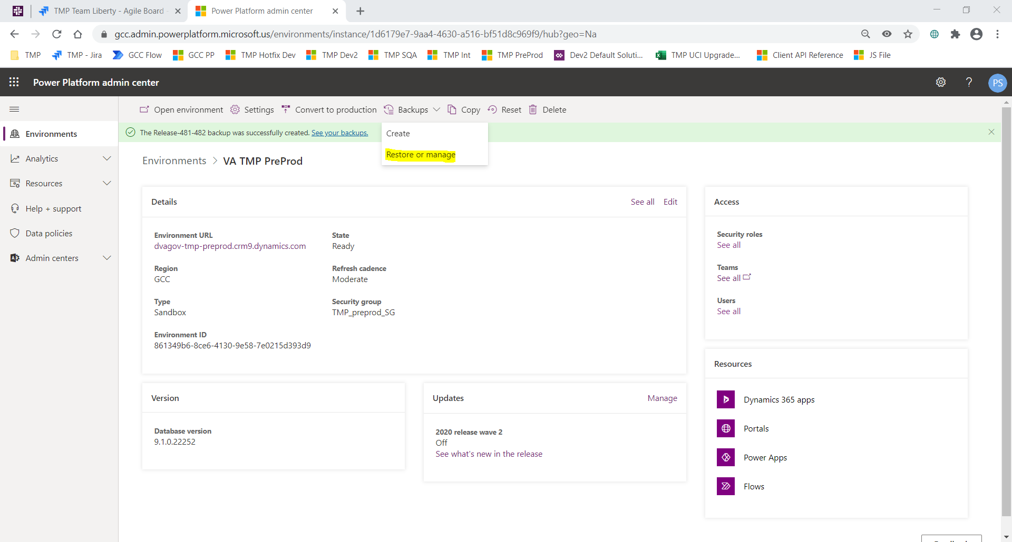
- Select the backup created in Backup step #1 -> Click Restore
