Veterans Health Information Exchange (VHIE) Portal Build 3.6 VHIE Portal User Guide

Version 3.7
August 2020

Department of Veterans Affairs (VA) Office of Information and Technology (OIT)

Revision History

Date | Revision | Description | Author
08/27/2020 | 3.7 | Updates:  - Section 3.2: Inserted Health Information Exchange (HIE) portal new user request instructions.  - Added captions to all figures throughout.  - Updated document to follow current standards and style guidelines.  - Reformatted content with bullet or numbered lists where appropriate.  - Spelled out first occurrence of all acronyms.  - Added acronyms to Table 21.  - Verified document is Section 508 conformant (e.g., added alternate text to all images, verified first table rows are repeated heading rows, etc.). | VA Tech Writer: REDACTED
04/2020 | 3.6 | Updates:  - Updated language from AITC to AWS.  - Update Section 3 to include instructions for requesting access to the VHIE Portal. | VHIE Agile Development
03/2020 | 3.5 | Replaced screenshots to mask all data resembling PII format and structure. | VHIE Agile Development
03/2020 | 3.4 | - Removed Recent Activity tab, Accounting of Disclosures tab, and the Disclosures Detailed Report for the current Patch 3.6 release.  - Updated VHIE Portal Roles table and description in Section 4.1. to differentiate Prod and Non-Prod AD policy groups. | VHIE Agile Development
03/2020 | 3.3 | Updated Section 4.1 to include description for all VHIE Roles. | VHIE Agile Development
03/2020 | 3.2 | Added Section 4.1 to let ROI Operators know the appropriate VHIE Role to use when requesting access to the VHIE Portal. | VHIE Agile Development
03/2020 | 3.1 | Updated Sections 4.2.2 and 4.2.3 with updated screenshots to reflect updated VA Forms for Opt-Out and Re-participation.  Updated Section 4.14.3 with updated screenshot to reflect the most recent software version. | VHIE Agile Development

Date | Revision | Description | Author
03/2020 | 3.0 | Updated Section 3 to include the Production Uniform Resource Locator (URL).  Removed/updated sub-sections under Sections 4.11 and 4.12 regarding the reports that are hidden from the GUI for the current release (Deceased Veteran Detailed, Expiring Consent Detailed, Deceased Veteran Summary, Disclosures Summary). | VHIE Agile Development
12/2019 | 2.9 | Update Section 4.1 Patient Search to include expected response for loading an Inactive Patient for Build 3.1. | VHIE Agile Development
09/2019 | 2.8 | Updated Section 5.1 Special Instructions for Error Correction and updated instructions for exporting to Comma-Separated Values (CSV) and Save Extensible Markup Language (XML) throughout the document. | VHIE Agile Development
08/2019 | 2.7 | Updated additional language and labels for tables/figures. | VHIE Agile Development
08/2019 | 2.6 | Updated based on PMO review. | VHIE Agile Development
08/2019 | 2.5 | Updated UIs and content to reflect changes during Build 3. | VHIE Agile Development
06/11/2019 | 2.4 | Updated content, tables, and figures to reflect Build 3 functionalities. | VHIE Agile Development
04/16/2019 | 2.3 | Updated UIs and language throughout to reflect most recent design changes. | VHIE Agile Development
04/05/2019 | 2.2 | Added a note in Section 4.5 to let users know Print functionality is available through the browser. | VHIE Agile Development
03/15/2019 | 2.1 | Added a note under “Generate Documents” to recommend users to allow pop-ups and redirects in the browser’s setting for the VHIE Portal. | VHIE Agile Development
02/28/2019 | 2.0 | Updated content, images, and document text to reflect Maintaining Internal Systems and Strengthening Integrated Outside Networks (MISSION) Act language. | VHIE Agile Development
01/17/2019 | 1.0 | Initial Draft. | VHIE Agile Development

Artifact Rationale
Per the Veteran-focused Integrated Process (VIP) Guide, the User’s Guide is required to be completed prior to Critical Decision Point #2 (CD2), with the expectation that it will be updated as needed. A user guide is a technical communication document intended to give assistance to people using a system, such as Veterans Health Information Systems and Technology Architecture (VistA) end-users. It is usually written by a technical writer, although it can also be written by programmers, product or project managers, or other technical staff. Most user guides contain both a written guide and the associated images. In the case of computer applications, it is usual to include screenshots of the human-machine interfaces, and hardware manuals often include clear, simplified diagrams. The language used is matched to the intended audience, with jargon kept to a minimum or explained thoroughly. The user guide is a mandatory, build-level document, and should be updated to reflect the contents of the most recently deployed build. The sections documented herein are required if applicable to your product.

Table of Contents

Revision History ii
List of Tables vi
List of Figures vii
- Introduction 1
  - Purpose 1
- System Summary 1
- Getting Started 1
  - VHIE Portal Roles 1
  - VHIE Portal New User Request Instructions 3
    - Step 1. Complete Training 3
    - Step 2. Submit Access Request 5
  - Log in Via SSOi 12
  - Understanding the Functionalities 15
  - Exit System 15
- Using the Software 16
  - Patient Search 16
    - Prerequisite 16
  - Patient Detail Summary 20
    - Prerequisite 20
    - View Patient Demographic Details 21
    - Patient-Centric Functions 21
  - Consent Status Tab 22
    - Prerequisite 22
    - Participation Preference: Opt-Out of Sharing (Not Participating) 23
    - Participation Preference: Patient Re-Participate in Sharing 24
    - Deceased Patient Notification Message 27
  - Comments Tab 28
    - Prerequisite 28
  - Generate Documents Tab 30
    - Prerequisite 30
  - Facilities Tab 39
    - Prerequisite 39
  - Search Menu—Return to Patient Search 40
    - Prerequisite 40
  - Reports—Dashboard Widgets 40
    - Prerequisite 40
  - Reports—Detailed HIE and Consent Reports 44
    - Prerequisite 44
    - Consent Directive Detailed Report 45
    - Legacy Detailed Report 48
    - Patient Opt-Out Detailed Report 50
  - Reports—Summary HIE and Consent Reports 52
    - Prerequisite 52
    - Consent Directive Summary Report 54
    - Patient Opt-Out Summary Report 57
  - Admin Menu—Partner Organizations and Facilities List 59
    - Prerequisite 59
    - Access or Modify Partner Organizations List 60
    - Access or Modify Facilities List 65
  - Welcome Menu—User Preferences, User Guide, and About VHIE Portal 69
    - Prerequisite 70
    - Set or Update User’s Default Facility 70
    - Prerequisite 70
    - Access User Guide 75
    - View System Software Information 77
- Troubleshooting 79
  - Special Instructions for Error Correction 79
- Acronyms and Abbreviations 81

List of Tables
Table 1: VHIE Portal Roles Description 2
Table 2: Log in via SSOi 12
Table 3: Patient Search 17
Table 4: Patient Opt-Out of Sharing 23
Table 5: Patient Re-Participate in Sharing 25
Table 6: View/Add Patient Comments 28
Table 7: Generate CCD 1.1, CCD 2.1, and C32 31
Table 8: Generate C62 and SES 35
Table 9: Reports - Dashboard Widgets 41
Table 10: Consent Directive Detailed Report 45
Table 11: Legacy Detailed Report 48
Table 12: Patient Opt-Out Detailed Report 50
Table 13: Consent Directive Summary Report 54

Table 14: Patient Opt-Out Summary Report 57
Table 15: Access or Modify Partner Organizations List 61
Table 16: Access or Modify Facilities List 66
Table 17: Set or Update User’s Default Facility 71
Table 18: Access User Guide 75
Table 19: View System Software Information 77
Table 20: Special Instructions for Error Correction 79
Table 21: Acronyms and Abbreviations 81

List of Figures
Figure 1: Zipping together Completed Training Certificates 4
Figure 2: Verifying Training Certificates Zip File Name 4
Figure 3: Selecting the “EO: System Access Request (e9957)” Document 5
Figure 4: Microsoft Outlook Global Address List (GAL)—General Tab 7
Figure 5: LAN and Exchange Access Checkbox 7
Figure 6: Searching for “AAC VDIF” Security Groups 8
Figure 7: Affirmations Dialog—Signing Document 8
Figure 8: Security and Privacy Dialog Entries 9
Figure 9: Entering Comment Text 10
Figure 10: Apply Digital Signature 11
Figure 11: Sample Error Message—Problem with Website's Security Certificate 12
Figure 12: “VA Single Sign-On” Screen (PIV Card) 13
Figure 13: Windows Security—"Select a Certificate” Screen 13
Figure 14: ActivClient Login—PIV PIN Pop-Up Screen 14
Figure 15: VHIE Portal—Landing Page 14
Figure 16: VHIE Portal—"Patient Search” Screen 17
Figure 17: VHIE Portal—"Patient Search” Screen: Field Validation 18
Figure 18: VHIE Portal—“Patient Search” Screen: Data Entries (Masked) and Progress Status Bar 19
Figure 19: VHIE Portal—Notification Message: Patient Loading and to Try Search Later
...................................................................................................................................... 20
Figure 20: VHIE Portal—"Patient Detail” Screen: Patient Demographic Details 21
Figure 21: VHIE Portal—"Patient Detail” Screen: Patient-Centric Information Tabs 22
Figure 22: VHIE Portal—"Patient Detail” Screen: Opt-Out Button 23
Figure 23: VHIE Portal—"Opt-Out of Sharing” Screen 24
Figure 24: VHIE Portal—“Patient Detail”: Opt-In Button 25
Figure 25: VHIE Portal—“Reparticipate in Sharing” Screen 26

Figure 26: VHIE Portal—“Patient Detail” Screen: Deceased Veteran Notification Message 27
Figure 27: VHIE Portal—“Patient Detail” Screen: Add Comment Button 28
Figure 28: VHIE Portal—“Patient Detail” Screen: Adding Comments 29
Figure 29: VHIE Portal—“Patient Detail” Screen: Viewing Comments 30
Figure 30: VHIE Portal—Generate Documents Tab: Generate CCD 1.1, CCD 2.1, and C32 31
Figure 31: Sample Health Summary Document 32
Figure 32: VHIE Portal—Generate Documents Tab: Saving CCD 1.1 as XML File 33
Figure 33: Sample Dialog to Save XML Document 33
Figure 34: Selecting Tool to Open XML File 34
Figure 35: VHIE Portal—Generate Documents Tab: Generating a C62 File 35
Figure 36: VHIE Portal—Generate Documents Tab: Reviewing Documents 36
Figure 37: Downloading and Saving XML File 37
Figure 38: Selecting Tool to Open XML File 38
Figure 39: VHIE Portal—Facilities Tab: View Patient's Treatment Facilities 39
Figure 40: VHIE Portal—Return to Patient Search 40
Figure 41: VHIE Portal—Selecting Consent Activity Dashboard Report 41
Figure 42: Consent Activity Dashboard—Sample Web Calls within 24 Hours Report 42
Figure 43: VHIE Portal—Selecting User Activity Dashboard Report 43
Figure 44: User Activity Dashboard—Sample User Logins within Past 24 Hours Report
...................................................................................................................................... 43
Figure 45: Detailed Reports Menu—Selecting Detailed HIE and Consent Reports 44
Figure 46: Detailed Reports Menu—Selecting Consent Directive Detailed Report 45
Figure 47: Consent Directive Detailed Report—Selecting Search Criteria 46
Figure 48: Sample Consent Directive Detailed Report—Exporting to a CSV File 47
Figure 49: Detailed Reports Menu—Selecting Legacy Detailed Report 48
Figure 50: Legacy Detailed Report—Selecting Search Criteria 49
Figure 51: Sample Legacy Detailed Report—Exporting to a CSV File 49
Figure 52: Detailed Reports Menu—Selecting Patient Opt-Out Detailed Report 50
Figure 53: Patient Opt-Out Detailed Report—Selecting Search Criteria 51
Figure 54: Sample Patient Opt-Out Detailed Report—Export and View Options 52
Figure 55: Reports Menu—Summary HIE and Consent Reports 53
Figure 56: Summary Reports Menu—Selecting Consent Directive Summary Report 54
Figure 57: Consent Directive Summary Report—Selecting Search Criteria 55
Figure 58: Sample Consent Directive Summary Report—Exporting to a CSV File 56
Figure 59: Summary Reports Menu—Selecting Patient Opt-Out Summary Report 57
Figure 60: Patient Opt-Out Summary Report—Selecting Search Criteria 58
Figure 61: Sample Patient Opt-Out Summary Report—Exporting to a CSV File 59

Figure 62: Admin Menu—Partner Organizations and Facilities List 60
Figure 63: Admin Menu—Selecting Organizations 61
Figure 64: Partner Organizations—Adding a New Partner Organization 62
Figure 65: Add Partner Organization—Entering Required Fields and Saving New Partner Organization 63
Figure 66: Partner Organizations—Selecting an Existing Partner Organization 64
Figure 67: Edit Partner Organizations—Editing Required Fields and Saving Changes or Deleting a Partner Organization 65
Figure 68: Admin Menu—Selecting Facilities 66
Figure 69: Facilities—Adding a New Facility 66
Figure 70: Add Facility—Entering Required Fields and Saving New VA Facility 67
Figure 71: Facilities—Selecting an Existing Facility 68
Figure 72: Edit Facility—Editing Required Fields and Saving Changes or Deleting a Facility 69
Figure 73: Welcome Menu—User Preferences, User Guide, and About VHIE Portal 70
Figure 74: VHIE Portal—Landing Page: Notification Message to Set Default Facility 71
Figure 75: Welcome Menu—Selecting User Preferences 72
Figure 76: Default Facility—Setting Default Facility 73
Figure 77: Default Facility—Removing Default Facility 74
Figure 78: Welcome Menu—Selecting User Guide 75
Figure 79: VA Software Document Library (VDL)—VHIE Portal User Guide PDF 76
Figure 80: Welcome Menu—Selecting About VHIE Portal 77
Figure 81: “About VHIE Portal” Screen 78

Introduction
The Veterans Health Information Exchange (VHIE) Program was tasked by the Department of Veterans Affairs (VA) to replace the eHealth Exchange (eHX) solution with a commercial-off- the-shelf (COTS) product called the HealthShare Enterprise Platform (HEP). As part of the enhancement, HealthShare (HS) will consume legacy applications that rely on the connection with the eHX Adapter, and in this case, the Veteran Authorization and Preferences (VAP) system.
At a high-level, VAP manages a Patient’s Consent, also known as the Patient’s Participation Preferences (PPP) and the requests for generating Clinical Document Architecture (CDA)-type documents for selected Veterans, as well as generate and display Health Information Exchange (HIE) and Consent reports. To improve user experience and provide a more streamlined and robust interface, the VAP interface and functionalities will be replaced by a custom-coded interface known, henceforth, as the VHIE Portal.

Purpose
The purpose of the VHIE Portal User Guide is to familiarize internal Veterans Health Administration (VHA) personnel and other authorized users about using the VHIE Portal interface.

System Summary
The VHIE Portal application is hosted on Amazon Web Service (AWS). The system is only accessible within the VA intranet to authorized users. The VHIE Portal is intended for internal VHIE users to perform consent management tasks.

Getting Started
This section describes the steps for logging in and understanding the VHIE Portal functionalities.

VHIE Portal Roles
When requesting access to the VHIE Portal, the following VHIE Portal roles are available based on the level of access that is required.
NOTE: The AD Policy Groups for the Non-Production and Production Environments are differentiated by “NPD” and “PRD” at the end of the AD Policy Group name. Operators of the system will need to submit for the “PRD” role when requesting access (e.g., VHIE Operators would submit for the role of “AAC VDIF VHIE Operators PRD”).

Table 1: VHIE Portal Roles Description

Role Name | Role Description | AD Policy Groups
AAC VDIF  VHIE Data Quality Reporters | These users run and view results for Data Quality Reports, and all other Reports available to the VHIE Operators, perform patient searches, as well as download the CDA documents as XML, but do not have the ability to edit consent policies. There are no specific Data Quality reports implemented in VHIE Portal currently. | - AAC VDIF VHIE Data Quality Reporters NPD  - AAC VDIF VHIE Data Quality Reporters PRD
AAC VDIF VHIE  Operators | These users have the same access as the Veterans Data Integration and Federation (VDIF) Reporters, plus can search for patients, view patient details, retrieve CDA Patient Summary documents in HyperText Markup Language (HTML) or XML, as well as edit eHX consent policies for a Veteran (i.e., set a Veteran to opt-out or re-participate in eHX data-sharing). | - AAC VDIF VHIE Operators NPD  - AAC VDIF VHIE Operators PRD
AAC VDIF  VHIE Portal Technical Administrators | These users are technical administrators, who have access to the full VHIE Portal site, plus technical- admin-only resources, but do not have access to any tester-only resources. For the current build, this role has the same resources as the VDIF Super User role. | - AAC VDIF VHIE Portal Tech Admin NPD  - AAC VDIF VHIE Portal Tech Admin PRD
AAC VDIF  VHIE Portal Testers | These users have access to the full VHIE Portal site, including the tester-only resources. For the current build, only the capability to view CDA patient summary documents as XML is a tester-only resource. | - AAC VDIF VHIE Portal Testers NPD  - AAC VDIF VHIE Portal Testers PRD
AAC VDIF VHIE  Reporters | These users run and view results for the detailed and summary reports (but cannot run an individual patient search or edit consent policies). | - AAC VDIF VHIE Reporters NPD  - AAC VDIF VHIE Reporters PRD
AAC VDIF  VHIE Super Users | These users are administrative users at the business level, and have the same access as the VDIF Operators, plus all of the Admin reports and functions, but do not have access to the technical-admin-only resources and tester-only resources. | - AAC VDIF VHIE Super Users NPD  - AAC VDIF VHIE Super Users PRD

VHIE Portal New User Request Instructions
This section describes how to request access to the VHIE Portal. There are two steps needed to request access to the VHIE Portal:
- Step 1. Complete Training
- Step 2. Submit Access Request

NOTE: If you need assistance with completing this process, please contact your supervisor/community coordinator.

Step 1. Complete Training
Complete required training in the VA Talent Management System (TMS):
      - Log into the REDACTED) and complete the following training or view current certificates in the “My Learning History”:

VA Privacy and Information Security Awareness and Rules of Behavior (VA 10176)
        - Privacy and HIPAA Training (VA 10203)

      - Save completed training certificates:
- Save the completion certificates from both courses in a folder on your desktop.
- Open the folder where you saved the certificates.
- Select both certificates by holding the CTRL key and selecting each certificate.

- Right click on one of the certificates and select Send To → Compressed (zipped) folder, as shown in Figure 1:

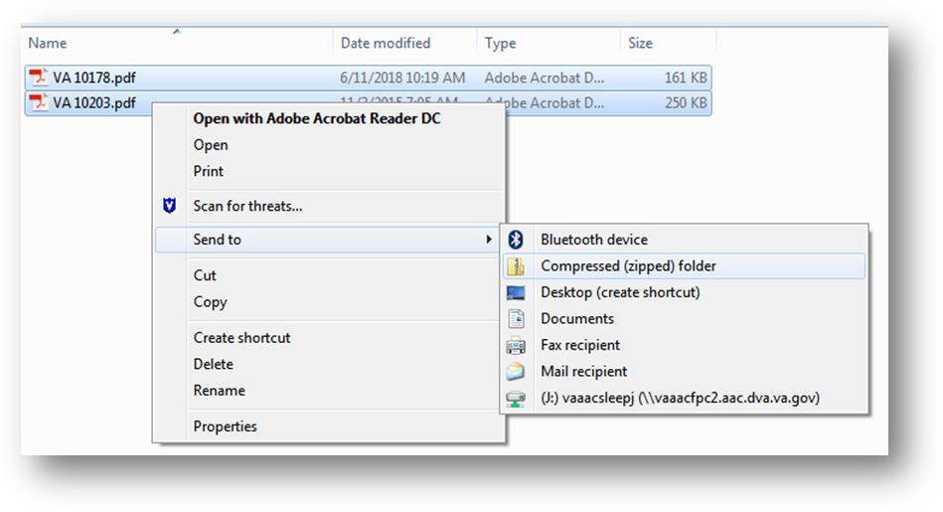
Figure 1: Zipping together Completed Training Certificates

- Name the new Zip file created in the same folder: “Certifications.zip,” as shown in Figure 2:

Figure 2: Verifying Training Certificates Zip File Name

NOTE: You will upload this file to the Electronic Permission Access System (ePAS) request in Step 2 of these instructions.

Step 2. Submit Access Request
Submit an access request via OIT Electronic Permission Access System (ePAS) 9957:
      - Navigate to the Office of Information and Technology (OIT) Electronic Permission Access System (ePAS) e9957 page.
      - Ensure that the “EO: System Access Request (e9957)” document is selected from the drop-down list, as shown in Figure 3:

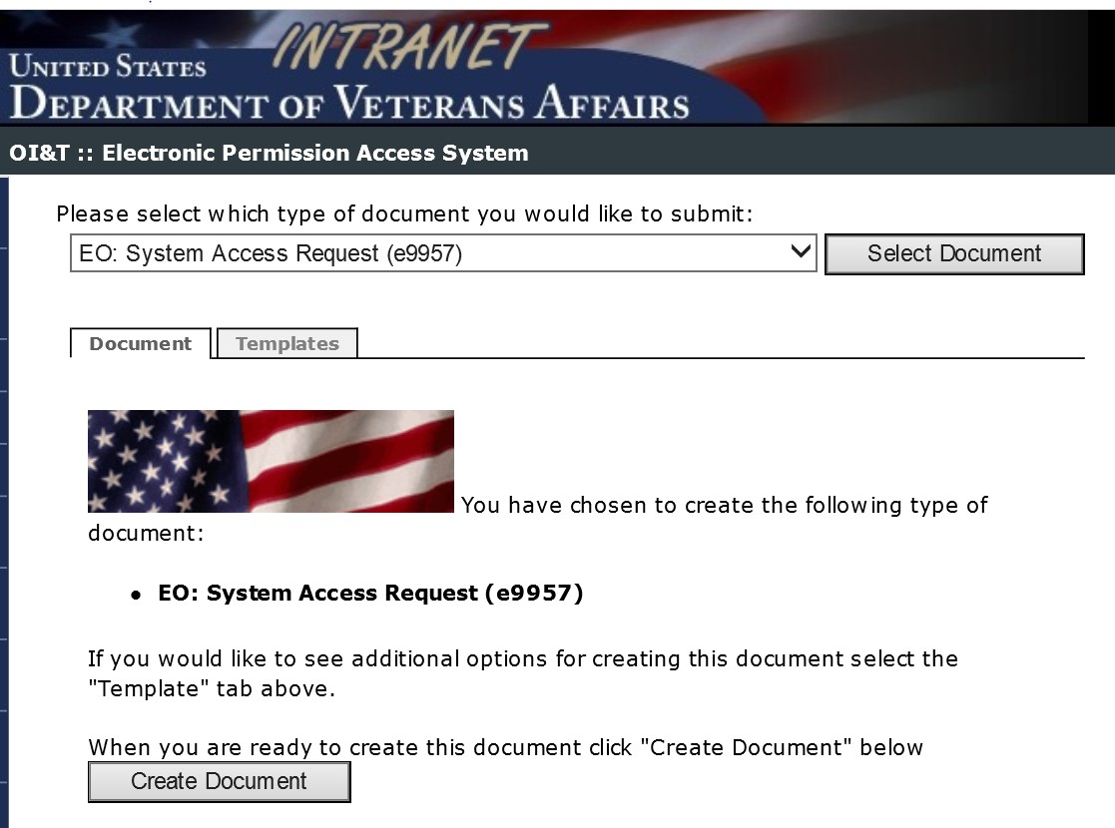
Figure 3: Selecting the “EO: System Access Request (e9957)” Document

      - Select Create Document.

NOTE: In the steps that follow, you will complete entries for the following tabs on the e9957 form in the following order:
        - Request tab (Step 4)
        - Type of Access tab (Step 5)
        - Comment tab (Step 6)

CAUTION: Do not submit until all steps have been completed!

      - From the Request tab, complete all required fields (yellow shading on the e9957 form), as well as the non-required fields (clear/white text boxes on the e9957 form) that are highlighted below:
- Complete the “Request” section entries:
  - Action: Choose “Modification of Account”
  - Type of Employment: choose “VA Staff” or “Contractor”
  - Deactivation Date: Enter an expiration date for the access or the end date for the contract if request is for contractor staff
- Complete the “General Information” section entries:
  - Full Legal Name (Last, First, and Middle Initial).
  - Previous Name (if applicable).
  - Start Date: Date when you started working at the VA or when your current contract started.
  - Mailing Address: Mailing address of the VA site where you work or the Field Office with which you are affiliated.
  - Duty Title: Your title.
  - Duty Station: Unless geographically located at one of the regional Information Technology Centers (ITC), select Other from the drop-down list. If Other, list the duty station: Enter the site/facility where you are affiliated.
  - Company: Enter “Department of Veterans Affairs” or the name of your company.
  - Department: Enter the identity of the VA department you support.
  - Office: Enter your VA office or “100% Remote.”
  - Mail Code/Division: Enter the mail code for the VA site or the field office with which you are affiliated.
  - Phone Number: Provide your phone number.
  - Project/Application Code: Enter “VDIF” for Veterans Data Integration & Federation program

  - AD Username: The Active Directory (AD) username is listed as the Alias in the Microsoft Outlook Global Address List (GAL) under the General tab, as shown in Figure 4:

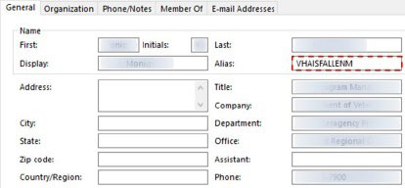
Figure 4: Microsoft Outlook Global Address List (GAL)—General Tab

- Complete the “Approver Information” section entries:
  - Supervisor: Use the “Lookup Supervisor…” button to search for and select your immediate supervisor.
  - Designated Approving Officer (DAO): Use the “Lookup DAO…” button to search for and select your service chief.

NOTE: The supervisor and DAO can be the same approver.

      - On the Type of Access tab, complete the following “LAN Access” section entries:
- Check the LAN and Exchange Access checkbox, as shown in Figure 5:

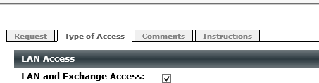
Figure 5: LAN and Exchange Access Checkbox

- Update the Security Groups:
  - Press the Select Security Group button.
  - From the “Select Security Group” dialog in the Search for Group field, type “AAC VDIF”, as shown in Figure 6:

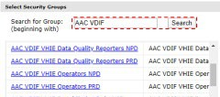
Figure 6: Searching for “AAC VDIF” Security Groups

  - Click Search.
  - Select appropriate Security Group:
    - AAC VDIF VHIE Reporters PRD—Users run and view results for the detailed and summary reports (individual patient search or edit consent policies are not available.
OR
    - AAC VDIF VHIE Operators PRD—Same access as the VDIF Reporters, plus users can search for patients, view patient details, retrieve CDA Patient Summary documents in HTML or XML, as well as edit eHX consent policies, i.e., set a Veteran to opt-out or re-participate in eHX data-sharing.

  - Click OK.

- Scroll to the bottom of the page and complete the “Affirmations” dialog entries. Check the “Affirmation” checkbox, as shown in Figure 7:

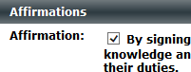
Figure 7: Affirmations Dialog—Signing Document

- Complete the “Security and Privacy” dialog entries (Figure 8):
  - Select Browse.
  - Locate and attach the ZIP file containing certificates that you created in Step 2.
  - Enter the date of your last “Rules of Behavior” training. To ensure the date is entered correctly, use the “calendar” icon to select the date.

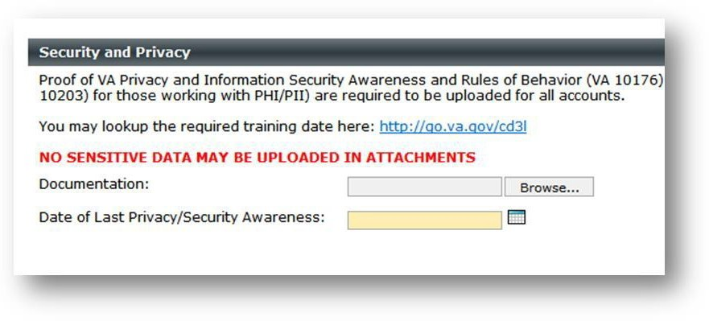
Figure 8: Security and Privacy Dialog Entries

      - On the Comments tab, do the following:
- Type the following text into the “Comments” box, as shown in Figure 9:

This request is for Single Sign On – internal (SSOi) to the VHIE Portal, under the VDIF program. I will be using my PIV for logging into the VHIE Portal.

Figure 9: Entering Comment Text
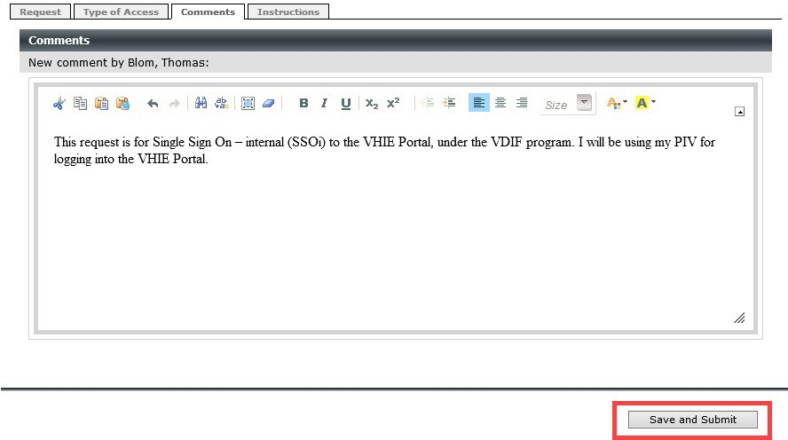

- Select the Save and Submit button, see Figure 9.

- If prompted with the “Signature” dialog pop-up, as shown in Figure 10, do the following:
  - Select the Click here to digitally sign this document link.
  - When prompted, enter your Personal Identity Verification (PIV) smart card pin.

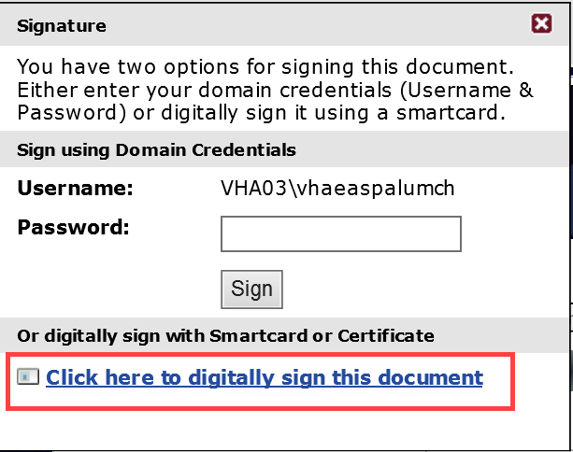
Figure 10: Apply Digital Signature

Log in Via SSOi
Take the following steps to log in via Single Sign On – internal (SSOi):
NOTE: Once integrated with SSOi, users will only use their PIV card for login per VA’s HSPD-12 implementation of mandatory PIV, unless a special exemption is permitted, and the user requires a VA username and password.

Table 2: Log in via SSOi

Step | Action
1. | Navigate to the “VHIE Portal Login” screen at REDACTED  NOTE: If presented with the website’s security certificate error (Figure 11), select “Continue to this website (not recommended)”.  Figure 11: Sample Error Message—Problem with Website's Security Certificate  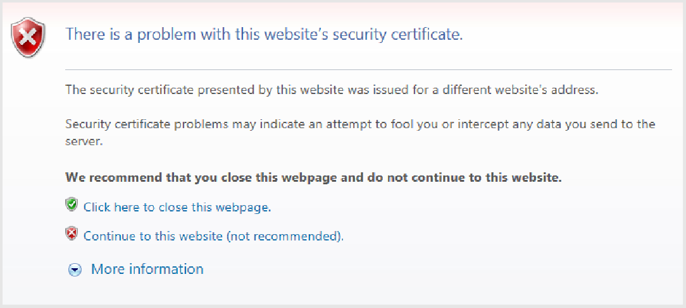

Step | Action
2. | Log in using your PIV card (Figure 12).  Figure 12: “VA Single Sign-On” Screen (PIV Card)  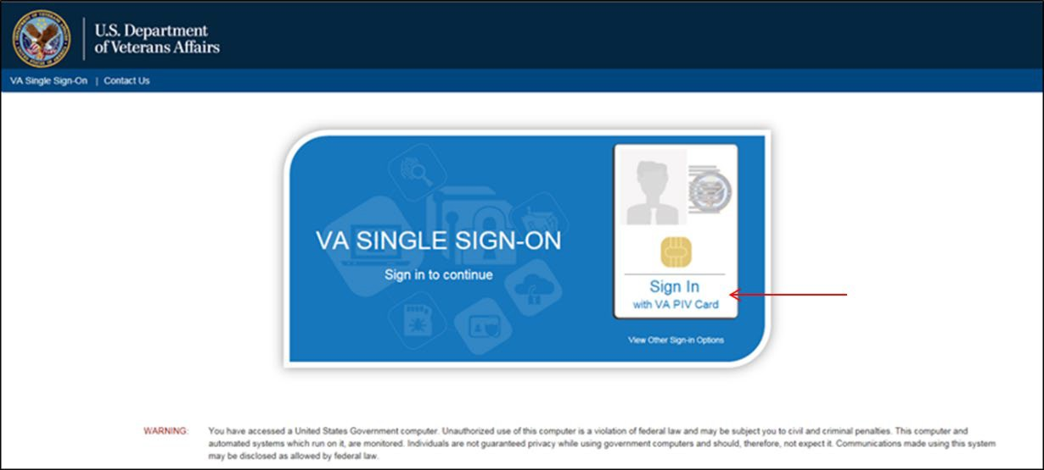
3. | Select the appropriate certificate and select OK.  NOTE: Always select the second certificate as the authentication certificate (Figure 13). If you see more than two certificates displayed, make sure to clear your browser’s cached certificates under Internet Tools.  Figure 13: Windows Security—"Select a Certificate” Screen  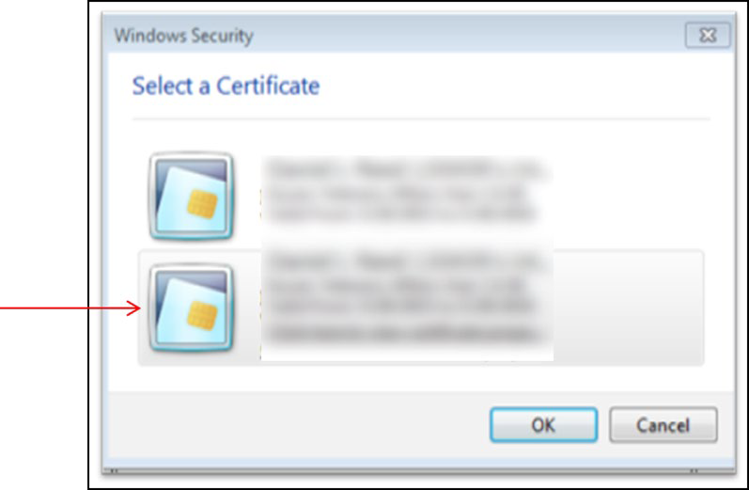

Step | Action
4. | Enter the PIN associated with your PIV card and select OK (Figure 14).  Figure 14: ActivClient Login—PIV PIN Pop-Up Screen
5. | Arrive at the “VHIE Portal” Landing Page (Figure 15).  Figure 15: VHIE Portal—Landing Page  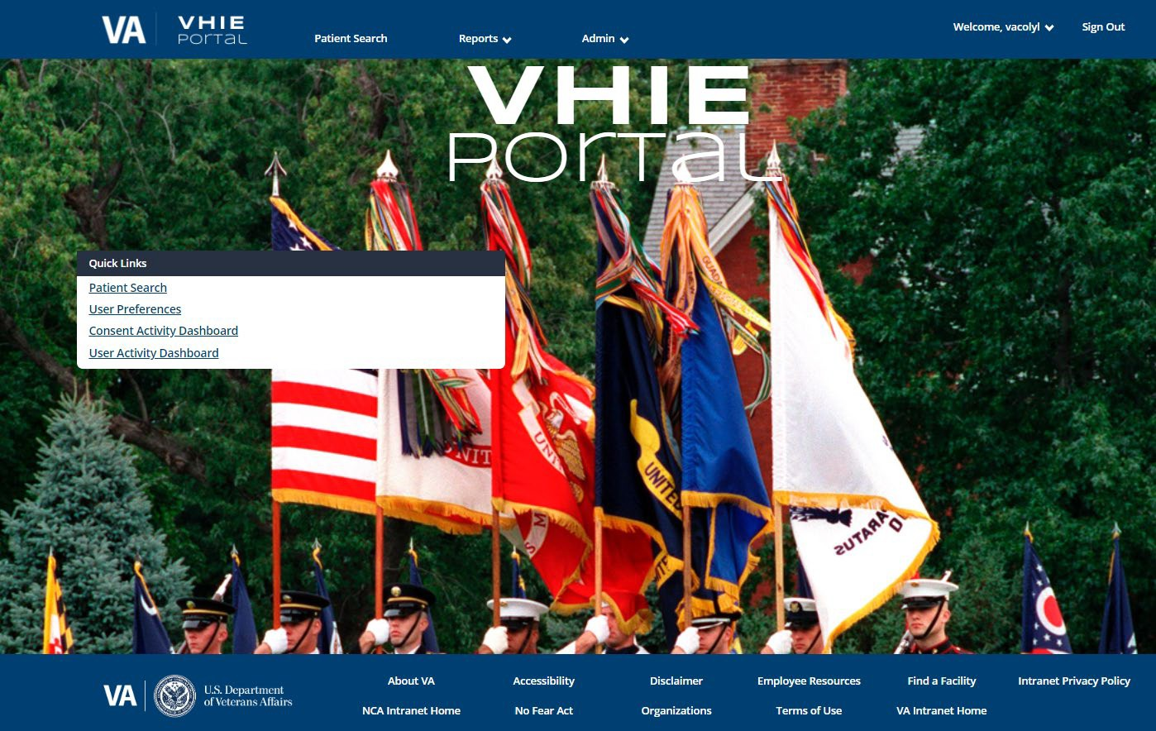

Understanding the Functionalities
The VHIE Portal provides the following functionalities:
- “VHIE Portal” Landing Page
- Patient Search
- View Patient Demographic Details
- Participation Preference: Patient Not Participating
- Participation Preference: Patient Re-participate
- Deceased Patient Notification Message
- View or Add Patient Comments
- Generate Documents (CDA-type Health Documents)
- View Patient’s VA Treatment Facilities
- Search Menu – Return to Patient Search
- Report Menu – Consent Activity Dashboard
- Report Menu – User Activity Dashboard
- Report Menu – Detailed HIE and Consent Reports
- Report Menu – Summary HIE and Consent Reports
- Admin Menu – View or Modify Partner Organization(s) List
- Admin Menu – View or Modify Facilities List
- Welcome Menu – Set or Update User’s Default Facility
- Welcome Menu – Access User Guide
- Welcome Menu – View System Software Information

Exit System
Log out of the VHIE Portal by selecting the Logout option under the Welcome menu at the top of the screen.

Using the Software
This section describes how to use the application with the following assumed experience/skills of the audience:
- Users have basic knowledge of the operating system (such as the use of commands, menu options, and navigation tools).
- Users are using the VHIE Portal to do their jobs.
- Users have been provided active roles and access to the VHIE Portal.
- Users have completed any prerequisite training.

Consult your supervisor or the VA Help Desk if you need help meeting any of the above conditions.

Patient Search
The Patient Search allows for a VHIE user to search by the following patient identifiers:
- Social Security Number (SSN)
- First Name
- Last Name.

Prerequisite
The user has logged in via SSOi or another VA-approved method for authentication.

Table 3: Patient Search

Step | Action
1. | Complete the Social Security Number, First Name, and Last Name fields, and then select  Search (Figure 16).  NOTE: The Social Security Number, First Name, and Last Name fields are all required fields. The Social Security Number field accepts numeric characters with and without dashes (e.g., xxx-xxx-xxxx and xxxxxxxxxx).  Figure 16: VHIE Portal—"Patient Search” Screen  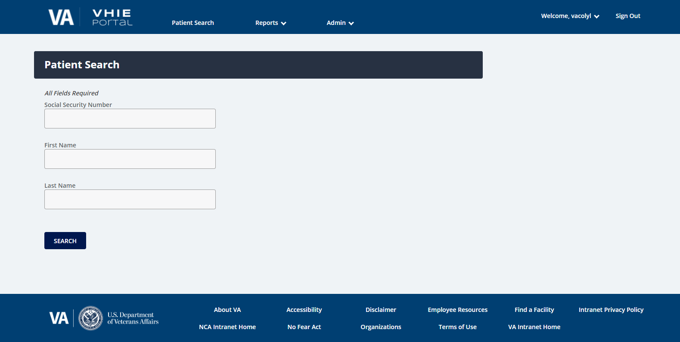

Step | Action
2. | Form validation is enforced to ensure that users complete each field in the correct format (Figure 17).  Figure 17: VHIE Portal—"Patient Search” Screen: Field Validation

Step | Action
3. | A progress bar will display to indicate that a patient search is processing (Figure 18).  Figure 18: VHIE Portal—“Patient Search” Screen: Data Entries (Masked) and Progress Status Bar
 | 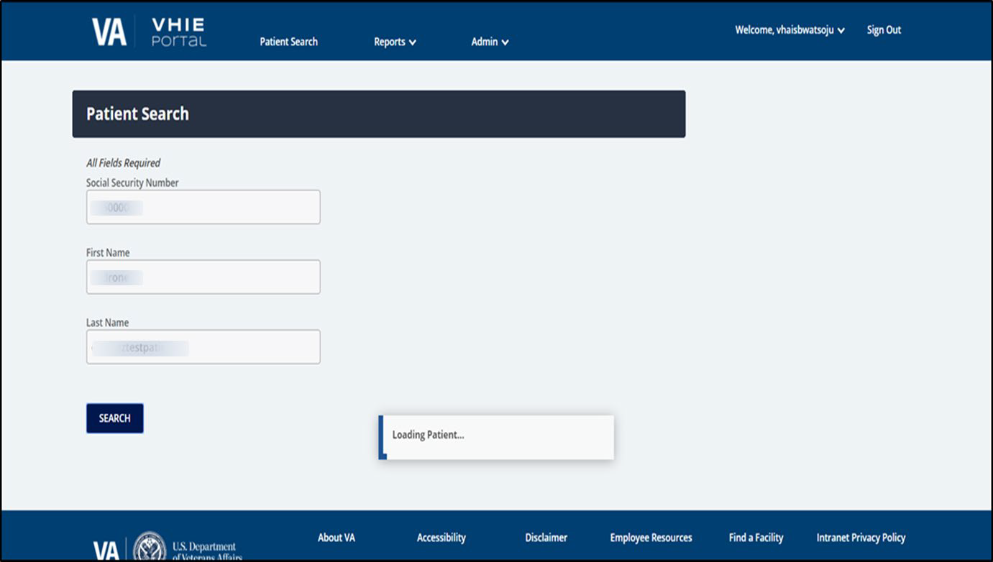

Step | Action
4. | If the patient’s record has not been loaded from the Legacy system, a notification message will display for the user to try the search again later (Figure 19).  Figure 19: VHIE Portal—Notification Message: Patient Loading and to Try Search Later
 | 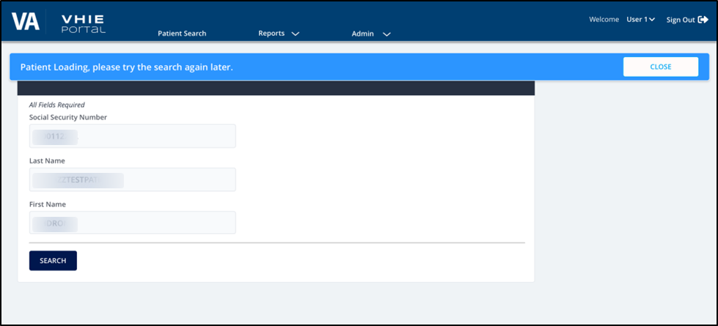

Patient Detail Summary
After retrieving a record from a patient search, the VHIE user will be able to view the patient’s demographic details and perform various patient-centric tasks, depending on the role(s) assigned to the VHIE user.

Prerequisite
- The user has logged in via SSOi or another VA-approved method for authentication.
- The user has successfully retrieved a record from a Patient Search.

View Patient Demographic Details
The patient’s demographic details will be displayed at the top of the screen (if available) for the VHIE user to view, as shown in Figure 20:

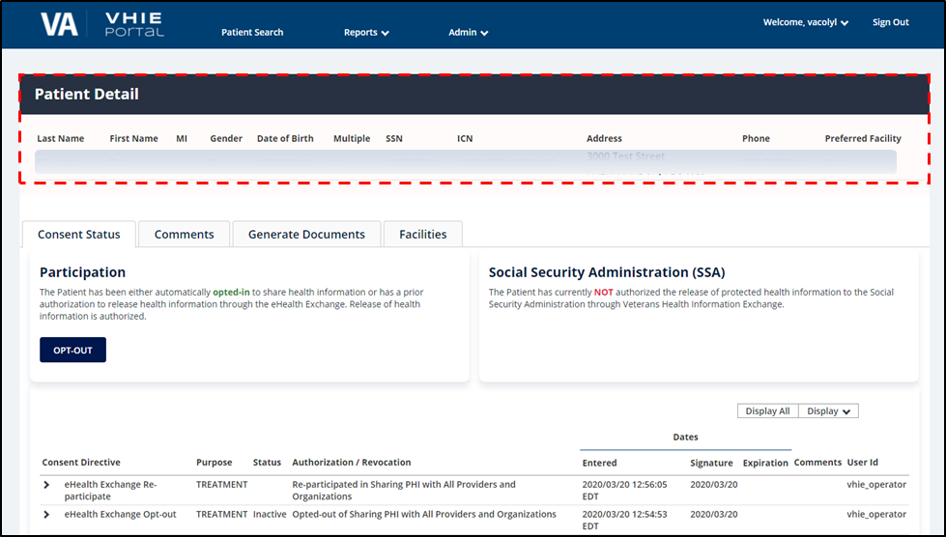
Figure 20: VHIE Portal—"Patient Detail” Screen: Patient Demographic Details

Patient-Centric Functions
The following functional tabs (Figure 21) allow the VHIE user to navigate to different pages to perform various tasks and retrieve important information on the patient:

Consent Status
- Comments
- Generate Documents (CDA-type Health Documents)
- Facilities (Patient’s VA Treatment Facilities)

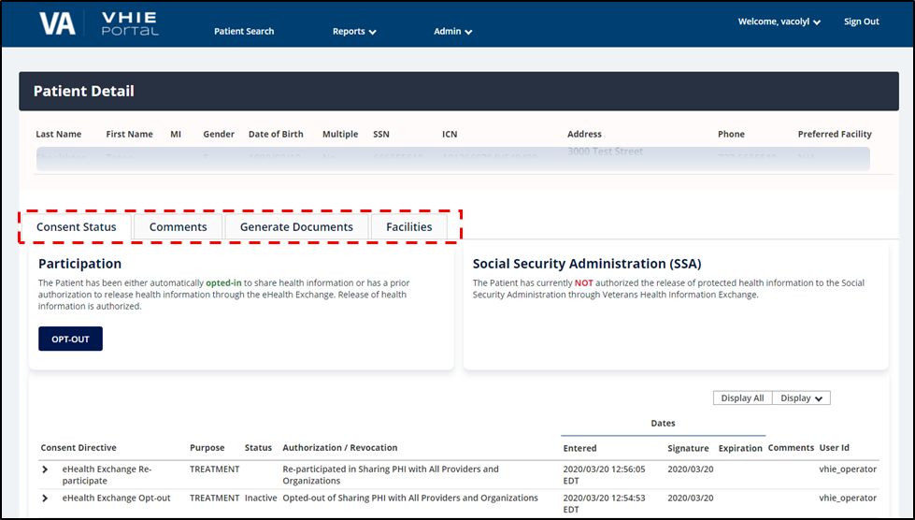
Figure 21: VHIE Portal—"Patient Detail” Screen: Patient-Centric Information Tabs

Consent Status Tab
The Consent Status tab displays status information about the patient’s participation preferences for:
- Health Treatment
- Social Security Administration (SSA)-authorization for Coverage
- Historical participation preference information

The “Consent Status” page also allows the VHIE user to initiate the workflows to process the patient’s preference to either participate or not participate in sharing of health information for treatment.

Prerequisite
- The user has logged in via SSOi or another VA-approved method for authentication.
- The user has successfully retrieved a record from a patient search.

Participation Preference: Opt-Out of Sharing (Not Participating)
If the patient is currently participating in the sharing of Health information, a VHIE user can take the following steps to update the patient’s consent status so that the patient is opted-out of sharing.

Prerequisite
        - The user has logged in via SSOi or another VA-approved method for authentication.
        - The user has successfully retrieved a record from a Patient Search.
        - The Patient has an opt-in consent status.

Table 4: Patient Opt-Out of Sharing

Step | Action
1. | If the Veteran is currently participating in sharing, there will be an Opt-Out button under the “Participation” section (Figure 22). Select the Opt-Out button to open the participation form and fill out the required information.  Figure 22: VHIE Portal—"Patient Detail” Screen: Opt-Out Button  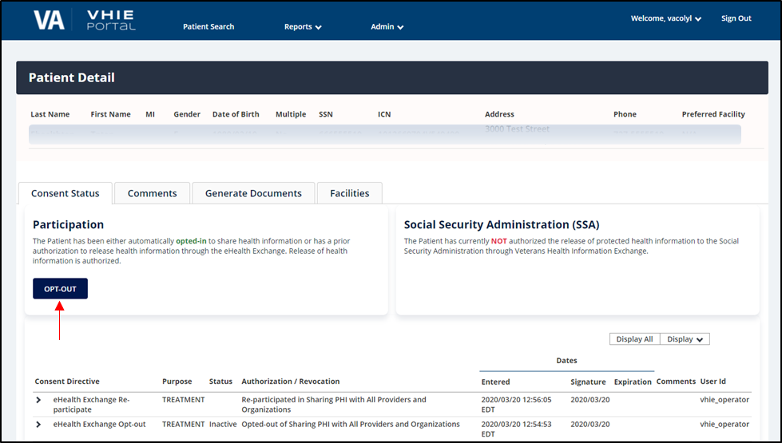

Step | Action
2. | Complete the required information fields and select the Save button to update the Veteran’s participation status (Figure 23).  Figure 23: VHIE Portal—"Opt-Out of Sharing” Screen

Participation Preference: Patient Re-Participate in Sharing
If the patient is currently opted-out of sharing, a VHIE user can take the following steps to change the patient’s consent status so that the patient is opted-in for sharing.

Prerequisite
        - The user has logged in via SSOi or another VA-approved method for authentication.
        - The user has successfully retrieved a record from a Patient Search.
        - The Patient has an opt-out consent status.

NOTE: If the patient has an explicitly opted-out (not participating) preference in the legacy system, the opt-out preference is honored in HealthShare. A message will also display under the patient’s “Detail” section to notify the user of the patient’s “Not Participating” preference.

Table 5: Patient Re-Participate in Sharing

Step | Action
1. | If the veteran is currently not participating in sharing, there will be an Opt-In button under the “Participation” section (Figure 24). Select the Opt-In button to open the participation form and fill out the required information.  Figure 24: VHIE Portal—“Patient Detail”: Opt-In Button  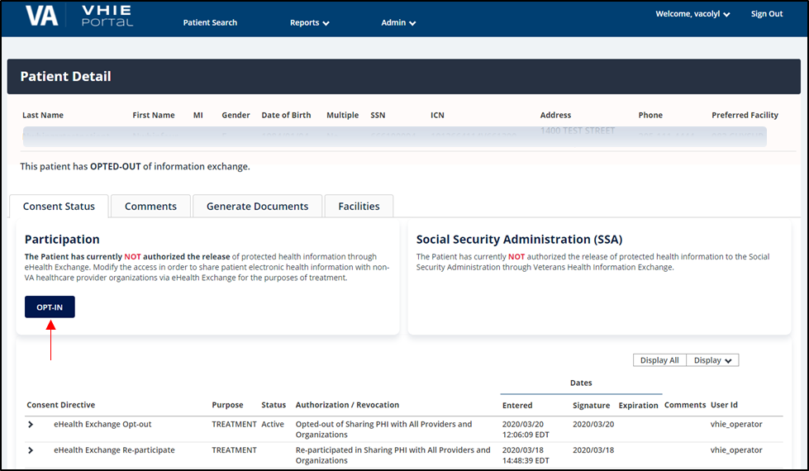

Step | Action
2. | Complete the required information fields, then select the Save button to update the Veteran’s participation status (Figure 25).  Figure 25: VHIE Portal—“Reparticipate in Sharing” Screen

Deceased Patient Notification Message
If the Patient is deceased, a message will display in the “Patient Detail” and “Participation” sections (Figure 26) to notify the user that the patient is deceased.
NOTE: If the deceased patient had a Participate in Sharing Preference for Treatment, this preference will be honored for a period of six (6) months from the date of death.

Prerequisite
        - The user has logged in via SSOi or another VA-approved method for authentication.
        - The user has successfully retrieved a record from a Patient Search.

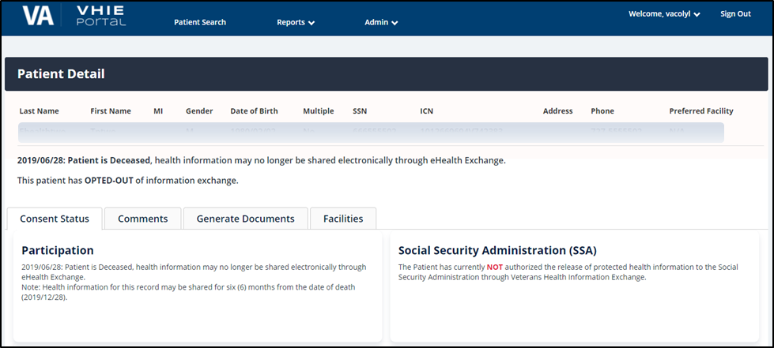
Figure 26: VHIE Portal—“Patient Detail” Screen: Deceased Veteran Notification Message

Comments Tab
A VHIE user can select the Comments tab to view or add general comments about the patient.

Prerequisite
      - The user has logged in via SSOi or another VA-approved method for authentication.
      - The user has successfully retrieved a record from a Patient Search.

Table 6: View/Add Patient Comments

Step | Action
1. | To add a comment, under the Comments tab, select Add Comment (Figure 27).  Figure 27: VHIE Portal—“Patient Detail” Screen: Add Comment Button  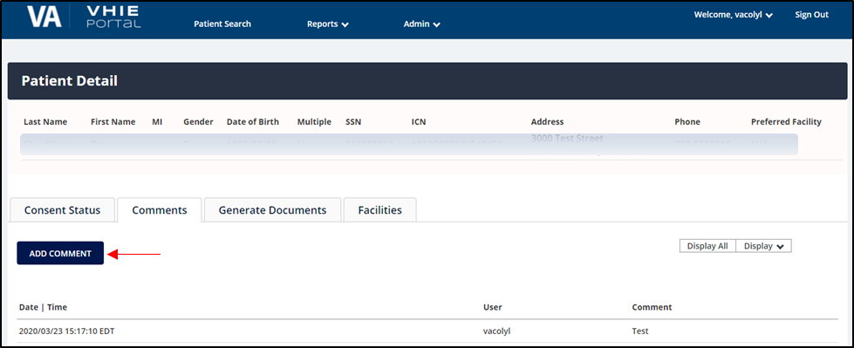

Step | Action
2. | Complete the Add Comment field and select the Post Comment button to submit comment (Figure 28).  Figure 28: VHIE Portal—“Patient Detail” Screen: Adding Comments  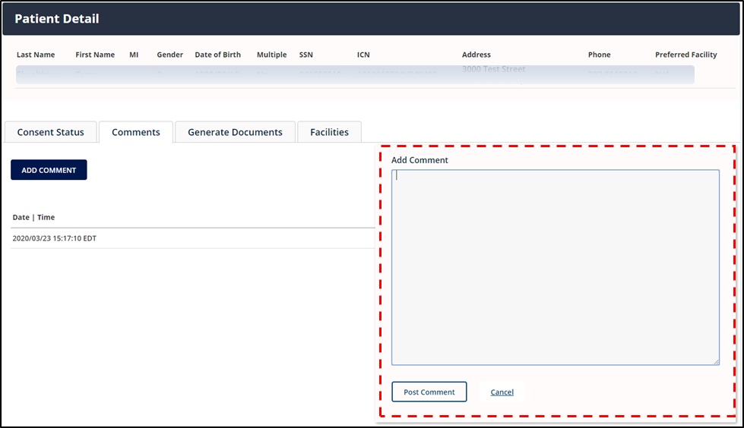

Step | Action
3. | The most current comment will display as the top comment (Figure 29).  NOTE: Comments posted in this area are only viewable in VHIE Portal.  Figure 29: VHIE Portal—“Patient Detail” Screen: Viewing Comments  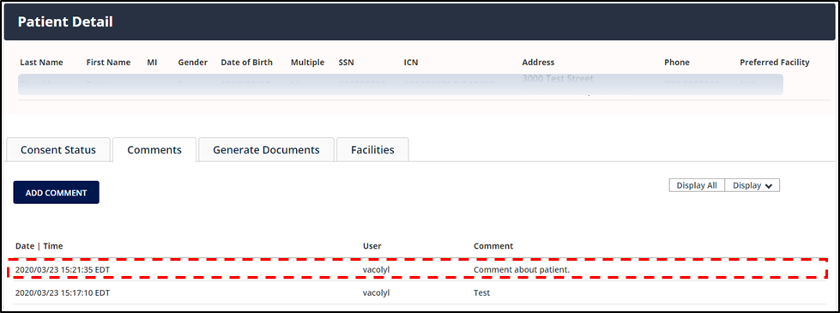

Generate Documents Tab
A VHIE user can select the Generate Documents tab in the “Patient Detail” page to generate the following documents:

CCD v1.1
- CCD v2.1

C32
- C62
- Single Encounter Summary (SES)

Prerequisite
      - The user has logged in via SSOi or another VA-approved method for authentication.
      - The user has successfully retrieved a record from a Patient Search.

NOTE:
- When generating a CCD v1.1, CCD v2.1, or C32, the artifact is generated in a new browser window.
- When generating a C62 or SES, the results may return multiple documents and the user can choose which C62 or SES documents to view.
- If the user experiences any issues with generating a document, it is recommended to configure the browser’s security and privacy settings for the VHIE Portal to allow pop- ups and redirects.
If generating a C62, use the Google Chrome web browser for best result. Contents of the C62 text note are base64 encoded, requiring the browser to translate the data link Uniform Resource Locator (URL), which IE is not doing for the C62.
- To print the CDA-type document, the user can use the browser’s built-in Print functionality to either print or do a print preview.

Table 7: Generate CCD 1.1, CCD 2.1, and C32

Step | Action
1. | Under the Generate Documents tab, select CCD 1.1, CCD 2.1, or C32 as the Document Type  and select Generate (Figure 30).  Figure 30: VHIE Portal—Generate Documents Tab: Generate CCD 1.1, CCD 2.1, and C32  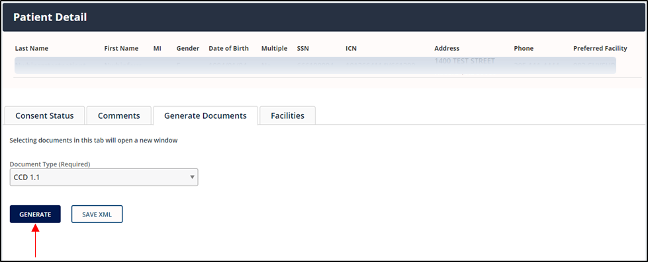

Step | Action
2. | If available, the selected health document (Figure 31) will generate in a new browser window.  Figure 31: Sample Health Summary Document  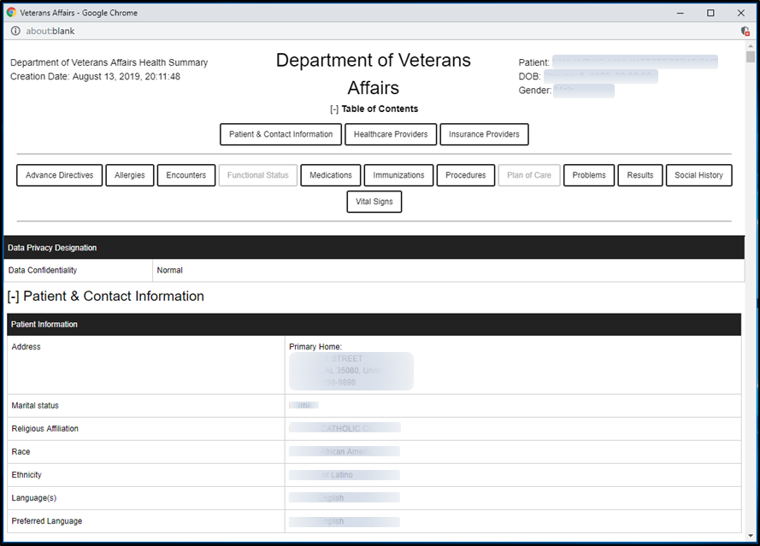

Step | Action
3. | To download the CCD 1.1, CCD 2.1, or C32 as an XML, select the document under the  Document Type field and select Save XML (Figure 32).  Figure 32: VHIE Portal—Generate Documents Tab: Saving CCD 1.1 as XML File  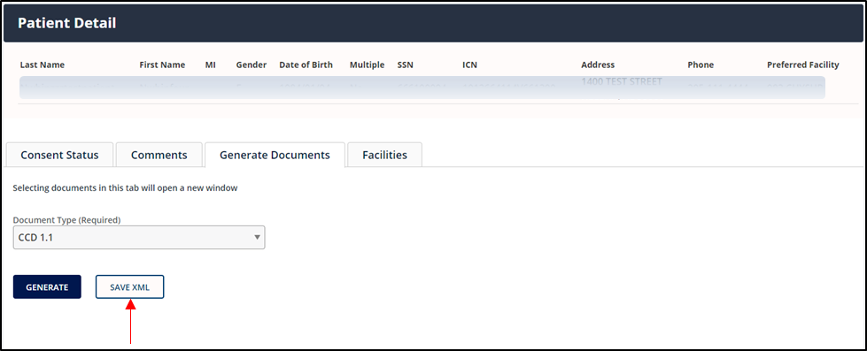
4. | The user will be prompted to save the file as an XML Document. Select the appropriate save location and select Save (Figure 33).  Figure 33: Sample Dialog to Save XML Document

Step | Action
5. | If using Google Chrome as the browser, the user must open the saved file using Google Chrome or another XML viewer application (e.g., Microsoft [MS] Edge or Notepad), see Figure 34.  NOTE: If the user is using Internet Explorer (IE) as the browser when downloading the XML, this step is not necessary as IE is used as the default browser for the XML viewer.  For more information, see Section 5, “Troubleshooting.”  Figure 34: Selecting Tool to Open XML File  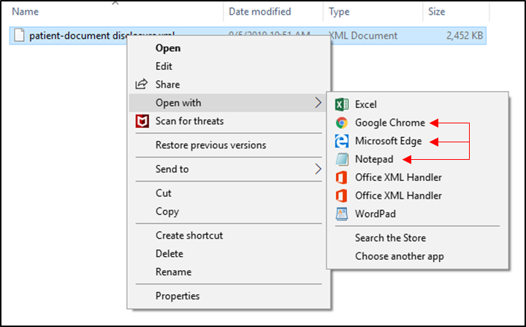

Table 8: Generate C62 and SES

Step | Action
1. | Under the Generate Documents tab, select either C62 or Encounter Summary as the  Document Type and select Generate (Figure 35).  NOTE: If generating a C62, use the Google Chrome web browser for best result. Contents of the C62 text note are base64 encoded, requiring the browser to translate the data link URL, which IE is not doing for the C62.  Figure 35: VHIE Portal—Generate Documents Tab: Generating a C62 File  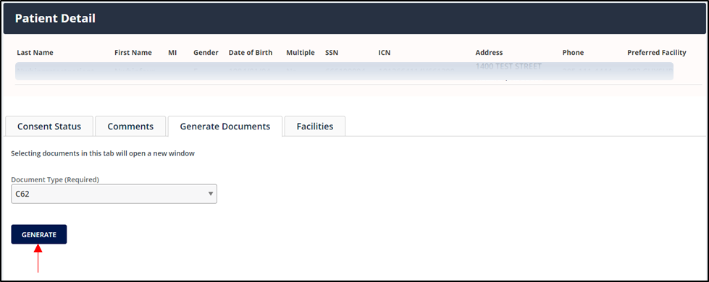

Step | Action
2. | If multiple documents are returned, select View Document to generate the appropriate document or select Save XML to download and save the XML (Figure 36).  NOTE: View Document will open the document in a new browser window and Save XML  will prompt the user to save the file as an XML document.  Figure 36: VHIE Portal—Generate Documents Tab: Reviewing Documents  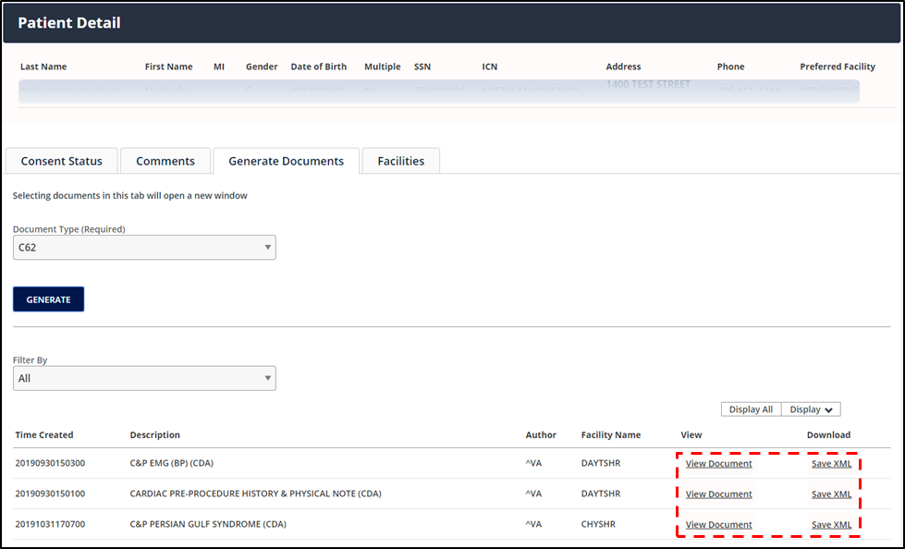

Step | Action
3. | When downloading the XML, Save the file as an XML type (Figure 37).  Figure 37: Downloading and Saving XML File  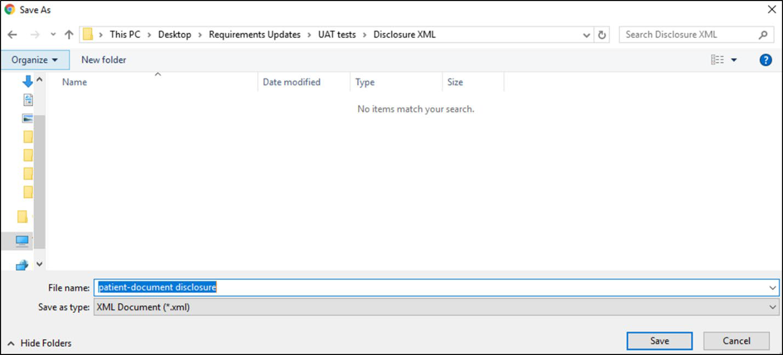

Step | Action
4. | If using Google Chrome as the browser, the user must open the saved file using Google Chrome or another XML viewer application (e.g., MS Edge or Notepad), see Figure 38.  NOTE: If the user is using IE as the browser when downloading the XML, this step is not necessary as IE is used as the default browser for the XML viewer. For more information, see Section 5, “Troubleshooting.”  Figure 38: Selecting Tool to Open XML File

Facilities Tab
A VHIE user can select the Facilities tab in the “Patient Detail” page (Figure 39) to view the Patient’s VA Treatment Facilities.
NOTE: The Patient’s VA Treatment Facilities information under the Facilities tab is read-only.

Prerequisite
      - The user has logged in via SSOi or another VA-approved method for authentication.
      - The user has successfully retrieved a record from a Patient Search.

Figure 39: VHIE Portal—Facilities Tab: View Patient's Treatment Facilities

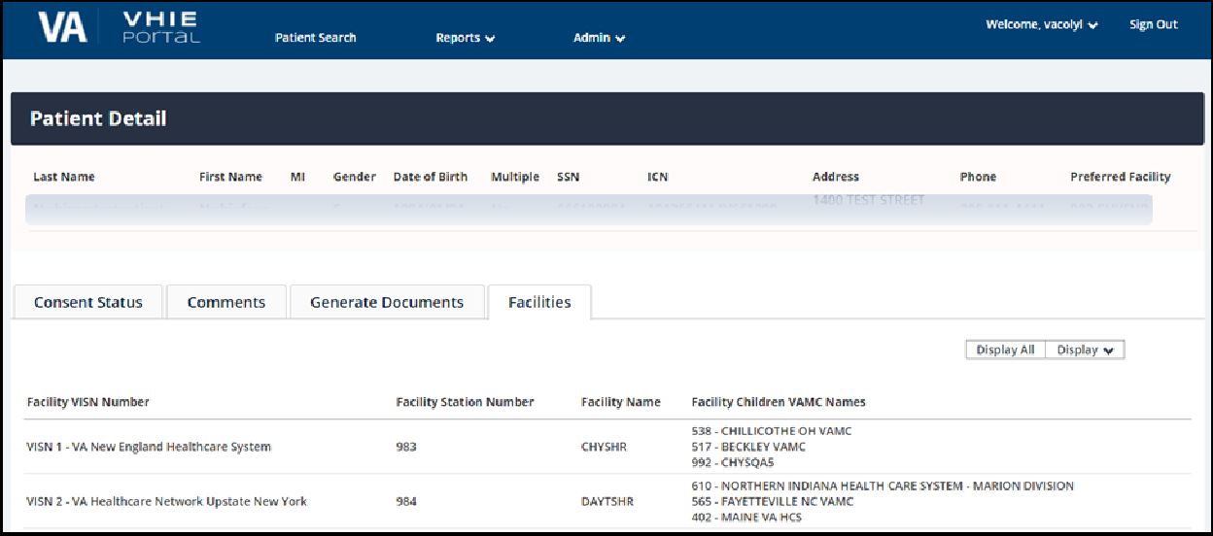

Search Menu—Return to Patient Search
From within the VHIE Portal, a VHIE user can select the Patient Search option at the top of the web page (Figure 40) to return to the default “Patient Search” page.

Prerequisite
      - The user has logged in via SSOi or another VA-approved method for authentication.
      - The user has successfully retrieved a record from a Patient Search.

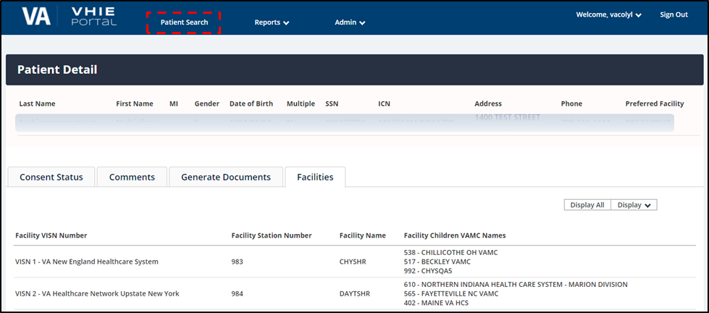
Figure 40: VHIE Portal—Return to Patient Search

Reports—Dashboard Widgets
From within the VHIE Portal, a VHIE user can select the Reports option at the top of the web page (Figure 41) to select and generate either of the following dashboards:
- Consent Activity Dashboard—Displays the number of web calls made to the VHIE Portal within the past 24-hours.
- User Activity Dashboard—Displays the number of user logins to the VHIE Portal within the past 24-hours.

Prerequisite
      - The user has logged in via SSOi or another VA-approved method for authentication.
      - The user has been assigned the appropriate roles to generate VHIE reports.

Table 9: Reports - Dashboard Widgets

Step | Action
1. | To generate the Consent Activity Dashboard, under the Reports menu, select  Consent Activity Dashboard (Figure 41).  Figure 41: VHIE Portal—Selecting Consent Activity Dashboard Report  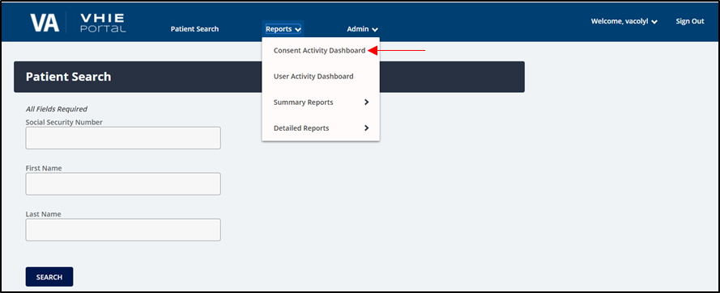

Step | Action
2. | If there have been web calls made to the VHIE Portal application for consent activities within the past 24-hours, the information will display in the generated graph (Figure 42).  Figure 42: Consent Activity Dashboard—Sample Web Calls within 24 Hours Report

Step | Action
3. | To generate the User Activity Dashboard, under the Reports menu, select User Activity Dashboard (Figure 43).  Figure 43: VHIE Portal—Selecting User Activity Dashboard Report  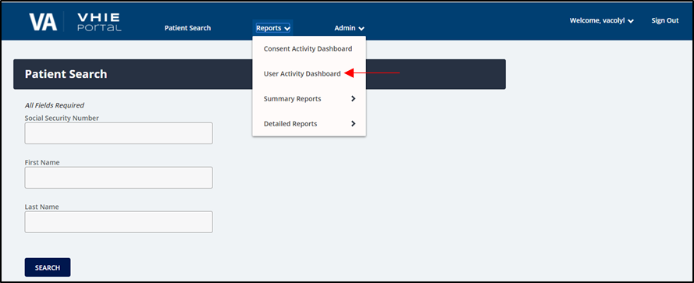
4. | If any user accounts were logged into the VHIE Portal application within the past 24- hours, the information will display in the generated graph (Figure 44).  Figure 44: User Activity Dashboard—Sample User Logins within Past 24 Hours Report

Reports—Detailed HIE and Consent Reports
From within the VHIE Portal, a VHIE user can select the Reports option at the top of the web page (Figure 45) to select and generate the Detailed HIE and Consent Reports. The Detailed HIE and Consent Reports includes the following:

Consent Directive Detailed Report
- Legacy Detailed Report
- Patient Opt-Out Detailed Report

Prerequisite
      - The user has logged in via SSOi or another VA-approved method for authentication.
      - The user has been assigned the appropriate roles to generate VHIE reports.

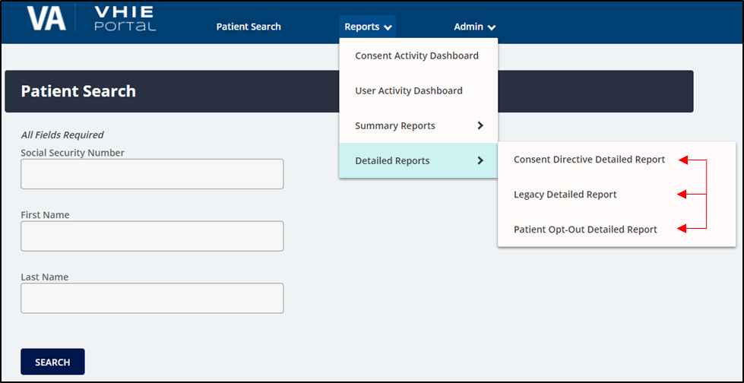
Figure 45: Detailed Reports Menu—Selecting Detailed HIE and Consent Reports

Consent Directive Detailed Report
The Consent Directive Detailed Report provides a detailed listing of specified "participate in sharing" and "opt-out of sharing" activities for one or more patients for a selected range of dates at selected VA Authenticating facilities.

Table 10: Consent Directive Detailed Report

Step | Action
1. | From the Reports menu, select Detailed Reports, and then select Consent Directive Detailed Report (Figure 46).  Figure 46: Detailed Reports Menu—Selecting Consent Directive Detailed Report  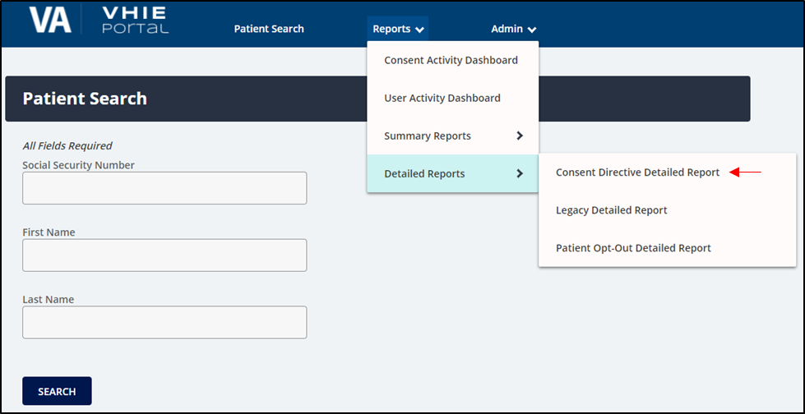

Step | Action
2. | Complete the appropriate search criteria, then select Search (Figure 47).  Figure 47: Consent Directive Detailed Report—Selecting Search Criteria  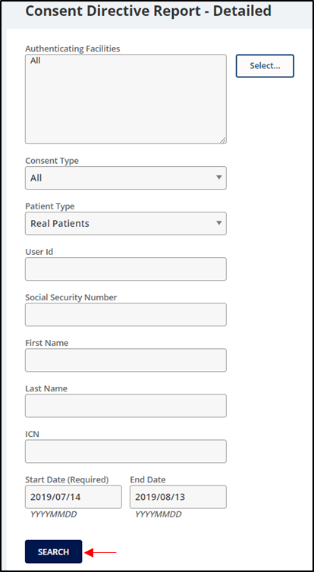

Step | Action
3. | In the returned results, the user can export the report to a .CSV (Comma-Separated Values) file by selecting Export CSV (Figure 48).  Figure 48: Sample Consent Directive Detailed Report—Exporting to a CSV File  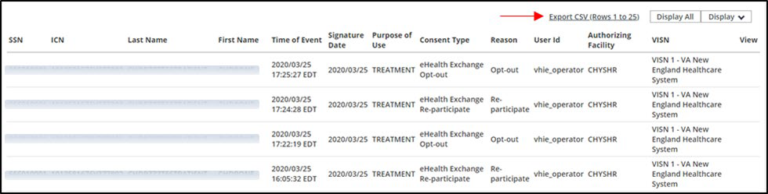

Legacy Detailed Report
The Legacy Detailed Report shows historical consent data of the Patient’s Participation Preferences (PPP; legacy opt-in and opt-out consent policies), prior to the Maintaining Internal Systems and Strengthening Integrated Outside Networks (MISSION) Act.

Table 11: Legacy Detailed Report

Step | Action
1. | From the Reports menu, select Detailed Reports, and then select Legacy Detailed Report  (Figure 49).  Figure 49: Detailed Reports Menu—Selecting Legacy Detailed Report  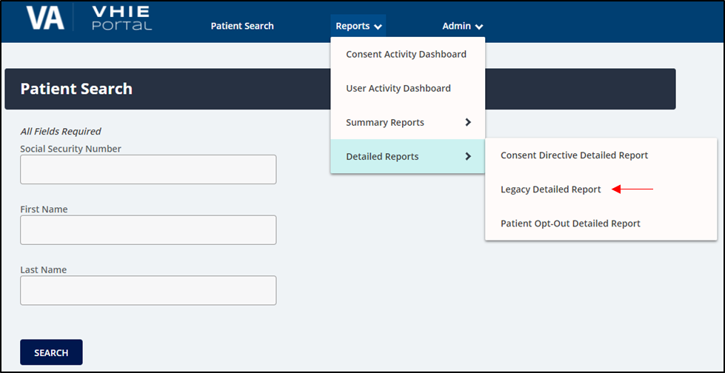

Step | Action
2. | Complete the appropriate search criteria, then select Search (Figure 50).  Figure 50: Legacy Detailed Report—Selecting Search Criteria  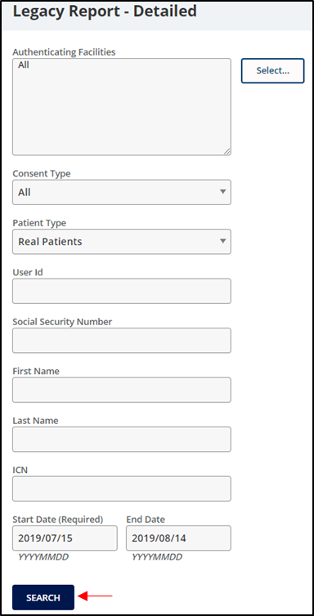
3. | In the returned results, the user can export the report to a .CSV file by selecting Export CSV  (Figure 51).  Figure 51: Sample Legacy Detailed Report—Exporting to a CSV File  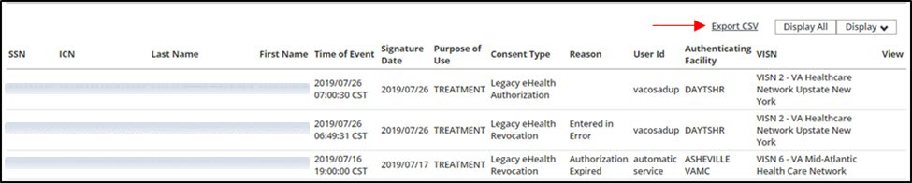

Patient Opt-Out Detailed Report
The Patient Opt-Out Detailed Report provides a detailed listing of patients that are opt-out of sharing.

Table 12: Patient Opt-Out Detailed Report

Step | Action
1. | From the Reports menu, select Detailed Reports, and then select Patient Opt-Out Detailed Report (Figure 52).  Figure 52: Detailed Reports Menu—Selecting Patient Opt-Out Detailed Report  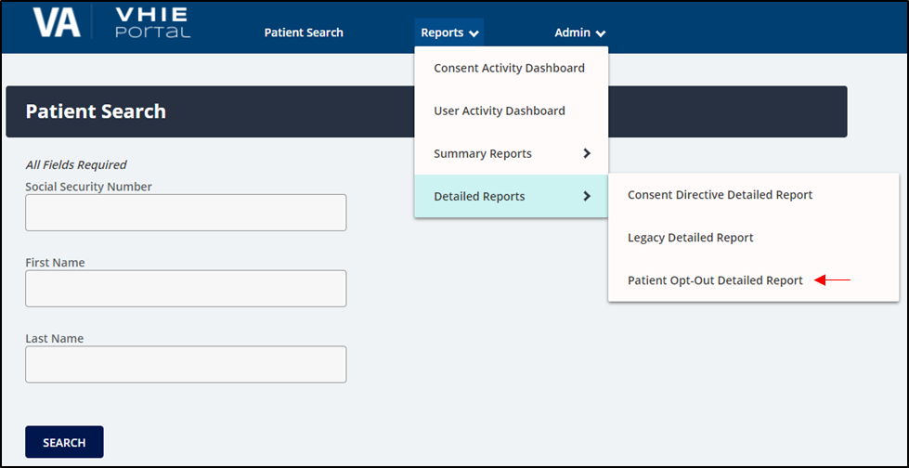

Step | Action
2. | Complete the appropriate search criteria, and then select Search (Figure 53).  Figure 53: Patient Opt-Out Detailed Report—Selecting Search Criteria  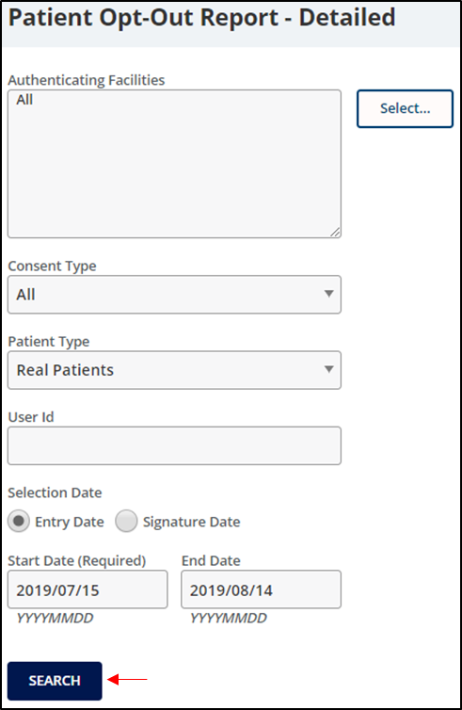

Step | Action
3. | In the returned results for the Patient Opt-Out Detailed Report (Figure 54), the user can:  - Export the report to a .CSV file by selecting Export CSV.  - View the SSA Portable Document Format (PDF) by selecting the View button next to the SSA consent.  Figure 54: Sample Patient Opt-Out Detailed Report—Export and View Options  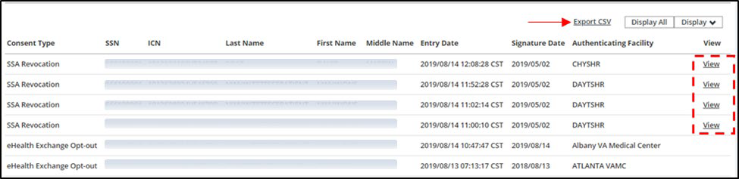

Reports—Summary HIE and Consent Reports
From within the VHIE Portal, a VHIE user can select the Reports option at the top of the web page (Figure 55) to select and generate the Summary HIE and Consent Reports. The Summary HIE and Consent Reports includes the following:

Consent Directive Summary Report
- Patient Opt-Out Summary Report

Prerequisite
      - The user has logged in via SSOi or another VA-approved method for authentication.
      - The user has been assigned the appropriate roles to generate VHIE reports.

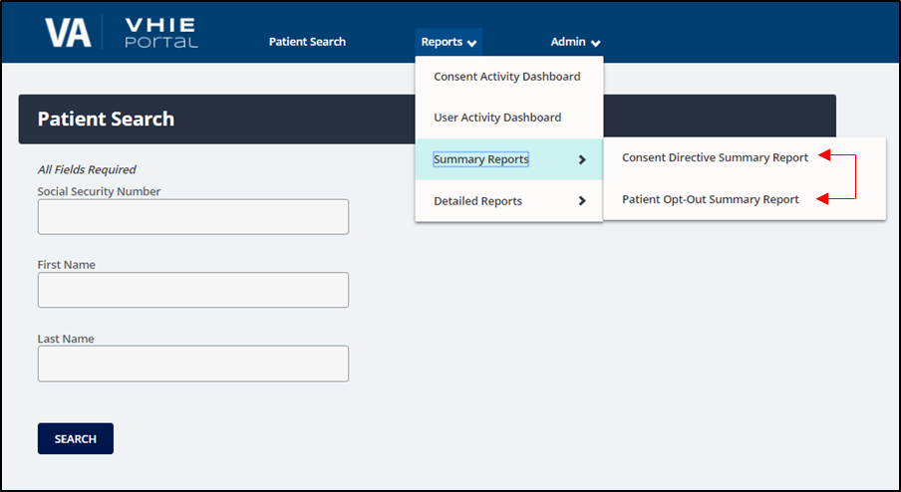
Figure 55: Reports Menu—Summary HIE and Consent Reports

Consent Directive Summary Report
The Consent Directive Summary Report provides a summary listing of the selected Consent Directive totals for a selected range of dates at the selected Authenticating facility or facilities.

Table 13: Consent Directive Summary Report

Step | Action
1. | From the Reports menu, select Consent Directive Summary Report (Figure 56).  Figure 56: Summary Reports Menu—Selecting Consent Directive Summary Report  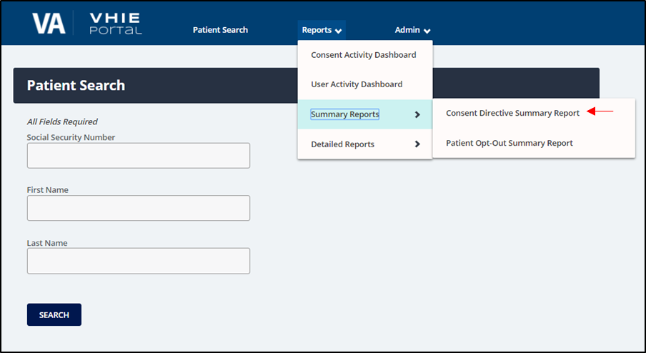

Step | Action
2. | Complete the appropriate search criteria, and then select Search (Figure 57).  Figure 57: Consent Directive Summary Report—Selecting Search Criteria  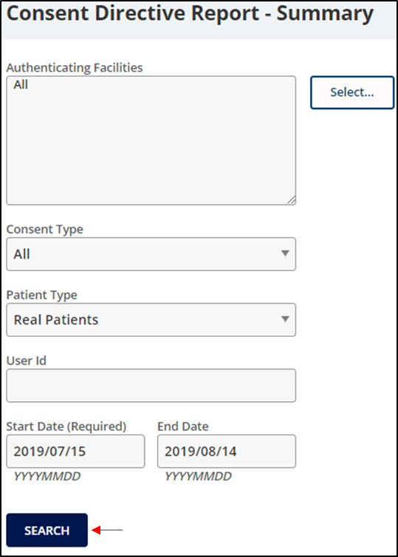

Step | Action
3. | In the returned results, the user can export the report to a .CSV file by selecting Export CSV  (Figure 58).  Figure 58: Sample Consent Directive Summary Report—Exporting to a CSV File  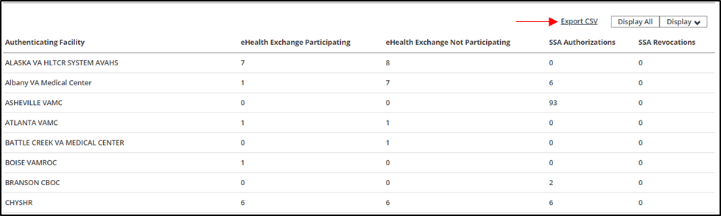

Patient Opt-Out Summary Report
The Patient Opt-Out Summary Report provides a summary listing of patients that are opt-out of sharing.

Table 14: Patient Opt-Out Summary Report

Step | Action
1. | From the Reports menu, select Patient Opt-Out Summary Report (Figure 59).  Figure 59: Summary Reports Menu—Selecting Patient Opt-Out Summary Report  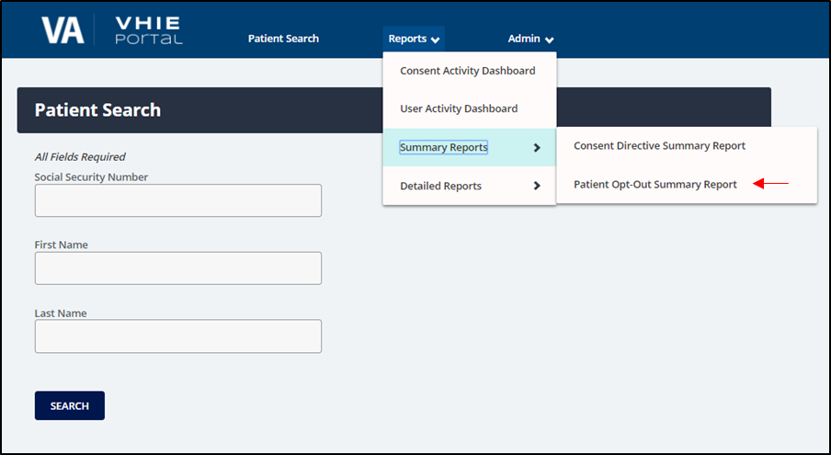

Step | Action
2. | Complete the appropriate search criteria, and then select Search (Figure 60).  Figure 60: Patient Opt-Out Summary Report—Selecting Search Criteria  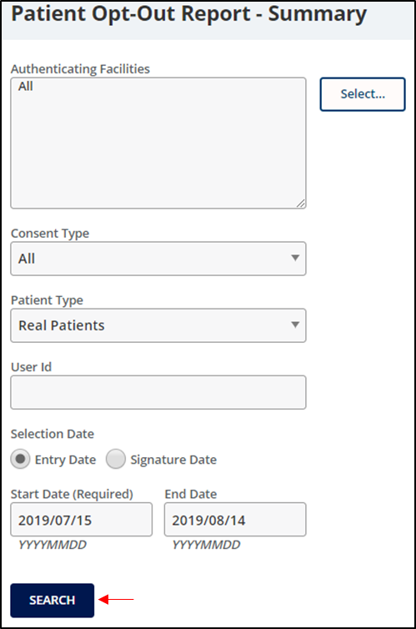

Step | Action
3. | In the returned results, the user can export the report to a .CSV file by selecting Export CSV  (Figure 61).  Figure 61: Sample Patient Opt-Out Summary Report—Exporting to a CSV File  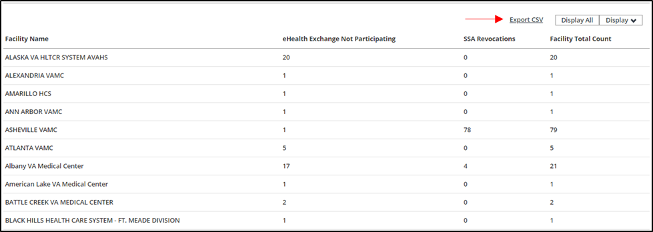

Admin Menu—Partner Organizations and Facilities List
From within the VHIE Portal, a VHIE user can select Admin at the top of the web page (Figure 62) to access and modify the list of Partner Organizations and Facilities.

Prerequisite
      - The user has logged in via SSOi or another VA-approved method for authentication.
      - The user has been assigned the appropriate roles to access and modify the list of Partner Organizations and VA Facilities.

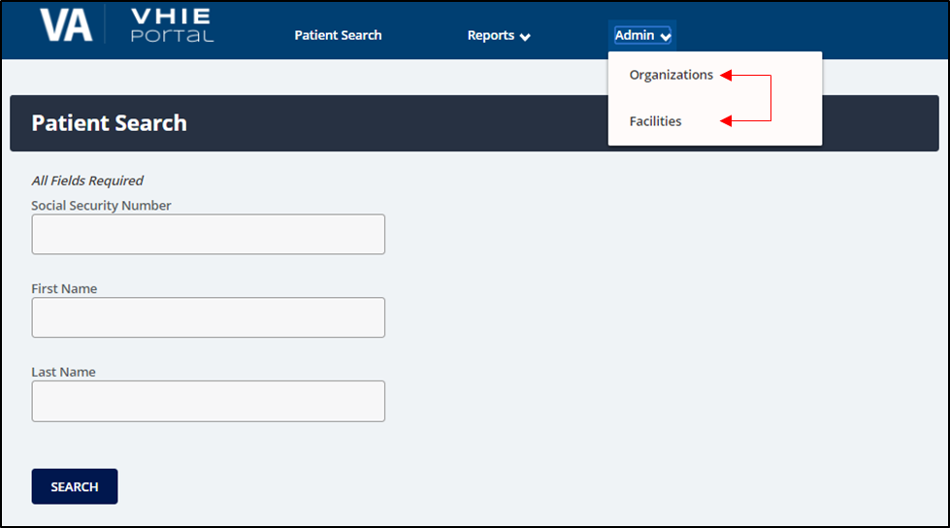
Figure 62: Admin Menu—Partner Organizations and Facilities List

Access or Modify Partner Organizations List
The VHIE admin user can access the list of Partner Organizations to view, edit, delete, or add new organizations.

Prerequisite
        - The user has logged in via SSOi or another VA-approved method for authentication.
        - The user is provided with elevated admin privileges to access and modify the list of Partner Organizations.

Table 15: Access or Modify Partner Organizations List

Step | Action
1. | From the Admin menu, select Organizations (Figure 63).  Figure 63: Admin Menu—Selecting Organizations  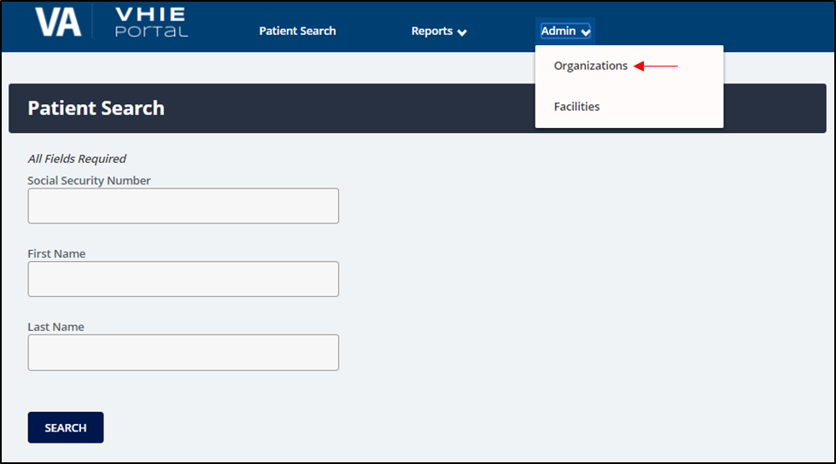

Step | Action
2. | To add a new Partner Organization, select Add Partner Organization (Figure 64).  Figure 64: Partner Organizations—Adding a New Partner Organization  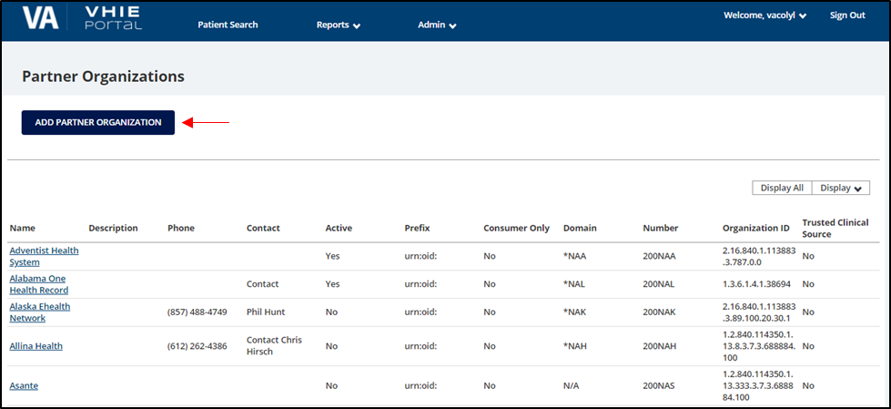

Step | Action
3. | Complete the appropriate required fields, and then select Save to add the new Partner Organization (Figure 65).  Figure 65: Add Partner Organization—Entering Required Fields and Saving New Partner Organization  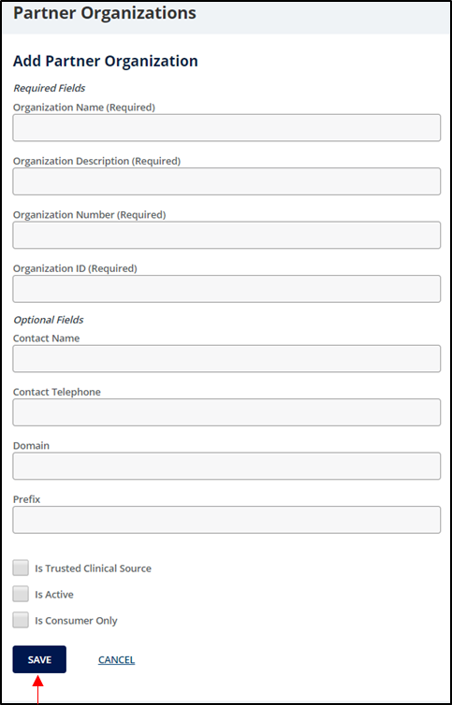

Step | Action
4. | To edit or delete an existing Partner Organization, select the targeted organization name (Figure 66).  Figure 66: Partner Organizations—Selecting an Existing Partner Organization  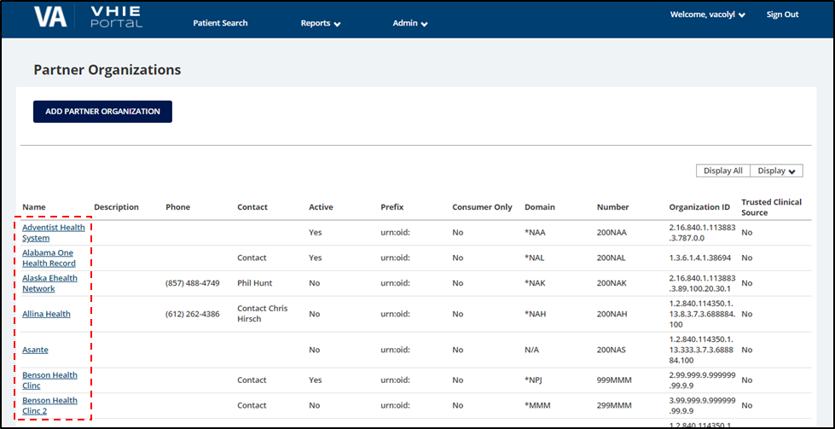

Step | Action
5. | Complete the appropriate required fields and select Save to edit the organization or select  Delete to remove the organization from the list (Figure 67).  Figure 67: Edit Partner Organizations—Editing Required Fields and Saving Changes or Deleting a Partner Organization  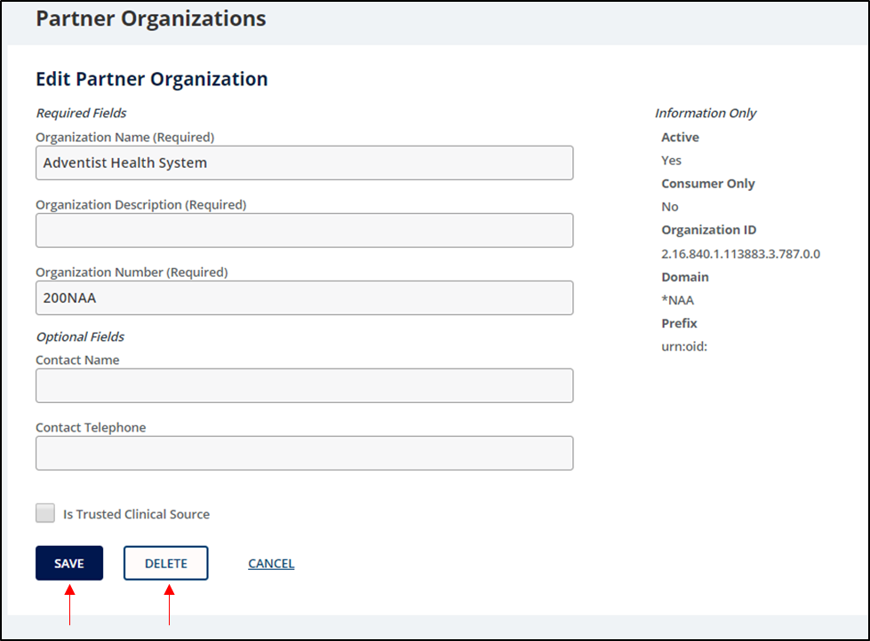

Access or Modify Facilities List
The VHIE admin user can access the list of VA Facilities to view, edit, delete, or add new facilities.

Prerequisite
        - The user has logged in via SSOi or another VA-approved method for authentication.
        - The user is provided with elevated admin privileges to access and modify the list of VA Facilities.

Table 16: Access or Modify Facilities List

Step | Action
1. | From the Admin menu, select Facilities (Figure 68).  Figure 68: Admin Menu—Selecting Facilities  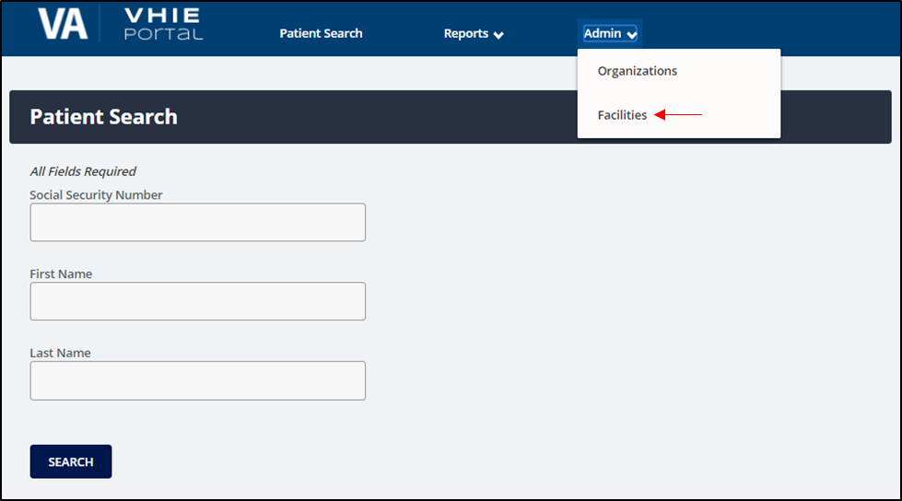
2. | To add a new VA Facility, select Add Facility (Figure 69).  Figure 69: Facilities—Adding a New Facility  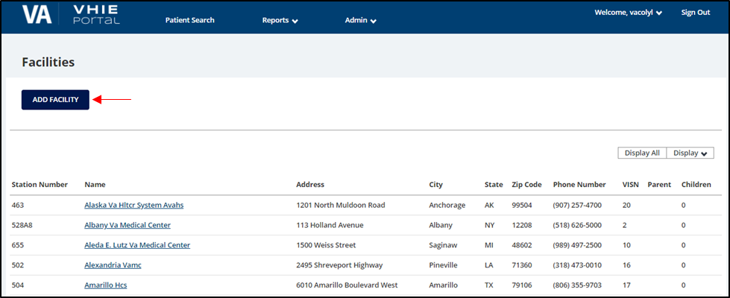

Step | Action
3. | Complete the appropriate required fields, then select Save to add the new VA Facility (Figure 70).  Figure 70: Add Facility—Entering Required Fields and Saving New VA Facility  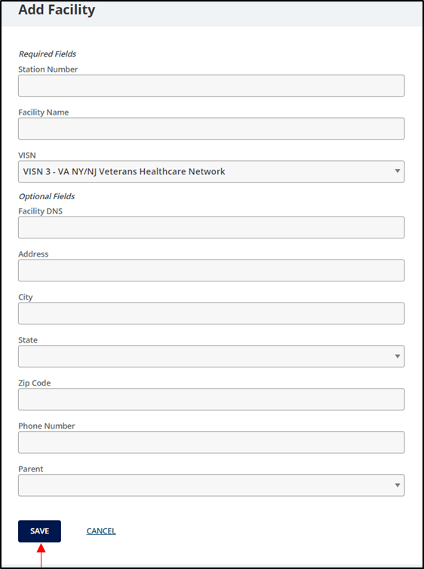

Step | Action
4. | To edit or delete an existing VA Facility, select the targeted facility name (Figure 71).  Figure 71: Facilities—Selecting an Existing Facility  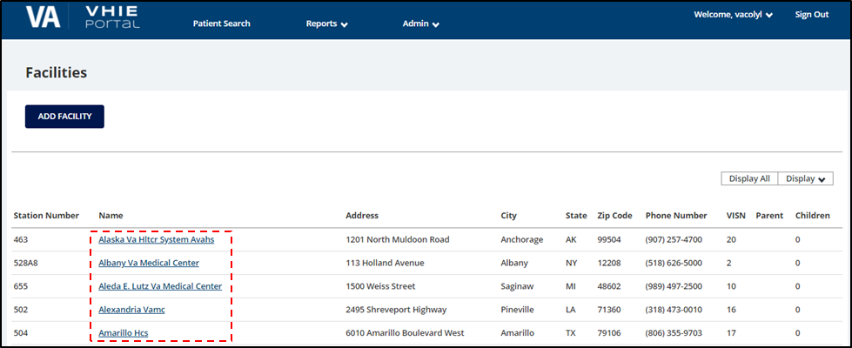

Step | Action
5. | Complete the appropriate required fields and select Save to edit the facility or select Delete to remove the facility from the list (Figure 72).  Figure 72: Edit Facility—Editing Required Fields and Saving Changes or Deleting a Facility  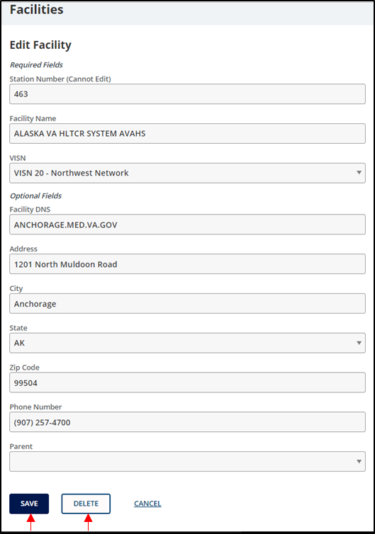

Welcome Menu—User Preferences, User Guide, and About VHIE Portal
From within the VHIE Portal, a VHIE user can select the displayed username at the top of the web page (Figure 73) to select the Welcome menu items:
- User Preferences—Set or update a default facility.
- User Guide—Access the Portal User Guide.
- About VHIE Portal—View information about the VHIE Portal software.

Prerequisite
The user has logged in via SSOi or another VA-approved method for authentication.

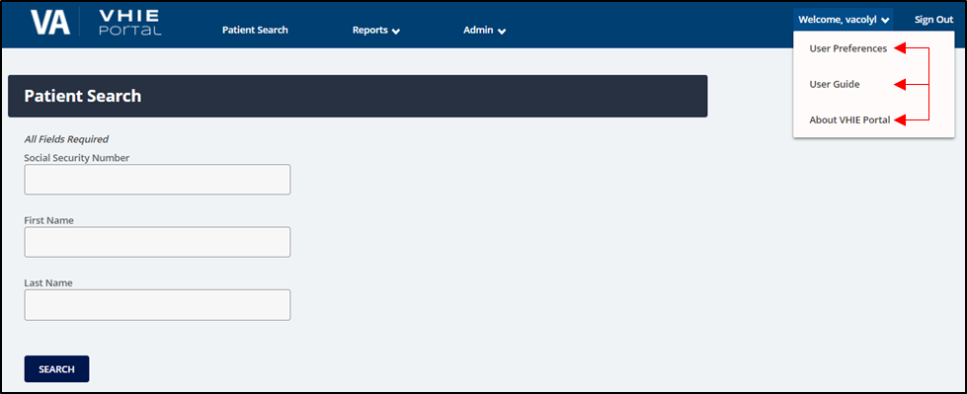
Figure 73: Welcome Menu—User Preferences, User Guide, and About VHIE Portal

Set or Update User’s Default Facility
The VHIE user can set or remove their default facility from the notification message at the “VHIE Portal” Landing Page or by selecting User Preferences from the Welcome menu, under the username.

Prerequisite
The user has logged in via SSOi or another VA-approved method for authentication.

Table 17: Set or Update User’s Default Facility

Step | Action
1. | If the VHIE user has not set a default facility, a notification message displays at the “VHIE Portal” Landing Page after login (Figure 74).  NOTE: The notification message will continue to display at the “VHIE Portal” Landing Page until the VHIE user has set a default facility.  Figure 74: VHIE Portal—Landing Page: Notification Message to Set Default Facility  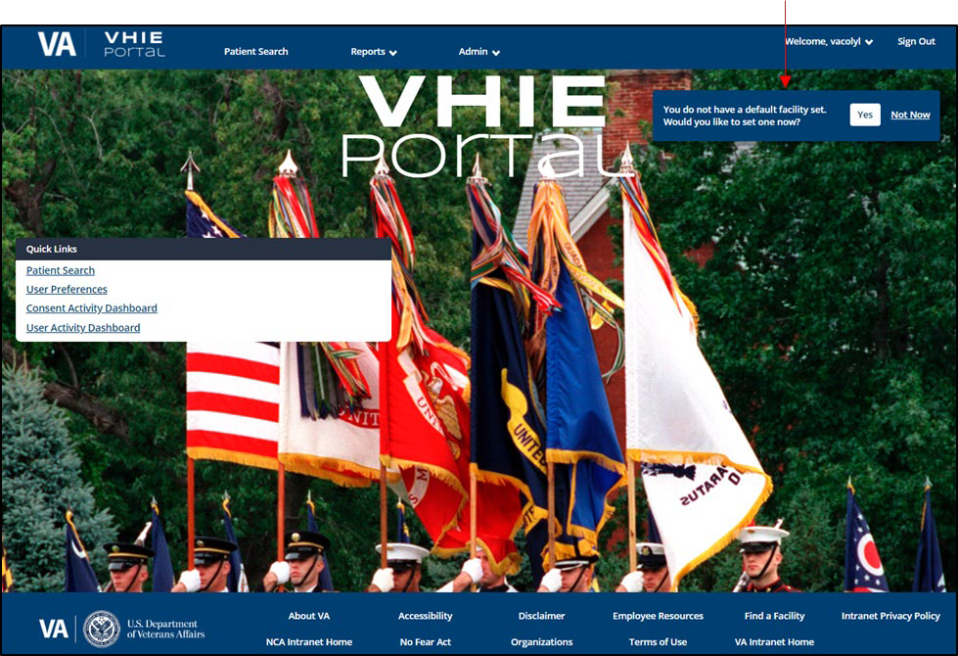

Step | Action
2. | If the VHIE user moves on from the “VHIE Portal” Landing Page without setting a default facility, the VHIE user can access the web page to set a default facility by selecting User Preferences from the Welcome menu (Figure 75).  Figure 75: Welcome Menu—Selecting User Preferences  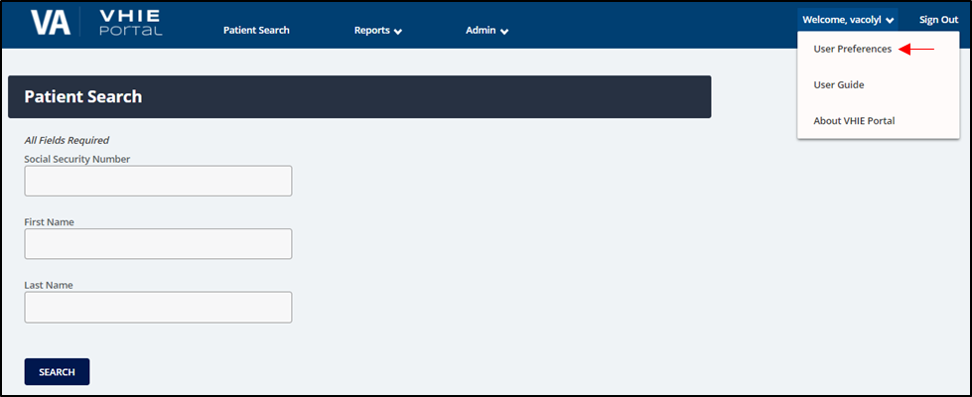

Step | Action
3. | Select the VA Facility from the drop-down list to use as the default facility, then select Set Default Facility (Figure 76).  Figure 76: Default Facility—Setting Default Facility  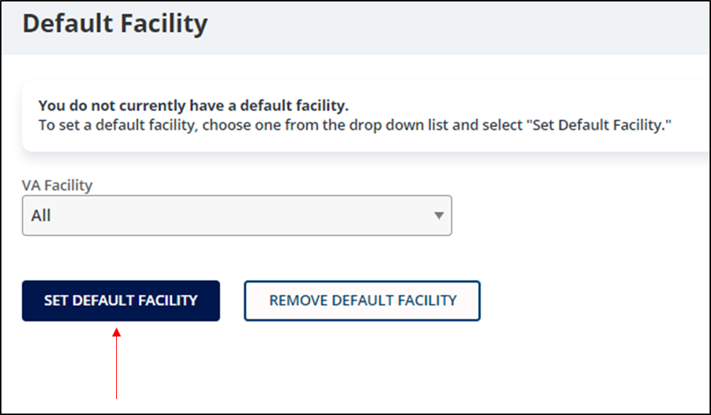

Step | Action
4. | After setting a default facility, the VHIE user can set a new default facility at any time or remove the current default facility by selecting Remove Default Facility (Figure 77).  Figure 77: Default Facility—Removing Default Facility  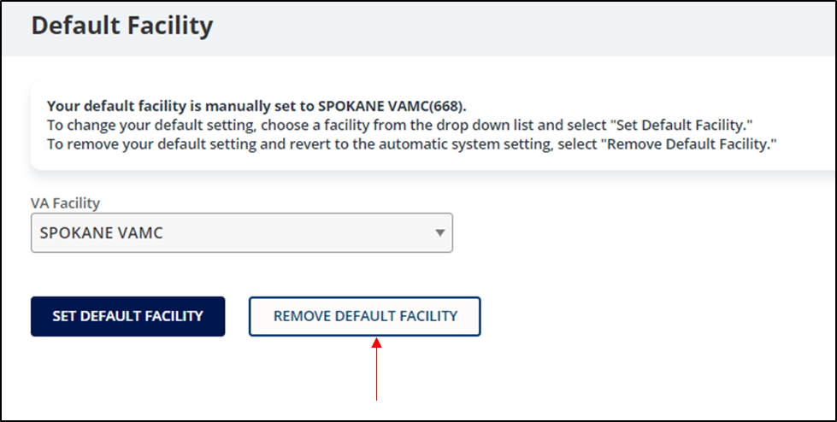

Access User Guide
The VHIE user can access the VHIE Portal User Guide by selecting User Guide from the
Welcome menu, under the username.

4.12.4.1 Prerequisite
The user has logged in via SSOi or another VA-approved method for authentication.

Table 18: Access User Guide

Step | Action
1. | From the Welcome menu, select User Guide (Figure 78).  Figure 78: Welcome Menu—Selecting User Guide  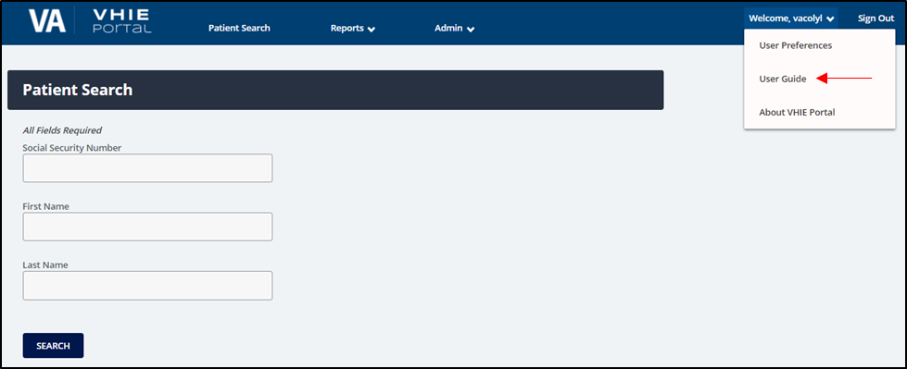

Step | Action
2. | The VHIE user is automatically re-directed to the VA Software Document Library (VDL) to download the PDF file of the applicable VHIE Portal User Guide (Figure 79).  Figure 79: VA Software Document Library (VDL)—VHIE Portal User Guide PDF  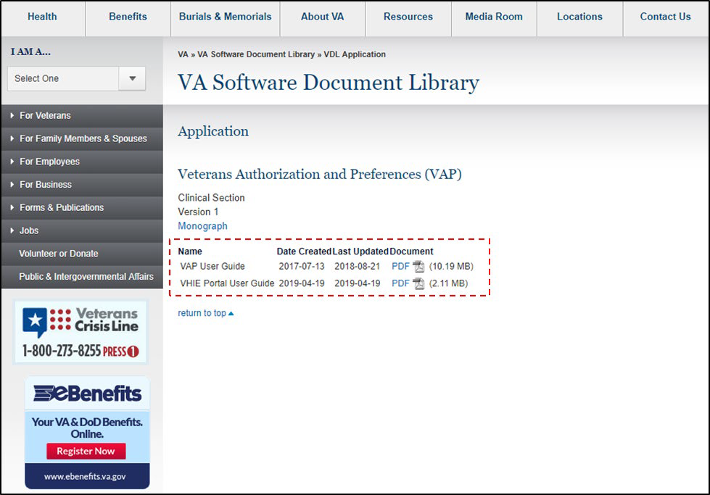

View System Software Information
The VHIE user can view the system status and software version of the VHIE Portal by selecting
About VHIE Portal from the Welcome menu, under the username.

4.12.5.1 Prerequisite
The user has logged in via SSOi or another VA-approved method for authentication.

Table 19: View System Software Information

Step | Action
1. | From the Welcome menu, select About VHIE Portal (Figure 80).  Figure 80: Welcome Menu—Selecting About VHIE Portal  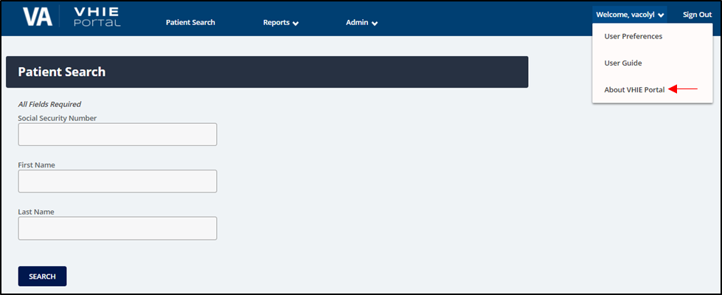

Step | Action
2. | The information is displayed for the software version and the system status of the VHIE Portal (Figure 81).  Figure 81: “About VHIE Portal” Screen

Troubleshooting

Special Instructions for Error Correction

Table 20: Special Instructions for Error Correction

User Interface | Error | Cause | Resolution
Login Screen | User does not have permissions. | This is caused when the user account, passed from SSOi, is not mapped to the VHIE Portal user access list. | If you need access or have existing permissions, contact the Enterprise Service Desk (ESD) for support.
Patient Search Screen | SSN is required.  Last Name is required.  First Name is required. | The SSN, Last Name, and First Name fields must be filled before pressing the Search button. Any or all of these errors can occur depending on which fields were filled in and which were not. | The SSN, Last Name, and First Name fields must all be filled in before pressing the Search button.
Patient Search Screen | SSN is not valid. | The SSN field needs to contain nine (9) numeric characters. This error occurs if less than nine (9) numeric characters or any non-numeric characters are entered. | The SSN field must contain exactly nine (9) numeric and no other characters before pressing the Search button. (The Last Name and First Name fields must also be populated.)
Patient Search Screen | Last Name is not valid.  First Name is not valid. | The Last Name and First Name fields must contain alphabetic characters only. Some special characters, such as periods and apostrophes, are allowed. Either or both errors can occur depending on which fields were filled incorrectly. | The Last Name and First Name fields must contain only alphabetic characters before pressing the Search button. (Some special characters are allowed, such as periods and apostrophes.)
Opt-out of Sharing Screen | Patient Signature Date must be after the date the authorization was signed. | This message occurs when you choose the Opt-out option on the “Opt-out of Sharing” screen if the patient signature date entered is earlier than the date the authorization was originally signed. | The Patient Signature Date field on the “Opt-out of Sharing” screen must be filled with a date later than the date the authorization was originally signed if you choose "Opt-out" as the reason.
Export Disclosures Report to  .CSV | Date column is not displaying the date in a standard Date and  Time format | This is a result of Excel automatically converting the text file into a different into a default format. | - Right-click on the Date  column.  - Select Format Cells.  - Under the Number tab, select Date as the Category.

User Interface | Error | Cause | Resolution
 | when opening using Excel. |  | 4. Select the format Type to display the Date and Time (e.g., 2/14/12 1:30 PM).
View Saved XML for Disclosures Reports and CDA- type Health Documents | Saved XML displays error message on the browser. | If using Google Chrome as the browser, after opening the XML file, the file is opened using IE as the default application. | - Resolution 1:  Use Microsoft (MS) Internet Explorer (IE) as the browser when downloading XML.  - Resolution 2:  If using Google Chrome as the browser, the user must open the saved file using Google Chrome or another XML viewer application (e.g., MS Edge or Notepad).

Acronyms and Abbreviations

Table 21: Acronyms and Abbreviations

Term | Definition
508 | Section 508 Accessibility
AD | Active Directory
AWS | Amazon Web Service
CDA | Clinical Document Architecture
COTS | Commercial-Off-the-Shelf
CSV | Comma-Separated Values
DAO | Designated Approving Officer
DoD | Department of Defense
eHX | eHealth Exchange
ePAS | Electronic Permission Access System
ESR | Enrollment System Redesign
GAL | Global Address List
HC IdM | Healthcare Identity Management
HEP | HealthShare Enterprise Platform
HITSP | Healthcare Information Technology Standards Panel
HS | HealthShare
HTML | HyperText Markup Language
ICN | Integration Control Number (MVI)
ID | Identifier or Identification
IE | Internet Explorer
LAN | Local Area Network
MISSION | Maintaining Internal Systems and Strengthening Integrated Outside Networks
MS | Microsoft
MVI | Master Veteran Index
PDF | Portable Document Format
PII | Personally Identifiable Information
PIV | Personal Identity Verification
POC | Point of Contact

Term | Definition
PPP | Patient’s Participation Preferences
SES | Single Encounter Summary
SSA | Social Security Administration
SSN | Social Security Number
SSOi | Single Sign On – internal
TMS | Talent Management System
UG | User Guide
UI | User Interface
URL | Uniform Resource Locator
VA | Department of Veterans Affairs
VAP | Veterans Authorizations and Preferences
VDIF | Veterans Data Integration and Federation
VDL | VA Software Document Library
VHA | Veterans Health Administration
VHIE | Veterans Health Information Exchange
VIP | Veteran-focused Integrated Process
VistA | Veterans Health Information Systems and Technology Architecture
VLER | Virtual Lifetime Electronic Record
WWW | World Wide Web
XML | Extensible Markup Language

