VistA Blood Establishment Computer Software (VBECS) – Erytra Interface Configuration and Setup Guide, Version 2.0

August 2017

Department of Veterans Affairs
Enterprise Project Management Office

Revision History
Date | Revision | Description | Author
02-09-17 | 1.0 | Initial version (Defect 452048). | BBM team
08-03-17 | 2.0 | Added information about requirement for Specimen Management Module being active (Defect 465496) | BBM team
Table of Contents
Revision History 2
Table of Contents 3
Introduction 6
Related Manuals and Reference Materials 7
Set up Automated Instrument 9
1 Network Connectivity Setup 9
2 Testing Template Setup 9
3 User ID Setup 9
Set Up Instrument Manager 11
1 Instrument Manager version 11
2 Instrument Manager to Automated Instrument Connectivity 11
3 Installing Instrument Driver 12
4 Set Up Instrument Manager Configuration 12
4.1 Download instrument configuration files 12
4.2 Import Instrument side configuration 14
4.3 Verify test code mapping for instrument side configuration 17
4.4 Verify rules 18
4.5 Configure rules 20
4.6 Import VBECS (HL7) side configuration 23
4.7 Verify test code mapping for VBECS side configuration 26
5 Set Up HL7 Connection to VBECS TEST 28
6 Set Up Instrument Connection 31
7 Test New Connections 33
8 Validate Instrument connectivity to VBECS TEST 35
9 Set up HL7 Connection to VBECS PROD 35
Glossary 40
Appendices 41
Appendix A: Instrument Side Mapping 41
Appendix B: HL7 (VBECS) Side Mapping 44
Appendix C: Rules 47
Appendix D: Testing Templates 49
Appendix E: CA SDM Support Ticket Template 51
Appendix F: Validation Planning and Example Test Scenarios 53
Test Group One: AI interface disabled 54
Test Group Two: Verify AI individual test(s) 55
Test Group 2 Scenario 1: Verify AI TAS test 56
Test Group 2 Scenario 2: Verify AI serologic crossmatch test 57
Test Group 2 Scenario 3: Verify AI patient diagnostic tests 58
Test Group 2 Scenario 4: Verify AI blood unit tests 59

This page intentionally left blank.
Introduction

VBECS is a Blood Bank application that facilitates ongoing compliance with Food and Drug Administration (FDA) standards for medical devices and enhances the VA’s ability to produce high-quality blood products and services to veterans. The system follows blood bank standards, standards of national accrediting agencies, FDA regulations and VA policies.
VBECS 2.2.0 introduced a new interface for blood bank testing performed by blood bank instrumentation to VBECS. The implementation of the interface and its associated validation are described in this guide.
Unauthorized access or misuse of this system and/or its data is a federal crime. Use of all data must be in accordance with VA security and privacy policies.
The U.S. FDA classifies this software as a medical device. Unauthorized modifications will render this device an adulterated medical device under Section 501 of the Medical Device Amendments to the Federal Food, Drug, and Cosmetic Act. Acquiring and implementing this software through the Freedom of Information Act requires the implementer to assume total responsibility for the software and become a registered manufacturer of a medical device, subject to FDA regulations. Adding to or updating VBECS software without permission is prohibited.
Instructions in this Setup Guide must be followed for the interface to deliver information to VBECS. Local validation is required to confirm proper operation before use. Validation and verification is required to ensure connectivity to VBECS.
This guide is provided to assist you with the multi-faceted required setup of your local blood bank testing instrument(s), Data Innovations Instrument Manager (DI IM) and VBECS to electronically transmit instrument test results to VBECS for use in the transfusion service.
There are specific setup requirements to test and transmit those testing results to VBECS for review using DI IM (Figure 1).
Figure 1: Hardware and Interface Configuration
Testing instrument
VBECS
DI IM

Your local testing instrument(s) communicates with DI IM via an instrument specific driver provided by DI that must be downloaded from DI and installed locally.
DI IM communicates directly with VBECS via a generic HL7 interface driver that must be downloaded from DI and installed, locally. This driver is customized for VBECS by downloading and installing the driver configuration file.
VBECS has an interface that must be configured in VBECS Administrator to receive messages from DI IM (Figure 2).

Figure 2: Setup Path
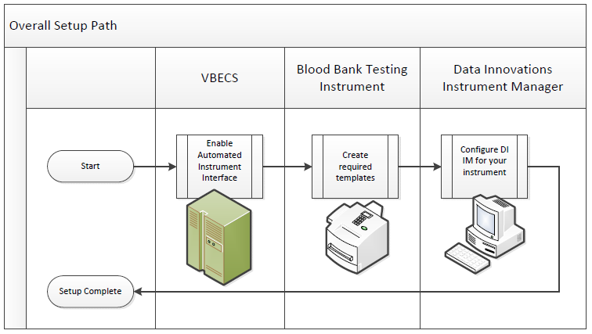

Related Manuals and Reference Materials
- VistA Blood Establishment Computer Software (VBECS) 2.2.0 Technical Manual-Security Guide
- Data Innovations Instrument Manager Manual
- Blood Bank Analyzer user’s guide (Instrument Manual)

This page intentionally left blank.

Set up Automated Instrument

Network Connectivity Setup

In order to ensure a proper functioning of an interface between an Automated Instrument and Instrument Manager, the Instrument needs to be connected to the VA network. The static IP Address and Port number has to be assigned to the Instrument (further referred in this document as <Instrument IP> and <Instrument Port>). Please refer to the Instrument Manual or contact your vendor for the instructions about how to perform this setup. Check with Local IT staff to establish the connection to Instrument Manager.

Testing Template Setup
If testing templates are not configured properly it will be impossible for instrument results to be accepted in VBECS.

Please refer to Appendix D: Testing Templates for the list of instrument templates. These test templates must be set up on your Instrument before any results can be sent to VBECS. Always use them for results that are sent to VBECS. Any results sent that do not follow the above templates will be rejected. Please refer to the Instrument Manual or contact your vendor for the instructions about how to perform template setup.
AABB Standards require a serological XM to detect ABO incompatibility (5.16.1) and a local policy must be in place if the site is not performing an IS AHG as part of their serologic crossmatch test, manual or using an instrument.

User ID Setup
Failure to set up proper user IDs on an instrument will prevent instrument results from being accepted in VBECS.
In order for VBECS to properly recognize the person who performed testing on an Instrument, all users accessing the instrument must have their user IDs set up to match their network user IDs (e.g., VHAISHBURNSK).
Due to the constraints of the Erytra messaging system, only 10 characters of the user name can be transferred with test results to VBECS. To ensure the uniqueness of all user names, please strip the front characters of network user ID to ensure that it is no longer than 10 characters long. For user IDs that are already 10 characters or shorter you can use full user ID in Erytra. For example:

Length of User ID | Example of User ID | Erytra ID
12 | VHASFCYOUNGS | SFCYOUNGS
11 | VHASFCTRANK | HASFCTRANK
10 or less | VHASFCTSTU | VHASFCTSTU

Please refer to the Instrument Manual or contact your vendor for the instructions about how to perform setup of user IDs.

Set Up Instrument Manager

Instrument Manager version
Please verify that you are using Instrument Manager Version 8.13 or greater (Figure 3). In Instrument Manager navigate to Help -> About Instrument Manager.
Figure 3: Instrument Manager Version Screen
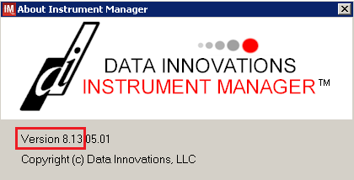
If your version of Instrument Manger is older than 8.13 please STOP executing this guide and update the software first. Do not proceed until the issue is resolved.

If your Instrument Manager is greater than 8.13 you may proceed. The user must execute the instructions and validate functionality on newer version. Discrepancies in the instructions must be reported as a REDACTED. See Appendix E.

Instrument Manager must have the Specimen Management Module licensed and activated. Do not proceed until this issue is resolved.

Instrument Manager to Automated Instrument Connectivity

Please contact your local network administrative staff and ensure that your local network allows two-way TCP/IP connectivity between <Instrument Manager IP> address and <Instrument IP> address on <Instrument Port>.

Installing Instrument Driver

Two drivers are required for the correct operation of the Automated Instrument interface to VBECS (Figure 4).
Figure 4: Required Drivers
Driver | Name | Version | Description
Grifols Erytra | griertri | 8.00.0001 | Instrument to DI IM driver
Data Innovations LLC, Configurable HL7 | diihl7ml | 8.00.0049 | DI IM to VBECS (HL7) driver

Please refer to the user’s manual for Instrument Manager or contact Data Innovations for the instructions on how to install drivers for Instrument Manager.

After successful installation of drivers, please go to Report -> Available Drivers menu option in Instrument Manager and verify that the drivers listed in Figure 4 are present.

Set Up Instrument Manager Configuration
Execute instructions in this section for each instrument that will be connecting to VBECS.
Modifying rules or test code mappings as imported using this Instrument Manager configuration Setup Guide may lead to malfunction of the Automated Instrument to VBECS interface.
Prerequisites for the Instrument Manager Configuration files download:
- You must be an administrator on <Instrument Manager Server>.
- Once the above prerequisite is met you may proceed.

Download instrument configuration files

Use local procedures for copying the instrument configuration files to the Instrument Manager server.

- Navigate to http://vaww.oed.portal.va.gov/projects/vbecs/Pages/Instrument-Manager-Configuration-Files-Release.aspx (Figure 5).
Figure 5: Connecting to the VBECS Share
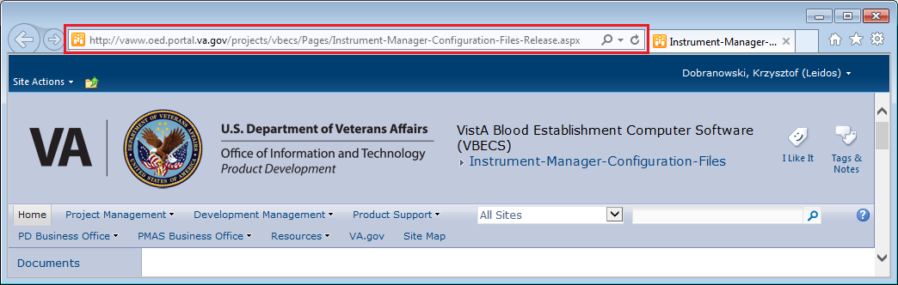

- To download a file from the SharePoint, right-click on it and select Save target as (Figure 6).
Figure 6: Example of Save target as...
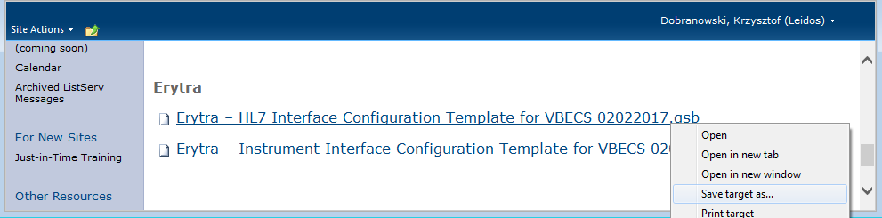
- In the next screen, specify the directory to save (Figure 7).
Figure 7: Example of Save As
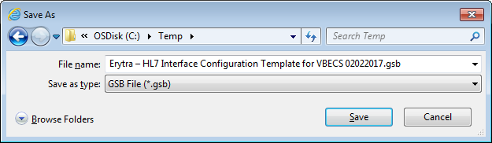
- Save both the Erytra – HL7 Interface Configuration Template for VBECS 02022017.gsb and the Erytra – Instrument Interface Configuration Template for VBECS 02022017.gsb files to the C:\temp directory.
- Per local procedures copy both files to C:\temp on the Instrument Manager server
- On the Instrument Manager server; Click Start, and in the “Search programs and files” box type Run and hit enter. Type Powershell and click OK to launch PowerShell
- Copy and paste or type the following commands to generate checksums for configuration files:

certutil –hashfile “C:\Temp\Erytra – HL7 Interface Configuration Template for VBECS 02022017.gsb” MD5 <press Enter>
certutil –hashfile “C:\Temp\Erytra – Instrument Interface Configuration Template for VBECS 02022017.gsb” MD5 <press Enter>

To copy, highlight the lines in grey and enter CTRL-C.
To insert the copied line into a PowerShell window, right click in the PowerShell window and select “Paste”.

- Verify that checksums for both files match those shown in Figure 8.
Figure 8: Instrument Manager Configuration File checksums
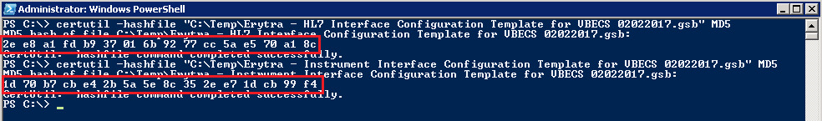
If the checksums do not match, stop and file a national CA SDM ticket to coordinate assistance with installation using the template in Appendix E. Do not proceed until the issue is resolved.

- Close the PowerShell window.

Import Instrument side configuration

- After downloading and verifying configuration files, open Instrument Manager and navigate to Configuration -> Configuration Editor.
- Click on the Import button (Figure 9).
Figure 9: Example of Configuration Editor
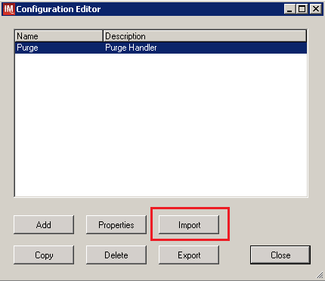

- Once the import screen opens, click the Browse button and select C:\Temp folder (Figure 10).
- Click OK.

Figure 10: Example of Configuration Import Screen
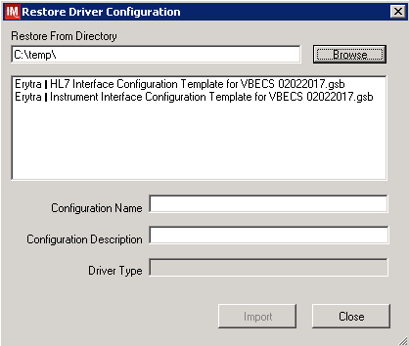
- Select Erytra – Instrument Interface Configuration Template for VBECS 02022017.gsb file from the list.

- Enter Configuration Name that contains 3 letter location code of the instrument (e.g., HIN for Hines VAMC), word Erytra and sequence number (1 for the first instrument, 2 for the second etc.). Example Configuration Name for instrument configuration located at Hines would be:

HIN_Erytra_1

This configuration name will be further referred in this document as <Instrument Side Configuration>.

- Enter Configuration Description and click Import button. Verify that the following confirmation window displays (Figure 11).
Figure 11: Example of Successful Configuration Import
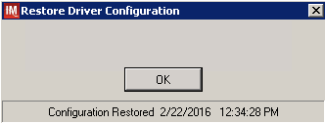

If you are using newer version of the driver than the one mentioned in section 3, the Instrument Manager will warn you about the discrepancy in driver versions. Please acknowledge this warning and continue.

- Click OK and close the Restore Driver Configuration window.
- Verify that Configuration Editor shows the new configuration on the list (Figure 12).
Figure 12: Example of Configuration Editor Window Showing Newly Imported Configuration
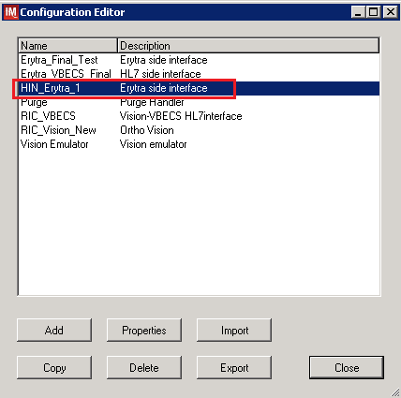

10. Close the Configuration Editor Window

Verify test code mapping for instrument side configuration

- Navigate to Reports -> Configuration Options and Mappings.
- Select the <Instrument Side Configuration Name> from the pull down menu (Figure 13)
- Select the Results Test Code Mapping Tab (Figure 13).
- Verify the Results Test Code Mapping Report Tab matches the list in Appendix A: Instrument Side Mapping.

Figure 13: Example of Results Test Code Mapping Tab
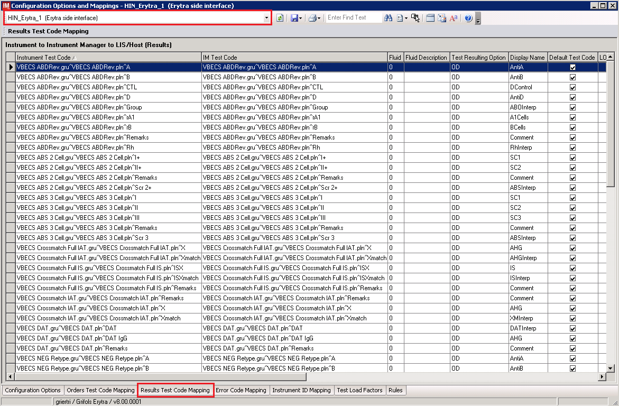

If mismatches in Test Codes names, missing or extra Test Codes are encountered, file a national CA SDM ticket to coordinate assistance with installation using the template in Appendix E. Do not proceed until the issue is resolved.

- Close Configuration Options and Mappings window.

Verify rules

- Next navigate to Reports -> Configuration Options and Mappings.
- Select the <Instrument Side Configuration Name> from the drop-down in the upper left corner. (Figure 14).
- Select the Rules Tab (Figure 14).
- Verify the Rules Tab matches all rules listed in Appendix C: Rules.
Figure 14: Example of Rules Tab
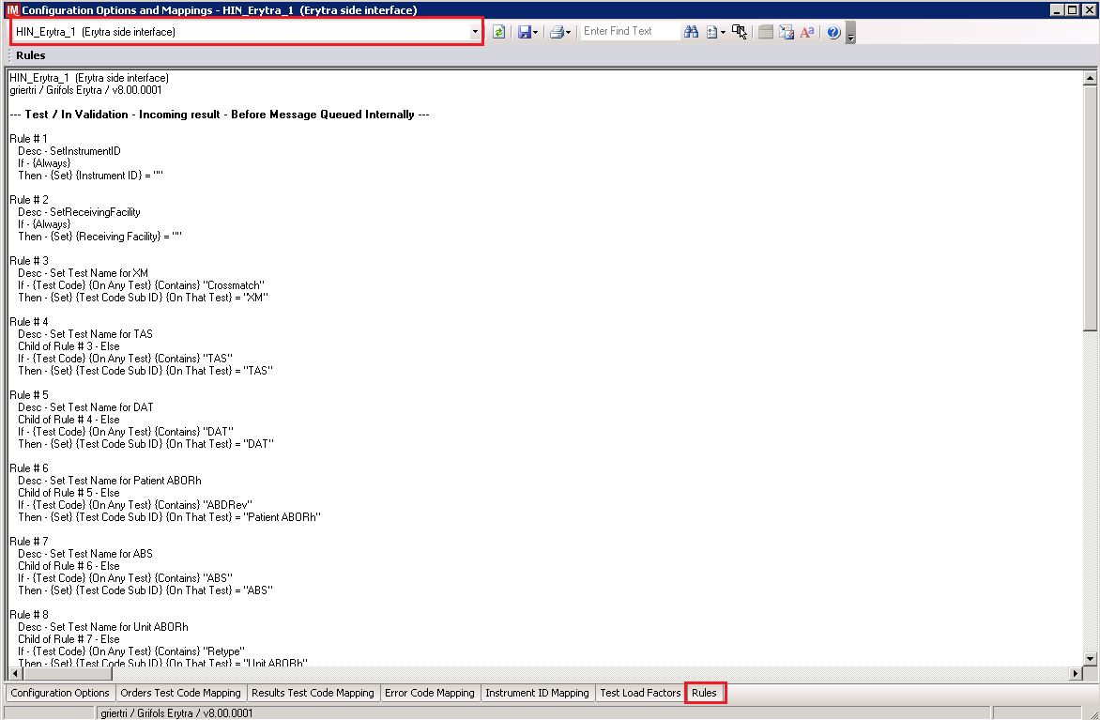

- Close the Configuration Options and Mappings window.

If mismatches in rules are encountered, file a national CA SDM ticket to coordinate assistance with installation using the template in Appendix E. Do not proceed until the issue is resolved.

Configure rules
In this section your will establish the name of the instrument associated with test results for VBECS reports. If you are setting up multiple instruments, make sure that each has a unique name.

- Navigate to Configuration -> Specimen Management Configuration -> Rules Processing.
- Select <Instrument Side Configuration Name> from the pull down menu (Figure 15).
- Locate rule SetInstrumentID.
- Click on the Then line in the rule.
- Modify the rule by typing <Instrument Name> between the quotation marks as shown in the lower box (Figure 15).
Figure 15: Example of Instrument Name Setup
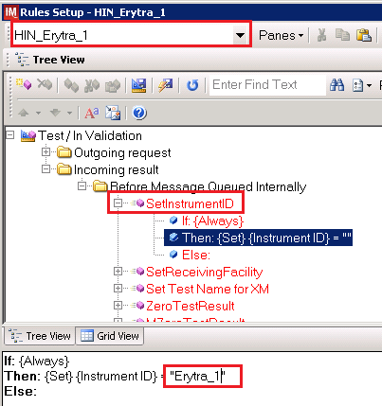

- Locate rule SetReceivingFacility. Click on Then line in the rule. Modify the rule by typing the <Division Code> between the quotation marks as shown (Figure 16).

<Division Code> also known as Station Number in Vista is a unique alphanumeric code that is associated with each hospital (e.g. 589 for VA Heartland West VAMC). This code must match the division code configured in VBECS Administrator application for a given site.

Figure 16: Example of Division Code Setup
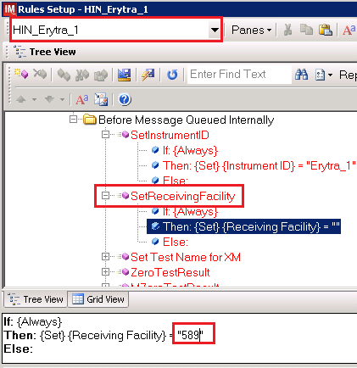

- After the change was made, both rules’ text should be displayed in red color on the screen.
- Click on Save Test / In Validation Rule Set button located in the toolbar above the rules (Figure 17).
Figure 17: Example of Save Rules Button
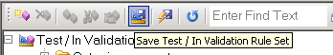

- Verify that the message is received (Figure 18).
Figure 18: Example of Successful Rule Save
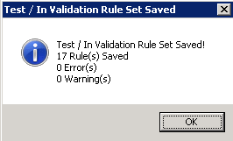

If errors while saving rules are encountered, file a national CA SDM ticket to coordinate assistance with installation using the template in Appendix E. Do not proceed until the issue is resolved.

- Click on the Save Live Rule Set button (Figure 19) located in the toolbar and click Yes to confirm.
Figure 19: Example of Save Rules in Live Set Button
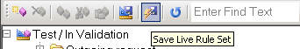

- Expand the Live Rule Set, and verify that rule text matches Appendix C: Rules and includes changes made to SetInstrumentID and SetReceivingFacility (Figure 20).
Figure 20: Example of Live Rules Set View
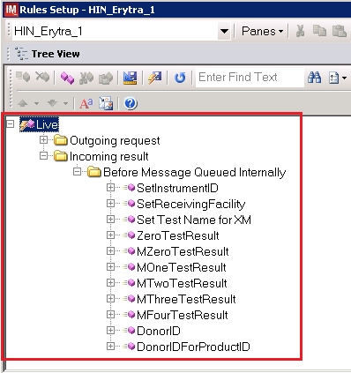
If differences in rules are encountered ,file a national CA SDM ticket to coordinate assistance with installation using the template in Appendix E. Do not proceed until the issue is resolved.

- Close the Rule Setup window, returning to the main menu.

Import VBECS (HL7) side configuration
Only one VBECS side configuration is needed even if you use multiple Erytra instruments. All Erytras will share the same configuration.
Modifying rules or test code mappings in the Instrument Manager configuration outside of this Setup Guide is not allowed and may lead to malfunction of the Automated Instrument to VBECS interface.

- Navigate to Configuration -> Configuration Editor (Figure 21).
- Click on the Import button.

Figure 21: Example of Configuration Editor Window
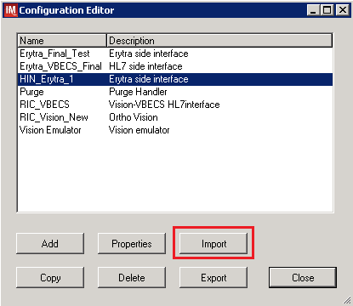

- Once the Restore Driver Configuration window opens, click the Browse button and select C:\Temp folder (Figure 22).
- Select Erytra – HL7 Interface Configuration Template for VBECS 02022017.gsb file from the list.
- Enter a Configuration Name that contains 3 letter location code of the instrument (e.g. HIN for Hines VAMC), word VBECS and sequence number (1 for the first configuration, 2 for the second etc.). Example Configuration Name for VBECS side configuration located at Hines would be:

HIN_VBECS_1

This configuration name will be further referred in this document as <HL7 Side Configuration>.
Figure 22: Example of Configuration Import Window
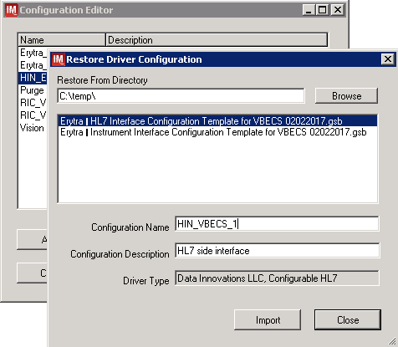

- Enter Configuration Description and click Import button. Verify that the following confirmation window (Figure 23) displays.
Figure 23: Example of Successful Configuration Import

If you are using newer version of the driver than the one mentioned in section 3, the Instrument Manager will warn you about the discrepancy in driver versions. Please acknowledge this warning and continue.

- Click OK and close the Restore Driver Configuration window.
- Verify that Configuration Editor shows the new configuration on the list (Figure 24).
Figure 24: Example of Newly Imported HL7 Configuration
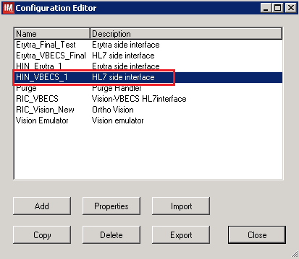

Verify test code mapping for VBECS side configuration

- Navigate to Reports ->Configuration Options and Mappings.
- Select the <HL7 Side Configuration Name> from the drop-down in the upper left corner (Figure 25).
- Select the Results Test Code Mapping Tab (Figure 25).
- Verify that the Results Test Code Mapping Tab matches all rules listed in Appendix B: HL7 (VBECS) Side Mapping.

Figure 25: Example of HL7 Configuration Report Window
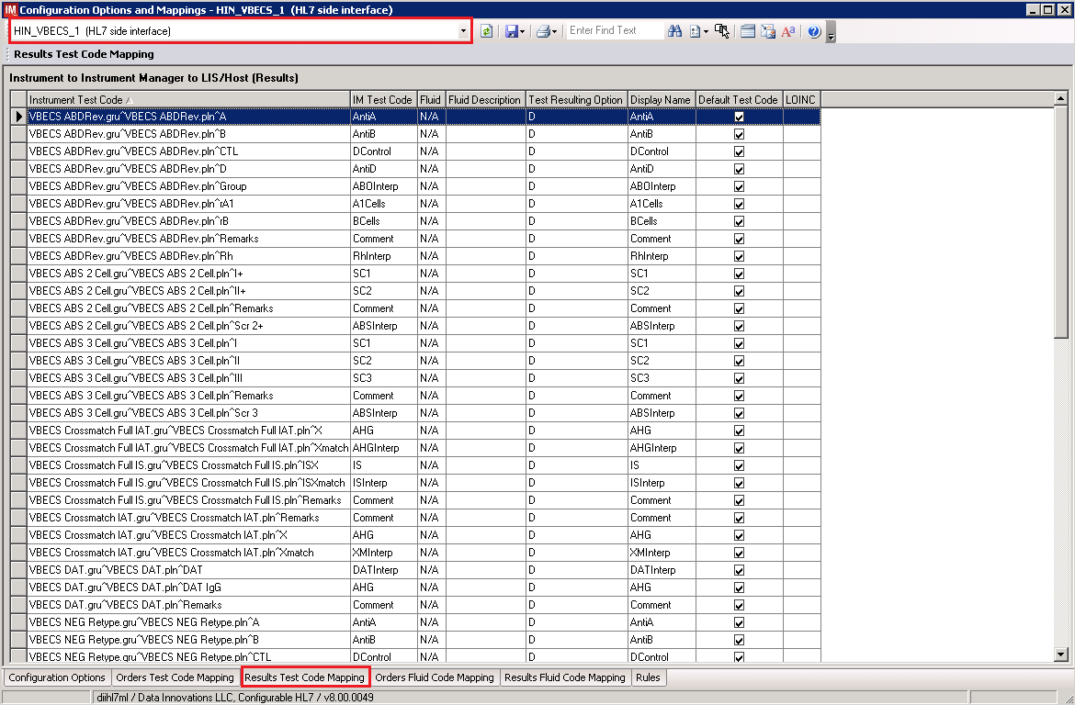

- Close Configuration Options and Mappings window.

If mismatches in Test Codes names, missing or extra Test Codes are encountered, file a national CA SDM ticket to coordinate assistance with installation of the automated interface associated with VBECS 2.2.0 using template in Appendix E. Do not proceed until the issue is resolved.

Set Up HL7 Connection to VBECS TEST
Modifying rules or test code mappings as imported using this Instrument Manager configuration Setup Guide may lead to malfunction of the Automated Instrument to VBECS interface.

- Navigate to Configuration -> Connection Assignment.
- On the Connection Assignment window click Add button.
- Select Configuration Name <HL7 Side Configuration> (Figure 26).
- Enter the Connection Name that matches the <HL7 Side Configuration> and word Connection. For example:

HIN_VBECS_1_Connection

- Check Include in Specimen Management check box (Figure 26).
- Select TCP/IP connection in Device (Figure 26).
Figure 26: Example of Connection Properties Window
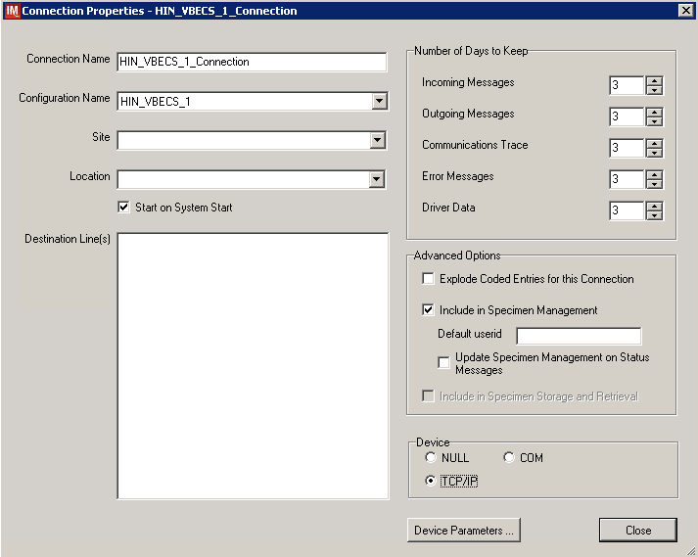

- Click on Device Parameters button.
- Enter TCP/IP Address and TCP/IP Port Number that matches VBECS TEST Application IP Address and IP Port Number configured in VBECS TEST Administrator application for Auto Instrument Interface (Figure 27). (Please refer to VistA Blood Establishment Computer Software (VBECS) 2.2.0 Technical Manual Security Guide for instruction on how to configure interfaces for VBECS.)
Figure 27: Example of TCP/IP Configuration Window
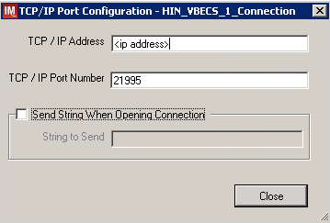

- Close the TCP/IP Port Configuration window and click Yes to save.
- Close the Connection Properties window and click Yes to save.
- Verify that the newly created connection shows on the Connection Assignment window (Figure 28).
Figure 28: Example of Newly Created Connection
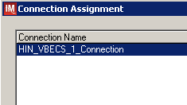

Set Up Instrument Connection
Execute instructions in this section for each instrument that will be connecting to VBECS.
Modifying connection settings in the Instrument Manager outside of this Setup Guide is not allowed and may lead to malfunction of the Automated Instrument to VBECS interface.

- On the Connection Assignment window, click Add button.
- On the Connection Properties window, enter the Connection Name. Enter a name that contains <Instrument Side Configuration> and word Connection. For example:

HIN_Erytra_1_Connection

- Select <Instrument Side Configuration> as Configuration Name.
- Check Include in Specimen Management check box.
- Select TCP/IP connection.
- On the Destination Lines list, check the box next to connection configured in previous section (Figure 29).
Figure 29: Example of Connection Properties Window
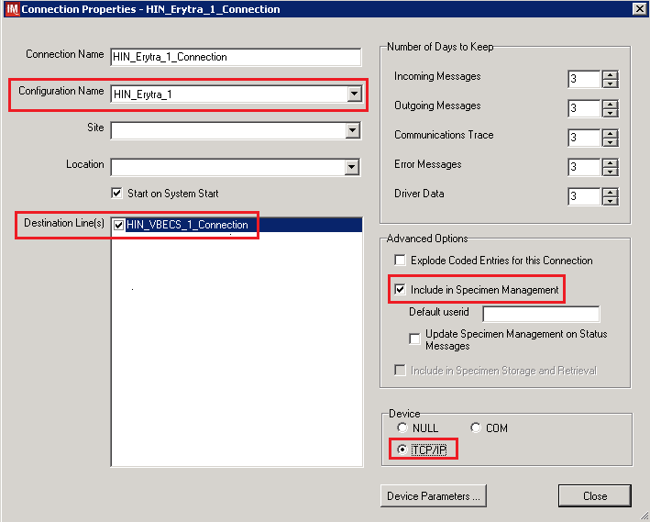

- Click on Device Parameters button.
- Enter TCP/IP Address and TCP/IP Port Number that matches <Instrument IP> and <Instrument Port> discussed in Section Network Connectivity Setup.
- Uncheck Send String When Opening Connection check box (Figure 30).
Figure 30: Example of TCP/IP Configuration Window
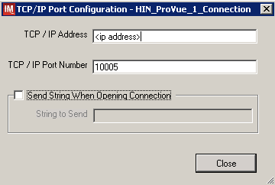

- Click close on the TCP/IP Port Configuration window and click Yes to save.
- Click close on the Connection Properties window and click Yes to save.
- Verify the newly created connection shows on Connection Assignment window (Figure 31).
- Close the Connection Assignment window.
Figure 31: Example of Newly Created Connection
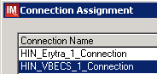

Test New Connections

- Navigate to System -> Status.
- Right-click on each newly created connection and choose option to Start Selected Connections (Figure 32).
Figure 32: Example of Connection Status Window
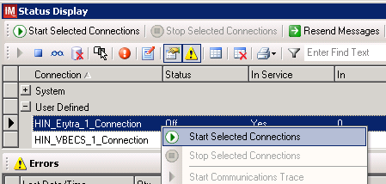

- Verify that all newly created connections are showing Status of On after about a minute or so. (Figure 33).
Figure 33: Example of Successful Connection Test
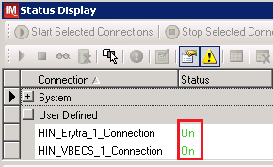
If one or more connections fail to start, file a national CA SDM ticket to coordinate assistance with installation of the automated interface associated with VBECS 2.2.0 using template in Appendix E. Do not proceed until the issue is resolved.

- Close the Status Display.

Validate Instrument connectivity to VBECS TEST

Execute validation instructions from Appendix F to verify that Instrument is properly interfacing with VBECS.
If one or more validation scenarios fail, file a national CA SDM ticket to coordinate assistance with installation of the automated interface associated with VBECS 2.2.0 using template in Appendix E. Do not proceed until the issue is resolved.

Set up HL7 Connection to VBECS PROD

- Navigate to System -> Status.
- Right-click <VBECS_Connection> and choose option to Stop Selected Connections (Figure 34).
Figure 34: Example of Stop Selected Connections
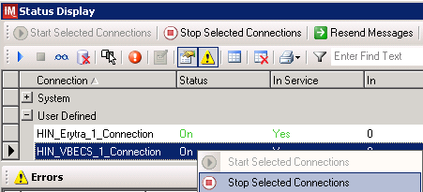

- Wait until connection status changes to Off. Navigate to Configuration -> Connection Assignment.
- Select <VBECS_Connection> and click Properties (Figure 35).

Figure 35: Example of Connection Assignment
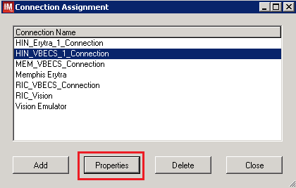
- On Connection Properties window click Device Parameters (Figure 36).
Figure 36: Example of Connection Properties
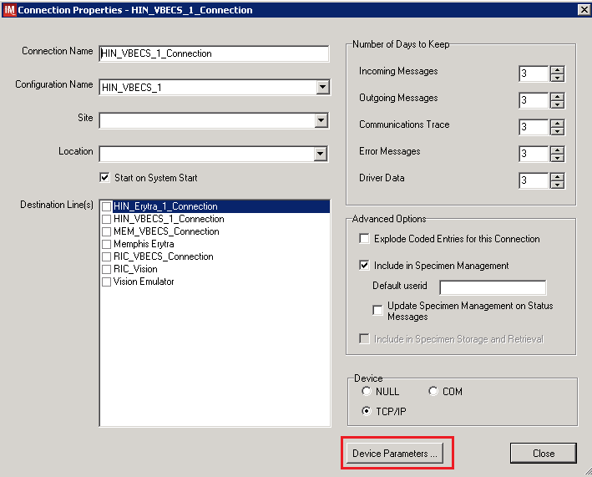

- Enter TCP/IP Address and TCP/IP Port Number that matches VBECS PROD Application IP Address and IP Port Number configured in VBECS PROD Administrator application for Auto Instrument Interface (Figure 37). Please refer to VistA Blood Establishment Computer Software (VBECS) Technical Manual Security Guide for instruction on how to configure interfaces for VBECS.
Figure 37: Example of TCP/IP Configuration Window
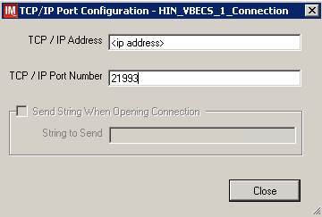

- Close the TCP/IP Port Configuration and click Yes to confirm changes.
- Close the Connection Properties window and click Yes to confirm changes.
- Close the Connection Assignment window.
- Navigate to System -> Status.
- Right-click <VBECS_Connection> and choose option to Start Selected Connections (Figure 38).

Figure 38: Example of Connection Status Window

- Verify that <VBECS_Connection> is showing Status of On after about a minute or so. (Figure 39).
Figure 39: Example of Successful Connection Test
If connection fails to start, file a national CA SDM ticket to coordinate assistance with installation using template in Appendix E. Do not proceed until the issue is resolved.
- Close the Status Display and Log Off the system.
Glossary

Acronym, Term | Definition
Automated Instrument | Blood Bank Analyzer that performs blood testing.
Division Code | Also known as Station Number in Vista is the unique alphanumeric code that is associated with each hospital (e.g. 589 for VA Heartland West).
Instrument Manager (IM) | Software created by Data Innovations that serves as a middleware between Automated Instrument and VBECS. It translates messages containing test results sent from an instrument into HL7 messages that are then parsed into VBECS.
VA | Department of Veterans Affairs.
VBECS | VistA Blood Establishment Computer Software.
VistA | Veterans Health Information Systems and Technology Architecture. VistA software, developed by the VA, is used to support clinical and administrative functions at VA Medical Centers nationwide. VistA is composed of packages that undergo a verification process to ensure conformity with name spacing and other VistA standards and conventions.

Appendices

Appendix A: Instrument Side Mapping
Table 1: Instrument Side Mapping
Instrument Test Code | IM Test Code | Display Name
VBECS ABDRev.gru^VBECS ABDRev.pln^A | VBECS ABDRev.gru^VBECS ABDRev.pln^A | AntiA
VBECS ABDRev.gru^VBECS ABDRev.pln^B | VBECS ABDRev.gru^VBECS ABDRev.pln^B | AntiB
VBECS ABDRev.gru^VBECS ABDRev.pln^CTL | VBECS ABDRev.gru^VBECS ABDRev.pln^CTL | DControl
VBECS ABDRev.gru^VBECS ABDRev.pln^D | VBECS ABDRev.gru^VBECS ABDRev.pln^D | AntiD
VBECS ABDRev.gru^VBECS ABDRev.pln^Group | VBECS ABDRev.gru^VBECS ABDRev.pln^Group | ABOInterp
VBECS ABDRev.gru^VBECS ABDRev.pln^rA1 | VBECS ABDRev.gru^VBECS ABDRev.pln^rA1 | A1Cells
VBECS ABDRev.gru^VBECS ABDRev.pln^rB | VBECS ABDRev.gru^VBECS ABDRev.pln^rB | BCells
VBECS ABDRev.gru^VBECS ABDRev.pln^Remarks | VBECS ABDRev.gru^VBECS ABDRev.pln^Remarks | Comment
VBECS ABDRev.gru^VBECS ABDRev.pln^Rh | VBECS ABDRev.gru^VBECS ABDRev.pln^Rh | RhInterp
VBECS ABS 2 Cell.gru^VBECS ABS 2 Cell.pln^I+ | VBECS ABS 2 Cell.gru^VBECS ABS 2 Cell.pln^I+ | SC1
VBECS ABS 2 Cell.gru^VBECS ABS 2 Cell.pln^II+ | VBECS ABS 2 Cell.gru^VBECS ABS 2 Cell.pln^II+ | SC2
VBECS ABS 2 Cell.gru^VBECS ABS 2 Cell.pln^Remarks | VBECS ABS 2 Cell.gru^VBECS ABS 2 Cell.pln^Remarks | Comment
VBECS ABS 2 Cell.gru^VBECS ABS 2 Cell.pln^Scr 2+ | VBECS ABS 2 Cell.gru^VBECS ABS 2 Cell.pln^Scr 2+ | ABSInterp
VBECS ABS 3 Cell.gru^VBECS ABS 3 Cell.pln^I | VBECS ABS 3 Cell.gru^VBECS ABS 3 Cell.pln^I | SC1
VBECS ABS 3 Cell.gru^VBECS ABS 3 Cell.pln^II | VBECS ABS 3 Cell.gru^VBECS ABS 3 Cell.pln^II | SC2
VBECS ABS 3 Cell.gru^VBECS ABS 3 Cell.pln^III | VBECS ABS 3 Cell.gru^VBECS ABS 3 Cell.pln^III | SC3
VBECS ABS 3 Cell.gru^VBECS ABS 3 Cell.pln^Remarks | VBECS ABS 3 Cell.gru^VBECS ABS 3 Cell.pln^Remarks | Comment
VBECS ABS 3 Cell.gru^VBECS ABS 3 Cell.pln^Scr 3 | VBECS ABS 3 Cell.gru^VBECS ABS 3 Cell.pln^Scr 3 | ABSInterp
VBECS Crossmatch Full IAT.gru^VBECS Crossmatch Full IAT.pln^X | VBECS Crossmatch Full IAT.gru^VBECS Crossmatch Full IAT.pln^X | AHG
VBECS Crossmatch Full IAT.gru^VBECS Crossmatch Full IAT.pln^Xmatch | VBECS Crossmatch Full IAT.gru^VBECS Crossmatch Full IAT.pln^Xmatch | AHGInterp
VBECS Crossmatch Full IS.gru^VBECS Crossmatch Full IS.pln^ISX | VBECS Crossmatch Full IS.gru^VBECS Crossmatch Full IS.pln^ISX | IS
VBECS Crossmatch Full IS.gru^VBECS Crossmatch Full IS.pln^ISXmatch | VBECS Crossmatch Full IS.gru^VBECS Crossmatch Full IS.pln^ISXmatch | ISInterp
VBECS Crossmatch Full IS.gru^VBECS Crossmatch Full IS.pln^Remarks | VBECS Crossmatch Full IS.gru^VBECS Crossmatch Full IS.pln^Remarks | Comment
VBECS Crossmatch IAT.gru^VBECS Crossmatch IAT.pln^Remarks | VBECS Crossmatch IAT.gru^VBECS Crossmatch IAT.pln^Remarks | Comment
VBECS Crossmatch IAT.gru^VBECS Crossmatch IAT.pln^X | VBECS Crossmatch IAT.gru^VBECS Crossmatch IAT.pln^X | AHG
VBECS Crossmatch IAT.gru^VBECS Crossmatch IAT.pln^Xmatch | VBECS Crossmatch IAT.gru^VBECS Crossmatch IAT.pln^Xmatch | XMInterp
VBECS DAT.gru^VBECS DAT.pln^DAT | VBECS DAT.gru^VBECS DAT.pln^DAT | DATInterp
VBECS DAT.gru^VBECS DAT.pln^DAT IgG | VBECS DAT.gru^VBECS DAT.pln^DAT IgG | AHG
VBECS DAT.gru^VBECS DAT.pln^Remarks | VBECS DAT.gru^VBECS DAT.pln^Remarks | Comment
VBECS NEG Retype.gru^VBECS NEG Retype.pln^A | VBECS NEG Retype.gru^VBECS NEG Retype.pln^A | AntiA
VBECS NEG Retype.gru^VBECS NEG Retype.pln^B | VBECS NEG Retype.gru^VBECS NEG Retype.pln^B | AntiB
VBECS NEG Retype.gru^VBECS NEG Retype.pln^CTL | VBECS NEG Retype.gru^VBECS NEG Retype.pln^CTL | DControl
VBECS NEG Retype.gru^VBECS NEG Retype.pln^D | VBECS NEG Retype.gru^VBECS NEG Retype.pln^D | AntiD
VBECS NEG Retype.gru^VBECS NEG Retype.pln^Fwd Gr | VBECS NEG Retype.gru^VBECS NEG Retype.pln^Fwd Gr | ABOInterp
VBECS NEG Retype.gru^VBECS NEG Retype.pln^Remarks | VBECS NEG Retype.gru^VBECS NEG Retype.pln^Remarks | Comment
VBECS NEG Retype.gru^VBECS NEG Retype.pln^Rh | VBECS NEG Retype.gru^VBECS NEG Retype.pln^Rh | RhInterp
VBECS Phenotype Kell.gru^VBECS Phenotype Kell.pln^K | VBECS Phenotype Kell.gru^VBECS Phenotype Kell.pln^K | AntiK
VBECS Phenotype Kell.gru^VBECS Phenotype Kell.pln^Remarks | VBECS Phenotype Kell.gru^VBECS Phenotype Kell.pln^Remarks | Comment
VBECS Phenotype Rh.gru^VBECS Phenotype Rh.pln^C | VBECS Phenotype Rh.gru^VBECS Phenotype Rh.pln^C | AntiC
VBECS Phenotype Rh.gru^VBECS Phenotype Rh.pln^E | VBECS Phenotype Rh.gru^VBECS Phenotype Rh.pln^E | AntiE
VBECS Phenotype Rh.gru^VBECS Phenotype Rh.pln^Remarks | VBECS Phenotype Rh.gru^VBECS Phenotype Rh.pln^Remarks | Comment
VBECS Phenotype Rh.gru^VBECS Phenotype Rh.pln^sm c | VBECS Phenotype Rh.gru^VBECS Phenotype Rh.pln^sm c | Antic
VBECS Phenotype Rh.gru^VBECS Phenotype Rh.pln^sm e | VBECS Phenotype Rh.gru^VBECS Phenotype Rh.pln^sm e | Antie
VBECS POS Retype.gru^VBECS POS Retype.pln^A | VBECS POS Retype.gru^VBECS POS Retype.pln^A | AntiA
VBECS POS Retype.gru^VBECS POS Retype.pln^B | VBECS POS Retype.gru^VBECS POS Retype.pln^B | AntiB
VBECS POS Retype.gru^VBECS POS Retype.pln^Fwd Gr | VBECS POS Retype.gru^VBECS POS Retype.pln^Fwd Gr | ABOInterp
VBECS POS Retype.gru^VBECS POS Retype.pln^Remarks | VBECS POS Retype.gru^VBECS POS Retype.pln^Remarks | Comment
VBECS TAS 2 Cell.gru^VBECS TAS 2 Cell.pln^A | VBECS TAS 2 Cell.gru^VBECS TAS 2 Cell.pln^A | AntiA
VBECS TAS 2 Cell.gru^VBECS TAS 2 Cell.pln^B | VBECS TAS 2 Cell.gru^VBECS TAS 2 Cell.pln^B | AntiB
VBECS TAS 2 Cell.gru^VBECS TAS 2 Cell.pln^CTL | VBECS TAS 2 Cell.gru^VBECS TAS 2 Cell.pln^CTL | DControl
VBECS TAS 2 Cell.gru^VBECS TAS 2 Cell.pln^D | VBECS TAS 2 Cell.gru^VBECS TAS 2 Cell.pln^D | AntiD
VBECS TAS 2 Cell.gru^VBECS TAS 2 Cell.pln^Group | VBECS TAS 2 Cell.gru^VBECS TAS 2 Cell.pln^Group | ABOInterp
VBECS TAS 2 Cell.gru^VBECS TAS 2 Cell.pln^I+ | VBECS TAS 2 Cell.gru^VBECS TAS 2 Cell.pln^I+ | SC1
VBECS TAS 2 Cell.gru^VBECS TAS 2 Cell.pln^II+ | VBECS TAS 2 Cell.gru^VBECS TAS 2 Cell.pln^II+ | SC2
VBECS TAS 2 Cell.gru^VBECS TAS 2 Cell.pln^rA1 | VBECS TAS 2 Cell.gru^VBECS TAS 2 Cell.pln^rA1 | A1Cells
VBECS TAS 2 Cell.gru^VBECS TAS 2 Cell.pln^rB | VBECS TAS 2 Cell.gru^VBECS TAS 2 Cell.pln^rB | BCells
VBECS TAS 2 Cell.gru^VBECS TAS 2 Cell.pln^Remarks | VBECS TAS 2 Cell.gru^VBECS TAS 2 Cell.pln^Remarks | Comment
VBECS TAS 2 Cell.gru^VBECS TAS 2 Cell.pln^Rh | VBECS TAS 2 Cell.gru^VBECS TAS 2 Cell.pln^Rh | RhInterp
VBECS TAS 2 Cell.gru^VBECS TAS 2 Cell.pln^Scr 2+ | VBECS TAS 2 Cell.gru^VBECS TAS 2 Cell.pln^Scr 2+ | ABSInterp
VBECS TAS 3 Cell.gru^VBECS TAS 3 Cell.pln^A | VBECS TAS 3 Cell.gru^VBECS TAS 3 Cell.pln^A | AntiA
VBECS TAS 3 Cell.gru^VBECS TAS 3 Cell.pln^B | VBECS TAS 3 Cell.gru^VBECS TAS 3 Cell.pln^B | AntiB
VBECS TAS 3 Cell.gru^VBECS TAS 3 Cell.pln^CTL | VBECS TAS 3 Cell.gru^VBECS TAS 3 Cell.pln^CTL | DControl
VBECS TAS 3 Cell.gru^VBECS TAS 3 Cell.pln^D | VBECS TAS 3 Cell.gru^VBECS TAS 3 Cell.pln^D | AntiD
VBECS TAS 3 Cell.gru^VBECS TAS 3 Cell.pln^Group | VBECS TAS 3 Cell.gru^VBECS TAS 3 Cell.pln^Group | ABOInterp
VBECS TAS 3 Cell.gru^VBECS TAS 3 Cell.pln^I | VBECS TAS 3 Cell.gru^VBECS TAS 3 Cell.pln^I | SC1
VBECS TAS 3 Cell.gru^VBECS TAS 3 Cell.pln^II | VBECS TAS 3 Cell.gru^VBECS TAS 3 Cell.pln^II | SC2
VBECS TAS 3 Cell.gru^VBECS TAS 3 Cell.pln^III | VBECS TAS 3 Cell.gru^VBECS TAS 3 Cell.pln^III | SC3
VBECS TAS 3 Cell.gru^VBECS TAS 3 Cell.pln^rA1 | VBECS TAS 3 Cell.gru^VBECS TAS 3 Cell.pln^rA1 | A1Cells
VBECS TAS 3 Cell.gru^VBECS TAS 3 Cell.pln^rB | VBECS TAS 3 Cell.gru^VBECS TAS 3 Cell.pln^rB | BCells
VBECS TAS 3 Cell.gru^VBECS TAS 3 Cell.pln^Remarks | VBECS TAS 3 Cell.gru^VBECS TAS 3 Cell.pln^Remarks | Comment
VBECS TAS 3 Cell.gru^VBECS TAS 3 Cell.pln^Rh | VBECS TAS 3 Cell.gru^VBECS TAS 3 Cell.pln^Rh | RhInterp
VBECS TAS 3 Cell.gru^VBECS TAS 3 Cell.pln^Scr 3 | VBECS TAS 3 Cell.gru^VBECS TAS 3 Cell.pln^Scr 3 | ABSInterp

Appendix B: HL7 (VBECS) Side Mapping
Table 2: HL7 (VBECS) Side Mapping
Instrument Test Code | IM Test Code
VBECS ABDRev.gru^VBECS ABDRev.pln^A | AntiA
VBECS ABDRev.gru^VBECS ABDRev.pln^B | AntiB
VBECS ABDRev.gru^VBECS ABDRev.pln^CTL | DControl
VBECS ABDRev.gru^VBECS ABDRev.pln^D | AntiD
VBECS ABDRev.gru^VBECS ABDRev.pln^Group | ABOInterp
VBECS ABDRev.gru^VBECS ABDRev.pln^rA1 | A1Cells
VBECS ABDRev.gru^VBECS ABDRev.pln^rB | BCells
VBECS ABDRev.gru^VBECS ABDRev.pln^Remarks | Comment
VBECS ABDRev.gru^VBECS ABDRev.pln^Rh | RhInterp
VBECS ABS 2 Cell.gru^VBECS ABS 2 Cell.pln^I+ | SC1
VBECS ABS 2 Cell.gru^VBECS ABS 2 Cell.pln^II+ | SC2
VBECS ABS 2 Cell.gru^VBECS ABS 2 Cell.pln^Remarks | Comment
VBECS ABS 2 Cell.gru^VBECS ABS 2 Cell.pln^Scr 2+ | ABSInterp
VBECS ABS 3 Cell.gru^VBECS ABS 3 Cell.pln^I | SC1
VBECS ABS 3 Cell.gru^VBECS ABS 3 Cell.pln^II | SC2
VBECS ABS 3 Cell.gru^VBECS ABS 3 Cell.pln^III | SC3
VBECS ABS 3 Cell.gru^VBECS ABS 3 Cell.pln^Remarks | Comment
VBECS ABS 3 Cell.gru^VBECS ABS 3 Cell.pln^Scr 3 | ABSInterp
VBECS Crossmatch Full IAT.gru^VBECS Crossmatch Full IAT.pln^X | AHG
VBECS Crossmatch Full IAT.gru^VBECS Crossmatch Full IAT.pln^Xmatch | AHGInterp
VBECS Crossmatch Full IS.gru^VBECS Crossmatch Full IS.pln^ISX | IS
VBECS Crossmatch Full IS.gru^VBECS Crossmatch Full IS.pln^ISXmatch | ISInterp
VBECS Crossmatch Full IS.gru^VBECS Crossmatch Full IS.pln^Remarks | Comment
VBECS Crossmatch IAT.gru^VBECS Crossmatch IAT.pln^Remarks | Comment
VBECS Crossmatch IAT.gru^VBECS Crossmatch IAT.pln^X | AHG
VBECS Crossmatch IAT.gru^VBECS Crossmatch IAT.pln^Xmatch | XMInterp
VBECS DAT.gru^VBECS DAT.pln^DAT | DATInterp
VBECS DAT.gru^VBECS DAT.pln^DAT IgG | AHG
VBECS DAT.gru^VBECS DAT.pln^Remarks | Comment
VBECS NEG Retype.gru^VBECS NEG Retype.pln^A | AntiA
VBECS NEG Retype.gru^VBECS NEG Retype.pln^B | AntiB
VBECS NEG Retype.gru^VBECS NEG Retype.pln^CTL | DControl
VBECS NEG Retype.gru^VBECS NEG Retype.pln^D | AntiD
VBECS NEG Retype.gru^VBECS NEG Retype.pln^Fwd Gr | ABOInterp
VBECS NEG Retype.gru^VBECS NEG Retype.pln^Remarks | Comment
VBECS NEG Retype.gru^VBECS NEG Retype.pln^Rh | RhInterp
VBECS Phenotype Kell.gru^VBECS Phenotype Kell.pln^K | AntiK
VBECS Phenotype Kell.gru^VBECS Phenotype Kell.pln^Remarks | Comment
VBECS Phenotype Rh.gru^VBECS Phenotype Rh.pln^C | AntiC
VBECS Phenotype Rh.gru^VBECS Phenotype Rh.pln^E | AntiE
VBECS Phenotype Rh.gru^VBECS Phenotype Rh.pln^Remarks | Comment
VBECS Phenotype Rh.gru^VBECS Phenotype Rh.pln^sm c | Antic
VBECS Phenotype Rh.gru^VBECS Phenotype Rh.pln^sm e | Antie
VBECS POS Retype.gru^VBECS POS Retype.pln^A | AntiA
VBECS POS Retype.gru^VBECS POS Retype.pln^B | AntiB
VBECS POS Retype.gru^VBECS POS Retype.pln^Fwd Gr | ABOInterp
VBECS POS Retype.gru^VBECS POS Retype.pln^Remarks | Comment
VBECS TAS 2 Cell.gru^VBECS TAS 2 Cell.pln^A | AntiA
VBECS TAS 2 Cell.gru^VBECS TAS 2 Cell.pln^B | AntiB
VBECS TAS 2 Cell.gru^VBECS TAS 2 Cell.pln^CTL | DControl
VBECS TAS 2 Cell.gru^VBECS TAS 2 Cell.pln^D | AntiD
VBECS TAS 2 Cell.gru^VBECS TAS 2 Cell.pln^Group | ABOInterp
VBECS TAS 2 Cell.gru^VBECS TAS 2 Cell.pln^I+ | SC1
VBECS TAS 2 Cell.gru^VBECS TAS 2 Cell.pln^II+ | SC2
VBECS TAS 2 Cell.gru^VBECS TAS 2 Cell.pln^rA1 | A1Cells
VBECS TAS 2 Cell.gru^VBECS TAS 2 Cell.pln^rB | BCells
VBECS TAS 2 Cell.gru^VBECS TAS 2 Cell.pln^Remarks | Comment
VBECS TAS 2 Cell.gru^VBECS TAS 2 Cell.pln^Rh | RhInterp
VBECS TAS 2 Cell.gru^VBECS TAS 2 Cell.pln^Scr 2+ | ABSInterp
VBECS TAS 3 Cell.gru^VBECS TAS 3 Cell.pln^A | AntiA
VBECS TAS 3 Cell.gru^VBECS TAS 3 Cell.pln^B | AntiB
VBECS TAS 3 Cell.gru^VBECS TAS 3 Cell.pln^CTL | DControl
VBECS TAS 3 Cell.gru^VBECS TAS 3 Cell.pln^D | AntiD
VBECS TAS 3 Cell.gru^VBECS TAS 3 Cell.pln^Group | ABOInterp
VBECS TAS 3 Cell.gru^VBECS TAS 3 Cell.pln^I | SC1
VBECS TAS 3 Cell.gru^VBECS TAS 3 Cell.pln^II | SC2
VBECS TAS 3 Cell.gru^VBECS TAS 3 Cell.pln^III | SC3
VBECS TAS 3 Cell.gru^VBECS TAS 3 Cell.pln^rA1 | A1Cells
VBECS TAS 3 Cell.gru^VBECS TAS 3 Cell.pln^rB | BCells
VBECS TAS 3 Cell.gru^VBECS TAS 3 Cell.pln^Remarks | Comment
VBECS TAS 3 Cell.gru^VBECS TAS 3 Cell.pln^Rh | RhInterp
VBECS TAS 3 Cell.gru^VBECS TAS 3 Cell.pln^Scr 3 | ABSInterp

Appendix C: Rules

--- Test / In Validation - Incoming result - Before Message Queued Internally ---

Rule # 1
Desc - SetInstrumentID
If - {Always}
Then - {Set} {Instrument ID} = ""

Rule # 2
Desc - SetReceivingFacility
If - {Always}
Then - {Set} {Receiving Facility} = ""

Rule # 3
Desc - Set Test Name for XM
If - {Test Code} {On Any Test} {Contains} "Crossmatch"
Then - {Set} {Test Code Sub ID} {On That Test} = "XM"

Rule # 4
Desc - Set Test Name for TAS
Child of Rule # 3 - Else
If - {Test Code} {On Any Test} {Contains} "TAS"
Then - {Set} {Test Code Sub ID} {On That Test} = "TAS"

Rule # 5
Desc - Set Test Name for DAT
Child of Rule # 4 - Else
If - {Test Code} {On Any Test} {Contains} "DAT"
Then - {Set} {Test Code Sub ID} {On That Test} = "DAT"

Rule # 6
Desc - Set Test Name for Patient ABORh
Child of Rule # 5 - Else
If - {Test Code} {On Any Test} {Contains} "ABDRev"
Then - {Set} {Test Code Sub ID} {On That Test} = "Patient ABORh"

Rule # 7
Desc - Set Test Name for ABS
Child of Rule # 6 - Else
If - {Test Code} {On Any Test} {Contains} "ABS"
Then - {Set} {Test Code Sub ID} {On That Test} = "ABS"

Rule # 8
Desc - Set Test Name for Unit ABORh
Child of Rule # 7 - Else
If - {Test Code} {On Any Test} {Contains} "Retype"
Then - {Set} {Test Code Sub ID} {On That Test} = "Unit ABORh"

Rule # 9
Desc - Set Test Name for Antigen Typing
Child of Rule # 8 - Else
If - {Test Code} {On Any Test} {Contains} "Phenotype"
Then - {Set} {Test Code Sub ID} {On That Test} = "Antigen Typing"

Rule # 10
Desc - ZeroTestResult
If - {Result} {On Any Test} = "-"
Then - {Set} {Result} {On That Test} = "0"

Rule # 11
Desc - MZeroTestResult
If - {Result} {On Any Test} = "M-"
Then - {Set} {Result} {On That Test} = "0"

Rule # 12
Desc - MOneTestResult
If - {Result} {On Any Test} = "M1+"
Then - {Set} {Result} {On That Test} = "1+"

Rule # 13
Desc - MTwoTestResult
If - {Result} {On Any Test} = "M2+"
Then - {Set} {Result} {On That Test} = "2+"

Rule # 14
Desc - MThreeTestResult
If - {Result} {On Any Test} = "M3+"
Then - {Set} {Result} {On That Test} = "3+"

Rule # 15
Desc - MFourTestResult
If - {Result} {On Any Test} = "M4+"
Then - {Set} {Result} {On That Test} = "4+"

Rule # 16
Desc - DonorID
If - ( ( {Length of} {Specimen ID} = "16" ) {AND} ( {Specimen ID} {Contains} "=" ) )
Then - {Set} {Specimen ID} = {Extract Section of} {Specimen ID} {From} "2" {To} "14"

Rule # 17
Desc - DonorIDForProductID
If - ( ( {Length of} {Product ID} {On Test} {Value List:crossmatch} = "16" ) {AND} ( {Product ID} {On Test} {Value List:crossmatch} {Contains} "=" ) )
Then - {Set} {Product ID} {On Test} {Value List:crossmatch} = {Extract Section of} {Product ID} {On Test} {Value List:crossmatch} {From} "2" {To} "14"

Value List
"Row Enabled","crossmatch"
"1","VBECS Crossmatch IAT.gru^VBECS Crossmatch IAT.pln^X"
"1","VBECS Crossmatch IAT.gru^VBECS Crossmatch IAT.pln^Xmatch"
"1","VBECS Crossmatch IAT.gru^VBECS Crossmatch IAT.pln^Remarks"
"1","VBECS Crossmatch Full IAT.gru^VBECS Crossmatch Full IAT.pln^X"
"1","VBECS Crossmatch Full IAT.gru^VBECS Crossmatch Full IAT.pln^Xmatch"
"1","VBECS Crossmatch Full IAT.gru^VBECS Crossmatch Full IAT.pln^Remarks"
"1","VBECS Crossmatch Full IS.gru^VBECS Crossmatch Full IS.pln^ISX"
"1","VBECS Crossmatch Full IS.gru^VBECS Crossmatch Full IS.pln^ISXmatch"
"1","VBECS Crossmatch Full IS.gru^VBECS Crossmatch Full IS.pln^Remarks"

Appendix D: Testing Templates
Table 3: Testing Templates
Template Name | Selected Fields | VBECS Test | Test Component
VBECS ABDRev.gru  VBECS ABDRev.pln | A  B  rA1  rB  D  CTL  Group  RH  Remarks | Patient ABO/Rh | Anti-A  Anti-B  A1 Cells  B Cells  Anti-D  D Control  ABO Interp  Rh Interp  Comments
VBECS ABS 2 Cell.gru  VBECS ABS 2 Cell.pln | I  II  Scr 2+  Remarks | Antibody Screen (2 Cell) | Screening Cells1  Screening Cells2  ABS Interp  Comments
VBECS ABS 3 Cell.gru  VBECS ABS 3 Cell.pln | I  II  III  Scr 3  Remarks | Antibody Screen (3 Cell) | Screening Cells1  Screening Cells 2  Screening Cells 3  ABS Interp  Comments
VBECS TAS 2 Cell.gru  VBECS TAS 2 Cell.pln | A  B  rA1  rB  D  CTL  Group  RH  I  II  Scr 2+  Remarks | Type and Screen (2 Cell Screen) | Anti-A  Anti-B  A1 Cells  B Cells  Anti-D  D Control  ABO Interp  Rh Interp  Screening Cells1  Screening Cells2  ABS Interp  Comments
VBECS TAS 3 Cell.gru  VBECS TAS 3 Cell.pln | A  B  rA1  rB  D  CTL  Group  RH  I  II  III  Scr 3  Remarks | Type and Screen (3 Cell Screen) | Anti-A  Anti-B  A1 Cells  B Cells  Anti-D  D Control  ABO Interp  Rh Interp  Screening Cells1  Screening Cells2  Screening Cells 3  ABS Interp  Comments
VBECS DAT.gru  VBECS DAT.pln | DAT  DAT IgG  Remarks | DAT | AHG  DAT Interp  Comment
VBECS Crossmatch IAT.gru VBECS Crossmatch IAT.pln | X  Xmatch  Remarks | Crossmatch (IAT only) | AHG  XM Interp  Comments
VBECS Crossmatch Full IS.gru VBECS Crossmatch Full IS.pln | ISX  ISXmatch  Remarks | Full Crossmatch (IS + IAT) | IS  IS Interp  Comments
VBECS Crossmatch Full IAT.gru VBECS Crossmatch Full IAT.pln | X  Xmatch  Remarks | Full Crossmatch (IS + IAT) | AHG  AHG Interp  Comments
VBECS POS Retype.gru  VBECS POS Retype.pln | A  B  Fwd Gr  Remarks | Unit ABO/Rh Confirmation | Anti-A  Anti-B  ABO Interp  Comments
VBECS NEG Retype.gru  VBECS NEG Retype.pln | A  B  D  CTL  Fwd Gr  Rh  Remarks | Unit ABO/Rh Confirmation | Anti-A  Anti-B  Anti-A,B  Anti-D  ABO Interp  Rh Interp  Comments
VBECS Phenotype RH.gru  VBECS Phenotype RH.pln | C  E  sm c  sm e  Rh Pheno  Remarks | Patient and Unit Antigen Typing (RH) | Anti-C  Anti-E  Anti-c  Anti-e  N/A  Comment
VBECS Phenotype Kell.gru  VBECS Phenotype Kell.pln | K  K Ag  Remarks | Patient and Unit Antigen Typing (K) | Anti-K  K Interp  Comment

Appendix E: CA SDM Support Ticket Template

Please use the following to complete your ticket:
- REDACTED
- Add additional information as required.

This page intentionally left blank.

Appendix F: Validation Planning and Example Test Scenarios

The following is a flowchart to help assess any one change and plan accordingly.

These are examples of test scenarios. Each site is responsible for evaluating changes for their intended use, assess risk, and for establishing additional validation test scenarios.
All test scenarios have a suggested user role, this may require adjustment to align with the patient or unit data selected to execute the scenario. Process any overrides as well, based on patient or unit selection.
*The Expected Outcome numbering corresponds to the Step number where the change verification appears.

Test Group One: AI interface disabled
Test Objective: Demonstrate that the system will reject test results sent from automated instrument if the Automated Instrument interface is disabled.
Option: VBECS Administrator, Automated Instrument Interface
At least one instrument available in any division and configured for connection with VBECS via Instrument Manager.
Note: This may be executed at only one division if VBECS is used in a multidivisional configuration as the interface is enabled/disabled for all or none.

Data | Before beginning, verify current configuration, activity, and status of the existing interfaces, VistALink, and CPRS in your test account.  Make sure that the VBECS-OERR HL7 link in VistA is NOT shutdown.  - Create RBC and TAS orders in CPRS and accept them in VBECS.
User | VBECS Administrator access is required to configure the AUTOMATED TESTING interface.  No specific user role is required to process TAS and RBC orders in VBECS.
Steps | - Log into VBECS Administrator:  - Disable the AUTOMATED TESTING interface using Configure Interfaces option.  - A message appears (You are about to disable Auto Instrument Interface. It will cause VBECS to stop sending and receiving messages via that interface. Continue?), Click Yes.  - Close the window as all fields are disabled.  - Perform TAS test on the instrument and send results of testing to VBECS
Expected Outcome | - Verify that after sending test results from an instrument fails it is possible to complete TAS test using manual testing grids and subsequently issue and transfuse blood unit to a patient.
Reports: | - Review the Audit Trail report for changes to the interface.

Test Group Two: Verify AI individual test(s)
Test Objective: Demonstrate that the system will allow the selected user role to perform normal workflow activities using your local blood bank testing instrument.
Note: Validate all tests that are performed at your site using an automated instrument.
Prior to initiating any testing of the automated instrument interface, see the VistA Blood Establishment Computer Software (VBECS) 2.2.0 Technical Manual-Security Guide for instructions for configuring your local instrument and Data Innovations Instrument Manager.
Configure your Test UID to clearly differentiate from a Production UID during your validation, for example, production is 1234567890, with 123 being your consistent prefix, change 123 or 12 to TS or TST or 999. Please change the Numeric Identifier for the Blood Bank Accession Area in your site Test Account.
Enable Automated Instrument Interface in VBECS Admin if it was disabled while performing testing in Test Group One.
Verify your VBECS processes with the Automated Instrument interface.
Your local test plan will demonstrate that the system will perform normal daily work per your local policies, procedures and local validation plan that may include:
Blood Units: Automated Instrument or via the short cut key
- ABO-Rh confirmation
- Unit Antigen Typing or Repeat
Patients: Automated Instrument or via the short cut key
- Perform a Type and Screen test (ABS and ABS with Auto-control only)
- Perform crossmatch tests: Serologic (Selected in Blood Units: Select Units before testing.*)
- Patient Tests:
ABO/Rh or Repeat
Antibody Screen or Repeat
Direct Antiglobulin Test or Repeat
Antigen Typing or Repeat
- Overrides, (ABO/Rh Discrepancy, Crossmatch incompatible: Give with Medical Director Approval)
- Report data from these actions is available for retrieval.
Testing Worklist Report
Patient History Report
Unit History Report
Exception Report (ABO/Rh Discrepancy, Give with Medical Director Approval)
*Remember to click NO to proceeding to the serologic crossmatch when selecting units for automated instrument testing.

Test Group 2 Scenario 1: Verify AI TAS test

Note: the Type and Screen (TAS) is a combination of two tests and may be saved as individual tests without completing the TAS as a whole.
Data | VBECS: Select a patient.  CPRS: Place a Type and Screen (TAS) order for the patient  LAB: Accession the order  VBECS: Accept the order. (Orders, Accept Orders)
User | No specific user role is required to process TAS order in VBECS.
Steps | - User checks the Patient testing list to make sure the order is accepted in VBECS and appears on the Pending Task List (PTL). (Patient, Patient Testing, Diagnostic Tests).  - Close the PTL.  - Process the specimen on the instrument using the recommended TAS template for that instrument. Complete all work needed to transmit the information to VBECS.  - Select Patients, Automated Instrument to review TAS results.  - Select the specimen UID, scanning the UID is preferred.  - Review TAS test results.  - Accept only the ABS or ABO/Rh test. Close the window.  - Open the PTL.  - Try to select TAS on PTL and complete testing on it manually.  - Open the Automated instrument window and accept the second part of TAS.  - Close the automated instrument window.  - Check Reports
Expected Outcome | - Verify that the specimen UID is selectable by scanning, entry or patient selection  - Verify that the correct test results appear on the Automated Instrument review list.  - Verify that the TAS appears on the PTL with a status of “Instrument Results Pending Review”.  - Verify that system prevents user from completing TAS since they are still pending results from an instrument for it.  - Verify that the results and comments appear as expected on the reports:  - Testing Worklist Report  - Patient History Report  - Exception Report

Test Group 2 Scenario 2: Verify AI serologic crossmatch test
Data | VBECS: Select a patient.  CPRS: Place a Type and Screen (TAS) order and Red Blood Cell order for the patient  LAB: Accession the orders  VBECS: Accept the order. (Orders, Accept Orders)  Process the TAS to completion.  Select a blood unit for a selected patient*:  - Previously entered into the division’s inventory (Blood Units, Incoming Shipment)  - ABO compatible  - May be available or selected for another patient (available, selected, crossmatched) status.  - May or may not trigger selection overrides  *Remember to click NO to proceeding to the serologic crossmatch when selecting units for automated instrument testing.
User | No specific user role is required to process crossmatch test in VBECS.
Steps | - Process the component unit’s specimen on the instrument using the recommended template for that instrument. Complete all work needed to transmit the information to VBECS.  - Select Patients, Automated Instrument to review crossmatch results.  - Select the specimen UID, scanning the UID is preferred.  - Review results, select compatibility and accept crossmatch result.  - Print or do not print tag as desired.  - Accept the test and close the automated instrument window.  - Check Reports.
Expected Outcome | - Verify that crossmatch results sent from an instrument show correctly on the screen.  - Verify that the results and comments appear as expected on the reports:  - Testing Worklist Report  - Patient History Report (interpretations only).  - Exception Report

Test Group 2 Scenario 3: Verify AI patient diagnostic tests
(ABO/Rh, Antibody Screen, Direct Antiglobulin Test, Patient Antigen Typing, and the reflex test)
Data | VBECS: Select a patient.  CPRS: Place a diagnostic test order for the patient  LAB: Accession the order  VBECS: Accept the order. (Orders, Accept Orders)
User | No specific user role is required to process diagnostic tests in VBECS.
Steps | - User checks the Patient testing list to make sure the order is accepted in VBECS and appears on the Pending Task List (PTL). (Patients, Patient Testing, Diagnostic Tests).  - Close the PTL.  - Process the specimen on the instrument using the recommended testing template for that instrument. Complete all work needed to transmit the information to VBECS.  - Select Patients, Automated Instrument to review test results.  - Select the specimen UID, scanning the UID is preferred.  - Review and accept test results  - Close the automated instrument window.  - Check reports.
Expected Outcome | - Verify that the specimen UID is selectable by scanning, entry or patient selection.  - Verify that patient test results sent from an instrument show correctly on the screen.  - Verify that the results and comments appear as expected on the reports:  - Testing Worklist Report  - Patient History Report  - Exception Report

Test Group 2 Scenario 4: Verify AI blood unit tests
Data | VBECS: Select a blood unit previously entered into the division’s inventory (Blood Units, Incoming Shipment).  For ABO/Rh Confirmation testing on the instrument, unit should be in a Limited status.  For Unit Antigen Typing, the unit may or may not have been confirmed.
User | No specific user role is required to process blood unit tests in VBECS.
Steps | - Process the component unit’s specimen on the instrument using the recommended template for that instrument. Complete all work needed to transmit the information to VBECS.  - Select Blood Units, Automated Instrument to review test results.  - Select the blood component unit’s Donor Identification Number (DIN), scanning the DIN is preferred.  - Select the product code (if there are multiple blood units with the same product code)  - Review the transmitted blood unit test.  - Accept the test and close the automated instrument window.  - Check Reports
Expected Outcome | - Verify that blood unit test results show correctly on the screen.  - Verify that the results and comments appear as expected on the reports:  - Testing Worklist Report  - Unit History Report (interpretations only).  - Exception Report

